REPORT FORMAT: CL-1 | Version: 1.0_2018

FILE No.: VIS(2023-24)-PL699-600-924 Date: 09-02-2024

- CERTIFICATE NAME: Cost Vetting Certificate for CNC machines which is proposed to be installed in Plot No. B-42, RIICO Industrial Area, Karoli, Tapukahena, Tijara, Alwar, Rajasthan
- PREPARED FOR ORGANIZATION: State Bank of India, SME Branch, Shahdara, Delhi
- BORROWER COMPANY’S NAME: M/s. Hi-Tech Auto Parts
- ASSET TYPE: CNC Machine & accessories
- CURRENT LOCATION OF THE MACHINES: Proposed to be installed at Plot No. B-42, RIICO Industrial Area, Karoli, Tapukahena, Tijara, Alwar, Rajasthan.
TO WHOM IT MAY CONCERN

S. NO. | PARTICULARS | DESCRIPTION
1. | Date of Survey | Not Applicable
2. | Date of Certificate | 09-02-2024
3. | Documents provided for perusal | Quotations
4. | Current Location of the Machines | Plot No. B-42, RIICO Industrial Area, Karoli, Tapukahena, Tijara, Alwar, Rajasthan
5. | Borrowing Company | M/s. Hi-Tech Auto Parts
6. | Type of Asset | CNC machine & accessories
7. | Type of Assessment | Cost vetting
8. | Scope of Assessment | Cost Vetting of the new equipment which has to be/ already purchased by the company
9. | Nature of Machinery | Machines used in machining industry.
10. | Year of Manufacturing | Plant is currently being installed.
11. | Total Purchase Cost | Rs.3.03 Cr. (Total project Cost including supply and installation as per the List of machinery / quotations / invoices / purchase orders provided by the company).
12. | Current Estimated Market Value | The range of current market rates of such type of machinery & equipment is verified from various suppliers and also from the public domain for the new machinery and equipment’s.  As per quotes received from market, we are of the view that rate range for establishing the machinery of similar kind of machinery are available in the range Rs.2.90 Cr to Rs.3.05 Cr.  According to our observation, the rate as per the list of machinery and their total purchase price provided to us by the company/ bank are quite reasonable when compared to the rates of similar machines currently prevailing in the market.
13. | Condition of Machines | All the machines are yet to be purchased or in transit.

OBSERVATIONS:
- We have been provided with the copy of quotation with cost of machines/ equipment by the borrower company.
- As per the information provided by the company officials these items are already/planned to be installed at Plot No. B-42, RIICO Industrial Area, Karoli, Tapukahena, Tijara, Alwar, Rajasthan
- We have contacted several suppliers for similar items and also enquired in the public domain. Accordingly, we have got the quotation from the suppliers and found that the price given in the list of quotations provided to us is well within the price range of similar items available in the market and seems to be reasonable.
- In this certificate, there can be some difference in the cost of some of the machines due to the auxiliary equipment and accessories as some of the quotations from the market are only for the main machines.
- Based on the information provided by the company (M/s. Hi-Tech Auto Parts) and enquiries made by us in the open market and references found in the public domain for similar machines/items, it is certified that total market cost for setting up plants of similar specification should be around Rs.2.90 Cr to Rs.3.05 Cr and therefore the total purchase price of Rs.3,03,13,350/- (Excl. GST) (as per the quotations provided to us by the company) appears to be reasonable.

Disclaimer:
  - We can’t comment about the current status of machines whether these are purchased, installed or in transit. This cost vetting is done only on the basis of quotations provided to us by the company and we don’t recommend any sort of recommendation in our Certificate.
  - The estimated cost verification of item to item can’t exactly match as per our vetting due to several market consideration. In some of the items it is lower while in some of the item’s price comes to be higher but on an average the price as per list provided to us falls in the range as confirmed by us.
  - There can be variation in the estimated price if the specification & make of any items procured is different from the list provided to us during assessment.
  - The estimated cost verification is made based on the third-party information which has been replied upon in good faith.
  - The estimated price may vary at the time of actual procurement because of change in prices in the market for such kind of machinery/items for which we will not have any control. The cost vetting is only limited to the date of Certificate issued. We do not assume any responsibility in change of prices of the said machinery/items after this date.
  - This certificate doesn’t include any work related to drawing, design, sketch plan, procurement of the machines.
  - Ownership and other legal point of view in respect of the asset is not considered in this report as same is out of scope of this certificate.
  - This certificate is made at the request of the Bank.

For R.K Associates Valuers & Techno FOR INTERNAL USE Engineering Consultants (P) Ltd. TYPED BY: Yash Bhatnagar REVIEWED BY: Manas Upmanyu

ANNEXURE: - I (COMPARISON LIST)
S. No. | Name | Vendor | QTY | Amount shown by company  (Excluding GST) (INR) | Total Value with GST  (INR) | Market Rate as per RKA  (INR)
1 | CNC VERTICAL MACHINING CENTER, Model: Virat 1530 | Kothari Group | 1 | 1,40,00,000 | 1,65,20,000 | 1,55,85,200
2 | Spindle Chiller unit | Kothari Group | 1 | 1,80,000 | 2,12,400 | 1,55,85,200
3 | Slat type conveyor for steel and long curly chips in lieu of coolant tank | Kothari Group | 1 | 3,02,500 | 3,56,950 | 1,55,85,200
4 | Scraper type chip conveyor for cast iron and steel chips in lieu of coolant tank | Kothari Group | 1 | 2,75,000 | 3,24,500 | 1,55,85,200
5 | Scraper type chip conveyor with drum filtration for Aluminium and cast-iron chips in lieu of coolant tank | Kothari Group | 1 | 3,24,500 | 3,82,910 | 1,55,85,200
6 | Linear glass scale feedback in all three axes | Kothari Group | 1 | 13,00,000 | 15,34,000 | 1,55,85,200
7 | Coolant through tool facility @ 16 bar with Hydro Cyclone and Bag filtration (applicable for belt driven spindle) | Kothari Group | 1 | 3,85,000 | 4,54,300 | 1,55,85,200
8 | Inline Spindle Gear box drive @ 6000rpm with chiller unit to gear box (NA for CTS) Spindle power 22Kw/26Kw | Kothari Group | 1 | 10,00,000 | 11,80,000 | 1,55,85,200
9 | Manual UVMH head with parking station | Kothari Group | 1 | 7,00,000 | 8,26,000 | 1,55,85,200
10 | Manual Guide for Fanuc OiMF | Kothari Group | 1 | 38,500 | 45,430 | 1,55,85,200
11 | Alarm Diagnostics Fanuc OiMF | Kothari Group | 1 | 27,500 | 32,450 | 1,55,85,200
12 | Memory expansion upto 2MB in FANUC OiMF | Kothari Group | 1 | 30,000 | 35,400 | 1,55,85,200
13 | Machining condition selection for Fanuc OiMF | Kothari Group | 1 | 38,500 | 45,430 | 1,55,85,200
14 | Dynamic Graphic Display for Fanuc OiMF | Kothari Group | 1 | 1,37,500 | 1,62,250 | 1,55,85,200
15 | AICC -II with 200 lookahead | Kothari Group | 1 | 75,000 | 88,500 | 1,55,85,200
16 | AICC -II with 400 lookahead | Kothari Group | 1 | 1,50,000 | 1,77,000 | 1,55,85,200
17 | OEM PCMCIA Card | Kothari Group | 1 | 27,000 | 31,860 | 1,55,85,200
18 | Ring Coolant around spindle | Kothari Group | 1 | 16,500 | 19,470 | 1,55,85,200
19 | Pull stud 20 no’s | Kothari Group | 1 | 15,000 | 17,700 | 1,55,85,200
20 | Air Nozzle near spindle with M code | Kothari Group | 1 | 8,250 | 9,735 | 1,55,85,200
21 | Renishaw Probe – RMP60-Q | Kothari Group | 1 | - | - | 1,55,85,200
22 | Edge Finder – BT50 | Kothari Group | 1 | 24,200 | 28,556 | 1,55,85,200
23 | CNC VERTICAL MACHINING CENTER, Model: Virat 1020 with SIEMENS CNC CONTROLLER | Kothari Group | 1 | 1,07,09,150 | 1,26,36,797 | 1,42,00,000
24 | Spindle with Chiller unit | Kothari Group | 1 | 1,80,000 | 2,12,400 | 1,42,00,000
25 | Slat type conveyor for steel and long curly chips in lieu of coolant tank | Kothari Group | 1 | 3,02,500 | 3,56,950 | 1,42,00,000
26 | Memory card with reader | Kothari Group | 1 | 27,000 | 31,860 | 1,42,00,000
27 | Ring Coolant around spindle | Kothari Group | 1 | 16,500 | 19,470 | 1,42,00,000
28 | Pull stud 20 no’s | Kothari Group | 1 | 15,000 | 17,700 | 1,42,00,000
29 | Air Nozzle near spindle with M code | Kothari Group | 1 | 8,250 | 9,735 | 1,42,00,000
Total |  |  |  | 3,03,13,350 | 3,57,69,753 | 2,97,85,200

ANNEXURE: - II (QUOTATIONS/ REFERENCES FROM MARKET)

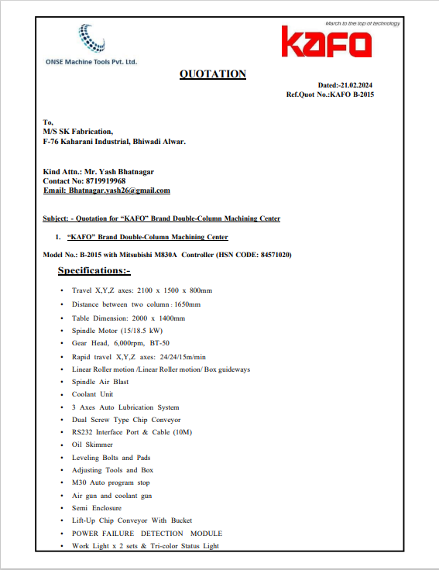

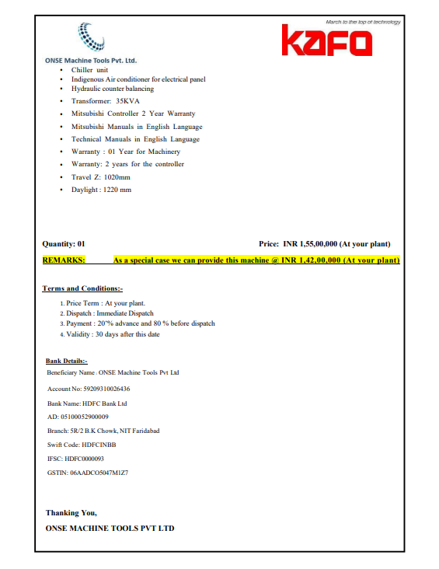

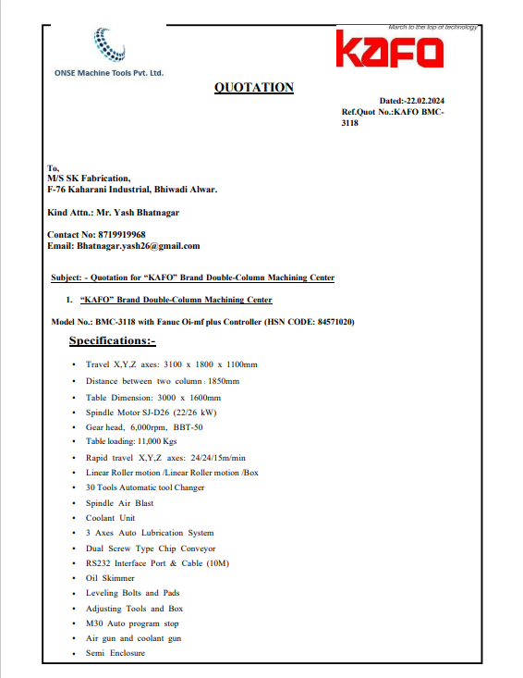

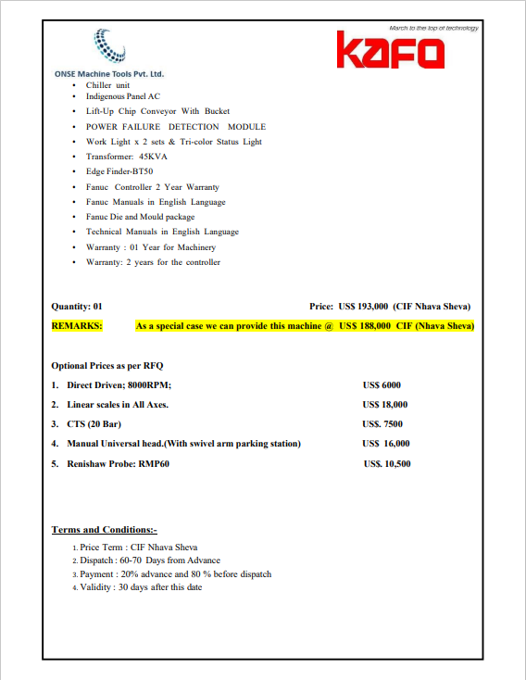

ANNEXURE: - III (DOCUMNETS PROVIDED BY CLIENT)

