REPORT FORMAT: V-L16 (Project Tie Up format) _V_10.2_2022

CASE NO. VIS(2023-24)-PL705-606-929 DATED: 05/03/2024

PROJECT TIE-UP REPORT
OF
NATURE OF ASSETS | GROUP HOUSING PROJECT
CATEGORY OF ASSETS | RESIDENTIAL
TYPE OF ASSETS | GROUP HOUSING SOCIETY
NAME OF PROJECT | JOYVILLE PHASE-1,2,3,4,5,6

SITUATED AT

SECTOR 102, VILLAGE KHERKI MAJRA, TEHSIL KADIPUR, GURUGRAM HARYANA 122001

DEVELOPER/ PROMOTER
M/S JOYVILLE SHAPOORJI HOUSING PRIVATE LIMITED

REPORT PREPARED FOR

BANK OF INDIA, RBC BRANCH, GURUGRAM

**Important - In case of any query/ issue/ concern or escalation you may please contact Incident Manager @ valuers@rkassociates.org. We will appreciate your feedback in order to improve our services.
NOTE: As per IBA Guidelines please provide your feedback on the report within 15 days of its submission after which report will be considered to be accepted & correct.
Terms of Services & Consultant’s Important Remarks are available at www.rkassociates.org for reference.

PART A | SNAPSHOT OF THE GROUP HOUSING PROJECT
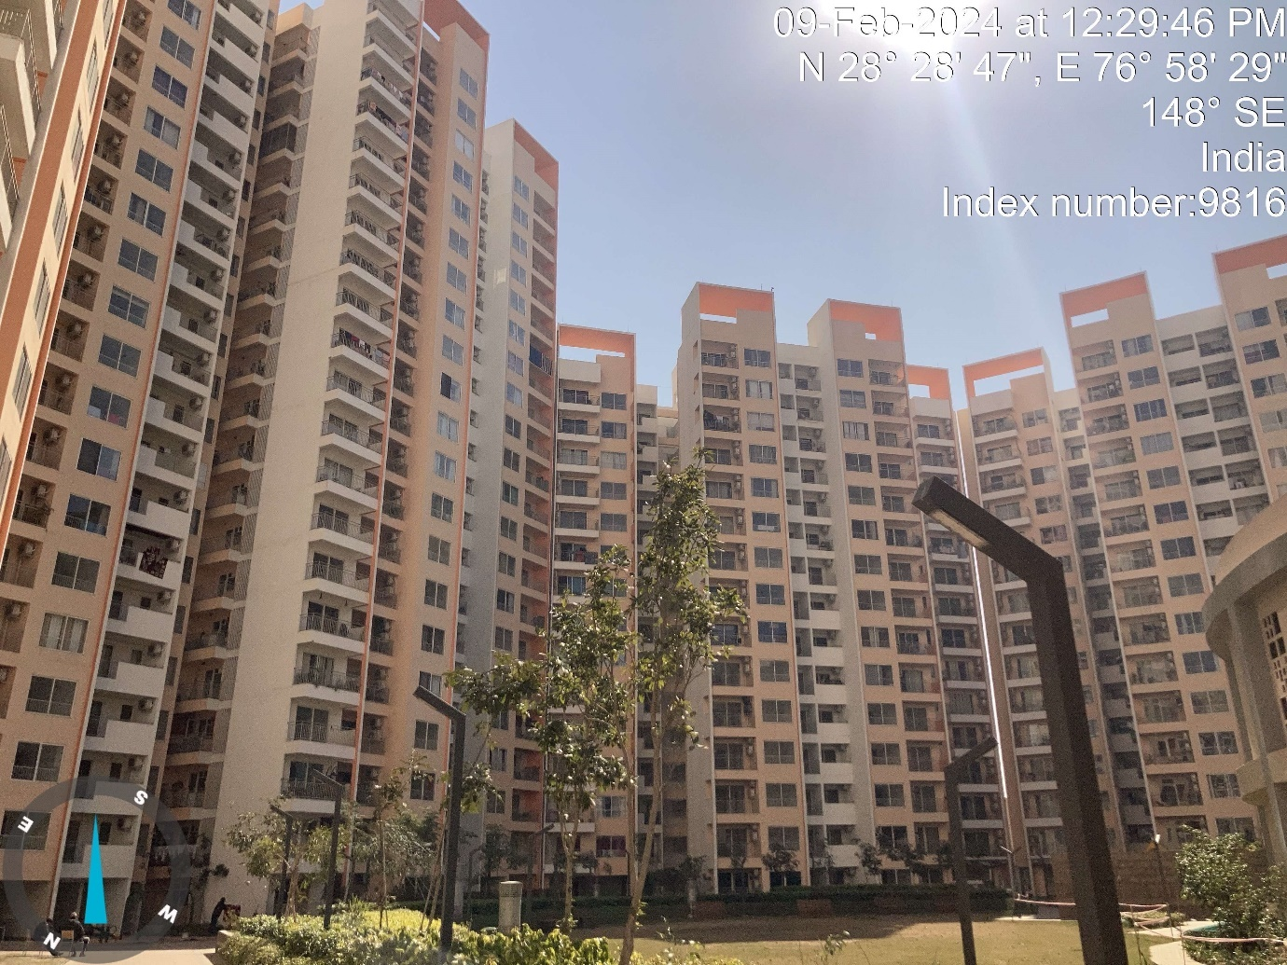
SITUATED AT
SECTOR 102, VILLAGE KHERKI MAJRA, TEHSIL KADIPUR, GURUGRAM HARYANA 122001
PART B | SUMMARY OF THE PROJECT TIE-UP REPORT

Name & Address of Branch | Bank of India, RBC Branch, Gurugram
Name of Project | Joyville Gurugram
Work Order No. & Date | Via E-mail dated 03rd February 2024

S. NO. | CONTENTS | DESCRIPTION
 | GENERAL DETAILS
 | Report prepared for | Bank of India, RBC Branch, Gurugram
 | Name of Developer/ Promoter | M/s Joyville Shapoorji Housing Private Limited
 | Registered Address of the Developer as per MCA website | SP Centre, 41/44, Minoo Desai Marg, Colaba, Mumbai,  Maharashtra
 | Type of the Property | Group Housing Society
 | Type of Report | Project Tie-up Report
 | Report Type | Project Tie-up Report
 | Date of Inspection of the Property | 9 February 2024
 | Date of Assessment | 5 March 2024
 | Date of Report | 5 March 2024
 | Property Shown by | Name |  | Relationship with Owner |  |  | Contact Number
 | Property Shown by | Mr. Anil |  | Company representative |  |  | +91 91369 49519
 | Purpose of the Report | For Project Tie-up for individual Flat Financing
 | Scope of the Report | Opinion on general assessment of Project cost and Market Price of Flats inventory for Project Tie-up.
 | Out-of-Scope of Report | - Verification of authenticity of documents from originals or cross checking from any Govt. deptt. is not done at our end.  - Legal aspects of the property are out-of-scope of this report.  - Identification of the property is only limited to cross verification from its boundaries at site if mentioned in the provided documents.  - Getting cizra map or coordination with revenue officers for site identification is not done at our end.  - Measurement is only limited up to sample random measurement.  - Measurement of the property as a whole is not done at our end.  - Designing and drawing of property maps and plans is out of scope of the work.  - Valuation techniques and principles.
 | Documents provided for perusal | Documents Requested |  |  | Documents Provided |  | Documents Reference No.
 | Documents provided for perusal | Documents requested. |  |  | Documents provided. |  | Reference No.
 | Documents provided for perusal | Ownership Documents & RERA Certificate |  |  | Refer Part-E
 | Documents provided for perusal | NOC's & Approval |  |  | Refer Part-E |  | ---
 | Identification of the property |  | Done from the name plate displayed on the property
 | Identification of the property |  | Identified by the Owner's representative
 | SUMMARY
 | Total Prospective Fair Market Value | Rs. 845,00,00,000/-
 | Total Expected Realizable/ Fetch Value | Rs. 718,25,00,000/-
 | Total Expected Distress/ Forced Sale Value | Rs. 633,75,00,000/-
 | Total No. of Dwelling Units | 2BHK- 588 DUs  3BHK- 848 DUs  4BHK- 92 DUs |  |  |  | Total = 1528 DUs
 | Carpet area of the project | 14,70,783 sq. ft.
 | Saleable Area of the Project | 24,12,166 sq. ft.
 | Inventory Cost as on “Date of Assessment” | Rs. 2,170.95 Cr. to Rs. 2,653.38 Cr.
 | ENCLOSURES
 | Enclosure 1 | Screenshot of the price trend references of the similar related properties available on public domain
 | Enclosure 2 | Google Map
 | Enclosure 3 | Photographs of The property
 | Enclosure 4 | Copy of Guideline rate
 | Enclosure 5 | Other relevant documents
 | Enclosure 6 | Consultant’s Remarks

PART C | CHARACTERISTICS DESCRIPTION OF THE PROJECT

 | BRIEF DESCRIPTION OF THE PROJECT
This project Tie-up report is prepared for the Group Housing Project ‘Joyville Gurugram’ being developed on total land area of 17.90 Acre as per copy of approved sanction plan. The project is being developed into 06 nos. of phases. There are total 13 nos. of towers being constructed.

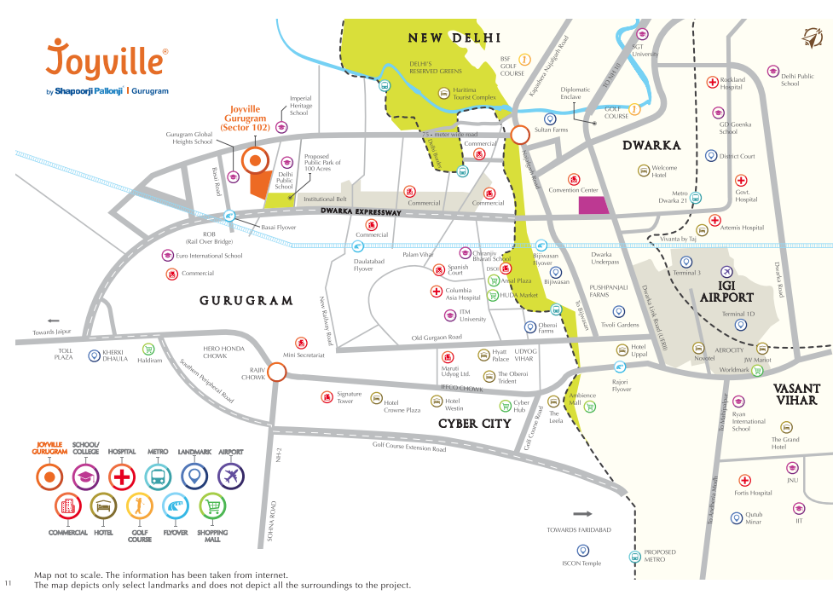
Unit configuration and its saleable area are as follows:-
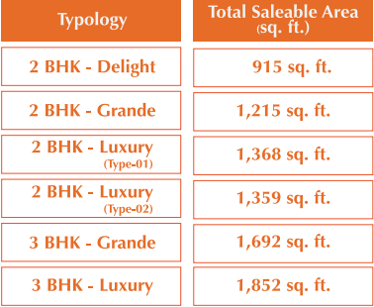
All the phases are registered under different RERA registration no. these details are as follows:-
RERA No. | Phase |  | Unit Configuration | Units
RC/REP/HARERA/GGM/2018/27 | Phase-1 | T-3 | 2BHK-Delight, Grande, Luxury-1 | 117
RC/REP/HARERA/GGM/2018/27 | Phase-1 | T-4 | 2BHK-Delight, Grande, Luxury-1 | 118
RC/REP/HARERA/GGM/2018/28 | Phase-2 | T-1 | 3BHK-Grande, Luxury-1 & 2 | 159
RC/REP/HARERA/GGM/2018/28 | Phase-2 | T-2 | 3BHK-Grande, Luxury-1 & 2 | 122
RC/REP/HARERA/GGM/335/67/2019/29 | Phase-3 | T-10 | 2BHK-Delight, Grande, Luxury-1 & 2 | 118
RC/REP/HARERA/GGM/335/67/2019/29 | Phase-3 | T-11 | 2BHK-Delight, Grande, Luxury-1 | 117
RC/REP/HARERA/GGM/336/68/2019/30 | Phase-4 | T-12 | 3BHK-Grande, Luxury-1 & 2 | 122
RC/REP/HARERA/GGM/336/68/2019/30 | Phase-4 | T-13 | 3BHK-Grande, Luxury-1 & 2 | 159
RC/REP/HARERA/GGM/345/77/2019/39 | Phase-5 | T-5 | 4BHK-Suite-1 & 2 | 92
RC/REP/HARERA/GGM/434/166/2021/02 | Phase-6 | T-6 | 3BHK-Grande, Luxury-1 & 2 | 112
RC/REP/HARERA/GGM/434/166/2021/02 | Phase-6 | T-7 | 3BHK-Grande, Luxury-1 & 2 | 87
RC/REP/HARERA/GGM/434/166/2021/02 | Phase-6 | T-8 | 3BHK-Grande, Luxury-1 & 2 | 87
RC/REP/HARERA/GGM/434/166/2021/02 | Phase-6 | T-9 | 2BHK-Delight & Grande | 118
Total |  |  |  | 1528

We have only provided with old Tie-up report by the bank. Details like FAR area, Non-FAR area, land area, has been taken from approved site plan. But NOCs & approvals data is taken from old report only. However the latest construction stage & flat rates are assessed as per the market research & site survey done by our engineer.
This tie up report is primarily the re validation of price of individual unit and updation of progress of the project. No new information/ data have been provided. Other details have been taken from old report.
The developer of the project has obtained most of the preliminary necessary statutory approvals from different government agencies to develop a group housing society comprising of all the basic & urban facilities & amenities.

The project is in under construction stage and as per the inspection during our site survey, we see that the progress of the project for different tower is as follows:-

Phase | Towers | Construction Status
Phase-1 | T-3 | Construction completed, ready to move
Phase-1 | T-4 | Construction completed, ready to move
Phase-2 | T-1 | Construction completed, ready to move
Phase-2 | T-2 | Construction completed, ready to move
Phase-3 | T-10 | Construction completed, applied for Occupation Certificate
Phase-3 | T-11 | Construction completed, applied for Occupation Certificate
Phase-4 | T-12 | Internal finishing is in progress
Phase-4 | T-13 | Internal finishing is in progress
Phase-5 | T-5 | Super Structure work completed, finishing work is in progress
Phase-6 | T-6 | Super Structure work completed
Phase-6 | T-7 | Super Structure work completed, finishing work is in progress
Phase-6 | T-8
Phase-6 | T-9

As per details available on Haryana RERA website, phase-wise completion dates are as follows:-

 | Start Date | Completion Date
Phase-1 | 01-01-2019 | 15-07-2022
Phase-2 | 01-01-2019 | 15-03-2023
Phase-3 | 01-07-2019 | 30-04-2024
Phase-4 | 01-08-2019 | 31-12-2024
Phase-5 | 02-01-2021 | 31-07-2025
Phase-6 | 02-01-2021 | 31-07-2025
The location of the subject project is in a good developing area of Sector-102 of Gurugram in which other group housing projects are also developing and some are proposed in future. Subject project is located on newly developed Dwarka Expressway which provides fast connectivity to Delhi Airport and other regions of Gurugram.
In case of discrepancy in the address mentioned in the property documents and the property shown to us at the site due to change in zoning or administrative level at the site or client misled the valuer by providing the fabricated document, the progress assessment should be considered of the property shown to us at the site of which the photographs are also attached. Our responsibility will be only related to the progress assessment of the property shown to us on the site and not regarding matching from the documents or searching the property from our own. Banker to verify from district administration/ tehsil level the identification of the property if it is the same matching with the document pledged.

This is a Project Tie-up report. Scope of work is opinion on general assessment of Project cost and Market Price of Flats inventory for Project Tie-up Wherever the term of valuation or anything related to it is mentioned in the report, it is only for illustration purpose in relation to pricing assessment and should not be construed as pure valuation assignment or for any other purpose.

This report only contains general assessment & opinion on the Guideline Value and the indicative, estimated Market Value of the property found on as-is-where basis on site for which the Bank/ customer has shown & asked us to conduct the assessment for which photographs is also attached with the report. No legal aspects in terms of ownership or any other legal aspect is taken into consideration. It doesn’t contain any due-diligence other than the assessment of the property shown to us on site. Information/ data/ documents given to us by Bank/ client has been relied upon in good faith. This report doesn’t contain any other recommendations of any sort.
 | LOCATION CHARACTERISTICS OF THE PROPERTY
 | Nearby Landmark |  |  |  |  |  |  |  | Adani Oyster Grande
 | Name of similar projects available nearby with distance from this property |  |  |  |  |  |  |  | Adani Oyster Grande (400 mtr), BPTP Amstoria (1 Km), Emaar Imperial Gardens (1.50 Km)
 | Postal Address of the Project |  |  |  |  |  |  |  | Shapoorji Pallonji Joyville Gurugram, Sector 102, Village: Kherki Majra, Tehsil: Kadipur, Gurugram, Haryana 122001
 | Independent access/ approach to the property |  |  |  |  |  |  |  | Clear independent access is available
 | Google Map Location of the Property with a neighborhood layout map |  |  |  |  |  |  |  | Enclosed with the Report
 |  |  |  |  |  |  |  |  | Coordinates or URL: 28°28'47.5"N 76°58'29.9"E
 | Description of adjoining property |  |  |  |  |  |  |  | Other residential projects & Sector road
 | Plot No. / Survey No. |  |  |  |  |  |  |  | Please refer to sale deeds
 | Village/ Zone |  |  |  |  |  |  |  | Village- Kherki Majra, Zone- Residential
 | Sub registrar |  |  |  |  |  |  |  | Kadipur
 | District |  |  |  |  |  |  |  | Gurugram
 | City Categorization |  |  |  |  |  |  |  | Metro City |  |  |  |  | Urban developing
 | Type of Area |  |  |  |  |  |  |  | Residential Area
 | Classification of the area/Society |  |  |  |  |  |  |  | Upper Middle Class (Good) |  |  |  |  | Urban developing
 | Type of Area |  |  |  |  |  |  |  | Within urban developing zone
 | Characteristics of the locality |  |  |  |  |  |  |  | Good |  |  |  |  | Within urban developing zone
 | Property location classification |  |  |  |  |  |  |  | On Wide Road |  |  | Near to Highway |  |  |  |  |  |  |  | Normal location within locality
 | Property Facing |  |  |  |  |  |  |  | North Facing
 | DETAILS OF THE ROADS ABUTTING THE PROPERTY
 | - Main Road Name & Width |  |  |  |  |  |  |  | Dwarka Expressway |  |  |  |  |  |  |  |  | ~200 ft.
 | - Front Road Name & width |  |  |  |  |  |  |  | Sector road |  |  |  |  |  |  |  |  | ~100 ft.
 | - Type of Approach Road |  |  |  |  |  |  |  | Bituminous Road
 | - Distance from the Main Road |  |  |  |  |  |  |  | ~700 mtr
 | Is property clearly demarcated by permanent/ temporary boundary on site |  |  |  |  |  |  |  | Yes
 | Is the property merged or colluded with any other property |  |  |  |  |  |  |  | No
 | BOUNDARIES SCHEDULE OF THE PROPERTY
 | Are Boundaries matched |  |  |  |  |  |  |  | No, boundaries are not mentioned in the documents.
 | Directions |  |  |  | As per Title Deed/TIR |  |  |  |  |  |  | Actual found at Site
 | East |  |  |  | No information available |  |  |  |  |  |  | Vacant Land
 | West |  |  |  | No information available |  |  |  |  |  |  | Oyster Grande
 | North |  |  |  | No information available |  |  |  |  |  |  | Road & Entry/Exit
 | South |  |  |  | No information available |  |  |  |  |  |  | Other’s property
 | TOWN PLANNING/ ZONING PARAMETERS
 | Planning Area/ Zone |  |  |  |  |  |  |  |  | DTCP Gurgaon Manesar Urban Complex FDP -2031
 | Master Plan currently in force |  |  |  |  |  |  |  |  | DTCP Gurgaon Manesar Urban Complex FDP -2031
 | Municipal limits |  |  |  |  |  |  |  |  | Municipal Corporation of Gurugram
 | Developmental controls/ Authority |  |  |  |  |  |  |  |  | Director of Town and Country Planning, Haryana
 | Zoning regulations |  |  |  |  |  |  |  |  | Residential
 | Master Plan provisions related to property in terms of Land use |  |  |  |  |  |  |  |  | Group Housing
 | Any conversion of land use done |  |  |  |  |  |  |  |  | NA
 | Current activity done in the property |  |  |  |  |  |  |  |  | Group Housing Society
 | Is property usage as per applicable zoning |  |  |  |  |  |  |  |  | Yes, used as residential as per zoning.
 | Any notification on change of zoning regulation |  |  |  |  |  |  |  |  | No such information came to our knowledge
 | Street Notification |  |  |  |  |  |  |  |  | Residential
 | Status of Completion/ Occupational certificate |  |  |  |  |  |  |  |  | Under construction, 06 nos. towers completed
 | Comment on unauthorized construction if any |  |  |  |  |  |  |  |  | NA as property is under construction (Partially)
 | Comment on Transferability of developmental rights |  |  |  |  |  |  |  |  | Free hold
 | Comment on the surrounding land uses & adjoining properties in terms of uses |  |  |  |  |  |  |  |  | The surrounding properties are currently being used for  Residential purpose.
 | Comment of Demolition proceedings if any |  |  |  |  |  |  |  |  | NA as property is under construction (Partially)
 | Comment on Compounding/ Regularization proceedings |  |  |  |  |  |  |  |  | NA as property is under construction (Partially)
 | Any information on encroachment |  |  |  |  |  |  |  |  | No, as information available during site visit
 | Is the area part of unauthorized area/ colony |  |  |  |  |  |  |  |  | No (As per general information available).
 | LEGAL ASPECTS OF THE PROPERTY
 | Ownership documents provided |  |  |  |  |  |  |  |  | Sale deeds |  |  |  |  |  |  | RERA Certificate
 | Names of the Developer/Promoter |  |  |  |  |  |  |  |  | M/s Joyville Shapoorji Housing Private Limited
 | Constitution of the Property |  |  |  |  |  |  |  |  | Free hold
 | Agreement of easement if any |  |  |  |  |  |  |  |  | Not required
 | Notice of acquisition if any and area under acquisition |  |  |  |  |  |  |  |  | No, as per general information available in the public domain
 | Notification of road widening if any and area under acquisition |  |  |  |  |  |  |  |  | Yes, some of the total land area already acquired in zoning
 | Heritage restrictions, if any |  |  |  |  |  |  |  |  | No
 | Comment on Transferability of the property ownership |  |  |  |  |  |  |  |  | Free hold, complete transferable rights
 | Comment on existing mortgages/ charges/ encumbrances on the property, if any |  |  |  |  |  |  |  |  | No, Information available to us.
 | Comment on whether the owners of the property have issued any guarantee (personal or corporate) as the case may be |  |  |  |  |  |  |  |  | No, Information available to us.
 | Building Plan sanction:
 | - Authority approving the plan |  |  |  |  |  |  |  |  | Director of Town and Country Planning, Haryana
 | - Any violation from the approved Building Plan |  |  |  |  |  |  |  |  | Cannot comment since the project is under construction. (Partially)
 | Whether Property is Agricultural Land if yes, any conversion is contemplated |  |  |  |  |  |  |  |  | No not an agricultural property
 | Whether the property SARFAESI complaint |  |  |  |  |  |  |  |  | Yes
 | Information regarding municipal taxes (property tax, water tax, electricity bill) |  |  |  |  |  |  |  |  | Tax name |  |  |  |  | NA
 |  |  |  |  |  |  |  |  |  | Receipt number |  |  |  |  | NA
 |  |  |  |  |  |  |  |  |  | Receipt in the name of |  |  |  |  | NA
 |  |  |  |  |  |  |  |  |  | Tax amount |  |  |  |  | NA
 | Observation on Dispute or Dues if any in payment of bills/ taxes |  |  |  |  |  |  |  |  | Not known to us
 | Is property tax been paid for this property |  |  |  |  |  |  |  |  | NA
 | Property or Tax Id No. |  |  |  |  |  |  |  |  | NA
 | Whether entire piece of land on which the unit is set up / property is situated has been mortgaged or to be mortgaged |  |  |  |  |  |  |  |  | No information available.
 | Property presently occupied/ possessed by |  |  |  |  |  |  |  |  | The property is currently possessed by the subject promoter/company only.
 | Title verification |  |  |  |  |  |  |  |  | Title verification to be done by competent advocate as the same is out of our scope of work.
 | Details of leases if any |  |  |  |  |  |  |  |  | Not applicable
 | SOCIO - CULTURAL ASPECTS OF THE PROPERTY
 | Descriptive account of the location of the property in terms of social structure of the area in terms of population, social stratification, regional origin, age groups, economic levels, location of slums settlements nearby, etc. |  |  |  |  |  |  |  |  | Medium Income Group
 | Whether property belongs to social infrastructure like hospital, school, old age homes etc. |  |  |  |  |  |  |  |  | No
 | FUNCTIONAL AND UTILITARIAN SERVICES, FACILITIES & AMENITIES
 | Drainage arrangements |  |  |  |  |  |  |  |  | Yes
 | Water Treatment Plant |  |  |  |  |  |  |  |  | Yes
 | Power Supply arrangements |  |  |  |  | Permanent |  |  |  | Yes
 |  |  |  |  |  | Auxiliary |  |  |  | Yes, D.G sets
 | HVAC system |  |  |  |  |  |  |  |  | Yes, only in common mobility areas
 | Security provisions |  |  |  |  |  |  |  |  | Yes
 | Lift/ Elevators |  |  |  |  |  |  |  |  | Yes
 | Compound wall/ Main Gate |  |  |  |  |  |  |  |  | Yes
 | Whether gated society |  |  |  |  |  |  |  |  | Yes
 | Car parking facilities |  |  |  |  |  |  |  |  | Yes
 | Internal development
 | Garden/ Park/ Land scaping |  | Water bodies |  |  |  | Internal roads |  |  |  |  |  | Pavements |  |  |  |  |  |  |  | Boundary Wall
 | Yes (proposed) |  | Yes (Proposed) |  |  |  | Yes (Proposed) |  |  |  |  |  | Yes (Proposed) |  |  |  |  |  |  |  | Yes
 | INFRASTRUCTURE AVAILABILITY
 | Description of Water Infrastructure availability in terms of:
 | - Water Supply |  |  |  |  |  |  |  |  | Yes from municipal connection
 | - Sewerage/ sanitation system |  |  |  |  |  |  |  |  | Yes
 | - Storm water drainage |  |  |  |  |  |  |  |  | Yes
 | Description of other Physical Infrastructure facilities in terms of:
 | - Solid waste management |  |  |  |  |  |  |  |  | Yes from municipal connection
 | - Electricity |  |  |  |  |  |  |  |  | Yes
 | - Road and Public Transport connectivity |  |  |  |  |  |  |  |  | Yes
 | - Availability of other public utilities nearby |  |  |  |  |  |  |  |  | Transport, Market, Hospital etc. available in close vicinity
 | Proximity & availability of civic amenities & social infrastructure
 | School | Hospital |  | Market |  |  |  | Bus Stop |  |  | Railway Station |  |  |  |  |  | Metro |  | Airport
 | 1 Km. | 5 km. |  | 2.5 km. |  |  |  | 3 km. |  |  | 5 Km. |  |  |  |  |  | 14 Km |  | 23 km. (IGI)
 | Availability of recreation facilities (parks, open spaces etc.) |  |  |  |  |  |  | It is a developing area and recreational facilities are planned to be developed nearby.
 | MARKETABILITY ASPECTS OF THE PROPERTY:
 | Location attribute of the subject property |  |  |  |  |  |  | Good
 | Scarcity |  |  |  |  |  |  | Similar kind of properties are available in this area.
 | Market condition related to demand and supply of the kind of the subject property in the area |  |  |  |  |  |  | Good demand of such properties in the market.
 | Any New Development in surrounding area |  |  |  |  |  |  | Newly developed Dwarka Expressway
 | Any negativity/ defect/ disadvantages in the property/ location |  |  |  |  |  |  | Not as such
 | Any other aspect which has relevance on the value or marketability of the property |  |  |  |  |  |  | None
 | ENGINEERING AND TECHNOLOGY ASPECTS OF THE PROPERTY:
 | Type of construction & design |  |  |  |  |  |  | RCC framed pillar beam column structure on RCC slab
 | Method of construction |  |  |  |  |  |  | Construction being done using professional contractor workmanship based on architect plan.
 | Specifications
 | - Class of construction |  |  |  |  |  |  | Class B construction (Good)
 | - Appearance/ Condition of structures |  |  |  |  |  |  | Internal - Good
 |  |  |  |  |  |  |  | External - Good
 | - Roof |  |  |  |  |  |  | Floors/ Blocks |  |  |  |  |  |  |  | Type of Roof
 |  |  |  |  |  |  |  | RCC |  |  |  |  |  |  |  | RCC
 | - Floor height |  |  |  |  |  |  | Approx. 10 feet
 | - Type of flooring |  |  |  |  |  |  | Vitrified tiles, Ceramic Tiles, Wooden flooring
 | - Doors/ Windows |  |  |  |  |  |  | Wooden frame with glass panel windows, Aluminum flushed doors & windows
 | - Interior Finishing |  |  |  |  |  |  | Neatly plastered and putty coated walls (Proposed)
 | - Exterior Finishing |  |  |  |  |  |  | Simple plastered walls
 | - Interior decoration/ Special architectural or decorative feature |  |  |  |  |  |  | Good looking interiors. Medium use of interior decoration. (Proposed)
 | - Class of electrical fittings |  |  |  |  |  |  | Internal/ High quality fittings used
 | - Class of sanitary & water supply fittings |  |  |  |  |  |  | Internal/ High quality fittings used
 | Maintenance issues |  |  |  |  |  |  | None, since construction work of the project is in progress partially
 | Age of building/ Year of construction |  |  |  |  |  |  | New/Under construction |  |  |  |  |  |  |  | New/Under construction
 | Total life of the structure/ Remaining life expected |  |  |  |  |  |  | ~65 to 70 years |  |  |  |  |  |  |  | ~65 to 70 years
 | Extent of deterioration in the structure |  |  |  |  |  |  | No deterioration came into notice through visual observation
 | Protection against natural disasters viz. earthquakes etc. |  |  |  |  |  |  | All the proposed structures are asumed to be designed for seismic consideration for Zone IV
 | Visible damage in the building if any |  |  |  |  |  |  | No
 | System of air conditioning |  |  |  |  |  |  | As per requirement by individual flat owners on their own
 | Provision of firefighting |  |  |  |  |  |  | Yes
 | Status of Building Plans/ Maps |  |  |  |  |  |  | Building plans are approved by the concerned authority.
 | - Is Building as per approved Map |  |  |  |  |  |  | Yes
 | - Details of alterations/ deviations/ illegal construction/ encroachment noticed in the structure from the original approved plan |  |  |  |  |  |  | ☐ Permissible Alterations
 |  |  |  |  |  |  |  | ☐ Not permitted alteration
 | - Is this being regularized |  |  |  |  |  |  | NA
 | ENVIRONMENTAL FACTORS:
 | Use of environment friendly building materials like fly ash brick, other green building techniques if any |  |  |  |  |  | Yes
 | Provision of rainwater harvesting |  |  |  |  |  | Yes
 | Use of solar heating and lighting systems, etc. |  |  |  |  |  | None
 | Presence of environmental pollution in the vicinity of the property in terms of industries, heavy traffic, etc. if any |  |  |  |  |  | Yes, normal construction and vehicular pollution present
 | ARCHITECTURAL AND AESTHETIC QUALITY OF THE PROPERTY:
 | Descriptive account on whether the building is modern, old fashioned, etc., plain looking or with decorative elements, heritage value if applicable, presence of landscape elements etc. |  |  |  |  |  | Plain looking simple structure
 | PROJECT DETAILS:
 | Name of the Developer | M/s. Joyville Shapoorji Housing Private Limited
 | Name of the Project | Joyville Gurugram
 | Total no. of Dwelling units | 2BHK- 588 DUs  3BHK- 848 DUs  4BHK- 92 DUs  Total = 1528 DUs
 | Developer market reputation | Established Builder with years long experience in market and have successfully delivered multiple Projects.
 | Name of the Architect | M/s RSP Design Consultant India Private Limited
 | Architect Market Reputation | Established Architect with years long experience in market and have successfully delivered multiple Projects.
 | Proposed completion date of the Project | Please Refer to part-C
 | Progress of the Project | Please Refer to for phase/tower-wise progress part-C
 | Other Salient Features of the Project | ☒ High end modern apartment, ☐ Ordinary Apartments, ☐ Affordable housing, ☒ Club, ☒ Swimming Pool, ☒ Play Area, ☒ Walking Trails, ☒ Gymnasium, ☒ Convenient Shopping, ☒ Parks, ☒ Multiple Parks, ☒ Kids Play Area

PART D | AREA DESCRIPTION OF THE PROPERTY

 | Total area of site |  |  | 17.90 Acres / 72,439 sq. mtr
 | Total Site area for calculation |  |  | 17.90 Acres / 72,439 sq. mtr
 | Land Area of the Subject Phase (as per RERA) |  |  | 17.90 Acres / 72,439 sq. mtr (for all 06 phases)
 | Ground Coverage Area | Permissible |  | 28278.588 sqm (40%)
 | Ground Coverage Area | Proposed |  | 14481.236 sqm (20.162%)
 | Covered Area | UNDER FAR |  | Proposed | Present Status
 | Covered Area | TOTAL | Permissible | 181536.635 sqm | Refer part-C
 | Covered Area | TOTAL | Proposed | 181477.339 sqm | Refer part-C
 | Covered Area | UNDER NON-FAR
 | Covered Area | TOTAL | Proposed | 68,180.759 sqm | Refer part-C
 | Covered Area | TOTAL | Permissible | --- | Refer part-C
 | Car Parking | Proposed |  | 1569 cars
 | Car Parking | Minimum Required |  | 1091 cars
 | Car Parking | For EWS |  | 55 cars
 | Density | Proposed |  | 8486 persons
 | Density | Permissible |  | 6944 persons to 8486 persons
 | Amenities | Nursery School |  | 02 nos.
 | Amenities | Primary School |  | 01 nos.
 | Plinth/ Built-up Area  (As per IS 3861-1966) |  |  | 249658.098 sqm (including EWS, Community, School)
 | Carpet Area |  |  | 14,70,783 sq.ft. (Towers only)
 | Net Floor Area |  |  | 24,12,166 sq.ft (Towers only)

Total Blocks/ Floors/ Flats
 | Approved as per Sanctioned Plan |  | Actually provided  (as per inventory list/ brochure) |  | Current Status
 | Tower-1: 159 DUs (B+G+26) |  | Tower-1: 159 DUs (B+G+26) |  | Construction completed, ready to move
 | Tower-2: 122 DUs (B+G+20) |  | Tower-2: 122 DUs (B+G+20)
 | Tower-3: 117 DUs (B+G+14) |  | Tower-3: 117 DUs (B+G+14)
 | Tower-4: 118 DUs (B+G+14) |  | Tower-4: 118 DUs (B+G+14)
 | Tower-5: 92 DUs (B+G+23) |  | Tower-5: 92 DUs (B+G+23) |  | Super Structure work completed, finishing work is in progress
 | Tower-6: 112 DUs (B+G+18) |  | Tower-6: 112 DUs (B+G+18) |  | Super Structure work completed
 | Tower-7: 87 DUs (B+G+14) |  | Tower-7: 87 DUs (B+G+14) |  | Super Structure work completed, finishing work is in progress
 | Tower-8: 87 DUs (B+G+14) |  | Tower-8: 87 DUs (B+G+14)
 | Tower-9: 118 DUs (B+G+14) |  | Tower-9: 118 DUs (B+G+14)
 | Tower-10: 118 DUs (B+G+14) |  | Tower-10: 118 DUs (B+G+14) |  | Construction completed, applied for Occupation Certificate
 | Tower-11: 117 DUs (B+G+14) |  | Tower-11: 117 DUs (B+G+14)
 | Tower-12: 122 DUs (B+G+20) |  | Tower-12: 122 DUs (B+G+20) |  | Internal finishing is in progress
 | Tower-13: 159 DUs (B+G+26) |  | Tower-13: 159 DUs (B+G+26)
 | Total no. of Flats/ Units | Main Units | 1528 DU
 | Total no. of Flats/ Units | EWS | 270 DU
 | Type of Flats |  | Type of Flat | Project Name |  | Super Area  (Sq. ft.)
 |  |  | Please refer to Part-C

Note:

- Area measurements considered in the report pertaining to Land & Building is adopted from relevant approved documents only.
- Area of the large land parcels of more than 2500 sq. mtr or of uneven shape, is taken as per property documents verified with digital survey through google which has been relied upon.
- Drawing Map, design & detailed estimation of the property/ building is out of scope of our services.

PART E | PROJECT APPROVAL DETAILS

S. No. | REQUIRED APPROVALS | REFERENCE NO./ DATE | STATUS
Phase-I
 | Sale Deed | Dated 21st June, 2018 | Approved
 | BR-III | Dated 12th November, 2018 | Approved
 | Infrastructure Development Charges Receipt | Dated 2nd August, 2018 | Approved
 | Environmental Clearance | Dated 20th August, 2018 | Approved
 | Fire NOC | Dated 14th December, 2018 | Applied
 | Pollution NOC | Dated 30th October, 2018 | Approved
 | RERA Certificate | Dated 29th November, 2018 | Approved
 | Forest NOC | Dated 23rd April, 2018 | Approved
 | Assurance letter for Sewerage Connection | Dated 11th June, 2018 in the name of M/s. Eventual Builders Priavte Limited | Approved
 | Electricity Connection Certificate | Dated 24th May, 2018 in the name of M/s. Eventual Builders Priavte Limited | Approved
 | Structural Stability Certificate | Dated 10th July, 2018 | Approved
Phase-II
 | Sale Deed | Dated 21st June, 2018 | Approved
 | LC-V (License from Town And Country Planning Department) | License No. 14 of 2018  Dated: 07/02/2018  Valid Up to: 06/02/2023 | Approved
 | Approved Map | Dated: 08/01/2019 | Approved
 | NOC from Aravali Department | No.21/MB  Dated: 03/05/2018 | Approved
 | BR-III | Memo No. ZP-1257/AD(RA)/2018/31334  Dated 12th November, 2018 | Approved
 | Infrastructure Development Charges Receipt | Dated 2nd August, 2018 | Approved
 | Environmental Clearance from SEIAA, Haryana | No. SEIAA/HR/2018/1077  Dated 20/08/2018 | Approved
 | Provisional Fire NOC | Dated 14th December, 2018 | Applied
 | Consent to establish from HSPCB | No. HSPCB/Consent/:329962318GUNOCTE5671401  Dated 30/10/2018 | Approved
 | RERA Certificate | RC/REP/HARERA/GGM/335/67/2019/29  Dated 25/05/2019 | Approved
 | NOC from Forest Department | Dated 23rd April, 2018 | Approved
 | Assurance letter for Sewerage Connection | Memo No.117719  Dated 11/06/2018 in the name of M/s. Eventual Builders Private Limited | Approved
 | Electricity Assurance Certificate | Memo No. Ch-76/Drg./UPLR-99/City  Dated 24/05/2018 in the name of M/s. Eventual Builders Private Limited | Approved
 | Form BR-V | Dated 10/07/2018 | Approved
Phase-III
 | Sale Deed | Dated 21st June, 2018 | Approved
 | LC-V (License from Town And Country Planning Department) | License No. 14 of 2018  Dated:-07/02/2018  Valid Upto : -06/02/2023 | Approved
 | Approved Map | Dated: -08/01/2019 | Approved
 | NOC from Aravali Department | No.21/MB  Dated: -03/05/2018 | Approved
 | BR-III | Memo No. ZP-1257/AD(RA)/2018/31334  Dated 12th November, 2018 | Approved
 | Infrastructure Development Charges Receipt | Dated 2nd August, 2018 | Approved
 | Environmental Clearance from SEIAA, Haryana | No.SEIAA/HR/2018/1077  Dated 20/08/2018 | Approved
 | Fire NOC | Dated 14th December, 2018 | Applied
 | Consent to establish from HSPCB | No. HSPCB/Consent/:329962318GUNOCTE5671401  Dated 30/10/2018 | Approved
 | RERA Certificate | RC/REP/HARERA/GGM/335/67/2019/29  Dated 25/05/2019 | Approved
 | NOC from Forest Department | Dated 23rd April, 2018 | Approved
 | Assurance letter for Sewerage Connection | Memo No.117719  Dated 11/06/2018 in the name of M/s. Eventual Builders Private Limited | Approved
 | Electricity Assurance Certificate | Memo No. Ch-76/Drg./UPLR-99/City  Dated 24/05/2018 in the name of M/s. Eventual Builders Private Limited | Approved
 | Form BR-V | Dated 10/07/2018 | Approved
Phase-IV
 | Sale Deed | Dated 21st June, 2018 | Approved
 | LC-V (License from Town And Country Planning Department) | License No. 14 of 2018  Dated:-07/02/2018  Valid Upto : -06/02/2023 | Approved
 | Approved Map | Dated: -08/01/2019 | Approved
 | NOC from Aravali Department | No.21/MB  Dated: -03/05/2018 | Approved
 | BR-III | Memo No. ZP-1257/AD(RA)/2018/31334  Dated 12th November, 2018 | Approved
 | Infrastructure Development Charges Receipt | Dated 2nd August, 2018 | Approved
 | Environmental Clearance from SEIAA, Haryana | No.SEIAA/HR/2018/1077  Dated 20/08/2018 | Approved
 | Fire NOC | Dated 14th December, 2018 | Applied
 | Consent to establish from HSPCB | No. HSPCB/Consent/:329962318GUNOCTE5671401  Dated 30/10/2018 | Approved
 | RERA Certificate | RC/REP/HARERA/GGM/336/68/2019/30  Dated 25/05/2019 | Approved
 | NOC from Forest Department | Dated 23rd April, 2018 | Approved
 | Assurance letter for Sewerage Connection | Memo No.117719  Dated 11/06/2018 in the name of M/s. Eventual Builders Private Limited | Approved
 | Electricity Assurance Certificate | Memo No. Ch-76/Drg./UPLR-99/City  Dated 24/05/2018 in the name of M/s. Eventual Builders Private Limited | Approved
 | Form BR-V | Dated 10/07/2018 | Approved
Phase-V
 | Sale Deed | Dated 21st June, 2018 | Approved
 | LC-V (License from Town and Country Planning Department) | License No. 14 of 2018  Dated: 07/02/2018  Valid Up to: 06/02/2023 | Approved
 | Approved Map | Dated: 08/01/2019 | Approved
 | NOC from Aravali Department | No.21/MB  Dated: 03/05/2018 | Approved
 | BR-III | Memo No. ZP-1257/AD(RA)/2018/31334  Dated 12th November, 2018 | Approved
 | Infrastructure Development Charges Receipt | Dated 2nd August, 2018 | Approved
 | Environmental Clearance from SEIAA, Haryana | No. SEIAA/HR/2018/1077  Dated 20/08/2018 | Approved
 | Provisional Fire NOC | Dated 14th December, 2018 | Applied
 | Consent to establish from HSPCB | No. HSPCB/Consent/:329962318GUNOCTE5671401  Dated 30/10/2018 | Approved
 | RERA Certificate | RC/REP/HARERA/GGM/335/67/2019/29  Dated 25/05/2019 | Approved
 | NOC from Forest Department | Dated 23rd April, 2018 | Approved
 | Assurance letter for Sewerage Connection | Memo No.117719  Dated 11/06/2018 in the name of M/s. Eventual Builders Private Limited | Approved
 | Electricity Assurance Certificate | Memo No. Ch-76/Drg./UPLR-99/City  Dated 24/05/2018 in the name of M/s. Eventual Builders Private Limited | Approved
 | Form BR-V | Dated 10/07/2018 | Approved
Phase-VI
 | Sale Deed | Dated 21st June, 2018 | Approved
 | LC-V (License from Town and Country Planning Department) | License No. 14 of 2018  Dated: 07/02/2018  Valid Up to: 06/02/2023 | Approved
 | Approved Map | Dated: 08/01/2019 | Approved
 | NOC from Aravali Department | No.21/MB  Dated: -03/05/2018 | Approved
 | BR-III | Memo No. ZP-1257/AD(RA)/2018/31334  Dated 12th November, 2018 | Approved
 | Infrastructure Development Charges Receipt | Dated 2nd August, 2018 | Approved
 | Environmental Clearance from SEIAA, Haryana | No. SEIAA/HR/2018/1077  Dated 20/08/2018 | Approved
 | Fire NOC | Dated 14th December, 2018 | Applied
 | Consent to establish from HSPCB | No. HSPCB/Consent/:329962318GUNOCTE5671401  Dated 30/10/2018 | Approved
 | RERA Certificate | RC/REP/HARERA/GGM/335/67/2019/29  Dated 25/05/2019 | Approved
 | NOC from Forest Department | Dated 23rd April, 2018 | Approved
 | Assurance letter for Sewerage Connection | Memo No.117719  Dated 11/06/2018 in the name of M/s. Eventual Builders Private Limited | Approved
 | Electricity Assurance Certificate | Memo No. Ch-76/Drg./UPLR-99/City  Dated 24/05/2018 in the name of M/s. Eventual Builders Private Limited | Approved
 | Form BR-V | Dated 10/07/2018 | Approved

- NOC details have been taken from HRERA & old tie up report, since no documents have been provided.

PART F | PROCEDURE OF ASSESMENT

 | GENERAL INFORMATION
 | Important Dates | Date of Inspection of the Property |  | Date of Assessment | Date of Report
 | Important Dates | 3 February 2024 |  | 5 March 2024 | 5 March 2024
 | Client | Bank of India, RBC Branch, Gurugram
 | Intended User | Bank of India, RBC Branch, Gurugram
 | Intended Use | To know the general idea on the pricing assessment trend of the property as per free market transaction. This report is not intended to cover any other internal mechanism, criteria, and considerations of any organization as per their own need, use & purpose.
 | Purpose of Report | For Project Tie-up for individual Flat Financing
 | Scope of the Assessment | Non binding opinion on the cost assessment of the project, asertaining the Construction status of the project and Market Price of the Flats Inventory for which bank has asked us to do Project TIe up report.
 | Restrictions | This report should not be referred for any other purpose, by any other user and for any other date other than as specified above.
 | Manner in which the property is identified |  | Done from the nameplate displayed on the property
 | Manner in which the property is identified |  | Identified by the owner’s representative
 | Type of Survey conducted | Only photographs taken (No sample measurement verification),

 | ASSESSMENT FACTORS
 | Nature of the Report | Project Tie-up
 | Nature/ Category/ Type/ Classification of Asset under Valuation | Nature |  |  | Category |  | Type
 |  | Group Housing Project |  |  | Residential |  | Group Housing Society
 |  | Classification |  |  | Residential Group Housing
 | Basis of Inventory assessment (for Project Tie up Purpose) | Primary Basis |  | Market Price Assessment & Govt. Guideline Value
 | Basis of Inventory assessment (for Project Tie up Purpose) | Secondary Basis |  | Not Applicable
 | Present market state of the Asset assumed Total No. of Dwelling Units | Under Normal Marketable State
 |  | Reason: Asset under free market transaction state
 | Property Use factor | Current/ Existing Use |  |  | Highest & Best Use  (in consonance to surrounding use, zoning and statutory norms) |  | Considered for Assessment
 | Property Use factor | Residential |  |  | Residential |  | Residential
 | Legality Aspect Factor | Assumed to be fine as per copy of the documents & information produced to us. However, Legal aspects of the property of any nature are out-of-scope of the Services. In terms of the legality, we have only gone by the documents provided to us in good faith.  Verification of authenticity of documents from originals or cross checking from any Govt. dept. have to be taken care by Legal expert/ Advocate.
 | Land Physical Factors | Shape |  |  |  | Size
 | Land Physical Factors | Irregular |  |  |  | Large
 | Property Location Category Factor | City Categorization | Locality Characteristics |  |  | Property location characteristics |  | Floor Level
 | Property Location Category Factor | Metro City | Good |  |  | On Wide Road |  | B+G+26  B+G+20  B+G+14  B+G+23  B+G+18
 | Property Location Category Factor | Urban developing | Within urban developing zone |  |  | Near to Highway |  | B+G+26  B+G+20  B+G+14  B+G+23  B+G+18
 | Property Location Category Factor | Urban developing | Within developing Residential zone |  |  | Not Applicable |  | B+G+26  B+G+20  B+G+14  B+G+23  B+G+18
 | Property Location Category Factor | Property Facing
 | Property Location Category Factor | North Facing
 | Physical Infrastructure availability factors of the locality | Water Supply | Sewerage/ sanitation system |  |  | Electricity |  | Road and Public Transport connectivity
 | Physical Infrastructure availability factors of the locality | Yes | Underground |  |  | Yes |  | Easily available
 | Physical Infrastructure availability factors of the locality | Availability of other public utilities nearby |  |  |  | Availability of communication facilities
 | Physical Infrastructure availability factors of the locality | Transport, Market, Hospital etc. are available in close vicinity |  |  |  | Major Telecommunication Service Provider & ISP connections are available
 | Social structure of the area (in terms of population, social stratification, regional origin, age groups, economic levels, location of slums/ squatter settlements nearby, etc.) | Medium Income Group
 | Neighbourhood amenities | Good
 | Any New Development in surrounding area | Some group housing projects are under construction in the vicinity
 | Any specific advantage/ drawback in the property | Newly constructed Dwarka Expressway in near to the project
 | Property overall usability/ utility Factor | High
 | Do property has any alternate use? | None. The property can only be used for residential purpose.
 | Is property clearly demarcated by permanent/ temporary boundary on site | Yes demarcated properly.
 | Is the property merged or colluded with any other property | No
 | Is the property merged or colluded with any other property | Comments: None
 | Is independent access available to the property | Clear independent access is available
 | Is property clearly possessable upon sale | Yes
 | Best Sale procedure to realize maximum Value for inventory sale (in respect to Present market state or premise of the Asset as per point (iv) above) | Market Value
 |  | Free market transaction at arm's length wherein the parties, after full market survey each acted knowledgeably, prudently and without any compulsion.
 | Hypothetical Sale transaction method assumed for the inventory cost analysis | Market Value
 |  | Free market transaction at arm's length wherein the parties, after full market survey each acted knowledgeably, prudently and without any compulsion.
 | Approach & Method Used for inventory cost analysis | PROJECT INVENTORY
 | Approach & Method Used for inventory cost analysis | Approach for assessment |  |  |  | Method of assessment
 | Approach & Method Used for inventory cost analysis | Market Approach |  |  |  | Market Comparable Sales Method
 | Type of Source of Information | Level 3 Input (Tertiary)
 | Market Comparable
 | References on prevailing market Rate/ Price trend of the property and Details of the sources from where the information is gathered (from property search sites & local information) |  |  | Name: | Mr. Suresh
 |  |  |  | Contact No.: | +91 90131 77241
 |  |  |  | Nature of reference: | Property dealer
 |  |  |  | Size of the Property: | 1215 sq. ft. Super built-up area
 |  |  |  | Location: | Sector-102, Gurugram
 |  |  |  | Rates/ Price informed: | Rs. 1.25 Cr.
 |  |  |  | Any other details/ Discussion held: | According to the discussion held with the property dealer, the asking price of a 2BHK unit in Joyville is Rs.1.25 Cr. i.e. Rs. 10,288/- per sq.ft. on Super built-up area.
 |  |  |  | Name: | Mr. Vikas
 |  |  |  | Contact No.: | +91 99996 82228
 |  |  |  | Nature of reference: | Property Consultant
 |  |  |  | Size of the Property: | ~1,215 to 1,692 sq. ft. Super built-up area
 |  |  |  | Location: | Joyville Gurugram
 |  |  |  | Rates/ Price informed: | ~9,000 sq.ft. to 11,000 sq.ft. super built-up area
 |  |  |  | Any other details/ Discussion held: | According to the discussion held with the property dealer, the asking rate of a in Joyville Gurugram is Rs. 9.000/- to Rs. 11,000/- per sq.ft. on Super built-up area.
 | Adopted Rates Justification |  |  | As per our discussion with the locals inhabitants and property dealers of the subject location, we came to know that rates for unfurnished residential flats in resale in the subject project varies from Rs.9,000/- to Rs.11,000/- per sq. ft. on super built up area (Ongoing basic selling price) further depending upon the various attributes of the flats.
 | OTHER MARKET FACTORS
 | Current Market condition |  | Normal
 |  |  | Remarks: NA
 |  |  | Adjustments (-/+): 0%
 | Comment on Property Salability Outlook |  | Easily sellable
 |  |  | Adjustments (-/+): 0%
 | Comment on Demand & Supply in the Market |  | Demand |  |  | Supply
 |  |  | Good |  |  | Adequately available
 |  |  | Remarks: Good demand of such properties in the market
 |  |  | Adjustments (-/+): 0%
 | Any other special consideration |  | Reason: NA
 |  |  | Adjustments (-/+): 0%
 | Any other aspect which has relevance on the value or marketability of the property |  | NA
 |  |  | Adjustments (-/+): 0%
 | Final adjusted & weighted Rates considered for the subject property |  | As per information available in public domain the FSI rate is prevailing in this sector is between Rs. 1,800/- to Rs.2,200/- per sq. ft. and taking into consideration all the factors like size of the land and demand of flat in this sector we have taken Rs.2,000/- per sq.ft., which is reasonable in our view
 | Considered Rates Justification |  | As per the thorough property & market factors analysis as described above, the considered market rates for sale/purchase of flats appears to be reasonable in our opinion.
Basis of computation & working
- In this Project Tie-up report. We have adopted any land value as per RERA. However, as such the value of land is immaterial and have no relevance. If any Value/Market rates are enquired for the land then the same has only been given for the reference purpose.
- FAR & NON-FAR have been taken as per the sanctioned area statement provided to us.
- Also, since this is a Licensed land for group housing project on which the developer has started selling the flats which includes the proportionate land portion in each Flat sale and the buyer rights on the land has been created, therefore this cost of land should not be used for Project funding especially considering the land and for Land mortgage process since land can’t be sold as such.
- Assessment of the asset is done as found on as-is-where basis on the site as identified to us by client/ owner/ owner representative during site inspection by our engineer/s unless otherwise mentioned in the report.
- Analysis and conclusions adopted in the report are limited to the reported assumptions, conditions and information came to our knowledge during the course of the work and based on the Standard Operating Procedures, Best Practices, Caveats, Limitations, Conditions, Remarks, Important Notes, Valuation TOR and definition of different nature of values.
- For knowing comparable market rates, significant discreet local enquiries have been made from our side based on the hypothetical/ virtual representation of ourselves as both buyer and seller for the similar type of properties in the subject location and thereafter based on this information and various factors of the property, rate has been judiciously taken considering the factors of the subject property, market scenario and weighted adjusted comparison with the comparable properties unless otherwise stated.
- References regarding the prevailing market rates and comparable are based on the verbal/ informal/ secondary/ tertiary information which are collected by our team from the local people/ property consultants/ recent deals/ demand-supply/ internet postings are relied upon as may be available or can be fetched within the limited time & resources of the assignment during market survey in the subject location. No written record is generally available for such market information and analysis has to be derived mostly based on the verbal information which has to be relied upon.
- Market Rates are rationally adopted based on the facts of the property which came to our knowledge during the course of the assessment considering many factors like nature of the property, size, location, approach, market situation and trends and comparative analysis with the similar assets. During comparative analysis, price assessment metrics is prepared and necessary adjustments are made on the subject asset.
- The indicative value has been suggested based on the prevailing market rates that came to our knowledge during secondary & tertiary market research and is not split into formal & informal payment arrangements. Most of the deals takes place which includes both formal & informal payment components. Deals which take place in complete formal payment component may realize relatively less actual transaction value due to inherent added tax, stamp registration liabilities on the buyer.
- Secondary/ Tertiary costs related to asset transaction like Stamp Duty, Registration charges, Brokerage, Commission, Bank interest, selling cost, Marketing cost, etc. pertaining to the sale/ purchase of this property are not considered while assessing the indicative estimated Market Value.
- This report includes both, Govt. Guideline Value and Indicative Estimated Prospective Market Value as described above. As per the current market practice, in most of the cases, formal transaction takes place for an amount less than the actual transaction amount and rest of the payment is normally done informally.
- Area measurements considered Report pertaining to asset/ property is adopted from relevant approved documents or sample site measurement whichever is less unless otherwise mentioned. All area measurements are on approximate basis only.
- Area of the large land parcels of more than 2500 sq. mtr. or of uneven shape in which there can be practical difficulty in sample measurement, is taken as per property documents which has been relied upon unless otherwise stated.
- Drawing, Map, design & detailed estimation of the property/ building is out of scope of the services.
- Construction rates are adopted based on the present market replacement cost of construction and calculating applicable depreciation & deterioration factor as per its age, existing condition & specifications based on visual observation only of the structure. No structural, physical tests have been carried out in respect of it. No responsibility is assumed for latent defects of any nature whatsoever, which may affect value, or for any expertise required to disclose such conditions.
- Construction rates are adopted based on the plinth area rates prevailing in the market for the structure as a whole and not based on item wise estimation or Bills of Quantity method unless otherwise stated.
- The condition assessment and the estimation of the residual economic life of the structure are only based on the visual observations and appearance found during the site survey. We have not carried out any structural design or stability study; nor carried out any physical tests to assess structural integrity & strength.
- Any kind of unpaid statutory, utilities, lease, interest or any other pecuniary dues on the asset or on its owners has not been factored in the Report.
- Project tie-up report is prepared based on the macro analysis of the asset/ property considering it in totality and not based on the micro, component or item wise analysis. Analysis done is a general assessment and is neither investigative in nature nor an audit activity.
- Project tie up is done for the asset found on as-is-where basis which owner/ owner representative/ client/ bank has shown to us on site of which some reference has been taken from the information/ data given in the copy of documents provided to us which have been relied upon in good faith and we have assumed that it to be true and correct.
ASSUMPTIONS
- Documents/ Information/ Data provided by the client/ property owner or his representative both written & verbally is true and correct without any fabrication and has been relied upon in good faith.
- Local verbal enquiries during micro market research came to our knowledge are assumed to be taken on record as true & factual.
- The assets and interests therein have been valued free and clear of any liens or encumbrances unless stated otherwise. No hidden or apparent conditions regarding the subject assets or their ownership are assumed to exist. No opinion of title is rendered in this report and a good title is assumed unless stated otherwise.
- It is assumed that the concerned Lender/ Financial Institution has asked for the Project Tie up report of that property after satisfying the authenticity of the documents given to us and for which the legal verification has been already taken and cleared by the competent Advocate before requesting for the Project Tie up report. I/ We assume no responsibility for the legal matters including, but not limited to, legal or title concerns.
- Payment condition during transaction in the Project tie up report has been considered on all cash bases which includes both formal & informal payment components as per market trend.
- Sale transaction method of the asset is assumed as Free market transaction without any compulsion unless otherwise mentioned while assessing Indicative & Estimated Fair Prospective Market Value of the asset unless otherwise stated.
- This Project tie up report is prepared for the specific unit based on the assumption that complete Group Housing Society/ Integrated Township is approved and complied with all relevant laws and the subject unit is also approved within the Group Housing Society/ Township.
SPECIAL ASSUMPTIONS
None
LIMITATIONS
None

 | COST ASSESSMENT OF LAND
Sr. No. | Particulars | Govt. Circle/ Guideline Value | Cost of Land  (As per HRERA)
 | Prevailing Rate range | 4 x Rs.3,60,00,000/- per acre  (As per the govt. norms, the rates for Group Housing Society land is four times the collector rates of agriculture land) | Rs.1,800/- to 2,200/- per sq.ft.
 | Deduction on Market Rate | --- | ---
 | Rate adopted considering all characteristics of the property | Rs.14,40,00,000/- per acre | Rs.2,000/- per sq.ft.
 | Total Land Area/ FAR Area considered (as per RERA registration certificate) | 17.90 Acre | 1,81,477.339 sqm  (19,53,422 sq. ft.)
 | Total Value of land (A) | 17.90 acres x Rs.14,40,00,000/- per acre | ----
 | Total Value of land (A) | Rs. 257,76,00,000/- | Rs. 390,68,44,154/-
Note:
If any Value/Market rates are enquired for the land then the same has only been given for the reference purpose.
Also, since this is a Licensed land for group housing Project on which the developer has started selling the flats which includes the proportionate land portion also in each Flat sale and the buyer rights on the land has been created, therefore this cost of land should not be used for Project funding especially considering the land and for Land mortgage process since land can’t be sold as such.

 | COST ASSESSMENT OF BUILDING CONSTRUCTION
 | Particulars |  | EXPECTED BUILDING CONSTRUCTION VALUE
 |  |  | FAR | NON-FAR
 | Building Construction Value | Rate range | Rs. 1,600/- to 2,000/- per sq. ft. | Rs. 1,200/- to 1,600/- per sq. ft.
 | Building Construction Value | Rate adopted | Rs.1,800/- per sq. ft. | Rs.1,400/- per sq. ft.
 | Building Construction Value | Built-up Area | 1,81,477 sq.mtr. (19,53,422 ft.²) | 68,181 sq.mtr. (7,33,898 sq.ft.)
 | Building Construction Value | Pricing Calculation | 19,53,422 sq. ft. X Rs. 1,800/- per sq. ft. | 7,33,898 sq. ft. X Rs.1,400/- per sq. ft.
 | Building Construction Value | Total Value | Rs. 351,61,59,739/- | Rs. 102,74,56,766/-
 | Depreciation percentage  (Assuming salvage value % per year) |  | NA  (Above replacement rate is calculated after deducting the prescribed depreciation)
 | Age Factor |  | NA
 | Structure Type/ Condition |  | RCC framed structure / Under Construction
 | Construction Depreciated Replacement Value (B) |  | Rs. 454,36,16,504/-

 | COST ASSESSMENT OF ADDITIONAL BUILDING & SITE AESTHETIC WORKS
 | Particulars | Specifications | Expected Construction Value
 | Add extra for Architectural aesthetic developments, improvements  (Add lump sum cost) | ---- | Incorporated in the above valuation
 | Add extra for fittings & fixtures  (Doors, windows, wood work, cupboards, modular kitchen, electrical/ sanitary fittings) | ---- | Incorporated in the above valuation
 | Add extra for services  (Water, Electricity, Sewerage, Main gate, Boundary, Lift, Auxiliary power, AC, HVAC, Firefighting etc.) | ---- | Incorporated in the above valuation
 | Add extra for internal & external development and other facilities  (Internal roads, Landscaping, Pavements, Street lights, Park Area, External area landscaping, Land development, Approach Road, Play Area, etc.) | ---- | Incorporated in the above valuation
 | Expected Construction Value (C) | ---- | Incorporated in the above valuation

 | MARKET/ SALEABLE AMOUNT OF THE FLATS
 | Total No. of DU | 1528 DU
 | Total No. of EWS Units | 270 Nos.
 | Total Proposed Salable Area for flats | 24,12,166 (Excluding EWS other amenities)
 | Market Rate in secondary sale  (Excluding PLC + Car Parking + EDC + IDC + Club & other charges) | Rs.9,000/- to Rs.11,000/- per sq. ft. on saleable area
 | Remarks | - Details of the inventory is as mentioned in old tie-up report.  - Pricing assessment of the inventory is done based on the prospective number of flats which builder intends to create in this Project as provided by the builder.  - Value of Commercial/EWS are not considered in this report.

INVENTORY ANALYSIS:

Phase | Tower | Total Units | Total Carpet Area  (In sq. ft.) | Total Saleable Area  (In sq. ft.) | Sale Price  @9,000/-  per Sq. ft.  (in Rs. Cr.) | Sale Price @11,000/- per Sq. ft. (in Rs. Cr.)
Phase-1 | T-3 | 117 | 83,745 | 1,37,745 | 123.97 | 151.52
Phase-1 | T-4 | 118 | 86,972 | 1,42,992 | 128.69 | 157.29
Phase-2 | T-1 | 159 | 1,74,052 | 2,86,184 | 257.57 | 314.80
Phase-2 | T-2 | 122 | 1,33,516 | 2,19,482 | 197.53 | 241.43
Phase-3 | T-10 | 118 | 87,150 | 1,43,280 | 128.95 | 157.61
Phase-3 | T-11 | 117 | 83,745 | 1,37,745 | 123.97 | 151.52
Phase-4 | T-12 | 122 | 1,33,516 | 2,19,482 | 197.53 | 241.43
Phase-4 | T-13 | 159 | 1,74,052 | 2,86,184 | 257.57 | 314.80
Phase-5 | T-5 | 92 | 1,23,257 | 1,99,318 | 179.39 | 219.25
Phase-6 | T-6 | 112 | 1,22,536 | 2,01,540 | 181.39 | 221.69
Phase-6 | T-7 | 87 | 95,136 | 1,56,422 | 140.78 | 172.06
Phase-6 | T-8 | 87 | 95,136 | 1,56,422 | 140.78 | 172.06
Phase-6 | T-9 | 118 | 77,970 | 1,25,370 | 112.83 | 137.91
Total |  | 1528 | 14,70,783 | 24,12,166 | 2,170.95 | 2,653.38
Note- Unit-wise area details along with EWS units are not shared with us. Thus, EWS units are not considered for inventory analysis

Note: Normally, apart from the Basic Sale Price mentioned in the Agreement to Sale, a onetime cost of additional amenities & other costs related to the property which are permanent in nature and add up to the realizable value of security/property (viz. Township Corpus Fund, One Time Maintenance fund/deposit/corpus, Development Charges, Premium for insurance of Mortgaged Property, Electrical Fittings, One Time Generator Charges, Club House Membership Charges, Electricity/Water/Sewerage Board one time charges/deposits, cost of rooftop Solar Photo Voltaic System) are charged. Now GST will be added as part of Project Cost for assessing the loan amount in lieu of VAT, Service Tax, etc. However, Stamp Duty, Registration Charges and other documentation Charges, which are not realizable in nature will not be included in the value of the property/agreement to sale for arriving at the loan eligibility.
7. | CONSOLIDATED COST ASSESSMENT OF THE ASSET
Sr. No. | Particulars | Govt. Circle/ Guideline Value | Indicative & Estimated Prospective Market Value
 | Land Value (A) | Rs. 257,76,00,000/- | Rs. 390,68,44,154/-
 | Structure Construction Value (B) | --- | Rs. 454,36,16,504/-
 | Additional Aesthetic Works Value (C) | --- | Incorporated in the above valuation
 | Total Add (A+B+C) | Rs. 257,76,00,000/-  (land value only) | Rs. 845,04,60,658/-
 | Additional Premium if any | --- | ---
 | Details/ Justification | --- | ---
 | Deductions charged if any | --- | ---
 | Details/ Justification | --- | ---
 | Total Indicative & Estimated Prospective Fair Market Value | --- | Rs. 845,04,60,658/-
 | Rounded Off | --- | Rs. 845,00,00,000/-
 | Indicative & Estimated Prospective Fair Market Value in words | --- | Rupees Eight Hundred and Forty-Five Crore Only
 | Expected Realizable Value | --- | Rs. 718,25,00,000/-
 | Expected Distress Sale Value | --- | Rs. 633,75,00,000/-
 | Percentage difference between Circle Rate and Market Value | More than 20%
 | Likely reason of difference in Circle Value and Fair Market Value in case of more than 20% | Circle rates are determined by the District administration as per their own theoretical internal policy for fixing the minimum valuation of the property for property registration tax collection purpose and Market rates are adopted based on prevailing market dynamics found as per the discrete market enquiries which is explained clearly in Valuation assessment factors.
 | Concluding Comments/ Disclosures if any
- The subject property is a Group Housing project.

- We are independent of client/ company and do not have any direct/ indirect interest in the property.

- This Project tie up report has been conducted by R.K Associates Valuers & Techno Engineering Consultants (P) Ltd. and its team of experts.

- In this Project Tie-up report, we have adopted any land value as per RERA. However, as such the value of land is immaterial and have no relevance. If any Value/Market rates are enquired for the land then the same has only been given for the reference purpose.

- Also, since this is a Licensed land for group housing Project on which the developer has started selling the flats which includes the proportionate land portion also in each Flat sale and the buyer rights on the land has been created, therefore this cost of land should not be used for Project funding especially considering the land and for Land mortgage process since land can’t be sold as such.

- This is a Project Tie-up report. Scope of work is opinion on general assessment of Project cost and Market Price of Flats inventory for Project Tie-up Wherever the term of valuation or anything related to it is mentioned in the report is only for illustration purpose in relation to pricing assessment and should not be construed as pure valuation assignment or for any other purpose.

- This Project Tie-up is done for the property found on as-is-where basis as shown on the site by the Bank/ customer of which photographs is also attached with the report.

- Reference of the property is also taken from the copies of the documents/ information which interested organization or customer could provide to us out of the standard checklist of documents sought from them and further based on our assumptions and limiting conditions. All such information provided to us has been relied upon in good faith and we have assumed that it is true and correct. However, we do not vouch the absolute correctness of the property identification, exact address, physical conditions, etc. based on the documents provided to us since property shown to us may differ on site Vs as mentioned in the documents or incorrect/ fabricated documents may have been provided to us.

- Legal aspects for eg. investigation of title, ownership rights, lien, charge, mortgage, lease, verification of documents from originals or from any Govt. department, etc. has to be taken care by legal experts/ Advocates and same has not been done at our end.

- The pricing assessment of an asset is an estimate of the worth of that asset which is arrived at by the Valuer in his expert opinion after factoring in multiple parameters and externalities. This may not be the actual price of that asset and the market may discover a different price for that asset.

- This report only contains opinion based on technical & market information which came to our knowledge during the course of the assignment. It doesn’t contain any recommendations.

- This report is prepared following our Standard Operating Procedures & Best Practices and will be subject to Limitations, Conditions, Valuer’s Remarks, Important Notes, Valuation TOS and basis of computation & working as described above.

- The use of this report will become valid only after payment of full fees as per the Payment Terms. Using this report or any part content created in this report without payment of charges will be seen as misuse and unauthorized use of the report.
 | IMPORTANT KEY DEFINITIONS
Fair Value suggested by the competent Valuer is that prospective estimated amount in his expert & prudent opinion of the subject asset/ property without any prejudice after he has carefully & exhaustively evaluated the facts & information came in front of him or which he could reasonably collect during the course of the assessment related to the subject asset on an as-is, where-is basis in its existing conditions, with all its existing advantages & disadvantages and its potential possibilities which is just & equitable at which the subject asset/ property should be exchanged between a willing buyer and willing seller at an arm’s length transaction in an open & unrestricted market, in an orderly transaction after proper marketing, wherein the parties, each acted knowledgeably, prudently without any compulsion on the date of the Report.
Fair Value without using the term “Market” in it describes that the value suggested by the Valuer may not mandatorily follow or may not be in complete consonance to the established Market in his expert opinion. It may or may not follow market dynamics. But if the suggested value by the valuer is not within the prevailing Market range or is assessed for an asset is located in an un-established Market then the valuer will give reasonable justification & reasoning that for what reasons the value suggested by him doesn’t follow the prevailing market dynamics.
Fair Market Value suggested by the competent Valuer is that prospective estimated amount in his expert & prudent opinion of the subject asset/ property without any prejudice in consonance to the Market dynamics after he has carefully & exhaustively evaluated the facts & information came in front of him or which he could reasonably collect during the course of assessment related to the subject asset on an as-is, where-is basis in its existing conditions, with all its existing advantages & disadvantages and its potential possibilities which is just & equitable at which the subject asset/ property should be exchanged between a willing buyer and willing seller at an arm’s length transaction in an open & unrestricted market, in an orderly transaction after proper marketing, wherein the parties, each acted knowledgeably, prudently without any compulsion on the date of the Report.
Here the words “in consonance to the established Market” means that the Valuer will give opinion within the realms & dynamics of the prevailing market rates after exhaustively doing the micro market research. However due to the element of “Fair” in it, valuer will always look for the factors if the value should be better than the market realms which is just & equitable backed by strong justification and reasoning.
Market Value suggested by the competent Valuer is that prospective estimated amount which is average price of the similar comparable assets prevailing in an open & established market during the near period of the date of valuation at which the subject asset/ property should be exchanged between a willing buyer and willing seller on an as-is, where-is basis in its existing conditions, with all its existing advantages & disadvantages and its potential possibilities at an arm’s length transaction in an open, established & unrestricted market, in an orderly transaction, wherein the parties, each acted without any compulsion on the date of the Valuation.
Using the term “Market Value” without “Fair” omits the elements of proper marketing, acting knowledgeably & prudently.
Market and market participants can be sentimental, inclined towards the transaction without the element of complete knowledge & prudence about facts or due diligence of the asset therefore “each acted knowledgeably, prudently” has been removed from the marker Value definition.
 | Realizable Value is that minimum prospective estimated value of the asset/ property which it may be able to fetch at the time of actual property transaction factoring in the element of discount due to the prospects of deep negotiations between the buyer & seller when the parties in-principally find Fair Market Value reasonable and sits together to close the deal and the transaction across the table. Discount percentage on the Fair Market Value due to negotiation will depend on the nature, size, various salability prospects of the subject asset, the needs of the buyer & the seller and kind of payment terms. In some of the cases Realizable and Fair Market Value may also be equal.
 | Distress Sale Value* is that value when the property is attached with any process such as mortgaged financing, financial or operational dues which is under any stress condition or situation and the stakeholders are under process of finding resolution towards it to save the property from being attached to a formal recovery process. In this type of sale, minimum fetch value assessed will always be less than the estimated Fair Market Value where the discount of percentage will depend upon various circumstances and factors such as nature, size, salability prospects of the property and kind of encumbrance on the property. In this type of sale, negotiation power of the buyer is always more than the seller and eagerness & pressure of selling the property will be more on the seller than the buyer.
 | Liquidation Value is the amount that would be realized when an asset or group of assets are sold due to any compulsion or constraints such as in a recovery process guided by statute, law or legal process, clearance sale or any such condition or situation thereof where the pressure of selling the asset/ property is very high to realize whatever maximum amount can be from the sale of the assets in a limited time for clearance of dues or due to closure of business. In other words, this kind of value is also called as forced sale value.
Difference between Costs, Price & Value: Generally, these words are used and understood synonymously. However, in reality each of these has a completely different meaning, premise and also having different definitions in professional & legal terms. Therefore, it is our professional responsibility to describe the definitions of these words to avoid ambiguity & confusion in the minds of the user of this report.
The Cost of an asset represents the actual amount spend in the construction/ actual creation of the asset.
The Price is the amount paid for the procurement of the same asset.
The Value is defined as the present worth of future rights in the property/ asset and is a hypothetical or notional price that buyers and sellers are most likely to conclude for a good or service. Value is not a fact, but an estimate of the likely price to be paid for a good or service at a given time in accordance with a particular definition of value.
Therefore, in actual for the same asset/ property, cost, price & value remain different since these terms have different usage & meaning.

Enclosures with the Report:
- Enclosure I: Screenshot of the price trend references of the similar related properties available on public domain
- Enclosure II: Google Map Location
- Enclosure III: Photographs of the property
- Enclosure IV: Copy of Circle Guideline Rate
- Enclosure V: Other Relevant Documents/Articles taken for reference
- Enclosure VI: Consultant’s Remarks

Declaration | - The information provided by us is true and correct to the best of our knowledge and belief.  - The analysis and conclusions are limited by the reported assumptions, limiting conditions, remarks.  - Firm have read the Handbook on Policy, Standards and Procedures for Real Estate Valuation by Banks and HFIs in India, 2009 issued by IBA and NHB, fully understood the provisions of the same and followed the provisions of the same to the best of our ability and this report is in conformity to the Standards of Reporting enshrined in the above Handbook as much as practically possible in the limited time available. Procedures and standards adopted in carrying out the assessment is mentioned in Part-F of the report which may have certain departures to the said IBA and IVS standards in order to provide better, just & fair assessment as per the purpose.  - No employee or member of R.K Associates has any direct/ indirect interest in the property.  - Our authorized surveyor Sachin Pandey has visited the subject property on 9/2/2024 in the presence of the owner's representative with the permission of owner.  - Firm is an approved Valuer of the Bank.  - We have not been depanelled or removed from any Bank/Financial Institution/Government Organization at any point of time in the past.  - We have submitted the Valuation Report directly to the Bank.

IMPORTANT NOTES

DEFECT LIABILITY PERIOD - In case of any query/ issue or escalation you may please contact Incident Manager by writing at valuers@rkassociates.org. We try our level best to ensure maximum accuracy in the Calculations done, Rates adopted and various other data points & information mentioned in the report but still can’t rule out typing, human errors, assessment or any other mistakes. In case you find any mistake, variation, discrepancy or inaccuracy in any data point mentioned in the report, please help us by bringing all such points into our notice in writing at valuers@rkassociates.org within 30 days of the report delivery, to get these rectified timely, failing which R.K Associates shouldn’t be held responsible for any inaccuracy in any manner. Also, if we do not hear back anything from you within 30 days, we will assume that the report is correct in all respect and no further claim of any sort will be entertained thereafter. We would welcome and appreciate your feedback & suggestions in order to improve our services.

Our DATA RETENTION POLICY is of ONE YEAR. After this period, we remove all the concerned records related to the assignment from our repository. No clarification or query can be answered after this period due to unavailability of the data.

COPYRIGHT FORMAT - This report is prepared on the copyright format of R.K Associates to serve our clients in the best possible way. Legally no one can- copy or distribute this format without prior approval from R.K Associates. It is meant only for the organization as mentioned on the cover page of this report. Distribution or use of this format or any content of this report wholly or partially other than R.K Associates will be seen as unlawful act and necessary legal action can be taken against the defaulters.

IF REPORT IS USED FOR BANK/ FIs
NOTE: As per IBA Guidelines in case the valuation report submitted by the valuer is not in order, the banks / FIs shall bring the same to the notice of the valuer within 15 days of submission for rectification and resubmission. In case no such communication is received, it shall be presumed that the valuation report has been accepted.

At our end we have not verified the authenticity of any documents provided to us. Bank is advised to verify the genuineness of the property documents before taking any credit decision.

Terms of Services & Consultant’s Important Remarks are available at www.rkassociates.org for reference.

SURVEY ANALYST | ENGINEERING ANALYST | REVIEWER
Sachin Pandey | Abhinav Chaturvedi | Rajani Gupta

ENCLOSURE 1: PRICE TREND REFERENCES OF THE SIMILAR RELATED PROPERTIES AVAILABLE ON PUBLIC DOMAIN

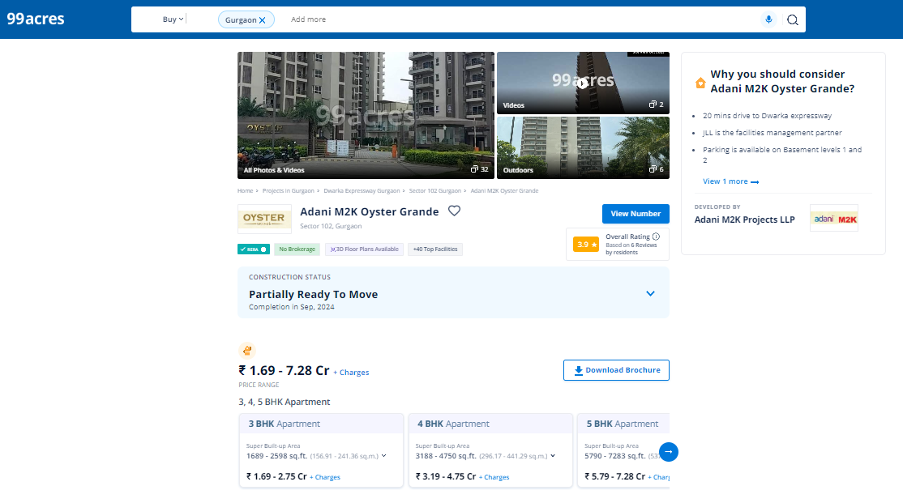
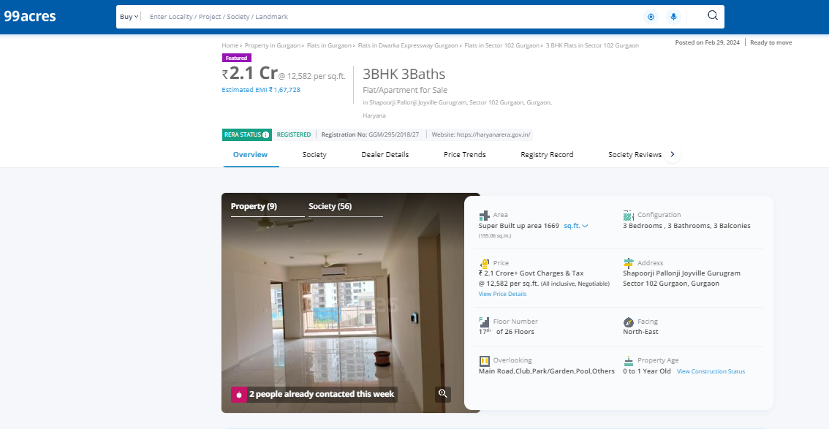

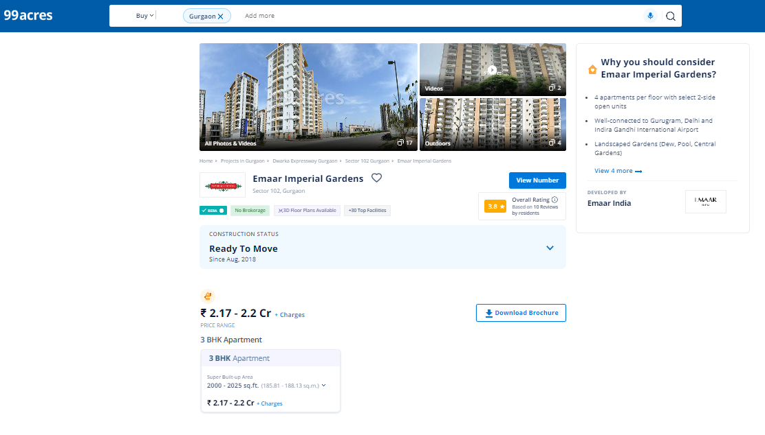

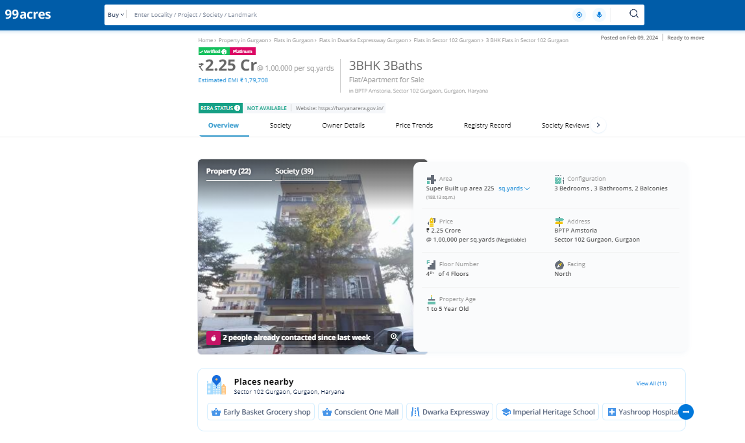
ENCLOSURE 2: GOOGLE MAP LOCATION

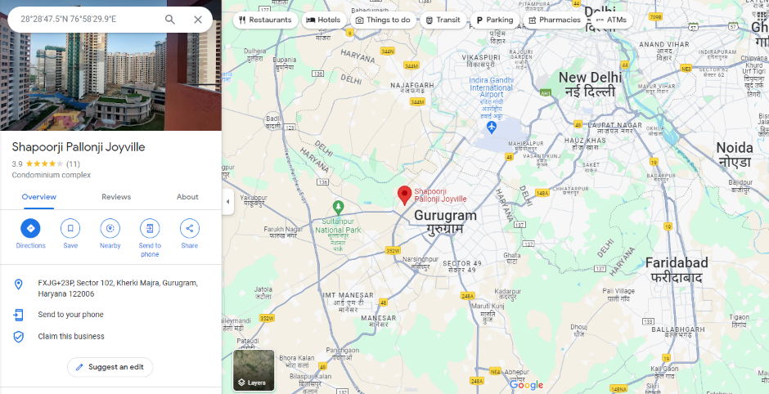
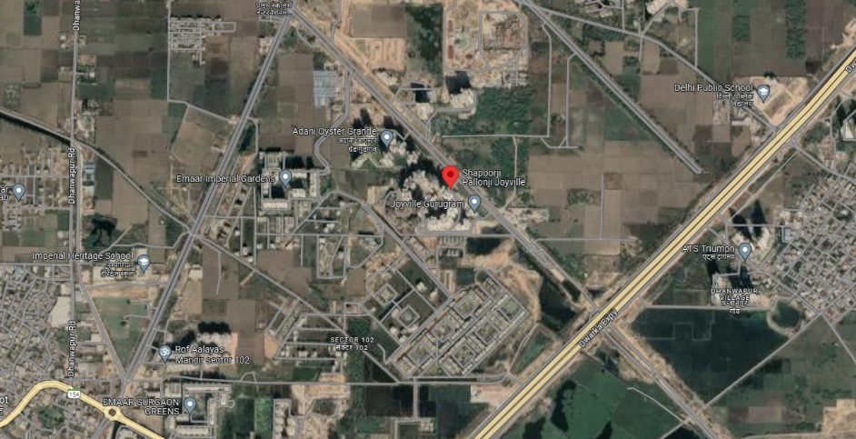
ENCLOSURE 3: PHOTOGRAPHS OF THE PROPERTY

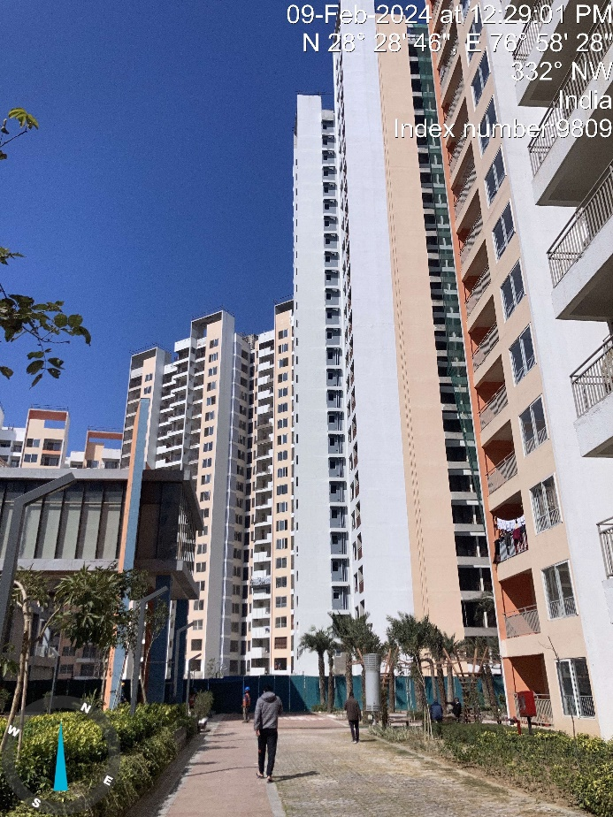 | 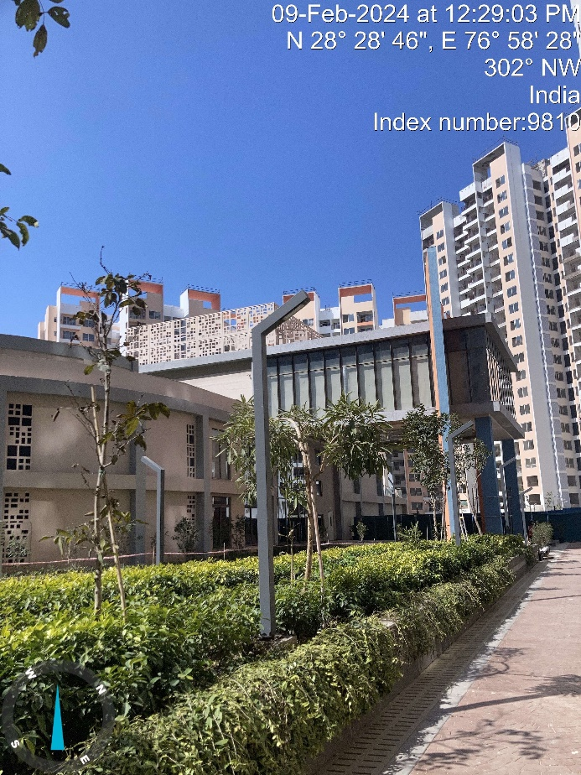
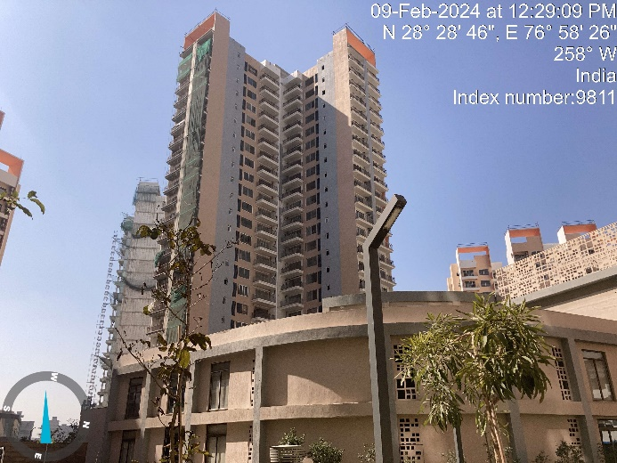 | 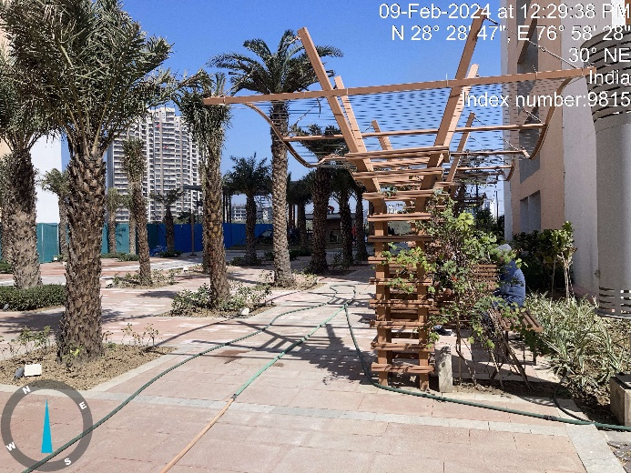

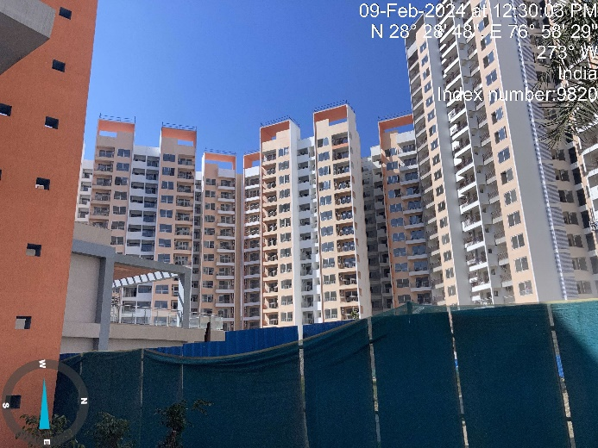 | 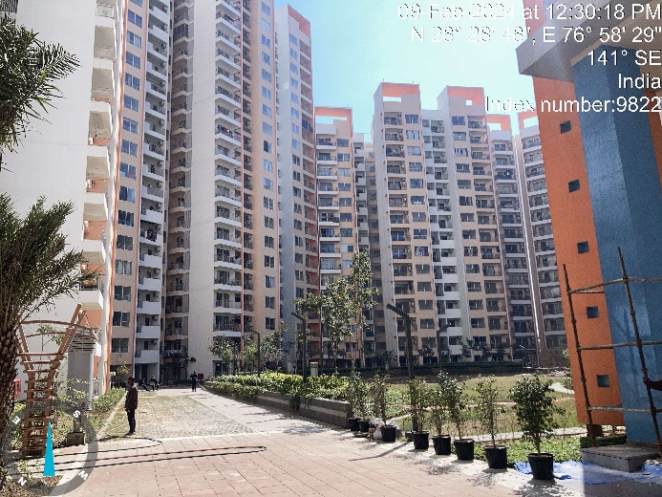
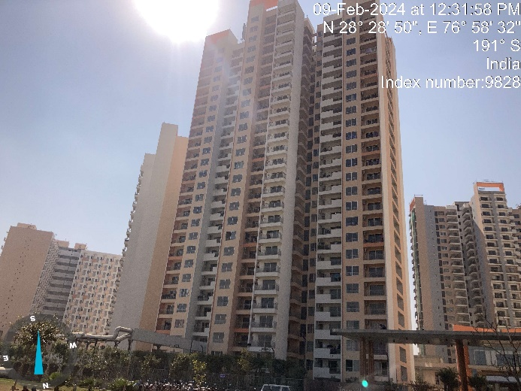 | 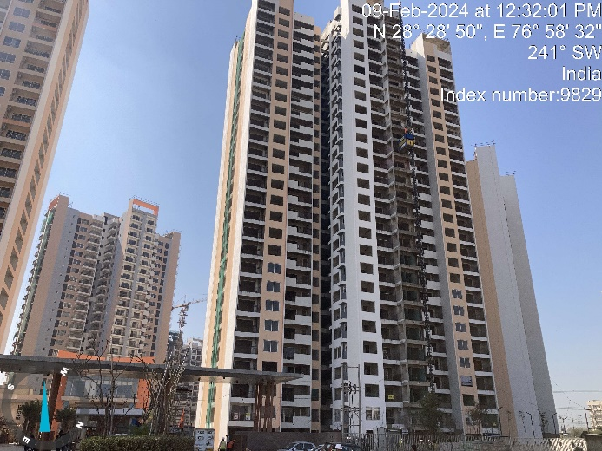
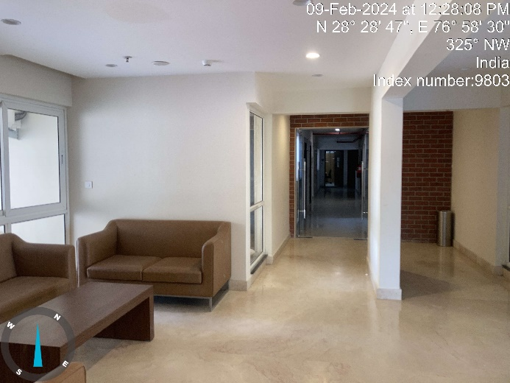 | 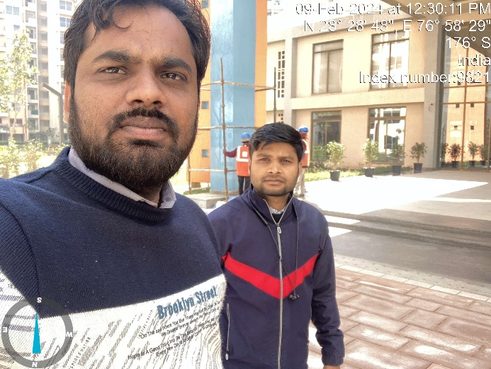

ENCLOSURE: 4– COPY OF CIRCLE RATE

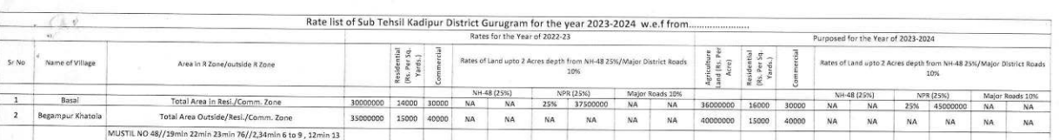
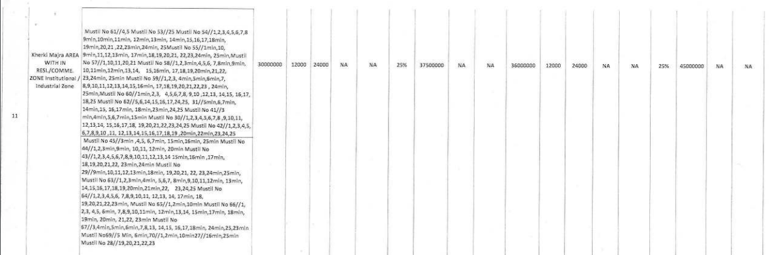
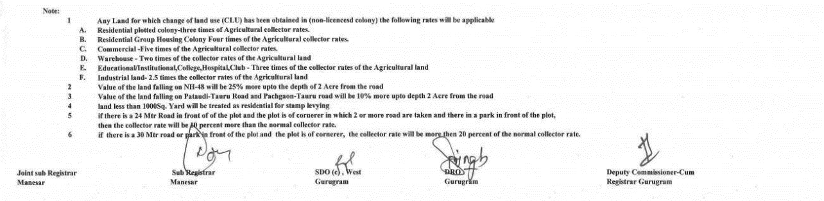

ENCLOSURE 5: OTHER RELEVANT DOCUMENTS

RERA Certificate Phase-I:

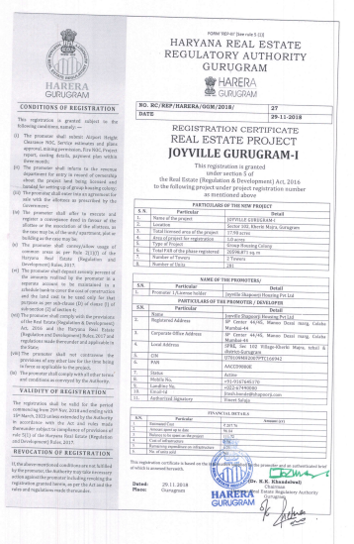

RERA Certificate Phase-II:

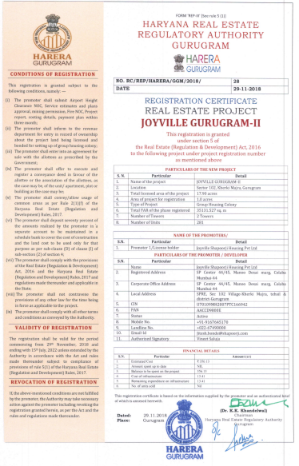

RERA Certificate Phase-III:

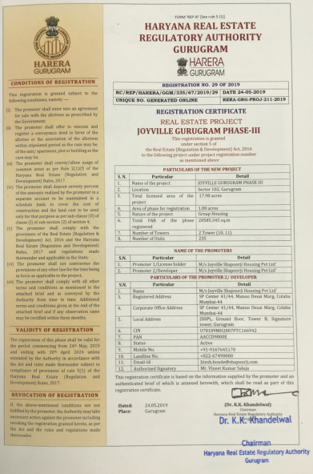

RERA Certificate Phase-IV:

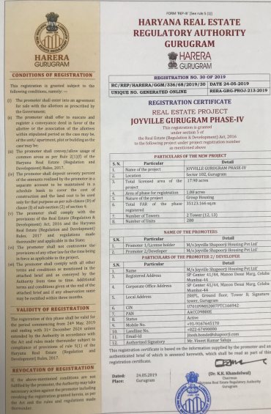

RERA Certificate Phase-V:

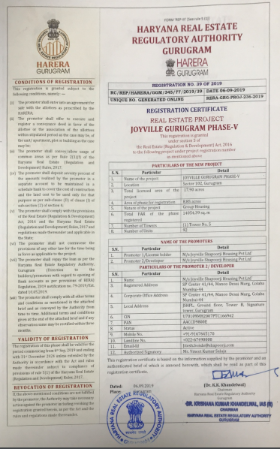

RERA Certificate Phase-VI:

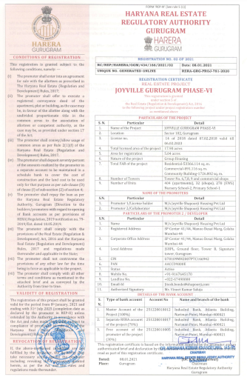

ENCLOSURE 6: CONSULTANT’S REMARKS

This Tie up report is done for the asset found on as-is-where basis which owner/ owner representative/ client/ bank has shown/ identified to us on the site unless otherwise mentioned in the report of which some reference has been taken from the information/ data given in the copy of documents provided to us and informed verbally or in writing out of the standard checklist of documents sought from the client & its customer which they could provide within the reasonable expected time out of the standard checklist of documents sought from them and further based on certain assumptions and limiting conditions. The information, facts, documents, data which has become primary basis of the report has been supplied by the client which has been relied upon in good faith and is not generated by the Valuer.
The client/ owner and its management/ representatives warranted to us that the information they have supplied was complete, accurate and true and correct to the best of their knowledge. All such information provided to us either verbally, in writing or through documents has been relied upon in good faith and we have assumed that it is true & correct without any fabrication or misrepresentation. I/We shall not be held liable for any loss, damages, cost or expenses arising from fraudulent acts, misrepresentations, or willful default on part of the owner, company, its directors, employee, representative or agents.
Legal aspects for eg. Investigation of title, ownership rights, lien, charge, mortgage, lease, sanctioned maps, verification of documents provided to us such as title documents, Map, etc. from any concerned Govt. office etc. have to be taken care by legal expert/ Advocate and same is not done at our end. It is assumed that the concerned Lender/ Financial Institution has asked for the Project tie up report of that property after satisfying the authenticity of the documents given to us for which the legal verification has been already taken and cleared by the competent Advocate before requesting for the tie up report. I/ We assume no responsibility for the legal matters including, but not limited to, legal or title concerns.
In the course of the preparation of this tie up report, we were provided with both written and verbal information. We have however, evaluated the information provided to us through broad inquiry, analysis and review but have not carried out a due diligence or audit of the information provided for the purpose of this engagement. Our conclusions are based on the assumptions and other information provided to us by the client during the course of the assessment.
Getting cizra map or coordination with revenue officers for site identification is a separate activity and is not part of the tie up report services and same has not been done in this report unless otherwise stated.
We have made certain assumptions in relation to facts, conditions & situations affecting the subject of, or approach to this exercise that has not been verified as part of the engagement rather, treated as “a supposition taken to be true”. If any of these assumptions prove to be incorrect then our estimate on value will need to be reviewed.
This is just an opinion report based on technical & market information having general assessment & opinion on the indicative, estimated Market Value of the property for which Bank has asked to conduct the tie up report. It doesn’t contain any other recommendations of any sort including but not limited to express of any opinion on the suitability or otherwise of entering into any transaction with the borrower.
We have relied on the data from third party, external sources & information available on public domain to conclude this tie up report. These sources are believed to be reliable and therefore, we assume no liability for the truth or accuracy of any data, opinions or estimates furnished by others that have been used in this analysis. Where we have relied on the data, opinions or estimates from external sources, reasonable care has been taken to ensure that such data is extracted from authentic sources, however we still can’t vouch its authenticity, correctness, or accuracy.
Analysis and conclusions adopted in the report are limited to the reported assumptions, conditions and information came to our knowledge during the course of the work and based on the Standard Operating Procedures, Best Practices, Caveats, Limitations, Conditions, Remarks, Important Notes, Valuation TOR and definition of different nature of values.
Value varies with the Purpose/ Date/ Asset Condition & situation/ Market condition, demand & supply, asset utility prevailing on a particular date/ Mode of sale. The indicative & estimated prospective Value of the asset given in this report is restricted only for the purpose and other points mentioned above prevailing on a particular date as mentioned in the report. If any of these points are different from the one mentioned aforesaid in the Report then this report should not be referred.
Our report is meant ONLY for the purpose mentioned in the report and should not be used for any other purpose. The Report should not be copied or reproduced for any purpose other than the purpose for which it is prepared for. I/we do not take any responsibility for the unauthorized use of this report.
We owe responsibility only to the authority/client that has appointed us as per the scope of work mentioned in the report. We will not be liable for any losses, claims, damages or liabilities arising out of the actions taken, omissions or advice given by any other person. In no event shall we be liable for any loss, damages, cost or expenses arising in any way from fraudulent acts, misrepresentations or willful default on part of the client or companies, their directors, employees or agents.
This report is having limited scope as per its fields & format to provide only the general basic idea of the value of the property prevailing in the market based on the site inspection and documents/ data/ information provided by the client. The suggested indicative prospective estimated value should be considered only if transaction is happened as free market transaction.
The sale of the subject property is assumed to be on an all cash basis. Financial arrangements would affect the price at which the property may sell for if placed on the market.
The actual realizable value that is likely to be fetched upon sale of the asset under consideration shall entirely depend on the demand and supply of the same in the market at the time of sale.
While our work has involved an analysis & computation of project pricing, it does not include detailed estimation, design/ technical/ engineering/ financial/ structural/ environmental/ architectural/ compliance survey/ safety audit & works in accordance with generally accepted standards of audit & other such works. The report in this work in not investigative in nature. It is mere an opinion on the likely estimated price based on the facts & details presented to us by the client and third party market information came in front of us within the limited time of this assignment, which may vary from situation to situation.
Where a sketched plan is attached to this report, it does not purport to represent accurate architectural plans. Sketch plans and photographs are provided as general illustrations only.
Documents, information, data including title deeds provided to us during the course of this assessment by the client is reviewed only upto the extent required in relation to the scope of the work. No document has been reviewed beyond the scope of the work. These are not reviewed in terms of legal rights for which we do not have expertise. Wherever any information mentioned in this report is mentioned from the documents like owners name, etc., it is only for illustration purpose and may not necessary represent accuracy.
The report assumes that the borrower/company/business/asset complies fully with relevant laws and regulations applicable in its area of operations and usage unless otherwise stated, and that the companies/business/assets is managed in a competent and responsible manner. Further, as specifically stated to the contrary, this report has given no consideration to matters of a legal nature, including issues of legal title and compliance with relevant laws, and litigations and other contingent liabilities that are not recorded/reflected in the documents/ details/ information/ data provided to us.
This tie up report is not a qualification for accuracy of land boundaries, schedule (in physical terms), dimensions & identification. For this land/ property survey report can be sought from a qualified private or Govt. surveyor.
This tie up report is prepared based on the facts of the property on the date of the survey. Due to possible changes in market forces, socio-economic conditions, property conditions and circumstances, this tie up report can only be regarded as relevant as at the reported date. Hence before financing, Banker/ FI should take into consideration all such future risk and should loan conservatively to keep the advanced money safe in case of the downward trend of the property value.
Cost assessment of the same asset/ property can fetch different values under different circumstances & situations. For eg. Cost assessment of a running/ operational shop/ hotel/ factory will fetch better value and in case of closed shop/ hotel/ factory it will have considerable lower value. Similarly, an asset sold directly by an owner in the open market through free market transaction then it will fetch better value and if the same asset/ property is sold by any financer due to encumbrance on it, will fetch lower value. Hence before financing, Lender/ FI should take into consideration all such future risks while financing and take decision accordingly.

Tie up report has been prepared for the property identified to us by the owner/ owner representative. At our end we have just visually matched the land boundaries, schedule (in physical terms) & dimensions of the property with reference to the documents produced for perusal. Method by which identification of the property is carried out is also mentioned in the report clearly. Responsibility of identifying the correct property to the Valuer/ its authorized surveyor is solely of the client/ owner for which the report is prepared. It is requested from the Bank to cross check from their own records/ information if this is the same property for which tie up has to be carried out to ensure that owner has not misled the Valuer company or misrepresented the property due to any vested interest. Where there is a doubt about the precision position of the boundaries, schedule, dimensions of site & structures, it is recommended that a Licensed Surveyor be contacted.
In India more than 70% of the geographical area is lying under rural/ remote/ non municipal/ unplanned area where the subject property is surrounded by vacant lands having no physical demarcation or having any display of property survey or municipal number / name plate on the property clearly. Even in old locations of towns, small cities & districts where property number is either not assigned or not displayed on the properties clearly and also due to the presence of multiple/ parallel departments due to which ownership/ rights/ illegal possession/ encroachment issues are rampant across India and due to these limitations at many occasions it becomes tough to identify the property with 100% surety from the available documents, information & site whereabouts and thus chances of error, misrepresentation by the borrower and margin of chances of error always persists in such cases. To avoid any such chances of error it is advised to the Bank to engage municipal/ revenue department officials to get the confirmation of the property to ensure that the property shown to Valuer/ Banker is the same as for which documents are provided.
If this Project Tie up report is prepared for the Flat/ dwelling unit situated in a Group Housing Society or Integrated Township then approvals, maps of the complete group housing society/ township is out of scope of this report and this report will be made for the specific unit based on the assumption that complete Group Housing Society/ Integrated Township and the subject unit must be approved in all respect.
Due to fragmented & frequent change in building/ urban planning laws/ guidelines from time to time, different laws/ guidelines between regions/ states and no strict enforceability of Building Bye-Laws in India specially in non-metro and scale b & c cities & Industrial areas, property owners many times extend or make changes in the covered area/ layout from the approved/ applicable limits. There are also situations where properties are decades old when there was no formal Building Bye-Laws applicable the time when the construction must have been done. Due to such discrete/ unplanned development in many regions sometimes it becomes tough for the Valuer to determine the exact lawful situation on ground. Unless otherwise mentioned in the report, the covered area present on the site as per site survey will be considered in the report.
Area of the large land parcels of more than 2500 sq.mtr or of uneven shape in which there can be practical difficulty in sample measurement, is taken as per property documents which has been relied upon unless otherwise stated.

Drawing Map, design & detailed estimation of the property/ building is out of scope of the Project tie up services.
Cost assessment is a subjective field and opinion may differ from consultant to consultant. To check the right opinion, it is important to evaluate the methodology adopted and various data point/ information/ factors/ assumption considered by the consultant which became the basis for the Project tie up report before reaching to any conclusion.
Although every scientific method has been employed in systematically arriving at the value, there is, therefore, no indisputable single value and the estimate of the value is normally expressed as falling within a likely range.
Value analysis of any asset cannot be regarded as an exact science and the conclusions arrived at in many cases will, of necessity, be subjective and dependent on the exercise of individual judgment. Given the same set of facts and using the same assumptions, expert opinions may differ due to the number of separate judgment decisions, which have to be made. Therefore, there can be no standard formula to establish an indisputable exchange ratio. In the event of a transaction, the actual transaction value achieved may be higher or lower than our indicative analysis of value depending upon the circumstances of the transaction. The knowledge, negotiability and motivations of the buyers and sellers, demand & supply prevailing in the market and the applicability of a discount or premium for control will also affect actual price achieved. Accordingly, our indicative analysis of value will not necessarily be the price at which any agreement proceeds. The final transaction price is something on which the parties themselves have to agree. However, our pricing analysis can definitely help the stakeholders to take informed and wise decision about the Value of the asset and can help in facilitating the arm’s length transaction.
This cost assessment is conducted based on the macro analysis of the asset/ property considering it in totality and not based on the micro, component, or item wise analysis. Analysis done is a general assessment and is not investigative in nature.
This report is prepared on the V-L10 (Project Tie Up format) _V_10.2_2022 Tie up format as per the client requirement and scope of work. This report is having limited scope as per its fields & format to provide only the general estimated & indicative basic idea of the value of the property prevailing in the market based on the information provided by the client. No detailed analysis, audit or verification has been carried out of the subject property. There may be matters, other than those noted in this report, which might be relevant in the context of the transaction and which a wider scope might uncover.
This is just an opinion report and doesn’t hold any binding on anyone. It is requested from the concerned Client/ Bank/ Financial Institution which is using this report for mortgaging the property that they should consider all the different associated relevant & related factors & risks before taking any business decision based on the content of this report.
All Pages of the report including annexures are signed and stamped from our office. In case any paper in the report is without stamp & signature then this should not be considered a valid paper issued from this office.
As per IBA Guidelines & Bank Policy, in case the valuation report submitted by the valuer is not in order, the banks / FIs shall bring the same to the notice of the valuer within 15 days of submission for rectification and resubmission. In case no such communication is received, it shall be presumed that the valuation report has been accepted.
Defect Liability Period is 15 DAYS. We request the concerned authorized reader of this report to check the contents, data, information, and calculations in the report within this period and intimate us in writing at valuers@rkassociates.org within 15 days of report delivery, if any corrections are required or in case of any other concern with the contents or opinion mentioned in the report. If no intimation is received within 15 (Fifteen) days in writing from the date of issuance of the report, then it shall be considered that the report is complete in all respect and has been accepted by the client upto their satisfaction & use and further to which R.K Associates shall not be held responsible in any manner. After this period no concern/ complaint/ proceedings in connection with the Valuation Services will be entertained due to possible change in situation and condition of the property.
Though adequate care has been taken while preparing this report as per its scope, but still we can’t rule out typing, human errors, over sightedness of any information or any other mistakes. Therefore, the concerned organization is advised to satisfy themselves that the report is complete & satisfactory in all respect. Intimation regarding any discrepancy shall be brought into our notice immediately. If no intimation is received within 15 (Fifteen) days in writing from the date of issuance of the report, to rectify these timely, then it shall be considered that the report is complete in all respect and has been accepted by the client upto their satisfaction & use and further to which R.K Associates shall not be held responsible in any manner.
Our Data retention policy is of ONE YEAR. After this period we remove all the concerned records related to the assignment from our repository. No clarification or query can be answered after this period due to unavailability of the data.
This Project tie up report is governed by our (1) Internal Policies, Processes & Standard Operating Procedures, (2) R.K Associates Quality Policy, (3) Valuation & Survey Best Practices Guidelines formulated by management of R.K Associates, (4) Information input given to us by the customer and (4) Information/ Data/ Facts given to us by our field/ office technical team. Management of R.K Associates never gives acceptance to any unethical or unprofessional practice which may affect fair, correct & impartial assessment and which is against any prevailing law. In case of any indication of any negligence, default, incorrect, misleading, misrepresentation or distortion of facts in the report then we request the user of this report to immediately or atleast within the defect liability period to bring all such act into notice of R.K Associates management so that corrective measures can be taken instantly.
R.K Associates never releases any report doing alterations or modifications by pen. In case any information/ figure of this report is found altered with pen then this report will automatically become null & void.
We are fully aware that based on the opinion of value expressed in this report, we may be required to give testimony or attend court / judicial proceedings with regard to the subject assets, although it is out of scope of the assignment, unless specific arrangements to do so have been made in advance, or as otherwise required by law. In such event, the party seeking our evidence in the proceedings shall bear the cost/professional fee of attending court / judicial proceedings and my / our tendering evidence before such authority shall be under the applicable laws.
The final copy of the report shall be considered valid only if it is in hard copy on the company’s original letter head with proper stamp and sign on it of the authorized official upon payment of the agreed fees. User shall not use the content of the report for the purpose it is prepared for only on draft report, scanned copy, email copy of the report and without payment of the agreed fees. In such a case the report shall be considered as unauthorized and misused.

ENCLOSURE 7 - MODEL CODE OF CONDUCT FOR VALUERS

Integrity and Fairness

- A valuer shall, in the conduct of his/its business, follow high standards of integrity and fairness in all his/its dealings with his/its clients and other valuers.
- A valuer shall maintain integrity by being honest, straightforward, and forthright in all professional relationships.
- A valuer shall endeavor to ensure that he/it provides true and adequate information and shall not misrepresent any facts or situations.
- A valuer shall refrain from being involved in any action that would bring disrepute to the profession.
- A valuer shall keep public interest foremost while delivering his services.

Professional Competence and Due Care

- A valuer shall render at all times high standards of service, exercise, ensure proper care and exercise independent professional judgment.
- A valuer shall carry out professional services in accordance with the relevant technical and professional standards that may be specified from time to time.
- A valuer shall continuously maintain professional knowledge and skill to provide competent professional service based on up-to-date developments in practice, prevailing regulations/guidelines and techniques.
- In the preparation of a valuation report, the valuer shall not disclaim liability for his/its expertise or deny his/its duty of care, except to the extent that the assumptions are based on statements of fact provided by the company or its auditors or consultants or information available in public domain and not generated by the valuer.
- A valuer shall not carry out any instruction of the client in so far as they are incompatible with the requirements of integrity, objectivity and independence.
- A valuer shall clearly state to his client the services that he would be competent to provide and the services for which he would be relying on other valuers or professionals or for which the client can have a separate arrangement with other valuers.

Independence and Disclosure of Interest

- A valuer shall act with objectivity in his/its professional dealings by ensuring that his/its decisions are made without the presence of any bias, conflict of interest, coercion, or undue influence of any party, whether directly connected to the valuation assignment or not.
- A valuer shall not take up an assignment if he/it or any of his/its relatives or associates is not independent in terms of association to the company.
- A valuer shall maintain complete independence in his/its professional relationships and shall conduct the valuation independent of external influences.
- A valuer shall wherever necessary disclose to the clients, possible sources of conflicts of duties and interests, while providing unbiased services.
- A valuer shall not deal in securities of any subject company after any time when he/it first becomes aware of the possibility of his/its association with the valuation, and in accordance with the Securities and Exchange Board of India (Prohibition of Insider Trading) Regulations, 2015 or till the time the valuation report becomes public, whichever is earlier.
- A valuer shall not indulge in “mandate snatching or offering” convenience valuations” in order to cater to a company or client’s needs.
- As an independent valuer, the valuer shall not charge success fee.
- In any fairness opinion or independent expert opinion submitted by a valuer, if there has been a prior engagement in an unconnected transaction, the valuer shall declare the association with the company during the last five years.

Confidentiality
- A valuer shall not use or divulge to other clients or any other party any confidential information about the subject company, which has come to his/its knowledge without proper and specific authority or unless there is a legal or professional right or duty to disclose.

Information Management

- A valuer shall ensure that he/ it maintains written contemporaneous records for any decision taken, the reasons for taking the decision, and the information and evidence in support of such decision. This shall be maintained so as to sufficiently enable a reasonable person to take a view on the appropriateness of his/its decisions and actions.
- A valuer shall appear, co-operate and be available for inspections and investigations carried out by the authority, any person authorised by the authority, the registered valuers organization with which he/it is registered or any other statutory regulatory body.
- A valuer shall provide all information and records as may be required by the authority, the Tribunal, Appellate Tribunal, the registered valuers organization with which he/it is registered, or any other statutory regulatory body.
- A valuer while respecting the confidentiality of information acquired during the course of performing professional services, shall maintain proper working papers for a period of three years or such longer period as required in its contract for a specific valuation, for production before a regulatory authority or for a peer review. In the event of a pending case before the Tribunal or Appellate Tribunal, the record shall be maintained till the disposal of the case.

Gifts and hospitality.

- A valuer or his/its relative shall not accept gifts or hospitality which undermines or affects his independence as a valuer.
Explanation: For the purposes of this code the term ‘relative’ shall have the same meaning as defined in clause (77) of Section 2 of the Companies Act, 2013 (18 of 2013).
- A valuer shall not offer gifts or hospitality or a financial or any other advantage to a public servant or any other person with a view to obtain or retain work for himself/ itself, or to obtain or retain an advantage in the conduct of profession for himself/ itself.

Remuneration and Costs.

- A valuer shall provide services for remuneration which is charged in a transparent manner, is a reasonable reflection of the work necessarily and properly undertaken, and is not inconsistent with the applicable rules.
- A valuer shall not accept any fees or charges other than those which are disclosed in a written contract with the person to whom he would be rendering service.

Occupation, employability and restrictions.

- A valuer shall refrain from accepting too many assignments, if he/it is unlikely to be able to devote adequate time to each of his/ its assignments.
- A valuer shall not conduct business which in the opinion of the authority or the registered valuer organisation discredits the profession.

Miscellaneous

- A valuer shall refrain from undertaking to review the work of another valuer of the same client except under written orders from the bank or housing finance institutions and with knowledge of the concerned valuer.
- A valuer shall follow this code as amended or revised from time to time

Signature of the Authorized Person: ________________
Name of the Valuation company: R.K Associates Valuers & Techno Engg. Consultants (P) Ltd.
Address of the Valuer: D-39, Sector-2, Noida-201301
Date: 5/3/2024
Place: Noida

