**Dated: 15-02-2024**

# To,

AGM

Indian Bank

Pahasu Branch

Bulandshahar, Uttar Pradesh

**SUB: Cost Estimate for the proposed Renovation works at FLAT NO H 1108, WINDSOR PREMIUM TOWER, OFFICERS CITY 2, RAJNAGAR EXTENSION, GHAZIABAD, UTTAR PRADESH**

# Dear Sir,

Cost Estimate for the proposed Renovation works Flat No H 1108, Windsor Premium Tower, Officers City 2, Rajnagar Extension, Ghaziabad, Uttar Pradesh, with the super area of 995 sq. ft. is as per the table below. The flat is currently in favor of Mr. Pankaj Singhal.

The Agreement to sell executed between Mr. Pankaj Signhal & Mr. Saurabh Kumar and Mrs. Sakshi on 06/0/2024 for the total sale consideration of Thirty Six Lakhs Fifty Thousands only.

Our view is in line with the prevailing market rates of the items as per the material specifications and type & quality of work. Quantities taken are on approximate basis and as per the Floor Plan provided to us.

|  |  |  |  |  |  |
| --- | --- | --- | --- | --- | --- |
| **S. No.** | **Item** | **Full Description of work** | **Rate in INR** | **Quantity**  **(In INR per sq. ft.)** | **Amount**  **(In INR)** |
| 1 | Modular Kitchen | It includes quartz counter top, pre made cabinet parts, upper or wall module cabinets, chimney, sink and miscellaneous. | - | Lump sum | 3,00,000 |
| 2 | Wooden flooring | Removing of old tile and fixing to new one. | 350 | 474 | 1,65,900 |
| 3 | wall Putty | Scrapping of old paint on the wall and two coats of wall putty. | 45 | 3000 | 1,35,000 |
| 4 | Wall Paint | Two coats of primer over putty, one or two coat of primer and two coats of oil bound royal paint | 60 | 3000 | 1,80,000 |
| 5 | Painting of door shutters | Removing of old paint by chemical and scraping and two of enamel pain. | 150 | 192 | 28,800 |
| 6 | Fall Ceiling in Living and Bedroom room | Fall Ceiling with putty finish and concealed led light fittings. | 125 | 400 | 50,000 |
| 7 | Glass Work | Fixing of Glass with Power coated aluminium channel, sliding doors. | 475 | 90 | 42,750 |
| 8 | Bath room and Toilet renovations | Removing of old tile and plaster, two coats of water proofing on floor and wall upto 4 feet, fixing of new non skit tiles, fixing of new taps ,wash basin, WC, and other sanitary fittings | - | Lump sum | 2,00,000 |
| 9 | Electric Work | Changing of old fitting with new modular fittings and changing of Old wire with new copper wire and MCCBs. | - | Lump sum | 1,50,000 |
| 10 | Miscellaneous work | Repairing of old plaster and damage plaster, refixing of loose door frame, | - | Lump sum | 1,00,000 |
| **Total** | | | | | **13,52,450** |
| **Or SAY** | | | | | **13,50,000** |

***NOTE:***

***We have not considered any repair and renovation of external fascia.***

***Disclaimer: Cost Estimate can vary from the final actual construction cost as the actual construction cost comes as per final plans and prevailing market rates for the material & labour at that point of time.***

**For R.K Associates Valuers & Techno Engg. Consultants (P) Ltd.**

**Authorized Signatory**

|  |  |  |  |
| --- | --- | --- | --- |
| **1.** | **DECLARATION** | | |
|  | 1. This cost estimate is done based on the documents/ details/ information provided by the customer. 2. The undersigned does not have any direct/indirect interest in the above property. 3. The information furnished herein is true and correct to the best of our knowledge. 4. We have submitted this certificate directly to the Bank. 5. This estimate is carried out by our Engineering team on the request from **Indian Bank, Pahasu Branch, Pahasu , Bulandshahar, Uttar Pradesh** | | |
| **2.** | **Name & Address of Valuer company** | | **Signature of the authorized person** |
| M/s R.K. Associates Valuers & Techno Engineering  Consultants Pvt. Ltd. D-39, Sector-2, Noida, U.P. | |  |
| **3.** | **Enclosed Documents** | 1. Floor Plan. 2. Allotment Letter 3. Agreement to sale | |
| **4.** | **Total Number of Pages in the Report with Enclosures** | 07 | |
| **5.** | **Engineering Team worked on the report** | ***SURVEYED BY:*** NA | |
| ***PREPARED BY:*** *Er****.*** Amit Jaiswal | |
| ***REVIEWED BY:*** Mr. HoD Engineering | |

**R.K ASSOCIATES IMPORTANT NOTES:**

***DEFECT LIABILITY PERIOD*** *- In case of any query/ issue or escalation you may please contact Incident Manager by writing at* [*valuers@rkassociates.org.*](mailto:valuers@rkassociates.org) *We ensure 100% accuracy in the Calculations done, Rates adopted and various other data points &* information mentioned in the report but still can’t rule out typing, human errors or any other mistakes. In case you find any mistake, variation, discrepancy or inaccuracy in any data point of the report, please help us by bringing all such points into our notice in writing at [valuers@rkassociates.org](mailto:valuers@rkassociates.org)within 30 days of the report delivery, to get these rectified timely, failing which R.K Associates won’t be held responsible for any inaccuracy in any manner. Also if we will not hear back anything from you within 30 days, we will assume that report is correct in all respect and no further claim of any sort will be entertained thereafter. We would welcome and appreciate your feedback & suggestions in order to improve our services.

***COPYRIGHT FORMAT*** *- This report is prepared on the copyright format of R.K Associates to serve our clients in the best possible way. Legally no one can copy or distribute this format without prior approval from R.K Associates. It is meant only for the* Organization as mentioned on the cover page of this report. Distribution or use of this format other than R.K Associates will be seen as unlawful act and necessary legal action can be taken against the defaulters.

***IF REPORT IS USED FOR BANK/ FIs***

**NOTE:** As per IBA Guidelines in case the valuation report submitted by the valuer is not in order, the banks / FIs shall bring the same to the notice of the valuer within 15 days of submission for rectification and resubmission. In case no such communication is received, it shall be presumed that the valuation report has been accepted.

***At our end we have not verified the authenticity of any documents provided to us. Bank is advised to verify the genuineness of the property documents before taking any credit decision.***

***ENCLOSURE***

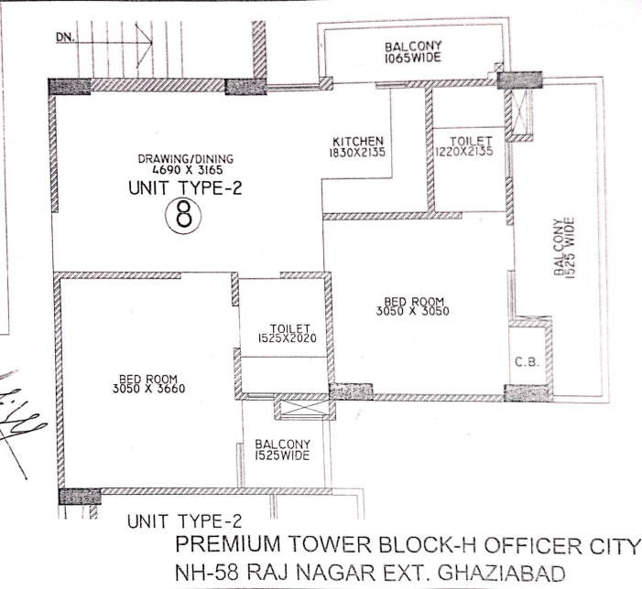***FLOOR PLAN.***

***ALLOTMENT LETTER***

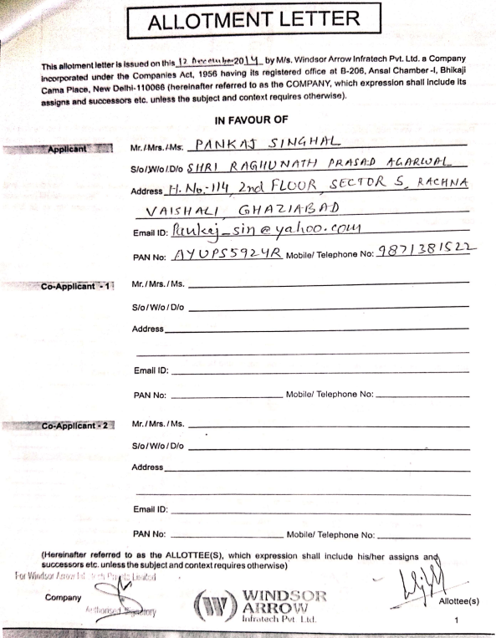

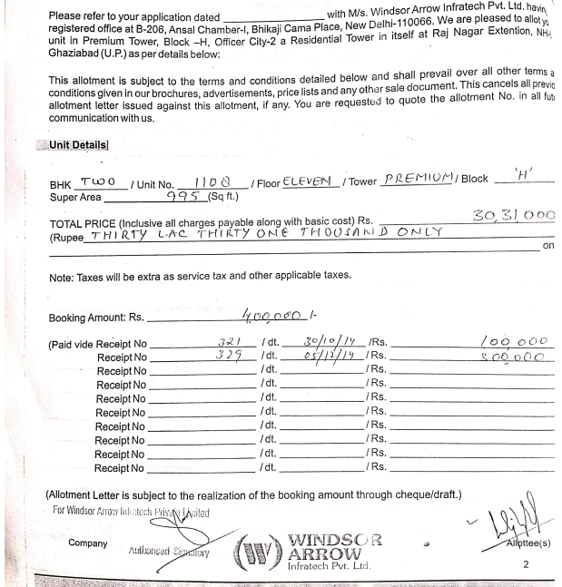

***AGREEMENT TO SELL***

