REPORT FORMAT: CL-1 | Version: 1.0_2018

FILE No.: VIS(2023-24)-PL731-631-985 Date: 22-02-2024

CERTIFICATE NAME: Progress Report on the machines and equipment for manufacturing products primarily Tablets, Capsules, Liquids orals and Ointments which are installed and proposed to be installed at Plot No.50, Sector-8A, Industrial Area IIE, Haridwar, Uttarakhand.
- FOR ORGANIZATION: State Bank of India, SME Branch, Ranipur, Haridwar.

- BORROWER COMPANY’S NAME: M/s. Parrish Pharmaceuticals Private Limited.

ASSET TYPE: Machines required for manufacturing of Pharmaceuticals products mainly Tablets, Capsules, Liquids orals and Ointments.
- CURRENT LOCATION OF THE MACHINES: Installed & proposed to be installed at Plot No.50, Sector-8A, Industrial Area IIE, Haridwar, Uttarakhand.

TO WHOMSOEVER IT MAY CONCERN

S. NO. | PARTICULARS | DESCRIPTION
1. | Date of Survey | 20-02-2024
2. | Date of Certificate | 22-02-2024
3. | Documents provided for perusal | List of machines
4. | Current Location of the Machines | Part of Plot No.50, Sector-8A, Industrial Area IIE, Haridwar, Uttarakhand.
5. | Borrowing Company | M/s. Parrish Pharmaceuticals Private Limited.
6. | Type of Asset | Machines required for manufacturing of Pharmaceuticals products mainly Tablets, Capsules, Liquids orals and Ointments.
7. | Type of Assessment | Progress of machines purchased, installed & proposed to be installed at site.
8. | Scope of Assessment | Progress of machines purchased, installed & proposed to be installed at site.
9. | Nature of Machinery | Machines required for manufacturing of Pharmaceuticals products mainly Tablets, Capsules, Liquids orals and Ointments.
10. | Current Progress of the machines | As per physical inspection made during site visit,  Company has purchased and installed all the machines as per the list provided.
11. | Condition of Machines | Purchased machines and equipment are new and ready for production.

OBSERVATIONS:

We have been provided with the list of machines that has to be purchased/ installed/ proposed to be installed by the borrower company.
  - Based on the information provided by the subject company (M/s. Parrish Pharmaceuticals Private Limited), it is certified that the following machines have been purchased, installed & proposed to be installed at the above-mentioned site address.

LIST OF MACHINES AND EQUIPMENTS
S. NO. | NAME OF MACHINERY | Status During Site Visit
1 | Laboratory Instruments | Purchased & installed
2 | Liquid Filling & Sealing Section | Purchased & installed
3 | AHU | Purchased & installed
4 | Automatic Voltage Regulator | Under transits
5 | Compressed Air System | Purchased & installed
6 | Lift | Not installed
7 | Collied Mill | Purchased & installed
8 | Fluid Bed Dryer | Purchased & installed
9 | Rapid Mixture Granulator | Purchased & installed
10 | Strip Machine | Purchased & installed
11 | Multi Mill | Purchased & installed
12 | UV-Visible Spectrometer | Under transits
13 | Ftir System | Under transits
14 | Shimarzu Hpic System | Under transits
15 | Effluent Treatment Plant | Purchased & installed
16 | Reverse Osmosis Water Plant | Purchased & installed
17 | Liquid Manufacturing Plant | Purchased & installed
18 | Tablet Section | Purchased & installed
19 | Alu-Alu Bister Packing Machine | Purchased & installed
20 | Capfill Model-Semi Automatic Capsule | Purchased & installed
21 | Tablet Compresson Machine (2no.) | Purchased & installed
22 | Blister Pack Machine | Purchased & installed
23 | Lab Instrument(Industrial Solution Company) | Under transits
24 | Misc. Tools | Purchased & installed

Disclaimer:
- This progress report is stated on the basis of the site visit by the surveyor and we don’t recommend any sort of recommendation in our Certificate.
- As per physical inspection and observation made during site visit dated 20th February 2024. Company has installed & proposed to be installed of all the machines mentioned in the provided list.
- As on date of site survey i.e. 20th February 2024, we were informed that the plant is planned to be start by 10rd March 2024.
- This certificate doesn’t include any work related to drawing, design, sketch plan, and technical specifications of the machines.
- Ownership and other legal point of view in respect of the asset is not considered in this report as same is out of scope of this certificate.
- This certificate is made at the request of the Bank.

For R.K Associates Valuers & Techno FOR INTERNAL USE Engineering Consultants (P) Ltd.
TYPED BY: Er. Nischay Gautam

REVIEWED BY: Er. Abhinav Chaturvedi

ANNEXURE: LIST OF MACHINES AS PROVIDED BY THE CLIENT

S. NO. | NAME OF MACHINERY
1 | LABORATORY INSTRUMENTS
2 | LIQUID FILLING & SEALING SECTION
3 | AHU
4 | AUTOMATIC VOLTAGE REGULATOR
5 | COMPRESSED AIR SYSTEM
6 | LIFT
7 | COLLIED MILL
8 | FLUID BED DRAYER
9 | RAPID MIXTURE GRANULATOR
10 | STRIP MACHINE
11 | MULTI MILL
12 | UV-VISIBLE SPECTOMETER
13 | FTIR SYSTEM
14 | SHIMARZU HPIC SYSTEM
15 | EFFLUENT TREATMENT PLANT
16 | REVERSE OSMOSIS WATER PLANT
17 | LIQUID MANUFATURING PLANT
18 | TABLET SECTION
19 | ALU-ALU BISTER PACKING MACHINE
20 | CAPFILL MODEL-SEMI AUTOMATIC CAPSULE
21 | TABLET COMPRESSON MACHINE (2NO.)
22 | BLISTER PACK MACHINE
23 | LAB INSTRUMENT(INDUSTRIAL SOLUTION COMPANY)
24 | MISC TOOLS

ANNEXURE: PHOTOGRAPHS

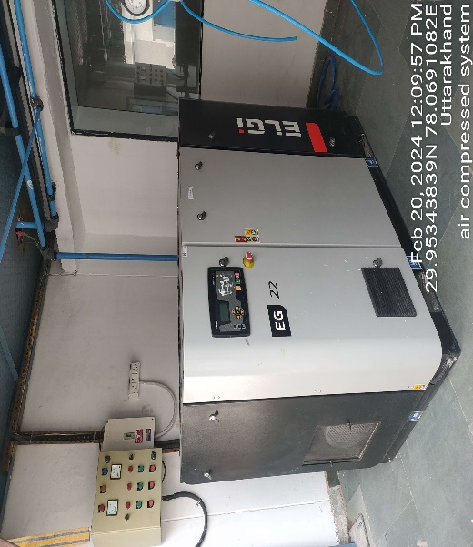 | 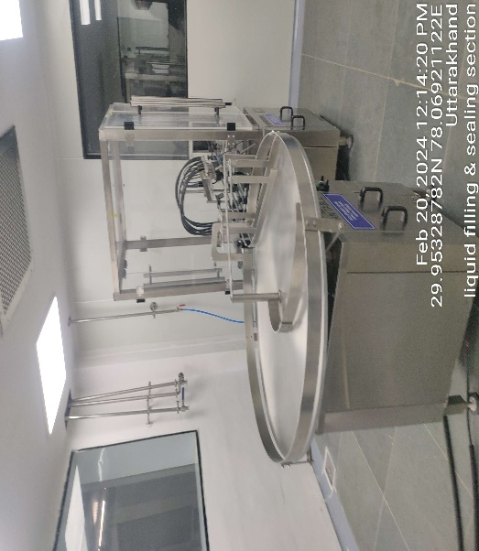
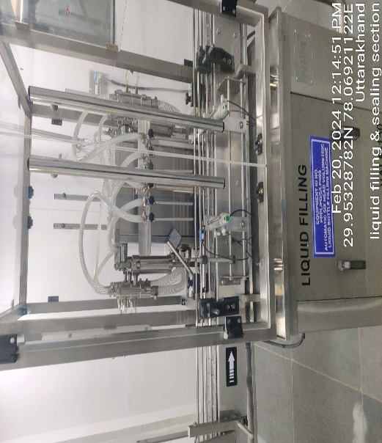 | 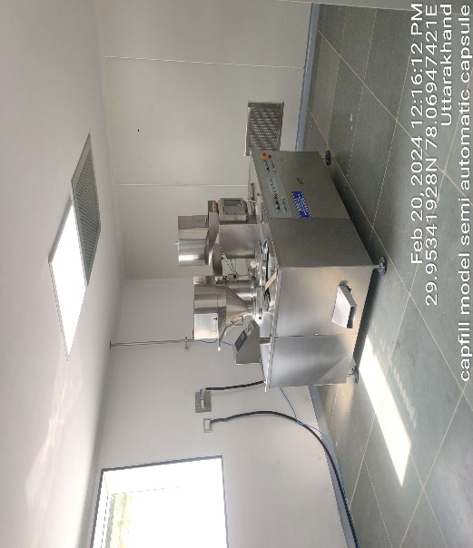
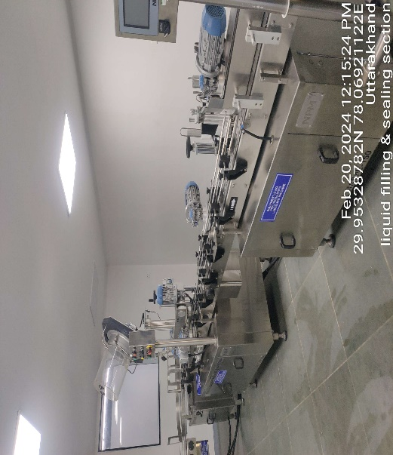 | 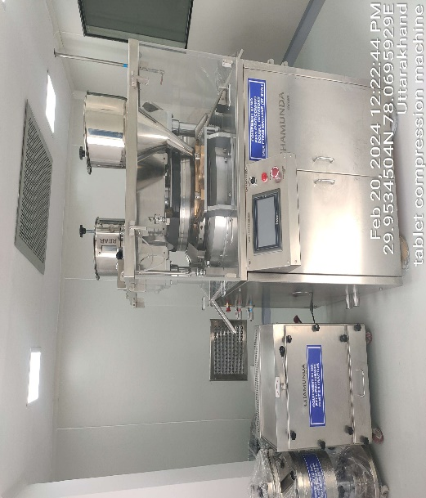

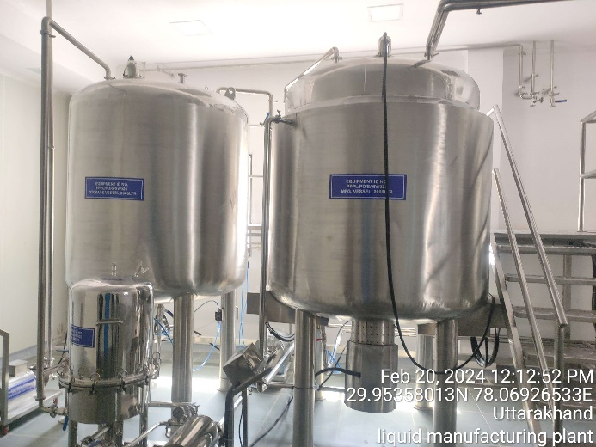 | 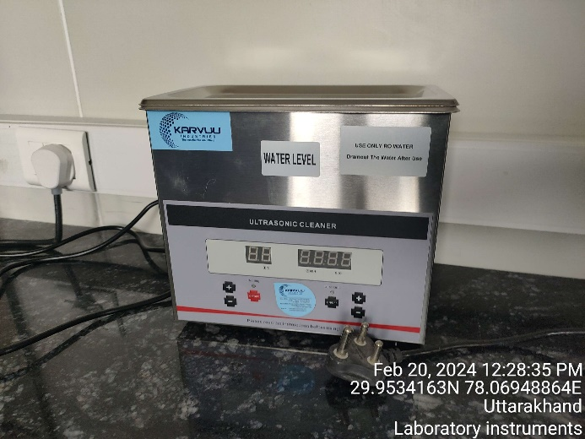
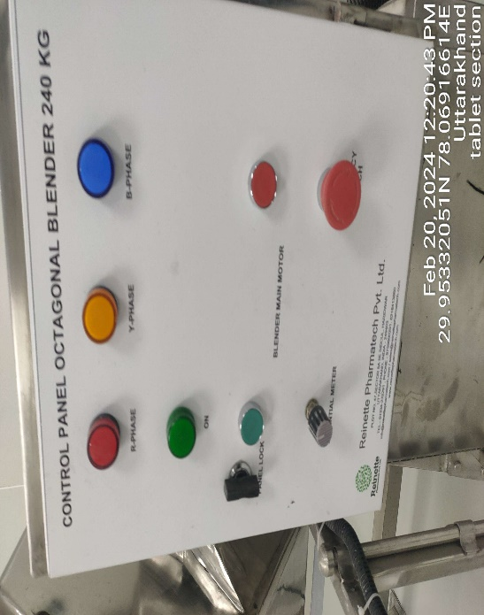 | 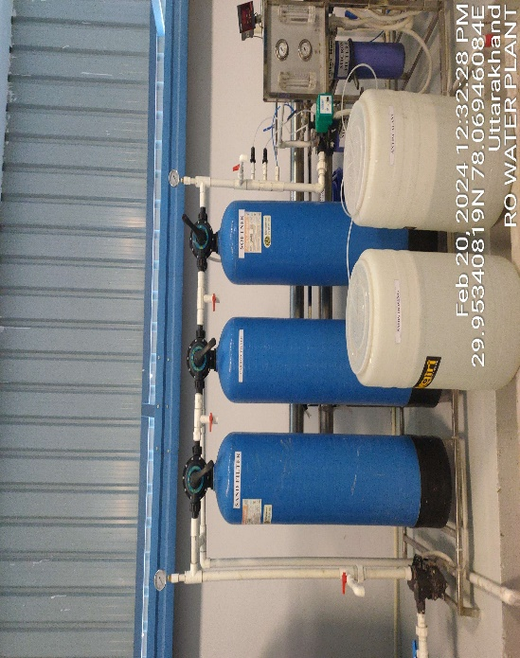
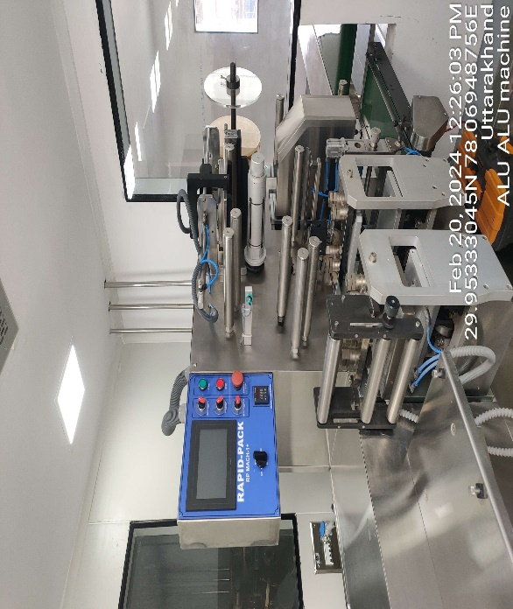 | 