**File No.: VIS (2023-24)-PL744-643-1001 Dated: 07-05-2024**

**CAPITAL EXPENDITURE VERIFICATION REPORT**

**OF**

**“COURTYARD BY MARRIOTT”**

**(*A Unit of M/S. AISSHPRA RESORTS SOLUTIONS PRIVATE LIMITED & KK Group*)**

**SITUATED AT**

**NAUKA VIHAR ROAD, RAIL VIHAR COLONY PHASE 3RD, TARAMANDAL, GORAKHPUR, UTTAR PRADESH 273010**

**PROMOTER**

**M/S. AISSHPRA RESORTS SOLUTIONS PRIVATE LIMITED**

**REPORT PREPARED FOR**

**UTTAR PRADESH TOURISM**

***\*\*Important - In case of any query/ issue or escalation you may please contact Incident Manager***

***at le@rkassociates.org. We will appreciate your feedback in order to improve our services.***

***NOTE: Please provide your feedback on the report within 15 days of its submission after which report will be considered to be correct***

**IMPORTANT NOTICE**

***COPYRIGHT FORMAT:*** *This report is prepared on the copyright format of R.K Associates to serve our clients with the best possible information and analysis to facilitate them to take rational business decisions. Legally no one can copy or distribute this format without prior approval from R.K Associates. It is meant only for the advisory/ reference purpose for the organization/s as mentioned on the cover page of this report. Distribution or use of this format by any organization or individual other than R.K Associates will be seen as an unlawful act and necessary legal action can be taken against the defaulters.*

*This report is intended for the sole use of the intended recipient/s and contains material that is STRICTLY CONFIDENTIAL AND PRIVATE.*

***DEFECT LIABILITY PERIOD:*** *- In case of any query/ issue or escalation you may please contact Incident Manager at le@rkassociates.org. We try to ensure maximum accuracy in the calculations done, rates adopted, assumptions taken and various other data points & information mentioned in the report but even still can’t rule out typing, human errors or any other bonafede mistakes. In case you find any such mistake or inaccuracy in any data point of the report, please help us by bringing all such points into our notice immediately or within 15 days of the report delivery in writing, to rectify these timely failing after which R.K Associates won’t be held responsible for any such inaccuracy in any manner. We would highly appreciate your feedback in order to improve our services.*

|  |  |  |
| --- | --- | --- |
| **TABLE OF CONTENTS** | | |
|  | | |
| **SECTIONS** | **PARTICULARS** | **PAGE NO.** |
| **Part A** | **REPORT SUMMARY** | 03 |
| **Part B** | **INTRODUCTION** | 04 |
|  | 1. Name of the Project | 04 |
| 1. Project Overview | 04 |
| 1. Project Location | 10 |
| 1. Scope of the Report | 10 |
| 1. Purpose of the Report | 10 |
| 1. Survey Details | 10 |
| 1. Methodology Adopted | 11 |
| **Part C** | **PROJECT INFRASTRUCTURE SECTIONS & FACILITY DETAILS** | 12 |
| 1. Building & Structural Details | 13 |
| 1. Plant & Equipment Details | 12 |
| **Part D** | **PROJECT CAPITAL EXPENDITURE EVALUATION** | 14 |
| **Part E** | **PHOTOGRAPHS FROM THE SURVEY** | 20 |
| **Part F** | **DISCLAIMER** | 23 |

|  |  |
| --- | --- |
| **PART A** | **REPORT SUMMARY** |

|  |  |  |  |
| --- | --- | --- | --- |
| **1.** | **Name of the Project** | **:** | Courtyard By Marriott *(A Unit of M/s. Aisshpra Resorts Solutions Private Limited & KK Group)* |
| **2.** | **Project Location** | **:** | “Courtyard By Marriott”, Nauka Vihar Rd, Rail Vihar Colony Phase 3rd, Taramandal, Gorakhpur, Uttar Pradesh 273010 |
| **3.** | **Name of the Promoter** | **:** | M/S. AISSHPRA RESORTS SOLUTIONS PRIVATE LIMITED |
| **4.** | **Prepared for Organization** | **:** | 1. Uttar Pradesh Tourism |
| **5.** | **Chartered Engineer Firm** | **:** | M/s. R. K. Associates Valuers & TechnoEngineering Consultants (P) Ltd. |
| **6.** | **Date of Survey** | **:** | 11th & 12th April 2024 |
| **7.** | **Date of Report** | **:** | 24th April 2024 |
| **8.** | **Report Type** | **:** | Capital Expenditure Report |
| **9.** | **Purpose of the Report** | **:** | To verify and examine capital expenditure status of the Project in regard to the special facilities & incentives given to Hotel projects as per Uttar Pradesh Tourism Policy-2022. |
| **10.** | **Scope of the Report** | **:** | To verify and examine capital expenditure of the Project. |
| **11.** | **Documents produced for Perusal** | **:** | 1. Break-up of the cost heads 2. Copy of Invoices of Items 3. Copies of various NOCs & Approvals 4. Information received on e-mail |
| **12.** | **Annexure with the Report** | **:** | 1. Photographs |

|  |  |
| --- | --- |
| **PART B** | **INTRODUCTION** |

1. **NAME OF THE PROJECT: “Courtyard By Marriott”** *(A Unit of M/s. Aisshpra Resorts Solutions Private Limited & KK Group)*

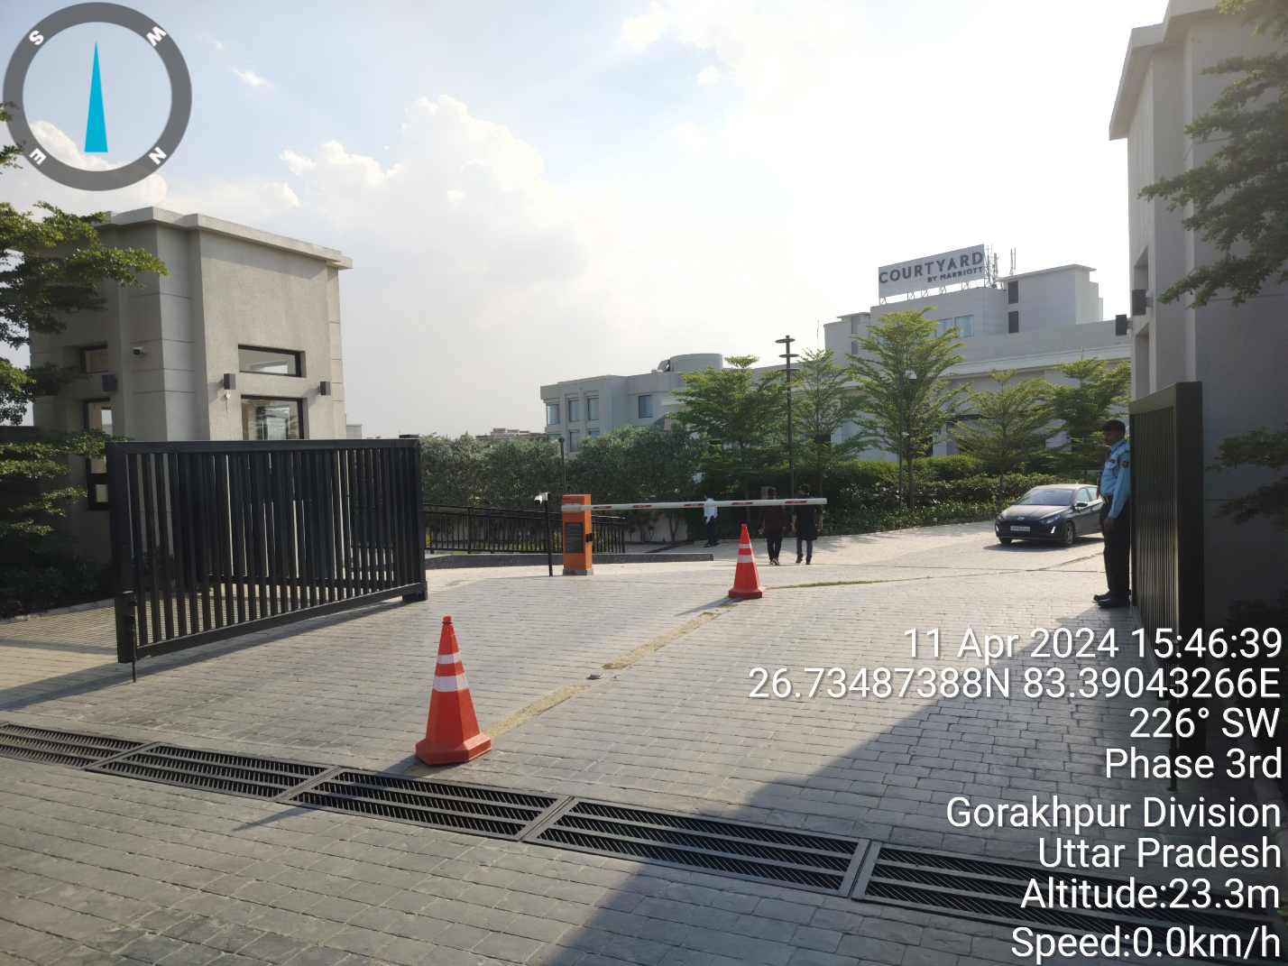

1. **PROJECT OVERVIEW:** This hotel is established by A Unit of M/s. Aisshpra Resorts Solutions Private Limited & KK Group located at Ramgarh Tall Road, Taramandal, Gorakhpur.

As per the site layout plan, the company took land parcel of area measuring 28,960 sq. mtr. and built-up area 4611 sq. mtr. on lease From the Directorate of Tourism, Government of Uttar Pradesh vide Lease Agreement dated 20/03/2017.

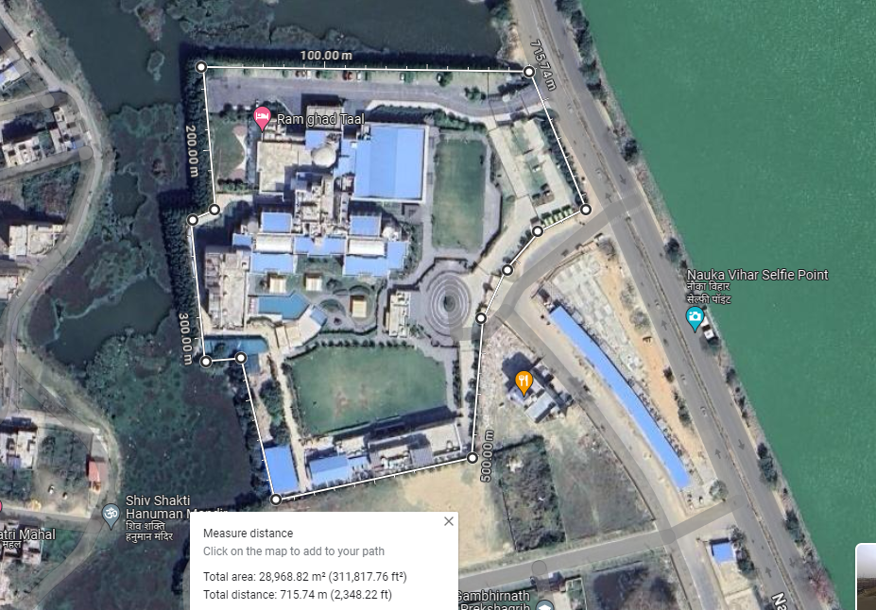

Entry/Exit

Entry/Exit

MAIN ROAD

As per the subsidy application filed by the project proponents, the subject land is shown as leased and hence no cost of it has not been taken into consideration. Since this is only a cost verification report of the project, therefore land lease has not been referred and details pertaining to land as mentioned in the report is taken only from the sanctioned alteration map for illustration purpose only.

Company has obtained sanctioned alteration map for the existing building M/s. Rahi Tourist Bungalow vide sanctioned map dated 26.08.2021 from the Gorakhpur Development Authority.

For the purpose of this report, we have considered the area mentioned in sanctioned alteration map. As per the copy of sanctioned alteration plan, the subject Hotel is built on Ground + 4 storey RCC framed structure with RCC slab roofing with a total built-area of 14,232.28 sq. mtr. / 1,53,140.61 sq. ft. As per information provided by the company, construction of the hotel began on May 2018 and commercial operations had started from 15th December 2023 as per the document provided however the first invoice has been raised on dated 16/12/2023 hence we are considering the date 16/12/2023 as the COD for the Hotel. This is a 136 key room hotel with 3 banquet halls, 1 restaurant, 4 kitchens, 2 swimming pool. There are 5 category of rooms as follows: -

* Deluxe Rooms
* Deluxe Rooms Pool View
* Executive Guest Room Pool View
* Guest room Lake View
* Executive Suite room

To promote Tourism & Hospitality Industry in the State, UP State Government has offered capital subsidy and financial assistance as per Uttar Pradesh Tourism Policy-2022 on the capital investment on hotels, resorts, heritage hotels, motels, theme parks, etc. in the State. As the subject project has been successfully completed and is commercially operational since 15th December 2023, therefore, the company had applied for the subsidy under Uttar Pradesh Tourism Policy-2022.

For the purpose of verifying capital investment done by the M/s. Aisshpra Resorts & Solutions Pvt. Ltd. on the construction of Hotel, Department of Tourism, UP Government had appointed us as a consultant to provide an opinion on the capital investment incurred by the promoter under the eligible heads.

As per the ‘Operational Guidelines for Implementation of Uttar Pradesh Tourism Policy 2022’, below are the eligible and ineligible capital investments in the tourism units:

1. **ELIGIBLE CAPITAL INVESTMENTS:**

The eligible capital investment shall be expenditure incurred on the following:

* **Land** (only the eligible part) purchased at circle rate or transaction rate whichever is lower as per the registered sale deed, during the operative period, under ownership of registered tourism unit/name of the proprietor and is being used exclusively for the construction and operation of eligible tourism unit(s).

The eligible part of the land cost will mean:

* + Cost of the plinth area as approved in the layout map/master plan excluding service areas such as water treatment plant, sewerage treatment plant and such ancillary facilities etc. which are non-core areas of respective Eligible Tourism unit.
  + Cost of land purchased at prevailing circle rate at the time of purchase subject to maximum of 10% of the ECI for Eligible Tourism units in case of Caravan Parking Places, Public Golf Course units- Open and Non-restricted and Theme Park/ Amusement Park/ Water park.

* **Cost of Building** i.e., any built-up area and all such constructed spaces which are required for the commercial operation of the eligible tourism unit which include but are not limited to:
  + Landscape (only 5% of the total ECI)
  + In case of Adaptive Reuse, the cost of Classified and Heritage Buildings, prior to adaptive reuse development as declared by applicant or assessed by Chartered Engineer in the Panel of Department of Tourism, will not be considered as an eligible project cost.
* **Plant and Machinery (as mentioned under the ‘machinery and plant’ subhead in the depreciation schedule used for computation of income tax) which include but are not limited to:**
  + Televisions (not more than Rs. 1 lakh per Television)
  + Chandeliers (not more than Rs. 75 thousand per chandelier)
  + Amusement rides/games
  + Safety equipment (e.g., fire detector and firefighting system, fire extinguisher, smoke detector, sprinkler, surveillance systems, door metal detector, handheld metal detector, room barrier, vehicle scanner, etc.)
  + Sound and PA system etc.
  + Electrical fittings (electrical wiring, switches, and sockets etc.)
  + Heating Ventilation and Air-conditioning (HVAC) equipment (including split and window AC), water heating system
  + Non-shiftable equipment for kitchen, laundry, wellness, conventional hall, exhibition halls etc.
  + D.G power backup (for self-use)
  + Adventure Sports equipment(s)
  + Rainwater harvesting system, Solar/bio energy system
  + Sewerage treatment plant and waste management system
  + Water supply system (pipeline, tanks, pump house, water treatment plant, etc.)
  + Equipment for gymnasium
  + Underground/ multi-level parking machinery and equipment.
  + Establishment of treatment plant for Air and Water Pollution/ incinerator etc.
  + Telecommunication Tower (self-established for own use), WIFI routers, boosters
  + Computers including software’s
  + Other equipment(s) including vehicles / boats / ships/ cruise etc. (which are registered in the name of the eligible tourism unit) which are exclusively used for working of the eligible tourism unit.
* **Cost of development of the site of the location of the eligible tourism unit, such as:**
  + Boundary wall, fencing, entrance gate, guard room
  + Store, kitchen
  + Construction of all internal roads
  + Underground/ multi-level parking
  + Construction of linkage/ approach roads as per need (maximum length of 1,000 mts. and width as per local bylaws as per the prevailing SOR of PWD)
  + All power infrastructure used to facilitate electricity supply to the tourism unit, (e.g., electric poles, transformers, substations, etc.)
  + Establishment of sound, light, public address & internet system, and network of fixed nature
  + Electric lining, gas/steam, water supply lining
  + Swimming pool, establishment of stationary swing-set, climbing walls, amusement /playing structure, etc. in play areas and parks and related infrastructure, which the eligible tourism unit must incur under the project.
  + Fixed residential tents for tourists.
* Any Consultancy charges related to the establishment/operationalization of the eligible Tourism unit like Fees paid for obtaining technical know-how, etc. (actual consultancy paid or Rs 10 lakhs, whichever is lower excluding GST/Tax).
* Any service charges e.g., Installation charges for machinery/equipments/ services
* Any other component which is not mentioned in the eligible components but is felt necessary for functioning of the tourism unit(s). Such components will be identified by District Scanning Committee and recommended to the State Level Special Tourism Committee for further consideration and approval.
* The above investment should be made till the date of application for claim on subsidy.

1. **INELIGIBLE COMPONENTS OF INVESTMENT AMOUNT**

* The following investment heads with respect of the unit shall be ineligible for Incentives/subsidy/concession.
* Working Capital
* Interest Capitalized
* Pre-operative expenses and preliminary expenses
* Second-hand plant and machinery purchased or shifted from within or outside India
* Consumable stores/ inventories for maintenance or repairs
* Furniture and fixtures, mattresses, linens, curtains, carpets/matting, cutlery, crockery, and utensils
* Any taxes including GST, fees/bills payable to the State or Central Government
* All such constructions which are not being exclusively used for the working of the eligible tourism unit and which are meant for sale / lease / rent. However, the expenses done on such construction will be part of eligible components of investment for following tourism units:
  + Cultural centers (If constructed more than 5 allowed shops/commercial sale outlets)
  + Cultural, Rural Village or Tourist Village (If constructed more than 1 allowed souvenir shop)

As per the copy of application form for ‘Capital Investment Subsidy to Eligible Tourism Units’, the company had informed to the Govt. of U.P that the total capital expenditure done in the project is Rs.101,83,72,105.53/-. Out of that the eligible capital expenditure on which the subsidy had been claimed is Rs.74,58,88,380.53/- and the same has been tabulated below:

|  |  |  |
| --- | --- | --- |
| **Sl. No.** | **Heads of Capital Expenditure** | **Amount  (in Rs.)** |
| 1 | **Eligible Capital Expenditure** | |
| 1.1 | Land (only the eligible part) as per the operational guidelines of Uttar Pradesh Tourism Policy, 2022 | **NA** |
| 1.2 | Cost of Building, i.e., any built-up area and all such constructed spaces which are required for the commercial  operation of the eligible tourism unit | **42,26,58,976.2** |
| 1.3 | Landscape (only 5% of the total ECI) | **0** |
| 1.4 | **Plant and Machinery (as mentioned under the ‘machinery and plant’ subhead in the depreciation schedule used for computation of income tax) which include but are not limited to: -** | |
| 1.4.1 | Televisions (not more than 1 lakh per television set) | **35,41,242** |
| 1.4.2 | Chandeliers (not more than Rs. 75 thousand per chandelier) | **22,10,938** |
| 1.4.3 | Amusement rides/games | **0** |
| 1.4.4 | Safety equipment’s (e.g., fire detector and firefighting system, fire extinguisher, smoke detector, sprinkler, Surveillance systems, door metal detector, handheld metal detector, room barrier, vehicle scanner, etc.) | **3,81,20,351** |
| 1.4.5 | Sound System and PA System, etc | **63,75,790** |
| 1.4.6 | Electrical fittings (electrical wiring, switches, and sockets etc.) | **6,52,29,865** |
| 1.4.7 | Heating Ventilation and Air-conditioning (HVAC) equipment (including split and window AC), water heating system. | **2,40,27,958.65** |
| 1.4.8 | Non-shiftable equipments for kitchen, laundry, wellness, conventional hall, exhibition halls etc. | **0** |
| 1.4.9 | D.G. power backup (for self-use) | **62,50,000** |
| 1.4.10 | Adventure Sports equipment(s) | **0** |
| 1.4.11 | Rainwater harvesting system, Solar/bio energy system | **18,81,064** |
| 1.4.12 | Sewerage treatment plant and waste management system | **39,89,955.41** |
| 1.4.13 | Water supply system (pipeline, tanks, pump house, water treatment plant, etc.) | **3,21,52,001.72** |
| 1.4.14 | Equipments for gymnasium | **29,87,878** |
| 1.4.15 | Underground/ multi-level parking machinery and equipments | **0** |
| 1.4.16 | Establishment of treatment plant for Air and Water Pollution/incinerator etc. | **18,09,231.5** |
| 1.4.17 | Telecommunication tower (self-established for own use), WIFI routers, boosters | **1,57,295.85** |
| 1.4.18 | Computers including software’s | **17,19,470.37** |
| 1.4.19 | Other equipment(s) including vehicles / boats / ships/ cruise etc. (which are registered in the name of the eligible tourism unit) which are exclusively used for working of the eligible tourism unit. | **0** |
| 1.5 | **Cost of development of the site of the location of the eligible tourism unit:** | |
| 1.5.1 | Boundary wall, fencing, entrance gate, guard room | **0** |
| 1.5.2 | Store(s), Kitchen(s) | **2,08,93,810** |
| 1.5.3 | Construction of all internal roads | **0** |
| 1.5.4 | Underground/Multi-level Parking | **0** |
| 1.5.5 | Construction of linkage/ approach roads as per need (maximum length of 1,000 mts. and width as per local bylaws as per the prevailing SOR of PWD) | **0** |
| 1.5.6 | All power infrastructure used to facilitate electricity supply to the tourism unit, (e.g., electric poles, transformers, substations, etc.) | **1,73,03,344.72** |
| 1.5.7 | Establishment of sound, light, public address & internet system, and network of fixed nature. | **84,91,156** |
| 1.5.8 | Electric lining, gas/steam, water supply lining | **14,74,302.73** |
| 1.5.9 | Swimming pool, establishment of stationary swing-set, climbing walls, amusement /playing structure, etc. in play areas and parks and related infrastructure, which the eligible tourism unit must incur under the project | **24,48,597** |
| 1.5.10 | Fixed residential tents for tourists | **0** |
| 1.6 | Other fixed structures and plant & machinery which are essential for commercial operation of the tourism unit | **18,98,868.12** |
| 1.7 | Any Consultancy charges related to the establishment/operationalization of the eligible Tourism unit like Fees paid for obtaining technical know-how, etc. (actual consultancy paid or Rs 10 lakhs, whichever is lower excluding GST/Tax) | **0** |
| 1.8 | Any service charges e.g., Installation charges of machinery / equipment / service | **3,69,31,247** |
| 1.9 | Expenses done on any construction which is in nature of real estate transactions e.g., shops, flats, offices, etc., meant for sale / lease / rent for following tourism units: a. Cultural centers (If constructed more than 5 allowed shops/commercial sale outlets) b. Cultural, Rural Village or Tourist Village (If constructed more than 1 allowed souvenir shop) | **0** |
| 1.10 | Any other component which is not mentioned in the eligible components but is felt necessary for functioning of the tourism unit(s). | **4,33,35,037.26** |
|  | **Total** | **74,58,88,380.53** |

1. **PROJECT LOCATION:** The subject hotel is located at Ramgarh Taal Road, Taramandal. The nearest railway station from the hotel is Gorakhpur railway station located at the distance of ~6 Km. It is also well connected via Varanasi-Gorakhpur Highway which approx. 1.3 Km away from the subject property.
2. **SCOPE OF THE REPORT:** To verify and examine the capital expenditure of the eligible investment of the project in regard to avail subsidy given to Hotel Projects development under Uttar Pradesh Tourism Policy-2022.

*All the assessment carried out for the Project is done based on the documents provided to us and its correlation by the Engineering team through site inspection, various other discussions with the Project proponents and its resources and Industry standards and benchmark cost and thus forming an opinion out of it.*

*This report doesn’t cover any ownership rights of the property.*

1. **PURPOSE OF THE REPORT:**  To provide opinion on the Capital Expenditure incurred by the promoter in the development of the Hotel to help Directorate of Tourism, Government of Uttar Pradesh to take informed decision on the project in relation to grant subsidy.
2. **SURVEY DETAILS:** This Hotel has been surveyed by our engineers Mr. Amit Jaiswal & Mr. Deepak Kumar Singh on 11th & 12th April 2024. Site inspection was done in the presence of the following people:

|  |  |  |
| --- | --- | --- |
| **S. No.** | **Name** | **Designation** |
| 1 | Mr. Gaurav Mehta | Chartered Accountant |
| 2 | Mr. Rahul Saraf | Employee |

All the details pertaining to physical setup and progress of the hotel have been cross checked as per the documents provided to us.

1. During the site visit we found that the construction of the hotel had been built more or less as per the copy of sanctioned alteration map provided to us and the commercial operation date has been achieved.
2. All the required machinery & assets mentioned in the list (group wise) provided to us by the client were found available at the site and seems to be in good condition.
3. As per our visual observations, the main structure of the hotel was found to be built as per the copy of sanctioned alteration map provided to us. As per the copy of approved plan, the hotel was proposed to have a total of 136 rooms out of which 97 was in operation and rest 39 are under finishing stage and the same is verified at the time of site survey.
4. Completion certificate of the hotel issued by the competent authority was received dated 2nd November 2022.
5. Photographs of various sections of the hotel along with machinery have been taken to give a clear visual representation of the hotel establishment. At the time of the site survey, we found that the hotel and restaurant is operational.
6. Some of the photographs have been annexed with the report.
7. **METHADOLOGY ADOPTED:**
8. Documents, data and information collection of the Project.
9. Review of the provided information & documents.
10. Site visit by our engineers to assess the project execution status on ground comparing with the available documents.
11. Discussions with the Owner’s representative on the site.
12. Assessment of the capital expenditure of different section with Civil, P&M based industry benchmark with the provided copy of bills & invoices.
13. Assessment of the provided information with the industry standards, CPWD Plinth Area rates, etc.
14. Other information obtained regarding the project from the sources in the public domain.
15. Computation and compilation in the report.

|  |  |
| --- | --- |
| **PART C** | **PROJECT INFRASTRUCTURE SECTIONS & FACILITY DETAILS** |

1. **BUILDING & STRUCTURAL DETAILS:** This Hotel project is a Ground + 4 floor RCC roofed structure with total built up area of 14,232.38 sq. mtr as per compounding Map. M/s. Aisshpra Resorts Solution Pvt. Ltd. had shown an expenditure of Rs.42,26,58,976.17/- in cost of Building of the Hotel.

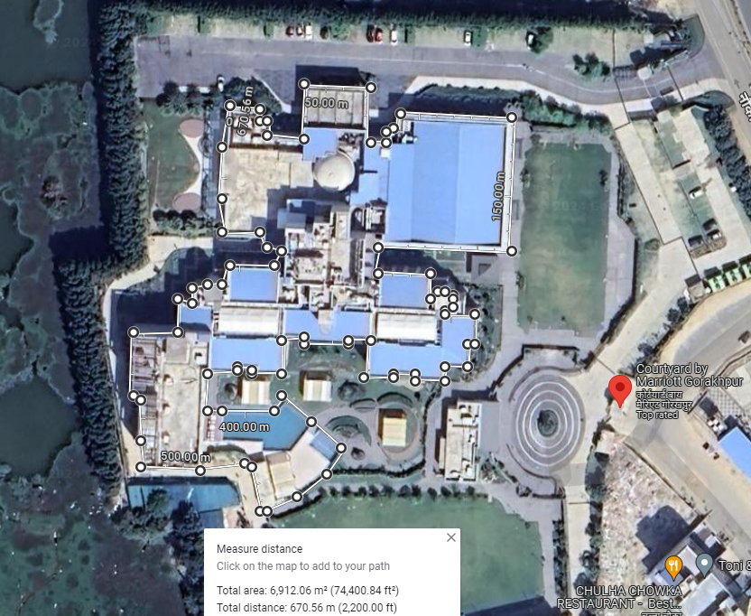

Main Office

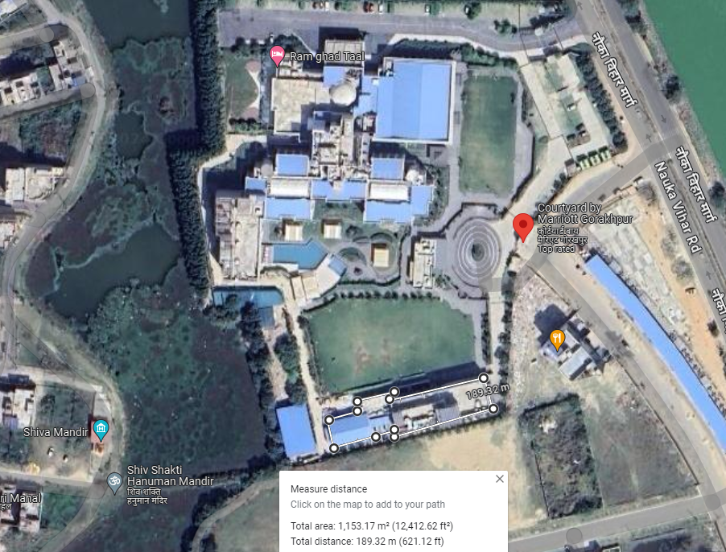M/s. Aisshpra Resorts Solutions Pvt. Ltd. has engaged local masons and laborers for the building and Civil works. Project architect was Ar. Ashish Srivastava.

Back Office

1. **PLANT & EQUIPMENT DETAILS:** In machinery section promoter has shown various equipment’s which have been installed which are needed for day-to-day operations of the hotel. Details of major heads with their cost is shown in the table below. Breakup of expenses under each head is annexed in the later section of the report. Cost has been taken based on the item wise breakup and their bills/ invoices provided by the promoter and found installed on the site.

|  |  |
| --- | --- |
| **PART D** | **PROJECT CAPITAL EXPENDITURE EVALUATION** |

*(All Figures in Rs.)*

| **S. No.** | **PARTICULARS** | **TOTAL AS SHOWN BY PROMOTER**  **(***As per CA certificate)* | **TOTAL APPROVED**  **AMOUNT BY IE** | **REMARKS** |
| --- | --- | --- | --- | --- |
|  | **Cost of Building, i.e., any built-up area and all such constructed spaces which are required for the commercial**  **operation of the eligible tourism unit (1.2)** | **Rs.42,26,58,976/-** | **Rs.31,80,47,725/-** | * Based on the benchmarking cost as per construction industry standards and CPWD norms, the similar type of construction of same type of quality of construction having similar built-up area cost around Rs.2,000/- to Rs.2,500/- per sq. ft. As per CPWD Plinth Area Rates 2023 Plinth area rate for non-residential is Rs.30,820/- per sq. mtr. or Rs.2,863.24/- per sq. ft. * Rs.10,81,52,494/- cost shown by the company is beyond the COD date i.e. 16/12/2023 hence it is ineligible as per the policy 2022. * As per our assessment the eligible cost under this head will be Rs.31,80,47,725/- |
|  | **Televisions (not more than 1 lakh per television set)**  **(1.4.1)** | **Rs.35,41,242/-** | **Rs.0/-** | * Break-up of the cost not shown by the promoter. |
|  | **Chandeliers (not more than Rs. 75 thousand per chandelier)**  **(1.4.2)** | **Rs.22,10,938/-** | **Rs.6,96,008/-** | * Rs.15,14,930/- cost shown by the company is beyond the COD date i.e. 16/12/2023 hence it is ineligible as per the policy 2022. * As per our assessment the eligible cost under this head will be Rs.6,96,008/- |
|  | **Safety equipment’s (e.g., fire detector and firefighting system, fire extinguisher, smoke detector, sprinkler, Surveillance systems, door metal detector, handheld metal detector, room barrier, vehicle scanner, etc.) (1.4.4)** | **Rs.3,81,20,351/-** | **Rs.3,50,80,220/-** | * Rs.30,40,133/- cost shown by the company is beyond the COD date i.e. 16/12/2023 hence it is ineligible as per the policy 2022. * As per our assessment the eligible cost under this head will be Rs.3,50,80,220/- |
|  | **Sound System and PA System, etc. (1.4.5)** | **Rs.63,75,790/-** | **Rs.62,74,433/-** | * Rs.1,01,357/- cost shown by the company is beyond the COD date i.e. 16/12/2023 hence it is ineligible as per the policy 2022. * As per our assessment the eligible cost under this head will be Rs.62,74,433/- |
|  | **Electrical fittings (electrical wiring, switches, and sockets etc.)**  **(1.4.6)** | **Rs.6,52,29,865/-** | **Rs.6,43,95,170/-** | * Rs.8,34,696/- cost shown by the company is beyond the COD date i.e. 16/12/2023 hence it is ineligible as per the policy 2022. * As per our assessment the eligible cost under this head will be Rs.6,43,95,170/- |
|  | **Heating Ventilation and Air-conditioning (HVAC) equipment (including split and window AC), water heating system.**  **(1.4.7)** | **Rs.2,40,27,958/-** | **Rs.2,29,73,505/-** | * Rs.10,54,454/- cost shown by the company is beyond the COD date i.e. 16/12/2023 hence it is ineligible as per the policy 2022. * As per our assessment the eligible cost under this head will be Rs.2,29,73,505/- |
|  | **D.G. power backup (for self-use)**  **(1.4.9)** | **Rs.62,50,000/-** | **Rs.0/-** | * Break-up of cost not shown by the promoter. |
|  | **Rainwater harvesting system, Solar/bio energy system (1.4.11)** | **Rs.18,81,064/-** | **Rs.18,81,064/-** | * As per our assessment the eligible cost under this head will be Rs.18,81,064/- |
|  | **Sewerage treatment plant and waste management system**  **(1.4.12)** | **Rs.39,89,955/-** | **Rs.39,89,955/-** | * As per our assessment the eligible cost under this head will be Rs.39,89,955/- |
|  | **Water supply system (pipeline, tanks, pump house, water treatment plant, etc.)**  **(1.4.13)** | **Rs.3,21,52,001/-** | **Rs.3,13,07,219/-** | * Rs.8,56,512/- cost shown by the company is beyond the COD date i.e. 16/12/2023 hence it is ineligible as per the policy 2022. * As per our assessment the eligible cost under this head will be Rs.3,13,07,219/- |
|  | **Equipments for gymnasium (1.4.14)** | **Rs.29,87,878/-** | **Rs.3,375/-** | * The cost shown under tis head is only Rs.3,375/- which seems eligible. |
|  | **Establishment of treatment plant for Air and Water Pollution/ incinerator etc.**  **(1.4.16)** | **Rs.18,09,231/-** | **Rs.18,09,232/-** | * As per our assessment the eligible cost under this head will be Rs.18,09,232/- |
|  | **Telecommunication tower (self-established for own use), WIFI routers, boosters**  **(1.4.17)** | **Rs.1,57,295/** | **Rs.1,57,295/** | * As per our assessment the eligible cost under this head will be Rs.1,57,295/ |
|  | **Computers including software’s**  **(1.4.18)** | **Rs.17,19,470/-** | **Rs.15,31,235/-** | * Rs.1,88,236/- cost shown by the company is beyond the COD date i.e. 16/12/2023 hence it is ineligible as per the policy 2022. * As per our assessment the eligible cost under this head will be Rs.15,31,235/- |
|  | **Store(s), Kitchen(s)**  **(1.5.2)** | **Rs.2,08,93,810/-** | **Rs.1,33,19,397/-** | * Rs.75,74,414/- cost shown by the company is is ineligible as per the policy 2022. * As per our assessment the eligible cost under this head will be Rs.3,50,80,220/- |
|  | **All power infrastructure used to facilitate electricity supply to the tourism unit, (e.g., electric poles, transformers, substations, etc.)**  **(1.5.6)** | **Rs.1,73,03,344/-** | **Rs.1,73,03,344/-** | * As per our assessment the eligible cost under this head will be Rs.1,73,03,344/- |
|  | **Establishment of sound, light, public address & internet system, and network of fixed nature.**  **(1.5.7)** | **Rs.84,91,156/-** | **Rs.76,09,929/-** | * Rs.8,81,228/- cost shown by the company is beyond the COD date i.e. 16/12/2023 hence it is ineligible as per the policy 2022. * As per our assessment the eligible cost under this head will be Rs.76,09,929/- |
|  | **Electric lining, gas/steam, water supply lining**  **(1.5.8)** | **Rs.14,74,302/-** | **Rs.12,34,103/-** | * Rs.2,40,200/- cost shown by the company is beyond the COD date i.e. 16/12/2023 hence it is ineligible as per the policy 2022. * As per our assessment the eligible cost under this head will be Rs.12,34,103/- |
|  | **Swimming pool, establishment of stationary swing-set, climbing walls, amusement /playing structure, etc. in play areas and parks and related infrastructure, which the eligible tourism unit must incur under the project**  **(1.5.9)** | **Rs.24,48,597/-** | **Rs.24,48,597/-** | * As per our assessment the eligible cost under this head will be Rs.24,48,597/- |
|  | **Other fixed structures and plant & machinery which are essential for commercial operation of the tourism unit**  **(1.6)** | **Rs.18,98,868/-** | **Rs.9,80,000/-** | * Rs.9,18,868/- cost shown by the company is beyond the COD date i.e. 16/12/2023 hence it is ineligible as per the policy 2022. * As per our assessment the eligible cost under this head will be Rs.9,80,000/- |
|  | **Any service charges e.g., Installation charges of machinery / equipment / service**  **(1.8)** | **Rs.3,69,31,247/-** | **Rs.3,66,09,379/-** | * Rs.3,21,868/- cost shown by the company is beyond the COD date i.e. 16/12/2023 hence it is ineligible as per the policy 2022. * As per our assessment the eligible cost under this head will be Rs.3,66,09,379/- |
|  | **Any other component which is not mentioned in the eligible components but is felt necessary for functioning of the tourism unit(s).**  **(1.10)** | **Rs.4,33,35,037/-** | **Rs.4,33,35,037/-** | * Cost under this head should be identified by the district Scanning Committee and recommended to the State Level Special Tourism Committee for further Consideration & Approval. |
|  | **Total** | **Rs. 74,58,88,380/-** | **Rs.56,76,51,185/- +**  **Rs.4,33,35,037/- (subject to consideration & approval by State Level Special Tourism Committee)** | * As per the UP-Tourism Guidelines 2022 the capital expenditure of Rs.56,76,51,185/-is eligible and cost shown under the head 1.10 which is Rs.4,33,35,037/- is subject to consideration & approval by State Level Special Tourism Committee. |
|  | **CURRENT STATUS OF WORK AND REMARKS:**   * All the expenditure shown above is cross checked with the work done on site and from the respective Invoices / Bills provided to us. * In case of Plant & Machinery, no specific benchmark cost standard is available. Therefore, the cost verification is conducted as per the individual invoices, bills for the particular items. * We have cross-checked the copy of bills/ invoices provided to us under different heads to match the amount provided in the subsidy application. | | | |

**Note:-**

1. There is No expenditure shown in below mentioned eligible head/s, hence not shown in the above table of Expenditure: -

* 1.3 Landscape (only 5% of the total ECI)
* 1.4.3 Amusement rides/games
* 1.4.8 Non-shiftable equipments for kitchen, laundry, wellness, conventional hall, exhibition halls etc.
* 1.4.10 Adventure Sports equipment(s)
* 1.4.15 Underground/ multi-level parking machinery and equipments
* 1.4.19 other equipment(s) including vehicles / boats / ships/ cruise etc. (which are registered in the name of the eligible tourism unit) which are exclusively used for working of the eligible tourism unit.
* 1.5.1 Boundary wall, fencing, entrance gate, guard room
* 1.5.3 Construction of all internal roads 1.18 Establishment of stationary swing sets, climbing walls, amusement / playing structure, permanent tents, etc. in play areas and parks
* 1.5.4 Underground/Multi-level Parking
* 1.5.5 Construction of linkage/ approach roads as per need (maximum length of 1,000 mts. and width as per local bylaws as per the prevailing SOR of PWD)
* 1.5.10 Fixed residential tents for tourists 1.23 fixed residential tents for tourists, meant for use round the year and not for temporary use like mela, events or seasonal camps, etc.
* 1.7 Any Consultancy charges related to the establishment/operationalization of the eligible Tourism unit like Fees paid for obtaining technical know-how, etc. (actual consultancy paid or Rs 10 lakhs, whichever is lower excluding GST/Tax)
* 1.9 Expenses done on any construction which is in nature of real estate transactions e.g., shops, flats, offices, etc., meant for sale / lease / rent for following tourism units: a. Cultural centers (If constructed more than 5 allowed shops/commercial sale outlets) b. Cultural, Rural Village or Tourist Village (If constructed more than 1 allowed souvenir shop)

|  |  |
| --- | --- |
| **PART E** | **PHOTOGRAPHS** |

|  |  |
| --- | --- |
| Z:\In Progress Files\Amit Jaiswal\VIS(2023-24)-PL744-643-1001_Aishpra Resort\Pics\TimePhoto_20240411_125649.jpg | Z:\In Progress Files\Amit Jaiswal\VIS(2023-24)-PL744-643-1001_Aishpra Resort\Pics\TimePhoto_20240411_125658.jpg |
| Z:\In Progress Files\Amit Jaiswal\VIS(2023-24)-PL744-643-1001_Aishpra Resort\Pics\TimePhoto_20240411_125511.jpg | Z:\In Progress Files\Amit Jaiswal\VIS(2023-24)-PL744-643-1001_Aishpra Resort\Pics\TimePhoto_20240411_125816.jpg |
| Z:\In Progress Files\Amit Jaiswal\VIS(2023-24)-PL744-643-1001_Aishpra Resort\Pics\TimePhoto_20240411_125823.jpg | Z:\In Progress Files\Amit Jaiswal\VIS(2023-24)-PL744-643-1001_Aishpra Resort\Pics\TimePhoto_20240411_125835.jpg |
| Z:\In Progress Files\Amit Jaiswal\VIS(2023-24)-PL744-643-1001_Aishpra Resort\Pics\TimePhoto_20240411_125842.jpg | Z:\In Progress Files\Amit Jaiswal\VIS(2023-24)-PL744-643-1001_Aishpra Resort\Pics\TimePhoto_20240411_125911.jpg |
| Z:\In Progress Files\Amit Jaiswal\VIS(2023-24)-PL744-643-1001_Aishpra Resort\Pics\TimePhoto_20240411_130051.jpg | Z:\In Progress Files\Amit Jaiswal\VIS(2023-24)-PL744-643-1001_Aishpra Resort\Pics\TimePhoto_20240411_130224.jpg |
| Z:\In Progress Files\Amit Jaiswal\VIS(2023-24)-PL744-643-1001_Aishpra Resort\Pics\TimePhoto_20240411_130616.jpg | Z:\In Progress Files\Amit Jaiswal\VIS(2023-24)-PL744-643-1001_Aishpra Resort\Pics\TimePhoto_20240411_130822.jpg |
| Z:\In Progress Files\Amit Jaiswal\VIS(2023-24)-PL744-643-1001_Aishpra Resort\Pics\TimePhoto_20240411_131359.jpg | Z:\In Progress Files\Amit Jaiswal\VIS(2023-24)-PL744-643-1001_Aishpra Resort\Pics\TimePhoto_20240411_131416.jpg |
| Z:\In Progress Files\Amit Jaiswal\VIS(2023-24)-PL744-643-1001_Aishpra Resort\Pics\TimePhoto_20240411_132536.jpg | Z:\In Progress Files\Amit Jaiswal\VIS(2023-24)-PL744-643-1001_Aishpra Resort\Pics\TimePhoto_20240411_132856.jpg |
| Z:\In Progress Files\Amit Jaiswal\VIS(2023-24)-PL744-643-1001_Aishpra Resort\Pics\TimePhoto_20240411_133022.jpg | Z:\In Progress Files\Amit Jaiswal\VIS(2023-24)-PL744-643-1001_Aishpra Resort\Pics\TimePhoto_20240411_134733.jpg |
| Z:\In Progress Files\Amit Jaiswal\VIS(2023-24)-PL744-643-1001_Aishpra Resort\Pics\TimePhoto_20240411_135834.jpg | Z:\In Progress Files\Amit Jaiswal\VIS(2023-24)-PL744-643-1001_Aishpra Resort\Pics\TimePhoto_20240411_140337.jpg |
| Z:\In Progress Files\Amit Jaiswal\VIS(2023-24)-PL744-643-1001_Aishpra Resort\Pics\TimePhoto_20240412_140514.jpg | Z:\In Progress Files\Amit Jaiswal\VIS(2023-24)-PL744-643-1001_Aishpra Resort\Pics\TimePhoto_20240411_154612.jpg |

|  |  |
| --- | --- |
| **PART F** | **DISCLAIMER** |

* + - 1. No employee or member of R.K Associates has any direct/ indirect interest in the Project.
      2. This report is prepared based on the copies of the documents/ information which interested organization or customer could provide to us out of the standard checklist of documents sought from them and further based on our assumptions and limiting conditions. All such information provided to us has been relied upon and we have assumed that it is true and correct. Verification or cross checking of the documents provided to us has not been done at our end from the originals. If at any time in future it’s found or came to our knowledge that misrepresentation of facts or incomplete or distorted information has been provided to us then this report shall automatically become null & void.
      3. This report is a general analysis of the project and not an audit report. All the information gathered is based on the facts seen on the site during survey, verbal discussion & documentary evidence provided by the client and is believed that information given by the Promoter is true best of their knowledge.
      4. All observations mentioned in the report is only based on the visual observation and the documents/ data/ information provided by the client. No mechanical/ technical tests, measurements or any design review have been performed or carried out from our side during Project assessment.
      5. Interested organization should ONLY take this report as an Advisory document from the Financial/ Chartered Engineering firm and it’s specifically advised to the stakeholder to cross verify the original documents for the facts mentioned in the report which can be availed directly from the subject Promoter directly.
      6. In case of any default in loans or the credit facility extended to the borrowing Promoter, R.K Associates shall not be held responsible for whatsoever reason may be and any request for seeking any explanation from the employee/s of R.K Associates will not be entertained at any instance or situation.
      7. This Report is prepared by our competent technical team which includes Engineers and financial experts & analysts.
      8. This is just an opinion report and doesn’t hold any binding on anyone. It is requested from the concerned Financial Institution which is using this report for taking financial decision on the project that they should consider all the different associated relevant & related factors also before taking any business decision based on the content of this report.
      9. All Pages of the report including annexures are signed and stamped from our office. In case any paper in the report is without stamp & signature then this should not be considered a valid paper issued from this office.
      10. Defect Liability Period is **30 DAYS**. We request the concerned authorized reader of this report to check the contents, data and calculations in the report within this period and intimate us in writing if any corrections are required or in case of any other concern with the contents or opinion mentioned in the report. Corrections only related to typographical, calculation, spelling mistakes will be entertained within the defect liability period. No request for any illegitimate value revision, date change or any other facts & figures changes will be entertained other than the one mentioned above.
      11. R.K Associates encourages its customers to give feedback or inform concerns over its services through proper channel at valuer[@rkassociates.org](mailto:ers@rkassociates.org) in writing within 30 days of report delivery. After this period no concern/ complaint/ proceedings in connection with the Valuation Services can be entertained due to possible change in situation and condition of the property.
      12. Our Data retention policy is of **ONE YEAR**. After this period we remove all the concerned records related to the assignment from our repository. No clarification or query can be answered after this period due to unavailability of the data.
      13. This Valuation report is governed by our (1) Internal Policies, Processes & Standard Operating Procedures, (2) R.K Associates Quality Policy, (3) Valuation & Survey Best Practices Guidelines formulated by management of R.K Associates, (4) Information input given to us by the customer and (4) Information/ Data/ Facts given to us by our field/ office technical team. Management of R.K Associates never gives acceptance to any unethical or unprofessional practice which may affect fair, correct & impartial assessment and which is against any prevailing law. In case of any indication of any negligence, default, incorrect, misleading, misrepresentation or distortion of facts in the report then it is the responsibility of the user of this report to immediately or atleast within the defect liability period bring all such act into notice of R.K Associates management so that corrective measures can be taken instantly.
      14. R.K Associates never releases any report doing alterations or modifications from pen. In case any information/ figure of this report is found altered with pen then this report will automatically become null & void.
      15. If this report is prepared for the matter under litigation in any Indian court, no official or employee of R.K Associates will be under any obligation to give in person appearance in the court as a testimony. For any explanation or clarification, only written reply can be submitted on payment of charges by the plaintiff or respondent which will be 10% of the original fees charged where minimum charges will be Rs.15,000/-.

|  |  |
| --- | --- |
| Place : New Delhi  Date : 07.05.2024  Note : This report contains 26 pages | **FOR INTERNAL USE**  ***SURVEYED BY: Deepak Kumar Singh and***  ***Amit Jaiswal***  ***PREPARED BY: Engg. Team***  ***REVIEWED BY: Anil Kumar*** |

**For R.K Associates Valuers & Techno**

**Engineering Consultants Pvt. Ltd.**

**Project Engineering Team**

***R.K ASSOCIATES IMPORTANT NOTES:***

1. ***DEFECT LIABILITY PERIOD - In case of any query/ issue or escalation you may please contact Incident Manager by writing at le@rkassociates.org. We ensure 100% accuracy in the Calculations done, Rates adopted and various other data points & information mentioned in the report but still can’t rule out typing, human errors or any other mistakes. In case you find any mistake, variation, discrepancy or inaccuracy in any data point of the report, please help us by bringing all such points into our notice in writing at*** [***le@rkassociates.org***](mailto:le@rkassociates.org) ***within 30 days of the report delivery, to get these rectified timely, failing which R.K Associates Valuers Techno Engineering Consultants (P) Ltd. won’t be held responsible for any inaccuracy in any manner. Also if we do not hear back anything from you within 30 days, we will assume that report is correct in all respect and no further claim of any sort will be entertained thereafter. We would welcome and appreciate your feedback & suggestions in order to improve our services.***
2. ***COPYRIGHT FORMAT - This report is prepared on the copyright format of R.K Associates Valuers Techno Engineering Consultants (P) Ltd. to serve our clients in the best possible way. Legally no one can copy or distribute this format without prior approval from R.K Associates. It is meant only for the organization as mentioned on the cover page of this report. Distribution or use of this format other than R.K Associates will be seen as unlawful act and necessary legal action can be taken against the defaulter.***