File No.: VIS(2023-24)-PL755-654-1011 Dated: 06-03-2024

LENDER’S INDEPENDENT ENGINEER’s REPORT

OF

6.221 (± 5%) MWp GRID CONNECTED ROOF-TOP SOLAR POWER PLANT

PROPOSED TO BE SET-UP AT
M/S CAVENDISH INDUSTRIES LIMITED (A UNIT OF JK TYRE), DABKI KALAN, LAKSAR, HARIDWAR

DEVELOPER:
M/S TRUERE UP 2 PRIVATE LIMITED

REPORT PREPARED FOR
STATE BANK OF INDIA, SME BRANCH, ASAF ALI ROAD, DELHI

**Important - In case of any query/ issue or escalation you may please contact Incident Manager
at le@rkassociates.org. We will appreciate your feedback in order to improve our services.
NOTE: As per IBA Guidelines please provide your feedback on the report within 15 days of its submission after which report will be considered to be correct.

IMPORTANT NOTICE

COPYRIGHT FORMAT: This report is prepared on the copyright format of R.K Associates to serve our clients with the best possible information and analysis to facilitate them to take rational business decisions. Legally no one can copy or distribute this format without prior approval from R.K Associates. It is meant only for the advisory/ reference purpose for the organization/s as mentioned on the cover page of this report. Distribution or use of this format by any organization or individual other than R.K Associates will be seen as an unlawful act and necessary legal action can be taken against the defaulters.
This report is intended for the sole use of the intended recipient/s and contains material that is STRICTLY CONFIDENTIAL AND PRIVATE.

DEFECT LIABILITY PERIOD: - In case of any query/ issue or escalation you may please contact Incident Manager at le@rkassociates.org.
Though adequate care has been taken while preparing this report as per its scope, but still we can’t rule out typing, human errors, over sightedness of any information or any other mistakes. Therefore, the concerned organization is advised to satisfy themselves that the report is complete & satisfactory in all respect. Intimation regarding any discrepancy shall be brought into our notice immediately. If no intimation is received within 15 (Fifteen) days in writing from the date of issuance of the report, to rectify these timely, then it shall be considered that the report is complete in all respect and has been accepted.

TABLE OF CONTENTS
SECTIONS | PARTICULARS | PAGE NO.
Part A | REPORT SUMMARY | 03
Part B | INTRODUCTION | 04
 | - Name of the Project | 04
 | - Project Overview | 04
 | - Scope of the Report | 06
 | - Purpose of the Report | 06
 | - Methodology Adopted | 06
Part C | PROJECT DETAILS AND KEY TECHNICAL PARAMETERS | 07
Part D | ENERGY YIELD ASSESSMENT | 08
Part E | POWER PURCHASE AGREEMENT TERMS | 13
Part F | CURRENT STATUS OF WORK | 15
Part G | PROJECT COST & EXPENDITURE | 16
Part H | PHOTOGRAPHS | 18
Part I | OTHER DOCUMENTS & REFERENCES | 19
Part J | DISCLAIMER | 28

PART A | REPORT SUMMARY

 | Name of the Project | 6.221 (±5%) MWp Grid Connected Solar Rooftop Power Plant
 | Project Location | M/s Cavendish Industries Limited (A Unit of JK Tyre), Dabki Kalan, Laksar, Haridwar
 | Seller Company | M/s Truere UP 2 Private Limited
 | Prepared for Organization | State Bank Of India, Sme Branch, Asaf Ali Road, Delhi
 | LIE Consultant Firm | M/s. R.K. Associates Valuers & Techno Engineering Consultants (P) Ltd.
 | Work Oder Details | Via mail dated 29-02-2024
 | Date of Survey | 27-02-2024
 | Date of Report | 06-03-2024
 | Details & documents provided by | Mr. Monu Prajapati (Manager Finance)
 | Report Type | Lender’s Independent Engineering Report
 | Purpose of the Report | Review of Project cost, CUF and Irradiation Data, current status to facilitate bankers to take business decision on the Project.
 | Scope of the Report | To review Project cost and examine the current status of installation/ Commissioning of the Project.
 | Documents produced for Perusal | - Copy of Power Purchase Agreements (PPAs)  - Copy of Plant Layout  - Copy of PVSyst report dated 05-03-2024  - Techno commercial offer
 | Annexure with the Report | - Benchmark Cost by MNRE  - Market Comparables  - Global Solar Atlas by World Bank Group

PART B | INTRODUCTION

- NAME OF THE PROJECT: 6.221 (± 5%) MWp Grid Connected Solar Rooftop Power Plant in RESCO Model to be installed at M/s Cavendish Industries Limited (A Unit of JK Tyre) by M/s Truere UP 2 Private Limited.
- PROJECT OVERVIEW: M/s Truere UP 2 Private Limited is an private incorporated which is into Manufacturing, supplying, installing and distribution of electric power generation using solar energy.
M/s Cavendish Industries Limited had signed 01 nos. of Power Purchase Agreement (PPA) with M/s Truere UP 2 Private Limited for Design, Finance, Build and Operate of roof-top solar power plant at its location having a total DC capacity of 6.221 (± 5%) MWp for 15 years of plant operation/ PPA tenure.
As per Detailed Project Report shared by the company, the estimated project cost is Rs.27.50 Cr. including duties and taxes.
M/s M/s Truere UP 2 Private Limited has State Bank of India, SME Branch, Asaf Ali Road, Delhi for credit facility to construct these plants who have in turned appointed M/s R.K Associates Valuers & Techno Engineering Consultants Pvt. Ltd. as Lenders Independent Engineer for a specific scope of work.
As on date of site visit, presently physical work has not started yet. Thus, our scope of work includes only review & comment on total Project cost, CUF and Irradiation Data.

RESCO Model: -
MNRE had introduced the PPP/RESCO model policy setting tariff rates for solar to be arrived on transparent competitive bidding model through PPP route.

The RESCO model is one of the methods of implementing rooftop solar installations. Under the RESCO model, a renewable energy service company ("RESCO"), (i.e., an energy service company that provides energy to consumers from renewable energy sources), develops, installs, finances, operates and owns the rooftop solar power project ("Project"), and supplies power generated from the Project to the consumer on whose premises the Project is set up ("Customer") or to the grid through net-metering.

'Build, Own, Operate and Transfer' (BOOT) is a special kind of RESCO model in which the RESCO constructs, owns, operates, and transfers the ownership of the Project to the Customer after the expiry of a predefined period. The RESCO and the Customer enter into a long-term power purchase agreement ("PPA") for an agreed tenure, which sets out, among others, the terms at which the power generated from the Project will be sold to the Customer and the tariff at which the power will be sold. Excess power from the Project (if any) could be sold by the Customer to the distribution utility through net metering system – the net metering regulations differ from state to state.

Under the PPA, the RESCO owns the Project and is responsible for its installation as well as its operation and maintenance of the Project throughout the tenure of the Project, and at the end of the PPA term, the ownership of the Project is transferred to the Customer. Thereafter, the Customer may either choose to retain the RESCO for operation and maintenance services or engage a third-party operator.

If the entity on whose premises the Project is located does not intend to buy the power generated from the Project and does not entered into a PPA with the RESCO, that entity can either lease the rooftop premises to the RESCO by means of a lease agreement or enter into a license agreement granting the RESCO the right to use the premises for the limited purpose of setting up and operating the Project. The RESCO then operates the Project and exports the energy generated to the local distribution utility at a predetermined feed-intariff (FiT) approved by the State Electricity Regulator under relevant schemes issued by the relevant state.

- SCOPE OF THE REPORT: To verify and review the Project cost, CUF and Irradiation Data of the Solar Power Plants set-up/ being set-up by M/s Truere UP 2 Private Limited:-
- Industry/ sector research and demand & supply trend is out of scope of the report.
- Financial feasibility study of the Project is out of scope of the report.
- Providing any kind of design report or map is out-of-scope of the report.
- Scrutiny of contracts, Agreements and arrangement between the parties from legal perspective is out-of-scope of this report.
- Location feasibility is ascertained based on the PVSyst Report provided by the client.
- Any kind of technical & economic feasibility of the Project is out-of-scope of this Report.

All the assessment carried out for the Project is done based on the documents and information provided to us and various other discussions with the Project proponents and thus forming an opinion out of it.

Project assessment uis done in totality and not component wise unless otherwise mentioned..

- PURPOSE OF THE REPORT: To provide fair detailed analysis report to the Bank based on the “in-scope points” mentioned above for facilitating them to take appropriate business decision on the Project.

- METHODOLOGY ADOPTED:
- To gather relevant data/ information/ documents related to Project planning, execution, current status.
- Study of copy of Project Planning documents/ Agreements to know the scope of work of the company.
- To procure, study and analysis of any additional information, data, and documents required/ provided by the company.
- Research about the Project/ sector from the sources in the public domain.
- Correlation of the provided information against Industry/ sector benchmarks/ trend.
- Information compilation, analysis and reporting.

PART C | PROJECT DETAILS AND KEY TECHNICAL PARAMETERS
As per DPR shared by the management of the company, details of the subject plants has been tabulated below:
S.  No. | Offtaker | DC Power (kWp) | AC Power  (kWp)
1 | Cavendish Industries Limited | ~6.00 | ~5.00
Total |  | ~6.00 | ~5.00

Location Map: -
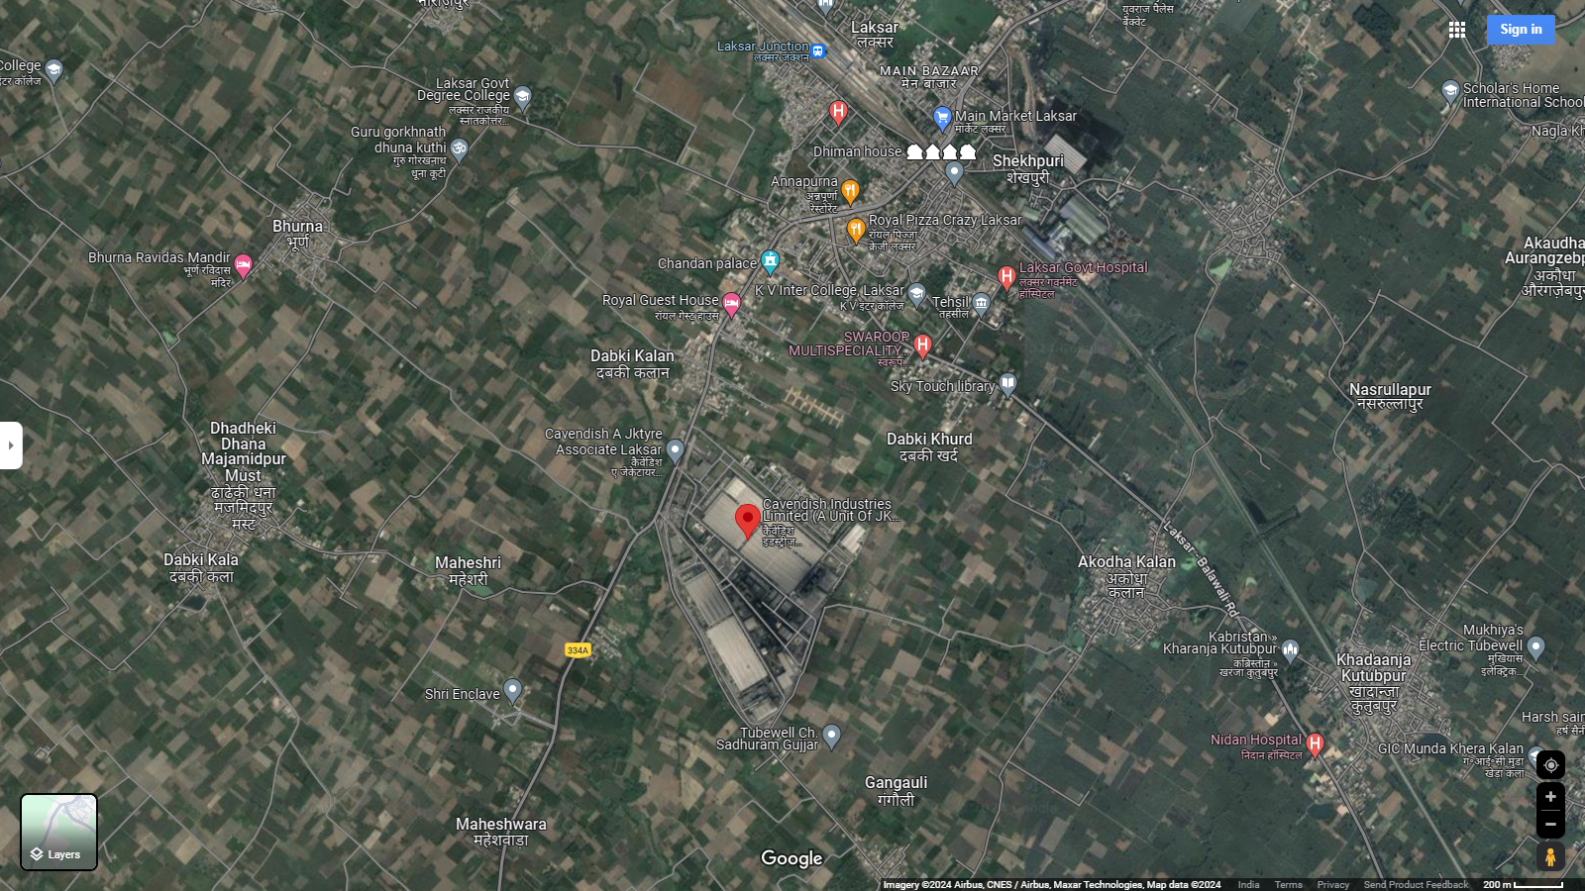
Location: Cavendish Industries Limited, Laksar GPS: 29°44'13.9"N 78°00'49.9"E

Technical parameters/specifications of solar plant to be installed are as follow:-

S. No. | Particulars | Plant-1
1 | No. of modules | 10,914 Modules
2 | Modules capacity | Jinko/JA/Trina/Adani/Equivalent  Mono-Crystalline (570Wp)
3 | Invertor make | Goodwe
4 | Invertor AC Voltage | 415V AC
5 | DC capacity | 6221kWp
6 | AC capacity | 5000 kW
7 | Roof Tilt | As per Roof

PART D | ENERGY YIELD ASSESSMENT

Company has used PVSyst V7.4.5 to assess energy yield calculation which is the standard Industry practice. The yearly average of main results of irradiation and energy yield from the provided PVSyst is as under:
Annual production probability (kWh/kWp/Year):

S. No. | Plant | As per PVSyst  (In kWh/kWp/Year) |  | Performance  Ratio (%) | CUF (%)
 |  | P50 | P90
1 | CIL Plant | 1,334 | 1,299 | 84.98% | 15.23%

Estimated Annual production (kWh/Year):

S. No. | Plant | As per PPA  (kWh/Year) | As per PVSyst  (kWh/Year) | As per DPR  (kWh/Year)
1 | CIL Plant | 76,31,301 | 83,00,599 | 74,90,000

Estimated Specific Production (kWh/kWp/Year):

S. No. | Plant | As per PPA  (In kWh/kWp/Year) |  | As per PVSyst  (In kWh/kWp/Year) | As per Global Solar Atlas  (In kWh/kWp/Year)
 |  | Estimated | Guaranteed
1 | CIL Plant | 1,363 | 1,227 | 1,334 | 1,498

Observations and Remarks:

- As per above inputs and analysis estimated annual production as specified in PPA is in between as mentioned DPR & PVSyst report.
- Estimated specific production as per PPA is same as specified in PvSyst report and Global Solar Atlas Report.

Analysis of Irridiation & PV Output data: In respect to Irridiation & PV Output data, company has provided to us PVSyst Report V7.4.5 in which key Irrdidation components and PV Output data is given as enumerated in table below. We have analysed and compared it with other data source points also such as Solar Resource by Global Solar Atlas of World Bank and ISRO Solar Calculator to confirm its legitimacy as mentioned in table below:
Particulars | Cavendish Industries Limited
 | As per Global Solar Atlas | As per PVSyst
Global horizontal Irradiation (kWh/m²) | 1735.3 | 1566.1
Diffuse horizontal Irradiation (kWh/m²) | 897.3 | 881.0
Direct Normal Irradiation (kWh/m²) | 1260.8 | -
Specific Photovoltaic Power Output per year (kWh/kWp/year) | 1498.3 | 1204.0
Annual Global Insolation (ISRO Solar Calculator) (kWh/m2/year) | 1441

Observations and Remarks:
- As per the PVsyst - Simulation reports dated 03rd March 2024, the estimated energy that can be produced by the subject plants as specified in PPA is in between as mentioned DPR & PVSyst report.
- As per comparative analysis, PVSyst Irrdiation and PV Output data is almost in line to our analysis from Global Solar Atlas of World Bank and ISRO Solar Calculator.
- The guaranteed specific production as per PPA for Plant is 1,227 kWh/kWp/year which is within range of specific production as per Global Solar Atlas & PVSyst Report (refer table above).
- As per the information provided by the management of the company, the estimated average Capacity Utilization Factor (CUF) is ~15.23%.
Monthly averages- Direct Normal Irradiation (kWh/m²)

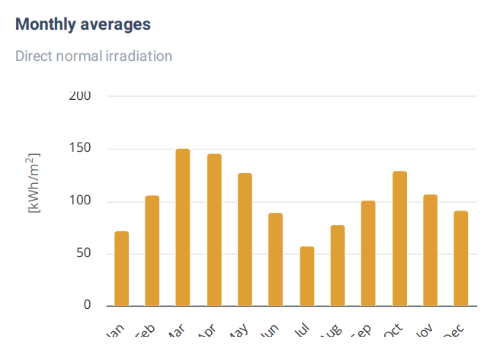
Source: Global Solar Atlas

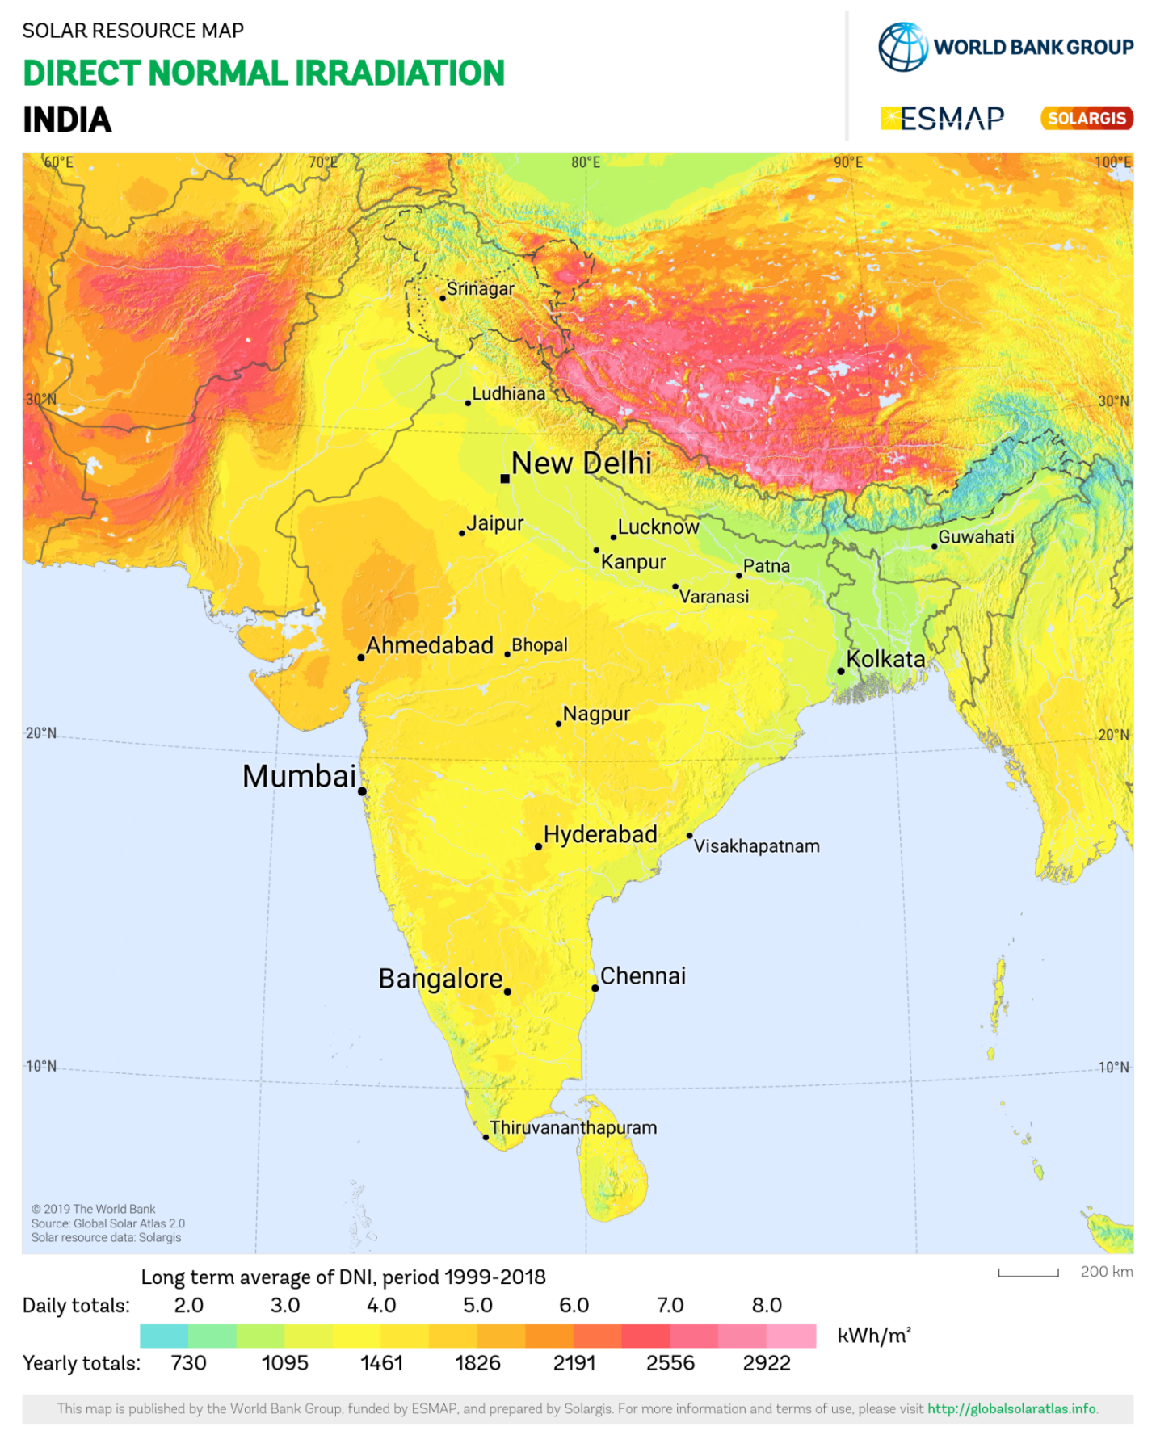
Cavendish Industries Limited Plant lies above 3.0 daily (1095 annually) Kwh/m².
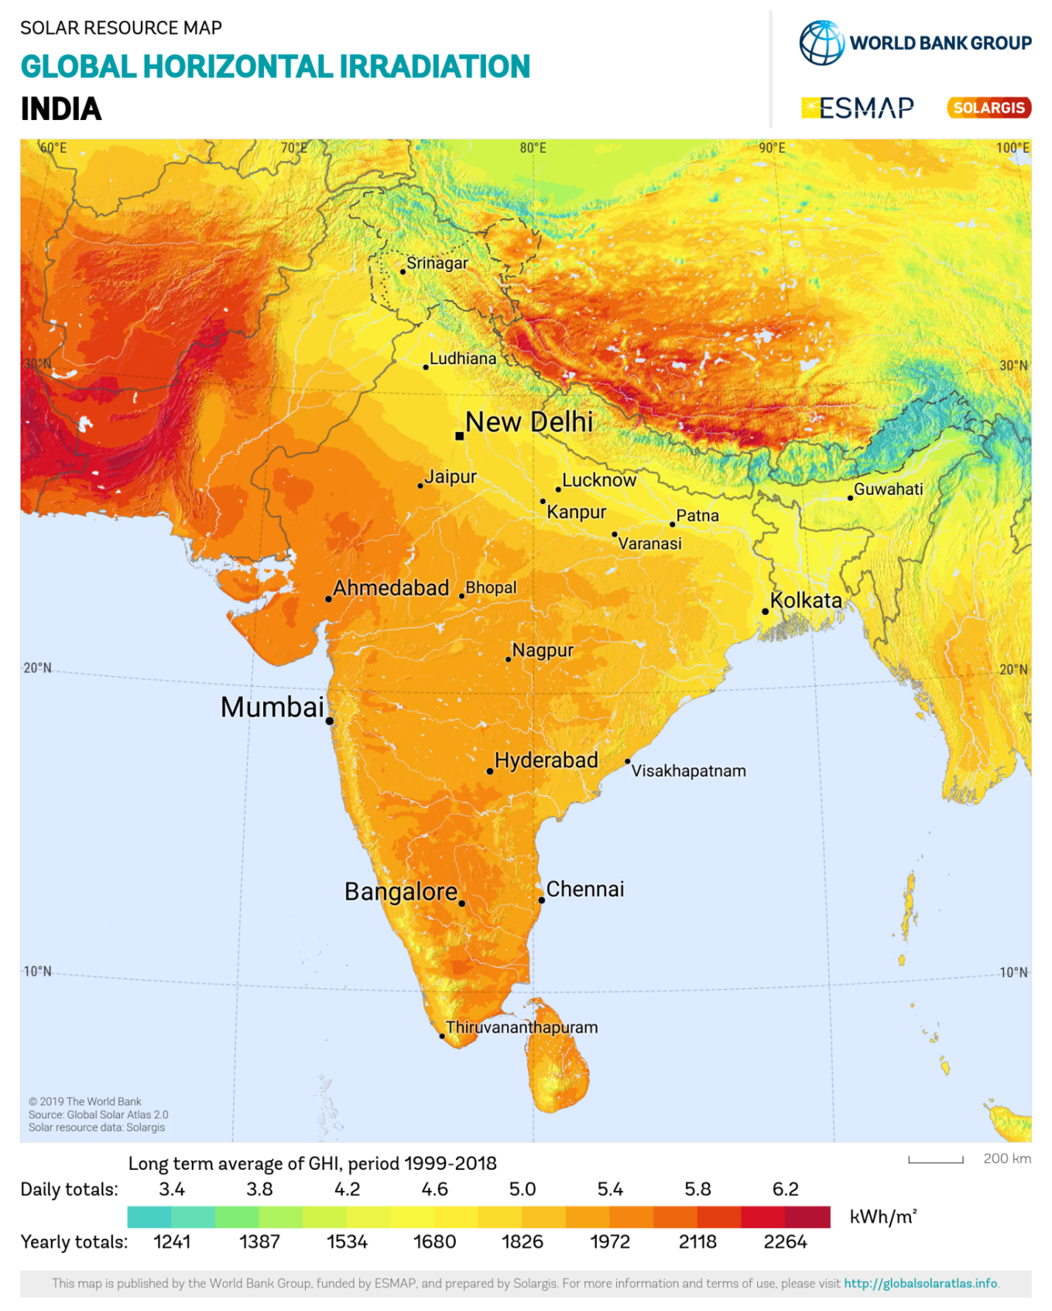
Cavendish Industries Limited Plant lies below 4.5 daily (1680 annually) Kwh/m².
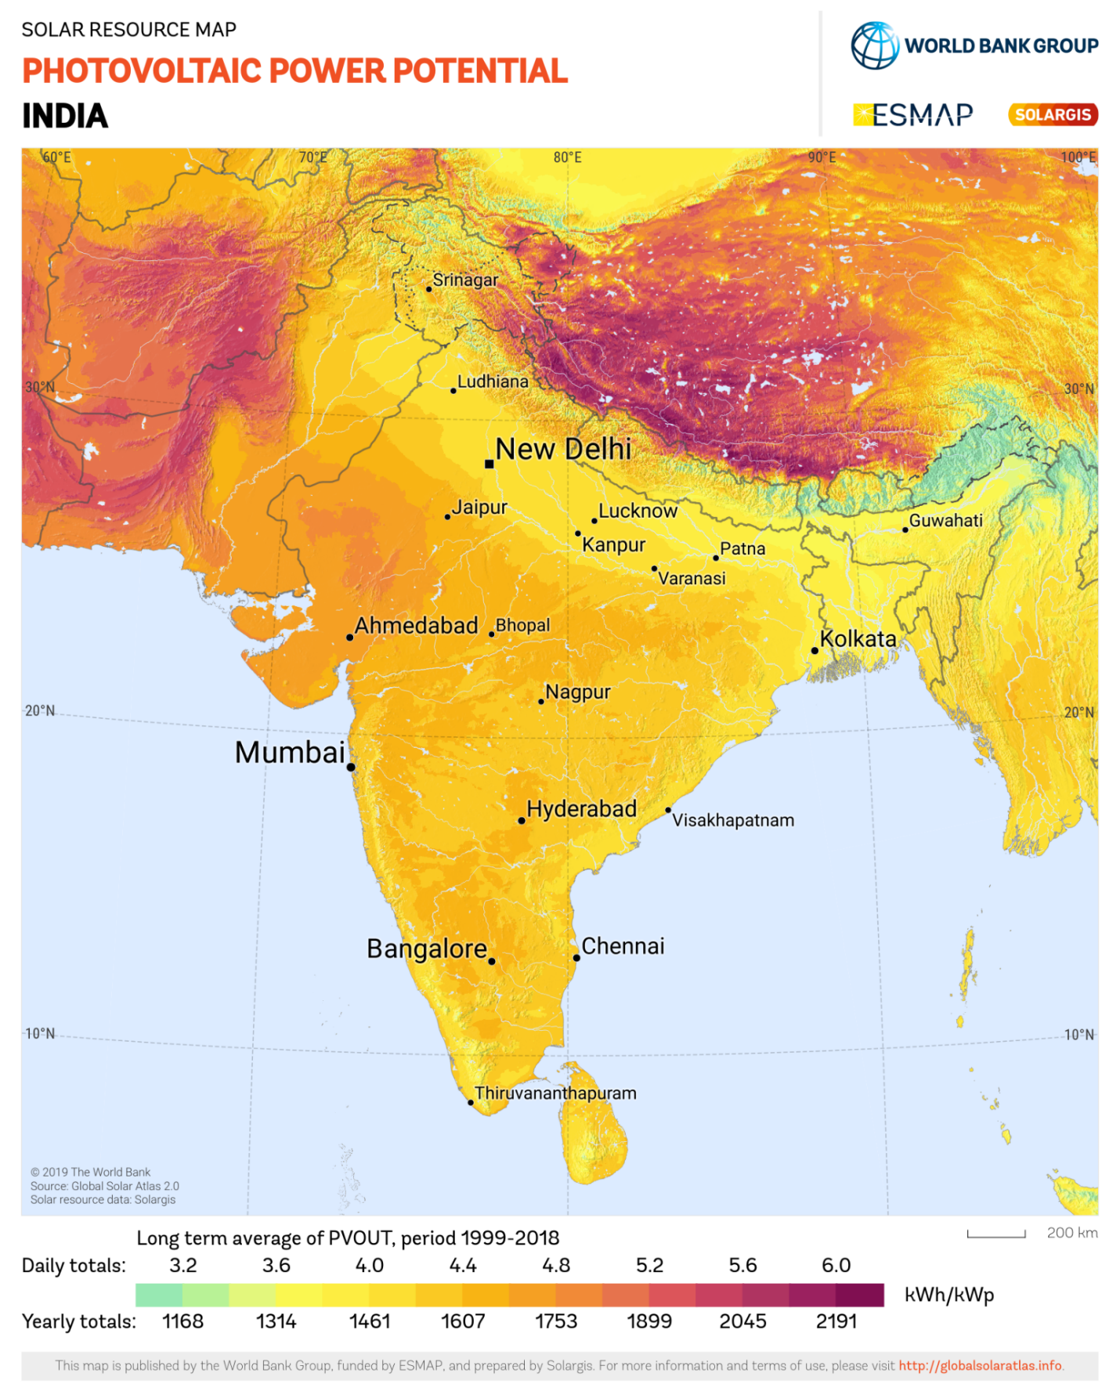
Cavendish Industries Limited Plant lies below 4.0 daily (1461 annually) Kwh/m².
PART E | POWER PURCHASE AGREEMENT TERMS

As per the information provided by the company, the total proposed capacity of the solar power plant is 6.221 MWp (± 5%). As on date, company has signed PPA to install the power plant and supply power. The PPA had been signed between M/s Cavendish Industries Limited and M/s Truere UP 2 Private Limited. Details as mentioned in PPA are tabulated below:
S. No. | Offtaker | DC Capacity  (kWp) | Tariff  (Rs./kWh) | PPA Date | PPA Tenure
1 | Cavendish Industries Limited | ~5000 | 4.79 | 30-01-2024 | 15 Years
Total |  | ~5000

Buy out Value for 15 Years as per PPA | Estimated Genration and Guaranteed generation as per PPA
Year Purchase Price (In Rs.)  At Start of 1st Contract Year 31,05,52,320  At End of 1st Contract Year 28,98,48,832  At End of 2nd Contract Year 26,91,45,344  At End of 3rd Contract Year 24,84,41,856  At End of 4th Contract Year 22,77,38,368  At End of 5th Contract Year 20,70,34,880  At End of 6th Contract Year 18,63,31,392  At End of 7th Contract Year 16,56,27,904  At End of 8th Contract Year 14,49,24,416  At End of 9th Contract Year 14,42,20,928  At End of 10th Contract Year 10,35,17,440  At End of 11th Contract Year 8,28,13,952  At End of 12th Contract Year 6,21,10,464  At End of 13th Contract Year 4,14,06,976  At End of 14th Contract Year 2,07,03,488  At End of 15th Contract Year 1 | Year Estimated Generation (kWh/Year) Guaranteed Units (kWh/Year)  1st 84,79,223 76,31,301  2nd 82,67,242 74,40,518  3rd 82,07,888 73,87,099  4th 81,48,533 73,33,680  5th 80,89,179 72,80,261  6th 80,29,824 72,26,842  7th 79,70,470 71,73,423  8th 79,11,115 71,20,003  9th 78,51,760 70,66,584  10th 77,92,406 70,13,165  11th 77,33,051 69,59,746  12th 76,73,697 69,26,327  13th 76,14,342 68,52,908  14th 75,54,988 67,99,489  15th 74,95,633 67,46,070

PART F | CURRENT STATUS OF WORK

As on date of site visit, Solar Panel Installation work is not started yet. As per analysis made during site inspection, we did not find any shadow/obstruction on which may block the Direct Sunlight on solar panels.
As per google satellite measurement tools, total shed roof area is about 1,00,000 sqm. The approximate size of 570Wp Solar Panel is 2278 x 1134 x 30 (mm). As per DPR, total quantity of solar panels to be installed is 10,914 nos. Thus, 28,194 sqm are is sufficient to install 6.21 MW solar plant.
Please refer to the image attached below:-
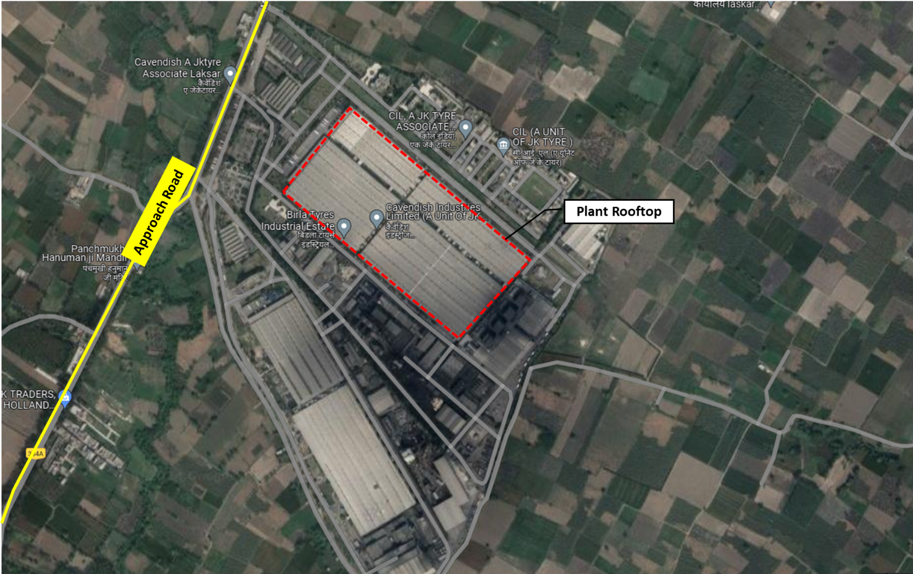

PART G | PROJECT COST & EXPENDITURE

- PROJECT COST: As per technical commercial offer from M/s OPPL TGS Pvt. Ltd. shared by the company, the total project cost for installation of 6.221 MW solar project is Rs. 27.50 Cr. including GST. Component-wise cost break-up shared by the company is as follows:-
S.No. | Item | Cost/kW  (In Rs. Cr.)
1 | EPC Cost + GST | 24.88
 | Pre-Operational Expenses | 0.12
2 | IDC | 2.49
Total Cost of the project (In Rs. Crore) |  | 27.50
Total Cost In Rs. per kW |  | 44,205

Observations and Remarks:
- Project cost calculated on the basis of the Benchmark Cost provided by the MNRE has been tabulated below:
S. No. | Particulars | Benchmark Cost  (In Rs./kW) | Project Capacity  (In MW) | Total Project Cost  (Excluding GST)  (In Rs.) | Total Project Cost  (Including ~14% GST)  (In Rs.)
1 | As per Ministry of New & Renewable Energy | 35,886* | 6.221 | 22,32,46,806 | 25,45,01,359
 |  |  | 6.221 MWp |  | ~Rs. 25.45 Cr.
*Benchmark cost for 2021-22 Excludes GST

- Project cost calculated on the basis of market comparable:
S. No. | Particulars | Excluding GST | Including GST | Remark
 |  | Per KW Cost  (In Rs.) | Per KW Cost  (In Rs.)
1 | Subject project installation cost | -- | 44,205 | As per Compnay
Market Research Details
2 | MNRE Benchmark Cost | 35,886 | - | Refer Annexure-1
Market Research
3 | Quotation-1 (250 KW) | 37,740 | 42,500 | Refer Annexure-2
4 | Quotation-2 (150 KW) | 39,037 | 44,000
5 | Quotation-3 (150 KW) | - | 55,000
6 | Quotation-4 (150 KW) | 50,000 | 56,900
7 | Quotation-5 (243 KW) | - | 46,480

- As per our analysis and market research, the installation cost of Solar Power Plant varies from Rs. 42,500/- per KW to Rs. 56,900/- per KW. For the smaller setups the price is higher and for large set-up, price is less.
- The project cost solely depends upon the project location, contractors profit, type of module and its supporting structures, make, etc.
- Based upon the above mentioned details, the project cost amounting to Rs. 27.45 Cr. which is Rs. 44,205/- per kW inclusive of GST for the installation of subject solar power plant seems to be reasonable as this is falling within the expected market price range of Rs. 42,500/- per KW to Rs. 56,900/- per KW.
Note:
- Project cost is analyzed based on lump sum cost only and not item wise.
- Project cost is assessed for the date of this report only and due to price fluctuations it may vary from time to time.

- EXPENDITURE: As per observation made during site visit and information provided by the company management, solar plant installation work is not started yet and company has not incurred any expenses.

PART H | PHOTOGRAPHS

Proposed Rooftop where solar panels to be installed

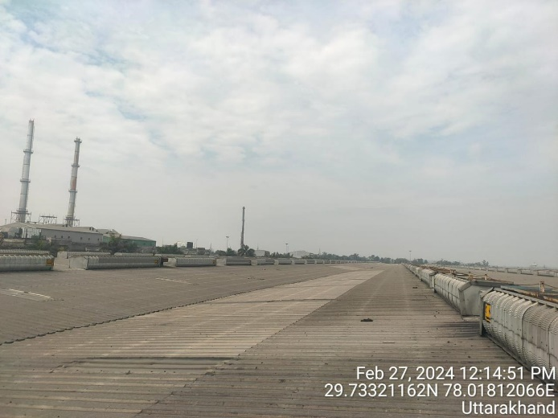 | 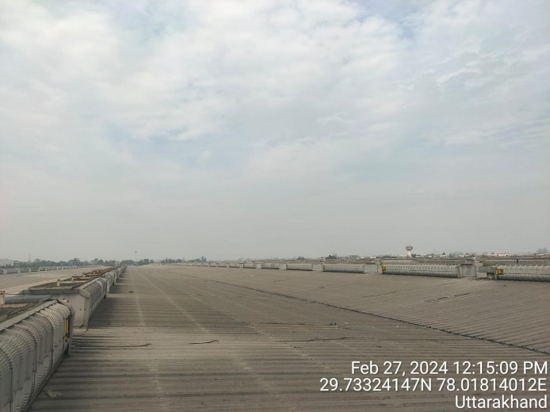
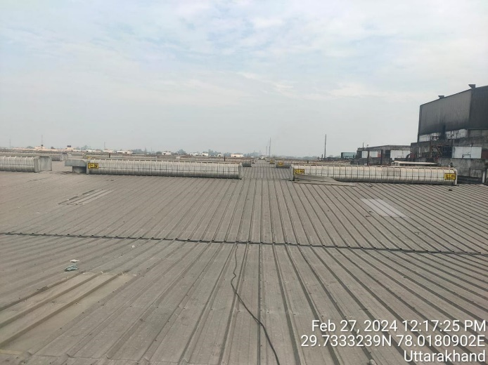 | 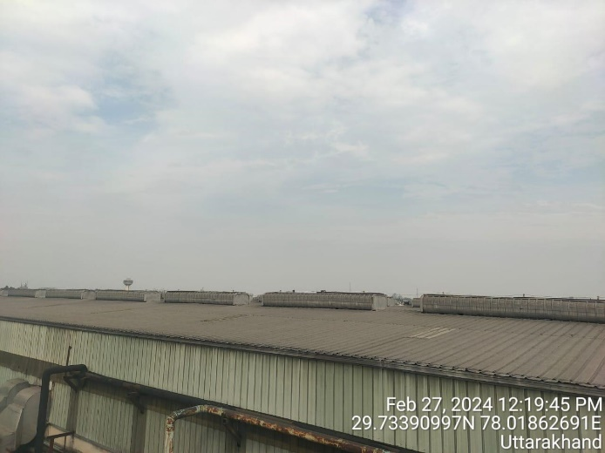
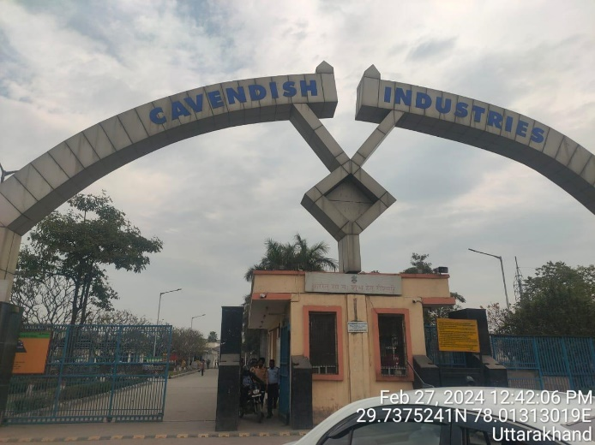 | 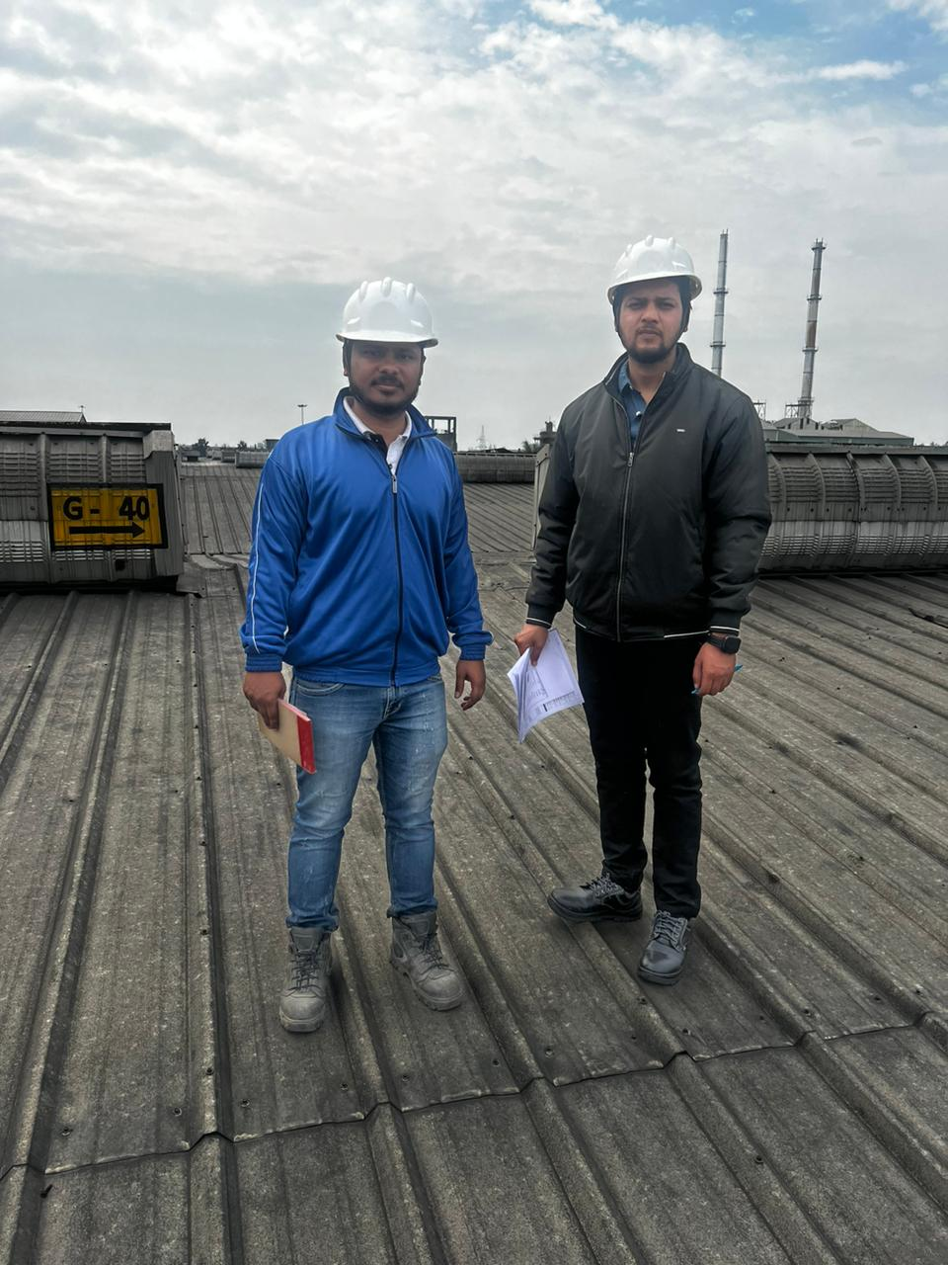

PART I | OTHER DOCUMENTS & REFERENCES

Annexure-1: Benchmark Cost by MNRE:

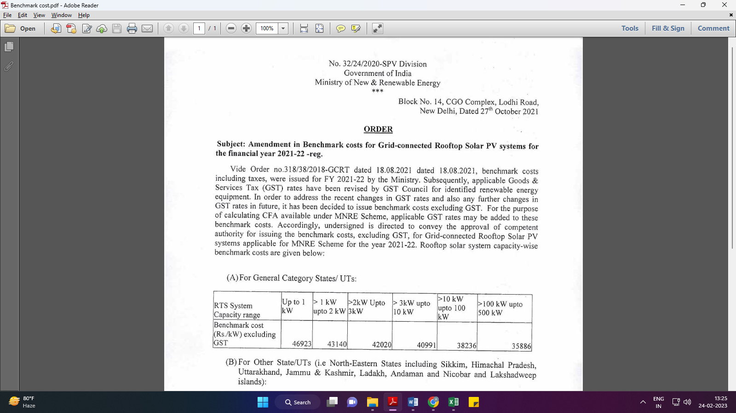
Market Comparables:
Annexure-2
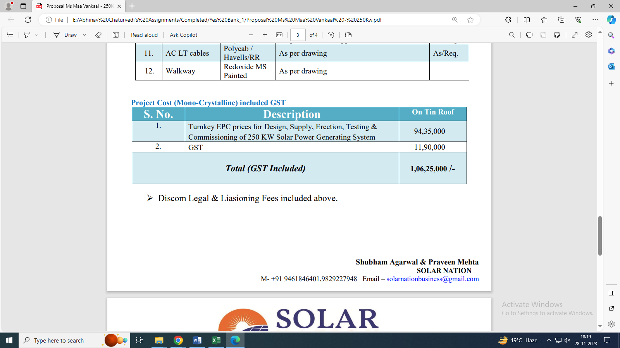

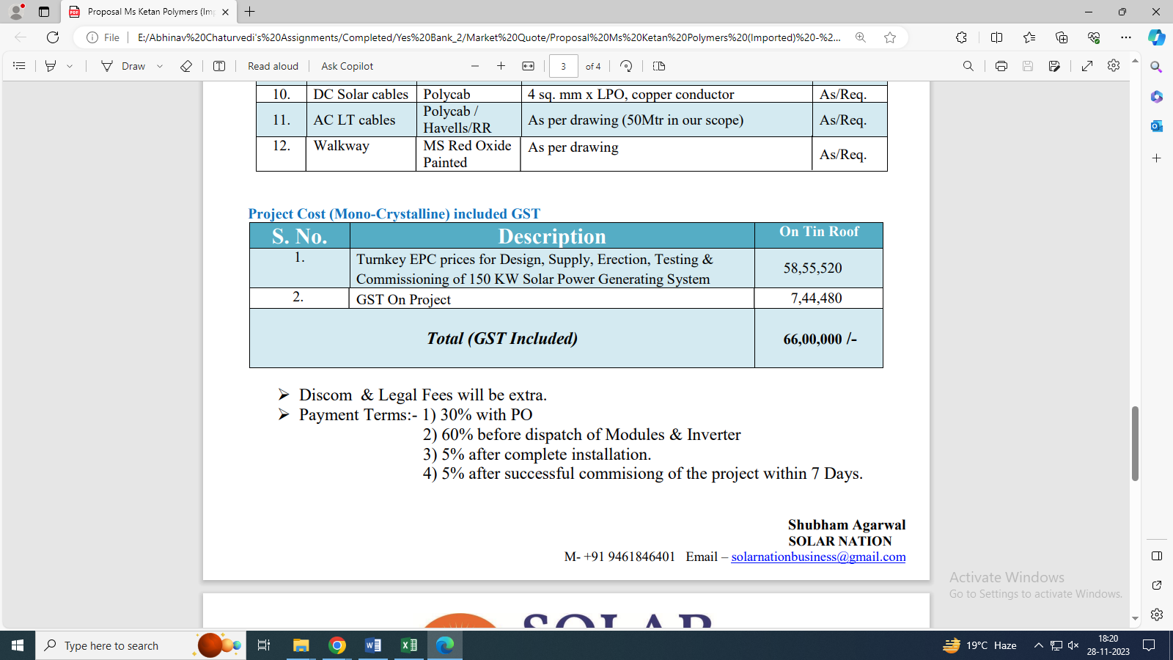

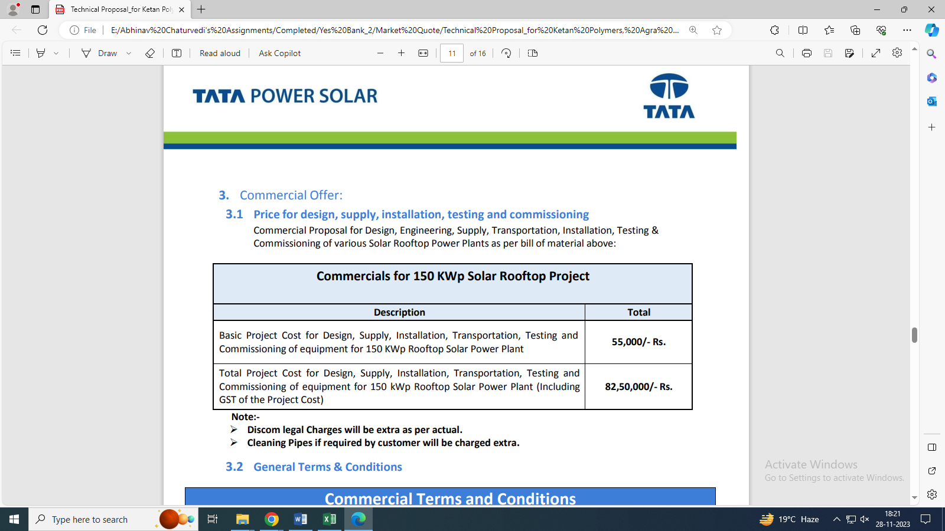

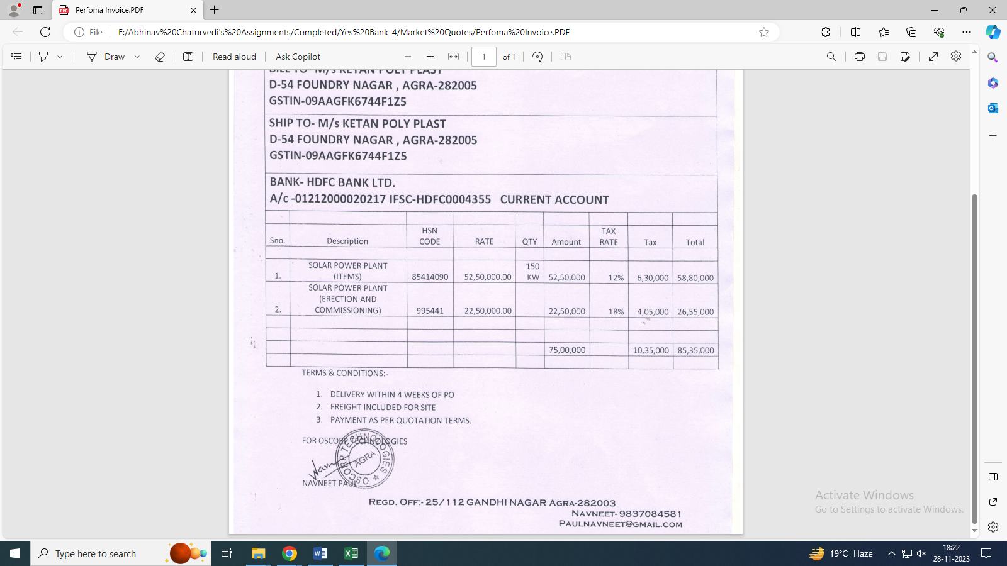

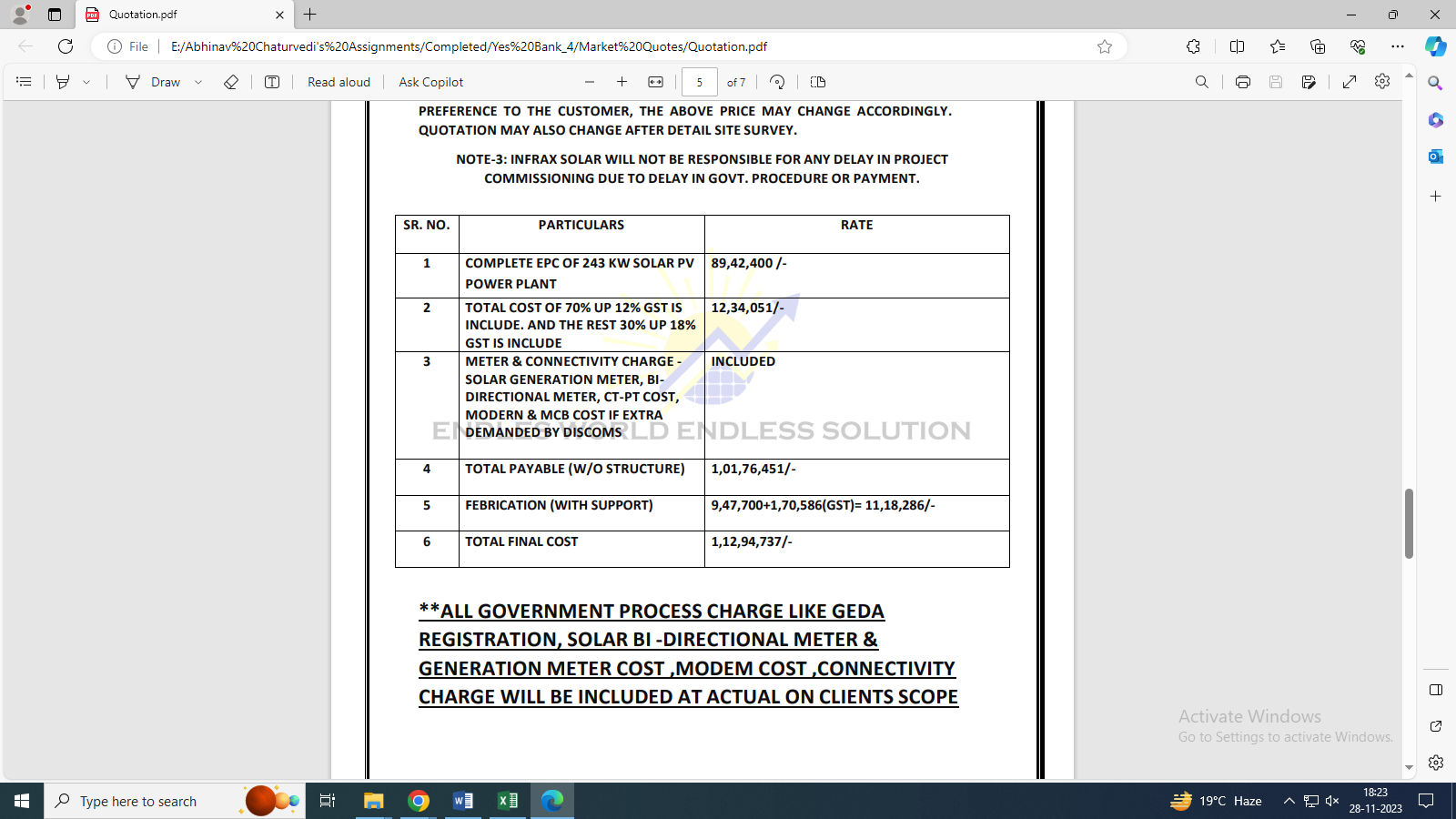

Data by Global Solar Atlas by World Bank Group
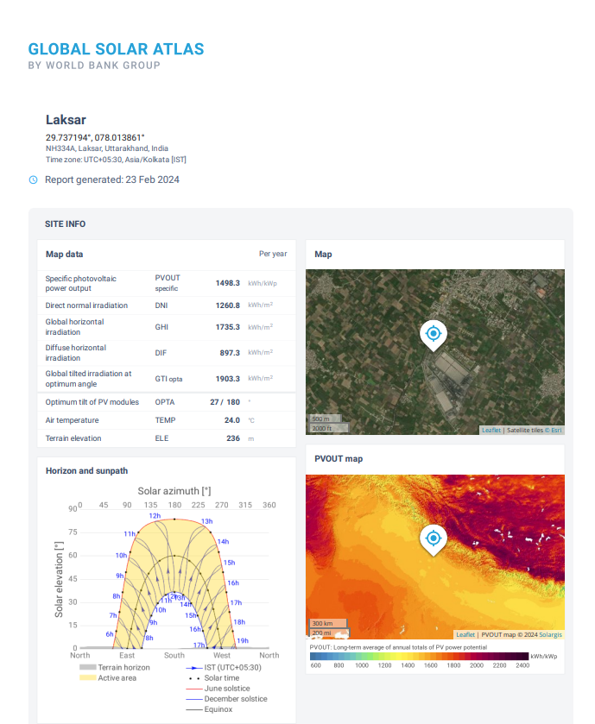

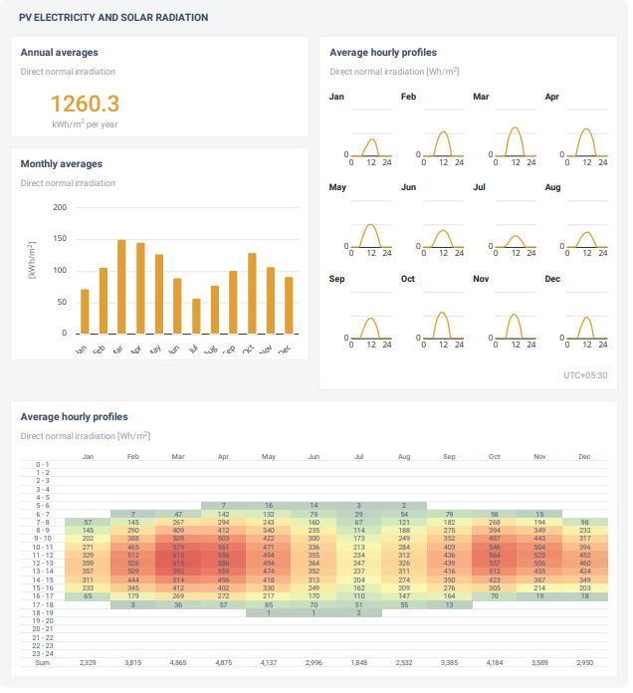

SLD Disgram

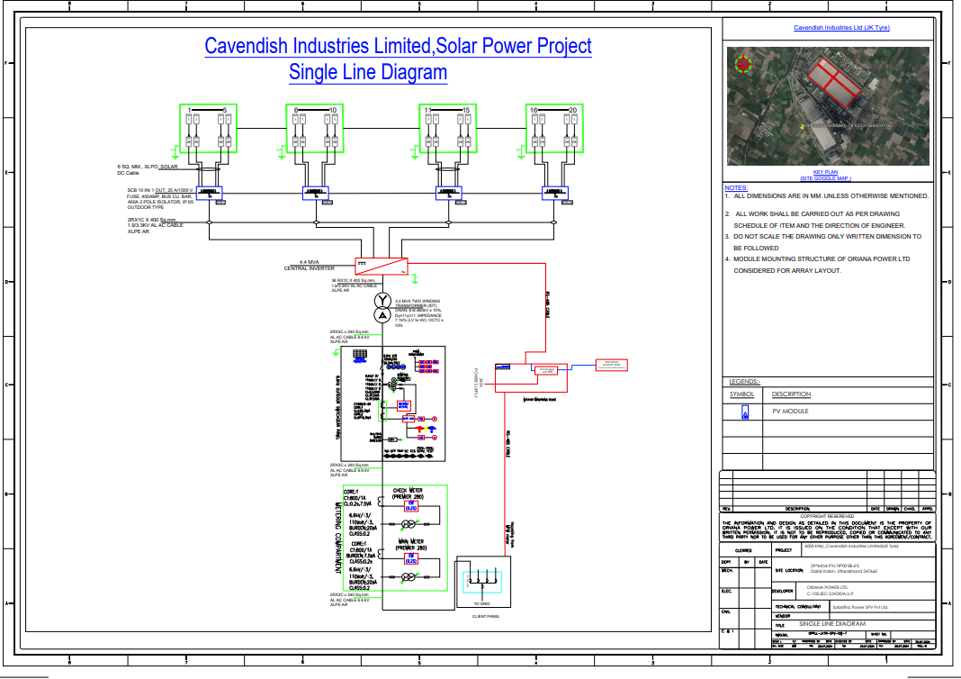

Layout

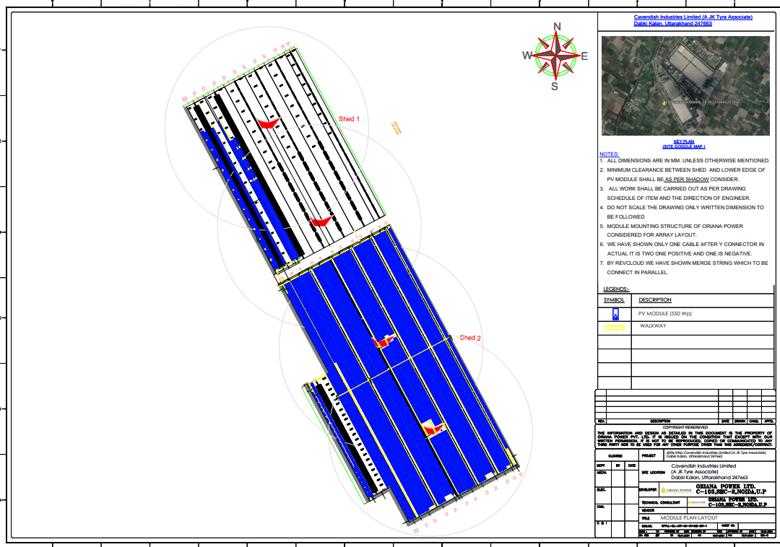

Copy of PPA

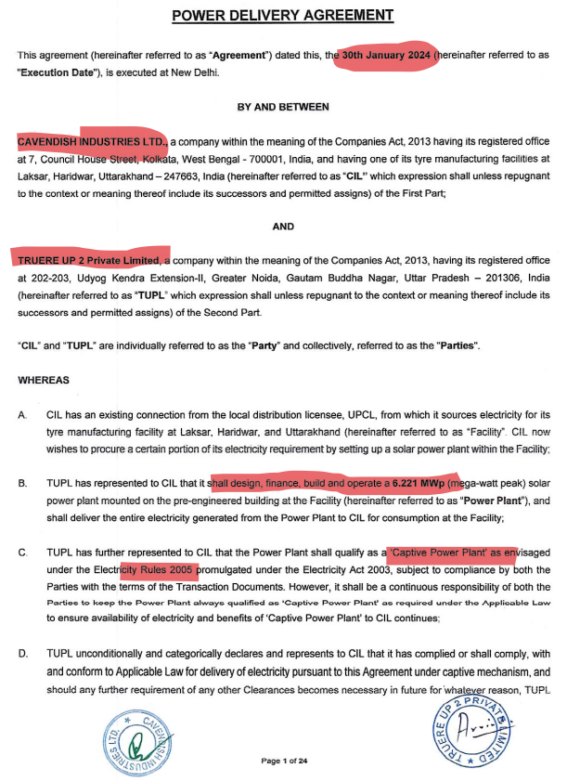

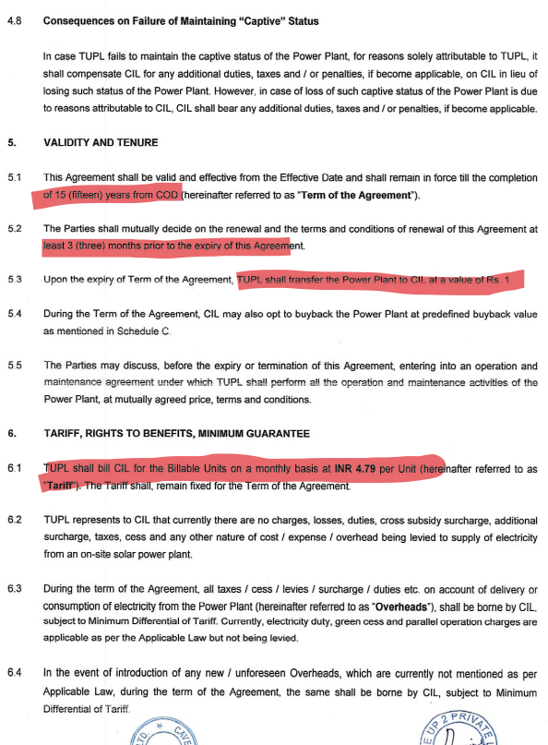

PVSyst Report

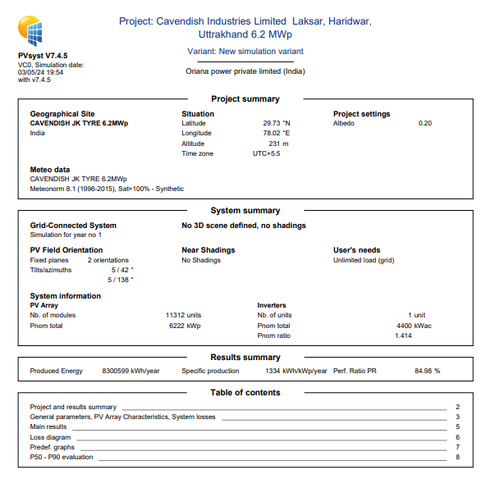

PART J | DISCLAIMER

- No employee or member of R.K Associates has any direct/ indirect interest in the Project.
- This report is prepared based on the standard checklist of documents sought from them and further based on our assumptions and limiting conditions. All such information provided to us has been relied upon in good faith and we have assumed that it is true and correct in all respect.
- Although we have taken adequate care as much as professionally possible but shall not be liable in future for the incomplete, fabricated, false or distorted information / data provided for the purpose of this assignment.
- This report offers a General analysis of the project within the specified scope, focusing on total project cost, CUF, and irradiation data. For the sake of clarity it does not encompass any other analysis such as audit, design, DPR, TEV study which is not in scope of work.
- Structural stability certificate and load stress analysis in respect to the building on which solar panels are required to be installed is not taken separately considering that the implementing agency will take care of all such curcial points during Project implementation.
- Project implemention, execution, operation is the sole responsibility of the project proponent and for the non-functioning, defaults, defraud of the company & its promoters, R.K Associates shall not be held responsible.
- This report reflects our opinion based on our knowledge and technical expertise. However, other expert opinions may vary. Therefore, it should not be regarded as the sole opinion.
- All Pages of the report including annexures are signed and stamped from our office. In case any paper in the report is without stamp & signature then this should not be considered a valid paper issued from this office.
- Though adequate care has been taken while preparing this report as per its scope, but still we can’t rule out typing, human errors, over sightedness of any information or any other mistakes. Therefore, the concerned organization is advised to satisfy themselves that the report is complete & satisfactory in all respect and intimation regarding any discrepancy in the report within 15 (Fifteen) days in writing from the date of issuance of the report, to rectify these timely.
- R.K Associates encourages its customers to give feedback or inform concerns over its services through proper channel at le@rkassociates.org in writing within 30 days of report delivery. After this period no concern/ complaint/ proceedings in connection with the Lender’s Independent Engineering Services will be entertained due to possible change in situation and condition of the subject Project.
- Our Data retention policy is of THREE YEAR. After this period, we remove all the concerned records related to the assignment from our repository. No clarification or query can be answered after this period due to unavailability of the data.
- This Lender’s Independent Engineering report is governed by our (1) Internal Policies, Processes & Standard Operating Procedures, (2) Information/ Data/ Inputs given to us by the client and (3) Information/ Data/ Facts given to us by our field/ office technical team. Management of R.K Associates never gives acceptance to any unethical or unprofessional practice which may affect fair, correct & impartial assessment and which is against any prevailing law. In case of any indication of any negligence, default, incorrect, misleading, misrepresentation or distortion of facts in the report then please bring all such act into notice of R.K Associates management so that corrective measures can be taken instantly.
- R.K Associates never releases any report doing alterations or modifications from pen. In case any information/ figure of this report is found altered with pen then this report will automatically become null & void.
FOR INTERNAL USE
Place : Noida  Date : 06.03.2024  Note : This report contains 31 pages | SURVEYED BY:  PREPARED BY:  REVIEWED BY: | Deepak Joshi  Abhinav Chaturvedi  Sr. V.P. Projects

For R.K Associates Valuers & Techno Engineering Consultants (P) Ltd.

