**File No.: VIS (2023-24) –** **PL-787-684-1049 Dated: 27th March, 2024**

**1st PROJECT PROGRESS REPORT**

**(UPTO MARCH, 2024)**

**OF**

**50000 MT WHEAT STORAGE SILOS**

**SITUATED AT**

**VILLAGE-TINICH, NEAR- TINICH RAILWAY STATION, TEHSIL – BHANPUR, DISTRICT – BASTI, UTTAR PRADESH**

**IMPLEMENTED BY**

**NCML BASTI PVT. LTD.**

**REPORT PREPARED FOR**

**STATE BANK OF INDIA, SME, CONNAUGHT CIRCUS, NEW DELHI**

***\*\*Important - In case of any query/ issue or escalation you may please contact Incident Manager at le@rkassociates.org. We will appreciate your feedback in order to improve our services.***

***NOTE: As per IBA Guidelines please provide your feedback on the report within 15 days of its submission after which report will be considered to be correct.***

|  |  |  |
| --- | --- | --- |
| **TABLE OF CONTENTS** | | |
| **SR. NO.** | **DESCRIPTION** | **PAGE NO.** |
| **PART A** | **Report Summary** | **03** |
| **PART B** | **Introduction** | **05** |
| 1. The Project | **05** |
| 1. About the Borrower | **05** |
| 1. Location of the Project | **05** |
| 1. Project Overview | **06** |
| 1. Scope of the Project During Project Duration | **07** |
| 1. Purpose of the Report | **07** |
| 1. Methodology Adopted | **07** |
| **PART C** | **Plant Infrastructure Sections & Facility Details with Actual Progress** | **08** |
| 1. Land Details | **08** |
| 1. Building and Structure Details | **08** |
| 1. Plant Machinery and Equipment | **11** |
| **PART D** | **Project Consultants, Contractors & Suppliers** | **15** |
| 1. List of Contractors and Agreements | **19** |
| **PART E** | **Project Cost and Means of Finance** | **18** |
| 1. Cost of Project | **18** |
| 1. Current Status and Total Expenditure Incurred Till Date | **19** |
| 1. Sources of Finance & Utilization of Funds | **31** |
| **PART F** | **Statutory & Regulatory Approvals, Clearances & NOC** | **32** |
| **PART G** | **Project Schedule & Current Status** | **33** |
| 1. Project Schedule Chart | **33** |
| **PART H** | **Disclaimer** | **34** |
| **PART I** | **Enclosure** | **38** |
| **PART J** | **Photographs** | **48** |

# 

# IMPORTANT NOTICE

***COPYRIGHT FORMAT:*** *This report is prepared on the copyright format of R.K Associates, to serve our clients with the best available information and analysis to facilitate them to take rational business decisions. Legally no one can copy or distribute this format without prior approval from R.K Associates. It is meant only for the advisory/ reference purpose for the organization/s as mentioned on the cover page of this report. Distribution or use of this format by any organization or individual other than R.K Associates will be seen as unlawful act and necessary legal action can be taken against the defaulters.*

*This report is intended for the sole use of the intended recipient/s and contain material that is STRICTLY CONFIDENTIAL AND PRIVATE.*

***DEFECT LIABILITY PERIOD:*** *- In case of any query/ issue or escalation you may please contact Incident Manager: le@rkassociates.org. We try our level best to ensure correctness in the calculations done, rates adopted and various other data points & information mentioned in the report but still can’t rule out typing, human errors or any other mistakes. In case you find any such mistake or inaccuracy in any data point of the report please help us by bringing all such points into our notice immediately or within 15 days of the report delivery in writing, to rectify these timely failing after which R.K Associates won’t be held responsible for any such inaccuracy in any manner. We would highly appreciate your feedback in order to improve our services.*

|  |  |
| --- | --- |
| **P ART A** | **REPORT SUMMARY** |

|  |  |  |
| --- | --- | --- |
| **1.** | **Name of Project:** | NCML Basti Pvt. Ltd. has set up wheat / grain storage capacity of 50,000 MT (4 X 12500) Silos, in the District – Basti, Uttar Pradesh |
| **2.** | **Project Location:** | * Village: Tinich * District: Basti * State: Uttar Pradesh * Co-ordinates: 26°53'04.9"N 82°38'08.4"E |
| **3.** | **Name of the Borrower:** | M/s. NCML Basti Pvt. Ltd. |
| **4.** | **Key management:** | * Mr. Pankaj Tomar : Director * Mr. Ravi Shankar : Director |
| **5.** | **Prepared for Bank:** | State Bank of India, SME, Connaught Circus, New Delhi |
| **6.** | **LIE Consultant Firm:** | M/s. R.K. Associates Valuers & Techno Engineering Consultants (P) Ltd. |
| **7.** | **Date of Survey:** | 27th March 2024 |
| **8.** | **Date of Report:** | 06th May 2024 |
| **9.** | **Purpose of the Report:** | To provide fair detailed analysis report to the Bank based on the “in-scope points” mentioned below to know the current status of the Project. |
| **10.** | **Scope of the work provided by the Lender:** | 1. Review Project details & facilities 2. Project Progress vis-a-vis construction schedule 3. Review of Project towards Licenses, NOCs, Approvals |
| **11.** | **Documents provided for the Project *(out of documents requested)*:** | 1. Detailed Project Report (DPR) 2. Project Statutory approvals 3. CA certificate as on 31st July, 2023 4. Invoices of P&M, L&B & others. |
| **12.** | **Annexure with the report:** | 1. Project Statutory approvals 2. CA certificate as on 31st July, 2023 3. List of invoices of P&M, L&B & others |

|  |  |
| --- | --- |
| **PART B** | **INTRODUCTION** |

1. **THE PROJECT:**

**M/s NCML Basti Pvt. Ltd.** has set up 4 nos. grain / wheat storage silos with a capacity of 50,000 MT (4 X 12500) in the Basti district of Uttar Pradesh. NCML Basti Pvt. Ltd. is one of the 11 locations awarded by FCI to NCML to build silo project on Design, Build, Finance, Own and Operate (DBFOO) basis. The objective of the project is to safely store the grain / wheat for a long period of time. To know the Project progress bank has appointed M/s R.K Associates Valuers & Techno Engineering Consultants (P) Ltd. for review of periodic physical status of the project. This is Progress Report up to March, 2024.

1. **ABOUT THE PROMOTER/BORROWER:**

The National Collateral Management Services Limited (NCML) is the country’s leading organization providing a bouquet of commodity based services under a single umbrella. Since its incorporation in 2004, NCML has empowered a multitude of stakeholders in the commodity value chain in managing their risks.

NCML is governed by an independent and professional Board consisting of eminent experts and professional personalities from different fields. NCML has a department of Science and Technology recognised R&D centre working in the area of weather and crop monitoring, yield guidance and various aspects of food safety.

The company is having its corporate office in 6th floor, Tower – B, SAS Tower, Support Area, Medicity, Sector – 38, Gurugram - 122001

1. **PROJECT LOCATION:**

|  |  |
| --- | --- |
| **Particulars** | **Description** |
| **Address** | |
| Village: Tinich, Basti, Uttar Pradesh | |
| **Google Coordinates** | |
| Latitude | 26°53'04.9"N |
| Longitude | 82°38'08.4"E |
| **Connectivity Systems** | |
| Road | The project site of the subject under construction plant is connected by a village road. The National Highway that leads to the plant is Basti – Lucknow Highway, which is at a distance of ~31 km. |
| Rail | The nearest railway station is Tinich, located at a distance of ~ 3 km. However, the main line railway station is Basti Railway Station at a distance of approx. 20 km. |
| Air | The nearest domestic as well as international airport is at Ayodhya at about 76 km distance from the plant site. |

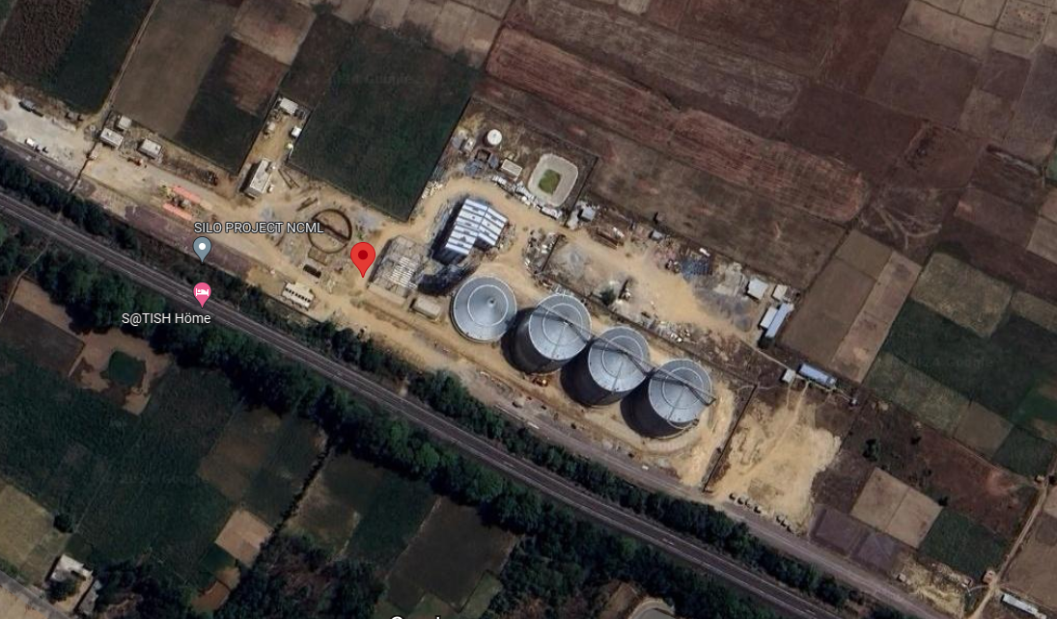 Source: Google Maps

**Figure: Location of site for NCML Basti Pvt. Ltd. project**

1. **PROJECT OVERVIEW:**

**M/s NCML Basti Pvt. Ltd.** has set up 4 nos. grain / wheat storage silos with a capacity of 50,000 MT (4 X 12500) in the Basti district of Uttar Pradesh. Basti, UP is one of the 11 locations awarded by FCI to NCML to build silo project on Design, Build, Finance, Own and Operate (DBFOO) basis. The major raw material for these silos is 2 feet by 3 feet corrugated G.I. Sheets comes from the factory in a collapsible form.

This project is on about total land area of 17.98 acres located at Village: Tinich, Sultanpur, Uttar Pradesh which is about at a distance of 30 Kms from main Basti town towards south.

The total project cost is approx. 59.94 Crore as per the DPR, which includes major heads such as Land and Site Development, Civil and Railway Works, Plant and Machinery. Detailed description of the same can be found further in the report.

During our site inspection dated 27th March, 2024 civil work was observed to be almost complete (about 90%) and all the machineries were installed. As informed by the company, trail run of machinery is done from their end. At the time of inspection, facility was not operational but it was evident that the facility has been operated once.

**Company has got Consent to Establish from Uttar Pradesh Pollution Control Board for following capacities:**

**Table No.1**

|  |  |  |  |
| --- | --- | --- | --- |
| **S. No.** | **Activity/Product** | **CTE Quantity** | **Applied Quantity** |
| 1 | Storage of Food Grains | 50,000 MT | 50,000 MT |
| 2 | Water Requirement | 3 KL/Day | 3 KL/Day |
| 3 | Quantity of Effluent | 3 KL/Day | 3 KL/Day |

1. **SCOPE OF WORK OF THIS REPORT:**
2. Periodic Project physical status review
3. Periodic review of expenditure of the Project

**Note:**

1. *Carrying out the scope of work will depend on the details/ information/ data provided to us by the borrower from time to time.*
2. **PURPOSE OF THE REPORT:** To provide fair detailed analysis report to the Bank based on the “in-scope points” mentioned above for facilitating them to know the current project status.
3. **METHODOLOGY ADOPTED:**
4. Study of Project Planning documents/ reports to know about the Project.
5. Additional information, data, documents collected from the borrower.
6. Site Inspection.
7. Review and analysis of the documents and information obtained from the borrower and corroborating it with the site inspection status.
8. Information compilation, analysis and reporting.

|  |  |
| --- | --- |
| **PART C** | **PLANT INFRASTRUCTURE SECTIONS & FACILITY DETAILS WITH ACTUAL PROGRESS** |

1. **LAND & SITE DEVELOPMENT:** The project land area is 17.98 Acres, as mentioned in DPR. However, NCML Basti Pvt. Ltd. has acquired 18.4 acres of land parcels via multiple sale deeds. The details of the same and land demarcation are as follows:

**Table No.2**

|  |  |  |  |  |  |
| --- | --- | --- | --- | --- | --- |
| **Sl. No.** | **Deed No.** | **Date** | **Type of Land** | **Land Area (in Hectare)** | **Land Area (in Acre)** |
| 1 | 1142 | 03-05-2018 | Agricultural | 0.2 | 0.4 |
| 2 | 344 | 02-02-2018 | Agricultural | 0.4 | 0.9 |
| 3 | 11 | 02-01-2018 | Agricultural | 0.2 | 0.4 |
| 4 | 39 | 04-01-2018 | Agricultural | 0.2 | 0.4 |
| 5 | 2398 | 23-12-2017 | Agricultural | 0.1 | 0.3 |
| 6 | 957 | 06-04-2018 | Agricultural | 0.1 | 0.2 |
| 7 | 2248 | 06-09-2018 | Agricultural | 0.0 | 0.0 |
| 8 | 570 | 05-03-2018 | Agricultural | 0.3 | 0.7 |
| 9 | 330 | 08-02-2018 | Agricultural | 0.5 | 1.2 |
| 10 | 511 | 26-02-2018 | Agricultural | 0.2 | 0.6 |
| 11 | 329 | 08-02-2018 | Agricultural | 0.1 | 0.2 |
| 12 | 40 | 04-01-2018 | Agricultural | 0.1 | 0.4 |
| 13 | 956 | 07-04-2018 | Agricultural | 0.2 | 0.5 |
| 14 | 343 | 12-02-2018 | Agricultural | 0.1 | 0.2 |
| 15 | BD-165451 | 06-09-2018 | Agricultural | 0.015 | 0.037 |
| 16 | 621 | 09-03-2018 | Agricultural | 1.4 | 3.4 |
| 17 | 51 | 08-01-2018 | Agricultural | 0.1 | 0.3 |
| 18 | 224 | 27-01-2018 | Agricultural | 0.7 | 1.6 |
| 19 | 128 | 16-01-2018 | Agricultural | 0.3 | 0.8 |
| 20 | 187 | 22-01-2018 | Agricultural | 0.3 | 0.6 |
| 21 | 2399 | 23-12-2017 | Agricultural | 0.2 | 0.6 |
| 22 | 2407 | 26-12-2017 | Agricultural | 0.4 | 0.9 |
| 23 | 2408 | 26-12-2017 | Agricultural | 0.1 | 0.2 |
| 24 | 2409 | 20-12-2017 | Agricultural | 0.3 | 0.7 |
| 25 | 2410 | 26-12-20147 | Agricultural | 0.5 | 1.3 |
| 26 | 2411 | 26-12-20147 | Agricultural | 0.3 | 0.6 |
| 27 | 2449 | 29-12-2017 | Agricultural | 0.1 | 0.2 |
| 28 | 2512 | 15-10-2018 | Agricultural | 0.1 | 0.2 |
| 29 | 2540 | 22-10-2018 | Agricultural | 0.2 | 0.4 |
| **TOTAL** | | | | **7.4254** | **18.4** |

***Source: Copy of sale deeds provided by Client***

**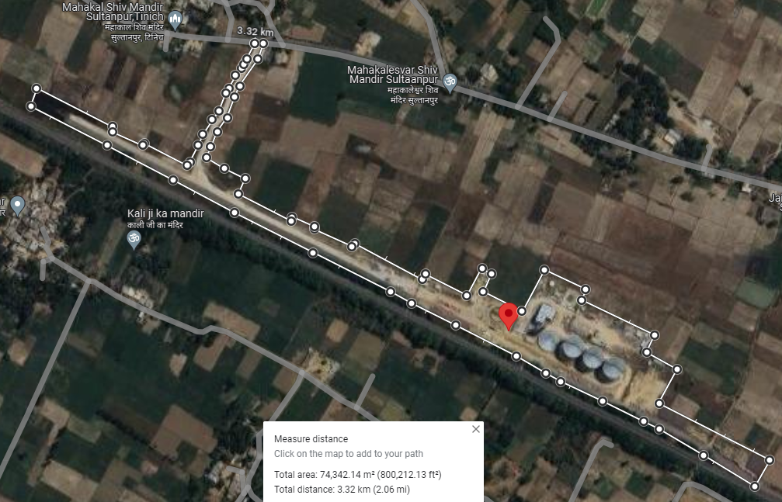**

*Note: We have not undertaken the verification of land ownership in our assessment. As per present status based on our site inspection, the actual project land was observed to be in possession of the company.*

1. **BUILDING & STRUCTURAL DETAILS:**

NCML, Basti has constructed following Building/ structures as per the requirement of the Silo Project. Sanctioned Plan/ Building area details were not provided to us. We have measured the covered area of the buildings from our end during site survey as mentioned in the table below:

**Table No.3**

|  |  |  |  |  |  |  |  |
| --- | --- | --- | --- | --- | --- | --- | --- |
| **Sr No** | **Building Name** | **Type of construction** | **Year of  construction** | **No. of Floors** | **Height (in ft.)** | **Area /Length (in sq. mt./mt.)** | **Status** |
| 1 | Office | RCC | 2024 | G+1 | 10 | 210 | Completed |
| 2 | Unloading Shed | G.I.Shed | 2024 | Ground floor | 82 | 122 | Completed |
| 3 | Truck Unloading  Shed | G.I.Shed | 2024 | Ground floor | 82 | 465 | Completed |
| 4 | Process Tower | G.I.Shed | 2024 | Ground floor | 115 | 77 | Completed |
| 5 | Tunnel | RCC | 2024 | Ground Floor | 7 | 980 | Completed |
| 6 | Warehouse 1 | G.I.Shed | 2024 | Ground Floor | 25 | 350 | Completed |
| 7 | Warehouse 1 | G.I.Shed | 2024 | Ground Floor | 45 | 152 | Completed |
| 8 | DG Panel Room | RCC | 2024 | Ground Floor | 10 | 32 | Completed |
| 9 | Room near Transformer | RCC | 2024 | Ground Floor | 10 | 11 | Completed |
| 10 | Fire Pump Room | RCC | 2024 | Ground Floor | 10 | 28 | 50%  construction |
| 11 | Gunny Bag Room | RCC | 2024 | Ground Floor | 10 | 42 | Completed |
| 12 | Toilet | RCC | 2024 | Ground Floor | 10 | 28 | Completed |
| 13 | Weigh Bridge Room | RCC | 2024 | Ground Floor | 10 | 7 | Completed |
| 14 | Security Office 1 | RCC | 2024 | Ground Floor | 10 | 39 | Completed |
| 15 | Security Office 2 | RCC | 2024 | Ground Floor | 10 | 22 | Completed |
| 16 | Security Room at gate | RCC | 2024 | Ground Floor | 10 | 7 | Completed |
| 17 | Boundary Wall | Precast | 2024 | NA | 8 | 1,100 | Completed |
| 18 | Drain | Brickwork | 2024 | NA | 2.0 | 784 | Completed |
| 19 | Road | RCC | 2024 | NA | 1.6 | 5,954 | Completed |
| **TOTAL** | | | | | | **2,573.36** |  |

***Source: Measurement during site survey***

**Table No.4**

|  |  |  |  |  |  |  |  |  |  |  |
| --- | --- | --- | --- | --- | --- | --- | --- | --- | --- | --- |
| **Progress Of Building And Civil Structures As Per Site Visit On 27th March 2024** | | | | | | | | | | |
| **Sl. No.** | **Building Name** | **No. of Floors** | **Type of  Construction** | **Height  (in ft.)** | **Area / Length  (in sq. mt. / mt.)** | **Area / Length  (in sq. ft. / ft.)** | **Progress** | | | **Overall Completion  percentage** |
| **Foundation  (in % approx.)** | **Civil Structure  (in % approx.)** | **Finishing  (in % approx.)** |
| 1 | Office | G+1 | RCC | 10 | 210 | 2,260 | 100% | 100% | 100% | 100% |
| 2 | Unloading Shed | Ground floor | G.I. Shed | 82 | 122 | 1,315 | 100% | 100% | 100% | 100% |
| 3 | Truck Unloading  Shed | Ground floor | G.I. Shed | 82 | 465 | 5,005 | 100% | 100% | 100% | 100% |
| 4 | Process Tower | Ground floor | G.I. Shed | 115 | 77 | 829 | 100% | 100% | 100% | 100% |
| 5 | Tunnel | Ground Floor | RCC | 7 | 277 | 2,985 | 100% | 100% | 100% | 100% |
| 6 | Warehouse 1 | Ground Floor | G.I. Shed | 25 | 350 | 3,770 | 100% | 100% | 100% | 100% |
| 7 | Warehouse 1 | Ground Floor | G.I. Shed | 45 | 152 | 1,632 | 100% | 100% | 100% | 100% |
| 8 | DG Panel Room | Ground Floor | RCC | 10 | 32 | 344 | 100% | 100% | 100% | 100% |
| 9 | Room near Transformer | Ground Floor | RCC | 10 | 11 | 120 | 100% | 100% | 100% | 100% |
| **10** | **Fire Pump Room** | **Ground Floor** | **RCC** | **10** | **28** | **303** | **100%** | **50%** | **0%** | **50%** |
| 11 | Gunny Bag Room | Ground Floor | RCC | 10 | 42 | 451 | 100% | 100% | 100% | 100% |
| 12 | Toilet | Ground Floor | RCC | 10 | 28 | 306 | 100% | 100% | 100% | 100% |
| 13 | Weigh Bridge Room | Ground Floor | RCC | 10 | 7 | 76 | 100% | 100% | 100% | 100% |
| 14 | Security Office 1 | Ground Floor | RCC | 10 | 39 | 420 | 100% | 100% | 100% | 100% |
| 15 | Security Office 2 | Ground Floor | RCC | 10 | 22 | 234 | 100% | 100% | 100% | 100% |
| 16 | Security Room at gate | Ground Floor | RCC | 10 | 7 | 80 | 100% | 100% | 100% | 100% |
| 17 | Boundary Wall | NA | Precast | 8 | 2,750 | 29,590 | 100% | 100% | 100% | 100% |
| **Average completion percentage** | | | | | | | | | | **97%** |

**Chart representation of progress in building and civil structures:**

**Note:**

1. *The above building details is as per the measurement done during site survey.*
2. *Sanctioned Map of the building was not available.*
3. *The Physical progress captured in the above table is based on approximate observations of status of structures constructed on site during our site inspection and our subsequent discussions held with the engineers/ company representatives with whom the site visit was conducted. Thus, the above progress is on approximate basis which may vary from 5%-10% (+-).*
4. *As per our site visit on 23rd March 2024, the construction work was observed to be almost completed except fire pump room and all the machines were installed and trial of the machinery was also done from company’s end.*
5. **PLANT MACHINERY & EQUIPMENT:**

In DPR, no machine details were provided. During site inspection our team was provided which company has installed on site. The list of the plant & machinery attached below:

**Table No.5**

|  |  |  |  |  |  |  |
| --- | --- | --- | --- | --- | --- | --- |
| **S.no** | **Model Description** | **Qty.** | **UOM** | **Make** | **Progress on date of  survey** | **Remarks** |
| **LONG TERM STORAGE SILO (12500 MT) & ITS ACCESSORIES** | | | | | | |
| 1 | FBS - 1 | 1 | Nos. | SHIRKE | Installed & Trial Done | Ready to Use |
| 2 | FBS-2 | 1 | Nos. | SHIRKE | Installed & Trial Done | Ready to Use |
| 3 | FBS-3 | 1 | Nos. | SHIRKE | Installed & Trial Done | Ready to Use |
| 4 | FBS-4 | 1 | Nos. | SHIRKE | Installed & Trial Done | Ready to Use |
| **FLAT BOTTOM SILO (4000 MT) & ITS ACCESSORIES** | | | | | | |
| 5 | Flat Bottom Silo - 4000 MT | 1 | Nos. | SHIRKE | Installed & Trial Done | Ready to Use |
| **Intake Pit** | | | | | | |
| 6 | Chain Conveyor - Feeding from Intake hoppers | 1 | Nos. | SHIRKE | Installed & Trial Done | Ready to Use |
| 7 | Elevator- feeding from CC-4 to El-3 | 1 | Nos. | SHIRKE | Installed & Trial Done | Ready to Use |
| 8 | Drum sieve- feeding from El-3 to drum seive | 2 | Nos. | Buhler | Installed & Trial Done | Ready to Use |
| 9 | Pre-Cleaner- Feeding from drum sieve to pre cleaner | 2 | Nos. | Buhler | Installed & Trial Done | Ready to Use |
| 10 | Online Weigher - feeding from Pre-Cleaner to Online weigher | 1 | Nos. | VENKA TESHWARA ENG. | Installed & Trial Done | Ready to Use |
| 11 | Elevator- feeding from online Weigher to El-4 | 1 | Nos. | SHIRKE | Installed & Trial Done | Ready to Use |
| 12 | Chain Conveyor -On top of 12500 MT Silos | 1 | Nos. | SHIRKE | Installed & Trial Done | Ready to Use |
| 13 | Chain Conveyor -On top of 12500 MT Silos | 1 | Nos. | SHIRKE | Installed & Trial Done | Ready to Use |
| 14 | Dust Extraction System | 1 | Nos. | SHIRKE | Installed & Trial Done | Ready to Use |
| **Weigh Bridge** | | | | | | |
| 15 | Weigh Bridge - 1 | 1 | Nos. | Rice Lake | Installed & Trial Done | Ready to Use |
| 16 | Weigh Bridge -2 | 1 | Nos. | Rice Lake | Installed & Trial Done | Ready to Use |
| **Dispatch System** | | | | | | |
| 17 | Chain Conveyor - Bottom of 12500 MT Silos | 1 | Nos. | SHIRKE | Installed & Trial Done | Ready to Use |
| 18 | Chain Conveyor - Bottom of 12500 MT Silo | 1 | Nos. | SHIRKE | Installed & Trial Done | Ready to Use |
| 19 | Elevator- feeding from CC-7 & CC-8 to EL-5 | 1 | Nos. | SHIRKE | Installed & Trial Done | Ready to Use |
| 20 | Chain Conveyor -Top of Bagging /Bulk System | 1 | Nos. | SHIRKE | Installed & Trial Done | Ready to Use |
| 21 | Hopper Bottom Silos for Bulk load out  Capacity-60 MT | 1 | Nos. | SHIRKE | Installed & Trial Done | Ready to Use |
| 22 | Bagging System  Capacity-30 TPH | 2 | Nos. | VENKA TESHWARA ENG. | Installed & Trial Done | Ready to Use |
| 23 | Hopper Bottom Silos for Bagging  Capacity-30 MT | 2 | Nos. | SHIRKE | Installed & Trial Done | Ready to Use |
| **Laboratory Equipment** | | | | | | |
| 24 | Dockage Tester | 1 | Nos. | Carter day | Installed & Trial Done | Ready to Use |
| 25 | Moisture Meter | 1 | Nos. | Dickey John | Installed & Trial Done | Ready to Use |
| 26 | Heap Sample/ Trier | 6 | Nos. | Ambala Associate | Installed & Trial Done | Ready to Use |
| 27 | Heap Sample/ Trier | 2 | Nos. | Ambala Associate | Installed & Trial Done | Ready to Use |
| 28 | Parkhi 12" Made of Steel | 6 | Nos. | Ambala Associate | Installed & Trial Done | Ready to Use |
| 29 | Boerner type | 1 | Nos. | Ambala Associate | Installed & Trial Done | Ready to Use |
| 30 | Test Sieve | 1 | Nos. | Ambala Associate | Installed & Trial Done | Ready to Use |
| 31 | Precision gold balance, 1000 gm with 2 pans | 1 | Nos. | Wensar | Installed & Trial Done | Ready to Use |
| 32 | Precision gold balance, 200 gm with 2 pans | 1 | Nos. | Wensar | Installed & Trial Done | Ready to Use |
| 33 | Hot Air Oven | 1 | Nos. | Ambala Associate | Installed & Trial Done | Ready to Use |
| 34 | Sample Tray | 6 | Nos. | Ambala Associate | Installed & Trial Done | Ready to Use |
| **Wagon Unloading System** | | | | | | |
| 35 | Chain Conveyor- feeding from wagon Unloading hoppers to CC-1 | 1 | Nos. | SHIRKE | Installed & Trial Done | Ready to Use |
| 36 | Chain Conveyor- feeding from wagon Unloading hoppers to CC-1A | 1 | Nos. | SHIRKE | Installed & Trial Done | Ready to Use |
| 37 | Elevator- feeding from CC-1 to El-1 | 1 | Nos. | SHIRKE | Installed & Trial Done | Ready to Use |
| 38 | Elevator- feeding from CC-1A to El-1A | 1 | Nos. | SHIRKE | Installed & Trial Done | Ready to Use |
| 39 | Elevator- feeding from EL-1 to EL-2 | 1 | Nos. | SHIRKE | Installed & Trial Done | Ready to Use |
| 40 | Elevator- feeding from EL-1A to EL-2A | 1 | Nos. |  | Installed & Trial Done | Ready to Use |
| 41 | Chain Conveyor - feeding from EL-2 to CC-2 | 1 | Nos. |  | Installed & Trial Done | Ready to Use |
| 42 | Chain Conveyor - feeding from EL-2A to CC-2A | 1 | Nos. |  | Installed & Trial Done | Ready to Use |
| 43 | Chain Conveyor- Below of 4000 MT Silo | 1 | Nos. | SHIRKE | Installed & Trial Done | Ready to Use |
| 44 | Wagon Unloading Tower | 1 | Nos. | SHIRKE | Installed & Trial Done | Ready to Use |
| 45 | Wagon unloading shed | 1 | Nos. | SHIRKE | Installed & Trial Done | Ready to Use |
| **Electrical System** | | | | | | |
| 46 | Transformer | 1 | Nos. | Voltamp Transformer Limited | Installed & Trial Done | Ready to Use |
| 47 | DG Set - 160 KVA | 1 | Nos. | KOEL | Installed & Trial Done | Ready to Use |
| 48 | DG Set - 200 KVA | 1 | Nos. | KOEL | Installed & Trial Done | Ready to Use |
| 49 | High transmission(HT) Breaker | 2 | Nos. | ABB | Installed & Trial Done | Ready to Use |
| 50 | Main LT Panel with AMF system CUM Capacitor panel | 1 | Nos. | GEMTECH | Installed & Trial Done | Ready to Use |
| 51 | MCC Panel | 1 | Nos. | GEMTECH | Installed & Trial Done | Ready to Use |
| 52 | PLC System with SCADA System + Server PC | 1 | Nos. | GEMTECH | Installed & Trial Done | Ready to Use |

**Note:**

1. In DPR no machinery information is given.
2. The above list is shared with us during site survey.
3. Machines and equipment is also cross checked from the available Invoices/ Bills provided to us.
4. Supporting photographs have been attached in the report. These photos serve as visual evidence provide a clear representation of the current status of the unit.
5. During site survey it was observed that all the machines were installed, trial running of the machinery was also done & the machines were ready to operate.

|  |  |
| --- | --- |
| **PART D** | **PROJECT CONSULTANTS, CONTRACTORS & SUPPLIERS** |

The borrower has engaged the following major contractors in the project. Details are as follows:

**Table No.6**

|  |  |  |
| --- | --- | --- |
| Sr. No. | Major Vendor | Description |
| 1. | Vahin Hi Tech | Civil Contractor |
| 2. | Archita Engineering | Civil Contractor |
| 3. | Shivam Construction | Civil Contractor |
| 4. | Sachin Builders | Civil Contractor |
| 5. | Kiyan Enterprises | Civil Contractor |
| 6. | JPR Balaji | Civil Contractor |
| 7.  8 | Buhler | Mechanical Contractor |
| 8. | Shirke | Mechanical Contractor |
| 9. | ABS Tile | Mechanical Contractor |
| 10. | Industrial Equip. Co. | Mechanical Contractor |
| 11. | Arsenal Steel silos | Mechanical Contractor |
| 12. | Kusum Trading | Railway Work |

The purchase orders of different contractors, suppliers, consultants associated with the silo project of M/s NCML Basti Pvt. Ltd. shared by the client’s to us is as follows:

**Table No.7**

|  |  |  |  |  |  |  |
| --- | --- | --- | --- | --- | --- | --- |
| **S. No.** | **Date** | **Location** | **PO/WO No.** | **Vendor** | **Description** | **Amount** |
| 1 | 18.08.2018 | Basti | NCML-BASTI/FCI-PRJ/PO/18-19/017 | M/s Exponite | SUPPLY OF SAFETY ITEMS | 7,695 |
| 2 | 29.09.2018 | Basti | NCML-BASTI/FCI-PRJ/PO/18-19/033 | M/s Rice Lake Weighing Systems | SUPPLY OF WEIGHBRIDGES | 25,55,000 |
| 3 | 14.12.2018 | Basti | NCML/BASTI/PO/18-19/042 | M/s Kiyaan Enterprises | Supply of stone | 2,06,58,619 |
| 4 | 01.09.2021 | Basti | NCML-BASTI/FCI/PRJ/PO/21-22/140 | RICELAKE | SUPPLY OF WEIGHBRIDGES | 31,04,180 |
| 5 | 19.10.2021 | BASTI | NCML-BASTI /PO/21-22/153 | Venkateshwara | Supply of Online weighers & Bagging System | 53,12,164 |
| 6 | 03.11.2021 | Basti | NCML-BASTI/PO/21-22/162 | Goel Enterprises | Supply of consumer durables | 91,900 |
| 7 | 03.11.2021 | Basti | NCML-BASTI/PO/21-22/163 | Sai Enterprises | Supply of Furniture | 82,895 |
| 8 | 17.11.2021 | Basti | NCML-BASTI/PO/21-22/169 | Vikas Fibre | Supply of bio septic tank | 5,18,000 |
| 9 | 03.12.2021 | Basti | NCML-BASTI/PO/21-22/173 | Khatana Concrete Work | Supply of paver block | 1,11,000 |
| 10 | 30.12.2021 | Basti | NCML-BASTI/PO/21-22/178 | Arsenal Steel Silos | Supply of fire water tank | 6,50,000 |
| 11 | 07.03.2022 | Basti | NCML-BASTI/PO/21-22/207 | Exponite Retails | Supply of PPE | 13,840 |
| 12 | 22.04.2020 | Basti | NCML-BASTI/FCI-PRJ/PO/20-21/068 | B.G. Shirke | Supply of Silo's& MHE | 18,78,22,000 |
| 13 | 08.11.2021 | Basti | NCML-BASTI/PO/21-22/166 | Industrial Equipments Company | Supply of DG | 25,40,000 |
| 14 | 04.01.2023 | Basti | NCML/Silo/Basti/22-23/PO069 | Buhler | Supply of Drum Sieve & Precleaner | 40,84,209 |
| 15 | 27.08.2019 | Basti | NCML/RAILWAY/CIVIL/18-19/015/014 | GRV | Railway siding work | 6,19,87,603 |
| 16 | 31.08.2019 | Basti | NCML/BASTI/CIVIL/18-19/014/015 | JPR Balaji Pavers Pvt Ltd | Civil Works | 14,49,92,514 |
| 17 | 03.10.2020 | Basti | NCML/BASTI/CIVIL/20-21/21/021 | Vahin Hi-Tech | Civil Works Option 1 | 8,80,98,077 |
| 18 | 24.05.2021 | Basti | NCML/BASTI/CIVIL/21-22/22/022 | Sachin Builders | Civil Works Option 2 | 3,43,99,994 |
| 19 | 15.09.2021 | Basti | NCML/BASTI/CIVIL/2021-22/025/024 | Archita Engineering | Civil Works Option 3 | 3,31,92,388 |
| 20 | 27.12.2021 | Basti | NCML/BASTI/RAILWAY/2021-22/026/025 | Kusum Trading Company | Railway Works Part 1 | 4,12,52,988 |
| 21 | 27.12.2021 | Basti | NCML/BASTI/RAILWAY/2022-23/026/027 | Kusum Trading Company | Railway Works Part 2 | 4,56,23,438 |
| 22 | 08.04.2022 | Basti | NCML/BASTI/CIVIL/2021-22/027/026 | Shivam Construction Comp | Civil Works Option 2 | 3,01,43,122 |
| 23 | 17.10.2017 | Basti | NCML/FCI-BASTI/WO/17-18/013 | Shah Pant | WO for GEO TECH Survey for BASTI | 51,500 |
| 24 | 24.11.2017 | Basti | NCML/FCI-BASTI/WO/17-18/018 | Shah Pant | WO for GEO TECH Survey for Uttar Pradesh Basti | 1,50,000 |
| 25 | 01.03.2018 | Basti | NCML/FCI-BASTI/WO/17-18/024 | ORIMON SURVEY | WO for TOPOGRAPHICAL SURVEY- BASTI | 70,000 |
| 26 | 01.06.2018 | Basti | NCML/FCI-BASTI/18-19/036 | Cengre Geotechnical Pvt Ltd | WO FOR GEO SURVEY | 2,51,000 |
| 27 | 11.10.2018 | Basti | NCML/FCI-BASTI /18-19/058 | VISION ENGINEERING | Land Survey | 30,000 |
| 28 | 26.10.2018 | Basti | NCML/FCI-BASTI/WO/18-19/060 | Keller | Ground Improvement | 1,95,80,000 |
| 29 | 26.10.2018 | Basti | NCML/FCI-BASTI/WO/18-19/062 | VISION ENGINEERING | TOPOSURVEY | 40,000 |
| 30 | 21.11.2018 | Basti | NCML/FCI-BASTI/WO/18-19/067 | Ghanshyam Gupta | Land Demarcation | 22,500 |
| 31 | 20.12.2018 | Basti | NCML/FCI-BASTI/WO/18-19/069 | Krishna Construction | Fencing work | 31,21,660 |
| 32 | 29.01.2019 | Basti | NCML/FCI-BASTI/WO/18-19/072 | Aecom India Pvt Ltd | E&SSD | 1,31,500 |
| 33 | 03.04.2019 | Basti | NCML/FCI-BASTI/18-19/097 | Shri Sai Associates | Pollution NOC | 1,25,000 |
| 34 | 24.05.2019 | Basti | NCML/BASTI/RWO/2019-20/111 | Swami Samarth | Jungle Clearance | 1,20,000 |
| 35 | 17-02-2020 | Basti | NCML/FCI-BASTI/WO/19-20/153 | Ar. Dinesh Kumar | Project Layout Approval | 39,000 |
| 36 | 16.09.2020 | Basti | NCML/FCI-BASTI/WO/20-21/172 | Rameshwar Traders | Temporary approach road | 2,63,200 |
| 37 | 20.10.2020 | Basti | NCML/FCI-BASTI/WO/20-21/184 | Atul Engineer & Associates | CE for valuation | 35,000 |
| 38 | 6.08.2021 | Basti | NCML/FCI-BASTI/WO/21-22/222 | Arvi Encon Limited | Safety Supervisor | 3,30,000 |
| 39 | 13.08.2021 | Basti | NCML/FCI-BASTI/WO/21-22/224 | Pihu Work & Solutions | JCB | 1,20,000 |
| 40 | 27.01.2022 | Basti | NCML/BASTI/WO/21-22/271 | Rameshwar Traders | Hiring of Vehicle | 2,25,000 |
| 41 | 22.02.2022 | Basti | NCML/BASTI/WO/21-22/277 | Vahin Hi-Tech | Piling Work | 22,43,846 |
| **TOTAL** | | | | | | **73,41,90,831** |

**Note:**

1. Around 85-90% POs have been provided to us against the above list which is matching with the above contact figures.

|  |  |
| --- | --- |
| **PART E** | **PROJECT COST & MEANS OF FINANCE** |

1. **TOTAL PROJECT COST:** NCML Basti Pvt. Ltd. has estimated the Total Project Cost amounting to Rs.59.94 Crores which has been proposed to be funded in DER of approx. 80% Debt and 20% Equity. Details of Rs.59.94 Crore is as below:

**Table No.8**

|  |  |  |
| --- | --- | --- |
| **Sl. No.** | **Particulars** | **Amount (in Cr.)** |
| 1 | Land | 7.96 |
| 2 | Civil & Railway | 27.75 |
| 3 | Plat & Machinery | 24.22 |
| **Total Project Cost** | | **59.94** |

***Source: DPR***

1. **CURRENT STATUS & TOTAL EXPENDITURE INCURRED TILL DATE:** Details of the expenditure in the Table below is recordedfor the expenditure incurred up to March 2024.

**Table No.9**

|  |  |  |  |  |
| --- | --- | --- | --- | --- |
| **Particulars** | **Proposed Amount as per DPR** | **Amount as per C.A. Certificate**  **(Till 31/07/23)** | **Amount Incurred Till March, 2024**  **(As per LIE Assessment)** | **Remarks** |
| Land, Railway, Civil and building works with Site Development | 35.72 | 11.8 | 52.01 | 1. Rs.9.39 Cr. is spent in land purchase with stamp duty (as per the value mentioned in the sale deed). Please refer to Table No.10, attached below. 2. Rs.1.20 Cr. company have spent in Loose Earth Supply Work, Re-routing works, Ground Improvement work, Consultation for land records, Amendment, Mutation and Area rectification related works. Please refer to Table No.11, attached below. 3. The cost assessment for building and civil works is done in accordance with the benchmark or market cost, as per the percentage of work completed. The cost assessed is Rs.9.43 Cr. For detailed calculation please refer to Table No. 14 below. Please refer to Table No.12, attached below. 4. Rs.32.08 Cr. is spent by the company in construction and development of railway sidings. Please refer to Table No.13, attached below. |
| Plant and Machinery | 24.22 | 59.3 | 4.47 | 1. Plant & Machinery assessment is done based on the Invoices provided by the company. 2. As per CA Certificate issued dated: 8th November, 2023, amount spent is Rs.59.3 crores. 3. Amount of Invoices/ Bills given provided to us is Rs.4.47 Crores. Please refer to Table No.14, attached below for these breakup of invoices. |
| Furniture’s & Other Expenses | --- | --- | 0.47 | Rs.0.47 Cr. is spent in Manpower, Vehicle Rent, Furniture and Insurance. Please refer to Table No.15, attached below. |
| **Total** | **59.94** | **71.28** | **57.04** | **---** |

**Table No.10**

|  |  |  |  |  |  |  |  |  |
| --- | --- | --- | --- | --- | --- | --- | --- | --- |
| **Cost incurred for Land Purchase** | | | | | | | | |
| **Sl. No.** | **Deed No.** | **Date** | **Type of Land** | **Land Area (in Hectare)** | **Land Area (in Acre)** | **Sale Price (in Rs.)** | **Stamp Duty (in Rs.)** | **Total Cost (in Rs.)** |
| 1 | 1142 | 03-05-2018 | Agricultural | 0.2 | 0.4 | 18,06,938 | 90,350 | 18,97,288 |
| 2 | 344 | 02-02-2018 | Agricultural | 0.4 | 0.9 | 42,76,428 | 2,13,850 | 44,90,278 |
| 3 | 11 | 02-01-2018 | Agricultural | 0.2 | 0.4 | 21,68,328 | 1,08,450 | 22,76,778 |
| 4 | 39 | 04-01-2018 | Agricultural | 0.2 | 0.4 | 20,84,004 | 1,04,250 | 21,88,254 |
| 5 | 2398 | 23-12-2017 | Agricultural | 0.1 | 0.3 | 15,05,784 | 75,300 | 15,81,084 |
| 6 | 957 | 06-04-2018 | Agricultural | 0.1 | 0.2 | 11,56,440 | 57,850 | 12,14,290 |
| 7 | 2248 | 06-09-2018 | Agricultural | 0.0 | 0.0 | 2,04,000 | 10,200 | 2,14,200 |
| 8 | 570 | 05-03-2018 | Agricultural | 0.3 | 0.7 | 33,24,768 | 1,66,250 | 34,91,018 |
| 9 | 330 | 08-02-2018 | Agricultural | 0.5 | 1.2 | 56,13,559 | 2,80,700 | 58,94,259 |
| 10 | 511 | 26-02-2018 | Agricultural | 0.2 | 0.6 | 28,18,825 | 1,40,950 | 29,59,775 |
| 11 | 329 | 08-02-2018 | Agricultural | 0.1 | 0.2 | 10,11,886 | 50,600 | 10,62,486 |
| 12 | 40 | 04-01-2018 | Agricultural | 0.1 | 0.4 | 17,94,896 | 89,750 | 18,84,646 |
| 13 | 956 | 07-04-2018 | Agricultural | 0.2 | 0.5 | 23,12,880 | 1,15,650 | 24,28,530 |
| 14 | 343 | 12-02-2018 | Agricultural | 0.1 | 0.2 | 9,99,840 | 50,000 | 10,49,840 |
| 15 | BD-165451 | 06-09-2018 | Agricultural | 0.015 | 0.037 | 1,80,000 | 9,000 | 1,89,000 |
| 16 | 621 | 09-03-2018 | Agricultural | 1.4 | 3.4 | 1,65,51,559 | 8,27,600 | 1,73,79,159 |
| 17 | 51 | 08-01-2018 | Agricultural | 0.1 | 0.3 | 16,26,245 | 81,350 | 17,07,595 |
| 18 | 224 | 27-01-2018 | Agricultural | 0.7 | 1.6 | 78,30,068 | 3,91,550 | 82,21,618 |
| 19 | 128 | 16-01-2018 | Agricultural | 0.3 | 0.8 | 39,23,400 | 1,96,200 | 41,19,600 |
| 20 | 187 | 22-01-2018 | Agricultural | 0.3 | 0.6 | 31,36,846 | 1,56,850 | 32,93,696 |
| 21 | 2399 | 23-12-2017 | Agricultural | 0.2 | 0.6 | 28,06,779 | 1,40,350 | 29,47,129 |
| 22 | 2407 | 26-12-2017 | Agricultural | 0.4 | 0.9 | 42,16,191 | 2,10,850 | 44,27,041 |
| 23 | 2408 | 26-12-2017 | Agricultural | 0.1 | 0.2 | 11,32,349 | 56,650 | 11,88,999 |
| 24 | 2409 | 20-12-2017 | Agricultural | 0.3 | 0.7 | 36,86,155 | 1,84,350 | 38,70,505 |
| 25 | 2410 | 26-12-20147 | Agricultural | 0.5 | 1.3 | 61,91,780 | 3,09,600 | 65,01,380 |
| 26 | 2411 | 26-12-20147 | Agricultural | 0.3 | 0.6 | 31,07,936 | 1,55,400 | 32,63,336 |
| 27 | 2449 | 29-12-2017 | Agricultural | 0.1 | 0.2 | 9,80,850 | 49,050 | 10,29,900 |
| 28 | 2512 | 15-10-2018 | Agricultural | 0.1 | 0.2 | 1144394.0 | 57,250 | 12,01,644 |
| 29 | 2540 | 22-10-2018 | Agricultural | 0.2 | 0.4 | 19,27,401 | 96,400 | 20,23,801 |
| **TOTAL** | | | | **7.4254** | **18.4** | **8,64,48,734** | **44,76,600** | **9,39,97,129** |

**Table No.11**

|  |  |  |  |  |  |  |
| --- | --- | --- | --- | --- | --- | --- |
| **Cost Incurred in Land (Misc.)** | | | | | | |
| **Sl. No.** | **Type of work** | **Quantity of Work** | **Vendor** | **Invoice No.** | **Invoice Date** | **Amount Paid (in *INR*) inclusive GST** |
|
| 1 | Ground Improvement work | 1 | Keller | KEL/187/934/2 | 24-06-2019 | 46,48,422 |
| 2 | Ground Improvement work | 1 | Keller | KEL/187/934/4 | 21-02-2019 | 38,68,039 |
| 3 | Ground Improvement work | 1 | Keller | KEL/187/934/1 | 09-01-2019 | 31,99,880 |
| 4 | Consultation for land records amendment, Mutation, Area Rectification & related | Not mentioned | Santosh Dubey | 5 | 11-07-2020 | 75,000 |
| 5 | Loose Earth Supply Work | 1.2 | Santosh Dubey | 1 | 03-08-2019 | 1,26,000 |
| 6 | Re-routing works | Not mentioned | Santosh Dubey | 2 | 19-08-2019 | 1,45,000 |
| **TOTAL** | | | | |  | **1,20,62,341** |

**Table No.12**

|  |  |  |  |  |  |  |  |  |  |
| --- | --- | --- | --- | --- | --- | --- | --- | --- | --- |
| **Cost incurred for Civil Work** | | | | | | | | | |
| **Sr No** | **Building Name** | **Type of construction** | **No. of Floors** | **Height (in ft.)** | **Area /Length (in sq. mt./mt.)** | **Unit** | **Status** | **Rate *(per Unit)*** | **Cost** |
| 1 | Office | RCC | G+1 | 10 | 210 | Sq.Ft. | Completed | 1,600 | 36,15,360 |
| 2 | Unloading Shed | G.I.Shed | Ground floor | 82 | 122 | Sq.Ft. | Completed | 1,600 | 21,04,000 |
| 3 | Truck Unloading  Shed | G.I.Shed | Ground floor | 82 | 465 | Sq.Ft. | Completed | 1,600 | 80,08,000 |
| 4 | Process Tower | G.I.Shed | Ground floor | 115 | 77 | Sq.Ft. | Completed | 1,800 | 14,91,480 |
| 5 | Tunnel | RCC | Ground Floor | 7 | 140 | Rmt | Completed | 35,000 | 49,00,000 |
| 6 | Warehouse 1 | G.I.Shed | Ground Floor | 25 | 350 | Sq.Ft. | Completed | 1,300 | 49,01,000 |
| 7 | Warehouse 1 | G.I.Shed | Ground Floor | 45 | 152 | Sq.Ft. | Completed | 1,500 | 24,47,775 |
| 8 | DG Panel Room | RCC | Ground Floor | 10 | 32 | Sq.Ft. | Completed | 1,600 | 5,50,912 |
| 9 | Room near Transformer | RCC | Ground Floor | 10 | 11 | Sq.Ft. | Completed | 1,600 | 1,92,000 |
| 10 | Fire Pump Room | RCC | Ground Floor | 10 | 28 | Sq.Ft. | 50%  construction | 800 | 2,42,229 |
| 11 | Gunny Bag Room | RCC | Ground Floor | 10 | 42 | Sq.Ft. | Completed | 1,600 | 7,22,039 |
| 12 | Toilet | RCC | Ground Floor | 10 | 28 | Sq.Ft. | Completed | 1,600 | 4,90,140 |
| 13 | Weigh Bridge Room | RCC | Ground Floor | 10 | 7 | Sq.Ft. | Completed | 1,600 | 1,21,889 |
| 14 | Security Office 1 | RCC | Ground Floor | 10 | 39 | Sq.Ft. | Completed | 1,600 | 6,71,596 |
| 15 | Security Office 2 | RCC | Ground Floor | 10 | 22 | Sq.Ft. | Completed | 1,600 | 3,73,932 |
| 16 | Security Room at gate | RCC | Ground Floor | 10 | 7 | Sq.Ft. | Completed | 1,600 | 1,28,259 |
| 17 | Boundary Wall | Precast | NA | 8 | 1,100 | Sq.Ft. | Completed | 130 | 15,38,680 |
| 18 | Drain | Brickwork | NA | 2.0 | 784 | Rmt | Completed | 3,000 | 23,52,000 |
| 19 | Road | RCC | NA | 1.6 | 5,954 | CUM | Completed | 10,000 | 5,95,35,000 |
| **TOTAL** | | | | | **1,733.36** |  |  |  | **9,43,86,291** |

**Note:** *Cost incurred in interior and external development has not been considered in the report, as no data has been shared from client’s end.*

**Table No.13**

|  |  |  |  |  |  |  |
| --- | --- | --- | --- | --- | --- | --- |
| **Breakup of Railway siding Invoices/ Bills** | | | | | | |
| **Sl. No.** | **Name of  Machine** | **No. of Machines** | **Vendor** | **Invoice No.** | **Invoice Date** | **Amount Paid (in *INR*) inclusive GST** |
|
| 1 | Rail & Sleepers IU | Not mentioned | Kusum Trading | KTC/BASTI/RA05 | 05-10-2023 | 3,57,00,251 |
| 2 | Points & Crossings |
| 3 | Small P. way |
| 4 | Linking & Laying |
| 5 | Earthwork | Not mentioned | Kusum Trading | KTC/BASTI/RA09 | 05-11-2023 | 3,77,06,076 |
| 6 | Ballast Stacking |
| 7 | RCC Box bridge |
| 8 | Rail & Sleepers IU | Not mentioned | Kusum Trading | KTC/BASTI/RA04 | 28-02-2023 | 3,20,59,084 |
| 9 | Rail & Sleepers Prime |
| 10 | PSC Sleepers |
| 11 | Points & Crossings |
| 12 | Small P. way |
| 13 | Linking & Laying |
| 14 | Earthwork | Not mentioned | Kusum Trading | KTC/BASTI/RA06 | 13-09-2022 | 2,80,62,101 |
| 15 | Blanketing |
| 16 | Ballast Stacking |
| 17 | Safety fencing |
| 18 | Earthwork | Not mentioned | Kusum Trading | KTC/BASTI/RA07 | 20-10-2022 | 3,09,63,393 |
| 19 | Blanketing |
| 20 | Ballast Stacking |
| 21 | Safety fencing |
| 22 | Earthwork | Not mentioned | Kusum Trading | KTC/BASTI/RA02 | 04-04-2022 | 93,02,332 |
| 23 | Blanketing |
| 24 | Ballast |
| 25 | Earthwork | Not mentioned | Kusum Trading | KTC/BASTI/RA04 | 07-06-2022 | 1,99,05,297 |
| 26 | Blanketing |
| 27 | Ballast |
| 28 | Safety fencing |
| 29 | Earthwork | Not mentioned | Kusum Trading | KTC/BASTI/RA01 | 07-03-2022 | 39,90,730 |
| 30 | Blanketing |
| 31 | Earthwork | Not mentioned | Kusum Trading | KTC/BASTI/RA03 | 02-05-2022 | 1,52,71,612 |
| 32 | Blanketing |
| 33 | Ballast |
| 34 | Safety fencing |
| 35 | Earthwork | Not mentioned | Kusum Trading | KTC/BASTI/RA05 | 16-07-2022 | 2,54,25,997 |
| 36 | Blanketing |
| 37 | Ballast |
| 38 | Safety fencing |
| 39 | Rail & sleepers IU | Not mentioned | Kusum Trading | KTC/BASTI/RA01 | 30-10-2022 | 1,19,10,721 |
| 40 | Rail & sleepers prime |
| 41 | Ballast Stacking |
| 42 | Rail & sleepers IU | Not mentioned | Kusum Trading | KTC/BASTI/RA02 | 18-11-2022 | 1,94,40,256 |
| 43 | Rail & sleepers prime |
| 44 | Ballast Stacking |
| 45 | Rail & sleepers IU | Not mentioned | Kusum Trading | KTC/BASTI/RA03 | 26-11-2022 | 1,90,35,206 |
| 46 | Rail & sleepers prime |
| 47 | PSC Sleepers |
| 48 | Ballast Stacking |
| 49 | Rail & sleepers IU | Not mentioned | Kusum Trading | KTC/BASTI/RA04 | 28-02-2023 | 3,20,59,084 |
| 50 | Rail & sleepers prime |
| 51 | PSC Sleepers |
| 52 | Points & Crossings |
| 53 | Small P. way |
| 54 | Linking & Laying |
| **TOTAL** | | | | | | **32,08,32,140** |

**Table No.14**

|  |  |  |  |  |  |  |
| --- | --- | --- | --- | --- | --- | --- |
| **Breakup of Plant & Machinery Invoices/ Bills** | | | | | | |
| **Sl. No.** | **Name of  Machine** | **No. of Machines** | **Vendor** | **Invoice No.** | **Invoice Date** | **Amount Paid (in *INR*) inclusive GST** |
|
| 1 | Drum Sieve Laka 200 | 2 | Buhler | 7276047230 | 28-06-2023 | 17,66,903.7 |
| 2 | Pre sieve round hole 17 mm dia | 1 | Buhler | 7272316977 | 28-06-2023 | 9,020.0 |
| 3 | Pre sieve round hole 18 mm dia | 1 | Buhler | 28-06-2023 | 8,805.0 |
| 4 | Main Sieve Fishbone slots 1.75 x 23 mm | 2 | Buhler | 28-06-2023 | 49,084.0 |
| 5 | Screening Drum to Discharge cylinder, 20 | 1 | Buhler | 28-06-2023 | 23,861.0 |
| 6 | Screening Drum to Discharge cylinder, 30 | 1 | Buhler | 28-06-2023 | 20,000.0 |
| 7 | Main Sieve Fishbone slots 1 x 23 mm-Rice | 2 | Buhler | 28-06-2023 | 80,000.0 |
| 8 | LKGA 20E Grain plus cleaner | 2 | Buhler | 7276047228 | 28-06-2023 | 30,52,457.0 |
| 9 | COM/ACC of GIC Silo SYS-Bucket Elevator 350 TPH X 31.5 mt. | 0.85 | Shirke | GIN232709788 | 18-03-2023 | 34,49,817.7 |
| 10 | COM/ACC of GIC Silo SYS-FBT GIC silo cap 4000 MT | 0.07 | Shirke | GIN242702250 | 05-06-2023 | 7,72,256.8 |
| 11 | COM/ACC of GIC Silo SYS tower FR Onlineweigher, Staircase LAD | 0.12 | Shirke | GIN232710055 | 25-03-2023 | 11,33,592.9 |
| 12 | COM/ACC of GIC Silo SYS chain conveyor 60TPH X 67 mt. | 0.05 | Shirke | GIN242700235 | 10-04-2023 | 44,36,756.7 |
| 13 | COM/ACC of GIC Silo SYS chain conveyor 350TPH X 14.1 mt. | 0.05 |
| 14 | COM/ACC of GIC Silo SYS chain conveyor 350TPH X 8.6 mt. | 0.05 |
| 15 | COM/ACC of GIC Silo SYS chain conveyor 150TPH X 40.8 mt. | 0.05 |
| 16 | COM/ACC of GIC Silo SYS chain conveyor 150TPH X 24.8 mt. | 0.05 |
| 17 | COM/ACC of GIC Silo SYS chain conveyor 150TPH X 55.7 mt. | 0.05 |
| 18 | COM/ACC of GIC Silo SYS chain conveyor 150TPH X 67.4 mt. | 0.05 |
| 19 | COM/ACC of GIC Silo SYS Bucket elevators 350 TPH X 31.5 mt. | 0.05 |
| 20 | COM/ACC of GIC Silo SYS Bucket elevators 350 TPH X 28.7 mt. | 0.48 |
| 21 | COM/ACC of GIC Silo SYS Bucket elevators 150 TPH X 26 mt. | 0.13 |
| 22 | COM/ACC of GIC Silo SYS Bucket elevators 150 TPH X 36.3 mt. | 0.16 |
| 23 | COM/ACC of GIC Silo SYS Bucket elevators 60 TPH X 26 mt. | 0.12 |
| 24 | COM/ACC of GIC Silo SYS slide gate manual 300 mm-1X4000 Tons | 5 |
| 25 | COM/ACC of GIC Silo SYS slide gate manual 300 mm-1X60 Tons | 3 |
| 26 | COM/ACC of GIC Silo SYS slide gate manual 200 mm-4 X 12500 tons | 36 |
| 27 | COM/ACC of GIC Silo SYS slide gate electric 300 mm-1X4000 | 1 |
| 28 | COM/ACC of GIC Silo SYS slide gate electric 300 mm-1X60tons | 3 |
| 29 | COM/ACC of GIC Silo SYS slide gate M.300mm, intake conveyor | 6 |
| 30 | COM/ACC of GIC Silo SYS chain conveyor 150TPH X 67.4 mt. | 0.01 | Shirke | GIN242701079 | 28-04-2023 | 29,17,034.0 |
| 31 | COM/ACC of GIC Silo SYS chain conveyor 60TPH X 67.4 mt. | 0.01 |
| 32 | COM/ACC of GIC Silo SYS chain conveyor 60TPH X 79.5 mt. | 0.02 |
| 33 | COM/ACC of GIC Silo SYS chain conveyor 350TPH X 14.1 mt. | 0.01 |
| 34 | COM/ACC of GIC Silo SYS chain conveyor 350TPH X 8.6 mt. | 0.23 |
| 35 | COM/ACC of GIC Silo SYS chain conveyor 150TPH X 40.8 mt. | 0.03 |
| 36 | COM/ACC of GIC Silo SYS chain conveyor 150TPH X 24.8 mt. | 0.03 |
| 37 | COM/ACC of GIC Silo SYS chain conveyor 150TPH X 55.7 mt. | 0.09 |
| 38 | COM/ACC of GIC Silo SYS bucket elevators 350TPH X 31.5 mt. | 0.24 |
| 39 | COM/ACC of GIC Silo SYS bucket elevators 350TPH X 28.7 mt. | 0.17 |
| 40 | COM/ACC of GIC Silo SYS bucket elevators 150TPH X 26 mt. | 0.04 |
| 41 | COM/ACC of GIC Silo SYS bucket elevators 150TPH X 36.3 mt. | 0.11 |
| 42 | COM/ACC of GIC Silo SYS bucket elevators 60TPH X 26 mt. | 0.09 |
| 43 | COM/ACC of GIC Silo FBT GIC silo 12500 MT | 0.001 | Shirke | GIN242701598 | 15-05-2023 | 27,079.8 |
| 44 | COM/ACC of GIC Silo sys dedusting mechanism FR Road intake S | 0.4 | Shirke | GIN242701764 | 20-05-2023 | 7,74,540.6 |
| 45 | COM/ACC of GIC Silo SYS tower FR Onlineweigher, Staircase LAD | 0.04 | Shirke | GIN242701895 | 23-05-2023 | 5,56,235.4 |
| 46 | COM/ACC of GIC Silo SYS Chute FR tower of online weigher-350 T | 0.28 |
| 47 | COM/ACC of GIC Silo sys dedusting mechanism FR Cleaning section | 0.3 | Shirke | GIN242703486 | 15-07-2023 | 8,37,357.32 |
| 48 | COM/ACC of GIC Silo sys FBT GIC Silo cap 4000 MT | 0.14 | Shirke | GIN242702251 | 05-06-2023 | 15,44,514.76 |
| 49 | COM/ACC of GIC Silo sys FBT GIC Silo cap 4000 MT | 0.09 | Shirke | GIN242702305 | 06-06-2023 | 41,43,636.11 |
| 50 | COM/ACC of GIC Silo sys chain conveyor 350 TPH X 14.1 mt. | 0.19 |
| 51 | COM/ACC of GIC Silo sys chain conveyor 350 TPH X 8.6 mt. | 0.07 |
| 52 | COM/ACC of GIC Silo sys chain conveyor 150 TPH X 40.8 mt. | 0.12 |
| 53 | COM/ACC of GIC Silo sys chain conveyor 150 TPH X 24.8 mt. | 0.31 |
| 54 | COM/ACC of GIC Silo sys chain conveyor 150 TPH X 67.4 mt. | 0.06 |
| 55 | COM/ACC of GIC Silo sys chain conveyor 60 TPH X 8.7 mt. | 0.06 |
| 56 | COM/ACC of GIC Silo sys chain conveyor 60 TPH X 79.5 mt. | 0.01 |
| 57 | COM/ACC of GIC Silo sys chain conveyor 60 TPH X 67 mt. | 0.03 |
| 58 | COM/ACC of GIC Silo SYS Bucket elevators 350 TPH X 31.5 mt. | 0.06 |
| 59 | COM/ACC of GIC Silo SYS Bucket elevators 350 TPH X 28.7 mt. | 0.29 |
| 60 | COM/ACC of GIC Silo SYS Bucket elevators 150 TPH X 36.3 mt. | 0.09 |
| 61 | COM/ACC of GIC Silo SYS Bucket elevators 60 TPH X 26 mt. | 0.01 |
| 62 | COM/ACC of GIC Silo SYS tower FR Onlineweigher, Staircase LAD | 0.06 | Shirke | GIN242702346 | 07-06-2023 | 7,75,231.96 |
| 63 | COM/ACC of GIC Silo SYS HBT Silo 60 MT | 0.19 |
| 64 | COM/ACC of GIC Silo SYS tower FR Onlineweigher, Staircase LAD | 0.11 | Shirke | GIN242702378 | 08-03-2023 | 10,39,126.54 |
| 65 | COM/ACC of GIC Silo SYS tower FR Onlineweigher, Staircase LAD | 0.07 | Shirke | GIN242702384 | 08-06-2023 | 6,61,262.24 |
| 66 | COM/ACC of GIC Silo SYS HBT Silo 60 MT | 0.5 | Shirke | GIN242703432 | 13-07-2023 | 15,55,155.86 |
| 67 | COM/ACC of GIC Silo SYS HBT Silo 30 MT | 0.6 |
| 68 | COM/ACC of GIC Silo sys chain conveyor 60 TPH X 67 mt. | 0.03 |
| 69 | COM/ACC of GIC Silo sys chain conveyor 60 TPH X 79.5 mt. | 0.09 |
| 70 | COM/ACC of GIC Silo SYS Bucket elevators 150 TPH X 36.3 mt. | 0.05 |
| 71 | COM/ACC of GIC Silo SYS tower FR Onlineweigher, Staircase LAD | 0.07 | Shirke | GIN242703454 | 14-07-2023 | 6,61,262.24 |
| 72 | COM/ACC of GIC Silo sys FBT GIC Silo cap 4000 MT | 0.05 | Shirke | GIN242703474 | 14-07-2023 | 8,50,566.11 |
| 73 | COM/ACC of GIC Silo sys wagon intake pit shed along with rail | 0.04 |
| 74 | COM/ACC of GIC Silo dedusting mechanism FR cleaning sectn | 0.1 | Shirke | GIN242703487 | 15-07-2023 | 2,79,118.38 |
| 75 | COM/ACC of GIC Silo sys FBT GIC Silo cap 4000 MT | 0.13 | Shirke | GIN242703489 | 15-07-2023 | 15,43,895.67 |
| 76 | COM/ACC of GIC Silo SYS HBT Silo 60 MT | 0.1 |
| 77 | Outdoor VFD Panel silo 45.4 | Not mentioned | Gemtech | 2023-2024/045 | 10-04-2023 | 30,86,585.00 |
| 78 | Outdoor VFD Panel for 400 MT silo 5.5 |
| 79 | PLC Panel 6.1 |
| 80 | Cable copper flexible 3C X 1.5 MM 7.16 |
| 81 | Cable copper flexible 24C X 1.5 MM 7.17 |
| 82 | LED 9 watt tube light fitting 10.1 |
| 83 | LED Street light fitting 72 w lamp 10.16 |
| 84 | Aviation obstruction light 18 w 10.16 |
| 85 | Online weighers | 1 | Venkateswara  Engineers | VE/21-22/NCML/ BASTI/02 | 25-11-2021 | 10,62,432.0 |
| 86 | Feed Hopper | 1 |
| 87 | Bagging System-30TPH | 2 |
| 88 | Heavy Duty Slat Conveyor-4m long | 2 |
| 89 | Stitching Machine | 2 |
| 90 | Loading Slat Conveyor-6m long | 2 |
| 91 | Air compresor | 1 |
| 92 | Material Supply | 1 | Rice Lake Weighing  Systems Pvt. Ltd. | 2021222122841 | 25-02-2022 | 31,44,960.0 |
| 93 | Material Supply | 2 |
| 94 | Freight | 1 |
| 95 | Erection & Commissioning | 1 |
| 96 | Electric Generating set 160 KVA | 1 | Industrial  Equipments  Company | BWL/21-22/1392 | 23-02-2022 | 12,50,800 |
| 97 | Electric Generating set 250 KVA | 1 | Industrial  Equipments  Company | BWL/21-22-/1393 | 23-02-2022 | 17,46,400 |
| 98 | GI Tank, Sheet make : Zincalume\* Dia : 7.38 m, Ht.:4.25 m, Gross volume : 181871.19 L Free Board : 300 mm, Effective Volume :  1,69,034.16 L | 1 | Arsenal Steel silos & machinery pvt.Ltd. | 0041/2022-23 | 22-04-2022 | 7,67,000 |
| 99 | GI Tank, Sheet make : Zincalume\* Installation and commisssioning | 1 |
| 100 | GI Tank, Sheet make : Zincalume\* Freight Charges | 1 |
| 101 | Vibration Table | 1 | ABS Tile making machinery | 37 | 06-09-2021 | 13,130 |
| 102 | Concrete mixer | 1 |
| 103 | I shape 100 mm | 1000 |
| 104 | Milano 40 mm | 100 |
| 105 | Samsung AC -1.5 t, 3 Star, inverter | 1 | Goel Enterprise | RE/A/21-22/3403 | 07-11-2021 | 91,900 |
| 106 | Livguard Stabilizer LA- 410 XS | 1 |
| 107 | Whirpool Refrigerator 200 IMPC, PRM 1S Wine LINNEA-72259 Flower Print, 155 L | 1 |
| 108 | Havells MG ASPRO plus 500 W | 1 |
| 109 | Bajaj CF-150 MM edge | 3 |
| 110 | Kent R.O.Super plus -11005 | 1 |
| 111 | IFB Microwave oven 17 PM-MEC1 | 1 |
| 112 | Bio Tank | 1 | Vikas Fiber | 35 | 13-07-2022 | 6,00,440 |
| 113 | Bio Tank | 1 |
| 114 | Bio Tank | 2 |
| 115 | Bar Screen Chamber | 4 |
| **Total** | | | | | | **4,47,32,218** |

**Table No.15**

|  |  |  |  |  |
| --- | --- | --- | --- | --- |
| **S. No.** | **PO/WO No.** | **Vendor** | **Description** | **Amount** |
| 1 | NCML-BASTI/FCI-PRJ/PO/18-19/017 | M/s Exponite | SUPPLY OF SAFETY ITEMS | 7,695 |
| 7 | NCML-BASTI/PO/21-22/163 | Sai Enterprises | Supply of Furniture | 82,895 |
| 11 | NCML-BASTI/PO/21-22/207 | Exponite Retails | Supply of PPE | 13,840 |
| 23 | NCML/FCI-BASTI/WO/17-18/013 | Shah Pant | WO for GEO TECH Survey for BASTI | 51,500 |
| 24 | NCML/FCI-BASTI/WO/17-18/018 | Shah Pant | WO for GEO TECH Survey for Uttar Pradesh Basti | 1,50,000 |
| 25 | NCML/FCI-BASTI/WO/17-18/024 | ORIMON SURVEY | WO for TOPOGRAPHICAL SURVEY- BASTI | 70,000 |
| 26 | NCML/FCI-BASTI/18-19/036 | Cengre Geotechnical Pvt Ltd | WO FOR GEO SURVEY | 2,51,000 |
| 29 | NCML/FCI-BASTI/WO/18-19/062 | VISION ENGINEERING | TOPOSURVEY | 40,000 |
| 32 | NCML/FCI-BASTI/WO/18-19/072 | Aecom India Pvt Ltd | E&SSD | 1,31,500 |
| 33 | NCML/FCI-BASTI/18-19/097 | Shri Sai Associates | Pollution NOC | 1,25,000 |
| 34 | NCML/BASTI/RWO/2019-20/111 | Swami Samarth | Jungle Clearance | 1,20,000 |
| 35 | NCML/FCI-BASTI/WO/19-20/153 | Ar. Dinesh Kumar | Project Layout Approval | 39,000 |
| 37 | NCML/FCI-BASTI/WO/20-21/184 | Atul Engineer & Associates | CE for valuation | 35,000 |
| 38 | NCML/FCI-BASTI/WO/21-22/222 | Arvi Encon Limited | Safety Supervisor | 3,30,000 |
| 39 | NCML/FCI-BASTI/WO/21-22/224 | Pihu Work & Solutions | JCB | 1,20,000 |
| 40 | NCML/BASTI/WO/21-22/271 | Rameshwar Traders | Hiring of Vehicle | 2,25,000 |
| 42 | NRMG/2023-24/35 | NRM Geomatics | Forest Clearance | 1,77,826 |
| 43 | Not mentioned | Future Generalli | Insurance | 13,23,065 |
| 44 | Multiple Invoices | Public Security & placement  Services | Payment for security | 14,61,095 |
| **TOTAL** | | | | **47,54,416** |

**Note:**

*Above Table is the breakup of the Invoices/ Bills provided to us.*

*Above amount is as shown in the CA Certificate dated 31/07/2023 UDIN.*

1. **SOURCES OF FINANCE & UTILIZATION OF FUNDS:** The Project cost mentioned above has been planned to be covered from following resources:

**Table No.16**

|  |  |
| --- | --- |
| PARTICULARS | ENVISAGED  MEANS OF FINANCE |
| Promoter’s Contribution (Equity) | 47.95 |
| Term Loan (Debt) | 11.99 |
| TOTAL (*INR* Cr.) | **59.94** |

|  |  |
| --- | --- |
| **PART F** | **STATUTORY & REGULATORY APPROVALS, CLEARANCES & NOC** |

**Table No.17**

|  |  |  |  |  |  |
| --- | --- | --- | --- | --- | --- |
| **Sl. No.** | **Name of License/Registration** | **Date** | **License No.** | **Issuing Authority** | **Current Status** |
|  | Conversion to Land Use | 03-04-2019 | T201917140200240 | Sub District Magistrate | Obtained |
|  | Gram Panchayat NOC | 27-05-2018 | ---------------------- | Tinich Gram Panchayat | Obtained |
|  | Construction of warehouse | 19-08-2019 | UPISMA56000001 | Labour Deptt., Uttar Pradesh | Obtained |
|  | Height Clearance | 08-02-2019 | System auto generated | Airports Authority  of India | Obtained |
|  | Consent to Establish | 16-06-2019 | 58223/UPPCB/Basti(UPPCBRO)/CTE/BASTI/2019 | U.P. Pollution control board | Obtained |
|  | Inspection of electrical installation | 09-07-2023 | 24VSNOC03022043/2023-24 | Vidyut Suraksha Nideshalay | Obtained |
| ***Observations & Comments*** | | | | | |
| 1. Major approvals & permission are shown above as obtained from the company 2. Few NOC’s such as Fire NOC’s, environmental NOC’s have not been shared with us | | | | | |

|  |  |
| --- | --- |
| **PART G** | **PROJECT IMPLEMENTATION SCHEDULE & STATUS** |

**Table No.18**

|  |  |  |  |
| --- | --- | --- | --- |
| **IMPLEMENTATION SCHEDULE** | | | |
| **S. No.** | **Particulars** | **Start** | **Status** |
|  | Land and Site Development | 2016 | Achieved |
|  | Project Statutory Approvals | 2016 | Achieved |
|  | Building and Civil works | 2017 | Achieved |
|  | Order of Plant and Machinery | 2017 | Achieved |
|  | Railway Work | 2017 | Achieved |
|  | Boundary wall & Fencing | 2017 | Achieved |
|  | Trial runs and Commissioning of Plant | --- | Achieved |

**Note:** During our site inspection dated 27th March, 2024 civil work was observed to be almost complete (about 95%) and all the machineries were installed. As informed by the company, trail run of machinery is done from their end. At the time of inspection, facility was not operational but it was evident that the facility has been operated earlier.

|  |  |
| --- | --- |
| **PART H** | **DISCLAIMER** |

* + - 1. No employee or member of R.K Associates has any direct/ indirect interest in the Project.
      2. This report is prepared based on the copies of the documents/ information which the Bank/ Borrower has provided to us out of the standard checklist of documents sought from them and further based on our assumptions and limiting conditions. The client/owner and its management/representatives warranted to us that the information they supplied was complete, accurate and true and correct to the best of their knowledge. All such information provided to us has been relied upon in good faith and we have assumed that it is true and correct in all respect. I/We shall not be liable for any loss, damages, cost or expenses arising from fraudulent acts, misrepresentations, or wilful default on part of the owner, borrower, its directors, employee, representative or agents. Verification or cross checking of the documents provided to us from the originals or from any Govt. departments/ Record of Registrar has not been done at our end since this is beyond the scope of our work. If at any time in future, it is found or came to our knowledge that misrepresentation of facts or incomplete or distorted information has been provided to us then this report shall automatically become null & void.
      3. Legal aspects for eg. investigation of title, ownership rights, lien, charge, mortgage, lease, sanctioned maps, verification of documents, etc. have not been done at our end and same has to be taken care by legal expert/ Advocate. It is assumed that the concerned Lender/ Financial Institution has satisfied them with the authenticity of the documents, information given to us and for which the legal verification has been already taken and cleared by the competent Advocate before requesting for this report. I/ We assume no responsibility for the legal matters including, but not limited to, legal or title concerns.
      4. This report is a general analysis of the project based on the scope mentioned in the report. This is not an Audit report, Design document, DPR or Techno feasibility study. All the information gathered is based on the facts seen on the site during survey, verbal discussion & documentary evidence provided by the client and is believed that information given by the borrower is true best of their knowledge.
      5. All observations mentioned in the report is only based on the visual observation and the documents/ data/ information provided by the client. No mechanical/ technical tests, measurements or any design review have been performed or carried out from our side during Project assessment.
      6. This report doesn’t claim any quality assurance of the Products and the material being used in the Project.
      7. Bank/FII should ONLY take this report as an Advisory document from the Financial/ Chartered Engineering firm and its specifically advised to the creditor to cross verify the original documents for the facts mentioned in the report which can be availed from the borrowing borrower directly.
      8. In case of any default in loans or the credit facility extended to the borrowing borrower, R.K Associates shall not be held responsible for whatsoever reason may be and any request for seeking any explanation from the employee/s of R.K Associates will not be entertained at any instance or situation.
      9. The documents, information, data provided to us during the course of this assessment by the client is reviewed only up to the extent required in relation to the scope of the work. No document has been reviewed beyond the scope of the work.
      10. This report only contains general assessment & opinion as per the scope of work evaluated as per the information given in the copy of documents, information, data provided to us and/ and confirmed by the owner/ owner representative to us at site which has been relied upon in good faith. It doesn’t contain any other recommendations of any sort including but not limited to express of any opinion on the suitability or otherwise of entering into any transaction with the borrower.
      11. We have relied on data from third party, external sources & information available on public domain also to conclude this report. These sources are believed to be reliable and therefore, we assume no liability for the truth or accuracy of any data, opinions or estimates furnished by others that have been used in this analysis. Where we have relied on data, opinions or estimates from external sources, reasonable care has been taken to ensure that such data has been correctly extracted from those sources and /or reproduced in its proper form and context, however still we can’t vouch its authenticity, correctness or accuracy.
      12. This Report is prepared by our competent technical team which includes Engineers and financial experts & analysts.
      13. This is just an opinion report and doesn’t hold any binding on anyone. It is requested from the concerned Financial Institution which is using this report for taking financial decision on the project that they should consider all the different associated relevant & related factors also before taking any business decision based on the content of this report.
      14. All Pages of the report including annexures are signed and stamped from our office. In case any paper in the report is without stamp & signature then this should not be considered a valid paper issued from this office.
      15. Though adequate care has been taken while preparing this report as per its scope, but still we can’t rule out typing, human errors, over sightedness of any information or any other mistakes. Therefore, the concerned organization is advised to satisfy themselves that the report is complete & satisfactory in all respect. Intimation regarding any discrepancy shall be brought into our notice immediately. If no intimation is received within 15 (Fifteen) days in writing from the date of issuance of the report, to rectify these timely, then it shall be considered that the report is complete in all respect and has been accepted by the client up to their satisfaction & use and further to which R.K Associates shall not be held responsible in any manner.
      16. Defect Liability Period is **15 DAYS**. We request the concerned authorized reader of this report to check the contents, data and calculations in the report within this period and intimate us in writing if any corrections are required or in case of any other concern with the contents or opinion mentioned in the report. Corrections only related to typographical, calculation, spelling mistakes, incorrect data/ figures/ statement will be entertained within the defect liability period. Any new changes for any additional information in already approved report will be regarded as additional work for which additional fees may be charged. No request for any illegitimate change in regard to any facts & figures will be entertained.
      17. R.K Associates encourages its customers to give feedback or inform concerns over its services through proper channel at valuers@rkassociates.org in writing within 15 days of report delivery. After this period no concern/ complaint/ proceedings in connection with the Financial Feasibility Study Services will be entertained due to possible change in situation and condition of the subject Project.
      18. Our Data retention policy is of **ONE YEAR**. After this period, we remove all the concerned records related to the assignment from our repository. No clarification or query can be answered after this period due to unavailability of the data.
      19. This Lender’s Independent Engineer report is governed by our (1) Internal Policies, Processes & Standard Operating Procedures, (2) Information/ Data/ Inputs given to us by the client and (3) Information/ Data/ Facts given to us by our field/ office technical team. Management of R.K Associates never gives acceptance to any unethical or unprofessional practice which may affect fair, correct & impartial assessment and which is against any prevailing law. In case of any indication of any negligence, default, incorrect, misleading, misrepresentation or distortion of facts in the report then it is the responsibility of the user of this report to immediately or at least within the defect liability period bring all such act into notice of R.K Associates management so that corrective measures can be taken instantly.
      20. R.K Associates never releases any report doing alterations or modifications from pen. In case any information/ figure of this report is found altered with pen then this report will automatically become null & void.

|  |  |  |
| --- | --- | --- |
| **SURVEYED BY** | **PREPARED BY** | **REVIEWED BY** |
| Sachin Pandey  &  Yash Bhatnagar | Anirban Roy | Sr. V.P. Projects |
| **Date:** 27th March 2024 | **Date:** 06th May 2024 | **Date:** 25th July, 2024 |

***DEFECT LIABILITY PERIOD - In case of any query/ issue or escalation you may please contact Incident Manager by writing at valuers@rkassociates.org. We ensure 100% accuracy in the Calculations done, Rates adopted and various other data points & information mentioned in the report but still can’t rule out typing, human errors or any other mistakes. In case you find any mistake, variation, discrepancy or inaccuracy in any data point of the report, please help us by bringing all such points into our notice in writing at*** [**valuers@rkassociates.org**](mailto:valuers@rkassociates.org)***within 30 days of the report delivery, to get these rectified timely, failing which R.K Associates Valuers Techno Engineering Consultants (P) Ltd. won’t be held responsible for any inaccuracy in any manner. Also, if we will not hear back anything from you within 30 days, we will assume that report is correct in all respect and no further claim of any sort will be entertained thereafter. We would welcome and appreciate your feedback & suggestions in order to improve our services.***

***COPYRIGHT FORMAT - This report is prepared on the copyright format of R.K Associates Valuers Techno Engineering Consultants (P) Ltd. to serve our clients in the best possible way. Legally no one can copy or distribute this format without prior approval from R.K Associates. It is meant only for the organization as mentioned on the cover page of this report. Distribution or use of this format other than R.K Associates will be seen as unlawful act and necessary legal action can be taken against the defaulter.***

|  |  |
| --- | --- |
| **PART I** | **ENCLOSURE** |

***CA CERTIFICATE DATED 31st July 2023***

**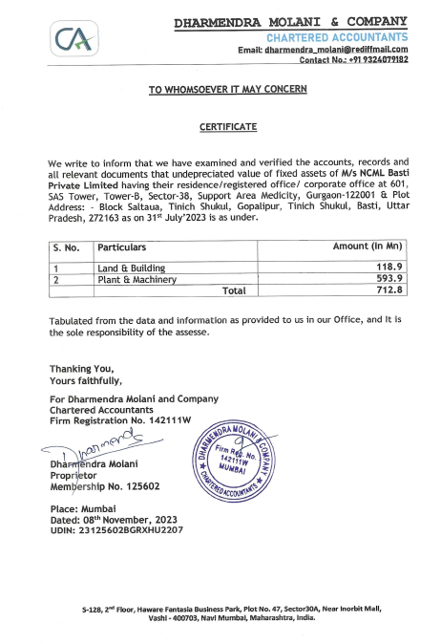**

**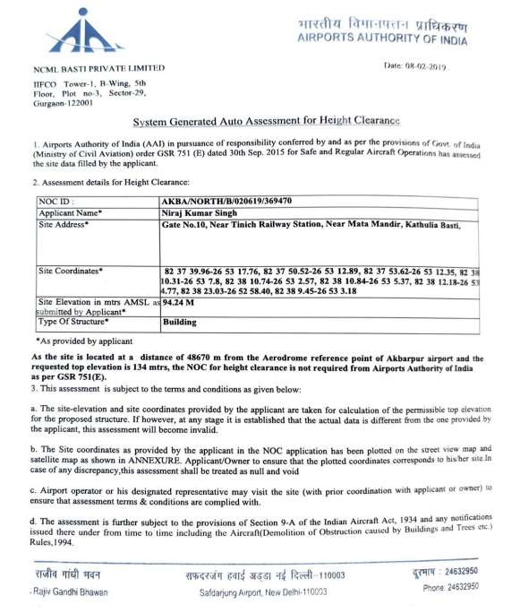**

**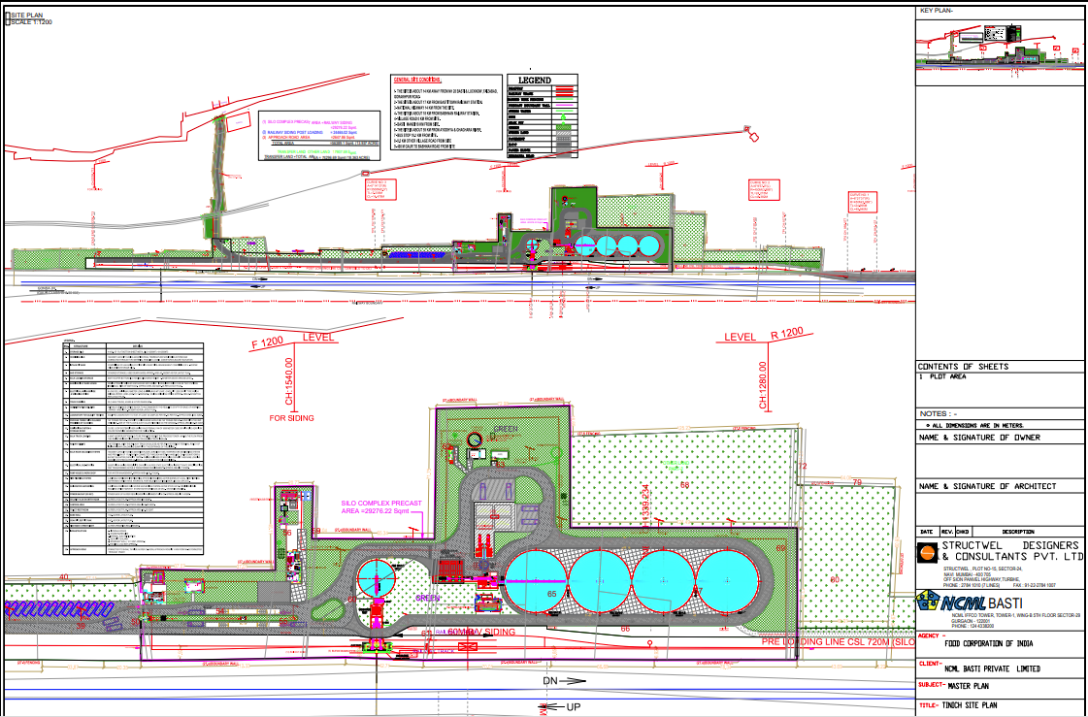**

**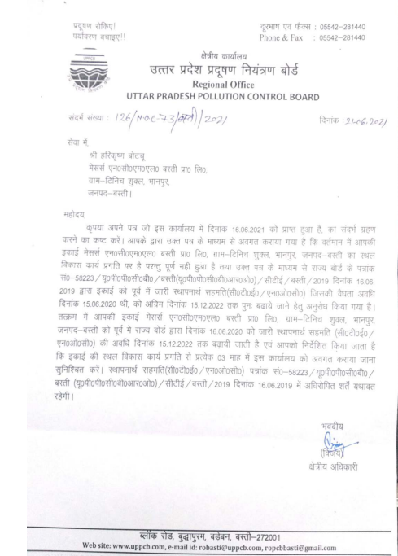**

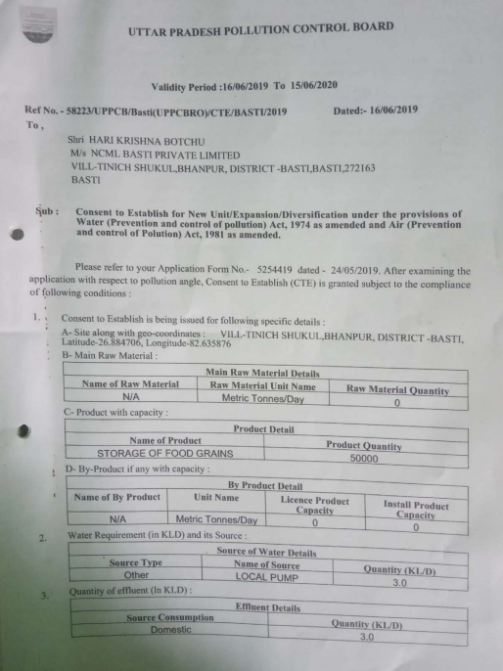

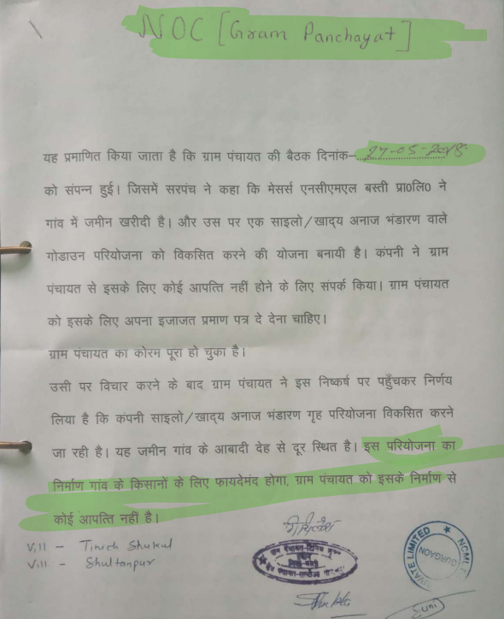

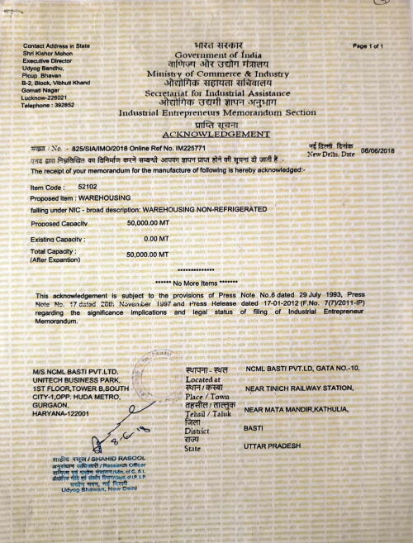

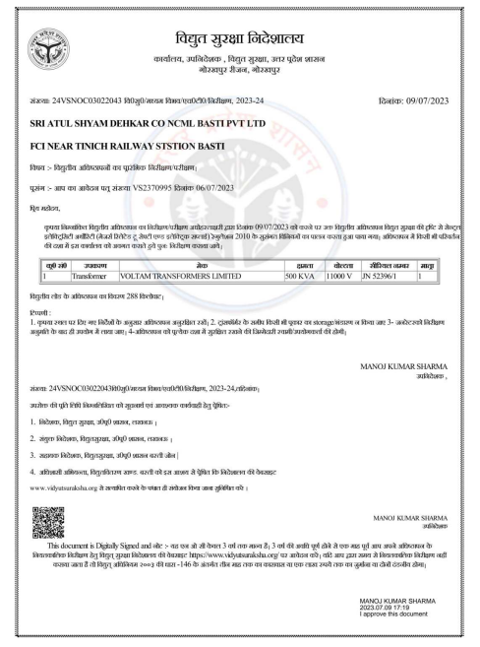

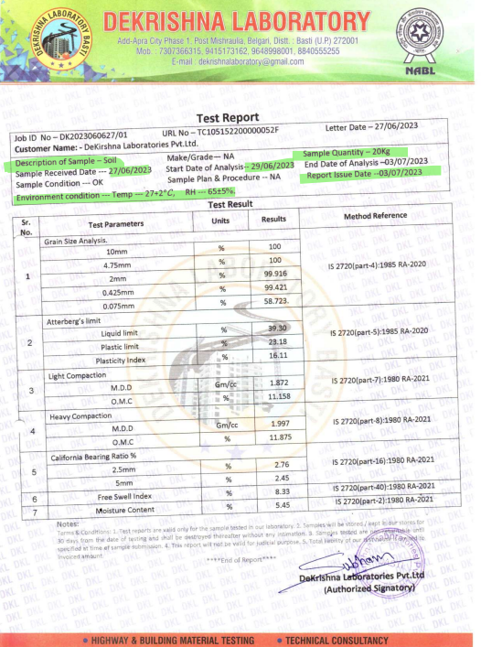

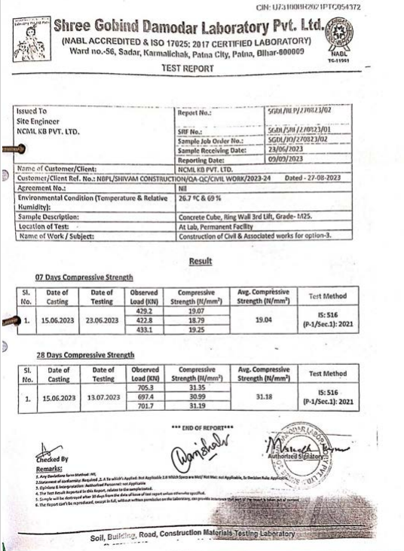

|  |  |
| --- | --- |
| **PART J** | **PHOTOGRAPHS** |

|  |  |
| --- | --- |
| Y:\In Progress Files\Anirban Roy\VIS(2023-24)-PL787-684-1049 -NCML Basti\SiteImage\c_TimePhoto_20240327_133543.jpg | Y:\In Progress Files\Anirban Roy\VIS(2023-24)-PL787-684-1049 -NCML Basti\SiteImage\c_TimePhoto_20240327_120230.jpg |
| Y:\In Progress Files\Anirban Roy\VIS(2023-24)-PL787-684-1049 -NCML Basti\SiteImage\c_TimePhoto_20240327_114635.jpg | Y:\In Progress Files\Anirban Roy\VIS(2023-24)-PL787-684-1049 -NCML Basti\SiteImage\c_TimePhoto_20240327_114601.jpg |
| Y:\In Progress Files\Anirban Roy\VIS(2023-24)-PL787-684-1049 -NCML Basti\SiteImage\c_TimePhoto_20240327_114129.jpg | Y:\In Progress Files\Anirban Roy\VIS(2023-24)-PL787-684-1049 -NCML Basti\SiteImage\c_TimePhoto_20240327_105747.jpg |

|  |  |
| --- | --- |
| Y:\In Progress Files\Anirban Roy\VIS(2023-24)-PL787-684-1049 -NCML Basti\SiteImage\c_TimePhoto_20240327_145141.jpg | Y:\In Progress Files\Anirban Roy\VIS(2023-24)-PL787-684-1049 -NCML Basti\SiteImage\c_TimePhoto_20240327_133351.jpg |
| Y:\In Progress Files\Anirban Roy\VIS(2023-24)-PL787-684-1049 -NCML Basti\SiteImage\c_TimePhoto_20240327_115359.jpg | Y:\In Progress Files\Anirban Roy\VIS(2023-24)-PL787-684-1049 -NCML Basti\SiteImage\c_TimePhoto_20240327_113219.jpg |
| Y:\In Progress Files\Anirban Roy\VIS(2023-24)-PL787-684-1049 -NCML Basti\SiteImage\c_TimePhoto_20240327_114201.jpg | Y:\In Progress Files\Anirban Roy\VIS(2023-24)-PL787-684-1049 -NCML Basti\SiteImage\c_TimePhoto_20240327_145324.jpg |

|  |  |
| --- | --- |
| Y:\In Progress Files\Anirban Roy\VIS(2023-24)-PL787-684-1049 -NCML Basti\SiteImage\c_TimePhoto_20240327_105223.jpg | Y:\In Progress Files\Anirban Roy\VIS(2023-24)-PL787-684-1049 -NCML Basti\SiteImage\c_TimePhoto_20240327_105426.jpg |
| Y:\In Progress Files\Anirban Roy\VIS(2023-24)-PL787-684-1049 -NCML Basti\SiteImage\c_TimePhoto_20240327_105431.jpg | Y:\In Progress Files\Anirban Roy\VIS(2023-24)-PL787-684-1049 -NCML Basti\SiteImage\c_TimePhoto_20240327_105908.jpg |
| Y:\In Progress Files\Anirban Roy\VIS(2023-24)-PL787-684-1049 -NCML Basti\SiteImage\c_TimePhoto_20240327_110306.jpg | Y:\In Progress Files\Anirban Roy\VIS(2023-24)-PL787-684-1049 -NCML Basti\SiteImage\c_TimePhoto_20240327_111218.jpg |

|  |  |
| --- | --- |
| Y:\In Progress Files\Anirban Roy\VIS(2023-24)-PL787-684-1049 -NCML Basti\SiteImage\c_TimePhoto_20240327_112256.jpg | Y:\In Progress Files\Anirban Roy\VIS(2023-24)-PL787-684-1049 -NCML Basti\SiteImage\c_TimePhoto_20240327_113527.jpg |
| Y:\In Progress Files\Anirban Roy\VIS(2023-24)-PL787-684-1049 -NCML Basti\SiteImage\c_TimePhoto_20240327_115116.jpg | Y:\In Progress Files\Anirban Roy\VIS(2023-24)-PL787-684-1049 -NCML Basti\SiteImage\c_TimePhoto_20240327_133328.jpg |
| Y:\In Progress Files\Anirban Roy\VIS(2023-24)-PL787-684-1049 -NCML Basti\SiteImage\c_TimePhoto_20240327_133430.jpg | Y:\In Progress Files\Anirban Roy\VIS(2023-24)-PL787-684-1049 -NCML Basti\SiteImage\c_TimePhoto_20240327_114745.jpg |
| Y:\In Progress Files\Anirban Roy\VIS(2023-24)-PL787-684-1049 -NCML Basti\SiteImage\c_TimePhoto_20240327_115141.jpg | Y:\In Progress Files\Anirban Roy\VIS(2023-24)-PL787-684-1049 -NCML Basti\SiteImage\c_TimePhoto_20240327_111814.jpg |