File No.: VIS (2023-24)-PL-790-687-1051 Dated: 29.04.2024

TECHNO-ECONOMIC VIABILITY
STUDY REPORT

OF

86000 TPA KRAFT PAPER PLANT WITH 5 MW CO-GENERATION POWER PLANT
(36000 TPA EXISTING + 50000 TPA PROPOSED EXPANSION)

SETUP BY

M/S SARDHANA PAPERS PVT LTD

REPORT PREPARED FOR

CORPORATE BANKING BRANCH, PNB MEERUT

**Important - In case of any query/ issue or escalation you may please contact Incident Manager Valuers@rkassociates.org. We will appreciate your feedback in order to improve our services.

NOTE: As per IBA Guidelines please provide your feedback on the report within 15 days of its submission after which report will be considered to be correct.

IMPORTANT NOTICE

COPYRIGHT FORMAT: This report is prepared on the copyright format of R. K. Associates Valuers & Techno Engineering Consultants (P) Ltd. (R. K. Associates) to serve our clients with the best possible information and analysis to facilitate them to take rational business decisions. Legally no one can copy or distribute this format without prior approval from R. K. Associates. It is meant only for the advisory/ reference purpose for the organization/s as mentioned on the cover page of this report. Distribution or use of this format or report or any of its content/ information/ data by any organization or individual other than R.K Associates will be seen as an unlawful act and necessary legal action can be taken against the defaulters.
This report is intended for the sole use of the intended recipient/s and contains material that is STRICTLY CONFIDENTIAL AND PRIVATE.

DEFECT LIABILITY PERIOD: In case of any query/ issue or escalation you may please contact Incident Manager at valuers@rkassociates.org. Though adequate care has been taken while preparing this report as per its scope, but still we can’t rule out typing, human errors, over sightedness of any information or any other mistakes. Therefore, the concerned organization is advised to satisfy themselves that the report is complete & satisfactory in all respect. Intimation regarding any discrepancy shall be brought into our notice immediately. If no intimation is received within 15 (Fifteen) days in writing from the date of issuance of the report, to rectify these timely, then it will be considered that the report is complete in all respect and has been accepted by the client up to their satisfaction & use and further to which R.K Associates shall not be held responsible in any manner.

Part O: R. K. Associates Important Disclaimer and Remarks are integral part of this report and Feasibility assessment is subject to this section. Reader of the report is advised to read all the points mentioned in these sections carefully.

TABLE OF CONTENTS
SECTIONS | PARTICULARS | PAGE NO.
Part A | REPORT SUMMARY | 4
Part B | INTRODUCTION
Part B | - About the Report | 6
Part B | - Executive summary | 6
Part B | - Purpose of the Report | 8
Part B | - Scope of the Report | 8
Part B | - Methodology/ Model Adopted | 9
Part B | - Data Information received from | 9
Part B | - Documents/ Data Referred | 10
Part C | Company Profile
Part C | - Company Overview | 11
Part C | - Shareholding Details | 12
Part C | - Organisational Structure | 12
Part C | - Directors Profile | 13
Part D | Infrastructure Details
Part D | - Plant Location | 16
Part D | - Location Map | 16
Part D | - Layout Plan | 19
Part D | - Land Details | 20
Part D | - Site pictures | 22
Part D | - Building & Civil Works | 28
Part D | - Plant and Machinery/ Equipment details | 29
Part D | - Utilities | 31
Part E | Project Technical details
Part E | - Capacity of Proposed Kraft Paper Manufacturing Plant | 32
Part E | - Production Process | 32
Part E | - Process Flow Chart | 35
Part E | - Proposed Technology (Kraft Paper Unit) | 38
Part E | - Technical Assessment (Power Plant Section) | 39
Part E | - Testing/Quality Assurance | 43
Part E | - Manpower | 43
Part F | Product Profile
Part F | - Introduction | 45
Part F | - Product Category | 47
Part F | - Pricing Strategy | 49
Part F | - Marketing, Selling & Distribution Plan | 50
Part G | Raw Material Analysis | 51
Part H | Industry Overview | 54
Part I | SWOT Analysis | 59
Part J | Project Cost and Means of Finance | 61
Part K | Project Implementation Schedule | 63
Part L | Statutory Approvals | Licences | NOC | 65
Part M | Company’s Financial Feasibility | 67
Part N | Conclusion | 86
Part O | Disclaimer | Remarks | 88

PART A | REPORT SUMMARY

S. No. | PARTICULAR | DESCRIPTION
 | Name of the Company: | M/s Sardhana Papers Pvt Ltd
 | Registered Address: | Opp. Power Sub Station, Meerut Road, Sardhana, Meerut, Uttar Pradesh - 250342
 | Project Name | 86000 TPA Kraft Paper Plant (Existing Capacity: 36000 TPA; Proposed Expansion: 50000 TPA) with 5 MW Co-generation Power Plant
 | Project Location: | Opp. Power Sub Station, Meerut Road, Sardhana, Meerut, Uttar Pradesh - 250342
 | Project Type: | 18 B.F. & 20 B.F. Kraft Paper (80 GSM - 230 GSM)
 | Project Industry: | Paper Manufacturing Industry
 | Product Type / Deliverables: | High B.F. Quality Kraft Paper
 | Report Prepared for Organization: | Punjab National Bank, Corporate Banking Brach (CBB) Meerut
 | TEV Consultant Firm: | M/s. R.K Associates Valuers & Techno Engineering Consultants (P) Ltd.
 | Report type: | Techno-Economic Viability Report
 | Purpose of the Report: | To assess Technical & Economic Viability for the purpose of seeking external financial assistance to expand the existing brown field Project.
 | Scope of the Report: | To assess, evaluate & comment on Technical, Economical & Commercial Viability of the Project as per data information provided by the client, independent Industry research and data/ information available on public domain.
 | Date of Report: | 29th April, 2024
 | Documents referred for the Project: | - PROJECT INITIATION DOCUMENTS:  - Project Report  - Financial Projections of the Project  - Project proposed Schedule  - Statutory Approval Details  - Layout and Site Plan  - PROCUREMENT DOCUMENTS:  - List of Plant & Machinery along with acquisition costs for the same  - Major Existing Customer Line  - List of Expected Raw material Supplier  - Process Flow Chart  - Sanction/proposed map of the sites  - Deed-wise statement of the Land  - STATUTORY APPROVALS, LICENCES & NOCs  - MSME UDYAM Registration Certificate  - Pollution Control Application/Certificates  - Consent to Establish (NOC) Application
 | Means of Finance: | Equity & Debt (D/E Ratio 3.50 TPC)
 | Key Financial Indicators:
  Key Indicators | Value
  Average DSCR | 2.73
  Average EBITDA Margin | 17.83%
  Avg. PAT Margin | 10.36%
  NPV & IRR | INR 102.25 Cr. & 39.63%
  Payback Period | 3.20 years
Note: Above financial indicators are based on the financial projections of the proposed project provided by the firm and assessment and analysis of the same done by us.

PART B | INTRODUCTION

- ABOUT THE REPORT:
This is a Techno-Economic Viability Study Report of the proposed expansion of Kraft Paper Manufacturing Plant (86000 TPA from existing 36000 TPA) at Opp. Power Sub Station, Meerut Road, Sardhana, Meerut, Uttar Pradesh - 250342, setup by M/s Sardhana Papers Private Limited.

- EXECUTIVE SUMMARY:
M/s Sardhana Papers Private Limited (SPPL) was incorporated on 26th March, 1985 with registrar of Companies Kanpur vide CIN No. U21011UP1985PTC007097. M/s Sardhana Papers Private Limited has been into the business of Manufacturing of Kraft Paper since 1987 and having its presence in the market as one of the oldest manufacturers of Kraft Paper in Meerut.
M/s Sardhana Papers Private Limited is promoted by Mr. Saurabh Gupta and Mr. Shiva Rastogi who appears to be well experience in businesses of paper manufacturing as company is already running an established Kraft paper manufacturing plant with a capacity of 36000 TPA in Meerut.
As per the data/information provided by the client, Company has decided to increase its production capacity from existing 36,000 TPA to 86,000 TPA as shown in the below table, due to higher demand of Kraft paper in the market.
Particular | Existing Capacity | Proposed Expansion | Total Capacity
Location | TPA | TPA | TPA
Opp. Power Sub Station, Meerut Road, Sardhana, Meerut, Uttar Pradesh - 250342 | 36,000 | 50,000 | 86,000
Total | 36,000 | 50,000 | 86,000
Source: Information provided by the company
Currently, company is only manufacturing 18 B.F. Kraft paper with GSM ranges from 120-230. Company will be able to manufacture 20 BF Kraft paper with GSM ranges from 80-230 after commissioning the proposed expansion project.
To meet the increased demand of products delivered by the company, management of M/s SPPL proposed to install new Plant & Machinery with latest technology during FY 2022-23. The expansion plan has already been started from December 2022, for which company has availed a term loan of INR 30 Crores also from Punjab National Bank on 29.12.2022.
As per the data/information provided by the client, existing plant is operational at a land parcel of 48970 Square meter. Out of which, ~ 25,000 Sq. Mt. of land was vacant which was proposed to be utilized for the proposed expansion project. The layout plan has been prepared by the architect Mr. Umesh Kumar (Reg. CA/2014/64945) dated 25.12.2016 which is approved by Gram Panchayat Officer, Block – Sardhana (Meerut) dated 03.01.2017.
As per the details shared by the company, Gaurav & Associates, Chartered Engineers was appointed as consultant for construction work of proposed expansion. Company has appointed Mr. Piyush D. Desai as EPC consultant for the implementation of the proposed expansion for providing Engineering Services & Procurement of plant & machineries. The contract period is for a term of 15 Months & commenced from 1st January 2024 & will automatically terminate on 31st March 2025.
As per data/information provided to us, the company has obtained some Statutory Approvals/NOC’s such as NOC from Ground Water Department, Sanctioned Map approval, Fire NOC etc. from the respective authorities. (Refer the section Statutory Approval in the later part of the report).
The total cost of the project for the proposed expansion project is being estimated as INR 70.68 Crores, which is proposed to be funded through unsecured loan/cash accruals of INR 15.68 Crores and term loan of INR 55.00 Crores out of INR 30 Crores have already been sanctioned by the Punjab National Bank.
As per the information provided by the client, company has started civil work and has paid advances to vendors of machineries to whom final order of machineries has been placed and thus, already incurred INR 17.63 Crores on the proposed expansion till 31st March 2024. The breakup of the cost incurred and means of financing is shown in the table below:
Total Cost Incurred till now
Particulars | Amount (INR Crores)
CWIP | 6.86
Advance against capital goods | 10.77
Total | 17.63
Means of Financing
Disbursement from Bank | 9.60
From Unsecured Loans | 8.04
Total | 17.63
As per the plan shared by the company, the order placement of Plant & Machinery will be completed by May 2024. Commercial production from the proposed expansion project is expected to start from April 2025.
As per the information provided by the client, Company is consuming ~350 units to produce per MT of Paper at present. The cost of per unit electricity ranges between Rs.6.50 to Rs.7.00 from public electricity grid. Therefore power & fuel is one of the major expense for the company as electricity cost per tonne production of Kraft paper is INR ~2350 PMT. The total cost of power may double after commissioning the proposed expanded manufacturing facility.
Thus, to make the production more economic, Company has also decided to install a new Boiler (40TPH) and Turbine machine for In-house production of electricity to minimise the overall electricity cost which is one the major expense in production of Kraft Paper and company will only bear the fixed charge which is INR ~74,82,000 (2000 KVA Load*311.75/ KVA*12 months) only.
As per informed by client, Consent to Establish (NOC) under the provisions of Water (Prevention and control of pollution) Act, 1974 as amended and Air (Prevention and control of Pollution) Act, 1981 for installation of 40TPH multifuel boiler and 5 MW Turbine along with expansion project is applied on 1st April 2024 vide Application No. 25567386. At present, the company is in discussion with bank to provide the additional funding for the installation of Boiler and Turbine through a term loan of INR 25.00 crores.
In this regard Punjab National Bank, CBB, Meerut has appointed R.K. associates to assess the Techno-Economic Viability of the proposed expansion of Kraft Paper Manufacturing Unit along with the installation of 40 TPH Boiler and 5MW Turbine at Opp. Power Sub Station, Meerut Road, Sardhana, Meerut, Uttar Pradesh - 250342. The company plans to achieve the financial closure by May, 2024 (expected).
- PURPOSE OF THE REPORT: To assess Project’s Technical and Financial Feasibility for lender’s requirement.

- SCOPE OF THE REPORT: To only assess, evaluate & comment on Technical & Financial Feasibility of the proposed expansion of Kraft Paper Manufacturing Plant being set up by M/s Sardhana Papers Pvt Ltd as per the information provided by the company.
NOTES:
- Scrutiny about the company, background check, and credibility, credit worthiness of the company or its promoters is out-of-scope of this report.
- Any verification of the documents/ information from originals/ source is out-of-scope of this report.
- This report is only an opinion in respect to Technical and Financial Feasibility of the project as per the future Projections provided by the firm and independent analysis done by us and doesn’t contain any recommendations including taking decision on the loan or any other financial exposure.
- This is not an audit activity of any kind. We have relied upon the data/ information shared by the company in good faith.
- Any review of the existing business of the promoters is out of scope of this report.
- Detailed cost estimation or detailed cost vetting is out of scope of the project.
- This is not a Detailed Project Report or a detailed design or architecture document. Land and property details mentioned in the report is only for illustration purpose as per the information provided to us by the client. The same doesn’t tantamount for taking any responsibility regarding its legality, ownership and conforming to statutory norms.
- Project status is taken as per the Site inspection carried out by our survey team.

- METHODOLOGY/ MODEL ADOPTED:
- Data/ Information collection.
- Review of Data/ Information collected related to TEV study.
- Independent review & assessment of technology used and financial projections provided by the company.
- Projections of Revenue, P&L, Balance Sheet, Working Capital Schedule, Depreciation Schedule, Loan Schedule as per the inputs given by the company and assessed by us
- Calculation of key financial indicators and ratio analysis including DSCR, NPV & IRR and payback period of the project.
- Report compilation and Final conclusion.

- DATA/ INFORMATION RECEIVED FROM: All the data/Information has been received from Mr. Parvesh Agrawal and the required details about him shown in the below table:

Particulars | Details
Designation | General Manager - Finance
Company | M/s Sardhana Papers Private Limited
Email Address | sardhanapapers@gmail.com
Contact No. | +91-9319801926

- DOCUMENTS / DATA REFFERED:

- Detailed Project Report and Promoters Profile
- Financial Projections of the proposed expansion of Kraft Paper Manufacturing Plant.
- Production flow chart.
- List of existing Raw Material Suppliers and customers.
- Selling, Marketing & Distribution Plan
- Approved Site/Layout Plan
- Deed-wise Statement of Land
- Contract agreement with EPC consultant along with details of Plant & Machinery.
- Certificates of Statutory approvals/NOCs.
- Survey Report conducted at the site.
PART C | COMPANY PROFILE

- COMPANY OVERVIEW:
As per certificate of incorporation shared by the client/company, M/s Sardhana Papers Pvt Ltd has been into the business of Manufacturing of Kraft Paper since 1987. Company was incorporated on 26th March 1985 as an unlisted private company limited by shares with Registration no. 007097 and Tax Deduction and Collection Account Number (TAN) is MRTS00324C.
The Permanent Account Number (PAN) of the company is AABCS9548K and GSTIN is 09AABCS9548K1ZP. As per Udyam registration certificate provided by the client, the company is categorised as Medium enterprise having the Udyam Registration Number UDYAM-DL-02-0029530.
Currently, company manufactures Kraft Paper in various grammage starting from 120 GSM and varying up to 230 GSM with Moisture Content (7% to 8%), Ash Content (5% to 10%) and Bursting Factor of 18. Below table shows the incorporation details of the company:
Incorporation Details of the Company
Particular | Description
Company / LLP Name | M/s Sardhana Papers Private Limited
Date of Incorporation | 26rd March, 1985
CIN | U21011UP1985PTC007097
Company Category | Unlisted Company limited by Share
Company Subcategory | Non-govt. company
ROC | Kanpur
Registration Number | 007097
Registered Address | Opp. Power Sub Station, Meerut Road, Sardhana, Meerut, Uttar Pradesh - 250342
Authorized Capital | INR 15,00,00,000/-
Paid up Capital | INR 15,00,00,000/-
Date of last AGM | 30/09/2023
Date of Balance Sheet | 31/03/2023
The promoters of the company are Mr. Neeraj Gupta and Mr. Sanjay Gupta with shareholding of 8.79% and 0.60% respectively with the company.
- SHAREHOLDING DETAILS:
As per the provisional financials as on 31st March 2024 shared by the client, Company is having authorized share capital of Rs. 15.00 crores and the total subscribed and paid-up capital is Rs 15.00 crores. The shareholding pattern of the company is mentioned in the below table:

Particulars | As at 31st March, 2024
Particulars | No of Shares | INR Crore
Authorised Share Capital
Equity shares of Rs. 10/- each | 1,50,00,000 | 15.00
Subscribed & fully paid up
Equity Share of Re. 10/- each fully subscribed & paid up | 1,50,00,000 | 15.00
Source: Data/Information provided by the Client.

Details of Shareholders holding more than 5% shares in the Company

S. No. | Name of Shareholder | Number of shares as on 31.03.2024 | % of Holding | Number of shares as on 31.03.2023 | % of Holding
1 | Shri Sanjay Rastogi | 9,37,500 | 6.25% | 9,37,500 | 6.25%
2 | Smt Rubee Rastogi | 9,37,500 | 6.25% | 9,37,500 | 6.25%
3 | M/s Ghyanshyam Papers (P) Ltd | 14,74,400 | 9.83% | 14,74,400 | 9.83%
4 | Shri Neeraj Gupta | 13,18,566 | 8.79% | 13,18,566 | 8.79%
5 | Shri Kailash Chand Gupta | - | 0.00% | 12,50,000 | 8.33%
6 | Shri Subhash Chand Gupta | - | 0.00% | 12,50,000 | 8.33%
7 | Smt Raj Bala Gupta | - | 0.00% | 12,50,000 | 8.33%
8 | Shri Mayank Gupta | 9,75,000 | 6.50% | 9,75,000 | 6.50%
9 | Smt Palak | 9,75,000 | 6.50% | 9,75,000 | 6.50%
10 | Shri Krishan Avtar Rastogi | 9,37,500 | 6.25% | 9,37,500 | 6.25%
11 | Smt Sashi Bala Rastogi | 9,37,500 | 6.25% | 9,37,500 | 6.25%
12 | Shri Naveen Gupta | 9,37,500 | 6.25% | - | 0.00%
13 | Shri Sarthak Gupta | 9,37,500 | 6.25% | - | 0.00%
14 | Shri Sparsh Gupta | 9,37,500 | 6.25% | - | 0.00%
15 | Shri Akansh Gupta | 9,37,500 | 6.25% | - | 0.00%
Source: Data/Information provided by the Client.

- ORGANISATIONAL STRUCTURE:
As per the information shared by the client/company, the organisational structure of M/s SPPL is shown below:

ORGANIZATION CHART
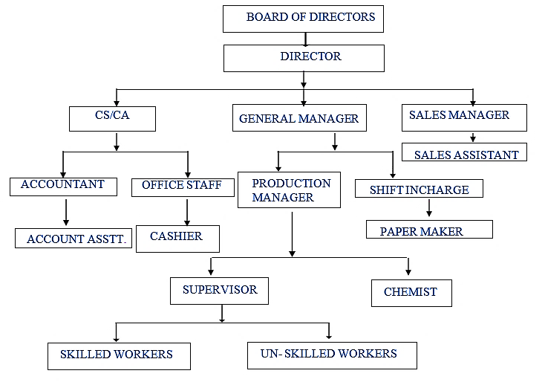

- DIRECTORS PROFILE:
Mr. Saurabh Gupta and Mr. Shiva Rastogi are the directors of M/s Sardhana Papers Private Limited. Currently, they are successfully running their company and have acquired good knowledge & experience in paper industry.
As per data/information provided to us, below table illustrate the educational & professional experience of the promoters along with the DIN and contact details:
- Directors/Promoters Details
Name | DIN | Age | Address | Designation | Contact Details
Mr. Saurabh Gupta | 01075042 | 54 | 315-C, Palm View Road, Sheel Kunj, Meerut-250001 | Whole-time Director | +91-8755301326
Mr. Shiva Rastogi | 08306873 | 29 | 3C, Pocket, B-6, Mayur Vihar, Phase -3, Delhi-110096 | Director | +91- 9897526226
- Education & Experience
Mr. Saurabh Gupta | - Appointed as Director on 16th August 1989.  - As per data/information shared by the client, Mr. Saurabh Gupta is an engineering graduate with a degree of B-Tech (B.E. Production). He has an experience of 34 years in the paper industry.  - Currently Mr. Saurabh Gupta is successfully running M/s SPPL.
Mr. Shiva Rastogi | - Appointed as Director on 23rd June 2020.  - As per data/information shared by the client, Mr. Shiva Rastogi is a graduate with a degree of B-Tech (B.E. Production). He has an experience of 4 years in the relevant industry.  - Currently Mr. Shiva Rastogi is successfully running M/s SPPL.
Source: Data/ Information provided by the company
Below tables shows the information of the companies with which each Director is associated with to give a basic background detail of the promoters as found on public domain in general/ tertiary category research.
(MR. SAURABH GUPTA)
S. No | Company Name  (CIN/FCRN) | Designation | Original Date of Appointment | Date Of Appointment at Current Designation | Date Of Cessation (If Applicable)
1 | Sardhana Papers Private Limited (U21011UP1985PTC007097) | Whole-Time Director | 16/08/1989 | 01/08/2012 | -
2 | Sardhana Papers Private Limited (U21011UP1985PTC007097) | Director | - | 16/08/1989 | 01/08/2012
3 | Sardhana Spinning Mills Private Limited (U17291UP2010PTC041808) | Director | - | 03/11/2010 | 22/07/2016
4 | Ghan Shyam Papers Pvt Ltd (U21012UP1990PTC011867) | Director | - | 29/09/2017 | 14/09/2020
5 | Ghan Shyam Papers Pvt Ltd (U21012UP1990PTC011867) | Additional Director | - | 28/09/2016 | 29/09/2017
Source: Information extracted from MCA website & public domain

(MR. SHIVA RASTOGI)
S. No | Company Name  (CIN/FCRN) | Designation | Original Date of Appointment | Date Of Appointment at Current Designation | Date Of Cessation (If Applicable)
1 | Sardhana Papers Private Limited (U21011UP1985PTC007097) | Director | 23/06/2020 | 23/06/2020 | -
2 | Sardhana Papers Private Limited (U21011UP1985PTC007097) | Additional Director | - | 23/06/2020 | 23/06/2020
Source: Information extracted from MCA website & public domain

PART D | INFRASTRUCTURE DETAILS

- PLANT LOCATION:
M/s Sardhana Papers Private Limited is operating an existing Kraft Paper Manufacturing Unit at Opp. Power Sub Station, Meerut Road, Sardhana, Meerut, Uttar Pradesh – 250342, which is spread over an area of 48,970 Square meter as per the deed-wise statement and site plan provided to us by the company. Out of the total area of existing unit, ~25000 Sq. Mt. of land is vacant which is proposed to be utilized for capacity expansion and captive thermal power plant project.
The property is having the proximity to the civic amenities such as hospital is situated ~1.5 km away, school is situated ~1.0 km away and market is situated ~1.0 km away from the plant location. The site connects to the main road of 15 ft. wide which is at a distance of ~3.5 KM from the NH-709A. Table: 1 is showing the details of the adjoining properties of the land for plant’s site location and Table: 2 is showing the Connectivity Details of the Proposed Location:
Table: 1 Adjoining Property Details
Location | Details
East | ~15 Ft. Road
West | Vacant Land
North | Sardhana Spring Mills Pvt Ltd
South | Drainage

Table: 2 Connectivity Details of the Proposed Location
Connectivity | Details
Road | NH 709A - ~3.5 km away
Rail | Meerut City Junction - ~23.2 km away
Airport | Indira Gandhi International Airport – Delhi - ~112 km away

- LOCATION MAP:
- GOOGLE MAP LOCATION:
Project location is 29°07'40.6" North and 77°36'33.4" East at Opp. Power Sub Station, Meerut Road, Sardhana, Meerut, Uttar Pradesh – 250342 and the location as per the Google map has been attached below:
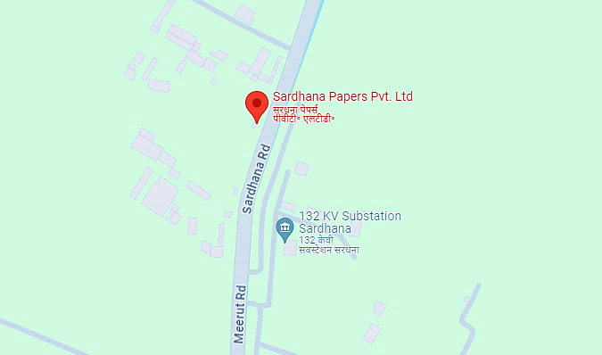
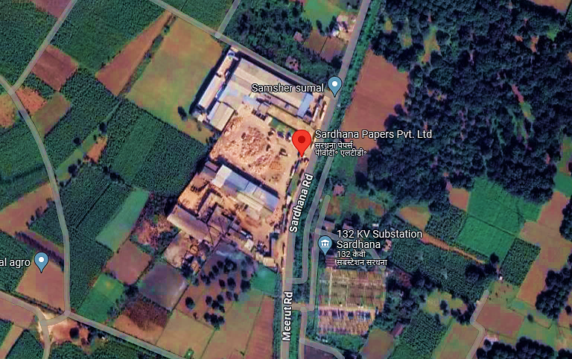
- Google Map Layout:
Demarcation of the whole plant site and proposed expansion with approximate measurement on the Google map are attached below:
DEMARCATION OF WHOLE PLANT INCLUDING THE PROPOSED EXPANSION
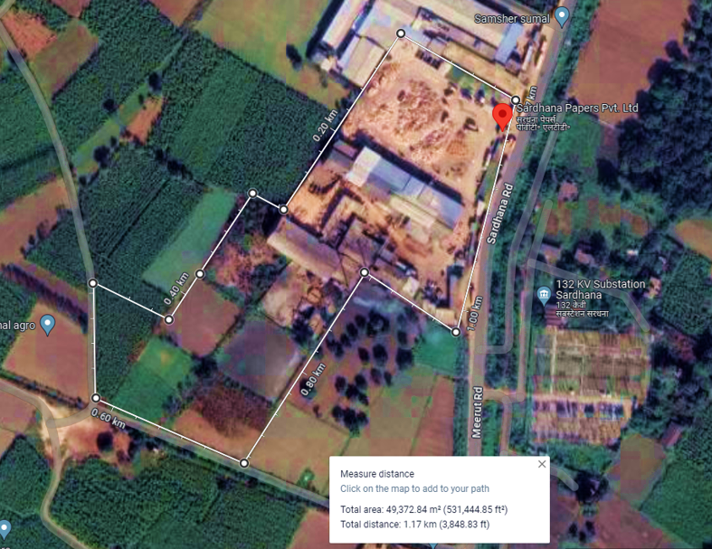

DEMARCATION OF PROPOSED EXPANSION
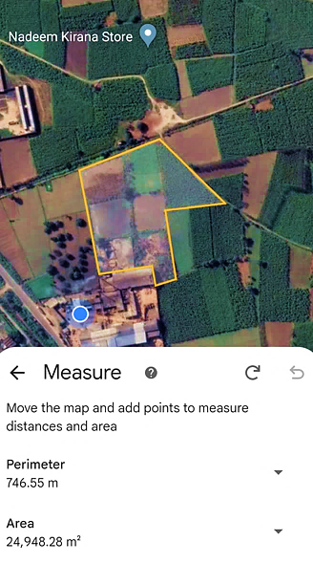
- LAYOUT PLAN:
As per the data/information provided by the client, layout plan has been prepared by the architect Mr. Umesh Kumar (Reg. CA/2014/64945) which is approved by Gram Panchayat Officer, Block – Sardhana (Meerut). For reference, approved layout plan has been attached below:
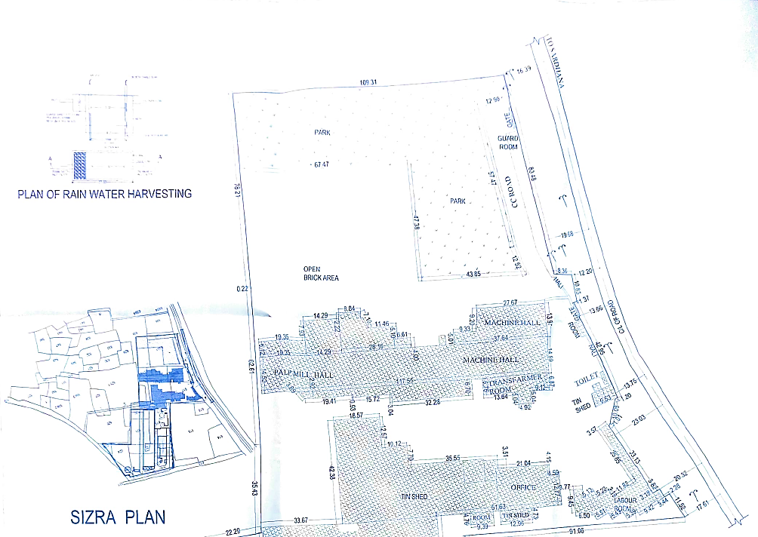
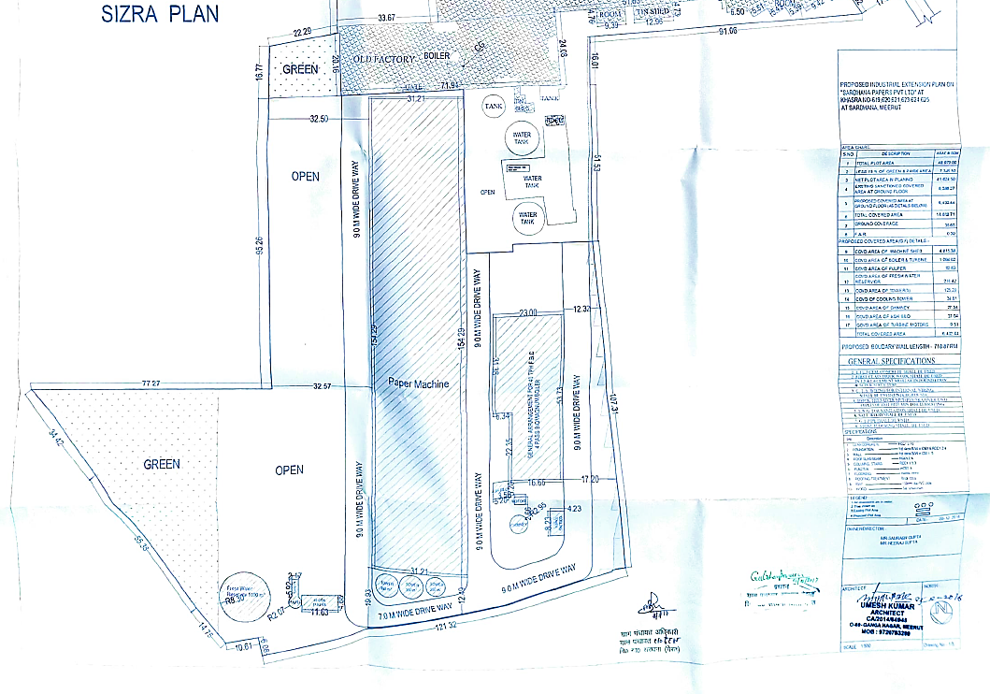
- LAND DETAILS:
M/s Sardhana Papers Private Limited is operating an existing Kraft Paper Manufacturing Unit at Opp. Power Sub Station, Meerut Road, Sardhana, Meerut, Uttar Pradesh – 250342, which is spread over an area of 48,970 Square meter including 15% green belt area as per the deed-wise statement and site plan provided to us by the company.
Out of the total area of existing unit, ~25000 Sq. Mt. of land was vacant which has been proposed to be utilized for capacity expansion and captive thermal power plant project. As per the approved layout plan, the existing plant operational on a sanctioned covered area of 8386.27 square meter and the proposed covered area at ground floor for the expansion is 6432.44 square meter.
The land is located at Khasra No. 619, 620, 621, 623, 624 & 625, Sardhana, Meerut, Uttar Pradesh - 250342 as per the approved sizra map shared with us. As per the information provided by the company, the land is already mortgaged with the bank.
Original sale/lease deed has not been provided to us by the client, however for the purpose of TEV deed-wise details in excel has been given by the client, we have relied upon in good faith assuming that the shared data/information is true & fair in nature:
S. No. | Khasra No. | Area (Square Meter) | Total Area  (Square Meter) | Details of purchased deed
1 | 618, 617 | 15,851.0 | 15,851.0 | Purchased deed  Ledger No.1 Folio no 1422  Page 350/351, Registration.no.4259  Dated. 28.09.1985
2 | 618, 619, 628 | 15,851.0 | 15,851.0 | Purchase deed  Ledger No.1 Folio 1439 to1441  Page 67 to 69 Registration no.4258  dated. 28.09.1985
3 | 618, 636 | 15,851.0 | 15,851.0 | Purchase deed  Ledger No.1 Folio 1426 to 1441  Page 281, Registration no. 4260  dated. 28.09.1985
4 | 619/1 | 250.0 | 250.0 | - Purchase deed  Ledger No.1 Folio 27  Page 299 to 332, Registration no.546  Dated 01.02.1994  - Purchase deed  Ledger No.1 Folio 273  Page 247 to 280, Registration no.613  Dated 05.02.1994  - Purchase deed  Ledger No.1 Folio 275  Page 51 to 140, Registration no.712  Dated14.02.1994
5 | 621 | 1,664.0 | 1,664.0
6 | 622 | 126.0 | 126.0
7 | 623/1 | 650.0 | 650.0
8 | 623/2 | 6,798.0 | 6,798.0
9 | 620 | 2,624.0 | 2,624.0 | Purchase deed  Ledger No.1 Folio 1745  Page 398, Registration no. 5120  dated. 14.11.1990
10 | 635/1 | 4,215.0 | 4,215.0 | Purchase deed  Ledger No.1 Folio 2321  Page 361 to 366, Registration no.1107  dated. 20.02.2001
11 | 635/1 | 450.0 | 6,641.0 | Purchase deed  Ledger No.1 Folio 2412  Page 383 to 412, Registration no.10270  dated. 23.09.2009
12 | 636/1 | 6,053.0 | 6,641.0
13 | 637 | 38.0 | 6,641.0
14 | 636/1 | 100.0 | 6,641.0
15 | 635 | 550.0 | 550.0 | Purchase deed  Ledger No.1 Folio 2413  Page 9 to 24, Registration no.10272  dated. 23.09.2009
16 | 619/1 | 1,899.0 | 3,035.0 | Purchase deed  Ledger No.1 Folio 17  Page 111 to 122, Registration no.2564  dated. 08.04.1991
17 | 619/1 | 2,786.0 | 3,035.0
18 | 621 | 3,036.0 | 3,035.0
19 | 626 | 130.0 | 3,035.0
20 | 619/1, 619/2, 621, 626 | 7,851.0 | 3,035.0
21 | 619/1 | 1,899.0 | 2,408.0 | Purchase deed  Ledger No.1 Folio 3105  Page 77 to 104, Registration no.15013  dated. 24.12.2010
22 | 619/2 | 2,786.0 | 2,408.0
23 | 621 | 3,036.0 | 2,408.0
24 | 626 | 130.0 | 2,408.0
 |  | 7,851.0 | 2,408.0
25 | 624/1 | 526.0 | 526.0 | Purchase deed  Ledger No.1 Folio 990  Page 61 to 78, Registration no.4102  dated. 29.04.2006
26 | 625/1 | 380.0 | 380.0
27 | 625/2 | 100.0 | 100.0
28 | 624/1 | 2,100.0 | 2,100.0 | Purchase deed  Ledger No.1 Folio 2321  Page 361 to 366, Registration no.1107  Dated. 20.02.2001
29 | 624/1 | 548.0 | 548.0
30 | 621 | 100.0 | 100.0
31 | 623 | 153.0 | 153.0
32 | 623/2 | 246.0 | 246.0
33 | 638 | 5.0 | 5.0
 | Total Land |  | 48,970.0

As per the information shared by the client, ~53,905 sq. mt. of land is mortgaged with the bank. However, the rest 4,935 sq. meter area (with Khasra No. 607,608,609 & 611) is outside of the boundary wall of the existing plant location.
During the site visit on 19th April 2024, we found that the demarcation and boundary wall work has been completed for the proposed expansion project.
- SITE PICTURES: Site pictures were captured during the site survey on 19th April 2024, for reference few of the pictures are attached below:
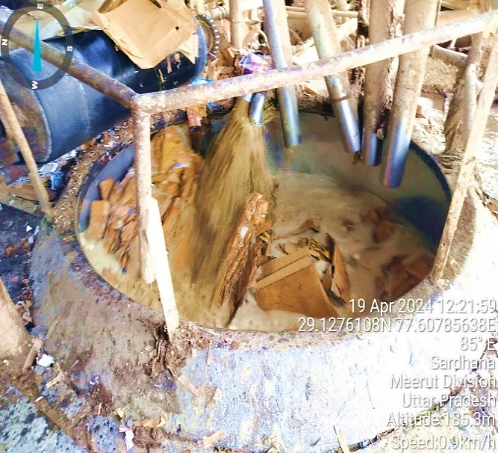 | 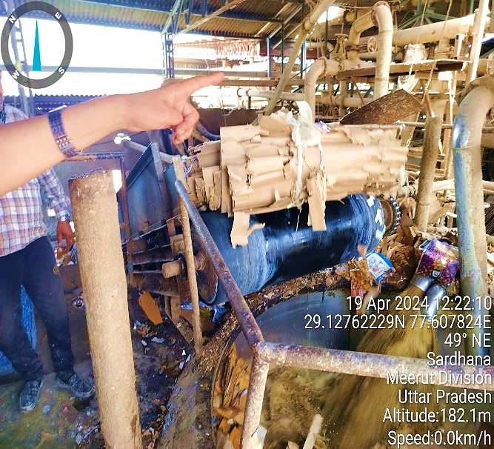
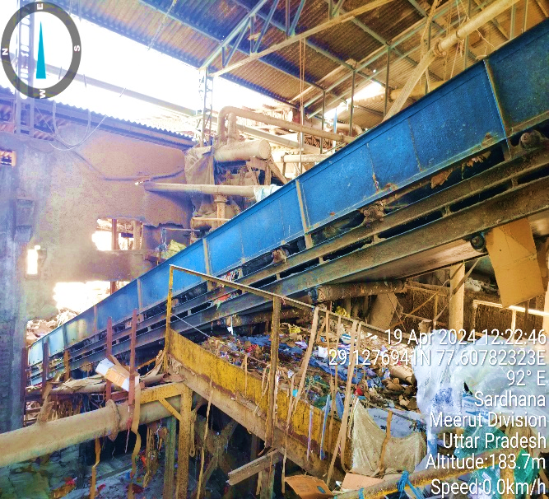 | 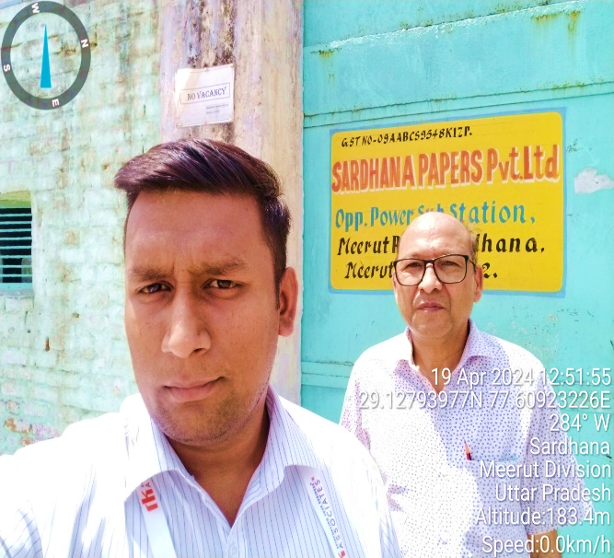
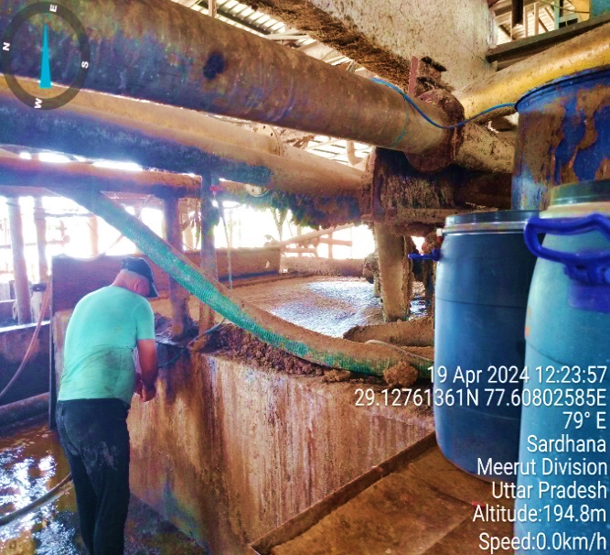 | 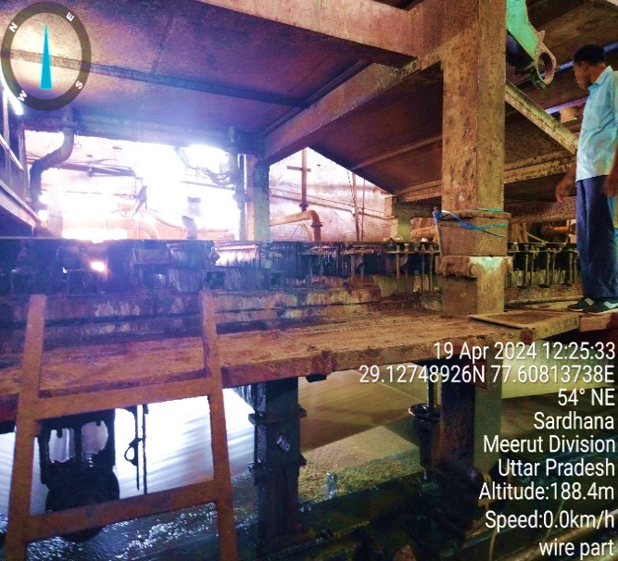
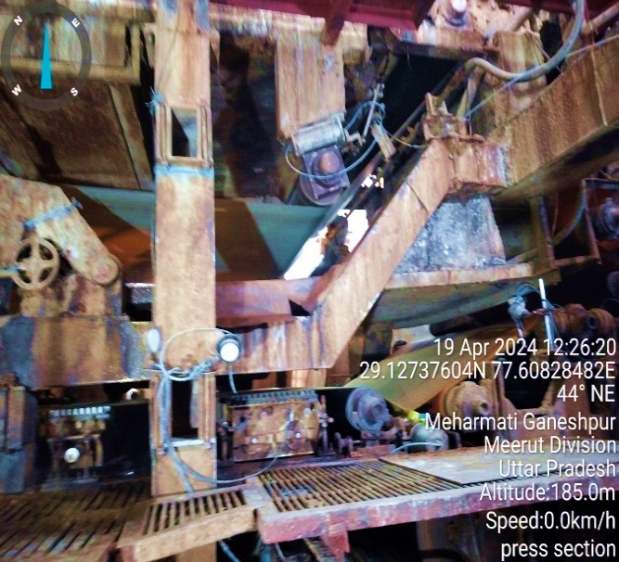 | 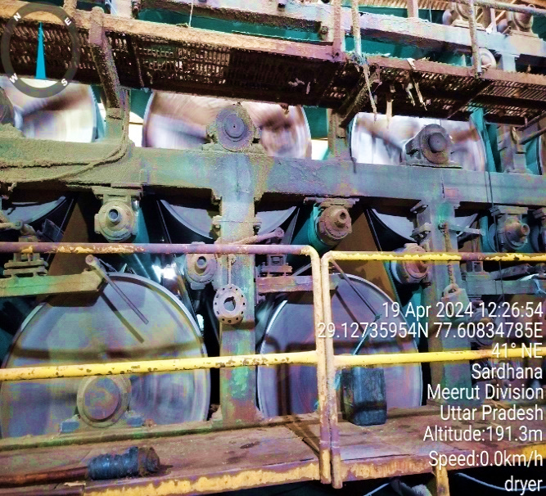
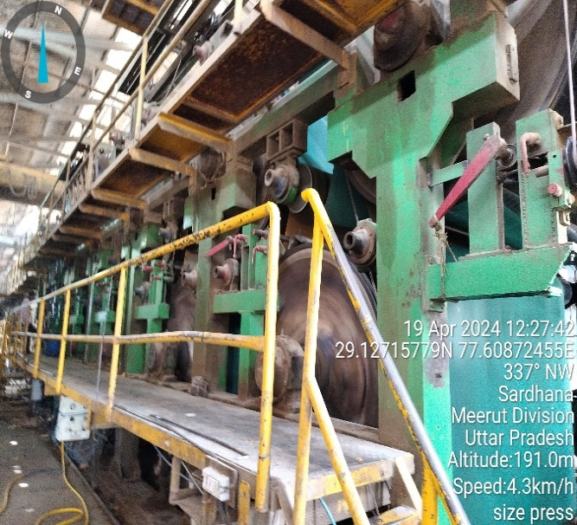 | 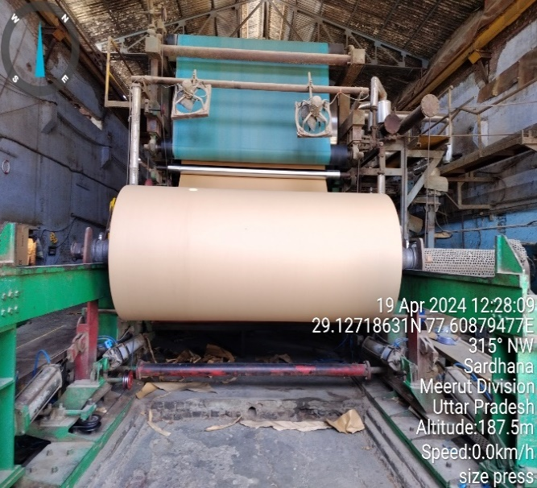
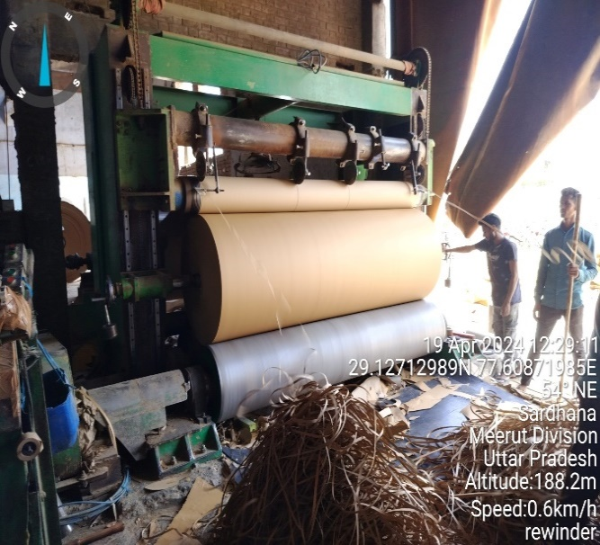 | 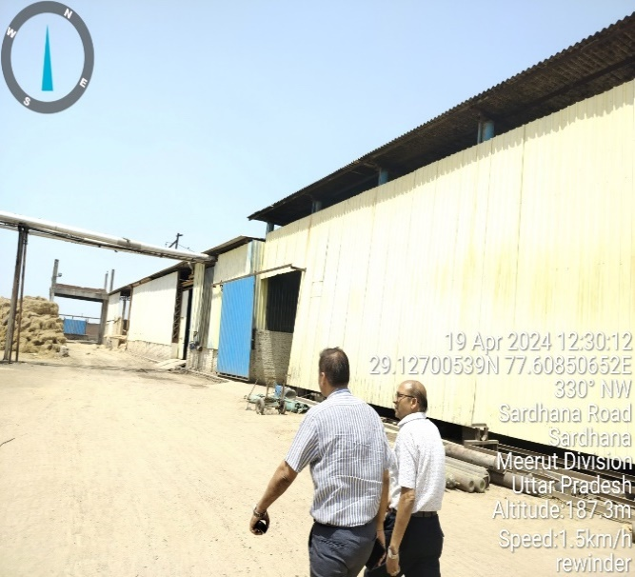
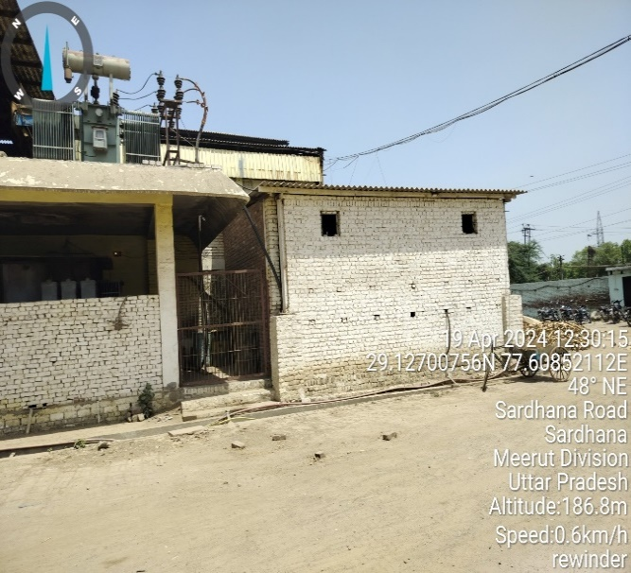 | 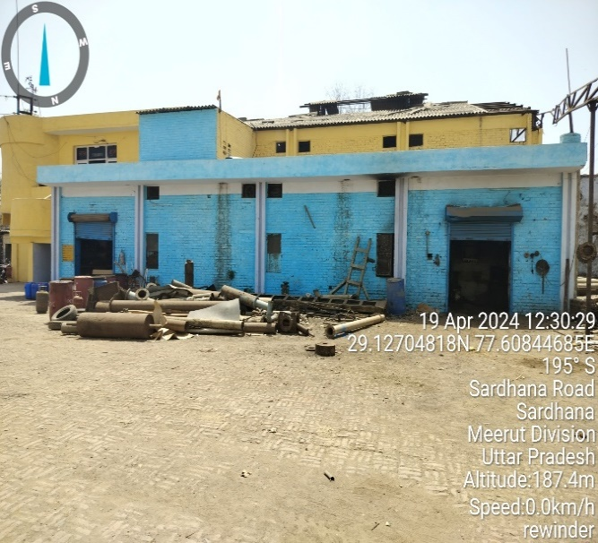
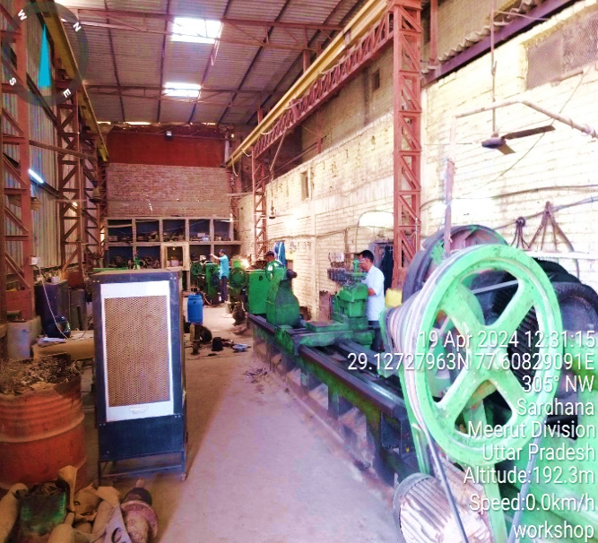 | 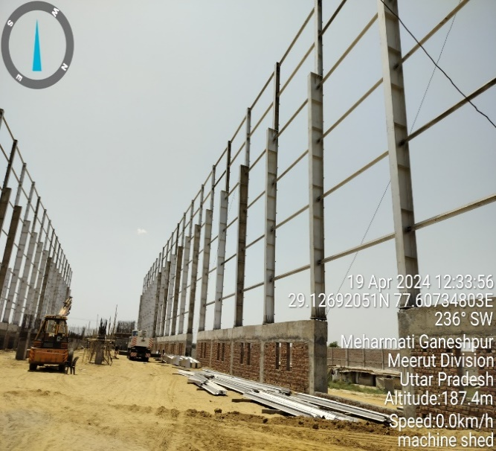
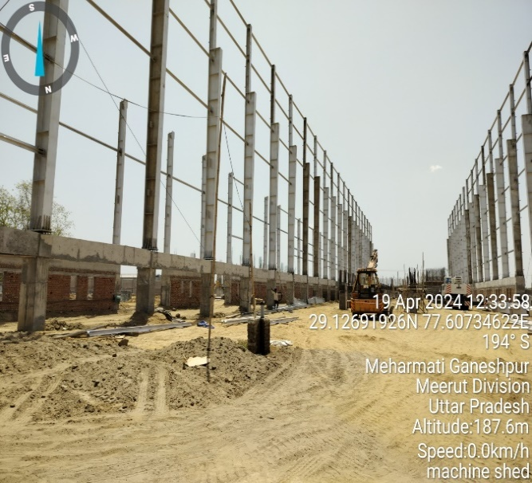 | 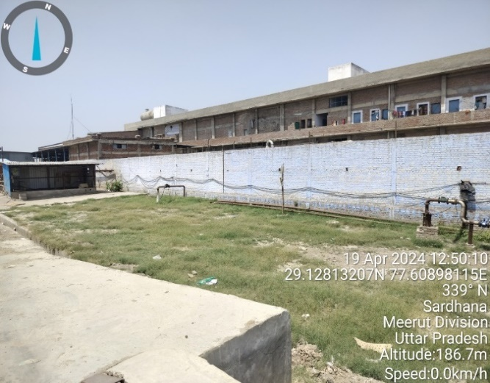
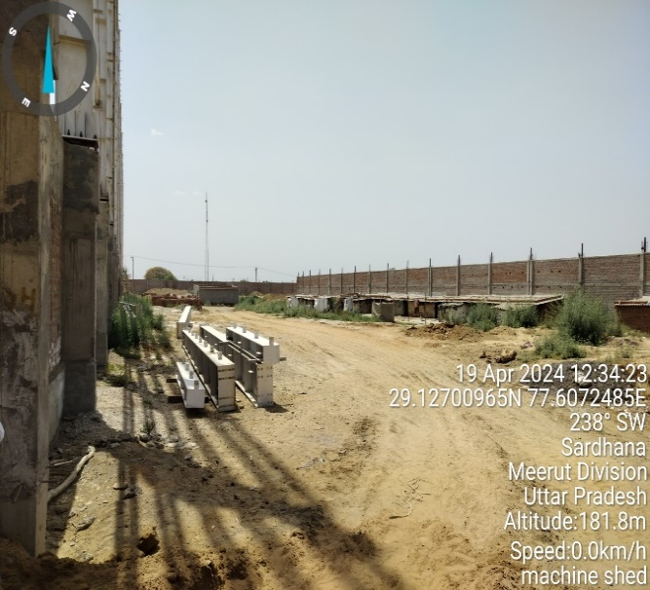 | 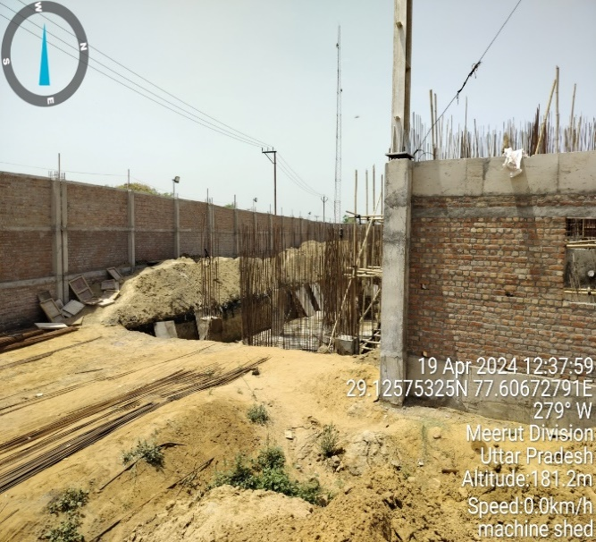
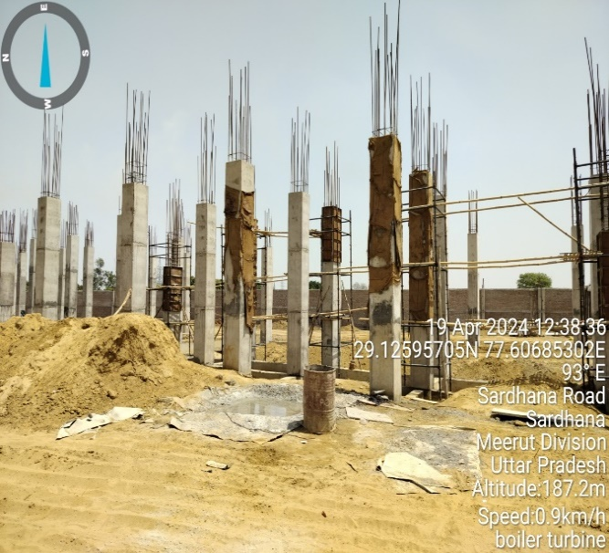 | 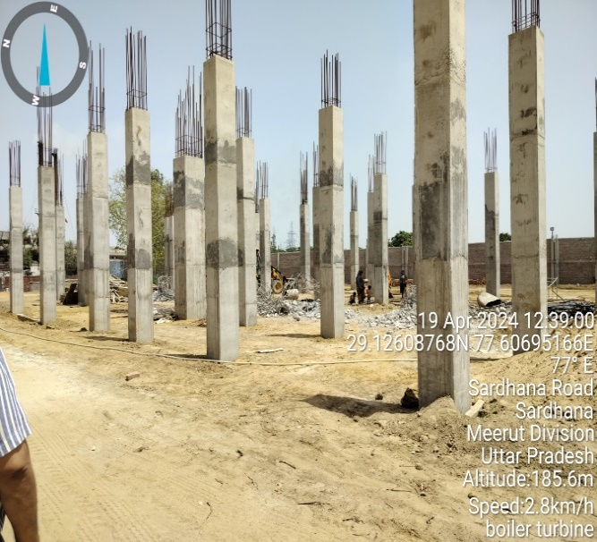
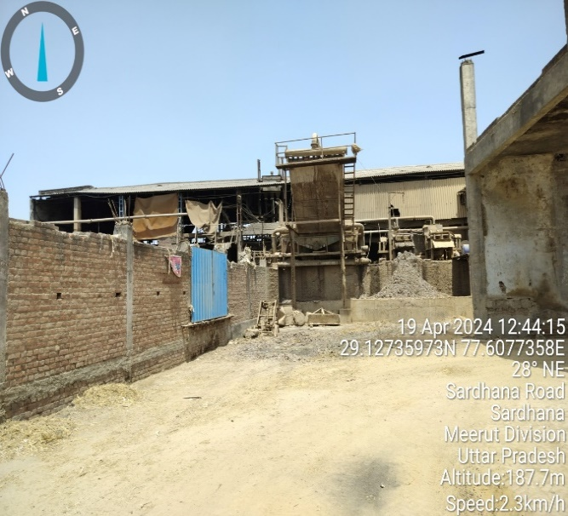 | 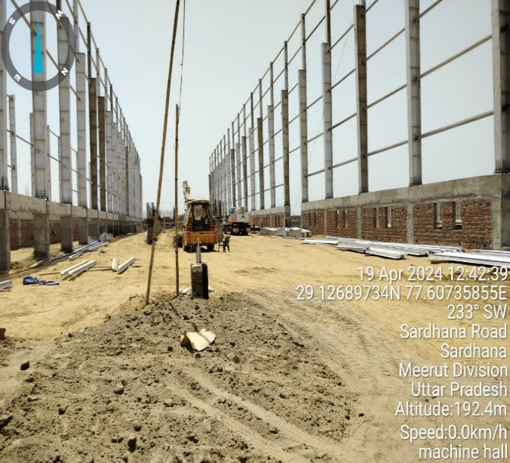
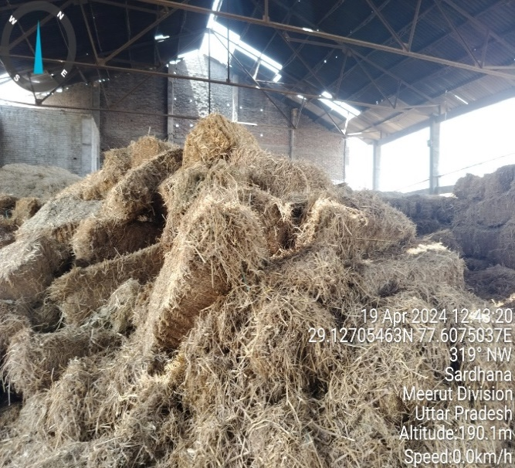 | 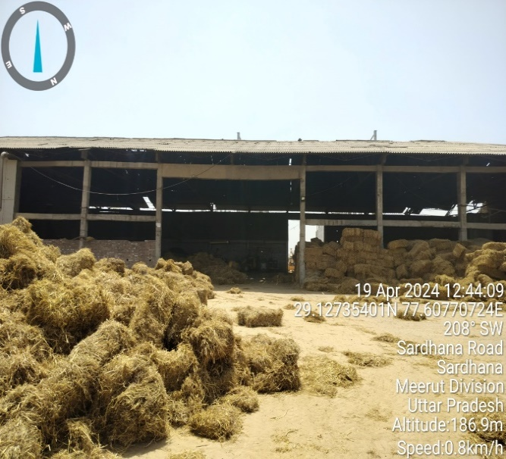
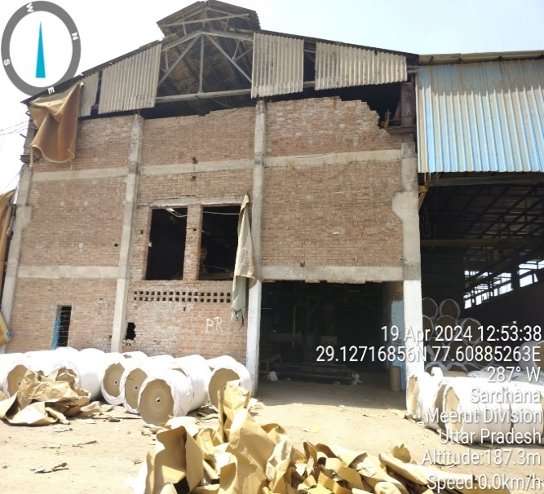 | 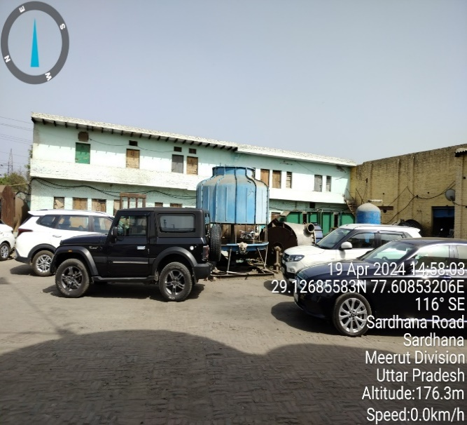
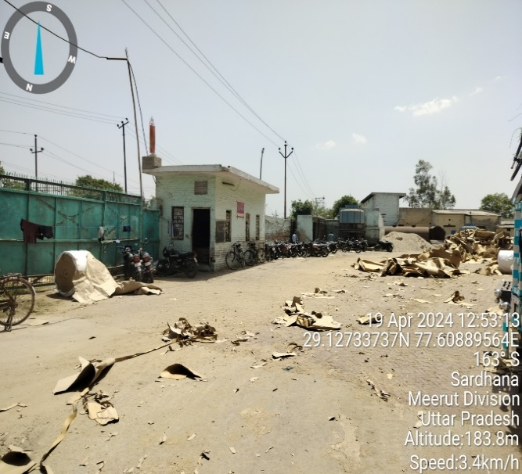 | 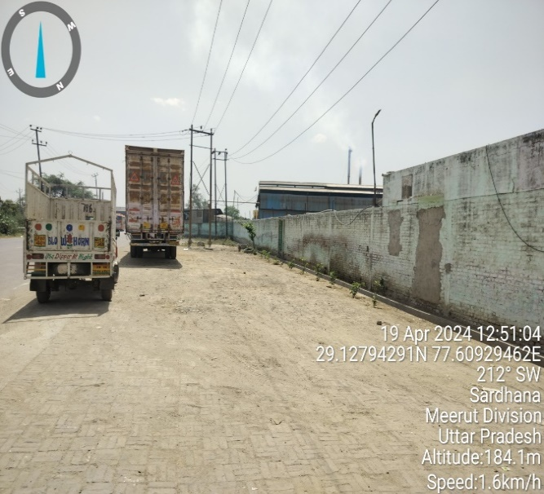
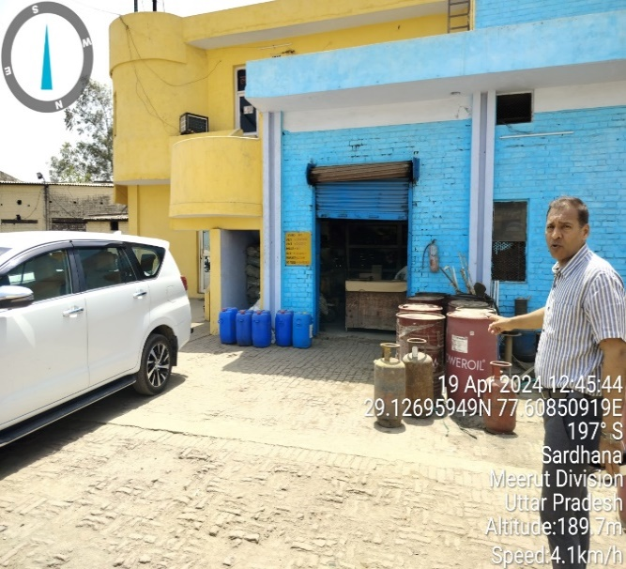 | 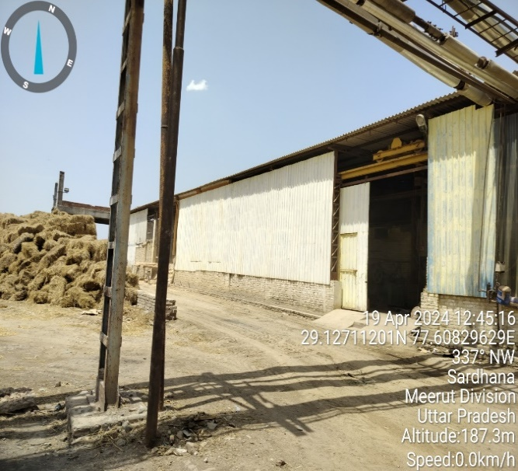
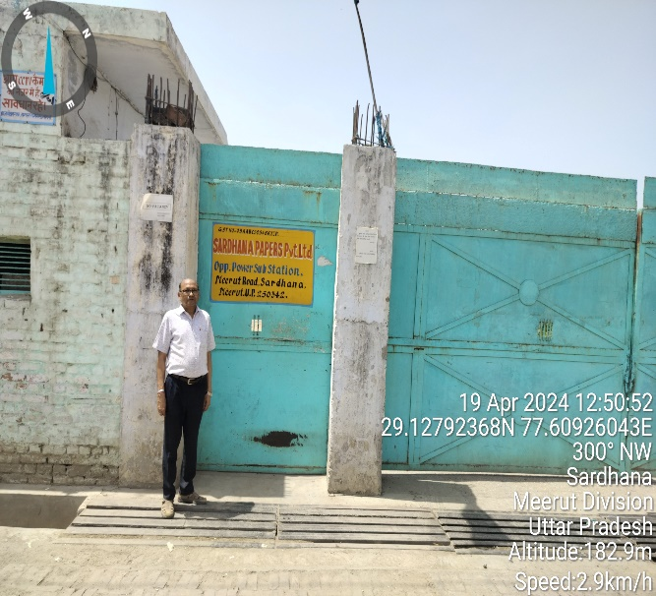 | 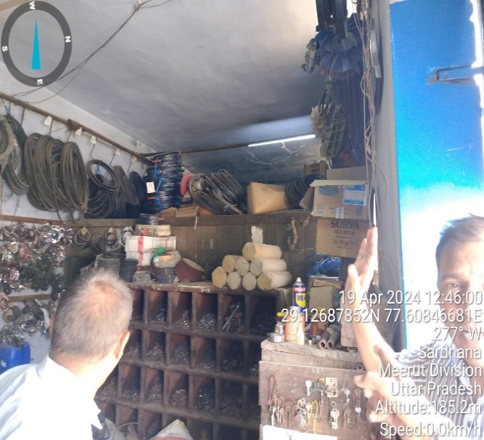
- BUILDING & CIVIL WORKS:
As per the approved layout plan, the proposed expansion would be spreading over a covered area of ~6,432.44 Sq. at ground floor, out of which ~4,815.38 Sq. Mt. is required for machine shed, ~1,094.02 Sq. Mt. is required for Boiler and Turbine, ~216.42 Sq. Mt. is required for Fresh Water Reservoir and ~306.62 Sq. Mt. of covered area is required to house the various other machines like Pulper, Chimney, Ash Silo, Turbine Motors, etc.
As per the status shared by the client and verified by us during the site visit on 19th April 2024, the boundary wall of the site location has been completed. Apart from that, the pillars of Machine Hall and Boiler & Turbine House have also been completed.
Proposed expansion was found under construction and Building & Civil work is in progress. The details regarding the status of Building & Civil Work at the time of site visit is shown below:
Civil Work | Status
Boundary wall | Completed
Machine Hall | Steels columns are erected, covering and roof cover is due
Boiler & Turbine | Column work is in progress
Detailed bifurcation of the proposed Building & Civil works has been shown in the below table:
Particulars | Height | Length | Breadth
Main Machine Hall | 21 meters | 140 meters | 31 meters
Boiler & Turbine House | 25 meters | 31 meters | 23 meters

AAs per the estimated cost of proposed Building & Civil works provided by the client, the proposed cost along with the cost already incurred for the said structure is shown below:
Structure | Total Proposed Cost | Cost Already Incurred
Boundary wall | INR 43.50 lacs | INR 43.50 lacs
Main Machine Hall | INR 60.50 lacs | INR 20.10 lacs
Boiler & Turbine House | INR 42.00 lacs | INR 15.00 lacs
TOTAL | INR 146.00 lacs | INR 78.60 lacs

Thus the company has achieved ~53.84% physical progress as shown above. The estimated cost of the Building & Civil works has been provided to us by the client. It is to be noted here that the cost vetting of the proposed expansion project is out of scope of this report. As a TEV consultant, the estimated Building & Civil works cost has been verified independently by us, which we found reasonable & in the permissible range while it may change as per specifications & material brand.

- PLANT & MACHINERY/ EQUIPMENTS DETAILS:
As per the contract agreement executed on 1st January 2024 with EPC consultant, Company has appointed a Gujrat based Business consultant & service Provider Mr. Piyush Desai, who will be providing engineering services and helping in procurement of Plant & Machinery as per scope of work of the agreement. Detailed bifurcation of the proposed Plant & Machinery has been shown in the below table along with the estimated cost:
Particulars | Supplier | Amount | GST | Total
List of Plant and Machinery
Machine Section | CAD Paper Machine Pvt Ltd | 20,01,00,000 | 3,60,18,000 | 23,61,18,000
Pulp Section & Pressure Screen | Su-Tantra Equipment Pvt Ltd | 2,50,00,000 | 45,00,000 | 2,95,00,000
Scanner | Any Reputed Supplier | 50,00,000 | 9,00,000 | 59,00,000
Motor | Any Reputed Supplier | 50,00,000 | 9,00,000 | 59,00,000
Drives | Any Reputed Supplier | 1,25,00,000 | 22,50,000 | 1,47,50,000
Cable | Any Reputed Supplier | 50,00,000 | 9,00,000 | 59,00,000
Pumps | Any Reputed Supplier | 50,00,000 | 9,00,000 | 59,00,000
Pipeline | Any Reputed Supplier | 50,00,000 | 9,00,000 | 59,00,000
Vacuum Pump | Premier Pumps Pvt Ltd | 1,05,00,000 | 18,90,000 | 1,23,90,000
Overhead Crane | Pull-Mac Cranes India Pvt Ltd | 1,48,70,000 | 26,76,600 | 1,75,46,600
Miscellaneous-Freight inward & Escalations | L.S | 59,35,400 | - | 59,35,400
Foundation & Erection Work | L.S | 70,00,000 | 12,60,000 | 82,60,000
Sub-Total |  | 30,09,05,400 | 5,30,94,600 | 35,40,00,000
List of Boiler & Turbine Machinery
Boiler 40MT with ESP, 2 No Feed Pump, VPD, PLC Panel & Other | Industrial Boilers Limited | 9,15,00,000 | 1,64,70,000 | 10,79,70,000
5MW Back Pressure Turbine along with Alternator, Gear Box & Control Panel | I B Turbo Pvt Ltd | 3,21,00,000 | 57,78,000 | 3,78,78,000
Steel Structure for Boiler & Turbine | Jupiter International Infra Pvt Ltd | 3,23,75,000 | 58,27,500 | 3,82,02,500
Erection Boiler, Turbine, ESP | CAD Paper Machine Pvt Ltd | 1,00,00,000 | 18,00,000 | 1,18,00,000
Chimney | CAD Paper Machine Pvt Ltd | 40,00,000 | 7,20,000 | 47,20,000
Boiler & Turbine Shed | CAD Paper Machine Pvt Ltd | 60,00,000 | 10,80,000 | 70,80,000
DM Plant | CAD Paper Machine Pvt Ltd | 50,00,000 | 9,00,000 | 59,00,000
Ash Handling | CAD Paper Machine Pvt Ltd | 60,00,000 | 10,80,000 | 70,80,000
Fuel Handling | CAD Paper Machine Pvt Ltd | 20,00,000 | 3,60,000 | 23,60,000
SOX, NOX | CAD Paper Machine Pvt Ltd | 21,40,000 | 3,85,200 | 25,25,200
Non-Pressure Part, Ducting, Platform, Ladder, Railing, Elevator, MCC Panels, Cables, Electricals, Refectories, Insulation, Compressor | CAD Paper Machine Pvt Ltd | 4,00,00,000 | 72,00,000 | 4,72,00,000
Cooling Water | CAD Paper Machine Pvt Ltd | 20,00,000 | 3,60,000 | 23,60,000
Feed Water Tank | CAD Paper Machine Pvt Ltd | 5,00,000 | 90,000 | 5,90,000
PRDS, High Pressure Pipeline, Low Pressure Pipeline, Turbine Oil & Centrifuge | CAD Paper Machine Pvt Ltd | 15,00,000 | 2,70,000 | 17,70,000
EOT Crane | Pull-Mac Crains India Pvt Ltd | 66,01,600 | 11,88,288 | 77,89,888
Miscellaneous-Freight inward & Escalations | LS | 53,40,000 | - | 53,40,000
Auxiliaries- Stair Case, Platform, Relling, Pipe Line Support | CAD Paper Machine Pvt Ltd | 40,00,000 | 7,20,000 | 47,20,000
Pre-operation-: Nut, Bolt, Packing, Brass steam, Taper wage etc. | CAD Paper Machine Pvt Ltd | 40,00,000 | 7,20,000 | 47,20,000
Sub-Total |  | 25,50,56,600 | 4,49,48,988 | 30,00,05,588
Grand Total with GST |  | INR 65,40,05,588

Thus, as per shared quotations and invoices provided by the client, the estimated cost for plant & machinery will be ~INR 65.40 crores including the applicable GST of 18%. Currently company has already paid the advance of INR 10.77 Cr. for capital goods.
The estimated cost of the Plant & Machinery has been provided to us by the client. It is to be noted here that the cost vetting of the proposed expansion project is out of scope of this report. However, as a TEV consultant, the cost of major plant & machinery has been verified by us independently, which we found reasonable & in the permissible range although the cost may change as per specifications & brand.

- UTILITIES: Details of Water, Electricity and other utilities are as below:
- WATER:
The source of water to meet the plant’s make up water requirement will be through Bore wells. The company had already obtained NOC certificate for ground water from Uttar Pradesh government (Ref: Certificate Number: REG047206, Valid from 05.12.2021 to 04.12.2026)
As per the data/information provided by the client, Company needs 1.6 KL of water per ton of paper production. Now, the company is also planning to construct a fresh water reservoir to meet its water requirements in-house.
- ELECTRICITY:
As per the data/information provided to us by the client, the company has a sanctioned load of 2000 KVA for the existing plant. Now the company is planning to install in-house 5MW cogeneration power plant which will be sufficient for both the existing and proposed expansion. However, as per the information shared with us, the company will keep its sanctioned load of 2000 KVA and will pay fixed charges for the electricity connection.

PART E | PROJECT TECHNICAL DETAILS

- PROPOSED CAPACITY OF KRAFT PAPER MANUFACTURING UNIT:
As per the data/information provided by the client, Company has decided to increase its capacity from existing 36,000 MTPA to 86,000 MTPA through the proposed expansion project along with 5MW cogeneration power plant as shown in the below table:
Year | Installed Capacity Mt | Capacity Utilisation% | Production in M.T. | Sales in M.T.
2024-25 | 36000 | 100% | 36000 | 35500
2025-26 | 86000 | 80% | 68800 | 68117
2026-27 | 86000 | 82% | 70520 | 70484
2027-28 | 86000 | 84% | 72240 | 72204
2028-29 | 86000 | 86% | 73960 | 73924
2029-30 | 86000 | 88% | 75680 | 75644
2030-31 | 86000 | 90% | 77400 | 77364
2031-32 | 86000 | 92% | 79120 | 79084
2032-33 | 86000 | 94% | 80840 | 80804
Source: Data provided by client
- PRODUCTION PROCESS:
- KRAFT PAPER SECTION
The detailed process of manufacturing kraft paper includes the following steps:
- Collection: First of all, the waste paper is collected from various sources such as offices, shopping malls, markets, etc. Then the collected paper is wrapped in tight bales and then transported to the paper mill.
- Sorting: Paper is sorted into different grades such as newspapers, duplex, white cutting, boards, core pipes, etc. suitable for manufacturing different grades of papers. Afterwards, the bales are transferred to the conveyors.
- Wire Section: At the wet end of the paper machine sits the headbox, which distributes a uniform jet of watery stock. The liquid falls onto the wire or forming fabric. Beneath the wire foils (short for hydrofoils) remove water and improve fibre uniformity, ensuring that the fibres weave together in a tight mat. The wire passes over suction boxes that vacuum out the water, leaving a soft mat of pulp that forms the paper sheet, also known as the paper web. By now the wire has travelled 30-40 metres. The water content has dropped to 75%-80%, and the web has lost its wet sheen.
- Press Section: The next stage of water removal consists of passing the paper web through a series of nip rollers that squeeze the water out of the pulp mat. This pressure also compresses the fibres so they intertwine to form a dense, smooth sheet. At this stage, about 45%-55% of the water content is reduced.
- Drying Section: The paper web goes through a number of steam-heated drying cylinders. They are warmed up to 130°C using steam heat to ensure that the paper is now 80% to 85% dry. Wet sizing solution is now applied to the paper in order to add a thin layer of starch to the surface. At the end of this process, the paper roughly loses 93% of its water.
- Finishing: To give the paper a smooth and glossy surface to optimise it for printing, the paper passes through a set of smooth rollers, which can be hard or soft, that press the paper.
- POWER PLANT SECTION
A steam turbine is driven with high pressure steam produced by a boiler or heat recovery steam generator (HRSG). Unlike gas turbines or microturbines, steam turbines do not directly consume fuel. Rather, the fuel driving the process is the fired boiler or plant equipment that produces heat for the HRSG (e.g., a gas turbine).
Steam turbine’s function based on the well-known Rankine cycle as per the image shown below. The thermodynamic cycle involves several stages:
- Water pumping: Water is first pumped to a high-pressure level.
- Heating: The high-pressure water is then heated to generate high-pressure steam.
- Expansion: The high-pressure steam passes through a steam turbine, where its energy is converted into mechanical power.
- Power generation: The mechanical power from the turbine drives an electrical generator, producing electricity.
- Combined Heat and Power (CHP): In CHP configurations, the low-pressure steam exiting the turbine is utilized to meet on-site thermal needs, such as heating or other industrial processes.
- Condensation and Return: The steam, after expanding through the turbine, condenses back into a liquid state. The condensed liquid is then returned to the pump, and the cycle repeats.
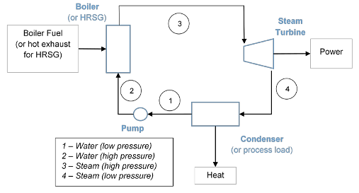
This continuous cycle of water pumping, heating, expansion, power generation, and condensation allows steam turbines to efficiently convert steam energy into both mechanical power and thermal energy, making them suitable for various applications, including combined heat and power systems. Steam turbines used in combined heat and power (CHP) applications can be categorized as either non-condensing or extraction turbines.
- Non-condensing turbines, also known as backpressure turbines, release the exhaust steam directly into an industrial process or a steam distribution system. These turbines are typically operated at common pressure levels such as 50, 150, and 250 pounds per square inch gauge (psig). Lower pressures are often employed in district heating systems, while higher pressures are more commonly used in industrial processes. The backpressure turbine configuration allows for flexibility in meeting specific steam pressure requirements.
- Extraction turbines feature openings in their casings to extract steam at an intermediate pressure level. This extracted steam is then utilized in CHP setups that require steam pressures higher than those available from backpressure turbines. By extracting steam at different pressure points, extraction turbines enable the optimization of steam usage in CHP systems with varying thermal energy demands.
Irrespective of whether they are backpressure or extraction turbines, the primary objective of most steam turbine CHP systems is to deliver substantial amounts of thermal energy, with electricity generation being a by-product of heat generation. Consequently, these systems typically exhibit low power-to-heat ratios, often below 0.2. This emphasis on maximizing thermal energy output ensures that steam turbine CHP systems are highly efficient in meeting the thermal needs of industrial processes or district heating while simultaneously producing electricity.

- PROCESS FLOW CHART:
- KRAFT PAPER SECTION
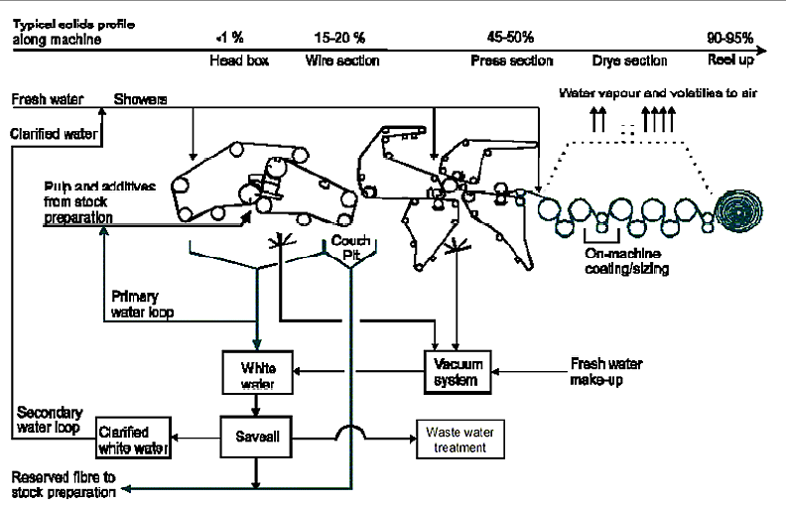
PULP MILL FLOW SHEET
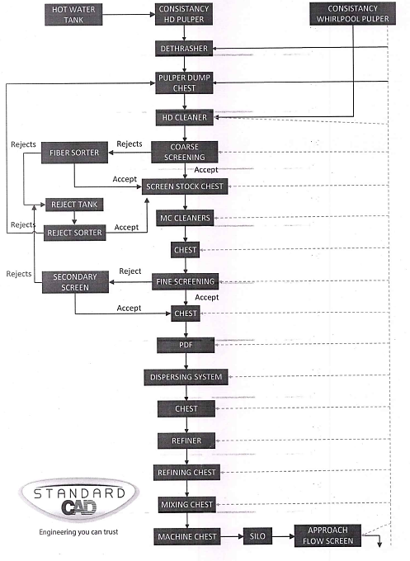

PAPER MACHINE FLOW SHEET
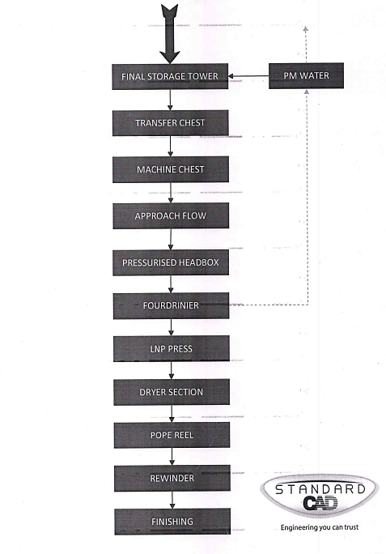
- POWER PLANT SECTION
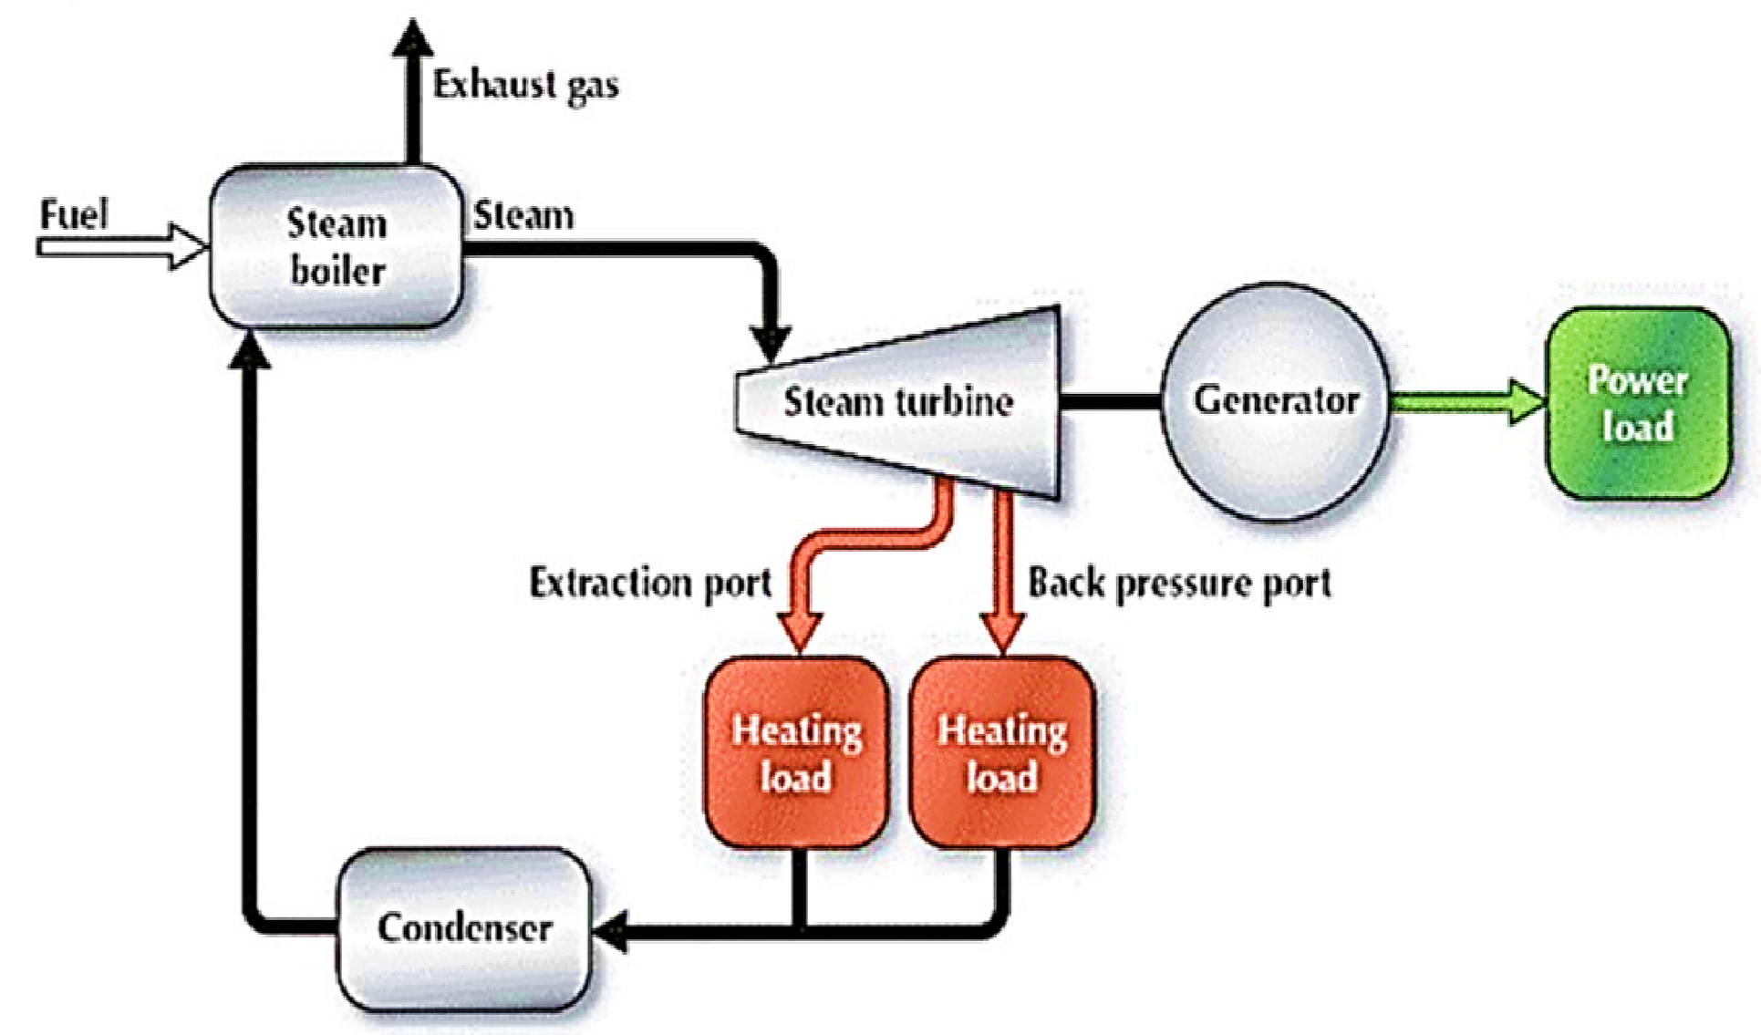
- PROPOSED TECHNOLOGY (KRAFT PAPER UNIT):
- TECHNOLOGY USED:
Company is producing recycled Kraft paper, which is developed from recycled paper and paper products. The fibres of recycled Kraft paper are smaller in size and it has less bright appearance than other Kraft papers.
During the site visit we found that the existing unit of the company is a semi-automatic Kraft paper manufacturing plant. As per discussion with the company, the proposed expansion project would be commissioned with an installed capacity of 50,000 MTPA and the plant would be semi-automatic in nature as similar to the existing unit.
Kraft paper machine used by company, mainly consists of three sectional systems namely forming section, press section, drying section, and lastly the calendar section. Kraft Paper machines systems are the drive systems that increase the performance of the machine and delivers improved quality of the paper.
As per the informed by the client, company has proposed to use recycling technology as similar to the existing unit. Recycling can be defined as the conversion of waste paper into useful Kraft Paper. The waste paper is pulped with water and chemicals to remove plastic, staples and glue etc.
- MODERN/LATEST TECHNOLOGY:
The latest technology in Kraft paper machineries is automatic PLC control system. A Programmable logic controller (PLC) is an industrial microprocessor-based controller with programmable memory used to store program instructions and various functions.
This high-end technology has paved the way to an easy manufacturing process in the pulp and paper industry. With the help of automatic PLC system, the machine gains ample speed and faster manufacturing with lesser human efforts. The increased speed reduced the time taken for manufacturing of the products and thus, saves energy and power.
The latest innovations in paper manufacturing are transforming the industry in many ways. They are making paper production more sustainable, efficient, and cost-effective, while also improving the quality and functionality of paper products. These innovations are using advanced technologies such as digital printing, nanotechnology, and smart paper, and are exploring new materials and production methods such as biodegradable paper, lightweight corrugated board, and pulp molding.
Overall, these innovations are helping the paper industry to adapt to changing market demands and consumer preferences, while also addressing environmental concerns and contributing to a more sustainable future.
- TECHNOLOGICAL ASSESSMENT:
As per the above technical analysis, M/s Sardhana Paper Pvt. Ltd. is using the technology which is a prevailing, going on, recognized and trending in the market at present. Thus, based on the above analysis, it seems to be reasonable to comment that the company will be technologically viable by holding the ownership of the proposed equipment, plant & machinery.
- TECHNICAL ASSESSMENT (POWER PLANT SECTION):
- TECHNOLOGY USED AND PERFORMANCE CHARACTERISTIC:
As per the information provided by the client, the company will be installing a steam turbine of 5 MW alongwith the boiler of 40TPH. Steam turbines are also commonly used for combined heat and power (CHP) installations (see the table below for summary of CHP attributes).
Size range | Steam turbines are available in sizes from under 100 kW to over 250 MW.
Thermal output | CHP configurations use backpressure or extraction steam turbines to generate power and thermal energy. Backpressure steam turbines produce low pressure steam while extraction turbines deliver both low pressure and medium pressure steam.
Part-load operation | Steam turbines have relatively good part-load performance, but efficiency does decline as power output is reduced.
Fuel | Boilers are commonly used to generate steam required for steam turbines, and boilers can utilize a wide range of fuels, including natural gas, oil, coal, and biomass. For CHP applications, steam turbines are often implemented when there is access to a low-cost opportunity fuel that can be combusted in a boiler to generate steam.
Reliability | Steam turbines are a mature technology with excellent durability and reliability.
Other | Steam turbines are typically designed to deliver relatively large amounts of thermal energy with electricity generated as a by-product of heat generation. Overall CHP efficiencies can reach or exceed 80%.

PERFORMANCE CHARACTERISTICS:
The performance characteristics for three representative backpressure steam turbines used in CHP applications with electric power capacities of 500 kW, 3 MW, and 15 MW are shown in the table below:
STEAM TURBINE PERFORMANCE CHARACTERISTICS WHEN INTEGRATED WITH A NATURAL GAS BOILER
Description |  | System
Description | 1 | 2 | 3
Net Electric Power (kW) | 500 | 3,000 | 15,000
Fuel Input (MMBtu/hr, HHV) | 27.2 | 208.0 | 700.1
Steam Flow (lbs/hr) | 20,050 | 152,600 | 494,464
Steam Inlet Pressure (psig) | 500 | 600 | 700
Steam Inlet Temperature (°F) | 550 | 575 | 650
Steam Outlet Pressure (psig) | 50 | 150 | 150
Steam Outlet Temperature (°F) | 298 | 373 | 380
Useful Thermal (MMBtu/hr) | 20.0 | 155.5 | 506.8
Power to Heat Ratio | 0.086 | 0.066 | 0.101
Electric (%, Efficiency HHV) | 6.3% | 4.9% | 7.3%
Thermal (%, Efficiency HHV) | 73.3% | 74.8% | 72.4%
Overall (%, Efficiency HHV) | 79.6% | 79.7% | 79.7%
As indicated, all three systems have overall efficiencies near 80% and power to heat ratios of 0.1 or lower. High overall efficiencies and low power to heat ratios are common characteristics for steam turbines configured for CHP applications.
- LATEST/MODERN TECHNOLOGY:
A steam turbine is an important component in a combined heat and power plant, converting biomass, RDF/SRF, or waste into electricity and/or steam. As per our tertiary research and the information available on the public domain, there are some advancements in steam turbines in the last few years like Advanced Blade Designs, Supercritical and Ultra-Supercritical Steam Conditions, Combined Heat and Power (CHP) Systems, Improved Efficiency through Reheat and Regenerative Systems, Digitalization and Predictive Maintenance, Advanced Control Systems, etc. These advancements collectively aim to make steam turbines more efficient, reliable, and environmentally sustainable, thus contributing to the transition towards cleaner and more sustainable energy systems.
As per the above technical analysis, the company is using Combined Heat and Power (CHP) technology which is a prevailing, going on and recognized in the market at present. Thus, based on the above analysis, it seems to be reasonable to comment that the company will be technologically viable by holding the ownership of the proposed steam turbine & boiler for the existing as well as proposed kraft paper manufacturing unit.
- TECHNICAL ASSESSMENT OF VIABILITY:
As per the information provided by the client, the company is consuming ~350 units of electricity to produce per MT of Paper at present and the current electricity rates are around INR 6.50 – INR 7.00 per unit from public electricity grid which makes the current electricity cost per tonne of paper to be around INR 2350 PMT.
After installation of Turbine, the electricity consumption from government grid would be NIL and all the consumption will be through captive production thus cost will be reduced to fixed charges only which are around INR 74,82,000 (2000 KVA Load * INR 311.75 per KVA * 12 months).
Although, the turbine will require steam to operate thus the company is installing a New Boiler which has a capacity to produce around 40 Tons of Steam per hour. So, there will be an increase in fuel cost. Currently, the company is incurring fuel cost of around INR 1300 to produce per MT of paper. As per the information provided by the client, this cost will increase by approx. 30-40% thereby increasing fuel Cost to around INR 1800 PMT.
So approximate net savings due to Installation of turbine and boiler for FY 2025-26 will be as follows:-

Particulars | Calculation | Description
Financial Year |  | 2025-26
Capacity Utilization |  | 80%
Production | Total Capacity = 86,000 MT * 80% | 68,800 MT
Calculation of Saving Power Cost
Power Cost PMT if no Turbine is installed |  | INR 2,350 PMT
Total Power Cost if no Turbine is installed | (INR 2,350 PMT * 68,800 MT) - A | INR 16,16,80,000.00
Power Cost if Turbine is installed (Fixed Charges only) | (2,000 KVA Load * INR 311.75 per KVA per month * 12 months) - B | INR 74,82,000.00
Savings in Power Cost | (A - B) = C | INR 15,41,98,000.00
Calculation of Increase in Fuel Cost
Fuel Cost PMT if no Turbine is installed |  | INR 1300 PMT
Total Fuel Cost if no Turbine is installed | (INR 1,300 PMT * 68,800 MT) - D | INR 8,94,40,000
Fuel Cost PMT if Turbine is installed | (Fuel Cost increased by around 30-40% after installation of Turbine) | INR 1800 PMT
Total Fuel Cost PMT if Turbine is installed | (INR 1,800 PMT * 68,800 MT) - E | INR 12,38,40,000
Increase in Fuel Cost | (E - D) = F | INR 3,44,00,000
Savings in Power cost less Increase in Fuel Cost | (F – C) = G | INR 11,97,98,000.00
Instalment (Principal + Interest) of INR 25 Crores Proposed Term Loan in FY 2026-27 | H | INR 4,21,74,996.00
Net Savings/ Surplus to company after payment of Instalment of Term Loan | G - H | INR 7,76,23,004.00
Thus, the decision to install a new 40TPH Boiler and 5MW Steam Turbine for Inhouse production of electricity for cost saving purpose seems to be an economical decision of the management and it also seems to be technically viable to install Combined Heat and Power (CHP) System based power generation plant
- TESTING/QUALITY ASSURANCE:
Quality is an important ingredient of kraft paper manufacturing process. Utmost emphasis is placed on the quality of the products of the company. Every Kraft Paper Product undergoes stringent quality tests, across various parameters, at different stages of manufacture.
As per the data/information provided to us by the client, all the contemporary machines are equipped for efficient drying and quality control. This ensures the production of high quality Kraft Paper with uniform and superior basis weight and moisture that meet International Quality Standards.
Company ensures the quality check of the product based on the criteria such as Strength, Burst, Tear and Moisture, GSM (Grams per Square Meter), Load Bearing Capacity, Surface Finish, Cobb Value, Dimensions etc.
As per communicated by client, company will be having a quality control Laboratory, wherein, they check the entire range on defined parameters like design, quality and finish. The unit is proposed to be equipped with all the essential tools, machine, and technology in order to ensure the production quality as per the standard benchmark for the expansion project.
- MANPOWER:
As per the data/information shared by the client, currently the company has employed 99 workers including the production staff and administrative & managerial staff. The additional executive level of manpower, i.e., CA/CS, GM & sales manager are not required for the new project as the duties will be taken by the existing executive manpower as new expansion project will be benefitted by existing management.
As per information provided by the company, an estimate of manpower requirement allowing for leave, absentecism, sickness and holidays for smooth and for efficient operation of different sections of the plant including its administrative and commercial departments, has been prepared based on technical and management ground primarly to indicate the order of manpower requirement. The company has estimated an additional 72 workers will be required when expanded paper manufacturing plant will be operational. The basic structure of the manpower will require the following kind of resources:
Particulars | No. of Man power
Supervisory | 5
Admin of Official staff | 7
Skilled Labour | 20
Unskilled Labour | 40
TOTAL | 72

PART F | PRODUCT PROFILE

- INTRODUCTION:
Kraft paper is primarily used in the corrugated box packaging industry. In India, recycled Kraft paper is among the widely utilized types, and plays a crucial role in manufacturing multi-ply corrugated boxes, with the common ones being 3-ply, 4-ply (litho laminated), 5-ply, and 7-ply boxes. Sometimes even 9 ply and 11 ply boxes are made.
 | Types of Kraft Paper and Their Best Business Uses
S. No. | Type of Kraft Paper | Description
 | Virgin Natural Kraft Paper | - Virgin natural kraft paper is the heavy lifter of the paper world. Its clean and durable fiber content and its low cost make it an ideal option for heavy-duty applications that require a high level of tear resistance.  - It is perfect for printing as well, so it's a natural for branded packaging and protective layering, wrapping, pallet interleaving, carrier sheets, and dunnage.  - Virgin kraft paper come standard in weights from 30# to 70#
 | Natural Recycled Kraft Paper | - Although not as strong and tear resistant as virgin natural kraft, natural recycled kraft paper is a more environmentally friendly option, and still carries enough strength to do an excellent job with dunnage and void fill applications, as liners for trays and boxes, interleavers, and bottom wrap for newspapers.  - Recycled kraft paper come standard in weights from 30# to 70#
 | Black Kraft Paper | - The most common use of black kraft paper is as a dark, durable backing for pictures frames, but that’s not its only use.
 | Colored Kraft Paper | - Colored kraft paper is available in just about every color of the rainbow. Its vibrant hues make it perfect for all manner of craft projects, as well as fun backings for bulletin boards, standard school supplies, scrapbooking, and similar applications.
 | White or Bleached Kraft Paper | - Similar to virgin natural kraft in strength and durability, white or bleached kraft paper makes an especially powerful impact when a crisp, clean appearance is desired.  - Many restaurants like to use white kraft paper as an attractive and economical alternative to linen tablecloths.  - It also serves well for wrapping and can stand up well to the standard wear and tear a package may receive.
 | Printed Kraft Paper | - Many different industries take advantage of the versatility and value of custom printed kraft paper for creating branded wrapping, packaging, and in-store displays.  - Many fashion manufacturers ship their garments out with printed kraft paper sleeves or sheets between individual articles, or wrapping the inside of a shoebox, again with branded logos and other information prominently displayed.
 | Insulating Kraft Paper | - Insulating kraft paper is treated with special additives to improve its electrical insulating properties. It is used in electrical applications to provide insulation and protection.  - It is widely used in Electrical Insulation, High Voltage Cables
 | Bituminized Kraft Paper | - Bituminized kraft paper is coated with bitumen, a type of asphalt or tar, on one or both sides. The bitumen coating provides water resistance and enhances its durability.  - It is widely used in Roofing Underlayment, Pipe Wrapping
 | Medical Grade Kraft Paper | - Medical grade kraft paper is specially manufactured to meet the stringent requirements of the medical and healthcare industries.  - Medical grade kraft paper is used in medical packaging for sterilization purposes. It is commonly used in packaging items for autoclaving and ethylene oxide (ETO) sterilization.  - It is used in hospitals and healthcare facilities to wrap medical instruments and equipment for sanitation and hygiene.
Source: Data/information available in public domain.
The key specifications that determine the quality and usability of Kraft paper are GSM (Grams per Square Meter) and BF (Burst Factor). These parameters influence the paper's strength, weight, thickness, and durability.
- PRODUCT CATEGORY:
GSM is a metric that describes the weight of the paper per square meter. A higher GSM means a heavier and thicker paper, often indicating a higher quality product. For example, a newspaper might have a GSM of around 55, while a business card might be 350 GSM.
The range of GSM values in paper production can vary significantly based on the intended use of the paper. Higher GSM values typically correlate with increased paper thickness and, subsequently, higher strength and stiffness. The type of box (3-ply, 5-ply, or 7-ply) is often associated with specific Board GSM values to ensure the box's durability and resilience.
The Bursting Factor is a key indicator of the strength of Kraft paper. It signifies the pressure the paper can withstand before rupturing, calculated by a standard method. A higher BF means the paper has a higher burst strength, making it suitable for applications requiring superior quality and toughness.
 | Types of Recycled Kraft Paper Based on GSM and BF
S. No. | Grade of Craft Paper | Description
 | Low GSM (100-150) and Low BF (14-18) | - This type of Kraft paper is lightweight and relatively less robust due to its lower GSM and BF. It is generally used for making 3-ply boxes, ideal for packaging lightweight items like cosmetics, pharmaceutical products, and small electronic items.
 | Medium GSM (180-200) and Medium BF (20-22) | - This category offers a balanced combination of weight and strength. Its medium GSM and BF make it versatile, suitable for creating 3-ply and 5-ply boxes.  - These boxes are used to package slightly heavier items like books, toys, and kitchen appliances. At U-Pack we use 180 GSM paper to make our corrugated carton boxes.
 | High GSM (230-250) and High BF (24-28) | - High GSM and high BF Kraft paper offer the best strength and durability. It is commonly used to manufacture 5-ply and 7-ply boxes, perfect for shipping heavier items like home appliances, machinery, and automotive parts.
Source: Data/information available in public domain.
Company is manufacturing 18 B.F. Kraft paper with GSM ranges from 120-230 in the existing manufacturing unit having the capacity of 36,000 MTPA. After commissioning the proposed expansion project with the capacity of 50,000 MTPA, company will be able to manufacture 20 BF Kraft paper with GSM ranges from 80-230 also.
- 18 BF KRAFT PAPER, GSM: 120 – 230:
M/s Sardhana Papers Private Limited is producing 18 BF Kraft Paper at present in the existing unit, which is available in various length and thickness as per the client' specifications.
Company’s array of Kraft papers is made with premium grade paper pulp owing to which the products have deluxe fair surface, smoothness and high strength. These Kraft papers are used in varied paper-based applications due to their perfect finishing and high seal-ability. Furthermore, it is also suitable for any type of cartons for FMCG products.
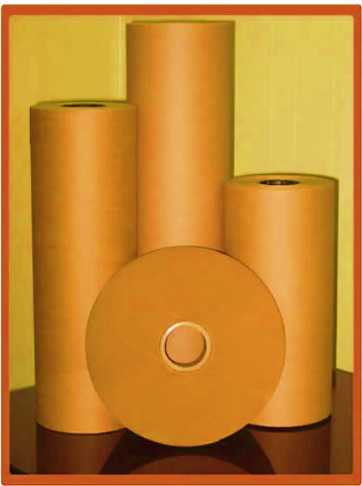
- 20 BF KRAFT PAPER, GSM: 80 – 230:
By commissioning the new proposed expansion project, company will be able to present an excellent quality assortment of 20 BF Kraft Paper. With the assistance of the team of professionals, company will be able to provide a premium quality range of 20 BF Kraft Paper Roll. These Kraft Papers are used for roll type packaging.
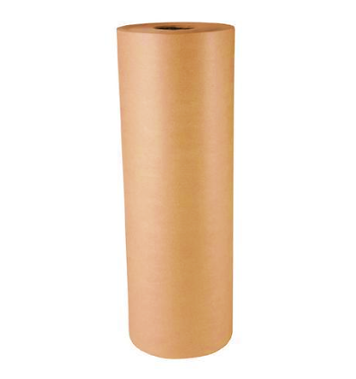
- PRICING STRATEGY:
After achieving the completion of the expansion of the existing unit, the company will be manufacturing the Kraft Paper in various grammage starting from 80 GSM and varying upto 230 GSM. As per data/information shared by the client, company will be selling its finished (Kraft paper) product through distributors at an average price of INR 26,250 for FY 2024-25 & INR 28,000 per MT post COD.
As per the current market scenario and as per our tertiary research on the industry trends, we found that the average price per MT ranges from INR 21,250 per MT to INR 35,000 Per MT for more than 80 GSM paper depending on the quality and specification of the product.
Thus, the average selling price of 80-230 GSM Kraft Paper has been considered as INR 28000 per MT post COD, which is reasonable and on conservative side and is in the line with industry trends.
References:
- https://www.indiamart.com/proddetail/brown-kraft-paper-roll-17813142291.html
- https://www.indiamart.com/proddetail/200-gsm-kraft-paper-sheet-22073740833.html
- https://www.indiamart.com/proddetail/200-gsm-kraft-paper-roll-20045545148.html
- https://www.aajjo.com/paper-paper-products/brown-kraft-paper-for-packaging-150-to-200gsm-in-tirupur-sri-sanjiv-agency/product

- MARKETING, SELLING & DISTRIBUTION PLAN:
The company has been in the business of manufacturing Kraft Paper since 1987. As per information provided by the company, the company has a strong customer base. Currently, the company is receiving excess demand than its production capacity which is one of the main reasons for expansion of the plant. The company will sell its increased production to the existing customers.
As per our market research and information available in the public domain, some of the top most competitor of M/s Sardhana Papers Pvt Ltd are in a range of around 80-100km of site location.
M/s SPPL knows that marketing in the business is extremely important. When marketers know their customers, they are able to connect with them on an emotional level and develop a product as per their requirements. This will be a win-win situation for both the businesses as well as the consumers.

PART G | RAW MATERIAL ANALYSIS

- INTRODUCTION:
Kraft paper is the most used material in packaging Industry. It is made by the sulphate pulping process. The product to be manufactured under the envisaged project is high B.F. Kraft paper, which is the most important raw material in the Packaging Industry particularly after the ban on plastic.
In the manufacturing process, colors and chemicals like S.S. Powder, Maize, Starch, Retention-Aids & B.F. Booster etc. are used as per requirement.
The major raw materials used by the company for production of High-quality Kraft Paper is Indian Waste Paper with a yield of about 95% to produce High quality Kraft Paper of required strength. The Waste Paper required is old used Cartons, Boxes and Scrap Paper.

- RAW MATERIAL USED:
As per the information shared by the client, the raw materials to be used in the manufacturing of Kraft Paper by M/s Sardhana Papers Private Limited includes below mentioned list.
S. No. | Particulars | Average Rate (Per Kg)
1 | Waster Paper | 14.50
2 | Starch | 31.91
3 | S.S. Powder | 3.37
4 | Colour | 164.98
5 | Kore Size | 68.89
6 | Poly Aluminium Chloride (Powder) | 34.64
7 | Boiler Chemical | 153.62
8 | Retention Aids | 113.21
9 | Defoamer | 99.71
M/s Sardhana Paper Pvt. Ltd. will get the synergies from the existing running plant in regard to the raw material supply. Hence, this integration will be beneficial for the company. Since, Meerut area is well-known for the paper industry and the easy availability of the raw material will be an added advantage for the company.
As per our independent research and information available on public domain, the major raw material, i.e., waste paper has price ranging from Rs. 10500/- to Rs 20000/- per MT. The cost estimated by the company was also verified by the invoices/quotations shared by the client.
Thus, we considered the average price as INR 14500 per MT for indigenous waste paper which is reasonable and in the line with industrial trend.
References:
- https://www.indiamart.com/proddetail/pepar-scrap-27291278673.html?pos=2
- https://www.justdial.com/jdmart/Vadodara/Recyclable-Old-Notebooks-Scrap/pid-2221994896/0265PX265-X265-191220123221-Y1I5?idx=0&jdmid=jdm-1117809-ent-2-17740778&flow=result&searchfrom=b2b_prsltpg.
- https://www.justdial.com/jdmart/Navi-Mumbai/Waste-Paper-Scrap/pid-2220099319/022PXX22-XX22-220811165017-W2Z8?idx=0&jdmid=&flow=result&searchfrom=b2b_prsltpg
- https://www.indiamart.com/proddetail/used-paper-scrap-20196247648.html
- https://www.indiamart.com/proddetail/occ-waste-paper-scrap-2851118039355.html?pos=4
- https://www.indiamart.com/proddetail/paper-scrap-17022567930.html?pos=5

- RAW MATERIAL SUPPLY ANALSIS:
As per data information provided by the client, the promoters have established a strong network of suppliers, customers through their existing business. This network can be leveraged for sourcing raw materials, securing sales contracts, and establishing strategic partnerships. Their existing relationships in the industry will facilitate smooth operations and market penetration.
The company has long standing relationship with its suppliers thereby ensuring timely supply of key raw materials. As per the data/information shared by the client, the following list shows some of the major suppliers of the raw material of the company.
S. No. | Supplier Name | Description
1 | Shri Ram Enterprises | Waste Paper
2 | Om Shreekrishna Enterprises | Waste Paper
3 | HSJ Malik Trading Co. | Waste Paper
4 | Shakumbhri Craft & Tissue (P) Ltd. | Waste Paper
5 | Fortune Paper Trader | Waste Paper
6 | Agarwal Chemicals | Maize Starch
7 | Meshcon India | SS Powder
8 | Rang Creation | S.F.G. Yellow (Dyes)

PART H | INDUSTRY OVERVIEW

- INTRODUCTION:
The Indian Paper Industry accounts for about 4% of the world's production and is positive over the coming years. The growth is expected to be driven by the rising demand for paper products, which is majorly supported by various government education programmes. India’s per capita consumption of paper is just around 14 kg, one of the lowest in the world whereas for USA, it is around 320 kg, European Union -129 kg, Asia 45 kg and 75 kg in China. It is said, an increase of 1 kg in per capita consumption will lead to a demand of 1 million tonnes of paper products.
There are vast demands in the area of tea bags, filer paper, tissue paper, medical-grade coated paper, lightweight online coated paper, etc. This denotes a huge potential. However, the industry is facing challenge to adopt environment friendly technology and to practice conservation measures. Its capacity utilization is also wavering around 80% due to old technology.
From just 17 paper mills in the year 1951 with a capacity of 0.14 million tonnes, the Indian paper industry has grown to 825 mills with a total capacity of 17 million tonnes. While the paper Industry comprises a number of small-scale mills, relatively large mills continue to contribute to a sizable share of total production. Large Paper Mills, about 80 units accounts for production share of about 60% and balance smaller units produce the remaining 40% of paper goods.

- MARKET OVERVIEW:
India’s Paper Industry Sector is set to grow at a 7.81% CAGR over the next five years and will reach 27 million tonne capacity from the current capacity by 2028.
Printing & Writing (P&W): Printing and writing segment caters to school books, office stationery, printed textbooks, copier papers, notebooks etc. This segment forms ~31% of domestic paper industry. Governments thrust on education through steps like Sarva Shiksha Abhiyan, Right to Education, increase in e-commerce venture and other service sector are key factors contributing to the growth of this segment.
Packaging & Paper board: This segment primarily caters to packaging industry in tertiary and flexible packaging of FMCG goods, pharmaceuticals, textiles and e-commerce deliveries. This segment forms ~47% of the domestic paper industry and is currently rising rapidly due to factors of ecommerce, urbanization and higher share in organized retail in FMCG and pharmaceuticals. This is currently fastest growing segment owing to the above factors. On the packaging segment, corrugated boxes made of Kraft paper segment is highly
Unorganized with nearly 90 percent of the production coming from small and unorganized players. Within Paperboards, there is also a rising demand for Value-Added Paperboards (VAP)
Newsprint: Newsprint is used in production of newspaper & magazines industry. India has 84,000 Newspapers in multiple languages and 110 million copies in circulation. Newsprint segment forms ~18% of Indian paper industry. However, this segment is under stress from imports from South East Asia.
The urban population is driving the growth, with 80% of urban populace with read and writing ability, it creates a latent demand for consumption of newspaper/magazines. The regional media in tier-2 and 3 penetration is growing at 10-15%. Another case with India is newspaper have become brand advertorials and purchase guide.
The growing usage of compostable and sustainable packaging materials owing to the increasing awareness regarding the detrimental impact of plastic and other non-biodegradable variants is primarily propelling the growth of the Indian Kraft paper market.
Indian Kraft paper industry is fragmented across India and not even a single mill has more than 1% of market share, mostly all are into the MSME Sector and there are around 600 mills scattered across the country.
Most of these units are located at some of the most backward areas and offer millions of jobs to rag pickers, sorters, loaders, unloaders, truckers, etc. These Kraft paper mills are real eco-friendly turning waste paper into a quality Kraft Paper. It’s the paper waste recyclers who handle the waste and produce good quality packaging paper and supply to the converters who make the boxes for the end consumers.

- POLICY MEASURES:
The Excise Duty on Paper and Paperboard has been reduced to 10% and less under free trade agreement with many ASEAN over the years. This has resulted in increased imports and is in danger of dumping from China India and Indonesia. In the last nine years, imports have risen at a compounded annual growth rate of 11.34 per cent in value terms (from Rs 3,411 crore in 2010-11 to Rs 8,972 crore in 2019-20), and 13.23 per cent in volume terms (from 0.54 million tonnes in 2010-11 to 1.64 million tonnes in 2019-20).

- ENVIROMENTAL CONCERN:
The availability of paper pulp- the key raw-material has always been a matter of concern for the industry with increasing deforestation and civilization encroachment into pasture lands. The industry has been requesting the government to allot degraded revenue and forest lands to cultivate fodder for wood pulp and social forestry programme for generating feedstock. But nothing major has been done by government.
Another concern from environmentalists are water consumption and waste discharge. The industry which used to consume 200 cu. meter of water has reduced it now to 50 cu. meter and efforts are on to reduce it further to 40 cu. meter. Many paper mills have been forced to shut down on account of water shortage

- TECHNOLOGIES AND RELATED ISSUES:
Large number of industries has been facing issues due to obsolescence of technology used by them for paper making operations. The major problem in upgradation and modernization is due to the high capital requirement for up gradation and scale of operation at which no standard state of the art equipment and machinery are available.
The large number of small and micro level units operating in India face problems in technology up gradation, as most of them are based on decade’s old machinery. Three segments of industry namely-wood, agro and recycled fibre based have different technological levels.
Many of the agro and recycled paper mills still use conventional process technology which is otherwise obsolete by international standards. Some of the wood-based mills and few agro / recycled mills have upgraded the technology from time to time for improvement in the quality of paper, energy efficiency and reduction in the pollution load.
The foremost difference between the Indian paper industry and global leaders lies in the economies of scale. As compared to international capacities, we lag far behind. Scandinavian countries, USA, the Russian Federation, China, Indonesia and Japan are the major players in the field of pulp and paper.
These countries have some of the best available raw materials for paper production, cutting edge technologies and control the global trade. However, only a few mills in India employ the state-of-art technologies. One of the serious implications of technological obsolescence is the environmental impact which can be overcome only through appropriate technology upgradation and modernization.
The technological interventions required to fulfil the technology gaps may be taken up through a dedicated technology modernization programme in the wood and agro based & recycled fibre-based paper mills. Technology modernisation should basically aim to improve the competitiveness of industry through acquisition of state-of-art technologies. This can be achieved through Acquisition of proven technology of foreign or indigenous origin/design and drawing, Acquisition / license of patent rights, Acquisition of capital goods for transfer of process technology, Contractual R&D activities leading to technology upgradation of the units.

- CONCLUSION:
The rising focus of the Indian government authorities on banning the use of plastics is also creating a positive outlook for the Kraft paper market across the country. For instance, in June 2022, the Central Pollution Control Board (CPCB), a federal agency under the Ministry of Environment, issued a list of steps to be taken to prohibit the use of specific single-use plastic products.
Numerous other factors, such as the inflating popularity of Kraft paper in the printing and publication sectors and the introduction of advanced packaging solutions, including stand-up pouches, zipper pouches, etc., are anticipated to stimulate the Indian Kraft paper market over the forecasted period.
The paper Industry holds immense potential for growth in India as the per capita consumption globally is one of the lowest. Around 15 per cent of the world population stays in India but consumes only 5 per cent of the total paper produced in the world.
The technology modernisation & upgradation should lead to emergence of core competencies in critical areas including quantifiable increase in productivity, quality improvement with reduced cost, improvement in energy efficiency norms and better compliance with environmental protection legislations, safeguards for Eco sustainability of products as well as also compliance with legislation relating to patent as per the WTO regime. Issues faced by paper industry such as raw material upgradation, Resource conservation, Product quality, Process improvement, Energy conservation, Environmental compliance, Research & Development.
Paper industry is bracing for consolidation and now time is ripe for another round of consolidation and co-operation among various players in the next few years. The move will help leverage fast changing manufacturing technologies and smoothen backward integration for raw materials. At the end of this decade, we may see only 10 players dominating the industry like cement.
Despite the continued focus on digitization, India’s demand for paper is expected to rise 53 per cent in the next six years, primarily due to a sustained increase in thrust in rural education, growing ecommerce consumerism, increase in organized modern retailing, increasing use of documentation are expected to positively affect paper consumption and demand in India.

PART I | SWOT ANALYSIS

SWOT ANALYSIS
STRENGTHS | - Strategic Location: M/s Sardhana paper mill is located in Meerut, which is famous for paper mills. Two adjacent districts of Uttar Pradesh are well known belt of paper industry and having good connectivity with Delhi is also an additional advantage to contact with big dealers.  - Manufacturing Experience: Directors are having several years of experience in the same line of business & industry as company is running an existing unit having 36,000 MTPA capacity, hence new proposed expansion project is expected to get the synergies form the existing unit to achieve its desired economies of scale.  - Established chain of buyers and sellers: The company is running the kraft paper manufacturing plant since 1987 and has developed connections with both the buyers of the final product and suppliers of the raw material.  - Cogeneration: With the installation of Steam Turbine & Boiler, the company will be generating the electricity required in-house and the excess steam will be used in the production process. Therefore, the company will get dual benefits by installing the turbine and it will be able to remove its dependency on the external sources for the required power to run the plant.  - Synergies from existing Unit: Manpower, Management, Supply chain, market behaviour, bulk selling etc.
WEAKNESSES | - CAPEX: The CAPEX requirement in the pulp and paper industry is quite high as the majority of the plant and machinery used in the industry are quite expensive.  - Environmental Impact: Most of the paper manufacturing factories are associated with pollution and causing harm to adjacent areas.  - Depletion of Natural Resources: The kraft paper industry often involves the consumption of vast quantities of natural resources, including water and energy.  - GSM: Company is producing low and medium GSM Kraft paper only, thus can lose the opportunity to acquire the high GSM demanding customers.
OPPORTUNITIES | - Recyclability: Recycling can be defined as a great boost for the kraft paper industry as it uses the process of conversion of waste paper into useful Kraft Paper.  - E-Commerce: The increase in e-commerce industry has resulted in high demand for packaging solutions.  - Pizza & Medical Industry: These industry demand huge amount of Kraft paper to fulfil their day-to-day operations need which can boost higher demand of Kraft paper in India.  - Growing Demand: Demand for India’s Paper Industry Sector is expected to grow at a CAGR of ~7.81 % in the upcoming years.
THREATS | - Increasing Competition: The number of paper mills is growing and so is the competition between the mills.  - Entry of New Substitutes: Entry of substitutes like E-Paper, Eco-friendly Plastics and other similar products pose a threat to the kraft paper industry.  - Economic Factors: Profitability of the project may hamper due to any blockage of feed stock.  - Growth in the local distributors can also be assumed as a threat as they are focused on marginal costs and would prefer the paper mills that provide them with greater margins.  - Changing Government Regulations: New rules and regulations imposed by the Government regarding pollution and the environmental protection pose a constant threat to the industry.  - Water Scarcity for future: Water is one of the key necessary ingredients to manufacture Kraft Paper. But the scarcity of this natural resource is very critical for the paper industry.

PART J | PROJECT COST AND MEANS OF FINANCE
As per data/information shared by the client, the proposed expansion project of the Kraft Paper Manufacturing is proposed to be commissioned by making an investment of INR 70.73 crores as shown in the below table along with Means of finance:
Total Project Cost
S. No. | Capital Cost Head | Amount (INR Crores)
1 | Building | 1.46
2 | Plant & Machinery | 35.40
3 | Boiler & Turbine | 30.00
4 | Interest During Construction (IDC) | 3.87
 | TOTAL | 70.73

Means of Finance
S. No. | Particular | Amount (INR)
1 | Unsecured Loan/Cash Accruals | 15.73
2 | Loan from Banks (Existing for expansion) | 30.00
3 | Loan from Banks (Additional for Boiler & Turbine) | 25.00
 | TOTAL | 70.73
 | CC Loan | 14.00
Source: Data/Information provided by the company.
Notes:
- As per the information available with us, the company has already incurred INR 17.63 Crores on the proposed Kraft paper manufacturing expansion project till 31st March 2024, while for funding the proposed In-house 5 MW power plant, company is in the discussion with bank for additional term loan of INR 25.00 Crore.
- M/s Sardhana Papers Private Limited is operating an existing Kraft Paper Manufacturing Unit in Meerut, Uttar Pradesh, which is spread over an area of 48,970 Square meter, Out of the total area of existing unit, ~25000 Sq. Mt. of land was vacant which has been proposed to be utilized for capacity expansion and captive thermal power plant project as per the deed-wise statement and site plan provided to us by the company. Hence, Land is not considered in the Total Project Cost.
- The estimated cost of the Building & Civil works is ~INR 1.46 crores. Out of which INR 78.60 Cr. has already been incurred by the company, thus the company has achieved ~53.84% physical progress.
The estimated cost of the Building & Civil works has been provided to us by the client. It is to be noted here that the cost vetting of the proposed expansion project is out of scope of this report. As a TEV consultant, the estimated Building & Civil works cost has been verified independently by us, which we found reasonable & in the permissible range while it may change as per specifications & material brand.
- Plant & Machinery cost has been taken as per the details provided by the client and as per the break-up, the total cost of INR 35.40 Crores has been considered. Apart from that, the total cost for Boiler & Turbine has been considered as INR 30.00 crores. Thus, the total cost of plant & machinery will be ~INR 65.40 crores including the applicable GST of 18%. Currently company has already paid the advance of INR 10.77 Cr. for capital goods.
It is to be noted here that the cost vetting of the proposed expansion project is out of scope of this report. However, as a TEV consultant, the cost of major plant & machinery has been verified by us independently, which we found reasonable & in the permissible range although the cost may change as per specifications & brand.
- As per the loan schedule prepared for projected period, Company will be paying an Interest during construction of INR 3.87 Crore, considering the interest rate of 10% as informed by bank.
- The project is proposed to be funded through a term loan of INR 55.00 crores (30.00+25.00) and unsecured loan and cash accruals of INR 15.73 crores. Further, as per the working capital assessment, the company will require working capital ~ INR 20.84 crores, which will be funded through WC loan of INR 14.00 crores and rest will be provided by the promoters’ margin of INR 6.84 crores (which is more than the 25% threshold of the required WC).

PART K | PROJECT IMPLEMENTETION SCHEDULE

The proposed expansion of the Kraft Paper Manufacturing Plant is expected to achieve its C.O.D till 1st April 2025, as per the proposed implementation schedule shown in the table below:
S. No. | Particulars | Activity | Expected completion date | Status
 | Land | Land Procurement | - | Already Acquired
 | Land | Land Development | - | Already Acquired
 | Sanction of Term Loan | For Expansion P&M | Done | Completed
 | Sanction of Term Loan | For Turbine & Boiler | May 2024 | Pending
 | Disbursal of Term Loan | For Expansion P&M | Till November 2024 | Pending
 | Disbursal of Term Loan | For Turbine & Boiler | June 2024 to December 2024 | Pending
 | Building & Civil Works | Building & Civil Works commencement | May 2023 | Construction in progress
 | Building & Civil Works | Building & Civil Works completion | December 2024 | Pending
 | Plant & Machinery | Quotation Collection Period | March 2024 | Completed
 | Plant & Machinery | Order Placing Period | April 2024 to July 2024 | Pending
 | Plant & Machinery | Machine Acquisition Period | July 2024 to January 2025 | Pending
 | Plant & Machinery | Installation of P&M | July 2024 to February 2025 | Pending
 | Statutory Approvals, registrations & NOCs | Most of the approvals are already taken from the respective authorities. | March 2025 | Except post COD approvals
 | Finishing & Trail Run | Informed by client | March, 2025 | Pending
 | Commercial Operation Date | Informed by client | 1st April 2025 | Pending

Notes:
- Schedule has been made as per feasibility to achieve different milestones.
- Achievement of Milestone will depend on sanction of term loan as per proposed timeline.
- For current status of statutory approvals, kindly refer the “Section L” of this report.
- As per this timeline, the expected C.O.D will be 1st April 2025.

PART L | STATUTORY APPROVALS | LICENCES | NOC

As shown in the below table along with current status, following major approvals are required. However, the list is not exhaustive and State/District Authorities may be approached for further clearances required (if any):
S. No. | REQUIRED APPROVALS | DATE  REFERENCE NO. | STATUS  (Approved/ Applied For/ Pending)
 | Certificate of Incorporation  Ministry of Corporate Affairs, Government of India | 26th March 1985  CIN: U21011UP1985PTC007097 | Approved
 | GST Registration Certificate | 6th October 2020 | Already Achieved
 | Labour Licence  Registration & grant of license under Section 6 of The Factories Act, 1948 Department of Labour, Uttar Pradesh | 24th October 2019  Registration No. UPFA7000246 | Approved
 | Importer-Exporter Code  DGFT, Ministry of Commerce and Industry | Date of Issue: 5th Sep. 1989  Last Modified: 21st April 2023  IEC: 0589023799 | Approved
 | Building and Civil Works Plan Sanction Approval  Concerned local development authority | January 2017 | Approved
 | Fire NOC (on completion)  Fire Services Department | - | Pending
 | Consent to Establish under Air (Prevention and Control of Pollution) Act, 1981 & Water (Prevention and Control of Pollution) Act, 1974  Uttar Pradesh Pollution Control Board | 1st April 2024  Application No: 25567386 | Applied For
 | Consent under Section 25/26 of The Water (Prevention and control of Pollution) Act, 1974  Uttar Pradesh Pollution Control Board | - | Pending
 | No Objection Certificate (NOC) for ground water abstraction  (Namami Gange & Rural Water Supply Department)  Ministry Of Jal Shakti, Govt. Of India | 5th December 2021  NOC No. REG047206 | Approved
 | Udyam Registration Certificate (MSME) | 26th August 2020  UDYAM-UP-56-0001040 | Approved

Observation Note:
- Consent to Establish under Air (Prevention and Control of Pollution) Act, 1981 & Water (Prevention and Control of Pollution) Act, 1974 has been applied by the company on 1st April 2024 (Ref: Application No: 25567386) for proposed production of KRAFT PAPER 250 TPD per/day along with 40 TPH Boiler based on multifuel RDF 400 TPD, Biomass 200 TPD, low Sulphur coal 100 TPD with 5 MW turbine as per data/information provided by the client.
- As per the data/information provided by the client, Fire NOC for proposed expansion project would be applied post COD.
- Above is the only illustration of the major approvals sought or to be sought by the company. It should not be construed as the exhaustive list and in case any approval is missed to be mentioned then it is the sole responsibility of the company to keep the unit compliant with the necessary statutory approvals/ NOCs.

PART M | COMPANY’S FINANCIAL FEASIBILITY

- HISTORICAL PERFORMANCE OF THE COMPANY:
As per the financial statements provided by the company/client, below table shows the historical performance of the company from FY 2017-18 to FY 2023-24(Provisional).
- HISTORICAL PROFIT & LOSS ACCOUNT:
(INR Crores)
Particulars | FY 2018 A | FY 2019 A | FY 2020 A | FY 2021 A | FY 2022 A | FY 2023 A | FY 2024 P
Net Revenue | 67.82 | 70.13 | 67.39 | 77.78 | 117.83 | 111.04 | 99.65
Other Operating Revenue | 0.03 | 0.00 | 0.01 | 0.06 | 0.00 | - | -
Other Income | 0.01 | 0.07 | 0.04 | 0.02 | 0.19 | 0.13 | 0.16
Total Income | 67.85 | 70.20 | 67.45 | 77.86 | 118.02 | 111.17 | 99.82
Purchase of Traded Goods | - | 0.01 | 1.47 | 0.22 | 10.55 | 3.44 | 1.21
Cost of Material Consumed | 44.03 | 42.58 | 37.15 | 46.35 | 68.24 | 66.66 | 56.91
Changes in Inventories of finished goods and stock-in-progress | -0.07 | -0.09 | -0.05 | -0.27 | -0.48 | -0.43 | 0.62
Excise Duty related to the difference between closing stock and opening stock | -0.01 | - | - | - | - | - | -
Employee Benefit Expense | 1.45 | 1.55 | 1.83 | 1.55 | 2.07 | 2.20 | 2.51
Other Expenses | 21.39 | 21.13 | 23.34 | 25.81 | 33.47 | 34.38 | 33.65
Total Expenses | 66.79 | 65.18 | 63.74 | 73.66 | 113.84 | 106.25 | 94.90
EBITDA | 1.06 | 5.03 | 3.71 | 4.20 | 4.19 | 4.91 | 4.92
Depreciation | 1.19 | 1.16 | 1.23 | 1.28 | 1.36 | 1.51 | 1.52
EBIT | -0.12 | 3.86 | 2.48 | 2.91 | 2.83 | 3.41 | 3.40
Finance Cost | 3.33 | 2.97 | 2.45 | 2.06 | 1.57 | 1.79 | 1.80
Profit before Tax | -3.46 | 0.89 | 0.03 | 0.85 | 1.26 | 1.61 | 1.60
Tax Expense
Deferred Tax | -1.07 | 0.14 | 0.01 | 0.23 | 0.31 | 0.42 | 0.42
Tax relating to earlier year | 0.00 | - | 0.00 | 0.01 | - | 0.14 | -
Profit After Tax | -2.39 | 0.75 | 0.01 | 0.62 | 0.94 | 1.05 | 1.19

- HISTORICAL BALANCE SHEET:
(INR Crores)
Particulars | FY 2018 A | FY 2019 A | FY 2020 A | FY 2021 A | FY 2022 A | FY 2023 A | FY 2024 P
Non-Current Assets
Property, Plant & Equipment | 23.70 | 23.60 | 24.84 | 25.32 | 25.71 | 27.77 | 26.48
Capital Work in Progress | - | - | 0.09 | 0.10 | 3.53 | 0.19 | 6.86
Security Deposits | 0.17 | 0.17 | 0.17 | 0.97 | 0.97 | 0.97 | 0.97
MAT Credit Entitlements | 0.71 | 0.71 | 0.72 | 0.85 | 1.06 | 1.33 | 1.59
Advance against Capital Goods | - | - | - | - | - | 1.50 | 10.77
Total Non-Current Assets | 24.58 | 24.48 | 25.81 | 27.23 | 31.26 | 31.76 | 46.68
Current Assets
Inventories | 8.88 | 11.44 | 11.99 | 12.84 | 13.65 | 19.64 | 13.76
Trade Receivables | 12.91 | 12.69 | 9.10 | 9.71 | 12.20 | 6.62 | 6.54
Cash and bank balances | 0.29 | 0.14 | 0.04 | 0.06 | 0.07 | 0.07 | 0.09
Short-term Loans & Advances | 2.15 | 1.10 | 2.47 | 0.59 | 0.61 | 0.16 | 0.39
Total Current Assets | 24.23 | 25.37 | 23.59 | 23.20 | 26.53 | 26.50 | 20.79
Total Assets | 48.81 | 49.85 | 49.40 | 50.44 | 57.79 | 58.26 | 67.47
Shareholders' Funds
Share Capital | 7.50 | 15.00 | 15.00 | 15.00 | 15.00 | 15.00 | 15.00
Reserve and Surplus | -1.35 | -0.60 | -0.59 | 0.03 | 0.97 | 2.03 | 3.21
Total Equity | 6.15 | 14.40 | 14.41 | 15.03 | 15.97 | 17.03 | 18.21
Non-Current Liabilities
Long-term Borrowings | 9.62 | 5.80 | 0.33 | 2.56 | 3.18 | 6.65 | 13.61
Other long-term liabilities | 7.41 | 7.36 | 11.19 | 10.16 | 14.13 | 9.91 | 6.61
Deferred Tax Liabilities (net) | 0.67 | 0.81 | 0.82 | 1.05 | 1.36 | 1.78 | 2.20
Unsecured Loans | - | - | 2.63 | 4.16 | 3.90 | 9.07 | 12.95
Total Non-Current Liabilities | 17.70 | 13.97 | 14.97 | 17.93 | 22.57 | 27.41 | 35.37
Current Liabilities
Working Capital Limit | 15.64 | 15.31 | 15.49 | 11.43 | 12.72 | 6.83 | 8.68
Trade Payable | 2.94 | 2.31 | 1.64 | 1.26 | 3.51 | 3.45 | 2.59
Other Current Liabilities | 6.39 | 3.86 | 2.87 | 3.20 | 1.66 | 1.92 | 1.21
Short-term Provision | - | - | 0.00 | 0.01 | 0.05 | 0.09 | 0.04
Short term Maturity of Long-Term Loan | - | - | - | 1.58 | 1.31 | 1.55 | 1.37
Total Current Liabilities | 24.97 | 21.48 | 20.01 | 17.47 | 19.25 | 13.83 | 13.89
Total Equity and Liabilities | 48.81 | 49.85 | 49.39 | 50.43 | 57.79 | 58.26 | 67.47

- KEY FINANCIAL RATIO:
YEAR | FY 2018 A | FY 2019 A | FY 2020 A | FY 2021 A | FY 2022 A | FY 2023 A | FY 2024 P
EBITDA Margin % | 1.57% | 7.16% | 5.50% | 5.39% | 3.55% | 4.42% | 4.93%
Average | 4.64%
EBIT Margin % | -0.18% | 5.51% | 3.67% | 3.74% | 2.40% | 3.06% | 3.41%
Average | 3.09%
PAT Margin % | -5.09% | 1.27% | 0.04% | 1.09% | 1.06% | 1.45% | 1.61%
Average | 0.20%

Note: As per the historical analysis, it is observed that EBITDA Margin of the company is showing an upward trend as it has gone up from 1.57% in FY 2017-18 to 5.50% in FY 2019-20 but dipped to 3.55% in FY2021-22 and again increased to 4.93% in FY 2023-24 due to fluctuation in the cost of raw material consumed. EBIT Margin of the company is showing an upward trend as it has gone up from -0.18% in FY 2017-18 to 5.51% in FY 2018-19 but dipped to 2.40% in FY2021-22 and again increased to 3.41% in FY 2023-24 due to fluctuation in the cost of raw material consumed. PAT margin is growing from -5.09% in FY 2017-18 to 1.61% in FY 2023-24 due to the lower interest cost in the latest historical years.
- GRAPHICAL REPRESENTATION OF KEY RATIOS:
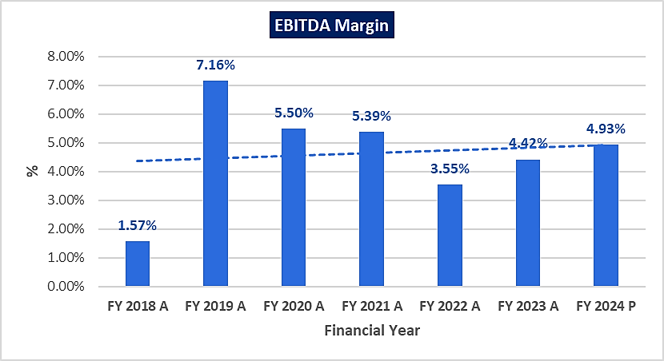
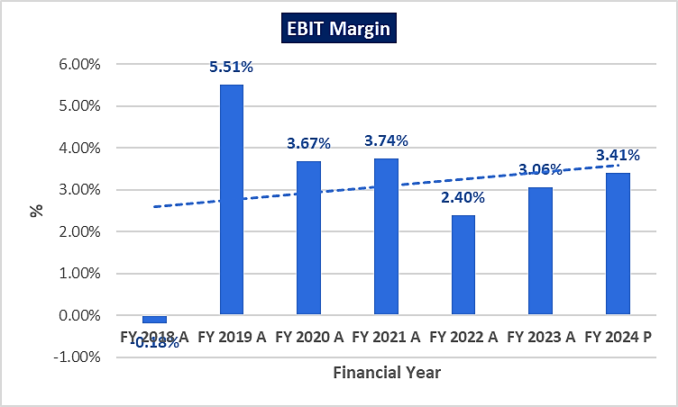
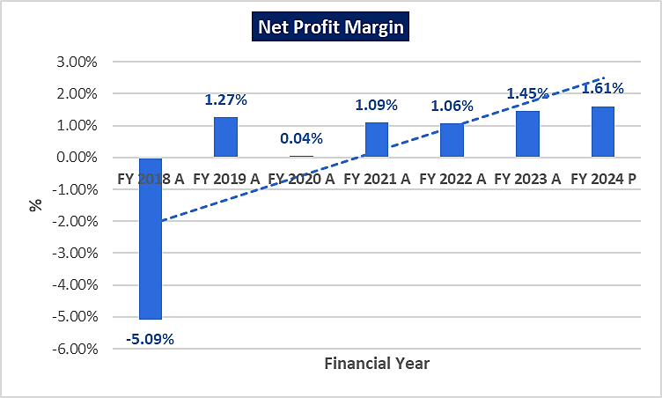
- PROJECTIONS OF THE FIRM:
The financial projections of the project are prepared from FY 2024-25 to FY 2032-33 based on the expected COD and loan tenor as per the best practice in industry to assess the financial feasibility of the project are elaborated below:
- PROJECTED PROFIT & LOSS ACCOUNT:
(INR Crores)
PARTICULARS | 2024-25 | 2025-26 | 2026-27 | 2027-28 | 2028-29
Installed Capacity Mt | 36000 | 86000 | 86000 | 86000 | 86000
Capacity Utilisation% | 100% | 80% | 82% | 84% | 86%
Production in M.T. | 36000 | 68800 | 70520 | 72240 | 73960
Sales in M.T. | 35500 | 68117 | 70484 | 72204 | 73924
Net Sales | 93.19 | 190.73 | 197.36 | 202.17 | 206.99
Cost of Sales:
Raw Materials | 54.95 | 105.01 | 107.64 | 110.26 | 112.89
Other Spares | 3.96 | 3.44 | 3.53 | 3.61 | 3.70
Power & Fuel
- Power | 8.46 | 0.75 | 0.75 | 0.75 | 0.75
- Fuel | 4.68 | 12.38 | 12.69 | 13.00 | 13.31
Direct Labour | 2.64 | 4.33 | 4.54 | 4.77 | 5.01
Other Manufacturing Expenses
- Chemicals | 10.80 | 20.64 | 21.16 | 21.67 | 22.19
- Packing Materials | 1.51 | 2.89 | 3.00 | 3.07 | 3.14
Repair and Maintenance | 0.61 | 1.65 | 1.74 | 1.82 | 1.91
Depreciation | 1.58 | 4.13 | 4.13 | 4.13 | 4.13
Sub Total | 89.19 | 155.22 | 159.16 | 163.09 | 167.02
Add: Opening Stock in Process | 0.11 | 0.37 | 0.64 | 0.65 | 0.67
Less: Closing Stock in Process | 0.37 | 0.64 | 0.65 | 0.67 | 0.69
Total | 88.93 | 154.95 | 159.15 | 163.07 | 167.01
Add: Opening Finished Goods | 0.83 | 1.86 | 3.23 | 3.32 | 3.40
Less: Closing Finished Goods | 1.86 | 3.23 | 3.32 | 3.40 | 3.48
Total Cost of Sales | 87.91 | 153.58 | 159.06 | 162.99 | 166.93
Selling & Distribution Exp. | 2.97 | 3.12 | 3.27 | 3.44 | 3.61
Sub Total | 90.88 | 156.70 | 162.34 | 166.43 | 170.54
Operating Profit before interest | 2.31 | 34.03 | 35.02 | 35.75 | 36.45
(a) Interest on T/L | 0.44 | 5.82 | 5.47 | 4.84 | 4.21
(b) Interest on W/C | 1.40 | 1.40 | 1.40 | 1.40 | 1.40
(c) Other Finance & Bank Charges
Profit Before Tax | 0.47 | 26.81 | 28.15 | 29.51 | 30.85
Provision for Taxes | 0.00 | 4.48 | 4.70 | 4.93 | 6.22
Net Profit | 0.47 | 22.33 | 23.45 | 24.58 | 24.63

(Continued)
PARTICULARS | 2029-30 | 2030-31 | 2031-32 | 2032-33
Installed Capacity Mt | 86000 | 86000 | 86000 | 86000
Capacity Utilisation% | 88% | 90% | 92% | 94%
Production in M.T. | 75680 | 77400 | 79120 | 80840
Sales in M.T. | 75644 | 77364 | 79084 | 80804
Net Sales | 211.80 | 216.62 | 221.44 | 226.25
Cost of Sales:
Raw Materials | 115.51 | 118.14 | 120.76 | 123.39
Other Spares | 3.78 | 3.87 | 3.96 | 4.04
Power & Fuel
- Power | 0.75 | 0.75 | 0.75 | 0.75
- Fuel | 13.62 | 13.93 | 14.24 | 14.55
Direct Labour | 5.26 | 5.52 | 5.80 | 6.09
Other Manufacturing Expenses
- Chemicals | 22.70 | 23.22 | 23.74 | 24.25
- Packing Materials | 3.21 | 3.29 | 3.36 | 3.43
Repair and Maintenance | 2.01 | 2.11 | 2.22 | 2.33
Depreciation | 4.13 | 4.13 | 4.14 | 4.14
Sub Total | 170.98 | 174.96 | 178.96 | 182.97
Add: Opening Stock in Process | 0.69 | 0.70 | 0.72 | 0.74
Less: Closing Stock in Process | 0.70 | 0.72 | 0.74 | 0.75
Total | 170.97 | 174.94 | 178.94 | 182.95
Add: Opening Finished Goods | 3.48 | 3.56 | 3.64 | 3.73
Less: Closing Finished Goods | 3.56 | 3.64 | 3.73 | 3.81
Total Cost of Sales | 170.88 | 174.86 | 178.86 | 182.87
Selling & Distribution Exp. | 3.79 | 3.98 | 4.18 | 4.39
Sub Total | 174.67 | 178.84 | 183.04 | 187.26
Operating Profit before interest | 37.13 | 37.78 | 38.40 | 39.00
(a) Interest on T/L | 3.55 | 2.72 | 1.75 | 0.65
(b) Interest on W/C | 1.40 | 1.40 | 1.40 | 1.40
(c) Other Finance & Bank Charges
Profit Before Tax | 32.18 | 33.66 | 35.25 | 36.95
Provision for Taxes | 8.79 | 9.49 | 10.18 | 10.86
Net Profit | 23.39 | 24.17 | 25.07 | 26.08

- PROJECTED BALANCE SHEET:
Below table shows the Projected Balance Sheet of the proposed Bio CNG generating project from the period FY 2024-25 to FY 2032-33. FY 2024-25 would be the implementation period of the project:
(INR Crores)
PARTICULARS | 2024-25 | 2025-26 | 2026-27 | 2027-28 | 2028-29
Non-Current Assets
Property, Plant & Equipment (Gross) | 115.5 | 115.5 | 115.5 | 115.5 | 115.5
Less: Accumulated Depreciation | 19.8 | 23.9 | 28.1 | 32.2 | 36.3
Net Block | 95.8 | 91.7 | 87.6 | 83.4 | 79.3
Security Deposit | 1.0 | 1.0 | 1.0 | 1.0 | 1.0
MAT Credit Entitlement | 1.6 | 6.1 | 4.3 | 1.9 | 0.0
Total Non-Current Assets | 98.3 | 98.7 | 92.8 | 86.3 | 80.3
Current Assets
Inventories:
Raw Material
-Indigenous (W/P Paper) | 6.9 | 13.1 | 13.5 | 13.8 | 14.1
-Chemical/Packing/Fuel/ Stores | 3.5 | 6.6 | 6.7 | 6.9 | 7.1
Stock in Process | 0.4 | 0.6 | 0.7 | 0.7 | 0.7
Finished Stock | 1.9 | 3.2 | 3.3 | 3.4 | 3.5
Trade Receivables | 11.6 | 23.8 | 24.7 | 25.3 | 25.9
Cash and bank balances | 2.0 | 1.7 | 23.6 | 46.9 | 70.5
Short-term Loans & Advances | 0.4 | 0.4 | 0.4 | 0.4 | 0.4
Total Current Assets | 26.6 | 49.4 | 72.8 | 97.3 | 122.1
Total Assets | 124.9 | 148.2 | 165.6 | 183.6 | 202.4
Shareholders' Funds
Share Capital | 15.0 | 15.0 | 15.0 | 15.0 | 15.0
Reserve and Surplus | 3.7 | 26.0 | 49.5 | 74.0 | 98.7
Total Equities | 18.7 | 41.0 | 64.5 | 89.0 | 113.7
Non-Current Liabilities
Long-term Borrowings | 57.6 | 51.5 | 44.8 | 38.2 | 31.6
Other long-term liabilities | 8.8 | 8.8 | 8.8 | 8.8 | 8.8
Unsecured Loans | 20.6 | 20.6 | 20.6 | 20.6 | 20.6
Total Non-Current Liabilities | 87.1 | 80.9 | 74.2 | 67.6 | 61.0
Current Liabilities
Working Capital Limit | 14.0 | 14.0 | 14.0 | 14.0 | 14.0
Short term Maturity of Long-Term Loan | 1.4 | 6.2 | 6.7 | 6.6 | 7.2
Trade Payable | 2.5 | 4.8 | 4.9 | 5.1 | 5.2
Other Current Liabilities | 1.3 | 1.3 | 1.3 | 1.3 | 1.3
Total Current Liabilities | 19.2 | 26.2 | 26.9 | 26.9 | 27.6
Total Equity and Liabilities | 124.9 | 148.2 | 165.6 | 183.6 | 202.4
(Continued)
PARTICULARS | 2029-30 | 2030-31 | 2031-32 | 2032-33
Non-Current Assets
Property, Plant & Equipment (Gross) | 115.5 | 115.5 | 115.5 | 115.5
Less: Accumulated Depreciation | 40.5 | 44.6 | 48.7 | 52.9
Net Block | 75.3 | 71.4 | 67.2 | 63.1
Security Deposit | 1.0 | 1.0 | 1.0 | 1.0
MAT Credit Entitlement | 0.0 | 0.0 | 0.0 | 0.0
Total Non-Current Assets | 76.3 | 72.3 | 68.2 | 64.1
Current Assets
Inventories:
Raw Material
-Indigenous (W/P Paper) | 14.4 | 14.8 | 15.1 | 15.4
-Chemical/Packing/Fuel/ Stores | 7.2 | 7.4 | 7.5 | 7.7
Stock in Process | 0.7 | 0.7 | 0.7 | 0.8
Finished Stock | 3.6 | 3.6 | 3.7 | 3.8
Trade Receivables | 26.5 | 27.1 | 27.7 | 28.3
Cash and bank balances | 89.6 | 107.0 | 125.2 | 142.3
Short-term Loans & Advances | 0.4 | 0.4 | 0.4 | 0.4
Total Current Assets | 142.4 | 161.0 | 180.4 | 198.7
Total Assets | 218.7 | 233.4 | 248.6 | 262.8
Shareholders' Funds
Share Capital | 15.0 | 15.0 | 15.0 | 15.0
Reserve and Surplus | 122.1 | 146.2 | 171.3 | 197.4
Total Equities | 137.1 | 161.2 | 186.3 | 212.4
Non-Current Liabilities
Long-term Borrowings | 22.0 | 12.0 | 0.0 | 0.0
Other long-term liabilities | 8.8 | 8.8 | 8.8 | 8.8
Unsecured Loans | 20.6 | 20.6 | 20.6 | 20.6
Total Non-Current Liabilities | 51.4 | 41.4 | 29.4 | 29.4
Current Liabilities
Working Capital Limit | 14.0 | 14.0 | 14.0 | 14.0
Short term Maturity of Long-Term Loan | 9.6 | 10.0 | 12.0 | 0.0
Trade Payable | 5.3 | 5.4 | 5.5 | 5.7
Other Current Liabilities | 1.3 | 1.3 | 1.3 | 1.3
Total Current Liabilities | 30.1 | 30.7 | 32.8 | 20.9
Total Equity and Liabilities | 218.7 | 233.4 | 248.6 | 262.8
- PROJECTED CASH FLOW STATEMENT:
(INR Crores)
PARTICULARS | 2024-25 | 2025-26 | 2026-27 | 2027-28 | 2028-29
A. SOURCES OF FUNDS:
Change in Share Capital | - | - | - | - | -
Increase in Working Capital Limit | 5.32 | - | - | - | -
Cash Accruals | 2.04 | 26.46 | 27.58 | 28.71 | 28.76
Increase In Secured Loan | 44.03 | - | - | - | -
Increase in Unsecured Loan | 7.69 | - | - | - | -
Decrease in Current Assets | - | - | - | - | -
Increase in Current Liabilities | -0.05 | 7.06 | 0.64 | 0.04 | 0.72
Decrease in Non-Current Assets | 17.63 | - | 1.80 | 2.40 | 1.87
TOTAL | 76.66 | 33.52 | 30.02 | 31.15 | 31.34
B. APPLICATION OF FUNDS:
Acquisition of Fixed Assets | 70.86 | 0.04 | 0.00 | 0.00 | 0.03
Decrease in Secured Loan | - | 6.16 | 6.68 | 6.60 | 6.60
Decrease in Current Liabilities | - | - | - | - | -
Increase in Current Assets | 3.92 | 23.17 | 1.42 | 1.19 | 1.19
Increase in Non-Current Assets | - | 4.48 | - | - | -
TOTAL | 74.78 | 33.83 | 8.10 | 7.79 | 7.82
C. SURPLUS
Opening Balance | 0.09 | 1.97 | 1.66 | 23.58 | 46.94
Surplus (A-B) | 1.88 | -0.31 | 21.92 | 23.36 | 23.52
Closing Balance | 1.97 | 1.66 | 23.58 | 46.94 | 70.47

(Continued)
PARTICULARS | 2029-30 | 2030-31 | 2031-32 | 2032-33
A. SOURCES OF FUNDS:
Change in Share Capital | - | - | - | -
Increase in Working Capital Limit | - | - | - | -
Cash Accruals | 27.52 | 28.30 | 29.21 | 30.22
Increase In Secured Loan | - | - | - | -
Increase in Unsecured Loan | - | - | - | -
Decrease in Current Assets | - | - | - | -
Increase in Current Liabilities | 2.52 | 0.52 | 2.12 | -
Decrease in Non-Current Assets | - | - | - | -
TOTAL | 30.04 | 28.83 | 31.33 | 30.22
B. APPLICATION OF FUNDS:
Acquisition of Fixed Assets | 0.14 | 0.16 | 0.00 | 0.00
Decrease in Secured Loan | 9.60 | 10.00 | 12.00 | 0.00
Decrease in Current Liabilities | - | - | - | 11.88
Increase in Current Assets | 1.19 | 1.19 | 1.19 | 1.19
Increase in Non-Current Assets | - | - | - | -
TOTAL | 10.93 | 11.35 | 13.19 | 13.07
C. SURPLUS
Opening Balance | 70.47 | 89.57 | 107.04 | 125.18
Surplus (A-B) | 19.11 | 17.47 | 18.14 | 17.15
Closing Balance | 89.57 | 107.04 | 125.18 | 142.33

- KEY FINANCIAL RATIO:
YEAR | FY 2025 | FY 2026 | FY 2027 | FY 2028 | FY 2029 | FY 2030 | FY 2031 | FY 2032 | FY 2033
EBITDA Margin % | 4.17% | 20.01% | 19.83% | 19.72% | 19.60% | 19.48% | 19.35% | 19.21% | 19.06%
Average | 17.83%
EBIT Margin % | 2.48% | 17.84% | 17.74% | 17.68% | 17.61% | 17.53% | 17.44% | 17.34% | 17.24%
Average | 15.88%
PAT Margin % | 0.50% | 11.71% | 11.88% | 12.16% | 11.90% | 11.04% | 11.16% | 11.32% | 11.53%
Average | 10.36%
- GRAPHICAL REPRESENTATION OF KEY RATIOS:
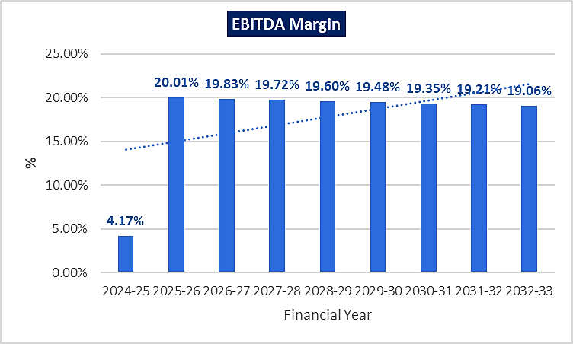
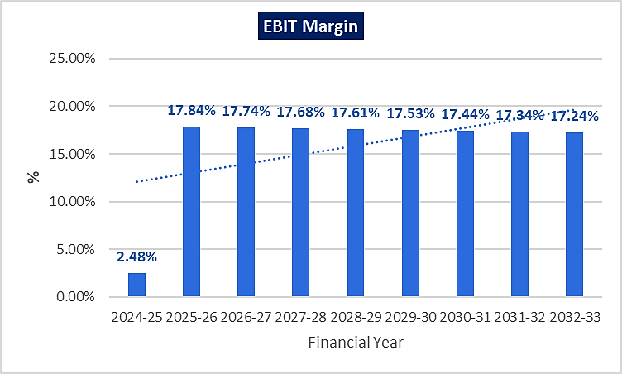
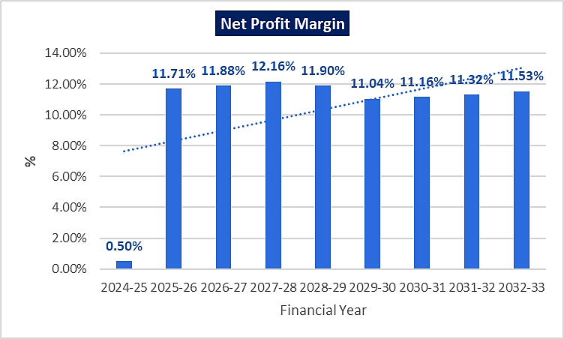
- ESTIMATED KEY FINANCIAL METRICS:
DEBT SERVICE COVERAGE RATIO (DSCR)
(FOR LOAN REPAYMENT PERIOD)
Particular | 2025-26 |  | 2026-27 | 2027-28 | 2028-29 | 2029-30 | 2030-31 | 2031-32 | 2032-33
Cash Accruals | 26.46 |  | 27.58 | 28.71 | 28.76 | 27.52 | 28.30 | 29.21 | 30.22
Interest on term loan | 5.82 |  | 5.47 | 4.84 | 4.21 | 3.55 | 2.72 | 1.75 | 0.65
Interest on CC | 1.40 |  | 1.40 | 1.40 | 1.40 | 1.40 | 1.40 | 1.40 | 1.40
Subtotal | 33.68 |  | 34.45 | 34.95 | 34.36 | 32.47 | 32.42 | 32.36 | 32.27
Interest on term loan | 1.38 |  | 6.16 | 6.68 | 6.60 | 7.20 | 9.60 | 10.00 | 12.00
Interest on CC | 5.82 |  | 5.47 | 4.84 | 4.21 | 3.55 | 2.72 | 1.75 | 0.65
Loan Repayment | 1.40 |  | 1.40 | 1.40 | 1.40 | 1.40 | 1.40 | 1.40 | 1.40
Subtotal | 8.60 |  | 13.02 | 12.92 | 12.21 | 12.15 | 13.72 | 13.15 | 14.05
DSCR | 3.92 |  | 2.65 | 2.71 | 2.82 | 2.67 | 2.36 | 2.46 | 2.30
Average D.S.C.R. |  | 2.73
Max. D.S.C.R. |  | 3.92

- SENSITIVITY ANALYSIS OF D.S.C.R:
The proposed project is found comparatively more sensitive with respect to the revenue, than with the cost of raw material. Sensitivity analysis of the project with respect to 5% decrease in the revenue and 5% increase in the cost of raw material has been shown in the below table:

Sensitivity Analysis of D.S.C.R.
S. No. | Particular | Average D.S.C.R. | Max. D.S.C.R.
 | If the projected revenue decreased by 5% | 1.98 | 2.74
 | If the projected Cost of raw material increased by 5% | 2.25 | 3.10

- NPV,IRR AND PAYBACK PERIOD OF THE PROJECT:
(INR Crores)
Free Cash Flow for the project
Particulars | 2024-25 | 2025-26 | 2026-27 | 2027-28 | 2028-29 | 2029-30 | 2030-31 | 2031-32 | 2032-33
EBIT | 2.31 | 34.03 | 35.02 | 35.75 | 36.45 | 37.13 | 37.78 | 38.40 | 39.00
Less: Taxes | -0.67 | -9.91 | -10.20 | -10.41 | -10.61 | -10.81 | -11.00 | -11.18 | -11.36
NOPAT | 1.64 | 24.12 | 24.82 | 25.34 | 25.84 | 26.32 | 26.78 | 27.22 | 27.64
Add: Depreciation & Amortisation | 1.58 | 4.13 | 4.13 | 4.13 | 4.13 | 4.13 | 4.13 | 4.14 | 4.14
+/- WCC | -3.97 | -16.10 | -0.78 | -1.15 | -0.47 | 1.33 | -0.67 | 0.93 | -1.19
Capex | -70.86 | -0.04 | 0.00 | 0.00 | -0.03 | -0.14 | -0.16 | 0.00 | 0.00
Free Cash Flow to Firm (FCFF) | -71.62 | 12.11 | 28.17 | 28.31 | 29.46 | 31.63 | 30.08 | 32.28 | 30.58
Discount Rate | 15.16%
Expected Terminal Growth Rate | 1.00%
Discount Period | 0.92 | 1.92 | 2.92 | 3.92 | 4.92 | 5.92 | 6.92 | 7.92 | 8.92
Discount Factor | 0.88 | 0.76 | 0.66 | 0.58 | 0.50 | 0.43 | 0.38 | 0.33 | 0.28
Terminal Value | - | - | - | - | - | - | - | - | 218.14
FCFF + TV | -71.62 | 12.11 | 28.17 | 28.31 | 29.46 | 31.63 | 30.08 | 32.28 | 248.73
PV(FCFF+TV) | -62.92 | 9.24 | 18.66 | 16.29 | 14.72 | 13.72 | 11.33 | 10.56 | 70.65

Key Input for NPV & IRR
S. No. | Key Input | Description
 | Nifty 50 Returns (CAGR) in the Last 20 Years | 14.16% (https://kunaldesai.blog/nifty-returns/)
 | Company Risk Premium | 1%
 | Discount Rate | 15.16%
 | Perpetual Growth Rate | 1%
NPV |  | INR 102.25 Crores
IRR |  | 39.63%
Payback Period of the Project
Financial Year | Cash Accrual | Accumulated Cash Accrual
2024-25 | 2.04 | 2.04
2025-26 | 26.46 | 28.50
2026-27 | 27.58 | 56.08
2027-28 | 28.71 | 84.79
2028-29 | 28.76 | 113.55
2029-30 | 27.52 | 141.07
2030-31 | 28.30 | 169.37
2031-32 | 29.21 | 198.58
2032-33 | 30.22 | 228.80
Total | 228.80
TPC | INR 70.73 Crores
Payback Period | 3.20 Years
Thus, the project will be having a payback period of 3.20 years and NPV & IRR of the project as on COD will INR 113.68 Crores & 40.04% respectively, which indicates worthiness of the project.

- OTHER FINANCIAL RATIOS:
Particulars | 2024-25 | 2025-26 | 2026-27 | 2027-28 | 2028-29 | 2029-30 | 2030-31 | 2031-32 | 2032-33
Current Ratio | 1.39 | 1.89 | 2.71 | 3.62 | 4.42 | 4.72 | 5.25 | 5.50 | 9.50
DER | 4.74 | 2.12 | 1.26 | 0.83 | 0.60 | 0.45 | 0.32 | 0.22 | 0.14
TOL/ATNW | 5.69 | 2.61 | 1.57 | 1.06 | 0.78 | 0.60 | 0.45 | 0.33 | 0.24
ROE | 2.50% | 54.46% | 36.38% | 27.60% | 21.67% | 17.07% | 14.99% | 13.46% | 12.28%

- BREAK-EVEN ANALYSIS:
(INR Crores)
Particulars | 2024-25 | 2025-26 | 2026-27 | 2027-28 | 2028-29 | 2029-30 | 2030-31 | 2031-32 | 2032-33
Sales | 93.19 | 190.73 | 197.36 | 202.17 | 206.99 | 211.80 | 216.62 | 221.44 | 226.25
Variable Expenses | 87.99 | 155.60 | 161.05 | 165.20 | 170.43 | 176.96 | 181.63 | 186.31 | 191.01
Contribution | 5.20 | 35.13 | 36.30 | 36.97 | 36.55 | 34.84 | 34.99 | 35.12 | 35.24
Fixed Expenses | 4.99 | 13.07 | 12.87 | 12.40 | 11.94 | 11.47 | 10.83 | 10.06 | 9.17
BEP% | 95.95% | 37.19% | 35.44% | 33.55% | 32.67% | 32.91% | 30.96% | 28.66% | 26.03%
CASH BEP% | 65.64% | 25.45% | 24.08% | 22.39% | 21.38% | 21.07% | 19.15% | 16.88% | 14.30%

- TERM LOAN INPUTS:
Term Loan Repayment Inputs
Term Loan for Expansion (Loan 1) | INR 30.00 Crores
Term Loan for Boiler & Turbine (Loan 2) | INR 25.00 Crores
Total loan amount | INR 55.00 Crores
Rate of Interest | 10% (Loan 1 & 2)
1st Disbursement | March 2023 (Loan 1) & June-24 (Loan 2)
IDC Period (construction period) | 36 Months (Loan 1) & 9 Months (Loan 2)
Commencement /Operation Start | April 2025 (Loan 1 & 2)
Moratorium Start & End Month (only interest to pay) | April 2025 to March 2026 (Loan 1 & 2)
Moratorium Period after COD | 12 Months (Loan 1 & 2)
Repayment Start | April 2026 (Loan 1 & 2)
Repayment End | March 2033 (Loan 1 & 2)
Repayment Period | 10

Financial Year (FY) | 2024-25 | 2025-26 | 2026-27 | 2027-28 | 2028-29 | 2029-30 | 2030-31 | 2031-32 | 2032-33
Op. Bal | 14.58 | 59.01 | 57.64 | 51.48 | 44.80 | 38.80 | 31.60 | 22.00 | 12.00
Disbursement | 44.03 | 0.00 | 0.00 | 0.00 | 0.00 | 0.00 | 0.00 | 0.00 | 0.00
Repayment of Principal | 1.37 | 1.38 | 6.16 | 6.68 | 6.60 | 7.20 | 9.60 | 10.00 | 12.00
Closing balance | 59.01 | 57.64 | 51.48 | 44.80 | 38.80 | 31.60 | 22.00 | 12.00 | 0.00
Interest | 3.93 | 5.82 | 5.47 | 4.84 | 4.21 | 3.55 | 2.72 | 1.75 | 0.65
IDC | 3.48 | 0.00 | 0.00 | 0.00 | 0.00 | 0.00 | 0.00 | 0.00 | 0.00
TL Interest | 0.45 | 5.82 | 5.47 | 4.84 | 4.21 | 3.55 | 2.72 | 1.75 | 0.65

- DEPRECIATION SCHEDULE (STRAIGHT LINE METHOD):
(INR Crores)
Particulars | 2024-25 | 2025-26 | 2026-27 | 2027-28 | 2028-29 | 2029-30 | 2030-31 | 2031-32 | 2032-33
Building | 1.98 | 3.44 | 3.44 | 3.44 | 3.44 | 3.44 | 3.44 | 3.44 | 3.44
Addition | 1.46 | 0.00 | 0.00 | 0.00 | 0.00 | 0.00 | 0.00 | 0.00 | 0.00
Depreciation - Building | 0.06 | 0.10 | 0.10 | 0.10 | 0.10 | 0.10 | 0.10 | 0.10 | 0.10
Plant & Machinery | 40.94 | 110.21 | 110.21 | 110.21 | 110.21 | 110.21 | 110.21 | 110.21 | 110.21
Addition – P&M | 69.27 | 0.00 | 0.00 | 0.00 | 0.00 | 0.00 | 0.00 | 0.00 | 0.00
Depreciation - P&M | 1.48 | 3.98 | 3.98 | 3.98 | 3.98 | 3.98 | 3.98 | 3.98 | 3.98
Furniture & Fixtures | 0.02 | 0.02 | 0.02 | 0.02 | 0.02 | 0.03 | 0.03 | 0.03 | 0.03
Depreciation – Furniture & Fixtures | 0.00 | 0.00 | 0.00 | 0.00 | 0.00 | 0.00 | 0.00 | 0.00 | 0.00
Office Equip. | 0.11 | 0.13 | 0.13 | 0.13 | 0.13 | 0.13 | 0.13 | 0.16 | 0.16
Depreciation – Office Equipment | 0.02 | 0.02 | 0.02 | 0.02 | 0.02 | 0.02 | 0.02 | 0.03 | 0.03
Computer | 0.03 | 0.03 | 0.04 | 0.04 | 0.04 | 0.04 | 0.04 | 0.04 | 0.04
Depreciation - Computer | 0.01 | 0.01 | 0.01 | 0.01 | 0.01 | 0.01 | 0.01 | 0.01 | 0.01
Vehicle | 0.07 | 0.07 | 0.07 | 0.07 | 0.07 | 0.07 | 0.10 | 0.10 | 0.10
Depreciation - Vehicle | 0.01 | 0.01 | 0.01 | 0.01 | 0.01 | 0.01 | 0.01 | 0.01 | 0.01
Total SLM Depreciation | 1.58 | 4.13 | 4.13 | 4.13 | 4.13 | 4.13 | 4.13 | 4.14 | 4.14
- WORKING CAPITAL REQUIREMENT:
(INR Crores)
Financial Year (FY) | 2024-25 | 2025-26 | 2026-27 | 2027-28 | 2028-29 | 2029-30 | 2030-31 | 2031-32 | 2032-33
Net Working Capital | 20.84 | 41.72 | 43.03 | 44.10 | 45.17 | 46.24 | 47.32 | 48.39 | 49.46
Working Capital Margin | 5.21 | 10.43 | 10.76 | 11.02 | 11.29 | 11.56 | 11.83 | 12.10 | 12.37
Working Capital Required | 15.63 | 31.29 | 32.27 | 33.07 | 33.88 | 34.68 | 35.49 | 36.29 | 37.10
Proposed CC Loan | 14.00 | 14.00 | 14.00 | 14.00 | 14.00 | 14.00 | 14.00 | 14.00 | 14.00

- KEY ASSUMPTIONS & BASIS:
S. No. | Item | Assumptions and Basis
 | General | - The projections of the firm are done for the period from FY 2024-25 to FY 2032-33, 9 years, to cover the term loan period as per the industry best practices. It is assumed that the plant will be achieving COD on 1st April 2025.  - We have considered both Revenue & cost-based model (top to bottom approach) while making the future financial projections.  - Revenue modelling and Expense modelling has been done based on the capacity utilization during the respective year.
 | Revenue Build up | - The plant is assumed to be operational for 330 days annually. Total income for the respective financial years during the forecasted period will be generating from selling of different category of Kraft papers.  - To calculate the operating revenue at 100% capacity utilization, Sales price has been considered as INR 26250 for FY 2024-25 & INR 28000 per MT post COD based on the data/information provided by the client and based on our tertiary research and information available in the public domain.  - Sales Value of the production has been calculated by multiplying the average price to the total production at the respective year capacity.  - Thus, the company is generating INR 93.19 Crore in the first year of projections and revenue generated after achieving COD, i.e., FY 2025-26 is INR 190.73 crores, further it has increased up to INR 226.25 Crore till FY 2032-33.
 | Pricing (Average Price Per Unit) | - As per data/information shared by the client, company will be selling its finished (Kraft paper) product through distributors at a pre decided price of INR 26250 for FY 2024-25 & INR 28000 per MT post COD.  - Also, as per secondary and tertiary research, industry trend and pricing offered by other companies and vendors in this line and data/information available in public domain, we found that the price per MT ranges from INR 21250 per MT to INR 35000 Per MT for more than 80 GSM paper depending on the quality and specification of the product.  (Ref: https://www.indiamart.com/proddetail/brown-kraft-paper-roll-17813142291.html)  - Thus, justifiably average price has been considered as INR 28000 per MT post COD, which is reasonable and on conservative side and is in the line with industry trends.
 | Capacity Utilization | - For the proposed expansion of the facility, the company is planning to install new plant & machinery to increase the total capacity to 86000 TPA from 36000 TPA.  - We have considered the capacity utilisation at 80% in the first year after expansion i.e., FY 2025-26 which has been escalated by 2% each year after FY2025-26 for the projected years up to 94% in FY 2032-33.  - Thus, to start the capacity utilization from 80% is in the line with industry and it is reasonable and on conservative side to keep a mark-up for future market & economic risks in the Project.  - As per the Kraft paper manufacturing sectoral trends, it is assumed that the project will be achieving a 94% capacity utilization in 9th year of the forecasted period.
 | Capital Expenditure | - The estimated cost of the Building & Civil works is ~INR 1.46 crores. Out of which INR 78.60 Cr. has already been incurred by the company, thus the company has achieved ~53.84% physical progress.  - Plant & Machinery cost has been taken as per the details provided by the client and as per the break-up, the total cost of INR 35.40 Crores has been considered. Apart from that, the total cost for Boiler & Turbine has been considered as INR 30.00 crores. Thus, the total cost of plant & machinery will be ~INR 65.40 crores including the applicable GST of 18%. Currently company has already paid the advance of INR 10.77 Cr. for capital goods.  - As per the loan schedule prepared for projected period, Company will be paying an Interest during construction of INR 3.87 Crore, considering the interest rate of 10% as informed by bank.\
 | Expenses | - Major expenses include raw material, power and fuel, salaries and wages, Repair and maintenance, SG&A, etc.  - For the proposed plant and machinery, quantity of raw material will be from indigenous waste paper which will be yielding at 95%. The rate of indigenous waste paper is considered as INR 14500 per MT at 100% capacity utilization.  Sardhana Paper Pvt. Ltd. will get the synergies from the existing running plant in regard to the raw material supply. Hence, this integration will be beneficial for the company.  Since, Meerut area is well-known for the paper industry and the easy availability of the raw material will be an added advantage for the company.  As per our independent research and information available on public domain raw material price ranging from Rs. 10500/- to Rs 20000/- per MT. The cost estimated by the company was also verified by the invoices/quotations shared by the client. (Refer to the Raw Material Analysis section of the report)  Thus, we considered the average price as INR 14500 per MT for indigenous waste paper which is reasonable and in the line with industrial trends and multiplied it by raw material quantity used, to calculate total cost of raw material used.  - A power connection of 2000 KVA is already sanctioned by the UPPCL but with the expansion and installation of turbine & boiler. The plant will be self-sufficient to run the plant smoothly and to meet the electricity demands. However, the company will not disconnect the sanctioned load and will continue to pay the fixed charges of ~ INR 75 Lakhs annually.  - In estimating the manpower requirement, salary and wages, a proper ratio between the administrative, managerial, supervisory and shop floor staff has been maintained with a view to affording proper industrial and professional management at various levels. The fringe benefits have been taken 10% of the basic salary. Also, we have considered 5% escalation rate in every year.  - Selling & Administrative Overheads majorly consists of Fixed Costs. It is assumed to increase @ 5% per annum.  - Annual cost of consumables and stores at 100% capacity is estimated at INR 4.30 Crore. The cost of per MT production is assumed to be INR 500.  - Average Fuel Cost of Plant & Machinery is approx. 1300 PMT. But Company is installing a new boiler & Turbine. Turbine will require steam for production of electricity. So overall steam consumption of company will increase & thereby more fuel consumption by boiler. Hence from year 2025-26, we have assumed that the Fuel cost will increase by approx. 40% from the average fuel cost to around Rs.1800 PMT.  - Average Packing cost is assumed to be INR 425 per MT which is in line with the historical average of the respective expenses.  - Repair & Maintenance has been estimated at 1.5% of P&M for the first year of projection and thereafter an increase of 5% has been considered.
 | Term Loan | - As per the discussion with the client, the company will apply for the loan to procure plant & machinery and boiler & turbine which is estimated to be costing around INR 70.79 Crores which will be funded through a term loan of INR 55.00 Crores and the remaining INR 15.79 Crores from unsecured loans/cash accruals.  - The project is scheduled to be achieving the COD on 1st April 2025. The next twelve months, i.e., from April 2025 to March 2026 will serve as the moratorium period and the loan repayment period will be 7 years, i.e., from FY 2026-27 to FY 2032-33. The interest rate is considered as 10%.  - The company is planning to fund the project through term loan to setup the expansion of manufacturing unit and PNB has sanctioned INR 30.00 Crores and the company is approaching the financial institutions to provide the remaining required capital of INR 25.00 Crores for the installation of turbine & boiler.  - The company will be requiring a Fund Based Cash Credit Limit of INR 14.00 crores from FY 2024-25 onwards.

Key Findings:
      - Average DSCR, EBIDTA margin, EBIT margin is 2.73, 17.83% and 15.88% respectively during the estimated period.
      - The company is having a positive NPV and IRR of INR 102.25 crores and 39.63% respectively at the base cases while it may vary with changes in the assumptions & micro and macro-economic trends considered as on date.
      - The proposed project is having a payback period of 3.20 years.
      - Based on the above key financial ratios of the proposed Project during the forecasted period shows that the project appears financially viable if the promoters of the project are able to maintain assumed capacity utilization, revenue and can contain cost as assumed above in the calculation.

PART N | CONCLUSION

Based on the technological, economical and market analysis done above, various assumptions of sectoral trends taken, product pricing to be adopted by the company, the Project appears to be Techno-commercially viable subject to the risks, threats, weaknesses, limitations of the product as detailed previously.
As per financial projections for the estimated period, Average DSCR, EBITDA Margin and EBIT Margin of the project are 2.73, 17.83% and 15.88% respectively, where higher DSCR is the indicator of the project capability to pay out its outstanding debt and EBITDA margin shows the capability of the project to generate the operating profits over the forecasted period. Also, the project is having the payback period of 3.20 Years in the line with sectoral trends.
The proposed expansion of Kraft Paper Manufacturing facility is having a positive NPV and IRR as INR 102.25 Crores and 39.63% respectively. While it is not avoidable that the future projections may change in the upcoming years due to various factors impacting the operation, managerial, financial efficiency and economies of scale of the project.
While it would be depending on the management’s capability in future that how efficiently company adopts marketing and advertisement strategy, supply chain and carry out inventory & resource management to achieve higher profitability. After considering the foreseen demand of the Kraft Paper both domestically and globally, financial analysis of the project based on the assumptions taken over the projected period, it appears reasonable to comment that the proposed project is “Technically and Economically” Viable subject to current assumptions considered and occurring the same in the upcoming years same as the forecasted period which is dependent on the sincerity and efforts of the management and various micro and macroeconomic & industry situation.
We have tried our level best to analyse the Project techno-economic feasibility of the Project based on the industry research, Project information and various futuristic assumption taken within the limitations and challenges came in front of us. However, achieving the financial milestones depends on the ability, sincerity and efforts of the company, promoters and its key management to maintain the projected revenue level Y-o-Y basis keeping the fact in mind that the project is found sensitive with respect to the down side fluctuation in the revenue.

Declaration | - The undersigned does not have any direct/indirect interest in the above property/project/Company.  - The information furnished herein is true and correct to the best of our knowledge, logical and scientific assumptions.  - This TEV Report is carried out by our Financial Analyst team on the request from PNB, Corporate Banking Branch, Meerut.  - Meeting of Financial projections will be subject to the market & economy stability factors, judicious business operations and proper & timely implementation of the project and putting proper plan for achieving high productivity, efficiency and achieving cost saving benefits to increase profitability.  - We have submitted TEV report to the client.
Number of Pages in the Repost | 91
Enclosed Documents | Disclaimer & Remarks 88-91
Place | Noida
Date | 29th April 2024

FOR ON BEHALF OF
M/S. R.K. ASSOCIATES VALUER & TECHNO ENGINEERING CONSULTANTS PVT. LTD.
SURVEYED BY | PREPARED BY | REVIEWED BY
Mr. Deepak Kumar Singh | Mr. Rachit Gupta | Mr. Gaurav Kumar

PART O | DISCLAIMER | REMARKS

      - No employee or member of R.K Associates has any direct/ indirect interest in the Project.
      - This report is prepared based on the copies of the documents/ information which the Bank/ Company has provided to us out of the standard checklist of documents sought from them and further based on our assumptions and limiting conditions. The client/owner and its management/representatives warranted to us that the information they supplied was complete, accurate and true and correct to the best of their knowledge. All such information provided to us has been relied upon in good faith and we have assumed that it is true and correct in all respect. I/We shall not be liable for any loss, damages, cost or expenses arising from fraudulent acts, misrepresentations, or wilful default on part of the owner, company, its directors, employee, representative or agents. Verification or cross checking of the documents provided to us from the originals or from any Govt. departments/ Record of Registrar has not been done at our end since this is beyond the scope of our work. If at any time in future, it is found or came to our knowledge that misrepresentation of facts or incomplete or distorted information has been provided to us then this report shall automatically become null & void.
      - Legal aspects for e.g. investigation of title, ownership rights, lien, charge, mortgage, lease, sanctioned maps, verification of documents, etc. have not been done at our end and same has to be taken care by legal expert/ Advocate. It is assumed that the concerned Lender/ Financial Institution has satisfied them with the authenticity of the documents, information given to us and for which the legal verification has been already taken and cleared by the competent Advocate before requesting for this report. I/ We assume no responsibility for the legal matters including, but not limited to, legal or title concerns.
      - This report is a general analysis of the project based on the scope mentioned in the report. This is not an Audit report, Design document, DPR or Techno feasibility study. All the information gathered is based on the facts seen on the site during survey, verbal discussion & documentary evidence provided by the client and is believed that information given by the company is true best of their knowledge.
      - This Techno Economic-Viability study is prepared based on certain futuristic assumption which are intra dependent on economic, market and sectorial growth condition in future and socio-economic, socio-political condition at macro and micro level.
      - Meeting of assumption and financial ratio will entirely depend on the sincerity and efforts of the company, promoters and its key managerial performance.
      - All observations mentioned in the report is only based on the visual observation and the documents/ data/ information provided by the client. No mechanical/ technical tests, measurements or any design review have been performed or carried out from our side during Project assessment.
      - This report has been diligently prepared by our techno-financial team to the best of their ability. However, it's important to note that the recommendations provided in this Total Economic Viability (TEV) assessment do not imply an endorsement, validation, or certification of the accuracy or completeness of the disclosed information by the involved stakeholders. Furthermore, we do not claim or endorse that the opinions presented herein are the sole best course of action for decision-makers to follow. There may exist additional approaches and inputs that have not been covered within this report or fall outside the scope of this report.
      - Bank/FII should ONLY take this report as an Advisory document from the Financial/ Chartered Engineering firm and its specifically advised to the creditor to cross verifies the original documents for the facts mentioned in the report which can be availed from the borrowing company directly.
      - In case of any default in loans or the credit facility extended to the borrowing company, R.K Associates shall not be held responsible for whatsoever reason may be and any request for seeking any explanation from the employee/s of R.K Associates will not be entertained at any instance or situation.
      - The documents, information, data provided to us during the course of this assessment by the client are reviewed only up to the extent required in relation to the scope of the work. No document has been reviewed beyond the scope of the work.
      - This report only contains general assessment & opinion as per the scope of work evaluated as per the information given in the copy of documents, information, data provided to us and/ and confirmed by the owner/ owner representative to us at site which has been relied upon in good faith. It doesn’t contain any other recommendations of any sort including but not limited to express of any opinion on the suitability or otherwise of entering into any transaction with the borrower.
      - We have relied on data from third party, external sources & information available on public domain also to conclude this report. These sources are believed to be reliable and therefore, we assume no liability for the truth or accuracy of any data, opinions or estimates furnished by others that have been used in this analysis. Where we have relied on data, opinions or estimates from external sources, reasonable care has been taken to ensure that such data has been correctly extracted from those sources and /or reproduced in its proper form and context, however still we can’t vouch its authenticity, correctness or accuracy.
      - This Report is prepared by our competent technical team which includes Engineers and financial experts & analysts.
      - This is just an opinion report and doesn’t hold any binding on anyone. It is requested from the concerned Financial Institution which is using this report for taking financial decision on the project that they should consider all the different associated relevant & related factors also before taking any business decision based on the content of this report.
      - All Pages of the report including annexure are signed and stamped from our office. In case any paper in the report is without stamp & signature then this should not be considered a valid paper issued from this office.
      - Though adequate care has been taken while preparing this report as per its scope, but still we can’t rule out typing, human errors, over sightedness of any information or any other mistakes. Therefore, the concerned organization is advised to satisfy themselves that the report is complete & satisfactory in all respect. Intimation regarding any discrepancy shall be brought into our notice immediately. If no intimation is received within 15 (Fifteen) days in writing from the date of issuance of the report, to rectify these timely, then it shall be considered that the report is complete in all respect and has been accepted by the client up to their satisfaction & use and further to which R.K Associates shall not be held responsible in any manner.
      - Defect Liability Period is 15 DAYS. We request the concerned authorized reader of this report to check the contents, data and calculations in the report within this period and intimate us in writing if any corrections are required or in case of any other concern with the contents or opinion mentioned in the report. Corrections only related to typographical, calculation, spelling mistakes, incorrect data/ figures/ statement will be entertained within the defect liability period. Any new changes for any additional information in already approved report will be regarded as additional work for which additional fees may be charged. No request for any illegitimate change in regard to any facts & figures will be entertained.
      - R.K Associates encourages its customers to give feedback or inform concerns over its services through proper channel at valuers@rkassociates.org in writing within 15 days of report delivery. After this period no concern/ complaint/ proceedings in connection with the Techno- Economic Viability Study Services will be entertained due to possible change in situation and condition of the subject Project.
      - Our Data retention policy is of ONE YEAR. After this period, we remove all the concerned records related to the assignment from our repository. No clarification or query can be answered after this period due to unavailability of the data.
      - This Techno Economic Viability Study report is governed by our (1) Internal Policies, Processes & Standard Operating Procedures, (2) Information/ Data/ Inputs given to us by the client and (3) Information/ Data/ Facts given to us by our field/ office technical team. Management of R.K Associates never gives acceptance to any unethical or unprofessional practice which may affect fair, correct & impartial assessment and which is against any prevailing law. In case of any indication of any negligence, default, incorrect, misleading, misrepresentation or distortion of facts in the report then it is the responsibility of the user of this report to immediately or at least within the defect liability period bring all such act into notice of R.K Associates management so that corrective measures can be taken instantly.
      - R.K Associates never releases any report doing alterations or modifications from pen. In case any information/ figure of this report is found altered with pen then this report will automatically become null & void.
      - If this report is prepared for the matter under litigation in any Indian court, no official or employee of R.K Associates will be under any obligation to give in person appearance in the court as a testimony. For any explanation or clarification, only written reply can be submitted on payment of charges by the plaintiff or respondent which will be 10% of the original fees charged where minimum charges will be Rs. 15,000/.

EXTRACTS OF IMPORTANT STATUTORY APPROVALS PROVIDED BY THE CLIENT

