REPORT FORMAT: V-L2 (Large with P&M - SBI) | Version: 12.0_Nov.2022

CASE NO.VIS (2023-24)-PL794-690-1067 Dated: 15.04.2024

FIXED ASSETS VALUATION REPORT

OF

NATURE OF ASSETS | LAND & BUILDING, PLANT & MACHINERY & OTHER MISCELLANEOUS FIXED ASSET
CATEGORY OF ASSETS | INDUSTRIAL
TYPE OF ASSETS | INDUSTRIAL PLANT

SITUATED AT
M/S. BAJAJ HINDUSTHAN SUGAR LTD., VILLAGE- KHAMBHARKHERA, TEHSIL- SADAR LAKHIMPUR, DISTRICT- KHERI, UTTAR PRADESH 261501

REPORT PREPARED FOR
STATE BANK OF INDIA, INDUSTRIAL FINANCE BRANCH, JAWAHAR VYAPAR BHAWAN, TOLSTOY MARG, JANPATH, NEW DELHI

**Important - In case of any query/ issue or escalation you may please contact Incident Manager
at valuers@rkassociates.org. We will appreciate your feedback in order to improve our services.

NOTE: As per IBA & Bank’s Guidelines please provide your feedback on the report within 15 days of its submission after which report will be considered to be correct.
Valuation Terms of Services & Valuer’s Important Remarks are available at www.rkassociates.org for reference.

PART A | SNAPSHOT OF THE ASSET/ PROPERTY UNDER VALUATION

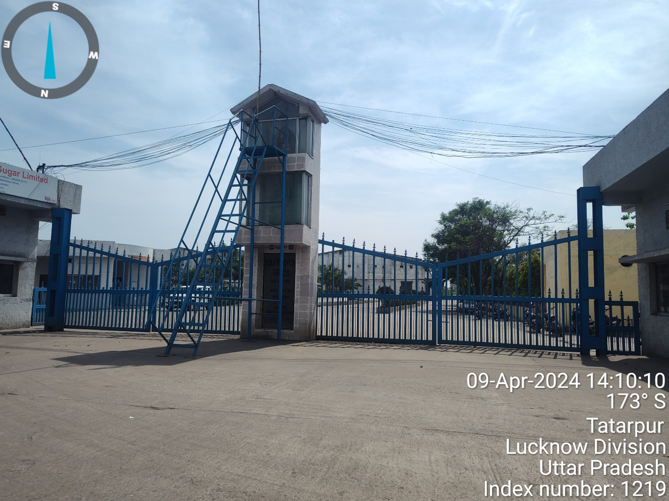

M/S. BAJAJ HINDUSTHAN SUGAR LTD., VILLAGE- KHAMBHARKHERA, TEHSIL- SADAR LAKHIMPUR, DISTRICT- KHERI, UTTAR PRADESH 261501

PART B | SBI FORMAT OF OPINION REPORT ON VALUATION

Name & Address of Branch | State Bank of India, IFB Branch, Jawahar Vyapar Bhawan, Tolstoy Marg, Janpath, New Delhi
Name of Customer (s)/ Borrower Unit | M/s. Bajaj Hindusthan Sugar Limited
Work Order No. & Date | Via letter no. IFB-ND/AMT-1/2023-24/452 Dated 16th March 2024

S.NO. | CONTENTS | DESCRIPTION
 | INTRODUCTION
 | Name of Property Owner | M/s. Bajaj Hindusthan Sugar Limited
 | Address & Phone Number of the Owner | Address: Village- Khambharkhera, Tehsil- Sadar Lakhimpur, District- Kheri, Uttar Pradesh
 | Purpose of the Valuation | For Periodic Re-valuation of the mortgaged property
 | Date of Inspection of the Property | 09.04.2024
 | Property Shown By | Name | Relationship with Owner | Contact Number
 | Property Shown By | Mr. Yogesh Singh | Account Unit Head | +91 91510 03654
 | Date of Valuation Report | 15.04.2024
 | Name of the Developer of the Property | --
 | Type of Developer | --

 | PHYSICAL CHARACTERISTICS OF THE PROPERTY
About the Project:
BHSL has set up a Sugar plant with the capacity of 10,000 TCD, Distillery of 160 KLPD & 35MW Co-Gen Unit. As per information/ data provided to us by the client, the company has adopted modern technology for manufacturing of Sugar.
As per the scope of work, this Valuation report is prepared for the project Land & Building located the aforesaid address based on the copies of the documents and the information provided by the client which has been relied upon in good faith.

Land Requirement:
For the purpose of setting up a Sugar Plant, BHSL has procured total 82.38 Hectare/ 203.48 Acres of land. As per the information provided by the company official, the company has acquired total land area from local villagers by virtue of multiple sale deeds. Due to the voluminous nature of the title deeds, the company did not provide land title deeds expect land area statement for the subject project land. A copy of same of same is annexed with the Valuation report.
As per the information provided by the company official, out of the total land area around 197.42 acres is converted into non-agricultural under section 143 and balance land area i.e. 6.064 acres of land is coming under abadi land and no conversion is required for the use for Industrial purpose. No documentary evidence has been given in this regard. Bank is advised to legally check the status. However, the Valuation assessment of the subject land parcel has been on the basis of as-is-where-is basis at the site.
Further company has taken around 1.34 acres of land on lease from the local Gram Panchayat and this land has not been considered in our Valuation assessment.
~197.42 acres of land area has been used for the development of Plant machinery, building, roads, culverts, drains, Bio compost yard, ash yard, bagasse yard, electric poles & etc. and rest land parcel is being used for drains, poles, storage of bio mannure & etc.
During our visit it also came to our knowledge that a part of the land has been leased out to M/s. Bajaj Energy Pvt. Ltd. out of 134.26 Acres of land 27.645 Acres have been leased out to BEL for a period of 29 years whose tenure started from July 2010 as per the documents provided to us from client’s end. Both have their individual access and are properly demarcated.
During our site visit we have also come to know that the (M/s. Bajaj Hindusthan Sugar Limited) BHSL has leased some portion of its land (24.76 acre) to (Bajaj Energy Limited) BEL which is the sister entity of the subject property for a period of 29 years starting from 1st July 2010.
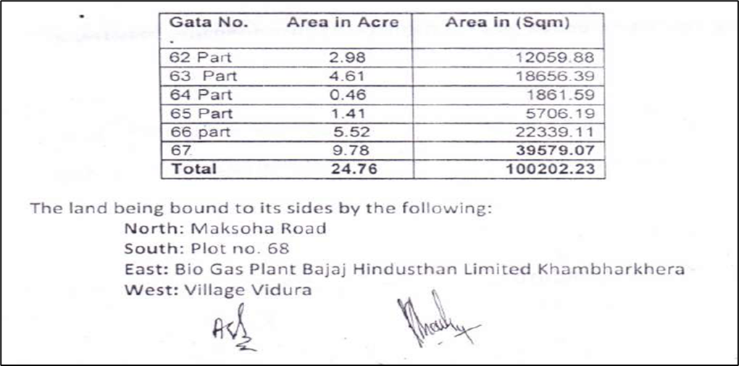

As mentioned in the ‘list of documents produced for perusal’ various approvals & NOC’s has been obtained by the client for the smooth running of the subject industry.

Building & Civil work:
Major Buildings and Civil work in this power plant are Mill House, Boiler Control Room, DM Plant, Time Office, Cooling Tower, Boiler, Cane Store, Sugar Godown, Residential Colony, RCC Roads, Bituminous roads, boundary wall and other miscellaneous buildings and civil work.
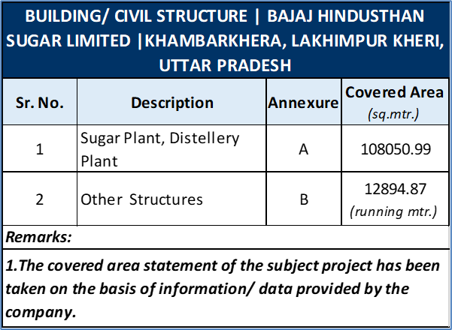
Buildings of the Plant are constructed on various construction techniques like GI shed mounted and cladded on prefabricated steel Structure & RCC Structures. Area of Administration & Official Blocks is constructed of RCC framed Structures. Office blocks and electrical control room are Air conditioned. Fire Fighting system is installed in the various Buildings. Year of construction, Type of construction, Physical condition of various buildings is mentioned in the Building Sheet.

Plant & Machinery Specifications:
Technical specification of major machinery installed in the plant area tabulated below:-
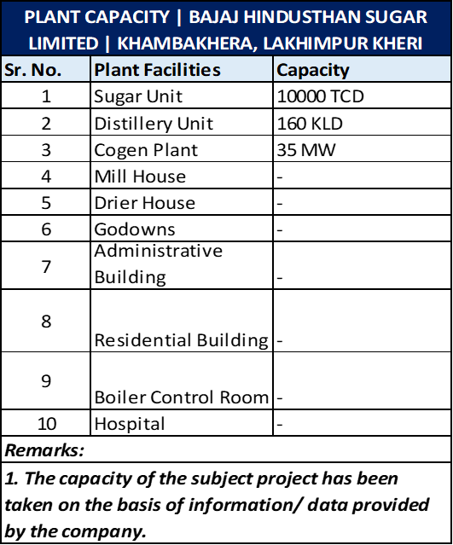

Project Location:
Bajaj Hindusthan Sugar Limited- Khamberkhera unit located at Khambarkheri village of District & Tehsil- Kheri, Uttar Pradesh, India. The nearest airport from the site is Chaudhary Charan Singh International Airport, Lucknow, located at the distance approx. 157 km and nearest railway station is Baraut Railway Station which is around 400 meters away from the Project Site. The subject property is located around 1 km away from Karnawal Narangpur road. Most of the land parcels in the subject vicinity is used for agricultural purpose.
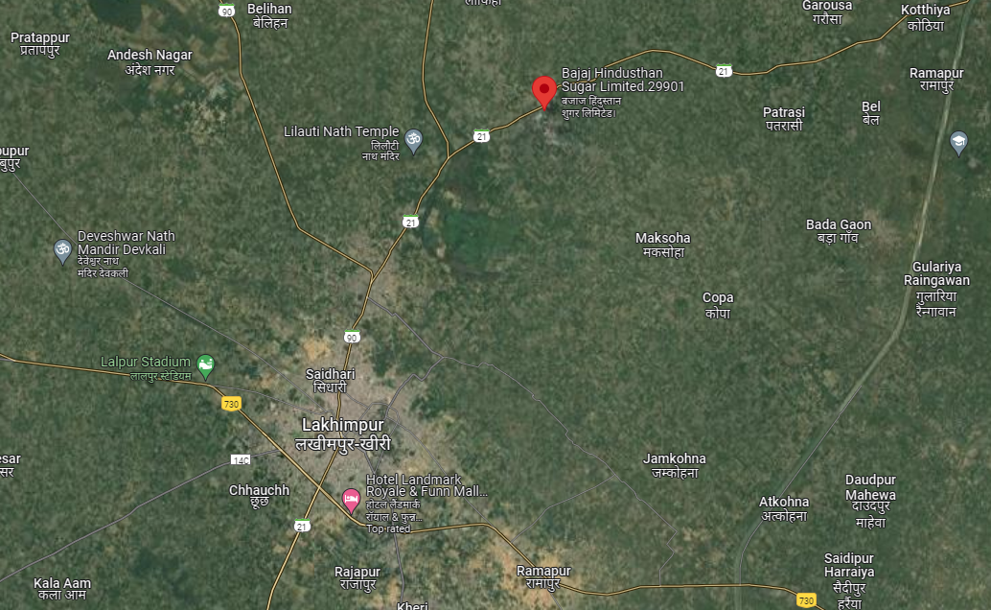

Observation made during the site visit as on date:
During the latest site visit conducted by our engineer, Sugar Mill was found to be at a state of complete overhauling and full-scale maintenance is going on, since it is off season for sugar production and most of the machines has been dismantled but distillery unit is running at its 80% -90% capacity. However, our team examined & verified the machines and utilities from the FAR provided to us by the company. Only major machinery, process line & equipment’s have been verified. Photographs have also been taken of all the Machines and its accessories installed there. Site Survey has been carried out on the basis of the physical existence of the assets rather than their technical expediency.
The machines installed at the aforesaid address are being used for the manufacturing of Sugar, & Power. Main machineries of the plant are Turbine, Boiler, Milling Machine, Cooling Tower, conveyor belt & other machineries. The valuation of the plant & machinery is done on the basis of the list of machines (FAR) provided to us by the client along with the capitalization date and purchase cost.

This report only contains general assessment & opinion on the Guideline Value and the indicative, estimated Market Value of the property of which Bank/ customer asked us to conduct the Valuation for the property found on as-is-where basis as shown on the site by the Bank/ customer of which photographs is also attached with the report. No legal aspects in terms of ownership or any other legal aspect is taken into consideration. Even if any such information is mentioned in the report it is only referred from the information provided for which we do not assume any responsibility. Due care has been given while doing valuation assessment, but it doesn’t contain any due-diligence or audit or verification of any kind other than the valuation computation of the property shown to us on site. Information/ data/ documents given to us by Bank/ client have been relied upon in good faith. This report doesn’t contain any other recommendations of any sort.

In case of discrepancy in the address/ property number mentioned in the property documents and the property shown to us at the site due to change in zoning or administrative level at the site or the client misled the valuer by providing the fabricated/ incorrect document or information, the valuation should be considered of the property shown to us at the site by the client of which the photographs are also attached. In case of any doubt, best would be to contact the concerned authority/ district administration/ tehsil level for the identification of the property if the property depicted in the photographs in this report is same with the documents pledged.
 | Location attribute of the property
 | Nearby Landmark |  | State bank of India
 | Postal Address of the Property |  | M/s. Bajaj Hindusthan Sugar Limited, Village- Khamberkhera, Tehsil & District: Lakhimpur Kheri, Uttar Pradesh
 | Type of Land |  | Solid Land/ on road level
 | Independent access/ approach to the property |  | Clear independent access is available
 | Google Map Location of the Property with a neighborhood layout map |  | Enclosed with the Report
 |  |  | Coordinates or URL: 28°01'11.1"N 80°49'45.6"E
 | Details of the roads abutting the property
 | - Main Road Name & Width |  | Nighshan Road |  |  |  |  |  |  |  |  |  |  | Approx. 40 ft. wide
 | - Front Road Name & width |  | Nighshan Road |  |  |  |  |  |  |  |  |  |  | Approx. 40 ft. wide
 | - Type of Approach Road |  | Bituminous Road
 | - Distance from the Main Road |  | -
 | Description of adjoining property |  | Majorly all nearby lands are used for Agriculture purpose
 | Plot No. / Survey No. |  | Various Gata Number. Please refer to the land valuation part
 | Zone/ Block |  | Village- Khamberkhera |  |  |  |  |  |  |  |  |  |  | ---
 | Sub registrar |  | Tehsil- Lakhimpur Kheri
 | District |  | District- Lakhimpur Kheri
 | Any other aspect |  | Valuation is done for the property found as per the information given in the copy of documents provided to us and/ or confirmed by the owner/ owner representative to us at site.  Getting cizra map or coordination with revenue officers for site identification is a separate activity and is not covered in this Valuation services.
 | - List of documents produced for perusal (Documents has been referred only for reference purpose as provided. Authenticity to be ascertained by legal practitioner) |  | Documents Requested |  |  |  | Documents Provided |  |  |  |  |  |  |  |  | Documents Reference No.
 |  |  | Total 10 documents requested. |  |  |  | Total 08 documents provided |  |  |  |  |  |  |  |  | Total 08 documents provided
 |  |  | Property Title document |  |  |  | Land Area Details |  |  |  |  |  |  |  |  | ---
 |  |  | Change of Land Use |  |  |  | Change of Land Use |  |  |  |  |  |  |  |  | Dated: 04-09-2009,  Dated: 30-05-2006,  Dated: 07-02-2008,  Dated: 14-05-2008, & Others
 |  |  | Cizra Map |  |  |  | --- |  |  |  |  |  |  |  |  | ---
 |  |  | Copy of FAR |  |  |  | Copy of FAR |  |  |  |  |  |  |  |  | Dated: 31-12-2023
 |  |  | PPA |  |  |  | Banking Agreement |  |  |  |  |  |  |  |  | Dated: 29-10-2020
 |  |  | Pollution NOC |  |  |  | Air-Water CTO |  |  |  |  |  |  |  |  | Dated: 19-12-2022  Dated: 04-01-2024
 |  |  | Environmental Clearence |  |  |  | Environmental Clearence |  |  |  |  |  |  |  |  | Dated: 07-12-2006
 |  |  | Factory License |  |  |  | Factory License |  |  |  |  |  |  |  |  | Reg. No.- UPFA24000008 Reg. No.- UPFA240000017
 |  |  | Explosive License |  |  |  | Explosive License |  |  |  |  |  |  |  |  | Dated: 08-01-2023
 |  |  | Approved Map |  |  |  | Plant Layout |  |  |  |  |  |  |  |  | ---
 | - Documents provided by |  | Owner's representative
 |  |  | Name |  |  |  | Relationship with Owner |  |  |  |  |  |  |  |  | Contact Number
 |  |  | Mr. Narendra Kumar Soni |  |  |  | Finance Department |  |  |  |  |  |  |  |  | +91 78382 11190
 | - Identification procedure followed of the property |  |  | Identified by owner’s representative
 |  |  |  | Done from the name plate displayed on the property
 | - Type of Survey |  | Full survey (inside-out with approximate measurements & photographs).
 | - Is property clearly demarcated by permanent/ temporary boundary on site |  | Yes demarcated properly
 | - Is the property merged or colluded with any other property |  | No. It is an independent single bounded property
 |  |  | -------
 | - City Categorization |  | Scale-B City |  |  |  |  |  |  |  |  |  |  | Semi Urban
 | - Characteristics of the locality |  | Ordinary |  |  |  |  |  |  |  |  |  |  | Within good village area
 | - Property location classification |  | Road Facing |  |  |  |  |  | Normal location within locality
 | - Property Facing |  | West Facing
 | Area description of the Property  Also please refer to Part-B Area description of the property. Area measurements considered in the Valuation Report is adopted from relevant approved documents or actual site measurement whichever is less, unless otherwise mentioned. Verification of the area measurement of the property is done only based on sample random checking. |  | Land |  |  |  |  |  |  | Construction
 |  |  |  |  |  |  |  |  |  | Built-up Area
 |  |  | 82.38 Hectare/ 203.48 Acres |  |  |  |  |  |  | 1,90,548 sqm for Sugar Mill, Distillery & Residential
 | Boundaries schedule of the Property
 | Are Boundaries matched |  | No, boundaries are not mentioned in the documents.
 | Directions | As per Sale Deed/TIR |  |  |  |  |  | Actual found at Site
 | East | --- |  |  |  |  |  | Agricultural Land
 | West | --- |  |  |  |  |  | Nigashan Road
 | North | --- |  |  |  |  |  | Chak road
 | South | --- |  |  |  |  |  | Agricultural Land
 | TOWN PLANNING/ ZONING PARAMETERS
 | Master Plan provisions related to property in terms of Land use |  |  |  |  | Area not notified under Master Plan
 | - Any conversion of land use done |  |  |  |  | As per the documents provided to us and the information that came to our knowledge this land is not an agricultural land
 | - Current activity done in the property |  |  |  |  | Used for Industrial purpose
 | - Is property usage as per applicable zoning |  |  |  |  | It is a village area, no zoning regulations defined,
 | - Any notification on change of zoning regulation |  |  |  |  | No, No such information came in front of us and could be found on public domain.
 | - Street Notification |  |  |  |  | Mixed use
 | Provision of Building by-laws as applicable |  |  |  |  | PERMITTED |  |  |  |  |  |  | CONSUMED
 | - FAR/FSI |  |  |  |  | Please refer to area chart description |  |  |  |  |  |  | Please refer to area chart description
 | - Ground coverage
 | - Number of floors
 | - Height restrictions
 | - Front/ Back/Side Setback
 | - Status of Completion/ Occupational certificate |  |  |  |  | NA, as plant is operational since 2007 and relevant NoCs are available with respect to the plant.
 | Comment on unauthorized construction if any |  |  |  |  | No, as per Layout Map shared.
 | Comment on Transferability of developmental rights |  |  |  |  | Free hold, complete transferable rights
 | - Planning Area/ Zone |  |  |  |  | Not within zoning area
 | - Master Plan Currently in Force |  |  |  |  | NA
 | - Municipal Limits |  |  |  |  | Gram Panchayat
 | Developmental controls/ Authority |  |  |  |  | NA
 | Zoning regulations |  |  |  |  | Rural
 | Comment on the surrounding land uses & adjoining properties in terms of uses |  |  |  |  | Majorly all nearby lands are used for Agriculture purpose
 | Comment of Demolition proceedings if any |  |  |  |  | No
 | Comment on Compounding/ Regularization proceedings |  |  |  |  | No
 | Any other aspect |  |  |  |  | ---
 | - Any information on encroachment |  |  |  |  | No
 | - Is the area part of unauthorized area/ colony |  |  |  |  | No (As per general information available)
 | DOCUMENT DETAILS AND LEGAL ASPECTS OF THE PROPERTY
 | Ownership documents provided |  |  |  | CLU, Licenses & NOCs
 | Names of the Legal Owner/s |  |  |  | M/s. Bajaj Hindusthan Sugar Limited
 | Constitution of the Property |  |  |  | Free hold, complete transferable rights
 | Agreement of easement if any |  |  |  | Not required
 | Notice of acquisition if any and area under acquisition |  |  |  | No
 | Notification of road widening if any and area under acquisition |  |  |  | No such information came in front of us and could be found on public domain
 | Heritage restrictions, if any |  |  |  | No
 | Comment on Transferability of the property ownership |  |  |  | Free hold, complete transferable rights
 | Comment on existing mortgages/ charges/ encumbrances on the property, if any |  |  |  | Yes |  |  |  |  |  |  | State Bank of India
 | Comment on whether the owners of the property have issued any guarantee (personal or corporate) as the case may be |  |  |  | No, as per audited financials |  |  |  |  |  |  | NA
 | Building plan sanction:
 | - Is Building Plan sanctioned |  |  |  | Internally approved plant layout shared
 | - Authority approving the plan |  |  |  | Internally approved plant layout shared
 | - Any violation from the approved Building Plan |  |  |  | No
 | - Details of alterations/ deviations/ illegal construction/ encroachment noticed in the structure from the original approved plan |  |  |  | ☐ Permissible Alterations
 |  |  |  |  | ☐ Not permitted alteration
 | Whether Property is Agricultural Land if yes, any conversion is contemplated |  |  |  | No not an agricultural property
 | Whether the property SARFAESI complaint |  |  |  | Yes
 | - Information regarding municipal taxes (property tax, water tax, electricity bill) |  |  |  | Property Tax |  |  |  |  |  | Not Applicable
 |  |  |  |  | Water Tax |  |  |  |  |  | Company is using underground water. Thus, water tax is not applicable. However, as per information provided, water conservation fees is applicable which have been duly paid.
 |  |  |  |  | Electricity Bill |  |  |  |  |  | Details not shared
 | - Observation on Dispute or Dues if any in payment of bills/ taxes |  |  |  | No such information came to knowledge on site
 | - Is property tax been paid for this property |  |  |  | Not Applicable
 | - Property or Tax Id No. |  |  |  | Not Applicable
 | Whether entire piece of land on which the unit is set up / property is situated has been mortgaged or to be mortgaged |  |  |  | Yes, as informed by owner/ owner representative.
 | Qualification in TIR/Mitigation suggested if any |  |  |  | Legal opinion has to be given by Advocate/ legal expert.
 | Any other aspect |  |  |  | This is just an opinion report on Valuation based on the copy of the documents/ information provided to us by the client and has been relied upon in good faith of the property found as per the information given in the documents provided to us and/ or confirmed by the owner/ owner representative to us on site.  Legal aspects, Title verification, Verification of authenticity of documents from originals or cross checking from any Govt. deptt. of the property have to be taken care by legal expert/ Advocate.
 | - Property presently occupied/ possessed by |  |  |  | Owner
*NOTE: Please see point 6 of Enclosure: VIII – Valuer’s Important Remarks

 | ECONOMIC ASPECTS OF THE PROPERTY
 | Reasonable letting value/ Expected market monthly rental |  |  |  |  |  |  | NA
 | Is property presently on rent |  |  |  |  |  |  | No
 | - Number of tenants |  |  |  |  |  |  | NA
 | - Since how long lease is in place |  |  |  |  |  |  | NA
 | - Status of tenancy right |  |  |  |  |  |  | NA
 | - Amount of monthly rent received |  |  |  |  |  |  | NA
 | Taxes and other outgoing |  |  |  |  |  |  | Not Applicable
 | Property Insurance details |  |  |  |  |  |  | Details not shared
 | Monthly maintenance charges payable |  |  |  |  |  |  | Not Applicable, as in-house maintenance is done.
 | Security charges, etc. |  |  |  |  |  |  | Not Applicable since property is not on rent.
 | Any other aspect |  |  |  |  |  |  | NA
 | SOCIO - CULTURAL ASPECTS OF THE PROPERTY
 | Descriptive account of the location of the property in terms of Social structure of the area in terms of population, social stratification, regional origin, age groups, economic levels, location of slums/squatter settlements nearby, etc. |  |  |  |  |  |  | Low Income Group
 | Whether property belongs to social infrastructure like hospital, school, old age homes etc. |  |  |  |  |  |  | No
 | FUNCTIONAL AND UTILITARIAN SERVICES, FACILITIES & AMENITIES
 | Description of the functionality & utility of the property in terms of:
 | - Space allocation |  |  |  |  |  |  | Yes
 | - Storage spaces |  |  |  |  |  |  | Yes
 | - Utility of spaces provided within the building |  |  |  |  |  |  | Yes
 | - Car parking facilities |  |  |  |  |  |  | Yes
 | - Balconies |  |  |  |  |  |  | No
 | Any other aspect
 | - Drainage arrangements |  |  |  |  |  |  | Yes
 | - Water Treatment Plant |  |  |  |  |  |  | Yes
 | - Power Supply arrangements |  |  | Permanent |  |  |  | Yes
 |  |  |  | Auxiliary |  |  |  | Yes, D.G sets
 | - HVAC system |  |  |  |  |  |  | Yes
 | - Security provisions |  |  |  |  |  |  | Yes/ Private security guards
 | - Lift/ Elevators |  |  |  |  |  |  | Yes
 | - Compound wall/ Main Gate |  |  |  |  |  |  | Yes
 | - Whether gated society |  |  |  |  |  |  | Yes
 | Internal development
 | Garden/ Park/ Land scraping |  | Water bodies |  |  | Internal roads |  |  |  | Pavements |  |  |  |  | Boundary Wall
 | Yes |  | Yes |  |  | Yes |  |  |  | Yes |  |  |  |  | Yes
 | INFRASTRUCTURE AVAILABILITY
 | Description of Aqua Infrastructure availability in terms of:
 | - Water Supply |  |  |  |  |  |  | Yes
 | - Sewerage/ sanitation system |  |  |  |  |  |  | Underground
 | - Storm water drainage |  |  |  |  |  |  | Yes
 | Description of other Physical Infrastructure facilities in terms of:
 | - Solid waste management |  |  |  |  |  |  | Yes
 | - Electricity |  |  |  |  |  |  | Yes
 | - Road and Public Transport connectivity |  |  |  |  |  |  | Yes
 | - Availability of other public utilities nearby |  |  |  |  |  |  | Transport, Market, Hospital etc. available in close vicinity
 | Proximity & availability of civic amenities & social infrastructure
 | School | Hospital |  |  | Market |  | Bus Stop |  | Railway Station |  |  | Metro |  |  |  |  | Airport
 | ~ 3 K.M. | ~2 Km |  |  | ~3 Km. |  | ~ 500 mtr. |  | ~ 3 Km |  |  | NA |  |  |  |  | NA
 | Availability of recreation facilities (parks, open spaces etc.) |  |  |  |  |  | No, This is a rural remote area. No recreational facility is available nearby.
 | MARKETABILITY ASPECTS OF THE PROPERTY
 | Marketability of the property in terms of
 | - Location attribute of the subject property |  |  |  |  |  |  | Good
 | - Scarcity |  |  |  |  |  |  | Multiple sugar Sugar Mills are available with-in 100 km radius.
 | - Demand and supply of the kind of the subject property in the locality |  |  |  |  |  |  | Good demand of such properties in the market.
 | - Comparable Sale Prices in the locality |  |  |  |  |  |  | Please refer to Part D: Procedure of Valuation Assessment
 | Any other aspect which has relevance on the value or marketability of the property |  |  |  |  |  |  | Property is located on main road.
 | - Any New Development in surrounding area |  |  |  |  |  |  | Road widening is in-progress |  |  |  |  |  | NA
 | - Any negativity/ defect/ disadvantages in the property/ location |  |  |  |  |  |  | Demand is related to the current use of the property only and only limited to the selected type of buyers. |  |  |  |  |  | NA
 | ENGINEERING AND TECHNOLOGY ASPECTS OF THE PROPERTY
 | Type of construction |  |  |  |  |  |  | Structure |  |  | Slab |  |  |  |  | Walls
 |  |  |  |  |  |  |  | RCC Framed structure & Steel frame structure |  |  | Reinforced Cement Concrete |  |  |  |  | Brick walls
 | Material & Technology used |  |  |  |  |  |  | Material Used |  |  |  |  | Technology used
 |  |  |  |  |  |  |  | Grade B Material |  |  |  |  | RCC Framed structure & Steel frame structure
 | Specifications
 | - Roof |  |  |  |  |  |  | Floors/ Blocks |  |  |  |  | Type of Roof
 |  |  |  |  |  |  |  | Please refer to the building sheet attached |  |  |  |  | GI Shed & RCC
 | - Floor height |  |  |  |  |  |  | Varying from10 ft.to 30 ft.
 | - Type of flooring |  |  |  |  |  |  | Vitrified tiles, PCC
 | - Doors/ Windows |  |  |  |  |  |  | Doors & windows, Wooden frame & panel doors
 | - Class of construction/ Appearance/ Condition of structures |  |  |  |  |  |  | Internal - Class B construction (Good)
 |  |  |  |  |  |  |  | External - Class B construction (Good)
 | - Interior Finishing & Design |  |  |  |  |  |  | Ordinary regular architecture, Simple Plastered Walls
 | - Exterior Finishing & Design |  |  |  |  |  |  | Ordinary regular architecture, Simple Plastered Walls
 | - Interior decoration/ Special architectural or decorative feature |  |  |  |  |  |  | Simple plain looking structure.
 | - Class of electrical fittings |  |  |  |  |  |  | Internal / Normal quality fittings used
 | - Class of sanitary & water supply fittings |  |  |  |  |  |  | Internal / Normal quality fittings used
 | Maintenance issues |  |  |  |  |  |  | No maintenance issue, structure are maintained properly
 | Age of building/ Year of construction |  |  |  |  |  |  | 2006-2007 |  |  |  |  | ~17-18 years
 | Total life of the structure/ Remaining life expected |  |  |  |  |  |  | Approx. 40-60 Years |  |  |  |  | Please refer to the  Building Area Statement
 | Extent of deterioration in the structure |  |  |  |  |  |  | Any normal depletion in the structure is taken care through regular maintenance
 | Structural safety |  |  |  |  |  |  | Structure built on RCC technique so it can be assumed as structurally stable. However no structural stability certificate is available
 | Protection against natural disasters viz. earthquakes etc. |  |  |  |  |  |  | Since this is a RCC structure so should be able to withstand moderate intensity earthquakes. Comments are been made only based on visual observation and not any technical testing.
 | Visible damage in the building if any |  |  |  |  |  |  | Yes but not so significantly, being taken care by yearly maintenance.
 | System of air conditioning |  |  |  |  |  |  | HVAC System & Partially covered with window/ split ACs
 | Provision of firefighting |  |  |  |  |  |  | Fire Hydrant System
 | Copies of the plan and elevation of the building to be included |  |  |  |  |  |  | Internal plant layout only. (Refer Annexure)
 | ENVIRONMENTAL FACTORS
 | Use of environment friendly building materials like fly ash brick, other Green building techniques if any |  |  |  |  |  |  | No, regular building techniques of RCC and burnt clay bricks are used
 | Provision of rainwater harvesting |  |  |  |  |  |  | Yes
 | Use of solar heating and lighting systems, etc. |  |  |  |  |  |  | No
 | Presence of environmental pollution in the vicinity of the property in terms of industries, heavy traffic, etc. if any |  |  |  |  |  |  | Yes
 | ARCHITECTURAL AND AESTHETIC QUALITY OF THE PROPERTY
 | Descriptive account on whether the building is modern, old fashioned, etc., plain looking or with decorative elements, heritage value if applicable, presence of landscape elements,  etc. |  |  |  |  |  |  | Plain looking industrial structure
 | VALUATION
 | Methodology of Valuation – Procedures adopted for arriving at the Valuation |  |  |  |  |  |  | Please refer to Part D: Procedure of Valuation Assessment of the report.
 | Prevailing Market Rate/ Price trend of the Property in the locality/ city from property search sites |  |  |  |  |  |  | Please refer to Part D: Procedure of Valuation Assessment of the report and the screenshot annexure in the report, if available.
 | Guideline Rate obtained from Registrar’s office/ State Govt. gazette/ Income Tax Notification |  |  |  |  |  |  | Please refer to Point 3 of Part D: Procedure of Valuation Assessment of the report and the screenshot annexure in the report, if available.
 | Summary of Valuation |  |  |  |  |  |  | For detailed Valuation calculation please refer to Part D: Procedure of Valuation Assessment of the report.
 | - Guideline Value |  |  |  |  |  |  | Rs. 41,17,35,630/-
 | - Land |  |  |  |  |  |  | Rs. 41,17,35,630/-
 | - Building |  |  |  |  |  |  | ----
 | - Plant & Machinery |  |  |  |  |  |  | ----
 | - Indicative Prospective Estimated Fair Market Value |  |  |  |  |  |  | Rs. 357,00,00,000/-
 | - Expected Estimated Realizable Value |  |  |  |  |  |  | Rs. 303,45,00,000/-
 | - Expected Forced/ Distress Sale Value |  |  |  |  |  |  | Rs. 214,20,00,000/-
 | - Valuation of structure for Insurance purpose |  |  |  |  |  |  | ---
 | - Justification for more than 20% difference in Market & Circle Rate |  |  |  |  |  |  | Circle rates are determined by the District administration as per their own theoretical internal policy for fixing the minimum valuation of the property for property registration tax collection purpose and Market rates are adopted based on prevailing market dynamics found as per the discrete market enquiries which is explained clearly in Valuation assessment factors.
 | - Details of last two transactions in the locality/ area to be provided, if available |  |  |  |  |  |  | No authentic last two transactions details could be known. However prospective transaction details as per information available on public domain and gathered during site survey is mentioned in Part D: Procedure of Valuation Assessment of the report and the screenshots of the references are annexed in the report for reference.
 | Declaration |  | - The information provided by us is true and correct to the best of our knowledge and belief.  - The analysis and conclusions are limited by the reported assumptions, limiting conditions, remarks.  - Firm have read the Handbook on Policy, Standards and Procedures for Real Estate Valuation by Banks and HFIs in India, 2011 issued by IBA and NHB, fully understood the provisions of the same and followed the provisions of the same to the best of our ability and this report is based on the Standards of Reporting enshrined in the above Handbook as much as practically possible related to the asset in the limited time available.  - No employee or member of R.K Associates has any direct/ indirect interest in the property.  - Our authorized surveyor Abhinav Chaturvedi has visited the subject property on 9/4/2024 in the presence of the owner's representative with the permission of owner.  - Firm is an approved Valuer of the Bank having registered valuers under section 34AB of Wealth Tax Act, 1957, Category: L&B, P&M for valuing upto any size.  - Firm has not been depanelled or removed from any Bank/Financial Institution/Government Organization at any point of time in the past.  - We have submitted the Valuation Report directly to the Bank.  Name & Address of the Valuation Company: R.K Associates Valuers & Techno Engg. Consultants (P) Ltd. D-39, Sector-2, Second Floor, Noida (U.P) – 201301  Signature of the Authorized Person:  Date: 15/4/2024  Tel. No. 0120-4110117  Mobile No.+91-9958632707  Email: valuers@rkassociates.org
 | ENCLOSED DOCUMENTS
 | Layout plan sketch of the area in which the property is located with latitude and longitude |  |  |  |  |  |  | Google Map enclosed with coordinates
 | Building Plan |  |  |  |  |  |  | Enclosed with the report
 | Floor Plan |  |  |  |  |  |  | Enclosed with the report
 | Photograph of the property (including geo-stamping with date) and owner (in case of housing loans, if borrower is available) including a “Selfie’ of the Valuer at the site |  |  |  |  |  |  | Enclosed with the report along with other property photographs
 | Certified copy of the approved / sanctioned plan wherever applicable from the concerned office |  |  |  |  |  |  | Plant Layout attached
 | Google Map location of the property |  |  |  |  |  |  | Enclosed with the Report
 | Price trend of the property in the locality/city from property search sites viz Magickbricks.com, 99Acres.com, Makan.com etc. |  |  |  |  |  |  | Enclosed with the Report
 | Any other relevant documents/extracts  (All enclosures & annexures to remain integral part & parcel of the main report) |  |  |  |  |  |  | - Enclosure: I- Google Map  - Enclosure: II- References on price trend of the similar related properties available on public domain, if available  - Enclosure: III- Photographs of the property  - Enclosure: IV- Copy of Circle Rate  - Enclosure: V- Important property documents exhibit  - Enclosure: VI- SBI Annexure: VI - Declaration-Cum-Undertaking  - Enclosure: VII- SBI Annexure: VII - Model Code of Conduct for Valuers  - Enclosure: VIII- Part E: Valuer’s Important Remarks
 | Total Number of Pages in the Report with enclosures |  |  |  |  |  |  | 66

As a result of our appraisal and analysis as defined in Part-D, it is our considered opinion that the present Fair Market Value of the above property in the prevailing condition with aforesaid specifications is estimated as Rs. 357,00,00,000/- (Rupees Three Hundred and Fifty-Seven Crore only). The Realizable Value of the above property is estimated as Rs. 303.45,00,000/- (Rupees Three Hundred Three Crore and Forty-Five Lakh only). The Book Value of the above property as of 31st December 2023 is Rs. 410,07,13,206/- (Rupees Four Hundred Ten Crore Seven Lakh Thirteen Thousand Two Hundred and Six only) and the Distress Value is Rs. 214,20,00,000/- (Rupees Two Hundred Fourteen Crore and Twenty Lakh only).

Signature

Place: Noida
Date: 15/4/2024

The undersigned has inspected the property detailed in the Valuation Report dated ______________ on _____________. We are satisfied that the fair and reasonable market value of the property is _______________________________________________.
Signature
PART C | AREA DESCRIPTION OF THE PROPERTY

 | Land Area considered for Valuation | 82.38 Hectare/ 203.48 Acres
 | Area adopted on the basis of | Property documents & site survey both
 | Remarks & observations, if any | As per site survey & Google Satellite Measurement tools, the land area of the plant is matching with the area mentioned in the area statement shared with us. Thus, the area mentioned in the area statement considered for valuation.
 | Constructed Area considered for Valuation  (As per IS 3861-1966) | Built-up Area | 1,90,548 sqm
 | Area adopted on the basis of | Building area sheet shared
 | Remarks & observations, if any | Building area sheet is shared by the company, which was randomly verified at site on sample basis to cross-verify the area. The area measured at site is same as area sheet shared. Thus, area sheet shared by the company is considered for valuation purpose.

Note:
- Area measurements considered in the Valuation Report pertaining to Land & Building is adopted from relevant approved documents or actual site measurement whichever is less. All area measurements are on approximate basis only.

- Verification of the area measurement of the property is done based on sample random checking only.

- Area of the large land parcels of more than 2500 sq.mtr or of uneven shape, is taken as per property documents verified with digital survey through google which has been relied upon.

- Drawing Map, design & detailed estimation of the property/ building is out of scope of the Valuation services.

PART D | PROCEDURE OF VALUATION ASSESSMENT

 | GENERAL INFORMATION
 | Important Dates | Date of Appointment |  | Date of Inspection of the Property | Date of Valuation Assessment | Date of Valuation Report
 | Important Dates | 16 March 2024 |  | 9 April 2024 | 15 April 2024 | 15 April 2024
 | Client | State Bank of India, IFB Branch, Jawahar Vyapar Bhawan, Tolstoy Marg, Janpath, New Delhi
 | Intended User | State Bank of India, IFB Branch, Jawahar Vyapar Bhawan, Tolstoy Marg, Janpath, New Delhi
 | Intended Use | To know the general idea on the market valuation trend of the property as per free market transaction. This report is not intended to cover any other internal mechanism, criteria, considerations of any organization as per their own need, use & purpose.
 | Purpose of Valuation | For Periodic Re-valuation of the mortgaged property
 | Scope of the Assessment | Non binding opinion on the assessment of Plain Physical Asset Valuation of the property identified to us by the owner or through his representative.
 | Restrictions | This report should not be referred for any other purpose, by any other user and for any other date other then as specified above. This report is not a certification of ownership or survey number/ property number/ Khasra number which are merely referred from the copy of the documents provided to us.
 | Manner in which the proper is identified |  | Identified by owner’s representative
 | Manner in which the proper is identified |  | Done from the name plate displayed on the property
 | Is property number/ survey number displayed on the property for proper identification? | Multiple Gata No.(Refer Annexure)
 | Type of Survey conducted | Full survey (inside-out with approximate measurements & photographs).

 | ASSESSMENT FACTORS
 | Valuation Standards considered | Mix of standards such as IVS and others issued by Indian authorities & institutions and improvised by the RKA internal research team as and where it is felt necessary to derive at a reasonable, logical & scientific approach. In this regard proper basis, approach, working, definitions considered is defined below which may have certain departures to IVS.
 | Nature of the Valuation | Fixed Assets Valuation
 | Nature/ Category/ Type/ Classification of Asset under Valuation | Nature |  |  |  |  | Category |  |  |  |  |  | Type
 |  | LAND & BUILDING, PLANT & MACHINERY & OTHER MISCELLANEOUS FIXED ASSET |  |  |  |  | INDUSTRIAL |  |  |  |  |  | INDUSTRIAL PLANT
 |  | Classification |  |  |  |  | Income/ Revenue Generating Asset
 | Type of Valuation (Basis of Valuation as per IVS) | Primary Basis |  |  |  | Market Value & Govt. Guideline Value
 | Type of Valuation (Basis of Valuation as per IVS) | Secondary Basis |  |  |  | Not Applicable
 | Present market state of the Asset assumed (Premise of Value as per IVS) | Under Normal Marketable State
 |  | Reason: Asset under free market transaction state
 | Property Use factor | Current/ Existing Use |  |  |  |  |  | Highest & Best Use  (in consonance to surrounding use, zoning and statutory norms) |  |  |  |  | Considered for Valuation purpose
 | Property Use factor | Industrial |  |  |  |  |  | Industrial |  |  |  |  | Industrial
 | Legality Aspect Factor | Assumed to be fine as per copy of the documents & information produced to us.  However Legal aspects of the property of any nature are out-of-scope of the Valuation Services. In terms of the legality, we have only gone by the documents provided to us in good faith.  Verification of authenticity of documents from originals or cross checking from any Govt. deptt. have to be taken care by Legal expert/ Advocate.
 | Class/ Category of the locality | Lower Class (Poor)
 | Property Physical Factors | Shape |  |  |  |  |  |  | Size |  |  |  | Layout
 | Property Physical Factors | Irregular |  |  |  |  |  |  | Large |  |  |  | Very Good Layout
 | Property Location Category Factor | City Categorization |  |  | Locality Characteristics |  |  |  |  |  | Property location characteristics |  |  | Floor Level
 | Property Location Category Factor | Scale-C City |  |  | Average |  |  |  |  |  | On Wide Road |  |  | Refer Building Valuation
 | Property Location Category Factor | Rural |  |  | Rural Area |  |  |  |  |  | Good location within locality |  |  | Refer Building Valuation
 | Property Location Category Factor |  |  |  | Within good village area |  |  |  |  |  | On Wide Road |  |  | Refer Building Valuation
 | Property Location Category Factor | Property Facing
 | Property Location Category Factor | North Facing
 | Physical Infrastructure availability factors of the locality | Water Supply |  |  | Sewerage/ sanitation system |  |  |  |  |  | Electricity |  |  | Road and Public Transport connectivity
 | Physical Infrastructure availability factors of the locality | Yes from borewell/ submersible |  |  | Underground |  |  |  |  |  | Yes |  |  | Easily available
 | Physical Infrastructure availability factors of the locality | Availability of other public utilities nearby |  |  |  |  |  |  |  |  | Availability of communication facilities
 | Physical Infrastructure availability factors of the locality | Transport, Market, Hospital etc. are available in close vicinity |  |  |  |  |  |  |  |  | Major Telecommunication Service Provider & ISP connections are available
 | Social structure of the area (in terms of population, social stratification, regional origin, age groups, economic levels, location of slums/ squatter settlements nearby, etc.) | Rural Income Group
 | Neighbourhood amenities | Average
 | Any New Development in surrounding area | Road widening was under construction
 | Any specific advantage in the property | No such specific observation came into consideration
 | Any specific drawback in the property | No such specific observation came into consideration
 | Property overall usability/ utility Factor | Good
 | Do property has any alternate use? | No
 | Is property clearly demarcated by permanent/ temporary boundary on site | Demarcated with permanent boundary
 | Is the property merged or colluded with any other property | No
 | Is the property merged or colluded with any other property | Comments: --- It is an independent single bounded property comprising multiple Gata No.
 | Is independent access available to the property | Clear independent access is available
 | Is property clearly possessable upon sale | Yes
 | Best Sale procedure to realize maximum Value (in respect to Present market state or premise of the Asset as per point (iv) above) | Fair Market Value
 |  | Free market transaction at arm's length wherein the parties, after full market survey each acted knowledgeably, prudently and without any compulsion.
 | Hypothetical Sale transaction method assumed for the computation of valuation | Fair Market Value
 |  | Free market transaction at arm's length wherein the parties, after full market survey each acted knowledgeably, prudently and without any compulsion.
 | Approach & Method of Valuation Used | Land |  | Approach of Valuation |  |  |  |  |  |  | Method of Valuation
 | Approach & Method of Valuation Used |  |  | Market Approach |  |  |  |  |  |  | Market Comparable Sales Method
 | Approach & Method of Valuation Used | Building |  | Cost Approach |  |  |  |  |  |  | Depreciated Reproduction Cost Method
 | Approach & Method of Valuation Used | Plant & Machinery |  | Cost Approach |  |  |  |  |  |  | Depreciated Replacement Cost Method
 | Type of Source of Information | Level 3 Input (Tertiary)
 | Market Comparable
 | References on prevailing market Rate/ Price trend of the property and Details of the sources from where the information is gathered (from property search sites & local information) | 1. | Name: |  |  |  |  |  |  |  |  | Mr. Ishu Gupta
 |  | 1. | Contact No.: |  |  |  |  |  |  |  |  | +91 95060 56672
 |  | 1. | Nature of reference: |  |  |  |  |  |  |  |  | Property Consultant
 |  | 1. | Size of the Property: |  |  |  |  |  |  |  |  | Not specified
 |  | 1. | Location: |  |  |  |  |  |  |  |  | SH-21 Road
 |  | 1. | Rates/ Price informed: |  |  |  |  |  |  |  |  | Around Rs. 50,00,000/- to Rs. 60,00,000/- per Acre
 |  | 1. | Any other details/ Discussion held: |  |  |  |  |  |  |  |  | As per discussion with local property dealer of the location, it was informed that land of 5-10 acre in size, on highway is not available for sale. One will have to buy multiple adjacent land. However, the land rate on highway for smaller land parcel is about Rs. 50,00,000/- to Rs. 60,00,000/- per Acre depending upon availability and negotiation.
 |  | 2. | Name: |  |  |  |  |  |  |  |  | Local People
 |  | 2. | Contact No.: |  |  |  |  |  |  |  |  | ---
 |  | 2. | Nature of reference: |  |  |  |  |  |  |  |  | Habitant of subject location
 |  | 2. | Size of the Property: |  |  |  |  |  |  |  |  | ---
 |  | 2. | Location: |  |  |  |  |  |  |  |  | State Highway-21
 |  | 2. | Rates/ Price informed: |  |  |  |  |  |  |  |  | Around Rs. 50,00,000/- to Rs. 60,00,000/- per Acre
 |  | 2. | Any other details/ Discussion held: |  |  |  |  |  |  |  |  | As per discussion with the local people, the land agriculture land rate away from highway shall be available from Rs. 50,00,000/- to Rs. 60,00,000/- per Acre depending upon availability. However, land rate on highway is on higher side and shall fetch rate above Rs. 70,00,000/- per Bigha.
 |  | NOTE: The given information above can be independently verified to know its authenticity.
 | Adopted Rates Justification | As per our discussion with the property dealers and habitants of the subject location we have gathered the following information:-  - The location of the subject property is in the midst of urban developing area of Lakhimpur district and demand of the property is good. The subject land property is fully developed and being used for the sugar plant purpose by the concerned company.  - The subject is located in Khamberkhera village and all the nearby land are being used agriculture purpose. Therefore there is huge availability of agriculture land.  - The subject property is the only industrial setup, no other economic activity observed in the locality.  - The Market Rates for land will depend upon the size, location & shape.  - The agriculture lands are available for sale ranging Rs. 50,00,000/- to Rs. 60,00,000/- per Acre depending upon shape, size, frontage,, distance from the main road etc.  - Our subject land parcel is huge in size and is located adjacent to State Highway, Thus, we have are in view to adopt Land rate of Rs. 55,00,000/- per Acre.
NOTE: We have taken due care to take the information from reliable sources. The given information above can be independently verified from the provided numbers to know its authenticity. However due to the nature of the information most of the market information came to knowledge is only through verbal discussion with market participants which we have to rely upon where generally there is no written record.
Related postings for similar properties on sale are also annexed with the Report wherever available.
 | Other Market Factors
 | Current Market condition | Normal
 | Current Market condition | Remarks: ---
 | Current Market condition | Adjustments (-/+): 0%
 | Comment on Property Salability Outlook | Due to the nature of the property, it will have limited buyers.
 | Comment on Property Salability Outlook | Adjustments (-/+): 0%
 | Comment on Demand & Supply in the Market | Demand |  |  |  |  |  |  |  | Supply
 | Comment on Demand & Supply in the Market | Good |  |  |  |  |  |  |  | Low
 | Comment on Demand & Supply in the Market | Remarks: Demand is related to the current use of the property only and only limited to the selected type of buyers
 | Comment on Demand & Supply in the Market | Adjustments (-/+): 0%
 | Any other special consideration | Reason: ----
 | Any other special consideration | Adjustments (-/+): 0%
 | Any other aspect which has relevance on the value or marketability of the property | NA  Valuation of the same asset/ property can fetch different values under different circumstances & situations. For eg. Valuation of a running/ operational shop/ hotel/ factory will fetch better value and in case of closed shop/ hotel/ factory it will fetch considerably lower value. Similarly, an asset sold directly by an owner in the open market through free market arm’s length transaction then it will fetch better value and if the same asset/ property is sold by any financer or court decree or Govt. enforcement agency due to any kind of encumbrance on it then it will fetch lower value. Hence before financing, Lender/ FI should take into consideration all such future risks while financing.  This Valuation report is prepared based on the facts of the property & market situation on the date of the survey. It is a well-known fact that the market value of any asset varies with time & socio-economic conditions prevailing in the region/ country. In future property market may go down, property conditions may change or may go worse, property reputation may differ, property vicinity conditions may go down or become worse, property market may change due to impact of Govt. policies or effect of domestic/ world economy, usability prospects of the property may change, etc. Hence before financing, Banker/ FI should take into consideration all such future risk while financing.
 |  | Adjustments (-/+): 0%
 | Final adjusted & weighted Rates considered for the subject property | Please refer to attached sheet
 | Considered Rates Justification | - Land Valuation assessment is done considering the Land use for Sugar Project Land only as its highest & best use since the transaction of this land will be done based on the established Project only and separation of it from the Project will be virtually impossible, at least up to the complete economic life cycle of this plant which is taken as 30-35 years and also due to the location no other more productive use can be thought of.  - Overall Valuation assessment is done based on the fact that if any new promoter/ buyer would plan to setup a similar Plant today at same location and same size then what will cost him today for acquisition. To acquire 203.48 acres of land parcel, one would either go to Govt. to provide the land for Industry or would approach individual land owners to purchase their land portions.  - Valuation of free hold land is done on the basis of comparable market approach.  - Since it is a very large parcel of land and transaction of the whole parcel of land at one go is very difficult, therefore we have opted belting method to calculate the value of land.  - Fragmentation sale of a large land may have different values. While assessing the Valuation of the land in this Valuation Report, it is considered as on-is-where basis for the purpose it is used for which was found at the time of site survey.
 | Basis of computation & working
- Valuation of the asset is done as found on as-is-where basis on the site as identified to us by client/ owner/ owner representative during site inspection by our engineer/s unless otherwise mentioned in the report.
- Analysis and conclusions adopted in the report are limited to the reported assumptions, conditions and information came to our knowledge during the course of the work and based on the Standard Operating Procedures, Best Practices, Caveats, Limitations, Conditions, Remarks, Important Notes, Valuation TOR and definition of different nature of values.
- For knowing comparable market rates, significant discreet local enquiries have been made from our side based on the hypothetical/ virtual representation of ourselves as both buyer and seller for the similar type of properties in the subject location and thereafter based on this information and various factors of the property, rate has been judiciously taken considering the factors of the subject property, market scenario and weighted adjusted comparison with the comparable properties unless otherwise stated.
- References regarding the prevailing market rates and comparable are based on the verbal/ informal/ secondary/ tertiary information which are collected by our team from the local people/ property consultants/ recent deals/ demand-supply/ internet postings are relied upon as may be available or can be fetched within the limited time & resources of the assignment during market survey in the subject location. No written record is generally available for such market information and analysis has to be derived mostly based on the verbal information which has to be relied upon.
- Market Rates are rationally adopted based on the facts of the property which came to our knowledge during the course of the assessment considering many factors like nature of the property, size, location, approach, market situation and trends and comparative analysis with the similar assets. During comparative analysis, valuation metrics is prepared and necessary adjustments are made on the subject asset.
- The indicative value has been suggested based on the prevailing market rates that came to our knowledge during secondary & tertiary market research and is not split into formal & informal payment arrangements. Most of the deals takes place which includes both formal & informal payment components. Deals which takes place in complete formal payment component may realize relatively less actual transaction value due to inherent added tax, stamp registration liabilities on the buyer.
- Secondary/ Tertiary costs related to asset transaction like Stamp Duty, Registration charges, Brokerage, Commission, Bank interest, Selling cost, Marketing cost, etc. pertaining to the sale/ purchase of this property are not considered while assessing the indicative estimated Market Value.
- This report includes both, Govt. Guideline Value and Indicative Estimated Prospective Market Value as described above. As per the current market practice, in most of the cases, formal transaction takes place for an amount less than the actual transaction amount and rest of the payment is normally done informally.
- Area measurements considered in the Valuation Report pertaining to asset/ property is adopted from relevant approved documents or sample site measurement whichever is less unless otherwise mentioned. All area measurements are on approximate basis only.
- Verification of the area measurement of the property is done based on sample random checking only.
- Area of the large land parcels of more than 2500 sq.mtr or of uneven shape in which there can be practical difficulty in sample measurement, is taken as per property documents which has been relied upon unless otherwise stated.
- Drawing, Map, design & detailed estimation of the property/ building is out of scope of the Valuation services.
- Construction rates are adopted based on the present market replacement cost of construction and calculating applicable depreciation & deterioration factor as per its age, existing condition & specifications based on visual observation only of the structure. No structural, physical tests have been carried out in respect of it. No responsibility is assumed for latent defects of any nature whatsoever, which may affect value, or for any expertise required to disclose such conditions.
- Construction rates are adopted based on the plinth area rates prevailing in the market for the structure as a whole and not based on item wise estimation or Bills of Quantity method unless otherwise stated.
- The condition assessment and the estimation of the residual economic life of the structure are only based on the visual observations and appearance found during the site survey. We have not carried out any structural design or stability study; nor carried out any physical tests to assess structural integrity & strength.
- Any kind of unpaid statutory, utilities, lease, interest or any other pecuniary dues on the asset or on its owners has not been factored in the Valuation.
- This Valuation is conducted based on the macro analysis of the asset/ property considering it in totality and not based on the micro, component or item wise analysis. Analysis done is a general assessment and is neither investigative in nature nor an audit activity.
- Valuation is done for the asset found on as-is-where basis which owner/ owner representative/ client/ bank has shown to us on site of which some reference has been taken from the information/ data given in the copy of documents provided to us which have been relied upon in good faith and we have assumed that it to be true and correct.
 | ASSUMPTIONS
- Documents/ Information/ Data provided by the client/ property owner or his representative both written & verbally is true and correct without any fabrication and has been relied upon in good faith.
- Local verbal enquiries during micro market research came to our knowledge are assumed to be taken on record as true & factual.
- The assets and interests therein have been valued free and clear of any liens or encumbrances unless stated otherwise. No hidden or apparent conditions regarding the subject assets or their ownership are assumed to exist. No opinion of title is rendered in this report and a good title is assumed unless stated otherwise.
- It is assumed that the concerned Lender/ Financial Institution has asked for the valuation of that property after satisfying the authenticity of the documents given to us and for which the legal verification has been already taken and cleared by the competent Advocate before requesting for the Valuation report. I/ We assume no responsibility for the legal matters including, but not limited to, legal or title concerns.
- Payment condition during transaction in the Valuation has been considered on all cash bases which includes both formal & informal payment components as per market trend.
- Sale transaction method of the asset is assumed as Free market transaction without any compulsion unless otherwise mentioned while assessing Indicative & Estimated Fair Prospective Market Value of the asset unless otherwise stated.
- If this Valuation Report is prepared for the Flat/ dwelling unit situated in a Group Housing Society or Integrated Township then approvals, maps of the complete group housing society/ township is out of scope of this report. This valuation report is prepared for the specific unit based on the assumption that complete Group Housing Society/ Integrated Township is approved and complied with all relevant laws and the subject unit is also approved within the Group Housing Society/ Township.
 | SPECIAL ASSUMPTIONS
 | None
 | LIMITATIONS
 | None

VALUATION OF LAND

Market Value of this Project land would be the value which any new promoters’ company will be spending the amount in procuring the equal measurement of the land parcel if it wants to setup a similar plant today at the same or similar location. Hence Market value of the land is assessed based on the significant local enquiries, reference of historical sales comparable searched by our team and making rational factors of adjustment on it based on current market situation & condition.
- Based on the above available data/ information, law of average is taken on the complete land to reach out the value of Project land in current times if it is acquired now.
- In our opinion applying the law of average for such a large land parcel Rs. 55,00,000/- per Acre would be reasonable for the front belt of the land, for the middle belt we have considered Rs. 41,25,000/- per Acre and for the rear belt we have considered Rs. 33,00,000/-.
- In addition to this basic rate premium charges are added as mentioned below on the basis of the location and purpose of the land:
- Around 5% premium is added for non-agricultural land.
- Around 5% premium is added on this rate which covers the land arranging costs, Land development and site levelling and for the other administrative charges. etc.
BARKHERA LAND VALUATION BELTING METHOD
Calculation by Belting Method | Total Area | Area (front side) | Area (middle part) | Area (back side)
Area (Acre) | 203.48 | 50.87 | 101.74 | 50.87
Rate (Acre) |  | ₹ 55,00,000 | ₹ 41,25,000 | ₹ 33,00,000
Value |  | ₹ 27,97,85,000 | ₹ 41,96,77,500 | ₹ 16,78,71,000
Total Value |  | ₹ 86,73,33,500
Average Rate (Acre) |  | ₹ 42,62,500
Add 5% premium for non-agriculture land |  |  |  | ₹ 4,33,66,675
Add 5% for cost & effort considerations to cover administrative cost, effort towards land acquisition & consolidation etc. |  |  |  | ₹ 4,33,66,675
Final Fair Market Value of Land |  |  |  | ₹ 95,40,66,850

GOVERNMENT GUIDELINE VALUATION OF BAJAJ ENERGY LIMITED-KHAMBERKHERA
Sr. No | Village Name | Area (Hectare) | Area (Acre) | Area  (sq. mtr.) | Govt. Guidelines Rates for Agriculture Land  (INR per Hectare) | Govt. Guidelines Rates for Non-Agriculture Land  (INR per sq. mtr.) | Agricultural Govt. Guideline Value  (INR) | Non- Agricultural Govt. Guideline Value  (INR)
1 | Khamberkhera | 82.35 | 203.484 | 823471 | 50,00,000 | 3,800 | 41,17,35,630 | 2,96,44,94,581
Total |  | 82.35 | 203.48 | 823471 |  |  | 41,17,35,630 | 2,96,44,94,581
Remarks:
1. The above-mentioned land area has been taken on the basis of information/ data provided by the company.
2. These circle rates gives only the indicative values. However, actually this value has no reference to the real market transaction value which is much less for this kind of land considering the land used for Industrial purpose comparing it with non-agricultural land. Hence no reference can be derived out of the Circle Guideline Value

VALUATION COMPUTATION OF BUILDING & CIVIL WORKS

- METHODOLOGY ADOPTED: The fair market value of the building as on the date of valuation is its cost of reproduction on that date less the depreciation & other deterioration deductions from the date of completion of the buildings to the date of its valuation. Thus, for building valuation we have used “Depreciated Reproduction Cost Method” under “Cost Approach”.

- BUILDINGS & CIVIL WORKS VALUATION: We have been provided building area sheet for considering built-up are of plant building & structure and other infrastructures such road, drain, boundary walls etc.
BUILDING/ CIVIL STRUCTURE | BAJAJ HINDUSTHAN SUGAR LIMITED |BARKHERA, UTTAR PRADESH
Sr. No. | Description | Gross Current Replacement Cost | Fair Market Value
1 | Sugar Plant | ₹ 69,74,91,027 | ₹ 47,76,18,013
2 | Residential Block | ₹ 8,11,80,675 | ₹ 8,11,80,675
Total |  | ₹ 77,86,71,702 | ₹ 55,87,98,688
Remarks:
- Buildings & Civil works only related to the BHSL, Khamberkhera, Lakhimpur Khiri, U.P Plant and associated facilities are considered in this report.
- On our request, BHSL provided us the area measurement of Buildings. Hence we have believed on the area statement provided by the company in good faith. However, our team have cross-verified all the structure present within the boundary of the company.
- Some sample verification has been done with the provided area which was found to be different as provided in the sheet.(Ex: Height of Sugar Godown, Area of Dispensary & cane office, Labour Hutment, Guest House
- For evaluation of the useful economic life for the calculation of depreciation, company’s act 2013 and the general practical trend of same Buildings are taken into consideration.
- The economic life of the Main Plant Building is taken as 25 years, for Industrial RCC structure is taken as 60 years, and others structure related to Sugar, Manufacturing Plant varies from 40 to 60 years.
- For calculating reproduction cost of Civil & Structural Assets as on date, we have taken reference from open market and calculated depreciation on the same.

 | VALUATION OF ADDITIONAL AESTHETIC/ INTERIOR WORKS IN THE PROPERTY
S. No. | Particulars | Specifications | Depreciated Replacement Value
 | Add extra for Architectural aesthetic developments, improvements (add lump sum cost) | ---- | Already considered in valuation above
 | Add extra for fittings & fixtures  (Doors, windows, wood work, cupboards, modular kitchen, electrical/ sanitary fittings) | ---- | Already considered in valuation above
 | Add extra for services  (Water, Electricity, Sewerage, Main gate, Boundary, Lift, Auxiliary power, AC, HVAC, Firefighting etc.) | ---- | Already considered in valuation above
 | Add extra for internal & external development  (Internal roads, Landscaping, Pavements, Street lights, Green area development, External area landscaping, Land development, Approach road, etc.) | ---- | Already considered in valuation above
 | Depreciated Replacement Value (B) | NA | NA
Note:
- Value for Additional Building & Site Aesthetic Works is considered only if it is having exclusive/ super fine work specification above ordinary/ normal work. Ordinary/ normal work value is already covered under basic rates above.

PART E | CHARACTERISTICS DESCRIPTION OF PLANT/ MACHINERY

S.NO. | CONTENTS | DESCRIPTION

 | TECHNICAL DESCRIPTION OF THE PLANT/ MACHINERY
 | Nature of Plant & Machinery | Sugar, Ethanol
 | Size of the Plant | - Large scale Plant
 | Type of the Plant | - Semi Automatic
 | Year of Installation/ Commissioning/ COD (Commercial Operation Date) | 2007
 | Production Capacity | Sugar: 10,000 TCD  Distillery: 160 KLPD  Co-gen: 35 MW
 | Capacity at which Plant was running at the time of Survey | Sugar plant is under maintenance, since the availability of raw material (Sugarcane) is not available, as it is off season. Distillery & Co-gen plant was operational.
 | Number of Production Lines | No specific production lines.
 | Condition of Machines | Good. (Under complete overhauling Sugar Plant only)
 | Status of the Plant | Under periodic maintenance (Sugar Plant only)
 | Products Manufactured in this Plant | - Sugar  - Ethanol
 | Recent maintenance carried out on | 2023 (As per information provided to us.)
 | Recent upgradation, improvements if done any | None
 | Total Gross Block & Net Block of Assets | Gross Block | Net Block
 | Total Gross Block & Net Block of Assets | As on 31/12/2023
 | Total Gross Block & Net Block of Assets | Rs. 505,48,45,689/- | Rs. 174,87,77,746/-
 | Any other Details if any | As on date of site visit, the plant was not operational due seasonal off. It was shut recently & will operate again after complete overhaul & maintenance. It is expected to run again in Next November. However, Distillery & Co-gen units were operational.

 | MANUFACTURING PROCESS
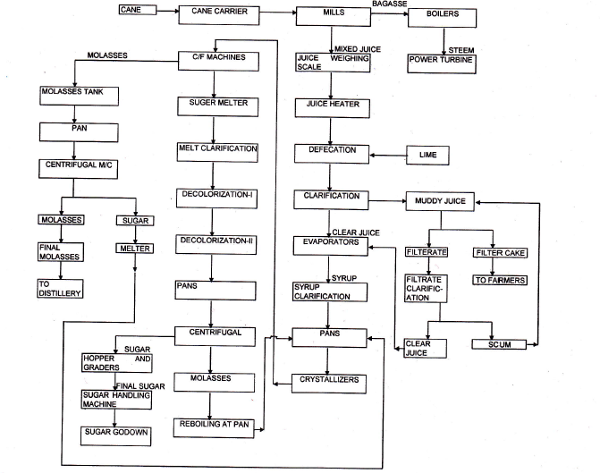
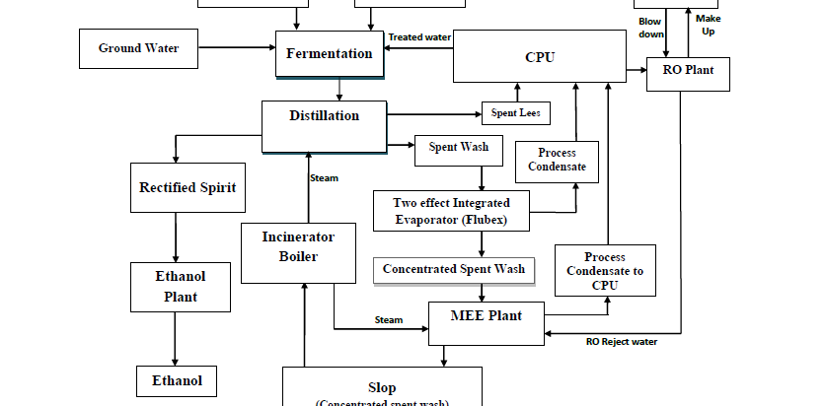
 | TECHNOLOGY TYPE/ GENERATION USED AND TECHNOLOGICAL COLLABORATIONS IF ANY
 | - Technology Type/ Generation Used in this Plant | Indigenous
 | Technological Collaborations If Any | No
 | Current Technology used for this Industry in Market | Milling Process, Fragmentation Process
 | RAW MATERIALS REQUIRED & AVAILABILITY
 | Type of Raw Material | Sugarcane
 | Availability | The sugar mill lies in the main sugar cane producing area and availability of sugar cane is plentiful in season.
 | AVAILABILITY & STATUS OF UTILITIES
 | Power/ Electricity | Co-generation power plant within the subject property and from the main grid.
 | Water | Available from bore wells
 | Road/ Transport | Yes
 | COMMENT ON AVAILABILITY OF LABOUR
 | Availability | Appears to be easily & adequately available and no labour issues came to our knowledge during site inspection.
 | Number of Labours working in the Factory | ---
 | SALES TRANSACTIONAL PROSPECTS OF SUCH PLANTS/ MACHINERY
 | Strategic Sale as part of the ongoing concern company.
 | Reason: This is a Large Scale Plant and can only be sold only as an Integrated Industry to preserve its value since complete process line & machines are special purpose machines and can't be used in any other Industry. So for fetching maximum value is through strategic sale to the players who are already into same or similar Industry who have plans for expansion or any large conglomefrate who plans to enter into this new Industry
 | DEMAND OF SUCH PLANT & MACHINERY IN THE MARKET
 | Appears to be good as per general information available in public domain.
 | SURVEY DETAILS
 | Plant has been surveyed by our Engineering Team on dated 09/04/2024
 | Site inspection was done in the presence of Company's Employee Mr. Yogesh Singh who were available from the company to furnish any specific detail about the Plant & Machinery.
 | Our team examined & verified the machines and utilities from the FAR provided by the Company. Only major machinery & equipment installed in the plant has been verified.
 | Photographs have also been taken of all the Machines and its accessories installed there.
 | Plant was under seasonal maintenance at the time of survey.
 | Details have been cross checked as per the documents provided to us by the company and what was observed at the site.
 | Condition of the machines is checked through visual observation only. No technical/ mechanical/ operational testing has been carried out to ascertain the condition and efficiency of machines.
 | Site Survey has been carried out on the basis of the physical existence of the assets rather than their technical expediency.
 | As per the overall site visit summary, the Plant appeared to be in good condition.

PART F | PROCEDURE OF VALUATION ASSESMENT – PLANT & MACHINERY

 | GENERAL INFORMATION
 | Important Dates | Date of Inspection of the Property |  | Date of Valuation Assessment | Date of Valuation Report
 | Important Dates | 9 April 2024 |  | 15 April 2024 | 15 April 2024
 | Client | State Bank of India, IFB Branch, Jawahar Vyapar Bhawan, Tolstoy Marg, Janpath, New Delhi
 | Intended User | State Bank of India, IFB Branch, Jawahar Vyapar Bhawan, Tolstoy Marg, Janpath, New Delhi
 | Intended Use | To know the general idea on the market valuation trend of the property as per free market transaction. This report is not intended to cover any other internal mechanism, criteria, and considerations of any organization as per their own need, use & purpose.
 | Purpose of Valuation | For Periodic Re-valuation of the mortgaged property
 | Scope of the Assessment | Non binding opinion on the assessment of Plain Physical Asset Valuation of the property identified to us by the owner or through his representative.
 | Restrictions | This report should not be referred for any other purpose, by any other user and for any other date other then as specified above.
 | Identification of the Assets |  | Cross checked from the name of the machines mentioned in the FAR list name plate displayed on the machine
 | Identification of the Assets |  | Identified by the company's representative
 | Identification of the Assets |  | Due to large number of machines only major production lines & machines have been checked
 | Type of Survey conducted | Full survey (inside-out with approximate sample random measurements verification & photographs).
 | ASSESSMENT FACTORS
 | Nature of the Valuation | Fixed Assets Valuation
 | Nature/ Category/ Type/ Classification of Asset under Valuation | Nature |  |  | Category |  |  | Type
 |  | PLANT & MACHINERY |  |  | INDUSTRIAL |  |  | SUGAR MILL
 |  | Classification |  |  | Income/ Revenue Generating Asset
 | Type of Valuation (Basis of Valuation as per IVS) | Primary Basis |  | Fair Market Value
 | Type of Valuation (Basis of Valuation as per IVS) | Secondary Basis |  | On-going concern basis
 | Present market state of the Asset assumed (Premise of Value as per IVS) | Under Normal Marketable State
 |  | Reason: Asset under free market transaction state
 | Physical Infrastructure availability factors of the locality | Water Supply | Sewerage/ Sanitation system |  |  |  | Electricity |  | Road and Public Transport connectivity
 | Physical Infrastructure availability factors of the locality | Yes from borewell/ submersible | Underground |  |  |  | Yes |  | Easily available
 | Physical Infrastructure availability factors of the locality | Availability of other public utilities nearby |  |  |  |  | Availability of communication facilities
 | Physical Infrastructure availability factors of the locality | Transport, Market, Hospital etc. are available in close vicinity |  |  |  |  | Major Telecommunication Service Provider & ISP connections are available
 | Neighbourhood amenities | Average
 | Any New Development in surrounding area | Road widening was progress |  |  |  | NA
 | Any specific advantage/ drawback in the plant and machines | No such specific drawback
 | Machines overall usability/ utility Factor | Good
 | Best Sale procedure to realize maximum Value (in respect to Present market state or premise of the Asset as per point (iv) above) | Fair Market Value
 |  | Free market transaction at arm's length wherein the parties, after full market survey each acted knowledgeably, prudently and without any compulsion.
 | Hypothetical Sale transaction method assumed for the computation of valuation | Fair Market Value
 |  | Free market transaction at arm's length wherein the parties, after full market survey each acted knowledgeably, prudently and without any compulsion.
 | Approach & Method of Valuation Used | Approach of Valuation |  |  |  |  | Method of Valuation
 | Approach & Method of Valuation Used | Cost Approach |  |  |  |  | Depreciated Reproduction Cost Method
 | Type of Source of Information | Level 3 Input (Tertiary)

 | Any other aspect which has relevance on the value or marketability of the machines | The marketability for the machines depends upon the industry outlook, make, market condition, raw material, maintenance, raw material, usability, capacity.  This Valuation report is prepared based on the facts of the assets & market situation on the date of the survey. It is a well-known fact that the market value of any asset varies with time & socio-economic conditions prevailing in the region/ country. In future assets market may go down, asset conditions may change or may go worse, plant vicinity conditions may go down or become worse, plant market may change due to impact of Govt. policies or effect of domestic/ world economy, usability prospects of the Plant may change, etc. Hence before financing, Banker/ FI should take into consideration all such future risk while financing.
 | Basis of computation & working
Main Basis:

- We have conducted valuation of physical assets rather than business valuation. Thus, we have applied Cost and Market Approach for Valuation Purpose.
- Basic Methodology: For arriving at fair market value of P&M & other fixed assets our engineering team has rationally applied the mixture of ‘sales comparison approach (market approach)’ and the ‘cost approach (depreciated replacement cost)’. The fair market value of Plant & Machinery on the date of valuation is its cost of reproduction & commissioning on that date less the depreciation from the date of commissioning of the machinery to the date of its valuation.
- Core P&M Asset Valuation is done keeping in mind various factors like technology used, machines availability, its condition, average age, maintenance & service and parts replacement availability of the machines and more importantly demand in the market.
- Main Machinery of this Plant are specific purpose machines.
- The main data point for the Valuation of Plant & Machinery is the Fixed Asset Register maintained by the company. Plant & Machinery FAR has been provided by the company which has been relied upon in good faith. Bifurcation of assets is not mentioned in shared FAR. However, we have categorized the assets into Land, Building & land development and Plant & Machinery, for valuation purpose, From the Fixed Asset Register List two key inputs, Date of Capitalization and Cost of capitalization are taken which play vital role in evaluating used Plant & Machinery valuation.
- Provided Capitalization cost in FAR doesn't include any kind of soft cost like pre-operative, finance, IDC expenses, etc. incurred during establishment of the Project.
- For calculating Replacement Cost of the machines as on date, Whole Sale Price Index (WPI) is used issued by Department Economic Advisor, Govt. of India.
- For evaluating depreciation, Chart of Companies Act-2013, Central Electricity Commission Guidelines & Industry & institutional standards are used for ascertaining useful life of different types of machines are followed.
- Market & Industry scenario is also explored for demand of such Plants.
- Underline assumption for the evaluation of this Plant & Machinery is that it will be sold as an Integrated Plant and not as discrete/ piecemeal machinery basis.
- Valuation of the asset is done as found on as-is-where basis on the site as identified to us by client/ owner/ owner representative during site inspection by our engineer/s unless otherwise mentioned in the report.
- The valuation of the Plant/ Machinery has been done considering the plant as a whole. The indivisual cost for machines shown is for illustration purpose, and may vary from market rates since the valuation is done using cost approach method and finally cross verified from market approach as a whole plant and not individual machine.
- Consolidated valuation sheet of Plant & Machinery and other asset items are mentioned below with depreciated current market value as per different category of the machines/assets cumulated together. Our engineering team has separated the Cost of Equipment’s in the different sections of the plant. The cost of equipment considered from P&M List doesn't includes Pre-operative, Finance, and IDC Charges etc. The capitalized/ purchase cost of machinery considered from P&M List consists of final commissioning of machines which includes freight, taxes, insurance, etc.

Other Basis:

- Analysis and conclusions adopted in the report are limited to the reported assumptions, conditions and information came to our knowledge during the course of the work and based on the Standard Operating Procedures, Best Practices, Caveats, Limitations, Conditions, Remarks, Important Notes, Valuation TOR and definition of different nature of values.
- The indicative value has been suggested based on the prevailing market rates that came to our knowledge during secondary & tertiary market research and is not split into formal & informal payment arrangements. Most of the deals takes place which includes both formal & informal payment components. Deals which take place in complete formal payment component may realize relatively less actual transaction value due to inherent added tax, stamp registration liabilities on the buyer.
- Secondary/ Tertiary costs related to asset transaction like Installation, maintenance and Logistics costs pertaining to the sale/ purchase of the assets are not considered separately while assessing the indicative estimated Market Value and is assumed to be included in the Cost of capitalization provided by the client.
- The condition assessment and the estimation of the residual economic life of the machinery and assets are only based on the visual observations and appearance found during the site survey. We have not carried out any physical tests to assess the working and efficiency of the machines and assets.
- Any kind of unpaid statutory, utilities, lease, interest or any other pecuniary dues on the asset or on its owners has not been factored in the Valuation.
- Valuation is done for the asset found on as-is-where basis which owner/ owner representative/ client/ bank has shown to us on site of which some reference has been taken from the information/ data given in the copy of documents provided to us which have been relied upon in good faith and we have assumed that it to be true and correct.
- This is just the fixed asset valuation of the project based on the cost & market approach methodologies considering the utility of the asset for the business & the company as on-ongoing concern basis. This Valuation shall not be construed as the transactional value of the Project which may be determined through Enterprise/ Business Valuation based on Income approach methodologies
 | ASSUMPTIONS
- Documents/ Information/ Data provided by the client/ property owner or his representative both written & verbally is true and correct without any fabrication and has been relied upon in good faith.
- The assets and interests therein have been valued free and clear of any liens or encumbrances unless stated otherwise. No hidden or apparent conditions regarding the subject assets or their ownership are assumed to exist. No opinion of title is rendered in this report and a good title is assumed unless stated otherwise.
- It is assumed that the concerned Lender/ Financial Institution has asked for the valuation of that property after satisfying the authenticity of the documents given to us and for which the legal verification has been already taken and cleared by the competent Advocate before requesting for the Valuation report. I/ We assume no responsibility for the legal matters including, but not limited to, legal or title concerns.
- Payment condition during transaction in the Valuation has been considered on all cash basis which includes both formal & informal payment components as per market trend.
- Sale transaction method of the asset is assumed as Free market transaction without any compulsion unless otherwise mentioned while assessing Indicative & Estimated Fair Prospective Market Value of the asset unless otherwise stated.
 | SPECIAL ASSUMPTIONS
 | As per information shared by the company management during site survey, Sugar Plant was operational normally without any breakdown during seasonal operation. Thus, it is assumed that the overall condition of plant was good.
 | LIMITATIONS
 | Unavailability of the data & information in public domain pertaining to the subject location.

Figures in ₹.
PLANT & MACHINERY VALUATION SUMMARY-BARKHERA PLANT
S. No. | As per BHSL as on 31-12-2023 |  |  | As per RKA as on 15-04-2023
S. No. | Particular | Gross Block | Net Block | Gross Current Replacement Cost | Prospective Fair  Market Value
Sugar Unit
1 | Plant & Machinery | 239,11,68,712 | 78,23,75,876 | 312,16,18,221 | 85,36,45,836
2 | Furniture, Fixtures & Office Equipment | 1,74,53,828 | 24,14,789 | 2,71,27,956 | 22,14,768
3 | Vehicles & Aircraft | 25,69,773 | 1,21,280 | 37,12,939 | 1,85,647
Subtotal-A |  | 241,11,92,313 | 78,49,11,945 | 315,24,59,116 | 85,60,46,251
Distillery Unit
1 | Plant & Machinery | 110,40,06,519 | 45,01,72,778 | 156,67,09,941 | 43,61,58,304
2 | Vehicles & Aircraft | 34,36,695 | 1,71,834 | 48,82,027 | 6,51,041
3 | Furniture, Fixtures & Office Equipment | 32,03,917 | 4,91,919 | 43,91,088 | 4,42,243
Subtotal-B |  | 111,06,47,131 | 45,08,36,531 | 157,59,83,056 | 43,72,51,588
Co-Gen Unit
1 | Plant & Machinery | 153,29,52,465 | 51,30,26,581 | 166,34,15,766 | 76,72,82,798
2 | Furniture, Fixtures & Office Equipment | 53,779 | 2,689 | 85,047 | 4,252
Subtotal-C |  | 153,30,06,244 | 51,30,29,270 | 166,35,00,813 | 76,72,87,050
Grand Total |  | 505,48,45,689 | 174,87,77,746 | 639,19,42,986 | 206,05,84,889
Note:
- Asset items pertaining to M/s Bajaj Hindusthan Sugar Limited, Village-Khambherkhera, Lakhimpur Kheri U.P Plant is only considered in this report.
- BHSL has provided us the Fixed Asset Register (FAR) for the purpose of Valuation. This FAR has the capitalization of the items based on the capex incurred under various heads and shown it in under various phases. Hence, for the purpose of Valuation, we have taken the FAR having capex incurred.
- For evaluating useful life for calculation of depreciation, Central Electricity Commission Guidelines, Chart of Companies Act-2013 and finally general practical trend of Sugar Plants are referred.
- Useful life of Primary machines of the Plant like Boiler, Mills, Molasses Tank, Sugar Bins, Centrifugal Machines, Crystallizer, Pan etc. is taken as 20-30 years. For other auxiliary machinery & equipment average life varies from 5 – 25 years.
- Therefore, even though the Plants are well maintained and running well within their class of technology but only for technology obsolescence as described above we have taken 20% discount on Plant & Machinery
- For evaluating the Gross current replacement cost of the machines and equipment, we have adopted the benchmark cost from the same type of plant with the same technology established recently.
- During the site visit, the units of the plant was in operational (Maintenance work going on since, it is an off season). Our engineering team visited all the sections and manually inspected the machines and equipment’s on the basis of their physical existence not on the basis technical.

 | CONSOLIDATED VALUATION ASSESSMENT OF THE ASSET
S. No. | Particulars | Book Value | Indicative & Estimated Prospective Fair Market Value
 | Land Value (A) | Rs. 149,46,44,442/- | Rs. 95,40,66,850
 | Total BUILDING & CIVIL WORKS (B) | Rs. 85,72,91,018/- | Rs. 55,87,98,688
 | Additional Aesthetic Works Value (C) | --- | Rs. 55,87,98,688
 | Plant & Machinery Value (D) | Rs. 174,87,77,746/- | Rs. 95,40,66,850
 | Total Add (A+B+C+D) | Rs. 410,07,13,206/- | Rs. 357,30,51,387/-
 | Additional Premium if any | --- | ---
 | Details/ Justification | --- | ---
 | Deductions charged if any | --- | ---
 | Details/ Justification | --- | ---
 | Total Indicative & Estimated Prospective Fair Market Value | --- | Rs. 357,30,51,387/-
 | Rounded Off | --- | Rs. 357,00,00,000/-
 | Indicative & Estimated Prospective Fair Market Value in words | --- | Rupees Three Hundred and Fifty-Seven Crore Only/-
 | Expected Realizable Value (@ ~15% less) | --- | Rs. 303,45,00,000/-
 | Expected Distress Sale Value (@ ~40% less) | --- | Rs. 214,20,00,000/-
 | Concluding Comments/ Disclosures if any
- This is just core Asset Valuation and not an Enterprise Valuation. This report doesn’t cover any prospective sale value of the Power Plant as a whole which is based on the cash flows of the business.
- Fragmented/ Individual component wise may fetch different values, however this Valuation is prepared based on the ongoing concern and the Values has been applied in totality/ group of assets.
- This is just a physical asset valuation and doesn’t cover any kind of financial, operational, tax, utility liabilities or dues.
- Based on the economic conditions and current business outlook of the country, market study of sugar sector where there is mixed outlook with challenges and opportunities, demand of the sector, Plant assets in question, brand consideration and above all reviewing & weighing the enterprise value and financial indicators of the financial projections we have reasonably taken 15% as realizable value and 40% Distress Value.
- The values have been suggested as on-going concern basis only.
- It should be noted that this is only a fixed asset valuation of the Plant on an as-is-were basis. It doesn’t cover any kind of liabilities, contingent liabilities or dues and assessment of current assets. If the transaction is taking place on a fixed asset basis, then the transaction value can be arrived at only after adjustment of all the liabilities, dues & current assets. If the transaction is taking place based on business/ economic basis, then it can only arrive based on the business Enterprise Valuation which is not the scope of the work. Therefore, the above value shall not be construed as a transaction value.
- We are independent of client/ company and do not have any direct/ indirect interest in the property.
- This valuation has been conducted by R.K Associates Valuers & Techno Engineering Consultants (P) Ltd. and its team of experts.
- This Valuation is done for the property found on as-is-where basis as shown on the site by the Bank/ customer of which photographs is also attached with the report.
- Reference of the property is also taken from the copies of the documents/ information which interested organization or customer could provide to us out of the standard checklist of documents sought from them and further based on our assumptions and limiting conditions. All such information provided to us has been relied upon in good faith and we have assumed that it is true and correct. However, we do not vouch the absolute correctness of the property identification, exact address, physical conditions, etc. based on the documents provided to us since property shown to us may differ on site Vs as mentioned in the documents or incorrect/ fabricated documents may have been provided to us.
- Legal aspects for eg. investigation of title, ownership rights, lien, charge, mortgage, lease, verification of documents from originals or from any Govt. department, etc. has to be taken care by legal experts/ Advocates and same has not been done at our end.
- The valuation of an asset is an estimate of the worth of that asset which is arrived at by the Valuer in his expert opinion after factoring in multiple parameters and externalities. This may not be the actual price of that asset and the market may discover a different price for that asset.
- This report only contains opinion based on technical & market information which came to our knowledge during the course of the assignment. It doesn’t contain any recommendations.
- This report is prepared following our Standard Operating Procedures & Best Practices and will be subject to Limitations, Conditions, Valuer’s Remarks, Important Notes, Valuation TOS and basis of computation & working as described above.
- The use of this report will become valid only after payment of full fees as per the Payment Terms. Using this report or any part content created in this report without payment of charges will be seen as misuse and unauthorized use of the report.
- This is just the fixed asset valuation of the project based on the cost & market approach methodologies considering the utility of the asset for the business & the company as on-ongoing concern basis. This Valuation shall not be construed as the transactional value of the Project which may be determined through Enterprise/ Business Valuation based on Income approach methodologies.
- This report only contains general assessment & opinion on the Depreciated market value of the assets of the project found on as-is-where basis on site for which the Bank/ customer has shown & asked us to conduct the Valuation for which photographs is also attached with the report. No legal aspects in terms of ownership or any other legal aspect is taken into consideration. It doesn’t contain any due-diligence other than the valuation assessment of the property shown to us on site. Information/ data/ documents given to us by Bank/ client has been relied upon in good faith. This report doesn’t contain any other recommendations of any sort.
 | IMPORTANT KEY DEFINITIONS
Fair Value suggested by the competent Valuer is that prospective estimated amount in his expert & prudent opinion of the subject asset/ property without any prejudice after he has carefully & exhaustively evaluated the facts & information came in front of him or which he could reasonably collect during the course of the assessment related to the subject asset on an as-is, where-is basis in its existing conditions, with all its existing advantages & disadvantages and its potential possibilities which is just & equitable at which the subject asset/ property should be exchanged between a willing buyer and willing seller at an arm’s length transaction in an open & unrestricted market, in an orderly transaction after proper marketing, wherein the parties, each acted knowledgeably, prudently without any compulsion on the date of the Valuation.
Fair Value without using the term “Market” in it describes that the value suggested by the Valuer may not mandatorily follow or may not be in complete consonance to the established Market in his expert opinion. It may or may not follow market dynamics. But if the suggested value by the valuer is not within the prevailing Market range or is assessed for an asset is located in an un-established Market then the valuer will give reasonable justification & reasoning that for what reasons the value suggested by him doesn’t follow the prevailing market dynamics.
Fair Market Value suggested by the competent Valuer is that prospective estimated amount in his expert & prudent opinion of the subject asset/ property without any prejudice in consonance to the Market dynamics after he has carefully & exhaustively evaluated the facts & information came in front of him or which he could reasonably collect during the course of assessment related to the subject asset on an as-is, where-is basis in its existing conditions, with all its existing advantages & disadvantages and its potential possibilities which is just & equitable at which the subject asset/ property should be exchanged between a willing buyer and willing seller at an arm’s length transaction in an open & unrestricted market, in an orderly transaction after proper marketing, wherein the parties, each acted knowledgeably, prudently without any compulsion on the date of the Valuation.
Here the words “in consonance to the established Market” means that the Valuer will give opinion within the realms & dynamics of the prevailing market rates after exhaustively doing the micro market research. However due to the element of “Fair” in it, valuer will always look for the factors if the value should be better than the market realms which is just & equitable backed by strong justification and reasoning.
Market Value suggested by the competent Valuer is that prospective estimated amount which is average price of the similar comparable assets prevailing in an open & established market during the near period of the date of valuation at which the subject asset/ property should be exchanged between a willing buyer and willing seller on an as-is, where-is basis in its existing conditions, with all its existing advantages & disadvantages and its potential possibilities at an arm’s length transaction in an open, established & unrestricted market, in an orderly transaction, wherein the parties, each acted without any compulsion on the date of the Valuation.
Using the term “Market Value” without “Fair” omits the elements of proper marketing, acting knowledgeably & prudently.
Market and market participants can be sentimental, inclined towards the transaction without the element of complete knowledge & prudence about facts or due diligence of the asset therefore “each acted knowledgeably, prudently” has been removed from the marker Value definition.
 | Realizable Value is that minimum prospective estimated value of the asset/ property which it may be able to fetch at the time of actual property transaction factoring in the element of discount due to the prospects of deep negotiations between the buyer & seller when the parties in-principally find Fair Market Value reasonable and sits together to close the deal and the transaction across the table. Discount percentage on the Fair Market Value due to negotiation will depend on the nature, size, various salability prospects of the subject asset, the needs of the buyer & the seller and kind of payment terms. In some of the cases Realizable and Fair Market Value may also be equal.
 | Distress Sale Value* is that value when the property is attached with any process such as mortgaged financing, financial or operational dues which is under any stress condition or situation and the stakeholders are under process of finding resolution towards it to save the property from being attached to a formal recovery process. In this type of sale, minimum fetch value assessed will always be less than the estimated Fair Market Value where the discount of percentage will depend upon various circumstances and factors such as nature, size, salability prospects of the property and kind of encumbrance on the property. In this type of sale, negotiation power of the buyer is always more than the seller and eagerness & pressure of selling the property will be more on the seller than the buyer.
 | Liquidation Value is the amount that would be realized when an asset or group of assets are sold due to any compulsion or constraints such as in a recovery process guided by statute, law or legal process, clearance sale or any such condition or situation thereof where the pressure of selling the asset/ property is very high to realize whatever maximum amount can be from the sale of the assets in a limited time for clearance of dues or due to closure of business. In other words, this kind of value is also called as forced sale value.
Difference between Cost, Price & Value: Generally, these words are used and understood synonymously. However, in reality each of these has a completely different meaning, premise and also having different definitions in professional & legal terms. Therefore, it is our professional responsibility to describe the definitions of these words to avoid ambiguity & confusion in the minds of the user of this report.
The Cost of an asset represents the actual amount spend in the construction/ actual creation of the asset.
The Price is the amount paid for the procurement of the same asset.
The Value is defined as the present worth of future rights in the property/ asset and is a hypothetical or notional price that buyers and sellers are most likely to conclude for a good or service. Value is not a fact, but an estimate of the likely price to be paid for a good or service at a given time in accordance with a particular definition of value.
Therefore, in actual for the same asset/ property, cost, price & value remain different since these terms have different usage & meaning.
Enclosures with the Report:

- Enclosure: I- Google Map
- Enclosure: II- References on price trend of the similar related properties available on public domain, if available
- Enclosure: III- Photographs of the property
- Enclosure: IV- Copy of Circle Rate
- Enclosure: V- Important property documents exhibit
- Enclosure: VI- SBI Annexure: VI - Declaration-Cum-Undertaking
- Enclosure: VII- SBI Annexure: VII - Model Code of Conduct for Valuers
- Enclosure: VIII- Part E: Valuer’s Important Remarks

IMPORTANT NOTES

DEFECT LIABILITY PERIOD - In case of any query/ issue or escalation you may please contact Incident Manager by writing at valuers@rkassociates.org. We try our level best to ensure maximum accuracy in the Calculations done, Rates adopted and various other data points & information mentioned in the report but still can’t rule out typing, human errors, assessment or any other mistakes. In case you find any mistake, variation, discrepancy or inaccuracy in any data point mentioned in the report, please help us by bringing all such points into our notice in writing at valuers@rkassociates.org within 30 days of the report delivery, to get these rectified timely, failing which R.K Associates shouldn’t be held responsible for any inaccuracy in any manner. Also, if we do not hear back anything from you within 30 days, we will assume that the report is correct in all respect and no further claim of any sort will be entertained thereafter. We would welcome and appreciate your feedback & suggestions in order to improve our services.

Our DATA RETENTION POLICY is of ONE YEAR. After this period we remove all the concerned records related to the assignment from our repository. No clarification or query can be answered after this period due to unavailability of the data.

COPYRIGHT FORMAT - This report is prepared on the copyright format of R.K Associates to serve our clients in the best possible way. Legally no one can copy or distribute this format without prior approval from R.K Associates. It is meant only for the organization as mentioned on the cover page of this report. Distribution or use of this format or any content of this report wholly or partially other than R.K Associates will be seen as unlawful act and necessary legal action can be taken against the defaulters.

IF REPORT IS USED FOR BANK/ FIs
NOTE: As per IBA Guidelines in case the valuation report submitted by the valuer is not in order, the banks / FIs shall bring the same to the notice of the valuer within 15 days of submission for rectification and resubmission. In case no such communication is received, it shall be presumed that the valuation report has been accepted.

At our end we have not verified the authenticity of any documents provided to us. Bank is advised to verify the genuineness of the property documents before taking any credit decision.
Valuation Terms of Services & Valuer’s Important Remarks are available at www.rkassociates.org for reference.

SURVEY ANALYST | VALUATION ENGINEER | L1/ L2 REVIEWER
Abhinav Chaturvedi | Abhinav Chaturvedi | Sr. V.P. Projects

ENCLOSURE: I – GOOGLE MAP LOCATION

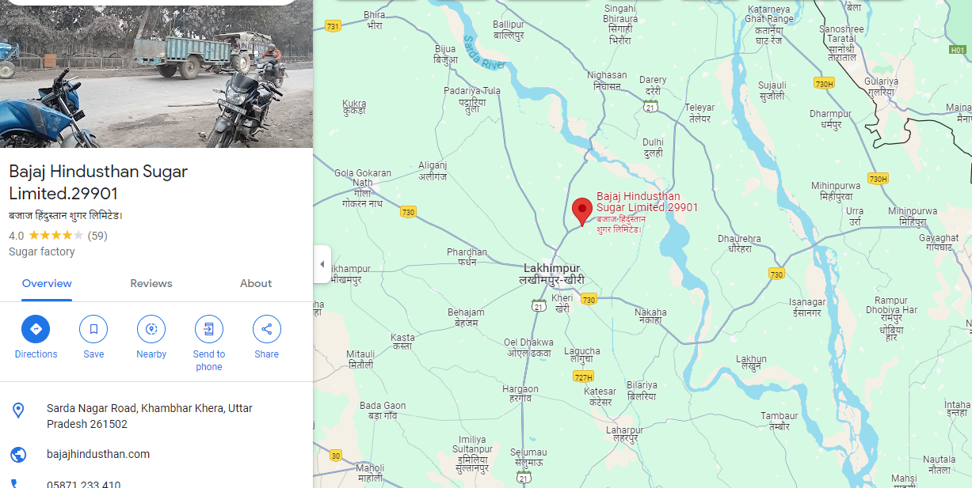
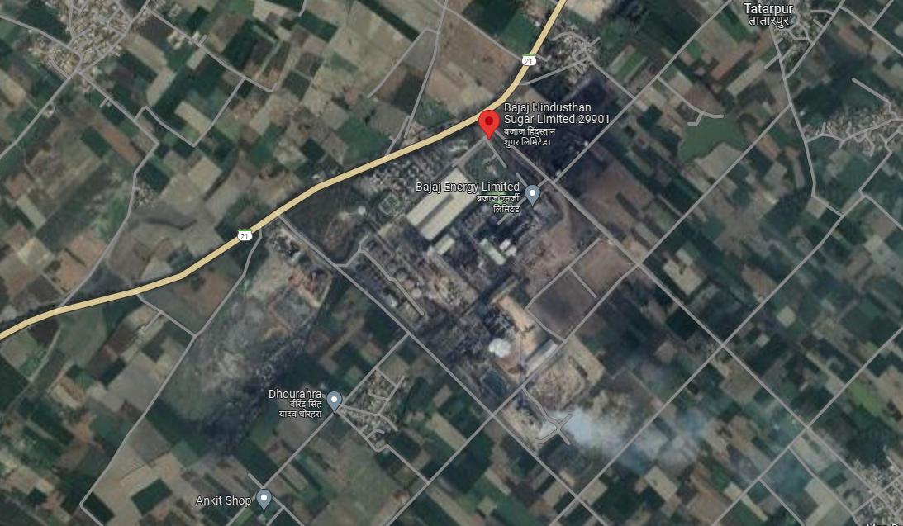

ENCLOSURE: II - REFERENCES ON PRICE TREND OF THE SIMILAR RELATED PROPERTIES AVAILABLE ON PUBLIC DOMAIN

NO PROPERTY REFERENCES OF SIMILAR PROPERTIES WERE FOUND ON PUBLIC DOMAIN FOR BARKHERA LOCATION

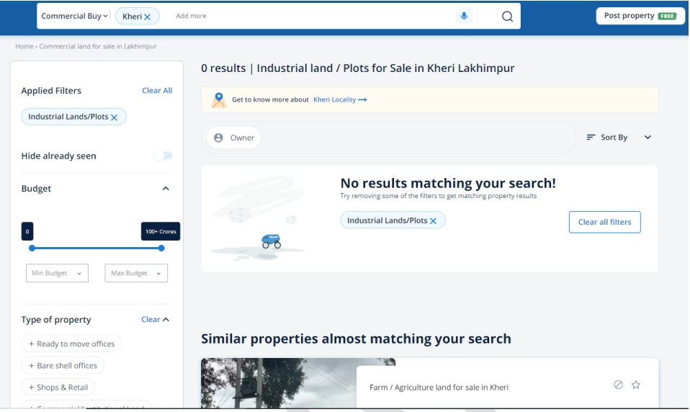

ENCLOSURE: III – PHOTOGRAPHS OF THE PROPERTY

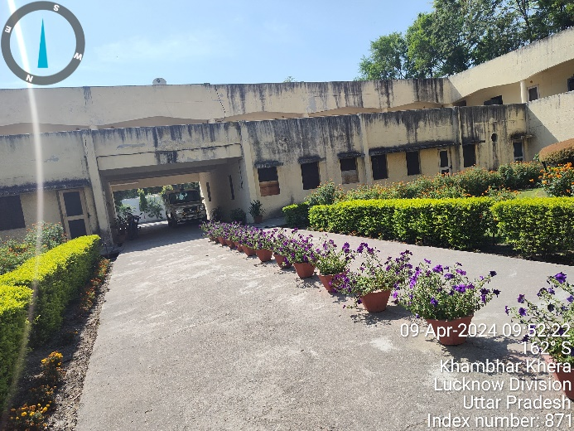 | 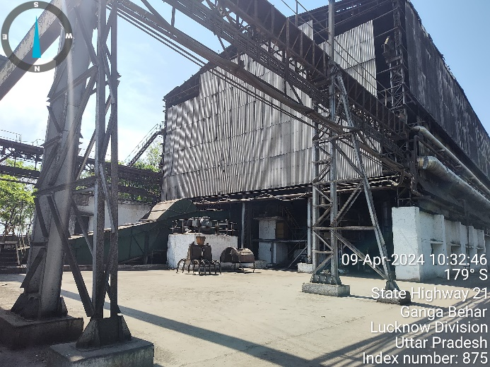
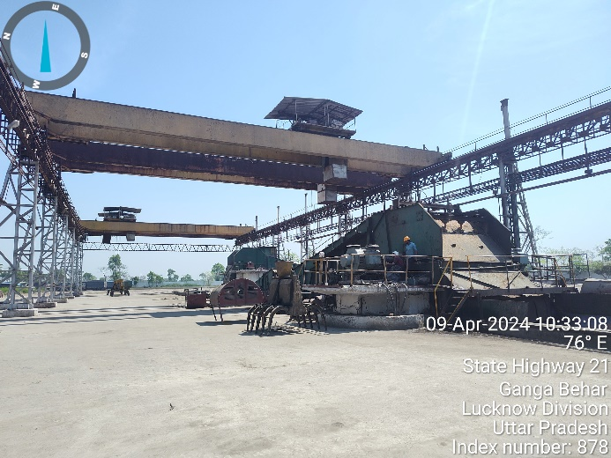 | 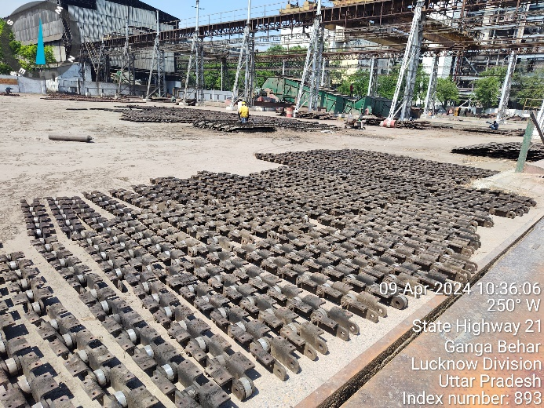
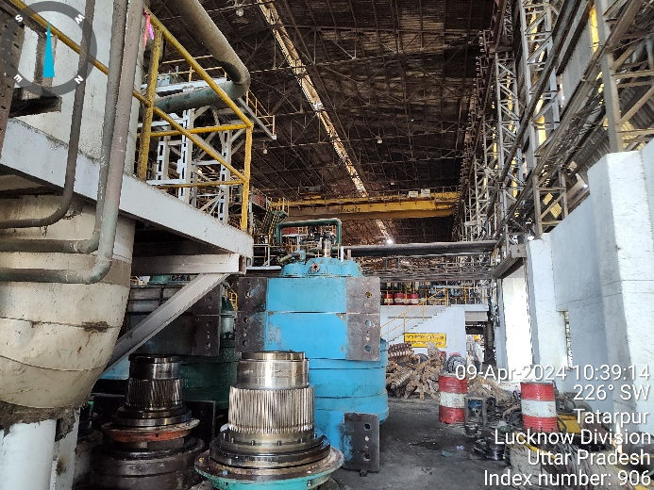 | 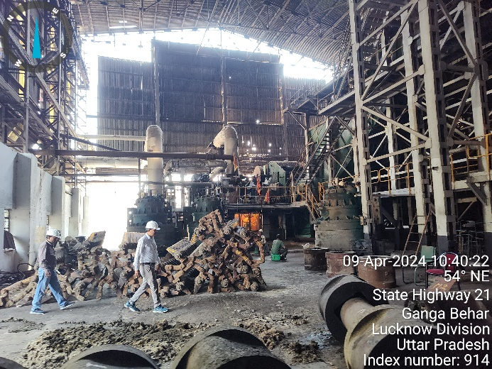

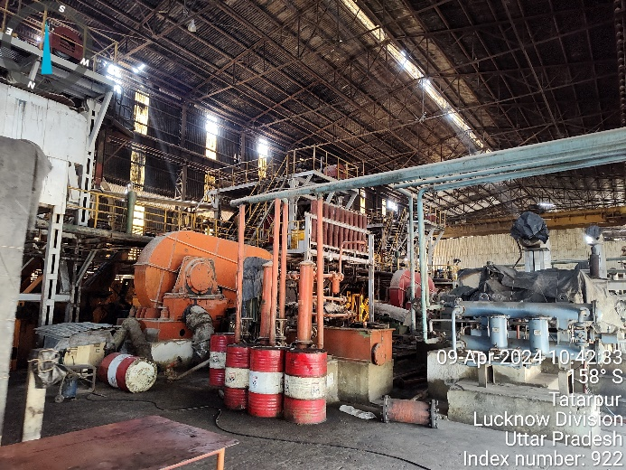 | 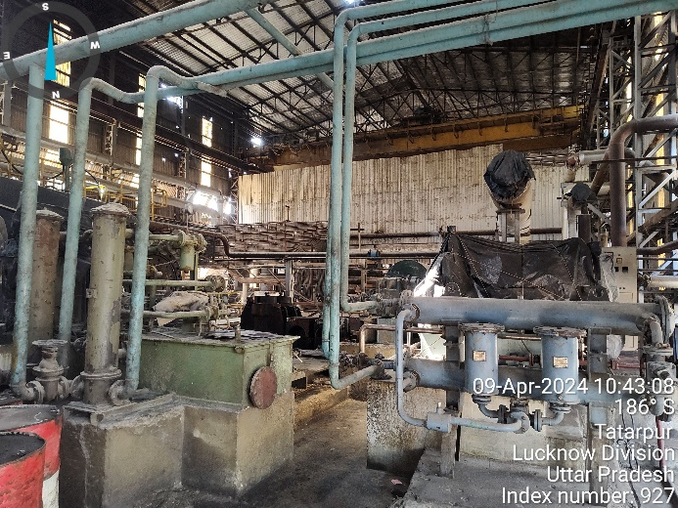
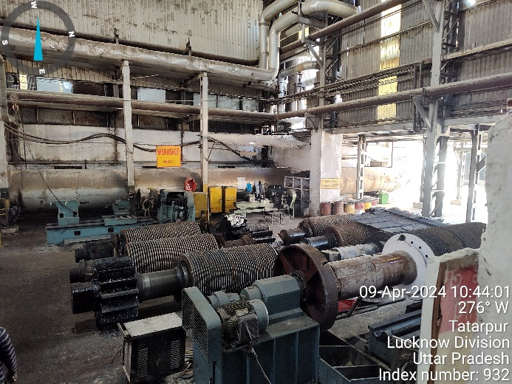 | 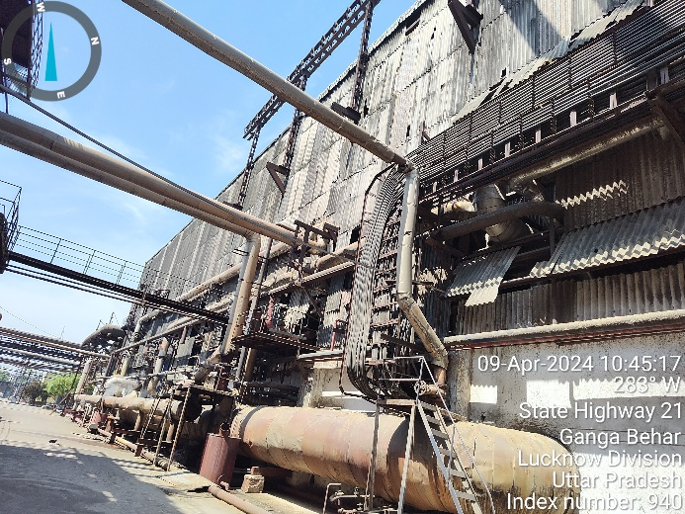
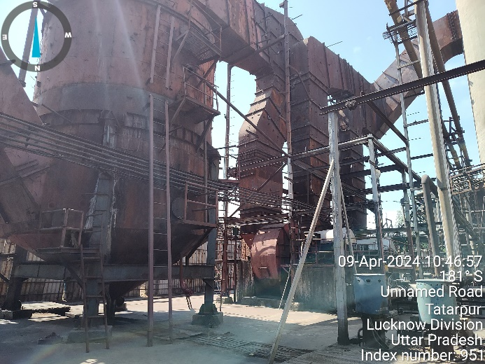 | 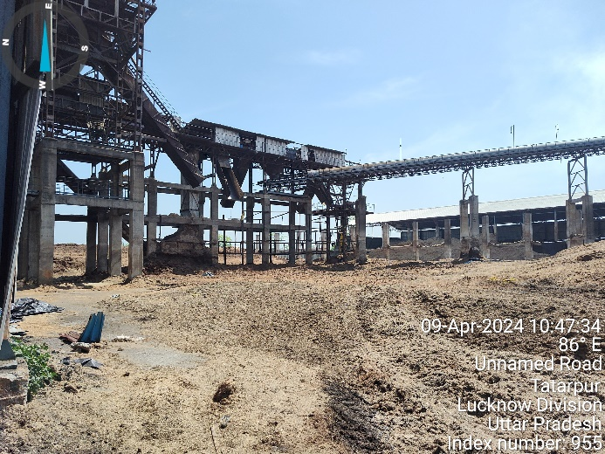

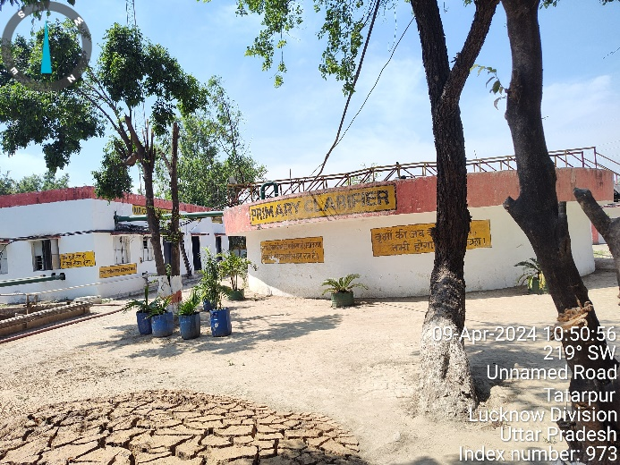 | 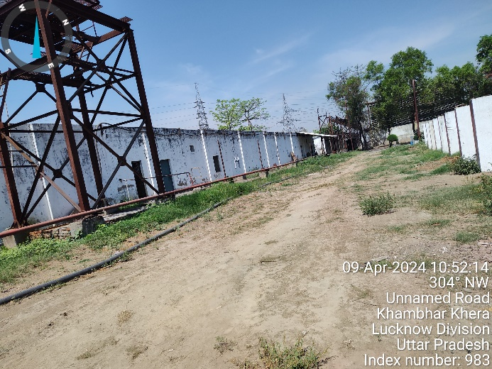
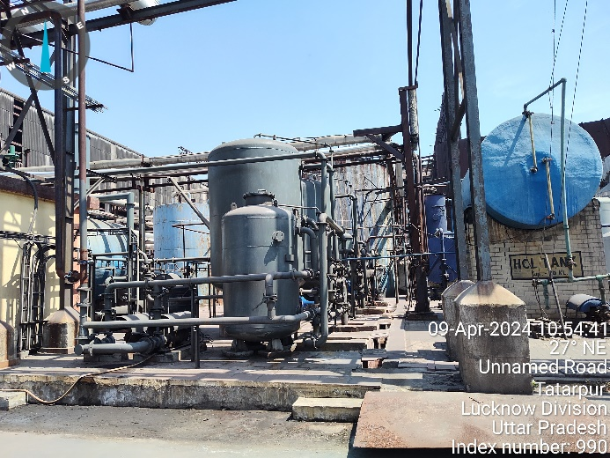 | 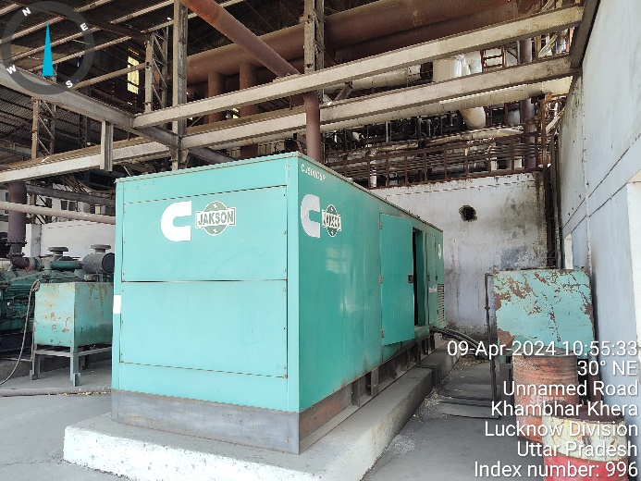
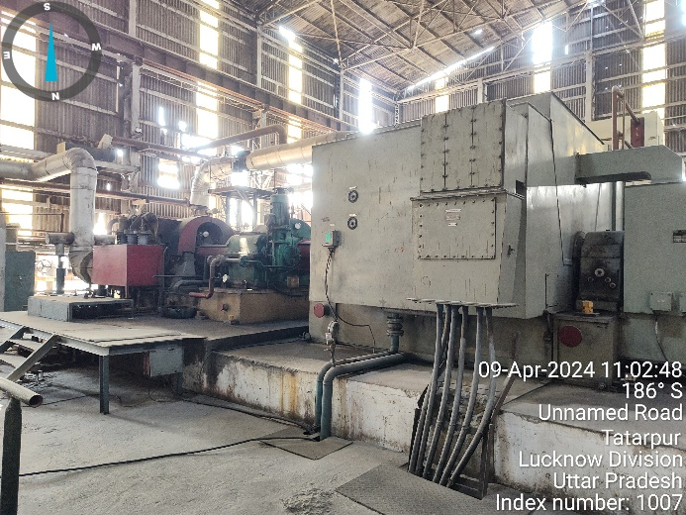 | 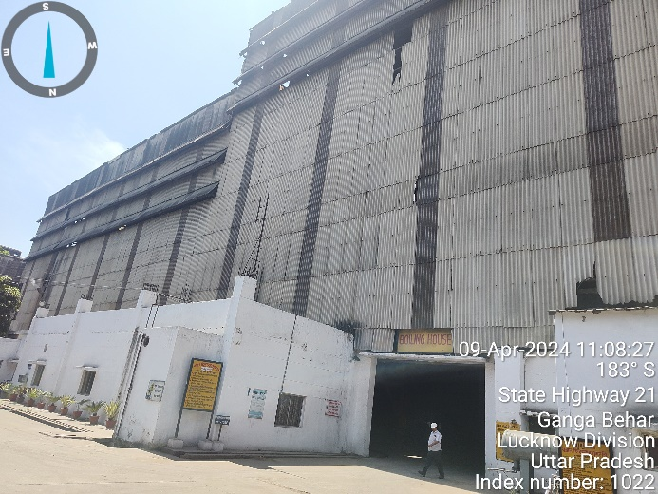

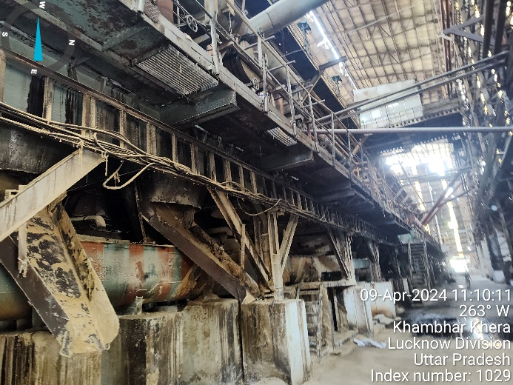 | 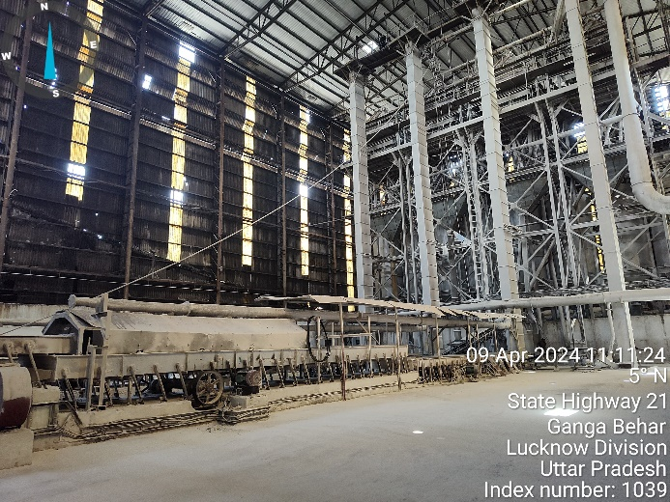
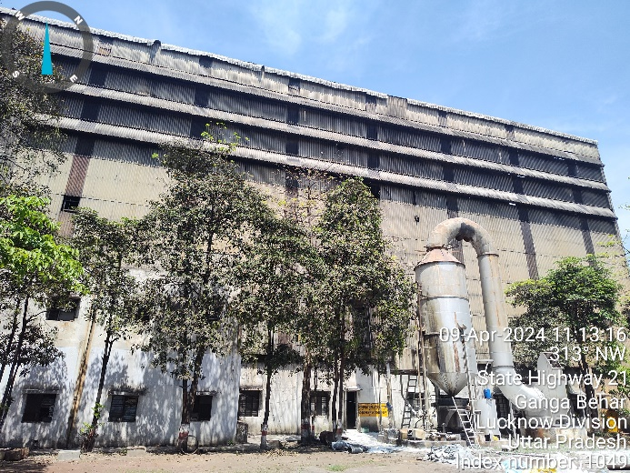 | 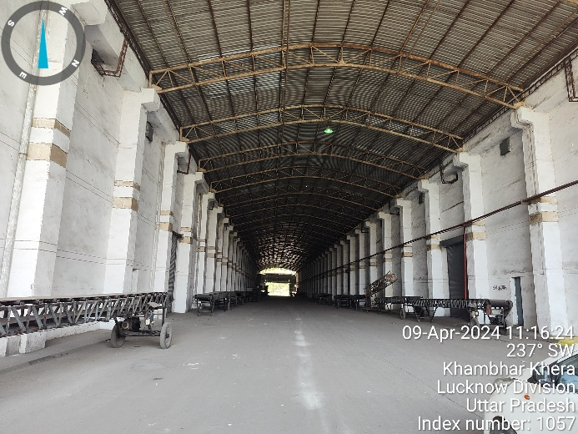
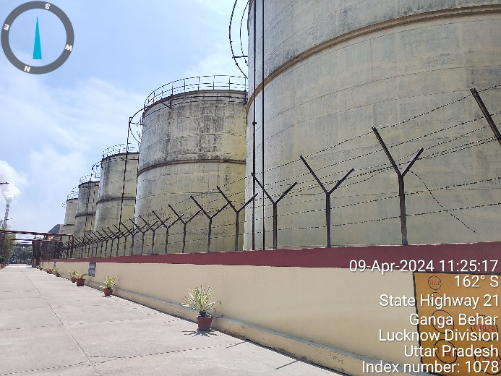 | 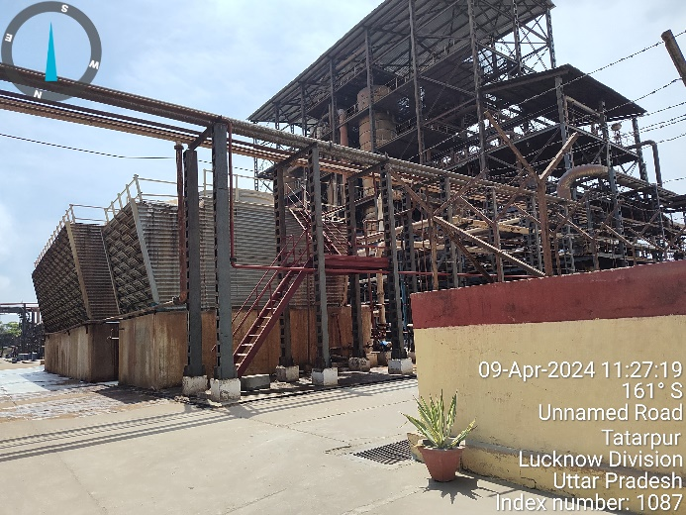

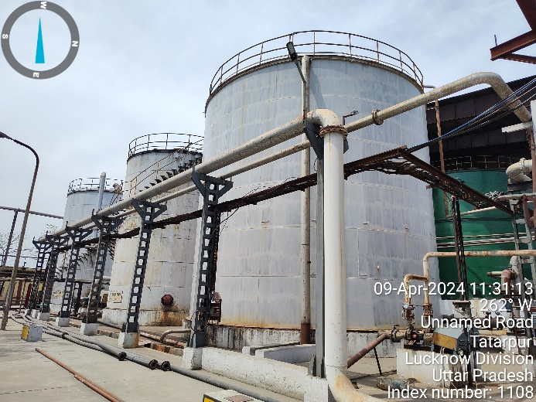 | 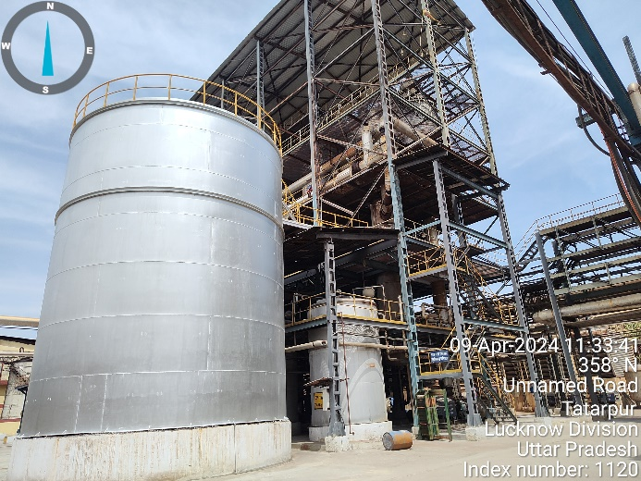
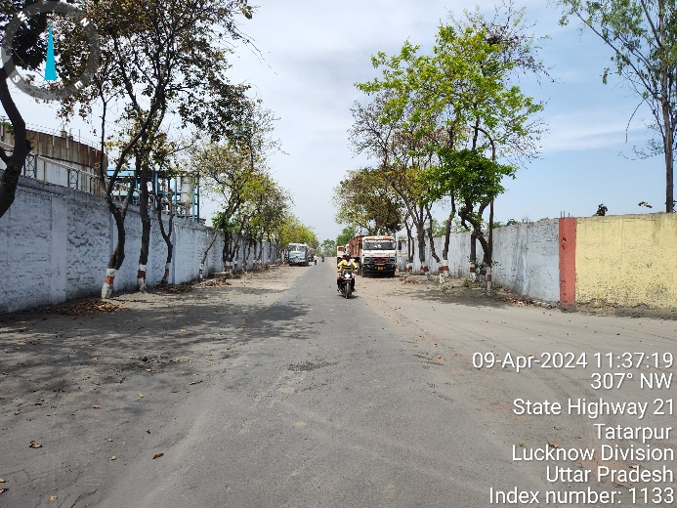 | 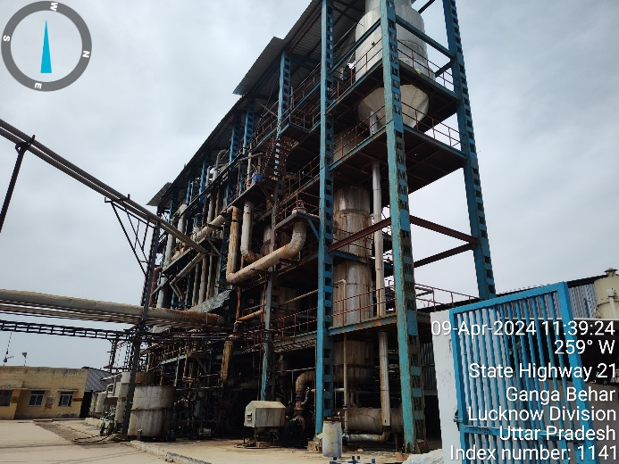
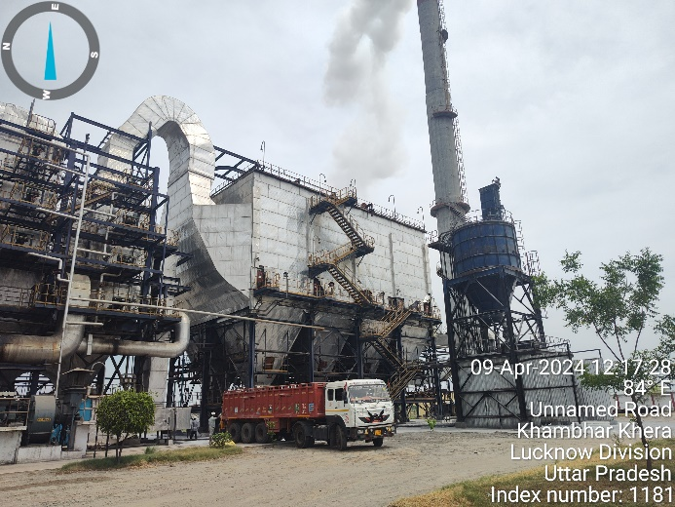 | 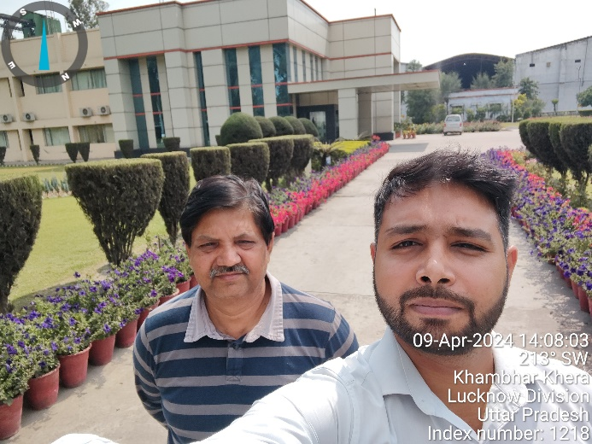

ENCLOSURE: IV – COPY OF CIRCLE RATE

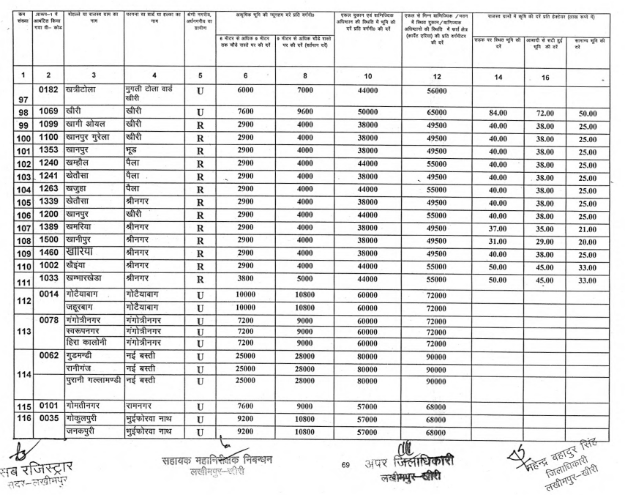

ENCLOSURE V: IMPORTANT PROPERTY DOCUMENTS EXHIBIT

CLU

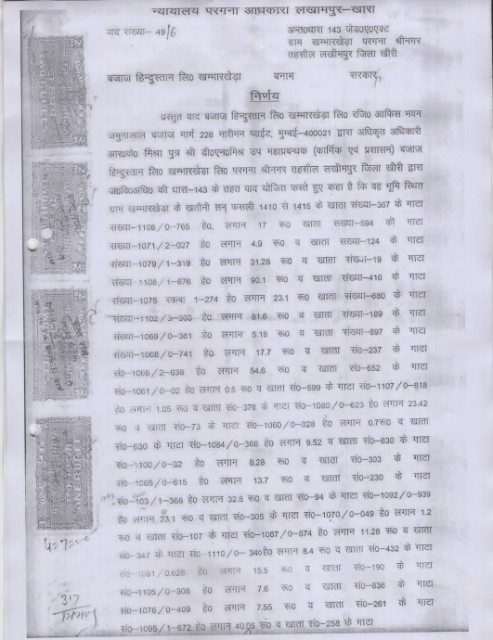

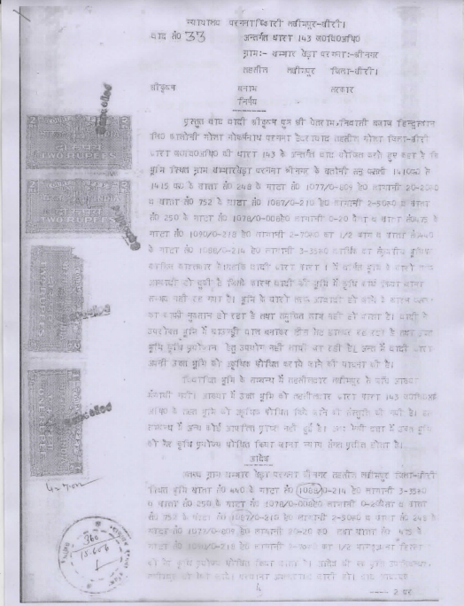

Banking Agreement

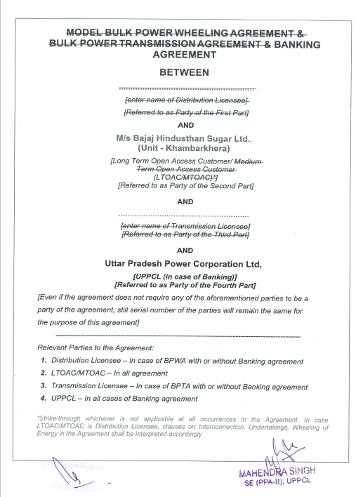

Pollution NOC

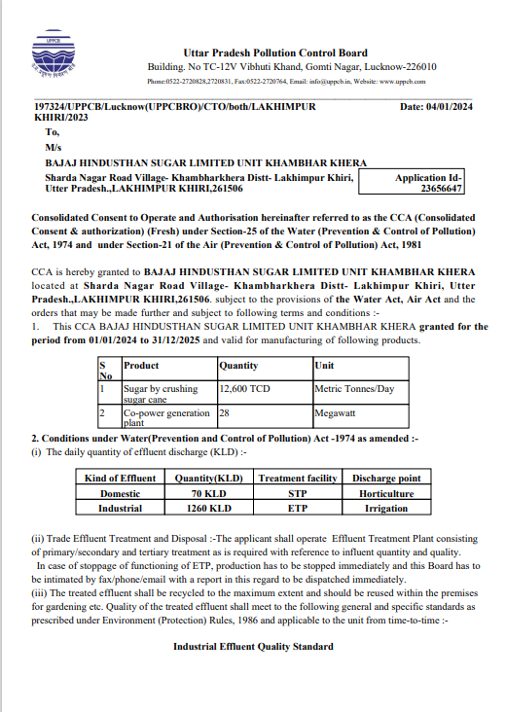

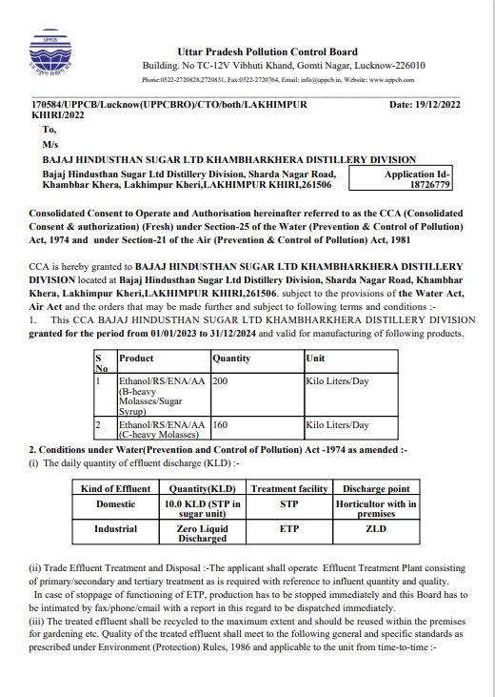

Environment Clearance

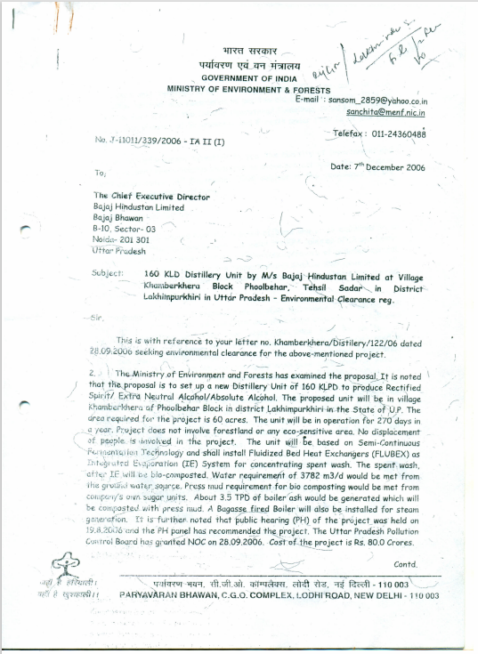

PESO Certificate

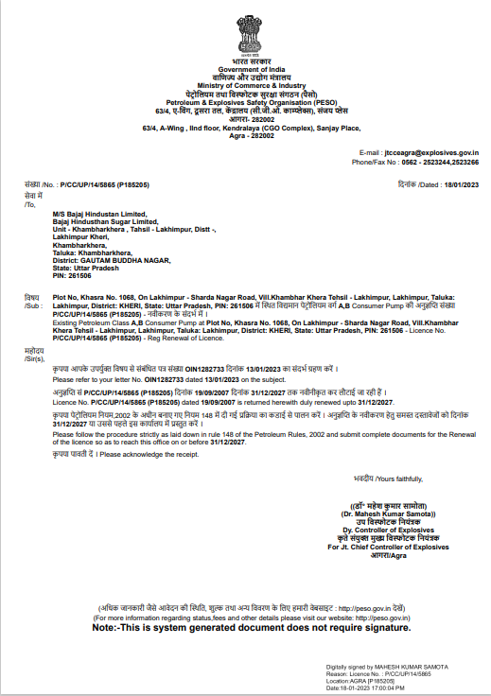

Factory License

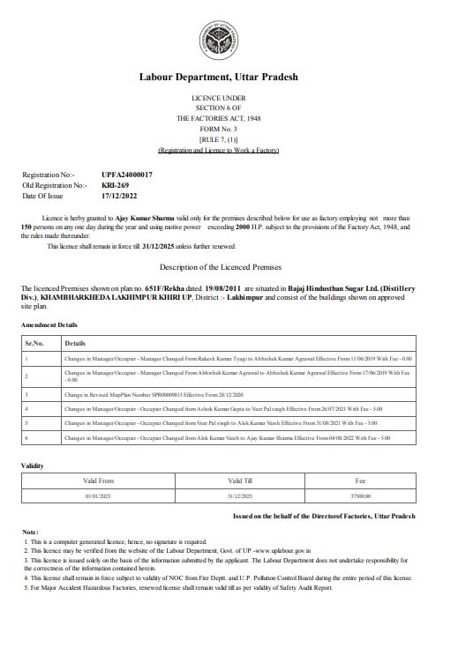
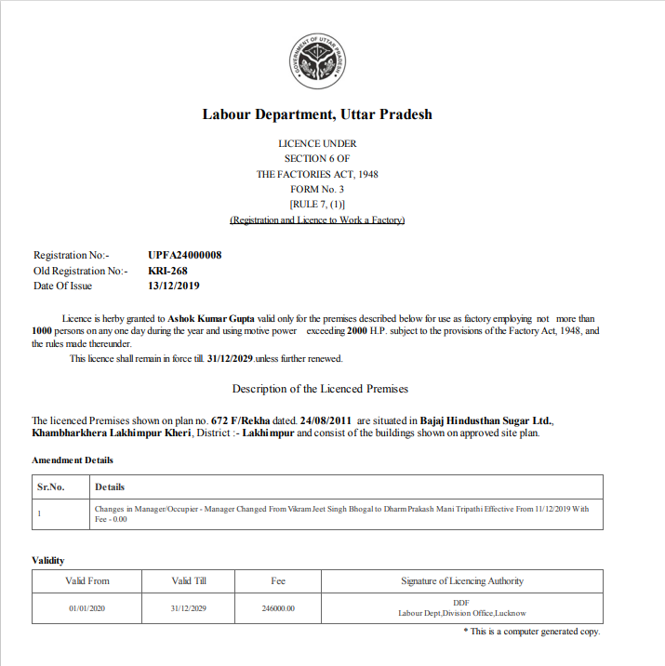

Site Plan

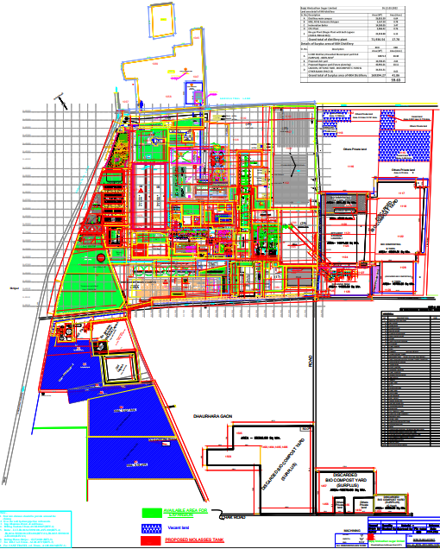

ENCLOSURE VI: ANNEXURE: DECLARATION-CUM-UNDERTAKING

- Persons worked on this report are citizen of India.
- No employee or member of R.K Associates has any direct/ indirect interest in the property or become so interested at any time during a period of three years prior to our appointment as valuer or three years after the valuation of assets was conducted by us.
- The information furnished in our valuation report dated 15/4/2024 is true and correct to the best of our knowledge and belief and we have made an impartial and true valuation of the property.
- Our authorized Engineer/ surveyor Mr. Abhinav Chaturvedi have personally inspected the property on 9/4/2024 the work is not subcontracted to any other valuation firm and is carried out by us.
- Valuation Report is covering all the points as per the format as prescribed by the Bank.
- We have not been depanelled/ delisted by any other bank and in case any such depanelment by other banks during my empanelment with you, we will inform you within 3 days of such depanelment.
- We have not been removed/ dismissed from service/employment earlier.
- We have not been convicted of any offence and sentenced to a term of imprisonment.
- Company is not found guilty of misconduct in professional capacity.
- Persons worked on this report are not declared to be unsound mind.
- Company is not undischarged bankrupt or has not applied to be adjudicated as a bankrupt.
- Company is not an undischarged insolvent.
- No penalty is levied under section 271J of Income-tax Act, 1961 (43 of 1961) and time limit for filing appeal before Commissioner of Income tax (Appeals) or Income-tax Appellate Tribunal, as the case may be has expired, or such penalty has been confirmed by Income-tax Appellate Tribunal, and five years have not elapsed after levy of such penalty.
- Company is not been convicted of an offence connected with any proceeding under the Income Tax Act 1961, Wealth Tax Act 1957 or Gift Tax Act 1958 and
- Our PAN Card number/ GST number as applicable is AAHCR0845G/ 09AAHCR0845G1ZP.
- We undertake to keep you informed of any events or happenings which would make us ineligible for empanelment as a valuer.
- We have not concealed or suppressed any material information, facts and records and we have made a complete and full disclosure.
- We have read the Handbook on Policy, Standards and procedure for Real Estate Valuation, 2011 of the IBA and has tried to apply the “Standards” enshrined for valuation in the Part-B of the above handbook to the best of our ability as much as practically possible in the limited time available.
- We have read the International Valuation Standards (IVS) and the report submitted to the Bank for the respective asset class and has tried to apply the “Standards” as enshrined for valuation in the IVS in “General Standards” and “Asset Standards” as applicable to the best of our ability as much as practically possible in the limited time available.
- Procedures and standards adopted in carrying out the valuation and is mentioned in Part-D of the report which may have certain departures to the said IBA and IVS standards in order to provide better, just & fair valuation.
- We abide by the Model Code of Conduct for empanelment of valuer in the Bank.
- The authorized Engineers of the company who has worked on the assignment has signed this valuation report.
- The work is taken on the instructions of the Bank.
- Further, we hereby provide the following information.

S. No. | Particulars | Valuer comment
 | Background information of the asset being valued | This is a 10,000TCD Sugar Mill located at aforesaid address having total land area as 82.35 Hectare/ 203.48 acre having total built-up area of 1,90,548 sqm found on as-is-where basis which company’s representative has shown/ identified to us on the site physically unless otherwise mentioned in the report of which some reference has been taken from the information/ data given in the copy of documents provided to us and informed verbally or in writing.
 | Purpose of valuation and appointing authority | Please refer to Part-D of the Report.
 | Identity of the experts involved in the valuation | Survey Analyst: Er. Abhinav Chaturvedi  Valuation Engineer: Er. Abhinav Chaturvedi  L1/ L2 Reviewer: Er. Sr. V.P. Projects
 | Disclosure of valuer interest or conflict, if any | No relationship with the borrower and no conflict of interest.
 | Date of appointment, valuation date and date of report | Date of Appointment: | 16/3/2024
 | Date of appointment, valuation date and date of report | Date of Survey: | 9/4/2024
 | Date of appointment, valuation date and date of report | Valuation Date: | 15/4/2024
 | Date of appointment, valuation date and date of report | Date of Report: | 15/4/2024
 | Inspections and/ or investigations undertaken | Yes, by our authorized Survey Engineer Abhinav Chaturvedi on 9/4/2024. Property was shown and identified by Mr. Yogesh Singh (-+91 91510 03654)
 | Nature and sources of the information used or relied upon | Please refer to Part-D of the Report. Level 3 Input (Tertiary) has been relied upon.
 | Procedures adopted in carrying out the valuation and valuation standards followed | Please refer to Part-D of the Report.
 | Restrictions on use of the report, if any | Value varies with the Purpose/ Date/ Market & Asset Condition & Situation prevailing in the market. We recommend not to refer the indicative & estimated prospective Value of the asset given in this report if any of these points are different from the one mentioned aforesaid in the Report.  This report has been prepared for the purposes stated in the report and should not be relied upon for any other purpose. Our client is the only authorized user of this report and is restricted for the purpose indicated in this report. I/we do not take any responsibility for the unauthorized use of this report.  During the course of the assignment, we have relied upon various information, data, documents in good faith provided by Bank/ client both verbally and in writing. If at any point of time in future it comes to knowledge that the information given to us is untrue, fabricated, misrepresented then the use of this report at very moment will become null & void.  This report only contains general assessment & opinion on the indicative, estimated Market Value of the property for which Bank has asked to conduct the Valuation for the asset as found on as-is-where basis which owner/ owner representative/ client/ bank has shown/ identified to us on the site unless otherwise mentioned in the report of which some reference has been taken from the information/ data given in the copy of documents provided to us and informed verbally or in writing which has been relied upon in good faith. It doesn’t contain any other recommendations of any sort including but not limited to express of any opinion on the suitability or otherwise of entering into any transaction with the borrower.  This report is not a certification of ownership or survey number/ property number/ Khasra number which are merely referred from the copy of the documents provided to us.
 | Major factors that were taken into account during the valuation | Please refer to Part A, B & C of the Report.
 | Major factors that were not taken into account during the valuation | Please refer to Part A, B & C of the Report.
 | Caveats, limitations and disclaimers to the extent they explain or elucidate the limitations faced by valuer, which shall not be for the purpose of limiting his responsibility for the valuation report. | Please refer to Part E of the Report and Valuer’s Important Remarks enclosed herewith.

Date: 15/4/2024
Place: Noida

Signature

(Authorized Person of R.K Associates Valuers & Techno Engg. Consultants (P) Ltd.)

ENCLOSURE VII: ANNEXURE: MODEL CODE OF CONDUCT FOR VALUERS

Integrity and Fairness

- A valuer shall, in the conduct of his/its business, follow high standards of integrity and fairness in all his/its dealings with his/its clients and other valuers.
- A valuer shall maintain integrity by being honest, straightforward, and forthright in all professional relationships.
- A valuer shall endeavor to ensure that he/it provides true and adequate information and shall not misrepresent any facts or situations.
- A valuer shall refrain from being involved in any action that would bring disrepute to the profession.
- A valuer shall keep public interest foremost while delivering his services.

Professional Competence and Due Care

- A valuer shall render at all times high standards of service, exercise due diligence, ensure proper care and exercise independent professional judgment.
- A valuer shall carry out professional services in accordance with the relevant technical and professional standards that may be specified from time to time.
- A valuer shall continuously maintain professional knowledge and skill to provide competent professional service based on up-to-date developments in practice, prevailing regulations/guidelines and techniques.
- In the preparation of a valuation report, the valuer shall not disclaim liability for his/its expertise or deny his/its duty of care, except to the extent that the assumptions are based on statements of fact provided by the company or its auditors or consultants or information available in public domain and not generated by the valuer.
- A valuer shall not carry out any instruction of the client in so far as they are incompatible with the requirements of integrity, objectivity and independence.
- A valuer shall clearly state to his client the services that he would be competent to provide and the services for which he would be relying on other valuers or professionals or for which the client can have a separate arrangement with other valuers.

Independence and Disclosure of Interest

- A valuer shall act with objectivity in his/its professional dealings by ensuring that his/its decisions are made without the presence of any bias, conflict of interest, coercion, or undue influence of any party, whether directly connected to the valuation assignment or not.
- A valuer shall not take up an assignment if he/it or any of his/its relatives or associates is not independent in terms of association to the company.
- A valuer shall maintain complete independence in his/its professional relationships and shall conduct the valuation independent of external influences.
- A valuer shall wherever necessary disclose to the clients, possible sources of conflicts of duties and interests, while providing unbiased services.
- A valuer shall not deal in securities of any subject company after any time when he/it first becomes aware of the possibility of his/its association with the valuation, and in accordance with the Securities and Exchange Board of India (Prohibition of Insider Trading) Regulations, 2015 or till the time the valuation report becomes public, whichever is earlier.
- A valuer shall not indulge in “mandate snatching or offering” convenience valuations” in order to cater to a company or client’s needs.
- As an independent valuer, the valuer shall not charge success fee.
- In any fairness opinion or independent expert opinion submitted by a valuer, if there has been a prior engagement in an unconnected transaction, the valuer shall declare the association with the company during the last five years.

Confidentiality

- A valuer shall not use or divulge to other clients or any other party any confidential information about the subject company, which has come to his/its knowledge without proper and specific authority or unless there is a legal or professional right or duty to disclose.

Information Management

- A valuer shall ensure that he/ it maintains written contemporaneous records for any decision taken, the reasons for taking the decision, and the information and evidence in support of such decision. This shall be maintained so as to sufficiently enable a reasonable person to take a view on the appropriateness of his/its decisions and actions.
- A valuer shall appear, co-operate and be available for inspections and investigations carried out by the authority, any person authorised by the authority, the registered valuers organization with which he/it is registered or any other statutory regulatory body.
- A valuer shall provide all information and records as may be required by the authority, the Tribunal, Appellate Tribunal, the registered valuers organization with which he/it is registered, or any other statutory regulatory body.
- A valuer while respecting the confidentiality of information acquired during the course of performing professional services, shall maintain proper working papers for a period of three years or such longer period as required in its contract for a specific valuation, for production before a regulatory authority or for a peer review. In the event of a pending case before the Tribunal or Appellate Tribunal, the record shall be maintained till the disposal of the case.

Gifts and hospitality.

- A valuer or his/its relative shall not accept gifts or hospitality which undermines or affects his independence as a valuer.
Explanation: For the purposes of this code the term ‘relative’ shall have the same meaning as defined in clause (77) of Section 2 of the Companies Act, 2013 (18 of 2013).
- A valuer shall not offer gifts or hospitality or a financial or any other advantage to a public servant or any other person with a view to obtain or retain work for himself/ itself, or to obtain or retain an advantage in the conduct of profession for himself/ itself.

Remuneration and Costs.
- A valuer shall provide services for remuneration which is charged in a transparent manner, is a reasonable reflection of the work necessarily and properly undertaken, and is not inconsistent with the applicable rules.
- A valuer shall not accept any fees or charges other than those which are disclosed in a written contract with the person to whom he would be rendering service.

Occupation, employability and restrictions.

- A valuer shall refrain from accepting too many assignments, if he/it is unlikely to be able to devote adequate time to each of his/ its assignments.
- A valuer shall not conduct business which in the opinion of the authority or the registered valuer organisation discredits the profession.

Miscellaneous
- A valuer shall refrain from undertaking to review the work of another valuer of the same client except under written orders from the bank or housing finance institutions and with knowledge of the concerned valuer.
- A valuer shall follow this code as amended or revised from time to time
Signature of the Authorized Person: ________________
Name of the Valuation company: R.K Associates Valuers & Techno Engg. Consultants (P) Ltd.
Address of the Valuer: D-39, Sector-2, Noida-201301
Date: 15/4/2024
Place: Noida
PART E | ENCLOSURE: VIII - VALUER’S IMPORTANT REMARKS

Valuation is done for the asset found on as-is-where basis which owner/ owner representative/ client/ bank has shown/ identified to us on the site unless otherwise mentioned in the report of which some reference has been taken from the information/ data given in the copy of documents provided to us and informed verbally or in writing out of the standard checklist of documents sought from the client & its customer which they could provide within the reasonable expected time out of the standard checklist of documents sought from them and further based on certain assumptions and limiting conditions. The information, facts, documents, data which has become primary basis of the report has been supplied by the client which has been relied upon in good faith and is not generated by the Valuer.
The client/ owner and its management/ representatives warranted to us that the information they have supplied was complete, accurate and true and correct to the best of their knowledge. All such information provided to us either verbally, in writing or through documents has been relied upon in good faith and we have assumed that it is true & correct without any fabrication or misrepresentation. I/We shall not be held liable for any loss, damages, cost or expenses arising from fraudulent acts, misrepresentations, or willful default on part of the owner, company, its directors, employee, representative or agents.
Legal aspects for eg. Investigation of title, ownership rights, lien, charge, mortgage, lease, sanctioned maps, verification of documents provided to us such as title documents, Map, etc. from any concerned Govt. office etc. have to be taken care by legal expert/ Advocate and same is not done at our end. It is assumed that the concerned Lender/ Financial Institution has asked for the valuation of that property after satisfying the authenticity of the documents given to us for which the legal verification has been already taken and cleared by the competent Advocate before requesting for the Valuation report. I/ We assume no responsibility for the legal matters including, but not limited to, legal or title concerns.
In the course of the valuation, we were provided with both written and verbal information. We have however, evaluated the information provided to us through broad inquiry, analysis and review but have not carried out a due diligence or audit of the information provided for the purpose of this engagement. Our conclusions are based on the assumptions and other information provided to us by the client during the course of the assessment.
Getting cizra map or coordination with revenue officers for site identification is a separate activity and is not part of the Valuation services and same has not been done in this report unless otherwise stated.
Wherever any details are mentioned in the report in relation to any legal aspect of the property such as name of the owner, leases, etc. is only for illustration purpose and should not be construed as a professional opinion. Legal aspects are out of scope of this report. Details mentioned related to legal aspect are only based on the copy of the documents provided to us and whatever we can interpret as a non-legally trained person. This should be cross validated with a legal expert. We do not vouch any responsibility regarding the same.
We have made certain assumptions in relation to facts, conditions & situations affecting the subject of, or approach to this exercise that has not been verified as part of the engagement rather, treated as “a supposition taken to be true”. If any of these assumptions prove to be incorrect then our estimate on value will need to be reviewed.
This is just an opinion report based on technical & market information having general assessment & opinion on the indicative, estimated Market Value of the property for which Bank has asked to conduct the Valuation. It doesn’t contain any other recommendations of any sort including but not limited to express of any opinion on the suitability or otherwise of entering into any transaction with the borrower.
We have relied on the data from third party, external sources & information available on public domain to conclude the valuation. These sources are believed to be reliable and therefore, we assume no liability for the truth or accuracy of any data, opinions or estimates furnished by others that have been used in this analysis. Where we have relied on the data, opinions or estimates from external sources, reasonable care has been taken to ensure that such data is extracted from authentic sources, however we still can’t vouch its authenticity, correctness, or accuracy.
Analysis and conclusions adopted in the report are limited to the reported assumptions, conditions and information came to our knowledge during the course of the work and based on the Standard Operating Procedures, Best Practices, Caveats, Limitations, Conditions, Remarks, Important Notes, Valuation TOR and definition of different nature of values.
Value varies with the Purpose/ Date/ Asset Condition & situation/ Market condition, demand & supply, asset utility prevailing on a particular date/ Mode of sale. The indicative & estimated prospective Value of the asset given in this report is restricted only for the purpose and other points mentioned above prevailing on a particular date as mentioned in the report. If any of these points are different from the one mentioned aforesaid in the Report then this report should not be referred.
Our report is meant ONLY for the purpose mentioned in the report and should not be used for any other purpose. The Report should not be copied or reproduced for any purpose other than the purpose for which it is prepared for. I/we do not take any responsibility for the unauthorized use of this report.
We owe responsibility only to the authority/client that has appointed us as per the scope of work mentioned in the report. We will not be liable for any losses, claims, damages or liabilities arising out of the actions taken, omissions or advice given by any other person. In no event shall we be liable for any loss, damages, cost or expenses arising in any way from fraudulent acts, misrepresentations or willful default on part of the client or companies, their directors, employees or agents.
This report is having limited scope as per its fields & format to provide only the general basic idea of the value of the property prevailing in the market based on the site inspection and documents/ data/ information provided by the client. The suggested indicative prospective estimated value should be considered only if transaction is happened as free market transaction.
The sale of the subject property is assumed to be on an all cash basis. Financial arrangements would affect the price at which the property may sell for if placed on the market.
The actual realizable value that is likely to be fetched upon sale of the asset under consideration shall entirely depend on the demand and supply of the same in the market at the time of sale.
While our work has involved an analysis & computation of valuation, it does not include detailed estimation, design/ technical/ engineering/ financial/ structural/ environmental/ architectural/ compliance survey/ safety audit & works in accordance with generally accepted standards of audit & other such works. The report in this work in not investigative in nature. It is mere an opinion on the likely estimated valuation based on the facts & details presented to us by the client and third party market information came in front of us within the limited time of this assignment, which may vary from situation to situation.
Where a sketched plan is attached to this report, it does not purport to represent accurate architectural plans. Sketch plans and photographs are provided as general illustrations only.
Documents, information, data including title deeds provided to us during the course of this assessment by the client is reviewed only upto the extent required in relation to the scope of the work. No document has been reviewed beyond the scope of the work. These are not reviewed in terms of legal rights for which we do not have expertise. Wherever any information mentioned in this report is mentioned from the documents like owners name, etc., it is only for illustration purpose and may not necessary represent accuracy.
The report assumes that the borrower/company/business/asset complies fully with relevant laws and regulations applicable in its area of operations and usage unless otherwise stated, and that the companies/business/assets is managed in a competent and responsible manner. Further, as specifically stated to the contrary, this report has given no consideration to matters of a legal nature, including issues of legal title and compliance with relevant laws, and litigations and other contingent liabilities that are not recorded/reflected in the documents/ details/ information/ data provided to us.
This valuation report is not a qualification for accuracy of land boundaries, schedule (in physical terms), dimensions & identification. For this land/ property survey report can be sought from a qualified private or Govt. surveyor.
This Valuation report is prepared based on the facts of the property on the date of the survey. Due to possible changes in market forces, socio-economic conditions, property conditions and circumstances, this valuation report can only be regarded as relevant as at the valuation date. Hence before financing, Banker/ FI should take into consideration all such future risk and should loan conservatively to keep the advanced money safe in case of the downward trend of the property value.
Valuation of the same asset/ property can fetch different values under different circumstances & situations. For eg. Valuation of a running/ operational shop/ hotel/ factory will fetch better value and in case of closed shop/ hotel/ factory it will have considerable lower value. Similarly, an asset sold directly by an owner in the open market through free market transaction then it will fetch better value and if the same asset/ property is sold by any financer due to encumbrance on it, will fetch lower value. Hence before financing, Lender/ FI should take into consideration all such future risks while financing and take decision accordingly.

Valuation is done for the property identified to us by the owner/ owner representative. At our end we have just visually matched the land boundaries, schedule (in physical terms) & dimensions of the property with reference to the documents produced for perusal. Method by which identification of the property is carried out is also mentioned in the report clearly. Responsibility of identifying the correct property to the Valuer/ its authorized surveyor is solely of the client/ owner for which Valuation has to be carried out. It is requested from the Bank to cross check from their own records/ information if this is the same property for which Valuation has to be carried out to ensure that owner has not misled the Valuer company or misrepresented the property due to any vested interest. Where there is a doubt about the precision position of the boundaries, schedule, dimensions of site & structures, it is recommended that a Licensed Surveyor be contacted.
In India more than 70% of the geographical area is lying under rural/ remote/ non municipal/ unplanned area where the subject property is surrounded by vacant lands having no physical demarcation or having any display of property survey or municipal number / name plate on the property clearly. Even in old locations of towns, small cities & districts where property number is either not assigned or not displayed on the properties clearly and also due to the presence of multiple/ parallel departments due to which ownership/ rights/ illegal possession/ encroachment issues are rampant across India and due to these limitations at many occasions it becomes tough to identify the property with 100% surety from the available documents, information & site whereabouts and thus chances of error, misrepresentation by the borrower and margin of chances of error always persists in such cases. To avoid any such chances of error it is advised to the Bank to engage municipal/ revenue department officials to get the confirmation of the property to ensure that the property shown to Valuer/ Banker is the same as for which documents are provided.
If this Valuation Report is prepared for the Flat/ dwelling unit situated in a Group Housing Society or Integrated Township then approvals, maps of the complete group housing society/ township is out of scope of this report and this report will be made for the specific unit based on the assumption that complete Group Housing Society/ Integrated Township and the subject unit must be approved in all respect.
Due to fragmented & frequent change in building/ urban planning laws/ guidelines from time to time, different laws/ guidelines between regions/ states and no strict enforceability of Building Bye-Laws in India specially in non-metro and scale b & c cities & Industrial areas, property owners many times extend or make changes in the covered area/ layout from the approved/ applicable limits. There are also situations where properties are decades old when there was no formal Building Bye-Laws applicable the time when the construction must have been done. Due to such discrete/ unplanned development in many regions sometimes it becomes tough for the Valuer to determine the exact lawful situation on ground. Unless otherwise mentioned in the report, the covered area present on the site as per site survey will be considered in the Valuation.
Area of the large land parcels of more than 2500 sq.mtr or of uneven shape in which there can be practical difficulty in sample measurement, is taken as per property documents which has been relied upon unless otherwise stated.

Drawing Map, design & detailed estimation of the property/ building is out of scope of the Valuation services.
Valuation is a subjective field and opinion may differ from consultant to consultant. To check the right opinion, it is important to evaluate the methodology adopted and various data point/ information/ factors/ assumption considered by the consultant which became the basis for the Valuation report before reaching to any conclusion.
Although every scientific method has been employed in systematically arriving at the value, there is, therefore, no indisputable single value and the estimate of the value is normally expressed as falling within a likely range.
Value analysis of any asset cannot be regarded as an exact science and the conclusions arrived at in many cases will, of necessity, be subjective and dependent on the exercise of individual judgment. Given the same set of facts and using the same assumptions, expert opinions may differ due to the number of separate judgment decisions, which have to be made. Therefore, there can be no standard formula to establish an indisputable exchange ratio. In the event of a transaction, the actual transaction value achieved may be higher or lower than our indicative analysis of value depending upon the circumstances of the transaction. The knowledge, negotiability and motivations of the buyers and sellers, demand & supply prevailing in the market and the applicability of a discount or premium for control will also affect actual price achieved. Accordingly, our indicative analysis of value will not necessarily be the price at which any agreement proceeds. The final transaction price is something on which the parties themselves have to agree. However, our Valuation analysis can definitely help the stakeholders to take informed and wise decision about the Value of the asset and can help in facilitating the arm’s length transaction.
This Valuation is conducted based on the macro analysis of the asset/ property considering it in totality and not based on the micro, component, or item wise analysis. Analysis done is a general assessment and is not investigative in nature.
This report is prepared on the RKA V-L1 (Basic) Valuation format as per the client requirement and scope of work. This report is having limited scope as per its fields & format to provide only the general estimated & indicative basic idea of the value of the property prevailing in the market based on the information provided by the client. No detailed analysis, audit or verification has been carried out of the subject property. There may be matters, other than those noted in this report, which might be relevant in the context of the transaction and which a wider scope might uncover.
This is just an opinion report and doesn’t hold any binding on anyone. It is requested from the concerned Client/ Bank/ Financial Institution which is using this report for mortgaging the property that they should consider all the different associated relevant & related factors & risks before taking any business decision based on the content of this report.
All Pages of the report including annexures are signed and stamped from our office. In case any paper in the report is without stamp & signature then this should not be considered a valid paper issued from this office.
As per IBA Guidelines & Bank Policy, in case the valuation report submitted by the valuer is not in order, the banks / FIs shall bring the same to the notice of the valuer within 15 days of submission for rectification and resubmission. In case no such communication is received, it shall be presumed that the valuation report has been accepted.
Defect Liability Period is 15 DAYS. We request the concerned authorized reader of this report to check the contents, data, information, and calculations in the report within this period and intimate us in writing at valuers@rkassociates.org within 15 days of report delivery, if any corrections are required or in case of any other concern with the contents or opinion mentioned in the report. If no intimation is received within 15 (Fifteen) days in writing from the date of issuance of the report, then it shall be considered that the report is complete in all respect and has been accepted by the client up to their satisfaction & use and further to which R.K Associates shall not be held responsible in any manner. After this period no concern/ complaint/ proceedings in connection with the Valuation Services will be entertained due to possible change in situation and condition of the property.
Though adequate care has been taken while preparing this report as per its scope, but still we can’t rule out typing, human errors, over sightedness of any information or any other mistakes. Therefore, the concerned organization is advised to satisfy themselves that the report is complete & satisfactory in all respect. Intimation regarding any discrepancy shall be brought into our notice immediately. If no intimation is received within 15 (Fifteen) days in writing from the date of issuance of the report, to rectify these timely, then it shall be considered that the report is complete in all respect and has been accepted by the client upto their satisfaction & use and further to which R.K Associates shall not be held responsible in any manner.
Our Data retention policy is of ONE YEAR. After this period we remove all the concerned records related to the assignment from our repository. No clarification or query can be answered after this period due to unavailability of the data.
This Valuation report is governed by our (1) Internal Policies, Processes & Standard Operating Procedures, (2) R.K Associates Quality Policy, (3) Valuation & Survey Best Practices Guidelines formulated by management of R.K Associates, (4) Information input given to us by the customer and (4) Information/ Data/ Facts given to us by our field/ office technical team. Management of R.K Associates never gives acceptance to any unethical or unprofessional practice which may affect fair, correct & impartial assessment and which is against any prevailing law. In case of any indication of any negligence, default, incorrect, misleading, misrepresentation or distortion of facts in the report then we request the user of this report to immediately or at least within the defect liability period to bring all such act into notice of R.K Associates management so that corrective measures can be taken instantly.
R.K Associates never releases any report doing alterations or modifications by pen. In case any information/ figure of this report is found altered with pen then this report will automatically become null & void.
We are fully aware that based on the opinion of value expressed in this report, we may be required to give testimony or attend court / judicial proceedings with regard to the subject assets, although it is out of scope of the assignment, unless specific arrangements to do so have been made in advance, or as otherwise required by law. In such event, the party seeking our evidence in the proceedings shall bear the cost/professional fee of attending court / judicial proceedings and my / our tendering evidence before such authority shall be under the applicable laws.
The final copy of the report shall be considered valid only if it is in hard copy on the company’s original letter head with proper stamp and sign on it of the authorized official upon payment of the agreed fees. User shall not use the content of the report for the purpose it is prepared for only on draft report, scanned copy, email copy of the report and without payment of the agreed fees. In such a case the report shall be considered as unauthorized and misused.

