File No.: VIS (2023-24)-PL802-698-1088 Dated: 25.03.2024

TECHNO-ECONOMIC VIABILITY
STUDY REPORT

OF

40MTPD TORREFIED BIOMASS PELLET MANUFACTURING PLANT

SETUP BY

M/S NATURAL GAS INDIA PVT LTD

REPORT PREPARED FOR

SBI, SME BRANCH, GREATER NOIDA - 201308

**Important - In case of any query/ issue or escalation you may please contact Incident Manager Valuers@rkassociates.org. We will appreciate your feedback in order to improve our services.

NOTE: As per IBA Guidelines please provide your feedback on the report within 15 days of its submission after which report will be considered to be correct.

IMPORTANT NOTICE

COPYRIGHT FORMAT: This report is prepared on the copyright format of R. K. Associates Valuers & Techno Engineering Consultants (P) Ltd. (R. K. Associates) to serve our clients with the best possible information and analysis to facilitate them to take rational business decisions. Legally no one can copy or distribute this format without prior approval from R. K. Associates. It is meant only for the advisory/ reference purpose for the organization/s as mentioned on the cover page of this report. Distribution or use of this format or report or any of its content/ information/ data by any organization or individual other than R.K Associates will be seen as an unlawful act and necessary legal action can be taken against the defaulters.
This report is intended for the sole use of the intended recipient/s and contains material that is STRICTLY CONFIDENTIAL AND PRIVATE.

DEFECT LIABILITY PERIOD: In case of any query/ issue or escalation you may please contact Incident Manager at valuers@rkassociates.org. Though adequate care has been taken while preparing this report as per its scope, but still we can’t rule out typing, human errors, over sightedness of any information or any other mistakes. Therefore, the concerned organization is advised to satisfy themselves that the report is complete & satisfactory in all respect. Intimation regarding any discrepancy shall be brought into our notice immediately. If no intimation is received within 15 (Fifteen) days in writing from the date of issuance of the report, to rectify these timely, then it will be considered that the report is complete in all respect and has been accepted by the client up to their satisfaction & use and further to which R.K Associates shall not be held responsible in any manner.

Part O: R. K. Associates Important Disclaimer and Remarks are integral part of this report and Feasibility assessment is subject to this section. Reader of the report is advised to read all the points mentioned in these sections carefully.

TABLE OF CONTENTS
SECTIONS | PARTICULARS | PAGE NO.
Part A | Report Summary | 4
Part B | INTRODUCTION
 | - About the Report | 6
 | - Executive summary | 6
 | - Purpose of the Report | 8
 | - Scope of the Report | 8
 | - Methodology/ Model Adopted | 8
 | - Data Information received from | 9
 | - Documents/ Data Referred | 9
Part C | Company Profile
 | - Company Overview | 10
 | - Proposed Shareholding Pattern | 11
 | - Key Promoters/Directors Profile | 11
Part D | Proposed Unit’s Infrastructure Details
 | - Proposed Plant Location | 17
 | - Location Map | 18
 | - Layout Plan | 19
 | - Land Details | 19
 | - Site pictures | 20
 | - Building & Civil Works | 22
 | - Plant and Machinery/ Equipment details | 23
 | - Utilities | 24
Part E | Project Technical details
 | - Capacity of Manufacturing Facility | 26
 | - Process Description | 26
 | - Basic Architecture: Flow Chart of The Biomass Pellets Plant | 28
 | - Technical Specification of the Proposed Manufacturing Facility | 28
 | - Technology Used | 32
 | - Technological Assessment | 33
 | - Effluent Treatment and Abetment | 34
 | - Testing Standards For Production | 34
 | - Manpower | 34
Part F | Product Profile
 | - Introduction | 35
 | - Product Category | 35
 | - Pricing Strategy | 35
 | - Marketing, Selling & Distribution Plan | 36
Part G | Feedstock Analysis & Supply | 37
Part H | Industry Overview & Analysis | 43
Part I | SWOT Analysis | 46
Part J | Project Cost and Means of Finance | 48
Part K | Project Schedule | 50
Part L | Statutory Approvals | Licences | NOC | 52
Part M | Company’s Financial Feasibility | 54
Part N | Conclusion | 69
Part O | Disclaimer | Remarks | 71

PART A | REPORT SUMMARY

S. No. | PARTICULAR | DESCRIPTION
 | Name of the Company: | M/s Natural Gas India Private Limited
 | Registered Address: | 36, Model Town West, Ghaziabad, Uttar Pradesh – 201002
 | Project Name | 40 MTPD torrified biomass pellet manufacturing plant
 | Project Location: | Khasra no. 421 & Khata No. 195, Village Bhuiawai, Tehsil Chandausi, District Sambhal, Uttar Pradesh
 | Project Type: | Biomass pellet manufacturing plant
 | Project Industry: | Renewable Energy
 | Product Type / Deliverables: | Biomass pellets
 | Report Prepared for Organization: | SME Branch, SBI Greater Noida - 201308
 | TEV Consultant Firm: | M/s. R.K Associates Valuers & Techno Engineering Consultants (P) Ltd.
 | Report type: | Techno-Economic Viability Report
 | Purpose of the Report: | To assess Technical & Economic Viability for the purpose of seeking external financial assistance to start a green field Project.
 | Scope of the Report: | To assess, evaluate & comment on Technical, Economical & Commercial Viability of the Project as per data information provided by the client, independent Industry research and data/ information available on public domain.
 | Date of Report: | 25th March, 2024
 | Documents referred for the Project: | - PROJECT INITIATION DOCUMENTS:  - Detailed Project Report  - Financial Projections of the Project  - Project proposed Schedule  - Statutory Approval Details  - Layout and Master Plan  - PROCUREMENT DOCUMENTS:  - List of Plant & Machinery along with acquisition costs for the same  - Major Expected Customer Line  - List of Expected Raw material Supplier  - Process Flow Chart  - Sanction/proposed map of the sites  - Lease/Sale deeds of the Land  - STATUTORY APPROVALS, LICENCES & NOCs  - MSME UDYAM Registration Certificate  - Pollution Control Application  - Gram Panchayat NOC
 | Means of Finance: | Equity & Debt
 | Key Financial Indicators: | Key Indicators Value  Average DSCR 2.07  Average EBITDA Margin 16.29%  Avg. PAT Margin 4.67%  NPV INR 1.13 Cr.  IRR 18.11%  Payback Period 7.50 years

Note: Above financial indicators are based on the financial projections of the proposed project provided by the firm and assessment and analysis of the same done by us.

PART B | INTRODUCTION

- ABOUT THE REPORT:
This is a Techno-Economic Viability Study Report of the proposed 40 MTPD torrified biomass pellet manufacturing plant at Khasra no. 421 & Khata No. 195, Village Bhuiawai, Tehsil Chandausi, District Sambhal, Uttar Pradesh, 201002 setup by M/s Natural Gas India Private Limited.

- EXECUTIVE SUMMARY:
M/s Natural Gas India Private Limited, the Sole promoter of the Project, has decided to install torrified biomass pellet manufacturing plant under national mission for biomass called SAMARTH. As per data/information provided by the client/Company, the final product, biomass pellets is proposed to be sold to thermal power plant operators like NTPC, state owned power plants, Industrial units running boiler for their process and other applications. As per the certificate of incorporation shared by the client, Company was established on 17th December 2020 under the Company’s Act, 2013.
M/s Natural Gas India Private Limited has proposed to set up this Greenfield project at Bhulawai, District Sambhal in Uttar Pradesh, 201002 for the production of 40,000 Kg / Day of biomass pellets. The Biomass pellets plant is proposed to be setup with total investment of INR 882.55 Lakhs.

Proposed Biomass Pellets Plant Capacity
Sr. No. | PARTICUALR | Capacity | Unit
1 | Biomass Pellets Plant Design Capacity | 40,000 | Kg/Day
Source: DPR/data/information provided by the company
Promoters of the Company are Mr. Subodh Kumar, Mr. Mohd Babar, Mrs. Pinky Qaiser and Mr. Sumi Sardar having diversified experience in waste to energy sector, human resource and administration.
The project is proposed to be commissioned based on the Biomass Palletisation technology. The Company has not appointed any EPC consultant but has invited quotes for suppliers for prefabricated structure and pellet mill.
As shown in the below table, the cost of the proposed project from scratch to trial run is being estimated as INR 883 lakhs, which is proposed to be funded through promoter’s margin of INR 274 lakhs and bank loan (including WC loan) of INR 609 lakhs.

TOTAL PROJECT COST
S. No. | Particulars | Amount (INR)
 | Civil Work | ₹ 1,02,00,000
 | Plant & Machinery | ₹ 5,80,00,000
 | Preliminary Expense | ₹ 35,00,000
 | Working Capital Margin (WCM) | ₹ 1,42,54,853
 | Interest During Construction (IDC) | ₹ 23,00,375
 | Total | INR 883.00 Lakhs
As per the lease deed executed on 10th Jan 2024, promoters have leased 0.178 hectares (1,780 sq. m.) of land at Khasra no. 421, Village Bhulawai, Tehsil Chandausi, District Sambhal, Uttar Pradesh for 20 years on an annual lease rental of INR 20,000 excluding GST. A change of land use (CLU) certificate has been obtained by the company as of July 27, 2023, from the respective authority.
As per data/information provided to us, company has obtained some Statutory Approvals/NOC’s such as NOC from village panchayat, etc. from the respective authorities (Refer the section Statutory Approval in the later part of the report). Nazri Naksha of the land has been approved by Lakhpal Mr. Anil Kumar on 4th march 2024.
During the site visit, we found that the proposed land is a vacant land which is not demarcated. As per informed by client, land development work will start soon. (Kindly refer the site pictures captured during the survey attached in the later section of the report).
The plant needs about 300 kWh of power and 10,000 Litre/ day of water to meet process energy requirement. Currently, Company is in the process to apply for power load Connection. Company has planned to achieve the C.O.D by October 2024.
At present Company is in discussion with bank to fund the project through a term loan of INR 502 lakhs. In this regard State Bank of India, SME Branch, Greater Noida has appointed R.K. associates to assess the Techno-Economic Viability of the proposed Bio-CNG production plant at Village Bhulawai, District Sambhal, Uttar Pradesh. Company plans to achieve the financial closure by March, 2024 (expected).
- PURPOSE OF THE REPORT: To assess Project’s Technical and Financial Feasibility for lender’s requirement.
- SCOPE OF THE REPORT: To only assess, evaluate & comment on Technical & Financial Feasibility of the proposed Biomass pellets manufacturing plant being set up by M/s Natural Gas India Pvt Ltd as per the information provided by the company.

NOTES:
- Project status is taken as per the Site inspection carried out by our survey team.
- Scrutiny about the company, background check, and credibility, credit worthiness of the company or its promoters is out-of-scope of this report.
- Any verification of the documents/ information from originals/ source is out-of-scope of this report.
- This report is only an opinion in respect to Technical and Financial Feasibility of the project as per the future Projections provided by the firm and independent analysis done by us and doesn’t contains any recommendations including taking decision on the loan or any other financial exposure.
- This is not an audit activity of any kind. We have relied upon the data/ information shared by the company in good faith.
- Any review of the existing business of the promoters is out of scope of this report.
- Detailed cost estimation or detailed cost vetting is out of scope of the project.
- This is not a Detailed Project Report or a detailed design or architecture document. Land and property details mentioned in the report is only for illustration purpose as per the information provided to us by the client. The same doesn’t tantamount for taking any responsibility regarding its legality, ownership and conforming to statutory norms.
- METHODOLOGY/ MODEL ADOPTED:
- Data/ Information collection.
- Review of Data/ Information collected related to TEV study.
- Independent review & assessment of technology used and financial projections provided by the company.
- Projections of Revenue, P&L, Balance Sheet, Working Capital Schedule, Depreciation Schedule, Loan Schedule as per the inputs given by the company and assessed by us
- Calculation of key financial indicators and ratio analysis including DSCR, NPV & IRR and payback period of the project.
- Report compilation and Final conclusion.
- DATA/ INFORMATION RECEIVED FROM: All the data/Information has been received from Mr. Babar Shah (Managing Director) and the required details about him shown in the below table:

Particulars | Details
Designation | Managing Director
Company | M/s Natural Gas India Pvt Ltd
Email Address | bd@zakventure.com
Contact No. | +91-9654953201

- DOCUMENTS / DATA REFFERED:

- Detailed Project Report
- Promoters Profile
- Financial Projections of the company.
- Proposed shareholding pattern
- Company KYC documents
- Production flow chart, Product profile, Pricing Strategy etc.
- List of expected Raw Material Suppliers.
- List of proposed manpower
- Lease deed of the land/CLU.
- Details of Plant & Machinery and civil structure.
- Technical specification of the proposed unit
- Certificates of Statutory approvals/NOC’s.

PART C | COMPANY PROFILE

- COMPANY OVERVIEW:
As per certificate of incorporation shared by the client/company, M/s Natural Gas India Pvt Ltd was incorporated on December 17, 2020 under the Companies Act, 2013 as an unlisted company limited by shares.
As per Memorandum of Association (MoA), Company is incorporated with the objective to carry on the business to production, generation, distribution and marketing of Biogas in any form (through any feedstock) and business relating thereof and to promote, market, execute, construct, commission, operate Biogas Projects as EPC vendor. Below table shows the incorporation details of the company:

Incorporation Details of the Company
Particular | Description
Company / LLP Name | M/s Natural Gas India Pvt Ltd
Date of Incorporation | 17th December 2020
CIN | U23300UP2020PTC139374
Company Category | Unlisted Company limited by Share
Company Subcategory | Non-govt. company
ROC | ROC Kanpur
ROC Number | 139374
Category of Company | Company limited by shares
Subcategory of the Company | Non-government company
Registered Address | 36, Model Town, Ghaziabad, Uttar Pradesh - 201002
Authorized Capital | INR 10,00,000/-
Paid up Capital | INR 1,00,000/-
Date of last AGM | 30th Sep 2023
Source: Ministry of Corporate Affairs.
The Company is categorised as micro enterprise with Udyam Registration Number UDYAM-UP-29-0076684. As per the MoA, the share capital of the company is INR 10,00,000 (1,00,000 equity shares of INR 10 per share). In this company, promoters has proposed to setup 40,000 Kg / Day of Biomass Pellets manufacturing plant.
- PROPOSED SHAREHOLDING DETAILS:
As per data/information provided by the client, the proposed shareholding pattern of the company on 24th Jan 2024 is presented in the below table:
Shareholders of M/s Natural Gas India Pvt. Ltd.
S. No. | Name | PAN No. | Address | Share Holding %
1 | Mrs. Pinky Qaiser | AAIPQ7980M | C-905, Lincoln Tower, Grand Omaxe, Sector 93- B, Noida, U.P.-201304 | 60%
2 | Mr. Mohd. Babar | AJIPB9336R | D-36, 2nd Floor, Flat No- 201, Street No-28, God Grace School, Abul Fazal Enclave, Delhi- 110025 | 10%
3 | Mr. Subodh Kumar | AMAPS7552D | B-177, Sector-46, Noida, Gautam Buddh Nagar, Uttar Pradesh-201301 | 10%
4 | Mr. Sumi Sardar | MFCPS7537H | South Ramnagar, Barulpur, South 24, Parganas, West Bengal - 743387 | 20%
Source: Data/Information provided by the Company
- KEY PROMOTER’S/DIRECTORS PROFILE:
As per the data/information available on MCA website, Mr. Subodh Kumar, Mr. Mohd Babar, Mrs. Pinky Qaiser and Mr. Sumi Sardar are the appointed Directors of M/s Natural Gas India Private Limited at present as shown in the below table:
Director’s Profile
Name/Designation | DIN | Appointment Date | Qualifications/Experience
Mrs. Pinky Qaiser  (Director) | 06436683 | 17/12/2020 | As per data information provided by the client, Mrs. Pinky Qaiser is 41 year old at present and holding a graduate degree in HRM with strong understanding of human resource principles, labor laws, organizational behavior, and strategic management. Excellent communication, interpersonal and leadership skills.  She is having experience of more than 8 years in Human Resource & Administration in ZAK Venture Pvt Ltd with Proven track record in strategic HR leadership, bring expertise in talent management, organizational development, and administrative oversight to drive business success.  She is committed to fostering a positive work environment and maximizing employee potential, leveraging a collaborative approach to align HR initiatives with company objectives and deliver measurable results.
Mr. Mohd Babar  (Managing director) | 06427087 | 14/08/2023 | He is 39 years old and has over 15 years of experience in the waste to energy sector in India including Biogas to Power and Compressed Biogas plants.  He is an engineering graduate from Faculty of Engineering and technology, JMI with masters in marketing from Welingkar Institute of Management Development & Research, Mumbai.  He is a waste-to-energy professional, with a specializing in the Biogas to power and compressed biogas sector, and having expertise in the field of sustainable waste management and renewable energy producing along with the knowledge of regulatory requirements, sustainability standards, and renewable energy policy frameworks.  He has worked with many established multinational companies like CLARKE ENERGY, QUIPPO ENERGY, and CUMMINS in the key role position and plays a crucial role in developing the organization's long-term strategic plan, analyze market trends, competitive landscapes, and internal capabilities to formulate strategies for growth and sustainability.  As per information provided by the company, during his professional tenure he has established various waste to energy projects based on “Anaerobic Digestion”.
Mr. Subodh Kumar  (Director) | 06990253 | 14/08/2023 | As per data/information provided to us by the client, Mr. Subodh Kumar (64 Year old) is a MBA/B. tech. graduate. He has 38 years’ experience in the field of Petroleum Marketing, Alternate Energy and Sustainable Development.  He is also a consultant on biofuels to the Asian Development Bank. He worked closely with the Ministry of Petroleum & Natural Gas, Government of India, in conceiving and launching the Sustainable Alternative towards Affordable Transportation (SATAT) program for promoting the production and use of compressed biogas in India.  He is also a former Executive Director of (Petrochemicals, Alternate Energy & Sustainable Development), Indian Oil Corporation Ltd, a Fortune Global 500 Company, and a Maharatna Public Sector Enterprise of the Government of India.  He was actively involved in increasing the portfolio of IOCL in the areas of Solar, Wind, Nuclear, and Bio- fuels, waste to fuel etc. along with planning and monitoring sustainable development and climate change mitigation & adaptation activities.  He has been instrumental in Indian Oil’s foray in alternative fuels like production of ethanol from lignocellulosic bio-mass sources, production of Bio-CNG from various waste streams and exploring opportunities in electric mobility towards setting up charging stations and battery manufacturing facilities.  He has also been a pioneer in implementation of decentralized solar solutions in retail outlets (petrol pumps) across the country. He is also spearheading the critical Petrochemicals group towards creation of new business opportunities.  He has served on the Boards of various companies in the biofuels and clean energy space such as CEO & Director - IOT Biogas Pvt. Ltd, Director - NPCIL-Indian Oil Nuclear Energy Corp. Ltd, Director - Indian Oil Panipat Power Consortium Ltd, Director - Indian Oil-Ruchi Biofuels LLP and Director - Indian Oil-CREDA Biofuels Ltd. He is actively associated with various industry bodies such as Confederation of Indian Industries - Bioenergy Task Force; Biodiesel Association of India and Indian Federation of Green Energy, as Advisor / Co-chair/Chair.
Mr. Sumi  Sardar  (Director) | 09274502 | 14/09/2023 | As per data/information provided by the client, Mr. Sumi Sardar is 42 year old and is a graduate with 8 years of experience in the field of renewable energy.
Source: Information extracted from MCA & Data/Information provided by the client
To give a brief overview of the background of Directors we have listed down the basic company information as found on public domain in general/ tertiary category research.
(Mrs. Pinky Qaiser)
List of Associated Companies
S. No. | CIN/FCRN | Company Name | Appointment Date
 | U23300UP2020PTC139374 | Natural Gas India Private Limited | 17/12/2020
 | U85100DL2013PTC248268 | Indo Global Medicare Private Limited | 14/02/2013
 | U40106UP2020PTC138480 | Zak Venture Renewables Private Limited | 25/11/2020
 | U40106UP2020PTC138524 | Biomethane Gaztech Private Limited | 26/11/2020
 | U24233UP2016PTC077163 | Zak Venture Private Limited | 14/03/2016
Source: Information extracted from MCA & public domain
(Mr. Mohd. Babar)
List of Associated Companies
S. No. | CIN/FCRN | Company Name | Appointment Date
 | U23300UP2020PTC139374 | Natural Gas India Private Limited | 14/08/2023
 | U40106UP2020PTC138524 | Biomethane Gaztech Private Limited | 20/01/2023
 | U24233UP2016PTC077163 | Zak Venture Private Limited | 20/01/2023
 | U51502DL2012PTC246006 | Greenwelt Energy Private Limited | 14/08/2013
Source: Information extracted from MCA & public domain
(Mr. Subodh Kumar)
List of Associated Companies
S. No. | CIN/FCRN/LLPIN | Company Name | Appointment Date
 | U23300UP2020PTC139374 | Natural Gas India Private Limited | 14/08/2023
 | U40106UP2020PTC138524 | Biomethane Gaztech Private Limited | 14/08/2023
 | U29197MH1997PTC109003 | Lars Enviro Private Limited | 30/09/2022
 | U74999UP2022PTC160982 | 3e Bioedhan Sustainable Solutions Private Limited | 21/03/2022
 | U01119CT2009GOI021044 | Indian oil - Creda Biofuels Limited | 17/08/2015
 | U29197MH1997PTC109003 | Lars Enviro Private Limited | 01/06/2022
 | U01119CT2009GOI021044 | Indian oil - Creda Biofuels Limited | 07/01/2015
 | U40104MH2011GOI215870 | NPCIL - Indian oil Nuclear Energy Corporation Limited | 30/10/2014
 | U74899DL1999PLC101853 | Integral Energy Limited | 18/02/2015
 | U40107TZ2007PTC028391 | IAV Biogas Private Limited | 10/12/2018
 | AAW-9376 | Infra Domain Experts LLP | 05/05/2021
Source: Information extracted from MCA & public domain
(Mr. Sumi Sardar)
List of Associated Companies
S. No. | CIN/FCRN/LLPIN | Company Name | Appointment Date
 | U23300UP2020PTC139374 | Natural Gas India Private Limited | 14/09/2023
 | U67120WB1993PTC057723 | Avop Dealcom Private Limited | 09/08/2021
 | U24233UP2016PTC077163 | Zak Venture Private Limited | 15/12/2022
 | U52190WB2009PTC136594 | Ancient Suppliers Private Limited | 02/07/2021
Source: Information extracted from MCA & public domain
PART D | PROPOSED UNIT’S INFRASTRUCTURE DETAILS

- PROPOSED PLANT LOCATION:
The proposed torrifoed biomass pellets manufacturing plant will be set up by M/s Natural Gas India Private Limited at Khasra no. 421, Village Bhuiawai, Tehsil Chandausi, District Sambhal, Uttar Pradesh, 201002 which is spread over an area of 0.178 hectare (1,780 Square meter) as per the lease deed provided to us by the company.
During the site visit we found that the property is merged with ~5 acre big land parcel and not demarcated till the date of survey done by us. The property is having the proximity to the civic amenities such as hospital is situated ~5 km away and market is situated ~5 km away from the proposed plant location.
Table: 1 is showing the details of the adjoining properties of the land for proposed CBG plant and Table: 2 is showing the Connectivity Details of the Proposed Location:
Table: 1 Adjoining Property Details
Location | Details
East | Another vacant land (Agricultural)
West | Kacha road
North | Part of ~5 Acre land parcel
South | Agricultural land

Table: 2 Connectivity Details of the Proposed Location
Connectivity | Details
Road | NH 43 Moradabad Chandausi Road - ~500 m away
Rail | Chandausi Junction - ~7 km away
Airport | IGI Airport – Delhi - ~217 km away
The required raw material availability is the advantage of the proposed location as is near to agricultural belt of Sambhal district. Four districts which are within the 100KM range to the proposed location to support the manufacturing unit for the raw material, Badaun, Moradabad, Bareilly and Rampur.
As per the data/information provided to us by the client, approximately 1 million tons of biomass waste is being generated every year in these four districts whereas to fulfil the requirement of the manufacturing plant, Company will need only 19000 Tons per year which is approximately 2% of the waste generated.
- LOCATION MAP:
- Google Map Location:
The Biomass pellets plant is proposed to be commissioned at Khasra no. 421 & Khata No. 195, Village Bhuiawai, Tehsil Chandausi, District Sambhal, Uttar Pradesh with GPS coordinates 28°29'52.0" North and 78°47'24.0" East as per the Google map attached below:
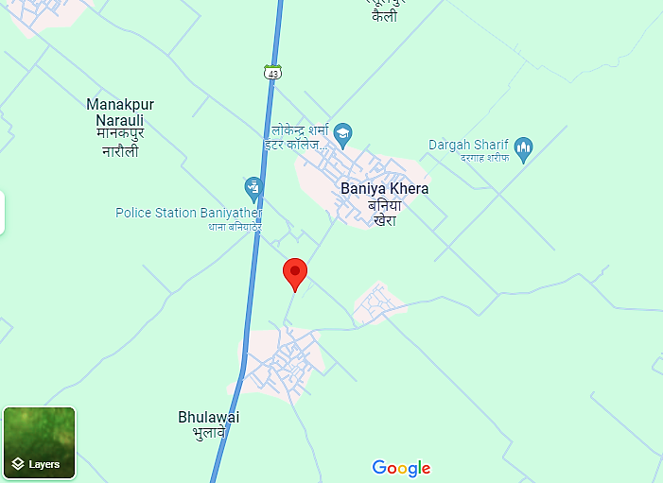
- Google Map Layout: Demarcation of the land with approximate measurement on the Google map is attached in the below picture:
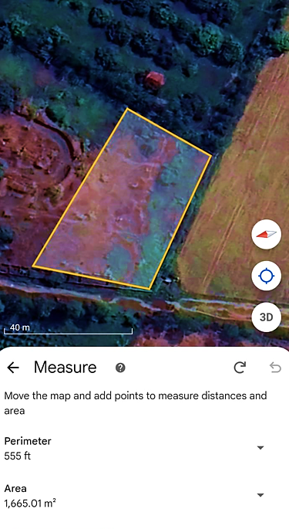
- LAYOUT PLAN:
As per the data/information provided by the client/Company, Nazri Naksha approved by Lekhpa (Baniyakhera, U.P) Mr. Anil Kumar on 4th March 2024 has been attached below:
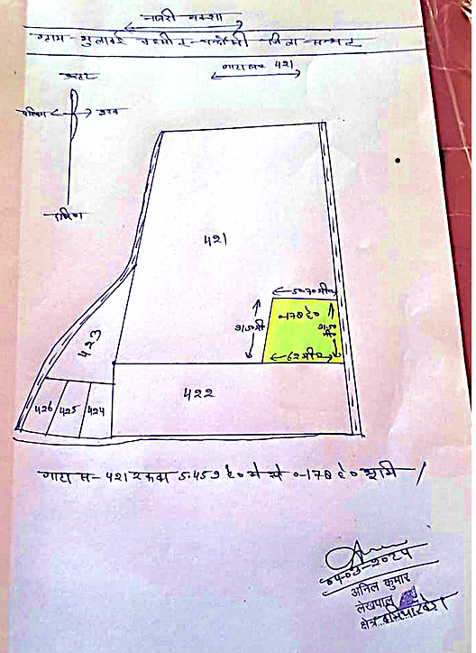
- LAND DETAILS:
The proposed Biomass pellets plant needs a total of about 1,780 Sq. Mt. land area to install the plant machinery for the pellet manufacturing Unit and as per informed by the company officials, additional ~16,200 Sq. Mt. land shall be taken on lease in future to store the required raw material.
As per the lease deed executed on 26th December 2023, the Company has leased a 0.178 hectare (1,780 Sq. Mt.) land at Khasra no. 421, Village Bhuiawai, Tehsil Chandausi, District Sambhal, Uttar Pradesh for a period of 20 years on an annual lease rental of INR 20,000/annum (excluding all other charges). Change of land use (CLU) has been approved on 27th July 2023, for setting up the proposed Biomass pellets plant.
During the site visit on 21st March 2024, we found it as a vacant land merged with the adjacent plots as a pat of ~5 acre big land parcel. As informed by the client, Company will start the demarcation and land development work after the sanction of term loan.
- SITE PICTURES: Site pictures were captured during the site survey on 21st March 2024, for reference few of the pictures are attached below:
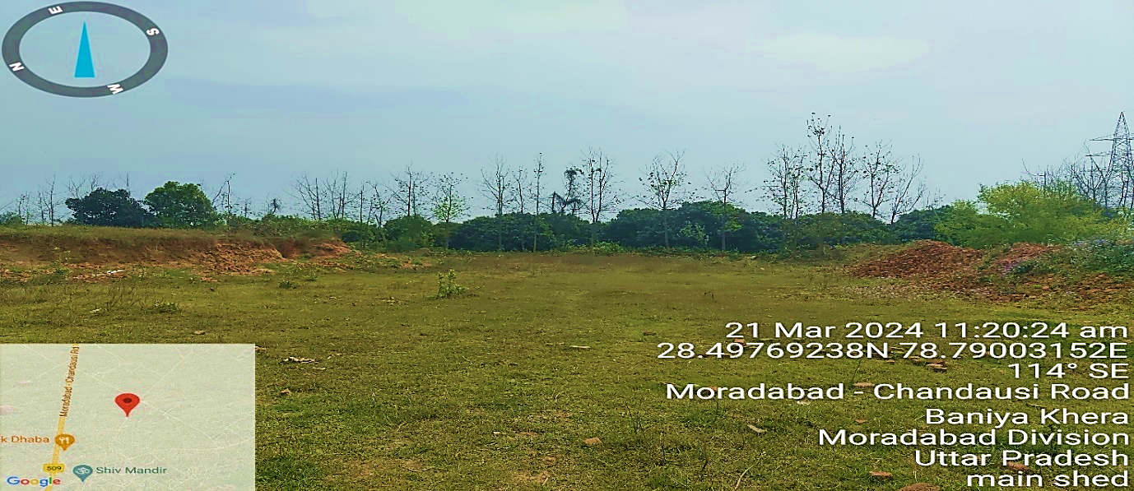
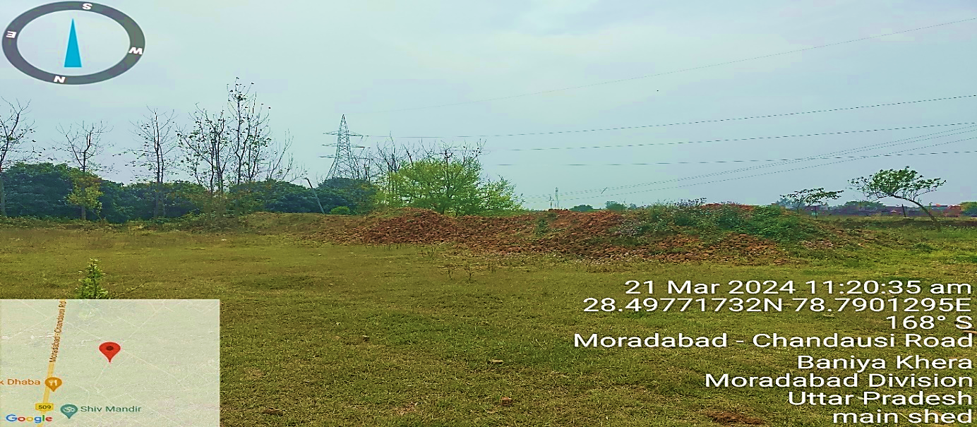
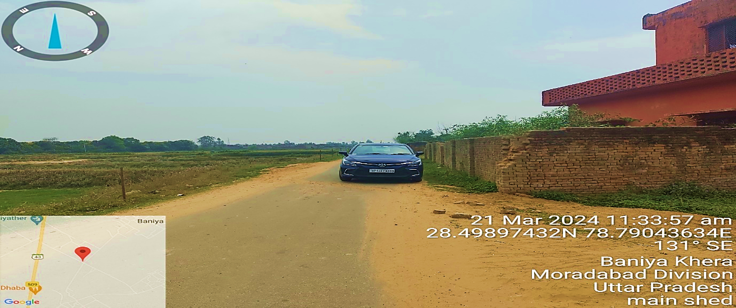
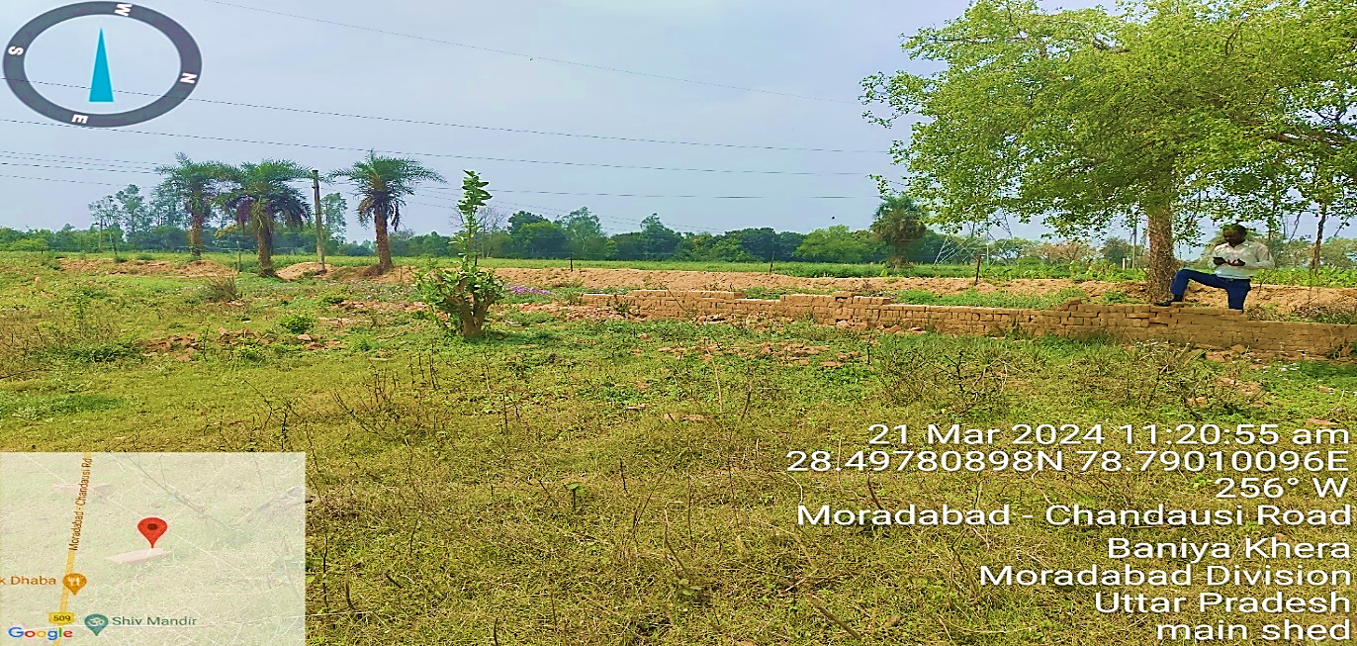
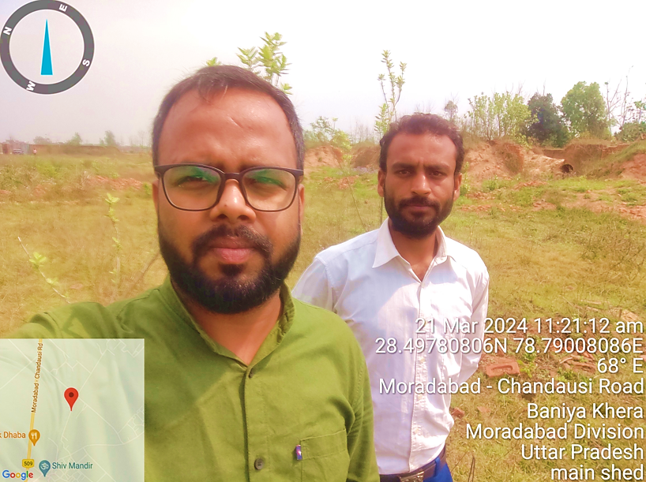
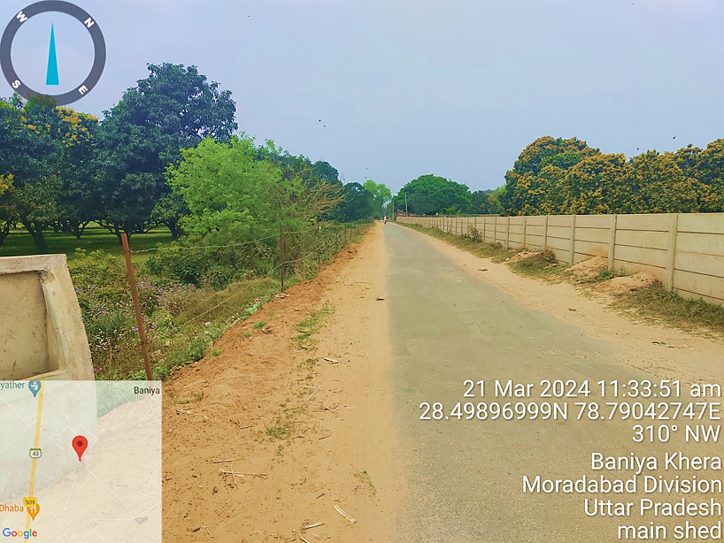
- BUILDING & CIVIL WORKS:
As per informed by the client/Company, out of 1,780 Sq. Mt. reserved for pellet mill, ~1,400 Sq. Mt. of area would be utilised for building & civil works with Pre-Fabricated Structure. Company has invited quotation for pre-fabricated structure from a Ghaziabad based civil contractor “MR Building System”, according to which detailed bifurcation of the proposed Building & Civil works has been shown in the below table along with the estimated cost:
Proposed Building & Civil Works
S. No. | Capital Cost Head | Area | Units | Unit Rate | Amount (INR)
1 | Prefabricated Structure
A | PEB Steel Building And supply with all necessary accessories | 29000 | Kg | 95 | 27,55,000
B | Sheet And supply with all necessary accessories | 1535 | SQMT | 540 | 8,28,900
C | Gutter And Flashing | 695 | RFT | 200 | 1,39,000
D | Drain Pipe | 260 | RFT | 100 | 26,000
E | 15x15 Gate | 225 | SQF | 200 | 45,000
F | Supply and installation cost of Roof turbo ventilators with base skylight sheet. |  |  |  | 5,000
 | Sub Total |  |  |  | 37,93,900
2 | Civil Works
A | Civil Foundation Cost As per PEB design | 20 | No | 45,000 | 9,00,000
B | Ground floor aggregate compacting and Ground floor Trimix 100mm thick with hardness as per design requirement. | 10,760 | SQF | 150 | 16,14,000
C | 230mm brick wall and Column beam with both side plaster Cost | 4450 | SQF | 250 | 11,12,500
D | 300x230mm Plinth beam Cost | 460 | RFT | 450 | 2,07,000
E | 330 mm under brick |  | SQF |  | Extra
 | Sub Total |  |  |  | 38,33,500
 | Total Cost |  |  |  | 76,27,400
4 | Applicable GST
A | GST | 18 | % |  | 13,72,932
 | Total For Civil Works |  |  |  | INR 90,00,332

As per the above table, the estimated cost of the Building & Civil works is ~INR 90.00 lakhs including applicable 18% GST. Electrical work would require additional ~INR 12.00 lakhs of capex.
As a TEV consultant, the estimated Building & Civil works cost has been verified independently by us, which we found in the permissible range, however, since it is a proposed cost based on the quotation shared with us, the actual cost may change as per specifications & material brand.
As per data/information provided by the client, appointment of the architect for preparation of site map/layout plan and agreement with civil contractor will be done after the sanction of bank loan.
- PLANT & MACHINERY/ EQUIPMENTS DETAILS:
As per the data/information provided by client, the technology suppliers will be finalised after the sanction of bank loan. Currently, company has invited quotations from various vendors/suppliers for required plant & machinery. Detailed bifurcation of the proposed Plant & Machinery has been shown in the below table along with the estimated cost as per the shared quotations shared by the client:
Proposed Plant & Machinery
S. No. | Capital Cost Head | QTY. | Units | Unit Rate | Amount (INR)
1 | Equipment/ Machinery For Biomass Pellet Manufacturing
A | Dryer | 1 | SET | 60,00,000 | 60,00,000
B | Chipper | 1 | SET | 30,00,000 | 30,00,000
C | Hammer | 1 | SET | 30,00,000 | 30,00,000
D | Pellet Mill | 3 | SET | 70,00,000 | 2,10,00,000
E | Torrefection Machine / Furnace | 1 | SET | 2,50,00,000 | 2,50,00,000
Sub Total |  | INR 5,80,00,000

Thus the estimated cost for plant & machinery will be ~INR 580.00 lakhs including the applicable GST.
However, the cost vetting is out of scope of the report, the cost of major plant & machinery has been verified by us independently as a TEV consultant, which we found reasonable & in the permissible range except the cost of Pellet Mill, which is found to be comparatively higher, than the acquisition cost of the same at present.
In our independent research the cost of pellet mills on standard basis are found in the range of INR 30-40 lakhs per unit including applicable GST & transportation charges. However the cost of pellet mill provided to us by the client is INR ~70 lakhs per unit, which is almost double.
As per the justification provided by the client in this regard, The proposed pellet mill is customized and basically designed to handle the torrefied biomass for which it will have the inbuilt cooling system (additional conveyors and bins required) and the proposed pellet mill is designed for both pellet as well as briquettes and it is capable of manufacturing 6mm pellet to 90 mm briquettes, however the standard pellet mills available in the market produce more than 10mm pellet.
Due to which the proposed pellet mill is expected to have the superior Material of Construction (MOC) because all the component will be manufactured with the tempered steel with chroming to deliver the uninterrupted operations compare to normal pellet mill available in the market. The major difference in the cost is that the normal pellet mills are design to handling the non-torrefied biomass only.
- UTILITIES: Details of Water, Electricity and other utilities are describes as below:
- WATER:
As informed by client, the water supply of local Jal Board is available. The Company will be applying for water connection post disbursement of loan. The total requirement of the plant will be ~10000 Litre per day.
- ELECTRICITY:
The estimated connected load requirement would be 295 kW out of which the total running load would be 190 kW. The Company will be applying for sanction of power load post disbursement of loan.

Thus, ~INR 3.22 Crore per ton/hour will be the CAPEX for the proposed Torrefied Biomass pellets manufacturing plant including GST, pre-operative and preliminary expenses, etc. The capex per ton/hour is higher due to the customized plant & machinery (pellet mill) is proposed to be installed by Company.
The Cost of Project varies on case to case basis depending on various factors. Typically, the Cost of Equipment needed for Non-Torrefied Biomass pellets manufacturing lies in the vicinity of approx. INR 50 Lakhs per Ton /Hour (Source Year 2022-23). However, cost of setting up torrified biomass pellets plant can be significantly higher. (Ref: https://samarth.powermin.gov.in/content/policies/860414f7-0733-409f-a636-e629dcc55159.pdf).
As per our tertiary research and data/information available in the public domain, we found that for a small state biomass pellet manufacturing business that is only making wood pellets, the investment required can be anywhere from 5 lakhs to 15 lakhs. But for an ideal output that is around of 500 kgs per hour, including the cost of plant & machinery, that will include the cost of the shed (for dry storage), running cost (cost of labour and transportation) of power, and working capital for a land size of 1000 sq. feet., a minimum investment of around INR 30 lakh will be required.
For a state of art biomass pellet manufacturing business that can perform pelletizing, briquetting of Biomass etc., and the estimated cost will be around five crores or more. (https://corpbiz.io/learning/how-to-start-biomass-pellet manufacturingbusiness/#:~:text=Government%20Assistance%20for%20setting%20up%20Biomass%20Pellets%20Plants,The%20GOI%20is&text=70%20Lakhs%20and%20for%20Torrefied,1.40%20Crores.)

PART E | PROJECT TECHNICAL DETAILS

- CAPACITY OF THE PROPOSED BIO-CNG UNIT:
This torrified biomass pellets manufacturing plant is proposed to be set up with a designed capacity of 40,000 Kg/Day as illustrated in the below table:
Capacity of the proposed Bio-CNG plant
Particular | Capacity
Biomass Pellets Plant Design Capacity | 40,000 Kg/Day

- PRODUCTION PROCESS OF BIOMASS PELLETS:
OVERVIEW:
The biomass palletisation process consists of multiple steps including raw material pre-treatment, palletisation and post-treatment. The first step in the Palletisation process is the preparation of feedstock which includes selecting a feedstock suitable for this process, its filtration, storage and protection. Raw materials used are sawdust, wood shavings, wood wastes, agricultural residues like straw, switchgrass etc.
Filtration is done to remove unwanted materials like stone, metal, etc. The feedstock should be stored in such a manner that it is away from impurities and moisture. In cases where there are different types of feedstocks, a blending process is used to achieve consistency.
The moisture content in biomass can be considerably high and are usually up to 50% – 60% which should be reduced to 10 to 15%. Rotary drum dryer is the most common equipment used for this purpose. Superheated steam dryers, flash dryers, spouted bed dryers and belt dryers can also be used. Drying increases the efficiency of biomass and it produces almost no smoke on combustion.
It should be noted that the feedstock should not be over dried, as a small amount of moisture helps in binding the biomass particles. The drying process is the most energy intensive process and accounts for about 70% of the total energy used in the palletisation process.
Before feeding biomass to pellet mills, the biomass should be reduced to small particles of the order of not more than 3mm. If the pellet size is too large or too small, it affects the quality of pellet and in turn increases the energy consumption. Therefore the particles should have proper size and should be consistent. Size reduction is done by grinding using a hammer mill equipped with a screen of size 3.2 to 6.4 mm. If the feedstock is quite large, it goes through a chipper before grinding.
- FEEDSTOCK PREPARATION:
The first step is to collect and prepare the biomass feedstock like shredding and drying.
- GRINDING / MILLING:
The main goal of this step is to create a uniform and consistent feedstock that can be easily processed into pellets.
- TORREFACTION:
Torrefaction is a thermolysis process that subjects the feedstock to thermal treatment at temperature of 200–300 ◦C in the absence of oxygen and converts it into a coal like material. Torrefaction of biomass improves its physical properties like grind-ability, particle shape, size, and distribution, pellet-ability, and physical properties like moisture, carbon and hydrogen contents, and calorific value. This makes biomass suitable for higher Cofiring ratios in Thermal Power Plants.
- PELLETIZING:
The pellet mill uses a combination of heat, pressure, and friction to force the feedstock through a die with small holes, forming the pellets.
- COOLING:
The newly formed pellets are then cooled to room temperature, typically using a counter-flow cooler. The cooler removes excess moisture and prevents the pellets from sticking together.
- PACKAGING:
The final step is to package the pellets in bags or bulk containers for storage and transportation.

- PROCESS FLOW CHART OF THE PROPOSED BIOMASS PELLETS PLANT:
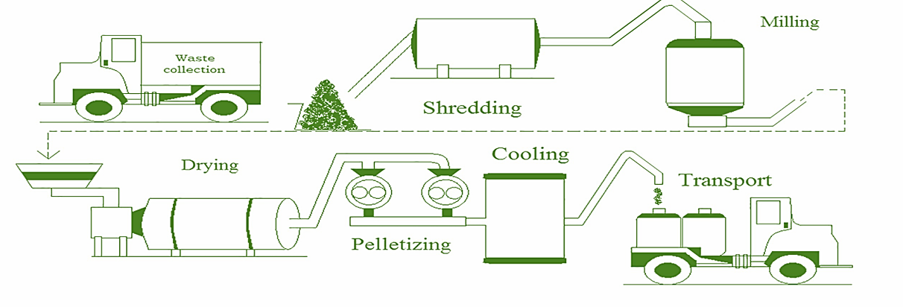
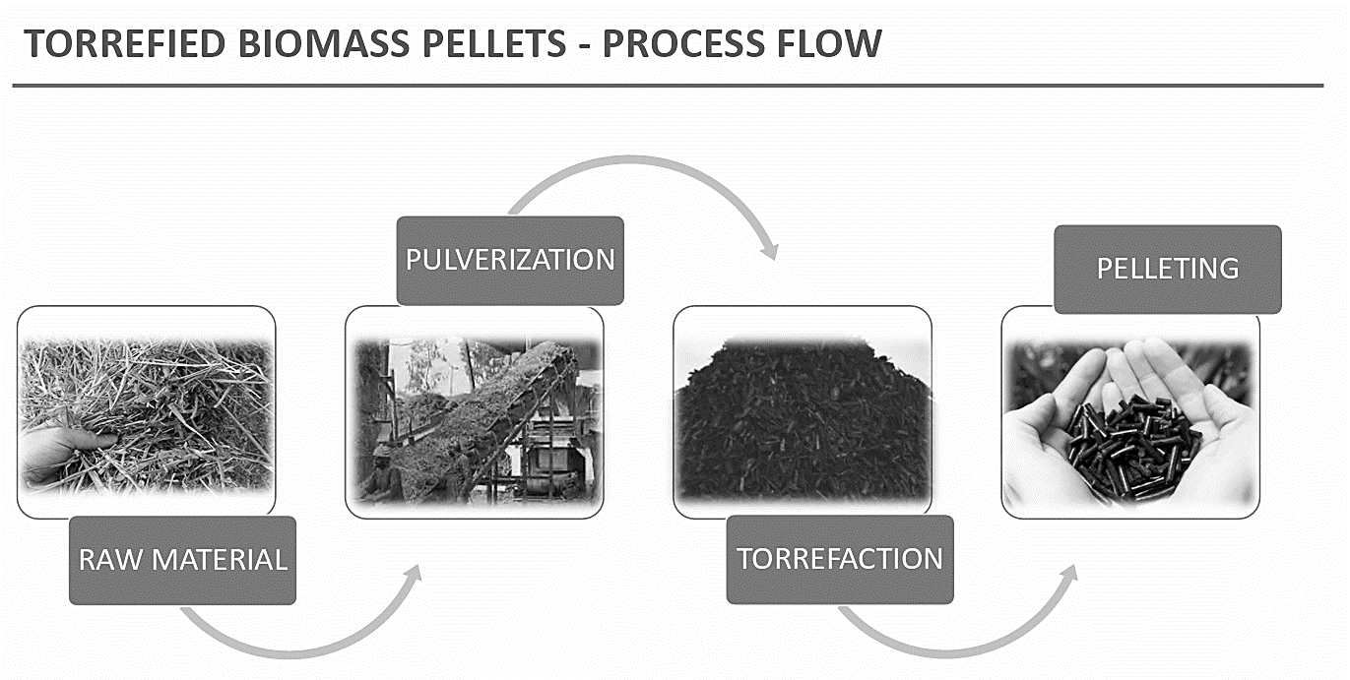

- TECHNICAL SPECIFICATIONS OF THE PROPOSED BIOMASS PELLETS PLANT:
Technical specification of the proposed Biomass pellets plant is presented in the below table:
Biomass Pellets Plant Technical Specification
S. No. | Characteristics | Values | Figures
1 | Quantity of feedstock | Tons / day | ~57
2 | Base material | mm | Not more than 25 mm
3 | Length | mm | Not more than 50 mm
4 | Bulk density | kg/m3 | Not less than 600 kg/m3
5 | Fines% (length <3 mm) (ARB*) | Weight % | fines ≤ 5%**
6 | Gross calorific value  (ARB*) | kcal/kg | Non- torrefied pellets: 3500 ± 100 Torrefied pellets: 4500 ± 100
7 | Moisture (ARB*) | Weight % | Not more than 9%
8 | Ash (ARB*) | Weight % | Not more than 20%
9 | Hard grove Grind ability Index$ (HGI) | - | 50 or more
10 | Particle size distribution$$ (After crushing and pulverizing in site lab pulverizer) | Weight % | Passing proportion from 2 mm mesh size sieve: ≥ 75% Passing proportion from 3 mm mesh size sieve: =100%
Note: *ARB – As Received Basis, ** Assessment of Fines shall be as per durability test of pellets, $ Applicable for torrefied pellets, $$ Applicable for non- torrefied pellets. As per the data/information provided to us by the client/company, major component of the proposed Biomass Pellets manufacturing plant are as follows:
- SHREDDER:
Dual shaft shredder is a two shaft shredder with multiple shredding blades, spacers equipped with cleaning fingers to clean the blades and give raw-material a precise cut. The Shredder is a Robust design machine made for heavy duty functioning. The In-feed & outlet conveyors can be purchased as an optional item for easy operation.
The extra wide feed opening in-feed chamber is provided for trouble free operation. Shredder is equipped with Programmed Control Panel which ensures smooth function and fully automatic operation with auto reverse and forward function in case of over feeding. The raw-material can be fed directly into an in-feed chamber with the help of lifting loaders or in-feed conveyors. Further, the material enters into an in-feed chamber and shredder blades cut the material into required size as per specification.
The cleaning fingers help to keep the blades clean for smooth functioning of the machine and proper cutting of the raw-material. The shredded material is discharged at the discharged end and is ready to be used for further processing.
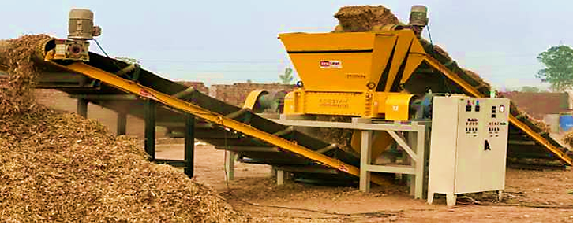
Specifications of Shredder
Production Capacity | 2,000 - 3000 KG/HR
Raw Material | Paddy straw or forest waste or any other agriculture
Power Required | 80 HP

- CHIPPER GRINDER: Chipper Grinder is drum type chipper, the material is fed into chipper via help of in-feed belt conveyor, through which the material goes into chipper drum where it gets cut into smaller pieces with the help of moving chipper blades. The chipped material is screened out through perforated screen to ensure the appropriate output size of the material.
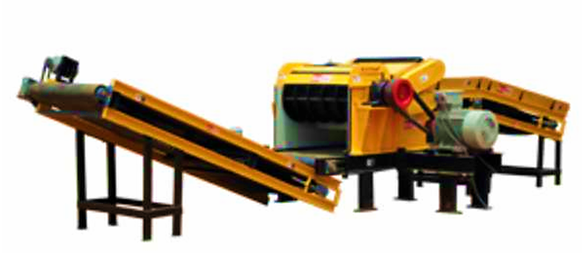
Specifications of Chipper Grinder
Production Capacity | Up to 2,000 KG/HR
Input Size of Raw Material | Up to 25 mm Diameter
Power Required | 65 HP

- HAMMER:
The dried agricultural and forest waste in chipped form is fed and conveyed into the hammer mill with the help of in-feed screw conveyor. The material is clashed by the hammer batten and is thereby shredded and expelled through perforated screen of a selected size which is pneumatically conveyed into cyclone with the help of ID Fan(s). The grinded material in granulated form is discharged by the airlock(s) at the discharge end.
Specifications of Hammer
Production Capacity | Up to 2,000 KG/HR
Input Size of Raw Material | Up to Dia 20 mm x 4 inches long
Input Raw Material Moisture Content | Up to 12%
Power Required | 65 HP
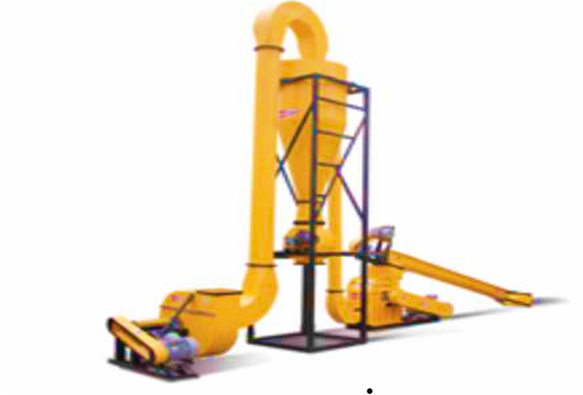
- TORREFACTION FURNACE:
A torrefaction furnace is a type of reactor used to perform the torrefaction process on biomass. The process involves heating biomass in a low-oxygen environment at temperatures typically between 200-300°C (392-572°F) for a period of time ranging from 30 minutes to several hours.
The working principle of a torrefaction furnace involves several steps. First, the biomass is loaded into the furnace, typically in a conveyor or hopper system. The furnace is then sealed to create a low-oxygen environment. After the torrefaction process is complete, the furnace is cooled, and the torrefied biomass is removed from the reactor. The torrefied biomass will be used for pellet manufacturing.
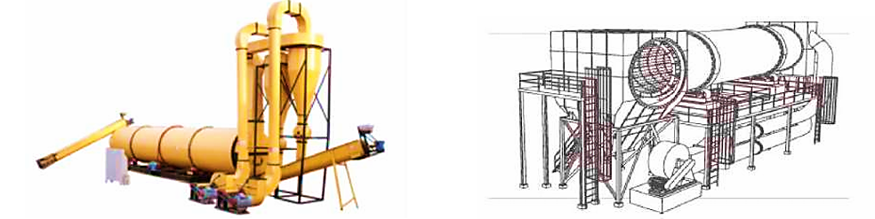
- PELLET:
The torrefied and granulated raw-material is fed into the machine with the help of in-feed screw conveyor. Further, the material enters into the machine keep, the keep worm pushes the material into the briquetting chamber. The biofuel briquettes are formed in the briquetting chamber without the need of any binder with high pressure mechanical punch. Next, the briquettes come out from the cooling line and are ready to use.
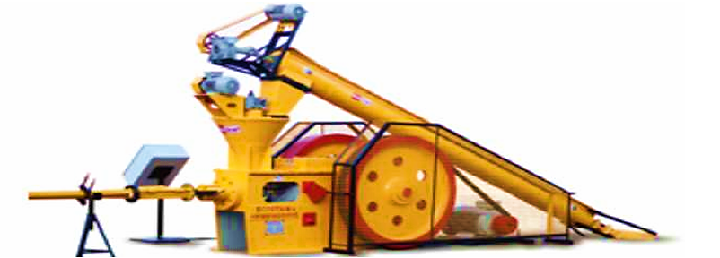
Specifications of Pellet
Production on Briquettes | Up to 2,300 KG/HR
Production on Pellets | Up to 1,400 KG/HR
Input Raw Material Moisture Content | 8%- 12%
Input Raw Material Size | Granulated
Power Required | 92 HP

- TECHNOLOGY USED:
- PROPOSED TORREFECATION TECHNOLOGY:
Company has proposed to commission the plant with “Waste biomass to bio coal by rotating reactor type torrefaction technique”, which is a thermochemical pre-treatment process at 200–300 °C in an environment with low oxygen, which transforms biomass into a relatively superior handling, milling, co-firing and clean renewable energy into solid biofuel (coal-like pellets).
Torrefaction carries devolatilisation, depolymerisation and carbonization of lignocellulose components in order to generate bio-coal. During this process, 70% of the mass is retained as a solid product, and retains 90 % of the initial energy content.
In the proposed 40 TPD Biomass Pellet Manufacturing plant, the Company shall be using an inclined type of rotary drum reactor for the torrefaction process which shall be unique of its kind at present. Inside the reactor the biomass will be fed at the higher high end of the drum.
The drum will rotate at a constant low speed with the help of electric motors for uniform heating. As the drum rotates, the biomass progresses by gravity down the slope of the rotating drum and internal fixtures mix the biomass generated gas recycled using turbocharger.
- LATEST TECHNOLOGY/TECHNOLOGICAL ASSESSMENT:
The proposed 40 TPD biomass pellet manufacturing plant is proposed to be commissioned with Torrefaction technology, which is a thermal process. Torrefied biomass is the most elegant solution to convert raw biomass into a coal-like material. It involves the heating of biomass with limited oxygen to a temperature of typically 200 to 300°C. Torrefaction enhances the fuel properties by adding higher energy density and near zero moisture whereby making the GCV and NCV nearly the same.
Resultant product has better fuel characteristics than the original biomass. Simplified storage of the torrefied material. Minimal biological degradation and water uptake Makes biomass friable (80%-90% less energy consumption for grinding). In comparison to normal Pellets, Torrefied Pellet has higher density, Reduced Moisture & Ash content, reduced emissions due to low Volatile Solids, Longer Storage period.
Torrefied Wood Pellets Compared To Coal
Characteristic | Coal | Torrefied Wood Pellets
Heating Value | 18 GJ/T | >22 GJ/T
ASH | 20-30% | <3%
Sulphur | 3-5% | >0.01%
Nitrogen | 1.5-3% | <0.1%
Chlorine | 0.05% | >0.01%
Torrefied biomass is believed to be a superior solid fuel for combustion, especially when co-fired with coal due to its higher energy density and coal-like handling proper-ties. Typically during torrefaction, 70% of the mass is retained as a solid product, containing 90% of the initial energy content. Torrefaction releases combustible gases that can be used to generate the required heat, making the process self-powering.
Thus the Torrefied pellets becomes an ideal coal replacement because of its features such as Grinds & burns like coal – Existing Infrastructure Can be used, Lower Feedstock Costs, Lower shipping and Transport Costs, Minimal de-rating of the Power Plant, Provides Non-Intermittent Renewable Energy, Lower sulphur and Ash Content (compared with coal)
Thus as per the above technical assessment, M/s Natural Gas India Pvt Ltd is going to use the appropriate technology which is a going on, recognized and trending in the market at present.

- EFFLUENT TREATMENT AND ABETMENT:
As per the information provided by the client/Company, during the production of biomass pellets, no liquid discharged will be there and no by-product shall be generated.

- TESTING STANDARDS FOR PRODUCTION:
Each consignment should be accompanied by general details (such as name of company/firm/agency, address, date of dispatch, batch number, vehicle type and number, weight of consignment etc.) and technical details which shall contain the values of all parameters as specified in previous section of the report. The charges incurred on account of sampling analysis at loading end shall be borne by the supplier. Biomass pellets sample shall be tested for various parameters in owner’s power plant site lab.

- MANPOWER:
As per information shared by the client/.company, an estimate of manpower requirement allowing for leave, absentecism, sickness and holidays for smooth and for efficient operation of different sections of the plant including its administrative and commercial departments, has been prepared based on technical and management ground primarly to indicate the order of manpower requirement.
The basic structure of the manpower will require the following kind of resources to opearte the plant 24*7 for 330 days a year:
Proposed manpower details along with Cost (INR)
Category | Number | Average Monthly Salary
Plant Manager | 1 | 75,000
Supervisors | 1 | 45,000
Operators | 3 | 25,000
Labours | 4 | 15,000
Security | 3 | 15,000
Total for Office Staff | 12 | INR 3,00,000

PART F | PRODUCT PROFILE

- INTRODUCTION:
The current availability of biomass in India is estimated at about 750 million metric tones per year. The estimated surplus biomass availability is at about 230 million metric tones per annum covering agricultural residues. Ministry of Power (MOP) vide its policy dated 17.11.2017 on biomass utilization for power generation had advised that all fluidized bed and pulverized coal units (coal based thermal power plants) except those having ball and tube mill, of power generation utilities, public or private, located in India, to use 5-10% blend of biomass pellets made, primarily, of agro residue along with coal after assessing the technical feasibility, viz. safety aspect etc. The Biomass policy of the country was revised in October 2021, according to which a 5-10 % co-firing in power plants was made mandatory weight.
- PRODUCT CATEGORY: BIOMASS PELLETS
Biomass pellets are small, compressed organic materials made from various sources of biomass, such as paddy husk, cotton stalks, mustard stalks, maize straw, bamboo, elephant grass and other agricultural residues. The pellets are used as a green fuel, as they are an environmentally friendly and sustainable alternative to traditional fossil fuels.
- PRICING STRATEGY:
The price of Biomass pellets depends on various factors, such as the Calorific Value, quality, quantity, uses, availability and demand. The Price benchmarking Committee apoointed by Ministry of Power carried out study for Northern Region (excluding NCR) and submitted its report with recommended benchmark price for Northern Region (excluding NCR).
As per the recommendation of the Committee, biomass fuel price has been specified for a period of 1 year w.e.f 08.11.2023. The benchmark prices for non-torrefied biomass pellets in the Northern Region (excluding NCR) have been derived as Rs 2.27/1000 kcal i.e. 10.11/4500 kcal. The price specified is excluding GST & transportation cost at the pellet manufacturing plant site. The pellets shall have moisture content below 14% and GCV between 2800-4000 kcal/kg. Reference:
(https://powermin.gov.in/sites/default/files/Price_Benchmarking_of_Biomass_Pellets_for_co_firing_in_Thermal_Power_Plants_for_Northern_Region_excluding_NCR_0.pdf).

As per the guidelines of Ministry of Power regarding the technical specifications of the Biomass pellets, Company has proposed to produce the Torrefied Biomass pellets with the Gross calorific value (GCV) as 4500 ± 100. Thus, the price range is typically between INR 9-11 per kg, but it can go up to INR 14 per kg for high-quality pellets.
- MARKETING, SELLING & DISTRIBUTION PLAN:
As per the proposed selling & distribution plan shared with us by the client, Company will be generating the revenue by selling Biomass Pellets to NTPC (Dadri Unit) and other Industrial & Commercial units. NTPC release the bid/tenders to procure the required Biomass pellets (Torrefied/ Non-Torrefied) time to time. (https://ntpctender.ntpc.co.in/Uploads/job_40033.pdf).
As per informed by the client, after studying the past tenders it is found that the minimum 20TPD has to be supplied to participate in the Bid processes.
Based on a 5-10%% coal replacement with biomass pellets, the demand for the closest NTPC power plant in Dadri is 1835 TPD which is around 150KM from the proposed site. The proposed plant's production capacity is 40 TPD and requirement in Dadri power plant is 1835 TPD.
NTPC has 9 additional plants in U.P. and Bihar, where these biomass pellets can be sold in addition to the Dadri power plant as per data/information provided by the client/company.
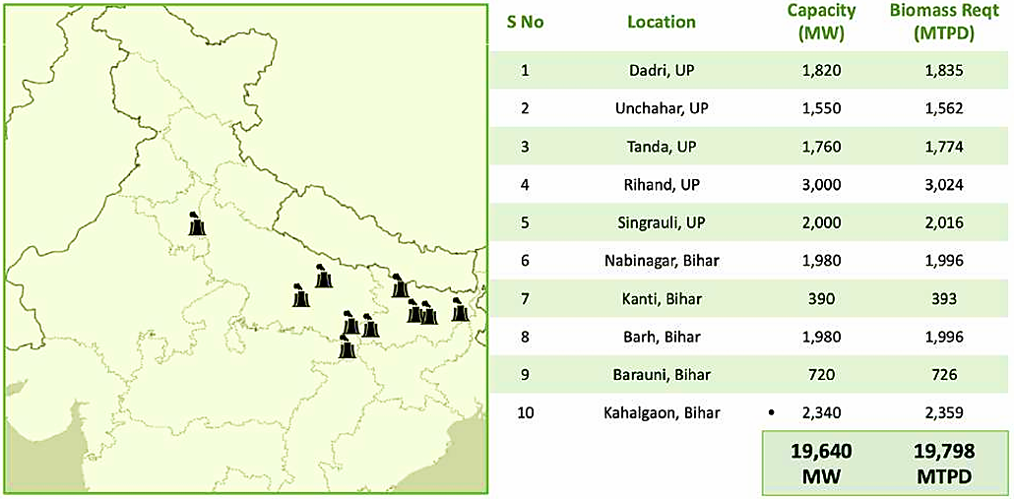

PART G | FEEDSTOCK ANALYSIS & SUPPLY

- INTRODUCTION:
Biomass pellets can be produced from a variety of feedstock types, each with its own characteristics and suitability for Palletisation. The choice of feedstock depends on factors such as availability, cost, energy content, and environmental considerations. Approximately 60 MTPD raw material will be utilized to produce 40MTPD biomass pellets.
Suitable Biomass For Bioenergy Project
Name | key characteristics
Paddy Straw | - Average Yield per Hectare: Paddy straw yield can vary depending on factors such as rice variety, soil fertility, climate, and management practices. On average, paddy straw yields can range from about 3 to 6 tons per hectare (1.2 to 2.4 tons per acre).  - Length and Texture: Paddy straw varies in length and texture, with the stalks typically ranging from 60 to 120 centimetres (2 to 4 feet) in length.  - Fibrous Structure: Paddy straw consists mainly of cellulose, hemicellulose, and lignin, giving it a fibrous and woody structure.  - Carbon-to-Nitrogen Ratio: Paddy straw has a high carbon-to-nitrogen (C: N) ratio, typically ranging from 60:1 to 100:1. This high C: N ratio makes paddy straw a valuable organic material for soil amendment and composting, as it helps improve soil structure and fertility while promoting microbial activity.  - Bulk Density: Paddy straw has a relatively low bulk density, which means it occupies a large volume relative to its weight. This characteristic can influence storage and transportation considerations, as compacting or densifying paddy straw may be necessary to optimize storage space and handling efficiency.  - Combustibility: Paddy straw is highly combustible and can be utilized as a biomass fuel for energy production.  - Availability: Paddy straw availability is seasonal, typically coinciding with the rice harvesting season which is typically 120 days per year.
Napier Grass | - Height and Growth Habit: Napier grass is known for its tall and vigorous growth, capable of reaching heights of 3 to 5 meters (10 to 15 feet) under favourable conditions. Its upright growth habit and dense foliage make it an ideal candidate for biomass production.  - Fresh Weight Yield: On average, Napier grass can yield approximately 40 to 70 tons of fresh biomass per Acre per harvest under optimal conditions. This yield can vary based on factors such as irrigation, fertilization, and harvesting frequency. Dry Matter Yield: The dry matter content of Napier grass typically ranges from 20% to 30% of the fresh weight.  - Harvest Frequency: Napier grass can be harvested multiple times throughout the growing season, with each harvest interval typically ranging from 60 to 90 days. With proper management, including fertilization and irrigation, 4-6 harvests can be obtained in a single growing season, maximizing biomass production.  - Adaptability: One of the notable characteristics of Napier grass is its adaptability to various soil types and climatic conditions.  - Nutritive Value: While Napier grass is primarily cultivated for biomass production, it also has value as a livestock feed. The foliage of Napier grass is relatively nutritious, with high protein content and digestibility.  - Regeneration Capacity: Napier grass has excellent regenerative capacity, capable of regrowing vigorously after harvesting or grazing. With proper management practices, including timely cutting and fertilization, it can sustain multiple harvests without significant loss in productivity.

For the proposed 40 TPD Biomass Pellet plant, company has considered the following feedstock based on the mentioned factors
- Vegetable Waste:
Vegetable processing involves peeling and trimming operations, resulting in a significant amount of waste material. Peelings and trimmings from Peas, Potatoes, Carrots, Onions, and other vegetables shall be collected and processed into biomass pellets. As per the data/information provided to us by the client, Company already executed LOI on 2nd March 2024, with “M/s Natura Green Food Products Pvt Ltd” a vegetable waste processing industry based in Chandausi for the supply of vegetable waste of 300 tons per day (TPD) at INR 2,800 per ton.
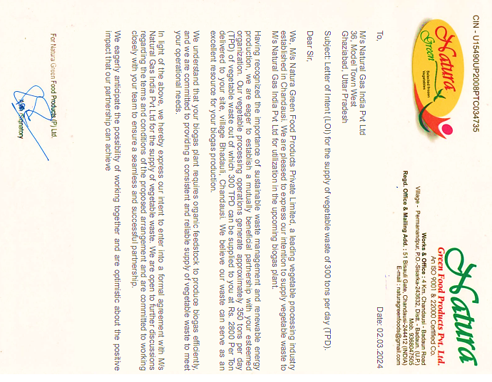
- Agricultural Residues:
Agriculture residue availability is in abundance in Chandausi as the main occupation is agriculture. Company aggregate the rice crop residue which is paddy straw, and it is one of the huge agriculture waste which generates after each harvest of rice crop. The Paddy Straw will be collected by using Straw baler from local farmers. As per the assessment ~5 Baling Set are required For 40 TPD Biomass Pellet Plant
- Energy Crops:
To have round the year uninterrupted supply of feedstock we have also considered the contract farming of Napier grass. Napier Grass is a Perennial grass with high biomass yield and adaptability to various climates.
On average, Napier grass production yield is approximately 200 tons of fresh biomass per acre per year in 3-5 harvest under optimal conditions. This yield can vary based on factors such as irrigation, fertilization, and harvesting frequency. Napier Grass Required for 40 TPD Biomass Pellet Plant is presented in the below table:
Napier Grass Required for 40 TPD Biomass Pellet Plant
Napier Grass Required Per Day | Total Production of Napier Per Acre per Year | Napier Grass required Per Year in Tons | Land Required in Acre
114 | 227 | 37714 | 166
The capital expenditure (CAPEX) involved in Napier grass farming can vary depending on several factors, including the scale of the operation, land acquisition costs, infrastructure requirements, equipment investment, and ongoing operational expenses as shown in the below table:
CAPEX - Initial Cost | Value in INR | Unit
Infrastructure Development | 1,50,000 | Per Acre
Planting Materials | 20,000 | Per acre
Equipment and Machinery | 30,00,000 | Per Set
Infrastructure for Biomass Storage | 1,50,000 | Per Acre
Utilities and Energy | 1,50,000 | Lump Sump
Operating expenses (OPEX) in Napier grass farming encompass the various costs associated with cultivating, managing, and maintaining a Napier grass plantation. These expenses can vary depending on factors such as farm size, location, labour availability, management practices, input costs, and market conditions.
Napier grass OPEX cost calculation
S. No. | Description | Unit | Value in INR
1 | Land Size | Acre | 100
2 | Number of seed required per acre | Nos. / Acre | 10,000
3 | Total weight of grass per harvest | Kg / Per acre | 1,03,950
4 | Cost of Seeds | INR / Acre | 11,000
5 | Lease charges of the Land | INR / Acre/Year | 1,00,000
6 | Cost of seed (3 Years life) | INR / year | 3,66,667
7 | Lease charges for land | INR /Year | 1,00,00,000
8 | Total yearly cost | INR / Year | 1,03,66,667
9 | Total Yearly Grass Generation | Tons / Year | 23,389
10 | Organic fertilizer required | Ton/Acre | 10
11 | Cost of organic fertilizer | INR /ton | 2,500
12 | NPK Required | Ton/Acre | 0
13 | Cost of NPK | INR /Ton | 2,000
14 | Cost of organic fertilizer and NPK | INR /Year | 76,49,393
15 | Cost of Fertilizer per ton of grass | INR /Ton | 327
16 | Labor cost | INR /Ton | 31
17 | Tractor cost for transportation | INR /ton | 156
18 | Seed and land cost | INR /ton | 443
Total Cost of Grass |  | INR/Ton | 957
As per data/information provided by the client, Company has executed a contract farming agreement for ensuring the availability the Napier Grass on 5th March 2024 with a local farmer Mr Padmendra Singh (Baniya Khera, Sambhal) for 54.68 Acre land, according to which minimum 100 Ton per day Napier grass will be supplied at INR 1,000 per ton.
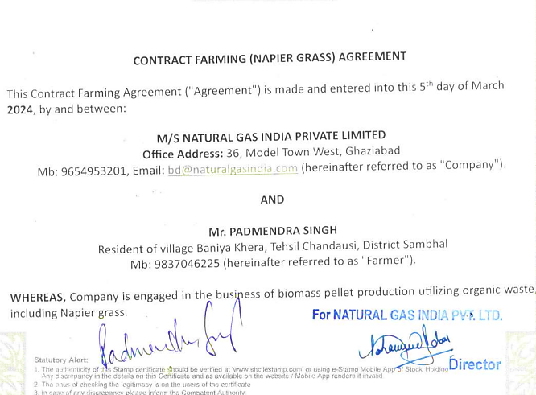
- AVAILABILITY OF RAW MATERIAL:
As per the data/information provided to us by the client, Company has identified four district which are within the 100KM range to the proposed location to support the manufacturing unit for the raw material, Badaun, Moradabad, Bareilly and Rampur.
Approximately 1 million tons of biomass waste is being generated every year in these four districts whereas to fulfil the requirement of the manufacturing plant, the Company will need only 19000 Tons per year which is approximately 2% of the waste generated.
- PRICING:
The price of agro-residue for Biomass pellets depends on various factors, such as the quality, quantity, uses, availability and demand. The Company has contracted to buy 300 TPD of vegetable waste INR 2800 Per Ton and executed a contract farming agreement with local farmers to ensure the availability of Napier grass at INR 1,000 per ton.

PART H | INDUSTRY OVERVIEW & ANALYSIS

- INTRODUCTION:
The Indian market for biomass pellets has been growing steadily in recent years due to various factors such as the increasing demand for renewable energy, government policies supporting the use of biomass pellets, and the rising prices of traditional fossil fuels.
According to a report by the Ministry of New and Renewable Energy (MNRE), India has been actively implementing the biomass power and co-generation program since the mid-nineties. This initiative has resulted in the installation of over 800 projects, including biomass power and bagasse/non-bagasse co-generation facilities, with a total capacity of 10,205.61 MW, contributing power to the national grid.
- POTENTIAL AND EXPANSION:
The demand for biomass pellets in India is increasing due to the government's focus on renewable energy and the need to reduce carbon emissions. The supply of biomass pellets in India is also growing, but there are some challenges that need to be addressed.
Demand: The major demand for biomass pellets in India is from the power sector and the industrial sector. A study supported by MNRE reveals that India's current biomass availability stands at around 750 million metric tonnes per year. The study further indicates a surplus biomass availability of approximately 230 million metric tonnes annually, primarily consisting of agricultural residues, which has the potential to generate about 28 GW of power.
Moreover, if the 550 sugar mills in the country were to adopt technically and economically optimal levels of cogeneration, an additional 14 GW of power could be generated through bagasse-based cogeneration, utilizing the bagasse produced by these mills.
Supply: The supply of biomass pellets in India is growing, and there are around 150 pellet manufacturers in the country. The total production capacity of biomass pellets in India was 9 MMTPA in 2021, and it is expected to increase to 19 MMTPA by 2025. The major raw materials used for pellet production are agricultural residues, forestry waste, sawdust, and other biomass materials.
Market price: The market price of biomass pellets in India varies depending on the quality and source of the pellets. The price range is typically between INR 9-11 per kg, but it can go up to INR 14 per kg for high-quality pellets.
- CHALLENGES:
Biomass pellet manufacturers in India face several challenges. Firstly, the inconsistent and unreliable supply of biomass feedstock poses a challenge, impacting production capacity and quality control.
Secondly, the lack of proper infrastructure and logistics, including storage facilities and transportation networks, hinders efficient operations. Lastly, financial constraints and difficulties in accessing capital and financing impede the expansion and modernization of biomass pellet manufacturing facilities.

- GOVERNMENT INITIATIVES:
The Indian government has implemented policies and incentives to drive the market demand for biomass pellets. These measures include subsidies, tax benefits, and favourable tariffs, aiming to promote the production and utilization of biomass pellets. The National Bioenergy Mission and other initiatives enhance affordability, stimulate investment in biomass technology, and increase renewable energy in India's energy mix. Financial assistance of up to INR 45 lakhs per plant is available for briquette/pellet manufacturing plants, with a subsidy of INR 9 lakhs per MTPH manufacturing capacity. Under this program, a 3TPH pellet plant can avail a subsidy of INR 27 lakhs.
- CONCLUSION:
The surge in demand for biomass pellets has created an immediate requirement for the biomass pellet manufacturing business. Biomass pellet suppliers can also cater to industries like textile, metal-based, food processing or in the open market. The demand from thermal power plants is also expected to rise exponentially after the remaining plants complete their trial runs.
According to the power ministry’s policy on biomass utilisation, nearly 0.25-0.3 million tonnes of biomass pellets can generate 1 GW of electricity at 7 per cent co-firing in thermal power plants, which is a hint at the immense future demand for these pellets in the future and therefore, biomass pellet manufacturing businesses, in every region of the country.
The market opportunity for biomass pellets in India is significant. The Indian government has set a target of achieving 500 GW of renewable energy by 2030. This presents a significant opportunity for the biomass pellet industry. The annual electricity generation potential from biomass pellets is estimated to be 244 twh in 2030/31 out of a total 4,000 twh of electricity production in India in 2030/31.
The market for biomass pellets in India is expected to grow significantly over the coming years, with estimates suggesting that the market could reach $4 billion by 2025. However, the industry faces several challenges, including the availability of raw materials, the lack of infrastructure for storage and transportation, and the need for more efficient and cost-effective production technologies.
Overall, the market opportunity for biomass pellets in India is significant, and the industry has the potential to play a critical role in India's transition to a more sustainable energy future.

PART I | SWOT ANALYSIS

SWOT ANALYSIS
STRENGTHS | - Strategic Location: The project is situated in Sambhal where feedstock availability like agriculture waste especially paddy straw is good within 100 km radius of the proposed location of the plant. There are plenty of feedstock aggregators which are ready to supply agriculture waste, saw dust and mustard straw. NTPC unit is also just 150km away.  - Experienced Promoters: The promoters are having rich experience with proven track record in the energy sector, strengthening the future of the project.  - Growing Demand: Due to renewable source of energy, demand for Bio mass is expected to grow at a CAGR of ~5-6 % in the upcoming years.  - Government Support: Briquette/ Pellet Manufacturing plants are entitled to avail incentives of INR 9 Lakh per MTPH (metric ton/hour) manufacturing capacity (maximum CFA of INR 45 Lakhs per plant) under the Biomass Programme for FY 2021-22 up to FY 2025-26. (https://mnre.gov.in/bio-mass/) and “One-time financial assistance scheme for setting up pellets plant in NCR” as per CPCB guidelines.  - Technology: The proposed plant will be commissioned with Torrefaction technology which enables the Plant and Machinery for handling various feedstock without any changes.
WEAKNESSES | - CAPEX: The proposed Bio pallet manufacturing plant would be set up by a high initial investment, in which ~70% capital would be required for customized plant & machinery.  - Infrastructure Requirements: The project's power load and water consumption are significant, and ensuring uninterrupted power supply and adequate water resources may pose challenges.  - Raw Material Market: There is no any formal market for raw material, leading to establish a feedstock pricing mechanism.
OPPORTUNITIES | - Increasing Alternate fuel’s Demand: Biomass pellet manufacturing businesses are in huge demand after the ‘National Mission on use of Biomass in coal-based thermal power plants’ that was launched on 12th July 2021, mandating all thermal power plants (TPP) in the country to use 5% of biomass pellets for co-firing with coal.  - Rice Belt: Due to rice belt of Northern India huge Agriculture waste is being generated every year and the proposed plant need is only 3% of the total waste available.  - Government Support: The project can benefit from government initiatives and policies aimed at promoting the Biomass pellet production to achieve Net Zero target by 2070.
THREATS | - Economic Factors: Farmers may substitute another crop for rice, which can be adversely impact the operations and generation of the revenue of the company.  - Manufacturing Experience: Promoters are having rich experience in the field of renewable energy, however entering into Biomass pellet manufacturing business may explore new multidimensional challenges.

PART J | PROJECT COST AND MEANS OF FINANCE

As per data/information shared by the client, the proposed Torrefied Biomass Pellet manufacturing project is proposed to be commissioned by making an investment of INR 883.00 lakhs as shown in the below table along with Means of finance:
Sr. No. | Capital Cost Head | Amount (INR)
A | Project Cost
1 | Civil Work | ₹ 1,02,00,000
2 | Plant & Machinery | ₹ 5,80,00,000
3 | Preliminary Expense | ₹ 35,00,000
4 | Working Capital Margin (WCM) | ₹ 1,42,54,853
5 | Interest During Construction (IDC) | ₹ 23,00,375
 | Total Project Cost | ₹ 8,82,55,228
Source: As per data/information provided by the client.
Means Of Finance
Particulars | Amount (INR)
Promoters' Equity | ₹ 2,73,74,088
Loan from Banks | ₹ 5,01,90,000
Working Capital Loan | ₹ 1,06,91,140
Total | ₹ 8,82,55,228
Notes:
- As per the lease deed executed on 26th December 2023, the Company has leased a 0.178 hectare (1,780 Sq. Mt.) land at Khasra no. 421, Village Bhuiawai, Tehsil Chandausi, District Sambhal, Uttar Pradesh for a period of 20 years on an annual lease rental of INR 20,000/annum (excluding all other charges).
- As per informed by the client, out of 1,780 Sq. Mt. reserved for pellet mill, ~1,400 Sq. Mt. of area would be utilised for building & civil works with Pre-Fabricated Structure. Company has invited quotation for pre-fabricated structure from a Ghaziabad based civil contractor “MR Building System”, according to which the estimated cost of the Building & Civil works is ~INR 90.00 lakhs including applicable 18% GST. Electrical work would require additional ~INR 12.00 lakhs of capex. However, cost vetting is out of scope of work, the estimated Building & Civil works cost has been verified independently by us as a TEV consultant, which we found in the permissible range.
- As per the data/information provided by client, the technology suppliers will be finalised after the sanction of bank loan. Currently, company has invited quotations from various vendors/suppliers for required plant & machinery. As per client, the estimated cost for plant & machinery will be ~INR 580.00 lakhs including the applicable GST. In our independent research the cost of pellet mills on standard basis are found in the range of INR 30-40 lakhs per unit including applicable GST & transportation charges. However the cost of pellet mill provided to us by the client is INR ~70 lakhs per unit, which is almost double due to customization for manufacturing 6mm pellet to 90 mm briquettes.
- IDC will be paid by the company @11% till the date of expected C.O.D on Oct 2024.

PART K | PROJECT SCHEDULE

The proposed Torrefied Biomass Pellet manufacturing unit is expected to achieve its C.O.D till 31st October 2024, as per the proposed implementation schedule shown in the table below:
S. No. | Particulars | Activity | Expected completion date | Status
 | Land | Land Procurement | 26.12.2023 | As per lease deed. CLU taken from the authority.
 |  | Land Development | April 2024 | Pending
 | Sanction of Rupee Term Loan | Sanction of Rupee Term Loan | March 2024 | Pending
 | Building & Civil Works | Appointment of Architect | May 2024 | Pending
 |  | Building Plan Preparation | May 2024 | Pending
 |  | Building Plan Sanction | May 2024 | Pending
 |  | Appointment of Civil contractor/ developer | June 2024 | Pending
 |  | Building & Civil Works completion | 15th August 2024 | Pending
 | Plant & Machinery | Finalization of P&M suppliers | June 2024 | Pending
 |  | Orders to P&M suppliers | June 2024 | Pending
 |  | Arrival of P&M | August 2024 | Pending
 |  | Installation of P&M | September 2024 | Pending
 |  | Utility Installation | September 2024 | Pending
 | Statutory Approvals, registrations & NOCs | From the respective authorities | September 2024 | Pending
 | Finishing & Trial Run | Informed by client | September 2024 | Pending
 | Commercial Operation Date | Informed by client | October 2024 | Pending

Notes:
- Schedule has been made as per feasibility to achieve different milestones.
- Achievement of Milestone will depend on sanction of term loan as per proposed timeline.
- For current status of statutory approvals, kindly refer the “Section L” of this report.
- As per this timeline, expected COD will be October 2024.

PART L | STATUTORY APPROVALS | LICENCES | NOC

As shown in the below table along with current status, following major approvals are required. However the list is not exhaustive and State/District Authorities may be approached for further clearances required (if any):
S. No. | REQUIRED APPROVALS | DATE  REFERENCE NO. | STATUS  (Approved/ Applied For/ Pending)
 | Certificate of Incorporation  Ministry of Corporate Affairs, Government of India | 17th Dec 2020  CIN: U23300UP2020PTC139374 | Approved
 | Land conversion to Industrial/Non agriculture  Sub Divisional Magistrate, Chandausi, Sambhal | 27th July 2023 | Approved
 | NOC from Gram Panchayat  Gram Panchayat Bhulawai, Baniyakhera, Sambhal | 24th Jan 2024 | Approved
 | Registration & grant of license under The Factories Act, 1948  Labour Commissioner Organisation,  Government of Uttar Pradesh | - | Apply in due course
 | Building and civil works Plan Sanction Approval  Concerned local development authority | - | Apply in due course
 | Pre-establishment fire NOC  Uttar Pradesh Fire and Emergency Services, Government Of Uttar Pradesh | - | Apply in due course
 | Fire NOC (on completion)  Uttar Pradesh Fire and Emergency Services, Government Of Uttar Pradesh | - | Apply in due course
 | New HT line - non domestic /industrial Power Connection  Uttar Pradesh Power Corporation Limited | - | Apply in due course
 | Consent to Establish under Air (Prevention and Control of Pollution) Act, 1981 & Water (Prevention and Control of Pollution) Act, 1974  Uttar Pradesh Pollution Control Board | - | Applied
 | No Objection Certificate (NOC) for ground water abstraction  Central Ground Water Authority, Department of Water Resources, River Development And Ganga Rejuvenation  Ministry Of Jal Shakti, Govt. Of India | - | Apply in due course
 | Udyam Registration Certificate (MSME) | 17th April 2023  UDYAM-UP-29-0076684 | Approved

Observation Note:
- As per data/information provided by the client, Nazri Naksha of the 0.178 hectare land has been approved by Lekhpal (Baniya Khera) Mr. Anil Kumar on 4th March 2024.
- Company has applied for Consent to Establish (No Objection Certificate) on 20th March 2024 to the Uttar Pradesh Pollution Control Board and awaiting for approval.
- Above is the only illustration of the major approvals sought or to be sought by the company. It should not be construed as the exhaustive list and in case any approval is missed to be mentioned then it is the sole responsibility of the company to keep the unit compliant with the necessary statutory approvals/ NOCs.

PART M | COMPANY’S FINANCIAL FEASIBILITY

- PROJECTIONS OF THE FIRM:
The financial projections of the project are prepared from FY 2024-25 to FY 2035-36 based on the expected COD and loan tenor as per the best practice in industry to assess the financial feasibility of the project are elaborated below:
- PROJECTED PROFIT & LOSS ACCOUNT (FROM FY 2025 TO FY 2035):
(INR Lakhs)
Particulars | FY 2025 | FY 2026 | FY 2027 | FY 2028 | FY 2029 | FY 2030 | FY 2031 | FY 2032 | FY 2033 | FY 2034 | FY 2035
Year | Cons./ 6 M | 12 M | 12 M | 12 M | 12 M | 12 M | 12 M | 12 M | 12 M | 12 M | 6 M
Gross Annual Sale | 415.8 | 997.9 | 1047.8 | 1100.2 | 1299.6 | 1364.6 | 1432.8 | 1504.5 | 1579.7 | 1658.7 | 870.8
Variable Expenses
Raw Material | 184.8 | 443.5 | 465.7 | 489.0 | 577.6 | 606.5 | 636.8 | 668.7 | 702.1 | 737.2 | 387.0
Transportation Cost | 69.3 | 166.3 | 174.6 | 183.4 | 216.6 | 227.4 | 238.8 | 250.7 | 263.3 | 276.4 | 145.1
Power | 37.3 | 89.5 | 94.0 | 98.7 | 116.6 | 122.4 | 128.6 | 135.0 | 141.7 | 148.8 | 78.1
Total Variable Cost | 291.4 | 699.4 | 734.3 | 771.1 | 910.8 | 956.4 | 1004.2 | 1054.4 | 1107.1 | 1162.5 | 610.3
Fixed Expenses
Office and other Overheads | 57.3 | 120.2 | 126.2 | 132.5 | 139.2 | 146.1 | 153.4 | 161.1 | 169.2 | 177.6 | 93.3
Lease Rental | 2.0 | 4.2 | 4.4 | 4.6 | 4.9 | 5.1 | 5.4 | 5.6 | 5.9 | 6.2 | 3.3
Misc. expenses | 9.5 | 19.9 | 20.9 | 21.9 | 23.0 | 24.2 | 25.4 | 26.7 | 28.0 | 29.4 | 15.4
Total Fixed Cost | 68.7 | 144.3 | 151.5 | 159.1 | 167.1 | 175.4 | 184.2 | 193.4 | 203.1 | 213.2 | 111.9
Total Production Cost | 360.1 | 843.7 | 885.9 | 930.2 | 1077.9 | 1131.8 | 1188.4 | 1247.8 | 1310.2 | 1375.7 | 722.2
EBIDTA | 55.7 | 154.2 | 161.9 | 170.0 | 221.7 | 232.8 | 244.5 | 256.7 | 269.5 | 283.0 | 148.6
Interest on Term Loan | 27.6 | 51.3 | 43.4 | 35.5 | 27.6 | 19.7 | 11.8 | 3.9 | 0.0 | 0.0 | 0.0
Interest on Working Capital Loan | 11.8 | 13.3 | 15.3 | 16.2 | 18.4 | 20.7 | 21.9 | 23.1 | 24.4 | 25.7 | 13.2
Depreciation | 100.5 | 85.9 | 73.5 | 62.9 | 53.9 | 46.1 | 39.5 | 33.9 | 29.0 | 24.9 | 21.4
Preliminary Expenses | 3.5 | 7.0 | 7.0 | 7.0 | 7.0 | 3.5 | 0.0 | 0.0 | 0.0 | 0.0 | 0.0
PBT | -87.7 | 3.7 | 29.7 | 55.4 | 121.8 | 146.2 | 171.2 | 195.8 | 216.1 | 232.4 | 114.0
Less : Taxation @ 25.168% | 0.0 | 0.0 | 0.0 | 0.3 | 30.7 | 36.8 | 43.1 | 49.3 | 54.4 | 58.5 | 28.7
PAT | -87.7 | 3.7 | 29.7 | 55.1 | 91.2 | 109.4 | 128.1 | 146.5 | 161.7 | 173.9 | 85.3

- PROJECTED BALANCE SHEET:
(INR Lakhs)
Particulars | FY 2025 | FY 2026 | FY 2027 | FY 2028 | FY 2029 | FY 2030 | FY 2031 | FY 2032 | FY 2033 | FY 2034 | FY 2035
Years | Cons./ 6 M | 12 M | 12 M | 12 M | 12 M | 12 M | 12 M | 12 M | 12 M | 12 M | 6 M
Liabilities
Equity | 273.7 | 273.7 | 273.7 | 273.7 | 273.7 | 273.7 | 273.7 | 273.7 | 273.7 | 273.7 | 273.7
Reserve & Surplus | -87.7 | -84.0 | -54.3 | 0.8 | 92.0 | 201.4 | 329.6 | 476.1 | 637.8 | 811.6 | 896.9
Secured Loan | 430.2 | 358.5 | 286.8 | 215.1 | 143.4 | 71.7 | 0.0 | 0.0 | 0.0 | 0.0 | 0.0
Current Liabilities
Trade Payables | 66.6 | 73.8 | 76.0 | 78.3 | 87.1 | 89.9 | 92.9 | 96.1 | 99.4 | 102.8 | 0.0
Term liabilities payable within one year | 71.7 | 71.7 | 71.7 | 71.7 | 71.7 | 71.7 | 71.7 | 0.0 | 0.0 | 0.0 | 0.0
Working capital loan | 106.9 | 135.6 | 143.5 | 151.8 | 183.4 | 193.6 | 204.5 | 215.8 | 227.7 | 240.2 | 0.0
TOTAL | 861.5 | 829.3 | 797.4 | 791.4 | 851.3 | 902.1 | 972.4 | 1061.7 | 1238.6 | 1428.4 | 1170.7
Fixed Assets
Civil Work | 105.4 | 105.4 | 105.4 | 105.4 | 105.4 | 105.4 | 105.4 | 105.4 | 105.4 | 105.4 | 0.0
Plant & Machinery | 599.6 | 599.6 | 599.6 | 599.6 | 599.6 | 599.6 | 599.6 | 599.6 | 599.6 | 599.6 | 0.0
Total Gross Block | 705.0 | 705.0 | 705.0 | 705.0 | 705.0 | 705.0 | 705.0 | 705.0 | 705.0 | 705.0 | 0.0
Depreciation | 100.5 | 186.4 | 259.9 | 322.8 | 376.7 | 422.8 | 462.4 | 496.2 | 525.3 | 550.2 | 0.0
Net Block | 604.5 | 518.6 | 445.1 | 382.2 | 328.3 | 282.2 | 242.6 | 208.8 | 179.7 | 154.8 | 0.0
Current Assets
Trade Receivables | 205.6 | 246.1 | 258.4 | 271.3 | 320.5 | 336.5 | 353.3 | 371.0 | 389.5 | 409.0 | 0.0
Inventories | 3.5 | 8.5 | 8.9 | 9.4 | 11.1 | 11.6 | 12.2 | 12.8 | 13.5 | 14.1 | 0.0
Cash & Bank | 16.3 | 31.7 | 67.6 | 118.1 | 187.9 | 271.9 | 364.2 | 469.1 | 655.9 | 850.5 | 1170.7
Preliminary Expenses W/off | 31.5 | 24.5 | 17.5 | 10.5 | 3.5 | 0.0 | 0.0 | 0.0 | 0.0 | 0.0 | 0.0
TOTAL | 861.5 | 829.3 | 797.4 | 791.4 | 851.3 | 902.1 | 972.4 | 1061.7 | 1238.6 | 1428.4 | 1170.7

- PROJECTED CASH FLOW STATEMENT:
(INR Lakhs)
Particulars | FY 2025 | FY 2026 | FY 2027 | FY 2028 | FY 2029 | FY 2030 | FY 2031 | FY 2032 | FY 2033 | FY 2034 | FY 2035
Years | Cons./ 6 M | 12 M | 12 M | 12 M | 12 M | 12 M | 12 M | 12 M | 12 M | 12 M | 6 M
Source Of Fund
Net Profit | -87.7 | 3.7 | 29.7 | 55.1 | 91.2 | 109.4 | 128.1 | 146.5 | 161.7 | 173.9 | 85.3
Increase in Equity / Share Capital | 273.7 | 0.0 | 0.0 | 0.0 | 0.0 | 0.0 | 0.0 | 0.0 | 0.0 | 0.0 | 0.0
Increase in TL | 501.9 | 0.0 | 0.0 | 0.0 | 0.0 | 0.0 | 0.0 | 0.0 | 0.0 | 0.0 | 0.0
Increase in WC loan | 106.9 | 28.7 | 7.9 | 8.3 | 31.6 | 10.3 | 10.8 | 11.3 | 11.9 | 12.5 | 0.0
Trade receivables | 0.0 | 0.0 | 0.0 | 0.0 | 0.0 | 0.0 | 0.0 | 0.0 | 0.0 | 0.0 | 409.0
Inventory | 0.0 | 0.0 | 0.0 | 0.0 | 0.0 | 0.0 | 0.0 | 0.0 | 0.0 | 0.0 | 14.1
Depreciation | 100.5 | 85.9 | 73.5 | 62.9 | 53.9 | 46.1 | 39.5 | 33.9 | 29.0 | 24.9 | 21.4
Preliminary Exps w/off | 3.5 | 7.0 | 7.0 | 7.0 | 7.0 | 3.5 | 0.0 | 0.0 | 0.0 | 0.0 | 0.0
Trade payables | 66.6 | 7.2 | 2.2 | 2.3 | 8.8 | 2.9 | 3.0 | 3.1 | 3.3 | 3.5 | 0.0
Salvage value | 0.0 | 0.0 | 0.0 | 0.0 | 0.0 | 0.0 | 0.0 | 0.0 | 0.0 | 0.0 | 133.4
TOTAL | 965.5 | 132.5 | 120.3 | 135.6 | 192.4 | 172.2 | 181.5 | 194.9 | 206.0 | 214.8 | 663.2
Capital Expenses | 705.0 | 0.0 | 0.0 | 0.0 | 0.0 | 0.0 | 0.0 | 0.0 | 0.0 | 0.0 | 0.0
Preliminary Expenses | 35.0 | 0.0 | 0.0 | 0.0 | 0.0 | 0.0 | 0.0 | 0.0 | 0.0 | 0.0 | 0.0
Decrease in Term Loan | 0.0 | 71.7 | 71.7 | 71.7 | 71.7 | 71.7 | 71.7 | 71.7 | 0.0 | 0.0 | 0.0
Decrease in WC loan | 0.0 | 0.0 | 0.0 | 0.0 | 0.0 | 0.0 | 0.0 | 0.0 | 0.0 | 0.0 | 240.2
Trade Receivable | 205.6 | 40.4 | 12.3 | 12.9 | 49.2 | 16.0 | 16.8 | 17.7 | 18.5 | 19.5 | 0.0
Trade payables | 0.0 | 0.0 | 0.0 | 0.0 | 0.0 | 0.0 | 0.0 | 0.0 | 0.0 | 0.0 | 102.8
Inventory | 3.5 | 5.0 | 0.4 | 0.4 | 1.7 | 0.6 | 0.6 | 0.6 | 0.6 | 0.7 | 0.0
TOTAL | 949.2 | 117.1 | 84.4 | 85.1 | 122.6 | 88.3 | 89.1 | 90.0 | 19.2 | 20.1 | 343.1
Opening Balance | 0.0 | 16.3 | 31.7 | 67.6 | 118.1 | 187.9 | 271.9 | 364.2 | 469.1 | 655.9 | 850.5
Net Surplus/ Deficit | 16.3 | 15.4 | 35.9 | 50.6 | 69.8 | 83.9 | 92.3 | 104.9 | 186.8 | 194.6 | 320.2
Cumulative Balance | 16.3 | 31.7 | 67.6 | 118.1 | 187.9 | 271.9 | 364.2 | 469.1 | 655.9 | 850.5 | 1170.7

- KEY FINANCIAL RATIO:
Particulars | FY 2025 | FY 2026 | FY 2027 | FY 2028 | FY 2029 | FY 2030 | FY 2031 | FY 2032 | FY 2033 | FY 2034 | FY 2035
Year | Cons./ 6 M | 12 M | 12 M | 12 M | 12 M | 12 M | 12 M | 12 M | 12 M | 12 M | 6 M
EBITDA Margin % | 13.4% | 15.5% | 15.5% | 15.5% | 17.1% | 17.1% | 17.1% | 17.1% | 17.1% | 17.1% | 17.1%
Average | 16.29%
EBIT Margin % | -10.8% | 6.8% | 8.4% | 9.7% | 12.9% | 13.7% | 14.3% | 14.8% | 15.2% | 15.6% | 14.6%
Average | 10.49%
Net Profit Margin | -21.1% | 0.4% | 2.8% | 5.0% | 7.0% | 8.0% | 8.9% | 9.7% | 10.2% | 10.5% | 9.8%
Average | 4.67%
Revenue Growth % (Y.O.Y.) | - | 20.0% | 5.0% | 5.0% | 18.1% | 5.0% | 5.0% | 5.0% | 5.0% | 5.0% | 5.0%
Average | 7.81%
Note: EBITDA Margins are positive and increasing fairly during the estimated period. Net profit margins have increased from -21.1% in FY 2025 (Negative due to 6 operational months only and on account of preliminary expenses) to 9.8% in FY 2035. Revenue growth rate is constant as 5% during the forecasted period. Net Operating Margin (EBIT) Margins are positive and increasing fairly during the estimated period, however initially it is -10.8% due to 6 months of operations at 70% capacity utilization.
- GRAPHICAL REPRESENTATION OF KEY RATIOS:
Below is the graphical representation of the key financial metrics of the company, showing the efficiency and financial performance of the company throughout the forecasted period:

- ESTIMATED KEY FINANCIAL METRICS:
DEBT SERVICE COVERAGE RATIO (DSCR)
Particulars | FY 2025 | FY 2026 |  | FY 2027 | FY 2028 | FY 2029 | FY 2030 | FY 2031 | FY 2032 | FY 2033 | FY 2034 | FY 2035
PAT | -87.7 | 3.7 |  | 29.7 | 55.1 | 91.2 | 109.4 | 128.1 | 146.5 | 161.7 | 173.9 | 85.3
Depreciation | 100.5 | 85.9 |  | 73.5 | 62.9 | 53.9 | 46.1 | 39.5 | 33.9 | 29.0 | 24.9 | 21.4
Interest on term loan | 27.6 | 51.3 |  | 43.4 | 35.5 | 27.6 | 19.7 | 11.8 | 3.9 | 0.0 | 0.0 | 0.0
Interest on CC | 11.8 | 13.3 |  | 15.3 | 16.2 | 18.4 | 20.7 | 21.9 | 23.1 | 24.4 | 25.7 | 13.2
Subtotal | 52.2 | 154.2 |  | 161.9 | 169.8 | 191.1 | 196.0 | 201.4 | 207.4 | 215.1 | 224.5 | 119.9
Interest on term loan | 27.6 | 51.3 |  | 43.4 | 35.5 | 27.6 | 19.7 | 11.8 | 3.9 | 0.0 | 0.0 | 0.0
Interest on CC | 11.8 | 13.3 |  | 15.3 | 16.2 | 18.4 | 20.7 | 21.9 | 23.1 | 24.4 | 25.7 | 13.2
Loan Repayment | 0.0 | 71.7 |  | 71.7 | 71.7 | 71.7 | 71.7 | 71.7 | 71.7 | 0.0 | 0.0 | 0.0
Subtotal | 39.4 | 136.3 |  | 130.4 | 123.4 | 117.7 | 112.2 | 105.4 | 98.8 | 24.4 | 25.7 | 13.2
DSCR | 1.3 | 1.1 |  | 1.2 | 1.4 | 1.6 | 1.7 | 1.9 | 2.1 | 8.8 | 8.7 | 9.1
Average DSCR |  |  | 2.07
As per information provided by client/Company, initial one year will be moratorium period out of total loan repayment period of 8 years. Average DSCR of the project will be 2.07 during the forecasted period.
- SENSITIVITY ANALYSIS OF D.S.C.R:
The proposed project is found comparatively more sensitive with respect to the revenue, than the cost of raw material and any surge in the interest rate. D.S.C.R of the project become less than 1 in first three projected years if the revenue is decreased by 5%. Sensitivity analysis of the project with respect to 5% decrease in the revenue, 5% increase in the cost of raw material and 2% increment in the proposed interest rate has been shown in the below table:

Sensitivity Analysis of D.S.CR
S. No. | Particular | Average D.S.C.R
 | If the projected revenue decreased by 5% | 1.56
 | If the projected Cost of raw material decreased by 5% | 1.84
 | If interest rate is increased by 2% | 2.01

- OTHER KEY FINANCIAL RATIOS
Year | FY 2025 | FY 2026 | FY 2027 | FY 2028 | FY 2029 | FY 2030 | FY 2031 | FY 2032 | FY 2033 | FY 2034 | FY 2035
Return On Capital (%) | -8% | 12% | 17% | 22% | 33% | 34% | 34% | 30% | 26% | 24% | 11%
Return On Investment | -32% | 1% | 11% | 20% | 33% | 40% | 47% | 54% | 59% | 64% | 31%
Return On Net Worth | -47% | 2% | 14% | 20% | 25% | 23% | 21% | 20% | 18% | 16% | 7%
FACR | 1.4 | 1.4 | 1.6 | 1.8 | 2.3 | 3.9 | - | - | - | - | -
Interest Service Coverage Ratio | 1.4 | 2.4 | 2.8 | 3.3 | 4.8 | 5.8 | 7.2 | 9.5 | 11.0 | 11.0 | 11.2
Current Ratio | 1.6 | 2.0 | 2.3 | 2.7 | 3.3 | 3.8 | 4.4 | 8.9 | 10.7 | 12.4 | -
Tol / TNW | 3.6 | 3.4 | 2.6 | 1.9 | 1.3 | 0.9 | 0.6 | 0.4 | 0.4 | 0.3 | -
Debt - Equity Ratio | 1.8 | 1.6 | 1.3 | 1.0 | 0.8 | 0.5 | 0.3 | - | - | - | -

- NPV,IRR AND PAYBACK PERIOD OF THE PROJECT:
Particulars | FY 2025 | FY 2026 | FY 2027 | FY 2028 | FY 2029 | FY 2030 | FY 2031 | FY 2032 | FY 2033 | FY 2034 | FY 2035
EBIT | (48.3) | 68.3 | 88.4 | 107.1 | 167.9 | 186.7 | 204.9 | 222.8 | 240.5 | 258.1 | 127.2
(-) Taxes | 0.0 | 0.0 | 0.0 | 0.3 | 30.7 | 36.8 | 43.1 | 49.3 | 54.4 | 58.5 | 28.7
(+) D & A | 100.5 | 85.9 | 73.5 | 62.9 | 53.9 | 46.1 | 39.5 | 33.9 | 29.0 | 24.9 | 21.4
(+/-) WCC | 142.5 | 38.2 | 10.5 | 11.1 | 42.1 | 13.7 | 14.4 | 15.1 | 15.9 | 16.7 | -320.3
(-) CAPEX | 705.0 | 0.0 | 0.0 | 0.0 | 0.0 | 0.0 | 0.0 | 0.0 | 0.0 | 0.0 | -133.4
FCFF | -795.4 | 116.0 | 151.4 | 158.7 | 149.0 | 182.3 | 187.0 | 192.3 | 199.3 | 207.8 | 573.6
IRR |  |  |  | 18.11%
WACC |  |  |  | 13%
Discount Rate |  |  |  | 14.75%
Period | 1.0 | 2.0 | 3.0 | 4.0 | 5.0 | 6.0 | 7.0 | 8.0 | 9.0 | 10.0 | 11.0
Discount Factor | 0.87 | 0.76 | 0.66 | 0.58 | 0.50 | 0.44 | 0.38 | 0.33 | 0.29 | 0.25 | 0.22
PV OF FCFF | -693.1 | 88.1 | 100.2 | 91.5 | 74.9 | 79.8 | 71.4 | 64.0 | 57.8 | 52.5 | 126.3
PV Of Cash Inflow |  |  |  | 806.4
PV of cash outflow |  |  |  | 693.1
NPV |  |  |  | INR 113.30 lakhs (as on C.O.D)

Payback Period of the Project
Financial Year | Cash Accrual | Accumulated Cash Accrual
2025 | 12.81 | 12.81
2026 | 89.63 | 102.44
2027 | 103.22 | 205.65
2028 | 118.03 | 323.68
2029 | 145.04 | 468.72
2030 | 155.57 | 624.29
2031 | 167.65 | 791.94
2032 | 180.37 | 972.31
2033 | 190.75 | 1,163.06
2034 | 106.68 | 1,269.74
2035 | - | 1,269.74
Total | 1,269.74
TPC | INR 882.55 lakhs
Payback Period | 7.50 Years
Thus, the project will be having a payback period of 7.50 years and NPV & IRR of the project as on COD will INR 113.30 Lakhs & 18.11% respectively, which indicates worthiness of the project.
- BREAK-EVEN ANALYSIS:
Year | FY 2025 | FY 2026 | FY 2027 | FY 2028 | FY 2029 | FY 2030 | FY 2031 | FY 2032 | FY 2033 | FY 2034 | FY 2035
Sales | 415.8 | 997.9 | 1047.8 | 1100.2 | 1299.6 | 1364.6 | 1432.8 | 1504.5 | 1579.7 | 1658.7 | 870.8
Variable Expenses | 291.4 | 699.4 | 734.3 | 771.1 | 910.8 | 956.4 | 1004.2 | 1054.4 | 1107.1 | 1162.5 | 610.3
Contribution | 124.4 | 298.5 | 313.5 | 329.1 | 388.8 | 408.2 | 428.7 | 450.1 | 472.6 | 496.2 | 260.5
Total Fixed Cost | 208.6 | 294.8 | 283.8 | 273.8 | 267.0 | 262.0 | 257.4 | 254.3 | 256.5 | 263.9 | 146.5
Profit / PBT | -84.2 | 3.7 | 29.7 | 55.4 | 121.8 | 146.2 | 171.2 | 195.8 | 216.1 | 232.4 | 114.0
PV Ratio | 29.9% | 29.9% | 29.9% | 29.9% | 29.9% | 29.9% | 29.9% | 29.9% | 29.9% | 29.9% | 29.9%
Break Even Sales | 697.2 | 985.6 | 948.5 | 915.1 | 892.4 | 875.8 | 860.5 | 850.1 | 857.4 | 882.0 | 489.8
BEP % | 167 % | 98.8% | 90.5% | 83.2% | 68.7% | 64.2% | 60.1% | 56.5% | 54.3% | 53.2% | 56.2%
- LOAN AMORTIZATION SCHEDULE:
As per Loan disbursement and amortization schedule shared by the client, according to the project costs incurred during the estimated period below table shows the closing balance of principle and intrest during the forecasted period.
Inputs for Loan Repayment Schedule
1st Disbursement | Apr-24
IDC Start & End Month | April-24 to Sep-24
IDC Period | 6 Months
Commencement /Operation Start | Oct-24
Moratorium Start & End Month (only interest to pay) | April-24 to Mar-25
Moratorium Period | 1 year
Repayment Start | Apr-25
Repayment End | Mar-32
Repayment Period | 7 years
Rate of Interest | 11.00%

Particular | FY 2025 | FY 2026 | FY 2027 | FY 2028 | FY 2029 | FY 2030 | FY 2031 | FY 2032 | FY 2033 | FY 2034 | FY 2035
Opening Bal | 0.0 | 501.9 | 430.2 | 358.5 | 286.8 | 215.1 | 143.4 | 71.7 | 0.0 | 0.0 | 0.0
Disbursement | 501.9 | 0.0 | 0.0 | 0.0 | 0.0 | 0.0 | 0.0 | 0.0 | 0.0 | 0.0 | 0.0
Repayment | 0.0 | 71.7 | 71.7 | 71.7 | 71.7 | 71.7 | 71.7 | 71.7 | 0.0 | 0.0 | 0.0
Closing Principal o/s | 501.9 | 430.2 | 358.5 | 286.8 | 215.1 | 143.4 | 71.7 | 0.0 | 0.0 | 0.0 | 0.0
Interest | 50.6 | 51.3 | 43.4 | 35.5 | 27.6 | 19.7 | 11.8 | 3.9 | 0.0 | 0.0 | 0.0
IDC | 23.0 | 0.0 | 0.0 | 0.0 | 0.0 | 0.0 | 0.0 | 0.0 | 0.0 | 0.0 | 0.0
TL Interest | 27.6 | 51.3 | 43.4 | 35.5 | 27.6 | 19.7 | 11.8 | 3.9 | 0.0 | 0.0 | 0.0

- DEPRECIATION SCHEDULE:
Depreciation schedule is prepared based on the Income tax Act, 1961 by using written down value (WDV) Method. Below table shows the Depreciation Schedule along with applicable rate and allocated IDC:

Particulars | Amount | IDC | Total Project Cost | WDV rate
Civil Work / Construction | 102.0 | 3.4 | 105.4 | 10.00%
Plant & Machinery | 580.0 | 19.6 | 599.6 | 15.00%
Total Project Cost | 682.0 | 23.0 | 705.0

Depreciation Schedule As Per Income Tax Act (INR Lakh)
Particular | 2025 | 2026 | 2027 | 2028 | 2029 | 2030 | 2031 | 2032 | 2033 | 2034 | 2035
Building | 105.4 | 94.9 | 85.4 | 76.9 | 69.2 | 62.3 | 56.0 | 50.4 | 45.4 | 40.8 | 36.8
Less : Depreciation | 10.5 | 9.5 | 8.5 | 7.7 | 6.9 | 6.2 | 5.6 | 5.0 | 4.5 | 4.1 | 3.7
WDV of Building | 94.9 | 85.4 | 76.9 | 69.2 | 62.3 | 56.0 | 50.4 | 45.4 | 40.8 | 36.8 | 33.1
Plant & Machinery | 599.6 | 509.6 | 433.2 | 368.2 | 313.0 | 266.0 | 226.1 | 192.2 | 163.4 | 138.9 | 118.0
Less : Depreciation | 89.9 | 76.4 | 65.0 | 55.2 | 46.9 | 39.9 | 33.9 | 28.8 | 24.5 | 20.8 | 17.7
WDV of Plant & Machinery | 509.6 | 433.2 | 368.2 | 313.0 | 266.0 | 226.1 | 192.2 | 163.4 | 138.9 | 118.0 | 100.3
Total WDV | 604.5 | 518.6 | 445.1 | 382.2 | 328.3 | 282.2 | 242.6 | 208.8 | 179.7 | 154.8 | 133.4
Total WDV Depreciation | 100.5 | 85.9 | 73.5 | 62.9 | 53.9 | 46.1 | 39.5 | 33.9 | 29.0 | 24.9 | 21.4

- WORKING CAPITAL REQUIREMENT: As per the calculation of working capital requirement in the below table, the company will be required for a WC loan of INR 106.91 lakhs from the first year onwards during the frecasted period.
Working Capital (INR Lakhs)
Particulars | 2025 | 2026 | 2027 | 2028 | 2029 | 2030 | 2031 | 2032 | 2033 | 2034 | 2035
Month | 6 | 12 | 12 | 12 | 12 | 12 | 12 | 12 | 12 | 12 | 6
Net WC | 142.5 | 180.8 | 191.3 | 202.4 | 244.5 | 258.2 | 272.6 | 287.7 | 303.6 | 320.3 | 0.0
Working Cap Margin @25% | 35.6 | 45.2 | 47.8 | 50.6 | 61.1 | 64.5 | 68.2 | 71.9 | 75.9 | 80.1 | 0.0
CC loan | 106.9 | 135.6 | 143.5 | 151.8 | 183.4 | 193.6 | 204.5 | 215.8 | 227.7 | 240.2 | 0.0

- KEY ASSUMPTIONS & BASIS:
S. No. | Item | Assumptions and Basis
 | General | - The projections of the firm are done for the period from FY 2024-25 to FY 2034-35, 11 years, to cover the term loan period as per the industry best practices. Project life has been considered as 10 years post COD, i.e., October 2024 to September 2034.  - Revenue and expense modelling has been done based on the capacity utilization during the respective year.
 | Revenue Build up | - The plant is assumed to be operational for 330 days for 20 hours annually. However, in the initial year, the plant will be running for 6 months only post achieving C.O.D (Oct, 2024) in FY 2024-25.  - As per the proposed selling & distribution plan shared with us by the client, Company will be generating the revenue by selling Biomass Pellets to NTPC (Dadri Unit) and other Industrial & Commercial units. Below table shows the Revenue of the company @100% capacity utilization, which comes to the INR 1,188.00 Lakhs at 100% capacity utilisation:  Revenue @100% capacity  Products INR/Kg Annual Quantity Amount (INR)  Biomass Pellets 9.00 1,32,00,000 11,88,00,000  Gross Annual Sale INR 11,88,00,000  - Thus the company is expected to generate INR 415.8 Lakhs (@ 70% capacity and 6 months operational) in the initial year. Further it has increased up to INR 1658.7 Lakhs in FY 2033-34 and INR 870.8 Lakhs in FY 2034-35 which represents 6 months of operations.  - Based on the current projections, average revenue growth rate of the company comes to 7.81% during the forecasted period.
 | Pricing (Average Price Per Unit) | - In order to promote and develop sustainable supply chain of biomass pellets and enable faster pellet procurement by power utilities, Ministry of Power (MoP) vide letter No. 11/86/2021 Th. II (C.No:238797) dated 16th June, 2023 a Committee on price benchmarking of biomass pellets was constituted on 22nd June, 2023 to carry out region-wise price benchmarking of biomass pellets. Reference:  (https://powermin.gov.in/sites/default/files/Price_Benchmarking_of_Biomass_Pellets_for_co_firing_in_Thermal_Power_Plants_for_Northern_Region_excluding_NCR_0.pdf).  - In this regard, the Price benchmarking Committee carried out study for Northern Region (excluding NCR). As per the recommendation of the Committee, biomass fuel price has been specified for a period of 1 year w.e.f. 08.11.2023. The benchmark prices for non-torrefied biomass pellets in the Northern Region (excluding NCR) have been derived as INR 2.27/1000 kcal i.e. 10.22/4500 kcal. The price specified is excluding GST & transportation cost at the pellet manufacturing plant site. The pellets shall have moisture content below 14 % and GCV between 2800-4000 kcal/kg.  - As per the guidelines of Ministry of Power regarding the technical specifications of the Biomass pellets, Company has proposed to produce the Torrefied Biomass pellets with the Gross calorific value (GCV) as 4500 ± 100. Thus, the price range is typically between INR 9-11 per kg, but it can go up to INR 14 per kg for high-quality pellets.  - Hence, average price has been considered as INR 9.00 per kg, which is reasonable and on conservative side and company is expecting to sell its Biomass pellets @ INR 9 per kg. An escalation factor of 5% has been considered in the prices of the sellable products during the forecasted periods considering the micro and macro-economic factors.
 | Capacity Utilization | - The proposed biomass pellets plant will be installed with a Design capacity of 40,000 Kg/Day, which is expected to operate at 90% (36,000 Kg/Day) of the designed capacity in later years.  - We have considered the capacity utilisation at 70% in the first year (for 6 months only), 80% from the 2nd year onwards and 90% from 5th year onwards.  - As per the feedstock analysis and Selling & distribution plan of the company, it seems reasonable to start the capacity utilization from 70% conservatively to keep a mark-up for future market & economic risks in the Project.
 | Capital Expenditure | - As per the lease deed executed on 26th December 2023, the Company has leased a 0.178 hectare (1,780 Sq. Mt.) land at Khasra no. 421, Village Bhuiawai, Tehsil Chandausi, District Sambhal, Uttar Pradesh for a period of 20 years on an annual lease rental of INR 20,000/annum (excluding all other charges).  - As per informed by the client, out of 1,780 Sq. Mt. reserved for pellet mill, ~1,400 Sq. Mt. of area would be utilised for building & civil works with Pre-Fabricated Structure. Company has invited quotation for pre-fabricated structure from a Ghaziabad based civil contractor “MR Building System”, according to which the estimated cost of the Building & Civil works is ~INR 90.00 lakhs including applicable 18% GST. Electrical work would require additional ~INR 12.00 lakhs of capex. However, cost vetting is out of scope of work, the estimated Building & Civil works cost has been verified independently by us as a TEV consultant, which we found in the permissible range.  - As per the data/information provided by client, the technology suppliers will be finalised after the sanction of bank loan. Currently, company has invited quotations from various vendors/suppliers for required plant & machinery. As per client, the estimated cost for plant & machinery will be ~INR 580.00 lakhs including the applicable GST.  - In our independent research the cost of pellet mills on standard basis are found in the range of INR 30-40 lakhs per unit including applicable GST & transportation charges. However the cost of pellet mill provided to us by the client is INR ~70 lakhs per unit, which is almost double due to customization of plant & machinery for manufacturing 6mm pellet to 90 mm briquettes.  - INR ~ 23 lakhs will be paid as IDC by the company @11% till the date of expected C.O.D on Oct 2024.  - Thus INR 3.2 Crore per ton hour from scratch to successful trial run (including pre-operative and preliminary expenses) will be the capex for this proposed plant, which is little higher as per our independent research, since the plant is proposed to be commissioned with Torrefaction technology along with customized plant & machinery.
 | Expenses | - Company already executed LOI on 2nd March 2024, with “M/s Natura Green Food Products Pvt Ltd” for the supply of vegetable waste of 300 tons per day (TPD) at INR 2,800 per ton and also executed a contract farming agreement on 5th March 2024 with a local farmer for 54.68 Acre land, according to which minimum 100 Ton per day Napier grass will be supplied at INR 1,000 per ton.  - As per the LOI shared with us, the cost of raw material has been considered as @ INR 2800/Ton including transportation charges during the forecasted period.  - The estimated annual consumption of the power will be 12, 54,000 Kwh. and the applicable per unit charges is considered as INR 8.5 per Kwh as per the data information available on UPPCL website. Thus, the annual electricity expenses would be INR 1,06,59,000 at 100% capacity. Escalation rate of 5% considered.  - As per the requirement, the company has proposed to initiate its operations with 12 human resources. A 5% escalation rate has been considered during the forecasted period, on the salary & wages of the proposed manpower.  - 5 % escalation rate has been considered in the Lease rentals of the land during the forecasted period. Pre-operative and preliminary expenses include Loan processing fee and other professional fees.
 | Term & CC Loan | - As per the discussion with the client, company will apply for a term loan of INR 5.02 Crore from the total project cost of INR 8.83 ore for the proposed Biomass pellets plant.  - The tenure of the loan will be 8 years in which first 1 year will be considered as moratorium period. Interest rate has been considered as 11%.  - As per working capital schedule, the company will be requiring a working capital loan of INR 106.91 Lakhs from first year onwards (75% of net working capital) which will increase proportionately with increase in net working capital. Repayment will be made in last year of operations.
Conclusion:
      - DSCR, has achieved more than 1 during the loan repayment period.
      - Average DSCR, EBIDTA margin, EBIT margin is 2.07, 16.29%, and 10.49% respectively during the estimated period.
      - The company is having a positive NPV and IRR as on COD, of INR 113.30 Lakhs and 18.11% respectively at the base cases while it may vary with changes in the assumptions & micro and macro-economic trends considered as on date.
      - Based on the above key financial ratios of the proposed Project during the forecast period shows that the project looks financially viable if the Project Company & promoters are able to maintain assumed capacity utilization, revenue and can contain cost as assumed above.
PART N | CONCLUSION

Based on the technological, economical and market analysis done above, various assumptions of sectoral trends taken, product pricing to be adopted by the company, the Project appears to be Techno-commercially viable subject to the risks, threats, weaknesses, limitations of the product as detailed previously.
As per financial projections for the estimated period, Average DSCR, EBITDA Margin and EBIT Margin of the project are 2.07, 16.29% and 10.49% respectively, where higher DSCR is the indicator of the project capability to pay out its outstanding debt and EBITDA margin shows the capability of the project to generate the operating profits over the forecasted period. Also the project is having the payback period of 7.50 Years in the line with sectoral trends.
The proposed Biomass pellet manufacturing facility is having a positive NPV and IRR as INR 113.30 Lakhs and 18.11% respectively at a 70%-90% capacity utilization as the industry is expected to grow at CAGR of ~5.50% during 2023-2032. While it is not avoidable that the future projections may change in the upcoming years due to various factors impacting the operation, managerial, financial efficiency and economies of scale of the project.
While it would be depending on the management’s capability in future that how efficiently company adopts marketing and advertisement strategy, supply chain and carry out inventory & resource management to achieve higher profitability. After considering the foreseen demand of the Biomass pellets domestically and globally, various initiatives taken by government, financial analysis of the project based on the assumptions taken over the projected period, it appears reasonable to comment that the proposed project is “Technically and Economically” Viable subject to current assumptions considered and occurring the same in the upcoming years same as the forecasted period which is dependent on the sincerity and efforts of the management and various micro and macroeconomic & industry situation.
We have tried our level best to analyse the Project techno-economic feasibility of the Project based on the Industry research, Project information and various futuristic assumption taken within the limitations and challenges came in front of us. However achieving the financial milestones depends on the ability, sincerity and efforts of the company, promoters and its key management to maintain the projected revenue level Y-o-Y basis keeping the fact in mind that the project is found sensitive with respect to the down side fluctuation in the revenue.

Declaration | - The undersigned does not have any direct/indirect interest in the above property.  - The information furnished herein is true and correct to the best of our knowledge, logical and scientific assumptions.  - This TEV Report is carried out by our Financial Analyst team on the request from SBI, SME Branch, Greater Noida.  - Meeting of Financial projections will be subject to subject to the market & economy stability factors, judicious business operations and proper & timely implementation of its process & product re-engineering & improvements plans for achieving high productivity, efficiency and achieving cost saving benefits.  - We have submitted TEV report to the Client.
Name & Address of consultant company |  |  | Signature of the authorized person
M/s. R.K. Associates Valuer & Techno Engineering Consultants Pvt. Ltd.
D-39, 2nd Floor. Sector-2, Noida- 201301
Enclosed Documents |  | Disclaimer & Remarks 71-74
Number of Pages in the Report |  | 77
Financial Analyst Team worked on the report |  | PREPARED BY: Mr. Aneesh Mallick
 |  | REVIEWED BY: Mr. Gaurav Kumar

For R.K Associates Valuer & Techno Place: Noida

Engineering Consultants (P) Ltd. Date: 25/03/2024

(Authorized Signatory)

PART O | DISCLAIMER | REMARKS

      - No employee or member of R.K Associates has any direct/ indirect interest in the Project.
      - This report is prepared based on the copies of the documents/ information which the Bank/ Company has provided to us out of the standard checklist of documents sought from them and further based on our assumptions and limiting conditions. The client/owner and its management/representatives warranted to us that the information they supplied was complete, accurate and true and correct to the best of their knowledge. All such information provided to us has been relied upon in good faith and we have assumed that it is true and correct in all respect. I/We shall not be liable for any loss, damages, cost or expenses arising from fraudulent acts, misrepresentations, or wilful default on part of the owner, company, its directors, employee, representative or agents. Verification or cross checking of the documents provided to us from the originals or from any Govt. departments/ Record of Registrar has not been done at our end since this is beyond the scope of our work. If at any time in future, it is found or came to our knowledge that misrepresentation of facts or incomplete or distorted information has been provided to us then this report shall automatically become null & void.
      - Legal aspects for e.g. investigation of title, ownership rights, lien, charge, mortgage, lease, sanctioned maps, verification of documents, etc. have not been done at our end and same has to be taken care by legal expert/ Advocate. It is assumed that the concerned Lender/ Financial Institution has satisfied them with the authenticity of the documents, information given to us and for which the legal verification has been already taken and cleared by the competent Advocate before requesting for this report. I/ We assume no responsibility for the legal matters including, but not limited to, legal or title concerns.
      - This report is a general analysis of the project based on the scope mentioned in the report. This is not an Audit report, Design document, DPR or Techno feasibility study. All the information gathered is based on the facts seen on the site during survey, verbal discussion & documentary evidence provided by the client and is believed that information given by the company is true best of their knowledge.
      - This Techno Economic-Viability study is prepared based on certain futuristic assumption which are intra dependent on economic, market and sectorial growth condition in future and socio-economic, socio-political condition at macro and micro level.
      - Meeting of assumption and financial ratio will entirely depend on the sincerity and efforts of the company, promoters and its key managerial performance.
      - All observations mentioned in the report is only based on the visual observation and the documents/ data/ information provided by the client. No mechanical/ technical tests, measurements or any design review have been performed or carried out from our side during Project assessment.
      - This report has been diligently prepared by our techno-financial team to the best of their ability. However, it's important to note that the recommendations provided in this Total Economic Viability (TEV) assessment do not imply an endorsement, validation, or certification of the accuracy or completeness of the disclosed information by the involved stakeholders. Furthermore, we do not claim or endorse that the opinions presented herein are the sole best course of action for decision-makers to follow. There may exist additional approaches and inputs that have not been covered within this report or fall outside the scope of this report.
      - Bank/FII should ONLY take this report as an Advisory document from the Financial/ Chartered Engineering firm and its specifically advised to the creditor to cross verifies the original documents for the facts mentioned in the report which can be availed from the borrowing company directly.
      - In case of any default in loans or the credit facility extended to the borrowing company, R.K Associates shall not be held responsible for whatsoever reason may be and any request for seeking any explanation from the employee/s of R.K Associates will not be entertained at any instance or situation.
      - The documents, information, data provided to us during the course of this assessment by the client are reviewed only up to the extent required in relation to the scope of the work. No document has been reviewed beyond the scope of the work.
      - This report only contains general assessment & opinion as per the scope of work evaluated as per the information given in the copy of documents, information, data provided to us and/ and confirmed by the owner/ owner representative to us at site which has been relied upon in good faith. It doesn’t contain any other recommendations of any sort including but not limited to express of any opinion on the suitability or otherwise of entering into any transaction with the borrower.
      - We have relied on data from third party, external sources & information available on public domain also to conclude this report. These sources are believed to be reliable and therefore, we assume no liability for the truth or accuracy of any data, opinions or estimates furnished by others that have been used in this analysis. Where we have relied on data, opinions or estimates from external sources, reasonable care has been taken to ensure that such data has been correctly extracted from those sources and /or reproduced in its proper form and context, however still we can’t vouch its authenticity, correctness or accuracy.
      - This Report is prepared by our competent technical team which includes Engineers and financial experts & analysts.
      - This is just an opinion report and doesn’t hold any binding on anyone. It is requested from the concerned Financial Institution which is using this report for taking financial decision on the project that they should consider all the different associated relevant & related factors also before taking any business decision based on the content of this report.
      - All Pages of the report including annexure are signed and stamped from our office. In case any paper in the report is without stamp & signature then this should not be considered a valid paper issued from this office.
      - Though adequate care has been taken while preparing this report as per its scope, but still we can’t rule out typing, human errors, over sightedness of any information or any other mistakes. Therefore, the concerned organization is advised to satisfy themselves that the report is complete & satisfactory in all respect. Intimation regarding any discrepancy shall be brought into our notice immediately. If no intimation is received within 15 (Fifteen) days in writing from the date of issuance of the report, to rectify these timely, then it shall be considered that the report is complete in all respect and has been accepted by the client up to their satisfaction & use and further to which R.K Associates shall not be held responsible in any manner.
      - Defect Liability Period is 15 DAYS. We request the concerned authorized reader of this report to check the contents, data and calculations in the report within this period and intimate us in writing if any corrections are required or in case of any other concern with the contents or opinion mentioned in the report. Corrections only related to typographical, calculation, spelling mistakes, incorrect data/ figures/ statement will be entertained within the defect liability period. Any new changes for any additional information in already approved report will be regarded as additional work for which additional fees may be charged. No request for any illegitimate change in regard to any facts & figures will be entertained.
      - R.K Associates encourages its customers to give feedback or inform concerns over its services through proper channel at valuers@rkassociates.org in writing within 15 days of report delivery. After this period no concern/ complaint/ proceedings in connection with the Techno- Economic Viability Study Services will be entertained due to possible change in situation and condition of the subject Project.
      - Our Data retention policy is of ONE YEAR. After this period, we remove all the concerned records related to the assignment from our repository. No clarification or query can be answered after this period due to unavailability of the data.
      - This Techno Economic Viability Study report is governed by our (1) Internal Policies, Processes & Standard Operating Procedures, (2) Information/ Data/ Inputs given to us by the client and (3) Information/ Data/ Facts given to us by our field/ office technical team. Management of R.K Associates never gives acceptance to any unethical or unprofessional practice which may affect fair, correct & impartial assessment and which is against any prevailing law. In case of any indication of any negligence, default, incorrect, misleading, misrepresentation or distortion of facts in the report then it is the responsibility of the user of this report to immediately or at least within the defect liability period bring all such act into notice of R.K Associates management so that corrective measures can be taken instantly.
      - R.K Associates never releases any report doing alterations or modifications from pen. In case any information/ figure of this report is found altered with pen then this report will automatically become null & void.
      - If this report is prepared for the matter under litigation in any Indian court, no official or employee of R.K Associates will be under any obligation to give in person appearance in the court as a testimony. For any explanation or clarification, only written reply can be submitted on payment of charges by the plaintiff or respondent which will be 10% of the original fees charged where minimum charges will be Rs. 15,000/.

EXTRACTS OF IMPORTANT STATUTORY APPROVALS PROVIDED BY THE CLIENT
