File No.: VIS (2023-24)-PL-007-007-007 Dated: 15.04.2024

TECHNO-ECONOMIC VIABILITY
STUDY REPORT

OF

PROPOSED EXPANSION OF PHARMACEUTICAL MANUFACTURING UNIT
(216 MTPA FERMENTATION BASED)

SITUATED AT
69/C, GIDC INDUSTRIAL ESTATE, VAPI VALSAD GUJARAT 396195 INDIA

OWNERS/ PROMOTERS
M/S GUJARAT THEMIS BIOSYN LIMITED

REPORT PREPARED FOR
BANK OF BARODA SME BRANCH, 1ST FLOOR, 10/12, HORNIMAN CIRCLE, MUMBAI SAMACHAR MARG, FORT, MUMBAI 400023

**Important - In case of any query/ issue or escalation you may please contact Incident Manager Advisory@rkassociates.org. We will appreciate your feedback in order to improve our services.

NOTE: As per IBA Guidelines please provide your feedback on the report within 15 days of its submission after which report will be considered to be correct

IMPORTANT NOTICE

COPYRIGHT FORMAT: This report is prepared on the copyright format of R. K. Associates Valuers & Techno Engineering Consultants (P) Ltd. (R. K. Associates) to serve our clients with the best possible information and analysis to facilitate them to take rational business decisions. Legally no one can copy or distribute this format without prior approval from R. K. Associates. It is meant only for the advisory/ reference purpose for the organization/s as mentioned on the cover page of this report. Distribution or use of this format or report or any of its content/ information/ data by any organization or individual other than R.K Associates will be seen as an unlawful act and necessary legal action can be taken against the defaulters.
This report is intended for the sole use of the intended recipient/s and contains material that is STRICTLY CONFIDENTIAL AND PRIVATE.

DEFECT LIABILITY PERIOD: In case of any query/ issue or escalation you may please contact Incident Manager at advisory@rkassociates.org. Though adequate care has been taken while preparing this report as per its scope, but still we can’t rule out typing, human errors, over sightedness of any information or any other mistakes. Therefore, the concerned organization is advised to satisfy themselves that the report is complete & satisfactory in all respect. Intimation regarding any discrepancy shall be brought into our notice immediately. If no intimation is received within 15 (Fifteen) days in writing from the date of issuance of the report, to rectify these timely, then it will be considered that the report is complete in all respect and has been accepted by the client up to their satisfaction & use and further to which R.K Associates shall not be held responsible in any manner.

Part N: R. K. Associates Important Disclaimer and Remarks are integral part of this report and Feasibility assessment is subject to this section. Reader of the report is advised to read all the points mentioned in these sections carefully.

TABLE OF CONTENTS
SECTIONS | PARTICULARS | PAGE NO.
Part A | Report Summary | 4
Part B | Introduction
 | - About the Report | 6
 | - Executive summary | 6
 | - Purpose of the Report | 8
 | - Scope of the Report | 8
 | - Methodology/ Model Adopted | 9
 | - Data Information received from | 9
 | - Documents/ Data Referred | 10
Part C | Company Profile
 | - Company Overview | 11
 | - Shareholding Details | 12
 | - Promoters/Directors Profile | 12
Part D | Proposed Unit’s Infrastructure Details
 | - Proposed Plant Location | 20
 | - Location Map | 21
 | - Layout Plan | 22
 | - Land Details | 23
 | - Photographs of the Project | 24
 | - Building & Civil Works | 27
 | - Plant and Machinery Details | 28
 | - Utilities | 30
 | - Environmental Pollution Prevention and Control | 31
 | - Compliance Under Water Act | 32
Part E | Project Technical details
 | - Fermentation Process | 33
 | - Technological Assessment | 34
 | - Raw Material | 40
 | - Manpower | 42
 | - Selling Marketing & Distribution Plan | 43
Part F | Product Profile
 | - Product Details | 44
 | - Flow Chart of Products Manufactured at Manufacturing Facility | 46
 | - Pricing Strategy | 52
 | - Customer Base
Part G | Industry Overview & Analysis | 54
Part H | SWOT Analysis | 60
Part I | Project Cost and Means of Finance | 62
Part J | Project Schedule | 64
Part K | Statutory Approvals | Licences | NOC | 66
Part L | Company’s Financial Feasibility | 69
Part M | Conclusion | 85
Part N | Disclaimer | Remarks | 87

PART A | REPORT SUMMARY

S. No. | PARTICULAR | DESCRIPTION
 | Name of the Company: | M/s Gujarat Themis Biosyn Limited
 | Registered Address: | 69/C, GIDC Industrial Estate, Vapi, Valsad, Gujarat - 396195 India.
 | Project Name | M/s Gujarat Themis Biosyn Limited
 | Project Location: | 69/C, GIDC Industrial Estate, Vapi, Valsad, Gujarat - 396195
 | Project Type: | Fermentation Based Pharmaceutical Manufacturing Unit
 | Project Industry: | Pharmaceutical Industry (Manufacturing)
 | Product Type / Deliverables: | Rifamycin – S, Rifamycin – O etc.
 | Report Prepared for Organization: | Bank Of Baroda SME Branch, 1st Floor, 10/12, Horniman Circle, Mumbai Samachar Marg, Fort, Mumbai 400023.
 | TEV Consultant Firm: | M/s. R.K Associates Valuers & Techno Engineering Consultants (P) Ltd.
 | Report type: | Techno-Economic Viability Report
 | Purpose of the Report: | To assess Project’s Technical, Economical & Commercial Viability for the purpose of seeking external financial assistance to start a green field Project.
 | Scope of the Report: | To assess, evaluate & comment on Technical, Economical & Commercial Viability of the Project as per data information provided by the client, independent Industry research and data/ information available on public domain.
 | Date of Report: | 15th April, 2024
 | Documents referred for the Project: | - PROJECT INITIATION DOCUMENTS:  - Financial Projections of the Project  - Project proposed Schedule  - Statutory Approval Details  - Layout and Master Plan  - PROCUREMENT DOCUMENTS:  - List of Plant & Machinery along with acquisition costs for the same  - Major Existing Customer Line  - Process Flow Chart  - Sanction/proposed map of the sites  - Lease/Sale deeds of the Land  - STATUTORY APPROVALS, LICENCES & NOCs  - Licence to Manufacture Drug  - Pollution Control Certificates  - Factory Permission Certificate
 | Means of Finance: | Equity & Debt
 | Key Financial Indicators: | Key Indicators Value  Average DSCR 14.05  Maximum DSCR 31.53  Average EBITDA Margin 48.16%  Avg. PAT Margin 30.24%  Promoters' Contribution ~50%
Note: Above financial indicators are based on the financial projections provided by the firm and assessment and analysis of the same done by us.

PART B | INTRODUCTION

- ABOUT THE REPORT:
Techno Economic Viability Study Report of the proposed expansion Project of Fermentation based pharmaceutical manufacturing unit (Capacity: 216 MT/annum) situated at 69/C, GIDC Industrial Estate, Vapi, Valsad, Gujarat - 396195 set-up by M/s Gujarat Themis Biosyn Limited.

- EXECUTIVE SUMMARY:
M/s GTBL is engaged in the manufacturing of APIs, namely, Rifamycin S and Rifamycin O. Rifamycin S is an intermediate for manufacturing drug Rifampicin (antibiotic used for the treatment of several types of bacterial infections, including tuberculosis, Mycobacterium avium complex, leprosy, and Legionnaires’ disease).
Rifamycin O is an intermediate for manufacturing drug Rifaximin (antibiotic used for the treatment of traveller’s diarrhoea, irritable bowel syndrome, and hepatic encephalopathy). These are niche products and Company does not face considerable competition for its key products Rifa O and Rifa S in the domestic market. Products in fermentation-based chemistry has lesser competition due to existence of few players in the same products segment.
GTBL was established in 1981 as a joint venture company between the Government of Gujarat in form of GIIC and Chemosyn (P) Ltd. which subsequently become a listed entity in 1984. GTBL has grown over the years through collaboration with various other players such as the pharmaceuticals business group that is PBG and Yuhan Corporation.
Then product portfolio grew with Rifampicin in 1991 and Lovastatin in 2003. Subsequently the company started manufacturing Rifamycin as an intermediate for Rifampicin. During the year 2020, the company changed its business model from contract manufacturing to own manufacturing and sale model to fulfil the contractual obligations. The strategic shift led to improve realisation and substantial improvement in margins.
The company caters to only two customers at present, i.e., Lupin Limited, contributing 44% of the sales, and Optrix Laboratories Private Limited, contributing the balance 56% of sales. To mitigate the concentration risk, company has a ‘take or pay’ agreement renewable annually with Optrix Laboratories Private Limited and has a contract with Lupin Limited for five years.
Promoters of the company seems to be experienced in the field of pharmaceutical research, biotechnology, fermentation technology etc. as the company is running an existing fermentation plant under the directorship of Mr. Vikram Dulerai Sanghvi and Mr. Dinesh Shantilal Patel.
The total current fermentation capacity is about 216 MT/annum. The company has also set up a warehouse and a partially operational R&D department. As per the data/information provided by the client, API unit and fermenters are under execution at present and is expected to be completed by FY 2026 which is subject to the credit facility available on time to avoid any cost and time overruns. Below table shows the historical financial performance of M/s Gujarat Themis Biosyn Limited:
Particular | Mar-21 A | Mar-22 A | Mar-23 A | Mar-24 E
Revenue | 93.83 | 118.90 | 155.00 | 165.89
EBITDA | 43.60 | 62.10 | 80.24 | 72.52
EBITDA Margin % | 46.46% | 52.22% | 51.77% | 43.71%
EBIT | 41.86 | 59.86 | 77.67 | 69.41
EBIT Margin % | 44.62% | 50.35% | 50.11% | 41.84%
Net profit | 30.18 | 43.62 | 57.97 | 49.95
Net Profit Margin % | 32.16% | 36.69% | 37.40% | 30.11%
As per the above table, EBITDA margin, EBIT Margin and Net Profit Margin are continued to remain healthy historically, which indicate the financial strength of the company.
Currently, GTBL has 9 fermenters of 50,000 litres each making the total installed fermentation volume of 450 cubic meter per annum. This capacity is fully utilized since last 5 years for the production of Rifamycin–O and Rifamycin-S. As per information provided by bank/client, Company has planned to expand its existing capacity due to higher demand from existing and expected new customers for its products/services.
The demand of Rifamycin derivatives is increasing domestically and globally due to the increase in the incidence cases of Tuberculosis. GTBL has thus taken a decision to establish an additional fermentation capacity of 450 cubic meter. GTBL will be installing 9 fermenters of 50000 litres (50 cum) each making the total volume of 450 cubic meters per annum.
Accordingly, the company has proposed to double its installed capacity from 216 MT/annum to 432 MT /annum for which company has already obtained required environmental Clearance from Gujrat Pollution Control Board on 31st January 2024 (Ref: GPCB/CCA-VSD-132(10)-ID:23513/782519).
Particular | Existing Capacity | Proposed Expansion | Total Capacity
Location | MTPA | MTPA | MTPA
Vapi, Valsad, Gujrat | 216 | 216 | 432
Total | 216 | 216 | 432
As per the data/information provided by the client/bank, the new fermentation plant (design and infrastructure) will be commissioned as per the European and US regulatory guidelines. The cost of the proposed expansion is estimated ~INR 151.97 Crores, which will be funded through a bank term loan of Rs. 75.00 Crores and Unsecured loan (promoter contribution) of Rs. 76.97 Crores.
As per the data/information provided by the client, existing plant is operational at a land parcel of 53,869 Square meter. Out of which, more than 6,386.17 Sq. Mt. of land was vacant before start of expansion Project which was proposed to be utilized for the expansion. Mr. Kalpesh M. Patel. B.E. Civil (Lic. No. VM/ENG/015/01) has prepared the layout plan for the proposed expansion which was approved by Gujarat Industrial Development Corporation (GIDC).
Further, Company has given the building & civil works contract to Vapi based consultant Sangam Engineers. The supplier of plant and machinery is yet to be finalized for the proposed expansion of fermentation plant.
The proposed fermentation pharmaceutical manufacturing facility is under construction at present. At the time of site visit, our engineer observed that plinth and column casting for the ground floor has been completed, while the shuttering work for the slab is still in progress. (Kindly refer the site pictures captured during the survey attached in the later section of the report). The company has planned to achieve the C.O.D by 31st March 2025 expectedly.
To procure the funding of INR 75.00 Crores, the company approached the BOB SME Branch for financial assistance. Further, the BOB SME branch, Horniman Circle, Mumbai Samachar Marg, Fort, Mumbai has appointed R.K. associates to perform the Techno Economic Viability study for proposed expansion of fermentation pharmaceutical manufacturing facility at Vapi, Valsad, Gujarat.

- PURPOSE OF THE REPORT: To assess the Technical, Economical and Financial Feasibility of the project as a part of proposed expansion in the existing capacity for lender’s requirement.

- SCOPE OF THE REPORT: To only assess, evaluate & comment on Technical, Economical & Financial Feasibility of the proposed expansion project of fermentation based pharmaceutical manufacturing unit as per the data/information provided by the company.
NOTES:
- Scrutiny about the company, background check, and credibility, credit worthiness of the company or its promoters is out-of-scope of this report.
- Any verification of the documents/ information from originals/ source is out-of-scope of this report.
- This report is only an opinion in respect to Technical and Financial Feasibility of the project as per the future Projections provided by the firm and independent analysis done by us and doesn’t contains any recommendations including taking decision on the loan or any other financial exposure.
- This is not an audit activity of any kind. We have relied upon the data/ information shared by the company in good faith.
- Any review of the existing business of the promoters is out of scope of this report.
- Detailed cost estimation or detailed cost vetting is out of scope of the project.
- This is not a Detailed Project Report or a detailed design or architecture document. Land and property details mentioned in the report is only for illustration purpose as per the information provided to us by the client. The same doesn’t tantamount for taking any responsibility regarding its legality, ownership and conforming to statutory norms.
- Project status is taken as per the Site inspection carried out by our survey team.

- METHODOLOGY/ MODEL ADOPTED:
- Data/ Information collection.
- Review of Data/ Information collected related to TEV study.
- Independent review & assessment of technology used and financial projections provided by the company.
- Projections of Revenue, P&L, Balance Sheet, Working Capital Schedule, Depreciation Schedule, Loan Schedule as per the inputs given by the company and assessed by us
- Calculation of key financial indicators and ratio analysis including DSCR.
- Report compilation and Final conclusion.

- DATA/ INFORMATION RECEIVED FROM: Data/ Information received from:
Person from Whom Data Obtained
Particulars | Details
Name | Mr. Amit Gupta
Company | BOB SME Branch
Email Address | Smebranch.mumbai@bankofbaroda.com
Contact No. | NA

- DOCUMENTS / DATA REFFERED:
- Detailed Project Report
- Financial Projections for next 7 Years.
- Brief history and description of the company.
- List of Raw Material Suppliers.
- Selling, Marketing & Distribution Plan of the Company.
- List of expected customers of the company.
- List of Plant and Machinery along with their acquisition cost.
- Historical Financials of the existing pharmaceutical unit.
- Layout Plan.
- Certificates of Statutory approvals/NOCs.
- Survey Report conducted at the site.
- Data information in Public Domain.

PART C | COMPANY PROFILE

- COMPANY OVERVIEW:
As per the certificate of incorporation shared by the client/company, M/s. Gujarat Themis Biosyn Limited, is a listed public company incorporated on 11th December, 1981. It is classified as a public limited company and is located in Vapi, Valsad, Gujarat. The Corporate Identification Number (CIN) of the company is L24230GJ1981PLC004878. The registered office address is 69/C, GIDC Industrial Estate, Vapi, Valsad, Gujarat – 396195, India.
As per Memorandum of Association (MOA), the company will carry on trade and business or manufacturing, producing, sterile repacking, formulating, producing, refining, processing, extracting, finishing, converting and developing all kinds and all forms of fermentation products, natural products, synthetic products, drugs, medicines, medicinal preparations and formulations, pharmaceuticals, medicines, medicinal preparations, pesticides, disinfectants, dyes and dyestuffs, essences, extracts, antibiotics, tranquilisers, fine chemicals, diagnostic, agents and intermediates, reagents and raw materials thereof and reagents for analysis of pharmaceuticals, chemicals cosmetics and other purposes and minerals and the derivatives and by-products.
As per data/information available on MCA website below table shows the incorporation details of the company:
Incorporation Details Of The Company
Name of the Company | M/s Gujarat Themis Biosyn Limited
Date of Incorporation | 11th December 1981
CIN | L24230GJ1981PLC004878
Registered office Address | 69/C, GIDC Industrial Estate, Vapi, Valsad, Gujarat – 396195
Company Category | Listed company Limited by Shares
Company Subcategory | Non-government company
Registrar of Companies (ROC) | ROC Ahmedabad
ROC Number | 004878
Date of last AGM | 09.09.2023
Date of Last Balance Sheet filed | 31.03.2023
Authorised Capital | INR 25,00,00,000
Paid up Capital | INR 7,26,43,510
Company Status | Active
Source: Data/Information extracted from MCA website.

- SHAREHOLDING DETAILS:
As per the information shared by the client/bank, the company is having authorised share capital of INR 25,00,00,000 and paid-up capital is INR 7,26,43,510 as shown in the below table:
Particulars | No. of Shares | (INR)
Authorised Share Capital
Equity Share of Rs. 10/- each | 250,00,000 | 25,00,00,000
Total | 250,00,000 | 25,00,00,000
Issued, subscribed & fully paid up
Equity Share of Rs. 10/- each fully paid up | 72,64,351 | 7,26,43,510
Total | 72,64,351 | 7,26,43,510
Source: Data/Information provided by the Client.
Details of Shareholders in the Company
Category of Shareholder | Nos. of Shareholders | No. of Equity Shares | % of Holdings
Promoter & Promoter Group | 9 | 5,14,78,725 | 71%
Public | 28647 | 2,11,64,785 | 29%
Total | 28656 | 7,26,43,510 | 100%
Source: Data/Information provided by the Client.
- KEY PROMOTERS/DIRECTORS DETAILS:
Key Promoter’s / Director’s Profile
DIN | Name | Appointment Date | Qualification/Experience
06858267 | Mr. Vikram Dulerai Sanghvi  (Director) | 25th March, 2015 | - Dr. Vikram D Sanghvi is an Independent Director on the Board since 25th March, 2015.
00033273 | Mr. Dinesh Shantilal Patel  (Director) | 25th May 1992 | - Dr. Dinesh S. Patel holds a Doctorate in Medicinal Chemistry. He is a Fellow of the Royal Society of Chemistry, London, U.K. He is an Industrialist and having more than 40 years’ experience.  - His areas of expertise are pharmaceutical research, Biotechnology, Fermentation technology, Banking and Business management.
00033353 | Mr. Sachin Dinesh Patel  (Director) | 25th October 2008 | - Dr. Sachin D Patel is a Member of the Company’s Audit Committee and Chairman of Share Transfer & Investors Grievance Committee.  - Mr. Patel holds Doctorate in Biological chemistry from Christ's College, University of Cambridge, UK. He is an Industrialist and having expertise in Business development.
ACCPD5998A | Mr. Bharat Amratlal Desai  (CFO) | 17th March 2015 | NA
00058548 | Mr. Vijay Kumar Agarwal  (Director) | 31st March 2006 | - Mr. Vijay Agarwal is an Independent Director on the Board since 31st March, 2006. He is also Chairman of the Company’s Audit Committee & member of Share Transfer and Investors Grievance Committee. He is a practicing Chartered Accountant with expertise in finance and taxation.
01676799 | Mr. Siddharth Yogesh Kusumgar  (Director) | 28th May 2015 | - Mr. Siddharth Yogesh Kusumgar is an Independent Director on the Board since 28th May, 2015.
00686547 | Ms. Kirandeep Kumar Madan  (Director) | 1st May 2021 | - Ms. Kirandeep Madan is a Physiotherapist and Sociologist by education. She has been involved in social work for over 20 years now, working closely with children, women and senior citizens on health, environment, civic and governance issues.  - She was associated with AGNI i (Action for Good Governance & amp: Networking in India), a wellknown NGO in Mumbai, for over 4 years. During this period, apart from coordinating the activities of the NGO, she authored 3 citizens “guides on the Fundamentals of Voting and The Right to information Acts, among other key projects.
CJRIPS1574F | Mr. Rahul Dwaraka Soni  (Company Secretary) | 12th May 2021 | NA
ACOPG0995N | Mr. Tapas Bhudebendranath Guhathakurata(CEO) | 5th January 2023 | NA
Source: Data/ Information provided by the Company and extracted from MCA website.

Below tables shows the information of the companies with which each Director is associated with to give a basic background detail of the promoters as found on public domain in general/ tertiary category research.
MR. VIKRAM DULERAI SANGHVI
S. No | Company Name (CIN/FCRN) | Designation | Original Date of Appointment | Date Of Appointment at Current Designation | Date Of Cessation (If Applicable)
1 | Alchemy Realty Private Limited (U45201MH2013PTC241386) | Director | 28/04/2014 | 28/04/2014 | -
2 | Gujarat Themis Biosyn Limited (L24230GJ1981PLC004878) | Director | 25/03/2015 | 21/09/2015 | -
3 | Gujarat Themis Biosyn Limited (L24230GJ1981PLC004878) | Additional Director | - | 25/03/2015 | 21/09/2015
Source: Information extracted from MCA website & public domain
MR. DINESH SHANTILAL PATAL
S. No | Company Name (CIN/FCRN) | Designation | Original Date of Appointment | Date Of Appointment at Current Designation | Date Of Cessation (If Applicable)
1 | Dr. Themis Private Limited (U21001MH2023PTC410855) | Director | 19/09/2023 | 19/09/2023 | -
2 | Themis Medicare Limited (L24110GJ1969PLC001590) | Whole-time director | 29/06/2007 | 14/02/2017 | -
3 | Gujarat Themis Biosyn Limited (L24230GJ1981PLC004878) | Director | 25/05/1992 | 25/05/1992 | -
4 | Richter Themis Medicare (India) Private Limited  (U24230GJ2004PTC044969) | Director | 01/11/2004 | 01/11/2004 | -
5 | Artemis Biotech Limited (U24233MH2011PLC212359) | Director | 14/01/2011 | 14/01/2011 | -
6 | Themis Chemicals Private Limited (U33111MH2010PTC209797) | Director | 03/11/2010 | 03/11/2010 | -
7 | Vividhmargi Investments Private Limited (U65910MH1983PTC205761) | Director | 31/05/1983 | 31/05/1983 | -
8 | Pharmaceutical Business Group (India) Limited (U24239MH1991PLC059995) | Director | - | 25/01/1991 | 16/05/2008
9 | Themis Medicare Limited (L24110GJ1969PLC001590) | Managing Director | - | 29/06/2007 | 14/02/2017
Source: Information extracted from MCA website & public domain
MR. SACHIN DINESH PATEL
S. No | Company Name (CIN/FCRN) | Designation | Original Date of Appointment | Date Of Appointment at Current Designation | Date Of Cessation (If Applicable)
1 | Dr. Themis Private Limited (U21001MH2023PTC410855) | Director | 19/09/2023 | 19/09/2023 | -
2 | Kibitzer Property Ventures Limited (U74140MH2006PLC165539) | Additional Director | 22/06/2023 | 22/06/2023 | -
3 | Protevista Business Advisors Limited (L24230GJ1981PLC004878) | Additional Director | 22/06/2023 | 22/06/2023 | -
4 | Artemis Biotech Limited (U24233MH2011PLC212359) | Director | 14/01/2011 | 14/01/2011 | -
5 | Themis Chemicals Private Limited (U33111MH2010PTC209797) | Director | 03/11/2010 | 03/11/2010 | -
6 | Vividhmargi Investments Private Limited (U65910MH1983PTC205761) | Director | 26/08/2005 | 26/08/2005 | -
7 | Long Island Nutritionals Private Limited (U15500MH1995PTC087434) | Additional Director | 27/03/2012 | 27/03/2012 | -
8 | Richter Themis Medicare (India) Private Limited  (U24230GJ2004PTC044969) | Director | 01/11/2004 | 01/11/2004 | -
9 | Gujarat Themis Biosyn Limited (L24230GJ1981PLC004878) | Director | 25/10/2008 | 26/09/2009 | -
10 | Pharmaceutical Business Group (India) Limited (U24239MH1991PLC059995) | Director | 08/08/2018 | 28/09/2018 | -
Source: Information extracted from MCA website & public domain
MR. VIJAY KUMAR AGARWAL
S. No | Company Name (CIN/FCRN) | Designation | Original Date of Appointment | Date Of Appointment at Current Designation | Date Of Cessation (If Applicable)
1 | Bewakoof Brands Private Limited (U74999MH2011PTC220994) | Director | 27/09/2023 | 27/09/2023 | -
2 | Krystal Integrated Services Limited (U74920MH2000PLC129827) | Director | 21/06/2023 | 08/09/2023 | -
3 | Abrel Green Energy Limited (U40200MH2022PLC385194) | Director | 06/04/2023 | 07/08/2023 | -
4 | Abrel (Odisha) Spv Limited (U40109MH2022PLC384633) | Director | 06/04/2023 | 07/08/2023 | -
5 | Triveni Sangam Estate Private Limited (U70101RJ2005PTC020865) | Director | 12/01/2007 | 12/01/2007 | 20/05/2019
6 | Abnl It & Ites Limited (U72300GJ2013PLC084682) | Director | 31/03/2015 | 31/08/2015 | -
7 | Sanskar India Foundation (U91990MH2005NPL151828) | Director | 07/03/2005 | 07/03/2005 | -
8 | Motilal Oswal Trustee Company Limited (U93090MH2008PLC188187) | Director | 27/09/2021 | 01/09/2022 | -
9 | Birla Machining & Toolings Limited  (U93090MH2008PLC188187) | Director | 31/10/2002 | 31/10/2002 | -
10 | Aditya Birla Insurance Brokers Limited (U99999GJ2001PLC062239) | Director | 26/04/2017 | 05/06/2017 | -
Source: Information extracted from MCA website & public domain
MR. SIDDHARTH YOGESH KUSUMGAR
S. No | Company Name (CIN/FCRN) | Designation | Original Date of Appointment | Date Of Appointment at Current Designation | Date Of Cessation (If Applicable)
1 | Kusumgar Private Limited (U65990MH1990PTC056871) | Director | 01/08/2000 | 01/08/2000 | -
2 | V.B.Kusumgar And Company Pvt Ltd (U34201GJ1921PTC000055) | Director | 01/08/2001 | 01/08/2001 | -
3 | Engineered Coated Fabric Private Limited (U17100MH1985PTC036626) | Director | 20/02/1998 | 20/02/1998 | -
4 | Toray Kusumgar Advanced Textile Private Limited (U17120GJ2014FTC080776) | Director | 13/09/2014 | 13/09/2014 | -
5 | Shubita Fabrics Pvt Ltd (U29262MH1984PTC033194) | Director | 02/06/1997 | 02/06/1997 | -
6 | Specialty Fabrics Private Limited (U17120MH2009PTC191201) | Managing Director | 24/03/2009 | 01/01/2010 | -
7 | Pertex Innovations Private Limited (U17299MH2022PTC385438) | Director | 27/06/2022 | 27/06/2022 | -
8 | Gujarat Themis Biosyn Ltd (L24230GJ1981PLC004878) | Director | 28/05/2015 | 21/09/2015 | -
9 | Concord Weaving Preparatory Pvt Ltd (U17120MH1985PTC037950) | Director | 03/09/2003 | 03/09/2003 | -
10 | Gujarat Themis Biosyn Ltd (L24230GJ1981PLC004878) | Additional Director | - | 28/05/2015 | 21/09/2015
Source: Information extracted from MCA website & public domain
MR. KIRANDEEP KAUR MADAN
S. No | Company Name (CIN/FCRN) | Designation | Original Date of Appointment | Date Of Appointment at Current Designation | Date Of Cessation (If Applicable)
1 | Sanskar India Foundation (U91990MH2005NPL151828) | Director | 07/03/2005 | 07/03/2005 | -
2 | Gujarat Themis Biosyn Limited (L24230GJ1981PLC004878) | Director | 01/05/2021 | 17/09/2021 | -
3 | Gujarat Themis Biosyn Limited (L24230GJ1981PLC004878) | Additional Director | - | 01/05/2021 | 17/09/2021
Source: Information extracted from MCA website & public domain

PART D | PROPOSED UNIT’S INFRASTRUCTURE DETAILS

- PROPOSED PLANT LOCATION:
The proposed expansion of pharmaceutical manufacturing facility is located at 69/C, GIDC Industrial Estate, Vapi 396, 195 Valsad Gujarat, India, which is spread over a total area of 53,869 Sq. mt., as per the lease deed provided to us by the company. Out of this total area, 6,386.17 Sq. mt will be used for the proposed expansion unit.
The locational advantages of the M/s Gujarat Themis Biosyn Limited plant in Vapi make it an attractive location for manufacturing of Synthetic Organic Chemicals (API & Its Intermediates), providing access to resources, markets, and infrastructure.
Gujarat government has been proactive in promoting industrial development in the state. It offers various incentives and subsidies to attract businesses. Vapi has a well-developed infrastructure, including roads, railways, and ports, which facilitates the movement of goods and materials.
Vapi is part of the Gujarat Industrial Development Corporation (GIDC) Industrial Estate, which is a well-established industrial cluster with a supportive ecosystem for businesses. Being part of an industrial cluster provides access to shared resources and services, enhancing operational efficiency.
Vapi, is well-connected to major ports and has access to a wide range of raw materials required for pharmaceutical manufacturing. This reduces transportation costs and ensures a steady supply of inputs. This is crucial for a manufacturing plant like GTBL, which needs to transport finished products to markets across India and overseas.
Gujarat has a large pool of skilled and semi-skilled workers, which is beneficial for manufacturing companies like GTBL. The availability of skilled labour helps in maintaining production efficiency and quality standards. The landmark to the property is near to Vapi Railway Station and approach road to the plant is GIDC road. Details of adjoining properties and Connectivity, found during the site visit described in the below tables:
Location | Adjoining Property
East | GIDC Open Land
West | Railway Track
North | GIDC Road
South | Suraj Carrying Corporation

Connectivity Details of the Proposed Location
Connectivity | Details
School | Mother Teresa High School ~ 1 km away
Rail | Vapi Railway Station – ~1 km away
Airport | Daman Airport - ~13.8 km away
Road | Mumbai – Ahmedabad Highway ~1 km away

- LOCATION MAP:
- GOOGLE MAP LOCATION:
Project location is 20°21'35.3" North and 72°54'33.1" East in GIDC Industrial Area Vapi, Valsad, Gujarat Pahse-1 and the location as per the Google map has been attached below:
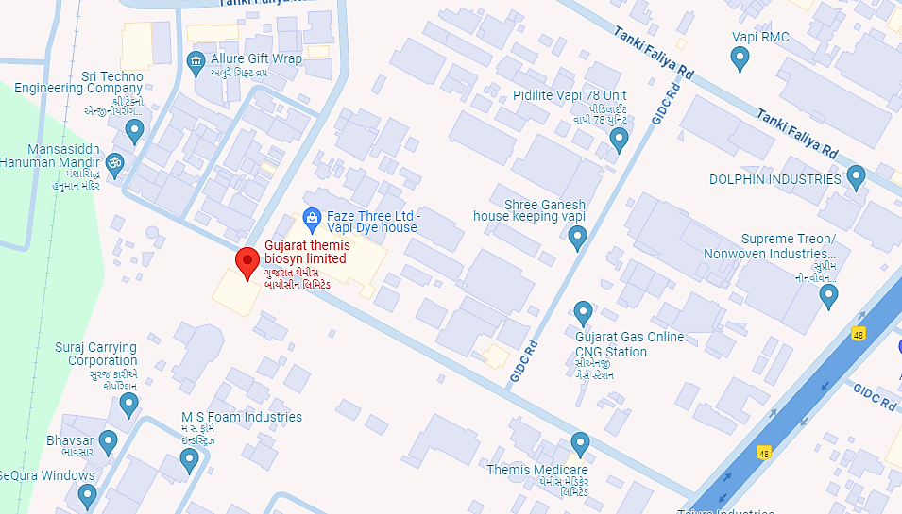
- GOOGLE LAYOUT PLAN:
Demarcation of the land with measurement on the Google map is as shown in the below picture:
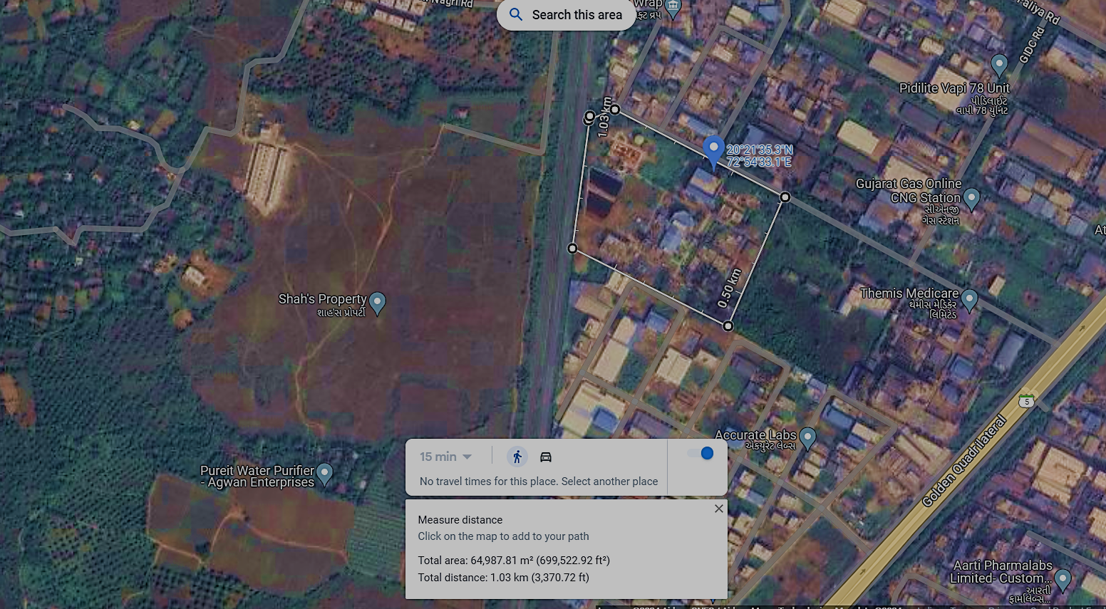

- LAYOUT PLAN: As per the data/information provided by the client/Company, the layout plan has been prepared by the architect Mr. Kalpesh M. Patel (Lic. No. VM/ENG/015/01) which is approved by Gram Panchayat Officer, Vapi, Valsad, Gujarat. For reference, layout plan has been attached below:
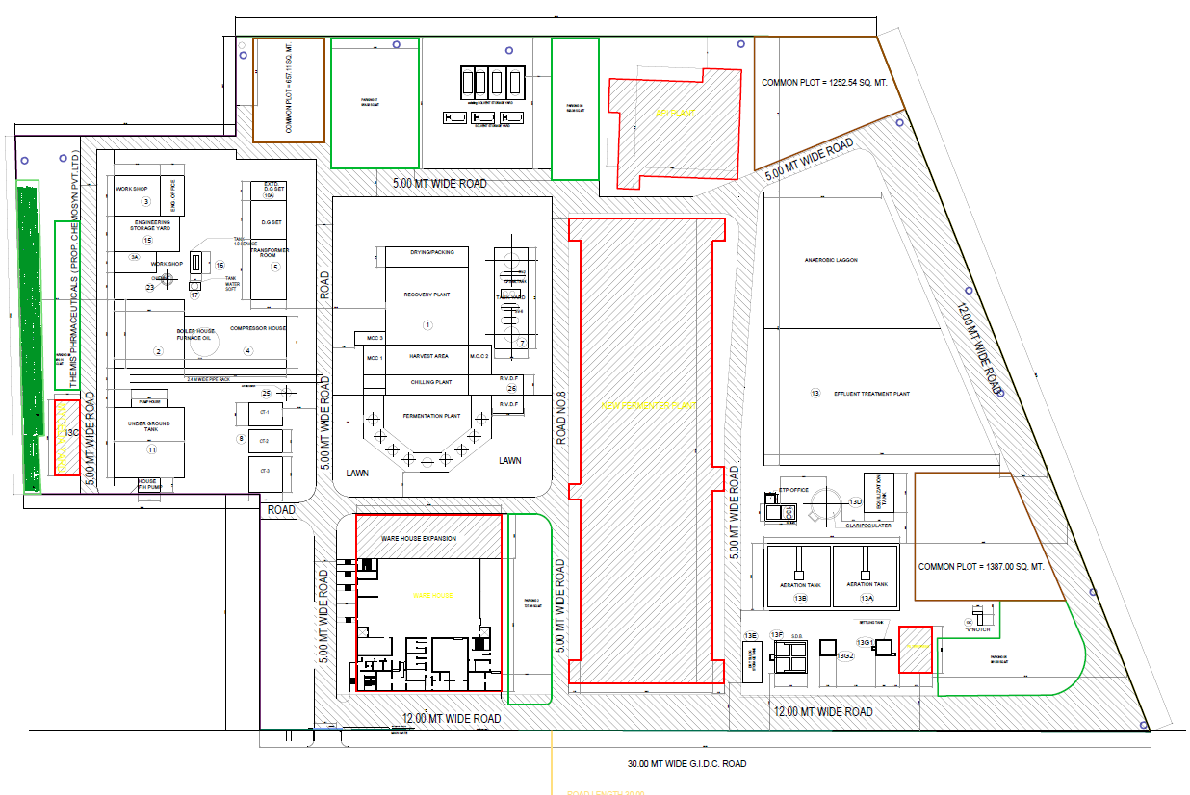
From above picture, we can see that the area highlighted by red out line and in rectangular shape is considered for proposed expansion (new fermentation plant). The layout plan and area for the proposed expansion unit has been attached below:

AREA FOR PROPOSED EXPANSION
Ground Floor | 46.29 X 137.96 | 6386.17 Sq. Mt.
First Floor | 46.29 X 137.96 | 6386.17 Sq. Mt.
Second Floor | 46.29 X 137.96 | 6386.17 Sq. Mt.
Terrace Floor | 46.29 X 137.96 | 6386.17 Sq. Mt.
TOTAL AREA |  | 25544.68 Sq. Mt.

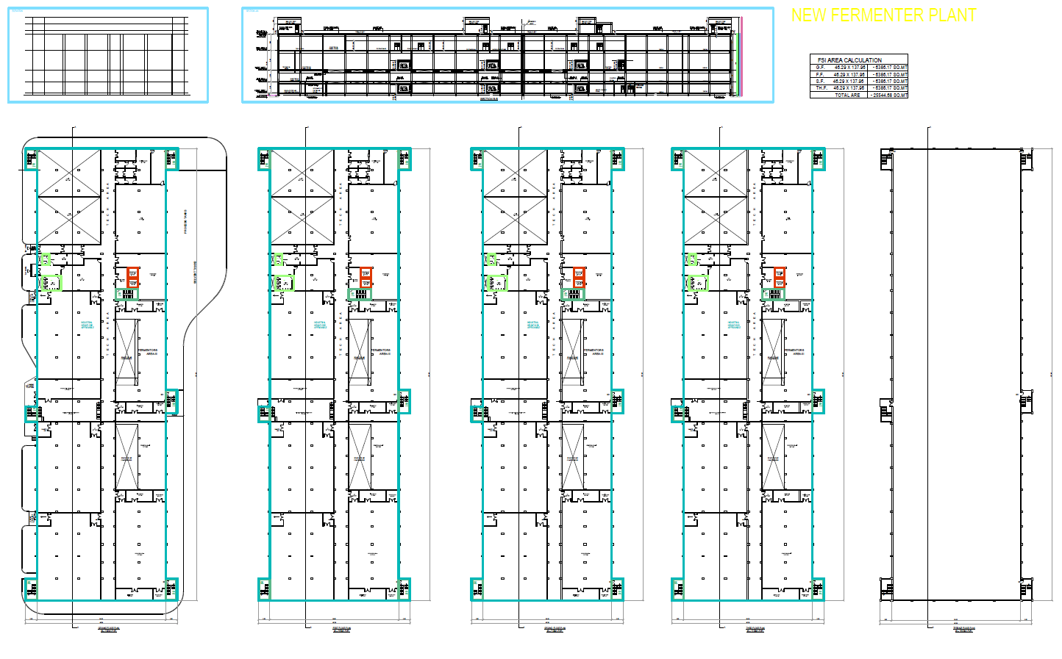

- LAND DETAILS:
As per lease deed shared by the client/company and verified during survey, company has procured a leased land spread over an area of 53,869 Sq. mt., for the pharmaceutical manufacturing facility at GIDC Industrial Area Vapi, Valsad, Gujarat, India, 396195. From total area of 53,869 Sq. mt, 6,386.17 square meters is allocated to the proposed expansion of fermentation unit.
The Lease deed was executed on 31th August 1968, for the lease of 99 years, by and between, The Gujarat Industrial Development Corporation, a corporation under The Gujarat Industrial Development Act, 1962 head office at 3rd Floor, Fadia Chambers, Ashram Road, Navrangpura, Ahmedabad - 380009 and M/s Gujarat Themis Biosyn Limited residing at Plot No. 69/C, G.I.D.C. Indistrial Estate, Vapi, Valsad, Gujarat, India, 396195, for setting up an Industrial unit for manufacturing of pharmaceutical products.
At the end of 99 years, computed from the date of as hereinbefore mentioned, the lease shall have the right to renew this lease for a further period of 99 years. Lease rentals shall be payable by the lessee from the lease execution date.
Land Details As per Sale/Lease Deed
S. No. | Particular | Details
 | Type of Land | Industrial Land
 | Village Name | Vapi, Valsad
 | Property Attributes | Plot No. 69/C, G.I.D.C. Indistrial Estate, Vapi
 | Property Description | Land Area: 53,869 Sq. mt.
 | Document Execution Date | 31st August 1968
 | Lessor | The Gujarat Industrial Development Corporation, a corporation under The Gujarat Industrial Development Act, 1962 head office at 3rd Floor, Fadia Chambers, Ashram Road, Navrangpura, Ahmedabad - 380009
 | Lessee | M/s Gujarat Themis Biosyn Limited residing at Plot No. 69/C, G.I.D.C. Indistrial Estate, Vapi, Valsad, Gujarat, India, 396195.
 | Property Rates at the time of Lease | INR 2,25,173/-
 | Market Value as per GIDC current allotment price | INR 3,17,28,861.02/- (6,340/- per Sq. Mtr. For Fy 2023-24)

- PHTOGRAPHS OF THE PROJECT:

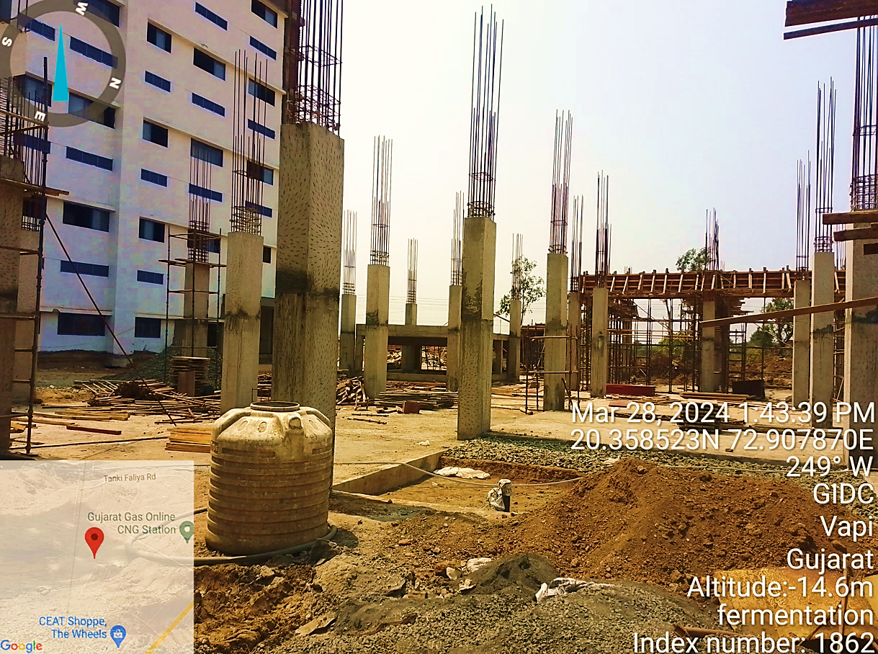
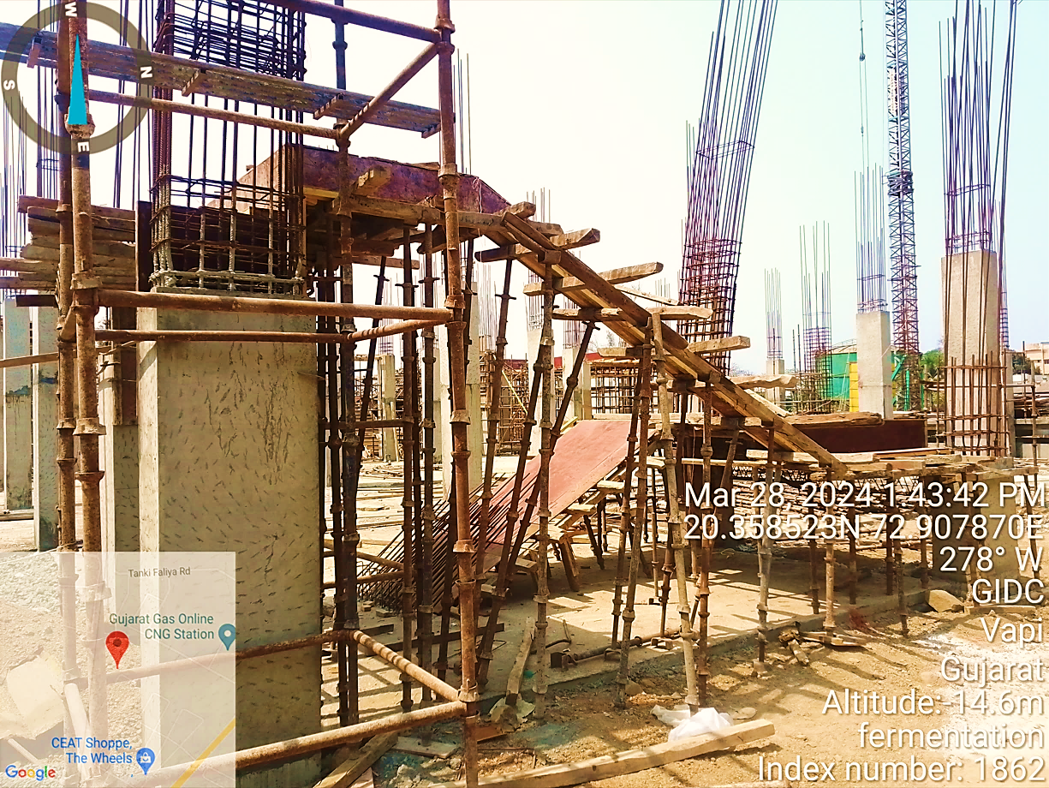
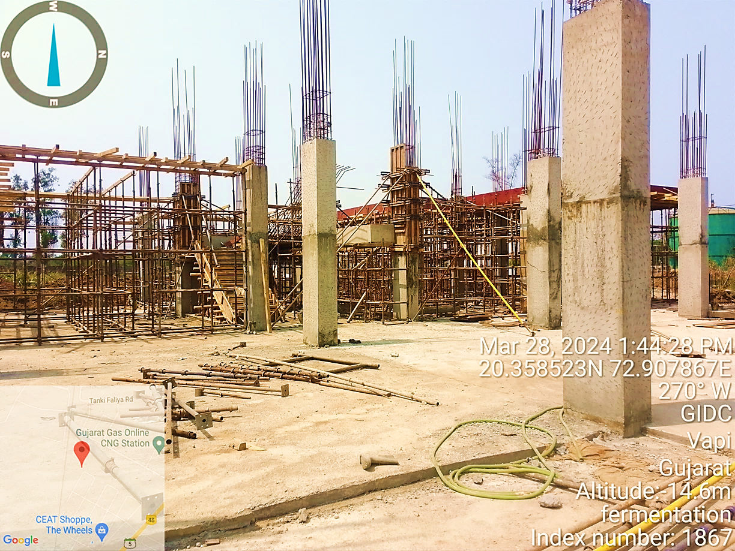

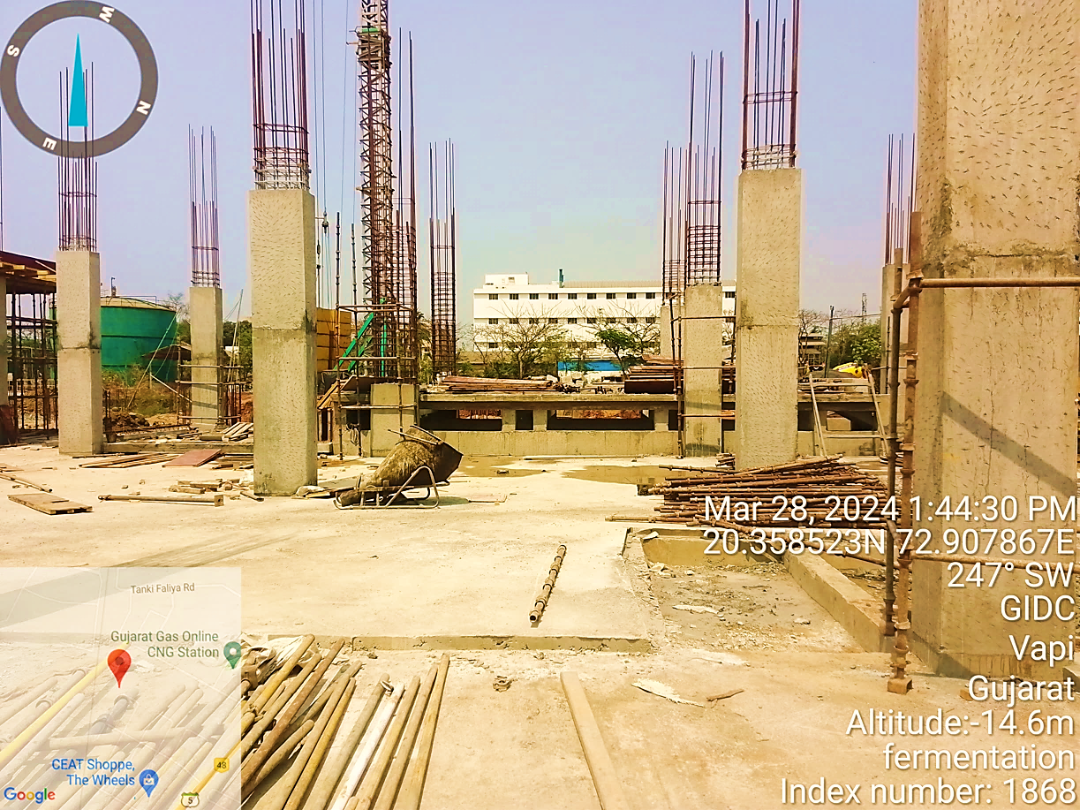

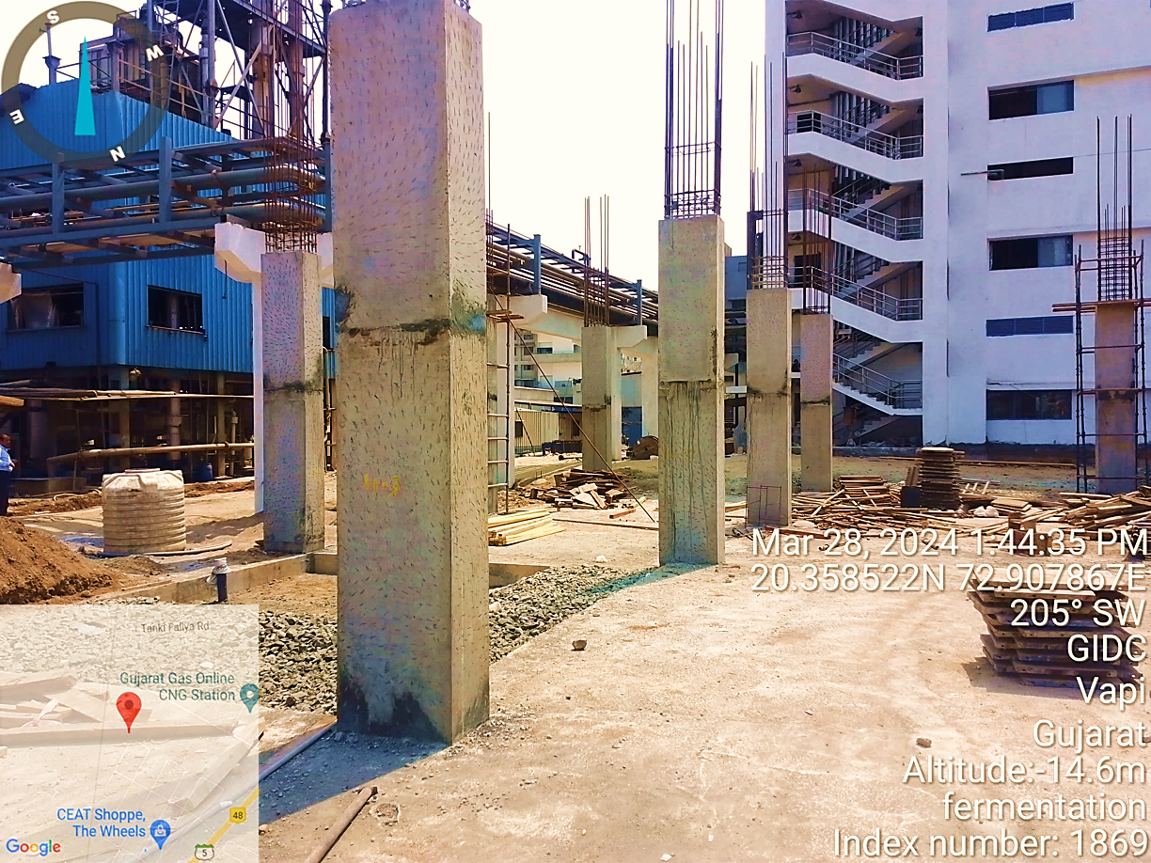

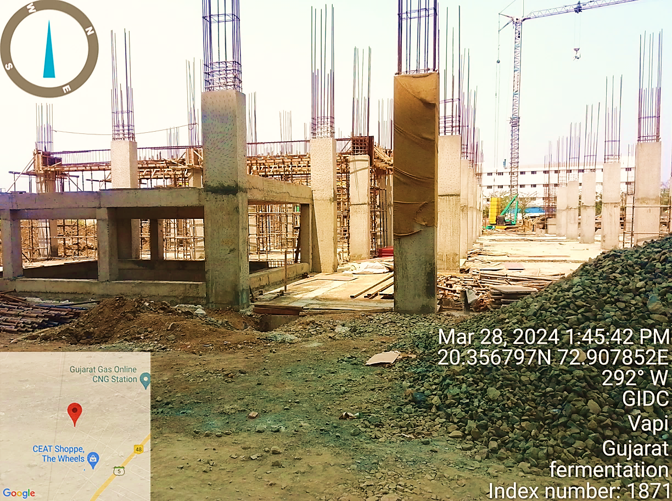

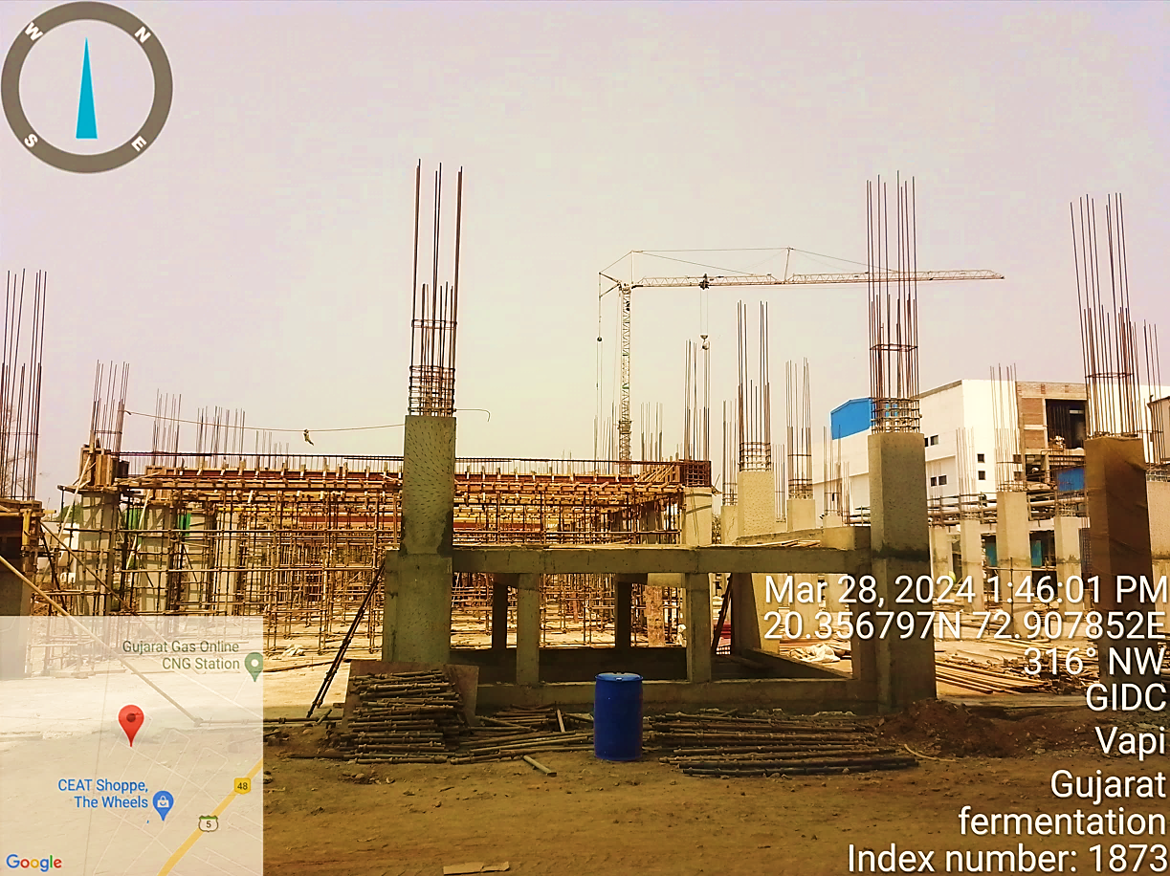

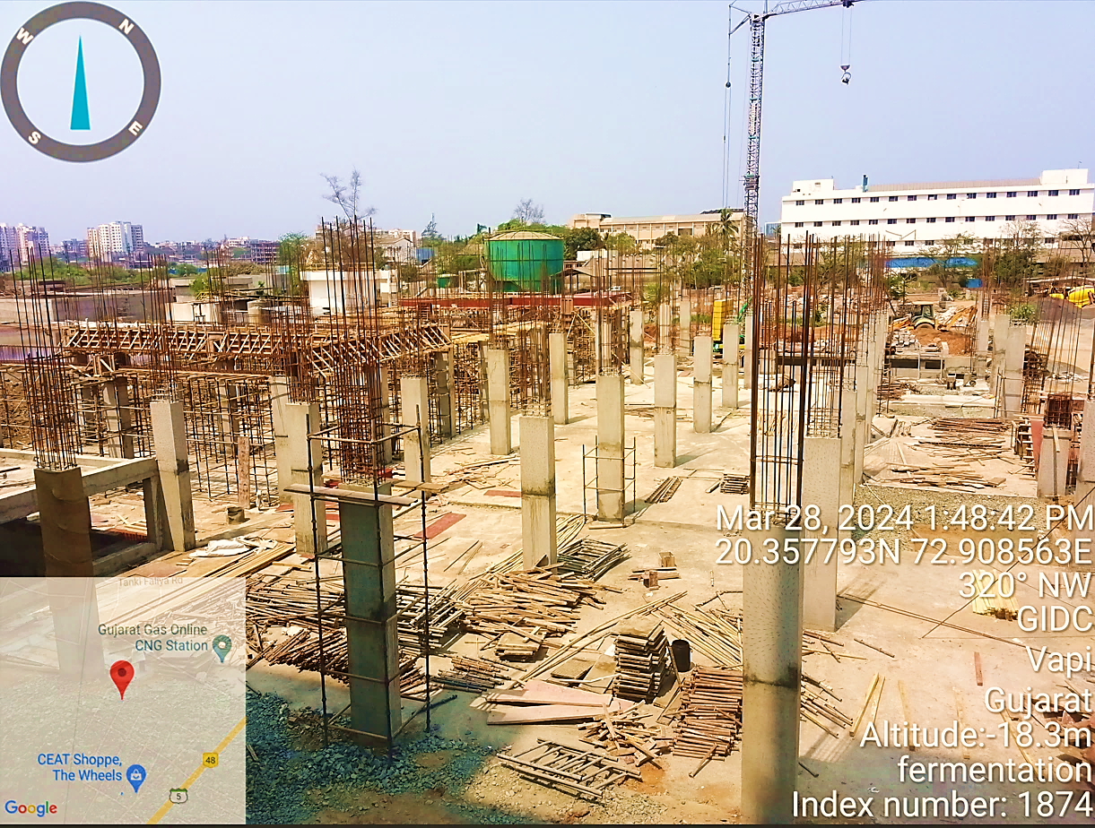

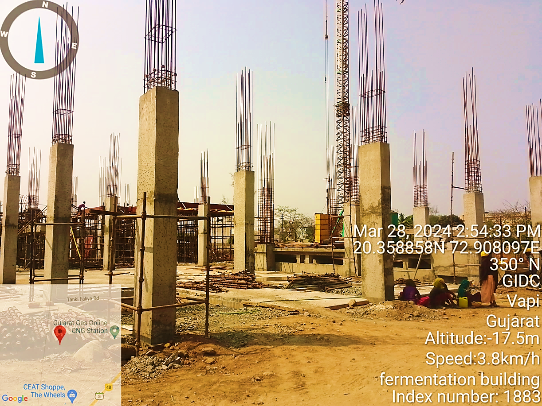

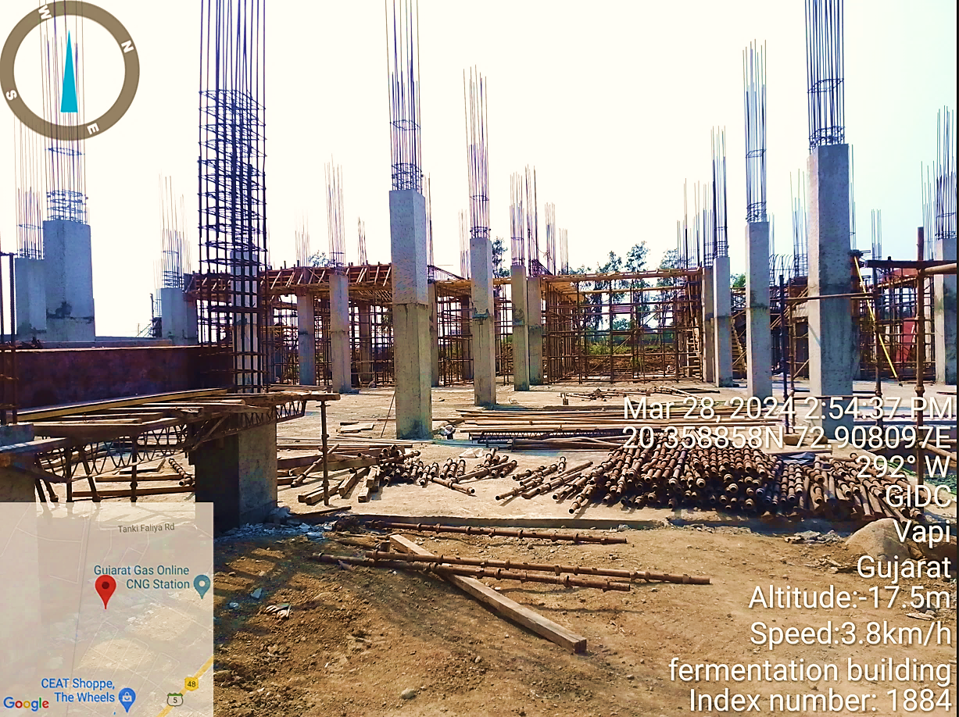

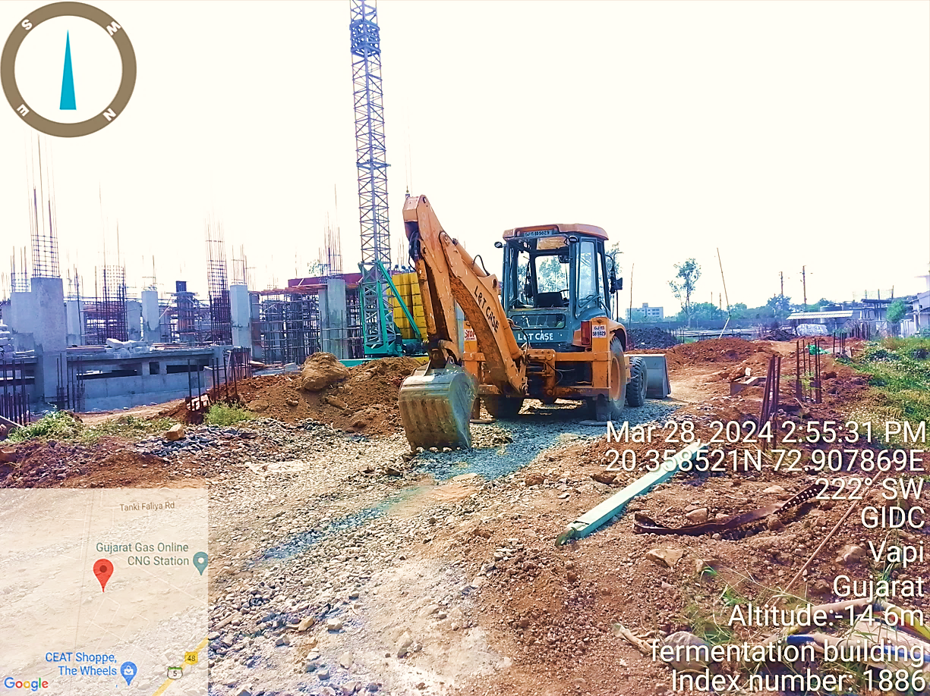

- BUILDING & CIVIL WORKS:
As per site map provided by company, the total Build-up area of the new fermentation plant with its civil structures admeasures to about 25544.68 Sq. Mt. As per information provided by company, GTBL has given the building & civil works contract to Vapi based consultant Sangam Engineers.
Sangam Engineers offers a wide range of services, including fabrication of industrial equipment, structural fabrication, piping solutions, and machinery maintenance to diverse industries such as pharmaceuticals, chemicals, textiles, and more.
As per the shared contract with Sangam Engineers, contract specifies only a range of rates based on terms and conditions, without specifying the quantity of materials. Below table shows the cost assessment of building & civil construction, electrical and instrumentation work, piping and erection:
New Fermenter Plant
Floor | Area in (Mt.) | Area in sq. ft. | Cost per sq. ft. | Total Value
Ground Floor | 6,386 | 68,741 | 2,100 | 14,43,55,541
First Floor | 6,386 | 68,741 | 2,100 | 14,43,55,541
Second Floor | 6,386 | 68,741 | 2,100 | 14,43,55,541
Terrace Floor | 6,386 | 68,741 | 2,100 | 14,43,55,541
Total | 25,545 | 2,74,963 |  | 57,74,22,165
Below table shows the cost assessment of HVAC, partition, and false ceiling expenses:
New Fermenter Plant
Floor | Area in (Mt.) | Area in sq. ft. | Cost per sq. ft. | Total Value
Ground Floor | 6,386 | 68,741 | 400 | 2,74,96,294
First Floor | 6,386 | 68,741 | 400 | 2,74,96,294
Second Floor | 6,386 | 68,741 | 400 | 2,74,96,294
Terrace Floor | 6,386 | 68,741 | 400 | 2,74,96,294
Total | 25,545 | 2,74,963 |  | 10,99,85,174
As a TEV consultant, we have conducted a general assessment based on plinth area rates to determine the total construction cost for building & civil works, which comes out to INR ~68.99 Crore. Our calculation suggests a cost range from Rs. 68.6 crores to Rs. 69.2 crores. However as per client’s estimates provided to us, cost for building & civil works comes out to INR ~68.89 Crore.
The variation in the cost is primarily due to the limited information available in the Bill of Quantity (BOQ) and estimate, which impacts the determination of material quality. This range may vary further based on the quality of construction and other factors agreed upon with the contractor.
The proposed expansion of the fermentation facility is found under construction as per the site survey conducted by our engineer on 27th March 2024. It was observed that the plinth and column casting for the ground floor has been completed, while the shuttering work for the slab was found in WIP stage till the date of survey.
Note: It is to be noted here that the cost estimation done by us is just a general assessment as material cost estimation was not given to us by the client and it is out of scope of this TEV report.

- PLANT AND MACHINERY DETAILS:
As per data / information provided by bank/client, the supplier of plant and machinery is yet to be finalize for the proposed expansion of fermentation plant.
Currently, company has invited quotations from various vendors / suppliers for required plant & machinery. Detailed bifurcation of the proposed plant and machinery has been shown in the below table along with the estimated cost by client:
 | 50MKL FERMENTER PROJECT
S. No. | Equipment Name | Capacity | QTY | Cost (INR Lakhs)
1 | Primary Culture Fermenter | 300 LTRS | 4 | 208
2 | Secondary Culture Fermenter | 8000 LTRS | 4 | 240
3 | Main Fermenter | 50000 LTRS | 9 | 1,100
4 | Automation for Pri , Sec & Main fermenters | 15 No | 15 | 500
5 | Broth Cooker | 12000 LTRS | 1 | 30
6 | Cal Carbonet Sol Pre Agi Vessel | 4000 L | 1 | 15
7 | Amm SulSol Pre Agi Vessel | 4001 L | 1 | 15
8 | Dextrose Storage Tank | 50000L | 2 | 90
9 | Haerveter Tank | 100000L | 1 | 50
10 | Haerveter Tank | 10000L | 4 | 100
11 | Harvest Tank(Broth Holding Tank) | 500000 LTRS | 1 | 30
12 | RVDF | 27M2 | 3 | 225
13 | Oxidation & Work up | 50000 LTRS | 3 | 120
14 | Emulsion Extraction Reactor | 10000L | 1 | 15
15 | Sod Sulphate Washing Reactor | 8000L | 1 | 15
16 | Emulsion Tripping Reactor | 4000L | 1 | 15
17 | Sparkler Filter | 18" | 2 | 4
18 | Wash Org Holding Tank | 5000L | 1 | 8
19 | WFE Reactor | 5000L | 1 | 12
20 | Con Holding tank | 5000L | 1 | 5
21 | Hydrolysis Reactor | 50000L | 1 | 50
22 | Org Holding Tank | 5000L | 2 | 20
23 | Dist Reactor | 7000L | 2 | 50
24 | Crystalizer Reactor | 5000L | 2 | 50
25 | Piller Centrifuge | 48" | 2 | 150
26 | Miller | 100kg/ hr | 1 | 2
27 | Sifter | 30" | 1 | 2
28 | Methanol Dist. columns | Cont Dist | 3 | 100
29 | IPA Dist Column | Cont Dist | 1 | 100
30 | Batch dist reactor | 3kl | 4 | 120
31 | Workup reactor | 3kl | 2 | 50
32 | Storage tanks - Spent streams | 3 to 30 kl | 9 | 45
33 | Storage Tanks Recovered solvents storage | 3 to 5 KL | 12 | 60
34 | CENTRFUGALAIR COMPRESSOR | 10000CFM | 2 | 400
35 | CHILLER 1200 TR | 700 TR | 2 | 200
36 | BOILER 8 TON CAPACITY with Shed | 8 T per Hour | 1 | 400
37 | COOLING TOWER 8000 TR | 240 | 6 | 60
38 | UTILTY PUMPS FOR CHILLERS | 150 | 4 | 25
39 | BRINE PLANT MINUS 10 DEGC 60 TR | 60 | 1 | 100
40 | PUMPS FOR BRINE CHILLER | 200 | 2 | 30
41 | PROCESS TRFR PUMPS | 100 | 100 | 300
 | Sub-Total |  |  | 5,111
42 | 66 KV SUBSTATION COST |  | 1
43 | GEB COST |  | 1 | 700
44 | ONE 2000KVA TRANSFORMER 11 KV/440V |  | 1 | 30
45 | 66/11KV TRANSFORMER |  | 1 | 75
46 | VCB 11 KV 4 NOS |  | 2 | 100
47 | VCB 66 KV KV 1NO |  | 2 | 50
48 | HT CABLE |  | 2 | 10
49 | GENERATOR FOR STAND BY 3000 KVA WITH INSTALLATION |  | 1 | 250
TOTAL COST |  |  |  | 6,326
Source: Data/information provided by the client.
Thus, the estimated cost for plant & machinery will be INR 63.26 crores as per the client. Please note that here we are not aware that weather this cost includes transportation cost, installation cost and applicable GST or not. Also, we have received the quotations only for few machineries not for all the machineries. However, the cost of such highly technical Plant & Machinery can’t be assessed accurately due to limited data/information about the brand name, technical specification, capacity, passage of time and other factors.
The cost vetting of plant and machinery is out of scope of the report; however, the cost of major plant & machinery has been assessed by us independently as a TEV consultant, which we found reasonable and in the permissible range.

- UTILITIES:
- ELECTRICITY:
The electricity requirement for the plant will depends on the demand and capacity utilization of the plant. As per information provided by the client, required electricity to run the new plant (expansion) will be provided by Gujarat State Electricity Board. The company will be going to install a 66KV sub station with one 66/11 KV transformer and one more transformer for 11KV / 440 V.
On request power consumption unit calculation for the new setup was not provided to us. Bank is suggested to advise the company to provide power unit consumption estimation from any expert consultant for the required power load connection for the proposed expansion of new fermentation plant to validate the claim that existing power load will be enough for the expansion as well.
- WATER:
Water is required at different stages of production process. The quantity of total water consumption shall not exceed 424 KLD (For both the units existing as well as expansion) as per breakup mentioned in the Consent to Establish (NOC).
The water requirement is fulfilled by the Municipal water supply and submersible available within the plant premises. As per informed by the client, Water is required for manufacturing process, washing, drinking and sanitation purposes. ~400 m3 per month (4,00,000 Litres) of water will be sufficient to run the project smoothly.
- TRANSPORTATION:
At the time of site visit it was observed that utilised internal roads are under construction and approach road is good towards the Expressway. The plant is situated in the area just ~1 Km from Mumbai-Ahmedabad Expressway (NH-8) which is well connected with the nearby cities therefore as such no transport problems are envisaged.

- ENVIRONMENTAL POLLUTION PREVENTION AND CONTROL:
Gujarat Pollution control committee has provided Consent to Establish (Fresh) under Section 25 of the Water (Prevention & Control Pollution) Act, 1974 and under section 21 of the Air (Prevention & Control of Pollution) Act, 1981, as amended is granted in favour of M/s Gujarat Themis Biosyn Limited Plot No. 69/C, G.I.D.C. Indistrial Estate, Vapi, Valsad, Gujarat, India, 396195 (Consent No: GPCB/CCA-VSD-132(10)/ID: 23513 date: 08/11/2023) for the period seven years till 7th November 2030 for the list of products mentioned in the consent to establish (NOC). Any change / enhancement in production capacity, process, raw materials etc. shall have to be intimated to the Committee and the unit holder has to apply a fresh for the same.

- COMPLIANCE UNDER WATER ACT:
Under Water prevention and control of Pollution) Act-1974 the quantity of total water consumption shall not exceed 424 KLD. Generation of waste water from manufacturing process and other ancillary operation shall not exceed 178.9 KLD. Generated industry effluent shall be treated in Effluent Treatment Plants (ETP) sent it to Common effluent treatment plant (CETP) – Vapi for further treatment and disposal. The quantity of sewage effluent from the industry shall not exceed 19 KLD which shall be disposed off through septic tank / sack pit system.

PART E | PLANT TECHNICAL DETAILS

- FERMENTATION PROCESS:
The Company has proposed to manufacture Rifamycin – S, Rifamycin – O and Rifapentine. The major stages involved in the production of these APIs through Unique Fermentation Process is shown below:
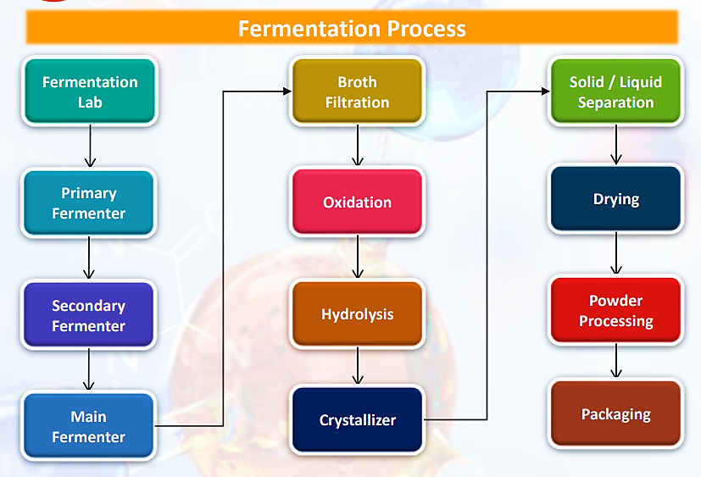
As per the data/information provided by the client, M/s Gujarat Themis Biosyn Limited (GTBL) employs a sophisticated fermentation process to produce pharmaceutical compounds that starts by preparing a culture of the microorganism (such as bacteria or yeast) responsible for producing the desired compound.
This culture, known as the inoculum, is grown in a small volume of nutrient-rich medium to ensure that the microorganisms are active and ready for the main fermentation process. A large-scale fermentation medium is prepared, containing all the necessary nutrients required for the growth and metabolism of the microorganisms.
This medium is often composed of carbon sources (like glucose), nitrogen sources (such as ammonium salts or yeast extract), minerals, and other essential nutrients.
The prepared inoculum is transferred into a larger fermentation vessel containing the fermentation medium. The conditions within the vessel, such as temperature, pH, oxygen levels, and agitation, are carefully controlled to optimize the growth of the microorganisms and the production of the desired compound. This fermentation process can take several days to weeks, depending on the specific requirements of the microorganism and the compound being produced.
Throughout the fermentation process, various parameters are monitored and controlled to ensure optimal conditions for microbial growth and compound production. This includes monitoring of pH, temperature, oxygen levels, and the concentration of nutrients and by-products in the medium.
Once the fermentation process is complete and the desired compound has been produced at the desired concentration, the culture is harvested. This typically involves separating the microbial biomass from the fermentation medium and recovering the desired compound from the resulting mixture.
The harvested compound is then purified to remove impurities and other unwanted components. This purification process often involves multiple steps, such as filtration, chromatography, and crystallization, to obtain a pure final product.
Finally, the purified compound is formulated into the desired pharmaceutical product and packaged for distribution and use.
Overall, GTBL's fermentation process is a complex and carefully controlled series of steps designed to efficiently produce high-quality pharmaceutical compounds for the treatment of various diseases.

- TECHNOLOGICAL ASSESSMENT:
    - FERMENTATION TECHNOLOGY / APPROACH USED BY GTBL:
Fermentation is the core competency of the company. GTBL became India’s first company to start commercial production of Rifampicin used as Anti-tuberculosis (TB) drug using fermentation process. GTBL has evolved into an integrated biopharmaceutical company that also includes a contract development and manufacturing business of intermediates based on fermentation technology.
Nearly two years ago, GTBL terminated its strategic partnership with Yuhan Corporation, a South Korea-based company. The promoters then acquired Yuhan's stake in GTBL. Yuhan was one of GTBL's longstanding technology partner. According to information provided by company officials during the survey, after ending the partnership with Yuhan, GTBL hired the same microbiologist team from Yuhan for its fermentation process.
Based on the information provided by client / company and site visit done by our engineer, it seems that the fermentation technology used by Gujarat Themis Biosyn Limited is considered confidential and has not been disclosed by the company.
However, the company has shared some information and data regarding their process and approach, which we have described below. If there have been any specific questions or need further clarification about their fermentation technology, it may be best to directly contact the company for more information.
Developing new and efficient processes - Going down synthetic route not only requires significant development but is time consuming and entails higher costs than fermentation option. Semi-synthetic approach draws upon advantages of fermentation in generation of new drugs. Natural molecules are produced through fermentation then modified synthetically, reducing toxicity, increasing potency and selectivity, and overcoming bacterial resistance to traditional antibiotics.
Differentiated Approach: The complexity starts from the fact that fermentation needs to be able to develop those microbes that are going to produce Rifamycin S and O. That is only the beginning. The second part is the way these microbes behave very differently when one moves them from a laboratory to a 50,000-litre fermenter. So, the economics completely changed. That is the second part of complexity. At each stage it gets understanding about the environmental conditions which are best suited for a microbe to grow and produce what would be produced and that's how the process works.
The third is how to design these kind of fermentation facilities from lab data to commercial data. So that's know-how that knowledge is very important which not many players have. And fourth is the CAPEX which is required. A replacement value of a facility that GTBL right now would be upwards of Rs.200 crores excluding the land and the paraphernalia that goes with it. So that is the kind of CAPEX that needs to put in while not knowing a lot of what is going to happen from the laboratory till you reach final production. And then there is time because it would take at least two years if not more to set up this facility, followed by that it would take even more time for regulatory and customer approvals to come.
The therapeutic category that involves fermentation, is starting from penicillin derivatives to other anti-infectives, in the field of statins which is cholesterol reduction. So, it more depends upon what is the synthesis or how a product is produced more than therapeutic category. And selection would be based on technology-dependent. And with regards to biologics, the company is not into it yet. At the moment focus is on secondary metabolite fermentation products and not biologics.
    - LATEST/MODERN TECHNOLOGIES:
As per our tertiary research and available public domain data, here are some of the latest advancements and innovations in fermentation technology:
- CRISPR-Cas9 GENOME EDITING: CRISPR-Cas9 technology is being used to engineer microbial strains for improved fermentation performance. This includes enhancing productivity, modifying metabolic pathways, and increasing tolerance to harsh fermentation conditions. CRISPR-Cas9 offers powerful tools for modifying the genomes of microorganisms used in industrial processes, such as bacteria, yeast, and filamentous fungi.
CRISPR-Cas9 genome editing technology is used in fermentation to precisely modify the genetic makeup of microorganisms. This technology allows for targeted genetic modifications, such as gene knockouts, knock-ins, and point mutations, to enhance fermentation characteristics. CRISPR-Cas9 enables the engineering of microbial strains with improved metabolic pathways, stress tolerance, and other desirable traits, accelerating strain development and optimization of fermentation processes. This technology is scalable and allows for the creation of designer microbes tailored for specific fermentation applications, making it a powerful tool in the field of fermentation technology.
- Metabolic Engineering for Biochemical Production: Advances in metabolic engineering are enabling the development of microbial strains capable of producing a wide range of biochemicals through fermentation. This includes biofuels, specialty chemicals, and pharmaceutical intermediates. Metabolic engineering involves modifying the genetic makeup of microbial strains to optimize their metabolic pathways for the production of desired products.
Metabolic engineering is employed in fermentation to optimize microbial metabolic pathways for the production of biochemicals. This approach involves designing and modifying metabolic pathways within microbial strains to enhance the production of specific products. Metabolic engineers manipulate gene expression, balance metabolic fluxes, and engineer cofactor availability to improve substrate utilization, redox balance, and stress tolerance. These efforts result in microbial strains that can efficiently produce desired biochemicals, such as biofuels, specialty chemicals, and pharmaceutical intermediates. Metabolic engineering enables the development of sustainable and efficient fermentation processes for biochemical production.
- High-Throughput Strain Screening and Selection: Automation and robotics are being used to accelerate the screening and selection of microbial strains with desirable fermentation characteristics. This allows for faster development of new fermentation processes.
High-throughput strain screening and selection in fermentation involves the rapid screening of a large number of microbial strains to identify those with desirable fermentation characteristics. This process includes creating a diverse strain library, conducting parallel fermentations in miniature bioreactors or microtiter plates, and using automated monitoring and high-throughput analytics for data collection and analysis. The data are then analyzed to identify strains with the highest productivity, yield, and other desired traits. Selected strains undergo further validation and scale-up, leading to the development of microbial strains optimized for industrial fermentation applications. High-throughput screening and selection accelerate strain development and optimize fermentation processes for the production of various biochemicals.
- Advanced Bioreactor Design: Bioreactor design has evolved to improve process control and scalability. This includes the development of miniaturized bioreactors for high-throughput experimentation, as well as large-scale bioreactors with enhanced mixing and aeration capabilities.
Advanced bioreactor design in fermentation technology focuses on improving process control and scalability. These bioreactors are designed to provide optimal conditions for microbial growth and product formation. They often include features such as enhanced mixing and aeration capabilities, as well as advanced control and monitoring systems. Advanced bioreactors can be integrated with automation and data analytics tools to enable real-time monitoring and optimization of fermentation processes. These bioreactors are used in various industries, including pharmaceuticals, biotechnology, and food and beverage, to improve the efficiency and scalability of fermentation processes.
- In Situ Product Recovery: In situ product recovery techniques are being developed to improve product yields and reduce downstream processing costs. This includes techniques such as foam fractionation, membrane filtration, and adsorption.
In situ product recovery (ISPR) is a technique used in fermentation to continuously separate and recover products from the fermentation broth without disrupting the fermentation process. This technique aims to improve product yields and reduce downstream processing costs. ISPR methods include foam fractionation, membrane filtration, and adsorption, among others. These methods selectively remove the product from the fermentation broth, allowing the fermentation process to continue producing more product. ISPR is used in various industries, including pharmaceuticals, biofuels, and food and beverage, to improve the efficiency and economics of fermentation processes.
- Synthetic Biology Tools: Synthetic biology tools, such as genetic circuits and biosensors, are being used to engineer microbial strains with complex and controllable behavior. This allows for the development of microbial consortia and communities for specialized fermentation processes.
Synthetic biology tools are utilized in fermentation to engineer microbial strains with enhanced capabilities for biochemical production. These tools include genetic circuits, biosensors, and gene editing technologies like CRISPR-Cas9. Synthetic biology enables precise control over genetic elements within microbial cells, allowing for the design of strains with optimized metabolic pathways and regulatory networks. By reprogramming microbial behavior, synthetic biology enhances the efficiency, specificity, and scalability of fermentation processes. These tools have broad applications in industries such as pharmaceuticals, biofuels, and agriculture, where they are used to develop novel products and improve existing fermentation processes.
- Digitalization and Data Analytics: The use of digitalization and data analytics is increasing in fermentation processes. This includes the use of advanced sensors and monitoring systems to collect data, as well as machine learning algorithms to analyze and optimize fermentation conditions in real time.
Digitalization and data analytics are transforming fermentation technology by enabling real-time monitoring, analysis, and optimization of fermentation processes. Advanced sensors and monitoring systems collect data on key parameters such as temperature, pH, and oxygen levels. This data is then analyzed using data analytics and machine learning algorithms to identify patterns and trends, optimize process parameters, and predict fermentation outcomes. Digitalization and data analytics improve process efficiency, product quality, and resource utilization in fermentation, making it a valuable tool in industries such as pharmaceuticals, biotechnology, and food and beverage.
- Circular Economy Approaches: Fermentation processes are being integrated into circular economy approaches, where waste streams from one process are used as feedstocks for another. This reduces waste and maximizes resource utilization.
Circular economy approaches in fermentation technology focus on maximizing resource efficiency and minimizing waste by integrating fermentation processes into a closed-loop system. This involves using waste streams or by-products from one process as feedstocks for another process, thereby reducing the need for virgin resources and minimizing environmental impact. Circular economy approaches in fermentation technology aim to create sustainable and cost-effective processes for producing biochemicals, biofuels, and other products. These approaches align with the principles of the circular economy, which seeks to eliminate waste and promote the efficient use of resources.
These advancements and innovations are driving the development of more efficient, sustainable, and versatile fermentation processes for a wide range of applications.
    - TECHNOLOGICAL ASSESSMENT: Gujarat Themis Biosyn Limited (GTBL) is dedicated to advancing the field of fermentation by developing new cultures. The company has made fermentation its core strength, demonstrating a commitment to innovation and excellence in this area. A notable achievement for GTBL was becoming the first company in India to commercially produce Rifampicin, an essential anti-tuberculosis drug, using the fermentation process. This milestone not only highlights GTBL's pioneering spirit but also its ability to leverage fermentation technology for critical pharmaceutical applications.
In its journey, GTBL has grown into an integrated biopharmaceutical company. In addition to its groundbreaking work with Rifampicin, GTBL has expanded its operations to include a contract development and manufacturing business focused on intermediates derived from fermentation technology. This evolution underscores GTBL's strategic vision to diversify its offerings and strengthen its position in the biopharmaceutical sector.
GTBL has developed a new and efficient processes via synthetic route, which not only requires significant development but is time consuming and entails higher costs than fermentation option. GTBL adopted semi-synthetic approach which draws upon advantages of fermentation in generation of new drugs. Natural molecules are produced through fermentation then modified synthetically, reducing toxicity, increasing potency and selectivity, and overcoming bacterial resistance to traditional antibiotics.
The fermentation technology employed by Gujarat Themis Biosyn Limited is confidential and has not been publicly disclosed. However, the company has demonstrated strong performance in manufacturing APIs using fermentation technology. Due to high demand, they are considering doubling their fermentation-based production capacity. While we cannot comment on the specific technology utilized, expanding the plant to double capacity appears to be a viable decision based on the current demand for their products.

- RAW MATERIAL:
    - RAW MATERIAL USED: As per data / information provided by client / company the raw materials to be used in the manufacturing of pharmaceutical API’s Rifamycin S and Rifamycin O by M/s Gujarat Themis Biosyn Limited includes below mentioned list.
S. No. | Name of Raw Material | Rate Per KG
 | Casein Hydrolysate | INR 1505/-
 | Cobalt Chloride – COCL2 | INR 5054/-
 | Copper Sulphate – CUSO4 | INR 692/-
 | K2HPO4 | INR 166/-
 | Ferric Sulphate – CUSO4 | INR 252/-
 | Glycerine
 | Malt Extract Powder | INR 410/-
 | Zink Sulphate | INR 366/-
 | Antifoam T106 | INR 167/-
 | Ammonium Sulphate | INR 275/-
 | Calcium Carbonate
 | Dextrose Monohydrate | INR 48/-
 | Magnesium Sulphate
 | Potassium Nitrate | INR 921/-
 | Liquid Dextrose | INR 31.50/-
 | Caustic Soda Flakes
 | Peptone | INR 785/-
 | Sodium Barbital | INR 2300/-
 | Yeast Powder | INR 705/-
 | Soyabean Flour | INR 55/-
Please note that the raw materials used by Gujarat Themis Biosyn Limited for the manufacturing of Rifamucin-S, Rifamysin-O and Rifapentine are proprietary and not publicly disclosed however we have got the list of raw material at the time of site visit from company officials. The specific composition of raw materials and the manufacturing process are considered confidential information by the company.
Due to unique fermentation technology used by GTBL and the confidenciality of the pharmaceutical formulation (A multistep process where the active drug is mixed with all other components by considering the factors of particle size, polymorphism, pH, and solubility and becomes the final product) to produce medicinal product, company is bound not to disclose the ratio in which raw materials are used.
Therefore, we have to relied upon the data/information provided by the client regarding the product wise per MT cost and the same has been used during the projected period.

    - RAW MATERIAL SUPPLY ANALYSIS:
As per data information provided by the client, the promoters have established a strong network of suppliers, customers through their existing business. This network can be leveraged for sourcing raw materials, securing sales contracts, and establishing strategic partnerships. Their existing relationships in the industry will facilitate smooth operations and market penetration.
The company has long standing relationship with its suppliers thereby ensuring timely supply of key raw materials. Furthermore, the supplier profile of the company also remained concentrated, with the top 10 suppliers contributing 83% of the total purchases in FY23 vis-à-vis 70% of the total purchases in FY22.
- MANPOWER:
As per information shared by the client/company, an estimate of manpower requirement allowing for leave, absenteeism, sickness and holidays for smooth and for efficient operation of different sections of the proposed manufacturing unit including its production department, In Process Quality Assurance (IPQA) department, Quality Control (QC) department and R&D department has been prepared based on technical and management ground primarily to indicate the order of manpower requirement.
In estimating the manpower requirement, a proper ratio between the administrative, managerial, supervisory and floor staff has been maintained with a view to affording proper industrial and professional management at various levels.
As per informed by client, company have estimated around 56 workers will be required at the time of commencement of commercial operations which is in the line with the industry. The basic structure of the manpower will require for the proposed project is:
Designation | No. of Persons
Department - Production
Asst. Plant Manager | 1
Production Executive | 2
Shift Officer | 8
Documentation Executive | 1
Operators | 10
Department - IPQA (In Process Quality Assurance)
Officers | 4
Q4 Executive | 1
Department - QC (Quality Control)
Senior Microbiologist | 1
Junior Microbiologist | 3
Department - R&D
Senior Microbiologist (Fermentation) | 2
Junior Microbiologist (Fermentation) | 3
Operator | 20
Total No. of employees | 56

In general the state of Gujarat has a lot of trained manpower which is required for the pharmaceutical manufacturing industry, as the area has been catering to the medicinal industry. Hence, the lower level staff would be hired locally. The senior and additional staff requirements would be met from the management company with whom marketing tie up/agreement will be entered by the company.

- SELLING, MARKETING & DISTRIBUTION PLAN:
With their existing experience in the API pharmaceutical business and understanding of the market dynamics, coupled with their established business network, provide a competitive advantage for the project. The project will be getting the synergies from the existing customer base along with new customers emerging due to growing demand. The marketing strategy of a pharmaceutical manufacturing plant in India would typically focus on several key aspects to promote its products effectively. Here are some key elements that might be included in such a strategy:
Product Portfolio: As the company is engaged in manufacturing of APIs namely Rifamycin S and Rifamycin O. And for the proposed plant the same products will be produced. GTBL has been evolved into an integrated biopharmaceutical company that also includes a contract development and manufacturing business of intermediates based on fermentation technology, which is a unique feature and give GTBL upper hand over its competitors.
Target Market: As the company has already identified specific segments of the market (e.g., hospitals, clinics, retail pharmacies) where the plant's products are most likely to be successful based on factors such as demographics, geography, and healthcare needs. Better growth in domestic sales of medicine would depend on the ability of companies to align their product portfolio towards chronic therapies for diseases such as cardiovascular, anti-diabetes, antidepressants and anti-cancers, which are on the rise. Therefore, GTBL’s business will run smoothly in future.
Distribution Channels: GTBL is currently in the same business hance it has established a strong distribution channel to ensure the availability of products in key markets. This includes partnerships with distributors, wholesalers, and retail pharmacies. The company has long standing relationship with its suppliers thereby ensuring timely supply of key raw materials.
Promotional Activities: GTBL utilizes various promotional activities such as advertising, sales promotions, and public relations to create awareness and generate interest in the plant's products. This involves both traditional and digital marketing channels.
PART F | PRODUCT PROFILE

- PRODUCT DETAILS:
Gujarat Themis Biosyn Limited (GTBL) is engaged in manufacturing of APIs namely Rifamycin S and Rifamycin O. The company’s manufacturing plant is located in Vapi, Dist.- Valsad, Gujarat. Company has installed capacity for manufacturing 18,000 kg per month for Rifamycin S and Rifamycin O in total. GTBL is planning for the extension of existiung plant for the same product. Proposed product’s profile is mentioned in the below table:
S. No. | Product’s Name | Proposed Production | Product Profile
- Intermediate products
 | Rifamycin - S | 10,000 Kg per Month | - GTBL proposed manufacturing plant will manufacture Rifamycin S, which is an intermediate for manufacturing the drug Rifampicin.  - Rifamycin S is a broad-spectrum antibiotic derived from the bacterium Amycolatopsis mediterranei. It belongs to the rifamycin group of antibiotics and is used primarily in the treatment of bacterial infections, particularly those caused by gram-positive bacteria.  - Rifamycin S works by inhibiting the bacterial RNA polymerase, which is essential for bacterial RNA synthesis. It is not commonly used in clinical practice but has been studied for its potential in treating various infections.  - Rifamycin S is used as an Antibiotic for the treatment of bacterial infections, including tuberculosis, Mycobacterium avium complex, leprosy, and Legionnaires' disease.  - India is still importing Rifamycin S from China, thus higher output from Company results in lowering imports requirements.
 | Rifamycin - O | 6,000 – 8,000 Kg per Month | - GTBL proposed manufacturing plant will manufacture Rifamycin O, which is an intermediate for manufacturing the drug Rifaximin.  - Rifamycin O is another member of the rifamycin group of antibiotics. Like Rifamycin S, it is derived from the bacterium Amycolatopsis mediterranei. Rifamycin O shares similar properties with Rifamycin S, including its mechanism of action, which involves inhibiting bacterial RNA polymerase.  - It is also used primarily in the treatment of bacterial infections, particularly caused by gram-positive bacteria.  - Rifamycin O has been used in the treatment of tuberculosis and gastrointestinal infections. However, its clinical use is less common compared to other rifamycin antibiotics such as rifampicin.  - It is also used as an antibiotic used for treatment of traveler's diarrhea, irritable bowel syndrome, and hepatic encephalopathy.
- Medicine
 | Rifapentine | - | - GTBL is planning to manufacture a drug called Rifapentine, in which Rifamycin is used as an intermediate.  - Rifapentine is an antibiotic medication used to treat tuberculosis (TB). It belongs to a class of antibiotics known as rifamycins, which work by inhibiting the growth of TB bacteria.  - Rifapentine is often used in combination with other medications to effectively treat TB infections. It's usually taken orally and is effective in both the treatment of active TB disease and the prevention of TB infection in people at high risk of developing the disease.

Note: As per data/information provided by company, the new fermentation plant will have the total capacity of 216,000 Kgs/annum. This plant will be dedicated to the production of Rifa-S and Rifa-O, which will serve as intermediates for subsequent medication manufacturing, including Rifapentine. Additionally, the company intends to market these intermediates both domestically and internationally.

- FLOW CHART OF PRODUCTS MANUFACTURED AT MANUFACTURING FACILITY:
RIFAMYCIN – S FLOW CHART
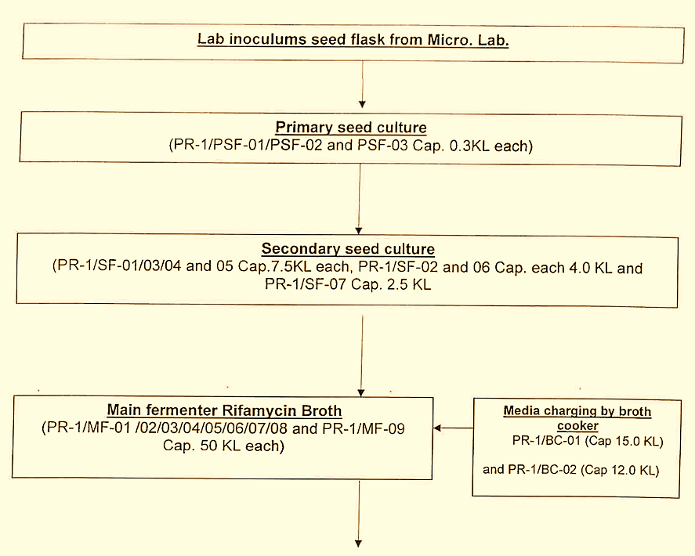
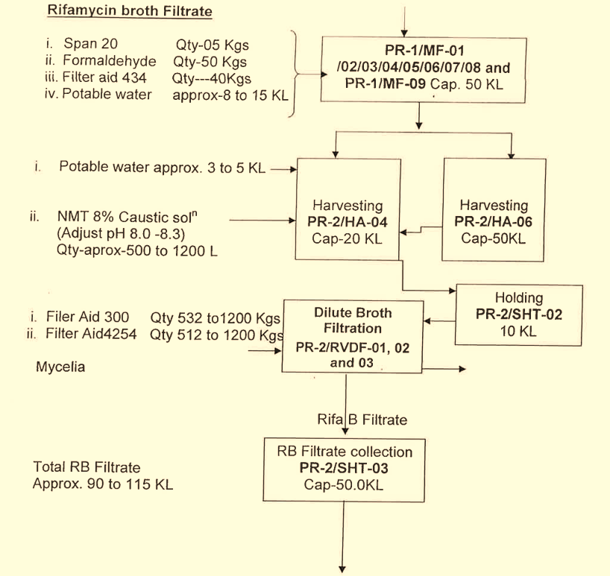
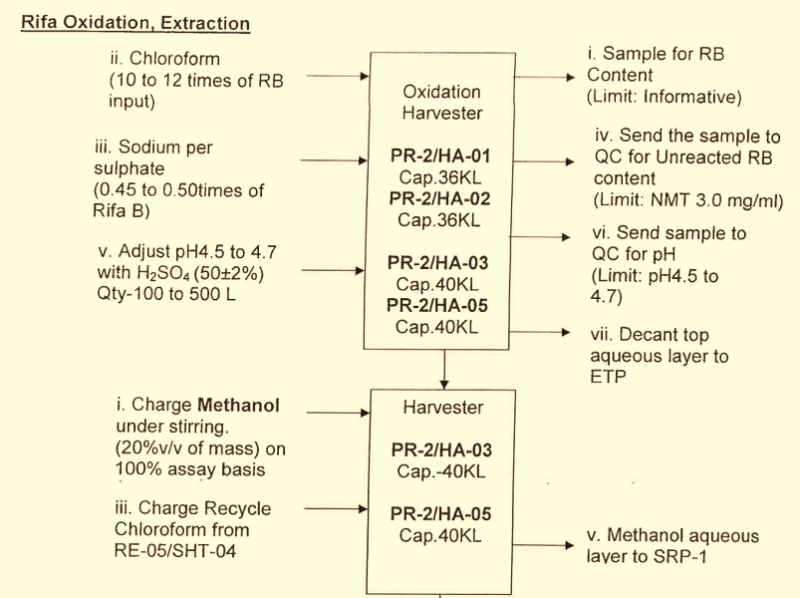
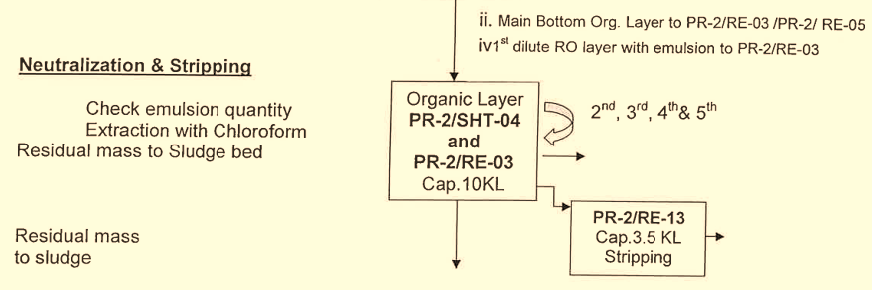
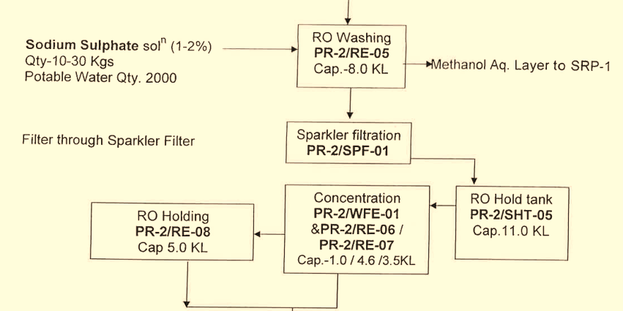
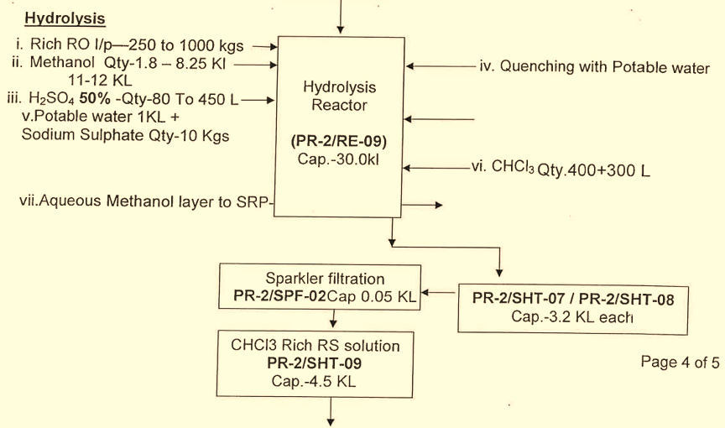
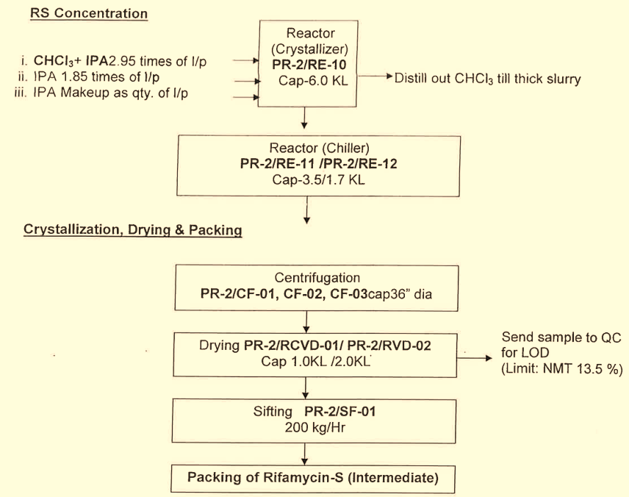

RIFAMYCIN – O FLOW CHART

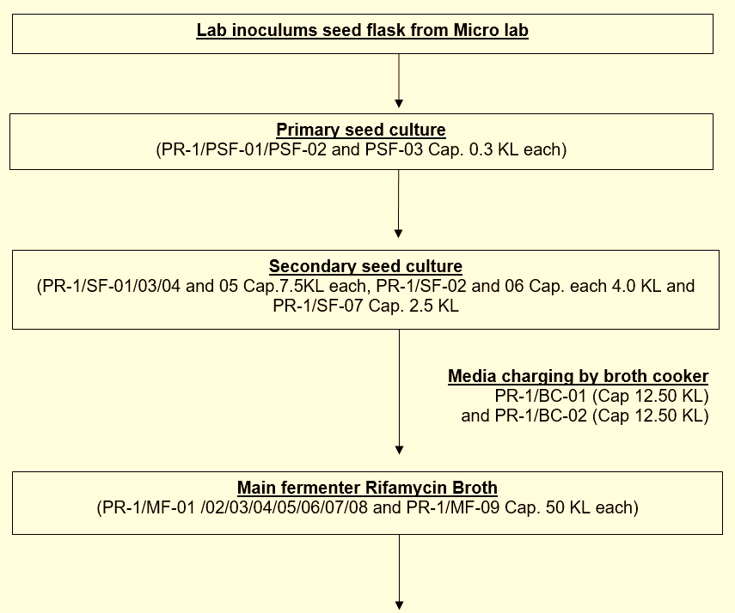
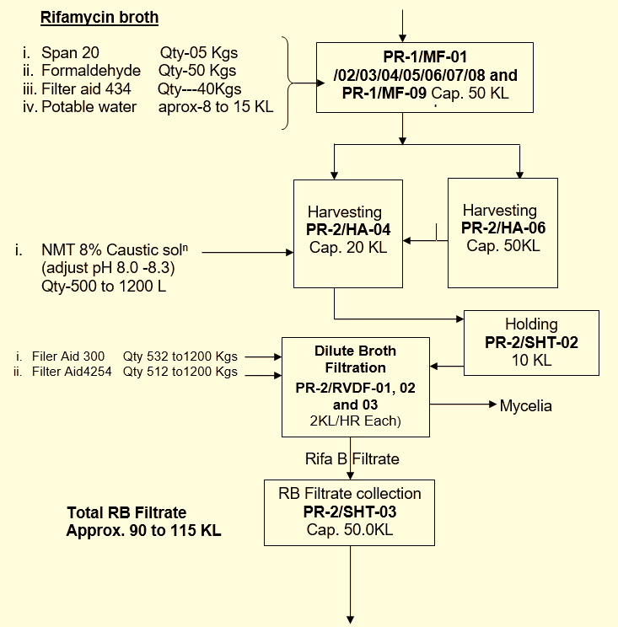
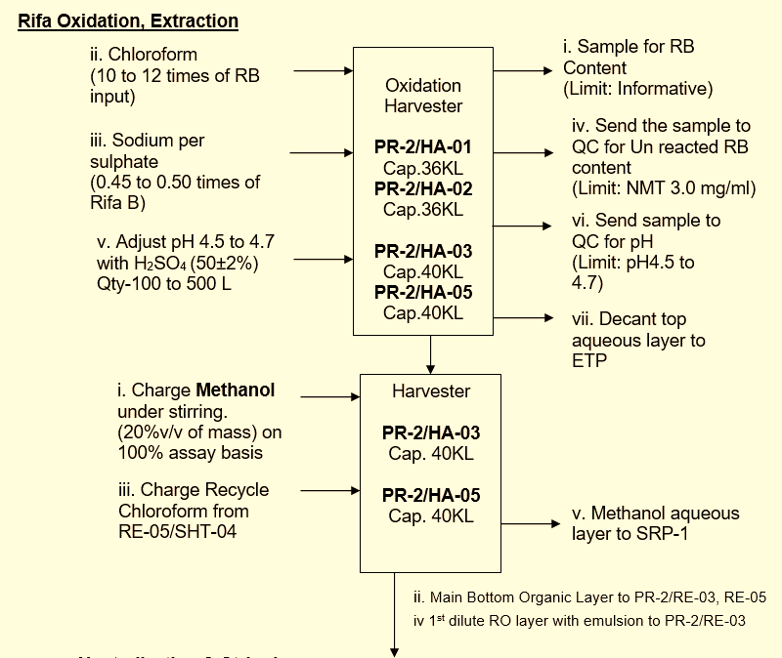
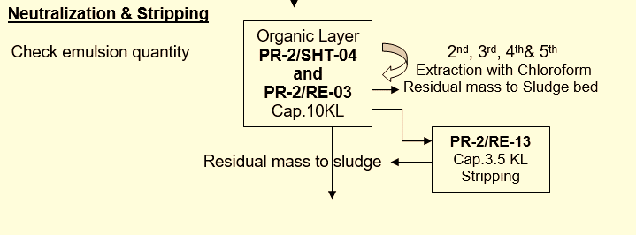
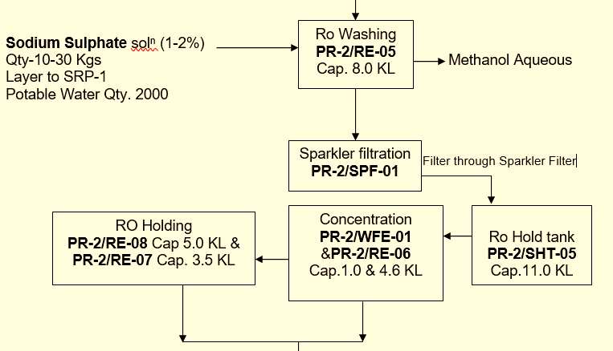
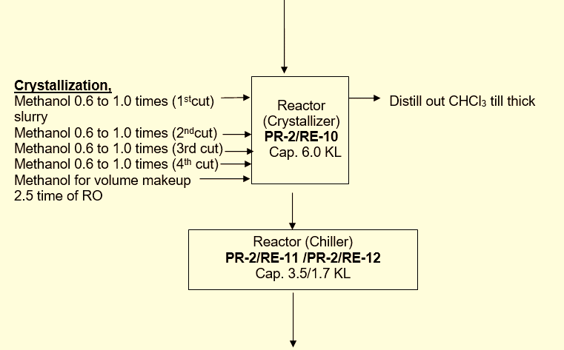
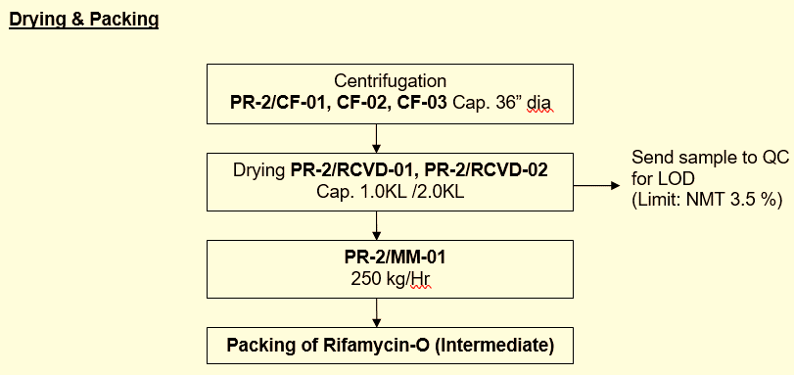

- PRICING STRATEGY: The annual pricing trends of the company for three forecasted years for Rifamycin – S, Rifamycin – O and Rifapentine provided by company are given below:
PRODUCTS | RIFA-S |  | RIFA-O
YEAR | QTY IN MT | SALES VALUE RS IN LAKHS | QTY IN MT | SALES VALUE RS IN LAKHS
2024-25 | 70.00 | 5,250.00 | 81.00 | 6,069.60
2025-26 | 70.00 | 5,250.00 | 90.00 | 6,930.00
2026-27 | 70.00 | 5,250.00 | 90.00 | 7,110.00

PRODUCTS | RIFAPENTINE
YEAR | QTY IN MT | SALES VALUE RS IN LAKHS
2024-25 | 32.88 | 12,280.68
2025-26 | 58.00 | 21,663.00
2026-27 | 144.65 | 54,026.03
Rifa-S and Rifa-O are intermediary compounds formulated in laboratories to meet specific pharmaceutical requirements. The exact proportions utilized by the company to produce these compounds are proprietary information and not disclosed by the company. Similarly, pricing details for these products are not publicly accessible. Therefore, we have to rely upon the prices provided by the company.
Rifapentine is a drug used as an antibiotic medication to treat tuberculosis (TB). As per our tertiary research, this medicine is available in the market. We have asked some vendors about the MRP of the medicine and found that 150 mg with MRP 21 for 10 tablets including ~10-14% margin of the vendors. Therefore, pricing strategy of the company for Rifapentine seems to be in the line with market, as per our independent assessment. Hence, we have to rely upon the prices provided by the company.
- CUSTOMER BASE:
Company caters to only two customers Lupin (40-45% of sales) and Optrix Laboratories Private Limited (50-55% of sales). Company has ‘take or pay’ agreement with Optrix Laboratories Private Limited which is renewed annually and has a contract with Lupin for five years. Hence concentration risk is mitigated to an extent.
Any major setback due to fall in orders of these clients could significantly impact growth of GTBL. It plans to onboard 2 more customers over medium term to reduce concentration risk. It is to be noted that since 2011 and 2020, Lupin and Optrix Laboratories are respectively associated with GTBL. Hence these customers’ have been associated with the company since long time. GTBL is suppling 25% of the total quantity required to Lupin and 100% of the total quantity required to Optrix Laboratories.
As per information provided by company, GTBL depends on two products Rifa –S and Rifa – O for major portion of its sales. Any new innovation in TB treatment and new drugs could impact sales of GTBL.
Furthermore, GTBL has few new products under development and these are expected to be launched mostly in FY25. These would address new therapeutic areas. Company also has plans to establish a new R&D lab to take care of technological developments for new products that are being identified for global markets.

PART G | INDUSTRY OVERVIEW & ANALYSIS

- INTRODUCTION: India leads the global market in generic drugs, renowned for its affordable vaccines and medications. The Indian Pharmaceutical industry, now ranked third in pharmaceutical production by volume, has grown steadily at a CAGR of 9.43% over the past nine years. Major segments include generic drugs, over-the-counter medications, bulk drugs, vaccines, contract research & manufacturing, biosimilars, and biologics.
India boasts the highest number of pharmaceutical manufacturing facilities compliant with the US Food and Drug Administration (USFDA), with 500 API producers accounting for around 8% of the global API market. The sector supplies over 50% of global demand for various vaccines, 40% of generic demand in the US, and 25% of all medicine in the UK.
The domestic industry comprises approximately 3,000 drug companies and ~10,500 manufacturing units. India's strength lies in its pool of scientists and engineers, driving the industry to new heights. Over 80% of global antiretroviral drugs used to combat AIDS are supplied by Indian firms, earning India the title of the "pharmacy of the world."
The sector contributes around 1.72% to India’s GDP. A recent EY FICCI report predicts the Indian pharmaceutical market could reach US$ 130 billion by 2030, reflecting a growing demand for innovative therapies. Globally, the pharmaceutical market is expected to surpass US$ 1 trillion by 2023.

- MARKET SIZE: The market size of India's pharmaceutical industry is projected to reach US$ 65 billion by 2024 and around US$ 130 billion by 2030. Currently, the industry is valued at approximately US$ 50 billion, with over US$ 25 billion of this value coming from exports. India meets about 20% of the global demand for generic drugs.
India is recognized as one of the top 12 destinations for biotechnology globally and the third-largest in the Asia Pacific region. In 2022, the biotechnology industry in India surpassed US$ 80.12 billion, reflecting a 14% growth from the previous year. From FY18 to FY23, the Indian pharmaceutical industry achieved a compound annual growth rate (CAGR) of 6-8%, primarily driven by an 8% increase in exports and a 6% rise in the domestic market. The industry is expected to reach about 13% of the global pharmaceutical market, focusing on enhancing quality, affordability, and innovation.
India is also the third-largest producer of Active Pharmaceutical Ingredients (APIs), contributing 8% to the global API industry. The current market size of the medical devices sector in India is estimated to be US$ 11 billion, with a 1.5% share in the global market. The domestic pharmaceutical sector expects sales to grow 8-10% in the financial year 2023-24, according to analysis by CRISIL.
Indian pharmaceutical companies have a significant share in the prescription market in the US and EU, with the largest number of FDA-approved plants outside the US located in India. The domestic pharmaceutical market is expected to grow threefold in the next decade, reaching US$ 65 billion by 2024 and expanding to US$ 120-130 billion by 2030. India's biotechnology industry, which includes biopharmaceuticals, bio-services, bio-agriculture, bio-industry, and bioinformatics, was valued at US$ 70.2 billion in 2020 and is expected to reach US$ 150 billion by 2025. The medical devices market in India is projected to grow at a CAGR of 37% from 2020 to 2025, reaching US$ 50 billion.
Overall, India is a significant and growing player in the global pharmaceutical sector, being the world's largest supplier of generic medications, accounting for 20% of the global supply by volume, and supplying about 60% of the global vaccination demand.

- INVESTMENTS AND RECENT DEVELOPMENTS:
The Indian pharmaceuticals industry holds a significant position in the global market, ranking third in production by volume and 14th by value. Recent years have seen substantial investments and developments in the sector, including:
- Up to 100% foreign direct investment (FDI) allowed through the automatic route for Greenfield pharmaceutical projects. For Brownfield projects, FDI up to 74% is permitted through the automatic route and beyond that through government approval.
- Cumulative FDI equity inflow in the Drugs and Pharmaceuticals industry amounts to US$ 21.58 billion from April 2000 to September 2023, comprising nearly 3.3% of the total FDI inflow across sectors.
- In August 2023, Union Minister Bhupender Yadav launched Chemotherapy Services in 30 ESIC Hospitals nationwide.
- An MoU was signed in June 2023 between the Indian Pharmacopoeia Commission (IPC) and the Ministry of Health in Suriname for the recognition of Indian Pharmacopoeia (IP) in Suriname.
- In May 2023, the Ministry of Minority Affairs and the Ministry of Ayush collaborated to advance the Unani System of Medicine in India.
- Prime Minister Narendra Modi announced plans during his Independence Day 2023 speech to increase the number of 'Jan Aushadhi Kendras' from 10,000 to 25,000.
- The Department of Pharmaceuticals will soon launch the Scheme for the Promotion of Research and Innovation in Pharma (PRIP) MedTech Sector, approved by the Union Cabinet with a total outlay of Rs. 5,000 crore (US$ 604.5 million) for five years starting from 2023-24 to 2027-28.
- Emcure Pharmaceuticals Limited (EPL) launched Orofer FCM 750, a new extension of its parenteral iron brand suitable for the majority of Indian patients with iron deficiency and iron deficiency anemia.
- Japanese companies are invited to invest in the Indian Pharmaceutical and Medical Device Industry to stabilize the global supply chain, especially of APIs and Medical Devices.
- Sun Pharmaceutical Industries Limited completed its acquisition of Concert Pharmaceuticals, Inc. on March 6, 2023, a late-stage clinical biopharmaceutical company developing deuruxolitinib for the potential treatment of adult patients with moderate to severe alopecia areata.
- Glenmark Pharmaceuticals Ltd. (Glenmark) launched Akynzeo I.V., a unique I.V. injection formulation for the prevention of chemotherapy-induced nausea and vomiting (CINV), under an exclusive licensing agreement with Helsinn.
- Entod Pharmaceuticals introduced a new ocular aesthetic range focused on improving eye comfort and enhancing eye aesthetics.
- BDR Pharmaceutical launched the first generic apalutamide (Apatide) in India to treat metastatic castration-sensitive prostate cancer and non-metastatic castration-resistant prostate cancer, available across India.
- Anglo French Drugs & Industries Limited (AFDIL) entered the fertility space with the launch of the LYBER range.

- GOVERNMENT INITIATIVES: The government has implemented several initiatives to promote the pharmaceutical sector in India, including:
- Launching a mission to eliminate sickle cell anemia by 2047, which involves raising awareness, conducting comprehensive screening of seven crore individuals in impacted tribal regions aged 0 to 40, and providing counseling through coordinated efforts.
- Introducing a new initiative to encourage pharmaceutical research and innovation through centers of excellence, persuading businesses to invest in R&D in selected priority fields.
- Approval of the National Medical Devices Policy, 2023, to facilitate the orderly growth of the medical device sector to meet public health objectives of access, affordability, quality, and innovation.
- Implementation of the Ayushman Bharat Digital Mission (ABDM) to enable citizens to create their Ayushman Bharat Health Account (ABHA) numbers, linking their digital health records and improving clinical decision-making by healthcare providers.
- Completion of the ABDM pilot in six Union Territories, demonstrating successful technology platforms developed by the National Health Authority (NHA).
- Preparation of an Umbrella Scheme by the Department of Pharmaceuticals called the 'Scheme for Development of Pharma Industry,' which includes sub-schemes such as:
- Assistance to Bulk Drug Industry for Common Facilitation Centres
- Assistance to Medical Device Industry for Common Facilitation Centres
- Assistance to Pharmaceutical Industry (CDP-PS)
- Pharmaceutical Promotion and Development Scheme (PPDS)
- Pharmaceutical Technology Upgradation Assistance Scheme (PTUAS).
- Allocation of Rs. 3,201 crore (US$ 419.2 million) for research and Rs. 83,000 crore (US$ 10.86 billion) for the Ministry of Health and Family Welfare in the Union Budget 2022-23.
- Allocation of Rs. 37,000 crore (US$ 4.83 billion) to the 'National Health Mission' and Rs. 10,000 crore (US$ 1.28 billion) to the Pradhan Mantri Swasthya Suraksha Yojana in the Union Budget 2022-23.
- Increase in the allocation for the Ministry of AYUSH to Rs. 3,050 crore (US$ 399.4 million) from Rs. 2,970 crore (US$ 389 million).

- CHALLENGES TO PHARMACEUTICAL INDUSTRY: India is the third largest manufacturer of pharmaceutical products in terms of volume and it is growing steadily. The market has seen the entry of many foreign players as well as rise of many domestic manufacturers. However, the industry faces many speed breakers:
- The Indian pharma industry faces lack of research and development components and lack of real time good manufacturing practices.
- Low Margins of profits due to government pricing policies – Drug Price Control Order
- Dependency on China for the supply of raw material for generic medicines production
- Lack of good quality of indigenously produced Raw Materials
- Lack of Skilled Labour
- Inadequate healthcare infrastructure, uneven distribution of healthcare facilities, and low health insurance coverage pose barriers to accessing medicines.
- Indian pharmaceutical companies have faced allegations of violating Intellectual Property Rights (IPR) laws, resulting in legal disputes with multinational pharmaceutical companies.

- FUTURE OUTLOOK: The pharmaceutical industry in India plays a significant role in the nation's foreign trade and presents attractive opportunities for investors. India is a major supplier of affordable generic medications to millions worldwide and maintains numerous plants compliant with Good Manufacturing Practices (GMP) standards set by the World Health Organization (WHO) and the United States Food and Drug Administration (USFDA). India has consistently ranked among the top pharmaceutical producers globally.
Medicine spending in India is expected to grow at a rate of 9-12% over the next five years, positioning the country among the top 10 in terms of medicine expenditure. Future growth in domestic sales will hinge on companies' ability to align their product portfolios with chronic therapies for diseases such as cardiovascular, diabetes, depression, and cancer, which are increasing in prevalence.
The Indian Government has implemented various measures to reduce healthcare costs, including the National Health Protection Scheme, aimed at providing universal healthcare. Factors such as an ageing population, the rise in chronic diseases, and government initiatives, such as the establishment of pharmacies offering affordable generic drugs, are expected to boost the Indian pharmaceutical industry.
The swift introduction of generic drugs into the market is a key focus area and is anticipated to benefit Indian pharmaceutical companies. Additionally, the emphasis on rural health programs, essential drugs, and preventive vaccines bodes well for the industry's future growth.

PART H | SWOT ANALYSIS

SWOT ANALYSIS
STRENGTHS | - Established Player: Established presence in the pharmaceutical industry, with a history dating back to 1981. And GTBL’s strong focus on research and development, leading to a robust pipeline of innovative products.  - Experienced management: Experienced management team with industry knowledge. Running an existing unit in the same line will be an advantage to know the challenges in the real time.  - Growing Demand: Demand side remains strong for product manufactured by GTBL, as they are producing intermediates based on fermentation technology.  - Long-Term Contracts: GTBL have secure, long-term contracts to ensure steady order book along with right mix of Buy & Sell orders leading to optimal profitability.  - Monopoly in the Market: One of the very few players in India with technology and capacity/scale for fermentation-based product development.  - Zero Debt: GTBL is a Debt Free Company as the net debt to equity ratio of the Company stood at 0.0 (zero debt) as on 31st March, 2023.  - Location Advantage: Locational advantages of the Gujarat Themis Biosyn Limited plant in Vapi make it an attractive location for pharmaceutical manufacturing, providing access to resources, markets, and infrastructure necessary for business success.
WEAKNESSES | - Product Portfolio: Product portfolio of the company includes only 2 to 3 products. Hence dependency on a few products for a significant portion of revenue can adversely affect the company, if by any reason GTBL will not be able to sale the product in the market.  - Raw Material Market: Required raw materials are not easily available in the market, as company is producing intermediate products which are produced by fermentation process.  - Regulatory Pressure: Vulnerability to changes in regulatory environment and pricing pressures shows the helplessness of the company.
OPPORTUNITIES | - New Market Segment: Increasing focus on generic and biosimilar products, with the help of strategic partnerships and collaborations for research and development, could benefit GTBL's portfolio.  - CAGR: The Indian healthcare and pharmaceuticals sector is one of the fastest growing in the world. India supplies around 20% of the global pharmaceuticals demand in terms of volume. Growth in Pharma Sector opens the gate for company progress, as the CAGR of the sector for last 10 years is 9.43%.  - Growth Plans: Company’s plans for growth can proceed unhindered as existing land under ownership is available for capacity expansion initiatives.  - R&D Centre: New, R&D centre under construction for new product development will give benefit to the company and increase its revenue.
THREATS | - Exchange Rates: Price fluctuations in currency exchange rates affects the revenue of the company.  - Quality Standards: GTBL has to meet quality standards as per the regulatory guidelines issued by the government.  - Intellectual property rights: As company is exploring new market segment through R&D centre hence intellectual property rights will be issued and in the same way potential litigation will also increase.  - Government Policies: The Government policies are creating new Threads for domestic market by including new molecules to the price control umbrella and also by issuing ban on various Fixed Dose Combinations.

PART I | PROJECT COST AND MEANS OF FINANCE

- As per data/information shared by the client, below are the details of Total project Cost (TPC) and means of finance of the proposed Pharmaceutical Manufacturing Unit:
Total Project Cost
Particulars | Total (INR Crores)
Land | 0.00
Building | 68.89
Plant And Machinery | 63.26
Other Cost | 19.82
Total | INR 151.97 Crores

Means Of Finance
Particular | Total (INR Crores)
Term Loan | 75.00
Equity (Share Capital + Securities Premium) | 76.97
Total | INR 151.97 Crores
Notes:
- It is to be noted that the estimation/vetting of the project cost is out of scope of this TEV report and we have relied upon the data/information provided by the client regarding Total Project cost in good faith, however as a TEV consultant we have cross verified the cost of the components of TPC wherever required, independently, if they are falling under the permissible range.
- As per lease deed shared by the client/company and verified during survey, company has procured a leased land spread over an area of 53,869 Sq. mt., for the pharmaceutical manufacturing facility at GIDC Industrial Area Vapi, Valsad, Gujarat, India, 396195. From total area of 53,869 Sq. mt, 6,386.17 square meters is allocated to the proposed expansion of fermentation unit, with total built-up area of 25,544.68 square meters.
- As per site map provided by company, the total Build-up area of the new fermentation plant with its civil structures admeasures to about 25544.68 Sq. Mt. As per information provided by company, GTBL has given the building & civil works contract to Vapi based consultant Sangam Engineers. As a TEV consultant, we have conducted a general assessment based on plinth area rates to determine the total construction cost for building & civil works, which comes out to INR ~68.99 Crore. Our calculation suggests a cost range from Rs. 68.6 crores to Rs. 69.2 crores. However as per client’s estimates provided to us, cost for building & civil works comes out to INR ~68.89 Crore.
- The estimated cost for plant & machinery will be INR 63.26 crores as per the client. Please note that here we are not aware that whether this cost includes transportation cost, installation cost and applicable GST or not. Also, we have received the quotations only for few machineries not for all the machineries. However, the cost of such highly technical Plant & Machinery can’t be assessed accurately due to limited data/information about the brand name, technical specification, capacity, passage of time and other factors.
- Preliminary & Pre-Operative Expenses and litigation expenses has been taken as lump sum basis in the other cost. It is based on the time period of construction and estimate of company’s resources involvement during this time in supervision & monitoring of the construction as INR 19.82 lakhs.
- The estimated cost of the proposed fermentation project is INR 151.97 Crores, intended to be financed through a combination of debt and equity. Specifically, the project will be funded by a bank term loan of Rs. 75.00 Crores for Plant & Machinery and a promoter contribution of Rs. 76.97 Crores.

PART J | PROJECT SCHEDULE

Below is the tabulated presentation of the status of the project showing expected duration shared by the project manager of the company. The project is expected to be complete soon.
S. No. | Particulars | Activity | Expected completion date | Status
 | Land | Land Procurement | 31th August 1968 | As per lease deed
 |  | Land Development | October 2023 | Completed
 | Sanction of Rupee Term Loan | Sanction of Rupee Term Loan | December 2024 | Pending
 | Building & Civil Works | Appointment of Architect | April 2023 | Completed
 |  | Building Plan Preparation | October 2023 | Completed
 |  | Building Plan Sanction | October 2024 | Pending
 |  | Appointment of Civil contractor/ developer | October 2023 | Completed
 |  | Building & Civil Works completion | December 2024 | Started
 | Plant & Machinery | Finalization of P&M suppliers | May 2024 | Started
 |  | Orders to P&M suppliers | June 2024 | Already started and it will be completed by June 2024
 |  | Arrival of P&M | June 2024 | Pending
 |  | Installation of P&M | October 2024 | Pending
 |  | Utility Installation | October 2024 | Pending
 | Statutory Approvals, registrations & NOCs | From the respective authorities | Almost all the approval | Post COD pending
 | Finishing & Trail Run | Informed by client | February 2025 | Pending
 | Commercial Operation Date | Informed by client | April 2025 | Pending

Notes:
- Schedule has been made based on current status as per feasibility to achieve different milestones.
- Achievement of Milestone will depend on sanction of term loan as per proposed timeline.
- As per this timeline, expected COD will be 31st March 2025.
- Most of the pre-operational NOC’s and approvals has been taken by the company. (Kindly refer Statutory Approvals Part -K of the report)

PART K | STATUTORY APPROVALS | LICENCES | NOC

Following major approvals are required. However, the list is not exhaustive and State / district Authorities may be approached for further clearances required (if any):
S. No. | REQUIRED APPROVALS | REFERENCE NO./ DATE | STATUS  (Approved/ Applied For/ Pending)
 | Certificate of Commencement of Business or Incorporation, under Companies act 1956  Registrar of Companies Gujarat, Government of India | 11th December 1981 | Approved
 | GST & PAN | 24AABCG0802CIZJ, AABCG0802C | Approved
 | Land conversion to Industrial/Non agriculture | - | NA
 | License to Work a Factory, Directorate Industrial Safety & Health Gujarat State | 550/24232/1985  12th January, 2024 | Approved
 | Licence to Manufacture Drug under Drugs Rules, 1945, Food & Drugs Control Administration Gujarat State | G/29/33131  19th March 2024 | Approved
 | Importer-Exporter Code, Directorate General of Foreign Trade, Ministry of Commerce and Industry, Government of India | IEC- 0392011522  18th May 1992 | Approved
 | Food and Drug Administration (FDA) Registration | - | NA
 | Employees State Insurance Corporation (ESIC)  Ministry of Labour & Employment, Government of India. | 39000136020000304 | Approved
 | Building and civil works Plan Sanction Approval  Gujarat Industrial Development Corporation | - | Pending
 | Fire NOC, Fire Services Department  Urban Development & Urban Housing Department, Government of Gujarat | 25th April 2021  (NOC- G/29/21531) | Approved
 | Power Load Sanction  Gujarat state Electricity board | - | NA
 | Consent to Establish (NOC) (under Water Act & Air Act)  Gujarat Pollution Control Board | Consent No. GPCB/CCA-VSD-132(10)/ID: 23513  8th November 2023 | Approved
 | Consent to Establish (After obtaining Environment Clearance) under Section 25 of Water Act 1974 and Section 21 of Air Act 1981,  State Level Environment Impact Assessment Authority Gujarat | SEIAA/GUJ/EC/5(f)/591/2021  11th May 2021 | Approved
 | Permission for extraction of ground water  Gujarat Industrial Development Corporation | - | NA

Observation Notes:
- Above is the only illustration of the major approvals sought or to be sought by the company. It should not be construed as the exhaustive list and in case any approval is missed to be mentioned then it is the sole responsibility of the company to keep the unit compliant with the necessary statutory approvals/ NOCs.
- Some of the Approvals are pending and will be applied in due course as per above schedule.
- Land conversion to Industrial/Non agriculture is not applicable in case of GTBL as it is a leased land allotted by GIDC (In lease deed type of land mentioned is Industrial Land).
- Food and Drug Administration (FDA) Registration is not required, as company is producing intermediate products.
- The company indicated that they do not need additional approval for the proposed expansion to obtain power load sanction, as they plan to fulfil the electricity needs using the existing unit approval. However, they did not provide us with the requested power consumption unit calculation for the new setup. We recommend that the bank advise the company to engage an expert consultant to estimate the power unit consumption for the required power load connection for the proposed expansion of the new fermentation plant. This will help validate the assertion that the existing power load will be adequate for the expansion.

PART L | COMPANY’S FINANCIAL FEASIBILITY

- PROJECTIONS OF THE FIRM: The projections of the proposed manufacturing unit are done for next 7 years period from FY 2024-25 to 2030-31 based on the expected COD and loan tenor are elaborated below:
- PROJECTED PROFIT & LOSS ACCOUNT:
(INR Crores)
Particulars | Mar-25 | Mar-26 | Mar-27 | Mar-28 | Mar-29 | Mar-30 | Mar-31
Revenue from Operations
Finished Goods | 236.00 | 338.43 | 663.86 | 740.45 | 782.03 | 825.97 | 872.41
Scrap sales | 0.42 | 0.44 | 0.47 | 0.50 | 0.53 | 0.55 | 0.59
Other Income | 4.34 | 4.59 | 4.85 | 5.12 | 5.42 | 5.72 | 6.05
Total Revenue | 240.76 | 343.46 | 669.18 | 746.07 | 787.97 | 832.25 | 879.05
Expenses
Cost of Materials Consumed | 43.46 | 62.33 | 122.26 | 136.36 | 144.02 | 152.11 | 160.66
Changes in Inventories | 7.15 | 7.74 | 24.58 | 5.79 | 3.14 | 3.32 | 3.51
Employee Cost | 12.29 | 17.55 | 18.55 | 19.61 | 20.72 | 21.90 | 23.15
Manufacturing Expenses | 51.92 | 74.45 | 146.05 | 162.90 | 172.05 | 181.71 | 191.93
Administrative Expenses | 11.80 | 16.92 | 33.19 | 37.02 | 39.10 | 41.30 | 43.62
Selling & Distribution Expenses | 4.72 | 6.77 | 13.28 | 14.81 | 15.64 | 16.52 | 17.45
Total Expenses | 131.34 | 185.76 | 357.91 | 376.48 | 394.67 | 416.87 | 440.32
EBITDA | 109.42 | 157.70 | 311.27 | 369.59 | 393.30 | 415.39 | 438.73
Depreciation | 4.33 | 8.50 | 13.81 | 13.79 | 13.77 | 13.77 | 13.77
EBIT | 105.10 | 149.20 | 297.46 | 355.80 | 379.52 | 401.61 | 424.95
Finance Cost | 2.81 | 7.55 | 7.30 | 5.90 | 4.28 | 2.44 | 0.21
Profit before Tax | 102.28 | 141.66 | 290.16 | 349.90 | 375.25 | 399.18 | 424.75
Income Tax | 29.78 | 41.25 | 101.39 | 122.27 | 131.13 | 139.49 | 148.42
Profit after Tax | 72.50 | 100.41 | 188.77 | 227.63 | 244.12 | 259.69 | 276.32

- PROJECTED BALANCE SHEET:
(INR Crores)
Particular | Mar-25 | Mar-26 | Mar-27 | Mar-28 | Mar-29 | Mar-30 | Mar-31
Non-Current Assets
Property Plant Equipment | 30.63 | 174.35 | 160.55 | 146.76 | 132.98 | 119.21 | 105.43
Capital Work in Progress | 181.92 | 71.92 | 71.92 | 71.92 | 71.92 | 71.92 | 71.92
Right of Use Assets | 0.24 | - | - | - | - | - | -
Other Financial Assets | 42.74 | 42.74 | 42.74 | 42.74 | 42.74 | 42.74 | 42.74
Other Non-Current Assets | 6.81 | 6.81 | 6.81 | 6.81 | 6.81 | 6.81 | 6.81
Total Non-Current Assets | 262.35 | 295.82 | 282.01 | 268.22 | 254.45 | 240.68 | 226.90
Current Assets
Inventories | 17.83 | 25.56 | 50.15 | 55.93 | 59.07 | 62.39 | 65.90
Trade Receivables | 40.34 | 57.85 | 113.49 | 126.58 | 133.69 | 141.20 | 149.14
Cash & Cash Equivalents | 16.01 | 77.97 | 213.10 | 420.13 | 653.39 | 909.69 | 1,173.7
Other Bank Balances | 2.62 | 2.62 | 2.62 | 2.62 | 2.62 | 2.62 | 2.62
Loans | 13.25 | 13.25 | 13.25 | 13.25 | 13.25 | 13.25 | 13.25
Other Financial Assets | 0.76 | 0.76 | 0.76 | 0.76 | 0.76 | 0.76 | 0.76
Other Current Assets | 0.67 | 0.67 | 0.67 | 0.67 | 0.67 | 0.67 | 0.67
Total Current Assets | 91.48 | 178.69 | 394.04 | 619.94 | 863.45 | 1,130.59 | 1,405.50
Total Assets | 353.83 | 474.51 | 676.05 | 888.16 | 1,117.90 | 1,371.26 | 1,632.41
Equity
Equity Share Capital | 7.26 | 7.26 | 7.26 | 7.26 | 7.26 | 7.26 | 7.26
Reserves & Surplus | 263.93 | 364.33 | 553.10 | 780.73 | 1,024.85 | 1,284.54 | 1,560.86
Total Equities | 271.19 | 371.60 | 560.37 | 787.99 | 1,032.12 | 1,291.80 | 1,568.13
Non-Current Liabilities
Borrowings | 49.00 | 57.00 | 43.00 | 27.00 | 9.00 | 9.00 | -
Lease Liabilities | 1.92 | 1.92 | 1.92 | 1.92 | 1.92 | 1.92 | 1.92
Provisions | 0.64 | 0.64 | 0.64 | 0.64 | 0.64 | 0.64 | 0.64
Deferred Tax Liabilities (Net) | 1.59 | 1.59 | 1.59 | 1.59 | 1.59 | 1.59 | 1.59
Total Non-Current Liabilities | 53.16 | 61.16 | 47.16 | 31.16 | 13.16 | 13.16 | 4.16
Current Liabilities
Borrowings | - | - | - | - | - | - | -
Lease Liabilities | 0.12 | 0.12 | 0.12 | 0.12 | 0.12 | 0.12 | 0.12
Trade Payables - Non-MSME | 16.33 | 22.61 | 47.38 | 45.86 | 47.48 | 50.15 | 52.97
Other Financial Liabilities | 5.53 | 5.53 | 5.53 | 5.53 | 5.53 | 5.53 | 5.53
Current Maturities of Non-Current Borrowings | 6.00 | 12.00 | 14.00 | 16.00 | 18.00 | 9.00 | -
Other Current Liabilities | 1.23 | 1.23 | 1.23 | 1.23 | 1.23 | 1.23 | 1.23
Provisions | 0.27 | 0.27 | 0.27 | 0.27 | 0.27 | 0.27 | 0.27
Total Current Liabilities | 29.48 | 41.75 | 68.52 | 69.01 | 72.63 | 66.30 | 60.12
Total Equities + Liabilities | 353.83 | 474.51 | 676.05 | 888.16 | 1,117.90 | 1,371.26 | 1,632.40

- KEY FINANCIAL RATIO:
Particulars | Mar-25 | Mar-26 | Mar-27 | Mar-28 | Mar-29 | Mar-30 | Mar-31
Total Revenue | 240.76 | 343.46 | 669.18 | 746.07 | 787.97 | 832.25 | 879.05
EBITDA | 109.42 | 157.70 | 311.27 | 369.59 | 393.30 | 415.39 | 438.73
EBIT | 105.10 | 149.20 | 297.46 | 355.80 | 379.52 | 401.61 | 424.95
PAT | 72.50 | 100.41 | 188.77 | 227.63 | 244.12 | 259.69 | 276.32
Current Ratio | 3.13 | 3.10 | 4.28 | 5.75 | 8.98 | 11.89 | 17.05
Debt Equity Ratio | 0.20 | 0.19 | 0.10 | 0.05 | 0.03 | 0.01 | -
Fixed Asset Cover Ratio (FACR) | 3.87 | 3.57 | 4.08 | 5.09 | 7.59 | 21.24 | -
EBITDA Margin % | 45.45% | 45.92% | 46.52% | 49.54% | 49.91% | 49.91% | 49.91%
EBIT Margin % | 43.65% | 43.44% | 44.45% | 47.69% | 48.16% | 48.26% | 48.34%
Net Profit Margin % | 30.11% | 29.23% | 28.21% | 30.51% | 30.98% | 31.20% | 31.43%
DSCR | 28.31 | 8.59 | 10.87 | 12.43 | 12.93 | 13.50 | 31.53
Note: EBITDA Margins, EBIT Margins and Net profit margins are positive during the estimated period. Net profit margins have increased from 30.11% in FY 2025 to 31.43% in FY 2031. The company is getting benefit from ramp up of new products post large capital expenditure. Management of the company aims to start revenue from export markets mostly from FY25E. It has identified new products, for both domestic as well as international markets. Operating margins are expected to remain at around 43-47% over the next 3-4 years as the company focuses on products, which has limited competition. Then for last 3 years of forecasting it will remain at around 48-49%, which shows the sustainability of the business.
- GRAPHICAL REPRESENTATION OF KEY RATIOS:
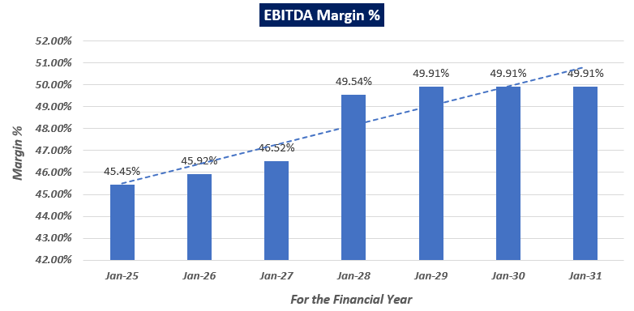
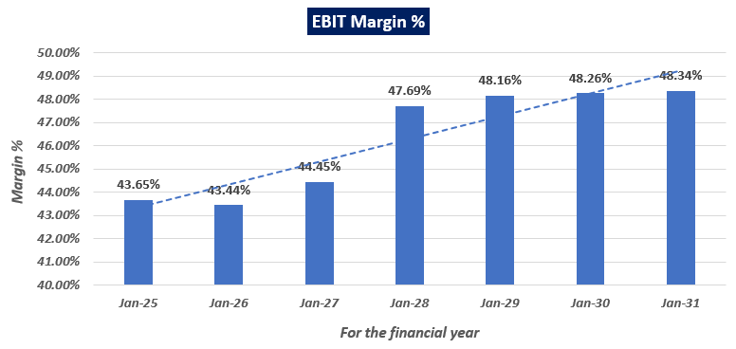

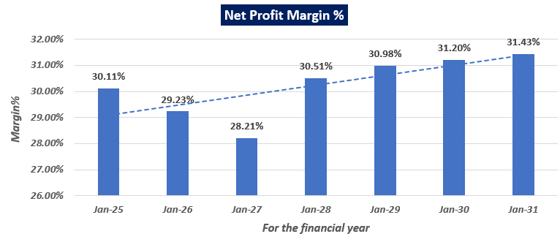
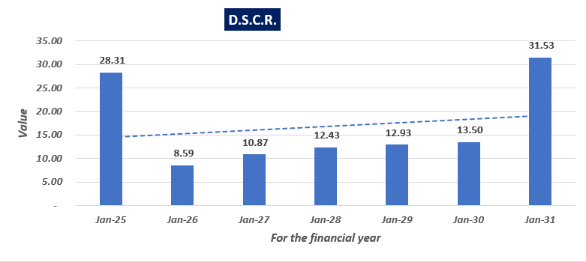

- REVENUE BUILD-UP:
Particulars | Units | Mar-25 | Mar-26 | Mar-27 | Mar-28 | Mar-29 | Mar-30 | Mar-31
Plant 1 | Kgs/annum | 2,16,000 | 2,16,000 | 2,16,000 | 2,16,000 | 2,16,000 | 2,16,000 | 2,16,000
Plant 2 | Kgs/annum | - | 2,16,000 | 2,16,000 | 2,16,000 | 2,16,000 | 2,16,000 | 2,16,000
Total Installed Capacity | Kgs/annum | 2,16,000 | 4,32,000 | 4,32,000 | 4,32,000 | 4,32,000 | 4,32,000 | 4,32,000
Rifamycin S
Sales Quantity (KGs) | Kgs/annum | 70,000 | 70,000 | 70,000 | 74,748 | 79,819 | 85,233 | 91,014
Total Sales | Rs. Cr. | 52.50 | 52.50 | 52.50 | 59.86 | 63.92 | 68.26 | 72.89
Avg. Selling Price per unit | Rs./kg | 7,500.00 | 7,500.00 | 7,500.00 | 8,008.74 | 8,008.74 | 8,008.74 | 8,008.74
Rifamycin O
Sales Quantity (KGs) | Kgs/annum | 81,000 | 90,000 | 90,000 | 93,716 | 97,586 | 1,01,616 | 1,05,812
Total Sales | Rs. Cr. | 60.70 | 69.30 | 71.10 | 77.09 | 80.28 | 83.59 | 87.04
Avg. Selling Price per unit | Rs./kg | 7,493.33 | 7,700.00 | 7,900.00 | 8,226.22 | 8,226.22 | 8,226.22 | 8,226.22
Rifampentine
Sales Quantity (KGs) | Kgs/annum | 32,880 | 58,000 | 1,44,648 | 1,52,878 | 1,61,577 | 1,70,771 | 1,80,488
Total Sales | Rs. Cr. | 122.81 | 216.63 | 540.26 | 603.49 | 637.83 | 674.12 | 712.48
Avg. Selling Price per unit | Rs./kg | 37,350.0 | 37,350.0 | 37,350.0 | 39,475.2 | 39,475.2 | 39,475.2 | 39,475.2
Total Revenue | Rs.Cr | 236.00 | 338.43 | 663.86 | 740.45 | 782.03 | 825.97 | 872.41

- ESTIMATED KEY FINANCIAL METRICS:
DEBT SERVICE COVERAGE RATIO (DSCR)
PARTICULARS | Mar-25 | Mar-26 | Mar-27 | Mar-28 | Mar-29 | Mar-30 | Mar-31
Funds Available For Servicing Debts:
Profit after tax | 72.50 | 100.41 | 188.77 | 227.63 | 244.12 | 259.69 | 276.32
Add: Depreciation for the year | 4.33 | 8.50 | 13.81 | 13.79 | 13.77 | 13.77 | 13.77
Add: Interest on Term Loan | 2.81 | 7.55 | 7.30 | 5.90 | 4.28 | 2.44 | 0.21
TOTAL (A) | 79.64 | 116.45 | 209.87 | 247.32 | 262.17 | 275.90 | 290.31
Debts To Be Serviced:
Repayment of Term Loan | 0.00 | 6.00 | 12.00 | 14.00 | 16.00 | 18.00 | 9.00
Interest on Term Loan | 2.81 | 7.55 | 7.30 | 5.90 | 4.28 | 2.44 | 0.21
TOTAL (B) | 2.81 | 13.55 | 19.30 | 19.90 | 20.28 | 20.44 | 9.21
D.S.C.R. (A/B) | 28.31 | 8.59 | 10.87 | 12.43 | 12.93 | 13.50 | 31.53
AVERAGE D.S.C.R | 14.05

Note: Higher DSCR is showing the worthness of the project. Company is getting the synergies from its existing manufacturing unit and thus generating high PAT because of the nature of Industry and product profile, due to which the availability of the funds to service the required debt is good. Further the Debt to Equity Ratio for the proposed expansion is ~50:50 due to which compnay need to service lower debt as compare to avilable funds. Hence Average DSCR of the project is very high indicating the financial strenth of the proposed expantion during the projected period while Financial projection are subject to the micro & macro assumption taken during the forecasted period and financials may vary as these assumption vary.
- SENSITIVITY ANALYSIS OF DSCR:
DSCR IF REVENUE DECREASED BY 05%
Particulars | Mar-25 | Mar-26 | Mar-27 | Mar-28 | Mar-29 | Mar-30 | Mar-31
Net Sales | 228.73 | 326.29 | 635.72 | 708.77 | 748.57 | 790.64 | 835.10
Total Operating Expenses | 131.34 | 185.76 | 357.91 | 376.48 | 394.67 | 416.87 | 440.32
Finance Expenses | 2.81 | 7.55 | 7.30 | 5.90 | 4.28 | 2.44 | 0.21
Depreciation | 4.33 | 8.50 | 13.81 | 13.79 | 13.77 | 13.77 | 13.77
Total Expenditure | 138.48 | 201.81 | 379.02 | 396.17 | 412.72 | 433.08 | 454.30
Income before Tax | 90.24 | 124.48 | 256.70 | 312.59 | 335.85 | 357.56 | 380.80
Taxation | 26.28 | 36.25 | 89.70 | 109.23 | 117.36 | 124.95 | 133.07
Income after Tax | 63.97 | 88.23 | 167.00 | 203.36 | 218.49 | 232.62 | 247.73
Cash Accruals | 68.29 | 96.73 | 180.81 | 217.15 | 232.26 | 246.39 | 261.51
Interest on T/L | 2.61 | 7.34 | 7.10 | 5.69 | 4.07 | 2.23 | 0.37
Instalment of T/L | - | 6.00 | 12.00 | 14.00 | 16.00 | 18.00 | 9.00
D.S.C.R. (A/B) | 27.20 | 7.80 | 9.84 | 11.32 | 11.77 | 12.29 | 27.94
Average D.S.C.R | 12.76

DSCR IF OPERATING COST INCREASED BY 05%
Particulars | Mar-25 | Mar-26 | Mar-27 | Mar-28 | Mar-29 | Mar-30 | Mar-31
Net Sales | 240.76 | 343.46 | 669.18 | 746.07 | 787.97 | 832.25 | 879.05
Total Operating Expenses | 137.91 | 195.05 | 375.81 | 395.31 | 414.41 | 437.71 | 462.34
Finance Expenses | 2.81 | 7.55 | 7.30 | 5.90 | 4.28 | 2.44 | 0.21
Depreciation | 4.33 | 8.50 | 13.81 | 13.79 | 13.77 | 13.77 | 13.77
Total Expenditure | 145.05 | 211.09 | 396.91 | 415.00 | 432.46 | 453.92 | 476.32
Income before Tax | 95.72 | 132.37 | 272.27 | 331.07 | 355.51 | 378.33 | 402.73
Taxation | 27.87 | 38.55 | 95.14 | 115.69 | 124.23 | 132.20 | 140.73
Income after Tax | 67.84 | 93.82 | 177.13 | 215.38 | 231.28 | 246.13 | 262.00
Cash Accruals | 72.17 | 102.32 | 190.93 | 229.17 | 245.06 | 259.90 | 275.78
Interest on T/L | 2.61 | 7.34 | 7.10 | 5.69 | 4.07 | 2.23 | 0.37
Instalment of T/L | - | 6.00 | 12.00 | 14.00 | 16.00 | 18.00 | 9.00
D.S.C.R. (A/B) | 28.68 | 8.22 | 10.37 | 11.93 | 12.41 | 12.96 | 29.47
Average D.S.C.R | 13.45

DSCR IF TERM LOAN’S INTEREST RATE INCREASED BY 1%
Particulars | Mar-25 | Mar-26 | Mar-27 | Mar-28 | Mar-29 | Mar-30 | Mar-31
Net Sales | 240.76 | 343.46 | 669.18 | 746.07 | 787.97 | 832.25 | 879.05
Total Operating Expenses | 131.34 | 185.76 | 357.91 | 376.48 | 394.67 | 416.87 | 440.32
Finance Expenses | 2.84 | 8.01 | 7.74 | 6.21 | 4.44 | 2.43 | 0.41
Depreciation | 4.33 | 8.50 | 13.81 | 13.79 | 13.77 | 13.77 | 13.77
Total Expenditure | 138.51 | 202.27 | 379.46 | 396.48 | 412.89 | 433.07 | 454.50
Income before Tax | 102.25 | 141.19 | 289.72 | 349.59 | 375.08 | 399.18 | 424.55
Taxation | 29.78 | 41.12 | 101.24 | 122.16 | 131.07 | 139.49 | 148.35
Income after Tax | 72.48 | 100.08 | 188.48 | 227.43 | 244.01 | 259.69 | 276.19
Cash Accruals | 76.80 | 108.58 | 202.29 | 241.22 | 257.79 | 273.47 | 289.97
Interest on T/L | 2.84 | 8.01 | 7.74 | 6.21 | 4.44 | 2.43 | 0.41
Instalment of T/L | - | 6.00 | 12.00 | 14.00 | 16.00 | 18.00 | 9.00
D.S.C.R. (A/B) | 28.01 | 8.32 | 10.64 | 12.24 | 12.83 | 13.50 | 30.87
Average D.S.C.R | 13.84

- BREAK-EVEN (SALES) ANALYSIS:
Particulars | Mar-25 | Mar-26 | Mar-27 | Mar-28 | Mar-29 | Mar-30 | Mar-31
Total Sales | 236.00 | 338.43 | 663.86 | 740.45 | 782.03 | 825.97 | 872.41
Capacity Utilisation | 85.13% | 50.46% | 70.52% | 74.38% | 78.47% | 82.78% | 87.34%
Variable Cost
Total Variable Cost | 144.12 | 246.94 | 343.10 | 349.44 | 366.12 | 386.71 | 396.70
Contribution | 91.88 | 91.49 | 320.76 | 391.01 | 415.91 | 439.26 | 475.71
Contribution Margin | 39% | 27% | 48% | 53% | 53% | 53% | 55%
Fixed Cost
Total Fixed Cost | 18.94 | 32.97 | 54.30 | 56.71 | 57.15 | 57.51 | 57.60
Profit Volume (PV) Ratio | 38.93% | 27.03% | 48.32% | 52.81% | 53.18% | 53.18% | 54.53%
Break Even Point Sales | 48.65 | 121.95 | 112.38 | 107.39 | 107.47 | 108.14 | 105.64
Break Even Point as % of Sales | 21% | 36% | 17% | 15% | 14% | 13% | 12%

- TERM LOAN INPUTS:
Term Loan Repayment Inputs
Amount of Term Loan (in Crores) | 75.00
Rate of Interest | 11.00%
SCOD (Scheduled Commercial Operation Date) | Apr-25
Disbursal Start Date | Mar-24
Repayment Start Date | Dec-25
Repayment Period (Years) | 6
Total Quarterly Instalments | 20
Moratorium from first drawl (Months) | 18
Door to Door Tenure in Months (including Principal Moratorium of 1.5 Years) | 66
Number of Months a year | 12
- NPV AND PAYBACK PERIOD OF THE PROJECT:
(INR Crores)
Free Cash Flow for the project
Particulars | FY 2025 | FY 2026 | FY 2027 | FY 2028 | FY 2029 | FY 2030 | FY 2031
Period (Months) | 12 | 12 | 12 | 12 | 12 | 12 | 12
EBIT | 105.1 | 149.2 | 297.5 | 355.8 | 379.5 | 401.6 | 425.0
Less: Taxes | 30.60 | 43.45 | 103.95 | 124.33 | 132.62 | 140.34 | 148.50
Add: Depreciation & Amortisation | 4.3 | 8.5 | 13.8 | 13.8 | 13.8 | 13.8 | 13.8
Gross Cash Flow | 78.8 | 114.3 | 207.3 | 245.3 | 260.7 | 275.0 | 290.2
+/- WCC | 0.0 | 0.0 | 0.0 | 0.0 | 0.0 | 0.0 | 0.0
Capex | 110.0 | 42.0 | 0.0 | 0.0 | 0.0 | 0.0 | 0.0
Free Cash Flow to Firm (FCFF) | -31.2 | 72.3 | 207.3 | 245.3 | 260.7 | 275.0 | 290.2
Discount Period | 1.0 | 2.0 | 3.0 | 4.0 | 5.0 | 6.0 | 7.0
Discount Factor | 0.90 | 0.80 | 0.72 | 0.65 | 0.58 | 0.52 | 0.47
PV Of FCFF | (28.0) | 58.1 | 149.6 | 158.7 | 151.3 | 143.1 | 135.46
TV |  |  |  |  |  |  | 177.35
PV Of TV |  |  |  |  |  |  | 82.78
PV(FCFF+TV) | (27.97) | 58.14 | 149.56 | 158.68 | 151.26 | 143.14 | 218.24

Key Input for NPV
S. No. | Key Input | Description
 | Cost of Equity | 13.64%
 | Cost of Debt | 11%
 | Tax Rate | 34.94
 | Discount Rate | 10.44%
NPV |  | INR 890.91 Crores

Payback Period of the Project
Financial Year | Cash Accrual | Accumulated Cash Accrual
2025 | 68.29 | 68.29
2026 | 96.73 | 165.02
2027 | 180.81 | 345.83
2028 | 217.15 | 562.98
2029 | 232.26 | 795.24
2030 | 246.39 | 1,041.63
2031 | 261.51 | 1,303.14
Total | 1,303.14
TPC | INR 151.97 Crores
Payback Period | 1.87 Years
Thus, the project will be having a payback period of 1.87 years and NPV of the project as on COD will INR 890.91 Crores, which indicates worthiness of the project.
- KEY ASSUMPTIONS & BASIS:
S. No. | Item | Assumptions and Basis
 | General | - The projections of the firm are done for the period from FY 2025 to FY 2031, 7 years, to cover the term loan period as per the industry best practices. It is assumed that the plant will be achieving COD on 31st March 2025.  - We have considered both Revenue & cost based model (top to bottom approach) while making the future financial projections.  - Revenue and expense modelling has been done based on the historical data provided by company, during the forecasted years.
 | Revenue Build up | - Total income for the financial years during the forecasted period will be generating from selling of Rifamycin S, Rifamycin O and Rifapentine.  - The selling price of the proposed products varies based on specifications, quality, and may fluctuate due to the price volatility of raw materials influenced by geopolitical aspects, demand, supply, and other factors.  - According to information provided by the company, GTBL is manufacturing API Rifamycin S and O and Rifapentine, requiring approx. 20 raw materials in specified ratios. While we have a list of these raw materials, we do not have the proportions in which they are used to manufacture these products.  - As per information provided by company below tables shows the Quantity in MT and sales value for each product:  RIFA-S  YEAR QTY IN MT SALES VALUE RS IN LAKHS  2020-21 101.87 6,285.46  2021-22 81.01 5,137.00  2022-23 95.88 6,542.49  2023-24 137.27 10,300.77  2024-25 70.00 5,250.00  2025-26 70.00 5,250.00  2026-27 70.00 5,250.00  RIFA-O  YEAR QTY IN MT SALES VALUE RS IN LAKHS  2020-21 37.27 2,594.04  2021-22 110.52 6,282.06  2022-23 108.30 8,270.48  2023-24 79.32 5,837.78  2024-25 81.00 6,069.60  2025-26 90.00 6,930.00  2026-27 90.00 7,110.00  RIFAPENTINE  YEAR QTY IN MT SALES VALUE RS IN LAKHS  2020-21  2021-22  2022-23  2023-24  2024-25 32.88 12,280.68  2025-26 58.00 21,663.00  2026-27 144.65 54,026.03  - For the first four years i.e. FY 21 to FY 24 provided quantity and sales figures are given on historical basis. And for the first 3 Forecasted years i.e. FY 25, FY 26 & FY 27, quantity and sales figures have been provided by the company management sales team on the basis of demand of the products.  - Rifa-S and Rifa-O are intermediary compounds formulated in laboratories to meet specific pharmaceutical requirements. The exact proportions utilized by the company to produce these compounds are proprietary information and not disclosed by the company. Similarly, pricing details for these products are not publicly accessible. Therefore, we have to rely upon the prices provided by the company.  - Rifapentine is a drug used as an antibiotic medication to treat tuberculosis (TB). As per our tertiary research, this medicine is available in the market. We have asked some vendors about the MRP of the medicine and found that 150 mg with MRP 21 for 10 tablets including ~10-14% margin of the vendors. Therefore, pricing strategy of the company for Rifapentine seems to be in the line with market, as per our independent assessment. Hence, we have to rely upon the prices provided by the company.  - In absence of further information, Revenue growth assumption for FY 28, FY 29, FY 30 and FY31, is taken as historical average for Rifa S and Rifa O for the years FY21 to FY 24, which comes out 7% and 4% respectively for both the products.  - As it is clear from above table that historically Rifapentine was not produced by the company. Therefore, for Rifapentine revenue growth assumption for FY 28, FY 29, FY 30 and FY31, is taken as per the rate of inflation.  RIFA-S  YEAR QTY IN MT SALES VALUE RS IN LAKHS  2027-28 74.75 5,986.39  2028-29 79.82 6,392.46  2029-30 85.23 6,826.07  2030-31 91.01 7,289.09  RIFA-O  YEAR QTY IN MT SALES VALUE RS IN LAKHS  2027-28 93.72 7,709.31  2028-29 97.59 8,027.65  2029-30 101.62 8,359.14  2030-31 105.81 8,704.31  RIFAPENTINE  YEAR QTY IN MT SALES VALUE RS IN LAKHS  2027-28 152.88 60,349.11  2028-29 161.58 63,782.97  2029-30 170.77 67,412.22  2030-31 180.49 71,247.98  - The price of the pharmaceutical products is volatile with respect to the various market factors such as Demand & Supply, Specification, Raw Material Cost Variances and Other Production Costs.  - Thus, justifiably average price has been considered during the forecasted periods considering the micro and macro-economic factors as per the facts came in front of us during the course of assignment, which is reasonable and on conservative side.  - Scrap sales and other income basis figure provided in 9 months data (1st April 2023 to 31st Dec 2023), the resultant figure for the entire FY 24 have calculated on pro-rata basis. To forecast for all the years revenue growth assumption from FY 25 to FY31, is taken as per the rate of inflation.
 | Capital Expenditure | - As per lease deed shared by the client/company and verified during survey, company has procured a leased land spread over an area of 53,869 Sq. mt., for the pharmaceutical manufacturing facility at GIDC Industrial Area Vapi, Valsad, Gujarat, India, 396195. From total area of 53,869 Sq. mt, 6,386.17 square meters is allocated to the proposed expansion of fermentation unit, with total built-up area of 25,544.68 square meters.  - As per site map provided by company, the total Build-up area of the new fermentation plant with its civil structures admeasures to about 25544.68 Sq. Mt. As per information provided by company, GTBL has given the building & civil works contract to Vapi based consultant Sangam Engineers. As a TEV consultant, we have conducted a general assessment based on plinth area rates to determine the total construction cost for building & civil works, which comes out to INR ~68.99 Crore. Our calculation suggests a cost range from Rs. 68.6 crores to Rs. 69.2 crores. However as per client’s estimates provided to us, cost for building & civil works comes out to INR ~68.89 Crore.  - The estimated cost for plant & machinery will be INR 63.26 crores as per the client. Please note that here we are not aware that weather this cost includes transportation cost, installation cost and applicable GST or not. Also, we have received the quotations only for few machineries not for all the machineries. However, the cost of such highly technical Plant & Machinery can’t be assessed accurately due to limited data/information about the brand name, technical specification, capacity, passage of time and other factors.  - Preliminary & Pre-Operative Expenses and litigation expenses has been taken as lump sum basis in the other cost. It is based on the time period of construction and estimate of company’s resources involvement during this time in supervision & monitoring of the construction as INR 19.82 lakhs.  - The estimated cost of the proposed fermentation project is INR 151.97 Crores, intended to be financed through a combination of debt and equity. Specifically, the project will be funded by a bank term loan of Rs. 75.00 Crores for Plant & Machinery and a promoter contribution of Rs. 76.97 Crores.
 | Raw Material | - Company has provided last 4 years historical financials along with provisional financial TIL 31ST Dec 2023. Thus, expenses for the projected period have been extrapolated as per the historical trends.  - Cost of materials consumed has been considered as 18.42 % of sales during the forecasted period which is an average of last 4 years historical trends.
 | Other Expenses | - Number of employees for the proposed expansion of fermentation plant is considered as per the workforce in the existing manufacturing facility since the proposed expansion is of similar scope & scale as existing operations.  - Thus, the number of employees comes out to be 109 in the historical years. Thereafter we have considered an increase of 20% and 25% in the number of employees For FY 2025 & FY 2026 as per the expected operational efficiency in these years. Further No. of employees from FY 2026 will remain same as that in FY 26 i.e. 177.  - Employee cost for FY 2024 comes out to be Rs. 0.09 Cr. After that an Escalation rate of 5% has been considered in the salary & wages during the forecasted years Y-o-Y basis.  - Manufacturing expenses includes Consumption of stores and spares, Power charges, Fuel charges, Water charges, Building, Plant and Machinery.  - For each forecast year Manufacturing expenses are calculated as a % of Finished Goods sales wherein cost % is average of Manufacturing Expenses appearing in prior years (i.e. from FY 22 to FY 24) is taken i.e. 22%.  - Administrative Expenses includes Insurance, Rates and taxes, Donation, Legal and professional fees, Repairs and maintenance, Rent for Flats, Printing and Stationary Expenses, Travelling and conveyance expenses and others.  - For each forecast year Administrative Expenses are calculated as a % of Finished Goods sales wherein cost % is average of Manufacturing Expenses appearing in prior years (i.e. from FY 22 to FY 24) is taken i.e. 5%.  - Selling & Distribution Expenses includes Disposal Charges for removal of waste material, Central Effluent Treatment Charges, Drainage Cess Charges, Freight and Forwarding and other Work charges.  - For each forecast year Administrative Expenses are calculated as a % of Finished Goods sales wherein cost % is average of Manufacturing Expenses appearing in prior years (i.e. from FY 22 to FY 24) is taken i.e. 2%.  - The figures of FY 2024 have been calculated on pro-rata basis which are based on 9 months data (1st April 2023 to 31st Dec 2023).  - As per data/information provided, the rates of depreciation have been considered as per Companies Act, 2013. Depreciation as per company’s act is allowed on the basis of useful life of assets and residual value. And depreciation is calculated on SLM basis.  - We have considered the corporate tax rate applicable to GTBL.
 | Working Capital Assumptions | - Trade Receivables: For all the forecast years, it has been calculated basis Average Trade receivables days (Average of FY 21, FY 22 & FY 23) i.e. 62 Days  - Inventories: For all the forecast years, it has been calculated basis Average Inventory days (Average of FY 21, FY 22 & FY 23) i.e. 150 Days  - Trade Payables: For all the forecast years, it has been calculated basis Average Trade receivables days (Average of FY 21, FY 22 & FY 23) i.e. 118 Days.
 | Term Loan | - As per discussion with the client, company will apply for a term loan of INR 75.00 Crores from the total project cost of INR 151.97 Crores for the proposed pharmaceutical fermentation manufacturing unit.  - The tenure of the loan will be 6.5 years in which first 18 months will be considered as moratorium period from the date of COD. Interest rate has been considered as 11% as per discussion with the banker.  - Drawdown of the Term Loan was begun from 31st March 2024 and it will end on 30th September 2025 (at quarterly intervals).  - Also, the repayment of the term loan will be in 20 quarterly structured instalments beginning from 31st December 2025 and ending on 30th September 2030.

Key Findings:
      - As per the latest audited financials of GTBL, it is a Debt Free Company as the net debt to equity ratio of the Company stood at 0.0 (zero debt) as on 31st March, 2023. And from forecasted financials GTBL’s Debt Service Coverage Ratio (DSCR) comes out more than 14 which would indicate a very strong ability to cover its debt obligations. And it also shows that company is financially stable and has a strong ability to repay its debts.
      - DSCR is sensitive with respect to revenue and operating cost fluctuations. If revenue is decreased by 5% and operating cost is increase by 5%, Y-o-Y basis, DSCR will very between 12.75 to 13.50.
      - If the interest rate will be increased by 1%, the average DSCR will be 13.84, during the forecasted period. Thus, we found that the DSCR is sensitive with respect to upside fluctuation of 1% in the interest rate.
      - Average DSCR, EBIDTA margin, EBIT margin is 14.05, 48.16%, and 46.29% respectively during the estimated period.
      - Based on the above key financial ratios of the proposed Project during the forecasted period shows that the project appears financially viable if the Project Company & promoters are able to maintain assumed capacity utilization, revenue and can contain cost as assumed above in the calculation.

PART N | CONCLUSION

Based on the technological, economic and market analysis done above and various assumptions of sectoral trends taken, product pricing assumed by the company, the Project appears to be Techno-commercially viable subject to the risks, threats, weaknesses, limitations of the product as detailed previously.
As per financial projections for the estimated period, average DSCR, EBITDA Margin and EBIT Margin of the project is estimated as 14.05, 48.16%, and 46.29% respectively, where higher DSCR is the indicator of the project capability to pay out its outstanding debt and EBITDA margin shows the capability of the project to generate the operating profits over the forecasted period. Also, the project is having the payback period of 1.87 Years in the line with sectoral trends. The proposed fermentation pharmaceutical facility is having a positive NPV as INR 890.91 Crores at 100% capacity utilization as the industry is growing at a CAGR of 9.43% for a decade.
The future of fermentation-based pharmaceutical manufacturing plants in India is promising due to increasing global demand for pharmaceuticals, technological advancements in fermentation processes, regulatory support, India's growing competitiveness in the global pharmaceutical market, and a shift towards biopharmaceuticals. While it is not avoidable that the future projections may change in the upcoming years due to various factors impacting the operation, managerial, financial efficiency and economies of scale of the project.
It would also be depending on the management’s capability in future that how efficiently company adopts marketing and advertisement strategy, supply chain and carry out inventory & resource management to achieve higher profitability. After considering the foreseen demand of the fermentation pharmaceutical API-products domestically and globally, various initiatives taken by the government. Financial analysis of the project based on the assumptions taken over the projected period, it appears reasonable to comment that the proposed project is “Technically and Economically” Viable subject to current assumptions considered and occurring the same in the upcoming years same as the forecasted period which is dependent on the sincerity and efforts of the management and various micro and macroeconomic & industry situation.
We have tried our level best to analyse the Project techno-economic feasibility of the Project based on the industry research, Project information and various futuristic assumption taken within the limitations and challenges came in front of us. However, achieving the financial milestones depends on the ability, sincerity and efforts of the company, promoters and its key management to maintain the projected revenue level Y-o-Y basis.
Declaration | - The undersigned does not have any direct/indirect interest in the above property/project/Company.  - The information furnished herein is true and correct to the best of our knowledge, logical and scientific assumptions.  - This TEV Report is carried out by our Financial Analyst team on the request from Bank of Baroda SME Branch, 1st Floor, 10/12, Horniman Circle, Mumbai Samachar Marg, Fort, Mumbai 400023.  - Meeting of Financial projections will be subject to the market & economy stability factors, judicious business operations and proper & timely implementation of the project and putting proper plan for achieving high productivity, efficiency and achieving cost saving benefits to increase profitability.  - We have submitted TEV report to the BOB SME Branch Mumbai.
Number of Pages in the Repost | 96
Enclosed Documents | Disclaimer & Remarks 87-90
Place | Noida
Date | 15th April 2024

FOR ON BEHALF OF
M/S. R.K. ASSOCIATES VALUER & TECHNO ENGINEERING CONSULTANTS PVT. LTD.
SURVEYED BY | PREPARED BY | REVIEWED BY
Mr. Anit Bhanji | Mrs. Chhavi Toshan | Mr. Gaurav Kumar

PART N | DISCLAIMER | REMARKS

      - No employee or member of R.K Associates has any direct/ indirect interest in the Project.
      - This report is prepared based on the copies of the documents/ information which the Bank/ Company has provided to us out of the standard checklist of documents sought from them and further based on our assumptions and limiting conditions. The client/owner and its management/representatives warranted to us that the information they supplied was complete, accurate and true and correct to the best of their knowledge. All such information provided to us has been relied upon in good faith and we have assumed that it is true and correct in all respect. I/We shall not be liable for any loss, damages, cost or expenses arising from fraudulent acts, misrepresentations, or wilful default on part of the owner, company, its directors, employee, representative or agents. Verification or cross checking of the documents provided to us from the originals or from any Govt. departments/ Record of Registrar has not been done at our end since this is beyond the scope of our work. If at any time in future, it is found or came to our knowledge that misrepresentation of facts or incomplete or distorted information has been provided to us then this report shall automatically become null & void.
      - Legal aspects for e.g. investigation of title, ownership rights, lien, charge, mortgage, lease, sanctioned maps, verification of documents, etc. have not been done at our end and same has to be taken care by legal expert/ Advocate. It is assumed that the concerned Lender/ Financial Institution has satisfied them with the authenticity of the documents, information given to us and for which the legal verification has been already taken and cleared by the competent Advocate before requesting for this report. I/ We assume no responsibility for the legal matters including, but not limited to, legal or title concerns.
      - This report is a general analysis of the project based on the scope mentioned in the report. This is not an Audit report, Design document, DPR or Techno feasibility study. All the information gathered is based on the facts seen on the site during survey, verbal discussion & documentary evidence provided by the client and is believed that information given by the company is true best of their knowledge.
      - This Techno Economic-Viability study is prepared based on certain futuristic assumption which are intra dependent on economic, market and sectorial growth condition in future and socio-economic, socio-political condition at macro and micro level.
      - Meeting of assumption and financial ratio will entirely depend on the sincerity and efforts of the company, promoters and its key managerial performance.
      - All observations mentioned in the report is only based on the visual observation and the documents/ data/ information provided by the client. No mechanical/ technical tests, measurements or any design review have been performed or carried out from our side during Project assessment.
      - This report has been diligently prepared by our techno-financial team to the best of their ability. However, it is important to note that the recommendations provided in this Techno Economic Viability (TEV) assessment do not imply an endorsement, validation, or certification of the accuracy or completeness of the disclosed information by the involved stakeholders. Furthermore, we do not claim or endorse that the opinions presented herein are the sole best course of action for decision-makers to follow. There may exist additional approaches and inputs that have not been covered within this report or fall outside the scope of this report.
      - Bank/FII should ONLY take this report as an Advisory document from the Financial/ Chartered Engineering firm and its specifically advised to the creditor to cross verifies the original documents for the facts mentioned in the report which can be availed from the borrowing company directly.
      - In case of any default in loans or the credit facility extended to the borrowing company, R.K Associates shall not be held responsible for whatsoever reason may be and any request for seeking any explanation from the employee/s of R.K Associates will not be entertained at any instance or situation.
      - The documents, information, data provided to us during the course of this assessment by the client are reviewed only up to the extent required in relation to the scope of the work. No document has been reviewed beyond the scope of the work.
      - This report only contains general assessment & opinion as per the scope of work evaluated as per the information given in the copy of documents, information, data provided to us and/ and confirmed by the owner/ owner representative to us at site which has been relied upon in good faith. It doesn’t contain any other recommendations of any sort including but not limited to express of any opinion on the suitability or otherwise of entering into any transaction with the borrower.
      - We have relied on data from third party, external sources & information available on public domain also to conclude this report. These sources are believed to be reliable and therefore, we assume no liability for the truth or accuracy of any data, opinions or estimates furnished by others that have been used in this analysis. Where we have relied on data, opinions or estimates from external sources, reasonable care has been taken to ensure that such data has been correctly extracted from those sources and /or reproduced in its proper form and context, however still we can’t vouch its authenticity, correctness or accuracy.
      - This Report is prepared by our competent technical team which includes Engineers and financial experts & analysts.
      - This is just an opinion report and doesn’t hold any binding on anyone. It is requested from the concerned Financial Institution which is using this report for taking financial decision on the project that they should consider all the different associated relevant & related factors also before taking any business decision based on the content of this report.
      - All Pages of the report including annexure are signed and stamped from our office. In case any paper in the report is without stamp & signature then this should not be considered a valid paper issued from this office.
      - Though adequate care has been taken while preparing this report as per its scope, but still we can’t rule out typing, human errors, over sightedness of any information or any other mistakes. Therefore, the concerned organization is advised to satisfy themselves that the report is complete & satisfactory in all respect. Intimation regarding any discrepancy shall be brought into our notice immediately. If no intimation is received within 15 (Fifteen) days in writing from the date of issuance of the report, to rectify these timely, then it shall be considered that the report is complete in all respect and has been accepted by the client up to their satisfaction & use and further to which R.K Associates shall not be held responsible in any manner.
      - Defect Liability Period is 15 DAYS. We request the concerned authorized reader of this report to check the contents, data and calculations in the report within this period and intimate us in writing if any corrections are required or in case of any other concern with the contents or opinion mentioned in the report. Corrections only related to typographical, calculation, spelling mistakes, incorrect data/ figures/ statement will be entertained within the defect liability period. Any new changes for any additional information in already approved report will be regarded as additional work for which additional fees may be charged. No request for any illegitimate change in regard to any facts & figures will be entertained.
      - R.K Associates encourages its customers to give feedback or inform concerns over its services through proper channel at advisory@rkassociates.org in writing within 15 days of report delivery. After this period no concern/ complaint/ proceedings in connection with the Techno- Economic Viability Study Services will be entertained due to possible change in situation and condition of the subject Project.
      - Our Data retention policy is of ONE YEAR. After this period, we remove all the concerned records related to the assignment from our repository. No clarification or query can be answered after this period due to unavailability of the data.
      - This Techno Economic Viability Study report is governed by our (1) Internal Policies, Processes & Standard Operating Procedures, (2) Information/ Data/ Inputs given to us by the client and (3) Information/ Data/ Facts given to us by our field/ office technical team. Management of R.K Associates never gives acceptance to any unethical or unprofessional practice which may affect fair, correct & impartial assessment and which is against any prevailing law. In case of any indication of any negligence, default, incorrect, misleading, misrepresentation or distortion of facts in the report then it is the responsibility of the user of this report to immediately or at least within the defect liability period bring all such act into notice of R.K Associates management so that corrective measures can be taken instantly.
      - R.K Associates never releases any report doing alterations or modifications from pen. In case any information/ figure of this report is found altered with pen then this report will automatically become null & void.
      - If this report is prepared for the matter under litigation in any Indian court, no official or employee of R.K Associates will be under any obligation to give in person appearance in the court as a testimony. For any explanation or clarification, only written reply can be submitted on payment of charges by the plaintiff or respondent which will be 10% of the original fees charged where minimum charges will be Rs. 15,000/.

EXTRACTS OF IMPORTANT STATUTORY APPROVALS PROVIDED BY THE CLIENT

