File No.: VIS (2024-25) –PL-010-010-010 Dated: 04th May 2024

1st PROJECT LIE REPORT
(FOR QUARTER ENDING MARCH 2024)

OF

2.0 MMTPA GRINDING UNIT (GU)

SITUATED AT

VILLAGE- LEDAR, SANKARGARH, DISTRICT- PRAYAGRAJ,
UTTAR PRADESH

IMPLEMENTED BY
JK CEMENT LIMITED



REPORT PREPARED FOR
HDFC BANK, EMERGING CORPORATE GROUP, KANPUR

**Important - In case of any query/ issue or escalation you may please contact Incident Manager at le@rkassociates.org. We will appreciate your feedback in order to improve our services.
NOTE: As per IBA Guidelines please provide your feedback on the report within 15 days of its submission after which report will be considered to be correct.

TABLE OF CONTENTS
SR.NO. | DESCRIPTION | PAGE NO.
PART A | Report Summary | 03
PART B | Introduction | 04
PART B | - The Project | 04
PART B | - About the Borrower | 04
PART B | - Location of the Project | 05
PART B | - Project Overview | 06
PART B | - Scope of the Project During Project Duration | 07
PART B | - Purpose of the Report | 07
PART B | - Methodology Adopted | 08
PART C | Plant Infrastructure Sections & Facility Details with Actual Progress | 09
PART C | - Land Details | 09
PART C | - Building and Structure Details | 11
PART C | - Plant Machinery and Equipment | 15
PART D | Project Consultants, Contractors & Suppliers | 22
PART D | - List of Contractors and Agreements | 22
PART E | Project Cost and Means of Finance | 23
PART E | - Cost of Project | 23
PART E | - Current Status and Total Expenditure Incurred Till Date | 24
PART E | - Sources of Finance & Utilization of Funds | 24
PART F | Statutory & Regulatory Approvals, Clearances & NOC | 25
PART G | Project Schedule & Current Status | 26
PART G | - Project Schedule Chart | 26
PART H | Conclusion | 27
PART J | Disclaimer | 28
PART K | Enclosure | 32
PART L | Photographs | 36-40

IMPORTANT NOTICE

COPYRIGHT FORMAT: This report is prepared on the copyright format of R.K Associates, to serve our clients with the best available information and analysis to facilitate them to take rational business decisions. Legally no one can copy or distribute this format without prior approval from R.K Associates. It is meant only for the advisory/ reference purpose for the organization/s as mentioned on the cover page of this report. Distribution or use of this format by any organization or individual other than R.K Associates will be seen as unlawful act and necessary legal action can be taken against the defaulters.

This report is intended for the sole use of the intended recipient/s and contain material that is STRICTLY CONFIDENTIAL AND PRIVATE.

DEFECT LIABILITY PERIOD: - In case of any query/ issue or escalation you may please contact Incident Manager: le@rkassociates.org. We try our level best to ensure correctness in the calculations done, rates adopted and various other data points & information mentioned in the report but still can’t rule out typing, human errors or any other mistakes. In case you find any such mistake or inaccuracy in any data point of the report please help us by bringing all such points into our notice immediately or within 15 days of the report delivery in writing, to rectify these timely failing after which R.K Associates won’t be held responsible for any such inaccuracy in any manner. We would highly appreciate your feedback in order to improve our services.

PART A | REPORT SUMMARY

1. | Name of Project: | JK Cement Limited, herein referred as “JKCL” is setting up a 2.0 MMTPA clinker grinding unit (GU) in Prayagraj district in the State of Uttar Pradesh.
2. | Project Location: | - Village: Ledar  - District: Prayagraj  - State: Uttar Pradesh  - Co-ordinates: 25°12'05"N 81°34'04"E
3. | Name of the Borrower: | M/s. JK Cement Ltd. (JKCL)
4. | Prepared for Bank: | HDFC Bank, Emerging Corporate Group, Kanpur
5. | LIE Consultant Firm: | M/s. R.K. Associates Valuers & Techno Engineering Consultants (P) Ltd.
6. | Date of Survey: | 26th April 2024
7. | Date of Report: | 3rd May 2024
8. | Purpose of the Report: | To provide fair detailed analysis report to the Bank based on the “in-scope points” mentioned below to know the current status of the Project.
9. | Scope of the work provided by the Lender: | - Review Project details & facilities  - Project Progress vis-a-vis construction schedule  - Review of Project Licenses, NOCs, Approvals
10. | Documents provided for the Project (out of documents requested): | - Techno economic feasibility report  - Project Statutory approvals  - CA certificate
11. | Annexure with the report: | - Project Statutory approvals  - CA Certificate

PART B | INTRODUCTION

- THE PROJECT:
JK Cement Limited (JKCL) is establishing a Clinker Grinding Unit (GU) with a capacity of 2 million tonnes per annum (MTPA) in district Prayagraj, Uttar Pradesh using Vertical Rolling Mill. To know the Project progress bank has appointed M/s R.K Associates Valuers & Techno Engineering Consultants (P) Ltd. As Lender’s Independent Engineer to review periodic physical status of the project and inform the Bank through Quarterly Reports. This is 1st LIE Report for Quarter ending March.’24. This report primarily captures physical status of the Project as per the survey conducted on 26th April 2024.

- ABOUT THE PROMOTER/BORROWER:
JK Cement Ltd is an affiliate of the multi-disciplinary industrial conglomerate JK Organisation founded by Lala Kamlapat Singhania, which is a 100+ year’s group. The Company has over four decades of experience in cement manufacturing. Their operations commenced with commercial production at their first grey cement plant at Nimbahera in the state of Rajasthan in May 1975. As per the information provide by the company, subsequently the Company also set up 2 more units in Rajasthan at Mangrol and Gotan. In the year 2009 the Company extended its footprint by setting up a green-field unit in Muddapur, Karnataka giving it access to the markets of southwest India.

The Company has made its first international foray with setting up of a green-field dual process White Cement-cum-Grey Cement Plant in the free trade zone at Fujairah, U.A.E to cater to the GCC and African markets. The plant at Fujairah has a capacity of 0.6 Mn.TPA for White Cement with a flexibility to change over its operation to produce upto 1 Mn.TPA of Grey Cement. Recently, company has successfully commissioned the Greenfield projects of 2 MnTPA at Panna in Madhya Pradesh, along with a 2 Mn TPA grinding unit at Hamirpur in Uttar Pradesh.

- PROJECT LOCATION:
Particulars | Description
Address
Village: Ledar, Prayagraj, Uttar Pradesh
Google Coordinates
Latitude | 25°12'05"N
Longitude | 81°34'04"E
Connectivity Systems
Road | The project site of the under-construction plant lies on NH-35 known as Chitrakoot - Prayagraj road.
Rail | Bevra Railway Station is the nearest railway station, located at about 12 km from the proposed plant site. Prayagraj Railway station is the nearest major junction, located at a distance of about 57 km from the plant site.
Air | The nearest domestic airport is at Prayagraj at about 65 km distance from the plant site.
Key Observation
- Site is located right on Chitrakoot - Prayagraj highway having good connectivity via road. Through rail and Air also it has connectivity within a distance of 1-1.5 hours.
- Company is setting up the Plant at this location to cover North-East UP and South-East UP and to exploit the available incentives under Uttar Pradesh State’s Industrial Investment and Employment Promotion Policy 2017 (IIEPP-2017).
- Project site is around 9.6 Km far from Prayagraj Thermal Power Station which is a good source of fly ash a major raw material required for manufacturing of Cement.
- Major raw material for the company is clinker which company will be procuring from their another Plant in Panna, MP which is approx. 300 Km from the subject Plant.

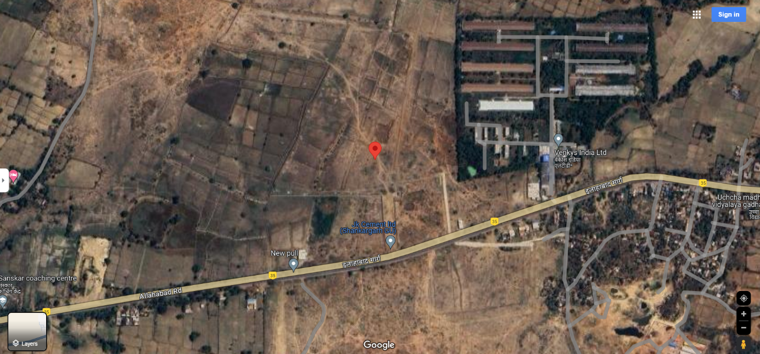
Source: Google Maps
Figure: Location of Subject Plant

- PROJECT OVERVIEW:
JK Cement Limited (JKCL) is establishing a Clinker Grinding Unit (GU) with a capacity of 2.0 million tonnes per annum (MTPA) using Vertical roller mill (VRM) in the Prayagraj district of Uttar Pradesh to cover North-East UP and South-East UP. The major raw material for this clinker grinding unit is to be sourced from JCL's plant in Panna, Madhya Pradesh.

Under the said Plant, JKCL proposes to produce 100% PPC as per relevant BIS standards: IS:1489-2015 with approximate cement volume of 6060 tpd.

As per TEFR the total land area of the proposed site under consideration totals to nearly 23 hectares (approx. 57 acres), however during site survey we gathered information from company representatives that the company has finally acquired ~18.30 hectare or approx. 40.45 acres of land. Rough demarcation on Google maps as guided by the company representatives has been done as shown in the later section of the report.

The total project cost is approx. 492.16 Crore as per TEFR report by M/s HOLTEK, which includes major heads such as Land and Site Development, Civil Works, Plant and Machinery, etc. Detailed description of the same can be found further in the report.

Out of the various alternatives, based on parameters like power consumption, investment cost, proven performance, and JKCL preference, it is envisaged to install one VRM (Vertical Roller Mill) of capacity 250 tph PPC @ 3,800 Blaine.

Power
The maximum power demand for the proposed Grinding Unit has been estimated at about 12 MW based on specific power consumption of 31.5 kWh/ t of PPC including power requirement for material handling, clinker grinding, packing, lighting & utilities. Power will be sourced from the 132/33 kV grid substation of U.P. Power Transmission Corporation Limited, located near Shankargarh spanning a distance of about 5 km from the proposed plant site. In this regard, company has already obtained electricity connection of 13000 KVA from PPDCL. For receiving power, transmission line, switchyard and main receiving substation shall be constructed.

To meet the emergency power requirement, a DG set of 1250 KVA capacity has been planned.

Water
As per the Holtec TEF report, the water requirement for the proposed Grinding Unit has been estimated as 400 m3 / day including about 300 m3 / day for plant process, 25 m3 / day for office & canteen and 50 m3 / day for landscaping. Additionally, provision of 500 m3 water storage has been kept for fire fighting purpose. Water requirement is envisaged to be met from underground sources by means of bore wells. However as per Consent to Establish obtained from Uttar Pradesh Pollution Control Board the water requirement for the plant, will be about 200 KLD, which is planned to be met from bore well. In this respect company has obtained total 3 NOC for ground water extraction totalling 200 KLD fulfilling requirement as per CTE requirement. For plant equipment, water shall be re-circulated after cooling to avoid any wastage and only losses shall be made up from fresh water.

An implementation period of 18-months from the date of signing/ effectiveness (zero date) of the main equipment supply contract is foreseen for the project. Zero date of the Project is August, 2023. Therefore accordingly the Project shall be around February 2025.

During our site inspection dated 26th April 2024, the construction and plant machinery work was observed to be in progress. As per information provided by the company representative, the company is planning to achieve its commercial operation by June-July 2024 i.e. before the scheduled completion date i.e. February 2025.

- SCOPE OF WORK OF THIS REPORT:
- Review Project details & facilities
- Project Progress vis-a-vis construction schedule
- Review of Project Licenses, NOCs, Approvals

Note:
- The scope of work is for the complete duration up to the completion of the project and not for a specific report.
- Carrying out the scope of work will depend on the details/ information/ data provided to us by the borrower from time to time.

- PURPOSE OF THE REPORT: To provide fair detailed analysis report to the Bank based on the “in-scope points” mentioned above for facilitating them to know the current Project status.

- METHODOLOGY ADOPTED:
- Study of Project Planning documents/ reports to know about the Project.
- Additional information, data, documents collection the borrower.
- Site Inspection.
- Review and analysis of the documents and information obtained from the borrower and corroborating it with the site inspection status.
- Information compilation, analysis and reporting.

PART C | PLANT INFRASTRUCTURE SECTIONS & FACILITY DETAILS WITH ACTUAL PROGRESS

- LAND & SITE DEVELOPMENT: As per TEFR the total land area of the proposed site under consideration totals to nearly 23 hectares (approx. 57 acres), however during site survey we gathered information from company representatives that the company has finally acquired ~18.30 hectare or approx. 40.45 acres of land. Rough demarcation on Google maps as guided by the company representatives has been done.
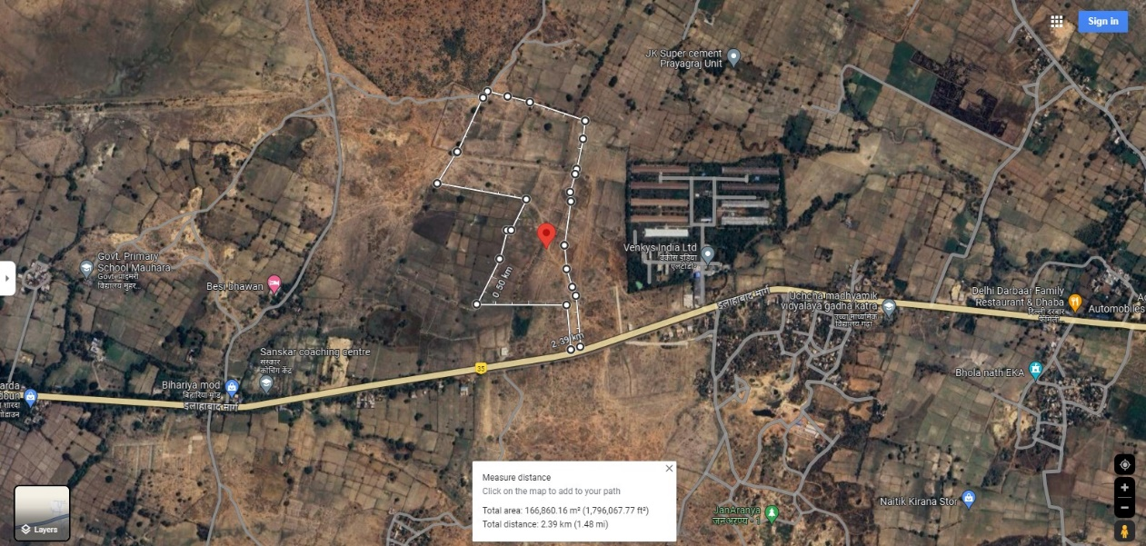

Breakup of the cost of land and site development is tabulated below:
Sr. No. | Particular | Amount
1. | Capital Cost of procured land for setting up the plant | 2,100
2. | Site preparation & development | 200
3. | Site enabling investigations (Topographical, Geotechnical & Hydrological) | 80
4. | Boundary Wall | 160
5. | Gates, Security Pickets, etc. | 30
6. | Approach Road to Plant | 250
7. | Plant Internal Roads | 555
8. | Truck Parking & Logistics Office | 425
9. | Plant Drainage | 175
10. | Landscaping and Provision of Green Belt | 25
 | Total(Amount in Rs. Lakhs) | 4,000
Source: TEFR prepared by HOLTEC Consultancy

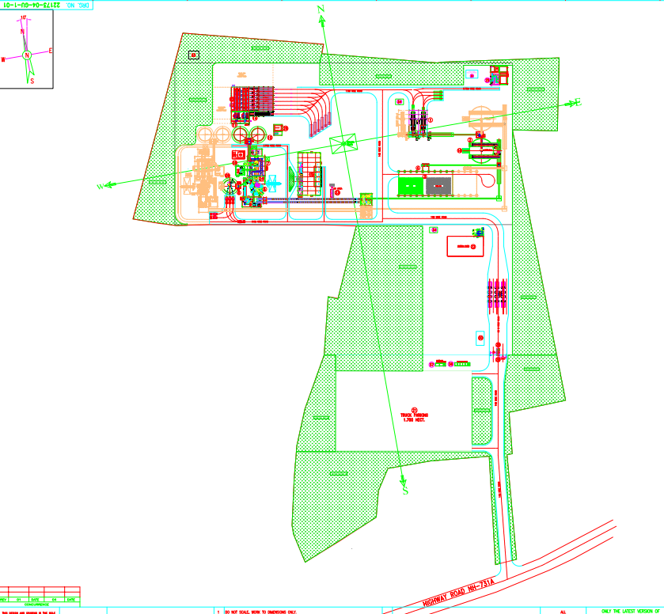

Note:
- Land is bounded by a permanent boundary wall.
- As per present status based on our site inspection, the actual project land was observed to be in possession of the company.
- Any ownership and legal verification is out of scope of this report.
- Title documents related to the land have not been provided to us.

- BUILDING & STRUCTURAL DETAILS: JKCL has planned following Building/ structures as per the requirement of the Plant. For the development of below listed sections, JKCL has estimated Rs.116.32 Crore in Building/ structures out of total project cost of 492.16 crores. Bifurcation of Rs.116.32 Crore is as below:
(Amount in Rs. Lakhs)
Sr. No. | Particular | Amount
1. | Main Factory Buildings | 2,335
2. | Silos, Hoppers, Storages, Covered Gantry, etc. | 4,465
3. | Auxiliary Services | 2,000
4. | Office/ non-factory buildings | 310
5. | Equip. Foundations (Machine Foundations) civil cost component | 477
6. | Indicative GST component on civil works | 2,045
 | Total | 11,632
Source: TEFR prepared by HOLTEC Consultancy

- Detailed breakup of above building sections:

Sr. No. | Particulars  (as per TEV) | Building Nomenclature used at Site | Building  Cost
 | Main Factory Buildings
 | HAG supporting structure | Hot air gas structure | 260
 | Cement mill house & deducting building | Grinding mill | 1,390
 | Cement mill house & deducting building | Bag House | 1,390
 | Cement mill house & deducting building | Reject Building | 1,390
 | Packing plant, truck loading, bags godown  Packing plant, truck loading, bags godown | Packing Plant | 685
 | Sub Total |  | 2,335
 | Silos, Hoppers, Storages, Covered Gantry, etc.
 | Additives (Gypsum, Pond ash) covered storage | Gypsum Storage | 575
 | Clinker silo & transport supporting infrastructure | Clinker Silo | 1,890
 | Support structure for cement mill hoppers (hoppers excluded) | Hopper Structure | 305
 | Dry Fly ash silo | Fly ash silo | 665
 | Cement silos (2nos. RCC silos) | Cement Silo | 1030
 | Sub Total |  | 4,465
 | Auxiliary Services
 | Switchyard & Main receiving substation | CCU Building Back Side | 125
 | CCU, Technical office, Laboratory, etc. | CCU Building | 385
 | MCC rooms & Load centres | CCU Building | 270
 | M&E Workshop (Not envisaged at this stage) | Future development | Future development
 | Liquid fuel storage tanks, dyke wall and pump foundations |  | 210
 | Compressor house (under Packing plant itself) | Packing Plant | -
 | Plant belt conveyor galleries & transfer towers | Spread All-over Plant | 570
 | Water storage (UG+OH) & Water treatment plant | Water Treatment Plant | 100
 | Weigh bridges & weigh rooms | Weigh Bridge | 5
 | BRU & truck tippler foundations with common ramp for receiving clinker & gypsum | Bulk Un-Loading Unit | 180
 | Overhead cable galleries | Spread All-over Plant | 135
 | Cable tunnels & trenches, etc. | Spread All-over Plant | 20
 | Sub Total |  | 2,000
 | Office/ non-factory buildings
 | Offices (Project, Logistics, Administration, Services) | CCU Building | 100
 | Time, security & dispatch offices block | --- | 20
 | Executives' & workers' canteens | Not constructed yet | 85
 | General store & yard (Basic provisioning only) | Not constructed yet | 90
 | Shift units/ washrooms (in general/common areas) | Not constructed yet | 15
 | Sub Total |  | 310
 | Equip. Foundations (Machine Foundations) civil cost component | Foundations | 477
 | Indicative GST component on civil works | --- | 2,045
Total (Amount in Rs. Lakhs) |  |  | 11,632
Source: TEFR prepared by HOLTEC Consultancy

Notes:

- The above estimation of cost is as per the TEFR prepared by HOLTEC consultancy.
- Building Plans have been prepared by HOLTEC consultancy only.
- Pertaining to our scope of work and unavailability of BOQ of the above buildings and structure, assessment of the cost has not been done in the report.
- The concerned building plans and HOLTEC consultancy TEFR provided to us doesn’t have individual measurements of various structures but consisted of estimated Cost to be incurred for the individual buildings. However, our team has physically measured major of the buildings as shown below:

Unit Name | Floors | Type Of Building | Area  (In Sq. Ft.) | Height  (In Ft.)
Bulk Unloading Unit | Single Floor | G.I Shed over steel structure | 6,370 | ~55
Gypsum Storage | Single Floor | G.I Shed over steel structure | 20,250 | ~45
Hopper Structure | --- | R.C.C & Steel structure both | 824 | ---
CCU | Ground +2 Floors | R.C.C framed structure | 8,120  (Ground floor area) | ~12
HAG Building | Single Floor | R.C.C framed structure | 1,225 | ~20
Source: Measurements done during site survey

Table No. 01

Progress Of Building and Civil Structures as Per Site Visit On 26th April 2024
Particulars | Type of Structure | Progress as on March 2024 | Remarks
Plant Building and its progress
Bulk Un-Loading Unit | G.I Shed over steel structure | ~90% | All the structure work is completed, minor finishing work is due.
Clinker Silo | R.C.C Structure | ~90% | All the structure work is completed, minor finishing work is due.
Gypsum Storage | G.I Shed over steel structure | ~95% | All the structure work is completed, minor finishing work is due.
Hopper Structure | Steel structure | ~90% | Major civil work is completed.
Grinding Unit (Mill) | Steel structure | ~85% | Major civil work is completed.
Reject Building | Steel structure | ~60% | Few structures work and finishing work is in progress.
Bag House | G.I Shed over steel structure | ~85% | Flooring and few finishing work are due.
Cement Silo 1 & 2 | R.C.C Structure | ~65% | Elevator root work in progress
Fly ash silo | R.C.C Structure | ~80% | Work in progress
Packing Plant | R.C.C Framed Structure | ~65% | Civil structure as well as finishing work in progress.
Central Control Unit | R.C.C Framed Structure | ~50% | Structure work is completed, major of the finishing work is in progress
Hot Air Gas Structure | R.C.C Framed Structure | ~90% | Structure work is completed, minor of the finishing work is in progress
Average Completion |  |  | ~79%
Non-Plant Building and its progress
Transport Office | R.C.C Framed Structure | ~50% | Structure work is complete, the Plaster work is in progress
Weigh Bridge Control Room | R.C.C Framed Structure | ~35% | Ramp work is in progress
Water Treatment Plant Civil Work | R.C.C Structure  and G.I shed work | ~80% | - R.C.C structure work is completed  - G.I Shed work is due
Landscape Development
Road | Concrete Roads | ~50% | Work currently in progress.
Drain | --- | ~80% | Work currently in progress.
Paver Blocks | --- | ~90% | Work currently in progress.

Chart representation of the Progress of Building & Civil Structures as on 26/04/24:

Note: The Physical progress captured in the above table is based on approximate observations during our site inspection and our subsequent discussions held with the engineers/ company representatives.

- PLANT MACHINERY & EQUIPMENT: JKCL has estimated Rs.220.61 Crore for plant and machinery, of total cost Rs.492.16 Crore for below listed Machinery/Equipment:

S. No. | Description | Cost
 | Mechanical Equipment
 | Gypsum & Pond ash - handling, storage & transport to mill feed hoppers | -
 | Gypsum crushing & Pond ash drying - (Not envisaged at this stage) | -
 | Dry Fly ash - pneumatic transport, storage, handling & feeding to mill | -
 | HAG system; including Liquid fuel (LDO) handling, storage & firing | -
 | Clinker transport, handling, storage, extraction & feeding system | -
 | Clinker grinding circuit & feeding to cement silos | -
 | Cement mill feeding hoppers' equipment (weigh feeders, level pilots, etc.) | -
 | Cement mill dedusting system | -
 | Cement extraction from silos, transport up to feed bin for packers | -
 | Packing, loading & dispatch (2 packers, 6 truck loaders, 2 bulk loaders) | -
 | Sub-total(1.0) | --
 | Mechanical Auxiliary Equipment | -
 | Structural steel for sheds, hoppers, conveyors, ducts, chutes, etc. | -
 | Material receiving system (Bulk receiving with truck tippler facility, 3 nos.) | -
 | Material conveying system (approx.800m @Rs.40,000/ m) | -
 | Insulation (approx.12,000sqm @Rs.1200/ sqm) | -
 | Refractories for HAG & wear lining of mill exhaust | -
 | Auxiliary bag filters | -
 | Lubricants | -
 | Passenger lift (for CCR) | -
 | Roots blowers | -
 | Compressors & dryers | -
 | Misc. items like water pump & pipeline, compressed air piping, etc. | -
 | Cranes/Hoists and other miscellaneous items, etc. | -
 | Sub-total(2.0)
 | Electrical and Instrumentation | -
 | HT motors | -
 | LV & MV AC variable Speed Drives | -
 | LT motors | -
 | Table-top XRF | -
 | Control & Automation | -
 | Sub-total(3.0)
 | Total (1.0+2.0+3.0) | 2,600
 | Imported Equipment’s
 | F.O.B Cost(1.0+2.0+3.0) | 2,600
 | Provisioning for Ocean Freight, Insurance, etc. | 155
 | Basic Import Duty provision | 205
 | GST | 535
 | Clearing/ Loading/ Inland Freight, etc. | 140
 | Subtotal of Imported Equipment(4.1) | 3,635
 | Indigenous Equipment
 | F.O.R. cost | 11,771
 | GST provisioning on F.O.R. cost (@18% of 4.2.1) | 2,120
 | Provisioning for freight, handling, insurance, etc. (approx.@5% of 4.2.1) | 590
 | Sub-total of Indigenous Equipment (4.2) | 14,481
 | Total Cost of equipment(4.1+4.2) | 18,116
 | Others
 | Provisioning for Spares (approx. @5% of F.O.B. & F.O.R. landed cost) | 905
 | Fabrication of Str. Steel as in 2.1 above (2,250 t @Rs.25,000/ t) | 565
 | Erection, Commissioning & Supervision Charges | 2,010
 | GST on Fabrication, erection & supervision charges | 465
 | Total cost of Mechanical and Electrical equipment | 22,061

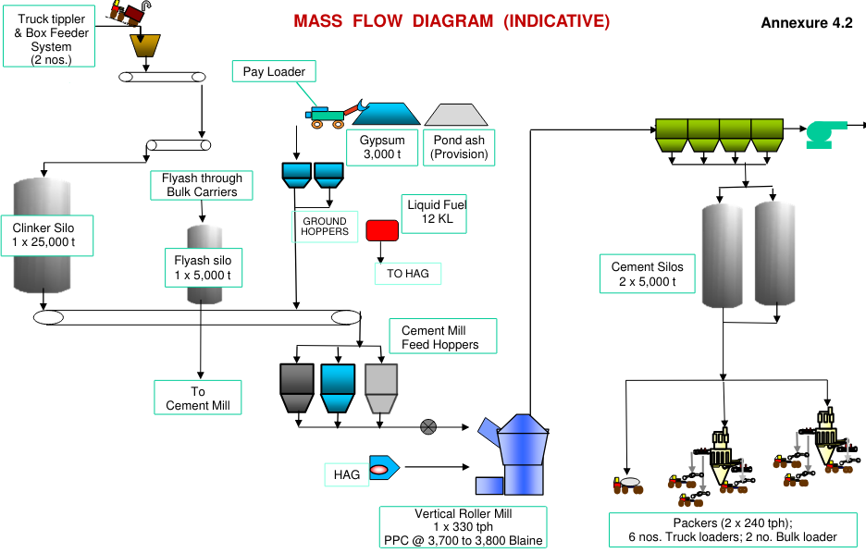
SOURCE: TEFR
Bulk/ Truck Loading/Feeder Unit:
From bulk load unit, the raw materials are loaded onto a clinker transport belt, this belt system is designed to move materials from one location to another, in this case, from bulk load unit to the clinker silo.

- Clinker Silo:
Raw materials transported through belts is put and stored in clinker silo, which is made of R.C.C, and has a capacity of 15,000 MT.

- Cement Mill Hoppers:
The hopper building is equipped with three silos, each storing distinct materials: Fly ash, Additives, and Clinker, delivered through dedicated transport belts. These materials are subsequently conveyed to the Vertical Roller Mill or Grinding Unit for further processing. The ratio of mixing these resources is remotely monitored and controlled from the central control unit (CCU). This system ensures precise blending of the materials, enabling the production of cement with the desired properties and characteristics.

- Grinding unit (Mill):

In this process, clinker, additives, and fly ash are obtained from the hopper, according to the specific quality requirements for cement production. These materials are then mixed and ground to achieve the desired size and quality of the final cement product. This blending and grinding process is a crucial step in cement manufacturing to meet the necessary quality standards.
Approved product | Rejected product

Cement Silos: | Reject Building:
The cement product, once it meets the required quality standards, is transported to cement silos via an air vent or shoot. These silos serve as storage units for the finished cement product, ready for distribution and use in various applications.
Cement products that do not meet the required quality standards are returned to the vertical roller mill for re-grinding and blending. This process allows for the correction of any deviations from the desired product specifications, ensuring that only cement of the specified quality is ultimately stored in the silos for distribution and use
- Packing Plant/Bulk Loading:
The packing plant is a multi-story structure with five floors (G+5), receiving the finished cement product from the cement silos through an air vent or strip. In this facility, the finished product is packaged using two well-equipped packing machines, each with 16 nozzles for efficient packaging. These packing machines have a capacity of 1.5 metric tons per hour (MTH) each and can simultaneously provide material for loading onto six trucks.

For larger bulk orders, a bulk loader is available to load containers directly, facilitating the efficient handling of larger quantities of cement for transportation and distribution.
Table 02

Progress of Plant/Machinery and Equipment’s as per site visit dated 26th April 2024
Particular | Percentage % | Remarks
Bulk Loading Unit | ~100% | All the necessary work for the installation of this unit has been completed, and it is now fully prepared and ready after testing.
Clinker Silo | ~90% | Major work for the installation of this unit has been completed, some minor material handling work such as conveyer work is due.
Central Control unit | ~50% | Panels and electrical equipment’s have been kept, commissioning of the same is due.
Hoppers | ~85% | Major works are completed, testing and commissioning is due.
Grinding Unit (Mill) | ~80% | Assembly of major parts/ equipment’s such as gear box, rotator is completed, few fabrications works were in progress, after which the team is planning for testing of the unit.
Reject Building | ~60% | Work was observed to be in progress.
Bag House | ~80% | Work was observed to be in progress.
Cement Silo 1 & 2 | ~60% | Work was currently in progress, such as elevator root work (30% completed)
Packing Plant | ~65% | Work was observed to be in progress.  The packing plant will consist of:  - Unit 1(16 nozzle)  - Unit 2 (16 nozzle)  - Unit 3 i.e. Truck Loading Unit (240 Ton per hour)
Weigh Bridge | ~60% | Work was observed to be in progress.
Overall Completion | ~73%

Observations and comments:
- Supporting photographs have been attached in the report. These photos serve as visual evidence of the completed works and provide a clear representation of the current status of the unit.
- During our site inspection dated 26th April 2024, the construction and plant machinery work was observed to be in progress. As per the information provided the representative, the company is planning to achieve its commercial operation by June-July 2024 i.e. before the scheduled completion date which was supposed to be on February 2025.
- The Physical progress captured in the above table is based on approximate observations of status of plant/machineries installed on site during our site inspection and our subsequent discussions held with the engineers/ company representatives with whom the site visit was conducted. Thus, the above progress is on approximate basis which may vary from 5%-10% (+-).
- Apart from the machineries listed above, below listed essential machineries were also observed during site visit:

- Bag filter fans for raw mill  - Chain conveyors and rollers at various location  - Small motors at various locations  - Parts of cement machineries  - Other small and miscellaneous machineries | - Electrical and automation works  - Weigh bridges.  - Hot air generator system in Cement mill  - Interconnecting chutes in cement mill  - Control panel and switches

PART D | PROJECT CONSULTANTS, CONTRACTORS & SUPPLIERS
The borrower has provided information about the list of contractors deployed in the project at Prayagraj, Uttar Pradesh. However, we are unable to verify the contract amounts due to the unavailability of contract agreements or purchase orders (POs). Brief details of vendors as per the information provided by company representative during site survey is shown below:
Sr. No. | Major Vendor | Description
 | M/s Buildwell | Civil Contractor
 | M/s BV Construction | Civil Contractor
 | M/s Kanha Developers & Builders | Civil Contractor
 | HAPBCO | Mechanical Contractor (Erection)
 | R.K Steel | Equipment’s (Erection)
 | Schneider | Lifts
 | LOESCHE | VRM Supplier

PART E | PROJECT COST & MEANS OF FINANCE

- TOTAL PROJECT COST: JKCL has estimated the Total Project Cost amounting to Rs.492.16 Crore which has been proposed to be funded in DER of approx. 62% Debt and 38% Equity. Details of Rs.492.16 Crore is as below:

Sr. No. | Particulars | Amount (in Rs. Lakh)
1. | Land and Site Development | 4,000
2. | Civil Works, Buildings and Structures | 11,632
3. | Plant and Machinery | 22,061
4. | Expenses on technical know-how & training | 450
5. | Miscellaneous Fixed Assets | 5,125
6. | Pre-Operative Expenses  (including Interest During Construction &Finance charges) | 2,960
7. | Contingency | 2,229
8. | Margin Money for Working Capital | 759
Estimated Total Project Cost |  | 49,216
Source: TEFR prepared by HOLTEC Consultancy

- CURRENT STATUS & TOTAL EXPENDITURE INCURRED TILL DATE: Details of the expenditure in the Table below is recorded for the expenditure incurred up to 31st Jan 2024:
Particulars | Total Estimated Cost  (In Rs. Cr.) | Amount Incurred Till 31.00.2024  (As per CA Cert.) | Remarks
Land and Site Development. | 40.00 | 22.06 | As per CA Certificate UDIN. 24424004BKAQAY2271 the borrower has shown an expenditure amounting to Rs.22.06 Crore towards land and site development. Due to unavailability of contract agreements, invoices, independent assessment of expenditure is not carried out at our end.
Plant, Machinery/ Building & Civil Structures | 336.93 | 174.63 | The amount mentioned is only as per CA Certificate dated 27/02/2024 UDIN. 24424004BKAQAY2271. Due to unavailability of invoices, and also as per our scope of report assessment of expenditure is not carried out at our end.
Pre-operative Expenses | 29.60 | 5.99 | Amount as per CA Certificate
Contingency | 22.29 | --- | ---
Margin Money for Working Capital | 7.59 | --- | ---
Other Expenses | 55.75 | ---
Total | 492.16 | 202.68 | Amount as per CA Certificate.

Note:
            - Above amount is as shown in the CA Certificate dated 27/02/2024 UDIN. 24424004BKAQAY2271.
            - The LIE assessment is for the quarter ending March 2024, but the expense shown is as per CA Certificate of January ending month, this is mainly because CA Certificate for the March ending month was not available with the client.

- SOURCES OF FINANCE & UTILIZATION OF FUNDS: The Project cost mentioned above has been planned to be covered from following resources:
PARTICULARS | ENVISAGED  MEANS OF FINANCE | AMOUNT INCURRED  Till 31.01.2024  (As per CA Cert.)
Promoter’s Contribution (Equity) | 307.14 | 120.11
Term Loan (Debt) | 185.02 | 76.54
Others (Project Creditors) | --- | 6.03
TOTAL (In Rs. In Cr.) | 492.16 | 202.68

PART F | STATUTORY & REGULATORY APPROVALS, CLEARANCES & NOC

Sr.  No. | NAME OF LICENSE/ REGISTRATION | PURPOSE/ | DATE OF ISSUE | Current Status
Sr.  No. | ISSUING AUTHORITY | PURPOSE/ | LICENCE NO. | Current Status
 | Site Plan | Layout | 16-06-2023 | Provided
 | Unapproved | Layout | 16-06-2023 | Provided
 | Fire Plan Approval Certificate | Provisional NOC | 03-05-2024 | Applied
 | Chief Fire-Fighting Officer | Provisional NOC | 03-05-2024 | Applied
 | Environment Clearance | Approval as per environment guidelines in the area | Dated: 19/07/2023 | As on date the clearance is valid
 | Ministry of Environment, Forest and Climate Change | Approval as per environment guidelines in the area | EC NO.: 23A009UP119311 | As on date the clearance is valid
 | Consent to Establish | Approval as per Pollution norms applicable in that area | Dated:- 28/07/2023 | Validity Period 28/07/2023 To 27/07/2028
 | Uttar Pradesh Pollution Control Board | Approval as per Pollution norms applicable in that area | Ref No. 187582/UPPCB/  Allahabad(UPPCBRO)/  CTE/PRAYAGRAJ/2023 | Validity Period 28/07/2023 To 27/07/2028
 | For Sinking of New / Existing Well for Industrial/Commercial/ Infrastructural Or Bulk User Of Ground Water. | Approval to use ground water | Registration No.: 202208001083  Form Submission date: 27/08/2022 | Valid Period  04/11/2022 To 03/11/2027
 | Ground Water Department (Ministry of Jal Shakti) | Approval to use ground water | Registration No.: 202209001112  Form Submission date: 21/09/2022 | Valid Period  04/11/2022 To 03/11/2027
 | Ground Water Department (Ministry of Jal Shakti) | Approval to use ground water | Registration No.: 202209001116  Form Submission date: 21/09/2022 | Valid Period  04/11/2022 To 03/11/2027
 | GST Registration Certificate | GST Registration | 09AABCJ0355R6Z0 | Obtained
 | Government of India Form GST REG-06 | GST Registration | 31/07/2023 | Obtained
Observations & Comments:
- Only major approvals are shown above as obtained by the company and shared with us.

PART G | PROJECT IMPLEMENTATION SCHEDULE AND CURRENT STATUS

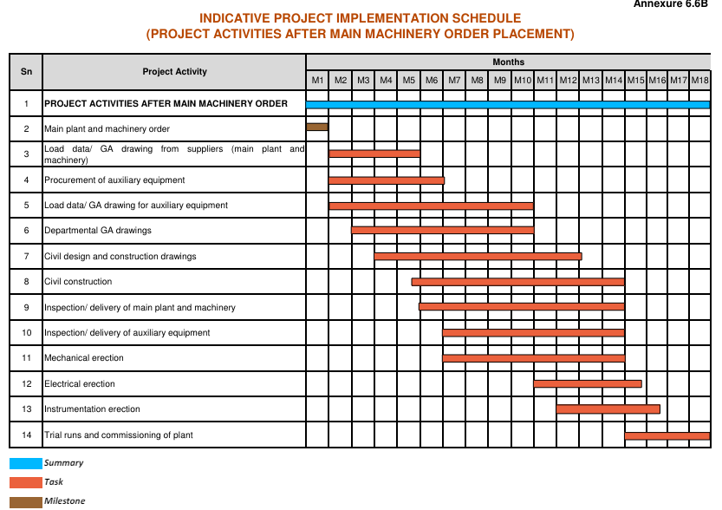
M1 = August 2023
M18 = February 2025

Current Status

PART H | CONCLUSION

- Based on visual observation and subsequent discussions held with the engineers from the company accompanying our team during site visit, it appears that approximately 80% construction of the essential civil structures like Raw mills, Cement mill building, Switchyard control room, Clinker Silo, fly ash silos, Cement silos, packing plant, Bag house & De dusting building, Fly ash silo, Cement hopper building, Clinker silo, Additive shed, Bulk reception unit is completed and around 70% of essential machineries required for commercial production were installed as described in detail in Table No. 01 (Page no. 13) & Table No. 02 (Page no. 19). However overall project’s progress may vary due to ancillary works and site development works which are yet to take shape & commence.

- As per the information provided the representative, the company is planning to achieve its commercial operation by June-July 2024 i.e. before the scheduled completion date which is slated in February 2025. As per the site visit on 26th April 2024 the target seems to be achievable for trial run by July-August 24 as per current progress.

- As per our site visit on 26th April 2024 the civil and building construction work is progressing at a satisfactory pace.

PART I | DISCLAIMER

      - No employee or member of R.K Associates has any direct/ indirect interest in the Project.
      - This report is prepared based on the copies of the documents/ information which the Bank/ Borrower has provided to us out of the standard checklist of documents sought from them and further based on our assumptions and limiting conditions. The client/owner and its management/representatives warranted to us that the information they supplied was complete, accurate and true and correct to the best of their knowledge. All such information provided to us has been relied upon in good faith and we have assumed that it is true and correct in all respect. I/We shall not be liable for any loss, damages, cost or expenses arising from fraudulent acts, misrepresentations, or wilful default on part of the owner, borrower, its directors, employee, representative or agents. Verification or cross checking of the documents provided to us from the originals or from any Govt. departments/ Record of Registrar has not been done at our end since this is beyond the scope of our work. If at any time in future, it is found or came to our knowledge that misrepresentation of facts or incomplete or distorted information has been provided to us then this report shall automatically become null & void.
      - Legal aspects for eg. investigation of title, ownership rights, lien, charge, mortgage, lease, sanctioned maps, verification of documents, etc. have not been done at our end and same has to be taken care by legal expert/ Advocate. It is assumed that the concerned Lender/ Financial Institution has satisfied them with the authenticity of the documents, information given to us and for which the legal verification has been already taken and cleared by the competent Advocate before requesting for this report. I/ We assume no responsibility for the legal matters including, but not limited to, legal or title concerns.
      - This report is a general analysis of the project based on the scope mentioned in the report. This is not an Audit report, Design document, DPR or Techno feasibility study. All the information gathered is based on the facts seen on the site during survey, verbal discussion & documentary evidence provided by the client and is believed that information given by the borrower is true best of their knowledge.
      - All observations mentioned in the report is only based on the visual observation and the documents/ data/ information provided by the client. No mechanical/ technical tests, measurements or any design review have been performed or carried out from our side during Project assessment.
      - This report doesn’t claim any quality assurance of the Products and the material being used in the Project.
      - Bank/FII should ONLY take this report as an Advisory document from the Financial/ Chartered Engineering firm and its specifically advised to the creditor to cross verify the original documents for the facts mentioned in the report which can be availed from the borrowing borrower directly.
      - In case of any default in loans or the credit facility extended to the borrowing borrower, R.K Associates shall not be held responsible for whatsoever reason may be and any request for seeking any explanation from the employee/s of R.K Associates will not be entertained at any instance or situation.
      - The documents, information, data provided to us during the course of this assessment by the client is reviewed only up to the extent required in relation to the scope of the work. No document has been reviewed beyond the scope of the work.
      - This report only contains general assessment & opinion as per the scope of work evaluated as per the information given in the copy of documents, information, data provided to us and/ and confirmed by the owner/ owner representative to us at site which has been relied upon in good faith. It doesn’t contain any other recommendations of any sort including but not limited to express of any opinion on the suitability or otherwise of entering into any transaction with the borrower.
      - We have relied on data from third party, external sources & information available on public domain also to conclude this report. These sources are believed to be reliable and therefore, we assume no liability for the truth or accuracy of any data, opinions or estimates furnished by others that have been used in this analysis. Where we have relied on data, opinions or estimates from external sources, reasonable care has been taken to ensure that such data has been correctly extracted from those sources and /or reproduced in its proper form and context, however still we can’t vouch its authenticity, correctness or accuracy.
      - This Report is prepared by our competent technical team which includes Engineers and financial experts & analysts.
      - This is just an opinion report and doesn’t hold any binding on anyone. It is requested from the concerned Financial Institution which is using this report for taking financial decision on the project that they should consider all the different associated relevant & related factors also before taking any business decision based on the content of this report.
      - All Pages of the report including annexures are signed and stamped from our office. In case any paper in the report is without stamp & signature then this should not be considered a valid paper issued from this office.
      - Though adequate care has been taken while preparing this report as per its scope, but still, we can’t rule out typing, human errors, over sightedness of any information or any other mistakes. Therefore, the concerned organization is advised to satisfy themselves that the report is complete & satisfactory in all respect. Intimation regarding any discrepancy shall be brought into our notice immediately. If no intimation is received within 15 (Fifteen) days in writing from the date of issuance of the report, to rectify these timely, then it shall be considered that the report is complete in all respect and has been accepted by the client upto their satisfaction & use and further to which R.K Associates shall not be held responsible in any manner.
      - Defect Liability Period is 15 DAYS. We request the concerned authorized reader of this report to check the contents, data and calculations in the report within this period and intimate us in writing if any corrections are required or in case of any other concern with the contents or opinion mentioned in the report. Corrections only related to typographical, calculation, spelling mistakes, incorrect data/ figures/ statement will be entertained within the defect liability period. Any new changes for any additional information in already approved report will be regarded as additional work for which additional fees may be charged. No request for any illegitimate change in regard to any facts & figures will be entertained.
      - R.K Associates encourages its customers to give feedback or inform concerns over its services through proper channel at valuers@rkassociates.org in writing within 15 days of report delivery. After this period no concern/ complaint/ proceedings in connection with the Financial Feasibility Study Services will be entertained due to possible change in situation and condition of the subject Project.
      - Our Data retention policy is of ONE YEAR. After this period, we remove all the concerned records related to the assignment from our repository. No clarification or query can be answered after this period due to unavailability of the data.
      - This Lender’s Independent Engineer report is governed by our (1) Internal Policies, Processes & Standard Operating Procedures, (2) Information/ Data/ Inputs given to us by the client and (3) Information/ Data/ Facts given to us by our field/ office technical team. Management of R.K Associates never gives acceptance to any unethical or unprofessional practice which may affect fair, correct & impartial assessment and which is against any prevailing law. In case of any indication of any negligence, default, incorrect, misleading, misrepresentation or distortion of facts in the report then it is the responsibility of the user of this report to immediately or at least within the defect liability period bring all such act into notice of R.K Associates management so that corrective measures can be taken instantly.
      - R.K Associates never releases any report doing alterations or modifications from pen. In case any information/ figure of this report is found altered with pen then this report will automatically become null & void.

SURVEY ANALYST | VALUATION ENGINEER | L1/ L2 REVIEWER
Vishal Singh | Vishal Singh | Sr. V.P Projects

DEFECT LIABILITY PERIOD - In case of any query/ issue or escalation you may please contact Incident Manager by writing at valuers@rkassociates.org. We ensure 100% accuracy in the Calculations done, Rates adopted and various other data points & information mentioned in the report but still can’t rule out typing, human errors or any other mistakes. In case you find any mistake, variation, discrepancy or inaccuracy in any data point of the report, please help us by bringing all such points into our notice in writing at valuers@rkassociates.orgwithin 30 days of the report delivery, to get these rectified timely, failing which R.K Associates Valuers Techno Engineering Consultants (P) Ltd. won’t be held responsible for any inaccuracy in any manner. Also, if we will not hear back anything from you within 30 days, we will assume that report is correct in all respect and no further claim of any sort will be entertained thereafter. We would welcome and appreciate your feedback & suggestions in order to improve our services.

COPYRIGHT FORMAT - This report is prepared on the copyright format of R.K Associates Valuers Techno Engineering Consultants (P) Ltd. to serve our clients in the best possible way. Legally no one can copy or distribute this format without prior approval from R.K Associates. It is meant only for the organization as mentioned on the cover page of this report. Distribution or use of this format other than R.K Associates will be seen as unlawful act and necessary legal action can be taken against the defaulter.

ENCLOSURE
CA CERTIFICATE DATED 27th February 2024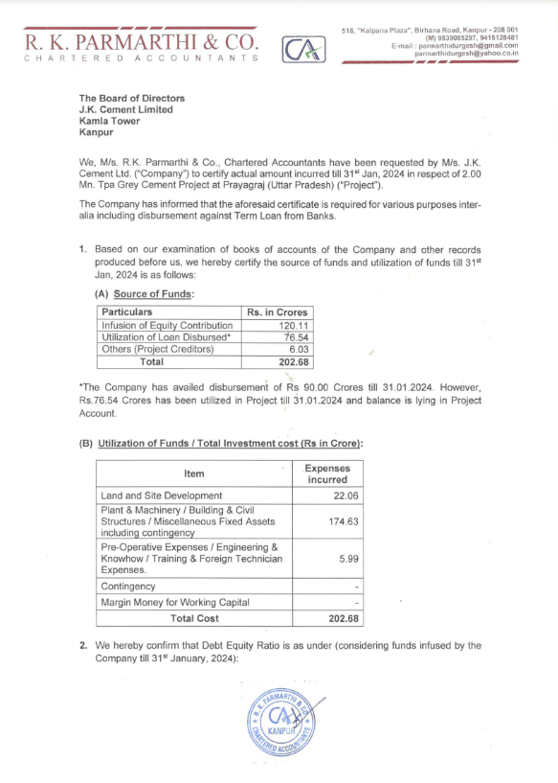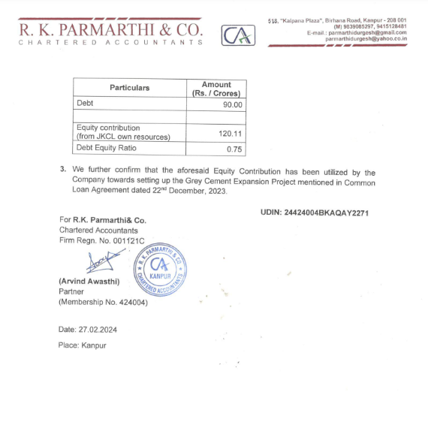
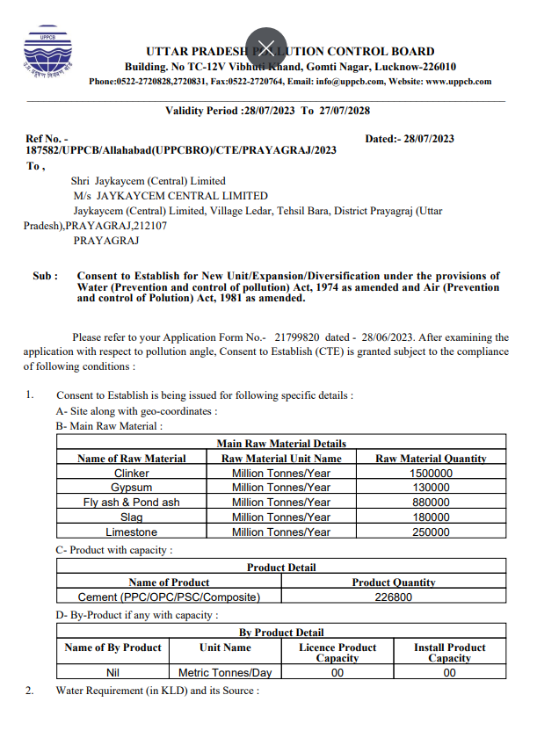
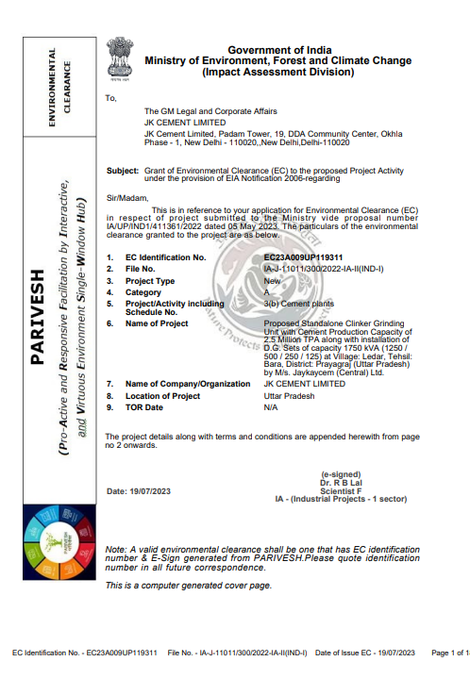

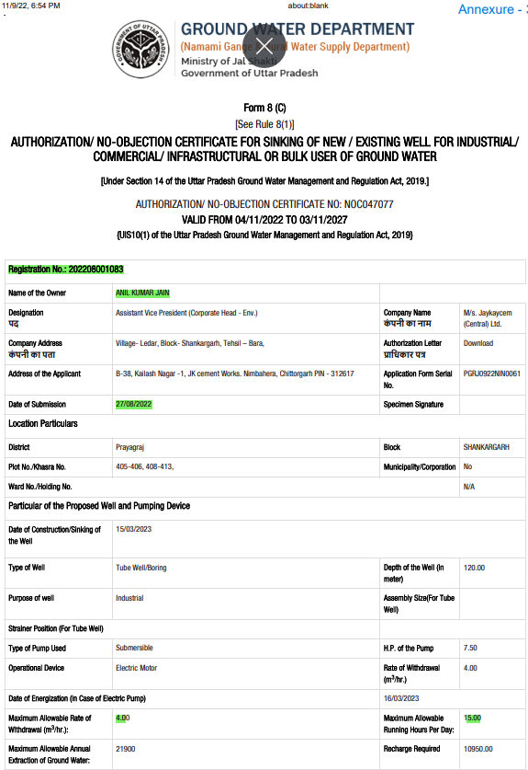 | 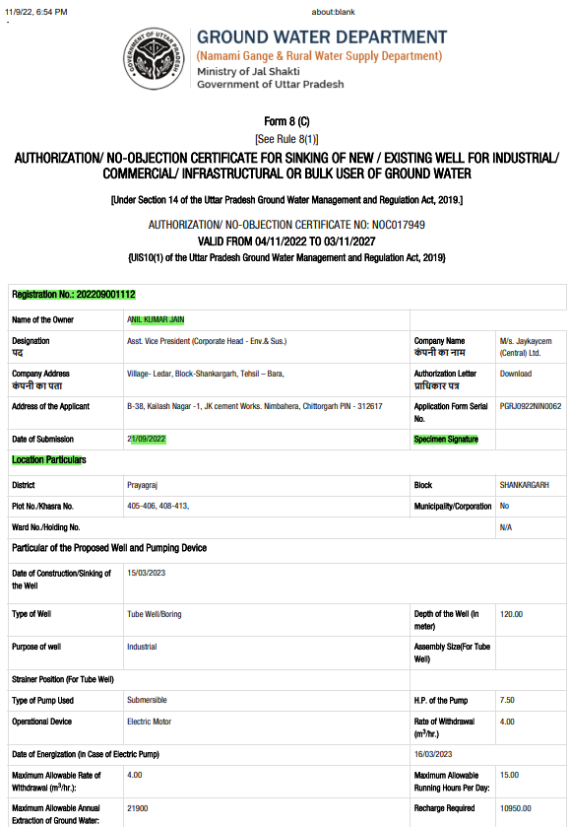
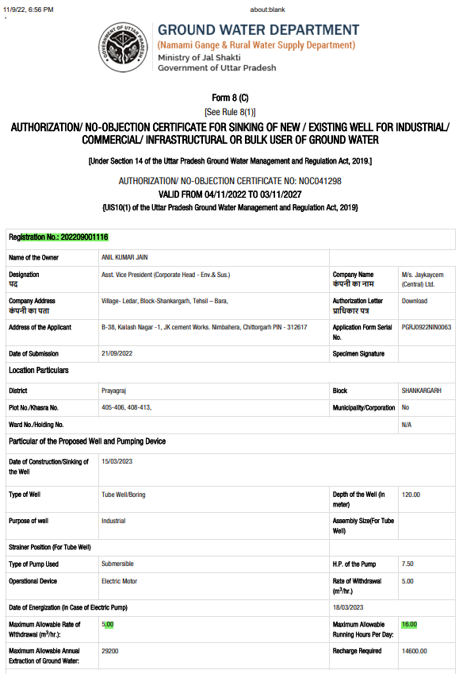

BULK LOADING UNIT
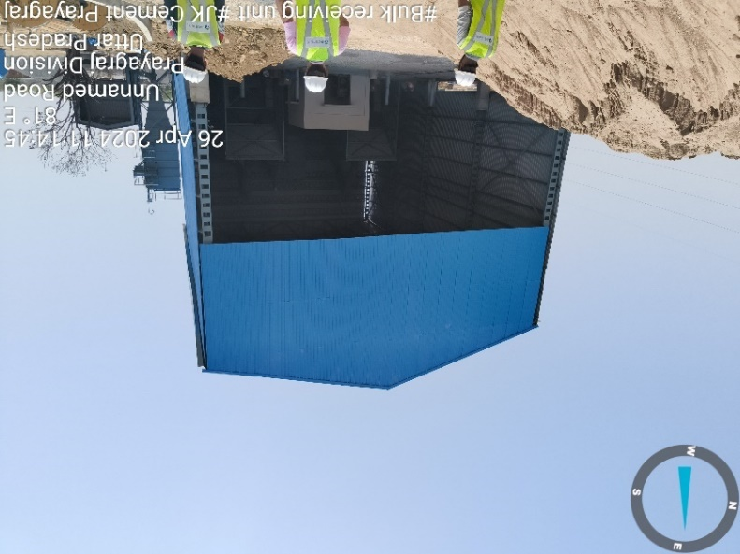 |  |  |  | 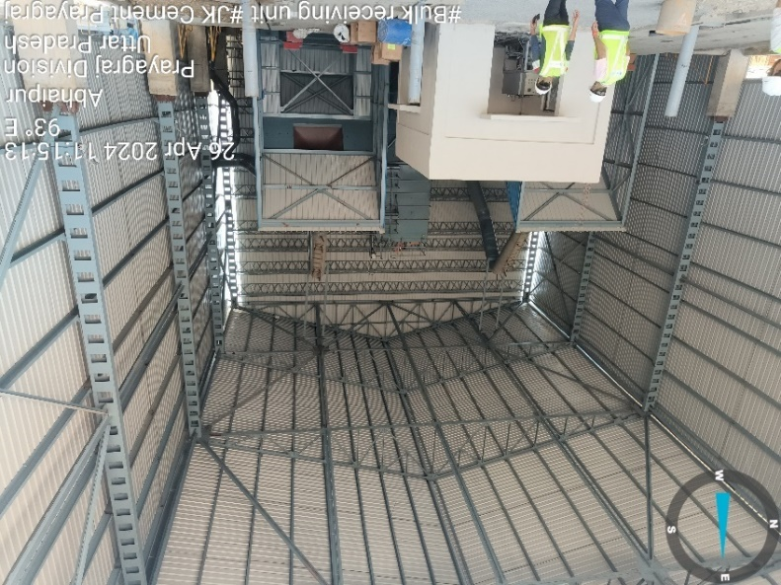
GYPSUM AND POND ASH STORAGE UNIT
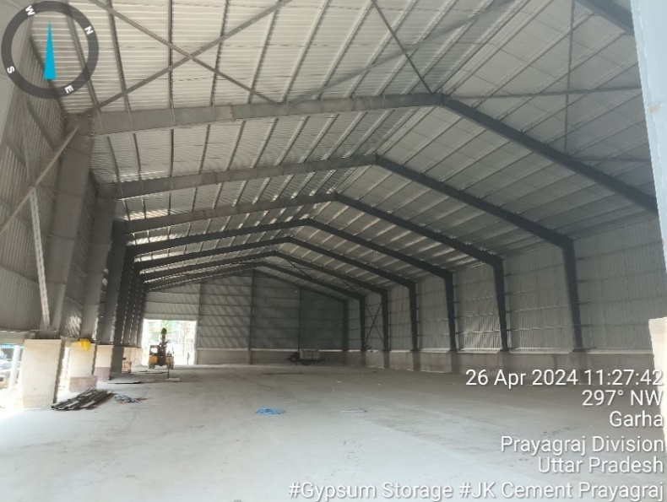 |  |  |  |  | 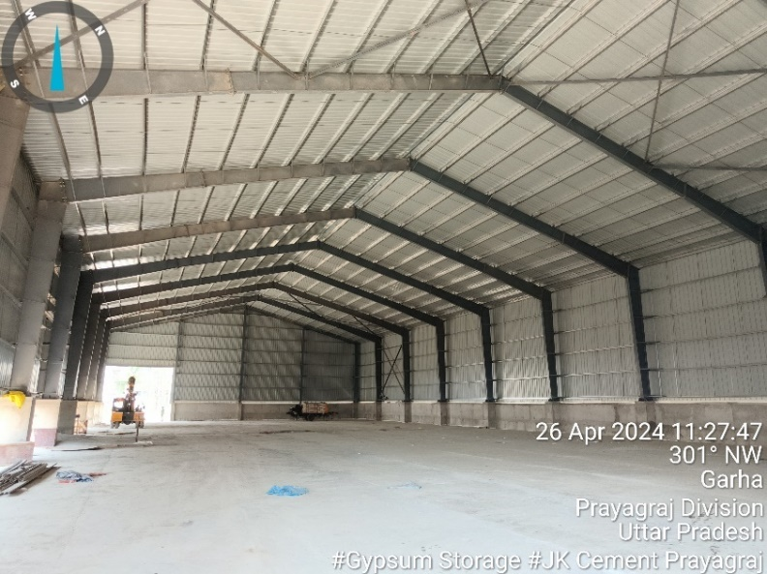
CLINKER SILO
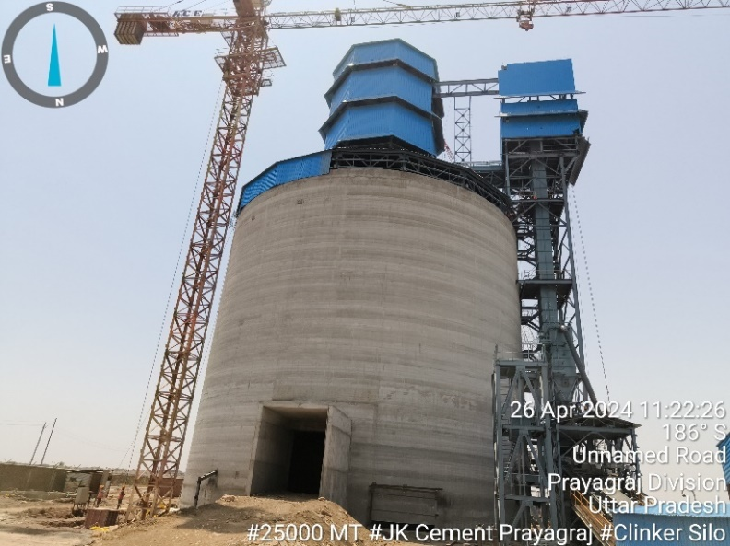 | 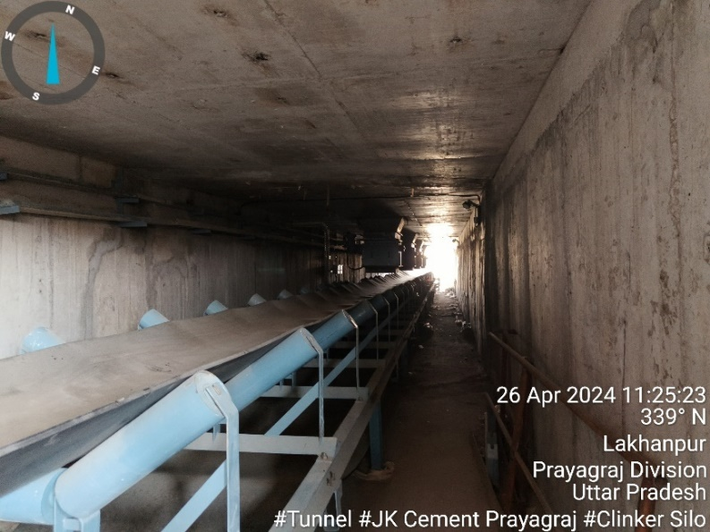
HOPPER
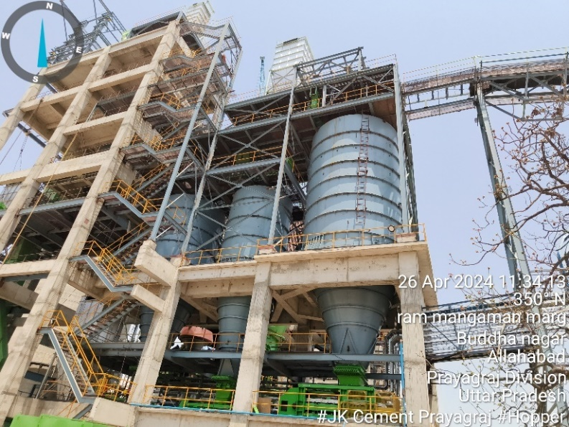 |  |  | 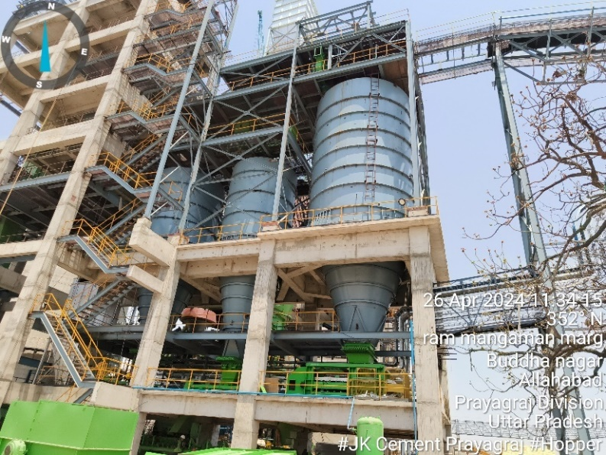
GRINDER UNIT / MILL / VRM
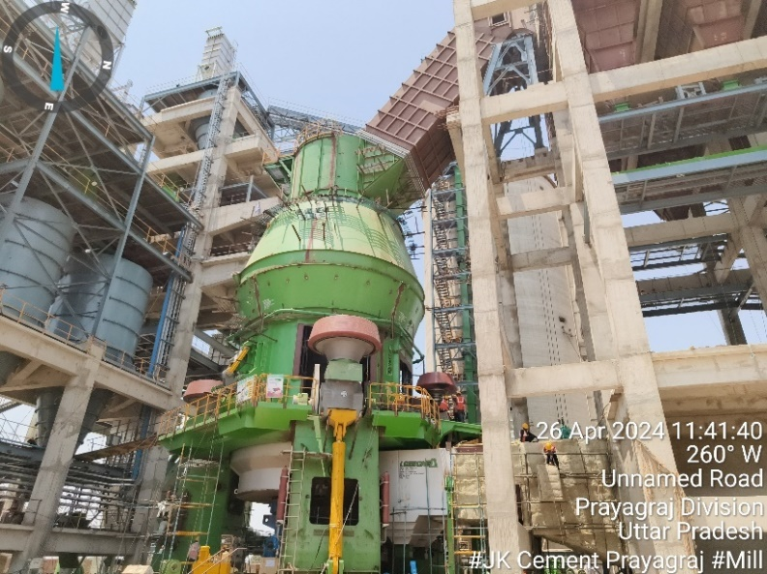 | 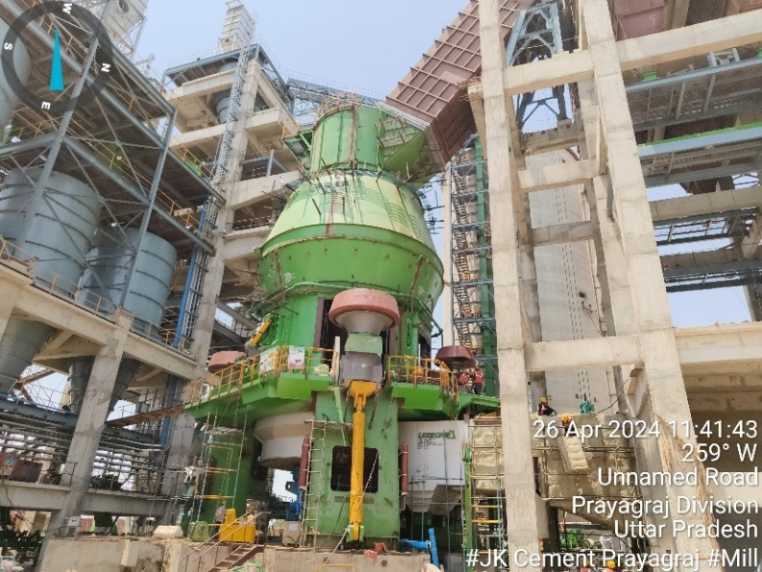
PACKING UNIT
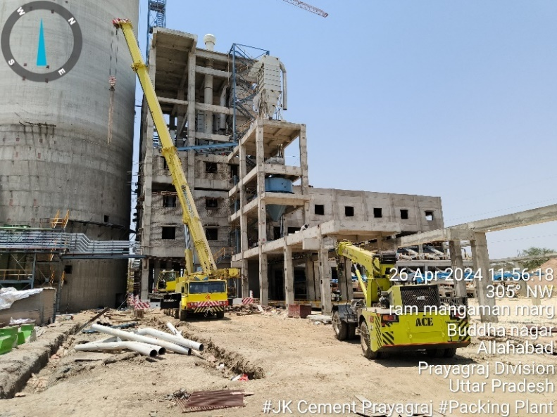 |  | 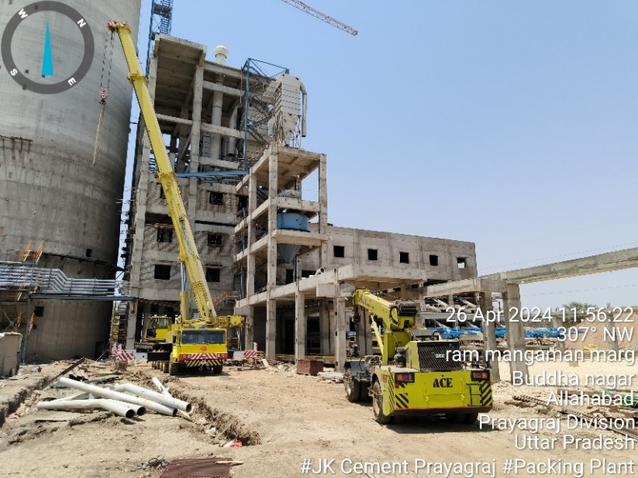
CEMENT SILO
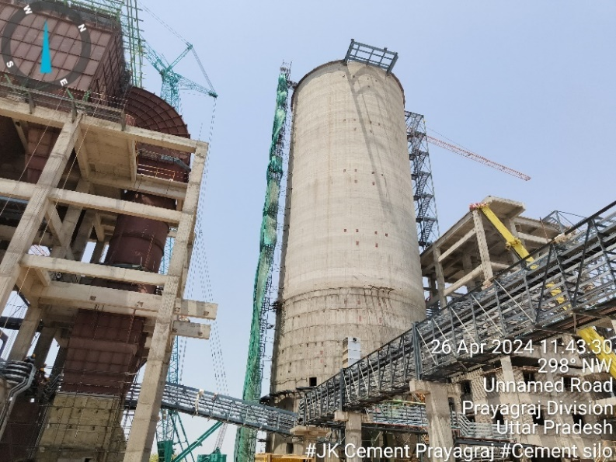 |  |  | 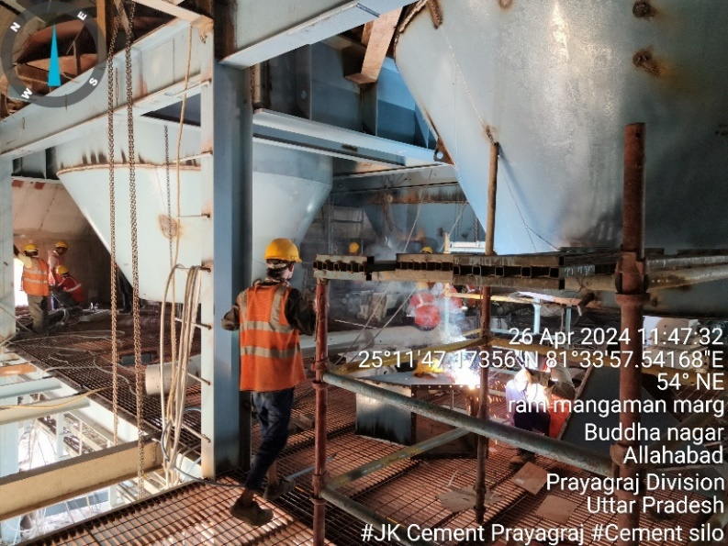
CENTRAL CONTROL UNIT(CCU)
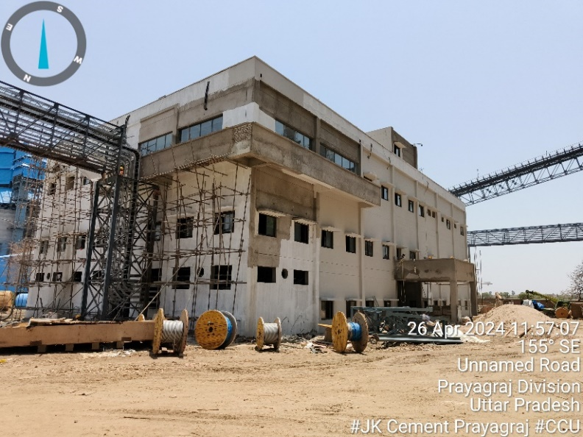 |  |  | 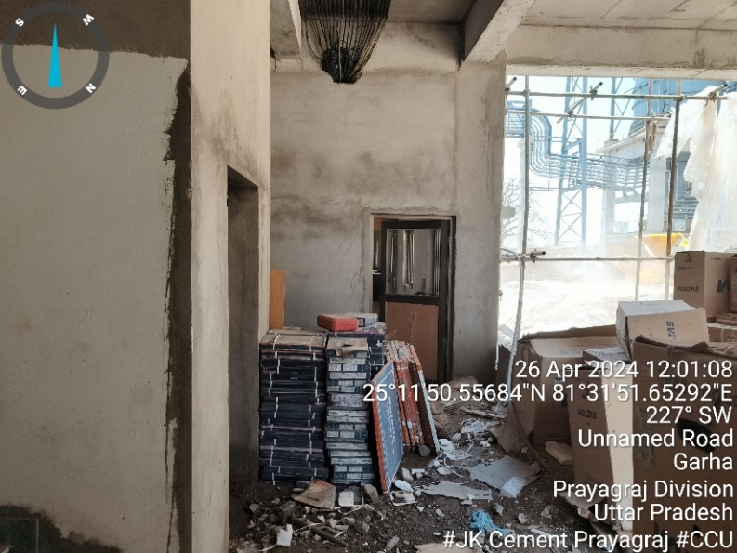
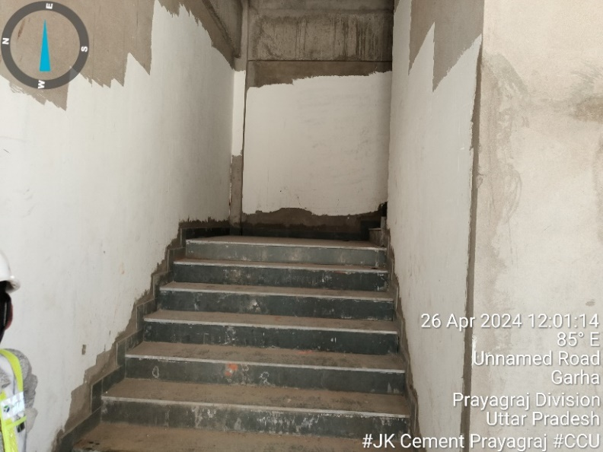 |  |  | 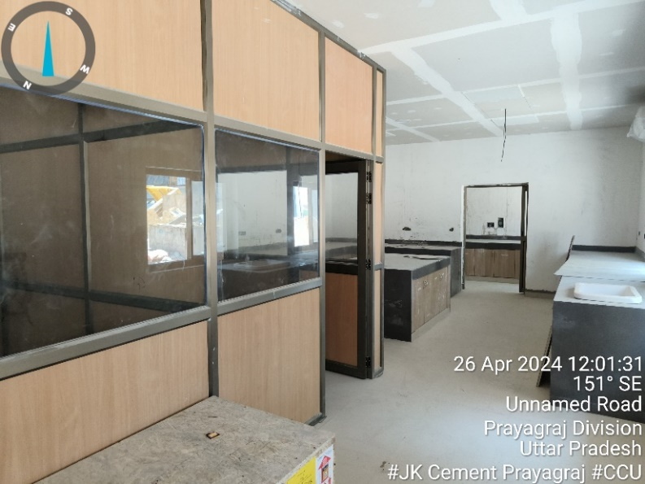

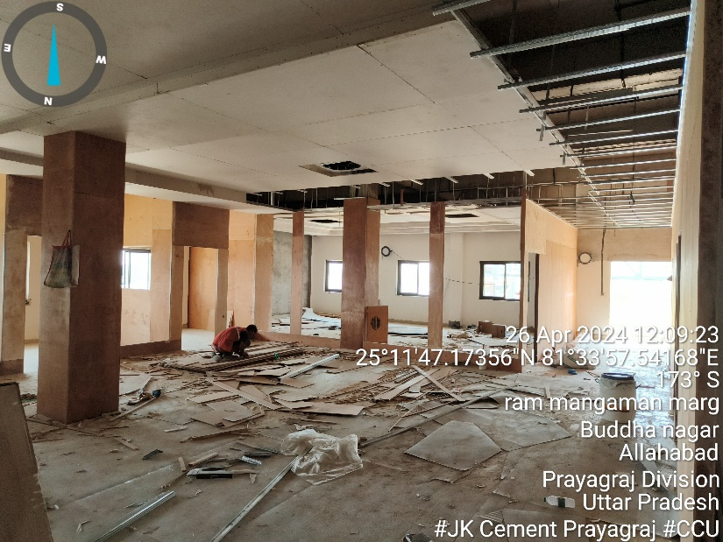 | 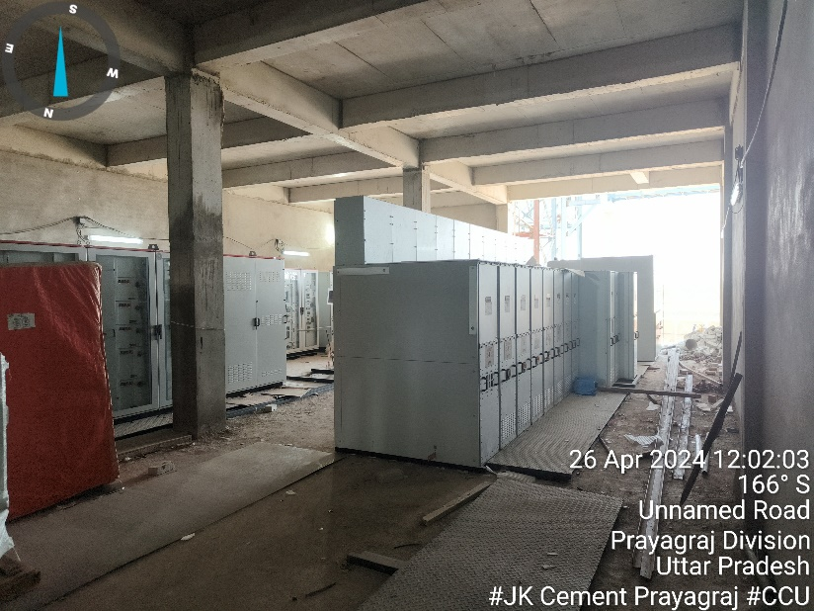
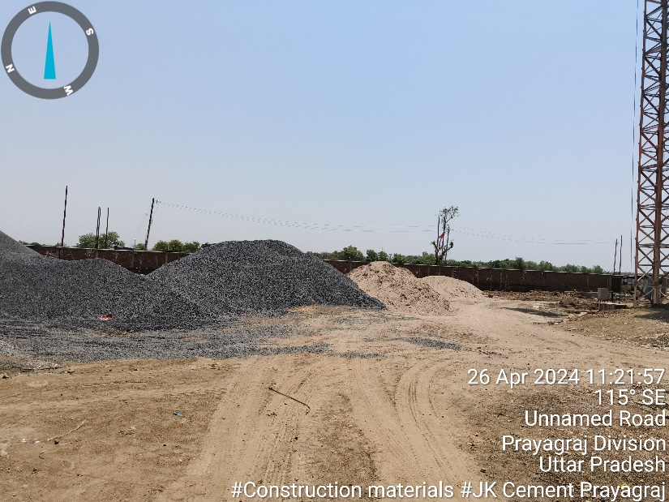 | 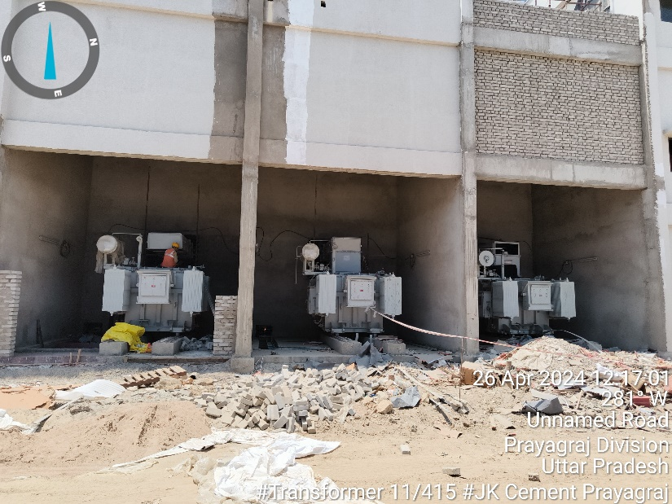
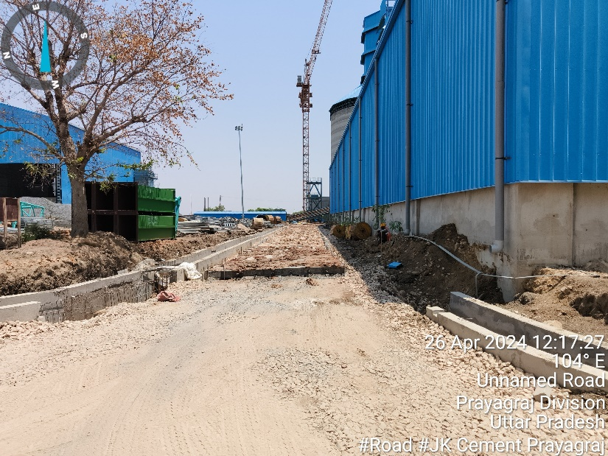 | 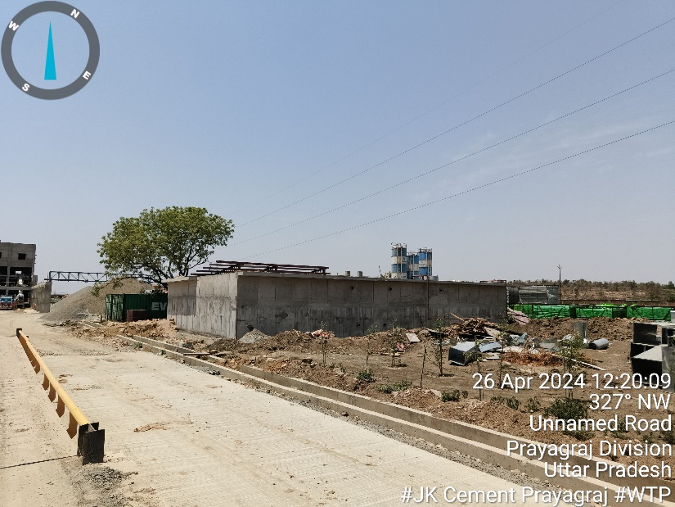

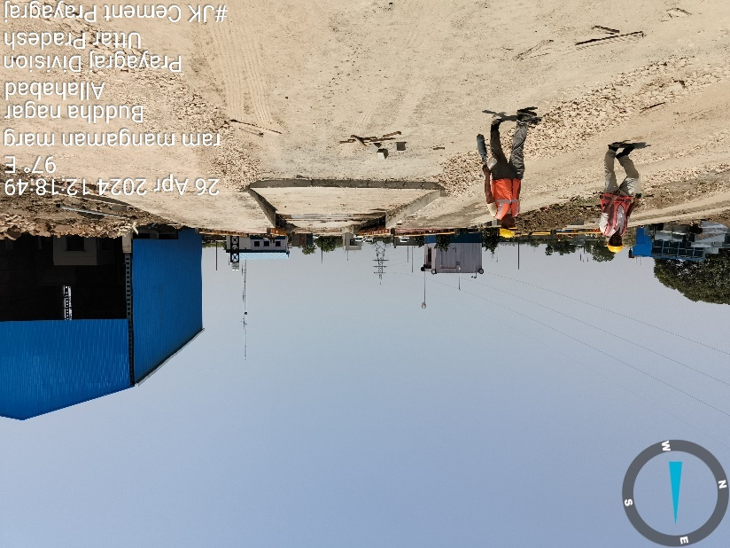 | 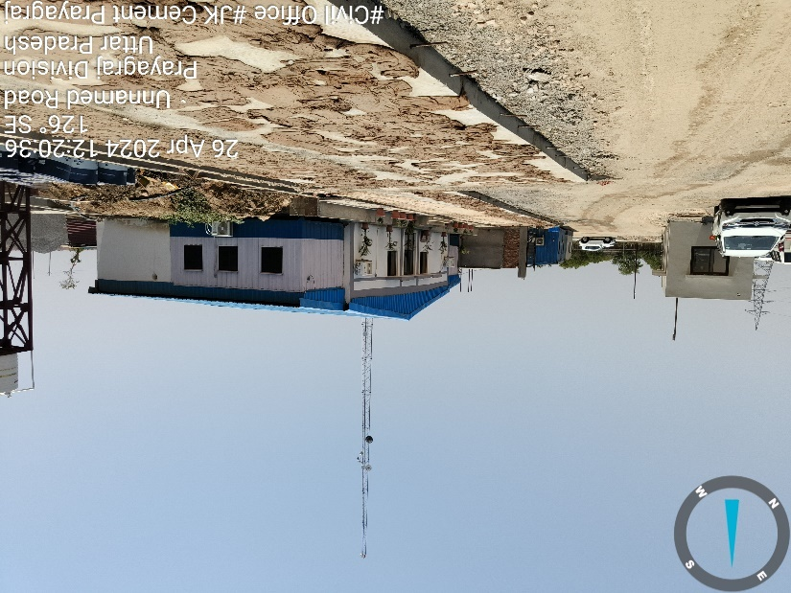
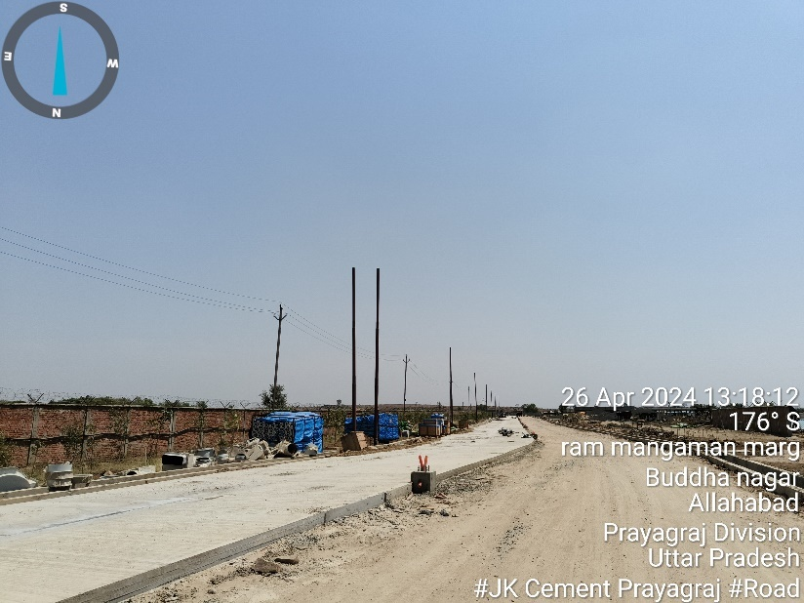 | 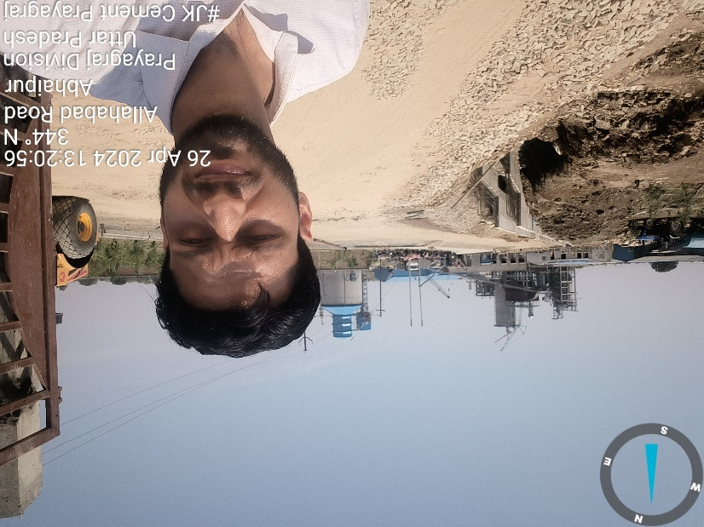
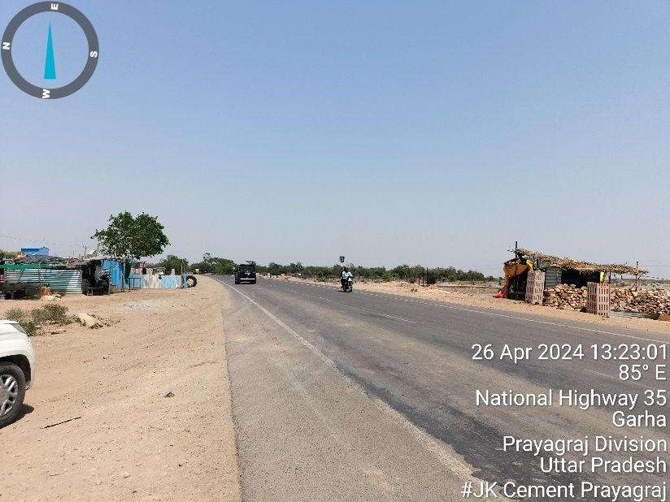 | 