REPORT FORMAT: CL-1 | Version: 1.0_2018

FILE No.: VIS(2024-25)-PL012-012-012 Date: 08-04-2024

CERTIFICATE NAME: Progress Report for Machines of M/s. Baldeep Pack (I) Pvt. Ltd. installed at Khasra No. 22, Mauza Amarpur Urf Begumpur, Pargana Harora, Gagarhedi Road, U.P.
- FOR ORGANIZATION: State Bank of India, SME Branch, Roorkee, Haridwar

- BORROWER COMPANY’S NAME: M/s. Baldeep Pack (I) Pvt. Ltd.

ASSET TYPE: Packing Machinery.

CURRENT LOCATION OF THE MACHINES: Installed at Khasra No. 22, Mauza Amarpur Urf Begumpur, Pargana Harora, Gagarhedi Road, U.P.

TO WHOMSOEVER IT MAY CONCERN

S. NO. | PARTICULARS | DESCRIPTION
1. | Date of Survey | 04-04-2024
2. | Date of Certificate | 08-04-2024
3. | Documents provided for perusal | List of machines
4. | Current Location of the Machines | Installed at Khasra No. 22, mauza Amarpur Urf Begumpur, Pargana Harora, Gagarhedi Road, U.P.
5. | Borrowing Company | M/s. Baldeep Pack (I) Pvt. Ltd.
6. | Type of Asset | Machines required for packing industry
7. | Type of Assessment | Progress of machines installed at site.
8. | Scope of Assessment | Progress of machines installed at site.
9. | Nature of Machinery | Packing Industry Machinery
10. | Current Progress of the machines | As per physical inspection made during site visit,  Company has installed all the machines as per the list provided.
11. | Condition of Machines | Installed machines and equipment are new and ready for production.

OBSERVATIONS:

We have been provided with the list of machines that has to be purchased/ installed/ proposed to be installed by the borrower company.
  - Based on the information provided by the subject company (M/s. Baldeep Pack (I) Private Limited), it is certified that the following machines have been installed at the above-mentioned site address.

 |  | LIST OF MACHINES AND EQUIPMENTS
S. NO. | NAME OF MACHINERY |  | Quantity/Nos | Status During Site Visit
1 | 5 Ply Automatic Board making Plant 1800MM |  | 1 | Purchased & Installed
2 | 4 Ton Boiler And Fitting Charge With Chimney With Electricals Parts |  | 1 | Purchased & Installed
3 | Three Colour LRDAGE Printer With RS-4 With Rotary Die Cutter |  | 1 | Purchased & Installed
4 | Two Colour LRDAGE Printer With RS-4 With Rotary Die Cutter |  | 1 | Purchased & Installed
5 | Semi-Automatic Double Pin Movable Head Stitching Machine 120nail/min |  | 3 | Purchased & Installed
6 | Fork Lifter |  | 1 | Purchased & Installed
7 | Automatic Folder Gluer Machine With Stacker Speed 150pc/min |  | 1 | Purchased & Installed

Disclaimer:
- This progress report is stated on the basis of the site visit by the surveyor and we don’t recommend any sort of recommendation in our Certificate.
- As per physical inspection and observation made during site visit dated 4th April 2024. Company has installed of all the machines mentioned in the provided list.
- This certificate doesn’t include any work related to drawing, design, sketch plan, and technical specifications of the machines.
- Ownership and other legal point of view in respect of the asset is not considered in this report as same is out of scope of this certificate.
- This certificate is made at the request of the Bank.

For R.K Associates Valuers & Techno FOR INTERNAL USE Engineering Consultants (P) Ltd.
TYPED BY: Er. Deepak Kumar Singh

REVIEWED BY: Er. Anirban Roy

ANNEXURE: LIST OF MACHINES AS PROVIDED BY THE CLIENT

S. NO. | NAME OF MACHINERY
1 | 5 Ply Automatic Board making Plant 1800MM
2 | 4 Ton Boiler And Fitting Charge With Chimney With Electricals Parts
3 | Three Colour LRDAGE Printer With RS-4 With Rotary Die Cutter
4 | Two Colour LRDAGE Printer With RS-4 With Rotary Die Cutter
5 | Semi-Automatic Double Pin Movable Head Stitching Machine 120nail/min
6 | Fork Lifter
7 | Automatic Folder Gluer Machine With Stacker Speed 150pc/min

ANNEXURE: PHOTOGRAPHS

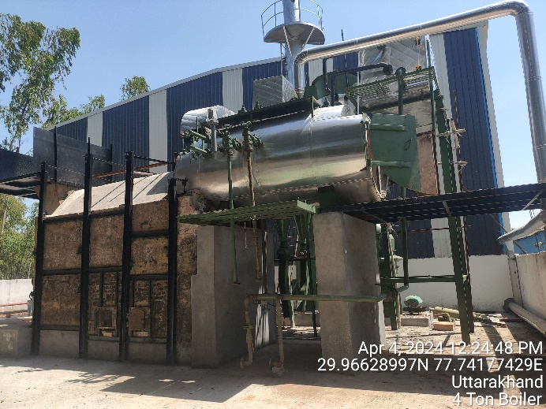 | 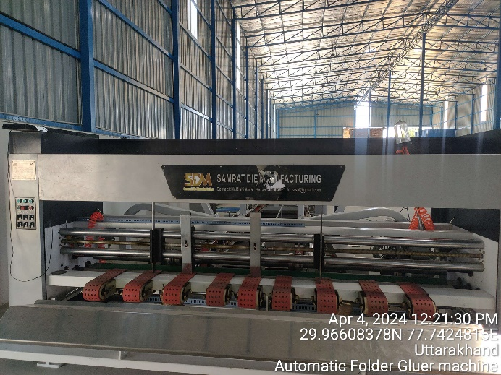
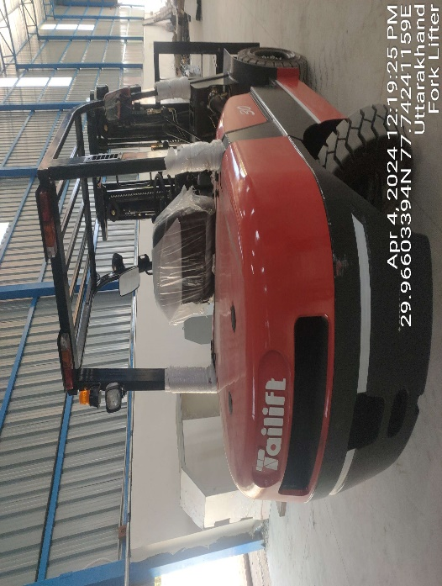 | 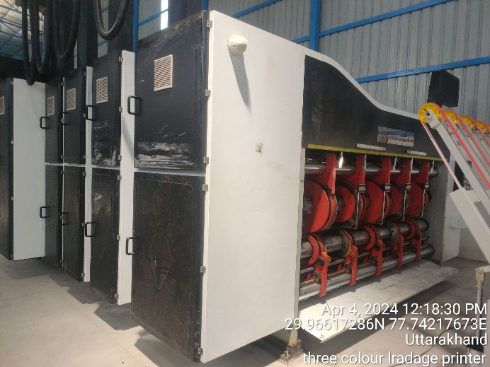
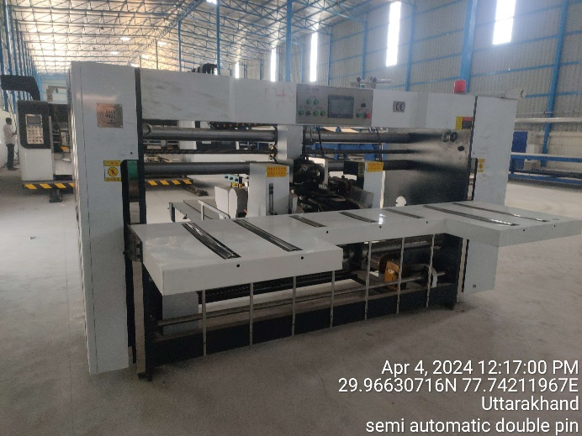 | 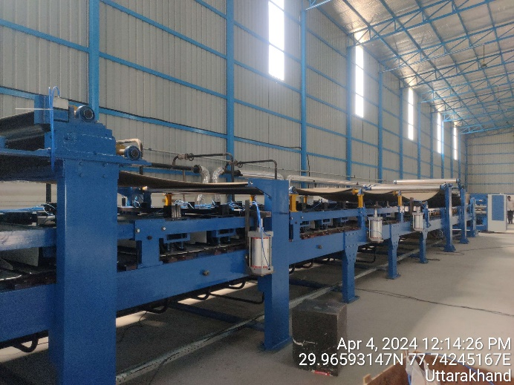

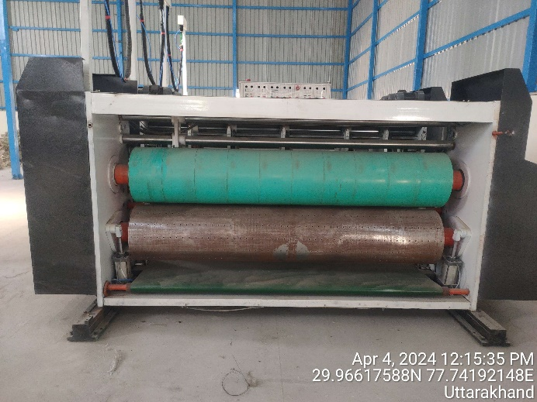 | 