File No.: VIS (2024-25)-PL-017-017-017 Dated: 02.09.2024

TECHNO-ECONOMIC VIABILITY
STUDY REPORT

OF

90 ROOMS LUXURY RESORT
(IN THE TIE UP WITH THE INDIAN HOTELS COMPANY LIMITED)

UNDER THE BRAND NAME OF “TAJ”
HUMPI, KARNATAKA

SETUP BY

M/S DHRUVDESH VENTURES LLP

REPORT PREPARED FOR

SBI SME BRANCH (04091) VIR ANNEXE, NEAR SARVODAYA CIRCLE, KUSUGAL ROAD, HUBBALLI, KARNATAKA - 580023

**Important - In case of any query/ issue or escalation you may please contact Incident Manager Advisory@rkassociates.org. We will appreciate your feedback in order to improve our services.

NOTE: As per IBA Guidelines please provide your feedback on the report within 15 days of its submission after which report will be considered to be correct

IMPORTANT NOTICE

COPYRIGHT FORMAT: This report is prepared on the copyright format of R. K. Associates Valuers & Techno Engineering Consultants (P) Ltd. (R. K. Associates) to serve our clients with the best possible information and analysis to facilitate them to take rational business decisions. Legally no one can copy or distribute this format without prior approval from R. K. Associates. It is meant only for the advisory/ reference purpose for the organization/s as mentioned on the cover page of this report. Distribution or use of this format or report or any of its content/ information/ data by any organization or individual other than R.K Associates will be seen as an unlawful act and necessary legal action can be taken against the defaulters.
This report is intended for the sole use of the intended recipient/s and contains material that is STRICTLY CONFIDENTIAL AND PRIVATE.

DEFECT LIABILITY PERIOD: In case of any query/ issue or escalation you may please contact Incident Manager at advisory@rkassociates.org. Though adequate care has been taken while preparing this report as per its scope, but still we can’t rule out typing, human errors, over sightedness of any information or any other mistakes. Therefore, the concerned organization is advised to satisfy themselves that the report is complete & satisfactory in all respect. Intimation regarding any discrepancy shall be brought into our notice immediately. If no intimation is received within 15 (Fifteen) days in writing from the date of issuance of the report, to rectify these timely, then it will be considered that the report is complete in all respect and has been accepted by the client up to their satisfaction & use and further to which R.K Associates shall not be held responsible in any manner.

Part L: R. K. Associates Important Disclaimer and Remarks are integral part of this report and Feasibility assessment is subject to this section. Reader of the report is advised to read all the points mentioned in these sections carefully.

TABLE OF CONTENTS
SECTIONS | PARTICULARS | PAGE NO.
Part A | Report Summary | 3
Part B | Introduction
 | - About the Report | 5
 | - Executive summary | 5
 | - Purpose of the Report | 9
 | - Scope of the Report | 9
 | - Methodology/ Model Adopted | 9
 | - Data Information received from | 10
 | - Documents/ Data Referred | 10
Part C | Company Profile
 | - Company/LLP Overview | 11
 | - Partners Shares and Contribution | 12
 | - Key Designated Partners/Directors Details | 12
Part D | Proposed Unit’s Infrastructure Details
 | - Proposed Location | 16
 | - Location Map | 17
 | - Layout Plan | 18
 | - Land Details | 21
 | - Photographs of the Project | 21
 | - Building & Civil Works | 27
 | - Equipment Details | 28
 | - Furniture and Fixtures | 31
 | - Interior & Landscape Design | 33
 | - Utilities | 37
 | - Manpower | 38
 | - Marketing Strategies | 38
 | - Current Status of the Project | 39
Part E | Industry Overview & Analysis | 41
Part F | SWOT Analysis | 47
Part G | Project Cost and Means of Finance | 49
Part H | Project Schedule | 53
Part I | Statutory Approvals | Licences | NOC | 55
Part J | Company’s Financial Feasibility | 58
Part K | Conclusion | 82
Part L | Disclaimer | Remarks | 84

PART A | REPORT SUMMARY

S. No. | PARTICULAR | DESCRIPTION
 | Name of the Company: | M/s Dhruvdesh Ventures LLP
 | Registered Address: | 372 Nilay First Floor RT Nagar Main Road R T Nagar Bangalore North Bangalore Karnataka - 560032 India.
 | Project Name | “TAJ” Luxury Resort Project
 | Project Location: | Survey No. 901/1 and 9, Near Kannada University, Atal Bihari Vajpayee Zoological Park Road, Hallekeri, Kamalapur, Hosapete, Karnataka - 583221
 | Project Type: | Luxury Resort with mix room inventory of 90 Rooms
 | Project Industry: | Hospitality Industry
 | Product Type / Deliverables: | Luxury Resort with mix room inventory of Superior Rooms, Suites and stand-alone Villas, including Presidential Villa
 | Report Prepared for Organization: | SBI SME Branch (04091) Vir Annexe, Near Sarvodaya Circle, Kusugal Road, Hubballi, Karnataka - 580023
 | TEV Consultant Firm: | M/s. R.K Associates Valuers & Techno Engineering Consultants (P) Ltd.
 | Report type: | Techno-Economic Viability Report
 | Purpose of the Report: | To assess Project’s Technical, Economical & Commercial Viability for the purpose of seeking external financial assistance to start a green field Project.
 | Scope of the Report: | To assess, evaluate & comment on Technical, Economical & Commercial Viability of the Project as per data information provided by the client, independent Industry research and data/ information available on public domain.
 | Date of Report: | 02-Sep-2024
 | Documents referred for the Project: | - PROJECT INITIATION DOCUMENTS:  - Financial Projections of the Project  - Project proposed Schedule  - Statutory Approval Details  - Layout and Master Plan  - PROCUREMENT DOCUMENTS:  - List of Equipment along with estimated costs for the same  - List of furniture & fixtures along with estimated costs for the same  - Proposed map of the site  - Sale/Lease deeds of the Land  - STATUTORY APPROVALS, LICENCES & NOCs  - Limited Liability Partnership Agreement  - GST Certificate  - Pollution Control Certificates  - Hotel Permission Certificate  - Water Permission Agreement
 | Means of Finance: | Equity & Debt
 | Key Financial Indicators: | Key Indicators Value  Average DSCR 2.31  Average EBITDA Margin 30.98%  Avg. PAT Margin 10.25%  NPV INR 117.75 Cr.  IRR 21.58%  Paybackp period 8.17 years
Note: Above financial indicators are based on the financial projections provided by the firm and assessment and analysis of the same done by us.

PART B | INTRODUCTION

- ABOUT THE REPORT:
Techno-Economic Viability Study Report of the proposed luxury resort of 90 rooms under the brand name “TAJ” and tie up with the Indian Hotels Company Limited at Kamalapur, Hosapete, Karnataka, India, setup by M/s Dhruvdesh Ventures LLP.

- EXECUTIVE SUMMARY:
The proposed green-field project entails the development of a luxurious resort situated at Survey No. 901/1 and 9, Near Kannada University, Atal Bihari Vajpayee Zoological Park Road, Hallekeri, Kamalapur, Hosapete, Karnataka – 583221.
M/s Dhruvdesh Ventures LLP, established on 20 December 2022 under the Company’s Act, 2013, for the purpose to enter into hospitality industry. Company changes its name from Dhruvdesh Ventures to Dhruvdesh Ventures LLP, as per Certificate of Registration on Conversion (LLP Identification Number: ABZ-5457).
As per the Limited Liability Partnership (LLP) agreement provided by the company, the LLP comprises two designated partners and two additional partners. The designated partners, Mr. Prasad Raghunath Deshpande and Mrs. Meghana Prasad Deshpande, came from a prominent business family and claim over a decade of experience spanning various industries. Currently, they spearhead successful ventures across the nation.
Additional partners of the LLP are Viva Megna Wheelers Private Limited, represented by Mr. Bhaskar Banerjee, Group Finance Head, and Dhruvdesh Motors Private Limited, represented by Mr. Manjunath H M, Manager Finance at present.
Initially, Dhruvdesh Ventures LLP (Owner) and The Indian Hotels Company Limited (Operator) have entered into Hotel Management Agreement (The “Operating Agreement”), and Technical Services And Development Assistance Agreement (The “Technical Services Agreement”) dated March 24,2021, whereby the Owner has appointed the Operator to, inter-alia, manage and operate the Hotel at Hampi (“Hotel”) under the Brand ‘Vivanta’ on the terms and conditions more particularly laid down in the said Operating Agreement and Technical Services Agreement.
Further both the Parties (M/s Dhruvdesh Ventures LLP (Owner) and The Indian Hotels Company Limited (Operator)) have signed a supplemental agreement on 17th July 2024 and mutually decided to revise few terms & conditions of the agreemnt dated March 24, 2021. According to which, parties agreed that the Hotel shall now be operated by the Operator under its brand “Taj” instead of “Vivanta” and have thus agreed to change the Brand of the Hotel to “Taj” and further the owner will construct 90 guest rooms & suits instead of 80 guest rooms & suits as per the Brand standard of “Taj”.
Also the parties have agreed that the projected opening date was defined as 48 months from the execution date which expires on 24th March 2024, but due to pandemic the projected opening date is extended through supplemental agreement for a further period of 15 months with effect from 24th March 2025 expiring on 24th June 2026. For any further delay beyond 24th June 2026, the owner will pay a fees of INR 2.0. Lakhs per month up to the opening date along with out-of-pocket expenses.
Further “Clause 39 – Area of Protection” will be substituted as the operator will not operate another Taj branded hotel for nine year from execution date or 5 year from 24th March 2025 whichever is earlier within a limited area of 07 km radius from the hotel lobby. For a subsequent period of 5 year from 24th March 2025 up to 24th March 2030 within a limited area of 05 km radius from the hotel lobby. For balance period from 24th March 2030 until 24th March 2045 within a limited area of 03 km radius from the hotel lobby.
All the terms and conditions of this supplemental agreement will supersede the terms & conditions of the Technical service agreement, rest all other terms and conditions of the Operating Agreement and Technical Services Agreement shall remain the same and be valid, binding and subsisting as it contained in the earlier agreement. Company has provided us the draft copy of Supplemental Agreements.
The initial duration of the agreement spans 25 years from the resort's commencement of operations (Opening Date), with provisions for renewal, consisting of two consecutive terms of 5 years each.
The Indian Hotels Company Limited (IHCL) stands as a beacon of luxury and hospitality in India and beyond. IHCL is renowned for its iconic Taj Hotels, Resorts & Palaces brand, offering unparalleled service and exquisite accommodations. With a commitment to preserving heritage and culture, IHCL's portfolio also includes the vibrant Taj brand and the unique SeleQtions collection. As part of the esteemed Tata Group, IHCL exemplifies excellence, integrity, and a dedication to exceeding guest expectations. From opulent palaces to contemporary urban retreats, IHCL continues to set the standard for luxury hospitality worldwide.
The luxury resort at the proposed site enjoys good accessibility, connectivity, and neighbourhood. The envisioned resort will comprise a total of 90 rooms, each equipped with modern amenities including attached bathrooms, shower cubicles, air-conditioners, minibars, LCD TVs, room safes, tea & coffee makers, and hair dryers.
As per proposed site master plan provided by company, the room inventory is envisaged as a mix of 74 Superior Rooms, 6 Executive Rooms, a Presidential Suite and 9 stand-alone Villas, including a Presidential Villa. Other guest facilities include a 75-cover All-Day Dining restaurant with alfresco dining, as well as a 40-cover exclusive lobby bar, a 40 covers Speciality Restaurant, a pool bar attached to an outdoor swimming pool, a state-of-the-art Gym, Spa, a Family (Kids & Adults) Activity Zone and a Retail shop.
Proposed facility would also include approx. 9,000 sq. ft of flexible meeting spaces and pre-function areas (indoors) and an outdoor lawn for social and corporate events. Aligned with its luxury status and tie up with IHCL (Taj Resort), it will offer curated experiences such as village walks, mountain treks, visits to local monuments, and sunset views to allure tourists.
According to the information provided by the company, the proposed project is committed to integrating eco-friendly measures. Additionally, the project is expected to create both direct and indirect employment opportunities for nearby cities and villages. Furthermore, the launch of the resort will foster exposure to local arts, crafts, and other businesses, enriching the cultural and economic landscape of the region.
As per data/information provided by the client, the total cost of the project for developing the 90 room’s luxury resort is being estimated as INR 132.54 Crores, which is proposed to be funded through term loan of INR 80.00 Crores and INR 52.54 Crore as promoter’s equity.
As per sale deed, LLP has purchased approx. 40954.18 Sq. Mt. (~10.12 acres) of land at Survey No. 901/1 and 9, Near Kannada University, Kamalapur, Hosapete, Karnataka 583221.
M/s Dhruvdesh Ventures LLP had submitted the revised site map plan of 90 Keys to Hampi World Heritage Area Management Authority (HWAMA) for Approval for which LLP had made a payment for revised plan to Town Municipal Authority Hampi, on 12th June 2024 (Town Municipal Council Kamalapura, Challan Receipt No.: 1559KMPOC10062024). LLP has obtained the approval of master layout plan.
As per the approved master plan provided by client, LLP has planned to utilize 32,501.50 Sq. Mt. of land for the resort purpose. Change of land use (CLU) has been approved by District collector’s Office Bellary for 2.62 acres land on 1st November 2019 and for 7.50 acres land on 26th August 2015.
Further, as per the letter of intent (LOI) shared by the client, company has given the building & civil works (Main building civil shell & core works) contract to Bengaluru based M/s HemaSri Construction Pvt. Ltd. on 22nd November 2023. As per the scope of work mention in LOI, Hemsari will carry out Civil & Structure work, Masonry, Plastering & water proofing work, other work as per mentioned in the tender and nomination of sub-contractor for excavation/waterproofing/structural steel work.
On 25th October 2023, Mr. Pradeep V Shenvi Kunde is appointed as project manager of Dhruvdhesh Ventures LLP. The supplier of the required Equipment is yet to be finalized for the proposed resort. Layout plan has been prepared by the SJK architects (Lic. No. KMP/BL/10015/22-23) a Mumbai based Architecture Company.
As per data/information provided to us, the company has obtained some Statutory Approvals/NOC’s such as LLP Agreement, NOC from village panchayat, GST Number, Pollution Certificate, Ground Water NOC etc. from the respective authorities. (Refer the section Statutory Approval in the later part of the report).
Currently, the construction of the proposed luxury resort is underway. As per the Taj Hampi master schedule program provided by company, only 3% of the total work has been completed till the date of site visit on 26th April 2024. During the site visit, our engineer also noted that approximately 3% to 5% of the total work has been finished, including excavation, footing, plinth, and column casting till 26th April 2024. However, the majority of the construction activities are yet to commence. (Kindly refer the site pictures captured during the survey attached in the later section of the report).
The superstructure is scheduled to be completed by 24th June, 2026 as per Agreement b/w IHCL and promoters, with parallel finishing, the entire project is anticipated to be finished by the end of first quarter of FY 2027 i.e. expected C.O.D of the project is 1st July 2026 as informed by promoters .
To procure the funding of INR 80.00 Crores through debt, the company approached the State Bank of India for financial assistance. Further, the SBI SME Branch, Hubballi Karnataka has appointed R.K. associates to perform the Techno-Economic Viability study for the proposed luxury segment Resort at Kamalapur, Vijaynagara District Hosapete, Karnatanka.

- PURPOSE OF THE REPORT:
To assess the Technical, Economical and Financial Feasibility of the proposed green field luxury resort project under the brand name of TAJ for the purpose of financial assistance.

- SCOPE OF THE REPORT:
To assess, evaluate & comment on the Technical, Economical & Financial Feasibility of the proposed luxury segment resort set by M/s Dhruvdesh Ventures LLP, as per the data/information provided by the client/company/stakeholder and our independent research.
NOTES:
- Scrutiny about the company, background check, and credibility, credit worthiness of the company or its promoters/partners is out-of-scope of this report.
- Any verification of the documents/ information from originals/ source is out-of-scope of this report.
- This report is only an opinion in respect to Technical and Financial Feasibility of the project as per the future Projections provided by the firm and independent analysis done by us and doesn’t contain any recommendations including taking decision on the loan or any other financial exposure.
- This is not an audit activity of any kind. We have relied upon the data/ information shared by the company in good faith.
- Any review of the existing business of the promoters is out of scope of this report.
- Detailed cost estimation or detailed cost vetting is out of scope of the project.
- This is not a Detailed Project Report or a detailed design or architecture document. Land and property details mentioned in the report is only for illustration purpose as per the information provided to us by the client. The same doesn’t tantamount for taking any responsibility regarding its legality, ownership and conforming to statutory norms.
- Project status is taken as per the Site inspection carried out by our survey team.

- METHODOLOGY/ MODEL ADOPTED:
- Data/ Information collection from client/bank/public domain/ suppliers/vendors etc.
- Review of Data/ Information collected related to TEV study.
- Independent review & assessment of technology used and financial projections provided by the company.
- Projections of Revenue, P&L, Balance Sheet, Working Capital Schedule, Depreciation Schedule, Loan Schedule as per the inputs given by the company and assessed by us
- Calculation of key financial indicators and ratio analysis including DSCR.
- Report compilation and Final conclusion.

- DATA/ INFORMATION RECEIVED FROM:
All the data/Information has been received from Mr. Bhaskar Banerjee (Group Finance Head) and the required details about him shown in the below table:
Person from Whom Data Obtained
Particulars | Details
Designation | Group Finance Head
Company | M/s Dhruvdesh Ventures LLP
Email Address | headfinance@vivatoyota.co.in
Contact No. | +91-9720150888

Apart from the above, we have referred the data/information available in public domain, information provided by various vendors/consultant and Industrial/sectoral benchmarks and organisational expertise during preparation of the TEV study.
- DOCUMENTS / DATA REFFERED:
- Operating Agreement and Technical Services Agreement with IHCL.
- Limited Liability Partnership (LLP) agreement.
- Financial Projections for next 5 Years.
- Brief history and description of the company.
- Selling, Marketing & Distribution Plan of the Company.
- Market study report of the proposed project.
- List of equipment, furniture & fixtures along with their estimated cost.
- Layout Plan.
- Certificates of Statutory approvals/NOCs.
- Survey Report conducted at the site.
- Data information in Public Domain.

PART C | COMPANY/LLP PROFILE

- COMPANY/LLP OVERVIEW:
M/s. Dhruvdesh Ventures LLP was incorporated on 20th December 2022 with LLP Identification Number: ABZ-5457. It is a Limited Liability Partnership firm, having its Registered Office at 372 Nilay First Floor, RT Nagar Main Road, R T Nagar Bangalore, North Bangalore, Karnataka India - 560032.
Under this entity, company has taken up to set up a luxury resort with 90 rooms equipped with modern amenities & facilities as its first Project/ establishment at Survey No. 901/1 and 9, Near Kannada University, Atal Bihari Vajpayee Zoological Park Road, Hallekeri, Kamalapur, Hosapete, Karnataka - 58322.
As per data/information available on MCA website below table shows the incorporation details of the company:
Incorporation Details of the Company
Particular | Description
Company / LLP Name | M/s Dhruvdesh Ventures LLP
Date of Incorporation | 20st December 2022
LLPIN | ABZ-5457
PAN | AAJFD1589N
Company Category | Limited Liability Partnership firm
ROC | Bangalore
Status | Active
Registered Address | 372 Nilay First Floor, RT Nagar Main Road, R T Nagar Bangalore, North Bangalore, Karnataka India - 560032
Total Obligation of Contribution | INR 0.10 Crore
Total Contribution Received | INR 0.10 Crore
Sum of Charges | INR 0.00 Crore
LLP Status | Active
Date of Filling | 31st March 2024
LEI | 9845007AE4C3D1B6A035 ( ISSUED )
Source: Data/Information extracted from MCA website.

- PARTNERS SHARES AND CONTRIBUTION:
As per the data/information provided by client/LLP, Contribution by Partners and Body Corporate(s) is as specified in the below table on 31st March 2024:
Name of the Partner’s | Designation | Obligation of Contribution (Rs. Crore) | Contribution Received (Rs. Crore)
- Contribution by Partners - 31 Mar, 2024
Mrs. Meghana Prasad Deshpande | Designated Partner | 0.05 | 0.05
Mr. Prasad Raghunath Deshpande | Designated Partner | 0.05 | 0.05
Source: Data/Information provided by the Client.
Name | Nominee Name | Obligation of Contribution (Rs. Crore) | Contribution Received (Rs. Crore)
- Contribution by Body Corporate(s) - 31 Mar, 2024
Viva Magna Wheelers Private Limited | Mr. Bhaskar Banerjee | 0.05 | -
Dhruvdesh Motors Private Limited | Mr. Hosakote Mahantinamutt Manjunath | 0.05 | -
Source: Data/Information provided by the Client.
- KEY DIRECTOR/DESIGNATED PARTNER DETAILS:
Key Designated partner Profile
DIN/DPIN | Name | Appointment Date | Qualification/Experience
00105150 | Mr. Prasad Raghunath Deshpande  (Designated partner) | 20th December, 2022 | - Mr. Prasad Raghunath Deshpande is registered with the Ministry of Corporate Affairs as a Director in Indian Companies.  - Currently, he serves as a director in 15 Companies in India. The companies he is associated with are from various industries such as Real estate activities, Unknown, Construction, Hotels and Restaurants, Business Services, Trading, Supporting and auxiliary transport activities, activities of travel agencies, Agriculture and Allied Activities etc.
00105120 | Mrs. Meghana Prasad Deshpande  (Designated partner) | 20th December, 2022 | - Mrs. Meghana Prasad Deshpande is registered with the Ministry of Corporate Affairs as a Director in Indian Companies.  - Currently, she serves as a director in 10 Companies in India. The companies, she is associated with are from various industries such as Real estate activities, Unknown, Construction, Business Services, Trading, Supporting and auxiliary transport activities, activities of travel agencies etc.
Source: Data/ Information provided by the Company and extracted from MCA website.
Below tables shows the information of the companies/LLPs with which each designated partner is associated with to give a basic background detail of the partners as found on public domain in general/ tertiary category research as on 25th July 2024.
MR. PRASAD RAGHUNATH DESHPANDE - (DIN/DPIN: 00105150)
S. No | Company Name (CIN/FCRN) | Designation | Original Date of Appointment | Date Of Appointment at Current Designation
- List of Associated Companies
1 | SHODHA MOTORS PRIVATE LIMITED (U63090KA2000PTC027438) | Managing Director | 10/07/2000 | 03/04/2023
2 | DHRUVDESH MOTORS PRIVATE LIMITED (U51102KA1999PTC025376) | Director | 26/03/2002 | 01/04/2023
3 | COMPSHELL ENGINEERING PRIVATE LIMITED (U74900KA1996PTC019595) | Director | 26/06/1997 | 26/06/1997
4 | SUNRISE REALTY AND LEISURE PRIVATE LIMITED (U07010KA2003PTC032454) | Director | 27/08/2003 | 27/08/2003
5 | OMTEK TECHNOLOGY PARK PRIVATE LIMITED (U07010KA1998PTC032087) | Director | 19/05/2002 | 19/05/2002
6 | DHRUVDESH METASTEEL PRIVATE LIMITED (U02710KA2003PTC032456) | Director | 27/08/2003 | 27/08/2003
7 | DHRUVDESH INVESTMENTS PRIVATE LIMITED (U74930KA1997PTC189453) | Director | 03/05/2008 | 03/05/2008
8 | DHRUVDESH AUTOMOTIVE PRIVATE LIMITED (U45101KA2005PTC036364) | Director | 24/05/2005 | 24/05/2005
9 | VIVA MAGNA WHEELERS PRIVATE LIMITED (U50401KA2010PTC052657) | Director | 23/02/2010 | 23/02/2010
10 | STALE TRACOM PVT LTD (U51229KA1995PTC121496) | Director | 22/03/2004 | 22/03/2004
- List of Associated LLPs
1 | DHRUVDESH VENTURES LLP  (ABZ-5457) | Designated Partner | - | 20/12/2022
2 | DHRUVDESH NFRASTRUCTURE LLP (AAW-6395) | Designated Partner | - | 09/04/2021
3 | AT ONE PROJECTS LLP  (AAB-8564) | Partner | - | 11/08/2015
Source: Information extracted from MCA website & public domain on 25th July 2024.
MR. MEGHANA PRASAD DESHPANDE - (DIN/DPIN: 00105120)
S. No | Company Name (CIN/FCRN) | Designation | Original Date of Appointment | Date Of Appointment at Current Designation
- List of Associated Companies
1 | D & V Green-Wheels Private Limited (U51900KA2022PTC168381) | Director | 26/08/2023 | 30/09/2023
2 | Omtek Technology Park Private Limited (U07010KA1998PTC032087) | Director | 27/03/2023 | 29/09/2023
3 | Dhruvdesh Motors Private Limited (U51102KA1999PTC025376) | Director | 26/03/2002 | 26/03/2002
4 | Shodha Motors Private Limited (U63090KA2000PTC027438) | Director | 10/07/2000 | 10/07/2000
5 | Pd Wealth Advisory Services Private Limited (U74140KA2007PTC044618) | Director | 10/12/2007 | 10/12/2007
6 | Dhruvdesh Automotive Private Limited (U45101KA2005PTC036364) | Director | 14/07/2020 | 29/12/2020
7 | Compshell Engineering Private Limited (U74900KA1996PTC019595) | Director | 14/07/2020 | 31/12/2020
8 | Sunrise Realty And Leisure Private Limited (U07010KA2003PTC032454) | Director | 14/07/2020 | 29/12/2020
9 | Viva Magna Wheelers Private Limited (U50401KA2010PTC052657) | Director | 23/02/2010 | 23/02/2010
10 | D & V Green-Wheels Private Limited (U51900KA2022PTC168381) | Additional Director | - | 26/08/2023
- List of Associated LLPs
1 | DHRUVDESH VENTURES LLP  (ABZ-5457) | Designated Partner | - | 20/12/2022
2 | DHRUVDESH NFRASTRUCTURE LLP (AAW-6395) | Designated Partner | - | 09/04/2021
Source: Information extracted from MCA website & public domain on 25th July 2024.

PART D | PROPOSED RESORT’S INFRASTRUCTURE DETAILS

- PROPOSED LOCATION:
The proposed green field project is a 90-rooms luxury resort, which will be set up by M/s Dhruvdesh Ventures LLP at Survey No. 901/1 and 9, Near Kannada University, Atal Bihari Vajpayee Zoological Park Road, Hallekeri, Kamalapur, Hosapete, Karnataka - 58322, which is spread over an area of 10.12 Acres (40,954.18 Square meter) as per the sale deed provided to us by the company.
On 28 December 2022, company has taken the building permit to construct buildings for commercial purpose as per regulations of Urban Development Department by Kamalpura Town Panchayat (No. KMP-LBPAS-10035/22-23/BP).
Site is a large vanilla parcel of land, congenial for the development of a spacious luxury Leisure Resort. The land parcel presents an almost flat terrain, with little or no plants or forestation, making it ready and easy for immediate development.
On three sides i.e. N, S, W the land parcel has open views as it is surrounded by agricultural land & paddy fields. On the E side there is an existing road that will form the frontage of the hotel. The West side enjoys great sunset views. There is only one access to the site i.e. from the main road which is east facing. Both staff & guest entrance will have to be accommodated from the same side.
Hosapete is the gateway to the UNESCO World Heritage site of Hampi, which is renowned for its ancient temples, ruins, and historical significance. Hampi has 85 ASI protected monuments and more than 3,000 listed monuments and is renowned for its rich heritage and archaeological significance. Hampi is one of the most beautiful and evocative of all historical sites in south India known for its sculptures and ruins. Since it was declared a UNESCO World Heritage Site (1986), it has been attracting foreigners and domestic travellers, and is a thriving tourism destination.
Hosapete is well connected to several important cities in India. It is located on the Tungabhadra River, 12 km from Hampi. Bellary is located approximately 60 km away and Bangalore, the state capital is 330 km away. In addition, the city has a well-developed market area.
The site is well connected by air, rail and road. The site is connected by national and state highways. The shortest and the best route to travel between Bangalore and Hampi is via NH 48 and NH 50. The highways have been upgraded reducing travel time. The site enjoys excellent accessibility, and a pristine neighbourhood with good proximity to sightseeing. The site is in the route between Hampi to Bellary and has good accessibility and visibility. Owing to a 212m long frontage, it will be very visible from the road. Details of adjoining properties and Connectivity, found during the site visit described in the below tables:
Location | Adjoining Property
East | Road (22 FT)
West | Agricultural Vacant land
North | Agricultural Vacant land
South | Agricultural Vacant land

Connectivity Details of the Proposed Location
Connectivity | Details
Rail | Papinayakanahalli Railway Station – 10.2 km away
Airport | Jindal Vijaynagar Airport - ~30 km away
Bus Stop | Hospat Bypass – 14.8 Km away
Road | State Highway 131 – less than 1 km away

- LOCATION MAP:
- GOOGLE MAP LOCATION:
Project location is 15°17'05.9" North and 76°28'56.2" East near to Near Kannada University, Atal Bihari Vajpayee Zoological Park Road, Kamalapur, Hosapete, Karnataka and the location as per the Google map has been attached below:
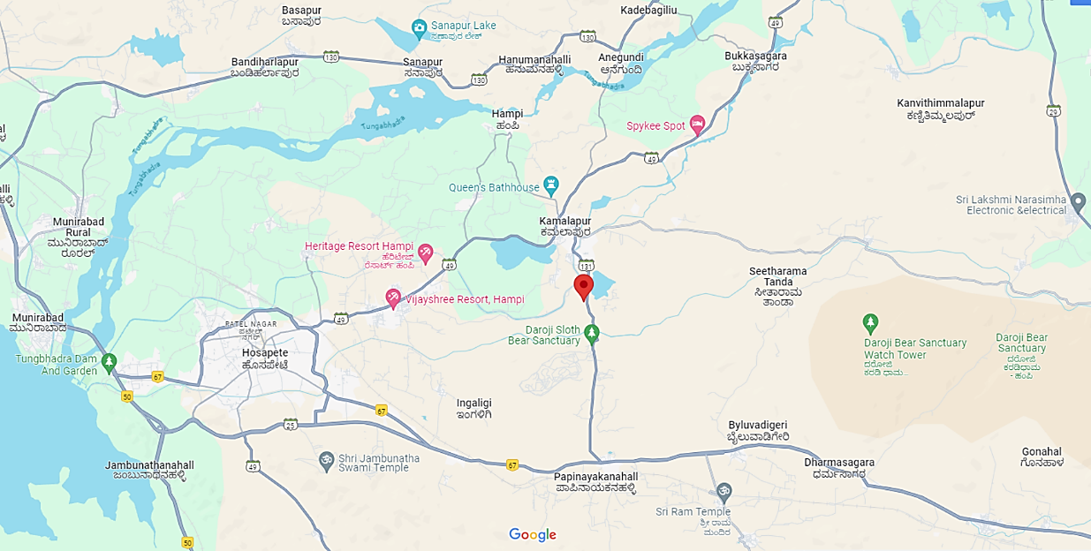
- GOOGLE LAYOUT PLAN:
Demarcation of the land with measurement on the Google map is as shown in the below picture: 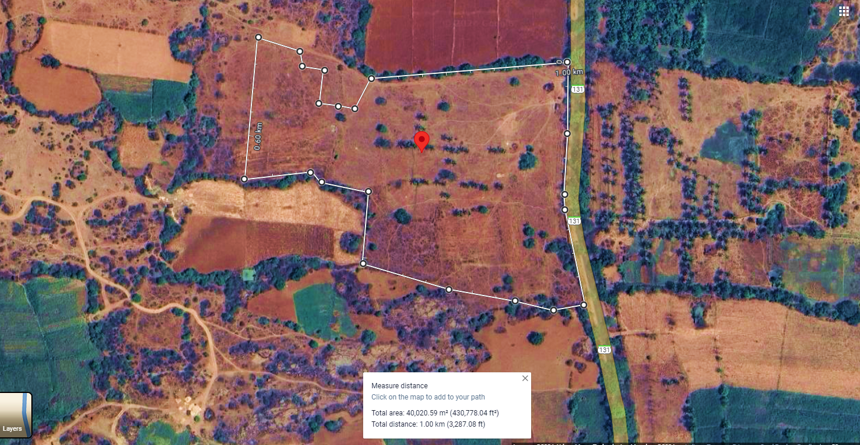

- LAYOUT PLAN:
Dhruvdesh Ventures LLP has obtained approval for revised site map plan for 90 keys (previously approved for 80 keys) from the Hampi World Heritage Area Management Authority (HWAMA). Masterplan layout plan has been prepared by Mumbai-based architecture firm SJK Architects (License No. KMP/BL/10015/22-23) appointed by Dhruvdesh LLP, which is an architecture, interior design and master planning practice with a portfolio constituting various typologies, ranging from residential, industrial and hospitality to recreational projects such as museums and galleries.
According to the approved masterplan provided by the Company, architecture firm M/s Srushti Architects has been prepared the drawing of layout plan which is a Hospete, Karnatka based Architect & Interior designer having License No. KMP/BL/10024/23-24. For reference, approved site plan has been attached below:
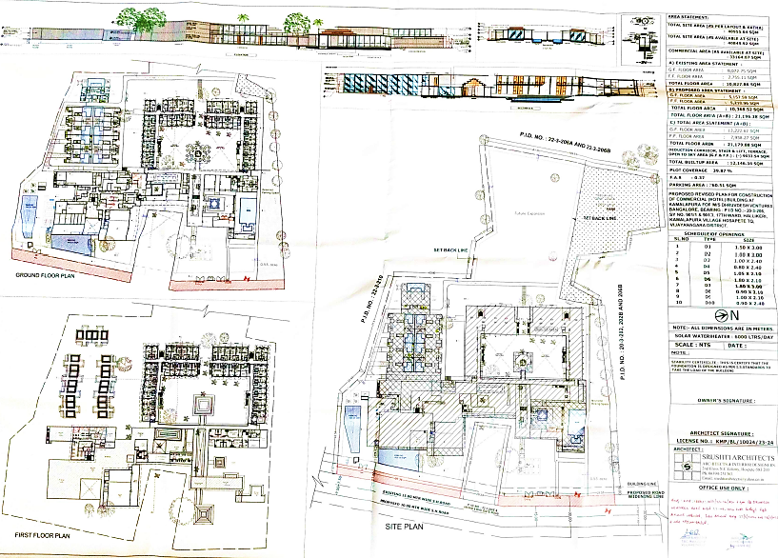
Below table shows the area statement mentioned in the approved master plan for the proposed project:
Area Statement As per Approved Masterplan
S. No. | Description | Area (Sq. Mt.)
 | Total Site Area (As per layout & Katha) | 40,955.64 Sq. Mt.
 | Total Site Area (As available at Site) | 40,849.92 Sq. Mt.
 | Commercial Area as available at site | 33,164.07 Sq. Mt.
- Existing Area Statement
 | Ground Floor Area | 8072.75 Sq. Mt.
 | First Floor Area | 2755.11 Sq. Mt.
 | Total Floor Area | 10827.86 Sq. Mt.
- Proposed Area Statement
 | Ground Floor Area | 5157.59 Sq. Mt.
 | First Floor Area | 5210.96 Sq. Mt.
 | Total Floor Area | 10368.52 Sq. Mt.
 | Total Floor Area (A+B) | 21196.38 Sq. Mt.
 | (-) Corridor, Stair & Lift, Terrace, Open to sky area (G.F+F.F) | 9033.54 Sq. Mt.
 | Total Built up area | 12146.34 Sq. Mt.
 | Plot Coverage | 39.87%
 | Parking Area | 760.51 Sq. Mt.
Based on the above image, there are vacant areas reserved for future expansion. Room inventory includes 74 Superior Rooms, 6 Executive Rooms, a Presidential Suite, and 9 stand-alone Villas, including a Presidential Villa. As per the detailed layout plan prepared by SJK Architects, LLP has decided to build the Superior Rooms of ~29.45 Sq. Mt.
Area of rooms
S. No. | Room Type | No. of room | Area per room Sq. Ft. | Total Area in Sq. Ft.
1 | Superior Rooms | 74 | 317.00 | 23458.00
2 | Executive Rooms | 6 | 691.04 | 4146.24
3 | Presidential Suite | 1 | 211.5 | 2276.57
4 | Stand-alone Villas | 8 | 1071 | 8568
5 | Presidential Villa | 1 | 1428.37 | 1428.37
Sources: Master plan shared by the client/LLP.
Area covered by various amenities
Amenities | Area Sq. Ft. | Floor
All Day Dining | 2271.19 | 1
Specialty Restaurant | 1278.75 | 1
Bar | 1281.00 | 1
Pool Bar | 968.00 | 1
Ball Rooms (A ballroom or ball hall is a large room inside a building, the primary purpose of which is holding large formal parties called balls.) | 4305.56 | 1
Conference Rooms | 914.93 | 1
Meeting Rooms | 473.61 | 1
Board Rooms | 297.06 | 1
Sources: Master plan shared by the client/LLP.
Floor wise construction: (hotel complex)
Floor | Area of construction Sq. Ft. | Area of construction Sq. m | No of rooms | Amenities
Ground | 142326.99 | 13222.61 | 50 | 16
1st Floor | 85662.11 | 7958.27 | 40 | 2
Sources: Master plan shared by the client/LLP.
Note: After considering 9 villas as a single unit there would be 50 rooms at ground floor and 40 rooms at first floor.
According to our tertiary research, room sizes can vary based on location and market position. Taj hotels offer Superior Rooms ranging from 25 to 30 square meters (Refer to links: https://www.tajhotels.com/en-in/hotels/taj-palace-new-delhi/rooms-and-suites, http://www.thetajhotel.com/rooms/regular-room/). Therefore, it's evident that the company has aligned the room sizes with Taj hotel standards, including those for Executive Rooms, the Presidential Suite, and stand-alone Villas.

- LAND DETAILS:
M/s Dhruvdesh Ventures LLP acquired 10.12 acres (40,954.18 Sq. Mt.) of land in two transactions to facilitate the development of the proposed luxury resort. According to the sale deeds provided by the company, the first portion, comprising 7.50 acres (30,351.45 Sq. Mt.), was purchased on 18th January, 2016, for a sale consideration of INR 40,00,000/-, which was paid by Dhruvdesh Ventures, while the second portion, 2.62 acres (10,602.77 Sq. Mt.) in size, was purchased on 7th March, 2019 for INR 9,00,000/-.
Hence, as per sale deeds total book value of the land (10.12 acres) was INR 49,00,000/- lakhs, which is INR 484189.72/- per Acre. As per the cost vetting report prepared by SBI panelled & Govt. Registered valuer P.I. Miskin (Chartered Engineer) on 24th July 2024, rate of this land as per prevailing guidelines is INR 577.00 Per Sq. Ft. i.e. valur of the land is ~INR 25.44 Cr., while market value of the land is ~INR 500-650 Per Sq. Ft. i.e. ~INR 22.04 to 28.65 Cr.
During the site visit on 26th April 2024, we found that the rates of commercial land near to the proposed project are ~2 Crores per Acre. This higher rate attributed to Hampi's distinguished status as a UNESCO World Heritage Site in Karnataka, which attracts tourists from various parts of India and around the world.
The growing tourism industry, coupled with Hampi's historical significance, positions the region as a lucrative investment destination. Hence, the decision made by the owner to purchase the land seems to be an economically viable decision.
Please note that change of land use (CLU) from Agriculture to commercial conversion has been approved by District collector’s Office Bellary for 2.62 acres land on 1st November 2019 and for 7.50 acres land on 26th August 2015. And LLP has taken the building permit on the above mentioned land on 28 December 2022, to construct buildings for commercial purpose as per regulations of Urban Development Department by Kamalpura Town Panchayat (No. KMP-LBPAS-10035/22-23/BP).

- PHTOGRAPHS OF THE PROJECT:
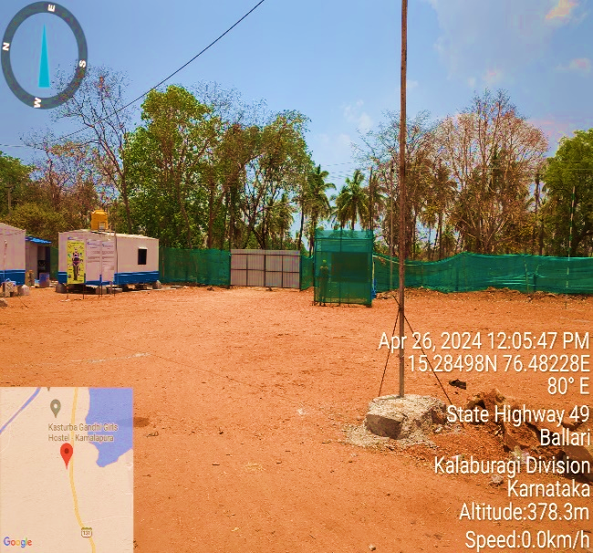 | 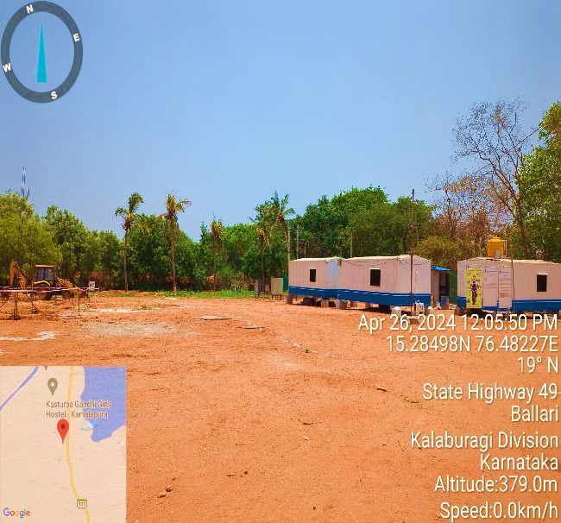
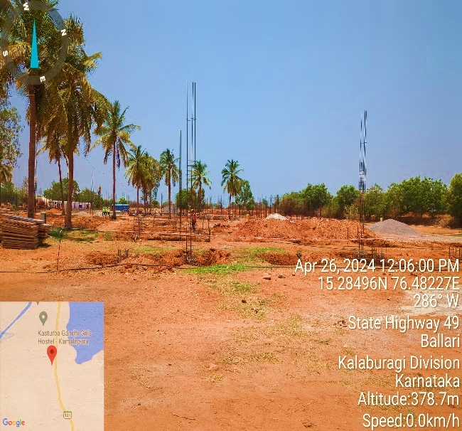 | 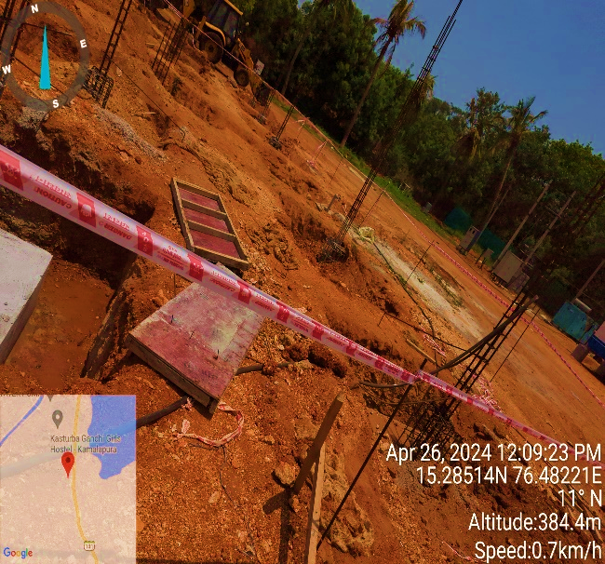
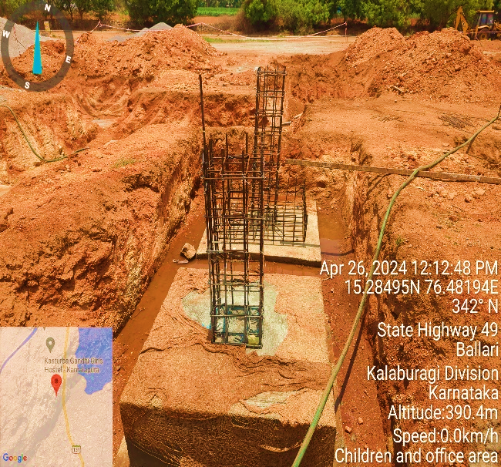 | 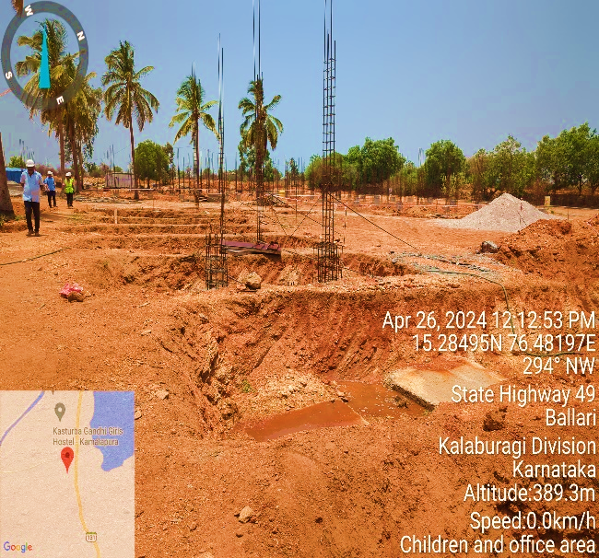
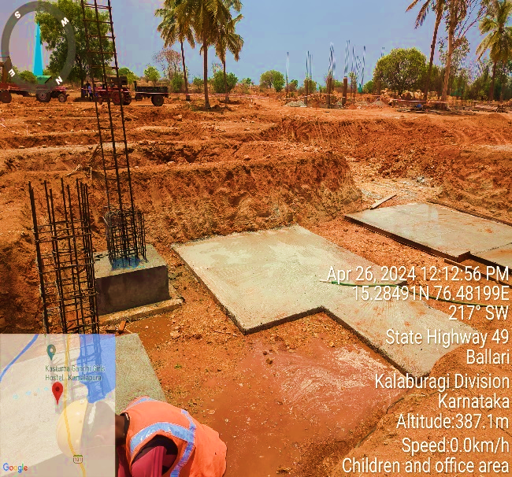 | 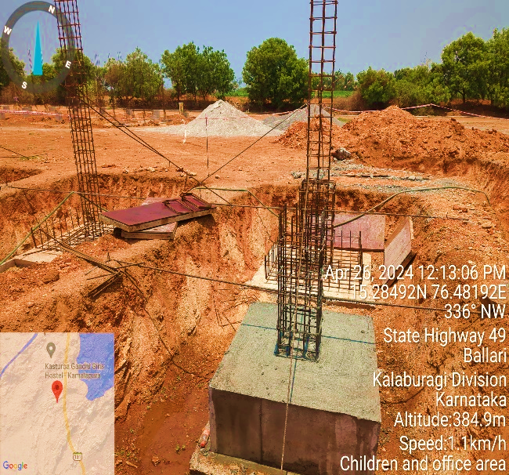
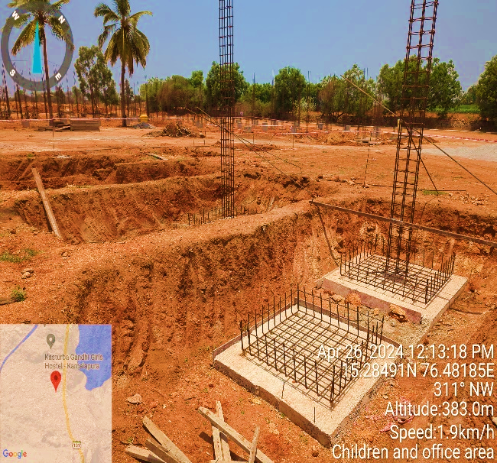 | 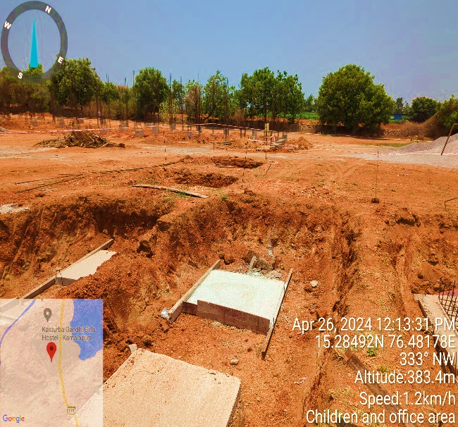
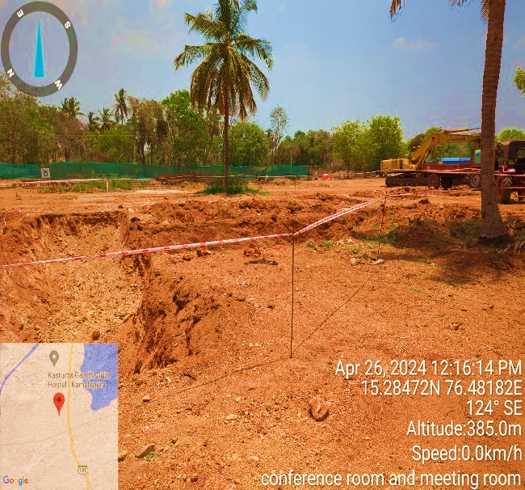 | 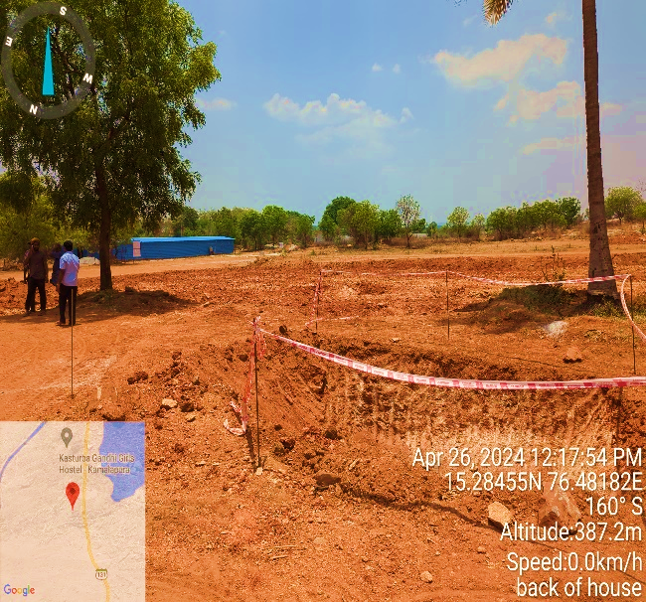
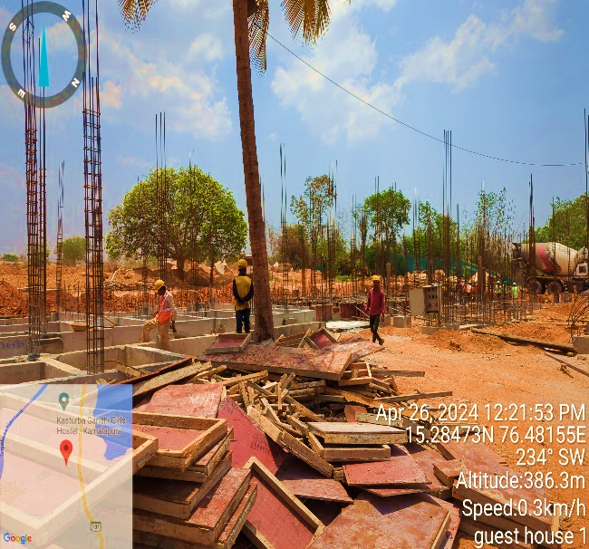 | 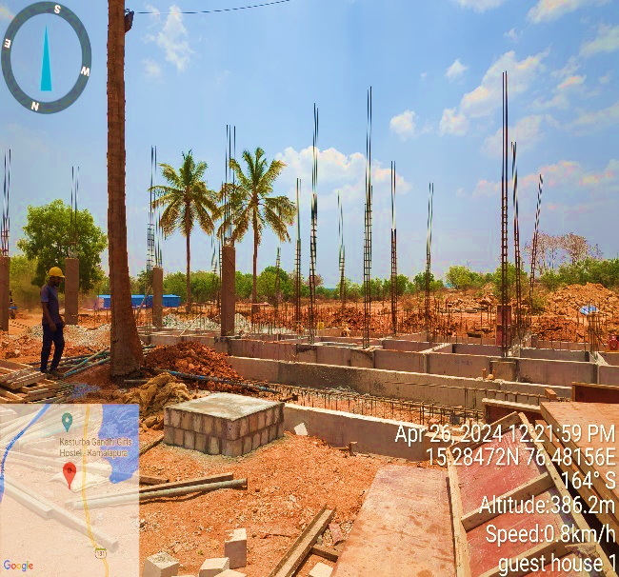
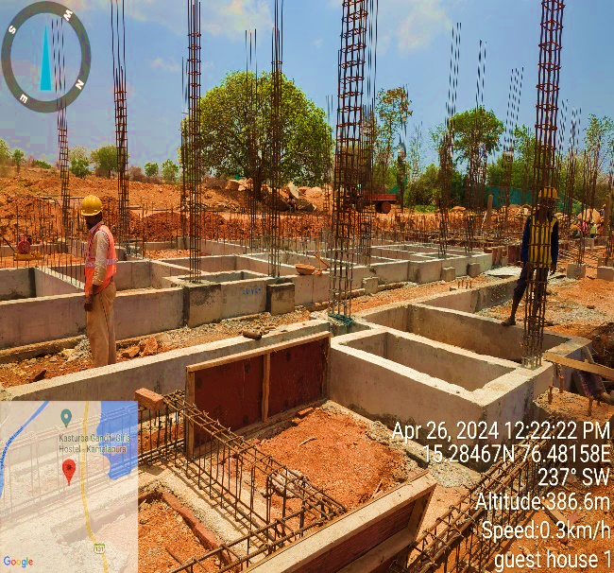 | 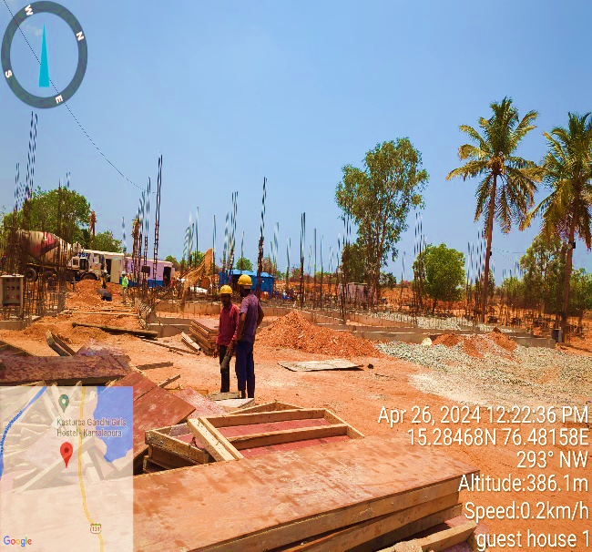
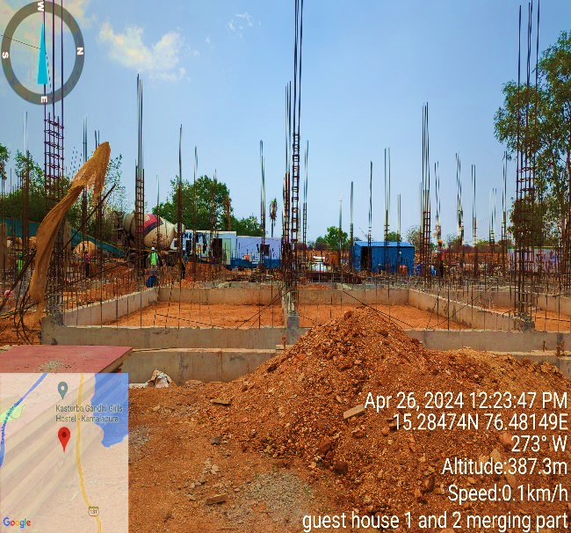 | 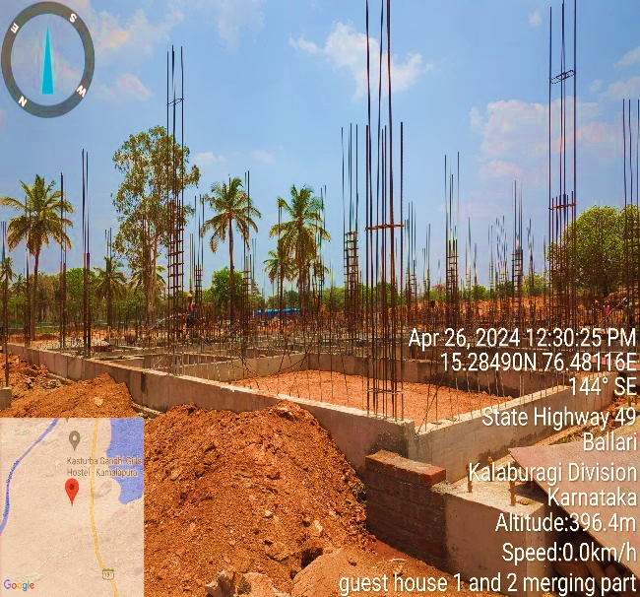
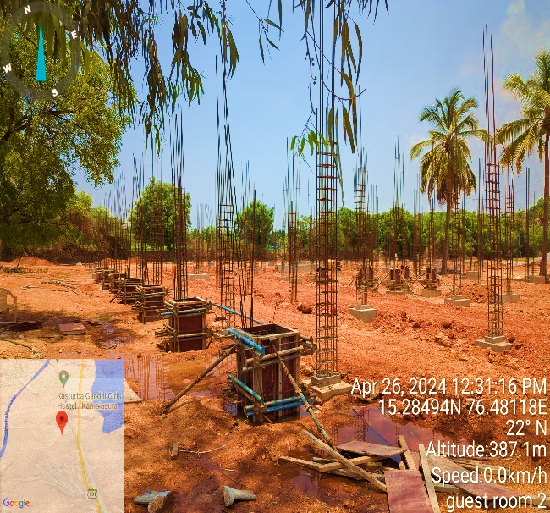 | 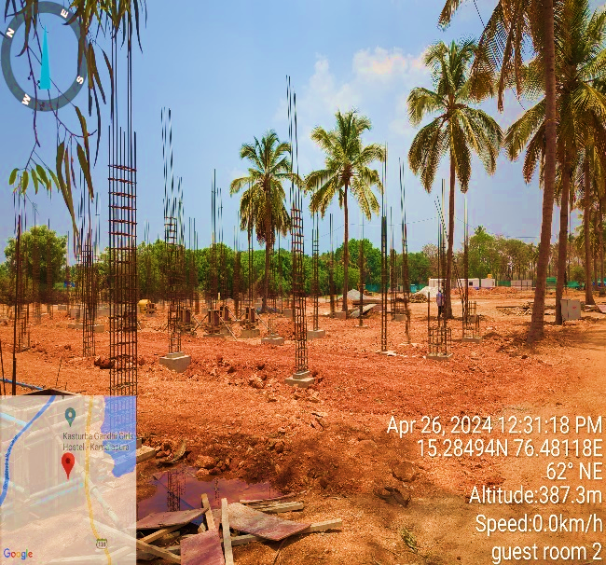
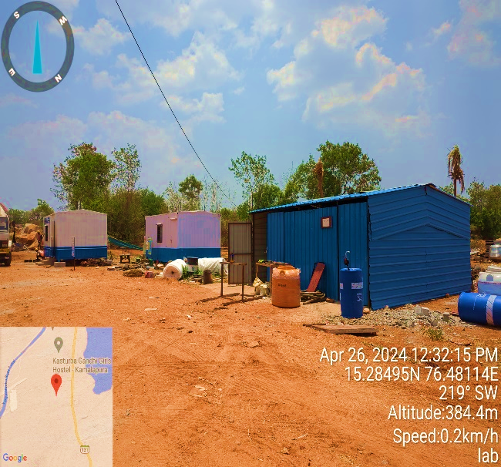 | 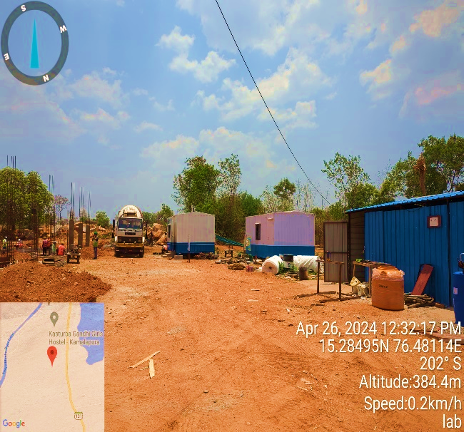
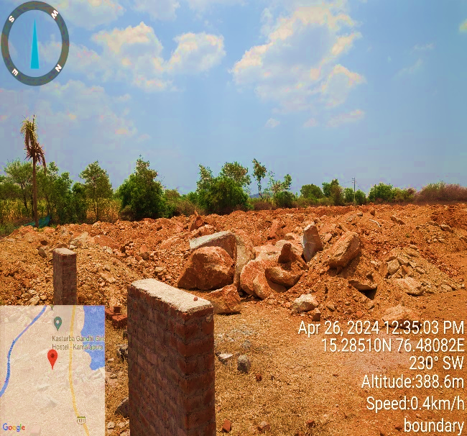 | 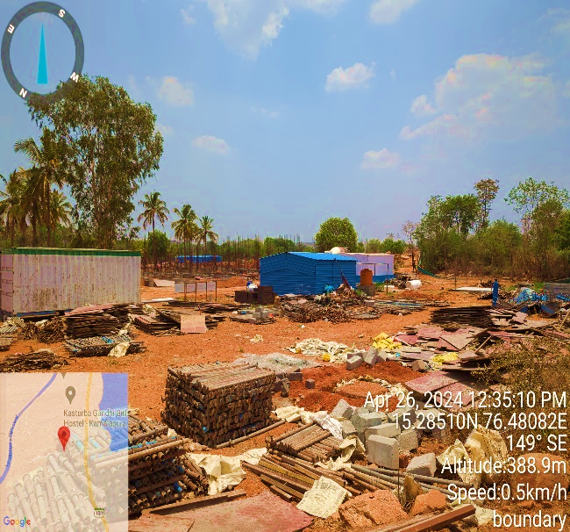
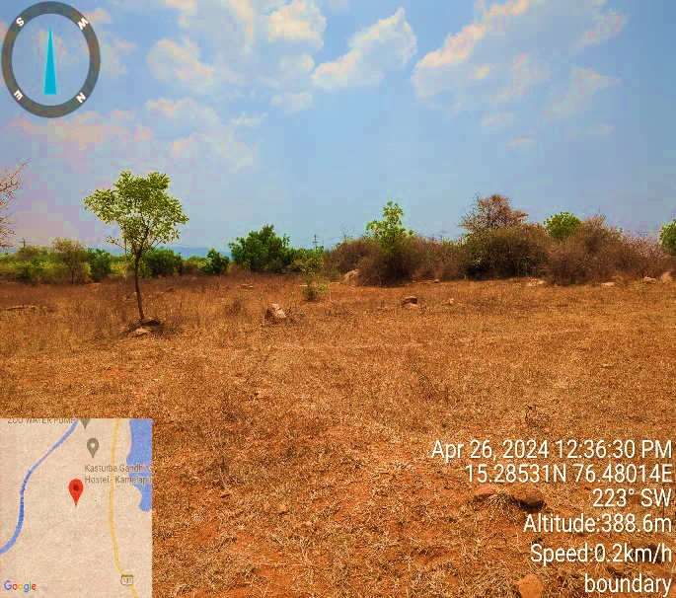 | 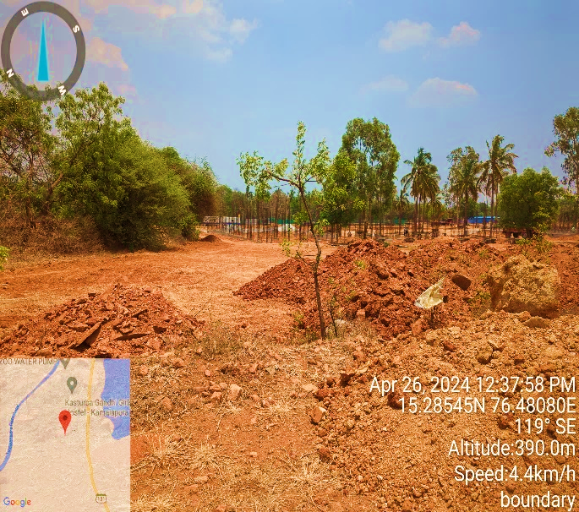
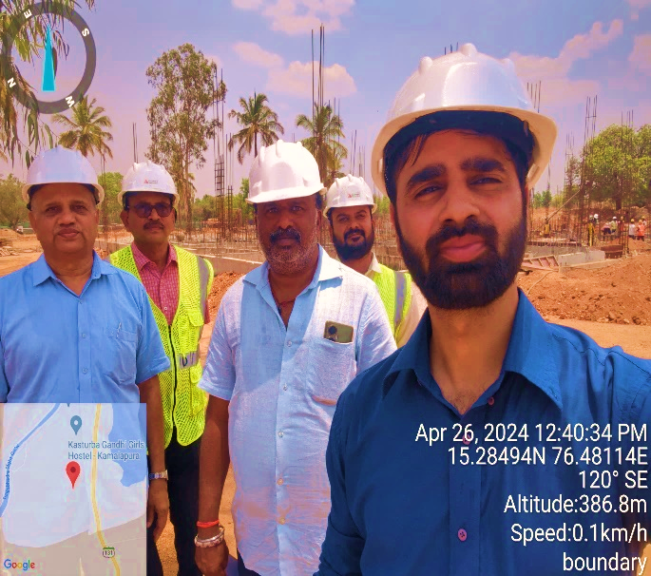 | 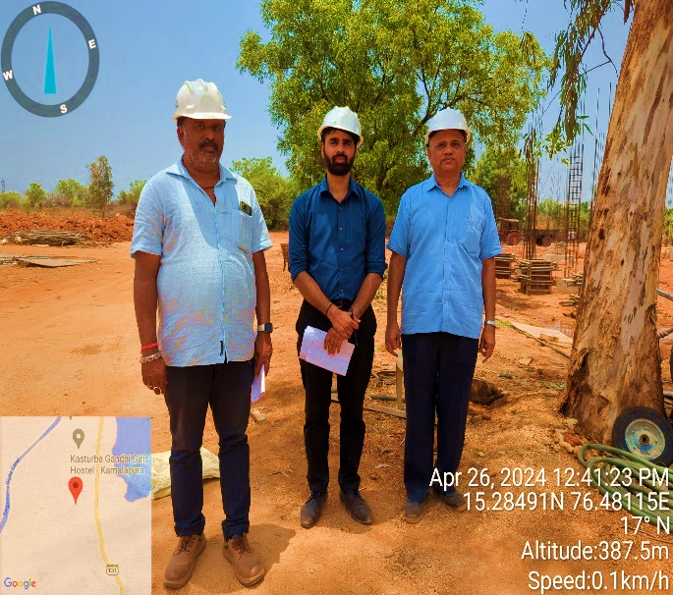

- BUILDING & CIVIL WORKS:
As per the masterplan of 90 Keys shared by M/s Dhruvdesh Ventures Pvt Ltd approved by Hampi World Heritage Area Management Authority (HWAMA), the total commercial area available at site is 33,164.07 Sq. Mt., out of which Build-up area of the proposed luxury resort with its civil structures admeasures 21,196.38 Sq. Mt.
As per the letter of intent dated 22nd Nov 2023 shared by the client, Company had appointed M/s Hemasri Construction Pvt Ltd. for main building civil shell and core works. As per scope of work, M/s Hemasri Construction Pvt Ltd. will be engaged for civil and structure work, masonry, plastering, waterproof and other work for the proposed resort project. Below table shows the bifurcation of the estimated cost of construction provided by the client/LLP:
Cost Of Construction
S. No. | Description Of Each Building | Area Sq. Mt. | Area Sq. Ft. | Rate Per Sq. Ft. | Estimated Cost INR Cr.
1 | Civil Work - Hotel consisting of 90 rooms | 12146.34 | 1,30,746 | 1,754.50 | 22.94
2 | Landscaping of Gardens & Horticulture | 8822 | 94,961 | 474 | 4.50
3 | Swimming pool | 1047 | 11,270 | 1,525 | 1.72
4 | Internal paths | 2155 | 23,196 | 427 | 0.99
5 | Fencing and Compound wall | 1019 | 10,969 | 903 | 0.99
6 | Water Tanks /Sumps | 215 | 2,310 | 5,671 | 1.31
Total |  |  |  |  | 32.45
Source: Data/information provided by the client.
As per the above table, the Total estimated cost of the Building & Civil works is ~INR 32.45 Crore including Landscaping of Gardens & Horticulture, Swimming pool, internal paths, Fencing and boundary wall, Water Tanks, the same has been vetted and certified by SBI panelled & Govt. Registered valuer P.I. Miskin (Chartered Engineer) on 24th July 2024.
Out of total Building & Civil works cost, main building civil shell and core works will be costing ~INR 22.94 Crore which comes out as INR 1754.50 per Sq. ft. excluding interior work which is seems reasonable for the proposed luxury resort project. Also it is ~24% of the total project cost as per the industry benchmark. (Ref: Hotel Development Cost Survey 2023 India done by Hotelivate).
The estimated cost of Boundary wall/fencing work is ~INR 0.99 Cr. which comes out as INR 902.50 per Sq. ft., The estimated cost of water tank/sumps work is ~INR 1.31 Cr. which comes out as INR 5671.00 per Sq. ft., which we found in the line with prevailing standard market rates in the nearby areas during our tertiary research. However, the cost may variate as per specifications & brand of the material. As per the site inspection on April 26th, 2024, below are the observations about the progress of construction work:
- Excavation and footing work for the children's area and front office have been finished.
- Excavation work is currently underway for the conference/meeting rooms and back-of-house area.
- Concerning the guest houses, the columns for Guest House are prepared, and concreting work is ongoing.
- As for the merging area of guest houses plinth work has been completed. Temporary shades have been erected for lab work, office activities, and to provide shelter for the labour force.

- EQUIPMENT AND PLANT & MACHINERY DETAILS:
As per the data/information provided by the client, the proposed luxury resort will use equipment, which are marketed for easy to control, operate, install and maintain like washers, dryers, ironers, modern stoves and refrigerators, frozen cells, self-service elements, dishwashers, bar and stainless-steel furniture and fittings use by customers and guests. Detailed bifurcation of the proposed plant and machinery has been shown in the below table along with the estimated cost provided by client:
S. No | Particulars | QTY | Rate per Unit | Estimated Cost  (INR Crores)
1 | Air Conditioner | 115 | - | 6.97
2 | Fans | 90 | 2,000 | 0.02
3 | LED TVS | 100 | 50,000 | 0.50
4 | Mini Bars for the rooms | 90 | 15,000 | 0.14
5 | Safes for the rooms | 90 | 18,000 | 0.16
6 | Hair Dryers | 90 | 4,000 | 0.04
7 | Electric Kettles for the rooms | 90 | 3,000 | 0.03
8 | Front office equipment | 10 | 40,000 | 0.04
9 | Housekeeping Equipment | 25 | 26,000 | 0.07
10 | Computer Hardware & Software | 10 | 1,00,000 | 0.10
11 | Firefighting system | 1 | 1,51,76,526 | 1.52
12 | Intercom and Wi Fi System | 1 | 6,00,000 | 0.06
13 | Gardening Tools and Equipment | 15 | 40,000 | 0.06
14 | CCTV & Camera | 1 | 1,19,85,064 | 1.20
15 | Electric connection including transformer | 1 | 5,54,24,391 | 5.54
16 | DG set-850 KVA each | 2 | 43,94,911 | 0.88
17 | STP plant & connection + Water harvesting pipelines etc. | 1 | 33,48,214 | 0.33
18 | Kitchen Equipment | 583 | 94,979 | 5.54
19 | Crockery & Cutlery for Restaurant & Bar | 500 | 600 | 0.03
20 | Lift | 8 | 9,94,958 | 0.80
21 | Miscellaneous | 1 | - | -
Total |  |  |  | 24.01
Source: Data/information provided by the client.
Thus, the estimated cost for the proposed equipment is INR 24.01 crores according to the client's estimate. As per the tender documents shared by the client, below are the quotations of expected vendors received by the LLP and shared with us to justify the estimated costs:
Project : Taj - Hampi, Karnataka Fire Fighting System Cost Comparison
Description | Aeon | C&W | Sobha | Total Solutions | Vkbs | Rout Tech | Firepro | Douse Fire | Lowest Of Low Quote From Vendors R1
Fire Fighting Pumps | 22,23,800 | 25,83,422 | 35,04,276 | 26,01,598 | 43,35,452 | 43,37,008 | 43,08,181 | 39,45,443 | 28,04,487
Internal & External Hydrant System | 44,99,675 | 75,94,328 | 81,10,553 | 81,35,555 | 95,86,392 | 84,36,273 | 1,04,49,111 | 94,52,879 | 64,66,554
Sprinkler System | 68,55,150 | 88,48,384 | 1,02,43,989 | 91,72,156 | 1,09,80,312 | 91,64,407 | 1,27,00,598 | 1,06,83,955 | 82,06,776
Hand Appliance System | 1,67,000 | 1,48,694 | 1,78,268 | 91,950 | 2,10,892 | 2,67,915 | 1,79,769 | 2,13,288 | 1,46,670
Electrical Installation | 4,63,250 | 6,38,810 | 27,75,112 | 7,28,950 | 19,43,386 | 7,07,811 | 11,12,871 | 12,15,318 | 6,75,093
Total Basic Value | 1,42,08,875 | 1,98,13,638 | 2,48,12,198 | 2,07,30,209 | 2,70,56,434 | 2,29,13,414 | 2,87,50,530 | 2,55,10,883 | 1,82,99,580
SGST | 12,78,799 | 17,83,227 | 22,33,098 | 18,65,719 | 24,35,079 | 20,62,207 | 25,87,548 | 22,95,979 | 16,46,962
CGST | 12,78,799 | 17,83,227 | 22,33,098 | 18,65,719 | 24,35,079 | 20,62,207 | 25,87,548 | 22,95,979 | 16,46,962
Total Wo Value | 1,67,66,473 | 2,33,80,093 | 2,92,78,394 | 2,44,61,647 | 3,19,26,592 | 2,70,37,829 | 3,39,25,625 | 3,01,02,842 | 2,15,93,504

TAJ HAMPI - HVAC R0 COMPARISION
Description of Item | ACCUMEN | SOBHA | AIRMECH | ENMAC SYSTEM | BLUSTAR | POWER TECH | VAYUCON | VKBS | EMKAY | LOWEST OF LOW
EQUIPMENT | 3,27,69,918 | 3,43,76,826 | 3,07,71,333 | 3,20,70,708 | 3,23,38,592 | 4,06,69,700 | 3,14,32,268 | 3,47,84,804 | 2,94,42,577 | 2,26,25,943
PIPING CONDENSER | 24,82,893 | 29,03,246 | 27,01,072 | 25,27,700 | 34,87,436 | 21,50,630 | 34,58,360 | 24,89,722 | 26,53,618 | 18,51,885
PIPING CHILLED WATER | 1,10,06,650 | 1,14,69,795 | 1,03,71,316 | 1,03,19,018 | 1,22,97,990 | 90,74,827 | 1,27,68,262 | 95,23,926 | 1,00,82,747 | 74,16,807
AIR DISTRIBUTION | 1,15,63,538 | 1,20,81,272 | 1,34,27,389 | 1,20,37,811 | 1,28,44,754 | 1,28,43,700 | 1,36,73,271 | 1,25,80,184 | 1,10,34,620 | 94,83,704
THERMAL INSULATION | 72,89,920 | 62,90,640 | 75,91,840 | 60,86,740 | 82,83,620 | 71,08,000 | 74,74,700 | 55,55,560 | 48,79,480 | 39,36,620
ELECTRICAL INSTALLATION | 32,85,995 | 89,47,775 | 51,89,754 | 71,85,738 | 53,52,534 | 20,05,000 | 33,32,989 | 32,43,738 | 30,71,266 | 16,72,015
TOTAL BASIC VALUE | 6,83,98,914 | 7,60,69,554 | 7,00,52,704 | 7,02,27,715 | 7,46,04,926 | 7,38,51,857 | 7,21,39,850 | 6,81,77,934 | 6,11,64,308 | 4,69,86,974
Difference from Lowest | 2,14,11,940 | 2,90,82,580 | 2,30,65,730 | 2,32,40,741 | 2,76,17,952 | 2,68,64,883 | 2,51,52,876 | 2,11,90,960 | 1,41,77,334
SGST 9% | 61,55,902 | 68,46,260 | 63,04,743 | 63,20,494 | 67,14,443 | 66,46,667 | 64,92,587 | 61,36,014 | 55,04,788 | 42,28,828
CGST 9% | 61,55,902 | 68,46,260 | 63,04,743 | 63,20,494 | 67,14,443 | 66,46,667 | 64,92,587 | 61,36,014 | 55,04,788 | 42,28,828
TOTAL WO VALUE | 8,07,10,719 | 8,97,62,074 | 8,26,62,191 | 8,28,68,704 | 8,80,33,813 | 8,71,45,191 | 8,51,25,023 | 8,04,49,962 | 7,21,73,883 | 5,54,44,629

TAJ HAMPI - ELECTRICAL R0 COMPARISION
Description | R&M Power | Southern Electric | Sabah | Helio | Vkbs | Emkay | Proton | Lowest Of Low
Substation Equipment | 6,84,505 | 14,70,546 | 17,75,119 | 6,04,375 | 18,42,416 | 17,94,857 | 6,76,900 | 4,85,746
Lt Panels & Distribution Boards | 1,06,20,247 | 97,26,868 | 1,16,87,961 | 1,43,25,120 | 1,36,36,533 | 1,25,30,683 | 1,60,44,134 | 93,33,553
Lt Cables & Cable Trays: | 1,34,07,535 | 1,31,85,472 | 1,46,28,800 | 1,28,89,050 | 2,50,21,319 | 1,51,78,848 | 2,28,64,481 | 1,08,71,869
Earthing & Lightning Protection System | 25,69,962 | 29,01,632 | 25,15,190 | 51,68,530 | 40,17,242 | 32,59,182 | 36,70,956 | 21,65,719
Wiring & Conduiting | 94,83,640 | 1,01,65,761 | 91,73,306 | 1,61,90,080 | 2,81,48,121 | 1,27,40,956 | 2,57,21,753 | 76,34,970
Internal Lighting Fixtures | 7,76,700 | 19,18,415 | 16,45,873 | 22,92,670 | 33,74,693 | 6,71,381 | 30,83,794 | 5,60,231
Infrastructure For It, Voice & Tv System | 11,22,120 | 13,04,810 | 10,88,655 | 12,87,750 | 17,81,655 | 16,51,800 | 16,28,076 | 9,73,943
Ups | 11,22,440 | 14,27,710 | 15,82,639 | 14,37,070 | 25,43,568 | 13,53,823 | 23,24,312 | 7,28,386
Infrastructure For External Lighting System | 25,71,890 | 24,46,025 | 44,31,687 | 23,51,600 | 62,27,707 | 28,01,681 | 56,90,879 | 17,23,525
Total Basic Value | 4,23,59,039 | 4,45,47,239 | 4,85,29,230 | 5,65,46,245 | 8,65,93,254 | 5,19,83,211 | 8,17,05,286 | 3,44,77,942
Difference From Lowest | 78,81,097 | 1,00,69,297 | 1,40,51,288 | 2,20,68,303 | 5,21,15,312 | 1,75,05,269 | 4,72,27,345 | -
SGST 9% | 38,12,314 | 40,09,252 | 43,67,631 | 50,89,162 | 77,93,393 | 46,78,489 | 73,53,476 | 31,03,015
CGST 9% | 38,12,314 | 40,09,252 | 43,67,631 | 50,89,162 | 77,93,393 | 46,78,489 | 73,53,476 | 31,03,015
Total Wo Value | 4,99,83,666 | 5,25,65,742 | 5,72,64,491 | 6,67,24,569 | 10,21,80,040 | 6,13,40,189 | 9,64,12,238 | 4,06,83,971
Thus the cost of firefighting systems may vary from INR 1.67 to 3.39 crore including GST. Similarly, cost of HVAC may vary from INR 5.54 to 8.07 Crore and cost of electrical works may variate from INR 4.06 to 10.21 Crore depending on the brand name and technical specifications.
However tenders of major equipment’s such Air Conditioner, Firefighting system , CCTV and Camera and Electrical connection including transformer as are in process at present as informed by LLP/client and actual costs along with Performa invoices will be provided after finalised the suitable vendors. Bank need to obtain the same before disbursement.
Hence, we have considered these cost as tentative in nature since costs are seeming in the line with prevailing market rates. As per our cost estimation ~INR 23-26 Crore is the standard cost for a luxury segment hotel and it’s important to note that the cost of proposed equipment may vary depending on the brand name and technical specifications of the equipment. As per the Hotel Development Cost Survey 2023, India done by Hotelivate standard cost of FF&E is ~25% of the Total project cost. Thus cost of equipment is taken in the line with industrial benchmark.

- FURNITURE AND FIXTURES:
The list of furniture to be utilized at the proposed hotel includes items such as beds, chairs, tables, desks, wardrobes and sofas. The furniture chosen should be comfortable, functional and durable. It should also align with the hotel’s design aesthetic and brand image. Fixtures refer to items that are attached to the walls or floors of the hotel, such as mirrors, towel racks, lighting fixtures, etc. These items are crucial in creating a comfortable and functional space for guests. Accordingly, proposed hotel management shared the details of furniture and fixtures with quantity, rate and estimated cost:
S. No. | Description | QTY | Rate per Unit | Estimated Cost (In Crores)
1 | Furniture | 810 | 100000 | 8.10
2 | Restaurant | 90 | 50000 | 0.45
3 | Banquet | 200 | 10000 | 0.20
4 | Bar | 40 | 50000 | 0.20
8 | Stores | 15 | 10000 | 0.02
9 | Kitchen | 26 | 10000 | 0.03
10 | Pantry | 30 | 10000 | 0.03
11 | Time Office | 30 | 10000 | 0.03
12 | Security Office | 6 | 10000 | 0.01
13 | Administration Office | 15 | 50000 | 0.08
14 | Laundry Room | 20 | 10000 | 0.02
15 | Staff Changing room | 30 | 10000 | 0.03
16 | Front office furniture | 10 | 30000 | 0.03
17 | Furniture of garden | 52 | 40000 | 0.21
18 | Misc. Furniture | 1 | 2000000 | 0.20
Total |  |  |  | 9.62
Source: Data/information provided by the client
Thus, the estimated cost for the proposed furniture & fixtures will be INR 9.62 crores as per the client. As TEV consultants, we have independently verified the cost of the proposed furniture & fixtures by consulting several vendors who specialize in similar market. We found that proposed furniture & fixtures costs to be reasonable and within permissible ranges.
It's important to note that the cost of proposed furniture & fixtures may vary depending on the brand name and quality of the furniture & fixtures. As per the Hotel Development Cost Survey 2023, India done by Hotelivate standard cost of FF&E is ~25% of the Total project cost. Thus cost of equipment is taken in the line with industrial benchmark. As per the data/information shared by the client, tenders are in progress till date and bank needs to obtain the final list of vendors/supplier along with actual scope of work & final cost before disbursement, details of expected vendors/supplier for furniture are shown in the below table:
Furniture Vendors for Taj, Hampi
S. No. | Company Name | Website | Major Work Area | Scope of work
1 | Blue loft | https://www.blueloft.com/ | Loose Furniture | Tender is in process
2 | AKFD | https://akfdstudio.com/ | Loose Furniture | Tender is in process
3 | Manąroove Collective | https://manąrovecollective.in/ | Loose Furniture | Tender is in process
4  5 | Isha Desiąnz  MurA Group | Dont Have Website  www.muraindia.com | Hotel & Office Furniture  Loose Furniture, Hotel in room product, Interior Turnkey & Facade | Tender is in process
6 | Interscape | www.interscape.co.in | Loose Furniture, Interior Turnkey & Architecture | Tender is in process
7 | Hipeak Interiors Pvt Ltd | https://hipeakinteriors.in/ | Interiors, Loose Furniture, Interior Products | Tender is in process
8 | Swati Interiors | http://swatiinterior.com/ | Loose Furniture, Interior Turnkey & Concept | Tender is in process
9 | Sprinąfit | https://www.sprinąfit.com/ | Bed and Mattress | Tender is in process
10 | Orient Lights | orientlites1980@yahoo.com | Decorative Lights | Tender is in process
Source: Data/information provided by the client
- INTERIOR & LANDSCAPE DESIGN:
Interior design plans indoor spaces like guest rooms, public areas, restaurants, lounges, and recreational facilities to create a luxurious and welcoming atmosphere reflecting Taj's standards and local culture. Landscape design arranges outdoor spaces like gardens, pathways, water features, and recreational areas to enhance ambiance, provide relaxation, and complement the hotel's architecture.
These elements combine to ensure a cohesive, aesthetically pleasing environment that upholds Taj Hotel's reputation for luxury and hospitality. Accordingly, proposed company had shared the details of Interior & Landscape estimated cost:
Interior & Landscape estimated cost
Guest Rooms
Standard Rooms | 10,50,70,899
Executive rooms | 2,12,04,000
Presidential Suite | 55,96,800
Total | 13,18,71,699
Total Public Areas
Lobby & Reception | 37,40,705
Day Lounge | 8,19,571
Retail | 8,05,147
ADD (All Day Dining) | 1,61,98,884
Bar | 87,64,049
Speciality Restaurant | 76,39,329
Pool Bar | 8,60,017
Banquet Hall 1 | 3,22,92,000
Meeting Room 1 | 16,40,703
Meeting Room 2 (Board Room) | 9,96,477
Conference | 23,33,097
Spa Reception | 13,23,972
Couple's Treatment Room with attached toilet | 19,06,304
Spa Treatment room with attached toilet | 10,92,546
Ayurvedic treatment Room | 11,64,127
Relaxation Room | 7,64,782
Yoga Room | 16,78,377
Salon | 23,85,302
Gym | 34,87,536
Adult Recreation | 32,61,492
Kid's Recreation Area | 19,34,291
public toilet | 24,52,577
banquet toilet | 30,94,542
changing rooms | 38,20,144
banquet Prefunction | 39,63,843
Meeting area Prefunction | 15,37,228
Guest Area Circulation | 1,34,79,918
Public Area Circulation | 1,34,47,783
Tier roof cladding | 1,02,37,500
Stone Cladding - Columns | 1,45,01,516
Stone Cladding - Walls | 2,30,00,000
Total | 18,46,23,759
Villas
Standard | 3,21,23,520
Presidential | 78,10,875
Total | 3,99,34,395
BOH | 2,37,62,276
FOH | 32,54,102
Façade | 1,65,00,000
Interior & Landscape | 39,99,46,231
Below table shows the list of expected vendors/suppliers shared by the client/LLP for interior work for the proposed luxury resort project:
S. No. | Company Name | Address | Email | Scope of work
1 | M/s. KP Interiors | Shop No.11, Gulshan Compound, New Link Rd, near royal enfield Service Center, Colony No 2, Laxmi Nagar, Goregaon West, Mumbai, | kpinterior@gmail.com jatinmistry23@gmail.com | Tender is in process
2 | M/s. D N Mistry | 332, Sarita bldg,Prabhat Industry, Near Dahisar Toll Naka,Dahisar (E), Mumbai - 400 068. | dnmistry7@gmail.com  mistrydnm@gmail.com | Tender is in process
3 | M/s. BNP INTERIOR | 519 / 520, Laxmi Mall, Laxmi Industrial Estate, New Link Road, Andheri (W), Mumbai - 400053 | tender@bnpinteriors.com  ajaymasand@bnpinteriors.com | Tender is in process
4 | M/s. ASHISH INTERBUILD PVT. LTD. | 204, 2nd Floor,ARK Industrial Estate, Makwana Road,Marol Andheri  East Mumbai 400059 | bh@ashishinterbuild.com | Tender is in process
5 | M/s. HARIOM INTERIOR | 1001, 10th Floor, Synergy Business Park, Behind Virwani Industrial  Estate, Goregoan East, Mumbai-400063 | ramniwas@hariominterior.in | Tender is in process
6 | M/s. JUNEJA ASSOCIATES | 23 DSIDC, Okhla Estate Marg, Phase - II, Scheme - II, New Okhla Complex, Pocket W, Okhla Phase II, Okhla Industrial Estate, New Delhi, Delhi 110020 | s.juneja@japl.in | Tender is in process
7 | M/s. Garnet Interiors Pvt Ltd | D.S Business Galleria, 1101-1104, Near Toyo House,LBS Road,  Kanjurmarg-West, Mumbai-400078. | nikitamaurya.garnet@gmail.com | Tender is in process
8 | M/s. Interscape | 236, Blue Rose Industrial Estate, Besides Metro Cash & Carry, Western Express, Highway, Borivali East, Mumbai, Maharashtra 400066 | vinoonaik@yahoo.co.in Interscape3006@gmail.com | Tender is in process
9 | M/s. Vishal Woodworks | Sahyog Welfare Society, Gr Floor, Filmcity Road,East Mumbai, Maharashtra - 400097 | jmmistry_2006@yahoo.co.in | Tender is in process
10 | Kaishar Interiors Pvt. Ltd Professional. | Shop No.10, Yunus Building, 3rd Dhobitialo Ln, Marine Lines East, Dhobi Talao, Sonapur, Marine Lines, Mumbai, Maharashtra 400002 | sunal@kaisharinteriors.com – BD | Tender is in process
Source: Data/information provided by the client
Thus, the estimated cost for the proposed Interior & Landscape will be INR 39.99 crores as per the data/information provided by the client. Detailed Breakup of BOH, FOH & Façade is in the process and will be shared by LLP soon.
As per the data/information shared by the client, tenders are in progress till date. We recommend the bank to obtain the final list of vendors/supplier along with actual scope of work & final cost before disbursement.
The FOH (Front of House) areas are public areas where employees deal with the customers face-to-face. These spaces include Entrance & Reception Lobby & Lounge, Food & Beverage: Restaurants, Dining, etc., Function rooms – Ball rooms, Banquet halls, Meeting/ conference rooms, Gymnasium & Spa, Swimming pool, etc. We have considered the tentative cost as INR 2,37,62,276 as estimates provided by the client.
BOH (Back of house) areas are hidden from the guests. These are used for the back of house services for the functioning of the hotel. Separate consultants are required for the integration of these services. These include areas such as Service entrance, Kitchen – food preparation area, Employee areas – Locker rooms, Laundry area, Housekeeping, Storage areas, Locker rooms, Administration, offices, etc.
The cost of interior and landscape design for a 5-star Taj hotel in India can vary significantly based on factors such as the hotel's location, size, design complexity, and luxury level. Total Estimated Cost for Interior and Landscape Design: Small to Medium 5-Star Hotel: ₹20-40 crores, Includes both interior design and landscape elements for hotels with moderate size and luxury standards. Large or High-End 5-Star Hotel: ₹50-100 crores, Encompasses extensive interior design work and elaborate landscaping for high-end properties. Approximate Cost Breakdown is as follows:
Interior Design: Cost per Square Foot: ₹2,000 - ₹5,000 per square foot.
Components: Guest Rooms: High-end finishes, luxury furnishings, custom-designed interiors. Public Areas: Lobbies, lounges, restaurants, and conference rooms with premium materials and unique design elements. Special Features: Spa areas, fitness centres, and other specialized amenities.
Example Cost: Taj Mahal Palace, Mumbai: Renovation and interior design can range from ₹25-50 crores, depending on the scale of refurbishment and luxury standards.
Landscape Design: Cost per Acre: ₹1 crore - ₹3 crores ($1.2 million - $3.6 million) per acre.
Components: Garden Layout: Landscaping for gardens, pools, and outdoor seating areas. Green Spaces: Integration of local flora, water features, and decorative elements. Maintenance and Irrigation Systems: Installation of automated irrigation systems and ongoing maintenance costs.
Example Cost: Taj Falaknuma Palace, Hyderabad: Landscape design and maintenance might range between ₹5-10 crores, depending on the size of the grounds and the complexity of the design.
- UTILITIES:
- WATER: As per consent to establishment expand (Consent Order No. CTE-341428; Dated: 4th January, 2024), the proposed Luxury resort will require approximately 100 KLD of water, which will be sourced from borewell.
On 6th April 2024, M/s Dhruvdesh Ventures LLP and DHARE Consultants entered into an agreement, to obtain the NOC from Ground Water Authority for construction of proposed 90 key of Taj Hotel Project, at Hampi Karnataka. It is mentioned in the agreement that time to obtain NOC from Karnataka Ground Water Authority (KGWA) will take about 10 to 11 Months.

- ELECTRICITY: As per the information shared by the client, sufficient electric supply is available in the area. Electrical connections are available on demand for resort. For the green-field project, commercial electric connection from the Gulbarga Electricity Supply Company Ltd (GESCOM) has been taken and currently company have 150 KW (3,600 kWh per day) load approval for construction work and the load would be extended as per the requirement once the resort becomes operational.
For backup support, two 630 kVA DG sets would also be provided. A 100-room hotel, on an average, consumes between 3,000 and 4,000 units of electricity per day. (https://economictimes.indiatimes.com/industry/services/hotels-/-restaurants/itc-hotels-trident-oberoi-and-others-ask-executives-to-tame-rising-power-bills/articleshow/11160662.cms?from=mdr). Thus the proposed 90 room hotel will be required ~2,700 kWh to 3,600 kWh or units per day.
- TRANSPORTATION:
The proposed luxury resort is conveniently located near to the State Highway 131, which is connected to SH-49 of Kamalapur, offering excellent connectivity via road to Hosapete and Humpi. Bangalore, the capital city of Karnataka, which is one of the major feeder markets for Hampi. It is well-connected to Hampi by road, rail and air. Bangalore enjoys excellent transportation links to various parts of the country, including Jaipur, Delhi, Mumbai, Chennai and Kolkata. This easy accessibility ensures enhanced business opportunities for the resort.

- MANPOWER:
According to the Technical Services Agreement, Dhruvdesh Ventures LLP will be project owner, and The Indian Hotels Company Limited will be project operator. Clause 5.4.1.(a) specifies that "at owners cost, operator will assist in the recruitment, hiring and training of Hotel Employees, including (if required) executives who are not citizens or residents of the country in which the Hotel is located required for opening and operating the Hotel." Therefore, once the hotel is handed over to the operator by the owner, the operator will handle the recruitment of manpower.

- MARKETING STRATEGIES:
As per information provided by the client/company, marketing strategies for proposed luxury hotels will be according to the marketing strategies followed by Taj brand (IHCL). Taj resorts in India employ several marketing strategies to attract and retain guests while maintaining their luxury brand image. Here are the major marketing strategies used by Taj:
Brand Positioning: Taj positions itself as a premium luxury brand, emphasizing its exclusive amenities, exceptional service, and unique experiences to differentiate itself from competitors.
Targeted Advertising: Taj uses targeted advertising campaigns across various channels, including print, digital, and social media, to reach affluent travelers and those interested in luxury experiences.
Content Marketing: Taj creates and shares engaging content related to travel, lifestyle, and local experiences to attract and engage potential guests. This content may include blog posts, videos, and social media updates showcasing the resort's offerings and destinations.
Partnerships and Collaborations: Taj collaborates with airlines, travel agencies, and other luxury brands to offer exclusive packages, promotions, and loyalty programs, expanding its reach and attracting new guests.
Event Sponsorship and Hosting: Taj sponsors and hosts various events, including cultural festivals, corporate retreats, and weddings, to showcase its facilities and attract event planners and high-profile guests.
Online Presence: Taj maintains a strong online presence through its website and social media channels, where it showcases its properties, shares guest reviews and testimonials, and engages with followers to build brand loyalty.
Personalized Marketing: Taj uses data analytics and customer relationship management (CRM) systems to personalize marketing communications and offers based on guest preferences, booking history, and demographic information.
Seasonal Promotions: Taj offers seasonal promotions, discounts, and packages to attract guests during off-peak periods and capitalize on peak travel seasons.
By implementing the above marketing strategies in combination with Taj, M/s Dhruvdesh Ventures LLP aim to attract discerning travellers seeking luxury experiences while maintaining a competitive edge in the hospitality industry.
- CURRENT STATUS OF THE PROJECT:
As per the recent communication with LLP/bank/client, the outcome of the meetings with PMC and other consultants are as follows:
- Plumbing Package has been finalised with M/s Sobha Limited, Bangalore. Tender has been finalised @INR 3.95 Crores including GST.
- The Fire Fighting Package has been narrowed down to 2 tenders from 6 by now. The lowest quotation received till date has been Rs 1.80 Crs. LLP is trying to bring it down to through value engineering. It may take another fortnight to finalise this tender.
- Regarding HVAC also, LLP have floated tenders since the lowest tenderer has a difference with the budgeted target in which there are 9 applicants to ensure best quality at best price.
- Electrical work tender has been floated. 7 tenderers have been analysed. Out of them LLP shall narrow down to 3. Budgeted Cost is Rs 5.54 Crs. Lowest Tender has come to Rs. 4.83 Crs. (without transformer of Rs 60 lacs).
- Interior Decoration Package total allocated budget is Rs 37 Crs out of which LLP have floated for 74 rooms till now. Mock Up room has been quoted by 8 vendors out of which they have narrowed down to three. The quotes are slightly higher than the target, hence LLP have requested the vendors to match the budget. LLP will next go for the balance 16 rooms as Mock up once approved for one room will enable us to complete 74 rooms. The entire process would take till 15th August 2024 for finalisation of mock up room vendor. The mock up room then takes two and half to three months for completion. LLP wish to start mock up room in Sept 2024 to present IHCL on or after Dec 24. By Jan 25 civil work get almost completed. Interior can start from March 2025 as it takes 180 days to complete.
- STP & ETP package has been finalised at Rs 27 lakhs plus GST i.e. Rs 32 lacs . It has been allotted to Crystal Drops, Bangalore, who are experts in the field and have done extensive work in five star hotels.
- Façade and Landscaping would be taken up at a later stage as these two packages are not exactly involved now. BOH shall be their next target and shall be taken up in August 2024. Since these are required after Dec 2024. LLP have spent Rs 14.61 Crores till now in the Project including Civil & consultant payments on milestones.
Thus as per the overall analysis of the proposed luxury resort project at Humpi, Karnataka, The estimated total project cost of the proposed luxury segment resort is INR 132.54 Crores, which comes out as INR 1.47 Crore per key as per the proposed plan, which is on the conservative side and seems to be in the line with the Indian Hospitality industry trends and benchmark prevailing in the market at present. This cost may variate based on the actual cost as many of the tenders are in process till date and bank need to obtain them before disbursement.
As per the Hotel Development Cost Survey 2023, India done by Hotelivate, Budget/economy hotels necessitate an investment of INR 0.37 Cr. per key, while luxury hotels require a substantially higher amount, at INR 2.36 Cr. per key, representing more than six times the cost. On average, the overall development cost for hotel projects amounts to INR 1.03 Cr. per key, with a median development cost of INR 0.88 Cr. per key.
As per our tertiary research, we found that prevailing Cost for a 5 star rating hotel projects is ~2.48 Crore per key. (https://www.hindustantimes.com/india-news/pm-modi-to-inaugurate-5-star-hotel-built-atop-gandhinagar-railway-station-at-the-cost-of-rs-790-crores-101626222143939.html) Recently, Prime Minister has inaugurated a 5-star hotel on July 16 via video conferencing, built atop Gandhinagar railway station at the cost of ₹790 crores. The luxury hotel has 318 rooms and will be operated by a private entity. It is spread across 7,400 square meters and has been built at a cost of ₹790 crore. The hotel has been built to host national and international guests who would come for seminars and conferences at Mahatma Mandir, a convention centre, located right opposite the hotel.

PART E | HOSPITALITY AND TOURISM INDUSTRY OVERVIEW

- INTRODUCTION:
The hospitality market in India is experiencing an unprecedented boom, driven by a combination of economic growth, increasing disposable incomes, and a burgeoning middle class with a penchant for travel and leisure. As the world's seventh-largest country by land area and second-most populous nation, India's diverse landscape and rich cultural heritage offer immense potential for the hospitality sector.
In 2023, India continued its ascent on the global stage, building on its status as the world’s fifth-largest economy achieved the previous year. The country seized the spotlight, surpassing China as the most populous country, hosting over 200 meetings during its G20 presidency, and achieving a historic milestone by successfully landing Chandrayaan-3 on the moon’s unexplored South Pole, the first country to ever do so. Moreover, fuelled by favourable demographics, robust domestic demand, and increased investments, India’s economic resilience persisted amidst global challenges. Fuelled by these positive sentiments, both leisure and business travel increased significantly in the country.
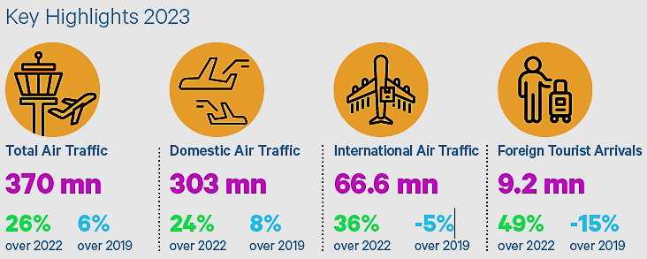
Sources: Airport Authority of India, Ministry of Tourism, India, HVS Research.
The hospitality industry in India experienced a remarkable revival in 2023, marked by escalating hotel prices, soaring airfares, and increased travel expenditures. This translated into a promising year for hospitality in India. As we delve into 2024, sustained growth is strongly indicated in domestic as well as international travel. Premium hotels nationwide reported impressive occupancy rates ranging from 70% to 72%. The Indian Luxury Hotel Market size is expanding at a CAGR of 8.1% from 2023 to 2032.
India has become one of the most sought-after travel destinations worldwide, resulting in the tourism and hospitality industry emerging as a major growth driver in the services sector. Similar to many other countries, tourism in India plays a pivotal role in generating foreign exchange earnings. Foreign exchange earnings experienced a Compound Annual Growth Rate (CAGR) of 7%.
- MARKET SIZE:
As per the Ministry of Tourism, Foreign Tourist Arrivals (FTAs) in March 2023 were 7,95,827 as compared to 3,42,308 in March 2022 with a positive growth rate of 132.5%. FTAs during the period January-March 2023 were 25,29,766 as compared to 7,84,750 in January-March, 2022 and 31,79,792 in January-March 2019 registering a growth of 222.4% and -20.4% with respect to 2023 and 2019 respectively.
In 2021, the travel and tourism industry's contribution to India's GDP was valued at US$ 178 billion, and it is projected to reach US$ 512 billion by 2028. The industry's direct contribution to India's GDP is expected to grow annually at a rate of 7-9% between 2019 and 2030. In 2020, the travel and tourism industry contributed US$ 121.9 billion to India's GDP. By 2022, the contribution of the travel and tourism industry to India's economy reached US$ 15.7 trillion.
The travel market in India is expected to reach US$ 125 billion by FY27, an increase from an estimated US$ 75 billion in FY20. The Indian airline travel market, valued at approximately US$ 20 billion, is projected to double in size by FY27 due to improvements in airport infrastructure and increased passport accessibility.
The Indian hotel market, including domestic, inbound, and outbound segments, was estimated at around US$ 32 billion in FY20 and is expected to reach approximately US$ 52 billion by FY27. This growth will be driven by the rising demand from travellers and the ongoing efforts of travel agents to stimulate the market.
By 2028, international tourist arrivals are projected to reach 30.5 billion, generating revenue of over US$ 59 billion. However, the growth in the tourism sector is expected to be primarily driven by domestic tourists in the post-pandemic period. International hotel chains are expanding their presence in India and it reached approximately 50% of the country's tourism and hospitality sector.

- PERFORMANCE ANALYSIS OF INDIAN HOTEL SECTOR FY2023:
The Indian hotel sector closed the calendar year 2023 with a nationwide occupancy rate in the range of 63-65%, up 3-5 percentage points (pp) from the previous year and nearly reaching the pre-pandemic level of 65-67% in 2019. The average rate (ARR) for 2023 reached an impressive INR 7,400-7,600, which surpassed the figures from 2022 by 21-23% and 2019 by 24-26%, highlighting the sector’s ability to push rates driven by the buoyant demand.
The growth in average rates helped RevPAR to reach INR 4,662-4,940 in 2023, indicating a significant increase of 29-31% from 2022 and 19-21% in 2019. As per our tertiary research and data/information available in the public domain, KPIs of Indian hotel sector is shown in the below picture for FY 2023:
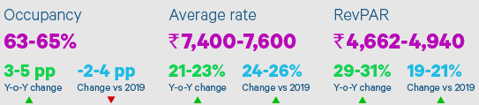
Sources: STR, HVS Research; all the data is for the calendar year and represents averages for the Indian hotel sector
The year got off to a good start with the nationwide occupancy rate breaching the 70% mark in February 2023, a first since the pandemic. The weddings segment, the upswing in business travel, and the Men’s IPL helped boost demand for hotel accommodation. The occupancy rate of 65-67% in Q1 2023 was 15-17 pp higher than in Q1 2022, which was impacted by the Omicron wave and the reintroduction of travel restrictions in the country. ARR meanwhile, experienced a year-on-year increase of 49-51% in Q1 2023, helping RevPAR to nearly double during this period.
Due to the seasonal retreat of travel, the occupancy rate moderated to 62-65% in the second quarter and while the trend was similar to Q2 2019 levels, it was 1-3 pp lower than Q2 2022. Despite this, ARR continued its growth trajectory and was 16- 18% and 23-25% higher than Q2 2022 and Q2 2019, respectively, driven by strong demand in the leisure and social events segments.
The seasonal moderation in Q2 continued into Q3, with occupancy rate in the 60-62% range. International events such as the G20 Summit, along with sustained demand from corporate travel and the growing popularity of Leisure helped drive the average rates in several key corporate markets such as Delhi and Mumbai. During this quarter, average rates experienced a year-on-year growth of 15-17% to reach INR 6,700-6,900, and were 24-26% higher than the same period in 2019.
The final quarter saw occupancy in the range of 64-66%, with ARR reaching INR 8,200-8,400. This helped RevPAR to reach INR 5,250-5,545. The ICC Men’s Cricket World Cup coupled with the wedding season and year-end holiday season, allowed the sector to end the year on a high note. Goa and Bengaluru continued to garner the highest interest from hotel operators in 2023 as shown in the below table. Hotel brands also increased their presence in smaller cities.
Ranking 2023 | By Keys |  | Ranking in 2022
S. No. | City | Number
1 | Goa | 1350 | 2
2 | Bengaluru | 1093 | 1
3 | Hyderabad | 1062 | 52
4 | Guwahati | 1038 | 79
5 | Amritsar | 926 | 5
6 | Jaipur | 908 | 12
7 | Indore | 801 | 37
8 | Lucknow | 768 | 38
9 | Ayodhya | 699 | 119
10 | Kasauli | 624 | 42

BRAND OPENINGS DURING 2019 TO 2023
In 2023, the surge in travel demand facilitated the opening of 12,435 branded hotel rooms, marking a 13% increase from 2022, with hotel operators continuing the trend of partial opening of their properties. Notably, domestic brands led the expansion, accounting for 73% of the new openings by properties, thereby continuing their dominance over international hotel chains in the market.

Note: openings include full and partial openings; Data received from 21 hotel operators as of 31st March 2024

- INVESTMENTS AND RECENT DEVELOPMENTS:
The Ministry of Tourism received an investment of Rs. 2,400 crore as the tourism sector presents significant opportunities for youth employment and entrepreneurship. To promote the establishment of new hotels, an investment-linked deduction is available under Section 35 AD of the Income Tax Act. This allows a 100% deduction for capital expenditures incurred in setting up hotels of 2-star category and above across India.
In the Union Budget 2023-24, the Ministry of Tourism was allocated US$ 290.64 million to leverage the sector's potential for job creation, youth entrepreneurship, and tourism promotion. The focus is on active state participation, government program convergence, and public-private partnerships.
Additionally, states will be encouraged to set up Unity Malls in their capital cities, serving as prominent tourism centers to promote local products, including One District One Product, Geographical Indication (GI) products, handicrafts, and products from other states. Below are some investments and developments:
- The Indian government has set a target to create 220 new airports by 2025, aiming to enhance connectivity and facilitate tourism growth.
- The Emergency Credit Line Guarantee Scheme (ECLGS) has been expanded to include tourism and hospitality stakeholders, providing financial support to micro, small, and medium enterprises (MSMEs). Exhibition-cum-convention centres have been granted infrastructure status.
- A separate liquidity window of INR 15,000 crore has been established for the tourism sector to address financial challenges.
- As of September 2022, a total of 48,775 accommodation units (classified and unclassified) have been registered on the National Integrated Database of Hospitality Industry (NIDHI) portal. Additionally, 11,220 units have self-certified for SAATHI standards, ensuring quality and safety.
- The Medical Tourism sector is projected to grow at a Compound Annual Growth Rate (CAGR) of 21.1% from 2020 to 2027.
- The Indian government estimates that India will have a market size of 1.2 million cruise visitors by 2030-31. Dream Hotel Group plans to invest approximately US$ 300 million in the next 3-5 years to develop India's cruise sector.
- India is at the forefront of digital travel, with its population utilizing digital tools for travel planning, booking, and experiences. The growing middle class and increasing disposable income have contributed to the growth of domestic and outbound tourism.

- GOVERNMENT INITIATIVES:
The Indian government has recognized the immense potential of the tourism industry and has implemented various measures to position India as a global tourism hub. In the Union Budget 2023-24, the Ministry of Tourism has been allocated a budget of US$ 290.4 million. Within this budget, an allocation of US$ 170.85 million has been made for the Swadesh Darshan Scheme.
This scheme aims to develop a comprehensive package of 50 tourist destinations, focusing on enhancing physical, digital, and virtual connectivity, as well as ensuring the availability of tourist guides and improving tourist security. Under the Budget 2023-24, an allocation of US$ 30.25 million has been made for the development of tourist circuits under the PRASHAD scheme. Since its launch in January 2015, the Ministry has sanctioned 37 projects in 24 states, with an estimated expenditure of US$ 146.4 million.
The Government of India, has collaborated with the Quality Council of India (QCI) for an initiative called SAATHI (System for Assessment, Awareness, and Training for the Hospitality Industry). This initiative aims to assist the hospitality industry in operating safely and mitigating risks arising from the COVID-19 pandemic. To support the tourism service sector affected by COVID-19, the government introduced the Loan Guarantee Scheme for Covid Affected Tourism Service Sector (LGSCATSS). This scheme provides loans of up to US$ 12,110 to approved and recognized tour operators, travel agents, and tourist transport operators under the Ministry of Tourism.
Furthermore, guarantees for skill development loans, up to INR 1.5 lakh, are being extended by member banks of the Indian Banks' Association (IBA) to eligible borrowers without collateral or third-party guarantee. This initiative aims to promote skill development within the tourism sector.
- FUTURE OUTLOOK:
The 2024 outlook for India’s hotel sector is exceptionally positive, despite the nationwide elections, which have in the past impacted travel. The sector is poised for significant expansion, fuelled by ongoing growth in domestic tourism and corporate travel, including the MICE segment. Furthermore, the recovery and expected increase in inbound tourism, spurred by a growing global interest in India’s rich cultural diversity and landscapes coupled with India’s growing global economic and geopolitical stature is expected to substantially contribute to the Sector’s growth. Initiatives from both the government and private sectors will continue to be integral to this growth and support the sector’s ascent to prominence.

PART F | SWOT ANALYSIS

SWOT ANALYSIS
STRENGTHS | - Synergy from Brand: Taj is a luxury branded resort name with a good location and site orientation. It is a well-known brand under the Taj Hotels group, which has a reputation for luxury and quality service. M/s Dhruvdesh Ventures will get synergy from Taj and raise the bar of performance and increase its profit margin.  - Prime Locations: Hosapete & Hampi are immensely rich in heritage, architecture and religious relevance, and has huge untapped potential. The location is near to UNESCO World Heritage, which attract leisure and business travellers.  - Diverse Portfolio: Taj offers a diverse portfolio of services, including accommodation, dining, spa, and event facilities, catering to a wide range of guest needs.  - High-Quality Service: Taj resorts are known for providing exceptional service, including personalized attention to guests and luxurious amenities.  - Connectivity: Hosapete & Hampi are well connected via road/air, especially from Bangalore, which enhanced the attractiveness of the destination, for short-haul weekend getaways.
WEAKNESSES | - High Price Point: Luxury segment resorts are positioned as luxury properties, which may limit their appeal to budget-conscious travellers.  - Limited Market Reach: Compared to some international hotel chains, Taj's market reach may be limited to certain regions, potentially limiting growth opportunities.  - Dependency on Tourism: Taj resorts in tourist destinations may be vulnerable to fluctuations in tourist arrivals, which can impact occupancy rates and revenue.  - Competition: As industry is growing with technology advancement such as Robotics, AI, IT etc., new and existing players may impact the footfall and revenue generation in future.
OPPORTUNITIES | - Expansion into New Markets: The proposed luxury resort is exploring opportunities to expand into new geographic location to reach a broader customer base.  - Diversification of Offerings: Introducing new services or amenities by proposed resort, such as wellness programs, culinary experiences, or eco-friendly initiatives, could attract new customers and enhance the overall guest experience.  - Partnerships and Collaborations: Forming strategic partnerships with airlines, travel agencies, or local businesses could help Taj resorts to reach new customers and drive bookings.  - Digital Innovation: Leveraging technology to enhance the booking process, improve guest communication, and personalize the guest experience will provide a competitive edge for Taj resorts.  - Expected CAGR: The industry for hospitality in India is expected to increase at a compound annual growth rate (CAGR) of 5.41% between 2024 and 2030.
THREATS | - Competition: Taj faces intense competition from other luxury hotel chains both domestically and internationally, as well as from alternative accommodation options such as vacation rentals and boutique hotels.  - Economic Factors: Economic downturns or fluctuations in currency exchange rates can impact disposable income and travel spending, potentially affecting demand for luxury accommodations.  - Regulatory Challenges: Changes in government policies or regulations related to tourism, taxation, or licensing can impact the operating environment for Taj resorts in India.

PART G | PROJECT COST AND MEANS OF FINANCE
As per data/information shared by the client, below are the details of Total project Cost (TPC) and means of finance of the proposed Pharmaceutical Manufacturing Unit:
Total Project Cost
Particulars | Total (INR Crores)
Land | 0.00
Building | 32.45
Plant & Machinery Equipment | 24.41
Furniture & Fixtures | 9.62
Interest Capitalisation & Other cost | 5.44
Interiors Decoration | 39.99
Consultancy Fees | 9.61
Preliminary & Preoperative expenses | 3.06
Contingencies | 7.95
Total | INR 132.54 Crores

Means Of Finance
Particular | Total (INR Crores)
Term Loan | 80.00
Equity (Share Capital + Securities Premium) | 52.54
Total | INR 132.54 Crores
Notes:
- Total project cost estimation has been provided to us by the client, as a TEV consultant we have cross verified the cost of the components of TPC independently, for TEV purpose only as a general assessment.
- As per sale deed shared by the client/company and verified during survey, company has owned a land spread over an area of 40,954.18 (10.12 acres), for the proposed luxury segment resort at Hallekeri, Kamalapur, Hosapete, Karnataka, India, 583221. From total area of 40,954.18 Sq. mt, 21,196.38 square meters built up area is allocated to the proposed luxury segment resort.
- As per data / information provided by company, Total estimated cost of the Building & Civil works is ~INR 32.45 Crore including Landscaping of Gardens & Horticulture, Swimming pool, internal paths, Fencing and boundary wall, Water Tanks, the same has been vetted and certified by SBI panelled & Govt. Registered valuer P.I. Miskin (Chartered Engineer) on 24th July 2024.
Out of total Building & Civil works cost, main building civil shell and core works will be costing ~INR 22.94 Crore which comes out as INR 1754.50 per Sq. ft. excluding interior work which is reasonable for the proposed luxury resort project. Also it is ~24% of the total project cost as per the industry benchmark. (Ref: Hotel Development Cost Survey 2023 India done by Hotelivate).
The estimated cost of Boundary wall/fencing work is ~INR 0.99 Cr. which comes out as INR 902.50 per Sq. ft., The estimated cost of water tank/sumps work is ~INR 1.31 Cr. which comes out as INR 5671.00 per Sq. ft., which we found in the line with prevailing standard market rates in the nearby areas during our tertiary research. However, the cost may variate as per specifications & brand of the material.
- The estimated cost for the proposed plant & machinery and equipment is INR 24.01 crores according to the client's estimate. However tenders of major equipment’s such Air Conditioner, Firefighting system , CCTV and Camera and Electrical connection including transformer as are in process at present as informed by LLP/client and actual costs along with Performa invoices will be provided after finalised the suitable vendors.
Hence, we have considered these cost as tentative in nature since costs are seeming in the line with prevailing market rates. As per our cost estimation ~INR 23-26 Crore is the standard cost for a luxury segment hotel and it’s important to note that the cost of proposed equipment may vary depending on the brand name and technical specifications of the equipment. As per the Hotel Development Cost Survey 2023, India done by Hotelivate standard cost of FF&E is ~25% of the Total project cost. Thus cost of equipment is taken in the line with industrial benchmark.
- The estimated cost for furniture & fixtures will be INR 9.62 crores as per the client. As TEV consultants; we have independently verified the cost of the proposed furniture & fixtures by consulting several vendors who specialize in similar market. We found that proposed furniture & fixtures costs to be reasonable and within permissible ranges.
It's important to note that the cost of proposed furniture & fixtures may vary depending on the brand name and quality of the furniture & fixtures. As per the Hotel Development Cost Survey 2023, India done by Hotelivate standard cost of FF&E is ~25% of the Total project cost. Thus cost of equipment is taken in the line with industrial benchmark.
- As per the loan schedule, LLP will be paying an IDC (Interest during construction) of INR 5.44 Crore, while Pre-operative and preliminary expenses are ~3.06 Crore as shown in the below table:
Interest Capitalisation & Other cost
S. No. | Particulars | Amount
1 | Technical Service fees payable to the Hotel Management Group | 1.06
2 | Interest during construction (3 years) | 5.44
3 | Preopening Advertisement & Publicity Expenses | 2.00
 | Total | 8.50 Cr.
- As per the data/information provided by the client, the estimated cost for the proposed Interior & Landscape will be INR 39.99 crores. Detailed Breakup of BOH, FOH & Façade is in the process and will be shared by LLP soon. These cost are tentative and can be change as per actual scope of work. As per the data/information shared by the client, final scope of work yet to be finalized as tenders are in progress till date. We recommend the bank to obtain the final list of vendors/supplier along with actual scope of work & final cost before disbursement.
- As per the data/information provided by the client, the estimated cost for Consultancy Fees will be INR 9.61 crores. Below table shows the bifurcation:
Head | Consultant | Fees
Architects | SJK Studios LLP | 3,02,90,179
PMC | Cushman & Wakefield as per the shared agreement | 3,75,34,141
Structural | Manjunatha & Co | 15,80,357
MEP | AEON Consultants India Pvt Ltd | 47,20,000
Landscape | John Petitgrew, Indonesia | 50,47,924
Lighting Consultants | Lucent Worldwide, New Delhi | 25,96,000
Facility Consultant | DMA Consultants, New Delhi | 11,19,420
Voice and Data | Tendering is on | 5,26,786
CFE consultant | Samrakshan Bangalore | 1,31,696
Liasioning consultant | Shrushti Architecets, Hampi | 13,16,964
Security Systems | Tendering is on | 5,26,786
IT Consultant | Tendering is on | 7,90,179
Future Consultants | - | 1,00,00,000
Consultants Fee |  | 9,61,80,431
Source: Data/information provided by the client.
- The estimated cost for contingencies is set at 7.95 crores (~6% of TPC). This allocation is not fixed and serves as a provisional figure, which could potentially cover expenses related to areas such as Interiors, BOH (Back of House), MEP (Mechanical, Electrical, and Plumbing), Landscape, and others. Contingencies may or may not arise. Therefore, this provision has been made based on the advice of the Project Consultant.
- The total estimated cost of the proposed luxury segment resort is INR 132.54 Crores, intended to be financed through a combination of debt and equity. Specifically, the project will be funded by a term loan of INR 80.00 Crores and a promoter contribution of INR 52.54 Crores.

PART H | PROJECT SCHEDULE

Below is the tabulated presentation of the status of the project showing expected duration shared by the project manager of the company. The project is expected to be complete soon.
S. No. | Particulars | Activity | Start Date | Expected Completion Date | Status
1. | Acquisition of Land | Land Procurement | Mar 2019 | Feb 2021 | Owned
 |  | Land Development | Oct 2023 | June 2024 | Scheduled
2. | Sanction of Rupee Term Loan | Sanction of Rupee Term Loan | May 2024 | June 2024 | Scheduled
3. | Building & Civil Works | Appointment of Architect | 2021 | 2024 | Completed
 |  | Building Plan Preparation | 2023 | 2024 | Completed
 |  | Building Plan Sanction | Dec 2022 | - | Completed
 |  | Appointment of Civil contractor/ developer | Nov 2023 | - | Completed
 |  | Building & Civil Works | Nov 2023 | Dec 2025 | WIP
4. | Plant & Machinery | Finalization of P&M suppliers | May 2024 | June 2025 | Scheduled
 |  | Orders to P&M suppliers | May 2024 | June 2025
 |  | Arrival of P&M | August 2024 | June 2025
 |  | Installation of P&M | Oct 2024 | Dec 2025
 |  | Utility Installation | Jun 2025 | Jan 2026
5. | Furniture and Fixtures | Purchase of other Fixed Assets/ Furniture & Fixtures | Mar 2025 | Dec 2025 | Scheduled
6. | Statutory Approvals, registrations & NOCs | Most of the approvals are taken from the respective authorities. | - | May 2026 | Scheduled
7. | Trail Run | - | 1st June 2026 | 30th June 2026 | Scheduled
8. | Commercial Operation Date | - | - | 1st July2026 | Scheduled

Notes:
- Schedule has been made based on current status as per feasibility to achieve different milestones.
- Achievement of Milestone will depend on sanction of term loan as per proposed timeline.
- It is to be noted here that, as per the original technical services agreement the schedule was as under:
Particular | Date
Date of signing of Agreement | 02-Mar-21
Completion of design | 02-Jul-23
Mock-up room | 02-Mar-23
Super Structure | 02-Mar-24
Date of Completion | 02-Mar-25
However, as per the supplementary agreement dated 17.07.2024, the tail of the project has been extended by 15 months and the project to be completed by 24.06.2026.
- Thus, as per this timeline, expected COD will be 1st July 2026 and financial projection also has been made accordingly.
- Please refer to Part-I of the report, for statutory approvals, licenses, and NOCs.

PART I | STATUTORY APPROVALS | LICENCES | NOC

Following major approvals are required. However, the list is not exhaustive and State / district Authorities may be approached for further clearances required (if any):
S. No. | REQUIRED APPROVALS | REFERENCE NO./ DATE | STATUS  (Approved/ Applied For/ Pending)
1. | Registration Certificate from GST REG-06, Government of India | 29AAJFD1589N1ZP  1st July 2017 | Approved
2. | Certificate of Registration on Conversion of Dhruvdesh Ventures to Dhruvdesh Ventures LLP from Ministry of Corporate Affairs, Government of India | ABZ-5457  12th December 2022 | Approved
3. | Limited Liability partnership Agreement from Government of Karnataka, India | IN-KA34460893309949V  5th April 2023 | Approved
4. | Land Conversion Certificate, Office of the Deputy Commissioner, Bellary District, Karnataka, India | 361/2014-15  26th August 2015 | Approved
5. | Revised Site Map Plan Approval by Hampi World Heritage Area Management Authority | - | Applied
6. | Application for Revision, Urban Development Department, Kamalapura Town Panchayat, Hosapete, Karnataka | KMP-LBPAS-10071/23-24/REV  16th March 2024 | Applied
7. | Pollution Certificate from Karnataka State Pollution Control Board | CTE-341428  4th January 2024 | Approved
8. | No Objection Certificate (NOC) For Ground Water Abstraction, Ministry of Jal Shakti, Government of India | - | Pending
9. | Fire Safety Permit  Karnataka State Fire and Emergency Services Department | - | Pending
10. | Trade License from Department of the Local Authority | - | Pending
11. | Bar License from Excise Department, State Government | - | Pending
12. | License under prevention of Food Adulteration Act (FASSAI License) | - | Pending

Observation Notes:
- Above is the only illustration of the major approvals sought or to be sought by the company. It should not be construed as the exhaustive list and in case any approval is missed to be mentioned then it is the sole responsibility of the company to keep the unit compliant with the necessary statutory approvals/ NOCs.
- M/s Dhruvdesh Ventures had submitted the revised plan of 90 Keys to Hampi World Heritage Area Management Authority (HWAMA) for Approval. Although company had made a payment for revised plan to Town Municipal Authority Hampi, on 12th June 2024, they are still awaiting for the formal approval letter for the same. (Town Municipal Council Kamalapura, Challan Receipt No.: 1559KMPOC10062024).
- As per consent to establishment expand (Consent Order No. CTE-341428; Dated: 4th January, 2024) Consent for Expansion of hospitality (hotel with lodging - 10 rooms) - BAU - 2604 Sq. Mt. is granted by the authority. The approval for 80 keys which is obtained by the LLP in past need to be obtained and to be held on record by bank before sanction of term loan as we have not received during the preparation of this TEV study.
- As per agreement shared by company, on 6th April 2024, M/s Dhruvdesh Ventures LLP and DHARE Consultants entered into an agreement, to obtain the NOC from Ground Water Authority for construction of proposed 90 key of Taj Hotel Project, at Hampi Karnataka. It is mentioned in the agreement that time to obtain NOC from Karnataka Ground Water Authority (KGWA) will take about 10 to 11 Months.
- As per consent to establishment expand (Consent Order No. CTE-341428; Dated: 4th January, 2024), water requirement for the proposed resort is 100 KLD and the source of water consumption will be from borewell.
- Some of the Approvals are pending and will be applied in due course as per above schedule.
PART J | COMPANY’S FINANCIAL FEASIBILITY

- PROJECTIONS OF THE FIRM:
The projections of the proposed manufacturing unit are done for next 14 years period from FY 2026-27 to 2039-40 based on the expected COD and loan tenor are elaborated below:
- PROJECTED PROFIT & LOSS ACCOUNT:
(INR Crores)
Particulars | Mar-27 | Mar-28 | Mar-29 | Mar-30 | Mar-31 | Mar-32 | Mar-33
Total Gross Revenue | 36.33 | 54.66 | 60.57 | 67.23 | 74.64 | 83.02 | 92.00
Total Departmental Expenses | 9.56 | 14.35 | 15.88 | 17.59 | 19.48 | 21.61 | 23.91
Gross Departmental Income | 26.77 | 40.31 | 44.69 | 49.64 | 55.15 | 61.41 | 68.09
Operating Expenses | 11.99 | 18.04 | 20.59 | 22.86 | 25.38 | 29.06 | 32.20
Gross Operating Profit | 14.78 | 22.27 | 24.10 | 26.78 | 29.78 | 32.36 | 35.89
Less Management Fees –Hosp. | 2.49 | 4.02 | 4.41 | 4.90 | 5.44 | 6.42 | 7.11
Income Before Fixed Expenses –Hosp. | 12.30 | 18.25 | 19.68 | 21.88 | 24.33 | 25.94 | 28.78
FF&E Expense
Less Fixed Expenses – Hosp. | 1.19 | 1.11 | 1.03 | 0.96 | 0.88 | 0.81 | 0.73
EBITDA | 11.11 | 17.14 | 18.65 | 20.93 | 23.45 | 25.14 | 28.05
Less Book Depreciation | 5.64 | 7.62 | 7.62 | 7.62 | 7.62 | 7.62 | 7.62
Operating Income (EBIT) | 5.47 | 9.52 | 11.03 | 13.30 | 15.83 | 17.51 | 20.43
Less Interest on Term Loan | 5.28 | 6.53 | 5.95 | 5.36 | 4.78 | 4.20 | 3.62
Interest on Working Capital
Interest Expenses | 5.28 | 6.53 | 5.95 | 5.36 | 4.78 | 4.20 | 3.62
Preliminary/pre-operative Expenses Written off | 2.53 | 2.53 | 2.53 | 2.53 | 2.53 | 0.00 | 0.00
Profit Before Tax | -2.34 | 0.46 | 2.55 | 5.41 | 8.52 | 13.31 | 16.81
Current Tax | 0.00 | 0.00 | 0.00 | 0.00 | 0.00 | 0.49 | 2.88
Profit After Tax | -2.34 | 0.46 | 2.55 | 5.41 | 8.52 | 12.83 | 13.93
Cash Accruals | 5.83 | 10.62 | 12.70 | 15.56 | 18.67 | 20.45 | 21.55

(Continue)
Particulars |  | Mar-34 |  | Mar-35 |  | Mar-36 |  | Mar-37 |  | Mar-38 |  | Mar-39 | Mar-40
Total Gross Revenue | 97.30 |  | 102.91 |  | 109.06 |  | 120.88 |  | 127.86 |  | 135.26 |  | 143.36
Total Departmental Expenses | 25.24 |  | 26.64 |  | 28.15 |  | 31.16 |  | 32.89 |  | 34.72 |  | 36.71
Gross Departmental Income | 72.07 |  | 76.28 |  | 80.91 |  | 89.72 |  | 94.97 |  | 100.53 |  | 106.66
Operating Expenses | 34.06 |  | 36.02 |  | 38.17 |  | 42.31 |  | 44.75 |  | 47.34 |  | 50.18
Gross Operating Profit | 38.01 |  | 40.26 |  | 42.74 |  | 47.41 |  | 50.22 |  | 53.19 |  | 56.48
Less Management Fees –Hosp. | 7.53 |  | 7.96 |  | 8.45 |  | 9.36 |  | 9.91 |  | 10.49 |  | 11.12
Income Before Fixed Expenses –Hosp. | 30.49 |  | 32.29 |  | 34.30 |  | 38.05 |  | 40.31 |  | 42.71 |  | 45.36
FF&E Expense
Less Fixed Expenses – Hosp. | 0.65 |  | 0.58 |  | 0.50 |  | 0.42 |  | 0.35 |  | 0.27 |  | 0.20
EBITDA | 29.83 |  | 31.72 |  | 33.80 |  | 37.63 |  | 39.96 |  | 42.43 |  | 45.16
Less Book Depreciation | 7.62 |  | 7.62 |  | 7.62 |  | 7.62 |  | 7.62 |  | 7.62 |  | 7.62
Operating Income (EBIT) | 22.21 |  | 24.10 |  | 26.17 |  | 30.00 |  | 32.34 |  | 34.81 |  | 37.54
Less Interest on Term Loan | 3.08 |  | 2.50 |  | 1.92 |  | 1.33 |  | 0.75 |  | 0.18 |  | 0.00
Interest on Working Capital
Interest Expenses | 3.08 |  | 2.50 |  | 1.92 |  | 1.33 |  | 0.75 |  | 0.18 |  | 0.00
Preliminary/pre-operative Expenses Written off | 0.00 |  | 0.00 |  | 0.00 |  | 0.00 |  | 0.00 |  | 0.00 |  | 0.00
Profit Before Tax | 19.13 |  | 21.60 |  | 24.26 |  | 28.67 |  | 31.59 |  | 34.63 |  | 37.54
Current Tax | 7.90 |  | 9.26 |  | 10.37 |  | 12.05 |  | 13.16 |  | 14.30 |  | 15.37
Profit After Tax | 11.23 |  | 12.34 |  | 13.89 |  | 16.62 |  | 18.42 |  | 20.33 |  | 22.17
Cash Accruals | 18.85 |  | 19.96 |  | 21.51 |  | 24.24 |  | 26.05 |  | 27.95 |  | 29.79

- OPERATING STATEMENT:
(INR Crores)
Particular | Mar-27 | Mar-28 | Mar-29 | Mar-30 | Mar-31 | Mar-32 | Mar-33
Gross Sales:
Domestic Sales | 36.33 | 54.66 | 60.57 | 67.23 | 74.64 | 83.02 | 92.00
Export Sales
Total Gross Sales | 36.33 | 54.66 | 60.57 | 67.23 | 74.64 | 83.02 | 92.00
Net Sales | 36.33 | 54.66 | 60.57 | 67.23 | 74.64 | 83.02 | 92.00
Cost Of Sales:
Departmental Expenses | 9.56 | 14.35 | 15.88 | 17.59 | 19.48 | 21.61 | 23.91
Total Departmental Expenses | 9.56 | 14.35 | 15.88 | 17.59 | 19.48 | 21.61 | 23.91
Total Spares | 0.00 | 0.00 | 0.00 | 0.00 | 0.00 | 0.00 | 0.00
Power & Fuel | 3.63 | 5.47 | 6.06 | 6.72 | 7.46 | 8.30 | 9.20
Direct Labour | 4.54 | 6.83 | 7.57 | 8.40 | 9.33 | 10.38 | 11.50
Other Direct Costs | 3.09 | 4.65 | 5.75 | 6.39 | 7.09 | 8.72 | 9.66
Insurance | 1.14 | 1.07 | 0.99 | 0.91 | 0.84 | 0.76 | 0.68
Property Taxes | 0.04 | 0.04 | 0.04 | 0.04 | 0.04 | 0.04 | 0.04
Depreciation & Amortisation | 5.64 | 7.62 | 7.62 | 7.62 | 7.62 | 7.62 | 7.62
Cost Of Production | 27.65 | 40.03 | 43.92 | 47.68 | 51.87 | 57.43 | 62.63
Cost Of Sales | 27.65 | 40.03 | 43.92 | 47.68 | 51.87 | 57.43 | 62.63
Selling & General Administrative Expenses | 3.21 | 5.11 | 5.62 | 6.24 | 6.94 | 8.08 | 8.95
Operating Profit Before Interest | 5.47 | 9.52 | 11.03 | 13.30 | 15.83 | 17.51 | 20.43
Interest On Term Loan | 5.28 | 6.53 | 5.95 | 5.36 | 4.78 | 4.20 | 3.62
Total Interest Outgo | 5.28 | 6.53 | 5.95 | 5.36 | 4.78 | 4.20 | 3.62
Operating Profit After Interest | 0.19 | 2.99 | 5.08 | 7.94 | 11.05 | 13.31 | 16.81
Preliminary Expenses Written Off | 2.53 | 2.53 | 2.53 | 2.53 | 2.53 | 0.00 | 0.00
Total Other Non-Operating Expenses | 2.53 | 2.53 | 2.53 | 2.53 | 2.53 | 0.00 | 0.00
Net Non-Operating Income | -2.53 | -2.53 | -2.53 | -2.53 | -2.53 | 0.00 | 0.00
Profit Before Tax / Loss | -2.34 | 0.46 | 2.55 | 5.41 | 8.52 | 13.31 | 16.81
Provision For Taxes | 0.00 | 0.00 | 0.00 | 0.00 | 0.00 | 0.49 | 2.88
Net Profit / Loss | -2.34 | 0.46 | 2.55 | 5.41 | 8.52 | 12.83 | 13.93
Retained Profit | -2.34 | 0.46 | 2.55 | 5.41 | 8.52 | 12.83 | 13.93
Amount Transferred To Profit & Loss Account | -2.34 | 0.46 | 2.55 | 5.41 | 8.52 | 12.83 | 13.93

(Continue)
Particular | Mar-34 | Mar-35 | Mar-36 | Mar-37 | Mar-38 | Mar-39 | Mar-40
Gross Sales:
Domestic Sales | 97.30 | 102.91 | 109.06 | 120.88 | 127.86 | 135.26 | 143.36
Export Sales
Total Gross Sales | 97.30 | 102.91 | 109.06 | 120.88 | 127.86 | 135.26 | 143.36
Net Sales | 97.30 | 102.91 | 109.06 | 120.88 | 127.86 | 135.26 | 143.36
Cost Of Sales:
Departmental Expenses | 25.24 | 26.64 | 28.15 | 31.16 | 32.89 | 34.72 | 36.71
Total Departmental Expenses | 25.24 | 26.64 | 28.15 | 31.16 | 32.89 | 34.72 | 36.71
Total Spares | 0.00 | 0.00 | 0.00 | 0.00 | 0.00 | 0.00 | 0.00
Power & Fuel | 9.73 | 10.29 | 10.91 | 12.09 | 12.79 | 13.53 | 14.34
Direct Labour | 12.16 | 12.86 | 13.63 | 15.11 | 15.98 | 16.91 | 17.92
Other Direct Costs | 10.22 | 10.81 | 11.45 | 12.69 | 13.43 | 14.20 | 15.05
Insurance | 0.61 | 0.53 | 0.46 | 0.38 | 0.30 | 0.23 | 0.15
Property Taxes | 0.04 | 0.04 | 0.04 | 0.04 | 0.04 | 0.04 | 0.04
Depreciation & Amortisation | 7.62 | 7.62 | 7.62 | 7.62 | 7.62 | 7.62 | 7.62
Cost Of Production | 65.62 | 68.80 | 72.26 | 79.09 | 83.06 | 87.25 | 91.84
Cost Of Sales | 65.62 | 68.80 | 72.26 | 79.09 | 83.06 | 87.25 | 91.84
Selling & General Administrative Expenses | 9.47 | 10.02 | 10.63 | 11.78 | 12.47 | 13.19 | 13.99
Operating Profit Before Interest | 22.21 | 24.10 | 26.17 | 30.00 | 32.34 | 34.81 | 37.54
Interest On Term Loans | 3.08 | 2.50 | 1.92 | 1.33 | 0.75 | 0.18 | 0.00
Total Interest Outgo | 3.08 | 2.50 | 1.92 | 1.33 | 0.75 | 0.18 | 0.00
Operating Profit After Interest | 19.13 | 21.60 | 24.26 | 28.67 | 31.59 | 34.63 | 37.54
Preliminary Expenses Written Off | 0.00 | 0.00 | 0.00 | 0.00 | 0.00 | 0.00 | 0.00
Total Other Non-Operating Expenses | 0.00 | 0.00 | 0.00 | 0.00 | 0.00 | 0.00 | 0.00
Net Non-Operating Income | 0.00 | 0.00 | 0.00 | 0.00 | 0.00 | 0.00 | 0.00
Profit Before Tax / Loss | 19.13 | 21.60 | 24.26 | 28.67 | 31.59 | 34.63 | 37.54
Provision For Taxes | 7.90 | 9.26 | 10.37 | 12.05 | 13.16 | 14.30 | 15.37
Net Profit / Loss | 11.23 | 12.34 | 13.89 | 16.62 | 18.42 | 20.33 | 22.17
Retained Profit | 11.23 | 12.34 | 13.89 | 16.62 | 18.42 | 20.33 | 22.17
Amount Transferred To Profit & Loss Account | 11.23 | 12.34 | 13.89 | 16.62 | 18.42 | 20.33 | 22.17

- PROJECTED BALANCE SHEET:
(INR Crores)
Particulars | Mar-27 | Mar-28 | Mar-29 | Mar-30 | Mar-31 | Mar-32 | Mar-33
Equity & Liability
Equity | 52.5 | 52.5 | 52.5 | 52.5 | 52.5 | 52.5 | 52.5
Net Profit after tax | -2.3 | -1.9 | 0.7 | 6.1 | 14.6 | 27.4 | 41.3
Total Equity | 50.2 | 50.7 | 53.2 | 58.6 | 67.1 | 80.0 | 93.9
long Term Loan | 68.8 | 62.4 | 56.0 | 49.6 | 43.2 | 36.8 | 30.4
Short Term loan | 6.4 | 6.4 | 6.4 | 6.4 | 6.4 | 6.4 | 6.4
Current Liabilities | 4.2 | 6.3 | 7.0 | 7.7 | 8.5 | 9.6 | 10.7
Total Equity and Liabilities | 129.6 | 125.7 | 122.6 | 122.3 | 125.3 | 132.8 | 141.3
Assets
Total Building Cost | 36.5 | 36.5 | 36.5 | 36.5 | 36.5 | 36.5 | 36.5
Furniture & Fixtures Interiors | 55.9 | 55.9 | 55.9 | 55.9 | 55.9 | 55.9 | 55.9
Plants & Equipment | 27.5 | 27.5 | 27.5 | 27.5 | 27.5 | 27.5 | 27.5
Total Gross Block | 119.9 | 119.9 | 119.9 | 119.9 | 119.9 | 119.9 | 119.9
Depreciation | 5.6 | 13.3 | 20.9 | 28.5 | 36.1 | 43.8 | 51.4
Fixed assets Net Block | 114.2 | 106.6 | 99.0 | 91.4 | 83.7 | 76.1 | 68.5
Pre- Operative Expenses Not Written Off | 10.1 | 7.6 | 5.1 | 2.5 | 0.0 | 0.0 | 0.0
Sundry Debtors | 3.0 | 4.5 | 4.9 | 5.5 | 6.1 | 6.8 | 7.5
Stock | 0.5 | 0.7 | 0.8 | 0.8 | 0.9 | 1.0 | 1.1
Cash & Bank Balance | 1.8 | 6.4 | 12.8 | 22.1 | 34.5 | 48.9 | 64.2
Total Assets | 129.6 | 125.7 | 122.6 | 122.3 | 125.3 | 132.8 | 141.3

(INR Continue)
Particulars | Mar-34 | Mar-35 | Mar-36 | Mar-37 | Mar-38 | Mar-39 | Mar-40
Equity & Liability
Equity | 52.5 | 52.5 | 52.5 | 52.5 | 52.5 | 52.5 | 52.5
Net Profit after tax | 52.6 | 64.9 | 78.8 | 95.4 | 113.8 | 134.2 | 156.3
Total Equity | 105.1 | 117.5 | 131.3 | 148.0 | 166.4 | 186.7 | 208.9
long Term Loan | 24.0 | 17.6 | 11.2 | 4.8 | 0.0 | 0.0 | 0.0
Short Term loan | 6.4 | 6.4 | 6.4 | 6.4 | 4.8 | 0.0 | 0.0
Current Liabilities | 11.2 | 11.9 | 12.5 | 13.9 | 14.6 | 15.5 | 16.4
Total Equity and Liabilities | 146.8 | 153.3 | 161.5 | 173.0 | 185.8 | 202.2 | 225.2
Assets
Total Building Cost | 36.5 | 36.5 | 36.5 | 36.5 | 36.5 | 36.5 | 36.5
Furniture & Fixtures Interiors | 55.9 | 55.9 | 55.9 | 55.9 | 55.9 | 55.9 | 55.9
Plants & Equipment | 27.5 | 27.5 | 27.5 | 27.5 | 27.5 | 27.5 | 27.5
Total Gross Block | 119.9 | 119.9 | 119.9 | 119.9 | 119.9 | 119.9 | 119.9
Depreciation | 59.0 | 66.6 | 74.2 | 81.9 | 89.5 | 97.1 | 104.7
Fixed assets Net Block | 60.9 | 53.2 | 45.6 | 38.0 | 30.4 | 22.8 | 15.1
Pre- Operative Expenses Not Written Off | 0.0 | 0.0 | 0.0 | 0.0 | 0.0 | 0.0 | 0.0
Sundry Debtors | 7.9 | 8.4 | 8.9 | 9.8 | 10.4 | 11.0 | 11.6
Stock | 1.2 | 1.3 | 1.3 | 1.5 | 1.5 | 1.6 | 1.7
Cash & Bank Balance | 76.8 | 90.4 | 105.7 | 123.8 | 143.6 | 166.9 | 196.8
Total Assets | 146.7 | 153.3 | 161.5 | 173.0 | 185.8 | 202.2 | 225.2

- PROJECTED CASH FLOW STATEMENT:
(INR Crore)
Particulars |  | Mar-27 |  | Mar-28 |  | Mar-29 |  | Mar-30 |  | Mar-31 |  | Mar-32 | Mar-33
Sources of Funds
Share Capital a/c | 27.07 |  | 0.00 |  | 0.00 |  | 0.00 |  | 0.00 |  | 0.00 |  | 0.00
Profit before tax but after  Interest & depreciation | -2.34 |  | 0.46 |  | 2.55 |  | 5.41 |  | 8.52 |  | 13.31 |  | 16.81
Increase in Term Loan | 19.00 |  | 0.00 |  | 0.00 |  | 0.00 |  | 0.00 |  | 0.00 |  | 0.00
Depreciation | 5.64 |  | 7.62 |  | 7.62 |  | 7.62 |  | 7.62 |  | 7.62 |  | 7.62
Preliminary Expenses Written Off | 2.53 |  | 2.53 |  | 2.53 |  | 2.53 |  | 2.53 |  | 0.00 |  | 0.00
Increase in Current Liabilities | 4.20 |  | 2.05 |  | 0.73 |  | 0.73 |  | 0.81 |  | 1.12 |  | 1.01
Total | 56.11 |  | 12.67 |  | 13.44 |  | 16.29 |  | 19.49 |  | 22.05 |  | 25.44
Application of Funds
Capital Expenditure | 46.08 |  | 0.00 |  | 0.00 |  | 0.00 |  | 0.00 |  | 0.00 |  | 0.00
Increase in Current Assets | 3.43 |  | 1.72 |  | 0.55 |  | 0.62 |  | 0.69 |  | 0.78 |  | 0.84
Repayment of Term Loan | 4.80 |  | 6.40 |  | 6.40 |  | 6.40 |  | 6.40 |  | 6.40 |  | 6.40
Preliminary Expenses | 0.00 |  | 0.00 |  | 0.00 |  | 0.00 |  | 0.00 |  | 0.00 |  | 0.00
Taxation | 0.00 |  | 0.00 |  | 0.00 |  | 0.00 |  | 0.00 |  | 0.49 |  | 2.88
Total | 54.31 |  | 8.12 |  | 6.95 |  | 7.02 |  | 7.09 |  | 7.66 |  | 10.12
Opening Balance | 0.00 |  | 1.80 |  | 6.35 |  | 12.84 |  | 22.11 |  | 34.51 |  | 48.90
Surplus | 1.80 |  | 4.55 |  | 6.49 |  | 9.27 |  | 12.40 |  | 14.39 |  | 15.32
Closing Balance | 1.80 |  | 6.35 |  | 12.84 |  | 22.11 |  | 34.51 |  | 48.90 |  | 64.22

Particulars |  | Mar-34 |  | Mar-35 |  | Mar-36 |  | Mar-37 |  | Mar-38 |  | Mar-39 | Mar-40
Sources of Funds
Share Capital a/c | 0.00 |  | 0.00 |  | 0.00 |  | 0.00 |  | 0.00 |  | 0.00 |  | 0.00
Profit before tax but after  Interest & depreciation | 19.13 |  | 21.60 |  | 24.26 |  | 28.67 |  | 31.59 |  | 34.63 |  | 37.54
Increase in Term Loan | 0.00 |  | 0.00 |  | 0.00 |  | 0.00 |  | 0.00 |  | 0.00 |  | 0.00
Depreciation | 7.62 |  | 7.62 |  | 7.62 |  | 7.62 |  | 7.62 |  | 7.62 |  | 7.62
Preliminary Expenses Written Off | 0.00 |  | 0.00 |  | 0.00 |  | 0.00 |  | 0.00 |  | 0.00 |  | 0.00
Increase in Current Liabilities | 0.59 |  | 0.62 |  | 0.68 |  | 1.33 |  | 0.77 |  | 0.82 |  | 0.90
Total | 27.34 |  | 29.84 |  | 32.56 |  | 37.62 |  | 39.99 |  | 43.07 |  | 46.06
Application of Funds
Capital Expenditure | 0.00 |  | 0.00 |  | 0.00 |  | 0.00 |  | 0.00 |  | 0.00 |  | 0.00
Increase in Current Assets | 0.49 |  | 0.51 |  | 0.55 |  | 1.10 |  | 0.62 |  | 0.68 |  | 0.72
Repayment of Term Loan | 6.40 |  | 6.40 |  | 6.40 |  | 6.40 |  | 6.40 |  | 4.80 |  | 0.00
Preliminary Expenses | 0.00 |  | 0.00 |  | 0.00 |  | 0.00 |  | 0.00 |  | 0.00 |  | 0.00
Taxation | 7.90 |  | 9.26 |  | 10.37 |  | 12.05 |  | 13.16 |  | 14.30 |  | 15.37
Total | 14.79 |  | 16.17 |  | 17.32 |  | 19.54 |  | 20.19 |  | 19.78 |  | 16.09
Opening Balance | 64.22 |  | 76.77 |  | 90.44 |  | 105.68 |  | 123.76 |  | 143.56 |  | 166.85
Surplus | 12.55 |  | 13.67 |  | 15.24 |  | 18.08 |  | 19.80 |  | 23.29 |  | 29.97
Closing Balance | 76.77 |  | 90.44 |  | 105.68 |  | 123.76 |  | 143.56 |  | 166.85 |  | 196.82

- KEY FINANCIAL RATIO:
Particulars | Mar-27 | Mar-28 | Mar-29 | Mar-30 | Mar-31 | Mar-32 | Mar-33
EBITDA Margin | 30.58% | 31.36% | 30.79% | 31.13% | 31.42% | 30.28% | 30.49%
EBIT Margin | 15.06% | 17.42% | 18.21% | 19.79% | 21.21% | 21.09% | 22.20%
Net Profit Margin | -6.44% | 0.84% | 4.21% | 8.04% | 11.41% | 15.45% | 15.14%
Revenue Growth |  | 50.44% | 10.80% | 11.00% | 11.02% | 11.24% | 10.82%
Current Ratio | -1.75 | 2.86 | 3.57 | 4.51 | 5.62 | 6.54 | 7.43
DER | 1.50 | 1.36 | 1.17 | 0.96 | 0.74 | 0.54 | 0.39
TOL/ATNW | 1.58 | 1.48 | 1.30 | 1.09 | 0.87 | 0.66 | 0.51
ROCE | 4.36% | 7.97% | 9.54% | 11.61% | 13.56% | 14.22% | 15.63%
ROE | -4.7% | 0.9% | 4.8% | 9.2% | 12.7% | 16.0% | 14.8%

Particulars | Mar-34 | Mar-35 | Mar-36 | Mar-37 | Mar-38 | Mar-39 | Mar-40
EBITDA Margin | 30.66% | 30.82% | 30.99% | 31.13% | 31.26% | 31.37% | 31.50%
EBIT Margin | 22.82% | 23.41% | 24.00% | 24.82% | 25.29% | 25.74% | 26.18%
Net Profit Margin | 11.54% | 11.99% | 12.73% | 13.75% | 14.41% | 15.03% | 15.46%
Revenue Growth | 5.76% | 5.76% | 5.97% | 10.83% | 5.78% | 5.78% | 5.99%
Current Ratio | 8.21 | 8.97 | 9.75 | 10.19 | 10.94 | 11.60 | 12.84
DER | 0.29 | 0.20 | 0.13 | 0.08 | 0.03 | 0.00 | 0.00
TOL/ATNW | 0.40 | 0.31 | 0.23 | 0.17 | 0.12 | 0.08 | 0.08
ROCE | 16.39% | 17.04% | 17.57% | 18.85% | 18.89% | 18.65% | 17.97%
ROE | 10.7% | 10.5% | 10.6% | 11.2% | 11.1% | 10.9% | 10.6%

- GRAPHICAL REPRESENTATION OF KEY RATIOS:

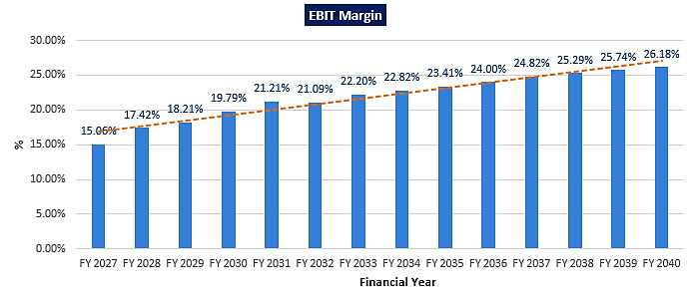
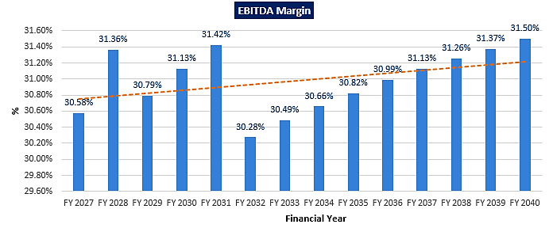
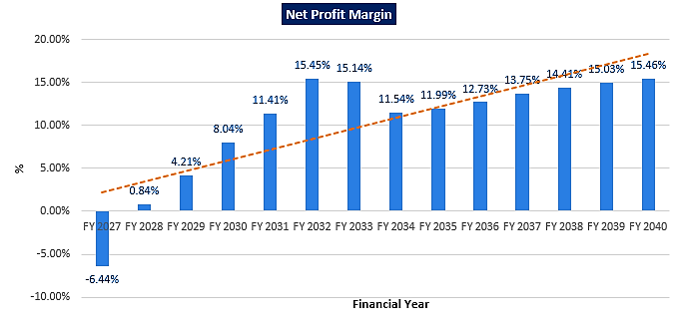

- REVENUE BUILD-UP:
Particulars | Mar-27 | Mar-28 | Mar-29 | Mar-30 | Mar-31 | Mar-32 | Mar-33
Room Inventory | 90 | 90 | 90 | 90 | 90 | 90 | 90
Days Operational | 270 | 366 | 365 | 365 | 365 | 366 | 365
Total Room Nights Available | 24300 | 32940 | 32850 | 32850 | 32850 | 32940 | 32850
Forecast Occupancy | 50.0% | 52.50% | 55.13% | 57.88% | 60.78% | 63.81% | 67.00%
Total Room Nights Occupied | 12150 | 17294 | 18109 | 19014 | 19965 | 21020 | 22011
Average Daily Rooms Occupied | 45 | 47 | 50 | 52 | 55 | 57 | 60
Forecast ARR (Rs) | 20000 | 21200 | 22472 | 23820 | 25250 | 26765 | 28370
Revenues (INR Crore)
Rooms | 24.30 | 36.66 | 40.69 | 45.29 | 50.41 | 56.26 | 62.45
Food & Beverage | 11.23 | 16.78 | 18.50 | 20.40 | 22.49 | 24.79 | 27.34
Spa & Fitness | 0.36 | 0.57 | 0.66 | 0.76 | 0.88 | 1.02 | 1.17
Minor Operating Departments | 0.30 | 0.46 | 0.52 | 0.58 | 0.65 | 0.74 | 0.83
Rentals & Other Income | 0.14 | 0.19 | 0.20 | 0.20 | 0.21 | 0.22 | 0.23
Total Gross Revenues | 36.33 | 54.66 | 60.57 | 67.23 | 74.64 | 83.02 | 92.00

Particulars | Mar-34 | Mar-35 | Mar-36 | Mar-37 | Mar-38 | Mar-39 | Mar-40
Room Inventory | 90 | 90 | 90 | 90 | 90 | 90 | 90
Days Operational | 365 | 365 | 366 | 365 | 365 | 365 | 366
Total Room Nights Available | 32850 | 32850 | 32940 | 32850 | 32850 | 32850 | 32940
Forecast Occupancy | 67.00% | 67.00% | 67.00% | 70.36% | 70.36% | 70.36% | 70.36%
Total Room Nights Occupied | 22011 | 22011 | 22071 | 23112 | 23112 | 23112 | 23175
Average Daily Rooms Occupied | 60 | 60 | 60 | 63 | 63 | 63 | 63
Forecast ARR (Rs) | 30073 | 31877 | 33790 | 35817 | 37966 | 40244 | 42659
Revenues (INR Crore)
Rooms | 66.19 | 70.16 | 74.58 | 82.78 | 87.75 | 93.01 | 98.86
Food & Beverage | 28.70 | 30.14 | 31.65 | 34.89 | 36.63 | 38.47 | 40.39
Spa & Fitness | 1.29 | 1.42 | 1.56 | 1.80 | 1.98 | 2.18 | 2.40
Minor Operating Departments | 0.88 | 0.95 | 1.01 | 1.14 | 1.22 | 1.30 | 1.40
Rentals & Other Income | 0.24 | 0.25 | 0.26 | 0.28 | 0.29 | 0.30 | 0.32
Total Gross Revenues | 97.30 | 102.91 | 109.06 | 120.88 | 127.86 | 135.26 | 143.36

- ESTIMATED KEY FINANCIAL METRICS:
DEBT SERVICE COVERAGE RATIO (DSCR)
Particulars | Mar-27 | Mar-28 | Mar-29 | Mar-30 | Mar-31 | Mar-32 | Mar-33
Profit after tax | -2.34 | 0.46 | 2.55 | 5.41 | 8.52 | 12.83 | 13.93
Add: Depreciation | 5.64 | 7.62 | 7.62 | 7.62 | 7.62 | 7.62 | 7.62
Add: Pre-Operating Expenses Written Off | 2.53 | 2.53 | 2.53 | 2.53 | 2.53 | 0.00 | 0.00
Add: Interest on Term Loan | 5.28 | 6.53 | 5.95 | 5.36 | 4.78 | 4.20 | 3.62
TOTAL (A) | 11.11 | 17.14 | 18.65 | 20.93 | 23.45 | 24.65 | 25.16
Repayment of Term Loan | 4.80 | 6.40 | 6.40 | 6.40 | 6.40 | 6.40 | 6.40
Interest on Term Loan | 5.28 | 6.53 | 5.95 | 5.36 | 4.78 | 4.20 | 3.62
TOTAL (B) | 10.08 | 12.93 | 12.35 | 11.76 | 11.18 | 10.60 | 10.02
D.S.C.R. (A/B) | 1.10 | 1.33 | 1.51 | 1.78 | 2.10 | 2.33 | 2.51

Particulars | Mar-34 | Mar-35 | Mar-36 | Mar-37 | Mar-38 | Mar-39 | Mar-40
Profit after tax | 11.23 | 12.34 | 13.89 | 16.62 | 18.42 | 20.33 | 22.17
Add: Depreciation for the year | 7.62 | 7.62 | 7.62 | 7.62 | 7.62 | 7.62 | 7.62
Add: Pre-Operating Expenses Written Off | 0.00 | 0.00 | 0.00 | 0.00 | 0.00 | 0.00 | 0.00
Add: Interest on Term Loan | 3.08 | 2.50 | 1.92 | 1.33 | 0.75 | 0.18 | 0.00
TOTAL (A) | 21.93 | 22.46 | 23.43 | 25.58 | 26.80 | 28.14 | 29.79
Repayment of Term Loan | 6.40 | 6.40 | 6.40 | 6.40 | 6.40 | 4.80 | 0.00
Interest on Term Loan | 3.08 | 2.50 | 1.92 | 1.33 | 0.75 | 0.18 | 0.00
TOTAL (B) | 9.48 | 8.90 | 8.32 | 7.73 | 7.15 | 4.98 | 0.00
D.S.C.R. (A/B) | 2.31 | 2.52 | 2.82 | 3.31 | 3.75 | 5.65 | 0.00
AVERAGE D.S.C.R | 2.31

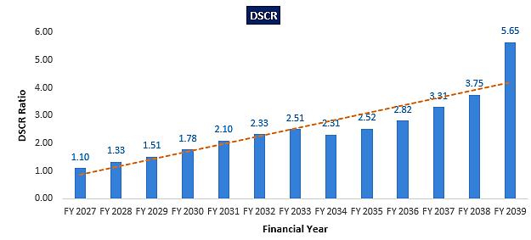
- SENSITIVITY ANALYSIS OF DSCR:
DSCR IF THERE IS A DECREASE IN OCCUPANCY RATE BY 5%
Particulars | Mar-27 | Mar-28 | Mar-29 | Mar-30 | Mar-31 | Mar-32 | Mar-33
Profit after tax | -3.42 | -1.15 | 0.80 | 3.46 | 6.35 | 10.98 | 12.47
Add: Depreciation | 5.64 | 7.62 | 7.62 | 7.62 | 7.62 | 7.62 | 7.62
Add: Pre-Operating Expenses Written Off | 2.53 | 2.53 | 2.53 | 2.53 | 2.53 | 0.00 | 0.00
Add: Interest on Term Loan | 5.28 | 6.53 | 5.95 | 5.36 | 4.78 | 4.20 | 3.62
TOTAL (A) | 10.03 | 15.54 | 16.90 | 18.98 | 21.29 | 22.80 | 23.71
Repayment of Term Loan | 4.80 | 6.40 | 6.40 | 6.40 | 6.40 | 6.40 | 6.40
Interest on Term Loan | 5.28 | 6.53 | 5.95 | 5.36 | 4.78 | 4.20 | 3.62
TOTAL (B) | 10.08 | 12.93 | 12.35 | 11.76 | 11.18 | 10.60 | 10.02
D.S.C.R. (A/B) | 1.00 | 1.20 | 1.37 | 1.61 | 1.90 | 2.15 | 2.37

Particulars | Mar-34 | Mar-35 | Mar-36 | Mar-37 | Mar-38 | Mar-39 | Mar-40
Profit after tax | 12.37 | 10.45 | 11.87 | 14.39 | 16.05 | 17.82 | 19.50
Add: Depreciation for the year | 7.62 | 7.62 | 7.62 | 7.62 | 7.62 | 7.62 | 7.62
Add: Pre-Operating Expenses Written Off | 0.00 | 0.00 | 0.00 | 0.00 | 0.00 | 0.00 | 0.00
Add: Interest on Term Loan | 3.08 | 2.50 | 1.92 | 1.33 | 0.75 | 0.18 | 0.00
TOTAL (A) | 23.08 | 20.57 | 21.41 | 23.34 | 24.43 | 25.62 | 27.12
Repayment of Term Loan | 6.40 | 6.40 | 6.40 | 6.40 | 6.40 | 4.80 | 0.00
Interest on Term Loan | 3.08 | 2.50 | 1.92 | 1.33 | 0.75 | 0.18 | 0.00
TOTAL (B) | 9.48 | 8.90 | 8.32 | 7.73 | 7.15 | 4.98 | 0.00
D.S.C.R. (A/B) | 2.43 | 2.31 | 2.57 | 3.02 | 3.42 | 5.14 | 0.00
AVERAGE D.S.C.R | 2.13

DSCR IF THERE IS DECREASE IN ROOM RENT BY 05%
Particulars | Mar-27 | Mar-28 | Mar-29 | Mar-30 | Mar-31 | Mar-32 | Mar-33
Profit after tax | -2.88 | -0.34 | 1.67 | 4.43 | 7.43 | 12.15 | 12.85
Add: Depreciation | 5.64 | 7.62 | 7.62 | 7.62 | 7.62 | 7.62 | 7.62
Add: Pre-Operating Expenses Written Off | 2.53 | 2.53 | 2.53 | 2.53 | 2.53 | 0.00 | 0.00
Add: Interest on Term Loan | 5.28 | 6.53 | 5.95 | 5.36 | 4.78 | 4.20 | 3.62
TOTAL (A) | 10.57 | 16.34 | 17.78 | 19.95 | 22.37 | 23.97 | 24.09
Repayment of Term Loan | 4.80 | 6.40 | 6.40 | 6.40 | 6.40 | 6.40 | 6.40
Interest on Term Loan | 5.28 | 6.53 | 5.95 | 5.36 | 4.78 | 4.20 | 3.62
TOTAL (B) | 10.08 | 12.93 | 12.35 | 11.76 | 11.18 | 10.60 | 10.02
D.S.C.R. (A/B) | 1.05 | 1.26 | 1.44 | 1.70 | 2.00 | 2.26 | 2.41

Particulars | Mar-34 | Mar-35 | Mar-36 | Mar-37 | Mar-38 | Mar-39 | Mar-40
Profit after tax | 12.77 | 11.39 | 12.88 | 15.50 | 17.24 | 19.07 | 20.84
Add: Depreciation for the year | 7.62 | 7.62 | 7.62 | 7.62 | 7.62 | 7.62 | 7.62
Add: Pre-Operating Expenses Written Off | 0.00 | 0.00 | 0.00 | 0.00 | 0.00 | 0.00 | 0.00
Add: Interest on Term Loan | 3.08 | 2.50 | 1.92 | 1.33 | 0.75 | 0.18 | 0.00
TOTAL (A) | 23.47 | 21.52 | 22.42 | 24.46 | 25.61 | 26.88 | 28.46
Repayment of Term Loan | 6.40 | 6.40 | 6.40 | 6.40 | 6.40 | 4.80 | 0.00
Interest on Term Loan | 3.08 | 2.50 | 1.92 | 1.33 | 0.75 | 0.18 | 0.00
TOTAL (B) | 9.48 | 8.90 | 8.32 | 7.73 | 7.15 | 4.98 | 0.00
D.S.C.R. (A/B) | 2.48 | 2.42 | 2.70 | 3.16 | 3.58 | 5.39 | 0.00
AVERAGE D.S.C.R | 2.23

DSCR IF THERE IS INCREASE IN INTEREST RATE BY 1.00%
Particulars | Mar-27 | Mar-28 | Mar-29 | Mar-30 | Mar-31 | Mar-32 | Mar-33
Profit after tax | -2.96 | -0.30 | 1.85 | 4.77 | 7.95 | 12.81 | 13.56
Add: Depreciation | 5.67 | 7.66 | 7.66 | 7.66 | 7.66 | 7.66 | 7.66
Add: Pre-Operating Expenses Written Off | 2.53 | 2.53 | 2.53 | 2.53 | 2.53 | 0.00 | 0.00
Add: Interest on Term Loan | 5.86 | 7.25 | 6.60 | 5.95 | 5.31 | 4.66 | 4.01
TOTAL (A) | 11.10 | 17.14 | 18.64 | 20.92 | 23.45 | 25.13 | 25.24
Repayment of Term Loan | 4.80 | 6.40 | 6.40 | 6.40 | 6.40 | 6.40 | 6.40
Interest on Term Loan | 5.86 | 7.25 | 6.60 | 5.95 | 5.31 | 4.66 | 4.01
TOTAL (B) | 10.66 | 13.65 | 13.00 | 12.35 | 11.71 | 11.06 | 10.41
D.S.C.R. (A/B) | 1.04 | 1.26 | 1.43 | 1.69 | 2.00 | 2.27 | 2.42

Particulars | Mar-34 | Mar-35 | Mar-36 | Mar-37 | Mar-38 | Mar-39 | Mar-40
Profit after tax | 13.55 | 12.12 | 13.71 | 16.49 | 18.33 | 20.28 | 22.13
Add: Depreciation for the year | 7.66 | 7.66 | 7.66 | 7.66 | 7.66 | 7.66 | 7.66
Add: Pre-Operating Expenses Written Off | 0.00 | 0.00 | 0.00 | 0.00 | 0.00 | 0.00 | 0.00
Add: Interest on Term Loan | 3.42 | 2.77 | 2.13 | 1.48 | 0.83 | 0.20 | 0.00
TOTAL (A) | 24.63 | 22.56 | 23.50 | 25.63 | 26.83 | 28.14 | 29.79
Repayment of Term Loan | 6.40 | 6.40 | 6.40 | 6.40 | 6.40 | 4.80 | 0.00
Interest on Term Loan | 3.42 | 2.77 | 2.13 | 1.48 | 0.83 | 0.20 | 0.00
TOTAL (B) | 9.82 | 9.17 | 8.53 | 7.88 | 7.23 | 5.00 | 0.00
D.S.C.R. (A/B) | 2.51 | 2.46 | 2.76 | 3.25 | 3.71 | 5.63 | 0.00
AVERAGE D.S.C.R | 2.25

- BREAK-EVEN (SALES) ANALYSIS:
Particulars | Mar-27 | Mar-28 | Mar-29 | Mar-30 | Mar-31 | Mar-32 | Mar-33
Sales | 36.33 | 54.66 | 60.57 | 67.23 | 74.64 | 83.02 | 92.00
Occupancy | 0.50 | 0.53 | 0.55 | 0.58 | 0.61 | 0.64 | 0.67
Fixed Costs
Interest on Term Loan | 5.28 | 6.53 | 5.95 | 5.36 | 4.78 | 4.20 | 3.62
Other Fixed Expenses | 3.72 | 3.64 | 3.57 | 3.49 | 3.42 | 0.81 | 0.73
Depreciation | 5.64 | 7.62 | 7.62 | 7.62 | 7.62 | 7.62 | 7.62
Total Fixed Costs | 14.64 | 17.79 | 17.14 | 16.48 | 15.82 | 12.63 | 11.97
Variable Costs
Rooms | 3.65 | 5.50 | 6.10 | 6.79 | 7.56 | 8.44 | 9.37
Food & Beverage | 5.61 | 8.39 | 9.25 | 10.20 | 11.24 | 12.40 | 13.67
Spa & Fitness | 0.18 | 0.29 | 0.33 | 0.38 | 0.44 | 0.51 | 0.58
Minor Operating Departments | 0.09 | 0.14 | 0.16 | 0.17 | 0.20 | 0.22 | 0.25
Rentals & Other Income | 0.03 | 0.04 | 0.04 | 0.04 | 0.04 | 0.04 | 0.05
Admin & General | 4.54 | 6.83 | 7.57 | 8.40 | 9.33 | 10.38 | 11.50
Sales & Marketing | 0.73 | 1.09 | 1.21 | 1.34 | 1.49 | 1.66 | 1.84
Property Operations & Maintenance | 2.73 | 4.10 | 4.54 | 5.04 | 5.60 | 6.23 | 6.90
Utilities & Energy Costs | 3.63 | 5.47 | 6.06 | 6.72 | 7.46 | 8.30 | 9.20
Brand Marketing Fees | 0.36 | 0.68 | 0.76 | 0.84 | 0.93 | 1.04 | 1.15
Management Fees | 0.73 | 1.09 | 1.21 | 1.34 | 1.49 | 2.08 | 2.30
Incentive Fees | 1.03 | 1.56 | 1.69 | 1.87 | 2.08 | 2.26 | 2.51
Interest to Others | 0.00 | 0.00 | 0.00 | 0.00 | 0.00 | 0.00 | 0.00
Taxes | 0.00 | 0.00 | 0.00 | 0.00 | 0.00 | 0.49 | 2.88
Total Variable Costs | 23.31 | 35.18 | 38.92 | 43.16 | 47.88 | 53.55 | 59.32
Contribution | 13.02 | 19.48 | 21.65 | 24.07 | 26.76 | 29.47 | 32.69
PV Ratio | 35.84% | 35.64% | 35.75% | 35.80% | 35.85% | 35.49% | 35.53%
Break Even Point Sales | 40.84 | 49.92 | 47.93 | 46.02 | 44.12 | 35.57 | 33.68
Break-even Point % of Sales | 112% | 91% | 79% | 68% | 59% | 43% | 37%

Particulars | Mar-34 | Mar-35 | Mar-36 | Mar-37 | Mar-38 | Mar-39 | Mar-40
Sales | 97.30 | 102.91 | 109.06 | 120.88 | 127.86 | 135.26 | 143.36
Occupancy | 0.67 | 0.67 | 0.67 | 0.70 | 0.70 | 0.70 | 0.70
Fixed Costs
Interest on Term Loan | 3.08 | 2.50 | 1.92 | 1.33 | 0.75 | 0.18 | 0.00
Other Fixed Expenses | 0.65 | 0.58 | 0.50 | 0.42 | 0.35 | 0.27 | 0.20
Depreciation | 7.62 | 7.62 | 7.62 | 7.62 | 7.62 | 7.62 | 7.62
Total Fixed Costs | 11.36 | 10.70 | 10.04 | 9.38 | 8.72 | 8.08 | 7.82
Variable Costs
Rooms | 9.93 | 10.52 | 11.19 | 12.42 | 13.16 | 13.95 | 14.83
Food & Beverage | 14.35 | 15.07 | 15.82 | 17.44 | 18.32 | 19.23 | 20.19
Spa & Fitness | 0.64 | 0.71 | 0.78 | 0.90 | 0.99 | 1.09 | 1.20
Minor Operating Departments | 0.27 | 0.28 | 0.30 | 0.34 | 0.36 | 0.39 | 0.42
Rentals & Other Income | 0.05 | 0.05 | 0.05 | 0.06 | 0.06 | 0.06 | 0.06
Admin & General | 12.16 | 12.86 | 13.63 | 15.11 | 15.98 | 16.91 | 17.92
Sales & Marketing | 1.95 | 2.06 | 2.18 | 2.42 | 2.56 | 2.71 | 2.87
Property Operations & Maintenance | 7.30 | 7.72 | 8.18 | 9.07 | 9.59 | 10.14 | 10.75
Utilities & Energy Costs | 9.73 | 10.29 | 10.91 | 12.09 | 12.79 | 13.53 | 14.34
Brand Marketing Fees | 1.22 | 1.29 | 1.36 | 1.51 | 1.60 | 1.69 | 1.79
Management Fees | 2.43 | 2.57 | 2.73 | 3.02 | 3.20 | 3.38 | 3.58
Incentive Fees | 2.66 | 2.82 | 2.99 | 3.32 | 3.52 | 3.72 | 3.95
Interest to Others | 0.00 | 0.00 | 0.00 | 0.00 | 0.00 | 0.00 | 0.00
Taxes | 7.90 | 9.26 | 10.37 | 12.05 | 13.16 | 14.30 | 15.37
Total Variable Costs | 62.68 | 66.24 | 70.13 | 77.69 | 82.12 | 86.80 | 91.91
Contribution | 34.62 | 36.67 | 38.93 | 43.19 | 45.75 | 48.46 | 51.45
PV Ratio | 35.58% | 35.63% | 35.70% | 35.73% | 35.78% | 35.82% | 35.89%
Break Even Point Sales | 31.92 | 30.03 | 28.13 | 26.26 | 24.38 | 22.55 | 21.79
Break-even Point % of Sales | 33% | 29% | 26% | 22% | 19% | 17% | 15%

- TERM LOAN INPUTS:
Term Loan Repayment Inputs
Amount of Term Loan (in Crores) | 80.00
Rate of Interest | 9.10%
SCOD (Scheduled Commercial Operation Date) | July-26
Disbursal Start Date | Oct-24
Repayment Start Date | Jul-27
Repayment Period (Years) | 12.7
Total Monthly Instalments | 151
Moratorium from first drawl (Months) | 21
Door to Door Tenure in Months (including Principal Moratorium period) | 172

- NPV, IRR AND PAYBACK PERIOD OF THE PROJECT:
(INR Crores)
Financial Year | FY 2025 | FY 2026 | FY 2027 | FY 2028 | FY 2029 | FY 2030 | FY 2031 | FY 2032
EBIT |  |  | 5.47 | 9.52 | 11.03 | 13.30 | 15.83 | 17.51
Adjusted Tax |  |  | 1.83 | 3.18 | 3.85 | 4.65 | 5.53 | 6.12
NOPAT |  |  | 3.64 | 6.34 | 7.17 | 8.65 | 10.30 | 11.39
depreciation |  |  | 5.64 | 7.62 | 7.62 | 7.62 | 7.62 | 7.62
WCC |  |  | 1.02 | 4.22 | 6.31 | 9.16 | 12.27 | 14.05
CAPEX | -23.24 | -63.23 | -46.08 | 0.00 | 0.00 | 0.00 | 0.00 | 0.00
Free Cash Flow to Firm | -23.24 | -63.23 | -37.82 | 9.74 | 8.49 | 7.12 | 5.65 | 4.97

Financial Year | FY 2033 | FY 2034 | FY 2035 | FY 2036 | FY 2037 | FY 2038 | FY 2039 | FY 2040
EBIT | 20.43 | 22.21 | 24.10 | 26.17 | 30.00 | 32.34 | 34.81 | 38.94
Adjusted Tax | 7.14 | 7.76 | 8.42 | 9.15 | 10.48 | 11.30 | 12.16 | 13.61
NOPAT | 13.29 | 14.45 | 15.68 | 17.03 | 19.52 | 21.04 | 22.65 | 25.33
depreciation | 7.62 | 7.62 | 7.62 | 7.62 | 7.62 | 7.62 | 7.62 | 8.95
WCC | 15.14 | 12.45 | 13.56 | 15.11 | 17.84 | 19.65 | 23.15 | -174.34
CAPEX | 0.00 | 0.00 | 0.00 | 0.00 | 0.00 | 0.00 | 0.00 | 0.00
Free Cash Flow to Firm | 5.77 | 9.62 | 9.74 | 9.54 | 9.30 | 9.01 | 7.12 | 208.62

Key Input for NPV
S. No. | Key Input | Description
 | Nifty 50 Returns (CAGR) in the Last 10 Years | 14.16%
 | Company Risk Premium | 0.50%
 | Discount Rate | 14.66%
NPV |  | INR 117.75 Crores
IRR |  | 21.58%

Payback Period of the Project
Financial Year | Cash Accrual | Accumulated Cash Accrual
2027 | 5.83 | 5.83
2028 | 10.62 | 16.45
2029 | 12.70 | 29.15
2030 | 15.56 | 44.72
2031 | 18.67 | 63.39
2032 | 20.45 | 83.84
2033 | 21.55 | 105.39
2034 | 18.85 | 124.24
2035 | 19.96 | 144.20
2036 | 21.51 | 165.71
2037 | 24.24 | 189.95
2038 | 26.05 | 216.00
2039 | 27.95 | 243.95
2040 | 29.79 | 273.75
Total | 273.75
TPC | INR 132.54 Crores
Payback Period | 8.17 Years

Thus, the project will be having a payback period of 8.17 years and NPV and IRR of the project as on COD will INR 117.75 Crores and 21.58% respectively, which indicates worthiness of the project.

- KEY ASSUMPTIONS & BASIS:

S. No. | Item | Assumptions and Basis
 | General | - The projections of the firm are done for the period from FY 2027 (9 Months) to FY 2040, 14 years, to cover the term loan period as per the industry best practices. It is assumed that the plant will be achieving COD on 1st July 2026.  - We have considered both Revenue & cost-based model (top to bottom approach) while making the future financial projections.  - Revenue and expense modelling has been done based on the data /information provided by company, during the forecasted years.
 | Occupancy Rate | - We have considered an occupancy rate of 50% for the first projected year. Then for next six years we have considered an increase of 5% in occupancy rate. 7th year onwards, we keep it constant for four years considering the stability factor of business cycle. Then in 11th year again, we anticipate another 5% growth, bringing the occupancy rate to ~70%, keeping in mind, the peak seasons and slack seasons.  Particulars Mar-27 Mar-28 Mar-29 Mar-30 Mar-31 Mar-32 Mar-33  Occupancy Rate 50.00% 52.50% 55.13% 57.88% 60.78% 63.81% 67.00%  Particulars Mar-34 Mar-35 Mar-36 Mar-37 Mar-38 Mar-39 Mar-40  Occupancy Rate 67.00% 67.00% 67.00% 70.36% 70.36% 70.36% 70.36%  - During the site visit on 26th April 2024, we have checked the occupancy rates of the nearby hotels at the proposed location, which we found as per the trends considered above.  - With regards to demand for hotel accommodation, Industrial trend indicates that the peak demand in Hampi occurs during Oct to March due to festive season, pleasant weather, supplemented by the leisure travellers over weekends in the city.  - During this period occupancy rate of the Hotels is higher (~90-100%). Thus the period between Oct to March is considered as seasonality factor of the industry near Hampi since attracts the international travellers.  - The rest of the time, occupancies operate between 50-60%, catering to the cost-conscious tourist, weddings, pilgrim tourists and corporates business from MSMEs in the Hosapete city-centre etc.  - Considering the fact above the occupancy rate estimated for the project seems to be reasonable keeping in mind of micro & macro-economic factors.
 | Room Revenue | - As per our tertiary research, we have considered an average room rent (ARR) of INR 20,000 per night for the first year, projecting a 6% annual increase thereafter. By FY 2040, the projected room rate reaches INR 42,659 considering increasing demand and other micro & macro-economic factors in this regard.  - At the time of survey, we have checked per room rent from the nearby hotels like Evolve Back Resort a 5 star hotel, Humpi, which is having an ARR of ~INR 30,000 per night per key. Another 5-star hotel, WelcomHeritage Shivavilas Palace Hotel, Hampi is having an ARR of INR 16,000 to 22,000 per night per key.  - Thus based on our tertiary research, client’s information and data/information available in public domain we have formulated revenue forecasts for the proposed 90-room luxury resort, which is reasonable & acceptable, considering the facts mentioned above.
 | Food & Beverage Revenue | - Our forecasted annual F&B revenue for the first year reflects these considerations, taking into account the competitive environment of the location.  Particulars All Day Dining Specialty Restaurant Bar Pool Bar Ball Rooms Conference Rooms Meeting Rooms Board Rooms  Capacity 75 40 40 20 300 65 34 15  Days 365 365 365 365 365 365 365 365  Forecast Occupancy %  Breakfast 50% 0% 0% 0% 10% 5% 10% 5%  Lunch 30% 0% 10% 20% 10% 15% 10% 5%  Dinner 50% 40% 20% 30% 20% 5% 0% 0%  Annual Covers  Breakfast 13688 0 0 0 10950 1186 1241 274  Lunch 8213 0 1460 1460 10950 3559 1241 274  Dinner 13687.5 5840 2920 2190 21900 1186 0 0  Estimated APC (Rs.)  Breakfast 500 0 0 0 500 500 500 500  Lunch 2000 0 1000 1000 1400 1500 1500 1500  Dinner 2500 3000 2000 1500 1500 1800 2000 2000  Rev. 5.75 1.75 0.73 0.47 5.37 0.81 0.25 0.05  Total Rev - (In Crores)  - The average daily Food & Beverage (F&B) sales per person in a luxury hotel vary widely based on factors like location, hotel reputation, dining choices, and guest preferences. These factors contribute to significant variations in F&B sales among hotels and regions. Annual revenue of INR 15.18 Cr. from F&B seems to be reasonable considering the facts above.  - For the rest of the projected financial years, we have considered an annual escalation rate of 5%.
 | Spa & Fitness Revenue | - Below are the spa & fitness assumptions for the first forecasting year:  Particulars Assumptions  Inventory 90  Days Operational 365  Total Room Nights Available 32850  Forecast Occupancy 50%  Total Room Nights Occupied 16425  Total No: Guests (Annual) 24637.5  Average Spa Visitation Rate 5%  Total No of Spa Guests (Annual) 1232  Forecast Spend per Visit (Rs.) 4000  Forecasted Revenue (In Crores) 0.49  - Forecasting spa and fitness revenue involves analysing historical data, market trends, and pricing changes to estimate future demand and revenue accurately. Considering these facts It seems to be reasonable.  - For the rest of the projected financial years, we have considered an annual escalation rate of 10%.
 | Minor Operating Departments Revenue | - Income from minor operating department comes from Gift Shops, water sports, tennis, horseback riding, or guided tours organized by the resort. Below are the assumptions for the first forecasting year:  Particulars Assumptions  Rs. Per Room Nights Occupied 250  Total Room Nights Occupied 16425  Forecasted Income from Minor Operating (In Crores) 0.41  - For the rest of the projected financial years, we have considered an annual escalation rate of 7%.
 | Rentals Revenue | - Below are the rentals revenue assumptions for the first forecasting year:  Particulars Assumptions  Rental Area in Sq ft (Per Month) 430  Rental per sq. ft. 360  Forecasted Rental Income (In Crores) 0.18  - For the rest of the projected financial years, we have considered an annual escalation rate of 5%.
 | Departmental Expenses | - Departmental expenses cover room, food & beverages, spa & fitness, minor operating departments, and rentals. These expenses are forecasted as a percentage of revenue generated by each respective department.  - Below table shows the assumptions for departmental expenses for the forecasting years:  Particulars Assumptions  Rooms 15%  Food & Beverage 50%  Spa & Fitness 50%  Minor Operating Departments 30%  Rentals 20%  - The above assumption takes into account the growing trend of tourism in India and the potential increase in demand for such services, considering these facts departmental expenses seems to be reasonable and in line with individual expense head.
 | Other Operating Expenses | - Below table shows the assumptions for other operating expenses for the forecasting years:  Particulars Assumptions  Admin & General 12.50%  Sales & Marketing 2.00%  Property Operations & Maintenance 7.5%  Utilities & Energy Costs 10%  - The above assumption takes into account the industry trend of these expenses in India and the potential increase in demand for such services.  - After considering the nature of these head, other operating expenses are seeming reasonable.
 | Other Expenses | - Under the O&M Agreement between Dhruvdesh Ventures and IHCL, the following table outlines the terms and conditions for Management Fee, Incentive Fee, Brand Marketing Fee (S&M), and FF&E Expenses.  Management Fee % of Total Revenue  For 1 to 5 Years 2%  6 year onwards 2.50%  Incentive Fee - GOP % Incentive Fee as a % of GOP  GOP % < 20% 3%  20% <= GOP % <25% 4%  25% <= GOP % <30% 5%  30% <= GOP % <35% 6%  35% <= GOP % <45% 7%  GOP % > = 45% 8%  Brand Marketing Fee (S&M) % of Total Revenue  Year 1 1.00%  Year 2 Onwards 1.25%  Central Group Service Charges % of Total Revenue  Year 1 1.00%  Year 2 Onwards 1.25%  FF&E Expense % of Total Revenue  Year 1 & 2 1%  Year 3, 4 & 5 2%  6th year onwards 3%  - All the above expenses are considered as per the terms and conditions mentioned in the Hotel Management Agreement between M/s Dhruvdesh Ventures LLP and IHCL.  - As per data/information provided, the rates of depreciation have been considered as per Companies Act, 2013. Depreciation as per company’s act is allowed on the basis of useful life of assets and residual value. And depreciation is calculated on SLM basis.  - We have considered the corporate tax rate applicable to Dhruvdesh Vantures LLP.
 | Capital Expenditure | - LLP owns a land area of 40,954.18 square meters (10.12 acres) in Hallekeri, Kamalapur, Hosapete, Karnataka, India, allocated for a proposed luxury segment resort. Out of this, 21,146.34 square meters are designated for built-up area for the resort.  - The estimated cost for Building & Civil works is approximately INR 32.45 Crores, the same has been vetted and certified by SBI panelled & Govt. Registered valuer P.I. Miskin (Chartered Engineer) on 24th July 2024.  Out of total Building & Civil works cost, main building civil shell and core works will be costing ~INR 22.94 Crore which comes out as INR 1754.50 per Sq. ft. excluding interior work which seems to be reasonable for the proposed luxury resort. Also it is ~24% of the total project cost as per the industry benchmark. (Ref: Hotel Development Cost Survey 2023 India done by Hotelivate).  - The estimated cost for plant & machinery and equipment is INR 24.40 Crores as per the client. As per our cost estimation ~INR 23-26 Crore is the standard cost for a luxury segment hotel and it’s important to note that the cost of proposed equipment may vary depending on the brand name and technical specifications of the equipment. As per the Hotel Development Cost Survey 2023, India done by Hotelivate standard cost of FF&E is ~25% of the Total project cost. Thus cost of equipment is taken in the line with industrial benchmark.  - The estimated cost for furniture & fixtures is INR 9.62 Crores as per the client's estimate. It's important to note that the cost of proposed equipment may vary depending on the brand name and quality of the furniture & fixtures. As per the Hotel Development Cost Survey 2023, India done by Hotelivate standard cost of FF&E is ~25% of the Total project cost. Thus cost of furniture & fixtures is taken in the line with industrial benchmark.  - The estimated cost for interiors work will be 39.99 Crores as per data/information provided by the client. The cost of interior and landscape design for a 5-star Taj hotel in India can vary significantly based on factors such as the hotel's location, size, design complexity, and luxury level. Total Estimated Cost for Interior and Landscape Design: Small to Medium 5-Star Hotel: ₹20-40 crores, Includes both interior design and landscape elements for hotels with moderate size and luxury standards. Large or High-End 5-Star Hotel: ₹50-100 crores, Encompasses extensive interior design work and elaborate landscaping for high-end properties. Thus, the cost of Interior & landscape design for the proposed hotel has been considered reasonably.  - Thus the total estimated cost of the proposed luxury segment resort is INR 132.54 Crores, which comes out as INR 1.47 Crore per key as per the proposed plan, which seems to be reasonable and in the line with industrial trends considering various micro & macro-economic factors. Kindly refer below references for the same:  As per the Hotel Development Cost Survey 2023, India done by Hotelivate, Budget/economy hotels necessitate an investment of INR 0.37 Cr. per key, while luxury hotels require a substantially higher amount, at INR 2.36 Cr. per key, representing more than six times the cost. On average, the overall development cost for hotel projects amounts to INR 1.03 Cr. per key, with a median development cost of INR 0.88 Cr. per key.  As per our tertiary research, we found that prevailing Cost for a 5 star rating hotel projects is ~2.48 Crore per key. (https://www.hindustantimes.com/india-news/pm-modi-to-inaugurate-5-star-hotel-built-atop-gandhinagar-railway-station-at-the-cost-of-rs-790-crores-101626222143939.html) Recently, Prime Minister has inaugurated a 5-star hotel on July 16 via video conferencing, built atop Gandhinagar railway station at the cost of ₹790 crores. The luxury hotel has 318 rooms and will be operated by a private entity. It is spread across 7,400 square meters and has been built at a cost of ₹790 crore. The hotel has been built to host national and international guests who would come for seminars and conferences at Mahatma Mandir, a convention centre, located right opposite the hotel.
 | Term Loan | - As per discussion with the client, company will apply for a term loan of INR 80.00 Crores from the total project cost of INR 132.54Crores for the proposed luxury segment resort.  - The tenure of the loan will be 14.33 years in which first 21 months will be considered as moratorium period. As per informed by the bank, Interest rate has been considered as 9.10% as per discussion with the banker.  - Drawdown of the Term Loan will began from 1st October 2024 and it will end on 30th June 2026 (at quarterly intervals).  - Also, the repayment of the term loan will be in 151-month structured instalments beginning from 31st July 2027 and ending on 31st January 2040.

Key Findings:
      - DSCR, EBITDA, EBIT and Net Profit margin are showing a positive trend in all the projected years. The company has achieved DSCR of more than 1 during the loan repayment period.
      - Throughout the estimated period, the Average DSCR is 2.31, with Average EBIDTA margin, EBIT margin, and Net Profit margin registering at 30.98%, 21.95%, and 10.25% respectively.
      - The DSCR is responsive to variations in customer footfall at the resort and fluctuations in operating costs. A decrease of 5% in the occupancy rate would lower the Average DSCR to 2.13. Similarly, a 5% reduction in ARR would increase the Average DSCR to 2.23.
      - In the forecasted period, a 1% increase in the interest rate will result in the Average DSCR reaching 2.25. This sensitivity analysis highlights the responsiveness of the DSCR to a 1% upward fluctuation in the interest rate.
      - Based on the above key financial ratios of the proposed Project during the forecasted period shows that the project appears financially viable if the Project Company & promoters are able to maintain assumed occupancy rate, revenue and can contain cost as assumed above in the calculation. However, the above-mentioned projections are calculated on the basis of the plan shared by the client/company. If the company differs from the approved plan during the implementation, the projections may differ resulting to altered concluded viability.

PART K | CONCLUSION

Based on the technological, economic and market analysis done above and various assumptions of sectoral trends taken, product pricing assumed by the company, the Project appears to be Techno-commercially viable subject to the risks, threats, weaknesses, limitations of the product as detailed previously.
As per financial projections for the estimated period, average DSCR, EBITDA Margin and EBIT Margin of the project is estimated as 2.31, 30.98%, and 21.95% respectively, where more than 1 DSCR is the indicator of the project capability to pay out its outstanding debt and EBITDA margin shows the capability of the project to generate the operating profits over the forecasted period. Also, the project is having the payback period of 8.17 Years. The proposed luxury segment resort is having a positive NPV and IRR as INR 117.75 Crores and 21.58%. The Indian Luxury Hotel Market size is expanding at a CAGR of 8.1% from 2023 to 2032.
M/s Dhruvdesh Ventures LLP plans to leverage the synergy of the Taj brand operated by IHCL. They aim to incorporate Taj (IHCL) brand standards (for construction, equipment, furniture & fixtures etc.), into their project implementation. They are also applying marketing strategies followed by Taj Hotel. Recognizing the importance of market research, analysis of consumer behaviour, and flexible marketing strategies, they seek to address the evolving needs of luxury travellers, which will be a key focus for the resort management. Bank/ Financial Institutions are advised to take firm plan from the company in this regard before taking any decision.
It would also be depending on the management’s capability in future that how efficiently company adopts the marketing and advertisement strategy, supply chain and carry out inventory & resource management to achieve higher profitability. Financial analysis of the project based on the assumptions taken over the projected period, it appears reasonable to comment that the proposed project is “Technically and Economically” Viable subject to current assumptions considered and occurring the same in the upcoming years same as the forecasted period which is dependent on the sincerity and efforts of the management and various micro and macroeconomic & industry situation.
We have tried our level best to analyse the Project techno-economic feasibility of the Project based on the industry research, Project information and various futuristic assumption taken within the limitations and challenges came in front of us. However, achieving the financial milestones depends on the ability, sincerity and efforts of the company, promoters and its key management to maintain the projected revenue level Y-o-Y basis.
Declaration | - The undersigned does not have any direct/indirect interest in the above property/project/Company.  - The information furnished herein is true and correct to the best of our knowledge, logical and scientific assumptions.  - This TEV Report is carried out by our Financial Analyst team on the request from SBI SME Branch (04091) Vir Annexe, Near Sarvodaya Circle, Kusugal Road, Hubballi, Karnataka - 580023.  - Meeting of Financial projections will be subject to the market & economy stability factors, judicious business operations and proper & timely implementation of the project and putting proper plan for achieving high productivity, efficiency and achieving cost saving benefits to increase profitability.  - We have submitted TEV report to the SBI SME Branch Hubballi, Karnataka.
Number of Pages in the Repost | 93
Enclosed Documents | Disclaimer & Remarks 84-87
Place | Noida
Date | 02 SEP 2024

FOR ON BEHALF OF
M/S. R.K. ASSOCIATES VALUER & TECHNO ENGINEERING CONSULTANTS PVT. LTD.
SURVEYED BY | PREPARED BY | REVIEWED BY
Mr. Nischay Gautam | Mrs. Chhavi Toshan | Mr. Gaurav Kumar

PART L | DISCLAIMER | REMARKS

      - No employee or member of R.K Associates has any direct/ indirect interest in the Project.
      - This report is prepared based on the copies of the documents/ information which the Bank/ Company has provided to us out of the standard checklist of documents sought from them and further based on our assumptions and limiting conditions. The client/owner and its management/representatives warranted to us that the information they supplied was complete, accurate and true and correct to the best of their knowledge. All such information provided to us has been relied upon in good faith and we have assumed that it is true and correct in all respect. I/We shall not be liable for any loss, damages, cost or expenses arising from fraudulent acts, misrepresentations, or wilful default on part of the owner, company, its directors, employee, representative or agents. Verification or cross checking of the documents provided to us from the originals or from any Govt. departments/ Record of Registrar has not been done at our end since this is beyond the scope of our work. If at any time in future, it is found or came to our knowledge that misrepresentation of facts or incomplete or distorted information has been provided to us then this report shall automatically become null & void.
      - Legal aspects for e.g. investigation of title, ownership rights, lien, charge, mortgage, lease, sanctioned maps, verification of documents, etc. have not been done at our end and same has to be taken care by legal expert/ Advocate. It is assumed that the concerned Lender/ Financial Institution has satisfied them with the authenticity of the documents, information given to us and for which the legal verification has been already taken and cleared by the competent Advocate before requesting for this report. I/ We assume no responsibility for the legal matters including, but not limited to, legal or title concerns.
      - This report is a general analysis of the project based on the scope mentioned in the report. This is not an Audit report, Design document, DPR or Techno feasibility study. All the information gathered is based on the facts seen on the site during survey, verbal discussion & documentary evidence provided by the client and is believed that information given by the company is true best of their knowledge.
      - This Techno Economic-Viability study is prepared based on certain futuristic assumption which are intra dependent on economic, market and sectorial growth condition in future and socio-economic, socio-political condition at macro and micro level.
      - Meeting of assumption and financial ratio will entirely depend on the sincerity and efforts of the company, promoters and its key managerial performance.
      - All observations mentioned in the report is only based on the visual observation and the documents/ data/ information provided by the client. No mechanical/ technical tests, measurements or any design review have been performed or carried out from our side during Project assessment.
      - This report has been diligently prepared by our techno-financial team to the best of their ability. However, it is important to note that the recommendations provided in this Techno Economic Viability (TEV) assessment do not imply an endorsement, validation, or certification of the accuracy or completeness of the disclosed information by the involved stakeholders. Furthermore, we do not claim or endorse that the opinions presented herein are the sole best course of action for decision-makers to follow. There may exist additional approaches and inputs that have not been covered within this report or fall outside the scope of this report.
      - Bank/FII should ONLY take this report as an Advisory document from the Financial/ Chartered Engineering firm and its specifically advised to the creditor to cross verifies the original documents for the facts mentioned in the report which can be availed from the borrowing company directly.
      - In case of any default in loans or the credit facility extended to the borrowing company, R.K Associates shall not be held responsible for whatsoever reason may be and any request for seeking any explanation from the employee/s of R.K Associates will not be entertained at any instance or situation.
      - The documents, information, data provided to us during the course of this assessment by the client are reviewed only up to the extent required in relation to the scope of the work. No document has been reviewed beyond the scope of the work.
      - This report only contains general assessment & opinion as per the scope of work evaluated as per the information given in the copy of documents, information, data provided to us and/ and confirmed by the owner/ owner representative to us at site which has been relied upon in good faith. It doesn’t contain any other recommendations of any sort including but not limited to express of any opinion on the suitability or otherwise of entering into any transaction with the borrower.
      - We have relied on data from third party, external sources & information available on public domain also to conclude this report. These sources are believed to be reliable and therefore, we assume no liability for the truth or accuracy of any data, opinions or estimates furnished by others that have been used in this analysis. Where we have relied on data, opinions or estimates from external sources, reasonable care has been taken to ensure that such data has been correctly extracted from those sources and /or reproduced in its proper form and context, however still we can’t vouch its authenticity, correctness or accuracy.
      - This Report is prepared by our competent technical team which includes Engineers and financial experts & analysts.
      - This is just an opinion report and doesn’t hold any binding on anyone. It is requested from the concerned Financial Institution which is using this report for taking financial decision on the project that they should consider all the different associated relevant & related factors also before taking any business decision based on the content of this report.
      - All Pages of the report including annexure are signed and stamped from our office. In case any paper in the report is without stamp & signature then this should not be considered a valid paper issued from this office.
      - Though adequate care has been taken while preparing this report as per its scope, but still we can’t rule out typing, human errors, over sightedness of any information or any other mistakes. Therefore, the concerned organization is advised to satisfy themselves that the report is complete & satisfactory in all respect. Intimation regarding any discrepancy shall be brought into our notice immediately. If no intimation is received within 15 (Fifteen) days in writing from the date of issuance of the report, to rectify these timely, then it shall be considered that the report is complete in all respect and has been accepted by the client up to their satisfaction & use and further to which R.K Associates shall not be held responsible in any manner.
      - Defect Liability Period is 15 DAYS. We request the concerned authorized reader of this report to check the contents, data and calculations in the report within this period and intimate us in writing if any corrections are required or in case of any other concern with the contents or opinion mentioned in the report. Corrections only related to typographical, calculation, spelling mistakes, incorrect data/ figures/ statement will be entertained within the defect liability period. Any new changes for any additional information in already approved report will be regarded as additional work for which additional fees may be charged. No request for any illegitimate change in regard to any facts & figures will be entertained.
      - R.K Associates encourages its customers to give feedback or inform concerns over its services through proper channel at advisory@rkassociates.org in writing within 15 days of report delivery. After this period no concern/ complaint/ proceedings in connection with the Techno- Economic Viability Study Services will be entertained due to possible change in situation and condition of the subject Project.
      - Our Data retention policy is of ONE YEAR. After this period, we remove all the concerned records related to the assignment from our repository. No clarification or query can be answered after this period due to unavailability of the data.
      - This Techno Economic Viability Study report is governed by our (1) Internal Policies, Processes & Standard Operating Procedures, (2) Information/ Data/ Inputs given to us by the client and (3) Information/ Data/ Facts given to us by our field/ office technical team. Management of R.K Associates never gives acceptance to any unethical or unprofessional practice which may affect fair, correct & impartial assessment and which is against any prevailing law. In case of any indication of any negligence, default, incorrect, misleading, misrepresentation or distortion of facts in the report then it is the responsibility of the user of this report to immediately or at least within the defect liability period bring all such act into notice of R.K Associates management so that corrective measures can be taken instantly.
      - R.K Associates never releases any report doing alterations or modifications from pen. In case any information/ figure of this report is found altered with pen then this report will automatically become null & void.
      - If this report is prepared for the matter under litigation in any Indian court, no official or employee of R.K Associates will be under any obligation to give in person appearance in the court as a testimony. For any explanation or clarification, only written reply can be submitted on payment of charges by the plaintiff or respondent which will be 10% of the original fees charged where minimum charges will be Rs. 15,000/.

EXTRACTS OF IMPORTANT STATUTORY APPROVALS PROVIDED BY THE CLIENT

