File No.: VIS (2024-25)-PL034-034-042 Dated: 02.05.2024

TECHNO-ECONOMIC VIABILITY
STUDY REPORT

OF

CLINICAL RESEARCH ORGANIZATION (CRO) UNIT
(160 BIOAVAILABILITY/BIOEQUIVALENCE STUDIES)

SETUP BY

M/S SKYLIMIT RESEARCH PRIVATE LIMITED

REPORT PREPARED FOR

MID CORPORATE CENTRE (MCC), PNB GHAZIABAD - 201002

**Important - In case of any query/ issue or escalation you may please contact Incident Manager Valuers@rkassociates.org. We will appreciate your feedback in order to improve our services.

NOTE: As per IBA Guidelines please provide your feedback on the report within 15 days of its submission after which report will be considered to be correct.

IMPORTANT NOTICE

COPYRIGHT FORMAT: This report is prepared on the copyright format of R. K. Associates Valuers & Techno Engineering Consultants (P) Ltd. (R. K. Associates) to serve our clients with the best possible information and analysis to facilitate them to take rational business decisions. Legally no one can copy or distribute this format without prior approval from R. K. Associates. It is meant only for the advisory/ reference purpose for the organization/s as mentioned on the cover page of this report. Distribution or use of this format or report or any of its content/ information/ data by any organization or individual other than R.K Associates will be seen as an unlawful act and necessary legal action can be taken against the defaulters.
This report is intended for the sole use of the intended recipient/s and contains material that is STRICTLY CONFIDENTIAL AND PRIVATE.

DEFECT LIABILITY PERIOD: In case of any query/ issue or escalation you may please contact Incident Manager at valuers@rkassociates.org. Though adequate care has been taken while preparing this report as per its scope, but still we can’t rule out typing, human errors, over sightedness of any information or any other mistakes. Therefore, the concerned organization is advised to satisfy themselves that the report is complete & satisfactory in all respect. Intimation regarding any discrepancy shall be brought into our notice immediately. If no intimation is received within 15 (Fifteen) days in writing from the date of issuance of the report, to rectify these timely, then it will be considered that the report is complete in all respect and has been accepted by the client up to their satisfaction & use and further to which R.K Associates shall not be held responsible in any manner.

Part O: R. K. Associates Important Disclaimer and Remarks are integral part of this report and Feasibility assessment is subject to this section. Reader of the report is advised to read all the points mentioned in these sections carefully.

TABLE OF CONTENTS
SECTIONS | PARTICULARS | PAGE NO.
Part A | Report Summary | 4
Part B | INTRODUCTION
 | - About the Report | 6
 | - Executive summary | 6
 | - Purpose of the Report | 7
 | - Scope of the Report | 7
 | - Methodology/ Model Adopted | 8
 | - Data Information received from | 8
 | - Documents/ Data Referred | 9
Part C | Company Profile
 | - Company Overview | 10
 | - Promoters/Directors Profile | 11
Part D | Proposed Infrastructure Details
 | - Proposed Location | 14
 | - Google Map Location | 14
 | - Google Map Layout | 15
 | - Land & Building Details | 15
 | - Site pictures | 18
 | - Interior Works | 22
 | - Plant and Machinery/ Equipment details | 23
 | - Utilities | 26
Part E | Project Technical details
 | - Capacity of Proposed CRO Unit | 27
 | - Technical Specification of the Proposed CRO Unit | 27
 | - Technological Assessment | 30
 | - Testing/ Quality Assurance | 31
 | - Manpower | 31
Part F | Service Profile
 | - Introduction | 33
 | - Service Category | 34
 | - Marketing Plan | 35
Part G | Industry Overview & Analysis | 36
Part H | RISK Analysis | 48
Part I | SWOT Analysis | 50
Part J | Project Cost and Means of Finance | 53
Part K | Project Schedule | 55
Part L | Statutory Approvals | Licences | NOC | 57
Part M | Company’s Financial Feasibility | 60
Part N | Conclusion | 77
Part O | Disclaimer | Remarks | 79

PART A | REPORT SUMMARY

S. No. | PARTICULAR | DESCRIPTION
 | Name of the Company: | M/s Skylimit Research Private Limited
 | Registered Address: | Villa-2/9, Land 2, Jaypee Greens, Greater Noida, Uttar Pradesh - 201306
 | Project Name | Clinical Research Organization (CRO) unit
 | Project Location: | Plot No. 28, Sector- 155, Noida, Gautam Budh Nagar, Uttar Pradesh - 201301
 | Project Type: | Clinical Research Organization (CRO) unit for conducting Bioavailability/Bioequivalence studies dictated for the drug/medicine/ pharmaceutical companies/manufacturers
 | Project Industry: | Biotechnology (Clinical Research)
 | Product Type / Deliverables: | Bioavailability/Bioequivalence (BA/BE) studies
 | Report Prepared for Organization: | Punjab National Bank, Mid Corporate Centre (MCC), Ghaziabad - 201002
 | TEV Consultant Firm: | M/s. R.K Associates Valuers & Techno Engineering Consultants (P) Ltd.
 | Report type: | Techno-Economic Viability Report
 | Purpose of the Report: | To assess Technical & Economic Viability for the purpose of seeking external financial assistance to start a green field Project.
 | Scope of the Report: | To assess, evaluate & comment on Technical, Economical & Commercial Viability of the Project as per data information provided by the client, independent Industry research and data/ information available on public domain.
 | Date of Report: | 2nd May, 2024
 | Documents referred for the Project: | - PROJECT INITIATION DOCUMENTS:  - Project Report  - Financial Projections of the Project  - Project proposed Schedule  - Statutory Approval Details  - Interior Layout Plan  - PROCUREMENT DOCUMENTS:  - High level breakup of Equipment Cost  - Quotations of Equipment Required and Interior Works  - Lease deed of the site  - STATUTORY APPROVALS, LICENCES & NOCs  - MSME UDYAM Registration Certificate  - Fire NOC
 | Means of Finance: | Equity & Debt (D/E Ratio 3.05)
 | Key Financial Indicators: | Key Indicators Value  Average DSCR 2.03 (FY26-FY34)  Average EBITDA Margin 25% (FY26-FY35)  Avg. PAT Margin 7% (FY26-FY35)  NPV & IRR INR 25.39 Cr. & 25.29%  Payback Period 6.71 years
Note: Above financial indicators are based on the financial projections of the proposed project provided by the firm and assessment and analysis of the same done by us.

PART B | INTRODUCTION

- ABOUT THE REPORT:
This is a Techno-Economic Viability Study Report of the proposed Clinical Research Organization (CRO) unit for conducting Bioavailability/Bioequivalence studies at Plot No. 28, Sector- 155, Noida, Gautam Budh Nagar, Uttar Pradesh - 201301, setup by M/s Skylimit Research Private Limited.

- EXECUTIVE SUMMARY:
M/s Skylimit Research Private Limited was incorporated on 11th December 2023 under the Company’s Act, 2013 as per the certificate of incorporation shared by the client to carry on the business of Clinical Research for various Pharmaceuticals Companies.
The promoters of the company are Mr. Karan Pratap Rawat, Ms. Sandeepika Sharma, Mrs. Poonam Rawat, Mr. Yash Pratap Singh and Mr. Arjun Singh, who are young entrepreneurs.
M/s Skylimit Research Private Limited has proposed to set up this Greenfield project at Noida in Uttar Pradesh, for conducting Bioavailability/Bioequivalence studies dedicated for the drug/medicine/pharmaceutical companies/manufacturers. The Clinical Research Organization unit is proposed to be setup with total investment of INR 4,045.70 Lakhs.
As shown in the below table, the cost of the proposed project is being estimated as INR 4,045.70 lakhs, which is proposed to be funded through promoter’s equity of INR 1,000.00 lakhs, unsecured promoter loan of INR 45.70 lakhs and bank loan of INR 3,000.00 lakhs.
As per the lease deed shared by the client/company, promoters have taken a 4-story building constructed on a plot area 1,000 square on lease having a leasable area of 32,000 square feet at Plot no. 28, Sector 155, Phase II, Noida, Uttar Pradesh. This building has been leased out by the promoters in the name of the company for 5 years as per the shared lease deed.
The company has arranged Architectural firm Architects Atelier to get help in the interior designing of the proposed unit as per industry norms. The interior layout plan has been prepared by M/s SG Architects. As per the data/information provided to us, company has received quotation for MEP & Interior work from Adharshila Power Corporation @ 2,000 per Sq. feet inclusive of GST.
The projected cost for interior and MEP work including false ceiling, wall partition, flooring, painting, glass and window (interior building), office furniture, washroom modification, Internal Conduit, wiring & Fixture/Equipment, HVAC systems and modular lab furniture is estimated at INR 7.13 Cr including consultation charges.
The Company is proposed to have a comprehensive setup covering clinical, bioanalytical, and administrative areas. The company’s management has finalized the vendors of these equipment, and the final negotiation with these vendors is in process as per information provided by the client. (Kindly refer Section D of the report).
As per data/information provided to us, the company has obtained some Statutory Approvals/NOC’s such as Fire NOC etc. from the respective authorities (Refer the section Statutory Approval in the later part of the report).
During the site visit, we found that the work on the Project has started, and work is being done on basement, ground floor, first floor, second floor and third floor (Kindly refer the site pictures captured during the survey attached in the later section of the report).
The Lessor has agreed to provide a 54 KW power load in the premises and further power load can be enhanced from the power distribution companies whenever there is such requirement. The leased property is situated in the Authority notified Institutional/industrial area and there is no problem in getting the requisite power load and water connections.
At present, the company is in discussion with bank to fund the project through a term loan of INR 3,000 lakhs. In this regard Punjab National Bank, MCC Ghaziabad has appointed R.K. associates to assess the Techno-Economic Viability of the proposed Clinical Research Organization (CRO) unit for conducting Bioavailability/Bioequivalence studies at Plot No. 28, Sector- 155, Noida, Gautam Budh Nagar, Uttar Pradesh - 201301. The company plans to achieve the financial closure by June 2024 (expected).
- PURPOSE OF THE REPORT: To assess Project’s Technical and Financial Feasibility for lender’s requirement.
- SCOPE OF THE REPORT: To only assess, evaluate & comment on Technical & Financial Feasibility of the proposed Clinical Research Organization (CRO) Unit being set up by M/s Sky limit Research Private Limited as per the information provided by the Company.

NOTES:
- Project status is taken as per the Site inspection carried out by our survey team.
- Scrutiny about the company, background check, and credibility, credit worthiness of the company or its promoters is out-of-scope of this report.
- Any verification of the documents/ information from originals/ source is out-of-scope of this report.
- This report is only an opinion in respect to Technical and Financial Feasibility of the project as per the future Projections provided by the firm and independent analysis done by us and doesn’t contains any recommendations including taking decision on the loan or any other financial exposure.
- This is not an audit activity of any kind. We have relied upon the data/ information shared by the company in good faith.
- Any review of the existing business of the promoters is out of scope of this report.
- Detailed cost estimation or detailed cost vetting is out of scope of the project.
- This is not a Detailed Project Report or a detailed design or architecture document. Land and property details mentioned in the report is only for illustration purpose as per the information provided to us by the client. The same doesn’t tantamount for taking any responsibility regarding its legality, ownership and conforming to statutory norms.
- METHODOLOGY/ MODEL ADOPTED:
- Data/ Information collection.
- Review of Data/ Information collected related to TEV study.
- Independent review & assessment of technology used and financial projections provided by the company.
- Projections of Revenue, P&L, Balance Sheet, Working Capital Schedule, Depreciation Schedule, Loan Schedule as per the inputs given by the company and assessed by us.
- Calculation of key financial indicators and ratio analysis including DSCR, NPV & IRR and payback period of the project.
- Report compilation and Final conclusion.
- DATA/ INFORMATION RECEIVED FROM: All the data/Information has been received from Mr. MC Bhatt (Consultant) and the required details about him shown in the below table:

Particulars | Details
Designation | Consultant
Company | M/s Skylimit Research Pvt Ltd
Email Address | mcbhatt13@gmail.com
Contact No. | +91-9634461280

- DOCUMENTS / DATA REFFERED:

- Financial Projections of the proposed project up to FY 2035.
- Information memorandum and description of the company (DPR)
- Promoter’s Details.
- Proposed Total project cost.
- Lease deed.
- List of Plant and Machinery along with their acquisition cost.
- Quotations and Purchase Orders provided by the client/company.
- Details of Furniture & Fixtures along with acquisition cost.
- Interior Layout Plan.
- Manpower proposal.

PART C | COMPANY PROFILE

- COMPANY OVERVIEW:
As per certificate of incorporation shared by the client/company, M/s Skylimit Research Private Limited was incorporated on 11th December 2023 under the Companies Act, 2013 as an unlisted company limited by shares. As per Memorandum of Association (MoA), the company is incorporated with the objective to carry on the business of independent diagnostic/pathological laboratories, provide scientific research for development and improvement of pharmaceutical and medicinal substances and conduct clinical trials and pharmaceutical testing. Below table shows the incorporation details of the company:
Incorporation Details of the Company
Particular | Description
Company / LLP Name | M/s Skylimit Research Private Limited
Date of Incorporation | 11th December 2023
CIN | U32502UP2023PTC193875
Company Category | Unlisted Company limited by Share
Company Subcategory | Non-govt. company
ROC | Uttarakhand
Registered Address | Villa-2/9, Land 2, Jaypee Greens, Greater Noida, Uttar Pradesh - 201306
Authorized Capital | INR 10,00,000/-
Paid up Capital | INR 1,00,000/-
Source: Ministry of Corporate Affairs website
The company is categorised as micro enterprise with Udyam Registration Number UDYAM-UP-28-0099655. The promoters of the company are Mr. Karan Pratap Rawat (DIN: 08163436), Mr. Yash Pratap Singh (DIN: 10075889), Mrs, Poonam Rawat, Mr. Arjun Singh Rawat and Ms. Sandeepika Sharma (DIN: 10399143). Mr. Karan Pratap Rawat, Mr. Yash Pratap Singh and Ms. Sandeepika Sharma are also appointed as Directors of the company. As per the data/information provided by the client, current shareholding pattern is as below:
Name of Shareholder | No. of shares held | % of holding
Mr. Karan Pratap Rawat | 4,000 | 40%
Ms. Sandeepika Sharma | 500 | 5%
Mrs. Poonam Rawat | 2,000 | 20%
Mr. Yash Pratap Rawat | 2,500 | 25%
Mr. Arjun Singh Rawat | 1,000 | 10%
Source: Data/ Information provided by the company
- KEY PROMOTER’S/DIRECTORS PROFILE:
Mr. Karan Pratap Rawat, Mr. Yash Pratap Singh and Ms. Sandeepika Sharma are the promoters and directors of M/s Skylimit Research Private Limited.
- Directors/Promoters Details
Name | DIN | Age | Address | Designation | Contact Details
Mr. Karan Pratap Rawat | 08163436 | 24 | M.I.G.-701, Avas Vikas Ist, D.M. Road, Bulandshahr, Uttar Pradesh - 203001 | Director | NA
Mr. Yash Pratap Singh | 10075889 | 23 |  | Additional Director | NA
Ms. Sandeepika Sharma | 10399143 | 24 | 380, Kather Bye Pass Road, Solan, Himachal Pradesh - 173213 | Director | sandeepika456@gmail.com
- Education & Experience
Mr. Karan Pratap Rawat | - Appointed As Director On 11st December 2023.  - As per data/information shared by the client, Mr. Karan Pratap Rawat Is an Alumnus of University of Westminster, London.  - Mr. Karan Pratap Rawat as also a Director in Glomax Infra Projects Private Limited, Karnam Industries Private Limited and Rawat Corporates Private Limited.
Mr. Yash Pratap Singh | - Appointed as Additional Director on 26th February 2024.  - As per data/information shared by the client, Mr. Yash Pratap Singh is a graduate.  - Mr. Yash Pratap Singh is also a Director in Glomax Infra Projects Private Limited.
Ms. Sandeepika Sharma | - Appointed as Director on 11th December 2023.  - As per data/information shared by the client, Ms. Sandeepika Sharma is a postgraduate.
Source: Data/ Information provided by the company and extracted from MCA website
Below tables shows the information of the companies with which each Director is associated to give a basic background detail of the promoters as found on public domain in general/ tertiary category research.
MR. KARAN PRATAP RAWAT
S. No | Company Name | Designation | Original Date of Appointment | Date Of Appointment at Current Designation | Date Of Cessation (If Applicable)
1 | Karnam Industries Private Limited  (CIN: U24319UP2023PTC186402) | Director | 27th July, 2023 | 27th July, 2023 | NA
2 | Glomax Infra Projects Private Limited  (CIN: U70109UP2011PTC045093) | Additional Director | 17th February, 2023 | 17th February, 2023 | NA
3 | Skylimit Research Private Limited  (CIN: U32502UP2023PTC193875) | Director | 11th December, 2023 | 11th December, 2023 | NA
4 | Rawat Corporates Private Limited  (CIN: U46632UP2023PTC188915) | Director | 13th September, 2023 | 13th September, 2023 | NA
Source: Information extracted from MCA website & public domain
MR. YASH PRATAP SINGH
S. No | Company Name | Designation | Original Date of Appointment | Date Of Appointment at Current Designation | Date Of Cessation (If Applicable)
1 | Skylimit Research Private Limited  (CIN: U32502UP2023PTC193875) | Additional Director | 26th February, 2024 | 26th February, 2024 | NA
2 | Glomax Infra Projects Private Limited  (CIN: U70109UP2011PTC045093) | Director | 22nd February, 2023 | 22nd February, 2023 | NA
Source: Information extracted from MCA website & public domain

MS. SANDEEPIKA SHARMA
S. No | Company Name | Designation | Original Date of Appointment | Date Of Appointment at Current Designation | Date Of Cessation (If Applicable)
1 | Skylimit Research Private Limited  (CIN: U32502UP2023PTC193875) | Director | 11th December, 2023 | 11th December, 2023 | NA
Source: Information extracted from MCA website & public domain

PART D | PROPOSED INFRASTRUCTURE DETAILS

- PROPOSED LOCATION:
The proposed Clinical Research Organization Unit will be set up by M/s Skylimit Research Private Limited at Plot No. 28, Sector- 155, Noida, Gautam Budh Nagar, Uttar Pradesh – 201301, which is a 4-story building constructed on a plot area 1,000 square meters and having a leasable area of 32,000 square feet as per the lease deed provided to us by the Company. Availability of good volunteers in Noida/Greater Noida region and presence of few CROs in North India is the advantage of location. Also Good connectivity to road, airport, metro, railway station, highway and hospitals also provides favourable conditions to set up CRO:
Connectivity | Details
Road | Adjacent to a 40 ft wide road
Airport | Indira Gandhi International Airport ~ 50 kms far away from unit
Metro | 2 Kms from subject property
Railway station | New Delhi railway station ~ 35 kms far away from unit
Highway | Noida Expressway
Nearby hospitals | Yatharth Hospital, Prakash hospital, Salix hospital
Source: Google Map
LOCATION MAP:
- Google Map Location: The proposed Clinical Research Organization Unit will be set up at Plot No. 28, Sector- 155, Noida, Gautam Budh Nagar, Uttar Pradesh – 201301 with GPS coordinates 28°27'12.9" North and 77°27'30.4" East as per the Google map attached below:
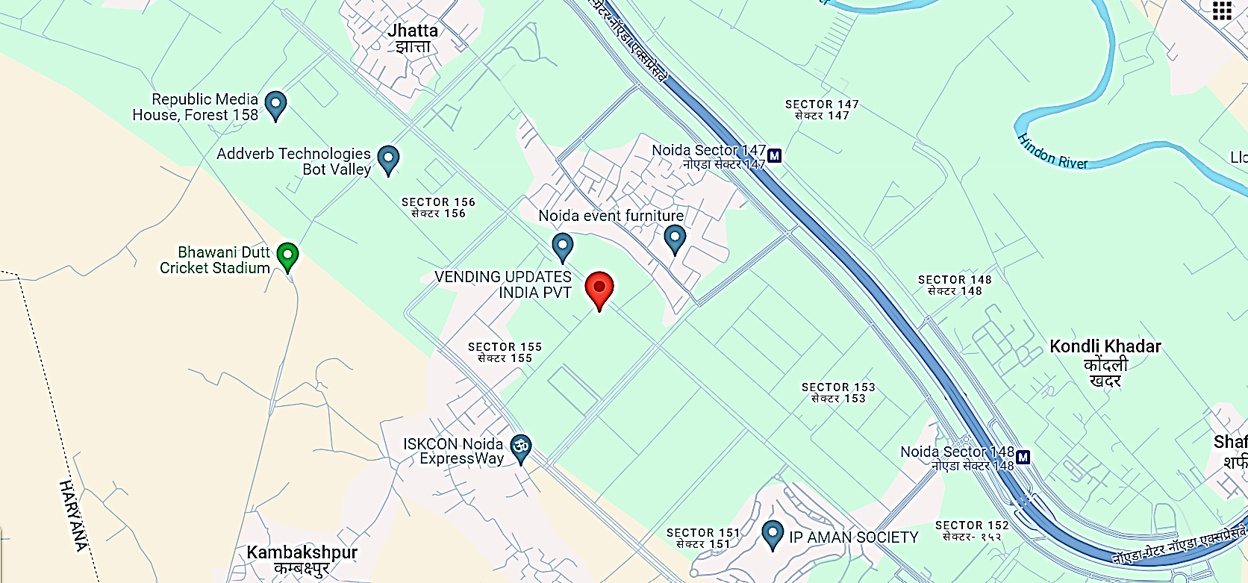
- Google Map Layout: Demarcation of the land with approximate measurement on the Google map is attached in the below picture:
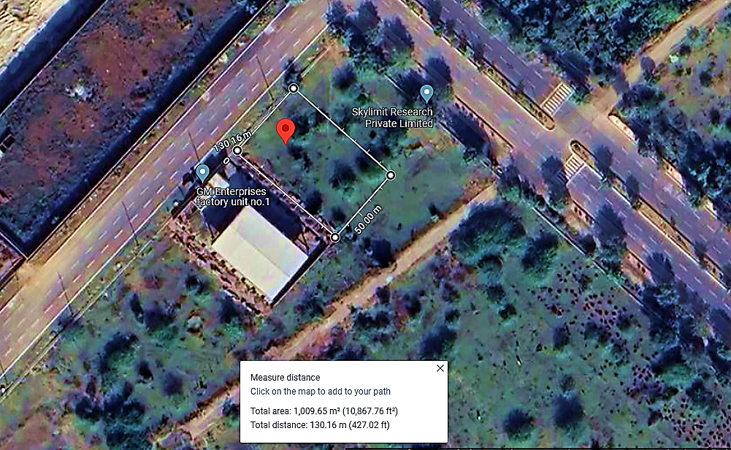

- LAND & BUILDING DETAILS:
The Company has executed lease agreement on 29th January 2024 for the premises situated at Plot no. 28, Sector 155, Phase II, Noida which is a 4-story building constructed on a plot area 1,000 square meters and having a leasable area of ~32,000 square feet. The monthly lease rent is Rs. 6,40,000.00 and the initial lease period is for 5 years with 5% annual increase in rent after expiry of 12 months of lease period and the lease agreement shall be automatically renewed for next 5 years after the expiry of the agreement as per the agreed terms.
During the site visit on 1st May 2024, we found that work on the project has started. Current Status of building & civil works is as under:
- Basement - partitions made by plywood and electrical work in progress.
- Ground Floor - partitions made by plywood and electrical work in progress.
- First Floor - partitions made by plywood and electrical work in progress.
- Second Floor - electrical work in progress.
- Third Floor - electrical work in progress.
- Terrace - work yet to commence.
LAYOUT PLAN (INTERIOR STRUCTURE): As per the data/information provided by the client/Company, the interior layout plan has been prepared by M/s SG Architects. For reference, interior layout plan has been attached below:
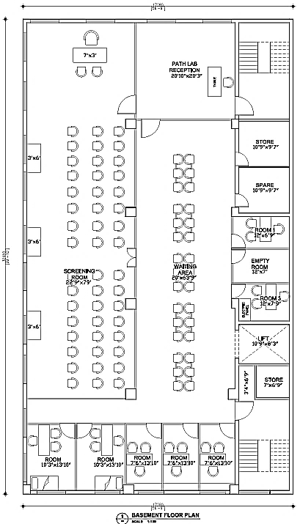
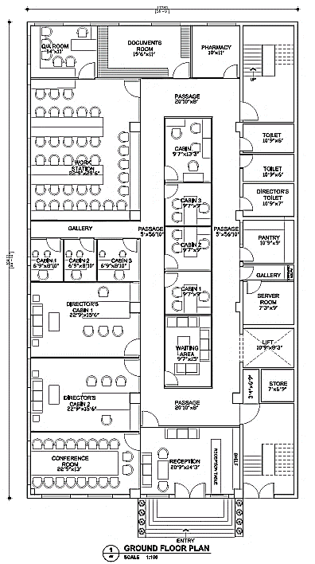
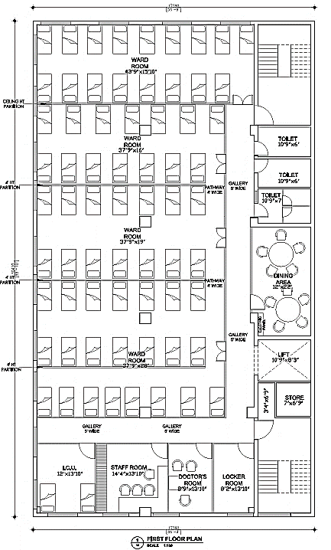
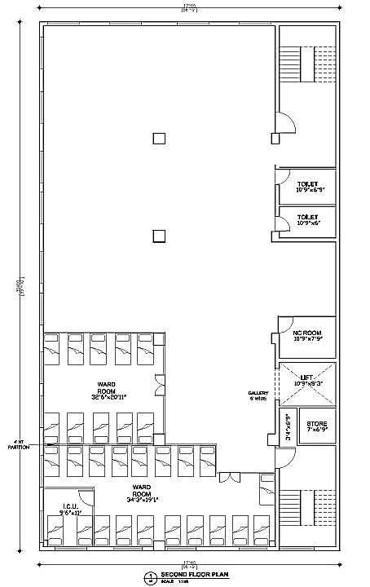
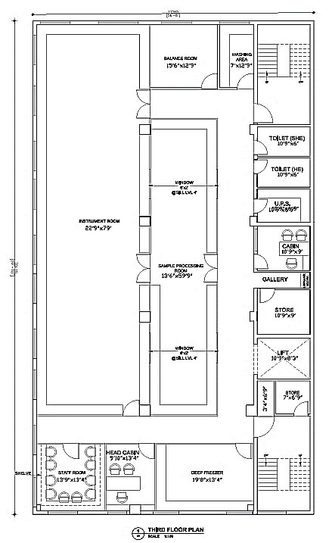
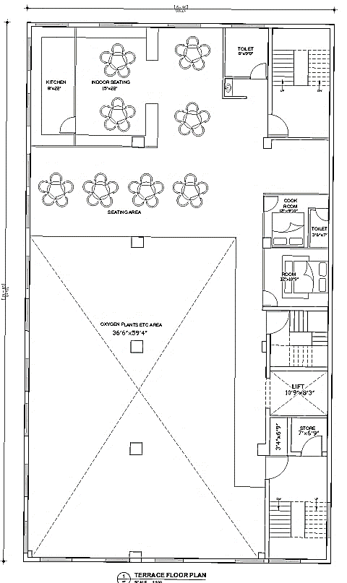
- SITE PICTURES: Site pictures were captured during the site survey on 1st May 2024, for reference few of the pictures are attached below:
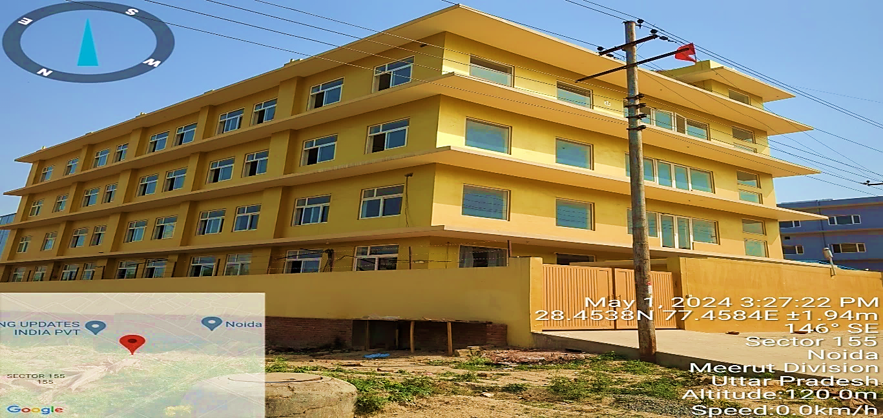
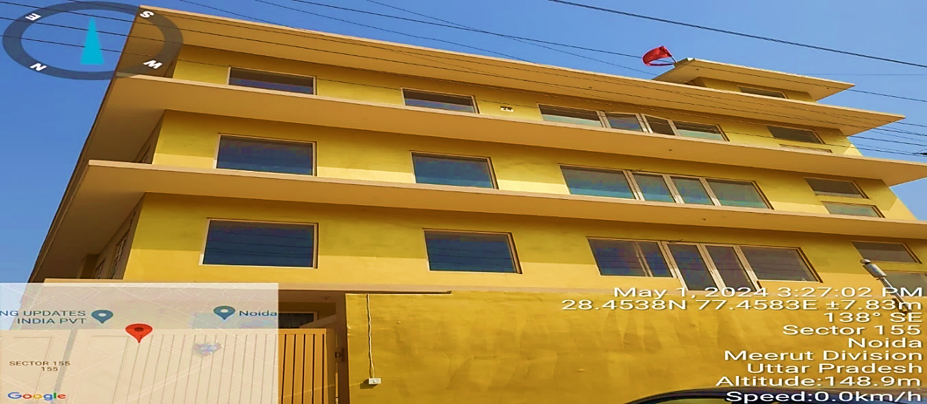
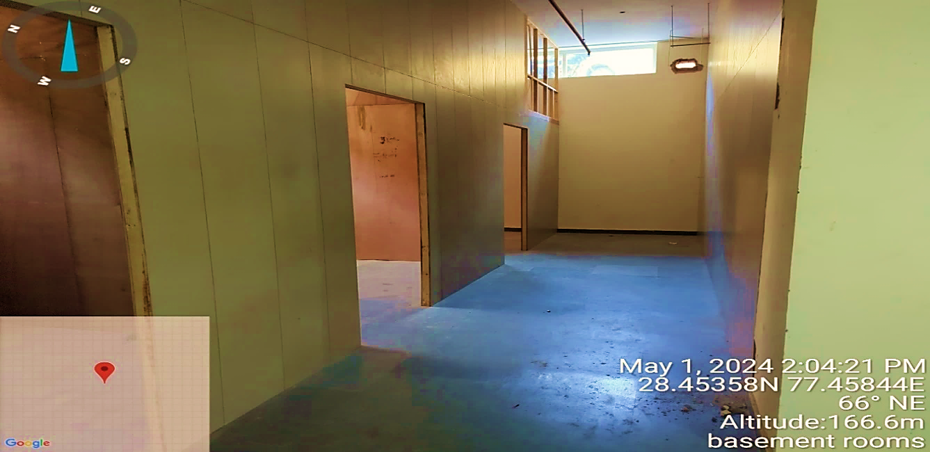
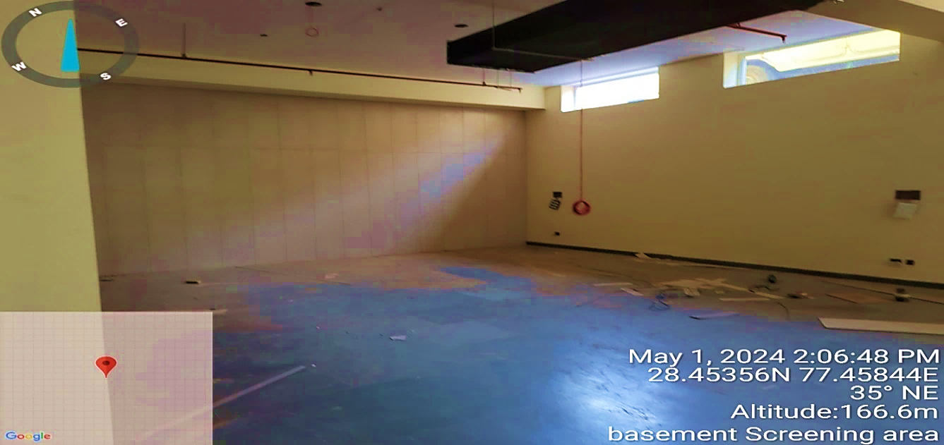
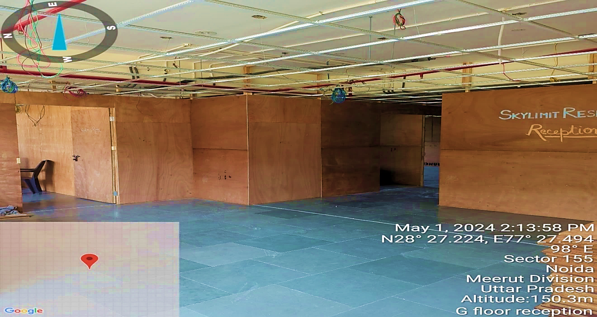
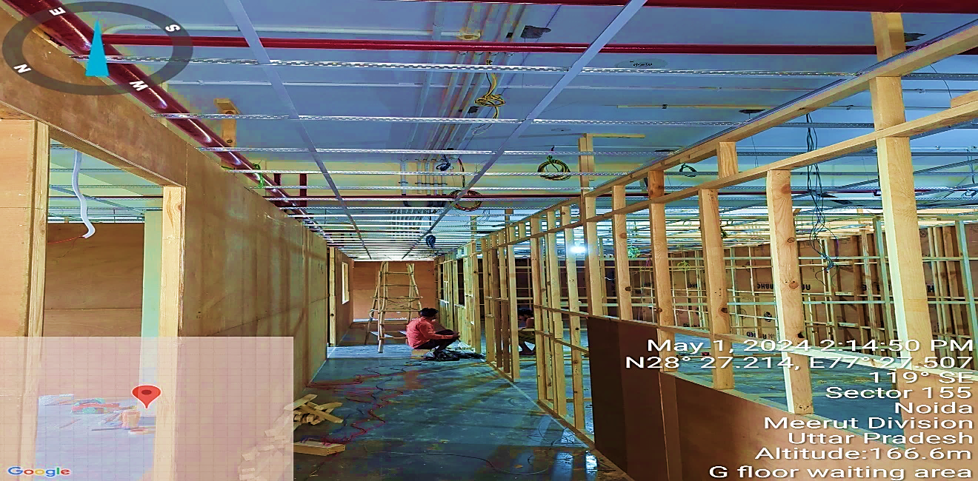
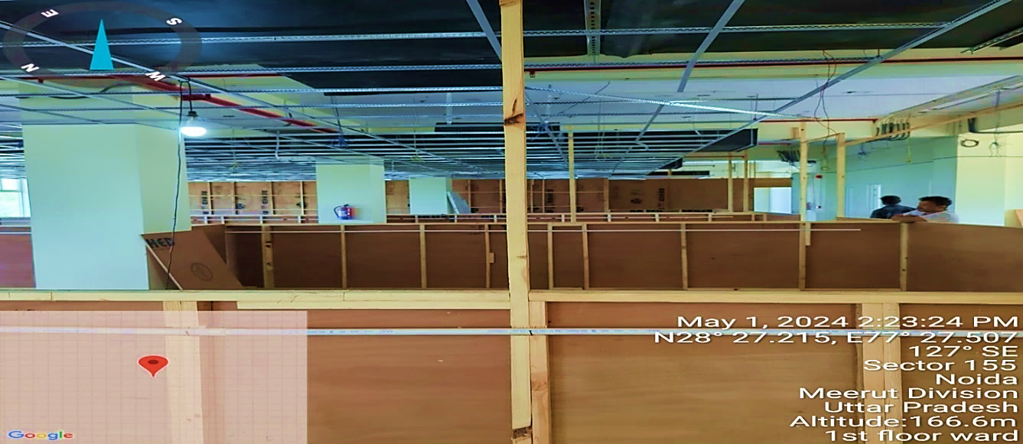
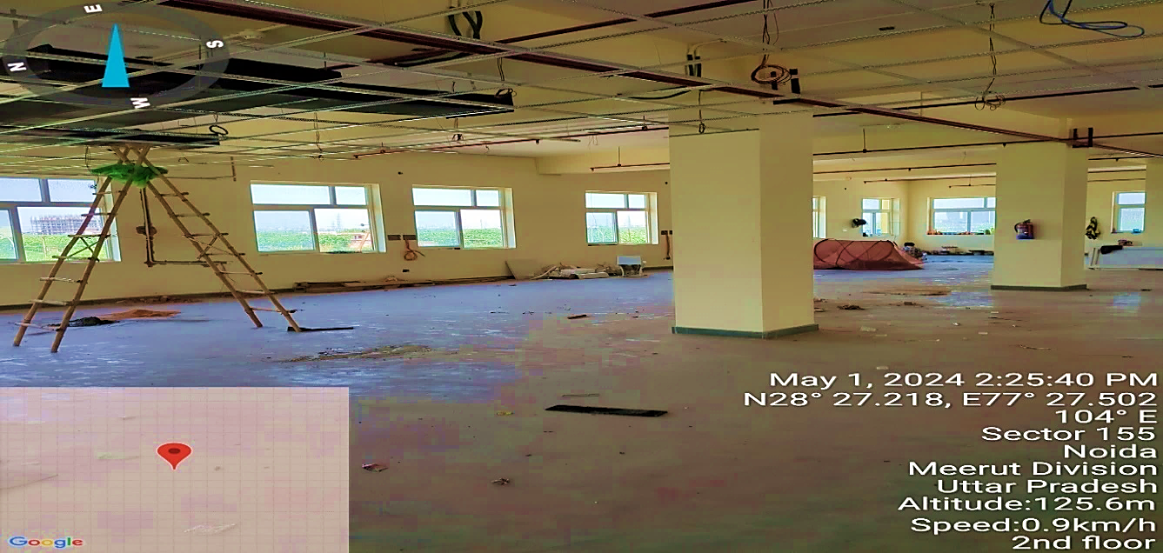
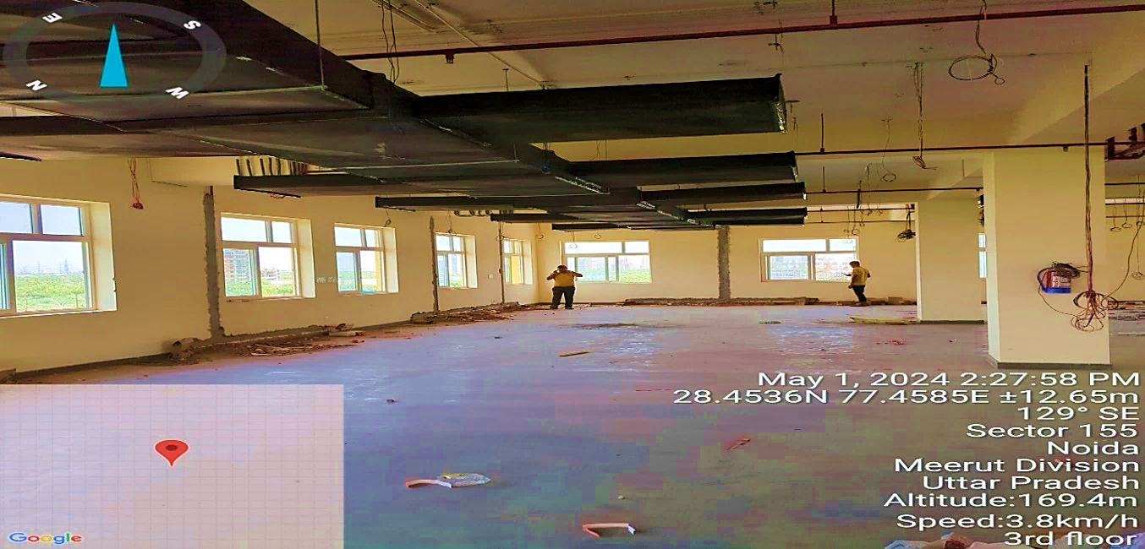
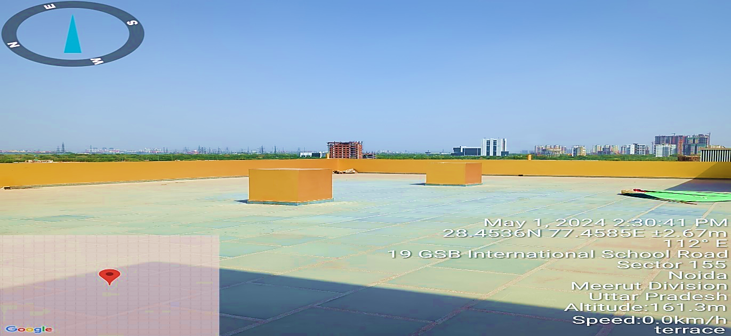
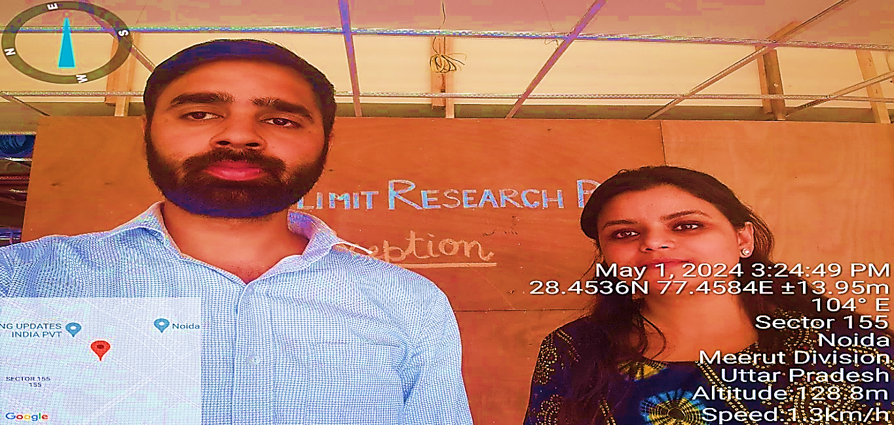
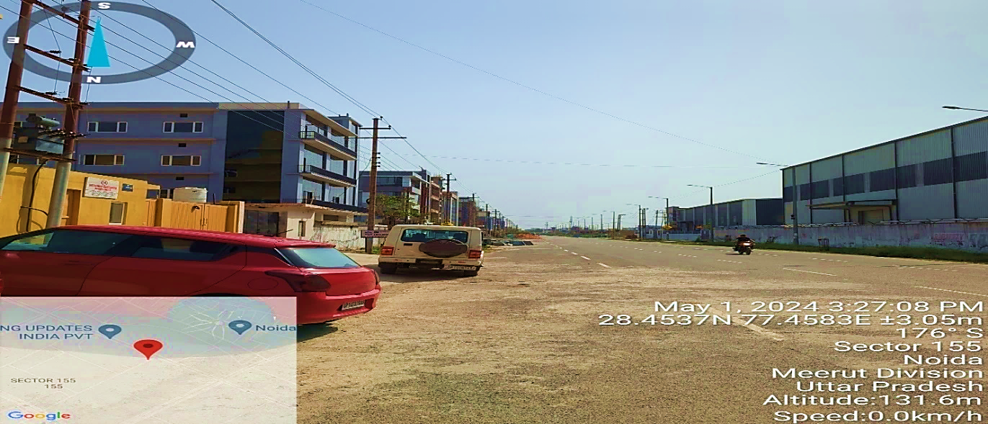
- INTERIOR WORKS AND FURNITURE & FIXTURE FOR THE PROPOSED BUILDING:
The proposed Clinical Research Organization (CRO) Unit shall be constructed as per the interior layout plan prepared by SG Architects. It will consist of clinical, bioanalytical, and administrative areas and other utility areas for the smooth working of the proposed unit from here among other supportive facilities like adequate parking space and other public utilities.
Clinical department:
- Screening area
- Clinical unit (recreation, dining, phlebotomy)
- Pharmacy
- Sample separation area
- Emergency care unit.

Bioanalytical department:

- Instrument room
- Sample preparation room
- Balance room
- Deep freezer room
- Store room
- Scientist room
- Washing area

Administrative area:

- HR and Admin
- Report writing
- Quality assurance
- Archival.
The company has arranged Architectural firm Architects Atelier to get help in the interior designing of the proposed unit as per industry norms. The interior layout plan has been prepared by M/s SG Architects.
As per the data/information provided to us, company has received quotation for MEP & Interior work from Adharshila Power Corporation @ 2,000 per sq feet inclusive of GST.
The projected cost for interior and MEP work including false ceiling, wall partition, flooring, painting, glass and window (interior building), office furniture, washroom modification, Internal Conduit, wiring & Fixture/Equipment, HVAC systems and modular lab furniture is estimated at INR 7.13 Cr including consultation charges.
External civil work, lab set up and beds not included in the quotation, but the Company is negotiating with the vendor for including the same in the scope of work without any additional cost. The company is expecting the completion of the proposed diagnostic centre buildings by September 2023, and it is expected to start its commercial operations in December 2023.
- PLANT & MACHINERY/ EQUIPMENTS DETAILS:
The Company is proposed to have a comprehensive setup covering clinical, bioanalytical, and administrative areas. The company’s management has finalized the vendors of these equipment, and the final negotiation with these vendors is in process as per information provided by the client. Below table shows the details of major equipment, plant & machinery along with expected cost and suppliers as per quotation of the respective vendor’s shared by the client:
Cost Estimation of Major Equipment, Plant & Machinery
S. No. | Equipment | Qty. | Amount | Expected Supplier
 | Haier make Freezer, 230V/50 Hz. Model : DW-86L828J Type Upright - 86°C ULT Freezer  Capacity : 828 Litres | 4 | 46,02,000 | Care Biosystems India Pvt. Ltd Mumbai
 | SCIEX Triple Quad 5500 + and 4500 System  Upgradeable to QTRAP functionality with PN 5072277 & PN 5049829 respectively  Enhanced high performance triple quadrupole LC-MS/MS mass  spectrometer.- Four Numbers each  Plus  TQ/QT Software Starter Kit - with SCIEX OS-MQ 3.3- Sixteen Numbers  Plus  Some other items | 4 | 16,70,88,000 | SCIEX India Pvt. Limited  Registered office: 3rd floor, Unit # 9215, B-Wing, Art Guild House, Phoenix Market city, LBS Road, Vimersia Media technologies Pvt Limited Kurla West, Mumbai,  Maharashtra 400070. Phone: 022 3026 7000.
 | Logan Water Jacketed Automated Transdermal Diffusion Cell System(24CellSystem) | 1 | 2,62,97,515 | SANGUINE BIO INSTUMENTS Flat No. 103, Sai Vinayaka Residency, Road No. 2, NBR Colony, Meerpet, Saroor Nagar (M), R.R. Dist., Hyderabad
 | Supply & Installation of Walk in Freezer Room with Ante Room as per the Annexure - Basis of Design (Including 15 Rft Copper Piping for the distance between IDU & ODU) 20’ W x 15’L x 8’ Ht. (300 Sqft.) | 1 | 12,57,502 | BLUE COOL SOLUTIONS  G-62, Ground Floor, Shagun Arcade, Near Dindoshi Bus Depot, Dr. A K Vaidya Marg,  MALAD – EAST, MUMBAI – 400 097, INDIA, Mobile: +91 84549 45070
 | Bio-eVap DP Nitrogen Evaporator(Dual Press 144 Position) one set plus speX Series 144 Position Solid Phase Extraction one set plus Multitube Vortexer Main Unit two sets | 1 | 18,23,100 | Takahe Analytical Instruments, Navi Mumbai
 | Price for 5702 R with A-4-38 rotor incl. adaptor for 13/16 mm blood collection tubes, 2 set of 2 adaptors | 5 | 26,55,000 | Eppendorf India Private Limited Jasola Vihar, New Delhi
 | Micropipettes ( Volume range 10-100 ul, 20-200 ul , 100-1000 ul and 500-5000 ul ) each Volume range | 5 | 3,54,000 | Eppendorf India Private Limited Jasola Vihar, New Delhi
 | Multipette M4 Starter kit , 1- channel, incl. Combitips advance rack, Combitips advance assortment pack | 5 | 1,85,850 | Eppendorf India Private Limited Jasola Vihar, New Delhi
 | Kirloskar 125 KVA water cooled Genset three phase | 1 | 33,51,200 | Kirloskar
 | Entris II Analytical balance and Cubis II Micro Analytical balance | 2 | 29,78,320 | SB Bio Chem
 | Agilent ICPMS – 7850 • PC and Printer are included • Microwave Digestion Included • IQ/OQ included • Autosampler Included • Gases supplies are not Included | 1 | 1,07,38,000 | Agilent Technologies, Agilent Technologies India Pvt. Ltd. Block C, RMZ Centennial, Plot Nos. 8A, 8B, 8C & 8D, Doddanakundi Industrial Area, ITPL Road, Mahadevapura Post, Bangalore- 560048
 | Agilent ECM – XT Server to connect HPLC/LCMS and ICPMS  IQ/OQ included | 1 | 59,00,000 | Agilent Technologies, Agilent Technologies India Pvt. Ltd. Block C, RMZ Centennial, Plot Nos. 8A, 8B, 8C & 8D, Doddanakundi Industrial Area, ITPL Road, Mahadevapura Post, Bangalore- 560048
 | Supply of DAIKIN Make Ductable /Cassette Type/ Split Type  Air conditioners and Installation Work | 1 | 49,30,375 | Uniaer Engineering Company, Noida
 | Mahindra Scorpio Classic S 75 TR | 1 | 15,83,332 | Shiva Auto Cat (India) Pvt Ltd, Patparganj Indstrial Area, Delhi-92
 | Mahindra Bolero Power Plus 86 | 1 | 11,05,911 | Shiva Auto Cat (India) Pvt Ltd, Patparganj Indstrial Area, Delhi-92
 | Entire electrical system & fittings work | 1 | 53,78,063 | Supreme Industrial Corporation LLP 1715, Gali Piao, Dariba Delhi-110006
 | Effluent Treatment Plant | 1 | 2,71,400 | HYDROFLUX ENGINEETRING PVT LTD, GHITORNI, NEW DELHI
 | Schindler 3000 15 passenger capacity lift | 1 | 21,80,000 | Scindler India Pvt Ltd, Mumbai
Total |  |  | INR 24,26,79,568
Source: Data/information provided by the client.
Thus, the estimated cost for plant & machinery will be ~INR 2,426.79 lakhs including the applicable GST. The estimated cost of the Plant & Machinery has been provided to us by the client as per the quotations received by the client. However, as a TEV consultant the cost of major plant & machinery has been verified by us independently, which we found reasonable & in the permissible range although the cost may change as per specifications & brand.
- UTILITIES: Details of Water, Electricity and other utilities are described as below:
- ELECTRICITY:
As per the data/information provided by the client, the Lessor has agreed to provide a 54 KW power load in the premises and further power load can be enhanced from the power distribution companies whenever there is such requirement.
- WATER:
As per the data/information provided by the client, the leased premises has the requisite water connections.

PART E | PROJECT TECHNICAL DETAILS

- CAPACITY OF THE PROPOSED CRO UNIT:
The leased premises having 32,000 square feet of carpet area is sufficient to house 100 beds for the subjects, clinical department, statistical/archive department, administrative, bioanalytical, screening, pharmacy and other areas. The leased premises are sufficient to smoothly conduct upto ~100 studies each year with 100 beds in initial couple of years of operations. There is ample vacant space on the 2nd floor of the rented premises which will be used for providing 60 more beds in third year of operations which will increase the capacity to ~160 studies each year with 160 beds. After touching this milestone, the company will explore additional premises in the neighbourhood.
- TECHNICAL SPECIFICATIONS OF THE PROPOSED CRO UNIT:
For the proposed CRO unit below table shows the details of major equipment, plant & machinery along with quantity, use and specification:
Specification of Major Proposed Equipment’s, Plant & Machinery
S. No. | Equipment | Qty. | Use | Specification
 | Haier make Freezer, 230V/50 Hz. Model : DW-86L828J Type Upright - 86°C ULT Freezer  Capacity : 828 Litres | 4 | Sample Storage | 230V/50 Hz. Model : DW-86L828J Type Upright - 86°C ULT Freezer Capacity : 828 Litres
 | SCIEX Triple Quad 5500 + and 4500 System  Upgradeable to QTRAP functionality with PN 5072277 & PN 5049829 respectively  Enhanced high performance triple quadrupole LC-MS/MS mass spectrometer.- Four Numbers each  Plus TQ/QT Software Starter Kit - with SCIEX OS-MQ 3.3- Sixteen Numbers  Plus  Some other items | 4 | Analysis of samples | SCIEX Triple Quad 5500+  Includes: Turbo V Source that accepts either the  TurboIonSpray Probe or APCI Probe  Includes: TurboIonSpray Probe  Includes: APCI Probe  Includes: One standard wet pump kit (roughing pump).  Includes: Data Acquisition Workstation PC with Win10 64 bit OS  Includes: Standard Monitor  SCIEX Triple Quad 4500 System  Includes: Turbo V Source that accepts either the  TurboIonSpray Probe or APCI Probe  Includes: TurboIonSpray Probe  Includes: APCI Probe  Includes: One standard wet pump kit (roughing pump).  Includes: Data Acquisition Workstation PC with Win10 64-bit OS  Includes: Standard Monitor
 | Logan Water Jacketed Automated Transdermal Diffusion Cell System(24CellSystem) | 1 | For IVRT/IVPT sample analysis | System (24CellSystem)
 | Supply & Installation of Walk in Freezer Room with Ante Room as per the Annexure - Basis of Design (Including 15 Rft Copper Piping for the distance between IDU & ODU) 20’ W x 15’L x 8’ Ht. (300 Sqft.) | 1 | Sample Storage | 15 Rft Copper Piping for the distance between IDU & ODU) 20’ W x 15’L x 8’ Ht. (300 Sqft.)
 | Bio-eVap DP Nitrogen Evaporator (Dual Press 144 Position) one set plus speX Series 144 Position Solid Phase Extraction one set plus Multitube Vortexer Main Unit two sets | 1 | For Sample Processing | (Dual Press 144 Position) one set plus speX Series 144 Position Solid Phase Extraction one set plus Multitube Vortexer Main Unit two sets
 | Price for 5702 R with A-4-38 rotor incl. adaptor for 13/16 mm blood collection tubes, 2 set of 2 adaptors | 5 | Sample separations | A-4-38 rotor incl. adaptor for 13/16 mm blood collection tubes, 2 set of 2 adaptors
 | Micropipettes (Volume range 10-100 ul, 20-200 ul , 100-1000 ul and 500-5000 ul ) each Volume range | 5 | Pipetting Device ,for aliquoting, sample dispensing, stock and dilution preparation. | Fixed and Variable range for Volume range 10-100 ul, 20-200 ul , 100-1000 ul and 500-5000 ul
 | Multipette M4 Starter kit , 1- channel, incl. Combitips advance rack, Combitips advance assortment pack | 5 | Pipetting Device ,for aliquoting, sample dispensing, Bulk Spiking | 1- channel, incl. Combitips advance rack, Combitips advance assortment pack  Variable range for Volume range for 500-5000 ul
 | Kirloskar 125 KVA water cooled Genset three phase | 1 | Backup of electricity | 125 KVA
 | Entris II Analytical balance and Cubis II Micro Analytical balance | 2 | Buffer, standard weighing | Ultra micro balance :For 1mg to 1gm weighing range  Analytical Balance : For 20 mg to 220 gm weighing range
 | Agilent ICPMS – 7850 • PC and Printer are included • Microwave Digestion Included • IQ/OQ included • Autosampler Included • Gases supplies are not Included | 1 | IVRT /IVPT sample analysis | Agilent ICPMS – 7850; • PC and Printer are included • Microwave Digestion Included • IQ/OQ included • Autosampler Included
 | Agilent ECM – XT Server to connect HPLC/LCMS and ICPMS  IQ/OQ included | 1 | Data Storage | XT Server to connect HPLC/LCMS and ICPMS
 | Supply of DAIKIN Make Ductable /Cassette Type/ Split Type  Air conditioners and Installation Work | 1 | Air conditioning | Split ACs
 | Mahindra Scorpio Classic S 75 TR | 1 | Transportation of subjects | Scorpio Classic S 7STR
 | Mahindra Bolero Power Plus 86 | 1 | Transportation of subjects | Bolero Power Plus B6
 | Entire electrical system & fittings work | 1 | Electrification
 | Effluent Treatment Plant | 1 | Wastewater Treatment | Plant Capacity- 1.0 KLD
 | Schindler 3000 15 passenger capacity lift | 1 | Movement of passengers | 15 passenger capacity lift
Total |  |  | INR 24,26,79,568

- LATEST TECHNOLOGY/TECHNOLOGICAL ASSESSMENT:
M/S Skylimit Research Private Limited, proposes to be a leader in In-vitro Release Testing (IVRT) and In-vitro Permeation Testing (IVPT) analytical method development, validation, and testing services, to meet the fast-growing demand for these types of topical and transdermal drug analytical services with the most up to date regulatory requirement.
Through the use of appropriately selected In Vitro and In Vivo surrogate tests, the assessment of the BE of topical drug products can be accomplished. For most products IVRT, IVPT, and additional testing would be essential to establish BE along with Q1/Q2 testing:
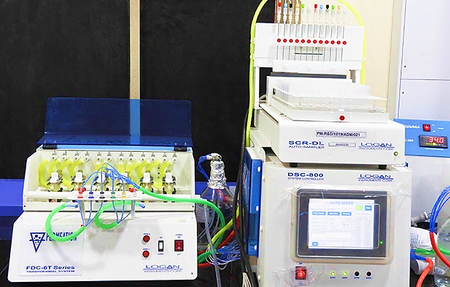Source: Indicative photograph provided by the client
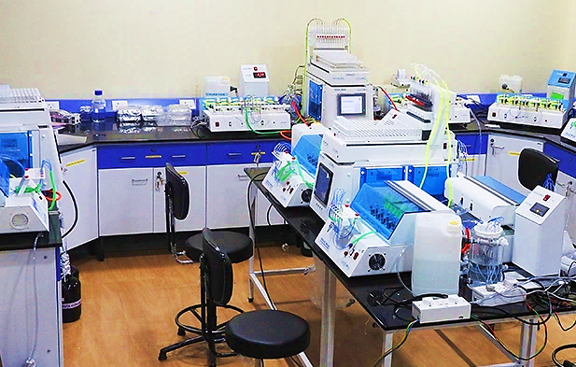Source: Indicative photograph provided by the client
- TESTING/ QUALITY ASSURANCE:
As per communicated by client, All the activities of BA/BE studies will be conducted as per Standard Operating Procedures (SOP) based on various regulatory guidelines mentioned below:
- EMA/CHMP/ICH/172948/2019 Committee for Medicinal Products for Human Use ICH guideline M10 on bioanalytical method validation and study sample analysis.
- Bioanalytical Method Validation Guidance for Industry FDA- May 2018.
- Electronic Data – 21 CFR 11
- Good Laboratory Practice -21 CFR 58, ISO 17025-2017
- ISO 9001:2015, Quality Management Systems

- MANPOWER:
As per information shared by the client/.company, an estimate of manpower requirement allowing for leave, absentecism, sickness and holidays for smooth and for efficient operation of different sections of the plant including its administrative and commercial departments, has been prepared based on technical and management ground primarly to indicate the order of manpower requirement.
In estimating the manpower requirement, a proper ratio between the administrative, managerial, clinical, bioanalytical, quality assurance and statistical staff has been maintained with a view to affording proper professional management at various levels.
As per information provided by the company, it is estimated that around 45 workers will be required when CRO unit will be operational. The basic structure of the manpower will require the following kind of resources:
Proposed manpower details along with Cost (INR)
Clinical Department
Designation of staff | Number | Average Monthly Salary
Head Clinical | 1 | 25,00,000
Principal Investigators | 2 | 30,00,000
Research Associates for clinical department | 4 | 16,00,000
Phlebotomists | 5 | 12,50,000
Pharmacists | 2 | 5,00,000
Trainee | 4 | 8,00,000
Custodian and Recruiter | 2 | 15,00,000
Sub Total | 20 | 1,11,50,000
Bioanalytical Department
Designation of staff | Number | Average Monthly Salary
Head Bioanalytical | 1 | 15,00,000
Team Leader | 3 | 36,00,000
Research Associate | 4 | 20,00,000
Trainee | 4 | 10,00,000
Custodian | 1 | 7,50,000
Sub Total | 13 | 88,50,000
Quality Assurance Department
Designation of staff | Number | Average Monthly Salary
Head Quality Assurance | 1 | 15,00,000.00
Clinical QA | 1 | 10,00,000.00
Clinical QA Associate | 2 | 10,00,000.00
Bioanalytical QA | 1 | 10,00,000.00
Bioanalytical QA Associate | 2 | 10,00,000.00
Sub Total | 7 | 55,00,000
Statistical, Report Writing and HR
Designation of staff | Number | Average Monthly Salary
Statistician | 1 | 6,00,000.00
Report Writing team leader | 1 | 7,50,000.00
Report Writing Research Associate | 2 | 12,00,000.00
HR Manager | 1 | 7,50,000.00
Sub Total | 5 | 33,00,000
Grand Total | 45 | 2,88,00,000
Source: Data/information provided by the client.
The company has already employed requisite staff for the preliminary work on the project which includes medical, administrative, accounts departments for assisting in the timely implementation of the project. The company has also enrolled Dr. Bratati Sanyal who has almost 20 years of experience working in the Clinical Research Industry and the requisite number of experienced & qualified staff are being recruited.

PART F | CLINICAL RESEARCH ORGANIZATION SERVICES PROFILE

- INTRODUCTION:
The project is for setting up a Clinical Research Organization (CRO) unit for conducting Bioavailability/Bioequivalence studies dictated for the drug/medicine/pharmaceutical companies/manufacturers by the stringent regulatory guidelines. Bioavailability refers to the relative amount of drug from an administered dosage from which enters the systemic circulation and the rate at which the drug appears in the systemic circulation. Bioequivalence of a drug product is achieved if its extent and rate of absorption are not statistically significantly different from those of the reference product when administered at the same molar dose.
In the life sciences, a contract research organization (CRO) is a company that provides support to the pharmaceutical, biotechnology, and medical device industries in the form of research services outsourced on a contract basis.
A CRO may provide such services as biopharmaceutical development, biological assay development, commercialization, clinical development, clinical trials management, pharmacovigilance, outcomes research, and real world evidence. CROs are designed to reduce costs for companies developing new medicines and drugs in niche markets. They aim to simplify entry into drug markets, and simplify development, as the need for large pharmaceutical companies to do everything ‘in house’ is now redundant. CROs also support foundations, research institutions, and universities, in addition to governmental organizations.
Many CROs specifically provide clinical-study and clinical-trial support for drugs and/or medical devices. However, the sponsor of the trial retains responsibility for the quality of the CRO's work. CROs range from large, international full-service organizations to small, niche specialty groups. CROs that specialize in clinical-trials services can offer their clients the expertise of moving a new drug or device from its conception to FDA/EMA marketing approval, without the drug sponsor having to maintain a staff for these services.
Organizations who have had success in working with a particular CRO in a particular context (e.g. therapeutic area) might be tempted or encouraged to expand their engagement with that CRO into other, unrelated areas; however, caution is required as CROs are always seeking to expand their experience and success in one area cannot reliably predict success in unrelated areas that might be new to the organization.
- SERVICES CATEGORY:
Brief details of the services proposed to be offered by M/s Skylimit are set forth below:
BA & BE Studies:
The Company proposes to offer a offers a portfolio of clinical and bioanalytical services to support innovator, biosimilar and generic drug development programs of the global clientele. Capabilities to conduct BA & BE studies shall comprise:
- Solid oral formulations [Tablets (Immediate release & modified release, e.g., ER, DR, SR), capsules, soft gels, sprinkles, etc.]
- Parenteral formulations
- Topical transdermal products (Patches, Cream, Ointments, Solutions)
- Inhalation
- Nasal and oral sprays
- Rectal products (Suppository & foam)
- Vaginal products (Tablet, cream, gel)
- Long acting injectable

The CRO shall have a capacity to ~100 studies per year in initial couple of years which will be increased to ~160 studies per year.
The study timelines encompassing various phases, namely the clinical phase, bioanalytical phase, statistical phase, and report generation are proposed as follows:
Clinical phase:
- Subject Screening: Approximately 10 days
- Subject In-house: Approximately 6 days
- Ambulatory Visit: Approximately 2 days
- Total Duration for Clinical Phase (Normal): 22-24 days

Bioanalytical phase:
- Method Development: Approximately 10 days
- Method Validation: Approximately 8 days
- Subject Sample Analysis: 16 days (Considering a minimum of 3 subjects each day for a 30-subject study)

Statistical phase:
- Statistical Analysis: 2 days
Report generation:
- Report Compilation: 15 days
- MARKETING PLAN:
As per the details shared by the client containing the information of marketing & selling strategy of M/s Skylimit Research Private Limited, there are around 1,000 drug and medicines manufacturing companies/units in state of Himanchal Pradesh, Uttarakhand, Haryana and Uttar Pradesh which normally require services of the CROs for introducing any bio-equivalent and bio-acceptable medicine in the market. Presently most of the CROs are concentrated in the states of Maharashtra, Tamil Nadu and Karnataka. As such there is strong demand of the services.
For BA/BE study, M/s Skylimit Research Private Limited has a futuristic plan to enroll volunteers from the data bank. As informed to us by the client, Skylimit has 20,000+ (male and female) volunteer data bank containing all the information of local volunteers. For screening process and volunteer management, the Company will recruit experienced staff. Screening Executive/Designee will coordinate with the Principal Investigator regarding study dates. Screening Executive/Designee will inform the volunteers about the date and time to report for undergoing the screening process.
Initially, the Company will apply for CRO registration with CDSCO, the topmost regulator of clinical trials in India. Going forward, the Company will also apply with International Regulators like USFDA, WHO, UK MHRA, TGA (Australia), Canada, etc and expects to derive substantial revenue from export market in medium to long term.
Observation Note:
Verification of volunteer data bank is out of our scope of work. Bank is suggested to verify the same.
PART G | CLINICAL RESEARCH ORGANISATION INDUSTRY OVERVIEW

- INTRODUCTION:
CROs are a key constituent of the drug development process, providing a range of services to pharmaceutical, biotechnology, and medical device companies, as well as governments, academic institutions, and other research entities. These services can encompass all phases of the drug development lifecycle, from compound selection, discovery, preclinical (pre-human in-vitro and in-vivo) research, clinical (in-human) testing, as well as post approval functions such as commercialization, safety assessment, monitoring, and consulting, among other services. Overall, CROs help pharmaceutical companies manage the drug development process, and given CROs’ global scale and therapeutic expertise, they are often able to do so more cost effectively and with a shorter time-to-market than in-house research and development departments at pharmaceutical companies.
During the years between 2022-30, the global contract research outsourcing market is expected to grow @ CAGR of 7 % and reach USD 90.4 Billion by 2030. The contract research outsourcing market in US which was estimated to be USD 20.1 Billion in 2022 is expected to grow @ CAGR of around 8% and reach USD 37.20 Billion by 2030. US will be the biggest contributor to the contract research outsourcing market with share of around 41% of global pharmaceutical contract research outsourcing market. China is expected to steadily be moving at a CAGR@ 10.1% during the forecast period of 2022-2030 and reach a market of USD 5.6 Billion by 2030.
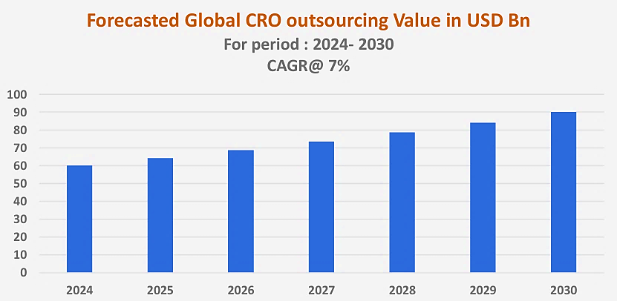
Source: Study on Cro Sector in India Conducted by Department of Pharmaceuticals Ministry of Chemicals & Fertilizers Government of India August 2023
- POTENTIAL FOR GROWTH IN THE CRO INDUSTRY IN INDIA:
Indian CRO market captures about 3% of the global market share by value, estimated at USD 2 Bn in 2021 and is expected to be the fastest growing market with a CAGR of about 12% from 2021 to 2026. The CRO sector in India has been growing @ CAGR 10.75 % is expected to reach USD 2.5 Billion by the year 2030. The recent favorable changes in the Indian regulatory landscape for the CRO industry, higher acceptability of India as an outsourcing destination by the global pharmaceutical companies and favorable demographics of India in terms of cost, technical skills (English speaking population) and diversity of volunteers required for trials are expected to drive the Indian CRO market.
- THE CRO VALUE CHAIN
The drug pipeline moves through various phases during the research and development process and CRO players function as contributors at the various stages incentivized for their efforts through monetization at every milestone.
Drug Development Life Cycle: Timeline for New Drug Approvals as per US FDA
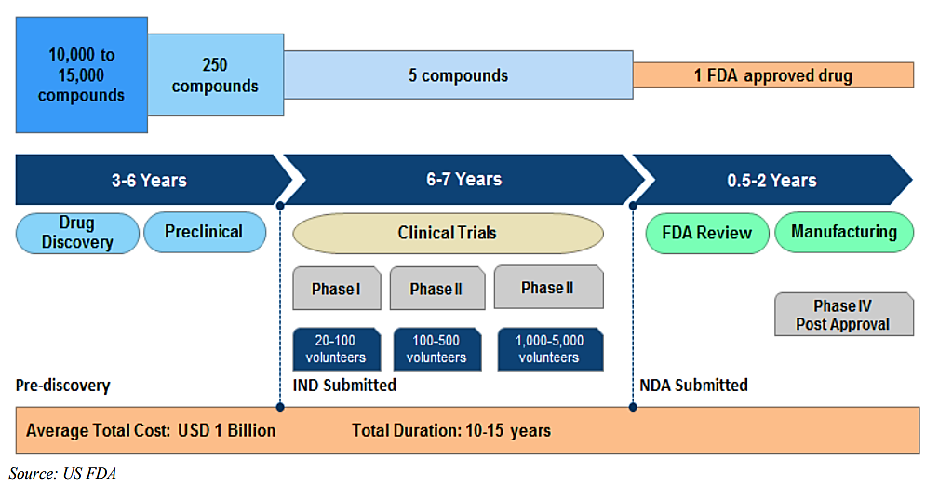
- CRO MARKET SEGMENTATION BY SUB-SEGMENTS:
The Indian Pharmaceutical CRO market can be classified into four categories by broad service types. As per the data analysed for 50 CROs in a study, 54% of the CROs operating in India are operating in the service areas related to patient-based Phase I-IV clinical trials conducted at the hospitals. It is followed by the segment (18% of the total number) which primarily offers the clinical Bioequivalence/ Bioavailability service from their inhouse BE centres and normally conduct the Pharmacokinetic studies in healthy subjects for ANDA submissions sand generic product marketing authorisations but also have the capabilities to conduct the patient-based studies in hospitals. India also has good percentage (20%) of integrated drug discovery and development companies which offer end to end services including chemistry/biology discovery, preclinical and clinical development services. A small percentage (8%) of preclinical CRO also work in which offer the animal testing services for the pharmaceutical, biotech and medical device companies.
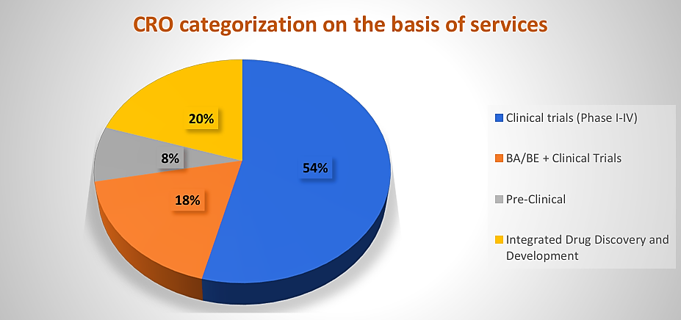
Source: Study on Cro Sector in India Conducted by Department of Pharmaceuticals Ministry of Chemicals & Fertilizers Government of India August 2023
- Discovery CROs offering the Medicinal and Biology Service:
In the field of drug development, drug discovery plays a pivotal role in the identification and optimization of small molecule drug candidates. However, the complexities and resource-intensive nature of medicinal chemistry require specialized expertise and infrastructure. This is where Contract Chemistry and Medicinal Discovery Services come into play, offering pharmaceutical and biotechnology companies access to a range of expertise and resources to expedite the drug discovery process. Outsourcing medicinal chemistry activities to CROs can provide significant cost and time savings for pharmaceutical and biotechnology companies. CROs have the necessary infrastructure, compound libraries, and expertise readily available, eliminating the need for companies to invest in establishing and maintaining their own medicinal chemistry capabilities.
- Preclinical CROs offering the animal testing services:
Preclinical development is a stage of drug development that begins after before clinical trials (testing in humans) and during which important feasibility, iterative testing and drug safety data are collected, typically in laboratory animals. The main goals of preclinical studies are to determine a starting, safe dose for first-in-human study and assess potential toxicity of the products. The preclinical CRO is an independent entity specializing in managing the complexities inherent to the preclinical phase of drug development and is employed by pharmaceutical organizations.
- Clinical Trial CROs offering the Phase I-IV clinical trial services:
Clinical development is a stage of drug development that begins after the successful testing of investigational new drugs in laboratory animals. In case of New Chemical entities, after the completion of successful preclinical toxicology studies, an Investigational New Drug (IND) or Clinical Trial Application (CTA) is filed by a company and it prepares itself for the testing of drugs in humans.
Phase I-IV with each part serving a different purpose
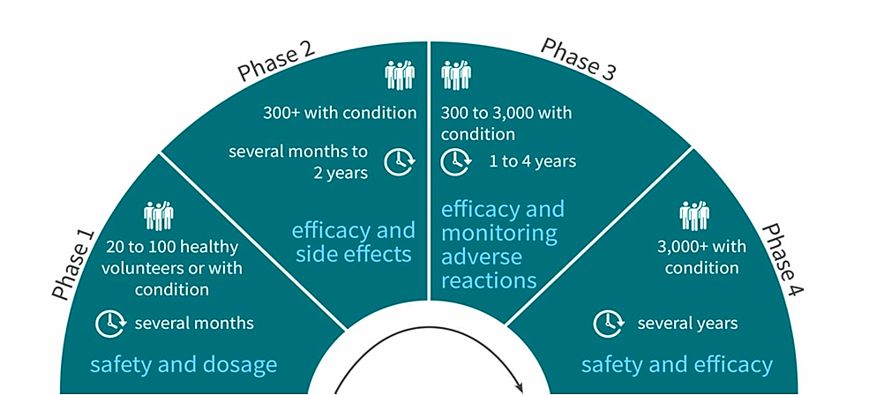
Source: Study on Cro Sector in India Conducted by Department of Pharmaceuticals Ministry of Chemicals & Fertilizers Government of India August 2023
- Bioequivalence Clinical CROs offering the Pharmacokinetic studies in healthy subjects:
For the generic pharmaceutical products, the pharmaceutical companies do not need to go through entire clinical development cycle of Phase I to Phase IV. It is because the innovator drugs are in the market for a long period and have already been proven to be safe and efficacious in a particular disease indication. In such case, the generic companies need to perform the Bioequivalence clinical studies to prove that their products have similar pharmacokinetic profile and safety profile to the innovator drug and therefore can substitute the innovator product.
Pharmacokinetic profile and safety profile of innovator drugs v/s generic drugs
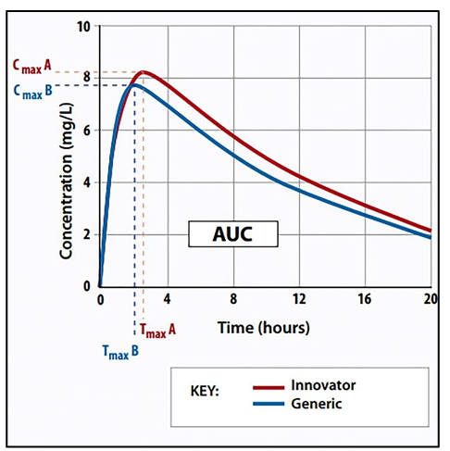
Source: Study on Cro Sector in India Conducted by Department of Pharmaceuticals Ministry of Chemicals & Fertilizers Government of India August 2023
The generic drugs of the clients of CRO are tested on these healthy subjects and the biological samples of these subjects are then tested for pharmacokinetic parameters in the associated bioanalytical laboratories equipped with high end machines like HPLC and LCMS.
The bioequivalence data provided by these CROs is an integral part of Abbreviated New Drug Application filed in USFDA by the pharmaceutical companies to get the approval for generic products. It is important to note that many of the CROs mentioned above also provide the clinical trial services at the hospitals for some of advance phase (Phase II-IV) clinical trials. Bioequivalence CROs also follow the ICH-GCP norms and come under the regulatory framework of CDSCO. Some of the services offered by the Bioequivalence CROs include:
- Protocol development & Study documentation
- Regulatory approval of BA/BE studies from CDSCO office
- Clinical conduct of the BA/BE study
- Method Development and Validation services
- Bioanalysis of plasma samples
- Data management and PK analysis
- Report writing and eCTD preparation
- Dossier preparation with complete data compilation

Life Cycle of Drug Development
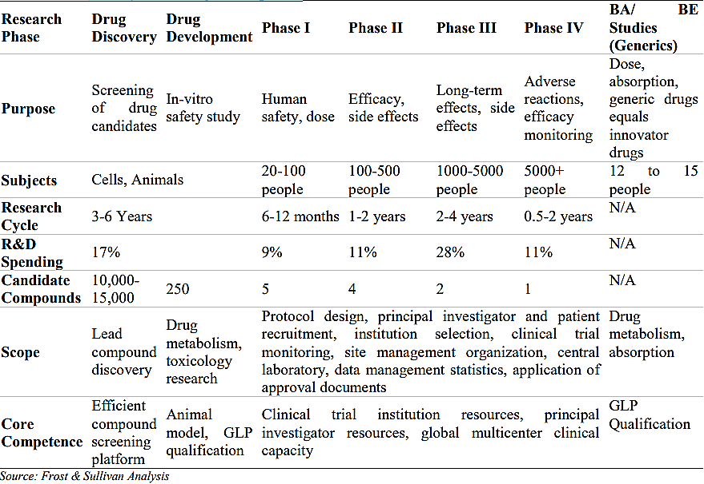
- CROS CATEGORIZATION BY LOCATION
As per a research report, most of the CROs (40%) are based in the western region comprising of Mumbai, Pune, Ahmedabad, Vadodara. It is followed by Southern region where 34 % of the CROs have presence mainly in cities like Bangalore, Chennai and Hyderabad. The northern part of India has around 18% of the contract research organizations which are mainly located in and around Delhi/NCR area. The eastern region of the country stands at 4% with CROs located in. The research report further elucidates that CRO generally prefer to set up their centres and offices in Metro or Tier 1 cities across the country.
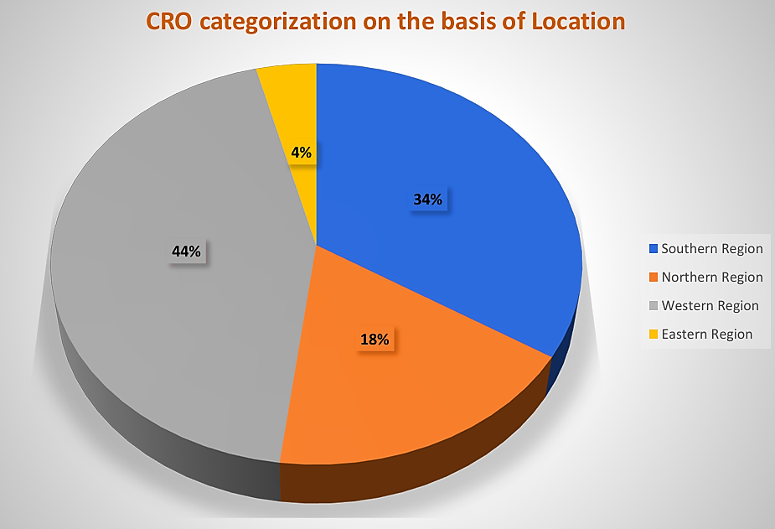
Source: Study on Cro Sector in India Conducted by Department of Pharmaceuticals Ministry of Chemicals & Fertilizers Government of India August 2023
- GLOBAL BIOAVAILABILITY (BA)/ BIO-EQUIVALENCE (BE) MARKET OVERVIEW
BA/ BE testing plays a vital role in generic drug development. BA/ BE studies are important elements in support of INDs, NDAs, ANDAs, and their supplements. To introduce a generic drug into a regulated market, the generic drug industry needs to meet the stringent criteria in the same way as innovative drugs. India is emerging as a force to reckon with in the global pharmaceutical space. India is one of the top five manufacturers of bulk drugs in the world and ranks amongst the top 20 pharmaceutical exporters in the world. Every fifth application for marketing a generic drug in the US, the world’s largest pharmaceutical market, is filed by an Indian company; thereby creating a great opportunity for Indian CROs in the BA/ BE segment.
BA/ BE segment globally expected to witness the highest growth rate of about 13%. The clinical trial support services segment is estimated to capture about 9% of the total market share in 2021 with BA/ BE studies contributing to 30% of USD 5.4 Bn of the clinical trial support services market in 2021. Though BA/ BE segment captures only about 3% of the total global market share, this segment is expected to witness the highest growth rate of about 12.6% between 2021 and 2026, primarily driven by greater adoption of generic drug manufacturing and emergence of biosimilars.
The BA/ BE market in India is expected on a higher growth trajectory as compared to the global trends. The BA/ BE market in India is estimated to grow from USD 0.4 Bn in 2021 to USD 0.8 Bn by 2026 with a CAGR of 13.4%.
India is considered as one of the major destinations for BA/ BE studies due to its current CRO infrastructure, increased outsourcing rate of these studies to Indian CROs, emergence and growth of the biosimilars industry, increased demand for complex generics, availability of a large population base to participate in the BA/ BE studies, cost-efficiency, changing regulatory landscape and evolving clinical trials evaluation standards in the country. Additionally, India accounts for 20% of global generic drug exports and captures 70% of the global generic drug market share by revenue. These attributes also drive the BA/ BE studies market in India.
BA/ BE studies expected to be made mandatory for all the approved drugs in India further driving the market growth. The impact of COVID-19 has put the CROs in the country into a tough situation as there is a poor participation of healthy volunteers for clinical trials to conduct BA/ BE studies. Though the pandemic has temporarily hampered the growth of the BA/ BE studies market, this segment is expected to see a double digit growth amidst the growth factors stated above as well as BA/ BE studies expected to be made mandatory for all the approved drugs in India as the Indian government is evaluating steps to promote generic versions of all medicines as a cost-containment strategy.
With the drugs worth USD 251 Billion going off-patent by the year 2030, the Indian clinical CROs operating in Bioequivalence and Bioavailability services have numerous opportunities to capitalize on.
BA/ BE Market, 2021-2026, USD Bn Global: CAGR 2021-2026 (12.6%) Outsourced Business CAGR 2021-2026 (14.8%)
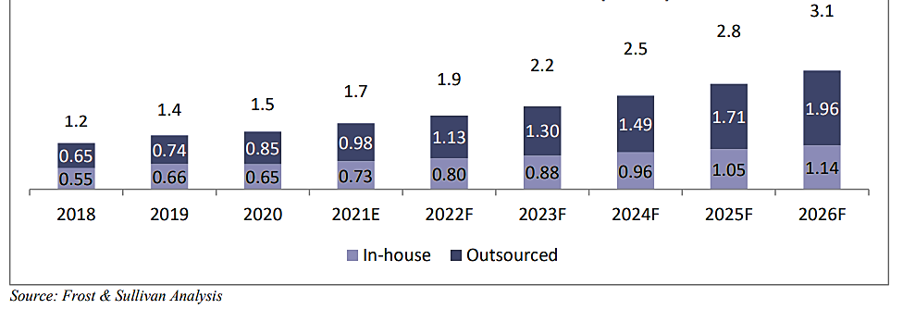
BA/ BE Market, 2021-2026, USD Bn Global: CAGR 2021-2026 (12.6%) India: CAGR 2021-2026 (13.4%)
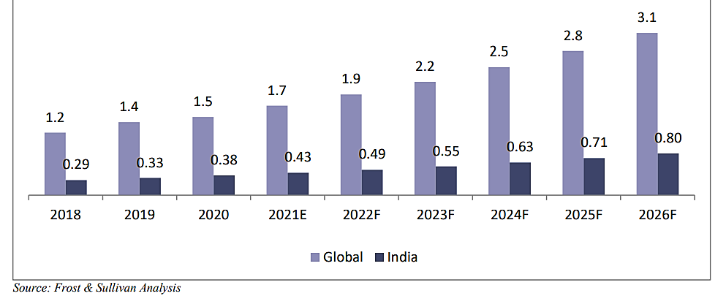
- CHALLENGES:
- Industry - Academia collaboration gap: The industry-academia gap poses a significant challenge for the growth of the contract research organization (CRO) industry specially in India. There is often a lack of effective collaboration and knowledge transfer between the academic research community and the industry, including CROs.
- Regulatory Complexity and Approval delays: The regulatory landscape in the pharmaceutical industry is complex and constantly continuously evolving. CROs need to navigate a multitude of regulatory requirements imposed by different regulatory bodies, such as the U.S. Food and Drug Administration (FDA), the European Medicines Agency (EMA), and other national regulatory authorities. Regulatory requirements and approval processes can vary significantly across different regions and countries. CROs operating globally must navigate these regional variations and adapt their strategies accordingly. Each region may have unique documentation requirements, local safety reporting obligations, and specific regulatory approval timelines.
- Data Integrity Issues: There have been few cases in past where Indian and global pharmaceutical sponsor companies have been caught in the crosshairs of serious issues related to misconduct and data integrity violations by their hired CROs particularly working in the domain clinical bioequivalence and bioavailability studies. Since this had resulted in the submission of invalid study data to regulatory agencies, many of the previous Marketing authorizations licenses which were approved on basis of the studies conducted at the facilities of these CROs, were also cancelled.
- Historical Perception of Clinical Trials in India: India has the perceived disadvantage of a country with vulnerable population to clinical trials. The country has gained its fair share of media attention of late owing to the ICH- GCP violations and unethical drug trials being conducted on ineligible patient populations. There have been instances in the past where unethical practices, inadequate participant protection, or adverse events in clinical trials have garnered negative media attention.
- Patient Recruitment and Retention: Patient recruitment and retention pose significant challenges for the clinical research organization market in India. Limited awareness among the general population about clinical trials and their importance can hinder patient recruitment efforts. Many individuals may have misconceptions or reservations about participating in clinical trials, including concerns about safety, efficacy, and potential side effects. Educating the public about the benefits of clinical research, addressing misconceptions, and providing accurate information can help improve patient recruitment in India.
- Guinea Pig Syndrome: Negative Public perception of clinical trials (Guinea Pig Syndrome) indeed poses a challenge for the growth of the contract research organization (CRO) market in India. Most of the potential clinical trial participants have limited awareness and understanding of clinical trials and their significance in advancing medical research and developing new treatments. This lack of awareness can lead to scepticism, fear, and misconceptions among the public including the media, making it challenging to recruit participants for clinical trials.
- Patient Data Confidentiality: CROs operate in a highly regulated environment, and compliance with data protection regulations is of utmost importance. Regulations such as the General Data Protection Regulation (GDPR) in Europe and the Health Insurance Portability and Accountability Act (HIPAA) in the United States impose strict requirements for the collection, storage, processing, and transfer of personal and 29 INDIAN CRO SECTOR health-related data. CROs handle sensitive and confidential data throughout the clinical research process, including patient health records, medical histories, and research findings. Maintaining the privacy and confidentiality of this data is crucial to protect the rights and privacy of participants, maintain regulatory compliance, and uphold ethical standards. Any breach of data confidentiality can have severe consequences, including legal and reputational damage. Ensuring compliance with these regulations can be complex, especially when working with multinational studies and handling data from different regions.

- GOVERNMENT INITIATIVES:
- The government has consistently raised the budget spending on healthcare which has gone up by 13 per cent to Rs 89,155 crore in FY24. Of this, Rs 2,980 crore has been earmarked for healthcare research.
- Department of Pharmaceuticals under the aegis of Ministry of Chemicals and Fertilizers, Government of India has been running various schemes under the initiative “Strengthening of Pharmaceutical Industry (SPI)", with a total financial outlay of Rs.500 Cr (USD 60.9 million) for the period from FY 21-22 to FY 25-26.
- The regulatory scenario in India, including drug approval processes, clinical trial regulations, and intellectual property protection has significantly improved significantly post 2014. Further progressive and industry friendly changes in government policies, regulations, and the enforcement of ethical guidelines are going to positively influence the operational and legal frameworks within which CROs operate.
- Regulatory reforms post 2013 and the introduction of New Drugs and Clinical Trial Rules of 2019 have partially streamlined the approval processes, reduced the timelines by 30-40%, and introduced several exemptions and provisions to improve the overall efficiency of conducting clinical trials. In addition, some other initiatives like Audio Visual consenting of patients, Ethics committee registration, new compensation law and robust scrutiny system for the Clinical Trial applications have been implemented. These are aimed at streamlining the processes and making the systems transparent
- The government will table New Drugs, Medical Devices and Cosmetics Bill, 2023, in the Parliament in the monsoon session which seeks to regulate “the import, manufacture, distribution and sale of drugs, medical devices and cosmetics; and ensure their quality, safety, efficacy, performance and clinical trial of new drugs and clinical investigation of investigational medical devices and clinical performance evaluation of new in vitro diagnostic medical device including AYUSH drugs, medical devices and cosmetics with the objective of highest possible regulatory standards and a transparent regulatory regime and to repeal the Drugs and Cosmetics Act, 1940
- The Government has allowed up to 100 percent FDI through automatic route to Greenfield pharmaceutical projects. For Brownfield projects also Indian government has permitted the FDI allowed is up to 74% through automatic route and beyond that through government approval.
- CONCLUSION:

Indian CRO market captures about 3% of the global market share by value, estimated at USD 2 Bn in 2021 and is expected to be the fastest growing market with a CAGR of about 12% from 2021 to 2026. The CRO sector in India has been growing @ CAGR 10.75 % is expected to reach USD 2.5 Billion by the year 2030.

The BA/ BE market in India is expected on a higher growth trajectory as compared to the global trends. The BA/ BE market in India is estimated to grow from USD 0.4 Bn in 2021 to USD 0.8 Bn by 2026 with a CAGR of 13.4%. With the drugs worth USD 251 Billion going off-patent by the year 2030, the Indian clinical CROs operating in Bioequivalence and Bioavailability services have numerous opportunities to capitalize on.

PART H | RISK ANALYSIS

Risk | Impact | Description
Time Overrun | Medium | - Although the management is determined to complete the project as per the decided milestones, any delay due to factors not in control of the company/ management can affect the cash flows to that extent.
Cost Overrun | Medium | - It is assumed the total project cost will be to the tune of INR ~45.27 Cr. Any unwarranted increase due to higher inflation, regulatory requirements, competition etc. may increase the said project costs.
Operational Risk | Medium | - Contractual requirements, regulatory standards, availability of volunteers and ethical considerations could impact the CRO’s performance and the financial condition subsequently.  - Also, any adverse changes in outsourcing trends in the pharmaceutical and biopharmaceutical industry and changes in aggregate spending and research and development budgets could adversely affect the operating results and growth rate.
Competition | Medium | - Competition in this business is based on pricing, relationships with clients and, to an extent, is also affected by perceived quality of services, technological competencies, capabilities and expertise. Growing competition in the domestic and/or international markets may subject the Company to pricing pressures and require the Company to make adjustments in pricing the services in order to retain or attract clients.  - Most of the CROs (40%) are based in the western region comprising. It is followed by Southern region with 34% of the CROs. The northern part of India has only around 18% of the contract research organisations.  - The Company expects to tap drug and medicines manufacturing companies/units operating in nearby states.
Regulatory Issues | Medium | - The CRO need to take various approvals and licenses for BA/BE services from regulatory authorities. A delay in getting the approvals may cause potential hurdles.
Threat Of New Entrants | Medium | - The threat of new entrants to the Pharmaceutical CRO market in India is relatively moderate. While the industry requires significant investments in infrastructure, expertise, and regulatory compliance, the potential for new entrants exists. However, established CROs often benefit from economies of scale, established client relationships, and expertise in navigating complex regulatory frameworks, creating barriers to entry for new players.

PART I | SWOT ANALYSIS

SWOT ANALYSIS – BA/BE Studies Market
STRENGTHS | - Growing demand for generic drugs: the increasing prevalence of chronic diseases and the need for affordable treatment options have fuelled the demand for generic drugs, driving the growth of the bioequivalence studies market.  - Stringent regulatory guidelines: regulatory authorities, such as FDA & EMA, have established struct guidelines for conducting bioequivalence studies. Compliance with these guidelines is essential for generic drug approval, creating a significant demand for bioequivalence study services.  - Availability of volunteer database: as informed to us by the client, Skylimit has 20,000+ (male and female) volunteer data bank containing all the information of local volunteers.  - Presence of few CROs in North India: most of the CROs (40%) are based in the western region comprising. It is followed by Southern region with 34% of the CROs. The northern part of India has only around 18% of the contract research organisations.  - Advancement in analytical techniques: technological advancements in analytical techniques, such as high-performance liquid chromatography (HPLC) and mass spectrometry, have enhanced the accuracy and efficiency of bioequivalence studies. These advancements have further propelled the market growth.  - Increasing awareness and acceptance: patients and healthcare professionals are becoming more aware of the benefits of generic drugs and the importance of bioequivalence studies. This increased awareness and acceptance contribute to the market expansion.  - Growing focus on Biosimilars: in addition to generic drugs, the market for biosimilars is also gaining traction. Bioequivalence studies are crucial for demonstrating the similarity between biosimilars and their reference products, driving the demand for these studies.
WEAKNESSES | - Lack of experience: the promoters are planning to enter a new industry which can be a risk for new/unexperienced promoters.  - Complex study design: bioequivalence studies require meticulous study design, including subject recruitment, sample size determination and statistical analysis. The complexity involved in conducting these studies can be a significant challenge for researchers and may hinder market growth.  - High development costs: conducting bioequivalence studies involved significant investment in infrastructure, analytical equipment, and skilled personnel. These high development costs may deter small and medium sized pharmaceutical companies from entering the market.  - Regulatory variations across regions: regulatory requirements for bioequivalence studies vary across regions and countries. Companies operating in multiple jurisdictions may face challenges in meeting the diverse regulatory standards, affecting market expansion.  - Potential risks and side effects: although bioequivalence studies aim to ensure the safety of generic drugs, there is still a possibility of risks and side effects. Adverse events observed during the studies can impact the perception and acceptance of generic drugs, acting as a restraint for the market.
OPPORTUNITIES | - Emerging markets: the demand for generic drugs and the need for bioequivalence studies is rising in emerging markets. Increasing healthcare investments, expanding patient populations, and the expiration of drug patents create significant opportunities for market growth in these regions.  - Higher growth trajectory of Indian Market: the BA/BE market in India is expected on a higher growth trajectory as compared to the global trends (13.4% vs. 12.6%). The global BA/BE market is estimated to grow from USD 1.7 Bn in 2021 to USD 3.1 Bn by 2026 at a CAGR of about 12.6%. The BA/BE market in India is estimated to grow from USD 0.4 Bn in 2021 to USD 0.8 Bn by 2026 with a CAGR of 13.4%.  - Technological advancements: ongoing advancement in analytical techniques, such as bioanalytical assays and modelling software, present opportunities for improving the efficiency and accuracy of bioequivalence studies. Adoption of these technologies can enhance the market potential.  - Collaboration and partnerships: collaboration between pharmaceutical companies, CROs, and academic institutions can facilitate knowledge sharing, resource pooling, and faster development of bioequivalence studies. Partnerships can open new avenues for research and development, creating opportunities for market expansion.  - Personalized medicine: the growing emphasis on personalized medicine and precision therapies requires a deeper understanding of individual drug response. Bioequivalence studies can contribute to personalized medicine by assessing inter-individual variability in drug absorption and metabolism.  - Adoption of real-world evidence: real-world evidence, derived from post-marketing surveillance and observational studies, is gaining importance in drug development. Incorporating real-world evidence in bioequivalence studies can provide valuable insights into drug performance, opening new opportunities in the market.
THREATS | - Ethical considerations: bioequivalence studies involve administrating drugs to human subjects, necessitating adherence to strict ethical guidelines. These considerations, including informed consent and participant safety, may pose challenges for conducting large scale studies.  - Regulatory challenges: BA/BE studies are subject to contractual requirements, regulatory standards and ethical considerations. Any change in regulatory requirements could have a could have a material adverse effect on the business.  - Competition from brand-name drugs: branded generics continue to account for more than 75% share by volume and 90% by value. This is because of concerns around continuous availability and quality that have limited their traction in non-rural markets in India.

PART J | PROJECT COST AND MEANS OF FINANCE
As per data/information shared by the client, the proposed Clinical Research Organization project is proposed to be commissioned by making an investment of INR 4,816.77 lakhs as shown in the below table along with Means of finance:
Total Project Cost
S. No. | Capital Cost Head | Amount (INR)
1 | Furniture & Fittings | ₹ 7,13,20,733
2 | Plant & Machinery | ₹ 24,26,79,568
3 | Preliminary Expense | ₹ 3,43,20,000
4 | Interest During Moratorium (IDM) after COD | ₹ 4,50,00,000
5 | Interest During Construction (IDC) | ₹ 1,12,50,000
 | TOTAL | ₹ 40,45,70,302
Means of Finance
S. No. | Particular | Amount (INR)
1 | Promoters' Equity | ₹ 10,00,00,000
2 | Unsecured Loan from Promoters | ₹ 45,70,302
3 | Loan from Banks | ₹ 30,00,00,000
 | TOTAL | ₹ 40,45,70,302
 | Total Loan | ₹ 30,00,00,000
Source: Data/Information provided by the company.
Notes:
- It is to be noted that the estimation/vetting of the project cost is out of scope of this TEV report, and we have relied upon the data/information provided by the client regarding Total Project cost such as quotations, etc. However, as a TEV consultant, the cost of major plant & machinery has been verified by us independently, which we found reasonable & in the permissible range although the cost may change as per brand & specifications.
- As per the shared lease deed, the Company has executed lease agreement on 29th January 2024 for the premises situated at Plot no. 28, Sector 155, Phase II, Noida which is a 4-story building constructed on a plot area 1,000 square meters and having a leasable area of ~32,000 square feet. The monthly lease rent is Rs. 6,40,000.00 and the initial lease period is for 5 years with 5% annual increase in rent after expiry of 12 months of lease period and the lease agreement shall be automatically renewed for next 05 years after the expiry of the agreement as per the agreed terms.
- The cost of Civil and interior works has been considered as per the quotations received from the vendors The estimated cost of Civil and interior works is ~INR 713.20 lakhs including applicable GST.
- The cost of Plant & Machinery has been considered as per the quotations received from the vendors. The estimated cost for plant & machinery will be ~INR 2,426.79 lakhs including the applicable GST.
- Preliminary & Pre-Operative Expenses has been taken as lump sum basis, based on the time period of civil works, estimate of company’s resources involvement during this time in supervision & monitoring of the civil works, estimated lease expenses and other estimated regulatory expenses as INR 343.20 lakhs.
- The project is proposed to be funded through a term loan of INR 30.00 crores, promoter’s equity of INR 10.00 crores and unsecured loan from promoters of INR 0.46 crores.

PART K | PROJECT IMPLEMENTETION SCHEDULE

The proposed Clinical Research Organization unit is expected to achieve its C.O.D by 1st December 2024, as per the proposed implementation schedule shown in the table below:
S. No. | Particulars | Activity | Expected completion date | Status
 | Sanction of Rupee Term Loan | Sanction of Rupee Term Loan | June 2024 | Pending
 | Building & Civil Works | Appointment of Architect | 2nd Jan 2024 | Completed
 |  | Appointment of Civil contractor/ developer | 3rd Jan 2024 | Completed
 |  | Building & Civil Works completion | September 2024 | Pending
 | Plant & Machinery | Finalization of P&M suppliers | April 2024 | Completed
 |  | Orders to P&M suppliers | June 2024 | Pending
 |  | Arrival of P&M | August, 2024 | Pending
 |  | Installation of P&M | September 2024 | Pending
 |  | Utility Installation | November, 2024 | Pending
 | Statutory Approvals, registrations & NOCs | From the respective authorities | November, 2024 | Pending
 | Finishing & Trial Run | Informed by client | November, 2024 | Pending  (Post C.O.D approval)
 | Commercial Operation Date | Informed by client | 1st December 2024 | Pending
Notes:
- Schedule has been made as per feasibility to achieve different milestones.
- Achievement of Milestone will depend on sanction of term loan as per proposed timeline.
- For current status of statutory approvals, kindly refer the “Section L” of this report.
- As per this timeline, the expected C.O.D will be 1st December 2024.

PART L | STATUTORY APPROVALS | LICENCES | NOC

As shown in the below table along with current status, following major approvals are required. However, the list is not exhaustive, and State/District Authorities may be approached for further clearances required (if any):
S. No. | REQUIRED APPROVALS | DATE  REFERENCE NO. | STATUS  (Approved/ Applied For/ Pending)
 | Certificate of Incorporation  Ministry of Corporate Affairs, Government of India | 11th December 2023  CIN: U32502UP2023PTC193875 | Approved
 | Labour Licence  Registration & grant of license under The Factories Act, 1948 Department of Labour, Uttar Pradesh | - | Pending
 | Fire & Safety  Uttar Pradesh Fire Service Department | 8th February 2023 | Approved
 | Establishment of Enterprises  State Nodal Agency, Govt. of Uttar Pradesh | - | Pending
 | Consent to Establish (NOC)  Uttar Pradesh Pollution Control Board | 27th April 2024 | Applied For
 | Udyam Registration Certificate (MSME) | 5th February 2024  UDYAM-UP-28-0099655 | Approved
 | BE centre approval  Central Drug Standards Control Organization (CDSCO), India | - | Pending
 | Independent Ethics committee (IEC) registration  Central Drug Standards Control Organization (CDSCO), India | - | Pending
 | Foreign Regulatory Approvals  USFDA, EMEA, UKMHRA, ANVISA, TGA etc. | - | Pending
 | NABL certification as per ISO 15189:2016  National Accreditation Board for Testing and Calibration Laboratories | - | Pending
 | GLP compliance of Bioanalytical Section of Bioequivalence centre  National Good Laboratory Practice (GLP) Compliance Monitoring Authority, Department of Science and Technology, Government of India | - | Pending
 | ICH-GCP compliance  Central Drug Standards Control Organization (CDSCO), India | - | Pending
 | ISO 9001:2015 (Quality Management System)  International Organization for Standardization | - | Pending
 | Registration for License under Clinical Establishment Act.  State Bio-Medical Waste treatment Board or Authority | - | Pending
Observation Notes:
- As informed to us by the client, application for grant of NOC from Uttar Pradesh Pollution Control Board has been submitted to Regional Office on 27th April 2024. Copy of Pollution Control Board Clearance application has not been provided to us. Bank is suggested to verify the same.
- The landlord has obtained NOC of Fire department on 8th February 2023 which is valid for 3 years.
- The building is a leased property and background check of the same including approved building plan and other approvals related to the building from relevant authority is out of our scope of work we shall not be liable if any discrepancies are found in this regard. Bank is suggested to verify the same.
- As per the lease deed, if any permission is required for setting up CRO unit from Noida Authority, the lessor is completely responsible for making available all required permissions from Noida Authority.
- As informed to us by the client, the mandatory/requisite approvals, accreditations & certifications from Central Drug Standards Control Organization (CDSCO), India, which is the prime regulatory body in India will be obtained in August/September 2024. The company expects getting all the requisite Approvals, Accreditations & Certifications from the Regulating Authorities/ Central Drug Standards Control Organization within 3 months’ time by December 2024. The approvals from other overseas regulatory bodies such as the U.S. Food and Drug Administration (FDA), the European medicines Agency (EMA), and other national regulatory authorities will be pursued thereafter.
- Above is the only illustration of the major approvals sought or to be sought by the company. It should not be construed as the exhaustive list and in case any approval is missed to be mentioned then it is the sole responsibility of the company to keep the unit compliant with the necessary statutory approvals/ NOCs.

PART M | COMPANY’S FINANCIAL FEASIBILITY

- PROJECTIONS OF THE FIRM:
The financial projections of the project are prepared from FY 2024-25 to FY 2034-35 based on the expected COD and loan tenor as per the best practice in industry to assess the financial feasibility of the project are elaborated below:
- PROJECTED PROFIT & LOSS ACCOUNT:
(INR Lakhs)
Financial Year | FY 2025 | FY 2026 | FY 2027 | FY 2028 | FY 2029 | FY 2030
Months | 4 | 12 | 12 | 12 | 12 | 12
Revenue from pilot studies | 41.9 | 277.6 | 706.2 | 898.3 | 952.2 | 1009.3
Revenue from pivotal studies | 159.8 | 1058.7 | 2693.3 | 3425.8 | 3631.4 | 3849.3
Gross Annual Revenue | 201.7 | 1336.3 | 3399.5 | 4324.1 | 4583.5 | 4858.6
1. Cost of material consumed | 16.1 | 106.9 | 272.0 | 345.9 | 366.7 | 388.7
2. Testing expenditure | 66.6 | 441.0 | 1121.8 | 1427.0 | 1512.6 | 1603.3
3. Selling/marketing expenses | 2.0 | 13.4 | 34.0 | 43.2 | 45.8 | 48.6
4 General and other operating expenses | 6.1 | 40.1 | 102.0 | 129.7 | 137.5 | 145.8
Total Variable Expenses | 90.8 | 601.3 | 1529.8 | 1945.8 | 2062.6 | 2186.4
1. Employee benefit expenses | 96.0 | 457.9 | 849.4 | 1080.5 | 1145.3 | 1214.0
2. Lease Rental | 25.6 | 80.6 | 84.7 | 88.9 | 93.4 | 98.0
3. R & M of Plant & Machinery | 16.2 | 51.4 | 54.5 | 57.8 | 61.3 | 65.0
4. Misc expenses | 3.3 | 10.6 | 11.2 | 11.9 | 12.6 | 13.4
Total Fixed Expenses | 141.1 | 600.6 | 999.9 | 1239.1 | 1312.6 | 1390.4
Total Expenses | 231.9 | 1201.9 | 2529.6 | 3185.0 | 3375.2 | 3576.7
EBIDTA | -30.2 | 134.3 | 869.8 | 1139.1 | 1208.4 | 1281.8
Interest on Term Loan | 100.0 | 300.0 | 287.0 | 250.0 | 212.5 | 175.0
Interest on Unsecured Loan | 0.0 | 0.0 | 0.0 | 0.0 | 0.0 | 0.0
Depreciation | 225.5 | 419.0 | 360.2 | 354.4 | 304.1 | 261.1
Preliminary Expenses | 22.9 | 68.6 | 68.6 | 68.6 | 68.6 | 45.8
PBT | -378.5 | -653.3 | 154.0 | 466.1 | 623.1 | 800.0
Less: Taxation | 0.0 | 0.0 | 0.0 | 0.0 | 53.2 | 201.3
PAT | -378.5 | -653.3 | 154.0 | 466.1 | 569.9 | 598.7

(Continued)
Financial Year | FY 2031 | FY 2032 | FY 2033 | FY 2034 | FY 2035
Months | 12 | 12 | 12 | 12 | 12
Revenue from pilot studies | 1069.8 | 1134.0 | 1202.1 | 1274.2 | 1350.7
Revenue from pivotal studies | 4080.2 | 4325.0 | 4584.5 | 4859.6 | 5151.2
Gross Annual Revenue | 5150.1 | 5459.1 | 5786.6 | 6133.8 | 6501.9
1. Cost of material consumed | 412.0 | 436.7 | 462.9 | 490.7 | 520.1
2. Testing expenditure | 1699.5 | 1801.5 | 1909.6 | 2024.2 | 2145.6
3. Selling/marketing expenses | 51.5 | 54.6 | 57.9 | 61.3 | 65.0
4 General and other operating expenses | 154.5 | 163.8 | 173.6 | 184.0 | 195.1
Total Variable Expenses | 2317.5 | 2456.6 | 2604.0 | 2760.2 | 2925.8
1. Employee benefit expenses | 1286.9 | 1364.1 | 1445.9 | 1532.7 | 1624.7
2. Lease Rental | 102.9 | 108.1 | 113.5 | 119.1 | 125.1
3. Repair & Maintenace | 68.8 | 73.0 | 77.4 | 82.0 | 86.9
4. Misc expenses | 14.2 | 15.0 | 15.9 | 16.9 | 17.9
Total Fixed Expenses | 1472.8 | 1560.2 | 1652.7 | 1750.7 | 1854.6
Total Expenses | 3790.4 | 4016.8 | 4256.7 | 4511.0 | 4780.4
EBIDTA | 1359.7 | 1442.3 | 1529.9 | 1622.9 | 1721.4
Interest on Term Loan | 137.5 | 100.0 | 62.5 | 25.0 | 0.5
Interest on Unsecured Loan | 0.0 | 0.0 | 0.0 | 0.0 | 0.0
Depreciation | 224.2 | 192.7 | 225.7 | 193.5 | 166.0
Preliminary Expenses | 0.0 | 0.0 | 0.0 | 0.0 | 0.0
PBT | 998.0 | 1149.6 | 1241.8 | 1404.4 | 1554.9
Less: Taxation | 251.2 | 289.3 | 312.5 | 353.4 | 391.3
PAT | 746.8 | 860.3 | 929.2 | 1050.9 | 1163.6
- PROJECTED BALANCE SHEET:
Below table shows the Projected Balance Sheet of the proposed Clinical Research Organization project from the period FY 2024-25 to FY 2034-35. FY 2025 would be the implementation period of the project:
(INR Lakhs)
Financial Year | FY 2025 | FY 2026 | FY 2027 | FY 2028 | FY 2029 | FY 2030
Months | Constr. | 12 M | 12 M | 12 M | 12 M | 12 M
Equity | 1000.0 | 1000.0 | 1000.0 | 1000.0 | 1000.0 | 1000.0
Reserve & Surplus | -378.5 | -1031.8 | -877.8 | -411.7 | 158.2 | 756.9
Secured Loan | 3000.0 | 2687.5 | 2312.5 | 1937.5 | 1562.5 | 1187.5
Unsecured loan | 45.7 | 45.7 | 45.7 | 45.7 | 45.7 | 45.7
Trade Payables | 34.0 | 38.8 | 52.4 | 58.4 | 60.1 | 61.9
Term liabilities payable within one year | 0.0 | 312.5 | 375.0 | 375.0 | 375.0 | 375.0
Total Equity & Liabilities | 3701.2 | 3052.7 | 2907.7 | 3004.9 | 3201.6 | 3427.0
Furniture & Fittings | 738.8 | 738.8 | 744.8 | 744.8 | 744.8 | 744.8
Plant & Machinery | 2513.7 | 2513.7 | 2513.7 | 2813.7 | 2813.7 | 2813.7
Total Gross Block | 3252.5 | 3252.5 | 3258.5 | 3558.5 | 3558.5 | 3558.5
Depreciation | 225.5 | 644.4 | 1004.7 | 1359.0 | 1663.1 | 1924.2
Net Block | 3027.0 | 2608.1 | 2253.8 | 2199.5 | 1895.4 | 1634.3
Trade Receivables | 50.4 | 109.8 | 279.4 | 355.4 | 376.7 | 399.3
Inventories | 4.0 | 8.8 | 22.4 | 28.4 | 30.1 | 31.9
Cash & Bank | 299.4 | 74.3 | 169.1 | 307.2 | 853.6 | 1361.4
Current Assets | 353.9 | 192.9 | 470.8 | 691.1 | 1260.4 | 1792.7
Preliminary Expenses W/off | 320.3 | 251.7 | 183.0 | 114.4 | 45.8 | 0.0
Total Assets | 3701.2 | 3052.7 | 2907.7 | 3004.9 | 3201.6 | 3427.0
(Continued)
Financial Year | FY 2031 | FY 2032 | FY 2033 | FY 2034 | FY 2035
Particulars | 12 M | 12 M | 12 M | 12 M | 12 M
Equity | 1000.0 | 1000.0 | 1000.0 | 1000.0 | 1000.0
Reserve & Surplus | 1503.7 | 2364.0 | 3293.2 | 4344.1 | 5507.7
Secured Loan | 812.5 | 437.5 | 62.5 | 0.0 | 0.0
Unsecured loan | 45.7 | 45.7 | 45.7 | 45.7 | 45.7
Trade Payables | 63.9 | 65.9 | 68.0 | 70.3 | 72.8
Term liabilities payable within one year | 375.0 | 375.0 | 375.0 | 62.5 | 0.0
Total Equity & Liabilities | 3800.8 | 4288.1 | 4844.5 | 5522.7 | 6626.2
Furniture & Fittings | 744.8 | 744.8 | 744.8 | 744.8 | 744.8
Plant & Machinery | 2813.7 | 2813.7 | 3213.7 | 3213.7 | 3213.7
Total Gross Block | 3558.5 | 3558.5 | 3958.5 | 3958.5 | 3958.5
Depreciation | 2148.4 | 2341.1 | 2566.8 | 2760.3 | 2926.3
Net Block | 1410.1 | 1217.4 | 1391.7 | 1198.2 | 1032.2
Trade Receivables | 423.3 | 448.7 | 475.6 | 504.1 | 534.4
Inventories | 33.9 | 35.9 | 38.0 | 40.3 | 42.8
Cash & Bank | 1933.5 | 2586.1 | 2939.1 | 3780.0 | 5016.8
Current Assets | 2390.7 | 3070.7 | 3452.8 | 4324.5 | 5593.9
Preliminary Expenses W/off | 0.0 | 0.00 | 0.00 | 0.00 | 0.00
Total Assets | 3800.8 | 4288.1 | 4844.5 | 5522.7 | 6626.2

- PROJECTED CASH FLOW STATEMENT:
(INR Lakhs)
Financial Year | FY 2025 | FY 2026 | FY 2027 | FY 2028 | FY 2029 | FY 2030
Particulars | Constr. | 12 M | 12 M | 12 M | 12 M | 12 M
Net Profit | -378.5 | -653.3 | 154.0 | 466.1 | 569.9 | 598.7
Increase in Equity / Share Capital | 1000.0 | 0.0 | 0.0 | 0.0 | 0.0 | 0.0
Increase in TL | 3000.0 | 0.0 | 0.0 | 0.0 | 0.0 | 0.0
Increase in Unsecured Loan | 45.7 | 0.0 | 0.0 | 0.0 | 0.0 | 0.0
Depreciation | 225.5 | 419.0 | 360.2 | 354.4 | 304.1 | 261.1
Preliminary Expenses w/off | 22.9 | 68.6 | 68.6 | 68.6 | 68.6 | 45.8
Trade payables | 34.0 | 4.8 | 13.6 | 6.1 | 1.7 | 1.8
TOTAL | 3949.6 | -160.9 | 596.4 | 895.2 | 944.4 | 907.3
Capital Expenses | 3252.5 | 0.0 | 6.0 | 300.0 | 0.0 | 0.0
Decrease in Term Loan | 0.0 | 0.0 | 312.5 | 375.0 | 375.0 | 375.0
Decrease in Unsecured Loan | 0.0 | 0.0 | 0.0 | 0.0 | 0.0 | 0.0
Trade Receivable | 50.4 | 59.4 | 169.6 | 76.0 | 21.3 | 22.6
Inventory | 4.0 | 4.8 | 13.6 | 6.1 | 1.7 | 1.8
Preliminary Expense | 343.2 | 0.0 | 0.0 | 0.0 | 0.0 | 0.0
TOTAL | 3650.2 | 64.2 | 501.6 | 757.1 | 398.0 | 399.4
Opening Balance | 0.0 | 299.4 | 74.3 | 169.1 | 307.2 | 853.6
Net Surplus/ Deficit | 299.4 | -225.1 | 94.8 | 138.1 | 546.3 | 507.9
Cumulative Balance | 299.4 | 74.3 | 169.1 | 307.2 | 853.6 | 1361.4

(Continued)
Financial Year | FY 2031 | FY 2032 | FY 2033 | FY 2034 | FY 2035
Particulars | 12 M | 12 M | 12 M | 12 M | 12 M
Net Profit | 746.8 | 860.3 | 929.2 | 1050.9 | 1163.6
Increase in Equity / Share Capital | 0.0 | 0.0 | 0.0 | 0.0 | 0.0
Increase in TL | 0.0 | 0.0 | 0.0 | 0.0 | 0.0
Increase in Unsecured Loan | 0.0 | 0.0 | 0.0 | 0.0 | 0.0
Depreciation | 224.2 | 192.7 | 225.7 | 193.5 | 166.0
Preliminary Expenses w/off | 0.0 | 0.0 | 0.0 | 0.0 | 0.0
Trade payables | 1.9 | 2.0 | 2.2 | 2.3 | 2.4
TOTAL | 973.0 | 1055.0 | 1157.1 | 1246.7 | 1332.0
Capital Expenses | 0.0 | 0.0 | 400.0 | 0.0 | 0.0
Decrease in Term Loan | 375.0 | 375.0 | 375.0 | 375.0 | 62.5
Decrease in Unsecured Loan | 0.0 | 0.0 | 0.0 | 0.0 | 0.0
Trade Receivable | 24.0 | 25.4 | 26.9 | 28.5 | 30.2
Inventory | 1.9 | 2.0 | 2.2 | 2.3 | 2.4
Preliminary Expense | 0.0 | 0.0 | 0.0 | 0.0 | 0.0
TOTAL | 400.9 | 402.4 | 804.1 | 405.8 | 95.2
Opening Balance | 1361.4 | 1933.5 | 2586.1 | 2939.1 | 3780.0
Net Surplus/ Deficit | 572.1 | 652.6 | 353.0 | 840.9 | 1236.8
Cumulative Balance | 1933.5 | 2586.1 | 2939.1 | 3780.0 | 5016.8

- KEY FINANCIAL RATIO:
YEAR | FY 2025 | FY 2026 | FY 2027 | FY 2028 | FY 2029 | FY 2030 | FY 2031 | FY 2032 | FY 2033 | FY 2034 | FY 2035
EBITDA Margin % | -15.0  % | 10.1% | 25.6% | 26.3% | 26.4% | 26.4% | 26.4% | 26.4% | 26.4% | 26.5% | 26.5%
EBIT Margin % | -126.7% | -21.3% | 15.0% | 18.1% | 19.7% | 21.0% | 22.0% | 22.9% | 22.5% | 23.3% | 23.9%
PAT Margin % | -187.7% | -48.9% | 4.5  % | 10.8% | 12.4% | 12.3% | 14.5% | 15.8% | 16.1% | 17.1% | 17.9%
Revenue Growth % |  | 120.8% | 154.4% | 27.2% | 6.0  % | 6.0  % | 6.0  % | 6.0  % | 6.0  % | 6.0  % | 6.0  %
- GRAPHICAL REPRESENTATION OF KEY RATIOS:

- ESTIMATED KEY FINANCIAL METRICS:
DEBT SERVICE COVERAGE RATIO (DSCR)

Particular | FY 2025 | FY 2026 | FY 2027 | FY 2028 | FY 2029 | FY 2030
PAT (Profit After Tax) | -378.5 | -653.3 | 154.0 | 466.1 | 569.9 | 598.7
Depreciation | 225.5 | 419.0 | 360.2 | 354.4 | 304.1 | 261.1
Preliminary Expenses | 22.9 | 68.6 | 68.6 | 68.6 | 68.6 | 45.8
Interest on term loan | 100.0 | 300.0 | 287.0 | 250.0 | 212.5 | 175.0
Subtotal | -30.2 | 134.3 | 869.8 | 1139.1 | 1155.2 | 1080.5
Interest on term loan | 100.0 | 300.0 | 287.0 | 250.0 | 212.5 | 175.0
Loan Repayment | 0.0 | 0.0 | 312.5 | 375.0 | 375.0 | 375.0
Subtotal | 100.0 | 300.0 | 599.5 | 625.0 | 587.5 | 550.0
DSCR | -0.3 | 0.4 | 1.5 | 1.8 | 2.0 | 2.0

(Continued)
Particular | FY 2031 | FY 2032 | FY 2033 | FY 2034 | FY 2035
PAT (Profit After Tax) | 746.8 | 860.3 | 929.2 | 1050.9 | 1163.6
Depreciation | 224.2 | 192.7 | 225.7 | 193.5 | 166.0
Preliminary Expenses | 0.0 | 0.0 | 0.0 | 0.0 | 0.0
Interest on term loan | 137.5 | 100.0 | 62.5 | 25.0 | 0.5
Subtotal | 1108.5 | 1153.0 | 1217.4 | 1269.4 | 1330.1
Interest on term loan | 137.5 | 100.0 | 62.5 | 25.0 | 0.5
Loan Repayment | 375.0 | 375.0 | 375.0 | 375.0 | 62.5
Subtotal | 512.5 | 475.0 | 437.5 | 400.0 | 63.0
DSCR | 2.2 | 2.4 | 2.8 | 3.2 | 21.1
Average D.S.C.R (FY26-34) | 2.03
Max. D.S.C.R (FY26-34) | 3.17

- SENSITIVITY ANALYSIS OF D.S.C.R:
The proposed project is found comparatively more sensitive with respect to the revenue, than the cost of raw material and any surge in the interest rate. Sensitivity analysis of the project with respect to 10% decrease in the revenue, 10% increase in the variable cost and 2% increment in the proposed interest rate has been shown in the below table:

Sensitivity Analysis of D.S.CR
S. No. | Particular | Average D.S.C.R (FY26-34) | Max. D.S.C.R (FY26-34)
 | If the projected revenue decreased by 10% | 1.66 | 2.54
 | If the projected variable cost increased by 10% | 1.73 | 2.66
 | If interest rate is increased by 2% | 1.92 | 3.14

- NPV,IRR AND PAYBACK PERIOD OF THE PROJECT:
(INR Lakhs)
Free Cash Flow for the project
Particulars | FY 2025 | FY 2026 | FY 2027 | FY 2028 | FY 2029 | FY 2030
Period (Months) | 4.0 | 12.0 | 12.0 | 12.0 | 12.0 | 12.0
EBIT | (278.5) | (353.3) | 440.9 | 716.1 | 835.6 | 975.0
Less: Taxes | 0.0 | 0.0 | 0.0 | 0.0 | 53.2 | 201.3
Add: Depreciation & Amortisation | 225.5 | 419.0 | 360.2 | 354.4 | 304.1 | 261.1
NOPAT | -53.1 | 65.7 | 801.2 | 1070.5 | 1086.5 | 1034.7
+/- WCC | 20.4 | 59.4 | 169.6 | 76.0 | 21.3 | 22.6
Capex | 3252.5 | 0.0 | 6.0 | 300.0 | 0.0 | 0.0
Free Cash Flow to Firm (FCFF) | -3326.0 | 6.3 | 625.6 | 694.5 | 1065.2 | 1012.1
Discount Period | 0.3 | 1.3 | 2.3 | 3.3 | 4.3 | 5.3
Discount Factor | 0.95 | 0.82 | 0.70 | 0.61 | 0.52 | 0.45
PV Of FCFF | (3163.2) | 5.1 | 440.3 | 420.4 | 554.7 | 453.4
TV | 0.00 | 0.00 | 0.00 | 0.00 | 0.00 | 0.00
PV Of TV | 0.00 | 0.00 | 0.00 | 0.00 | 0.00 | 0.00
PV(FCFF+TV) | (3163.2) | 5.1 | 440.3 | 420.4 | 554.7 | 453.4
(Continued)
Particulars | FY 2031 | FY 2032 | FY 2033 | FY 2034 | FY 2035
Period (Months) | 12.0 | 12.0 | 12.0 | 12.0 | 12.0
EBIT | 1135.5 | 1249.6 | 1304.3 | 1429.4 | 1555.4
Less: Taxes | 251.2 | 289.3 | 312.5 | 353.4 | 391.3
Add: Depreciation & Amortisation | 224.2 | 192.7 | 225.7 | 193.5 | 166.0
NOPAT | 1108.5 | 1153.0 | 1217.4 | 1269.4 | 1330.1
+/- WCC | 24.0 | 25.4 | 26.9 | 28.5 | 30.2
Capex | 0.0 | 0.0 | 400.0 | 0.0 | 0.0
Free Cash Flow to Firm (FCFF) | 1084.6 | 1127.6 | 790.5 | 1240.9 | 1299.8
Discount Period | 6.3 | 7.3 | 8.3 | 9.3 | 10.3
Discount Factor | 0.39 | 0.33 | 0.29 | 0.25 | 0.21
PV Of FCFF | 417.9 | 373.8 | 225.4 | 304.4 | 274.3
TV | 0.00 | 0.00 | 0.00 | 0.00 | 10582.5
PV Of TV | 0.00 | 0.00 | 0.00 | 0.00 | 2232.9
PV(FCFF+TV) | 417.9 | 373.8 | 225.4 | 304.4 | 2507.1

Key Input for NPV & IRR
S. No. | Key Input | Description
 | Market Risk Premium | 7.81% (Damodaran ERP India Jan 2024)
 | Company Specific Risk Premium | 5%
 | Discount Rate | 16.25%
 | Perpetual Growth Rate | 5.0%
NPV |  | INR 2,539.34 Lakhs
IRR |  | 25.29%

Payback Period of the Project
Financial Year | Cash Accrual | Accumulated Cash Accrual
2025 | (153.06) | (153.06)
2026 | (234.30) | (387.36)
2027 | 514.19 | 126.83
2028 | 820.50 | 947.34
2029 | 874.03 | 1821.36
2030 | 859.72 | 2681.08
2031 | 971.04 | 3652.12
2032 | 1052.98 | 4705.09
2033 | 1154.91 | 5860.00
2034 | 1244.42 | 7104.42
2035 | 1329.57 | 8434.00
Total | 8434.00
TPC | INR 4045.70 lakhs
Payback Period | 6.71 Years
Thus, the project will be having a payback period of 6.71 years and NPV & IRR of the project as on COD will INR 2,539.34 Lakhs & 25.29% respectively, which indicates worthiness of the project.

- OTHER FINANCIAL RATIOS:
Financial Year | 2025 | 2026 | 2027 | 2028 | 2029 | 2030 | 2031 | 2032 | 2033 | 2034 | 2035
Return On Revenue (%) | -188  % | -49  % | 5  % | 11  % | 12  % | 12  % | 15  % | 16  % | 16  % | 17  % | 18  %
Return On Capital (%) | -8  % | -13  % | 18  % | 28  % | 31  % | 33  % | 34  % | 33  % | 30  % | 27  % | 24  %
Return On Investment | -38  % | -65  % | 15  % | 47  % | 57  % | 60  % | 75  % | 86  % | 93  % | 105  % | 116  %
Return On Net Worth | -61  % | 2055% | 126  % | 79  % | 49  % | 34  % | 30  % | 26  % | 22  % | 20  % | 18  %
Fixed Assets Coverage | 1.0 | 0.9 | 0.8 | 1.0 | 1.0 | 1.0 | 1.2 | 1.5 | 3.2 | 19.2 | NA
Interest Coverage Ratio | -0.3 | 0.4 | 3.0 | 4.6 | 5.7 | 7.3 | 9.9 | 14.4 | 24.5 | 64.9 | 3305.2
Current Ratio | 10.4 | 0.5 | 1.1 | 1.6 | 2.9 | 4.1 | 5.4 | 7.0 | 7.8 | 32.6 | 76.9
TOL / TNW | 4.9 | -95.6 | 22.4 | 4.0 | 1.7 | 0.9 | 0.5 | 0.3 | 0.1 | 0.0 | 0.0
Debt - Equity Ratio | 3.0 | 3.0 | 2.7 | 2.3 | 1.9 | 1.6 | 1.2 | 0.8 | 0.4 | 0.1 | 0.0

- BREAK-EVEN ANALYSIS:
(INR lakhs)
Financial Year | 2025 | 2026 | 2027 | 2028 | 2029 | 2030 | 2031 | 2032 | 2033 | 2034 | 2035
Revenue | 201.7 | 1336.3 | 3399.5 | 4324.1 | 4583.5 | 4858.6 | 5150.1 | 5459.1 | 5786.6 | 6133.8 | 6501.9
Variable Expenses | 90.8 | 601.3 | 1529.8 | 1945.8 | 2062.6 | 2186.4 | 2317.5 | 2456.6 | 2604.0 | 2760.2 | 2925.8
Contribution | 110.9 | 734.9 | 1869.7 | 2378.3 | 2521.0 | 2672.2 | 2832.5 | 3002.5 | 3182.6 | 3373.6 | 3576.0
Fixed Expenses | 466.6 | 1319.6 | 1647.1 | 1843.5 | 1829.2 | 1826.5 | 1834.6 | 1852.9 | 1940.9 | 1969.2 | 2021.1
Profit / PBT | -355.6 | -584.6 | 222.6 | 534.8 | 691.8 | 845.8 | 998.0 | 1149.6 | 1241.8 | 1404.4 | 1554.9
PV RATIO | 55.0% | 55.0% | 55.0% | 55.0% | 55.0% | 55.0% | 55.0% | 55.0% | 55.0% | 55.0% | 55.0%
BEP Revenue | 848.3 | 2399.2 | 2994.7 | 3351.8 | 3325.8 | 3320.8 | 3335.6 | 3368.8 | 3528.9 | 3580.4 | 3674.8
BEP% | 420.6% | 179.5% | 88.1% | 77.5% | 72.6% | 68.3% | 64.8% | 61.7% | 61.0% | 58.4% | 56.5%

- TERM LOAN INPUTS:
Term Loan Repayment Inputs
Total loan amount | INR 3000.00 lakhs
Rate of Interest | 10.00%
1st Disbursement | Jun-24
IDC Start & End Month | Jun-24 to Nov-24
IDC Period (construction period) | 6 Months
Commencement /Operation Start | Dec-24
Moratorium Start & End Month (only interest to pay) | Jun-24 to May-26
Moratorium Period after COD | 18 Months
Repayment Start | Jun-26
Repayment End | May-34
Repayment Period | 8 years

Financial Year (FY) | 2025 | 2026 | 2027 | 2028 | 2029 | 2030 | 2031 | 2032 | 2033 | 2034 | 2035
Op. Bal | 0.0 | 3000.0 | 3000.0 | 2687.5 | 2312.5 | 1937.5 | 1562.5 | 1187.5 | 812.5 | 437.5 | 62.5
Disbursement | 3000.0 | 0.0 | 0.0 | 0.0 | 0.0 | 0.0 | 0.0 | 0.0 | 0.0 | 0.0 | 0.0
Rep. | 0.0 | 0.0 | 312.5 | 375.0 | 375.0 | 375.0 | 375.0 | 375.0 | 375.0 | 375.0 | 62.5
Closing balance | 3000.0 | 3000.0 | 2687.5 | 2312.5 | 1937.5 | 1562.5 | 1187.5 | 812.5 | 437.5 | 62.5 | 0.0
Interest | 212.5 | 300.0 | 287.0 | 250.0 | 212.5 | 175.0 | 137.5 | 100.0 | 62.5 | 25.0 | 0.5
IDC | 112.5 | 0.0 | 0.0 | 0.0 | 0.0 | 0.0 | 0.0 | 0.0 | 0.0 | 0.0 | 0.0
TL Interest | 100.0 | 300.0 | 287.0 | 250.0 | 212.5 | 175.0 | 137.5 | 100.0 | 62.5 | 25.0 | 0.5

- DEPRECIATION SCHEDULE (WRITTEN DOWN VALUE METHOD):
(INR lakhs)
Depreciation Schedule
Financial Year (FY) | 2025 | 2026 | 2027 | 2028 | 2029 | 2030 | 2031 | 2032 | 2033 | 2034 | 2035
Furniture & Fittings | 738.8 | 738.8 | 744.8 | 744.8 | 744.8 | 744.8 | 744.8 | 744.8 | 744.8 | 744.8 | 744.8
Depreciation - Furniture & Fittings | 36.9 | 70.2 | 63.8 | 57.4 | 51.6 | 46.5 | 41.8 | 37.7 | 33.9 | 30.5 | 27.4
Plant & Machinery | 2,513.7 | 2,513.7 | 2,513.7 | 2,813.7 | 2,813.7 | 2,813.7 | 2,813.7 | 2,813.7 | 3,213.7 | 3,213.7 | 3,213.7
Depreciation - P&M | 188.5 | 348.8 | 296.5 | 297.0 | 252.4 | 214.6 | 182.4 | 155.0 | 191.8 | 163.0 | 138.6
Total WDV Depreciation | 225.5 | 419.0 | 360.2 | 354.4 | 304.1 | 261.1 | 224.2 | 192.7 | 225.7 | 193.5 | 166.0

- WORKING CAPITAL REQUIREMENT:
(INR lakhs)
Financial Year (FY) | 2025 | 2026 | 2027 | 2028 | 2029 | 2030 | 2031 | 2032 | 2033 | 2034 | 2035
Net Working Capital | 20.4 | 79.8 | 249.4 | 325.4 | 346.7 | 369.3 | 393.3 | 418.7 | 445.6 | 474.1 | 504.4

- KEY ASSUMPTIONS & BASIS:

S. No. | Item | Assumptions and Basis
 | General | - The projections of the firm are done for the period from FY 2025 to FY 2035, ~10.3 years, to cover the term loan period as per the industry best practices. It is assumed that the unit will be achieving COD on 1st December 2024.  - We have considered both Revenue & cost-based model (top to bottom approach) while making the future financial projections.
 | Revenue Build up | - Total income for the financial years during the forecasted period will be generating from conducting bioavailability and bioequivalence studies.  - Revenue per pilot/pivotal study has been calculated based on the assumption of expected average number of subjects per study in a year multiplied by average expected clinical and bioanalytical cost per subject.  - Average no of subjects per pilot study and per pivotal study has been considered at 15 and 60 respectively. Average number of samples per subject has been considered at 50.  - The CRO shall have a capacity to ~100 studies per year in initial couple of years which will be increased to ~160 studies per year from FY27 onwards. As per our tertiary research we found that on average, 100 studies can be conducted with 100 bed capacity.  - Total revenue has been calculated based on the assumption of, revenue per pilot/pivotal study multiplied by assumed capacity utilisation for that particular year.  - Thus, the company is generating INR 2.02 Crores in the initial year. Further it has increased up to INR 65.02 Crores till FY 2034-35.  - Therefore, the company is achieving a revenue growth rate Y-o-Y basis, which is also in the line with industrial & economic trends and on conservative side.
 | Pricing (Average Price Per Subject) | - Company has decided to charge INR 24,000 clinical cost per subject, INR 1,500 clinical test per subject and INR 800 average cost for a single bioanalytical sample in the base year (FY25).  As a very typical industry, there is data limitation available in the public domain and we have relied upon the proposed pricing strategy provided by the client in good faith.  - An escalation factor of 6% has been considered in the prices of the services during the forecasted periods considering the micro and macro-economic factors.
 | Capacity Utilization | - For the proposed CRO unit, initially we have assumed an 8% capacity utilization for starting 4 months. Capacity utilisation has been projected to increase to 50% in 2nd year, 75% in 3rd year and 90% from 4th year onwards as the new proposed unit will take some time to achieve the economies of scale and is expected to operate at a higher capacity in the later years.  - We have considered the capacity utilization on conservative basis to keep a mark-up for future market & economic risks in the Project. The actual study will depend on the management’s efficiency and volunteers acquisitions as planned by the company.
 | Capital Expenditure | - The estimated cost of the Civil works for interior is ~INR 7.13 crores including applicable GST as per the quotations received from M/s Adharshila Power Corporation, M/s Architects Atelier and M/s Art Lab.  - The company has an agreement with Greater Noida-based Architectural firm M/s Architects Atelier to get help in the designing of the proposed unit as per industry norms.  - The cost of Plant & Machinery/Equipment has been estimated at Rs. 24.27 crores, including purchases of all the required equipment for the proposed CRO unit as per the quotations received from the vendors.  - Estimated cost of Pre-Operative Expenses has been estimated at INR 3.43 crores, based on the time period of construction and estimate of company’s resources involvement during this time in supervision & monitoring of the construction, lease expenses during construction and other regulatory expenses.  - The estimation/vetting of Total Project Cost or its component is out of scope of this TEV report, and we have relied upon the data/information provided by the client in this regard as quotations has been shared by the client. However, as a TEV consultant, we have verified the cost of major equipment/building & civil works independently which we found in the permissible range although the cost may change as per brand & specifications.
 | Expenses | - Major expenses include consumables, testing expenditure, employee benefit expenses, lease Rental, repair & maintenance etc.  - Variable expenses have been considered as a % of revenue and are growing with the company’s revenue as it is growing Y-o-Y basis, which is also in the line with industrial & economic trends and on conservative side.  - As per our tertiary research and limited data available in public domain, cost of material consumed, testing expenses, selling expenses and other operating expenses have been considered at 8%, 33%, 1% & 3% of revenue respectively.  - Cost of materials consumed comprises chemicals, disposable and other miscellaneous items.  - Testing expenditure comprises subject screening, sample processing, subject remunerations, laboratory and analytical tests, professional services of phlebotomists, nurses and doctors.  - General and other operating expenses comprises house Keeping and premises maintenance, security charges, recruitment and training expenses, etc.  - As per tertiary research regarding the average number of employees required to operate a CRO unit and proposed employee’s details shared by the client, we have considered salary and wages at INR 2.88 crores in the base year. The company will be having 45 employees initially to start the operations of CRO unit. Average salary is being provided by the client based on the trending in the market. Employee benefit expenses are projected to increase by 50% in 2nd year, 75% in 3rd year & 20% in 4th year (excluding wage growth rate) on account of increase in capacity utilisation and bed capacity in later years.  - Lease expenses have been considered at INR 0.77 crores in the base year which is as per the agreement. A 5% escalation rate has been considered during the forecasted period.  - Repair & maintenance expense has been estimated at INR 0.49 crores in the base year.  - Other expenses have been estimated at INR 0.10 crores in the base year.  - A 6% escalation rate has been considered during the forecasted period, on the salary & wages of the proposed manpower, repair and maintenance and other expenses.  - Company is expected to have a similar EBITDA as compared to industry trends and peer’s scales.
 | Partial Loan | - The project is proposed to be funded through a term loan of INR 30.00 crore, promoter’s equity of INR 10.00 and unsecured loan of INR 0.46 crores.  - The tenure of the loan will be 10 years from June 2024 to May 2034. First disbursement shall be in June 2024 and the next 24 months will be considered as moratorium period. As per discussion with bank, Interest rate has been considered as 10.00%.

Key Findings:
      - Average DSCR (FY26-34), EBIDTA margin (FY26-35), EBIT margin (FY26-35) is 2.03, 24.7%, and 16.7% respectively during the estimated period.
      - The company is having a positive NPV and IRR as on COD, of INR 2,539.34 lakhs and 25.29% respectively at the base cases while it may vary with changes in the assumptions & micro and macro-economic trends considered as on date.
      - The proposed project is having a payback period of 6.71 years.
      - Based on the above key financial ratios of the proposed Project during the forecasted period shows that the project appears financially viable if the promoters of the project are able to maintain assumed capacity utilization, revenue and can contain cost as assumed above in the calculation.
PART N | CONCLUSION

Based on the technological, economic and market analysis done above, various assumptions of sectoral trends taken, product pricing to be adopted by the company, the Project appears to be Techno-commercially viable subject to the risks, threats, weaknesses, limitations of the product as detailed previously.
As per financial projections for the estimated period, Average DSCR (FY26-FY34), EBITDA Margin (FY26-FY35) and EBIT Margin (FY26-FY35) of the project are 2.03, 24.7%, and 16.7% respectively, where higher DSCR is the indicator of the project capability to pay out its outstanding debt and EBITDA margin shows the capability of the project to generate the operating profits over the forecasted period. Also, the project is having the payback period of 6.71 Years in the line with sectoral trends.
The proposed Clinical Research Organization unit is having a positive NPV and IRR as INR 2,539.34 lakhs and 25.29% respectively at a 90% capacity utilization as the industry is expectedly growing at a CAGR of 13.4% during the forecasted period. While it is not avoidable that the future projections may change in the upcoming years due to various factors impacting the operation, managerial, financial efficiency and economies of scale of the project.
While it would be depending on the management’s capability in future that how efficiently company adopts marketing and advertisement strategy, supply chain and carry out inventory & resource management to achieve higher profitability. After considering the foreseen demand of the bioavailability and bioequivalence studies domestically and globally, various initiatives taken by the government, financial analysis of the project based on the assumptions taken over the projected period, it appears reasonable to comment that the proposed project is “Technically and Economically” Viable subject to current assumptions considered and occurring the same in the upcoming years same as the forecasted period which is dependent on the sincerity and efforts of the management and various micro and macroeconomic & industry situation.
We have tried our level best to analyse the Project techno-economic feasibility of the Project based on the Industry research, Project information and various futuristic assumption taken within the limitations and challenges came in front of us. However, achieving the financial milestones depends on the ability, sincerity and efforts of the company, promoters and its key management to maintain the projected revenue level Y-o-Y basis keeping the fact in mind that the project is found sensitive with respect to the down side fluctuation in the revenue.

Declaration | - The undersigned does not have any direct/indirect interest in the above property/project/Company.  - The information furnished herein is true and correct to the best of our knowledge, logical and scientific assumptions.  - This TEV Report is carried out by our Financial Analyst team on the request from PNB, MCC Branch, Ghaziabad, 201002.  - Meeting of Financial projections will be subject to the market & economy stability factors, judicious business operations and proper & timely implementation of the project and putting proper plan for achieving high productivity, efficiency and achieving cost saving benefits to increase profitability.  - We have submitted TEV report to the PNB, MCC Branch.
Number of Pages in the Repost | 84
Enclosed Documents | Disclaimer & Remarks 79-82
Place | Noida
Date | 2nd May 2024

FOR ON BEHALF OF
M/S. R.K. ASSOCIATES VALUER & TECHNO ENGINEERING CONSULTANTS PVT. LTD.
SURVEYED BY | PREPARED BY | REVIEWED BY
Mr. Nischay Gautam | Mr. Aneesh Mallick | Mr. Gaurav Kumar

PART O | DISCLAIMER | REMARKS

      - No employee or member of R.K Associates has any direct/ indirect interest in the Project.
      - This report is prepared based on the copies of the documents/ information which the Bank/ Company has provided to us out of the standard checklist of documents sought from them and further based on our assumptions and limiting conditions. The client/owner and its management/representatives warranted to us that the information they supplied was complete, accurate and true and correct to the best of their knowledge. All such information provided to us has been relied upon in good faith and we have assumed that it is true and correct in all respect. I/We shall not be liable for any loss, damages, cost or expenses arising from fraudulent acts, misrepresentations, or wilful default on part of the owner, company, its directors, employee, representative or agents. Verification or cross checking of the documents provided to us from the originals or from any Govt. departments/ Record of Registrar has not been done at our end since this is beyond the scope of our work. If at any time in future, it is found or came to our knowledge that misrepresentation of facts or incomplete or distorted information has been provided to us then this report shall automatically become null & void.
      - Legal aspects for e.g. investigation of title, ownership rights, lien, charge, mortgage, lease, sanctioned maps, verification of documents, etc. have not been done at our end and same has to be taken care by legal expert/ Advocate. It is assumed that the concerned Lender/ Financial Institution has satisfied them with the authenticity of the documents, information given to us and for which the legal verification has been already taken and cleared by the competent Advocate before requesting for this report. I/ We assume no responsibility for the legal matters including, but not limited to, legal or title concerns.
      - This report is a general analysis of the project based on the scope mentioned in the report. This is not an Audit report, Design document, DPR or Techno feasibility study. All the information gathered is based on the facts seen on the site during survey, verbal discussion & documentary evidence provided by the client and is believed that information given by the company is true best of their knowledge.
      - This Techno Economic-Viability study is prepared based on certain futuristic assumption which are intra dependent on economic, market and sectorial growth condition in future and socio-economic, socio-political condition at macro and micro level.
      - Meeting of assumption and financial ratio will entirely depend on the sincerity and efforts of the company, promoters and its key managerial performance.
      - All observations mentioned in the report is only based on the visual observation and the documents/ data/ information provided by the client. No mechanical/ technical tests, measurements or any design review have been performed or carried out from our side during Project assessment.
      - This report has been diligently prepared by our techno-financial team to the best of their ability. However, it's important to note that the recommendations provided in this Total Economic Viability (TEV) assessment do not imply an endorsement, validation, or certification of the accuracy or completeness of the disclosed information by the involved stakeholders. Furthermore, we do not claim or endorse that the opinions presented herein are the sole best course of action for decision-makers to follow. There may exist additional approaches and inputs that have not been covered within this report or fall outside the scope of this report.
      - Bank/FII should ONLY take this report as an Advisory document from the Financial/ Chartered Engineering firm and its specifically advised to the creditor to cross verifies the original documents for the facts mentioned in the report which can be availed from the borrowing company directly.
      - In case of any default in loans or the credit facility extended to the borrowing company, R.K Associates shall not be held responsible for whatsoever reason may be and any request for seeking any explanation from the employee/s of R.K Associates will not be entertained at any instance or situation.
      - The documents, information, data provided to us during the course of this assessment by the client are reviewed only up to the extent required in relation to the scope of the work. No document has been reviewed beyond the scope of the work.
      - This report only contains general assessment & opinion as per the scope of work evaluated as per the information given in the copy of documents, information, data provided to us and/ and confirmed by the owner/ owner representative to us at site which has been relied upon in good faith. It doesn’t contain any other recommendations of any sort including but not limited to express of any opinion on the suitability or otherwise of entering into any transaction with the borrower.
      - We have relied on data from third party, external sources & information available on public domain also to conclude this report. These sources are believed to be reliable and therefore, we assume no liability for the truth or accuracy of any data, opinions or estimates furnished by others that have been used in this analysis. Where we have relied on data, opinions or estimates from external sources, reasonable care has been taken to ensure that such data has been correctly extracted from those sources and /or reproduced in its proper form and context, however still we can’t vouch its authenticity, correctness or accuracy.
      - This Report is prepared by our competent technical team which includes Engineers and financial experts & analysts.
      - This is just an opinion report and doesn’t hold any binding on anyone. It is requested from the concerned Financial Institution which is using this report for taking financial decision on the project that they should consider all the different associated relevant & related factors also before taking any business decision based on the content of this report.
      - All Pages of the report including annexure are signed and stamped from our office. In case any paper in the report is without stamp & signature then this should not be considered a valid paper issued from this office.
      - Though adequate care has been taken while preparing this report as per its scope, but still we can’t rule out typing, human errors, over sightedness of any information or any other mistakes. Therefore, the concerned organization is advised to satisfy themselves that the report is complete & satisfactory in all respect. Intimation regarding any discrepancy shall be brought into our notice immediately. If no intimation is received within 15 (Fifteen) days in writing from the date of issuance of the report, to rectify these timely, then it shall be considered that the report is complete in all respect and has been accepted by the client up to their satisfaction & use and further to which R.K Associates shall not be held responsible in any manner.
      - Defect Liability Period is 15 DAYS. We request the concerned authorized reader of this report to check the contents, data and calculations in the report within this period and intimate us in writing if any corrections are required or in case of any other concern with the contents or opinion mentioned in the report. Corrections only related to typographical, calculation, spelling mistakes, incorrect data/ figures/ statement will be entertained within the defect liability period. Any new changes for any additional information in already approved report will be regarded as additional work for which additional fees may be charged. No request for any illegitimate change in regard to any facts & figures will be entertained.
      - R.K Associates encourages its customers to give feedback or inform concerns over its services through proper channel at valuers@rkassociates.org in writing within 15 days of report delivery. After this period no concern/ complaint/ proceedings in connection with the Techno- Economic Viability Study Services will be entertained due to possible change in situation and condition of the subject Project.
      - Our Data retention policy is of ONE YEAR. After this period, we remove all the concerned records related to the assignment from our repository. No clarification or query can be answered after this period due to unavailability of the data.
      - This Techno Economic Viability Study report is governed by our (1) Internal Policies, Processes & Standard Operating Procedures, (2) Information/ Data/ Inputs given to us by the client and (3) Information/ Data/ Facts given to us by our field/ office technical team. Management of R.K Associates never gives acceptance to any unethical or unprofessional practice which may affect fair, correct & impartial assessment and which is against any prevailing law. In case of any indication of any negligence, default, incorrect, misleading, misrepresentation or distortion of facts in the report then it is the responsibility of the user of this report to immediately or at least within the defect liability period bring all such act into notice of R.K Associates management so that corrective measures can be taken instantly.
      - R.K Associates never releases any report doing alterations or modifications from pen. In case any information/ figure of this report is found altered with pen then this report will automatically become null & void.
      - If this report is prepared for the matter under litigation in any Indian court, no official or employee of R.K Associates will be under any obligation to give in person appearance in the court as a testimony. For any explanation or clarification, only written reply can be submitted on payment of charges by the plaintiff or respondent which will be 10% of the original fees charged where minimum charges will be Rs. 15,000/.

EXTRACTS OF IMPORTANT STATUTORY APPROVALS PROVIDED BY THE CLIENT

