File No.: VIS (2024-25)-PL040-052-071 Dated: 27.05.2024

LENDER’S INDEPENDENT ENGINEER REPORT (1ST)
(TILL MAY 2024)

OF

15,000 BRICKS PER HOUR KILN PLANT

SITUATED AT

KHASRA NO. 961, ADARSH NANGLA – SHABGA ROAD, VILLAGE SHABGA, BLOCK BARAUT, DISTRICT BAGHPAT, UTTAR PRADESH - 250617

IMPLEMENTED BY
M/S. SAUGA BRICKS PRIVATE LIMITED

REPORT PREPARED FOR
STATE BANK OF INDIA, SME MEERUT

**Important - In case of any query/ issue or escalation you may please contact Incident Manager at le@rkassociates.org. We will appreciate your feedback in order to improve our services.
NOTE: As per IBA Guidelines please provide your feedback on the report within 15 days of its submission after which report will be considered to be correct.

TABLE OF CONTENTS
SR. NO. | DESCRIPTION | PAGE NO.
PART A | Report Summary | 03
PART B | Introduction | 05
 | - The Assignment | 05
 | - Project Overview | 05
 | - Project Location | 06
 | - Scope of the Work During Assignment Duration | 07
 | - Purpose of the Report | 07
 | - Methodology Adopted | 07
PART C | Plant Infrastructure Sections & Facility Details with Actual Progress | 09
 | - Land and Land Development | 09
 | - Building and Civil Works | 10
 | - Plant Machinery and Equipment | 11
PART D | Project Consultants, Contractors & Suppliers | 14
PART E | Project Cost and Means of Finance | 15
 | - Cost of Project | 15
 | - Cost Expenditure Analysis | 17
 | - Sources of Finance & Utilization of Funds | 19
PART F | Statutory & Regulatory Approvals, Clearances & NOC | 20
PART G | Project Schedule & Current Status | 21
PART H | Disclaimer | 28
 | Enclosure | 32
 | Photograph | 38

IMPORTANT NOTICE

COPYRIGHT FORMAT: This report is prepared on the copyright format of R.K Associates, to serve our clients with the best available information and analysis to facilitate them to take rational business decisions. Legally no one can copy or distribute this format without prior approval from R.K Associates. It is meant only for the advisory/ reference purpose for the organization/s as mentioned on the cover page of this report. Distribution or use of this format by any organization or individual other than R.K Associates will be seen as unlawful act and necessary legal action can be taken against the defaulters.

This report is intended for the sole use of the intended recipient/s and contain material that is STRICTLY CONFIDENTIAL AND PRIVATE.

DEFECT LIABILITY PERIOD: - In case of any query/ issue or escalation you may please contact Incident Manager: le@rkassociates.org. We try our level best to ensure correctness in the calculations done, rates adopted and various other data points & information mentioned in the report but still can’t rule out typing, human errors or any other mistakes. In case you find any such mistake or inaccuracy in any data point of the report please help us by bringing all such points into our notice immediately or within 15 days of the report delivery in writing, to rectify these timely failing after which R.K Associates won’t be held responsible for any such inaccuracy in any manner. We would highly appreciate your feedback in order to improve our services.

PART A | REPORT SUMMARY

1. | Name of Project: | M/s Sauga Bricks Private Limited (SBPL) is establishing a Tunnel Kiln Technology based Perforated Bricks Manufacturing Unit with a total capacity of 15,000 Bricks Per Hour in Khasra No. 961, Adarsh Nangla – Shabga Road, Village Shabga, Block Baraut, District Baghpat, Uttar Pradesh.
2. | Project Location: | Khasra No. 961, Adarsh Nangla – Shabga Road, Village Shabga, Block Baraut, District Baghpat, Uttar Pradesh
3. | Name of the Borrower: | M/s Sauga Bricks Private Limited
4. | Director’s/Partner’s: | Mr. Nitin Arya  Mr. Deepak Chaudhary
5. | Prepared for Bank: | State Bank of India SME Branch, Meerut, Uttar Pradesh
6. | LIE Consultant Firm: | M/s. R.K. Associates Valuers & Techno Engineering Consultants (P) Ltd.
7. | Date of Survey: | 15th May 2024
8. | Date of Report: | 27th May 2024
9. | Purpose of the Report: | To provide fair detailed analysis report to the Bank based on the “in-scope points” mentioned below to know the current status of the Project.
10. | Scope of the work provided by the Lender: | - Project physical status review  - Review of expenditure of the Project based on the invoices/ bills submitted by the client
11. | Documents perused for Proposal: | - Brief description of the project.  - Detailed Project Report.  - CA Certificate  - Care Edge TEV Report  - Other approvals.  - Site/Plot Plan  - Property Title Documents  - Plant Layout
12. | Annexure with the report: | - Copies of Project Statutory approvals  - CA Certificate  - Copy of Invoices  - Site/Plot Plan

PART B | INTRODUCTION

- ABOUT THE ASSIGNMENT:
This progress of the plant in LIE Report captured till 15th May 2024 of Tunnel Kiln Technology based Perforated Bricks Manufacturing Unit located at Village Shabga, Block Baraut, District Baghpat, Uttar Pradesh. M/s. Sauga Bricks Private Limited (SBPL) is establishing a Tunnel Kiln Technology based Perforated Bricks Manufacturing Unit with a total capacity of 15,000 Bricks Per Hour in Khasra No. 961, Adarsh Nangla – Shabga Road, Village-Shabga, Block-Baraut, District-Baghpat, Uttar Pradesh. The proposed commercial operation date is 01st August 2024 for which bank has appointed M/S R.K Associates Valuers & Techno Engineering Consultants (P) Ltd. to review of physical & expenditure status of the project.

This report is prepared for physical & financial progress till 15th May 2024.

- PROJECT OVERVIEW:
M/s. Sauga Bricks Private Limited (SBPL) is establishing a Tunnel Kiln Technology based Perforated Bricks Manufacturing Unit with a total capacity of 15,000 Bricks per Hour at Village-Shabga, Block-Baraut, District-Baghpat, Uttar Pradesh. The project was started on 01st May 2023 and is scheduled to operate on 01st August 2024.

Whereas as per TEV report dated 01st June 2023, the appraised Project cost considered is Rs. 24.01 Cr. which includes Land development, Building, Plant & Machinery etc. Detailed breakup of the same is available in later section of the report.

As per MCA, M/s Sauga Bricks Private Limited (SBPL) was incorporated on 15th May 2019. Company is formed by Mr. Nitik Arya and Mr. Deepak Chaudhary who has experience in the same field. As per information provided to us, there was an ordinary Brick Kiln plant at the same location.

The Project is being executed through the package route, i.e appointment of different contractors / suppliers for different works and not through EPC route.

Current Status of Implementation as on 15th May 2024:
- Land: Company has acquired the requisite land for the proposed project at Khasra No. 961, Adarsh Nangla – Shabga Road, Village Shabga, Block Baraut, District Baghpat, Uttar Pradesh – 250617. The area of the project land is 20,070 m², which has been acquired by the Company on Lease basis for a period of 10 years.

- Civil Works/Land Development: As on of site visit, land development work & civil structure work was completed. The subject plant demarcated by permanent boundary wall in three sides.

- Plant & machinery: Work related to track for tunnel conveyer is in progress. Company had placed order for machinery which is expected to arrive in early June 2024.

- Electrical Power Requirement: Currently company had received temporary industrial setup 20KW electricity connection from Electricity Distribution Division, Baghpat. The total electricity requirement for the current capacity is about 1000 kVA. Further DG Sets shall also be installed for power backup.

- Water Requirement: Company has already received ground water NoC from Government of Uttar Pradesh. For this company has installed 1 commercial Tube Well of 1 H.P. with rate of withdrawal of 2.0 m³/hr.

- PROJECT LOCATION:
Details about Location of Unit is as below:

Particulars | Description
Postal Address
Khasra No. 961, Adarsh Nangla – Shabga Road, Village-Shabga, Block-Baraut, District-Baghpat, Uttar Pradesh
Location
The location is in rural part of village area, nearby lands are mostly agricultural area.
Google Coordinates
Latitude | 29°09'07.4"N
Longitude | 77°10'56.4"E
Connectivity Systems
Road | Shabga Village is around 30 km from Baghpat city via Delhi-Shamli-Saharanpur road. The project site is currently accessible via a metallic road of ~15 feet wide.
Rail | The Nearest Railway station to the subject locality is Baraut Railway Station which is about approximately 13 Km from the Subject Project.
Air | The nearest airport to subject location, i.e, IGI Airport, is located approximately 96 kilometres away.
Geographical Conditions On The Site
Temperature | The maximum temperature is around 115°F while the minimum is 42°F.
Rainfall | The average annual rainfall of this area is about 990 mm.
Seismic Zone | The above plant site area falls in Seismic Zone IV.

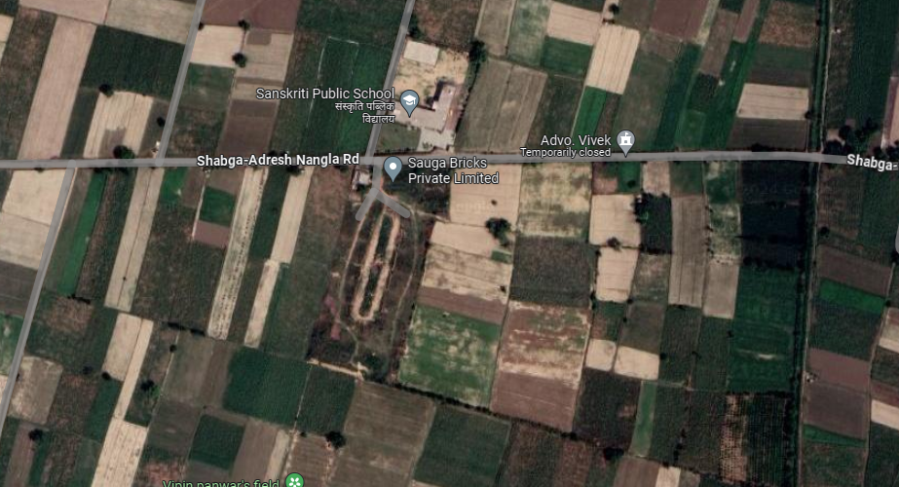

Source: Google Map
- SCOPE OF WORK DURING PROJECT DURATION:
- Project physical status review
- Review of expenditure of the Project.

- PURPOSE OF THE REPORT: To provide fair detailed analysis report to the Bank based on the “in-scope points” mentioned above for facilitating them to know the current status of the Project.

- METHODOLOGY ADOPTED:
- Study of Project Planning documents/ reports to know about the Project.
- Additional information, data, documents collection from the borrower.
- Site Inspection.
- Review and analysis of the documents and information obtained from the borrower and corroborating it with the site inspection status.
- Information compilation, analysis and reporting.
- Expenditure assessment of the civil works has been done as per the physical observation during site survey and by taking benchmark cost of the respective items.
- Verification of the bills & invoices have not been done on our end.

PART C | PLANT INFRASTRUCTURE SECTIONS & FACILITY DETAILS WITH  ACTUAL PROGRESS

- LAND AND LAND DEVELOPMENT: For the purpose of the Project, company has acquired 20,070 m³ of land at Rs.3,700/- per sqm.for period of 10 years. The boundary details of the land are provided in the exhibit below:
Direction | Description
North | Adarsh Nangla – Shabga Road
South | Water Canal Passage
East | Land of Shri Brijpal Singh
West | Land of Shri Udayveer Singh

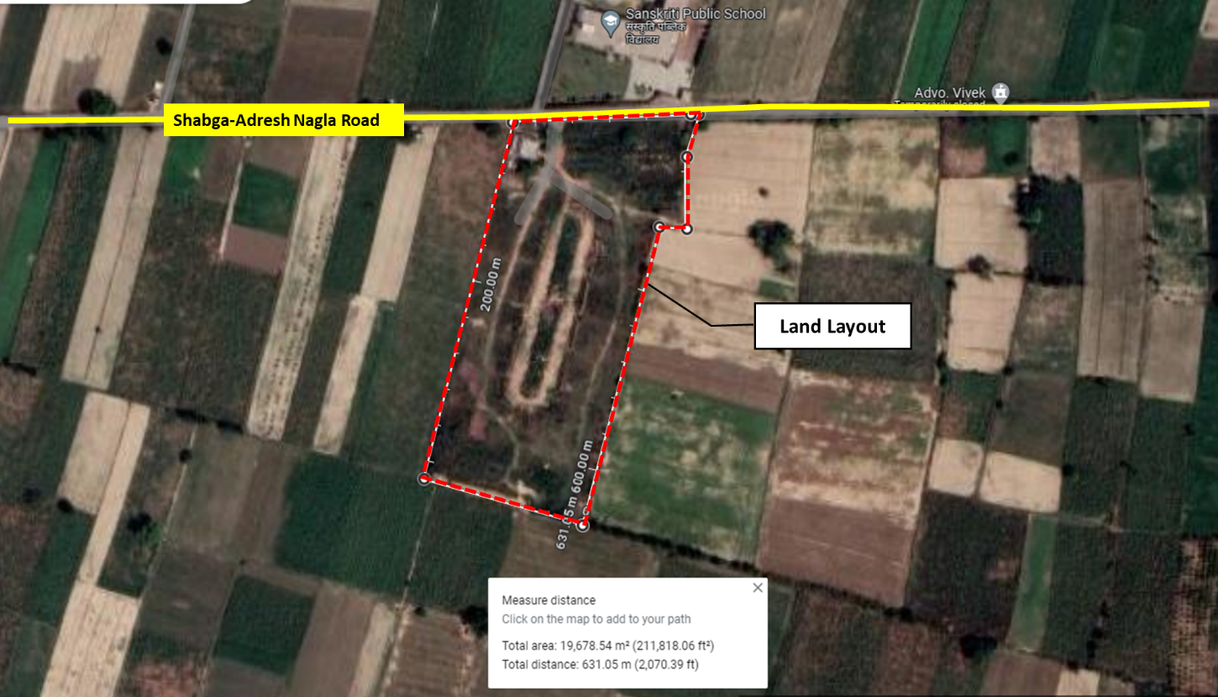

- BUILDING & CIVIL WORKS: as per approved layout plan & details shared, there is only main production in the plant. The contract for same is given to M/s MAK Building System (P) Limited. The shed is Double Slope Multi-Span building having total area of 7728 sqm. The contact value is Rs. 2,68,79,456/-.

The Physical progress is considered based on observation during our visit on 15th May 2024 of the subject Plant. During the Course of our visit to the subject Project Site following observations were made:
Sr. No. | Description | Current Status/ Progress
1. | Production Shed | - The construction work related to shed is completed already.  - It is a single storey PEB Structure with total covered are of 7,728 sqm.  - The size of the shed is 138 m x 56 m.  - There are total 04 nos. of ways/canopy.

Note: The Physical progress captured in the report is based on the approximate observations of the structures found during site during site inspection.

- PLANTS/ MACHINERIES & OTHER EQUIPMENTS AND UTILITIES: The total amount envisaged against the purchase of Plant and Machinery amounts to Rs. 16.95 Cr. out of which Rs. 1.53 Cr. has been paid to advances for imported machinery as per CA Certificate having UDIN No. 24505802BKCLAY2623. Total expenditure incurred till 03rd May 2024 2023 is 20.00 Cr.

S. No | Particulars | Supplier/Vendor | Current Status
 | Tunnel Fire Kiln (3.6m*130m) | M/s A. J. Consultancy & Enterprises | Work is in progress
 | Tunnel Dryer Kiln (3.6m*130m) | M/s A. J. Consultancy & Enterprises | Work is in progress
 | Wire, Cable, Lighting of the project | M/s A. J. Consultancy & Enterprises | Wiring work completed, panel work yet to be started
 | Belt Conveyor | M/s A. J. Consultancy & Enterprises | Advance amount paid. Belt is with the vendor & yet to be received at site
 | Track and Auxiliary Material | M/s A. J. Consultancy & Enterprises | Track foundation work is in progress. Company had already purchased Trolley wheels/ trolley
 | Kiln Car (trolley) YC 3.6x3.7 | M/s A. J. Consultancy & Enterprises
 | Equipment & Kiln Foundation, Carriage return & ferry line construction | M/s A. J. Consultancy & Enterprises | Track foundation work is in progress

Manufacturing Process of Burnt Clay Perforated Bricks:
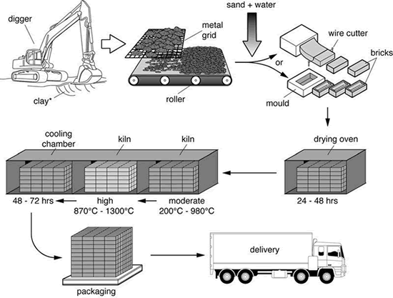
- Raw Material Preparation: To achieve the proper consistency for brick formation, the clay must be adequately prepared. This involves transforming the raw material from a hard, unyielding state into a plastic, mouldable form. Various methods can be employed to achieve this workable consistency. Initially, a primary crusher, such as a rotary crusher, breaks down large lumps of rock into manageable sizes (100-200mm). These chunks are then fed into a secondary crusher, like a pan mill, which further reduces the clay pieces to sizes ranging from 5-15mm. At this stage, water can be added in a process known as 'wet pan'. The clay is then further crushed by pairs of high-speed rolls, reducing the particles to about 1-2mm. During the clay preparation stage, various additives may be introduced, usually before or at the pan mill, to enhance the manufacturing process by providing additional dry strength or assisting in firing. Other materials can also be added to affect the aesthetic qualities of the brick, primarily its colour.
The clay is fed into a mixer in which final quantities of water are added and thoroughly mixed. Most modern mixers comprise a double shaft with attached blades or paddles, which are set at specific angles, to both mix and convey clay along a large trough.

- Moulding /Forming through Extrusion: The clay is transferred from the mixer into a vacuum chamber where air is extracted. It is then pushed by a corkscrew-shaped auger through a mouthpiece and an extrusion die. Typically, the extruder is equipped with perforation bars, creating the distinctive perforations seen in extruded bricks. The extruded column can undergo various processes to attain the desired finish.
Once cut, the bricks are usually placed onto steel rails or pallets before being sent to the dryer. Some brickworks extrude a very firm column of clay which allows wet bricks to be set straight onto kiln cars before drying the entire car.

- Drying – Tunnel Kiln Technology: All formed clay bricks contain water, which makes the clay sufficiently plastic to shape. The water content varies, ranging from about 12% for extruded bricks to over 25% for those made using the soft mud method. Before the bricks can be fired, this water must be removed. The drying process needs to be carefully controlled to prevent stressing the bricks, which could cause distortion and cracking.
The drying rate of a brick is regulated by adjusting temperature, humidity, and air movement. A typical drying cycle begins with a low temperature (around 30°C) and high humidity, gradually progressing to a higher temperature (up to 120°C) and lower humidity. Air movement, managed by fans, helps evenly distribute air around the bricks and remove saturated air.
A tunnel kiln is a continuous, moving ware kiln where clay products are fired as they travel on cars through a long, horizontal tunnel. The firing takes place in the central part of the tunnel. Tunnel kiln technology is considered the most advanced in brick making. Its main advantages include the ability to fire a wide range of clay products, better control over the firing process, and the production of high-quality bricks.

- Packing and distribution: Dried bricks are collected, packed and delivered to end user.

Note:
- As per copy of TEV Report 01 June 2023, the total cost of plant & Machinery is about Rs. 19.40 Cr.

PART D | PROJECT CONSULTANTS, CONTRACTORS & SUPPLIERS

As of now mentioned below are the list of Contractors/ Suppliers/ Consultants which have been currently engaged in the Project.
Contractors/ Suppliers/ Consultants | Nature of Work
M/s AJ Consultancy & Enterprises | Major Plant & Machinery work
M/s MAK Building System (P) Limited | Building/Civil Works
M/s Dabas Construction Company | Electric Work

Source: The above Information/Data is taken from the details provided during inspection & Copy of Contracts shared.
PART E | PROJECT COST & MEANS OF FINANCE

- TOTAL PROJECT COST & STATUS OF EXPERNDITURE: As per copy TEV Report by CARE Advisory Research & Training Ltd. dated 01st June 2023, the estimated total project cost was Rs. 24.01 Cr. Details of the same are as follows:-
S. No. | Particulars | Amount  (In Rs. Cr.)
1 | Land and Land Development | -
2 | Building and Civil Works | 2.00
3 | Plant and Machinery | 19.40
4 | Miscellaneous Fixed Assets | 0.04
5 | Contingency | 0.54
6 | Preliminary and Pre-operatives | 0.54
7 | Interest During Construction | 0.94
8 | Margin Money for Working Capital | 0.56
Total |  | 24.01

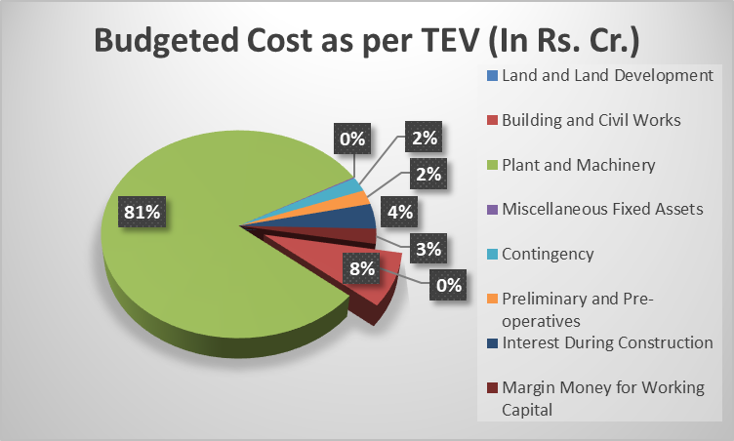

As per CA Certificate dated 04th May 2024, the total investment of the project is Rs. 2476.32 Lacs. Out of which Rs. 2,000.30 Lacs has been spent till 03rd May 2024 and Rs. 476.02 Lacs is yet be paid to different parties. Details of same are as follows:-
Particulars | Amount  (In Rs. Lacs)
Amount Already Paid
Investment in Land (taken on Lease by the company) | -
Investment in factory building construction (invoices received of Rs. 272.70 Lacs) | 263.15
Investment in plant & machinery (Indigenous) | 1,542.70
Imported machinery (Advance payment made) | 152.69
Other investment (Electricity Line etc.) | 41.69
Sub-total-A | 2,000.30
Amount to be Paid
Balance payment to machine supplier (approx.) on balance USD 2.94 Lacs @83/- per USD | 244.02
Import duty and other eligible taxes @30% approx. on total invoice | 120.00
Fright (Estimation) | 20.00
Installation and Commissioning of machine (Estimation) | 92.00
Sub-total-B | 476.02
Grand Total (A+B) | 2,476.32

- COST EXPENDITURE ANALYSIS: A detailed comparison between the actual construction expenses and the company's reported costs, as certified by a Chartered Accountant (CA), is presented below. Alongside this, a cost assessment based on a site survey is also provided:

PARTICULARS |  | AMOUNT  (As Per C.A. Certificate)  (In Rs. In Cr.) | AMOUNT  (As Per  Assessment) (In Rs. In Cr.) | REMARKS
Land and Land Development |  | --- | --- | - As per details provided, company had taken land of lease for a period of 10 years. Thus, the same in not capitalized
Building and Civil Works |  | 2.63 | 2.68 | - The approved cost of ₹2.68 Crores is in accordance with the amount specified in the construction agreement between M/s Sauga Bricks Pvt. Ltd. and MAK Building System Pvt. Ltd., dated 29/05/2023  - As the work has already been completed, the cost stated in the agreement is considered for the assessment. Which is also in line with the prevailing market rates
Plant and Machinery | Indigenous | 15.42 | 7.93 | - As per the site observation, against the Performa Invoice between M/s Sauga Bricks Pvt. Ltd. and AJ Consultancy & Enterprises dated 19-04-2023 only the following works could be verified:  - Kiln Car YC 3.6 x 3.7mtr (140 Vehicles) received at site of Rs. 3.68 Cr. including GST.  - Equipment Foundation, Kiln Foundation, Carriage Return & Ferry Line Construction- Rs. 1.29 Cr. including GST.  - Track & Auxiliary Material- Rs. 1.30 Cr. including GST.  - Wire, Cable, Workshop lighting work is progress of Rs. 0.96 Cr. including GST.  Rest of the works shown in the Performa Invoice couldn’t be verified at our end as the progress is yet not achieved on site.
Plant and Machinery | Imported | 1.52 | ~1.41 | - Amount verified is as per the Performa Invoice between M/s Sauga Bricks Pvt. Ltd. and Henan Yaxin Kiln Co. Ltd. dated 02-03-2024 of USD 1,70,000, attachment of same can be found in later part of report.  - Physical verification of the same couldn’t be done at our end, as the machine setup has not arrived on site yet.  - The USD conversion rate is as per the rate provided in CA certificate.
Electric work |  |  | 0.43 | It is related to electricity connect work from Electricity distribution department Baghpat.
Other Investments |  | 0.42 |  | - Not in scope of assessment
Total |  | 20.00 | 12.45

Note:
- We have given a general overview of the project based on expenses shown by chartered accountant in their CA certificate as per CA Certificate dated 04th May 2024 with UDIN No. 24505802BKCLAY2623, also based on the data/ information gathered from client and the observation made during the site survey.
- Bills/ Invoices of civil works has not been verified at our end.
- 5%-10% variance in measurement should be considered.
- The above mentioned assessment is against the material received at site or work in progress.
- Advances paid for material/machines which are yet to be received are not taken except for imported machine.
- As verified by CA dated 15-04-2024, M/s AJ Consultancy & Enterprises received total amount of Rs. 14.37 Cr. Out of which work pertaining to Rs. 7.93 Cr. is in progress at site and advance paid to M/s AJ consultancy & enterprises is Rs. 6.44 Cr. Details of M/s AJ consultancy & enterprises invoices are as follows:-
S. No. | Invoice Date | Invoices No. | Amount  (In Rs.) | Item Name
1 | 15-01-2024 | AJ/22/23-24 | 1,28,62,000 | Job Work for Equipment Foundation, kiln foundation, carriage return and ferry line construction.
2 | 11-04-2024 | AJ/02/24-25 | 95,58,000 | Material & Labour
3 | 20-11-2023 | AJ/20/23-24 | 1,29,80,000 | Job Work for Track & Auxiliary Material
4 | 01-11-2023 | AJ/19/23-24 | 3,68,16,000 | Job work for Kiln Car YC 3.6 X 3.7 (140 vehicles)
5 | 08-04-2024 | AJ/01/24-25 | 70,80,000 | Job work for Belt Conveyor
Total |  |  | 7,92,96,000

- SOURCES OF FINANCE & UTILIZATION OF FUNDS:

The Project cost mentioned above has been planned to be covered from following resources:
(Amount in Rs. Crore)
PARTICULARS | Amount
Equity | 8.01
Venture Capital Fund | --
Term Loan | 16.00
TOTAL | 24.01
Source: As per TEV
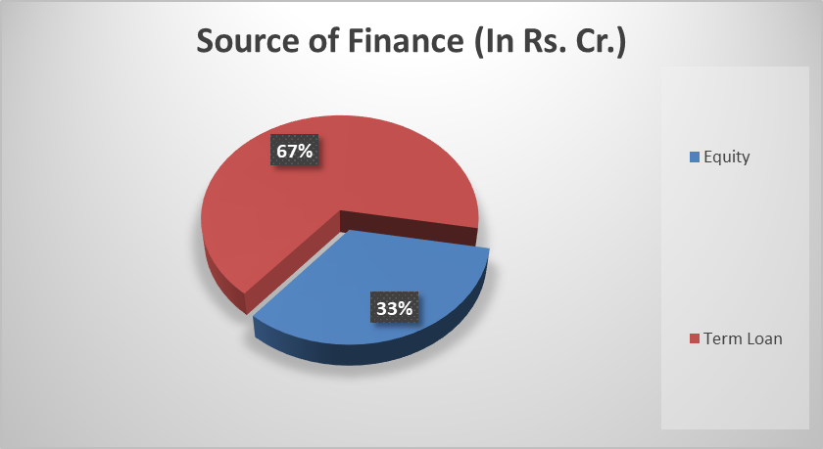

PART F | STATUTORY & REGULATORY APPROVALS, CLEARANCES & NOC

Sr. No. | NAME OF LICENSE/ REGISTRATION | PURPOSE | DATE OF ISSUE | CURRENT STATUS
Sr. No. | ISSUING AUTHORITY | PURPOSE | LICENCE NO. | CURRENT STATUS
 | Change of Land Use Certificate (CLU) | Change in land use | 28-12-2018 | Obtained  (for 6.02 hectare of Land)
 | Fire NoC | Fire Safety | UPFS/2024/106235/BGP/BAGHPAT/946/CFO dated 22-01-2024 | Obtained
 | Ground Water NoC | Ground water extraction | Registration No.: 202401000323 dated 02-02-2024 | Obtained
 | Approved Layout | construction | Dated 22-12-2020 | Obtained
 | Pollution NoC | Pollution NoC | 507/C/sauga brick (p) ltd./2023 dated 14-08-2023 | Obtained
Observations & Comments:
Above mentioned are the preliminary approvals which are required for the Project. The status mentioned above is as per the documents provided by the client.

PART G | PROJECT SCHEDULE & CURRENT STATUS

The timeline and scheduling for the implementation of the "Brick Kiln Plant" is expected to be completed by July 2024.
The target was to commission the project and start commercial production by 01st June 2024.
Activity | Commencement | Expected date of completion | Current Status
Land Purchased | --- | Purchased | Completed
Civil Construction | --- | Completed | Completed
Plant & Machinery | June-2024 | July 2024 | Track foundation work is in progress. Work related to conveyer, kiln tunnel, drying room is yet to be started
Trial Run | --- | July 2024 | To be done
Commercial Operation | --- | July 2024 | To be done

Current Status:
- During the recent site visit, it was observed that the project's progress is little bit slow as expected.
- Major civil works has been completed.
- Track foundation & laying work is in progress.
- Further, the company is proactively planning and implementing measures to get the project back on track and aiming to start the commissioning and COD (Commercial Operation Date) by July 2024 as informed by the representative on site.

PART H | DISCLAIMER

      - No employee or member of R.K Associates has any direct/ indirect interest in the Project.
      - This report is prepared based on the copies of the documents/ information which the Bank/ Borrower has provided to us out of the standard checklist of documents sought from them and further based on our assumptions and limiting conditions. The client/owner and its management/representatives warranted to us that the information they supplied was complete, accurate and true and correct to the best of their knowledge. All such information provided to us has been relied upon in good faith and we have assumed that it is true and correct in all respect. I/We shall not be liable for any loss, damages, cost or expenses arising from fraudulent acts, misrepresentations, or wilful default on part of the owner, borrower, its directors, employee, representative or agents. Verification or cross checking of the documents provided to us from the originals or from any Govt. departments/ Record of Registrar has not been done at our end since this is beyond the scope of our work. If at any time in future, it is found or came to our knowledge that misrepresentation of facts or incomplete or distorted information has been provided to us then this report shall automatically become null & void.
      - Legal aspects for eg. investigation of title, ownership rights, lien, charge, mortgage, lease, sanctioned maps, verification of documents, etc. have not been done at our end and same has to be taken care by legal expert/ Advocate. It is assumed that the concerned Lender/ Financial Institution has satisfied them with the authenticity of the documents, information given to us and for which the legal verification has been already taken and cleared by the competent Advocate before requesting for this report. I/ We assume no responsibility for the legal matters including, but not limited to, legal or title concerns.
      - This report is a general analysis of the project based on the scope mentioned in the report. This is not an Audit report, Design document, DPR or Techno feasibility study. All the information gathered is based on the facts seen on the site during survey, verbal discussion & documentary evidence provided by the client and is believed that information given by the borrower is true best of their knowledge.
      - All observations mentioned in the report is only based on the visual observation and the documents/ data/ information provided by the client. No mechanical/ technical tests, measurements or any design review have been performed or carried out from our side during Project assessment.
      - Bank/FII should ONLY take this report as an Advisory document from the Financial/ Chartered Engineering firm and its specifically advised to the creditor to cross verify the original documents for the facts mentioned in the report which can be availed from the borrowing borrower directly.
      - In case of any default in loans or the credit facility extended to the borrowing borrower, R.K Associates shall not be held responsible for whatsoever reason may be and any request for seeking any explanation from the employee/s of R.K Associates will not be entertained at any instance or situation.
      - The documents, information, data provided to us during the course of this assessment by the client is reviewed only up to the extent required in relation to the scope of the work. No document has been reviewed beyond the scope of the work.
      - This report only contains general assessment & opinion as per the scope of work evaluated as per the information given in the copy of documents, information, data provided to us and/ and confirmed by the owner/ owner representative to us at site which has been relied upon in good faith. It doesn’t contain any other recommendations of any sort including but not limited to express of any opinion on the suitability or otherwise of entering into any transaction with the borrower.
      - We have relied on data from third party, external sources & information available on public domain also to conclude this report. These sources are believed to be reliable and therefore, we assume no liability for the truth or accuracy of any data, opinions or estimates furnished by others that have been used in this analysis. Where we have relied on data, opinions or estimates from external sources, reasonable care has been taken to ensure that such data has been correctly extracted from those sources and /or reproduced in its proper form and context, however still we can’t vouch its authenticity, correctness or accuracy.
      - This Report is prepared by our competent technical team which includes Engineers and financial experts & analysts.
      - This is just an opinion report and doesn’t hold any binding on anyone. It is requested from the concerned Financial Institution which is using this report for taking financial decision on the project that they should consider all the different associated relevant & related factors also before taking any business decision based on the content of this report.
      - All Pages of the report including annexures are signed and stamped from our office. In case any paper in the report is without stamp & signature then this should not be considered a valid paper issued from this office.
      - Though adequate care has been taken while preparing this report as per its scope, but still we can’t rule out typing, human errors, over sightedness of any information or any other mistakes. Therefore, the concerned organization is advised to satisfy themselves that the report is complete & satisfactory in all respect. Intimation regarding any discrepancy shall be brought into our notice immediately. If no intimation is received within 15 (Fifteen) days in writing from the date of issuance of the report, to rectify these timely, then it shall be considered that the report is complete in all respect and has been accepted by the client upto their satisfaction & use and further to which R.K Associates shall not be held responsible in any manner.
      - Defect Liability Period is 15 DAYS. We request the concerned authorized reader of this report to check the contents, data and calculations in the report within this period and intimate us in writing if any corrections are required or in case of any other concern with the contents or opinion mentioned in the report. Corrections only related to typographical, calculation, spelling mistakes, incorrect data/ figures/ statement will be entertained within the defect liability period. Any new changes for any additional information in already approved report will be regarded as additional work for which additional fees may be charged. No request for any illegitimate change in regard to any facts & figures will be entertained.
      - R.K Associates encourages its customers to give feedback or inform concerns over its services through proper channel at valuers@rkassociates.org in writing within 15 days of report delivery. After this period no concern/ complaint/ proceedings in connection with the Financial Feasibility Study Services will be entertained due to possible change in situation and condition of the subject Project.
      - Our Data retention policy is of ONE YEAR. After this period, we remove all the concerned records related to the assignment from our repository. No clarification or query can be answered after this period due to unavailability of the data.
      - This Lender’s Independent Engineer report is governed by our (1) Internal Policies, Processes & Standard Operating Procedures, (2) Information/ Data/ Inputs given to us by the client and (3) Information/ Data/ Facts given to us by our field/ office technical team. Management of R.K Associates never gives acceptance to any unethical or unprofessional practice which may affect fair, correct & impartial assessment and which is against any prevailing law. In case of any indication of any negligence, default, incorrect, misleading, misrepresentation or distortion of facts in the report then it is the responsibility of the user of this report to immediately or at least within the defect liability period bring all such act into notice of R.K Associates management so that corrective measures can be taken instantly.
      - R.K Associates never releases any report doing alterations or modifications from pen. In case any information/ figure of this report is found altered with pen then this report will automatically become null & void.

SURVEY ANALYST | ENGINEERING ANALYST | L1 REVIEWER
Manmohan Dubey | Abhinav Chaturvedi | Vishal Singh

For
R.K. Associates Valuers and Techno Engineering Consultants Pvt. Ltd
Place: Noida
Date: 27th May 2024

DEFECT LIABILITY PERIOD - In case of any query/ issue or escalation you may please contact Incident Manager by writing at valuers@rkassociates.org. We ensure 100% accuracy in the Calculations done, Rates adopted and various other data points & information mentioned in the report but still can’t rule out typing, human errors or any other mistakes. In case you find any mistake, variation, discrepancy or inaccuracy in any data point of the report, please help us by bringing all such points into our notice in writing at valuers@rkassociates.org within 30 days of the report delivery, to get these rectified timely, failing which R.K Associates Valuers Techno Engineering Consultants (P) Ltd. won’t be held responsible for any inaccuracy in any manner. Also, if we will not hear back anything from you within 30 days, we will assume that report is correct in all respect and no further claim of any sort will be entertained thereafter. We would welcome and appreciate your feedback & suggestions in order to improve our services.

COPYRIGHT FORMAT - This report is prepared on the copyright format of R.K Associates Valuers Techno Engineering Consultants (P) Ltd. to serve our clients in the best possible way. Legally no one can copy or distribute this format without prior approval from R.K Associates. It is meant only for the organization as mentioned on the cover page of this report. Distribution or use of this format other than R.K Associates will be seen as unlawful act and necessary legal action can be taken against the defaulter

ENCLOSURE 1: IMPORTANT DOCUMENTS EXHIBIT

DOCUMENT-1: CA CERTIFICATE DATED 04/05/2024
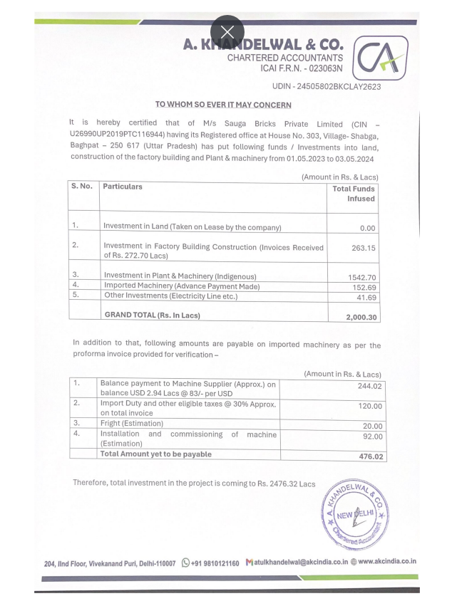
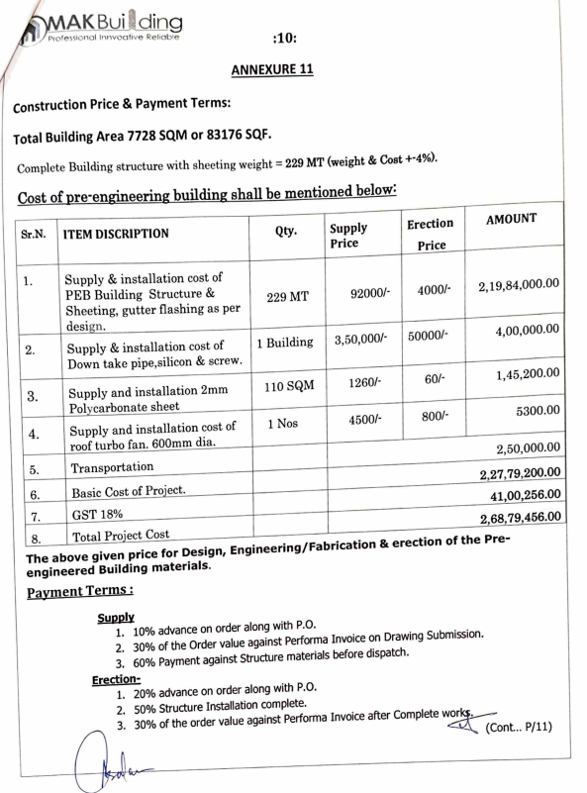
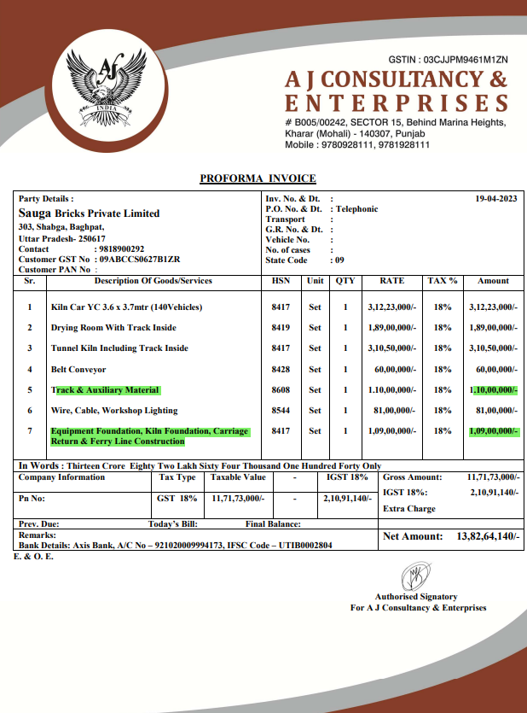

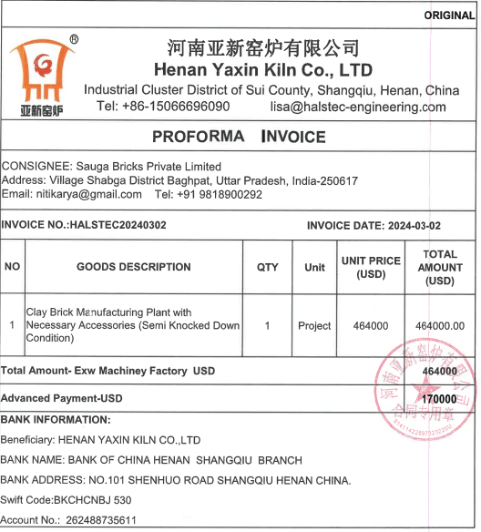

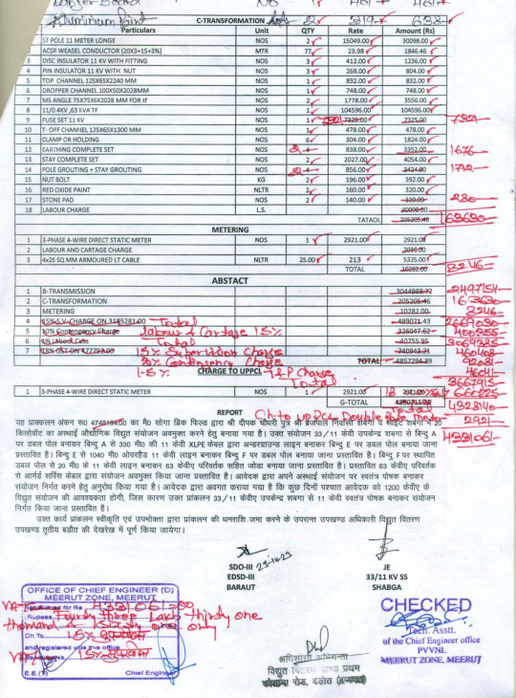

ENCLOSURE-2: - SITE PHOTOGRAPHS

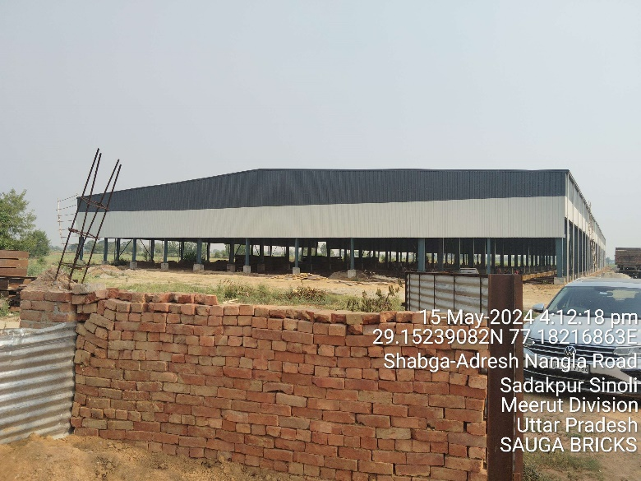 | 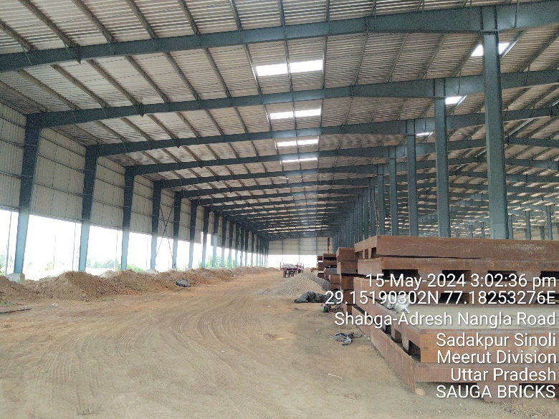
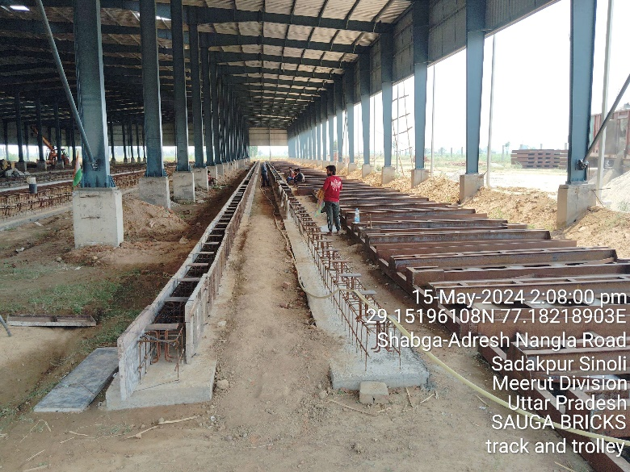 | 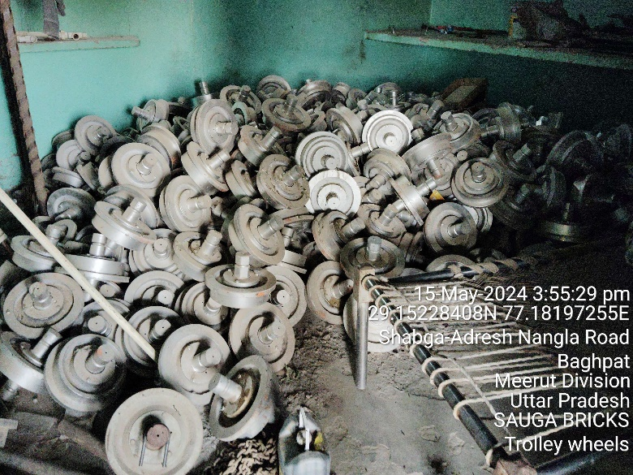
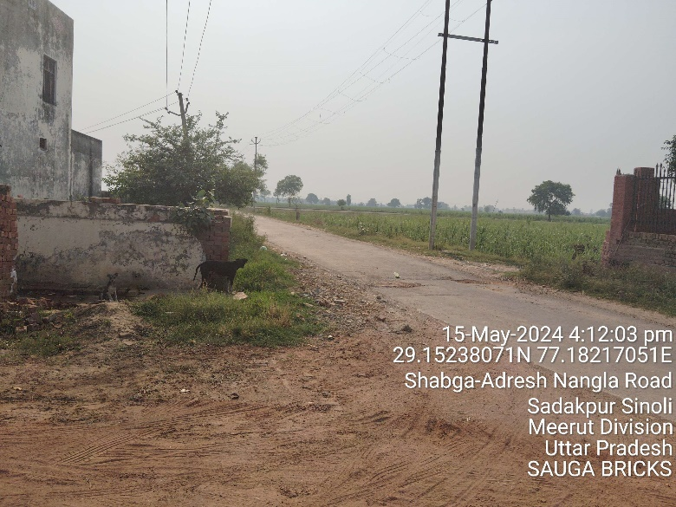 | 