File No.: VIS (2024-25)-PL041-039-051 Dated: 20.10.2024

TECHNO-ECONOMIC VIABILITY
STUDY REPORT

OF
6 TPD COMPRESSED BIO GAS PLANT
(14,500 METRIC CUBE PER DAY BIOGAS)

SETUP BY

M/S NRSBIOFUEL ENERGIES LLP

REPORT PREPARED FOR

M/S NRSBIOFUEL ENERGIES LLP, REG. ADDRESS - HOUSE NO-81, ATS HEAVENLY FOOTHILLS, SAHASTRADHARA ROAD, KULHAN, KARANPUR, DEHRADUN, UTTARAKHAND, INDIA, 248001

**Important - In case of any query/ issue or escalation you may please contact Incident Manager Valuers@rkassociates.org. We will appreciate your feedback in order to improve our services.

NOTE: As per IBA Guidelines please provide your feedback on the report within 15 days of its submission after which report will be considered to be correct.

IMPORTANT NOTICE

COPYRIGHT FORMAT: This report is prepared on the copyright format of R. K. Associates Valuers & Techno Engineering Consultants (P) Ltd. (R. K. Associates) to serve our clients with the best possible information and analysis to facilitate them to take rational business decisions. Legally no one can copy or distribute this format without prior approval from R. K. Associates. It is meant only for the advisory/ reference purpose for the organization/s as mentioned on the cover page of this report. Distribution or use of this format or report or any of its content/ information/ data by any organization or individual other than R.K Associates will be seen as an unlawful act and necessary legal action can be taken against the defaulters.
This report is intended for the sole use of the intended recipient/s and contains material that is STRICTLY CONFIDENTIAL AND PRIVATE.

DEFECT LIABILITY PERIOD: In case of any query/ issue or escalation you may please contact Incident Manager at valuers@rkassociates.org. Though adequate care has been taken while preparing this report as per its scope, but still we can’t rule out typing, human errors, over sightedness of any information or any other mistakes. Therefore, the concerned organization is advised to satisfy themselves that the report is complete & satisfactory in all respect. Intimation regarding any discrepancy shall be brought into our notice immediately. If no intimation is received within 15 (Fifteen) days in writing from the date of issuance of the report, to rectify these timely, then it will be considered that the report is complete in all respect and has been accepted by the client up to their satisfaction & use and further to which R.K Associates shall not be held responsible in any manner.

Part O: R. K. Associates Important Disclaimer and Remarks are integral part of this report and Feasibility assessment is subject to this section. Reader of the report is advised to read all the points mentioned in these sections carefully.

TABLE OF CONTENTS
SECTIONS | PARTICULARS | PAGE NO.
Part A | Report Summary | 4
Part B | INTRODUCTION
 | - About the Report | 6
 | - Executive summary | 6
 | - Purpose of the Report | 8
 | - Scope of the Report | 8
 | - Methodology/ Model Adopted | 9
 | - Data Information received from | 9
 | - Documents/ Data Referred | 10
Part C | Company/LLP Profile
 | - LLP Overview | 11
 | - Capital Contribution of LLP | 11
 | - Key Partners Profile | 12
Part D | Proposed Unit’s Infrastructure Details
 | - Proposed Plant Location | 19
 | - Google Map Location | 20
 | - Layout Plan | 21
 | - Land Details | 22
 | - Site pictures | 23
 | - Building & Civil Works | 26
 | - Plant and Machinery/ Equipment details | 28
 | - Miscellaneous Assets | 31
 | - Utilities | 32
Part E | Project Technical details
 | - Capacity of Proposed Bio CNG Plant | 36
 | - Production Process Description | 36
 | - Basic Architecture: Flow Chart Of The Bio CNG Plant | 39
 | - Technical Specification of the Proposed CBG Facility | 39
 | - Technology Used | 41
 | - Technological Assessment | 42
 | - Testing Standards For Production | 43
 | - Manpower | 44
Part F | Product Profile
 | - Introduction | 46
 | - Product Category | 46
 | - Pricing Strategy | 49
 | - Marketing, Selling & Distribution Plan | 51
Part G | Feedstock Analysis & Supply | 53
Part H | Industry Overview & Analysis | 59
Part I | SWOT Analysis | 63
Part J | Project Cost and Means of Finance | 65
Part K | Project Implementation Schedule | 68
Part L | Statutory Approvals | Licences | NOC | 70
Part M | Project’s Financial Feasibility | 72
Part N | Conclusion | 94
Part O | Disclaimer | Remarks | 96

PART A | REPORT SUMMARY

S. No. | PARTICULAR | DESCRIPTION
 | Name of the Company/LLP: | M/s NRS Biofuels Energies LLP
 | Registered Address: | House No-81, ATS Heavenly Foothills, Sahastradhara Road, Kulhan, Karanpur, Dehradun, Dehradun, India, 248001
 | Project Name | 6,000 Kg per day Bio CNG generating plant.
 | Project Location: | Village - Faizabad, Tehsil- Behat, Dist. – Saharanpur, Uttar Pradesh 247122
 | Project Type: | Bio CNG generating plant along with Fermented organic solid manure/fertilizer and Biomass Pellets
 | Project Industry: | Renewable Energy
 | Product Type / Deliverables: | Bio CNG, Fermented organic solid manure/fertilizer and Biomass Pellets
 | Report Prepared for Organization: | M/S NRS Biofuel Energies LLP
 | TEV Consultant Firm: | M/s. R.K Associates Valuers & Techno Engineering Consultants (P) Ltd.
 | Report type: | Techno-Economic Viability Report
 | Purpose of the Report: | To assess Technical & Economic Viability for the purpose of seeking external financial assistance to start a green field CBG Project.
 | Scope of the Report: | To assess, evaluate & comment on Technical, Economical & Commercial Viability of the Project as per data information provided by the client, independent Industry research and data/ information available on public domain.
 | Date of Report: | 20th October, 2024
 | Documents referred for the Project: | - PROJECT INITIATION DOCUMENTS:  - Detailed Project Report  - Financial Projections of the Project  - Project proposed Schedule  - Statutory Approval Details  - Layout and Master Plan  - PROCUREMENT DOCUMENTS:  - List of Plant & Machinery along with acquisition costs for the same  - List of Expected Raw material Supplier  - Process Flow Chart  - Sanction/proposed map of the sites  - Lease/Sale deeds of the Land  - STATUTORY APPROVALS, LICENCES & NOCs  - MSME UDYAM Registration Certificate  - NOC from Gram Panchayat  - NOC/Application for Ground water  - Consent to establish approval  - NOC from PESO
 | Means of Finance: | Equity & Debt (D/E Ratio 2.33 TPC)
 | Key Financial Indicators: | Key Indicators Value  Average DSCR 2.12  Average EBITDA Margin 30.83%  Avg. PAT Margin 14.67%  NPV & IRR INR 5.53 Cr. & 13.55%  Payback Period 6.28 years
Note: Above financial indicators are based on the financial projections of the proposed project provided by the firm and assessment and analysis of the same done by us.
PART B | INTRODUCTION

- ABOUT THE REPORT:
This is a Techno-Economic Viability Study Report of the proposed compressed biogas plant (Bio-CNG, 6,000 kg/day) at Khasra No., 725, 728, 727 & 729, Village - Faizabad, Pargana - Faizabad, Tehsil- Behat, District Saharanpur Uttar Pradesh, 247122.

- EXECUTIVE SUMMARY:
M/s NRS Biofuels Energies LLP, established on 11th March 2024 pursuant to section 12(1) of the Limited Liability Partnership Act 2008 as per the certificate of incorporation shared by the client for the establishment of Waste to Energy Management based on the waste & residual organic substances from Urban, Industrial and Agricultural activities of Rural India, such as Municipal Waste, Farm Residue, Vegetable Food Waste, Cattle Dung, Sugarcane Press mud, Napier Grass etc.
Designated partners of the LLP are Mr. Shobhit Mangal, Mrs. Sakshi Goel, Mrs. Rashmi Gosain, Mr. Naman Rana, Mrs. Neha Mangal and Mr. Neeraj Gosain, who are the promoters also of the proposed Bio CBG plant in this LLP who all are well educated and having rich industrial/sectoral experience in different field
Designated partners have conceived this Greenfield Project to reap out the opportunity of growing demand of Bio-CNG in the transport sector due to the phased mandatory blending of compressed biogas (CBG) in compressed natural gas (CNG) which has been announced by the Government of India in the recent Interim budget of FY 2024-25. The subject project is part of the Govt. initiative “Swachh Bharat Abhiyan” for providing green energy.
The project is proposed to be set up at Khasra No, 725, 728, 727 & 729, Village - Faizabad, Tehsil- Behat, Saharanpur Uttar Pradesh, 247122 for the production of 6,000 Kg/ Day of Bio-CNG (compressed biogas) along with 20 Ton/day PROM (Phosphate Rich Organic Manure) & 10 Ton/day Biomass Pellet which will be sold as value added by-products. The Bio-CNG plant is proposed to be setup with an expected investment of INR 41.61 Crore.
Proposed Biogas Plant Capacity
Sr. No. | PARTICUALR | Capacity | Unit
1 | Bio-CNG Plant Design Capacity | 14,500 | M3/Day
3 | Bio-CNG Plant Running Capacity | 6,000 | kg/Day
4 | PROM | 20,000 | Kg/day
5 | Biomass Pellet | 10,000 | Kg/day
Source: DPR/data/information provided by the LLP.
For the sale of the produced CBG, LLP has already secured a LOI from Indian Oil Corporation limited under SATAT initiative to promote Compressed Bio-Gas as an alternative, green transport fuel. (Ref No.: Indian Oil/SATAT/01/3810 Date: 16.05.2024) for which LLP has paid bank guarantee of INR 5.00 lakhs through HDFC bank ltd. on 26th July 2024. Commercial agreement will be signed before C.O.D between the parties.
The project is proposed to be commissioned based on the Sequential Gas Mixing System (Ro-Flo, USA) and Thermophiles Therminibe Technology (NIBE, India), in this technology the mixing is done by gas bubbling from the bottom and power consumption is comparatively low due to no friction between sludge and mechanical parts.
As per the revised agreement dated 18th July 2024 provided by the client, LLP has appointed an ISO 9001 certified Ghaziabad based solution provider M/s Vimal Organics Ltd as EPC consultant. As per the scope of work mentioned in the agreement, EPC Contractor will supply the Equipment, Plant & Machinery, Building & Civil work and will provide its services for electrical, instrumentation & data collection work including erection and commissioning.
As per the land registry dated 16th July 2024, partners of the LLP has purchased a 5.42 Acre (2.1960 Hectare) agricultural land at Khasra No, 725, 728, 727 & 729, Village - Faizabad, Tehsil- Behat, Saharanpur Uttar Pradesh, 247122. As per the provision of UP Bio Energy Policy 2022, the Change of land use (CLU) for Biogas Plant is obtained by LLP dated 25th Oct 2024 from sub-divisional magistrate Behat, Saharanpur.
As per the shared data/information by the client, NOC from the Gram Panchayat has already been taken by the LLP on 25th July 2024 (Ref: Gram Panchayat - Faizabad, Development Block – Sadoli Kadim, District Sahranpuri). The Biogas Plant’s layout plan has been prepared by the appointed technical consultant M/s Geeta Biofuels PVT. LTD., Pune, MH. India on 1st June 2024 and LLP has obtained the NOC from PESO on the proposed layout plan.
As per data/information provided to us, LLP has obtained some Statutory Approvals/NOC’s such as NOC from village panchayat, PESO approval etc. from the respective authorities (Refer the section Statutory Approval in the later part of the report).
During the site visit, we found that the proposed land is a vacant agricultural land which is not demarcated and work on the Project has not been started yet. As per informed by client, land development work will start soon. (Kindly refer the site pictures captured during the survey attached in the later section of the report).
As per the provisional estimation of power shared by the client, ~500 KWA (Tentative) of power load connection will be required to run the proposed CBG plant. LLP has applied for power load connection to Paschimanchal Vidyut Vitran Nigam Limited, Meerut dated 19th Sep 2024 Application Number: 1016444577. NOC for ground water extraction will be applied post loan sanction. LLP has planned to achieve the C.O.D by 1st October 2025.
The proposed project will be eligible to get the subsidy from MNRE and UPNEDA (Govt. of U.P.) as shown in the below table:
Proposed Subsidy From MNRE and UPNEDA
80 lakhs per ton MNRE CFA (INR 10 Crore) | 80.00 | INR lakhs per ton
UPNEDA subsidy 75 lakh per ton (INR 20 Crore) | 75.00 | INR lakhs per ton
Total subsidy in UP @1.55 Crore per ton | 1.55 | Crore
Capacity of the proposed plant | 6.00 | TPD
Expected Subsidy | 9.30 | Crore
Source: As per Government Notifications.
Note: It is to be noted here that proposed subsidy has not been taken into consideration while preparing the financial projection as requested by financial institution/bank to assess the viability of the project excluding any financial assistance.
Further, the cost of the proposed project from scratch to trial run is being estimated as INR 41.27 Crore, which is proposed to be funded through promoter’s equity of INR 12.84 Crore and bank loan of INR 28.43 Crore. Working capital requirements will be met through a WC loan of INR 150.00 lakhs.
At present, the LLP is in discussion with Financial Institutions to fund the project through a term loan of INR 28.43 Crore. In this regard M/s NRS Bio Fuel Energies LLP has appointed R.K. associates to assess the Techno-Economic Viability of the proposed Bio-CNG production plant. The LLP plans to achieve the financial closure by 30th November, 2024 (expected).
- PURPOSE OF THE REPORT:
To assess Project’s Technical and Financial Feasibility for Client’s requirement.
- SCOPE OF THE REPORT:
To only assess, evaluate & comment on Technical & Financial Feasibility of the proposed Bio-CNG generating plant being set up by M/s NRS Bio Fuel Energies LLP as per the data/information provided by the company/LLP.

NOTES:
- Project status is taken as per the Site inspection carried out by our survey team.
- Scrutiny about the company/LLP, background check, and credibility, credit worthiness of the company/LLP or its promoters is out-of-scope of this report.
- Any verification of the documents/ information from originals/ source is out-of-scope of this report.
- This report is only an opinion in respect to Technical and Financial Feasibility of the project as per the future Projections provided by the firm and independent analysis done by us and doesn’t contains any recommendations including taking decision on the loan or any other financial exposure.
- This is not an audit activity of any kind. We have relied upon the data/ information shared by the LLP in good faith.
- Any review of the existing business of the promoters is out of scope of this report.
- Detailed cost estimation or detailed cost vetting is out of scope of the project.
- This is not a Detailed Project Report or a detailed design or architecture document. Land and property details mentioned in the report is only for illustration purpose as per the information provided to us by the client. The same doesn’t tantamount for taking any responsibility regarding its legality, ownership and conforming to statutory norms.
- METHODOLOGY/ MODEL ADOPTED:
- Data/ Information collection.
- Review of Data/ Information collected related to TEV study.
- Independent review & assessment of technology used and financial projections provided by the LLP.
- Projections of Revenue, P&L, Balance Sheet, Working Capital Schedule, Depreciation Schedule, Loan Schedule as per the inputs given by the LLP and assessed by us
- Calculation of key financial indicators and ratio analysis including DSCR, NPV & IRR and payback period of the project.
- Report compilation and Final conclusion.
- DATA/ INFORMATION RECEIVED FROM:
All the data/Information has been received from Mr. Amit Rana (CEO) and the required details about him shown in the below table:

Particulars | Details
Designation | CEO
Company/LLP | M/s NRS Bio Fuel Energies LLP
Email Address | amitrana2002@gmail.com
Contact No. | +91-9911351936

- DOCUMENTS / DATA REFFERED:

- Detailed Project Report and Promoters Profile
- Financial Projections of the proposed Bio CNG generating project.
- Production flow chart,
- Product profile along with Pricing Strategy etc.
- Long term Raw Material Supply agreement with FPO.
- Selling, Marketing & Distribution Plan, LOI with the OMC.
- Site/Layout Plan
- Sale/Lease deed of the land
- Quotation/Contract agreement with EPC consultant along with details of Plant & Machinery.
- Certificates of Statutory approvals/NOC’s.
- Survey Report.

PART C | LLP PROFILE

- LLP OVERVIEW:
As per certificate of incorporation shared by the client/LLP, M/s NRS Bio Fuel Energies LLP was incorporated on 11th March 2024 pursuant to section 12(1) of the Limited Liability Partnership Act 2008 as per the certificate of incorporation shared by the client. Below table shows the incorporation details of the LLP:
Incorporation Details of the LLP
Particular | Description
LLP Name | M/s NRS Biofuels Energies LLP
LLPIN | ACF-9886
Date of Incorporation | 11th March 2024
ROC Name | ROC Uttarakhand
Number of Designated Partners | 6
Registered Address | House No-81, ATS Heavenly Foothills, Sahastradhara Road, Kulhan, Karanpur, Dehradun, Dehradun, Uttarakhand, India, 248001
Total Obligation of Contribution | INR 1,00,00,000
Date of Filing | 18th May 2024
LLP Status | Active
Source: Information extracted from MCA website & public domain
The LLP is incorporated with the objective to carry on the business of manufacturing and dealing in Bio CNG, Bio fertilizers, insecticides, pesticides, chemical manure, agro chemicals, and mixtures including nitrogenous, phosphoric, potassium, organic and inorganic fertilizers.
The LLP is categorised as micro enterprise with Udyam Registration Number UDYAM-UK-05-0075675 dated 31th May 2024. In this LLP, the designated partners have proposed to setup 6,000 Kg/Day of Bio-CNG (compressed biogas) plant along with 20 Ton/day PROM (Phosphate Rich Organic Manure) and 10 Ton/day Biomass pellets.
- CAPITAL CONTRIBUTION OF LLP:
As per the LLP deed dated 19th March 2024 shared by the client, the total contribution of the Partners in the LLP shall be INR 1,00,00,000 (Hundred Lakh) which will be contributed by the Partners in the proportions as mentioned in the below table:
Capital Contribution as per LLP deed
S. No. | Name of the Partners | Nature of Contribution | Capital Contribution | Profit/Loss %
 | Mr. Sobhit Mangal | Cash | 15% (INR 15,00,000) | 15%
 | Mrs. Neha Mangal | Cash | 15% (INR 15,00,000) | 15%
 | Mrs. Sakhsi Goel | Cash | 30% (INR 30,00,000) | 30%
 | Mr. Neeraj Gosain | Cash | 15% (INR 15,00,000) | 15%
 | Mrs. Rashmi Gosain | Cash | 15% (INR 15,00,000) | 15%
 | Mr. Naman Rana | Cash | 10% (INR 10,00,000) | 10%
Source: Data/information provided by the client.
The further Contribution, if any, required by the LLP shall be brought by the Partners in their existing capital contribution ratio or at any ratio as agreed and decided by the majority of the Partners.
The net profits of the LLP arrived at after providing for payment of remuneration to the working Partners or designated Partners and interest to the partners on the loan given by them shall be divided by the Partners in the ratio mentioned in the above table and the losses of the LLP including loss of Capital, if any, shall be borne and paid by the Partners in their Profit sharing ratio.
- KEY PARTNERS PROFILE:
- Partners Profile
Name | DPIN | Age | Address | Designation | Contact Details
Mr. Sobhit Mangal | 08122668 | 36 | KK 59, Kavi Nagar, Ghaziabad 201001 Uttar Pradesh | Designated  Partner | -
Mrs. Neha Mangal | 10544349 | 32 | KK 59, Kavi Nagar, Ghaziabad 201001 Uttar Pradesh | Designated Partner | -
Mrs. Sakhsi Goel | 10024785 | 34 | 128/21, Kochar Colony, Lane No. 5, Officer Enclave, Dehradun 248001 Uttrakhand | Designated Partner | 8527212901  goel.sakshi1990@gmail.com
Mr. Neeraj Gosain | 10324497 | 38 |  | Designated Partner
Mrs. Rashmi Gosain | 10327568 | 38 |  | Designated Partner
Mr. Naman Rana | 08497327 | 26 | 506, T1, Arcadia Hillocks, Mussoorie Road, Dehradun, 248009 Uttrakhand, India | Designated Partner | +91 7835840110  naman.nrc@gmail.com
- Education & Experience
Mr. Sobhit Mangal | - Appointed As Designated Partner on 11th March 2024.  - Academic Profile: MBA In aviation management from UPES Dehradun 2011  Experience Profile:  - Partner in N/s. NRS Bio Fuel Energies LLP  - Owner of Multiplex Chain Silvercity Cinemas in Dehradun, Ghaziabad and Faridabad.  - Managing Director of M/s. Sterling Palm Bliss (A 4 start boutique resort) in Rishikesh, UK.  - Involved with father in the clothing line (biggest whole sale distributor of major brands of Raymond, Reid and Tailor, Siyaram , Absoluto , Itanlino Channel , Hollan Sherry etc) since 1981 under the name of Ram Nath Manoj Kumar, Velvet Home and Sumangal.  - Joint business of retail clothing outlet in Noida and Pitampura under the name of M/s. Mangaldeep Couture.  - Family in export business of Pre rolled cones having 4 units, exporting 10 million pcs per month in USA and Canada under the name of M/s. Queens Bay International.
Mrs. Neha Mangal | - Appointed as Designated/Principle Partner on 11th March 2024.  - Academic Profile: Graduate from Amity International University, Noida 2015  Experience Profile:  - Partner in N/s. NRS Bio Fuel Energies LLP  - Involved in management of Multiplex Chain Silvercity Cinemas in Dehradun, Ghaziabad and Faridabad.  - Shareholder of M/s. Sterling Palm Bliss (A 4 start boutique resort) in Rishikesh, UK.  - Holding commercial and residential properties in Dehradun and Rishikesh, UK.  - Holding good amount of FDs with PNB bank.  - Involved in family business with her father Mr Bhim Sen Kansal who is a renowned businessman of Muzaffarnagar running various Iron , Steel , Paper and Pharmaceutical industries under the name of Sidhbali and M/s. AXA Parenterals Ltd. is one of the leading Indian pharmaceutical research companies that manufactures and export drugs and formulations worldwide.
Mrs. Sakhsi Goel | - Appointed as Designated/Principle Partner on 11th March 2024.  Experience Profile:  - Having 10 Years of rich experience in Human Resource Development field by performing various functions and roles in real estate organizations, such as Recruitment & Selection, screening, hiring, and retaining qualified and talented employees who can meet the current and future needs of the organization. Managing the recruitment and selection process.  - Facilitates process of candidate selection; interviewing; job offer; background check; and candidate on-boarding details.  - Employee life cycle management. Developing and implementing the human resource policies and procedures.  - Developing and implementing HR strategies and initiatives aligned with the overall business strategy. Conducts weekly meetings with respective business units.  - Actively participates in annual budget planning/labour forecasting process with business partners.
Mr. Neeraj Gosain | - Appointed As Designated Partner on 19th March 2024.  - Graduation in B.Com from Delhi University. Proprietor of surya paper company having turnover of around 60cr works as distributor of paper mills of northern India
Mrs. Rashmi Gosain | - Appointed As Designated Partner on 11th March 2024.  - Graduation in B.A from Delhi University. Partner in printing perfections. She is having partnership in Asgar textiles having number of properties in it in Dehradun
Mr. Naman Rana | - Appointed As Designated Partner on 11th March 2024.  Academic Profile:  - B.Eng. - Automotive Engineering, (First, with Honors), (2019 - 2022).  - Diploma in Mechanical Engineering (First, with Academic Excellence) Amity University, India (2016 - 2019)  Skills & Software:  - Aerodynamic engineering tools (Star CCM+, ANSYS Fluent and CFD, SOLIDWORKS Flow Simulation), CAD (CATIA, AutoCAD, SOLIDWORKS, Siemens NX)  - Material selection (Granta Edupack), Mechatronics system prototyping and programming (Arduino IDE), Powertrain management and simulation (GT-Suite, MATLAB Simulink), Carbon fibre panel development (Ansys ACP)  - FEA/Generative design/Structural analysis and modelling (ABAQUS, Altair Hyperworks Optistruct, Solidworks Simulation, Fusion 360, Siemens NX, Ansys ACP for composites)  - Thermal analysis (Analysis Thermal), Vehicle Dynamics (Simpack)  Experience Profile:  - Worked in Honda Motors from December 2018 to May 2019  - CAD Engineer: Sevozone Energies and Fertilizers Pvt. Ltd.  - Group Project: Rear Wing Upright Design for Lotus Cars UK  - Dissertation Project: Aerodynamic Analysis and Development of a new LMh (Le-Mans Hypercar) class Concept Racecar.  - Chassis Designer at iNe Engineering for a lightweight sports car  - Exhaust Sound Production System and Method for Electric Vehicles
Source: Data/ Information provided by the LLP and extracted from MCA website.
Below tables shows the information of the companies/LLP with which each Designated/Principal partner is associated to give a basic background detail of the promoters as found on public domain in general/ tertiary category research.
MR. SHOBHIT MANGAL
S. No | Company Name | Designation | Original Date of Appointment | Date Of Appointment at Current Designation
List of Associated Companies
1 | MSX BUILDCON PRIVATE LIMITED (CIN/FCRN: U45200DL2010PTC200124) | Director | 03/05/2018 | 25/09/2018
2 | MSX BUILDCON PRIVATE LIMITED (CIN/FCRN: U45200DL2010PTC200124) | Additional Director | - | 03/05/2018
List of Associated LLPs
1 | NRS BIO FUEL ENERGIES LLP  (CIN/LLPIN: ACF-9886) | Designated Partner | - | 11/03/2024
Source: Information extracted from MCA website & public domain.
MRS. NEHA MANGAL
S. No | Company Name | Designation | Original Date of Appointment | Date Of Appointment at Current Designation
List of Associated Companies
1 | NA | NA | NA | NA
List of Associated LLPs
1 | NRS BIO FUEL ENERGIES LLP  (CIN/LLPIN: ACF-9886) | Designated Partner | - | 11/03/2024
Source: Information extracted from MCA website & public domain.
MRS. SAKSHI GOEL
S. No | Company Name | Designation | Original Date of Appointment | Date Of Appointment at Current Designation
List of Associated Companies
1 | SUPERIOR AGRO VENTURES PRIVATE LIMITED  (CIN/FCRN: U35200PB2022PTC056613) | Additional Director | 22-07-2024 | 22/07/2024
List of Associated LLPs
1 | NRS BIO FUEL ENERGIES LLP  (CIN/LLPIN: ACF-9886) | Designated Partner | - | 11/03/2024
2 | RIDHAAN HOMES LLP (CIN/LLPIN: ACB-6611) | Designated Partner | - | 20/06/2023
3 | Ridhaan Buildwell LLP (CIN/LLPIN: ABC-7960) | Designated Partner | - | 18/10/2022
Source: Information extracted from MCA website & public domain.
MR. NEERAJ GOSAIN
S. No | Company Name | Designation | Original Date of Appointment | Date Of Appointment at Current Designation
List of Associated Companies
1 | NA | NA | NA | NA
List of Associated LLPs
1 | NRS BIO FUEL ENERGIES LLP  (CIN/LLPIN: ACF-9886) | Designated Partner | - | 19/03/2024
2 | NRS BIO FUEL ENERGIES LLP  (CIN/LLPIN: ACF-9886) | Partner | - | 11/03/2024
Source: Information extracted from MCA website & public domain.
MRS. RASHMI GOSAIN
S. No | Company Name | Designation | Original Date of Appointment | Date Of Appointment at Current Designation
List of Associated Companies
1 | NA | NA | NA | NA
List of Associated LLPs
1 | NRS BIO FUEL ENERGIES LLP  (CIN/LLPIN: ACF-9886) | Designated Partner | - | 11/03/2024
Source: Information extracted from MCA website & public domain.
MR. NAMAN RANA
S. No | Company Name | Designation | Original Date of Appointment | Date Of Appointment at Current Designation
List of Associated Companies
1 | SEVOZONE ENERGIES & FERTILIZERS PRIVATE LIMITED  (CIN/FCRN: U11100CH2021PTC043865) | Director | 06/02/2024 | 06/02/2024
List of Associated LLPs
1 | NRS BIO FUEL ENERGIES LLP  (CIN/LLPIN: ACF-9886) | Designated Partner | - | 11/03/2024
Source: Information extracted from MCA website & public domain.
As per informed by the client and data/information available in the public domain, Mr. Amit Rana is appointed as CEO of the LLP who belongs to farmer family and working towards the Agriculture Development/Green Energy, Advisor & Execution of Biogas Plants, Transformation with new technologies, interaction with Farmers, Cooperatives, SHG and FPO with an ability for uncovering opportunities in both the market place and within the organization. He has worked with MNRE in past. He also having the experience in the field of Retail, Distribution and manufacturing of Agro Products.

PART D | PROPOSED INFRASTRUCTURE DETAILS

- PROPOSED PLANT LOCATION:
The proposed Bio-CNG generating plant will be set up by Ms NRS Bio Fuel Energies LLP at Khasra No, 725, 728, 727 & 729, Faizabad, Behat, Saharanpur U.P. 247122, which is spread over an area of 5.42 Acre (2.1960 Hectare) as per the registry details provided to us by the LLP.
The location of the plant is in the well-known sugarcane belt of the western Uttara Pradesh, where accessibility of agricultural land for cultivating the Sugarcane & Napier grass is sufficient. Availability of the required raw material is the advantage of the proposed location as many Sugar mill are situated near by the location as shown in the below table:
S. No. | Name of the Sugar Mill | Distance from location
 | Shakumbhari Sugar Mill, Village & P. O. Todarpur , Saharanpur, Uttar Pradesh, India - 247231 | ~25 km away
 | Saraswati Sugar Mills | ~ 58 km away
 | Sarsawa Sugar Mill | ~48 km away
 | Bajaj Hindustan Sugar Mill | ~67 km away
 | Uttam Sugar Mills Ltd Village libberheri, Tehsil - Roorkee, Distt. Haridwar Uttrakhand, Uttar Pradesh | ~70 km away
Source: Google Map
During the site visit we found that the property is an agricultural land and merged with adjacent plots and not demarcated till the date of survey done by us. The property is having the proximity to the civic amenities such as hospital is situated ~5 km away and market is situated ~3 km away from the proposed plant location. Table: 1 is showing the details of the adjoining properties of the land for proposed CBG plant and Table: 2 is showing the Connectivity Details of the Proposed Location:
Table: 1 Adjoining Property Details
Location | Details
East | Agricultural land
West | Agricultural land
North | Road
South | Agricultural land

Table: 2 Connectivity Details of the Proposed Location
Connectivity | Details
Road | Delhi Yamnotri Marg - NH799B - ~3 km away
Rail | Saharanpur Railway station - ~27 km away
Airport | Jollygrant Airport, Dehradun - ~80 km away

- LOCATION MAP:
- GOOGLE MAP LOCATION:
The Bio-CNG plant is proposed to be commissioned at Khasra No, 725, 728, 727 & 729, Faizabad, Behat, Saharanpur U.P. 247122 with GPS coordinates 30°19'30.2"North 77°36'43.0"East as per the Google map attached below:
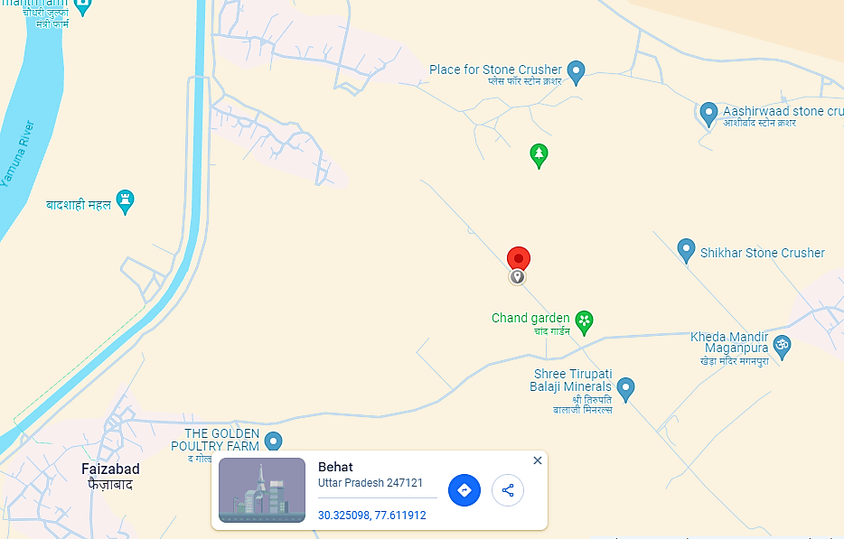
- GOOGLE MAP LAYOUT:
Demarcation of the land with approximate measurement on the Google map and land shape as per Shajra shared by client/LLP is attached in the below picture:
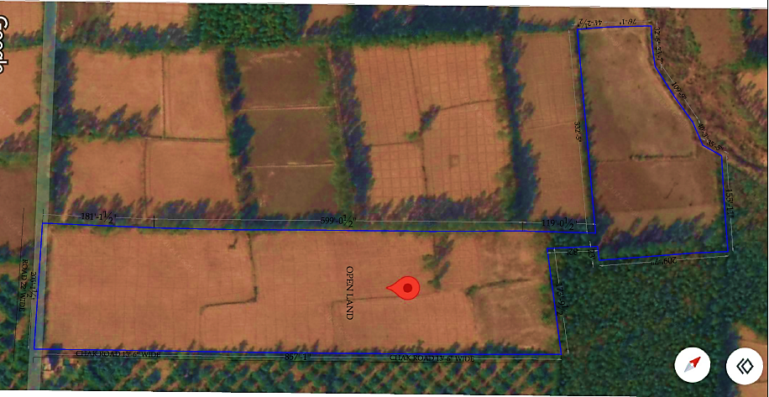
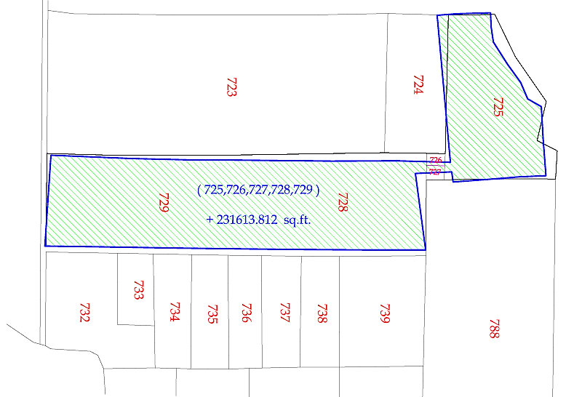
- LAYOUT PLAN:
As per the data/information provided by the client/LLP, Proposed layout plan has been prepared by the appointed technical consultant M/s Geeta Biofuels PVT. LTD., Pune, MH. India on 1st June 2024. Proposed layout plan has been attached below for reference:
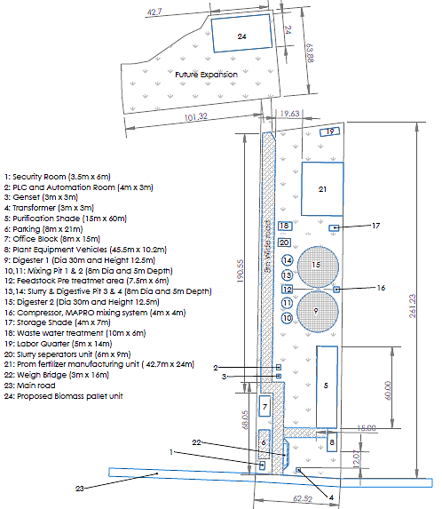
- LAND DETAILS:
As per the land registry dated 16th July 2024, LLP has procured a 5.42 Acre (2.1960 Hectare) land at Khasra No, 725, 728, 727 & 729, Faizabad, Behat, Saharanpur U.P. 247122 in INR 0.81 Crore. Below table shows the detail of procured land to set up the proposed Bio CBG unit:
Details of Procured Land for the proposed Unit
Particular | Land Details
Location | Faizabad, Behat, Saharanpur U.P. 247122
Area | 5.42 Acre
Address | Khasra No, 725, 728, 727 & 729
Type of land | Agricultural
Buyer Name | Ms NRS Bio Fuel Energies LLP
Considered Value of Land | INR 81,25,200

As per informed by client, LLP needs to obtain Change of land use (CLU) on this agricultural land, to use the land for commercial/industrial purpose by setting up the proposed Bio-CNG plant. The total cost of the land is INR ~0.91 Crore including CLU and other charges of INR 10 lakhs.
During the site visit on 8th May 2024, we found it as a vacant (agricultural) land which was merged with the adjacent agricultural lands and entry of the land is directly connected with 48 ft. UN -Chausana Link Road. As informed by the client, LLP will start the demarcation and land development work after the sanction of term loan.
- SITE PICTURES:
Site pictures were captured during the site visit on 8th May 2024, for reference few of the pictures are attached below:
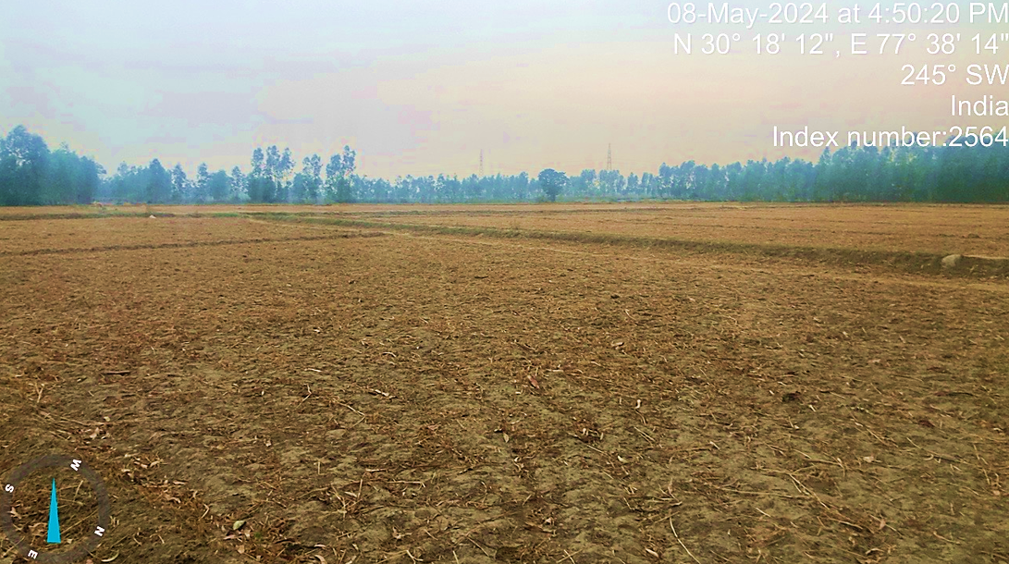
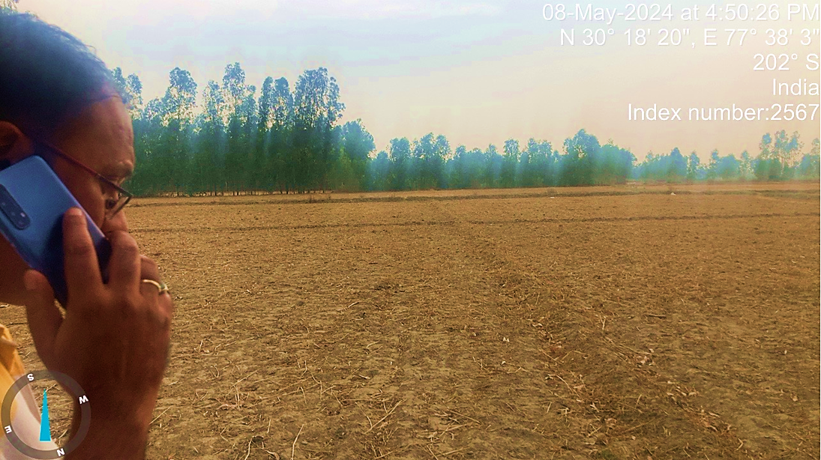
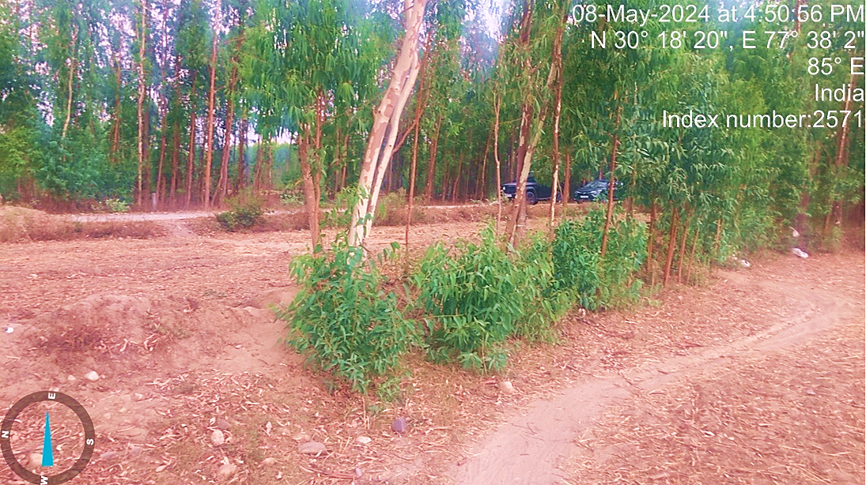
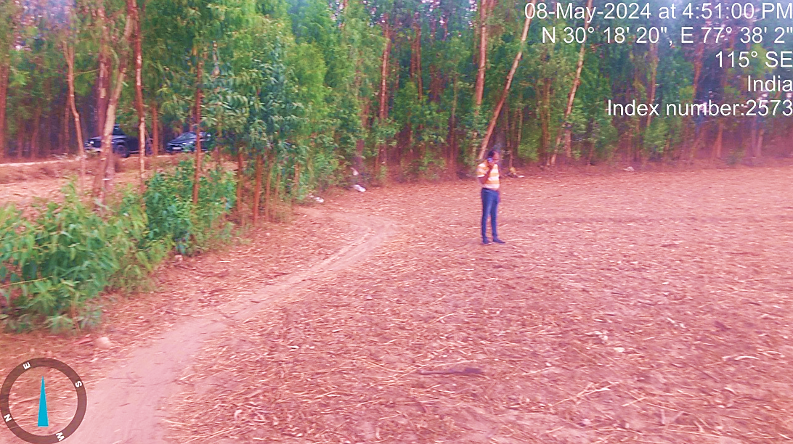
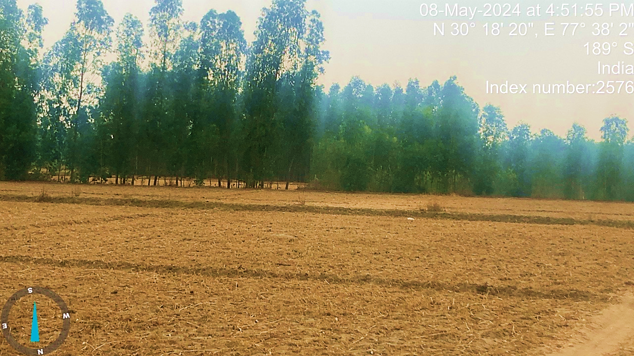
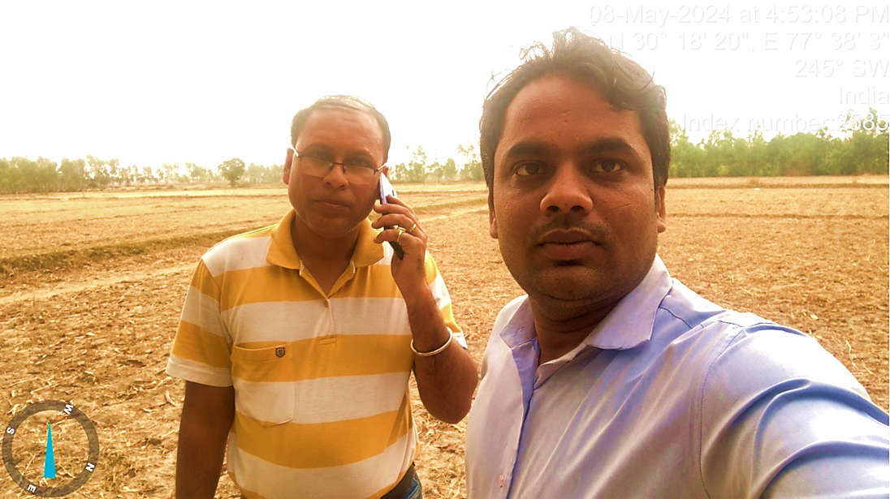
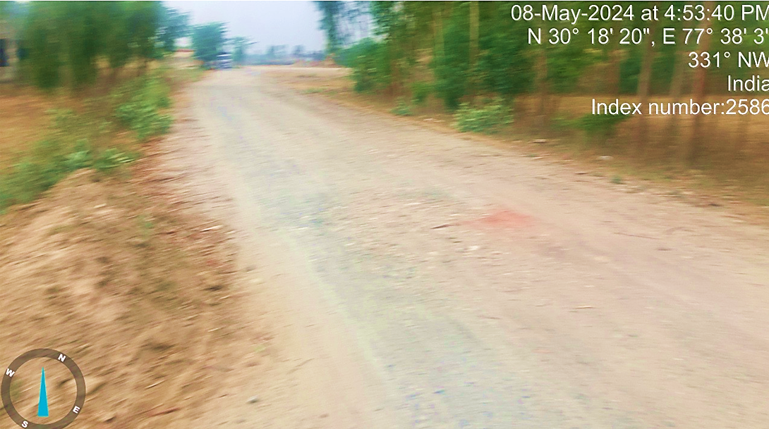
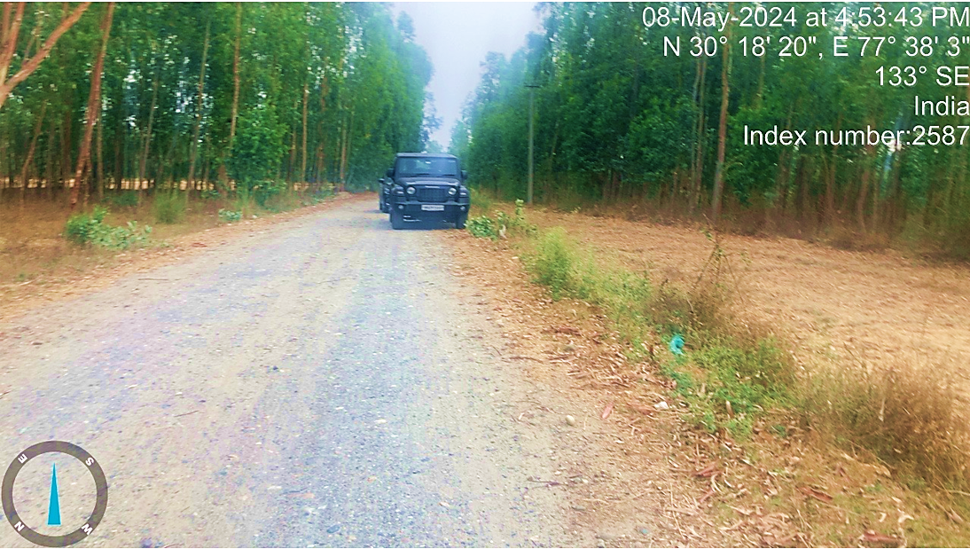
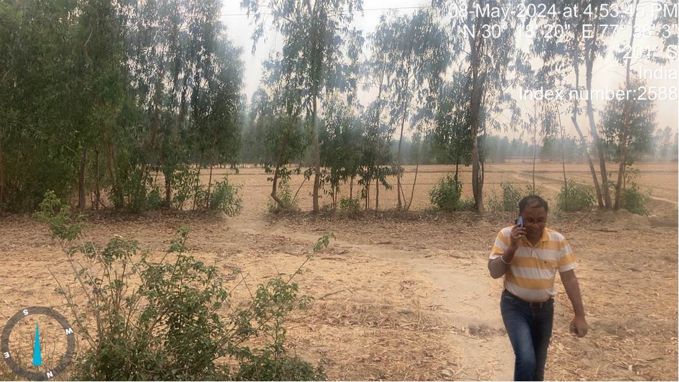
- BUILDING & CIVIL WORKS:
As per the proposed layout plan, Security Room (3.5m x 6m), PLC and Automation Room (4m x 3m), Genset (3m x 3m), Transformer (3m x 3m), Purification Shade (15m x 60m), Parking (8m x 21m), Office Block (8m x 15m), Plant Equipment Vehicles (45.5m x 10.2m), Digester 1 (Dia 30m and Height 12.5m), Mixing Pit 1 & 2 (8m Dia and 5m Depth), Feedstock Pre treatmet area (7.5m x 6m), Slurry & Digestive Pit 3 & 4 (8m Dia and 5m Depth), Digester 2 (Dia 30m and Height 12.5m), Compressor, MAPRO mixing system (4m x 4m), Storage Shade (4m x 7m), Waste water treatment (10m x 6m), Labor Quarter (5m x 14m), Slurry seperators unit (6m x 9m), Prom fertilizer manufacturing unit ( 42.7m x 24m), Weigh Bridge (3m x 16m), Main road, Proposed Biomass pallet unit are proposed to be built at this 5.42 Acre (2.1960 Hectare) land. Detailed bifurcation of the proposed Building & Civil works has been shown in the below table along with the estimated cost:
CIVIL WORKS - Site Development + Feed Preparation & Slurry Pits + Digesters (Lakhs)
S. No. | Particular | Unit | Rate | Amount | GST | Amount Including GST
1 | Excavation in M3 (Mixing Pits (03 Nos & Slurry Pit (8 Mtrs X 4 Mtrs) and Digestors (02 Nos) - 30 Mtrs X 10 Mtrs | 205 | 8,000 | 16.40 | 2.46 | 18.86
2 | Soil filling in M3 | 235 | 13,600 | 31.96 | 4.79 | 36.75
3 | Boundry Wall in RMT (upto 1 Mtr height) - 5 Acres of Plot Size Wall RCC Plat Fancing with Structure Support & Main Gate in Ss fts | 14,500 | 110 | 15.95 | 2.39 | 18.34
4 | Pilling of Digesters (02 No) - 32 Mtrs Dia X 11 Mtrs height (Pilling in Nos) | 180 | 3,300 | 5.94 | 0.89 | 6.83
5 | RCC / PCC of Mixing & Slurry Pits (04 No) - (8 Mtrs Dia X 4.5 Mtrs height (M30) in M3 | 310 | 7,000 | 21.70 | 3.26 | 24.96
6 | Biogas Digester Pre-fabricated Tank (Roofless) with Accessories INNER Surface - surface cleaning, Sand blasted followed by one coat Epigard Primary and one coat of Epoxy (total thickness should be 250 microns) to avoid the corrosion from H2S and other gases.  OUTER Surface - Outer Surface cleaning with one coat of zinc red oxide primer and two coats of HR (Heat Resistant) Aluminium paint (Total thickness should be Min. 150 microns) | 2 | 150.00 | 300.00 | 36.00 | 336.00
7 | Transformer & Genset Platform - 2 Nos (1.8 mtr X 2 Mtrs) in M3 | 7.20 | 9,000 | 0.65 | 0.10 | 0.75
8 | Civil Work for Purification Shed (15 M X 50 M) | 163 | 6,400 | 10.43 | 1.56 | 12.00
9 | Fabrication Work for Purification Shed (15 M X 50 M) in Sq. Mt. | 750 | 3,300 | 24.75 | 3.71 | 28.46
10 | Civil Work for Solid Liquid Separators (6 M X 9 M) | 63.38 | 6,400 | 4.06 | 0.61 | 4.66
11 | Fabrication Work for Solid Liquid Separators (6 M X 9 M) | 54 | 3,300 | 1.78 | 0.27 | 2.05
12 | Civil Work for storage of Liquid Slurry Pond (20 Mrs X 20 Sq. Mt.) | 250.00 | 6,400 | 16.00 | 2.40 | 18.40
13 | Civil Work for Pre-Treatment of Raw Material (Shredder Unit (6 M X 9 M X 7 M ht) | 58.83 | 6,400 | 3.77 | 0.56 | 4.33
14 | Fabrication Work for Pre-Treatment of Raw Material (Shredder Unit (6 M X 9 M X 7 M ht) | 54 | 3,300 | 1.78 | 0.27 | 2.05
15 | Road - GSB in M3 | 215 | 3,200 | 6.88 | 1.03 | 7.91
16 | Road - PCC in M3 | 215 | 6,500 | 13.98 | 2.10 | 16.07
17 | VCB Room in Sq. Mt. | 10 | 13,000 | 1.30 | 0.20 | 1.50
18 | Staff Quarters in Sq. Mt. | 160 | 16,000 | 25.60 | 3.84 | 29.44
19 | Guard Room (4 m X 6 M) | 24 | 13,000 | 3.12 | 0.47 | 3.59
20 | Office + PLC Room + Store (4 m X 6 M) in M3 | 250 | 15,000 | 37.50 | 5.63 | 43.13
21 | Labour Quarters (6 M X 15 M) | 90 | 13,000 | 11.70 | 1.76 | 13.46
22 | Retaining Wall - RCC Wall (122 Sq. Mt. X 4 Sq. Mt.) | 90 | 13,000 | 11.70 | 1.76 | 13.46
23 | Total Steel in Ton for project including handling lifting + wastage + local cartage + binding Wire | 156 | 85,000 | 132.60 | 15.91 | 148.51
24 | Soil Testing & Horticulture Work | INR |  | 25.00 | 3.75 | 28.75
25 | Digester monitoring ladder & crow’s nest | INR |  | 10.00 | 1.50 | 11.50
26 | Construction of Water Treatment Area & Water Storage | INR |  | 15.00 | 2.25 | 17.25
27 | CCTV + Street Lights | INR | L/S | 10.00 | 1.80 | 11.80
28 | Parking Area | INR |  | 7.00 | 1.26 | 8.26
 | Total |  |  | 766.54 | 102.51 | 869.05
 | EPC Contractor fee @5% |  |  | 38.33 | 6.90 | 45.23
 | Grand Total |  |  | 804.87 | 109.41 | 914.28
Sources: Data/Information provided by the client.
As per the above table, the estimated cost of the Building & Civil works is ~INR 914.28 lakhs including applicable GST and 5% EPC consultant cost as per the signed agreement. Cost of the Building & Civil works has been considered on the basis of shared details/EPC contract provided to us by the client. As a TEV consultant we have checked major unit cost considered in EPC contract which we found in permissible range.
Note: LLP needs to share the revised EPC agreement as few items are changed and their costs are revised as per the final cost sheet shared by the client. We recommend the financial institution to advice the client to share the revised EPC agreement so that cost can be justified.
- PLANT & MACHINERY/ EQUIPMENTS DETAILS:
Appointed EPC consultant M/s Vimal Organics Ltd is agreed to supply all the Equipment, Plant & Machinery as per scope of work mentioned in the EPC agreement. Detailed bifurcation of the proposed Plant & Machinery has been shown in the below table along with the estimated cost:
Plant & Machinery and Mechanical Equipment (Lakhs)
S. No. | Particulars of unit required | Unit | Rate | Amount | GST | Amount Including GST
1 | Feed Stock-Pre Treatment Unit with De-Stoner & Conveyor | 1 | 100.00 | 100.00 | 12.00 | 112.00
2 | Mixers of 11 Kva for Mixing Pits & Slurry Pit (04 Nos) with Accessories | 4 | 8.00 | 32.00 | 3.84 | 35.84
3 | Submersible Pumps of 11 KVA for transferring the Slurry with Accessories | 4 | 9.00 | 36.00 | 4.32 | 40.32
4 | Installation of Pumps & Mixers in Mixing & Slurry Pits | 8 | 2.00 | 16.00 | 2.88 | 18.88
5 | Sequential Gas Mixing System with Technology (Ro-Flo, USA) - 100 HP with Accessories | 1 | 50.00 | 50.00 |  | 50.00
6 | CFD Analysis | 1 | 10.00 | 10.00 |  | 10.00
7 | Gas Mixing System - Peso approved flame proof 1000 RPM Motor, Cyclone Separator for removal of oil from the gas, Compressor mounted Indian Instrumentation & gauges, Suction Filter, Sound Reducing Canopy, Control Panel with soft Starter, HDP & SS Pipes, Valves, PLC Panel for Operation of the pneumatic valves, Control Panel for air compressor, blower etc., Gravel filter 1100 NM3/hr. with other accessories & Installations | 2 | 55.00 | 110.00 | 19.80 | 129.80
8 | Mixing System - Piping (HDPE / SS / Heat Resitance Gas Pipes & Valves | 2.00 | 35.00 | 70.00 | 12.60 | 82.60
9 | Heating System | L/S |  | 74.00 | 13.32 | 87.32
10 | EU Origin Double Membrane Roof (2000 CuM each), outer shell PVC coated Polyester fabric, inner shell PVC/PE, belts from wall to Centre pillar Polyester fabric, Safety net & border rope, incl. valve & coupling, Air blower with hosepipes, flanges, deflation flap, Over-/Under pressure valve for membrane gas roof mechanical gas level indicator. | 2 | 55.00 | 110.00 | 19.80 | 129.80
11 | Standalone EU Origin Double Membrane Gas Holder (1000 CuM) with Accessories | 1 | 25.00 | 25.00 | 4.50 | 29.50
12 | VPSA Biogas Purification Plant + Automatic Control Panel + Methane Recovery Unit | 1 | 125.00 | 125.00 |  | 125.00
13 | H2S Desulphurization Tower + Chiller + Gas Draying, De-humidifier - (Output Pressure 0.2-0.4 Bar) with Control panel + Methane Recovery Unit | 1 | 70.00 | 70.00 |  | 70.00
14 | PSA Absorber Towers - Filled with Molecular Sieves (P140 + 4A + Booster Chemical) - Made in France | 1 | 40.00 | 40.00 | 7.20 | 47.20
15 | Piping & Valves | 1 | 45.00 | 45.00 | 8.10 | 53.10
16 | Biogas burner / Flare | 1 | 18.00 | 18.00 | 3.24 | 21.24
17 | Condensate and Sediment trap (VS-5) for removing the Moisture | 2 | 16.00 | 32.00 | 5.76 | 37.76
18 | Honeywell Biogas chromatograph analyzer + Online Biogas Analyzer for (Ch4, H2S + Co2 + Moisture) | 1 | 75.00 | 75.00 | 13.50 | 88.50
19 | Over / Under Gas Pressure Relief Valve ((Hydraulic - OUPV) | 2 | 8.00 | 16.00 | 2.88 | 18.88
20 | Biogas Compressor (JYOTECH) of capacity 550 Nm3/hr with discharge pressure 250 Kg/cm2g for bottling of CNG into Cascades with Suction Pressure :1.05 to 1.3 Bar | 1 | 100.00 | 100.00 | 18.00 | 118.00
21 | CNG Cylinder Cascade with Capacity- 4500 litre (75L X 60 Nos) with Tubing Sandvik, Parker / Swagelok / Jindal Fittings - Seamless Alloy Steel & PESO approved | 8 | 21.00 | 168.00 | 30.24 | 198.24
22 | Cascades Safety Valves, Tubing SS 316 connecting System with 4 Nos of Output for Cascades filling, Pressure Gauge, Safety Valves, Seal Excel Ratnamani / Sandvik | L/s |  | 16.00 | 2.88 | 18.88
23 | LCV Post with Mass Flow Meter, GIC Gauge Manifold with QRC & Connected 5 Meters Hose, QRC and Vent Line | 3 | 3.45 | 10.35 | 1.86 | 12.21
24 | Solid Liquid Separators with Platform & Conveyor | 3 | 15.00 | 45.00 | 8.10 | 53.10
25 | WTP / ETP & Rain Water Harvesting System | 1 | 50.00 | 50.00 | 9.00 | 59.00
26 | PROM Plant (150 TPD) | L/S |  | 160.00 | 28.80 | 188.80
27 | Biomass Pallet Plant (2 TPH) | L/S |  | 130.00 | 23.40 | 153.40
 | Total |  |  | 1,753.3 | 259.62 | 2,012.97
 | EPC Contractor fee @5% |  |  | 87.67 | 15.78 | 103.45
 | Grand Total |  |  | 1,841.0 | 275.40 | 2,116.42
Source: Data/information provided by the client.
Thus, the estimated cost for plant & machinery will be ~INR 2116.42 lakhs including applicable GST and 5% EPC fees. ~53% of TPC is the cost Plant & Machinery The estimated cost of the Plant & Machinery has been provided to us by the client as per EPC agreement. However, as a TEV consultant, the cost of major plant & machinery has been verified by us independently, which we found reasonable & in the permissible range although the cost may change as per specifications & brand.
Note: It is to be noted here that the cost estimation done by us is just a general assessment for TEV purpose. However, detailed cost vetting is out of scope of this TEV report. LLP needs to share the revised EPC agreement as few items are changed and their costs are revised as per the final cost sheet shared by the client. We recommend the financial institution to advice the client to share the revised EPC agreement so that cost can be justified. PROM Plant (150 TPD) and Biomass Pallet Plant (2 TPH) is out of scope of EPC and cost of these items are considered based on the quotations shared by the client separately.
- MISCELLANEOUS ASSETS:
Apart from the major Plant & Machinery miscellaneous assets such as Electricity Infrastructure (Electrical, Instrumentation, PLC, and data collection), Vehicles and Office equipment will also be required for the proposed CBG manufacturing unit. Detailed bifurcation of the proposed miscellaneous assets has been shown in the below table along with the estimated cost:
Miscellaneous Assets (INR lakhs)
S. No. | Particulars of unit required | Unit | Rate | Amount | GST | Amount Including GST
- Electrical, Instrumentation, PLC, data collection
1 | Grid OLTC Transformer 1000 KWA with Cables | 2 | 14.00 | 28.00 | 5.04 | 33.04
2 | LT Panel with SCADA - Schneider / Honeywell Process Solutions with Control Panel with Switches | 1 | 45.00 | 45.00 | 8.10 | 53.10
3 | CT-PT, GO-DO Set, Lighting Arrestors, Servo, Earthing, ACB Panel with Power Factor (400 KVAR APFC with 1600 AMP ACB), VCB and Cable for HT & LT | 1 | 50.00 | 50.00 | 9.00 | 59.00
4 | Gas Cramettograph & Online Anaylser on Input | 1 | 70.00 | 70.00 | 12.60 | 82.60
5 | Cables & Fittings | L/S | 60.00 | 60.00 | 10.80 | 70.80
6 | Genset (Diesel) - 350 KVA | 1 | 32.00 | 32.00 | 5.76 | 37.76
7 | Fire Fighting System | 1 | 25.00 | 25.00 | 4.50 | 29.50
8 | Lighting & UPS | 10 | 1.00 | 10.00 | 1.80 | 11.80
 | Total |  |  | 320.00 | 57.60 | 377.60
 | EPC Contractor fee @5% |  |  | 16.00 | 2.88 | 18.88
 | Total |  |  | 336.00 | 60.48 | 396.48
- Off-site Facilities and office equipment
1 | Tractor Mounted Pay loaders, Trollies & Tankers (3 Nos & 02 Trollies) | 2 | 15 | 30.00 | 1.50 | 31.50
2 | Grass Cutter Machine (10 TPH) with 75 HP Tractors | 2 | 26.45 | 52.90 | 9.52 | 62.42
3 | Weighbridge - 100 Ton | 1 | 9.10 | 9.10 | 1.64 | 10.74
4 | Computer & Furniture etc. | L/S |  | 10.00 |  | 10.00
 | Total |  |  | 102.00 | 12.66 | 114.66
Source: Data/information provided by the client.
Thus the cost of Electrical, Instrumentation, PLC, data collection is INR 396.48 lakhs including GST & 5% EPC fess. Tentative cost of Off-site Facilities and office equipment is INR 114.66 lakhs including applicable GST. We found that the costs are in the line with prevailing market standard. It is to be noted here that the cost vetting of the proposed project cost is out of scope of this report.
- UTILITIES: Details of Water, Electricity and other utilities are describes as below:
- WATER:
As per the data/information provided by the client, ~96 kl water will required on daily basis for proposed plant and water requirement will be fulfilled by setting up the proposed Well (70 Mt. depth). LLP is in the process to apply for "No Objection Certificate" for groundwater extraction to Ground water department (Namami Gange & Rural Water supply department), Ministry of Jal Shakti, Government of Uttara Pradesh, after approval the LLP can extract 25 m³ water per hour for 2 hours on daily basis.
- ELECTRICITY:
As per the data/information provided to us by the client regarding Parasitic Consumption of Power (Tentative), proposed Bio CBG plant will be required a connected load of 500 KVA. Out of which, ~85% of connected load i.e. 426 kva will be the expected running load for the proposed plant. Component wise estimation of the power consumption is shown in the below table:
Parasitic Consumption of Power (Tentative)
Particulars | Connected Load (Kwh) | Units | operational hours | Power consumption
Feed Pre-Treatment Unit | 20 | 2 | 6 | 240
Submersible Pumps for Feeding | 7.5 | 2 | 8 | 120
Compressors for Balloon & Pneumatic valves | 10 | 2 | 2 | 40
Feeding system | 11 | 2 | 8 | 176
Liquid Gas Mix system | 55 | 1 | 16 | 880
Heating System | 80 | 1 | 6 | 480
Solid Liquid Separators | 10 | 2 | 12 | 240
Pressure boosting system | 10 | 2 | 16 | 320
H2S scrubber | 15 | 1 | 16 | 240
CO2 removal & purification system | 66 | 1 | 16 | 1056
Compressors | 97 | 1 | 16 | 1552
Instrumentation and biogas piping and electric panels | 5 | 1 | 16 | 80
Organic fertiliser plant | 30 | 1 | 10 | 300
Miscellaneous | 10 | 1 | 16 | 160
Total Load & Unit | 426.5 |  |  | 5884 Kwh/day
Sources: Data/information shared by the client.
Thus, ~INR 6.94 Crore per ton is the expected CAPEX for the proposed 6,000 KGPD Bio-CNG generating plant including GST, land, pre-operative and preliminary expenses, transportation costs, convey vehicle etc. As a TEV consultant we have verified the major costs which we found reasonable & in the permissible range after considering the escalation factor and other economic factors as per the tertiary research done by us, data/information available in the public domain and information provided by the third party consultants/vendors.
For reference, Asia's largest Compressed Bio Gas (CBG) plant inaugurated in Sangrur on 18th Oct 2022 by Ministry of Petroleum & Natural Gas. The Plant was commissioned with an FDI investment of ~INR 220 crores, which is spread over an area of 20 acres. The installed capacity of the plant is 33 TPD. The capital expenditure of the plant is ~INR 6.67 Crore per ton. (Ref: https://pib.gov.in/PressReleasePage.aspx?PRID=1868887). Some of the other references are shown in the below table:
Reference for Bio Gas Plant
S. No. | Name of the Party | Contact details | Remarks
 | M/s Jog Waste to Energy Pvt Ltd | info@jogwte.com  +91 9723269295  www.jogwte.com | - As per JOGWTE, the average installation cost as per EPC basis from scratch to successful trial run would be ranging INR 5.5-6.5 Crore per ton including preliminary and pre-operative expenses and other contingent costs.
 | The Global Green Growth Institute, GGGI India | nishant.bhardwaj@gggi.org | - As per information provided by GGGI, The capital expenditure (CAPEX) for a typical 8-10 TPD Bio-CNG plant varies from INR 32-50 Crore which varies based on the type of biomass feedstock and technology deployed.  - It has been estimated that the plant and machinery costs contributes ~76% of CAPEX. (Excluding preliminary and pre-operative expenses and excluding all other costs such as engineering, consultancy, installation costs etc. i.e. EPC Costs)
 | Ministry of New & Renewable energy | MNRE | - The economics of a CBG plant can vary depending on various factors such as the scale of the plant, technology used, feedstock cost, government incentives and market demand for CBG.  - ~INR 20-25 crore is the cost of installing a 5 TPD capacity CBG plant, while ~75-80% of the CAPEX cost is for purchasing plant machinery.
 | Others vendors | On the public domain | - CSTR technology which is flexible for all types of organic wastes including mixed wastes. Capital cost for this technology is approximately INR 4-6 Crore per ton including all the costs from scratch to Successful trial run.

Note: It is to be noted that the detailed cost vetting is out of scope of this TEV and we have done this activity for TEV purpose only.
PART E | PROJECT TECHNICAL DETAILS

- CAPACITY OF THE PROPOSED BIO-CNG UNIT:
This Bio-CNG generating plant is proposed to be set up with a designed capacity of 14,500 M3/Day to generate the 6,000 kg/day bio CNG as per LOI with OMC along with 20 Ton/Day Produced PROM (Phosphate Rich Organic Manure) and 10 Ton/day Biomass pellet as illustrated in the below table:
Capacity of the proposed Bio-CNG plant
Particular | Capacity
Bio-CNG Plant Design Capacity | 14,500 M3/Day
Biogas Plant Generation (Design Capacity x 86%) | 13,416 M3/Day
Bio-CNG Plant Capacity | 6,120 kg/Day
Leakage factor @1.96% | ~120 kg/day
Net Output | 6,000 Kg/day
Produced PROM (Phosphate Rich Organic Manure) | 20,000 kg/Day
Biomass Pellet | 10,000 kg/day
Source: Data/information provided by the client.
- PRODUCTION PROCESS OF BIO CNG (CBG):
OVERVIEW:
Biogas is commercially produced by a process called anaerobic digestion. The process involves breakdown of organic waste materials such as animal waste, food waste and industrial sludge to produce biogas and digestate. The latter is further treated to be used as a fertilizer. Anaerobic digestion process is carried out in a sealed, oxygen-free tank, also called an anaerobic digester.
The biogas produced is subjected to scrubbing, upgradation and compression processes to produce Bio-CNG (CBG). The present organic waste to biogas system operates in a thermophilic process in continuous stirred tank reactor.
Bio-CNG or bio-compressed natural gas, also known as sustainable natural gas or bio methane, is a biogas which has been upgraded to a quality similar to fossil natural gas and having a methane concentration of 90% or greater. The process of bio-methanation consist of four steps i.e. Hydrolysis, Acidogenesis, Acetogenesis and Methanogenesis as described below:
- HYDROLYSIS:
In the first step of hydrolysis, the pulped material is sent to the Hydrolysis Tank, where the organic matter is enzymolyzed externally by extra cellular enzymes such as cellulose, amylase, protease and lipase etc. of microorganisms. The pulveriser stimulates this step by converting solid waste into liquid form.
Bacteria start decomposition of the long chain of the complex carbohydrates, proteins and lipids into shorter parts. Proteins are split into peptides and amino acids and fats into fatty alcohols. Hydrolysis occurs in the two hydrolysis tanks which are maintained at a high temperature and provided with insulation.
Various types of bacteria are involved in the remaining three processes which occur in the two digester tanks, which are likewise maintained at high temperature with insulation and continuously stirred.
- ACEDOGENESIS:
Acid-producing bacteria involved in the second step convert the intermediates of fermenting bacteria into volatile fatty acids along with ammonia (NH3), hydrogen sulphide (H2S) and Carbon-dioxide (CO2). The pH of the raw slurry falls from 7.5 to about (4.5 to 5.5) in this stage.
- ACETOGENESIS:
In Acetogenesis, bacteria which are aerobic and facultatively anaerobic, and can grow under acidic conditions, produce acetic acid, during which they use the oxygen dissolved in the solution or bounded oxygen. These bacteria largely convert the products of Acidogenesis into acetic acid (CH3COOH) carbon-di-oxide (CO2) hydrogen (H2) and traces of methane. Various zones are formed in fermentation pond and different bacteria dominate these zones.
- METHANOGENESIS:
A consortium of archaebacteria belonging to methanococcus group is involved in the fourth step and decomposes compounds with a low molecular weight. They occur to the extent that anaerobic conditions are provided, for instance under water (in marine sediments), in ruminant’s stomach and in marshes. They are obligate anaerobic and very sensitive to environmental changes. They have very heterogeneous morphology and a number of common biochemical and molecular-biological properties that distinguish them from all other bacteria.
The heat used for maintaining the temperature of the slurry in the hydrolysis tank and the digester tank is recovered in a cooling tank with the help of a heat pump coupled to heat exchangers. The undigested lingo-cellulosic and hemi-cellulosic materials are then passed to the sludge separator which recovers solid organic fertilizer from it. This fertilizer is dried packed and sold to the farming community.
- BIOGAS GENERATION:
The biogas produced is a mixture of methane, carbon dioxide water vapour and small quantities of contaminants such as H2S NH3 and N2. The average composition of biogas is as follows:
Particular | Concentration
Methane (CH4) | 50-60 %
Carbon dioxide (CO2) | 36-40 %
Water vapour (H2O) saturated mass | 3- 4 %
Hydrogen sulphide (H2S) | 50-2500 PPM
Ammonia (NH3) | 0-300 PPM
Non-gaseous particulates and oil | Low concentration

- BIOGAS UPGRADATION:
Biogas upgradation is the process of removing impurities like H2S, Moisture and Co2. The catalytic removal process is being used to remove H2S. The moisture is being removed in two steps, first by the chilling process and second by the desiccant adsorption process. The removal of CO2 is being done by four tower VPSA system, it’s a versatile and a proven technology for gas separation, in this system the LLP will be using four steps for removing CO2, as Adsorption, desorption (evacuation by vacuumed), purging and pressurization.
The process of Co2 adsorption on solid surface of porous material called molecular sieve at pressure of 0.7 bra G by Roots type gas Blower, after its saturation this tower will come in desorption in this step the vacuum shall be taken up to minus 0.8 bar by using water ring type vacuum pump, after the completion of the step tower will come in next step call purging during purging the product gas will be purged and final step is depressurization then the tower will be depressurize by equalize with the tower in process and tower purged and then pressurize with product gas. This process is the cyclic and repeated in cycle of 5 minutes. The system is controlled by programmable logical control system through a control panel.
- PROCESS FLOW CHART OF THE PROPOSED BIO-CNG PLANT:
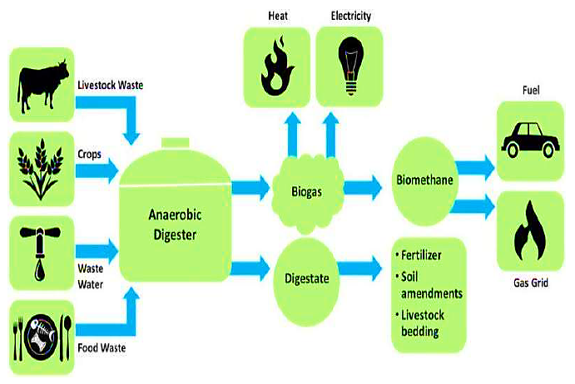
- TECHNICAL SPECIFICATIONS OF THE PROPOSED BIO-CNG PLANT:
As per the data/information provided by the client, below table shows the technical specification of the proposed Bio CBG generating plant:
Mechanical Equipment
S. No. | Particular | Technical specification
 | Mixers | 11 Kva for Mixing Pits & Slurry Pit (04 Nos) with Accessories
 | Submersible Pumps | 11 KVA for transferring the Slurry with Accessories
 | Mixing System | Sequential Gas Mixing System with Technology (Ro-Flo, USA) - 100 HP with Accessories
 | Gas Mixing System | Peso approved flame proof 1000 RPM Motor, Cyclone Separator for removal of oil from the gas, Compressor mounted Indian Instrumentation & gauges, Suction Filter, Sound Reducing Canopy, Control Panel with soft Starter, HDP & SS Pipes, Valves, PLC Panel for Operation of the pneumatic valves, Control Panel for air compressor, blower etc., Gravel filter 1100 NM3/hr. with other accessories & Installations
 | Double Membrane Raw Gas holder | EU Origin Double Membrane Roof (2000 CuM each), outer shell PVC coated Polyester fabric, inner shell PVC/PE, belts from wall to Centre pillar Polyester fabric, Safety net & border rope, incl. valve & coupling, Air blower with hosepipes, flanges, deflation flap, Over-/Under pressure valve for membrane gas roof mechanical gas level indicator.
 | VPSA Biogas Purification Plant | H2S Desulphurization Tower + Chiller + Gas Draying, De-humidifier - (Output Pressure 0.2-0.4 Bar) with Control panel + Metane Recovery Unit
 | PSA Absorber Towers | Filled with Molecular Sieves (P140 + 4A + Booster Chemical) - Made in France
 | Condensate and Sediment trap | (VS-5) for removing the Moisture
 | Biogas Analyser | Honeywell Biogas chromatograph analyzer + Online Biogas Analyzer for (Ch4, H2S + Co2 + Moisture)
 | Over/Under Gas Pressure Relief Valve | Hydraulic - OUPV
 | Biogas Compressor | (JYOTECH) of capacity 550 Nm3/hr with discharge pressure 250 Kg/cm2g for bottling of CNG into Cascades with Suction Pressure :1.05 to 1.3 Bar
 | CNG Cylinder Cascade | CNG Cylinder Cascade with Capacity- 4500 litre (75L X 60 Nos) with Tubing Sandvik, Parker / Swagelok / Jindal Fittings - Seamless Alloy Steel & PESO approved
 | Cascades | Cascades Safety Valves, Tubing SS 316 connecting System with 4 Nos of Output for Cascades filling, Pressure Gauge, Safety Valves, Seal Excel Ratnamani / Sandvik
 | LCV Post | with Mass Flow Meter, GIC Gauge Manifold with QRC & Connected 5 Meters Hose, QRC, Vent Line
 | PROM Plant (150 TPD) | 150 MTPD, 250 KW, 20 Hrs average per day
 | Biomass Pallat Plant (2 TPH) | Capacity – 1.5-2TPH
 | Weighbridge | AMCO Electronic Weighbridges Model - Aew100t1050plmad Capacity -100 Ton P P Size -50ftx10ft
 | Genset | (Diesel) - 250 KVA
 | Transformers | 630 KVA Oil Cooled Transformer As Per IS: 1180 (part-1) 2014, EEL-1,3P,50Hz Voltage ratio 11/.433 KV Wound COPPER WITH OLTC

- TECHNOLOGY USED:
- TECHNOLOGY SUPPLIER, EPC CONTRACTOR:
As per the data/information provided by the client, LLP has appointed an ISO 9001 certified Ghaziabad based solution provider M/s Vimal Organics Ltd. As per the scope of work mentioned in the agreement, EPC Contractor undertakes to supply 14500 CuM Compressed Bio Gas, Bio-Fertilizer. Below table shows the basic details of EPC contractor as per the data/information provided by the client and available in the public domain:
Particular | Description
Name | M/s Vimal Organics Limited
CIN | U27105DL1984PLC017452
GST No. | 09AAACV7698G1ZP
Reg. Address | D-35, B S R Industrial Area, Bulandshahr Road Industrial Area, Ghaziabad- 201009, Uttar Pradesh, India
Website | https://www.vimalorganics.com/
About the Company | As per the data/information available in public domain, Vimal Organics Limited was incorporated as a Private Limited Company in the year 1984 and converted into a Public Limited Company in 1994. Company is engaged in manufacturing, supplying and exporting a wide range of equipments which are used in industries.
Services | Turnkey Projects for Fertilizer & Micro Nutrients, Turnkey Projects for Chemicals, Turnkey Projects for Food Processing, Activated Bleaching Clay, Individual Equipment and Mechanical Conveying System.
Standards & Quality Certifications | SSI Registration No - (C/20/56/01683/PMT/SSI/0) CHEMEXCIL, FIEO, FICCI,CII, SEA,
Note: Due to data limitation we could not get much information regarding EPC company, In this regard, we recommend the bank advice the client to submit the detailed prolife of EPC contractor containing the information of Under Construction & Completed projects, Key team (Educational background & Professional Experience), Speciality & Expertise etc.
- PROPOSED TECHNOLOGY:
LLP has proposed to commission this Bio CNG plant with “Sequential Gas Mixing System” which is an Italian based technology supplied by “Mapro International S.p.A.” Sequential Gas Mixing (SGM) ensures anaerobic digesters are mixed continuously to without thermal layering and accumulation of volatile fatty acid (VFA) pockets.
Gas Injection Mixing Systems gives comparatively higher operational efficiency due to no sedimentation because of the mixing by gas bubbling from the bottom in the proposed. Further, production of gas is high due to complete and uniform mixing and to a low temperature gradient in the sludge.
Proposed Technology (Sequential Gas Mixing System)
S. No. | Particular | Description
 | Mapro/ Ro-Flo | Sequential Gas Mixing System with Technology (Ro-Flo, USA) - 100 HP with Accessories
 | Gas Mixing System | Peso approved flame proof 1000 RPM Motor, Cyclone Separator for removal of oil from the gas, Compressor mounted Indian Instrumentation & gauges, Suction Filter, Sound Reducing Canopy, Control Panel with soft Starter, HDP & SS Pipes, Valves, PLC Panel for Operation of the pneumatic valves, Control Panel for air compressor, blower etc., Gravel filter 1100 NM3/hr.
Power consumption is low up to 50% energy saving compared to mechanical mixing system due to no friction between sludge and mechanical parts. This technology is more reliability as no corrosion and no struvite. Maintenance cost is low as no parts in movement inside the sludge.
- LATEST TECHNOLOGY/TECHNOLOGICAL ASSESSMENT:
Anaerobic digester technology has come up with several innovations in the last few years which assists project developers to implement a scalable, viable bio-CNG plant with improved process efficiency at a lesser cost. Now a days several conventional anaerobic digester technologies exist such as Continuous stirred tank reactor (CSTR), KVIC models and more, recent innovations in technologies such as plug and play digester models ensure improved efficiency and automation of the process compared to conventional technologies.
Partners of M/s NRS Biofuels LLP are convinced by Sequential Gas Mixing System as it is more efficient and evidently proven Italian/USA technology.
CFD ANALYSIS COMPARISON:
As per the data/information provided by the client, Professors & scientists from Italian university has applied a three-dimensional CFD (Computational Fluid Dynamics) model in order to verify the mixing efficiency of a gas mixing system in comparison with mechanical mixing systems on a WWTP.
The study showed that the gas injection system gives better results than mechanical mixing systems both in terms of maximum sludge speed (3 m/s versus 1 m/s), kinetic energy (0.24 m2/s2 versus 0.001 m2/s2) and dead zones (5% versus 50%) with the same energy consumption, equal to 140 kWh for both systems.
In particular, the system mixed by means of gas recirculation, made it possible to reach linear speeds between 1 and 2 m/s while in the case of mixing with mixers, values > 0.5 m/s were not reached.
In terms of kinetic energy density, it is noted that in the case of mixing with gas lances, turbulent kinetic energies between 0.05 and 0.2 m2/s2 were observed while in the case of mixing with mechanical mixers, values <0.05 m2/s2 were observed. Concerning the distribution of dead zones, the effectiveness of the mixing system with gas lances is observed with even greater evidence, clearly superior to that obtained with mechanical mixing systems.
Thus as per the above technical assessment, M/s NRS Biofuels LLP has proposed the appropriate Sequential Gas Mixing System with Italian/U.S.A Technology which is a recognized and proven technology. It can be commented positively that the plant will be running smoothly. Technology & specification of the plant are matching with the need to run the plant to achieve the economies of scale.
- TESTING STANDARDS FOR PRODUCTION:
CBG or Compressed Bio Gas consist of mainly methane (more than 90%) and other gasses like carbon dioxide (less than 4%), etc. CBG is produced by anaerobic digestion of biomass and waste sources like agricultural residue, cattle dung, sugarcane press mud, municipal solid waste, sewage treatment plant waste, etc.
This Biogas can be purified to remove hydrogen sulphide (H2S), carbon dioxide (CO2), water vapor and when this purified biogas (methane content more than 90%) is compressed to maximum 250 bar and filled up in cascades (group of high pressure cyllinderical vessels) it is called Compressed Bio Gas or CBG.
CBG has properties almost similar to CNG and hence a vehicle running on CNG can straightway be filled with CBG without any modification in the vehicle. Ministry of Road Transport and Highways, Government of India, vide Gazette Notification no. 395 dated 16.6.2015 has permitted usage of CBG for motor vehicles as an alternate of CNG. BIS has issued IS 16087 2016 standards on CBG which is similar to BIS specifications IS 15958:2012 for CNG.
- MANPOWER:
As per information shared by the client/LLP, a proper ratio between the administrative, managerial, supervisory and shop foor staff has been maintained with a view to affording proper industrial and professional management at various levels in estimating the manpower requirement. The basic structure of the manpower will require the following kind of resources to opearte the plant 24*7 for 350 days a year:
Proposed manpower details along with Cost (INR)
Workers on Wages
Category | Number | Average Monthly Salary
Skilled Workers | 6 | 20,000
Semi-Skilled Workers | 2 | 15,000
Un-Skilled Worker | 6 | 12,000
Sub Total | 14
Factory Supervision
Category | Number | Average Monthly Salary
Shift Supervisor | 2 | 35,000
Field Officer | 1 | 25,000
Store In-Charge | 1 | 15,000
Store Assistant | 1 | 12,000
Chemist | 1 | 18,500
Sub Total | 6
Office Staff
Category | Number | Average Monthly Salary
General Manager | 1 | 80,000
Accounts Manager | 1 | 25,000
Accounts Assistant | 2 | 10,000
Office Assistant -Marketing | 2 | 15,000
Office boy | 2 | 10,000
Sub Total | 8
Grand Total | 28
Source: Data/information provided by the client
LLP has proposed to deploy 28 human resources initially as shown in the above table, which comes out with ~4 workers per ton for the proposed Bio-CNG generating plant which is in permissible range as per the standard benchmark of the industry considering the operational scope & scale of the proposed plant. This ia a tentative figure provided by the client, Estimated manpower may change as per the actual requirement post C.O.D.
(Ref: https://pib.gov.in/PressReleasePage.aspx?PRID=1868887) The Sangrur CBG Plant shall provide direct employment to 390 and indirect employment to 585 people. This is a 33TPD capcity plant, thus it comes out with ~12 (*390/33) workers per ton.

PART F | PRODUCT PROFILE

- INTRODUCTION:
BG has calorific value and other properties similar to CNG and hence can be utilized as green renewable automotive fuel. Thus it can replace CNG in automotive, industrial and commercial areas. Ministry of Road Transport and Highways, Government of India had permitted usage of bio-compressed natural gas (bio- CNG) for motor vehicles as an alternate composition of the compressed natural gas (CNG).
The compressed biogas, or Bio-CNG, is likely to play a crucial role in promoting India’s transition to a sustainable energy ecosystem. Bio-CNG is a green renewable automobile fuel with calorific value and other qualities similar to compressed natural gas (CNG).
- PRODUCT CATEGORY:
- BIO CNG:
The proposed plant will be generating 6,000 Kg/ day of Bio-CNG as per LOI with OMC which has a gross calorific value of 12,500 Kcal/Kg. Methane is the most valuable component under the aspect of using biogas as a fuel; the other components do not contribute to the calorific value and thus are "washed out" in the purification plants in order to obtain a gas with almost 95- 96% CH4. Methane is the flammable compound in biogas. Composition of the purified Bio-CNG has been shown in the below table:
Composition of Purified Bio-CNG
Ingredient | Value | Test Method
CH4(Percentage) | 95-96 % | IS-5130 (Part3)
CO2+ N2 + O2(Percentage) | 4-5 % | IS-15130 (Part3)
Only CO2 | < 4 % | IS-15130 (Part3)
H2S (Mg/M³) | 5 (Mg/M³) | ISO- 6326-3
Moisture (Mg/M³) | 5 (Mg/M³) | IS-15641 (Part2)
Source: Data/information provided by the client
Bio-CNG, a clean and renewable fuel, has vast potential in India. It can be a supplement to petroleum products, if used in compressed form in the cylinders. Biogas originates from bacteria in the process of biodegradation of organic material under anaerobic conditions.
Bio CNG is having the applicability in various Industries and used as Automobiles Fuel. It is capable to be used in Canteens, Restaurant, Hotels, Sweet shop, Dhabas etc.
Equivalent Quantity Of Fuel For 1 Cu M Of Biogas
Equivalent | Value
Biogas | 1.00 M³
Kerosene | 0.620 Liter
Fire wood | 3.474 Kg
Charcoal | 1.458 Kg
Butane | 0.433 Kg
LPG | 0.456 Kg
Electricity | - Kwh
- ORGANIC FERTILIZER (PROM):
The plant has a capacity to produce 20,000 Kg/ day of Produced PROM (Phosphate Rich Organic Manure). The material drawn from the digester is called sludge, or effluent., which is rich in nutrients (ammonia, phosphorus, potassium, and more than a dozen trace elements) and is an excellent soil conditioner.
Quality of Fermented Organic Manure: The C: N ratio of organic manure is between 12:1 to 16:1. It is a good source of nitrogen, phosphorous, potassium and iron. The typical elemental composition of the organic manure and biogas obtained at two of the operating plants based on BARC technology is given below:
Elemental Composition Of Organic Manure
Calcium | 0.39-0.65 %
Iron | 0.18-0.32 %
Magnesium | 0.032-0.01 %
Manganese | 0.0059-0.008 %
Nitrogen | 2.6-3.5 %
Phosphorous | 0.8-0.9 %
Zinc | 0.007-0.009 %
Potassium | 0.8-0.95 %
In other words, one ton of slurry provides 44 kg of nutrients as compared to 19 Kg through farmyard manure and 27 Kg by compost. Micro nutrients such as zinc (Zn), copper (Cu) and manganese present in the original material are also recovered in biogas slurry and can proved useful to crops when used as organic manure. The nutrient composition of slurry manure is shown in the below table:

Nutrient Composition Of Slurry Manure
Sr. No. | Ingredient | Value
1 | Total Nitrogen (%) | 1.40 – 1.84
2 | Total Phosphorous (%) | 1.10 – 1.72
3 | Total Potash (%) | 0.84 – 1.34
4 | Organic Carbon (%) | 35.0 – 38.4
5 | Zinc (mg/kg) | 103 – 116
6 | Copper (mg/kg) | 51 – 68
7 | Manganese (mg/kg) | 231 – 295
8 | Iron (mg/kg) | 3200 – 3600
9 | Carbon / Nitrogen ratio | 10 – 15
10 | Organic Matter | 65%

The organic manure is recommended for Short term crops such as vegetables and fodder, Mid-term crops such as wheat, cotton, rice, potato, sugarcane and maize and Long term crops such as kinnow, guava, grapes, mango, lemon and apple as per the shown inbelow table:

Application of organic manure
Crop | Doses | Time of application
Wheat, Rice, Maize and Cotton | 200-400 Kg/Acre | During preparation of Land for Sowing
Sugarcane, Potato | 400-800 Kg/Acre | Half Dose of Manure during preparation of Land and remaining half after two-three months of sowing
Vegetable | 200-400 Kg/Acre | 20-30 Days after plantation
Kinnow, Guava, grapes, Mango, Lemon and Apple. | 5-10 Kg/tree | Two times in a year

To derive maximum benefits from the stored digested slurry, it is essential to prevent its exposure to the sun as any such exposure would result in loss of ammoniacal nitrogen content of the slurry. It is advisable to dig, two or three manure pits near the biogas plant. The slurry is then carried and stored in these pits which are covered with solid waste from the farm. The fresh biogas slurry when used by mixing with irrigation water to growing crops gives better yields as compared to other modes of its applications.
- BIOMASS PELLET:
Biomass pellets are small, compressed organic materials made from various sources of biomass, such as paddy husk, cotton stalks, mustard stalks, maize straw, bamboo, elephant grass and other agricultural residues. The pellets are used as a green fuel, as they are an environmentally friendly and sustainable alternative to traditional fossil fuels. LLP has planned to produce 10 Ton/day Biomass pellet alon with PROM at the manufacturing facility.
- PRICING STRATEGY:
As per the data/information provided by the client, LLP has already signed a LOI with Indian Oil Corporation Ltd on 16th July 2024. (Ref No. - Indian Oil/SATAT/01/3810). However signing of commercial agreement between IOCL & LLP is in the process for which bank guarantee of INR 5.00 lakhs has been paid by the LLP.
As informed by the client, LLP has planned to sell its Bio CNG at two Retail Outlets of IOCL. The current retail selling price of CNG at OMC outlets in Sahranpur is around INR 93.96 per kg in August 2024. (https://www.v3cars.com/uttar-pradesh/cng-price-in-saharanpur), however the procurement price of Bio-CNG at Indian Oil as per the SATAT Scheme falls under the slab of INR 70.48 per kg without GST. “CBG Pricing Circular- SATAT Scheme” is attached below for reference:
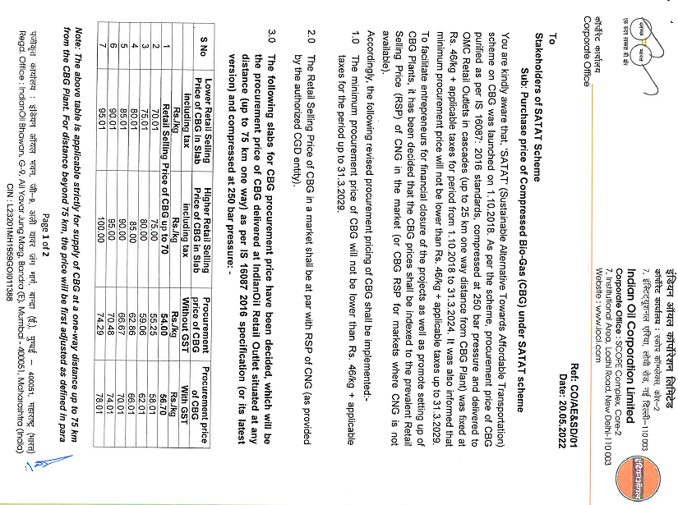
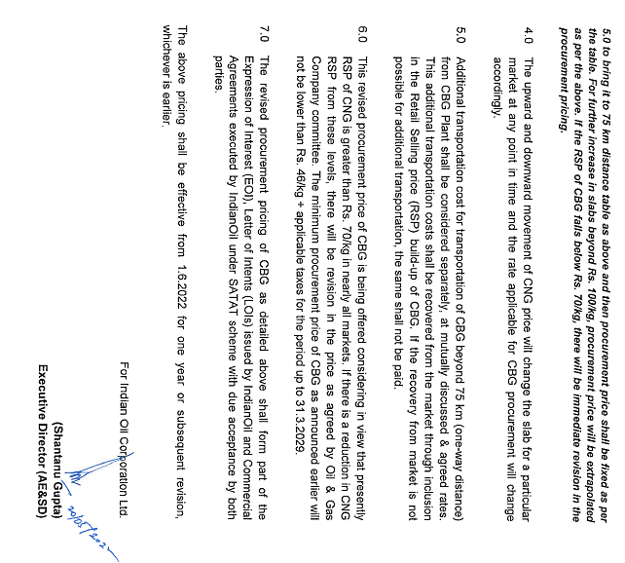
As per the shared agreement dated 1st June 2024 with M/s Anagram Development and farmers producers Private Ltd (FPO) for sale/handling of Bio-fertilizer produced at the proposed unit, Bio fertilizer will be selling out at an agreed price of INR 6.00 per kg which is reasonable and competitive rate of the market. For reference, IPL Rohana CBG Plant is selling FOM @ INR 10 per kg in 20 kg bags at present.
As per the current market scenario, the fermented organic solid manure/fertilizer is sold to farmers or outlets at around INR 6.00 to 7.00 per kg including with packing and bagging facilities. Whereas the bulk-selling rate of solid fermented organic manure/fertilizer is around 4.00 to 5.00 per kg.
Additionally, in a significant move towards promoting sustainable agriculture, the central government announced comprehensive guidelines to offer market development assistance (MDA) at INR 1500/MT (1.5 RS / Kg) for fermented organic manure (FOM) or bio-digestate derived from compressed biogas generating facilities. (Ref: https://pib.gov.in/PressReleasePage.aspx?PRID=1935893).
Further, The Indian Biogas Association (IBA) has recommended a fair and remunerative price of Rs 5.5 per kg for fermented organic manure (FOM), excluding the government incentive of Rs 1.5 per kg, to support biogas plants in the country. The IBA has suggested that the Ministry of Chemical and Fertilizer administer a fair market price for FOM, with an additional allowance for logistics and transportation charges. (https://economictimes.indiatimes.com/industry/indl-goods/svs/chem-/-fertilisers/fix-fair-remunerative-price-of-rs-5-5/kg-for-fermented-organic-manure-indian-biogas-association/articleshow/103100564.cms?from=mdr)
The IBA suggested a 'floor market price' at par with the Urea Retail Prices (presently at Rs 242 per 45 Kg bag), i.e. approx. Rs 5.5 per kg (exclusive of taxes). The market development Assistance (MDA) of Rs 1.5 per kg shall be realized over and above the floor market price by the FOM producer.
As IBA suggested the floor market price should have additional leeway to accommodate for additional logistics and transportation charges, if incurred and suggested an additional rate of approx. Rs 50/ton/km. According to the IBA, FOM is being sold at a rate ranging from Rs 0.50 to 4.50 per kg in the country. The selling price of Bio-CNG is considered on conservative side as INR 62.86/kg without GST. The selling rate of fermented organic solid and liquid fertilizers is assumed as INR 6.00 per kg.
Price of Biomass pellet is considered as INR 7.50 per kg which is on conservative side with respect to the current market rate. As per Government (Ref: F. No. 11/86/2017-TH.II (C. No 238797 dated: 23rd August 2023). the Price benchmarking Committee carried out study for National Capital Region (NCR) and submitted its report with recommended benchmark price for NcR. As per the recommendation of the committee, biomass fuel price has been specified for a period of 1 year w'e'f 01.09 .2023. The benchmark prices for non-torrefied biomass pellets in the NCR have been derived as Rs. 2.32l1000 kcal. The price specifled is excluding GST & transportation cost at the pellet manufacturing plant site. The pellets shall have moisture content below 14o/o and GCV between 2800-3400 kcal/kg.

- MARKETING, SELLING & DISTRIBUTION PLAN:
- BIO CNG:
The Bio-CNG produced has to be sold to Indian Oil Corporation Ltd stations, for which the LLP have already signed a LOI (Ref No. - Indian Oil/SATAT/01/3810, Date: 16th July 2024).
- PHOSPHATE RICH ORGANIC MANURE (PROM):
As per the agreement with M/s. Anagram Development and Farmer Producer Company Limited (FPO) dated 1st June 2024, Biogas plant may provide Bio-Fertilizers (PROM) to the local farmers through FPO on mutual agreed terms & rates. The current rate of produced FOM by IPL Rohana CBG plant is INR per kg in 20 kg bags and the rate of FPO will be competitive in the market. Further, Biogas plant may appoint the FPO and sales distributors for Saharanpur district on mutual agreed terms and conditions.
Additionally, Government of U.P. issued the government order number 43/2022/1101/87-8(1) AESD/2022 dated 3rd October 2022 and making the mandatory provision for sale of Bio fertilizer on Government Licensed fertilizers shop in the state under the clause of 2.4 of UP Bio Energy Policy 2022.
In a significant move towards promoting sustainable agriculture, the central government announced comprehensive guidelines to offer market development assistance (MDA) at INR 1500/MT (1.5 RS / Kg) for fermented organic manure (FOM) or bio-digestate derived from compressed biogas generating facilities. (Ref: https://pib.gov.in/PressReleasePage.aspx?PRID=1935893).
The government aims to bolster the production and use of organic fertilizers like FOM; liquid fermented organic manure (LFOM), and enriched phosphate rich organic manure (PROM). These fertilizers emerge as by-products from biogas (BG) and compressed biogas (CBG) plants. As informed by client, Biomass pellets will be sold to NTPC under the Government of India mandatory blending with coal in Thermal Power and other local paper industries
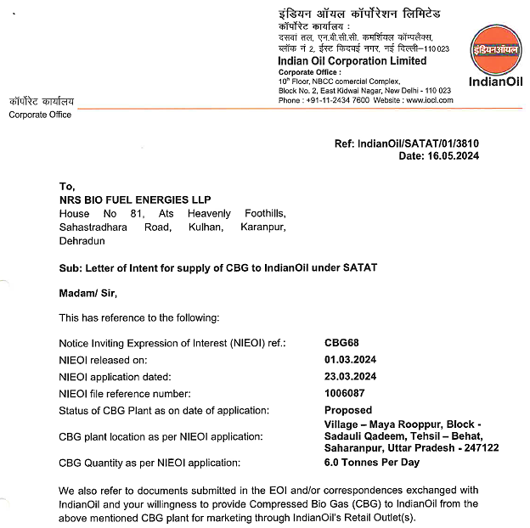
Note: LLP need to obtain a supplemental LOI with the changed address.
PART G | FEEDSTOCK ANALYSIS

- INTRODUCTION:
Bio-Methane from Anaerobic Digesters (AD): Anaerobic processes could either occur naturally or in a controlled environment such as a biogas plant. Organic waste such as livestock manure and various types of bacteria are put in an airtight container called digester so the process could occur. Depending on the waste feedstock and the system design, biogas is typically 55 to 60 percent pure methane. The state-of- the-art systems report producing biogas that is more than 95 percent pure methane.
The primary component of an AD system is the anaerobic digester, a waste vessel containing bacteria that digest the organic matter in waste streams under controlled conditions to produce Bio-methane. As an effluent, AD yields nearly all of the liquid that is fed to the digester. This remaining fluid consists of mostly water and is recycled to flush manure from the swine building to the digester.
Approximate Quantity Required For Generation Of One M3 Biogas
Sr. No. | Substance | Quantity (Kg)
1 | Cattle Dung | 20
2 | Paddy Straw | 4
3 | Napier grass | 8
4 | Poultry Waste | 8
5 | Horse/ Mule/ Elephant Dung | 12-15
6 | Food waste: Pre and post cooked leftover food from households, hotels and canteens. | 10-12
7 | Green waste (vegetable market waste): Vegetable  Refuses from Vegetable Markets or kitchens. | 10-12
8 | Paddy straw/ wheat straw/ mushroom spent waste:  Lawn cuttings, leafy biomass, dried flowers, finely chopped and ground straw or bagasse. | 5-8
9 | De-oiled rice bran | 3-4
10 | De-oiled seed cake (Pongamia/ Jatropha) | 3-4
11 | Segregated municipal solid waste (biodegradable) | 12-15
12 | Slaughter house waste | 5-10

Approximate Required Quantities of the Substances (Alone)
Sr. No. | Item | Daily Required Quantity (Ton)
1 | Agriculture Residue (Rice Stubble, Napier Grass etc.) | 100-110
2 | Poultry Droppings | 98-100
3 | Food Waste | 175-180
4 | Sugarcane Press mud | 120-150
Combination of any of these mentioned above can also work in proportionate quantity. However, as per feed stock analysis the proposed bio-CNG plant will be using the following Combination of Raw Materials, while it should be noted that the feed stock quantity may very base on dry matter and volatile matter available in the below mention combination of feed stock:
Proposed Combination of Raw material
S. No. | Item | Daily Input Quantity (Ton)
1 | Agriculture Residue (Rice Stubble, Napier Grass etc.) | Between 100 - 110
2 | Sugarcane Press mud | Between 40 - 50
Note: As informed by the client, the proposed plant will be designed for mix feed. Napier Grass will be used as feed stock and Pressmud is considered as backup Raw material source.
- AGRICULTURE RESIDUE (RICE STUBBLE, NAPIER GRASS ETC.):
Rice straw (RS) is a rich lignocellulosic biomass that can be employed for biogas generation through anaerobic digestion. Rice straw is one such biomass that is abundantly produced in India―about 160 million tonnes per year―and is widely available. Much of the surplus rice straw is burned by the farmers as a common practice, to get rid of the straw and prepare the field for the next crop.
Extraction of energy from rice straw is limited due to the presence of lignin mesh around the cellulose and hemicellulose structure, making it recalcitrant to microbial attack. Thermochemical pre-treatment such as acid or alkali pre-treatment at high temperature is required to break open the complex structure and make it amenable to biomethanation.
Napier grass, also known as elephant grass, is a productive and versatile forage grass native to Africa and Southeast Asia. Napier Grass is an ideal substrate for biogas Production. In India, the reported annual production yield of Napier grass ranges from 150-200 tonnes per acre per year, which is significantly higher (25-35 tonnes per hectare) compared to other energy grasses like miscanthus and switchgrass.
Composition of Super Napier grass
Parameters, % | Fresh, % | Dry Matter, %
Crude Protein, % | 1.21 | 8.12
Crude Fibre, % | 5.37 | 36.02
Crude Fat, % | 10.12 | 67.87
Moisture, % | 85.09 | -
Ash, % | 1.01 | 6.77
Neutral Detergent Fibre, % | 10.2 | 68.41
Napier grass is categorised as lignocellulosic biomass, with its carbohydrate composition typically consisting of 35-39 per cent cellulose, 19-23% xylan and 15-19% lignin on a dry mass basis. With an energy output-to-input ratio of approximately 25:1, it emerges as one of the most promising energy crop.
Studies have shown that Napier Grass has a high methane yield due to higher cellulose and crude protein, making it an efficient source of Bio-CNG with the potential for significant energy output. The cultivation of Super Napier stick seed grows very easy and fast and get the height of 6 feet in 30 days. This fast-growing perennial grass can reach a height of 10-15 feet and can be harvested 5-6 times annually. Below is the presentation of Bio methane Potential of Napier Grass:
Bio methane Potential of Napier Grass
S. No. | Solid loading (%) | HRT (days) | Inoculum (%) | Bio methane production (L/kg VS)
1 | 5 | 25 | 50 | 400.84
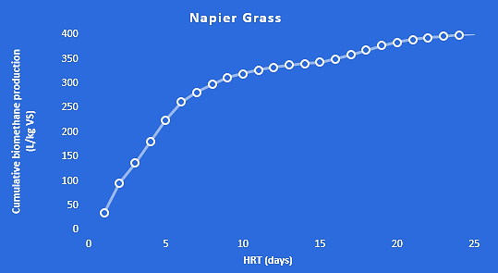

Napier grass, also known as elephant grass, is a productive and versatile forage grass native to Africa and Southeast Asia. Due to its high yield, it is widely used as feed for livestock and in bioenergy applications. While it may be a relatively new energy crop in India, Thai farmers have been cultivating it for over 30 years, with more than 130 varieties. This fast-growing perennial grass can reach a height of 10-15 feet and can be harvested 5-6 times annually.
The first harvest occurs four months after planting, followed by subsequent harvests every two months for up to seven years. Napier grass is categorised as lignocellulosic biomass, with its carbohydrate composition typically consisting of 35-39 per cent cellulose, 19-23 per cent xylan and 15-19 per cent lignin on a dry mass basis. With an energy output-to-input ratio of approximately 25:1, it emerges as one of the most promising energy crops for the creation of cost-effective and efficient bioenergy systems.
In India, the reported annual production yield of Napier grass ranges from 150-200 tonnes per acre per year, which is significantly higher (25-35 tonnes per hectare) compared to other energy grasses like miscanthus and switchgrass. However, there are specific varieties that have shown even higher yields. Few microbiologist and farmer, achieved biomass productivity of 350-400 tonnes per acre per year by cultivating a hybrid variety called Super Napier in Maharashtra's Gondia district.
Through experiments, it was discovered that with a 24-hour microbial pre-treatment, 100 kgs of the grass yielded 6 kgs. of biogas, which had a 62.3 per methane content. Alternatively, when the same feedstock underwent a 24-hour pre-treatment with 1 per cent Noah, a slightly higher yield of 6.5 kg of biogas with 61.5 per cent methane content was obtained.
Another crucial factor to consider is the operational intricacies of a CBG plant exclusively reliant on Napier grass. Numerous laboratory-scale studies have demonstrated that co-digestion, involving a combination of Napier grass with cow dung or food waste, results in higher yields compared to using Napier grass alone.
Moreover, it is essential to note that Napier grass is a warm-season grass and undergoes dormancy during the winter months. To ensure an uninterrupted supply of feedstock throughout the year for the CBG plant, it is vital to have alternative feedstock options available during the winter season.
There are many Operational and under construction plants using Napier Grass as Raw material in India such as Maruti Suzuki India Limited, Manesar Unit – Food waste or Napier Grass as Raw Material, APSS Adarsh Bio Agro Pvt. Ltd, Wardha, Maharashtra (EPC partner – Gruner Renewable Energy (GRE)) – 50 TPD of Napier grass, producing an output of 3 TPD of Bio-CNG per day, GPS Renewable – Multiple Bio-CNG projects with 150 TPD Agri-residue including paddy straw, Napier grass for Reliance Industries, producing an output of 18 to 20 TPD of Bio-CNG per day and Gruner Renewable Energy – Multiple Bio-CNG projects worth of Rs. 1500 Cr on Agri-residue including paddy straw, Napier grass.
- RAW MATERIAL SUPPLY ANALYSIS:
As per the data/information provided by client, plant will require ~80-90 tons per day Agriculture Residue (Rice Stubble, Napier Grass etc.) and ~20-30 ton per day sugarcane press mud to produce the 6 ton Bio-CNG per day.
Required Raw Materials for Plant
Particular | Quantity | Cubic Metre
Agriculture Residue (Rice Stubble, Napier Grass etc) | 100 Ton / Day | 222
Total Raw Material need / day for Feed | 100 Ton / Day | 222
Adding 100% Water to maintain TS @ 10% Max |  | 222
Sub-Total (Total input / day in both Digesters) |  | 444
hydraulic retention time HRT Time @ 26 Days |  | 12432
Source: Data/Information provided by the client.
As per the data/information provided by the client, LLP has made a long term raw material supply agreement with M/s. Anagram Development and Farmer Producer LLP Limited (FPO) on 1st June 2024.
According to the terms & conditions stated in the agreement, M/s. Anagram Development and Farmer Producer Company Limited (FPO) will supply 100 ton per day Agriculture Residual/Napier grass/Rice Stubble etc. to M/s Ms NRS Bio Fuel Energies LLP as per the specifications and in the manner as mutually agreed between the parties.
As per our tertiary research and data/information available in public domain, M/s. Anagram Development and Farmer Producer Company Limited is a private company incorporated on 19th October 2015 with prime focus on the production of cereal crops and vegetables, Black Gram, wheat, paddy, and mustard. These are the primary products. Bearing CIN U01403UP2015PTC073940 (ROC-Kanpur), Company is involved in Agricultural and animal husbandry service activities, except veterinary activities.
The FPC has 1500 farmers as its registered members with an average landholding size of 0.5 acres (0.2 hectares). The minimum and maximum size of landholding is 0.25 acres (0.1 hectares) and 2.5 acres (1.01 hectares).
Company is having a turnover of INR 56,47,105 in FY 2022 which has increased by ~59% in FY 2023 to INR 89,74,829.38.
The FPC rents out farm machinery obtained from Farm Machinery Bank (FMB), and agricultural inputs such as pesticides, micro-nutrients to its members. This is expected to result in quality agricultural production and would ultimately lead to improved market linkages. Through this plan, the company aims to enhance each farmer’s income by 20% by the end of the financial year 2024.
Broad service models of the FPC
Particular | Quantity
Farm Machinery Bank (FMB): | The FPC rents farm machinery to its member farmers and other farmers as per requirement. In the financial year 2023-2024, the FPC earned an income worth INR 2,95,000. For the five upcoming years, the FPC has planned to increase the rent by an inflation- adjusted rate of 3.23% as per CPI.
Inputs: | The FPC provides fertilizers, pesticides, micronutrients, and seeds to its farmers. The member farmers purchase input from the FPC. It is not planning to enhance its stock of inputs in next five years because it wants to utilize its capital for establishing a wheat mill. And therefore, the FPC looks forward to an opportunity to tie-up with CNG plants for supply of bio-fertilizer
 | Storage: The FPC has a pre-established space for storage capacity of 3000 MT at its premise which would be utilized for storing wheat grains and milled wheat. The same Space can be used by its farmers. The FPC would not bear the rental cost for storage.
Seed Processing Unit: | The FPC is done for establishing a 200 MT seed processing unit. The unit would be operational by the end of financial year 2024.
Small Food processing Unit: | The FPC having the small food processing unit like Oil expeller with filter press, Dall mill & wheat dalia making machines. FPC processes the mustard oil, Wheat Dalia & different grams and packaging in own brand for further marketing.

- PRICING: Pricing of the raw material i.e. Agriculture Residue (Napier Grass/Rice Stubble etc.) is considered as per the long term supply agreement with FPO, according to which rate of chopped Napier grass mutually agreed between the parties as INR 100 per quintals i.e. INR 1.00 per kg excluding INR 60 per ton for diesel expenses and promotional incentive of INR 20 per quintal to farmer for first year crop to compensate the yields.

PART H | INDUSTRY OVERVIEW

- INTRODUCTION:
Bio-CNG is considered a renewable fuel and has also been proven to reduce the emission of greenhouse gasses when used as a transport fuel. Bio-CNG, derived from the filtration of biogas, is also referred to as Compressed Biogas (CBG) and bio-methane. It is derived from biogas after removing impurities like carbon dioxide and hydrogen sulphide. As per the details available on Gobardhan Portal (https://gobardhan.co.in/), approx. 81 CBG/Bio CNG plants are completed and functional in 153 districts and 163 CBG/ Bio CNG plants are under construction at present.
Bio-CNG plants get financial and other incentives from the Union government under the Sustainable Alternative towards Affordable Transport (SATAT) Scheme. The scheme, launched in 2018, supports the establishment and expansion of bio-CNG plants that use waste to produce biofuel. Under the scheme, the Union government plans to establish a total of 5,000 bio-CNG plants in India by the end of FY 2025.
- POTENTIAL AND EXPANSION:
In India, around 70 percent of the sugarcane is produced by three major states – Uttar Pradesh, Maharashtra, and Karnataka. India produces, on an average, over 300 million metric tonnes of sugarcane per year. Around 3.5 percent of this, can be the amount of press mud produced. At this rate, India has the potential to produce around 10 million metric tonnes of press mud/filter cake per year that could be diverted for producing bio-CNG.
Indian sugar industry while crushing around 300 million tonnes of sugarcane and producing about 10 million tonnes of press mud annually can offer compressed bio-methane/bio-CNG to the extent of 0.4 million metric tonnes .
Feedstock | Pan India accessible amount (TPD) | Biogas potential per ton (kg) | Bio-CNG potential per ton (kg) | pan India CBG potential (TPD)
Urban food waste, fruit and vegetable | 50,000 | 75 | 40 | 2000
Poultry litter | 100,000 | 100 | 60 | 6000
Press mud | 100,000 | 150 | 80 | 8000
Total |  |  |  | 16000
The Bio-CNG potential in India is estimated at 62 million metric tonnes (MMT) per annum, out of which the Sustainable Alternative towards Affordable Transportation (SATAT) scheme aims to tap 15 MMT. India biogas market is expected to grow from $1.47 billion in 2022 to $2.25 Billion in 2029 at a CAGR of 6.3% during the forecasted period.
The sector is about to attract over USD 2 Billion investment in the next 5-7 years under its SATAT scheme, the govt. announced an ambitious plan of touching 15 million metric ton per annum, which is roughly 40,000 ton per Day.
Demand for alternative fuel vehicles in India is on the upswing and clearly seen in the increasing sales of CNG-powered vehicles. Given the favourable price arbitrage of CNG versus petrol and diesel, retail sales of CNG vehicles, across four sub-segments, crossed the 650,000-unit mark for the first time in a fiscal in FY2023. Cumulative sales of 660,153 units (see data table below) translate into strong double-digit YoY growth of 46% (FY2022: 451,552 units). (Ref.: https://www.autocarpro.in/analysis-sales/cng-vehicle-sales-surge-by-46-to-over-650000-units-in-fy2023-114656).
CNG passenger vehicles (PVs), with 318,752 units, account for 48% of the total retail sales in FY2023 and surged by 40.71% year on year (FY2022: 226,547 units) and took an 8.80% share of overall retail sales of 36,20,039 PVs in India.
- CHALLENGES:
The GOI has formulated various policies and schemes to promote and mitigate challenges associated with the Bio-CNG sector. There are still some operational and technological challenges such as sensitivity towards biomass quality, biogas upgradation process among others which are impeding the uptake of Bio-CNG projects. Below table shows the challenges:
Feedstock Availability | Quality of Feedstock (including multiple feedstocks) | Technology Challenges | Bio-CNG and by- products' Market Challenges | Financing, and Implementation Challenges
- No formal market for trading of feedstock  - Uncertainty of long-term regular supply of feedstock  - Demand supply mismatch - requirement of large storage facility  - Unorganized biomass value chain – lack of suﬃcient collection, processing and transportation facility | - Variation in quality of feedstock throughout the year  - Some projects are designed to take multiple feedstock – optimal operation is a challenge and may also aﬀect the quantity and quality of Bio-CNG  - Source segregation is important – receiving non-segregated waste is an operational challenge | - Technologies are sensitive to the quality of feedstock – slight change in feedstock quality will signiﬁcantly impact the Bio-CNG production rate  - Capital intensive technologies high upfront project cost | - Year-on-year variation in feedstock price – established feedstock pricing mechanism is required.  - Base price of Bio-CNG should be linked with feedstock cost variation mitigates the economic viability risks  - Create market demand for by- products such as Bio manure etc. | - There are schemes by public sector banks to ﬁnance Bio-CNG project, but less private sector banks are ﬁnancing Bio-CNG project that too at high cost of debt.  - Lack of access to infrastructure i.e. road network and CGD network near project sites.  - Large set of approvals are required from PESO, pollution control board, MNRE - subsidy disbursement etc.

- GOVERNMENT INITIATIVES:
- Government has announced the phased mandatory blending of compressed biogas (CBG) in compressed natural gas (CNG) for transportation and piped natural gas (PNG) for domestic purposes in the latest interim budget for FY 2024-25.
- The government has increasingly focused on the production of compressed biogas in India. It is currently aiming to set up 5,000 CBG plants by FY25 under SATAT.
- Under Waste To Energy Programme, MNRE is providing the subsidy of INR 4.0 Cr per 4800 kg/day for Bio CNG generation from new biogas plant and INR 3.0 Cr per 4800 kg/day for Bio CNG generation from existing Biogas plant, while the maximum CFA of INR 10.0 Cr/project for both cases.
- GOBARDHAN: Ministry of Drinking Water and Sanitation, Financial assistance of INR 50 lakh per district is available for setting up model GOBARDHAN projects. SATAT Scheme OF MoPNG for encouraging OMCS's to issuance of LOI to the producers.
- Eight Biogas Development and Training Centres (BDTCs) have been established at India’s premier Institutions to provide Technical Assistance, R & D, Testing and Validation of New Biogas Models / Designs, field inspections of biogas plants, and training and skill development.
- Ministry of Road Transport and Highways amended the Central Motor Vehicles Rules, 1989 in June 2015 and included the provisions for usage in motor vehicles Bio-CNG produced from waste (including MSW).
- Government of Uttar Pradesh is providing the subsidy of INR 75 lac / Ton under the provision of UP Bio Energy Policy 2022 and Benefit up to INR 2.0 Cr from Agriculture Infrastructure Fund (AIF) – Circular dated 27th Oct. 2020.
- Market Development Assistance (MDA) for Promotion of Organic Fertilizers @ Rs. 1500 / Ton to CBG Plants
- CONCLUSION:
The business of bio CNG gases is in high demand because it is a clean and renewable source of energy. Additionally, it is more cost-effective than traditional sources of energy, and it can be used to power a variety of vehicles. Bio CNG gas is also a versatile fuel that can be used in a variety of applications.
Though there are a few reasons for this increase in demand, the primary one seems to be that environmentalism is becoming more and more popular. As people become more aware of the damaging effects that traditional forms of energy have on the environment, they are searching for alternatives that are cleaner and renewable.
India biogas market is expected to grow from $1.47 billion in 2022 to $2.25 Billion in 2029 at a CAGR of 6.3% in forecast period, 2022-2029. Bio CNG gas is one such alternative, and its popularity is only increasing as time goes on. Bio CNG can be produced from a variety of organic materials, making it a sustainable choice for energy production. Additionally, bio CNG produces fewer emissions than traditional fossil fuels, making it a more environmentally-friendly option. Finally, bio CNG is becoming increasingly cost-competitive as technology advances and production methods improve.

PART I | SWOT ANALYSIS

SWOT ANALYSIS
STRENGTHS | - Strategic Location: The project is situated in Saharanpur, U.P. Many sugar mills are situated near by the location of the proposed Bio CNG plant ensures the availability of raw material (press mud). Further availability of agricultural land in western U.P., supply of Napier grass will also be good as farmers are interest towards commercial agriculture & contract farming.  - Growing Demand: Due to renewable source of energy, demand for Bio-CNG is expected to grow at a CAGR of ~6 % in the upcoming years.  - LOI: The produced 6 TPD Bio CNG will be supplied to IOCL as per the LOI issued by OMC under SATAT scheme, which is an effortless avenue for the project to generate the revenue. (Ref No. - Indian Oil/SATAT/01/3810, Date: 16th May 2024).  - Government Support: The project will be entitled to avail incentives of INR 4.0 Cr per 4800 kg/day for Bio CNG generation from new biogas plant, Under Waste to Energy Programme of Ministry of New and Renewable Energy.  Further, Government of Uttar Pradesh is providing the subsidy of INR 75 lac / Ton under the provision of UP Bio Energy Policy 2022 and project is eligible for benefit up to INR 2.0 Cr from Agriculture Infrastructure Fund (AIF) – Circular dated 27th Oct. 2020. Market Development Assistance (MDA) for Promotion of Organic Fertilizers INR 1500 / Ton to CBG Plants. Expected subsidy/CFA of the project is ~9.30 cr.  - Technology: The proposed plant will be commissioned with Mapro -Sequential Gas Mixing Technology (U.S.A), which is a proven technology empirically.
WEAKNESSES | - CAPEX: The proposed Bio CNG plant would be set up by a high initial investment, in which ~65% capital would be required for land, building and plant & machinery only.  - Infrastructure Requirements: The project's power load and water consumption are significant, and ensuring uninterrupted power supply and adequate water resources may pose challenges.  - Raw Material Market: There is no any formal market for raw material, leading to establish a feedstock pricing mechanism.
OPPORTUNITIES | - Increasing Alternate fuel’s Demand: As the transportation industry is expanding, there will be an organic demand for Bio CNG/CBG as an alternate fuel due to mandatory blending of compressed biogas (CBG) in compressed natural gas (CNG) for transportation.  - Expansion Potential: The LLP is having the plan to expand its business in future for manufacturing Bio Coal and Bio Pellets.  - Government Support: The project can benefit from government initiatives and policies aimed at promoting the Bio CNG production to achieve Net Zero target by 2070.
THREATS | - Fluctuating Raw Material Prices: With the increasing demand of sugarcane press mud, the prices are shooting up rapidly.  - Economic Factors: Profitability of the project may hamper due to any blockage of feed stock.  - Dependency on LOI: Any breach of the LOI agreement with OMC, the LLP may require to search the new approach to sell its production in the market.  - Manufacturing Experience: Promoters are having experience of different industries, however entering into Bio CNG generating business may explore new multidimensional challenges.  - Farmers Awareness: Increasing awareness of Bio Fertilizer in Farmers and Marketing of Organic Fertilizer can adversely affect the projected revenue of the LLP expected to generate from by-products.

PART J | PROJECT COST AND MEANS OF FINANCE
As per data/information shared by the client, the proposed Bio CNG generating project is proposed to be commissioned by making an investment of INR 41.27 Crore as shown in the below table along with Means of finance:
Total Project Cost
S. No. | Capital Cost Head | Amount (INR Crore)
 | Land Cost | 0.91
 | Building & Civil Works | 9.14
 | Plant & Machinery | 21.90
 | Electricity Infrastructure | 3.96
 | Vehicles | 0.32
 | Office equipment | 0.10
 | Miscellaneous Fixed Assets | 0.70
 | Interest During Construction (IDC) | 1.63
 | Sub Total | 38.66
 | Preliminary & Preoperative | 1.90
 | Sub Total | 40.56
 | Working Capital Margin @ 25% of WC Gap | 0.71
 | Grand Total (TPC) | 41.27
Source: Data/Information provided by the company/LLP.
Means of Finance
S. No. | Particular | Amount (INR Crore)
 | Equity | 12.84
 | Term Loan from Bank | 28.43
 | Total | 41.27
 | CC Loan | 1.50
 | Total Loan Amount | 29.93
Source: Data/Information provided by the company/LLP.
Notes:
- It is to be noted that the detailed vetting of the project cost is out of scope of this TEV report and we have relied upon the data/information provided by the client regarding Total Project cost in good faith, however as a TEV consultant we have cross verified the cost of the major components of TPC independently wherever required for the purpose of TEV only.
- As per the land registry executed on 16th July 2024, partners of the LLP has purchased a 5.42 Acre (2.1960 Hectare) agricultural land at Khasra No, 725, 728, 727 & 729,, Vill - Faizabad, Pargana- Faizabad, Tehsil- Behat, Dist - Saharanpur -247122, Faizabad, Saharanpur, Taluka: Behat, District: Saharanpur, State, Uttar Pradesh, 247122. Total cost of the land registration would be INR 0.91 Crore including INR 10 lakhs for Change of land use (CLU) and other charges.
- As per the above table, the estimated cost of the Building & Civil works is ~INR 914.28 lakhs including applicable GST and 5% EPC consultant cost as per the signed agreement. Cost of the Building & Civil works has been considered on the basis of shared details/EPC contract provided to us by the client. As a TEV consultant we have checked major unit cost considered in EPC contract which we found in permissible range. LLP needs to share the revised EPC agreement as few items are changed and their costs are revised as per the final cost sheet shared by the client. We recommend the financial institution to advice the client to share the revised EPC agreement so that cost can be justified.
- The estimated cost for plant & machinery will be ~INR 2189.58 lakhs including applicable GST and 5% EPC fees. ~53% of TPC is the cost Plant & Machinery The estimated cost of the Plant & Machinery has been provided to us by the client as per EPC agreement. However, as a TEV consultant, the cost of major plant & machinery has been verified by us independently, which we found reasonable & in the permissible range although the cost may change as per specifications & brand. LLP needs to share the revised EPC agreement as few items are changed and their costs are revised as per the final cost sheet shared by the client. We recommend the financial institution to advice the client to share the revised EPC agreement so that cost can be justified. PROM Plant (150 TPD) and Biomass Pallet Plant (2 TPH) is out of scope of EPC and cost of these items are considered based on the quotations shared by the client separately.
- The cost of Electrical, Instrumentation, PLC, data collection is INR 396.48 lakhs including GST & 5% EPC fess. Tentative cost of Off-site Facilities, Vehicles and office equipment is INR 114.66 lakhs including applicable GST. We found that the costs are in the line with prevailing market standard.
- Cost of Misc. Fixed Asset is considered in the form of contingencies as INR 70 lakhs which is ~2% of Total hard cost. We recommend that the bank/financial institutions advice the LLP to submit actual cost based on the final quotations/invoices/bills. This will help validate the assertion of different costs considered by the client.
- As per the data/information provided by the Bank/client, applicable Interest rate during Construction (IDC) is 9.50% and LLP is required to pay INR 1.63 Crore as IDC from November 2024 till September 2025 (11 months) as per the proposed Loan repayment schedule.
- Preliminary & Pre-Operative Expenses has been considered based on the estimate of LLP’s resources involvement as INR 1.90 Crore. However, LLP did not provide us any invoices/bills against these tentative costs considered. We recommend that the bank/financial institutions advice the LLP to submit actual cost based on the final quotations/invoices/bills. This will help validate the assertion of different costs considered by the client.
- The project is proposed to be funded through a term loan of INR 28.43 crores and promoter’s Equity of INR 12.84 crores. Further, as per the working capital assessment, the working capital will require as INR 2.00 Crore, which will be funded through WC loan of INR 1.50 Cr. and promoter’s margin of INR 0.71 Cr. (~25% of required WC).

PART K | PROJECT IMPLEMENTETION SCHEDULE

The proposed Bio CNG generating unit is expected to achieve its C.O.D till 1st October 2025, as per the proposed implementation schedule shown in the table below:
S. No. | Particulars | Activity | Expected completion date | Status
 | Land | Land Procurement | 16th July 2024 | CLU is pending
 |  | Land Development | 31st October 2024 | Scheduled
 | Sanction of Rupee Term Loan | Sanction of Rupee Term Loan | 30th November 2024 | Scheduled
 | Building & Civil Works | Appointment of Architect | July 2023 | Completed
 |  | Building/Layout Plan Preparation | 9th May 2023 | Completed
 |  | Building Plan Sanction | December 2024 | Scheduled
 |  | Appointment of Civil contractor/ developer | 31st December 2024 | Scheduled
 |  | Building & Civil Works completion | 31st March, 2025 | Scheduled
 | Plant & Machinery | Finalization of P&M suppliers | 1st December 2024 | Scheduled
 |  | Orders to P&M suppliers | February, 2024 | Scheduled
 |  | Arrival of P&M | May, 2025 | Scheduled
 |  | Installation of P&M | July, 2025 | Scheduled
 |  | Utility Installation | August, 2025 | Scheduled
 | Statutory Approvals, registrations & NOCs | From the respective authorities | 1st September, 2025 | Pending except the approval obtained as per “Section L”
 | Finishing & Trail Run | Informed by client | 20th September, 2025 | Scheduled
 | Commercial Operation Date | Informed by client | 1st October 2025 | Scheduled

Notes:
- Schedule has been made as per feasibility to achieve different milestones.
- Achievement of Milestone will depend on sanction of term loan as per proposed timeline.
- For current status of statutory approvals, kindly refer the “Section L” of this report.
- As per this timeline, the expected C.O.D will be 1st October 2025.

PART L | STATUTORY APPROVALS | LICENCES | NOC

As shown in the below table along with current status, following major approvals are required, However the list is not exhaustive and State/District Authorities may be approached for further clearances required (if any):
S. No. | REQUIRED APPROVALS | DATE  REFERENCE NO. | STATUS  (Approved/ Applied For/ Pending)
 | Certificate of Incorporation  Ministry of Corporate Affairs, Government of India | 11th March 2024  LLPIN: ACF-9886 | Approved
 | Land conversion to Industrial/Non agriculture  Sub Divisional Magistrate, Behat, Sahrabpur, U.P. | 25th October 2024  Docs Number: T802024050229 | Approved
 | NOC from Gram Panchayat  Gram Panchayat Faizabad, Sahranpur Uttar Pradesh | 25th July 2024 | Approved
 | Labour Licence  Registration & grant of license under The Factories Act, 1948  Labour Department, Government of Uttar Pradesh | - | Pending
 | Building and civil works Plan Sanction Approval  Concerned local development authority | - | Pending
 | Pre-establishment fire NOC  Fire and Emergency Services, Government Of Uttar Pradesh | - | Apply in due course
 | Fire NOC (on completion)  Fire and Emergency Services, Government Of Uttar Pradesh | - | Will be Applied post C.O.D
 | New HT line - non domestic /industrial Power Connection  Paschimanchal Vidyut Vitran Nigam Limited, U.P | 19th Sep 2024  Application No. 1016444577 | Applied
 | Consent to Establish under Air (Prevention and Control of Pollution) Act, 1981 & Water (Prevention and Control of Pollution) Act, 1974  Uttar Pradesh Pollution Control Board | - | Pending
 | No Objection Certificate (NOC) for ground water abstraction  Ground water department (Namami Gange & Rural Water supply department), Ministry of Jal Shakti, Government of Uttara Pradesh | - | Pending
 | Petroleum & Explosives Safety Organisation (PESO)  Ministry of Commerce & Industry, Government of India | 4th July 2024  Prior Approval No : A/G/HO/UP/05/651 & A/G/HO/UP/06/630 (G135421) | Approved

Observation Note:
- As informed by client, LLP is in the process to apply for Consent to Establish under Air (Prevention and Control of Pollution) Act, 1981 & Water (Prevention and Control of Pollution) Act, 1974 and No Objection Certificate (NOC) for ground water abstraction. We recommend the financial institution to suggest the client to provide the details of timeline along with current status of the same.
- LLP has applied for electricity connection to Paschimanchal Vidyut Vitran Nigam Limited, Meerut and paid INR 156076.72 charges dated 19th Sep 2024 Application No. 1016444577.
- Above is the only illustration of the major approvals sought or to be sought by the LLP. It should not be construed as the exhaustive list and in case any approval is missed to be mentioned then it is the sole responsibility of the company/LLP to keep the unit compliant with the necessary statutory approvals/ NOCs.

PART M | PROJECT’S FINANCIAL FEASIBILITY

- PROJECTIONS OF THE FIRM:
The financial projections of the project are prepared from FY 2026 (6 months) to FY 2035 based on the expected COD and loan tenure as per the best practice in industry to assess the financial feasibility of the project:
- PROJECTED PROFIT & LOSS ACCOUNT:
(INR Crore)
Year Ending | 31-Mar-26 | 31-Mar-27 | 31-Mar-28 | 31-Mar-29 | 31-Mar-30
Year | 1 | 2 | 3 | 4 | 5
No. of Months | 6 | 12 | 12 | 12 | 12
Revenue | 13.34 | 26.93 | 28.28 | 29.73 | 29.69
Raw Material | 2.78 | 5.62 | 5.90 | 6.20 | 6.51
Power & Fuel | 1.09 | 2.21 | 2.32 | 2.43 | 2.55
Salary & Wages | 0.32 | 0.71 | 0.78 | 0.86 | 0.94
Biomass Pellet Processing Cost | 0.41 | 0.83 | 0.87 | 0.91 | 0.96
PROM Processing Cost | 2.37 | 4.78 | 5.02 | 5.27 | 5.53
Repair & Maintenance | 0.09 | 0.20 | 0.21 | 0.22 | 0.23
Insurance expenses | 0.09 | 0.09 | 0.08 | 0.08 | 0.07
Depreciation | 1.13 | 2.30 | 2.30 | 2.30 | 2.30
Cost of production | 8.29 | 16.73 | 17.47 | 18.26 | 19.09
Add: Opening Stock in Process | 0.00 | 0.46 | 0.48 | 0.51 | 0.53
Sub-Total | 8.29 | 17.19 | 17.96 | 18.77 | 19.62
Less: Closing Stock in Process | 0.46 | 0.48 | 0.51 | 0.53 | 0.56
Sub-Total | 7.83 | 16.70 | 17.45 | 18.24 | 19.07
Add: Opening Stocks of Finished Goods | 0.00 | 0.60 | 0.71 | 0.75 | 0.78
Sub-Total | 7.83 | 17.30 | 18.16 | 18.98 | 19.85
Less: Closing stocks of Finished Goods | 0.60 | 0.71 | 0.75 | 0.78 | 0.82
Total Cost of Sales | 7.23 | 16.59 | 17.41 | 18.20 | 19.03
Selling, General & administration Expenses | 1.86 | 3.66 | 3.84 | 4.03 | 4.11
Preliminary Expenses written off | 0.38 | 0.38 | 0.38 | 0.38 | 0.38
Total Expenses | 9.48 | 20.63 | 21.64 | 22.61 | 23.52
EBIT | 3.86 | 6.30 | 6.64 | 7.11 | 6.17
Interest on term loan | 1.35 | 2.55 | 2.25 | 1.95 | 1.65
Interest on working capital | 0.07 | 0.14 | 0.14 | 0.14 | 0.14
Total Interest Expenses | 1.42 | 2.69 | 2.39 | 2.09 | 1.79
Profit before Taxes | 2.44 | 3.60 | 4.25 | 5.02 | 4.37
Tax | 0.41 | 0.60 | 0.71 | 0.84 | 0.73
Profit after Taxes (PAT) | 2.03 | 3.00 | 3.54 | 4.18 | 3.64
(Continued)
Year Ending | 31-Mar-31 | 31-Mar-32 | 31-Mar-33 | 31-Mar-34 | 31-Mar-35
Year | 6 | 7 | 8 | 9 | 10
No. of Months | 12 | 12 | 12 | 12 | 12
Revenue | 31.17 | 32.73 | 34.37 | 36.09 | 37.89
Raw Material | 6.83 | 7.18 | 7.54 | 7.91 | 8.31
Power & Fuel | 2.68 | 2.81 | 2.95 | 3.10 | 3.26
Salary & Wages | 1.04 | 1.14 | 1.26 | 1.38 | 1.52
Biomass Pellet Processing Cost | 1.01 | 1.06 | 1.11 | 1.16 | 1.22
PROM Processing Cost | 5.81 | 6.10 | 6.40 | 6.72 | 7.06
Repair & Maintenance | 0.24 | 0.25 | 0.26 | 0.28 | 0.29
Insurance expenses | 0.07 | 0.06 | 0.05 | 0.05 | 0.04
Depreciation | 2.29 | 2.28 | 2.28 | 2.26 | 2.24
Cost of production | 19.96 | 20.88 | 21.86 | 22.87 | 23.94
Add: Opening Stock in Process | 0.56 | 0.59 | 0.62 | 0.65 | 0.68
Sub-Total | 20.52 | 21.46 | 22.47 | 23.52 | 24.62
Less: Closing Stock in Process | 0.59 | 0.62 | 0.65 | 0.68 | 0.71
Sub-Total | 19.93 | 20.85 | 21.83 | 22.84 | 23.91
Add: Opening Stocks of Finished Goods | 0.82 | 0.85 | 0.89 | 0.93 | 0.98
Sub-Total | 20.75 | 21.70 | 22.72 | 23.77 | 24.88
Less: Closing stocks of Finished Goods | 0.85 | 0.89 | 0.93 | 0.98 | 1.02
Total Cost of Sales | 19.90 | 20.81 | 21.78 | 22.79 | 23.86
Selling, General & administration Expenses | 4.31 | 4.52 | 4.75 | 4.98 | 5.22
Preliminary Expenses written off | 0.00 | 0.00 | 0.00 | 0.00 | 0.00
Total Expenses | 24.21 | 25.33 | 26.53 | 27.77 | 29.08
EBIT | 6.96 | 7.40 | 7.84 | 8.32 | 8.81
Interest on term loan | 1.35 | 1.05 | 0.74 | 0.40 | 0.06
Interest on working capital | 0.14 | 0.14 | 0.14 | 0.14 | 0.14
Total Interest Expenses | 1.49 | 1.19 | 0.88 | 0.54 | 0.20
Profit before Taxes (PBT) | 5.47 | 6.21 | 6.96 | 7.77 | 8.61
Tax | 0.91 | 1.04 | 1.16 | 1.30 | 2.45
Profit after Taxes (PAT) | 4.56 | 5.17 | 5.80 | 6.47 | 6.15

- PROJECTED BALANCE SHEET:
Below table shows the Projected Balance Sheet of the proposed Bio CNG generating project from the period FY 2025 to FY 2035. From 1st November 2024 to 30th September 2025 would be the implementation period of the project:
(INR Crore)
Year Ending | 31-Mar-25 | 30-Sep-25 | 31-Mar-26 | 31-Mar-27 | 31-Mar-28 | 31-Mar-29
Year | Constr. | Constr. | 1 | 2 | 3 | 4
No. of Months | 5 | 6 | 6 | 12 | 12 | 12
Liabilities
Equity | 12.13 | 12.13 | 12.84 | 12.84 | 12.84 | 12.84
Reserve & Surplus | 0.00 | 0.00 | 2.03 | 5.03 | 8.57 | 12.75
Secured Loan | 14.22 | 28.43 | 25.27 | 22.11 | 18.95 | 15.80
Unsecured Loans | 0.00 | 0.00 | 0.00 | 0.00 | 0.00 | 0.00
Current Liabilities
Trade Payables | 0.00 | 0.00 | 0.97 | 1.02 | 1.07 | 1.12
Term liabilities payable within one year | 0.00 | 0.00 | 3.16 | 3.16 | 3.16 | 3.16
CC Limit | 0.00 | 0.00 | 1.50 | 1.50 | 1.50 | 1.50
Other Current Liabilities | 0.00 | 0.00 | 0.00 | 0.00 | 0.00 | 0.00
Provision for taxes |  |  | 0.41 | 1.01 | 1.72 | 2.56
Shareholder’s Equity & Liabilities | 26.34 | 40.56 | 46.17 | 46.66 | 47.80 | 49.72
Assets
Land | 0.91 | 0.91 | 0.91 | 0.91 | 0.91 | 0.91
Building & Civil works | 9.56 | 9.56 | 9.56 | 9.56 | 9.56 | 9.56
Plant & Machinery | 8.67 | 22.89 | 22.89 | 22.89 | 22.89 | 22.89
Electricals & Fittings | 4.14 | 4.14 | 4.14 | 4.14 | 4.14 | 4.14
Vehicles | 0.33 | 0.33 | 0.33 | 0.33 | 0.33 | 0.33
Office equipment | 0.10 | 0.10 | 0.10 | 0.10 | 0.10 | 0.10
Misc. Fixed Assets | 0.73 | 0.73 | 0.73 | 0.73 | 0.73 | 0.73
Total Gross Block | 24.45 | 38.66 | 38.66 | 38.66 | 38.66 | 38.66
Depreciation | 0.00 | 0.00 | 1.13 | 3.43 | 5.73 | 8.03
Net Block | 24.45 | 38.66 | 37.54 | 35.24 | 32.94 | 30.63
Total Non-Current Assets | 24.45 | 38.66 | 37.54 | 35.24 | 32.94 | 30.63
Current Assets
Trade Receivables | 0.00 | 0.00 | 1.83 | 1.92 | 2.02 | 2.12
Inventories | 0.00 | 0.00 | 1.97 | 2.16 | 2.26 | 2.37
Cash & Cash Equivalent | 0.00 | 0.00 | 2.27 | 3.28 | 4.84 | 6.94
Other Current Assets | 0.00 | 0.00 | 0.64 | 1.92 | 3.26 | 4.71
Total Current Assets | 0.00 | 0.00 | 6.71 | 9.28 | 12.39 | 16.15
Preliminary Expenses W/off | 1.90 | 1.90 | 1.52 | 1.14 | 0.76 | 0.38
MAT Credit Entitlement |  |  | 0.41 | 1.01 | 1.72 | 2.56
Total Assets | 26.34 | 40.56 | 46.17 | 46.66 | 47.80 | 49.72
(Continued)
Year Ending | 31-Mar-30 | 31-Mar-31 | 31-Mar-32 | 31-Mar-33 | 31-Mar-34 | 31-Mar-35
Year | 5 | 6 | 7 | 8 | 9 | 10
No. of Months | 12 | 12 | 12 | 12 | 12 | 12
Liabilities
Equity | 12.84 | 12.84 | 12.84 | 12.84 | 12.84 | 12.84
Reserve & Surplus | 16.39 | 20.95 | 26.12 | 31.92 | 38.39 | 44.55
Secured Loan | 12.64 | 9.48 | 6.07 | 2.37 | 0.00 | 0.00
Unsecured Loans | 0.00 | 0.00 | 0.00 | 0.00 | 0.00 | 0.00
Current Liabilities
Trade Payables | 1.17 | 1.24 | 1.30 | 1.37 | 1.44 | 1.51
Term liabilities payable within one year | 3.16 | 3.16 | 3.41 | 3.70 | 2.37 | 0.00
CC Limit | 1.50 | 1.50 | 1.50 | 1.50 | 1.50 | 1.50
Other Current Liabilities | 0.00 | 0.00 | 0.00 | 0.00 | 0.00 | 0.00
Provision for taxes | 3.28 | 2.76 | 2.06 | 1.19 | 0.16 | 0.00
Shareholder’s Equity & Liabilities | 50.99 | 51.92 | 53.29 | 54.87 | 56.70 | 60.39
Assets
Land | 0.91 | 0.91 | 0.91 | 0.91 | 0.91 | 0.91
Building & Civil works | 9.56 | 9.56 | 9.56 | 9.56 | 9.56 | 9.56
Plant & Machinery | 22.89 | 22.89 | 22.89 | 22.89 | 22.89 | 22.89
Electricals & Fittings | 4.14 | 4.14 | 4.14 | 4.14 | 4.14 | 4.14
Vehicles | 0.33 | 0.33 | 0.33 | 0.33 | 0.33 | 0.02
Office equipment | 0.10 | 0.10 | 0.01 | 0.01 | 0.01 | 0.01
Misc. Fixed Assets | 0.73 | 0.73 | 0.73 | 0.73 | 0.73 | 0.73
Total Gross Block | 38.66 | 38.66 | 38.56 | 38.56 | 38.56 | 38.25
Depreciation | 10.33 | 12.62 | 14.90 | 17.18 | 19.44 | 21.69
Net Block | 28.33 | 26.04 | 23.66 | 21.38 | 19.12 | 16.56
Total Non-Current Assets | 28.33 | 26.04 | 23.66 | 21.38 | 19.12 | 16.56
Current Assets
Trade Receivables | 2.12 | 2.23 | 2.34 | 2.45 | 2.58 | 2.71
Inventories | 2.49 | 2.61 | 2.74 | 2.87 | 3.01 | 3.16
Cash & Cash Equivalent | 10.04 | 13.57 | 17.78 | 22.27 | 27.11 | 33.25
Other Current Assets | 4.71 | 4.71 | 4.71 | 4.71 | 4.71 | 4.71
Total Current Assets | 19.37 | 23.12 | 27.57 | 32.31 | 37.42 | 43.83
Preliminary Expenses W/off | 0.00 | 0.00 | 0.00 | 0.00 | 0.00 | 0.00
MAT Credit Entitlement | 3.28 | 2.76 | 2.06 | 1.19 | 0.16 | 0.00
Total Assets | 50.99 | 51.92 | 53.29 | 54.87 | 56.70 | 60.39

- PROJECTED CASH FLOW STATEMENT:
(INR Crore)
Year Ending | 31-Mar-25 | 30-Sep-25 | 31-Mar-26 | 31-Mar-27 | 31-Mar-28 | 31-Mar-29
Year | Constr. | Constr. | 1 | 2 | 3 | 4
No. of Months | 5 | 6 | 6 | 12 | 12 | 12
A. Source Of Fund
Net Profit | 0.00 | 0.00 | 2.03 | 3.00 | 3.54 | 4.18
Increase in Equity / Share Capital/USL | 12.13 | 0.00 | 0.71 | 0.00 | 0.00 | 0.00
Increase in TL | 14.22 | 14.22 | 0.00 | 0.00 | 0.00 | 0.00
Increase in CC Limit | 0.00 | 0.00 | 1.50 | 0.00 | 0.00 | 0.00
Depreciation | 0.00 | 0.00 | 1.13 | 2.30 | 2.30 | 2.30
Preliminary Expenses w/off | 0.00 | 0.00 | 0.38 | 0.38 | 0.38 | 0.38
Trade payables |  |  | 0.97 | 0.04 | 0.05 | 0.05
Total | 26.34 | 14.22 | 6.71 | 5.73 | 6.27 | 6.92
B. Application Of Funds
Capital Expenses | 24.45 | 14.22 | 0.00 | 0.00 | 0.00 | 0.00
Decrease in Term Loan | 0.00 | 0.00 | 0.00 | 3.16 | 3.16 | 3.16
Trade Receivable | 0.00 | 0.00 | 1.83 | 0.09 | 0.10 | 0.10
Inventory | 0.00 | 0.00 | 1.97 | 0.18 | 0.11 | 0.11
Other Current Assets | 0.00 | 0.00 | 0.64 | 1.28 | 1.35 | 1.45
Other Non-Current Assets | 0.00 | 0.00 | 0.00 | 0.00 | 0.00 | 0.00
Preliminary Expenses | 1.90 | 0.00 | 0.00 | 0.00 | 0.00 | 0.00
Total | 26.34 | 14.22 | 4.44 | 4.72 | 4.71 | 4.82
Opening Balance | 0.00 | 0.00 | 0.00 | 2.27 | 3.28 | 4.84
Net Surplus/ Deficit | 0.00 | 0.00 | 2.27 | 1.01 | 1.56 | 2.09
Cumulative Balance | 0.00 | 0.00 | 2.27 | 3.28 | 4.84 | 6.94

(Continued)
Year Ending | 31-Mar-30 | 31-Mar-31 | 31-Mar-32 | 31-Mar-33 | 31-Mar-34 | 31-Mar-35
Year | 5 | 6 | 7 | 8 | 9 | 10
No. of Months | 12 | 12 | 12 | 12 | 12 | 12
A. Source Of Fund
Net Profit | 3.64 | 4.56 | 5.17 | 5.80 | 6.47 | 6.15
Increase in Equity / Share Capital/USL | 0.00 | 0.00 | 0.00 | 0.00 | 0.00 | 0.00
Increase in TL | 0.00 | 0.00 | 0.00 | 0.00 | 0.00 | 0.00
Increase in CC Limit | 0.00 | 0.00 | 0.00 | 0.00 | 0.00 | 0.00
Depreciation | 2.30 | 2.29 | 2.28 | 2.28 | 2.26 | 2.24
Preliminary Expenses w/off | 0.38 | 0.00 | 0.00 | 0.00 | 0.00 | 0.00
Trade payables | 0.05 | 0.06 | 0.06 | 0.07 | 0.07 | 0.07
Total | 6.38 | 6.91 | 7.51 | 8.15 | 8.81 | 8.47
B. Application Of Funds
Capital Expenses | 0.00 | 0.00 | -0.10 | 0.00 | 0.00 | -0.31
Decrease in Term Loan | 3.16 | 3.16 | 3.16 | 3.41 | 3.70 | 2.37
Trade Receivable | 0.00 | 0.11 | 0.11 | 0.12 | 0.12 | 0.13
Inventory | 0.12 | 0.12 | 0.13 | 0.13 | 0.14 | 0.15
Other Current Assets | 0.00 | 0.00 | 0.00 | 0.00 | 0.00 | 0.00
Other Non-Current Assets | 0.00 | 0.00 | 0.00 | 0.00 | 0.00 | 0.00
Preliminary Expenses | 0.00 | 0.00 | 0.00 | 0.00 | 0.00 | 0.00
Total | 3.27 | 3.39 | 3.30 | 3.66 | 3.96 | 2.33
Opening Balance | 6.94 | 10.04 | 13.57 | 17.78 | 22.27 | 27.11
Net Surplus/ Deficit | 3.10 | 3.52 | 4.22 | 4.48 | 4.85 | 6.13
Cumulative Balance | 10.04 | 13.57 | 17.78 | 22.27 | 27.11 | 33.25

- KEY FINANCIAL RATIO:
Year Ending | 31-Mar-26 | 31-Mar-27 | 31-Mar-28 | 31-Mar-29 | 31-Mar-30 | 31-Mar-31 | 31-Mar-32 | 31-Mar-33 | 31-Mar-34 | 31-Mar-35
EBITDA Margin % | 37.38% | 31.93% | 31.62% | 31.67% | 28.52% | 29.69% | 29.57% | 29.45% | 29.31% | 29.16%
Average | 30.83%
EBIT Margin % | 28.94% | 23.38% | 23.49% | 23.93% | 20.77% | 22.34% | 22.60% | 22.81% | 23.04% | 23.25%
Average | 23.46%
PAT Margin % | 15.21% | 11.15% | 12.51% | 14.07% | 12.27% | 14.62% | 15.79% | 16.87% | 17.94% | 16.24%
Average | 14.67%
Revenue growth rate Y-o-Y (%) |  | 101.92% | 5.00% | 5.13% | -0.12% | 5.00% | 5.00% | 5.00% | 5.00% | 5.00%
Average | 15.21%

Note:
Revenue growth rate is constant as 5% during the forecasted period since the proposed plant will be operating at ~85% of designed capacity to produce 6 TPD CBG as per the LOI with OMC, however the growth of 5% here is due to the escalation in selling price assumed during the forecasted period. Average PAT margin of the project is 14.67% in during the projected years.
- GRAPHICAL REPRESENTATION OF KEY RATIOS:
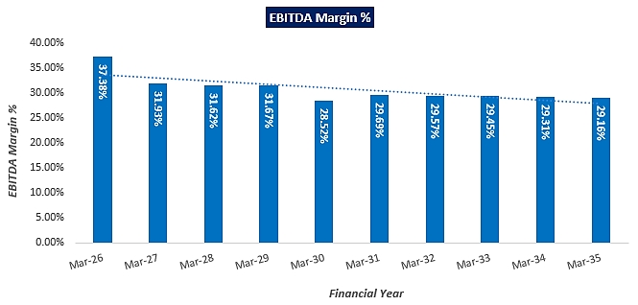
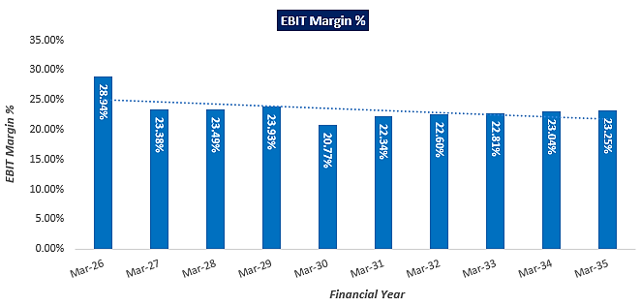
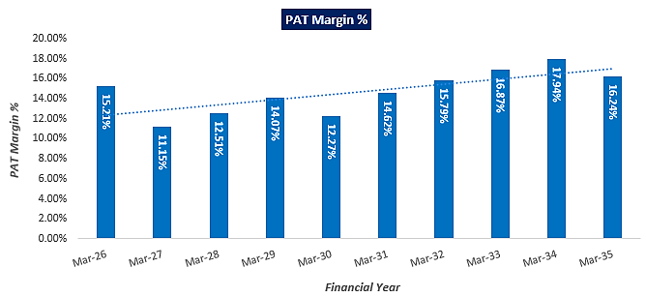
- ESTIMATED KEY FINANCIAL METRICS:
DEBT SERVICE COVERAGE RATIO (DSCR)

Year Ending | 31-Mar-26 | 31-Mar-27 | 31-Mar-28 | 31-Mar-29 | 31-Mar-30 | 31-Mar-31 | 31-Mar-32 | 31-Mar-33 | 31-Mar-34 | 31-Mar-35
Year | 1 | 2 | 3 | 4 | 5 | 6 | 7 | 8 | 9 | 10
Months | 6 | 12 | 12 | 12 | 12 | 12 | 12 | 12 | 12 | 12
Cash accrual | 3.53 | 5.68 | 6.22 | 6.86 | 6.32 | 6.85 | 7.45 | 8.08 | 8.74 | 8.39
Interest on term loan | 1.35 | 2.55 | 2.25 | 1.95 | 1.65 | 1.35 | 1.05 | 0.74 | 0.40 | 0.06
Interest on WC | 0.07 | 0.14 | 0.14 | 0.14 | 0.14 | 0.14 | 0.14 | 0.14 | 0.14 | 0.14
Subtotal | 4.96 | 8.38 | 8.61 | 8.96 | 8.12 | 8.34 | 8.64 | 8.96 | 9.28 | 8.60
Interest on term loan | 1.35 | 2.55 | 2.25 | 1.95 | 1.65 | 1.35 | 1.05 | 0.74 | 0.40 | 0.06
Interest on WC | 0.07 | 0.14 | 0.14 | 0.14 | 0.14 | 0.14 | 0.14 | 0.14 | 0.14 | 0.14
Loan Repayment | 0.00 | 3.16 | 3.16 | 3.16 | 3.16 | 3.16 | 3.16 | 3.41 | 3.70 | 2.37
Subtotal | 1.42 | 5.85 | 5.55 | 5.25 | 4.95 | 4.65 | 4.35 | 4.29 | 4.24 | 2.57
DSCR | 3.48 | 1.43 | 1.55 | 1.71 | 1.64 | 1.79 | 1.99 | 2.09 | 2.19 | 3.34
Avg. DSCR | 2.12
Max. DSCR | 3.48
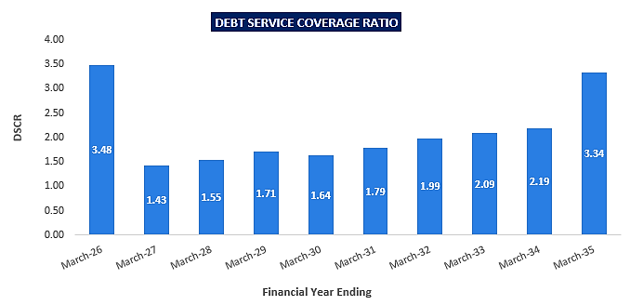

- NPV,IRR AND PAYBACK PERIOD OF THE PROJECT:
(INR Crore)
Year Ending | 31-Mar-25 | 30-Sep-25 | 31-Mar-26 | 31-Mar-27 | 31-Mar-28 | 31-Mar-29
Year Counter | 0 | 0 | 1 | 2 | 3 | 4
Months Counter | 7 | 6 | 6 | 12 | 12 | 12
EBIT | 0.00 | 0.00 | 3.86 | 6.30 | 6.64 | 7.11
Less: Taxes | 0.00 | 0.00 | 0.41 | 0.60 | 0.71 | 0.84
Add: Depreciation & Amortisation | 0.00 | 0.00 | 1.13 | 2.30 | 2.30 | 2.30
NOPAT | 0.00 | 0.00 | 4.58 | 8.00 | 8.23 | 8.58
Increase/(Decrease) in working capital | 0.00 | 0.00 | 2.83 | 0.23 | 0.15 | 0.16
Capex | 24.45 | 14.22 | 0.00 | 0.00 | 0.00 | 0.00
Free Cash Flow to Firm (FCFF) | -24.45 | -14.22 | 1.75 | 7.76 | 8.08 | 8.42
(Countinue)
Year Ending | 31-Mar-30 | 31-Mar-31 | 31-Mar-32 | 31-Mar-33 | 31-Mar-34 | 31-Mar-35
Year Counter | 5 | 6 | 7 | 8 | 9 | 10
Months Counter | 12 | 12 | 12 | 12 | 12 | 12
EBIT | 6.17 | 6.96 | 7.40 | 7.84 | 8.32 | 8.81
Less: Taxes | 0.73 | 0.91 | 1.04 | 1.16 | 1.30 | 2.45
Add: Depreciation & Amortisation | 2.30 | 2.29 | 2.28 | 2.28 | 2.26 | 2.24
NOPAT | 7.74 | 8.34 | 8.64 | 8.96 | 9.28 | 8.60
Increase/(Decrease) in working capital | 0.06 | 0.17 | 0.17 | 0.18 | 0.19 | 0.20
Capex | 0.00 | 0.00 | -0.10 | 0.00 | 0.00 | -0.31
Free Cash Flow to Firm (FCFF) | 7.68 | 8.17 | 8.37 | 8.78 | 9.09 | 8.08

Key Input for NPV & IRR
S. No. | Key Input | Description
 | Required Rate of Return | 8.50%
 | Project Risk Premium | 2%
 | Discount Rate | 10.50%
NPV |  | INR 5.53 Crore
IRR |  | 13.55%

WACC
Debt | 28.43
Equity | 12.84
Total Capital | 41.27
Weight of Debt Wd | 68.90%
Weight of Equity We | 31.10%
Cost of Debt (Kd) | 9.50%
Tax rate | 27.82%
Post tax Cost of debt | 6.86%
Cost of Equity (Ke) | 12.14% (Nifty Fifty 10 Year CAGR)
WACC | 8.50%

Payback Period of the Project
Financial Year | Cash Accrual | Accumulated Cash Accrual
Mar-26 | 3.53 | 3.53
Mar-27 | 5.68 | 9.22
Mar-28 | 6.22 | 15.43
Mar-29 | 6.86 | 22.30
Mar-30 | 6.32 | 28.62
Mar-31 | 6.85 | 35.47
Mar-32 | 7.45 | 42.92
Mar-33 | 8.08 | 51.00
Mar-34 | 8.74 | 59.73
Mar-35 | 8.39 | 68.13
Total | 68.13
Total Project Cost | INR 41.27 Crore
Payback Period | 6.28 Years
Thus, the project will be having a payback period of 6.28 years and NPV & IRR of the project is INR 5.53 Crore & 13.55% respectively from C.O.D to loan repayment period, which indicates worthiness of the project.
- SENSITIVITY ANALYSIS:
Sensitivity analysis of the project with respect to 10% decrease in the revenue, 10% increase in the cost of raw material and 2% increment in the proposed interest rate has been shown in the below table:

Sensitivity Analysis of D.S.CR, NPV & IRR
S. No. | Particular | Average D.S.C.R | IRR
 | As a base case | 2.12 | 13.55%
 | If the projected revenue decreased by 10% | 1.49 | 5.33%
 | If the projected Cost of raw material increased by 10% | 1.99 | 11.85%
 | If interest rate is increased by 2% | 1.98 | 13.68%
Observation: The proposed project is found comparatively higher sensitive with respect to the downside variation in the projected revenue, than the upside variation in the projected cost of raw material and any surge in the interest rate.
- OTHER FINANCIAL RATIOS:
Year Ending | 31-Mar-26 | 31-Mar-27 | 31-Mar-28 | 31-Mar-29 | 31-Mar-30 | 31-Mar-31 | 31-Mar-32 | 31-Mar-33 | 31-Mar-34 | 31-Mar-35
Return on Capital employed (%) | 9.62% | 15.75% | 16.45% | 17.19% | 14.73% | 16.09% | 16.43% | 16.64% | 16.23% | 15.35%
Average | 15.45%
Return on Investment (%) | 15.81% | 23.39% | 27.57% | 32.58% | 28.38% | 35.51% | 40.28% | 45.17% | 50.45% | 47.93%
Average | 34.71%
Return on Net Worth | 13.65% | 16.80% | 16.53% | 16.34% | 12.46% | 13.49% | 13.27% | 12.95% | 12.64% | 10.72%
Average | 13.89%
ISCR | 3.50 | 3.19 | 3.74 | 4.50 | 4.72 | 6.20 | 8.11 | 11.49 | 19.47 | 54.29
Average | 11.92
FACR | 1.49 | 1.59 | 1.74 | 1.94 | 2.24 | 2.75 | 3.90 | 9.02 | - | -
Average | 3.10
Current Ratio | 3.91 | 4.02 | 4.01 | 4.01 | 3.92 | 3.92 | 3.91 | 3.90 | 3.89 | 3.88
Average | 3.94
TOL/TNW | 2.32 | 1.66 | 1.20 | 0.86 | 0.63 | 0.45 | 0.32 | 0.20 | 0.10 | 0.05
Average | 0.78
Debt to Equity Ratio | 2.21 | 1.97 | 1.72 | 1.48 | 1.23 | 0.98 | 0.74 | 0.47 | 0.18 | 0.00
Average | 1.10

- BREAK-EVEN ANALYSIS:
(INR Crore)
Year Ending | 31-Mar-26 | 31-Mar-27 | 31-Mar-28 | 31-Mar-29 | 31-Mar-30 | 31-Mar-31 | 31-Mar-32 | 31-Mar-33 | 31-Mar-34 | 31-Mar-35
Year | 1 | 2 | 3 | 4 | 5 | 6 | 7 | 8 | 9 | 10
Months | 6 | 12 | 12 | 12 | 12 | 12 | 12 | 12 | 12 | 12
Sales | 13.34 | 26.93 | 28.28 | 29.73 | 29.69 | 31.17 | 32.73 | 34.37 | 36.09 | 37.89
Variable Expenses | 6.97 | 14.14 | 14.88 | 15.67 | 16.49 | 17.37 | 18.29 | 19.26 | 20.28 | 21.37
Contribution | 6.36 | 12.79 | 13.39 | 14.06 | 13.20 | 13.81 | 14.45 | 15.11 | 15.81 | 16.53
Fixed Expenses | 2.05 | 3.95 | 4.13 | 4.33 | 4.41 | 4.62 | 4.84 | 5.06 | 5.30 | 5.55
Profit / PBT | 4.31 | 8.84 | 9.26 | 9.73 | 8.78 | 9.19 | 9.61 | 10.05 | 10.50 | 10.97
PV RATIO | 47.70% | 47.49% | 47.36% | 47.29% | 44.45% | 44.29% | 44.14% | 43.97% | 43.80% | 43.61%
BEP Sales | 4.30 | 8.31 | 8.72 | 9.14 | 9.93 | 10.43 | 10.96 | 11.52 | 12.11 | 12.74
BEP% | 32.26% | 30.88% | 30.84% | 30.76% | 33.44% | 33.45% | 33.47% | 33.51% | 33.56% | 33.61%

- TERM LOAN INPUTS:
Term Loan Repayment Inputs
Total loan amount | INR 28.43 Crore
Interest During Construction | 9.50%
Rate of Interest | 9.50%
1st Disbursement | Nov-24
IDC Start & End Month | Nov-24 to Sep-25
IDC Period (construction period) | 11 Month
Commencement /Operation Start | Oct-25
Moratorium Start & End Month (only interest to pay) | Nov 2024 to March 2026
Moratorium Period after COD | 6 Month
Repayment Start | April-26
Repayment End | Sep-34
Repayment Period | 8.5 Years

(INR Crore)
Year Ending | 31-Mar-26 | 31-Mar-27 | 31-Mar-28 | 31-Mar-29 | 31-Mar-30 | 31-Mar-31 | 31-Mar-32 | 31-Mar-33 | 31-Mar-34 | 31-Mar-35
Year | 1 | 2 | 3 | 4 | 5 | 6 | 7 | 8 | 9 | 10
Months | 6 | 12 | 12 | 12 | 12 | 12 | 12 | 12 | 12 | 12
Opening Bal | 28.43 | 28.43 | 25.27 | 22.11 | 18.95 | 15.80 | 12.64 | 9.48 | 6.07 | 2.37
Disbursed | 0.00 | 0.00 | 0.00 | 0.00 | 0.00 | 0.00 | 0.00 | 0.00 | 0.00 | 0.00
Repayment | 0.00 | 3.16 | 3.16 | 3.16 | 3.16 | 3.16 | 3.16 | 3.41 | 3.70 | 2.37
Closing Principal o/s | 28.43 | 25.27 | 22.11 | 18.95 | 15.80 | 12.64 | 9.48 | 6.07 | 2.37 | 0.00
Interest | 1.35 | 2.55 | 2.25 | 1.95 | 1.65 | 1.35 | 1.05 | 0.74 | 0.40 | 0.06
IDC | 0.00 | 0.00 | 0.00 | 0.00 | 0.00 | 0.00 | 0.00 | 0.00 | 0.00 | 0.00
TL Interest | 1.35 | 2.55 | 2.25 | 1.95 | 1.65 | 1.35 | 1.05 | 0.74 | 0.40 | 0.06

- DEPRECIATION SCHEDULE (STRAIGHT LINE METHOD):
(INR Crore)
Particulars | Life Years | Amount | IDC & Cont. | Total COP | SLM Rate
Land Cost |  | 0.91 | 0.00 | 0.91 | 0.00%
Building & Civil Works | 30 | 9.14 | 0.41 | 9.56 | 3.17%
Plant & Machinery | 15 | 21.90 | 0.99 | 22.89 | 6.33%
Electricity Connection & Infrastructure | 10 | 3.96 | 0.18 | 4.14 | 9.50%
Vehicles | 8 | 0.32 | 0.01 | 0.33 | 11.88%
Office equipment & Furniture Fixtures | 5 | 0.10 | 0.00 | 0.10 | 19.00%
Misc. Fixed Asset | 15 | 0.70 | 0.03 | 0.73 | 6.33%
Cost of the Project |  | 37.03 | 1.63 | 38.66

(INR Crore)
Depreciation Schedule as per Company's Act, 2013
Particular | 31-Mar-26 | 31-Mar-27 | 31-Mar-28 | 31-Mar-29 | 31-Mar-30 | 31-Mar-31 | 31-Mar-32 | 31-Mar-33 | 31-Mar-34 | 31-Mar-35
Land | 0.91 | 0.91 | 0.91 | 0.91 | 0.91 | 0.91 | 0.91 | 0.91 | 0.91 | 0.91
Depreciation | 0.00 | 0.00 | 0.00 | 0.00 | 0.00 | 0.00 | 0.00 | 0.00 | 0.00 | 0.00
Building & Civil Works | 9.56 | 9.56 | 9.56 | 9.56 | 9.56 | 9.56 | 9.56 | 9.56 | 9.56 | 9.56
Depreciation | 0.15 | 0.30 | 0.30 | 0.30 | 0.30 | 0.30 | 0.30 | 0.30 | 0.30 | 0.30
Plant & Machinery | 22.89 | 22.89 | 22.89 | 22.89 | 22.89 | 22.89 | 22.89 | 22.89 | 22.89 | 22.89
Depreciation | 0.72 | 1.50 | 1.50 | 1.50 | 1.50 | 1.50 | 1.50 | 1.50 | 1.50 | 1.50
Electricity Connection & Infra. | 4.14 | 4.14 | 4.14 | 4.14 | 4.14 | 4.14 | 4.14 | 4.14 | 4.14 | 4.14
Depreciation | 0.20 | 0.39 | 0.39 | 0.39 | 0.39 | 0.39 | 0.39 | 0.39 | 0.39 | 0.39
Vehicles | 0.33 | 0.33 | 0.33 | 0.33 | 0.33 | 0.33 | 0.33 | 0.33 | 0.33 | 0.02
Depreciation | 0.02 | 0.04 | 0.04 | 0.04 | 0.04 | 0.04 | 0.04 | 0.04 | 0.02 | 0.00
Office equipment | 0.10 | 0.10 | 0.10 | 0.10 | 0.10 | 0.10 | 0.01 | 0.01 | 0.01 | 0.01
Depreciation | 0.01 | 0.02 | 0.02 | 0.02 | 0.02 | 0.01 | 0.00 | 0.00 | 0.00 | 0.00
Misc. Fixed Assets | 0.73 | 0.73 | 0.73 | 0.73 | 0.73 | 0.73 | 0.73 | 0.73 | 0.73 | 0.73
Depreciation | 0.02 | 0.05 | 0.05 | 0.05 | 0.05 | 0.05 | 0.05 | 0.05 | 0.05 | 0.05
Total SLM Depreciation | 1.13 | 2.30 | 2.30 | 2.30 | 2.30 | 2.29 | 2.28 | 2.28 | 2.26 | 2.24

- WORKING CAPITAL REQUIREMENT:
(INR Crore)
Year Ending | 31-Mar-26 | 31-Mar-27 | 31-Mar-28 | 31-Mar-29 | 31-Mar-30 | 31-Mar-31 | 31-Mar-32 | 31-Mar-33 | 31-Mar-34 | 31-Mar-35
Year | 1 | 2 | 3 | 4 | 5 | 6 | 7 | 8 | 9 | 10
Months | 6 | 12 | 12 | 12 | 12 | 12 | 12 | 12 | 12 | 12
Current Assets | 3.81 | 4.08 | 4.28 | 4.50 | 4.61 | 4.84 | 5.08 | 5.33 | 5.59 | 5.87
Current Liabilities | 0.97 | 1.02 | 1.07 | 1.12 | 1.17 | 1.24 | 1.30 | 1.37 | 1.44 | 1.51
Working Capital | 2.83 | 3.06 | 3.22 | 3.38 | 3.44 | 3.60 | 3.78 | 3.96 | 4.15 | 4.36
Margin @25% | 0.71 | 0.77 | 0.80 | 0.84 | 0.86 | 0.90 | 0.94 | 0.99 | 1.04 | 1.09
Working Capital gap | 2.12 | 2.30 | 2.41 | 2.53 | 2.58 | 2.70 | 2.83 | 2.97 | 3.12 | 3.27
CC Limit | 1.50 | 1.50 | 1.50 | 1.50 | 1.50 | 1.50 | 1.50 | 1.50 | 1.50 | 1.50

- KEY ASSUMPTIONS & BASIS:
S. No. | Item | Assumptions and Basis
 | General | - The projections of the firm are done for the period from FY 2026 to FY 2035, 9 years, to cover the term loan period as per the industry best practices. It is assumed that the plant will be achieving COD on 1st October 2025.  - We have considered both Revenue & cost based model (top to bottom approach) while making the future financial projections.  - Revenue modelling has been done based on the quantity of the proposed production as per the letter of intent (LOI) with the OMC (IOCL) and pricing circular of Compressed Bio Gas under SATAT scheme CO/AE&SD/01 dated 20th May 2022.  - Expense modelling has been done based on the required resources and current market inputs such as cost, supply etc. and few expenses projected as % of sales as per the best practice of the industry.  - The plant is assumed to be operational for 350 days for 24 hours annually, while operation days are 182 in FY 2026 due to implementation period till September 2025.
 | Revenue Build up | - Project will be generating the revenue by selling 6 TPD Bio-CNG to IOCL as per LOI with OMC dated 16th May 2024 (Ref: IndianOil/SATAT/01/3810), 20 TPD PROM (Phosphate Rich Organic Manure) as its by-products and 10 TPD Bio Mass pellet. Below table shows the Revenue of the LLP @ 100% capacity:  Revenue @100% capacity  Products Unit Price Annual Quantity Amount (INR)  Bio-CNG 70.48 INR/Kg 21,00,000 kg 14,80,08,000  PROM 10.00 INR/Kg 70,00,000 kg 7,00,00,000  Bio Pellet 7.50 INR/Kg 35,00,000 kg 2,62,50,000  Total Revenue (INR) 24,42,58,000  - Thus the LLP is expected to generate INR 24.42 Crore annual revenue. In the initial year there are 182 operating days and projected revenue of the LLP is 13.34 Cr. which is expected to increase up to INR 37.89 Crore till FY 2035.  - Revenue of the LLP is expected to grow at the rate of 5% Y-o-Y basis from FY 2028, since selling price are assumed to be inflated @5% during the forecasted period.  - Further, LLP has paid a GST of INR 4.71 Crore to commission the proposed plant, which has been adjusted as GST input from FY 2026 to FY 2030 and considered as other income for the LLP.
 | Pricing (Average Price Per Unit) | - Proposed selling price per unit of CBG and by-products are shown in the below table:  Selling price per unit  Products Unit prices  Selling price of Bio-CNG INR 70.48 per kg  Selling price of PROM INR 10.00 per kg  Selling price of Biomass Pellet INR 7.50 per kg  - LLP has already signed a LOI with Indian Oil Corporation Ltd dated 16th May 2024 (Ref: IndianOil/SATAT/01/3810). However signing commercial agreement between IOCL & LLP is in the process and Retail outlet for procurement will be allocated before C.O.D.  - As informed by the client, LLP has planned to sell its Bio CNG at Retail Outlets of IOCL in Saharanpur. The current retail selling price of CNG at OMC outlets in Saharanpur is around INR 93.96 per kg in August 2024. (https://www.v3cars.com/uttar-pradesh/cng-price-in-saharanpur), however the procurement price of Bio-CNG at Indian Oil as per the SATAT Scheme falls under the slab of INR 70.48 per kg without GST. Kindly refer “Section F” of the report for detailed proposed pricing arrangements.  - As per the shared agreement dated 1st June 2024 with M/s Anagram Development and farmers producers Private Ltd (FPO) for sale/handling of Bio-fertilizer produced at the proposed unit, Bio fertilizer (PROM) will be selling out at an agreed price of INR 10.00 per kg which is reasonable and competitive rate of the market. For reference, IPL Rohana CBG Plant is selling FOM @ INR 10 per kg in 20 kg bags at present.  - Biomass pellet will be sold to nearest thermal power plant in INR 7.50 per kg.  - An escalation factor of 5% has been considered in the prices of the sellable products during the forecasted periods considering the micro and macro-economic factors.
 | Capacity Utilization | - The proposed CBG generating plant will be commissioned with a Design capacity of 14,500 M3/Day which can generate ~6 TPD Bio CNG per day, LLP has proposed to operate the plant at 85% of the designed capacity to generate 6000 Kg Bio-CNG per day as per letter of Intent (LOI) with Indian Oil under SATAT scheme.
 | Capital Expenditure | - As per the land registry executed on 16th July 2024, partners of the LLP has purchased a 5.42 Acre (2.1960 Hectare) agricultural land at Khasra No, 725, 728, 727 & 729,, Vill - Faizabad, Pargana- Faizabad, Tehsil- Behat, Dist - Saharanpur -247122, Faizabad, Saharanpur, Taluka: Behat, District: Saharanpur, State, Uttar Pradesh, 247122. Total cost of the land registration would be INR 0.91 Crore including INR 10 lakhs for Change of land use (CLU) and other charges.  - As per the above table, the estimated cost of the Building & Civil works is ~INR 914.28 lakhs including applicable GST and 5% EPC consultant cost as per the signed agreement. Cost of the Building & Civil works has been considered on the basis of shared details/EPC contract provided to us by the client. As a TEV consultant we have checked major unit cost considered in EPC contract which we found in permissible range.  - The estimated cost for plant & machinery will be ~INR 2189.58 lakhs including applicable GST and 5% EPC fees. ~53% of TPC is the cost Plant & Machinery The estimated cost of the Plant & Machinery has been provided to us by the client as per EPC agreement. However, as a TEV consultant, the cost of major plant & machinery has been verified by us independently, which we found reasonable & in the permissible range although the cost may change as per specifications & brand. It is to be noted here that PROM Plant (150 TPD) and Biomass Pallet Plant (2 TPH) is out of scope of EPC agreement and cost of these items are considered based on the quotations shared by the client separately.  - The cost of Electrical, Instrumentation, PLC, data collection is INR 396.48 lakhs including GST & 5% EPC fess. Tentative cost of Off-site Facilities, vehicles and office equipment is INR 114.66 lakhs including applicable GST. We found that the costs are in the line with prevailing market standard.  - Cost of Misc. Fixed Asset is considered in the form of contingencies as INR 70 lakhs which is ~2% of Total hard cost. We recommend that the bank/financial institutions advice the company/LLP to submit actual cost based on the final quotations/invoices/bills. This will help validate the assertion of different costs considered by the client.  - As per the data/information provided by the Bank/client, applicable Interest rate during Construction (IDC) is 9.50% and LLP is required to pay INR 1.63 Crore as IDC from November 2024 till September 2025 (11 months) as per the proposed Loan repayment schedule.  - Preliminary & Pre-Operative Expenses has been considered based on the estimate of Project’s resources involvement as INR 1.90 Crore. However, LLP did not provide us any invoices/bills against these tentative costs considered. We recommend that the bank/financial institutions advice the LLP to submit actual cost based on the final quotations/invoices/bills. This will help validate the assertion of different costs considered by the client.  - Therefore, TPC of the proposed project is INR 41.27 Cr. including Biomass pellet plant and PROM plant. The project is proposed to be funded through a term loan of INR 28.43 crores and promoter’s Equity of INR 12.84 crores.  - Hence, INR 6.88 Crore per ton including land, GST, transportation IDC, pre-operative and preliminary expenses etc. will be the capex for this proposed plant, which seems reasonable and in the line with industrial and sectoral benchmarks after considering the fact that client is setting up PROM plant and Biomass pellet plant to customize its by-products.  As per Ministry of New and Renewable energy, the approx. CAPEX of installing a 5 TPD capacity CBG plant is estimated between INR 20-25 crore and ~75 80% of the CAPEX cost is for purchasing plant machinery. (https://cdn.cseindia.org/attachments/0.11235300_1687759489_cse---overview-and-current-status-of--cbg-in-india.pdf)
 | Expenses | - As per the agreement with M/s. Anagram Development and Farmer Producer Company Limited (FPO) on 1st June 2024 shared by the client, FPO will supply 100 ton per day Agriculture Residual/Napier grass and 40-50 ton per day Sugarcane press mud. However, Sugarcane press mud supply is depending on the availability and requirement of LLP.  - As per the agreement, rate of chopped Napier grass has been considered as INR 100 per quintals i.e. INR 1.00 per kg. Excluding INR 60 per ton for diesel expenses and promotional incentive of INR 20 per quintal to farmer for first year crop to compensate the yields. Thus the cost comes ~INR 1.50 per kg Escalation of 5% is considered during forecasted period.  - As per information provided by the client, estimated annual consumption of the power will be ~6,000 Kwh per day. Applicable tariff in Uttara Pradesh is INR 10 per Kwh. An escalation rate of 5% is assumed on it.  - As per the data/information provided by the client, ~28 employees will be deployed initially based on the requirement. 10% escalation rate has been considered on the salary & wages of the proposed manpower.  - Biomass Pellet Processing Charges and PROM Processing Charges are considered as INR 2.25 per kg and INR 6.50 per kg respectively as per the input provided by the management.  - As per informed by the client, Packaging cost of FOM is considered as INR 20 per 20 kg bag i.e. 1.00 per kg for PROM and INR 20 per 50 kg bag i.e. 0.40 per kg for Biomass pellet during projected period.  - Transportation cost has been considered as 3% of the total revenue after assessing the distance of proposed IOCL’s RO from the project location. Marketing & Selling & Distribution expenses has been considered as 1.50% of the revenue.  - Maintenance of the plant has been considered as per the industrial trends as shown in the below table:  Maintenance on Plant (% of Gross Block)  Civil 0.50%  P&M 0.50%  Electricity Infrastructure 0.50%  Vehicles 0.25%  Office equipment 0.25%  Misc. Fixed Assets 0.50%  - Plant & Administrative Overhead Expenses and Insurance Expenses are considered as 1.50% of revenue and 0.25% of net block respectively during the projected period.  - Other manufacturing expenses are considered as 1.50% of Revenue.  - Expenses for Occupational Health and Safety are considered as INR 10 lakhs annually after considering expected occurrence of hazardous situation.
 | Term Loan | - The project is proposed to be funded through a term loan of INR 28.43 crores and promoter’s margin of INR 12.84 crores.  - Interest rate has been considered as 9.50% on the term loan.  - Further, as per the working capital assessment, the working capital will require as INR 2.00 Crore, which will be funded through WC loan of INR 1.50 Cr. and promoter’s margin of INR 71 lakhs (~25% of required WC).

Key Findings:
      - Average DSCR, EBIDTA margin, EBIT margin is 2.12, 30.83%, and 23.46% respectively during the estimated period.
      - D.S.C.R of the proposed Bio CBG plant is found highly sensitive with respect to any downside fluctuation in the projected revenue.
      - The project is having a positive NPV and IRR of INR 5.53 Crore and 13.55% respectively from C.OD to loan repayment period while it may vary with changes in the assumptions & micro and macro-economic trends considered as on date.
      - The proposed project is having a payback period of 6.28 years.
      - Based on the above key financial ratios of the proposed Project during the forecasted period shows that the project appears financially viable if the promoters of the project are able to maintain assumed capacity utilization, revenue and can contain cost as assumed above in the calculation.

PART N | CONCLUSION

Based on the technological, economical and market analysis done above, various assumptions of sectoral trends taken, product pricing to be adopted by the company/LLP, the Project appears to be Techno-commercially viable subject to the risks, threats, weaknesses, limitations of the product as detailed previously.
As per financial projections for the estimated period, Average DSCR, EBITDA Margin and EBIT Margin of the project are 2.12, 30.83% and 23.46% respectively, where higher DSCR is the indicator of the project capability to pay out its outstanding debt and EBITDA margin shows the capability of the project to generate the operating profits over the forecasted period. Also the project is having the payback period of 6.28 Years in the line with sectoral trends.
The proposed Bio-CNG generating facility is having a positive NPV and IRR as INR 5.53 Crore and 13.55% respectively from C.O.D till loan repayment period as the industry is expectedly growing at a CAGR of 6.34% during the forecasted period. While it is not avoidable that the future projections may change in the upcoming years due to various factors impacting the operation, managerial, financial efficiency and economies of scale of the project.
While it would be depending on the management’s capability in future that how efficiently promoters adopts marketing and advertisement strategy, supply chain and carry out inventory & resource management to achieve higher profitability. After considering the foreseen demand of the Bio CNG and its by-products domestically and globally, various initiatives taken by the government, financial analysis of the project based on the assumptions taken over the projected period, it appears reasonable to comment that the proposed project is “Technically and Economically” Viable subject to current assumptions considered and occurring the same in the upcoming years same as the forecasted period which is dependent on the sincerity and efforts of the management and various micro and macroeconomic & industry situation.
We have tried our level best to analyse the Project techno-economic feasibility of the Project based on the Industry research, Project information and various futuristic assumption taken within the limitations and challenges came in front of us. However achieving the financial milestones depends on the ability, sincerity and efforts of the LLP, promoters and its key management to maintain the projected revenue level Y-o-Y basis keeping the fact in mind that the project is found sensitive with respect to the down side fluctuation in the revenue.

Declaration | - The undersigned does not have any direct/indirect interest in the above property/project/Company/LLP.  - The information furnished herein is true and correct to the best of our knowledge, logical and scientific assumptions.  - This TEV Report is carried out by our Financial Analyst team on the request from M/s NRS Biofuels Energies LLP.  - Meeting of Financial projections will be subject to the market & economy stability factors, judicious business operations and proper & timely implementation of the project and putting proper plan for achieving high productivity, efficiency and achieving cost saving benefits to increase profitability.  - We have submitted TEV report to M/s NRS Biofuels Energies LLP.
Number of Pages in the Report | 102
Enclosed Documents | Disclaimer & Remarks 96-99
Place | Noida
Date | 20th October 2024

FOR ON BEHALF OF
M/S. R.K. ASSOCIATES VALUER & TECHNO ENGINEERING CONSULTANTS PVT. LTD.
SURVEYED BY | PREPARED BY | REVIEWED BY
Mr. Sachin Pandey | Mr. Gaurav Kumar | Mr. Rachit Gupta

PART O | DISCLAIMER | REMARKS

      - No employee or member of R.K Associates has any direct/ indirect interest in the Project.
      - This report is prepared based on the copies of the documents/ information which the Bank/ Company has provided to us out of the standard checklist of documents sought from them and further based on our assumptions and limiting conditions. The client/owner and its management/representatives warranted to us that the information they supplied was complete, accurate and true and correct to the best of their knowledge. All such information provided to us has been relied upon in good faith and we have assumed that it is true and correct in all respect. I/We shall not be liable for any loss, damages, cost or expenses arising from fraudulent acts, misrepresentations, or wilful default on part of the owner, company, its directors, employee, representative or agents. Verification or cross checking of the documents provided to us from the originals or from any Govt. departments/ Record of Registrar has not been done at our end since this is beyond the scope of our work. If at any time in future, it is found or came to our knowledge that misrepresentation of facts or incomplete or distorted information has been provided to us then this report shall automatically become null & void.
      - Legal aspects for e.g. investigation of title, ownership rights, lien, charge, mortgage, lease, sanctioned maps, verification of documents, etc. have not been done at our end and same has to be taken care by legal expert/ Advocate. It is assumed that the concerned Lender/ Financial Institution has satisfied them with the authenticity of the documents, information given to us and for which the legal verification has been already taken and cleared by the competent Advocate before requesting for this report. I/ We assume no responsibility for the legal matters including, but not limited to, legal or title concerns.
      - This report is a general analysis of the project based on the scope mentioned in the report. This is not an Audit report, Design document, DPR or Techno feasibility study. All the information gathered is based on the facts seen on the site during survey, verbal discussion & documentary evidence provided by the client and is believed that information given by the company is true best of their knowledge.
      - This Techno Economic-Viability study is prepared based on certain futuristic assumption which are intra dependent on economic, market and sectorial growth condition in future and socio-economic, socio-political condition at macro and micro level.
      - Meeting of assumption and financial ratio will entirely depend on the sincerity and efforts of the company, promoters and its key managerial performance.
      - All observations mentioned in the report is only based on the visual observation and the documents/ data/ information provided by the client. No mechanical/ technical tests, measurements or any design review have been performed or carried out from our side during Project assessment.
      - This report has been diligently prepared by our techno-financial team to the best of their ability. However, it's important to note that the recommendations provided in this Total Economic Viability (TEV) assessment do not imply an endorsement, validation, or certification of the accuracy or completeness of the disclosed information by the involved stakeholders. Furthermore, we do not claim or endorse that the opinions presented herein are the sole best course of action for decision-makers to follow. There may exist additional approaches and inputs that have not been covered within this report or fall outside the scope of this report.
      - Bank/FII should ONLY take this report as an Advisory document from the Financial/ Chartered Engineering firm and its specifically advised to the creditor to cross verifies the original documents for the facts mentioned in the report which can be availed from the borrowing company directly.
      - In case of any default in loans or the credit facility extended to the borrowing company, R.K Associates shall not be held responsible for whatsoever reason may be and any request for seeking any explanation from the employee/s of R.K Associates will not be entertained at any instance or situation.
      - The documents, information, data provided to us during the course of this assessment by the client are reviewed only up to the extent required in relation to the scope of the work. No document has been reviewed beyond the scope of the work.
      - This report only contains general assessment & opinion as per the scope of work evaluated as per the information given in the copy of documents, information, data provided to us and/ and confirmed by the owner/ owner representative to us at site which has been relied upon in good faith. It doesn’t contain any other recommendations of any sort including but not limited to express of any opinion on the suitability or otherwise of entering into any transaction with the borrower.
      - We have relied on data from third party, external sources & information available on public domain also to conclude this report. These sources are believed to be reliable and therefore, we assume no liability for the truth or accuracy of any data, opinions or estimates furnished by others that have been used in this analysis. Where we have relied on data, opinions or estimates from external sources, reasonable care has been taken to ensure that such data has been correctly extracted from those sources and /or reproduced in its proper form and context, however still we can’t vouch its authenticity, correctness or accuracy.
      - This Report is prepared by our competent technical team which includes Engineers and financial experts & analysts.
      - This is just an opinion report and doesn’t hold any binding on anyone. It is requested from the concerned Financial Institution which is using this report for taking financial decision on the project that they should consider all the different associated relevant & related factors also before taking any business decision based on the content of this report.
      - All Pages of the report including annexure are signed and stamped from our office. In case any paper in the report is without stamp & signature then this should not be considered a valid paper issued from this office.
      - Though adequate care has been taken while preparing this report as per its scope, but still we can’t rule out typing, human errors, over sightedness of any information or any other mistakes. Therefore, the concerned organization is advised to satisfy themselves that the report is complete & satisfactory in all respect. Intimation regarding any discrepancy shall be brought into our notice immediately. If no intimation is received within 15 (Fifteen) days in writing from the date of issuance of the report, to rectify these timely, then it shall be considered that the report is complete in all respect and has been accepted by the client up to their satisfaction & use and further to which R.K Associates shall not be held responsible in any manner.
      - Defect Liability Period is 15 DAYS. We request the concerned authorized reader of this report to check the contents, data and calculations in the report within this period and intimate us in writing if any corrections are required or in case of any other concern with the contents or opinion mentioned in the report. Corrections only related to typographical, calculation, spelling mistakes, incorrect data/ figures/ statement will be entertained within the defect liability period. Any new changes for any additional information in already approved report will be regarded as additional work for which additional fees may be charged. No request for any illegitimate change in regard to any facts & figures will be entertained.
      - R.K Associates encourages its customers to give feedback or inform concerns over its services through proper channel at valuers@rkassociates.org in writing within 15 days of report delivery. After this period no concern/ complaint/ proceedings in connection with the Techno- Economic Viability Study Services will be entertained due to possible change in situation and condition of the subject Project.
      - Our Data retention policy is of ONE YEAR. After this period, we remove all the concerned records related to the assignment from our repository. No clarification or query can be answered after this period due to unavailability of the data.
      - This Techno Economic Viability Study report is governed by our (1) Internal Policies, Processes & Standard Operating Procedures, (2) Information/ Data/ Inputs given to us by the client and (3) Information/ Data/ Facts given to us by our field/ office technical team. Management of R.K Associates never gives acceptance to any unethical or unprofessional practice which may affect fair, correct & impartial assessment and which is against any prevailing law. In case of any indication of any negligence, default, incorrect, misleading, misrepresentation or distortion of facts in the report then it is the responsibility of the user of this report to immediately or at least within the defect liability period bring all such act into notice of R.K Associates management so that corrective measures can be taken instantly.
      - R.K Associates never releases any report doing alterations or modifications from pen. In case any information/ figure of this report is found altered with pen then this report will automatically become null & void.
      - If this report is prepared for the matter under litigation in any Indian court, no official or employee of R.K Associates will be under any obligation to give in person appearance in the court as a testimony. For any explanation or clarification, only written reply can be submitted on payment of charges by the plaintiff or respondent which will be 10% of the original fees charged where minimum charges will be Rs. 15,000/.

EXTRACTS OF IMPORTANT STATUTORY APPROVALS PROVIDED BY THE CLIENT

