**File No.: VIS(2024-25)-PL042-040-052 Dated: 16.05.2024**

**PROJECT STATUS REPORT**

**OF**

**160 MT PER DAY RICE MILL**

**SITUATED AT**

**M/S JANKI DASS OVERSEAS PRIVATE LIMITED, VILLAGE-NARAINA (H.B. NO.60), TEHSIL-NILOKHERI, DISTRICT-KARNAL, HARYANA**

**OWNER**

**M/S JANKI DASS OVERSEAS PRIVATE LIMITED**

**REPORT PREPARED FOR**

**PUNJAB NATIONAL BANK, CORPORATE BANKING BRANCH,**

**94 BMK MARKET, PANIPAT**

***\*\*Important - In case of any query/ issue or escalation you may please contact Incident Manager at le@rkassociates.org. We will appreciate your feedback in order to improve our services.***

***NOTE: As per IBA Guidelines please provide your feedback on the report within 15 days of its submission after which report will be considered to be correct.***

|  |  |  |
| --- | --- | --- |
| **TABLE OF CONTENTS** | | |
| **SR. NO.** | **DESCRIPTION** | **PAGE NO.** |
| **PART A** | **Report Summary** | **03** |
| **PART B** | **Introduction** | **04** |
|  | 1. The Project | **04** |
|  | 1. Location of the Project | **04** |
|  | 1. Project Overview | **05** |
|  | 1. Scope of the Project During Project Duration | **06** |
|  | 1. Purpose of the Report | **06** |
|  | 1. Methodology Adopted | **06** |
| **PART C** | **Plant Infrastructure Sections & Facility Details with Actual Progress** | **07** |
|  | 1. Land Details | **07** |
|  | 1. Building/Structure details | **07** |
|  | 1. Machinery and Equipment | **08** |
|  | 1. Current Status | **09** |
| **PART D** | **Project Cost and Means of Finance** | **10** |
|  | 1. Cost of Project | **10** |
|  | 1. Sources of Finance & Utilization of Funds | **10** |
| **PART E** | **Statutory & Regulatory Approvals, Clearances & NOC** | **11** |
| **PART F** | **Disclaimer** | **12** |
|  | **Enclosure** | **16** |
|  | **Photographs** | **24-28** |

# 

# IMPORTANT NOTICE

***COPYRIGHT FORMAT:*** *This report is prepared on the copyright format of R.K Associates, to serve our clients with the best available information and analysis to facilitate them to take rational business decisions. Legally no one can copy or distribute this format without prior approval from R.K Associates. It is meant only for the advisory/ reference purpose for the organization/s as mentioned on the cover page of this report. Distribution or use of this format by any organization or individual other than R.K Associates will be seen as unlawful act and necessary legal action can be taken against the defaulters.*

*This report is intended for the sole use of the intended recipient/s and contain material that is STRICTLY CONFIDENTIAL AND PRIVATE.*

***DEFECT LIABILITY PERIOD:*** *- In case of any query/ issue or escalation you may please contact Incident Manager: le@rkassociates.org. We try our level best to ensure correctness in the calculations done, rates adopted and various other data points & information mentioned in the report but still can’t rule out typing, human errors or any other mistakes. In case you find any such mistake or inaccuracy in any data point of the report please help us by bringing all such points into our notice immediately or within 15 days of the report delivery in writing, to rectify these timely failing after which R.K Associates won’t be held responsible for any such inaccuracy in any manner. We would highly appreciate your feedback in order to improve our services.*

|  |  |
| --- | --- |
| **PART A** | **REPORT SUMMARY** |

|  |  |  |
| --- | --- | --- |
| **1.** | **Name of Project:** | M/s Janki Dass Overseas Pvt. Ltd. |
| **2.** | **Project Location:** | Village-Naraina (H.B. No.60), Tehsil-Nilokheri, District-Karnal, Haryana |
| **3.** | **Name of the Owner:** | M/s Janki Dass Overseas Pvt. Ltd. |
| **4.** | **Director’s/Partner’s:** | Mr. Ayush Singla  Mr. Shivam Singla  Mr. Anish Singla |
| **5.** | **Prepared for Bank:** | Punjab National Bank, Corporate Banking Branch, 94 BMK Market, Panipat |
| **6.** | **Report Consultant Firm:** | M/s. R.K. Associates Valuers & Techno Engineering Consultants (P) Ltd. |
| **7.** | **Date of Survey:** | 24th April 2024 |
| **8.** | **Date of Report:** | 16th May 2024 |
| **9.** | **Purpose of the Report:** | To provide fair detailed analysis report to the Bank based on the “in-scope points” mentioned below for facilitating them to know the current status of the Project. |
| **10.** | **Scope of the work provided by the Lender:** | 1. Review Project physical status |
| **11.** | **Documents perused for Proposal:** | 1. Copy of NoCs 2. Copy of sale Bill & E Way Bill 3. Copy of GST Return Filed 4. Copy of Deisel Bill 5. Copy of FSSAI License |
| **12.** | **Annexure with the report:** | 1. Copy of NoCs 2. Copy of sale Bill & E Way Bill 3. Copy of GST Return Filed 4. Copy of Deisel Bill 5. Copy of FSSAI License |

|  |  |
| --- | --- |
| **PART B** | **INTRODUCTION** |

1. **THE PROJECT:**

**M/S Janki Dass Overseas Pvt. Ltd.** has set up a new 08 TPH Rice Mill along with its associated machinery at Village-Naraina (H.B. No.60), Tehsil-Nilokheri, District-Karnal, Haryana. The unit is equipped to process 160 MT per day paddy to rice via rice milling plant. To know the Project progress bank has appointed M/s R.K Associates Valuers & Techno Engineering Consultants (P) Ltd. to review physical progress & current status of the plant based upon physical inspection & documents provided.

1. **PROJECT LOCATION:**

Details about Location of Unit is as below:

|  |  |
| --- | --- |
| **Particulars** | **Description** |
| **Postal Address** | |
| M/S Janki Dass Overseas Pvt. Ltd. Khasra No. 14/21/1, 22/1, 2, 3, 4, 5min, 7, 8, 9, 10, 11, 12, 20, 23/16, 17, 18/1, Village-Naraina (H.B. No.60), Tehsil-Nilokheri, District-Karnal, Haryana *(Khasra numbers taken as per documents provided to us)* | |
| **Location** | |
| Plant is located in rural village area. Nearby properties are moistly agricultural lands. Also, there are multiple rice mills and small industries located in the area. | |
| **Google Coordinates** | |
| Latitude | 29°46'37.8"N |
| Longitude | 76°53'45.9"E |
| **Connectivity System** | |
| Road | The subject plant has a ~20 feet wide uneven approach road named Village Road which further connects to Jammu-Delhi Highway at distance of 07 km from the subject project. |
| Rail | The Nearest Railway station to the subject locality is Taraori Railway Station which is about 6 Km from the Subject Project. |
| Air | The nearest International Airport to the subject project is IGI Airport which is about 164 Km from the subject project. |
| **Geographical Conditions of The Site** | |
| Temperature | The area has generally Tropical monsoon climate. The maximum temperature is around 110°F while the minimum is 45°F. |
| Rainfall | The average annual rainfall of this area is about 627 mm. |
| Seismic Zone | The above plant site area falls in Seismic Zone II. |

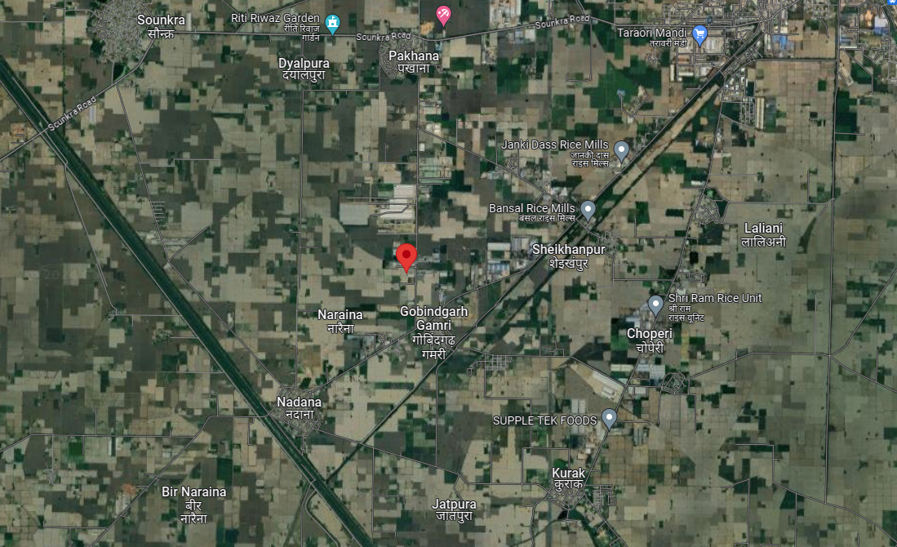

**Figure: Location of Manufacturing Unit**

1. **PROJECT OVERVIEW:**

**M/S Janki Dass Overseas Pvt. Ltd.** has set up a new 160 MT per day Rice Mill along with its associated machinery at Village-Naraina (H.B. No.60), Tehsil-Nilokheri, District-Karnal, Haryana. The unit is proposed to process 08 ton per hours paddy to rice via rice milling plant. The plant is developed on total land area 13.58 Acre (as per documents provided to us).

The cost of project is estimated to be Rs.15.94 Cr. which broadly consists of Rs. 1.00 Crore in Building & Civil works, and Rs.10.41 Crore in Plant & Machinery. Land has been taken on lease for a period of 10 years.

As per observation made during the site visit, major production shed has been completed and Plant & Machinery has been installed. According to Architect Map some of the buildings such as admin block, canteen, rear paddy shed, labour quarters are not constructed and will be constructed in future. Company has installed Buhler Rice Plant. Sortex machine has been taken from Satake Manufacturing (SUZHOU), China.

As per site inspection it was observed that internal development works like roads are yet to be done. Plant was found partially operated for trial during the site visit. Machines which were shown operational during site visit were sortex machine, Electric panels, Milling Plant, Cyclones, Cleaner, Destoner, Huskers, Separator, Rice Whitener, Wet Scrubber, Dryers, ETP, transformers, DG Set, Compressor etc.

As per acknowledgement of application of new connection letter, the company has applied for 750.00 kw of new electricity connection from Uttar Haryana Bijli Vitran Nigam Limited.

1. **SCOPE OF WORK DURING PROJECT DURATION:**
2. Project physical status review
3. **PURPOSE OF THE REPORT:** To provide fair detailed analysis report to the Bank based on the “in-scope points” mentioned above for facilitating them to know the current Project status.
4. **METHODOLOGY ADOPTED:**
5. Study of Project Planning documents/ reports to know about the Project.
6. Additional information, data, documents collection from the borrower.
7. Site Inspection.
8. Review and analysis of the documents and information obtained from the borrower and corroborating it with the site inspection status.
9. Information compilation, analysis and reporting.

|  |  |
| --- | --- |
| **PART C** | **PLANT INFRASTRUCTURE SECTIONS & FACILITY DETAILS WITH ACTUAL PROGRESS** |

1. **LAND DETAILS:** As per copy of lease deed no. 1954 dated 17-11-2023 between Smt. Sushila Devi and M/s Janki Dass Overseas Private Limited, the land admeasuring 108K-14.5 M or 13.58 acre is leased for a period of 10 years at Rs. 5,000/- per annum starting from 22-08-2023 to 31-05-2033.
2. **BUILDINGS/STRUCTURES DETAILS**: We have been provided an Architect layout plan dated 15th June 2023 of Vivek Consultants, which comprises of multiple building structure and supporting infrastructure. Copy approved sanction plan is not shared with us. Details of the buildings observed during the site inspection are as follows: -

|  |  |  |  |  |
| --- | --- | --- | --- | --- |
| **As Per Site Survey Dated 24th April 2024** | | | | |
| **Building Name** | **Area in**  **Sq. mtr.** | **Height**  **in ft.** | **Type of Structure** | **Status** |
| Shed-1 | 1,755 | 30 | GI shed over RCC walls | As on date site visit, the construction work was completed and related machines had been installed there. |
| Shed-2 | 1,755 | 30 |
| Shed-3 | 2,457 | 30 |
| D.G. & Transformer shed | 16 | 13 | GI shed over wall |
| ETP | 80 | - | RCC |
| Admin Block | - | - | - | To be constructed |
| Pavement | - | - | - | To be constructed |

**Notes:**

1. The Physical progress captured in the report is on approximate basis as per status of structures observed on site during site inspection and shown in terms of existence not in terms of matching measurements.
2. Buildings such as admin block, canteen, rear paddy shed, labour quarters as mentioned in Architect Map will be constructed in future.
3. During site visit it was observed that the construction work was completed expect some internal development work and Rice Mill Machines has been installed.
4. **MACHINERIES, OTHER EQUIPMENTS & UTILITIES:**

In the subject poultry project, following list of plant and machinery is proposed:

|  |  |  |
| --- | --- | --- |
| **S. No.** | **Description** | **Supplier Name** |
| 1 | Complete Milling Plant 16MTPΗ | Buhler (India) Pvt. Ltd. Bangalore |
| 2 | Dryer | Shri Vinayaka Rice Techno |
| 3 | Boiler | Star Boiler Pvt. Ltd. |
| 4 | DG set | Karan Power System Pvt. Ltd. |
| 5 | Sortex | --- |
| 6 | Machinery Structure & Foundation & elevator | --- |
| 7 | ETP | --- |
| 8 | Electrical panel, Transformer, Security, Servo, Cables and lab equipment | --- |

The status as on date 08/01/2024 is as below:-

|  |  |  |  |  |  |
| --- | --- | --- | --- | --- | --- |
| **S. No** | **Particulars** | **Supplier/Company** | **Status Achieved** | | |
| **Purchased** | **Received on site** | **Installed** |
| 1 | Complete Milling Plant 16MTPΗ | Buhler (India) Pvt. Ltd. Bangalore | Z:\In Progress Files\Abhinav Chaturvedi\Check.png | Z:\In Progress Files\Abhinav Chaturvedi\Check.png | Z:\In Progress Files\Abhinav Chaturvedi\Check.png |
| 2 | Dryer | Shri Vinayaka Rice Techno | Z:\In Progress Files\Abhinav Chaturvedi\Check.png | Z:\In Progress Files\Abhinav Chaturvedi\Check.png | Z:\In Progress Files\Abhinav Chaturvedi\Check.png |
| 3 | Boiler | Star Boiler Pvt. Ltd. | Z:\In Progress Files\Abhinav Chaturvedi\Check.png | Z:\In Progress Files\Abhinav Chaturvedi\Check.png | Z:\In Progress Files\Abhinav Chaturvedi\Check.png |
| 4 | DG set | Sudhir Power Ltd. | Z:\In Progress Files\Abhinav Chaturvedi\Check.png | Z:\In Progress Files\Abhinav Chaturvedi\Check.png | Z:\In Progress Files\Abhinav Chaturvedi\Check.png |
| 5 | Sortex | Satake Manufacturing (Suzhou) Co. Ltd. | Z:\In Progress Files\Abhinav Chaturvedi\Check.png | Z:\In Progress Files\Abhinav Chaturvedi\Check.png | Z:\In Progress Files\Abhinav Chaturvedi\Check.png |
| 6 | Machinery Structure & Foundation & elevator | --- | Z:\In Progress Files\Abhinav Chaturvedi\Check.png | Z:\In Progress Files\Abhinav Chaturvedi\Check.png | Z:\In Progress Files\Abhinav Chaturvedi\Check.png |
| 7 | ETP | --- | Z:\In Progress Files\Abhinav Chaturvedi\Check.png | Z:\In Progress Files\Abhinav Chaturvedi\Check.png | Z:\In Progress Files\Abhinav Chaturvedi\Check.png |
| 8 | Electrical panel, Transformer, Security, Servo, Cables and lab equipment | --- | Z:\In Progress Files\Abhinav Chaturvedi\Check.png | Z:\In Progress Files\Abhinav Chaturvedi\Check.png | Z:\In Progress Files\Abhinav Chaturvedi\Check.png |

**Note:**

1. The major machineries/ equipment’s mentioned in the above table have arrived on the site and installation of the same have been completed, as observed during the survey date 24th April 2024.
2. Copy of CA Certificate is not shared with us.

**Note:**

* The above assessment is done cumulatively as per site survey observation.
* Company has not started boiler as testing is not done and boiler certificate is not received yet.
* Only Physical progress have been assessed. Cost verification is not done from our end.
* During site visit, only electricity connection work was in-progress.
* As per information shared during the site visit, the plant became operational on 15th March 2024 via DG Sets even though the electricity connection was not done then.
* Copy of diesel bill no. 7318 dated 02-03-2024 from HP P.L. Petro Station Taraori is shared with us.
* To support their claim, the company has shared, copy of Invoice No. B2B-01 dated 17th March 2024 against M/s Goel International Pvt. Ltd. of Rs. 2,23,900/-.
* Apart from shared invoice, company has also shared March 2024 GST Return filed dated 11th April 2024 against the total sale value of Rs. 3,34,47,614/-.
* Based on the information provided by the company, it can be assumed that the plant may have become **operational on 15th March 2024.**

|  |  |
| --- | --- |
| **PART D** | **PROJECT COST & MEANS OF FINANCE** |

1. **TOTAL PROJECT COST:** M/s Janki Dass Overseas Pvt. Ltd. has estimated the Total Project Cost amounting to Rs. 15.94 Cr. Detailed bifurcation of same is as follows: -

|  |  |
| --- | --- |
| **Particulars** | **In Rs. (In Cr.)** |
| Land | Land Taken on lease from Smt. Sushila Devi |
| Building | 1.00 |
| Plant and machineries | 10.41 |
| Security Deposit | 0.10 |
| Pre-Operative Expenses | 0.23 |
| Margin Money for Working Capital | 4.20 |
| **Total** | **15.94** |

***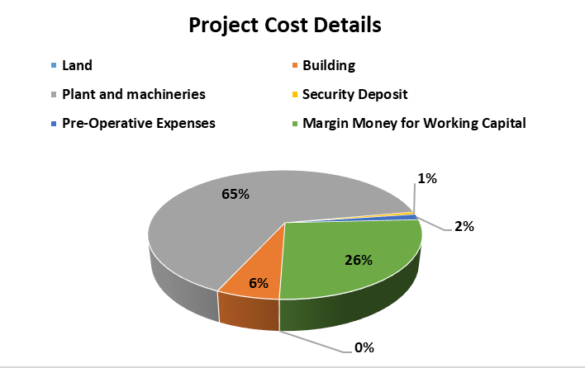***

1. **SOURCES OF FINANCE & UTILIZATION OF FUNDS:**

The Project cost mentioned above has been planned to be covered from following resources:

|  |  |
| --- | --- |
| (Amount in Rs. Crore) | |
| PARTICULARS |  |
| Capital | **5.00** |
| Term Loan | **3.44** |
| Unsecured loan | **7.50** |
| TOTAL | **15.94** |

***Source:*** *As per PNB Appendix-VI.*

|  |  |
| --- | --- |
| **PART E** | **STATUTORY & REGULATORY APPROVALS, CLEARANCES & NOC** |

|  |  |  |  |
| --- | --- | --- | --- |
| Sr. No. | NAME OF LICENSE/ REGISTRATION/ ISSUING AUTHORITY | DATE OF ISSUE/ LICENCE NO. | CURRENT STATUS |
|  | NoC for Land | Memo No. NOC-12140A/PK/STP/2394/2023 dated 03-07-2023 | Received |
| Senior Town Planner, Panchkula |
|  | Certificate of Incorporation | Identification no. U10612HR2023PTC112643 dated 19-06-2023 | Received |
| Ministry Of Corporate Affairs |
|  | GST Registration Certificate | Registration Number: 06AAGCJ0472L1ZG dated 12-09-2023 | Received |
| Government of India |
|  | Layout Plan | Unapproved architect plan dated 15-June-2023 | Approved plan yet to be obtained |
| Vivek Consultants |
|  | Grant of consent to Establish | No. HSPCB/Consent/: 313283123KARCTE41214297  Dated 17-08-2023 | Received |
| Haryana State Pollution Control Board |
|  | Electricity connection | Company had applied for Electricity Connection via application no. L21-1223-51 dated 09-12-2023 | Applied For |
| Uttar Haryana Bijli Vitran Nigam Ltd. |
|  | FSSAI License | License No. 10823010000185 dated 24-07-2023 valid till 23-07-2024 | Received |
| Government of Haryana |
| *Observations & Comments:*   * *Above are the major approvals as provided by the company which are not exhaustive in nature.* * *Copy of approved layout plan is not shared with us.* * *Copy of Boiler Certificate is not shared with us.* | | | |

|  |  |
| --- | --- |
| **PART F** | **DISCLAIMER** |

* + - 1. No employee or member of R.K Associates has any direct/ indirect interest in the Project.
      2. This report is prepared based on the copies of the documents/ information which the Bank/ Borrower has provided to us out of the standard checklist of documents sought from them and further based on our assumptions and limiting conditions. The client/owner and its management/representatives warranted to us that the information they supplied was complete, accurate and true and correct to the best of their knowledge. All such information provided to us has been relied upon in good faith and we have assumed that it is true and correct in all respect. I/We shall not be liable for any loss, damages, cost or expenses arising from fraudulent acts, misrepresentations, or wilful default on part of the owner, borrower, its directors, employee, representative or agents. Verification or cross checking of the documents provided to us from the originals or from any Govt. departments/ Record of Registrar has not been done at our end since this is beyond the scope of our work. If at any time in future, it is found or came to our knowledge that misrepresentation of facts or incomplete or distorted information has been provided to us then this report shall automatically become null & void.
      3. Legal aspects for eg. investigation of title, ownership rights, lien, charge, mortgage, lease, sanctioned maps, verification of documents, etc. have not been done at our end and same has to be taken care by legal expert/ Advocate. It is assumed that the concerned Lender/ Financial Institution has satisfied them with the authenticity of the documents, information given to us and for which the legal verification has been already taken and cleared by the competent Advocate before requesting for this report. I/ We assume no responsibility for the legal matters including, but not limited to, legal or title concerns.
      4. This report is a general analysis of the project based on the scope mentioned in the report. This is not an Audit report, Design document, DPR or Techno feasibility study. All the information gathered is based on the facts seen on the site during survey for the quarter ending September 2023, verbal discussion & documentary evidence provided by the client and is believed that information given by the borrower is true best of their knowledge.
      5. All observations mentioned in the report is only based on the visual observation and the documents/ data/ information provided by the client. No mechanical/ technical tests, measurements or any design review have been performed or carried out from our side during Project assessment.
      6. Bank/FII should ONLY take this report as an Advisory document from the Financial/ Chartered Engineering firm and its specifically advised to the creditor to cross verify the original documents for the facts mentioned in the report which can be availed from the borrowing borrower directly.
      7. In case of any default in loans or the credit facility extended to the borrowing borrower, R.K Associates shall not be held responsible for whatsoever reason may be and any request for seeking any explanation from the employee/s of R.K Associates will not be entertained at any instance or situation.
      8. The documents, information, data provided to us during the course of this assessment by the client is reviewed only upto the extent required in relation to the scope of the work. No document has been reviewed beyond the scope of the work.
      9. This report only contains general assessment & opinion as per the scope of work evaluated as per the information given in the copy of documents, information, data provided to us and/ and confirmed by the owner/ owner representative to us at site which has been relied upon in good faith. It doesn’t contain any other recommendations of any sort including but not limited to express of any opinion on the suitability or otherwise of entering into any transaction with the borrower.
      10. We have relied on data from third party, external sources & information available on public domain also to conclude this report. These sources are believed to be reliable and therefore, we assume no liability for the truth or accuracy of any data, opinions or estimates furnished by others that have been used in this analysis. Where we have relied on data, opinions or estimates from external sources, reasonable care has been taken to ensure that such data has been correctly extracted from those sources and /or reproduced in its proper form and context, however still we can’t vouch its authenticity, correctness or accuracy.
      11. This Report is prepared by our competent technical team which includes Engineers and financial experts & analysts.
      12. This is just an opinion report and doesn’t hold any binding on anyone. It is requested from the concerned Financial Institution which is using this report for taking financial decision on the project that they should consider all the different associated relevant & related factors also before taking any business decision based on the content of this report.
      13. All Pages of the report including annexures are signed and stamped from our office. In case any paper in the report is without stamp & signature then this should not be considered a valid paper issued from this office.
      14. Though adequate care has been taken while preparing this report as per its scope, but still we can’t rule out typing, human errors, over sightedness of any information or any other mistakes. Therefore, the concerned organization is advised to satisfy themselves that the report is complete & satisfactory in all respect. Intimation regarding any discrepancy shall be brought into our notice immediately. If no intimation is received within 15 (Fifteen) days in writing from the date of issuance of the report, to rectify these timely, then it shall be considered that the report is complete in all respect and has been accepted by the client upto their satisfaction & use and further to which R.K Associates shall not be held responsible in any manner.
      15. Defect Liability Period is **15 DAYS**. We request the concerned authorized reader of this report to check the contents, data and calculations in the report within this period and intimate us in writing if any corrections are required or in case of any other concern with the contents or opinion mentioned in the report. Corrections only related to typographical, calculation, spelling mistakes, incorrect data/ figures/ statement will be entertained within the defect liability period. Any new changes for any additional information in already approved report will be regarded as additional work for which additional fees may be charged. No request for any illegitimate change in regard to any facts & figures will be entertained.
      16. R.K Associates encourages its customers to give feedback or inform concerns over its services through proper channel at valuers@rkassociates.org in writing within 15 days of report delivery. After this period no concern/ complaint/ proceedings in connection with the Financial Feasibility Study Services will be entertained due to possible change in situation and condition of the subject Project.
      17. Our Data retention policy is of **ONE YEAR**. After this period, we remove all the concerned records related to the assignment from our repository. No clarification or query can be answered after this period due to unavailability of the data.
      18. This Project Status Report is governed by our (1) Internal Policies, Processes & Standard Operating Procedures, (2) Information/ Data/ Inputs given to us by the client and (3) Information/ Data/ Facts given to us by our field/ office technical team. Management of R.K Associates never gives acceptance to any unethical or unprofessional practice which may affect fair, correct & impartial assessment and which is against any prevailing law. In case of any indication of any negligence, default, incorrect, misleading, misrepresentation or distortion of facts in the report then it is the responsibility of the user of this report to immediately or at least within the defect liability period bring all such act into notice of R.K Associates management so that corrective measures can be taken instantly.
      19. R.K Associates never releases any report doing alterations or modifications from pen. In case any information/ figure of this report is found altered with pen then this report will automatically become null & void.

|  |  |  |
| --- | --- | --- |
| **SURVEY ANALYST** | **ENGINEERING ANALYST** | **REVIEWER** |
| Deepak Kumar Singh | Abhinav Chaturvedi | Sr. VP Projects |
|  |  |  |

**For**

**R.K. Associates Valuers and Techno Engineering Consultants Pvt. Ltd**

**Place: Noida**

**Date: 16th May 2024**

***DEFECT LIABILITY PERIOD - In case of any query/ issue or escalation you may please contact Incident Manager by writing at valuers@rkassociates.org. We ensure 100% accuracy in the Calculations done, Rates adopted and various other data points & information mentioned in the report but still can’t rule out typing, human errors or any other mistakes. In case you find any mistake, variation, discrepancy or inaccuracy in any data point of the report, please help us by bringing all such points into our notice in writing at valuers@rkassociates.org within 30 days of the report delivery, to get these rectified timely, failing which R.K Associates Valuers Techno Engineering Consultants (P) Ltd. won’t be held responsible for any inaccuracy in any manner. Also, if we will not hear back anything from you within 30 days, we will assume that report is correct in all respect and no further claim of any sort will be entertained thereafter. We would welcome and appreciate your feedback & suggestions in order to improve our services.***

***COPYRIGHT FORMAT - This report is prepared on the copyright format of R.K Associates Valuers Techno Engineering Consultants (P) Ltd. to serve our clients in the best possible way. Legally no one can copy or distribute this format without prior approval from R.K Associates. It is meant only for the organization as mentioned on the cover page of this report. Distribution or use of this format other than R.K Associates will be seen as unlawful act and necessary legal action can be taken against the defaulter.***

**ENCLOSURE 1: IMPORTANT DOCUMENTS EXHIBIT**

**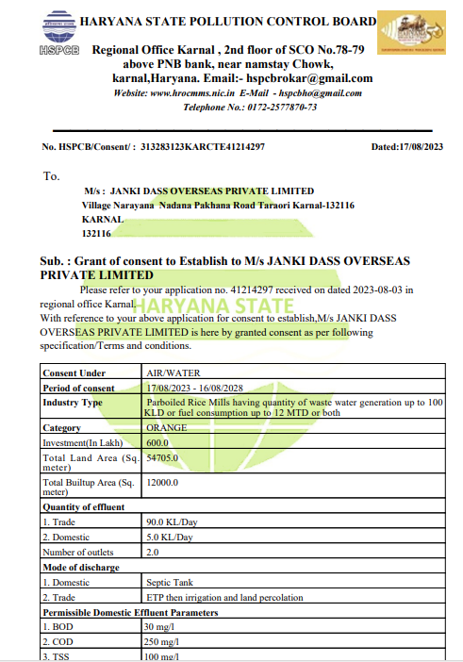**

**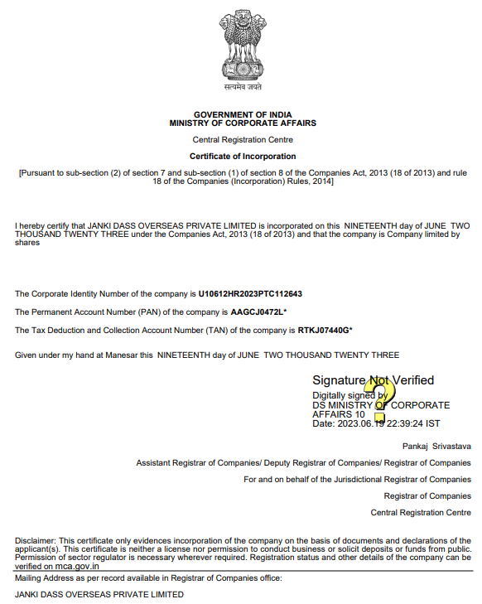**

**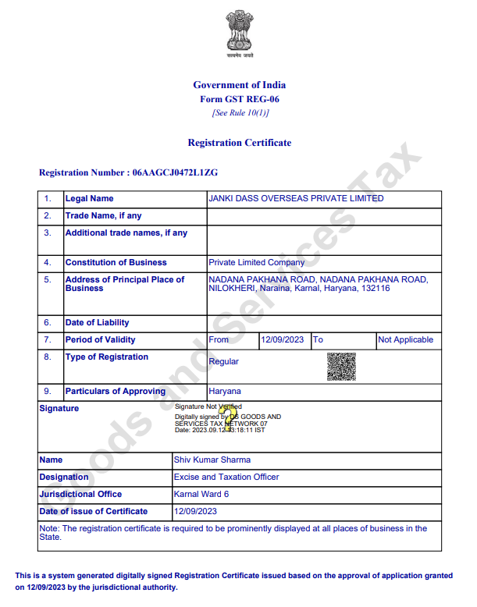**

**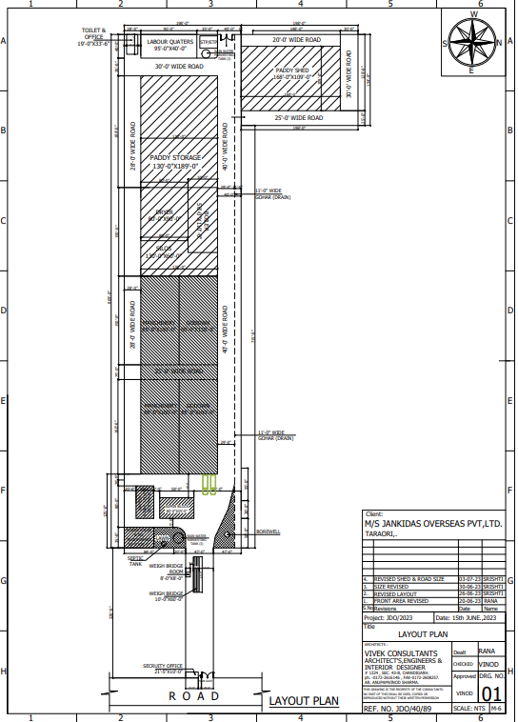**

**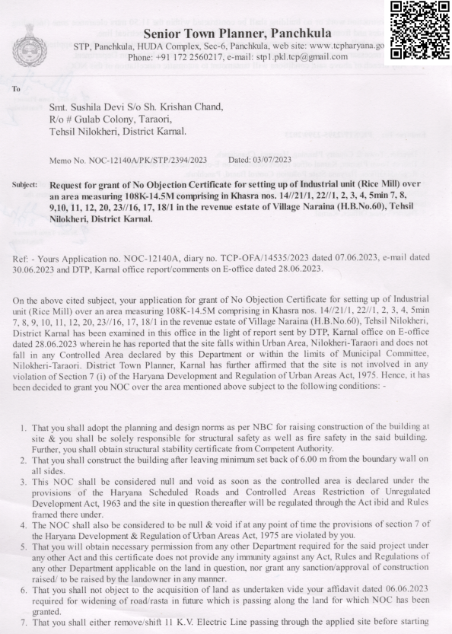**

**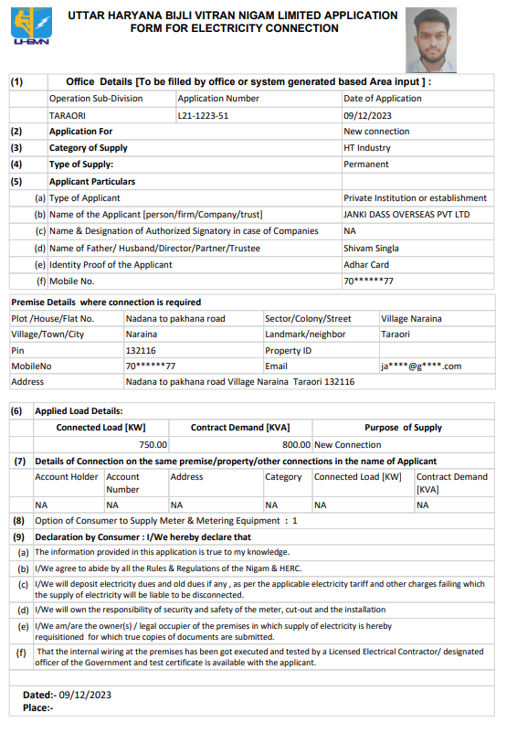**

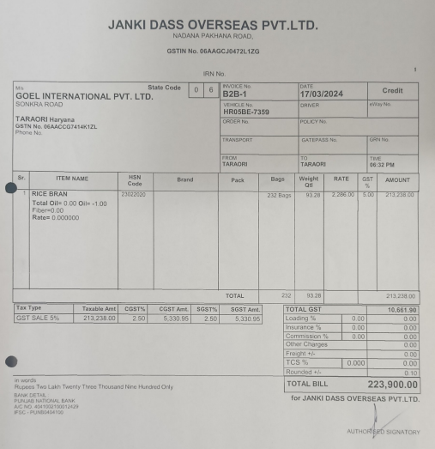

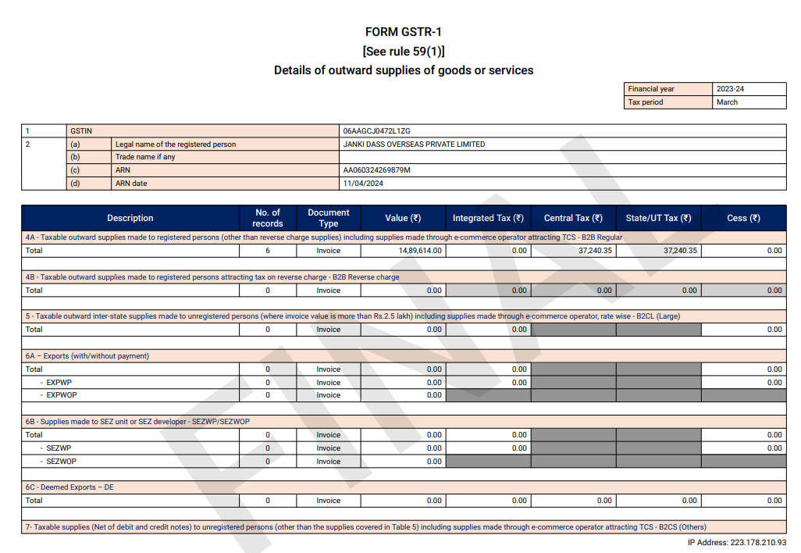

**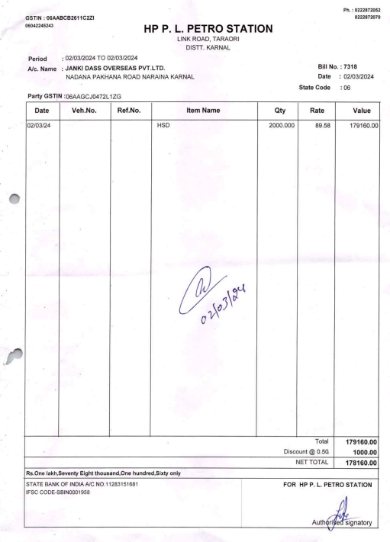**

**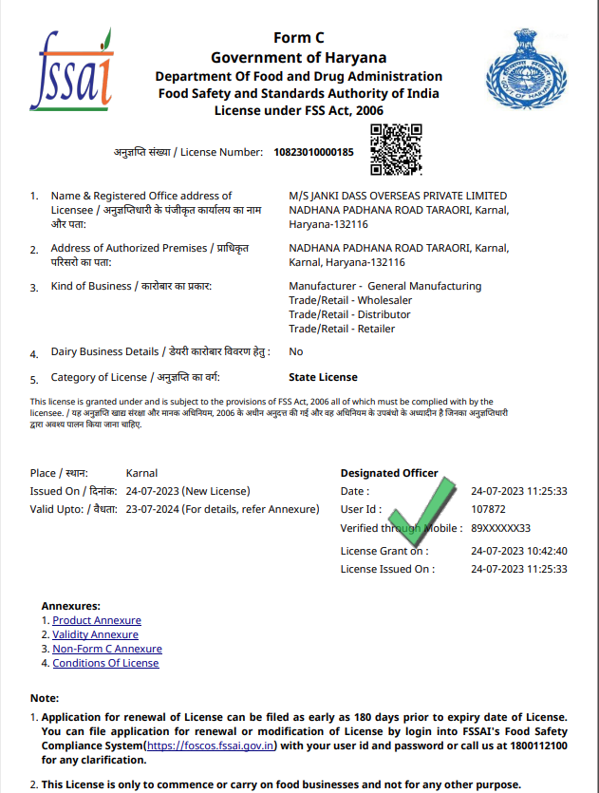**

**ENCLOSURE-2: - SITE PHOTOGRAPHS**

Bui

|  |  |
| --- | --- |
| E:\Abhinav Chaturvedi's Assignments\In-Progress\VIS(2024-25)-PL042-040-052_Janki Daas Overseas\SiteImage\TimePhoto_20240426_162418.jpg | E:\Abhinav Chaturvedi's Assignments\In-Progress\VIS(2024-25)-PL042-040-052_Janki Daas Overseas\SiteImage\TimePhoto_20240426_162508.jpg |
| E:\Abhinav Chaturvedi's Assignments\In-Progress\VIS(2024-25)-PL042-040-052_Janki Daas Overseas\SiteImage\TimePhoto_20240426_162848.jpg | E:\Abhinav Chaturvedi's Assignments\In-Progress\VIS(2024-25)-PL042-040-052_Janki Daas Overseas\SiteImage\TimePhoto_20240426_162908.jpg |
| E:\Abhinav Chaturvedi's Assignments\In-Progress\VIS(2024-25)-PL042-040-052_Janki Daas Overseas\SiteImage\TimePhoto_20240426_163102.jpg | E:\Abhinav Chaturvedi's Assignments\In-Progress\VIS(2024-25)-PL042-040-052_Janki Daas Overseas\SiteImage\TimePhoto_20240426_164111.jpg |

|  |  |
| --- | --- |
| E:\Abhinav Chaturvedi's Assignments\In-Progress\VIS(2024-25)-PL042-040-052_Janki Daas Overseas\SiteImage\TimePhoto_20240426_164143.jpg | E:\Abhinav Chaturvedi's Assignments\In-Progress\VIS(2024-25)-PL042-040-052_Janki Daas Overseas\SiteImage\TimePhoto_20240426_164220.jpg |
| E:\Abhinav Chaturvedi's Assignments\In-Progress\VIS(2024-25)-PL042-040-052_Janki Daas Overseas\SiteImage\TimePhoto_20240426_164242.jpg | E:\Abhinav Chaturvedi's Assignments\In-Progress\VIS(2024-25)-PL042-040-052_Janki Daas Overseas\SiteImage\TimePhoto_20240426_164352.jpg |
| E:\Abhinav Chaturvedi's Assignments\In-Progress\VIS(2024-25)-PL042-040-052_Janki Daas Overseas\SiteImage\TimePhoto_20240426_164559.jpg | E:\Abhinav Chaturvedi's Assignments\In-Progress\VIS(2024-25)-PL042-040-052_Janki Daas Overseas\SiteImage\TimePhoto_20240426_164645.jpg |

|  |  |
| --- | --- |
| E:\Abhinav Chaturvedi's Assignments\In-Progress\VIS(2024-25)-PL042-040-052_Janki Daas Overseas\SiteImage\TimePhoto_20240426_164818.jpg | E:\Abhinav Chaturvedi's Assignments\In-Progress\VIS(2024-25)-PL042-040-052_Janki Daas Overseas\SiteImage\TimePhoto_20240426_164825.jpg |
| E:\Abhinav Chaturvedi's Assignments\In-Progress\VIS(2024-25)-PL042-040-052_Janki Daas Overseas\SiteImage\TimePhoto_20240426_164951.jpg | E:\Abhinav Chaturvedi's Assignments\In-Progress\VIS(2024-25)-PL042-040-052_Janki Daas Overseas\SiteImage\TimePhoto_20240426_165217.jpg |
| E:\Abhinav Chaturvedi's Assignments\In-Progress\VIS(2024-25)-PL042-040-052_Janki Daas Overseas\SiteImage\TimePhoto_20240426_165432.jpg | E:\Abhinav Chaturvedi's Assignments\In-Progress\VIS(2024-25)-PL042-040-052_Janki Daas Overseas\SiteImage\TimePhoto_20240426_165843.jpg |

|  |  |
| --- | --- |
| E:\Abhinav Chaturvedi's Assignments\In-Progress\VIS(2024-25)-PL042-040-052_Janki Daas Overseas\SiteImage\TimePhoto_20240426_170003.jpg | E:\Abhinav Chaturvedi's Assignments\In-Progress\VIS(2024-25)-PL042-040-052_Janki Daas Overseas\SiteImage\TimePhoto_20240426_170103.jpg |
| E:\Abhinav Chaturvedi's Assignments\In-Progress\VIS(2024-25)-PL042-040-052_Janki Daas Overseas\SiteImage\TimePhoto_20240426_170158 - Copy.jpg | E:\Abhinav Chaturvedi's Assignments\In-Progress\VIS(2024-25)-PL042-040-052_Janki Daas Overseas\SiteImage\TimePhoto_20240426_170439.jpg |
| E:\Abhinav Chaturvedi's Assignments\In-Progress\VIS(2024-25)-PL042-040-052_Janki Daas Overseas\SiteImage\TimePhoto_20240426_170608.jpg | E:\Abhinav Chaturvedi's Assignments\In-Progress\VIS(2024-25)-PL042-040-052_Janki Daas Overseas\SiteImage\TimePhoto_20240426_170655.jpg |

|  |  |
| --- | --- |
| E:\Abhinav Chaturvedi's Assignments\In-Progress\VIS(2024-25)-PL042-040-052_Janki Daas Overseas\SiteImage\TimePhoto_20240426_170736.jpg | E:\Abhinav Chaturvedi's Assignments\In-Progress\VIS(2024-25)-PL042-040-052_Janki Daas Overseas\SiteImage\TimePhoto_20240426_171048.jpg |
| E:\Abhinav Chaturvedi's Assignments\In-Progress\VIS(2024-25)-PL042-040-052_Janki Daas Overseas\SiteImage\TimePhoto_20240426_165915.jpg | E:\Abhinav Chaturvedi's Assignments\In-Progress\VIS(2024-25)-PL042-040-052_Janki Daas Overseas\SiteImage\TimePhoto_20240426_170819.jpg |
| E:\Abhinav Chaturvedi's Assignments\In-Progress\VIS(2024-25)-PL042-040-052_Janki Daas Overseas\SiteImage\TimePhoto_20240426_171104.jpg | E:\Abhinav Chaturvedi's Assignments\In-Progress\VIS(2024-25)-PL042-040-052_Janki Daas Overseas\SiteImage\TimePhoto_20240426_171034.jpg |