**File No.: VIS (2024-25)-PL057-050-069 Dated: 13.05.2024**

**COMPOUNDING AREA ASSESSMENT REPORT**

**OF**

**M/s. LA ROCHE HOTELS & RESORTS**

****

**SITUATED AT**

**KHASRA NO. 279 KHA, 283, 284, 269, 282, 268KHA, 275KHA, 268KA, 281, 270, 272, 273, 274, MAUZA MALSI DEHRADUN**

**IMPLEMENTED BY**

**MR. AMARJEET SINGH & MR. PARVINDER SINGH**

**REPORT PREPARED FOR**

**PNB, RACECOURSE, DEHRADUN**

***\*\*Important - In case of any query/ issue or escalation you may please contact Incident Manager at le@rkassociates.org. We will appreciate your feedback in order to improve our services.***

***NOTE: As per IBA Guidelines please provide your feedback on the report within 15 days of its submission after which report will be considered to be correct.***

|  |  |  |
| --- | --- | --- |
| **TABLE OF CONTENTS** | | |
| **SR. NO.** | **DESCRIPTION** | **PAGE NO.** |
| **PART A** | **Report Summary** | **03** |
| **PART B** | **Introduction** | **04** |
|  | **Project Overview** | **04** |
|  | **Methodology Adopted** | **05** |
| **PART C** | **Project Sanctioned & Proposed Plan Details** | **06** |
|  | **Project Area Details** | **06** |
|  | **Sanctioned and Proposed Plan Layout** | **06** |
| **PART D** | **Actual Construction and Sanctioned Map Details** | **09** |
| **PART E** | **Disclaimer** | **11** |
| **PART I** | **Enclosure** | **15** |
| **PART J** | **Photograph** | **19** |

# 

***IMPORTANT NOTICE***

***COPYRIGHT FORMAT:*** *This report is prepared on the copyright format of R.K Associates, to serve our clients with the best available information and analysis to facilitate them to take rational business decisions. Legally no one can copy or distribute this format without prior approval from R.K Associates. It is meant only for the advisory/ reference purpose for the organization/s as mentioned on the cover page of this report. Distribution or use of this format by any organization or individual other than R.K Associates will be seen as unlawful act and necessary legal action can be taken against the defaulters.*

*This report is intended for the sole use of the intended recipient/s and contain material that is STRICTLY CONFIDENTIAL AND PRIVATE.*

***DEFECT LIABILITY PERIOD:*** *- In case of any query/ issue or escalation you may please contact Incident Manager: le@rkassociates.org. We try our level best to ensure correctness in the calculations done, rates adopted and various other data points & information mentioned in the report but still can’t rule out typing, human errors or any other mistakes. In case you find any such mistake or inaccuracy in any data point of the report please help us by bringing all such points into our notice immediately or within 15 days of the report delivery in writing, to rectify these timely failing after which R.K Associates won’t be held responsible for any such inaccuracy in any manner. We would highly appreciate your feedback in order to improve our services.*

|  |  |
| --- | --- |
| **PART A** | **REPORT SUMMARY** |

|  |  |  |
| --- | --- | --- |
| **1.** | **Name of Project:** | **M/s. La Roche Hotels & Resorts,** Mussoorie Road, Malsi, Dehradun, Uttarakhand. |
| **2.** | **Project Location:** | Khasra No. 279 Kha, 283, 284, 269, 282, 268kha, 275kha, 268ka, 281, 270, 272, 273, 274, Mauza Malsi Dehradun |
| **3.** | **Name of the Borrower:** | M/s. La Roche Hotels & Resorts |
| **4.** | **Director’s/Partner’s:** | Mr. Amarjeet Singh & Mr. Parvinder Singh |
| **5.** | **Prepared for Bank:** | PNB, Racecourse, Dehradun |
| **6.** | **CE Consultant Firm:** | M/s. R.K. Associates Valuers & Techno Engineering Consultants (P) Ltd. |
| **7.** | **Date of Survey:** | 02nd and 15th of May 2024. |
| **8.** | **Date of Report:** | 13th of May 2024 |
| **9.** | **Purpose of the Report:** | To provide Progress report to the Bank based on the “in-scope points” mentioned below for facilitating them to take appropriate credit decision on the Project. |
| **10.** | **Scope of the work provided by the Lender:** | 1. To verify the construction if it is as per the sanctioned plan / map and report deviation if any. 2. Whether extra constructed area is under the MDDA compounding limits or not. |
| **11.** | **Documents perused for Proposal:** | 1. Brief description of the project. 2. Site Plan 3. Revised site plan |
| **12.** | **Annexure with the report:** | 1. Sanctioned Site/Layout plan 2. Revised site/Layout plan |

|  |  |
| --- | --- |
| **PART B** | **INTRODUCTION** |

1. **PROJECT OVERVIEW:**

M/s. La Roche Hotels & Resorts is establishing a Taj branded 113 keys hotel in Dehradun, Uttarakhand with the total revised covered area of 13,051.57 sq. mtr.

As per the information gathered during site visit through the representative of owner the subject hotel was being built for Radisson Blu. But at present it is being built for Taj Hotel. Therefore, some changes have been proposed as per the requirement of the Taj Hotels management. These changes were observed during the site visit and have been enumerated in the succeeding paragraph of the report.

1. **Status of Project as on 02/05/2024:** The project is currently under final stage of construction. While main building construction is completed, construction of extra covered area i.e. the porches at GF is in progress and some finishing work in upper floor is under progress. Construction of the project stared during March 2022 as per the information gathered from the representative of owner.

1. **Project Location:**

Details about Location of Unit is as below:

|  |  |
| --- | --- |
| **Particulars** | **Description** |
| **Land Area Details** | |
| Khasra No. 279 Kha, 283, 284, 269, 282, 268kha, 275kha, 268ka, 281, 270, 272, 273, 274, Mauza Malsi Dehradun | |
| **Google Coordinates** | |
| Latitude | 30°22'29.9"N |
| Longitude | 78°04'38.7"E |
| **Connectivity.** | |
| Road | The subject property can be easily accessible from the Mussoorie Road. |
| Rail | The Nearest Railway station is Dehradun Railway Station which is about approximately 9 Km from the Subject Project. |
| Air | The nearest airport is, Jolly Grant Airport, Dehradun and is approximately 36 kilometres from the subject property. |
| Bus Terminal | The nearest bus stand is available ~14 kilometres from the subject property |

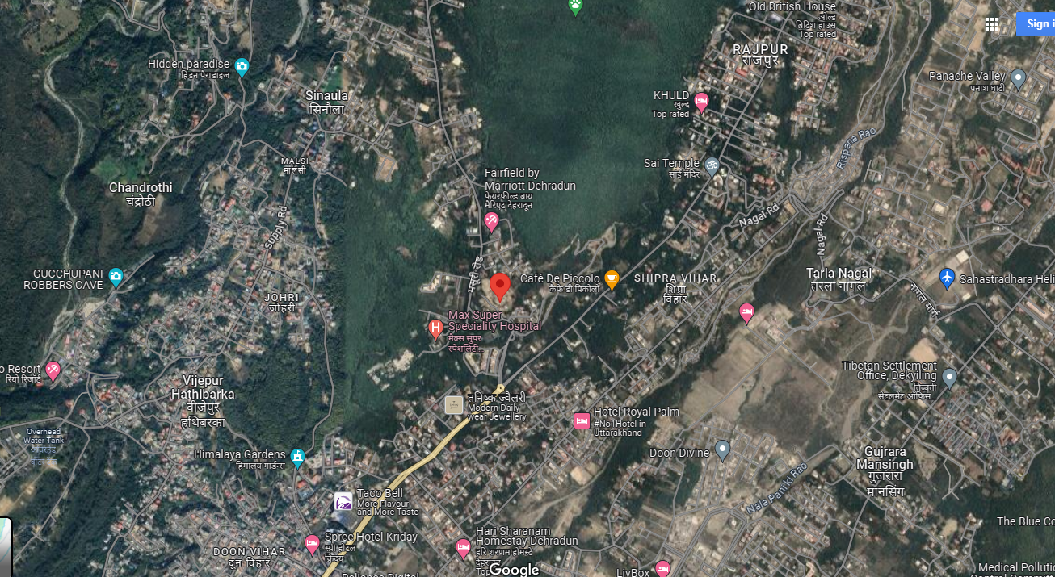

**Source: Google Maps**

**Figure: Location of Hotel**

1. **METHODOLOGY ADOPTED:**
2. Study of Project Planning documents/ reports, Sanctioned plan and proposed revised plan

to know about the Project.

1. Additional information, data, documents collection from the borrower.
2. Site Inspection.
3. Review and analysis of the documents with the information obtained from the rep of client and corroborating it with the current status of the project.
4. Information compilation, analysis and reporting.
5. Verification of structure and extra coverage/ deviation at the time of visit

|  |  |
| --- | --- |
| **PART C** | **PROJECT SANCTIONED & PROPOSED PLAN DETAILS** |

1. **PROJECT AREA DETAILS:**

|  |  |  |  |
| --- | --- | --- | --- |
| **S. No.** | **Floor** | **Area per the Sanctioned Plan**  ***(sq. mtr.)*** | **Area as planned to be proposed for compounding. (*sq. mtr.)*** |
|  | Lower Basement 3 | 2739.20 | 2739.20 |
|  | Lower Basement 2 | 2764.56 | 2764.56 |
|  | Lower Basement 1 | 2577.77 | 2577.77 |
|  | Ground Floor | 2537.94 | 3488.23 |
|  | Mezzanine Floor | 604.78 | 604.78 |
|  | First Floor | 1424.22 | 1602.90 |
|  | Services Floor | 1424.22 | 1424.22 |
|  | Second Floor | 1394.03 | 1482.86 |
|  | Third Floor | 1394.03 | 1482.86 |
|  | Fourth Floor | 13**9**4.03 | 1482.86 |
|  | Fifth/ Terrace Floor | 1394.03 | 1482.86 |
| **Total** | | **19648.81** | **21133.1** |

1. **SANCTIONED & PROPOSED PLAN LAYOUT:** As per the sanctioned plan provided to us the subject property is 3 Basement+Ground+4 upper storied building as per FAR 1.338 (including 20% for the Green Building) designed for the Radisson Blu hotel. However later the promoter changed the plan and constructing the subject property as per the requirement of Taj Hotel due to which few changes in building plan are planned to be proposed for compounding. Construction, therefore is progressing as per revised plan and hence deviation noted from the approved plan. Refer to the plan attached below: -
2. 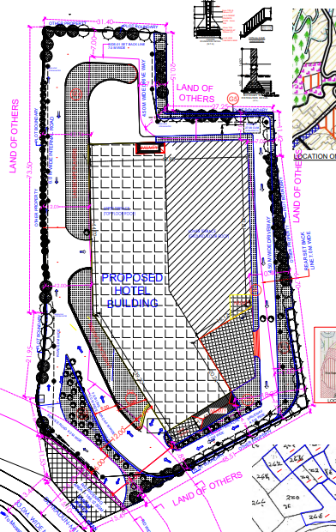**Sanctioned Plan:**
3. **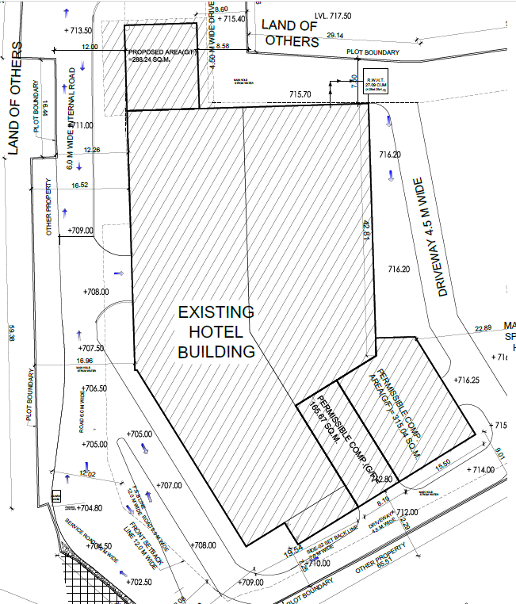Plan Planned to be Proposed for Compounding.**

|  |  |
| --- | --- |
| **PART D** | **ACTUAL CONSTRUCTION vs. SANCTIONED MAP DETAILS** |

1. **CURRENT STATUS OF CONSTRUCTION**: At the time of site visit it is observed that the superstructure of the building is completed and finishing work is in progress in upper floors. Also on ground floor two porches are being constructed which are in addition as per original plan.

|  |  |  |
| --- | --- | --- |
| **Sr. No.** | Particulars | Progress as on 15/05/2024 |
|  | Basement | Super Structure completed finishing & electric work is in progress. |
|  | Ground Floor | White wash in progress in banquet hall & finishing of Kitchen & Porches is in progress |
|  | Mezzanine Floor | False ceiling & electric fitting work is in progress. |
|  | First Floor | Finishing of Kitchen & Restaurant along with the fitting of wooden work is in progress. |
|  | Second Floor | Finishing of structures & fitting of wooden work is in progress. |
|  | Third Floor | Finishing of structures & fitting of wooden work is in progress. |
|  | Fourth Floor | Finishing of structures & fitting of wooden work is in progress. |

1. **DEVIATION OBSERVED FROM SANCTIONED PLAN**: The deviations/ differences in superstructure as compare to the site sanctioned plan dated 07/08/2021 were observed which are as under.
2. 3rd Lower Basement no deviation observed.
3. 2nd Lower Basement no deviation observed.
4. 1st Lower Basement no deviation observed.
5. Ground Floor. Two Porches have been added of area 950.29 sq. mtr.
6. 1st Floor Restaurant of Size 178.68 sq. mtr. have been added over the porch area.
7. 2nd Floor Balcony area 2 mtr wide taken in the rooms. Room size increased from (5.21x3.85) sq. mtr. to (6.23x3.83) sq. mtr. Toilet size (2.30x2.23) sq. mtr. to (2.89x1.79) sq. mtr.
8. 3rd Floor Balcony area 2 mtr wide taken in the rooms. Room size increased from (5.21x3.85) sq. mtr. to (6.23x3.83) sq. mtr. Toilet size (2.30x2.23) sq. mtr. to (2.89x1.79) sq. mtr.
9. 4th Floor Balcony area 2 mtr wide taken in the rooms. Room size increased from (5.21x3.85) sq. mtr. to (6.23x3.83) sq. mtr. Toilet size (2.30x2.23) sq. mtr. to (2.89x1.79) sq. mtr.

* Area details of changes is tabulated below:

|  |  |  |  |  |
| --- | --- | --- | --- | --- |
| **S. No.** | **Floor** | **Area per the Sanctioned Plan in *(sq. mtr.)*** | **Area as planned to be proposed for compounding.**  **(*sq. mtr.)*** | **Difference/ Deviation in**  ***(in sq. mtr.)*** |
|  | Lower Basement 3 | 2739.20 | 2739.20 | 0 |
|  | Lower Basement 2 | 2764.56 | 2764.56 | 0 |
|  | Lower Basement 1 | 2577.77 | 2577.77 | 0 |
|  | Ground Floor | 2537.94 | 3488.23 | 950.29 |
|  | Mezzanine Floor | 604.78 | 604.78 | 0 |
|  | First Floor | 1424.22 | 1602.90 | 178.68 |
|  | Services Floor | 1424.22 | 1424.22 | 0 |
|  | Second Floor | 1394.03 | 1482.86 | 88.83 |
|  | Third Floor | 1394.03 | 1482.86 | 88.83 |
|  | Fourth Floor | 13**9**4.03 | 1482.86 | 88.83 |
|  | Fifth/ Terrace Floor | 1394.03 | 1482.86 | 88.83 |
| **Total** | | **19,648.81** | **21,133.1** | **1484.29** |

Thus in all there is an increase in total built-up area from 19,648.81 sq. mtr. to 21,133.1 sq. mtr. Net increase 1,484.29 sq. mtr. It is also mentioned here that so far owner had not applied for obtaining the approval in the revised compounding plan. Total Net Plot Area is 8,929.88 sq. mtr. Therefore AS PER the MDDA Bylaws amended dated 01/01/2022 total FAR area can be maximum constructed is 16,073.78 sq. mtr. Whereas the construction is being done for total FAR area 10,144.49 sq. mtr. Which seems to be within the permissible by laws.

**COMPOUNDING DETAILS:**

|  |  |  |  |  |
| --- | --- | --- | --- | --- |
| Sr. no. | Particulars | Remarks | | |
|  | Status of compounding | | Proposed Plan not yet submitted to MDDA for compounding. |
|  | Applicable Building Bye-Law | | By Laws Amendment no. V-2/21/55(AA)/2006T.C.-1 Dated 07/01/2022 |
|  | Provisions of Building Bye-Laws taken reference | | Tourism Unit min. size of 1500 mtr. Situated at existing ROW 6 mtr. |
|  | Comment on veracity of applied compounding | | As per the amended bylaws by MDDA dated 07/01/2022 the FAR for Tourism Unit min. size of 1500 mtr. Situated at existing ROW 6 mtr. on hilly area will be 1.8 and it seems in line as per the subject Hotel.  Please refer to the Enclosure attached at Pg. no. 15. |

|  |  |
| --- | --- |
| **PART E** | **DISCLAIMER** |

* + - 1. No employee or member of R.K Associates has any direct/ indirect interest in the Project.
      2. This report is prepared based on the copies of the documents/ information which the Bank/ Borrower has provided to us out of the standard checklist of documents sought from them and further based on our assumptions and limiting conditions. The client/owner and its management/representatives warranted to us that the information they supplied was complete, accurate and true and correct to the best of their knowledge. All such information provided to us has been relied upon in good faith and we have assumed that it is true and correct in all respect. I/We shall not be liable for any loss, damages, cost or expenses arising from fraudulent acts, misrepresentations, or wilful default on part of the owner, borrower, its directors, employee, representative or agents. Verification or cross checking of the documents provided to us from the originals or from any Govt. departments/ Record of Registrar has not been done at our end since this is beyond the scope of our work. If at any time in future, it is found or came to our knowledge that misrepresentation of facts or incomplete or distorted information has been provided to us then this report shall automatically become null & void.
      3. Legal aspects for eg. investigation of title, ownership rights, lien, charge, mortgage, lease, sanctioned maps, verification of documents, etc. have not been done at our end and same has to be taken care by legal expert/ Advocate. It is assumed that the concerned Lender/ Financial Institution has satisfied them with the authenticity of the documents, information given to us and for which the legal verification has been already taken and cleared by the competent Advocate before requesting for this report. I/ We assume no responsibility for the legal matters including, but not limited to, legal or title concerns.
      4. This report is a general analysis of the project based on the scope mentioned in the report. This is not an Audit report, Design document, DPR or Techno feasibility study. All the information gathered is based on the facts seen on the site during survey for the quarter ending June 2022, verbal discussion & documentary evidence provided by the client and is believed that information given by the borrower is true best of their knowledge.
      5. All observations mentioned in the report is only based on the visual observation and the documents/ data/ information provided by the client. No mechanical/ technical tests, measurements or any design review have been performed or carried out from our side during Project assessment.
      6. Bank/FII should ONLY take this report as an Advisory document from the Financial/ Chartered Engineering firm and its specifically advised to the creditor to cross verify the original documents for the facts mentioned in the report which can be availed from the borrowing borrower directly.
      7. In case of any default in loans or the credit facility extended to the borrowing borrower, R.K Associates shall not be held responsible for whatsoever reason may be and any request for seeking any explanation from the employee/s of R.K Associates will not be entertained at any instance or situation.
      8. The documents, information, data provided to us during the course of this assessment by the client is reviewed only upto the extent required in relation to the scope of the work. No document has been reviewed beyond the scope of the work.
      9. This report only contains general assessment & opinion as per the scope of work evaluated as per the information given in the copy of documents, information, data provided to us and/ and confirmed by the owner/ owner representative to us at site which has been relied upon in good faith. It doesn’t contain any other recommendations of any sort including but not limited to express of any opinion on the suitability or otherwise of entering into any transaction with the borrower.
      10. We have relied on data from third party, external sources & information available on public domain also to conclude this report. These sources are believed to be reliable and therefore, we assume no liability for the truth or accuracy of any data, opinions or estimates furnished by others that have been used in this analysis. Where we have relied on data, opinions or estimates from external sources, reasonable care has been taken to ensure that such data has been correctly extracted from those sources and /or reproduced in its proper form and context, however still we can’t vouch its authenticity, correctness or accuracy.
      11. This Report is prepared by our competent technical team which includes Engineers and financial experts & analysts.
      12. This is just an opinion report and doesn’t hold any binding on anyone. It is requested from the concerned Financial Institution which is using this report for taking financial decision on the project that they should consider all the different associated relevant & related factors also before taking any business decision based on the content of this report.
      13. All Pages of the report including annexures are signed and stamped from our office. In case any paper in the report is without stamp & signature then this should not be considered a valid paper issued from this office.
      14. Though adequate care has been taken while preparing this report as per its scope, but still we can’t rule out typing, human errors, over sightedness of any information or any other mistakes. Therefore, the concerned organization is advised to satisfy themselves that the report is complete & satisfactory in all respect. Intimation regarding any discrepancy shall be brought into our notice immediately. If no intimation is received within 15 (Fifteen) days in writing from the date of issuance of the report, to rectify these timely, then it shall be considered that the report is complete in all respect and has been accepted by the client upto their satisfaction & use and further to which R.K Associates shall not be held responsible in any manner.
      15. Defect Liability Period is **15 DAYS**. We request the concerned authorized reader of this report to check the contents, data and calculations in the report within this period and intimate us in writing if any corrections are required or in case of any other concern with the contents or opinion mentioned in the report. Corrections only related to typographical, calculation, spelling mistakes, incorrect data/ figures/ statement will be entertained within the defect liability period. Any new changes for any additional information in already approved report will be regarded as additional work for which additional fees may be charged. No request for any illegitimate change in regard to any facts & figures will be entertained.
      16. R.K Associates encourages its customers to give feedback or inform concerns over its services through proper channel at valuers@rkassociates.org in writing within 15 days of report delivery. After this period no concern/ complaint/ proceedings in connection with the Financial Feasibility Study Services will be entertained due to possible change in situation and condition of the subject Project.
      17. Our Data retention policy is of **ONE YEAR**. After this period, we remove all the concerned records related to the assignment from our repository. No clarification or query can be answered after this period due to unavailability of the data.
      18. This Lender’s Independent Engineer report is governed by our (1) Internal Policies, Processes & Standard Operating Procedures, (2) Information/ Data/ Inputs given to us by the client and (3) Information/ Data/ Facts given to us by our field/ office technical team. Management of R.K Associates never gives acceptance to any unethical or unprofessional practice which may affect fair, correct & impartial assessment and which is against any prevailing law. In case of any indication of any negligence, default, incorrect, misleading, misrepresentation or distortion of facts in the report then it is the responsibility of the user of this report to immediately or at least within the defect liability period bring all such act into notice of R.K Associates management so that corrective measures can be taken instantly.
      19. R.K Associates never releases any report doing alterations or modifications from pen. In case any information/ figure of this report is found altered with pen then this report will automatically become null & void.

|  |  |  |
| --- | --- | --- |
| **SURVEY ANALYST** | **ENGINEERING ANALYST** | **REVIEWER** |
| Deepak Joshi | Amit Jaiswal | Anil Kumar |
|  |  |  |

**For**

**R.K. Associates Valuers and Techno Engineering Consultants Pvt. Ltd**

**Place: Noida**

**Date: 13th May 2024**

***DEFECT LIABILITY PERIOD - In case of any query/ issue or escalation you may please contact Incident Manager by writing at valuers@rkassociates.org. We ensure 100% accuracy in the Calculations done, Rates adopted and various other data points & information mentioned in the report but still can’t rule out typing, human errors or any other mistakes. In case you find any mistake, variation, discrepancy or inaccuracy in any data point of the report, please help us by bringing all such points into our notice in writing at valuers@rkassociates.org within 30 days of the report delivery, to get these rectified timely, failing which R.K Associates Valuers Techno Engineering Consultants (P) Ltd. won’t be held responsible for any inaccuracy in any manner. Also, if we will not hear back anything from you within 30 days, we will assume that report is correct in all respect and no further claim of any sort will be entertained thereafter. We would welcome and appreciate your feedback & suggestions in order to improve our services.***

***COPYRIGHT FORMAT - This report is prepared on the copyright format of R.K Associates Valuers Techno Engineering Consultants (P) Ltd. to serve our clients in the best possible way. Legally no one can copy or distribute this format without prior approval from R.K Associates. It is meant only for the organization as mentioned on the cover page of this report. Distribution or use of this format other than R.K Associates will be seen as unlawful act and necessary legal action can be taken against the defaulter***

**ENCLOSURE 1: IMPORTANT DOCUMENTS EXHIBIT**

1. **MDDA Amended Bylaws:**

|  |  |
| --- | --- |
|  |  |

**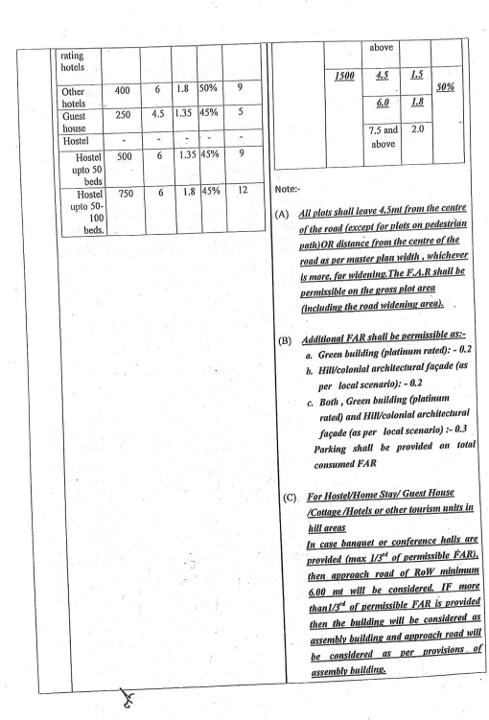**

1. **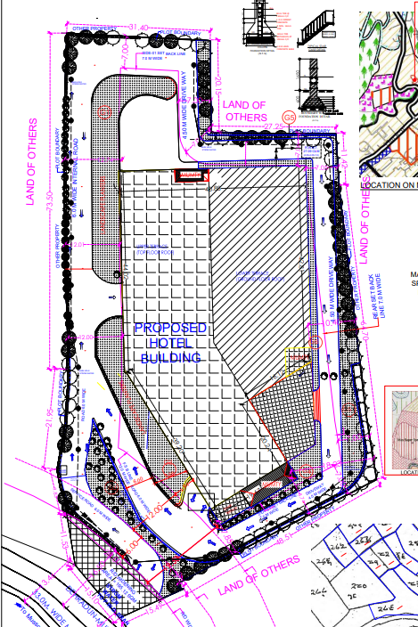Sanctioned Map:**
2. **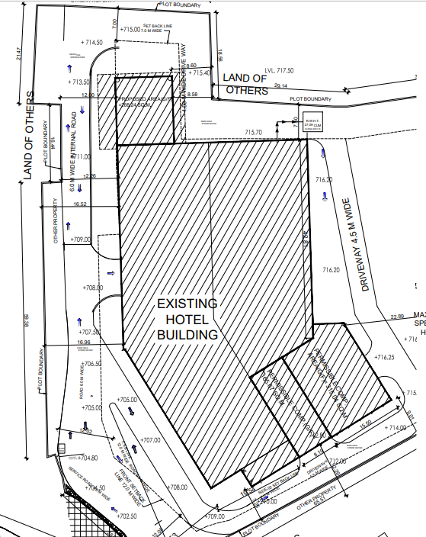Proposed Compounding Map:**

**ENCLOSURE-2: - SITE PHOTOGRAPHS**

|  |  |
| --- | --- |
| **D:\VIS(2024-25)-PL057-050-069_La_Roche\SiteImage\c_TimePhoto_20240502_141859.jpg** | **D:\VIS(2024-25)-PL057-050-069_La_Roche\SiteImage\c_TimePhoto_20240502_145142.jpg** |
| **D:\VIS(2024-25)-PL057-050-069_La_Roche\SiteImage\c_TimePhoto_20240502_140952.jpg** | **D:\VIS(2024-25)-PL057-050-069_La_Roche\SiteImage\c_TimePhoto_20240502_142029.jpg** |
| **D:\VIS(2024-25)-PL057-050-069_La_Roche\SiteImage\c_TimePhoto_20240502_142151.jpg** | **D:\VIS(2024-25)-PL057-050-069_La_Roche\SiteImage\c_TimePhoto_20240502_142116.jpg** |
|  |  |
|  |  |
|  |  |