File No. VIS (2024-25) - PL059-051-070 Dated: 26th July 2024

2ND PROJECT LIE REPORT
(FOR PERIOD ENDING APR’24)

OF

INTEGRATED SUGAR COMPLEX

SITUATED AT

VILLAGES SARKARA & NAKATPURA, TEHSIL SITRAGANJ, DISTRICT UDHAM SINGH NAGAR, UTTARAKHAND

IMPLEMENTED BY
M/S. JGN SUGAR AND BIOFUELS PRIVATE LIMITED

REPORT PREPARED FOR
STATE BANK OF INDIA, IFB BRANCH, NEW DELHI

**Important - In case of any query/ issue or escalation you may please contact Incident Manager at le@rkassociates.org. We will appreciate your feedback in order to improve our services.
NOTE: As per IBA Guidelines please provide your feedback on the report within 15 days of its submission after which report will be considered to be correct.

TABLE OF CONTENTS
SR. NO. | DESCRIPTION | PAGE NO.
PART A | Report Summary | 03
PART B | Introduction | 04-07
PART B | - The Project | 04
PART B | - Project Overview | 04-05
PART B | - Project Location | 06
PART B | - Scope of Work of this report | 07
PART B | - Purpose of the Report | 07
PART B | - Methodology Adopted | 07
PART C | Plant Infrastructure Sections & Facility Details with Actual Progress | 08-20
PART C | - Land & Site Development | 08
PART C | - Building and Structure Details | 08-14
PART C | - Plant Machinery and Equipment | 14-20
PART D | Project Consultants, Contractors & Suppliers | 21-24
PART E | Project Cost, Means of Finance & Cost Incurred till date | 25-
PART E | - Total Project Cost | 25
PART E | - Means of Finance | 25
PART E | - Total Expenditure Incurred till date | 26-27
PART F | Statutory & Regulatory Approvals, Clearances & NOC | 28-29
PART G | Project Schedule | 30
PART H | Disclaimer | 31-34
PART I | Enclosure: Important Documents provided | 35-44
PART J | Site Photographs | 45-46

IMPORTANT NOTICE

COPYRIGHT FORMAT: This report is prepared on the copyright format of R.K Associates, to serve our clients with the best available information and analysis to facilitate them to take rational business decisions. Legally no one can copy or distribute this format without prior approval from R.K Associates. It is meant only for the advisory/ reference purpose for the organization/s as mentioned on the cover page of this report. Distribution or use of this format by any organization or individual other than R.K Associates will be seen as unlawful act and necessary legal action can be taken against the defaulters.

This report is intended for the sole use of the intended recipient/s and contain material that is STRICTLY CONFIDENTIAL AND PRIVATE.

DEFECT LIABILITY PERIOD: - In case of any query/ issue or escalation you may please contact Incident Manager at le@rkassociates.org.
Though adequate care has been taken while preparing this report as per its scope, but still, we can’t rule out typing, human errors, over sightedness of any information or any other mistakes. Therefore, the concerned organization is advised to satisfy themselves that the report is complete & satisfactory in all respect. Intimation regarding any discrepancy shall be brought into our notice immediately. If no intimation is received within 15 (Fifteen) days in writing from the date of issuance of the report, to rectify these timely, then it shall be considered that the report is complete in all respect and has been accepted.

PART A | REPORT SUMMARY

1. | Name of Project: | M/s. JGN Sugar & Biofuels Private Limited proposes to set up a 3,000 TCD sugar syrup plant, 225 KLPD Ethanol processing plant and 21.8 MW Co- generation plant as proposed in Village- Sarkara, Sitarganj, District- Udham Singh Nagar, Uttarakhand.
2. | Project Location: | - Village: Sarkara  - City: Sitarganj  - District: Udham Singh Nagar, State: Uttarakhand
3. | Name of the Borrower: | M/s. JGN Sugar & Biofuels Private Limited
4. | Key management: | - Dr. Chandra Kumar Jain – Director (JGN)  - Mr. Naveen Jhanji – Director (JGN)
5. | Prepared for Bank: | State Bank of India, IFB Branch, New Delhi
6. | LIE Consultant Firm: | M/s. R.K. Associates Valuers & Techno Engineering Consultants (P) Ltd.
7. | Date of Survey: | 26th July 2024
8. | Date of Report: | 27th July 2024
9. | Purpose of the Report: | To provide fair detailed analysis of the Project to the Bank based on the “in-scope points” mentioned below to inform the periodic status of the Project.
10. | Scope of the work provided by the Lender: | - Review Project details & facilities  - Project Progress vis-a-vis construction schedule  - Review Project expenditure in line with construction schedule  - Review of Project towards Licenses, NOCs, Approvals
11. | Documents provided for the Project (out of documents requested): | - Techno economic feasibility report  - Project Statutory approvals  - Details of Amount Incurred  - List of contractors/Suppliers  - Work Orders/ LOI of the major contractors  - Bills/Invoices  - Reply to our queries raised
12. | Annexure with the report: | - Project Statutory approvals  - List of Contractors/ Suppliers  - List of PO’s

PART B | INTRODUCTION

- THE PROJECT:
M/s. JGN Sugar & Biofuels Private Limited is establishing an integrated sugar complex, with the expansion of the current sugar plant from 2,500 TCD to 3,240 TCD and a new 3,000 TCD raw syrup plant, the 21.8 MW Co- generation plant, 225 KLPD Ethanol processing plant.

- PROJECT OVERVIEW:
The scope of the work for this report is limited to the upgradation of existing sugar plant, 21.8 MW Co- generation plant, 3,000 TCD raw syrup plant and 225 KLPD Ethanol processing plant. Combining all, it will be an integrated sugar complex with the above-mentioned capacities. This is a 2nd LIE Report from the period Feb.’24 – April’24 and is in continuation to 1st Inception Report submitted to the Bank. This report covers physical status upto 26.07.2024 as on date of the survey but the financial expenditure is reported upto 30.04.2024 as per the report period.

Brief background and overview of the Project is already mentioned in 1st Inception Report. Therefore it has not been repeated again in this report for the purpose of brevity.

As per current status, upgradation of existing sugar plant is already completed and achieved. Work of other sections is in progress simultaneously. 21.8 MW Co-generation plant is approx.. ~70%-75% completed with boiler and chimney are erected and Turbine needs to be arrived at site. Raw syrup plan is approx.. ~ 65%-70%, and Ethanol plant is ~60% to 65% is completed as on the date of site visit dated: 26.07.2024.

Company is targeting to complete the work by November’24 which is in line to the original schedule. Up to 20.04.2024, company has shown an expenditure of Rs.199.33 crores out of which company has spent Rs.143.99 crores in Building & Civil works, Plant & Machinery, and Miscellaneous Fixed Assets, assessment of which is covered in later section of the report.

- PROJECT LOCATION:
Particulars | Description
Address
The subject property is a factory premises leased by JGN located on land bearing Khasra Nos. 506/1, 606, 527, 611, 512/1, 534/2, 543, 549/1/2, 610/1/2, 612/1, 614/1 & 651 of Villages Sarkara & Nakatpura, Tehsil Sitraganj, District Udham Singh Nagar, Uttarakhand, admeasuring total plot area of 94.35 Acres.
Google Coordinates
Latitude | 28°51'19.9"N
Longitude | 79°42'36.9"E
Connectivity Systems
Road | The subject plant is on the Pilibhit Road in Sarkara Village of district Udham Singh Nagar in the state of Uttrakhand.
Rail | The nearest railway station is Khatima Railway Station at a distance of approx. 36 km.
Air | The nearest domestic airport is Pantnagar Airport at about 46 km distance from the plant site.

Source: Google Maps as updated on 11/03/2024
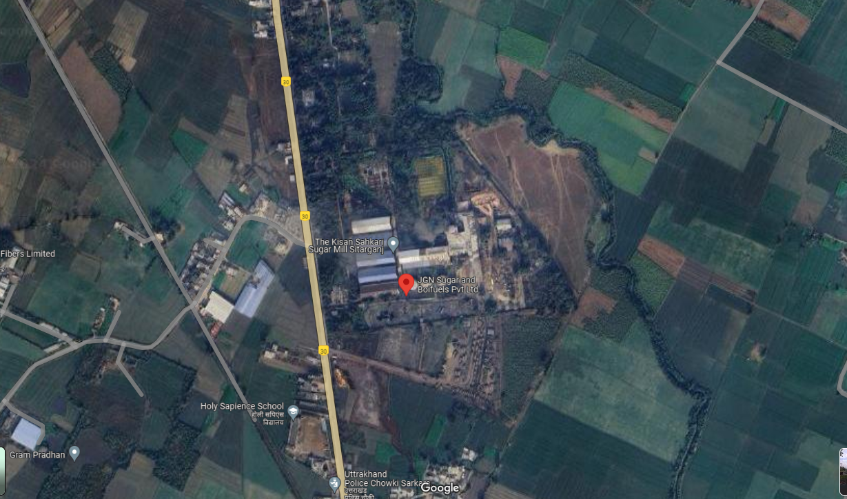

Figure: Location of JGN Sugar & Biofuels Private Limited

- SCOPE OF WORK OF THIS REPORT:

- To periodically check Project implementation status vis-a-vis as mentioned in TEV Report and in major Project contracts and comment accordingly.
- To periodically check Project Progress on site and achievement of various milestones vis-a-vis as mentioned in TEV Report and comment accordingly.
- To check whether Project expenditure in line to the work done and comment accordingly.
- Review status of Statutory Licenses, NOCs, Approvals.

Note:
- The scope of work is for the complete duration up to the completion of the project and not for a specific report.
- Carrying out the scope of work is subject to the details/ information/ data provided to us by the borrower from time to time.
- Project cost verification is out-of-scope of this report and Project cost considered in TEV Report is considered in this report for assessment of the work done and the cost incurred on the site.
- Amount incurred is referred from the details provided by the customer further corroborated from CA Certificate.

- PURPOSE OF THE REPORT: To provide fair detailed analysis report to the Bank based on the “in-scope points” mentioned above for facilitating them to take appropriate credit decision on the Project.

- METHODOLOGY ADOPTED:
- Gather information/ data/ documents related to the Project.
- Study and analysis of the documents and information obtained from the borrower.
- Additional information, data, documents collection from the borrower.
- Site Inspection
- Corroboration of the provided information and site inspection observation.
- Information compilation, analysis and reporting.

PART C | PLANT INFRASTRUCTURE SECTIONS & FACILITY DETAILS WITH ACTUAL PROGRESS

- LAND & SITE DEVELOPMENT:
As per the TEV report provided and as per the discussion with the company, the project land is under a lease of 30 years by M/s. JGN Sugar & Biofuels Private Limited as lessee.

- BUILDING & STRUCTURAL DETAILS:
- The erstwhile Kisan Sahakari Chini Mills Limited which is now been taken over by M/s. JGN Sugar & Biofuels Private Limited on lease was established in the year 1984-85 and has existing buildings for the Sugar Plant which includes Mill area, finished goods godown, necessary residential quarters (A, B, C & D type only), unloading area, crushing area, boiler, centrifuge, bagging section as also shown in the layout plan below marked in grey. Rest of the area shown in the layout plan below is either existing expansion or future expansion.
- Layout plan is prepared by EPC contractor M/s ISGEC Heavy Engineering Ltd., Noida.
- Copy of map stamped and signed by sub-inspector revenue is provided. Approval of expansion Plan is yet to be obtained from Chief Inspector Factories which will be obtained in due course as per the company.
- As per the TEV report provided to us, the proposed project cost under building and civil structures is mentioned as INR 55.90 Crore. Out of the above proposed cost, total cost incurred as on 20-04-2024 as shown by the company is INR 13.77 Crore.
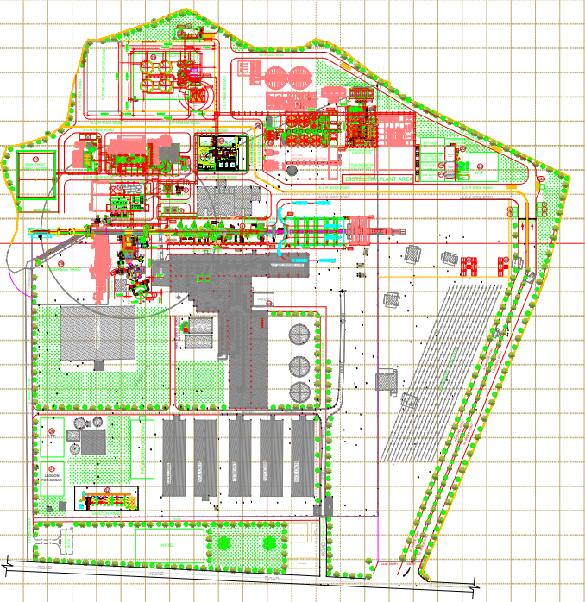
Note: Buildings marked in Grey represents the existing structures and those marked in green and red represents the current and future expansion.
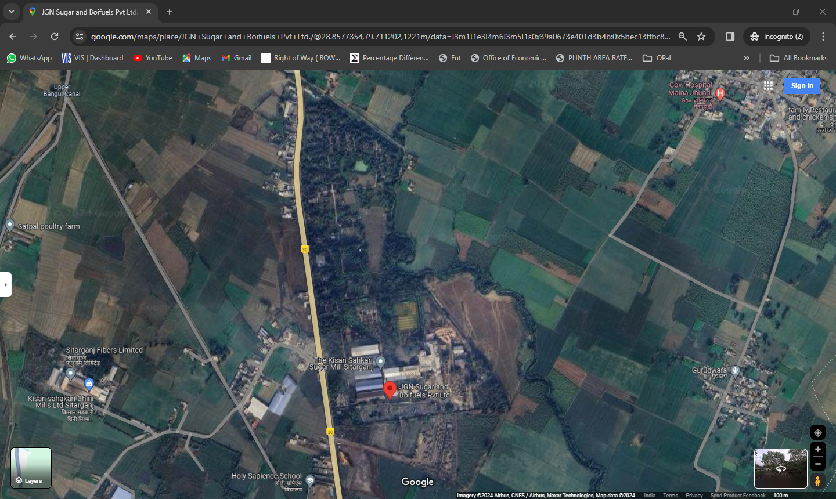

Notes:

- The building and civil work is being done by the local contractors, the list of the same is mentioned in Part D of the report below.
- Buildings and structure, cost assessment is not done independently by us as it is out of scope of work and same has been referred based on TEV Report.
- Building plans was not available, however approved Layout plan is provided.
- Our team has physically verified and inspected the civil work that is currently in progress as enumerated in Table below:

Progress of Building and Civil Structures as per site visit dated 26th July 2024:

Particulars | Absolute/ In terms of Weightage |  |  | Overall Completion Percentage
Particulars | Foundation | Civil structure | Finishing | Overall Completion Percentage
Plant Buildings and its progress
Milling House Section
Mill House | 100% | 100% | 0% | ----
 | 20% | 60% | 0% | 80%
Control Panel Room for Mill House (G+1) | 100% | 50% | 0%
 | 20% | 30% | 0% | 50%
Cooling Tower for Mill Bearing | 100% | 100% | 0%
 | 20% | 60% | 0% | 80%
Boiler Section
Boiler & Bagasse Handling Section | 100% | 100% | 0%
 | 20% | 60% | 0% | 80%
RCC Chimney | 100% | 100% | 100%
 | 20% | 60% | 20% | 100%
Power House Section
Power House | 100% | 100% | 50%
 | 20% | 60% | 10% | 90%
Control Room for Power House | 100% | 100% | 50%
 | 20% | 60% | 10% | 90%
Cooling Tower for Power House | 100% | 0% | 0%
 | 20% | 0% | 0% | 20%
Raw Syrup Plant Section
Raw Syrup Plant | 100% | 100% | 100%
 | 20% | 60% | 20% | 100%
MCC & DCS Control Room for Raw Syrup Plant (G+1) | 100% | 70% | 0%
 | 20% | 42% | 0% | 62%
Cooling Tower for Raw Syrup Plant | 100% | 50% | 0%
 | 20% | 30% | 0% | 50%
Other Sections
Evaporator Section | 100% | 100% | 100%
 | 20% | 60% | 20% | 100%
Distillation & MSDH Section | 100% | 100% | 100%
 | 20% | 60% | 20% | 100%
Cooling Tower for Distillation & MSDH Evaporator Section | 100% | 30% | 0%
 | 20% | 18% | 0% | 38%
Fermentation Section | 100% | 100% | 100%
 | 20% | 60% | 20% | 100%
MCC Room for Fermentation Section | 100% | 30% | 0%
 | 20% | 18% | 0% | 38%
Cooling Tower for Fermentation Section | 100% | 30% | 0%
 | 20% | 18% | 0% | 38%
Ethanol Storage Section (PESO) | 100% | 100% | 100% | 100%
 | 20% | 60% | 20% | 100%
Condensate Polishing Unit for Distillery | 20% | 0% | 0%
 | 4% | 0% | 0% | 4%
Excess Water Cooling Tower | 50% | 0% | 0%
 | 10% | 0% | 0% | 10%
Raw Spent Wash Lagoon | 100% | 80% | 0%
 | 20% | 48% | 0% | 68%
Water Treatment Plant | 100% | 30% | 0%
 | 20% | 18% | 0% | 38%
Fire Fighting System | 100% | 20% | 0%
 | 20% | 12% | 0% | 32%
Condensate Polishing Unit for Sugar (Milk of Lime Station) | 100% | 100% | 100%
 | 20% | 60% | 20% | 100%
Effluent Treatment Plant | 0% | 0% | 0%
 | 0% | 0% | 0% | 0%
Raw Water Tank | 100% | 30% | 0%
 | 20% | 18% | 0% | 38%
Bagasse Yard | 100% | 50% | 0%
 | 20% | 30% | 0% | 50%
Service Water Reservoir | 100% | 0% | 0%
 | 20% | 0% | 0% | 20%
Lagoon for Sugar | 100% | 0% | 0%
 | 20% | 0% | 0% | 20%
Switch Yard | 0% | 0% | 0%
 | 0% | 0% | 0% | 0%
Weigh Bridge Room | 0% | 0% | 0%
 | 0% | 0% | 0% | 0%
Non-Plant Buildings and its progress
Security Rooms | 0% |  |  | 0%
Time Office | 0% |  |  | 0%
Excise Office | 0% |  |  | 0%
Office for CE, CC, LAB & Toilet | 0% |  |  | 0%
Workers Toilet | 0% |  |  | 0%
Landscape Development
Internal Roads |  |  |  | 0%

Stages | Weightage
Excavation, Foundation & Plinth | 20%
Civil structure | 60%
Finishing | 20%
Overall | 100%

Note: Above weightage considered based on Industrial structure referring standard construction breakup norms. Structure to structure it may vary based on its design. However, for the purpose of assessment we have considered the above standardisation.

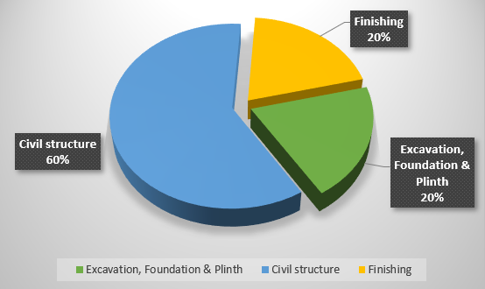

Note:

- The physical progress captured in the above table is based on approximate observations of status of structures constructed on site during our site inspection and our subsequent discussions held with the engineers/ company representatives with whom the site visit was conducted and not based on measurements. Thus, the above percentages are shown only for the purpose of presenting general guidance on site progress instead of any quantity measurements and is on approximate basis which may vary from 5% to 10% (+-).

- PLANT MACHINERY & EQUIPMENT:
For the project work related to plant & machinery, the company has appointed M/s. ISGEC Heavy Engineering Limited as a technical consultant and contractor vide copy of Letter of Intents with Ref. Nos. JGN/KSP/2023-24/87, JGN/KSP/2023-24/88, JGN/KSP/2023-24/89 dated 31-07-2023 for the design, manufacture, supply, erection and commissioning of 6000 TCD Milling Plant, 3000 TCD Raw Syrup Plant, 225 KLPD Ethanol Plant on syrup with 120 TPH Boiler and 21.8 MW Cogeneration Plant, and 40 TPH Incineration Boiler and 4.8 MW power plant. The total project cost proposed as mentioned in the LOI is shown in the table below:
S. No. | Contractor Name | Description of Work | Ref. No. | Project Cost  (INR Crore)
1 | ISGEC Heavy Engineering Limited, Noida | Design, Manufacture, Supply & Erection of 6000 TCD Milling Plant, 3000 TCD Raw Syrup Plant | JGN/KSP/2023-24/88 | 65.00
2 | ISGEC Heavy Engineering Limited, Noida | Design, Manufacture, Supply & Erection of 225 KLPD Ethanol Plant on Syrup, 120 TPH Boiler & 21.8 MW Cogeneration Plant | JGN/KSP/2023-24/87 | 147.00
3 | ISGEC Heavy Engineering Limited, Noida | Design, Manufacture, Supply & Erection of 40 TPH Incineration Boiler and 4.8 MW Power plant | JGN/KSP/2023-24/89 | 63.00
Total |  |  |  |  | 275.00

- High Level Section Wise Physical Progress of Plant and Machinery: As per site visit dated 26th July 2024 below is the high-level section wise progress:

 | Started
 | In Progress
 | Not started
 | Completed
In Progress
Completed

Particulars | Machine arrived at site | Machine Installation | Testing | Production | Completion Status
Milling House Section
Mill House |  |  |  |  | 
Control Panel Room for Mill House (G+1) |  |  |  |  | 
Cooling Tower for Mill Bearing |  |  |  |  | 
Boiler Section
Boiler & Bagasse Handling Section |  |  |  |  | 
RCC Chimney |  |  |  |  | 
Power House Section
Power House |  |  |  |  | 
Control Room for Power House |  |  |  |  | 
Cooling Tower for Power House |  |  |  |  | 
Raw Syrup Plant Section
Raw Syrup Plant |  |  |  |  | 
MCC & DCS Control Room for Raw Syrup Plant (G+1) |  |  |  |  | 
Cooling Tower for Raw Syrup Plant |  |  |  |  | 
Other Sections
Evaporator Section |  |  |  |  | 
Distillation & MSDH Section |  |  |  |  | 
Cooling Tower for Distillation & MSDH Evaporator Section |  |  |  |  | 
Fermentation Section |  |  |  |  | 
MCC Room for Fermentation Section |  |  |  |  | 
Cooling Tower for Fermentation Section |  |  |  |  | 
Ethanol Storage Section (PESO) |  |  |  |  | 
Condensate Polishing Unit for Distillery |  |  |  |  | 
Excess Water Cooling Tower |  |  |  |  | 
Raw Spent Wash Lagoon |  |  |  |  | 
Water Treatment Plant |  |  |  |  | 
Fire Fighting System |  |  |  |  | 
Condensate Polishing Unit for Sugar |  |  |  |  | 
Effluent Treatment Plant |  |  |  |  | 
Switch Yard |  |  |  |  | 

- Detailed Plant wise Physical Progress of Plant and Machinery: As per site visit dated 26th July 2024 below is the Plant wise detailed progress as per the list of the machinery/ equipment enumerated in Annexures of the Contract agreement with ISGEC (EPC contractor):

6000 TCD MILLING PLANT
S. No. | NAME OF EQUIPMENT | QUANTITY | MACHINE ARRIVED AT SITE | MACHINE INSTALLATION | TESTING | PRODUCTION
1 | Cane unloader | 5 nos. | Yes | Yes | No | No
2 | Cane Carrier | 1 no. | Yes | Yes | No | No
3 | Cane Chopper | 1 no. | Yes | Yes | No | No
4 | Cane leveler | 1 no. | Yes | Yes | No | No
5 | Swing hammer fibrizer | 1 no. | Yes | Yes | No | No
6 | Rake Elevator | 1 no. | Yes | In Progress | No | No
7 | Fibrized Cane Belt Type Carrier | 1 no. | Yes | No | No | No
8 | Cane equalizer | 1 no. | Yes | No | No | No
9 | Magnetic Tramp Iron Separator | 1 no. | No | No | No | No
10 | Automatic Cane Feeding Devices | 1 no. | No | No | No | No
11 | Milling Plant | 4 nos. | Yes | 3 nos. set up completed | No | No
12 | Hydraulic Pressure System | ---- | Yes | In Progress | No | No
13 | Lubrication | ---- | No | No | No | No
14 | Juice Tray | 4 nos. | Yes | Yes | No | No
15 | Mill Gangway | ---- | Yes | Yes | No | No
16 | Donnelly chute | 4 nos. | Yes | No | No | No
17 | Toothed underfeed roller | 4 nos. | Yes | In progress | No | No
18 | Mill Drive | 4 nos. | Yes | In progress | No | No
19 | VFD | 4 nos. | Yes | No | No | No
20 | Gearbox | 4 nos. | Yes | In progress | No | No
21 | Coupling |  | Yes | No | No | No
22 | Rake Type Intermediate Carrier with Imbibition Equipment and Mixed Juice Pumps | 3 nos. | Yes | In progress | No | No
23 | Rotary Screen | 1 no. | Yes | Yes | No | No
24 | Juice Pumps | ---- | Yes | No | No | No
24 | For 1st mill | 1 no. | Yes | No | No | No
24 | For 2nd mill | 1 no. | Yes | No | No | No
24 | For 3rd ,4th mill | 2 nos. | Yes | No | No | No
24 | Screened juice | 3 nos.  (2 W+1SB) | Yes | In progress | No | No
25 | Imb. Pumps | 02 nos.  (1W+1SB) | No | In progress | No | No
26 | Magnetic flow meter | 1 no. | No | In progress | No | No
27 | Auxiliary Cooling Tower for Mill bearing Cooling | 1 no. | Yes | In progress | No | No
28 | Mill House Crane and Gantry | 1 no. | Yes | In progress | No | No

3000 TCD RAW SYRUP PLANT
S. No. | NAME OF EQUIPMENT | QUANTITY | MACHINE ARRIVED AT SITE | MACHINE INSTALLATION | TESTING | PRODUCTION
 | Mass flow meter  for juice | 1 no. | No | No | No | No
 | Juice Heaters | 2 nos. | Yes | Yes | No | No
 | Juice Defecator | 1 no. | Yes | Yes | No | No
 | Defecated Juice Pumps | 2 nos. | Yes | Yes | No | No
 | Clarifier | 1 no. | Yes | Yes | No | No
 | Clear Juice Pumps | 2 nos. | Yes | Yes | No | No
 | Rotary Vacuum  Filter | 1 no. | Yes | Yes | No | No
 | MOL preparation  System | 1 no. | Yes | Yes | No | No
 | Evaporator with 9 nos. FFE | 1 no. | Yes | Yes | No | No
 | Syrup transfer to distillery | 1 no. | Yes | In progress | No | No
 | Condensate  extraction system | 1 no. | Yes | Yes | No | No
 | Steam consumption & Bleeding Scheme | 1 no. | No | No | No | No
 | CIP | 1 no. | Yes | No | No | No
 | Condensers | 2 nos. | Yes | Yes | No | No
 | Injection water pumps | 2 nos. | No | No | No | No
 | Cooling tower | 1 no. | Yes | In progress | No | No
 | Excess condensate cooling tower | 1 no. | No | No | No | No
 | Overhead tanks with water pumps | 2 nos. | No | No | No | No
 | Air compressor | 2 nos. | No | No | No | No
 | Structural Staging | ----- | No | No | No | No
 | Pipelines | ----- | No | No | No | No
 | Insulation and  Cladding | ----- | No | No | No | No
 | Electricals | ----- | No | No | No | No
 | Instrumentation | ----- | No | No | No | No

225 KLPD ETHANOL (DISTILLERY) PLANT
S. No. | NAME OF EQUIPMENT | QUANTITY | MACHINE ARRIVED AT SITE | MACHINE INSTALLATION | TESTING | PRODUCTION
 | Molasses Storage and Handling Section | 1 no. | Already existing | NA | NA | NA
 | Syrup Storage and Handling Section | 1 no. | Yes | In progress | No | No
 | Spent Wash Recycle Section | 1 no. | Yes | In progress | No | No
 | Fermentation Section | 1 no. | Yes | In progress | No | No
 | Distillation Section with Columns, Reboilers, Condensers & Coolers and Pumps | 1 no. | Yes | In progress | No | No
 | Dehydration Section | 1 no. | Yes | In progress | No | No
 | Product Receiving and Storage Section | 1 no. | Yes | In progress | No | No
 | Evaporation Section: Integrated + SA (Future Provision for B Molasses) | 1 no. | Yes | In progress | No | No
 | Condensate Polishing Unit | 1 no. | Yes | In progress | No | No
 | Utilities | 1 no. | No | No | No | No

120 TPH BOILER & 21.8 MW CO-GENERATION PLANT
S. No. | NAME OF EQUIPMENT | QUANTITY | MACHINE ARRIVED AT SITE | MACHINE INSTALLATION | TESTING | PRODUCTION
 | Boiler (120 TPH, 87 Kg/Cm²) | 1 no. | Yes | No | No | No
 | Turbo Generator | 1 no. | No | No | No | No
 | Auxiliary Cooling Tower | 1 no. | Yes | No | No | No
 | Ash Handling System | 1 no. | No | No | No | No
 | EOT Crane | 1 no. | Yes | No | No | No
 | Utilities | 1 no. | No | No | No | No
 | Electrical Equipment | 1 no. | No | No | No | No
 | Control & Instrumentation | 1 no. | No | No | No | No
 | 21.8 Mw Turbo Generator Set (Steam Turbine) | 1 Set | No | No | No | No
 | Gearbox | ---- | Yes | No | No | No
 | Couplings | ---- | Yes | No | No | No
 | Governing System | ---- | Yes | No | No | No
 | Lubrication System | ---- | Yes | No | No | No
 | Accessories | ---- | No | No | No | No
 | Electrical | ---- | No | No | No | No
 | Control & Instrumentation | ---- | No | No | No | No
 | Turbine Control Panel | ---- | No | No | No | No
 | Bagasse Elevator | 1 No. | Yes | In progress | No | No
 | Main Bagasse Carrier | 1 No. | Yes | In progress | No | No
 | Surplus Bagasse Belt Conveyor | 1 No. | No | No | No | No
 | Return Bagasse Carrier | 1 No. | Yes | No | No | No
 | Ro / Dm Water Plant | 1 No. | Yes | No | No | No
 | Auxiliary Cooling Tower | 1 No. | No | No | No | No
 | PRDS | 1 Set | No | No | No | No
 | Air Compressor for Instrument | 2 Nos.  (1W+1SB) | Yes | No | No | No
 | EOT Crane For TG | 1 No. | Yes | No | No | No
 | DG Set | 1 No. | No | No | No | No
 | DCS | ---- | No | No | No | No
 | Plant Piping | ---- | No | No | No | No
 | Effluent Treatment Plant | ---- | No | No | No | No
 | Condensate Polishing Unit Follower by UF & RO System | ---- | No | No | No | No
 | Air Conditioning System | ---- | No | No | No | No
 | Fire Protection System | ---- | No | No | No | No
 | Electrical Distribution System | ---- | No | No | No | No

Notes:
- The sections mentioned above have been considered as mentioned in the site plan provided to us by the company.
- The physical progress captured in the above table is based on approximate observations of status of plant/machineries installed on site during our site inspection and our subsequent discussions held with the engineers/ company representatives with whom the site visit was conducted. Thus, the above progress is on approximate basis which may vary from 5% to 10% (+-).

PART D | PROJECT CONSULTANTS, CONTRACTORS & SUPPLIERS
The borrower has provided following list of contractors deployed on the project site. The details of the same along with the respective scope of work is mentioned in the tables below:

- BUILDING & CIVIL STRUCTURES:
- Most of the vendors/ suppliers mentioned above are on work-to-work basis and doesn’t have any fixed contract or work order.
- For monitoring of the Civil and Building works, since it is done through local contractors and laborers, the company has appointed Civil Engineer Mr. Ashwani for the same. Additionally, directors of JGN Sugar are also directly monitoring construction & civil works for proper completion of the works. List of major contractors with their scope of work is shown below:

S. No. | Contractor Name | Description of Work
 | N.S Ready Mix Pvt. Ltd. Sitarganj | New Project -II( Machinery Foundation)
 | Kadri Contractor, Bareilly | New Project -II( Machinery Foundation)
 | Structures And Foundations Pvt. Ltd, Delhi | New Project -II( Machinery Foundation)
 | J K Cement Ltd, Rajasthan | New Project -II( Machinery Foundation)
 | Steel Con, Delhi | New Project -II( Machinery Foundation)
 | J K Cement Works, Aligarh | New Project -II( Machinery Foundation)
 | Pushkars Building Systems Pvt. Ltd, Delhi | New Project -II( Machinery Foundation)
 | Ultra Tech Cement Limited, Dehradun | New Project -II( Machinery Foundation)
 | Vijay Steels & Sons, Delhi | New Project -II( Machinery Foundation)
 | Shyam Engineers, Haridwar | New Project -II( Machinery Foundation)
 | Kansal Color Roofing India Pvt. Ltd. Haryana | Building -New Project
 | Galwalia Ispat Udyog Pvt. Ltd, Kashipur | Building -New Project
 | S N Construction, Kashipur | Building -New Project
 | Ultra Tech cement limited, Ghaziabad | Building -New Project
 | Guru Ramdas Contractor, Kashipur | Building -New Project

- PLANT & MACHINERY:
Figures in crores
S. No. | Contractor Name | Description of Work | Ref. No. | Work Order Dated | Project Cost  (INR Crore)
1 | ISGEC Heavy Engineering Limited, Noida | Design, Manufacture, Supply & Erection of 6000 TCD Milling Plant, 3000 TCD Raw Syrup Plant | JGN/KSP/2023-24/88 | 31-07-2023 | 65.00
2 | ISGEC Heavy Engineering Limited, Noida | Design, Manufacture, Supply & Erection of 225 KLPD Ethanol Plant on Syrup, 120 TPH Boiler & 21.8 MW Cogeneration Plant | JGN/KSP/2023-24/87 | 31-07-2023 | 147.00
3 | ISGEC Heavy Engineering Limited, Noida | Design, Manufacture, Supply & Erection of 40 TPH Incineration Boiler and 4.8 MW Power plant | JGN/KSP/2023-24/89 | 31-07-2023 | 63.00
Total |  |  |  |  | 275.00

Source: As provided by the company

PART E | PROJECT COST, MEANS OF FINANCE & COST INCURRED TILL DATE

- TOTAL PROJECT COST:
The project cost as mentioned in the TEV report provided by the company is shown below:

S. No. | Particulars | Total Cost  (INR in Crore) | %
1 | Building and Civil Construction | 55.90 | 14%
2 | Plant & Machinery | 275.00 | 69%
3 | Miscellaneous Assets - Existing Upgradation | 25.04 | 6%
4 | Interest During Construction & Pre-op | 16.73 | 4%
5 | Margin Money for Working Capital | 23.66 | 6%
 | Total | 396.33 | 100%
Source: TEV Report

Notes:
- Cost verification of the Project cost is not done at our end. Cost has been considered based on the TEV report.

- MEANS OF FINANCE:
The means of finance as mentioned in the TEV report provided by the company is shown below:

Particulars | Total Cost  (INR in Crore) | %
Promoter’s Contribution
Equity | 89.93 | 23%
Preference Shares | 46.40 | 12%
Bank Finance
Term Loan | 260.00 | 65%
Total | 396.33 | 100%
Source: TEV Report

- TOTAL EXPENDITURE INCURRED TILL DATE: Details of the expenditure in the Table below is recorded for the expenditure incurred up to 30th April 2024:

S. No. | Particulars | Total Estimated Cost | Cost Incurred till 31.01.2024 | Cost Incurred till 20.04.2024  As per CA certificate | Cost Incurred  In last Quarter with advance paid | % Incurred of proposed cost | % of Work completed | Remarks
 |  |  |  |  | Total Cost Incurred till date | % Incurred of proposed cost | % of Work completed | Remarks
 | Building and Civil Construction | 55.90 | 4.12 | 13.77 | 9.65 | 24% | ~64% | - Buildings/ Civil construction along with Machinery foundation under Project II is only considered here.  - As per the details shared by the company, out of Rs.13.77 spent, Rs.25 Lacs is advance amount, rest is the actual billing for the work done.  - Expenditure is considered based on the Invoices and CA Certificate.  - Due to nature of civil works and in the absence of bills of quantity, it can’t be assessed based on plinth area rate.  - The assessment of the cost is made in comparison to the work done and the amount spent which appears to be satisfactory.
 |  |  |  |  | 13.61 | 24% | ~64%
 | Plant & Machinery | 275.00 | 6.51 | 99.82 | 93.31 | 43% | --- | - As per the CA certificate and consolidated sheet provided by the company total Rs.49.40 crores worth of machines have been either installed or arrived at the site. Major invoices of the same have been shared & Invoices have been checked based on random sample checking.  - Out of Rs.99.82 crores spent, 67.50 crores is advance amount, rest is the actual billing for the work completed.
 |  |  |  |  | 116.90 | 43% | ---
 | Miscellaneous Assets - Existing Up gradation | 25.04 | 27.07 | 30.40 | 3.33 | 127% | 100% | - Amount referred from CA certificate dated 20.04.2024 and expenditure shown by the company till 30.04.2023.  - Existing up gradation completed as per certificate issued by EPC contractor Uttam Sucrotech International (P) Ltd.
 |  |  |  |  | 31.72 | 127% | 100%
 | Interest During Construction & Pre-operative | 16.73 | --- | --- | --- | --- | --- | Please refer to CA Certificate as it is out of scope of LIE.
 | Interest During Construction & Pre-operative | 23.66 | --- | --- | --- | --- | --- | Please refer to CA Certificate as it is out of scope of LIE.
TOTAL |  | 396.33 | 37.70 | 143.99 | --- | --- | --- | ---

Notes:
            - Above cost incurred is considered as per the information shared by the company via email and further corroborated through CA Certificate. CA Certificate is dated: 20.04.2024, however our working is up to 30.04.2024, so the minor difference is due to it.
            - It is confirmed by the Bank that all transaction to the vendors/ suppliers is taking place directly through them.
            - Major invoices of the expenditure have been shared & Invoices have been checked based on random sample checking.
            - This is only a quarterly report as per the quarterly visit conducted at site and not a continuous monitoring.
            - For Miscellaneous Assets - Existing Upgradation, amount is shown for illustration purpose referring CA Certificate. In this respect breakup of the expenditure is sought from the company. On the analysis of the breakup, it is found that out of Rs.30.40 crores, Rs. 25.31 crores is paid to Uttam Sucrotech International (P) Ltd. who have worked on Capacity Optimization with Efficiency Improvements in Mill & Boiling House at existing Sugar Plant of JGN Sugar & Biofuels Pvt. Ltd., Sitarganj, Uttarakhand.

PART F | STATUTORY & REGULATORY APPROVALS, CLEARANCES & NOC

SR. NO. | NAME OF LICENSE/ REGISTRATION | ISSUING AUTHORITY | DATE OF ISSUE | CURRENT STATUS
SR. NO. | NAME OF LICENSE/ REGISTRATION | ISSUING AUTHORITY | LICENCE NO. | CURRENT STATUS
 | Approved Building Plans | Chief Inspector Factories | Dated: 19.09.2023  (From Sub Inspector -Revenue Dept.) | For now authorization obtained from Sub Inspector – Revenue Dept. For expansion unit from Chief Inspector Factories in due course To be obtained.
 | Factory License | Labour Department, Uttarakhand | USN-187 | Renewed for exiting Factory as per Old Plan. For new plan and approval is yet to be obtained.
 | Factory License | Labour Department, Uttarakhand | Dated: 21-09-2023
 | Environment Clearance | Government of India  (Ministry of Environment, Forest and Climate Change) | File No: IA-J-11011/238/2023-IA-II(I)  Dated: 16.08.2024 | Obtained from concerned authority
 | Water and Air NOC for CTE Expansion | Uttarakhand Pollution Control Board | Dated: 18.09.2023 | Obtained from concerned authority.
 | Water and Air NOC for CTE Expansion | Uttarakhand Pollution Control Board | UKPCB/HO/NOC(R)-7869/2023/786 | Obtained from concerned authority.
 | Consent for Petroleum Storage Class A Installation | Petroleum & Explosives Safety Organization (PESO) | Dated : 08/03/2024 | Obtained from concerned authority
 | Consent for Petroleum Storage Class A Installation | Petroleum & Explosives Safety Organization (PESO) | A/P/HQ/UC/15/784 (P584602) | Obtained from concerned authority
 | Fire NOC | Chief Fire Service Officer, Udham Singh Nagar (Uttarakhand Fire Service) | --- | To be obtained after completion of the project
 | NOC for Ground Water Extraction | Department of Water Resources, River Development and Ganga Rejuvenation | Dated: 29-12-2023 | Approval for fresh water extraction of 409 m³/day.
 | NOC for Ground Water Extraction |  | Application No.: CGWA/NOC/IND/  ORIG/2023/19708  Valid Upto: 28-06-2026 | Approval for fresh water extraction of 409 m³/day.
 | Boiler Certificates | Chief Inspector, Boilers | --- | To be obtained.
 | Sulphur License | Licence for Acquisition and possession arm ammunition of categories III(C), V&VI | License No.02/ 2023 | Approved for 300 MT sulphur storage
 | Sulphur License |  | Dated: 04.09.2023  Valid up to 31.08.2024 | Approved for 300 MT sulphur storage
 | FSSAI License | Food Safety and Standards Authority of India | Dated: 20-09-2023 | Approved for refined Sugar
 | FSSAI License | Food Safety and Standards Authority of India | 12622999000007 | Approved for refined Sugar
 | Central Excise Registration Certificate | Central Board of Excise and Customs | --- | ---
Observations & Comments:
- Only Statutory approvals related to Plant establishment are considered.
- Above are the major approvals and NOCs information which company has obtained or will be in future.
It is not on exclusive basis.
- In comparison with the last quarter following are the new approvals taken by the company in this quarter:
- Water and Air NOC for CTE Expansion
- Consent for Petroleum Storage Class A Installation

PART G | PROJECT SCHEDULE

The tentative implementation schedule for the proposed project as mentioned in the TEV report is mentioned in the table below:

S. NO. | PARTICULARS | EXPECTED COMPLETION DATE |  | PHASE-II STATUS
S. NO. | PARTICULARS | PHASE-I | PHASE-II | PHASE-II STATUS
1 | Concessionaire Agreement for land and existing building | Completed | Completed | Completed
2 | Up gradation of existing plant and future expansion | September 2023 | September 2024 | ------
3 | Order for Machinery | Completed | Completed | Completed
4 | Arrival for Machinery | August 2023 | March 2024 | In Progress
5 | Installation and Commissioning of machinery | September 2023 | August 2024 | In Progress
6 | Testing & Trial Run of machinery | October 2023 | September 2024 | Yet to be achieved
7 | Commercial Production | October 2023 | October 2024 | Yet to be achieved

Observation & Comments:
- Cogeneration of 21.8 MW was also included since same was not completed in exisiting upgradation.
- As per the present status of work, it appears that the estimated COD is achievable with major sections if the pace of the work is kept same.

PART H | DISCLAIMER

      - No employee or member of R.K Associates has any direct/ indirect interest in the Project.
      - This report is prepared based on the copies of the documents/ information which the Bank/ Borrower has provided to us out of the standard checklist of documents sought from them and further based on our assumptions and limiting conditions. The client/owner and its management/representatives warranted to us that the information they supplied was complete, accurate and true and correct to the best of their knowledge. All such information provided to us has been relied upon in good faith and we have assumed that it is true and correct in all respect. I/We shall not be liable for any loss, damages, cost or expenses arising from fraudulent acts, misrepresentations, or wilful default on part of the owner, borrower, its directors, employee, representative or agents. Verification or cross checking of the documents provided to us from the originals or from any Govt. departments/ Record of Registrar has not been done at our end since this is beyond the scope of our work. If at any time in future, it is found or came to our knowledge that misrepresentation of facts or incomplete or distorted information has been provided to us then this report shall automatically become null & void.
      - Legal aspects for eg. investigation of title, ownership rights, lien, charge, mortgage, lease, sanctioned maps, verification of documents, etc. have not been done at our end and same has to be taken care by legal expert/ Advocate. It is assumed that the concerned Lender/ Financial Institution has satisfied them with the authenticity of the documents, information given to us and for which the legal verification has been already taken and cleared by the competent Advocate before requesting for this report. I/ We assume no responsibility for the legal matters including, but not limited to, legal or title concerns.
      - This report is a general analysis of the project based on the scope mentioned in the report. This is not an Audit report, Design document, DPR or Techno feasibility study. All the information gathered is based on the facts seen on the site during survey, verbal discussion & documentary evidence provided by the client and is believed that information given by the borrower is true best of their knowledge.
      - All observations mentioned in the report is only based on the visual observation and the documents/ data/ information provided by the client. No mechanical/ technical tests, measurements or any design review have been performed or carried out from our side during Project assessment.
      - This report doesn’t claim any quality assurance of the Products and the material being used in the Project.
      - Project implementation, execution, operation is the sole responsibility of the project proponent and for the non-functioning, defaults, defraud of the company & its promoters, R.K Associates shall not be held responsible.
      - This report reflects our opinion based on our knowledge and technical expertise. However, other expert opinions may vary. Therefore, it should not be regarded as the sole opinion.
      - Although we have taken adequate care as much as professionally possible but shall not be liable in future for the incomplete, fabricated, false or distorted information / data provided for the purpose of this assignment.
      - Bank/FII should ONLY take this report as an Advisory document from the Financial/ Chartered Engineering firm and its specifically advised to the creditor to cross verify the original documents for the facts mentioned in the report which can be availed from the borrowing borrower directly.
      - In case of any default in loans or the credit facility extended to the borrowing borrower, R.K Associates shall not be held responsible.
      - The documents, information, data provided to us during the course of this assessment by the client is reviewed only up to the extent required in relation to the scope of the work. No document has been reviewed beyond the scope of the work.
      - At our end we have not specifically checked the veracity of the bills or any transaction to the supplier/ contractor and wherever any such information is mentioned is only for illustration purpose and taken as per details provided to us by the customer.
      - As per the scope of the assignment, we have not undertaken the verification of land ownership in our assessment.
      - This report only contains general assessment & opinion as per the scope of work evaluated as per the information given in the copy of documents, information, data provided to us and/ and confirmed by the owner/ owner representative to us at site which has been relied upon in good faith. It doesn’t contain any other recommendations of any sort including but not limited to express of any opinion on the suitability or otherwise of entering into any transaction with the borrower.
      - We have relied on data from third party, external sources & information available on public domain also to conclude this report. These sources are believed to be reliable and therefore, we assume no liability for the truth or accuracy of any data, opinions or estimates furnished by others that have been used in this analysis. Where we have relied on data, opinions or estimates from external sources, reasonable care has been taken to ensure that such data has been correctly extracted from those sources and /or reproduced in its proper form and context, however still we can’t vouch its authenticity, correctness or accuracy.
      - This Report is prepared by our competent technical team which includes Engineers and financial experts & analysts.
      - This is just an opinion report and doesn’t hold any binding on anyone. It is requested from the concerned Financial Institution which is using this report for taking financial decision on the project that they should consider all the different associated relevant & related factors also before taking any business decision based on the content of this report.
      - All Pages of the report including annexures are signed and stamped from our office. In case any paper in the report is without stamp & signature then this should not be considered a valid paper issued from this office.
      - Though adequate care has been taken while preparing this report as per its scope, but still we can’t rule out typing, human errors, over sightedness of any information or any other mistakes. Therefore, the concerned organization is advised to satisfy themselves that the report is complete & satisfactory in all respect. Intimation regarding any discrepancy shall be brought into our notice immediately. If no intimation is received within 15 (Fifteen) days in writing from the date of issuance of the report, to rectify these timely, then it shall be considered that the report is complete in all respect and has been accepted by the client up to their satisfaction & use and further to which R.K Associates shall not be held responsible in any manner.
      - Defect Liability Period is 15 DAYS. We request the concerned authorized reader of this report to check the contents, data and calculations in the report within this period and intimate us in writing if any corrections are required or in case of any other concern with the contents or opinion mentioned in the report. Corrections only related to typographical, calculation, spelling mistakes, incorrect data/ figures/ statement will be entertained within the defect liability period. Any new changes for any additional information in already approved report will be regarded as additional work for which additional fees may be charged. No request for any illegitimate change in regard to any facts & figures will be entertained.
      - R.K Associates encourages its customers to give feedback or inform concerns over its services through proper channel at le@rkassociates.org in writing within 15 days of report delivery. After this period no concern/ complaint/ proceedings in connection with the Financial Feasibility Study Services will be entertained due to possible change in situation and condition of the subject Project.
      - Our Data retention policy is of ONE YEAR. After this period, we remove all the concerned records related to the assignment from our repository. No clarification or query can be answered after this period due to unavailability of the data.
      - This Lender’s Independent Engineer report is governed by our (1) Internal Policies, Processes & Standard Operating Procedures, (2) Information/ Data/ Inputs given to us by the client and (3) Information/ Data/ Facts given to us by our field/ office technical team. Management of R.K Associates never gives acceptance to any unethical or unprofessional practice which may affect fair, correct & impartial assessment and which is against any prevailing law. In case of any indication of any negligence, default, incorrect, misleading, misrepresentation or distortion of facts in the report then it is the responsibility of the user of this report to immediately or at least within the defect liability period bring all such act into notice of R.K Associates management so that corrective measures can be taken instantly.
      - R.K Associates never releases any report doing alterations or modifications from pen. In case any information/ figure of this report is found altered with pen then this report will automatically become null & void.

SURVEYED BY | PREPARED BY | REVIEWED BY
Babul Akhtar Gazi & Ashil Baby | Babul Akhtar Gazi | Sr. V.P Projects

PART I | ENCLOSURE: IMPORTANT DOCUMENTS PROVIDED

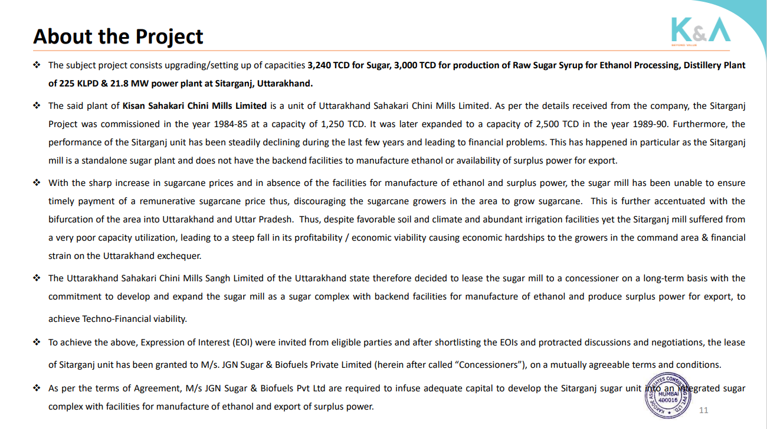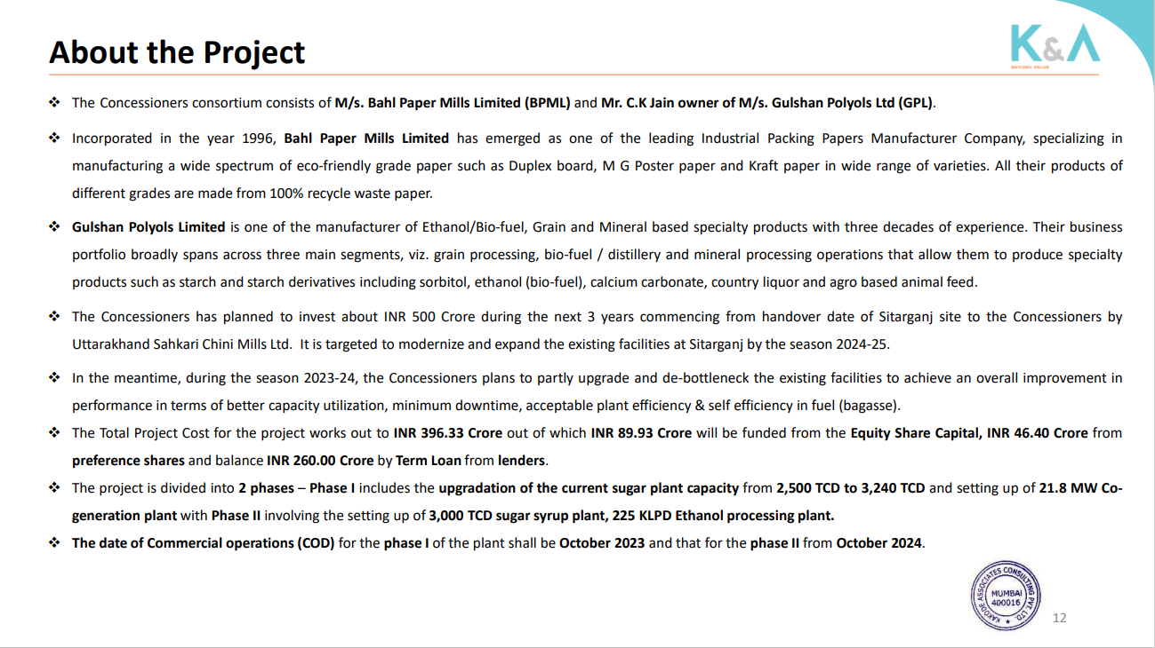
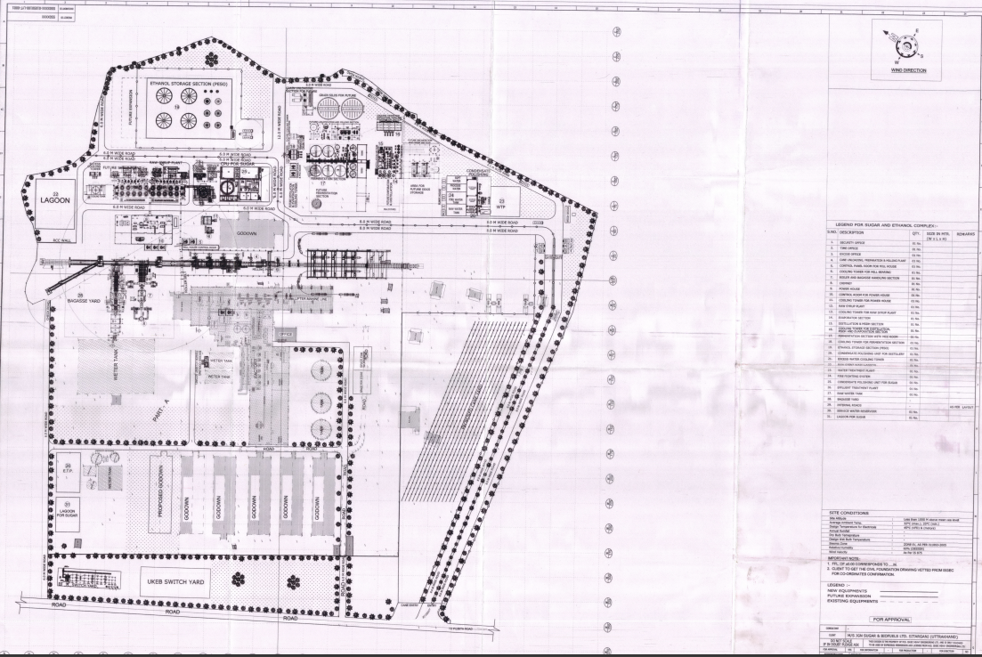
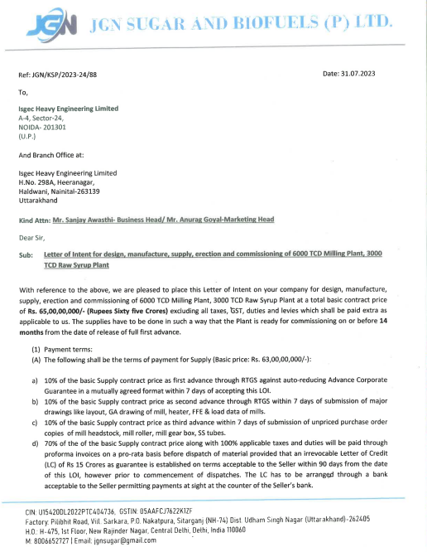
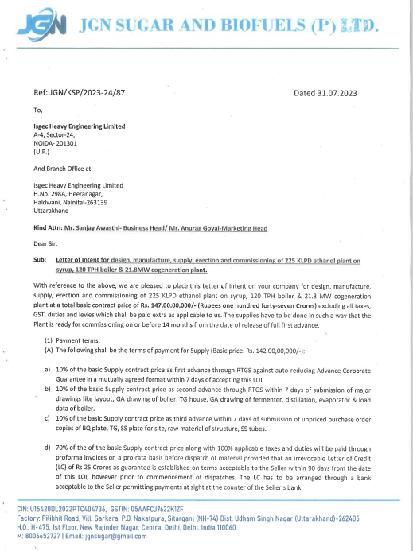
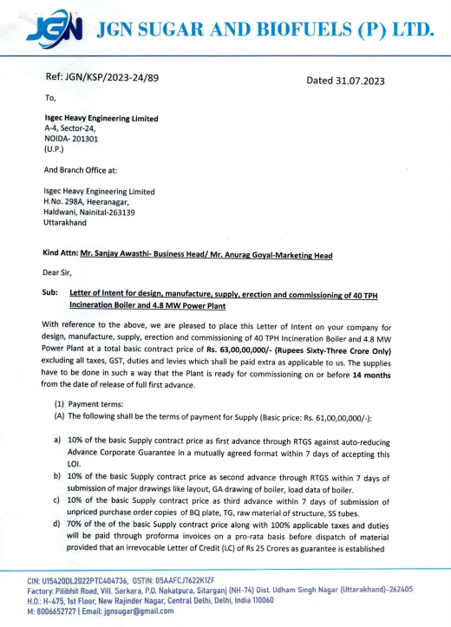
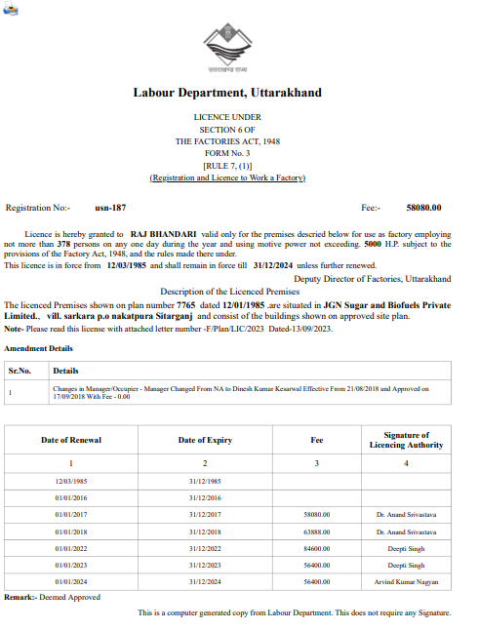
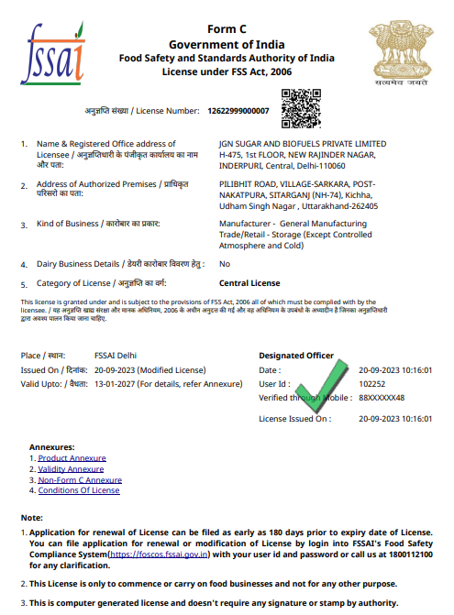

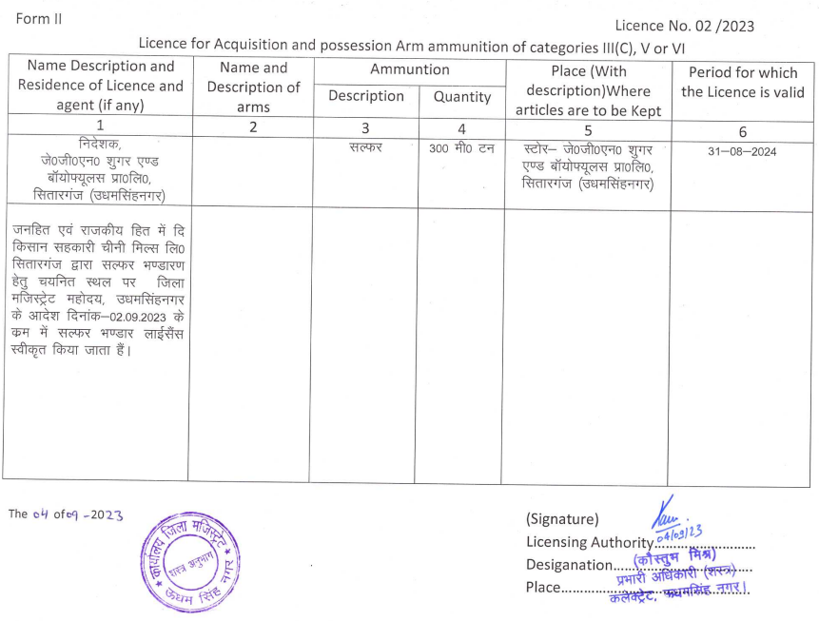
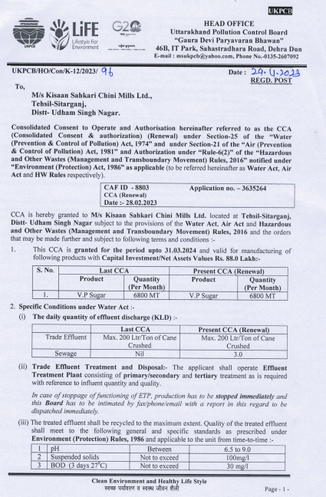
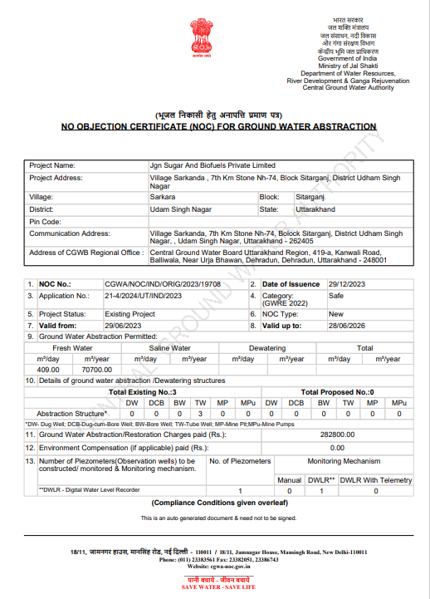

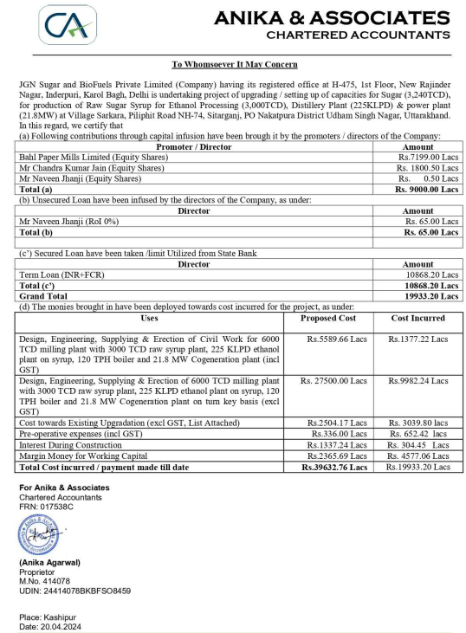
PART J | SITE PHOTOGRAPHS

6000 TCD MILLING PLANT
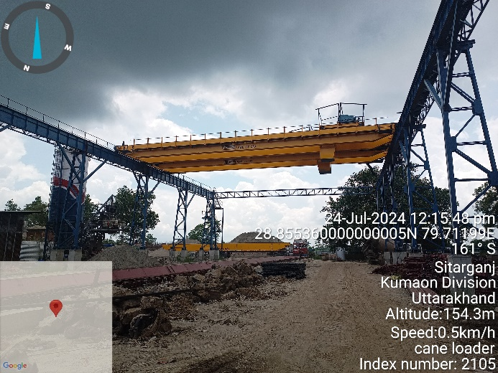 | 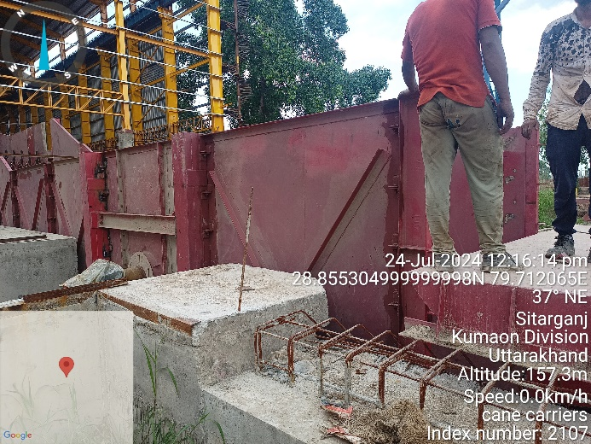
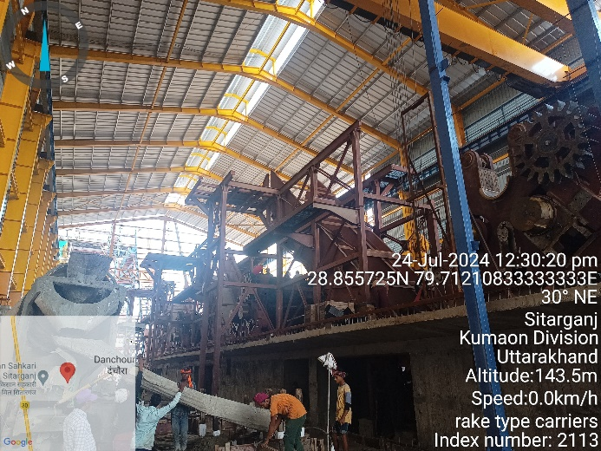 | 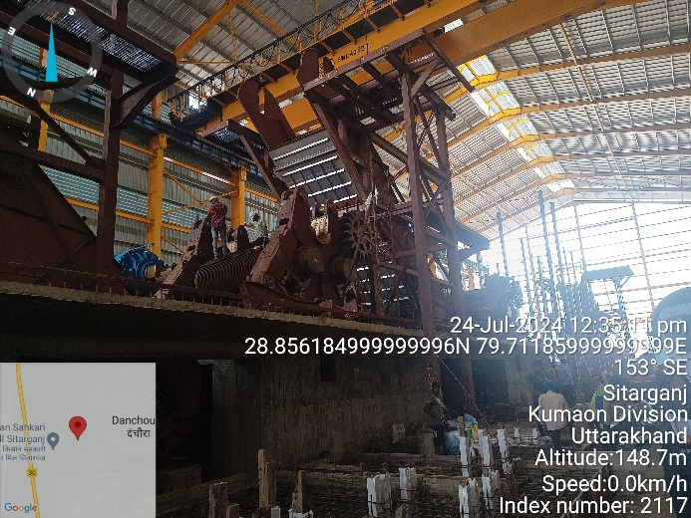
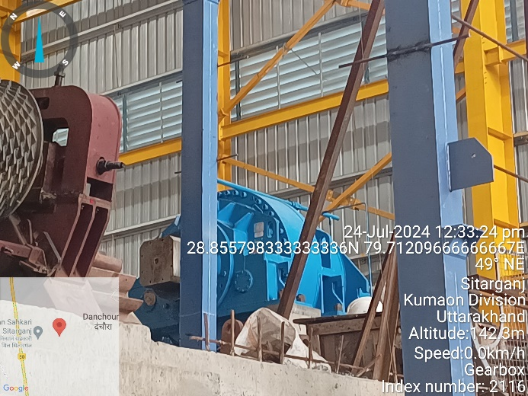 | 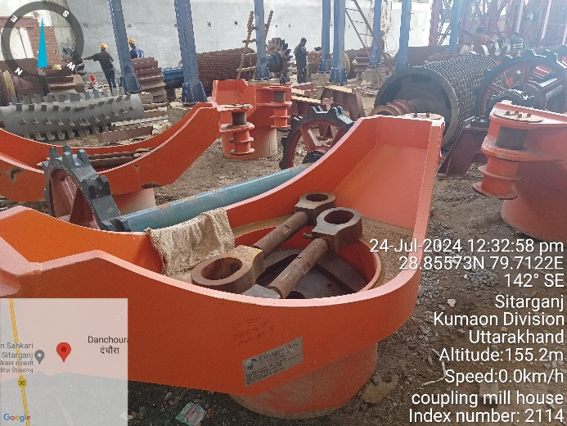

120 TPH BOILER & 21.8 MW CO-GENERATION PLANT
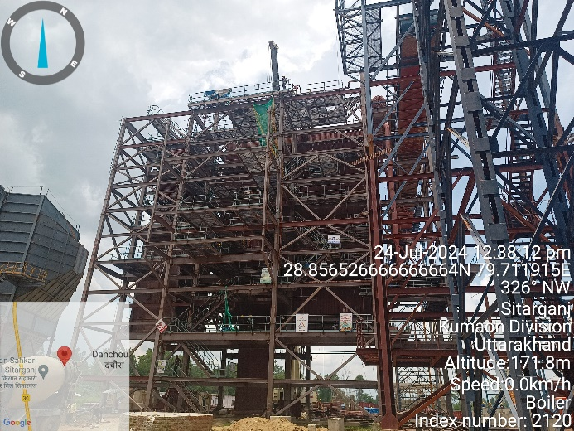 | 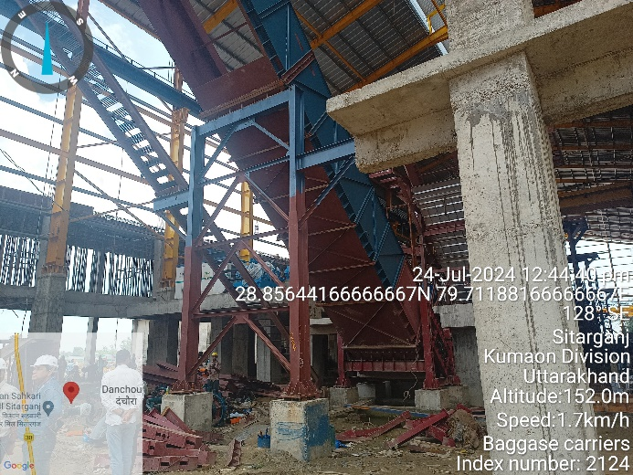
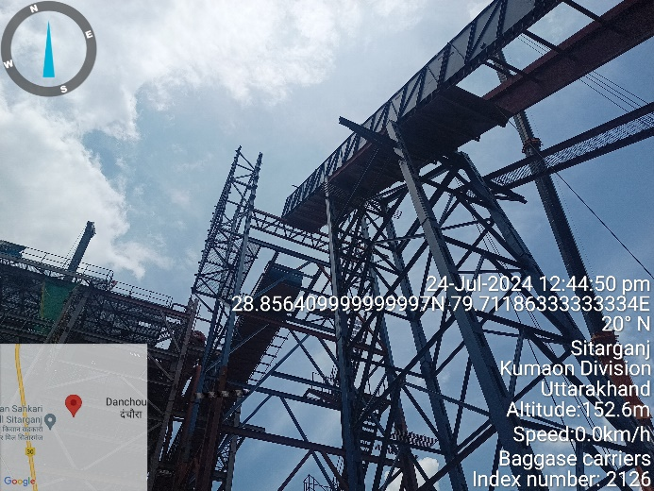 | 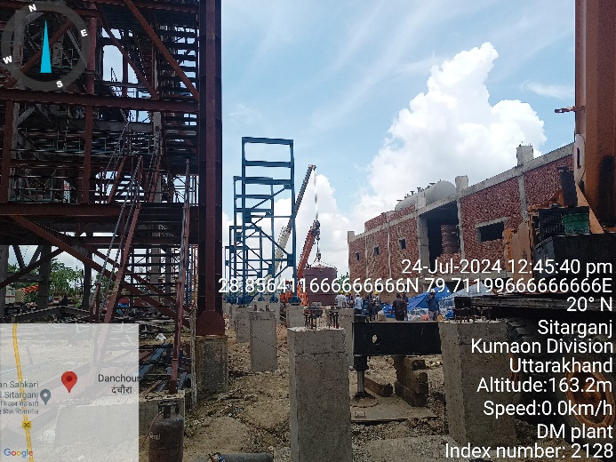
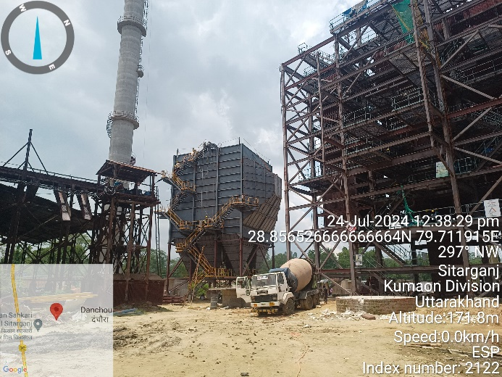 | 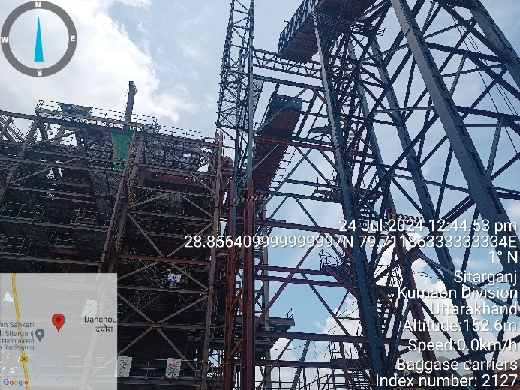

225 KLPD ETHANOL (DISTILLERY) PLANT
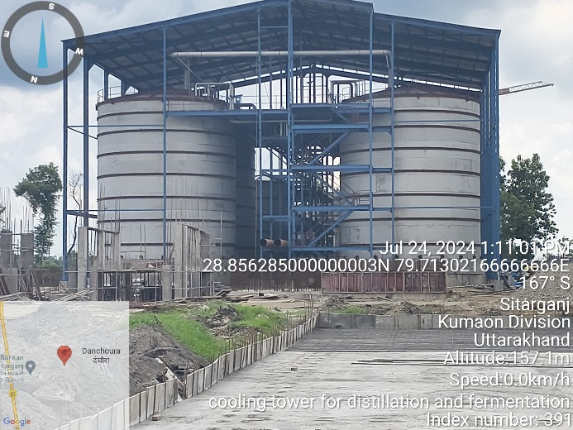 | 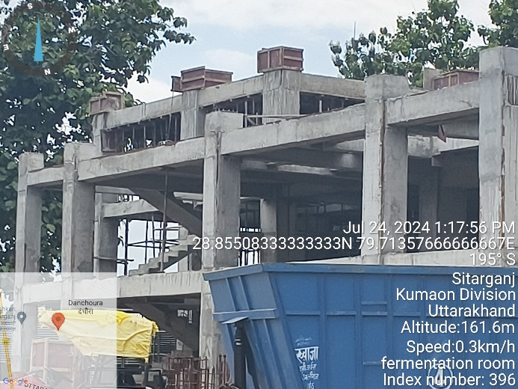
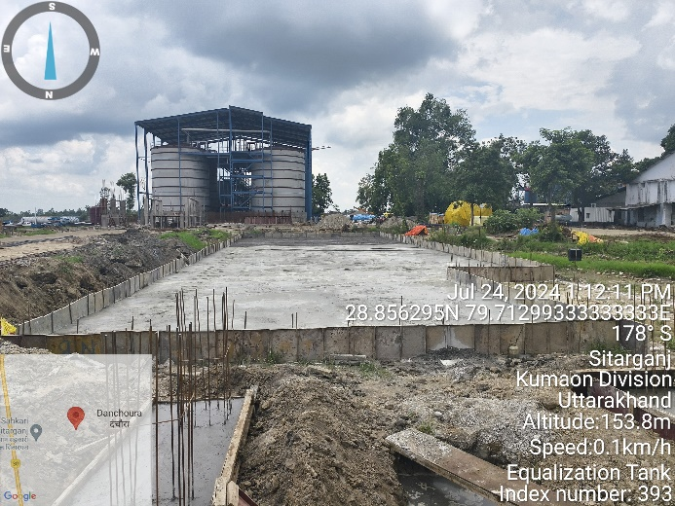 | 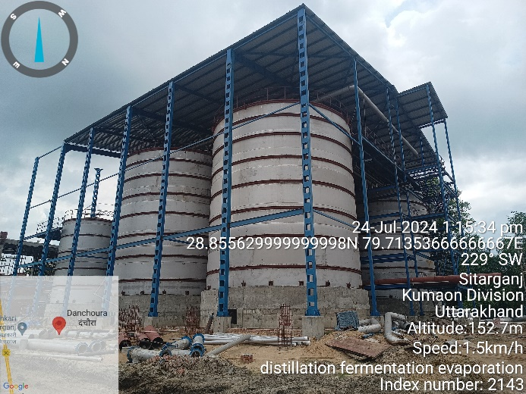
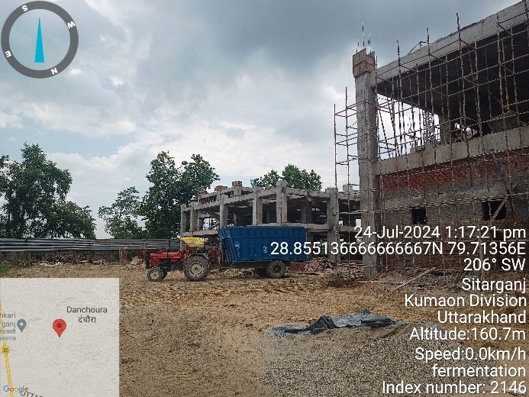 | 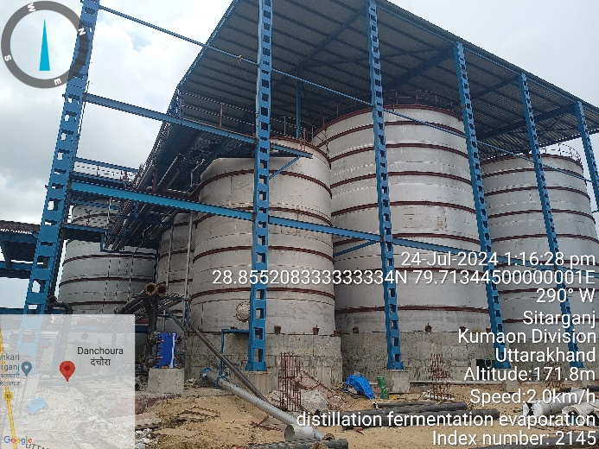

3000 TCD RAW SYRUP PLANT
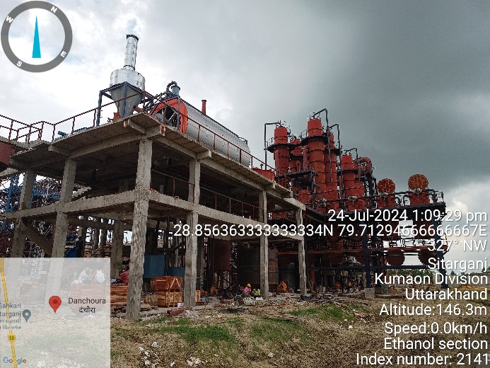 | 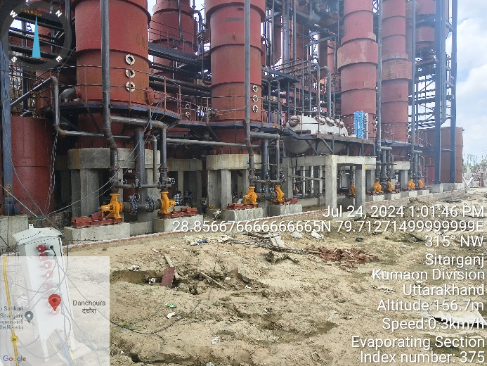
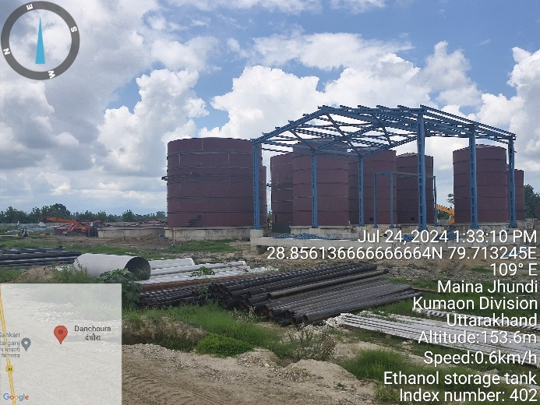 | 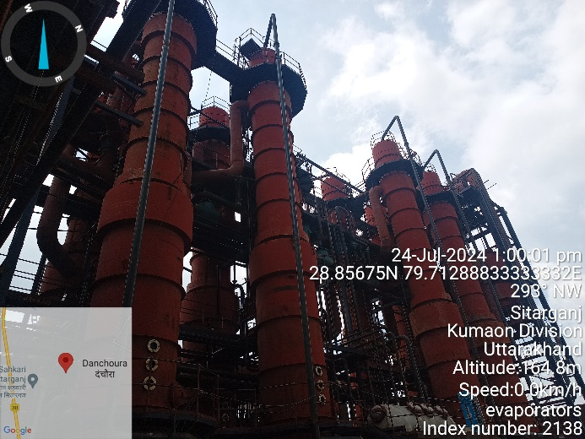
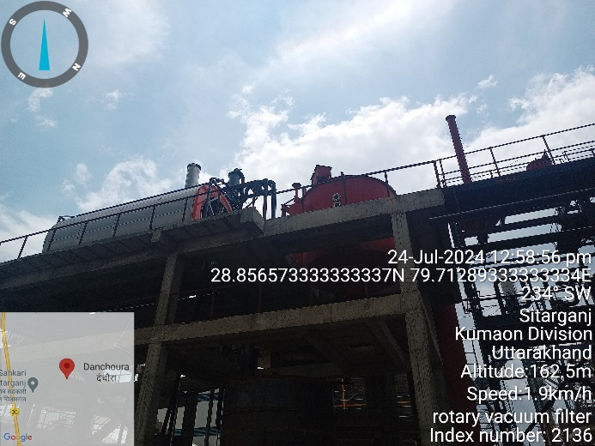 | 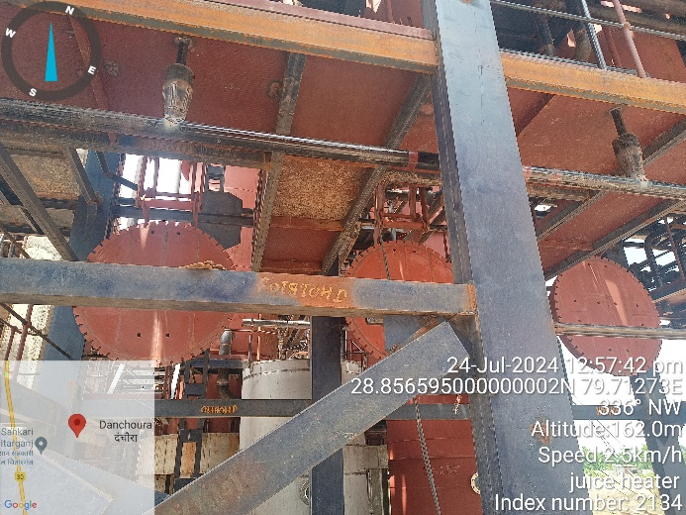

MISCELLANEOUS
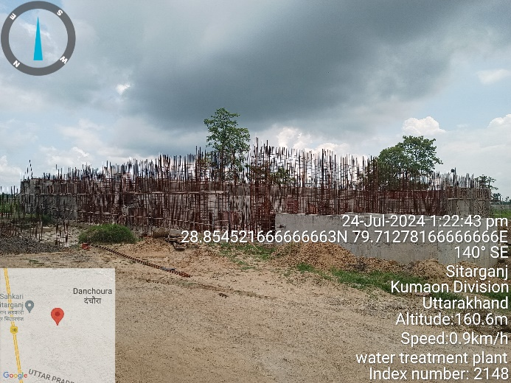 | 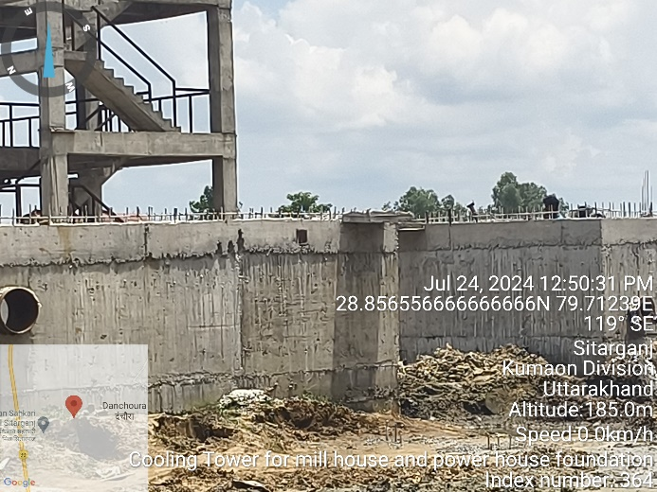
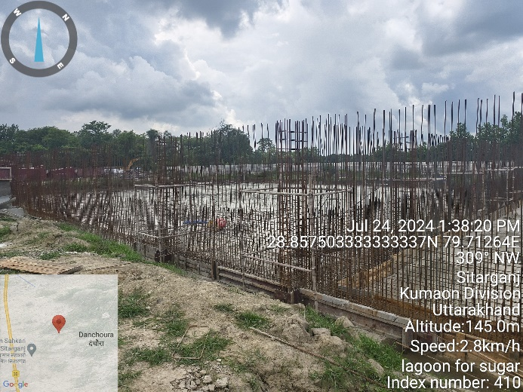 | 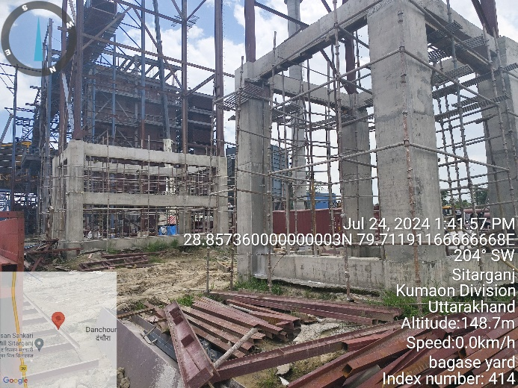
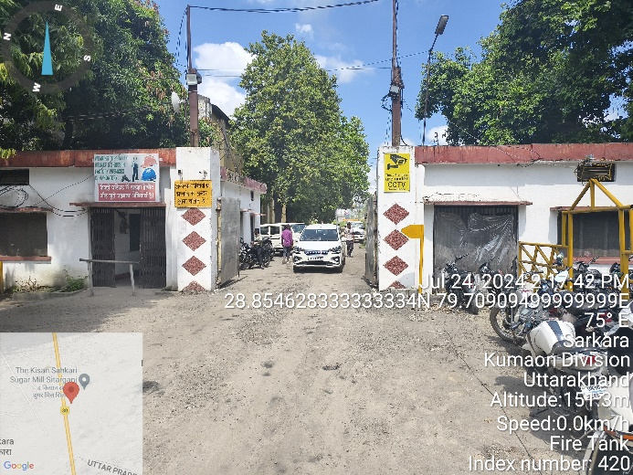 | 