REPORT FORMAT: V-L5 | Version: 4.2_2017

File No.: VIS (2024-25)-PL065-056-075 Dated: 20.12.2024

ENTERPRISE VALUATION REPORT

OF

SVIL MINES LIMITED

SITUATED AT
13B, 3RD FLOOR, NETAJI SUBHASH MARG, DARYAGANJ, CENTRAL DELHI, DELHI, INDIA- 110002

REPORT PREPARED FOR
PUNJAB NATIONAL BANK, ZONAL SASTRA CENTRE DELHI, 1ST FLOOR, 7TH BHIKAJI CAMA PLACE, NEW DELHI - 110066

**Important - In case of any query/ issue or escalation you may please contact Incident Manager at valuers@rkassociates.org. We will appreciate your feedback in order to improve our services.

NOTE: As per IBA Guidelines please provide your feedback on the report within 15 days of its submission after which report will be considered to be correct.

IMPORTANT NOTICE

COPYRIGHT FORMAT: This report is prepared on the copyright format of R. K. Associates Valuers & Techno Engineering Consultants (P) Ltd. (R. K. Associates) to serve our clients with the best possible information and analysis to facilitate them to take rational business decisions. Legally no one can copy or distribute this format without prior approval from R. K. Associates. It is meant only for the advisory/ reference purpose for the organization/s as mentioned on the cover page of this report. Distribution or use of this format or report or any of its content/ information/ data by any organization or individual other than R.K Associates will be seen as an unlawful act and necessary legal action can be taken against the defaulters.
This report is intended for the sole use of the intended recipient/s and contains material that is STRICTLY CONFIDENTIAL AND PRIVATE.

DEFECT LIABILITY PERIOD: In case of any query/ issue or escalation you may please contact Incident Manager at valuers@rkassociates.org. Though adequate care has been taken while preparing this report as per its scope, but still, we can’t rule out typing, human errors, over sightedness of any information or any other mistakes. Therefore, the concerned organization is advised to satisfy themselves that the report is complete & satisfactory in all respect. Intimation regarding any discrepancy shall be brought into our notice immediately. If no intimation is received within 15 (Fifteen) days in writing from the date of issuance of the report, to rectify these timely, then it shall be considered that the report is complete in all respect and has been accepted by the client up to their satisfaction & use and further to which R.K Associates shall not be held responsible in any manner.

Part E: R. K. Associates Important Disclaimer and Remarks are integral part of this report and Feasibility assessment is subject to this section. Reader of the report is advised to read all the points mentioned in these sections carefully.

TABLE OF CONTENTS
SECTIONS | PARTICULARS | PAGE NO.
PART A | INTRODUCTION | 3
PART A | - About the Report | 3
PART A | - Background of the Project | 3
PART A | - Type of Report | 6
PART A | - Purpose of the Report | 6
PART A | - Scope of the Report | 6
PART A | - Methodology/ Model Adopted | 7
PART A | - Documents/ Data Referred | 7
PART B | INCORPORATION DETAILS OF THE COMPANY | 8
PART C | VALUATION OF THE SHARES OF THE COMPANY | 10
PART C | M/s SVIL Mines Limited | 10
PART D | IMPORTANT DEFINITION | 21
PART E | DISCLAIMER & REMARKS | 23
 | ANNEXURES | 29

PART A | INTRODUCTION

- ABOUT THE REPORT:
Enterprise Valuation of Marble Mining and Processing Company, M/s SVIL Mines Limited with registered office at 13B, 3rd Floor, Netaji Subhash Marg, Daryaganj, Central Delhi, Delhi, India- 110002 and mines located at Village Gudri, Nimas, Bhaganwara, Kachargaon, District – Katni, Madhya Pradesh.

- BACKGROUND:
M/s SVIL Mines Limited (SML) was incorporated on 16th June, 2004 with Registrar of Companies, Delhi under Companies Act, 1956. The registered office of the company is located 13B, 3rd Floor, Netaji Subhash Marg, Daryaganj, Central Delhi, Delhi, India- 110002, whereas the mines of the company are located at Village Gudri, Nimas, Bhaganwara, Kachargaon, District – Katni, Madhya Pradesh - 483501.
However, as per the data/information provided by the client/bank, we found that the SVIL Mines Limited was incorporated on 16th December 2002 under the name of Yash Mines and Marbles (India) Private Limited. Subsequently, the name of the Company was changed to SVIL Mines Private Limited on 21st September 2004. The status of the Company was also changed from private company to public company on 8th October 2004. Pursuant to the scheme of amalgamation approved by Hon’ble High Court of New Delhi on 11th December 2008, the erstwhile Texefx Marble Industries Limited (the transferor Company) had been amalgamated with the Company on the appointed day i.e. 30th March 2008.
The Company also have wholly owned subsidiary, namely, SVIL Mines International FZE. SVIL Mines International FZE has also acquired 49% stake in another entity, namely, SVIL Mines International LLC. During the year 2010-11, the company has also incorporated wholly owned subsidiary, Namely, SVIL Mines International PTE Ltd.
SML is one of the group companies of Delhi based Floriana Group having registered and having corporate office at Delhi. The Company is primarily engaged in the extraction of marble blocks and processing of marble blocks into marble slabs and selling the same in the domestic and international market. As per the information available with us, the company had an installed capacity of 8,55,000 MTPA for Marble Slab and Tiles. The raw material (marble) is extracted from the mines which are located near the plant.
As per the information shared by client/company, SML had mines at Katni, Madhya Pradesh and Udaipur, Rajasthan. The Company’s Promoters namely Mr. Sanjay Jain and Mr. Rajic Jain had substantial shareholding in the SML. As on 31.03.2011, Citigroup Venture Capital (CVC) held about 23% equity share capital in the company.
The company had set up a fully integrated automatic plant in Madhya Pradesh for mining and processing of marble by adopting modern scientific technology of block impregnation and slab impregnation to improve recovery of non-renewable wasting assets and to increase the efficiency of block processing. The company had an International Patent for “method for consolidation of blocks and process” technology from an Italian Company.
As per the audited balance sheet dated 31.03.2011, the company had a chain of marble retail showrooms & warehouses with brand name Floriana Concept Marble. The distribution network of the company comprised of 45 exclusive stores in India, one showroom in Dubai and one in Singapore. The product range included finished-to-fit Slabs, Tiles, Mosaic panels and ready to fix Countertops.
On 01.12.2011, SML had inaugurated one showroom at Kundli, Haryana measuring about 66,000 sq. ft. To make the product globally, Company has two wholly owned subsidiaries across the globe named SVIL Mines International FZE at Ajman in Dubai and SVIL Mines International Pte. Ltd. in Singapore, to undertake general trading (including import/export) of Marble and other allied products & activities.
Below table shows the historical financial performance of the company from FY 2007-08 to FY 2010-11:
(INR)
Particulars | FY 2008 A | FY 2009 A | FY 2010 A | FY 2011 A
Revenue from Operations | 49,01,45,654 | 1,38,49,57,500 | 1,89,76,92,735 | 5,30,13,33,961
Other income | 8,65,99,560 | 3,39,70,771 | 2,64,05,830 | 8,19,10,274
Total Revenue | 57,67,45,214 | 1,41,89,28,271 | 1,92,40,98,565 | 5,38,32,44,235
Net Cost of Materials Consumed | 15,94,50,940 | 66,88,60,171 | -10,98,19,345 | -9,62,70,285
Contract cost | - | - | 47,66,47,399 | 3,94,25,15,722
Administrative, Selling & Other expenses | 21,43,28,682 | 26,98,13,224 | 1,05,01,89,043 | 87,62,90,819
Total expenses | 37,37,79,622 | 93,86,73,395 | 1,41,70,17,097 | 4,72,25,36,256
EBIT | 20,29,65,592 | 48,02,54,876 | 50,70,81,468 | 66,07,07,979
Finance costs | 17,84,90,398 | 41,32,23,173 | 43,00,36,197 | 43,87,17,519
Profit before tax | 2,44,75,194 | 6,70,31,703 | 7,70,45,271 | 22,19,90,460
Tax Expense | -30,97,196 | 40,01,116 | 16,66,956 | 75,16,423
Profit for the year | 2,75,72,390 | 6,30,30,587 | 7,53,78,315 | 21,44,74,037
EBIT Margin % | 41.41% | 34.68% | 26.72% | 12.46%
Net Profit Margin % | 5.63% | 4.55% | 3.97% | 4.05%
Revenue Growth Rate (Y.O.Y.) | - | 182.56% | 37.02% | 179.36%
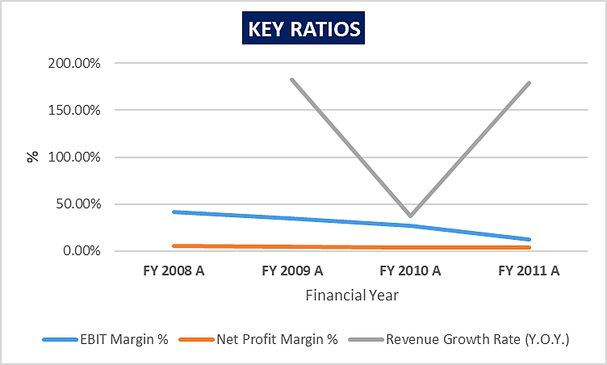
As per the previous years’ audited financials shared with us, the EBIT Margin and Net Profit Margin of the company have decreased from 41.41% & 5.63% in FY 2007-08 respectively to 12.46% & 4.05% in FY 2010-11 respectively.
As per the information available with us and on the public domain, the company has been non-operational since FY 2011 and as per the filling details available on MCA, latest Balance Sheet filled by the company is as on 31st March 2011. The company has last filed its financial statements on the MCA website for the FY ending 31.03.2011. At present, all properties and plant of the company are under the possession of Honorable High Court of Delhi for liquidation. Due to financial stress currently, company’s debt accounts are classified as NPA and hence Punjab National Bank, Zonal Sastra, Delhi need to take appropriate decision/resolution on this NPA account.
Thus, for the purpose of decision making on resolution of this stressed account, Punjab National Bank, Zonal Sastra Delhi has assigned R K Associated to assess & determine the Enterprise Value/Fair Market Value of M/s SVIL Mines Limited as per scope of work, to execute the appropriate action by the decision makers on this NPA account.

- TYPE OF REPORT: Enterprise Valuation Report.

- PURPOSE OF THE REPORT:
To assess & determine the Enterprise Value of the company on standalone basis as required by the lenders.

- SCOPE OF THE REPORT:
As per the client requirement and based on the purpose of the report, RKA subject matter expert team has arrived at Fair Valuation of the Project and describe in-depth detailed assessment of the clear basis of the Valuation assessment. To assess and determine Fair Market Valuation of M/s SVIL Mines Limited, the Enterprise Valuation is being calculated by using Net Asset Value (NAV) Method as per best fit method in present scenario.
- This is just the enterprise valuation of the company based on its fair market value of Current and Non-Current Assets. Further the Current and Non-Current Liabilities will be adjusted with the Fair market value of Total assets, which will give the Net Assets Value (adjusted) of the company which can be used as proxy of Enterprise Value of the company.
- This Valuation only covers the fair market value of Current and Non-Current assets of the company. It does not cover any transaction with the subject company’s subsidiary/ associate/ Joint Venture Companies, as per the requirement by the lender.
- This Valuation is prepared based on the current financial status and futuristic operational uncertainty of the company, financial data/ model, future projections, other facts & information provided by the company/ lender/ Client in writing & verbal discussions held during the course of the assignment and based on independent assessment of certain assumptions which are specifically mentioned in the Valuation section of the Report.
- This Enterprise Valuation report doesn’t cover vetting of the documents/ financial data/ projections or any other information provided to us by the Bank.
- The physical asset valuation (Fixed Asset Valuation) is based on the desktop Valuation as the physical site inspection was out of scope of this valuation report and virtual site survey is conducted only for one site at Gudri, Katni.
- We have relied on the data provided by the Bank and the Company in good faith.
- We have assumed that the information provided to us is correct and is not manipulated or distorted.
- The Market and Industrial assessment of the given company’s industry/ sector has not been done at our end. So, this valuation doesn’t cover the Market & industrial scenario in terms of the product demand & market potential.
- This exercise is neither an audit activity nor investigative in nature.
- It is important to point out that we have carried out these valuations based on the limited information which was available with us at the time of valuation. As and when any new or updated information comes forward, it is likely that the suggested valuation will no longer represent a true and fair representation of the situation.

- METHODOLOGY/ MODEL ADOPTED:
Net assets Value (NAV) method is adopted for the calculation of Enterprise Valuation of the Company.

- DOCUMENTS / DATA REFFERED:
- Last available Audited Financial Statements dated 31.03.2011 of M/s SVIL Mines Limited (SML).
- Fixed Asset Valuation Report of SML dated 10.11.2008, 24.06.2022 & 08.07.2022.
- Restructuring Proposal dated 01.04.2012.
- Bank Inspection Report, Due Diligence Report & Search Report.
- Registry, Khasra Copy and other documents.
- Details of Outstanding loan as on 31.07.2012
- Data/Information available on the public domain.

PART B | INCORPORATION DETAILS OF THE COMPANY
As per information available on MCA website, the incorporation detail of the Project Company is provided in the table below:
INCORPORATION DETAILS
Name of the Company | SVIL Mines Limited
CIN | U51909DL2004PLC126962
ROC Name | ROC Delhi
Registration Number | 126962
Registered Office Address | 13B, 3rd Floor, Netaji Subhash Marg, Daryaganj, Central Delhi, Delhi, India- 110002
Constitution | Public Company (Limited by Shares)
Date of Incorporation | 16th June 2004
Authorised Capital | INR 37,00,00,000
Paid up Capital (Equity) | INR 24,09,45,500
Date of Last AGM | 30th September 2011
Date of Last Balance Sheet | 31st March 2011
Source: As per data/information available on MCA website
Below table shows the details of directors/Promoters of the company along with their DIN details and date of appointment:
List of Directors of M/s SVIL Mines Limited
S. No. | Name | DIN/PAN | Designation | Date of Appointment
1 | Mr. Periannan Rajamani | 07811426 | Additional Director | 03/05/2017
2 | Mr. Sanjay Jain | 00026147 | Additional Director | 15/03/2017
3 | Mrs. Rajiv Jain | 00026004 | Additional Director | 15/03/2017
Source: MCA Data
We could not find much details of directors/promoters, their educational background and experience in the public domain.
CAPITAL STRUCTURE: The authorized Share Capital of the Company is INR 37.00 Crore divided into 37 Lakh Equity Shares of INR 100/- each as per audited financial statement dated 31.03.2011. During the year under review, paid up capital of the Company was INR 29,09,45,500.00 into 29,09,455 Equity Shares of INR 100/- each fully paid as on 31st March, 2011.
DEBT POSITION OF THE COMPANY: As per the data/information shared by the client/company, the details of outstanding dues of SVIL Mines Limited as on 31.07.2012 is shown in the table below:
(INR Crore)
S. No. | Name of Bank | Principal | Interest | Other Charges | Total
1 | Punjab National Bank | 39.77 | 2.55 | 0.43 | 42.75
2 | Bank of India | 10.75 | 0.80 | 0.00 | 11.55
3 | Canara Bank | 10.09 | 0.78 | 0.00 | 10.87
4 | Indian Bank | 9.15 | 0.65 | 0.00 | 9.80
5 | Oriental Bank of Commerce | 21.11 | 0.76 | 0.00 | 21.87
6 | State Bank of India | 15.79 | 0.71 | 0.00 | 16.50
7 | Syndicate Bank | 11.37 | 1.95 | 0.03 | 13.35
8 | The Federal Bank Limited | 9.16 | 0.77 | 0.00 | 9.93
9 | UCO Bank | 8.11 | 0.62 | 0.02 | 8.75
10 | United Bank of India | 11.53 | 2.43 | 0.00 | 13.96
11 | Vijaya Bank | 5.53 | 0.49 | 0.00 | 6.02
Total |  | 152.36 | 12.51 | 0.48 | 165.35

PART C | VALUATION OF THE COMPANY

- METHODOLOGY/ MODEL ADOPTED:
Out of the various Models & theories available, we have adopted the most widely used & acceptable approach to calculate the Enterprise Valuation of the Company, which is, Net Assets Value (NAV) Approach, and the adjusted NAV is being considered as the proxy of the Enterprise Value of M/s SVIL Mines Limited:
- The NAV approach used here, is based on the present value/fair market value of all its fixed asset and its financial assets.
- Fair value of fixed assets of the company including property, plant and equipment is calculated based on the Market and Cost Approach as-is-where-is basis for estimating the Current Depreciated Replacement value of the assets.
- Present value of the financial/ current assets is estimated based on the document/ information provided by the company.
- Further, the liabilities of the company will be net off with the Fair market value of Total asset value estimated based on the present scenario.
Rationale for using Net Asset Value (NAV) Approach for the Enterprise Valuation:
- The 3 Broad Model of Company Valuation are – Income based approach (Discounted Cash Flow Models), Asset Based and Market Multiple.
- The free cash flow method is not used here because the account is under liquidation process and due to going on hearings & pending litigations future cash flow cannot be projected easily since the company is non-operational since last 10-12 years and the account is already categorized NPA by the financial creditor as per norms of the RBI guidelines.
- Also, due to uncertain future operations as the same is communicated by the banker/client, estimating accurate future projections becomes difficult.
- Further, the Present Value Model gives us a variety of input options to use while calculating the Value of the firm - Dividend, Free Cash Flow to the Firm, Free Cash Flow to Equity, Capitalized Cash Flows and Residual Earnings.
- Dividends cannot be used as the Company has no history of paying dividends and we don’t foresee any dividend payments to occur in the future due to the high leverage of the firm.
- Market Comparable Approach was also not used since we could not find any suitable market comparable transactions and company of similar scale, scope & nature in the market.
- Asset Based Model is a more appropriate approach for estimating the Company’s present value/fair market value based on the present value calculation of the assets (fixed asset and financial assets).
- Therefore, the most appropriate Model left to Value M/s SVIL Mines Limited is Net Asset Value approach since there is an uncertainty regarding company’s futuristic operations.
- The best method input option for the NAV Model in the case of M/s SVIL Mines Limited will be current fair value of the fixed assets based on the market and cost-based approach and financial assets valuation based on the documents/information made available us by the client/company
- Hence, NAV method is used in the valuation process of the company.

For Financial and Current Assets: Gathering of Information on high level breakup of each head of Financial and Current Assets for assessment (as per RKA Format).
- Review of data/ inputs/ information which company could provide to us against the queries raised by the consultant.
- Final assessment as per the data /information available on record.
Notes:
- There is not a fixed criterion, formula or norm for the Valuation of Current Assets. It is purely based on the individual assessment and may differ from consultant to consultant based on the practicality he analyses in recoveries of the outstanding dues. Ultimate recovery depends on efforts, extensive follow-ups of the individual case by the company. So, our values should not be regarded as any judgement in regard to the recoverability of current assets but should only be read in terms of analysis.
- For arriving at the Fair Value, appropriate discounting factor against each current asset item is applied based on the nature of current asset and level of difficulty in realization of these.
- No audit of any kind is performed by us at our end from the books of account or ledger statements. All the data/ information/ input/ details provided to us by the company/ lenders are taken by us as-it-is on good faith and assumed that that these are factually correct information.
- This is a general assessment of the estimated fair value of the current assets based on the data/ input/ Information Company/ lenders could provide to us against our questions/ queries. In no manner this should be regarded as an audit activity/ report and NO micro analysis or detailed or forensic audit/ scrutiny of the financial transactions or accounts of any kind has been carried out at our end.
- Review of data/ inputs/ information which company could provide to us against the queries raised by the consultant. Final assessment as per the data /information available on record.

- SUMMARY OF VALUATION ASSESSMENT:
(Value in INR)
Particulars | Amount As On 31st March 2011 | Fair Market Value
Assets
Non-Current Assets
Property Plant & Equipment | 3,48,85,62,177.00 | 40,04,86,932.00
CWIP | 5,75,22,627.00 | -
Investments | 30,59,89,904.00 | -
Total Non-Current Assets | 3,85,20,74,708.00 | 40,04,86,932.00
Current Assets
Inventories | 2,55,86,99,429.00 | 2,20,92,000.00
Trade Receivables | 92,20,62,216.00 | -
Cash and Bank Balance | 2,88,88,495.00 | -
Loans | 52,03,56,860.00 | -
Total Current Assets | 4,03,00,07,000.00 | 2,20,92,000.00
Total Assets | 7,88,20,81,708.00 | 42,25,78,932.00
Liabilities
Non-Current Liabilities
Secured Loan | 2,52,68,80,972.00 | 2,52,68,80,972.00
Unsecured Loan | 75,84,26,375.00 | 75,84,26,375.00
Total Non-Current Liabilities | 3,28,53,07,347.00 | 3,28,53,07,347.00
Current Liabilities
Current Liabilities | 59,21,74,053.00 | 59,21,74,053.00
Provisions | 96,54,897.00 | 96,54,897.00
Total Current Liabilities | 60,18,28,950.00 | 60,18,28,950.00
Total Liabilities | 3,88,71,36,297.00 | 3,88,71,36,297.00

- NAV AS A PROXY OF ENTERPRISE VALUE:
CALCULATION OF ENTERPRISE VALUE
Particulars | Amount
Total Assets (A) | INR 42,25,78,932.00
Total Liabilities (B) | INR 3,88,71,36,297.00
Net Assets Value (NAV) (A-B) | NIL

As the fair value of the assets is less than the fair value of the liabilities, hence, the Net Asset Value (NAV) of M/s SVIL Mines Limited is estimated to be Nil.
ADJUSTED NET ASSET VALUE (NAV) OF M/S SVIL MINES LIMITED
NIL
Hence, the “Enterprise Value” of the Firm “M/s SVIL Mines Limited” is NIL.
This is only a general assessment of the current value of the Enterprise/Business based on the data/ input that the Bank/Client/Company could provide to us against our questions/ queries using the appropriate method with respect to the present scenario. In no manner this should be regarded as an audit activity/ report and NO micro analysis or detailed or forensic audit/ scrutiny of the financial transactions or accounts of any kind has been carried out at our end.

- KEY ASSUMPTIONS:
- NON-CURRENT ASSETS:
- PROPERTY PLANT & EQUIPMENT
- PLANT LOCATED AT PIPROUNDH, KATNI
S. No. | Particulars | Indicative & Estimated Prospective Fair Market Value
1. | Land Value (A) | Rs. 98,84,000/-
2. | Total Building & Civil Works (B) | Rs. 6,21,87,667/-
3. | Plant & Machinery Value (C) | Rs. 23,50,100/-
 | Total Add (A+B+C) | Rs. 7,44,21,767/-
Note: For detailed working, assumptions and calculations of the above valuation, please refer to the Annexure A.

- PLANT LOCATED AT GUDRI, KATNI
S. No. | Particulars | Indicative & Estimated Prospective Fair Market Value
1. | Land Value (A) | Rs. 5,66,35,320/-
2. | Total Building & Civil Works (B) | Rs. 25,12,57,864/-
3. | Plant & Machinery Value (C) | Rs. 1,81,71,981/-
 | Total Add (A+B+C) | Rs. 32,60,65,165/-
Note: For detailed working, assumptions and calculations of the above valuation, please refer to the Annexure B.

- ASSET LOCATED AT NIMAS, KATNI
As mentioned in the OVR, The Company also owns Land & Building and Plant & Machinery assets located in Village-Nimas, Kachargaon, Tehsil Salemnabad, Katni. Ownership documents are not shared with us regarding this property. Also, property couldn’t be found on google maps. Thus, we cannot comment upon the Estimated Fair Market Value of the property.
- FLATS
As per OVR, apart from 2 nos. of plant total 06 nos. of Flats are also in the name of M/s SVIL Mines Limited. Copy of sale deed and approved sanction plan is not shared with us. Land area & plinth area of the residential property is not mentioned in the OVR. In the absence of required documents/information, we cannot comment upon the Estimated Fair Market Value of the property.

- CWIP
As per audited balance sheet dated 31.03.2011, CWIP had a book value of INR 5,75,22,627. We have not received any details/ supporting documents regarding the Ownership documents, status of the construction, approved sanction plan, etc. In the absence of required documents/information, we cannot comment upon the Estimated Fair Market Value of the asset.

- INVESTMENTS
As per audited balance sheet dated 31.03.2011, M/s SVIL had made investments of book value of INR 30,59,89,904. We have not received any details/ supporting documents regarding the terms and conditions under which these investments were made, current status of investees, etc. In the absence of required documents/information, we cannot comment upon the Estimated Fair Market Value of the investments. Thus, we have not assigned any value to these investments.

- CURRENT ASSETS:
- INVENTORY
The company operates marble mines situated at Mouza-Gudri, within Block-Sleemnabad, Tehsil-Bahoriband, District-Katni. During a virtual survey conducted on 26th September 2024, it was observed that the plant contains a substantial volume of inventory categorized as Finished Goods. These goods are stored across multiple locations within the plant premises, indicating significant stock levels.
However, despite the virtual survey, crucial financial and quantitative details about the inventory remain unavailable. Specifically, neither the latest Balance Sheet nor the detailed inventory data, whether in terms of monetary valuation or physical quantity, has been shared with us. This lack of information limits our ability to accurately assess the inventory's value and overall contribution to the company’s assets.
The quantification of inventory at the site was conducted virtually with the assistance of the on-site Security Guard, Mr. Neeraj Yadav (+91 96859 51100). During this process, observations were made based on Mr. Yadav's inputs and the photographs provided by him. These inputs offered a visual and descriptive understanding of the inventory stored at the plant. From the observations and photographic evidence, it is apparent that the majority of the inventory comprises of White Marble. The photographs clearly depict substantial stacks of White Marble stored at various locations within the premises, confirming its predominance in the overall inventory. Details of the same are as follows: -
Location | Approx. Size  (sq. ft.) | No. of marble Slab in Each Stand | Total No. of Stand | Total Slabs | Total Marble Slab Area (sq. ft.)
Shed 1 | 16 | 16 | 40 | 640 | 10,240
Shed 1 | 32 | 11 | 20 | 220 | 7,040
Shed 1 | 20 | 22 | 171 | 3,762 | 75,240
Shed 2 | 24 | 30 | 50 | 1,500 | 36,000
Shed 4 | 38.5 | 40 | 60 | 2,400 | 92,400
TOTAL |  |  | 341 | 8,522 | 2,20,920
Valuation of Marble Slabs is as follows: -
Particulars | Book Value (In Rs.) | Estimated Fair Market Value (In Rs.) | Remarks
Inventory (Marble Slab) | Not shared | 2,20,92,000 | Based on our market research, the price of White Indian Marble in India typically ranges between Rs. 50 to Rs. 200 per square foot. This wide variation in pricing is influenced by multiple factors, including the availability of the marble, its thickness, the complexity and cost of the extraction process, and, most importantly, the overall quality of the material.  It is important to note that several key details specific to the marble inventory in question, such as its precise quality, trade name, and other technical specifications, have not been made available to us. These details are essential for determining a more accurate and definitive valuation of the marble slabs.  In light of the absence of this critical information such as the type of marble/granite and its quality, we have adopted a conservative approach to valuation. After careful consideration of market trends and the average price range, we have deemed it fair and reasonable to apply an average rate of Rs. 100 per square foot to estimate the value of marble slabs. This rate represents a balanced estimation that accounts for the potential variations in quality and market conditions, ensuring a prudent yet equitable assessment of the inventory's value.
TOTAL | --- | 2,20,92,000
REMARKS & NOTES: -
- Basis of the assessment is mentioned against observation made during survey based on the information provided to us by the Liquidator.
- During the virtual survey, it was observed that some of the marble slabs were stored in wooden racks. However, many of these racks were found to be damaged. As a result, the marbles stored in these damaged racks were excluded from the inventory calculation.
- The dimensions of the marble slabs were determined by the security guard using a method of random sampling for measurement.
- Each stand contained marble slabs of various sizes. For inventory purposes, the size of the slabs in each stand was determined based on the size that was most prevalent.
- The site contained marble slabs of varying qualities within each stand. However, due to the large quantity of slabs, it was not possible to segregate them based on quality.
- The number of marble slabs in each stand was estimated based on a count conducted by the security guard for a few selected stands. Using this data, a range was determined and applied for inventory calculation in the corresponding area.
- A large number of marble blocks were stored in the open; however, it was not possible remotely to estimate its quantity without physical measurement and counting.
- Stakeholder are advised to take into consideration the value of the unvalued material on the site.
- No audit of any kind is performed by us for the books of account or ledger statements and all this data/ information/ input/ details provided to us by the Liquidator/ Corporate Debtor are taken as is it on good faith that these are factually correct information.
- There is no fixed criteria, formula or norm for the Valuation of Securities or Financial Assets. It is purely based on the individual assessment and may differ from valuer to valuer based on the practicality he/she analyses in recoveries of outstanding dues. Ultimate recovery depends on efforts, extensive follow-ups, close scrutiny of individual case made by the Corporate Debtor. So, our values should not be regarded as any judgment in regard to the recoverability of Securities or Financial Assets.
- Since the company is not operational for a long time and as per bank, the liquidation process of the Corporate Debtor is being carried out on the piecemeal basis. Thus, only Liquidation Value on Piece-meal basis is arrived.

- TRADE RECEIVABLES
As per audited balance sheet dated 31.03.2011, Trade Receivables had a book value of INR 92,20,62,216. We have not received any details/ supporting documents regarding the legality, status of counterparty, any outstanding dues against the same or not and terms & conditions of these receivables, etc. In the absence of required documents/information, we cannot comment upon the Estimated Fair Market Value of the Receivables. Thus, we have not assigned any value to these trade receivables.
- CASH & BANK BALANCE
As per audited balance sheet dated 31.03.2011, Cash & Bank Balance had a book value of INR 2,88,88,495. We have not received any details/ supporting documents regarding the cash certificate, FD Details, Bank Statement, etc. In the absence of required documents/information, we cannot comment upon the Estimated Fair Market Value of the Cash & Bank Balance.
- LOANS
As per audited balance sheet dated 31.03.2011, Loans had a book value of INR 52,03,56,860. We have not received any details/ supporting documents regarding the legality, status of counterparty, any outstanding dues against the same or not and terms & conditions of these receivables, etc. In the absence of required documents/information, we cannot comment upon the Estimated Fair Market Value of the Loans.
- Thus, the Fair Market Value of Total Assets is being calculated as INR 42,25,78,932.00 as on valuation date.
- The fair market value of Total liabilities has been considered as 100% of the book value as on 31st March 2011.
Thus, the fair market value of Total Liabilities is being calculated as INR 3,88,71,36,297.00 as on valuation date.
- As the fair value of the assets is less than the fair value of the liabilities. Hence, the Net Asset Value (NAV) of M/s SVIL Mines Limited is estimated to be Nil.
Hence, after deducting the Total Liabilities from the fair market value of Total Assets, the Adjusted Net Asset Value (NAV) is being calculated as Nil, which is being considered as the proxy of Enterprise Value of “M/s SVIL Mines Limited” based on above assumptions, details provided by the company and considering the current operational status of the company.
- Enterprise Valuation of the subject company has been done by using Net Assets Value (NAV) Method.
- The Net Assets Value (NAV) of the project has been calculated after the deduction of Liabilities from the Total Assets Value of the company.
- This is just an opinion report on Valuation based on the copy of the documents/ information provided to us by the client which has been relied upon in good faith and the assessment and assumptions done by us.
- In the absence of critical data/information, we cannot comment upon the fair value of the Assets located at Nimas (Katni) and the flats owned by M/s SVIL Mines Limited.
- A large number of marble blocks were stored in the open; however, it was not possible remotely to estimate its quantity without physical measurement and counting. Hence, we cannot estimate the fair value of these marble blocks.
- The NAV method has been adopted for the calculation of Enterprise Valuation of the subject project since the project is categorized as NPA and as per the information provided by the banker/company, the future operation of the is uncertain as company is under Liquidation.
- No employee or member of R.K Associates has any direct/ indirect interest in the Project.
- This is only a general assessment of the Enterprise Value of the company based on the data/ input Company officials could provide to us against our questions/ queries and information available in the public domain. In no manner this should be regarded as an audit activity/ report and NO micro analysis or detailed or forensic audit/ scrutiny of the financial transactions or accounts of any kind has been carried out at our end.

Declaration | - The undersigned does not have any direct/indirect interest in the above property.  - The information furnished herein is true and correct to the best of our knowledge.  - This valuation work is carried out by our Financial Analyst team on the request from Punjab National Bank, Zonal Sastra Centre Delhi, 1st Floor, 7th Bhikaji Cama Place, New Delhi – 110066.  - We have submitted Valuation report to the Client.
Number of Pages in the Repost | 119
Enclosed Documents | Disclaimer & Remarks 23-28  Annexures 29-119
Place | Noida
Date | 20th December 2024

FOR ON BEHALF OF
M/S. R.K. ASSOCIATES VALUER & TECHNO ENGINEERING CONSULTANTS PVT. LTD.
PREPARED BY |  | REVIEWED BY
Mr. Rachit Gupta | Er. Abhinav Chaturvedi | Mr. Gaurav Kumar

PART D | IMPORTANT DEFINITION

Definitions:
- Enterprise Value: Enterprise value (EV) is the corporate valuation of a company, determined by using market capitalization and total debt. Market cap comprises preference stocks, common stocks, and minority interest; total debt comprises short-term and long-term liabilities of the company. Enterprise value (EV) refers to the overall valuation—equity, debt, cash, and cash equivalents. In other words, it is the cost of acquiring a firm. The EV/EBITDA is an enterprise multiple. It correlates EV with earnings before interest, taxes, depreciation, and amortization. The metric determines whether the firm is undervalued or overvalued.
EV is computed using the following formula: EV = (Market Capitalization + Market Value of Debt – Cash and Equivalents).
- Fair Market Value suggested by the competent Valuer is that prospective estimated amount in his expert & prudent opinion of the subject asset without any prejudice after he has carefully & exhaustively evaluated the facts & information came in front of him related to the subject asset at which the subject asset should be exchanged between a willing buyer and willing seller at an arm’s length transaction in an open & unrestricted market, after proper marketing, wherein the parties, each acted knowledgeably, prudently and without any compulsion on the date of the Valuation.
Forced, under compulsion & constraint, obligatory sales transactions data doesn’t indicate the Fair Market Value.
- Realizable Value is the minimum prospective estimated value of the Company which it may be able to realize at the time of actual transaction factoring in the potential prospects of deep negotiations carried out between the buyer & seller for ultimately finalizing the transaction across the table. Realizable value may be 10-20% less than the Fair Market Value depending on the various salability prospects of the subject asset and the needs of the buyer & the seller.
- Forced/ Distress Sale Value is the value when the company has to be sold due to any compulsion or constraint like financial encumbrances, dispute, as a part of a recovery process, legal issues or any such condition or situation. In this type of sale, minimum fetch value is assessed which can be 15-25% less than the estimated Fair Market Value. In this type of sale, negotiation power of the buyer is always more than the seller and eagerness & pressure of selling the asset is more than buying it. Therefore, the Forced/ Distress Sale Value will always fetch significantly less value compare to the estimated Fair Market Value.
- Liquidation Value is the amount that would be realized when an asset or group of assets are sold on a piecemeal basis that is without consideration of benefits (or detriments) associated with a going-concern business. Liquidation value can be either in an orderly transaction with a typical marketing period or in a forced transaction with a shortened marketing period.
- Difference between Costs, Price & Value: Generally, these words are used and understood synonymously. However, in reality each of these has a completely different meaning, premise and also have different definitions in the professional & legal terms. Therefore, to avoid confusion, it is our professional responsibility to describe the definitions of these words to avoid ambiguity & confusion in the minds of the user of this report.
- The Cost of an asset represents the actual amount spend in the construction/ actual creation of the asset.
- The Price is the amount paid for the procurement of the same asset.
- The Value is defined as the present worth of future rights in the asset and depends to a great extent on combination of various factors such as demand and supply, market situation, purpose, situation & needs of the buyer & seller, salability outlook, usability factor, market perception & reputation. Needs of the buyer & seller, salability outlook, usability factor, market perception & reputation.
- Therefore, in actual for the same asset, cost, price & value remain different since these terms have different usage & meaning.

PART E | DISCLAIMER | REMARKS

      - No employee or member of R.K. Associates has any direct/ indirect interest in the Project.
      - This is just an opinion report on Valuation based on the copy of the documents/ information provided to us by the client which has been relied upon in good faith and the assessment and assumptions done by us.
      - This report is prepared based on the copies of the documents/ information which the Bank/ Company has provided to us out of the standard checklist of documents sought from them and further based on our assumptions and limiting conditions. The client/owner and its management/representatives warranted to us that the information they supplied was complete, accurate and true and correct to the best of their knowledge. All such information provided to us has been relied upon in good faith and we have assumed that it is true and correct in all respect. I/We shall not be liable for any loss, damages, cost or expenses arising from fraudulent acts, misrepresentations, or willful default on part of the owner, company, its directors, employee, representative or agents. Verification or cross checking of the documents provided to us from the originals or from any Govt. departments/ Record of Registrar has not been done at our end since this is beyond the scope of our work. If at any time in future, it is found or came to our knowledge that misrepresentation of facts or incomplete or distorted information has been provided to us then this report shall automatically become null & void.
      - This Valuation is prepared based on the current financial status of the company, financial data, other facts & information provided by the client in writing & during verbal discussion during the course of the assignment and based on certain assumptions which are specifically mentioned in the Valuation section of the Report.
      - Key assumptions in the report are taken based on data, information, inputs, financial statements etc. provided by the client to us during the course of the assessment and on the basis of the assessment done by us and we have assumed that all such information is true & factual to the best of the knowledge of the promoter company.
      - Sale transaction method of the asset is assumed as free market transaction while assessing Prospective Fair Market Value of the asset.
      - Legal aspects for e.g., investigation of title, ownership rights, lien, charge, mortgage, lease, sanctioned maps, verification of documents, etc. have not been done at our end and same has to be taken care by legal expert/ Advocate. It is assumed that the concerned Lender/ Financial Institution has satisfied them with the authenticity of the documents, information given to us and for which the legal verification has been already taken and cleared by the competent Advocate before requesting for this report. I/ We assume no responsibility for the legal matters including, but not limited to, legal or title concerns.
      - All observations mentioned in the report is only based on the visual observation and the documents/ data/ information provided by the client. No mechanical/ technical tests, measurements or any design review have been performed or carried out from our side during Project assessment.
      - Bank/FII should ONLY take this report as an Advisory document from the Financial/ Chartered Engineering firm and its specifically advised to the creditor to cross verify the original documents for the facts mentioned in the report which can be availed from the borrowing company directly.
      - In case of any default in loans or the credit facility extended to the borrowing company, R.K Associates shall not be held responsible for whatsoever reason may be and any request for seeking any explanation from the employee/s of R.K Associates will not be entertained at any instance or situation.
      - We have relied on data from third party, external sources & information available on public domain also to conclude this report. These sources are believed to be reliable and therefore, we assume no liability for the truth or accuracy of any data, opinions or estimates furnished by others that have been used in this analysis. Where we have relied on data, opinions or estimates from external sources, reasonable care has been taken to ensure that such data has been correctly extracted from those sources and /or reproduced in its proper form and context, however still we can’t vouch its authenticity, correctness or accuracy.
      - This Report is prepared by our competent technical team which includes financial experts & analysts. This report is a general analysis of the project based on the scope mentioned in the report. This is not an Audit report, Design document, DPR or Techno feasibility study. All the information gathered is based on the facts seen on the site during survey, verbal discussion & documentary evidence provided by the client and is believed that information given by the company is true best of their knowledge.
      - Value varies with the Purpose/ Date/ Condition of the market. This report should not to be referred if any of these points are different from the one mentioned aforesaid in the Report.
      - Analysis and conclusions adopted in the report are limited to the reported assumptions, conditions and information came to our knowledge during the course of the work.
      - This report is having limited scope as per its fields to provide only the general indication of the Value of Enterprise of the companies prevailing in the market based on the documents/ data/ information/ financial statements provided by the client and the assessment and assumption taken by us. The suggested value should be considered only if transaction is happened as free market transaction.
      - Secondary/ Tertiary costs related to transaction like Stamp Duty, Registration charges, Brokerage, etc. pertaining to the sale/ purchase of the company are not considered while assessing the Market Value.
      - Appropriate methodology & assumptions are rationally adopted based on the facts of the case came to our knowledge during the course of the assignment considering many factors like nature of Industry, current market situation and trends.
      - Valuation is a subjective field and opinion may differ from consultant to consultant. To check the right opinion, it is important to evaluate the methodology adopted and various factors/ basis considered during the course of assessment before reaching to any conclusion.
      - At the outset, it is to be noted that Value analysis cannot be regarded as an exact science and the conclusions arrived at in many cases will, of necessity, be subjective and dependent on the exercise of individual judgment. Given the same set of facts and using the same assumptions, expert opinions may differ due to the number of different factors, which have to be made. Therefore, there can be no standard formulae to establish an indisputable exchange ratio. In the event of a transaction, the actual transaction value achieved may be higher or lower than our indicative analysis of value depending upon the circumstances of the transaction. The knowledge, negotiability and motivations of the buyers and sellers and the applicability of a discount or premium for control will also affect actual price achieved. Accordingly, our indicative analysis of value will not necessarily be the price at which any agreement proceeds. The final transaction price is something on which the parties themselves have to agree. However, our Valuation analysis can definitely help the stakeholders to make them informed and wise decision about the Value of the asset and can help in facilitating the arm’s length transaction.
      - This report is prepared on the Enterprise Valuation format as per the client requirement. This report is having limited scope as per its fields to provide only the indicative Fair value of the company based on the current financial position, future prospects & current Industry trends. The Valuation assessed in this Valuation Report should hold well only if transaction is happened as per free market transaction. No detailed analysis or verification of the information is carried upon pertaining to the value of the shares of the subject companies. No claim for any extra information will be entertained whatsoever be the reason. For any extra work over and above the fields mentioned in the report will have an extra cost which has to be borne by the customer.
      - As per the scope of the report no site survey has been carried out by us and no thorough vetting of the documents/ information provided to us has been done at our end.
      - This is just an opinion report and doesn’t hold any binding on anyone. It is requested from the concerned stakeholder which is using this report that they should consider all the different associated relevant & related factors also before taking any business decision based on the content of this report.
      - Though adequate care has been taken while preparing this report as per its scope, but still, we can’t rule out typing, human errors, over sightedness of any information or any other mistakes. Therefore, the concerned organization is advised to satisfy themselves that the report is complete & satisfactory in all respect. Intimation regarding any discrepancy shall be brought into our notice immediately. If no intimation is received within 15 (Fifteen) days in writing from the date of issuance of the report, to rectify these timely, then it shall be considered that the report is complete in all respect and has been accepted by the client up to their satisfaction & use and further to which R.K Associates shall not be held responsible in any manner.
      - This Valuation report is prepared based on the facts of the companies provided to us during the course of the assignment. However, in future the assumptions taken may change or may go worse due to impact of Govt. policies or effect of World economy, Industry/ market scenario may change, etc. Hence before taking any business decision the user of this report should take into consideration all such future risk.
      - The documents, information, data provided to us during the course of this assessment by the client is reviewed only up to the extent required in relation to the scope of the work. No document has been reviewed beyond the scope of the work.
      - In case of any default in repayment of credit facility extended to the borrowing company, as estimated by us, R.K Associates shall not be held responsible for whatsoever reason may be and any request for seeking any explanation from the employee/s of R.K Associates will not be entertained at any instance or situation.
      - This report only contains general assessment & opinion as per the scope of work evaluated and based on technical & market information which came to knowledge during course of the assignment as per the information given in the copy of documents, information, data provided to us and/ and confirmed by the owner/ owner representative to us at site which has been relied upon in good faith. It doesn’t contain any other recommendations of any sort including but not limited to express of any opinion on the suitability or otherwise of entering into any transaction with the borrower.
      - This Valuation is conducted based on the macro analysis of the asset/ property and operations of the companies and not based on the micro, component or item wise analysis. Analysis done is a general assessment and is not investigative in nature.
      - This report is prepared following our Standard Operating Procedures & Best Practices, Limitations, Conditions, Remarks, Important Notes, Valuation TOR.
      - Valuation is done based on the industry wide general accepted norms and based on the international standards & best practices for enterprise valuation.
      - Any kind of unpaid statutory, utilities, lease, interest or any other pecuniary dues on the asset has not been factored in the Valuation.
      - All Pages of the report including annexures are signed and stamped from our office. In case any paper in the report is without stamp & signature then this should not be considered a valid paper issued from this office.
      - Defect Liability Period is 15 DAYS. We request the concerned authorized reader of this report to check the contents, data and calculations in the report within this period and intimate us in writing if any corrections are required or in case of any other concern with the contents or opinion mentioned in the report. Corrections only related to typographical, calculation, spelling mistakes, incorrect data/ figures/ statement will be entertained within the defect liability period. Any new changes for any additional information in already approved report will be regarded as additional work for which additional fees may be charged. No request for any illegitimate change in regard to any facts & figures will be entertained.
      - R.K Associates encourages its customers to give feedback or inform concerns over its services through proper channel at valuers@rkassociates.org in writing within 15 days of report delivery. After this period no concern/ complaint/ proceedings in connection with the Financial Feasibility Study Services will be entertained due to possible change in situation and condition of the subject Project.
      - Our Data retention policy is of ONE YEAR. After this period, we remove all the concerned records related to the assignment from our repository. No clarification or query can be answered after this period due to unavailability of the data.
      - This Enterprise Valuation report is governed by our (1) Internal Policies, Processes & Standard Operating Procedures, (2) R.K Associates Quality Policy, (3) Valuation & Survey Best Practices Guidelines formulated by management of R.K Associates, (4) Information input given to us by the customer and (4) Information/ Data/ Facts given to us by our field/ office technical team. Management of R.K Associates never gives acceptance to any unethical or unprofessional practice which may affect fair, correct & impartial assessment and which is against any prevailing law. In case of any indication of any negligence, default, incorrect, misleading, misrepresentation or distortion of facts in the report then it is the responsibility of the user of this report to immediately or at least within the defect liability period bring all such act into notice of R.K Associates management so that corrective measures can be taken instantly.
      - R.K Associates never releases any report doing alterations or modifications from pen. In case any information/ figure of this report is found altered with pen then this report will automatically become null & void.
      - If this report is prepared for the matter under litigation in any Indian court, no official or employee of R.K Associates will be under any obligation to give in person appearance in the court as a testimony. For any explanation or clarification, only written reply can be submitted on the additional payment of charges.

ANNEXURE A

NATURE OF ASSETS | LAND & BUILDING, PLANT & MACHINERY & OTHER MISCELLANEOUS FIXED ASSETS
CATEGORY OF ASSETS | INDUSTRIAL
TYPE OF ASSETS | INDUSTRIAL PLANT

SITUATED AT
M/S. SVIL MINES LIMITED VILLAGE-PADUA & PIPROUNDH, TEHSIL-KATNI, DISTRICT-KATNI, MADHYA PRADESH

PART A | SNAPSHOT OF THE ASSET/ PROPERTY UNDER VALUATION

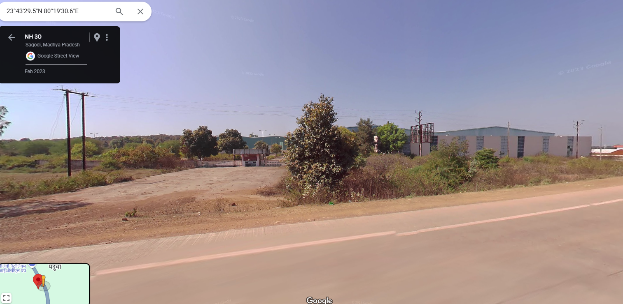
Entry Gate sourced from Google Map

PART B | PNB FORMAT OF OPINION REPORT ON VALUATION

Name & Address of the Branch | Punjab National Bank, Zonal Sastra, Bhikaji Cama Place, New Delhi
Name of Customer (s)/ Borrower Unit | M/s. SVIL Mines Limited (SVIL)
Work Order No. & Date | Via letter dated 23rd May 2024

S.NO. | CONTENTS |  |  |  |  |  | DESCRIPTION
 | INTRODUCTION
 | Name of Valuer |  |  |  |  |  | R.K Associates Valuers & Techno Engg. Consultants (P) Ltd.
 | - Date of Inspection of the Property |  |  |  |  |  | Desktop Valuation
 | - Property Shown By |  |  |  |  |  | Name |  |  |  |  |  | Relationship with Owner |  |  |  |  |  |  |  |  |  |  |  | Contact Number
 |  |  |  |  |  |  | NA as it is desktop valuation
 | - Title Deed Number and Date |  |  |  |  |  | Refer below section
 | - Date of Valuation Report |  |  |  |  |  | 20 December 2024
 | Purpose of the Valuation |  |  |  |  |  | For Distress Sale of mortgaged assets under NPA a/c
 | Name of the Property Owner  (Details of share of each owner in case of joint and Co-ownership) |  |  |  |  |  | M/s. SVIL Mines Limited
 | Name & Address of the Branch |  |  |  |  |  | Punjab National Bank, Zonal Sastra, Bhikaji Cama Place, New Delhi
 | Name of the Developer of the Property (in case of developer-built properties) |  |  |  |  |  | Details not available
 | Type of Developer |  |  |  |  |  | Details not available
 | Property presently occupied/ possessed by (owner / tenant/ etc.)? |  |  |  |  |  | Not known as it is a desktop valuation
 | If occupied by tenant, since how long? |  |  |  |  |  | ---
 | PHYSICAL CHARACTERISTICS OF THE ASSET
BRIEF DESCRIPTION OF THE PROPERTY UNDER VALUATION
This Valuation Report is prepared for a Mining & Processing Plant owned by M/s SVIL Mines Limited at Village-Padua & Piproundh, Tehsil-Katni, District-Katni

We have been provided with 01 sale deed. Details of same are as follows: -
Date | Deed No. | Seller | Buyer | Village | Khasra No. | Area (Ha) | Sale Value
14-06-2006 | 773 | M/s P.M.L. Builders & Developers Ltd. | SVIL Mines Limited | Piproundh & Padua | 499/2, 500/2, 501/2, 501/3, 503/1, 503/3,  2162/2, 2162/2, 2162/5 | 0.93  1.07 | 10,20,000
Total |  |  |  |  |  | 2.00 | 10,20,000

Copy of TIR dated 09-01-2009 from Advocate Mr. O.P. Nigam is also shared with us mentioning the same land area. An Old valuation Report dated 27-06-2022 is also shared with us. In the shared OVR, the land area considered for valuation is 1.79 Hectare.

Physical inspection of the plant was not conducted from our end at bank’s instruction, as it is under possession of Honorable High Court, Delhi. Thus, desktop valuation analysis of the property is done.
Copy of approved sanction plan and building area details are not shared with us. Thus, building area details are taken from the OVR provided by the bank. Building area details as per OVR are as follows: -
Particulars | Type of Structure | Floor | Plinth Area (sq. ft.) | Age  (In years)
Shed | Shed | GF | 1,10,000 | 14
Office/showroom | RCC | GF | 8750 | 14
Total |  |  | 1,18,750
Apart from the above-mentioned details, plant also comprises movable assets in the form of plant & machinery such as Cutting Line, Slab Stacker, EOT Cranes, Tile Cutter and some office equipment as mentioned in OVR. Conditions of these machines are not known to us as site survey was not done. All the information & facts mentioned in the reports is taken from OVR & information available in public domain.
Copy of FAR or machine list is not shared with us. Plant & machinery for valuation is considered from the machine list mentioned in the OVR. In the shared OVR only machine/equipment name & quantity is mentioned. Year of machine/equipment is available with us.
The subject plant is located on Katni-Jabalpur highway (NH-30). Multiple granite stone mining plants such as Mahakoshal Refractories Pvt. Ltd., Pal Marbel and Granites, MK Granite and Marble, Ojaswi Marble & Granite Pvt. Ltd. Rajas Marble Industries etc. are available in the nearby locality.
This report only contains general assessment & opinion on the Guideline Value and the indicative, estimated Market Value of the property of which Bank/ customer asked us to conduct the Valuation for the property found on as-is-where basis as shown on the site by the Bank/ customer of which photographs is also attached with the report. No legal aspects in terms of ownership or any other legal aspect is taken into consideration. Even if any such information is mentioned in the report it is only referred from the information provided for which we do not assume any responsibility. Due care has been given while doing valuation assessment, but it doesn’t contain any due-diligence or audit or verification of any kind other than the valuation computation of the property shown to us on site. Information/ data/ documents given to us by Bank/ client have been relied upon in good faith. This report doesn’t contain any other recommendations of any sort.
In case of discrepancy in the address/ property number mentioned in the property documents and the property shown to us at the site due to change in zoning or administrative level at the site or the client misled the valuer by providing the fabricated/ incorrect document or information, the valuation should be considered of the property shown to us at the site by the client of which the photographs are also attached. In case of any doubt, best would be to contact the concerned authority/ district administration/ tehsil level for the identification of the property if the property depicted in the photographs in this report is same with the documents pledged.
 | Location of the property in the city
 | Plot No. / Survey No.  (referred from the copy of the documents provided to us) |  |  |  |  | 499/2, 500/2, 501/2, 501/3, 503/1, 503/3, 2162/2, 2162/2, 2162/5
 | Door No. |  |  |  |  | ---
 | T.S. No. /Village |  |  |  |  | Village- Piproundh & Padua
 | Ward/ Taluka |  |  |  |  | Tehsil- Katni
 | Mandal/ District |  |  |  |  | Katni
 | Municipal Ward No. |  |  |  |  | District- Katni
 | City/Town |  |  |  |  | Village- Piproundh & Padua
 | Category of Area (Residential/ Commercial/ Industrial/ etc.) |  |  |  |  | Rural Area
 | Classification of the Area (High/Middle/Poor | Metro/Urban/Semi Urban/Rural) |  |  |  |  | Rural
 | - City Categorization |  |  |  |  | Village |  |  |  |  |  |  |  |  |  |  |  | Rural
 | - Characteristics of the locality |  |  |  |  | Ordinary |  |  |  |  |  |  |  |  |  |  |  | Within Remote area
 | - Property location classification |  |  |  |  | Road Facing |  |  |  |  |  | Near to Highway |  |  |  |  |  |  |  |  |  |  |  |  | ---
 | Local body jurisdiction (coming Under Corporation Limit/ Village Panchayat/ Municipality) |  |  |  |  | Piproundh & Padua Gram Panchayat
 | Postal Address of the Property (as mentioned in the documents provided) |  |  |  |  | M/s. SVIL Mines Limited Village-- Piproundh & Padua, Tehsil-Katni, District-Katni
 | Nearby Landmark |  |  |  |  | Petrol Pump
 | Google Map Location of the Property (Latitude/ Longitude and coordinates of the site) |  |  |  |  | Enclosed with the Report
 |  |  |  |  |  | Coordinates or URL: 23°43'30.1"N 80°19'32.1"E
 | Area of the Plot/ Land  Also please refer to Part-B Area description of the property. Area measurements considered in the Valuation Report is adopted from relevant approved documents or actual site measurement whichever is less, unless otherwise mentioned. Verification of the area measurement of the property is done only based on sample random checking. |  |  |  |  | 2.00 Ha or 4.94 acre
 | Layout plan of the area in which the property is located |  |  |  |  | Not available as it is not a part rural locality (Master Plan not available)
 | Development of Surrounding area |  |  |  |  | Rural area and most of the nearby land is lying barron
 | Details of the roads abutting the property |  |  |  |  | NH-30
 | Main Road Name & Width |  |  |  |  | NH-30 |  |  |  |  |  |  |  |  |  |  |  | Approx. 90 ft. wide
 | Front Road Name & width |  |  |  |  | NH-30 |  |  |  |  |  |  |  |  |  |  |  | Approx. 90 ft. wide
 | Type of Approach Road |  |  |  |  | Cement Concrete Road
 | Distance from the Main Road |  |  |  |  | Road highway
 | Whether covered under any State / Central Govt. enactments (e.g., Urban Land Ceiling Act) or notified under agency area / scheduled area / cantonment area |  |  |  |  | No such information available as per documents provided to us.
 | In case it is an agricultural land, any conversion to house site plots is contemplated |  |  |  |  | As per copy of Sale Deed, it was an uncultivated land. As mentioned in the OVR, it is an industrial property.
 | Boundaries schedule of the Property
 | Are Boundaries Matched |  |  |  |  | Multiple Khasra no. are merged together to form a bigger land parcel.
 | DIRECTIONS |  |  |  | AS PER SALE DEED/TIR (A) |  |  |  |  |  |  |  |  |  |  |  | ACTUAL FOUND AT SITE (B)
 | North |  |  |  | ---- |  |  |  |  |  |  |  |  |  |  |  | Extent of the property is not known. Also, Khasra map is not available
 | South |  |  |  | ----
 | East |  |  |  | ----
 | West |  |  |  | ----
 | Extent of the site considered for valuation (least of 14 A & 14 B)
- . | Description of adjoining property
- . | Property Facing |  |  | East Facing
- . | North |  |  | ---- |  |  |  |  |  |  |  |  |  |  |  | Vacant land
- . | South |  |  | ---- |  |  |  |  |  |  |  |  |  |  |  | Vacant land
- . | East |  |  | ---- |  |  |  |  |  |  |  |  |  |  |  | Entry/Exit & NH-30
- . | West |  |  | ---- |  |  |  |  |  |  |  |  |  |  |  | Vacant land
 | Survey No., If any |  |  |  |  | 499/2, 500/2, 501/2, 501/3, 503/1, 503/3, 2162/2, 2162/2, 2162/5
 | Type of Building (Residential/ Commercial/ Industrial) |  |  |  |  | Industrial. |  |  |  |  |  |  |  |  |  |  |  | Industrial
 | Details of the building/ buildings and other improvements in terms of area, height, no. of floors, plinth area floor wise, year of construction, year of making alterations/ additional constructions with details, full details of specifications to be appended along with building plans and elevations |  |  |  |  | Please refer to point-2 of Part-B.
 | Plinth area, Carpet area and Saleable area to be mentioned separately and clarified |  |  |  |  | Plinth Area |  |  |  |  |  |  |  |  |  |  |  | 1,18,750 sq. ft.
 | Any other aspect |  |  |  |  | Valuation is done for the property found as per the information given in the copy of documents provided to us and/ or confirmed by the owner/ owner representative to us at site.  Getting cizra map or coordination with revenue officers for site identification is a separate activity and is not covered in this Valuation services.
 | - List of documents produced for perusal (Documents has been referred only for reference purpose as provided. Authenticity to be ascertained by legal practitioner) |  |  |  |  | Documents Requested |  |  |  |  |  | Documents Provided |  |  |  |  |  |  |  |  |  |  |  |  | Documents Reference No.
 |  |  |  |  |  | Documents Requested- 12 |  |  |  |  |  | Documents Provided- 03 |  |  |  |  |  |  |  |  |  |  |  |  | Documents Reference No. 03
 |  |  |  |  |  | Balance Sheet |  |  |  |  |  | --- |  |  |  |  |  |  |  |  |  |  |  |  | ---
 |  |  |  |  |  | Fixed Assets Register |  |  |  |  |  | --- |  |  |  |  |  |  |  |  |  |  |  |  | ---
 |  |  |  |  |  | Machine List |  |  |  |  |  | Old Valuation Report |  |  |  |  |  |  |  |  |  |  |  |  | Dated: 27-06-2022
 |  |  |  |  |  | Land Ownership Documents |  |  |  |  |  | Sale Deed |  |  |  |  |  |  |  |  |  |  |  |  | Dated: 14-06-2006
 |  |  |  |  |  | Copy of TIR |  |  |  |  |  | Copy of TIR |  |  |  |  |  |  |  |  |  |  |  |  | Dated: 09-01-2009
 |  |  |  |  |  | Copy of Cizra Map |  |  |  |  |  | --- |  |  |  |  |  |  |  |  |  |  |  |  | ---
 |  |  |  |  |  | Approved Sanction Plan |  |  |  |  |  | --- |  |  |  |  |  |  |  |  |  |  |  |  | ---
 |  |  |  |  |  | Building Area Details |  |  |  |  |  | --- |  |  |  |  |  |  |  |  |  |  |  |  | ---
 |  |  |  |  |  | Maintenance Record |  |  |  |  |  | --- |  |  |  |  |  |  |  |  |  |  |  |  | ---
 |  |  |  |  |  | Copy of Utility Bills |  |  |  |  |  | --- |  |  |  |  |  |  |  |  |  |  |  |  | ---
 |  |  |  |  |  | Copy of NoCs |  |  |  |  |  | --- |  |  |  |  |  |  |  |  |  |  |  |  | ---
 |  |  |  |  |  | Capacity Utilization |  |  |  |  |  | --- |  |  |  |  |  |  |  |  |  |  |  |  | ---
 | - Documents provided by |  |  |  |  | Bank
 |  |  |  |  |  | Name |  |  |  |  |  | Relationship with Owner |  |  |  |  |  |  |  |  |  |  |  |  | Contact Number
 |  |  |  |  |  | Mr. Sanjeev Shrivastav |  |  |  |  |  | Banks Representative |  |  |  |  |  |  |  |  |  |  |  |  | +91 81304 56352
 | - Identification procedure followed of the property |  |  |  |  |  |  |  | GPS Co-ordinates mentioned in OVR
 | - Type of Survey conducted |  |  |  |  | None, as it is desktop valuation
 | - Is property clearly demarcated by permanent/ temporary boundary on site |  |  |  |  | Cannot comment as physical survey was not done
 | - Independent access/ approach to the property |  |  |  |  | Clear independent access is available
 | - Is the property merged or colluded with any other property |  |  |  |  | No information available since survey of the property was not carried out
 |  |  |  |  |  | Cannot comment as physical survey was not done
 | TOWN PLANNING/ ZONING PARAMETERS
 | Master Plan provisions related to property in terms of Land use |  |  |  |  |  |  |  |  | Industrial
 | - Master Plan Currently in Force |  |  |  |  |  |  |  |  | NA
 | - Any conversion of land use done |  |  |  |  |  |  |  |  | No information available
 | - Current activity done in the property |  |  |  |  |  |  |  |  | Used for Industrial purpose
 | - Is property usage as per applicable zoning |  |  |  |  |  |  |  |  | It is a village area, no zoning regulations defined
 | - Street Notification |  |  |  |  |  |  |  |  | Not notified
 | Date of issue and validity of layout of approved map / plan |  |  |  |  |  |  |  |  | Copy of approved map not shared
 | Approved map / plan issuing authority |  |  |  |  |  |  |  |  | NA
 | Whether genuineness or authenticity of approved map / plan is verified |  |  |  |  |  |  |  |  | NA
 | Any other comments by our empanelled valuers on authenticity of approved plan |  |  |  |  |  |  |  |  | NA
 | Planning area/zone |  |  |  |  |  |  |  |  | NA
 | Developmental controls/ Authority |  |  |  |  |  |  |  |  | NA
 | Zoning regulations |  |  |  |  |  |  |  |  | Area not notified under Master Plan
 | FAR/FSI |  |  |  |  |  |  |  |  | ----
 | Ground coverage |  |  |  |  |  |  |  |  | ----
 | Comment on Transferability of developmental rights |  |  |  |  |  |  |  |  | This is a Free hold property, therefore owner has complete transferable rights.
 | Provision of Building by-laws as applicable |  |  |  |  |  |  |  |  | PERMITTED |  |  |  |  |  |  |  |  |  |  |  | CONSUMED
 | - Number of floors |  |  |  |  |  |  |  |  | --- |  |  |  |  |  |  |  |  |  |  |  | Refer building area description
 | - Height restrictions |  |  |  |  |  |  |  |  | ---
 | - Front/ Back/Side Setback |  |  |  |  |  |  |  |  | ---
 | Comment on the surrounding land uses & adjoining properties in terms of uses |  |  |  |  |  |  |  |  | Majorly all nearby lands are used for Agriculture purpose
 | Comment on unauthorized construction if any |  |  |  |  |  |  |  |  | Cannot comment as copy of approved map not shared.
 | Comment of Demolition proceedings if any |  |  |  |  |  |  |  |  | No such information came to our knowledge
 | Comment on Compounding/ Regularization proceedings |  |  |  |  |  |  |  |  | No such information came to our knowledge
 | Comment on whether OC has been issued or not |  |  |  |  |  |  |  |  | No information provided
 | Any Other Aspect
 | - Any information on encroachment |  |  |  |  |  |  |  |  | Cannot comment as it is an desktop valuation
 | - Is the area part of unauthorized area/ colony |  |  |  |  |  |  |  |  | No (As per general information available)
 | LEGAL ASPECTS OF THE PROPERTY
 | Ownership documents provided |  |  |  |  |  |  |  |  | Sale Deed & TIR
 | Names of Owner/s (In case of Joint or Co-ownership, whether the shares are undivided or not?) |  |  |  |  |  |  |  |  | M/s. SVIL Mines Limited (referred from the copy of the documents provided to us.)
 | Comment on dispute/ issues of landlord with tenant/statutory body/any other agencies, if any in regard to immovable property. |  |  |  |  |  |  |  |  | NA
 | Comment on whether the IP is independently accessible? |  |  |  |  |  |  |  |  | Clear independent access is available
 | Title verification |  |  |  |  |  |  |  |  | Legal aspects or Title verification have to be taken care by competent advocate.
 | Details of leases if any |  |  |  |  |  |  |  |  | N/A
 | Constitution of the Property (Ordinary status of freehold or leasehold including restriction on transfer) |  |  |  |  |  |  |  |  | Free hold, complete transferable rights
 | Agreement of easement if any |  |  |  |  |  |  |  |  | No
 | Notice of acquisition if any |  |  |  |  |  |  |  |  | No such information came in front of us and could be found on public domain on our general search
 | Notification of road widening if any
 | Possibility of frequent flooding / sub-merging |  |  |  |  |  |  |  |  | No
 | Special remarks, if any, like threat of acquisition of land for public service purposes, road widening or applicability of CRZ provisions etc. (Distance from sea-coast / tidal level must be incorporated) |  |  |  |  |  |  |  |  | None
 | Heritage restrictions, if any |  |  |  |  |  |  |  |  | No
 | Comment on Transferability of the property ownership |  |  |  |  |  |  |  |  | Free hold, complete transferable rights
 | Comment on existing mortgages/ charges/ encumbrances on the property, if any |  |  |  |  |  |  |  |  | Yes |  |  |  |  |  |  |  |  |  |  | PNB & other banks
 | Comment on whether the owners of the property have issued any guarantee (personal or corporate) as the case may be |  |  |  |  |  |  |  |  | No information available |  |  |  |  |  |  |  |  |  |  | NA
 | Building plan sanction:
 | - Is Building Plan sanctioned |  |  |  |  |  |  |  |  | Cannot comment since no approved map provided to us on our request
 | - Authority approving the plan |  |  |  |  |  |  |  |  | NA
 | - Any violation from the approved Building Plan |  |  |  |  |  |  |  |  | Cannot comment since no approved map provided to us on our request
 | - Details of alterations/ deviations/ illegal construction/ encroachment noticed in the structure from the original approved plan |  |  |  |  |  |  |  |  | ☐ Permissible Alterations |  |  |  |  |  |  |  |  |  |  | ---
 |  |  |  |  |  |  |  |  |  | ☐ Not permitted alteration |  |  |  |  |  |  |  |  |  |  | ---
 | - Is this being regularized |  |  |  |  |  |  |  |  | NA
 | Any other aspect |  |  |  |  |  |  |  |  | This is just an opinion report on Valuation of the property confirmed to us by the owner/ owner representative to us on site. The copy of the documents/ information provided to us by the client has been relied upon in good faith.  Legal aspects, Title verification, Verification of authenticity of documents of the property from originals or from any Govt. deptt. have to be taken care by legal expert/ Advocate or verification of site location from any Govt. deptt. is not done at our end.
 | - Information regarding municipal taxes (property tax, water tax, electricity bill) |  |  |  |  |  |  |  |  | Property Tax |  |  |  |  |  |  |  |  |  | Details not shared
 |  |  |  |  |  |  |  |  |  | Water Tax |  |  |  |  |  |  |  |  |  | Details not shared
 |  |  |  |  |  |  |  |  |  | Electricity Bill |  |  |  |  |  |  |  |  |  | Details not shared
 | - Is property tax been paid for this property |  |  |  |  |  |  |  |  | Details not shared
 | - Property or Tax Id No., if any |  |  |  |  |  |  |  |  | Details not shared
 | - Whether entire piece of land on which the unit is set up / property is situated has been mortgaged or to be mortgaged |  |  |  |  |  |  |  |  | Not Applicable
 | - Property presently occupied/ possessed by |  |  |  |  |  |  |  |  | Court Sealed (as mentioned in the OVR)
 | *NOTE: Please see point 6 of Enclosure: VIII – Valuer’s Important Remarks
 | ECONOMIC ASPECTS OF THE PROPERTY
 | Details of ground rent payable |  |  |  |  |  |  |  |  | ---
 | Details of monthly rents being received if any |  |  |  |  |  |  |  |  | ---
 | Taxes and other outgoing |  |  |  |  |  |  |  |  | ---
 | Property Insurance details |  |  |  |  |  |  |  |  | ---
 | Monthly maintenance charges payable |  |  |  |  |  |  |  |  | ---
 | Security charges if paid any |  |  |  |  |  |  |  |  | ---
 | Any other aspect |  |  |  |  |  |  |  |  | ---
 | Reasonable letting value/ Expected market monthly rental |  |  |  |  |  |  |  |  | ---
 | SOCIO - CULTURAL ASPECTS OF THE PROPERTY
 | Descriptive account of the location of the property in terms of Social structure of the area in terms of population, social stratification, regional origin, age groups, economic levels, location of slums/squatter settlements nearby, etc. |  |  |  |  |  |  |  |  | Rural Area
 | FUNCTIONAL AND UTILITARIAN ASPECTS
 | Description of the functionality & utility of the property in terms of:
 | - Space allocation |  |  |  |  |  |  |  |  | No information available since survey couldn't be done
 | - Storage spaces |  |  |  |  |  |  |  |  | No information available since survey couldn't be done
 | - Utility of spaces provided within the building |  |  |  |  |  |  |  |  | No information available since survey couldn't be done
 | Any other aspect
 | - Drainage arrangements |  |  |  |  |  |  |  |  | No information available since survey couldn't be done
 | - Water Treatment Plant |  |  |  |  |  |  |  |  | No information available since survey couldn't be done
 | - Power Supply arrangements |  | Permanent |  |  |  |  |  |  | No information available since survey couldn't be done
 |  |  | Auxiliary |  |  |  |  |  |  | No information available since survey couldn't be done
 | - HVAC system |  |  |  |  |  |  |  |  | No information available since survey couldn't be done
 | - Security provisions |  |  |  |  |  |  |  |  | No information available since survey couldn't be done
 | - Lift/ Elevators |  |  |  |  |  |  |  |  | No information available since survey couldn't be done
 | - Compound wall/ Main Gate |  |  |  |  |  |  |  |  | No information available since survey couldn't be done
 | - Whether gated society |  |  |  |  |  |  |  |  | No information available since survey couldn't be done
 | - Car parking facilities |  |  |  |  |  |  |  |  | No information available since survey couldn't be done
 | - Balconies |  |  |  |  |  |  |  |  | No information available since survey couldn't be done
 | - Internal development
 | Garden/ Park/ Land scraping | Water bodies |  |  |  |  |  | Internal roads |  |  |  |  |  | Pavements |  |  |  |  |  |  |  |  |  |  |  | Boundary Wall
 | No information available since survey couldn't be done
 | INFRASTRUCTURE AVAILABILITY
 | Description of Aqua Infrastructure availability in terms of:
 | - Water Supply |  |  |  |  |  |  |  |  | No information available since survey couldn't be done
 | - Sewerage/ sanitation system |  |  |  |  |  |  |  |  | No information available since survey couldn't be done
 | - Storm water drainage |  |  |  |  |  |  |  |  | No information available since survey couldn't be done
 | Description of other Physical Infrastructure facilities in terms of:
 | - Solid waste management |  |  |  |  |  |  |  |  | No information available since survey couldn't be done
 | - Electricity |  |  |  |  |  |  |  |  | No information available since survey couldn't be done
 | - Road and Public Transport connectivity |  |  |  |  |  |  |  |  | Yes
 | - Availability of other public utilities nearby |  |  |  |  |  |  |  |  | It is a rural area and therefore Transport, Market, Hospital etc. are not available in close vicinity
 | Social Infrastructure in the terms of
 | - Schools |  |  |  |  |  |  |  |  | Not available in close vicinity
 | - Medical Facilities |  |  |  |  |  |  |  |  | Not available in close vicinity
 | - Recreation facilities in terms of parks and open spaces |  |  |  |  |  |  |  |  | This is a rural remote area. No recreational facility is available nearby.
 | MARKETABILITY ASPECTS OF THE PROPERTY
 | Location attribute of the subject property |  |  |  |  |  |  |  |  | Good |  |  |  |  |  |  |  |  | Good location Granite/Marble mining plants
 | - Any New Development in surrounding area |  |  |  |  |  |  |  |  | No |  |  |  |  |  |  |  |  | N/A
 | - Any negativity/ defect/ disadvantages in the property/ location |  |  |  |  |  |  |  |  | --- |  |  |  |  |  |  |  |  | ---
 | Scarcity |  |  |  |  |  |  |  |  | Ample vacant land available nearby. There is no issue of land availability in this area.
 | Demand and supply of the kind of the subject property in the locality |  |  |  |  |  |  |  |  | Demand of the subject property is in accordance with the current use/ activity perspective only which is currently carried out in the property.
 | Comparable Sale Prices in the locality |  |  |  |  |  |  |  |  | Please refer to Part D: Procedure of Valuation Assessment
 | ENGINEERING AND TECHNOLOGY ASPECTS OF THE PROPERTY
 | Type of construction |  |  |  |  |  |  |  |  | Structure |  |  |  |  | Slab |  |  |  |  |  |  |  |  |  |  |  | Walls
 |  |  |  |  |  |  |  |  |  | RCC & Shed Structure |  |  |  |  | Reinforced Cement Concrete |  |  |  |  |  |  |  |  |  |  |  | Brick walls
 | Material & Technology used |  |  |  |  |  |  |  |  | Material Used |  |  |  |  | Technology used
 |  |  |  |  |  |  |  |  |  | No information available since survey couldn't be done
 | Specifications
 | - Roof |  |  |  |  |  |  |  |  | Floors/ Blocks |  |  |  |  |  |  |  |  |  |  |  |  |  | Type of Roof
 |  |  |  |  |  |  |  |  |  | Refer building area description
 | - Floor height |  |  |  |  |  |  |  |  | Refer building area description
 | - Type of flooring |  |  |  |  |  |  |  |  | No information available since survey couldn't be done
 | - Doors/ Windows |  |  |  |  |  |  |  |  | No information available since survey couldn't be done
 | - Class of construction/ Appearance/ Condition of structures |  |  |  |  |  |  |  |  | Internal - No information available since survey couldn't be done
 |  |  |  |  |  |  |  |  |  | External - No information available since survey couldn't be done
 | - Interior Finishing & Design |  |  |  |  |  |  |  |  | No information available since survey couldn't be done
 | - Exterior Finishing & Design |  |  |  |  |  |  |  |  | No information available since survey couldn't be done
 | - Interior decoration/ Special architectural or decorative feature |  |  |  |  |  |  |  |  | No information available since survey couldn't be done
 | - Class of electrical fittings |  |  |  |  |  |  |  |  | No information available since physical survey couldn't be done
 | - Class of sanitary & water supply fittings
 | Maintenance issues
 | Age of building/ Year of construction |  |  |  |  |  |  |  |  | Approx. 14 years |  |  |  |  |  |  |  |  |  |  |  |  | Around year-2010
 | Total life of the building |  |  |  |  |  |  |  |  | Approx. 45 & 60 years
 | Extent of deterioration in the structure |  |  |  |  |  |  |  |  | No information available since survey couldn't be done
 | Structural safety |  |  |  |  |  |  |  |  | No information available since survey couldn't be done
 | Protection against natural disasters viz. earthquakes etc. |  |  |  |  |  |  |  |  | No information available since survey couldn't be done
 | Visible damage in the building if any |  |  |  |  |  |  |  |  | No information available since survey couldn't be done
 | Common facilities viz. lift, water pump, lights, security systems, etc., |  |  |  |  |  |  |  |  | No information available since physical survey couldn't be done
 | System of air conditioning
 | Provision of firefighting
 | ENVIRONMENTAL FACTORS
 | Use of environment friendly building materials, green building techniques if any |  |  |  |  |  |  |  |  | No information available since survey couldn't be done
 | Provision of rainwater harvesting |  |  |  |  |  |  |  |  | No information available since survey couldn't be done
 | Use of solar heating and lighting systems, etc. |  |  |  |  |  |  |  |  | No information available since survey couldn't be done
 | Presence of environmental pollution in the vicinity of the property in terms of industries, heavy traffic, etc. if any |  |  |  |  |  |  |  |  | No information available since survey couldn't be done
 | ARCHITECTURAL AND AESTHETIC QUALITY OF THE PROPERTY
 | Descriptive account on whether the building is modern, old fashioned, etc., plain looking or with decorative elements, heritage value if applicable, presence of landscape elements,  etc. |  |  |  |  |  |  |  |  | Industrial Buildings
 | IN CASE OF VALUATION OF INDUSTRIAL PROPERTY
 | Proximity to residential areas |  |  |  |  |  |  |  |  | ~1.00 km from Piproundh Village
 | Availability of public transport facilities |  |  |  |  |  |  |  |  | On highway
 | VALUATION OF THE ASSET
 | Procedures adopted for arriving at the Valuation along with detailed analysis and descriptive account of the approaches, assumptions made, basis adopted, supporting data (in terms of comparable sales), reconciliation of various factors, departures |  |  |  |  |  |  |  |  | Please refer to the Part D: Procedure of Valuation Assessment of the report.
 | Summary of Valuation |  |  |  |  |  |  |  |  | For detailed Valuation calculation please refer to Part D: Procedure of Valuation Assessment of the report.
 | - Book value of immovable property |  |  |  |  |  |  |  |  | ---
 | - Indicative Prospective Estimated Fair Market Value |  |  |  |  |  |  |  |  | Rs. 7,40,00,000/-
 | - Expected Estimated Realizable Value |  |  |  |  |  |  |  |  | Rs. 6,00,00,000/-
 | - Expected Forced/ Distress Sale Value |  |  |  |  |  |  |  |  | Rs. 5,30,00,000/-
 | - Guideline Value (value as per Circle Rates) |  |  |  |  |  |  |  |  | Rs. 5,11,94,000/- (Land Value)
S NO. | ENCLOSED DOCUMENTS |  |  |  |  |  |  |  |  |  | ENCLOSURE NO. |  |  |  |  |  |  |  | REMARKS
 | Declaration |  |  |  |  |  |  |  |  |  | Enclosure - VI |  |  |  |  |  |  |  | Enclosed with the report
 | Model Code of Conduct for Valuers |  |  |  |  |  |  |  |  |  | Enclosure - VII |  |  |  |  |  |  |  | Enclosed with the report
 | Photograph of owner with the property in the background |  |  |  |  |  |  |  |  |  | Enclosure - III |  |  |  |  |  |  |  | Enclosed with the report
 | Google Map Location |  |  |  |  |  |  |  |  |  | Enclosure – I |  |  |  |  |  |  |  | Google Map enclosed with coordinates
 | Layout plan of the area in which the property is located |  |  |  |  |  |  |  |  |  | Enclosed with the report |  |  |  |  |  |  |  | Enclosed with the report
 | Building Plan |  |  |  |  |  |  |  |  |  | Not Available |  |  |  |  |  |  |  | Not Available
 | Floor Plan |  |  |  |  |  |  |  |  |  | Not Available |  |  |  |  |  |  |  | Not Available
 | Any other relevant documents/extracts  (All enclosures & annexures to remain integral part & parcel of the main report) |  |  |  |  |  |  |  |  |  | Refer below. |  |  |  |  |  |  |  | Refer below.
 | - Enclosure Copy of Circle Rate |  |  |  |  |  |  |  |  |  | Enclosure - IV |  |  |  |  |  |  |  | Enclosed with the report
 | - References on Price Trend of the similar related properties available on public domain |  |  |  |  |  |  |  |  |  | Enclosure - II |  |  |  |  |  |  |  | Enclosed with the report
 | - Extracts of important property documents provided by the client |  |  |  |  |  |  |  |  |  | Enclosure - V |  |  |  |  |  |  |  | Enclosed with the report
 | - Valuer’s Important Remarks |  |  |  |  |  |  |  |  |  | Enclosure - VIII |  |  |  |  |  |  |  | Enclosed with the report
 | Total Number of Pages in the Annexure with enclosures |  |  |  |  |  |  |  |  |  | 41

PART C | AREA DESCRIPTION OF THE PROPERTY

 | Land Area considered for Valuation | 2 Hectare or 4.94 acres
 | Area adopted on the basis of | Property documents
 | Remarks & observations, if any | Land area is considered from the copy of sale deed & TIR provided.
 | Constructed Area considered for Valuation  (As per IS 3861-1966) | Built-up Area | 1,18,750 sq.ft.
 | Area adopted on the basis of | Old Valuation Report
 | Remarks & observations, if any | No relevant document provided from the bank also physical survey was not done.

Note:
- Area measurements considered in the Valuation Report pertaining to Land & Building is adopted from relevant approved documents or actual site measurement whichever is less. All area measurements are on approximate basis only.
- Verification of the area measurement of the property is done based on sample random checking only.
- Area of the large land parcels of more than 2500 sq.mtr or of uneven shape, is taken as per property documents verified with digital survey through google which has been relied upon.
- Drawing Map, design & detailed estimation of the property/ building is out of scope of the Valuation services.

PART D | PROCEDURE OF VALUATION ASSESSMENT – LAND & BUILDING

 | GENERAL INFORMATION
 | Important Dates | Date of Appointment |  | Date of Inspection of the Property | Date of Valuation Assessment | Date of Valuation Report
 | Important Dates | 23 May 2024 |  | Desktop Valuation | 4 December 2024 | 20 December 2024
 | Client | Punjab National Bank, Zonal Sastra, Bhikaji Cama Place, New Delhi
 | Intended User | Punjab National Bank, Zonal Sastra, Bhikaji Cama Place, New Delhi
 | Intended Use | To know the general idea on the market valuation trend of the property as per free market transaction. This report is not intended to cover any other internal mechanism, criteria, considerations of any organization as per their own need, use & purpose.
 | Purpose of Valuation | For Distress Sale of mortgaged assets under NPA a/c
 | Scope of the Assessment | Non binding opinion on the assessment of Plain Physical Asset Valuation of the property identified to us by the owner or through his representative.
 | Restrictions | This report should not be referred for any other purpose, by any other user and for any other date other then as specified above. This report is not a certification of ownership or survey number/ property number/ Khasra number which are merely referred from the copy of the documents provided to us.
 | Manner in which the proper is identified |  | GPS Co-ordinates mentioned in OVR
 | Is property number/ survey number displayed on the property for proper identification? | No information available since physical survey couldn't be done
 | Type of Survey conducted | None, as it is desktop valuation

 | ASSESSMENT FACTORS
 | Valuation Standards considered | Mix of standards such as IVS and others issued by Indian authorities & institutions and improvised by the RKA internal research team as and where it is felt necessary to derive at a reasonable, logical & scientific approach. In this regard proper basis, approach, working, definitions considered is defined below which may have certain departures to IVS.
 | Nature of the Valuation | Fixed Assets Valuation
 | Nature/ Category/ Type/ Classification of Asset under Valuation | Nature |  |  |  |  | Category |  |  |  |  |  | Type
 |  | LAND & BUILDING, PLANT & MACHINERY & OTHER MISCELLANEOUS FIXED ASSET |  |  |  |  | INDUSTRIAL |  |  |  |  |  | INDUSTRIAL PLANT
 |  | Classification |  |  |  |  | Non - Income/ Revenue Generating Asset
 | Type of Valuation (Basis of Valuation as per IVS) | Primary Basis |  |  |  | Market Value
 | Type of Valuation (Basis of Valuation as per IVS) | Secondary Basis |  |  |  | On-going concern basis
 | Present market state of the Asset assumed (Premise of Value as per IVS) | Under Distress State
 |  | Reason: Asset under Financial encumburance state
 | Property Use factor | Current/ Existing Use |  |  |  |  |  | Highest & Best Use  (in consonance to surrounding use, zoning and statutory norms) |  |  |  |  | Considered for Valuation purpose
 | Property Use factor | Industrial |  |  |  |  |  | Industrial |  |  |  |  | Industrial
 | Legality Aspect Factor | Assumed to be fine as per copy of the documents & information produced to us.  However Legal aspects of the property of any nature are out-of-scope of the Valuation Services. In terms of the legality, we have only gone by the documents provided to us in good faith.  Verification of authenticity of documents from originals or cross checking from any Govt. dept. have to be taken care by Legal expert/ Advocate.
 | Class/ Category of the locality | Rural Area
 | Property Physical Factors | Shape |  |  |  |  |  |  | Size |  |  |  | Layout
 | Property Physical Factors | Irregular |  |  |  |  |  |  | Medium |  |  |  | Normal Layout
 | Property Location Category Factor | City Categorization |  |  | Locality Characteristics |  |  |  |  |  |  | Property location characteristics |  | Floor Level
 | Property Location Category Factor | Village |  |  | Ordinary |  |  |  |  |  |  | Road Facing |  | Please refer to the sheet attached
 | Property Location Category Factor | Rural |  |  | Normal |  |  |  |  |  |  | Good location within locality |  | Please refer to the sheet attached
 | Property Location Category Factor |  |  |  | Within good village area |  |  |  |  |  |  | On Highway |  | Please refer to the sheet attached
 | Property Location Category Factor | Property Facing
 | Property Location Category Factor | East Facing
 | Physical Infrastructure availability factors of the locality | Water Supply |  |  | Sewerage/ sanitation system |  |  |  |  |  |  | Electricity |  | Road and Public Transport connectivity
 | Physical Infrastructure availability factors of the locality | No information available since survey couldn't be done
 | Physical Infrastructure availability factors of the locality | Availability of other public utilities nearby |  |  |  |  |  |  |  |  |  | Availability of communication facilities
 | Physical Infrastructure availability factors of the locality | Transport, Market, Hospital etc. are not available in close vicinity |  |  |  |  |  |  |  |  |  | Major Telecommunication Service Provider & ISP connections are available
 | Social structure of the area (in terms of population, social stratification, regional origin, age groups, economic levels, location of slums/ squatter settlements nearby, etc.) | Rural Area
 | Neighbourhood amenities | Average for Marble/Granite Plant
 | Any New Development in surrounding area | No new development
 | Any specific advantage in the property | On Highway NH-30
 | Any specific drawback in the property | Not, as such for Granite/Marble Plant
 | Property overall usability/ utility Factor | Normal
 | Do property has any alternate use? | No, can be used as commercial purpose after receiving NoC from concerned authority
 | Is property clearly demarcated by permanent/ temporary boundary on site | Cannot comment as physical survey was not done
 | Is the property merged or colluded with any other property | Cannot comment as physical survey was not done
 | Is the property merged or colluded with any other property | Comments: ---
 | Is independent access available to the property | Clear independent access is available
 | Is property clearly possessable upon sale | Yes
 | Best Sale procedure to realize maximum Value (in respect to Present market state or premise of the Asset as per point (iv) above) | Fair Market Value
 |  | Free market transaction at arm's length wherein the parties, after full market survey each acted knowledgeably, prudently and without any compulsion.
 | Hypothetical Sale transaction method assumed for the computation of valuation | Fair Market Value
 |  | Free market transaction at arm's length wherein the parties, after full market survey each acted knowledgeably, prudently and without any compulsion.
 | Approach & Method of Valuation Used | Land |  | Approach of Valuation |  |  |  |  |  |  |  | Method of Valuation
 | Approach & Method of Valuation Used |  |  | Market Approach |  |  |  |  |  |  |  | Market Comparable Sales Method
 | Approach & Method of Valuation Used | Building |  | Cost Approach |  |  |  |  |  |  |  | Depreciated Replacement Cost Method
 | Type of Source of Information | Level 3 Input (Tertiary)
 | Market Comparable
 | References on prevailing market Rate/ Price trend of the property and Details of the sources from where the information is gathered (from property search sites & local information) | 1. | Name: |  |  |  |  |  |  | Kanhaji Real Estate
 |  | 1. | Contact No.: |  |  |  |  |  |  | +91 98261 35045
 |  | 1. | Nature of reference: |  |  |  |  |  |  | Property dealer in Katni
 |  | 1. | Size of the Property: |  |  |  |  |  |  | 5.5 Acre
 |  | 1. | Location: |  |  |  |  |  |  | On Highway near to Village-Neganwa
 |  | 1. | Rates/ Price informed: |  |  |  |  |  |  | Rs. 20.00 Lakhs per acre
 |  | 1. | Any other details/ Discussion held: |  |  |  |  |  |  | As per discussion with the above-mentioned property dealer, the ongoing land rate on highway are about Rs. 20.00 Lakhs per acre.
 |  | NOTE: The given information above can be independently verified to know its authenticity.
 | Adopted Rates Justification | As per our discussion with the property dealer of nearby locality and information gathered on public domain, details are as follows: -  - The subject plant is a Manufacturing, Cutting, Shaping of Granite, Marble, Stone etc. plant.  - Many other such plants are located in the neighborhood.  - The subject plant is located on NH-30 which connects Jabalpur-Katni.  - The nearest industrial area is Amkuhi Industrial Area in Katni. The allotment rate of Amkuhi Industrial Area is Rs. 1901/- per sqm or Rs. 76,93,052/- per acre.  - The industrial circle rate of Village-Padua & Piproundh is Rs. 3,220/- per sqm & Rs. 1,800/- per sqm respectively.  - Only one property had the land available for sale on highway near to village-Neganwa which is about 4.00 km from our plant. The asking rate for the said property is Rs. 20.00 per acre. The rates are high as it is located on highway and can be used for commercial purpose i.e. Fuel Pump or Restaurant.  - Thus, we taken base reference rate as Rs. 20,00,000/- per acre and further discounting is applied to arrive fair market value of our subject land parcel.
NOTE: We have taken due care to take the information from reliable sources. The given information above can be independently verified from the provided numbers to know its authenticity. However due to the nature of the information most of the market information came to knowledge is only through verbal discussion with market participants which we have to rely upon where generally there is no written record.
Related postings for similar properties on sale are also annexed with the Report wherever available.
 | Other Market Factors
 | Current Market condition | Normal
 | Current Market condition | Remarks: ---
 | Current Market condition | Adjustments (-/+): 0%
 | Comment on Property Salability Outlook
 | Comment on Property Salability Outlook | Adjustments (-/+): 0%
 | Comment on Demand & Supply in the Market (in terms of land) | Demand |  |  |  |  |  |  |  |  | Supply
 | Comment on Demand & Supply in the Market (in terms of land) | Moderate |  |  |  |  |  |  |  |  | Abundantly available
 | Comment on Demand & Supply in the Market (in terms of land) | Remarks:
 | Comment on Demand & Supply in the Market (in terms of land) | Adjustments (-/+): 0%
 | Any other special consideration | Reason: ----
 | Any other special consideration | Adjustments (-/+): 0%
 | Any other aspect which has relevance on the value or marketability of the property | NA  Valuation of the same asset/ property can fetch different values under different circumstances & situations. For eg. Valuation of a running/ operational shop/ hotel/ factory will fetch better value and in case of closed shop/ hotel/ factory it will fetch considerably lower value. Similarly, an asset sold directly by an owner in the open market through free market arm’s length transaction then it will fetch better value and if the same asset/ property is sold by any financer or court decree or Govt. enforcement agency due to any kind of encumbrance on it then it will fetch lower value. Hence before financing, Lender/ FI should take into consideration all such future risks while financing.  This Valuation report is prepared based on the facts of the property & market situation on the date of the survey. It is a well-known fact that the market value of any asset varies with time & socio-economic conditions prevailing in the region/ country. In future property market may go down, property conditions may change or may go worse, property reputation may differ, property vicinity conditions may go down or become worse, property market may change due to impact of Govt. policies or effect of domestic/ world economy, usability prospects of the property may change, etc. Hence before financing, Banker/ FI should take into consideration all such future risk while financing.
 |  | Adjustments (-/+): 0%
 | Final adjusted & weighted Rates considered for the subject property | Rs. 20,00,000/- per acre
 | Considered Rates Justification | As per the thorough property & market factors analysis as described above, the considered estimated market rates appears to be reasonable in our opinion.
 | Basis of computation & working
- Valuation of the asset is done as found on as-is-where basis on the site as identified to us by client/ owner/ owner representative during site inspection by our engineer/s unless otherwise mentioned in the report.
- Analysis and conclusions adopted in the report are limited to the reported assumptions, conditions and information came to our knowledge during the course of the work and based on the Standard Operating Procedures, Best Practices, Caveats, Limitations, Conditions, Remarks, Important Notes, Valuation TOR and definition of different nature of values.
- For knowing comparable market rates, significant discreet local enquiries have been made from our side based on the hypothetical/ virtual representation of ourselves as both buyer and seller for the similar type of properties in the subject location and thereafter based on this information and various factors of the property, rate has been judiciously taken considering the factors of the subject property, market scenario and weighted adjusted comparison with the comparable properties unless otherwise stated.
- References regarding the prevailing market rates and comparable are based on the verbal/ informal/ secondary/ tertiary information which are collected by our team from the local people/ property consultants/ recent deals/ demand-supply/ internet postings are relied upon as may be available or can be fetched within the limited time & resources of the assignment during market survey in the subject location. No written record is generally available for such market information and analysis has to be derived mostly based on the verbal information which has to be relied upon.
- Market Rates are rationally adopted based on the facts of the property which came to our knowledge during the course of the assessment considering many factors like nature of the property, size, location, approach, market situation and trends and comparative analysis with the similar assets. During comparative analysis, valuation metrics is prepared and necessary adjustments are made on the subject asset.
- The indicative value has been suggested based on the prevailing market rates that came to our knowledge during secondary & tertiary market research and is not split into formal & informal payment arrangements. Most of the deals takes place which includes both formal & informal payment components. Deals which takes place in complete formal payment component may realize relatively less actual transaction value due to inherent added tax, stamp registration liabilities on the buyer.
- Secondary/ Tertiary costs related to asset transaction like Stamp Duty, Registration charges, Brokerage, Commission, Bank interest, selling cost, Marketing cost, etc. pertaining to the sale/ purchase of this property are not considered while assessing the indicative estimated Market Value.
- This report includes both, Govt. Guideline Value and Indicative Estimated Prospective Market Value as described above. As per the current market practice, in most of the cases, formal transaction takes place for an amount less than the actual transaction amount and rest of the payment is normally done informally.
- Area measurements considered in the Valuation Report pertaining to asset/ property is adopted from relevant approved documents or sample site measurement whichever is less unless otherwise mentioned. All area measurements are on approximate basis only.
- Verification of the area measurement of the property is done based on sample random checking only.
- Area of the large land parcels of more than 2500 sq. mt. or of uneven shape in which there can be practical difficulty in sample measurement, is taken as per property documents which has been relied upon unless otherwise stated.
- Drawing, Map, design & detailed estimation of the property/ building is out of scope of the Valuation services.
- Construction rates are adopted based on the present market replacement cost of construction and calculating applicable depreciation & deterioration factor as per its age, existing condition & specifications based on visual observation only of the structure. No structural, physical tests have been carried out in respect of it. No responsibility is assumed for latent defects of any nature whatsoever, which may affect value, or for any expertise required to disclose such conditions.
- Construction rates are adopted based on the plinth area rates prevailing in the market for the structure as a whole and not based on item wise estimation or Bills of Quantity method unless otherwise stated.
- The condition assessment and the estimation of the residual economic life of the structure are only based on the visual observations and appearance found during the site survey. We have not carried out any structural design or stability study; nor carried out any physical tests to assess structural integrity & strength.
- Any kind of unpaid statutory, utilities, lease, interest or any other pecuniary dues on the asset or on its owners has not been factored in the Valuation.
- This Valuation is conducted based on the macro analysis of the asset/ property considering it in totality and not based on the micro, component or item wise analysis. Analysis done is a general assessment and is neither investigative in nature nor an audit activity.
- Valuation is done for the asset found on as-is-where basis which owner/ owner representative/ client/ bank has shown to us on site of which some reference has been taken from the information/ data given in the copy of documents provided to us which have been relied upon in good faith and we have assumed that it to be true and correct.
 | ASSUMPTIONS
- Documents/ Information/ Data provided by the client/ property owner or his representative both written & verbally is true and correct without any fabrication and has been relied upon in good faith.
- Local verbal enquiries during micro market research came to our knowledge are assumed to be taken on record as true & factual.
- The assets and interests therein have been valued free and clear of any liens or encumbrances unless stated otherwise. No hidden or apparent conditions regarding the subject assets or their ownership are assumed to exist. No opinion of title is rendered in this report and a good title is assumed unless stated otherwise.
- It is assumed that the concerned Lender/ Financial Institution has asked for the valuation of that property after satisfying the authenticity of the documents given to us and for which the legal verification has been already taken and cleared by the competent Advocate before requesting for the Valuation report. I/ We assume no responsibility for the legal matters including, but not limited to, legal or title concerns.
- Payment condition during transaction in the Valuation has been considered on all cash bases which includes both formal & informal payment components as per market trend.
- Sale transaction method of the asset is assumed as Free market transaction without any compulsion unless otherwise mentioned while assessing Indicative & Estimated Fair Prospective Market Value of the asset unless otherwise stated.
- If this Valuation Report is prepared for the Flat/ dwelling unit situated in a Group Housing Society or Integrated Township then approvals, maps of the complete group housing society/ township is out of scope of this report. This valuation report is prepared for the specific unit based on the assumption that complete Group Housing Society/ Integrated Township is approved and complied with all relevant laws and the subject unit is also approved within the Group Housing Society/ Township.
 | SPECIAL ASSUMPTIONS
 | It is assumed that all the fixed assets as mentioned in the Old valuation report & Deed are under the ownership of M/s SVIL Mines Limited.
 | LIMITATIONS
 | Unavailability of the data & information in public domain pertaining to the subject location, also physical inspection of the site was not done.

3. | VALUATION COMPUTATION OF LAND
 | Particulars | Govt. Circle/ Guideline Value | Indicative & Estimated Prospective Fair Market Value
 | Prevailing Rate range | Rs. 3,220/- per sqm (for Padua)  Rs. 1,800/- per sqm (for Piproundh) | ~Rs. 20,00,000/- per acre
 | Rate adopted considering all characteristics of the property |  | Rs. 20,00,000/- per acre
 | Total Land Area considered (documents vs site survey whichever is less) | 20,000 sqm | 4.94 acre
 | Total Value of land (A) | 10,700 sqm x Rs. 3,220/- per sqm (for Padua)  9,300 sqm x Rs. 1,800/- per sqm (for Piproundh) | 4.94 Acre x Rs. 20,00,000/- per Acre
 | Total Value of land (A) | Rs. 5,11,94,000/- | Rs. 98,84,000/-

4. | VALUATION COMPUTATION OF BUILDING & CIVIL WORKS

- The valuation of building & civil structures is conducted based upon Cost Approach in which the fair market value of the building & civil structures on the valuation date is its cost of reproduction on that date less the depreciation & other deterioration deductions from the date of completion of the building to the date of its valuation.
- For calculating the Gross Replacement Value, Plinth Rate is considered as per the prevailing market rates.
- The subject plant was under Honorable High Court Delhi. Thus, physical inspection of the plant was not done. No physical/virtual survey of the plant was done. Valuation is based upon the OVR shared.
- Plinth area details of the building structures are taken from copy of Old Valuation Report dated 27-06-2024.
- The Total Economic Life of the RCC & Shed Structure are considered as 60 & 45 years respectively with 5% of salvage value.
S. No. | Plant Section | Type of Building | Floors | Plinth Area (in Sq. ft.) | Economic Life | Cost of Construction  (In Rs./sq.ft) | Gross Current Replacement Cost (In Rs.) | Depreciated Replacement Cost (In Rs.)
1 | Shed | Shed | GF | 1,10,000 | 35 | 800 | 11,00,00,000 | 5,45,60,000
2 | Office/showroom | RCC | GF | 8,750 | 45 | 1400 | 1,22,50,000 | 76,27,667
Total |  |  |  | 1,18,750 |  |  | 12,22,50,000 | 6,21,87,667

PART E | CHARACTERISTICS DESCRIPTION OF PLANT & MACHINERY

S.NO. | CONTENTS | DESCRIPTION
 | TECHNICAL DESCRIPTION OF THE PLANT/ MACHINERY
 | Nature of Plant & Machinery | Manufacture, Cutting, Shaping Granite, Marble, Stone etc. Plant
 | Size of the Plant | - Medium scale Plant
 | Type of the Plant | - Manual
 | Year of Installation/ Commissioning/ COD (Commercial Operation Date) | - Details not available
 | Production Capacity | Details not available
 | Capacity at which Plant was running at the time of Survey | Plant is not operational
 | Number of Production Lines | Details not available
 | Condition of Machines | Not known to us
 | Status of the Plant | Non-operational
 | Products Manufactured in this Plant | Granite, Marble, Stone etc.
 | Recent maintenance carried out on | Details not available
 | Recent upgradation, improvements if done any | Details not available
 | Total Gross Block & Net Block of Assets | Gross Block |  | Net Block
 | Total Gross Block & Net Block of Assets | As on 30/09/2024
 | Total Gross Block & Net Block of Assets | Copy of Balance sheet, FAR or machine list is not shared with us.
 | Any other Details if any
 | MANUFACTURING PROCESS
 | Details not shared with us.
 | TECHNOLOGY TYPE/ GENERATION USED AND TECHNOLOGICAL COLLABORATIONS IF ANY
 | - Technology Type/ Generation Used in this Plant |  | Cutting, polishing, quarrying machines
 | Technological Collaborations If Any |  | - Details not shared
 | Current Technology used for this Industry in Market |  | - Cutting, polishing, quarrying machines
 | RAW MATERIALS REQUIRED & AVAILABILITY
 | Type of Raw Material |  | Mining Stones
 | Availability |  | Available from nearby by Marble/Granite mines
 | AVAILABILITY & STATUS OF UTILITIES
 | Power/ Electricity |  | Details not available
 | Water |  | Details not available
 | Road/ Transport |  | Yes
 | COMMENT ON AVAILABILITY OF LABOUR
 | Availability |  | Appears to be easily & adequately available.
 | Number of Labours working in the Factory |  | None, as plant was not operational
 | SALES TRANSACTIONAL PROSPECTS OF SUCH PLANTS/ MACHINERY
 | Scrap Lot Sale
 | Reason: The subject Industry is not functional from last few years and due to the poor condition of the machines, chances of revival is also very less therefore it is best suited to sell it in auction as scrap sale in lot due to voluminous nature of machines.
 | DEMAND OF SUCH PLANT & MACHINERY IN THE MARKET
 | Appears to be good as per general information available in public domain.
 | SURVEY DETAILS
 | Survey of the Plant or equipment was not done by our Engineering Team.
 | For plant & machinery valuation OVR reference is taken.

PART F | PROCEDURE OF VALUATION ASSESMENT – PLANT & MACHINERY

 | GENERAL INFORMATION
 | Important Dates | Date of Inspection of the Property |  | Date of Valuation Assessment | Date of Valuation Report
 | Important Dates | Desktop Valuation |  | 4 December 2024 | 4 December 2024
 | Client | Punjab National Bank, Zonal Sastra, Bhikaji Cama Place, New Delhi
 | Intended User | Punjab National Bank, Zonal Sastra, Bhikaji Cama Place, New Delhi
 | Intended Use | To know the general idea on the market valuation trend of the property as per free market transaction. This report is not intended to cover any other internal mechanism, criteria, and considerations of any organization as per their own need, use & purpose.
 | Purpose of Valuation | For procuring equity stake in the Project as per restructuring proposal.
 | Scope of the Assessment | Non binding opinion on the assessment of Plain Physical Asset Valuation of the property identified to us by the owner or through his representative.
 | Restrictions | This report should not be referred for any other purpose, by any other user and for any other date other then as specified above.
 | Identification of the Assets | ☐ | Cross checked from the name of the machines mentioned in the FAR/ Inventory list name plate displayed on the machine
 | Identification of the Assets | ☐ | Identified by the company's representative
 | Identification of the Assets | ☐ | Identified by Security Guard over the video call
 | Identification of the Assets | ☐ | Due to large number of machines/ inventories, only major production lines & machines have been checked
 | Identification of the Assets |  | Survey of the plant was not done.
 | Type of Survey conducted | NA, Desktop Valuation

 | ASSESSMENT FACTORS
 | Nature of the Valuation | Fixed Assets Valuation
 | Nature/ Category/ Type/ Classification of Asset under Valuation | Nature |  |  | Category |  |  |  | Type
 |  | PLANT & MACHINERY |  |  | INDUSTRIAL |  |  |  | INDUSTRIAL PLANT & MACHINERY
 |  | Classification |  |  | Income/ Revenue Generating Asset
 | Type of Valuation (Basis of Valuation as per IVS) | Primary Basis |  | Fair Market Value
 | Type of Valuation (Basis of Valuation as per IVS) | Secondary Basis |  | On piecemeal basis
 | Present market state of the Asset assumed (Premise of Value as per IVS) | Under Distress State
 |  | Reason: Asset under Financial encumburance state
 | Physical Infrastructure availability factors of the locality | Water Supply | Sewerage/ Sanitation system |  |  | Electricity |  | Road and Public Transport connectivity
 | Physical Infrastructure availability factors of the locality | Cannot comment as physical survey was not done |  |  |  |  |  | Not easily available
 | Physical Infrastructure availability factors of the locality | Availability of other public utilities nearby |  |  |  |  | Availability of communication facilities
 | Physical Infrastructure availability factors of the locality | Transport, Market, Hospital etc. are available in close vicinity |  |  |  |  | Major Telecommunication Service Provider & ISP connections are available
 | Neighborhood amenities | Good for Marble/Granite Mines
 | Any New Development in surrounding area | None
 | Any specific advantage/ drawback in the plant and machines | Advantages: Near to Granite/Marble mines
 | Machines overall usability/ utility Factor | Low
 | Best Sale procedure to realize maximum Value (in respect to Present market state or premise of the Asset as per point (iv) above) | Fair Market Value
 |  | Free market transaction at arm's length wherein the parties, after full market survey each acted knowledgeably, prudently and without any compulsion.
 | Hypothetical Sale transaction method assumed for the computation of valuation | Fair Market Value
 |  | Free market transaction at arm's length wherein the parties, after full market survey each acted knowledgeably, prudently and without any compulsion.
 | Approach & Method of Valuation Used | Approach of Valuation |  |  |  |  | Method of Valuation
 | Approach & Method of Valuation Used | Market Approach & Cost Approach |  |  |  |  | Market Comparable Sales Method & Depreciated Replacement Cost Method
 | Type of Source of Information | Level 3 Input (Tertiary)

 | Any other aspect which has relevance on the value or marketability of the machines | The marketability for the machines depends upon the industry outlook, make, market condition, raw material, maintenance, raw material, usability, capacity.  This Valuation report is prepared based on the facts of the assets & market situation on the date of the survey. It is a well-known fact that the market value of any asset varies with time & socio-economic conditions prevailing in the region/ country. In future assets market may go down, asset conditions may change or may go worse, plant vicinity conditions may go down or become worse, plant market may change due to impact of Govt. policies or effect of domestic/ world economy, usability prospects of the Plant may change, etc. Hence before financing, Banker/ FI should take into consideration all such future risk while financing.
 | Basis of computation & working
Main Basis:

- Basic Methodology: For arriving at fair market value of P&M & other fixed assets our engineering team has rationally applied the mixture of ‘sales comparison approach (market approach)’ and the ‘cost approach (depreciated replacement cost)’. The fair market value of Plant & Machinery on the date of valuation is its cost of reproduction & commissioning on that date less the depreciation & other deterioration deductions (Technological, Economic, Functional obsolescence) or additions for good maintenance from the date of commissioning of the machinery to the date of its valuation.
- Core P&M Asset Valuation is done keeping in mind various factors like technology used, machines availability, its condition, average age, maintenance & service and parts replacement availability of the machines and more importantly demand in the market.
- No Fixed Asset Register or Inventory sheet has been provided to us. For the Machinery list & date, Old Valuation Report has been referred provided to us by the Bank/client. However Valuation has been done independently.
- No capitalization cost or purchase cost of machines were made available to us and this Valuation is done purely by searching rates of specific machine on public domain or used machinery dealers.
- Replacement cost has been taken based on the independent market research from public domain or used machinery dealers.
- Only scrap/salvage value is considered as Fair Market Value as condition of machine/equipment is very poor.
- Underline assumption for the evaluation of this Plant & Machinery is that it will be sold as a scrap sale only.
- Valuation of the asset is done as found on as-is-where basis on the site as identified to us by client/ owner/ owner representative during site inspection by our engineer/s unless otherwise mentioned in the report.
Other Basis:

- Analysis and conclusions adopted in the report are limited to the reported assumptions, conditions and information came to our knowledge during the course of the work and based on the Standard Operating Procedures, Best Practices, Caveats, Limitations, Conditions, Remarks, Important Notes, Valuation TOR and definition of different nature of values.
- The indicative value has been suggested based on the prevailing market rates that came to our knowledge during secondary & tertiary market research and is not split into formal & informal payment arrangements. Most of the deals takes place which includes both formal & informal payment components. Deals which take place in complete formal payment component may realize relatively less actual transaction value due to inherent added tax, stamp registration liabilities on the buyer.
- Secondary/ Tertiary costs related to asset transaction like Installation, maintenance and Logistics costs pertaining to the sale/ purchase of the assets are not considered separately while assessing the indicative estimated Market Value and is assumed to be included in the Cost of capitalization provided by the client.
- The condition assessment and the estimation of the residual economic life of the machinery and assets are only based on the visual observations and appearance found during the site survey. We have not carried out any physical tests to assess the working and efficiency of the machines and assets.
- Any kind of unpaid statutory, utilities, lease, interest or any other pecuniary dues on the asset or on its owners has not been factored in the Valuation.
- Valuation is done for the asset found on as-is-where basis which owner/ owner representative/ client/ bank has shown to us on site of which some reference has been taken from the information/ data given in the copy of documents provided to us which have been relied upon in good faith and we have assumed that it to be true and correct.
- This is just the fixed asset valuation of the project based on the cost & market approach methodologies considering the utility of the asset for the business & the company as on-ongoing concern basis. This Valuation shall not be construed as the transactional value of the Project which may be determined through Enterprise/ Business Valuation based on Income approach methodologies
 | ASSUMPTIONS
- Documents/ Information/ Data provided by the client/ property owner or his representative both written & verbally is true and correct without any fabrication and has been relied upon in good faith.
- The assets and interests therein have been valued free and clear of any liens or encumbrances unless stated otherwise. No hidden or apparent conditions regarding the subject assets or their ownership are assumed to exist. No opinion of title is rendered in this report and a good title is assumed unless stated otherwise.
- It is assumed that the concerned Lender/ Financial Institution has asked for the valuation of that property after satisfying the authenticity of the documents given to us and for which the legal verification has been already taken and cleared by the competent Advocate before requesting for the Valuation report. I/ We assume no responsibility for the legal matters including, but not limited to, legal or title concerns.
- Payment condition during transaction in the Valuation has been considered on all cash basis which includes both formal & informal payment components as per market trend.
- Sale transaction method of the asset is assumed as Free market transaction without any compulsion unless otherwise mentioned while assessing Indicative & Estimated Fair Prospective Market Value of the asset unless otherwise stated.
 | SPECIAL ASSUMPTIONS
 | It is assumed that all the movable assets as mentioned in the Old valuation report are under the ownership of M/s SVIL Mines Limited.
 | LIMITATIONS
 | Limited & inadequate time and information available.

3. | SUMMARY OF PLANT & MACHINERY VALUATION

All figures are in ₹
Particulars | Gross Block | Net Block | Gross Current Replacement Cost | Depreciated Replacement Cost
Plant & machinery and other movable assets | Not Provided |  | 2,35,01,000 | 23,50,100
Total | --- | --- | 2,35,01,000 | 23,50,100
Notes:
      - Assets mentioned in the OVR shared with us only considered for valuation in this report.
      - Physical inspection of the plant was not done as requested by the bank.
      - Valuation of Plant & Machinery and other assets is done based on the machine list mentioned in the OVR & photographs attached in OVR.
      - As observed in the photos attached in the OVR, these machines can no longer be used for any other purpose. Conditions of machinery is very poor. Only scrap/salvage value shall be realized.
      - Replacement cost of machines is arrived from market research & information available on public domain. Subsequently, only scrap/salvage i.e., to 10% of replacement cost is considered as fair value.

PART G | CONSOLIDATED VALUATION ASSESSMENT OF THE PLANT

1. | CONSOLIDATED VALUATION ASSESSMENT OF THE ASSET
S. No. | Particulars | Govt. Circle/ Guideline Value | Indicative & Estimated Prospective Fair Market Value
 | Land Value (A) | Rs. 5,11,94,000/- | Rs. 98,84,000/-
 | Total Building & Civil Works (B) | --- | Rs. 6,21,87,667/-
 | Plant & Machinery Value (C) | --- | Rs. 23,50,100/-
 | Total Add (A+B+C) | --- | Rs. 7,44,21,767/-
 | Additional Premium if any | --- | ---
 | Details/ Justification | --- | ---
 | Deductions charged if any | --- | ---
 | Details/ Justification | --- | ---
 | Total Indicative & Estimated Prospective Fair Market Value | --- | Rs. 7,44,21,767/-
 | Rounded Off | --- | Rs. 7,40,00,000/-
 | Indicative & Estimated Prospective Fair Market Value in words | --- | Rupees Seven Crores and Forty Lacs only
 | Expected Realizable Value (@ ~20% less) | --- | Rs. 6,00,00,000/-
 | Expected Distress Sale Value (@ ~30% less) | --- | Rs. 5,30,00,000/-
 | Percentage difference between Circle Rate and Fair Market Value | ----
 | Concluding Comments/ Disclosures if any
- We are independent of client/ company and do not have any direct/ indirect interest in the property.
- This valuation has been conducted by R.K Associates Valuers & Techno Engineering Consultants (P) Ltd. and its team of experts.
- This Valuation is done for the property found on as-is-where basis as shown on the site by the Bank/ customer of which photographs is also attached with the report.
- Reference of the property is also taken from the copies of the documents/ information which interested organization or customer could provide to us out of the standard checklist of documents sought from them and further based on our assumptions and limiting conditions. All such information provided to us has been relied upon in good faith and we have assumed that it is true and correct. However, we do not vouch the absolute correctness of the property identification, exact address, physical conditions, etc. based on the documents provided to us since property shown to us may differ on site Vs as mentioned in the documents or incorrect/ fabricated documents may have been provided to us.
- Legal aspects for eg. investigation of title, ownership rights, lien, charge, mortgage, lease, verification of documents from originals or from any Govt. department, etc. has to be taken care by legal experts/ Advocates and same has not been done at our end.
- The valuation of an asset is an estimate of the worth of that asset which is arrived at by the Valuer in his expert opinion after factoring in multiple parameters and externalities. This may not be the actual price of that asset and the market may discover a different price for that asset.
- This report only contains opinion based on technical & market information which came to our knowledge during the course of the assignment. It doesn’t contain any recommendations.
- This report is prepared following our Standard Operating Procedures & Best Practices and will be subject to Limitations, Conditions, Valuer’s Remarks, Important Notes, Valuation TOS and basis of computation & working as described above.
- The use of this report will become valid only after payment of full fees as per the Payment Terms. Using this report or any part content created in this report without payment of charges will be seen as misuse and unauthorized use of the report.
 | IMPORTANT KEY DEFINITIONS
Fair Value suggested by the competent Valuer is that prospective estimated amount in his expert & prudent opinion of the subject asset/ property without any prejudice after he has carefully & exhaustively evaluated the facts & information came in front of him or which he could reasonably collect during the course of the assessment related to the subject asset on an as-is, where-is basis in its existing conditions, with all its existing advantages & disadvantages and its potential possibilities which is just & equitable at which the subject asset/ property should be exchanged between a willing buyer and willing seller at an arm’s length transaction in an open & unrestricted market, in an orderly transaction after proper marketing, wherein the parties, each acted knowledgeably, prudently without any compulsion on the date of the Valuation.
Fair Value without using the term “Market” in it describes that the value suggested by the Valuer may not mandatorily follow or may not be in complete consonance to the established Market in his expert opinion. It may or may not follow market dynamics. But if the suggested value by the valuer is not within the prevailing Market range or is assessed for an asset is located in an un-established Market then the valuer will give reasonable justification & reasoning that for what reasons the value suggested by him doesn’t follow the prevailing market dynamics.
Fair Market Value suggested by the competent Valuer is that prospective estimated amount in his expert & prudent opinion of the subject asset/ property without any prejudice in consonance to the Market dynamics after he has carefully & exhaustively evaluated the facts & information came in front of him or which he could reasonably collect during the course of assessment related to the subject asset on an as-is, where-is basis in its existing conditions, with all its existing advantages & disadvantages and its potential possibilities which is just & equitable at which the subject asset/ property should be exchanged between a willing buyer and willing seller at an arm’s length transaction in an open & unrestricted market, in an orderly transaction after proper marketing, wherein the parties, each acted knowledgeably, prudently without any compulsion on the date of the Valuation.
Here the words “in consonance to the established Market” means that the Valuer will give opinion within the realms & dynamics of the prevailing market rates after exhaustively doing the micro market research. However due to the element of “Fair” in it, valuer will always look for the factors if the value should be better than the market realms which is just & equitable backed by strong justification and reasoning.
Market Value suggested by the competent Valuer is that prospective estimated amount which is average price of the similar comparable assets prevailing in an open & established market during the near period of the date of valuation at which the subject asset/ property should be exchanged between a willing buyer and willing seller on an as-is, where-is basis in its existing conditions, with all its existing advantages & disadvantages and its potential possibilities at an arm’s length transaction in an open, established & unrestricted market, in an orderly transaction, wherein the parties, each acted without any compulsion on the date of the Valuation.
Using the term “Market Value” without “Fair” omits the elements of proper marketing, acting knowledgeably & prudently.
Market and market participants can be sentimental, inclined towards the transaction without the element of complete knowledge & prudence about facts or due diligence of the asset therefore “each acted knowledgeably, prudently” has been removed from the marker Value definition.
 | Realizable Value is that minimum prospective estimated value of the asset/ property which it may be able to fetch at the time of actual property transaction factoring in the element of discount due to the prospects of deep negotiations between the buyer & seller when the parties in-principally find Fair Market Value reasonable and sits together to close the deal and the transaction across the table. Discount percentage on the Fair Market Value due to negotiation will depend on the nature, size, various salability prospects of the subject asset, the needs of the buyer & the seller and kind of payment terms. In some of the cases Realizable and Fair Market Value may also be equal.
 | Distress Sale Value* is that value when the property is attached with any process such as mortgaged financing, financial or operational dues which is under any stress condition or situation and the stakeholders are under process of finding resolution towards it to save the property from being attached to a formal recovery process. In this type of sale, minimum fetch value assessed will always be less than the estimated Fair Market Value where the discount of percentage will depend upon various circumstances and factors such as nature, size, salability prospects of the property and kind of encumbrance on the property. In this type of sale, negotiation power of the buyer is always more than the seller and eagerness & pressure of selling the property will be more on the seller than the buyer.
 | Liquidation Value is the amount that would be realized when an asset or group of assets are sold due to any compulsion or constraints such as in a recovery process guided by statute, law or legal process, clearance sale or any such condition or situation thereof where the pressure of selling the asset/ property is very high to realize whatever maximum amount can be from the sale of the assets in a limited time for clearance of dues or due to closure of business. In other words, this kind of value is also called as forced sale value.
Difference between Cost, Price & Value: Generally, these words are used and understood synonymously. However, in reality each of these has a completely different meaning, premise and also having different definitions in professional & legal terms. Therefore, it is our professional responsibility to describe the definitions of these words to avoid ambiguity & confusion in the minds of the user of this report.
The Cost of an asset represents the actual amount spend in the construction/ actual creation of the asset.
The Price is the amount paid for the procurement of the same asset.
The Value is defined as the present worth of future rights in the property/ asset and is a hypothetical or notional price that buyers and sellers are most likely to conclude for a good or service. Value is not a fact, but an estimate of the likely price to be paid for a good or service at a given time in accordance with a particular definition of value.
Therefore, in actual for the same asset/ property, cost, price & value remain different since these terms have different usage & meaning.
Enclosures with the Report:
- Enclosure: I- Google Map
- Enclosure: II- References on price trend of the similar related properties available on public domain, if available
- Enclosure: III- Photographs of the property
- Enclosure: IV- Copy of Circle Rate
- Enclosure: V- Important property documents exhibit
- Enclosure: VI- PNB Annexure: VI - Declaration-Cum-Undertaking
- Enclosure: VII- PNB Annexure: VII - Model Code of Conduct for Valuers
- Enclosure: VIII- Part E: Valuer’s Important Remarks

IMPORTANT NOTES

DEFECT LIABILITY PERIOD - In case of any query/ issue or escalation you may please contact Incident Manager by writing at valuers@rkassociates.org. We try our level best to ensure maximum accuracy in the Calculations done, Rates adopted and various other data points & information mentioned in the report but still can’t rule out typing, human errors, assessment or any other mistakes. In case you find any mistake, variation, discrepancy or inaccuracy in any data point mentioned in the report, please help us by bringing all such points into our notice in writing at valuers@rkassociates.org within 30 days of the report delivery, to get these rectified timely, failing which R.K Associates shouldn’t be held responsible for any inaccuracy in any manner. Also, if we do not hear back anything from you within 30 days, we will assume that the report is correct in all respect and no further claim of any sort will be entertained thereafter. We would welcome and appreciate your feedback & suggestions in order to improve our services.

Our DATA RETENTION POLICY is of ONE YEAR. After this period we remove all the concerned records related to the assignment from our repository. No clarification or query can be answered after this period due to unavailability of the data.

COPYRIGHT FORMAT - This report is prepared on the copyright format of R.K Associates to serve our clients in the best possible way. Legally no one can copy or distribute this format without prior approval from R.K Associates. It is meant only for the organization as mentioned on the cover page of this report. Distribution or use of this format or any content of this report wholly or partially other than R.K Associates will be seen as unlawful act and necessary legal action can be taken against the defaulters.

IF REPORT IS USED FOR BANK/ FIs
NOTE: As per IBA Guidelines in case the valuation report submitted by the valuer is not in order, the banks / FIs shall bring the same to the notice of the valuer within 15 days of submission for rectification and resubmission. In case no such communication is received, it shall be presumed that the valuation report has been accepted.

At our end we have not verified the authenticity of any documents provided to us. Bank is advised to verify the genuineness of the property documents before taking any credit decision.
Valuation Terms of Services & Valuer’s Important Remarks are available at www.rkassociates.org for reference.

SURVEY ANALYST | VALUATION ENGINEER | L1/ L2 REVIEWER
NA | Abhinav Chaturvedi | Anil Kumar

ENCLOSURE: I – GOOGLE MAP LOCATION

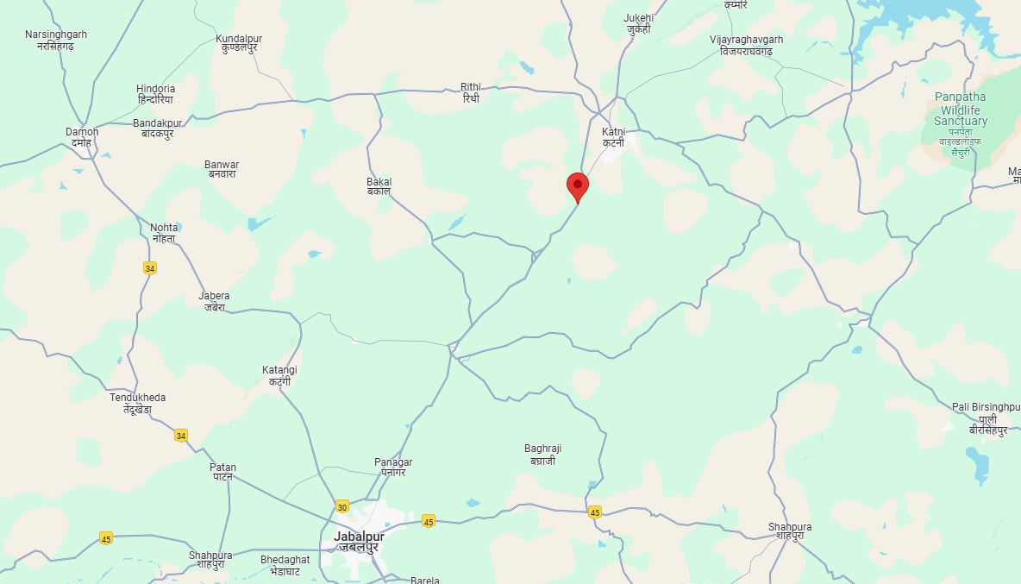
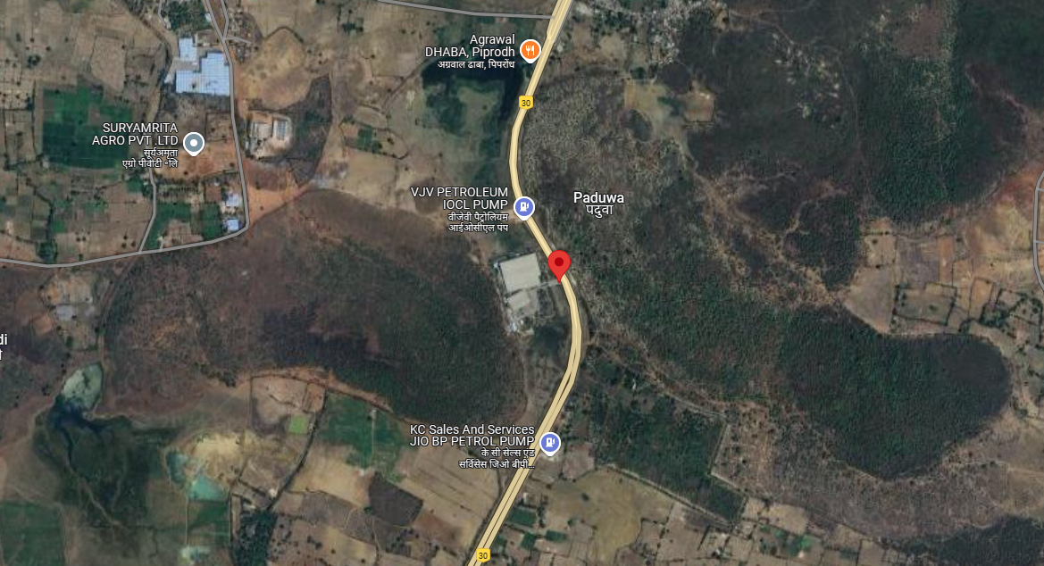

ENCLOSURE: II - REFERENCES ON PRICE TREND OF THE SIMILAR RELATED PROPERTIES AVAILABLE ON PUBLIC DOMAIN

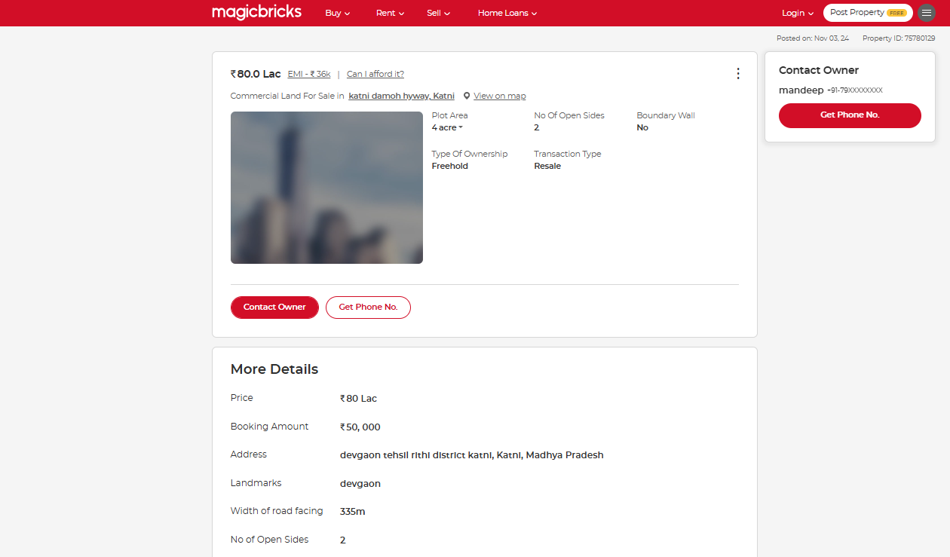

ENCLOSURE: III – PHOTOGRAPHS OF THE PROPERTY

NOT AVAILABLE AS IT IS A DESKTOP VALUATION

ENCLOSURE: IV – DOCUMENTS RELATED TO LAND CIRCLE RATE

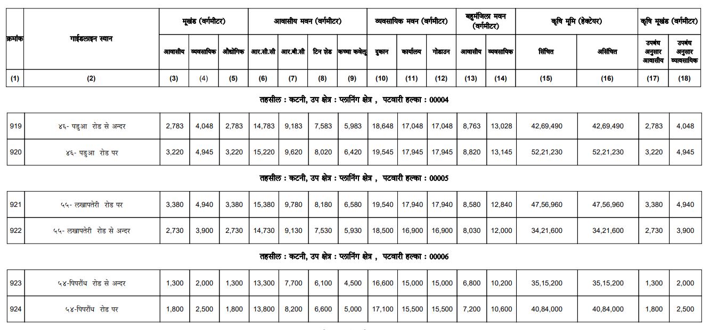

ENCLOSURE: V – IMPORTANT PROPERTY DOCUMENTS EXHIBIT

TIR
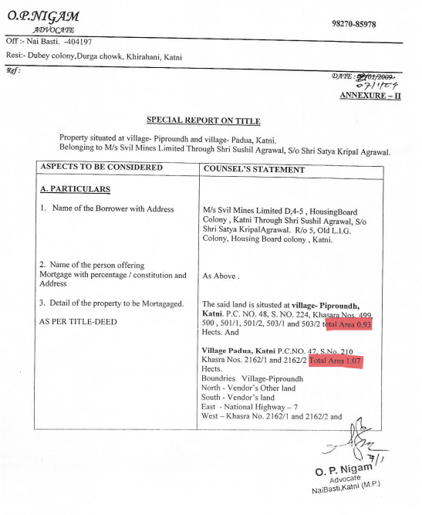

Sale Deed
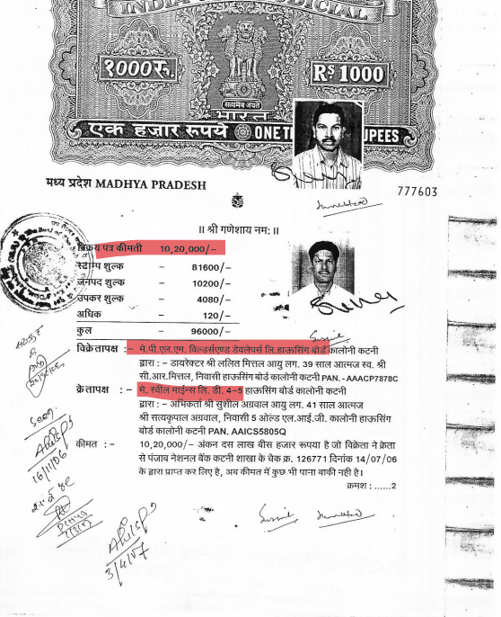

ENCLOSURE VI: ANNEXURE: DECLARATION

- The information furnished in our valuation report dated 20/12/2024 is true and correct to the best of our knowledge and belief and we have made an impartial and true valuation of the property.
- We have no direct or indirect interest in the property valued.
- Survey of the property was not done from our end.
- We have not been convicted of any offence and sentenced to a term of imprisonment.
- We have not been found guilty of misconduct in professional capacity.
- We have read the Handbook on Policy, Standards and procedure for Real Estate Valuation, 2009 of the IBA and has tried to apply the “Standards” enshrined for valuation in the Part-B of the above handbook to the best of our ability as much as practically possible in the limited time available.
- We have read the International Valuation Standards (IVS) and the report submitted to the Bank for the respective asset class and has tried to apply the “Standards” as enshrined for valuation in the IVS in “General Standards” and “Asset Standards” as applicable to the best of our ability as much as practically possible in the limited time available.
- Procedures and standards adopted in carrying out the valuation and is mentioned in Part-D of the report which may have certain departures to the said IBA and IVS standards in order to provide better, just & fair valuation.
- We abide by the Model Code of Conduct for empanelment of valuer in the Bank.
- I am the authorized official of the firm / company, who is competent to sign this valuation report.
S. No. | Particulars | Valuer comment
 | Background information of the asset being valued | This is a Marble/Granite Cutting, polishing plant located at the aforesaid address having total land area as per the scope of valuation admeasuring 4.96 acres (as per deeds shared) as found on as-is-where basis which owner/ owner representative/ client/ bank has shown/ identified to us on the site physically unless otherwise mentioned in the report of which some reference has been taken from the information/ data given in the copy of documents provided to us and informed verbally or in writing.
 | Purpose of valuation and appointing authority | Please refer to Part-D of the Report.
 | Identity of the experts involved in the valuation | Survey Analyst: NA  Valuation Engineer: Er. Abhinav Chaturvedi  L1/ L2 Reviewer: Anil Kumar
 | Disclosure of valuer interest or conflict, if any | No relationship with the borrower and no conflict of interest.
 | Date of appointment, valuation date and date of report | Date of Appointment: | 23/5/2024
 | Date of appointment, valuation date and date of report | Date of Survey: | NA
 | Date of appointment, valuation date and date of report | Valuation Date: | 4/12/2024
 | Date of appointment, valuation date and date of report | Date of Report: | 20/12/2024
 | Inspections and/ or investigations undertaken | None, as it is desktop valuation report
 | Nature and sources of the information used or relied upon | Please refer to Part-D of the Report. Level 3 Input (Tertiary) has been relied upon.
 | Procedures adopted in carrying out the valuation and valuation standards followed | Please refer to Part-D of the Report.
 | Restrictions on use of the report, if any | Value varies with the Purpose/ Date/ Market & Asset Condition & Situation prevailing in the market. We recommend not to refer the indicative & estimated prospective Value of the asset given in this report if any of these points are different from the one mentioned aforesaid in the Report.  This report has been prepared for the purposes stated in the report and should not be relied upon for any other purpose. Our client is the only authorized user of this report and is restricted for the purpose indicated in This report. I/we do not take any responsibility for the unauthorized use of this report.  During the course of the assignment, we have relied upon various information, data, documents in good faith provided by Bank/ client both verbally and in writing. If at any point of time in future it comes to knowledge that the information given to us is untrue, fabricated, misrepresented then the use of this report at very moment will become null & void.  This report only contains general assessment & opinion on the indicative, estimated Market Value of the property for which Bank has asked to conduct the Valuation for the asset which owner/ owner representative/ client/ bank has shown/ identified to us on the site and as found on as-is-where basis unless otherwise mentioned in the report of which some reference has been taken from the information/ data given in the copy of documents provided to us and informed verbally or in writing which has been relied upon in good faith. It doesn’t contain any other recommendations of any sort including but not limited to express of any opinion on the suitability or otherwise of entering into any transaction with the borrower.  This report is not a certification of ownership or survey number/ property number/ Khasra number which are merely referred from the copy of the documents provided to us.
 | Major factors that were taken into account during the valuation | Please refer to Part A, B & C of the Report.
 | Major factors that were not taken into account during the valuation | Please refer to Part A, B & C of the Report.
 | Caveats, limitations and disclaimers to the extent they explain or elucidate the limitations faced by valuer, which shall not be for the purpose of limiting his responsibility for the valuation report. | Please refer to Part D & Part E Valuer’s Important Remarks of the Report enclosed herewith.

Date: 20/12/2024
Place: Noida

Signature

(Authorized Person of R.K Associates Valuers & Techno Engg. Consultants (P) Ltd.)
ENCLOSURE VII: ANNEXURE: MODEL CODE OF CONDUCT FOR VALUERS

Integrity and Fairness

- A valuer shall, in the conduct of his/its business, follow high standards of integrity and fairness in all his/its dealings with his/its clients and other valuers.
- A valuer shall maintain integrity by being honest, straightforward, and forthright in all professional relationships.
- A valuer shall endeavour to ensure that he/it provides true and adequate information and shall not misrepresent any facts or situations.
- A valuer shall refrain from being involved in any action that would bring disrepute to the profession.
- A valuer shall keep public interest foremost while delivering his services.

Professional Competence and Due Care

- A valuer shall render at all times high standards of service, exercise due diligence, ensure proper care and exercise independent professional judgment.
- A valuer shall carry out professional services in accordance with the relevant technical and professional standards that may be specified from time to time
- A valuer shall continuously maintain professional knowledge and skill to provide competent professional service based on up-to-date developments in practice, prevailing regulations/guidelines and techniques.
- In the preparation of a valuation report, the valuer shall not disclaim liability for his/its expertise or deny his/its duty of care, except to the extent that the assumptions are based on statements of fact provided by the company or its auditors or consultants or information available in public domain and not generated by the valuer.
- A valuer shall not carry out any instruction of the client insofar as they are incompatible with the requirements of integrity, objectivity and independence.
- A valuer shall clearly state to his client the services that he would be competent to provide and the services for which he would be relying on other valuers or professionals or for which the client can have a separate arrangement with other valuers.

INDEPENDENCE AND DISCLOUSRE OF INTEREST

- A valuer shall act with objectivity in his/its professional dealings by ensuring that his/its decisions are made without the presence of any bias, conflict of interest, coercion, or undue influence of any party, whether directly connected to the valuation assignment or not.
- A valuer shall not take up an assignment if he/it or any of his/its relatives or associates is not independent in terms of association to the company.
- A valuer shall maintain complete independence in his/its professional relationships and shall conduct the valuation independent of external influences.
- A valuer shall wherever necessarily disclose to the clients, possible sources of conflicts of duties and interests, while providing unbiased services.

- A valuer shall not deal in securities of any subject company after any time when he/it first becomes aware of the possibility of his/its association with the valuation, and in accordance with the Securities and Exchange Board of India (Prohibition of Insider Trading) Regulations, 2015 or till the time the valuation report becomes public, whichever is earlier.
- A valuer shall not indulge in “mandate snatching” or offering “convenience valuations” in order to cater to a company or client’s needs.
- As an independent valuer, the valuer shall not charge success fee (Success fees may be defined as a compensation / incentive paid to any third party for successful closure of transaction. In this case, approval of credit proposals).
- In any fairness opinion or independent expert opinion submitted by a valuer, if there has been a prior engagement in an unconnected transaction, the valuer shall declare the association with the company during the last five years.

Confidentiality

- A valuer shall not use or divulge to other clients or any other party any confidential information about the subject company, which has come to his/its knowledge without proper and specific authority or unless there is a legal or professional right or duty to disclose.

Information Management

- A valuer shall ensure that he/ it maintains written contemporaneous records for any decision taken, the reasons for taking the decision, and the information and evidence in support of such decision. This shall be maintained so as to sufficiently enable a reasonable person to take a view on the appropriateness of his/its decisions and actions.
- A valuer shall appear, co-operate and be available for inspections and investigations carried out by the authority, any person authorised by the authority, the registered valuer’s organisation with which he/it is registered or any other statutory regulatory body.
- A valuer shall provide all information and records as may be required by the authority, the Tribunal, Appellate Tribunal, the registered valuer’s organization with which he/it is registered, or any other statutory regulatory body.
- A valuer while respecting the confidentiality of information acquired during the course of performing professional services, shall maintain proper working papers for a period of three years or such longer period as required in its contract for a specific valuation, for production before a regulatory authority or for a peer review. In the event of a pending case before the Tribunal or Appellate Tribunal, the record shall be maintained till the disposal of the case.

Gifts and hospitality:

- A valuer or his/its relative shall not accept gifts or hospitality which undermines or affects his independence as a valuer.
Explanation. ─ For the purposes of this code the term “relative‟ shall have the same meaning as defined in clause (77) of Section 2 of the Companies Act, 2013 (18 of 2013).
- A valuer shall not offer gifts or hospitality or a financial or any other advantage to a public servant or any other person with a view to obtain or retain work for himself/ itself, or to obtain or retain an advantage in the conduct of profession for himself/ itself.

Remuneration and Costs.

- A valuer shall provide services for remuneration which is charged in a transparent manner, is a reasonable reflection of the work necessarily and properly undertaken, and is not inconsistent with the applicable rules.
- A valuer shall not accept any fees or charges other than those which are disclosed in a written contract with the person to whom he would be rendering service.

Occupation, employability and restrictions.

- A valuer shall refrain from accepting too many assignments, if he/it is unlikely to be able to devote adequate time to each of his/ its assignments.
- A valuer shall not conduct business which in the opinion of the authority or the registered valuer organization discredits the profession.

Signature of the Authorized Person: ________________
Name of the Valuation company: R.K Associates Valuers & Techno Engg. Consultants (P) Ltd.
Address of the Valuer: D-39, Sector-2, Noida-201301
Date: 20/12/2024
Place: Noida

ENCLOSURE VIII: ANNEXURE: VALUER’S IMPORTANT REMARKS

Valuation is done for the asset found on as-is-where basis which owner/ owner representative/ client/ bank has shown/ identified to us on the site unless otherwise mentioned in the report of which some reference has been taken from the information/ data given in the copy of documents provided to us and informed verbally or in writing out of the standard checklist of documents sought from the client & its customer which they could provide within the reasonable expected time out of the standard checklist of documents sought from them and further based on certain assumptions and limiting conditions. The information, facts, documents, data which has become primary basis of the report has been supplied by the client which has been relied upon in good faith and is not generated by the Valuer.
The client/ owner and its management/ representatives warranted to us that the information they have supplied was complete, accurate and true and correct to the best of their knowledge. All such information provided to us either verbally, in writing or through documents has been relied upon in good faith and we have assumed that it is true & correct without any fabrication or misrepresentation. I/We shall not be held liable for any loss, damages, cost or expenses arising from fraudulent acts, misrepresentations, or willful default on part of the owner, company, its directors, employee, representative or agents.
Legal aspects for eg. Investigation of title, ownership rights, lien, charge, mortgage, lease, sanctioned maps, verification of documents provided to us such as title documents, Map, etc. from any concerned Govt. office etc. have to be taken care by legal expert/ Advocate and same is not done at our end. It is assumed that the concerned Lender/ Financial Institution has asked for the valuation of that property after satisfying the authenticity of the documents given to us for which the legal verification has been already taken and cleared by the competent Advocate before requesting for the Valuation report. I/ We assume no responsibility for the legal matters including, but not limited to, legal or title concerns.
In the course of the valuation, we were provided with both written and verbal information. We have however, evaluated the information provided to us through broad inquiry, analysis and review but have not carried out a due diligence or audit of the information provided for the purpose of this engagement. Our conclusions are based on the assumptions and other information provided to us by the client during the course of the assessment.
Getting cizra map or coordination with revenue officers for site identification is a separate activity and is not part of the Valuation services and same has not been done in this report unless otherwise stated.
Wherever any details are mentioned in the report in relation to any legal aspect of the property such as name of the owner, leases, etc. is only for illustration purpose and should not be construed as a professional opinion. Legal aspects are out of scope of this report. Details mentioned related to legal aspect are only based on the copy of the documents provided to us and whatever we can interpret as a non-legally trained person. This should be cross validated with a legal expert. We do not vouch any responsibility regarding the same.
We have made certain assumptions in relation to facts, conditions & situations affecting the subject of, or approach to this exercise that has not been verified as part of the engagement rather, treated as “a supposition taken to be true”. If any of these assumptions prove to be incorrect then our estimate on value will need to be reviewed.
This is just an opinion report based on technical & market information having general assessment & opinion on the indicative, estimated Market Value of the property for which Bank has asked to conduct the Valuation. It doesn’t contain any other recommendations of any sort including but not limited to express of any opinion on the suitability or otherwise of entering into any transaction with the borrower.
We have relied on the data from third party, external sources & information available on public domain to conclude the valuation. These sources are believed to be reliable and therefore, we assume no liability for the truth or accuracy of any data, opinions or estimates furnished by others that have been used in this analysis. Where we have relied on the data, opinions or estimates from external sources, reasonable care has been taken to ensure that such data is extracted from authentic sources, however we still can’t vouch its authenticity, correctness, or accuracy.
Analysis and conclusions adopted in the report are limited to the reported assumptions, conditions and information came to our knowledge during the course of the work and based on the Standard Operating Procedures, Best Practices, Caveats, Limitations, Conditions, Remarks, Important Notes, Valuation TOR and definition of different nature of values.
Value varies with the Purpose/ Date/ Asset Condition & situation/ Market condition, demand & supply, asset utility prevailing on a particular date/ Mode of sale. The indicative & estimated prospective Value of the asset given in this report is restricted only for the purpose and other points mentioned above prevailing on a particular date as mentioned in the report. If any of these points are different from the one mentioned aforesaid in the Report then this report should not be referred.
Our report is meant ONLY for the purpose mentioned in the report and should not be used for any other purpose. The Report should not be copied or reproduced for any purpose other than the purpose for which it is prepared for. I/we do not take any responsibility for the unauthorized use of this report.
We owe responsibility only to the authority/client that has appointed us as per the scope of work mentioned in the report. We will not be liable for any losses, claims, damages or liabilities arising out of the actions taken, omissions or advice given by any other person. In no event shall we be liable for any loss, damages, cost or expenses arising in any way from fraudulent acts, misrepresentations or willful default on part of the client or companies, their directors, employees or agents.
This report is having limited scope as per its fields & format to provide only the general basic idea of the value of the property prevailing in the market based on the site inspection and documents/ data/ information provided by the client. The suggested indicative prospective estimated value should be considered only if transaction is happened as free market transaction.
The sale of the subject property is assumed to be on an all cash basis. Financial arrangements would affect the price at which the property may sell for if placed on the market.
The actual realizable value that is likely to be fetched upon sale of the asset under consideration shall entirely depend on the demand and supply of the same in the market at the time of sale.
While our work has involved an analysis & computation of valuation, it does not include detailed estimation, design/ technical/ engineering/ financial/ structural/ environmental/ architectural/ compliance survey/ safety audit & works in accordance with generally accepted standards of audit & other such works. The report in this work in not investigative in nature. It is mere an opinion on the likely estimated valuation based on the facts & details presented to us by the client and third party market information came in front of us within the limited time of this assignment, which may vary from situation to situation.
Where a sketched plan is attached to this report, it does not purport to represent accurate architectural plans. Sketch plans and photographs are provided as general illustrations only.
Documents, information, data including title deeds provided to us during the course of this assessment by the client is reviewed only upto the extent required in relation to the scope of the work. No document has been reviewed beyond the scope of the work. These are not reviewed in terms of legal rights for which we do not have expertise. Wherever any information mentioned in this report is mentioned from the documents like owners name, etc., it is only for illustration purpose and may not necessary represent accuracy.
The report assumes that the borrower/company/business/asset complies fully with relevant laws and regulations applicable in its area of operations and usage unless otherwise stated, and that the companies/business/assets is managed in a competent and responsible manner. Further, as specifically stated to the contrary, this report has given no consideration to matters of a legal nature, including issues of legal title and compliance with relevant laws, and litigations and other contingent liabilities that are not recorded/reflected in the documents/ details/ information/ data provided to us.
This valuation report is not a qualification for accuracy of land boundaries, schedule (in physical terms), dimensions & identification. For this land/ property survey report can be sought from a qualified private or Govt. surveyor.
This Valuation report is prepared based on the facts of the property on the date of the survey. Due to possible changes in market forces, socio-economic conditions, property conditions and circumstances, this valuation report can only be regarded as relevant as at the valuation date. Hence before financing, Banker/ FI should take into consideration all such future risk and should loan conservatively to keep the advanced money safe in case of the downward trend of the property value.
Valuation of the same asset/ property can fetch different values under different circumstances & situations. For eg. Valuation of a running/ operational shop/ hotel/ factory will fetch better value and in case of closed shop/ hotel/ factory it will have considerable lower value. Similarly, an asset sold directly by an owner in the open market through free market transaction then it will fetch better value and if the same asset/ property is sold by any financer due to encumbrance on it, will fetch lower value. Hence before financing, Lender/ FI should take into consideration all such future risks while financing and take decision accordingly.

Valuation is done for the property identified to us by the owner/ owner representative. At our end we have just visually matched the land boundaries, schedule (in physical terms) & dimensions of the property with reference to the documents produced for perusal. Method by which identification of the property is carried out is also mentioned in the report clearly. Responsibility of identifying the correct property to the Valuer/ its authorized surveyor is solely of the client/ owner for which Valuation has to be carried out. It is requested from the Bank to cross check from their own records/ information if this is the same property for which Valuation has to be carried out to ensure that owner has not misled the Valuer company or misrepresented the property due to any vested interest. Where there is a doubt about the precision position of the boundaries, schedule, dimensions of site & structures, it is recommended that a Licensed Surveyor be contacted.
In India more than 70% of the geographical area is lying under rural/ remote/ non municipal/ unplanned area where the subject property is surrounded by vacant lands having no physical demarcation or having any display of property survey or municipal number / name plate on the property clearly. Even in old locations of towns, small cities & districts where property number is either not assigned or not displayed on the properties clearly and also due to the presence of multiple/ parallel departments due to which ownership/ rights/ illegal possession/ encroachment issues are rampant across India and due to these limitations at many occasions it becomes tough to identify the property with 100% surety from the available documents, information & site whereabouts and thus chances of error, misrepresentation by the borrower and margin of chances of error always persists in such cases. To avoid any such chances of error it is advised to the Bank to engage municipal/ revenue department officials to get the confirmation of the property to ensure that the property shown to Valuer/ Banker is the same as for which documents are provided.
If this Valuation Report is prepared for the Flat/ dwelling unit situated in a Group Housing Society or Integrated Township then approvals, maps of the complete group housing society/ township is out of scope of this report and this report will be made for the specific unit based on the assumption that complete Group Housing Society/ Integrated Township and the subject unit must be approved in all respect.
Due to fragmented & frequent change in building/ urban planning laws/ guidelines from time to time, different laws/ guidelines between regions/ states and no strict enforceability of Building Bye-Laws in India specially in non-metro and scale b & c cities & Industrial areas, property owners many times extend or make changes in the covered area/ layout from the approved/ applicable limits. There are also situations where properties are decades old when there was no formal Building Bye-Laws applicable the time when the construction must have been done. Due to such discrete/ unplanned development in many regions sometimes it becomes tough for the Valuer to determine the exact lawful situation on ground. Unless otherwise mentioned in the report, the covered area present on the site as per site survey will be considered in the Valuation.
Area of the large land parcels of more than 2500 sq.mtr or of uneven shape in which there can be practical difficulty in sample measurement, is taken as per property documents which has been relied upon unless otherwise stated.

Drawing Map, design & detailed estimation of the property/ building is out of scope of the Valuation services.
Valuation is a subjective field and opinion may differ from consultant to consultant. To check the right opinion, it is important to evaluate the methodology adopted and various data point/ information/ factors/ assumption considered by the consultant which became the basis for the Valuation report before reaching to any conclusion.
Although every scientific method has been employed in systematically arriving at the value, there is, therefore, no indisputable single value and the estimate of the value is normally expressed as falling within a likely range.
Value analysis of any asset cannot be regarded as an exact science and the conclusions arrived at in many cases will, of necessity, be subjective and dependent on the exercise of individual judgment. Given the same set of facts and using the same assumptions, expert opinions may differ due to the number of separate judgment decisions, which have to be made. Therefore, there can be no standard formula to establish an indisputable exchange ratio. In the event of a transaction, the actual transaction value achieved may be higher or lower than our indicative analysis of value depending upon the circumstances of the transaction. The knowledge, negotiability and motivations of the buyers and sellers, demand & supply prevailing in the market and the applicability of a discount or premium for control will also affect actual price achieved. Accordingly, our indicative analysis of value will not necessarily be the price at which any agreement proceeds. The final transaction price is something on which the parties themselves have to agree. However, our Valuation analysis can definitely help the stakeholders to take informed and wise decision about the Value of the asset and can help in facilitating the arm’s length transaction.
This Valuation is conducted based on the macro analysis of the asset/ property considering it in totality and not based on the micro, component, or item wise analysis. Analysis done is a general assessment and is not investigative in nature.
This report is prepared on the RKA V-L1 (Basic) Valuation format as per the client requirement and scope of work. This report is having limited scope as per its fields & format to provide only the general estimated & indicative basic idea of the value of the property prevailing in the market based on the information provided by the client. No detailed analysis, audit or verification has been carried out of the subject property. There may be matters, other than those noted in this report, which might be relevant in the context of the transaction and which a wider scope might uncover.
This is just an opinion report and doesn’t hold any binding on anyone. It is requested from the concerned Client/ Bank/ Financial Institution which is using this report for mortgaging the property that they should consider all the different associated relevant & related factors & risks before taking any business decision based on the content of this report.
All Pages of the report including annexures are signed and stamped from our office. In case any paper in the report is without stamp & signature then this should not be considered a valid paper issued from this office.
As per IBA Guidelines & Bank Policy, in case the valuation report submitted by the valuer is not in order, the banks / FIs shall bring the same to the notice of the valuer within 15 days of submission for rectification and resubmission. In case no such communication is received, it shall be presumed that the valuation report has been accepted.
Defect Liability Period is 15 DAYS. We request the concerned authorized reader of this report to check the contents, data, information, and calculations in the report within this period and intimate us in writing at valuers@rkassociates.org within 15 days of report delivery, if any corrections are required or in case of any other concern with the contents or opinion mentioned in the report. If no intimation is received within 15 (Fifteen) days in writing from the date of issuance of the report, then it shall be considered that the report is complete in all respect and has been accepted by the client up to their satisfaction & use and further to which R.K Associates shall not be held responsible in any manner. After this period no concern/ complaint/ proceedings in connection with the Valuation Services will be entertained due to possible change in situation and condition of the property.
Though adequate care has been taken while preparing this report as per its scope, but still we can’t rule out typing, human errors, over sightedness of any information or any other mistakes. Therefore, the concerned organization is advised to satisfy themselves that the report is complete & satisfactory in all respect. Intimation regarding any discrepancy shall be brought into our notice immediately. If no intimation is received within 15 (Fifteen) days in writing from the date of issuance of the report, to rectify these timely, then it shall be considered that the report is complete in all respect and has been accepted by the client upto their satisfaction & use and further to which R.K Associates shall not be held responsible in any manner.
Our Data retention policy is of ONE YEAR. After this period we remove all the concerned records related to the assignment from our repository. No clarification or query can be answered after this period due to unavailability of the data.
This Valuation report is governed by our (1) Internal Policies, Processes & Standard Operating Procedures, (2) R.K Associates Quality Policy, (3) Valuation & Survey Best Practices Guidelines formulated by management of R.K Associates, (4) Information input given to us by the customer and (4) Information/ Data/ Facts given to us by our field/ office technical team. Management of R.K Associates never gives acceptance to any unethical or unprofessional practice which may affect fair, correct & impartial assessment and which is against any prevailing law. In case of any indication of any negligence, default, incorrect, misleading, misrepresentation or distortion of facts in the report then we request the user of this report to immediately or at least within the defect liability period to bring all such act into notice of R.K Associates management so that corrective measures can be taken instantly.
R.K Associates never releases any report doing alterations or modifications by pen. In case any information/ figure of this report is found altered with pen then this report will automatically become null & void.
We are fully aware that based on the opinion of value expressed in this report, we may be required to give testimony or attend court / judicial proceedings with regard to the subject assets, although it is out of scope of the assignment, unless specific arrangements to do so have been made in advance, or as otherwise required by law. In such event, the party seeking our evidence in the proceedings shall bear the cost/professional fee of attending court / judicial proceedings and my / our tendering evidence before such authority shall be under the applicable laws.
The final copy of the report shall be considered valid only if it is in hard copy on the company’s original letter head with proper stamp and sign on it of the authorized official upon payment of the agreed fees. User shall not use the content of the report for the purpose it is prepared for only on draft report, scanned copy, email copy of the report and without payment of the agreed fees. In such a case the report shall be considered as unauthorized and misused.

ANNEXURE B

FIXED ASSETS VALUATION REPORT

OF

NATURE OF ASSETS | LAND & BUILDING, PLANT & MACHINERY & OTHER MISCELLANEOUS FIXED ASSETS
CATEGORY OF ASSETS | INDUSTRIAL
TYPE OF ASSETS | INDUSTRIAL PLANT

SITUATED AT
M/S. SVIL MINES LIMITED MOUZA-GUDRI, BLOCK- SLEEMNABAD, TEHSIL-BAHORIBAND, DISTRICT-KATNI

PART A | SNAPSHOT OF THE ASSET/ PROPERTY UNDER VALUATION

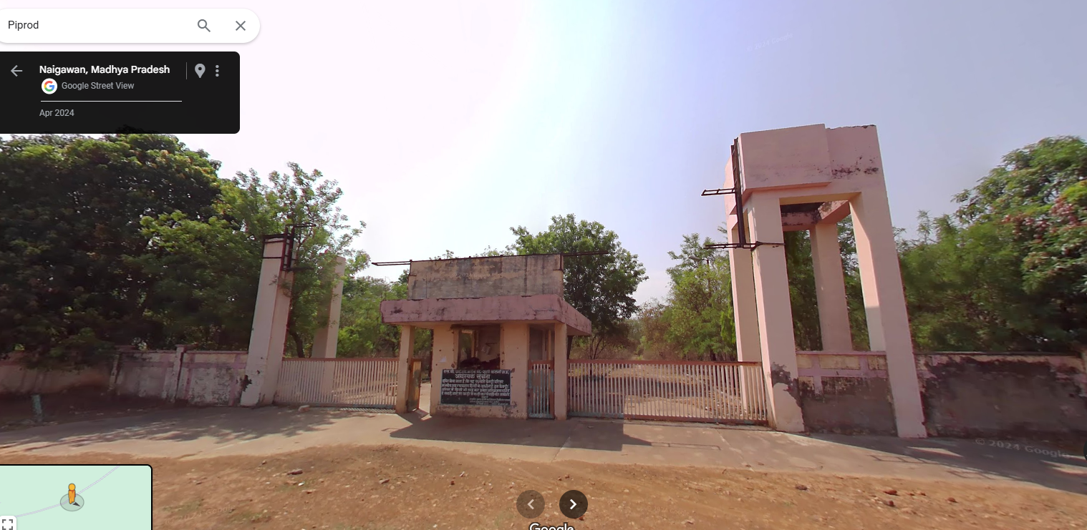
Entry Gate sourced from Google Map

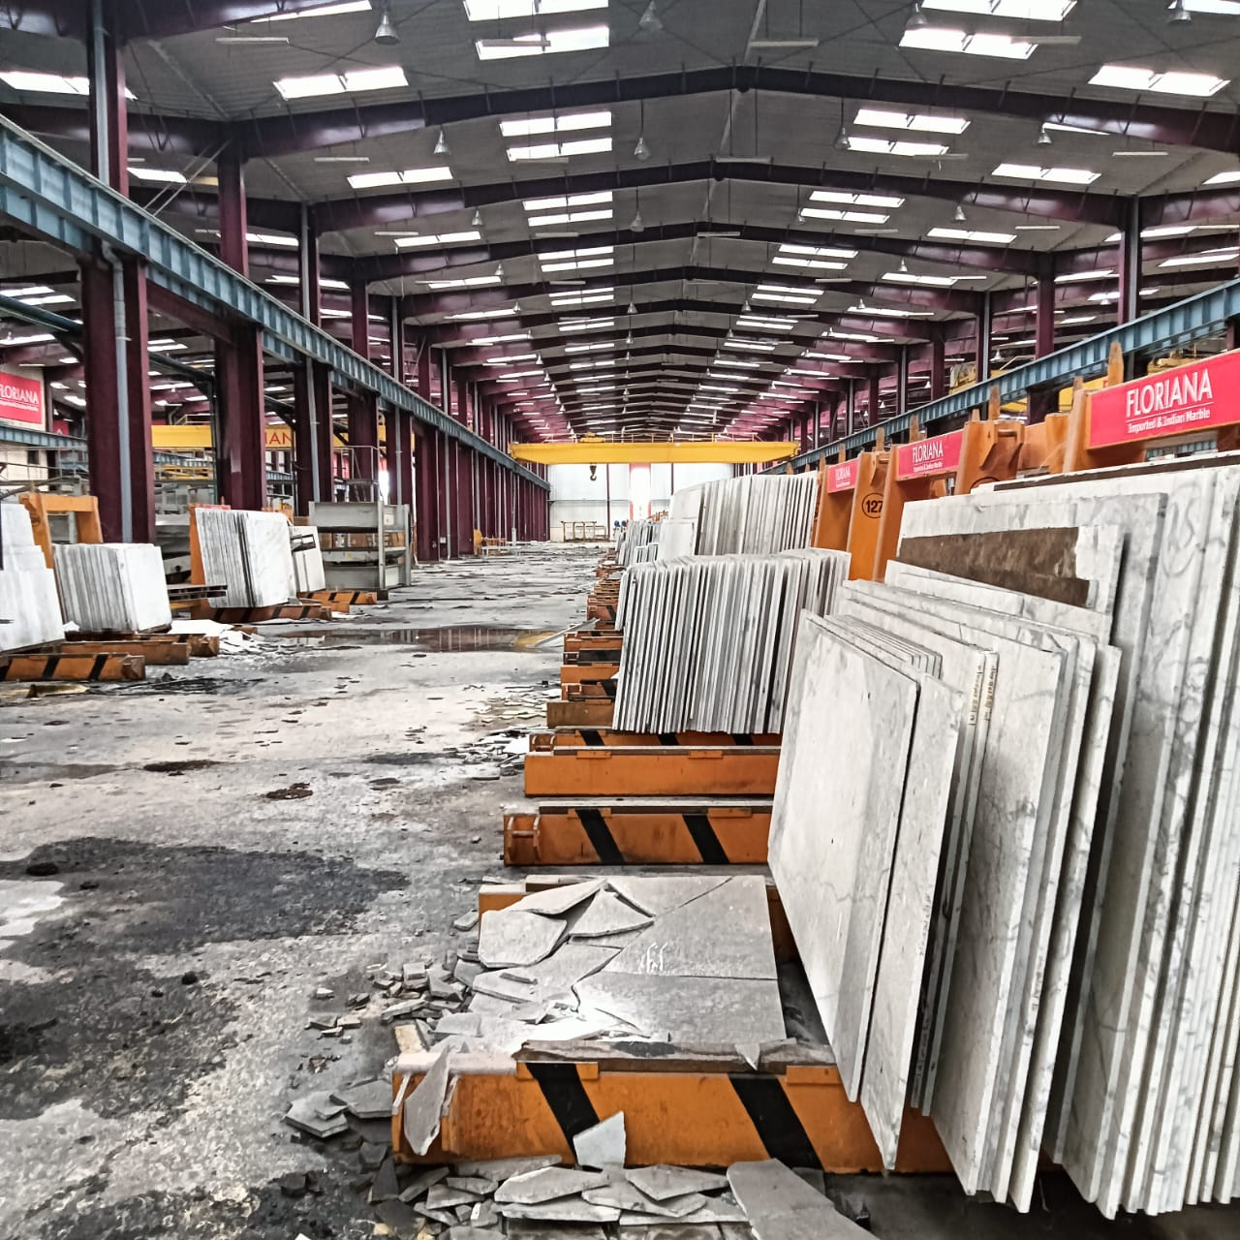
Plant Internal Photo Shared by Security Guard

PART B | PNB FORMAT OF OPINION REPORT ON VALUATION

Name & Address of the Branch | Punjab National Bank, Zonal Sastra, Bhikaji Cama Place, New Delhi
Name of Customer (s)/ Borrower Unit | M/s. SVIL Mines Limited (SVIL)
Work Order No. & Date | Via letter dated 23rd May 2024

S.NO. | CONTENTS |  |  |  |  |  | DESCRIPTION
 | INTRODUCTION
 | Name of Valuer |  |  |  |  |  | R.K Associates Valuers & Techno Engg. Consultants (P) Ltd.
 | - Date of Inspection of the Property |  |  |  |  |  | 26 September 2024 (Virtual Survey)
 | - Property Shown By |  |  |  |  |  | Name |  |  |  |  |  | Relationship with Owner |  |  |  |  |  |  |  |  |  |  |  | Contact Number
 |  |  |  |  |  |  | Mr. Neeraj Yadav |  |  |  |  |  | Security Guard |  |  |  |  |  |  |  |  |  |  |  | +91 96859 51100
 | - Title Deed Number and Date |  |  |  |  |  | Refer below section
 | - Date of Valuation Report |  |  |  |  |  | 4 December 2024
 | Purpose of the Valuation |  |  |  |  |  | For Distress Sale of mortgaged assets under NPA a/c
 | Name of the Property Owner  (Details of share of each owner in case of joint and Co-ownership) |  |  |  |  |  | M/s. SVIL Mines Limited
 | Name & Address of the Branch |  |  |  |  |  | Punjab National Bank, Zonal Sastra, Bhikaji Cama Place, New Delhi
 | Name of the Developer of the Property (in case of developer-built properties) |  |  |  |  |  | Details not available
 | Type of Developer |  |  |  |  |  | Details not available
 | Property presently occupied/ possessed by (owner / tenant/ etc.)? |  |  |  |  |  | Court Sealed
 | If occupied by tenant, since how long? |  |  |  |  |  | ---
 | PHYSICAL CHARACTERISTICS OF THE ASSET
BRIEF DESCRIPTION OF THE PROPERTY UNDER VALUATION
This Valuation Report is prepared for a Mining & Processing Plant owned by M/s SVIL Mines Limited at Mouza-Gudri, Block- Sleemnabad, Tehsil-Bahoriband, District-Katni
We have been provided with 03 nos. of sale deeds. Details of same are as follows: -
Date | Deed No. | Seller | Buyer | Village | Khasra No. | Area (Ha) | Sale Value
30-08-2005 | A1/1689 | Mr. Bhakoli,  Mr. Sonelal,  Mr. Hiralal  Mr. Premlal  Mr. Tijiya | SVIL Mines Limited | Gudri, Sleemnabad | 496, 504, 548 | 2.89 | 3,00,000
24-11-2004 | 5387 | Mr. Tekchand  Mr. Rajkumar  Mr. Padamchand  Mr. Gyanchand | SVIL Mines Limited | Gudri, Sleemnabad | 454,455,456, 482, 481, 460, 462 | 11.61 | 16,61,400
30-08-2005 | A1/1682 | Mr. Sitaram  Mrs. Krishna Kumari | SVIL Mines Limited | Gudri, Sleemnabad | 499, 503/1, 505 | 4.60 | 3,00,000
Total |  |  |  |  |  | 19.10 | 22,61,400
Physical inspection of the plant was not conducted from our end at bank’s instruction, as it is under possession of Honorable High Court, Delhi. Entry is restricted in the plant. Only virtual/video survey was done from end. It was coordinated by Plant’s Security Guard Mr. Neeraj Yadav.
As per copy of 03 nos. of sale deeds, total land area is 19.10 Ha or 47.20 acre. However, as per copy of OVR dated 27-06-2022, the total land area of the property is 53.33 Ha or 131.78 acre (including mines area). The land area within the plant boundary is about 8.66 Ha or 21.40 acre. Mines area is adjacent to the plant which is not demarcated (as seen from Google Maps). Copy of cizra map or Title Investigation Report is not shared with us. Thus, we have only considered land area as per copy of Sale Deed is shared with us i.e., 19.10 Ha or 47.20 acre.
As per copy of Sale Deeds, the land was agricultural usage. To start an industrial activity, company must had taken CLU for agriculture to non-agriculture usage. However, copy of same is not shared with us.
Copy of approved sanction plan and building area details are not shared with us. Thus, building area details are taken from the OVR provided by the bank. Building area details as per OVR are as follows: -
Particulars | Type of Structure | Floor | Plinth Area (sq.ft.) | Age  (In years)
Guest House-1 | RCC | G+1 | 7,074 | 13
Guest House-2 | RCC | GF | 3,225 | 13
Guest House-3 | RCC | G+1 | 10,204 | 13
Guard Room-1 | RCC | GF | 262 | 13
Admin Building | RCC | G+3 | 30,022 | 13
Building | RCC | GF | 2,807 | 13
Guard Room-2 | RCC | GF | 269 | 13
Workshop-1 | Shed | GF | 7,826 | 13
Workshop-2 | Shed | GF | 9,030 | 13
Other Building-1 | RCC | GF | 271 | 13
Other Building-2 | RCC | GF | 752 | 13
Other Building-3 | RCC | GF | 4,644 | 13
Other Building-4 | RCC | GF | 2,902 | 13
Other Building-5 | RCC | GF | 329 | 13
Other Building-6 | RCC | GF | 3,833 | 13
Other Building-7 | RCC | GF | 65,760 | 13
Other Building-8 | Shed | GF | 2,44,446 | 13
Total |  |  | 3,93,655
As measured via Google Satellite measurement tools, the length of plant boundary wall is about 1200 RMT.
Apart from the above-mentioned details property also comprises movable assets in the form of plant & machinery such as DG Set, Trucks, Cranes, Electric Panels, Cutting Conveyer lines, Excavator, Hydra etc. were also observed during virtual survey. Conditions of these machines were poor. Internal parts of these assets, tyres of vehicles were not in place.
Copy of FAR or machine list is not shared with us. Plant & machinery for valuation is considered from the machine list mentioned in the OVR. In the shared OVR only machine/equipment name & quantity is mentioned. Year of machine/equipment is available with us.
The subject plant is located in rural area of village-Gudri. It can be approach by 20ft wide Gudri village road which further connects to NH-30 at a distance of 4.50 km. Multiple granite stone mining plants such as Mahakoshal Refractories Pvt. Ltd., Pal Marbel and Granites, MK Granite and Marble, Ojaswi Marble & Granite Pvt. Ltd. Rajas Marble Industries etc. are are available in the nearby locality.
This report only contains general assessment & opinion on the Guideline Value and the indicative, estimated Market Value of the property of which Bank/ customer asked us to conduct the Valuation for the property found on as-is-where basis as shown on the site by the Bank/ customer of which photographs is also attached with the report. No legal aspects in terms of ownership or any other legal aspect is taken into consideration. Even if any such information is mentioned in the report it is only referred from the information provided for which we do not assume any responsibility. Due care has been given while doing valuation assessment, but it doesn’t contain any due-diligence or audit or verification of any kind other than the valuation computation of the property shown to us on site. Information/ data/ documents given to us by Bank/ client have been relied upon in good faith. This report doesn’t contain any other recommendations of any sort.
In case of discrepancy in the address/ property number mentioned in the property documents and the property shown to us at the site due to change in zoning or administrative level at the site or the client misled the valuer by providing the fabricated/ incorrect document or information, the valuation should be considered of the property shown to us at the site by the client of which the photographs are also attached. In case of any doubt, best would be to contact the concerned authority/ district administration/ tehsil level for the identification of the property if the property depicted in the photographs in this report is same with the documents pledged.
 | Location of the property in the city
 | Plot No. / Survey No.  (referred from the copy of the documents provided to us) |  |  |  |  | 496, 504, 548, 454, 455, 456, 482, 481, 460, 462, 499, 503/1, 505
 | Door No. |  |  |  |  | ---
 | T.S. No. /Village |  |  |  |  | Village-Gudri
 | Ward/ Taluka |  |  |  |  | Block-Sleemnabad
 | Mandal/ District |  |  |  |  | Katni
 | Municipal Ward No. |  |  |  |  | Tehsil- Bahoriband
 | City/Town |  |  |  |  | Village- Gudri
 | Category of Area (Residential/ Commercial/ Industrial/ etc.) |  |  |  |  | Rural Area
 | Classification of the Area (High/Middle/Poor | Metro/Urban/Semi Urban/Rural) |  |  |  |  | Rural
 | - City Categorization |  |  |  |  | Village |  |  |  |  |  |  |  |  |  |  |  | Rural
 | - Characteristics of the locality |  |  |  |  | Ordinary |  |  |  |  |  |  |  |  |  |  |  | Within Remote area
 | - Property location classification |  |  |  |  | Road Facing |  |  |  |  |  | Near to Granite/Marble Mines |  |  |  |  |  |  |  |  |  |  |  |  | Near to Highway
 | Local body jurisdiction (coming Under Corporation Limit/ Village Panchayat/ Municipality) |  |  |  |  | Gudri Gram Panchayat
 | Postal Address of the Property (as mentioned in the documents provided) |  |  |  |  | M/S. SVIL Mines Limited Mouza-Gudri, Block- Sleemnabad, Tehsil-Bahoriband, District-Katni
 | Nearby Landmark |  |  |  |  | Mahakoshal Refractories Pvt. Ltd. Gudri Unit
 | Google Map Location of the Property (Latitude/ Longitude and coordinates of the site) |  |  |  |  | Enclosed with the Report
 |  |  |  |  |  | Coordinates or URL: 23°40'11.3"N 80°18'50.2"E
 | Area of the Plot/ Land  Also please refer to Part-B Area description of the property. Area measurements considered in the Valuation Report is adopted from relevant approved documents or actual site measurement whichever is less, unless otherwise mentioned. Verification of the area measurement of the property is done only based on sample random checking. |  |  |  |  | 47.20 acre
 | Layout plan of the area in which the property is located |  |  |  |  | Not available as it is a part rural locality (Master Plan not available)
 | Development of Surrounding area |  |  |  |  | Rural area and most of the nearby land is lying barron
 | Details of the roads abutting the property |  |  |  |  | Village road
 | Main Road Name & Width |  |  |  |  | NH-30 |  |  |  |  |  |  |  |  |  |  |  | Approx. 90 ft. wide
 | Front Road Name & width |  |  |  |  | Village road |  |  |  |  |  |  |  |  |  |  |  | Approx. 20 ft. wide
 | Type of Approach Road |  |  |  |  | Bituminous Road
 | Distance from the Main Road |  |  |  |  | ~4.50 km
 | Whether covered under any State / Central Govt. enactments (e.g., Urban Land Ceiling Act) or notified under agency area / scheduled area / cantonment area |  |  |  |  | No such information available as per documents provided to us.
 | In case it is an agricultural land, any conversion to house site plots is contemplated |  |  |  |  | As per copy of Sale Deed, it was an agriculture land. However, copy of CLU is not shared with us.
 | Boundaries schedule of the Property
 | Are Boundaries Matched |  |  |  |  | Multiple Khasra no. are merged together to form a bigger land parcel.
 | DIRECTIONS |  |  |  | AS PER SALE DEED/TIR (A) |  |  |  |  |  |  |  |  |  |  |  | ACTUAL FOUND AT SITE (B)
 | North |  |  |  | ---- |  |  |  |  |  |  |  |  |  |  |  | Extent of the property is not known. Also, Khasra map is not available
 | South |  |  |  | ----
 | East |  |  |  | ----
 | West |  |  |  | ----
 | Extent of the site considered for valuation (least of 14 A & 14 B)
- . | Description of adjoining property
- . | Property Facing |  |  | North Facing
- . | North |  |  | ---- |  |  |  |  |  |  |  |  |  |  |  | Entry/Exit & vacant land
- . | South |  |  | ---- |  |  |  |  |  |  |  |  |  |  |  | Vacant land
- . | East |  |  | ---- |  |  |  |  |  |  |  |  |  |  |  | Marble/Granite mines
- . | West |  |  | ---- |  |  |  |  |  |  |  |  |  |  |  | Vacant land
 | Survey No., If any |  |  |  |  | 496, 504, 548, 454, 455, 456, 482, 481, 460, 462, 499, 503/1, 505
 | Type of Building (Residential/ Commercial/ Industrial) |  |  |  |  | Industrial. |  |  |  |  |  |  |  |  |  |  |  | Industrial
 | Details of the building/ buildings and other improvements in terms of area, height, no. of floors, plinth area floor wise, year of construction, year of making alterations/ additional constructions with details, full details of specifications to be appended along with building plans and elevations |  |  |  |  | Please refer to point-2 of Part-B.
 | Plinth area, Carpet area and Saleable area to be mentioned separately and clarified |  |  |  |  | Plinth Area |  |  |  |  |  |  |  |  |  |  |  | 3,93,655 sq. ft.
 | Any other aspect |  |  |  |  | Valuation is done for the property found as per the information given in the copy of documents provided to us and/ or confirmed by the owner/ owner representative to us at site.  Getting cizra map or coordination with revenue officers for site identification is a separate activity and is not covered in this Valuation services.
 | - List of documents produced for perusal (Documents has been referred only for reference purpose as provided. Authenticity to be ascertained by legal practitioner) |  |  |  |  | Documents Requested |  |  |  |  |  | Documents Provided |  |  |  |  |  |  |  |  |  |  |  |  | Documents Reference No.
 |  |  |  |  |  | Documents Requested- 12 |  |  |  |  |  | Documents Provided- 02 |  |  |  |  |  |  |  |  |  |  |  |  | Documents Reference No. 02
 |  |  |  |  |  | Balance Sheet |  |  |  |  |  | --- |  |  |  |  |  |  |  |  |  |  |  |  | ---
 |  |  |  |  |  | Fixed Assets Register |  |  |  |  |  | --- |  |  |  |  |  |  |  |  |  |  |  |  | ---
 |  |  |  |  |  | Machine List |  |  |  |  |  | Old Valuation Report |  |  |  |  |  |  |  |  |  |  |  |  | Dated: 27-06-2022
 |  |  |  |  |  | Land Ownership Documents |  |  |  |  |  | 03 nos. of Sale Deeds |  |  |  |  |  |  |  |  |  |  |  |  | Dated: 30-08-2005  24-11-2004  30-08-2005
 |  |  |  |  |  | Copy of TIR |  |  |  |  |  | --- |  |  |  |  |  |  |  |  |  |  |  |  | ---
 |  |  |  |  |  | Copy of Cizra Map |  |  |  |  |  | --- |  |  |  |  |  |  |  |  |  |  |  |  | ---
 |  |  |  |  |  | Approved Sanction Plan |  |  |  |  |  | --- |  |  |  |  |  |  |  |  |  |  |  |  | ---
 |  |  |  |  |  | Building Area Details |  |  |  |  |  | --- |  |  |  |  |  |  |  |  |  |  |  |  | ---
 |  |  |  |  |  | Maintenance Record |  |  |  |  |  | --- |  |  |  |  |  |  |  |  |  |  |  |  | ---
 |  |  |  |  |  | Copy of Utility Bills |  |  |  |  |  | --- |  |  |  |  |  |  |  |  |  |  |  |  | ---
 |  |  |  |  |  | Copy of NoCs |  |  |  |  |  | --- |  |  |  |  |  |  |  |  |  |  |  |  | ---
 |  |  |  |  |  | Capacity Utilization |  |  |  |  |  | --- |  |  |  |  |  |  |  |  |  |  |  |  | ---
 | - Documents provided by |  |  |  |  | Bank
 |  |  |  |  |  | Name |  |  |  |  |  | Relationship with Owner |  |  |  |  |  |  |  |  |  |  |  |  | Contact Number
 |  |  |  |  |  | Mr. Sanjeev Shrivastav |  |  |  |  |  | Banks Representative |  |  |  |  |  |  |  |  |  |  |  |  | +91 81304 56352
 | - Identification procedure followed of the property |  |  |  |  |  |  |  | Identified by Security Guard over the video call
 | - Type of Survey conducted |  |  |  |  | Virtual Survey
 | - Is property clearly demarcated by permanent/ temporary boundary on site |  |  |  |  | Cannot comment as physical survey was not done
 | - Independent access/ approach to the property |  |  |  |  | Clear independent access is available
 | - Is the property merged or colluded with any other property |  |  |  |  | No information available since full survey of the property couldn't be carried out
 |  |  |  |  |  | Cannot comment as physical survey was not done
 | TOWN PLANNING/ ZONING PARAMETERS
 | Master Plan provisions related to property in terms of Land use |  |  |  |  |  |  |  |  | Area not notified under Master Plan
 | - Master Plan Currently in Force |  |  |  |  |  |  |  |  | NA
 | - Any conversion of land use done |  |  |  |  |  |  |  |  | No information available
 | - Current activity done in the property |  |  |  |  |  |  |  |  | Used for Industrial purpose
 | - Is property usage as per applicable zoning |  |  |  |  |  |  |  |  | It is a village area, no zoning regulations defined
 | - Street Notification |  |  |  |  |  |  |  |  | Not notified
 | Date of issue and validity of layout of approved map / plan |  |  |  |  |  |  |  |  | Copy of approved map not shared
 | Approved map / plan issuing authority |  |  |  |  |  |  |  |  | NA
 | Whether genuineness or authenticity of approved map / plan is verified |  |  |  |  |  |  |  |  | NA
 | Any other comments by our empaneled valuers on authenticity of approved plan |  |  |  |  |  |  |  |  | ---
 | Planning area/zone |  |  |  |  |  |  |  |  | ---
 | Developmental controls/ Authority |  |  |  |  |  |  |  |  | NA
 | Zoning regulations |  |  |  |  |  |  |  |  | Area not notified under Master Plan
 | FAR/FSI |  |  |  |  |  |  |  |  | ----
 | Ground coverage |  |  |  |  |  |  |  |  | ----
 | Comment on Transferability of developmental rights |  |  |  |  |  |  |  |  | This is a Free hold property, therefore owner has complete transferable rights.
 | Provision of Building by-laws as applicable |  |  |  |  |  |  |  |  | PERMITTED |  |  |  |  |  |  |  |  |  |  |  | CONSUMED
 | - Number of floors |  |  |  |  |  |  |  |  | --- |  |  |  |  |  |  |  |  |  |  |  | Refer building area description
 | - Height restrictions |  |  |  |  |  |  |  |  | ---
 | - Front/ Back/Side Setback |  |  |  |  |  |  |  |  | ---
 | Comment on the surrounding land uses & adjoining properties in terms of uses |  |  |  |  |  |  |  |  | Majorly all nearby lands are used for Agriculture purpose
 | Comment on unauthorized construction if any |  |  |  |  |  |  |  |  | Cannot comment as copy of approved map not shared.
 | Comment of Demolition proceedings if any |  |  |  |  |  |  |  |  | No such information came to our knowledge
 | Comment on Compounding/ Regularization proceedings |  |  |  |  |  |  |  |  | No such information came to our knowledge
 | Comment on whether OC has been issued or not |  |  |  |  |  |  |  |  | No information provided
 | Any Other Aspect
 | - Any information on encroachment |  |  |  |  |  |  |  |  | Cannot comment
 | - Is the area part of unauthorized area/ colony |  |  |  |  |  |  |  |  | No (As per general information available)
 | LEGAL ASPECTS OF THE PROPERTY
 | Ownership documents provided |  |  |  |  |  |  |  |  | 03 nos. of Sale deed of land area measuring 19.10 Ha
 | Names of Owner/s (In case of Joint or Co-ownership, whether the shares are undivided or not?) |  |  |  |  |  |  |  |  | M/s. SVIL Mines Limited (referred from the copy of the documents provided to us.)
 | Comment on dispute/ issues of landlord with tenant/statutory body/any other agencies, if any in regard to immovable property. |  |  |  |  |  |  |  |  | NA
 | Comment on whether the IP is independently accessible? |  |  |  |  |  |  |  |  | Clear independent access is available
 | Title verification |  |  |  |  |  |  |  |  | Legal aspects or Title verification have to be taken care by competent advocate.
 | Details of leases if any |  |  |  |  |  |  |  |  | N/A
 | Constitution of the Property (Ordinary status of freehold or leasehold including restriction on transfer) |  |  |  |  |  |  |  |  | Free hold, complete transferable rights
 | Agreement of easement if any |  |  |  |  |  |  |  |  | No
 | Notice of acquisition if any |  |  |  |  |  |  |  |  | No such information came in front of us and could be found on public domain on our general search
 | Notification of road widening if any |  |  |  |  |  |  |  |  | No such information came in front of us and could be found on public domain on our general search
 | Possibility of frequent flooding / sub-merging |  |  |  |  |  |  |  |  | No
 | Special remarks, if any, like threat of acquisition of land for public service purposes, road widening or applicability of CRZ provisions etc. (Distance from sea-coast / tidal level must be incorporated) |  |  |  |  |  |  |  |  | None
 | Heritage restrictions, if any |  |  |  |  |  |  |  |  | No
 | Comment on Transferability of the property ownership |  |  |  |  |  |  |  |  | Free hold, complete transferable rights
 | Comment on existing mortgages/ charges/ encumbrances on the property, if any |  |  |  |  |  |  |  |  | Yes |  |  |  |  |  |  |  |  |  |  | PNB & other banks
 | Comment on whether the owners of the property have issued any guarantee (personal or corporate) as the case may be |  |  |  |  |  |  |  |  | No information available |  |  |  |  |  |  |  |  |  |  | NA
 | Building plan sanction:
 | - Is Building Plan sanctioned |  |  |  |  |  |  |  |  | Cannot comment since no approved map provided to us on our request
 | - Authority approving the plan |  |  |  |  |  |  |  |  | NA
 | - Any violation from the approved Building Plan |  |  |  |  |  |  |  |  | Cannot comment since no approved map provided to us on our request
 | - Details of alterations/ deviations/ illegal construction/ encroachment noticed in the structure from the original approved plan |  |  |  |  |  |  |  |  | ☐ Permissible Alterations |  |  |  |  |  |  |  |  |  |  | ---
 |  |  |  |  |  |  |  |  |  | ☐ Not permitted alteration |  |  |  |  |  |  |  |  |  |  | ---
 | - Is this being regularized |  |  |  |  |  |  |  |  | NA
 | Any other aspect |  |  |  |  |  |  |  |  | This is just an opinion report on Valuation of the property confirmed to us by the owner/ owner representative to us on site. The copy of the documents/ information provided to us by the client has been relied upon in good faith.  Legal aspects, Title verification, Verification of authenticity of documents of the property from originals or from any Govt. deptt. have to be taken care by legal expert/ Advocate or verification of site location from any Govt. deptt. is not done at our end.
 | - Information regarding municipal taxes (property tax, water tax, electricity bill) |  |  |  |  |  |  |  |  | Property Tax |  |  |  |  |  |  |  |  |  | Details not shared
 |  |  |  |  |  |  |  |  |  | Water Tax |  |  |  |  |  |  |  |  |  | Details not shared
 |  |  |  |  |  |  |  |  |  | Electricity Bill |  |  |  |  |  |  |  |  |  | Details not shared
 | - Is property tax been paid for this property |  |  |  |  |  |  |  |  | Details not shared
 | - Property or Tax Id No., if any |  |  |  |  |  |  |  |  | Details not shared
 | - Whether entire piece of land on which the unit is set up / property is situated has been mortgaged or to be mortgaged |  |  |  |  |  |  |  |  | Not Applicable
 | - Property presently occupied/ possessed by |  |  |  |  |  |  |  |  | Court Sealed
 | *NOTE: Please see point 6 of Enclosure: VIII – Valuer’s Important Remarks
 | ECONOMIC ASPECTS OF THE PROPERTY
 | Details of ground rent payable |  |  |  |  |  |  |  |  | ---
 | Details of monthly rents being received if any |  |  |  |  |  |  |  |  | ---
 | Taxes and other outgoing |  |  |  |  |  |  |  |  | ---
 | Property Insurance details |  |  |  |  |  |  |  |  | ---
 | Monthly maintenance charges payable |  |  |  |  |  |  |  |  | ---
 | Security charges if paid any |  |  |  |  |  |  |  |  | ---
 | Any other aspect |  |  |  |  |  |  |  |  | ---
 | Reasonable letting value/ Expected market monthly rental |  |  |  |  |  |  |  |  | ---
 | SOCIO - CULTURAL ASPECTS OF THE PROPERTY
 | Descriptive account of the location of the property in terms of Social structure of the area in terms of population, social stratification, regional origin, age groups, economic levels, location of slums/squatter settlements nearby, etc. |  |  |  |  |  |  |  |  | Rural Area
 | FUNCTIONAL AND UTILITARIAN ASPECTS
 | Description of the functionality & utility of the property in terms of:
 | - Space allocation |  |  |  |  |  |  |  |  | No information available since survey couldn't be done
 | - Storage spaces |  |  |  |  |  |  |  |  | No information available since survey couldn't be done
 | - Utility of spaces provided within the building |  |  |  |  |  |  |  |  | No information available since survey couldn't be done
 | Any other aspect
 | - Drainage arrangements |  |  |  |  |  |  |  |  | No information available since survey couldn't be done
 | - Water Treatment Plant |  |  |  |  |  |  |  |  | No information available since survey couldn't be done
 | - Power Supply arrangements |  | Permanent |  |  |  |  |  |  | No information available since survey couldn't be done
 |  |  | Auxiliary |  |  |  |  |  |  | No information available since survey couldn't be done
 | - HVAC system |  |  |  |  |  |  |  |  | No information available since survey couldn't be done
 | - Security provisions |  |  |  |  |  |  |  |  | No information available since survey couldn't be done
 | - Lift/ Elevators |  |  |  |  |  |  |  |  | No information available since survey couldn't be done
 | - Compound wall/ Main Gate |  |  |  |  |  |  |  |  | Yes
 | - Whether gated society |  |  |  |  |  |  |  |  | No
 | - Car parking facilities |  |  |  |  |  |  |  |  | Yes
 | - Balconies |  |  |  |  |  |  |  |  | No information available since survey couldn't be done
 | - Internal development
 | Garden/ Park/ Land scraping | Water bodies |  |  |  |  |  | Internal roads |  |  |  |  |  | Pavements |  |  |  |  |  |  |  |  |  |  |  | Boundary Wall
 | No | No |  |  |  |  |  | Yes |  |  |  |  |  | Yes |  |  |  |  |  |  |  |  |  |  |  | Yes
 | INFRASTRUCTURE AVAILABILITY
 | Description of Aqua Infrastructure availability in terms of:
 | - Water Supply |  |  |  |  |  |  |  |  | No information available since survey couldn't be done
 | - Sewerage/ sanitation system |  |  |  |  |  |  |  |  | No information available since survey couldn't be done
 | - Storm water drainage |  |  |  |  |  |  |  |  | No information available since survey couldn't be done
 | Description of other Physical Infrastructure facilities in terms of:
 | - Solid waste management |  |  |  |  |  |  |  |  | No information available since survey couldn't be done
 | - Electricity |  |  |  |  |  |  |  |  | No information available since survey couldn't be done
 | - Road and Public Transport connectivity |  |  |  |  |  |  |  |  | Yes
 | - Availability of other public utilities nearby |  |  |  |  |  |  |  |  | It is a rural area and therefore Transport, Market, Hospital etc. are not available in close vicinity
 | Social Infrastructure in the terms of
 | - Schools |  |  |  |  |  |  |  |  | Not available in close vicinity
 | - Medical Facilities |  |  |  |  |  |  |  |  | Not available in close vicinity
 | - Recreation facilities in terms of parks and open spaces |  |  |  |  |  |  |  |  | This is a rural remote area. No recreational facility is available nearby.
 | MARKETABILITY ASPECTS OF THE PROPERTY
 | Location attribute of the subject property |  |  |  |  |  |  |  |  | Good |  |  |  |  |  |  |  |  | Good location Granite/Marble mining plants
 | - Any New Development in surrounding area |  |  |  |  |  |  |  |  | No |  |  |  |  |  |  |  |  | N/A
 | - Any negativity/ defect/ disadvantages in the property/ location |  |  |  |  |  |  |  |  | --- |  |  |  |  |  |  |  |  | ---
 | Scarcity |  |  |  |  |  |  |  |  | Ample vacant land available nearby. There is no issue of land availability in this area.
 | Demand and supply of the kind of the subject property in the locality |  |  |  |  |  |  |  |  | Demand of the subject property is in accordance with the current use/ activity perspective only which is currently carried out in the property.
 | Comparable Sale Prices in the locality |  |  |  |  |  |  |  |  | Please refer to Part D: Procedure of Valuation Assessment
 | ENGINEERING AND TECHNOLOGY ASPECTS OF THE PROPERTY
 | Type of construction |  |  |  |  |  |  |  |  | Structure |  |  |  |  | Slab |  |  |  |  |  |  |  |  |  |  |  | Walls
 |  |  |  |  |  |  |  |  |  | RCC & Shed Structure |  |  |  |  | Reinforced Cement Concrete |  |  |  |  |  |  |  |  |  |  |  | Brick walls
 | Material & Technology used |  |  |  |  |  |  |  |  | Material Used |  |  |  |  | Technology used
 |  |  |  |  |  |  |  |  |  | Grade B Material |  |  |  |  | RCC Framed structure & Steel columns and trusses framed structure
 | Specifications
 | - Roof |  |  |  |  |  |  |  |  | Floors/ Blocks |  |  |  |  |  |  |  |  |  |  |  |  |  | Type of Roof
 |  |  |  |  |  |  |  |  |  | Refer building area description
 | - Floor height |  |  |  |  |  |  |  |  | Refer building area description
 | - Type of flooring |  |  |  |  |  |  |  |  | PCC
 | - Doors/ Windows |  |  |  |  |  |  |  |  | None
 | - Class of construction/ Appearance/ Condition of structures |  |  |  |  |  |  |  |  | Internal - Average
 |  |  |  |  |  |  |  |  |  | External - Average
 | - Interior Finishing & Design |  |  |  |  |  |  |  |  | Normal industrial shed design
 | - Exterior Finishing & Design |  |  |  |  |  |  |  |  | Normal industrial shed design
 | - Interior decoration/ Special architectural or decorative feature |  |  |  |  |  |  |  |  | Normal looking interiors
 | - Class of electrical fittings |  |  |  |  |  |  |  |  | No information available since physical survey couldn't be done
 | - Class of sanitary & water supply fittings |  |  |  |  |  |  |  |  | No information available since physical survey couldn't be done
 | Maintenance issues |  |  |  |  |  |  |  |  | No major maintenance issue observed in structure during virtual survey
 | Age of building/ Year of construction |  |  |  |  |  |  |  |  | Approx. 13 years |  |  |  |  |  |  |  |  |  |  |  |  | Around year-2011 & 2012
 | Total life of the building |  |  |  |  |  |  |  |  | Approx. 35 & 60 years
 | Extent of deterioration in the structure |  |  |  |  |  |  |  |  | No deterioration came into notice through visual observation
 | Structural safety |  |  |  |  |  |  |  |  | Structure built on RCC technique so it can be assumed as structurally stable. However no structural stability certificate is available
 | Protection against natural disasters viz. earthquakes etc. |  |  |  |  |  |  |  |  | Since this is a RCC structure so should be able to withstand moderate intensity earthquakes. Comments are been made only based on visual observation and not any technical testing.
 | Visible damage in the building if any |  |  |  |  |  |  |  |  | No visible damages in the structure
 | Common facilities viz. lift, water pump, lights, security systems, etc., |  |  |  |  |  |  |  |  | No information available since physical survey couldn't be done
 | System of air conditioning |  |  |  |  |  |  |  |  | No information available since physical survey couldn't be done
 | Provision of firefighting |  |  |  |  |  |  |  |  | No information available since physical survey couldn't be done
 | ENVIRONMENTAL FACTORS
 | Use of environment friendly building materials, green building techniques if any |  |  |  |  |  |  |  |  | No, regular building techniques of RCC and burnt clay bricks are used
 | Provision of rainwater harvesting |  |  |  |  |  |  |  |  | No
 | Use of solar heating and lighting systems, etc. |  |  |  |  |  |  |  |  | No
 | Presence of environmental pollution in the vicinity of the property in terms of industries, heavy traffic, etc. if any |  |  |  |  |  |  |  |  | No
 | ARCHITECTURAL AND AESTHETIC QUALITY OF THE PROPERTY
 | Descriptive account on whether the building is modern, old fashioned, etc., plain looking or with decorative elements, heritage value if applicable, presence of landscape elements,  etc. |  |  |  |  |  |  |  |  | Industrial Buildings
 | IN CASE OF VALUATION OF INDUSTRIAL PROPERTY
 | Proximity to residential areas |  |  |  |  |  |  |  |  | ~2.00 km from Gudri Village
 | Availability of public transport facilities |  |  |  |  |  |  |  |  | ~4.00 km at Teori Village
 | VALUATION OF THE ASSET
 | Procedures adopted for arriving at the Valuation along with detailed analysis and descriptive account of the approaches, assumptions made, basis adopted, supporting data (in terms of comparable sales), reconciliation of various factors, departures |  |  |  |  |  |  |  |  | Please refer to the Part D: Procedure of Valuation Assessment of the report.
 | Summary of Valuation |  |  |  |  |  |  |  |  | For detailed Valuation calculation please refer to Part D: Procedure of Valuation Assessment of the report.
 | - Book value of immovable property |  |  |  |  |  |  |  |  | ---
 | - Indicative Prospective Estimated Fair Market Value |  |  |  |  |  |  |  |  | Rs. 32,60,00,000/-
 | - Expected Estimated Realizable Value |  |  |  |  |  |  |  |  | Rs. 26,40,00,000/-
 | - Expected Forced/ Distress Sale Value |  |  |  |  |  |  |  |  | Rs. 23,20,00,000/-
 | - Guideline Value (value as per Circle Rates) |  |  |  |  |  |  |  |  | Rs. 33,61,51,730/- (Land Value)
S NO. | ENCLOSED DOCUMENTS |  |  |  |  |  |  |  |  |  | ENCLOSURE NO. |  |  |  |  |  |  |  | REMARKS
 | Declaration |  |  |  |  |  |  |  |  |  | Enclosure - VI |  |  |  |  |  |  |  | Enclosed with the report
 | Model Code of Conduct for Valuers |  |  |  |  |  |  |  |  |  | Enclosure - VII |  |  |  |  |  |  |  | Enclosed with the report
 | Photograph of owner with the property in the background |  |  |  |  |  |  |  |  |  | Enclosure - III |  |  |  |  |  |  |  | Enclosed with the report
 | Google Map Location |  |  |  |  |  |  |  |  |  | Enclosure – I |  |  |  |  |  |  |  | Google Map enclosed with coordinates
 | Layout plan of the area in which the property is located |  |  |  |  |  |  |  |  |  | Enclosed with the report |  |  |  |  |  |  |  | Enclosed with the report
 | Building Plan |  |  |  |  |  |  |  |  |  | Not Available |  |  |  |  |  |  |  | Not Available
 | Floor Plan |  |  |  |  |  |  |  |  |  | Not Available |  |  |  |  |  |  |  | Not Available
 | Any other relevant documents/extracts  (All enclosures & annexures to remain integral part & parcel of the main report) |  |  |  |  |  |  |  |  |  | Refer below. |  |  |  |  |  |  |  | Refer below.
 | - Enclosure Copy of Circle Rate |  |  |  |  |  |  |  |  |  | Enclosure - IV |  |  |  |  |  |  |  | Enclosed with the report
 | - References on Price Trend of the similar related properties available on public domain |  |  |  |  |  |  |  |  |  | Enclosure - II |  |  |  |  |  |  |  | Enclosed with the report
 | - Extracts of important property documents provided by the client |  |  |  |  |  |  |  |  |  | Enclosure - V |  |  |  |  |  |  |  | Enclosed with the report
 | - Valuer’s Important Remarks |  |  |  |  |  |  |  |  |  | Enclosure - VIII |  |  |  |  |  |  |  | Enclosed with the report
 | Total Number of Pages in the Report with enclosures |  |  |  |  |  |  |  |  |  | 47

PART C | AREA DESCRIPTION OF THE PROPERTY

 | Land Area considered for Valuation | 47.20 acres
 | Area adopted on the basis of | Property documents
 | Remarks & observations, if any | Land area is considered from the copy of sale deed provided.
 | Constructed Area considered for Valuation  (As per IS 3861-1966) | Built-up Area | 3,93,655 sq.ft.
 | Area adopted on the basis of | Old Valuation Report
 | Remarks & observations, if any | No relevant document provided from the bank also physical survey was not done.

Note:
- Area measurements considered in the Valuation Report pertaining to Land & Building is adopted from relevant approved documents or actual site measurement whichever is less. All area measurements are on approximate basis only.
- Verification of the area measurement of the property is done based on sample random checking only.
- Area of the large land parcels of more than 2500 sq.mtr or of uneven shape, is taken as per property documents verified with digital survey through google which has been relied upon.
- Drawing Map, design & detailed estimation of the property/ building is out of scope of the Valuation services.

PART D | PROCEDURE OF VALUATION ASSESSMENT – LAND & BUILDING

 | GENERAL INFORMATION
 | Important Dates | Date of Appointment |  | Date of Inspection of the Property | Date of Valuation Assessment | Date of Valuation Report
 | Important Dates | 23 May 2024 |  | 26 September 2024  (Virtual Survey) | 4 December 2024 | 4 December 2024
 | Client | Punjab National Bank, Zonal Sastra, Bhikaji Cama Place, New Delhi
 | Intended User | Punjab National Bank, Zonal Sastra, Bhikaji Cama Place, New Delhi
 | Intended Use | To know the general idea on the market valuation trend of the property as per free market transaction. This report is not intended to cover any other internal mechanism, criteria, considerations of any organization as per their own need, use & purpose.
 | Purpose of Valuation | For Distress Sale of mortgaged assets under NPA a/c
 | Scope of the Assessment | Non binding opinion on the assessment of Plain Physical Asset Valuation of the property identified to us by the owner or through his representative.
 | Restrictions | This report should not be referred for any other purpose, by any other user and for any other date other then as specified above. This report is not a certification of ownership or survey number/ property number/ Khasra number which are merely referred from the copy of the documents provided to us.
 | Manner in which the proper is identified |  | Identified by Security over the video call
 | Is property number/ survey number displayed on the property for proper identification? | No. (Name of the Plant is displayed for the identification)
 | Type of Survey conducted | Virtual Survey

 | ASSESSMENT FACTORS
 | Valuation Standards considered | Mix of standards such as IVS and others issued by Indian authorities & institutions and improvised by the RKA internal research team as and where it is felt necessary to derive at a reasonable, logical & scientific approach. In this regard proper basis, approach, working, definitions considered is defined below which may have certain departures to IVS.
 | Nature of the Valuation | Fixed Assets Valuation
 | Nature/ Category/ Type/ Classification of Asset under Valuation | Nature |  |  |  |  | Category |  |  |  |  |  | Type
 |  | LAND & BUILDING, PLANT & MACHINERY & OTHER MISCELLANEOUS FIXED ASSET |  |  |  |  | INDUSTRIAL |  |  |  |  |  | INDUSTRIAL PLANT
 |  | Classification |  |  |  |  | Non - Income/ Revenue Generating Asset
 | Type of Valuation (Basis of Valuation as per IVS) | Primary Basis |  |  |  | Market Value
 | Type of Valuation (Basis of Valuation as per IVS) | Secondary Basis |  |  |  | On-going concern basis
 | Present market state of the Asset assumed (Premise of Value as per IVS) | Under Distress State
 |  | Reason: Asset under Financial encumburance state
 | Property Use factor | Current/ Existing Use |  |  |  |  |  | Highest & Best Use  (in consonance to surrounding use, zoning and statutory norms) |  |  |  |  | Considered for Valuation purpose
 | Property Use factor | Industrial |  |  |  |  |  | Industrial |  |  |  |  | Industrial
 | Legality Aspect Factor | Assumed to be fine as per copy of the documents & information produced to us.  However Legal aspects of the property of any nature are out-of-scope of the Valuation Services. In terms of the legality, we have only gone by the documents provided to us in good faith.  Verification of authenticity of documents from originals or cross checking from any Govt. deptt. have to be taken care by Legal expert/ Advocate.
 | Class/ Category of the locality | Rural Area
 | Property Physical Factors | Shape |  |  |  |  |  |  | Size |  |  |  | Layout
 | Property Physical Factors | Irregular |  |  |  |  |  |  | Medium |  |  |  | Normal Layout
 | Property Location Category Factor | City Categorization |  |  | Locality Characteristics |  |  |  |  |  |  | Property location characteristics |  | Floor Level
 | Property Location Category Factor | Village |  |  | Ordinary |  |  |  |  |  |  | Road Facing |  | Please refer to the sheet attached
 | Property Location Category Factor | Rural |  |  | Normal |  |  |  |  |  |  | Near to Highway |  | Please refer to the sheet attached
 | Property Location Category Factor |  |  |  | Within good village area |  |  |  |  |  |  | Near to Granite/Marble Mines |  | Please refer to the sheet attached
 | Property Location Category Factor | Property Facing
 | Property Location Category Factor | North Facing
 | Physical Infrastructure availability factors of the locality | Water Supply |  |  | Sewerage/ sanitation system |  |  |  |  |  |  | Electricity |  | Road and Public Transport connectivity
 | Physical Infrastructure availability factors of the locality | No information available since survey couldn't be done
 | Physical Infrastructure availability factors of the locality | Availability of other public utilities nearby |  |  |  |  |  |  |  |  |  | Availability of communication facilities
 | Physical Infrastructure availability factors of the locality | Transport, Market, Hospital etc. are not available in close vicinity |  |  |  |  |  |  |  |  |  | Major Telecommunication Service Provider & ISP connections are available
 | Social structure of the area (in terms of population, social stratification, regional origin, age groups, economic levels, location of slums/ squatter settlements nearby, etc.) | Rural Area
 | Neighbourhood amenities | Good for Marble/Granite Mines
 | Any New Development in surrounding area | No new development
 | Any specific advantage in the property | Near to Granite/Marble mines
 | Any specific drawback in the property | Not as such for Granite/Marble Plant
 | Property overall usability/ utility Factor | Normal
 | Do property has any alternate use? | No
 | Is property clearly demarcated by permanent/ temporary boundary on site | Cannot comment as physical survey was not done
 | Is the property merged or colluded with any other property | Cannot comment as physical survey was not done
 | Is the property merged or colluded with any other property | Comments: ---
 | Is independent access available to the property | Clear independent access is available
 | Is property clearly possessable upon sale | Yes
 | Best Sale procedure to realize maximum Value (in respect to Present market state or premise of the Asset as per point (iv) above) | Fair Market Value
 |  | Free market transaction at arm's length wherein the parties, after full market survey each acted knowledgeably, prudently and without any compulsion.
 | Hypothetical Sale transaction method assumed for the computation of valuation | Fair Market Value
 |  | Free market transaction at arm's length wherein the parties, after full market survey each acted knowledgeably, prudently and without any compulsion.
 | Approach & Method of Valuation Used | Land |  | Approach of Valuation |  |  |  |  |  |  |  | Method of Valuation
 | Approach & Method of Valuation Used |  |  | Market Approach |  |  |  |  |  |  |  | Market Comparable Sales Method
 | Approach & Method of Valuation Used | Building |  | Cost Approach |  |  |  |  |  |  |  | Depreciated Replacement Cost Method
 | Type of Source of Information | Level 3 Input (Tertiary)
 | Market Comparable
 | References on prevailing market Rate/ Price trend of the property and Details of the sources from where the information is gathered (from property search sites & local information) | 1. | Name: |  |  |  |  |  |  | Kanhaji Real Estate
 |  | 1. | Contact No.: |  |  |  |  |  |  | +91 98261 35045
 |  | 1. | Nature of reference: |  |  |  |  |  |  | Property dealer in Katni
 |  | 1. | Size of the Property: |  |  |  |  |  |  | 5.5 Acre
 |  | 1. | Location: |  |  |  |  |  |  | On Highway near to Village-Neganwa
 |  | 1. | Rates/ Price informed: |  |  |  |  |  |  | Rs. 20.00 Lakhs per acre
 |  | 1. | Any other details/ Discussion held: |  |  |  |  |  |  | As per discussion with the above-mentioned property dealer, the ongoing land rate on highway are about Rs. 20.00 Lakhs per acre. Direct land comparable references near to our subject plant, are not available with the said property dealer.
 |  | NOTE: The given information above can be independently verified to know its authenticity.
 | Adopted Rates Justification | As per our discussion with the property dealer of nearby locality and information gathered on public domain, details are as follows: -  - The subject plant is a Manufacturing, Cutting, Shaping of Granite, Marble, Stone etc. plant.  - Granite, Marble, Stone mines are located near to the plant.  - Many other such plants are located in the neighborhood.  - The subject plant is located at a distance of ~4.5 km from NH-30 which connects Jabalpur-Katni.  - The nearest industrial area is Amkuhi Industrial Area in Katni. The allotment rate of Amkuhi Industrial Area is Rs. 1901/- per sqm or Rs. 76,93,052/- per acre.  - The industrial circle rate is Rs. 1901/- per sqm or Rs. 71,22,447/- per acre.  - As per our research & information gathered from public domain, no property dealer could give the land references or Comparables near to the subject property as it is located in the remote area. No such commercial, industrial activity is observed near by the locality, except for few villages.  - Only one property had the land available for sale on highway near to village-Neganwa which is nearest to the subject plant. The asking rate for the said property is Rs. 20.00 per acre. The rates are high as it is located on highway and can be used for commercial purpose i.e. Fuel Pump or Restaurant.  - Since our land parcel is situated ~4.5 km away from highway and ~500 km from approach road. Thus, land rates of the subject land parcel should be lower than that of comparable land.  - Thus, we taken base reference rate as Rs. 20,00,000/- per acre and further discounting is applied to arrive fair market value of the subject land parcel.
NOTE: We have taken due care to take the information from reliable sources. The given information above can be independently verified from the provided numbers to know its authenticity. However due to the nature of the information most of the market information came to knowledge is only through verbal discussion with market participants which we have to rely upon where generally there is no written record.
Related postings for similar properties on sale are also annexed with the Report wherever available.
 | Other Market Factors
 | Current Market condition | Normal
 | Current Market condition | Remarks: ---
 | Current Market condition | Adjustments (-/+): 0%
 | Comment on Property Salability Outlook
 | Comment on Property Salability Outlook | Adjustments (-/+): 0%
 | Comment on Demand & Supply in the Market (in terms of land) | Demand |  |  |  |  |  |  |  |  | Supply
 | Comment on Demand & Supply in the Market (in terms of land) | Moderate |  |  |  |  |  |  |  |  | Abundantly available
 | Comment on Demand & Supply in the Market (in terms of land) | Remarks:
 | Comment on Demand & Supply in the Market (in terms of land) | Adjustments (-/+): 0%
 | Any other special consideration | Reason: ----
 | Any other special consideration | Adjustments (-/+): 0%
 | Any other aspect which has relevance on the value or marketability of the property | NA  Valuation of the same asset/ property can fetch different values under different circumstances & situations. For eg. Valuation of a running/ operational shop/ hotel/ factory will fetch better value and in case of closed shop/ hotel/ factory it will fetch considerably lower value. Similarly, an asset sold directly by an owner in the open market through free market arm’s length transaction then it will fetch better value and if the same asset/ property is sold by any financer or court decree or Govt. enforcement agency due to any kind of encumbrance on it then it will fetch lower value. Hence before financing, Lender/ FI should take into consideration all such future risks while financing.  This Valuation report is prepared based on the facts of the property & market situation on the date of the survey. It is a well-known fact that the market value of any asset varies with time & socio-economic conditions prevailing in the region/ country. In future property market may go down, property conditions may change or may go worse, property reputation may differ, property vicinity conditions may go down or become worse, property market may change due to impact of Govt. policies or effect of domestic/ world economy, usability prospects of the property may change, etc. Hence before financing, Banker/ FI should take into consideration all such future risk while financing.
 |  | Adjustments (-/+): 0%
 | Final adjusted & weighted Rates considered for the subject property | Refer Valuation below
 | Considered Rates Justification | As per the thorough property & market factors analysis as described above, the considered estimated market rates appears to be reasonable in our opinion.
 | Basis of computation & working
- Valuation of the asset is done as found on as-is-where basis on the site as identified to us by client/ owner/ owner representative during site inspection by our engineer/s unless otherwise mentioned in the report.
- Analysis and conclusions adopted in the report are limited to the reported assumptions, conditions and information came to our knowledge during the course of the work and based on the Standard Operating Procedures, Best Practices, Caveats, Limitations, Conditions, Remarks, Important Notes, Valuation TOR and definition of different nature of values.
- For knowing comparable market rates, significant discreet local enquiries have been made from our side based on the hypothetical/ virtual representation of ourselves as both buyer and seller for the similar type of properties in the subject location and thereafter based on this information and various factors of the property, rate has been judiciously taken considering the factors of the subject property, market scenario and weighted adjusted comparison with the comparable properties unless otherwise stated.
- References regarding the prevailing market rates and comparable are based on the verbal/ informal/ secondary/ tertiary information which are collected by our team from the local people/ property consultants/ recent deals/ demand-supply/ internet postings are relied upon as may be available or can be fetched within the limited time & resources of the assignment during market survey in the subject location. No written record is generally available for such market information and analysis has to be derived mostly based on the verbal information which has to be relied upon.
- Market Rates are rationally adopted based on the facts of the property which came to our knowledge during the course of the assessment considering many factors like nature of the property, size, location, approach, market situation and trends and comparative analysis with the similar assets. During comparative analysis, valuation metrics is prepared and necessary adjustments are made on the subject asset.
- The indicative value has been suggested based on the prevailing market rates that came to our knowledge during secondary & tertiary market research and is not split into formal & informal payment arrangements. Most of the deals takes place which includes both formal & informal payment components. Deals which takes place in complete formal payment component may realize relatively less actual transaction value due to inherent added tax, stamp registration liabilities on the buyer.
- Secondary/ Tertiary costs related to asset transaction like Stamp Duty, Registration charges, Brokerage, Commission, Bank interest, Selling cost, Marketing cost, etc. pertaining to the sale/ purchase of this property are not considered while assessing the indicative estimated Market Value.
- This report includes both, Govt. Guideline Value and Indicative Estimated Prospective Market Value as described above. As per the current market practice, in most of the cases, formal transaction takes place for an amount less than the actual transaction amount and rest of the payment is normally done informally.
- Area measurements considered in the Valuation Report pertaining to asset/ property is adopted from relevant approved documents or sample site measurement whichever is less unless otherwise mentioned. All area measurements are on approximate basis only.
- Verification of the area measurement of the property is done based on sample random checking only.
- Area of the large land parcels of more than 2500 sq.mtr or of uneven shape in which there can be practical difficulty in sample measurement, is taken as per property documents which has been relied upon unless otherwise stated.
- Drawing, Map, design & detailed estimation of the property/ building is out of scope of the Valuation services.
- Construction rates are adopted based on the present market replacement cost of construction and calculating applicable depreciation & deterioration factor as per its age, existing condition & specifications based on visual observation only of the structure. No structural, physical tests have been carried out in respect of it. No responsibility is assumed for latent defects of any nature whatsoever, which may affect value, or for any expertise required to disclose such conditions.
- Construction rates are adopted based on the plinth area rates prevailing in the market for the structure as a whole and not based on item wise estimation or Bills of Quantity method unless otherwise stated.
- The condition assessment and the estimation of the residual economic life of the structure are only based on the visual observations and appearance found during the site survey. We have not carried out any structural design or stability study; nor carried out any physical tests to assess structural integrity & strength.
- Any kind of unpaid statutory, utilities, lease, interest or any other pecuniary dues on the asset or on its owners has not been factored in the Valuation.
- This Valuation is conducted based on the macro analysis of the asset/ property considering it in totality and not based on the micro, component or item wise analysis. Analysis done is a general assessment and is neither investigative in nature nor an audit activity.
- Valuation is done for the asset found on as-is-where basis which owner/ owner representative/ client/ bank has shown to us on site of which some reference has been taken from the information/ data given in the copy of documents provided to us which have been relied upon in good faith and we have assumed that it to be true and correct.
 | ASSUMPTIONS
- Documents/ Information/ Data provided by the client/ property owner or his representative both written & verbally is true and correct without any fabrication and has been relied upon in good faith.
- Local verbal enquiries during micro market research came to our knowledge are assumed to be taken on record as true & factual.
- The assets and interests therein have been valued free and clear of any liens or encumbrances unless stated otherwise. No hidden or apparent conditions regarding the subject assets or their ownership are assumed to exist. No opinion of title is rendered in this report and a good title is assumed unless stated otherwise.
- It is assumed that the concerned Lender/ Financial Institution has asked for the valuation of that property after satisfying the authenticity of the documents given to us and for which the legal verification has been already taken and cleared by the competent Advocate before requesting for the Valuation report. I/ We assume no responsibility for the legal matters including, but not limited to, legal or title concerns.
- Payment condition during transaction in the Valuation has been considered on all cash bases which includes both formal & informal payment components as per market trend.
- Sale transaction method of the asset is assumed as Free market transaction without any compulsion unless otherwise mentioned while assessing Indicative & Estimated Fair Prospective Market Value of the asset unless otherwise stated.
- If this Valuation Report is prepared for the Flat/ dwelling unit situated in a Group Housing Society or Integrated Township then approvals, maps of the complete group housing society/ township is out of scope of this report. This valuation report is prepared for the specific unit based on the assumption that complete Group Housing Society/ Integrated Township is approved and complied with all relevant laws and the subject unit is also approved within the Group Housing Society/ Township.
 | SPECIAL ASSUMPTIONS
 | It is assumed that all the fixed assets as mentioned in the Old valuation report & Deed are under the ownership of M/s SVIL Mines Limited.
 | LIMITATIONS
 | Unavailability of the data & information in public domain pertaining to the subject location, also physical inspection of the site was not done.

3. | VALUATION COMPUTATION OF LAND

Description | Part-C | Remarks
Base Land Rate considered | 20,00,000 | Rs. Per acre
Size | 20% | The size of comparable land parcel is ~8.5 times less than that of our subject land.
Distant form highway | 20% | The subject plant is situated at a distance of 4.5 km from the highway.
Total applied Discount | 40%
Land rate considered for Valuation | 12,00,000
Land area considered for valuation | 47.20 | Acre
Fair Market Value (In Rs.) | 5,66,35,320

4. | VALUATION COMPUTATION OF BUILDING & CIVIL WORKS
- The valuation of building & civil structures is conducted based upon Cost Approach in which the fair market value of the building & civil structures on the valuation date is its cost of reproduction on that date less the depreciation & other deterioration deductions from the date of completion of the building to the date of its valuation.
- For calculating the Gross Replacement Value, Plinth Rate is considered as per the prevailing market rates.
- The subject plant was under Honorable High Court Delhi. Thus, physical inspection of the plant was not done. We have only conducted virtual survey of the plant.
- Plinth area details of the building structures are taken from copy of Old Valuation Report dated 27-06-2024.
- The Total Economic Life of the RCC & Shed Structure are considered as 60 & 35 years respectively with 5% of salvage value.
S. No. | Plant Section | Type of Building | Floors | Plinth Area (in Sq.ft.) | Economic Life | Cost of Construction  (In Rs./sq.ft) | Gross Current Replacement Cost (In Rs.) | Depreciated Replacement Cost (In Rs.)
1 | Guest House | RCC | G+1 | 7,074 | 60 | 1400 | 99,03,320 | 62,91,909
2 | Guest House | RCC | GF | 3,225 | 60 | 1400 | 45,14,440 | 28,68,174
3 | Guest House | RCC | G+1 | 10,204 | 60 | 1400 | 1,42,86,020 | 90,76,385
4 | Guard Room | RCC | GF | 262 | 60 | 1400 | 3,66,800 | 2,33,040
5 | Admin Building | RCC | G+3 | 30,022 | 60 | 1400 | 4,20,30,800 | 2,67,03,568
6 | Building | RCC | GF | 2,807 | 60 | 1400 | 39,29,800 | 24,96,733
7 | Guard Room | RCC | GF | 269 | 60 | 1400 | 3,76,600 | 2,39,267
8 | Workshop | Shed | GF | 7,826 | 35 | 800 | 62,60,800 | 32,41,306
9 | Workshop | Shed | GF | 9,030 | 35 | 800 | 72,24,000 | 37,39,968
10 | Other Building-1 | RCC | GF | 271 | 60 | 1400 | 3,79,400 | 2,41,045
11 | Other Building-2 | RCC | GF | 752 | 60 | 1400 | 10,52,800 | 6,68,879
12 | Other Building-3 | RCC | GF | 4,644 | 60 | 1400 | 65,01,600 | 41,30,683
13 | Other Building-4 | RCC | GF | 2,902 | 60 | 1400 | 40,62,240 | 25,80,876
14 | Other Building-5 | RCC | GF | 329 | 60 | 1400 | 4,59,900 | 2,92,190
15 | Other Building-6 | RCC | GF | 3,833 | 60 | 1400 | 53,66,200 | 34,09,326
16 | Other Building-7 | RCC | GF | 65,760 | 60 | 1400 | 9,20,64,000 | 5,84,91,328
17 | Other Building-8 | Shed | GF | 2,44,446 | 35 | 1000 | 24,44,46,000 | 12,65,53,186
Total |  |  |  | 3,93,655 |  |  | 44,32,24,720 | 25,12,57,864

PART E | CHARACTERISTICS DESCRIPTION OF PLANT & MACHINERY

S.NO. | CONTENTS | DESCRIPTION
 | TECHNICAL DESCRIPTION OF THE PLANT/ MACHINERY
 | Nature of Plant & Machinery | Manufacture, Cutting, Shaping Granite, Marble, Stone etc. Plant
 | Size of the Plant | - Medium scale Plant
 | Type of the Plant | - Manual
 | Year of Installation/ Commissioning/ COD (Commercial Operation Date) | - Details not available
 | Production Capacity | 8,55,000 MTPA for Marble Slab & Tiles (as per Banks inspection dated 22-02-2022 report)
 | Capacity at which Plant was running at the time of Survey | Plant is not operational
 | Number of Production Lines | Details not available
 | Condition of Machines | Rusted & sulpharised all over. Most of the machine parts missing
 | Status of the Plant | Non-operational
 | Products Manufactured in this Plant | Granite, Marble, Stone etc.
 | Recent maintenance carried out on | Details not available
 | Recent upgradation, improvements if done any | Details not available
 | Total Gross Block & Net Block of Assets | Gross Block |  | Net Block
 | Total Gross Block & Net Block of Assets | As on 30/09/2024
 | Total Gross Block & Net Block of Assets | Copy of Balance sheet, FAR or machine list is not shared with us.
 | Any other Details if any | As per virtual survey conducted dated 26-09-2024, there were so many machines, vehicles, Equipment were seen at site. conditions of the machines were very poor. Machines were covered with wild vegetation and parts of DG Set, Electric Panels, Cranes, Hydra, Trucks were missing.
 | MANUFACTURING PROCESS
 | Details not shared with us.
 | TECHNOLOGY TYPE/ GENERATION USED AND TECHNOLOGICAL COLLABORATIONS IF ANY
 | - Technology Type/ Generation Used in this Plant |  | Cutting, polishing, quarrying machines
 | Technological Collaborations If Any |  | - Details not shared
 | Current Technology used for this Industry in Market |  | - Cutting, polishing, quarrying machines
 | RAW MATERIALS REQUIRED & AVAILABILITY
 | Type of Raw Material |  | Mining Stones
 | Availability |  | Available from nearby by Marble/Granite mines
 | AVAILABILITY & STATUS OF UTILITIES
 | Power/ Electricity |  | Details not available
 | Water |  | Details not available
 | Road/ Transport |  | Road is available, public transport is not easily available.
 | COMMENT ON AVAILABILITY OF LABOUR
 | Availability |  | Appears to be easily & adequately available.
 | Number of Labours working in the Factory |  | None, as plant was not operational
 | SALES TRANSACTIONAL PROSPECTS OF SUCH PLANTS/ MACHINERY
 | Scrap Lot Sale
 | Reason: The subject Industry is not functional from last few years and due to the poor condition of the machines, chances of revival is also very less therefore it is best suited to sell it in auction as scrap sale in lot due to voluminous nature of machines.
 | DEMAND OF SUCH PLANT & MACHINERY IN THE MARKET
 | Appears to be good as per general information available in public domain.
 | SURVEY DETAILS
 | Plant has been virtually surveyed by our Engineering Team on dated 26/09/2024
 | Virtual inspection was facilitated by Security Guard Mr. Neeraj Yadav.
 | Security guard didn’t have any technical knowledge about the plant.
 | Photographs have also been shared of almost all the machines and its accessories installed there.
 | Plant was found non-operational at the time of survey.
 | Machines have been cross checked as mentioned from OVR provided to us by the bank.
 | Condition of the machines is checked through photographs observation only.
 | Site Survey has been carried out on the basis of the physical existence of the assets rather than their technical expediency.
 | As per our visual survey & photographs shared, it seemed that plant was not operational for a long time. Machine components & parts had been taken out; machines are rusted.
 | As per the overall site visit summary, the plant is appeared to be in poor condition.

PART F | PROCEDURE OF VALUATION ASSESMENT – PLANT & MACHINERY

 | GENERAL INFORMATION
 | Important Dates | Date of Inspection of the Property |  | Date of Valuation Assessment | Date of Valuation Report
 | Important Dates | 26 September 2024  (Virtual Survey) |  | 4 December 2024 | 4 December 2024
 | Client | Punjab National Bank, Zonal Sastra, Bhikaji Cama Place, New Delhi
 | Intended User | Punjab National Bank, Zonal Sastra, Bhikaji Cama Place, New Delhi
 | Intended Use | To know the general idea on the market valuation trend of the property as per free market transaction. This report is not intended to cover any other internal mechanism, criteria, and considerations of any organization as per their own need, use & purpose.
 | Purpose of Valuation | For procuring equity stake in the Project as per restructuring proposal.
 | Scope of the Assessment | Non binding opinion on the assessment of Plain Physical Asset Valuation of the property identified to us by the owner or through his representative.
 | Restrictions | This report should not be referred for any other purpose, by any other user and for any other date other then as specified above.
 | Identification of the Assets | ☐ | Cross checked from the name of the machines mentioned in the FAR/ Inventory list name plate displayed on the machine
 | Identification of the Assets | ☐ | Identified by the company's representative
 | Identification of the Assets |  | Identified by Security Guard over the video call
 | Identification of the Assets | ☐ | Due to large number of machines/ inventories, only major production lines & machines have been checked
 | Type of Survey conducted | Virtual Survey

 | ASSESSMENT FACTORS
 | Nature of the Valuation | Fixed Assets Valuation
 | Nature/ Category/ Type/ Classification of Asset under Valuation | Nature |  |  | Category |  |  |  | Type
 |  | PLANT & MACHINERY |  |  | INDUSTRIAL |  |  |  | INDUSTRIAL PLANT & MACHINERY
 |  | Classification |  |  | Income/ Revenue Generating Asset
 | Type of Valuation (Basis of Valuation as per IVS) | Primary Basis |  | Fair Market Value
 | Type of Valuation (Basis of Valuation as per IVS) | Secondary Basis |  | On piecemeal basis
 | Present market state of the Asset assumed (Premise of Value as per IVS) | Under Distress State
 |  | Reason: Asset under Financial encumburance state
 | Physical Infrastructure availability factors of the locality | Water Supply | Sewerage/ Sanitation system |  |  | Electricity |  | Road and Public Transport connectivity
 | Physical Infrastructure availability factors of the locality | Cannot comment as physical survey was not done |  |  |  |  |  | Not easily available
 | Physical Infrastructure availability factors of the locality | Availability of other public utilities nearby |  |  |  |  | Availability of communication facilities
 | Physical Infrastructure availability factors of the locality | Transport, Market, Hospital etc. are available in close vicinity |  |  |  |  | Major Telecommunication Service Provider & ISP connections are available
 | Neighborhood amenities | Good for Marble/Granite Mines
 | Any New Development in surrounding area | None
 | Any specific advantage/ drawback in the plant and machines | Advantages: Near to Granite/Marble mines
 | Machines overall usability/ utility Factor | Normal
 | Best Sale procedure to realize maximum Value (in respect to Present market state or premise of the Asset as per point (iv) above) | Fair Market Value
 |  | Free market transaction at arm's length wherein the parties, after full market survey each acted knowledgeably, prudently and without any compulsion.
 | Hypothetical Sale transaction method assumed for the computation of valuation | Fair Market Value
 |  | Free market transaction at arm's length wherein the parties, after full market survey each acted knowledgeably, prudently and without any compulsion.
 | Approach & Method of Valuation Used | Approach of Valuation |  |  |  |  | Method of Valuation
 | Approach & Method of Valuation Used | Market Approach & Cost Approach |  |  |  |  | Market Comparable Sales Method & Depreciated Replacement Cost Method
 | Type of Source of Information | Level 3 Input (Tertiary)

 | Any other aspect which has relevance on the value or marketability of the machines | The marketability for the machines depends upon the industry outlook, make, market condition, raw material, maintenance, raw material, usability, capacity.  This Valuation report is prepared based on the facts of the assets & market situation on the date of the survey. It is a well-known fact that the market value of any asset varies with time & socio-economic conditions prevailing in the region/ country. In future assets market may go down, asset conditions may change or may go worse, plant vicinity conditions may go down or become worse, plant market may change due to impact of Govt. policies or effect of domestic/ world economy, usability prospects of the Plant may change, etc. Hence before financing, Banker/ FI should take into consideration all such future risk while financing.
 | Basis of computation & working
Main Basis:

- Basic Methodology: For arriving at fair market value of P&M & other fixed assets our engineering team has rationally applied the mixture of ‘sales comparison approach (market approach)’ and the ‘cost approach (depreciated replacement cost)’. The fair market value of Plant & Machinery on the date of valuation is its cost of reproduction & commissioning on that date less the depreciation & other deterioration deductions (Technological, Economic, Functional obsolescence) or additions for good maintenance from the date of commissioning of the machinery to the date of its valuation.
- Core P&M Asset Valuation is done keeping in mind various factors like technology used, machines availability, its condition, average age, maintenance & service and parts replacement availability of the machines and more importantly demand in the market.
- No Fixed Asset Register or Inventory sheet has been provided to us. For the Machinery list & date, Old Valuation Report has been referred provided to us by the Bank/client. However Valuation has been done independently.
- No capitalization cost or purchase cost of machines were made available to us and this Valuation is done purely by searching rates of specific machine on public domain or used machinery dealers.
- Replacement cost has been taken based on the independent market research from public domain or used machinery dealers.
- Only scrap/salvage value is considered as Fair Market Value as condition of machine/equipment is very poor.
- Underline assumption for the evaluation of this Plant & Machinery is that it will be sold as a scrap sale only.
- Valuation of the asset is done as found on as-is-where basis on the site as identified to us by client/ owner/ owner representative during site inspection by our engineer/s unless otherwise mentioned in the report.
Other Basis:

- Analysis and conclusions adopted in the report are limited to the reported assumptions, conditions and information came to our knowledge during the course of the work and based on the Standard Operating Procedures, Best Practices, Caveats, Limitations, Conditions, Remarks, Important Notes, Valuation TOR and definition of different nature of values.
- The indicative value has been suggested based on the prevailing market rates that came to our knowledge during secondary & tertiary market research and is not split into formal & informal payment arrangements. Most of the deals takes place which includes both formal & informal payment components. Deals which take place in complete formal payment component may realize relatively less actual transaction value due to inherent added tax, stamp registration liabilities on the buyer.
- Secondary/ Tertiary costs related to asset transaction like Installation, maintenance and Logistics costs pertaining to the sale/ purchase of the assets are not considered separately while assessing the indicative estimated Market Value and is assumed to be included in the Cost of capitalization provided by the client.
- The condition assessment and the estimation of the residual economic life of the machinery and assets are only based on the visual observations and appearance found during the site survey. We have not carried out any physical tests to assess the working and efficiency of the machines and assets.
- Any kind of unpaid statutory, utilities, lease, interest or any other pecuniary dues on the asset or on its owners has not been factored in the Valuation.
- Valuation is done for the asset found on as-is-where basis which owner/ owner representative/ client/ bank has shown to us on site of which some reference has been taken from the information/ data given in the copy of documents provided to us which have been relied upon in good faith and we have assumed that it to be true and correct.
- This is just the fixed asset valuation of the project based on the cost & market approach methodologies considering the utility of the asset for the business & the company as on-ongoing concern basis. This Valuation shall not be construed as the transactional value of the Project which may be determined through Enterprise/ Business Valuation based on Income approach methodologies
 | ASSUMPTIONS
- Documents/ Information/ Data provided by the client/ property owner or his representative both written & verbally is true and correct without any fabrication and has been relied upon in good faith.
- The assets and interests therein have been valued free and clear of any liens or encumbrances unless stated otherwise. No hidden or apparent conditions regarding the subject assets or their ownership are assumed to exist. No opinion of title is rendered in this report and a good title is assumed unless stated otherwise.
- It is assumed that the concerned Lender/ Financial Institution has asked for the valuation of that property after satisfying the authenticity of the documents given to us and for which the legal verification has been already taken and cleared by the competent Advocate before requesting for the Valuation report. I/ We assume no responsibility for the legal matters including, but not limited to, legal or title concerns.
- Payment condition during transaction in the Valuation has been considered on all cash basis which includes both formal & informal payment components as per market trend.
- Sale transaction method of the asset is assumed as Free market transaction without any compulsion unless otherwise mentioned while assessing Indicative & Estimated Fair Prospective Market Value of the asset unless otherwise stated.
 | SPECIAL ASSUMPTIONS
 | It is assumed that all the movable assets as mentioned in the Old valuation report are under the ownership of M/s SVIL Mines Limited.
 | LIMITATIONS
 | Limited & inadequate time and information available.

3. | SUMMARY OF PLANT & MACHINERY VALUATION

All figures are in ₹
As per FAR Dated 31-03-2023 |  |  | As per RKA
Particulars | Gross Block | Net Block | Gross Current Replacement Cost | Depreciated Replacement Cost
Plant & machinery and other movable assets | Not Provided |  | 22,35,26,809 | 1,81,71,981
Total | --- | --- | 22,35,26,809 | 1,81,71,981
Notes:
      - Assets mentioned in the OVR shared with us only considered for valuation in this report.
      - Physical inspection of the plant was not done as requested by the bank. Only virtual survey was done with the help of Mr. Neeraj Yadav (Security guard).
      - Valuation of Plant & Machinery and other assets is done based on the machine list mentioned in the OVR & Virtual survey.
      - As per our observation made during virtual inspection, all the assets were standing idle. It seemed that they were not operational for a long time. Internal parts of machines were removed or stolen, wiring of machines were missing and machines were rusted/sulphurated all over.
      - These machines can no longer be used for any other purpose. Only scrap/salvage value shall be realized.
      - Replacement cost of machines is arrived from market research & information available on public domain. Subsequently, only scrap/salvage i.e., 5% to 10% of replacement cost is considered as fair value.

PART G | CONSOLIDATED VALUATION ASSESSMENT OF THE PLANT

1. | CONSOLIDATED VALUATION ASSESSMENT OF THE ASSET
S. No. | Particulars | Govt. Circle/ Guideline Value | Indicative & Estimated Prospective Fair Market Value
 | Land Value (A) | Rs. 33,61,51,730/- | Rs. 5,66,35,320/-
 | Total Building & Civil Works (B) | --- | Rs. 25,12,57,864/-
 | Plant & Machinery Value (C) | --- | Rs. 1,81,71,981/-
 | Total Add (A+B+C) | --- | Rs. 32,60,65,165/-
 | Additional Premium if any | --- | ---
 | Details/ Justification | --- | ---
 | Deductions charged if any | --- | ---
 | Details/ Justification | --- | ---
 | Total Indicative & Estimated Prospective Fair Market Value | --- | Rs. 32,60,65,165/-
 | Rounded Off | --- | Rs. 32,60,00,000/-
 | Indicative & Estimated Prospective Fair Market Value in words | --- | Rupees Thirty-Two Crores and Sixty Lakh only
 | Expected Realizable Value (@ ~20% less) | --- | Rs. 26,40,00,000/-
 | Expected Distress Sale Value (@ ~30% less) | --- | Rs. 23,20,00,000/-
 | Percentage difference between Circle Rate and Fair Market Value | ----
 | Concluding Comments/ Disclosures if any
- We are independent of client/ company and do not have any direct/ indirect interest in the property.
- This valuation has been conducted by R.K Associates Valuers & Techno Engineering Consultants (P) Ltd. and its team of experts.
- This Valuation is done for the property found on as-is-where basis as shown on the site by the Bank/ customer of which photographs is also attached with the report.
- Reference of the property is also taken from the copies of the documents/ information which interested organization or customer could provide to us out of the standard checklist of documents sought from them and further based on our assumptions and limiting conditions. All such information provided to us has been relied upon in good faith and we have assumed that it is true and correct. However, we do not vouch the absolute correctness of the property identification, exact address, physical conditions, etc. based on the documents provided to us since property shown to us may differ on site Vs as mentioned in the documents or incorrect/ fabricated documents may have been provided to us.
- Legal aspects for eg. investigation of title, ownership rights, lien, charge, mortgage, lease, verification of documents from originals or from any Govt. department, etc. has to be taken care by legal experts/ Advocates and same has not been done at our end.
- The valuation of an asset is an estimate of the worth of that asset which is arrived at by the Valuer in his expert opinion after factoring in multiple parameters and externalities. This may not be the actual price of that asset and the market may discover a different price for that asset.
- This report only contains opinion based on technical & market information which came to our knowledge during the course of the assignment. It doesn’t contain any recommendations.
- This report is prepared following our Standard Operating Procedures & Best Practices and will be subject to Limitations, Conditions, Valuer’s Remarks, Important Notes, Valuation TOS and basis of computation & working as described above.
- The use of this report will become valid only after payment of full fees as per the Payment Terms. Using this report or any part content created in this report without payment of charges will be seen as misuse and unauthorized use of the report.
 | IMPORTANT KEY DEFINITIONS
Fair Value suggested by the competent Valuer is that prospective estimated amount in his expert & prudent opinion of the subject asset/ property without any prejudice after he has carefully & exhaustively evaluated the facts & information came in front of him or which he could reasonably collect during the course of the assessment related to the subject asset on an as-is, where-is basis in its existing conditions, with all its existing advantages & disadvantages and its potential possibilities which is just & equitable at which the subject asset/ property should be exchanged between a willing buyer and willing seller at an arm’s length transaction in an open & unrestricted market, in an orderly transaction after proper marketing, wherein the parties, each acted knowledgeably, prudently without any compulsion on the date of the Valuation.
Fair Value without using the term “Market” in it describes that the value suggested by the Valuer may not mandatorily follow or may not be in complete consonance to the established Market in his expert opinion. It may or may not follow market dynamics. But if the suggested value by the valuer is not within the prevailing Market range or is assessed for an asset is located in an un-established Market then the valuer will give reasonable justification & reasoning that for what reasons the value suggested by him doesn’t follow the prevailing market dynamics.
Fair Market Value suggested by the competent Valuer is that prospective estimated amount in his expert & prudent opinion of the subject asset/ property without any prejudice in consonance to the Market dynamics after he has carefully & exhaustively evaluated the facts & information came in front of him or which he could reasonably collect during the course of assessment related to the subject asset on an as-is, where-is basis in its existing conditions, with all its existing advantages & disadvantages and its potential possibilities which is just & equitable at which the subject asset/ property should be exchanged between a willing buyer and willing seller at an arm’s length transaction in an open & unrestricted market, in an orderly transaction after proper marketing, wherein the parties, each acted knowledgeably, prudently without any compulsion on the date of the Valuation.
Here the words “in consonance to the established Market” means that the Valuer will give opinion within the realms & dynamics of the prevailing market rates after exhaustively doing the micro market research. However due to the element of “Fair” in it, valuer will always look for the factors if the value should be better than the market realms which is just & equitable backed by strong justification and reasoning.
Market Value suggested by the competent Valuer is that prospective estimated amount which is average price of the similar comparable assets prevailing in an open & established market during the near period of the date of valuation at which the subject asset/ property should be exchanged between a willing buyer and willing seller on an as-is, where-is basis in its existing conditions, with all its existing advantages & disadvantages and its potential possibilities at an arm’s length transaction in an open, established & unrestricted market, in an orderly transaction, wherein the parties, each acted without any compulsion on the date of the Valuation.
Using the term “Market Value” without “Fair” omits the elements of proper marketing, acting knowledgeably & prudently.
Market and market participants can be sentimental, inclined towards the transaction without the element of complete knowledge & prudence about facts or due diligence of the asset therefore “each acted knowledgeably, prudently” has been removed from the marker Value definition.
 | Realizable Value is that minimum prospective estimated value of the asset/ property which it may be able to fetch at the time of actual property transaction factoring in the element of discount due to the prospects of deep negotiations between the buyer & seller when the parties in-principally find Fair Market Value reasonable and sits together to close the deal and the transaction across the table. Discount percentage on the Fair Market Value due to negotiation will depend on the nature, size, various salability prospects of the subject asset, the needs of the buyer & the seller and kind of payment terms. In some of the cases Realizable and Fair Market Value may also be equal.
 | Distress Sale Value* is that value when the property is attached with any process such as mortgaged financing, financial or operational dues which is under any stress condition or situation and the stakeholders are under process of finding resolution towards it to save the property from being attached to a formal recovery process. In this type of sale, minimum fetch value assessed will always be less than the estimated Fair Market Value where the discount of percentage will depend upon various circumstances and factors such as nature, size, salability prospects of the property and kind of encumbrance on the property. In this type of sale, negotiation power of the buyer is always more than the seller and eagerness & pressure of selling the property will be more on the seller than the buyer.
 | Liquidation Value is the amount that would be realized when an asset or group of assets are sold due to any compulsion or constraints such as in a recovery process guided by statute, law or legal process, clearance sale or any such condition or situation thereof where the pressure of selling the asset/ property is very high to realize whatever maximum amount can be from the sale of the assets in a limited time for clearance of dues or due to closure of business. In other words, this kind of value is also called as forced sale value.
Difference between Cost, Price & Value: Generally, these words are used and understood synonymously. However, in reality each of these has a completely different meaning, premise and also having different definitions in professional & legal terms. Therefore, it is our professional responsibility to describe the definitions of these words to avoid ambiguity & confusion in the minds of the user of this report.
The Cost of an asset represents the actual amount spend in the construction/ actual creation of the asset.
The Price is the amount paid for the procurement of the same asset.
The Value is defined as the present worth of future rights in the property/ asset and is a hypothetical or notional price that buyers and sellers are most likely to conclude for a good or service. Value is not a fact, but an estimate of the likely price to be paid for a good or service at a given time in accordance with a particular definition of value.
Therefore, in actual for the same asset/ property, cost, price & value remain different since these terms have different usage & meaning.
Enclosures with the Report:

- Enclosure: I- Google Map
- Enclosure: II- References on price trend of the similar related properties available on public domain, if available
- Enclosure: III- Photographs of the property
- Enclosure: IV- Copy of Circle Rate
- Enclosure: V- Important property documents exhibit
- Enclosure: VI- PNB Annexure: VI - Declaration-Cum-Undertaking
- Enclosure: VII- PNB Annexure: VII - Model Code of Conduct for Valuers
- Enclosure: VIII- Part E: Valuer’s Important Remarks

IMPORTANT NOTES

DEFECT LIABILITY PERIOD - In case of any query/ issue or escalation you may please contact Incident Manager by writing at valuers@rkassociates.org. We try our level best to ensure maximum accuracy in the Calculations done, Rates adopted and various other data points & information mentioned in the report but still can’t rule out typing, human errors, assessment or any other mistakes. In case you find any mistake, variation, discrepancy or inaccuracy in any data point mentioned in the report, please help us by bringing all such points into our notice in writing at valuers@rkassociates.org within 30 days of the report delivery, to get these rectified timely, failing which R.K Associates shouldn’t be held responsible for any inaccuracy in any manner. Also, if we do not hear back anything from you within 30 days, we will assume that the report is correct in all respect and no further claim of any sort will be entertained thereafter. We would welcome and appreciate your feedback & suggestions in order to improve our services.

Our DATA RETENTION POLICY is of ONE YEAR. After this period we remove all the concerned records related to the assignment from our repository. No clarification or query can be answered after this period due to unavailability of the data.

COPYRIGHT FORMAT - This report is prepared on the copyright format of R.K Associates to serve our clients in the best possible way. Legally no one can copy or distribute this format without prior approval from R.K Associates. It is meant only for the organization as mentioned on the cover page of this report. Distribution or use of this format or any content of this report wholly or partially other than R.K Associates will be seen as unlawful act and necessary legal action can be taken against the defaulters.

IF REPORT IS USED FOR BANK/ FIs
NOTE: As per IBA Guidelines in case the valuation report submitted by the valuer is not in order, the banks / FIs shall bring the same to the notice of the valuer within 15 days of submission for rectification and resubmission. In case no such communication is received, it shall be presumed that the valuation report has been accepted.

At our end we have not verified the authenticity of any documents provided to us. Bank is advised to verify the genuineness of the property documents before taking any credit decision.
Valuation Terms of Services & Valuer’s Important Remarks are available at www.rkassociates.org for reference.

VIRTUAL SURVEY ANALYST | VALUATION ENGINEER | L1/ L2 REVIEWER
Yash Bhatnagar | Abhinav Chaturvedi | Anil Kumar

ENCLOSURE: I – GOOGLE MAP LOCATION

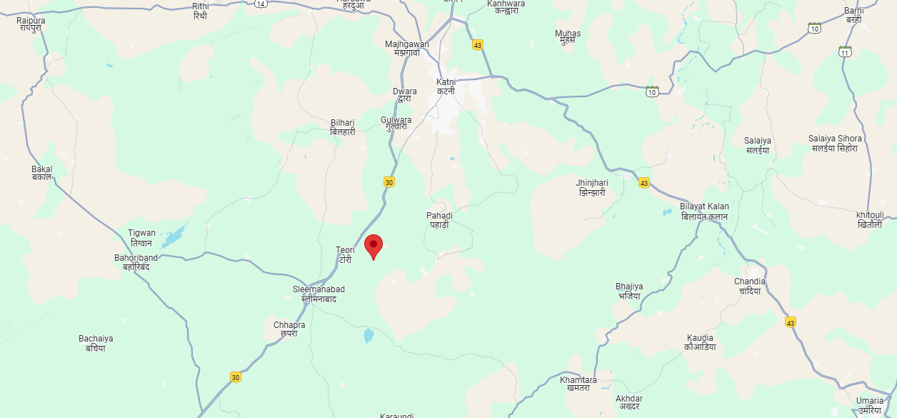
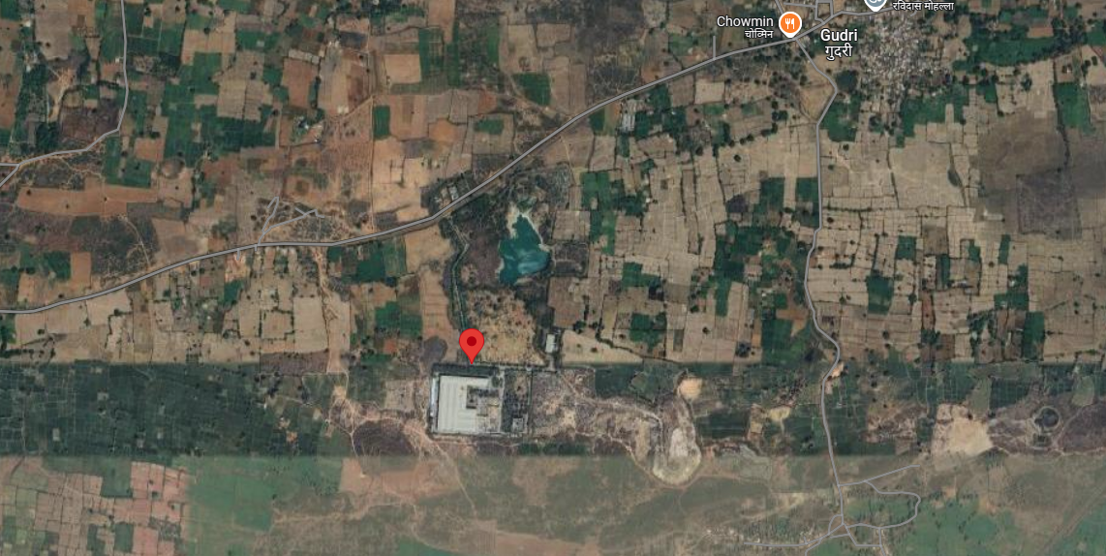

ENCLOSURE: II - REFERENCES ON PRICE TREND OF THE SIMILAR RELATED PROPERTIES AVAILABLE ON PUBLIC DOMAIN

ENCLOSURE: III – PHOTOGRAPHS OF THE PROPERTY

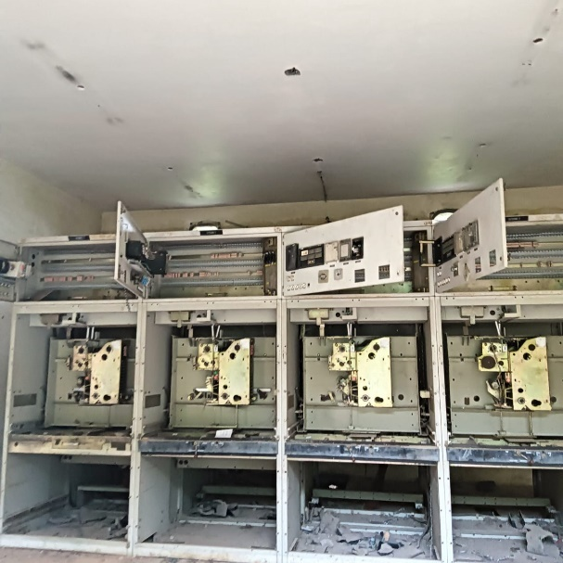 | 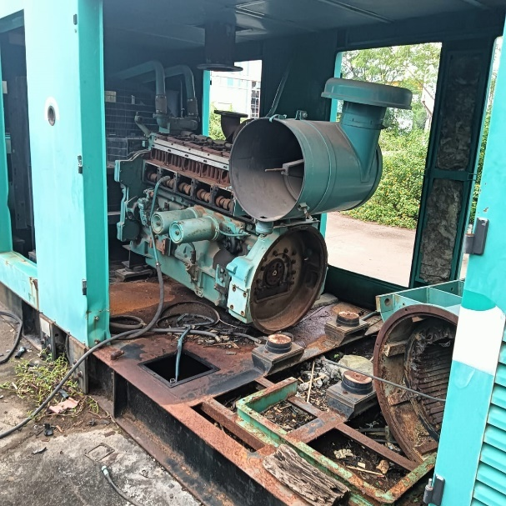
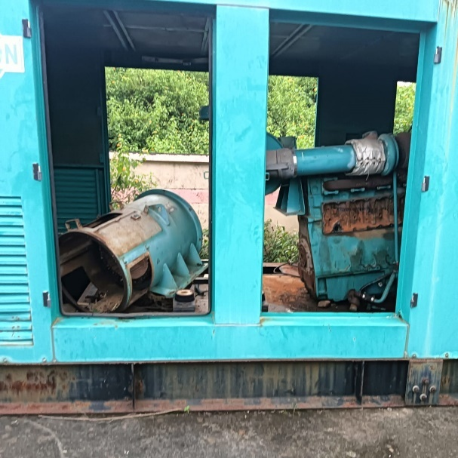 | 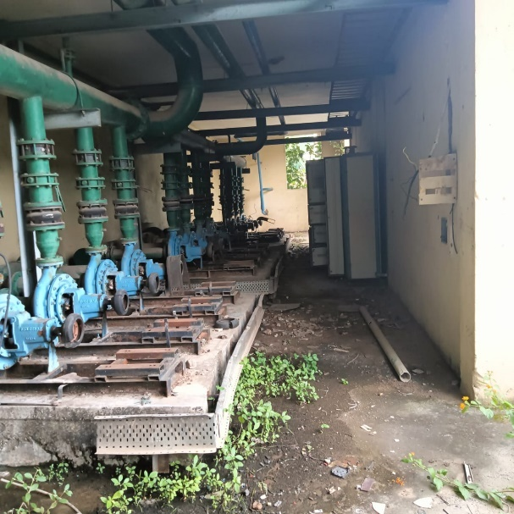
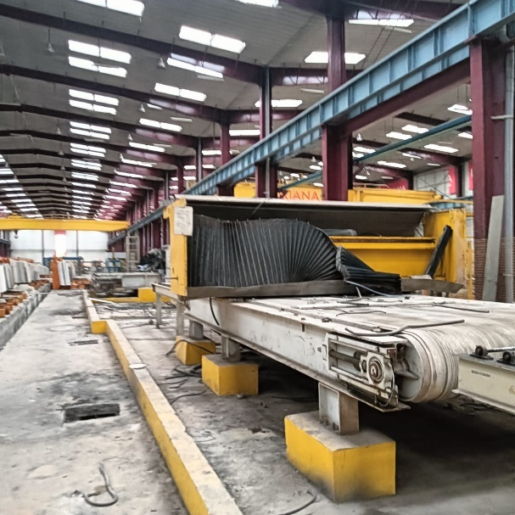 | 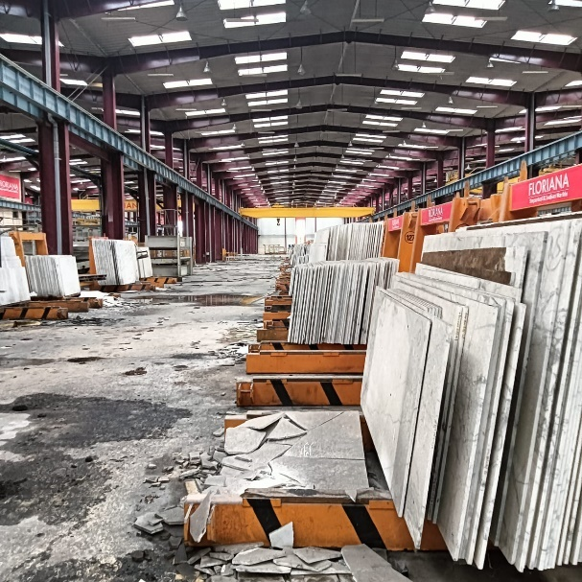

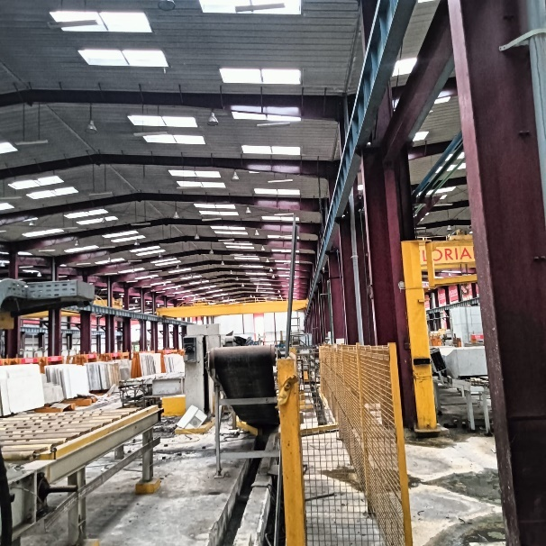 | 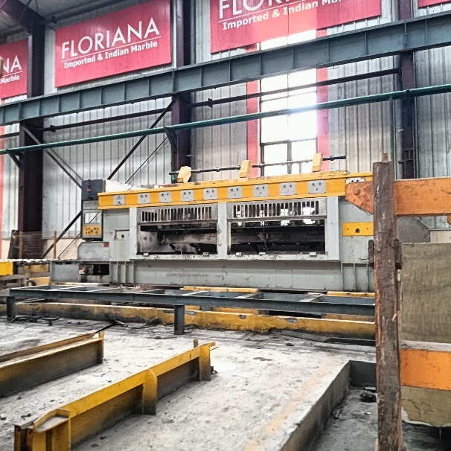
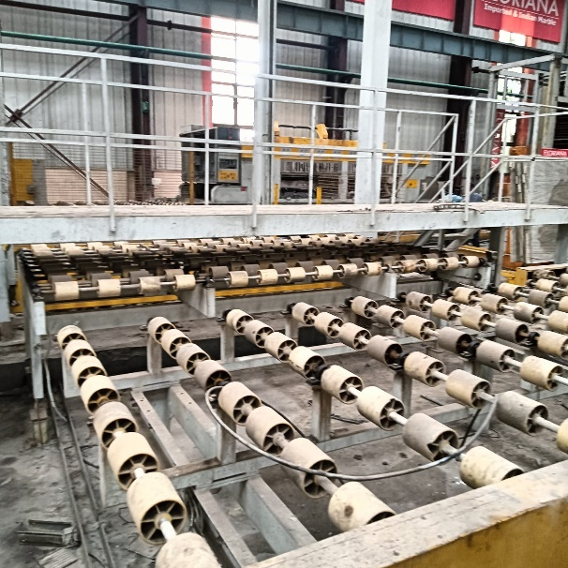 | 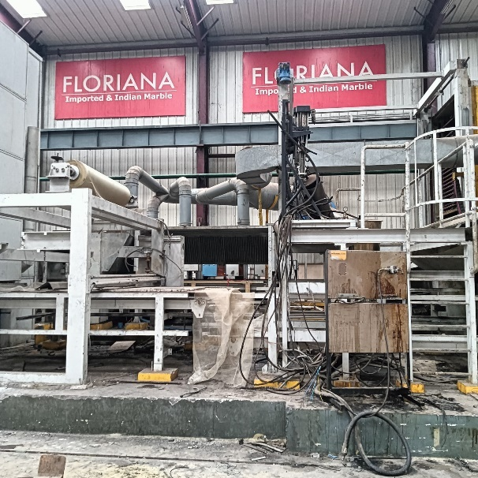
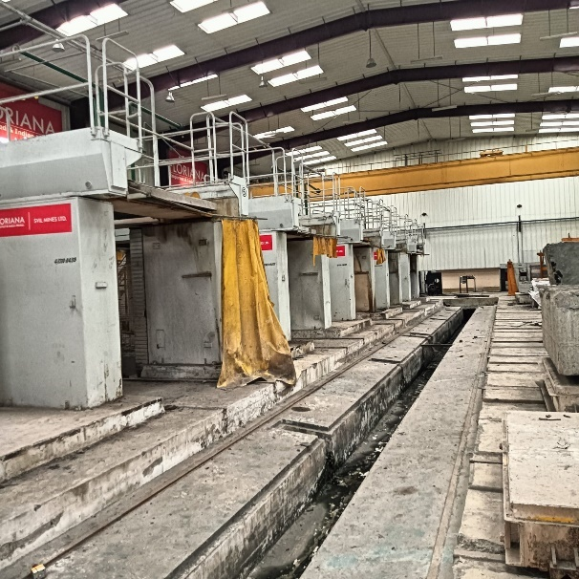 | 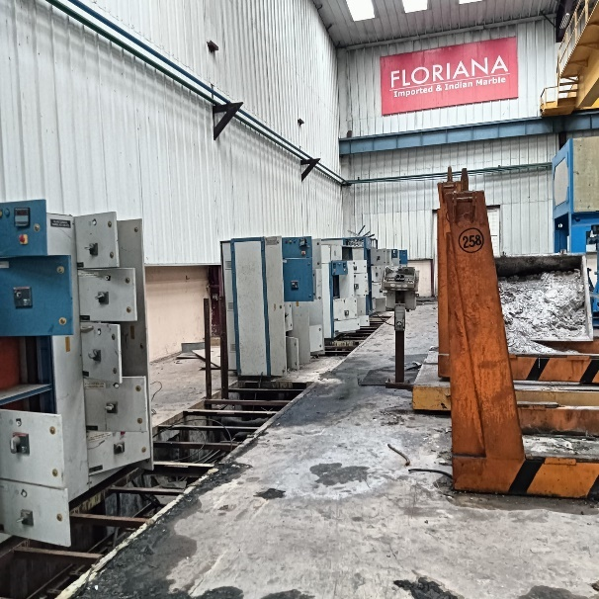

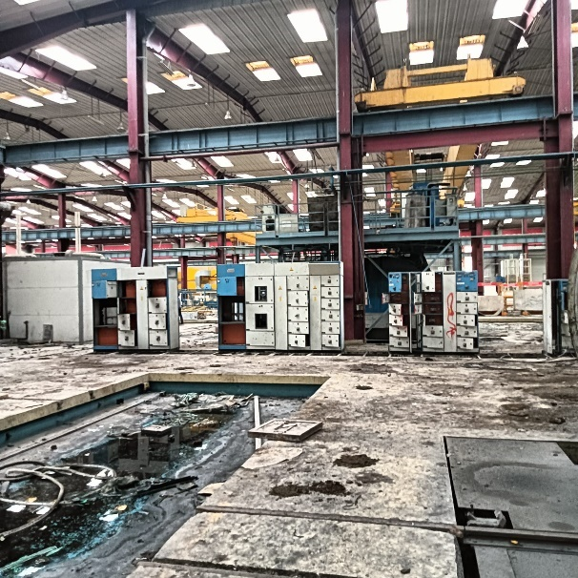 | 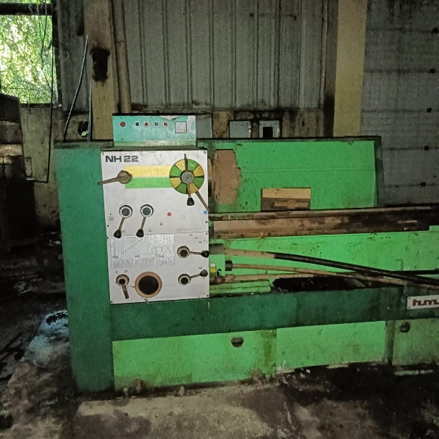
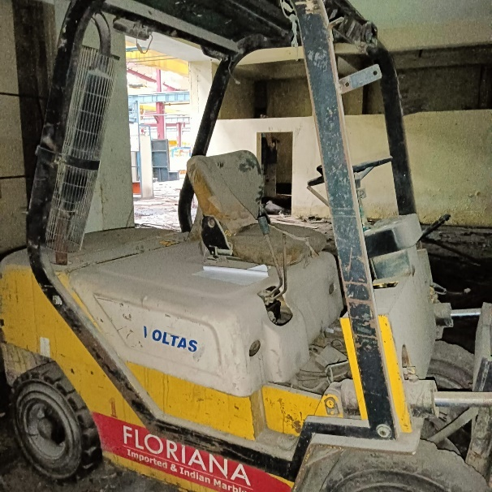 | 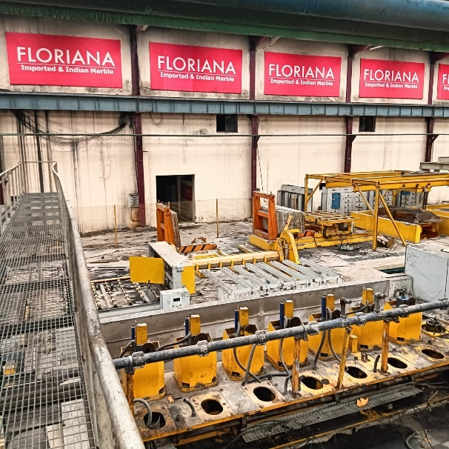
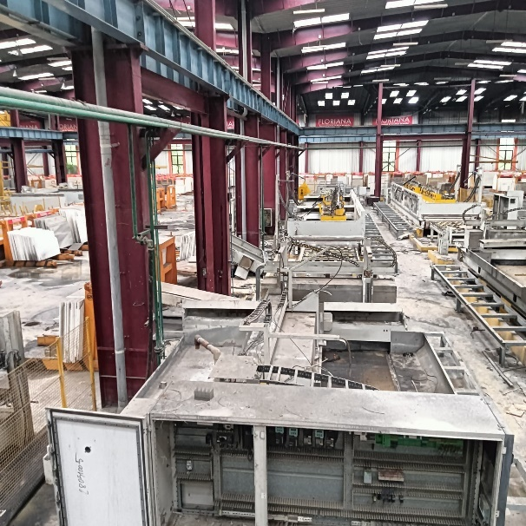 | 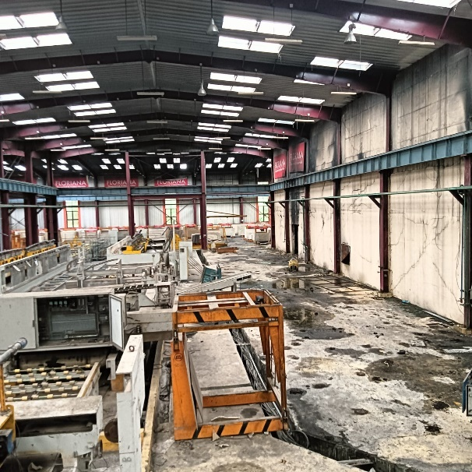

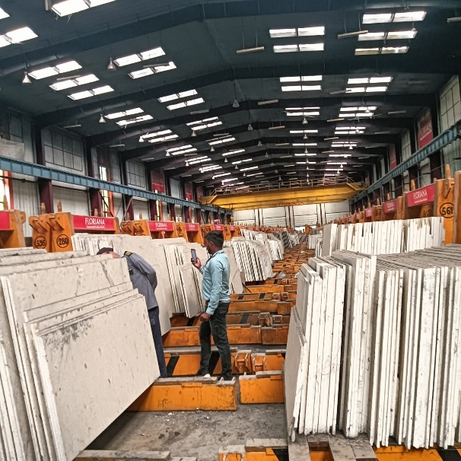 | 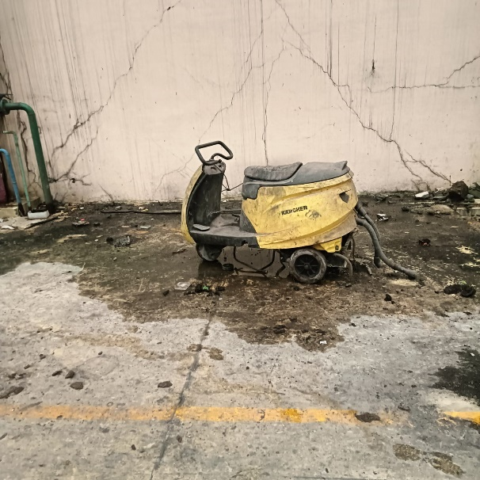
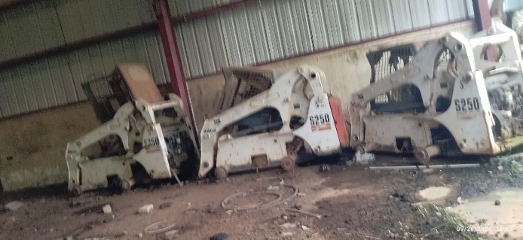 | 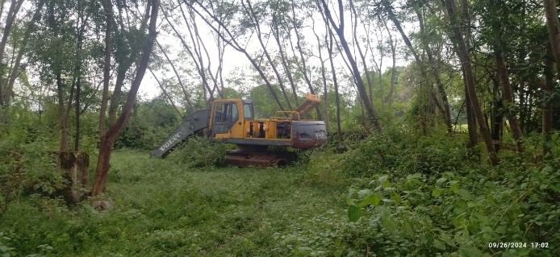
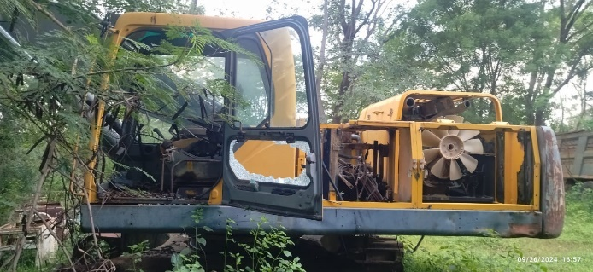 | 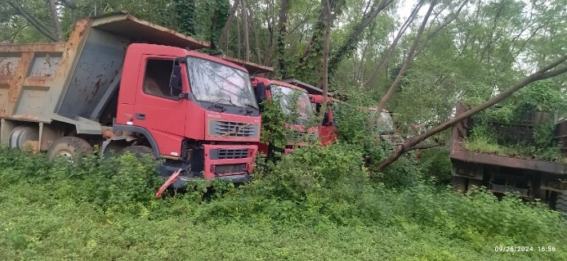

ENCLOSURE: IV – DOCUMENTS RELATED TO LAND RATE

Sale Deed- 4.60 Ha


Sale Deed- 2.89 Ha
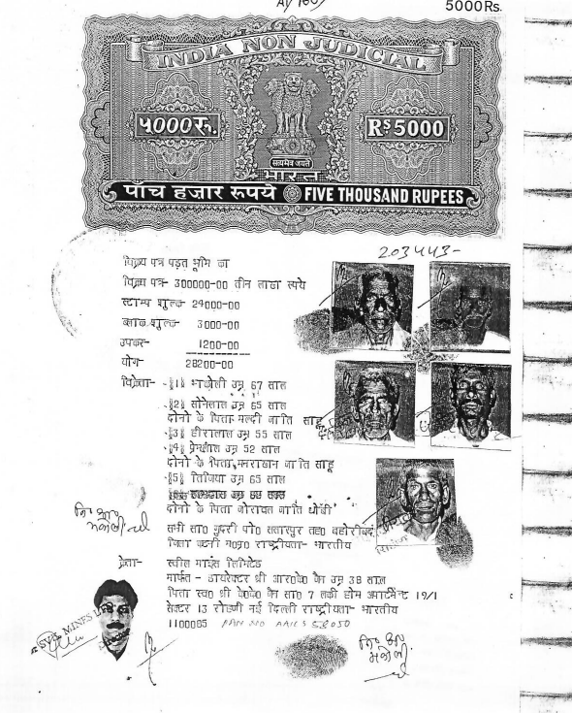

Sale Deed- 11.51 Ha
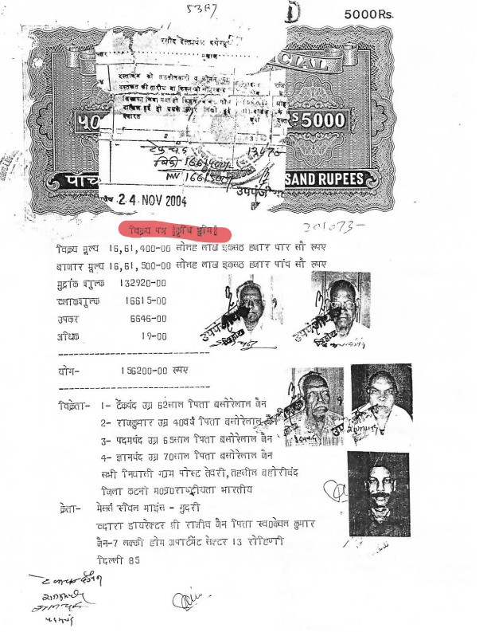

ENCLOSURE: V – IMPORTANT PROPERTY DOCUMENTS EXHIBIT

Bank Inspection Report
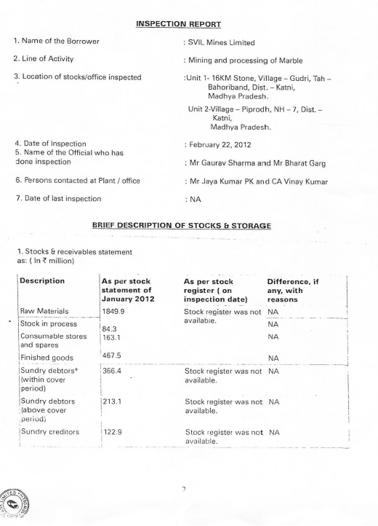

ENCLOSURE VI: ANNEXURE: DECLARATION

- The information furnished in our valuation report dated 20/12/2024 is true and correct to the best of our knowledge and belief and we have made an impartial and true valuation of the property.
- We have no direct or indirect interest in the property valued.
- Our authorized Engineer/ surveyor Mr. Yash Bhatnagar have personally inspected (Virtually) the property on 26/9/2024 the work is not subcontracted to any other valuer and is carried out by us.
- We have not been convicted of any offence and sentenced to a term of imprisonment.
- We have not been found guilty of misconduct in professional capacity.
- We have read the Handbook on Policy, Standards and procedure for Real Estate Valuation, 2009 of the IBA and has tried to apply the “Standards” enshrined for valuation in the Part-B of the above handbook to the best of our ability as much as practically possible in the limited time available.
- We have read the International Valuation Standards (IVS) and the report submitted to the Bank for the respective asset class and has tried to apply the “Standards” as enshrined for valuation in the IVS in “General Standards” and “Asset Standards” as applicable to the best of our ability as much as practically possible in the limited time available.
- Procedures and standards adopted in carrying out the valuation and is mentioned in Part-D of the report which may have certain departures to the said IBA and IVS standards in order to provide better, just & fair valuation.
- We abide by the Model Code of Conduct for empanelment of valuer in the Bank.
- I am the authorized official of the firm / company, who is competent to sign this valuation report.

S. No. | Particulars | Valuer comment
 | Background information of the asset being valued | This is a Marble/Granite Cutting, polishing plant located at the aforesaid address having total land area as per the scope of valuation admeasuring 47.196 acres (as per deeds shared) as found on as-is-where basis which owner/ owner representative/ client/ bank has shown/ identified to us on the site physically unless otherwise mentioned in the report of which some reference has been taken from the information/ data given in the copy of documents provided to us and informed verbally or in writing.
 | Purpose of valuation and appointing authority | Please refer to Part-D of the Report.
 | Identity of the experts involved in the valuation | Survey Analyst: Er. Yash Bhatnagar  Valuation Engineer: Er. Abhinav Chaturvedi  L1/ L2 Reviewer: Anil Kumar
 | Disclosure of valuer interest or conflict, if any | No relationship with the borrower and no conflict of interest.
 | Date of appointment, valuation date and date of report | Date of Appointment: | 23/5/2024
 | Date of appointment, valuation date and date of report | Date of Survey: | 26/9/2024
 | Date of appointment, valuation date and date of report | Valuation Date: | 4/12/2024
 | Date of appointment, valuation date and date of report | Date of Report: | 20/12/2024
 | Inspections and/ or investigations undertaken | Yes, by our authorized Survey Engineers Yash Bhatnagar on 26/9/2024. Property was shown and identified by Mr. Neeraj Yadav (+91 96859 51100)
 | Nature and sources of the information used or relied upon | Please refer to Part-D of the Report. Level 3 Input (Tertiary) has been relied upon.
 | Procedures adopted in carrying out the valuation and valuation standards followed | Please refer to Part-D of the Report.
 | Restrictions on use of the report, if any | Value varies with the Purpose/ Date/ Market & Asset Condition & Situation prevailing in the market. We recommend not to refer the indicative & estimated prospective Value of the asset given in this report if any of these points are different from the one mentioned aforesaid in the Report.  This report has been prepared for the purposes stated in the report and should not be relied upon for any other purpose. Our client is the only authorized user of this report and is restricted for the purpose indicated in This report. I/we do not take any responsibility for the unauthorized use of this report.  During the course of the assignment, we have relied upon various information, data, documents in good faith provided by Bank/ client both verbally and in writing. If at any point of time in future it comes to knowledge that the information given to us is untrue, fabricated, misrepresented then the use of this report at very moment will become null & void.  This report only contains general assessment & opinion on the indicative, estimated Market Value of the property for which Bank has asked to conduct the Valuation for the asset which owner/ owner representative/ client/ bank has shown/ identified to us on the site and as found on as-is-where basis unless otherwise mentioned in the report of which some reference has been taken from the information/ data given in the copy of documents provided to us and informed verbally or in writing which has been relied upon in good faith. It doesn’t contain any other recommendations of any sort including but not limited to express of any opinion on the suitability or otherwise of entering into any transaction with the borrower.  This report is not a certification of ownership or survey number/ property number/ Khasra number which are merely referred from the copy of the documents provided to us.
 | Major factors that were taken into account during the valuation | Please refer to Part A, B & C of the Report.
 | Major factors that were not taken into account during the valuation | Please refer to Part A, B & C of the Report.
 | Caveats, limitations and disclaimers to the extent they explain or elucidate the limitations faced by valuer, which shall not be for the purpose of limiting his responsibility for the valuation report. | Please refer to Part D & Part E Valuer’s Important Remarks of the Report enclosed herewith.
Date: 20/12/2024
Place: Noida

Signature

(Authorized Person of R.K Associates Valuers & Techno Engg. Consultants (P) Ltd.)
ENCLOSURE VII: ANNEXURE: MODEL CODE OF CONDUCT FOR VALUERS

Integrity and Fairness

- A valuer shall, in the conduct of his/its business, follow high standards of integrity and fairness in all his/its dealings with his/its clients and other valuers.
- A valuer shall maintain integrity by being honest, straightforward, and forthright in all professional relationships.
- A valuer shall endeavour to ensure that he/it provides true and adequate information and shall not misrepresent any facts or situations.
- A valuer shall refrain from being involved in any action that would bring disrepute to the profession.
- A valuer shall keep public interest foremost while delivering his services.

Professional Competence and Due Care

- A valuer shall render at all times high standards of service, exercise due diligence, ensure proper care and exercise independent professional judgment.
- A valuer shall carry out professional services in accordance with the relevant technical and professional standards that may be specified from time to time
- A valuer shall continuously maintain professional knowledge and skill to provide competent professional service based on up-to-date developments in practice, prevailing regulations/guidelines and techniques.
- In the preparation of a valuation report, the valuer shall not disclaim liability for his/its expertise or deny his/its duty of care, except to the extent that the assumptions are based on statements of fact provided by the company or its auditors or consultants or information available in public domain and not generated by the valuer.
- A valuer shall not carry out any instruction of the client insofar as they are incompatible with the requirements of integrity, objectivity and independence.
- A valuer shall clearly state to his client the services that he would be competent to provide and the services for which he would be relying on other valuers or professionals or for which the client can have a separate arrangement with other valuers.

INDEPENDENCE AND DISCLOUSRE OF INTEREST

- A valuer shall act with objectivity in his/its professional dealings by ensuring that his/its decisions are made without the presence of any bias, conflict of interest, coercion, or undue influence of any party, whether directly connected to the valuation assignment or not.
- A valuer shall not take up an assignment if he/it or any of his/its relatives or associates is not independent in terms of association to the company.
- A valuer shall maintain complete independence in his/its professional relationships and shall conduct the valuation independent of external influences.
- A valuer shall wherever necessarily disclose to the clients, possible sources of conflicts of duties and interests, while providing unbiased services.

- A valuer shall not deal in securities of any subject company after any time when he/it first becomes aware of the possibility of his/its association with the valuation, and in accordance with the Securities and Exchange Board of India (Prohibition of Insider Trading) Regulations, 2015 or till the time the valuation report becomes public, whichever is earlier.
- A valuer shall not indulge in “mandate snatching” or offering “convenience valuations” in order to cater to a company or client’s needs.
- As an independent valuer, the valuer shall not charge success fee (Success fees may be defined as a compensation / incentive paid to any third party for successful closure of transaction. In this case, approval of credit proposals).
- In any fairness opinion or independent expert opinion submitted by a valuer, if there has been a prior engagement in an unconnected transaction, the valuer shall declare the association with the company during the last five years.

Confidentiality

- A valuer shall not use or divulge to other clients or any other party any confidential information about the subject company, which has come to his/its knowledge without proper and specific authority or unless there is a legal or professional right or duty to disclose.

Information Management

- A valuer shall ensure that he/ it maintains written contemporaneous records for any decision taken, the reasons for taking the decision, and the information and evidence in support of such decision. This shall be maintained so as to sufficiently enable a reasonable person to take a view on the appropriateness of his/its decisions and actions.
- A valuer shall appear, co-operate and be available for inspections and investigations carried out by the authority, any person authorised by the authority, the registered valuer’s organisation with which he/it is registered or any other statutory regulatory body.
- A valuer shall provide all information and records as may be required by the authority, the Tribunal, Appellate Tribunal, the registered valuer’s organization with which he/it is registered, or any other statutory regulatory body.
- A valuer while respecting the confidentiality of information acquired during the course of performing professional services, shall maintain proper working papers for a period of three years or such longer period as required in its contract for a specific valuation, for production before a regulatory authority or for a peer review. In the event of a pending case before the Tribunal or Appellate Tribunal, the record shall be maintained till the disposal of the case.

Gifts and hospitality:

- A valuer or his/its relative shall not accept gifts or hospitality which undermines or affects his independence as a valuer.
Explanation. ─ For the purposes of this code the term “relative‟ shall have the same meaning as defined in clause (77) of Section 2 of the Companies Act, 2013 (18 of 2013).
- A valuer shall not offer gifts or hospitality or a financial or any other advantage to a public servant or any other person with a view to obtain or retain work for himself/ itself, or to obtain or retain an advantage in the conduct of profession for himself/ itself.

Remuneration and Costs.

- A valuer shall provide services for remuneration which is charged in a transparent manner, is a reasonable reflection of the work necessarily and properly undertaken, and is not inconsistent with the applicable rules.
- A valuer shall not accept any fees or charges other than those which are disclosed in a written contract with the person to whom he would be rendering service.

Occupation, employability and restrictions.

- A valuer shall refrain from accepting too many assignments, if he/it is unlikely to be able to devote adequate time to each of his/ its assignments.
- A valuer shall not conduct business which in the opinion of the authority or the registered valuer organisation discredits the profession.

Signature of the Authorized Person: ________________
Name of the Valuation company: R.K Associates Valuers & Techno Engg. Consultants (P) Ltd.
Address of the Valuer: D-39, Sector-2, Noida-201301
Date: 20/12/2024
Place: Noida
ENCLOSURE VIII: ANNEXURE: VALUER’S IMPORTANT REMARKS

Valuation is done for the asset found on as-is-where basis which owner/ owner representative/ client/ bank has shown/ identified to us on the site unless otherwise mentioned in the report of which some reference has been taken from the information/ data given in the copy of documents provided to us and informed verbally or in writing out of the standard checklist of documents sought from the client & its customer which they could provide within the reasonable expected time out of the standard checklist of documents sought from them and further based on certain assumptions and limiting conditions. The information, facts, documents, data which has become primary basis of the report has been supplied by the client which has been relied upon in good faith and is not generated by the Valuer.
The client/ owner and its management/ representatives warranted to us that the information they have supplied was complete, accurate and true and correct to the best of their knowledge. All such information provided to us either verbally, in writing or through documents has been relied upon in good faith and we have assumed that it is true & correct without any fabrication or misrepresentation. I/We shall not be held liable for any loss, damages, cost or expenses arising from fraudulent acts, misrepresentations, or willful default on part of the owner, company, its directors, employee, representative or agents.
Legal aspects for eg. Investigation of title, ownership rights, lien, charge, mortgage, lease, sanctioned maps, verification of documents provided to us such as title documents, Map, etc. from any concerned Govt. office etc. have to be taken care by legal expert/ Advocate and same is not done at our end. It is assumed that the concerned Lender/ Financial Institution has asked for the valuation of that property after satisfying the authenticity of the documents given to us for which the legal verification has been already taken and cleared by the competent Advocate before requesting for the Valuation report. I/ We assume no responsibility for the legal matters including, but not limited to, legal or title concerns.
In the course of the valuation, we were provided with both written and verbal information. We have however, evaluated the information provided to us through broad inquiry, analysis and review but have not carried out a due diligence or audit of the information provided for the purpose of this engagement. Our conclusions are based on the assumptions and other information provided to us by the client during the course of the assessment.
Getting cizra map or coordination with revenue officers for site identification is a separate activity and is not part of the Valuation services and same has not been done in this report unless otherwise stated.
Wherever any details are mentioned in the report in relation to any legal aspect of the property such as name of the owner, leases, etc. is only for illustration purpose and should not be construed as a professional opinion. Legal aspects are out of scope of this report. Details mentioned related to legal aspect are only based on the copy of the documents provided to us and whatever we can interpret as a non-legally trained person. This should be cross validated with a legal expert. We do not vouch any responsibility regarding the same.
We have made certain assumptions in relation to facts, conditions & situations affecting the subject of, or approach to this exercise that has not been verified as part of the engagement rather, treated as “a supposition taken to be true”. If any of these assumptions prove to be incorrect then our estimate on value will need to be reviewed.
This is just an opinion report based on technical & market information having general assessment & opinion on the indicative, estimated Market Value of the property for which Bank has asked to conduct the Valuation. It doesn’t contain any other recommendations of any sort including but not limited to express of any opinion on the suitability or otherwise of entering into any transaction with the borrower.
We have relied on the data from third party, external sources & information available on public domain to conclude the valuation. These sources are believed to be reliable and therefore, we assume no liability for the truth or accuracy of any data, opinions or estimates furnished by others that have been used in this analysis. Where we have relied on the data, opinions or estimates from external sources, reasonable care has been taken to ensure that such data is extracted from authentic sources, however we still can’t vouch its authenticity, correctness, or accuracy.
Analysis and conclusions adopted in the report are limited to the reported assumptions, conditions and information came to our knowledge during the course of the work and based on the Standard Operating Procedures, Best Practices, Caveats, Limitations, Conditions, Remarks, Important Notes, Valuation TOR and definition of different nature of values.
Value varies with the Purpose/ Date/ Asset Condition & situation/ Market condition, demand & supply, asset utility prevailing on a particular date/ Mode of sale. The indicative & estimated prospective Value of the asset given in this report is restricted only for the purpose and other points mentioned above prevailing on a particular date as mentioned in the report. If any of these points are different from the one mentioned aforesaid in the Report then this report should not be referred.
Our report is meant ONLY for the purpose mentioned in the report and should not be used for any other purpose. The Report should not be copied or reproduced for any purpose other than the purpose for which it is prepared for. I/we do not take any responsibility for the unauthorized use of this report.
We owe responsibility only to the authority/client that has appointed us as per the scope of work mentioned in the report. We will not be liable for any losses, claims, damages or liabilities arising out of the actions taken, omissions or advice given by any other person. In no event shall we be liable for any loss, damages, cost or expenses arising in any way from fraudulent acts, misrepresentations or willful default on part of the client or companies, their directors, employees or agents.
This report is having limited scope as per its fields & format to provide only the general basic idea of the value of the property prevailing in the market based on the site inspection and documents/ data/ information provided by the client. The suggested indicative prospective estimated value should be considered only if transaction is happened as free market transaction.
The sale of the subject property is assumed to be on an all cash basis. Financial arrangements would affect the price at which the property may sell for if placed on the market.
The actual realizable value that is likely to be fetched upon sale of the asset under consideration shall entirely depend on the demand and supply of the same in the market at the time of sale.
While our work has involved an analysis & computation of valuation, it does not include detailed estimation, design/ technical/ engineering/ financial/ structural/ environmental/ architectural/ compliance survey/ safety audit & works in accordance with generally accepted standards of audit & other such works. The report in this work in not investigative in nature. It is mere an opinion on the likely estimated valuation based on the facts & details presented to us by the client and third party market information came in front of us within the limited time of this assignment, which may vary from situation to situation.
Where a sketched plan is attached to this report, it does not purport to represent accurate architectural plans. Sketch plans and photographs are provided as general illustrations only.
Documents, information, data including title deeds provided to us during the course of this assessment by the client is reviewed only upto the extent required in relation to the scope of the work. No document has been reviewed beyond the scope of the work. These are not reviewed in terms of legal rights for which we do not have expertise. Wherever any information mentioned in this report is mentioned from the documents like owners name, etc., it is only for illustration purpose and may not necessary represent accuracy.
The report assumes that the borrower/company/business/asset complies fully with relevant laws and regulations applicable in its area of operations and usage unless otherwise stated, and that the companies/business/assets is managed in a competent and responsible manner. Further, as specifically stated to the contrary, this report has given no consideration to matters of a legal nature, including issues of legal title and compliance with relevant laws, and litigations and other contingent liabilities that are not recorded/reflected in the documents/ details/ information/ data provided to us.
This valuation report is not a qualification for accuracy of land boundaries, schedule (in physical terms), dimensions & identification. For this land/ property survey report can be sought from a qualified private or Govt. surveyor.
This Valuation report is prepared based on the facts of the property on the date of the survey. Due to possible changes in market forces, socio-economic conditions, property conditions and circumstances, this valuation report can only be regarded as relevant as at the valuation date. Hence before financing, Banker/ FI should take into consideration all such future risk and should loan conservatively to keep the advanced money safe in case of the downward trend of the property value.
Valuation of the same asset/ property can fetch different values under different circumstances & situations. For eg. Valuation of a running/ operational shop/ hotel/ factory will fetch better value and in case of closed shop/ hotel/ factory it will have considerable lower value. Similarly, an asset sold directly by an owner in the open market through free market transaction then it will fetch better value and if the same asset/ property is sold by any financer due to encumbrance on it, will fetch lower value. Hence before financing, Lender/ FI should take into consideration all such future risks while financing and take decision accordingly.

Valuation is done for the property identified to us by the owner/ owner representative. At our end we have just visually matched the land boundaries, schedule (in physical terms) & dimensions of the property with reference to the documents produced for perusal. Method by which identification of the property is carried out is also mentioned in the report clearly. Responsibility of identifying the correct property to the Valuer/ its authorized surveyor is solely of the client/ owner for which Valuation has to be carried out. It is requested from the Bank to cross check from their own records/ information if this is the same property for which Valuation has to be carried out to ensure that owner has not misled the Valuer company or misrepresented the property due to any vested interest. Where there is a doubt about the precision position of the boundaries, schedule, dimensions of site & structures, it is recommended that a Licensed Surveyor be contacted.
In India more than 70% of the geographical area is lying under rural/ remote/ non municipal/ unplanned area where the subject property is surrounded by vacant lands having no physical demarcation or having any display of property survey or municipal number / name plate on the property clearly. Even in old locations of towns, small cities & districts where property number is either not assigned or not displayed on the properties clearly and also due to the presence of multiple/ parallel departments due to which ownership/ rights/ illegal possession/ encroachment issues are rampant across India and due to these limitations at many occasions it becomes tough to identify the property with 100% surety from the available documents, information & site whereabouts and thus chances of error, misrepresentation by the borrower and margin of chances of error always persists in such cases. To avoid any such chances of error it is advised to the Bank to engage municipal/ revenue department officials to get the confirmation of the property to ensure that the property shown to Valuer/ Banker is the same as for which documents are provided.
If this Valuation Report is prepared for the Flat/ dwelling unit situated in a Group Housing Society or Integrated Township then approvals, maps of the complete group housing society/ township is out of scope of this report and this report will be made for the specific unit based on the assumption that complete Group Housing Society/ Integrated Township and the subject unit must be approved in all respect.
Due to fragmented & frequent change in building/ urban planning laws/ guidelines from time to time, different laws/ guidelines between regions/ states and no strict enforceability of Building Bye-Laws in India specially in non-metro and scale b & c cities & Industrial areas, property owners many times extend or make changes in the covered area/ layout from the approved/ applicable limits. There are also situations where properties are decades old when there was no formal Building Bye-Laws applicable the time when the construction must have been done. Due to such discrete/ unplanned development in many regions sometimes it becomes tough for the Valuer to determine the exact lawful situation on ground. Unless otherwise mentioned in the report, the covered area present on the site as per site survey will be considered in the Valuation.
Area of the large land parcels of more than 2500 sq.mtr or of uneven shape in which there can be practical difficulty in sample measurement, is taken as per property documents which has been relied upon unless otherwise stated.

Drawing Map, design & detailed estimation of the property/ building is out of scope of the Valuation services.
Valuation is a subjective field and opinion may differ from consultant to consultant. To check the right opinion, it is important to evaluate the methodology adopted and various data point/ information/ factors/ assumption considered by the consultant which became the basis for the Valuation report before reaching to any conclusion.
Although every scientific method has been employed in systematically arriving at the value, there is, therefore, no indisputable single value and the estimate of the value is normally expressed as falling within a likely range.
Value analysis of any asset cannot be regarded as an exact science and the conclusions arrived at in many cases will, of necessity, be subjective and dependent on the exercise of individual judgment. Given the same set of facts and using the same assumptions, expert opinions may differ due to the number of separate judgment decisions, which have to be made. Therefore, there can be no standard formula to establish an indisputable exchange ratio. In the event of a transaction, the actual transaction value achieved may be higher or lower than our indicative analysis of value depending upon the circumstances of the transaction. The knowledge, negotiability and motivations of the buyers and sellers, demand & supply prevailing in the market and the applicability of a discount or premium for control will also affect actual price achieved. Accordingly, our indicative analysis of value will not necessarily be the price at which any agreement proceeds. The final transaction price is something on which the parties themselves have to agree. However, our Valuation analysis can definitely help the stakeholders to take informed and wise decision about the Value of the asset and can help in facilitating the arm’s length transaction.
This Valuation is conducted based on the macro analysis of the asset/ property considering it in totality and not based on the micro, component, or item wise analysis. Analysis done is a general assessment and is not investigative in nature.
This report is prepared on the RKA V-L1 (Basic) Valuation format as per the client requirement and scope of work. This report is having limited scope as per its fields & format to provide only the general estimated & indicative basic idea of the value of the property prevailing in the market based on the information provided by the client. No detailed analysis, audit or verification has been carried out of the subject property. There may be matters, other than those noted in this report, which might be relevant in the context of the transaction and which a wider scope might uncover.
This is just an opinion report and doesn’t hold any binding on anyone. It is requested from the concerned Client/ Bank/ Financial Institution which is using this report for mortgaging the property that they should consider all the different associated relevant & related factors & risks before taking any business decision based on the content of this report.
All Pages of the report including annexures are signed and stamped from our office. In case any paper in the report is without stamp & signature then this should not be considered a valid paper issued from this office.
As per IBA Guidelines & Bank Policy, in case the valuation report submitted by the valuer is not in order, the banks / FIs shall bring the same to the notice of the valuer within 15 days of submission for rectification and resubmission. In case no such communication is received, it shall be presumed that the valuation report has been accepted.
Defect Liability Period is 15 DAYS. We request the concerned authorized reader of this report to check the contents, data, information, and calculations in the report within this period and intimate us in writing at valuers@rkassociates.org within 15 days of report delivery, if any corrections are required or in case of any other concern with the contents or opinion mentioned in the report. If no intimation is received within 15 (Fifteen) days in writing from the date of issuance of the report, then it shall be considered that the report is complete in all respect and has been accepted by the client up to their satisfaction & use and further to which R.K Associates shall not be held responsible in any manner. After this period no concern/ complaint/ proceedings in connection with the Valuation Services will be entertained due to possible change in situation and condition of the property.
Though adequate care has been taken while preparing this report as per its scope, but still we can’t rule out typing, human errors, over sightedness of any information or any other mistakes. Therefore, the concerned organization is advised to satisfy themselves that the report is complete & satisfactory in all respect. Intimation regarding any discrepancy shall be brought into our notice immediately. If no intimation is received within 15 (Fifteen) days in writing from the date of issuance of the report, to rectify these timely, then it shall be considered that the report is complete in all respect and has been accepted by the client upto their satisfaction & use and further to which R.K Associates shall not be held responsible in any manner.
Our Data retention policy is of ONE YEAR. After this period we remove all the concerned records related to the assignment from our repository. No clarification or query can be answered after this period due to unavailability of the data.
This Valuation report is governed by our (1) Internal Policies, Processes & Standard Operating Procedures, (2) R.K Associates Quality Policy, (3) Valuation & Survey Best Practices Guidelines formulated by management of R.K Associates, (4) Information input given to us by the customer and (4) Information/ Data/ Facts given to us by our field/ office technical team. Management of R.K Associates never gives acceptance to any unethical or unprofessional practice which may affect fair, correct & impartial assessment and which is against any prevailing law. In case of any indication of any negligence, default, incorrect, misleading, misrepresentation or distortion of facts in the report then we request the user of this report to immediately or at least within the defect liability period to bring all such act into notice of R.K Associates management so that corrective measures can be taken instantly.
R.K Associates never releases any report doing alterations or modifications by pen. In case any information/ figure of this report is found altered with pen then this report will automatically become null & void.
We are fully aware that based on the opinion of value expressed in this report, we may be required to give testimony or attend court / judicial proceedings with regard to the subject assets, although it is out of scope of the assignment, unless specific arrangements to do so have been made in advance, or as otherwise required by law. In such event, the party seeking our evidence in the proceedings shall bear the cost/professional fee of attending court / judicial proceedings and my / our tendering evidence before such authority shall be under the applicable laws.
The final copy of the report shall be considered valid only if it is in hard copy on the company’s original letter head with proper stamp and sign on it of the authorized official upon payment of the agreed fees. User shall not use the content of the report for the purpose it is prepared for only on draft report, scanned copy, email copy of the report and without payment of the agreed fees. In such a case the report shall be considered as unauthorized and misused.

