REPORT FORMAT: CL-1 | Version: 1.0_2018

FILE No.: VIS(2024-25)-PL070-063-087 Date: 16-05-2024

- CERTIFICATE NAME: Cold Commissioning Certificate of Compressed Biogas Plant located at Baheri, Bareilly, Uttar Pradesh.
- PREPARED FOR ORGANIZATION: State Bank of India, SME, Rudrapur
- BORROWER COMPANY’S NAME: M/s. Carbon Circle Private Limited
- INDUSTRY TYPE: Compressed Biogas Plant
- ADDRESS OF THE PLANT: Village Shahpur Dandi, Tehshil Baheri, District Bareilly

TO WHOM IT MAY CONCERN

S. NO. | PARTICULARS | DESCRIPTION
1. | Date of Survey | 10-05-2024
2. | Date of Certificate | 16-05-2024
3. | Work Order Reference No. | Email Dated-1st May 2024
4. | Documents provided for perusal | - Digester Installation Certificate
4. | Borrowing Company | M/s. Carbon Circle Private Limited
5. | Type of Asset | Compressed Biogas Plant
6. | Type of Assessment | Certificate towards Cold Commissioning Certificate of Compressed Biogas Plant
7. | Scope of Assessment | Providing the Certificate towards Cold Commissioning Certificate of Compressed Biogas Plant
8. | Project Background | M/S. Carbon Circle Private Limited (CCPL) is establishing a Compressed Biogas (CBG) plant in Baheri Tehsil, Bareilly District, Uttar Pradesh, with an aggregate capacity of 10 Tons per Day (TPD). The project will be implemented in two sequential phases, Phase-I and Phase-II, each dedicated to setting up a 5 TPD plant. This certificate covers only phase-I of the project i.e. 5 TPD plant
9. | Year of Installation | 2023
10. | Current Status | Plant was found to be in operation as on date of visit on 10.05.2024.
11. | Comment on Date of Commencement of Commercial Operations (DCCO) | Plant achieved commercial operation on 30.04.2024.

METHODOLOGY ADOPTED:
- Plant inspection on 10.05.2024.
- Reviewed the document such as Digester completion certificate
OBSERVATIONS:
- planET Biogas Global Gmbh. is appointed as contractor for installation of Digester in the CBG plant.
- The raw material was found adjacent to the plant and brought to dump in the mixer.
- The mixer was running and raw material was being dumped in it.
- The digester was operational and filled with raw material as seen in the digital meter.
- As per planET Biogas Global Gmbh certificate digester has been installed, tested and ready for use.
- As per observation made during site survey, the plant was operational and the machines were running as per their usage.
- Based on the information provided and observation made during site visit, it is certified that the plant was in operation.

For R.K. Associates Valuers & Techno Engineering Consultants (P) Ltd.
Survey Engineer | Engineer | L1/ L2 Reviewer
Vishal Singh & Deepak Kumar Singh | Deepak Kumar Singh | Sr. VP Projects

DISCLAIMER:
  - During the course of the assessment, several information/ data/ inputs is referred made available to us by the company and in the event, this is found to be incorrect then this certificate would be null & void.
  - This Certificate is stated on the basis of the site visit by the surveyor on 10.05.2024 and we don’t recommend any other sort of recommendation in our Certificate.
  - This certificate doesn’t include any work related to drawing, design, sketch plan, machine conditions, economic life.
  - Ownership and other legal point of view in respect of the asset is not considered in this report as same is out of scope of this certificate.
  - This certificate should not be used for any other purpose except as specified.
  - Level 1 (Primary) scrutiny approach is applied within the limited time to the best of the possibility using specified best practices. Due care has been given while issuing the certificate, however, chances of error can’t be ruled out which may require detailed verification & scrutiny.
  - This certificate is made at the request of the Bank.

ANNEXURE: I (DOCUMENTS REFERRED)
Machine Installation Completion Certificate
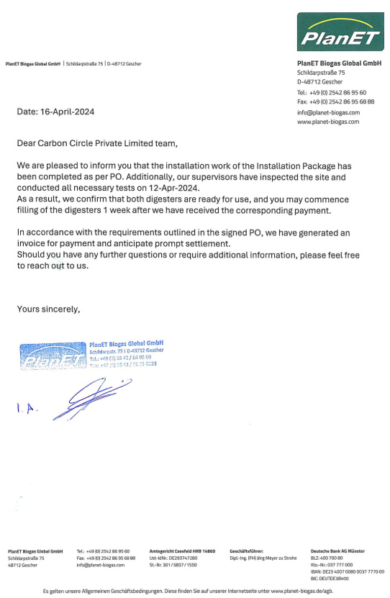

PHOTOGRAPHS
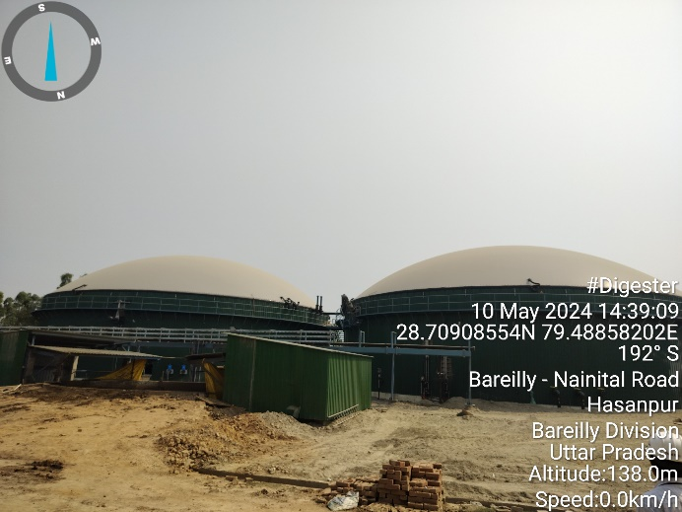 | 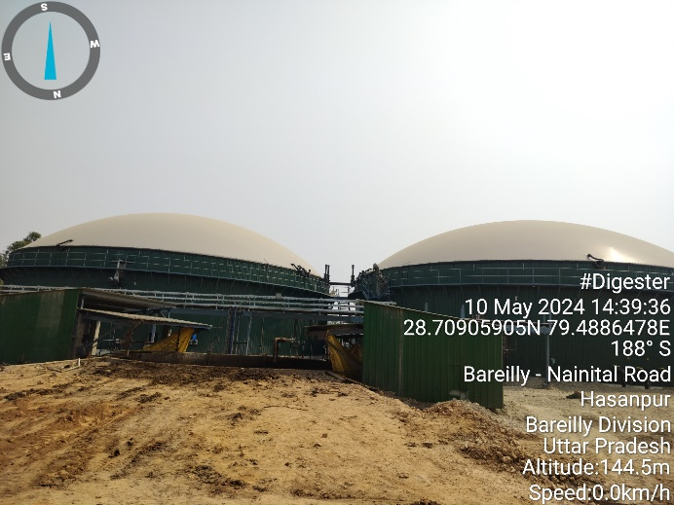
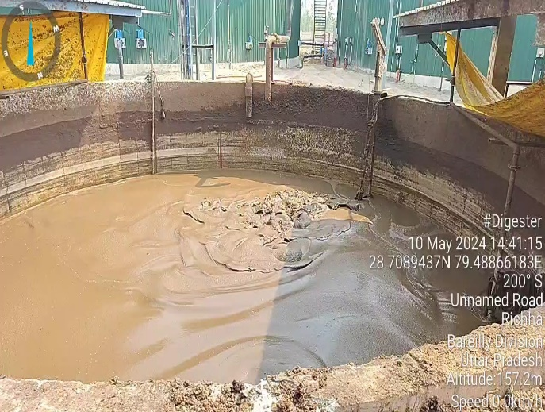 | 