**REPORT FORMAT:** CL-1 | Version: 1.0\_2018

# FILE No.: VIS(2024-25)-PL070-063-087 Date: 16-05-2024

* **DOCUMENT NAME:** Cold Commissioning assessment of Compressed Biogas Plant located at Baheri, Bareilly, Uttar Pradesh.
* **PREPARED FOR ORGANIZATION:** State Bank of India, SME, Rudrapur
* **BORROWER COMPANY’S NAME:** M/s. Carbon Circle Private Limited
* **INDUSTRY TYPE:** Compressed Biogas Plant
* **ADDRESS OF THE PLANT:** Village Shahpur Dandi, Tehshil Baheri, District Bareilly

|  |  |  |
| --- | --- | --- |
| **S. NO.** | **PARTICULARS** | **DESCRIPTION** |
| 1. | Date of Survey | 10-05-2024 |
| 2. | Date of Document | 16-05-2024 |
| 3. | Work Order Reference No. | Email Dated-9th May 2024 |
| 4. | Document provided for perusal | Digester Installation Certificate by PlanET Global BioGas Gmbh |
| 4. | Implementing Company | M/s. Carbon Circle Private Limited |
| 5. | Type of Asset | Compressed Biogas Plant |
| 6. | Type of Assessment | Cold Commissioning (Interim status) assessment of the Digester in the Compressed Biogas Plant. |
| 7. | Scope of Assessment | Providing Interim status assessment of the Digester in the Compressed Biogas Plant. |
| 8. | Project Background | M/S. Carbon Circle Private Limited (CCPL) is establishing a Compressed Biogas (CBG) plant in Baheri Tehsil, Bareilly District, Uttar Pradesh, with an aggregate capacity of 10 Tons per Day (TPD). The project is implemented in two sequential phases, Phase-I and Phase-II, each dedicated to setting up a 5 TPD plant. This assessment covers only phase-I of the project i.e. 5 TPD plant. |
| 9. | Year of Installation | 2023 - 24 |
| 10. | Current Status | During the site inspection:   1. Mixer was found running and sludge mix were being dumped. 2. The sludge mix from mixer was being filled in the digester, once the cycle is in active production during which it remains covered to maintain it atmospheric pressure and temperature. Filling of the digester was seen in digital screen in control room. 3. In CBG Plant, one production cycle typically takes around 30-45 days to complete one cycle of production. 4. As per information provided by the company, they have begun sludge feeding the Mixer with sludge mix on 30.04.2024. |

**METHODOLOGY ADOPTED:**

1. As per observations made during plant inspection on 10.05.2024.
2. Review of document such as Digester completion certificate.

**OBSERVATIONS:**

1. PlanET Biogas Global Gmbh. is appointed as contractor for installation of Digester in the CBG plant.
2. The sludge mix was found adjacent to the plant and brought to dump in the mixer.
3. The mixer was running and sludge mix was being dumped in it.
4. After the mixing process, sludge mix was being filled in the digester, which was seen through digital screen, during site survey.
5. As per PlanET Biogas Global Gmbh certificate also digester has been installed, tested and is ready for use since 12.04.2024.
6. As per observation made during site survey, the mixer and digester was observed to be in use.
7. Based on the information provided and observation made during site visit, it is certified that the mixer and digester was in operation.

|  |  |  |
| --- | --- | --- |
| For R.K. Associates Valuers & Techno Engineering Consultants (P) Ltd. | | |
| Survey Engineer | Engineer | L1/ L2 Reviewer |
| Vishal Singh  &  Deepak Kumar Singh | Deepak Kumar Singh | Vishal Singh |
|  |  |  |

**DISCLAIMER:**

* 1. *During the course of the assessment, several information/ data/ inputs is referred made available to us by the company and in the event, this is found to be incorrect then this document would be null & void.*
  2. *This Document is stated on the basis of the site visit by the surveyor on 10.05.2024 and we don’t recommend any other sort of recommendation in our Document.*
  3. *This Document doesn’t include any work related to drawing, design, sketch plan, machine conditions, economic life.*
  4. *Ownership and other legal point of view in respect of the asset is not considered in this report as same is out of scope of this Document.*
  5. *This Document should not be used for any other purpose except as specified.*
  6. *Level 1 (Primary) scrutiny approach is applied within the limited time to the best of the possibility using specified best practices. Due care has been given while issuing the document, however, chances of error can’t be ruled out which may require detailed verification & scrutiny.*
  7. *This Document is made at the request of the Bank.*

# ANNEXURE: I (DOCUMENTS REFERRED)

**Machine Installation Completion Certificate**

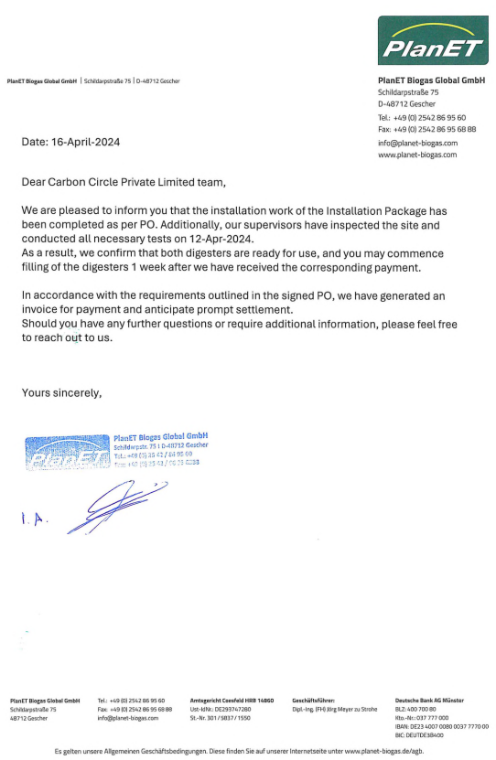

# PHOTOGRAPHS

|  |  |
| --- | --- |
| Z:\In Progress Files\Deepak Singh\April-May 2024\Carbon Circle Cold Commissioning Certificate\SIte images\IMG_20240516_14211298.jpg | Z:\In Progress Files\Deepak Singh\April-May 2024\VIS(2024-25)-PL070-063-087 Carbon Circle certificate\SIte images\TimePhoto_20240510_151347.jpg |
| Z:\In Progress Files\Deepak Singh\April-May 2024\VIS(2024-25)-PL070-063-087 Carbon Circle certificate\SIte images\TimePhoto_20240510_144646.jpg | Z:\In Progress Files\Deepak Singh\April-May 2024\VIS(2024-25)-PL070-063-087 Carbon Circle certificate\SIte images\TimePhoto_20240510_145708.jpg |
| Z:\In Progress Files\Deepak Singh\April-May 2024\VIS(2024-25)-PL070-063-087 Carbon Circle certificate\SIte images\TimePhoto_20240510_150153.jpg | Z:\In Progress Files\Deepak Singh\April-May 2024\VIS(2024-25)-PL070-063-087 Carbon Circle certificate\SIte images\TimePhoto_20240510_161304.jpg |