File No.: VIS(2024-25)-078-070-094 Dated: 27.05.2024

LENDER’S INDEPENDENT ENGINEER REPORT (2nd)

(TILL MAY 2024)

OF

SHARDA EDUCATIONAL TRUST

SITUATED AT

SHARDA UNIVERSITY CAMPUS, 32-34,
KNOWLEDGE PARK-III, GREATER NOIDA (UP)

DEVELOPED BY
M/S. SHARDA EDUCATIONsAL TRUST (SET)

REPORT PREPARED FOR
STATE BANK OF INDIA, IFB BRANCH, DELHI

**Important - In case of any query/ issue or escalation you may please contact Incident Manager at le@rkassociates.org. We will appreciate your feedback in order to improve our services.
NOTE: As per IBA Guidelines please provide your feedback on the report within 15 days of its submission after which report will be considered to be correct.

TABLE OF CONTENTS
SR. NO. | DESCRIPTION | PAGE NO.
PART A | Report Summary | 03
PART B | Introduction | 04
 | - The Project | 04
 | - Project Overview | 04
 | - Location of the Project | 06
 | - Scope of the Project During Project Duration | 07
 | - Purpose of the Report | 07
 | - Methodology Adopted | 07
PART C | Infrastructure Sections & Facility Details with Actual Progress | 07
 | - Land Details | 08
 | - Building & Civil Works | 08
 | - Furniture, Fixtures, Interior And Furnishing Works | 09
 | - Machinery and Equipment | 10
PART D | Project Consultants, Contractors & Suppliers | 11
PART E | Project Cost and Means of Finance | 12
 | - Cost of Project | 12
 | - Current Status and Total Expenditure Incurred Till Date | 13
 | - Sources of Finance & Utilization of Funds | 27
PART F | Statutory & Regulatory Approvals, Clearances & NOC | 28
PART G | Project Schedule & Current Status | 30
PART H | Disclaimer | 31
PART I | Enclosure | 35
PART I | Photographs | 41

IMPORTANT NOTICE

COPYRIGHT FORMAT: This report is prepared on the copyright format of R.K Associates, to serve our clients with the best available information and analysis to facilitate them to take rational business decisions. Legally no one can copy or distribute this format without prior approval from R.K Associates. It is meant only for the Advanceisory/ reference purpose for the organization/s as mentioned on the cover page of this report. Distribution or use of this format by any organization or individual other than R.K Associates will be seen as unlawful act and necessary legal action can be taken against the defaulters.

This report is intended for the sole use of the intended recipient/s and contain material that is STRICTLY CONFIDENTIAL AND PRIVATE.

DEFECT LIABILITY PERIOD: - In case of any query/ issue or escalation you may please contact Incident Manager: le@rkassociates.org. We try our level best to ensure correctness in the calculations done, rates adopted and various other data points & information mentioned in the report but still can’t rule out typing, human errors or any other mistakes. In case you find any such mistake or inaccuracy in any data point of the report please help us by bringing all such points into our notice immediately or within 15 days of the report delivery in writing, to rectify these timely failing after which R.K Associates won’t be held responsible for any such inaccuracy in any manner. We would highly appreciate your feedback in order to improve our services.

PART A | REPORT SUMMARY

 | Name of Project: | Expansion Project Phase-II of existing Hospital Block of Sharda University, Noida
 | Project Location: | Sharda University Campus, 32-34, Knowledge Park-III, Greater Noida (UP)
 | Name of the Borrower: | M/s. Sharda Educational Trust (SET).
 | Regd. Address of the Borrower: | Regd. Office: 10, Jawahar Nagar, Khandari, Agra (UP).  Corporate Office: M-11, South Extension, Part-II, New Delhi.
 | Director’s/Partner’s: | - Mr. Pradeep Kumar Gupta  - Mr. Yatendra Kumar Gupta
 | Prepared for Bank: | State Bank of India, IFB Branch, Delhi
 | LIE Consultant Firm: | M/s. R.K. Associates Valuers & Techno Engineering Consultants (P) Ltd.
 | Date of Survey: | 25th of May 2024
 | Date of Report: | 27th of May 2024
 | Purpose of the Report: | To provide fair detailed analysis report to the Bank based on the “in-scope points” mentioned below to know Project progress.
 | Scope of the work provided by the Lender: | - Periodic Project physical status review  - Periodic review of expenditure of the Project based on the expenditure Invoices/ Bills provided by the company
 | Documents perused for Proposal: | - TEV Report  - CA Certificate  - Vendor list with machine name and cost (as per excel sheet)  - Building Plan (Received post survey)  - Building approval letter (Received post survey)
 | Documents provided by | Client
 | Annexure with the report: | - CA Certificate  - Approved site plan

PART B | INTRODUCTION

- THE PROJECT: This is the expansion Project Phase-II of existing Hospital Block of Sharda University, Campus, 32-34, Knowledge Park-III, Greater Noida (UP) administered by Sharda Educational Trust (SET) for the below buildings & works:
  - Semi-Corporate Hospital with a built-up area of 2.52 lac square feet and a bed capacity of 440 under Blocks 10B, 10C, and 11.
  - Extension of Block-3G's Main Hospital Building, with a built-up size of 0.59 lac square feet.
  - Service Block 3 C Extension having built up area of 0.73 Lacs sq. ft.
  - Other projects include the construction of a stadium with a 10,000 square metre footprint and a 33/11 KV electric substation.

- PROJECT OVERVIEW: Sharda Educational Trust (SET) is a part of M/s Sharda Group of Institutions (SGI) which is a renowned group in education sector. SET is operating Sharda University, Greater Noida having thirteen schools pertaining to various courses including undergraduate, postgraduate, doctorate levels and others such as School of Engineering & Technology; School of Creative Art, Design & Media Studies; School of Medical Science & Research; School of Business Studies; School of Allied Health Sciences; School of Law; School of Architecture and Planning; School of Basic Science & Research; School of dental Science; School of Humanities and Social Sciences; School of Education; School of Nursing Science and Research; School of Pharmacy and 750 bedded Sharda Hospital.

With a view to further consolidate its strength in the segment, SET proposed expansion programs under Phase-II comprising of the following:

- Semi-corporate hospital, which has a capacity of 440 beds under Blocks 10B, 10C, and Block-11
- Extension of the Main Hospital Building under Block-3G, which has a built-up area of 0.59 Lacs sq. ft.
- The service block extension under Block-3C, which has a built-up area of 0.73 Lacs sq. ft.
- The construction of a stadium measuring roughly 10,000 square metres.

Total Project cost was proposed at Rs.192 crores comprising of building and civil works of Rs.78.64 crores, miscellaneous fixed assets such as furniture and fixture, interior & finishing of Rs.45.54 crores, plant & machineries of Rs.43 crores, soft cost of Rs.24.82 crores towards interest during construction period (Rs.13.76 crores) and provision for contingencies (Rs.11.06 crores). Project was proposed to be funded with Term Loan of Rs.135 crores and balance by way of internal accruals of Rs.57 crores on DER of 2.37 as per TEV Report.

SET has appointed M/s M S Satsangi & Associates, Architect being engineers and contractors headed by Shri M. S. Satsangi having business track record of 49 years and specializes in civil construction activities relating to schools and colleges.

Credit proposal was submitted to State Bank of India, Industrial Finance Branch, Jawahar Vyapar Bhawan, Janpath, New Delhi.

For due diligence of the Project, Bank has appointed M/s SJA Industrial Consultants (P Ltd. As TEV consultant.

For this purpose SET has submitted credit proposal to State Bank of India, Industrial Finance Branch, Jawahar Vyapar Bhawan, Janpath, New Delhi. Further Bank has appointed M/s R.K Associates as LIE of the project to review the periodic Project progress.

The proposed timeline for the completion of the Project is April, 2025.

As per current status of the Project major civil structures works have been completed except Block 3G for which the work has not started yet. Some of the medical equipment work orders have been placed to different vendors, however no machine and equipment has been arrived yet on the site as per our site inspection conducted on 25.05.2024.

- PROJECT LOCATION:
Particulars | Description
Postal Address
Sharda University Campus, 32-34, Knowledge Park-III, Greater Noida (UP)
Google Coordinates
28°28'23.8"N 77°28'58.6"E
Connectivity Systems
Road: Sharda University is well-connected by roads, making it accessible from various parts of Delhi-NCR (National Capital Region). It is situated in Greater Noida, which has good road connectivity with Delhi, Noida, and other neighbouring cities. The university is located near the Yamuna Expressway, which provides a smooth and efficient road link to major cities like Delhi, Agra, and Mathura.
Metro: The nearest metro station to Sharda University is the Knowledge Park III Metro Station. From Knowledge Park III Metro Station, students can avail local transport options like auto-rickshaws or buses to reach the university campus.
Rail: The nearest major railway station to Sharda University is the New Delhi Railway Station, which is well-connected to all parts of the country. From New Delhi Railway Station, students can either opt for road transport via buses or taxis to reach Greater Noida, or they can take a train to the nearest railway station in Noida or Ghaziabad and then proceed to the university via road.
Air: The nearest airport to Sharda University is the Indira Gandhi International Airport in Delhi, which is one of the busiest airports in India. The distance between the airport and Sharda University is approximately 50-60 kilometers, depending on the route taken.

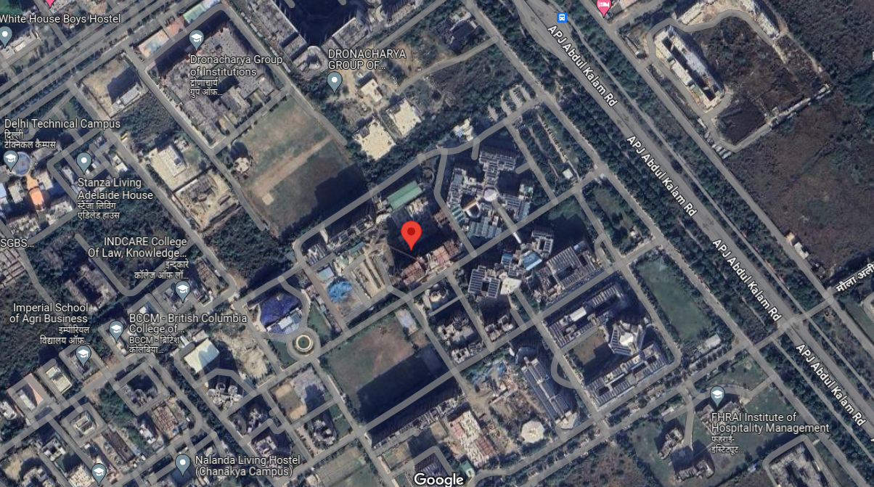
Source: Google map

- SCOPE OF WORK DURING PROJECT DURATION:
- Periodic Project physical status review.
- Periodic review of expenditure of the project.

- PURPOSE OF THE REPORT: To provide fair detailed analysis report to the Bank based on the “in-scope points” mentioned above to know Project progress.

- METHODOLOGY ADOPTED:
- Study of Project Planning documents/ reports to know about the Project.
- Additional information, data, documents collection from the borrower.
- Site Inspection.
- Review and analysis of the documents and information obtained from the borrower and corroborating it with the site inspection status.
- Information compilation, analysis and reporting.

PART C | INFRASTRUCTURE DETAILS OF THE PROJECT

- LAND: The expansion project is situated on 62.71 acres of land at 32–34 Knowledge Park–III, Greater Noida (UP) which is owned by SET as informed by the Trust. Since the land was already available with Sharda Educational Trust therefore no expense is done on the Land in the expansion Project. Therefore the expense of purchasing the land was not included in the project's allocated funds, hence is not included in our assessment.

- BUILDING & CIVIL WORKS: Under Phase-II, expansion project total built up area of 3.84 Lacs sq. ft. comprising following blocks/buildings is envisaged:

TABLE: 01
Sl. No. | Particulars | Floors | Structure Type | Built up area (in lakhs sq. ft.) | Estimated Cost in Cr.
 | Semi-Corporate Hospital having capacity of 440 beds under Block 10B, 10C and Block-11. | - 1) 2B+G+10 floors (Block 10B & 10C)  - 2) G+10 Floors (Block 11) | RCC | 2.52 | 44.10
 | Extension of Main Hospital Building under Block-3G | G+6 Floors | RCC | 0.59 | 14.75
 | Service Block-3C, Extension |  | RCC | 0.73 | 12.84
 | Miscellaneous development under stadium comprising of stands, road work, pavement and other civil works. | NA | NA | NA | 6.95
 | TOTAL |  |  | 3.84 | 78.64
Source: As per TEV Report

PHASE-II building area details:
TABLE: 02
Floor wise area of the Proposed building block in Phase II
FLOOR BLOCK | 10B&10C | BLOCK11 | BLOCK 3C+ESS | BLOCK-3G
Basement 2 | 0 | 0 | 0 | 0
Basement 1 | 0 | 0 | 0 | 0
Ground Floor | 0 | 0 | 1425.175 | 900
First Floor | 0 | 0 | 1395.27 | 650
Second Floor | 0 | 0 | 1395.27 | 785
Third Floor | 0 | 0 | 1395.27 | 785
Fourth Floor | 0 | 0 | 1061.037 | 785
Fifth Floor | 2068.787 | 0 | 0 | 785
Sixth Floor | 3744.425 | 397.778 | 0 | 725
Seventh Floor | 3744.425 | 397.778 | 0 | 0
Eighth Floor | 3744.425 | 418.928 | 0 | 0
Ninth Floor | 3744.425 | 418.928 | 0 | 0
Tenth Floor | 3744.425 | 257.902 | 0 | 0
Terrace Floor | 597.533 | 98.957 | 147.98 | 65
In Sq. mtr. | 21,388.45 | 1,990.27 | 6,820 | 5,480
In Sq. ft | 2,30,225 | 21,423 | 73,411 | 58,987

SET has appointed M S Satsangi & Associates, Architect being engineers and contractors headed by Shri M. S. Satsangi having business track record of 49 years and specializes in civil construction activities relating to schools and colleges. As per TEV report cost assessment is worked out by M/S Satsangi & Associates as shown above.
- FURNITURE, FIXTURES, INTERIOR AND FURNISHING WORKS: Following Furniture, fixtures and Interior and finishing work is proposed on following buildings:
TABLE: 03
Sl. No. | Particulars | Floors | Structure Type | Built up area (in lakhs sq. ft.) | Estimated Cost in Cr.
 | Semi-Corporate Hospital having capacity of 440 beds under Block 10B, 10C and Block-11. | - 1) 2B+G+10 floors (Block 10B & 10C)  - 2) G+10 Floors (Block 11) | RCC | 2.52 | 36.54
 | Service Block-3C, Extension |  | RCC | 0.73 | 5.50
 | Miscellaneous development under stadium comprising of stands, road work, pavement and other civil works. | NA | NA | NA | 3.50
 | TOTAL |  |  | 3.84 | 45.54
Source: As per TEV Report

- MACHINERY AND EQUIPMENT: Machinery & equipment mainly comprises of medical equipment Estimated cost of Rs.43 crores mainly include MRI & CT, PET CT, Generator sets, stadium lights, electrical equipment etc. Details of the machines has been shown below in the table:
TABLE: 05
Sl. No. | Particulars | Name of the Vendor | WO No. & Date | Estimated cost (in Cr. Rs.)
 | MRI & CT machines | M/s GE Wipro Healthcare (P) Ltd. | MRI & CT/2023/002 Dated 28.02.2023 | 20
 | PET CT | M/s Siemens Healthcare GMBH | 22-23/5 dated  4.2.2023 | 5.76
 | Gen Set 1500 KVA 3  Nos. | M/s Jackson India | PO No.SHSUN0000021913  Dated 14.2.2023. | 4.25
 | OT equipment | M/s Drager India through M/s Rishav Shelters Pvt. Ltd. | WO No. RSPL/Vendor/DIPL/Block10  A/MOT/WO/151A  dated 15.4.2023 | 1.89
 | Smart Scan | M/s IBA Dosimetry GMBH | 2023/003 dated 28.2.2023. | 1.01
 | Electrical Equipment including substation of 33/11 KV. | M/s Electro Solutions | Based on quotation | 6.37
 | Stadium lighting and  other equipment | Misc. | Based on provisional  assessment | 3
 | Others | Misc. | Based on provisional  assessment | 0.72
 | Total |  |  | 43
Source: As per TEV Report

PART D | PROJECT CONSULTANTS, CONTRACTORS & SUPPLIERS

According to the company representative, and the details obtained from the work orders, following below are some of the contractors appointed for different works. Details of the same has been shown in table below:
TABLE: 06

PROJECT CONSULTANTS, CONTRACTORS & SUPPLIERS
S. No. | Contractor / Suppliers name | Work Assigned
 | M/s M S Satsangi & Associates, | Architect & civil construction
 | M/s Rishav Shelters Pvt. Ltd. | Electrical, fabrication work, aluminium work, fire-fighting, plastering etc.
 | M/s GE Wipro Healthcare (P) Ltd. | MRI & CT machines
 | M/s Siemens Healthcare GMBH | PET CT
 | M/s IBA Dosimetry GmBH, Germany | Blue Phantom Smart-scan IBA
 | M/s Drager India | OT equipment
Source: TEV Report and Work Orders

PART E | PROJECT COST & MEANS OF FINANCE

- TOTAL PROJECT COST: M/s Sharda Educational Trust (SET) has estimated the Total Project Cost amounting to Rs.192 Cr. Breakage of the same has been shown in tabular and graphical form below:
TABLE: 07
Particulars | Amount
Building and civil work | 78.64 Cr.
Furniture, Fixtures, Interior and finishing | 45.54 Cr.
Plant & Machineries and utilities | 43 Cr.
Provision for contingencies | 11.06 Cr.
Interest during construction period | 13.76 Cr.
TOTAL | 192 Cr.
Source: TEV Report

- CURRENT STATUS & TOTAL EXPENDITURE INCURRED TILL DATE: M/s. Mukesh Goyal & Associates, Chartered Accountants, Agra, (FRN 005943C (ICAI)), has issued a certificate dated 20.05.2024 with UDIN No. 24074689BKBUOK7804 for quarter ending December. Expenditure along with present status of the each segment is given below:
TABLE: 08
Sr. No. | Particulars | Proposed  (In Rs. in Cr.) | As per CA Cert. dated  20/05/2024  (In Rs. In Cr.) | Amount as per LIE  Till Dec’24  (As per actual work done)  (In Rs. In Cr.) | Amount as per LIE  Till May’24 (As per actual work done)  (In Rs. In Cr.) | Remarks
 | Building Construction, Architect Fee and Authority fee and Project Management Consultant Fees | 78.64 | 85.08 | 35.54 | ~43.44 | - Amount estimated to have incurred on site is as per independent assessment as shown in Table 10.  - This amount doesn’t includes any professional charges, Architect Fee, Authority fee and Project Management Consultant paid if any  - The cost of material lying on site is not considered in our assessment.  - The difference in the cost shown in CA certificate and our assessment may be because of above reasons as it was done on Bill/ Invoices basis wherein as per LIE it as per independent assessment as per current status on site.
 | Furniture, Fixtures, Interior and finishing | 45.54 | 1.29 | --- | --- | - SET has provided us summary sheet amounting of ~Rs.0.85 Cr. of different vendors.  - All these amounts are on advance basis as no furniture and fixtures are arrived on the site yet.  - Invoices / bill against the items are yet to be received.
 | Plant & Machineries and utilities | 43 | 27.15 | --- | --- | - SET has provided us invoices amounting of ~Rs.19.50 Cr of different vendors.  - All these amounts are on advance basis as no machineries and equipment have arrived on the site yet.  Details of the Advance amount paid as provided by the customer can be referred in Table 11.
 | Provision for contingencies | 11.06 | 1.03 | Nil | Nil | Out of scope of work
 | Interest during construction period | 13.76 | 0.29 | Nil | Nil | Out of scope of work
 | TOTAL | Rs.192 Cr. | ~Rs.114.85 Cr. |  |  | ---

TABLE: 09
Block Name | Floor | Plinth area in sq. mtr. | Status of Building and civil work  As on survey dated 21/03/2024 | Status of Building and civil work  As on survey dated 25/05/2024
BLOCK 10B & 10C | Fifth Floor | 2,068.79 | - As per the representative all the works are completed and beds have been laid and as information provided. However these are the existing beds with University and has been shifted from other location to this floor. No new Bed have been purchased yet as proposed.  - Only AC and equipment installation is due. | - Progress same as previous report
BLOCK 10B & 10C | Sixth Floor | 3,744.43 | - Structure work is Completed  - Outer brickwork is completed  - Putty work was observed to be in progress | - Progress same as previous report
BLOCK 10B & 10C | Seventh Floor | 3,744.43 | - Structure work is Completed  - Outer brickwork is completed  - Putty work was observed to be in progress | - Progress same as previous report
BLOCK 10B & 10C | Eighth Floor | 3,744.43 | - Structure work is Completed  - Outer brickwork is completed  - Few de-shuttering work was observed to be in progress. | - Major progress is same as previous report  - Additionally putty work on ceiling is in progress
BLOCK 10B & 10C | Ninth Floor | 3,744.43 | - Structure work is Completed  - Outer brickwork is completed. | - Major progress is same as previous report  - Additionally putty work on ceiling is in progress
BLOCK 10B & 10C | Tenth Floor | 3,744.43 | - Structure work is Completed  - Outer brickwork is completed. | - Progress same as previous report
BLOCK 10B & 10C | Terrace Floor | 597.53 | - Structure work is in progress. | - Major progress is same as previous report  - Additionally few brickwork in the mumpty area is done
BLOCK 11 | Sixth Floor | 397.778 | - Structure work is Completed  - Outer brickwork is completed, internal finishing work of server room is in progress | - Internal brickwork was visually observed to be completed  - Flooring work was observed to be in progress  - Various services/ducts were laid for supply of fresh air etc.  - Fire and safety work was observed to achieve significant progress
BLOCK 11 | Seventh Floor | 397.778 | - Structure work is completed.  - Outer brickwork is completed.  - Internal brickwork and few plumbing work was observed to be in progress | - Internal brickwork was visually observed to be completed  - Flooring work was observed to be in progress
BLOCK 11 | Eighth Floor | 418.928 | - Structure work is completed.  - Outer brickwork is completed.  - Internal brickwork and few de-shuttering work was observed to be in progress | - Major progress is same as previous report  - Additionally plumbing work was also observed to be in progress
BLOCK 11 | Ninth Floor | 418.928 | - Structure work is completed, outer brickwork is completed.  - Internal brickwork was observed to be in progress | - Major progress is same as previous report  - The brickwork was observed to be nearing its completion stage
BLOCK 11 | Tenth Floor | 257.902 | - Structure work is completed.  - Outer brickwork is completed, internal brickwork was observed to be in progress | - Major progress is same as previous report  - The brickwork was observed to be nearing its completion stage
BLOCK 11 | Terrace Floor | 98.957 | - Structure work is in progress | - Progress same as previous report
ESS | Ground Floor | 141.3 | - Structure completed. Major civil work completed.  - Finishing and interior work is due. | - Progress same as previous report
ESS | First Floor | 141.30 | - Structure completed. Major civil work completed.  - Finishing and interior work is due. | - Progress same as previous report
BLOCK 3C | Ground Floor | 1,283.87 | - Structure work is completed. | - Outer brickwork was in progress
BLOCK 3C | First Floor | 1,253.97 | - Structure work is completed. De-shuttering work is in progress. | - De shuttering stage has been achieved, however no other significant progress was observed.
BLOCK 3C | Second Floor | 1395.27 | - Slab casting work is in progress. | - Slab casting work has been done
BLOCK 3C | Third Floor | 1395.27 | - Work not started yet. | - Slab casting work has been done
BLOCK 3C | Fourth Floor | 1061.037 | - Work not started yet. | - Column casting has been done, further structure work was in progress
BLOCK 3C | Terrace Floor | 147.98 | - Work not started yet. | - Progress same as previous report
BLOCK 3G | Ground Floor | 900 | - No construction work is started yet. Also no land demarcation has been done yet. | - Progress same as previous report
BLOCK 3G | First Floor | 650 |  | - Progress same as previous report
BLOCK 3G | Second Floor | 785 |  | - Progress same as previous report
BLOCK 3G | Third Floor | 785 |  | - Progress same as previous report
BLOCK 3G | Fourth Floor | 785 |  | - Progress same as previous report
BLOCK 3G | Fifth Floor | 785 |  | - Progress same as previous report
BLOCK 3G | Sixth Floor | 725 |  | - Progress same as previous report
BLOCK 3G | Terrace Floor | 65 |  | - Progress same as previous report
 | Total | 35,678.72
NOTE:
- In Block 10B & 10C, beds have been laid on 5th floor. However these are the existing beds of the University and has been shifted from other location to this floor. No new Bed have been purchased yet as proposed.

TABLE: 10
COST ASSESSMENT OF BUILDING AND CIVIL WORK IN PHASE II
Block Name | Floor | Plinth area in sq. mtr. | Plinth area in sq. ft. | Type of structure | Height(Ft.) | Plinth area rate per sq. ft. | Value assessed in Rs.
Block 10B &10C | Fifth Floor | 2,068.79 | 22,268 | RCC framed structure | ~10 | 2200 | 4,89,90,531
Block 10B &10C | Sixth Floor | 3,744.43 | 40,305 | RCC framed structure | ~10 | 1400 | 5,64,26,987
Block 10B &10C | Seventh Floor | 3,744.43 | 40,305 | RCC framed structure | ~10 | 1400 | 5,64,26,987
Block 10B &10C | Eighth Floor | 3,744.43 | 40,305 | RCC framed structure | ~10 | 1250 | 5,03,81,238
Block 10B &10C | Ninth Floor | 3,744.43 | 40,305 | RCC framed structure | ~10 | 1250 | 5,03,81,238
Block 10B &10C | Tenth Floor | 3,744.43 | 40,305 | RCC framed structure | ~10 | 1250 | 5,03,81,238
Block 10B &10C | Terrace Floor | 597.53 | 6,432 | RCC framed structure | ~10 | 950 | 61,10,253
BLOCK 11 | Sixth Floor | 397.778 | 4,282 | RCC framed structure | ~10 | 1400 | 59,94,355
BLOCK 11 | Seventh Floor | 397.778 | 4,282 | RCC framed structure | ~10 | 1350 | 57,80,271
BLOCK 11 | Eighth Floor | 418.928 | 4,509 | RCC framed structure | ~10 | 1200 | 54,11,209
BLOCK 11 | Ninth Floor | 418.928 | 4,509 | RCC framed structure | ~10 | 1100 | 49,60,275
BLOCK 11 | Tenth Floor | 257.902 | 2,776 | RCC framed structure | ~10 | 1100 | 30,53,663
BLOCK 11 | Terrace Floor | 98.957 | 1,065 | RCC framed structure | ~10 | 950 | 10,11,914
ESS | Ground Floor | 141.3 | 1,521 | RCC framed structure | ~12 | 1400 | 21,29,400
ESS | First Floor | 141.30 | 1,521 | RCC framed structure | ~12 | 1400 | 21,29,400
BLOCK 3C | Ground Floor | 1,283.87 | 13,820 | RCC framed structure | ~15 | 1300 | 1,79,65,459
BLOCK 3C | First Floor | 1,253.97 | 13,498 | RCC framed structure | ~12 | 1300 | 1,75,46,992
BLOCK 3C | Second Floor | 1395.27 | 15,019 | RCC framed structure | ~12 | 1300 | 1,95,24,292
BLOCK 3C | Third Floor | 1395.27 | 15,019 | RCC framed structure | NA | 1300 | 1,95,24,292
BLOCK 3C | Fourth Floor | 1061.037 | 11,421 | RCC framed structure | NA | 900 | 1,02,78,902
BLOCK 3C | Terrace Floor | 147.98 | 1,593 | RCC framed structure | NA | 0 | -
BLOCK 3G | Ground Floor | 900 | 9,688 | RCC framed structure | NA | 0 | -
BLOCK 3G | First Floor | 650 | 6,997 | RCC framed structure | NA | 0 | -
BLOCK 3G | Second Floor | 785 | 8,450 | RCC framed structure | NA | 0 | -
BLOCK 3G | Third Floor | 785 | 8,450 | RCC framed structure | NA | 0 | -
BLOCK 3G | Fourth Floor | 785 | 8,450 | RCC framed structure | NA | 0 | -
BLOCK 3G | Fifth Floor | 785 | 8,450 | RCC framed structure | NA | 0 | -
BLOCK 3G | Sixth Floor | 725 | 7,804 | RCC framed structure | NA | 0 | -
BLOCK 3G | Terrace Floor | 65 | 700 | RCC framed structure | NA | 0 | -
 | Total | 35,678.72 | 3,84,046 | RCC framed structure |  |  | 43,44,08,899

NOTE:
- Above cost estimation is done based on plinth area rates as per status of construction in each building and floor.
- Any material lying on the site is not taken into account in above estimation.

TABLE: 11
A/c Date | Invoice No. | Vendor Name | Amount | Remarks
14-12-2023 | DIPL/UP/ND/23-24/141223 | Draeger India Pvt. Ltd. | 2,98,70,593 | 25% Advance of total bill amount
31-08-2023 | 077/08-23/OPD/WC | Saksham Technologies Pvt Ltd | 2,32,96,300 | 25% advance of total bill amount
29-12-2023 | Po No - 22-24/19 | Yare Healthcare Private Limited | 1,11,45,045 | 65% Adv Angst P.O.( 65% of 1,71,46,223) = 11,145,045/-  Balance 15% within 15 days net of installation.
23-02-2024 | PO No-23-24/77 | A D S Diagnostic Ltd. | 67,20,000 | 20% Adv agst the PO No-23-24/77,70% on delivery & 10% after installation. Total Amt. 3,36,00,000  Hologic Selenia Dimensions 6000 3D Mammography System
23-01-2024 | PO No - 23-24/20 | Digimed Systems | 66,50,302 | 20% Advance, 65% on delivery or Against Dispatch Documents ,15% after installation testing & Commissioning  P.O. No. 23-24/20 dt 20/09/2023  for Medical Equipment  Total P.O. Amt = 1,02,31,234/-  1,02,31,234 @ 65% = 66,50,302/-
23-01-2024 | PO No - 23-24/51 | Digimed Systems | 52,33,240 | 20% Advance With Po, 65% on or Before delivery , Balance 15% With in one month from date of Delivery.  P.O. No. 23-24/51 dt 11/01/2024  for Medical Equipment  Total P.O. Amt = 80,51,138/-  80,51,138 @ 65% = 52,33,240 /-
31-03-2024 | ONCO/2023/62 | Oncotech | 50,54,885 | 100% Bill Payment done
09-02-2024 | P.O. No. 23-24/57 | Saffron Networks Pvt. Ltd. | 47,20,368 | 20% Advance 50% after delivery and 30% After Installation Total PO Amount - 94,40,735/-
18-01-2024 | Po No - 23-24/22 | Life Care Surgimed | 37,31,840 | 20% Advance, 70% on Delivery and rest 10% after installation  FMC HD 4008S NEXT Generation W/O BPM (4008S V10)-M204001.  Total Amount - 53,31,200 @ 70% = 3731840/-  As per approval of Mr. YK Gupta Sir.
01-03-2024 | Adv. agst BOE Amt-36,58,323 /- | Khimji Poonja Freight Forwarders Pvt. Lt | 36,58,323 | Custom Duty for PET-CT make Siemens  Agst PI No-MUM/I/DJ/7128/R Dt-01/03/2024
14-10-2023 | Po No - 22-24/19 | Yare Healthcare Private Limited | 34,29,245 | 20 % Adv agst P.O.( 20% of 17146223) = 3429245  65% On delivery, 15% within 15 days net of installation
06-03-2024 | Po No - 23-24/82 | Kirti Medicare Systems | 34,00,000 | Po No - 23-24/82 Dt. 29/02/2024  UltraSound System Machine - 1,70,00,000/-  20% Advance, 60% on Delivery & 20% Satisfactory Installation within 30 Days  Total Amount - 1,70,00,000 @ 20% = 34,00,000/-
30-03-2024 | WW/389/2324/D525 | Whiz Works | 32,74,500 | 100% Bill Payment done
28-08-2023 | PO No-23-24/15 | 3m India Ltd | 30,37,320 | Ethylene oxide gas sterilizer (50,62,200@60% = 30,37,320 Advance agst PO No-23-24/15 60% agst Delivery and balance 10% after installation)
03-02-2024 | Po No - 23-24/60 | Carestream Health India Private Limited | 29,70,000 | Po No - 23-24/60 Dt. 31/01/2024  Total Po Amount - 99,00,000/-  30% Advance , 60% on Delivery and 10% After Installation.  Total Po Amount - 99,00,000 @ 30% = 29,70,000/-
23-01-2024 | Po No - 23-24/46 | Sanvin India | 29,67,995 | Po No - 23-24/46  Total Amount = 59,35,990/-  59,35,990 @ 50% = 29,67,995/-  25% Advance, 50% Before Dispatch, 15% Balance After Delivery & 10% After Installation.
20-11-2023 | Po No - 23-24/30 | Mediquip Sales Private Limited | 28,50,412 | 45% With Po, 35% Before Dispatch from Germany, 15% Against Delivery and 5% After Handover.  Total Amount - 63,34,248 @ 45% = 28,50,412/-
30-03-2024 | PO No-23-24/81 @ 20% Adv | Rah Infotech Pvt Ltd. | 27,37,577 | 20% Advance agst the PO No-23-24/81, 50% after delivery & Bal. 30% after installation
29-02-2024 | TDS (194Q) Excess Deposited | Saffron Networks Pvt. Ltd. | 27,29,000 | As per telephonic discussion with you & Niraj Sir last month.  TDS (194Q) excess deposited Rs.2729/- on 05-03-2024 in BU SHSHL (Including SHLCO).  Please make an entry in Vendor Ledger in Feb-2024.
15-03-2024 | PO No-23-24/73 | Kryptonite Solutions | 26,61,120 | 10% Adv angst the PO NO-23-24/73, 80% on material delivery & Balance 10% after installation  Total Po Amount = 3326400@80% = 2661120/-
08-02-2024 | P.O. No. 23-24/58 | Saffron Networks Pvt. Ltd. | 26,60,259 | 10% Advance &10% Advance 50% after delivery and 30% after installation Total PO Amount - 2,66,02,591/-
09-02-2024 | P.O. No. 23-24/58 | Saffron Networks Pvt. Ltd. | 26,60,259 | 10% Advance &10% Advance 50% after delivery and 30% after installation Total PO Amount - 2,66,02,591/-
01-03-2024 | 294/2023-24 | Digimed Systems | 25,47,244 | 100% Bill Payment done
31-03-2024 | WW/388/2324/D538 | Whiz Works | 21,00,400 | 100% Bill Payment done
23-01-2024 | PO No - 23-24/20 | Digimed Systems | 20,46,247 | 20% Advance, 65% on delivery or Against Dispatch Documents , 15% after installation testing & Commissioning  P.O. No. 23-24/20 dt 20/09/2023  for Medical Equipment  Total P.O. Amt = 1,02,31,234/-  1,02,31,234 @ 20% = 20,46,247/-
24-01-2024 | ONCO/2023/60 | Oncotech | 19,34,070
08-02-2024 | P.O. No. 23-24/57 | Saffron Networks Pvt. Ltd. | 18,88,147 | 20% Advance 50% after delivery and 30% After Installation Total PO Amount - 94,40,735/-
27-03-2024 | PO No - 23-24/71 | Igen Biotechnology | 17,52,300 | 10KVA Medical Isolation Panel For OT & ICU Isolated Power - 9nos @3,00,000=27,00,000+18%GST=3,24,000/-  Total Amount - 31,86,000/-  55% Advance Payment=31,86,000@55%=1752300/-  10% Advance along 55% agst dispatch,30% after delivery & 5% after installation
29-02-2024 | PO No-23-24/74 | Mex India | 16,91,200 | 20% Adv agst the PO No-23/24/74 & 80% after delivery
29-02-2024 | PO No-23-24/79 | Allengers Medical Systems Ltd | 16,40,000 | 20% Adv. agst the PO No-23-24/79, 60% on delivery & 20% within 30 days from 1st patient scan
23-01-2024 | Po No - 23-24/47 | Alm Electromed System & Services | 16,20,864 | 20% Advance, 80 After With In 30 Day  Po No - 23-24/47 Dt. 29/12/2023  Total Po Amount - 20,26,080/-  80% Advance = 20,26,080 @ 80% = 16,20,864/-
23-01-2024 | PO No - 23-24/51 | Digimed Systems | 16,10,228 | 20% Advance With Po, 65% on or Before delivery , Balance 15% With in one month from date of Delivery.  P.O. No. 23-24/51 dt 11/01/2024  for Medical Equipment  Total P.O. Amt = 80,51,138/-  80,51,138 @ 20% = 16,10,228/-
30-03-2024 | WO No-23-24/28 @ 20% Adv | Rah Infotech Pvt Ltd. | 15,10,424 | 20% Advance agst the WO No-23-24/28, 50% after delivery & Bal. 30% after installation
05-01-2024 | Po No - 23-24/46 | Sanvin India | 14,83,998 | Po No - 23-24/46  Total Amount=59,35,990/-  59,35,990@25%=14,83,998/-  25% Advance, 50% Before Dispatch, 15% Balance After Delivery & 10% After Installation.
30-12-2023 | Po No - 23-24/248 | Guvi Surge Llp | 14,68,086 | Total Po Amount - 29,36,172/-  50% Advance and Remining 50% PDC cheque will be Submitted by Sharda Hospital to be Guvi Surge after Delivery Within 15 Days.  Total Po Amount - 29,36,172 @ 50% Advance = 14,68,086/-
17-02-2024 | PO No-23-24/56 | Whiz Works | 13,09,800 | 20% Adv PO No-23-24/56, 50% after delivery & Bal 30% after installation
04-03-2024 | Adv Agst BOE Amt-1172901 /- | Khimji Poonja Freight Forwarders Pvt. Lt | 11,72,901 | Custom Duty for PET-CT make Siemens  Angst PI No - DEL/I/DDA/4150/R Dt-02/03/2024
23-01-2024 | Po No - 23-24/45 | Igen Biotechnology | 11,68,200 | 10% Advance, 55% Against Dispatch, 30% After Delivery and 5% After Installation.  10KVA Medical Isolation Panel For OT & ICU Isolated Power - 6nos @3,00,000=18,00,000+18%GST=3,24,000/-  Total Amount - 21,24,000/-  55% Advance Payment = 21,24,000 @ 55% = 11,68,200/-
06-02-2024 | WO 23-24/21 | Whiz Works | 11,68,200 | 20% Advance 50% after delivery and 30% After Installation Total WO Amount - 58,41,000/-
19-01-2024 | Po No - 23-24/53 | Yare Healthcare Private Limited | 11,33,577 | Total Po Amount - 17,43,964/-  20% Advance, 65% on Delivery or Against Dispatch Documents and 15% Within 15 Days net of Successful Installation.  Total Po Amount - 17,43,964 @ 65% = 11,33,577/-
14-12-2023 | 23-24/38 | Jvh Corporation India | 11,20,380 | Payment will be made after delivery of material receipt of bill with all requisite details within 30 days
23-01-2024 | PO No - 23-24/54 | Seward Systems Inc | 11,08,800 | 20% Advance With Po, 55% against documents , 25% after Installation.  P.O. No. 23-24/54 dt 18/01/2024  for Master Suction Pump  Total P.O. Amt = 20,16,000/-  20,16,000 @ 55% = 11,08,800/-
03-02-2024 | PO No - 23-24/62 | Meditronix Corporation | 10,76,300 | Po No - 23-24/62 Dt. 31/01/2024  Total Po Amount - 21,52,600  75% Advance and Balance After Installation within 30 Days  75% Advance But Ajay Agarwal Sir Order By 25% paid to Sharda and 50% paid By Loan.  Total Po Amount - 21,52,600 @ 50% = 10,76,300/-
20-11-2023 | Po No - 23-24/22 | Life Care Surgimed | 10,66,240 | 20% Advance, 70% on Delivery and rest 10% after installation  FMC HD 4008S NEXT Generation W/O BPM (4008S V10)-M204001.  Total Amount - 53,31,200 @ 20% = 10,66,240/-
27-03-2023 | 19 | Scan-O-Plan Systems(India) | 10,40,760 | Adv agst P.O. No. 22-23/7 (14,86,800@70%=1040760) 70% After Delivery and 25% after Installation
23-01-2024 | PO No - 23-24/43 | Midmarks (India) Pvt Ltd | 10,28,879 | 1. Recliner with Motorized Hand Control (Midmark) - 16@73124.21 = 11,69,987/-  2. Bed Side Locker (Midmark) - 21@ 8164 = 1,71,445/-  Basic Amount - 13,41,432/-  +18%GST = 2,41,458/-  Total Amount = 15,82,890/-  65% Advance, 15,82,890 @ 65% = 10,28,879/- Against Dispatch Documents
23-01-2024 | Po No - 23-24/44 | Alm Electromed System & Services | 10,08,000 | 20% Advance, 80 After With In 30 Day  Po No - 23-24/44 Dt. 22/12/2023  Total Po Amount - 12,60,000/-  80% Advance = 12,60,000 @ 80% = 10,08,000/-
03-02-2024 | Po No - 23-24/48 | Kitcare Equipments | 10,00,000 | Po No - 23-24/48 Dt. 30/12/2023  Total Po Amount - 2120460  10,00,000 Advance As Per Mr. Y.K. Gupta Sir.
29-02-2024 | PO No-23-24/68 | Smith & Nephew Healthcare Pvt Ltd | 9,78,220 | 5% Adv. agst the PO No-23-24/68, 50% on delivery & 45% after installation
05-03-2024 | Wo No - 23-24/23 | Bright Eye Technologies India Pvt Ltd | 9,73,511 | Wo No - 23-24/23 Dt. 15/02/2023  Total Amount - 48,67,553/-  20% Advance, 50% After Delivery and 30% After Installation.  Total Amount - 48,67,553 @ 20% = 9,73,511/-
30-03-2024 | PO No - 23-24/71 | Igen Biotechnology | 9,55,800 | 10KVA Medical Isolation Panel For OT & ICU Isolated Power - 9nos @3,00,000=27,00,000+18%GST=3,24,000/-  Total Amount - 31,86,000/-  30% Advance Payment=31,86,000@30%=9,55,800/-  10% Advance along 55% agst dispatch,30% after delivery & 5% after installation
30-03-2024 | 60138260 | Smith & Nephew Healthcare Pvt Ltd | 8,80,398 | 100% Bill Payment done
30-03-2024 | 72 | Jvh Corporation India | 8,74,101 | 100% Bill Payment done
28-03-2024 | PO No-23-24/72 | Marrsis Disha | 8,46,720 | PO No-23-24/72, Dt. 16/02/2024  Total Po Amount - 21,16,800/-  25% Advance, 40% against delivery & 35 after installation  Total Po Amount - 21,16,800@40% = 8,46,720/-
06-12-2023 | MI/23-24/1218 | Mex India | 8,29,540 | On Bill Payment
23-01-2024 | Po No - 23-24/46 | Hi-Tech Lab Products | 6,72,600 | 1. Mortuary Freezer - 10 Chamber-20 Degree Model HTPL-065 - 1Nos@9,50,000+18%GST = 1,71,000/-  Total Amount - 11,21,000/-  60% Advance Payment = 11,21,000 @ 30% = 6,72,600/-  30% Advance, 60% After Delivery and 10% After Installation.
21-02-2024 | PO No-23-24/75 | Schiller Healthcare India Pvt Ltd | 6,70,065 | 20% Advance agst the PO No-23/24/75, 70% on Delivery & 10% after installation
23-01-2024 | Po No - 23-24/250 | Sanvin India | 6,65,343 | 1. Big CSSD Close Trolley-9@47300=425700/-  2. Small CSSD Close Trolley-18@39000 = 7,02,000/-  +18%GST=2,02,986/-  Total Amount=13,30,686/-  13,30,686@50%=6,65,343/-  25% Advance, 50% Before Dispatch, 15% Balance After Delivery & 10% After Installation.
07-02-2024 | Po No - 22-24/45 | Igen Biotechnology | 6,37,200 | 10% Advance, 55% Against Dispatch, 30% After Delivery and 5% After Installation.  10KVA Medical Isolation Panel For OT & ICU - 6nos @3,00,000=18,00,000+18%GST=3,24,000/-  Total Amount - 21,24,000/-  30% Advance Payment = 21,24,000 @ 30% = 6,37,200/-
05-03-2024 | Po No - 23-24/67 | Bright Eye Technologies India Pvt Ltd | 6,31,289 | Po No - 23-24/67 Dt. 14/02/2024  Exagrid EX 27-SEC-NAS = 31,56,447  20% Advance, 50% After Delivery and 30% After Installation.  Total Amount - 31,56,447 @ 20% = 6,31,289/-
09-03-2024 | PO No - 23-24/55 | Riello Power India Pvt Ltd | 6,28,625 | 65+100% GST Against PI After Material of Inspection & Balance 10% After Installation  Po No - 23-24/55 Dt. 19/01/2024  Total Po Amount - 9,41,500  65%+100 GST Advance = 9,41,500 @ 65% = 6,70,250-Extra GST Last Time Paid = 41625  Total Paid Amount = 6,28,625
11-12-2023 | PO No - 23-24/37 | Remi Sales & Engineering Ltd. | 5,98,703 | Deep Freezer 86Deg 360 Liter (Make Remi Ultra-Low Deep Freezer Touch Screen Display5,07,375+18%GST = 91,328  Total Amount - 5,98,703/-  100% Advance Payment.
28-11-2023 | 23-24/13 | H M Surgical Centre | 5,50,000 | 100% Advance
03-02-2024 | PO No - 23-24/62 | Meditronix Corporation | 5,38,150 | Po No - 23-24/62 Dt. 31/01/2024  Total Po Amount - 21,52,600  75% Advance and Balance After Installation within 30 Days  75% Advance But Ajay Agarwal Sir Order By 25% paid to Sharda and 50% paid By Loan.  Total Po Amount - 21,52,600 @ 25% = 5,38,150/-
19-01-2024 | Po No - 23-24/22 | Life Care Surgimed | 5,33,120 | 20% Advance, 70% on Delivery and rest 10% after installation  FMC HD 4008S NEXT Generation W/O BPM (4008S V10)-M204001.  Total Amount - 53,31,200 @ 10% = 533120/-  As per approval of Mr. YK Gupta Sir.
29-02-2024 | PO No-23-24/72 | Marrsis Disha | 5,29,200 | 25% Adv. agst PO No-23-24/72, 40% agst delivery & balance after installation
29-02-2024 | SSI2324/1245 | Seward Systems Inc | 5,04,000 | 100% Bill Payment done
05-12-2023 | 123/11-23/OPD/WC | Saksham Technologies Pvt Ltd | 4,49,441 | Bill No 123/11-23/OPD/WC Bill Amount - 4,49,441
04-03-2024 | Po No - 23-24/248 | Verventus Healthtech Solutions Pvt Ltd. | 4,41,792 | Po No - 23-24/24 Dt. 16/02/2024  20% Advance, 50% After Delivery, and 30% after Installation.  20% Advance = 22,08,960@20% = 4,41,792/-
26-02-2024 | Adv agst WO No. 23-24/25 | Rushail Aviation | 4,13,000 | 1652000@25% = 413000 25 % of the total amount at commencement of the work  25% after obtaining site clearance from DGCA ( all clearance )  25 % after obtaining security clearance  25% after the completion of the work
09-01-2024 | Po No - 23-24/47 | Alm Electromed System & Services | 4,05,216 | 20% Advance, 80 After With In 30 Day Po No - 23-24/47 Syringe Pump
23-01-2024 | PO No - 23-24/54 | Seward Systems Inc | 4,03,200 | 20% Advance With Po, 55% against documents , 25% after Installation.  P.O. No. 23-24/54 dt 18/01/2024  for Master Suction Pump  Total P.O. Amt = 20,16,000/-  20,16,000 @ 20% = 4,03,200/-
14-02-2024 | 452 | Cesta Solutions | 3,58,400 | Bill Amount Pending out of Total Rs.4,48,000/-
09-02-2024 | PO No - 23-24/66 | Chirron Meditek Llp | 3,53,920 | PO No - 23-24/66 Dt. 05/02/2024  Total Po Amount - 35,39,200/-  10% Advance, 80% on Delivery and 10% After Installation.  Total Po Amount - 35,39,200 @ 10% = 3,53,920/-
19-01-2024 | Po No - 23-24/53 | Yare Healthcare Private Limited | 3,48,793 | Total Po Amount - 17,43,964/-  20% Advance, 65% on Delivery or Against Dispatch Documents and 15% Within 15 Days net of Successful Installation.  Total Po Amount - 17,43,964 @ 20% = 3,48,793/-
19-01-2024 | Po No - 23-24/52 | Yare Healthcare Private Limited | 3,34,687 | Total Po Amount - 4,18,358/-  10% Advance, 80% After Delivery and 10% Within 30 Days of Successful Installation.  Total Po Amount - 4,18,358 @ 80% = 3,34,687/-
05-01-2024 | Po No - 23-24/250 | Sanvin India | 3,32,672 | Po No - 23-24/250 Dt. 27/12/2023 Total Amount = 13,30,686/- 13,30,686@25%=3,32,672/-  25% Advance, 50% Before Dispatch, 15% Balance After Delivery & 10% After Installation.
29-02-2024 | PO No-23-24/73 | Kryptonite Solutions | 3,32,640 | 10% Adv agst the PO NO-23-24/73, 80% on material delivery & Balance 10% after installation
21-02-2024 | PO No - 23-24/71 | Igen Biotechnology | 3,18,600 | 10KVA Medical Isolation Panel For OT & ICU Isolated Power - 9nos @3,00,000=27,00,000+18%GST=3,24,000/-  Total Amount - 31,86,000/-  10% Advance Payment = 31,86,000@10%=3,18,600/-  55% agst dispatch,30% after delivery & 5% after installation
18-03-2024 | PO No - 23-24/65@70% | Arcur Healthcare Private Limited | 3,11,248 | PO No - 23-24/65 Dt. 05/02/2024  Total Po Amount - 4,44,640/-  10% Advance, 70% On Delivery, 20% Within 30 Days After Installation.  10% Advance 4,44,640 @ 10% = 44,464/-
12-12-2023 | Po No-23-24/23 | Yare Healthcare Private Limited | 2,92,851 | 10% Adv agst PO No-23-24/23, 80% on Delivery & Bal-10% 30 days of successful installation.
18-03-2024 | Po No - 23-24/89 | Dermaindia | 2,69,200 | Po No - 23-24/89 Dt. 12/03/2024  Total Po Amount - 2692000  10% Advance balance after Installation Within 30 Days  Total Po Amount - 26,92,000@10% = 2,69,200/-
09-01-2024 | Po No - 23-24/44 | Alm Electromed System & Services | 2,52,200 | 20% Advance, 80 After Delivery Po No - 23-24/44 Infusion Pump
30-03-2024 | PO No-23-24/95 @ 20% | Multi Seats Pvt Ltd | 2,38,924 | 20% Advance agst the PO No-23-24/95 80% after inspection before dispatch
20-01-2024 | PO No - 23-24/55 | Riello Power India Pvt Ltd | 2,35,375 | 25 Advance, 65+100% GST Against Pi After Readiness of Material of Inspection, and the Balance 10% After Installation.  Po No - 23-24/55 Dt. 19/01/2024  Total Po Amount - 9,41,500  25% Advance = 9,41,500 @ 25% = 2,35,375/-
30-03-2024 | PMS-060/2023-24 | Promax Medical System | 2,33,856 | 100% Bill Payment done
07-03-2024 | SNPL/23-24/406 | Saffron Networks Pvt. Ltd. | 2,16,110 | Bill Payment done out of total amount Rs.33,97,229
21-02-2024 | WO. No.23-24/17 | Aero Survey Private Limited | 2,12,400 | 20% Advance agst OLS Survey for Rooftop Helipad 1st & 2nd
14-12-2023 | 23-24/16 | H M Surgical Centre | 1,80,000 | 10% Advance , 80 % After delivery, and 10% after successful installation, testing & commissioning. Total Po-1800000/-
08-12-2023 | W.O. No. 23-24/17 | Aero Survey Private Limited | 1,77,000 | OLS-1st Heliped & 2nd Heliped
15-02-2024 | PO No - 23-24/63 | Alm Electromed System & Services | 1,65,728 | PO No - 23-24/63 Dt. 01/02/2024  Total Po Amount - 8,28,641/-  20% Advance and 80% Within 30 Days  20% Advance 8,28,641 @ 20% = 1,65,728/-
14-12-2023 | 23-24/15 | H M Surgical Centre | 1,56,350 | 10% advance, 80 after delivery and 10% after successful installation. testing & commissioning.  Total Po-1563500/-
12-12-2023 | Po No-23-24/24 | Yare Healthcare Private Limited | 1,50,000 | 10% Adv agst PO No23-24/24 , 80% on Delivery & Bal-10% 30 days of successful installation.
13-03-2024 | Wo No - 23-24/31 | Prayana Enterprises | 1,10,448 | Wo No - 23-24/31 Dt. 09/03/2024  Pex Pipe With SS tee Pushpull Connectors * 26*6,000 = 1,56,000/-  +18% GST = 28,080/-  Total Amount = 1,84,080/-  20% Advance, 60% After Delivery and 20% After Installation.  Total Po Amount = 1,84,080@60% = 1,10,448/-
21-02-2024 | PO No-23-24/68 | Smith & Nephew Healthcare Pvt Ltd | 97,822 | 5% Adv. agst the PO No-23-24/68, 50% on delivery & 45% after installation
30-03-2024 | SAL/HR/2324/2288 | Riello Power India Pvt Ltd | 94,150 | 10% advanced payment done out of Rs.9,41,500/-
29-02-2024 | PO No-23-24/69 | Marrsis Disha | 91,392 | 15% Advance agst the PO No-23-24/69 & 85% after delivery  Blood Warmer ( Fluid Warmer) (Make-Surgical Netherland)
30-03-2024 | PO No - 23-24/65 | Arcur Healthcare Private Limited | 88,928 | 20% advanced payment done out of Rs.4,44,640/-
31-10-2023 | PO No-23-24/28 | Mutual Engineering Services | 62,540 | 20% Advance against the PO No-23-24/28 and 70% against Delivery at site & 10% after installation or within 30 days As per approval of Mr. YK Gupta Sir.  Total Po Amount - 3,12,700 @ 20% = 62,540/-
20-11-2023 | P.O. No. 23-24/31 | Draeger India Pvt. Ltd. | 62,457 | 100% Advance
03-02-2024 | Po No - 23-24/59 | Seward Systems Inc | 57,312 | Po No - 23-24/59 Dt. 30/01/2024  Portable Suction Machine & Stand For Portable Suction Machine  Total Po Amount - 2,86,560/-  20% Advance 55% Before Delivery or readiness of Material. and 25% after installation.  Total Po Amount - 2,86,560 @ 20% 57,312/-
13-02-2024 | PO No - 23-24/65 | Arcur Healthcare Private Limited | 44,464 | PO No - 23-24/65 Dt. 05/02/2024  Total Po Amount - 4,44,640/-  20% Advance, 70% On Delivery, 20% Within 30 Days After Installation.  20% Advance 4,44,640 @ 10% = 44,464/-
19-01-2024 | Po No - 23-24/52 | Yare Healthcare Private Limited | 41,836 | Total Po Amount - 4,18,358/-  10% Advance, 80% After Delivery and 10% Within 30 Days of Successful Installation.  Total Po Amount - 4,18,358 @ 10% = 41,836/-
13-03-2024 | Wo No - 23-24/31 | Prayana Enterprises | 36,816 | Wo No - 23-24/31 Dt. 09/03/2024  Pex Pipe With SS tee Pushpull Connectors * 26*6,000 = 1,56,000/-  +18% GST = 28,080/-  Total Amount = 1,84,080/-  20% Advance, 60% After Delivery and 20% After Installation.  Total Po Amount = 1,84,080@20% = 36,816/-
22-03-2024 | PO No-23-24/83 | Goldtron Scales & Systems | 17,582 | 20% Adv agst PO No-23-24/83 & 80% after delivery
21-02-2024 | PO No-23-24/69 | Marrsis Disha | 16,128 | 15% Advance agst the PO No-23-24/69 & 85% after delivery  Blood Warmer ( Fluid Warmer) (Make-Surgical Netherland)
24-11-2023 | 23-24/14 | Jvh Corporation India | 11,800 | Payment will be made after Submission of bill with all requisite details within30days'
Total |  |  | 19,50,67,691
Source: As per copy of Invoices provided by SET

- SOURCES OF FINANCE & UTILIZATION OF FUNDS:

The Project cost mentioned above has been planned to be covered from following resources:
(Amount in Rs. Crore)
PARTICULARS
Promoter’s Contribution (Equity) | 57
Term Loan (Debt) | 135
TOTAL | 192
Source: As per TEV report provided.
PART F | STATUTORY & REGULATORY APPROVALS, CLEARANCES & NOC

Sr. No. | NAME OF LICENSE/ REGISTRATION | DATE OF ISSUE | CURRENT STATUS
Sr. No. | ISSUING AUTHORITY | LICENCE NO. | CURRENT STATUS
 | Building Sanction Plan | - PLG / BP SM-22-Dec 2020:9671 dated: 03/11/2023 for Block 3C.  - PLG / BP SM-29-Oct-2021:12528 dated 12/10/2022 for Block 10B & 10C.  - PLG / BP SM-30-Dec-2020:9762 dated 24/12/2021 for Block 11. | Approval obtained
 | Noida Authority |  | Approval obtained
 | Consent for Air & Water Pollution | ---- | Approval yet to be obtained
 | U.P. Pollution Control Board | ---- | Approval yet to be obtained
 | NOC From Fire Department | ---- | Approval yet to be obtained
 | Fire Department Noida | ---- | Approval yet to be obtained
 | NOC for Generation Reception, Treatment, Storage, Disposal Of Biomedical Wastes | ---- | Approval yet to be obtained
 | Agreement For Waste Management | ---- | Approval yet to be obtained
 | U.P. Pollution Control Board | ---- | Approval yet to be obtained
 | DMHO (District Medical and Health Office) registration | ---- | Approval yet to be obtained
 | Director of Health, Ministry of Health and Family Welfare, State Government  The Clinical Establishments (Registration and Regulation) Act, 2010 | ---- | Approval yet to be obtained
 | Radiation License | ---- | Approval yet to be obtained
 | AERB Registration | ---- | Approval yet to be obtained
 | Radiation Protection & Waste management License | ---- | Approval yet to be obtained
 | Department of Atomic Energy under Atomic Energy (Radiation Protection) Rules, 2004 | ---- | Approval yet to be obtained
 | Pharmacy registration |  | Approval yet to be obtained
 | Office of the Drug Controller |  | Approval yet to be obtained
 | Drugs-Bulk license | ---- | Approval yet to be obtained
 | Office of the Drug Controller | ---- | Approval yet to be obtained
 | PCPNDT Approval | ---- | Approval yet to be obtained
 | CMO for Ultrasound | ---- | Approval yet to be obtained
 | GST Registration | ---- | Approval yet to be obtained
 | Goods and Services Tax, GOI | ---- | Approval yet to be obtained
 | Canteen/ F & B license | ---- | Approval yet to be obtained
 | Food Safety and Standards Authority of India under the Ministry of Health and Family welfare, Govt. of India. | ---- | Approval yet to be obtained
Note: The above licenses are only the major licenses and not be considered exhaustive in nature.

PART G | PROJECT SCHEDULE & CURRENT STATUS

IMPLEMENTATION SCHEDULE OF M/S SHARDA EDUCATIONAL TRUST (SET)

S. No. | Particular | Commencement | Estimated Completion
 | Building and Civil Works. | --- | March-25
 | Placement of orders for Plant & Machineries and Utilities. | Quotations have been invited for major equipment and orders are likely to be placed by March, 2024.
 | Delivery of Equipment. | June-24 | December-24
 | Erection of Equipment. | January-25 | March-24
 | COD | W.E.F. April, 2025

PART H | DISCLAIMER

      - No employee or member of R.K Associates has any direct/ indirect interest in the Project.
      - This report is prepared based on the copies of the documents/ information which the Bank/ Borrower has provided to us out of the standard checklist of documents sought from them and further based on our assumptions and limiting conditions. The client/owner and its management/representatives warranted to us that the information they supplied was complete, accurate and true and correct to the best of their knowledge. All such information provided to us has been relied upon in good faith and we have assumed that it is true and correct in all respect. I/We shall not be liable for any loss, damages, cost or expenses arising from fraudulent acts, misrepresentations, or wilful default on part of the owner, borrower, its directors, employee, representative or agents. Verification or cross checking of the documents provided to us from the originals or from any Govt. departments/ Record of Registrar has not been done at our end since this is beyond the scope of our work. If at any time in future, it is found or came to our knowledge that misrepresentation of facts or incomplete or distorted information has been provided to us then this report shall automatically become null & void.
      - Legal aspects for eg. investigation of title, ownership rights, lien, charge, mortgage, lease, sanctioned maps, verification of documents, etc. have not been done at our end and same has to be taken care by legal expert/ Advocate. It is assumed that the concerned Lender/ Financial Institution has satisfied them with the authenticity of the documents, information given to us and for which the legal verification has been already taken and cleared by the competent Advocate before requesting for this report. I/ We assume no responsibility for the legal matters including, but not limited to, legal or title concerns.
      - This report is a general analysis of the project based on the scope mentioned in the report. This is not an Audit report, Design document, DPR or Techno feasibility study. All the information gathered is based on the facts seen on the site during survey till May 2024, verbal discussion & documentary evidence provided by the client and is believed that information given by the borrower is true best of their knowledge.
      - All observations mentioned in the report is only based on the visual observation and the documents/ data/ information provided by the client. No mechanical/ technical tests, measurements or any design review have been performed or carried out from our side during Project assessment.
      - Bank/FII should ONLY take this report as an Advisory document from the Financial/ Chartered Engineering firm and its specifically Advisory to the creditor to cross verify the original documents for the facts mentioned in the report which can be availed from the borrowing borrower directly.
      - In case of any default in loans or the credit facility extended to the borrowing borrower, R.K Associates shall not be held responsible for whatsoever reason may be and any request for seeking any explanation from the employee/s of R.K Associates will not be entertained at any instance or situation.
      - The documents, information, data provided to us during the course of this assessment by the client is reviewed only upto the extent required in relation to the scope of the work. No document has been reviewed beyond the scope of the work.
      - This report only contains general assessment & opinion as per the scope of work evaluated as per the information given in the copy of documents, information, data provided to us and/ and confirmed by the owner/ owner representative to us at site which has been relied upon in good faith. It doesn’t contain any other recommendations of any sort including but not limited to express of any opinion on the suitability or otherwise of entering into any transaction with the borrower.
      - We have relied on data from third party, external sources & information available on public domain also to conclude this report. These sources are believed to be reliable and therefore, we assume no liability for the truth or accuracy of any data, opinions or estimates furnished by others that have been used in this analysis. Where we have relied on data, opinions or estimates from external sources, reasonable care has been taken to ensure that such data has been correctly extracted from those sources and /or reproduced in its proper form and context, however still we can’t vouch its authenticity, correctness or accuracy.
      - Any amount shown to have incurred in the report is considered from the Bills/ Invoices produced to us. However this shall not be construed as confirmation of actual transaction with the respective parties which is out of scope of this report.
      - This Report is prepared by our competent technical team which includes Engineers and financial experts & analysts.
      - This is just an opinion report and doesn’t hold any binding on anyone. It is requested from the concerned Financial Institution which is using this report for taking financial decision on the project that they should consider all the different associated relevant & related factors also before taking any business decision based on the content of this report.
      - All Pages of the report including annexures are signed and stamped from our office. In case any paper in the report is without stamp & signature then this should not be considered a valid paper issued from this office.
      - Though adequate care has been taken while preparing this report as per its scope, but still we can’t rule out typing, human errors, over sightedness of any information or any other mistakes. Therefore, the concerned organization is Advised to satisfy themselves that the report is complete & satisfactory in all respect. Intimation regarding any discrepancy shall be brought into our notice immediately. If no intimation is received within 15 (Fifteen) days in writing from the date of issuance of the report, to rectify these timely, then it shall be considered that the report is complete in all respect and has been accepted by the client up to their satisfaction & use and further to which R.K Associates shall not be held responsible in any manner.
      - Defect Liability Period is 15 DAYS. We request the concerned authorized reader of this report to check the contents, data and calculations in the report within this period and intimate us in writing if any corrections are required or in case of any other concern with the contents or opinion mentioned in the report. Corrections only related to typographical, calculation, spelling mistakes, incorrect data/ figures/ statement will be entertained within the defect liability period. Any new changes for any additional information in already approved report will be regarded as additional work for which additional fees may be charged. No request for any illegitimate change in regard to any facts & figures will be entertained.
      - R.K Associates encourages its customers to give feedback or inform concerns over its services through proper channel at valuers@rkassociates.org in writing within 15 days of report delivery. After this period no concern/ complaint/ proceedings in connection with the Financial Feasibility Study Services will be entertained due to possible change in situation and condition of the subject Project.
      - Our Data retention policy is of ONE YEAR. After this period, we remove all the concerned records related to the assignment from our repository. No clarification or query can be answered after this period due to unavailability of the data.
      - This Lender’s Independent Engineer report is governed by our (1) Internal Policies, Processes & Standard Operating Procedures, (2) Information/ Data/ Inputs given to us by the client and (3) Information/ Data/ Facts given to us by our field/ office technical team. Management of R.K Associates never gives acceptance to any unethical or unprofessional practice which may affect fair, correct & impartial assessment and which is against any prevailing law. In case of any indication of any negligence, default, incorrect, misleading, misrepresentation or distortion of facts in the report then it is the responsibility of the user of this report to immediately or at least within the defect liability period bring all such act into notice of R.K Associates management so that corrective measures can be taken instantly.
      - R.K Associates never releases any report doing alterations or modifications from pen. In case any information/ figure of this report is found altered with pen then this report will automatically become null & void.

FOR R.K. ASSOCIATES VALUERS AND TECHNO ENGINEERING CONSULTANTS PVT. LTD.
SURVEY ANALYST | ENGINEERING ANALYST | REVIEWER
Vishal Singh, Babul Akhtar Gazi | Babul Akhtar Gazi | Vishal Singh

Place: Noida

Date: 27th May 2024

DEFECT LIABILITY PERIOD - In case of any query/ issue or escalation you may please contact Incident Manager by writing at valuers@rkassociates.org. We ensure 100% accuracy in the Calculations done, Rates adopted and various other data points & information mentioned in the report but still can’t rule out typing, human errors or any other mistakes. In case you find any mistake, variation, discrepancy or inaccuracy in any data point of the report, please help us by bringing all such points into our notice in writing at valuers@rkassociates.org within 30 days of the report delivery, to get these rectified timely, failing which R.K Associates Valuers Techno Engineering Consultants (P) Ltd. won’t be held responsible for any inaccuracy in any manner. Also, if we will not hear back anything from you within 30 days, we will assume that report is correct in all respect and no further claim of any sort will be entertained thereafter. We would welcome and appreciate your feedback & suggestions in order to improve our services.

COPYRIGHT FORMAT - This report is prepared on the copyright format of R.K Associates Valuers Techno Engineering Consultants (P) Ltd. to serve our clients in the best possible way. Legally no one can copy or distribute this format without prior approval from R.K Associates. It is meant only for the organization as mentioned on the cover page of this report. Distribution or use of this format other than R.K Associates will be seen as unlawful act and necessary legal action can be taken against the defaulter

ENCLOSURE 1: IMPORTANT DOCUMENTS EXHIBIT

DOCUMENT-1: CA CERTIFICATE DATED 20/05/2024

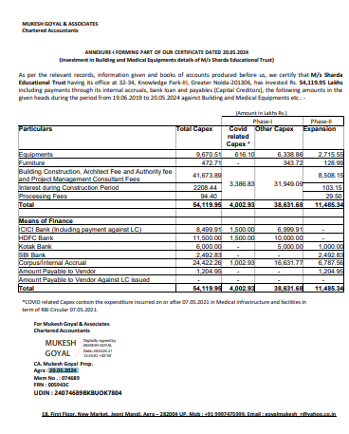
DOCUMENT- 2: GRANT OF SANCTION OF BUILDING PLAN

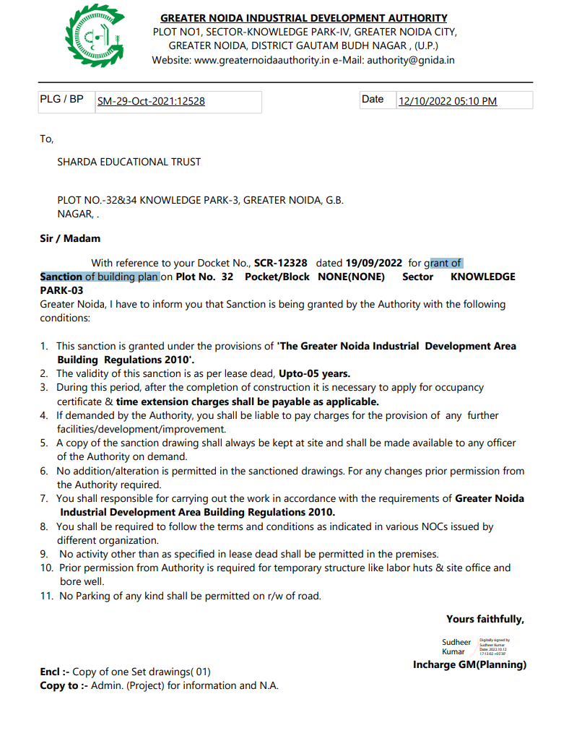

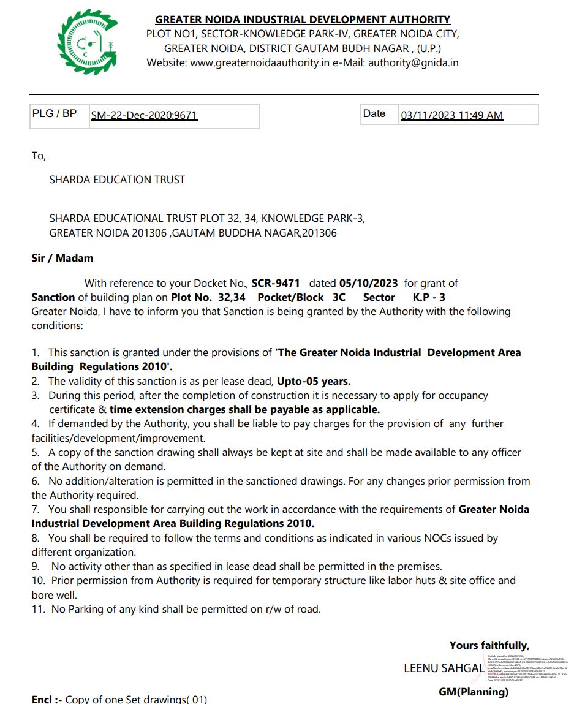

DOCUMENT-3: PROJECT TIMELINE

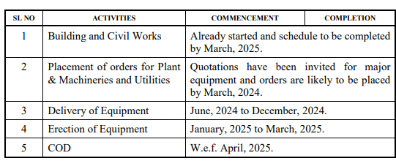

DOCUMENT 4: SANCTIONED PLAN
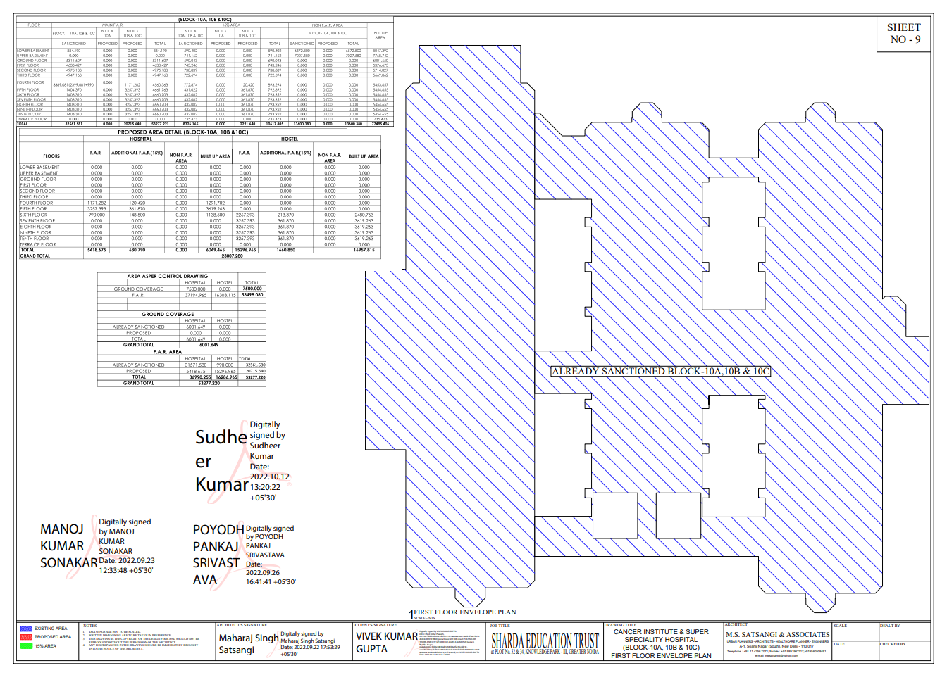

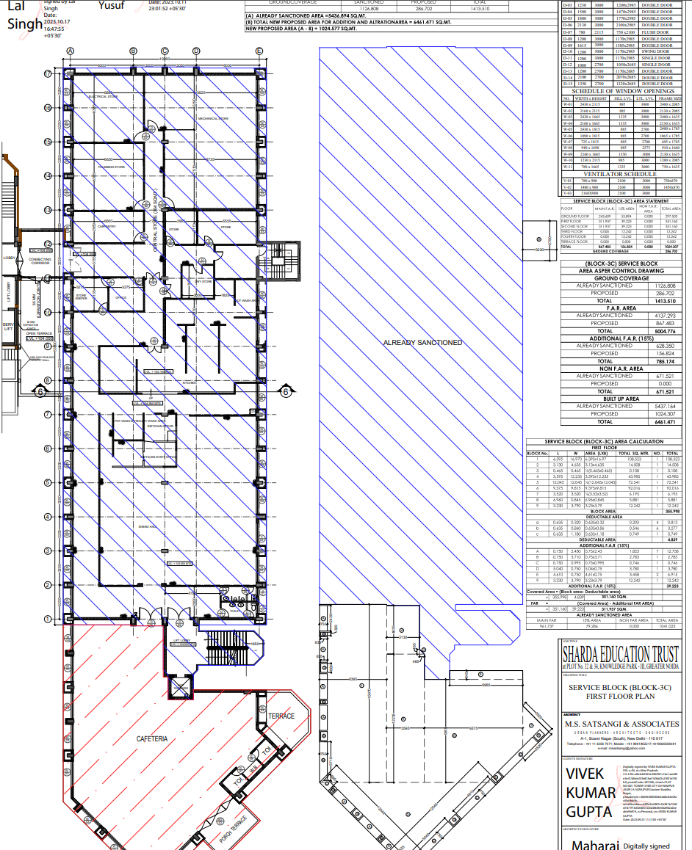
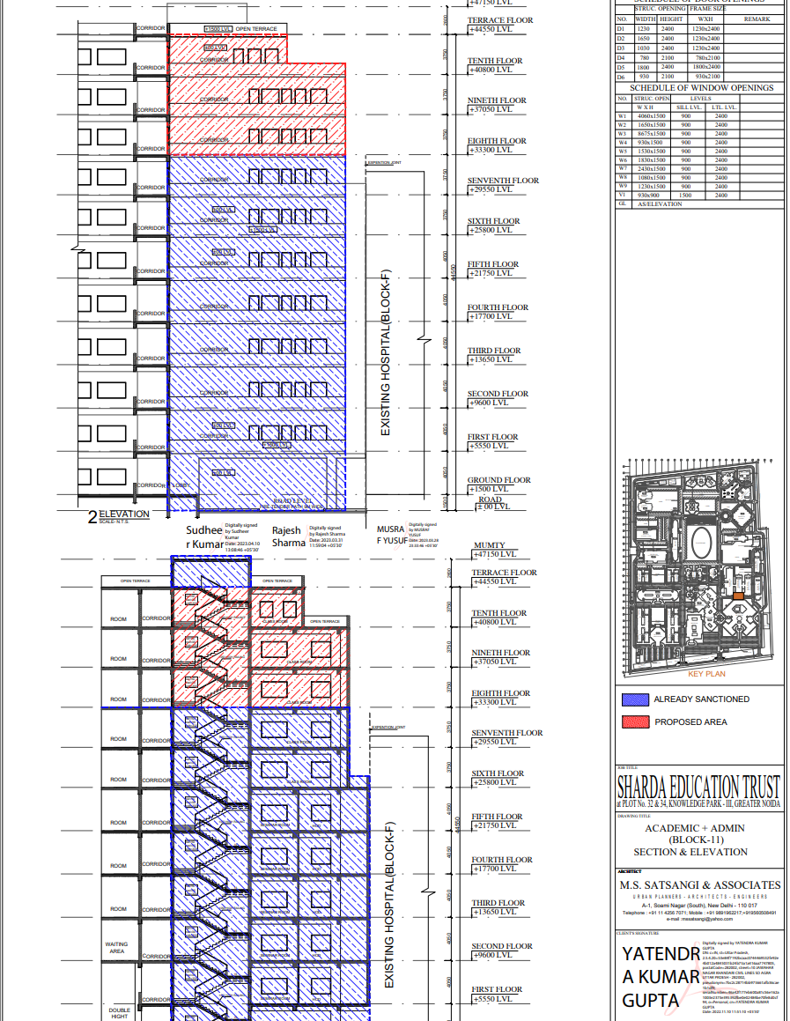

PHPTOGRAPHS OF PROPERTY

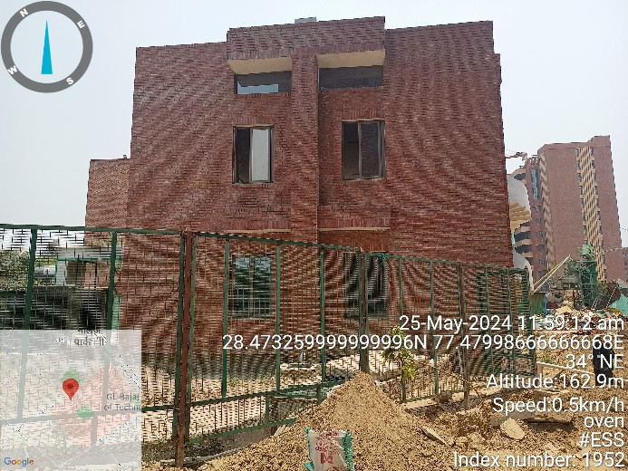 | 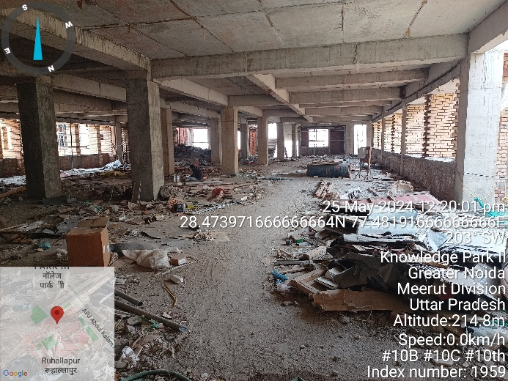
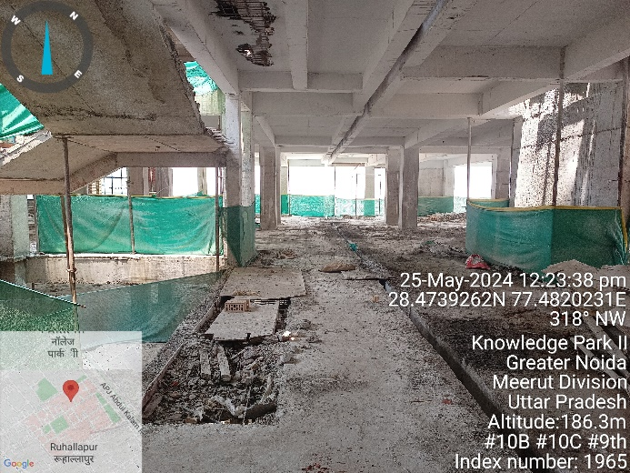 | 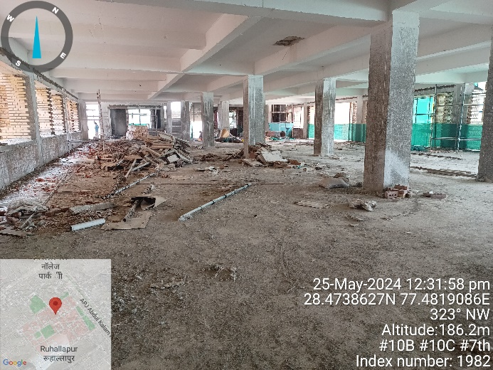
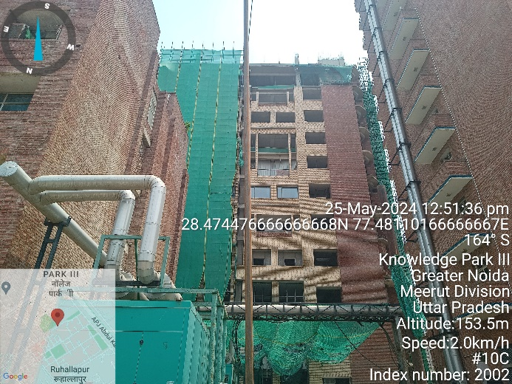 | 