File No.: VIS(2024-25)-PL079-071-096 Dated: 02-05-2024

LENDER’S INDEPENDENT ENGINEER’s REPORT

OF

410.30 (± 7.5%) KWp GRID CONNECTED ROOF-TOP SOLAR POWER PLANT

PROPOSED TO BE SET-UP AT
M/S SAMSON CONTROLS PRIVATE LIMITED IN D-281, RANJANGAON MIDC, TAL, SHIRUR, DISTRICT-PUNE, MAHARASHTRA

DEVELOPER:
M/S SAMARITAN SOLAR ENERGY PRIVATE LIMITED

REPORT PREPARED FOR
STATE BANK OF INDIA, SME UDYOG SADAN,
PATPARGANJ INDUSTRIAL AREA, NEW DELHI

**Important - In case of any query/ issue or escalation you may please contact Incident Manager
at le@rkassociates.org. We will appreciate your feedback in order to improve our services.
NOTE: As per IBA Guidelines please provide your feedback on the report within 15 days of its submission after which report will be considered to be correct.

IMPORTANT NOTICE

COPYRIGHT FORMAT: This report is prepared on the copyright format of R.K Associates to serve our clients with the best possible information and analysis to facilitate them to take rational business decisions. Legally no one can copy or distribute this format without prior approval from R.K Associates. It is meant only for the advisory/ reference purpose for the organization/s as mentioned on the cover page of this report. Distribution or use of this format by any organization or individual other than R.K Associates will be seen as an unlawful act and necessary legal action can be taken against the defaulters.
This report is intended for the sole use of the intended recipient/s and contains material that is STRICTLY CONFIDENTIAL AND PRIVATE.

DEFECT LIABILITY PERIOD: - In case of any query/ issue or escalation you may please contact Incident Manager at le@rkassociates.org.
Though adequate care has been taken while preparing this report as per its scope, but still we can’t rule out typing, human errors, over sightedness of any information or any other mistakes. Therefore, the concerned organization is advised to satisfy themselves that the report is complete & satisfactory in all respect. Intimation regarding any discrepancy shall be brought into our notice immediately. If no intimation is received within 15 (Fifteen) days in writing from the date of issuance of the report, to rectify these timely, then it shall be considered that the report is complete in all respect and has been accepted by the client upto their satisfaction & use and further to which R.K Associates shall not be held responsible in any manner.

TABLE OF CONTENTS
SECTIONS | PARTICULARS | PAGE NO.
Part A | REPORT SUMMARY | 03
Part B | INTRODUCTION | 04
 | - Name of the Project | 04
 | - Project Overview | 04
 | - Scope of the Report | 06
 | - Purpose of the Report | 06
 | - Methodology Adopted | 06
Part C | PROJECT DETAILS AND KEY TECHNICAL PARAMETERS | 07
Part D | ENERGY YIELD ASSESSMENT | 08
Part E | POWER PURCHASE AGREEMENT TERMS | 13
Part F | CURRENT STATUS OF WORK | 15
Part G | PROJECT COST & EXPENDITURE | 16
Part H | ENVIRONMENT, HEALTH, SAFETY, AND SUSTAINABILITY IMPACT (EHSS) | 18
Part I | TRACT RECORD OF EPC CONTRACTOR | 20
Part J | PHOTOGRAPHS | 21
Part K | OTHER DOCUMENTS & REFERENCES | 22
Part L | DISCLAIMER | 30

PART A | REPORT SUMMARY

 | Name of the Project | 410.30 (±7.5%) KWp Grid Connected Solar Power Plant
 | Project Location | M/s Samson Controls Private Limited In D-281, MIDC Ranjangaon, Tal. Shirur, District-Pune, Maharashtra
 | Seller Company | M/s Samaritan Solar Energy Private Limited
 | Prepared for Organization | State Bank Of India, SME Udyog Sadan, Patparganj Industrial Area, New Delhi
 | LIE Consultant Firm | M/s. R.K. Associates Valuers & Techno Engineering Consultants (P) Ltd
 | Work Oder Details | Via E-mail dated 11-01-2024
 | Date of Survey | Not applicable
 | Date of Report | 02-05-2024
 | Details & documents provided by | Bank
 | Report Type | Lender’s Independent Engineering Report
 | Purpose of the Report | Review of Project cost, CUF and Irradiation Data, current status to facilitate bankers to take business decision on the Project
 | Scope of the Report | To review Project cost and examine the current status of installation/ Commissioning of the Project
 | Documents produced for Perusal | - Copy of Power Purchase Agreements (PPAs)  - Copy of Plant Layout  - Copy of PV Syst reports
 | Annexure with the Report | - Benchmark Cost by MNRE  - Market Comparables  - Global Solar Atlas by World Bank Group

PART B | INTRODUCTION

- NAME OF THE PROJECT: 410.30 (± 7.5%) KWp Grid Connected Solar Power Plant in RESCO Model to be installed at M/s Samson Controls Private Limited located at D-281, MIDC Ranjangaon, Tal. Shirur, District-Pune, Maharashtra by M/s Samaritan Solar Energy Private Limited.
- PROJECT OVERVIEW: M/s Samaritan Solar Energy Private Limited is an private incorporated which is into Manufacturing, supplying, installing and distribution of electric power generation using solar energy.
M/s Samson Controls Private Limited had signed 01 nos. of Power Purchase Agreement (PPAs) with M/s Kirloskar Solar Technologies Private Limited for Design, Manufacture, Supply, Erection, Testing and Commissioning including Warranty, Operation & Maintenance of roof-top solar power plant having DC capacity of 410.30 (± 7.5%) KWp for 15 years of plant operation/ PPA tenure.
Further, Novation and Assignment Agreement dated 29th March 2024 was signed between M/s MPRNP Energy Udyog Private Limited and M/s Samson Controls Private Limited and M/s Samaritan Solar Energy Private Limited, in which Samson has unconditionally agreed to release and discharge the MPRNP from MPRNP's obligations, duties, liabilities and assign and transfer MPRNP's rights and benefits as per the Original Agreement in favour of Samaritan (except Operation and Maintenance of the Solar Power Plants by Kirloskar Solar Technologies Private Limited for first two years subject to renewal by Samaritan).
As per details dated 21st March 2024 shared by the company, the total project cost is estimated at a price of Rs. 1.95 Cr. including duties and taxes.
M/s Samaritan Solar Energy Private Limited has approached SBI for credit facility to construct these plants who have in turned appointed M/s R.K Associates Valuers & Techno Engineering Consultants Pvt. Ltd. as Lenders Independent Engineer for a specific scope of work.
As per information shared by the company, presently physical work has not started yet. Thus, our scope of work includes only review & comment on total Project cost, CUF and Irradiation Data.

RESCO Model: -
MNRE had introduced the PPP/RESCO model policy setting tariff rates for solar to be arrived on transparent competitive bidding model through PPP route.

The RESCO model is one of the methods of implementing rooftop solar installations. Under the RESCO model, a renewable energy service company ("RESCO"), (i.e., an energy service company that provides energy to consumers from renewable energy sources), develops, installs, finances, operates and owns the rooftop solar power project ("Project"), and supplies power generated from the Project to the consumer on whose premises the Project is set up ("Customer") or to the grid through net-metering.

'Build, Own, Operate and Transfer' (BOOT) is a special kind of RESCO model in which the RESCO constructs, owns, operates, and transfers the ownership of the Project to the Customer after the expiry of a predefined period. The RESCO and the Customer enter into a long-term power purchase agreement ("PPA") for an agreed tenure, which sets out, among others, the terms at which the power generated from the Project will be sold to the Customer and the tariff at which the power will be sold. Excess power from the Project (if any) could be sold by the Customer to the distribution utility through net metering system – the net metering regulations differ from state to state.

Under the PPA, the RESCO owns the Project and is responsible for its installation as well as its operation and maintenance of the Project throughout the tenure of the Project, and at the end of the PPA term, the ownership of the Project is transferred to the Customer. Thereafter, the Customer may either choose to retain the RESCO for operation and maintenance services or engage a third-party operator.

If the entity on whose premises the Project is located does not intend to buy the power generated from the Project and does not entered into a PPA with the RESCO, that entity can either lease the rooftop premises to the RESCO by means of a lease agreement or enter into a license agreement granting the RESCO the right to use the premises for the limited purpose of setting up and operating the Project. The RESCO then operates the Project and exports the energy generated to the local distribution utility at a predetermined feed-intariff (FiT) approved by the State Electricity Regulator under relevant schemes issued by the relevant state.

- SCOPE OF THE REPORT: To verify and review the Project cost, CUF and Irradiation Data of the Solar Power Plants set-up/ being set-up by M/s Samaritan Solar Energy Private Limited:-
- Industry/ sector research and demand & supply trend is out of scope of the report.
- Financial feasibility study of the Project is out of scope of the report.
- Providing any kind of design report or map is out-of-scope of the report.
- Scrutiny of contracts, Agreements and arrangement between the parties from legal perspective is out-of-scope of this report.
- Location feasibility is ascertained based on the PVSyst Report provided by the client.
- Any kind of technical & economic feasibility of the Project is out-of-scope of this Report.

All the assessment carried out for the Project is done based on the documents and information provided to us and various other discussions with the Project proponents and thus forming an opinion out of it.

Project assessment uis done in totality and not component wise unless otherwise mentioned..

- PURPOSE OF THE REPORT: To provide fair detailed analysis report to the Bank based on the “in-scope points” mentioned above for facilitating them to take appropriate business decision on the Project.

- METHODOLOGY ADOPTED:
- To gather relevant data/ information/ documents related to Project planning, execution, current status.
- Study of copy of Project Planning documents/ Agreements to know the scope of work of the company.
- To procure, study and analysis of any additional information, data, and documents required/ provided by the company.
- Research about the Project/ sector from the sources in the public domain.
- Correlation of the provided information against Industry/ sector benchmarks/ trend.
- Information compilation, analysis and reporting.

PART C | PROJECT DETAILS AND KEY TECHNICAL PARAMETERS
As per the information and copy of documents shared by the management of the company, details of the subject plants has been tabulated below:
S.  No. | Offtaker | DC Power (kWp) | AC Power  (kWp)
1 | Samson Constrols Private Limited | 410.30 | 330.00
Total |  | 410.30 | 330.00

Location Map: -
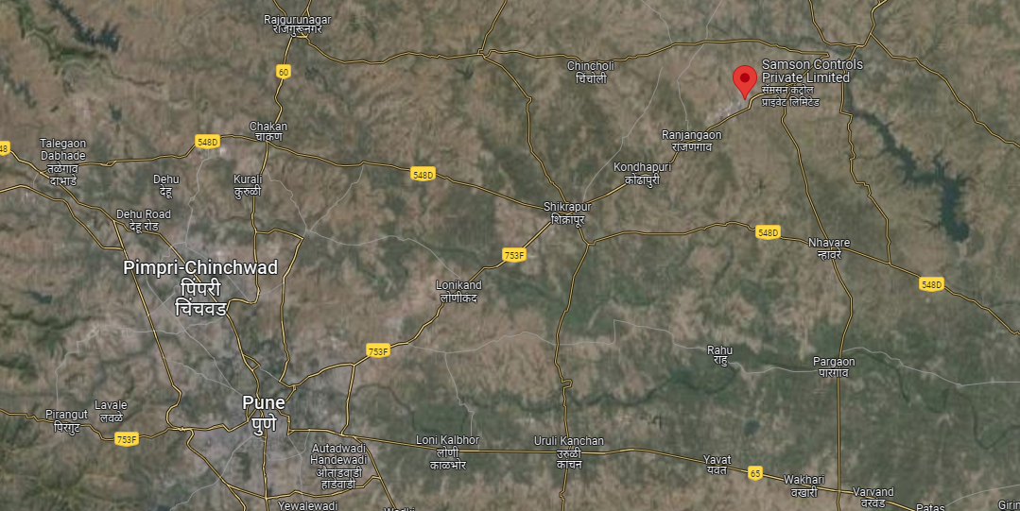
Location: Samson Controls Pvt. Ltd., Ranjangaon MIDC GPS: 18°47'32.8"N 74°17'34.1"E

Technical parameters/specifications of solar plant to be installed are as follow:-

S. No. | Particulars | 410.30 KW
1 | No. of modules | 753 Modules
2 | Modules capacity | Kirloskar 545Wp (Mono-Perc)
3 | Invertor make | Sungrow
4 | Invertor AC Output | 100kw x 3 nos & 30kw x 1 nos.
5 | Invertor AC Voltage | 400VAC
6 | DC capacity | 410.38 kWp
7 | AC capacity | 330 kW
8 | Roof Tilt | 10° Roof Slope

PART D | ENERGY YIELD ASSESSMENT

Company has used PVSyst V7.4.5 to assess energy yield calculation which is the standard Industry practice. The yearly average of main results of irradiation and energy yield from the provided PVSyst is as under:
Annual production probability (kWh):

S. No. | Plant | As per PVSyst  (In kWh/kWp/Year) |  | Performance  Ratio (%) | CUF (%)
S. No. | Plant | P50 | P90 | Performance  Ratio (%) | CUF (%)
1 | Samson Control 410.38 KW | 1,789 | 1,747 | 79.86% | 21%

Estimated Annual production (kWh):

S. No. | Plant | As per PPA  (kWh/Year) | As per PVSyst  (kWh/Year) | As per DPR  (kWh/Year)
1 | Samson Control 410.38 KW | 5,74,420 | 7,33,919 | 9,69,555

Estimated Specific Production (kWh/kWp/Year):

S. No. | Plant | As per PPA  (In kWh/kWp/Year) |  | As per PVSyst  (In kWh/kWp/Year) | As per Global Solar Atlas  (In kWh/kWp/Year)
S. No. | Plant | Estimated | Guaranteed | As per PVSyst  (In kWh/kWp/Year) | As per Global Solar Atlas  (In kWh/kWp/Year)
1 | Samson Control 410.38 KW | 1053.98 | 938.04 | 1789 | 1611.40

Observations and Remarks:

- As per above inputs and analysis estimated annual production and specific production as per PvSyst report and as per Global Solar Atlas data found to be generating more as specified as guaranteed generation in PPA.

Analysis of Irridiation & PV Output data: In respect to Irridiation & PV Output data, company has provided to us PVSyst Report V7.4.5 in which key Irrdidation components and PV Output data is given as enumerated in table below. We have analysed and compared it with other data source points also such as Solar Resource by Global Solar Atlas of World Bank and ISRO Solar Calculator to confirm its legitimacy as mentioned in table below:

Particulars | Samson Controls Private Limited
Particulars | As per Global Solar Atlas | As per PVSyst
Global horizontal Irradiation (kWh/m²) | 1947.8 | 2088.0
Diffuse horizontal Irradiation (kWh/m²) | 932.8 | 771.47
Direct Normal Irradiation (kWh/m²) | 1451.6 | -
Specific Photovoltaic Power Output per year (kWh/kWp/year) | 1611.4 | 1789
Annual Global Insolation (ISRO Solar Calculator) (kWh/m2/year) | 1629

Observations and Remarks:
- As per the PVsyst - Simulation reports dated 02th February 2024, the estimated energy that can be produced by the subject plants and their respective performance ratio is more than as agreed in the PPA.
- As per comparative analysis, PVSyst Irrdiation and PV Output data is in line to our analysis from Global Solar Atlas of World Bank and ISRO Solar Calculator.
- The guaranteed energy production as per PPA for Plant is 938.04 kWh/kWp/year respectively which is within range of specific production as per Global Solar Atlas & PVSyst Report (refer table above).
- As per the information provided by the management of the company, the estimated average Capacity Utilization Factor (CUF) is about 21.00% for all locations.
- As per details shared by the company for all projects, the expected Net Energy generation is about 729.83 MWh/year (± 5%). However, actual generation would be effected by weather and maintenance of the plant.
Monthly averages- Direct Normal Irradiation (kWh/m²)
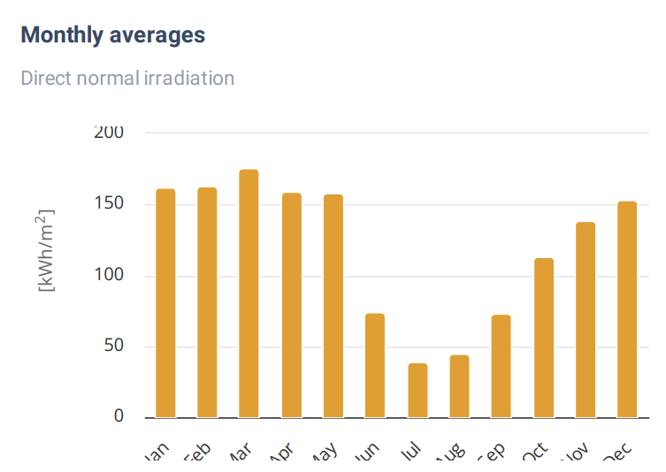
Source: Global Solar Atlas

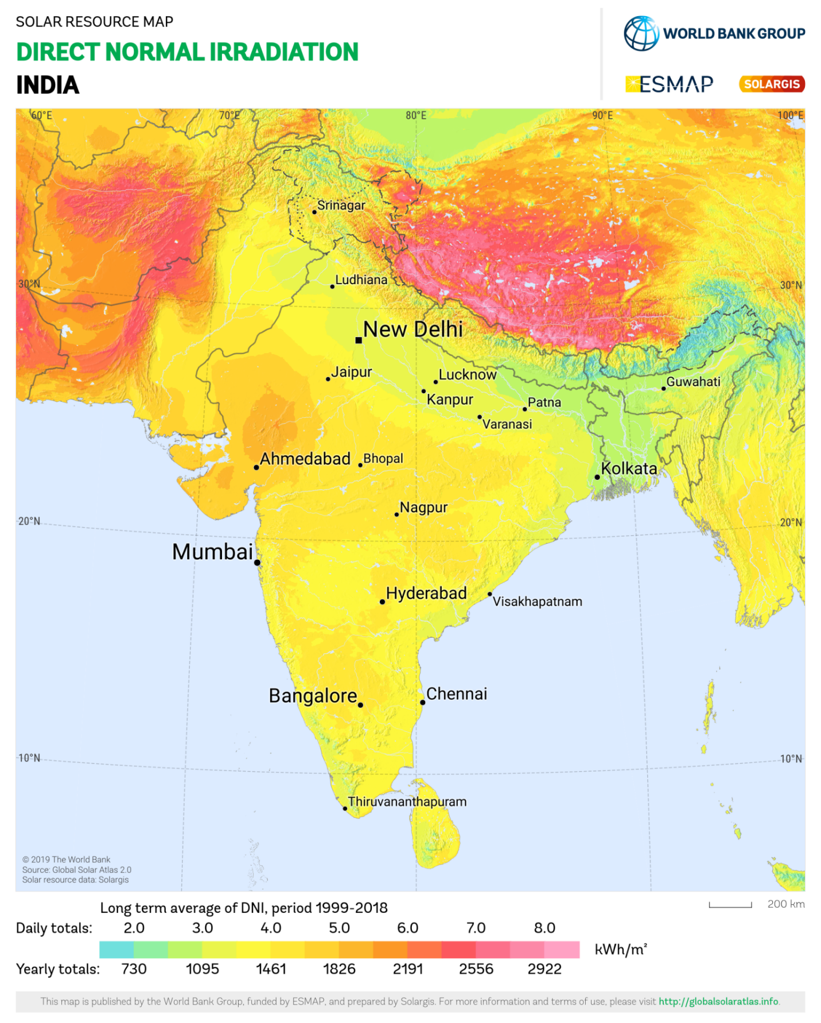
Samson Controls Private Limited Plant lies above 5.0 daily (1826 annually) Kwh/m².
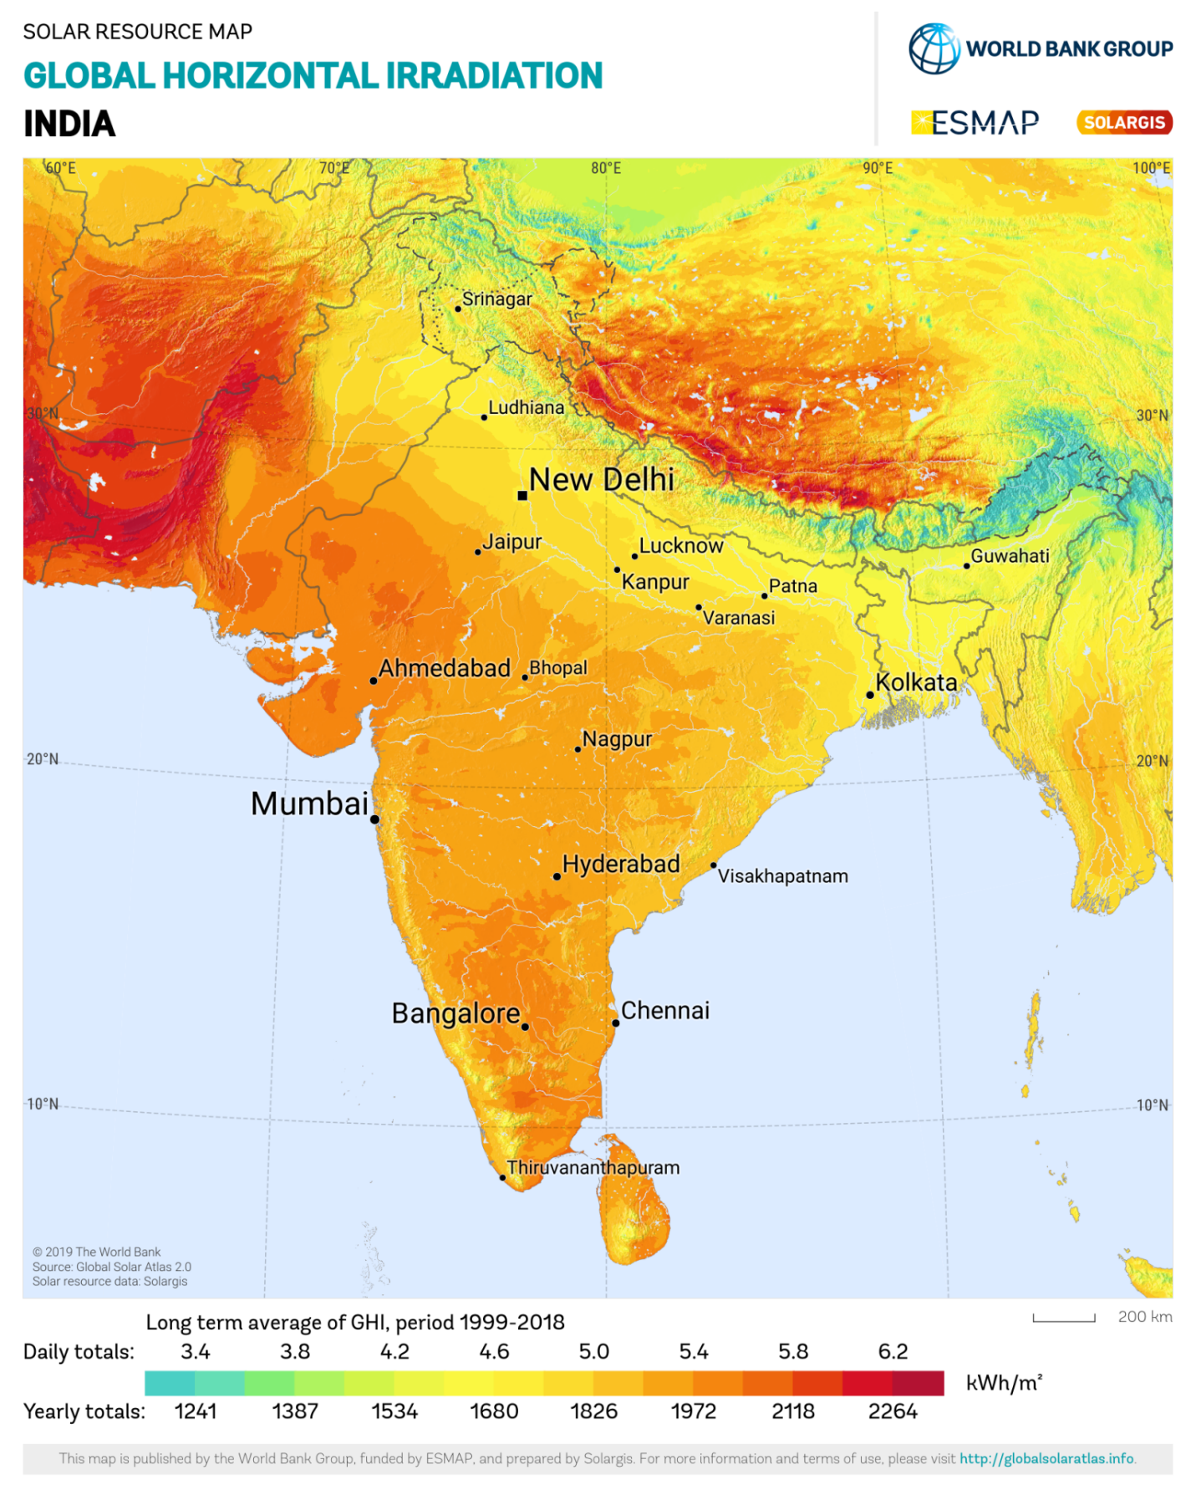
Samson Controls Private Limited Plant lies above 5.4 daily (1972 annually) Kwh/m².
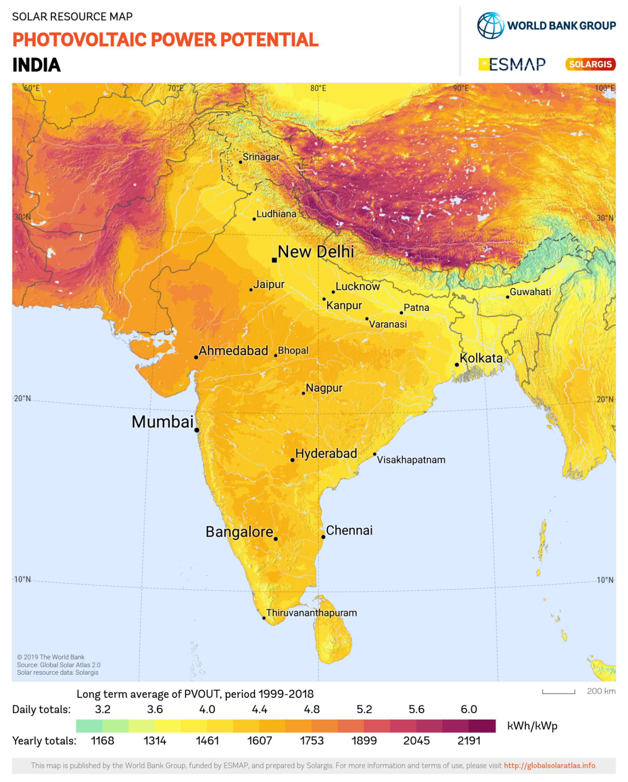
Samson Controls Private Limited Plant lies above 4.4 daily (1607 annually) Kwh/m².
PART E | POWER PURCHASE AGREEMENT TERMS

As per the information provided by the company, the total proposed capacity of the solar power plant is 410.38 KWp (± 10%). As on date, company has signed PPA to install the power plant and supply power. The PPA had been signed between M/s Kirloskar Solar Technologies Private Limited (Power Producer) and M/s Samson Controls Private Limited (Offtaker). Details as mentioned in PPA are tabulated below:
S. No. | Offtaker | DC Capacity  (kWp) | Tariff  (Rs./kWh) | PPA Date | PPA Tenure
1 | Samson Control 410.38 KW | 330.00 | 4.55 with 1% escalation in every two years | 26-11-2023 | 15 Years
Total |  | 330.00

Buy out Value for 15 Years as per PPA | Estimated Genration and Guaranteed Generation as per PPA
  Year | (End-of-The-year)  In Rs.
  1 | 1,37,66,667
  2 | 1,28,33,333
  3 | 1,19,00,000
  4 | 1,09,66,667
  5 | 1,00,33,333
  6 | 91,00,000
  7 | 81,66,667
  8 | 72,33,333
  9 | 63,00,000
  10 | 53,66,667
  11 | 44,33,333
  12 | 35,00,000
  13 | 25,66,667
  14 | 16,33,333
  15 | 7,00,000
  16 | 1
  Year | Estimated Generation (kWh/Year) | Guaranteed Units (kWh/Year)
  1 | 574420 | 511234
  2 | 562932 | 501009
  3 | 558991 | 497502
  4 | 555078 | 494020
  5 | 551193 | 490561
  6 | 547334 | 487127
  7 | 543503 | 483718
  8 | 539698 | 480332
  9 | 535920 | 476969
  10 | 532169 | 473630
  11 | 528444 | 470315
  12 | 524745 | 467023
  13 | 521072 | 463754
  14 | 517424 | 460507
  15 | 513802 | 457284

Novation and Assignment Agreement dated 29th March 2024 was signed between M/s Samaritan Solar Energy Private Limited (SEPL) and M/s Samson Controls Private Limited and MPRNP Energy Udyog Private Limited in which agreement details area as follows:-
- Samaritan hereby undertakes to observe, perform, discharge and be bound by the terms, conditions and covenants of the Original Agreement (including all the liabilities and obligations of MPRNP arising under the Original Agreement, whether actual, contingent or otherwise, and whether arising on or before or after the date hereof) in every way as if the Samaritan were, and had originally been, a party to the Original Agreement in place of the MPRNP AND ALSO THAT against the said CONSIDERATION all rights, titles, interests and ownerships arising under and in connection with Original Agreement (whether actual, contingent or otherwise, and whether arising on or before or after the date hereof) shall stand transferred and assigned from MPRNP to Samaritan in every way as if the MPRNP were, and had originally been, a party to the Original Agreement in place of the MPRNP (except Operation and Maintenance of the Solar Power Plants by Kirloskar Solar Technologies Private Limited for first two years subject to renewal by Samaritan).
- Samaritan hereby releases and discharges MPRNP from the performance of the Original Agreement (to the extent it relates to collection of the proceeds for the power units generated and except Operation and Maintenance of the Solar Power Plants by Kirloskar Solar Technologies Private Limited for first two years subject to renewal by Samaritan) and from all obligations, liabilities, claims and demands howsoever arising under or in relation to the Original Agreement and accepts the transfer and assignment of rights and benefits under the Original Agreement from MPRNP to Samaritan (to the extent it relates to collection of the proceeds for the power units generated and except Operation and Maintenance of the Solar Power Plants by Kirloskar Solar Technologies Private Limited for first two years subject to renewal by Samaritan) as if the Samaritan were, and had originally been, a party to the Original Agreement in place of the MPRNP.
- SAMSON hereby releases and discharges MPRNP from the performance of the Original Agreement and SAMSON covenants not to bring any suit, action or proceeding or make any demand or claim of any type against the MPRNP relating to or in connection with the Original Agreement or the relationship created thereby. Such release and discharge herein being without prejudice to the liabilities and obligation of Samaritan to SAMSON under the Original Agreement as novated and assigned by this Agreement.

PART F | CURRENT STATUS OF WORK

As per information shared by the company officials, Solar Plant installation work has not been started yet. Therefore, physical inspection of the plant was not conducted from our end. Hence, we have analyzed the plant location area via Google Map.
Please refer to the image attached below:-
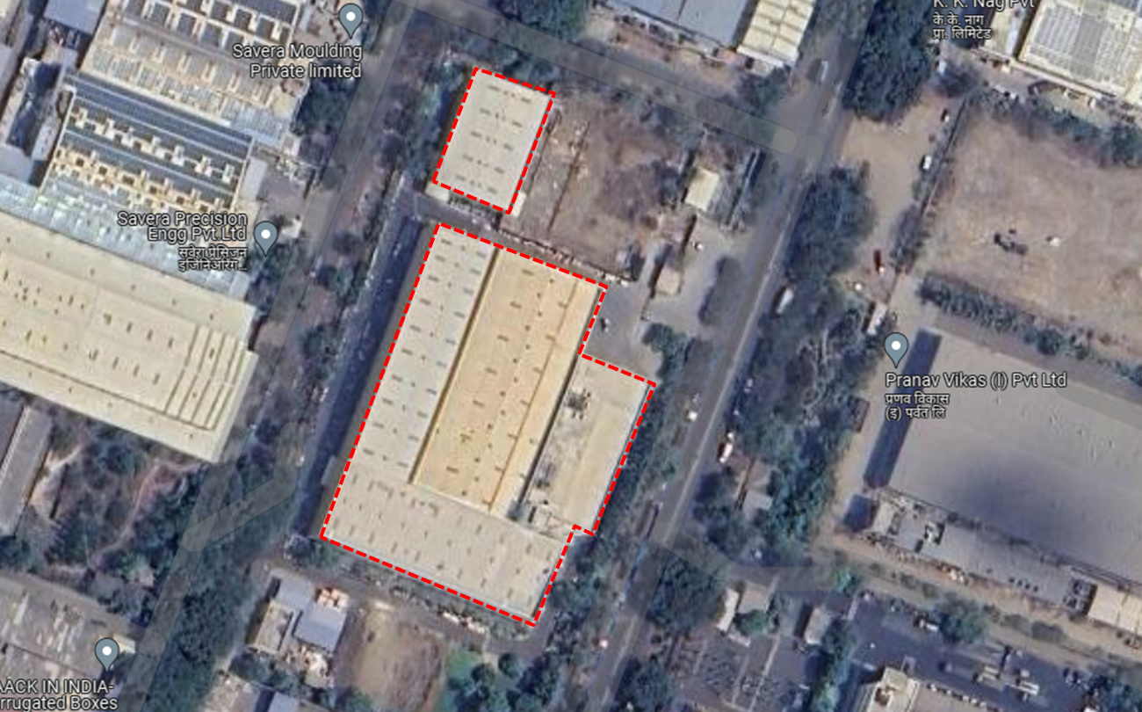
From google imaginery tool, no major shadow or obstruction is found on roof which may block the Direct Sunlight.

PART G | PROJECT COST & EXPENDITURE

- PROJECT COST: As per details shared by the company, the total project cost for installation of 410.30 KW solar project is Rs. 14.77 Cr. including GST. Component-wise cost break-up shared by the company is as follows:-
S.No. | Item | Cost/KW  (In Rs.) | Total EPC Value  (In Rs.)
1 | Solar Panel | 24.50 | 1,00,52,350
2 | Solar Inverter | 3.37 | 13,82,711
3 | Structure | 3.00 | 12,30,900
4 | Cables | 2.00 | 8,20,600
5 | LT Panel/ACDB | 2.10 | 8,61,630
6 | BOS / Misc. | 2.50 | 10,25,750
 | I&C | 2.00 | 8,20,600
8 | Govt Approval & Liasoning | 2.20 | 9,02,660
 |  |  | 1,70,97,201
 |  | *GST (13.8%) | 23,59,414
Total Cost of the project(In Rs.) |  |  | 1,94,56,615

- Combined GST of 12% & 18% will be charged according to the industry bencgmark & Govt. Policy.
- Total invoicing will be as per project billing of 410.30 Kw and bifurcated in 70/30 ratio of materials & services & service as per Govt. regulation & GST norms.
Observations and Remarks:
- Project cost calculated on the basis of the Benchmark Cost provided by the MNRE has been tabulated below:
S. No. | Particulars | Benchmark Cost  (In Rs./kW) | Project Capacity  (In MW) | Total Project Cost  (Excluding GST)  (In Rs.) | Total Project Cost  (Including ~14% GST)  (In Rs.)
1 | As per Ministry of New & Renewable Energy | 35,886* | 410.30 | 1,47,24,026 | 1,67,55,941
 |  |  |  |  | ~Rs. 1.67 Cr.
*Benchmark cost for 2021-22 Excludes GST

- Project cost calculated on the basis of market comparable:
S. No. | Particulars | Excluding GST | Including GST | Remark
S. No. | Particulars | Per KW Cost  (In Rs.) | Per KW Cost  (In Rs.) | Remark
1 | Subject project installation cost | 41,670 | 47,420 | As per Compnay
Market Research Details
Market Research
3 | Quotation-1 (6,221 KW) | --- | 39,994 | Refer Annexure-2
4 | Quotation-2 (3,240 KW) | --- | 44,564 | Refer Annexure-2
5 | Quotation-3 (1,190 KW) | --- | 46,088 | Refer Annexure-2

- The overall project cost is slightly higher than that of Benchmark cost.
- As per our analysis and market research, the installation cost of Solar Power Plant varies from Rs. 39,994/- per KW to Rs. 46,088/- per KW. For the smaller setups the price is higher and for large set-up, price is less.
- The project cost solely depends upon the project location, contractors profit, type of module and its supporting structures, make, etc.
- Based upon the above mentioned details, the project cost amounting to Rs. 1.95 Cr. which is Rs. 47,420/- per kW inclusive of GST for the installation of subject solar power plant seems to be reasonable as near to expected market price range of Rs. 39,994/- per KW to Rs. 46,088/- per KW.
Note:
- Project cost is analyzed based on lump sum cost only and not item wise.
- Project cost is assessed for the date of this report only and due to price fluctuations it may vary from time to time.

- EXPENDITURE: Details of expenses incurred till date are not shared with us. Thus, we cannot comment upon expenditure incurred till date on the project.

PART H | EHSS (ENVIRONMENT, HEALTH, SAFETY, AND SUSTAINABILITY) IMPACT

The impact of an industrial rooftop solar plant on EHSS (Environment, Health, Safety, and Sustainability) can be significant and positive if implemented and managed responsibly. Here are some key considerations:

PARAMETERS | POSITIVE | NEGATIVE | REMARKS
Environmental Impact | Solar Power comes under renewable energy Project. Solar Power Projects generates clean energy and thus contributes in reducing carbon footprints, as otherwise production of the same amount of energy through conventional methods would have required burning of coal which would have led to emission of greenhouse gases in our environment. | None directly from this Project implementation. | Positive
Health and Safety | Non polluting Project and doesn’t involve any industrial hazartdous process. | No health and safety impact as such. Since it is a rood top solar Project, therefore at times workers may require to work at high elevation or slanted rooftop. | It is advised that whenever any worker or technician is working at high elevation or slanted rooftop, they should be extra careful and use proper safety gears.
Social Impact | Implementation of Solar Rooftiop Project under RESCO model will help reduciung power bills of the Project owner which will have positive economic benefit.  Increases local employment.  Use of diesel generators may be avoided due to uninturrupted power supply through owned power system and thus further helps in keeping pollution and noise free environment.  Renewable energy ultimately reduces carbon footprint and thereby provides better health & environment. | None | Positive
Sustainability | Solar energy is a natural resources providing limitless renewable energy.  Moreover, since Solar Projects helps in lowering carbon footprints and thus good for our environment. Therefiore it is sustainable for human health and mother earth. | The only issue with Solar Power Project is its availability during peak power demand where its limitation comes for which battery storage can be the only solution but again mass use of battery storage again give rise to pollution due to its manufacturing and its disposal. | More towards positive.

However, it's crucial to note that the EHSS impact can be influenced by factors such as the design, construction, and ongoing operation and maintenance of the solar plant. Adhering to industry best practices, complying with regulations, and implementing robust EHSS management systems are essential to maximizing the positive impact and minimizing potential risks.

PART I | TRACK RECORD OF EPC CONTRACTOR

According to the information provided by the company, Jinko Solar, Sungrow, and Boond Solar serve as significant material suppliers for the construction of solar power plant. However, it is important to note that the company has not formalized any agreements with these suppliers; rather, they have only received quotations from them. The supplier companies have a track record of implementing projects in the past, and the details of these projects are as follows:-
Suppier | About Supplier | Past Projects
Kirloskar Solar | Kirloskar Solar Technologies Incorporated in year 2017. Kirloskar Solar has an extensive portfolio of customers in all segments like Residential, Commercial, Industries, SMEs across sectors like Healthcare, Hospitality, Automotive, Commercial, Education, Agriculture, and Manufacturing. Company provides sustainable energy efficient solutions to serve the entire spectrum of electricity consumers from those who have zero power cuts to those who have frequent power cuts. | - 70kW Rooftop + Ground Mounted  - 60kW Ground Mounted  - 60kW Hospital Rooftop Mounted  - 80kW GI Industrial Rooftop  - 140kW GI Industrial Rooftop  - 150kW GI Industrial Rooftop  - 110kW GI Industrial Rooftop  - 154kW IT Company RCC Rooftop  - 80kW Educational Institute RCC Rooftop  - 105kW Tin Shed Rooftop  - 125kW RCC Rooftop
Sungrow | Sungrow Power Supply Co., Ltd. is a leading global supplier of inverter solutions for renewable energy projects, specializing in solar and wind power. Established in 1997, this Chinese company has become one of the world's largest manufacturers of inverters. | - 1MW PV Plant in Vietnam  - 168 MW PV Plant in Algeria  - 166.5 MW PV Plant in Egypt  - 19.2 MW PV Plant in Americas  - 6.5 MW PV Plant in Spain  - 5 MW PV Plant in Dubai
Boond Solar | Boond Solar is a rapidly expanding developer of renewable energy power in India. Established in 2010 as a leader in technology and innovation, it offers affordable custom solutions that provide economic benefits to its customers. With a strategic approach to continuous growth of the nation. | - 3.85 MW at Sangam India Ltd., Bhilwara  - 2 MW at Panasonic India Ltd., Jhajjar  - 900 kW at XLRI, Jhajjar  - 800 kW at BSL Limited, Bhilwara  - 100 MW at Sonagazi Solar Plant, Bangladesh  - 750 kW at South Eastern Central Railways, Bilaspur  - 35 MW at Maharashtra
Samaritan Solar | Samaritan Solar is a USA based company was incorporated with ROC on 18 November 2020 having its registered office in Delhi. It had implemented multiple projects.
  - 9.6 KW system  - 5.42 KW system  - 12.54 KW system  - 5.7 KW system  - 3.71 KW system | - 4.27 KW system  - 11.4 KW system  - 6.3 KW system  - 7.4 KW system
Note:- The above mentioned are considered from information/details available on public domain.
Reference-
- https://solex.in/solar-power-plant/#
- https://en.sungrowpower.com/solutionsDetail/4/commercial-system
- https://boond.net/projects/
- https://www.kirloskarsolar.com/projects;jsessionid=030D4EC914F6DD748009891A6F9396AB
- https://samaritansolar.com/projects/
PART J | PHOTOGRAPHS

Since the installation work related to solar panels is yet to start and this is just a Desktop LIE based upon documents provided. Thus, Photographs are not available

PART K | OTHER DOCUMENTS & REFERENCES

Market Comparables:
Annexure-1
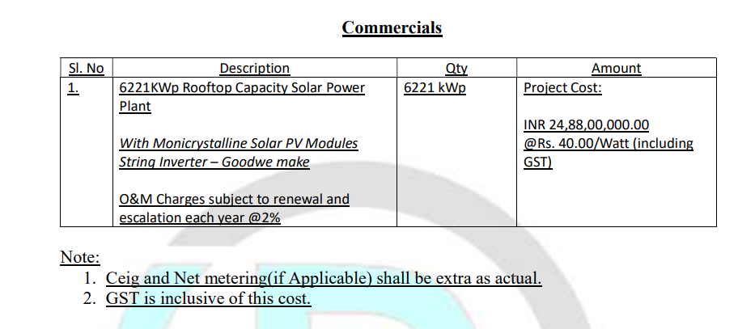
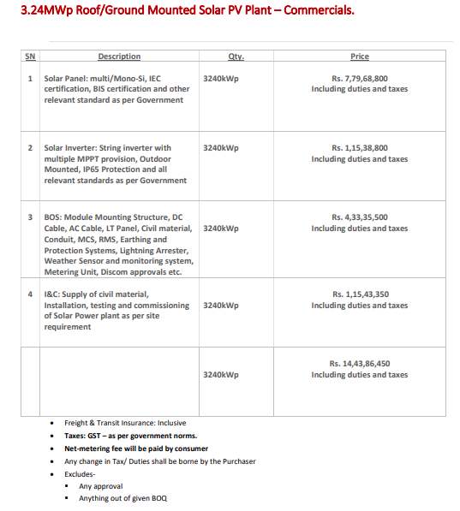
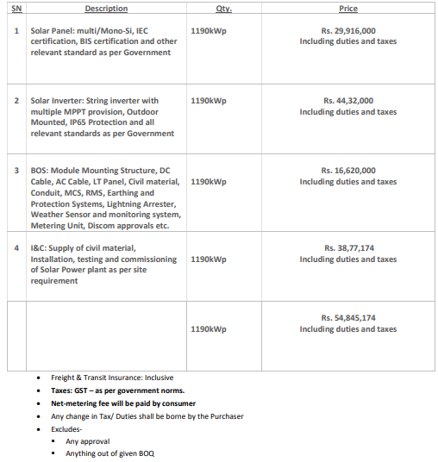

Data by Global Solar Atlas by World Bank Group
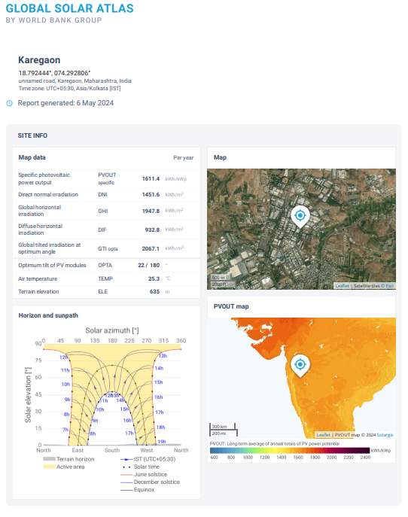

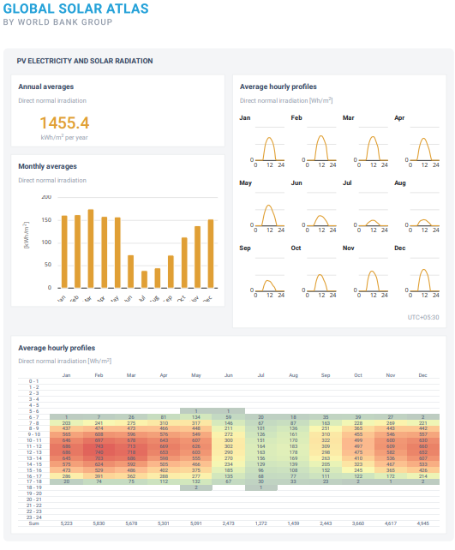

SLD Disgram
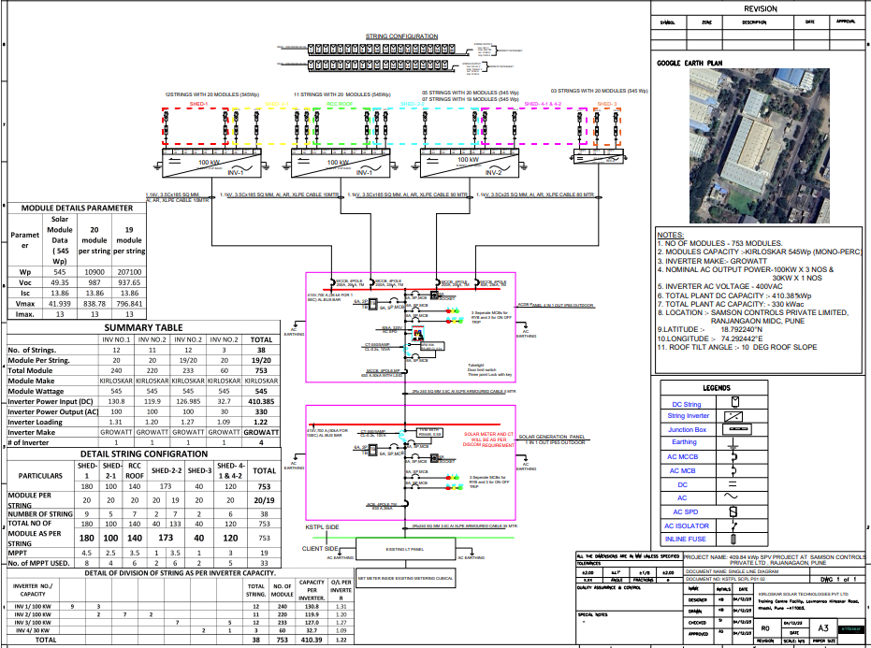

Layout

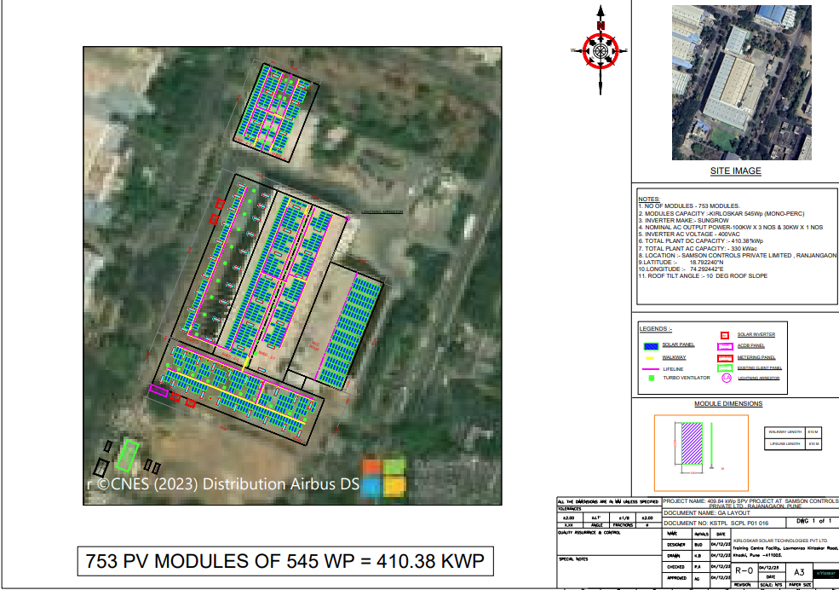

Copy of PPA

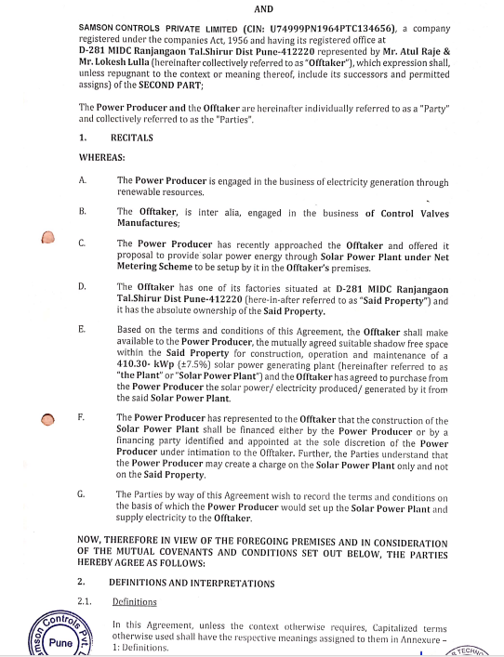

Copy of Novation Agreement
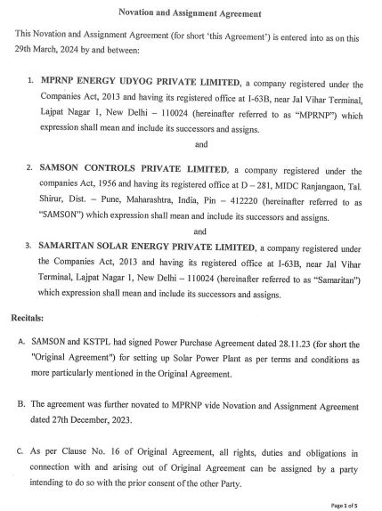

PART L | DISCLAIMER

      - No employee or member of R.K Associates has any direct/ indirect interest in the Project.
      - This report is prepared based on the copies of the documents/ information which the Bank/ Company has provided to us out of the standard checklist of documents sought from them and further based on our assumptions and limiting conditions. All such information provided to us has been relied upon in good faith and we have assumed that it is true and correct in all respect. Verification or cross checking of the documents provided to us has not been done at our end from the originals. If at any time in future, it is found or came to our knowledge that misrepresentation of facts or incomplete or distorted information has been provided to us then this report shall automatically become null & void.
      - This report is a general analysis of the project based on the scope mentioned in the report. This is not an Audit report, Design document, DPR or Techno-financial feasibility study. All the information gathered is based on the facts seen on the site during survey, verbal discussion & documentary evidence provided by the client and is believed that information given by the company is true best of their knowledge.
      - All observations mentioned in the report is only based on the visual observation and the documents/ data/ information provided by the client. No mechanical/ technical tests, measurements or any design review have been performed or carried out from our side during Project assessment.
      - Bank/FII should ONLY take this report as an Advisory document from the Financial/ Chartered Engineering firm and it’s specifically advised to the creditor to cross verify the original documents for the facts mentioned in the report which can be availed from the borrowing company directly.
      - In case of any default in loans or the credit facility extended to the borrowing company, R.K Associates shall not be held responsible for whatsoever reason may be and any request for seeking any explanation from the employee/s of R.K Associates will not be entertained at any instance or situation.
      - This Report is prepared by our competent technical team which includes Engineers and financial experts & analysts.
      - This is just an opinion report and doesn’t hold any binding on anyone. It is requested from the concerned Financial Institution which is using this report for taking financial decision on the project that they should consider all the different associated relevant & related factors also before taking any business decision based on the content of this report.
      - All Pages of the report including annexures are signed and stamped from our office. In case any paper in the report is without stamp & signature then this should not be considered a valid paper issued from this office.
      - Though adequate care has been taken while preparing this report as per its scope, but still we can’t rule out typing, human errors, over sightedness of any information or any other mistakes. Therefore, the concerned organization is advised to satisfy themselves that the report is complete & satisfactory in all respect. Intimation regarding any discrepancy shall be brought into our notice immediately. If no intimation is received within 15 (Fifteen) days in writing from the date of issuance of the report, to rectify these timely, then it shall be considered that the report is complete in all respect and has been accepted by the client upto their satisfaction & use and further to which R.K Associates shall not be held responsible in any manner.
      - Defect Liability Period is 15 DAYS. We request the concerned authorized reader of this report to check the contents, data and calculations in the report within this period and intimate us in writing if any corrections are required or in case of any other concern with the contents or opinion mentioned in the report. Corrections only related to typographical, calculation, spelling mistakes, incorrect data/ figures/ statement will be entertained within the defect liability period. Any new changes for any additional information in already approved report will be regarded as additional work for which additional fees may be charged. No request for any illegitimate change in regard to any facts & figures will be entertained.
      - R.K Associates encourages its customers to give feedback or inform concerns over its services through proper channel at le@rkassociates.org in writing within 30 days of report delivery. After this period no concern/ complaint/ proceedings in connection with the Lender’s Independent Engineering Services will be entertained due to possible change in situation and condition of the subject Project.
      - Our Data retention policy is of ONE YEAR. After this period, we remove all the concerned records related to the assignment from our repository. No clarification or query can be answered after this period due to unavailability of the data.
      - This Lender’s Independent Engineering report is governed by our (1) Internal Policies, Processes & Standard Operating Procedures, (2) Information/ Data/ Inputs given to us by the client and (3) Information/ Data/ Facts given to us by our field/ office technical team. Management of R.K Associates never gives acceptance to any unethical or unprofessional practice which may affect fair, correct & impartial assessment and which is against any prevailing law. In case of any indication of any negligence, default, incorrect, misleading, misrepresentation or distortion of facts in the report then it is the responsibility of the user of this report to immediately or at least within the defect liability period bring all such act into notice of R.K Associates management so that corrective measures can be taken instantly.
      - R.K Associates never releases any report doing alterations or modifications from pen. In case any information/ figure of this report is found altered with pen then this report will automatically become null & void.
FOR INTERNAL USE
SURVEYED BY | PREPARED BY | REVIWED BY
NA | Abhinav Chaturvedi | Sr. V.P. Projects

For R.K Associates Valuers & Techno Engineering Consultants (P) Ltd.

DEFECT LIABILITY PERIOD - In case of any query/ issue or escalation you may please contact Incident Manager by writing at valuers@rkassociates.org. We ensure 100% accuracy in the Calculations done, Rates adopted and various other data points & information mentioned in the report but still can’t rule out typing, human errors or any other mistakes. In case you find any mistake, variation, discrepancy or inaccuracy in any data point of the report, please help us by bringing all such points into our notice in writing at valuers@rkassociates.org within 30 days of the report delivery, to get these rectified timely, failing which R.K Associates Valuers Techno Engineering Consultants (P) Ltd. won’t be held responsible for any inaccuracy in any manner. Also if we will not hear back anything from you within 30 days, we will assume that report is correct in all respect and no further claim of any sort will be entertained thereafter. We would welcome and appreciate your feedback & suggestions in order to improve our services.

COPYRIGHT FORMAT - This report is prepared on the copyright format of R.K Associates Valuers Techno Engineering Consultants (P) Ltd. to serve our clients in the best possible way. Legally no one can copy or distribute this format without prior approval from R.K Associates. It is meant only for the organization as mentioned on the cover page of this report. Distribution or use of this format other than R.K Associates will be seen as unlawful act and necessary legal action can be taken against the defaulter.

