File No.: VIS (2024-25)-PL081-073-098 Dated: 26.06.2024

PROJECT PROGRESS REPORT (1st)
(FROM 1stAPRIL 2023 TO 31st MARCH 2024)

OF

GANGOTRI GREEN PRODUCTS LLP

SITUATED AT

KHALISANI, NEAR HANUMAN MANDIR, RAJAPUR, NH 45,
ULUBERIA, HOWRAH, WEST BENGAL, 711307

DEVELOPED BY

M/S RAJ CONSTRUCTION

REPORT PREPARED FOR

STATE BANK OF INDIA,
SME EXIM BRANCH KOLKATA, WEST BENGAL

**Important - In case of any query/ issue or escalation you may please contact Incident Manager at le@rkassociates.org. We will appreciate your feedback in order to improve our services.
NOTE: As per IBA Guidelines please provide your feedback on the report within 15 days of its submission after which report will be considered to be correct.

TABLE OF CONTENTS
SR. NO. | DESCRIPTION | PAGE NO.
PART A | Report Summary | 03
PART B | Introduction | 05
 | - The Report | 05
 | - The Project | 05
 | - Project Overview | 05
 | - Location of the Project | 06
 | - Scope of work during Project Duration | 07
 | - Purpose of the Report | 07
 | - Methodology Adopted | 08
PART C | Infrastructure Details Of The Project | 09
 | - Land Details | 09
 | - Building & Civil Works | 09
 | - Machinery And Equipment | 11
PART D | Project Consultants, Contractors & Suppliers | 12
PART E | Project Progress | 11
 | - Progress Of Building & Civil Works | 13
 | - Progress Report Of Plant Machinery & Equipment | 15
PART F | Project Cost, Means Of Finance And Cost Incurred Till Date | 16
PART G | Cost Assessment Of Industrial Building | 20
PART H | Statutory & Regulatory Approvals, Clearances & Noc | 22
PART I | Project Schedule & Current Status | 23
PART J | Disclaimer | 24
PART K | Enclosure | 28
PART L | Photographs | 42
IMPORTANT NOTICE

COPYRIGHT FORMAT: This report is prepared on the copyright format of R.K Associates, to serve our clients with the best available information and analysis to facilitate them to take rational business decisions. Legally no one can copy or distribute this format without prior approval from R.K Associates. It is meant only for the Advisory/ reference purpose for the organization/s as mentioned on the cover page of this report. Distribution or use of this format by any organization or individual other than R.K Associates will be seen as unlawful act and necessary legal action can be taken against the defaulters.

This report is intended for the sole use of the intended recipient/s and contain material that is STRICTLY CONFIDENTIAL AND PRIVATE.

DEFECT LIABILITY PERIOD: - In case of any query/ issue or escalation you may please contact Incident Manager: le@rkassociates.org. We try our level best to ensure correctness in the calculations done, rates adopted and various other data points & information mentioned in the report but still can’t rule out typing, human errors or any other mistakes. In case you find any such mistake or inaccuracy in any data point of the report please help us by bringing all such points into our notice immediately or within 15 days of the report delivery in writing, to rectify these timely failing after which R.K Associates won’t be held responsible for any such inaccuracy in any manner. We would highly appreciate your feedback in order to improve our services.

PART A | REPORT SUMMARY

S.No. | Particulars | Details
 | Name of Project | Manufacturing Unit of Paper Cups and Pulp Table Wares.
 | Project Location | Khalisani, Near Hanuman Mandir, Rajapur, NH 45,Uluberia, Howrah, West Bengal, 711307
 | Name of the Borrower | M/s Gangotri Green Products LLP
 | Regd. Address of the Borrower | 3B, Rammohan Mallick Garden, Manikaran, 7th Floor, Kolkata – 700 010.
 | Director’s/Partner’s | - Mr. Aayush Kumar Saraf  - Ms. Anushka Saraf
 | Prepared for Bank | State Bank of India, SME EXIM Branch Kolkata, West Bengal
 | LIE Consultant Firm | M/s. R.K. Associates Valuers & Techno Engineering Consultants (P) Ltd.
 | Date of Survey | 5th June 2024
 | Date of Report | 26th June 2024
 | Purpose of the Report | To provide fair detailed analysis report to the Bank based on the “in-scope points” mentioned below to know Project progress.
 | Scope of the work | - Periodic Project physical status review  - Periodic review of expenditure of the Project based on the expenditure Invoices/ Bills provided by the company
 | Documents perused for Proposal | - TEV Report  - CA Certificate  - Vendor list with Machine name and Cost  - Copy of Invoices for expenses incurred (Received post survey)  - Building Plan  - Building approval letter  - Pollution NOC  - Fire NOC  - Environmental NOC  - GST Registration Certificate  - Trade Reg. Certificate
 | Documents provided by | Name | Email id | Phone No.
 | Documents provided by | Mr. Shiba Prasad Bhattacharjee | shibaprasad.bhattacherjee  @sbi.co.in | 7029791431
 | Annexure with the report | - CA Certificate  - Approved site plan  - Building approval letter

PART B | INTRODUCTION

- THE REPORT: 1st Quarterly LIE Report from the period of 1st April 2023 to 31st March 2024. The status of the Project is as on 05/06/2024 as on the date of site inspection but the expenditure covered is from 1st April 2023 to 31st March 2024.

- THE PROJECT: New manufacturing unit of Paper Cup, Ripple Cup, Double Wall Cup, Pulp Table Ware, Plastic Container, and Paper Straw at Mouza Khalisani, P.S.- Uluberia, District- Howrah, Pin– 711 307 being setup by M/s Gangotri Green Products LLP (GGPL).

- PROJECT OVERVIEW: M/S Gangotri Green Products LLP (GGPL), a Limited Liability Partnership firm, incorporated on 14th February, 2022 under the provisions of the Limited Liability Partnership Act, 2008. The main objectives of the GGPL is to carry on business as manufacturers and/or dealers in and importers and exporters of all kind of packing and disposable items like paper cup, paper plates, paper straws and other similar and eco-friendly items wholly or partly. Gangotri Green Products LLP has come up with a plan to set up a manufacturing unit of Paper Cup, Ripple Cup, Double Wall Cup, Pulp Table Ware, Plastic Container, Printing of Paper Cup and Paper Straw with the following capacity:
Name of the Product | Avg. Production per day by single machine | Avg. Production per anum single machine
Paper Cup | 200 kg | 1500000 kg
Ripple Cup | 220 kg | 396000 kg
Double Wall Cup | 220 kg | 198000 kg
Pulp Table Ware | 400 kg | 720000 kg
Plastic Container | 110 kg | 99000 kg
Printing of Paper Cup | 4,000 kg | 1200000 kg
Paper Straw | 300 Kg | 90000 kg
Source: TEV Report
A paper cup is a disposable cup made out of paper and often lined or coated with plastic or wax to prevent liquid from leaking out or soaking through the paper. It may be made of recycled paper and is widely used around the world. Paper cups are made in a variety of sizes and shapes according to the amount of material to be filled. The product can be in any desired shape and size depending upon the die employed for manufacture.
For the purpose of setting up the Plant, the company has acquired around 73.195 Katha of land on lease rental basis, which is equivalent to 1.21 acres, i.e., 4887 sq. metres (approx.) or 52608 sq. ft. (approx.). GGPL has approached State Bank of India, SME EXIM Branch, Kolkata (SBISME-EXIM) for financial assistance for the proposed project. The total cost of the project for setting up the unit for manufacturing has been estimated at 37.84 Crore as per TEV Report Prepared by Sayantan Consultants Pvt. Ltd. The cost of construction of buildings is estimated to be 13.26 crore, as per TEV report provided by the client.
Cost of the project is to be funded by combination of promoters’ contribution in the form of partners’ capital and/or interest free subordinated unsecured loan and long-term debt from the State Bank of India, SME Exim Branch Kolkata, West Bengal. The expected commercial operation date of the Project is on April, 2025. For due diligence of the Project, Bank has appointed M/S Sayantan Consultants Pvt. Ltd. (SCPL) as TEV consultant and M/s R.K Associates as LIE of the project to review the periodic Project progress.
For the building construction, company has appointed and M/s Raj Construction for civil and other construction works and for the setup of the Plant Company has appointed M/s. Shri Sidhi Technical Services as a technical consultant for commissioning of the machines. However there is no formal contract agreement with the agencies done by the company. The Company has shown to have incurred a total cost of Rs.759.79 Lakhs as on 31.03.2024 as per the CA certificate dated 9.04.2024. As per the original schedule given in the TEV Report, Project has to be completed by Feb., 2025 and COD needs to be achieved by April, 2025. According to the site inspection that our engineering team performed on June 5, 2024, the raft foundation work for Block A is ongoing.
- LOCATION OF THE PROJECT
Postal Address
Khalisani, Near Hanuman Mandir, Rajapur, NH 45,Uluberia, Howrah, West Bengal, 711307
Google Coordinates
22°30'15.0"N 88°07'59.0"E
Connectivity Systems
- Road: The Subject property is situated approximately 240 m apart from Mumbai -Kolkata National Highway.
- Rail: The nearest railway station to the subject property is the Chengel railway station. It is situated at a distance of 3.7 km from the subject property
- Air: The nearest airport to the subject property is the Netaji Subhash Chandra Bose International Airport, in Kolkata It is one of the busiest airports in India. The distance between the airport and the subject property is approximately 44 Km.

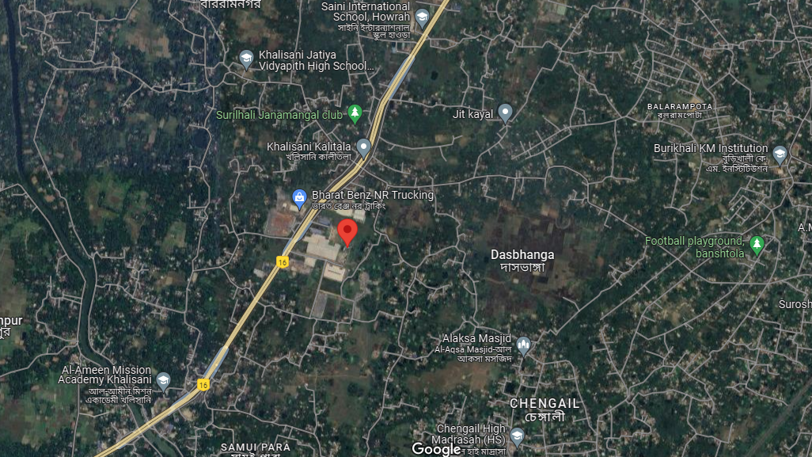 Source: Google map

- SCOPE OF WORK DURING PROJECT DURATION:
- To periodically check Project implementation status as mentioned in TEV Report and in major Project contracts.
- To periodically check Project Progress on site and achievement of various milestones as mentioned in TEV Report and comment accordingly.
- To check whether Project expenditure is in line to the work.
- Review status of Statutory Licenses, NOC’s and approvals.

Note:
- The scope of work is for the complete duration up to the completion of the project and not for a specific report.
- Carrying out the scope of work is subject to the details/ information/ data provided to us by the borrower from time to time.
- Report is considered for assessment of the work done and the cost incurred on the site.
- Amount incurred is referred from the details provided by the customer further corroborated from CA Certificate.

- PURPOSE OF THE REPORT: To provide fair detailed analysis report to the Bank based on the “in-scope points” mentioned above to inform the Bank on Project progress.

- METHODOLOGY ADOPTED:
- Gather information/ data/ documents related to the Project. Additional information, data, documents collection from the borrower.
- Site Inspection.
- Review and analysis of the documents and information obtained from the borrower and corroborating it with the site inspection status.
- Information compilation, analysis and reporting.

PART C | INFRASTRUCTURE DETAILS OF THE PROJECT

- LAND: The manufacturing unit is constructed on 1.21 acres/ 4897.060 sq. mtr. of land and is secured by a permanent boundary wall of about 10 ft. height. The expense of purchasing the land was not included in the project cost, hence is not included in our assessment.
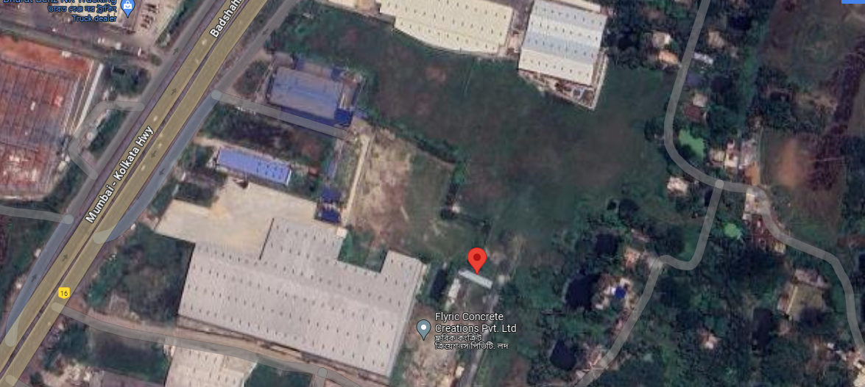

- BUILDING & CIVIL WORKS: The total built up area of the three storied Industrial building as per the map provided to us is 6,370.127 sq. mtr. as shown in the table below:

Sl. No | Particulars of Block A | Structure Type | Built up area ( sq. ft.)
 | Proposed Ground floor area | RCC | 2093.904
 | Proposed 1st floor area | RCC | 2093.904
 | Proposed 2nd floor area | RCC | 2093.904
 | Proposed stair head area | RCC | 88.415
 | TOTAL |  | 6370.127
Source: As per TEV Report

The total estimated cost for civil construction is Rs.13.26 Crore. GGPL has appointed Mr. Sabyasachi Patra as Structural Engineer, DJ Consultants as Architects and M/s Raj Construction as main contractor for the construction of the building.

LAYOUT PLAN OF THE BUILDING

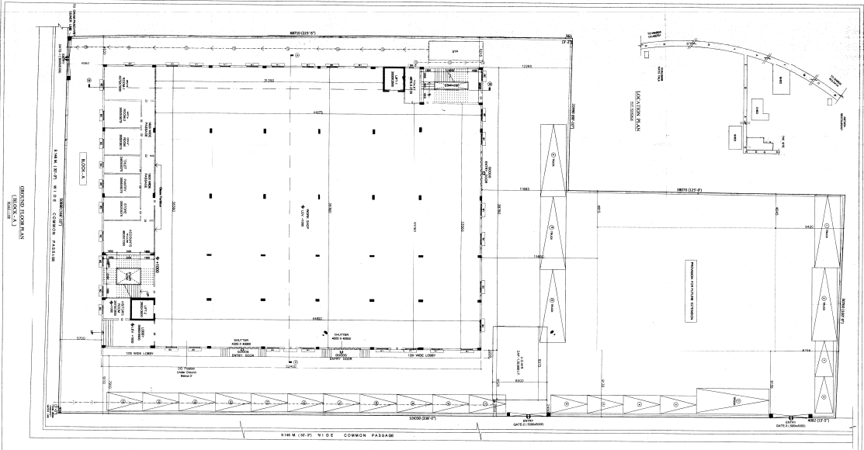

- MACHINERY AND EQUIPMENT: For the project work related to Plant & Machinery, the company has appointed M/S. Shri Sidhi Technical Services as a technical consultant for Commissioning of the machines. The list of vendors providing specific machines and estimated cost of the machines are also shown in the table below:
Sl. No. |  | Particulars | Name of the Vendor | Qty. | Price Per Unit in Rs. | Total Estimated Cost in Rs.
Machines for Paper Cup Manufacturing
1 |  | High Speed Paper Cup Machine  (GLI 1100) | --- | 4 | 11,80,000 | 47,20,000
2 |  | Paper Cup Machine (GLI 900) | --- | 4 | 8,80,000 | 35,20,000
3 |  | Paper Cup Machine (GLI 800) | --- | 17 | 7,60,000 | 1,29,20,000
Machines for Pulp Table Ware
4 |  | Pulp Molding Machine  (Imported) | Zhuhai Xing Yuan Development Co. | 1 | 7,29,60,209 | 7,29,60,209
5 |  | Pulping Station | Isotex Corporation Pvt. Ltd | 1 | 1,80,00,000 | 1,80,00,000
Printing Machine
6 | Flexo printing Machine |  | --- | 1 | 29,50,000 | 29,50,000
Paper Plate
7 | Paper Plate Machine (GLI 800) |  | --- | 1 | 8,00,000 | 8,00,000
Ripple Cup
8 | Ripple Paper Cup Machine |  | --- | 6 | 8,80,000 | 52,80,000
9 | Ripple Corrugation Machine |  | --- | 1 | 44,00,000 | 44,00,000
Double Wall Cup
10 | Double Wall Paper Cup |  | --- | 3 | 9,80,000 | 29,40,000
Plastic Container
11 | Injection Molding Machine |  | Weltech | 3. | 20,00,000 | 60,00,000
Paper Straw
12 | Paper Straw Machine |  | Sri Siddhi Technical Services | 1 | 31,00,000 | 31,00,000
Other Machineries
13 | Roll Die Cutting Machine |  | --- | 1 | 33,80,000 | 33,80,000
14 | Folder and Gluing Machine |  | --- | 2 | 8,80,000 | 17,60,000
15 | Slitting Machine |  | --- | 1 | 7,20,000 | 7,20,000
Source: As per TEV Report

PART D | PROJECT CONSULTANTS, CONTRACTORS & SUPPLIERS

According to the company representative and the details obtained from the work orders, following below are the contractors appointed for different works:

Sl. No. | Contractor / Suppliers name | Work Assigned
 | M/s Raj Construction | Civil Construction
 | Mr. Sabyasachi Patra | Structural Engineer
 | M/s DJ Consultants | Architects
 | M/S. Shri Sidhi Technical Services | Plant & Machinery Installation
 | M/s Haldia Petrochemicals Limited | Suppliers of plastic granules
 | Century Pulp & Paper (M/s. Century Textiles and Industries Limited) | Suppliers of Agro Pulp
 | M/s Yash Pakka Limited | Suppliers of Cup-stock Paper
 | M/s JK Paper Limited | Suppliers of Cup-stock and Coated Kraft Paper
 | M/s Kuantum Papers Limited | Suppliers of Straw Paper
Source: TEV Report and Invoices

PART E | PROJECT PROGRESS

- PROGRESS OF BUILDING & CIVIL WORKS:

TABLE 01

S.No. | Particulars | Foundation | Superstructure | Finishing | Overall Completion Percentage
 | Block A | - Pile Foundation work  100% completed  - Total 174 DMC pile each of 450 mm dia.  - Tie Beam works, Brick work above Tie Beam and plinth Beam Completed  - Raft Slab work on plinth Not started | - RCC framed structure  - Column work started | 0% | 10-15% work Completed
 | Drain | 100% completed | Work in progress | 0% | 50% work completed
 | UGWT outside Block A | 100% completed | 100% completed | 100% completed | 100% completed
 | Fire Pump Room | 0% | 0% | 0% | 0%
 | Zone for Boiler | 0% | 0% | 0% | 0%
 | Security Room | 0% | 0% | 0% | 0%
 | VCB Room | 0% | 0% | 0% | 0%
 | WBSC VCB Room | 0% | 0% | 0% | 0%
 | UG RCC Tank 1 inside Block A | 100% completed | - Form work completed  - Steel reinforcement work completed  - Concreting not done  - Top slab work pending | 0% | 60%
 | UG RCC Tank 2 inside Block A | 100% completed | - Form work completed  - Steel reinforcement work completed  - 50 % Concreting done  - Top slab work pending | 0% | 40%

Stage of Construction | Weightage
Sub structure construction up to Plinth level | 15%
Super structure | 40%
MEP Services | 17%
Finishing | 28%
Overall | 100%
Note: Above weightage is considered based on the Industrial structure referring standard construction breakup norms. Structure to structure it may vary based on its design. However, for the purpose of assessment we have considered the above standardisation.

Note:
- The physical progress captured in the above table is based on approximate observations of status of structures constructed on site during our site inspection and our subsequent discussions held with the engineers/ company representatives with whom the site visit was conducted and not based on measurements. Thus, the above percentages are shown only for the purpose of presenting general guidance on site progress instead of any quantity measurements and is on approximate basis which may vary from (+-) 5% to 10%.

- PROGRESS OF PLANT & MACHINERY:
- The company has not yet decided the vendors for majority of the machines except two viz., Zhuhai Xing Yuan Development Co. and Isotex Corporation Pvt. Ltd.
- Advances have been paid to both the vendors as per the details shared by the company.
- No machine/ equipment has arrived on the site yet.

- PROGRESS REPORT OF PLANT MACHINERY & EQUIPMENT:

TABLE 02
Sl. No. | Name of machine | Quantity | Machine arrived at site | Machine installation | Testing | Production | Advance amount paid in Rs.
 | High Speed Paper Cup Machine | 4 |  |  |  |  | ---
 | Paper Cup Machine GLI 900 | 4 |  |  |  |  | ---
 | Paper Cup Machine GLI 800 | 17 |  |  |  |  | ---
 | Pulp Moulding Machine | 6 |  |  |  |  | 1,45,72,202
 | Pulping Station | 1 |  |  |  |  | 12,88,400
 | Flexo printing Machine | 1 |  |  |  |  | ---
 | Paper Plate Machine (GLI 800) | 1 |  |  |  |  | ---
 | Ripple Paper Cup Machine | 6 |  |  |  |  | ---
 | Ripple Corrugation Machine | 1 |  |  |  |  | ---
 | Double Wall Paper Cup | 3 |  |  |  |  | ---
 | Injection Moulding Machine | 3 |  |  |  |  | ---
 | Paper Straw Machine | 1 |  |  |  |  | ---
 | Roll Die Cutting Machine | 1 |  |  |  |  | ---
 | Folder and Gluing Machine | 2 |  |  |  |  | ---
 | Slitting Machine | 1 |  |  |  |  | ---
PART F | PROJECT COST, MEANS OF FINANCE AND COST INCURRED TILL DATE

- TOTAL PROJECT COST: The estimated cost of the project is 37.84.Crore. Breakage of the amount has been shown in tabular and graphical form below: All amount in crores
S.No. | Particulars | Amount | Current Status  (As per Company/ CA)
 | Land Cost (free hold) | 0.00 | -----
 | Site Development Cost | 0.00 | -----
 | Civil Construction | 13.26 | 2.95
 | Plant and Machinery | 18.01 | 1.59
 | Electrical Installation | 1.3 | ----
 | Miscellaneous Fixed Assets | 0.55 | ----
 | Contingencies | 0.70 | ----
 | Pre-operative Expenses | 1.98 | 0.61
 | Margin for working capital | 1.95 | ----
 | Margin money for non-fund-based Limit (BG of Rs. 35 lacks * 25%) | 0.09 | ----
 | Total | 37.84 | 5.15
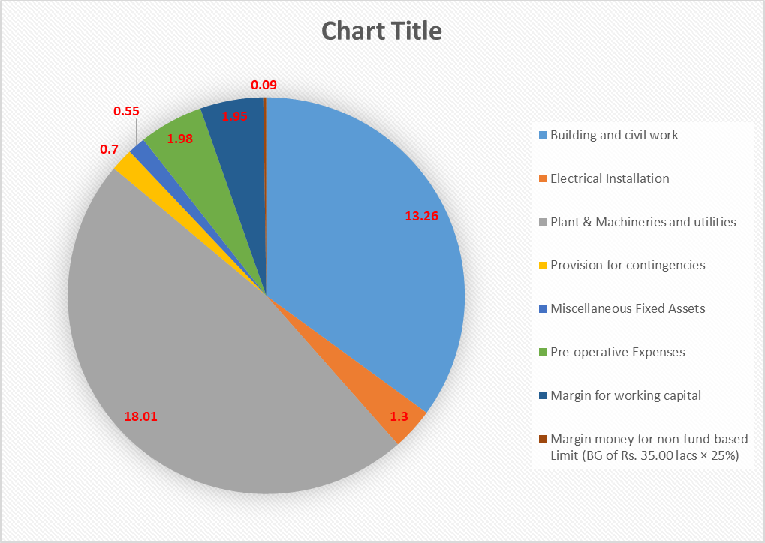`
- MEANS OF FINANCE: The Project cost has been proposed to be financed with following capital structure:
Sl. No. | Means of Finance | Amount  (In Rs. in Cr.) | Amount as on 31/03/24  (In Rs. In Cr.)
 | Promoter’s contribution by way of Partners' Capital | 7.00 | 1.85
 | Promoter’s contribution by way of Unsecured Loan | 6.84 | 4.28
 | Term Loan from Banks | 24.00 | 1.34
 | Total Cost | 37.84 | 7.47
- COST INCURRED TILL DATE: M/s Sumit Kumar Shaw, Chartered Accountants, Office 46/6, Banerjee Road, Kolkata, has issued a certificate dated 9.04.2024 with UDIN No. 24300981BKFNQD9753 for quarter ending 31st March, 2024 in respect to the expenditure made. The total expenditure incurred as per the details obtained from survey conducted on 05th of June 2024 is shown in the table below:

Table No. 3
Sr. No. | Particulars | Total Estimated  Cost in Cr. as per GGPL | Cost Incurred till 31.03.2024 as per GGPL | Remarks
 | Building Construction | 13.26 | 2,94,65,000 | - Presently only Pile foundation is completed and Raft foundation, Underground Tank work is in advance stage.  - Cost assessment of each is done independently.  - As per our assessment also around Rs. 2,68,47,146  Cost is spent. Refer to the Table No. 4, 7, 8, 9, 10, 11 on pg.nos 18, 20, 21 below for independent cost assessment.  - Client has submitted the Invoices/ Bills amounting of Rs.2,23,19,262 in relation to the said work which includes material & contractor invoices.  - Cost in Building include Material charges, labour charges and other miscellaneous expenses involved in the construction.  - The cost estimated by R.K is based on the current market rate and rate proposed by the Central Public works Department.  - The cost may vary depending up on the material cost and labour charges in the prevailing location and construction percentage adopted by us.  - As per CA Certificate value of material lying at site might be also included and this why some difference can be there between our assessment and CA.
 | Plant & Machineries and utilities | 18.01 | 1,58,60,602 | - No plant and machineries or equipment have been installed yet. Details of the proposed machinery are attached in Table 02 on pg. no. 15.  - Company has informed to have spent Rs. 1,58,60,602 paid as advances for the procurement of 2 machines. Please refer Table No. 5 pg.no 18 below for the same.  - Amount is referred from the invoices provided to us by the company. Refer Enclosure 1 in pg. no. 29.
 | Electrical Installation | --- | --- | - No work started yet.
 | Miscellaneous Fixed Assets | --- | --- | - No cost incurred yet.
 | Contingencies | --- | --- | - No cost incurred yet.
 | Pre-operative Expenses | --- | 61,45,000 | - Breakup of Pre-operative expenses Incurred by GGPL is shown in detail in Table 06 on pg.no 18 below.  - Since most of the expenses are of the nature of soft cost, therefore CA certificate is considered for the same.
 | TOTAL | --- | ₹ 5,14,70,602

TABLE 04
Total Construction Cost
Sl. No. | Particulars | Amount Incurred in Rs. | Table Reference
1 | Pile foundation including testing | ₹ 1,45,88,128 | Table 5 and 6
2 | Raft Foundation | ₹ 1,09,32,718 | Table 8
3 | UG Water Tank Construction | ₹ 13,26,300 | Table 9
Total |  | ₹ 2,68,47,146/-
5
TABLE 05
Cost incurred for Plant & Machineries
Sl. No. | Particulars | Invoice Number | Amount Incurred in Rs.
1 | Pulping Station.  Manufactured by  Isotex Corporation Pvt. Ltd | IC/G1P1/MC/2024  Dated 3/11/2023 | 12,88,400.00
2 | Pulp Moulding Machine  Manufactured by  Zhuhai Xing Yuan Development Co. | PI No.NYPA231227-04  Dated 27/12/2023  (Being 20% of the total amount) | 1,45,72,202
Total |  | ₹ 1,58,60,602

TABLE 06
Pre-operative expenses Incurred by GGPL
Sr. No. | Particulars | Total Estimated  Cost in Cr. as per GGPL | Cost Incurred till 31.03.2024 as per GGPL | Cost Estimated  as per R.K  As per survey dated 31.03.2024 | Remarks
 | Pollution fees | -- | 4,30,000 | 4,30,000 | - Amount referred from the invoice provided.  Refer Enclosure 1 in pg. no: 29.
 | Building Sanction Fees | -- | 6,50,000 | 6,50,000 | - Amount referred from the invoice provided.  Refer Enclosure 1 in pg. no: 29.
 | Fire Service Bill | -- | 1,25,000 | 1,25,000 | - Amount Calculated from the bills provided to us dated 02/06/2023.  - Refer Enclosure 1 in pg. no: 29
 | Electricity Expenses | -- | 1,25,000 | 1,26,782 | - Amount Calculated from the Electricity bills provided to us from 1/04/2023 to 31/03/2024  Refer Enclosure 1 in pg. no: 29
 | Employee Benefit Expense | -- | 3,000 | -- | Out of scope of LIE assessment. Refer CA Certificate.
 | Property Registration and stamp duty fees | -- | 5,01,000 | 5,01,138 | - Amount Calculated from the invoices provided.  Refer Enclosure 1 in pg. no: 29
 | NOC charges | -- | 3,72,000 | -- | Out of scope of LIE assessment. Refer CA Certificate.
 | Staff welfare Expenses | -- | 21,000 | -- | Out of scope of LIE assessment. Refer CA Certificate.
 | Bank Charges | -- | 6,000 | -- | Out of scope of LIE assessment. Refer CA Certificate.
 | General expenses | -- | 59,000 | -- | Out of scope of LIE assessment. Refer CA Certificate.
 | Interest on Loan | -- | 20,54,000 | -- | Out of scope of LIE assessment. Refer CA Certificate.
 | Insurance Premium | -- | 1,69,000 | 1,69,000 | - Amount Calculated from the invoices provided.  Refer Enclosure 1 in pg. no: 29
 | Legal Expenses | -- | 67,000 | -- | Out of scope of LIE assessment. Refer CA Certificate.
 | Security Charges | -- | 1,17,000 | -- | Out of scope of LIE assessment. Refer CA Certificate.
 | Printing and stationary | -- | 2,000 | -- | Out of scope of LIE assessment. Refer CA Certificate.
 | Rates and Taxes | -- | 2,000 | -- | Out of scope of LIE assessment. Refer CA Certificate.
 | Travelling and conveyance | -- | 61,000 | -- | Out of scope of LIE assessment. Refer CA Certificate.
 | Business Promotion | -- | 1,77,000 | -- | Out of scope of LIE assessment. Refer CA Certificate.
 | Audit Fees | -- | 15,000 | -- | Out of scope of LIE assessment. Refer CA Certificate.
 | Professional fees | -- | 11,07,000 | 9,81,828 | - Amount Calculated from the invoices provided.  - Refer Enclosure 1 in pg. no: 29
 | Brokerage | -- | 58,000 | -- | Out of scope of LIE assessment. Refer CA Certificate.
 | Salary |  | 19,000 | -- | Out of scope of LIE assessment. Refer CA Certificate.
 | Filing Fee |  | 5,000 | -- | Out of scope of LIE assessment. Refer CA Certificate.
Total |  |  | ₹ 61,45,000 | ₹ 29,83,748

PART G | COST ASSESSMENT OF INDUSTRIAL BUILDING
TABLE 07
Block Name | Particulars | Length of pile | Quantity | Rate in Rs. | Amount in Rs.
BLOCK A | Pile Foundation | 18.5 m | 174 | 83,148 | ₹ 1,44,67,768

TABLE 08
Rate for Pile testing
Block Name | Particulars | Unit | Quantity | Rate | Amount in Rs.
BLOCK A | Vertical load test | Nos. | L/S | L/S | ₹1,20,360
Considered as per the invoices provided to us.

TABLE 09
Total Built-up construction cost analysis
Sr. No. | Particulars | Height  (in m) | Type of Structure | Built-up area (in sq. mtr) | Built-up area  (in sq. ft) | Plinth Area Rate  (INR per sq. ft) | Gross Replacement Value  (INR)
 | GF | 6.1 | RCC framed structure | 2,093.904 | 22,539 | 1500 | ₹ 3,38,08,500.00
 | FF | 4 | RCC framed structure | 2,093.904 | 22,539 | 1250 | ₹ 2,81,73,750.00
 | SF | 4 | RCC framed structure | 2,093.904 | 22,539 | 1250 | ₹ 2,81,73,750.00
 | Stair Head | 14.3 | RCC framed structure | 88.415 | 952 | 1000 | ₹ 9,52,000.00
Total |  |  |  | 6,370.127 | 68,567 |  | ₹ 9,11,08,000.00

Note: The construction of Built-up unit has not started yet. The above is calculated only to take reference for the calculation of cost of raft foundation, which is ~15 – 18% of built-up cost as thumb rule.

TABLE 10
Sr. No. | Particulars | Type of Structure | Unit | Quantity | Rate | Gross Replacement Value (INR)
1 | Raft foundation | RCC + Brick work | Sq. ft. | 22,539 | 12% of total of Table 07 | ₹1,09,32,718/-
Note: The cost of raft foundation is calculated on Lump sum basis. 14% of the total construction cost of the building is considered as cost incurred for raft foundation as per current status of the work.

TABLE 11
Particulars | Number of Tanks | Type of construction | Capacity in litre | Unit | Rate per L | Amount in Rs.
UG RCC Water Tank 1 | 1 | RCC | 90,000 | Liters | 4.5 | ₹ 6,30,000
UG RCC Water Tank 2 | 1 | RCC | 90,000 | Liters | 3 | ₹ 6,30,000
RCC Water Tank Outside Block A | 1 | RCC | 1,00,200 | Liters | 6.5 | ₹ 8,01,600
Total |  |  |  |  |  | ₹ 13,26,300

Note
- Above cost estimation is done based on plinth area rates as per status of construction in each building and floor.

Observation & Comments:

- The sub structure work is almost completed and super structure work is in progress.
- The sub structure work like pile foundations, foundation testing, Raft foundation, Tie beam, Brick work, Plinth beam, outside water tank are completed and UG water tank construction is under process.
- The super structure work of the building such as casting of columns is in progress.

PART H | STATUTORY & REGULATORY APPROVALS, CLEARANCES & NOC

Sr. No. | Name of License/ Registration | Date of Issue | Current Status
Sr. No. | Issuing Authority | License No. | Current Status
 | Sanctioned Building Plan of the Factory Building | Dated 03/08/2023 | Approval obtained
 | District Engineer Howrah Zilla Parishad | Memo no: 135/032/H2P/PS | Approval obtained
 | Consent to Establish from Pollution Control Board, West Bengal | Dated 21/03/2024 | Approval obtained
 | West Bengal pollution Control Board | CTE Number WBPCB 3681054/2023 | Approval obtained
 | N.O.C/ Fire safety certificate from the Government of West Bengal | Dated 02/06/2023 | Approval obtained
 | Govt. of West Bengal Fire Services | Memo No: FSR/0225186231300278
 | Factory Licence from Chief Inspector of Factories | ---- | Approval yet to be obtained
 | The Directorate of Factories- Govt. of West Bengal | ---- | Approval yet to be obtained
 | Power connection from WBSEDCL | Consumer number 103261484 | Temporary power connection for Building construction obtained
 | West Bengal State Electricity Distribution Company Ltd | Consumer number 103261484
 | Registration under MSME Scheme | Dated 08/08/2023 | Approval obtained
 | Udyam Registration certificate from Govt. of India | UDYAM WB-08-0043143 | Approval obtained
 | Registration under Goods and Services Tax (GST) | 19AAYFG0176D | Approval obtained
 | Registration under Goods and Services Tax (GST) | Dated 14/01/2023 | Approval obtained

PART I | PROJECT SCHEDULE & CURRENT STATUS

S. No. | Particular | Commencement | Estimated Completion | Current status of the Project`
 | Building and Civil Works | January, 2023 | January, 2025 | - Sub structure works of Block A completed  - Super structure work in Progress
 | Placement of orders for Plant & Machineries and Utilities | May, 2023 | December, 2023 | - Order placement and advance payment for two machines completed  - Order placement for thirteen machines are still pending
 | Delivery of Equipment | August, 2023 | January, 2025 | - No equipment have been delivered till date of the report
 | Arrangement of raw materials | November, 2024 | February, 2025 | - Some vendors have been short listed for supply of raw materials  - The company has not started any commercial operation
 | Trial runs | March, 2025 |  | - The company might be starting the trial runs after successfully installing the machine on March, 2025
 | Commercial production | April, 2025 |  | - The company might start the commercial production after successful trial runs on April, 2025

Observations: During the site visit, it was observed that the construction work of the project is delayed by approx. two months, in reference with the project schedule. As informed by the company’s representative the delay is due to the labor un-availability in the summer season due to excessive heat waves.
PART J | DISCLAIMER

      - No employee or member of R.K Associates has any direct/ indirect interest in the Project.
      - This report is prepared based on the copies of the documents/ information which the Bank/ Borrower has provided to us out of the standard checklist of documents sought from them and further based on our assumptions and limiting conditions. The client/owner and its management/representatives warranted to us that the information they supplied was complete, accurate and true and correct to the best of their knowledge. All such information provided to us has been relied upon in good faith and we have assumed that it is true and correct in all respect. I/We shall not be liable for any loss, damages, cost or expenses arising from fraudulent acts, misrepresentations, or wilful default on part of the owner, borrower, its directors, employee, representative or agents. Verification or cross checking of the documents provided to us from the originals or from any Govt. departments/ Record of Registrar has not been done at our end since this is beyond the scope of our work. If at any time in future, it is found or came to our knowledge that misrepresentation of facts or incomplete or distorted information has been provided to us then this report shall automatically become null & void.
      - Legal aspects for eg. investigation of title, ownership rights, lien, charge, mortgage, lease, sanctioned maps, verification of documents, etc. have not been done at our end and same has to be taken care by legal expert/ Advocate. It is assumed that the concerned Lender/ Financial Institution has satisfied them with the authenticity of the documents, information given to us and for which the legal verification has been already taken and cleared by the competent Advocate before requesting for this report. I/ We assume no responsibility for the legal matters including, but not limited to, legal or title concerns.
      - This report is a general analysis of the project based on the scope mentioned in the report. This is not an Audit report, Design document, DPR or Techno feasibility study. All the information gathered is based on the facts seen on the site during survey for the quarter ending March 2024, verbal discussion & documentary evidence provided by the client and is believed that information given by the borrower is true best of their knowledge.
      - All observations mentioned in the report is only based on the visual observation and the documents/ data/ information provided by the client. No mechanical/ technical tests, measurements or any design review have been performed or carried out from our side during Project assessment.
      - Bank/FII should ONLY take this report as an Advisory document from the Financial/ Chartered Engineering firm and its specifically advisory to the creditor to cross verify the original documents for the facts mentioned in the report which can be availed from the borrowing borrower directly.
      - In case of any default in loans or the credit facility extended to the borrowing borrower, R.K Associates shall not be held responsible for whatsoever reason may be and any request for seeking any explanation from the employee/s of R.K Associates will not be entertained at any instance or situation.
      - The documents, information, data provided to us during the course of this assessment by the client is reviewed only upto the extent required in relation to the scope of the work. No document has been reviewed beyond the scope of the work.
      - This report only contains general assessment & opinion as per the scope of work evaluated as per the information given in the copy of documents, information, data provided to us and/ and confirmed by the owner/ owner representative to us at site which has been relied upon in good faith. It doesn’t contain any other recommendations of any sort including but not limited to express of any opinion on the suitability or otherwise of entering into any transaction with the borrower.
      - We have relied on data from third party, external sources & information available on public domain also to conclude this report. These sources are believed to be reliable and therefore, we assume no liability for the truth or accuracy of any data, opinions or estimates furnished by others that have been used in this analysis. Where we have relied on data, opinions or estimates from external sources, reasonable care has been taken to ensure that such data has been correctly extracted from those sources and /or reproduced in its proper form and context, however still we can’t vouch its authenticity, correctness or accuracy.
      - Any amount shown to have incurred in the report is considered from the Bills/ Invoices produced to us. However this shall not be construed as confirmation of actual transaction with the respective parties which is out of scope of this report.
      - This Report is prepared by our competent technical team which includes Engineers and financial experts & analysts.
      - This is just an opinion report and doesn’t hold any binding on anyone. It is requested from the concerned Financial Institution which is using this report for taking financial decision on the project that they should consider all the different associated relevant & related factors also before taking any business decision based on the content of this report.
      - All Pages of the report including annexures are signed and stamped from our office. In case any paper in the report is without stamp & signature then this should not be considered a valid paper issued from this office.
      - Though adequate care has been taken while preparing this report as per its scope, but still we can’t rule out typing, human errors, over sightedness of any information or any other mistakes. Therefore, the concerned organization is advised to satisfy themselves that the report is complete & satisfactory in all respect. Intimation regarding any discrepancy shall be brought into our notice immediately. If no intimation is received within 15 (Fifteen) days in writing from the date of issuance of the report, to rectify these timely, then it shall be considered that the report is complete in all respect and has been accepted by the client up to their satisfaction & use and further to which R.K Associates shall not be held responsible in any manner.
      - Defect Liability Period is 15 DAYS. We request the concerned authorized reader of this report to check the contents, data and calculations in the report within this period and intimate us in writing if any corrections are required or in case of any other concern with the contents or opinion mentioned in the report. Corrections only related to typographical, calculation, spelling mistakes, incorrect data/ figures/ statement will be entertained within the defect liability period. Any new changes for any additional information in already approved report will be regarded as additional work for which additional fees may be charged. No request for any illegitimate change in regard to any facts & figures will be entertained.
      - R.K Associates encourages its customers to give feedback or inform concerns over its services through proper channel at valuers@rkassociates.org in writing within 15 days of report delivery. After this period no concern/ complaint/ proceedings in connection with the Financial Feasibility Study Services will be entertained due to possible change in situation and condition of the subject Project.
      - Our Data retention policy is of ONE YEAR. After this period, we remove all the concerned records related to the assignment from our repository. No clarification or query can be answered after this period due to unavailability of the data.
      - This Lender’s Independent Engineer report is governed by our (1) Internal Policies, Processes & Standard Operating Procedures, (2) Information/ Data/ Inputs given to us by the client and (3) Information/ Data/ Facts given to us by our field/ office technical team. Management of R.K Associates never gives acceptance to any unethical or unprofessional practice which may affect fair, correct & impartial assessment and which is against any prevailing law. In case of any indication of any negligence, default, incorrect, misleading, misrepresentation or distortion of facts in the report then it is the responsibility of the user of this report to immediately or at least within the defect liability period bring all such act into notice of R.K Associates management so that corrective measures can be taken instantly.
      - R.K Associates never releases any report doing alterations or modifications from pen. In case any information/ figure of this report is found altered with pen then this report will automatically become null & void.

FOR R.K. ASSOCIATES VALUERS AND TECHNO ENGINEERING CONSULTANTS PVT. LTD.
SURVEY ANALYST | ENGINEERING ANALYST | REVIEWER
Rajat Choudhary | Ashil Baby | Sr. VP Projects

Place: Noida

Date: 26th June 2024

DEFECT LIABILITY PERIOD - In case of any query/ issue or escalation you may please contact Incident Manager by writing at valuers@rkassociates.org. We ensure 100% accuracy in the Calculations done, Rates adopted and various other data points & information mentioned in the report but still can’t rule out typing, human errors or any other mistakes. In case you find any mistake, variation, discrepancy or inaccuracy in any data point of the report, please help us by bringing all such points into our notice in writing at valuers@rkassociates.org within 30 days of the report delivery, to get these rectified timely, failing which R.K Associates Valuers Techno Engineering Consultants (P) Ltd. won’t be held responsible for any inaccuracy in any manner. Also, if we will not hear back anything from you within 30 days, we will assume that report is correct in all respect and no further claim of any sort will be entertained thereafter. We would welcome and appreciate your feedback & suggestions in order to improve our services.

COPYRIGHT FORMAT - This report is prepared on the copyright format of R.K Associates Valuers Techno Engineering Consultants (P) Ltd. to serve our clients in the best possible way. Legally no one can copy or distribute this format without prior approval from R.K Associates. It is meant only for the organization as mentioned on the cover page of this report. Distribution or use of this format other than R.K Associates will be seen as unlawful act and necessary legal action can be taken against the defaulter

PART K | ENCLOSURE 1: DETAILS OF INVOICES

Sl. No | Vendors Name | Type Of work | Invoice Number | Cost Incurred/ Bills Paid
 | Poddar Builders | Purchase of PCC Cement | A005372 | 48,000.00
 | Adhikary Enterprises | Purchase of PCC Cement | AE/04447/23-24 | 6,300.00
 | Rashmi Cement | Purchase of PCC Cement | 7052230117960 | 1,10,400.00
 | Poddar Builders | Purchase of PCC Cement | A005362 | 37,000.00
 | Poddar Builders | Purchase of PCC Cement | A005363 | 37,000.00
 | Poddar Builders | Purchase of PCC Cement | A005365 | 37,000.00
 | Poddar Builders | Purchase of PCC Cement | A005366 | 48,000.00
 | Poddar Builders | Purchase of PCC Cement | A005367 | 48,000.00
 | Poddar Builders | Purchase of PCC Cement | A005368 | 48,000.00
 | Poddar Builders | Purchase of PCC Cement | A005370 | 48,000.00
 | Poddar Builders | Purchase of PCC Cement | A005371 | 48,000.00
 | Poddar Builders | Purchase of PCC Cement | A005373 | 48,000.00
 | Poddar Builders | Purchase of PCC Cement | A005374 | 48,000.00
 | Poddar Builders | Purchase of PCC Cement | A005375 | 48,000.00
 | Poddar Builders | Purchase of PCC Cement | A005376 | 32,000.00
 | Poddar Builders | Purchase of PCC Cement | A005377 | 36,850.00
 | Poddar Builders | Purchase of PCC Cement | A005378 | 36,850.00
 | Poddar Builders | Purchase of PCC Cement | A005417 | 49,600.00
 | Poddar Builders | Purchase of PCC Cement | A005418 | 49,600.00
 | Poddar Builders | Purchase of PCC Cement | A0035364 | 37,000.00
 | Poddar Builders | Purchase of PCC Cement | A3005361 | 37,000.00
 | Poddar Builders | Purchase of PCC Cement | AA005369 | 48,000.00
 | Hitech Concrete Co. | Purchase of RMC | HCC/HWH/01693 | 50,799.00
 | Hitech Concrete Co. | Purchase of RMC | HCC/HWH/01697 | 43,542.00
 | Hitech Concrete Co. | Purchase of RMC | HCC/HWH/0519 | 43,542.00
 | Hitech Concrete Co. | Purchase of RMC | HCC/HWH/01422 | 47,171.00
 | Hitech Concrete Co. | Purchase of RMC | HCC/HWH/01423 | 47,171.00
 | Hitech Concrete Co. | Purchase of RMC | HCC/HWH/01427 | 43,542.00
 | Hitech Concrete Co. | Purchase of RMC | HCC/HWH/01439 | 43,542.00
 | Hitech Concrete Co. | Purchase of RMC | HCC/HWH/01443 | 47,170.00
 | Hitech Concrete Co. | Purchase of RMC | HCC/HWH/01445 | 43,542.00
 | Hitech Concrete Co. | Purchase of RMC | HCC/HWH/01478 | 43,542.00
 | Hitech Concrete Co. | Purchase of RMC | HCC/HWH/01521 | 43,542.00
 | Hitech Concrete Co. | Purchase of RMC | HCC/HWH/01523 | 29,028.00
 | Hitech Concrete Co. | Purchase of RMC | HCC/HWH/01542 | 21,771.00
 | Hitech Concrete Co. | Purchase of RMC | HCC/HWH/ 01551 | 29,028.00
 | Hitech Concrete Co. | Purchase of RMC | HCC/HWH/01691 | 50,799.00
 | Hitech Concrete Co. | Purchase of RMC | HCC/HWH/01692 | 50,799.00
 | Hitech Concrete Co. | Purchase of RMC | HCC/HWH/01732 | 21,771.00
 | Hitech Concrete Co. | Purchase of RMC | HCC/HWH/01969 | 25,400.00
 | Hitech Concrete Co. | Purchase of RMC | HCC/HWH/ 02123 | 32,657.00
 | Hitech Concrete Co. | Purchase of RMC | HCC/HWH/09614 | 47,170.00
 | Laskar Builders | Purchase of Steel | LB/23-24/0276 | 6,80,246.00
 | Laskar Builders | Purchase of Steel | LB/23-24/0277 | 8,19,763.00
 | Arihant Benchmark Projects Pvt Ltd | Purchase of Steel | ABPPL/192/23-24 | 5,47,067.00
 | Sujit Steel Udyog | Purchase of Steel | SSU/248/23-24 | 18,50,871.00
 | Arihant Benchmark Projects Pvt Ltd | Purchase of Steel | ABPPL/269/23-24 | 8,38,500.00
 | Adhikary Enterprises | Purchase of Steel | AE/04295/23-24 | 6,300.00
 | Kapoor Chand Jaiswal | Purchase of Steel | T/036/23-24 | 10,00,139.00
 | HMB Ispayt Pvt Ltd. | Purchase of MS Steel Tube | H2M24/12570 | 5,93,089.24
 | HMB Ispayt Pvt Ltd. | Purchase of MS Steel Tube | H2M24/12608 | 9,16,076.00
 | HMB Ispayt Pvt Ltd. | Purchase of MS Steel Tube | H2M24/12695 | 5,00,615.00
 | Raj Construction | Pile Testing | GST/24/2023-24  Dated 14/09/2023 | 1,20,360.00
 | Raj Construction | Labour Charge Bill | GST/24/2023-24 | 18,85,864.00
 | Arihant Benchmark Project Pvt. Ltd | Purchase of Steel Bars | ABPPL/80/22-23 | 8,36,234.00
 | Arihant Benchmark Project Pvt. Ltd | Purchase of Steel Bars | ABPPL/180/22-23 | 21,80,704.00
 | Arihant Iron and Steel Product Pvt. Ltd | Purchase of Steel Bars | AISPPL/267/22-23 | 9,88,092
 | Arihant Iron and Steel Product Pvt. Ltd | Purchase of Steel Bars | AISPPL/277/22-23 | 10,75,722
 | Geocon | Geotechnical Investigation | 34/2022-2023 | 79,502.00
 | Hitech Concrete Co. | Purchase of RMC | HCC/HW/975 | 23,975
 | Hitech Concrete Co. | Purchase of RMC | HCC/HW/976 | 47,950
 | Hitech Concrete Co. | Purchase of RMC | HCC/HW/984 | 47,950
 | Hitech Concrete Co. | Purchase of RMC | HCC/HW/985 | 47,950
 | Hitech Concrete Co. | Purchase of RMC | HCC/HW/988 | 23,975
 | Hitech Concrete Co. | Purchase of RMC | HCC/HW/996 | 47,950
 | Hitech Concrete Co. | Purchase of RMC | HCC/HW/966 | 47,950
 | Hitech Concrete Co. | Purchase of RMC | HCC/HW/1001 | 47,950
 | Hitech Concrete Co. | Purchase of RMC | HCC/HW/1004 | 47,950
 | Hitech Concrete Co. | Purchase of RMC | HCC/HW/1005 | 47,950
 | Hitech Concrete Co. | Purchase of RMC | HCC/HW/1006 | 47,950
 | Hitech Concrete Co. | Purchase of RMC | HCC/HW/1007 | 47,950
 | Hitech Concrete Co. | Purchase of RMC | HCC/HW/1008 | 47,950
 | Hitech Concrete Co. | Purchase of RMC | HCC/HW/1009 | 47,950
 | Hitech Concrete Co. | Purchase of RMC | HCC/HW/1010 | 23,975
 | Hitech Concrete Co. | Purchase of RMC | HCC/HW/1011 | 23,975
 | Hitech Concrete Co. | Purchase of RMC | HCC/HW/1013 | 23,975
 | Hitech Concrete Co. | Purchase of RMC | HCC/HW/1014 | 23,975
 | Hitech Concrete Co. | Purchase of RMC | HCC/HW/1016 | 23,975
 | Hitech Concrete Co. | Purchase of RMC | HCC/HW/1018 | 23,975
 | Hitech Concrete Co. | Purchase of RMC | HCC/HW/1020 | 47,950
 | Hitech Concrete Co. | Purchase of RMC | HCC/HW/10278 | 47,950
 | Hitech Concrete Co. | Purchase of RMC | HCC/HW/1029 | 47,950
 | Hitech Concrete Co. | Purchase of RMC | HCC/HW/1031 | 47,950
 | Hitech Concrete Co. | Purchase of RMC | HCC/HW/1036 | 23,975
 | Hitech Concrete Co. | Purchase of RMC | HCC/HW/1037 | 47,950
 | Hitech Concrete Co. | Purchase of RMC | HCC/HW/1039 | 47,950
 | Hitech Concrete Co. | Purchase of RMC | HCC/HW/1040 | 47,950
 | Hitech Concrete Co. | Purchase of RMC | HCC/HW/1041 | 47,950
 | Hitech Concrete Co. | Purchase of RMC | HCC/HW/1046 | 47,950
 | Hitech Concrete Co. | Purchase of RMC | HCC/HW/1048 | 47,950
 | Hitech Concrete Co. | Purchase of RMC | HCC/HW/1050 | 47,950
 | Hitech Concrete Co. | Purchase of RMC | HCC/HW/1052 | 47,950
 | Hitech Concrete Co. | Purchase of RMC | HCC/HW/1054 | 47,950
 | Hitech Concrete Co. | Purchase of RMC | HCC/HW/1056 | 23,975
 | Hitech Concrete Co. | Purchase of RMC | HCC/HW/1060 | 23,975
 | Hitech Concrete Co. | Purchase of RMC | HCC/HW/1061 | 47,950
 | Hitech Concrete Co. | Purchase of RMC | HCC/HW/1069 | 47,950
 | Hitech Concrete Co. | Purchase of RMC | HCC/HW/1071 | 47,950
 | Hitech Concrete Co. | Purchase of RMC | HCC/HW/1086 | 47,950
 | Hitech Concrete Co. | Purchase of RMC | HCC/HW/1087 | 47,950
 | Hitech Concrete Co. | Purchase of RMC | HCC/HW/1110 | 47,950
 | Hitech Concrete Co. | Purchase of RMC | HCC/HW/1113 | 47,950
 | Hitech Concrete Co. | Purchase of RMC | HCC/HW/1114 | 47,950
 | Hitech Concrete Co. | Purchase of RMC | HCC/HW/1115 | 47,950
 | Hitech Concrete Co. | Purchase of RMC | HCC/HW/1126 | 47,950
 | Hitech Concrete Co. | Purchase of RMC | HCC/HW/1131 | 47,950
 | Hitech Concrete Co. | Purchase of RMC | HCC/HW/1194 | 41,100
 | Hitech Concrete Co. | Purchase of RMC | HCC/HW/1255 | 47,950
 | Kailash Bathware Co. | Purchase of PVC Pipes | KBC1412 | 13,167
 | MAA Karunmoyee | purchase of Aggregate | Dated 26/08/2022 | 37,320
 | MAA Karunmoyee | purchase of Aggregate | Dated 14/09/2022 | 53,504
 | MAA Karunmoyee | purchase of Aggregate | Dated 20/08/2022 | 44,368
 | Surojit Labour Contractor | purchase of Aggregate | Dated 17/08/2022 | 40,000
 | Adhikary Enterprise | Purchase of cement | AE03482/23-24 | 32,700
 | Arihant Benchmark Project Pvt. Ltd | Purchase of Steel Bars | ABPPL/134/23-24 | 5,64,131
 | Arihant Benchmark Project Pvt. Ltd | Purchase of Steel Bars | ABPPL/134/23-24 | 5,49,125
 | Hitech Concrete Co. | Purchase of RMC | HCC/HWH/027 | 51,375
 | Hitech Concrete Co. | Purchase of RMC | HCC/HWH/028 | 47,950
 | Hitech Concrete Co. | Purchase of RMC | HCC/HWH/045 | 27,400
 | Hitech Concrete Co. | Purchase of RMC | HCC/HWH/01009 | 50,799
 | Hitech Concrete Co. | Purchase of RMC | HCC/HWH/01010 | 47,171
 | Hitech Concrete Co. | Purchase of RMC | HCC/HWH/01011 | 47,171
 | Hitech Concrete Co. | Purchase of RMC | HCC/HWH/01012 | 47,171
 | Hitech Concrete Co. | Purchase of RMC | HCC/HWH/01013 | 47,171
 | Hitech Concrete Co. | Purchase of RMC | HCC/HWH/01014 | 47,171
 | Hitech Concrete Co. | Purchase of RMC | HCC/HWH/01015 | 36,285
 | Hitech Concrete Co. | Purchase of RMC | HCC/HWH/01016 | 27,771
 | Hitech Concrete Co. | Purchase of RMC | HCC/HWH/01025 | 47,171
 | Hitech Concrete Co. | Purchase of RMC | HCC/HWH/01026 | 47,171
 | Hitech Concrete Co. | Purchase of RMC | HCC/HWH/01027 | 47,171
 | Hitech Concrete Co. | Purchase of RMC | HCC/HWH/01028 | 47,171
 | Hitech Concrete Co. | Purchase of RMC | HCC/HWH/01029 | 50,799
 | Hitech Concrete Co. | Purchase of RMC | HCC/HWH/01041 | 21,771
 | Hitech Concrete Co. | Purchase of RMC | HCC/HWH/01052 | 14,249
 | Hitech Concrete Co. | Purchase of RMC | HCC/HWH/01092 | 43,542
 | Hitech Concrete Co. | Purchase of RMC | HCC/HWH/01093 | 43,542
 | Hitech Concrete Co. | Purchase of RMC | HCC/HWH/01094 | 43,542
 | Hitech Concrete Co. | Purchase of RMC | HCC/HWH/01097 | 29,028
 | Hitech Concrete Co. | Purchase of RMC | HCC/HWH/01100 | 43,542
 | Hitech Concrete Co. | Purchase of RMC | HCC/HWH/01119 | 29,028
 | Hitech Concrete Co. | Purchase of RMC | HCC/HWH/01136 | 50,799
 | Hitech Concrete Co. | Purchase of RMC | HCC/HWH/01140 | 50,799
 | Hitech Concrete Co. | Purchase of RMC | HCC/HWH/01144 | 32,657
 | Hitech Concrete Co. | Purchase of RMC | HCC/HWH/01194 | 50,799
 | Hitech Concrete Co. | Purchase of RMC | HCC/HWH/01139 | 47,170
 | Hitech Concrete Co. | Purchase of RMC | HCC/HWH/01320 | 50,799
 | Hitech Concrete Co. | Purchase of RMC | HCC/HWH/01321 | 47,170
 | Hitech Concrete Co. | Purchase of RMC | HCC/HWH/01322 | 50,799
 | Hitech Concrete Co. | Purchase of RMC | HCC/HWH/01324 | 50,799
 | Hitech Concrete Co. | Purchase of RMC | HCC/HWH/01325 | 6,018
 | Hitech Concrete Co. | Purchase of RMC | HCC/HWH/01347 | 50,799
 | Hitech Concrete Co. | Purchase of RMC | HCC/HWH/01396 | 47,171
 | Hitech Concrete Co. | Purchase of RMC | HCC/HWH/01397 | 47,171
 | Hitech Concrete Co. | Purchase of RMC | HCC/HWH/01416 | 47,171
 | MAA Karunmoyee | Purchase of Aggregate | Dated 28/11/2023 | 42,000
 | Maa Tara Enterprise | Purchase of Cement | Dated 2/11/2023 | 17,000
 | National Electric Corporation | Purchase of Lights | 23-24/5038 | 42,244
 | Nazibur Rahman | Plumbing Charges | 238 | 23,850
 | Grap Reality | Purchase of PVC Pipes | GRPL/OH/001/12324 | 4,21,623
 | Adhikary Enterprise | Purchase of cement | AE03482/23-24 | 32,700
 | New Prahari Security Agency | Security Service | NSPA-23-24-176 | 45,107
 | New Prahari Security Agency | Security Service | NSPA-23-24-210 | 12,000
 | New Prahari Security Agency | Security Service | NSPA-23-24-298 | 12,000
 | New Prahari Security Agency | Security Service | NSPA-23-24-337 | 12,000
 | New Prahari Security Agency | Security Service | NSPA-23-24-432 | 12,000
 | New Prahari Security Agency | Security Service | NSPA-23-24-435 | 12,000
 | New Prahari Seccurity Agency | Security Service | NPSA/23-24/640 | 12,000.00
 | New Prahari Seccurity Agency | Security Service | NPSA/23-24/522 | 12,000.00
 | New Prahari Seccurity Agency | Security Service | NPSA/23-24/741 | 12,000.00
 | New Prahari Seccurity Agency | Security Service | NPSA/23-24/722 | 12,000.00
 | Sidharth Kumar Sharma | Brokerage Charges | 004-23-24 | 7,621
 | Sidharth Kumar Sharma | Brokerage Charges | 017-23-25 | 15,242
 | Sidharth Kumar Sharma | Brokerage Charges | 028-23-26 | 10,682
 | Sidharth Kumar Sharma | Brokerage Charges | 044-23-24 | 14,079
 | MNS | Professional Charges | MNSR/06353/23-24 | 6,608
 | MNS | Professional Charges | MNSR/06354/23-25 | 4,130
 | Legal Entity Identifier India Limited | Legal Fees | IRG-23-24-0004773 | 17,405
 | Govt: of West Bengal | Building Sanction fees | HU20K10U40 | 6,75,000.00
 | Pollution Control Board | Online fee payment receipt | 240109174188728 | 4,30,092.00
 | West Bengal State Electricity Distribution Company Ltd | Electricity Bill | 432015549394 | 11,042.00
 | West Bengal State Electricity Distribution Company Ltd | Electricity Bill | 454013159154 | 9,692.00
 | West Bengal State Electricity Distribution Company Ltd | Electricity Bill | 454013333782 | 10,196.00
 | Govt: of West Bengal | Fire Service Bill | 2730120231685430000 | 1,20,877.00
 | West Bengal State Electricity Distribution Company Ltd | Electricity Bill | 426015808513 | 13,552.00
 | West Bengal State Electricity Distribution Company Ltd | Electricity Bill | Dated 27/05/2023 | 4,406.00
 | West Bengal State Electricity Distribution Company Ltd | Electricity Bill | Dated 27/04/2023 | 5,212.00
 | West Bengal State Electricity Distribution Company Ltd | Electricity Bill | Dated 31/11/2022 | 4,496.00
 | West Bengal State Electricity Distribution Company Ltd | Electricity Bill | Dated 28/12/2023 | 7,863.00
 | West Bengal State Electricity Distribution Company Ltd | Electricity Bill | Dated 31/08/2023 | 3,712.00
 | West Bengal State Electricity Distribution Company Ltd | Electricity Bill | Dated 28/10/2023 | 13,519.00
 | West Bengal State Electricity Distribution Company Ltd | Electricity Bill | Dated 28/12/2023 | 14,271.00
 | West Bengal State Electricity Distribution Company Ltd | Electricity Bill | Dated 29/09/2023 | 9,803.00
 | West Bengal State Electricity Distribution Company Ltd | Electricity Bill | Dated 28/07/2023 | 9,459.00
 | West Bengal State Electricity Distribution Company Ltd | Electricity Bill | Dated 29/08/2023 | 9,650.00
 | Pulping Station.  Manufactured by  Isotex Corporation Pvt. Ltd | Machine Advance payment | IC/G1P1/MC/2024  Dated 3/11/2023 | 12,88,400.00
 | Pulp Moulding Machine  Manufactured by  Zhuhai Xing Yuan Development Co. | Machine Advance payment | PI No.NYPA231227-04  Dated 27/12/2023 | 1,45,92,041.80
 | Government of West Bengal | Property Reg. fees | 240920221012807000 | 2,46,197
 | Government of West Bengal | Property Reg . fees | 80220242037585000 | 2,54,941
 | Sabyasachi Patra | Professional Fees | Dated 30/08/2023 | 1,92,500
 | D Sahoo & Co. LLP | Professional Fees | 25-08-2023 | 750
 | D Sahoo & Co. LLP | Professional Fees | 26-12-2023 | 1,400
 | Joy Chakraborty | Professional Charges | Dated22/03/2024 | 59,000
 | Sayantan Consultants Pv. Ltd. | Professional Charges | Dated 13/03/2023 | 59,000
 | Sayantan Consultants Pv. Ltd. | Professional Charges | Dated 15/03/2023 | 59,000
 | Sudhir Kumar Budhia | Professional Fees | SKB/OCT-01/23-24 | 5,90,000
 | Sudhir Kumar Budhia | Professional Fees | SKB/NOV/02/23-24 | 9,440
 | Insurance Premium | Insurance | 105184564 | 1,69,000.00
 | Government of West Bengal | Property Reg . fees | 240920221012807000 | 2,46,197
 | Government of West Bengal | Property Reg . fees | 80220242037585000 | 2,54,941
TOTAL |  |  |  | 4,19,23,786.00

ENCLOSURE 2: IMPORTANT DOCUMENTS EXHIBIT
CA Certificate Dated 09/04/2024
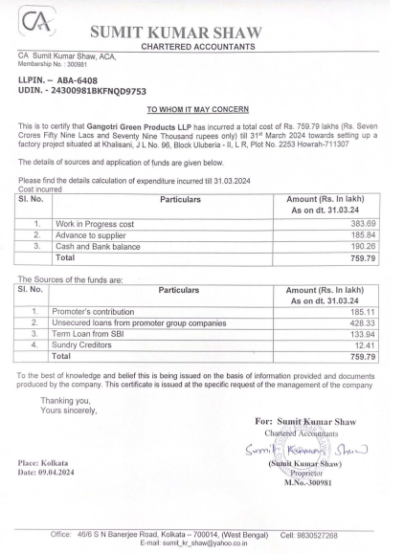

\
Copy of Proposed Building Plan

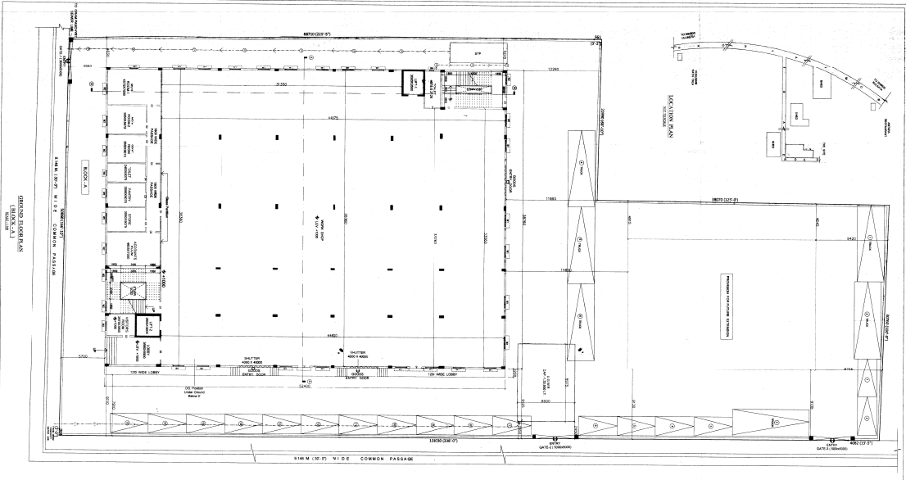
Copy of Site Plan

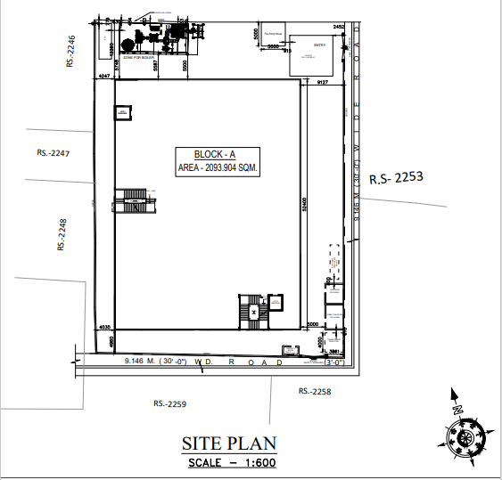
Copy of Pollution NOC
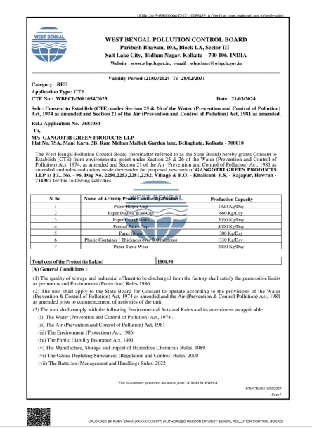

Area measured using Google Map
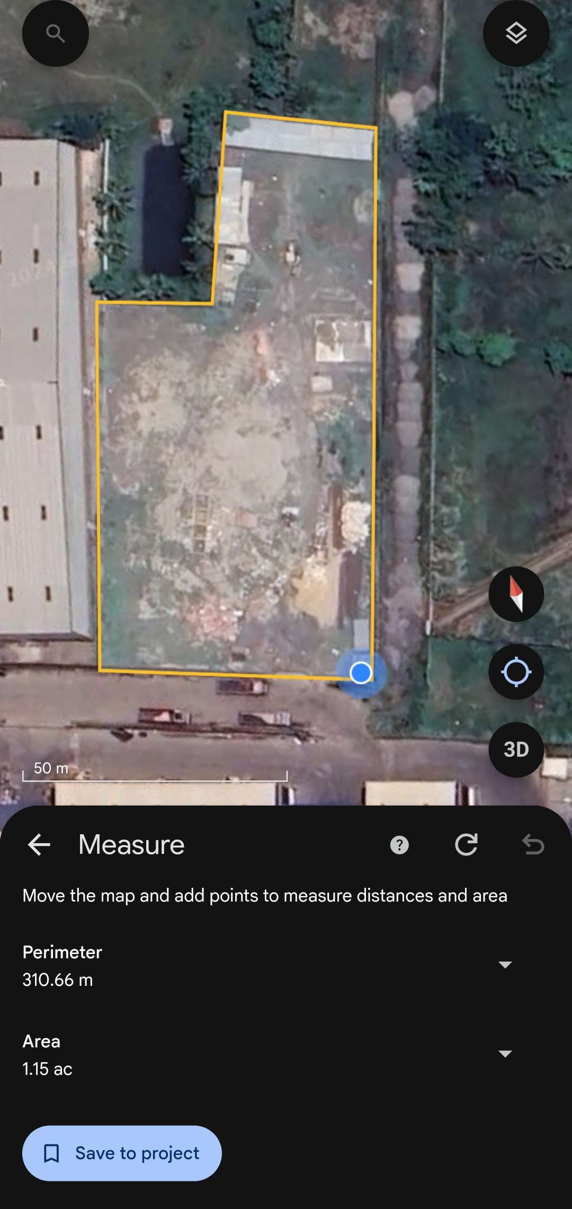

Copy of Trade Registration Certificate
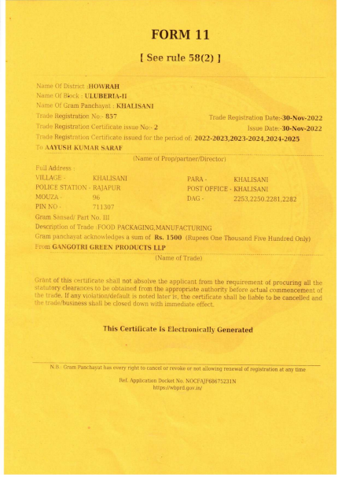
Copy of Registration Certificate
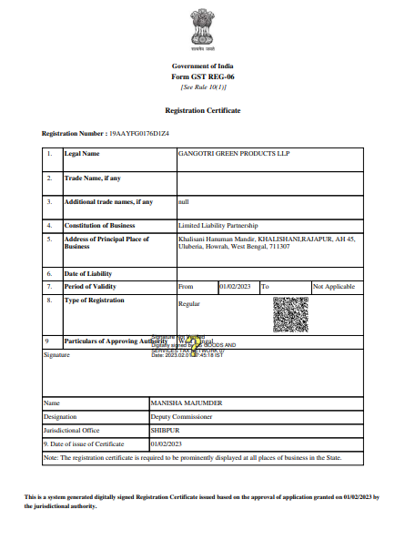
Copy of Fire NOC Receipt
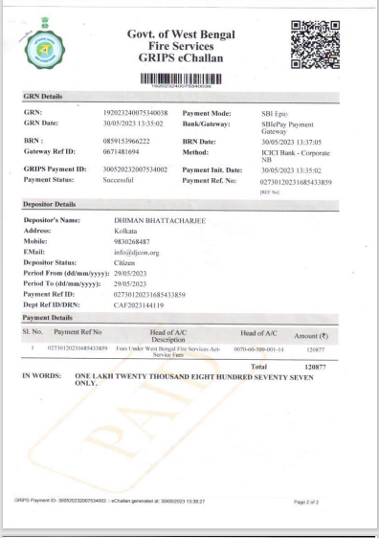
Copy of Fire NOC
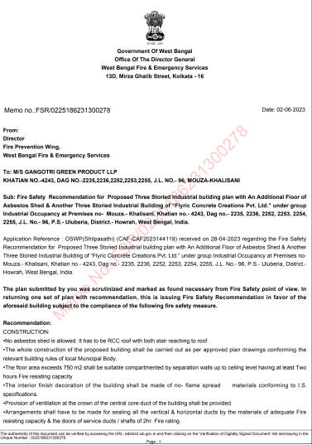
PART L | PHPTOGRAPHS OF PROPERTY
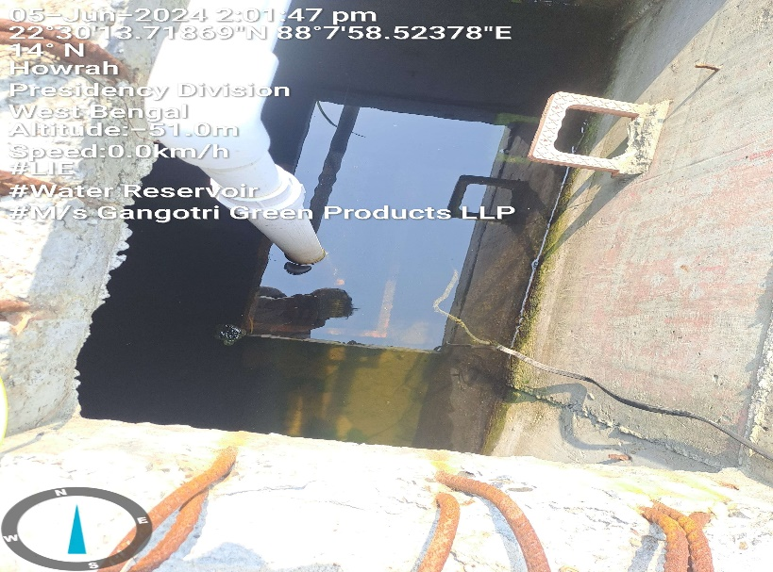 | 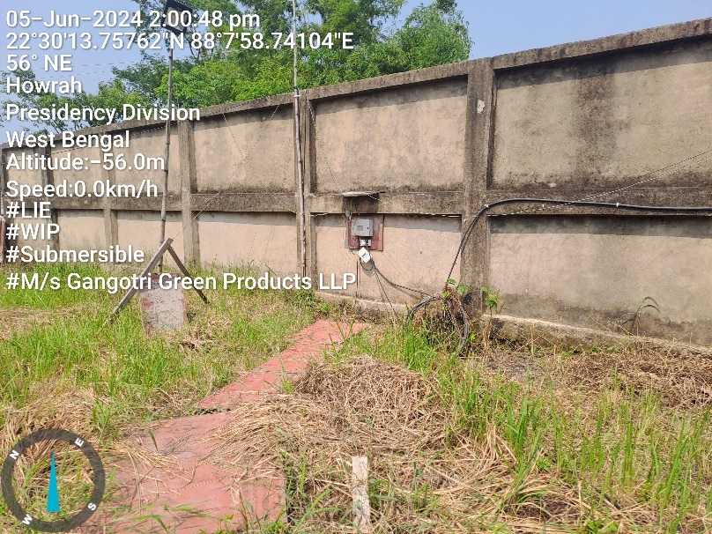
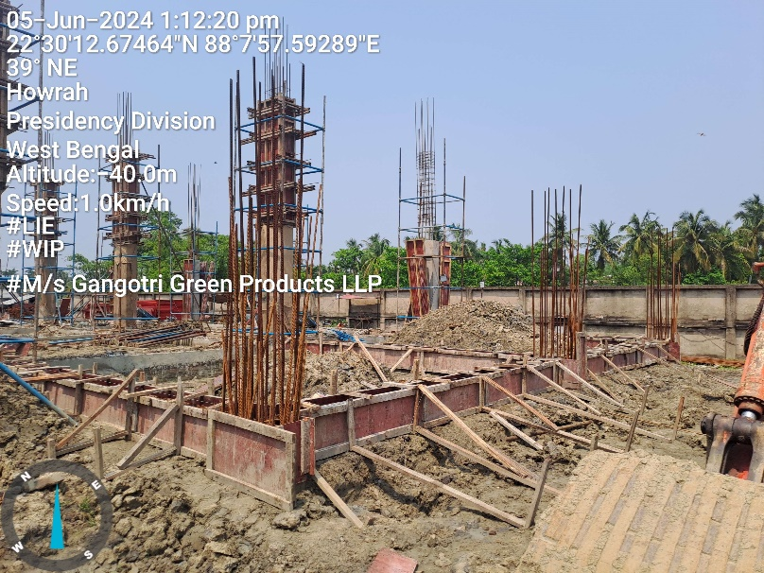 | 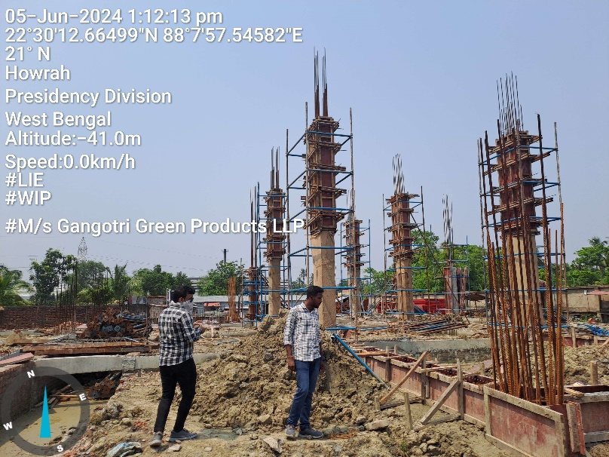
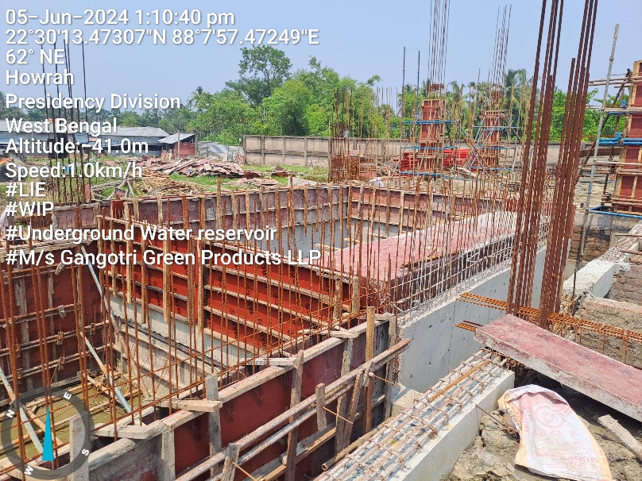 | 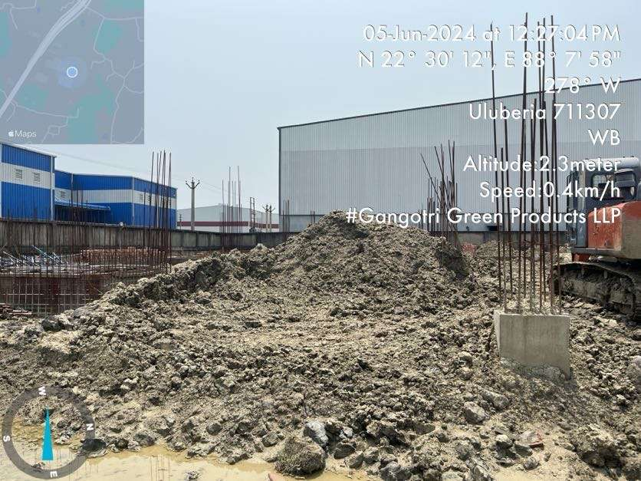

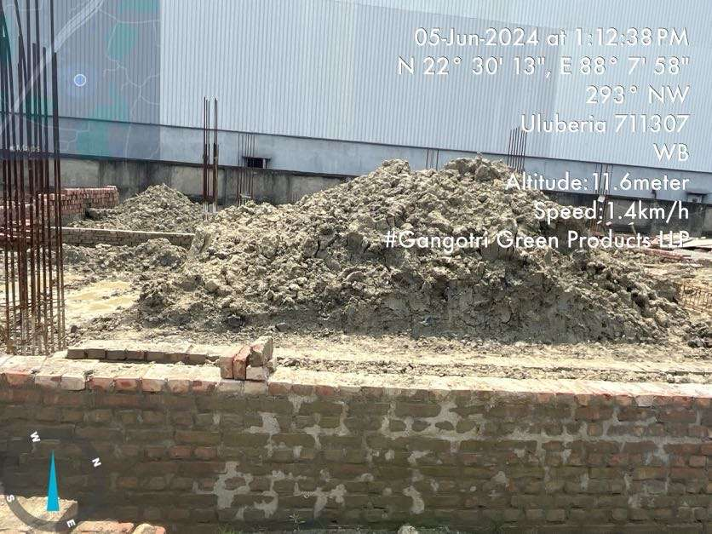 | 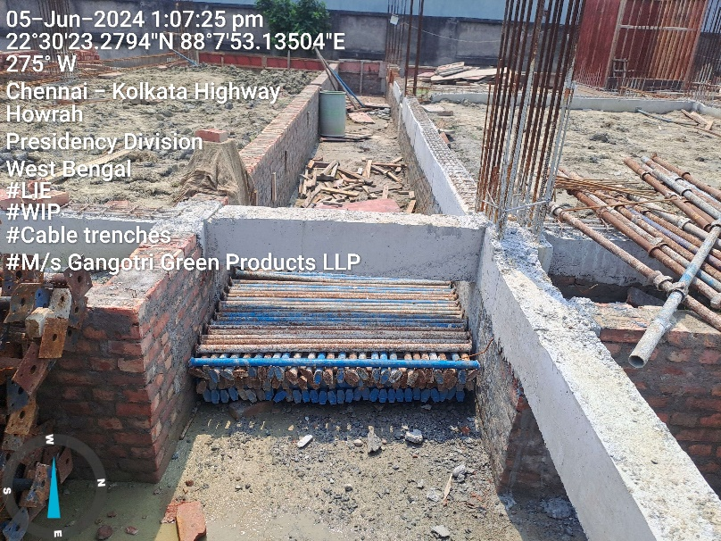
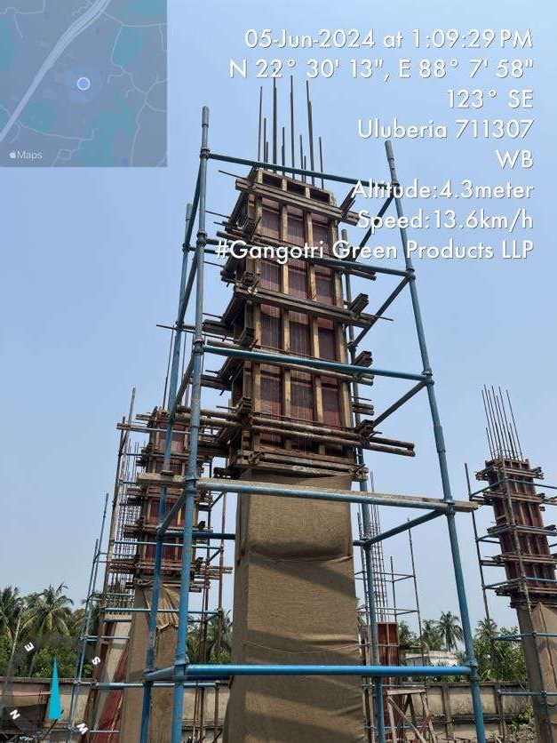  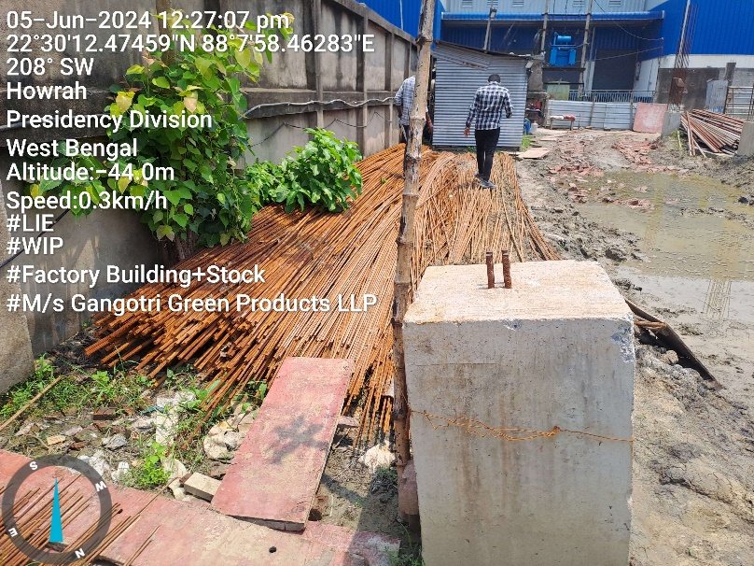 | 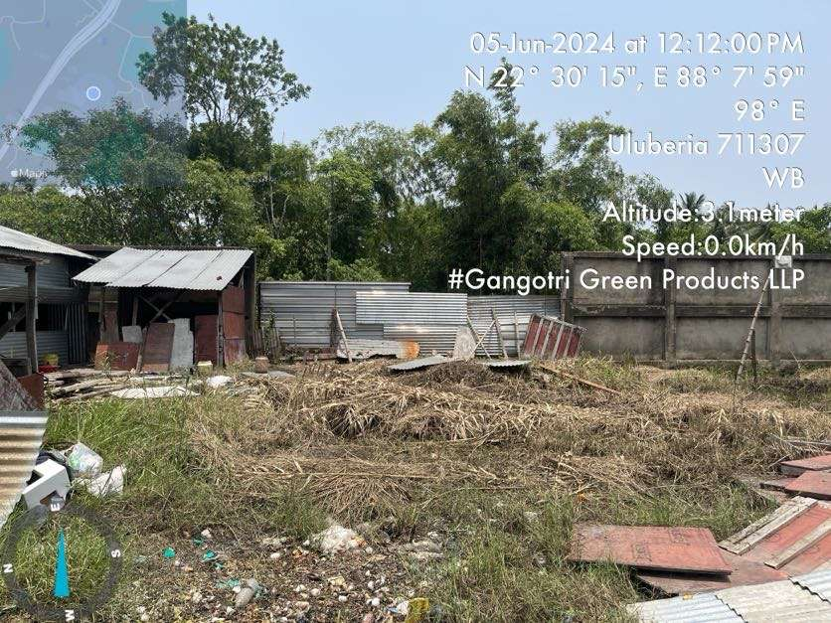  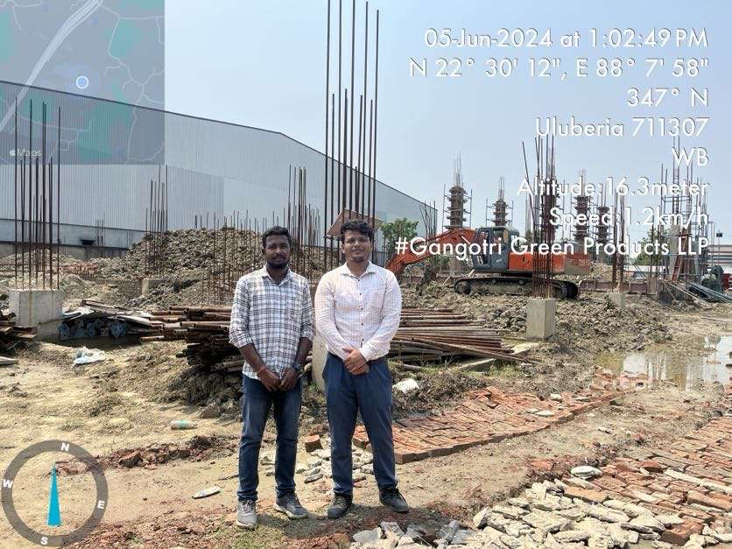

sss

