**File No.: VIS (2024-25)-** **PL300-260-344 Dated: 27.06.2024**

**PROJECT PROGRESS REPORT (2nd)**

**(FROM 1st APRIL TO 30th JUNE 2024)**

**OF**

**GANGOTRI GREEN PRODUCTS LLP**

**SITUATED AT**

**KHALISANI, NEAR HANUMAN MANDIR, RAJAPUR, NH 45,**

**ULUBERIA, HOWRAH, WEST BENGAL, 711307**

**DEVELOPED BY**

**M/S RAJ CONSTRUCTION**

**REPORT PREPARED FOR**

**STATE BANK OF INDIA,**

**SME EXIM BRANCH** **KOLKATA, WEST BENGAL**

***\*\*Important - In case of any query/ issue or escalation you may please contact Incident Manager at le@rkassociates.org. We will appreciate your feedback in order to improve our services.***

***NOTE: As per IBA Guidelines please provide your feedback on the report within 15 days of its submission after which report will be considered to be correct.***

|  |  |  |
| --- | --- | --- |
| **TABLE OF CONTENTS** | | |
| **SR. NO.** | **DESCRIPTION** | **PAGE NO.** |
| **PART A** | **Report Summary** | 03 |
| **PART B** | **Introduction** | 06 |
|  | 1. The Report | 06 |
|  | 1. The Project | 06 |
|  | 1. Project Overview | 05 |
|  | 1. Location of the Project | 07 |
|  | 1. Scope of work during Project Duration | 08 |
|  | 1. Purpose of the Report | 09 |
|  | 1. Methodology Adopted | 09 |
| **PART C** | **Infrastructure Details Of The Project** | 10 |
|  | 1. Land Details | 10 |
|  | 1. Building & Civil Works | 10 |
|  | 1. Machinery And Equipment | 12 |
| **PART D** | **Project Consultants, Contractors & Suppliers** | 13 |
| **PART E** | **Project Progress** | 14 |
|  | 1. Progress Of Building & Civil Works | 13 |
|  | 1. Progress Report Of Plant Machinery & Equipment | 15 |
| **PART F** | **Project Cost, Means Of Finance And Cost Incurred Till Date** | 18 |
| **PART G** | **Cost Assessment Of Industrial Building** | 23 |
| **PART H** | **Statutory & Regulatory Approvals, Clearances & Noc** | 25 |
| **PART I** | **Project Schedule & Current Status** | 26 |
| **PART J** | **Disclaimer** | 27 |
| **PART K** | **Enclosure** | 31 |
| **PART L** | **Photographs** | 54 |

***IMPORTANT NOTICE***

***COPYRIGHT FORMAT:*** *This report is prepared on the copyright format of R.K Associates, to serve our clients with the best available information and analysis to facilitate them to take rational business decisions. Legally no one can copy or distribute this format without prior approval from R.K Associates. It is meant only for the Advisory/ reference purpose for the organization/s as mentioned on the cover page of this report. Distribution or use of this format by any organization or individual other than R.K Associates will be seen as unlawful act and necessary legal action can be taken against the defaulters.*

*This report is intended for the sole use of the intended recipient/s and contain material that is STRICTLY CONFIDENTIAL AND PRIVATE.*

***DEFECT LIABILITY PERIOD:*** *- In case of any query/ issue or escalation you may please contact Incident Manager: le@rkassociates.org. We try our level best to ensure correctness in the calculations done, rates adopted and various other data points & information mentioned in the report but still can’t rule out typing, human errors or any other mistakes. In case you find any such mistake or inaccuracy in any data point of the report please help us by bringing all such points into our notice immediately or within 15 days of the report delivery in writing, to rectify these timely failing after which R.K Associates won’t be held responsible for any such inaccuracy in any manner. We would highly appreciate your feedback in order to improve our services.*

|  |  |
| --- | --- |
| **PART A** | **REPORT SUMMARY** |

|  |  |  |  |  |
| --- | --- | --- | --- | --- |
| **S.No.** | **Particulars** | **Details** | | |
|  | **Name of Project** | Manufacturing Unit of Paper Cups and Pulp Table Wares. | | |
|  | **Project Location** | Khalisani, Near Hanuman Mandir, Rajapur, NH 45,Uluberia, Howrah, West Bengal, 711307 | | |
|  | **Name of the Borrower** | M/s Gangotri Green Products LLP | | |
|  | **Regd. Address of the Borrower** | 3B, Rammohan Mallick Garden, Manikaran, 7th Floor, Kolkata – 700 010. | | |
|  | **Director’s/Partner’s** | * Mr. Aayush Kumar Saraf * Ms. Anushka Saraf | | |
|  | **Prepared for Bank** | State Bank of India, SME EXIM Branch Kolkata, West Bengal | | |
|  | **LIE Consultant Firm** | M/s. R.K. Associates Valuers & Techno Engineering Consultants (P) Ltd. | | |
|  | **Date of Survey** | 25th September 2024 | | |
|  | **Date of Report** | 28th September 2024 | | |
|  | **Purpose of the Report** | To provide fair detailed analysis report to the Bank based on the “in-scope points” mentioned below to know Project progress. | | |
|  | **Scope of the work** | 1. Periodic Project physical status review 2. Periodic review of expenditure of the Project based on the expenditure Invoices/ Bills provided by the company | | |
|  | **Documents perused for Proposal** | 1. TEV Report 2. CA Certificate 3. Vendor list with Machine name and Cost 4. Copy of Invoices for expenses incurred (Received post survey) 5. Building Plan 6. Building approval letter 7. Pollution NOC 8. Fire NOC 9. Environmental NOC 10. GST Registration Certificate 11. Trade Reg. Certificate | | |
|  | **Documents provided by** | Name | Email id | Phone No. |
| Mr. Shiba Prasad Bhattacharjee | shibaprasad.bhattacherjee  @sbi.co.in | 7029791431 |
|  | **Annexure with the report** | 1. CA Certificate 2. Approved site plan 3. Building approval letter | | |

|  |  |
| --- | --- |
| **PART B** | **INTRODUCTION** |

1. **THE REPORT:** Second quarterly LIE report from the period of 1st April 2024 to 30th June 2024. The status of the project is as on 25/09/2024 as on the date of site inspection but the expenditure covered is from 1st April 2024 to 30th June 2024.
2. **THE PROJECT:** New manufacturing unit of paper cup, ripple cup, double wall cup, pulp table ware, plastic container, and paper straw at Mouza Khalisani, P.S.- Uluberia, District- Howrah, Pin– 711 307 being setup by M/s Gangotri Green Products LLP (GGPL).
3. **PROJECT OVERVIEW**: M/S Gangotri Green Products LLP (GGPL), a limited liability partnership firm, incorporated on 14th February 2022 under the provisions of the Limited Liability Partnership Act, 2008. The main objectives of the GGPL is to carry on business as manufacturers and/or dealers in and importers and exporters of all kind of packing and disposable items like paper cup, paper plates, paper straws and other similar and eco-friendly items wholly or partly. Gangotri Green Products LLP has come up with a plan to set up a manufacturing unit of paper cup, ripple cup, double wall cup, pulp table ware, plastic container, printing of paper cup and paper straw with the following capacity:

This is a second project progressive report from the period April, 24 – June, 24 and is in continuation to first progress report submitted to the bank. This report covers physical status upto 25.09.2024 as on date of the survey but the financial expenditure is reported up to 30.06.2024 as per the report period.

|  |  |  |
| --- | --- | --- |
| **Name of the Product** | **Avg. Production per day by single machine** | **Avg. Production per anum single machine** |
| Paper Cup | 200 kg | 1500000 kg |
| Ripple Cup | 220 kg | 396000 kg |
| Double Wall Cup | 220 kg | 198000 kg |
| Pulp Table Ware | 400 kg | 720000 kg |
| Plastic Container | 110 kg | 99000 kg |
| Printing of Paper Cup | 4,000 kg | 1200000 kg |
| Paper Straw | 300 Kg | 90000 kg |

*Source: TEV Report*

A paper cup is a disposable cup made out of paper and often lined or coated with plastic or wax to prevent liquid from leaking out or soaking through the paper. It may be made of recycled paper and is widely used around the world. Paper cups are made in a variety of sizes and shapes according to the amount of material to be filled. The product can be in any desired shape and size depending upon the die employed for manufacture.

For the purpose of setting up the Plant, the company has acquired around 73.195 Katha of land on lease rental basis, which is equivalent to 1.21 acres, i.e., 4887 sq. metres (approx.) or 52608 sq. ft. (approx.). GGPL has approached State Bank of India, SME EXIM Branch, Kolkata (SBISME-EXIM) for financial assistance for the proposed project. The total cost of the project for setting up the unit for manufacturing has been estimated at 37.84 Crore as per TEV Report prepared by Sayantan Consultants Pvt. Ltd. The cost of construction of buildings is estimated to be 13.26 crore, as per TEV report provided by the client.

Cost of the project is to be funded by combination of promoters’ contribution in the form of partners’ capital and/or interest free subordinated unsecured loan and long-term debt from the State Bank of India, SME Exim Branch Kolkata, West Bengal. The expected commercial operation date of the Project is on April, 2025. For due diligence of the Project, Bank has appointed M/S Sayantan Consultants Pvt. Ltd. (SCPL) as TEV consultant and M/s R.K Associates as LIE of the project to review the periodic Project progress.

For the building construction, company has appointed M/s Raj Construction for civil and other construction works and for the setup of the Plant Company has appointed M/s. Shri Sidhi Technical Services as a technical consultant for commissioning of the machines. However there is no formal contract agreement with the agencies done by the company. Upto 30th June, 2024, Company has shown to have incurred a total cost of Rs.1132.87 Lakhs as per the CA certificate dated 20.07.2024. As per the original schedule given in the TEV Report, Project has to be completed by Feb., 2025 and COD needs to be achieved by April, 2025. According to the site inspection that our engineering team performed on 25-09-2024, the raft foundation work and Column work of super structure upto ground floor for Block A has been completed. The roof slab work of ground floor is ongoing.

1. **LOCATION OF THE PROJECT**

|  |
| --- |
| **Postal Address** |
| Khalisani, Near Hanuman Mandir, Rajapur, NH 45,Uluberia, Howrah, West Bengal, 711307 |
| **Google Coordinates** |
| 22°30'15.0"N 88°07'59.0"E |
| **Connectivity Systems** |
| * **Road:** The Subject property is situated approximately 240 m apart from Mumbai -Kolkata National Highway. * **Rail:** The nearest railway station to the subject property isthe Chengel railway station. It is situated at a distance of 3.7 km from the subject property * **Air:** The nearest airport to the subject property is the Netaji Subhash Chandra Bose International Airport, in Kolkata It is one of the busiest airports in India. The distance between the airport and the subject property is approximately 44 Km. |

**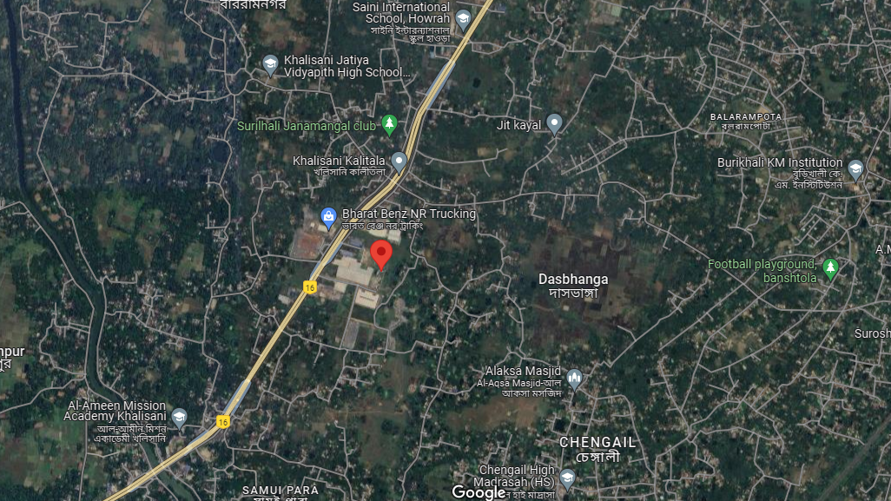**

**Source: Google map**

1. **SCOPE OF WORK DURING PROJECT DURATION:**
2. To periodically check project implementation status as mentioned in TEV report and in major project contracts.
3. To periodically check Project Progress on site and achievement of various milestones as mentioned in TEV Report and comment accordingly.
4. To check whether project expenditure is in line to the work.
5. Review status of statutory licenses, NOC’s and approvals.

**Note**:

1. *The scope of work is for the complete duration up to the completion of the project and not for a specific report.*
2. *Carrying out the scope of work is subject to the details/ information/ data provided to us by the borrower from time to time.*
3. *Report is considered for assessment of the work done and the cost incurred on the site.*
4. *Amount incurred is referred from the details provided by the customer further corroborated from CA Certificate*.
5. **PURPOSE OF THE REPORT:** To provide fair detailed analysis report to the Bank based on the “in-scope points” mentioned above to inform the Bank on Project progress.
6. **METHODOLOGY ADOPTED:**
7. Gather information/ data/ documents related to the Project. Additional information, data, documents collection from the borrower.
8. Site Inspection.
9. Review and analysis of the documents and information obtained from the borrower and corroborating it with the site inspection status.
10. Information compilation, analysis and reporting.

|  |  |
| --- | --- |
| **PART C** | **INFRASTRUCTURE DETAILS OF THE PROJECT** |

1. **LAND:** The manufacturing unit is constructed on 1.21 acres/ 4897.060 sq. mtr. of land and is secured by a permanent boundary wall of about 10 ft. height. The expense of purchasing the land was not included in the project cost, hence is not included in our assessment.

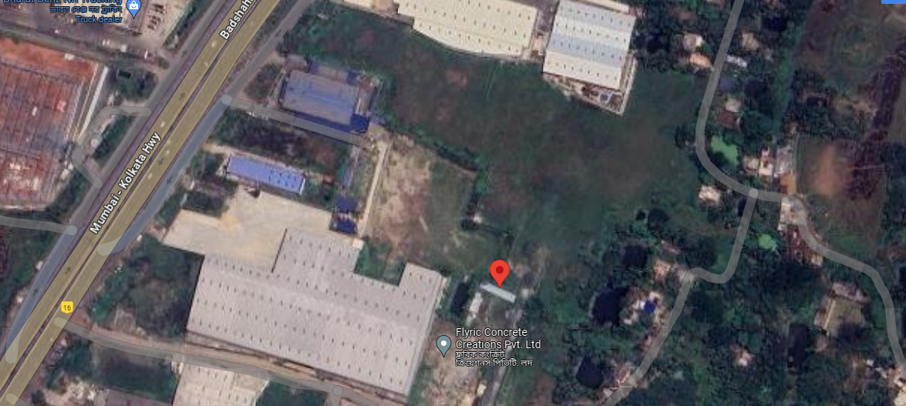

1. **BUILDING & CIVIL WORKS:** The total built up area of the three storied Industrial building as per the map provided to us is 6,370.127 sq. mtr. as shown in the table below:

|  |  |  |  |
| --- | --- | --- | --- |
| **Sl. No** | **Particulars of Block A** | **Structure Type** | **Built up area ( sq. ft.)** |
|  | Proposed Ground floor area | RCC | 2093.904 |
|  | Proposed 1st floor area | RCC | 2093.904 |
|  | Proposed 2nd  floor area | RCC | 2093.904 |
|  | Proposed stair head area | RCC | 88.415 |
|  | **TOTAL** |  | **6370.127** |

*Source: As per TEV Report*

The total estimated cost for civil construction is Rs.13.26 Crore**.** GGPL has appointed Mr. Sabyasachi Patra as Structural Engineer, DJ Consultants as Architects and M/s Raj Construction as main contractor for the construction of the building.

**LAYOUT PLAN OF THE BUILDING**

*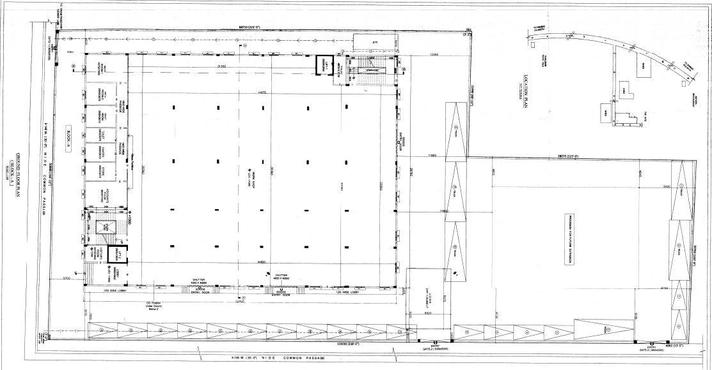*

1. **MACHINERY AND EQUIPMENT**: For the project work related to Plant & Machinery, the company has appointed M/S. Shri Sidhi Technical Services as a technical consultant for Commissioning of the machines. The list of vendors providing specific machines and estimated cost of the machines are also shown in the table below:

|  |  |  |  |  |  |  |
| --- | --- | --- | --- | --- | --- | --- |
| **Sl. No.** | | **Particulars** | **Name of the Vendor** | **Qty.** | **Price Per Unit in Rs.** | **Total Estimated Cost in Rs.** |
| Machines for Paper Cup Manufacturing | | | | | | |
| 1 | | High Speed Paper Cup Machine  (GLI 1100) | --- | 4 | 11,80,000 | 47,20,000 |
| 2 | | Paper Cup Machine (GLI 900) | --- | 4 | 8,80,000 | 35,20,000 |
| 3 | | Paper Cup Machine (GLI 800) | --- | 17 | 7,60,000 | 1,29,20,000 |
| Machines for Pulp Table Ware | | | | | | |
| 4 | | Pulp Molding Machine  (Imported) | Zhuhai Xing Yuan Development Co. | 1 | 7,29,60,209 | 7,29,60,209 |
| 5 | | Pulping Station | Isotex Corporation Pvt. Ltd | 1 | 1,80,00,000 | 1,80,00,000 |
| Printing Machine | | | | | | |
| 6 | Flexo printing Machine | | --- | 1 | 29,50,000 | 29,50,000 |
| Paper Plate | | | | | | |
| 7 | Paper Plate Machine (GLI 800) | | --- | 1 | 8,00,000 | 8,00,000 |
| Ripple Cup | | | | | | |
| 8 | Ripple Paper Cup Machine | | --- | 6 | 8,80,000 | 52,80,000 |
| 9 | Ripple Corrugation Machine | | --- | 1 | 44,00,000 | 44,00,000 |
| Double Wall Cup | | | | | | |
| 10 | Double Wall Paper Cup | | --- | 3 | 9,80,000 | 29,40,000 |
| Plastic Container | | | | | | |
| 11 | Injection Molding Machine | | Weltech | 3. | 20,00,000 | 60,00,000 |
| Paper Straw | | | | | | |
| 12 | Paper Straw Machine | | Sri Siddhi Technical Services | 1 | 31,00,000 | 31,00,000 |
| Other Machineries | | | | | | |
| 13 | Roll Die Cutting Machine | | --- | 1 | 33,80,000 | 33,80,000 |
| 14 | Folder and Gluing Machine | | --- | 2 | 8,80,000 | 17,60,000 |
| 15 | Slitting Machine | | --- | 1 | 7,20,000 | 7,20,000 |

***Source: As per TEV Report***

|  |  |
| --- | --- |
| **PART D** | PROJECT CONSULTANTS, CONTRACTORS & SUPPLIERS |

According to the company representative and the details obtained from the work orders, following below are the contractors appointed for different works:

|  |  |  |
| --- | --- | --- |
| **Sl. No.** | **Contractor / Suppliers name** | **Work Assigned** |
|  | M/s Raj Construction | Civil Construction |
|  | Mr. Sabyasachi Patra | Structural Engineer |
|  | M/s DJ Consultants | Architects |
|  | M/S. Shri Sidhi Technical Services | Plant & Machinery Installation |
|  | M/s Haldia Petrochemicals Limited | Suppliers of plastic granules |
|  | Century Pulp & Paper (M/s. Century Textiles and Industries Limited) | Suppliers of Agro Pulp |
|  | M/s Yash Pakka Limited | Suppliers of Cup-stock Paper |
|  | M/s JK Paper Limited | Suppliers of Cup-stock and Coated Kraft Paper |
|  | M/s Kuantum Papers Limited | Suppliers of Straw Paper |

***Source: TEV Report and Invoices***

|  |  |
| --- | --- |
| **PART E** | **PROJECT PROGRESS** |

1. **PROGRESS OF BUILDING & CIVIL WORKS:**

**TABLE 01**

|  |  |  |  |  |  |
| --- | --- | --- | --- | --- | --- |
| **S.No.** | **Particulars** | **Foundation** | **Superstructure** | **Finishing** | **Overall Completion Percentage** |
|  | Block A | * 100% work of Pile and Raft Foundation Completed | * RCC framed Structure work of ground floor in progress * Column work of ground floor completed * Roof slab work of ground floor is in progress. | 0% | 25% |
|  | Drain | 100% completed | 100% completed | 0% | 72% |
|  | UGWT outside Block A | 100% completed | 100% completed | 100% completed | 100% completed |
|  | Fire Pump Room | 0% | 0% | 0% | 0% |
|  | Zone for Boiler | 0% | 0% | 0% | 0% |
|  | Security Room | 0% | 0% | 0% | 0% |
|  | VCB Room | 0% | 0% | 0% | 0% |
|  | WBSC VCB Room | 0% | 0% | 0% | 0% |
|  | UG RCC Tank 1 inside Block A | 100% completed | * Structure completed. * Top slab pending | 0% | 60% |
|  | UG RCC Tank 2 inside Block A | 100% completed | * Structure completed. * Top slab pending | 0% | 60% |

|  |  |
| --- | --- |
| **Stage of Construction** | **Weightage** |
| Sub structure construction up to Plinth level | 15% |
| Super structure | 40% |
| MEP Services | 17% |
| Finishing | 28% |
| Overall | 100% |

***Note: Above weightage is considered based on the Industrial structure referring standard construction breakup norms. Structure to structure it may vary based on its design. However, for the purpose of assessment we have considered the above standardisation.***

**Note:**

1. *The physical progress captured in the above table is based on approximate observations of status of structures constructed on site during our site inspection and our subsequent discussions held with the engineers/ company representatives with whom the site visit was conducted and not based on measurements. Thus, the above percentages are shown only for the purpose of presenting general guidance on site progress instead of any quantity measurements and is on approximate basis which may vary from (+-) 5% to 10%.*
2. **PROGRESS OF PLANT & MACHINERY:**
3. Detailed progress is enumerated in the Table below:

**TABLE 02**

|  |  |  |  |  |  |  |  |
| --- | --- | --- | --- | --- | --- | --- | --- |
| **Sl. No.** | **Name of Machine** | **Quantity** | **Machine arrived at site** | **Machine installation** | **Testing** | **Production** | **Advance amount paid in Rs.** |
|  | High Speed Paper Cup Machine | 4 | 🗷 | 🗷 | 🗷 | 🗷 | --- |
|  | Paper Cup Machine GLI 900 | 4 | 🗷 | 🗷 | 🗷 | 🗷 | --- |
|  | Paper Cup Machine GLI 800 | 17 | 🗷 | 🗷 | 🗷 | 🗷 | --- |
|  | Pulp Moulding Machine | 6 | 🗷 | 🗷 | 🗷 | 🗷 | 1,45,72,202 |
|  | Pulping Station | 1 | 🗷 | 🗷 | 🗷 | 🗷 | 58,10,780 |
|  | Flexo printing Machine | 1 | 🗷 | 🗷 | 🗷 | 🗷 | --- |
|  | Paper Plate Machine (GLI 800) | 1 | 🗷 | 🗷 | 🗷 | 🗷 | --- |
|  | Ripple Paper Cup Machine | 6 | 🗷 | 🗷 | 🗷 | 🗷 | --- |
|  | Ripple Corrugation Machine | 1 | 🗷 | 🗷 | 🗷 | 🗷 | --- |
|  | Double Wall Paper Cup | 3 | 🗷 | 🗷 | 🗷 | 🗷 | --- |
|  | Injection Moulding Machine | 3 | 🗷 | 🗷 | 🗷 | 🗷 | 3,00,000 |
|  | Paper Straw Machine | 1 | 🗷 | 🗷 | 🗷 | 🗷 | --- |
|  | Roll Die Cutting Machine | 1 | 🗷 | 🗷 | 🗷 | 🗷 | --- |
|  | Folder and Gluing Machine | 2 | 🗷 | 🗷 | 🗷 | 🗷 | --- |
|  | Slitting Machine | 1 | 🗷 | 🗷 | 🗷 | 🗷 | --- |

1. Details of the advances paid by the company to various machinery suppliers is enumerated in the below table:

**TABLE 03**

|  |  |  |  |  |  |  |
| --- | --- | --- | --- | --- | --- | --- |
| **S.No.** | **Name of Machine** | **Name of the Part** | **Supplier Name** | **Total Value (exclusive of GST) in Rs.** | **Any formal work order released** | **Advance Amount Paid in Rs.** |
|  | Pulp Moulding Machine | Pulp Moulding Machine | Zhuhai Xing Yuan Development Co. | 7,34,75,200 | Proforma Invoice Only. | 1,45,72,202 |
|  | Pulping station | Air compressor for pulping station | Associated Agencies | 35,75,000 | Proforma Invoice Only. | 10,72,500 |
|  | Mould for food container lid in Injection Moulding Machine | Brotech | 1,00,00,000 | Proforma Invoice Only. | 2,00,000 |
|  | Thermic fluid heater for pulping station | Isotex Corporation Pvt. Ltd. | 32,21,000 | Proforma Invoice Only. | 38,00,780 |
|  | Vaccum pump for pulping station | PPI Pump Pvt. Ltd. | 23,50,000 | Proforma Invoice Only. | 8,22,500 |
|  | Stock chamber, inlet assembly and hub retainer for pulping station | Rehnu International | 3,25,000 | Proforma Invoice Only. | 15,000 |
|  | Water separation tank, hydra pulper and agilator for pulp tank for pulping station | Sri Siddhi Technical Services | 31,27,000 | Proforma Invoice Only. | 1,00,000 |
|  | Injection Moulding Machine | Drop valve for Injection Moulding Machine | Yudo Hot Runner India Pvt Ltd. | 52,00,000 | Proforma Invoice Only. | 1,00,000 |
|  | Mould for food container lid in Injection Moulding Machine | Brotech | 1,00,00,000 | Proforma Invoice Only. | 2,00,000 |

1. No machine/equipment has been arrived on the site yet.

|  |  |
| --- | --- |
| **PART F** | **PROJECT COST, MEANS OF FINANCE AND COST INCURRED** |

1. **TOTAL PROJECT COST:** The estimated cost of the project is 37.84.Crore. Breakage of the amount has been shown in tabular and graphical form below:

**TABLE 04**

*All amount in crores*

|  |  |  |  |
| --- | --- | --- | --- |
| **S.No.** | **Particulars** | **Amount** | **Current Status**  ***(As per Company/ CA)*** |
|  | Land Cost (free hold) | 0.00 | --- |
|  | Site Development Cost | 0.00 | --- |
|  | Civil Construction | 13.26 | 5.07 |
|  | Plant and Machinery | 18.01 | 2.07 |
|  | Electrical Installation | 1.3 | 0.014 |
|  | Miscellaneous Fixed Assets | 0.55 | --- |
|  | Contingencies | 0.70 | --- |
|  | Pre-operative Expenses | 1.98 | 0.70 |
|  | Margin for working capital | 1.95 | --- |
|  | Margin money for non-fund-based Limit (BG of Rs. 35 lacks \* 25%) | 0.09 | --- |
|  | Total | **37.84** | **7.86** |

**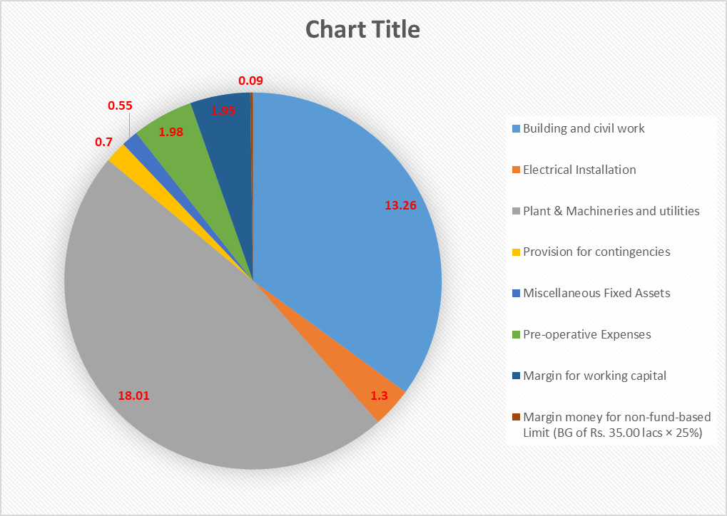**

1. **MEANS OF FINANCE:** The Project cost has been proposed to be financed with following capital structure:

**TABLE 05**

|  |  |  |  |
| --- | --- | --- | --- |
| **Sl. No.** | **Means of Finance** | **Amount**  **(In Rs. in Cr.)** | **Amount as on 30/06/24**  **(In Rs. In Cr.)** |
|  | Promoter’s contribution by way of Partners' Capital | 7.00 | 2.59 |
|  | Unsecured Loan from Promoter’s group of companies | 6.84 | 3.63 |
|  | Term Loan from SBI | 24.00 | 5.10 |
|  | Total Cost | **37.84** | **11.32** |

1. **COST INCURRED TILL DATE:** M/s Sumit Kumar Shaw, Chartered Accountants, Office 46/6, Banerjee Road, Kolkata, has issued a certificate dated 20.07.2024 with UDIN No. 24300981BKFNQS9106 for quarter ending 30th June, 2024 in respect to the expenditure made. The total expenditure incurred as per the details obtained from survey conducted on 25th of September, 2024 is shown in the table below:

**TABLE 06**

|  |  |  |  |  |
| --- | --- | --- | --- | --- |
| **Sr. No.** | **Particulars** | **Total Estimated**  **Cost in Cr. as per GGPL** | **Cost Incurred till 30.06.2024 as per GGPL** | **Remarks** |
|  | Building Construction | 13.26 | 5,07,00,000 | * The pile foundation and raft foundation has been completed * Cost assessment of each is done independently. * As per our assessment around **Rs. 4,71,31,862** cost is spent is estimated. Refer to the Table No. 7, 10, 11, 12, 13, 14, 15 on pg.nos 20, 21, 22, 23, 24 below for independent cost assessment. * Client has submitted the Invoices/ Bills amounting of **Rs.4,30,37,281** in relation to the said work which includes material & contractor invoices. * Cost in Building include Material charges, labour charges and other miscellaneous expenses involved in the construction. * The cost estimated by R.K is based on the current market rate and rate proposed by the Central Public works Department. * The cost may vary depending up on the material cost and labour charges in the prevailing location and construction percentage adopted by us. * As per CA Certificate value of material lying at site might be also included and this why some difference can be there between our assessment and CA. |
|  | Plant & Machineries and utilities | 18.01 | 2,06,82,982 | * No plant and machineries or equipment have been installed yet. Details of the proposed machinery are attached in Table 03 on pg. no. 16. * Company has informed to have paid Rs.2,06,82,982 as advances for the procurement of machines. Please refer Table No. 8 pg.no 20 below for the same.   Amount is referred from the Bank statement and Performa invoices provided to us by the company. Refer Enclosure 1 in pg. no. 31. |
|  | Electrical Installation | --- | 1,41,600 | * Advance paid for Electrical Installation works. * Amount has been calculated from the invoices provided to us. Refer Enclosure 1 in pg.no. 31 |
|  | Miscellaneous Fixed Assets | --- | --- | * No cost incurred yet. |
|  | Contingencies | --- | --- | * No cost incurred yet. |
|  | Pre-operative Expenses |  | 70,73,908 | * Breakup of Pre-operative expenses Incurred by GGPL is shown in detail in Table 09 on pg.no 21 below. * Since most of the expenses are of the nature of soft cost, therefore CA certificate is considered for the same. |
|  | **TOTAL** | **---** | **₹ 7,85,98,490** |  |

**TABLE 07**

|  |  |  |  |
| --- | --- | --- | --- |
| **Total Construction Cost** | | | |
| **Sl. No.** | **Particulars** | **Amount Incurred in Rs.** | **Table Reference** |
|  | Pile foundation including testing | ₹ 1,45,88,128 | Table 10 and 11 in pg.no.21 |
|  | Raft Foundation | ₹ 1,09,32,718 | Table 12 and 13 in pg.no. 22 |
|  | UG Water Tank Construction | ₹ 13,26,300 | Table 14 in pg.no. 23 |
|  | Ground Floor (Block A) | ₹ 2,02,84,716 | Table 15 in pg.no. 23 |
| **Total** | | **₹ 4,71,31,862** |  |

**TABLE 08**

|  |  |  |  |  |
| --- | --- | --- | --- | --- |
| **Sl.no.** | **Name of Machine** | **Vendors Name** | **Date of transaction as per bank statement** | **Amount Incurred in Rs.** |
| 1 | Pulping Station | PPI Pump Pvt. Ltd. | 24-04-2024 | 8,22,500 |
| 2 | Isotex Corporation Pvt Ltd | 02-02-2024 | 12,88,400 |
| 3 | Isotex Corporation Pvt Ltd | 06-06-2024 | 25,12,380 |
| 4 | Rehnu International | 24-04-2024 | 15,000 |
| 5 | Sri Siddhi Technical Services | 19-06-2023 | 1,00,000 |
| 6 | Associated Agencies | 24-05-2024 | 10,72,500 |
| 7 | Injection Moulding Machine | Yudo Hot Runner India Pvt Ltd. | 31-05-2024 | 1,00,000 |
| 8 |
| 9 |
| 10 | Brotech | 31-05-2024 | 2,00,000 |
| 11 | Pulp Moulding Machine | Zhuhai Xing Yuan Development Co. | 27-12-2023 | 1,45,72,202 |
| **Total** | | | | **2,06,82,982** |

**TABLE 09**

|  |  |  |  |  |  |
| --- | --- | --- | --- | --- | --- |
| **PRE-OPERATIVE EXPENSES INCURRED BY GGPL** | | | | | |
| **Sr. No.** | **Particulars** | **Total Estimated**  **Cost in Cr. as per GGPL** | **Cost Incurred till 30.06.2024 as per GGPL** | **Cost assessed**  **as per R.K**  **As per survey dated 30.06.2024** | **Remarks** |
|  | Pollution fees | -- | 4,30,000 | 4,30,000 | * Amount referred from the invoice provided. Refer Enclosure 1 in pg. no: 31. |
|  | Building Sanction Fees | -- | 6,75,000 | 6,75,000 | * Amount referred from the invoice provided. * Refer Enclosure 1 in pg. no: 31. |
|  | Fire Service Bill | -- | 1,25,000 | 1,25,000 | * Amount Calculated from the bills provided to us dated 02/06/2023. * Refer Enclosure 1 in pg. no: 31 |
|  | Electricity Expenses | -- | 1,51,229 | 1,62,299 | * Amount Calculated from the Electricity bills provided to us from 1/04/2023 to 31/03/2024. * Refer Enclosure 1 in pg. no: 31 |
|  | Employee Benefit Expense | -- | 3,000 | -- | Out of scope of LIE assessment. Refer CA Certificate. |
|  | Property Registration and stamp duty fees | -- | 5,01,000 | 5,01,138 | * Amount Calculated from the invoices provided.   Refer Enclosure 1 in pg. no: 31 |
|  | NOC charges | -- | 3,72,000 | -- | Out of scope of LIE assessment. Refer CA Certificate. |
|  | Staff welfare Expenses | -- | 21,000 | -- | Out of scope of LIE assessment. Refer CA Certificate. |
|  | Bank Charges | -- | 25,000 | -- | Out of scope of LIE assessment. Refer CA Certificate. |
|  | General expenses | -- | 64,000 | -- | Out of scope of LIE assessment. Refer CA Certificate. |
|  | Loading & Unloading Expense | -- | 2,000 | -- | Out of scope of LIE assessment. Refer CA Certificate. |
|  | Interest on Loan | -- | 20,54,000 | -- | Out of scope of LIE assessment. Refer CA Certificate. |
|  | Insurance Premium | -- | 1,88,679 | 1,88,679.00 | Amount referred from the invoice provided. Refer Enclosure 1 in pg. no: 32. |
|  | Legal Expenses | -- | 67,000 | -- | Out of scope of LIE assessment. Refer CA Certificate. |
|  | Security Charges | -- | 1,41,000 | -- | Out of scope of LIE assessment. Refer CA Certificate. |
|  | Printing and stationary | -- | 3,000 | -- | Out of scope of LIE assessment. Refer CA Certificate. |
|  | Telephone Expenses | -- | 6,000 | -- | Out of scope of LIE assessment. Refer CA Certificate. |
|  | Business Promotion | -- | 2,02,000 | -- | Out of scope of LIE assessment. Refer CA Certificate. |
|  | Audit Fees | -- | 15,000 | -- | Out of scope of LIE assessment. Refer CA Certificate. |
|  | Processing Charges | -- | 2,80,000 | -- | Out of scope of LIE assessment. Refer CA Certificate. |
|  | Professional fees | -- | 16,59,000 | 15,69,232 | Amount referred from the invoice provided. Refer Enclosure 1 in pg. no: 32. |
|  | Brokerage | -- | 81,000 | -- | Out of scope of LIE assessment. Refer CA Certificate. |
|  | Filing Fees |  | 6,000 | -- | Out of scope of LIE assessment. Refer CA Certificate. |
|  | Weighment Charges |  | 2,000 | -- | Out of scope of LIE assessment. Refer CA Certificate. |
| **Total** | | | **₹ 70,73,908** | **₹ 36,51,348** |  |

|  |  |
| --- | --- |
| **PART G** | **COST ASSESSMENT OF INDUSTRIAL BUILDING** |

**TABLE 10**

|  |  |  |  |  |  |
| --- | --- | --- | --- | --- | --- |
| **Block Name** | **Particulars** | **Length of pile** | **Quantity** | **Rate in Rs.** | **Amount in Rs.** |
| **BLOCK A** | Pile Foundation | 18.5 m | 174 | 83,148 | **₹ 1,44,67,768** |

**TABLE 11**

|  |  |  |  |  |  |
| --- | --- | --- | --- | --- | --- |
| **Rate for Pile testing** | | | | | |
| **Block Name** | **Particulars** | **Unit** | **Quantity** | **Rate** | **Amount in Rs.** |
| **BLOCK A** | Vertical load test | Nos. | L/S | L/S | **₹1,20,360** |

***Considered as per the invoices provided to us.***

**TABLE 12**

|  |  |  |  |  |  |  |  |
| --- | --- | --- | --- | --- | --- | --- | --- |
| **Total Built-up construction cost analysis** | | | | | | | |
| **Sr. No.** | **Particulars** | **Height  (in m)** | **Type of Structure** | **Built-up area (in sq. mtr)** | **Built-up area  (in sq. ft)** | **Plinth Area Rate  (INR per sq. ft)** | **Gross Replacement Value (INR)** |
|  | GF | 6.1 | RCC framed structure | 2,093.904 | 22,539 | 1500 | ₹ 3,38,08,500.00 |
|  | FF | 4 | RCC framed structure | 2,093.904 | 22,539 | 1250 | ₹ 2,81,73,750.00 |
|  | SF | 4 | RCC framed structure | 2,093.904 | 22,539 | 1250 | ₹ 2,81,73,750.00 |
|  | Stair Head | 14.3 | RCC framed structure | 88.415 | 952 | 1000 | ₹ 9,52,000.00 |
| **Total** | | | | **6,370.127** | **68,567** |  | **₹ 9,11,08,000.00** |

**Note: The construction of Built-up unit has not started yet. The above is calculated only to take reference for the calculation of cost of raft foundation, which is ~15 – 18% of built-up cost as thumb rule.**

**TABLE 13**

|  |  |  |  |  |  |  |
| --- | --- | --- | --- | --- | --- | --- |
| **Sr. No.** | **Particulars** | **Type of Structure** | **Unit** | **Quantity** | **Rate** | **Gross Replacement Value (INR)** |
|  | Raft foundation | RCC + Brick work | Sq. ft. | 22,539 | 12% of total of Table 07 | **₹**1,09,32,718/- |

**Note: The cost of raft foundation is calculated on Lump sum basis. 14% of the total construction cost of the building is considered as cost incurred for raft foundation as per current status of the work.**

**TABLE 14**

|  |  |  |  |  |  |  |
| --- | --- | --- | --- | --- | --- | --- |
| **Particulars** | **Number of Tanks** | **Type of construction** | **Capacity in litre** | **Unit** | **Rate per L** | **Amount in Rs.** |
| UG RCC Water Tank 1 | 1 | RCC | 90,000 | Liters | 4.5 | ₹ 6,30,000 |
| UG RCC Water Tank 2 | 1 | RCC | 90,000 | Liters | 3 | ₹ 6,30,000 |
| RCC Water Tank Outside Block A | 1 | RCC | 1,00,200 | Liters | 6.5 | ₹ 8,01,600 |
| **Total** | | | | | | **₹ 13,26,300** |

**TABLE 15**

|  |  |  |  |  |  |  |  |  |
| --- | --- | --- | --- | --- | --- | --- | --- | --- |
| **Sr. No.** | **Particulars** | **Height  (in m)** | **Type of Structure** | **Built-up area (in sq.mtr)** | **Buit-up area  (in sq ft)** | **Plinth area Rate  (INR per sq feet)** | **Total estimated construction cost (INR)** | **Gross Replacement Value (INR) as per current progress of work** |
|  | Block A (GF) | 6.1 | RCC framed structure | 2,093.904 | 22,539 | 1500 | ₹ 3,38,08,500 | ₹ 2,02,85,100 |

**Note**

1. Above cost estimation is done based on plinth area rates as per status of construction in each building and floor.

**Observation & Comments**:

1. The sub structure work is completed, and super structure work is in progress.
2. The sub structure work like pile foundations, foundation testing, Raft foundation, Tie beam, Brick work, Plinth beam, outside water tank are completed and the top slab work of the UG water tank construction is pending.
3. The ground floor super structure work of the building is in progress.

|  |  |
| --- | --- |
| **PART H** | **STATUTORY & REGULATORY APPROVALS, CLEARANCES & NOC** |

|  |  |  |  |
| --- | --- | --- | --- |
| Sr. No. | Name of License/ Registration | Date of Issue | Current Status |
| **Issuing Authority** | **License No.** |
|  | Sanctioned Building Plan of the Factory Building | Dated 03/08/2023 | Approval obtained |
| *District Engineer Howrah Zilla Parishad* | Memo no: 135/032/H2P/PS |
|  | Consent to Establish from Pollution Control Board, West Bengal | Dated 21/03/2024 | Approval obtained |
| *West Bengal pollution Control Board* | CTE Number WBPCB 3681054/2023 |
|  | N.O.C/ Fire safety certificate from the Government of West Bengal | Dated 02/06/2023 | Approval obtained |
| *Govt. of West Bengal Fire Services* | Memo No: FSR/0225186231300278 |
|  | Factory License from Chief Inspector of Factories | ---- | Approval yet to be obtained |
| *The Directorate of Factories- Govt. of West Bengal* | ---- |
|  | Power connection from WBSEDCL | Consumer number 103261484 | Temporary power connection for Building construction obtained |
| *West Bengal State Electricity Distribution Company Ltd* |
|  | Registration under MSME Scheme | Dated 08/08/2023 | Approval obtained |
| *Udyam Registration certificate from Govt. of India* | UDYAM WB-08-0043143 |
|  | Registration under Goods and Services Tax (GST) | 19AAYFG0176D | Approval obtained |
| Dated 14/01/2023 |
|  | | | |

|  |  |
| --- | --- |
| **PART I** | **PROJECT SCHEDULE & CURRENT STATUS** |

|  |  |  |  |  |
| --- | --- | --- | --- | --- |
| **S. No.** | **Particular** | **Commencement** | **Estimated Completion** | **Current status of the Project`** |
|  | Building and Civil Works | January, 2023 | January, 2025 | * Sub structure works of Block A completed * Super structure work in Progress |
|  | Placement of orders for Plant & Machineries and Utilities | May, 2023 | December, 2023 | * Order placement and advance payment for two machines completed * Order placement for thirteen machines are still pending |
|  | Delivery of Equipment | August, 2023 | January, 2025 | * No equipment have been delivered till date of the report |
|  | Arrangement of raw materials | November, 2024 | February, 2025 | * Some vendors have been short listed for supply of raw materials as per TEV Report. * The commercial operation is yet to start post completion of the construction. |
|  | Trial runs | March, 2025 | | * To be achieved |
|  | Commercial production | April, 2025 | | * To be achieved |

**Observations:** Duringthe site visit in the first quarter, it was observed that the construction work of the project was delayed by approx. two months, in reference with the proposed project schedule. As informed by the company’s representative the delay was due to the labor un-availability in the summer season due to excessive heat waves.

|  |  |
| --- | --- |
| **PART J** | **DISCLAIMER** |

* + - 1. No employee or member of R.K Associates has any direct/ indirect interest in the Project.
      2. This report is prepared based on the copies of the documents/ information which the Bank/ Borrower has provided to us out of the standard checklist of documents sought from them and further based on our assumptions and limiting conditions. The client/owner and its management/representatives warranted to us that the information they supplied was complete, accurate and true and correct to the best of their knowledge. All such information provided to us has been relied upon in good faith and we have assumed that it is true and correct in all respect. I/We shall not be liable for any loss, damages, cost or expenses arising from fraudulent acts, misrepresentations, or wilful default on part of the owner, borrower, its directors, employee, representative or agents. Verification or cross checking of the documents provided to us from the originals or from any Govt. departments/ Record of Registrar has not been done at our end since this is beyond the scope of our work. If at any time in future, it is found or came to our knowledge that misrepresentation of facts or incomplete or distorted information has been provided to us then this report shall automatically become null & void.
      3. Legal aspects for eg. investigation of title, ownership rights, lien, charge, mortgage, lease, sanctioned maps, verification of documents, etc. have not been done at our end and same has to be taken care by legal expert/ Advocate. It is assumed that the concerned Lender/ Financial Institution has satisfied them with the authenticity of the documents, information given to us and for which the legal verification has been already taken and cleared by the competent Advocate before requesting for this report. I/ We assume no responsibility for the legal matters including, but not limited to, legal or title concerns.
      4. This report is a general analysis of the project based on the scope mentioned in the report. This is not an Audit report, Design document, DPR or Techno feasibility study. All the information gathered is based on the facts seen on the site during survey for the quarter ending March 2024, verbal discussion & documentary evidence provided by the client and is believed that information given by the borrower is true best of their knowledge.
      5. All observations mentioned in the report is only based on the visual observation and the documents/ data/ information provided by the client. No mechanical/ technical tests, measurements or any design review have been performed or carried out from our side during Project assessment.
      6. Bank/FII should ONLY take this report as an Advisory document from the Financial/ Chartered Engineering firm and its specifically advisory to the creditor to cross verify the original documents for the facts mentioned in the report which can be availed from the borrowing borrower directly.
      7. In case of any default in loans or the credit facility extended to the borrowing borrower, R.K Associates shall not be held responsible for whatsoever reason may be and any request for seeking any explanation from the employee/s of R.K Associates will not be entertained at any instance or situation.
      8. The documents, information, data provided to us during the course of this assessment by the client is reviewed only upto the extent required in relation to the scope of the work. No document has been reviewed beyond the scope of the work.
      9. This report only contains general assessment & opinion as per the scope of work evaluated as per the information given in the copy of documents, information, data provided to us and/ and confirmed by the owner/ owner representative to us at site which has been relied upon in good faith. It doesn’t contain any other recommendations of any sort including but not limited to express of any opinion on the suitability or otherwise of entering into any transaction with the borrower.
      10. We have relied on data from third party, external sources & information available on public domain also to conclude this report. These sources are believed to be reliable and therefore, we assume no liability for the truth or accuracy of any data, opinions or estimates furnished by others that have been used in this analysis. Where we have relied on data, opinions or estimates from external sources, reasonable care has been taken to ensure that such data has been correctly extracted from those sources and /or reproduced in its proper form and context, however still we can’t vouch its authenticity, correctness or accuracy.
      11. Any amount shown to have incurred in the report is considered from the Bills/ Invoices produced to us. However this shall not be construed as confirmation of actual transaction with the respective parties which is out of scope of this report.
      12. This Report is prepared by our competent technical team which includes Engineers and financial experts & analysts.
      13. This is just an opinion report and doesn’t hold any binding on anyone. It is requested from the concerned Financial Institution which is using this report for taking financial decision on the project that they should consider all the different associated relevant & related factors also before taking any business decision based on the content of this report.
      14. All Pages of the report including annexures are signed and stamped from our office. In case any paper in the report is without stamp & signature then this should not be considered a valid paper issued from this office.
      15. Though adequate care has been taken while preparing this report as per its scope, but still we can’t rule out typing, human errors, over sightedness of any information or any other mistakes. Therefore, the concerned organization is advised to satisfy themselves that the report is complete & satisfactory in all respect. Intimation regarding any discrepancy shall be brought into our notice immediately. If no intimation is received within 15 (Fifteen) days in writing from the date of issuance of the report, to rectify these timely, then it shall be considered that the report is complete in all respect and has been accepted by the client up to their satisfaction & use and further to which R.K Associates shall not be held responsible in any manner.
      16. Defect Liability Period is **15 DAYS**. We request the concerned authorized reader of this report to check the contents, data and calculations in the report within this period and intimate us in writing if any corrections are required or in case of any other concern with the contents or opinion mentioned in the report. Corrections only related to typographical, calculation, spelling mistakes, incorrect data/ figures/ statement will be entertained within the defect liability period. Any new changes for any additional information in already approved report will be regarded as additional work for which additional fees may be charged. No request for any illegitimate change in regard to any facts & figures will be entertained.
      17. R.K Associates encourages its customers to give feedback or inform concerns over its services through proper channel at valuers@rkassociates.org in writing within 15 days of report delivery. After this period no concern/ complaint/ proceedings in connection with the Financial Feasibility Study Services will be entertained due to possible change in situation and condition of the subject Project.
      18. Our Data retention policy is of **ONE YEAR**. After this period, we remove all the concerned records related to the assignment from our repository. No clarification or query can be answered after this period due to unavailability of the data.
      19. This Lender’s Independent Engineer report is governed by our (1) Internal Policies, Processes & Standard Operating Procedures, (2) Information/ Data/ Inputs given to us by the client and (3) Information/ Data/ Facts given to us by our field/ office technical team. Management of R.K Associates never gives acceptance to any unethical or unprofessional practice which may affect fair, correct & impartial assessment and which is against any prevailing law. In case of any indication of any negligence, default, incorrect, misleading, misrepresentation or distortion of facts in the report then it is the responsibility of the user of this report to immediately or at least within the defect liability period bring all such act into notice of R.K Associates management so that corrective measures can be taken instantly.
      20. R.K Associates never releases any report doing alterations or modifications from pen. In case any information/ figure of this report is found altered with pen then this report will automatically become null & void.

|  |  |  |
| --- | --- | --- |
| **FOR R.K. ASSOCIATES VALUERS AND TECHNO ENGINEERING CONSULTANTS PVT. LTD.** | | |
| **SURVEY ANALYST** | **ENGINEERING ANALYST** | **REVIEWER** |
| Rajat Choudhary | Ashil Baby | Sr. VP Projects |
|  |  |  |

**Place: Noida**

**Date: 27th September 2024**

***DEFECT LIABILITY PERIOD - In case of any query/ issue or escalation you may please contact Incident Manager by writing at valuers@rkassociates.org. We ensure 100% accuracy in the Calculations done, Rates adopted and various other data points & information mentioned in the report but still can’t rule out typing, human errors or any other mistakes. In case you find any mistake, variation, discrepancy or inaccuracy in any data point of the report, please help us by bringing all such points into our notice in writing at valuers@rkassociates.org within 30 days of the report delivery, to get these rectified timely, failing which R.K Associates Valuers Techno Engineering Consultants (P) Ltd. won’t be held responsible for any inaccuracy in any manner. Also, if we will not hear back anything from you within 30 days, we will assume that report is correct in all respect and no further claim of any sort will be entertained thereafter. We would welcome and appreciate your feedback & suggestions in order to improve our services.***

***COPYRIGHT FORMAT - This report is prepared on the copyright format of R.K Associates Valuers Techno Engineering Consultants (P) Ltd. to serve our clients in the best possible way. Legally no one can copy or distribute this format without prior approval from R.K Associates. It is meant only for the organization as mentioned on the cover page of this report. Distribution or use of this format other than R.K Associates will be seen as unlawful act and necessary legal action can be taken against the defaulter***

|  |  |
| --- | --- |
| **PART K** | **ENCLOSURE 1: DETAILS OF INVOICES** |

|  |  |  |  |  |
| --- | --- | --- | --- | --- |
| **Sl. No** | **Vendors Name** | **Type Of work** | **Invoice Number** | **Cost Incurred/ Bills Paid** |
| 1 | Poddar Builders | Purchase of PCC Cement | A005372 | 48,000 |
| 2 | Adhikary Enterprises | Purchase of PCC Cement | AE/04447/23-24 | 6,300 |
| 3 | Rashmi Cement | Purchase of PCC Cement | 7.05223E+12 | 1,10,400 |
| 4 | Poddar Builders | Purchase of PCC Cement | A005362 | 37,000 |
| 5 | Poddar Builders | Purchase of PCC Cement | A005363 | 37,000 |
| 6 | Poddar Builders | Purchase of PCC Cement | A005365 | 37,000 |
| 7 | Poddar Builders | Purchase of PCC Cement | A005366 | 48,000 |
| 8 | Poddar Builders | Purchase of PCC Cement | A005367 | 48,000 |
| 9 | Poddar Builders | Purchase of PCC Cement | A005368 | 48,000 |
| 10 | Poddar Builders | Purchase of PCC Cement | A005370 | 48,000 |
| 11 | Poddar Builders | Purchase of PCC Cement | A005371 | 48,000 |
| 12 | Poddar Builders | Purchase of PCC Cement | A005373 | 48,000 |
| 13 | Poddar Builders | Purchase of PCC Cement | A005374 | 48,000 |
| 14 | Poddar Builders | Purchase of PCC Cement | A005375 | 48,000 |
| 15 | Poddar Builders | Purchase of PCC Cement | A005376 | 32,000 |
| 16 | Poddar Builders | Purchase of PCC Cement | A005377 | 36,850 |
| 17 | Poddar Builders | Purchase of PCC Cement | A005378 | 36,850 |
| 18 | Poddar Builders | Purchase of PCC Cement | A005417 | 49,600 |
| 19 | Poddar Builders | Purchase of PCC Cement | A005418 | 49,600 |
| 20 | Poddar Builders | Purchase of PCC Cement | A0035364 | 37,000 |
| 21 | Poddar Builders | Purchase of PCC Cement | A3005361 | 37,000 |
| 22 | Poddar Builders | Purchase of PCC Cement | AA005369 | 48,000 |
| 23 | Hitech Concrete Co. | Purchase of RMC | HCC/HWH/01693 | 50,799 |
| 24 | Hitech Concrete Co. | Purchase of RMC | HCC/HWH/01697 | 43,542 |
| 25 | Hitech Concrete Co. | Purchase of RMC | HCC/HWH/0519 | 43,542 |
| 26 | Hitech Concrete Co. | Purchase of RMC | HCC/HWH/01422 | 47,171 |
| 27 | Hitech Concrete Co. | Purchase of RMC | HCC/HWH/01423 | 47,171 |
| 28 | Hitech Concrete Co. | Purchase of RMC | HCC/HWH/01427 | 43,542 |
| 29 | Hitech Concrete Co. | Purchase of RMC | HCC/HWH/01439 | 43,542 |
| 30 | Hitech Concrete Co. | Purchase of RMC | HCC/HWH/01443 | 47,170 |
| 31 | Hitech Concrete Co. | Purchase of RMC | HCC/HWH/01445 | 43,542 |
| 32 | Hitech Concrete Co. | Purchase of RMC | HCC/HWH/01478 | 43,542 |
| 33 | Hitech Concrete Co. | Purchase of RMC | HCC/HWH/01521 | 43,542 |
| 34 | Hitech Concrete Co. | Purchase of RMC | HCC/HWH/01523 | 29,028 |
| 35 | Hitech Concrete Co. | Purchase of RMC | HCC/HWH/01542 | 21,771 |
| 36 | Hitech Concrete Co. | Purchase of RMC | HCC/HWH/ 01551 | 29,028 |
| 37 | Hitech Concrete Co. | Purchase of RMC | HCC/HWH/01691 | 50,799 |
| 38 | Hitech Concrete Co. | Purchase of RMC | HCC/HWH/01692 | 50,799 |
| 39 | Hitech Concrete Co. | Purchase of RMC | HCC/HWH/01732 | 21,771 |
| 40 | Hitech Concrete Co. | Purchase of RMC | HCC/HWH/01969 | 25,400 |
| 41 | Hitech Concrete Co. | Purchase of RMC | HCC/HWH/ 02123 | 32,657 |
| 42 | Hitech Concrete Co. | Purchase of RMC | HCC/HWH/09614 | 47,170 |
| 43 | Laskar Builders | Purchase of Steel | LB/23-24/0276 | 6,80,246 |
| 44 | Laskar Builders | Purchase of Steel | LB/23-24/0277 | 8,19,763 |
| 45 | Arihant Benchmark Projects Pvt Ltd | Purchase of Steel | ABPPL/192/23-24 | 5,47,067 |
| 46 | Sujit Steel Udyog | Purchase of Steel | SSU/248/23-24 | 18,50,871 |
| 47 | Arihant Benchmark Projects Pvt Ltd | Purchase of Steel | ABPPL/269/23-24 | 8,38,500 |
| 48 | Adhikary Enterprises | Purchase of Steel | AE/04295/23-24 | 6,300 |
| 49 | Kapoor Chand Jaiswal | Purchase of Steel | T/036/23-24 | 10,00,139 |
| 50 | HMB Ispayt Pvt Ltd. | Purchase of MS Steel Tube | H2M24/12570 | 5,93,089 |
| 51 | HMB Ispayt Pvt Ltd. | Purchase of MS Steel Tube | H2M24/12608 | 9,16,076 |
| 52 | HMB Ispayt Pvt Ltd. | Purchase of MS Steel Tube | H2M24/12695 | 5,00,615 |
| 53 | Raj Construction | Pile Testing | GST/24/2023-24 | 1,20,360 |
| Dated 14/09/2023 |
| 54 | Raj Construction | Labour Charge Bill | GST/24/2023-24 | 18,85,864 |
| 55 | Arihant Benchmark Project Pvt. Ltd | Purchase of Steel Bars | ABPPL/80/22-23 | 8,36,234 |
| 56 | Arihant Benchmark Project Pvt. Ltd | Purchase of Steel Bars | ABPPL/180/22-23 | 21,80,704 |
| 57 | Arihant Iron and Steel Product Pvt. Ltd | Purchase of Steel Bars | AISPPL/267/22-23 | 9,88,092 |
| 58 | Arihant Iron and Steel Product Pvt. Ltd | Purchase of Steel Bars | AISPPL/277/22-23 | 10,75,722 |
| 59 | Geocon | Geotechnical Investigation | 34/2022-2023 | 79,502 |
| 60 | Hitech Concrete Co. | Purchase of RMC | HCC/HW/975 | 23,975 |
| 61 | Hitech Concrete Co. | Purchase of RMC | HCC/HW/976 | 47,950 |
| 62 | Hitech Concrete Co. | Purchase of RMC | HCC/HW/984 | 47,950 |
| 63 | Hitech Concrete Co. | Purchase of RMC | HCC/HW/985 | 47,950 |
| 64 | Hitech Concrete Co. | Purchase of RMC | HCC/HW/988 | 23,975 |
| 65 | Hitech Concrete Co. | Purchase of RMC | HCC/HW/996 | 47,950 |
| 66 | Hitech Concrete Co. | Purchase of RMC | HCC/HW/966 | 47,950 |
| 67 | Hitech Concrete Co. | Purchase of RMC | HCC/HW/1001 | 47,950 |
| 68 | Hitech Concrete Co. | Purchase of RMC | HCC/HW/1004 | 47,950 |
| 69 | Hitech Concrete Co. | Purchase of RMC | HCC/HW/1005 | 47,950 |
| 70 | Hitech Concrete Co. | Purchase of RMC | HCC/HW/1006 | 47,950 |
| 71 | Hitech Concrete Co. | Purchase of RMC | HCC/HW/1007 | 47,950 |
| 72 | Hitech Concrete Co. | Purchase of RMC | HCC/HW/1008 | 47,950 |
| 73 | Hitech Concrete Co. | Purchase of RMC | HCC/HW/1009 | 47,950 |
| 74 | Hitech Concrete Co. | Purchase of RMC | HCC/HW/1010 | 23,975 |
| 75 | Hitech Concrete Co. | Purchase of RMC | HCC/HW/1011 | 23,975 |
| 76 | Hitech Concrete Co. | Purchase of RMC | HCC/HW/1013 | 23,975 |
| 77 | Hitech Concrete Co. | Purchase of RMC | HCC/HW/1014 | 23,975 |
| 78 | Hitech Concrete Co. | Purchase of RMC | HCC/HW/1016 | 23,975 |
| 79 | Hitech Concrete Co. | Purchase of RMC | HCC/HW/1018 | 23,975 |
| 80 | Hitech Concrete Co. | Purchase of RMC | HCC/HW/1020 | 47,950 |
| 81 | Hitech Concrete Co. | Purchase of RMC | HCC/HW/10278 | 47,950 |
| 82 | Hitech Concrete Co. | Purchase of RMC | HCC/HW/1029 | 47,950 |
| 83 | Hitech Concrete Co. | Purchase of RMC | HCC/HW/1031 | 47,950 |
| 84 | Hitech Concrete Co. | Purchase of RMC | HCC/HW/1036 | 23,975 |
| 85 | Hitech Concrete Co. | Purchase of RMC | HCC/HW/1037 | 47,950 |
| 86 | Hitech Concrete Co. | Purchase of RMC | HCC/HW/1039 | 47,950 |
| 87 | Hitech Concrete Co. | Purchase of RMC | HCC/HW/1040 | 47,950 |
| 88 | Hitech Concrete Co. | Purchase of RMC | HCC/HW/1041 | 47,950 |
| 89 | Hitech Concrete Co. | Purchase of RMC | HCC/HW/1046 | 47,950 |
| 90 | Hitech Concrete Co. | Purchase of RMC | HCC/HW/1048 | 47,950 |
| 91 | Hitech Concrete Co. | Purchase of RMC | HCC/HW/1050 | 47,950 |
| 92 | Hitech Concrete Co. | Purchase of RMC | HCC/HW/1052 | 47,950 |
| 93 | Hitech Concrete Co. | Purchase of RMC | HCC/HW/1054 | 47,950 |
| 94 | Hitech Concrete Co. | Purchase of RMC | HCC/HW/1056 | 23,975 |
| 95 | Hitech Concrete Co. | Purchase of RMC | HCC/HW/1060 | 23,975 |
| 96 | Hitech Concrete Co. | Purchase of RMC | HCC/HW/1061 | 47,950 |
| 97 | Hitech Concrete Co. | Purchase of RMC | HCC/HW/1069 | 47,950 |
| 98 | Hitech Concrete Co. | Purchase of RMC | HCC/HW/1071 | 47,950 |
| 99 | Hitech Concrete Co. | Purchase of RMC | HCC/HW/1086 | 47,950 |
| 100 | Hitech Concrete Co. | Purchase of RMC | HCC/HW/1087 | 47,950 |
| 101 | Hitech Concrete Co. | Purchase of RMC | HCC/HW/1110 | 47,950 |
| 102 | Hitech Concrete Co. | Purchase of RMC | HCC/HW/1113 | 47,950 |
| 103 | Hitech Concrete Co. | Purchase of RMC | HCC/HW/1114 | 47,950 |
| 104 | Hitech Concrete Co. | Purchase of RMC | HCC/HW/1115 | 47,950 |
| 105 | Hitech Concrete Co. | Purchase of RMC | HCC/HW/1126 | 47,950 |
| 106 | Hitech Concrete Co. | Purchase of RMC | HCC/HW/1131 | 47,950 |
| 107 | Hitech Concrete Co. | Purchase of RMC | HCC/HW/1194 | 41,100 |
| 108 | Hitech Concrete Co. | Purchase of RMC | HCC/HW/1255 | 47,950 |
| 109 | Kailash Bathware Co. | Purchase of PVC Pipes | KBC1412 | 13,167 |
| 110 | MAA Karunmoyee | purchase of Aggregate | Dated 26/08/2022 | 37,320 |
| 111 | MAA Karunmoyee | purchase of Aggregate | Dated 14/09/2022 | 53,504 |
| 112 | MAA Karunmoyee | purchase of Aggregate | Dated 20/08/2022 | 44,368 |
| 113 | Surojit Labour Contractor | purchase of Aggregate | Dated 17/08/2022 | 40,000 |
| 114 | Adhikary Enterprise | Purchase of cement | AE03482/23-24 | 32,700 |
| 115 | Arihant Benchmark Project Pvt. Ltd | Purchase of Steel Bars | ABPPL/134/23-24 | 5,64,131 |
| 116 | Arihant Benchmark Project Pvt. Ltd | Purchase of Steel Bars | ABPPL/134/23-24 | 5,49,125 |
| 117 | Hitech Concrete Co. | Purchase of RMC | HCC/HWH/027 | 51,375 |
| 118 | Hitech Concrete Co. | Purchase of RMC | HCC/HWH/028 | 47,950 |
| 119 | Hitech Concrete Co. | Purchase of RMC | HCC/HWH/045 | 27,400 |
| 120 | Hitech Concrete Co. | Purchase of RMC | HCC/HWH/01009 | 50,799 |
| 121 | Hitech Concrete Co. | Purchase of RMC | HCC/HWH/01010 | 47,171 |
| 122 | Hitech Concrete Co. | Purchase of RMC | HCC/HWH/01011 | 47,171 |
| 123 | Hitech Concrete Co. | Purchase of RMC | HCC/HWH/01012 | 47,171 |
| 124 | Hitech Concrete Co. | Purchase of RMC | HCC/HWH/01013 | 47,171 |
| 125 | Hitech Concrete Co. | Purchase of RMC | HCC/HWH/01014 | 47,171 |
| 126 | Hitech Concrete Co. | Purchase of RMC | HCC/HWH/01015 | 36,285 |
| 127 | Hitech Concrete Co. | Purchase of RMC | HCC/HWH/01016 | 27,771 |
| 128 | Hitech Concrete Co. | Purchase of RMC | HCC/HWH/01025 | 47,171 |
| 129 | Hitech Concrete Co. | Purchase of RMC | HCC/HWH/01026 | 47,171 |
| 130 | Hitech Concrete Co. | Purchase of RMC | HCC/HWH/01027 | 47,171 |
| 131 | Hitech Concrete Co. | Purchase of RMC | HCC/HWH/01028 | 47,171 |
| 132 | Hitech Concrete Co. | Purchase of RMC | HCC/HWH/01029 | 50,799 |
| 133 | Hitech Concrete Co. | Purchase of RMC | HCC/HWH/01041 | 21,771 |
| 134 | Hitech Concrete Co. | Purchase of RMC | HCC/HWH/01052 | 14,249 |
| 135 | Hitech Concrete Co. | Purchase of RMC | HCC/HWH/01092 | 43,542 |
| 136 | Hitech Concrete Co. | Purchase of RMC | HCC/HWH/01093 | 43,542 |
| 137 | Hitech Concrete Co. | Purchase of RMC | HCC/HWH/01094 | 43,542 |
| 138 | Hitech Concrete Co. | Purchase of RMC | HCC/HWH/01097 | 29,028 |
| 139 | Hitech Concrete Co. | Purchase of RMC | HCC/HWH/01100 | 43,542 |
| 140 | Hitech Concrete Co. | Purchase of RMC | HCC/HWH/01119 | 29,028 |
| 141 | Hitech Concrete Co. | Purchase of RMC | HCC/HWH/01136 | 50,799 |
| 142 | Hitech Concrete Co. | Purchase of RMC | HCC/HWH/01140 | 50,799 |
| 143 | Hitech Concrete Co. | Purchase of RMC | HCC/HWH/01144 | 32,657 |
| 144 | Hitech Concrete Co. | Purchase of RMC | HCC/HWH/01194 | 50,799 |
| 145 | Hitech Concrete Co. | Purchase of RMC | HCC/HWH/01139 | 47,170 |
| 146 | Hitech Concrete Co. | Purchase of RMC | HCC/HWH/01320 | 50,799 |
| 147 | Hitech Concrete Co. | Purchase of RMC | HCC/HWH/01321 | 47,170 |
| 148 | Hitech Concrete Co. | Purchase of RMC | HCC/HWH/01322 | 50,799 |
| 149 | Hitech Concrete Co. | Purchase of RMC | HCC/HWH/01324 | 50,799 |
| 150 | Hitech Concrete Co. | Purchase of RMC | HCC/HWH/01325 | 6,018 |
| 151 | Hitech Concrete Co. | Purchase of RMC | HCC/HWH/01347 | 50,799 |
| 152 | Hitech Concrete Co. | Purchase of RMC | HCC/HWH/01396 | 47,171 |
| 153 | Hitech Concrete Co. | Purchase of RMC | HCC/HWH/01397 | 47,171 |
| 154 | Hitech Concrete Co. | Purchase of RMC | HCC/HWH/01416 | 47,171 |
| 155 | MAA Karunmoyee | Purchase of Aggregate | Dated 28/11/2023 | 42,000 |
| 156 | Maa Tara Enterprise | Purchase of Cement | Dated 2/11/2023 | 17,000 |
| 157 | National Electric Corporation | Purchase of Lights | 23-24/5038 | 42,244 |
| 158 | Nazibur Rahman | Plumbing Charges | 238 | 23,850 |
| 159 | Grap Reality | Purchase of PVC Pipes | GRPL/OH/001/12324 | 4,21,623 |
| 160 | Adhikary Enterprise | Purchase of cement | AE03482/23-24 | 32,700 |
| 161 | New Prahari Security Agency | Security Service | NSPA-23-24-176 | 45,107 |
| 162 | New Prahari Security Agency | Security Service | NSPA-23-24-210 | 12,000 |
| 163 | New Prahari Security Agency | Security Service | NSPA-23-24-298 | 12,000 |
| 164 | New Prahari Security Agency | Security Service | NSPA-23-24-337 | 12,000 |
| 165 | New Prahari Security Agency | Security Service | NSPA-23-24-432 | 12,000 |
| 166 | New Prahari Security Agency | Security Service | NSPA-23-24-435 | 12,000 |
| 167 | New Prahari Seccurity Agency | Security Service | NPSA/23-24/640 | 12,000 |
| 168 | New Prahari Seccurity Agency | Security Service | NPSA/23-24/522 | 12,000 |
| 169 | New Prahari Seccurity Agency | Security Service | NPSA/23-24/741 | 12,000 |
| 170 | New Prahari Seccurity Agency | Security Service | NPSA/23-24/722 | 12,000 |
| 171 | Sidharth Kumar Sharma | Brokerage Charges | 004-23-24 | 7,621 |
| 172 | Sidharth Kumar Sharma | Brokerage Charges | 017-23-25 | 15,242 |
| 173 | Sidharth Kumar Sharma | Brokerage Charges | 028-23-26 | 10,682 |
| 174 | Sidharth Kumar Sharma | Brokerage Charges | 044-23-24 | 14,079 |
| 175 | MNS | Professional Charges | MNSR/06353/23-24 | 6,608 |
| 176 | MNS | Professional Charges | MNSR/06354/23-25 | 4,130 |
| 177 | Legal Entity Identifier India Limited | Legal Fees | IRG-23-24-0004773 | 17,405 |
| 178 | Govt: of West Bengal | Building Sanction fees | HU20K10U40 | 6,75,000 |
| 179 | Pollution Control Board | Online fee payment receipt | 2.40109E+14 | 4,30,092 |
| 180 | West Bengal State Electricity Distribution Company Ltd | Electricity Bill | 4.32016E+11 | 11,042 |
| 181 | West Bengal State Electricity Distribution Company Ltd | Electricity Bill | 4.54013E+11 | 9,692 |
| 182 | West Bengal State Electricity Distribution Company Ltd | Electricity Bill | 4.54013E+11 | 10,196 |
| 183 | Govt: of West Bengal | Fire Service Bill | 2.73012E+18 | 1,20,877 |
| 184 | West Bengal State Electricity Distribution Company Ltd | Electricity Bill | 4.26016E+11 | 13,552 |
| 185 | West Bengal State Electricity Distribution Company Ltd | Electricity Bill | Dated 27/05/2023 | 4,406 |
| 186 | West Bengal State Electricity Distribution Company Ltd | Electricity Bill | Dated 27/04/2023 | 5,212 |
| 187 | West Bengal State Electricity Distribution Company Ltd | Electricity Bill | Dated 31/11/2022 | 4,496 |
| 188 | West Bengal State Electricity Distribution Company Ltd | Electricity Bill | Dated 28/12/2023 | 7,863 |
| z | West Bengal State Electricity Distribution Company Ltd | Electricity Bill | Dated 31/08/2023 | 3,712 |
| 189 | West Bengal State Electricity Distribution Company Ltd | Electricity Bill | Dated 28/10/2023 | 13,519 |
| 190 | West Bengal State Electricity Distribution Company Ltd | Electricity Bill | Dated 28/12/2023 | 14,271 |
| 191 | West Bengal State Electricity Distribution Company Ltd | Electricity Bill | Dated 29/09/2023 | 9,803 |
| 192 | West Bengal State Electricity Distribution Company Ltd | Electricity Bill | Dated 28/07/2023 | 9,459 |
| 193 | West Bengal State Electricity Distribution Company Ltd | Electricity Bill | Dated 29/08/2023 | 9,650 |
| 194 | Pulping Station. | Machine Advance payment | IC/G1P1/MC/2024 | 12,88,400 |
| Manufactured by |
| Isotex Corporation Pvt. Ltd |
| 195 | Pulp Moulding Machine | Machine Advance payment | PI No.NYPA231227-04 | 1,45,92,042 |
| Manufactured by | Dated 27/12/2023 |
| Zhuhai Xing Yuan Development Co. |  |
| 196 | Chaudhary Transport Carrier | Transportation | CTC/005/24-25 | 50,048 |
| 197 | Concreteo TRMC LLP | Purchase of RMC | INV/41/D/24-25 | 28,400 |
| 198 | Concreteo TRMC LLP | Purchase of RMC | INV/42/D/24-25 | 24,850 |
| 199 | Concreteo TRMC LLP | Purchase of RMC | INV/50/D/24-25 | 31,950 |
| 200 | Concreteo TRMC LLP | Purchase of RMC | INV/55/D/24-25 | 28,400 |
| 201 | Concreteo TRMC LLP | Purchase of RMC | INV/64/D/24-25 | 35,500 |
| 202 | Concreteo TRMC LLP | Purchase of RMC | INV/71/D/24-25 | 28,400 |
| 203 | Concreteo TRMC LLP | Purchase of RMC | INV/72/D/24-25 | 31,950 |
| 204 | Concreteo TRMC LLP | Purchase of RMC | INV/74/D/24-25 | 31,950 |
| 205 | Concreteo TRMC LLP | Purchase of RMC | INV/75/D/24-25 | 28,400 |
| 206 | Concreteo TRMC LLP | Purchase of RMC | INV/77/D/24-25 | 46,150 |
| 207 | Concreteo TRMC LLP | Purchase of RMC | INV/78/D/24-25 | 46,150 |
| 208 | Concreteo TRMC LLP | Purchase of RMC | INV/79/D/24-25 | 46,150 |
| 209 | Concreteo TRMC LLP | Purchase of RMC | INV/80/D/24-25 | 46,150 |
| 210 | Concreteo TRMC LLP | Purchase of RMC | INV/83/D/24-25 | 31,875 |
| 211 | Concreteo TRMC LLP | Purchase of RMC | INV/85/D/24-25 | 42,600 |
| 212 | Concreteo TRMC LLP | Purchase of RMC | INV/87/D/24-25 | 42,600 |
| 213 | Concreteo TRMC LLP | Purchase of RMC | HCC/HWH/0108 | 21,300 |
| 214. | Sabyasachi Patra | Professional Fees | Dated 30/08/2023 | 1,92,500 |
| 215. | D Sahoo & Co. LLP | Professional Fees | 25-08-2023 | 750 |
| 216. | D Sahoo & Co. LLP | Professional Fees | 26-12-2023 | 1,400 |
| 217. | Joy Chakraborty | Professional Charges | JC/GST/854 | 59,000 |
| 218. | Sayantan Consultants Pv. Ltd. | Professional Charges | SCPL/43/2022-23 | 59,000 |
| 219. | Sayantan Consultants Pv. Ltd. | Professional Charges | SCPL/42/2022-23 | 59,000 |
| 220. | Sudhir Kumar Budhia | Professional Fees | SKB/OCT-01/23-24 | 5,90,000 |
| 221. | Sudhir Kumar Budhia | Professional Fees | SKB/NOV/02/23-24 | 9,440 |
| 222. | Government of West Bengal | Property Reg . fees | 2.4092E+17 | 2,46,197 |
| 223. | Government of West Bengal | Property Reg . fees | 8.02202E+16 | 2,54,941 |
| 224. | Insurance Premium | Insurance | 105184564 | 1,69,000 |
| 225. | West Bengal State Electricity Distribution Company Ltd | Electricity Bill | 4.54013E+11 | 10,196 |
| 226. | West Bengal State Electricity Distribution Company Ltd | Electricity Bill | 4.1002E+11 | 12,065 |
| 227. | West Bengal State Electricity Distribution Company Ltd | Electricity Bill | 4.56013E+11 | 14,038 |
| 228. | Grap Realty Pvt. Ltd | Floor Tiles | GRPL/OH/001/12324 | 2,85,003 |
| 229. | Grap Realty Pvt. Ltd | MS Pipe | GRPL/OH/002/12324 | 1,14,953 |
| 230. | Grap Realty Pvt. Ltd | MS Pipe | GRPL/OH/003/12324 | 37,344 |
| 231. | Hitech Concrete Co. | Purchase of RMC | HCC/HWH/025 | 39,914 |
| 232. | Hitech Concrete Co. | Purchase of RMC | HCC/HWH/027 | 50,799 |
| 233. | Hitech Concrete Co. | Purchase of RMC | HCC/HWH/055 | 50,799 |
| 234. | Hitech Concrete Co. | Purchase of RMC | HCC/HWH/058 | 50,799 |
| 235. | Hitech Concrete Co. | Purchase of RMC | HCC/HWH/059 | 50,799 |
| 236. | Hitech Concrete Co. | Purchase of RMC | HCC/HWH/081 | 50,799 |
| 237. | Hitech Concrete Co. | Purchase of RMC | HCC/HWH/0108 | 43,542 |
| 238. | Hitech Concrete Co. | Purchase of RMC | HCC/HWH/0111 | 21,771 |
| 239. | Hitech Concrete Co. | Purchase of RMC | HCC/HWH/0180 | 43,542 |
| 240. | Hitech Concrete Co. | Purchase of RMC | HCC/HWH/0138 | 43,542 |
| 241. | Hitech Concrete Co. | Purchase of RMC | HCC/HWH/0179 | 43,542 |
| 242. | Hitech Concrete Co. | Purchase of RMC | HCC/HWH/0184 | 50,799 |
| 243. | Hitech Concrete Co. | Purchase of RMC | HCC/HWH/0223 | 50,799 |
| 244. | Hitech Concrete Co. | Purchase of RMC | HCC/HWH/0264 | 50,799 |
| 245. | Hitech Concrete Co. | Purchase of RMC | HCC/HWH/0267 | 58,056 |
| 246. | Indcon | Professional Fees | IND/GGPL-PA/B01 | 1,41,600 |
| 247. | Jagnath Tarders | Purchase of PCC Cement | JT/0648/2024-25 | 74,800 |
| 248. | Jagnath Tarders | Purchase of PCC Cement | JT/0649/2024-25 | 74,800 |
| 249. | Jagnath Tarders | Purchase of PCC Cement | JT/0650/2024-25 | 74,800 |
| 250. | Jagnath Tarders | Purchase of PCC Cement | JT/0651/2024-25 | 68,000 |
| 251. | Jagnath Tarders | Purchase of PCC Cement | JT/0652/2024-25 | 68,000 |
| 252. | Jagnath Tarders | Purchase of PCC Cement | JT/0687/2024-25 | 74,800 |
| 253. | Jagnath Tarders | Purchase of PCC Cement | JT/0688/2024-25 | 81,600 |
| 254. | Jagnath Tarders | Purchase of PCC Cement | JT/0689/2024-25 | 81,600 |
| 255. | Jagnath Tarders | Purchase of PCC Cement | JT/0690/2024-25 | 81,600 |
| 256. | Jagnath Tarders | Purchase of PCC Cement | JT/0691/2024-25 | 88,400 |
| 257. | Jagnath Tarders | Purchase of PCC Cement | JT/0696/2024-25 | 93,600 |
| 258. | Jagnath Tarders | Purchase of PCC Cement | JT/0697/2024-25 | 93,600 |
| 259. | Jagnath Tarders | Purchase of PCC Cement | JT/0698/2024-25 | 81,600 |
| 260. | Jagnath Tarders | Purchase of PCC Cement | JT/0699/2024-25 | 81,600 |
| 261. | Jagnath Tarders | Purchase of PCC Cement | JT/0700/2024-25 | 81,600 |
| 262. | Jagnath Tarders | Purchase of PCC Cement | JT/0717/2024-25 | 81,600 |
| 263. | Jagnath Tarders | Purchase of PCC Cement | JT/0718/2024-25 | 88,400 |
| 264. | Jagnath Tarders | Purchase of PCC Cement | JT/0719/2024-25 | 93,600 |
| 265. | Jagnath Tarders | Purchase of PCC Cement | JT/0720/2024-25 | 33,600 |
| 266. | Jahar Polly | Earth work | Dated 19-06-2024 | 51,380 |
| 267. | Jahar Polly | Earth work | Dated 19-06-2024 | 77,310 |
| 268. | Jahar Polly | Earth work | Dated 19-06-2024 | 60,994 |
| 269. | Krishna Udyog | TMT Bar | KU/24-25/035 | 14,47,390 |
| 270. | Krishna Udyog | TMT Bar | KU/24-25/043 | 15,15,502 |
| 271. | Krishna Udyog | TMT Bar | KU/24-25/046 | 5,37,527 |
| 272. | New Prahari Security Agency | Security Service | NSPA-23-24-432 | 12,000 |
| 273. | New Prahari Security Agency | Security Service | NSPA-15-24-432 | 12,000 |
| 274. | Prism Jhonson Limited | Purchase of RMC | 6106603822 | 28,400 |
| 275. | Prism Jhonson Limited | Purchase of RMC | 6106603830 | 28,400 |
| 276. | Prism Jhonson Limited | Purchase of RMC | 6106603849 | 42,600 |
| 277. | Prism Jhonson Limited | Purchase of RMC | 6106603917 | 35,500 |
| 278. | Prism Jhonson Limited | Purchase of RMC | 6106603952 | 39,050 |
| 279. | Prism Jhonson Limited | Purchase of RMC | 6106603968 | 21,300 |
| 280. | Prism Jhonson Limited | Purchase of RMC | 6106604005 | 35,500 |
| 281. | Raj Construction | Contractor Bill | GST/2024-25-010 | 59,02,336 |
| 282. | Shri Ganesh Distributors | Purchase of PCC Cement | SGD/24-25/67 | 92,560 |
| 283. | Shri Ganesh Distributors | Purchase of PCC Cement | SGD/24-25/68 | 78,320 |
| 284. | Shri Ganesh Distributors | Purchase of PCC Cement | SGD/24-25/73 | 78,320 |
| 285. | Shri Ganesh Distributors | Purchase of PCC Cement | SGD/24-25/77 | 85,440 |
| 286. | Shri Ganesh Distributors | Purchase of PCC Cement | SGD/24-25/78 | 78,320 |
| 287. | Shri Ganesh Distributors | Purchase of PCC Cement | SGD/24-25/84 | 78,320 |
| 288. | Shri Ganesh Distributors | Purchase of PCC Cement | SGD/24-25/88 | 85,340 |
| 289. | Shri Ganesh Distributors | Purchase of PCC Cement | SGD/24-25/90 | 85,440 |
| 290. | Shri Ganesh Distributors | Purchase of PCC Cement | SGD/24-25/100 | 85,440 |
| 291. | Shri Ganesh Distributors | Purchase of PCC Cement | SGD/24-25/101 | 71,200 |
| 292. | Shri Ganesh Distributors | Purchase of PCC Cement | SGD/24-25/107 | 78,320 |
| 293. | Shri Ganesh Distributors | Purchase of PCC Cement | SGD/24-25/114 | 85,920 |
| 294. | Shri Ganesh Distributors | Purchase of PCC Cement | SGD/24-25/115 | 19,200 |
| 295. | Shree Shyam Udyog | Purchase of PCC Cement | SSU/24-25/007 | 13,47,890 |
| 296. | Shree Shyam Udyog | Purchase of PCC Cement | SSU/24-25/008 | 13,61,357 |
| 297. | Shree Shyam Udyog | Purchase of PCC Cement | SSU/24-25/064 | 8,05,115 |
| 298. | SSS Lohra Marketing Pvt. Ltd | TMR Bar | K/24-25/G-040 | 17,58,519 |
| 299. | Sudhir Kumar Budhia | Professional Fees | SKB/05/MAY/24-25 | 4,13,000 |
| 300. | Surojit Bhuniya | Earth work | Dated 27-04-2024 | 68,002 |
| 301. | Surojit Bhuniya | Earth work | Dated 27-04-2024 | 65,292 |
| 302. | Surojit Bhuniya | Earth work | Dated 30-04-2024 | 80,679 |
| 303. | Surojit Bhuniya | Earth work | Dated 07-04-2024 | 74,871 |
| 304. | Surojit Bhuniya | Earth work | Dated 07-04-2024 | 79,274 |
| 305. | Surojit Bhuniya | Earth work | Dated 07-05-2024 | 80,647 |
| 306. | Surojit Bhuniya | Earth work | Dated 07-05-2024 | 20,162 |
| 307. | Surojit Bhuniya | Earth work | Dated 07-05-2024 | 50,622 |
| 308. | Surojit Bhuniya | Earth work | Dated 07-05-2024 | 80,222 |
| 309. | Surojit Bhuniya | Earth work | Dated 06-05-2024 | 43,113 |
| 310. | Surojit Bhuniya | Earth work | Dated 22-05-2024 | 77,422 |
| 311. | Surojit Bhuniya | Earth work | Dated 22-05-2024 | 77,422 |
| 312. | Surojit Bhuniya | Earth work | Dated 31-05-2024 | 85,060 |
| 313. | Surojit Bhuniya | Earth work | Dated 31-05-2024 | 77,286 |
| 314. | Surojit Bhuniya | Earth work | Dated 12-06-2024 | 46,059 |
| 315. | Suvidha Corporate | Professional Fees | SCMLAPR24-25/04 | 29,500 |
| 316. | Insurance Premium | Insurance | 105809626 | 19,679 |
| 317. | Prakash Enterprise | Purchase of Sand | Dated 1/04/2024 | 6,500 |
| 318. | Prakash Enterprise | Purchase of Sand | Dated 2/04/2024 | 6,500 |
| 319. | Prakash Enterprise | Purchase of Sand | Dated 3/04/2024 | 6,500 |
| 320. | Prakash Enterprise | Purchase of Sand | Dated 4/04/2024 | 6,500 |
| 321. | Prakash Enterprise | Purchase of Sand | Dated 5/04/2024 | 6,500 |
| 322. | Prakash Enterprise | Purchase of Sand | Dated 6/04/2024 | 6,500 |
| 323. | Prakash Enterprise | Purchase of Sand | Dated 15/04/2024 | 6,500 |
| 324. | Prakash Enterprise | Purchase of Sand | Dated 16/04/2024 | 6,500 |
| 325. | Prakash Enterprise | Purchase of Sand | Dated 17/04/2024 | 6,500 |
| 326. | Prakash Enterprise | Purchase of Sand | Dated 18/04/2024 | 6,500 |
| 327. | Prakash Enterprise | Purchase of Sand | Dated 19/04/2024 | 6,500 |
| 328. | Prakash Enterprise | Purchase of Sand | Dated 20/04/2024 | 6,500 |
| 329. | Prakash Enterprise | Purchase of Sand | Dated 22/04/2024 | 6,500 |
| 330. | Prakash Enterprise | Purchase of Sand | Dated 23/04/2024 | 6,500 |
| 331. | Shiva Enterprise | Purchase of Gitty | Dated 1/04/2026 | 4,500 |
| 332. | Shiva Enterprise | Purchase of Gitty | Dated 2/04/2024 | 4,500 |
| 333. | Shiva Enterprise | Purchase of Gitty | Dated 3/04/2024 | 6,300 |
| 334. | Shiva Enterprise | Purchase of Gitty | Dated 4/04/2024 | 6,300 |
| 335. | Shiva Enterprise | Purchase of Gitty | Dated 5/04/2024 | 4,500 |
| 336. | Shiva Enterprise | Purchase of Gitty | Dated 6/04/2024 | 6,300 |
| 337. | Shiva Enterprise | Purchase of Gitty | Dated 8/04/2024 | 4,500 |
| 338. | Shiva Enterprise | Purchase of Gitty | Dated 9/04/2033 | 4,500 |
| 339. | Shiva Enterprise | Purchase of Gitty | Dated 10/04/2024 | 6,300 |
| 340. | Shiva Enterprise | Purchase of Gitty | Dated 12/04/2024 | 6,300 |
| 341. | Shiva Enterprise | Purchase of Gitty | Dated 13/04/2024 | 6,300 |
| 342. | Shiva Enterprise | Purchase of Gitty | Dated 20/04/2024 | 6,300 |
| 343. | Shiva Enterprise | Purchase of Gitty | Dated 21/04/2024 | 6,300 |
| 344. | Shiva Enterprise | Purchase of Gitty | Dated 22/04/2024 | 4,500 |
| 345. | Shiva Enterprise | Purchase of Gitty | Dated 23/04/2024 | 4,500 |
| 346. | Shiva Enterprise | Purchase of Gitty | Dated 24/04/2024 | 4,500 |
| 347. | Shiva Enterprise | Purchase of Gitty | Dated 25/04/2024 | 6,300 |
| 348. | Shiva Enterprise | Purchase of Gitty | Dated 26/04/2024 | 4,500 |
| 349. | Gopal Mondal | Purchase of Gitty | Dated 27/04/2024 | 6,500 |
| 350. | Gopal Mondal | Purchase of Gitty | Dated 24/04/2024 | 6,300 |
| 351. | Gopal Mondal | Purchase of Gitty | Dated 9/05/2024 | 4,500 |
| 352. | Gopal Mondal | Purchase of Gitty | Dated 10/05/2024 | 6,300 |
| 353. | Gopal Mondal | Purchase of Gitty | Dated 01/12/2024 | 6,500 |
| 354. | Gopal Mondal | Purchase of Gitty | Dated 02/12/2024 | 6,500 |
| 355. | Gopal Mondal | Purchase of Gitty | Dated 03/12/2024 | 6,500 |
| 356. | Gopal Mondal | Purchase of Gitty | Dated 04/12/2024 | 6,500 |
| 357. | Gopal Mondal | Purchase of Gitty | Dated 06/12/2024 | 6,500 |
| 358. | Gopal Mondal | Purchase of Gitty | Dated 07/12/2024 | 6,500 |
| 359. | Gopal Mondal | Purchase of Gitty | Dated 08/12/2024 | 6,500 |
| 360. | Gopal Mondal | Purchase of Gitty | Dated 09/12/2024 | 6,500 |
| 361. | Gopal Mondal | Purchase of Gitty | Dated 10/12/2024 | 6,500 |
| 362. | Gopal Mondal | Purchase of Gitty | Dated 11/12/2024 | 6,500 |
| 363. | Associated Agencies | Machine Advance payment | AA/P0078/24-25 | 10,73,000 |
| Purchase of Air Compressor |
| 364. | Sri Siddhi Technical Services | Machine Advance payment | PI/SRI/24-25/007 | 1,00,000 |
| Purchase of Hydra Pulper Machines |
| 365. | Rehnu International | Machine Advance payment | R1/7014/2024R1 | 15,000 |
| Purchase of Triple Disc Refiner |
| 366. | Brotech | Machine Advance payment | 24-25/101 | 2,00,000 |
| Purchase of Food containers |
| 367. | Yudo Hot Runner India Pvt. Ltd. | Machine Advance payment | 956 | 1,00,000 |
| Purchase of Pnuematic Valves |
| 368. | PPI Pumps Pvt. Ltd. | Machine Advance payment | Dated 16/04/2024 | 8,22,500 |
| Purchase of Pump | U29120GJ1987PTCO101048 |
| 369. | Pulping Station. | Machine Advance payment | IC/G1P1/MC/2024 | 25,12,380 |
| 370. | MNS | Professional Charges | MNSR/02798/24-25 | 1,652 |
| 371. | MNS | Professional Charges | MNSR/02863/24-25 | 1,652 |
| **Total** | | | | **6,75,72,077** |

**ENCLOSURE 2: IMPORTANT DOCUMENTS EXHIBIT**

**CA Certificate Dated 30/06/2024**

****

**Copy of Proposed Building Plan**

**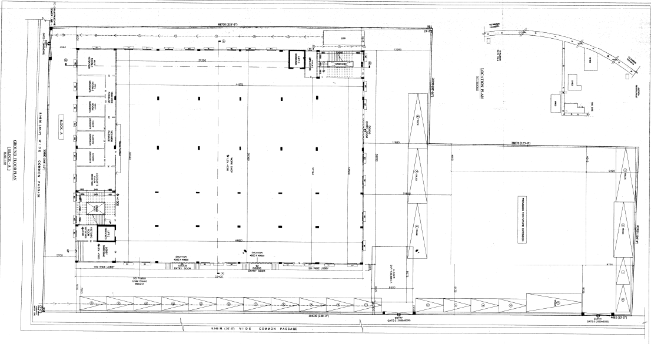**

**Copy of Site Plan**

**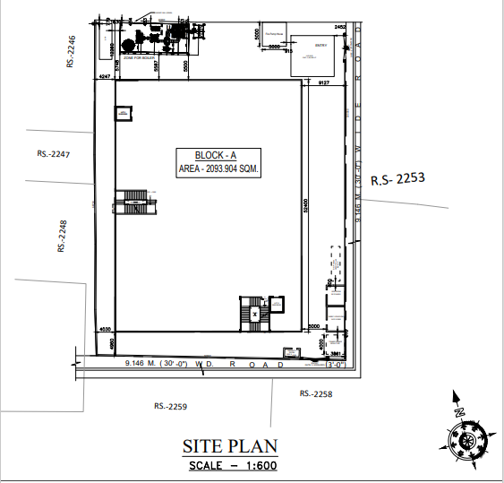**

**Copy of Pollution NOC**

**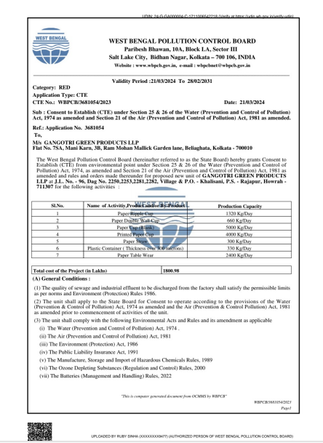**

**Area measured using Google Map**

**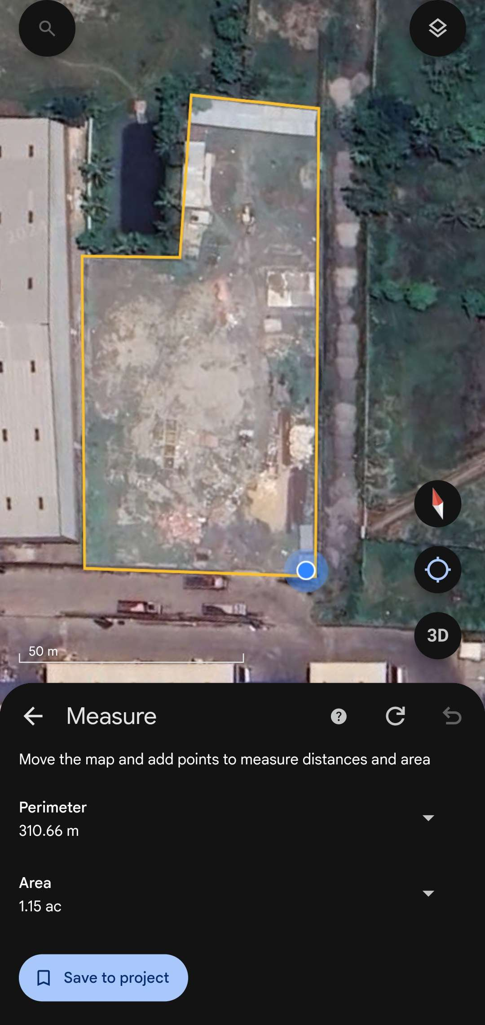**

**Copy of Trade Registration Certificate**

**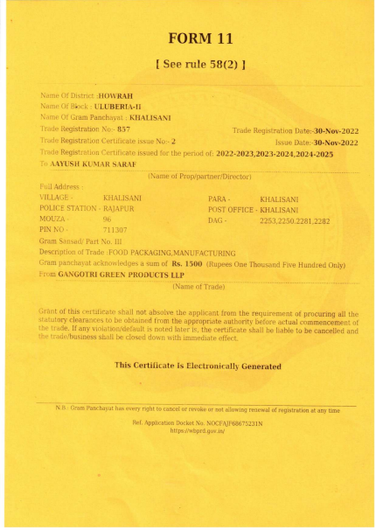**

**Copy of Registration Certificate**

**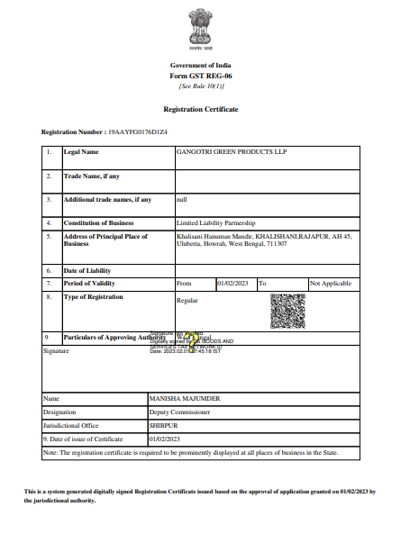**

**Copy of Fire NOC Receipt**

**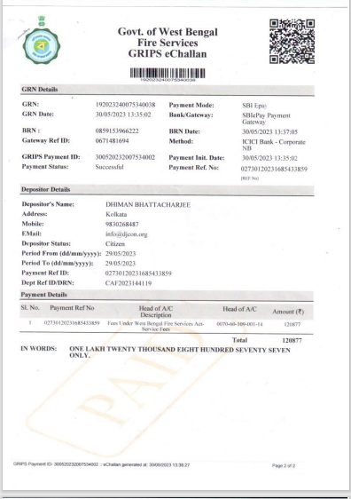**

**Copy of Fire NOC**

**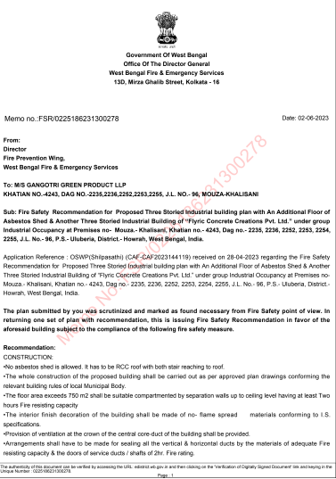**

|  |  |
| --- | --- |
| **PART L** | **PHPTOGRAPHS OF PROPERTY** |

|  |  |
| --- | --- |
|  |  |
|  |  |
|  |  |
|  |  |

|  |  |
| --- | --- |
| W:\In Progress Files\Ashil Baby\LIE REPORTS\UPDATED LIE REPORT\VIS(2024-25)-PL300-260-344\SECOND QUARTER\VIS(2024-25)-PL300-260-344_printing_1727415360\uploads\VIS(2024-25)-PL300-260-344\Site Pictures\uploads\SiteImage\c_TimePhoto_20240925_135603.jpg | W:\In Progress Files\Ashil Baby\LIE REPORTS\UPDATED LIE REPORT\VIS(2024-25)-PL300-260-344\SECOND QUARTER\VIS(2024-25)-PL300-260-344_printing_1727415360\uploads\VIS(2024-25)-PL300-260-344\Site Pictures\uploads\SiteImage\c_TimePhoto_20240925_135558.jpg |
| W:\In Progress Files\Ashil Baby\LIE REPORTS\UPDATED LIE REPORT\VIS(2024-25)-PL300-260-344\SECOND QUARTER\VIS(2024-25)-PL300-260-344_printing_1727415360\uploads\VIS(2024-25)-PL300-260-344\Site Pictures\uploads\SiteImage\c_TimePhoto_20240925_141042.jpg | W:\In Progress Files\Ashil Baby\LIE REPORTS\UPDATED LIE REPORT\VIS(2024-25)-PL300-260-344\SECOND QUARTER\VIS(2024-25)-PL300-260-344_printing_1727415360\uploads\VIS(2024-25)-PL300-260-344\Site Pictures\uploads\SiteImage\c_TimePhoto_20240925_135802.jpg |
| W:\In Progress Files\Ashil Baby\LIE REPORTS\UPDATED LIE REPORT\VIS(2024-25)-PL300-260-344\SECOND QUARTER\VIS(2024-25)-PL300-260-344_printing_1727415360\uploads\VIS(2024-25)-PL300-260-344\Site Pictures\uploads\SiteImage\c_TC_00907.jpg | W:\In Progress Files\Ashil Baby\LIE REPORTS\UPDATED LIE REPORT\VIS(2024-25)-PL300-260-344\SECOND QUARTER\VIS(2024-25)-PL300-260-344_printing_1727415360\uploads\VIS(2024-25)-PL300-260-344\Site Pictures\uploads\SiteImage\c_TimePhoto_20240925_135218.jpg |