File No.: VIS (2024-25)-PL105-089-119 Dated: 03-06-2024

COST VETTING ASSESSMENT

OF

M/S. ASHISH PIPES

SITUATED AT
INDUSTRIAL PLOT NO.- D-153, NOIDA EXTENTION PHASE-II, GAUTAM BUDDH NAGAR, U.P.

REPORT PREPARED FOR
STATE BANK OF INDIA, SME BRANCH, SECTOR 18, NOIDA

**Important - In case of any query/ issue or escalation you may please contact Incident Manager
at le@rkassociates.org. We will appreciate your feedback in order to improve our services.
NOTE: Please provide your feedback on the report within 15 days of its submission after which report will be considered to be correct

IMPORTANT NOTICE

COPYRIGHT FORMAT: This report is prepared on the copyright format of R.K Associates to serve our clients with the best possible information and analysis to facilitate them to take rational business decisions. Legally no one can copy or distribute this format without prior approval from R.K Associates. It is meant only for the advisory/ reference purpose for the organization/s as mentioned on the cover page of this report. Distribution or use of this format by any organization or individual other than R.K Associates will be seen as an unlawful act and necessary legal action can be taken against the defaulters.

This report is intended for the sole use of the intended recipient/s and contains material that is STRICTLY CONFIDENTIAL AND PRIVATE.

DEFECT LIABILITY PERIOD: - In case of any query/ issue or escalation you may please contact Incident Manager at le@rkassociates.org. We try to ensure maximum accuracy in the calculations done, rates adopted, assumptions taken and various other data points & information mentioned in the report but even still can’t rule out typing, human errors or any other bonafide mistakes. In case you find any such mistake or inaccuracy in any data point of the report, please help us by bringing all such points into our notice immediately or within 15 days of the r0eport delivery in writing, to rectify these timely failing after which R.K Associates won’t be held responsible for any such inaccuracy in any manner. We would highly appreciate your feedback in order to improve our services.
TABLE OF CONTENTS
SECTIONS | PARTICULARS | PAGE NO.
Part A | REPORT SUMMARY | 04
Part B | COST VETTING ASSESSMENT | 05 - 07
 | - DESCRIPTION | 06
 | - BUILDING & CIVIL WORKS: | 06 – 07
Part C | PHOTOGRAPHS | 08 - 09
Part D | IMPORTANT DOCUMENTS EXHIBIT | 10 – 11
Part E | DISCLAIMER | 12 - 13

PART A | REPORT SUMMARY

- DOCUMENT NAME: Cost Vetting Assessment
- PREPARED FOR: State Bank of India, SME Branch, Sector-18, Noida.
- BORROWER: M/s Ashish Pipes
- ASSET TYPE: Building Structure & Civil works
- ADDRESS OF THE ASSET: M/s Ashish Pipes, Industrial Plot No.- D-153, Noida Extension Phase-II, Gautam Buddha Nagar, U.P.
S. NO. | PARTICULARS | DESCRIPTION
 | Date of Work Order | Via Letter dated 20-05-2024
 | Date of site survey | 30-05-2024
 | Documents provided for perusal | Bill of Quantity
 | Project Location | M/s. Ashish Pipes, Industrial Plot No.- D-153, Noida Extension Phase-II, Gautam Buddha Nagar, U.P.
 | Borrowing Company | M/s. Ashish Pipes
 | Type of Assessment | Cost vetting.
 | Scope of Assessment | Cost Vetting of the Building Structure & civil work
 | Nature of Asset | Building Structure
 | Total Project Cost as informed by the borrower | Rs. 2.70 crores (Excluding GST)  (Including supply and installation as per the List/ quotations / invoices / Cost Estimate provided by the company.)
 | Project Cost as assessed by the consultant | Rs. 2.73 crores to Rs. 3.19 crores (Excluding GST)  (Including supply and installation as per the List/ quotations / invoices / Cost Estimate provided by the company.)
 | Total number of pages with Annexure. | 13

PART B | COST VETTING ASSESSMENT

- DESCRIPTION

This is a cost vetting document of the building structure located aforesaid address. As per the BOQ provided, the client proposed to develop Basement + Stilt + Ground + 2 floor structure. The subject locality is a well-developed notified Industrial area and adjacent properties are used for industrial purposes. The property is within 3 km from NSEZ metro station.

During site visit it has been observed that the building structure is under construction. The detailed progress of the construction is as given below,

S. No. | Description | Status
1 | Basement Floor | - Super structure is completed.  - Outer wall of the structure is complete.  - Finishing & MEP work is not done.
2 | Stilt Floor | - Super structure is completed.  - Part brick work done.  - Finishing & MEP work is not done.
3 | Ground Floor | - Super structure is completed.  - Partition wall of Kitchen & washroom is done. Balance brick work not yet done.  - Finishing & MEP work is not done.
4 | First Floor | Columns already casted. Shuttering work for roof slab in progress.
5 | Second Floor | Column casting in progress.
6 | Boundary Wall | Three side Boundary wall completed.

- BUILDING & CIVIL WORKS:

The cost involved in the construction of proposed structures and other civil work has been calculated from our analysis and market research. For reference we have considered CPWD DSR 2023.

Details estimate cost of the building construction is as shown below:

AS PER BOQ |  |  |  |  |  | AS PER CPWD DSR |  |  | AFTER APPLYING DISCOUNT  (Exclusive GST)
S. NO. | DESCRIPTION | QTY | RATE | UNIT | AMOUNT  (Exclusive GST) | RATE | AMOUNT  (Inclusive GST) | AMOUNT  (Exclusive GST) | Applying 40% discount for adjustment for market price and Industrial structure | Applying 30% discount for adjustment for market price and Industrial structure
1 | Earthwork in excavation of hard soil over area not exceeding 1.5m in width or 10sqm. On plane including dressing of sides & ramming of bottom & disposal of surplus within 50m head | 2450 | 140 | M3 | 3,43,000 | 177.50 | 4,34,875 | 3,68,538 | 2,21,123 | 2,57,977
2 | P/L in position cement concrete of specified grade excluding the cost of centring and shuttering all work up to plinth level 1:4:8 and 40mm thick nominal size | 600 | 2250 | M3 | 13,50,000 | 6812.00 | 40,87,200 | 34,63,729 | 20,78,237 | 24,24,610
3 | Brick work with Brick of class designation 7.5 in foundation plinth in cement mortar 1:4 | 300 | 2250 | M3 | 6,75,000 | 7370.65 | 22,11,195 | 18,73,894 | 11,24,336 | 13,11,726
4 | DPC providing & laying 25mm thick with cement concrete 1:2:4 | 900 | 280 | M2 | 2,52,000 | 247.88 | 2,23,088 | 1,89,057 | 1,13,434 | 1,32,340
5 | Brick work with Brick of class designation 7.5 in superstructure plinth in cement mortar 1:6 | 650 | 2400 | M3 | 15,60,000 | 9344.35 | 60,73,828 | 51,47,311 | 30,88,387 | 36,03,118
6 | RCC work in suspended floor roof, landing, balcony, excluding centring shattering & reinforcement with 1:2:4 | 510 | 3100 | M3 | 15,81,000 | 8583.40 | 43,77,534 | 37,09,775 | 22,25,865 | 25,96,842
7 | Centring of Shuttering | 5200 | 190 | M2 | 9,88,000 | 392.15 | 20,39,180 | 17,28,119 | 10,36,871 | 12,09,683
8 | Providing wood work in chowkat of door, window & fix in position of 2nd kiln seasoned and chemically treated hoolock wood | 19 | 38500 | M3 | 7,31,500 | 83378.05 | 15,84,183 | 13,42,528 | 8,05,517 | 9,39,770
9 | Providing & fixing 2nd classkail panelled & glazed shutter for door window, clearstory window including, bank enamelled MS butt hinges with nessery screen excluding panelling 40mm thick | 950 | 1480 | M2 | 14,06,000 | 3524.85 | 33,48,608 | 28,37,803 | 17,02,682 | 19,86,462
10 | 12mm cement plaster of 1:6 mix | 6200 | 150 | M2 | 9,30,000 | 333.35 | 20,66,770 | 17,51,500 | 10,50,900 | 12,26,050
11 | White washing with line to give an even shade work (three or more coat) | 6200 | 15 | M2 | 93,000 | 39.05 | 2,42,110 | 2,05,178 | 1,23,107 | 1,43,625
12 | Distempering with oil bond of approved brand & manufacture to give an even shade new work (two or more coat including a priming coat) | 6200 | 110 | M2 | 6,82,000 | 185.65 | 11,51,030 | 9,75,449 | 5,85,269 | 6,82,814
13 | 40mm thick Kota stone flooring rubbed and polish and granolithic finish under layer 20mm thick cement slurry etc. complected with light shade pigment with white cement | 4300 | 650 | M2 | 27,95,000 | 645.83 | 27,77,086 | 23,53,463 | 14,12,078 | 16,47,424
14 | Tor steels | 121500 | 70 | KG | 85,05,000 | 107.85 | 1,31,03,775 | 1,11,04,894 | 66,62,936 | 77,73,426
15 | Primer on wood work | 1400 | 60 | M2 | 84,000 | 74.65 | 1,04,510 | 88,568 | 53,141 | 61,997
16 | Paint on wood work | 1210 | 82 | M2 | 99,220 | 176.25 | 2,13,263 | 1,80,731 | 1,08,439 | 1,26,512
17 | Mud phaska | 471 | 160 | M2 | 75,360 | 137.70 | 64,857 | 54,963 | 32,978 | 38,474
TOTAL |  |  |  |  | 2,21,50,080 |  | 4,41,03,090 | 3,73,75,500 | 2,24,25,300 | 2,61,62,850
18 | Add: 8% Electrical |  |  |  | 17,72,006 |  | 35,28,247 | 29,90,040 | 17,94,024 | 20,93,028
19 | Add: 9% for Int. WS & Sanitary |  |  |  | 19,93,507 |  | 39,69,278 | 33,63,795 | 20,18,277 | 23,54,656
20 | Add: 5% Bringing of cost |  |  |  | 11,07,504 |  | 22,05,154 | 18,68,775 | 11,21,265 | 13,08,142
GRAND TOTAL |  |  |  |  | 2,70,23,098 |  | 5,38,05,770 | 4,55,98,110 | 2,73,58,866 | 3,19,18,677

REMARKS:
- Estimated cost by the company is almost 40% lesser than the CPWD DSR rates.
- Above DSR Rates are for non-industrial building and accordingly relevant discount has been applied to match the market rates for Industrial structure.
- Generally, DSR rates have 15-20% cushion with respect to Market Rates and accordingly adjustments can be made.
- As per our assessment cost may stretch from Rs.2.73 crores to Rs.3.19 crores the above work.
- Cost difference may be there when labour is deployed through local contractor on daily basis Vs engaging EPC contractor and also difference in using concrete mixer at site Vs using of RMC.

PART C | PHOTOGRAPHS

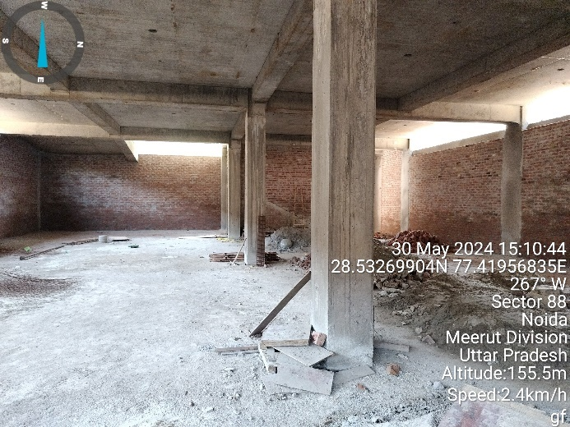 | 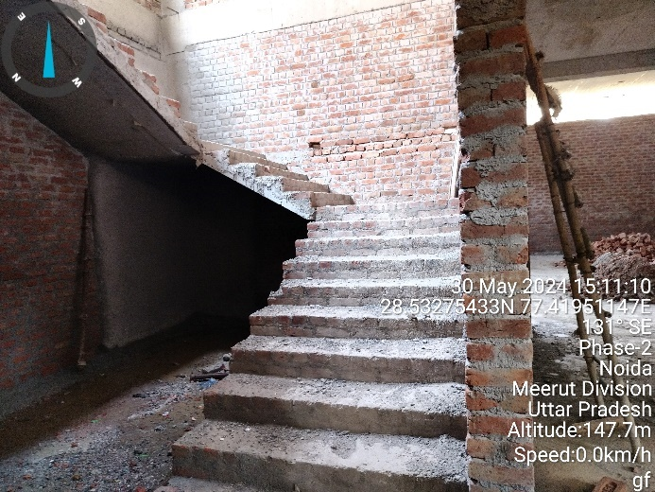
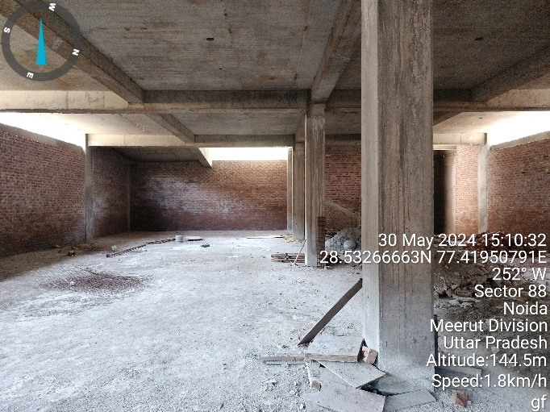 | 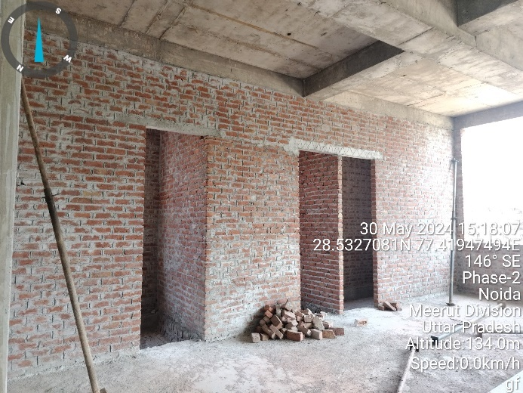
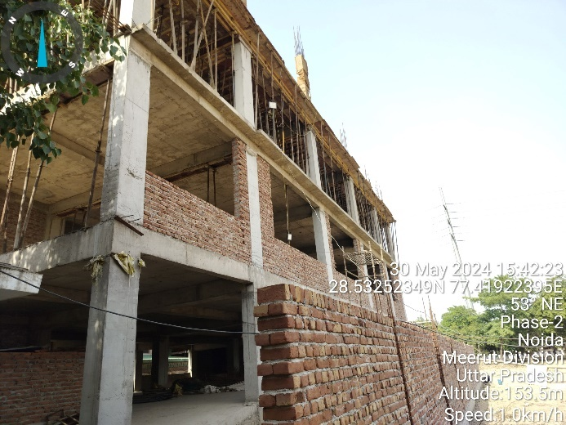 | 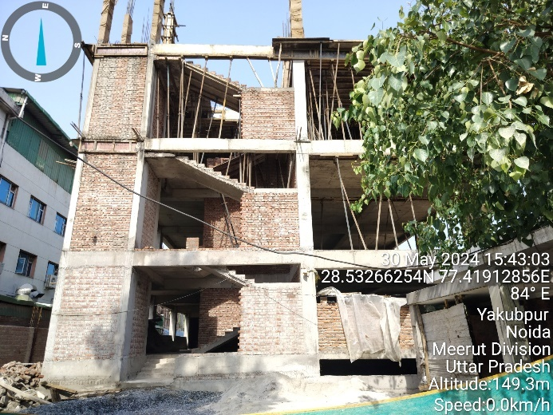
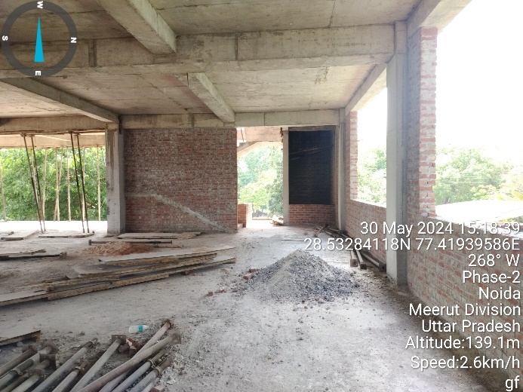 | 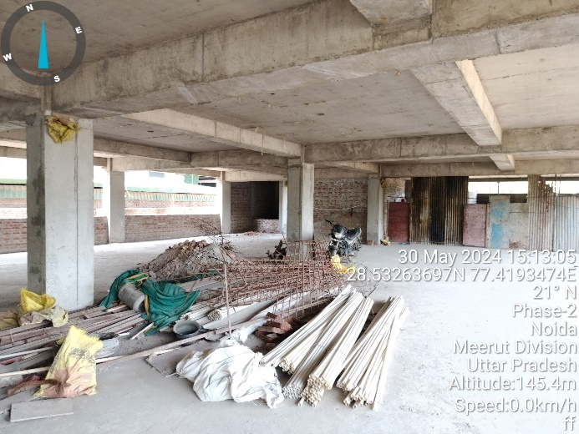
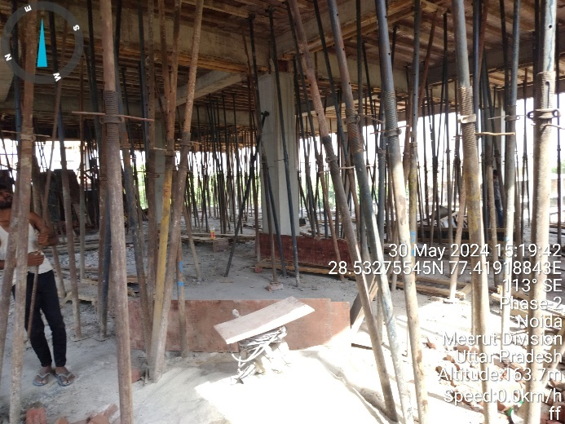 | 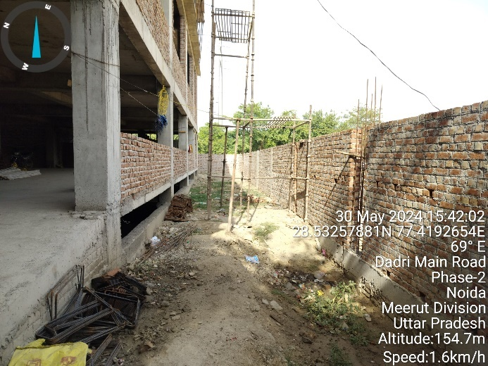
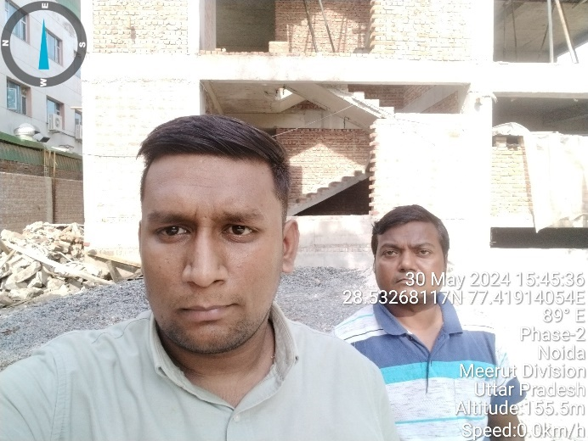 | 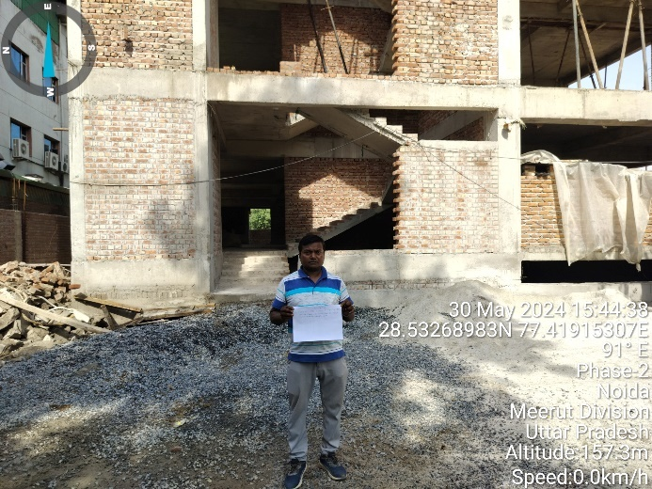

PART D | IMPORTANT DOCUMENT EXHIBIT

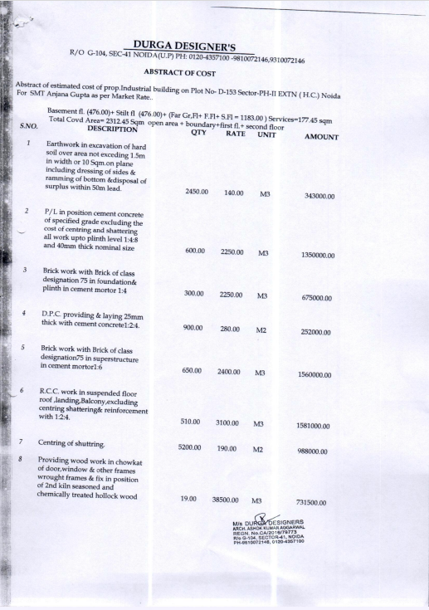

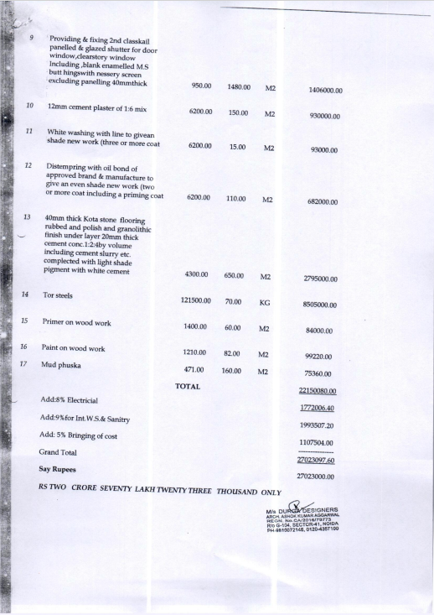

PART E | DISCLAIMER

- We have received sample BOQ for building construction and civil work.
- The client/ owner and its management/ representatives warranted to us that the information they have supplied was complete, accurate and true and correct to the best of their knowledge. All such information provided to us either verbally, in writing or through documents has been relied upon in good faith and we have assumed that it is true & correct without any fabrication or misrepresentation. I/We shall not be held liable for any loss, damages, cost or expenses arising from fraudulent acts, misrepresentations, or willful default on part of the owner, company, its directors, employee, representative or agents.
- Legal aspects for eg. Investigation of title, ownership rights, lien, charge, mortgage, lease, sanctioned maps, and verification of documents provided to us such as title documents, Map, etc. from any concerned Govt. office etc. have to be taken care by legal expert/ Advocate and same is not done at our end. I/ We assume no responsibility for the legal matters including, but not limited to, legal or title concerns.
- Wherever any details are mentioned in the report in relation to any legal aspect of the property such as name of the owner, leases, etc. is only for illustration purpose and should not be construed as a professional opinion. Legal aspects are out of scope of this report. Details mentioned related to legal aspect are only based on the copy of the documents provided to us and whatever we can interpret as a non-legally trained person. This should be cross validated with a legal expert. We do not vouch any responsibility regarding the same.
- We have relied on the data from third party, external sources & information available on public domain to conclude the valuation. These sources are believed to be reliable and therefore, we assume no liability for the truth or accuracy of any data, opinions or estimates furnished by others that have been used in this analysis. Where we have relied on the data, opinions or estimates from external sources, reasonable care has been taken to ensure that such data is extracted from authentic sources, however we still can’t vouch its authenticity, correctness, or accuracy.
- Documents, information, data including provided to us during the course of this assessment by the client is reviewed only upto the extent required in relation to the scope of the work. No document has been reviewed beyond the scope of the work. These are not reviewed in terms of legal rights for which we do not have expertise. Wherever any information mentioned in this report is mentioned from the documents like owner’s name, etc., it is only for illustration purpose and may not necessarily represent accuracy.
- This cost vetting is done only on the basis of market research and BOQ provided to us by the company and we don’t recommend any sort of recommendation in our Document.
- The estimated cost verification of item to item can’t exactly match as per our vetting due to several market consideration. In some of the items it is lower while in some of the item’s price comes to be higher but on an average the price as per list provided to us falls in the range as confirmed by us.
- There can be variation in the estimated price if the specification & make of any items procured is different from the list provided to us during assessment.
- The estimated cost verification is made based on the third-party information which has been replied upon in good faith.
- Ownership and other legal point of view in respect of the asset is not considered in this report as same is out of scope of this document.
- This document is made at the request of the Bank.

For R.K Associates Valuers & Techno FOR INTERNAL USE Engineering Consultants (P) Ltd. PREPARED BY: Yash Bhatnagar REVIEWED BY: Anil Kumar

