**REPORT FORMAT:** CL-1 | Version: 1.0_2024

# FILE No.: VIS (2024-25)-PL106-090-120 Date: 25-07-2024

* **DOCUMENT NAME:** Cost Vetting report for PVC Pipe & Fittings manufacturing unit which is proposed to be installed in Industrial Plot No. D-153, Hosiery Complexes, Noida, Phase 2 Extension, Gautam Budh Nagar, Uttar Pradesh
* **PREPARED FOR ORGANIZATION:** State Bank of India, Sector 18, Dharam Palace Complex, Gautam Budh Nagar, Uttar Pradesh.
* **BORROWER COMPANY’S NAME:** M/s Ashish Pipes.
* **ASSET TYPE**: PVC pipes and fittings manufacturing unit.
* **CURRENT LOCATION OF THE MACHINES**: Machines are not yet purchased.

**TO WHOM IT MAY CONCERN**

|  |  |  |
| --- | --- | --- |
| **S. NO.** | **PARTICULARS** | **DESCRIPTION** |
| 1. | Date of Survey | Not Applicable |
| 2. | Date of Certificate | 25-07-2024 |
| 3. | Documents provided for perusal | 1. List of machines 2. Quotations |
| 4. | Current Location of the Machines | Machines are not yet purchased. |
| 5. | Borrowing Company | M/s Ashish Pipes. |
| 6. | Type of Asset | Machinery required for the manufacture of PVC & RPVC pipes and fittings. |
| 7. | Type of Assessment | Cost vetting |
| 8. | Scope of Assessment | Cost Vetting of the new machines which has to be purchased by the company. |
| 9. | Nature of Machinery | Moulds used for manufacturing of PVC and RPVC pipe & fittings |
| 10. | Year of Manufacturing | Machineries are yet not installed. |
| 11. | Total Proposed Purchase Cost | Total purchase cost for P20 mould and Injection Moulding machine **= Rs. 1,94,60,000/-** |
| 12. | Current Estimated Market Value | Total cost as per RKA market research for P20 mould and Injection Moulding machine  =**Rs. 1,85,40,000/-**  The range of current market rates of such type of machinery & equipment is verified from various suppliers and also from the public domain.  According to our observation, the rate as per the list of machinery and their total purchase price provided to us by the company/ bank are matching when compared to the rates of similar machines currently prevailing in the market and seems to be reasonable.  The rate of machines can vary up to (+,-) 5% based on the brands, location and discounts on the negotiation by the client. Based on our analysis, the rate shown by M/s Ashish Pipes seems to be in line with current market rate. |
| 13. | Condition of Machines | All the machines are yet to be purchased. |

**OBSERVATIONS:**

1. We have been provided with the copy of purchase orders with cost of machines/ equipment by the borrower company.
2. As per the information provided by the company officials these items are proposed to be installed on Industrial Plot No. D-153, Hosiery Complexes, Noida, Phase 2 Extension, Gautam Budh Nagar, Uttar Pradesh.
3. We have contacted several suppliers for similar items and also enquired in the public domain. Accordingly, we have got the quotation from the suppliers and found that the price given in the list of quotations provided to us is well within the price range of similar items available in the market and seems to be reasonable.
4. In this certificate, there can be some difference in the cost of some of the machines due to the auxiliary equipment and accessories as some of the quotations from the market are only for the main machines.

Based on the information provided by the company (M/s. Ashish Pipes) and enquiries made by us in the open market and references found in the public domain for similar machines/items, it is certified that total market cost for purchasing up the listed machines is in the range of **Rs. 1,76,13,000/- to Rs.1,94,67,000/-.** Therefore the total purchase price of **Rs.1,94,60,000/-** as per the quotations & purchase orders provided to us by M/S Ashish Pipes appears to be in line and reasonable.

***Disclaimer:***

* 1. *We can’t comment about the current status of machines whether these are purchased, installed or in transit. This cost vetting is done only on the basis of Purchase Orders provided to us by the company and we don’t recommend any sort of recommendation in our Certificate.*
  2. *The estimated cost verification of item to item can’t exactly match as per our vetting due to several market consideration. In some of the items it is lower while in some of the items price comes to be higher but on an average the price as per list provided to us falls in the range as confirmed by us.*
  3. *There can be variation in the estimated price if the specification & make of any items procured is different from the list provided to us during assessment.*
  4. *The estimated cost verification is made based on the third-party information which has been replied upon in good faith.*
  5. *The estimated price may vary at the time of actual procurement because of change in prices in the market for such kind of machinery/items for which we will not have any control. The cost vetting is only limited to the date of Certificate issued. We do not assume any responsibility in change of prices of the said machinery/items after this date.*
  6. *Market Values of some of the machine’s equipment like Fire system, HVAC work, Electrical wiring & lighting and clean room panel & windows are considered same as the amount shown in the list provided to us due to the unavailability of technical specifications of machines and equipments.*
  7. *This certificate doesn’t include any work related to drawing, design, sketch plan, procurement of the machines.*
  8. *Ownership and other legal point of view in respect of the asset is not considered in this report as same is out of scope of this certificate.*
  9. *This certificate is made at the request of the Bank.*

**For R.K Associates Valuers** **& Techno** **FOR INTERNAL USE Engineering Consultants (P) Ltd. *TYPED BY: Ashil Baby***

# ANNEXURE: - I (COMPARISON LIST)

|  |  |  |  |  |  |
| --- | --- | --- | --- | --- | --- |
| **Sl. No.** | **Name of the Machine/ Mould** | **Specification** | **Vendor** | **Amount shown by company Excluding GST** | **Market rates as per RKA Excluding GST** |
| 1 | Elbow 90° (6 kg) | 90 | Adith Plastic | 6,30,000 | 7,75,000 |
| 2 | Elbow 90° (6 kg) | 110 | Adith Plastic | 8,10,000 | 9,25,000 |
| 3 | Tee Plain 90° (6 kg) | 90 | Adith Plastic | 8,10,000 | 8,70,000 |
| 4 | Tee Plain 90° (6 kg) | 110 | Adith Plastic | 12,15,000 | 10,35,000 |
| 5 | Coupler(6 kg) | 90 | Adith Plastic | 6,75,000 | 6,25,000 |
| 6 | Coupler(6 Kg) | 110 | Adith Plastic | 8,55,000 | 7,15,000 |
| 7 | End Cap Without Coller | 90 | Adith Plastic | 5,85,000 | 3,45,000 |
| 8 | End Cap Without Coller | 110 | Adith Plastic | 7,65,000 | 4,50,000 |
| 9 | Reducing Coupler | 110 X 90 | Adith Plastic | 7,65,000 | 8,00,000 |
| 10 | RPVC Injuction Moulding Machine with Servo drive technology | 200 TON x 2 | Avinya Machinery International Private Limited | 68,00,000 | 61,00,000 |
| 11 | RPVC Injuction Moulding Machine with Servo drive technology | 350 TON x 1 | Pratishna Engineers Limited | 55,50,000 | 59,00,000 |
|  | **Total Amount** | | | **1,94,60,000** | **1,85,40,000** |

**ANNEXURE: - II (QUOTATIONS/ provided by the company)**

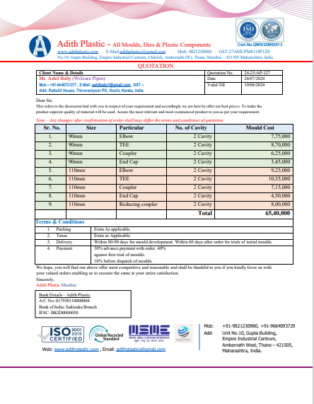

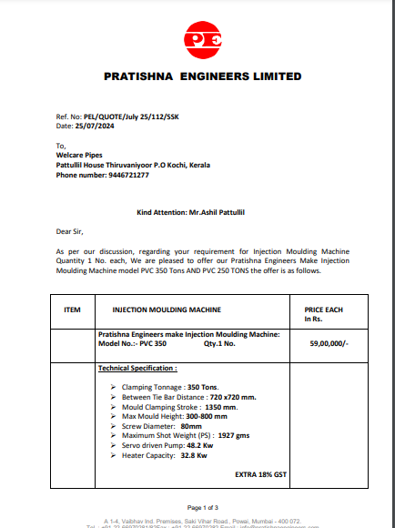

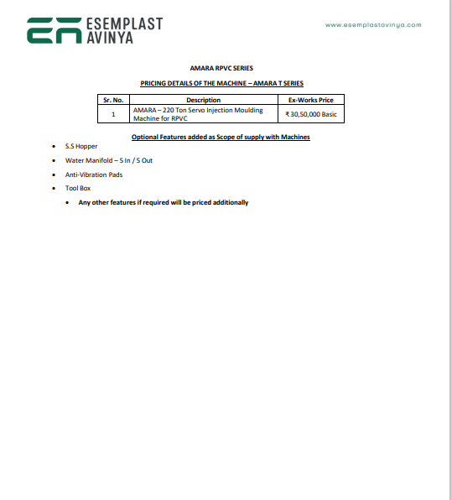

# ANNEXURE: - III (DOCUMNETS PROVIDED BY CLIENT)



 

