**REPORT FORMAT:** CL-1 | Version: 1.0_2018

# FILE No.: VIS(2024-25)-PL119-102-133 Date: 10-06-2024

* ***CERTIFICATE* NAME:** *Cost Verification of hydraulic crawler crane which is yet to be purchased.*
* ***PREPARED FOR ORGANIZATION:*** *State Bank of India, SME Branch, Chandigarh*
* ***BORROWER COMPANY’S NAME:*** *M/s Tara Chand Infralogistic Solutions Ltd.*
* ***ASSET TYPE****: Machine for lifting and erection of heavy objects/material/machines in the construction of plants/large infra projects.*
* ***CURRENT LOCATION OF THE MACHINES****: NA as machines is yet to be purchased.*

**TO WHOM IT MAY CONCERN**

|  |  |  |
| --- | --- | --- |
| **S. NO.** | **PARTICULARS** | **DESCRIPTION** |
| 1. | Date of Survey | Not Applicable |
| 2. | Date of Certificate | 10-06-2024 |
| 3. | Documents provided for perusal | Quotations from the market |
| 4. | Current Location of the Machines | Machine yet to be purchased. |
| 5. | Borrowing Company | M/s Tara Chand Infralogistic Solutions Ltd. |
| 6. | Type of Asset | 800 MT Hydraulic crawler crane |
| 7. | Type of Assessment | Cost verification |
| 8. | Scope of Assessment | Cost verification of the new Hydraulic crane which yet to be purchased by the company. |
| 9. | Nature of Machinery | 800 MT Hydraulic crawler crane |
| 10. | Year of Manufacturing | NA, Yet to be purchased. |
| 11. | Total Purchase Cost | **Rs.** **23,72,51,814.80 /-** (*Total project Cost as per the List of machinery / quotations provided by the company)*. |
| 12. | Current Estimated Market Value | The range of current market rates of such type of machine is verified from various suppliers and also from the public domain for the new machine.  As per the research, Hydraulic crawler crane machine is only manufactured in some specific countries. Which further imported. This type of machines are not manufactured in India.  It is used for lifting and erection of heavy objects/material/machines in the construction of plants/large infra projects.  As per the quotation provided to us by company/bank. Company is purchasing the machine from China shall be used for rental purpose.  As per our research and discussion with company who are already in the rental business, such as Solitary hydraulic crane and V J Crane, we came to know that for hydraulic crawler crane rental rate range for the machine of similar kind should be in the range **Rs.45.00 Lakhs to Rs.55.00 Lakhs** per month& market rate range for the machine of similar kind should be in the range **Rs.22.00 Crore to Rs.26.00 Crore.**  According to our observation, the rate as per the list of machinery and their total purchase price provided to us by the company/ bank are quite reasonable when compared to the rates of similar machines currently prevailing in the market.  However, in the last few months, the rates of metal have increased, so we have considered the range accordingly. |
| 13. | Condition of Machines | All machines are yet to be purchased. |

**OBSERVATIONS:**

1. We have been provided with the copy of quotations from the market with cost of machines/ equipment by the borrower company.
2. As per the market research, Hydraulic crawler crane machine is only manufactured in some specific countries. It is used for lifting and erection of heavy objects/material/machines in the construction of plants/large infra projects.
3. As per the quotation provided to us by company/bank, company is importing the machine from China which shall be used for rental purpose.
4. As per our research and discussion with company who are already in the rental business, such as Solitary hydraulic crane and V J Crane, we came to know that for hydraulic crawler crane rental rate range for the machine of similar kind should be in the range Rs.45 Lakhs to Rs.55 Lakhs per month.
5. We have contacted several suppliers for similar items and also enquired in the public domain. Accordingly we have got the tentative rates from the suppliers and we find that the rates provided to us is well within the price range of similar items available in the market and seems to be reasonable.
6. As per the references in the public domain annexed with the report, we came to know that the rates for a used similar machine manufactured in 2020 should be around **Rs.10.00 Crore to Rs.12.00 Crore**. Additionally, the market rate range for a new machine of similar kind should be in the range of **Rs.22.00 Crore to Rs.26.00 Crore.**
7. Based on the information provided by the company (M/s Tara Chand Infralogistic Solutions Ltd.) and enquiries made by us in the open market and references found in the public domain for similar machines/items, it is certified that total market cost of machine for similar specification should be around **Rs.22 Crore to Rs.26 Crore** and therefore the total purchase price of **Rs.** **23,72,51,814.80 /-** (as per the quotations provided to us by the company) appears to be reasonable.

***Disclaimer:***

* 1. *We can’t comment about the current status of machines whether these are purchased, installed or in transit. This cost vetting is done only on the basis of Quotations, Bills and Purchase Orders provided to us by the company and we don’t recommend any sort of recommendation in our Certificate.*
  2. *The estimated cost verification of item to item can’t exactly match as per our vetting due to several market consideration. In some of the items it is lower while in some of the items price comes to be higher but on an average the price as per list provided to us falls in the range as confirmed by us.*
  3. *There can be variation in the estimated price if the specification & make of any items procured is different from the list provided to us during assessment.*
  4. *The estimated cost verification is made based on the third party information which has been replied upon in good faith.*
  5. *The estimated price may vary at the time of actual procurement because of change in prices in the market for such kind of machinery/items for which we will not have any control. The cost vetting is only limited to the date of Certificate issued. We do not assume any responsibility in change of prices of the said machinery/items after this date.*
  6. *This certificate doesn’t include any work related to drawing, design, sketch plan, procurement of the machines.*
  7. *Ownership and other legal point of view in respect of the asset is not considered in this report as same is out of scope of this certificate.*
  8. *This certificate is made at the request of the Bank.*

**For R.K Associates Valuers** **& Techno** **FOR INTERNAL USE Engineering Consultants (P) Ltd. *TYPED BY: Nischay Gautam***  ***REVIEWED BY: Abhinav Chaturvedi***

**ANNEXURE: - I** **(REFERENCES ON PRICE TREND OF THE SIMILAR RELATED MACHINE AVAILABLE ON PUBLIC DOMAIN)**

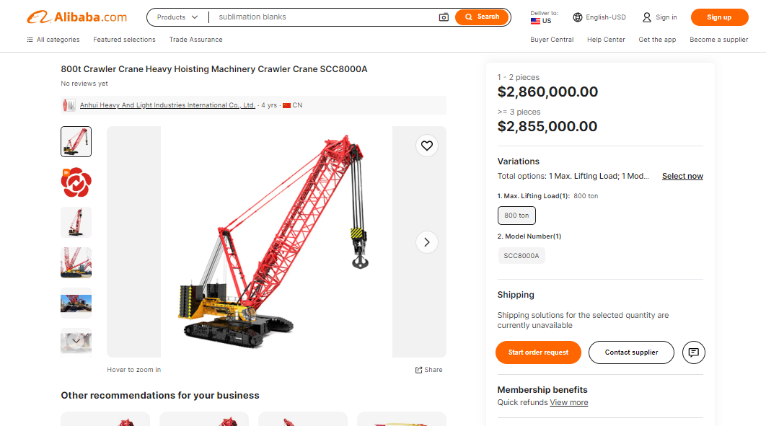

**ANNEXURE: - II** **(REFERENCES OF THE SIMILAR RELATED SECOND HAND MACHINE AVAILABLE ON PUBLIC DOMAIN)**

