**REPORT FORMAT:** CL-1 | Version: 1.0_2018

# FILE No.: VIS(2024-25)-PL122-105-136 Date: 03/06/2024

* **CERTIFICATE NAME:** Cost Verification Report for the machinery and equipment.
* **FOR ORGANIZATION:** StateBank of India, SME Branch, Faridabad, Haryana.
* **BORROWER COMPANY’S NAME:** M/s. Sterling Gtake E Mobility Ltd.
* **ASSET TYPE**: Manufacturer EV Motor Controller & Motor.
* **CURRENT LOCATION OF THE MACHINES:** 12/2, NH-19, Sector 27, Faridabad, Haryana.

**TO WHOMSOEVER IT MAY CONCERN**

|  |  |  |
| --- | --- | --- |
| **S. NO.** | **PARTICULARS** | **DESCRIPTION** |
| 1. | Date of Survey | Not Applicable |
| 2. | Date of Certificate | 03/06/2024 |
| 3. | Documents provided for perusal | List of machines, Invoices/Performa Invoices (Partially) |
| 4. | Current Location of the Machines | 12/2, NH-19, Sector 27, Faridabad, Haryana |
| 5. | Borrowing Company | M/s. Sterling Gtake E Mobility Ltd. |
| 6. | Type of Asset | Equipment required for Electric Vehicle Motor Controller & Motors manufacturing & other office equipment. |
| 7. | Type of Assessment | Cost Verification of machines/assets purchased, installed |
| 8. | Scope of Assessment | Cost Verification of machines/assets purchased, installed |
| 9. | Nature of Machinery | Equipment required for Electric Vehicle Motor Controller & Motors manufacturing & other office equipment. |
| 10. | Current Progress of the machines | As per information provided by the company official & copy of invoices shared, only few machines are purchased. |
| 11. | Condition of Machines | As per copy of bill of some machines shared, machines are newly purchased and some of the yet to be purchased. |

## Cost Verification of Machinery & Equipment: -

| **Particulars** | **Qty** | **Cost as per company**  **(In Lac)** | **Cost as per RKA**  **(In Lac)** | **Remarks** |
| --- | --- | --- | --- | --- |
| **Software & Infrastructure for NPD** |  |  |  |  |
| Ansys New Licenses | 1 | - | 1.00 | It comprises customized software which depends upon type of software required. Thus, it is assumed to be in line with the available market trend. |
| Orcad New Licenses | 1 | 5.00 | 6.64 |
| AutoCAD 3 Years With 2d and 3d | 2 | 7.00 | 10.00 |
| ALM | 30 | 10.00 | 15.04 |
| QLM Siemens Op-Center |  | 15.04 | 15.00 |
| QLM & PLM implementation |  | 15.00 | 1.35 |
| Beyon compare |  | 1.35 | 1.00 |
| **Sub Total** |  | **53.39** | **49.03** |  |
| **Low Voltage Capacity & Capability Enhancement** |  |  |  |  |
| ABZ+PWM senor motor (SEG 5Kw) | 4 | 1.20 |  |  |
| Hall sensor motor (SEG 5Kw) | 4 | 1.20 |  |  |
| ABZ+PWM senor motor (SEG 5Kw) | 2 | 0.60 |  |  |
| Hall sensor motor (SEG 5Kw) | 2 | 0.60 |  |  |
| Test bench table modification (application lab) | 1 | 1.00 | 1.00 | It is solely depending upon specification of assets to be purchased. It is line with current market scenario. |
| Vehicles | 2 | 4.00 | 4.00 |
| Vehicles (OLA) |  | 2.00 | 1.43 | The tentative on road price of OLA S1 Pro is ~1,43,369/- which is less than that of mentioned price. |
| CANOP/ CAN Analyzer | 1 | 10.00 |  |  |
| PCAN | 5 | 7.50 |  |  |
| Power Supplies (48V, 10A) | 5 | 2.50 | 2.50 | In line with the current market scenario. |
| Dyno Setup (40Kw) | 1 | 40.00 | 36.25 | Already purchased 12kW Dyno Setup at @36.25 Lacs. |
| **Sub Total** |  | **70.60** | **45.18** |  |
| **High Voltage Capability Enhancement** |  |  |  |  |
| High Voltage Dyno | 1 | 500.00 | 466.00 | Already purchased. |
| Power Supply Unit (Bench setup) (800V, 50A) | 1 | 30.00 | 59.05 | As per copy of Invoice provided. Company has already purchased the said equipment @ Rs.59,04,706/-. Which in line with the current market scenario as per information found on public domain. |
| Power Supply Unit (Bench setup) for G05 (400V, 50A) | 1 | 15.00 |
| Power Supply Unit (Bench setup) for G05 (400V, 50A) | 2 | 30.00 |
| **Sub Total** |  | **575.00** | **610.33** |  |
| **Facilities upgrade and Proto lines** |  |  |  |  |
| Proto assembly line Setup & Equipment | 1 | 10.00 | 10.00 | Within range of secondary market research. |
| Test bench table modification (application lab) | 1 | 1.00 |  |  |
| Tool Trolly | 2 | 1.50 |  |  |
| Dust chamber | 1 | 18.00 | 22.07 | As per copy of Invoice provided, it comprises Dust Chamber along with Rain Test Chamber |
| Endurance Testing Machine upgrade | 1 | 2.00 | 1.50 | 1.5 Lac available |
| Soldering Station | 1 | 2.50 | 1.50 | It seems to be on higher side. In the current market, Normal Soldering station can be purchased @1.5 lac only. |
| EOL for Proto testing (15 KW) | 1 | 61.00 |  |  |
| Environmental chamber |  | 21.00 | 24.44 | Company has already purchased Environmental chamber @24.44 Lac |
| Other Miscellaneous Items | 1 | 95.48 | 95.48 | It pertains to miscellaneous items. Thus, the same is considered. |
| **Sub Total** |  | **212.48** | **154.99** |  |
| **Localization** |  |  |  |  |
| tooling | 1 | 40.25 | 40.25 | Seems to be in-line with the current market value of individual assets. However, cost of each asset can only be verified after purchase. |
| Fixtures | 1 | 6.50 | 6.50 |
| Gauges | 1 | 4.00 | 4.00 |
| tooling | 1 | 112.50 | 112.50 |
| Fixtures | 1 | 5.00 | 5.00 |
| Gauges | 1 | 3.50 | 3.50 |
| tooling | 1 | 217.25 | 217.25 |
| Fixtures | 1 | 37.50 | 37.50 |
| Gauges | 1 | 11.50 | 11.50 |
| G05 Production Line |  | 100.00 |  |
| Tooling | 1 | 10.00 | 10.00 |
| Gauges | 1 | 1.00 | 1.00 |
| Fixtures | 1 | 6.00 | 6.00 |
| Gauges | 1 | 2.50 | 2.50 |
| Control Board Fixture |  | 2.64 | 2.64 |
| Housing Fixtures |  | 3.08 | 3.08 |
| Hipot Fixtures |  | 7.71 | 7.71 |
| IR Fixtures |  | 6.65 | 6.65 |
| EOL Fixtures |  | 7.39 | 7.39 |
| **Sub Total** |  | **584.97** | **484.97** |  |
| **New Lines & Balancing equipment** |  |  |  |  |
| Assembly Lines | 2 | 30.00 | 30.00 | Seems to be in-line with the current market value of individual assets. However, cost of each asset can only be verified after purchase. |
| Thermal Paste Machine | 1 | 2.70 | 2.70 |
| Material Handling & Storages | As per Budget | 10.58 | 10.58 |
| ESD Expansions (Ionizer Bars, snake bars) | 5.70 | 5.70 |
| Screw Drivers & counters | 6.30 | 6.30 |
| Scanners | 3.96 | 3.96 |
| Testing equipment (EOL & Hypot) | - |  |
| D06 (HIPOT) | 1 | 15.00 | 15.00 |
| M04 (EOL) | 1 | 25.00 | 25.00 |
| ESD Testers | 1 | 0.72 | 0.72 |
| Hygrometer | 1 | 0.05 | 0.05 |
| Weighing Machine | 1 | 0.25 | 0.25 |
| ESD pallet | 50 | 1.00 | 1.00 |
| Storage Bins | 233 | 1.74 | 1.74 |
| Packaging Bins | 2000 | 17.58 | 17.58 |
| Storage Racks | 52 | 15.60 | 15.60 |
| Working Table | 3 | 0.75 | 0.75 |
| Hand Lifter Repair & Purchases | 2 | 0.30 | 0.30 |
| Movement Trolley | 2 | 0.30 | 0.30 |
| Telehandler | 1 | - |  |
| **Sub Total** |  | **137.53** | **137.53** |  |
| **Plant & Office Expansion** |  |  |  |  |
| **IT capex** |  |  |  |  |
| New INFRA SGEM (Faridabad) |  | 47.53 | 47.53 | This amount pertains to infrastructure related to the plant. |
| New INFRA SGEM (Faridabad) |  | 17.73 | 17.73 |
| IPBX | 1 | 4.00 | 4.00 | In the current market Normal IP PBX systems are available in range of Rs. 1.00 lac to Rs. 2.00 lac. However, the IPBX shall have higher specifications. |
| IPBX | 1 | 4.00 | 4.00 |
| Projector | 1 | 1.90 | 1.90 | Seems to be in-line with the current market value of individual assets. However, cost of each asset can only be verified after purchase. |
| Camera | 1 | 0.65 | 0.65 |
| Camera |  | 0.65 | 0.65 |
| Motorized Screen | 1 | 0.13 | 0.13 |
| Speaker Phone | 1 | 0.30 | 0.30 |
| Speaker Phone | 1 | 0.30 | 0.30 |
| Samsung SMART Signage 65" | 5 | 4.00 | 0.80 |
| Samsung SMART Signage 65" | 1 | 0.80 | 0.80 |
| 65" TV Mount | 5 | 0.75 | 0.15 |
| 65" TV Mount | 5 | 0.15 | 0.03 |
| AV Installation | 1 | 0.15 | 0.15 |
| AV Installation | 1 | 0.15 | 0.15 |
| 10 KVA UPS  30 Min Backup UPS | 1 | 4.50 | 4.50 |
| **IT Hardware** |  |  |  |  |
| Laptops | 84 | 58.80 | 0.70 | Seems to be in-line with the current market value of individual assets. However, cost of each asset can only be verified after purchase. |
| Laptops | 30 | 21.00 | 0.70 |
| Desktops | 1 | 0.60 | 0.60 |
| Monitors | 30 | 3.60 | 0.12 |
| Barcode Printer | 6 | 2.10 | 0.35 |
| AD Server | 2 | 4.50 | 2.25 |
| NAS Storage 20tb | 1 | 6.00 | 6.00 |
| AD Server | 1 | 2.25 | 2.25 |
| NAS Storage 10Tb | 1 | 4.50 | 4.50 |
| ERP Implementation (SAP preferred) |  | 60.00 | 60.00 |
| Vehicles for Senior Leadership Team |  | 65.00 | 65.00 |
| **Sub Total** |  | **316.04** | **226.24** |  |
| **Grand Total** |  | **1,950.01** | **~1708.00** |  |

## OBSERVATIONS:

1. We have been provided with the list of machines that had been purchased or yet to be purchased by the company.
2. We have also verified purchase price of some of the equipment in secondary market.
3. We have contacted several suppliers for similar items and also enquired in the public domain. Accordingly, we have got the quotations from the suppliers and we find that the price given in the list of quotations provided to us is well within the price range of similar items available in the market and seems to be reasonable.
4. In this certificate, we have considered the value only for the plant and machinery which to be installed at the site as mentioned in the DPR shared.
5. Based on the information provided by the company (M/s. Sterling Gtake E Mobility Ltd.) and enquiries made by us in the open market and references found in the public domain for similar machines/items, it is certified that total market cost for setting up plants of similar specification should be in range of **Rs. 17.00 Cr. to Rs. 19.00 Cr** and therefore the total purchase price of **Rs. 19.50 Cr.** (as per the quotations, bills & purchase orders provided to us by the company) appears to be fair.

***Disclaimer:***

* 1. *This progress report is stated on the basis of the site visit by the surveyor and we don’t recommend any sort of recommendation in our Certificate.*
  2. *As per physical inspection and observation made during site visit dated 20th September 2023. Company has installed all the machines mentioned in the provided list.*
  3. *This certificate doesn’t include any work related to drawing, design, sketch plan, and technical specifications of the machines.*
  4. *Ownership and other legal point of view in respect of the asset is not considered in this report as same is out of scope of this certificate.*
  5. *This certificate is made at the request of the Bank.*

**For R.K Associates Valuers & Techno FOR INTERNAL USE Engineering Consultants (P) Ltd.**

***TYPED BY:*** *Er. Abhinav Chaturvedi*

***REVIEWED BY:*** *Er. Vishal Singh*

# ANNEXURE: MARKET REFERENCES

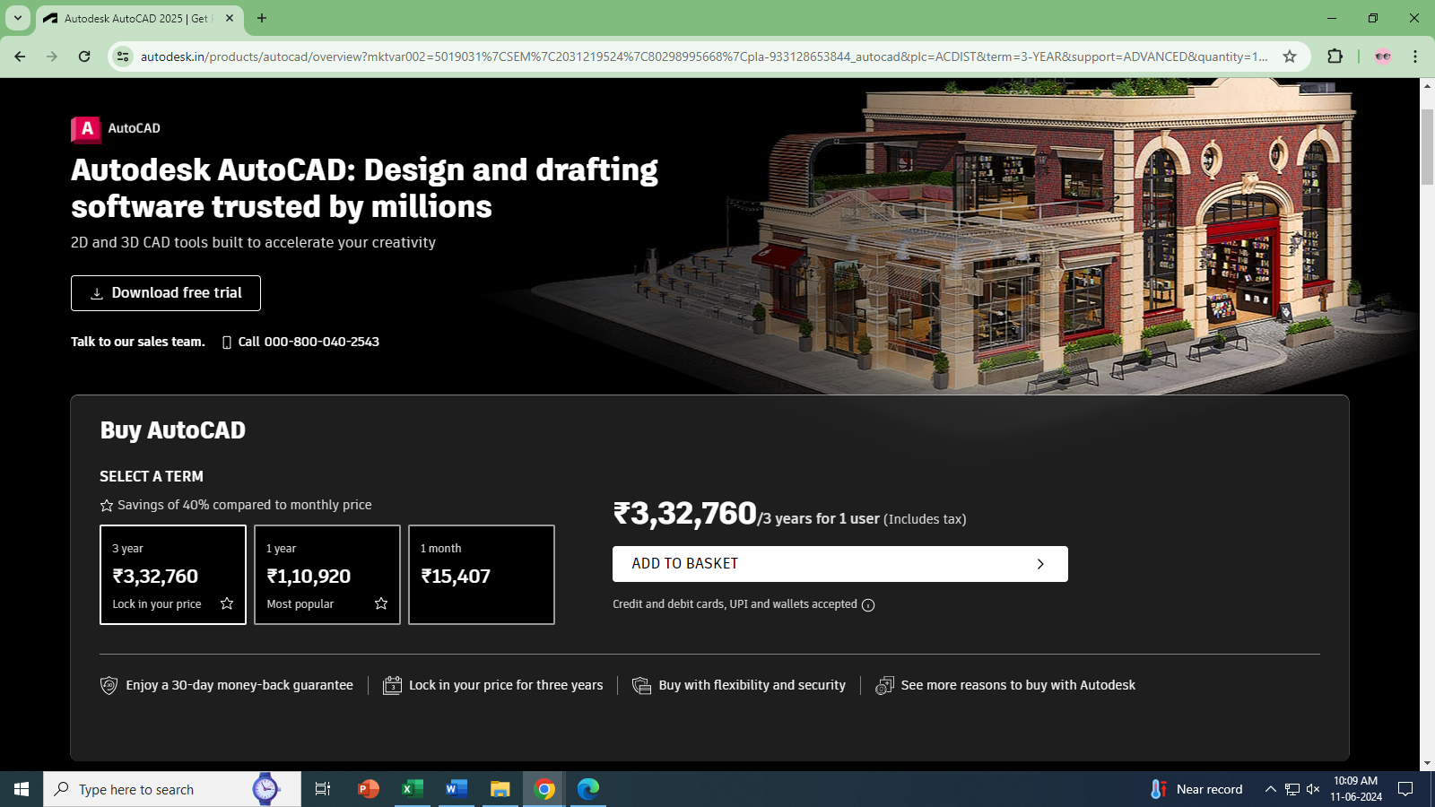

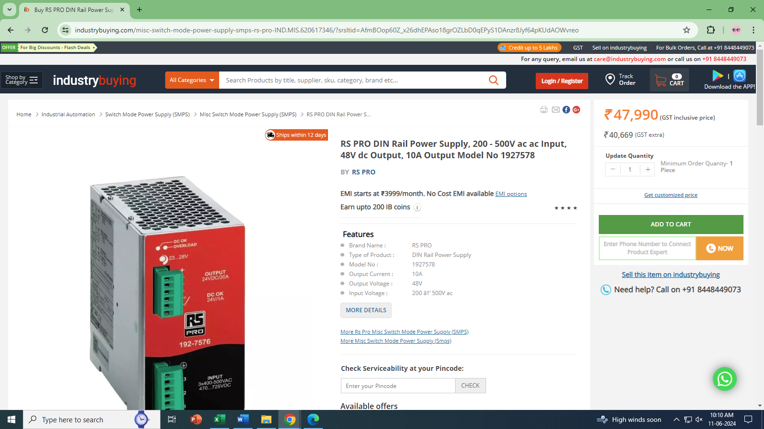

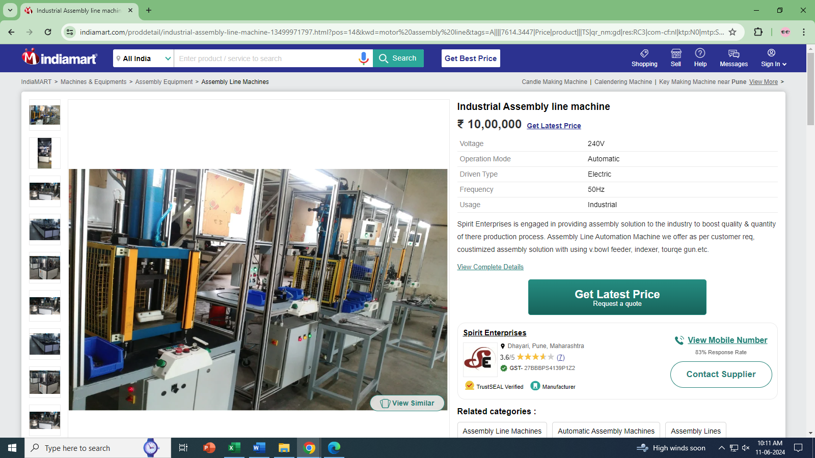

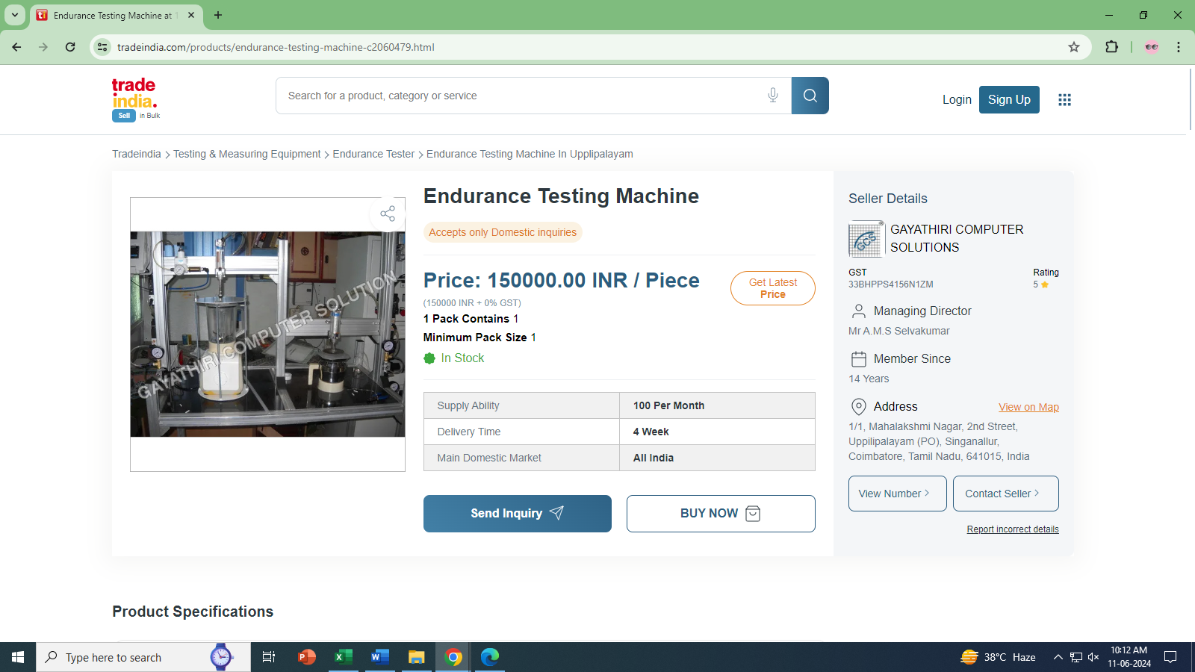

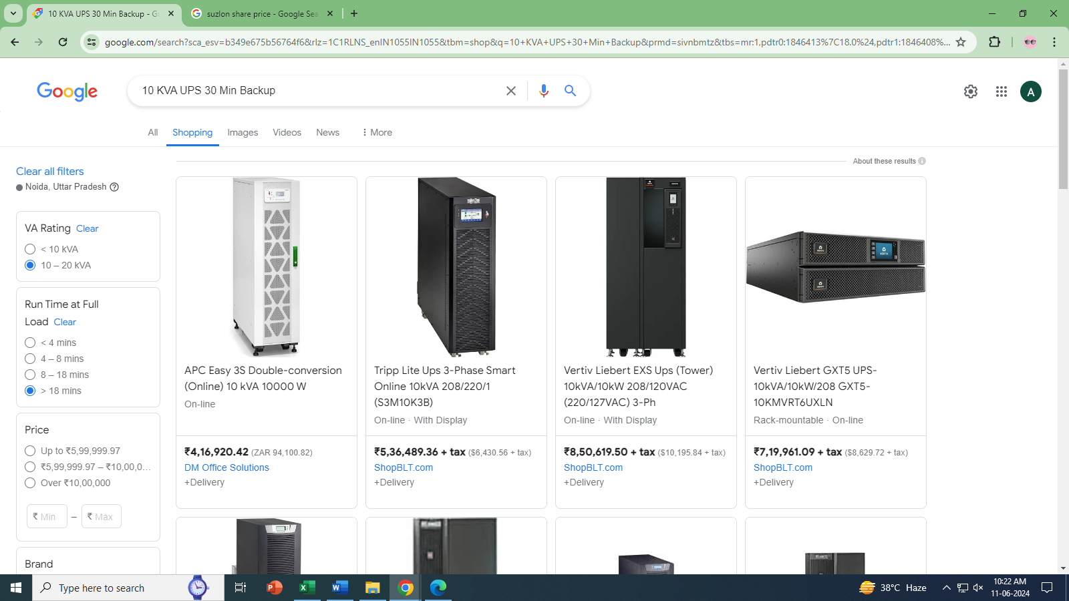

# ANNEXURE: Copy of Invoices

