**File No.: VIS (2024-25) PL071-064-088 Dated: 28.05.2024**

**LENDER’S INDEPENDENT ENGINEER REPORT**

**(FOR QUARTER ENDING DECEMBER 2023)**

**OF**

**M/S AKM HOTELS PVT. LTD.**

**SITUATED AT**

**VILLAGE SULTANPUR, TEHSIL MEHRAULI, MEHRAULI GURGAON ROAD (MG ROAD), NEW DELHI.**

**COMPANY/PROMOTER**

**M/S AKM HOTELS PVT. LTD.**

**REPORT PREPARED FOR**

**STATE BANK OF INDIA, SME BRANCH, SECTOR-24, FARIDABAD.**

***\*\*Important - In case of any query/ issue or escalation you may please contact Incident Manager at le@rkassociates.org. We will appreciate your feedback in order to improve our services.***

***NOTE: As per IBA Guidelines please provide your feedback on the report within 15 days of its submission after which report will be considered to be correct.***

|  |  |  |
| --- | --- | --- |
| **TABLE OF CONTENTS** | | |
| **SR. NO.** | **DESCRIPTION** | **PAGE NO.** |
| **PART A** | **Report Summary** | **03** |
| **PART B** | **Introduction** | **04** |
|  | 1. The Project | **04** |
|  | 1. Location of the Project | **04** |
|  | 1. Project Overview | **05** |
|  | 1. Scope of the Project During Project Duration | **06** |
|  | 1. Purpose of the Report | **06** |
|  | 1. Methodology Adopted | **06** |
| **PART C** | **Project Infrastructure Sections & Facility Details with Actual Progress** | **07** |
|  | 1. Interior Fit out and Furnishing | **08** |
|  | 1. Equipment’s | **10** |
|  | 1. Plant & Machinery | **10** |
|  | 1. Miscellaneous Fixed Assets | **12** |
| **PART D** | **Project Consultants, Contractors & Suppliers** | **13** |
| **PART E** | **Project Cost and Means of Finance** | **14** |
|  | 1. Cost of Project | **14** |
|  | 1. Current Status and Total Expenditure Incurred Till Date | **14** |
|  | 1. Sources of Finance & Utilization of Funds | **15** |
| **PART F** | **Statutory & Regulatory Approvals, Clearances & NOC** | **16** |
| **PART G** | **Disclaimer** | **17** |
| **PART H** | **Enclosure** | **21** |
| **PART I** | **Photographs** | **24** |

# 

# IMPORTANT NOTICE

***COPYRIGHT FORMAT:*** *This report is prepared on the copyright format of R.K Associates, to serve our clients with the best available information and analysis to facilitate them to take rational business decisions. Legally no one can copy or distribute this format without prior approval from R.K Associates. It is meant only for the advisory/ reference purpose for the organization/s as mentioned on the cover page of this report. Distribution or use of this format by any organization or individual other than R.K Associates will be seen as unlawful act and necessary legal action can be taken against the defaulters.*

*This report is intended for the sole use of the intended recipient/s and contain material that is STRICTLY CONFIDENTIAL AND PRIVATE.*

***DEFECT LIABILITY PERIOD:*** *- In case of any query/ issue or escalation you may please contact Incident Manager: le@rkassociates.org. We try our level best to ensure correctness in the calculations done, rates adopted and various other data points & information mentioned in the report but still can’t rule out typing, human errors or any other mistakes. In case you find any such mistake or inaccuracy in any data point of the report please help us by bringing all such points into our notice immediately or within 15 days of the report delivery in writing, to rectify these timely failing after which R.K Associates won’t be held responsible for any such inaccuracy in any manner. We would highly appreciate your feedback in order to improve our services.*

|  |  |
| --- | --- |
| **PART A** | **REPORT SUMMARY** |

|  |  |  |  |
| --- | --- | --- | --- |
| **1.** | **Name of Project:** |  | A four-star upscale luxury banquet cum hotel based on theme of “Banqueting Hotel” Project being setup by AKM Hotel Pvt. Ltd. |
| **2.** | **Project Location:** |  | * Village- Sultanpur * Tehsil- Mehrauli * Gurgaon Road * New Delhi |
| **3.** | **Name of the Borrower:** |  | M/s. AKM Hotels Pvt. Ltd. |
| **4.** | **Prepared for Bank:** |  | State Bank of India, SME Branch, Sector-24,  Faridabad. |
| **6.** | **LIE Consultant Firm:** |  | M/s. R.K. Associates Valuers & Techno Engineering Consultants (P) Ltd. |
| **7.** | **Date of Survey:** |  | 15th of May 2024 |
| **8.** | **Date of Report:** |  | 28th of May 2024 |
| **9.** | **Purpose of the Report:** |  | To provide fair detailed analysis report to the Bank based on the “in-scope points” mentioned below to know the current status of the Project. |
| **10.** | **Scope of the work provided by the Lender:** |  | 1. Project physical status review 2. Estimated cost of expenditure incurred |
| **11.** | **Documents perused for Proposal:** |  | 1. Approved Plan 2. Copy of CA Certificate 3. Copy of invoices of some items 4. Copy of TEV report 5. Other approvals |
| **12.** | **Annexure with the report:** |  | 1. TEV report 2. Photographs 3. Other annexures (e.g., CA Certificate, Invoices, and Sanctioned plan) |

|  |  |
| --- | --- |
| **PART B** | **INTRODUCTION** |

1. **THE PROJECT:**

**AKM Hotel Pvt. Ltd** is establishing a four-star upscale luxury banquet cum hotel based on theme of “Banqueting Hotel” at Village-Sultanpur, Tehsil-Mehrauli, Gurgaon Road (MG Road), New Delhi. To know the Project progress, bank has appointed M/s R.K Associates Valuers & Techno Engineering Consultants (P) Ltd. to review the Quarterly physical status of the project. This is 3rd LIE Report for Quarter ending December’23 in continuation to previous inception LIE Report submitted on 24/05/2023. This report primarily captures physical status of the Project as per the survey conducted on 15th May 2024 as per Bank’s requirement.

1. **PROJECT LOCATION:**

Details about Location of Unit is as below:

|  |  |
| --- | --- |
| **Particulars** | **Description** |
| **Address** | |
| Village Sultanpur Tehsil Mehrauli, MG Road, New Delhi. | |
| **Location** | |
| The nearest airport from the site is IGI Airport, Delhi located at the distance of approx. 11.2 km. The Project site is also well connected through road network and abutting Mehrauli Gurugram Road. Chhatarpur metro station is the nearest metro station at a distance of approx. 500 m from the project. | |
| **Google Coordinates** | |
| Latitude | 28°30'11.0"N |
| Longitude | 77°10'16.6"E |
| **Connectivity Systems** | |
| Road | Abutting Mehrauli-Gurugram Road |
| Metro | The nearest metro station from the site is Chhatarpur metro station, and is at a distance of approx. 500 meter. |
| Air | The nearest airport from the site is IGI Airport, Delhi, and is at the distance of approx. 11 km. |

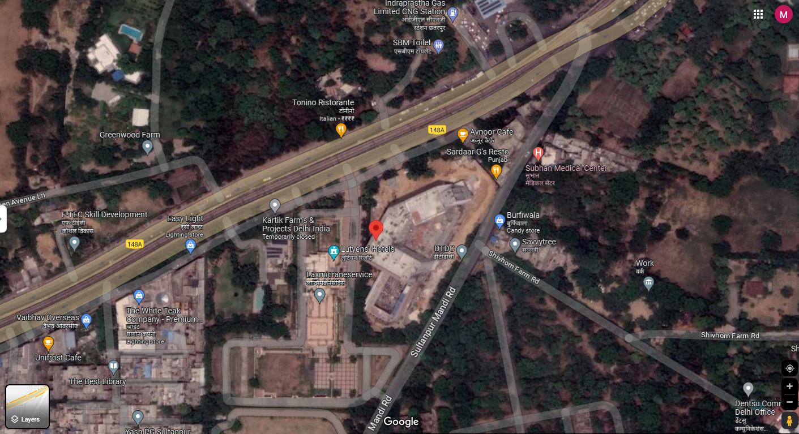

**Figure: Location of Manufacturing Unit**

1. **PROJECT OVERVIEW:**

As stated in the previous report, **AKM Hotel Pvt. Ltd** is setting up a four-star upscale luxury banquet cum hotel based on theme of “Banqueting Hotel” at a plot on the main Mehrauli Gurgaon Road (MG Road), New Delhi.

The project land is 2.90 acres (11,719.90 sq. m.). As per the sanctioned layout plan dated 15/10/2018 the total approved FAR is 13,459 sq. mtr and total built-up area is 30,507. The project has high end banqueting facilities duly supported by hotel and health club/ Spa/ Saloon activities. This is a 101 key room (94 standard rooms and 7 suite rooms) hotel with 4 star standards equipped with modern amenities and latest facilities offered with highest class standards as mentioned in the TEV report. Detailed description of the same can be found further in the report.

The project has already received a list of necessary approvals from the competent authority details of same can be found in later part of report.

Total proposed Project cost as estimated in TEV report is Rs.86 crores distributed in different items such as Interior Fit-outs and Furnishing, Equipment’s, Plant & Machinery and other soft cost. Detailed description of the same can be found further in the report.

Further AKMHPL has approached State Bank of India for funding of finishing, plant and equipment, utilities, electrical, furnishings, interiors, cutlery, etc. of the hotel other than structure works and accordingly SBI has sanctioned the loan for it.

As per present status, super structure of the building is already completed and within the scope of this report finishing is under progress at various stages. In Plant & Machinery DG set, STP, VRF is installed on the site, kitchen utensils have arrived on the site. Detailed item wise project status is described in the later section of the report.

Based on the TEV Report, the proposed date for the commercial operations of the hotel was July 2024. However, during our site visit on May 15, 2024, we observed that while the project is progressing, but it is unlikely to fully meet the July 2024 deadline. As a result, the management is considering an alternative plan. They intend to open the hotel to public while continuing construction on the 2nd and 4th floors concurrently, with separate entry and access for the construction activity.

1. **SCOPE OF WORK DURING PROJECT DURATION:** Periodic Project physical status review of the internal finishing, fittings and fixtres work.

* *Super structure work is out of scope of this report.*
* *This report captures the Project status as on 15th May 2024 and the expenditure is referred as per CA Certificate produced to us as per requirement of the Bank.*

1. **PURPOSE OF THE REPORT:** To provide fair detailed analysis report to the Bank based on the “in-scope points” mentioned below to know the current status of the Project.
2. **METHODOLOGY ADOPTED:**
3. Study of Project Planning documents/ reports to know about the Project.
4. Additional information, data, documents collection from the borrower.
5. Site Inspection.
6. Review and analysis of the documents and information obtained from the borrower and corroborating it with the site inspection status.
7. Information compilation, analysis and reporting.

|  |  |
| --- | --- |
| **PART C** | **PROJECT INFRASTRUCTURE & FACILITY DETAILS WITH ACTUAL PROGRESS** |

Total proposed Project cost as estimated in TEV report by Dun & Bradstreet is Rs.86 crores, breakup of the same is as below:

|  |  |  |
| --- | --- | --- |
| **Particulars** | **In Rs. (In Cr.)** | **% in total cost** |
| Interior Fit out and Furnishing | 29.49 | 34.3 % |
| Equipment’s | 14.03 | 16.3 % |
| Plant and Machinery | 27.88 | 32.4 % |
| Miscellaneous Fixed Assets | 5.27 | 6.1 % |
| Contingency | 2.11 | 2.5 % |
| Preliminary & Pre-op Expenses | 0.80 | 0.9 % |
| Interest During Construction | 6.42 | 7.5 % |
| **Total** | **86.00** | **100 %** |

1. **INTERIOR FIT OUT AND FURNISHING:** As per the TEV report the interior fit out and furnishing cost of the Project has been estimated at INR 29.49 Crore (Including Taxes). Breakup details of the same followed by current status have been presented in tabular form below:

|  |  |  |  |  |
| --- | --- | --- | --- | --- |
| **Sl. No.** | **Category** | **Scope of Work** | **Name of Vendor** | **Amount As per TEV**  **(Exclusive GST)** |
|  | Bath wares and Sanitary Fixtures | To Provide Complete Bath fittings, Faucets, WC, Bath wares and Sanitary Wares | Bath Affair, Trendz | 67,30,142 |
|  | Hotel Room & Corridor Finishing & Furnishing | Interior Works in Rooms and Corridors Area of Hotel - 25 Rooms | SA Associates & Contractors Pvt. Ltd. | 1,99,12,500 |
| Interior Works in Rooms and Corridors Area of Hotel - 25 Rooms | SA Associates & Contractors Pvt. Ltd. | 1,99,12,000 |
| Interior Works in Rooms and Corridors Area of Hotel - 25 Rooms | To Be Awarded | 1,99,12,500 |
| Interior Works in Rooms and Corridors Area of Hotel - 19 Rooms | To Be Awarded | 1,51,33,500 |
| Suite 7 Nos. Total | To Be Awarded | 1,11,51,000 |
|  | Interior & Finishing Works - Ground Floor | Flooring & Cladding Work, Ceiling, Paneling, Metal Door, Furniture & Storage, Paints and MS Work for Lobby, Banquet & Pre function and Washroom Work | SA Associates & Contractors Pvt. Ltd. | 3,71,69,947 |
|  | Interior Works - First Floor | Complete Interior and Furnishing and Flooring, Wall Cladding of First Floor, Toilets and Dining Area | Checkmate | 7,34,93,338 |
|  | Interior Works - 2nd Floor | Complete Interior and Furnishing and Flooring, Wall Cladding of 2nd Floor-  Both Banquet Hall, Pre- Function Area, Deck Area and Washrooms | Checkmate | 4,93,32,651 |
|  | Façade Lighting | Supply & fixing | Light Craft | 89,13,012 |
|  | Ground Floor Lighting | Supply & fixing | Light Craft | 85,50,716 |
|  | First Floor Lighting | Supply & fixing | -------- | 75,76,061 |
|  | 2nd Floor lighting | Supply & fixing |  | 72,68,109 |
|  | Fire doors | Supply & Fixing of Fire Doors | JBSS Engineers Pvt ltd. | 61,36,000 |
|  | Pumps (Willo) | Supply, installation & commissioning | Universal Tech Trade Pvt Ltd | 36,68,128 |
|  |  |  | **Total** | **Rs.29,48,60,104** |

***Source: TEV Report by Dun & Bradstreet***

|  |  |
| --- | --- |
| **FLOOR WISE STATUS AS ON 15TH MAY 2024** | |
| **Floor** | **Status** |
| **Basement 3** | * Painting work has been done * Fire fighting system has been installed, testing of the same is in progress * Ventilation system has been installed but currently not operational * Foaming work has been done * Metal tray for laying out electric cable has been set up |
| **Basement 2** | * Status same as Basement 2 |
| **Basement 1** | * Status same as Basement 2 |
| **Ground** | * Flooring work is done, only polishing is pending * Wall tile and glass façade have been installed * Fire fighting system has been installed, testing is in progress * Fire curtain testing is going on * Internal lights have been installed and is operational * HVAC system has been installed but currently not operational * Bathroom fitting work is in progress * Kitchen appliances have been arrived but not installed yet * Wooden work and carpet laying work in banquet hall is pending |
| **First** | * Setting up of live kitchen and bar is in progress * Internal electrical work has been done * Flooring has been done * HVAC is installed but not operational * Few wooden work is pending |
| **Second** | * Construction of swimming pool and laying out of mosaic tiles have been done * Finishing of Banquet Hall is in progress * Finishing of bar area is in progress |
| **Third** | * Flooring, electrical installation, bathroom fittings for individual rooms is in progress * Flooring, fire fighting system in the common corridor has been done * Electrical installation in the common corridor is pending |
| **Fourth** | * Internal finishing such as flooring, wooden work, furniture, and electrical work is partially done * HVAC is installed but not operational * Bathroom fittings in stallion work is in progress * Electrical installation, flooring, fire fighting work is done in the common corridor. |
| **Fifth** | * Internal finishing such as flooring, wooden work, furniture, and electrical work is partially done * HVAC is installed but not operational * Bathroom fittings in stallion work is in progress * Electrical installation, flooring, fire fighting work is done in the common corridor. |
| **Sixth** | * Flooring work is done * Finishing of wall, painting, electrical installation, HVAC, bathroom fittings for individual room is yet to be done * Only flooring, fire fighting work, electrical work in the common corridor is completed. |

1. **EQUIPMENT’S:** As per the TEV report the equipment cost of the Project has been estimated at INR 14.03 Crore. Breakup details of the same have been presented in the tabular form below:

|  |  |  |  |  |  |
| --- | --- | --- | --- | --- | --- |
| **Sl. No.** | **Category** | **Scope Of Work** | **Name Of Vendor** | **Amount (As per TEV)** | **Status as on**  **15th May 2024** |
|  | BOH Equipment | Back of House Equipment – Supply & Installation | A.M.I. Food Service Equipment Solutions Pvt. Ltd. | 10,41,11,844 | * Imported machines have arrived, unwrapping of the same has not been done yet. |
|  | Laundry Equipment | Supply, installation & Commissioning of Laundry equipment | No details available | 41,30,000 | * Not arrived on site yet |
|  | Mini Bars / Tea- Coffee Machine | Supply, installation & Commissioning of Mini Bars/Tea-Coffee Machine | No details available | --- | * Work in progress |
|  | Health Club | Supply, installation & Commissioning of Health Club | No details available | 56,25,001 | * Not arrived on site yet |
|  | SPA Equipment | Supply, installation & Commissioning of SPA Equipment | No details available | 88,50,000 | * Not arrived on site yet |
|  | Business Centre/Conf. Equipment | Supply, installation & Commissioning of Business Centre/Conference Equipment | No details available | 1,77,00,000 | * Not arrived on site yet |
|  |  |  | **Total** | **14,03,16,845** |  |

***Source: TEV Report by Dun & Bradstreet***

1. **PLANT AND MACHINERY:** As per the TEV report the Plant and Machinery cost of the Project has been estimated at INR 27.88 Crore. Breakup details of the same have been presented in the tabular form below:

|  |  |  |  |  |  |
| --- | --- | --- | --- | --- | --- |
| **Sl. No.** | **Category** | **Scope Of Work** | **Name Of Vendor** | **Amount Proposed (As per TEV)** | **Status as on**  **15th May 2024** |
|  | Security System | CCTV System, ACs & Boom Barrier System & all ELV | Phoenix Equipment India Pvt. Ltd | 2,95,11,328 | * Cameras are not installed yet, however as per information provided on the site, wiring for the same is initiated |
|  | HVAC VRF (High Side) | Supplying of VRF System Of 1000 Tons | GD Enterprises | 3,55,00,000 | * Installed but not operational |
|  | HVAC VRF (Low Side) | Design, Installation, Testing & Commissioning Of VRF System. Supply, Installation Work for Copper Piping, Insulation, Ducting, Drain Piping Work, Control Wiring Connection Between Indoor and Outdoor. | Phoenix Equipment’s India Pvt. Ltd. | 2,40,00,000 | * Installed but not operational |
|  | Ventilation Works | Basement Ventilation Works | Imperial Systems India | 89,45,580 | * Installed but not operational |
|  | Pressurization Works | Pressurization Works on Floor | Imperial Systems India | 61,99,720 | * Work in progress |
|  | Heat Pump & Allied Equipment | Supply Testing and Commissioning of Hot Water / Steam Equipment and Piping Heat Pumps | Explore Watek Systems Pvt. Ltd. | 47,20,000 | * Installed but not operational |
|  | STP | Supply, Installation, Testing & Commissioning of Sewage Treatment Plant | Explore Watek Systems Pvt. Ltd. | 38,35,000 | * Installed but testing is due |
|  | Solar | To Supply, Install, Test & Commission 125 KWp Grid Synchronized Solar PV Based Power System | Explore Watek Systems Pvt. Ltd. | 95,81,600 | * Installed but not operational |
|  | Lifts | Supply Installation, Testing & Commissioning Of 9 No. Of Elevators | Schindlier India Pvt. Ltd. | 1,55,50,000 | * Installation has been done, and is currently in use |
|  | Generator Set  (02 Pcs) | Supply, Testing and Commissioning Of Two No. 1250 KVA Silent Dg Set Comprising Of Engine Model Kta50-G Coupled To 415v 1250 KVA Alternator Both Mounted On Common Base Frame With Other Entire Accessories I.E Fuel Tank, Batteries With Lead Etc. | Sudhir Power Limited | 1,79,36,000 | * Installation has been done, and is currently in use |
|  | Stack For Fume Pipe 30 Mtr | Supply, Fabrication & Installation of Dg Set Stack Of 30 Mtr Height | Unipower Projects | 40,39,943 | * Installation is in progress |
|  | Plumbing System | Supply Installation, Testing & Commissioning of Electrical Panel, Swimming Pool, Water Treatment Plants & Miscellaneous Items, Internal Pumps, Equipment | OMT Plumbing | 1,34,12,055 | * Work is in progress |
|  | Plumbing System | Supply Installation, Testing & Commissioning of Pumps, Equipment & Electrical Panel, Swimming Pool, Water Treatment Plants & Miscellaneous Items | Hydro Chem Engineers & Consultant | 2,12,39,885 | * Work is in progress |
|  | Electrical System | Lt Cables & Cable Trays, Earthing System | Conquerent Control System Pvt. Ltd. | 6,09,12,426 | * Work is in progress |
| LT Panels | 99,12,000 | * Work is in progress |
|  | Fire Fighting | Installation, Testing & Commissioning of Fire Fighting System Complete in All respects | Fire Remedies | 1,35,00,000 | * Work is in progress |
|  |  |  | **Total** | **27,87,95,537** |  |

***Source: TEV Report by Dun & Bradstreet***

1. **MISCELLANEOUS FIXED ASSETS:** As per the TEV report the miscellaneous fixed assets cost of the Project has been estimated at INR 5.27 Crore. Breakup details of the same have been presented in the tabular form below:

|  |  |  |  |  |  |
| --- | --- | --- | --- | --- | --- |
| **Sl. No.** | **Category** | **Scope Of Work** | **Name Of Vendor** | **Amount As per TEV Report**  **(INR)** | **Status as on**  **15th May 2024** |
|  | LPG Pipeline | Laying, Installation & Commissioning of LPG system | Rawat Brother Engineers | 20,07,904 | * Installed but not operational |
|  | Furniture - Rooms, Banquet/ Conference Hall | Supply & Installation | No information available | NA | * Work In progress |
|  | Façade Cladding & Glazing Works | Supply and fixing of external cladding including frames etc. Supply and fixing of glazing for doors, windows & partitions | Devik Alu Glazing | 5,06,92,468 | * Major work has been completed |
|  |  | **Total** |  | **5,27,00,372** |  |

***Source: TEV Report by Dun & Bradstreet***

|  |  |
| --- | --- |
| **PART D** | **PROJECT CONSULTANTS, CONTRACTORS & SUPPLIERS** |

According to the TEV report provided, the company has appointed the following major consultants & contractors for the project:

|  |  |  |
| --- | --- | --- |
| **S. No.** | **Particular** | **Work Allotted** |
|  | Bath Affair | Complete Bath fittings, Faucets, WC, etc. |
|  | SA Associates & Contractors Pvt. Ltd. | Interior works |
|  | Xceptional | Paint Work |
|  | Devik Alu Glazing | Glass and façade works |
|  | Schindlier India Pvt. Ltd. | Lifts |
|  | Phoenix Equipment India Pvt. Ltd. | ELV Work |
|  | Fire Remedy Systems | Fire Safety Works |
|  | Indersons | Electrical Works |
|  | Light Axis Pvt. Ltd. | Electrical Works |
|  | Kaiser Vitals | Signage Works |

|  |  |
| --- | --- |
| **PART E** | **PROJECT COST & MEANS OF FINANCE** |

1. **TOTAL PROJECT COST:** M/S. AKM Hotels Pvt. Ltd. has estimated the total project cost amounting to Rs.86 Crores which has been proposed to be funded in DER of approx. 58% Debt and 42% Equity.

|  |  |
| --- | --- |
| **Particulars** | **In Rs. (In Cr.)** |
| Interior Fit out and Furnishing | 29.49 |
| Equipment’s | 14.03 |
| Plant and Machinery | 27.88 |
| Miscellaneous Fixed Assets | 5.27 |
| Contingency | 2.11 |
| Preliminary & Pre-op Expenses | 0.80 |
| Interest During Construction | 6.42 |
| **Total** | **86.00** |

1. **CURRENT STATUS & TOTAL EXPENDITURE INCURRED TILL DATE:** As per CA Certificate with UDIN. 24085893BKCWUG2695 dated 16th February 2024 for expenditure till 31st January 2024 the borrower has made an expenditure on the project amounting to Rs.85.36 Crore, showing Plant & Machinery, Building & Civil works and Miscellaneous fixed assets:

|  |  |  |  |
| --- | --- | --- | --- |
| **PARTICULARS** | **EXPENDITURE**  **(As per TEV)**  **(In Rs. In Cr.)** | **EXPENDITURE**  **(As per CA Cert. Dated**  **16th Feb 2024)**  **(In Rs. In Cr.)** | **REMARKS** |
| **Interior Fit out and Furnishing** | 29.49 | ~27.99 | 1. Amount of work done is as per the CA cert produced to us. 2. Further detailed Status is shown above. |
| **Electrical & Equipment’s** | 14.03 | ~18.24 | 1. Amount of work done is as per the CA cert produced to us. 2. Further detailed Status is shown above. |
| **Plant, Machinery and Furniture’s** | 27.88 | ~19.12 | 1. Amount of work done is as per the CA cert produced to us. 2. Further detailed Status is shown above. |
| **Pre-operative Expenses** | 0.80 | ~8.56 | 1. Amount of work done is as per the CA cert produced to us. 2. Further detailed Status is shown above. |
| **Other Expenses**  **(Advances+ Balances+ GST Inputs)** | 13.80 | ~11.42 | 1. Amount of work done is as per the CA cert produced to us. 2. Further detailed Status is shown above. |
| **Total** | **86.00** | **~85.36** |  |

**Note:**

1. Amount shown above is as per CA Certificate and it is just for illustration purpose.
2. As per CA Certificate with UDIN. 24085893BKCWUG2695 dated 16th February 2024 the borrower has made an expenditure on the project amounting to Rs.85.36, approx. 99% of the project cost (i.e. Rs.86 Cr.) till 31st January 2024. However as compared to the status of the work done, the project cost seems to overrun its scheduled expenditure.
3. **SOURCES OF FINANCE & UTILIZATION OF FUNDS:**

The Project cost mentioned above has been planned to be covered from following resources:

|  |  |
| --- | --- |
| (Amount in Rs. And In Crore) | |
| PARTICULARS |  |
| Promoter’s Contribution (Equity) | 7.00 |
| Unsecured Loan (Quasi Equity) | 29.00 |
| Term Loan (Debt) | 50.00 |
| TOTAL | **86.00** |

***Source: TEV by Dun & Bradstreet, dated 17th August 2022***

|  |  |
| --- | --- |
| **PART F** | **STATUTORY & REGULATORY APPROVALS, CLEARANCES & NOC** |

|  |  |  |  |  |
| --- | --- | --- | --- | --- |
| Sr. No. | NAME OF LICENSE/ REGISTRATION | PURPOSE | DATE OF ISSUE | Current Status |
| **ISSUING AUTHORITY** | **LICENCE NO.** |
|  | Approval for the Building Plan | Approval of building plans | File No. 10053614 | Obtained |
| SMDC | Dated:15/10/2018 |
|  | Grant Of Sanction | Building Plan Approval Letter | File No. 10053614 | Obtained  (Valid till 14/10/2023) |
| South Delhi Municipal Corporation | Dated: 15/10/2018 |
|  | Grant Of Revalidation | For revalidation of Original sanction Plan bearing sanctioned vide ID No. 10053614 dated 15.10.2018 having validity upto 14.10.2023 has been re-validated up to 13.10.2024 for one year only. | File No. 10053614 | Obtained |
| Delhi Municipal Corporation | Dated: 16/10/2023 |
|  | Consent to establish | Delhi Pollution Control Board | File No. G-40836 | Obtained |
| Pollution NOC | Dated: 29/04/2024 |
|  | Fire NOC | Delhi Fire Service | File No. F.6/DFS/MS/2018/BP/294 | Obtained  (Subject to few observations in the NOC) |
| Dated: 20/09/2018 |
| *Observations & Comments:*   1. *Various approvals obtained, as informed by the client is mentioned above.* 2. *Fire NOC is subject to few observations mentioned at clause no. 2,4,16 & 18, bank is requested to go through the same.* 3. *Above the major approvals and not exclusive in nature.* | | | | |

|  |  |
| --- | --- |
| **PART G** | **DISCLAIMER** |

* + - 1. No employee or member of R.K Associates has any direct/ indirect interest in the Project.
      2. This report is prepared based on the copies of the documents/ information which the Bank/ Borrower has provided to us out of the standard checklist of documents sought from them and further based on our assumptions and limiting conditions. The client/owner and its management/representatives warranted to us that the information they supplied was complete, accurate and true and correct to the best of their knowledge. All such information provided to us has been relied upon in good faith and we have assumed that it is true and correct in all respect. I/We shall not be liable for any loss, damages, cost or expenses arising from fraudulent acts, misrepresentations, or wilful default on part of the owner, borrower, its directors, employee, representative or agents. Verification or cross checking of the documents provided to us from the originals or from any Govt. departments/ Record of Registrar has not been done at our end since this is beyond the scope of our work. If at any time in future, it is found or came to our knowledge that misrepresentation of facts or incomplete or distorted information has been provided to us then this report shall automatically become null & void.
      3. Legal aspects for eg. investigation of title, ownership rights, lien, charge, mortgage, lease, sanctioned maps, verification of documents, etc. have not been done at our end and same has to be taken care by legal expert/ Advocate. It is assumed that the concerned Lender/ Financial Institution has satisfied them with the authenticity of the documents, information given to us and for which the legal verification has been already taken and cleared by the competent Advocate before requesting for this report. I/ We assume no responsibility for the legal matters including, but not limited to, legal or title concerns.
      4. This report is a general analysis of the project based on the scope mentioned in the report. This is not an Audit report, Design document, DPR or Techno feasibility study. All the information gathered is based on the facts seen on the site during survey for the quarter ending December 2023, verbal discussion & documentary evidence provided by the client and is believed that information given by the borrower is true best of their knowledge.
      5. All observations mentioned in the report is only based on the visual observation and the documents/ data/ information provided by the client. No mechanical/ technical tests, measurements or any design review have been performed or carried out from our side during Project assessment.
      6. Bank/FII should ONLY take this report as an Advisory document from the Financial/ Chartered Engineering firm and its specifically advised to the creditor to cross verify the original documents for the facts mentioned in the report which can be availed from the borrowing borrower directly.
      7. In case of any default in loans or the credit facility extended to the borrowing borrower, R.K Associates shall not be held responsible for whatsoever reason may be and any request for seeking any explanation from the employee/s of R.K Associates will not be entertained at any instance or situation.
      8. The documents, information, data provided to us during the course of this assessment by the client is reviewed only up to the extent required in relation to the scope of the work. No document has been reviewed beyond the scope of the work.
      9. This report only contains general assessment & opinion as per the scope of work evaluated as per the information given in the copy of documents, information, data provided to us and/ and confirmed by the owner/ owner representative to us at site which has been relied upon in good faith. It doesn’t contain any other recommendations of any sort including but not limited to express of any opinion on the suitability or otherwise of entering into any transaction with the borrower.
      10. We have relied on data from third party, external sources & information available on public domain also to conclude this report. These sources are believed to be reliable and therefore, we assume no liability for the truth or accuracy of any data, opinions or estimates furnished by others that have been used in this analysis. Where we have relied on data, opinions or estimates from external sources, reasonable care has been taken to ensure that such data has been correctly extracted from those sources and /or reproduced in its proper form and context, however still we can’t vouch its authenticity, correctness or accuracy.
      11. This Report is prepared by our competent technical team which includes Engineers and financial experts & analysts.
      12. This is just an opinion report and doesn’t hold any binding on anyone. It is requested from the concerned Financial Institution which is using this report for taking financial decision on the project that they should consider all the different associated relevant & related factors also before taking any business decision based on the content of this report.
      13. All Pages of the report including annexures are signed and stamped from our office. In case any paper in the report is without stamp & signature then this should not be considered a valid paper issued from this office.
      14. Though adequate care has been taken while preparing this report as per its scope, but still we can’t rule out typing, human errors, over sightedness of any information or any other mistakes. Therefore, the concerned organization is advised to satisfy themselves that the report is complete & satisfactory in all respect. Intimation regarding any discrepancy shall be brought into our notice immediately. If no intimation is received within 15 (Fifteen) days in writing from the date of issuance of the report, to rectify these timely, then it shall be considered that the report is complete in all respect and has been accepted by the client upto their satisfaction & use and further to which R.K Associates shall not be held responsible in any manner.
      15. Defect Liability Period is **15 DAYS**. We request the concerned authorized reader of this report to check the contents, data and calculations in the report within this period and intimate us in writing if any corrections are required or in case of any other concern with the contents or opinion mentioned in the report. Corrections only related to typographical, calculation, spelling mistakes, incorrect data/ figures/ statement will be entertained within the defect liability period. Any new changes for any additional information in already approved report will be regarded as additional work for which additional fees may be charged. No request for any illegitimate change in regard to any facts & figures will be entertained.
      16. R.K Associates encourages its customers to give feedback or inform concerns over its services through proper channel at valuers@rkassociates.org in writing within 15 days of report delivery. After this period no concern/ complaint/ proceedings in connection with the Financial Feasibility Study Services will be entertained due to possible change in situation and condition of the subject Project.
      17. Our Data retention policy is of **ONE YEAR**. After this period, we remove all the concerned records related to the assignment from our repository. No clarification or query can be answered after this period due to unavailability of the data.
      18. This Lender’s Independent Engineer report is governed by our (1) Internal Policies, Processes & Standard Operating Procedures, (2) Information/ Data/ Inputs given to us by the client and (3) Information/ Data/ Facts given to us by our field/ office technical team. Management of R.K Associates never gives acceptance to any unethical or unprofessional practice which may affect fair, correct & impartial assessment and which is against any prevailing law. In case of any indication of any negligence, default, incorrect, misleading, misrepresentation or distortion of facts in the report then it is the responsibility of the user of this report to immediately or at least within the defect liability period bring all such act into notice of R.K Associates management so that corrective measures can be taken instantly.
      19. R.K Associates never releases any report doing alterations or modifications from pen. In case any information/ figure of this report is found altered with pen then this report will automatically become null & void.

|  |  |  |
| --- | --- | --- |
| **SURVEY ANALYST** | **ENGINEERING ANALYST** | **REVIEWER** |
| Vishal Singh & Babul Akhtar Gazi | Vishal Singh | Sr. VP Projects |
|  |  |  |

**For**

**R.K. Associates Valuers and Techno Engineering Consultants Pvt. Ltd**

**Place: Noida**

**Date: 28th May 2024**

***DEFECT LIABILITY PERIOD - In case of any query/ issue or escalation you may please contact Incident Manager by writing at valuers@rkassociates.org. We ensure 100% accuracy in the Calculations done, Rates adopted and various other data points & information mentioned in the report but still can’t rule out typing, human errors or any other mistakes. In case you find any mistake, variation, discrepancy or inaccuracy in any data point of the report, please help us by bringing all such points into our notice in writing at valuers@rkassociates.org within 30 days of the report delivery, to get these rectified timely, failing which R.K Associates Valuers Techno Engineering Consultants (P) Ltd. won’t be held responsible for any inaccuracy in any manner. Also, if we will not hear back anything from you within 30 days, we will assume that report is correct in all respect and no further claim of any sort will be entertained thereafter. We would welcome and appreciate your feedback & suggestions in order to improve our services.***

***COPYRIGHT FORMAT - This report is prepared on the copyright format of R.K Associates Valuers Techno Engineering Consultants (P) Ltd. to serve our clients in the best possible way. Legally no one can copy or distribute this format without prior approval from R.K Associates. It is meant only for the organization as mentioned on the cover page of this report. Distribution or use of this format other than R.K Associates will be seen as unlawful act and necessary legal action can be taken against the defaulter***

**ENCLOSURE 1: IMPORTANT DOCUMENTS EXHIBIT**

**DOCUMENT-1: CA CERTIFICATE DATED 16/02/2024**

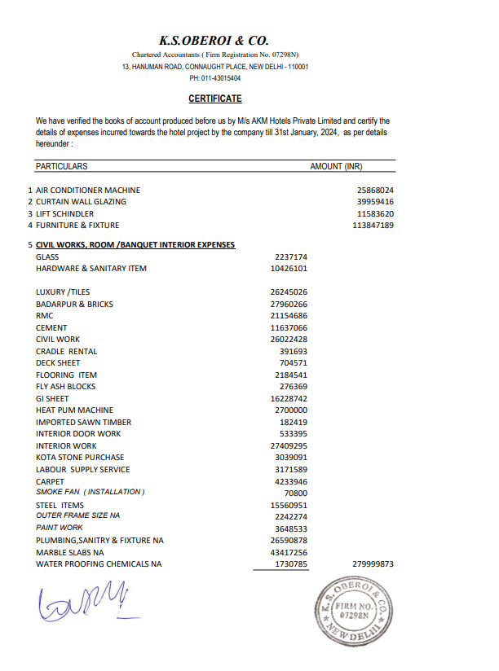

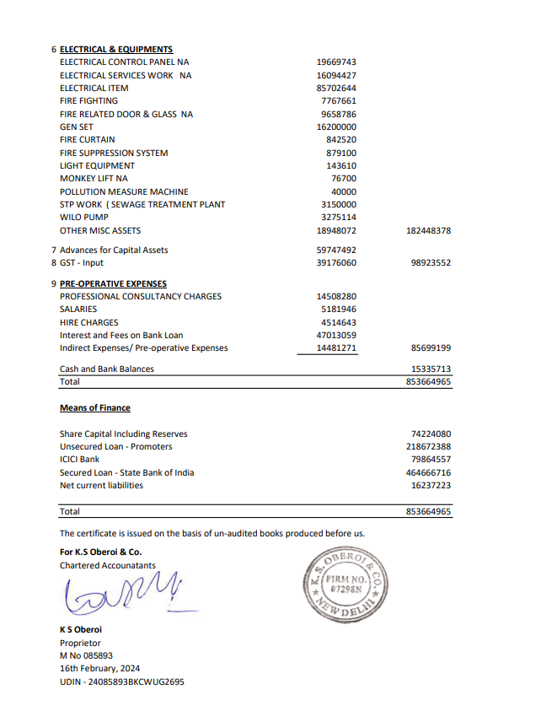

**DOCUMENT 2: COPY OF SANCTIONED PLAN**

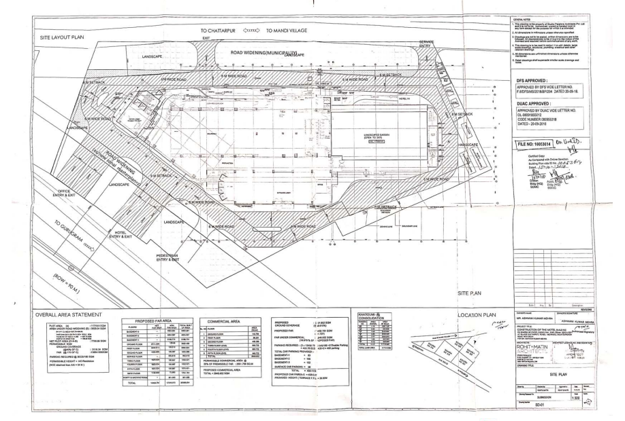

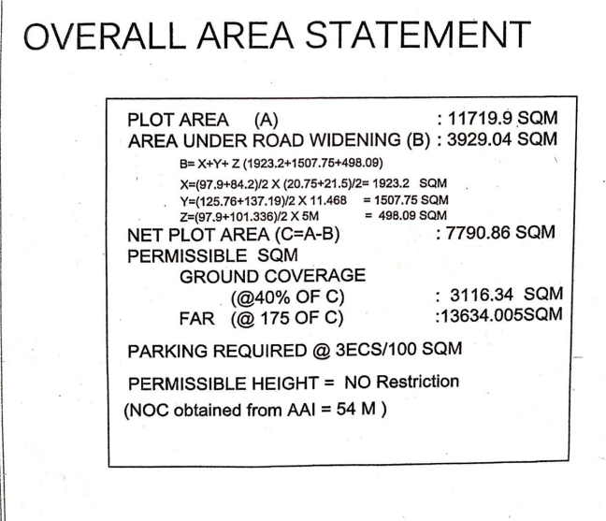

**DOCUMENT 3: Fire NOC**

|  |  |
| --- | --- |
|  |  |
|  |  |

**ENCLOSURE-2: - SITE PHOTOGRAPHS**

|  |  |
| --- | --- |
| Z:\In Progress Files\Vishal Singh\WIP\AKM Hotel\WhatsApp Image 2024-05-20 at 16.54.50.jpeg | Z:\In Progress Files\Vishal Singh\WIP\AKM Hotel\Photos\TimePhoto_20240515_150415.jpg |
| Z:\In Progress Files\Vishal Singh\WIP\AKM Hotel\Photos\TimePhoto_20240515_150016.jpg | Z:\In Progress Files\Vishal Singh\WIP\AKM Hotel\Photos\TimePhoto_20240515_150532.jpg |
| Z:\In Progress Files\Vishal Singh\WIP\AKM Hotel\Photos\TimePhoto_20240515_150608.jpg | Z:\In Progress Files\Vishal Singh\WIP\AKM Hotel\Photos\TimePhoto_20240515_150703.jpg |

|  |  |
| --- | --- |
| Z:\In Progress Files\Vishal Singh\WIP\AKM Hotel\Photos\TimePhoto_20240515_150709.jpg | Z:\In Progress Files\Vishal Singh\WIP\AKM Hotel\Photos\TimePhoto_20240515_150753.jpg |
| Z:\In Progress Files\Vishal Singh\WIP\AKM Hotel\Photos\TimePhoto_20240515_150812.jpg | Z:\In Progress Files\Vishal Singh\WIP\AKM Hotel\Photos\TimePhoto_20240515_151243.jpg |
| Z:\In Progress Files\Vishal Singh\WIP\AKM Hotel\Photos\TimePhoto_20240515_151300.jpg | Z:\In Progress Files\Vishal Singh\WIP\AKM Hotel\Photos\TimePhoto_20240515_151310.jpg |

|  |  |
| --- | --- |
| Z:\In Progress Files\Vishal Singh\WIP\AKM Hotel\Photos\TimePhoto_20240515_145325.jpg | Z:\In Progress Files\Vishal Singh\WIP\AKM Hotel\Photos\TimePhoto_20240515_145200.jpg |
| Z:\In Progress Files\Vishal Singh\WIP\AKM Hotel\Photos\TimePhoto_20240515_144524.jpg | Z:\In Progress Files\Vishal Singh\WIP\AKM Hotel\Photos\TimePhoto_20240515_144844.jpg |
| Z:\In Progress Files\Vishal Singh\WIP\AKM Hotel\Photos\TimePhoto_20240515_144425.jpg | Z:\In Progress Files\Vishal Singh\WIP\AKM Hotel\Photos\TimePhoto_20240515_144121.jpg |

|  |  |
| --- | --- |
| Z:\In Progress Files\Vishal Singh\WIP\AKM Hotel\Photos\TimePhoto_20240515_143930.jpg | Z:\In Progress Files\Vishal Singh\WIP\AKM Hotel\Photos\TimePhoto_20240515_143939.jpg |
| Z:\In Progress Files\Vishal Singh\WIP\AKM Hotel\Photos\TimePhoto_20240515_143550.jpg | Z:\In Progress Files\Vishal Singh\WIP\AKM Hotel\Photos\TimePhoto_20240515_143608.jpg |
| Z:\In Progress Files\Vishal Singh\WIP\AKM Hotel\Photos\TimePhoto_20240515_143256.jpg | Z:\In Progress Files\Vishal Singh\WIP\AKM Hotel\Photos\TimePhoto_20240515_143308.jpg |

|  |  |
| --- | --- |
| Z:\In Progress Files\Vishal Singh\WIP\AKM Hotel\Photos\TimePhoto_20240515_142948.jpg | Z:\In Progress Files\Vishal Singh\WIP\AKM Hotel\Photos\TimePhoto_20240515_142959.jpg |
| Z:\In Progress Files\Vishal Singh\WIP\AKM Hotel\Photos\TimePhoto_20240515_142822.jpg | Z:\In Progress Files\Vishal Singh\WIP\AKM Hotel\Photos\TimePhoto_20240515_142354.jpg |
| Z:\In Progress Files\Vishal Singh\WIP\AKM Hotel\Photos\TimePhoto_20240515_142029.jpg | Z:\In Progress Files\Vishal Singh\WIP\AKM Hotel\Photos\TimePhoto_20240515_141754.jpg |

|  |  |
| --- | --- |
| Z:\In Progress Files\Vishal Singh\WIP\AKM Hotel\Photos\TimePhoto_20240515_141719.jpg | Z:\In Progress Files\Vishal Singh\WIP\AKM Hotel\Photos\TimePhoto_20240515_141117.jpg |
| Z:\In Progress Files\Vishal Singh\WIP\AKM Hotel\Photos\TimePhoto_20240515_141554.jpg | Z:\In Progress Files\Vishal Singh\WIP\AKM Hotel\Photos\TimePhoto_20240515_140814.jpg |
| Z:\In Progress Files\Vishal Singh\WIP\AKM Hotel\Photos\TimePhoto_20240515_135802.jpg | Z:\In Progress Files\Vishal Singh\WIP\AKM Hotel\Photos\TimePhoto_20240515_140150.jpg |

|  |  |
| --- | --- |
| Z:\In Progress Files\Vishal Singh\WIP\AKM Hotel\Photos\TimePhoto_20240515_135949.jpg | Z:\In Progress Files\Vishal Singh\WIP\AKM Hotel\Photos\TimePhoto_20240515_135547.jpg |
| Z:\In Progress Files\Vishal Singh\WIP\AKM Hotel\Photos\TimePhoto_20240515_135240.jpg | Z:\In Progress Files\Vishal Singh\WIP\AKM Hotel\Photos\TimePhoto_20240515_135015.jpg |
| Z:\In Progress Files\Vishal Singh\WIP\AKM Hotel\Photos\TimePhoto_20240515_134912.jpg | Z:\In Progress Files\Vishal Singh\WIP\AKM Hotel\Photos\TimePhoto_20240515_151349.jpg |

|  |  |
| --- | --- |
| Z:\In Progress Files\Vishal Singh\WIP\AKM Hotel\WhatsApp Image 2024-05-20 at 16.54.53.jpeg | Z:\In Progress Files\Vishal Singh\WIP\AKM Hotel\WhatsApp Image 2024-05-20 at 16.54.50 (1).jpeg |
| Z:\In Progress Files\Vishal Singh\WIP\AKM Hotel\WhatsApp Image 2024-05-20 at 16.54.52.jpeg | Z:\In Progress Files\Vishal Singh\WIP\AKM Hotel\WhatsApp Image 2024-05-20 at 16.54.51.jpeg |
| Z:\In Progress Files\Vishal Singh\WIP\AKM Hotel\WhatsApp Image 2024-05-20 at 16.54.51 (1).jpeg | Z:\In Progress Files\Vishal Singh\WIP\AKM Hotel\WhatsApp Image 2024-05-20 at 16.54.56 (1).jpeg |