REPORT FORMAT: V-L2 (Medium - RKA) | Version: 12.0_Nov.2022

CASE NO.: VIS(2024-25)-PL227-194-255 Dated: 20.06.2024

VALUATION REPORT

OF

NATURE OF ASSETS | VACANT LAND (UNDER CONSTRCUTION)
CATEGORY OF ASSETS | INDUSTRIAL
TYPE OF ASSETS | WAREHOUSE VACANT LAND

SITUATED AT
M/S SUPRINDUSTRIAL PARK PRIVATE LIMITED, VILLAGE SELU, TALUKA-KAMLESHWAR, DISTRICT-NAGPUR, MAHARASHTRA

REPORT PREPARED FOR
CENTRAL BANK OF INDIA, CORPORATE FINANCE BRANCH, CENTRAL BANK BUILDING, 1ST FLOOR, M.G. ROAD FORT, MUMBAI- 400 001

**Important - In case of any query/ issue or escalation you may please contact Incident Manager
At valuers@rkassociates.org. We will appreciate your feedback in order to improve our services.

NOTE: As per IBA & Bank’s Guidelines please provide your feedback on the report within 15 days of its submission after which report will be considered to be correct.
Valuation Terms of Services & Valuer’s Important Remarks are available at www.rkassociates.org for reference.

PART A | SNAPSHOT OF THE ASSET/ PROPERTY UNDER VALUATION

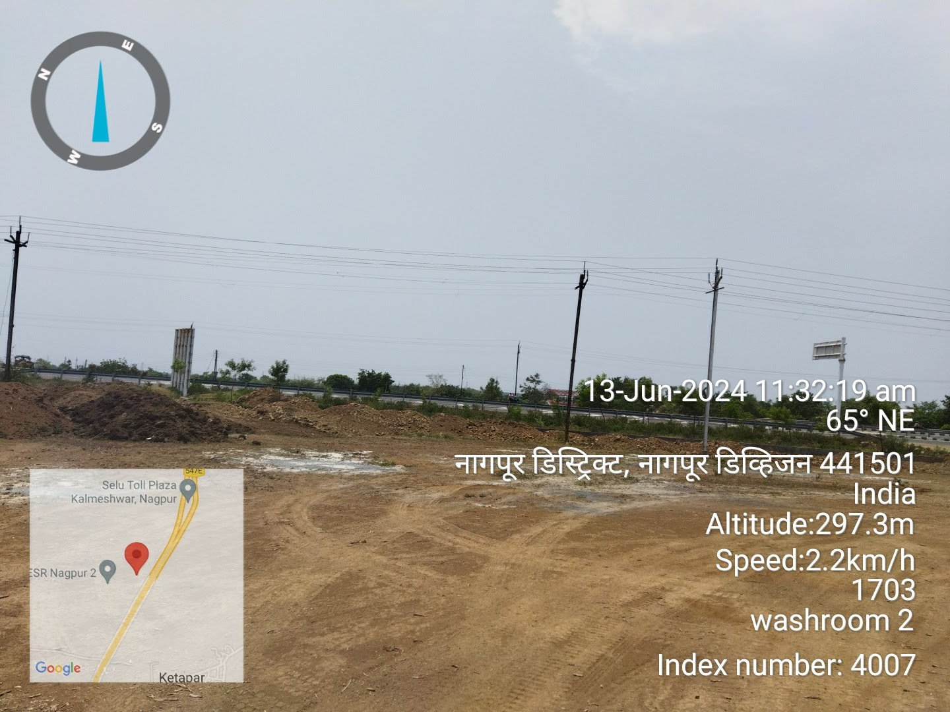

SITUATED AT:

VILLAGE SELU, TALUKA-KAMLESHWAR, DISTRICT-NAGPUR, MAHARASHTRA
PART B | RKA FORMAT OF OPINION REPORT ON VALUATION

Name & Address of Branch | Central Bank of India, Corporate Finance Branch, Central Bank Building, 1st Floor, M.G. Road Fort, Mumbai- 400 001
Name of Customer (s)/ Borrower Unit | M/s. Suprindustrial Park Private Limited
Work Order No. & Date | ---

S.NO. |  | CONTENTS |  | DESCRIPTION
 |  | INTRODUCTION
 |  | Name of the owner |  | M/s. Suprindustrial Park Private Limited (as per copy of TSR & Sale Deed provided)
 |  | Address & Phone Number of the Owner |  | Regd. Office: - Unit No. 803, 8th Floor, Parinee Crescenzo Plot Nos. C 38 & 39, G Block, Bandra-Kurla Complex, City: Bandra East, Dist: Mumbai, State: Maharashtra, India, Pin: 400051
 |  | Purpose of the Valuation |  | For Value assessment of the asset for bank loan security purpose
 |  | Date of Inspection of the Property |  | 13 June 2024
 |  | Property Shown By |  | Name |  |  |  |  |  | Relationship with Owner |  |  |  |  |  |  | Contact Number
 |  |  |  | Mr. Nitin Rotkar |  |  |  |  |  | Employee |  |  |  |  |  |  | +91 93592 71985
 |  | Date of Valuation Report |  | 20 June 2024
 |  | Name of the Developer of the Property |  | Not finalized yet
 |  | Type of Developer |  | ---
 | PHYSICAL CHARACTERISTICS OF THE PROPERTY
BRIEF DESCRIPTION OF THE PROPERTY UNDER VALUATION
This valuation report is prepared for the proposed industrial complex (Warehouse), situated at aforesaid address. Total land has been purchased through two sale deeds. As per copy of 2 nos. Sale deed & TSR provided total land area admeasuring 56.86 acres or 2,30,100 sqm. Google Satellite measurement of area is not possible since land is not demarcated.
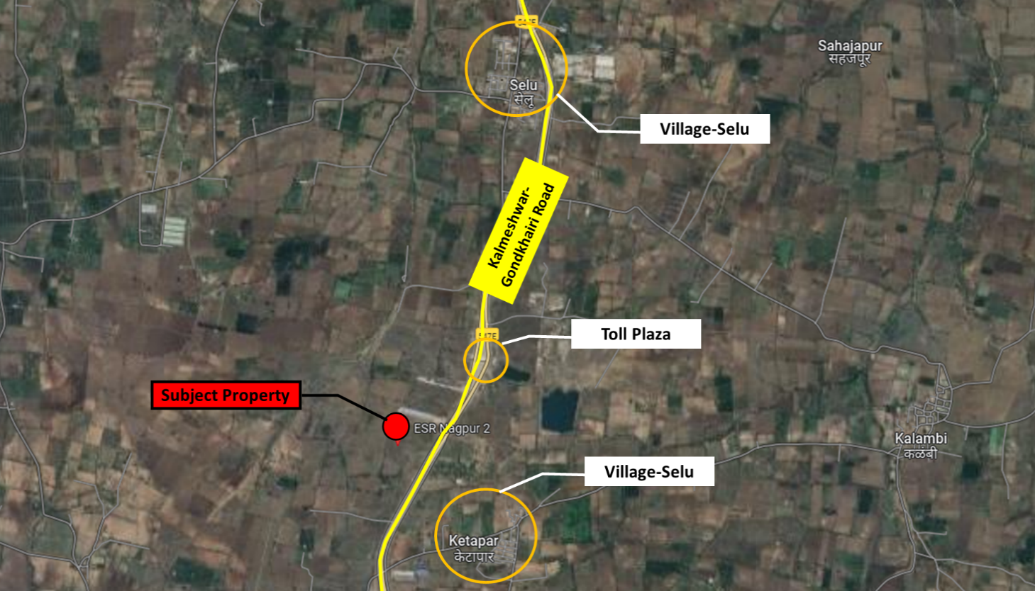

The exact demarcation on google map could not be highlighted as the land is not physically not demarcated on site at present. However, the approximate boundaries demarcated on google satellite measurement tools are as follows:

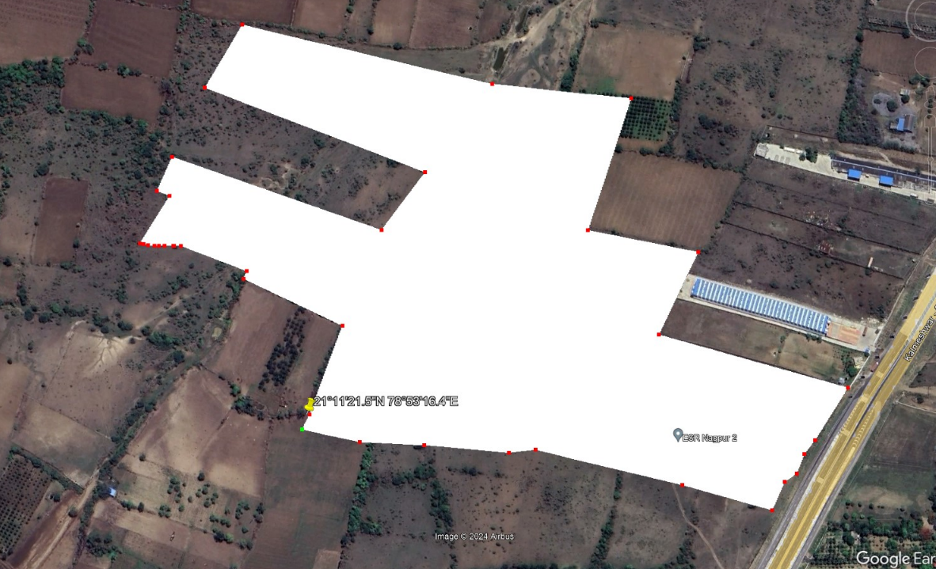

As attached in sale of land area measuring 24,500 sqm, company had received CLU for said land as industrial usage. As per information provided by the management, the company has applied for CLU for the balance land area.

As per copy of TSR dated 23-05-2024, out of the total land area, area measuring 24,500 sqm is Industrial in nature and balance land parcel is agricultural. As per information provided by the company management, company has applied for Change of Land Use (CLU). However, copy of the same is not shared with us. We have also checked the land records on sample basis to verify the ownership. As mentioned in TSR, Suprindustrial Park Private Limited has the full ownership of the said land. (refer annexure)

As per details available on Ministry of Environment Forest and Climate Change website, company has applied for Environment Clearance vide proposal no. IA/MH/INFRA2/479331/2024 dated 06-06-2024 and the case is under review.

As per the scope of work, valuation is done considering the subject property Industrial & Logistic Park. As per site survey, it was found that the construction work was in progress. About 30% - 40% work related to boundary have been completed.

The subject land situated at Village-Selu which is on 4 lane Kalmeshwar-Gondkhairi highway. Most of the nearby land parcel are agricultural in nature.

This report only contains general assessment & opinion on the Guideline Value and the indicative, estimated Market Value of the property of which Bank/ customer asked us to conduct the Valuation for the property found on as-is-where basis as shown on the site by the Bank/ customer of which photographs is also attached with the report. No legal aspects in terms of ownership or any other legal aspect is taken into consideration. Even if any such information is mentioned in the report it is only referred from the information provided for which we do not assume any responsibility. Due care has been given while doing valuation assessment, but it doesn’t contain any due-diligence or audit or verification of any kind other than the valuation computation of the property shown to us on site. Information/ data/ documents given to us by Bank/ client have been relied upon in good faith. This report doesn’t contain any other recommendations of any sort.

In case of discrepancy in the address/ property number mentioned in the property documents and the property shown to us at the site due to change in zoning or administrative level at the site or the client misled the valuer by providing the fabricated/ incorrect document or information, the valuation should be considered of the property shown to us at the site by the client of which the photographs are also attached. In case of any doubt, best would be to contact the concerned authority/ district administration/ tehsil level for the identification of the property if the property depicted in the photographs in this report is same with the documents pledged.
 | Location attribute of the property
 | Nearby Landmark |  |  | Selu Toll Plaza
 | Postal Address of the Property |  |  | Survey No. 248/1, 248/2, 250, 253/1/253/2/1, 254/1, 259(part), 260(part), 261, 262, 264, 266, 391, 390, Village-Selu, Taluka-Kamleshwar, District-Nagpur, Maharashtra
 | Type of Land |  |  | Solid Land/ below road level
 | Independent access/ approach to the property |  |  | Clear independent access is available
 | Google Map Location of the Property with a neighborhood layout map |  |  | Enclosed with the Report
 |  |  |  | Coordinates or URL: 21°11'22.1"N 78°53'35.2"E
 | Details of the roads abutting the property
 | - Main Road Name & Width |  |  | Kalmeshwar-Gondkhairi Road |  |  |  |  |  |  |  |  |  | Approx. 130 ft. wide
 | - Front Road Name & width |  |  | Kalmeshwar-Gondkhairi Road |  |  |  |  |  |  |  |  |  | Approx. 130 ft. wide
 | - Type of Approach Road |  |  | Bituminous Road
 | - Distance from the Main Road |  |  | On road
 | Description of adjoining property |  |  | Agricultural
 | Plot No. / Survey No. |  |  | Survey No. 248/1, 248/2, 250, 253/1/253/2/1, 254/1, 259(part), 260(part), 261, 262, 264, 266, 391, 390
 | Zone/ Block |  |  | Village- Selu
 | Sub registrar |  |  | Taluka- Kalmeshwar
 | District |  |  | Nagpur
 | Any other aspect |  |  | Valuation is done for the property found as per the information given in the copy of documents provided to us and/ or confirmed by the owner/ owner representative to us at site.  Getting cizra map or coordination with revenue officers for site identification is not covered in this Valuation services.
 | - List of documents produced for perusal (Documents has been referred only for reference purpose as provided. Authenticity to be ascertained by legal practitioner) |  |  | Documents Requested |  |  |  |  | Documents Provided |  |  |  |  |  |  |  | Documents Reference No.
 |  |  |  | Total documents requested. |  |  |  |  | Total documents provided |  |  |  |  |  |  |  | Total documents provided
 |  |  |  | Property Title document |  |  |  |  | 2 no. Sale Deeds |  |  |  |  |  |  |  | Dated 31-08-2023
 |  |  |  | Approved Map |  |  |  |  | Unapproved Map |  |  |  |  |  |  |  | Dated 31-08-2023
 |  |  |  | Environmental Clearance |  |  |  |  | Applied application |  |  |  |  |  |  |  | Dated 06-06-2024
 |  |  |  | Copy of TIR |  |  |  |  | Copy of TIR |  |  |  |  |  |  |  | 23-05-2024
 |  |  |  | Cizra Map |  |  |  |  | Cizra Map |  |  |  |  |  |  |  | ---
 | - Documents provided by |  |  | Name |  |  |  |  | Relationship with Owner |  |  |  |  |  |  |  | Contact Number
 |  |  |  | Mr. Arpit Shah |  |  |  |  | Employee |  |  |  |  |  |  |  | +91 98199 18199
 | - Identification procedure followed of the property |  |  | ☐ | Identified by the owner
 |  |  |  |  | Identified by owner’s representative
 |  |  |  | ☐ | Done from the name plate displayed on the property
 |  |  |  | ☐ | Cross checked from boundaries or address of the property mentioned in the survey report
 |  |  |  | ☐ | Enquired from local residents/ public
 |  |  |  | ☐ | Identification of the property could not be done properly
 |  |  |  | ☐ | Survey was not done
 | - Type of Survey |  |  | Only photographs taken (No sample measurement as no physical boundary of land)
 | - Is property clearly demarcated by permanent/ temporary boundary on site |  |  | Demarcation work is in progress
 | - Is the property merged or colluded with any other property |  |  | Demarcation work is in progress
 | - City Categorization |  |  | Metro City |  |  |  |  |  |  |  |  |  | Rural
 | - Characteristics of the locality |  |  | Good |  |  |  |  |  |  |  |  |  | Out of municipal limits
 | - Property location classification |  |  | On Highway |  |  |  |  |  |  | Road Facing |  |  |  |  |  | Normal location within locality
 | - Property Facing |  |  | East Facing
 | Area description of the Property  Also please refer to Part-B Area description of the property. Area measurements considered in the Valuation Report is adopted from relevant approved documents or actual site measurement whichever is less, unless otherwise mentioned. Verification of the area measurement of the property is done only based on sample random checking. |  |  | Land |  |  |  |  |  |  |  | Construction
 |  |  |  |  |  |  |  |  |  |  |  | Built-up Area
 |  |  |  | 56.86 acres or 2,30,100 sqm |  |  |  |  |  |  |  | 14,18,658 sq.ft. (Proposed)
 | Boundaries schedule of the Property
 | Are Boundaries matched |  |  | Boundary wall construction under progress
 | Directions |  | As per Sale Deed |  |  |  |  |  |  |  |  | Actual found at Site
 |  |  | Land 2,05,600 sqm |  |  |  |  | land 24,500 sqm
 | East |  | Road |  |  |  |  | Survey no. 248 |  |  |  | Road
 | West |  | Survey No. 269, 273, 265, 290 |  |  |  |  | Survey no. 391, 265 |  |  |  | Other’s Land
 | North |  | Pandhan |  |  |  |  | Survey no. 294, 295, 296 |  |  |  | Other’s Land
 | South |  | Survey No. 260, 259, 254/1, 265, 7/1 of Ketapar |  |  |  |  | Survey no. 264 |  |  |  | Other’s Land
 | TOWN PLANNING/ ZONING PARAMETERS
 | Master Plan provisions related to property in terms of Land use |  |  |  |  |  | Area not notified under Master Plan
 | - Any conversion of land use done |  |  |  |  |  | From Agricultural to Industrial for land measuring 24,500 sqm and company has applied for conversion for balance land parcel.
 | - Current activity done in the property |  |  |  |  |  | Under-construction Warehouse purpose
 | - Is property usage as per applicable zoning |  |  |  |  |  | It is a village area, no zoning regulations defined
 | - Any notification on change of zoning regulation |  |  |  |  |  | No information available on public domain
 | - Street Notification |  |  |  |  |  | National Highway
 | Provision of Building by-laws as applicable |  |  |  |  |  | PERMITTED |  |  |  |  |  |  |  |  | PROPOSED
 | - FAR/FSI |  |  |  |  |  | 1.00 |  |  |  |  |  |  |  |  | ~0.57
 | - Ground coverage
 | - Number of floors
 | - Height restrictions
 | - Front/ Back/Side Setback
 | - Status of Completion/ Occupational certificate |  |  |  |  |  | Not applicable as construction work just started
 | Comment on unauthorized construction if any |  |  |  |  |  | Not applicable as construction work just started
 | Comment on Transferability of developmental rights |  |  |  |  |  | Free hold, complete transferable rights
 | - Planning Area/ Zone |  |  |  |  |  | NA
 | - Master Plan Currently in Force |  |  |  |  |  | NA
 | - Municipal Limits |  |  |  |  |  | Area not within Municipal limits
 | Developmental controls/ Authority |  |  |  |  |  | NA
 | Zoning regulations |  |  |  |  |  | Not yet under zoning regulations
 | Comment on the surrounding land uses & adjoining properties in terms of uses |  |  |  |  |  | Rural area and most of the nearby land is lying barron
 | Comment of Demolition proceedings if any |  |  |  |  |  | NA
 | Comment on Compounding/ Regularization proceedings |  |  |  |  |  | NA
 | Any other aspect |  |  |  |  |  | ---
 | - Any information on encroachment |  |  |  |  |  | None as per information received during site visit.
 | - Is the area part of unauthorized area/ colony |  |  |  |  |  | No, as per information received during site visit
 | DOCUMENT DETAILS AND LEGAL ASPECTS OF THE PROPERTY
 | Ownership documents provided |  |  |  |  | Sale deed |  |  |  |  |  |  |  | Copy of TIR
 | Names of the owner |  |  |  |  | M/S Suprindustrial Park Private Limited
 | Constitution of the Property |  |  |  |  | Free hold, complete transferable rights
 | Agreement of easement if any |  |  |  |  | Not required
 | Notice of acquisition if any and area under acquisition |  |  |  |  | No such information came in front of us and could be found on public domain
 | Notification of road widening if any and area under acquisition |  |  |  |  | No information
 | Heritage restrictions, if any |  |  |  |  | No
 | Comment on Transferability of the property ownership |  |  |  |  | Free hold, complete transferable rights
 | Comment on existing mortgages/ charges/ encumbrances on the property, if any |  |  |  |  | The property is proposed to be charged to Central Bank of  India
 | Comment on whether the owners of the property have issued any guarantee (personal or corporate) as the case may be |  |  |  |  | Not Known to us |  |  |  |  |  |  |  |  | NA
 | Building plan sanction:
 | - Is Building Plan sanctioned |  |  |  |  | No, layout plan is yet to be approved
 | - Authority approving the plan |  |  |  |  | Applied for approval to NMRDA, application NMRDA202400127 dated 12-03-2024
 | - Any violation from the approved Building Plan |  |  |  |  | Not applicable since construction is in progress
 | - Details of alterations/ deviations/ illegal construction/ encroachment noticed in the structure from the original approved plan |  |  |  |  | ☐ Permissible Alterations |  |  |  |  |  |  |  | NA
 |  |  |  |  |  | ☐ Not permitted alteration |  |  |  |  |  |  |  | NA
 | Whether Property is Agricultural Land if yes, any conversion is contemplated |  |  |  |  | From Agricultural to Industrial for land measuring 24,500 sqm and company has applied for conversion for balance land parcel i.e. 2,05,600 sqm.
 | Whether the property SARFAESI complaint |  |  |  |  | Yes (if conversion for 2,05,600 sqm land is received)
 | - Information regarding municipal taxes (property tax, water tax, electricity bill) |  |  |  |  | Property Tax |  |  |  |  |  |  | Not Applicable since property is under construction
 |  |  |  |  |  | Water Tax |  |  |  |  |  |  | Not Applicable since property is under construction
 |  |  |  |  |  | Electricity Bill |  |  |  |  |  |  | Not Applicable since property is under construction
 | - Observation on Dispute or Dues if any in payment of bills/ taxes |  |  |  |  | No such information came to knowledge on site
 | - Is property tax been paid for this property |  |  |  |  | Not Applicable
 | - Property or Tax Id No. |  |  |  |  | --
 | Whether entire piece of land on which the unit is set up / property is situated has been mortgaged or to be mortgaged |  |  |  |  | Yes, as informed by owner/ owner representative.
 | Qualification in TIR/Mitigation suggested if any |  |  |  |  | As per TIR dated 23-05-2024, land ownership is in the name of Suprindustrial Park Private Limited
 | Any other aspect |  |  |  |  | This is just an opinion report on Valuation based on the copy of the documents/ information provided to us by the client and has been relied upon in good faith of the property found as per the information given in the documents provided to us and/ or confirmed by the owner/ owner representative to us on site.  Legal aspects, Title verification, Verification of authenticity of documents from originals or cross checking from any Govt. dep’t. of the property have to be taken care by legal expert/ Advocate.
 | - Property presently occupied/ possessed by |  |  |  |  | Developer

 | ECONOMIC ASPECTS OF THE PROPERTY
 | Reasonable letting value/ Expected market monthly rental |  |  |  |  |  |  | Property is under-construction
 | Is property presently on rent |  |  |  |  |  |  | No
 | - Number of tenants |  |  |  |  |  |  | Not applicable
 | - Since how long lease is in place |  |  |  |  |  |  | Not applicable
 | - Status of tenancy right |  |  |  |  |  |  | Not applicable
 | - Amount of monthly rent received |  |  |  |  |  |  | Not applicable
 | Taxes and other outgoing |  |  |  |  |  |  | NA
 | Property Insurance details |  |  |  |  |  |  | ---
 | Monthly maintenance charges payable |  |  |  |  |  |  | Not applicable
 | Security charges, etc. |  |  |  |  |  |  | Not applicable
 | Any other aspect |  |  |  |  |  |  | NA
 | SOCIO - CULTURAL ASPECTS OF THE PROPERTY
 | Descriptive account of the location of the property in terms of Social structure of the area in terms of population, social stratification, regional origin, age groups, economic levels, location of slums/squatter settlements nearby, etc. |  |  |  |  |  |  | Rural Area
 | Whether property belongs to social infrastructure like hospital, school, old age homes etc. |  |  |  |  |  |  | No
 | FUNCTIONAL AND UTILITARIAN SERVICES, FACILITIES & AMENITIES
 | Description of the functionality & utility of the property in terms of:
 | - Space allocation |  |  |  |  |  |  | Yes (proposed)
 | - Storage spaces |  |  |  |  |  |  | Yes (proposed)
 | - Utility of spaces provided within the building |  |  |  |  |  |  | Yes (proposed)
 | - Car parking facilities |  |  |  |  |  |  | Yes (proposed)
 | - Balconies |  |  |  |  |  |  | No
 | Any other aspect
 | - Drainage arrangements |  |  |  |  |  |  | Yes (proposed)
 | - Water Treatment Plant |  |  |  |  |  |  | No
 | - Power Supply arrangements |  |  | Permanent |  |  |  | Yes (proposed)
 |  |  |  | Auxiliary |  |  |  | Yes, D.G sets (proposed)
 | - HVAC system |  |  |  |  |  |  | No
 | - Security provisions |  |  |  |  |  |  | Yes (proposed)
 | - Lift/ Elevators |  |  |  |  |  |  | No
 | - Compound wall/ Main Gate |  |  |  |  |  |  | Yes (proposed)
 | - Whether gated society |  |  |  |  |  |  | Yes (proposed)
 | Internal development
 | Garden/ Park/ Land scraping |  | Water bodies |  |  | Internal roads |  |  |  | Pavements |  |  |  | Boundary Wall
 | No (proposed) |  | No |  |  | No (proposed) |  |  |  | No (proposed) |  |  |  | Under-construction
 | INFRASTRUCTURE AVAILABILITY
 | Description of Aqua Infrastructure availability in terms of:
 | - Water Supply |  |  |  |  |  |  | Yes
 | - Sewerage/ sanitation system |  |  |  |  |  |  | Yes
 | - Storm water drainage |  |  |  |  |  |  | No
 | Description of other Physical Infrastructure facilities in terms of:
 | - Solid waste management |  |  |  |  |  |  | Yes, by the local Authority
 | - Electricity |  |  |  |  |  |  | Yes
 | - Road and Public Transport connectivity |  |  |  |  |  |  | Yes
 | - Availability of other public utilities nearby |  |  |  |  |  |  | Transport, Market, Hospital etc. available in close vicinity
 | Proximity & availability of civic amenities & social infrastructure
 | School | Hospital |  |  | Market |  | Bus Stop |  | Railway Station |  |  | Metro |  |  |  | Airport
 | ~5 km. | ~5 km. |  |  | ~4 km. |  | ~3 km. |  | ~12 km |  |  | ~20 kms. |  |  |  | ~30 km
 | Availability of recreation facilities (parks, open spaces etc.) |  |  |  |  |  | No
 | MARKETABILITY ASPECTS OF THE PROPERTY
 | Marketability of the property in terms of
 | - Location attribute of the subject property |  |  |  |  |  |  | Good
 | - Scarcity |  |  |  |  |  |  | Ample vacant land available nearby. There is no issue of land availability in this area.
 | - Demand and supply of the kind of the subject property in the locality |  |  |  |  |  |  | Good demand of such properties in the market.
 | - Comparable Sale Prices in the locality |  |  |  |  |  |  | Please refer to Part D: Procedure of Valuation Assessment
 | Any other aspect which has relevance on the value or marketability of the property |  |  |  |  |  |  | Property is located on main road.
 | - Any New Development in surrounding area |  |  |  |  |  |  | Few warehouse & industries are available in the locality
 | - Any negativity/ defect/ disadvantages in the property/ location |  |  |  |  |  |  | Not as such
 | ENGINEERING AND TECHNOLOGY ASPECTS OF THE PROPERTY
 | Type of construction |  |  |  |  |  |  | Structure |  |  | Slab |  |  |  | Walls
 |  |  |  |  |  |  |  | Not applicable since currently the site is under construction |  |  | Not applicable since currently the site is under construction |  |  |  | Not applicable since currently the site is under construction
 | Material & Technology used |  |  |  |  |  |  | Material Used |  |  |  |  | Technology used
 |  |  |  |  |  |  |  | Not applicable since currently the site is under construction |  |  |  |  | Not applicable since currently the site is under construction
 | Specifications
 | - Roof |  |  |  |  |  |  | Floors/ Blocks |  |  |  |  | Type of Roof
 |  |  |  |  |  |  |  | Not applicable since currently the site is under construction |  |  |  |  | Not applicable since currently the site is under construction
 | - Floor height |  |  |  |  |  |  | Not applicable since currently the site is under construction
 | - Type of flooring |  |  |  |  |  |  | Not applicable since currently the site is under construction
 | - Doors/ Windows |  |  |  |  |  |  | Not applicable since currently the site is under construction
 | - Class of construction/ Appearance/ Condition of structures |  |  |  |  |  |  | Not applicable since currently the site is under construction
 |  |  |  |  |  |  |  | Not applicable since currently the site is under construction
 | - Interior Finishing & Design |  |  |  |  |  |  | Not applicable since currently the site is under construction
 | - Exterior Finishing & Design |  |  |  |  |  |  | Not applicable since currently the site is under construction
 | - Interior decoration/ Special architectural or decorative feature |  |  |  |  |  |  | Not applicable since currently the site is under construction
 | - Class of electrical fittings |  |  |  |  |  |  | Not applicable since currently the site is under construction
 | - Class of sanitary & water supply fittings |  |  |  |  |  |  | Not applicable since currently the site is under construction
 | Maintenance issues |  |  |  |  |  |  | Not applicable since currently the site is under construction
 | Age of building/ Year of construction |  |  |  |  |  |  | Not applicable since currently the site is under construction |  |  |  |  | Not applicable since currently the site is under construction
 | Total life of the structure/ Remaining life expected |  |  |  |  |  |  | Not applicable since currently the site is under construction |  |  |  |  | Not applicable since currently the site is under construction
 | Extent of deterioration in the structure |  |  |  |  |  |  | Not applicable since currently the site is under construction
 | Structural safety |  |  |  |  |  |  | Not applicable since currently the site is under construction
 | Protection against natural disasters viz. earthquakes etc. |  |  |  |  |  |  | Not applicable since currently the site is under construction
 | Visible damage in the building if any |  |  |  |  |  |  | Not applicable since currently the site is under construction
 | System of air conditioning |  |  |  |  |  |  | Not applicable since currently the site is under construction
 | Provision of firefighting |  |  |  |  |  |  | Not applicable since currently the site is under construction
 | Copies of the plan and elevation of the building to be included |  |  |  |  |  |  | Not applicable since currently the site is under construction
 | ENVIRONMENTAL FACTORS
 | Use of environment friendly building materials like fly ash brick, other Green building techniques if any |  |  |  |  |  |  | Not applicable since currently the site is under construction
 | Provision of rainwater harvesting |  |  |  |  |  |  | Not applicable since currently the site is under construction
 | Use of solar heating and lighting systems, etc. |  |  |  |  |  |  | Not applicable since currently the site is under construction
 | Presence of environmental pollution in the vicinity of the property in terms of industries, heavy traffic, etc. if any |  |  |  |  |  |  | Yes, normal air pollution from vehicles
 | ARCHITECTURAL AND AESTHETIC QUALITY OF THE PROPERTY
 | Descriptive account on whether the building is modern, old fashioned, etc., plain looking or with decorative elements, heritage value if applicable, presence of landscape elements,  etc. |  |  |  |  |  |  | Not Applicable
 | VALUATION
 | Methodology of Valuation – Procedures adopted for arriving at the Valuation |  |  |  |  |  |  | Please refer to Part D: Procedure of Valuation Assessment of the report.
 | Prevailing Market Rate/ Price trend of the Property in the locality/ city from property search sites |  |  |  |  |  |  | Please refer to Part D: Procedure of Valuation Assessment of the report and the screenshot annexure in the report, if available.
 | Guideline Rate obtained from Registrar’s office/ State Govt. gazette/ Income Tax Notification |  |  |  |  |  |  | Please refer to Point 3 of Part D: Procedure of Valuation Assessment of the report and the screenshot annexure in the report, if available.
 | Summary of Land Valuation |  |  |  |  |  |  | For detailed Valuation calculation please refer to Part D: Procedure of Valuation Assessment of the report.
 | - Guideline Value |  |  |  |  |  |  | Rs. 61,20,66,000/- (Land Value)
 | - Indicative Prospective Estimated Fair Market Value |  |  |  |  |  |  | Rs. 58,00,00,000/- (Land Value)
 | - Expected Estimated Realizable Value |  |  |  |  |  |  | Rs. 49,30,00,000/- (Land Value)
 | - Expected Forced/ Distress Sale Value |  |  |  |  |  |  | Rs. 43,50,00,000/- (Land Value)
 | - Valuation of structure for Insurance purpose |  |  |  |  |  |  | ---
 | - Justification for more than 20% difference in Market & Circle Rate |  |  |  |  |  |  | Circle rates are determined by the District administration as per their own theoretical internal policy for fixing the minimum valuation of the property for property registration tax collection purpose and Market rates are adopted based on prevailing market dynamics found as per the discrete market enquiries which is explained clearly in Valuation assessment factors.
 | - Details of last two transactions in the locality/ area to be provided, if available |  |  |  |  |  |  | No authentic last two transactions details could be known. However prospective transaction details as per information available on public domain and gathered during site survey is mentioned in Part D: Procedure of Valuation Assessment of the report and the screenshots of the references are annexed in the report for reference.
 | Declaration |  | - The information provided by us is true and correct to the best of our knowledge and belief.  - The analysis and conclusions are limited by the reported assumptions, limiting conditions, remarks.  - Firm have read the Handbook on Policy, Standards and Procedures for Real Estate Valuation by Banks and HFIs in India, 2009 issued by IBA and NHB, fully understood the provisions of the same and followed the provisions of the same to the best of our ability and practically possible and this report is in conformity to the Standards of Reporting enshrined in the above Handbook.  - No employee or member of R.K Associates has any direct/ indirect interest in the property.  - Our authorized surveyor Dhawal Banjari has visited the subject property on 13/6/2024 in the presence of the owner's representative with the permission of owner.  - Firm is an approved Valuer of the Bank.  - Firm is not depanelled or removed from any Bank/Financial Institution/Government Organization at any point of time in the past.  - We have submitted the Valuation Report directly to the Bank.
 | ENCLOSED DOCUMENTS
 | Layout plan sketch of the area in which the property is located with latitude and longitude |  |  |  |  |  |  | Google Map enclosed with coordinates
 | Building Plan |  |  |  |  |  |  | Enclosed with the report
 | Floor Plan |  |  |  |  |  |  | Enclosed with the report
 | Photograph of the property (including geo-stamping with date) and owner (in case of housing loans, if borrower is available) including a “Selfie’ of the Valuer representative at the site |  |  |  |  |  |  | Enclosed with the report along with other property photographs
 | Certified copy of the approved / sanctioned plan wherever applicable from the concerned office |  |  |  |  |  |  | Not Applicable
 | Google Map location of the property |  |  |  |  |  |  | Enclosed with the Report
 | Price trend of the property in the locality/city from property search sites viz Magickbricks.com, 99Acres.com, Makan.com etc. |  |  |  |  |  |  | No specific price trends available for this location on property search sites or public domain.
 | Any other relevant documents/extracts  (All enclosures & annexures to remain integral part & parcel of the main report) |  |  |  |  |  |  | - Part C: Area Description of the Property  - Part D: Procedure of Valuation Assessment  - Google Map  - References on price trend of the similar related properties available on public domain, if available  - Photographs of the property  - Copy of Circle Rate  - Important property documents exhibit  - Enclosure: VI - Declaration-Cum-Undertaking
 | Total Number of Pages in the Report with enclosures |  |  |  |  |  |  | 49

ENCLOSURE: I
PART C | AREA DESCRIPTION OF THE PROPERTY

 | Land Area considered for Valuation | 56.86 acres or 2,30,100 sqm
 | Area adopted on the basis of | Property documents only since site measurement couldn't be carried out
 | Remarks & observations, if any | As per copy of 2 nos. of sale deed & TIR shared, the total land area is 2,30,100 sqm. Thus, the same is considered for valuation.
 | Constructed Area considered for Valuation  (As per IS 3861-1966) | Built-up Area | As per Layout Plan.
 | Area adoption basis | Layout plan shared
 | Remarks & observations, if any | It is an under-construction industrial warehouse project and land development work is at initial stage.

Note:
- Area measurements considered in the Valuation Report pertaining to Land & Building is adopted from relevant approved documents or actual site measurement whichever is less. All area measurements are on approximate basis only.

- Verification of the area measurement of the property is done based on sample random checking only.

- Area of the large land parcels of more than 2500 sq.mtr or of uneven shape, is taken as per property documents verified with digital survey through google which has been relied upon.

- Drawing Map, design & detailed estimation of the property/ building is out of scope of the Valuation services.

ENCLOSURE: II
PART D | PROCEDURE OF VALUATION ASSESSMENT

 | GENERAL INFORMATION
 | Important Dates | Date of Appointment |  | Date of Inspection of the Property | Date of Valuation Assessment | Date of Valuation Report
 | Important Dates | 21 May 2024 |  | 13 June 2024 | 20 June 2024 | 20 June 2024
 | Client | Central Bank of India, Corporate Finance Branch, Central Bank Building, 1st Floor, M.G. Road Fort, Mumbai- 400 001
 | Intended User | Central Bank of India, Corporate Finance Branch, Central Bank Building, 1st Floor, M.G. Road Fort, Mumbai- 400 001
 | Intended Use | Only for the intended user, purpose of the assignment as per the scope of the assessment.
 | Purpose of Valuation | For Value assessment of the asset for creating collateral mortgage for Bank Loan purpose
 | Scope of the Assessment | For Value assessment of the present land value of the asset.
 | Restrictions | This report should not be referred for any other purpose, by any other user and for any other date other then as specified above. This report is not a certification of ownership or survey number/ property number/ Khasra number which are merely referred from the copy of the documents provided to us.
 | Manner in which the proper is identified | ☐ | Identified by the owner
 | Manner in which the proper is identified |  | Identified by owner’s representative
 | Manner in which the proper is identified | ☐ | Done from the name plate displayed on the property
 | Manner in which the proper is identified | ☐ | Cross checked from boundaries or address of the property mentioned in the survey report.
 | Manner in which the proper is identified | ☐ | Enquired from local residents/ public
 | Manner in which the proper is identified | ☐ | Identification of the property could not be done properly
 | Manner in which the proper is identified | ☐ | Survey was not done
 | Is property number/ survey number displayed on the property for proper identification? | No
 | Type of Survey conducted | Only photographs taken (No sample measurement as no physical boundary of land)

 | ASSESSMENT FACTORS
 | Valuation Standards considered | Mix of standards such as IVS and others issued by Indian authorities & institutions and improvised by the RKA internal research team as and where it is felt necessary to derive at a reasonable, logical & scientific approach. In this regard proper basis, approach, working, definitions considered is defined below which may have certain departures to IVS.
 | Nature of the Valuation | Fixed Assets Valuation
 | Nature/ Category/ Type/ Classification of Asset under Valuation | Nature |  |  |  |  | Category |  |  |  |  |  | Type
 |  | VACANT LAND |  |  |  |  | INDUSTRIAL |  |  |  |  |  | WAREHOUSE (Proposed)
 |  | Classification |  |  |  |  | Income/ Revenue Generating Asset
 | Type of Valuation (Basis of Valuation as per IVS) | Primary Basis |  |  |  | Fair Market Value
 | Type of Valuation (Basis of Valuation as per IVS) | Secondary Basis |  |  |  | Asset in use as per its utility
 | Present market state of the Asset assumed (Premise of Value as per IVS) | Under Normal Marketable State
 |  | Reason: Asset under free market transaction state
 | Property Use factor | Current/ Existing Use |  |  |  |  |  | Highest & Best Use  (in consonance to surrounding use, zoning and statutory norms) |  |  |  |  | Considered for Valuation purpose
 | Property Use factor | Industrial |  |  |  |  |  | Industrial |  |  |  |  | Industrial
 | Legality Aspect Factor | Assumed to be fine as per copy of the documents & information produced to us.  However Legal aspects of the property of any nature are out-of-scope of the Valuation Services. In terms of the legality, we have only gone by the documents provided to us in good faith.  Verification of authenticity of documents from originals or cross checking from any Govt. deptt. have to be taken care by Legal expert/ Advocate.
 | Class/ Category of the locality | Lower Middle Class (Average)
 | Property Physical Factors | Shape |  |  |  |  |  |  | Size |  |  |  | Layout
 | Property Physical Factors | Irregular |  |  |  |  |  |  | Large |  |  |  | Normal Layout
 | Property Location Category Factor | City Categorization |  |  | Locality Characteristics |  |  |  |  |  | Property location characteristics |  |  | Floor Level
 | Property Location Category Factor | Metro City |  |  | Good |  |  |  |  |  | On Highway |  |  | Under construction
 | Property Location Category Factor | Rural |  |  | Normal |  |  |  |  |  | Sunlight facing |  |  | Under construction
 | Property Location Category Factor |  |  |  | Out of municipal limits |  |  |  |  |  | Normal location within locality |  |  | Under construction
 | Property Location Category Factor | Property Facing
 | Property Location Category Factor | East Facing
 | Physical Infrastructure availability factors of the locality | Water Supply |  |  | Sewerage/ sanitation system |  |  |  |  |  | Electricity |  |  | Road and Public Transport connectivity
 | Physical Infrastructure availability factors of the locality | Yes from borewell/ submersible |  |  | No |  |  |  |  |  | Yes |  |  | Easily available
 | Physical Infrastructure availability factors of the locality | Availability of other public utilities nearby |  |  |  |  |  |  |  |  | Availability of communication facilities
 | Physical Infrastructure availability factors of the locality | Transport, Market, Hospital etc. are available in close vicinity |  |  |  |  |  |  |  |  | Major Telecommunication Service Provider & ISP connections are available
 | Social structure of the area (in terms of population, social stratification, regional origin, age groups, economic levels, location of slums/ squatter settlements nearby, etc.) | Rural Income Group
 | Neighbourhood amenities | Good
 | Any New Development in surrounding area | Newly constructed National Highway-547E
 | Any specific advantage in the property | The subject project is located on National Highway-547E.
 | Any specific drawback in the property | Not as such.
 | Property overall usability/ utility Factor | Normal
 | Do property has any alternate use? | No.
 | Is property clearly demarcated by permanent/ temporary boundary on site | It is partially demarcated as construction work was started recently.
 | Is the property merged or colluded with any other property | Cannot comment
 | Is the property merged or colluded with any other property | Comments: - No physical boundary of land parcel currently.
 | Is independent access available to the property | Clear independent access is available
 | Is property clearly possessable upon sale | Yes
 | Best Sale procedure to realize maximum Value (in respect to Present market state or premise of the Asset as per point (iv) above) | Fair Market Value
 |  | Free market transaction at arm's length wherein the parties, after full market survey each acted knowledgeably, prudently and without any compulsion.
 | Hypothetical Sale transaction method assumed for the computation of valuation | Fair Market Value
 |  | Free market transaction at arm's length wherein the parties, after full market survey each acted knowledgeably, prudently and without any compulsion.
 | Approach & Method of Valuation Used | Land |  | Approach of Valuation |  |  |  |  |  |  | Method of Valuation
 | Approach & Method of Valuation Used |  |  | Market Approach |  |  |  |  |  |  | Market Comparable Sales Method
 | Approach & Method of Valuation Used | Built-up Unit |  | Income Approach |  |  |  |  |  |  | Rent Capitalization Method
 | Type of Source of Information | Level 3 Input (Tertiary)
 | Market Comparable
 | References on prevailing market Rate/ Price trend of the property and Details of the sources from where the information is gathered (from property search sites & local information) | 1. | Name: |  |  |  |  |  |  |  |  | Mr. Sunil Shrikhande
 |  | 1. | Contact No.: |  |  |  |  |  |  |  |  | +91 97737 28216
 |  | 1. | Nature of reference: |  |  |  |  |  |  |  |  | Property Dealer
 |  | 1. | Size of the Property: |  |  |  |  |  |  |  |  | 20 Acre
 |  | 1. | Location: |  |  |  |  |  |  |  |  | Near to Selu Toll Plaza
 |  | 1. | Rates/ Price informed: |  |  |  |  |  |  |  |  | Rs. 1.00 Cr. per acre
 |  | 1. | Any other details/ Discussion held: |  |  |  |  |  |  |  |  | As per discussion with the above-mentioned property dealer, it was informed that the land rate has increased significantly due to construction of Highway. The said property dealer has an agriculture land parcel admeasuring 20.00 acre on highway near to Selu Toll Plaza. The asking land price of the property is Rs. 20.00 Crore.
 |  | 2. | Name: |  |  |  |  |  |  |  |  | Mr. Bhujang Chaudhary
 |  | 2. | Contact No.: |  |  |  |  |  |  |  |  | +91 98504 94117
 |  | 2. | Nature of reference: |  |  |  |  |  |  |  |  | Property dealer
 |  | 2. | Size of the Property: |  |  |  |  |  |  |  |  | 30 Acre
 |  | 2. | Location: |  |  |  |  |  |  |  |  | Next to the subject property
 |  | 2. | Rates/ Price informed: |  |  |  |  |  |  |  |  | Rs. 1.50 Cr. per acre
 |  | 2. | Any other details/ Discussion held: |  |  |  |  |  |  |  |  | As per discussion with the above-mentioned property dealer, the dealer is having an agriculture land parcel admeasuring 30.00 acre next to the subject property. The asking land price of the property is Rs. 45.00 Crore.
 |  | NOTE: The given information above can be independently verified to know its authenticity.
 | Adopted Rates Justification | Details of market research & information collected from public domain are as follows: -  - The subject property is situated on National Highway-547E, which is a four-lane access-controlled highway along with service lanes.  - Selu Toll plaza is at a distance of 500 mtr from the subject property.  - As per observation during site visit, it was observed that the locality of the subject property is agricultural. However, few industries and warehouse were found along the highway.  - As per discussion the respective property dealer who deals in the locality, it was informed, since the inauguration of NH-547E back in 2022, the land rates along with the highway have been increased significantly.  - The subject property is situated at a distance of ~5 km from Taluka-Kalmeshwar which is rural area along with highway.  - Not much information & details regarding the property sale instances are available on public domain.  - We only found one property reference on public domain of land area measuring 2.00 acre which is available on sale for Rs. 2.50 crore.  As per our market research through different article published online in public domain, we are of the view to adopt an average land rate of Rs. 1,20,00,000/- per Acre, which is reasonable in our opinion, close to our subject property.
NOTE: We have taken due care to take the information from reliable sources. The given information above can be independently verified from the provided numbers to know its authenticity. However, due to the nature of the information most of the market information came to knowledge is only through verbal discussion with market participants which we have to rely upon where generally there is no written record.
Related postings for similar properties on sale are also annexed with the Report wherever available.
 | Other Market Factors
 | Current Market condition | Normal
 | Current Market condition | Remarks: ---
 | Current Market condition | Adjustments (-/+): 0%
 | Comment on Property Salability Outlook | Easily sellable
 | Comment on Property Salability Outlook | Adjustments (-/+): 0%
 | Comment on Demand & Supply in the Market | Demand |  |  |  |  |  |  |  | Supply
 | Comment on Demand & Supply in the Market | Moderate |  |  |  |  |  |  |  | Abundantly available
 | Comment on Demand & Supply in the Market | Remarks: Good demand of such properties in the market
 | Comment on Demand & Supply in the Market | Adjustments (-/+): 0%
 | Any other special consideration | Reason: The size of comparable land is 2, 20 & 30 acre which is less than that of subject land parcel i.e. 56.86 acre.
 | Any other special consideration | Adjustments (-/+): -15%
 | Any other aspect which has relevance on the value or marketability of the property | High utility property as per its nature and location  Valuation of the same asset/ property can fetch different values under different circumstances & situations. For eg. Valuation of a running/ operational shop/ hotel/ factory will fetch better value and in case of closed shop/ hotel/ factory it will fetch considerably lower value. Similarly, an asset sold directly by an owner in the open market through free market arm’s length transaction then it will fetch better value and if the same asset/ property is sold by any financer or court decree or Govt. enforcement agency due to any kind of encumbrance on it then it will fetch lower value. Hence before financing, Lender/ FI should take into consideration all such future risks while financing.  This Valuation report is prepared based on the facts of the property & market situation on the date of the survey. It is a well-known fact that the market value of any asset varies with time & socio-economic conditions prevailing in the region/ country. In future property market may go down, property conditions may change or may go worse, property reputation may differ, property vicinity conditions may go down or become worse, property market may change due to impact of Govt. policies or effect of domestic/ world economy, usability prospects of the property may change, etc. Hence before financing, Banker/ FI should take into consideration all such future risk while financing.
 |  | Adjustments (-/+): 0%
 | Final adjusted & weighted Rates considered for the subject property | Rs. 1,02,00,000/- per acre
 | Considered Rates Justification | As per the thorough property & market factors analysis as described above, the considered estimated market rates appears to be reasonable in our opinion.
 | Basis of computation & working
- Valuation of the asset is done as found on as-is-where basis on the site as identified to us by client/ owner/ owner representative during site inspection by our engineer/s unless otherwise mentioned in the report.
- Analysis and conclusions adopted in the report are limited to the reported assumptions, conditions and information came to our knowledge during the course of the work and based on the Standard Operating Procedures, Best Practices, Caveats, Limitations, Conditions, Remarks, Important Notes, Valuation TOR and definition of different nature of values.
- For knowing comparable market rates, significant discreet local enquiries have been made from our side based on the hypothetical/ virtual representation of ourselves as both buyer and seller for the similar type of properties in the subject location and thereafter based on this information and various factors of the property, rate has been judiciously taken considering the factors of the subject property, market scenario and weighted adjusted comparison with the comparable properties unless otherwise stated.
- References regarding the prevailing market rates and comparable are based on the verbal/ informal/ secondary/ tertiary information which are collected by our team from the local people/ property consultants/ recent deals/ demand-supply/ internet postings are relied upon as may be available or can be fetched within the limited time & resources of the assignment during market survey in the subject location. No written record is generally available for such market information and analysis has to be derived mostly based on the verbal information which has to be relied upon.
- Market Rates are rationally adopted based on the facts of the property which came to our knowledge during the course of the assessment considering many factors like nature of the property, size, location, approach, market situation and trends and comparative analysis with the similar assets. During comparative analysis, valuation metrics is prepared and necessary adjustments are made on the subject asset.
- The indicative value has been suggested based on the prevailing market rates that came to our knowledge during secondary & tertiary market research and is not split into formal & informal payment arrangements. Most of the deals takes place which includes both formal & informal payment components. Deals which takes place in complete formal payment component may realize relatively less actual transaction value due to inherent added tax, stamp registration liabilities on the buyer.
- Secondary/ Tertiary costs related to asset transaction like Stamp Duty, Registration charges, Brokerage, Commission, Bank interest, Selling cost, Marketing cost, etc. pertaining to the sale/ purchase of this property are not considered while assessing the indicative estimated Market Value.
- This report includes both, Govt. Guideline Value and Indicative Estimated Prospective Market Value as described above. As per the current market practice, in most of the cases, formal transaction takes place for an amount less than the actual transaction amount and rest of the payment is normally done informally.
- Area measurements considered in the Valuation Report pertaining to asset/ property is adopted from relevant approved documents or sample site measurement whichever is less unless otherwise mentioned. All area measurements are on approximate basis only.
- Verification of the area measurement of the property is done based on sample random checking only.
- Area of the large land parcels of more than 2500 sq.mtr or of uneven shape in which there can be practical difficulty in sample measurement, is taken as per property documents which has been relied upon unless otherwise stated.
- Drawing, Map, design & detailed estimation of the property/ building is out of scope of the Valuation services.
- Construction rates are adopted based on the present market replacement cost of construction and calculating applicable depreciation & deterioration factor as per its age, existing condition & specifications based on visual observation only of the structure. No structural, physical tests have been carried out in respect of it. No responsibility is assumed for latent defects of any nature whatsoever, which may affect value, or for any expertise required to disclose such conditions.
- Construction rates are adopted based on the plinth area rates prevailing in the market for the structure as a whole and not based on item wise estimation or Bills of Quantity method unless otherwise stated.
- The condition assessment and the estimation of the residual economic life of the structure are only based on the visual observations and appearance found during the site survey. We have not carried out any structural design or stability study; nor carried out any physical tests to assess structural integrity & strength.
- Any kind of unpaid statutory, utilities, lease, interest or any other pecuniary dues on the asset or on its owners has not been factored in the Valuation.
- This Valuation is conducted based on the macro analysis of the asset/ property considering it in totality and not based on the micro, component or item wise analysis. Analysis done is a general assessment and is neither investigative in nature nor an audit activity.
- Valuation is done for the asset found on as-is-where basis which owner/ owner representative/ client/ bank has shown to us on site of which some reference has been taken from the information/ data given in the copy of documents provided to us which have been relied upon in good faith and we have assumed that it to be true and correct.
 | ASSUMPTIONS
- Documents/ Information/ Data provided by the client/ property owner or his representative both written & verbally is true and correct without any fabrication and has been relied upon in good faith.
- Local verbal enquiries during micro market research came to our knowledge are assumed to be taken on record as true & factual.
- The assets and interests therein have been valued free and clear of any liens or encumbrances unless stated otherwise. No hidden or apparent conditions regarding the subject assets or their ownership are assumed to exist. No opinion of title is rendered in this report and a good title is assumed unless stated otherwise.
- It is assumed that the concerned Lender/ Financial Institution has asked for the valuation of that property after satisfying the authenticity of the documents given to us and for which the legal verification has been already taken and cleared by the competent Advocate before requesting for the Valuation report. I/ We assume no responsibility for the legal matters including, but not limited to, legal or title concerns.
- Payment condition during transaction in the Valuation has been considered on all cash bases which includes both formal & informal payment components as per market trend.
- Sale transaction method of the asset is assumed as Free market transaction without any compulsion unless otherwise mentioned while assessing Indicative & Estimated Fair Prospective Market Value of the asset unless otherwise stated.
- If this Valuation Report is prepared for the Flat/ dwelling unit situated in a Group Housing Society or Integrated Township then approvals, maps of the complete group housing society/ township is out of scope of this report. This valuation report is prepared for the specific unit based on the assumption that complete Group Housing Society/ Integrated Township is approved and complied with all relevant laws and the subject unit is also approved within the Group Housing Society/ Township.
 | SPECIAL ASSUMPTIONS
 | Company has received change of land use certificate for land area measuring 24,500 sqm from the concerned authority. It was informed by the company management that the company has applied for balance land area along with respective NoC which are required to run the warehouse. Thus, it is assumed that company shall be able to obtain relevant/adequate NoCs in due course of time.
 | LIMITATIONS
 | None

 | VALUATION OF LAND
 | Particulars | Govt. Circle/ Guideline Value | Indicative & Estimated Prospective Fair Market Value
 | Prevailing Rate range | Rs. 2660/- per sq. mtr. | Rs. 1,02,00,000/- per acre
 | Rate adopted considering all characteristics of the property | Rs. 2660/- per sq. mtr. | Rs. 1,02,00,000/- per acre
 | Total Land Area considered (documents vs site survey whichever is less) | 2,30,100 sq.mtr or 56.86 acre | 56.86 acres
 | Total Value of land (A) | Rs. 2660/- per sq. mtr. X 2,30,100 sq. mtr. | Rs. 1,02,00,000/- per acre x 56.86 acres
 | Total Value of land (A) | Rs. 61,20,66,000/- | Rs. 57,99,72,000/-

4. | VALUATION OF ADDITIONAL AESTHETIC/ INTERIOR WORKS IN THE PROPERTY
S. No. | Particulars | Specifications | Depreciated Replacement Value
 | Add extra for Architectural aesthetic developments, improvements (add lump sum cost) | ---- | ----
 | Add extra for fittings & fixtures  (Doors, windows, wood work, cupboards, modular kitchen, electrical/ sanitary fittings) | ---- | ----
 | Add extra for services  (Water, Electricity, Sewerage, Main gate, Boundary, Lift, Auxiliary power, AC, HVAC, Firefighting etc.) | --- | ---
 | Add extra for internal & external development  (Internal roads, Landscaping, Pavements, Street lights, Green area development, External area landscaping, Land development, Approach road, etc.) | ---- | ----
 | ADDITIONAL AESTHETIC/ INTERIOR WORKS VALUE (B) | ---- | ---
Note:
- Value for Additional Building & Site Aesthetic Works is considered only if it is having exclusive/ super fine work specification above ordinary/ normal work. Ordinary/ normal work value is already covered under basic rates above.

5. | CONSOLIDATED VALUATION ASSESSMENT OF THE ASSET
 | (CURRENT MARKET VALUE OF LAND)

S.No. | Particulars | Govt. Circle/ Guideline Value | Indicative & Estimated Prospective Fair Market Value
 | Land Value (A) | Rs. 61,20,66,000/- | Rs. 57,99,72,000/-
 | Additional Aesthetic/ Interior Works Value (B) | NA | ---
 | Total Add (A+B) | Rs. 61,20,66,000/- | Rs. 57,99,72,000/-
 | Additional Premium if any | NA | NA
 | Details/ Justification | NA | NA
 | Deductions charged if any | NA | NA
 | Details/ Justification | NA | NA
 | Total Indicative & Estimated Prospective Fair Market Value | --- | Rs. 57,99,72,000/-
 | Rounded Off | --- | Rs. 58,00,00,000/-
 | Indicative & Estimated Prospective Fair Market Value in words | NA | Rupees Fifty-Eight Crore Only
 | Expected Realizable Value (@ ~15% less) | NA | Rs. 49,30,00,000/-
 | Expected Distress Sale Value (@ ~25% less) | NA | Rs. 43,50,00,000/-
 | Percentage difference between Circle Rate and Fair Market Value | Less than 20%
 | Likely reason of difference in Circle Value and Fair Market Value in case of more than 20% | There are several reasons why there might be a difference between government guideline rates and market rates in property valuation:  - Timing Differences: Government guideline rates are often updated infrequently, while market rates can fluctuate more frequently based on supply and demand dynamics, economic conditions, and other factors. Therefore, there may be a time difference between changes in market rates and updates to government guideline rates.  - Local Market Variations: Government guideline rates are typically set at a broader level, often at a regional level, and may not accurately reflect local market conditions which can vary significantly. Market rates, on the other hand, are influenced by specific factors such as location, neighborhood amenities, and local economic conditions.  - Property Characteristics: Government guideline rates may not take into account specific characteristics of individual properties, such as age, condition, size, or unique features, which can affect market value. Market rates are influenced by these factors and can vary based on the perceived value of these attributes.  - Market Sentiment and Investor Behavior: Market rates can also be influenced by investor sentiment, speculative activity, and other behavioral factors that may not be reflected in government guideline rates. In times of economic uncertainty or speculative bubbles, market rates may deviate significantly from government guideline rates.  Overall, while government guideline rates serve as a reference point for property valuation, market rates are influenced by a wide range of factors and may not always align perfectly with government guidelines
 | Concluding Comments/ Disclosures if any
In the present economic condition prevailing in the country, the demand for such commercial properties in general is good.
- The liabilities and contingent liabilities are not featured in this valuation report. Therefore, it has to be factored separately to get the transactional value.
- We are independent of client/ company and do not have any direct/ indirect interest in the property.
- This valuation has been conducted by R.K Associates Valuers & Techno Engineering Consultants (P) Ltd. and its team of experts.
- This Valuation is done for the property found on as is where is basis as shown on the site by the Bank/ customer of which photographs is also attached with the report.
- Reference of the property is also taken from the copies of the documents/ information which interested organization or customer could provide to us out of the standard checklist of documents sought from them and further based on our assumptions and limiting conditions. All such information provided to us has been relied upon in good faith and we have assumed that it is true and correct. However, we do not vouch the absolute correctness of the property identification, exact address, physical conditions, etc. based on the documents provided to us since property shown to us may differ on site Vs as mentioned in the documents or incorrect/ fabricated documents may have been provided to us.
- Legal aspects for eg. investigation of title, ownership rights, lien, charge, mortgage, lease, verification of documents from originals or from any Govt. department, etc. has to be taken care by legal experts/ Advocates and same has not been done at our end.
- The valuation of an asset is an estimate of the worth of that asset which is arrived at by the Valuer in his expert opinion after factoring in multiple parameters and externalities. This may not be the actual price of that asset and the market may discover a different price for that asset.
- This report only contains opinion based on technical & market information which came to our knowledge during the course of the assignment. It doesn’t contain any recommendations.
- This report is prepared following our Standard Operating Procedures & Best Practices and will be subject to Limitations, Conditions, Valuer’s Remarks, Important Notes, Valuation TOS and basis of computation & working as described above.
- The use of this report will become valid only after payment of full fees as per the Payment Terms. Using this report or any part content created in this report without payment of charges will be seen as misuse and unauthorized use of the report.
- During the site visit, the units of the plant was in operational (Maintenance work going on since, it is an off season). Our engineering team visited all the sections and manually inspected the machines and equipment’s on the basis of their physical existence not on the basis technical.
 | IMPORTANT KEY DEFINITIONS
Fair Value suggested by the competent Valuer is that prospective estimated amount in his expert & prudent opinion of the subject asset/ property without any prejudice after he has carefully & exhaustively evaluated the facts & information came in front of him or which he could reasonably collect during the course of the assessment related to the subject asset on an as-is, where-is basis in its existing conditions, with all its existing advantages & disadvantages and its potential possibilities which is just & equitable at which the subject asset/ property should be exchanged between a willing buyer and willing seller at an arm’s length transaction in an open & unrestricted market, in an orderly transaction after proper marketing, wherein the parties, each acted knowledgeably, prudently without any compulsion on the date of the Valuation.
Fair Value without using the term “Market” in it describes that the value suggested by the Valuer may not mandatorily follow or may not be in complete consonance to the established Market in his expert opinion. It may or may not follow market dynamics. But if the suggested value by the valuer is not within the prevailing Market range or is assessed for an asset is located in an un-established Market then the valuer will give reasonable justification & reasoning that for what reasons the value suggested by him doesn’t follow the prevailing market dynamics.
Fair Market Value suggested by the competent Valuer is that prospective estimated amount in his expert & prudent opinion of the subject asset/ property without any prejudice in consonance to the Market dynamics after he has carefully & exhaustively evaluated the facts & information came in front of him or which he could reasonably collect during the course of assessment related to the subject asset on an as-is, where-is basis in its existing conditions, with all its existing advantages & disadvantages and its potential possibilities which is just & equitable at which the subject asset/ property should be exchanged between a willing buyer and willing seller at an arm’s length transaction in an open & unrestricted market, in an orderly transaction after proper marketing, wherein the parties, each acted knowledgeably, prudently without any compulsion on the date of the Valuation.
Here the words “in consonance to the established Market” means that the Valuer will give opinion within the realms & dynamics of the prevailing market rates after exhaustively doing the micro market research. However due to the element of “Fair” in it, valuer will always look for the factors if the value should be better than the market realms which is just & equitable backed by strong justification and reasoning.
Market Value suggested by the competent Valuer is that prospective estimated amount which is average price of the similar comparable assets prevailing in an open & established market during the near period of the date of valuation at which the subject asset/ property should be exchanged between a willing buyer and willing seller on an as-is, where-is basis in its existing conditions, with all its existing advantages & disadvantages and its potential possibilities at an arm’s length transaction in an open, established & unrestricted market, in an orderly transaction, wherein the parties, each acted without any compulsion on the date of the Valuation.
Using the term “Market Value” without “Fair” omits the elements of proper marketing, acting knowledgeably & prudently.
Market and market participants can be sentimental, inclined towards the transaction without the element of complete knowledge & prudence about facts or due diligence of the asset therefore “each acted knowledgeably, prudently” has been removed from the marker Value definition.
 | Realizable Value is that minimum prospective estimated value of the asset/ property which it may be able to fetch at the time of actual property transaction factoring in the element of discount due to the prospects of deep negotiations between the buyer & seller when the parties in-principally find Fair Market Value reasonable and sits together to close the deal and the transaction across the table. Discount percentage on the Fair Market Value due to negotiation will depend on the nature, size, various salability prospects of the subject asset, the needs of the buyer & the seller and kind of payment terms. In some of the cases Realizable and Fair Market Value may also be equal.
 | Distress Sale Value* is that value when the property is attached with any process such as mortgaged financing, financial or operational dues which is under any stress condition or situation and the stakeholders are under process of finding resolution towards it to save the property from being attached to a formal recovery process. In this type of sale, minimum fetch value assessed will always be less than the estimated Fair Market Value where the discount of percentage will depend upon various circumstances and factors such as nature, size, salability prospects of the property and kind of encumbrance on the property. In this type of sale, negotiation power of the buyer is always more than the seller and eagerness & pressure of selling the property will be more on the seller than the buyer.
 | Liquidation Value is the amount that would be realized when an asset or group of assets are sold due to any compulsion or constraints such as in a recovery process guided by statute, law or legal process, clearance sale or any such condition or situation thereof where the pressure of selling the asset/ property is very high to realize whatever maximum amount can be from the sale of the assets in a limited time for clearance of dues or due to closure of business. In other words, this kind of value is also called as forced sale value.
Difference between Cost, Price & Value: Generally, these words are used and understood synonymously. However, in reality each of these has a completely different meaning, premise and also having different definitions in professional & legal terms. Therefore, it is our professional responsibility to describe the definitions of these words to avoid ambiguity & confusion in the minds of the user of this report.
The Cost of an asset represents the actual amount spend in the construction/ actual creation of the asset.
The Price is the amount paid for the procurement of the same asset.
The Value is defined as the present worth of future rights in the property/ asset and is a hypothetical or notional price that buyers and sellers are most likely to conclude for a good or service. Value is not a fact, but an estimate of the likely price to be paid for a good or service at a given time in accordance with a particular definition of value.
Therefore, in actual for the same asset/ property, cost, price & value remain different since these terms have different usage & meaning.
Enclosures with the Report:

- Enclosure: I – Google Map Location
- Enclosure: II - Photographs of the property
- Enclosure: III – Copy of Circle Guideline Rate
- Enclosure: IV – Important property documents exhibit
- Enclosure V: References on price trend of the similar related properties available on public domain
- Enclosure VI - Declaration-cum-Undertaking

6. | NET PRESENT VALUE COMPUTATION OF INDUSTRIAL PROJECT (WAREHOUSE) BASED ON RENTAL YIELD

Notes for special assumptions:

General:

- We have considered revenue and cost-based model while making the future financial projections.
- These projections are made based on the primary assumptions that a modern warehouse will be built on the said land as per details & layout shared.
- This is Net Present value based of future revenue projection of the project. Presently there is only vacant and only foundation work has started as on the date of site survey.
- For projections/data input/reference, we have been provided financial model by the company.
- The projections are forecasted for a period of 15 years from the proposed date of completion i.e. 31-12-2028.
- In the subject property, the only source of operational revenue is from rent/lease amount collected from the rented/leased space & interest on security deposit.
- Currently the site is under development. Foundation work is in progress as on the date of site survey. As per details provided by the company, the whole project will take 5 years to complete and will be ready for use from year 01-01-2029.
- As per information provided by the company, the construction shall be completed in phase-wise. Details of the same are as follows: -

Phase | Total BUA  (In Sq. ft.) | Gross Leasable Area  (In Sq. ft.) | Construction Start Date | Construction End Date
Phase-1 | 2,43,028 | 2,55,180 | 1-Jul-24 | 30-Jun-25
Phase-2 | 4,70,733 | 4,94,270 | 1-Jul-25 | 30-Jun-26
Phase-3 | 1,96,225 | 2,06,036 | 1-Apr-26 | 31-Mar-27
Phase-4 | 4,20,964 | 4,42,012 | 1-Jan-27 | 31-Dec-27
Phase-5 | 87,708 | 92,093 | 1-Oct-27 | 31-Dec-28
Total | 14,18,658 | 14,89,591

Revenue:

- We have done market research, information available in public domain and our micro analysis for the present market rent/lease rate for similar projects in the nearby locality. Details of the same are as follows: -
Area  (In Sq.ft.) | Rent  (In Rs. /Month) | Rent  (In Rs. /Sq.ft.) | Location | Distance from the subject property
8,500 | 1,30,000 | 15.29 | Surabardi | 13 km
70,000 | 11,20,000 | 16.00 | Nimji | 6 km
1,500 | 30,000 | 20.00 | Wanadongri | 21 km
5,000 | 85,000 | 17.00 | Hingna | 24 km
1,20,000 | 19,20,000 | 16.00 | Gondkheri | 11 km
1,90,000 | 32,30,000 | 17.00 | Mihan | 36 km
7,000 | 1,10,000 | 15.71 | Satnavari | 17 km

- As per information received & inquiry done, Reliance Projects & Property Management Services Limited has taken warehouse on monthly lease rental @ Rs. 17.50/- per sq.ft. from GATI Realtors Pvt Ltd. This warehouse is located at a distance of 20 km from the subject property.
- As per financial model and information shared by the company, the company is expected to fetch rent of ~Rs. 18.00/- per sq.ft. from leasing out the warehouse area. Thus, the same is considered for the valuation purpose.
- 5% annual income on security deposits shall be earned by the company.

Expenses:

- It assumed that 10% of total income shall be incurred in Operational expenses of the warehouse project.
- Project Cost & major expenses are shown in the tabular form below:

*All the values are in Cr.

Particulars | Total Cost | 31-03-2025 | 31-03-2026 | 31-03-2027 | 31-03-2028 | 31-12-2028
Expenses
Hard Cost
Land Cost (incl. GST) | 47.58 | 47.58 | - | - | - | -
Construction Cost | 254.45 | 32.69 | 74.22 | 75.18 | 62.92 | 9.44
Total Infra & Landscaping Costs | 61.60 | 8.02 | 18.07 | 18.55 | 14.69 | 2.29
Approval Cost | 5.02 | 0.77 | 1.58 | 1.89 | 0.71 | 0.07
Land Improvement Costs | 24.94 | 3.25 | 7.32 | 7.51 | 5.95 | 0.93
Soft Cost
Project Soft Cost | 18.41 | 2.40 | 5.40 | 5.54 | 4.39 | 0.68
Contingencies & Escalations | 34.10 | 4.40 | 9.96 | 10.12 | 8.36 | 1.26
DM Fee | 18.22 | 2.36 | 5.33 | 5.43 | 4.43 | 0.67
Marketing cost | 0.71 | 0.05 | 0.17 | 0.24 | 0.21 | 0.04
Brokerage | 5.73 | - | 1.05 | 2.03 | 0.84 | 1.81
DSRA for CF | 7.16 | - | - | - | - | 7.16
Processing Fees for CF | 2.12 | 2.12 | - | - | - | -
Interest Cost on CF | 71.48 | 2.17 | 8.66 | 16.23 | 23.72 | 20.70
Opex (10% of total Income) |  | - | 0.16 | 0.99 | 2.26 | 2.53
Total Expense | 551.54 | 105.80 | 131.92 | 143.70 | 128.47 | 47.59

All the above expenses details have been taken from the information given by the company.

Taxation: Corporate tax rate is considered as 29.12% as per current law.
Weights of Debt & Equity: Weights of Debt and Equity are assumed at 54% and 46% respectively. As the information provided by the company, for the consideration of weight of debt, we only considered debt of Rs.300.00 Cr. and for weight of equity, we considered Rs. 251.54 Cr.

- Cost of Equity: Cost of equity is considered, K_{e} = 14.60% as per the Nifty 50 Returns (CAGR) in the Last 10 Years.
Source: https://kunaldesai.blog/nifty-returns/
- Cost of Debt: We have assumed post-tax cost of debt is calculated at 6.21%.
Cost of Debt (K_{d})
Pre-Tax Cost of Debt | 9.55%
Tax Rate | 29.12%
Post Tax Cost Of Debt (K_{d}) | 6.21%

- WACC: WACC is calculated by multiplying the cost of each capital sources (Debt & Equity) by its relevant weight, then adding the product to determine the total. Below table shows the calculation of WACC: -
WACC
W_{d} | 54%
K_{d} | 6.21%
W_{e} | 46%
K_{e} | 14.60%
WACC | 10.34%

- DISCOUNT: Discount is calculated by adding company risk factor with the WACC. Below table shows the calculation of WACC: -
Discount Rate
WACC | 10.34%
Company Risk Premium | 0.40%
Discount Rate | 10.84%

- Projections & NPV Calculation:

From 31-03-2025 to 31-03-2030
Amounts are in Rs. Cr.

From 31-03-2031 to 31-03-2037

From 31-03-2038 to 31-03-2045

Net Present Value | Rs. 141.59 Crore
Realizable Value (90%) | Rs. 127.43 Crore
Distress Value (80%) | Rs. 113.27 Crore

7. | NET PRESENT VALUE COMPUTATION OF INDUSTRIAL PROJECT (WAREHOUSE) AS ON COMMERCIAL OPERATION DATE BASED ON RENTAL YIELD

- Projections & NPV Calculation:

From 31-03-2029 to 31-03-2036
Amounts are in Rs. Cr.

From 31-03-2037 to 31-03-2045

Net Present Value | Rs. 540.32 Crore
Realizable Value (90%) | Rs. 486.29 Crore
Distress Value (80%) | Rs. 432.25 Crore

Note: The part's assumption is the same as the one discussed in Part 6 above. The assessment in this section is done after COD, which is the only distinction. Consequently, the construction-related costs that were taken into account in part 6 are not taken into account in this section. As consequently, assumptions aren't addressed separately in this section.
8. | CONSOLIDATED VALUATION ASSESSMENT OF THE ASSET
 | VALUE AS ON THE VALUATION DATE & COMMERCIAL OPERATION DATE BASED ON RENTAL YIELD
S. No. | Particulars | Value in Crore
 | Enterprise Value/Business Value as on valuation date | Rs. 141.59 Crore
 | Realizable Value | Rs. 127.43 Crore
 | Distress Value | Rs. 113.27 Crore
 | Enterprise Value/Business Value as on commercial operation date | Rs. 540.32 Crore
 | Realizable Value | Rs. 486.29 Crore
 | Distress Value | Rs. 432.25 Crore
Note: The above value (Sl. No.) will hold good only if the Warehouse Project is completed as planned and leased out fully immediately after completion.

IMPORTANT NOTES

DEFECT LIABILITY PERIOD - In case of any query/ issue or escalation you may please contact Incident Manager by writing at valuers@rkassociates.org. We try our level best to ensure maximum accuracy in the Calculations done, Rates adopted and various other data points & information mentioned in the report but still can’t rule out typing, human errors, assessment or any other mistakes. In case you find any mistake, variation, discrepancy or inaccuracy in any data point mentioned in the report, please help us by bringing all such points into our notice in writing at valuers@rkassociates.org within 30 days of the report delivery, to get these rectified timely, failing which R.K Associates shouldn’t be held responsible for any inaccuracy in any manner. Also, if we do not hear back anything from you within 30 days, we will assume that the report is correct in all respect and no further claim of any sort will be entertained thereafter. We would welcome and appreciate your feedback & suggestions in order to improve our services.

Our DATA RETENTION POLICY is of ONE YEAR. After this period we remove all the concerned records related to the assignment from our repository. No clarification or query can be answered after this period due to unavailability of the data.

COPYRIGHT FORMAT - This report is prepared on the copyright format of R.K Associates to serve our clients in the best possible way. Legally no one can copy or distribute this format without prior approval from R.K Associates. It is meant only for the organization as mentioned on the cover page of this report. Distribution or use of this format or any content of this report wholly or partially other than R.K Associates will be seen as unlawful act and necessary legal action can be taken against the defaulters.

IF REPORT IS USED FOR BANK/ FIs
NOTE: As per IBA Guidelines in case the valuation report submitted by the valuer is not in order, the banks / FIs shall bring the same to the notice of the valuer within 15 days of submission for rectification and resubmission. In case no such communication is received, it shall be presumed that the valuation report has been accepted.

At our end we have not verified the authenticity of any documents provided to us. Bank is advised to verify the genuineness of the property documents before taking any credit decision.
Valuation Terms of Services & Valuer’s Important Remarks are available at www.rkassociates.org for reference.

SURVEY ANALYST | VALUATION ENGINEER | L1/ L2 REVIEWER
Dhawal Banjari | Abhinav Chaturvedi | Anil Kumar

ENCLOSURE: I – GOOGLE MAP LOCATION

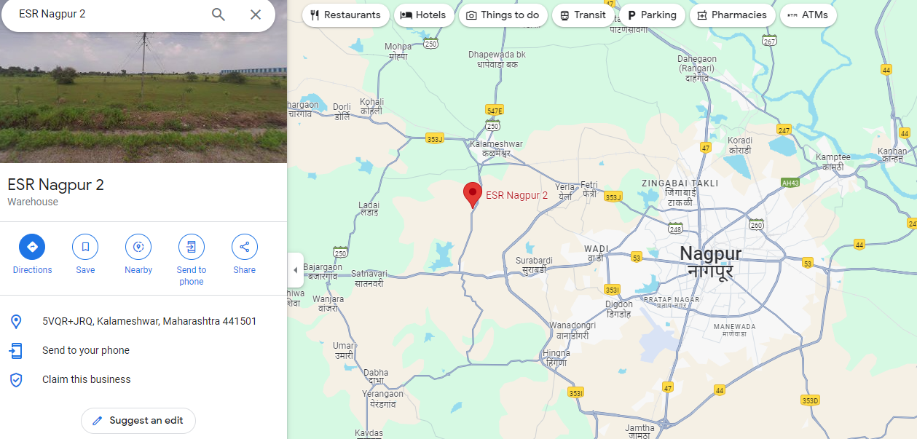
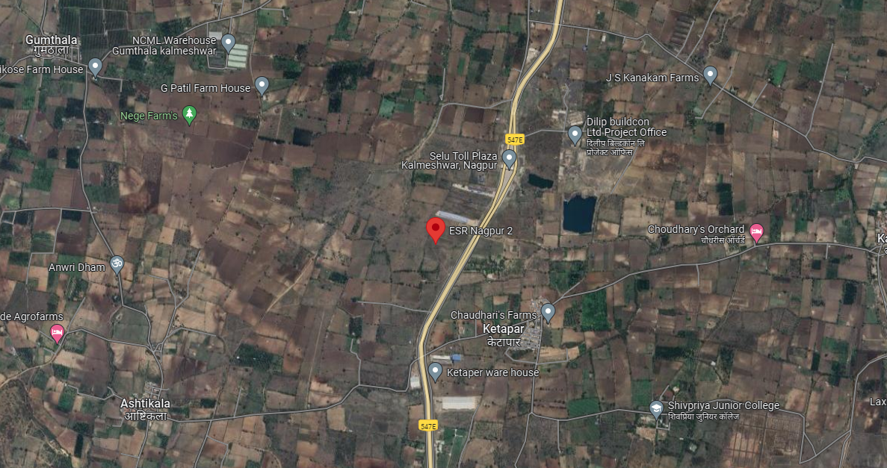

ENCLOSURE: II – PHOTOGRAPHS OF THE PROPERTY
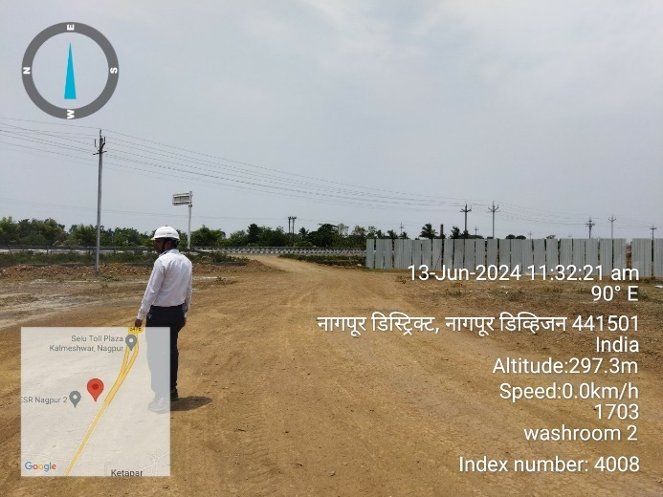 | 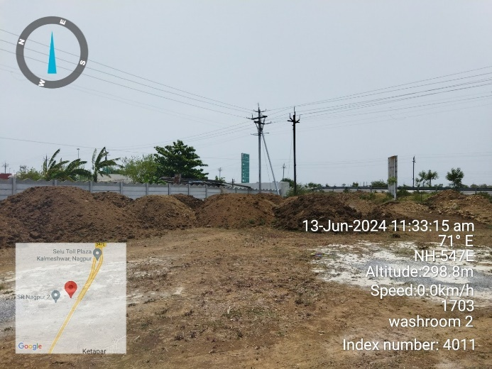
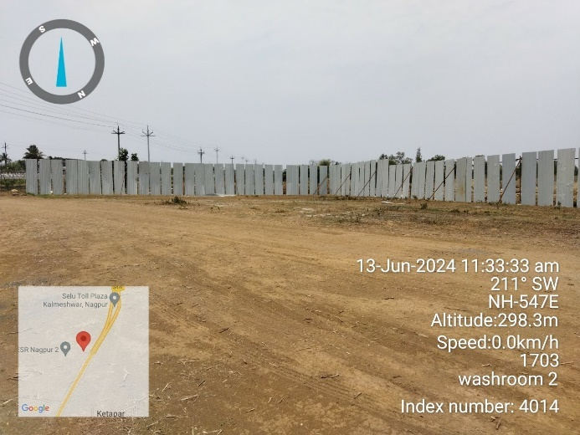 | 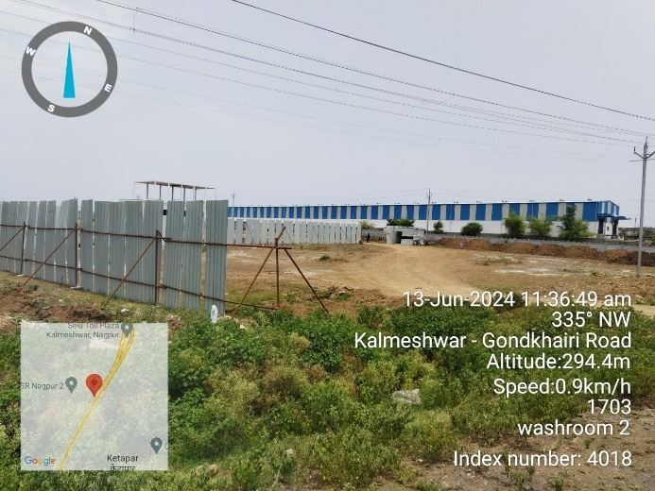
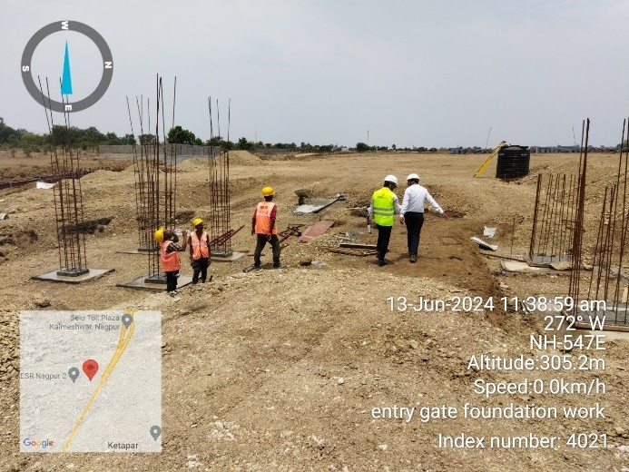 | 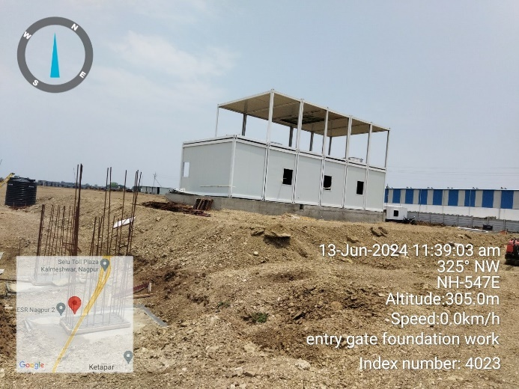

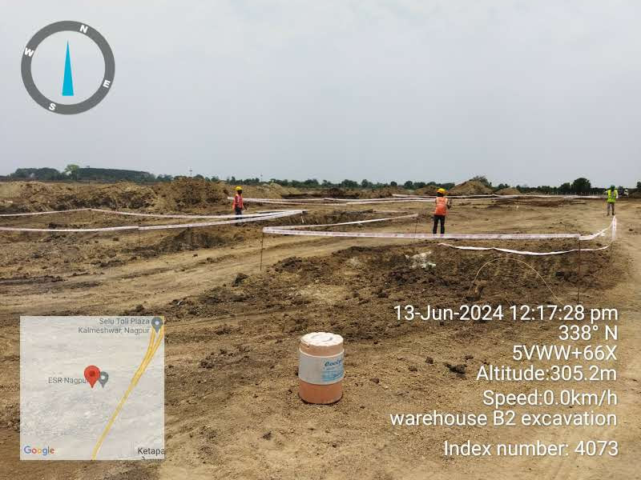 | 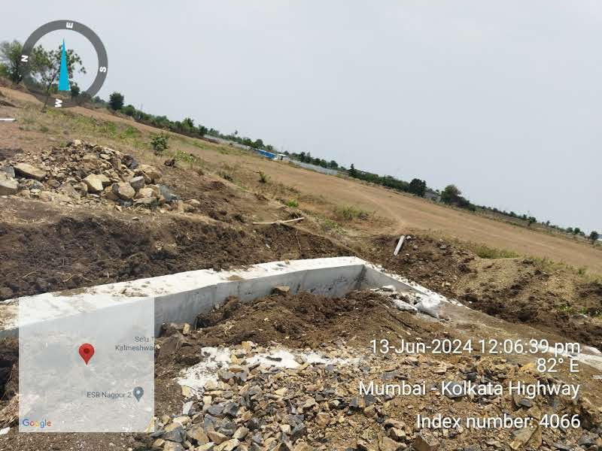
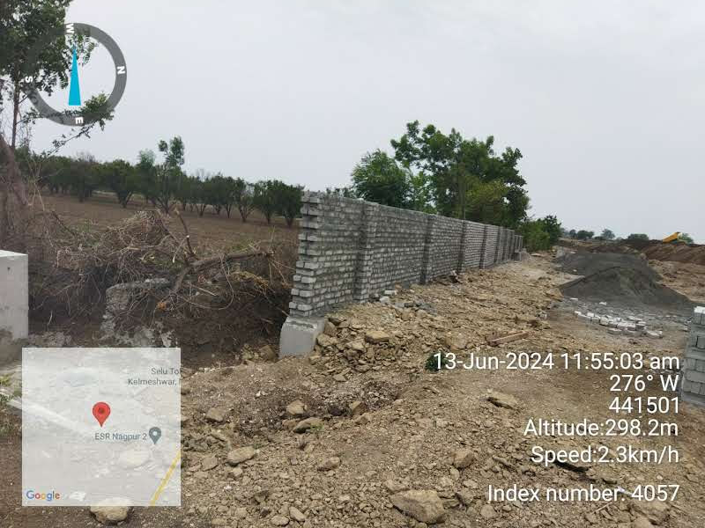 | 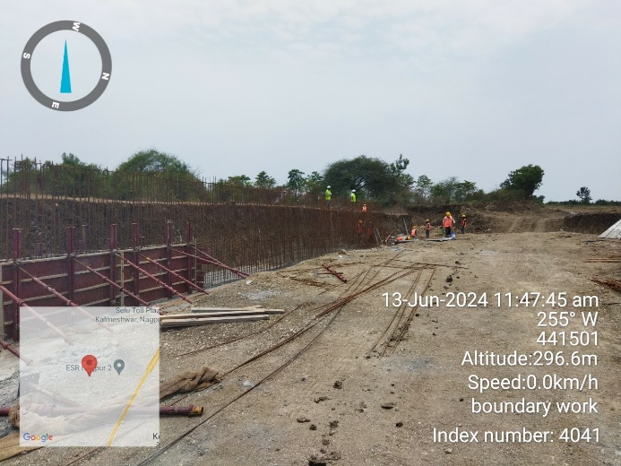
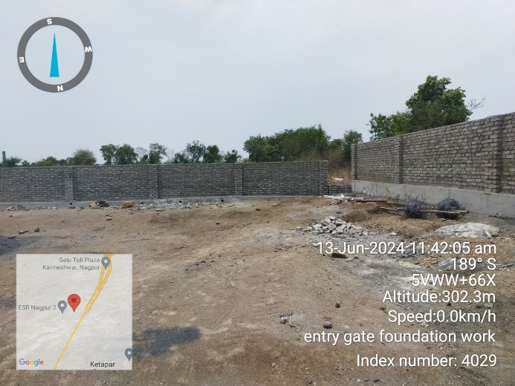 | 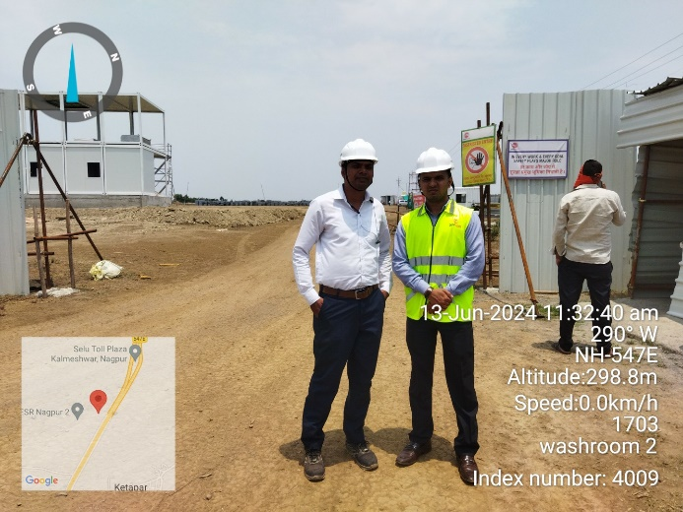

ENCLOSURE: III – COPY OF CIRCLE RATE
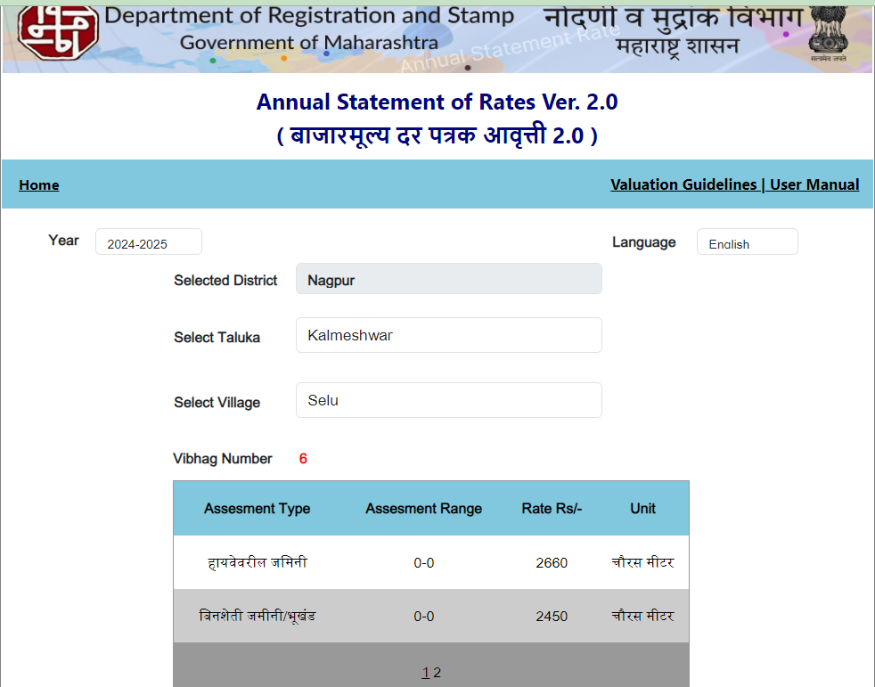

ENCLOSURE IV: IMPORTANT PROPERTY DOCUMENTS EXHIBIT
Sale Deed-1
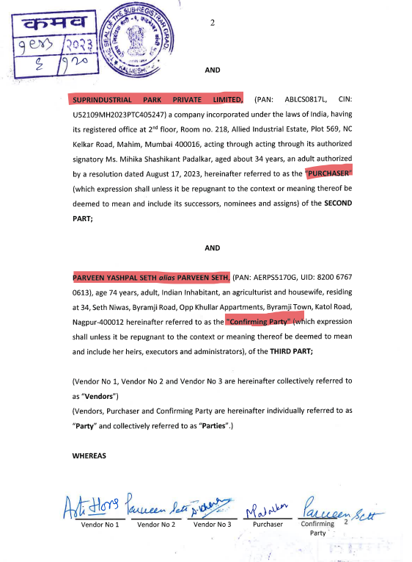

Sale Deed-2
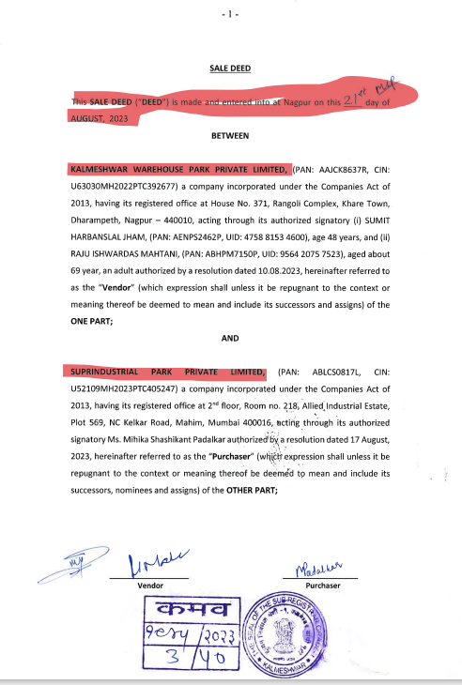

Title Search Report (TSR)
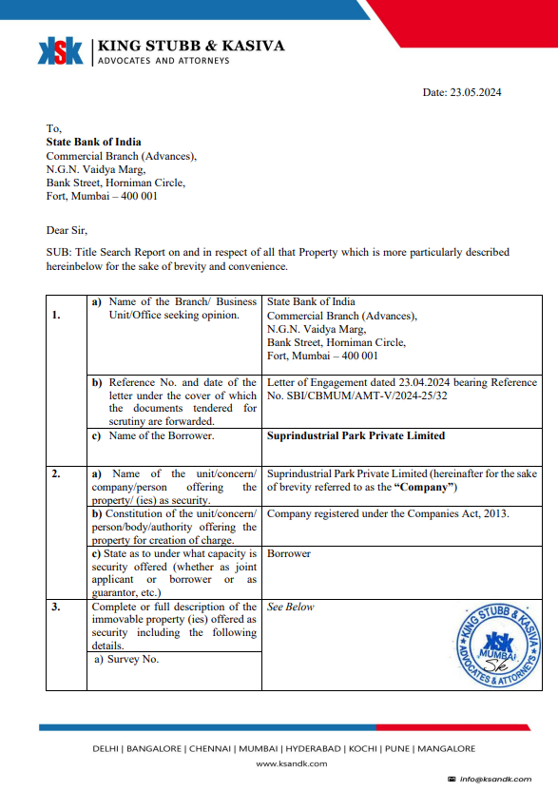

Cizra map
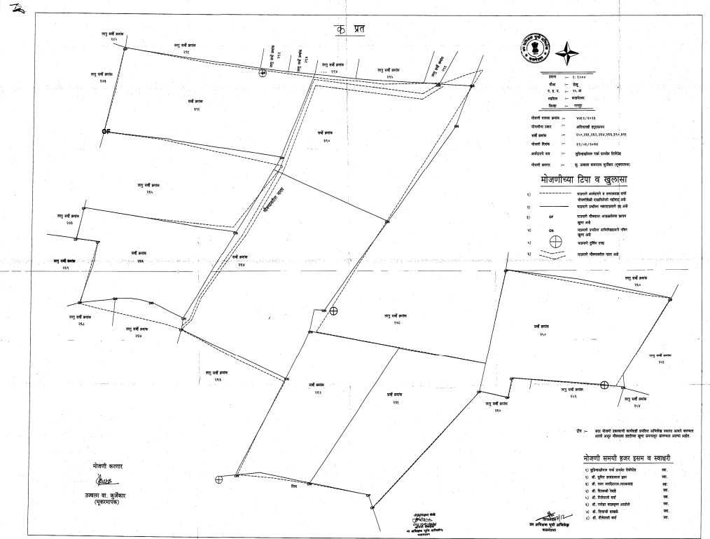

Unapproved Layout Plan
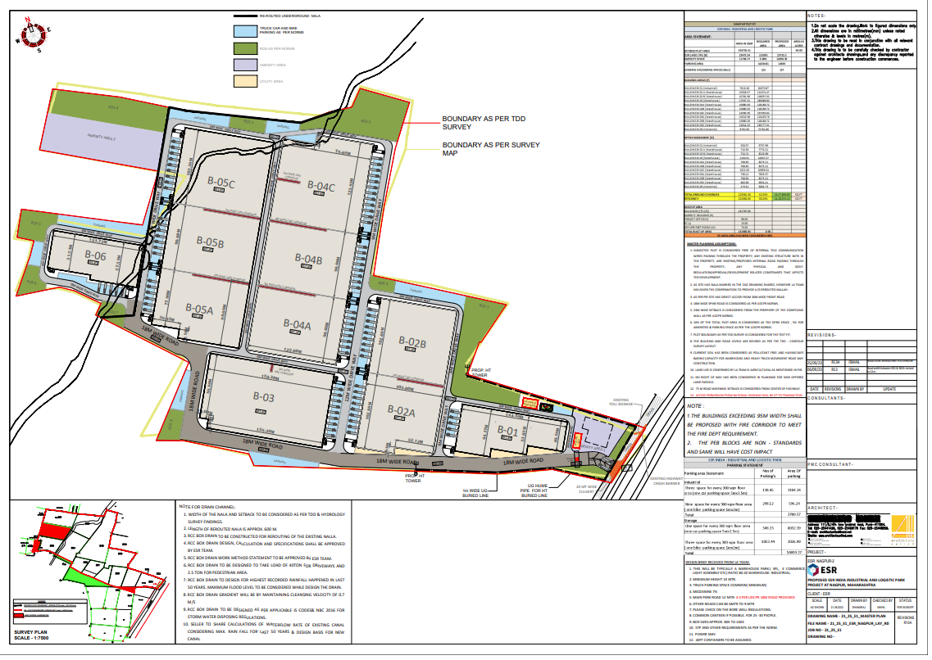
Environment Clearance Application
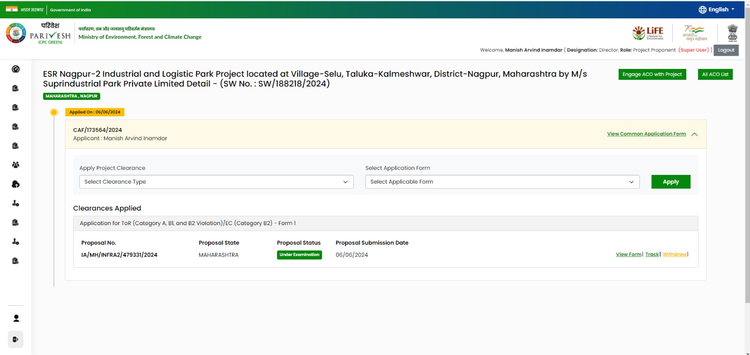

Construction LOI
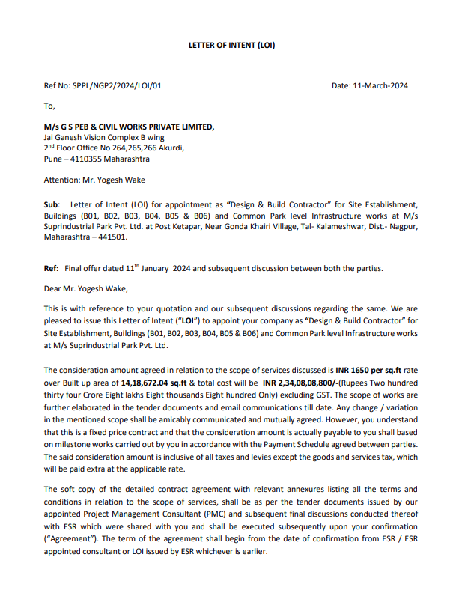

Land Records
Survey No. 250
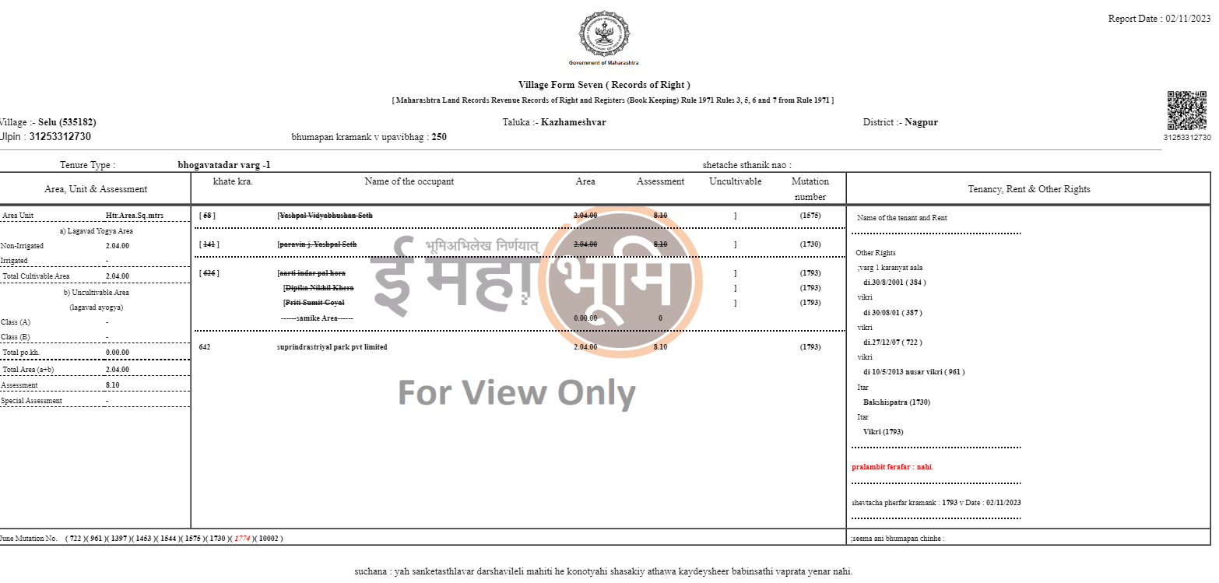
Survey No. 261
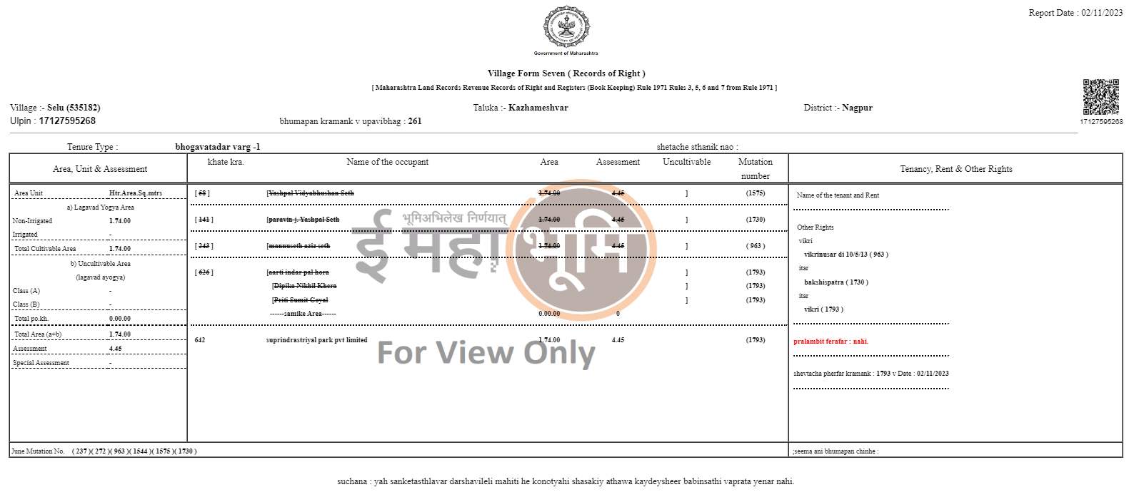
Survey No. 262
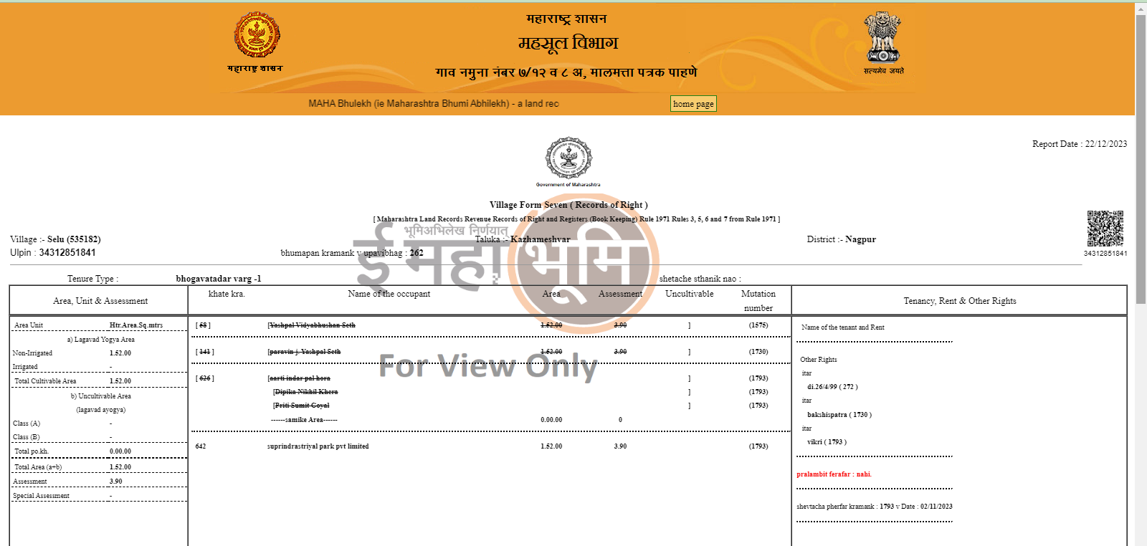
ENCLOSURE V: REFERENCES ON PRICE TREND OF THE SIMILAR RELATED PROPERTIES AVAILABLE ON PUBLIC DOMAIN

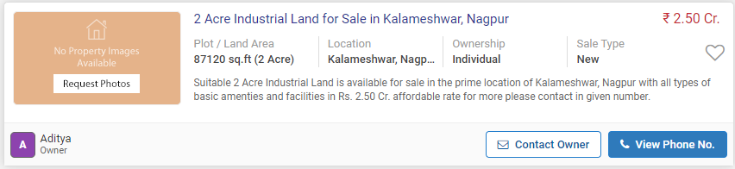

ENCLOSURE VI- DECLARATION-CUM-UNDERTAKING

Valuation is done for the asset found on as-is-where basis which owner/ owner representative/ client/ bank has shown/ identified to us on the site unless otherwise mentioned in the report of which some reference has been taken from the information/ data given in the copy of documents provided to us and informed verbally or in writing out of the standard checklist of documents sought from the client & its customer which they could provide within the reasonable expected time out of the standard checklist of documents sought from them and further based on certain assumptions and limiting conditions. The information, facts, documents, data which has become primary basis of the report has been supplied by the client which has been relied upon in good faith and is not generated by the Valuer.
The client/ owner and its management/ representatives warranted to us that the information they have supplied was complete, accurate and true and correct to the best of their knowledge. All such information provided to us either verbally, in writing or through documents has been relied upon in good faith and we have assumed that it is true & correct without any fabrication or misrepresentation. I/We shall not be held liable for any loss, damages, cost or expenses arising from fraudulent acts, misrepresentations, or willful default on part of the owner, company, its directors, employee, representative or agents.
Legal aspects for eg. Investigation of title, ownership rights, lien, charge, mortgage, lease, sanctioned maps, verification of documents provided to us such as title documents, Map, etc. from any concerned Govt. office etc. have to be taken care by legal expert/ Advocate and same is not done at our end. It is assumed that the concerned Lender/ Financial Institution has asked for the valuation of that property after satisfying the authenticity of the documents given to us for which the legal verification has been already taken and cleared by the competent Advocate before requesting for the Valuation report. I/ We assume no responsibility for the legal matters including, but not limited to, legal or title concerns.
In the course of the valuation, we were provided with both written and verbal information. We have however, evaluated the information provided to us through broad inquiry, analysis and review but have not carried out a due diligence or audit of the information provided for the purpose of this engagement. Our conclusions are based on the assumptions and other information provided to us by the client during the course of the assessment.
Getting cizra map or coordination with revenue officers for site identification is a separate activity and is not part of the Valuation services and same has not been done in this report unless otherwise stated.
Wherever any details are mentioned in the report in relation to any legal aspect of the property such as name of the owner, leases, etc. is only for illustration purpose and should not be construed as a professional opinion. Legal aspects are out of scope of this report. Details mentioned related to legal aspect are only based on the copy of the documents provided to us and whatever we can interpret as a non-legally trained person. This should be cross validated with a legal expert. We do not vouch any responsibility regarding the same.
We have made certain assumptions in relation to facts, conditions & situations affecting the subject of, or approach to this exercise that has not been verified as part of the engagement rather, treated as “a supposition taken to be true”. If any of these assumptions prove to be incorrect then our estimate on value will need to be reviewed.
This is just an opinion report based on technical & market information having general assessment & opinion on the indicative, estimated Market Value of the property for which Bank has asked to conduct the Valuation. It doesn’t contain any other recommendations of any sort including but not limited to express of any opinion on the suitability or otherwise of entering into any transaction with the borrower.
We have relied on the data from third party, external sources & information available on public domain to conclude the valuation. These sources are believed to be reliable and therefore, we assume no liability for the truth or accuracy of any data, opinions or estimates furnished by others that have been used in this analysis. Where we have relied on the data, opinions or estimates from external sources, reasonable care has been taken to ensure that such data is extracted from authentic sources, however we still can’t vouch its authenticity, correctness, or accuracy.
Analysis and conclusions adopted in the report are limited to the reported assumptions, conditions and information came to our knowledge during the course of the work and based on the Standard Operating Procedures, Best Practices, Caveats, Limitations, Conditions, Remarks, Important Notes, Valuation TOR and definition of different nature of values.
Value varies with the Purpose/ Date/ Asset Condition & situation/ Market condition, demand & supply, asset utility prevailing on a particular date/ Mode of sale. The indicative & estimated prospective Value of the asset given in this report is restricted only for the purpose and other points mentioned above prevailing on a particular date as mentioned in the report. If any of these points are different from the one mentioned aforesaid in the Report then this report should not be referred.
Our report is meant ONLY for the purpose mentioned in the report and should not be used for any other purpose. The Report should not be copied or reproduced for any purpose other than the purpose for which it is prepared for. I/we do not take any responsibility for the unauthorized use of this report.
We owe responsibility only to the authority/client that has appointed us as per the scope of work mentioned in the report. We will not be liable for any losses, claims, damages or liabilities arising out of the actions taken, omissions or advice given by any other person. In no event shall we be liable for any loss, damages, cost or expenses arising in any way from fraudulent acts, misrepresentations or willful default on part of the client or companies, their directors, employees or agents.
This report is having limited scope as per its fields & format to provide only the general basic idea of the value of the property prevailing in the market based on the site inspection and documents/ data/ information provided by the client. The suggested indicative prospective estimated value should be considered only if transaction is happened as free market transaction.
The sale of the subject property is assumed to be on an all cash basis. Financial arrangements would affect the price at which the property may sell for if placed on the market.
The actual realizable value that is likely to be fetched upon sale of the asset under consideration shall entirely depend on the demand and supply of the same in the market at the time of sale.
While our work has involved an analysis & computation of valuation, it does not include detailed estimation, design/ technical/ engineering/ financial/ structural/ environmental/ architectural/ compliance survey/ safety audit & works in accordance with generally accepted standards of audit & other such works. The report in this work in not investigative in nature. It is mere an opinion on the likely estimated valuation based on the facts & details presented to us by the client and third party market information came in front of us within the limited time of this assignment, which may vary from situation to situation.
Where a sketched plan is attached to this report, it does not purport to represent accurate architectural plans. Sketch plans and photographs are provided as general illustrations only.
Documents, information, data including title deeds provided to us during the course of this assessment by the client is reviewed only upto the extent required in relation to the scope of the work. No document has been reviewed beyond the scope of the work. These are not reviewed in terms of legal rights for which we do not have expertise. Wherever any information mentioned in this report is mentioned from the documents like owners name, etc., it is only for illustration purpose and may not necessary represent accuracy.
The report assumes that the borrower/company/business/asset complies fully with relevant laws and regulations applicable in its area of operations and usage unless otherwise stated, and that the companies/business/assets is managed in a competent and responsible manner. Further, as specifically stated to the contrary, this report has given no consideration to matters of a legal nature, including issues of legal title and compliance with relevant laws, and litigations and other contingent liabilities that are not recorded/reflected in the documents/ details/ information/ data provided to us.
This valuation report is not a qualification for accuracy of land boundaries, schedule (in physical terms), dimensions & identification. For this land/ property survey report can be sought from a qualified private or Govt. surveyor.
This Valuation report is prepared based on the facts of the property on the date of the survey. Due to possible changes in market forces, socio-economic conditions, property conditions and circumstances, this valuation report can only be regarded as relevant as at the valuation date. Hence before financing, Banker/ FI should take into consideration all such future risk and should loan conservatively to keep the advanced money safe in case of the downward trend of the property value.
Valuation of the same asset/ property can fetch different values under different circumstances & situations. For eg. Valuation of a running/ operational shop/ hotel/ factory will fetch better value and in case of closed shop/ hotel/ factory it will have considerable lower value. Similarly, an asset sold directly by an owner in the open market through free market transaction then it will fetch better value and if the same asset/ property is sold by any financer due to encumbrance on it, will fetch lower value. Hence before financing, Lender/ FI should take into consideration all such future risks while financing and take decision accordingly.

Valuation is done for the property identified to us by the owner/ owner representative. At our end we have just visually matched the land boundaries, schedule (in physical terms) & dimensions of the property with reference to the documents produced for perusal. Method by which identification of the property is carried out is also mentioned in the report clearly. Responsibility of identifying the correct property to the Valuer/ its authorized surveyor is solely of the client/ owner for which Valuation has to be carried out. It is requested from the Bank to cross check from their own records/ information if this is the same property for which Valuation has to be carried out to ensure that owner has not misled the Valuer company or misrepresented the property due to any vested interest. Where there is a doubt about the precision position of the boundaries, schedule, dimensions of site & structures, it is recommended that a Licensed Surveyor be contacted.
In India more than 70% of the geographical area is lying under rural/ remote/ non municipal/ unplanned area where the subject property is surrounded by vacant lands having no physical demarcation or having any display of property survey or municipal number / name plate on the property clearly. Even in old locations of towns, small cities & districts where property number is either not assigned or not displayed on the properties clearly and also due to the presence of multiple/ parallel departments due to which ownership/ rights/ illegal possession/ encroachment issues are rampant across India and due to these limitations at many occasions it becomes tough to identify the property with 100% surety from the available documents, information & site whereabouts and thus chances of error, misrepresentation by the borrower and margin of chances of error always persists in such cases. To avoid any such chances of error it is advised to the Bank to engage municipal/ revenue department officials to get the confirmation of the property to ensure that the property shown to Valuer/ Banker is the same as for which documents are provided.
If this Valuation Report is prepared for the Flat/ dwelling unit situated in a Group Housing Society or Integrated Township then approvals, maps of the complete group housing society/ township is out of scope of this report and this report will be made for the specific unit based on the assumption that complete Group Housing Society/ Integrated Township and the subject unit must be approved in all respect.
Due to fragmented & frequent change in building/ urban planning laws/ guidelines from time to time, different laws/ guidelines between regions/ states and no strict enforceability of Building Bye-Laws in India specially in non-metro and scale b & c cities & Industrial areas, property owners many times extend or make changes in the covered area/ layout from the approved/ applicable limits. There are also situations where properties are decades old when there was no formal Building Bye-Laws applicable the time when the construction must have been done. Due to such discrete/ unplanned development in many regions sometimes it becomes tough for the Valuer to determine the exact lawful situation on ground. Unless otherwise mentioned in the report, the covered area present on the site as per site survey will be considered in the Valuation.
Area of the large land parcels of more than 2500 sq.mtr or of uneven shape in which there can be practical difficulty in sample measurement, is taken as per property documents which has been relied upon unless otherwise stated.

Drawing Map, design & detailed estimation of the property/ building is out of scope of the Valuation services.
Valuation is a subjective field and opinion may differ from consultant to consultant. To check the right opinion, it is important to evaluate the methodology adopted and various data point/ information/ factors/ assumption considered by the consultant which became the basis for the Valuation report before reaching to any conclusion.
Although every scientific method has been employed in systematically arriving at the value, there is, therefore, no indisputable single value and the estimate of the value is normally expressed as falling within a likely range.
Value analysis of any asset cannot be regarded as an exact science and the conclusions arrived at in many cases will, of necessity, be subjective and dependent on the exercise of individual judgment. Given the same set of facts and using the same assumptions, expert opinions may differ due to the number of separate judgment decisions, which have to be made. Therefore, there can be no standard formula to establish an indisputable exchange ratio. In the event of a transaction, the actual transaction value achieved may be higher or lower than our indicative analysis of value depending upon the circumstances of the transaction. The knowledge, negotiability and motivations of the buyers and sellers, demand & supply prevailing in the market and the applicability of a discount or premium for control will also affect actual price achieved. Accordingly, our indicative analysis of value will not necessarily be the price at which any agreement proceeds. The final transaction price is something on which the parties themselves have to agree. However, our Valuation analysis can definitely help the stakeholders to take informed and wise decision about the Value of the asset and can help in facilitating the arm’s length transaction.
This Valuation is conducted based on the macro analysis of the asset/ property considering it in totality and not based on the micro, component, or item wise analysis. Analysis done is a general assessment and is not investigative in nature.
This report is prepared on the RKA V-L1 (Basic) Valuation format as per the client requirement and scope of work. This report is having limited scope as per its fields & format to provide only the general estimated & indicative basic idea of the value of the property prevailing in the market based on the information provided by the client. No detailed analysis, audit or verification has been carried out of the subject property. There may be matters, other than those noted in this report, which might be relevant in the context of the transaction and which a wider scope might uncover.
This is just an opinion report and doesn’t hold any binding on anyone. It is requested from the concerned Client/ Bank/ Financial Institution which is using this report for mortgaging the property that they should consider all the different associated relevant & related factors & risks before taking any business decision based on the content of this report.
All Pages of the report including annexures are signed and stamped from our office. In case any paper in the report is without stamp & signature then this should not be considered a valid paper issued from this office.
As per IBA Guidelines & Bank Policy, in case the valuation report submitted by the valuer is not in order, the banks / FIs shall bring the same to the notice of the valuer within 15 days of submission for rectification and resubmission. In case no such communication is received, it shall be presumed that the valuation report has been accepted.
Defect Liability Period is 15 DAYS. We request the concerned authorized reader of this report to check the contents, data, information, and calculations in the report within this period and intimate us in writing at valuers@rkassociates.org within 15 days of report delivery, if any corrections are required or in case of any other concern with the contents or opinion mentioned in the report. If no intimation is received within 15 (Fifteen) days in writing from the date of issuance of the report, then it shall be considered that the report is complete in all respect and has been accepted by the client up to their satisfaction & use and further to which R.K Associates shall not be held responsible in any manner. After this period no concern/ complaint/ proceedings in connection with the Valuation Services will be entertained due to possible change in situation and condition of the property.
Though adequate care has been taken while preparing this report as per its scope, but still we can’t rule out typing, human errors, over sightedness of any information or any other mistakes. Therefore, the concerned organization is advised to satisfy themselves that the report is complete & satisfactory in all respect. Intimation regarding any discrepancy shall be brought into our notice immediately. If no intimation is received within 15 (Fifteen) days in writing from the date of issuance of the report, to rectify these timely, then it shall be considered that the report is complete in all respect and has been accepted by the client upto their satisfaction & use and further to which R.K Associates shall not be held responsible in any manner.
Our Data retention policy is of ONE YEAR. After this period we remove all the concerned records related to the assignment from our repository. No clarification or query can be answered after this period due to unavailability of the data.
This Valuation report is governed by our (1) Internal Policies, Processes & Standard Operating Procedures, (2) R.K Associates Quality Policy, (3) Valuation & Survey Best Practices Guidelines formulated by management of R.K Associates, (4) Information input given to us by the customer and (4) Information/ Data/ Facts given to us by our field/ office technical team. Management of R.K Associates never gives acceptance to any unethical or unprofessional practice which may affect fair, correct & impartial assessment and which is against any prevailing law. In case of any indication of any negligence, default, incorrect, misleading, misrepresentation or distortion of facts in the report then we request the user of this report to immediately or at least within the defect liability period to bring all such act into notice of R.K Associates management so that corrective measures can be taken instantly.
R.K Associates never releases any report doing alterations or modifications by pen. In case any information/ figure of this report is found altered with pen then this report will automatically become null & void.
We are fully aware that based on the opinion of value expressed in this report, we may be required to give testimony or attend court / judicial proceedings with regard to the subject assets, although it is out of scope of the assignment, unless specific arrangements to do so have been made in advance, or as otherwise required by law. In such event, the party seeking our evidence in the proceedings shall bear the cost/professional fee of attending court / judicial proceedings and my / our tendering evidence before such authority shall be under the applicable laws.
The final copy of the report shall be considered valid only if it is in hard copy on the company’s original letter head with proper stamp and sign on it of the authorized official upon payment of the agreed fees. User shall not use the content of the report for the purpose it is prepared for only on draft report, scanned copy, email copy of the report and without payment of the agreed fees. In such a case the report shall be considered as unauthorized and misused.

