File No.: VIS (2023-24)-PL146-122-163 Dated: 26.08.2024

TECHNO-ECONOMIC VIABILITY
STUDY REPORT

OF

14,400 M3/DAY BIO GAS PRODUCING PLANT (6,000 KG PER DAY BIO CNG CAPACITY)

SETUP BY

M/S SRSBIOX RENEWABLE LLP.

REPORT PREPARED FOR

CORPORATE BANKING BRANCH, PNB E.K. ROAD MEERUT - 250004

**Important - In case of any query/ issue or escalation you may please contact Incident Manager Valuers@rkassociates.org. We will appreciate your feedback in order to improve our services.

NOTE: As per IBA Guidelines please provide your feedback on the report within 15 days of its submission after which report will be considered to be correct.

IMPORTANT NOTICE

COPYRIGHT FORMAT: This report is prepared on the copyright format of R. K. Associates Valuers & Techno Engineering Consultants (P) Ltd. (R. K. Associates) to serve our clients with the best possible information and analysis to facilitate them to take rational business decisions. Legally no one can copy or distribute this format without prior approval from R. K. Associates. It is meant only for the advisory/ reference purpose for the organization/s as mentioned on the cover page of this report. Distribution or use of this format or report or any of its content/ information/ data by any organization or individual other than R.K Associates will be seen as an unlawful act and necessary legal action can be taken against the defaulters.
This report is intended for the sole use of the intended recipient/s and contains material that is STRICTLY CONFIDENTIAL AND PRIVATE.

DEFECT LIABILITY PERIOD: In case of any query/ issue or escalation you may please contact Incident Manager at valuers@rkassociates.org. Though adequate care has been taken while preparing this report as per its scope, but still we can’t rule out typing, human errors, over sightedness of any information or any other mistakes. Therefore, the concerned organization is advised to satisfy themselves that the report is complete & satisfactory in all respect. Intimation regarding any discrepancy shall be brought into our notice immediately. If no intimation is received within 15 (Fifteen) days in writing from the date of issuance of the report, to rectify these timely, then it will be considered that the report is complete in all respect and has been accepted by the client up to their satisfaction & use and further to which R.K Associates shall not be held responsible in any manner.

Part O: R. K. Associates Important Disclaimer and Remarks are integral part of this report and Feasibility assessment is subject to this section. Reader of the report is advised to read all the points mentioned in these sections carefully.

TABLE OF CONTENTS
SECTIONS | PARTICULARS | PAGE NO.
Part A | Report Summary | 4
Part B | INTRODUCTION
 | - About the Report | 6
 | - Executive summary | 6
 | - Purpose of the Report | 9
 | - Scope of the Report | 9
 | - Methodology/ Model Adopted | 9
 | - Data Information received from | 10
 | - Documents/ Data Referred | 10
Part C | LLP Profile
 | - LLP Overview | 11
 | - Capital Contribution in LLP | 12
 | - Partners Profile | 12
Part D | Proposed Unit’s Infrastructure Details
 | - Proposed Plant Location | 15
 | - Google Map Location | 17
 | - Layout Plan | 18
 | - Land Details | 19
 | - Site pictures | 20
 | - Building & Civil Works | 24
 | - Plant and Machinery/ Equipment details | 26
 | - Miscellaneous Assets | 29
 | - Utilities | 30
Part E | Project Technical details
 | - Capacity of Proposed Bio CNG Plant | 33
 | - Process Description | 33
 | - Basic Architecture: Flow Chart Of The Bio CNG Plant | 36
 | - Technical Specification of the Proposed CBG Facility | 36
 | - Technology Used | 42
 | - Technological Assessment | 47
 | - Effluent Treatment and Abetment | 47
 | - Testing Standards For Production | 48
 | - Manpower | 48
Part F | Product Profile
 | - Introduction | 50
 | - Product Category | 50
 | - Pricing Strategy | 52
 | - Marketing, Selling & Distribution Plan | 54
Part G | Feedstock Analysis & Supply | 56
Part H | Industry Overview & Analysis | 61
Part I | SWOT Analysis | 65
Part J | Project Cost and Means of Finance | 67
Part K | Project Schedule | 69
Part L | Statutory Approvals | Licences | NOC | 71
Part M | LLP’s Financial Feasibility | 73
Part N | Conclusion | 93
Part O | Disclaimer | Remarks | 95
 | ANNEXURES | 99

PART A | REPORT SUMMARY

S. No. | PARTICULAR | DESCRIPTION
 | Name of the LLP: | M/s SRSBIOX Renewable LLP.
 | Registered Address: | 55, Vista Villa, Ansal Town, Dabka, Meerut, Meerut, Uttar Pradesh, India, 250001
 | Project Name | 6,000 Kg per day Bio CNG generating plant.
 | Project Location: | Khasra No. 749-jha, 749-Cha-mi & Khasra No.749-Ja, Khiwai, Tehsil - Sardhana, District - Meerut, Uttar Pradesh -250334 India
 | Project Type: | Bio CNG generating plant along with solid and liquid fertilizers
 | Project Industry: | Renewable Energy
 | Product Type / Deliverables: | Bio CNG and Solid organic fertilizer
 | Report Prepared for Organization: | Punjab National Bank, Corporate Banking Brach (CBB) E.K. Road, Meerut , 250004
 | TEV Consultant Firm: | M/s. R.K Associates Valuers & Techno Engineering Consultants (P) Ltd.
 | Report type: | Techno-Economic Viability Report
 | Purpose of the Report: | To assess Technical & Economic Viability for the purpose of seeking external financial assistance to start a green field Project.
 | Scope of the Report: | To assess, evaluate & comment on Technical, Economical & Commercial Viability of the Project as per data information provided by the client, independent Industry research and data/ information available on public domain.
 | Date of Report: | 26th August, 2024
 | Documents referred for the Project: | - PROJECT INITIATION DOCUMENTS:  - Project Report  - Financial Projections of the Project  - Project proposed Schedule  - Statutory Approval Details  - Layout and Master Plan  - PROCUREMENT DOCUMENTS:  - List of Plant & Machinery along with acquisition costs for the same  - Major Existing Customer Line  - List of Expected Raw material Supplier  - Process Flow Chart  - Sanction/proposed map of the sites  - Lease/Sale deeds of the Land  - STATUTORY APPROVALS, LICENCES & NOCs  - MSME UDYAM Registration Certificate  - Pollution Control Application/Certificates  - Factory Permission Application/Certificate  - PESO Preliminary Application/Certificate
 | Means of Finance: | Equity & Debt (D/E Ratio 2.27 TPC)
 | Key Financial Indicators: | Key Indicators Value  Average DSCR 2.53  Average EBITDA Margin 42.69%  Avg. PAT Margin 23.69%  NPV & IRR INR 5.28 Cr. & 21.84%  Payback Period 4.50 years
Note: Above financial indicators are based on the financial projections of the proposed project provided by the firm and assessment and analysis of the same done by us.
PART B | INTRODUCTION

- ABOUT THE REPORT:
This is a Techno-Economic Viability Study Report of the proposed compressed biogas plant (Bio-CNG, 6,000 kg/day) at Khasra No. 749-jha, 749-Cha-mi & Khasra No. 749-Ja, Khiwai, Tehsil - Sardhana, District - Meerut, Uttar Pradesh -250334 India setup by M/s SRSBIOX Renewable LLP.

- EXECUTIVE SUMMARY:
M/s SRSBIOX Renewable LLP, established on 12th July 2023 pursuant to section 12(1) of the Limited Liability Partnership Act 2008 bearing LLP Identification No. ACB-9890, as per the certificate of incorporation shared by the client for the establishment of Waste to Energy Management based on the waste and residual organic substances from Urban, Industrial and Agricultural activities of Rural India, such as Municipal Waste, Farm Residue, Vegetable Food Waste, Cattle Dung, Sugarcane Press mud, Napier Grass etc.,
As per the data/information shared by the client, Designated Partners of the LLP are Mr. Sunil Kumar Verma and Mr. Ranpal Singh Tomar who are holding rich experience in Sugar and by-products Industry. They have conceived this Project along with other partners to reap out the growing demand of Bio-CNG in the transport sector due to the phased mandatory blending of compressed biogas (CBG) in compressed natural gas (CNG) which has been announced by the Government of India in the recent Interim budget of FY 2024-25. The subject project is part of the Govt. initiative “Swachh Bharat Abhiyan” and for providing green energy.
M/s SRSBIOX Renewable LLP has proposed to set up this Greenfield project at Khasra No. 749-jha, 749-Cha-mi & Khasra No.749-Ja, Khiwai, Tehsil - Sardhana, District - Meerut, Uttar Pradesh -250334 India for the production of 6,000 Kg Per Day of Bio-CNG (compressed biogas) along with 23 Ton/day of fermented solid organic fertilizer which will be sold as value added by-products. The Bio-CNG plant is proposed to be setup with total investment of INR 22.58 Crore excluding land which is owned by the promoters.

Proposed Biogas Plant Capacity
Sr. No. | PARTICUALR | Capacity | Unit
1 | Bio-CNG Plant Design Capacity | 14,400 | M3/Day
2 | Bio-CNG Plant Capacity after leakage | 6,000 | kg/Day
3 | Fermented solid organic fertilizer | 23,000 | Kg/day
Source: DPR/data/information provided by the LLP
For the sale of the produced CBG, the LLP has already secured a Letter of Intent (LOI) from Indian Oil Corporation limited (Oil Manufacturing Company) under SATAT initiative to promote Compressed Bio-Gas as an alternative, green transport fuel. (Ref No.: Indian Oil/SATAT/01/3613 Date: 06.12.2023). As per the data/information provided by the client, cover letter of bank guarantee is issued by State Bank of India to annexed the Bank Guarantee No. 0187624BGO000003 dated 02.01.2024 for an amount of INR 5,00,000 on behalf of Ms SRSBIOX Renewable LLP valid till 01.01.2029 and claim period up to 01.01.2030.
As per the sale deed shared by the client/LLP, M/s SRSBIOX Renewable LLP have purchased 18,771 Sq. m. of land at Khasra No. 749-jha, 749-Cha-mi & Khasra No.749-Ja, Khiwai, Tehsil - Sardhana, District - Meerut, Uttar Pradesh -250334 India. As per the sale deeds, total stamp duty paid by M/s SRS BIOX for the registration of the land in favour of LLP is INR 27,68,600. As per Balance sheet of the LLP dated 31st March 2024, value of the land is INR 2.20 Crore including registration charges. Currently, CLU is obtained for 14871 Sq. Mt. land only and CLU is applied for remaining 3900 Sq. Mt. land.
Change of land use (CLU) has been approved by Sub Divisional Magistrate, Sardhana, Meerut on 14th July 2023, for setting up the proposed Bio-CNG plant.
The project is proposed to be commissioned based on the Continuous Stirred Tank Reactor (CSTR) –Anaerobic Digester Mesophilic bio-methanation technology, which will be a semi-automatic plant i.e. 80% mechanical and 20% manual. For the purpose of establishing the CBG Plant, LLP has appointed Delhi-based technology supplier M/s Sri Nitrokc Private Limited as technical consultant as per the contract agreement dated 8th March 2024 shared with us by the client on the letterhead of the Company/LLP.
As per the scope of work mentioned in the contract agreement, M/s Sri Nitrokc Private Limited will be providing its services for Consulting, Engineering, Project Execution and Project Management as per contract for 6000 kg Bio CNG (CBG) Producing capacity biogas/Bio CNG plant.
As per the data/information provided by the client/LLP, the layout plan has been prepared by Mr. Bal Krishan (Drawing No. SRS-CBG/R1) on 03/04/2024, which is digitally signed by Basudev Basak (Ref: A/G/HO/UP/05/639 & A/G/HO/UP/06/618) on 16/04/2024. LLP needs to obtain the approved layout plan however, PESO approval has been obtained by the LLP by submitting this layout plan.
As per data/information provided to us, the LLP has obtained some Statutory Approvals/NOC’s such as NOC from village panchayat, PESO etc. from the respective authorities. (Refer the section Statutory Approval in the later part of the report). Application for Consent to Establish has been submitted to Uttar Pradesh Pollution Control Board. (Ref: Application No: 25431997 Date: 21st March 2024).
During the site visit on 27th June 2024, we observed that the proposed land is a vacant land and currently demarcation work through boundary wall is in progress at site. As per informed by client, land development work will start soon. (Kindly refer the site pictures captured during the survey attached in the later section of the report).
As per the tentative estimation provided by the client, total consumption of electric units will be 5825 kWh per day and plant will be using variable frequency drive (VFD) in motors to reduce electricity load by 25%. Thus the estimated consumption of electric units will be ~4369 units/ kWh per day.
Further, the proposed unit will require ~2 lakhs Litre/ day of water (after 4,28,000 litre initial water for dilution of first charge) to operate the unit smoothly. Currently, the LLP is in the process to apply for power load connection and ground water extraction approval. LLP has planned to achieve the C.O.D by 1st April 2025, while from July 2024 to 31st March 2025 will be the implementation /construction period of the project.
The cost of the proposed project from scratch to trial run is being estimated as INR 22.58 Crore including land and applicable GST, which is proposed to be funded through ~38.01% equity of INR 8.58 Crore and bank loan of INR 14.00 Crore. Working capital requirements will be met through a WC loan of INR 50.00 lakhs. Project cost breakup is shown in later section of the report.
At present, the LLP is in discussion with bank/financial institution to fund the project through a term loan of INR 14.00 Crore. In this regard Punjab National Bank, CBB Meerut has appointed R.K. associates to assess the Techno-Economic Viability of the proposed Bio-CNG production plant at Tehsil- Sardhana, Meerut, Uttar Pradesh -250334. The LLP plans to achieve the financial closure by August, 2024 (expected).
- PURPOSE OF THE REPORT: To assess Project’s Technical and Financial Feasibility for lender’s requirement.
- SCOPE OF THE REPORT: To only assess, evaluate & comment on Technical & Financial Feasibility of the proposed Bio-CNG generating plant being set up by M/s SRSBIOX Renewable LLP as per the information provided by the LLP.

NOTES:
- Project status is taken as per the Site inspection carried out by our survey team.
- Scrutiny about the company/LLP, background check, and credibility, credit worthiness of the LLP or its designated partners is out-of-scope of this report.
- Any verification of the documents/ information from originals/ source is out-of-scope of this report.
- This report is only an opinion in respect to Technical and Financial Feasibility of the project as per the future Projections provided by the firm and independent analysis done by us and doesn’t contains any recommendations including taking decision on the loan or any other financial exposure.
- This is not an audit activity of any kind. We have relied upon the data/ information shared by the client/LLP in good faith.
- Any review of the existing business of the promoters is out of scope of this report.
- Detailed cost estimation or detailed cost vetting is out of scope of the project.
- This is not a Detailed Project Report or a detailed design or architecture document. Land and property details mentioned in the report is only for illustration purpose as per the information provided to us by the client. The same doesn’t tantamount for taking any responsibility regarding its legality, ownership and conforming to statutory norms.
- METHODOLOGY/ MODEL ADOPTED:
- Data/ Information collection.
- Review of Data/ Information collected related to TEV study.
- Independent review & assessment of technology used and financial projections provided by the LLP.
- Projections of Revenue, P&L, Balance Sheet, Working Capital Schedule, Depreciation Schedule, Loan Schedule as per the inputs given by the LLP and assessed by us
- Calculation of key financial indicators and ratio analysis including DSCR, NPV & IRR and payback period of the project.
- Report compilation and Final conclusion.
- DATA/ INFORMATION RECEIVED FROM: All the data/Information has been received from Mr. Sunil Verma (Designated Partner) and the required details about him shown in the below table:

Particulars | Details
Designation | Designated Partner
Name of the LLP | M/s SRSBIOX Renewable LLP.
Email Address | srsbioxrenewable@gmail.com
Contact No. | +91-9149357847

- DOCUMENTS / DATA REFFERED:

- Detailed Project Report
- Promoters Profile
- Financial Projections of the proposed Bio CNG generating project.
- Production flow chart,
- Product profile along with Pricing Strategy etc.
- List of expected Raw Material Suppliers.
- Selling, Marketing & Distribution Plan
- Details of LOI & Commercial Agreement with the OMCs.
- Approved/Proposed Site Layout Plan, Sale/Lease deed of the land
- Contract agreement with technical consultant along with details of Plant & Machinery.
- Certificates of Statutory approvals/NOC’s.
- Survey Report conducted at the site.

PART C | LLP PROFILE

- COMPANY/LLP OVERVIEW:
As per certificate of incorporation shared by the client, M/s SRSBIOX Renewable LLP was incorporated on 12th July 2023 pursuant to section 12(1) of the Limited Liability Partnership Act 2008. As per the LLP deed dated 12th July 2023 shared by client, Mr. Sunil Kumar Verma, Mr. Ranpal Singh Tomar, Mrs. Rakesh Panwar, and Mrs. Santosh Kumari are the partners in this Limited Liability Partnership under the Limited Liability Partnership (LLP) Act, 2008. Below table shows the incorporation details of the LLP:
Incorporation Details of the LLP
Particular | Description
Company / LLP Name | M/s SRSBIOX Renewable LLP
Date of Incorporation | 12th July 2023
LLPIN | ACB-9890
Number of Partners | 4
Number of Designated Partners | 2
ROC | ROC Kanpur
RD (name and Region) | RD, Northern Region
Registered Address | 55, Vista Villa, Ansal Town, Dabka, Meerut, Meerut, Uttar Pradesh, India, 250001
Total Obligation of Contribution | INR 1,00,000/-
LLP Status | Active
Source: Data/ Information provided by the LLP and extracted from MCA website
Note: As per the Supplementary agreement dated 6th August 2024, Smt. Akansha Verma became a retiring partner and Smt. Rama Verma became new partner of the firm by expressing the desire of being admitted as a partner in the firm and invested INR 14,000. Thus LLP is having 5 partners in total at present (Yet to be updated on MCA).
The LLP is incorporated with the objective to carry on the business of manufacturing and dealing in Bio CNG, Bio fertilizers, insecticides, pesticides, chemical manure, agro chemicals, and mixtures including nitrogenous, phosphoric, potassium, organic and inorganic fertilizers. As per the LLP deed Mr. Sunil Kumar Verma and Mr. Ranpal Singh Tomar are appointed as Designated Partners on Incorporation of the LLP.
In this LLP, designated partners & other partners have proposed to setup 6,000 Kg per Day of Bio-CNG plant (compressed biogas) along with 23 Ton/day of fermented solid organic fertilizer as its by-product. The LLP is categorised as micro enterprise with Udyam Registration Number UDYAM-UP-56-0071772 dated 4th Jan 2024.
- CAPITAL CONTRIBUTION OF LLP:
As per the LLP deed shared by the client, the total contribution of the Partners in the LLP shall be INR 100000 (One Lakh) which was contributed by the Partners in the proportions as mentioned in the below table:
Capital Contribution as per LLP deed dated 12th July 2023
S. No. | Name of the Partners | Nature of Contribution | Capital Contribution | Profit/Loss %
 | Mr. Sunil Kumar Verma | Cash | INR 29,000 | 29%
 | Mr. Ranpal Singh Tomar | Cash | INR 29,000 | 29%
 | Mrs. Rakesh Panwar | Cash | INR 29,000 | 29%
 | Mrs. Santosh Kumari | Cash | INR 13,000 | 13%
Source: LLP agreement dated 12th July 2023 provided by the client.
The further Contribution, if any, required by the LLP shall be brought by the Partners in their existing capital contribution ratio or at any ratio as agreed and decided by the majority of the Partners.
The net profits of the LLP arrived at after providing for payment of remuneration to the working Partners or designated Partners and interest to the partners on the loan given by them shall be divided by the Partners in the ratio mentioned in the above table and the losses of the LLP including loss of Capital, if any, shall be borne and paid by the Partners in their Profit sharing ratio.
Further, as per the Supplementary agreement dated 6th August 2024, Smt. Rama Verma became new partner of the firm by investing INR 14,000. Thus LLP is having 5 partners in total at present (Yet to be updated on MCA). Details of partners’ capital a/c as on 22nd August 2024:
DETAILS OF PARTNERS CAPITAL A/C AS ON 22 Aug 2024
Partner Name | Share | Opening Bal | Addition | Withdrawal |  | Loss | Closing balance
Rakesh Panwar | 29.00 | 79,95,212.00 |  |  | - | 89,327.00 | 79,05,885.00
Sunil Kumar Verma | 29.00 | 1,10,55,486 |  |  | 11,25,000 | 89,327.00 | 98,41,159.00
Ranpal Singh Tomar | 15.00 | 26,19,937.00 |  |  | - | 46,204.00 | 25,73,733.00
Santosh Kumari Tomar | 13.00 | 29,30,613.00 |  |  | - | 40,042.60 | 28,90,570.40
Rama Verma | 14.00 |  | 15,50,000 |  |  | 43,123.00 | 15,06,877.00
Total | 100.00 | 2,46,01,248 | 15,50,000 |  | 11,25,000 | 3,08,023.6 | 2,47,18,224.4
- KEY LLP PARTNER’S PROFILE:
- Partners Profile
Name | DPIN | Age | Address | Designation | Contact Details
Mr. Sunil Kumar Verma | 10236183 | 65 | 55, Vista Villa, Ansal Town, Meerut – 250110 | Designated/  Managing Partner | +91 9149357847  skumarverma59@gmail.com
Mr. Ranpal Singh Tomar | 10236184 | 67 | D-101, European Estate Colony, Near Best Price, NH 58, Kankerkhera, Meerut – 250001 | Designated Partner | +91 94123 79624  rpstomar501@gmail.com
Mrs. Rakesh Panwar | NA | 60 | Q-47, 3rd Phase, BHEL ,Shivalik Nagar,Haridwar-249403,Uttrakhand | Working  Partner | 08077413723  dr.sunilpanwar66@gmail.com
Mrs. Santosh Kumari | NA | 57 | B-23, Natesh Puram, Kankerkhera, Meerut Cantt. – 250001 | Working  Partner | +91 9719092764  tomarsantosh737@gmail.com
Mrs. Rama Verma | NA | 64 | W/o S.K Verma A1 Sugar Mill Colony, Ramala, Baghpat, 250623 | Working Partner | N/A
- Education & Experience of key partners
Mr. Sunil Kumar Verma | - Appointed As Designated Partner on 12th July 2023.  - As per data/information shared by the client, he is appointed as authorized signatory of M/s SRSBIOX RENEWABLE LLP on 29th Sep 2023.  - Academic Profile: BSc, ANSI (S.T)  - Experience Profile: Chief chemist (sugar mill), General Manager (sugar mill), Advisor Sugar technology UP Cooperative sugar mills federation Lucknow.  - Background: He is a Sugar Industry professional with an enriched experience of over 36 years. Having a sound technical, Sale/purchase, financial and administrative experience, and liasoning capability to deal with different government and private departments.  - As informed by client, he has under taken rigorous field survey of major CBG installation sites in India & abroad. He has evolved as an expert, collaborating with best in the arena & bringing in innovations in process & technology, thereby optimizing the entire operational parameters to ensure consistent CBG Production at most economical Project Cost, including EPC & O&M.  - He has thorough technical knowhow to establish & operate new CBG Plants & cater to its O&M.
Mr. Ranpal Singh Tomar | - Appointed as Designated/Principle Partner on 12th July 2023.  - Academic Profile: M.Com, M.A. Economics, M. A. Sociology  - Experience Profile: Purchase/Sale & Store Management, Liasoning Management  - Background: He is a Sugar Industry professional with an experience of 38 years with Co-operative Sugar Mill in the department of Purchase, Sales & Store. Also have an experience of Liasoning Management.
Mrs. Rakesh Panwar | - She is a working partner of M/s SRSBIOX RENEWABLE LLP.  - Academic Profile: B.A.M.S
Mrs. Santosh Kumari | - Appointed as working partner of M/s SRSBIOX RENEWABLE LLP.  - Academic Profile: B.Sc. in Industrial Chemistry (Delhi University), B.Ed. &amp; M.Ed. (MD University), M.A (CCS University), PG Diploma in Computer Programming.  - Experience Profile: Two years of experience in Evergreen Public School, Delhi, One year of experience in Lovely Public School, Delhi, Currently working in Dayawati Modi Academy, Modipuram, Meerut (for the last 27 years)  - Background: She is having three decades of experience in the educational sector and management.
Source: Data/ Information provided by the LLP and extracted from MCA website.
Below tables shows the information of the companies/LLP with which each Designated/Principal partner is associated to give a basic background detail of the promoters as found on public domain in general/ tertiary category research.
MR. SUNIL KUMAR VERMA
S. No | Company/LLP Name | Designation | Original Date of Appointment | Date Of Appointment at Current Designation
1 | SRSBIOX RENEWABLE LLP  (LLPIN: ACB-9890) | Designated Partner | 12th July, 2023 | 12th July, 2023
Source: Information extracted from MCA website & public domain.
MR. RANPAL SINGH TOMAR
S. No | Company/LLP Name | Designation | Original Date of Appointment | Date Of Appointment at Current Designation
1 | SRSBIOX RENEWABLE LLP  (LLPIN: ACB-9890) | Designated Partner | 12th July, 2023 | 12th July, 2023
Source: Information extracted from MCA website & public domain
PART D | PROPOSED INFRASTRUCTURE DETAILS

- PROPOSED PLANT LOCATION:
The proposed Bio-CNG generating plant will be set up by M/s SRSBIOX Renewable LLP at Khasra No. 749-jha, 749-Cha-mi & Khasra No.749-Ja, Khiwai, Tehsil - Sardhana, District - Meerut, Uttar Pradesh -250334 India, which is spread over an area of 1.8771 hectare (18,771 Square meter) as per the sale deed provided to us by the LLP.
The required raw material availability is the advantage of the proposed location as proposed location is the well-known agricultural belt of western U.P. and many Sugar mill are situated near by the location as shown in the below table:
S. No. | Name of the Sugar Mill | Distance from location
 | Bajaj Hindusthan Sugar Ltd., Bus Stop, near Jataula, Jitaula, Kaithwari, Uttar Pradesh 250502 | ~9.3 km away from the plant
 | Daurala Sugar Mill (DCM Shriram Industries Ltd.), Daurala, Daurala Rural, Uttar Pradesh 250221 | ~30 km away from the plant
 | SBEC Sugar Mill Limited, 46QJ+4FM, Loyan Malakpur, Uttar Pradesh 250611 | ~33 km away from the plant
 | Garg Sugar cane Crusher, 3G39+5C4, MDR 34W, Banwaripur, Mirpur, Uttar Pradesh 250502 | ~11 km away from the plant
Source: Google Map
During the site visit on 27th June 2024, we observed that the proposed land is a vacant land and currently demarcation work through boundary wall is in progress at site. As per informed by client, land development work will start after completion of boundary wall work. The property is having the proximity to the civic amenities such as hospital is situated ~2 km away and market is situated ~1 km away from the proposed plant location.
Table: 1 is showing the details of the adjoining properties of the land for proposed CBG plant and Table: 2 is showing the Connectivity Details of the Proposed Location:
Table: 1 Adjoining Property Details
Location | Details
East | Agricultural Land
West | Agricultural Land
North | Road
South | Gaushala land of U.P. Government

Table: 2 Connectivity Details of the Proposed Location
Connectivity | Details
Road | Sardhana - Binauli Road - ~0 km away
Rail | Meerut railway station - ~30 km away
Airport | Indira Gandhi International Airport, Delhi - ~100 km away

- LOCATION MAP:
- Google Map Location:
The Bio-CNG plant is proposed to be commissioned at Khasra No. 749-jha, 749-Cha-mi & Khasra No.749-Ja, Khiwai, Tehsil - Sardhana, District - Meerut, Uttar Pradesh -250334 India with GPS coordinates 29°06'55.7" North and 77°26'53.9"East as per the Google map attached below:
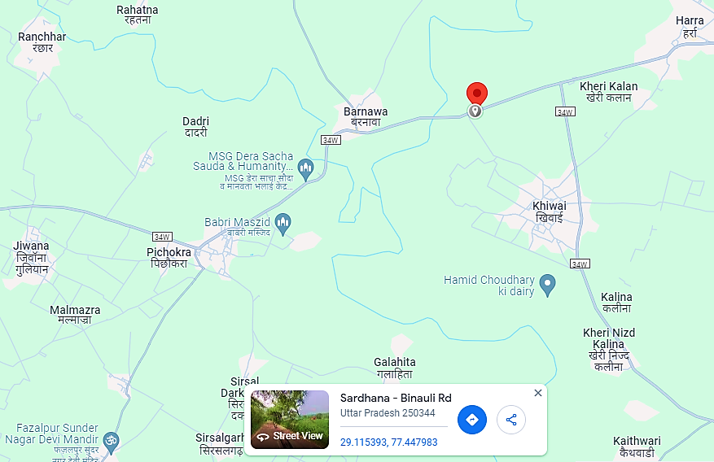
- Google Map Layout:
Demarcation of the land with approximate measurement on the Google map is attached in the below picture:
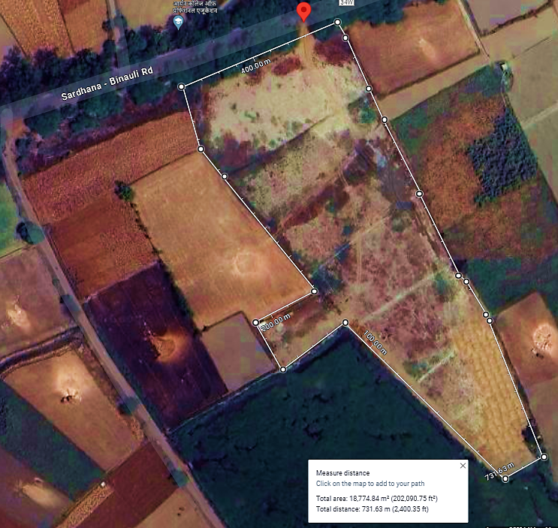
- LAYOUT PLAN:
As per the data/information provided by the client/LLP, the layout plan has been prepared by the Mr. Bal Krishan (Drawing No. SRS-CBG/R1) on 03/04/2024, which is digitally signed by Basudev Basak (Ref: A/G/HO/UP/05/639 & A/G/HO/UP/06/618) on 16/04/2024. LLP needs to obtain approved layout plan from the respective authority, however PESO approval has been obtained by the LLP by submitting this layout plan. For reference, layout plan has been attached below:
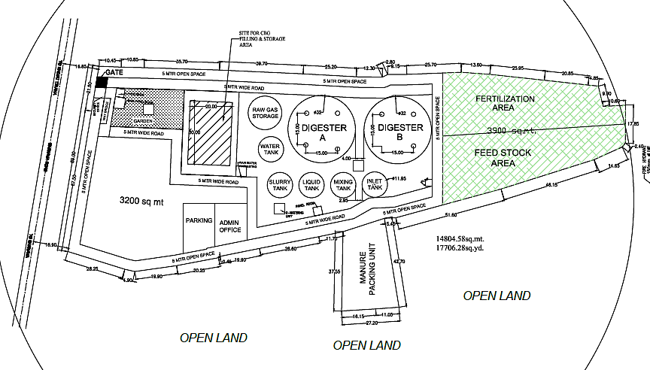
- LAND DETAILS:
The proposed Bio-CNG plant is proposed to be setup at a total of about 18,771 Sq. Mt. land area for Project implementation. As per the provisional Balance sheet dated 31st March 2024 shared by bank/cllient, details of purchased land in favour of M/s SRSBIOX Renewable LLP are as followings:
Deed wise details of land for proposed project
S. No. | Purchase Date | Purchased by | Area (Sq. Mt.) | Cost including Stamp Duty
1 | 18.09.2023 | SRSBIOX RENEWABLE LLP. | - | INR 80,32,294.40
2 | 18.09.2023 | SRSBIOX RENEWABLE LLP. | - | INR 29,61,234.40
3 | 18.10.2023 | SRSBIOX RENEWABLE LLP. | - | INR 25,84,010.00
4 | 13.10.2023 | SRSBIOX RENEWABLE LLP. | - | INR 6,39,060.00
5 | 16.10.2023 | SRSBIOX RENEWABLE LLP. | - | INR 25,84,010.00
6 | 13.10.2023 | SRSBIOX RENEWABLE LLP. | - | INR 25,84,010.00
7 | 16.10.2023 | SRSBIOX RENEWABLE LLP. | - | INR 25,84,010.00
 | Total |  | 18,771 | INR 2,19,68,628.80

As per Balance sheet of the LLP dated 31st March 2024, value of the land is INR 2.20 Crore including registration charges of ~ 27 lakhs as informed by client, which is considered as a part of total project cost. During the site visit on 27th June 2024, we observed that the proposed land is a vacant land and currently demarcation work through boundary wall is in progress at site.
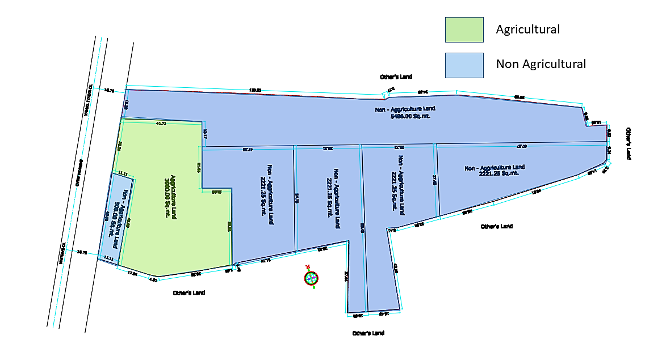
As informed by client, land development work will be initiated after completion of boundary wall work. Out of total 18771 Sq. Mt. of land, Change of land use (CLU) is has been obtained by LLP for 14871 Sq. Mt. of land, which has been approved by Sub Divisional Magistrate, Sardhana, Meerut on 14th July 2023, for setting up the proposed Bio-CNG plant. CLU is applied for remaining 3900 Sq. Mt. of land parcel as informed by designated partners of LLP. For reference, demarcation between Agricultural and Non-Agricultural land is shown in the above picture.
- SITE PICTURES: Site pictures were captured during the site survey on 27th June 2024, for reference few of the pictures are attached below:
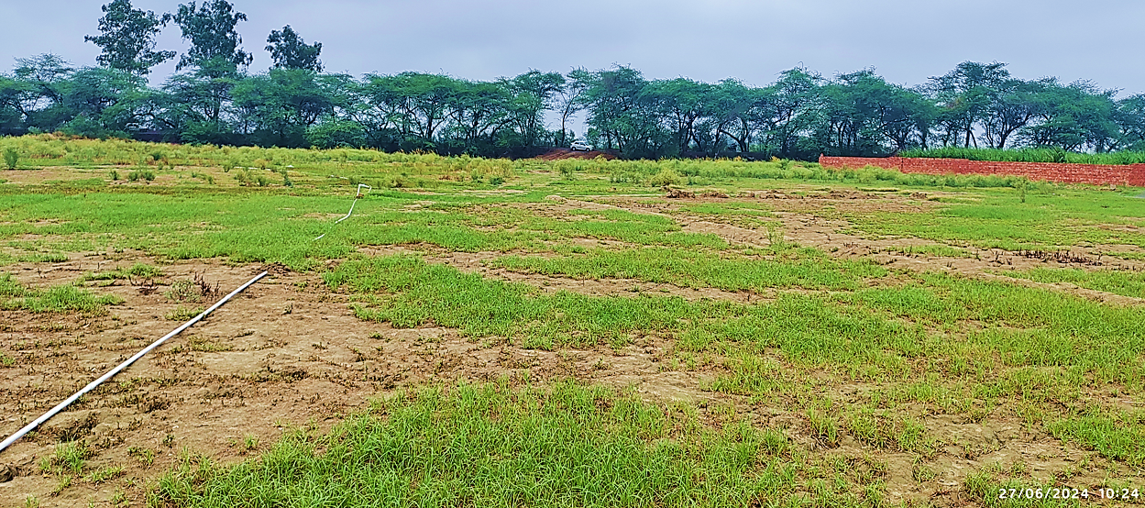
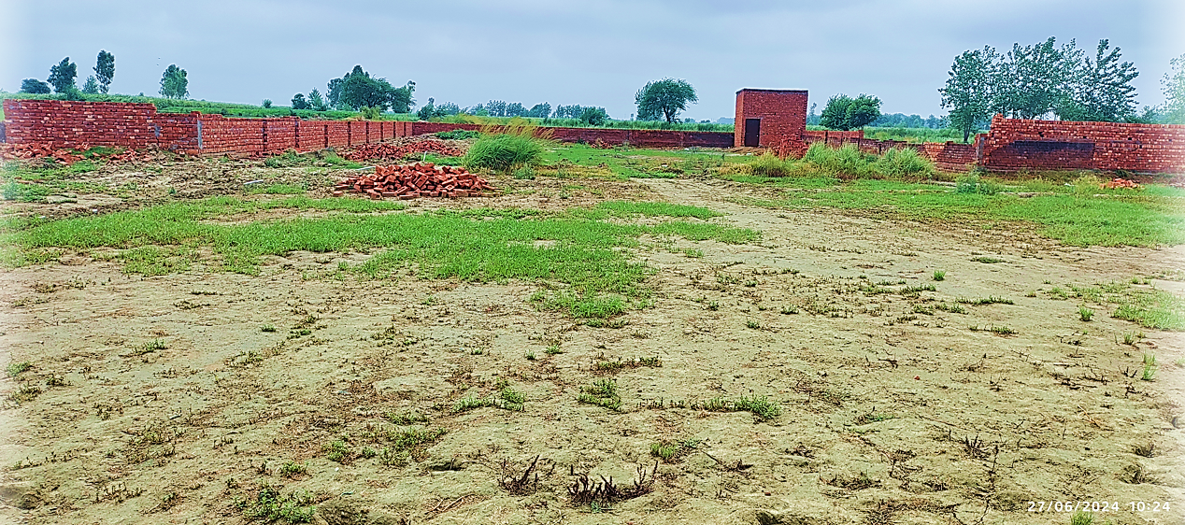
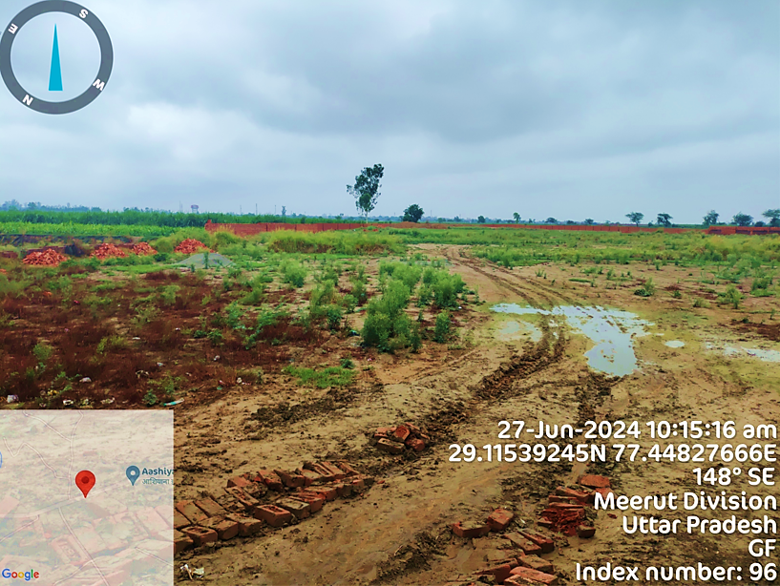
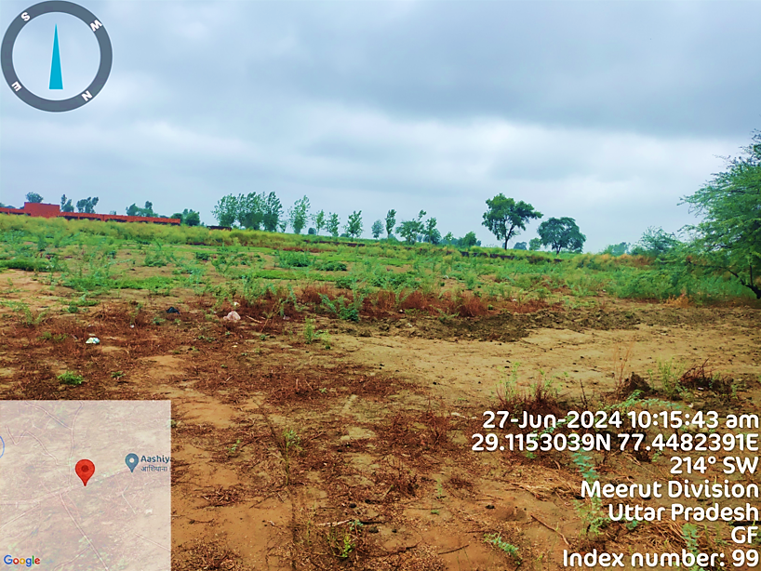
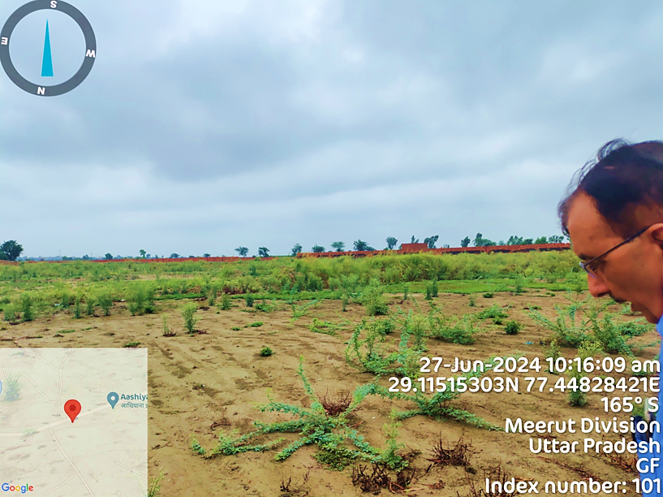
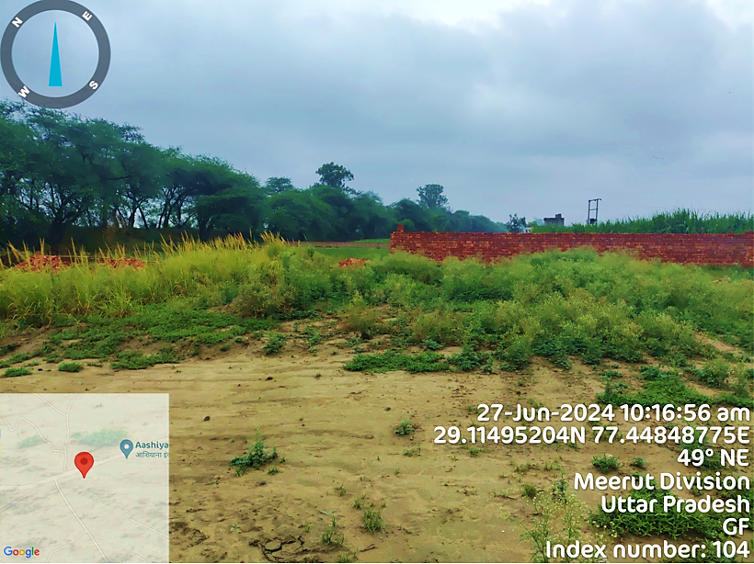
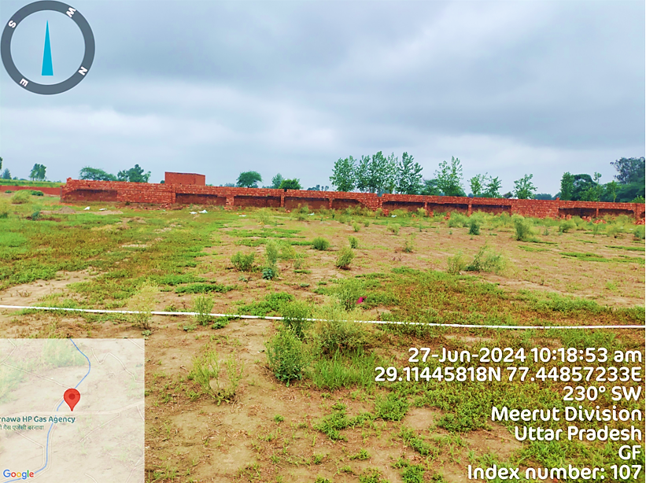
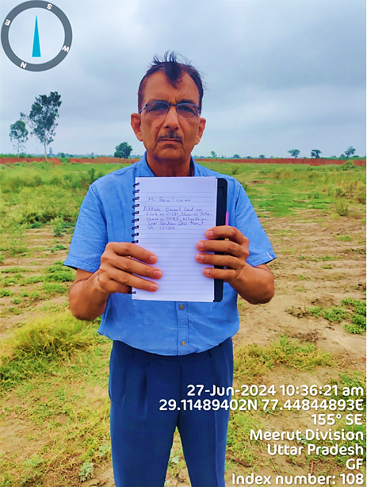
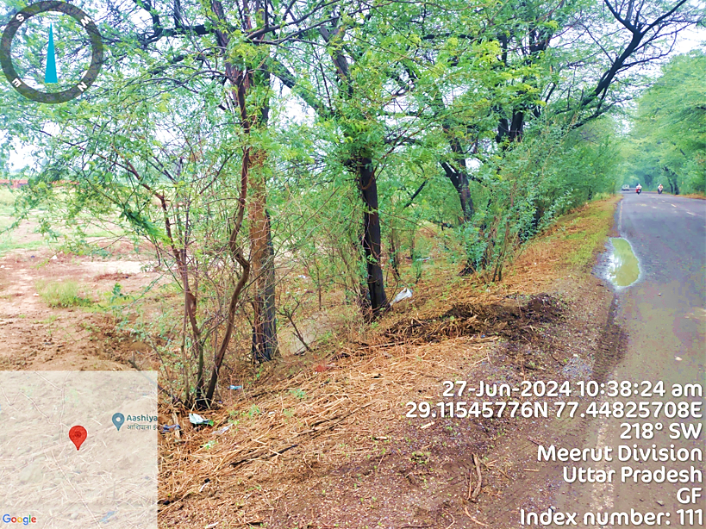
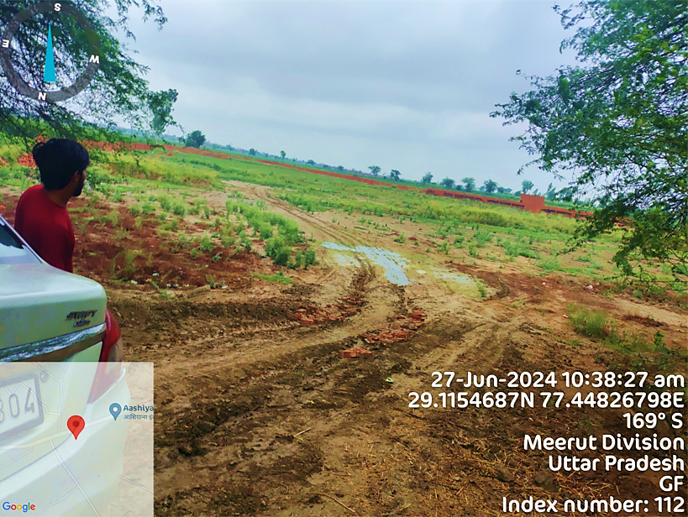
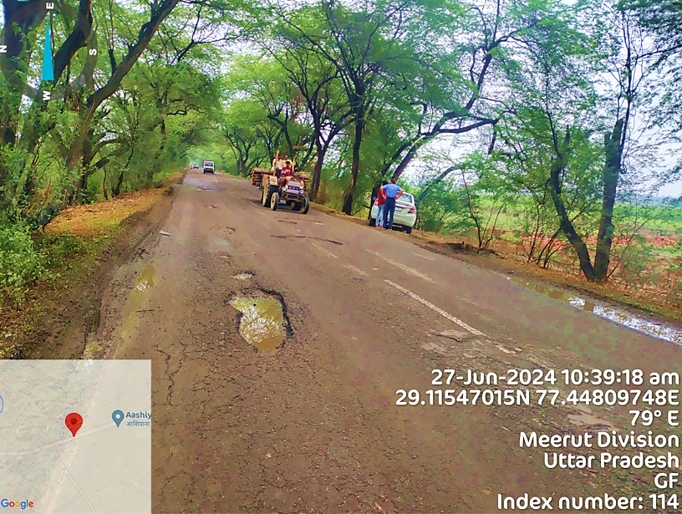
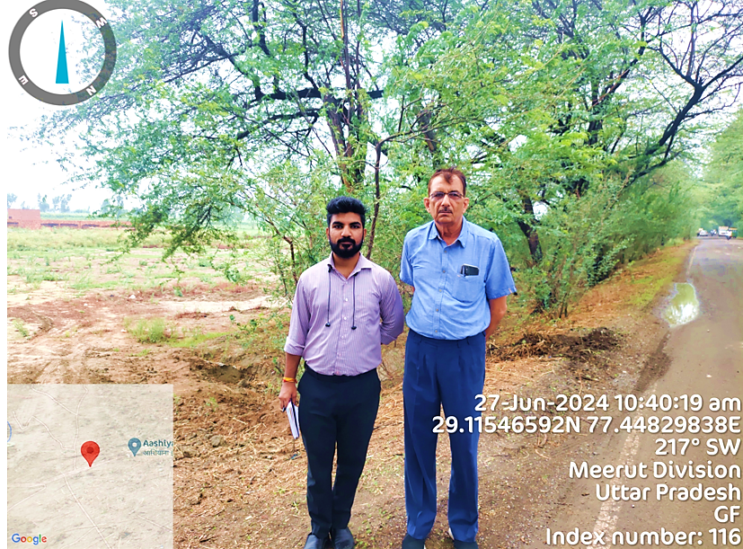
- BUILDING & CIVIL WORKS:
As per the data/information provided by the client, SRSBIOX LLP is having experienced In-house technical team which will assist for setting up the proposed Bio-CBG plant in the coordination with appointed technical consultant. Detailed bifurcation of the proposed Building & Civil works has been shown in the below table along with the estimated cost provided by the client:
Details of Building & Civil Works
S. No. | Description | Length | Width | Height | Total Area Sq. Ft. | Rate Per Sq. Ft. | Amount
1 | Land development & Boundary wall | 2466.25 |  | 8 | 19730 | 880.26 | 1,73,67,600
2 | Security Rooms | 18.15 | 15 | 12 | 272.25 | 180 | 49005
3 | Internal Road & Entry/Exit Gate | 1831.46 | 15 | Na | 27472 | 210 | 5769120
4 | Office Area & Admin Block | 49.5 | 67.65 | 12 | 3,348.68 | 240 | 803682
5 | Staff Room & Washrooms | 20 | 20 | 12 | 400 | 200 | 80000
6 | Labour Room & Washroom | 12 | 10 | 12 | 120 | 180 | 21600
7 | Laboratory | 24 | 10 | 12 | 240 | 240 | 57600
8 | Control Panel Room | 13.2 | 13.2 | 12 | 174.24 | 240 | 41817.6
9 | Foundation Of Weight Bridge | 39.6 | 9.24 | 4 | 365.904 | 220 | 80498.88
10 | Foundation Of Purification & Booster & Other Machinery | 99 | 66 | 24 | 6534 | 355 | 2319570
11 | D.G Room | 13.2 | 13.2 | 24 | 174.24 | 220 | 38332.8
12 | Main Panel Room | 18.48 | 16.5 | 24 | 304.92 | 220 | 67082.4
13 | Manure Packaging Area | 14 | 10.06 | 24 | 140.88 | 315 | 44376.255
14 | Fertilization Area | 284.145 | 70.18 | 24 | 19,941.34 | 315 | 6281522.1
15 | Feed Stoke Area | 294.69 | 71 | 24 | 20,924.76 | 315 | 6591299.4
16 | Parking | 67.65 | 49.5 | 15 | 3,348.68 | 130 | 435327.75
Total Cost |  |  |  |  |  |  | 4,00,48,434
Grand total |  |  |  |  |  |  | 4.00 Cr.
Sources: Data/Information provided by the client.
As per the above table, the estimated cost of building & civil works including Land development & Boundary wall would be ~INR 4.00 Crore including applicable GST, which has been considered as part of Total project cost.
However, as a TEV consultant, the estimated Building & Civil works cost has been verified independently by us as shown in the below table:
Assessment of Building & Civil works
Description | Average rate  Per Sq. Ft. | Total Area  Sq. Ft. | Amount | Observation | Assumptions
Less Than Market Standard Rates | Assuming RCC Construction | 19730 | 98,65,000 | In Line | -
Security Rooms | 1200 | 272.25 | 326700 | Less Than Market Standard Rates | Assuming RCC Construction
Internal Road & Entry/Exit Gate | 210 | 27472 | 5769120 | In Line | -
Office Area & Admin Block | 1400 | 3,348.68 | 4688145 | Less Than Market Standard Rates | Assuming RCC Construction
Staff Room & Washrooms | 1400 | 400 | 560000 | Less Than Market Standard Rates | Assuming RCC Construction
Labour Room & Washroom | 1100 | 120 | 132000 | Less Than Market Standard Rates | Assuming RCC Construction
Laboratory | 1500 | 240 | 360000 | Less Than Market Standard Rates | Assuming RCC Construction
Control Panel Room | 1400 | 174.24 | 243936 | Less Than Market Standard Rates | Assuming RCC Construction
Foundation Of Weight Bridge | 220 | 365.904 | 80498.88 | In Line | -
Foundation Of Purification & Booster & Other Machinery | 500 | 6534 | 3267000 | Cannot verify as the quantity and specification is not mentioned
D.G Room | 1500 | 174.24 | 261360 | Less Than Market Standard Rates | Assuming RCC Construction
Main Panel Room | 1500 | 304.92 | 457380
Manure Packaging Area | 800 | 140.88 | 112701.6 | Less Than Market Standard Rates | Assuming Shed Construction
Fertilization Area | 800 | 19,941.34 | 15953072
Feed Stoke Area | 800 | 20,924.76 | 16739808
Parking | 130 | 3,348.68 | 435327.7 | In Line
Total | INR 5,92,52,049.18

Note:
- The Cost verification of Civil Structure of Compressed Bio-gas plant is done based on the quantity provided by the client.
- The rates are adopted as per Market Standard Rates.
- Cost verification of some structure is not done due to unavailability of quantity of same.
- As per our assessment, the cost of the following civil work will be in range of ~INR 5.00-5.50 Crore depending upon the specification of the material and construction.
- We recommend the bank to get the verified cost of building & civil works from an appointed Architect/Chartered Engineer.
- PLANT & MACHINERY/ EQUIPMENTS DETAILS:
As per the data/information provided by the client, LLP has appointed a New Delhi based technology supplier M/s Sri Nitrokc Private Ltd. as the technical consultant for Consulting, Engineering, Project Execution and Project Management of proposed Bio-CBG plant by executing an agreement dated 8th March 2024 on the letterhead of the LLP. Detailed bifurcation of the proposed Plant & Machinery along with vendor name has been shown in the below table along with the estimated cost as provided by the client:
S. No | Equipment Name | Technical Specification | Vendor Name | Qty. | Amount
1 | TECHNICAL CONSULTANCY | 6TPD CBG PROJECT | SRI NITROKC PVT LTD | 1 NOS | 50,00,000
2 | DIGESTER & MIXING KIT | 7200M³(Ø32M×9.5M | SRI NITROKC PVT LTD | 2 NOS | 3,06,80,000
3 | PURIFICATION UNIT | 650M³/Hr | SRI NITROKC PVT LTD | 2 NOS | 2,40,00,000
4 | HOT WATER TANK | 12KL | SRI NITROKC PVT LTD | 1 NOS | 18,88,000
5 | HEATING COIL IN DIGESTER |  | SRI NITROKC PVT LTD | 2 NOS | 28,32,000
6 | HEAT EXCHANGER SHELL & TUBE |  | SRI NITROKC PVT LTD | 2 NOS | 13,00,000
7 | COOLING TOWER | 2.5-TON | NOT YET DECIDED | 2NOS | 1,60,000
8 | BIO GAS BALLON | 3536M³, DOUBLE MEMBRANE, RCC MOUNTED, 32.00M DIA, 8.10 Ht | NOT YET DECIDED | 1 NOS | 1,22,72,000
9 | BOOSTER COMPRESSOR | 600NM³/Hr@ 0.5 BARG DISCHARGE 250 BAR | JOYTECH ,KIRLOSKER, BAUR, BUCKARD | 1 NOS | 1,40,00,000
10 | CNG CYLINDERS CASCADE | 4500WL. THREE BANK, 75WLx60 NOS OF CNG/CBG CYLINDERS | NOT YET DECIDED | 6 NOS | 2,47,80,000
11 | CASCADE FOR STORAGE | 4500-WL | NOT YET DECIDED | 1NOS | 25,00,000
12 | SUBMERSIBLE HIGH FLOW PUMP WITH ACCESSORIES & INSTALLATION | 11KW | RISHANSHI/ SYNO | 2NOS | 6,00,000
13 | SUBMERSIBLE AGITATOR WITH ACCESSORIES & INSTALLATION | 11KW | NOT YET DECIDED | 2NOS | 16,52,000
14 | AXIAL HIGH FLOW PUMP WITH ACCESSORIES, INSTALLATION | 7.5KW | NOT YET DECIDED | 8NOS | 37,76,000
15 | RAW GAS GENERATOR (SLIENT) | 125KVA | ASHOK LEYLAND, KIRLOSKER , MAHINDRA | 1NOS | 15,00,000
16 | MANIFOLD SYSTEM FOR CASCADES: LCV POST WITH UNLOADING HOSE, MASS FLOW METER & OUTLET CONNECTIVITY FOR THREE BANK SYSTEM FOR BOOSTER MAKE: | 250 BAR | NOT YET DECIDED | 3NOS | 10,62,000
17 | "FILLING STATION WITH 3 GAS FILLING WITH ONLINE CH4 ANALYZER AND FLOW METER | 250 BAR | NOT YET DECIDED | 2NOS | 20,00,000
18 | "STATION TUBING- WITH MANPOWER, HYDROTESTING  & N2 PURGING & FITTINGS AND VALVES @ 7000/ MTRS " | 15 BAR | NOT YET DECIDED | 100NOS | 2,36,000
19 | PIPING, FITTINGS, CHAIN & CONVEYOR (L/S) SS PIPE / FABRICATOR WELDING |  | NOT YET DECIDED | 1NOS | 17,70,000
20 | AUTOMATION AND CONTROL SYSTEM INCLUDING (SCADA), TRANSFORMER 650  KVA, ELECTRICAL PANEL & CABLES |  | AOS HOUSE OF POWER AUTOMATION & ENGINEERING | 1NOS | 96,00,000
21 | WEIGHBRIDGE | 100-TON | MATIN & COMPANY | 1NOS | 9,44,000
22 | SOLAR SYSTEM 5KW & LIGHTING | 5KW | NOT YET DECIDED | 1NOS | 5,00,000
23 | FIRE FIGHTING SYSTEM | AS PER LAYOUT DRW | SRI NITROKC PVT LTD | 1NOS | 5,00,000
24 | MECHANICAL, ELECTRICAL & OTHER INSTALLATION |  | SRI NITROKC PVT LTD | 1NOS | 15,00,000
25 | TRACTOR & LOADER |  | MAHINDRA, FARMTRAC, KUBUTA, NEW-HOLAND | 1NOS | 17,11,000
26 | TANKER & SLURRY |  | NOT YET DECIDED | 2NOS | 5,00,000
27 | SERVICES CHARGES OF LIASIONING WORK |  | NONE | 1NOS | 15,00,000
28 | MISCELLANEOUS EXPENSES |  |  | 1NOS | 10,00,000
Total |  |  |  |  | 14.88 Cr.
Source: Data/information provided by the client.
The estimated cost for plant & machinery will be ~INR 14.88 Crore including the applicable GST. The estimated cost of the Plant & Machinery has been provided to us by the client as per quotations received by them from various vendors/suppliers. However, as a TEV consultant the cost of major plant & machinery has been verified by us independently, which we found comparatively lower than the industrial/sectoral benchmark although the cost may change as per specifications & brand.
The reference is taken from the report published by Ministry of New and Renewable Energy. As per MNRE, the cost of installing a 5 TPD CBG plant is around INR 20 to 25 crores including GST and 75 to 80% cost will be for purchasing Plant & Machinery. So, the cost of Plant & Machinery will be around INR 15 to 20 crores.
The subject plant is 6 TPD CBG plant, the cost of installation should be around INR 22 to 28 crores and the cost of Plant & Machinery should be around INR 16 to 21 crores. The cost of Plant & Machinery varies depending on the technology used in the plant. As per the quotation provided by the client, the cost of Plant & Machinery is INR 14.88 crores including GST and EPC consultant charges which seems reasonable as per the reference.
As per discussion with client, the cost in appears less because there is no EPC consultant hired for this project which effected the cost of machinery procurement as the procurement will be done by the promotors themselves. Installation will be manged by the owner’s in-house experienced team in coordination with appointed technical consultant M/s Sri Nitrokc Private Ltd.
- MISCELLANEOUS ASSETS: Apart from the major plant machinery and equipment, few miscellaneous assets are also proposed by the LLP to run the unit smoothly. Detailed bifurcation of the proposed miscellaneous assets has been shown in the below table along with the estimated cost:
Proposed Miscellaneous Assets
S. No. | Capital Cost Head | Amount (INR)
1 | Furniture & Fixtures | 5,00,000
2 | Office Equipment | 10,00,000
 | Total For Misc. Assets | 15,00,000
Source: Data/information provided by the client.
Note: As informed by client, the above cost are tentative in nature there may be some variation as per actual cost incurred.
- UTILITIES: Details of Water, Electricity and other utilities are describes as below:
- WATER: As per the data/information provided by the client, LLP needs to obtain a "No Objection Certificate" for groundwater extraction to extract 200 m³ water per day. The total requirement of the plant will be ~2 lakh Litre per day. As per the data/information provided by the client, ~4.28 lakh litre water will be required to initiate the plant for dilution of first charge. Out of which ~2.28 lakh litre water can be recycled and use for the plant as shown in the below table.
Expected Water Consumption
Particular | Quantity
Initial water for dilution of first charge | 4,28,000 L
Daily Recycled Water | 2,28,000 L
Total water requirement | 2,00,000 L/day
Source: Data/information provided by the client.
- ELECTRICITY: As per the data/information provided to us by the client, LLP is in the process to apply for sanction of 500 KVA power load. Estimated power consumption is described in the bellow table:
Estimated Electric Load
S. No. | Description | Connection  Load Kw | Qty. In Nos. | Actual Load Kw | Running Hours | Total No Of Units
1 | Submersible Pump | 11 | 1 | 11 | 5 | 55
2 | High Flow Pump | 8 | 4 | 32 | 5 | 160
3 | Submersible Mixer | 7.5 | 4 | 30 | 6 | 180
4 | Purification Units | 110 | 2 | 220 | 12 | 2640
5 | Booster Compressor | 110 | 2 | 220 | 12 | 2640
6 | Office & Street Light | 10 | 1 | 10 | 15 | 150
Estimated Number Of Units Consumption (Per Day) |  |  |  |  |  | 5825
Source: Data/information provided by the client.
As per the tentative estimation provided by the client, total consumption of electric units will be 5825 kWh per day and proposed CBG plant will be using variable frequency drive (VFD) in motors to reduce electricity load by 25%. Thus the estimated consumption of electric units will be ~4369 units/ kWh per day. This is a provisional number. The final number will be determined during detailed engineering

Thus, ~INR 3.76 Crore per ton will be the CAPEX for the proposed Bio-CNG generating plant including land, GST, transportation charges etc. considering the fact that the plant would be commissioned by the in-house experienced EPC/technical team of the LLP in coordination with the appointed technical consultant. This cost may variate as various vendors/supplier are yet to be finalized. We recommend the bank in this regard to obtain the final invoice and to be held on record before disbursement of term loan. CAPEX per ton is lower as per the industrial/sectoral benchmark as per the tertiary research done by us, data/information available in the public domain and information provided by the third party consultants/vendors. (Ref: https://pib.gov.in/PressReleasePage.aspx?PRID=1868887). Some of the other references are shown in the below table:
Reference for Bio Gas Plant
S. No. | Name of the Party | Contact details | Remarks
 | M/s Jog Waste to Energy Pvt Ltd | info@jogwte.com  +91 9723269295  www.jogwte.com | - As per JOGWTE, the average installation cost as per EPC basis from scratch to successful trial run would be ranging INR 5.5-6.5 Crore per ton including preliminary and pre-operative expenses and other contingent costs.
 | The Global Green Growth Institute, GGGI India | nishant.bhardwaj@gggi.org | - As per information provided by GGGI, The capital expenditure (CAPEX) for a typical 8-10 TPD Bio-CNG plant varies from INR 32-50 Crore which varies based on the type of biomass feedstock and technology deployed.  - It has been estimated that the plant and machinery costs contributes ~76% of CAPEX. (Excluding preliminary and pre-operative expenses and excluding all other costs such as engineering, consultancy, installation costs etc. i.e. EPC Costs).
 | Ministry of New & Renewable energy | MNRE | - The economics of a CBG plant can vary depending on various factors such as the scale of the plant, technology used, feedstock cost, government incentives and market demand for CBG.  - ~INR 20-25 crore is the cost of installing a 5 TPD capacity CBG plant, while ~75-80% of the CAPEX cost is for purchasing plant machinery.
 | Others vendors | On the public domain | - CSTR technology which is flexible for all types of organic wastes including mixed wastes. Capital cost for this technology is approximately INR 4-6 Crore per ton including all the costs from scratch to Successful trial run.

PART E | PROJECT TECHNICAL DETAILS

- CAPACITY OF THE PROPOSED BIO-CNG UNIT:
This Bio-CNG generating plant is proposed to be set up with a designed capacity of 14,400 M3/Day to generate the 6,000 kg/day bio CNG along with 23 Ton/Day of solid organic fertilizer as illustrated in the below table:
Capacity of the proposed Bio-CNG plant
Particular | Capacity
Bio-CNG Plant Design Capacity | 14,400 M3/Day
After Purification Content of CH4 @60% | 8,640 M3/Day
Density of CH4 | 0.7168 /KG per CU.M
Bio-CNG Plant Production | 6193 kg/Day
Bio-CBG post leakage @~3% | 6,000 kg/Day
Compost Plant Capacity | 23,000 kg/Day
Source: Data/information provided by the client.
- PRODUCTION PROCESS OF BIO CNG (CBG):
OVERVIEW:
Biogas is commercially produced by a process called anaerobic digestion. The process involves breakdown of organic waste materials such as animal waste, food waste and industrial sludge to produce biogas and digestate. The latter is further treated to be used as a fertilizer. Anaerobic digestion process is carried out in a sealed, oxygen-free tank, also called an anaerobic digester.
The biogas produced is subjected to scrubbing, upgradation and compression processes to produce Bio-CNG (CBG). The present organic waste to biogas system operates in a thermophilic process in continuous stirred tank reactor.
Bio-CNG or bio-compressed natural gas, also known as sustainable natural gas or bio methane, is a biogas which has been upgraded to a quality similar to fossil natural gas and having a methane concentration of 90% or greater. The process of bio-methanation consist of four steps i.e. Hydrolysis, Acidogenesis, Acetogenesis and Methanogenesis as described below:
- HYDROLYSIS:
In the first step of hydrolysis, the pulped material is sent to the Hydrolysis Tank, where the organic matter is enzymolyzed externally by extra cellular enzymes such as cellulose, amylase, protease and lipase etc. of microorganisms. The pulveriser stimulates this step by converting solid waste into liquid form.
Bacteria start decomposition of the long chain of the complex carbohydrates, proteins and lipids into shorter parts. Proteins are split into peptides and amino acids and fats into fatty alcohols. Hydrolysis occurs in the two hydrolysis tanks which are maintained at a high temperature and provided with insulation.
Various types of bacteria are involved in the remaining three processes which occur in the two digester tanks, which are likewise maintained at high temperature with insulation and continuously stirred.
- ACEDOGENESIS:
Acid-producing bacteria involved in the second step convert the intermediates of fermenting bacteria into volatile fatty acids along with ammonia (NH3), hydrogen sulphide (H2S) and Carbon-dioxide (CO2). The pH of the raw slurry falls from 7.5 to about (4.5 to 5.5) in this stage.
- ACETOGENESIS:
In Acetogenesis, bacteria which are aerobic and facultatively anaerobic, and can grow under acidic conditions, produce acetic acid, during which they use the oxygen dissolved in the solution or bounded oxygen. These bacteria largely convert the products of Acidogenesis into acetic acid (CH3COOH) carbon-di-oxide (CO2) hydrogen (H2) and traces of methane. Various zones are formed in fermentation pond and different bacteria dominate these zones.
- METHANOGENESIS:
A consortium of archaebacteria belonging to methanococcus group is involved in the fourth step and decomposes compounds with a low molecular weight. They occur to the extent that anaerobic conditions are provided, for instance under water (in marine sediments), in ruminant’s stomach and in marshes. They are obligate anaerobic and very sensitive to environmental changes. They have very heterogeneous morphology and a number of common biochemical and molecular-biological properties that distinguish them from all other bacteria.
The heat used for maintaining the temperature of the slurry in the hydrolysis tank and the digester tank is recovered in a cooling tank with the help of a heat pump coupled to heat exchangers. The undigested lingo-cellulosic and hemi-cellulosic materials are then passed to the sludge separator which recovers solid organic fertilizer from it. This fertilizer is dried packed and sold to the farming community.
- BIOGAS GENERATION:
The biogas produced is a mixture of methane, carbon dioxide water vapour and small quantities of contaminants such as H2S NH3 and N2. The average composition of biogas is as follows:
Particular | Concentration
Methane (CH4) | 50-60 %
Carbon dioxide (CO2) | 36-40 %
Water vapour (H2O) saturated mass | 3- 4 %
Hydrogen sulphide (H2S) | 50-2500 PPM
Ammonia (NH3) | 0-300 PPM
Non-gaseous particulates and oil | Low concentration

- BIOGAS UPGRADATION:
Biogas upgradation is the process of removing impurities like H2S, Moisture and Co2. The catalytic removal process is being used to remove H2S. The moisture is being removed in two steps, first by the chilling process and second by the desiccant adsorption process. The removal of CO2 is being done by four tower VPSA system, it’s a versatile and a proven technology for gas separation, in this system the LLP will be using four steps for removing CO2, as Adsorption, desorption (evacuation by vacuumed), purging and pressurization.
The process of Co2 adsorption on solid surface of porous material called molecular sieve at pressure of 0.7 bra G by Roots type gas Blower, after its saturation this tower will come in desorption in this step the vacuum shall be taken up to minus 0.8 bar by using water ring type vacuum pump, after the completion of the step tower will come in next step call purging during purging the product gas will be purged and final step is depressurization then the tower will be depressurize by equalize with the tower in process and tower purged and then pressurize with product gas. This process is the cyclic and repeated in cycle of 5 minutes. The system is controlled by programmable logical control system through a control panel.
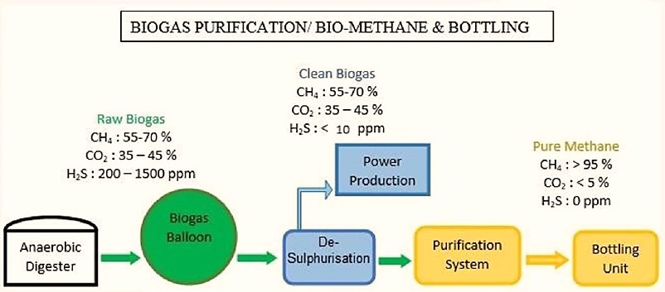
- PROCESS FLOW CHART OF THE PROPOSED BIO-CNG PLANT:
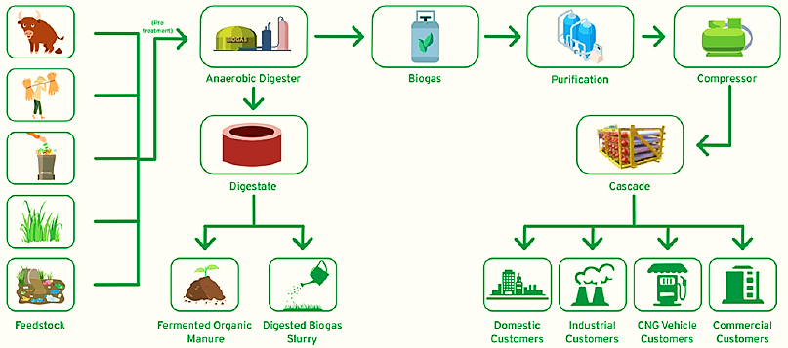
- TECHNICAL SPECIFICATIONS OF THE PROPOSED BIO-CNG PLANT:
This Bio-CBG plant is proposed to be commissioned based on the Continuous Stirred Tank Reactor (CSTR) –Anaerobic Digester Mesophilic bio-methanation technology, which will be a semi-automatic plant i.e. 80% mechanical and 20% manual, operating with PLC & SCADA. As informed by the client, all the proposed equipment/Machinery are up to latest/upgraded technology.
There will be 2 Nos. RCC Digester each having 7200 cum volume gas (in 24Hrs.). Digester volume shall subject to vary with the type & nature of the feedstock. VPSA Purification/ up gradation unit is proposed to be installed with state of art technology with stand-by critical parts for continuous supply.
Feeding of Raw material will be fully automated with underground pit and Screw feeder. This helps to Maintain International standard of hygiene and reduces waste handling labour work. To avoid breakdown in Biogas generation all critical equipment/machinery has stand by options. Technical specification of the proposed Bio-CNG plant are shown in the below table:
Biogas Plant Technical Specification
S. No. | Characteristics | Values | Figures
1 | Quantity of feedstock | Tons / day | 125 to 130
2 | TS% & VS% | % | As Per Given Data
3 | Biogas Plant Design Capacity | M3/ day | 14,400
4 | Biogas yield (Generation) | M3/ day | 14,400
5 | Methane content СН4 | % | 55-60
6 | Calorific value | Cal | 4500-4708
7 | Number of digesters | Pcs. | 2
8 | Digester volume (overall) | M3 | 7200
9 | Number of gasholders | Pcs. | 2
10 | Temperature in the digester | 0С | 38-40° C
11 | Pressure in the digester | MMW | 200-300
12 | Overall dimensions of the digester (diameter / height) Approx. | Mt. | 32/15/15
13 | Solid fertilizers yield (70-80% wet) | T/day | 23
Biogas to Bio-CNG plant characteristics
15 | Biogas Upgrading Capacity | M3/hour | 650
16 | Methane | % | >95-96
17 | Booster Compressor | M3/hour | 300
18 | electrical power Connected Load | KW | 500

As per the data/information provided to us by the client/LLP such as quotations, specifications of major component of the proposed Bio-CNG generating plant are as follows:
- ANAEROBIC DIGESTER:
CSTR Digester consist of continuous stirred tank reactor where continuous mixing of effluent and biomass take place with the help of central and lateral agitators. The essential feature of that the wash out of the active anaerobic bacterial biomass from the reactor is controlled by a sludge separator recycle system.
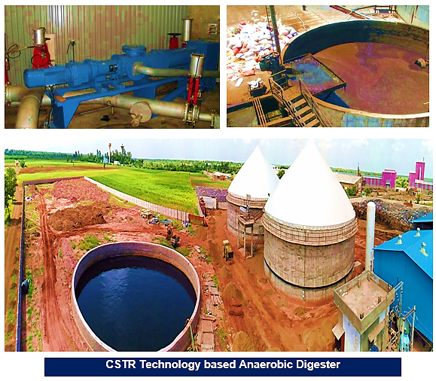
The basic idea underlying the anaerobic contact process is that it provides the contact between the active biomass and feed also utilize the digester volume effectively and Prevent stratification and temperature gradient, Minimize the formation of scum layer and the deposition of sludge solids. Specification of the proposed Digester are tabulated below:
Parameter of CSTR Digester
Particular | Specification
Digester Volume | 7200 Cubic Metre
Temperature of digester | 38 to 40 0 C
Digester inside pressure | 200 to 300 mmw
Digester PH | 7.0 to 7.5
Oxygen | Nil
COD load | 4 to 5 kgs/ m3 of Digester area
COD Reduction across the Reactor: | 65 ± 5 %
COD Reduction across the Reactor: | 85 ± 5 %

- PURIFICATION UNIT (VACUUM PRESSURE SWING ADSORPTION 600 NM3):
As per the data/information provided by the client, SRI NITROKC PVT LTD will be supplying the purification system with all accessories with P140 Chemical (Made in France) with 5 years Warrantee for the proposed Bio-CBG Plant.
This VPSA system has been especially designed for Industrial usage of Natural Gas i.e. Methane which is having a Gas Blower system with Motor, which supplies the Bio Gas at 0.5 kg/cm2g pressure to the Desulphurization tower. Post desulphurization, Biogas having component as Methane and Carbon-Di-Oxide majorly, passes through twin towers of PSA system having composite bed filled with special grade of molecular sieves that adsorbs the CO2 present in the Bio Gas.
After a pre-set cycle time, the towers are switched over through a sequence controller and a set of change over valves. With this, second tower comes into operation and first tower undergoes simultaneous regeneration. This cycle of towers changeover is repeated infinitely and methane gas is continuously produced.
Thus, Natural gas (Methane) with the purity of > 96% is available at the outlet. The pressure in the Absorbers varies with time and the gas available at the PSA outlet is taken to a surge vessel to take care of the pressure variations. The gas can be vented out initially through a 3-way valve and after the gas produced becomes of desired quality, it can be fed to the system for end use. Below table shows the technical specification of the same:
VPSA FOR BIO PURIFATION (CBG)
S. No. | Description | Technical Data
1 | Equipment | VPSA FOR BIO PURIFATION( CBG)
2 | Make | SRI NITROKC PVT LTD
3 | Model | SATAT 650
4 | Media | BIO GAS
5 | Input Gas Components | CH4 + CO2 + H2S
6 | Inlet Flow | 650M³/HR
7 | Out Let Flow | 390M³/HR
8 | Inlet Pressure | 0.5 kg/cm2g
9 | Out Let Pressure | 0.5 kg/cm2g
10 | Output Gas Components | CH4
11 | Purity Of Ch4 | 96% +-2
12 | Dew Point- Pure Biogas | - 400 C

- HEAT EXCHANGER SYSTEM:
As per the data/information provided by the client, SRI NITROKC PVT LTD will be supplying the Heat Exchanger system (Diameter: 32 Mt.) for digester along with water tanks (6 KL) for the proposed Bio-CBG Plant. Below table shows the technical specification of the same:
TECHNICAL DETAILS OF HEAT EXCHANGER SYSTEM FOR DIGESTER
S. No. | Description | Net Requirement
1 | Heat Exchangers System | FOR BIO GAS DIGESTER 32Meter Diameter
2 | Type Of Heat Exchanger | COIL TYPE
3 | Minimum Temperature | 10°C IN WINTER SEASON
4 | Temperature Maximum | 52°C
5 | Hot Media | WATER OF 55°C
6 | Pressure Of Hot Water | 3KGCM²G
7 | Tic | UP TO 100°C
8 | MoC Of Coil | SS 304/SS316 OPTIONAL
9 | Size Of Coil | 50NB
10 | SS 304 Angel L Type Support | 1 LOT
11 | Chemical Fasteners | 1 LOT
12 | Interlocking | Temperature Of Digester, Temperature Of Hot Water, Low Level Of Hot Water, High Level Of Hot Water Tank
13 | All Signals | Display In Scada
14 | Testing Of Heat Exchanger | 5KGCM²G AT SITE

- GAS HOLDER BALLOON 3536M3:
As per the data/information provided by the client, LLP has decided to go for 3536M³, Double Membrane, RCC Mounted Gas holder balloon for the proposed Bio-CBG Plant. LLP is in discussion with vendors and has not been finalised yet. As informed, vendor will be finalised based on the least cost offering. We recommend the bank to obtain the final quotation/invoice from bank before disbursement.
Specification: 3536M³, Double Membrane, RCC Mounted, 32.00M DIA, 8.10 Height
- BOOSTER COMPRESSOR 600 NM3/HR:
As per the data/information provided by the client, LLP has decided to go for 600NM³/Hr@ 0.5 BARG DISCHARGE 250 BAR Booster Compressor for the proposed Bio-CBG Plant. LLP is in discussion with multiple vendors such as Joytech, Kirlosker, Baur, Buckard etc. and has not been finalised yet. As informed, vendor will be finalised based on the least cost offering. We recommend the bank to obtain the final quotation/invoice from bank before disbursement.
Specification: 600NM³/Hr@ 0.5 BARG DISCHARGE 250 BAR
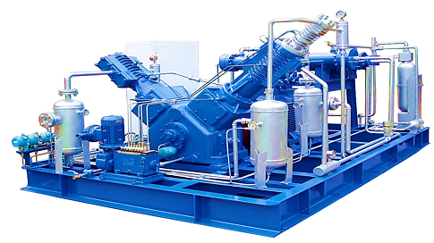
- AUTOMATION AND CONTROL SYSTEM INCLUDING (SCADA) OF CBG PLANT:
As per the data/information provided by the client, AOS House of Power Automation & Engineering will be supplying the Automation and Control System Including (SCADA), Transformer 650 KVA, Electrical Panel & Cables for the proposed Bio-CBG Plant. LLP is in discussion with vendors and has not been finalised yet. As informed, vendor will be finalised based on the least cost offering. We recommend the bank to obtain the final quotation/invoice from bank before disbursement.
- CNG CYLINDERS CASCADE SYSTEM:
As per the data/information provided by the client, LLP has decided to go for 4500WL. THREE BANK, 75WLx60 NOS OF CNG/CBG CYLINDERS for the proposed Bio-CBG Plant. LLP is in discussion with vendors and has not been finalised yet. As informed, vendor will be finalised based on the least cost offering. We recommend the bank to obtain the final quotation/invoice from bank before disbursement.
Specification: 4500WL. THREE BANK, 75WLx60 NOS OF CNG/CBG CYLINDERS
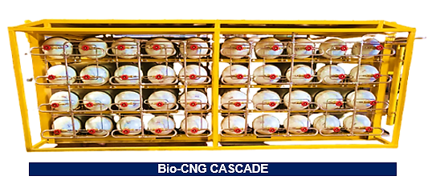
- ETP 30 M3/DAY:
As per the data/information provided by the client, LLP will go for ETP of 30 m3 per day having a flow rate of 1.5 m³ per hour considering 20 operating hours per day for the proposed Bio-CBG Plant. Below table shows the technical specification of the same:
Technical Details Of ETP Unit
Sewage Characteristics | Inlet | Outlet
BOD (ppm) | 600-700 mg/L | < 20 mg/L
COD (ppm) | 1000-1500mg/L | < 150 mg/L
TSS (ppm) | 500-700 mg/L | < 100 mg/L
Oil and Grease | 1000-1200 mg/L | <5 mg/l
pH | 4 – 6.0 | 7.0-8.0
Temperature (in degree Celsius) | ambient | ambient

As informed, vendor will be finalised based on the least cost offering. We recommend the bank to obtain the final quotation/invoice from bank before disbursement.
- TECHNOLOGY USED:
- TECHNOLOGY SUPPLIER & IN-HOUSE EXPERIENCED TECHNICALTEAM:
As per the data/information provided by the client, LLP has appointed a New Delhi based technology supplier M/s Sri Nitrokc Private Ltd. as its technical consultant for Consulting, Engineering, Project Execution and Project Management of proposed Bio-CBG plant by executing an agreement on 8th March 2024 on the letterhead of the company. Sri Nitrokc Private Limited is a Private incorporated on 28 January 2022. It is involved in Manufacture of special purpose machinery. Incorporation details of the company are as follows:
Company Information
Particular | Description
CIN | U29200DL2022PTC392976
Company Name | SRI NITROKC PRIVATE LIMITED
ROC Name | ROC Delhi
Registration Number | 392976
Date of Incorporation | 28/01/2022
Email Id | info@nitroxsys.com
Registered Address | H NO. 18 KH NO. 42 VIKASH VIHAR NILOTHI EXTN, New Delhi, Delhi, Delhi, India, 110041
Listed in Stock Exchange(s) (Y/N) | No
Category of Company | Company limited by shares
Subcategory of the Company | Non-government company
Class of Company | Private
Authorised Capital (Rs) | 1,00,000
Paid up Capital (Rs) | 1,00,000
Date of last AGM | 31/12/2023
Date of Balance Sheet | 31/03/2023
Company Status | Active
Source: Data/ Information provided by the client/LLP and extracted from MCA website.
As per the data/information provided by client & information available in public domain, Sri Nitrokc Private Limited is having expertise in the field of gas generation/separation/purification systems for gases including Oxygen, Nitrogen, CO2, CBG, CNG & various process developments, designs and Anaerobic Digestion plants. Sri Nitrokc provides turnkey Industrial, Agricultural, and other waste to bio-gas plants in India. Details of products offered by the company are shown in the below table:
Product portfolio of the technical consultant
Particular | Description
Products | Nitrogen Generator Plant, Oxygen Generator Plant, Bio-Gas Plant, Turnkey Projects, Diary Equipment, Pressure Vessels, Steam Methane Reforming Systems (H2 Generation), Methane Recovery & Enrichment Systems, Hydrogen Purification & Drying Systems, Ammonia Crackers, Co2 Generation And Recovery Plants, Co2 Removal / Recovery By, Amine Scrubbing, Air Dryers, Pneumatic Piping, Electric Panel
Spares | Activated Alumina, Activated Carbon, Oxygen Analyser, Pressure Gauge, Candle Filter, Pneumatic Valves, 13X, G5, P140, P180, Ox8 Sodium Base Zeolite, Ox19 Lithium Base Zeolite, Carbon Molecular Sieves
Source: Data/ Information available in public domain.
Key Team of M/s NITROX Pvt. Ltd.
Particular | Description
Mr. Davinder Kaur (Director) | Developed a well-equipped production unit, which is divided into several departments like R&D, Designing, Manufacturing, Quality Control, Packing Etc.
Mrs. Ruchi Sharma (Director) | She is working in the field of gas and industrial projects
Mr. Chetan Vashistha (Technical director) | He is having fifteen years of experience in advancements of gas and industrial projects. From Jan 2015 to 2021 worked as manager projects in KB Polytech Pvt Ltd. From 2021, worked for six months as general manager in Airox Nigen Pvt Ltd (Ahmedabad, Gujarat). Worked as general manager in Nihon Precision Fab Tech India (Khushkhera, Alwar, Rajasthan).
Mr. Harpreet Singh (Commercial director) | Handling Commercial work in the company.
Commissioning team | 12 Engineers
Fabrication team | 18 Skilled workers
Civil team | 23 workers
Source: Data/ Information available in public domain.
Product portfolio of the technical consultant
Particular | Description
On-Going CBG Projects | Srs biox Renewable Llp (Meerut), Shree Radhey Shyam Energy (Hathras), Bhuwneshwram Agro Tech ( Mirzapur), Shri Mani Mahesh Agro-Tech (Saharanpur), Natfrenz Technologies Pvt. Ltd., Aerostar Bio Energy Pvt. Ltd. (Jind)
Customer List | Star cement ltd. (Meghalaya), HPCL Bio fuels (Patna), HPCL (Pathmeda), Parle foods (Neemrana), Microtek new technologies pvt. Ltd. (Baddi), Aditya birla nuvo ltd. (Junagarh), Dalmia bharat sugar and industries ltd. (Sitapur), Sunmax auto engineering pvt. Ltd. (Manesar), Kuantum papers (Hoshiarpur), Paras terara (Gurugram), Jain agro foods (Thane), Pioneer park (Gurugram), Dharampal satyapal ltd. (Udaipur sikar)
Source: Data/ Information provided by the client/LLP/EPC contractor
Further, M/s SRSBIOX Renewable LLP is having in-house experienced rich technical team which will assist the LLP in commissioning the plant in coordination with appointed technical Consultant. Profile of the team is shown in the below table:
Details of In-house Technical Team of the LLP
Name | Profile
Mr. KP SINGH  Consultant & Solution Provider  (Sugar, Co-Gen, Distillery & Effluent Treatment ) | - He is a Mechanical Engineer having 43 + years of useful work experience in Sugar Industry Operation & Maintenance including Project management including conceptualization, specifications finalization, scheduling, resource planning and inspection of plant and equipment for timely completion and commissioning.  - As per information provided by client, he has worked for Sugar Project Management for 15 years and handled more than 20 sugar projects ranging from 3500 TCD to 9000 TCD, Cogeneration plants up to 35 MW and Ethanol plants of various sizes.  - He joined Sugar Industry operation in 1991 as Chief Engineer for plant operation & maintenance. Under the guidance and leader ship of him, Balrampur Chini Mills Limited expanded from 24000 TCD to 77000 TCD, power export from zero to 170 MWH and Distillery from 160 KLPD to 400 KLPD.  - One of the world class installation and state of the art construction at Haidergarh was conceptualized and executed by under signed. The plant is very popular in the sugar sector across the globe. More than 150 delegations from all sugar cane growing countries have visited this plant.
PRABHANSHU BHARDWAJ  PLC & DCS PROGRAMMING (ABB) with communication & networking, troubleshooting of control panels. | - He is having Bachelor Degree in Electronics from Feroze Gandhi Institute of technology, Rae Bareli, Utter Pradesh. Established own Industrial Automation company named “Arktos Control & Instruments” since July 2020.  - He is having 12+ year of industrial experience and executed many projects such as technical consultant for SMCG (State Mission of Clean Ganga, Uttar Pradesh) regarding Automation in 87 STP plants of Uttar Pradesh Government.  - Software Development, erection & commissioning of field instruments and DCS System for Mill and ACFC Automation for LAXMI SUGAR MILL CO. LTD, Roorkee, JK SUGAR MILL LTD, Bareilly, DIWAN SUGAR MILL LTD, Moradabad, CHADHA SUGAR MILL LTD, Dhanaura, DE AVADH SUGAR MILL LTD, Shamli.  - Software Development, erection & commissioning of field instruments and ABB PLC System for Furnace automation at RIMJHIM GLOBLE SMELTER STEEL LTD, Over-Head Bottling System at. DABUR NEPAL LTD.  - VFD Panels Design and Commissioning at BCML KUMBHI CHINI MILLS for 13MW Co-Gen Power plant, AMBE CEMENT, Birgunj, Nepal and JAY SPINNING TEXTILE, Birgunj, Nepal. Patanjali Ayurveda Ltd.  - Web based SCADA System and Process Instruments for Steam Flow measurement. Ambe Cement Pvt Ltd. VFD Panels for Blower Application -Jay Spinning Textile. VFD Panels for Spinning Machines- Vimal Organics Ltd. Supply Process Instruments for New Sulphuric Acid Plant. Automation System for New Sulphuric Acid Plants- Mahakaushal Sugar. Complete retrofitting job (Turn Key Basis) of 12.5MW Co-Gen Power Plant-Sonapur Cement Pvt Ltd.
Shree Laxman Singh  Expertise on all kinds of Civil Constructions & Foundations | - A veteran with over 35 years of enriched experience in Sugar & Distillery Industries. He has served as Chief Project Engineer in major Civil Construction & Projects in almost all major Sugar Mills & Distilleries, PAN India.
Source: Data/information provided by the client and data available in public domain.
- PROPOSED TECHNOLOGY:
BIO-METHANATION TECHNOLOGY:
- The CSTR Mesophilic bio-methanation technology along with its purification system is supplied by Sri Nitrokc Private Limited, New Delhi based solution provider, having expertise in biological degradation of organic wastes.
- The manufacturing process uses mesophilic CSTR bio-methanation for ensuring high efficiency in converting substrates to biogas, low environmental footprint and low capital cost of the plant and machinery, and 100% availability of plant independent of local climate and weather conditions.
- The plant has a low physical foot print as the hydraulic residence time of the mesophilic plant is just 28-30 days.
- The plant operates 24 X 7 throughout the year as the temperature is maintained at 36-40°C, and hence has constant output of biogas independent of the external temperature and climatic conditions. This ensures high plant availability throughout the year.
BIO-GAS UP-GRADATION TECHNOLOGY:
- The biogas so generated is separated into bio methane and CO2 using PSA system that recover approximately over 96-98% of the methane form biogas at methane purity 95-96%.
- The separated bio methane is compressed to 250 bar g using high efficiency compressor and filled in cascades of standard cylinders of 75 Litre of water capacity. The gas is directly supplied to IOCL CNG Pump Outlets/ consumers as automobile fuel at a retail outlet in the market areas, using state of art gas dispensers. The separated CO2 is released to the atmosphere.
- Most of the water used for the process is recovered and recycled from the biogas slurry, to cut down the requirement of make-up water for process requirement, thus reducing the water footprint of the project.
- All the macro and micro nutrients in the feedstock are recovered in the form of solid and liquid fertilizers, with ultra-filtration and reverse osmosis process plants, thus forming a virtuous closed loop.
PROCESS TECHNOLOGY:
- There are three temperature ranges in which bio methanation takes place mesophilic (35-38°C) and thermophilic (40 - 55°C) in this project about 10-15 MT/ day of cattle dung will be co-digested with about 120-125 MT/ day of Sugarcane Press Mud along with Jaggery waste & Non edible oil cake as an additive, which may be collected from nearby Sugar industries/kolhus.
- The pH and C: N ratios will be adjusted and the entire hydrolyser and digester are thermally insulated and heated to 35-38°C with a heat pump to provide the required temperature for thermophilic bacteria to thrive and maximize biogas output.
- The present project proposes to employ two stage thermophilic processes using a continuous stirred tank reactor configuration to optimize plant size and conversion efficiency.
- LATEST TECHNOLOGY/TECHNOLOGICAL ASSESSMENT:
Empirically, biological methanation of H2/CO2 has been tested for 151 days in a CSTR with no nutrients added. It is found that the Maximum CH4 yield was 355.8 mL/(L·d) at a CH4 content of 94.8% and Maximum CH4 content was 99.5% at a CH4 yield of 249.3 mL/(L·d), however, reactor ran stably at a pH around 8.5, and CO2 flow was adjusted for pH control.
Hence, the CSTR is found as a historically proven and well-established technology. ~95% of the currently used bioreactors are of CSTR-type due to providing effective mixing to obtain efficient gas-liquid mass transfer. Applying CSTR in biological methanation is conductive to the application of existing equipment and reliable technology.
Thus as per the above technical assessment, M/s SRSBIOX Renewable LLP is using the appropriate Mesophilic (25-40 Degree Celsius) CSTR technology which is a going on, recognized and trending in the market at present. It can be commented positively that the plant will be running smoothly. Technology & specification of the plant are matching with the need to run the plant smoothly and achieve the economies of scale.
- EFFLUENT TREATMENT AND ABETMENT:
- EFFLUENT TREATMENT APPROACH:
The philosophy underlying the effluent treatment system is predicated on the sustainability principles of renew, reuse, recycle and recover. The thrust is to use renewable resources, reuse “wastes” recycle valuable inputs such as water, energy and nutrients and recover through energy efficiency initiatives energy otherwise lost.
- PRODUCTION PROCESS:
The biogas plant generates about 12,700 m3/ day of biogas, which consists of 55-60 % methane, 36-40% CO2 and 2-5% water vapour, and contains about 1% of contaminants such as hydrogen sulphide (H2S) Ammonia (NH3) and N2 which are removed in the gas cleaning train. The cleaned gases, which contain ppb levels of the contaminants, are injected by the biogas pump into the biogas burners, which are specially designed to operate with biogas and used as cooking fuel, replacing the LPG.
- DISPOSAL OF THE BY-PRODUCTS:
Fertilizer by-products: The plant generates about 23,000 Kg/ day of solid organic fertilizer from the sludge separator which will be sold as fertilizer in the market.
- TESTING STANDARDS FOR PRODUCTION:
Bio-CNG/Enriched biogas to be produced will meet the BIS specifications as per IS 16087:2016 (as per guidelines from Ministry of New & Renewable Energy, Govt. of India and Oil Marketing Companies):
IS 16087: 2016 Standard
Sr. No. | Characteristic | Requirement
1 | Methane percentage (CH4), minimum | 90%
2 | Only Carbon Dioxide percentage (CO2), maximum | 4%
3 | Carbon Dioxide (CO2) + Nitrogen (N2) + Oxygen (O2) percentage maximum | 10%
4 | Oxygen (O2) percentage maximum | 0.50%
5 | Total Sulphur (including H2S) mg/m3, maximum | 20 mg/m3
6 | Moisture mg/m3, maximum | 5 mg/m3

- MANPOWER:
As per the datat/information shared by the client, Proposed plant will be initiated by deploying 35-40 human resources. The basic structure of the manpower will require the following kind of resources to opearte the plant 24*7 for 350 days a year:
Proposed manpower details along with Cost (INR)
Workers on Wages
Category | Number | Average Monthly Salary
Skilled Workers | 4 | 25,000
Semi-Skilled Workers | 4 | 20,000
Un-Skilled Worker | 7 | 12,000
Sub Total | 15
Factory Supervision
Category | Number | Average Monthly Salary
Plant In charge | 1 | 45,000
Plant Assistant | 4 | 35,000
Store In-Charge | 1 | 22,000
Store Assistant | 1 | 20,000
Chemist | 2 | 18,500
Driver for Transportation of Bio-CNG | 6 | 15,000
Sub Total | 15
Office Staff
Category | Number | Average Monthly Salary
General Manager | 1 | 80,000
Accounts Manager | 1 | 50,000
Accounts Assistant | 2 | 35,000
Office Assistant -Marketing | 1 | 25,000
Office boy | 2 | 10,000
Sub Total | 7
Grand Total | 37
Source: Data/information provided by the client.
LLP has proposed to deploy 37 human resources initially, which comes out with ~7 workers per ton for the proposed Bio-CNG generating plant which is in permissible range as per the standard benchmark of the industry considering the scope & scale of the proposed plant.
(Ref: https://pib.gov.in/PressReleasePage.aspx?PRID=1868887) The Sangrur CBG Plant shall provide direct employment to 390 and indirect employment to 585 people. This is a 33TPD capcity plant, thus it comes out with ~12 workers per ton.
PART F | PRODUCT PROFILE

- INTRODUCTION:
BG has calorific value and other properties similar to CNG and hence can be utilized as green renewable automotive fuel. Thus it can replace CNG in automotive, industrial and commercial areas. Ministry of Road Transport and Highways, Government of India had permitted usage of bio-compressed natural gas (bio- CNG) for motor vehicles as an alternate composition of the compressed natural gas (CNG).
The compressed biogas, or Bio-CNG, is likely to play a crucial role in promoting India’s transition to a sustainable energy ecosystem. Bio-CNG is a green renewable automobile fuel with calorific value and other qualities similar to compressed natural gas (CNG).
- PRODUCT CATEGORY:
- BIO CNG:
The proposed plant will be generating 6,000 Kg/ day of Bio-CNG which has a gross calorific value of 12,500 Kcal/Kg. Methane is the most valuable component under the aspect of using biogas as a fuel; the other components do not contribute to the calorific value and thus are "washed out" in the purification plants in order to obtain a gas with almost 95- 96% CH4. Methane is the flammable compound in biogas. Composition of the purified Bio-CNG has been shown in the below table:
Composition of Purified Bio-CNG
Ingredient | Value | Test Method
CH4(Percentage) | 95-96 % | IS-5130 (Part3)
CO2+ N2 + O2(Percentage) | 4-5 % | IS-15130 (Part3)
Only CO2 | < 4 % | IS-15130 (Part3)
H2S (Mg/M³) | 5 (Mg/M³) | ISO- 6326-3
Moisture (Mg/M³) | 5 (Mg/M³) | IS-15641 (Part2)
Source: Data/information available in public domain and as per our tertiary research.
Bio-CNG, a clean and renewable fuel, has vast potential in India. It can be a supplement to petroleum products, if used in compressed form in the cylinders. Biogas originates from bacteria in the process of biodegradation of organic material under anaerobic conditions.
Bio CNG is having the applicability in various Industries and used as Automobiles Fuel. It is capable to be used in Canteens, Restaurant, Hotels, Sweet shop, Dhabas etc.
Equivalent Quantity Of Fuel For 1 Cu M Of Biogas
Equivalent | Value
Biogas | 1.00 M³
Kerosene | 0.620 Liter
Fire wood | 3.474 Kg
Charcoal | 1.458 Kg
Butane | 0.433 Kg
LPG | 0.456 Kg
Electricity | - Kwh

- ORGANIC FERTILIZER:
The plant has a capacity to produce 23,000 Kg/ day of solid organic fertilizers. The material drawn from the digester is called sludge, or effluent., which is rich in nutrients (ammonia, phosphorus, potassium, and more than a dozen trace elements) and is an excellent soil conditioner.
Quality of Fermented Organic Manure: The C:N ratio of organic manure is between 12:1 to 16:1. It is a good source of nitrogen, phosphorous, potassium and iron. The typical elemental composition of the organic manure and biogas obtained at two of the operating plants based on BARC technology is given below:
Elemental Composition Of Organic Manure
Calcium | 0.39-0.65 %
Iron | 0.18-0.32 %
Magnesium | 0.032-0.01 %
Manganese | 0.0059-0.008 %
Nitrogen | 2.6-3.5 %
Phosphorous | 0.8-0.9 %
Zinc | 0.007-0.009 %
Potassium | 0.8-0.95 %
In other words, one ton of slurry provides 44 kg of nutrients as compared to 19 Kg through farmyard manure and 27 Kg by compost. Micro nutrients such as zinc (Zn), copper (Cu) and manganese present in the original material are also recovered in biogas slurry and can proved useful to crops when used as organic manure. The nutrient composition of slurry manure is shown in the below table:
Nutrient Composition Of Slurry Manure
Sr. No. | Ingredient | Value
1 | Total Nitrogen (%) | 1.40 – 1.84
2 | Total Phosphorous (%) | 1.10 – 1.72
3 | Total Potash (%) | 0.84 – 1.34
4 | Organic Carbon (%) | 35.0 – 38.4
5 | Zinc (mg/kg) | 103 – 116
6 | Copper (mg/kg) | 51 – 68
7 | Manganese (mg/kg) | 231 – 295
8 | Iron (mg/kg) | 3200 – 3600
9 | Carbon / Nitrogen ratio | 10 – 15
10 | Organic Matter | 65%

The organic manure is recommended for Short term crops such as vegetables and fodder, Mid-term crops such as wheat, cotton, rice, potato, sugarcane and maize and Long term crops such as kinnow, guava, grapes, mango, lemon and apple as per the shown inbelow table:

Application of organic manure
Crop | Doses | Time of application
Wheat, Rice, Maize and Cotton | 200-400 Kg/Acre | During preparation of Land for Sowing
Sugarcane, Potato | 400-800 Kg/Acre | Half Dose of Manure during preparation of Land and remaining half after two-three months of sowing
Vegetable | 200-400 Kg/Acre | 20-30 Days after plantation
Kinnow, Guava, grapes, Mango, Lemon and Apple. | 5-10 Kg/tree | Two times in a year

To derive maximum benefits from the stored digested slurry, it is essential to prevent its exposure to the sun as any such exposure would result in loss of ammoniacal nitrogen content of the slurry. It is advisable to dig, two or three manure pits near the biogas plant. The slurry is then carried and stored in these pits which are covered with solid waste from the farm. The fresh biogas slurry when used by mixing with irrigation water to growing crops gives better yields as compared to other modes of its applications.
- PRICING STRATEGY:

For the sale of the produced CBG, the LLP has already secured a Letter of Intent (LOI) from Indian Oil Corporation limited (Oil Manufacturing Company) under SATAT initiative to promote Compressed Bio-Gas as an alternative, green transport fuel. (Ref No.: Indian Oil/SATAT/01/3613 Date: 06.12.2023). However signing of commercial agreement between IOCL & LLP is in the process for which bank guarantee of INR 5.00 lakhs has been paid by the LLP as informed by the client
The current selling rate of CNG at OMC outlets in Meerut, Uttar Pradesh is around INR 80.50/kg as on 19th July 2024. (https://www.goodreturns.in/cng-price-in-meerut.html), however the procurement price of Bio-CNG at Indian Oil as per the SATAT Scheme falls under the slab of INR 62.86 per kg without GST. “CBG Pricing Circular- SATAT Scheme” is attached below for reference:
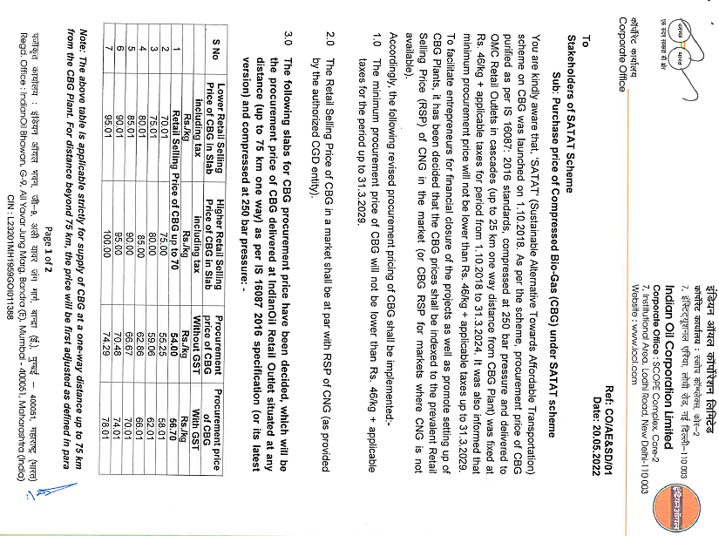
As per the current market scenario, the fermented organic solid manure/fertilizer is sold to farmers or outlets at around INR 6.00 to 7.00 per kg including with packing and bagging facilities. Whereas the bulk-selling rate of solid fermented organic manure/fertilizer is around 4.00 to 5.00 per kg.
Additionally, in a significant move towards promoting sustainable agriculture, the central government announced comprehensive guidelines to offer market development assistance (MDA) at INR 1500/MT (1.5 RS / Kg) for fermented organic manure (FOM) or bio-digestate derived from compressed biogas generating facilities. (Ref: https://pib.gov.in/PressReleasePage.aspx?PRID=1935893).
Further, The Indian Biogas Association (IBA) has recommended a fair and remunerative price of Rs 5.5 per kg for fermented organic manure (FOM), excluding the government incentive of Rs 1.5 per kg, to support biogas plants in the country. The IBA has suggested that the Ministry of Chemical and Fertilizer administer a fair market price for FOM, with an additional allowance for logistics and transportation charges. (https://economictimes.indiatimes.com/industry/indl-goods/svs/chem-/-fertilisers/fix-fair-remunerative-price-of-rs-5-5/kg-for-fermented-organic-manure-indian-biogas-association/articleshow/103100564.cms?from=mdr)
The IBA suggested a 'floor market price' at par with the Urea Retail Prices (presently at Rs 242 per 45 Kg bag), i.e. approx. Rs 5.5 per kg (exclusive of taxes). The market development Assistance (MDA) of Rs 1.5 per kg shall be realized over and above the floor market price by the FOM producer.
As IBA suggested the floor market price should have additional leeway to accommodate for additional logistics and transportation charges, if incurred and suggested an additional rate of approx. Rs 50/ton/km. According to the IBA, FOM is being sold at a rate ranging from Rs 0.50 to 4.50 per kg in the country.
The selling price of Bio-CNG is considered on conservative side as INR 62.86/kg without GST. The selling rate of fermented organic solid and liquid fertilizers is assumed as INR 5.50 per kg.

- MARKETING, SELLING & DISTRIBUTION PLAN:
- BIO CNG:
The Bio-CNG produced has to be sold to Indian Oil Corporation Ltd stations situated within 25-75 km, for which the LLP have already secured LOI (Ref No.: Indian Oil/SATAT/01/3613 Date: 06.12.2023).
- ORGANIC FERTILIZER:
The by-product of the biogas generation process is enriched fermented organic digestate, which is a perfect supplement to, or substitute for, chemical fertilizers. As per informed by the client, the fermented organic solid and liquid bio-fertilizers are in demand as a premium replacement for chemical fertilizers and are to be directly marketed using appropriate channels to the farming communities and sold @ INR 5.50/Kg.
The government has recently announced the Market Development Assistance (MDA) Scheme, under which the government approved Rs 1,451 crore for promoting organic fertilizers. Under MDA, the bio fertilizer coming out of a biogas plant -- technically known as FOM, the producers get Rs 1.5 for each kg, over and above the sale price of FOM.
The department of fertilizer in coordination with the Bureau of Indian Standards (BIS) and relevant industry stakeholders, should look forward to devising an appropriate BIS standard or Eco-Mark for defining a Quality protocol, enabling better market acceptance and linkage to the FOM.
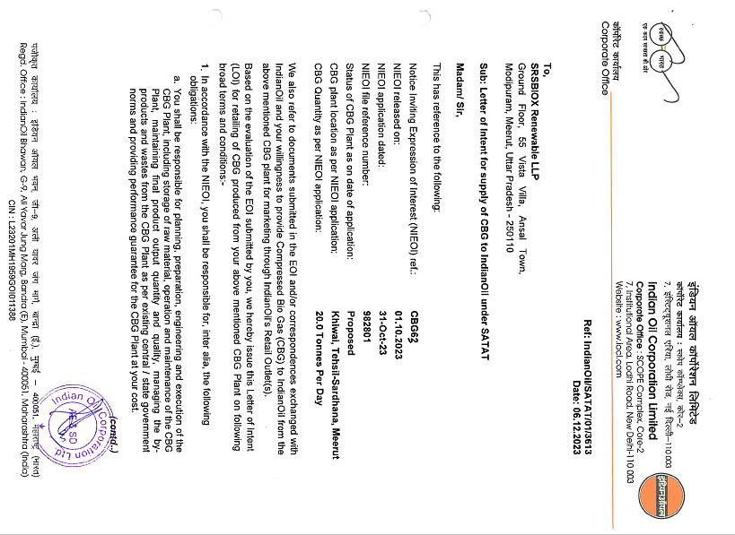
PART G | FEEDSTOCK ANALYSIS

- INTRODUCTION:
Bio-Methane from Anaerobic Digesters (AD): Anaerobic processes could either occur naturally or in a controlled environment such as a biogas plant. Organic waste such as livestock manure and various types of bacteria are put in an airtight container called digester so the process could occur. Depending on the waste feedstock and the system design, biogas is typically 55 to 60 percent pure methane. The state-of- the-art systems report producing biogas that is more than 95 percent pure methane.
The primary component of an AD system is the anaerobic digester, a waste vessel containing bacteria that digest the organic matter in waste streams under controlled conditions to produce Bio-methane. As an effluent, AD yields nearly all of the liquid that is fed to the digester. This remaining fluid consists of mostly water and is recycled to flush manure from the swine building to the digester.
Approximate Quantity Required For Generation Of One M3 Biogas
Sr. No. | Substance | Quantity (Kg)
1 | Cattle Dung | 20
2 | Paddy Straw | 4
3 | Napier grass | 8
4 | Poultry Waste | 8
5 | Horse/ Mule/ Elephant Dung | 12-15
6 | Food waste: Pre and post cooked leftover food from households, hotels and canteens. | 10-12
7 | Green waste (vegetable market waste): Vegetable  Refuses from Vegetable Markets or kitchens. | 10-12
8 | Paddy straw/ wheat straw/ mushroom spent waste:  Lawn cuttings, leafy biomass, dried flowers, finely chopped and ground straw or bagasse. | 5-8
9 | De-oiled rice bran | 3-4
10 | De-oiled seed cake (Pongamia/ Jatropha) | 3-4
11 | Segregated municipal solid waste (biodegradable) | 12-15
12 | Slaughter house waste | 5-10

Approximate Required Quantities of the Substances (Alone)
Sr. No. | Item | Daily Required Quantity (Ton)
1 | Cow Dung | 250
2 | Poultry Droppings | 98-100
3 | Food Waste | 175-180
4 | Sugarcane Press mud | 125
Combination of any of these mentioned above can also work in proportionate quantity. However, as per feed stock analysis the proposed bio-CNG plant will be using the following Combination of Raw Materials, while it should be noted that the feed stock quantity may very base on dry matter and volatile matter available in the below mention combination of feed stock:
Proposed Combination of Raw material
S. No. | Item | Daily Input Quantity (Ton)
1 | Cattle Dung Required | 10-15
2 | Sugarcane Press mud | 115-120
3 | Jaggery waste & Non edible oil cake as an additive | 0.50

- SUGARCANE PRESS MUD:
Press mud is a solid residue, obtained from sugarcane juice before crystallization of sugar. It generally contains 60-85% moisture (w/w); the chemical composition depends on cane variety, soil condition, nutrients applied in the field, process of clarification adopted and other environmental factors.
Press mud from sugar factory typically contains 71% moisture, 9% ash and 20% volatile solids, with 74-75% organic matter on solids. Sugar molasses has methane potential (i.e. CH4 per ton of raw material) of 230 m3. The typical composition of press- mud is given below in the table:
Composition Of Press Mud
Components | Percentage
Cellulose | 11.4%
Hemi cellulose | 10.0%
Lignin | 9.3%
Protein | 15.5%
Wax | 8.4%
Sugar | 5.7%
Na | 0.22%
As it contains appreciable proportion of biodegradable organic matter, it has very good potential for the production of biogas. Methane is the most valuable component under the aspect of using biogas as a fuel; the other components do not contribute to the calorific value and thus are "washed out" in the purification plants in order to obtain a gas with almost 97-100% CH4. Methane is the flammable compound in biogas.
- COW DUNG:
About one cubic foot of gas may be generated from one pound of cow manure at around 28°C. This is enough gas to cook a day’s meals for 4-6 people in India. About 1.7 cubic meters of biogas equals one Litre of gasoline. The manure produced by one cow in one year can be converted to methane, which is the equivalent of over 200 Litres of gasoline. In the state of Uttar Pradesh, million tons of animal dung is produced every year which can be utilized for better purposes. Hence, anaerobic digestion becomes a promising technology.
Percentage Proximate Composition And PH Values Of The Dung
Parameters | Cow Dung
Moisture % | 18.55 ± 0.28
Ash % | 10.10 ± 0.02
Crude Fiber % | 40.20 ± 0.12
Crude Protein % | 6.80 ± 0.06
Crude Fat % | 4.00 ± 0.42
Carbohydrate % | 20.35 ± 0.34
pH | 7.10 ± 0.01
Gas produced from cow dung is 55-65% methane, 30-35% carbon dioxide, with some hydrogen, nitrogen and other traces. Its heating value is around 600 B.T.U. per cubic foot. The cow dung slurry is composed of 1.8-2.4% nitrogen (N2), 1.0-1.2% phosphorus (P2O5), 0.6-0.8% potassium (K2O) and 50-75% organic humus.
- AVAILABILITY OF RAW MATERIAL:
As per the feedstock analysis and the data/information provided by the client, the plant will require cow dung around ~10-15 tons per day and sugarcane press around ~115-120 ton per day along with 500 kg per day Jaggery waste & Non edible oil cake as an additive to produce the 6 ton Bio-CNG per day. Meerut district is well known for sugar processing industries.
The required raw material availability is the advantage of the proposed location as proposed location is the well-known Sugarcane belt of western U.P. and many Sugar mill are situated near by the location as shown in the below table:
S. No. | Name of the Sugar Mill | Distance from location
 | Bajaj Hindusthan Sugar Ltd., Bus Stop, near Jataula, Jitaula, Kaithwari, Uttar Pradesh 250502 | ~9.3 km away from the plant
 | Daurala Sugar Mill (DCM Shriram Industries Ltd.), Daurala, Daurala Rural, Uttar Pradesh 250221 | ~30 km away from the plant
 | SBEC Sugar Mill Limited, 46QJ+4FM, Loyan Malakpur, Uttar Pradesh 250611 | ~33 km away from the plant
 | Garg Sugar cane Crusher, 3G39+5C4, MDR 34W, Banwaripur, Mirpur, Uttar Pradesh 250502 | ~11 km away from the plant
Source: Google Map
Availability of different feed stock in the adjoining area is in sufficient quantity. There are many sugar mills in the area as Bajaj group Kinoni and Budhana. U.P Cooperative sugar units Ramala and Baghpat and one mini sugar plant just 3km away fron the proposed unit which yields 40-50 Ton of press mud on daily basis.
Similarly, there are large no. of cow and buffalo dairies, U.P govt. funded goshalas. A very big poultry farm within 5km range yielding approximately 7-8 ton poultry litter daily as informed by client. As per data shared by the client, SRSBiox has entered into the agreement with few FPO/suppliers as described below:
FPO/RAW MATERIAL SUPPLIERS
Name | Agreement | Description about Supplier/FPO
Sanrakshak Farmer Producer Company Limited | Agreement on 24th June 2024 to supply Press mud, Cow dung, Paddy Straw, Agricultural residue as per the requirement @ market rate. | As per our tertiary research and data/information available in public domain, Sanrakshak Farmer Producer Company Limited is a Private company incorporated on 24 November 2021 having CIN U01100UP2021PTC155892.  It is involved in Growing of crops; market gardening; horticulture. Current status of Sanrakshak Farmer Producer Company Limited is – Active.  Its Email address is roc2019filing@gmail.com and its registered address is C/O Dharmender Singh R/O H.NO. 1, V Mukandpur, Baghpat, Uttar Pradesh, India - 250617. Its authorized share capital is Rs. 500,000 and its paid up capital is Rs. 100,000. Directors of Sanrakshak Farmer Producer Company Limited are Dharmendr Singh, Bijander Singh, Roshan Lal, Lokesh Kumar and Pradeep Kumar.
Shree Sumati Sugar Private Limited | Agreement on 24th June 2024 to supply Press mud (Mailley) as per the requirement as per the market rate. | As per our tertiary research and data/information available in public domain, Shree Sumati Sugar Private Limited is a Private company incorporated on 11 November 2003 having U15425UP2003PTC028058. It is involved in Manufacture of other food products. Current status of the company is Active.  Its Email address is atuljainonline23@gmail.com and its registered address is 116/4 Mahaveerji Nagar Meerut, Uttar Pradesh, India - 250001. Its authorized share capital is Rs. 45,000,000 and its paid up capital is Rs. 45,000,000. Directors of Shree Sumati Sugar Private Limited are Ambuj Kumar Jain and Anubhav Jain.

- PRICING:
As sugar mill owners have now recognised its potential for revenue generation. This realisation has resulted in a substantial increase in press mud prices over the last two years, rising from INR 100 per tonne to INR 500-600 per tonne including transportation. As escalated in recent years, the sugarcane press mud is generated by the sugar mill and made available to the project @ INR 1200/ Ton. The cattle dung is collected from various dairy farms/ nearby villages @ INR 1000/MT and used as inoculants.
Ref:(https://www.downtoearth.org.in/news/renewable-energy/sugarcane-byproduct-pressmud-can-be-a-sweet-spot-for-india-s-compressed-biogas-sector-93022#:~:text=This%20realisation%20has%20resulted%20in,as%20fuel%20in%20brick%20kilns).
Jaggery waste & Non edible oil cake will be used as an additive in the CBG production process, which is generally available @INR 25 per kg in the open market.
PART H | INDUSTRY OVERVIEW

- INTRODUCTION:
Bio-CNG is considered a renewable fuel and has also been proven to reduce the emission of greenhouse gasses when used as a transport fuel. Bio-CNG, derived from the filtration of biogas, is also referred to as Compressed Biogas (CBG) and bio-methane. It is derived from biogas after removing impurities like carbon dioxide and hydrogen sulphide. As per the details available on Gobardhan Portal (https://gobardhan.co.in/), approx. 81 CBG/Bio CNG plants are completed and functional in 153 districts and 163 CBG/ Bio CNG plants are under construction at present.
Bio-CNG plants get financial and other incentives from the Union government under the Sustainable Alternative towards Affordable Transport (SATAT) Scheme. The scheme, launched in 2018, supports the establishment and expansion of bio-CNG plants that use waste to produce biofuel. Under the scheme, the Union government plans to establish a total of 5,000 bio-CNG plants in India by the end of FY 2025.
- POTENTIAL AND EXPANSION:
In India, around 70 percent of the sugarcane is produced by three major states – Uttar Pradesh, Maharashtra, and Karnataka. India produces, on an average, over 300 million metric tonnes of sugarcane per year. Around 3.5 percent of this, can be the amount of press mud produced. At this rate, India has the potential to produce around 10 million metric tonnes of press mud/filter cake per year that could be diverted for producing bio-CNG.
Indian sugar industry while crushing around 300 million tonnes of sugarcane and producing about 10 million tonnes of press mud annually can offer compressed bio-methane/bio-CNG to the extent of 0.4 million metric tonnes .
Feedstock | Pan India accessible amount (TPD) | Biogas potential per ton (kg) | Bio-CNG potential per ton (kg) | pan India CBG potential (TPD)
Urban food waste, fruit and vegetable | 50,000 | 75 | 40 | 2000
Poultry litter | 100,000 | 100 | 60 | 6000
Press mud | 100,000 | 150 | 80 | 8000
Total |  |  |  | 16000
The Bio-CNG potential in India is estimated at 62 million metric tonnes (MMT) per annum, out of which the Sustainable Alternative towards Affordable Transportation (SATAT) scheme aims to tap 15 MMT. India biogas market is expected to grow from $1.47 billion in 2022 to $2.25 Billion in 2029 at a CAGR of 6.3% during the forecasted period.
The sector is about to attract over USD 2 Billion investment in the next 5-7 years under its SATAT scheme, the govt. announced an ambitious plan of touching 15 million metric ton per annum, which is roughly 40,000 ton per Day.
Demand for alternative fuel vehicles in India is on the upswing and clearly seen in the increasing sales of CNG-powered vehicles. Given the favourable price arbitrage of CNG versus petrol and diesel, retail sales of CNG vehicles, across four sub-segments, crossed the 650,000-unit mark for the first time in a fiscal in FY2023. Cumulative sales of 660,153 units (see data table below) translate into strong double-digit YoY growth of 46% (FY2022: 451,552 units). (Ref.: https://www.autocarpro.in/analysis-sales/cng-vehicle-sales-surge-by-46-to-over-650000-units-in-fy2023-114656).
CNG passenger vehicles (PVs), with 318,752 units, account for 48% of the total retail sales in FY2023 and surged by 40.71% year on year (FY2022: 226,547 units) and took an 8.80% share of overall retail sales of 36,20,039 PVs in India.
- CHALLENGES:
The GOI has formulated various policies and schemes to promote and mitigate challenges associated with the Bio-CNG sector. There are still some operational and technological challenges such as sensitivity towards biomass quality, biogas upgradation process among others which are impeding the uptake of Bio-CNG projects. Below table shows the challenges:
Feedstock Availability | Quality of Feedstock (including multiple feedstocks) | Technology Challenges | Bio-CNG and by- products' Market Challenges | Financing, and Implementation Challenges
- No formal market for trading of feedstock  - Uncertainty of long-term regular supply of feedstock  - Demand supply mismatch - requirement of large storage facility  - Unorganized biomass value chain – lack of suﬃcient collection, processing and transportation facility | - Variation in quality of feedstock throughout the year  - Some projects are designed to take multiple feedstock – optimal operation is a challenge and may also aﬀect the quantity and quality of Bio-CNG  - Source segregation is important – receiving non-segregated waste is an operational challenge | - Technologies are sensitive to the quality of feedstock – slight change in feedstock quality will signiﬁcantly impact the Bio-CNG production rate  - Capital intensive technologies high upfront project cost | - Year-on-year variation in feedstock price – established feedstock pricing mechanism is required.  - Base price of Bio-CNG should be linked with feedstock cost variation mitigates the economic viability risks  - Create market demand for by- products such as Bio manure etc. | - There are schemes by public sector banks to ﬁnance Bio-CNG project, but less private sector banks are ﬁnancing Bio-CNG project that too at high cost of debt.  - Lack of access to infrastructure i.e. road network and CGD network near project sites.  - Large set of approvals are required from PESO, pollution control board, MNRE - subsidy disbursement etc.

- GOVERNMENT INITIATIVES:
- Government has announced the phased mandatory blending of compressed biogas (CBG) in compressed natural gas (CNG) for transportation and piped natural gas (PNG) for domestic purposes in the latest interim budget for FY 2024-25.
- The government has increasingly focused on the production of compressed biogas in India. It is currently aiming to set up 5,000 CBG plants by FY25 under SATAT.
- Under Waste To Energy Programme, MNRE is providing the subsidy of INR 4.0 Cr per 4800 kg/day for Bio CNG generation from new biogas plant and INR 3.0 Cr per 4800 kg/day for Bio CNG generation from existing Biogas plant, while the maximum CFA of INR 10.0 Cr/project for both cases.
- GOBARDHAN: Ministry of Drinking Water and Sanitation, Financial assistance of INR 50 lakh per district is available for setting up model GOBARDHAN projects. SATAT Scheme OF MoPNG for encouraging OMCS's to issuance of LOI to the producers.
- Eight Biogas Development and Training Centres (BDTCs) have been established at India’s premier Institutions to provide Technical Assistance, R & D, Testing and Validation of New Biogas Models / Designs, field inspections of biogas plants, and training and skill development.
- Ministry of Road Transport and Highways amended the Central Motor Vehicles Rules, 1989 in June 2015 and included the provisions for usage in motor vehicles Bio-CNG produced from waste (including MSW)
- Carbon Credits, Priority Sector Lending, and CSR Funds, Agri Infrastructure Fund (AIF).
- CONCLUSION:
The business of bio CNG gases is in high demand because it is a clean and renewable source of energy. Additionally, it is more cost-effective than traditional sources of energy, and it can be used to power a variety of vehicles. Bio CNG gas is also a versatile fuel that can be used in a variety of applications.
Though there are a few reasons for this increase in demand, the primary one seems to be that environmentalism is becoming more and more popular. As people become more aware of the damaging effects that traditional forms of energy have on the environment, they are searching for alternatives that are cleaner and renewable.
India biogas market is expected to grow from $1.47 billion in 2022 to $2.25 Billion in 2029 at a CAGR of 6.3% in forecast period, 2022-2029. Bio CNG gas is one such alternative, and its popularity is only increasing as time goes on. Bio CNG can be produced from a variety of organic materials, making it a sustainable choice for energy production. Additionally, bio CNG produces fewer emissions than traditional fossil fuels, making it a more environmentally-friendly option. Finally, bio CNG is becoming increasingly cost-competitive as technology advances and production methods improve.

PART I | SWOT ANALYSIS

SWOT ANALYSIS
STRENGTHS | - Strategic Location: The project is situated in Meerut, U.P. many sugar mills are situated near by the location of the proposed Bio CNG plant and Dairy/Government Funded Gaushalas ensures the availability of raw material (press mud/Cattle dung).  - Growing Demand: Due to renewable source of energy, demand for Bio-CNG is expected to grow at a CAGR of ~6 % in the upcoming years.  - LOI: The produced Bio CNG will be supplied to IOCL as per the LOI issued by OMC under SATAT scheme, which is an effortless avenue for the project to generate the revenue. (Ref No.: Indian Oil/SATAT/01/3613 Date: 06.12.2023).  - Government Support: The project will be entitled to avail incentives of INR 4.0 Cr per 4800 kg/day for Bio CNG generation from new biogas plant, Under Waste to Energy Programme of Ministry of New and Renewable Energy.  - Technology: The proposed plant (Semi-Automatic) will be commissioned with CSTR Mesophilic bio-methanation technology, which is a proven technology empirically.  - Experienced In-house Technical Team: As per the data/information provided by the client, LLP is having an experience rich in-house technical team, which will assist in commissioning of the proposed plant in coordination with appointed technical consultant resulting cost cutting of EPC.
WEAKNESSES | - CAPEX: The proposed Bio CNG plant would be set up by a high initial investment, in which 66% capital would be required for plant & machinery.  - Infrastructure Requirements: The project's power load and water consumption are significant, and ensuring uninterrupted power supply and adequate water resources may pose challenges.  - Raw Material Market: There is no any formal market for raw material, leading to establish a feedstock pricing mechanism.
OPPORTUNITIES | - Increasing Alternate fuel’s Demand: As the transportation industry is expanding, there will be an organic demand for Bio CNG/CBG as an alternate fuel due to mandatory blending of compressed biogas (CBG) in compressed natural gas (CNG) for transportation.  - Expansion Potential: The LLP is having the opportunity to expand its business in future for manufacturing Bio Coal and Bio Pellets.  - Government Support: The project can benefit from government initiatives and policies aimed at promoting the Bio CNG production to achieve Net Zero target by 2070.
THREATS | - Fluctuating Raw Material Prices: With the increasing demand of sugarcane press mud, the prices are shooting up rapidly.  - Economic Factors: Profitability of the project may hamper due to any blockage of feed stock.  - Dependency on LOI: Any breach of the LOI agreement with OMC, the LLP may require to search the new approach to sell its production in the market.  - Manufacturing Experience: Promoters are having experience of other sugar industry, however entering into Bio CNG generating business may explore new multidimensional challenges.

PART J | PROJECT COST AND MEANS OF FINANCE
As per data/information shared by the client, the proposed Bio CNG generating project is proposed to be commissioned by making an investment of INR 22.58 Crore as shown in the below table along with Means of finance:
Total Project Cost
S. No. | Capital Cost Head | Amount (INR Crore)
1 | Land Registration | 2.20
2 | Electricity Connection | 0.00
3 | Civil & M.S. Work | 4.00
4 | P& M including other equipment | 14.88
5 | Furniture & Fixtures | 0.05
6 | Office Equipment | 0.10
7 | Interest During Construction (IDC) | 0.71
 | Sub Total | 21.93
1 | Preliminary & Preoperative | 0.15
2 | Contingencies at ~1% of Total Project Cost | 0.19
 | Sub Total | 22.27
1 | Working Capital Margin @ 25% of WC Gap | 0.31
 | Grand Total (TPC) | INR 22.58 Crore

Means of Finance
S. No. | Particular | Amount (INR)
1 | Equity (30% on Project Cost) | 8.58
2 | Loan from Banks | 14.00
 | TOTAL | INR 22.58 Crore
 | CC Loan | 0.50
 | Total Loan | INR 14.50 Crore
Source: Data/Information provided by the client/LLP/Bank.
Notes:
- The proposed Bio-CNG plant is proposed to be setup at a total of about 18,771 Sq. Mt. land area in Meerut, U.P. As per the sale deeds, total stamp duty paid by M/s SRS BIOX for the registration of the land in favour of LLP is INR 27,68,600. As per Balance sheet of the LLP dated 31st March 2024, value of the land is INR 2.20 Crore including registration charges as informed by client, which is considered as a part of total project cost.
- As per the data/information provided by the client, the estimated cost of the Building & Civil works is ~INR 4.00 Crore including Land development & Boundary wall. However, as a TEV consultant, the estimated Building & Civil works cost has been verified independently by us based on the quantity provided by the client as per Market Standard Rates. As per our assessment, the cost of the following civil work will be in range of ~INR 5-5.50 Crore depending upon the specification of the material and construction. We recommend the bank to get the verified cost of building & civil works from an appointed Architect/Chartered Engineer.
- The estimated cost for plant & machinery will be ~INR 14.88 Crore including the applicable GST. The estimated cost of the Plant & Machinery has been provided to us by the client as per quotations received by them from various vendors/suppliers. However, as a TEV consultant the cost of major plant & machinery has been verified by us independently, which we found comparatively lower than the industrial/sectoral benchmark although the cost may change as per specifications & brand.
- Estimated cost of miscellaneous assets such as office equipment and Furniture & Fixtures would be ~INR 15 lakhs (Tentative). Preliminary & Pre-Operative Expenses has been taken as lump sum basis, based on the time period of construction and estimate of LLP’s resources involvement during this time in supervision & monitoring of the construction as INR 15.00 lakhs including INR 5.00 Lakhs bank guarantee for LOI with IOCL.
- Contingency cost of INR 19 lakhs (~1% of TPC) has been considered based on general assumption and professional experience. Interest during Construction will be paid from September 2024 by the LLP @ 11.00%. As per the loan schedule prepared, IDC comes to INR 71 lakhs till March, 2025.
- The project is proposed to be funded through a term loan of INR 14 crores and promoter’s Equity of INR 8.58 crores. Further, as per the working capital assessment, the WC loan of INR 50.00 lakhs will be required to meet the day to day operational expenses.

PART K | PROJECT IMPLEMENTETION SCHEDULE

The proposed Bio CNG generating unit is expected to achieve its C.O.D till 1st April 2025, as per the proposed implementation schedule shown in the table below:
S. No. | Particulars | Activity | Expected completion date | Status
 | Land | Land Procurement | 18th Oct 2023  Reg. No. 20725 | Completed
 |  | Land Development | September, 2024 | Pending
 | Sanction of Rupee Term Loan | Sanction of Rupee Term Loan | Sep, 2024 | Pending
 | Building & Civil Works | Appointment of Architect | March 2024 | Completed
 |  | Building Plan Preparation | 16th April 2024 | Completed
 |  | Building Plan Sanction | September, 2024 | Pending
 |  | Appointment of Civil contractor/ developer | September 2024 | Pending
 |  | Building & Civil Works completion | November, 2024 | Pending
 | Plant & Machinery | Finalization of P&M suppliers | September 2024 | Pending
 |  | Orders to P&M suppliers | October, 2024 | Pending
 |  | Arrival of P&M | December, 2024 | Pending
 |  | Installation of P&M | January, 2025 | Pending
 |  | Utility Installation | February, 2025 | Pending
 | Statutory Approvals, registrations & NOCs | From the respective authorities | March, 2025 | Most of the Pre-operational NOC’s has been taken by the LLP
 | Finishing & Trail Run | Informed by client | March, 2025 | Pending
 | Commercial Operation Date | Informed by client | 1st April 2025 | Pending

Notes:
- Schedule has been made as per feasibility to achieve different milestones.
- Achievement of Milestone will depend on sanction of term loan as per proposed timeline.
- For current status of statutory approvals, kindly refer the “Section L” of this report.
- As per this timeline, the expected C.O.D will be 1st April 2025.

PART L | STATUTORY APPROVALS | LICENCES | NOC

As shown in the below table along with current status, following major approvals are required. However the list is not exhaustive and State/District Authorities may be approached for further clearances required (if any):
S. No. | REQUIRED APPROVALS | DATE  REFERENCE NO. | STATUS  (Approved/ Applied For/ Pending)
 | Certificate of Incorporation  Ministry of Corporate Affairs, Government of India | 12th July 2023  LLP Identification No.  ACB-9890 | Approved
 | Land conversion to Industrial/Non agriculture  Sub Divisional Magistrate, Sardhana, Meerut, Uttar Pradesh | 14th July 2023 | Out of total land, CLU is awaited for a land parcel.
 | NOC from Gram Panchayat/Municipal Authority  Khiwai municipal authority, Meerut, U.P. | 30th September 2023 | Approved
 | Labour Licence  Registration & grant of license under The Factories Act, 1948 Department of Labour, Uttar Pradesh | - | Pending
 | Building and civil works Plan Sanction Approval  Concerned local development authority | - | Pending
 | Pre-establishment fire NOC Uttarakhand Uttar Pradesh Fire and Emergency Services, Government Of Uttar Pradesh | - | Pending
 | Fire NOC (on completion)  Fire Services Department | - | Will be Applied post C.O.D
 | New HT line - non domestic /industrial Power Connection  Paschimanchal Vidyut Vitran Nigam Ltd | - | Pending
 | Consent to Establish under Air (Prevention and Control of Pollution) Act, 1981 & Water (Prevention and Control of Pollution) Act, 1974  Uttar Pradesh Pollution Control Board | 21st March 2024  Application No : 25431997 | Applied
 | No Objection Certificate (NOC) for ground water abstraction  Central Ground Water Authority, Department of Water Resources, River Development And Ganga Rejuvenation  Ministry Of Jal Shakti, Govt. Of India | - | Pending
 | Udyam Registration Certificate  Ministry of MSME | 4th Jan 2024  UDYAM-UP-56-0071772 | Approved
 | Petroleum & Explosives Safety Organisation (PESO)  Filling of Compressed Bio Gas (CBG) and Storage of Compressed Bio Gas (CBG) under Gas Cylinders Rules , 2016 Ministry of Commerce & Industry, Gov. of India | 16th April 2024  Prior Approval No : A/G/HO/UP/05/639 & A/G/HO/UP/06/618 (G131526) | Approved

Observation Note:
- As informed by client, out of total 18771 Sq. Mt. of land, Change of land use (CLU) has been obtained by LLP for 14871 Sq. Mt. of land, which has been approved by Sub Divisional Magistrate, Sardhana, Meerut on 14th July 2023. CLU is applied for remaining 3900 Sq. Mt. of land parcel as informed by designated partners of LLP.
- Above is the only illustration of the major approvals sought or to be sought by the LLP. It should not be construed as the exhaustive list and in case any approval is missed to be mentioned then it is the sole responsibility of the LLP to keep the unit compliant with the necessary statutory approvals/ NOCs.
PART M | LLP’S FINANCIAL FEASIBILITY

- PROJECTIONS OF THE FIRM:
The financial projections of the project are prepared from FY 2025-26 to FY 2032-33 based on the expected COD and loan tenor as per the best practice in industry to assess the financial feasibility of the project are elaborated below:
- PROJECTED PROFIT & LOSS ACCOUNT:
(INR Crore)
Year Ending | 31-Mar-26 | 31-Mar-27 | 31-Mar-28 | 31-Mar-29 | 31-Mar-30 | 31-Mar-31 | 31-Mar-32 | 31-Mar-33
Year Counter | 1 | 2 | 3 | 4 | 5 | 6 | 7 | 8
Months Counter | 12 | 12 | 12 | 12 | 12 | 12 | 12 | 12
Revenue
Revenue | 13.50 | 17.72 | 18.60 | 19.53 | 20.51 | 21.53 | 22.61 | 23.74
Cost of Sales
Raw Material | 4.46 | 5.86 | 6.15 | 6.46 | 6.78 | 7.12 | 7.47 | 7.85
Power & Utilities | 1.18 | 1.55 | 1.63 | 1.71 | 1.79 | 1.88 | 1.98 | 2.07
Salary & Wages | 1.04 | 1.14 | 1.25 | 1.38 | 1.52 | 1.67 | 1.83 | 2.02
Repair & Maintenance | 0.10 | 0.10 | 0.11 | 0.11 | 0.12 | 0.13 | 0.13 | 0.14
Insurance expenses | 0.05 | 0.05 | 0.05 | 0.04 | 0.04 | 0.04 | 0.04 | 0.03
Depreciation | 1.05 | 1.05 | 1.05 | 1.05 | 1.05 | 1.03 | 1.03 | 1.03
Cost of production | 7.88 | 9.75 | 10.23 | 10.75 | 11.30 | 11.87 | 12.48 | 13.15
Add: Opening Stock in Process | 0.00 | 0.53 | 0.70 | 0.73 | 0.77 | 0.81 | 0.85 | 0.89
Sub-Total | 7.88 | 10.28 | 10.93 | 11.49 | 12.07 | 12.68 | 13.33 | 14.04
Less: Closing Stock in Process | 0.53 | 0.70 | 0.73 | 0.77 | 0.81 | 0.85 | 0.89 | 0.94
Sub-Total | 7.35 | 9.58 | 10.20 | 10.72 | 11.26 | 11.83 | 12.44 | 13.10
Add: Opening Stocks of Finished Goods | 0.00 | 0.15 | 0.20 | 0.21 | 0.22 | 0.24 | 0.25 | 0.26
Sub-Total | 7.35 | 9.73 | 10.40 | 10.93 | 11.49 | 12.06 | 12.69 | 13.36
Less: Closing stocks of Finished Goods | 0.15 | 0.20 | 0.21 | 0.22 | 0.24 | 0.25 | 0.26 | 0.27
Total Cost of Sales | 7.20 | 9.53 | 10.18 | 10.70 | 11.25 | 11.81 | 12.43 | 13.09
SG&A Expenses | 1.09 | 1.43 | 1.50 | 1.58 | 1.66 | 1.74 | 1.83 | 1.92
Preliminary Expenses written off | 0.03 | 0.03 | 0.03 | 0.03 | 0.03 | 0.00 | 0.00 | 0.00
Total Expenses | 8.32 | 10.99 | 11.72 | 12.31 | 12.94 | 13.55 | 14.25 | 15.01
EBIT | 5.18 | 6.72 | 6.89 | 7.22 | 7.57 | 7.98 | 8.36 | 8.74
Interest on term loan | 1.54 | 1.46 | 1.31 | 1.12 | 0.90 | 0.68 | 0.44 | 0.16
Interest on working capital | 0.05 | 0.05 | 0.05 | 0.05 | 0.05 | 0.05 | 0.05 | 0.05
Total Interest Expenses | 1.59 | 1.51 | 1.36 | 1.17 | 0.95 | 0.73 | 0.49 | 0.21
Profit before Taxes | 3.59 | 5.21 | 5.53 | 6.05 | 6.62 | 7.25 | 7.86 | 8.53
Tax @ 25.17% | 0.90 | 1.31 | 1.39 | 1.52 | 1.67 | 1.82 | 1.98 | 2.15
Profit after Taxes (PAT) | 2.69 | 3.90 | 4.14 | 4.53 | 4.95 | 5.42 | 5.88 | 6.38

- PROJECTED BALANCE SHEET:
Below table shows the Projected Balance Sheet of the proposed Bio CNG generating project from the period FY 2025-26 to FY 2032-33, however from 1st Sep. 2024 to 31st March 2025 would be the implementation period of the project:
(INR Crore)
Year Ending | 31-Mar-25 | 31-Mar-26 | 31-Mar-27 | 31-Mar-28 | 31-Mar-29 | 31-Mar-30 | 31-Mar-31 | 31-Mar-32 | 31-Mar-33
Year Counter | 0 | 1 | 2 | 3 | 4 | 5 | 6 | 7 | 8
Months Counter | 9 | 12 | 12 | 12 | 12 | 12 | 12 | 12 | 12
Liabilities
Equity | 8.58 | 8.58 | 8.58 | 8.58 | 8.58 | 8.58 | 8.58 | 8.58 | 8.58
Reserve & Surplus | 0.00 | 2.69 | 6.58 | 10.72 | 15.25 | 20.20 | 25.62 | 31.51 | 37.89
Secured Loan | 14.00 | 12.60 | 11.20 | 9.20 | 7.20 | 5.20 | 2.85 | 0.00 | 0.00
Current Liabilities
Trade Payables | 0.00 | 0.91 | 1.17 | 1.23 | 1.30 | 1.37 | 1.44 | 1.52 | 1.61
Short term liabilities | 0.00 | 1.40 | 1.40 | 2.00 | 2.00 | 2.00 | 2.34 | 2.85 | 0.00
CC Limit | 0.00 | 0.50 | 0.50 | 0.50 | 0.50 | 0.50 | 0.50 | 0.50 | 0.50
Other Current Liabilities | 0.00 | 0.00 | 0.00 | 0.00 | 0.00 | 0.00 | 0.00 | 0.00 | 0.00
Total | 22.58 | 26.68 | 29.44 | 32.24 | 34.83 | 37.85 | 41.35 | 44.97 | 48.58
Assets
Land | 2.20 | 2.20 | 2.20 | 2.20 | 2.20 | 2.20 | 2.20 | 2.20 | 2.20
Electricity Infrastructure | 0.00 | 0.00 | 0.00 | 0.00 | 0.00 | 0.00 | 0.00 | 0.00 | 0.00
Civil & M.S. Work | 4.19 | 4.19 | 4.19 | 4.19 | 4.19 | 4.19 | 4.19 | 4.19 | 4.19
P& M including accessories | 15.58 | 15.58 | 15.58 | 15.58 | 15.58 | 15.58 | 15.58 | 15.58 | 15.58
Furniture & Fixtures | 0.05 | 0.05 | 0.05 | 0.05 | 0.05 | 0.05 | 0.05 | 0.05 | 0.05
Office Equipment | 0.10 | 0.10 | 0.10 | 0.10 | 0.10 | 0.10 | 0.10 | 0.10 | 0.10
Total Gross Block | 22.12 | 22.12 | 22.12 | 22.12 | 22.12 | 22.12 | 22.12 | 22.12 | 22.12
Depreciation | 0.00 | 1.05 | 2.10 | 3.15 | 4.20 | 5.25 | 6.28 | 7.31 | 8.34
Net Block | 22.12 | 21.07 | 20.02 | 18.98 | 17.93 | 16.88 | 15.84 | 14.81 | 13.78
Other Non-Current Assets | 0.00 | 0.00 | 0.00 | 0.00 | 0.00 | 0.00 | 0.00 | 0.00 | 0.00
Total Non-Current Assets | 22.12 | 21.07 | 20.02 | 18.98 | 17.93 | 16.88 | 15.84 | 14.81 | 13.78
Current Assets
Trade Receivables | 0.00 | 0.81 | 1.06 | 1.11 | 1.17 | 1.22 | 1.29 | 1.35 | 1.42
Inventories | 0.00 | 1.35 | 1.77 | 1.86 | 1.96 | 2.06 | 2.16 | 2.27 | 2.38
Cash & Cash Equivalent | 0.31 | 3.33 | 6.49 | 10.23 | 13.75 | 17.70 | 22.06 | 26.54 | 31.00
Other Current Assets | 0.00 | 0.00 | 0.00 | 0.00 | 0.00 | 0.00 | 0.00 | 0.00 | 0.00
Total Current Assets | 0.31 | 5.49 | 9.32 | 13.20 | 16.87 | 20.98 | 25.51 | 30.15 | 34.80
Preliminary Expenses W/off | 0.15 | 0.12 | 0.09 | 0.06 | 0.03 | 0.00 | 0.00 | 0.00 | 0.00
Total | 22.58 | 26.68 | 29.44 | 32.24 | 34.83 | 37.85 | 41.35 | 44.97 | 48.58

- PROJECTED CASH FLOW STATEMENT:
(INR Crore)
Year Ending | 31-Mar-25 | 31-Mar-26 | 31-Mar-27 | 31-Mar-28 | 31-Mar-29 | 31-Mar-30 | 31-Mar-31 | 31-Mar-32 | 31-Mar-33
Year Counter | 0 | 1 | 2 | 3 | 4 | 5 | 6 | 7 | 8
Months Counter | 9 | 12 | 12 | 12 | 12 | 12 | 12 | 12 | 12
A. Source Of Fund
Net Profit | 0.00 | 2.69 | 3.90 | 4.14 | 4.53 | 4.95 | 5.42 | 5.88 | 6.38
Increase in Equity / Share Capital/USL | 8.58 | 0.00 | 0.00 | 0.00 | 0.00 | 0.00 | 0.00 | 0.00 | 0.00
Increase in TL | 14.00 | 0.00 | 0.00 | 0.00 | 0.00 | 0.00 | 0.00 | 0.00 | 0.00
Increase in CC Limit | 0.00 | 0.50 | 0.00 | 0.00 | 0.00 | 0.00 | 0.00 | 0.00 | 0.00
Depreciation | 0.00 | 1.05 | 1.05 | 1.05 | 1.05 | 1.05 | 1.03 | 1.03 | 1.03
Preliminary Exp. w/off | 0.00 | 0.03 | 0.03 | 0.03 | 0.03 | 0.03 | 0.00 | 0.00 | 0.00
Trade payables |  | 0.91 | 0.26 | 0.06 | 0.07 | 0.07 | 0.07 | 0.08 | 0.08
Total | 22.58 | 5.18 | 5.24 | 5.28 | 5.67 | 6.10 | 6.53 | 6.99 | 7.50
B. Application Of Funds
Capital Expenses | 22.12 | 0.00 | 0.00 | 0.00 | 0.00 | 0.00 | 0.00 | 0.00 | 0.00
Decrease in Term Loan | 0.00 | 0.00 | 1.40 | 1.40 | 2.00 | 2.00 | 2.00 | 2.34 | 2.85
Trade Receivable | 0.00 | 0.81 | 0.25 | 0.05 | 0.06 | 0.06 | 0.06 | 0.06 | 0.07
Inventory | 0.00 | 1.35 | 0.42 | 0.09 | 0.09 | 0.10 | 0.10 | 0.11 | 0.11
Other Current Assets | 0.00 | 0.00 | 0.00 | 0.00 | 0.00 | 0.00 | 0.00 | 0.00 | 0.00
Other Non-Current Assets | 0.00 | 0.00 | 0.00 | 0.00 | 0.00 | 0.00 | 0.00 | 0.00 | 0.00
Prelim. Expenses | 0.15 | 0.00 | 0.00 | 0.00 | 0.00 | 0.00 | 0.00 | 0.00 | 0.00
Total | 22.27 | 2.16 | 2.08 | 1.55 | 2.15 | 2.16 | 2.16 | 2.52 | 3.04
Opening Balance | 0.00 | 0.31 | 3.33 | 6.49 | 10.23 | 13.75 | 17.70 | 22.06 | 26.54
Net Surplus | 0.31 | 3.02 | 3.16 | 3.73 | 3.52 | 3.95 | 4.37 | 4.48 | 4.46
Cumulative Balance | 0.31 | 3.33 | 6.49 | 10.23 | 13.75 | 17.70 | 22.06 | 26.54 | 31.00
- KEY FINANCIAL RATIO:
Year Ending | 31-Mar-26 | 31-Mar-27 | 31-Mar-28 | 31-Mar-29 | 31-Mar-30 | 31-Mar-31 | 31-Mar-32 | 31-Mar-33
EBITDA Margin % | 46.15% | 43.87% | 42.65% | 42.34% | 42.04% | 41.85% | 41.51% | 41.14%
Average | 42.69%
EBIT Margin % | 38.37% | 37.95% | 37.02% | 36.97% | 36.92% | 37.06% | 36.96% | 36.79%
Average | 37.25%
PAT Margin % | 19.90% | 22.00% | 22.23% | 23.17% | 24.15% | 25.19% | 26.02% | 26.88%
Average | 23.69%
Revenue growth rate Y-o-Y (%) |  | 31.25% | 5.00% | 5.00% | 5.00% | 5.00% | 5.00% | 5.00%
Average | 5.00%
Note:
Average EBITDA Margin and EBIT Margin are 42.69% and 37.25% respectively during the forecasted period. Average revenue growth rate is constant as 5% during the forecasted period since the proposed plant will be operating @ 100% capacity to produce 6 TPD CBG as per the LOI with OMC, however the growth of 5% here is due to the escalation in selling price assumed during the forecasted period. PAT margin is growing from 19.90% in FY 2026 to 26.88% in FY 2033 due to the lower interest cost in the later projected years.
- GRAPHICAL REPRESENTATION OF KEY RATIOS:
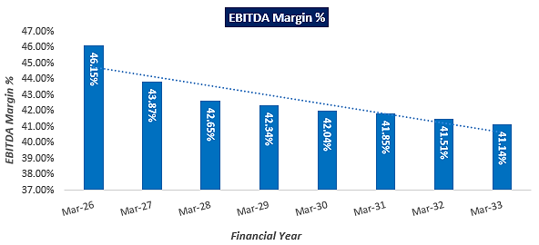
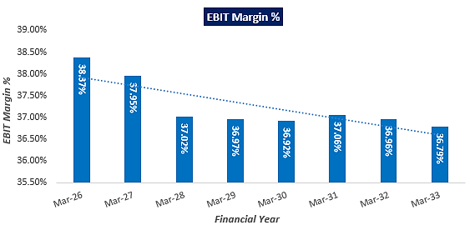
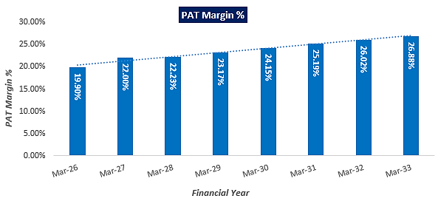
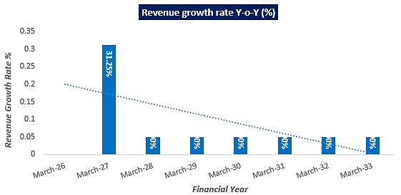

- ESTIMATED KEY FINANCIAL METRICS:
DEBT SERVICE COVERAGE RATIO (DSCR)

Year Ending | 31-Mar-26 | 31-Mar-27 | 31-Mar-28 | 31-Mar-29 | 31-Mar-30 | 31-Mar-31 | 31-Mar-32 | 31-Mar-33
Year Counter | 1 | 2 | 3 | 4 | 5 | 6 | 7 | 8
Months Counter | 12 | 12 | 12 | 12 | 12 | 12 | 12 | 12
Cash accrual | 3.77 | 4.98 | 5.21 | 5.61 | 6.03 | 6.46 | 6.91 | 7.41
Interest on term loan | 1.54 | 1.46 | 1.31 | 1.12 | 0.90 | 0.68 | 0.44 | 0.16
Interest on WC | 0.05 | 0.05 | 0.05 | 0.05 | 0.05 | 0.05 | 0.05 | 0.05
Subtotal | 5.36 | 6.49 | 6.57 | 6.78 | 6.99 | 7.19 | 7.41 | 7.62
Interest on term loan | 1.54 | 1.46 | 1.31 | 1.12 | 0.90 | 0.68 | 0.44 | 0.16
Interest on WC | 0.05 | 0.05 | 0.05 | 0.05 | 0.05 | 0.05 | 0.05 | 0.05
Loan Repayment | 0.00 | 1.40 | 1.40 | 2.00 | 2.00 | 2.00 | 2.34 | 2.85
Subtotal | 1.59 | 2.91 | 2.76 | 3.17 | 2.95 | 2.73 | 2.84 | 3.06
DSCR | 3.37 | 2.23 | 2.38 | 2.14 | 2.37 | 2.63 | 2.61 | 2.49
Average DSCR | 2.53
Maximum DSCR | 3.37

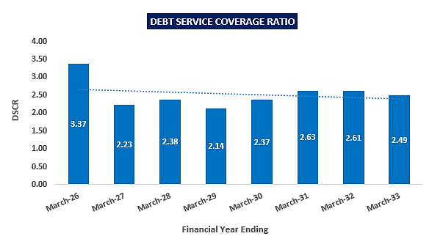

- SENSITIVITY ANALYSIS OF D.S.C.R:
The proposed project is found comparatively more sensitive with respect to the downside fluctuation in revenue, than the upside fluctuation in cost of raw material and any surge in the interest rate. Sensitivity analysis of the project with respect to 5% decrease in the revenue, 5% increase in the cost of raw material and 2% increment in the proposed interest rate has been done as requested by bank/client shown in the below table:

Sensitivity Analysis of D.S.C.R
S. No. | Particular | Average D.S.C.R | Max. D.S.C.R
 | If the projected revenue decreased by 5% | 2.25 | 3.05
 | If the projected revenue decreased by 10% | 1.98 | 2.73
 | If the projected Cost of raw material decreased by 5% | 2.44 | 3.28
 | If the projected Cost of raw material decreased by 10% | 2.35 | 3.19
 | If interest rate is increased by 2% | 2.40 | 3.12

- NPV,IRR AND PAYBACK PERIOD OF THE PROJECT:
(INR Crore)
Year Ending | 31-Mar-25 | 31-Mar-26 | 31-Mar-27 | 31-Mar-28 | 31-Mar-29 | 31-Mar-30 | 31-Mar-31 | 31-Mar-32 | 31-Mar-33
Year Counter | 0 | 1 | 2 | 3 | 4 | 5 | 6 | 7 | 8
Months Counter | 9 | 12 | 12 | 12 | 12 | 12 | 12 | 12 | 12
EBIT | 0.00 | 5.18 | 6.72 | 6.89 | 7.22 | 7.57 | 7.98 | 8.36 | 8.74
Less: Taxes | 0.00 | 0.90 | 1.31 | 1.39 | 1.52 | 1.67 | 1.82 | 1.98 | 2.15
Add: Depreciation & Amortisation | 0.00 | 1.05 | 1.05 | 1.05 | 1.05 | 1.05 | 1.03 | 1.03 | 1.03
NOPAT | 0.00 | 5.33 | 6.46 | 6.54 | 6.75 | 6.96 | 7.19 | 7.41 | 7.62
Increase/(Decrease) in working capital | 0.00 | 1.25 | 0.42 | 0.08 | 0.08 | 0.09 | 0.09 | 0.09 | 0.10
Capex | 22.12 | 0.00 | 0.00 | 0.00 | 0.00 | 0.00 | 0.00 | 0.00 | 0.00
Free Cash Flow to Firm (FCFF) | -22.12 | 4.08 | 6.05 | 6.46 | 6.67 | 6.87 | 7.10 | 7.31 | 7.52

Key Input for NPV & IRR
S. No. | Key Input | Description
 | Nifty 50 Returns (CAGR) in the Last 20 Years | 14.97% (https://kunaldesai.blog/nifty-50-cagr-last-20-years/)
 | Firm’s Risk Premium | 0.50%
 | Discount Rate | 15.47%
NPV |  | INR 5.28 Crore
IRR |  | 21.84%
(INR Crore)
Payback Period of the Project
Financial Year | Cash Accrual | Accumulated Cash Accrual
Mar-26 | 3.77 | 3.77
Mar-27 | 4.98 | 8.74
Mar-28 | 5.21 | 13.96
Mar-29 | 5.61 | 19.56
Mar-30 | 6.03 | 25.60
Mar-31 | 6.46 | 32.05
Mar-32 | 6.91 | 38.96
Mar-33 | 7.41 | 46.38
Total | 46.38
TPC | INR 22.58 Crore
Payback Period | 4.50 Years
Thus, the project will be having a payback period of 4.50 years and NPV & IRR of the project as on COD will INR 5.28 Crore & 21.84% respectively, which indicates worthiness of the project. Sensitivity Analysis for NPV, IRR and payback period of the proposed project is shown in the below table:
Sensitivity Analysis of NPV, IRR & Payback Period
S. No. | Particular | NPV | IRR | Payback Period
 | If the projected revenue decreased by 5% | 2.23 Cr. | 18.24% | 5.06 Years
 | If the projected revenue decreased by 10% | -0.82 Cr. | 14.42% | 5.82 Years
 | If the projected Cost of raw material increased by 5% | 4.24 Cr. | 20.63% | 4.67 Years
 | If the projected Cost of raw material increased by 10% | 3.20 Cr. | 19.40% | 4.85 Years
 | If interest rate is increased by 2% | 5.47 Cr. | 22.07% | 4.62 Years

- OTHER FINANCIAL RATIOS:
Year Ending | 31-Mar-26 | 31-Mar-27 | 31-Mar-28 | 31-Mar-29 | 31-Mar-30 | 31-Mar-31 | 31-Mar-32 | 31-Mar-33
ROCE (%) | 21.70% | 25.49% | 24.16% | 23.27% | 22.28% | 21.53% | 20.84% | 18.80%
Average | 22.26%
Return on Investment (%) | 31.29% | 45.41% | 48.18% | 52.72% | 57.70% | 63.19% | 68.54% | 74.34%
Average | 55.17%
Return on Net Worth | 23.83% | 25.70% | 21.42% | 18.99% | 17.21% | 15.86% | 14.68% | 13.73%
Average | 18.93%
DSCR | 3.37 | 2.23 | 2.38 | 2.14 | 2.37 | 2.63 | 2.61 | 2.49
Average | 2.53
ISCR | 3.92 | 5.14 | 5.84 | 7.05 | 9.05 | 12.31 | 19.03 | 47.07
Average | 13.68
Fixed Asset Coverage Ratio | 1.67 | 1.79 | 2.06 | 2.49 | 3.25 | 5.55 | - | -
Average | 2.80
Current Ratio | 2.37 | 2.42 | 2.41 | 2.40 | 2.40 | 2.38 | 2.37 | 2.36
Average | 2.39
TOL/TNW | 1.38 | 0.95 | 0.67 | 0.46 | 0.32 | 0.21 | 0.12 | 0.05
Average | 0.52
Debt to Equity Ratio | 1.64 | 1.48 | 1.31 | 1.08 | 0.84 | 0.61 | 0.33 | 0.00
Average | 0.91

(INR Cr.)
Year Ending | 31-Mar-26 | 31-Mar-27 | 31-Mar-28 | 31-Mar-29 | 31-Mar-30 | 31-Mar-31 | 31-Mar-32 | 31-Mar-33
Cash Accrual
PAT | 2.69 | 3.90 | 4.14 | 4.53 | 4.95 | 5.42 | 5.88 | 6.38
Add: Dep & Am | 1.05 | 1.05 | 1.05 | 1.05 | 1.05 | 1.03 | 1.03 | 1.03
Prel. Exp. written off | 0.03 | 0.03 | 0.03 | 0.03 | 0.03 | 0.00 | 0.00 | 0.00
Cash Accrual | 3.77 | 4.98 | 5.21 | 5.61 | 6.03 | 6.46 | 6.91 | 7.41
Repayment Obligations | 0.00 | 1.40 | 1.40 | 2.00 | 2.00 | 2.00 | 2.34 | 2.85
Net cash accrual | 3.77 | 3.58 | 3.81 | 3.61 | 4.03 | 4.46 | 4.57 | 4.56
Cumulative Internal Accruals | 3.77 | 7.34 | 11.16 | 14.76 | 18.79 | 23.25 | 27.82 | 32.38

- BREAK-EVEN ANALYSIS:
(INR Crore)
Year Ending | 31-Mar-26 | 31-Mar-27 | 31-Mar-28 | 31-Mar-29 | 31-Mar-30 | 31-Mar-31 | 31-Mar-32 | 31-Mar-33
Year Counter | 1 | 2 | 3 | 4 | 5 | 6 | 7 | 8
Months Counter | 12 | 12 | 12 | 12 | 12 | 12 | 12 | 12
Sales | 13.50 | 17.72 | 18.60 | 19.53 | 20.51 | 21.53 | 22.61 | 23.74
Variable Expenses | 6.68 | 8.54 | 9.03 | 9.54 | 10.09 | 10.67 | 11.29 | 11.94
Contribution | 6.82 | 9.17 | 9.57 | 9.99 | 10.42 | 10.87 | 11.33 | 11.80
Fixed Expenses | 1.24 | 1.59 | 1.66 | 1.74 | 1.82 | 1.91 | 2.00 | 2.09
Profit / PBT | 5.58 | 7.59 | 7.91 | 8.25 | 8.60 | 8.96 | 9.33 | 9.71
PV RATIO | 50.52% | 51.77% | 51.47% | 51.15% | 50.81% | 50.46% | 50.09% | 49.70%
BEP Sales | 2.46 | 3.06 | 3.22 | 3.40 | 3.58 | 3.78 | 3.99 | 4.21
BEP% (BEP Sales / sales) | 18.22% | 17.28% | 17.33% | 17.39% | 17.46% | 17.54% | 17.62% | 17.72%

- TERM LOAN INPUTS:
Term Loan Repayment Inputs
Total loan amount | INR 14.00 Crore
Rate of Interest | 11%
1st Disbursement | September-24
IDC Start & End Month | September-24 to March-25
IDC Period (construction period) | 7 Month
Commencement /Operation Start | April-25
Moratorium Start & End Month (only interest to pay) | September 2024 to March 2026
Moratorium Period after COD | 12 Month
Repayment Start | April 2026
Repayment End | March 2033
Repayment Period | 7 Years (84 Months)

Year Ending (INR Crore) | 31-Mar-25 | 31-Mar-26 | 31-Mar-27 | 31-Mar-28 | 31-Mar-29 | 31-Mar-30 | 31-Mar-31 | 31-Mar-32 | 31-Mar-33
Year Counter | 0 | 1 | 2 | 3 | 4 | 5 | 6 | 7 | 8
Months Counter | 9 | 12 | 12 | 12 | 12 | 12 | 12 | 12 | 12
Opening Bal | 0.00 | 14.00 | 14.00 | 12.60 | 11.20 | 9.20 | 7.20 | 5.20 | 2.85
Disbursement | 14.00 | 0.00 | 0.00 | 0.00 | 0.00 | 0.00 | 0.00 | 0.00 | 0.00
Repayment | 0.00 | 0.00 | 1.40 | 1.40 | 2.00 | 2.00 | 2.00 | 2.34 | 2.85
Closing Principal o/s | 14.00 | 14.00 | 12.60 | 11.20 | 9.20 | 7.20 | 5.20 | 2.85 | 0.00
Interest | 0.71 | 1.54 | 1.46 | 1.31 | 1.12 | 0.90 | 0.68 | 0.44 | 0.16
IDC | 0.71 | 0.00 | 0.00 | 0.00 | 0.00 | 0.00 | 0.00 | 0.00 | 0.00
TL Interest | 0.00 | 1.54 | 1.46 | 1.31 | 1.12 | 0.90 | 0.68 | 0.44 | 0.16

- DEPRECIATION SCHEDULE (STRAIGHT LINE METHOD):
(INR Crore)
Depreciation Schedule based on useful life of asset as per Company's Act, 2013 (INR Crore)
Particular | 31-Mar-26 | 31-Mar-27 |  |  | 31-Mar-28 | 31-Mar-29 |  | 31-Mar-30 |  |  | 31-Mar-31 | 31-Mar-32 |  |  | 31-Mar-33
Land | 2.20 | 2.20 |  |  | 2.20 | 2.20 |  | 2.20 |  |  | 2.20 | 2.20 |  |  | 2.20
Depreciation | 0.00 | 0.00 |  |  | 0.00 | 0.00 |  | 0.00 |  |  | 0.00 | 0.00 |  |  | 0.00
Electricity Connection & Infrastructure | 0.00 | 0.00 |  |  | 0.00 | 0.00 |  | 0.00 |  |  | 0.00 | 0.00 |  |  | 0.00
Depreciation | 0.00 |  | 0.00 | 0.00 |  |  | 0.00 |  | 0.00 | 0.00 |  |  | 0.00 | 0.00
Building & Civil Works | 4.19 | 4.19 |  |  | 4.19 | 4.19 |  | 4.19 |  |  | 4.19 | 4.19 |  |  | 4.19
Depreciation | 0.12 | 0.12 |  |  | 0.12 | 0.12 |  | 0.12 |  |  | 0.12 | 0.12 |  |  | 0.12
Plant & Machinery | 15.58 | 15.58 |  |  | 15.58 | 15.58 |  | 15.58 |  |  | 15.58 | 15.58 |  |  | 15.58
Depreciation | 0.91 | 0.91 |  |  | 0.90 | 0.91 |  | 0.91 |  |  | 0.91 | 0.90 |  |  | 0.91
Furniture & Fixtures | 0.05 | 0.05 |  |  | 0.05 | 0.05 |  | 0.05 |  |  | 0.05 | 0.05 |  |  | 0.05
Depreciation | 0.00 | 0.00 |  |  | 0.00 | 0.00 |  | 0.00 |  |  | 0.00 | 0.00 |  |  | 0.00
Office equipment | 0.10 | 0.10 |  |  | 0.10 | 0.10 |  | 0.10 |  |  | 0.10 | 0.10 |  |  | 0.10
Depreciation | 0.02 | 0.02 |  |  | 0.02 | 0.02 |  | 0.02 |  |  | 0.00 | 0.00 |  |  | 0.00
Total SLM Depreciation | 1.05 | 1.05 |  |  | 1.05 | 1.05 |  | 1.05 |  |  | 1.03 | 1.03 |  |  | 1.03

- WORKING CAPITAL REQUIREMENT:
(INR Crore)
Year Ending | 31-Mar-26 | 31-Mar-27 | 31-Mar-28 | 31-Mar-29 | 31-Mar-30 | 31-Mar-31 | 31-Mar-32 | 31-Mar-33
Current Assets | 2.16 | 2.83 | 2.98 | 3.12 | 3.28 | 3.44 | 3.62 | 3.80
Current Liabilities | 0.91 | 1.17 | 1.23 | 1.30 | 1.37 | 1.44 | 1.52 | 1.61
Working Capital | 1.25 | 1.66 | 1.74 | 1.83 | 1.91 | 2.00 | 2.09 | 2.19
Working Capital Margin @25% | 0.31 | 0.42 | 0.44 | 0.46 | 0.48 | 0.50 | 0.52 | 0.55
Working Capital gap | 0.93 | 1.25 | 1.31 | 1.37 | 1.43 | 1.50 | 1.57 | 1.64
CC Limit | 0.50 | 0.50 | 0.50 | 0.50 | 0.50 | 0.50 | 0.50 | 0.50
Interest Rate | 11% | 11% | 11% | 11% | 11% | 11% | 11% | 11%
Interest on CC loan | 0.05 | 0.05 | 0.05 | 0.05 | 0.05 | 0.05 | 0.05 | 0.05

- KEY ASSUMPTIONS & BASIS:
S. No. | Item | Assumptions and Basis
 | General | - The projections of the firm are done for the period from FY 2026 to FY 2036, 8 years, to cover the term loan period as per the industry best practices. It is assumed that the plant will be achieving COD on 1st April 2025. Initially Plant will operate @80% capacity during first projected year.  - We have considered both Revenue & cost based model (top to bottom approach) while making the future financial projections.  - Revenue modelling has been done based on required production as per the LOI with the IOCL. Expense modelling has been done based on the capacity utilization during the respective year except for the raw material which is considered based on raw material ratio and its price in the market.
 | Revenue Build up | - The plant is assumed to be operational for 335 days for 24 hours annually.  - LLP will be generating the revenue by selling 6 TPD Bio-CNG to IOCL as per LOI issued by the OMC on 6th Dec 2023 and 23 ton per day fermented Solid organic fertilizers as its by-products. Below table shows the Revenue of the LLP @100% capacity utilization:  Revenue @100% capacity  Products Unit Price Annual Quantity Amount (INR)  Sale of Bio-CNG 62.86 INR/Kg 20,09,975 13.27 Cr.  Sale of Compost/ Solid Manure 5.50 INR/Kg 77,05,000 4.45 Cr.  Total Revenue (INR) 17.72 Cr.  - Thus the LLP is expected to generate INR 13.50 Crore (@ 80% Capacity Utilization) in the initial year. Further it is expected to increase up to INR 23.74 Crore till FY 2032-33.  - Based on the forecasting, the LLP is achieving an average revenue growth rate of 5% Y-o-Y basis from FY 2026-27 due to a 5% escalation assumed in the selling price during the forecasted period.
 | Pricing (Average Price Per Unit) | - Proposed selling price per unit of CBG and by products are shown in the below table:  Selling price per unit  Products Unit prices  Selling price of Bio-CNG @ 62.86 as per Pricing Circular INR 62.86 per kg  Selling price of solid organic fertilizer INR 5.50 per kg  - The Bio-CNG produced has to be sold to Indian Oil Corporation Ltd stations situated within 25-75 km, for which the LLP has already secured a LOI (Ref No. - Indian Oil/SATAT/01/3613, Date: 06.012.2023). The procurement price of Bio-CNG is considered as INR 62.86 per kg without GST according to the pricing circular of CBG under SATAT Scheme.  Reference: CNG Price in Meerut as on 19th July 2024 was ~80.50 (https://www.goodreturns.in/cng-price.html) which comes under the slab of INR 62.86/- without G.S.T as per pricing Circular.  - As per the current market scenario, the fermented organic solid manure/fertilizer is sold to farmers or outlets at around INR 6.00 to 7.00 per kg including with packing and bagging facilities. Whereas the bulk-selling rate of solid fermented organic manure/fertilizer is around 4.00 to 5.00 per kg. We have considered the FOM price as per the recommendations of The Indian Biogas Association (IBA), for a fair and remunerative price of Rs 5.5 per kg for fermented organic manure (FOM), excluding the government incentive of Rs 1.5 per kg, to support biogas plants in the country. (https://economictimes.indiatimes.com/industry/indl-goods/svs/chem-/-fertilisers/fix-fair-remunerative-price-of-rs-5-5/kg-for-fermented-organic-manure-indian-biogas-association/articleshow/103100564.cms?from=mdr)  - The selling price of Bio-CNG & FOM is considered on conservative side, an escalation factor of 5% has been considered in the prices of the sellable products during the forecasted periods considering the micro and macro-economic factors.
 | Capacity Utilization | - The proposed CBG generating plant will be commissioned with a Design capacity of 14,400 M3/Day, which will be operating at 100% of the designed capacity to generate 6193 Kg Bio-CNG per day. After adjusting the leakage factor @~3% LLP will be able to supply 6TPD Bio-CBG as per letter of Intent (LOI) with Indian Oil under SATAT scheme.  - We have assumed 80% capacity utilisation of the plant in first year, and 100% from 2nd year onwards throughout the projected period since 6,000 kg Bio CNG has to be supply by the LLP to OMC (IOCL).
 | Capital Expenditure | - The proposed Bio-CNG plant is proposed to be setup at a total of about 18,771 Sq. Mt. land area in Meerut, U.P. As per provisional Balance sheet of the LLP dated 31st March 2024, value of the land is INR 2.20 Crore including registration charges as informed by client, which is considered as a part of total project cost.  - As per the data/information provided by the client, the estimated cost of the Building & Civil works is ~INR 4.00 Crore including Land development & Boundary wall. However, as a TEV consultant, the estimated Building & Civil works cost has been verified independently by us based on the quantity provided by the client as per Market Standard Rates.  As per our assessment, the cost of the following civil work will be in range of ~INR 5-5.5 Crore depending upon the specification of the material and construction. We recommend the bank to get the verified cost of building & civil works from an appointed Architect/Chartered Engineer.  - The estimated cost for plant & machinery will be ~INR 14.88 Crore including the applicable GST. The estimated cost of the Plant & Machinery has been provided to us by the client as per quotations received by them from various vendors/suppliers. However, as a TEV consultant the cost of major plant & machinery has been verified by us independently, which we found comparatively lower than the industrial/sectoral benchmark although the cost may change as per specifications & brand.  - Estimated cost of miscellaneous assets such as office equipment and Furniture & Fixtures would be ~INR 15 lakhs (Tentative). Preliminary & Pre-Operative Expenses has been taken as lump sum basis, based on the time period of construction and estimate of LLP’s resources involvement during this time in supervision & monitoring of the construction as INR 15.00 lakhs including INR 5.00 lakhs bank guarantee for LOI with IOCL.  - Contingency cost of INR 19 lakhs (~1% of TPC) has been considered based on general assumption and professional experience. Interest during Construction will be paid from September 2024 by the LLP @ 11.00%. As per the loan schedule prepared, IDC comes to INR 71 lakhs till March, 2025.  - Thus, ~INR 3.76 Crore per ton will be the CAPEX for the proposed Bio-CNG generating plant including land, GST, transportation charges etc. considering the fact that the plant would be commissioned by the in-house experienced EPC/technical team of the LLP in coordination with the appointed technical consultant and thus the CAPEX per ton is lower as per the industrial/sectoral benchmark as per the tertiary research done by us, data/information available in the public domain and information provided by the third party consultants/vendors.  - Also, the plant will produce only solid organic fertilizer which comparatively lowering the capex for proposed plant as there is no installation cost of plant & Machinery for liquid fertilizers production.  (Reference: As per Ministry of New and Renewable energy, the approx. CAPEX of installing a 5 TPD capacity CBG plant is estimated between INR 20-25 crore and ~75 80% of the CAPEX cost is for purchasing plant machinery).
 | Expenses | - As sugar mill owners have now recognised its potential for revenue generation. This realisation has resulted in a substantial increase in press mud prices over the last two years, rising from INR 100 per tonne to INR 500-600 per tonne including transportation. As escalated in recent years, the sugarcane press mud is generated by the sugar mill and made available to the project @ INR 1200/ Ton. The cattle dung is collected from various dairy farms/ nearby villages @ INR 1000/MT and used as inoculants. (Ref:https://www.downtoearth.org.in/news/renewable-energy/sugarcane-byproduct-pressmud-can-be-a-sweet-spot-for-india-s-compressed-biogas-sector-93022#:~:text=This%20realisation%20has%20resulted%20in,as%20fuel%20in%20brick%20kilns).  Jaggery waste & Non edible oil cake will be used as an additive in the CBG production process, which is generally available @INR 25 per kg in the open market. The cost of the raw material @ 100% capacity has been shown in the below table:  Raw material Cost @ 100% capacity  Raw Material INR/Ton Annual Quantity Amount INR  Cattle Dung 1000 3,350 0.35 Cr.  Sugarcane press mud 1,200 40200 5.07Cr.  Jaggery waste & Non edible oil cake as an additive 25000 167.5 0.44 Cr.  Total INR 5.86 Crore  - As per our tertiary research and data available in the public domain, we found the unit rate are in the permissible range. Escalation of 5% is considered during forecasted period.  - As per the tentative estimation provided by the client, total consumption of electric units will be 5825 kWh per day and proposed CBG will be using variable frequency drive (VFD) in motors to reduce electricity load by 25%. Thus the estimated consumption of electric units will be ~4369 units/ kWh per day. This is a provisional number. The final number will be determined during detailed engineering.  As per information available on Paschimanchal Vidyut Vitran Nigam Ltd website, the applicable per unit charges will INR 10 per Kwh. Thus the annual electricity expenses would be INR 1.54 Crore. An escalation rate of 5% is assumed on it.  - As per data provided by client, plant will initiate its operations with 37 human resources. ~INR 1.04 Crore will be the expenses for remuneration. A 10% escalation rate has been considered during the forecasted period, on the salary & wages of the proposed manpower.  - Packaging cost for solid manure has been considered as INR 20 per 50 kg bag as per the industry benchmark. Escalation of 5% has been considered during the forecasted period.  - Transpiration charges has been considered as 3% of the revenue Y-o-Y basis.  - Marketing, Selling and distribution Expenses has been considered as 0.50% of the revenue Y-o-Y basis.  - Maintenance expenses has been considered in % of gross block Y-o-Y basis as shown below:  Maintenance on Plant (% of Gross Block)  Electricity Infrastructure 0.20%  Civil & M.S. Work 0.50%  P& M including other equipment 0.50%  Furniture & Fixtures 0.20%  Office Equipment 0.20%  - Plant and Administrative Overhead Expenses, Other Manufacturing Expenses are considered as 1.50% and 1.25% respectively of the revenue on Y-o-Y basis. Insurance expenses has been considered as 0.25% of net block on Y-o-Y basis.
 | Partial Loan | - The project is proposed to be funded through a term loan of INR 14.00 crore and promoter’s equity of INR 8.58 crores.  - The tenure of the loan will be 8 years from C.O.D i.e. 1st April 2025 to 31st March 2033. Implementation period of 7 months and 12 months post C.O.D i.e. total 19 months are considered as moratorium period  - As per discussion with bank, Interest rate has been considered as 11%.  - Further, as per the working capital assessment, the working capital LLP will required a WC loan of INR 50.00 lakhs to meet the day to day operational expenses.

Key Findings:
      - Average DSCR, EBIDTA margin, EBIT margin is 2.53, 42.69%, and 37.25% respectively during the estimated period.
      - The Proposed CBG plant is having a positive NPV and IRR as on COD, of INR 5.28 Crore and 22.84% respectively at the base cases while it may vary with changes in the assumptions & micro and macro-economic trends considered as on date.
      - The proposed project is having a payback period of 4.50 years.
      - Based on the above key financial ratios of the proposed Project during the forecasted period shows that the project appears financially viable if the promoters of the project are able to maintain assumed capacity utilization, revenue and can contain cost as assumed above in the calculation.

PART N | CONCLUSION

Based on the technological, economical and market analysis done above, various assumptions of sectoral trends taken, product pricing to be adopted by the LLP, the Project appears to be Techno-commercially viable subject to the risks, threats, weaknesses, limitations of the product as detailed previously.
As per financial projections for the estimated period, Average DSCR, EBITDA Margin and EBIT Margin of the project are 2.53, 42.68% and 37.25% respectively, where higher DSCR is the indicator of the project capability to pay out its outstanding debt and EBITDA margin shows the capability of the project to generate the operating profits over the forecasted period. Also the project is having the payback period of 4.50 Years in the line with sectoral trends.
The proposed Bio-CNG generating facility is having a positive NPV and IRR as INR 5.28 Crore and 21.84% respectively at a 100% capacity utilization as the industry is expectedly growing at a CAGR of 6.34% during the forecasted period. While it is not avoidable that the future projections may change in the upcoming years due to various factors impacting the operation, managerial, financial efficiency and economies of scale of the project.
While it would be depending on the management’s capability in future that how efficiently LLP adopts marketing and advertisement strategy, supply chain and carry out inventory & resource management to achieve higher profitability. After considering the foreseen demand of the Bio CNG and its by-products domestically and globally, various initiatives taken by the government, financial analysis of the project based on the assumptions taken over the projected period, it appears reasonable to comment that the proposed project is “Technically and Economically” Viable subject to current assumptions considered and occurring the same in the upcoming years same as the forecasted period which is dependent on the sincerity and efforts of the management and various micro and macroeconomic & industry situation.
We have tried our level best to analyse the Project techno-economic feasibility of the Project based on the Industry research, Project information and various futuristic assumption taken within the limitations and challenges came in front of us. However achieving the financial milestones depends on the ability, sincerity and efforts of the LLP, partners/designated partners and its key management to maintain the projected revenue level Y-o-Y basis keeping the fact in mind that the project is found sensitive with respect to the down side fluctuation in the revenue.

Declaration | - The undersigned does not have any direct/indirect interest in the above property/project/LLP.  - The information furnished herein is true and correct to the best of our knowledge, logical and scientific assumptions.  - This TEV Report is carried out by our Financial Analyst team on the request from PNB, CBB Branch, E. K. Road Meerut - 250004.  - Meeting of Financial projections will be subject to the market & economy stability factors, judicious business operations and proper & timely implementation of the project and putting proper plan for achieving high productivity, efficiency and achieving cost saving benefits to increase profitability.  - We have submitted TEV report to the PNB, CBB Branch, Meerut.
Number of Pages in the Repost | 102
Enclosed Documents | Disclaimer & Remarks 95-98
Place | Noida
Date | 26th August 2024

FOR ON BEHALF OF
M/S. R.K. ASSOCIATES VALUER & TECHNO ENGINEERING CONSULTANTS PVT. LTD.
SURVEYED BY | PREPARED BY | REVIEWED BY
Mr. Atul Gola | Mr. Gaurav Kumar | Mr. Rachit Gupta

PART O | DISCLAIMER | REMARKS

      - No employee or member of R.K Associates has any direct/ indirect interest in the Project.
      - This report is prepared based on the copies of the documents/ information which the Bank/ Company/LLP has provided to us out of the standard checklist of documents sought from them and further based on our assumptions and limiting conditions. The client/owner and its management/representatives warranted to us that the information they supplied was complete, accurate and true and correct to the best of their knowledge. All such information provided to us has been relied upon in good faith and we have assumed that it is true and correct in all respect. I/We shall not be liable for any loss, damages, cost or expenses arising from fraudulent acts, misrepresentations, or wilful default on part of the owner, company/LLP, its directors, employee, representative or agents. Verification or cross checking of the documents provided to us from the originals or from any Govt. departments/ Record of Registrar has not been done at our end since this is beyond the scope of our work. If at any time in future, it is found or came to our knowledge that misrepresentation of facts or incomplete or distorted information has been provided to us then this report shall automatically become null & void.
      - Legal aspects for e.g. investigation of title, ownership rights, lien, charge, mortgage, lease, sanctioned maps, verification of documents, etc. have not been done at our end and same has to be taken care by legal expert/ Advocate. It is assumed that the concerned Lender/ Financial Institution has satisfied them with the authenticity of the documents, information given to us and for which the legal verification has been already taken and cleared by the competent Advocate before requesting for this report. I/ We assume no responsibility for the legal matters including, but not limited to, legal or title concerns.
      - This report is a general analysis of the project based on the scope mentioned in the report. This is not an Audit report, Design document, DPR or Techno feasibility study. All the information gathered is based on the facts seen on the site during survey, verbal discussion & documentary evidence provided by the client and is believed that information given by the company/LLP is true best of their knowledge.
      - This Techno Economic-Viability study is prepared based on certain futuristic assumption which are intra dependent on economic, market and sectorial growth condition in future and socio-economic, socio-political condition at macro and micro level.
      - Meeting of assumption and financial ratio will entirely depend on the sincerity and efforts of the company/LLP, promoters and its key managerial performance.
      - All observations mentioned in the report is only based on the visual observation and the documents/ data/ information provided by the client. No mechanical/ technical tests, measurements or any design review have been performed or carried out from our side during Project assessment.
      - This report has been diligently prepared by our techno-financial team to the best of their ability. However, it's important to note that the recommendations provided in this Total Economic Viability (TEV) assessment do not imply an endorsement, validation, or certification of the accuracy or completeness of the disclosed information by the involved stakeholders. Furthermore, we do not claim or endorse that the opinions presented herein are the sole best course of action for decision-makers to follow. There may exist additional approaches and inputs that have not been covered within this report or fall outside the scope of this report.
      - Bank/FII should ONLY take this report as an Advisory document from the Financial/ Chartered Engineering firm and its specifically advised to the creditor to cross verifies the original documents for the facts mentioned in the report which can be availed from the borrowing company/LLP directly.
      - In case of any default in loans or the credit facility extended to the borrowing company/LLP, R.K Associates shall not be held responsible for whatsoever reason may be and any request for seeking any explanation from the employee/s of R.K Associates will not be entertained at any instance or situation.
      - The documents, information, data provided to us during the course of this assessment by the client are reviewed only up to the extent required in relation to the scope of the work. No document has been reviewed beyond the scope of the work.
      - This report only contains general assessment & opinion as per the scope of work evaluated as per the information given in the copy of documents, information, data provided to us and/ and confirmed by the owner/ owner representative to us at site which has been relied upon in good faith. It doesn’t contain any other recommendations of any sort including but not limited to express of any opinion on the suitability or otherwise of entering into any transaction with the borrower.
      - We have relied on data from third party, external sources & information available on public domain also to conclude this report. These sources are believed to be reliable and therefore, we assume no liability for the truth or accuracy of any data, opinions or estimates furnished by others that have been used in this analysis. Where we have relied on data, opinions or estimates from external sources, reasonable care has been taken to ensure that such data has been correctly extracted from those sources and /or reproduced in its proper form and context, however still we can’t vouch its authenticity, correctness or accuracy.
      - This Report is prepared by our competent technical team which includes Engineers and financial experts & analysts.
      - This is just an opinion report and doesn’t hold any binding on anyone. It is requested from the concerned Financial Institution which is using this report for taking financial decision on the project that they should consider all the different associated relevant & related factors also before taking any business decision based on the content of this report.
      - All Pages of the report including annexure are signed and stamped from our office. In case any paper in the report is without stamp & signature then this should not be considered a valid paper issued from this office.
      - Though adequate care has been taken while preparing this report as per its scope, but still we can’t rule out typing, human errors, over sightedness of any information or any other mistakes. Therefore, the concerned organization is advised to satisfy themselves that the report is complete & satisfactory in all respect. Intimation regarding any discrepancy shall be brought into our notice immediately. If no intimation is received within 15 (Fifteen) days in writing from the date of issuance of the report, to rectify these timely, then it shall be considered that the report is complete in all respect and has been accepted by the client up to their satisfaction & use and further to which R.K Associates shall not be held responsible in any manner.
      - Defect Liability Period is 15 DAYS. We request the concerned authorized reader of this report to check the contents, data and calculations in the report within this period and intimate us in writing if any corrections are required or in case of any other concern with the contents or opinion mentioned in the report. Corrections only related to typographical, calculation, spelling mistakes, incorrect data/ figures/ statement will be entertained within the defect liability period. Any new changes for any additional information in already approved report will be regarded as additional work for which additional fees may be charged. No request for any illegitimate change in regard to any facts & figures will be entertained.
      - R.K Associates encourages its customers to give feedback or inform concerns over its services through proper channel at valuers@rkassociates.org in writing within 15 days of report delivery. After this period no concern/ complaint/ proceedings in connection with the Techno- Economic Viability Study Services will be entertained due to possible change in situation and condition of the subject Project.
      - Our Data retention policy is of ONE YEAR. After this period, we remove all the concerned records related to the assignment from our repository. No clarification or query can be answered after this period due to unavailability of the data.
      - This Techno Economic Viability Study report is governed by our (1) Internal Policies, Processes & Standard Operating Procedures, (2) Information/ Data/ Inputs given to us by the client and (3) Information/ Data/ Facts given to us by our field/ office technical team. Management of R.K Associates never gives acceptance to any unethical or unprofessional practice which may affect fair, correct & impartial assessment and which is against any prevailing law. In case of any indication of any negligence, default, incorrect, misleading, misrepresentation or distortion of facts in the report then it is the responsibility of the user of this report to immediately or at least within the defect liability period bring all such act into notice of R.K Associates management so that corrective measures can be taken instantly.
      - R.K Associates never releases any report doing alterations or modifications from pen. In case any information/ figure of this report is found altered with pen then this report will automatically become null & void.
      - If this report is prepared for the matter under litigation in any Indian court, no official or employee of R.K Associates will be under any obligation to give in person appearance in the court as a testimony. For any explanation or clarification, only written reply can be submitted on payment of charges by the plaintiff or respondent which will be 10% of the original fees charged where minimum charges will be Rs. 15,000/.

EXTRACTS OF IMPORTANT DATA/STATUTORY APPROVALS PROVIDED BY THE CLIENT

