PROJECT REPORT

OF



MAA VINDHYAVASINI FOILS LIMITED

**Registered Office :**

6/162, Raj Nagar, Ghaziabad, Uttar Pradesh 201001

**Works:**

Khasra No 138, Village Susanda, Pargana Mangalore, Tehsil Rudki, Haridwar, Uttarakhand

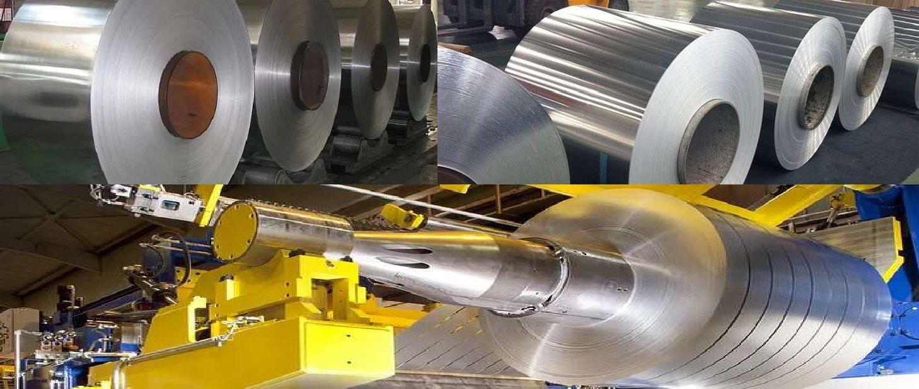

**Contact Person:**

Mr. Parag Gupta (Managing Director) +91 9870323332

Mr. akul Gupta (Director) +91 7088002911

## INDEX

1. INTRODUCTION 04
   * COMPANY OVERVIEW 04
2. PRODUCTION CAPACITIES……………………………………………………………………………………….04
3. ALUMINIUM PRODUCTS……………………………………………………………………………………….…04

* Aluminium Plain sheet……………………………………………………………………………….04
* Aluminium Chequered Sheet / Pattern Sheet…………………………………………….05
* Aluminium Closure Stock…………………………………………………………………………..06
* Aluminium Bare Foil…………………………………………………………………………………..06
* Aluminium Roofing Sheet………………………………………………………………………….07
* Aluminium Home Foil……………………………………………………………………………….07

1. ABOUT THE ALUMINIUM FOIL…………………………………………………………………………………07

* Properties of Aluminum Foil……………………………………………………………………………..07
* Aluminum Production Process………………………………………………………………………….08
* Common Uses of Aluminum……………………………………………………………………………..08

1. ALUMINIUM FOIL IN INDIAN ECONOMY 09
2. MAJOR CONTRIBUTORS OF ALUMINUM IN INDIA 10
3. ALUMINUM AND GLOBAL MARKET 11

* Asia Pacific Market……………………………………………………………………………………..12

1. MANUFACTURING PROCESS 12

* Cold Rolling Mill…………………………………………………………………………………………………….12
* Foil Mill Rolling ……………………………………………………………………………………………………..12
* Annealing………………………………………………………………………………………………………………13
* Slitting and Cutting……………………………………………………………………………………………….13
* Quality Control and Packaging……………………………………………………………………………….13
* Distribution…………………………………………………………………………………………………………..13
* Process Flow Sheet………………………………………………………………………………………………..14

1. MANUFACTURING UNIT LAYOUT 15
2. B.I.S. SPECIFICATIONS 17
3. MANUFACTURER/ SUPPLIERS/EXPORTERS 17
4. PLANT LOCATION FACTORS 19
5. EXPLANATION OF TERMS USED IN THE PROJECT REPORT 22
6. MANAGEMENT TEAM……………………………………………………………………………………………. 24
7. KEY PRODUCTS, SPECIFICATION & ITS USES 25
8. KEY EQUIPMENTS 27

APPENDIX - A

1. COST OF PLANT ECONOMICS 28
2. LAND & BUILDING 29
3. PLANT AND MACHINERY 30
4. OTHER FIXED ASSETS 31
5. FIXED CAPITAL 32
6. WORKING CAPITAL REQUIREMENT/MONTH RAW MATERIALS 33
7. SALARY & WAGES / MONTH 34
8. UTILITIES AND OVERHEADS 35
9. TOTAL WORKING CAPITAL/MONTH 36
10. TOTAL CAPITAL INVESTMENT 37
11. COST OF PRODUCTION/ANNUM 38
12. TURN OVER/ANNUM 39
13. BREAK EVEN POINT (B.E.P) 40
14. RESOURCES FOR FINANCE 41

**INTRODUCTION**

1. COMPANY OVERVIEW**:**

Maa Vindhyvasini Foils Limited was founded with the vision of establishing a state-of-the-art rolling mill for aluminum foil production, aiming to capture a significant share of the market with competitive pricing and build its own brand reputation. Our primary goal is to become the largest manufacturer of aluminum foils and sheets in India. Currently, our capacity stands at 16,800 metric tons per annum (MTPA) utilizing a rolling manufacturing process, positioning us as one of the leading caster plants in India. Our product range spans from 0.010 to 4 mm thickness, catering mainly to the Pharmaceutical and Beverage sectors, as well as producing consumer house foil and converted foil (Pharma/Blister/Plain/Printed/Chequered Sheet) for pharmaceutical clients.

Drawing from 22 years of experience in the packaging industry, we are dedicated to delivering superior quality and service. Our robust infrastructure has established us as a trusted source for best-selling brands. We continuously refine our manufacturing processes, practices, and systems to ensure that we meet and exceed the expectations of our customers.

Our company's facility is located in Makhdumpur, Pargana Manglore, approximately 22 kilometers from the center of Roorkee, Uttarakhand. Equipped with advanced rolling mills and finishing equipment, our Aluminum Roofing Sheets offer an ideal solution for roofing and cladding needs, facilitating durable, efficient, and cost-effective constructions.

**2.**PRODUCTION CAPACITY**:**

Our manufacturing facility is fully equipped to produce thin-gauge products with precise tolerances. Covering an expansive 10-acre area, our site is furnished with vital equipment such as a sheet mill, foil mill, slitting line, annealing furnace, roll grinders, and finishing and packing machinery, alongside a range of auxiliary equipment. These resources empower us to manufacture products that exceed international standards, meeting the needs of the most rigorous applications.

**3.**ALUMINIUM PRODUCTS**:**

Maa Vindhyvasini Foils Limited specializes in aluminum products, catering to rolled products, foil, and packaging segments. Our extensive product range encompasses various aluminum alloys, including 8011, 8079, 8006, 3105, 8021, and more. Renowned for our quality and reliability, we are the preferred supplier for customers across diverse manufacturing sectors.

**I. Plain sheet:**

Our cold-rolled sheets and coils boast uniform, bright surface finishes, meeting precise dimensional tolerances and metallurgical standards. In addition to our standard specifications, we offer customized products tailored to meet our customers' specific needs. Our aluminum plain sheets and coils find extensive use across various applications including architecture, transportation bodies, fan blades, general engineering, ceiling panels, dish antennas, and more. The primary alloys utilized are 8079 and 8011, ensuring optimal performance and reliability.

**Composition 8011**

|  |  |  |  |  |  |
| --- | --- | --- | --- | --- | --- |
| **Aluminum** | **Iron** | **Silicon** | **Copper** | **Zinc** | **Others** |
| **97.5 ~ 99.1** | **0.6 ~ 1** | **0.5 ~ 0.9** | **0 ~ 0.1** | **0 ~ 0.1** | **>0.3** |
|  |  |  |  |  |  |

**Composition 8079**

|  |  |  |  |  |  |
| --- | --- | --- | --- | --- | --- |
| **Aluminum** | **Iron** | **Silicon** | **Copper** | **Zinc** | **Others** |
| **98.1 ~ 99.1** | **0.7 ~ 1.3** | **0.05 ~ 0.3** | **0 ~ 0.05** | **0 ~ 0.1** | **>0.15** |

**II.Chequered Sheet / Pattern Sheet:**

Our pattern sheets offer a remarkable strength-to-weight ratio and exhibit excellent welding and forming characteristics. Available in two distinctive designs—Five Bar and Diamond—we provide this product in addition to our standard specifications. Furthermore, we offer customized pattern sheets in various alloys and sizes to suit specific requirements. Widely utilized across diverse sectors, our pattern sheets serve applications such as general engineering, flooring sheets for buses, tracks, and railways.

SPECIFICATION:

|  |  |  |  |  |  |
| --- | --- | --- | --- | --- | --- |
| **Thickness (max)** | **Thickness (min)** | **Width (max)** | **Width**  **(min)** | **Length** |  |
| **5.00 mm** | **0.45 mm** | **1550 mm** | **813 mm** | **Customized** |  |
|  |  |  |  |  |  |

Major Alloy Used 3109 and 3102.

**Composition 3109**

|  |  |  |  |  |  |
| --- | --- | --- | --- | --- | --- |
| **Aluminum** | **Iron** | **Silicon** | **Copper** | **Zinc** | **Others** |
| **97.5 ~ 99.1** | **0.6 ~ 1** | **0.5 ~ 0.9** | **0 ~ 0.1** | **0 ~ 0.1** | **>0.3** |
|  |  |  |  |  |  |

**Composition 3102**

|  |  |  |  |  |  |
| --- | --- | --- | --- | --- | --- |
| **Aluminum** | **Iron** | **Silicon** | **Copper** | **Zinc** | **Others** |
| **98.1 ~ 99.1** | **0.7 ~ 1.3** | **0.05 ~ 0.3** | **0 ~ 0.05** | **0 ~ 0.1** | **>0.15** |

**III.Closure Stock:**

Our product is manufactured using advanced automated mills to achieve precise tolerances, ensuring pilfer-proof caps that seamlessly integrate with our customers' high-speed machines, ensuring uninterrupted operations and optimal yield. Suitable for a wide range of applications including vial caps, liquid bottle caps, syrup caps, fruit bottle caps, and more.

SPECIFICATION:

|  |  |  |  |
| --- | --- | --- | --- |
| Thickness (min) | Thickness (max) | Width | Length |
| 0.15 mm | 0.22 mm | 870 mm | Upto 1.00 mtr |

|  |  |  |  |
| --- | --- | --- | --- |
| Thickness (min) | Thickness (max) | Width | Standard Inner Diameter |
| 0.15 mm | 0.22 mm | 870 mm | 152 mm |

Major Alloy 8011.

**Composition 8011**

|  |  |  |  |  |  |
| --- | --- | --- | --- | --- | --- |
| **Aluminum** | **Iron** | **Silicon** | **Copper** | **Zinc** | **Others** |
| **97.5 ~ 99.1** | **0.6 ~ 1** | **0.5 ~ 0.9** | **0 ~ 0.1** | **0 ~ 0.1** | **>0.3** |
|  |  |  |  |  |  |

**IV.Bare Foil:**

Given the critical nature of foil applications across multiple sectors, we guarantee that our products surpass the quality standards expected by all our customers. Our offerings are available in a range of widths and tempers, tailored to meet industry and customer specifications. Applications include tagger foil, semi-rigid containers (SRC), air filters, tobacco packaging, flexible packaging, and more.

Specification:

|  |  |  |  |
| --- | --- | --- | --- |
| Thickness (min) | Thickness (max) | Width | Standard Inner Diameter |
| 0.09 mm | 0.15 mm | 150 to 1550 mm | 76mm & 152 mm |

Major Alloy 8011 and 8006.

**Composition 8011**

|  |  |  |  |  |  |
| --- | --- | --- | --- | --- | --- |
| **Aluminum** | **Iron** | **Silicon** | **Copper** | **Zinc** | **Others** |
| **97.5 ~ 99.1** | **0.6 ~ 1** | **0.5 ~ 0.9** | **0 ~ 0.1** | **0 ~ 0.1** | **>0.3** |
|  |  |  |  |  |  |

**Composition 8006**

|  |  |  |  |  |  |
| --- | --- | --- | --- | --- | --- |
| **Aluminum** | **Iron** | **Manganese** | **Copper** | **Zinc** | **Others** |
| **95.5 ~ 98.5** | **1.2 ~ 2** | **0.3 ~ 1** | **0 ~ 0.3** | **0 ~ 0.1** | **>0.15** |
|  |  |  |  |  |  |

**V. Roofing Sheet:**

Aluminum roofing sheets are engineered for longevity, making them a top choice for roofing projects meant to endure for generations. Their lightweight nature, corrosion resistance, and exceptional resale value set them apart from alternative solutions such as galvalume and asbestos roofing sheets. Widely used in applications ranging from industrial sheds to residential roofing, aluminum roofing sheets offer unparalleled durability and performance.

Major Alloy Used 3105

**Composition 3105**

|  |  |  |
| --- | --- | --- |
| **Aluminum** | **Manganese** | **Magnesium** |
| **98.5 ~ 99** | **0.55** | **0.5** |

**VI.Home Foil:**

Our home foil comes in diverse specifications to fulfill all consumer needs. Widely utilized for food packaging purposes, this product undergoes annealing in our high-precision gas-fired furnaces before being hygienically packed.

SPECIFICATION:

|  |  |  |  |
| --- | --- | --- | --- |
| Thickness (min) | Thickness (max) | Standard Width | Standard Available Rolls |
| 0.15 mm | 0.22 mm | 870 mm | 9, 18, 72 meter and 1kg |

Major Alloy 8011.

**Composition 8011**

|  |  |  |  |  |  |
| --- | --- | --- | --- | --- | --- |
| **Aluminum** | **Iron** | **Silicon** | **Copper** | **Zinc** | **Others** |
| **97.5 ~ 99.1** | **0.6 ~ 1** | **0.5 ~ 0.9** | **0 ~ 0.1** | **0 ~ 0.1** | **>0.3** |
|  |  |  |  |  |  |

**4.** ABOUT THE ALUMINIUM FOIL

Aluminum foil is a versatile material extensively utilized across industries and households alike. This thin sheet of aluminum, usually less than 0.2 millimeters thick, finds myriad practical applications. In this discourse, we'll delve into its properties, production process, typical uses, and environmental considerations.

I. **Properties of Aluminum Foil:**

Aluminum foil boasts several distinct properties that render it a favored option for diverse uses. To begin with, its remarkable lightweight nature facilitates effortless handling and transportation. Despite its thinness, it offers robust protection against light, oxygen, and moisture, making it particularly suitable for packaging purposes.

Additionally, aluminum foil exhibits excellent thermal conductivity, making it perfect for applications requiring heat, such as cooking and insulation. Furthermore, its high resistance to corrosion ensures durability in a variety of environments.

**II. Production Process:**

The manufacturing process of aluminum foil encompasses several stages. It typically commences with the mining and extraction of bauxite, an ore rich in aluminum. After extraction, bauxite undergoes refining processes to yield alumina. Subsequently, electrolysis is utilized to extract pure aluminum from alumina.

Once aluminum is obtained, it undergoes a rolling process to decrease its thickness. This rolling process entails passing the metal through a sequence of rollers until the desired thinness is attained. Finally, the rolled aluminum is cut into sheets, resulting in the familiar aluminum foil.

**III. Common Uses of Aluminum:**

Aluminum foil is extensively utilized in both domestic and industrial environments. In kitchens, it serves as a versatile tool for wrapping and covering food items, withstanding high temperatures during baking, grilling, and roasting.

Within the packaging industry, aluminum foil plays a pivotal role in preserving perishable goods, thanks to its exceptional barrier properties. It helps maintain the freshness of food items while safeguarding them from external elements.

Aluminum foil typically features a shiny side and a matte side. The shiny side is created during the final rolling pass of the aluminum. Reflectivity varies between bright aluminum foil, which reflects 88%, and dull embossed foil, reflecting about 80%.

Foil applications can be broadly categorized into packaging and non-packaging uses. Packaging applications encompass various industries such as pharmaceuticals, cigarettes, teas, and food products. Non-packaging applications include heat exchanger tube fins in air conditioners, capacitors, and cable wraps, where specific properties like conductivity are essential.

One of the largest applications of aluminum foil lies in flexible packaging, including aseptic beverage cartons, confectionery, bakery products, and pharmaceutical packaging. Additionally, aluminum foil containers and household foil play crucial roles in food packaging and household applications, respectively.

Approximately 75% of aluminum foil is dedicated to packaging foods, cosmetics, and chemical products, while the remaining 25% serves industrial purposes such as thermal insulation, cables, and electronics. Construction and automotive markets also contribute significantly to aluminum foil demand, with aluminum being used in commercial building heating systems and lightweight components in vehicles.

Furthermore, aluminum finds widespread usage in utensils, household appliances, and consumer durables due to its conductivity, lightweight nature, durability, and non-toxicity. As high-strength alloys and attractive utensils continue to develop, aluminum consumption in this sector is expected to increase, contributing to fuel efficiency and broader sustainability goals.

**5.** ALUMINUM AND INDIAN ECONOMY**:**

In 2021, India's aluminum foil packaging market reached a value of USD 3 billion, and it is projected to grow to USD 4.2 billion by 2029. As the fourth largest producer of aluminum globally, India contributes approximately 5.3% to the worldwide aluminum output. With nearly 10% of the world's bauxite reserves, India's aluminum sector is on a growth trajectory, capitalizing on this abundant resource.

The domestic market demand is anticipated to expand by 8-10% in the coming years. Additionally, aluminum plays a crucial role in driving growth in downstream sectors, fostering the MSME (Micro, Small, and Medium Enterprises) ecosystem, and enhancing domestic value addition. Given its capital-intensive nature, augmenting domestic production capacity by 1 million tons per annum requires an investment of $7 billion.

This sector is poised to be a significant contributor to the government's developmental agenda and has the potential to be a cornerstone of the national vision for self-reliant India (Aatmanirbhar Bharat).

**Indian Aluminum Economy:**

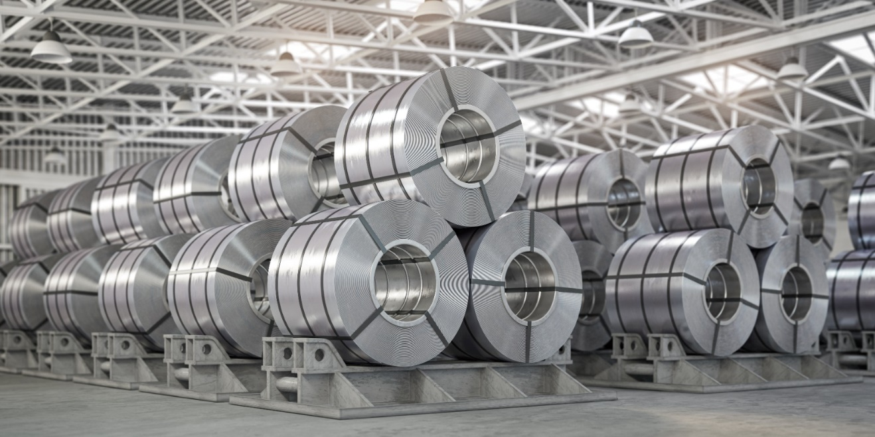

As the second-most widely consumed metal today, aluminum is "The Metal of the Future" for more reasons than one.

Despite domestic aluminum production surpassing domestic demand, India still imports approximately 15-20% of its total aluminum supply due to shortages in domestically produced ingots. These imports mainly consist of unwrought items like ingots, billets, scrap, bars, and rods, with primary aluminum products accounting for less than 10% of domestic consumption. Conversely, India also exports various aluminum products such as scrap, powder, flakes, bars, rods, foil, pellets, sheets, tubes, and pipes.

While India ranks among the largest producers of primary aluminum, limited opportunities for value addition domestically prompt primary aluminum producers to export significant quantities of primary aluminum products, while companies import a considerable volume of downstream products.

The India Aluminum Market is expected to witness significant growth during the forecast period from 2023 to 2029. This growth is driven by factors such as the rising infrastructure development, automotive industry expansion, and increasing demand from the electrical sector. Additionally, rapid urbanization is fueling construction activities, including the development of buildings, airports, and bridges, further boosting aluminum demand.

Aluminum's properties, including recyclability and visual appeal, make it an ideal choice for packaging materials like containers, foils, and cans. Furthermore, the surge in consumer goods purchases in India is driving demand for aluminum in various manufacturing processes, thereby bolstering market growth. Additionally, the renewable energy sector is creating a significant demand for aluminum, especially in solar panels and wind turbine components, further expanding market opportunities.

**6.**MAJOR CONTRIBUTORS OF ALUMINUM IN INDIA

 Aluminum production industry in India is mainly dominated by about five organizations that account for the majority of the country’s GDP:

Hindalco (Hindustan Aluminum Company)

Nalco (National Aluminum Company)

Balco (Bharat Aluminum Company)

Jindal

HINDALCO is the largest organization in Indian aluminum industry holding approximately 40% of the market share. The firm manufacturers a number of aluminum products like primary aluminum, extruded aluminum, aluminum rolled products, alloy wheels, and foil products.

NALCO is yet another leading producer of the aluminum metal in India. Government of India has purchased a stake of about 87.15% in this firm.

Jindal Aluminum is another leading manufacturer of aluminum extruded profiles in India. It has 100000 tons per annum installed capacity and 10 aluminum extrusion presses. JAL commands approximately 30% market share in India.

Ongoing Trends & Opportunities in the India Aluminum Market

The below mentioned are some ongoing latest trends and opportunities shaping the market growth at a tremendous rate.

* The aluminum industry is rapidly using green and sustainable practices, like recycling, energy-efficient production techniques, and GHG reduction. Consumers and industries are indulging more in eco-friendly products, which is leaving a positive impact on product use.
* The automotive industry focuses on manufacturing lightweight vehicles to improve fuel consumption and lower GHG emission, which drives the aluminum demand.
* The rising Aluminum production with the growing aluminum demand, is creating employment opportunities in rural areas, leading to market growth.
* The growth of electric vehicles in the country has generated a major opportunity for the aluminum industry. As the use of aluminum increases while vehicle manufacturing.

Challenges of the India Aluminum Market

India Aluminum Market is facing certain challenges that are impacting the market growth and development are mentioned below:

* Limited availability of raw materials due to the limited domestic stock, especially bauxite which is the primary raw material used to manufacture aluminum.
* Inadequate Infrastructure and Logistics: limited infrastructure, including transportation and port facilities, can affect the supply chain and lead to a slowdown in the manufacturing process.
* Energy Costs and Supply: Energy is a prominent cost factor in aluminum production. Fluctuations in energy prices and supply interruptions can affect the competitiveness of the market.

**7.** ALUMINUM AND GLOBAL MARKET**:**

The global aluminum market was valued at **$179.1 billion in 2022**, and is projected to **reach $277.5 billion by 2030**, growing at a **CAGR of 5.82%** from 2022 to 2031.

The rapidly rising demand for this abundant base metal in China has been fueling the expansion of the global aluminum sector. China's government owns the majority of its industries. Many of these businesses are expanding and changing quickly. Thus, it creates a requirement for more aluminum. Construction, packaging, transportation, and electrical are a few of the industries in China that heavily utilize aluminum. The largest portion of the total aluminum used by the Chinese industry each year is consumed by these four industries collectively. The government is making a lot of effort to increase industrialists' access to aluminum. Its results are expected to significantly contribute to the expansion of the global aluminum market. However, a few things are preventing the global aluminum sector from expanding. One of these is the fact that mining and processing bauxite into aluminum is not environment-friendly at all. Many processors of aluminum are addressing this fact by making and selling secondary aluminum. This is expected to hinder the growth in the aluminum market in both short and long-term.

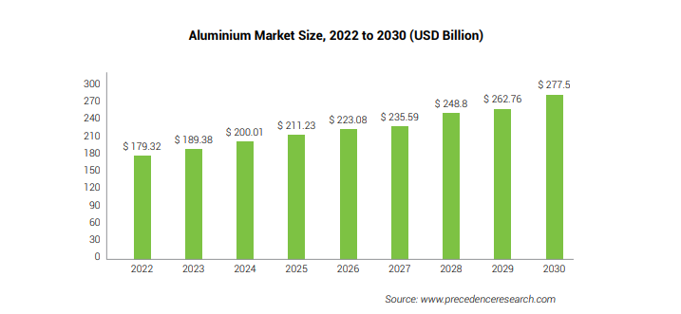

The high casting flexibility offered by cast alloys increase its use to form a wide range of shapes. This alloy is preferred in applications such as machine tools, farm equipment. In addition, cast alloys have a lower price relative to wrought alloys. The specific functionality and cost offered by cast alloys make them irreplaceable in many applications, thus resulting in high segment growth.

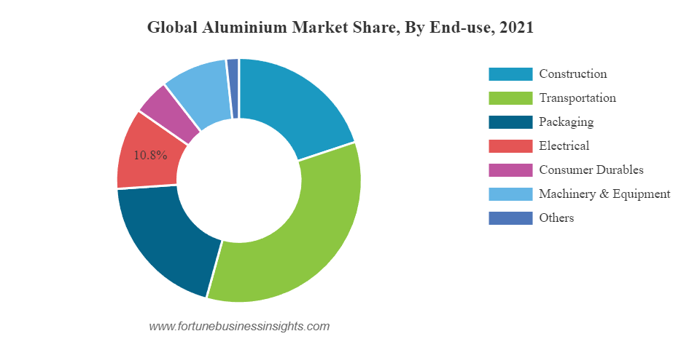

Asia Pacific Market**:**

Asia Pacific Aluminum Market size was valued at **USD 73.5 billion in 2023** and expected to reach **USD 121.2 billion by 2030**, at a **CAGR of 7.3% from 2024-2030.** Some of the key factors responsible for the market growth include rise in Asia Pacific economic growth rate, continuous advancements in transport industry, ongoing R&D activities to develop innovative and growing automobile industry.

Based on application, foil & packaging segment accounted for larger market revenue share in 2023 and projected gain market revenue share over the forecast period. Players focusing on innovation of newer products and collaboration strategies to retain market position in Asia Pacific Aluminum market

**8.** MANUFACTURING PROCESS**:**

1. **Cold Rolling Mill:**

The aluminum coils undergo a cold rolling process to further reduce their thickness and improve surface finish. The cold rolling process involves passing the aluminum coils through a series of cold rolling mills at ambient temperature. This process imparts a smooth, uniform finish to the aluminum foil and allows for precise control over its 6 to .350 mm thickness.

1. **Foil Mill Rolling:**

Following the initial stages, aluminum coils undergo a cold rolling process to further decrease their thickness and enhance surface quality. The foil mill rolling procedure entails feeding the aluminum roll through a sequence of foil rolling mills at room temperature. This process results in a smooth, consistent finish for the aluminum foil, enabling precise control over its thickness, ranging from .350 to .010 mm.

1. **Annealing:**

Following cold rolling, the aluminum foil undergoes an annealing process to relieve internal stresses and improve its mechanical properties. During annealing, the foil is heated to a controlled temperature and then cooled gradually to ensure uniformity and minimize distortion. This process also enhances the formability and machinability of the aluminum foil.

1. **Slitting and Cutting:**

Once annealing is complete, the aluminum foil is slit into narrower widths using precision slitting machines. This allows for the production of foil rolls of various sizes to meet customer specifications. Additionally, the foil may be cut to length using cutting machines to produce individual sheets or pre-cut lengths of foil.

1. **Quality Control and Packaging:**

Throughout the manufacturing process, stringent quality control measures are implemented to ensure the final product meets the required specifications for thickness, width, surface finish, and mechanical properties. The finished aluminum foil rolls or sheets are then inspected for defects and packaged in protective packaging materials to prevent damage during storage and transportation.

1. **Distribution:**

Finally, the packaged aluminum foil products are ready for distribution to customers across various industries, including food packaging, pharmaceuticals, insulation, and electronics. Aluminum foil is a versatile material prized for its excellent barrier properties, heat resistance, and recyclability, making it an essential component in numerous applications worldwide.

PROCESS FLOW SHEET

**1. Cold Mill Rolling:**

**- Coil Feeding**

**- Cold Rolling Mills**

**- Further Thickness Reduction**

**- Surface Finish Improvement**

**2. Foil Mill Rolling:**

**- Coil Feeding**

**- Foil Rolling Mills**

**- Further Thickness Reduction**

**- Surface Finish Improvement**

**3. Annealing:**

**- Foil Heating**

**- Controlled Cooling**

**- Stress Relief and Property Improvement**

**4. Slitting and Cutting:**

**- Annealed Foil Feeding**

**- Precision Slitting Machines**

**- Width Adjustment**

**- Cutting Machines (Optional)**

**5. Quality Control and Packaging:**

**- Inspection for Thickness, Width, Surface Finish, and Defects**

**- Protective Packaging**

**6. Distribution:**

**- Distribution to Customers**

**9.** MANUFACTURING UNIT LAYOUT**:**

Spanning across 10 acres of land, the plant layout of our manufacturing unit ensures ample space for safety, expansion, and efficient operations. Situated in Makhdumpur, Pargana Manglore, approximately 22 kilometers from the center of Roorkee, Uttarakhand, our location facilitates seamless transportation of raw materials and final products.

**Storage Layout:**

Storage facilities for raw materials, intermediate, and finished products are strategically located, considering safety and future expansion plans. Hazardous materials are isolated to minimize risks, while storage arrangements aim to optimize materials handling efficiency. Liquid materials are stored in containers, barrels, or tanks, indoors or outdoors, based on requirements.

**Equipment Layout:**

Adequate space is allocated for each piece of equipment to ensure accessibility for maintenance. Overcrowding of equipment within buildings is avoided, with a focus on spacious layouts for ease of operation and maintenance. Similar types of equipment are grouped together to streamline operations and facilitate division of labor.

**Safety:**

Compliance with local and national safety regulations is paramount. Fire protection measures, including reservoirs, fire pumps, sprinklers, and explosion barriers, are incorporated to safeguard personnel and assets. Planning also considers access for initial construction and ongoing maintenance activities.

**Plant Expansion:**

The layout is designed with future expansion in mind, balancing the need for scalability with economic considerations. Engineering judgment is exercised to determine the feasibility of expanding existing units or adding new ones, ensuring minimal disruption to operations.

**Floor Space:**

Efficient utilization of floor space is prioritized, considering factors such as material flow, equipment accessibility, maintenance requirements, and operator safety and comfort. Utilities servicing, including gas, air, water, steam, power, and electricity distribution, is optimized to support operational efficiency and minimize maintenance costs.

**Building:**

Building design is tailored to accommodate process requirements, with consideration for standard factory buildings or customized designs as needed. Outdoor construction layouts are also considered, depending on process requirements and space constraints.

**Material-handling Equipment:**

While material-handling equipment is a minor factor in most layout arrangements, critical consideration is given to processes where it plays a significant role. Topography and process requirements influence the selection and placement of material-handling equipment, with engineering judgment guiding decision-making.

Overall, the manufacturing unit layout is designed to optimize efficiency, safety, and flexibility, ensuring seamless operations and accommodating future growth and changes in process requirements.

**10.** B.I.S. SPECIFICATIONS

BIS: 2066-1962 - Coadding and classification for non ferrous scrap metal & residues. Section I of this standard deals with non ferrous scrap metal e.g. aluminium brass bronze copper lead tin nickel & zinc section - II deals with metallurgical residues

e.g. slags, skimming drosses etc. An appendix specifies conditions of slags. BIS: 8970-1991 - Aluminium foil laminates for packaging (first revision)

BIS 7161:1973 - Vegetable parchment or grease proof paper : Aluminium foil laminate for wrapping butter

BIS 10257:1982 - Aluminium foil stock Above Specifications may be obtained from Bureau of Indian Standards,9, B.S. Zafar Marg, New Delhi - 110 002.

**11.**MANUFACTURER/SUPPLIER/EXPORTER OF ALUMINIUM

Ashapura Steel

Address: 114/ A, R.K. Wadi, Shop No. 8, 2nd Parsiwada Lane, Mumbai, Maharashtra - 400 004

Phone: +(91)-(22)-66394870/66394492 Fax: +(91)-(22)-23821566

Mobile / Cell Phone: +(91)-9820469696/9320006141 Website: <http://www.ashapurasteel.com/non-ferrous.html>

Jindal Impex

Address: E-384, Phase-VI, Focal Point, Ludhiana, Punjab - 141 010, IndiaPhone: +(91)-(161)-5021500

Fax: +(91)-(161)-2678784

Mobile / Cell Phone: +(91)-9872969707/9878572700 Website: [http://www.jindalimpex.com](http://www.jindalimpex.com/)

J J Aluminium Private Limited

Address: Plot No. 117, Road No.6, Kathwada G.I.D.C., Kathwada, Odhav, Ahmedabad, Gujarat - 382 430, India

Phone: +(91)-(79)-22901182

Fax: +(91)-(79)-22901182

Mobile / Cell Phone: +(91)-9825773828/9825047875

Vijay Prakash Gupta & Sons

Address: No. 3019, Street No. 2, Chuna Mandi, Paharganj,

New Delhi - 110 055, India Phone: +(91)-(11)-23586472/23584321 Fax: +(91)-(11)-23585757 Mobile / Cell Phone: +(91)-9811125181

Nisarg Casting

Address: 54/b/1, Changodar Industrial Estate, Near Presion Bearing, Chnagodar,Ahmedabad, Gujarat - 382 213, India

Phone: +(91)-(2717)-250128 Mobile / Cell Phone: +(91)-978914205/ 9426015205

G. K. Founders Private Limited

Address: No. 13, Ranka House, Kale Marg, Bail Bazar Road, Mumbai, Maharashtra - 400 070, India

Phone: +(91)-(22)-25141266 Fax: +(91)-(22)-32569042

Mobile / Cell Phone: +(91)-9324258495/9825804585

Maruti Alluminium Private Limited

Address: Plot No.- 380, Raod No.- 9, G.I.D.C. Kathwada, Opposite Odhav Octroi Naka,Odhav, Ahmedabad, Gujarat - 382 430, India Phone: +(91)-(79)-22901347/22901330

Fax: +(91)-(79)-22901347 Mobile / Cell Phone: +(91)-9909030758

Manaksia Limited

Address: 8/1, Lal Bazar Street, Kolkata, West Bengal - 700 001, India Phone: +(91)-(33)-22210051

Mobile / Cell Phone: +(91)-9830790059/9830052173

Gold Star Alloys

Address: Plot No.276, Sector No. 7, Opposite Sahani Gas Industrial PCNDTA, Bhosari, Pune, Maharashtra - 411 026, India Mobile / Cell Phone: +(91)-9822401637

**12.** PLANT LOCATION FACTORS

Factors which generally apply to the economic and operability aspect of plant site location are classified into two major groups. The primary factors listed apply to choice of a region, whereas the specific factors looked at in choosing an exact site location within the region. All factors are important in making a site location selection.

### Primary Factors

* 1. Raw-material supply:
     1. Availability from existing or future suppliers
     2. Use of substitute materials
     3. Distance
  2. Markets:
     1. Demand versus distance
     2. Growth or decline
     3. Inventory storage requirements
     4. Competition - present and future.
  3. Power and fuel supply:
     1. Availability of electricity and various type of fuel
     2. Future reserves
     3. Costs
  4. Water supply:
     1. Quality - temperature, mineral content, bacteriological content
     2. Quantity
     3. Dependability - may involve reservoir construction
     4. Costs.
  5. Climate:
     1. Investment required for construction
     2. Humidity and temperature conditions
     3. Hurricane, a tornado, and earthquake history

### Specific Factors

* 1. Transportation:
     1. Availability of various services and projected rates
        1. Rail - dependable for light and heavy shipping over all distances
        2. Highways - regularly used for short distance and generally small quantities
        3. Water - cheaper, but may be slow and irregular
        4. Pipeline - for gases and liquids, particularly for petroleum products
        5. Air - for business transportation of personnel

1. Waste disposal:
   1. Regulations laws
   2. Stream carry-off possibilities
   3. Air-pollution possibilities
2. Labor:
3. Availability of skills
4. Labor relations - history and stability in area
5. Stability of labor rates
6. Regulatory laws:
   1. Building codes
   2. Zoning ordinances
   3. Highway restrictions
   4. Waste-disposal codes
7. Taxes:
   1. State and local taxes
      1. Income
      2. Unemployment insurance
      3. Franchise
      4. Use
      5. Property
   2. Low assessment or limited term exemptions to attract industry.
8. Site characteristics:
   1. Contour of site
   2. Soil structure
   3. Access to rail, highway, and water
   4. Room for expansion
   5. Cost of site
   6. Site and facilities available for expansion on present company-owned property
9. Community factors:
   1. Rural or Urban
   2. Housing costs

C. Cultural aspects - churches, libraries, theatres

1. School system
2. Recreation facilities
3. Medical facilities - hospitals, doctors
4. Vulnerability to wartime attack:
   1. Distance important facilities
   2. General industry concentration
5. Flood and fire control:
   1. Fire hazards in surrounding area
   2. Floor history and control

13. EXPLANATION OF TERMS USED IN THE PROJECT REPORT

1. DEPRECIATION:

This represents reduction in the utility and value of a capital asset because of wear and tear, lapse of time, obsolescence etc. The use of an asset helps in the generation of revenue for the business. A part of the cost of the asset, estimated to be equal to the reduction in the utility and economic life of the asset, because of its use, is charged off by way of depreciation charge against such revenue to arrive at the true profits.

1. FIXED ASSETS:

Represent those assets which remain permanently (till their useful lives) with the business and are not meant for resale. These assets are acquired for use in the operation of business and help in the generation of revenue for the business. These include land and building, plant and machinery etc.

1. WORKING CAPITAL:

This represents the total expenses on Raw materials, utilities & overheads, and salaries & wages, for a specified period of time.

1. BREAK-EVEN POINT:

This represents the level of output and sales at which the firm is able to recover all its expenses-both fixed and variable. In other words it indicates the level of output and sales at which the firm is neither making profit nor incurring any loss. Level of output more than the Break-Even Level generates profit for the firm.

1. OTHER FIXED EXPENSES:

These represent expenses which remain fixed irrespective of changes in level of output. In other words these are the expenses which the firm has to incur whether there is production or not. These include expenses such as preliminary and Preoperative expenses, Insurance and Freight, Technical Know-how and Consultancy, Erection & Commissioning etc. building, insurance, etc.

1. MARGIN MONEY:

This represents that part of the cost of project which the promoter has to meet from his own resources. This is the contribution which the promoter must make to the equity of the project for becoming eligible for assistance from financial institutions/Banks.

1. TOTAL LOAD:

It is the ratio of the maximum power consumed in KWH in a particular period of time to the number of operating hours of the unit in that particular period.



1. LAND AREA/MAN POWER RATIO:

It is the ratio of manpower utilised per unit area of land required for operating the unit.

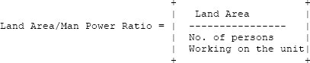

14. MANAGEMENT TEAM

## Mr. Parag Gupta - Chairman and Managing Director

Entrepreneur, 56 years of age with Commerce background. He is in aluminium foil

/Sheet industry from last 20 years and he has very vast knowledge of the industry and strong network. He is very hard worker and goal archiver. His marketing skill is very good. He initiated Megha Handles (Proprietor ship Firm) in 1999, one of the most sought-after manufacturers and suppliers of the wide array of Aluminium Foil. In 2005 Mr. Gupta initiated Premium Polymers Ltd, one of the Prestigious, leading manufacturer and supplier of an extensive gamut of all types of INDUCTION SEALING WADS/ALUMINIUM LIDS/PHARMA LIDS/LINERS.

## Mrs. Sima Gupta - Whole Time Director

She is the graduate and currently looking accounts & finance of the Megha Handles. And she will be looked after finance part of the company.

## Mr. Akul Gupta - Whole Time Director

Mr. Akul Gupta is MBA in international business A young, dynamic professional and expert in Printing and Packaging Industry Management. His wide experience covers areas like handling large Green Field Projects, including Project Financing, multi vocational manufacturing plants, business process mapping, requirement study & defining the various specifications for application implementation, organization building through effective technical, planning and man management skill.

## Ms. Megha Gupta – Sharholder Mr. Rahul Agrawal – Sharholder Mrs. Anu Agrawal- Shareholder

Mr. Krishnanshu Agrawal- Shareholder

15.KEY PRODUCTS, SPECIFICATIONS & IT’S USES

**FOIL ROLLS OF DIFFERENT THICKNESS & WIDTH**

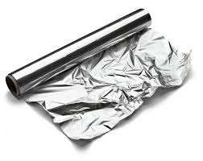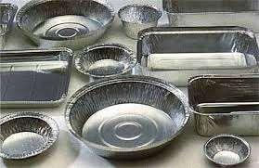

## SPECIFICATIONS

* WIDTH 150mm-950mm
* THICKNESS 0.025mm-0.04mm
* ALLOY AA8011
* TEMPER SOFT
* LENGTH AS REQUIRED

## USES

* It is used in food & beverage sector for covering a food.
* It is used for wrapping the different type of material.
* It is used for making a food container & packaging.

**FOIL ROLLS – PRINTED, FOR BLISTER PRODUCTS**

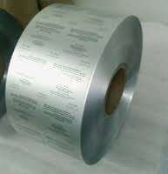

## SPECIFICATIONS

* ALLOY AA8011
* TEMPER HARD
* ALUMINIUM THICKNESS 0.02mm-0.03mm
* HSL COATING THICKNESS 4-6 GSM OR6-8 GSM
* NO. OF COLORS TO BE PRINTED UP TO 5 COLOR

## USES

* It is used in a pharmaceutical industry for packaging a tablets medicine.
* It is used to wrap a different types material according to their specification.

### USE OF PRINTED OR PLAIN FOIL ROLLS FOR PACKAGING & IN PHARMACEUTICAL INDUSTRY

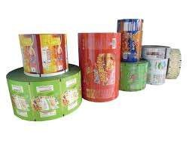

SPECIFICATIONSALLOY AA8011

* TEMPER HARD
* ALUMINIUM THICKNESS 0.02mm-0.03mm
* WIDTH 150mm-990mm
* HSL COATING THICKNESS 6-8 GSM
* POLY THICKNESS 37.4 MICRON
* POLY WIDTH 150mm-990mm, equal to aluminium width

## USES

* It is used to wrap a medicine.
* It is also used to pack a food product.

1. KEY EQUIPMENTS
   1. ROLLING MILL

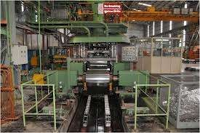

## SPECIFICATIONS

* ROLLING SPEED 1000MPM
* SPOOL SIZE 1800mm
* WIDTH 1100mm
* WEIGHT 3.5TON
* WORK ROLL 225*1100mm
* BACKUPROLL 600*100mm
  + - * 1. PLANT ECONOMICS

Rated Plant capacity = 1400.00 TONS./month of Sheet

= 16800.00 TONS/annum of Foil

### Basis

No. of working days = 25 days/month

= 300 days/annum

No. of shifts = 2 per day

One shift = 8 hours Currency - INR

* + - * 1. LAND & BUILDING

1. Land & Building Area required 28200 sq. mts.

@ **₹ 497.5**/- per sq. mts. **₹** 1,40,30,000.00

1. Production Shed in 100000 sq. fts.

@ **₹** 600/- per sq. fts. **₹** 6,00,00,000.00

**TOTAL ₹** **7,40,30,000.00**

* + - * 1. PLANT & MACHINERY

LIST ATTACHED

* + - * 1. OTHER FIXED ASSETS

|  |  |  |
| --- | --- | --- |
| 1. Office equipment, furniture plus  other equipment & accessories | Rs. | 5,75,000 |
| 2. Installation costs for water, |  |  |
| fuel etc. | Rs. | 3,25,000 |
| 3. Pre-operative & preliminary expenses | Rs. | 5,50,000 |
| 4. Technical Know-How & Consultancy | Rs. | 1,25,000 |
| 5. Misc. | Rs. | 2,20,000 |
| 6. Computer, Printer and Software | Rs. | 2,50,000 |

7. Installation cost of electricity Rs. 42,00,000

(1000KVA Connection)

**Rs.62,45,000**

* + - * 1. FIXED CAPITAL

1. LAND & BUILDING Rs. 7 ,40,30,000.00

2. PLANT & MACHINERY Rs. 10,30,31,741.00

3. OTHER FIXED ASSETS Rs. 62,45,000.00

**TOTAL Rs.18,33,06,741.00**

* + - * 1. WORKING CAPITAL REQUIREMENT/MONTH

RAW MATERIALS

1. Raw material 1400 Mt.

Aluminium @ Rs.219,000/- Mt. Rs. 30 ,66,00,000.00

1. Consumable items . Rs. 18,00,000.00

**TOTAL Rs. 30,84,00,000.00**

* + - * 1. SALARY & WAGES / MONTH

1. Manager cum Technologist 3 No. Rs. 7,00,000.00
2. Supervisors 3 No. Rs. 1,40,000.00
3. Sales/Mktg. Executives 3 No. Rs. 2,50,000.00
4. Accountant 3 No. Rs. 2,00,000.00
5. Clerk/Typist 1 No. Rs. 50,000.00
6. Skilled Workers 50 No. Rs. 14,00,000.00
7. Semi-Skilled Workers 14 No Rs. 2,50,000.00

8. Helpers 20 No. Rs. 3,50,000.00

9. Peon/Chowkidar 5 No. Rs. 80,000.00

**TOTAL Rs. 34,20,000.00**

* + - * 1. UTILITIES AND OVERHEADS

1. Power Consumption ( 9.0 Lac Unit Aprox @ Rs 7.3 ) Rs. 67,50,000.00
2. Stationery, Postage, Telephone etc. Rs. 1,25,000.00
3. Conveyance & Transportation etc. Rs. 7,50,000.00
4. Publicity & Sales Promotion Rs. 1,25,000.00
5. Repairs & maintenance Rs. 7,00,000.00
6. Miscellaneous, oil etc. Rs. 6,00,000.00

**TOTAL Rs. 90,50,000.00**

* + - * 1. TOTAL WORKING CAPITAL/MONTH

1. RAW MATERIAL Rs. 30,84,00,000.00

1. SALARY & WAGES Rs. 34,20,000.00
2. UTILITIES & OVERHEADS Rs. 90,50,000.00

**TOTAL Rs. 32,08,70,000.00**

1. WORKING CAPITAL FOR 1 MONTHS Rs. 32,08,70,000.00
2. MARGIN MONEY FOR W/C LOAN Rs. 8,02,17,500.00
3. COST OF PROJECT

TOTAL FIXED CAPITAL Rs. 18,33,06,751.00

MARGIN MONEY Rs. 8,02,17,500.00

**TOTAL Rs. 26,35,24,241.00**

1. TOTAL CAPITAL INVESTMENT

TOTAL FIXED CAPITAL Rs. 18,33,06,741.00 TOTAL WORKING CAPITAL FOR 1 MONTHS Rs. 32,08,70,000.00

**TOTAL Rs. 50,41,76,741.00**

1. COST OF PRODUCTION/ANNUM

1. Working Capital for 1 year Rs. 3,85,04,40,000.00

2. Interest @ 9% on T.C.I Rs. 4,53,75,906.00

1. Depreciation @ 10.00% on buildings Rs. 74,03,000.00
2. Depreciation @ 15.00% on Plant and Machinery Rs. 1,54,54,761.00
3. Depreciation @ 15.00% on office equipment& furnitures Rs. 9,36,750.00

**TOTAL Rs. 3,91,96,10,417.00**

1. TURN OVER/ANNUM
2. By sale of 15120 MT. Aluminium Foil

@ Rs. 255,000/- per MT. Rs. 3,85,56,00,000.00

1. By sale of 1680 MT. Scrap Aluminium Foil

@ Rs. 185,000/- per MT. Rs. 31,08,00,000.00

### TOTAL Rs. 4,16,64,00,000.00

PROFIT = RECEIPTS - COST OF PRODUCTION

= 4,16,64,00,000.00 - 3,91,96,10,417.00

= 24,67,89,583.00

PROFIT SALES RATIO = Profit / Sales x 100

# =5.92 %

24,67,89,583.00

4,16,64,00,000.00

X 100

RATE OF RETURN = Operating profit / T.C.I x 100

# =48.95 %

24,67,89,583.00

50,41,76,741.00

X 100

1. BREAK EVEN POINT (B.E.P)

Fixed Costs of the plant are as under

1. Interests Rs. 4,53,75,906.00

2. Depreciation Rs. 2,74,96,011.00

3. 40.00% of salaries Rs. 1,64,16,000.00

4. 40.00% of overheads Rs. 4,34,40,000.00

**TOTAL Rs. 13,27,27,917.00**

B.E.P. = FIXED COSTS

X100 FIXED COSTS + PROFIT

13,27,27,917.00

X100 13,27,27,917.00 + 24,67,89,583.00

# =34.97%

1. RESOURCES FOR FINANCE
   1. Director’s own Funds

Rs.8,02,75,000.00 2. Term Loan Rs.10,30,31,741.00

TOTAL Rs. 18,33,06,741.00