File No.: VIS (2024-25)-PL148-124-164 Dated: 20.06.2024

LENDER’S INDEPENDENT ENGINEER REPORT (3RD)
(FOR QUARTER ENDING APRIL 2024)

OF

5 TPD BIOMASS TO COMPRESSED BIOGAS (CBG)
PLANT (PHASE-I)


SITUATED AT

VILLAGE SHAHPUR DANDI, TEHSHIL: BAHERI, DISTRICT: BAREILLY.

IMPLEMENTED BY
M/S. CARBON CIRCLE PRIVATE LIMITED

REPORT PREPARED FOR
STATE BANK OF INDIA, SME RUDRAPUR.

**Important - In case of any query/ issue or escalation you may please contact Incident Manager at le@rkassociates.org. We will appreciate your feedback in order to improve our services.
NOTE: As per IBA Guidelines please provide your feedback on the report within 15 days of its submission after which report will be considered to be correct.
TABLE OF CONTENTS
SR. NO. | DESCRIPTION | PAGE NO.
PART A | Report Summary | 03
PART B | Introduction | 05
 | - The Assignment | 05
 | - Project Overview | 05
 | - Project Location | 08
 | - Scope of the Work During Assignment Duration | 09
 | - Purpose of the Report | 09
 | - Methodology Adopted | 09
PART C | Plant Infrastructure Sections & Facility Details with Actual Progress | 10
 | - Land and Land Development | 10
 | - Building and Civil Works | 10
 | - Plant Machinery and Equipment | 12
PART D | Project Consultants, Contractors & Suppliers | 16
PART E | Project Cost and Means of Finance | 17
 | - Cost of Project | 17
 | - Cost Expenditure Analysis | 18
 | - Sources of Finance & Utilization of Funds | 25
PART F | Statutory & Regulatory Approvals, Clearances & NOC | 26
PART G | Project Schedule & Current Status | 27
PART H | Disclaimer | 28
PART I | Enclosure | 32
PART J | Photograph | 38

IMPORTANT NOTICE

COPYRIGHT FORMAT: This report is prepared on the copyright format of R.K Associates, to serve our clients with the best available information and analysis to facilitate them to take rational business decisions. Legally no one can copy or distribute this format without prior approval from R.K Associates. It is meant only for the advisory/ reference purpose for the organization/s as mentioned on the cover page of this report. Distribution or use of this format by any organization or individual other than R.K Associates will be seen as unlawful act and necessary legal action can be taken against the defaulters.

This report is intended for the sole use of the intended recipient/s and contain material that is STRICTLY CONFIDENTIAL AND PRIVATE.

DEFECT LIABILITY PERIOD: - In case of any query/ issue or escalation you may please contact Incident Manager: le@rkassociates.org. We try our level best to ensure correctness in the calculations done, rates adopted and various other data points & information mentioned in the report but still can’t rule out typing, human errors or any other mistakes. In case you find any such mistake or inaccuracy in any data point of the report please help us by bringing all such points into our notice immediately or within 15 days of the report delivery in writing, to rectify these timely failing after which R.K Associates won’t be held responsible for any such inaccuracy in any manner. We would highly appreciate your feedback in order to improve our services.

PART A | REPORT SUMMARY

1. | Name of Project: | Carbon Circle Private Limited (CCPL) is establishing a Compressed Biogas (CBG) plant with a total capacity of 10 Tons Per Day (TPD) in Baheri Tehsil, Bareilly District, and Uttar Pradesh. The project will be executed in two phases, Phase –I and Phase-II, with each phase setting up a 5 TPD plant.
2. | Project Location: | Village Shahpur Dandi, Tehshil: Baheri, District: Bareilly, State: Uttar Pradesh, India.
3. | Name of the Borrower: | M/S. Carbon Circle Private Limited.
4. | Director’s/Partner’s: | Mr. Guru Inder Mohan Singh
5. | Prepared for Bank: | State Bank of India SME Branch, Rudrapur, Uttarakhand
6. | LIE Consultant Firm: | M/s. R.K. Associates Valuers & Techno Engineering Consultants (P) Ltd.
7. | Date of Survey: | 10th of May 2024
8. | Date of Report: | 20th of June 2024
9. | Purpose of the Report: | To provide fair detailed analysis report to the Bank based on the “in-scope points” mentioned below to know the current status of the Project.
10. | Scope of the work provided by the Lender: | - Periodic Project physical status review  - Periodic review of expenditure of the Project based on the invoices/ bills submitted by the client
11. | Documents perused for Proposal: | - Brief description of the project.  - Detailed Project Report.  - CA Certificate  - SBI’s TEV Report  - Amendment Letter or Purchase Order for machines to be installed.  - Other approvals.  - Site/Plot Plan  - Property Title Documents  - Plant Layout
12. | Annexure with the report: | - Copies of Project Statutory approvals  - CA Certificate  - Site/Plot Plan  - DPR

PART B | INTRODUCTION

- ABOUT THE ASSIGNMENT:
3rd LIE Report for the period (Quarter ending April 2024) of Compressed Biogas (CBG) plant being established at Baheri Tehsil, Bareilly District, and Uttar Pradesh. M/S. Carbon Circle Private Limited (CCPL) is establishing a Compressed Biogas (CBG) plant with a total capacity of 10 Tons per Day (TPD) in Baheri Tehsil, Bareilly District, and Uttar Pradesh. The project is executed in two phases, Phase –I and Phase-II, with each phase setting up a 5 TPD plant for which bank has appointed M/S R.K Associates Valuers & Techno Engineering Consultants (P) Ltd. for periodic review of physical & expenditure status of the project.

Although the report is for period Quarter ending April 2024, however the physical status in the report is reported of the date of survey which is 10th May 2024 but incurred expenses are considered between the period Jan. – April.’24.

- PROJECT OVERVIEW:
M/S. Carbon Circle Private Limited (CCPL) is establishing a Compressed Biogas (CBG) plant in Baheri Tehsil, Bareilly District, Uttar Pradesh, with an aggregate capacity of 10 Tons per Day (TPD). The project will be implemented in two sequential phases, Phase-I and Phase-II, each dedicated to setting up a 5 TPD plant. This phased approach is designed to facilitate the efficient development and scaling of the CBG plant.

Whereas as per CA Certificate the appraised Project cost considered is Rs.40.40 Cr. which includes Land development, Building, Plant & Machinery etc. Detailed breakup of the same is available in later section of the report. Further the Project was independently appraised by Consultancy Services Cell of SBI. As per Consultancy Services Cell of SBI the appraised cost is Rs. 39.50 crores, the difference on the same is observed in IDC value. Further in this report, only the appraised hard cost by SBI is taken into consideration. Soft cost such as IDC etc. is not covered in the part of report. This report covers only Phase-I of the Project i.e. 5 TPD Plant.

As per MCA, M/s Carbon Circle Private Limited (CCPL) was incorporated on 29/10/2021. Company is formed by Mr. Guru Inder Mohan Singh who has experience of implementing and scaling solar energy businesses. As per information provided to us, he started his career in Power Finance Corporation Ltd. (PFC) where he was involved in extending credit to biomass based and bagasse-based cogeneration power projects. Thereafter, he worked as executive in AES Corporation, a Fortune 500 company and Azure Power, a NYSE listed solar power company.

As per Project appraisal report, Phase-I of the Project is scheduled to be completed by June, 2024. As per the site inspection report, the Project work started in January 2023.

The Project is executed through the package route, i.e appointment of different contractors / suppliers for different works and not through EPC route.

- PROJECT LOCATION:
Details about Location of Unit is as below:
Table No: 1

Particulars | Description
Postal Address
Village- Shahpur Dandi, Tehhshil- Baheri, District-Bareilly, State-Uttar Pradesh, India
Location
The location is in rural part of village area, nearby lands are mostly agricultural area.
Google Coordinates
Latitude | 28°42'35.9"N
Longitude | 79°29'20.1"E
Connectivity Systems
Road | Baheri is around 45-50 km from Bareilly city through SH 37. The project site is currently accessible via a non-metallic road of ~15-20 feet wide, which runs parallel to the railway track.
Rail | The Nearest Railway station to the subject locality is Richha Railway Station which is about approximately 0.5 Km from the Subject Project.
Air | The nearest airport to subject location, i.e, Bareilly Airport, is located approximately 40 kilometres away.
Geographical Conditions On The Site
Temperature | The maximum temperature is around 104°F while the minimum is 41°F.
Rainfall | The average annual rainfall of this area is about 970 mm.
Seismic Zone | The above plant site area falls in Seismic Zone III.

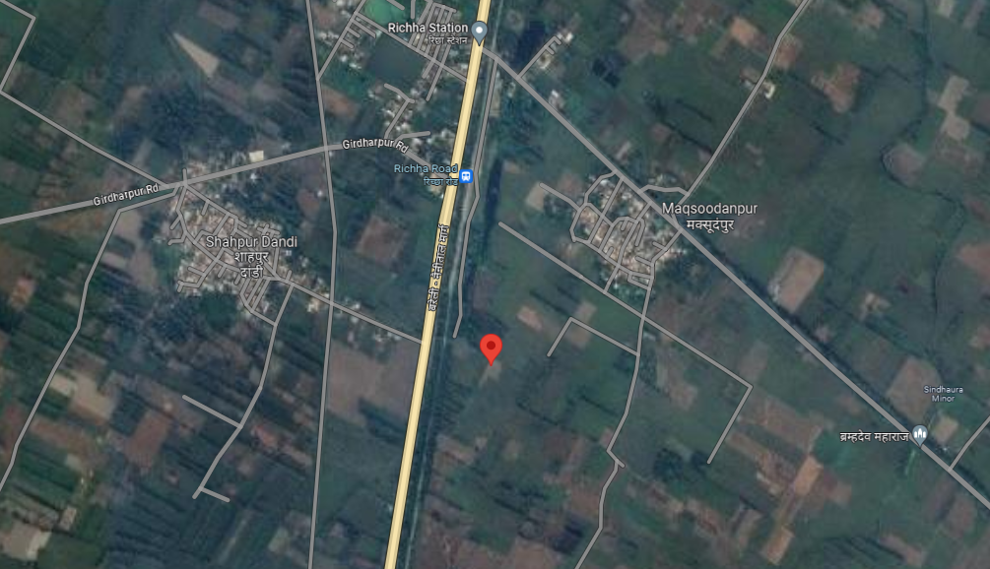

Source: Google Map
Figure: Location of CBG Plant
- SCOPE OF WORK DURING PROJECT DURATION:
- Periodic Project physical status review
- Periodic review of expenditure of the Project.

- PURPOSE OF THE REPORT: To provide fair detailed analysis report to the Bank based on the “in-scope points” mentioned above for facilitating them to know the current status of the Project.

- METHODOLOGY ADOPTED:
- Study of Project Planning documents/ reports to know about the Project.
- Additional information, data, documents collection from the borrower.
- Site Inspection.
- Review and analysis of the documents and information obtained from the borrower and corroborating it with the site inspection status.
- Information compilation, analysis and reporting.
- Expenditure assessment of the civil works has been done as per the physical observation during site survey and by taking benchmark cost of the respective items.

PART C | PLANT INFRASTRUCTURE SECTIONS & FACILITY DETAILS WITH  ACTUAL PROGRESS

- LAND AND LAND DEVELOPMENT: For the purpose of the Project, company has purchased 2.74 hectares (equivalent to 6.8 acres) of land at Rs.1,35,51,400/- as per the sale deed provided to us. However, during the site survey and based on the information provided, additional demarcated land was observed beyond the initial document. As per demarcated boundaries total land area is admeasuring approx. 7.68 Acres.
Table No: 2

S. No. | Gata No. | Area in (Hectares) | Sale Price | Stamp Duty | Total
1 | 391 | 1.0715 | 42,38,000 | 2,20,300 | 44,58,300
2 | 161 | 0.18575 | 7,34,000 | 36,700 | 7,70,700
3 | 161 | 0.18575 | 8,82,000 | 44,100 | 9,26,100
4 | 388 | 0.225 | 19,58,000 | 98,000 | 20,56,000
5 | 391 | 1.0715 | 50,86,000 | 2,54,300 | 53,40,300
Total |  | 2.7395 | 1,28,98,000 | 6,53,400 | 1,35,51,400

- BUILDING & CIVIL WORKS: For setting up/ development of below listed sections and other civil works, Carbon Circle Private Limited has estimated Rs.8.74 crore as per SBI appraisal report out of total project cost amounting to Rs.39.50 Crore. Same is considered in C.A. Certificate dated 20th May 2024.

The Physical progress is considered based on observation during our visit on 10th May 2024 of the subject Plant. During the Course of our visit to the subject Project Site following observations were made:
Table No: 3

Sr. No. | Description | Previous Report Status  (Date of Survey – 31/01/2024) | Current Status/ Progress  (Date of Survey – 10/05/2024)
1. | Bagging Unit | - The major civil work including P.C.C flooring and shed works have been completed. | - Same status as reported in last report.
2. | Sun Drying Area | - The footing structure work till plinth level is and P.C.C. flooring work is completed | - Same status as reported in last report.
3. | Biogas Up gradation Plant | - The major structure works has been completed.  - The soil filling work in the following structure is due. | - The major civil work including P.C.C flooring and shed works have been completed.
4. | Master control room and Office room | - Structure work (Pillar, column work) is completed up to 2nd floor.  - Slab work completed up to 1st Floor. 2nd slab casting is done, de-shuttering work is to be done.  - Brick work is in progress on Ground and First floor. | - Structure work is completed up to 2nd floor.  - MEP and finishing work are in progress
5. | Raw water Storage | - Construction of structure work is completed. | - Same status as reported in last report.
6. | Hot Water Treatment Plant | - Major structure work along with shed work is completed, only 20-30% of shed roof covering is due. | - The structure work along with shed work is completed
7. | Mixer | - All civil construction completed  - Final finishing and testing work of the same is due. | - It was found running and sludge mix were being dumped
8. | Anaerobic Digester 1 & 2 | - All civil construction completed.  - Outer insulation work is completed.  - Final finishing and testing work of the same is due. | - The above open area has been covered  - The sludge mix from mixer was being filled in it which was seen in the digital screen of control room
9. | Liquid Digest lagoon | - Same status as reported in last report. | - The structure work has been completed.
10. | Guard Room & Meter Room | - One guard room civil work is completed as before. Finishing not achieved yet.  - Other guard room civil work is completed and plaster is in progress. | - Guard room has been fully completed and has been found to be used.  - Meter room civil work has been completed
11. | Internal Road | - Some RCC road & drainage work is completed. | - RCC road and drainage has been completed.
12. | Pump House | - Not stated in last report | - Structure work has been completed.  - MEP and finishing work is due.

Note:The Physical progress captured in the above table is based on approximate observations of status of structures constructed on site during our site inspection and our subsequent discussions held with the engineer’s/ company representatives with whom the site visit was conducted. Thus, the above progress is on approximate basis which may vary from 5%-10% (+-).

The percentage completion of the civil work executed is shown in chart form below:

- PLANTS/ MACHINERIES & OTHER EQUIPMENTS AND UTILITIES: The total amount envisaged against the purchase of Plant and Machinery amounts to Rs.26.16 cr. and as per CA Certificate having UDIN No. 24519826BKARTF3612 expenditure incurred till 30th April 2024 is 32.15 cr.
Table No: 4

S. No | Particulars | Supplier/Vendor | Previous Report Status  (Date of Survey – 31-01-2024) | Current Status / Progress  (Date of Survey – 10-05-2024)
 | Digester | Planet Biogas Global Gmbh | Rotatory fan & peddle is installed and testing is due | Sludge mix was found being transferred to it from mixer which was seen through digital screen of control room.
 | Biogas Up gradation Plant | Biogas Engineering India Private Limited | Few machines have been arrived | Machine’s such as Chiller, Analyser, Carbon filter, Compressor & Vessel have arrived
 | Mixer | Planet Biogas Global Gmbh | Rotatory fan & peddle is installed and testing is due | It was found running and sludge mix were being dumped
 | Compressor | Kirloskar Pneumatic Comp. | Arrived on site | Same status as reported in last report
 | Hot Water Treatment Plant | HME Boilers Pvt Ltd. | Assembly of components of hot water treatment Plant is in progress. Generator is yet to come. | Machine has been assembled and ready for use
 | Water Treatment Plant | --- | Not to be commissioned in Phase-I | Same status as reported in last report
 | Transformer | Voltamp Transformers Ltd. | Arrived on site | Same status as reported in last report
 | HT/LT Panels | Electro Control Systems | Installation has been done, testing of the same is due | Same status as reported in last report
 | Bagging Unit | --- | No information available
 | Weigh bridge | Eagle Scale Manufacturing Works | Yet to arrive on site | Arrived on site
 | DG Set | Sterling Generators Pvt. Ltd | Yet to arrive on site | Arrived on site

Mass Balance Diagram for Biomass to CBG Plant
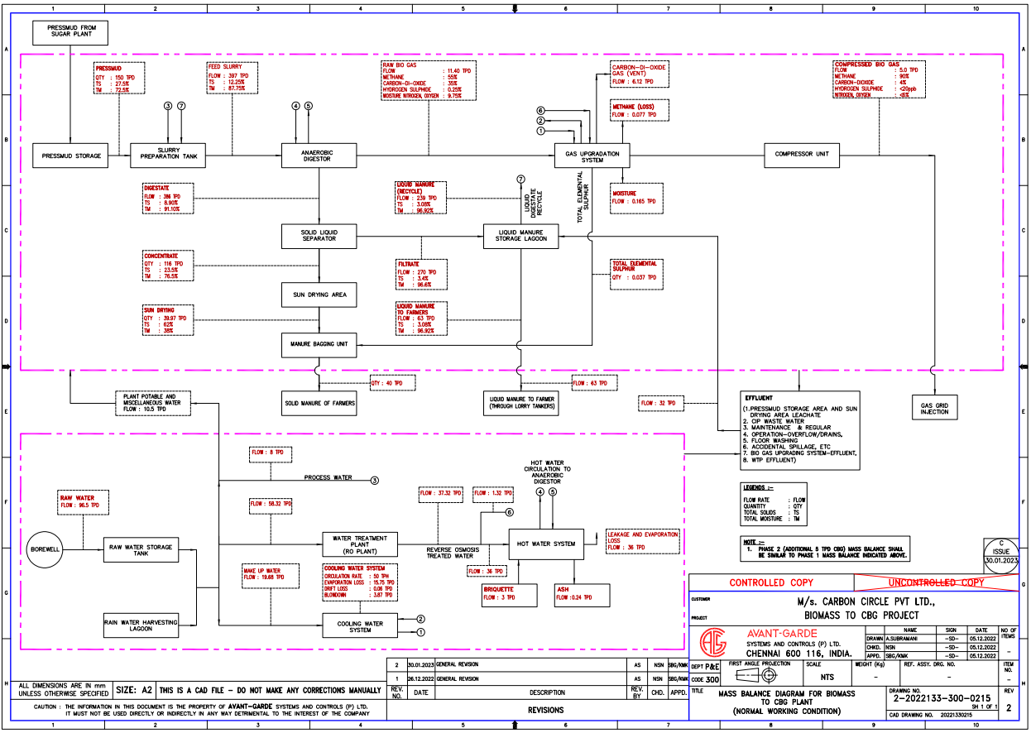
Source: As per DPR

PART D | PROJECT CONSULTANTS, CONTRACTORS & SUPPLIERS

As of now mentioned below are the list of Contractors/ Suppliers/ Consultants which have been currently engaged in the Project.
Table No: 5

Contractors/ Suppliers/ Consultants | Nature of Work
M/s Avant grade System and Controls Pvt. Ltd. (AGSCPL) | Engineering Consultants
M/s Makin Developers Pvt. Ltd. | Building/Civil Works
M/S Planet Biogas Global GMBH (PlanET) | Providing and installation of digester
M/S Biogas Engineering India Pvt. Ltd. (BGEI) | Biogas Up-gradation machines
M/S Kirloskar Pneumatic Company Limited. | Compressor
M/S Fabking Solutions Pvt Ltd. | Portable cabin container
M/S Steeline Buildcon Pvt Ltd. | PEB Shed
M/s Flowmore Ltd. | Pumps
M/S Ceasefire Industries Pvt. Ltd. | Fire Fighting System
M/S HME Boilers Pvt Ltd. | Hot water Generator
M/S Tata Bluescope Steel Pvt. Ltd. / Infinite Build Foam | Cladding Sheet / Insulation Material
M/S Tharayali Engineering Pvt. Ltd. | Erection, Commissioning & Quality
M/S UPPCL | Bay at 132 KV @ Richha S/s
M/S Electro Control Systems | Plant Electricals
M/S ARC Electro Enterprises | Electric Meter ( Supply & Services)
M/S Eagle Scale Manufacturing Works | Weigh machine
M/S Gandhi Automations Pvt Ltd. | Main Gate

Source: The above Information/Data is taken from the project progress report provided by the client.
PART E | PROJECT COST & MEANS OF FINANCE

- TOTAL PROJECT COST & STATUS OF EXPERNDITURE: M/s Carbon Circle Private Limited has estimated the total Project Cost amounting to Rs.40.40 Cr. and Rs.53.98 Cr. has been spent till 30th April 2024 as per CA Certificate dated 20th May 2024 with UDIN No. 24519826BKARTF3612.

Tabular and chart representation of the same is shown below:
Table No: 6

Amount in crores
Particulars | Project Cost as Budgeted  (As per SBI appraisal Report) | Project Cost as Budgeted  (As per CA Certificate) | Expenditure Incurred Till 30th April 2024  (As per CA Certificate) | Expenditure Incurred Till Date 10th May June 2024  (LIE Assessment)
Land including land developments | 1.15 | 1.15 | 1.63 | 1.35
Building & Civil works | 8.74 | 8.74 | 13.53 | 10.75
Plant Machinery | 26.16 | 26.16 | 32.15 | 24.57
Preoperative Expenses | 1.75 | 1.75 | 4.75 | ---
Interest During Construction | 1.50 | 2.40 | 1.46 | ---
Margin Money for Working Capital | 0.20 | 0.20 | 0.46 | ---
Total | 39.50 | 40.40 | 53.98 | 31.02

- COST EXPENDITURE ANALYSIS: A detailed comparison between the actual construction expenses and the company's reported costs, as certified by a Chartered Accountant (CA), is presented below. Alongside this, a cost assessment based on a site survey is also provided:
Table No: 7

S.NO. | PARTICULARS | ESTIMATED COST  (Rs. In Cr.) | AMOUNT SHOWN BY THE COMPANY  (UPTO 30.08.23)  (As Per C.A. Certificate) | AMOUNT SHOWN BY THE COMPANY  (UPTO 31.12.23)  (As Per C.A. Certificate) | AMOUNT INCURRED IN LAST QUARTER  (DIFFERENCE OF LAST CA CERTIFICATE AND CURRENT CA CERTIFICATE) | REMARKS
1 | Land including land developments | 1.15 | 1.63 | 1.63 | 0 | - Rs.1.35 crores is spent in land purchase with stamp duty (as per the value mentioned in the sale deed).  - Balance Rs. 28 lacs company has informed to have spent in soil filling & land levelling which is reasonable since site is around 7.68 acres and mud levelling has been done on the site.
2 | Building and other civil works. | 8.74 | 9.67 | 13.53 | 3.86 | - The cost assessment for building and civil works is done in accordance with the benchmark or market cost, as per the percentage of work completed. For detailed calculation please refer to Table No. 10 below.  - Material/ Inventory lying at site is not considered in this cost.  - Any advances paid to the parties for which work is not done is not captured which may have been included in the CA Certificate and this is why some difference may come between our assessment and CA certificate.
3 | Plant, Machinery and equipment. | 26.16 | 24.5 | 32.15 | 7.65 | - In last quarter as per survey done on 31-01-2024 significant machine installation work was done no machine was arrived but in this quarter as on date of survey on 10-05-2024 mixer was running as shown in Table No. 6.
4 | Pre-operative Expenses | 1.75 | 3.28 | 4.75 | 1.47 | Since breakup was not available therefore we were unable to verify its cost as of now and thus have not commented on this item.
5 | Interest During Construction | 2.4 | 0.61 | 1.46 | 0.85 | Can be referred directly from CA certificate as out of Engineering purview. Not in scope of LIE.
6 | Margin Money for Working Capital | 0.2 | 0 | 0.46 | 0.46 | Can be referred directly from CA certificate as out of Engineering purview. Not in scope of LIE.

Table No: 8

Building and other civil work
SR.NO | Particular | Type of Structure | Unit | Area/Qty | Rate | Amount (in Rs)
1 | Bagging Unit | G.I. Shed | Sq. Ft | 8,611 | 1,000 | 86,11,120
2 | Sun Drying Unit | Concrete Platform | Sq. Ft | 10,463 | 550 | 57,54,381
3 | Biogas Upgradation Plant | G.I. Shed | Sq. Ft | 13,950 | 1,200 | 1,67,40,017
4 | Master Control Room and Office Room | R.C.C. Structure | Sq. Ft | 11,044 | 1,400 | 1,54,61,266
5 | Raw Water | R.C.C. Structure | Sq. Ft | 5,038 | 1,000 | 50,37,505
6 | Hot Water Treatment Plant | G.I Shed | Sq. Ft | 5,038 | 1,200 | 60,45,006
7 | Mixer | R.C.C. Structure | Cum | 160 | 9,500 | 15,20,000
8 | Digester 1 | R.C.C. Structure | Cum | 850 | 10,000 | 85,00,000
9 | Digester 2 | R.C.C. Structure | Cum | 850 | 10,000 | 85,00,000
10 | Lagoon | R.C.C. Structure | Sq. Ft | 7,976 | 1,100 | 87,73,655
11 | Guard Room | R.C.C. Structure | Sq. Ft | 180 | 1,250 | 2,25,000
12 | Meter Room | R.C.C. Structure | Sq. Ft | 180 | 1,100 | 1,98,000
13 | Boundary Wall | Pre Cast | Sq. Ft | 21,643 | 140 | 30,30,046
14 | Column for support of fire pipe | R.C.C. Structure |  | 33 | 10,357 | 3,42,907
14 | Column for support of fire pipe | Steel |  | 2,599 | 89 | 2,31,314
15 | Road | R.C.C. Road | Cum | 759 | 10,357 | 78,60,963
16 | Drain | Brick Work and plaster | R.M. | 550 | 3,000 | 16,50,000
17 | Pump House | R.C.C. Structure | Sq. Ft | 3,100 | 1,200 | 37,20,004
18 | Extra Work (site development) |  |  |  |  | 53,11,000
Total |  |  |  |  |  | 10,75,12,185

Comment/Note:
- We have given a general overview of the project based on expenses shown by chartered accountant in their CA certificate as per CA Certificate dated 20th May 2024 with UDIN No. 24519826BKARTF3612 based on the data/ information gathered from client and the observation made during the site survey.
- Civil work cost expenditure assessment is done considering market rates and rates prescribed by CPWD based on the progress seen during the site visit.
- In Civil works cost assessment, area/ quantity is supplied by the company.
- The rates are adopted as per the percentage completion of work.
- 5%-10% variance in measurement should be considered.

Table No: 9

INVOICES/ BILLS FOR CIVIL WORKS
Name of the Package | Name of the Vendor – PO awarded | Total Contract Value (Rs. In Lacs) | Remarks | % allocation in Phase-1 | Phase-1 Amount | Bills/ Invoices Seen (Rs. In cr)
Civil Works Contractor | Makin Developers Pvt Ltd. | 1,221.06 | --- | 100% | 1221.06 | 10.91
PEB shed | Steeline Buildcon Pvt Ltd. | 204.41 | (for ultimate capacity of 10 TPD) | 50% | 102.205 | 2.04
TOTAL |  | 1,425.47 |  |  | 1323.265 | 12.19

Table No: 10

WORK WISE SUMMARY OF INVOICES BILLS FOR PLANT & MACHINERY
Name of the Package | Name of the Vendor – PO awarded | Total Contract Value (Rs. In Lacs) | Remarks | % allocation in Phase-1 | Phase-1 Amount | Bills/ Invoices Seen (Rs. In cr)
Digester vendor | PlanET (incl. Customs duty + CHA charges) | 1,547.75 | --- | 100% | 1547.75 | 11.65
Biogas Upgradation Plant (BUP) Vendor | Biogas Engineering India Pvt Ltd. | 929.95 | (for ultimate capacity of 10 TPD) | 50% | 464.975 | 9.27
Product Gas Compressor Supplier | Kirloskar Pneumatic Company Limited | 113 | (for ultimate capacity of 10 TPD) | 50% | 56.5 | 1.13
Portable Cabin Container Supplier | Fabking Solutions Pvt Ltd. | 5.47 | --- | 100% | 5.47 | .21
Bay at 132 KV @ Richha S/s | UPPCl | 45.45 | (for ultimate capacity of 10 TPD) | 50% | 22.725 | --
Cladding Sheet/ Insulation Material | Tata Bluescope Steel Pvt Ltd. / Infinite Build Foam | 73.9 | --- | 100% | 73.9 | --
Air Compressor | Kirloskar Pneumatic Company Limited | 12.39 | --- | 100% | 12.39 | --
Pumps | Flowmore Ltd. | 9.2 | --- | 100% | 9.2 | .09
Plant Electricals | Electro control Systems | 421.2 | (for ultimate capacity of 10 TPD) | 50% | 210.6 | 1.89
Fire Fighting System | Ceasefire Industries Pvt Ltd. | 123.34 | (for ultimate capacity of 10 TPD) | 50% | 61.67 | --
Hot Water Generator | HME Boilers Pvt Ltd. | 56.67 | (for ultimate capacity of 10 TPD) | 50% | 28.335 | .28
Erection, Commissioning & Quality | Tharayil Engineering Pvt Ltd. | 60.31 | (for ultimate capacity of 10 TPD) | 50% | 30.155 | .05
Electric Meter (Supply & Services) | ARC Electro Enterprises | 22.86 | (for ultimate capacity of 10 TPD) | 50% | 11.43 | --
Weigh Machine | Eagle Scale Manufacturing Works | 14.16 | (for ultimate capacity of 10 TPD) | 50% | 7.08 | --
Main Gate | Gandhi Automation Pvt Ltd. | 7.08 | (for ultimate capacity of 10 TPD) | 50% | 3.54 | --
Odorising, Metering & Pipeline | Yet to be awarded | --- | (for ultimate capacity of 10 TPD) | 50% | -- | --
Bagging Unit | Yet to be awarded | --- | (for ultimate capacity of 10 TPD) | 50% | -- | --
SCADA | Yet to be awarded | --- | (for ultimate capacity of 10 TPD) | 50% | -- | --
Lab | Yet to be awarded | --- | (for ultimate capacity of 10 TPD) | 50% | -- | --
TOTAL |  | 3,442.73 |  |  | 2545.72 | 24.57

- SOURCES OF FINANCE & UTILIZATION OF FUNDS:

The Project cost mentioned above has been planned to be covered from following resources:
Table No: 12

(Amount in Rs. Crore)
PARTICULARS | As per SBI Sanction Letter (5 TPD) | As on 30th April 2024
Promoter’s Contribution in the form of share capital | 10.00 | 11.06
Promoter’s Contribution in the form of interest free unsecured loan | 6.40 | 18.92
Term Loan (Debt) | 24.00 | 24.00
TOTAL | 40.40 | 53.98
Source: As per CA Certificate

PART F | STATUTORY & REGULATORY APPROVALS, CLEARANCES & NOC

Table No: 13

Sr. No. | NAME OF LICENSE/ REGISTRATION | PURPOSE | DATE OF ISSUE | CURRENT STATUS
Sr. No. | ISSUING AUTHORITY | PURPOSE | LICENCE NO. | CURRENT STATUS
 | Change of Land Use Certificate (CLU) | Change in land use | 29/03/2023, 29/12/2023 &  13/02/2024 | Obtained  (for 2.74 hectare of Land)
 | Building Plan Approval | Approval of building plans | --- | To be obtained
- 2. | Pollution Certificate | Consolidated Consent to operate | 02/04/2024 | Obtained
- 2. | Uttar Pradesh Pollution Control Board | Consolidated Consent to operate | 203836/UPPCB | Obtained
 | Electricity Connection | --- | 16/09/2023 | Obtained
 | Electricity Connection | --- | 4413 | Obtained
 | Electrical Safety Directorate | Initial inspection/testing of electrical installation | 17/02/2024 | Obtained
 | Office of the Deputy Collector, Electrical Safety, Government of Uttar Pradesh | Initial inspection/testing of electrical installation | 24VSNOC03064935 | Obtained
 | Fire NOC | --- | --- | To be obtained
- 3. | Application for filling & storage of compressed biogas | Application of filling & storage of compressed biogas | 30/05/2023 | Obtained
- 3. | PESO | Application of filling & storage of compressed biogas | A/G/HO/UP/05/607 &  A/G/HO/UP/06/586 | Obtained
 | Machine Installation Completion Certificate | Completion Certificate | 16/04/2024 | Obtained
 | planET Global Biogas Gmbh | Completion Certificate |  | Obtained
Observations & Comments:
Above mentioned are the preliminary approvals which are required for the Project. The status mentioned above is as per the documents provided by the client.

PART G | PROJECT SCHEDULE & CURRENT STATUS

The timeline and scheduling for the implementation of the "Bio Mass to CBG Plant" is to complete within twelve months from the date of ordering the main packages, specifically the Anaerobic Reactor package and Bio Gas purification package, which are long lead items for the project.

The target was to commission the project and start commercial production by 1st November 2023.
Table No: 14

AS PER CONSULTANCY SERVICES CELL, LHO NEW DELHI
Activity | Commencement | Expected date of completion | Current Status
Land Purchased | --- | Purchased | Completed
Civil Construction | April 2023 | Sep 2023 | Major work has been completed and the due work is in progress.
Plant & Machinery | August 2023 | Apr 2024 | Almost every machines has been arrived.
Trial Run | --- | May 2024 | Achieved
Commercial Operation | --- | June 2024 | To be done

Current Status:
- During the recent site visit, it was observed that the trial run has been achieved.
- Major civil works has been completed and the due works are in progress.
- Almost every machines were found to be arrived but few of the machines are yet to be arrived.

PART H | DISCLAIMER

      - No employee or member of R.K Associates has any direct/ indirect interest in the Project.
      - This report is prepared based on the copies of the documents/ information which the Bank/ Borrower has provided to us out of the standard checklist of documents sought from them and further based on our assumptions and limiting conditions. The client/owner and its management/representatives warranted to us that the information they supplied was complete, accurate and true and correct to the best of their knowledge. All such information provided to us has been relied upon in good faith and we have assumed that it is true and correct in all respect. I/We shall not be liable for any loss, damages, cost or expenses arising from fraudulent acts, misrepresentations, or wilful default on part of the owner, borrower, its directors, employee, representative or agents. Verification or cross checking of the documents provided to us from the originals or from any Govt. departments/ Record of Registrar has not been done at our end since this is beyond the scope of our work. If at any time in future, it is found or came to our knowledge that misrepresentation of facts or incomplete or distorted information has been provided to us then this report shall automatically become null & void.
      - Legal aspects for eg. investigation of title, ownership rights, lien, charge, mortgage, lease, sanctioned maps, verification of documents, etc. have not been done at our end and same has to be taken care by legal expert/ Advocate. It is assumed that the concerned Lender/ Financial Institution has satisfied them with the authenticity of the documents, information given to us and for which the legal verification has been already taken and cleared by the competent Advocate before requesting for this report. I/ We assume no responsibility for the legal matters including, but not limited to, legal or title concerns.
      - This report is a general analysis of the project based on the scope mentioned in the report. This is not an Audit report, Design document, DPR or Techno feasibility study. All the information gathered is based on the facts seen on the site during survey, verbal discussion & documentary evidence provided by the client and is believed that information given by the borrower is true best of their knowledge.
      - All observations mentioned in the report is only based on the visual observation and the documents/ data/ information provided by the client. No mechanical/ technical tests, measurements or any design review have been performed or carried out from our side during Project assessment.
      - Bank/FII should ONLY take this report as an Advisory document from the Financial/ Chartered Engineering firm and its specifically advised to the creditor to cross verify the original documents for the facts mentioned in the report which can be availed from the borrowing borrower directly.
      - In case of any default in loans or the credit facility extended to the borrowing borrower, R.K Associates shall not be held responsible for whatsoever reason may be and any request for seeking any explanation from the employee/s of R.K Associates will not be entertained at any instance or situation.
      - The documents, information, data provided to us during the course of this assessment by the client is reviewed only up to the extent required in relation to the scope of the work. No document has been reviewed beyond the scope of the work.
      - This report only contains general assessment & opinion as per the scope of work evaluated as per the information given in the copy of documents, information, data provided to us and/ and confirmed by the owner/ owner representative to us at site which has been relied upon in good faith. It doesn’t contain any other recommendations of any sort including but not limited to express of any opinion on the suitability or otherwise of entering into any transaction with the borrower.
      - We have relied on data from third party, external sources & information available on public domain also to conclude this report. These sources are believed to be reliable and therefore, we assume no liability for the truth or accuracy of any data, opinions or estimates furnished by others that have been used in this analysis. Where we have relied on data, opinions or estimates from external sources, reasonable care has been taken to ensure that such data has been correctly extracted from those sources and /or reproduced in its proper form and context, however still we can’t vouch its authenticity, correctness or accuracy.
      - This Report is prepared by our competent technical team which includes Engineers and financial experts & analysts.
      - This is just an opinion report and doesn’t hold any binding on anyone. It is requested from the concerned Financial Institution which is using this report for taking financial decision on the project that they should consider all the different associated relevant & related factors also before taking any business decision based on the content of this report.
      - All Pages of the report including annexures are signed and stamped from our office. In case any paper in the report is without stamp & signature then this should not be considered a valid paper issued from this office.
      - Though adequate care has been taken while preparing this report as per its scope, but still we can’t rule out typing, human errors, over sightedness of any information or any other mistakes. Therefore, the concerned organization is advised to satisfy themselves that the report is complete & satisfactory in all respect. Intimation regarding any discrepancy shall be brought into our notice immediately. If no intimation is received within 15 (Fifteen) days in writing from the date of issuance of the report, to rectify these timely, then it shall be considered that the report is complete in all respect and has been accepted by the client upto their satisfaction & use and further to which R.K Associates shall not be held responsible in any manner.
      - Defect Liability Period is 15 DAYS. We request the concerned authorized reader of this report to check the contents, data and calculations in the report within this period and intimate us in writing if any corrections are required or in case of any other concern with the contents or opinion mentioned in the report. Corrections only related to typographical, calculation, spelling mistakes, incorrect data/ figures/ statement will be entertained within the defect liability period. Any new changes for any additional information in already approved report will be regarded as additional work for which additional fees may be charged. No request for any illegitimate change in regard to any facts & figures will be entertained.
      - R.K Associates encourages its customers to give feedback or inform concerns over its services through proper channel at valuers@rkassociates.org in writing within 15 days of report delivery. After this period no concern/ complaint/ proceedings in connection with the Financial Feasibility Study Services will be entertained due to possible change in situation and condition of the subject Project.
      - Our Data retention policy is of ONE YEAR. After this period, we remove all the concerned records related to the assignment from our repository. No clarification or query can be answered after this period due to unavailability of the data.
      - This Lender’s Independent Engineer report is governed by our (1) Internal Policies, Processes & Standard Operating Procedures, (2) Information/ Data/ Inputs given to us by the client and (3) Information/ Data/ Facts given to us by our field/ office technical team. Management of R.K Associates never gives acceptance to any unethical or unprofessional practice which may affect fair, correct & impartial assessment and which is against any prevailing law. In case of any indication of any negligence, default, incorrect, misleading, misrepresentation or distortion of facts in the report then it is the responsibility of the user of this report to immediately or at least within the defect liability period bring all such act into notice of R.K Associates management so that corrective measures can be taken instantly.
      - R.K Associates never releases any report doing alterations or modifications from pen. In case any information/ figure of this report is found altered with pen then this report will automatically become null & void.

SURVEY ANALYST | ENGINEERING ANALYST | L2 REVIEWER
Vishal Singh & Deepak Kumar Singh | Deepak Kumar Singh | Sr. V.P. Projects

For
R.K. Associates Valuers and Techno Engineering Consultants Pvt. Ltd
Place: Noida
Date: 12th February 2024

DEFECT LIABILITY PERIOD - In case of any query/ issue or escalation you may please contact Incident Manager by writing at valuers@rkassociates.org. We ensure 100% accuracy in the Calculations done, Rates adopted and various other data points & information mentioned in the report but still can’t rule out typing, human errors or any other mistakes. In case you find any mistake, variation, discrepancy or inaccuracy in any data point of the report, please help us by bringing all such points into our notice in writing at valuers@rkassociates.org within 30 days of the report delivery, to get these rectified timely, failing which R.K Associates Valuers Techno Engineering Consultants (P) Ltd. won’t be held responsible for any inaccuracy in any manner. Also, if we will not hear back anything from you within 30 days, we will assume that report is correct in all respect and no further claim of any sort will be entertained thereafter. We would welcome and appreciate your feedback & suggestions in order to improve our services.

COPYRIGHT FORMAT - This report is prepared on the copyright format of R.K Associates Valuers Techno Engineering Consultants (P) Ltd. to serve our clients in the best possible way. Legally no one can copy or distribute this format without prior approval from R.K Associates. It is meant only for the organization as mentioned on the cover page of this report. Distribution or use of this format other than R.K Associates will be seen as unlawful act and necessary legal action can be taken against the defaulter

ENCLOSURE 1: IMPORTANT DOCUMENTS EXHIBIT

DOCUMENT-1: CA CERTIFICATE DATED 20/05/2024
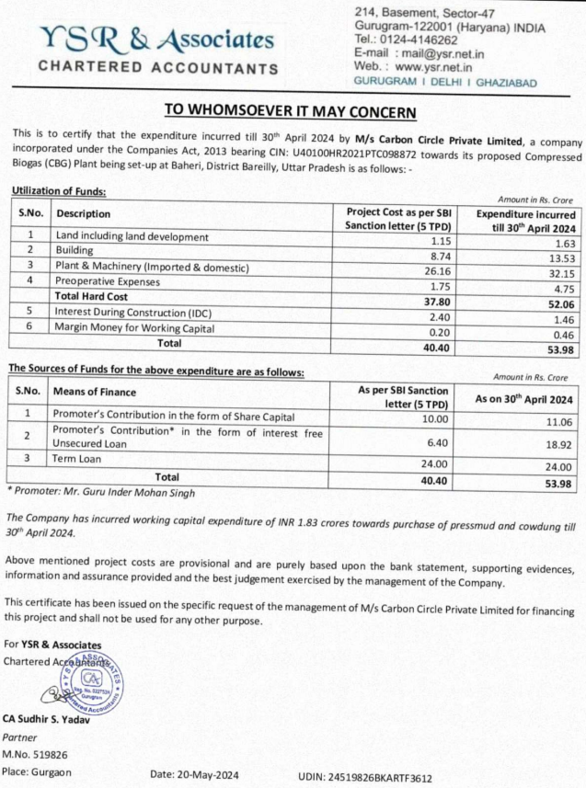
DOCUMENT- 2: APPROVAL OF FILLING OF COMPRESSED GAS CYLINDERS

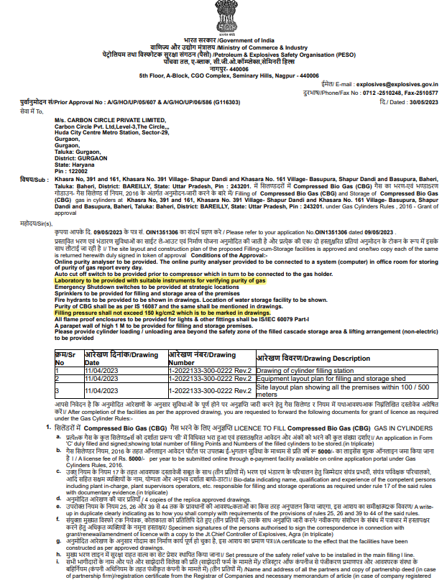

DOCUMENT-3: POLLUTION CERTIFICATE CONSENT TO ESTABLISH
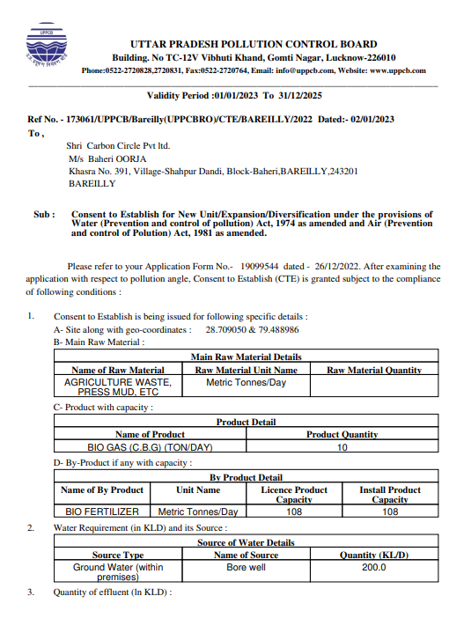
DOCUMENT-3: POLLUTION CERTIFICATE CONSOLIDATED CONSENT TO OPERATE
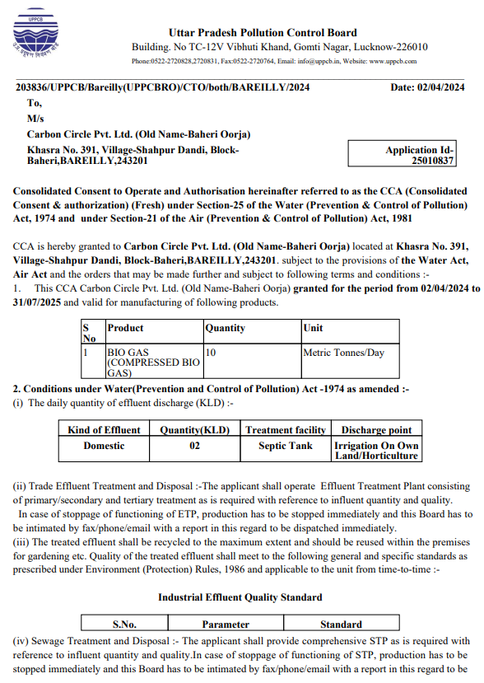

DOCUMENT 4: SITE PLAN
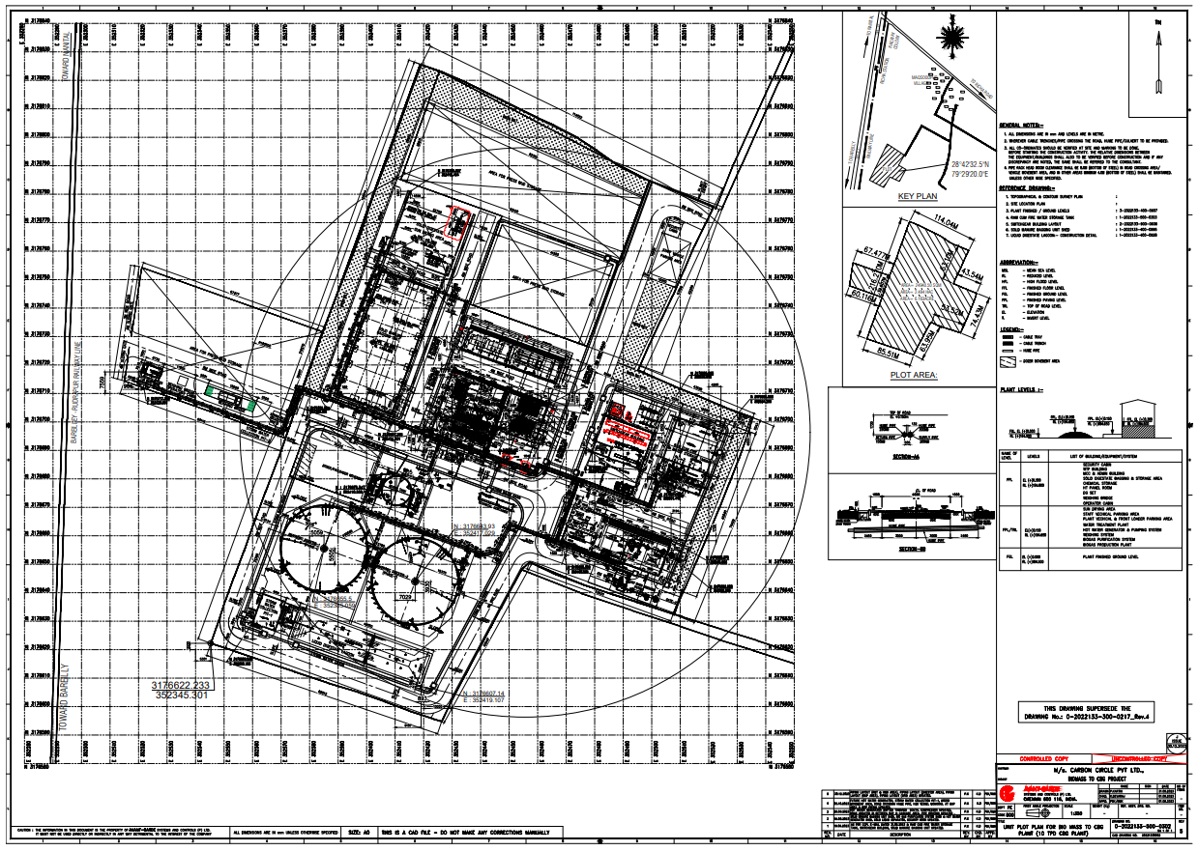

DOCUMENT 5: CHANGE IN LAND USE
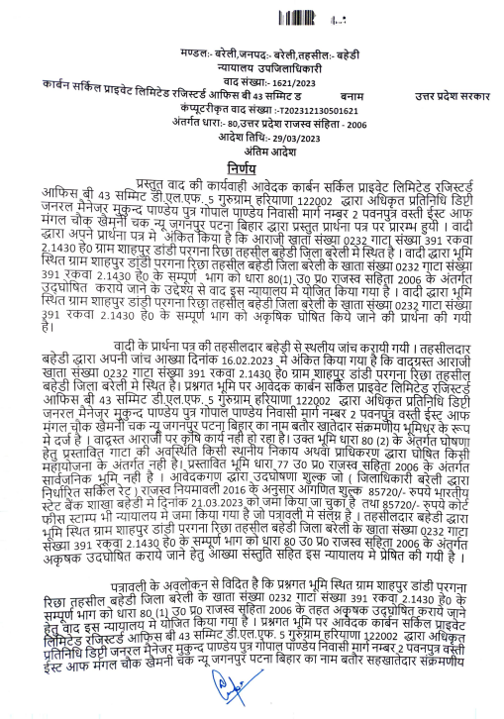
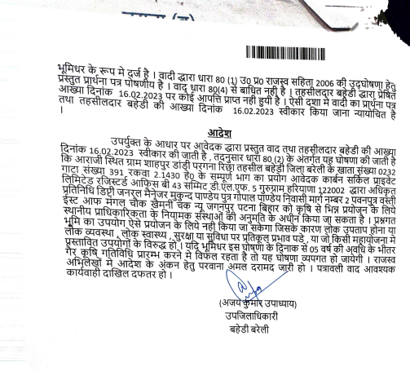

DOCUMENT 6: ELECTIRCAL CONNECTION CERTIFICATE
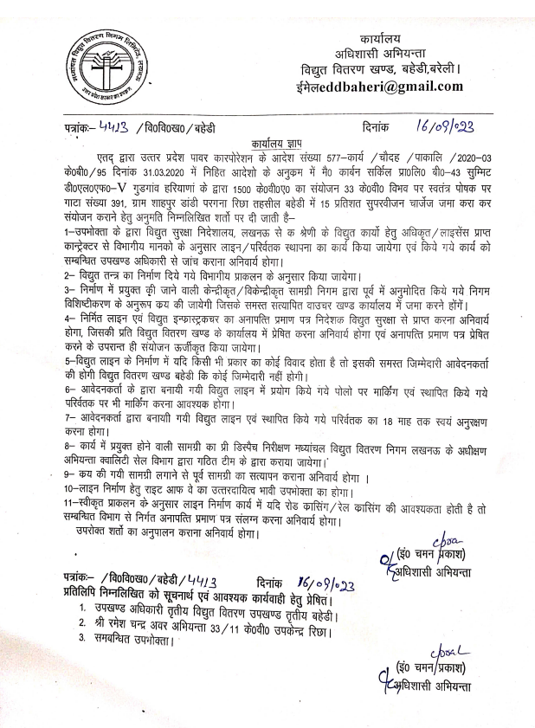

DOCUMENT 7: ELECTIRCAL SAFETY
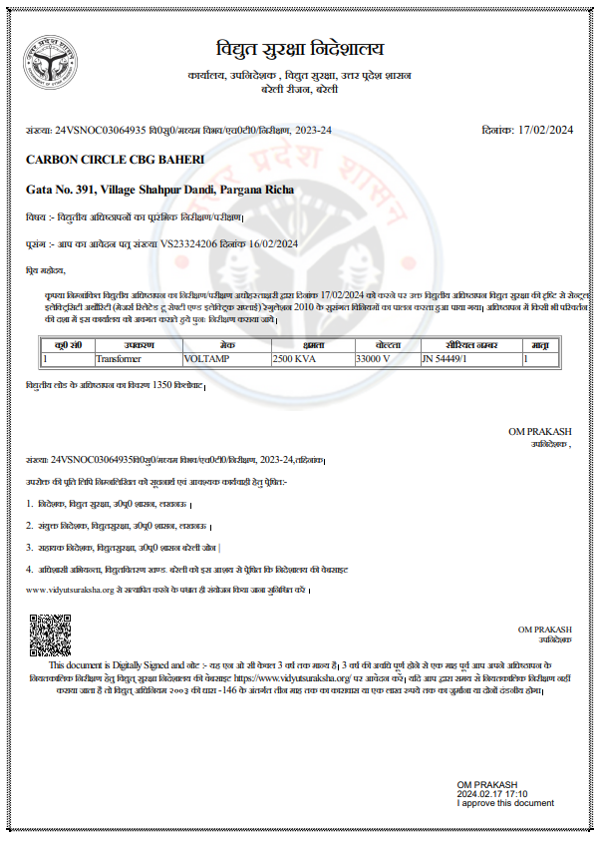

DOCUMENT 8: MACHINE INSTALLATION COMPLETION CERTIFICATE
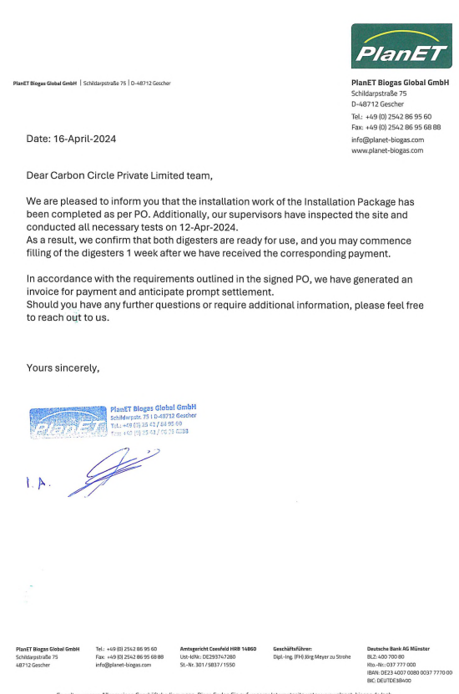
ENCLOSURE-2: - SITE PHOTOGRAPHS 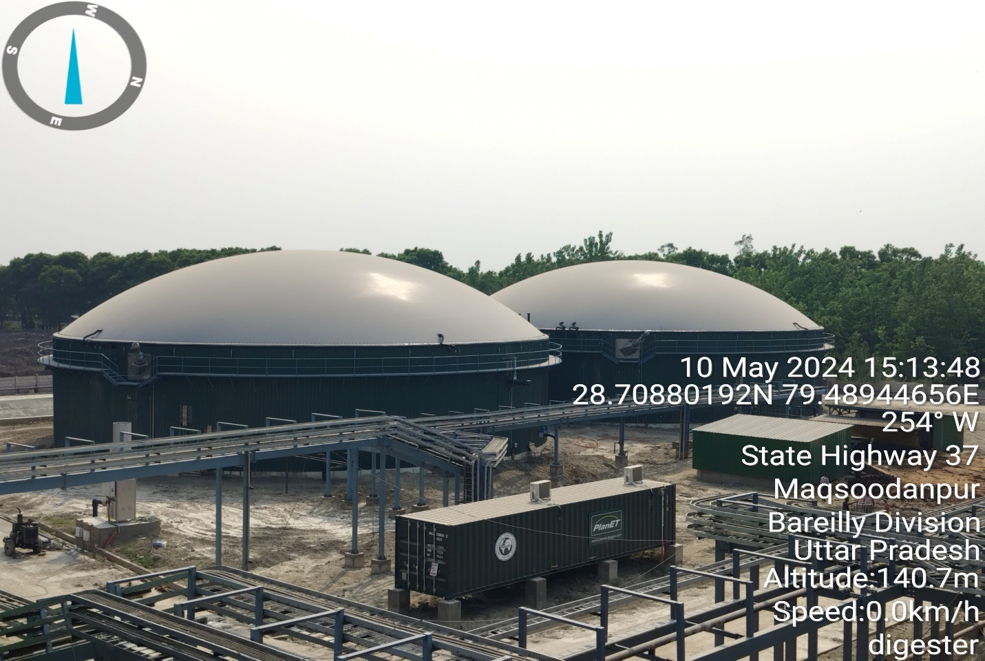

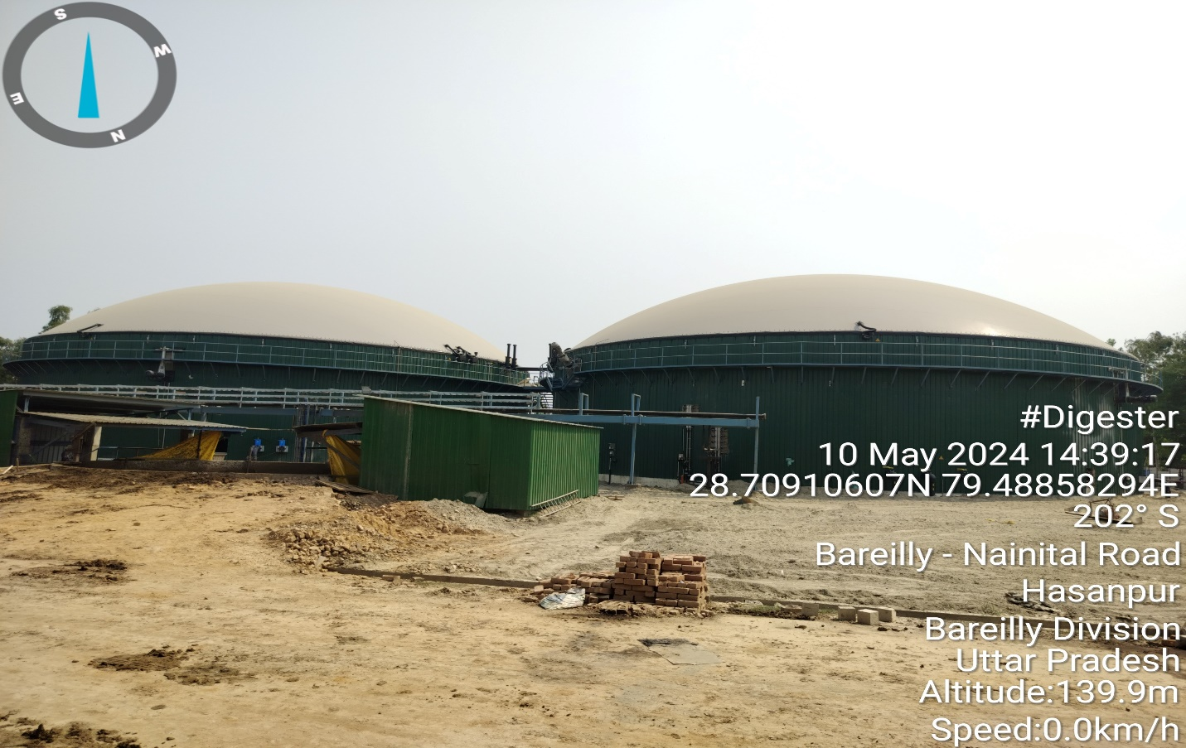

Anaerobic Digester
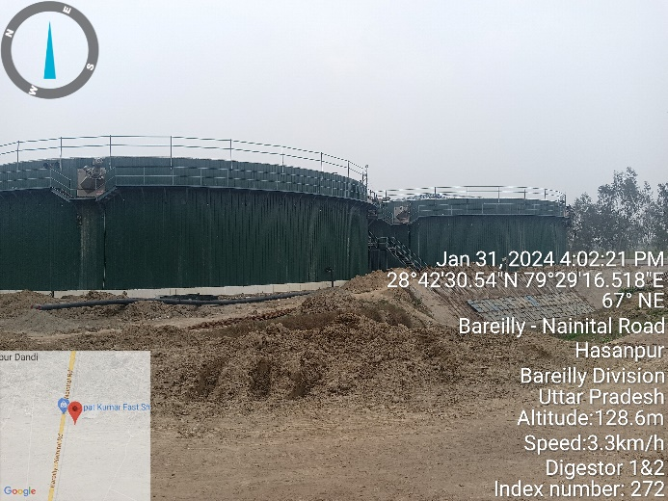 | 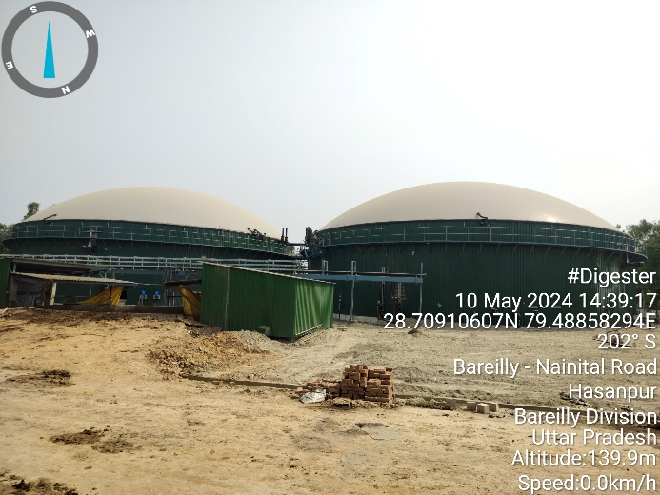

Mixer
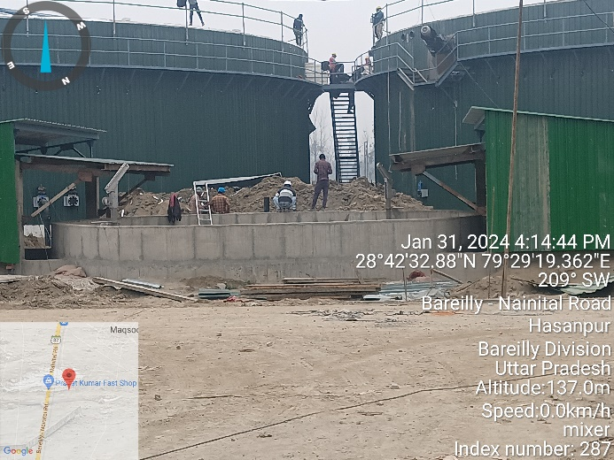 | 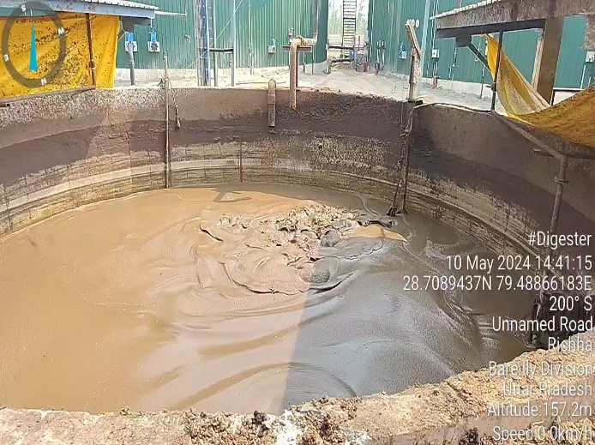

Lagoon

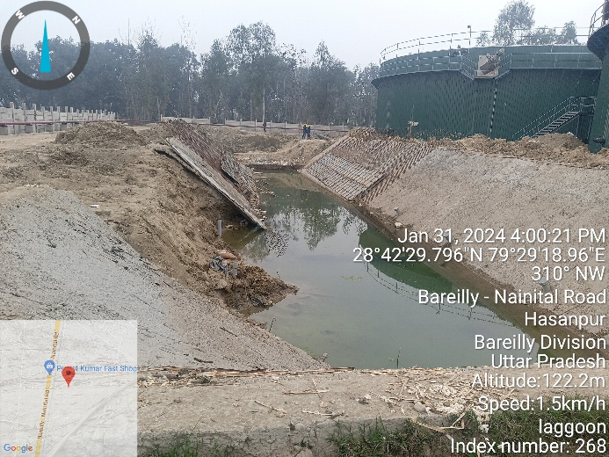 | 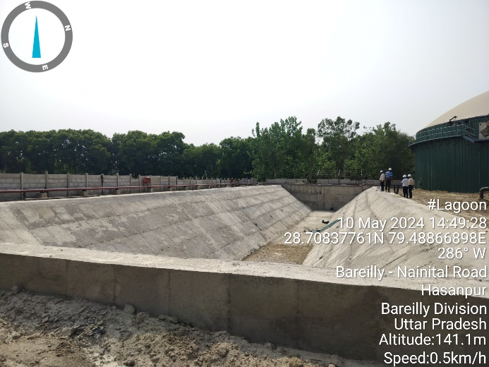
Sun Drying Unit

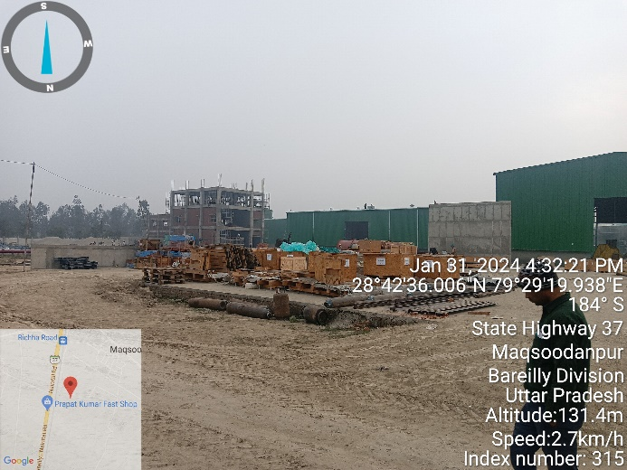 | 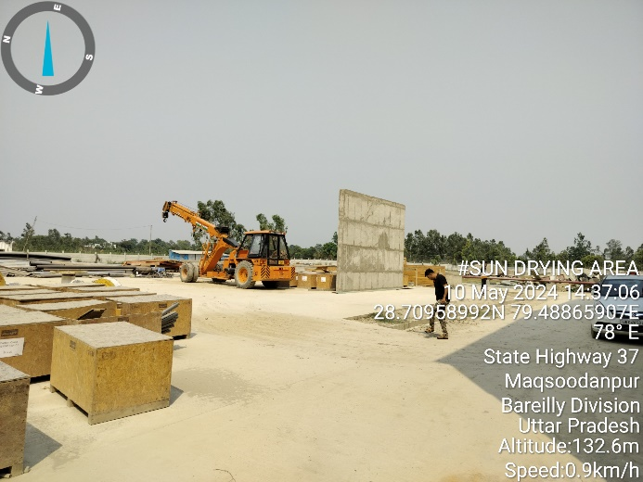

Bagging Unit

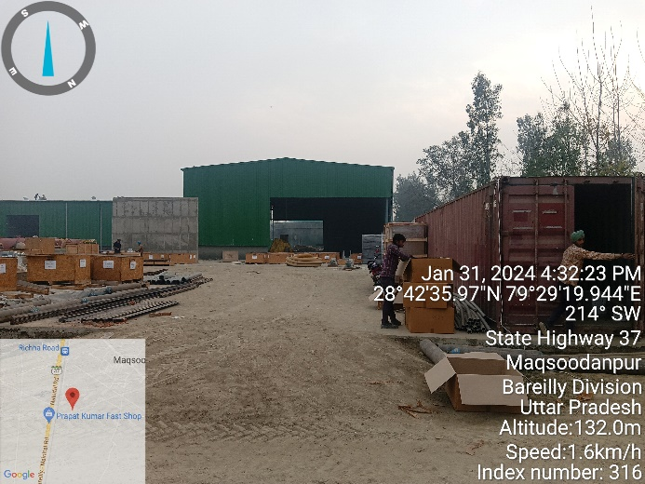 | 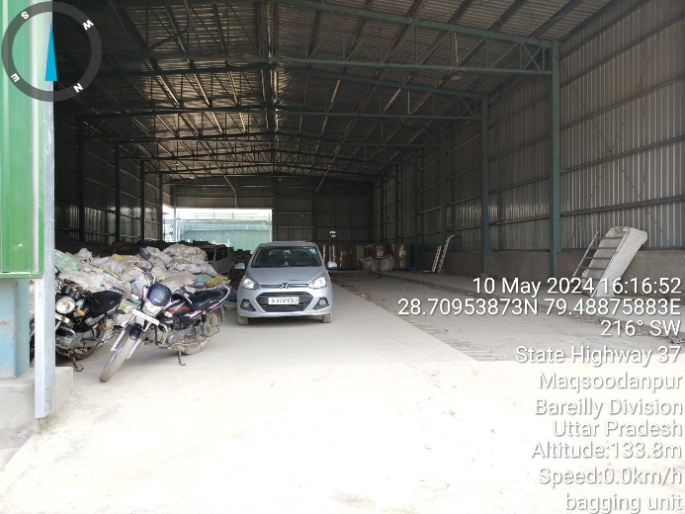

Biogas Upgradation Plant

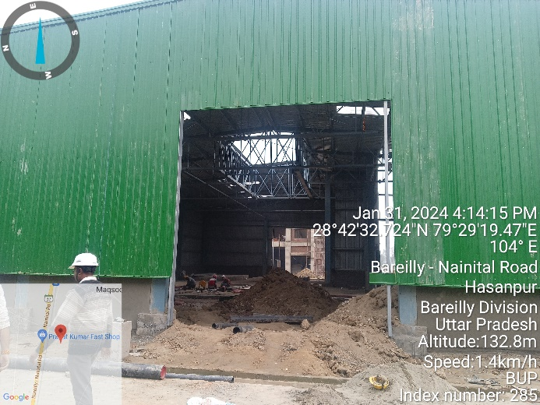 | 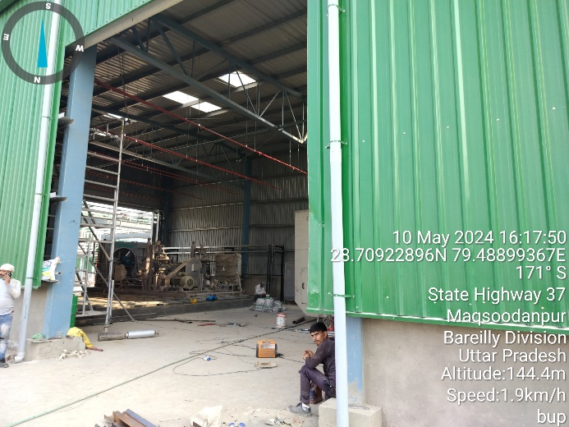

Hot Water Treatment Plant

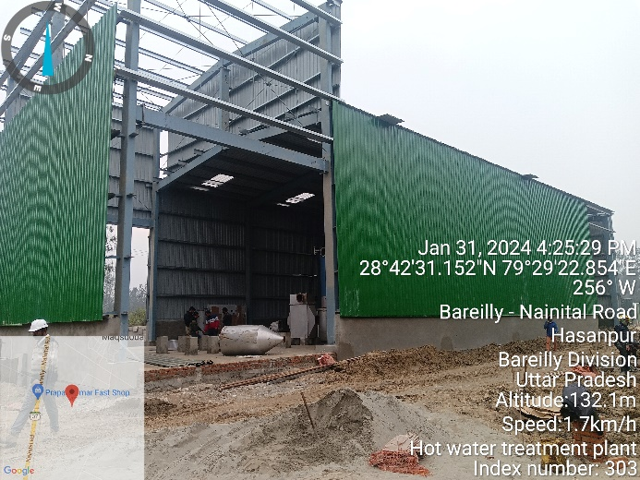 | 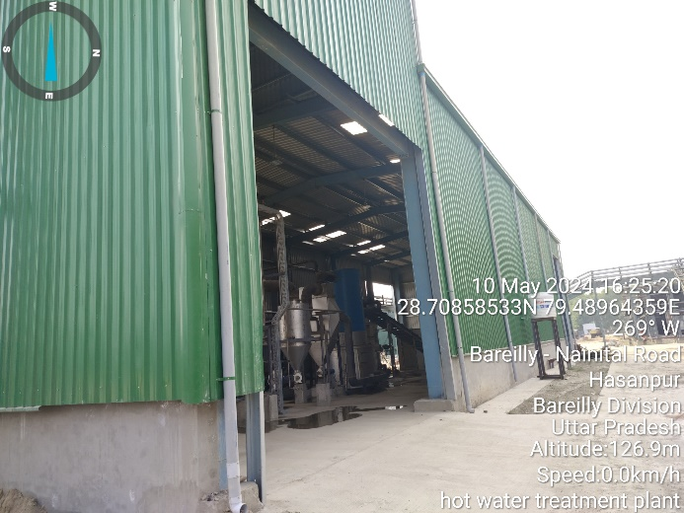

Master Control Room
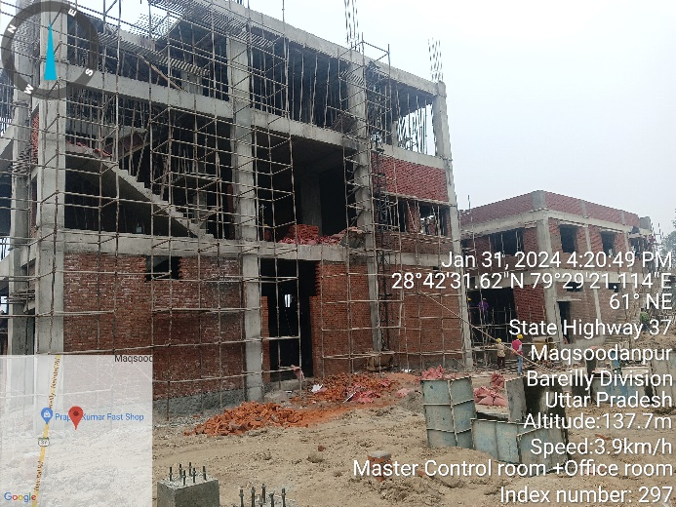 | 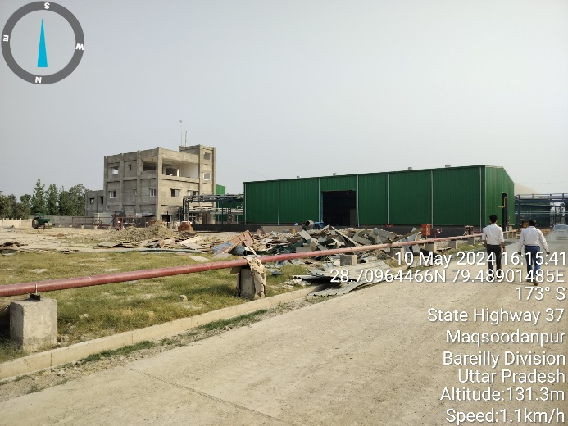

Pump House
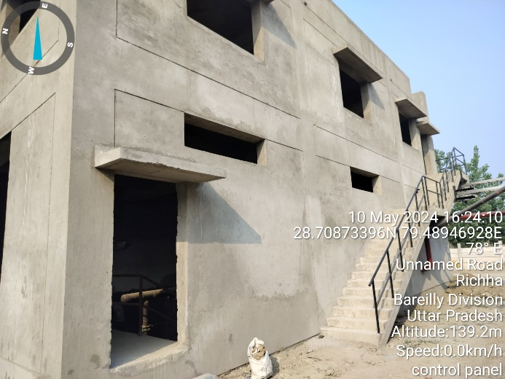
Guard Room
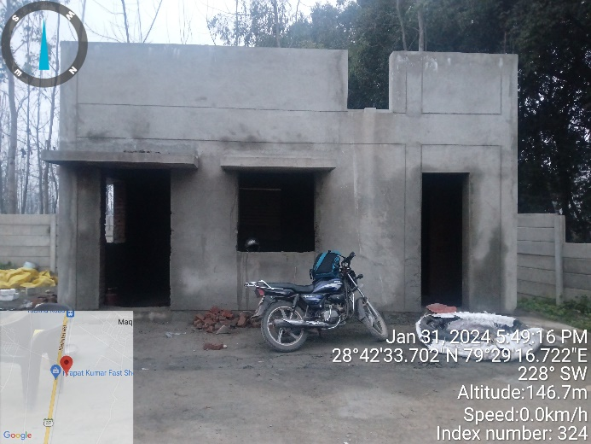 | 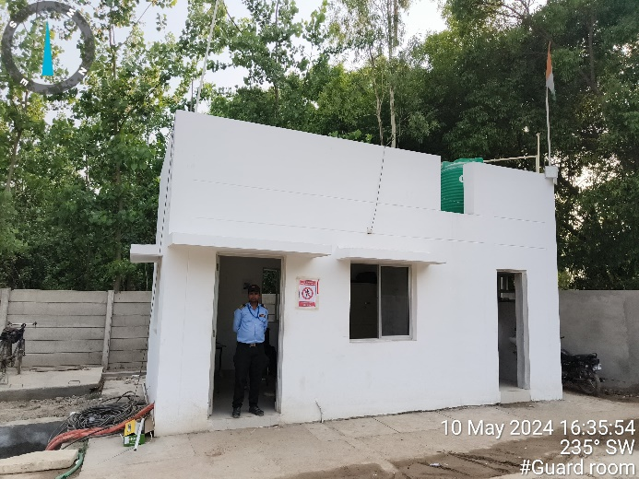

Machine’s
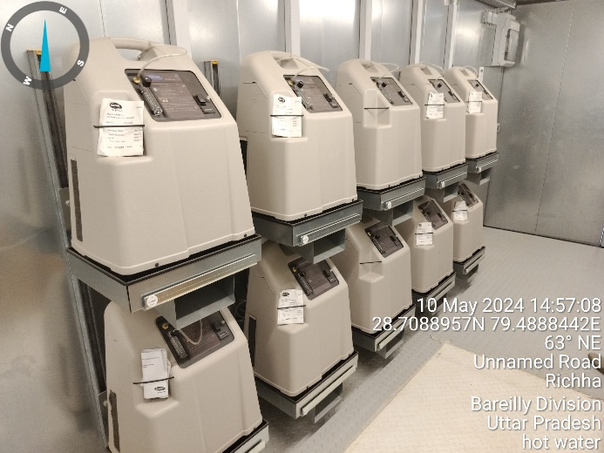 | 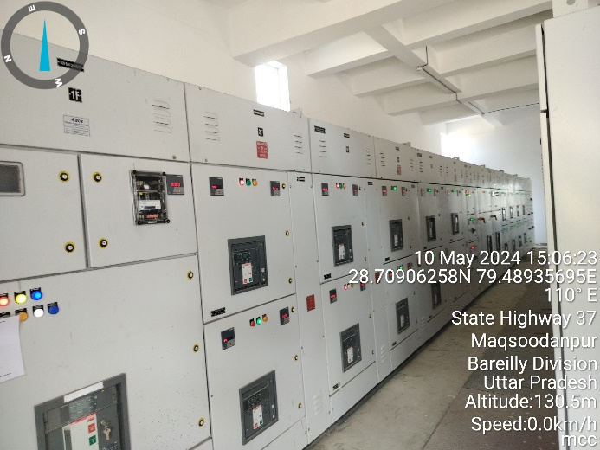
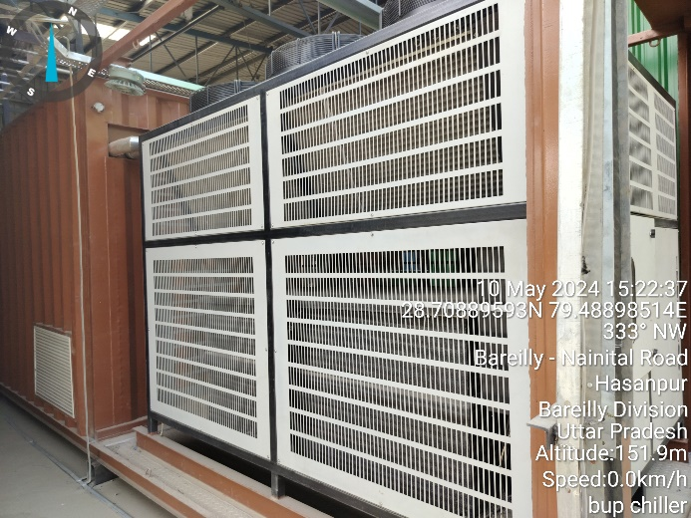 | 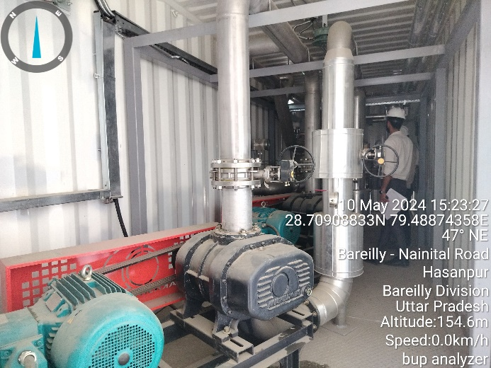

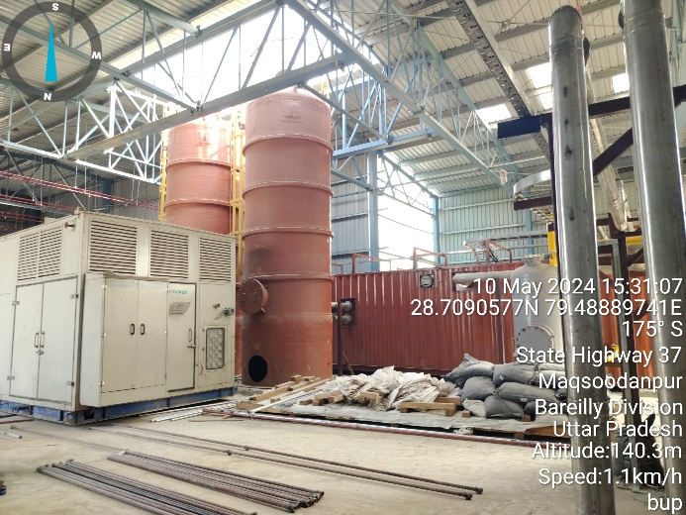 | 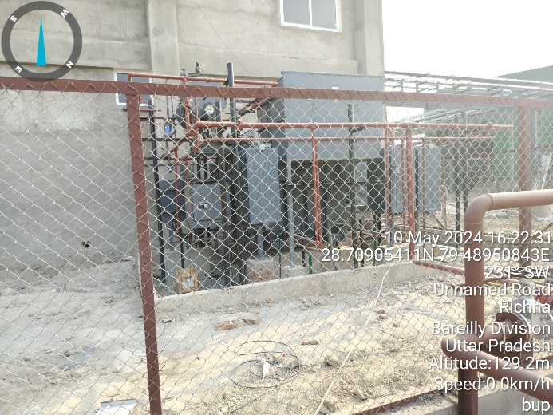
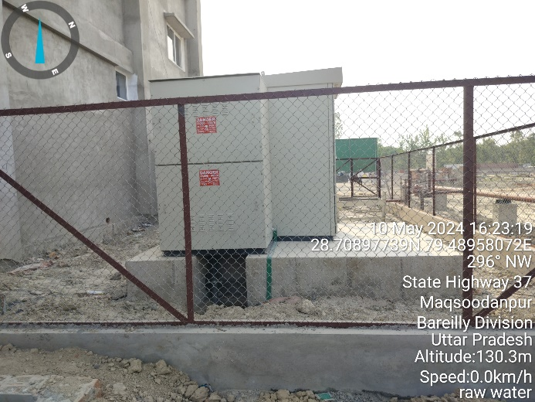 | 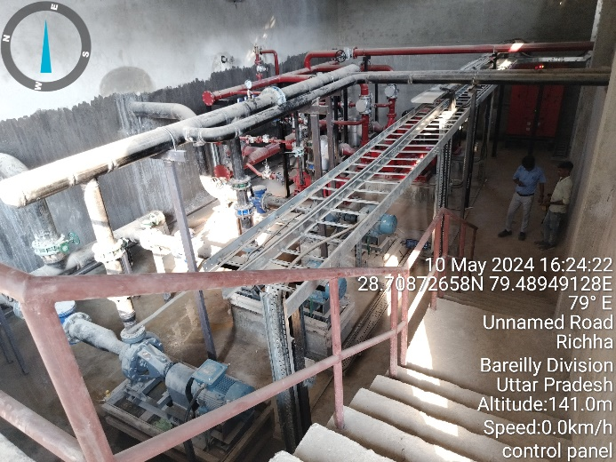
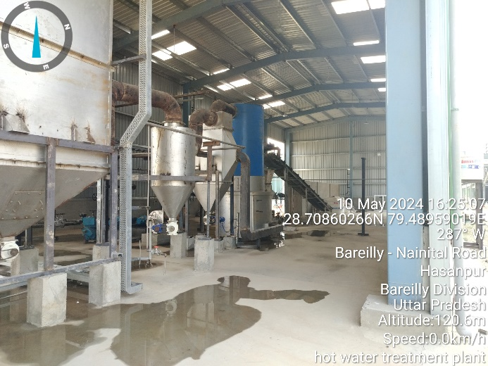 | 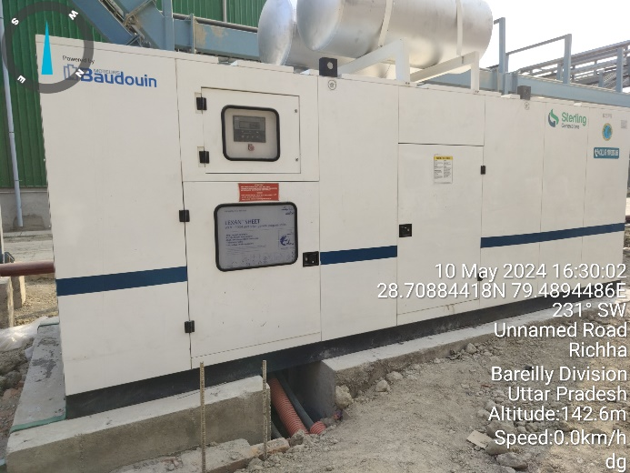

Other’s
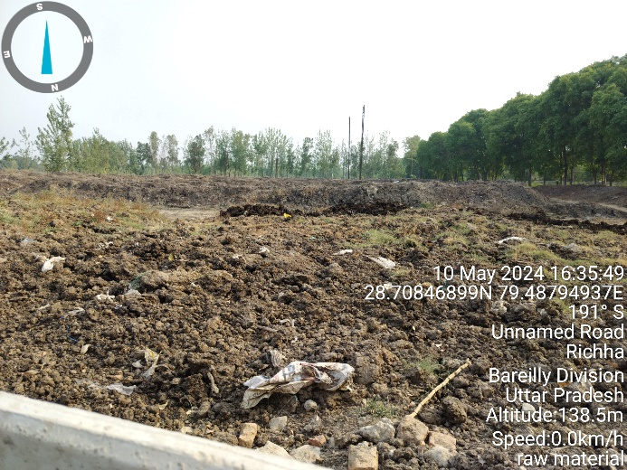 | 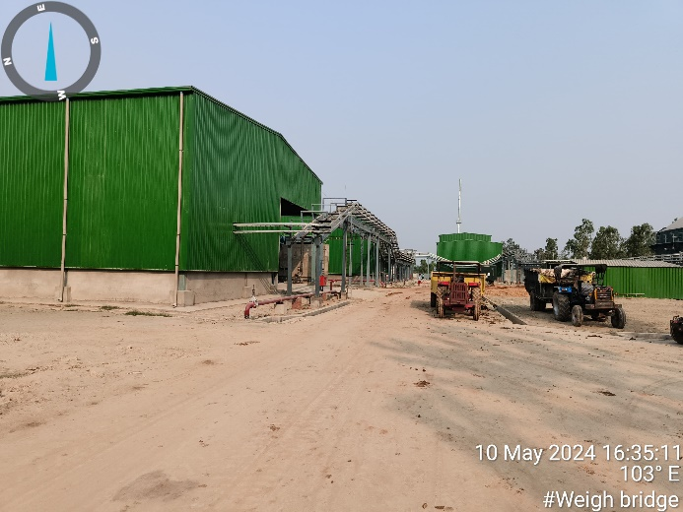
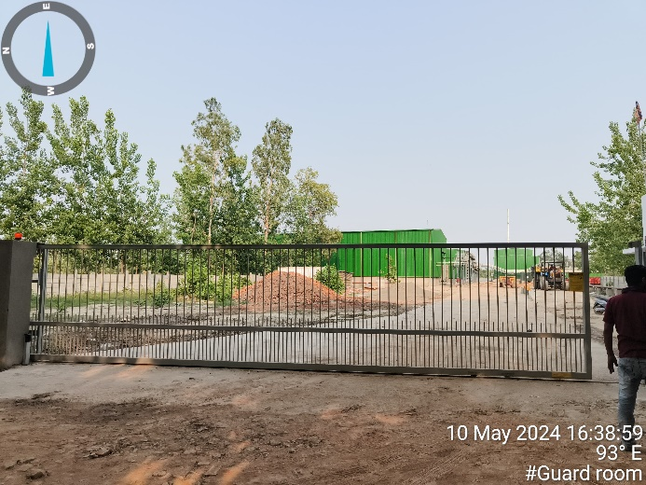 | 