REPORT FORMAT: V-L4 (RKA - Medium) | Version: 11.0_2022

CASE NO.: VIS (2024-25)-PL165-138-178 DATED: 12/07/2024

VALUATION REPORT

OF
NATURE OF ASSETS | PLANT & MACHINERY
CATEGORY OF ASSETS | INDUSTRIAL
TYPE OF ASSETS | INDUSTRIAL PLANT & MACHINERY

SITUATED AT

VILLAGE PITHODAI KI DHANI, DISTRICT JAISALMER, RAJASTHAN

&

VILLAGE DUSUDI, CHIKKABYLADAKERE & THIMMAPANAHALI, DISTRICT- TUMKUR, CHITRADURGA & CHIKKANAYAKANA HALLI, KARNATAKA

OWNER/S
M/S WIND WORLD WIND FARM (HINDUSTAN) PRIVATE LIMITED

REPORT PREPARED FOR
IDBI BANK LIMITED IDBI TOWER, WTC COMPLEX, CUFFE PARADE,
MUMBAI- 400005

**Important - In case of any query/ issue/ concern or escalation you may please contact Incident Manager @ valuers@rkassociates.org. We will appreciate your feedback in order to improve our services.
NOTE: As per IBA Guidelines please provide your feedback on the report within 15 days of its submission after which report will be considered to be accepted & correct.
Valuation Terms of Services & Valuer’s Important Remarks are available at www.rkassociates.org for reference.

PART A | SNAPSHOT OF THE ASSET/ PROPERTY UNDER VALUATION

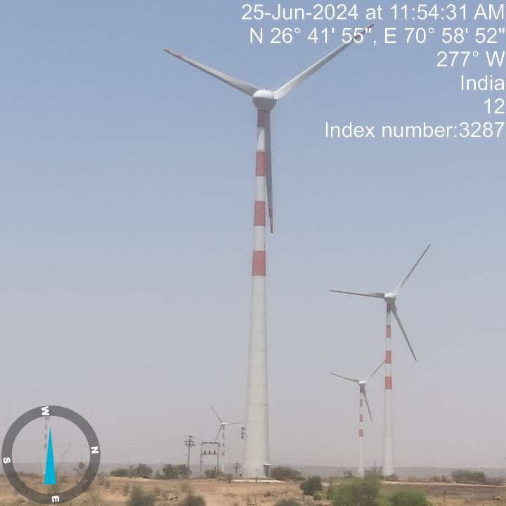
Village Pithodai Ki Dhani, District Jaisalmer, Rajasthan | Village Dusudi, Chikkabyladakere & Thimmapanahali, District- Tumkur, Chitradurga & Chikkanayakana Halli, Karnataka

PART B | SUMMARY OF THE VALUATION REPORT

S.NO. | CONTENTS | DESCRIPTION
 | GENERAL DETAILS
 | Report prepared for | IDBI Bank Limited, IDBI Tower, WTC Complex, Cuffe Parade,  Mumbai- 400005
 | Work Order No. & Date | Ref. No.: IDBI Bank/LCG/2024-25/084 dated 27-05-2024
 | Name of Customer | M/s Wind World Wind Farm (Hindustan) Private Limited
 | Name of Asset Owner | M/s Wind World Wind Farm (Hindustan) Private Limited
 | Address & Phone Number of the owner | Address: Village Pithodai Ki Dhani, District Jaisalmer, Rajasthan  & Village Dusudi, Chikkabyladakere & Thimmapanahali, District- Tumkur, Chitradurga & Chikkanayakana Halli, Karnataka
 | Type of the Property | Industrial Plant & Machinery
 | Type of Valuation Report | Industrial Plant & Machinery Valuation
 | Report Type | Plain Asset Valuation
 | Date of Inspection of the Property | 25 June 2024 (Rajasthan) & 10 July 2024(Karnataka)
 | Date of Valuation Assessment | 12 July 2024
 | Date of Valuation Report | 12 July 2024
 | Property Shown By | Name |  | Relationship with Owner | Contact Number
 |  | Mr. Mukesh (Rajasthan) |  | Employee | +91- 9425534135
 | Purpose of the Valuation | For Periodic Re-valuation of the mortgaged property
 | Scope of the Report | Non Binding Opinion on General Prospective Valuation Assessment of the Property identified by Property owner or through its representative
 | Out-of-Scope of Report | - Verification of authenticity of documents from originals or cross checking from any Govt. deptt. is not done at our end.  - Legal aspects & rights of the Plant & Machinery are out-of-scope of this report.  - Inventorization of Asset is out of scope of work.  - Componentization of Plant & Machinery is out of scope of this report.  - Identification of the Plant & Machinery is only limited to cross verification of major items.  - Technical/ mechanical/ operational testing of the Plant & Machinery is out-of-scope of the report.  - Comment/ determination on technological aspect is out of scope of this report.  - Any kind of process design is out of scope of the report.
 | Documents provided for perusal | Documents Requested |  | Documents Provided |  | Documents Reference No.
 |  | Total 04 |  | Total 03 |  | Total 03
 |  | Copy of FAR |  | Copy of FAR |  | Dated 31-09-2023
 |  | Process Flow Chart |  | --- |  | ---
 |  | Capacity Utilization |  | Capacity Utilization |  | Last 5 years
 |  | Details of maintenance record |  | Details of maintenance record |  | Last 3 years
 | Identification of the property |  | Cross checked from the name of items mentioned in the Inventory list
 |  |  | Identified by the company's representative
 |  |  | Due to large number of inventory, only items have been checked/verified

 | VALUATION SUMMARY
 | Total Prospective Fair Market Value | Rs. 151,70,00,000/-
 | Total Expected Realizable/ Fetch Value | Rs. 128,94,50,000/-
 | Total Expected Distress/ Forced Sale Value | Rs. 113,77,50,000/-

 | ENCLOSURES
 | Part A | Snapshot of The Asset/ Property Under Valuation
 | Part B | Summary of the Valuation Report
 | Part C | Characteristics Description of The Asset
 | Part D | Characteristics Description of Plant/ Machinery
 | Part E | Procedure Of Valuation Assessment
 | Annexure-I | Windmill Location Details
 | Annexure-II | Detailed Valuation
 | Enclosure-I | Google Map Location
 | Enclosure-II | Photographs of the Assets
 | Enclosure-III | Impotent Documents Exhibit
 | Enclosure-IV | Valuer’s Important Remarks

PART C | CHARACTERISTICS DESCRIPTION OF THE ASSET

BRIEF DESCRIPTION OF THE PROPERTY UNDER VALUATION
This valuation report is prepared for the offshore Wind Turbines installed by M/s Wind World Wind Farm (Hindustan) Private Limited (“WWWFHPL” or “Company”). M/s Wind World Wind Farm (Hindustan) Private Limited is an independent power producer with wind farms in Karnataka and Rajasthan.

As per the copy of PPA the company name is M/s Enercon Wind Farms (Hindustan) Private Limited. But, as per copy of work order and information provided to us during site survey the name has been changed to M/s Wind World Wind Farm (Hindustan) Private Limited. However, any name change certificate has not been provided to us. So, we have considered M/s Wind World Wind Farm (Hindustan) Private Limited as the owner for valuation purpose as per the work order given to us.

The company is involved in the generation, distribution, and transmission of electricity. WWWFHPL is having long term Power Purchase Agreements for the entire operational capacity for the period of 20 years (till FY-26) with DISCOMs in the state of Karnataka and Rajasthan. In Karnataka, PPA is with Bangalore Electricity Supply Company Limited (BESCL) at tariff of Rs. 3.40 per unit for installed capacity of 68.80 MW located at Tumkur District. Whereas in Rajasthan PPA is with Jaipur Vidyut Vitran Nigam Limited (JVVN) at tariff of Rs.3.79 per unit for 28.80 MW and with Ajmer Vidyut Vitran Nigam Limited (AVVN) at tariff of Rs.3.79 per unit for 31.20 MW.

As per information & documents provided, both plants were commissioned in year 2006. There are total 75 nos. of Wind Turbines in Rajasthan and 86 nos. in Tumkur, Karnataka having 0.8 MW capacity each. As on date of site visit, both sites were found operational. Details of the same are as follows: -
S. No. | Model No. | WTG in Karnataka  (in nos.) | WTG in Rajasthan  (in nos.) | Remarks
1. | E-48 | 70 | - | Refer annexure for more details
2. | E-53 | 16 | 75
Total WTG |  | 86 | 75
Capacity in MW each |  | 0.8 | 0.8
Total Capacity in MW |  | 68.8 | 60

The E-53 & E-48 800 KW is suited for use both in central grid regions and in remote locations a long way from the main electricity grids. Technical specifications of the 800 kW WTG are given in table below:
Particulars | E- 53 | E- 48
Rated Capacity | 800 kW | 800 kW
Rotor Diameter | 53 m | 48 m
Hub Height | 75 m | 75 m
Rotor | With pitch control | With pitch control
Type | Upwind rotor with active pitch control
Direction of Rotation | Clockwise | Clockwise
Number of Blades | 3 | 3
Swept Area | 2198 sq. m | 1810 sq. m
Blade Material | Fiberglass (reinforced epoxy) with integral lighting protection
Rotor Speed | Variable, 12- 29 rpm | Variable, 16- 31.5 rpm
Pitch Control | 3 synchronized blade pitch system with emergency supply Generator with drive train
Hub | Rigid | Rigid
Bearings | Tapered Roller bearings | Tapered Roller bearings
Generator | Synchronous Type | Synchronous Type
Grid Feeding | Enercon Inverter | Enercon Inverter
Braking System | 3 independent Aero Brakes | 3 independent Aero Brakes
Yaw Control | Active through Adjustment Gears, Friction Damping
Cut-in Wind Speed | 2.5 m/s | 3 m/s
Rated Wind Speed | 12 m/s | 14 m/s

As per details shared by the company, the capacity utilization factor of last 5 years is as follow: -
RAJASTHAN AVERAGE CAPACITY FACTOR (in %) (75 WTGs):
MONTH / FY | 2019-20 | 2020-21 | 2021-22 | 2022-23 | 2023-24 | Average
April | 12.62 | 14.62 | 12.81 | 14.85 | 14.08 | 13.79
May | 17.78 | 21.18 | 23.38 | 35.53 | 24.05 | 24.38
June | 21.52 | 29.54 | 33.65 | 38.29 | 26.61 | 29.92
July | 33.01 | 23.30 | 33.14 | 17.10 | 18.55 | 25.02
August | 19.08 | 18.11 | 33.10 | 15.26 | 38.77 | 24.86
September | 11.80 | 9.48 | 8.91 | 15.58 | 13.07 | 11.77
October | 6.22 | 6.94 | 10.82 | 6.71 | 10.76 | 8.29
November | 11.05 | 6.58 | 6.17 | 7.47 | 5.85 | 7.43
December | 9.70 | 9.34 | 6.50 | 6.42 | 7.18 | 7.83
January | 9.48 | 8.78 | 6.10 | 11.47 | 5.70 | 8.31
February | 10.95 | 6.83 | 10.20 | 9.32 | 10.75 | 9.61
March | 11.55 | 13.00 | 12.61 | 10.84 | 10.69 | 11.74
Average | 14.56 | 13.98 | 16.45 | 15.74 | 15.50 | 15.25

KARNATAKA AVERAGE CAPACITY FACTOR (in %) (86 WTGs):
MONTH / FY | 2019-20 | 2020-21 | 2021-22 | 2022-23 | 2023-24 | Average
April | 9.76 | 8.81 | 9.02 | 8.04 | 6.44 | 8.42
May | 15.74 | 13.67 | 16.35 | 23.79 | 12.53 | 16.42
June | 26.46 | 25.78 | 26.85 | 20.25 | 25.17 | 24.90
July | 30.55 | 17.54 | 35.71 | 30.44 | 40.87 | 31.02
August | 31.70 | 24.99 | 23.83 | 25.84 | 25.42 | 26.36
September | 21.11 | 16.94 | 23.82 | 17.85 | 25.93 | 21.13
October | 8.98 | 8.33 | 6.49 | 9.69 | 10.00 | 8.70
November | 9.49 | 13.87 | 9.59 | 10.35 | 9.65 | 10.59
December | 7.99 | 13.85 | 8.04 | 12.15 | 10.76 | 10.56
January | 4.50 | 10.73 | 8.20 | 10.82 | 8.65 | 8.58
February | 11.18 | 12.20 | 9.12 | 15.22 | 10.35 | 11.61
March | 7.02 | 12.25 | 11.26 | 12.34 | 7.36 | 10.04
Average | 15.37 | 14.91 | 15.69 | 16.40 | 16.09 | 15.69

Wind farms are exposed to inherent risk of weather fluctuations leading to variations in the wind patterns and velocity which affects the Plant Load Factor (PLF). Generally, the wind farms enjoy higher PLF during May – October (monsoon period) and lower PLFs in the remaining months of the year. Tamil Nadu as a state has witnessed unprecedented cyclones and floods in nearby state over past two years which has shortened the wind season in the last 2 years thereby affecting the PLF and the power generation levels across all wind firms over the last 2 years.

In case of discrepancy in the address mentioned in the property documents and the property shown to us at the site due to change in zoning or administrative level at the site or client misled the valuer by providing the fabricated document, the valuation should be considered of the property shown to us at the site of which the photographs are also attached. Our responsibility will be only related to the valuation of the property shown to us on the site and not regarding matching from the documents or searching the property from our own. Banker to verify from district administration/ tehsil level the identification of the property if it is the same matching with the document pledged.
This report only contains general assessment & opinion on the Guideline Value and the indicative, estimated Market Value of the property found on as-is-where basis on site for which the Bank/ customer has shown & asked us to conduct the Valuation for which photographs is also attached with the report. No legal aspects in terms of ownership or any other legal aspect is taken into consideration. It doesn’t contain any due-diligence other than the valuation assessment of the property shown to us on site. Information/ data/ documents given to us by Bank/ client has been relied upon in good faith. This report doesn’t contain any other recommendations of any sort.

PART D | CHARACTERISTICS DESCRIPTION OF PLANT/ MACHINERY

S.NO. | CONTENTS | DESCRIPTION

 | TECHNICAL DESCRIPTION OF THE PLANT/ MACHINERY
 | Nature of Plant & Machinery | Power, Wind Turbines
 | Size of the Plant | - Large scale Plant
 | Type of the Plant | - Fully Automatic
 | Year of Installation/ Commissioning/ COD (Commercial Operation Date) | - 2006 (as per information provided to us)
 | Production Capacity | Rajasthan; - 60 MW  Karnataka: - 68.8 MW
 | Capacity at which Plant was running at the time of Survey | Capacity Utilization 15% - 16%
 | Number of Production Lines | Rajasthan- 75 WTG  Karnataka- 86 WTG
 | Condition of Machines | Operational
 | Status of the Plant | Fully operational
 | Products Manufactured in this Plant | Power (Electricity)
 | Recent maintenance carried out on | Regular maintenance has been carried out by the company as per the information provided during the survey and Maintenance Record Provided by the Company.
 | Recent upgradation, improvements if done any | No, as per information provided during survey
 | Total Gross Block & Net Block of Assets | Gross Block |  | Net Block
 |  | As on 31/03/2024
 |  | Rs. 657,33,62,135/- |  | Rs. 164,90,86,652/-
 | Any other Details if any | As on date of site survey, all the wind turbines were operational on full capacity and the condition of the WTG was fair.
 | PROCESS FLOW DIAGRAM
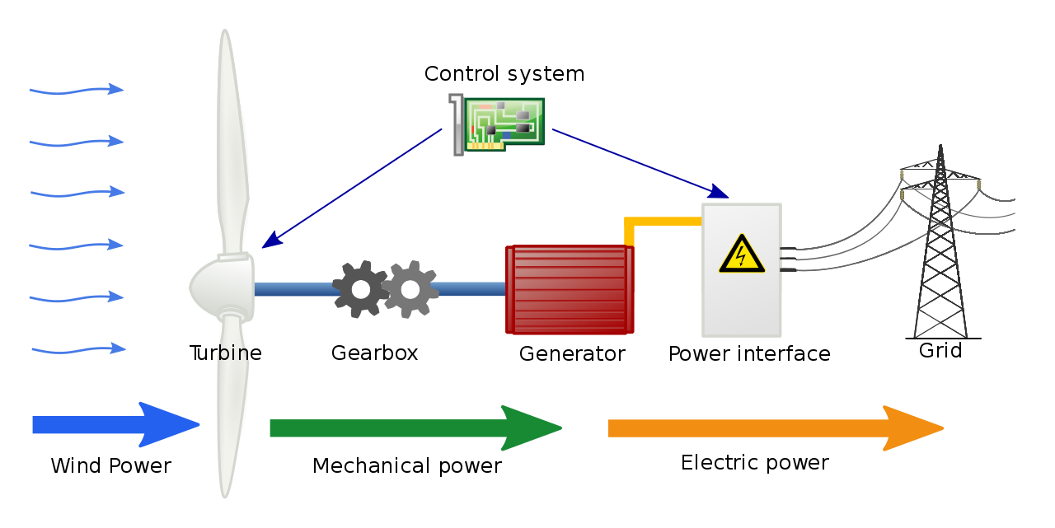
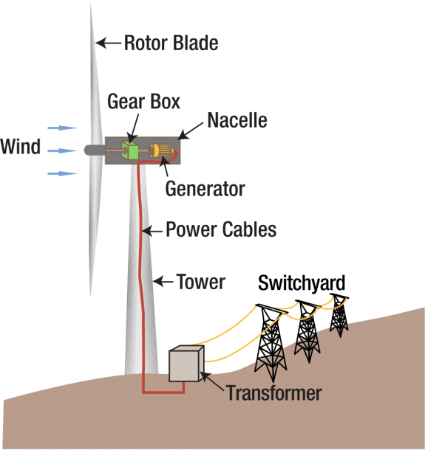
A wind turbine turns wind energy into electricity using the aerodynamic force from the rotor blades, which work like an airplane wing or helicopter rotor blade. When wind flows across the blade, the air pressure on one side of the blade decreases. The difference in air pressure across the two sides of the blade creates both lift and drag. The force of the lift is stronger than the drag and this causes the rotor to spin. The rotor connects to the generator, either directly (if it's a direct drive turbine) or through a shaft and a series of gears (a gearbox) that speed up the rotation and allow for a physically smaller generator. This translation of aerodynamic force to rotation of a generator creates electricity.
Transmission
Transmission lines carry electricity at high voltages over long distances from wind turbines and other energy generators to areas where that energy is needed.
Transformers
Transformers receive AC (alternating current) electricity at one voltage and increase or decrease the voltage to deliver the electricity as needed. A wind power plant will use a step-up transformer to increase the voltage (thus reducing the required current), which decreases the power losses that happen when transmitting large amounts of current over long distances with transmission lines. When electricity reaches a community, transformers reduce the voltage to make it safe and useable by buildings and homes in that community.
Substation
A substation links the transmission system to the distribution system that delivers electricity to the community. Within the substation, transformers convert electricity from high voltages to lower voltages which can then be delivered safely to electricity consumers.
Wind Turbine Tower
Made from tubular steel, the tower supports the structure of the turbine. Towers usually come in three sections and are assembled on-site. Because wind speed increases with height, taller towers enable turbines to capture more energy and generate more electricity. Winds at elevations of 30 meters (roughly 100 feet) or higher are also less turbulent.
Wind Vane
The wind vane measures wind direction and communicates with the yaw drive to orient the turbine properly with respect to the wind.
Blades
Most turbines have three blades which are made mostly of fiberglass. Turbine blades vary in size, but a typical modern land-based wind turbine has blades of over 170 feet (52 meters). The largest turbine is GE's Haliade-X offshore wind turbine, with blades 351 feet long (107 meters) – about the same length as a football field. When wind flows across the blade, the air pressure on one side of the blade decreases. The difference in air pressure across the two sides of the blade creates both lift and drag. The force of the lift is stronger than the drag and this causes the rotor to spin.
Land-Based Gearbox Turbine
The drivetrain on a turbine with a gearbox is comprised of the rotor, main bearing, main shaft, gearbox, and generator. The drivetrain converts the low-speed, high-torque rotation of the turbine’s rotor (blades and hub assembly) into electrical energy.
Nacelle
The nacelle sits atop the tower and contains the gearbox, low- and high-speed shafts, generator, and brake. Some nacelles are larger than a house and for a 1.5 MW geared turbine, can weigh more than 4.5 tons.
Yaw System
The yaw drive rotates the nacelle on upwind turbines to keep them facing the wind when wind direction changes. The yaw motors power the yaw drive to make this happen. Downwind turbines don’t require a yaw drive because the wind manually blows the rotor away from it.
Hub
Part of the turbine's drivetrain, turbine blades fit into the hub that is connected to the turbine's main shaft.
Gearbox
The drivetrain is comprised of the rotor, main bearing, main shaft, gearbox, and generator. The drivetrain converts the low-speed, high-torque rotation of the turbine's rotor (blades and hub assembly) into electrical energy.
Rotor
The blades and hub together form the turbine's rotor.
Low-Speed Shaft
Part of the turbine's drivetrain, the low-speed shaft is connected to the rotor and spins between 8–20 rotations per minute.
Main Shaft Bearing
Part of the turbine's drivetrain, the main bearing supports the rotating low-speed shaft and reduces friction between moving parts so that the forces from the rotor don't damage the shaft. Still frame of an illustrated wind turbine main shaft bearing highlighted in an animation window.
High-Speed Shaft
Part of the turbine's drivetrain, the high-speed shaft connects to the gearbox and drives the generator.
Still frame of an illustrated wind turbine high-speed shaft highlighted in an animation window.
Generator
The generator is driven by the high-speed shaft. Copper windings turn through a magnetic field in the generator to produce electricity. Some generators are driven by gearboxes (shown here) and others are direct-drives where the rotor attaches directly to the generator. Still frame of an illustrated wind turbine generator highlighted in an animation window.
Controller
The controller allows the machine to start at wind speeds of about 7–11 miles per hour (mph) and shuts off the machine when wind speeds exceed 55–65 mph. The controller turns off the turbine at higher wind speeds to avoid damage to different parts of the turbine. Think of the controller as the nervous system of the turbine. Still frame of an illustrated wind turbine controller bearing highlighted in an animation window.
Brake
Turbine brakes are not like brakes in a car. A turbine brake keeps the rotor from turning after it's been shut down by the pitch system. Once the turbine blades are stopped by the controller, the brake keeps the turbine blades from moving, which is necessary for maintenance.
 | TECHNOLOGY TYPE/ GENERATION USED AND TECHNOLOGICAL COLLABORATIONS IF ANY
 | - Technology Type/ Generation Used in this Plant |  | - Horizontal-axis wind turbines (HAWT) of 800 KW
 | Technological Collaborations If Any |  | - No
 | Current Technology used for this Industry in Market |  | - Similar but with higher capacity more than 1.5 MW
 | RAW MATERIALS REQUIRED & AVAILABILITY
 | Type of Raw Material |  | Wind
 | Availability |  | Available
 | AVAILABILITY & STATUS OF UTILITIES
 | Power/ Electricity |  | Itself is a Power Plant.
 | Water |  | ---
 | Road/ Transport |  | Available.
 | COMMENT ON AVAILABILITY OF LABOUR
 | Availability |  | Not much Labour-intensive industry. But Appears to be easily & adequately available and no labour issues came to our knowledge during site inspection.
 | SALES TRANSACTIONAL PROSPECTS OF SUCH PLANTS/ MACHINERY
 | On-going concern basis
 | Reason: This is a Large Scale Wind Power Plant and can only be sold only as an Integrated Industry to preserve its value since complete WTGs & machines are special purpose machines and can't be used in any other Industry. So, for fetching maximum value is through strategic sale to the players who are already into same or similar Industry who have plans for expansion or any large conglomerate who plans to enter into this new Industry
 | DEMAND OF SUCH PLANT & MACHINERY IN THE MARKET
 | Appears to be good in line to Govt. policy to promote renewable energy and hybrid Solar-Wind Plants.
 | SURVEY DETAILS
 | Plant has been surveyed by our Engineering Team on dated 25/06/2024 and 10/07/2024.
 | Site inspection was done in the presence of Owner's representative Mr. Mukesh who was available from the company to furnish any specific detail about the Plant & Machinery.
 | Our team examined & verified the machines and utilities from the FAR provided by the Company. Only major machinery, process line & equipment has been verified.
 | Plant was found to be operational at the time of survey.
 | Condition of the machines is checked through visual observation only. No technical/ mechanical/ operational testing has been carried out to ascertain the condition and efficiency of machines.
 | Site Survey has been carried out on the basis of the physical existence of the assets rather than their technical expediency.
 | As per the overall site visit summary, Plant appeared to be in average condition.

PART E | PROCEDURE OF VALUATION ASSESSMENT – PLANT & MACHINERY

 | GENERAL INFORMATION
 | Important Dates | Date of Inspection of the Property |  | Date of Valuation Assessment | Date of Valuation Report
 |  | 25 June 2024 (Rajasthan)  10 July 2024 (Karnataka) |  | 12 July 2024 | 12 July 2024
 | Client | IDBI Bank Limited, IDBI Tower, WTC Complex, Cuffe Parade, Mumbai
 | Intended User | IDBI Bank Limited, IDBI Tower, WTC Complex, Cuffe Parade, Mumbai
 | Intended Use | To know the general idea on the market valuation trend of the property as per free market transaction. This report is not intended to cover any other internal mechanism, criteria, and considerations of any organization as per their own need, use & purpose.
 | Purpose of Valuation | For Periodic Re-valuation of the mortgaged property
 | Scope of the Assessment | Non binding opinion on the assessment of Plain Physical Asset Valuation of the property identified to us by the owner or through his representative.
 | Restrictions | This report should not be referred for any other purpose, by any other user and for any other date other than as specified above.
 | Identification of the Assets |  | Cross checked from the name of the machines mentioned in the FAR/ Inventory list name plate displayed on the machine
 |  |  | Identified by the company's representative
 |  |  | Due to large number of machines/ inventories, only major production lines & machines have been checked
 | Type of Survey conducted | Full survey (inside-out with verification & photographs).
 | ASSESSMENT FACTORS
 | Nature of the Valuation | Fixed Assets Valuation
 | Nature/ Category/ Type/ Classification of Asset under Valuation | Nature |  |  | Category |  |  | Type
 |  | PLANT & MACHINERY |  |  | INDUSTRIAL |  |  | INDUSTRIAL PLANT & MACHINERY
 |  | Classification |  |  | Income/ Revenue Generating Asset
 | Type of Valuation (Basis of Valuation as per IVS) | Primary Basis |  | Fair Market Value
 |  | Secondary Basis |  | On-going concern basis
 | Present market state of the Asset assumed (Premise of Value as per IVS) | Under Normal Marketable State
 |  | Reason: Asset under free market transaction state
 | Physical Infrastructure availability factors of the locality | Water Supply | Sewerage/ Sanitation system |  |  |  | Electricity |  | Road and Public Transport connectivity
 |  | Yes | Underground |  |  |  | Yes |  | Easily available
 |  | Availability of other public utilities nearby |  |  |  |  | Availability of communication facilities
 |  | Transport, Market, Hospital etc. are available in close vicinity |  |  |  |  | Major Telecommunication Service Provider & ISP connections are available
 | Neighbourhood amenities | Average
 | Any New Development in surrounding area | No new development |  |  |  | NA
 | Any specific advantage/ drawback in the plant and machines | Not as such
 | Machines overall usability/ utility Factor | Normal
 | Best Sale procedure to realize maximum Value (in respect to Present market state or premise of the Asset as per point (iv) above) | Fair Market Value
 |  | Free market transaction at arm's length wherein the parties, after full market survey each acted knowledgeably, prudently and without any compulsion.
 | Hypothetical Sale transaction method assumed for the computation of valuation | Fair Market Value
 |  | Free market transaction at arm's length wherein the parties, after full market survey each acted knowledgeably, prudently and without any compulsion.
 | Approach & Method of Valuation Used | Approach of Valuation |  |  |  |  | Method of Valuation
 |  | Cost Approach |  |  |  |  | Depreciated Reproduction Cost Method
 | Type of Source of Information | Level 3 Input (Tertiary)

 | Any other aspect which has relevance on the value or marketability of the machines | The marketability for the machines depends upon the industry outlook, make, market condition, raw material, maintenance, raw material, usability, capacity.  This Valuation report is prepared based on the facts of the assets & market situation on the date of the survey. It is a well-known fact that the market value of any asset varies with time & socio-economic conditions prevailing in the region/ country. In future assets market may go down, asset conditions may change or may go worse, plant vicinity conditions may go down or become worse, plant market may change due to impact of Govt. policies or effect of domestic/ world economy, usability prospects of the Plant may change, etc. Hence before financing, Banker/ FI should take into consideration all such future risk while financing.
 | Basis of computation & working
Main Basis:

- Basic Methodology: For arriving at fair market value of P&M assets our engineering team has rationally applied the mixture of ‘sales comparison approach (market approach)’ and the ‘cost approach (depreciated replacement cost)’. The fair market value of Plant & Machinery on the date of valuation is its cost of reproduction & commissioning on that date less the depreciation & other deterioration deductions (Technological, Economic, Functional obsolescence) or additions for good maintenance from the date of commissioning of the machinery to the date of its valuation.
- Core P&M Asset Valuation is done keeping in mind various factors like technology used, machines availability, its condition, average age, maintenance & service and parts replacement availability of the machines and more importantly demand in the market.
- Main Machinery of this Plant are specific purpose machines.
- The main data point for the Valuation of Plant & Machinery is the Fixed Asset Register maintained by the company. Plant & Machinery FAR has been provided by the company which has been relied upon in good faith. Provided FAR includes details of Wind Turbines only. However, as per scope of work defined by the bank only Plant & Machinery Assets i.e. Wind Turbines are considered for valuation purpose. From the Fixed Asset Register List two key inputs, Date of Capitalization and Cost of capitalization are taken which play vital role in evaluating used Plant & Machinery valuation.
- Provided Capitalization cost include soft cost incurred during the Project establishment like Pre-operative, IDC & Finance cost expenses also. On our request we have not got break-up of hard & soft cost separately hence we have to go by the given figure.
- For calculating Replacement Cost of the machines as on date, Whole Sale Price Index (WPI) is used issued by Department Economic Advisor, Govt. of India.
- For evaluating depreciation, Chart of Companies Act-2013, Central Electricity Commission Guidelines & Industry & institutional standards are used for ascertaining useful life of different types of machines are followed.
- Market & Industry scenario is also explored for demand of such Plants.
- No further obsolescence/ deterioration or maintenance factor has been applied on the Depreciated Replacement Cost (DRC) since the Depreciated Replacement Cost (DRC) looks to be in line with the estimated Prospective Fair Market Value.
- Underline assumption for the evaluation of this Plant & Machinery is that it will be sold as an Integrated Plant and not as discrete/ piecemeal machinery basis.
- Valuation of the asset is done as found on as-is-where basis on the site as identified to us by client/ owner/ owner representative during site inspection by our engineer/s unless otherwise mentioned in the report.
- The valuation of the Plant/ Machinery has been done considering the plant as a whole. The indivisual cost for machines shown is for illustration purpose, and may vary from market rates since the valuation is done using cost approach method and finally cross verified from market approach as a whole plant and not individual machine.
- Consolidated valuation sheet of Plant & Machinery and other asset items are mentioned below with depreciated current market value as per different category of the machines/assets cumulated together. Our engineering team has separated the Cost of Equipment’s in the different sections of the plant. The cost of equipment considered from P&M List includes Pre-operative, Finance, and IDC Charges etc. The capitalized/ purchase cost of machinery considered from P&M List consists of final commissioning of machines which includes freight, taxes, insurance, etc.

Other Basis:
- Analysis and conclusions adopted in the report are limited to the reported assumptions, conditions and information came to our knowledge during the course of the work and based on the Standard Operating Procedures, Best Practices, Caveats, Limitations, Conditions, Remarks, Important Notes, Valuation TOR and definition of different nature of values.
- The indicative value has been suggested based on the prevailing market rates that came to our knowledge during secondary & tertiary market research and is not split into formal & informal payment arrangements. Most of the deals takes place which includes both formal & informal payment components. Deals which take place in complete formal payment component may realize relatively less actual transaction value due to inherent added tax, stamp registration liabilities on the buyer.
- Secondary/ Tertiary costs related to asset transaction like Installation, maintenance and Logistics costs pertaining to the sale/ purchase of the assets are not considered separately while assessing the indicative estimated Market Value and is assumed to be included in the Cost of capitalization provided by the client.
- The condition assessment and the estimation of the residual economic life of the machinery and assets are only based on the visual observations and appearance found during the site survey. We have not carried out any physical tests to assess the working and efficiency of the machines and assets.
- Any kind of unpaid statutory, utilities, lease, interest or any other pecuniary dues on the asset or on its owners has not been factored in the Valuation.
- Valuation is done for the asset found on as-is-where basis which owner/ owner representative/ client/ bank has shown to us on site of which some reference has been taken from the information/ data given in the copy of documents provided to us which have been relied upon in good faith and we have assumed that it to be true and correct.
- This is just the fixed asset valuation of the project based on the cost & market approach methodologies considering the utility of the asset for the business & the company as on-ongoing concern basis. This Valuation shall not be construed as the transactional value of the Project which may be determined through Enterprise/ Business Valuation based on Income approach methodologies
 | ASSUMPTIONS
- Documents/ Information/ Data provided by the client/ property owner or his representative both written & verbally is true and correct without any fabrication and has been relied upon in good faith.
- The assets and interests therein have been valued free and clear of any liens or encumbrances unless stated otherwise. No hidden or apparent conditions regarding the subject assets or their ownership are assumed to exist. No opinion of title is rendered in this report and a good title is assumed unless stated otherwise.
- It is assumed that the concerned Lender/ Financial Institution has asked for the valuation of that property after satisfying the authenticity of the documents given to us and for which the legal verification has been already taken and cleared by the competent Advocate before requesting for the Valuation report. I/ We assume no responsibility for the legal matters including, but not limited to, legal or title concerns.
- Payment condition during transaction in the Valuation has been considered on all cash basis which includes both formal & informal payment components as per market trend.
- Sale transaction method of the asset is assumed as Free market transaction without any compulsion unless otherwise mentioned while assessing Indicative & Estimated Fair Prospective Market Value of the asset unless otherwise stated.
 | SPECIAL ASSUMPTIONS
 | Machinery Value is given based on ongoing concern basis for plant as a whole.
 | LIMITATIONS
 | It is just fixed asset valuation not an enterprise valuation. This report doesn’t cover any prospective sale value of Wind Turbines as a whole which is based on the income approach and cash flows of the business

PLANT & MACHINERY VALUATION SUMMARY- WWWF HINDUSTAN PVT. LTD.
As per WWWFHPL. as on 31-03-2024 |  |  |  | As per RKA as on 01-07-2024
S. No. | Particular | Gross Block | Net Block | Gross Current Replacement Cost | Estimated Fair Market Value
1 | 161 nos. of Wind Turbines | 657,33,62,135 | 164,90,86,652 | 642,07,25,856 | 151,71,19,284
Total |  | 657,33,62,135 | 164,90,86,652 | 642,07,25,856 | 151,71,19,284
Per MW Cost (In Rs. Crore per MW) |  | 5.10 | 1.28 | 4.99 | 1.18
Note:
      - Asset items pertaining to M/s. WWWFH PVT. LTD. Rajasthan and Karnataka Plant is only considered in this report.
      - We have been provided us the Fixed Asset Register (FAR) for the purpose of Valuation. This FAR has the capitalization of the items based on the capex incurred under various heads and shown it in under various phases. Hence, for the purpose of Valuation, we have taken the FAR having capex incurred.
      - For evaluating useful life for calculation of depreciation, Central Electricity Regulatory Commission, Chart of Companies Act-2013 and finally general practical trend of Coal Power Plant are referred.
      - For evaluating the Gross current replacement cost of the machines and equipment, we have also compared with the benchmark cost from the same type of plant with the same technology established recently.
      - Based on publicly available data, the capital cost of wind turbine generators (WTGs) in India ranges from Rs. 5.35 crore per MW to Rs. 6.85 crore per MW, depending on factors such as the size, location, and technical specifications of the WTG. In the current market, 800 kW wind turbines are considered obsolete, with larger turbines ranging from 1.5 MW to 3 MW now being utilized. Therefore, comparable are not available for 800 KW. Hence, we have used the indexation method using WPI for estimating the replacement cost of the subject wind mill. Accordingly, the assessed replacement cost is about Rs. 4.99 crore per MW for the assets in question which appears to be reasonable.
      - Based on information obtained from various government sources, the economic life of modern wind turbines is generally 25 years. However, since the turbines in question were installed in 2006 and are now technology considered is obsolete, therefore we have assumed a reduced economic life of 22 years which is the same in Companies Act, 2013, with an estimated salvage value of 5%.
      - During the site visit, the units of the plant were operational and machines are in fair condition. Our engineering team visited all the sections and manually inspected the machines and equipment’s on the basis of their physical existence not on the basis technical.

 | CONSOLIDATED VALUATION ASSESSMENT OF THE ASSET
S. No. | Particulars | Book Value | Indicative & Estimated Prospective Fair Market Value
 | Plant & Machinery Value | Rs. 164,90,86,652/- | Rs. 151,71,19,284 /-
 | Total Add | Rs. 164,90,86,652/- | Rs. 151,71,19,284 /-
 | Additional Premium if any | --- | ---
 | Details/ Justification | --- | ---
 | Deductions charged if any | --- | ---
 | Details/ Justification | --- | ---
 | Total Indicative & Estimated Prospective Fair Market Value | --- | Rs. 151,71,19,284 /-
 | Rounded Off | --- | Rs. 151,70,00,000 /-
 | Indicative & Estimated Prospective Fair Market Value in words | --- | Rupees One Hundred Fifty-One Crore Seventy Lakhs Only/-
 | Expected Realizable Value (@ ~15% less) | --- | Rs. 128,94,50,000 /-
 | Expected Distress Sale Value (@ ~25% less) | --- | Rs. 113,77,50,000 /-
 | Percentage difference between Book Value and Fair Market Value | 9 %
 | Concluding Comments/ Disclosures if any
- We are independent of client/ company and do not have any direct/ indirect interest in the property.
- This valuation has been conducted by R.K Associates Valuers & Techno Engineering Consultants (P) Ltd. and its team of experts.
- Lease of the subject property had already expired and there is no document provided regarding the extension of lease period. Therefore, it is assumed that the land will revert back to lessor and hence value of land and the buildings/structures for the present lessee will be considered as NIL. Only value of Plant and Machinery is considered for Valuation.
- This Valuation is done for the property found on as-is-where basis as shown on the site by the Bank/ customer of which photographs is also attached with the report.
- Reference of the property is also taken from the copies of the documents/ information which interested organization or customer could provide to us out of the standard checklist of documents sought from them and further based on our assumptions and limiting conditions. All such information provided to us has been relied upon in good faith and we have assumed that it is true and correct. However, we do not vouch the absolute correctness of the property identification, exact address, physical conditions, etc. based on the documents provided to us since property shown to us may differ on site Vs as mentioned in the documents or incorrect/ fabricated documents may have been provided to us.
- Legal aspects for e.g. investigation of title, ownership rights, lien, charge, mortgage, lease, verification of documents from originals or from any Govt. department, etc. has to be taken care by legal experts/ Advocates and same has not been done at our end.
- The valuation of an asset is an estimate of the worth of that asset which is arrived at by the Valuer in his expert opinion after factoring in multiple parameters and externalities. This may not be the actual price of that asset and the market may discover a different price for that asset.
- This report only contains opinion based on technical & market information which came to our knowledge during the course of the assignment. It doesn’t contain any recommendations.
- This report is prepared following our Standard Operating Procedures & Best Practices and will be subject to Limitations, Conditions, Valuer’s Remarks, Important Notes, Valuation TOS and basis of computation & working as described above.
- The use of this report will become valid only after payment of full fees as per the Payment Terms. Using this report or any part content created in this report without payment of charges will be seen as misuse and unauthorized use of the report.
 | IMPORTANT KEY DEFINITIONS
Fair Value suggested by the competent Valuer is that prospective estimated amount in his expert & prudent opinion of the subject asset/ property without any prejudice after he has carefully & exhaustively evaluated the facts & information came in front of him or which he could reasonably collect during the course of the assessment related to the subject asset on an as-is, where-is basis in its existing conditions, with all its existing advantages & disadvantages and its potential possibilities which is just & equitable at which the subject asset/ property should be exchanged between a willing buyer and willing seller at an arm’s length transaction in an open & unrestricted market, in an orderly transaction after proper marketing, wherein the parties, each acted knowledgeably, prudently without any compulsion on the date of the Valuation.
Fair Value without using the term “Market” in it describes that the value suggested by the Valuer may not mandatorily follow or may not be in complete consonance to the established Market in his expert opinion. It may or may not follow market dynamics. But if the suggested value by the valuer is not within the prevailing Market range or is assessed for an asset is located in an un-established Market then the valuer will give reasonable justification & reasoning that for what reasons the value suggested by him doesn’t follow the prevailing market dynamics.
Fair Market Value suggested by the competent Valuer is that prospective estimated amount in his expert & prudent opinion of the subject asset/ property without any prejudice in consonance to the Market dynamics after he has carefully & exhaustively evaluated the facts & information came in front of him or which he could reasonably collect during the course of assessment related to the subject asset on an as-is, where-is basis in its existing conditions, with all its existing advantages & disadvantages and its potential possibilities which is just & equitable at which the subject asset/ property should be exchanged between a willing buyer and willing seller at an arm’s length transaction in an open & unrestricted market, in an orderly transaction after proper marketing, wherein the parties, each acted knowledgeably, prudently without any compulsion on the date of the Valuation.
Here the words “in consonance to the established Market” means that the Valuer will give opinion within the realms & dynamics of the prevailing market rates after exhaustively doing the micro market research. However due to the element of “Fair” in it, valuer will always look for the factors if the value should be better than the market realms which is just & equitable backed by strong justification and reasoning.
Market Value suggested by the competent Valuer is that prospective estimated amount which is average price of the similar comparable assets prevailing in an open & established market during the near period of the date of valuation at which the subject asset/ property should be exchanged between a willing buyer and willing seller on an as-is, where-is basis in its existing conditions, with all its existing advantages & disadvantages and its potential possibilities at an arm’s length transaction in an open, established & unrestricted market, in an orderly transaction, wherein the parties, each acted without any compulsion on the date of the Valuation.
Using the term “Market Value” without “Fair” omits the elements of proper marketing, acting knowledgeably & prudently.
Market and market participants can be sentimental, inclined towards the transaction without the element of complete knowledge & prudence about facts or due diligence of the asset therefore “each acted knowledgeably, prudently” has been removed from the marker Value definition.
 | Realizable Value is that minimum prospective estimated value of the asset/ property which it may be able to fetch at the time of actual property transaction factoring in the element of discount due to the prospects of deep negotiations between the buyer & seller when the parties in-principally find Fair Market Value reasonable and sits together to close the deal and the transaction across the table. Discount percentage on the Fair Market Value due to negotiation will depend on the nature, size, various salability prospects of the subject asset, the needs of the buyer & the seller and kind of payment terms. In some of the cases Realizable and Fair Market Value may also be equal.
 | Distress Sale Value* is that value when the property is attached with any process such as mortgaged financing, financial or operational dues which is under any stress condition or situation and the stakeholders are under process of finding resolution towards it to save the property from being attached to a formal recovery process. In this type of sale, minimum fetch value assessed will always be less than the estimated Fair Market Value where the discount of percentage will depend upon various circumstances and factors such as nature, size, salability prospects of the property and kind of encumbrance on the property. In this type of sale, negotiation power of the buyer is always more than the seller and eagerness & pressure of selling the property will be more on the seller than the buyer.
 | Liquidation Value is the amount that would be realized when an asset or group of assets are sold due to any compulsion or constraints such as in a recovery process guided by statute, law or legal process, clearance sale or any such condition or situation thereof where the pressure of selling the asset/ property is very high to realize whatever maximum amount can be from the sale of the assets in a limited time for clearance of dues or due to closure of business. In other words, this kind of value is also called as forced sale value.
Difference between Cost, Price & Value: Generally, these words are used and understood synonymously. However, in reality each of these has a completely different meaning, premise and also having different definitions in professional & legal terms. Therefore, it is our professional responsibility to describe the definitions of these words to avoid ambiguity & confusion in the minds of the user of this report.
The Cost of an asset represents the actual amount spend in the construction/ actual creation of the asset.
The Price is the amount paid for the procurement of the same asset.
The Value is defined as the present worth of future rights in the property/ asset and is a hypothetical or notional price that buyers and sellers are most likely to conclude for a good or service. Value is not a fact, but an estimate of the likely price to be paid for a good or service at a given time in accordance with a particular definition of value.
Therefore, in actual for the same asset/ property, cost, price & value remain different since these terms have different usage & meaning.
Enclosures with the Report:

- Enclosure: I- Google Map
- Enclosure: II- Photographs of the property
- Enclosure: III- Important documents exhibit
- Enclosure: IV- Valuer’s Important Remarks

IMPORTANT NOTES

DEFECT LIABILITY PERIOD - In case of any query/ issue or escalation you may please contact Incident Manager by writing at valuers@rkassociates.org. We try our level best to ensure maximum accuracy in the Calculations done, Rates adopted and various other data points & information mentioned in the report but still can’t rule out typing, human errors, assessment or any other mistakes. In case you find any mistake, variation, discrepancy or inaccuracy in any data point mentioned in the report, please help us by bringing all such points into our notice in writing at valuers@rkassociates.org within 30 days of the report delivery, to get these rectified timely, failing which R.K Associates shouldn’t be held responsible for any inaccuracy in any manner. Also, if we do not hear back anything from you within 30 days, we will assume that the report is correct in all respect and no further claim of any sort will be entertained thereafter. We would welcome and appreciate your feedback & suggestions in order to improve our services.

Our DATA RETENTION POLICY is of ONE YEAR. After this period we remove all the concerned records related to the assignment from our repository. No clarification or query can be answered after this period due to unavailability of the data.

COPYRIGHT FORMAT - This report is prepared on the copyright format of R.K Associates to serve our clients in the best possible way. Legally no one can copy or distribute this format without prior approval from R.K Associates. It is meant only for the organization as mentioned on the cover page of this report. Distribution or use of this format or any content of this report wholly or partially other than R.K Associates will be seen as unlawful act and necessary legal action can be taken against the defaulters.

IF REPORT IS USED FOR BANK/ FIs
NOTE: As per IBA Guidelines in case the valuation report submitted by the valuer is not in order, the banks / FIs shall bring the same to the notice of the valuer within 15 days of submission for rectification and resubmission. In case no such communication is received, it shall be presumed that the valuation report has been accepted.

At our end we have not verified the authenticity of any documents provided to us. Bank is advised to verify the genuineness of the property documents before taking any credit decision.

Valuation Terms of Services & Valuer’s Important Remarks are available at www.rkassociates.org for reference.

SURVEY ANALYST | VALUATION ENGINEER | L1/ L2 REVIEWER
Er. Sachin Pandey(RAJ.)  Er. Dhawal Vanjari (KA) | Er. Man Mohan | Er. Abhinav Chaturvedi

ANNEXURE – I - WINDMILL LOCATION DETAILS

KARNATAKA

S. No. | Site Name | Date of Commissioning | Project Location No. | Plant Model | Control System | Latitude (Deg. Dec) | Longitude (Deg. Dec)
1 | CK-1&2 | 26-10-2006 | 1 | E-53 | CS48a | 13.72246 | 76.51776
2 | CK-1&2 | 26-10-2006 | 2 | E-53 | CS48a | 13.72373 | 76.51709
3 | CK-1&2 | 26-10-2006 | 3 | E-53 | CS48a | 13.72499 | 76.51639
4 | CK-1&2 | 26-10-2006 | 4 | E-53 | CS48a | 13.72628 | 76.51589
5 | CK-1&2 | 26-10-2006 | 5 | E-53 | CS48a | 13.72758 | 76.51545
6 | CK-1&2 | 26-10-2006 | 6 | E-53 | CS48a | 13.72884 | 76.51475
7 | CK-1&2 | 26-10-2006 | 7 | E-53 | CS48a | 13.73056 | 76.51404
8 | CK-1&2 | 26-10-2006 | 8 | E-53 | CS48a | 13.73181 | 76.51332
9 | CK-1&2 | 26-10-2006 | 9 | E-53 | CS48a | 13.73442 | 76.51247
10 | CK-1&2 | 29-09-2006 | 10 | E-48 | CS48a | 13.75916 | 76.51831
11 | CK-1&2 | 29-09-2006 | 11 | E-48 | CS48a | 13.75783 | 76.51844
12 | CK-1&2 | 29-09-2006 | 12 | E-48 | CS48a | 13.7565 | 76.51861
13 | CK-1&2 | 29-09-2006 | 13 | E-48 | CS48a | 13.75524 | 76.5188
14 | CK-1&2 | 29-09-2006 | 14 | E-48 | CS48a | 13.75396 | 76.51896
15 | CK-1&2 | 29-09-2006 | 15 | E-48 | CS48a | 13.75284 | 76.51931
16 | CK-1&2 | 29-09-2006 | 16 | E-48 | CS48a | 13.74833 | 76.52009
17 | CK-1&2 | 29-09-2006 | 17 | E-48 | CS48a | 13.74699 | 76.5203
18 | CK-1&2 | 29-09-2006 | 18 | E-48 | CS48a | 13.74569 | 76.52076
19 | CK-1&2 | 29-09-2006 | 19 | E-48 | CS48a | 13.7444 | 76.5213
20 | CK-1&2 | 29-09-2006 | 20 | E-48 | CS48a | 13.74317 | 76.52219
21 | CK-1&2 | 29-09-2006 | 21 | E-48 | CS48a | 13.74179 | 76.52217
22 | CK-1&2 | 29-09-2006 | 22 | E-48 | CS48a | 13.74044 | 76.52228
23 | CK-1&2 | 29-09-2006 | 23 | E-48 | CS48a | 13.73935 | 76.52401
24 | CK-1&2 | 29-09-2006 | 24 | E-48 | CS48a | 13.73803 | 76.52436
25 | CK-1&2 | 29-09-2006 | 25 | E-48 | CS48a | 13.73668 | 76.5245
26 | CK-1&2 | 26-10-2006 | 26 | E-48 | CS48a | 13.73556 | 76.52495
27 | CK-1&2 | 29-09-2006 | 27 | E-48 | CS48a | 13.73268 | 76.53161
28 | CK-1&2 | 29-09-2006 | 28 | E-48 | CS48a | 13.7317 | 76.53197
29 | CK-1&2 | 29-09-2006 | 29 | E-48 | CS48a | 13.73041 | 76.53252
30 | CK-1&2 | 29-09-2006 | 30 | E-48 | CS48a | 13.72911 | 76.53294
31 | CK-1&2 | 29-09-2006 | 31 | E-48 | CS48a | 13.72778 | 76.53321
32 | CK-1&2 | 29-09-2006 | 32 | E-48 | CS48a | 13.72651 | 76.53385
33 | CK-1&2 | 29-09-2006 | 33 | E-48 | CS48a | 13.72517 | 76.53467
34 | CK-1&2 | 29-09-2006 | 34 | E-48 | CS48a | 13.71683 | 76.53948
35 | CK-1&2 | 29-09-2006 | 35 | E-48 | CS48a | 13.71519 | 76.53885
36 | CK-1&2 | 29-09-2006 | 36 | E-48 | CS48a | 13.71396 | 76.53972
37 | CK-1&2 | 29-09-2006 | 37 | E-48 | CS48a | 13.71266 | 76.54019
38 | CK-1&2 | 29-09-2006 | 38 | E-48 | CS48a | 13.71136 | 76.54065
39 | CK-1&2 | 29-09-2006 | 39 | E-48 | CS48a | 13.71009 | 76.54126
40 | CK-1&2 | 29-09-2006 | 40 | E-48 | CS48a | 13.70864 | 76.54206
41 | CK SERIES -4 | 29-09-2006 | 41 | E-48 | CS48a | 13.68255 | 76.59948
42 | CK SERIES -4 | 29-09-2006 | 42 | E-48 | CS48a | 13.68123 | 76.59983
43 | CK SERIES -4 | 29-09-2006 | 43 | E-48 | CS48a | 13.67992 | 76.60024
44 | CK SERIES -4 | 29-09-2006 | 44 | E-48 | CS48a | 13.67863 | 76.60072
45 | CK SERIES -4 | 29-09-2006 | 45 | E-48 | CS48a | 13.67733 | 76.60117
46 | CK SERIES -4 | 29-09-2006 | 46 | E-48 | CS48a | 13.67603 | 76.60162
47 | CK SERIES -4 | 29-09-2006 | 47 | E-48 | CS48a | 13.67048 | 76.60297
48 | CK SERIES -4 | 29-09-2006 | 48 | E-48 | CS48a | 13.6692 | 76.6035
49 | CK SERIES -4 | 29-09-2006 | 49 | E-48 | CS48a | 13.66796 | 76.60436
50 | CK SERIES -4 | 29-09-2006 | 50 | E-53 | CS48a | 13.65078 | 76.60967
51 | CK SERIES -4 | 29-09-2006 | 51 | E-53 | CS48a | 13.64963 | 76.61024
52 | CK SERIES -4 | 29-09-2006 | 52 | E-48 | CS48a | 13.64835 | 76.6108
53 | CK SERIES -4 | 29-09-2006 | 53 | E-48 | CS48a | 13.64709 | 76.61148
54 | CK SERIES -4 | 29-09-2006 | 54 | E-48 | CS48a | 13.6458 | 76.61198
55 | CK SERIES -4 | 29-09-2006 | 55 | E-48 | CS48a | 13.64451 | 76.61248
56 | CK SERIES -4 | 29-09-2006 | 56 | E-48 | CS48a | 13.64322 | 76.61303
57 | CK SERIES -4 | 29-09-2006 | 57 | E-48 | CS48a | 13.64193 | 76.61352
58 | CK SERIES -4 | 29-09-2006 | 58 | E-48 | CS48a | 13.64066 | 76.61415
59 | CK SERIES -4 | 29-09-2006 | 59 | E-53 | CS48a | 13.63953 | 76.61564
60 | CK SERIES -4 | 29-09-2006 | 60 | E-53 | CS48a | 13.63827 | 76.61634
61 | CK SERIES -4 | 29-09-2006 | 61 | E-53 | CS48a | 13.6366 | 76.61736
62 | CK SERIES -4 | 29-09-2006 | 62 | E-48 | CS48a | 13.63533 | 76.61795
63 | CK SERIES -4 | 29-09-2006 | 63 | E-48 | CS48a | 13.63405 | 76.61855
64 | CK SERIES -4 | 29-09-2006 | 64 | E-48 | CS48a | 13.63279 | 76.61923
65 | CK SERIES -4 | 29-09-2006 | 65 | E-48 | CS48a | 13.63152 | 76.61987
66 | CK SERIES -4 | 29-09-2006 | 66 | E-48 | CS48a | 13.63024 | 76.62047
67 | CK SERIES -4 | 29-09-2006 | 67 | E-48 | CS48a | 13.62898 | 76.62111
68 | CK SERIES -4 | 29-09-2006 | 68 | E-48 | CS48a | 13.62771 | 76.62177
69 | CK SERIES -4 | 29-09-2006 | 69 | E-48 | CS48a | 13.62642 | 76.62229
70 | CK SERIES -4 | 29-09-2006 | 70 | E-48 | CS48a | 13.62514 | 76.62286
71 | CK SERIES -4 | 29-09-2006 | 71 | E-48 | CS48a | 13.62387 | 76.62352
72 | CK - 6 | 19-11-2006 | 72 | E-48 | CS48a | 13.5403 | 76.72922
73 | CK - 6 | 05-12-2006 | 73 | E-48 | CS48a | 13.54166 | 76.729
74 | CK - 6 | 18-11-2006 | 74 | E-48 | CS48a | 13.54301 | 76.72909
75 | CK - 6 | 15-11-2006 | 75 | E-48 | CS48a | 13.54437 | 76.72902
76 | CK - 6 | 15-11-2006 | 76 | E-48 | CS48a | 13.54572 | 76.72885
77 | CK - 6 | 15-11-2006 | 77 | E-48 | CS48a | 13.54708 | 76.72849
78 | CK - 6 | 15-11-2006 | 78 | E-48 | CS48a | 13.54844 | 76.72837
79 | CK - 6 | 16-11-2006 | 79 | E-48 | CS48a | 13.55171 | 76.72588
80 | CK - 6 | 15-11-2006 | 80 | E-48 | CS48a | 13.55306 | 76.72614
81 | CK - 6 | 15-11-2006 | 81 | E-48 | CS48a | 13.55441 | 76.72627
82 | CK - 6 | 15-11-2006 | 82 | E-48 | CS48a | 13.55577 | 76.72626
83 | CK - 6 | 15-11-2006 | 83 | E-48 | CS48a | 13.5722 | 76.73355
84 | CK - 6 | 20-11-2006 | 84 | E-48 | CS48a | 13.5743 | 76.73398
85 | CK - 6 | 21-11-2006 | 85 | E-53 | CS48a | 13.58069 | 76.73745
86 | CK - 6 | 22-11-2006 | 86 | E-53 | CS48a | 13.58191 | 76.73744

RAJASTHAN

S. No. | Site Name | Date of Commissioning | Project Location No. | Plant Model | Control System | Latitude  (Deg. Dec) | Longitude (Deg. Dec)
1 | BHU-PKD | 27-12-2006 | 145 | E-53 | CS48a | 26.68403387 | 70.98041365
2 | BHU-PKD | 25-12-2006 | 146 | E-53 | CS48a | 26.68546381 | 70.97887052
3 | BHU-PKD | 25-12-2006 | 147 | E-53 | CS48a | 26.68689374 | 70.97732735
4 | BHU-PKD | 25-12-2006 | 148 | E-53 | CS48a | 26.68832366 | 70.97578413
5 | BHU-PKD | 25-12-2006 | 150 | E-53 | CS48a | 26.69083029 | 70.98007524
6 | BHU-PKD | 27-12-2006 | 151 | E-53 | CS48a | 26.69226024 | 70.97853202
7 | BHU-PKD | 25-12-2006 | 152 | E-53 | CS48a | 26.69369017 | 70.97698875
8 | BHU-PKD | 25-12-2006 | 153 | E-53 | CS48a | 26.6940172 | 70.98573111
9 | BHU-PKD | 25-12-2006 | 154 | E-53 | CS48a | 26.69544721 | 70.98418792
10 | BHU-PKD | 25-12-2006 | 155 | E-53 | CS48a | 26.69666748 | 70.98265012
11 | BHU-PKD | 20-12-2006 | 156 | E-53 | CS48a | 26.6983743 | 70.98112995
12 | BHU-PKD | 20-12-2006 | 157 | E-53 | CS48a | 26.69905666 | 70.9781935
13 | BHU-PKD | 20-12-2006 | 159 | E-53 | CS48a | 26.70034847 | 70.98519535
14 | BHU-PKD | 20-12-2006 | 160 | E-53 | CS48a | 26.7024953 | 70.98395671
15 | BHU-PKD | 20-12-2006 | 161 | E-53 | CS48a | 26.70459485 | 70.98269794
16 | BHU-PKD | 20-12-2006 | 167 | E-53 | CS48a | 26.71064377 | 70.98338649
17 | BHU-PKD | 26-11-2006 | 168 | E-53 | CS48a | 26.71191561 | 70.98231364
18 | BHU-PKD | 26-11-2006 | 169 | E-53 | CS48a | 26.71377935 | 70.9817861
19 | BHU-PKD | 26-11-2006 | 170 | E-53 | CS48a | 26.71569506 | 70.98131707
20 | BHU-PKD | 25-12-2006 | 177 | E-53 | CS48a | 26.71514103 | 70.99148296
21 | BHU-PKD | 25-12-2006 | 178 | E-53 | CS48a | 26.71371094 | 70.99302631
22 | BHU-PKD | 27-12-2006 | 179 | E-53 | CS48a | 26.71228083 | 70.99456961
23 | BHU-PKD | 25-12-2006 | 181 | E-53 | CS48a | 26.70895546 | 70.99745835
24 | BHU-PKD | 25-12-2006 | 183 | E-53 | CS48a | 26.71638671 | 70.99739092
25 | BHU-PKD | 25-12-2006 | 184 | E-53 | CS48a | 26.71828197 | 70.99604536
26 | BHU-PKD | 25-12-2006 | 186 | E-53 | CS48a | 26.72160733 | 70.99315635
27 | BHU-PKD | 27-12-2006 | 190 | E-53 | CS48a | 26.72364822 | 70.99725133
28 | BHU-PKD | 25-12-2006 | 191 | E-53 | CS48a | 26.72175295 | 70.99859693
29 | BHU-PKD | 25-12-2006 | 192 | E-53 | CS48a | 26.72032278 | 71.00014026
30 | BHU-PKD | 25-12-2006 | 193 | E-53 | CS48a | 26.71888883 | 71.00168761
31 | BHU-PKD | 25-12-2006 | 194 | E-53 | CS48a | 26.71746239 | 71.0032268
32 | BHU-KITA | 21-12-2006 | 218 | E-53 | CS48a | 26.75869024 | 71.00889578
33 | BHU-KITA | 21-12-2006 | 219 | E-53 | CS48a | 26.75478347 | 71.00642882
34 | BHU-KITA | 25-12-2006 | 220 | E-53 | CS48a | 26.74795212 | 71.01060566
35 | BHU-KITA | 25-12-2006 | 221 | E-53 | CS48a | 26.74791639 | 71.0131183
36 | BHU-KITA | 25-12-2006 | 222 | E-53 | CS48a | 26.74607696 | 71.01552874
37 | BHU-KITA | 21-12-2006 | 223 | E-53 | CS48a | 26.74890954 | 71.01816237
38 | BHU-KITA | 21-12-2006 | 224 | E-53 | CS48a | 26.75051775 | 71.02120676
39 | BHU-KITA | 21-12-2006 | 225 | E-53 | CS48a | 26.74551835 | 71.02304845
40 | BHU-KITA | 21-12-2006 | 226 | E-53 | CS48a | 26.74411323 | 71.02663249
41 | BHU-KITA | 21-12-2006 | 230 | E-53 | CS48a | 26.74024433 | 71.0320826
42 | BHU-KITA | 21-12-2006 | 232 | E-53 | CS48a | 26.73887489 | 71.03379728
43 | BHU-KITA | 21-12-2006 | 233 | E-53 | CS48a | 26.73725495 | 71.03535668
44 | BHU-KITA | 21-12-2006 | 234 | E-53 | CS48a | 26.73903165 | 71.04108791
45 | BHU-KITA | 21-12-2006 | 236 | E-53 | CS48a | 26.73261943 | 71.03949583
46 | BHU-KITA | 21-12-2006 | 237 | E-53 | CS48a | 26.73216027 | 71.04192012
47 | BHU-KITA | 21-12-2006 | 238 | E-53 | CS48a | 26.73247672 | 71.04435798
48 | BHU-KITA | 20-12-2006 | 241 | E-53 | CS48a | 26.73296441 | 71.04997578
49 | BHU-KITA | 20-12-2006 | 242 | E-53 | CS48a | 26.73106604 | 71.05142935
50 | BHU-KITA | 20-12-2006 | 245 | E-53 | CS48a | 26.74181325 | 71.05903084
51 | BHU-KITA | 26-11-2006 | 246 | E-53 | CS48a | 26.74235918 | 71.05624611
52 | BHU-KITA) | 26-11-2006 | 249 | E-53 | CS48a | 26.75260995 | 71.05390723
53 | BHU-KITA | 26-11-2006 | 250 | E-53 | CS48a | 26.7494757 | 71.0478492
54 | BHU-KITA | 21-11-2006 | 251 | E-53 | CS48a | 26.75011108 | 71.04572932
55 | BHU-KITA | 21-11-2006 | 252 | E-53 | CS48a | 26.75022333 | 71.04233337
56 | BHU-KITA | 21-11-2006 | 253 | E-53 | CS48a | 26.75119847 | 71.04043063
57 | BHU-KITA | 26-11-2006 | 254 | E-53 | CS48a | 26.75394837 | 71.03775101
58 | BHU-KITA | 26-11-2006 | 256 | E-53 | CS48a | 26.75661279 | 71.0404972
59 | BHU-KITA | 26-11-2006 | 257 | E-53 | CS48a | 26.76092108 | 71.04652621
60 | BHU-KITA | 26-11-2006 | 258 | E-53 | CS48a | 26.76188286 | 71.04367801
61 | BHU-KITA | 21-12-2006 | 259 | E-53 | CS48a | 26.762937 | 71.0406806
62 | BHU-KITA | 21-12-2006 | 260 | E-53 | CS48a | 26.76342821 | 71.03853775
63 | BHU-PKD | 20-12-2006 | 300 | E-53 | CS48a | 26.71316931 | 70.9734428
64 | BHU-PKD | 20-12-2006 | 301 | E-53 | CS48a | 26.71220456 | 70.97518401
65 | BHU-PKD | 20-12-2006 | 302 | E-53 | CS48a | 26.71075 | 70.97669444
66 | BHU-PKD | 21-12-2006 | 304 | E-53 | CS48a | 26.70744959 | 70.97961679
67 | BHU-PKD | 21-12-2006 | 305 | E-53 | CS48a | 26.70601963 | 70.98116019
68 | BHU-PKD | 21-12-2006 | 306 | E-53 | CS48a | 26.7047763 | 70.97201986
69 | BHU-PKD | 21-12-2006 | 307 | E-53 | CS48a | 26.70334641 | 70.97356333
70 | BHU-PKD | 25-12-2006 | 322 | E-53 | CS48a | 26.67985387 | 70.98282092
71 | BHU-PKD | 25-12-2006 | 323 | E-53 | CS48a | 26.68203935 | 70.98182441
72 | BHU-PKD | 21-12-2006 | 324 | E-53 | CS48a | 26.70157476 | 70.98996369
73 | BHU | 21-12-2006 | 326 | E-53 | CS48a | 26.72288398 | 70.98061148
74 | BHU-KITA | 20-12-2006 | 328 | E-53 | CS48a | 26.73581789 | 71.04902799
75 | BHU-KITA | 21-12-2006 | 329 | E-53 | CS48a | 26.74168711 | 71.03778069

Annexure-II - Valuation

S.  No. | Date of Capitalization | WTG No. | Gross Block  (In Rs.) | Net Block  (In Rs.)  As on  31-3-2024 | Economic life of the Assets (Years) | Gross Current Replacement Cost  (in Rs.) | Estimated Fair Market Value  (in Rs.)
1 | 26-11-2006 | 53030 | 4,01,77,477 | 1,01,61,837 | 22 | 3,92,44,539 | 93,05,713
2 | 26-11-2006 | 53031 | 4,01,77,477 | 1,01,61,837 | 22 | 3,92,44,539 | 93,05,713
3 | 26-11-2006 | 53032 | 4,01,77,477 | 1,01,61,837 | 22 | 3,92,44,539 | 93,05,713
4 | 26-11-2006 | 53033 | 4,01,77,477 | 1,01,61,837 | 22 | 3,92,44,539 | 93,05,713
5 | 26-11-2006 | 53034 | 4,01,77,477 | 1,01,61,837 | 22 | 3,92,44,539 | 93,05,713
6 | 26-11-2006 | 53035 | 4,01,77,477 | 1,01,61,837 | 22 | 3,92,44,539 | 93,05,713
7 | 26-11-2006 | 53036 | 4,01,77,477 | 1,01,61,837 | 22 | 3,92,44,539 | 93,05,713
8 | 26-11-2006 | 53037 | 4,01,77,477 | 1,01,61,837 | 22 | 3,92,44,539 | 93,05,713
9 | 26-11-2006 | 53038 | 4,01,77,477 | 1,01,61,837 | 22 | 3,92,44,539 | 93,05,713
10 | 26-11-2006 | 53039 | 4,01,77,477 | 1,01,61,837 | 22 | 3,92,44,539 | 93,05,713
11 | 20-12-2006 | 53040 | 4,01,77,477 | 1,02,42,785 | 22 | 3,92,44,539 | 94,46,933
12 | 20-12-2006 | 53041 | 4,01,77,477 | 1,02,42,785 | 22 | 3,92,44,539 | 94,46,933
13 | 20-12-2006 | 53042 | 4,01,77,477 | 1,02,42,777 | 22 | 3,92,44,539 | 94,46,933
14 | 20-12-2006 | 53043 | 4,01,77,477 | 1,02,42,777 | 22 | 3,92,44,539 | 94,46,933
15 | 20-12-2006 | 53044 | 4,01,77,477 | 1,02,42,777 | 22 | 3,92,44,539 | 94,46,933
16 | 20-12-2006 | 53045 | 4,01,77,477 | 1,02,42,777 | 22 | 3,92,44,539 | 94,46,933
17 | 20-12-2006 | 53046 | 4,01,77,477 | 1,02,42,777 | 22 | 3,92,44,539 | 94,46,933
18 | 20-12-2006 | 53047 | 4,01,77,477 | 1,02,42,777 | 22 | 3,92,44,539 | 94,46,933
19 | 20-12-2006 | 53048 | 4,01,77,477 | 1,02,42,777 | 22 | 3,92,44,539 | 94,46,933
20 | 20-12-2006 | 53049 | 4,01,77,477 | 1,02,42,777 | 22 | 3,92,44,539 | 94,46,933
21 | 20-12-2006 | 53050 | 4,01,77,477 | 1,02,42,777 | 22 | 3,92,44,539 | 94,46,933
22 | 20-12-2006 | 53051 | 4,01,77,477 | 1,02,42,777 | 22 | 3,92,44,539 | 94,46,933
23 | 20-12-2006 | 53052 | 4,01,77,477 | 1,02,42,777 | 22 | 3,92,44,539 | 94,46,933
24 | 20-12-2006 | 53053 | 4,01,77,477 | 1,02,42,777 | 22 | 3,92,44,539 | 94,46,933
25 | 20-12-2006 | 53054 | 4,01,77,477 | 1,02,42,777 | 22 | 3,92,44,539 | 94,46,933
26 | 20-12-2006 | 53055 | 4,01,77,477 | 1,02,42,777 | 22 | 3,92,44,539 | 94,46,933
27 | 20-12-2006 | 53056 | 4,01,77,477 | 1,02,42,777 | 22 | 3,92,44,539 | 94,46,933
28 | 20-12-2006 | 53057 | 4,01,77,477 | 1,02,42,777 | 22 | 3,92,44,539 | 94,46,933
29 | 20-12-2006 | 53058 | 4,01,77,477 | 1,02,42,777 | 22 | 3,92,44,539 | 94,46,933
30 | 20-12-2006 | 53059 | 4,01,77,477 | 1,02,42,777 | 22 | 3,92,44,539 | 94,46,933
31 | 20-12-2006 | 53060 | 4,01,77,477 | 1,02,42,777 | 22 | 3,92,44,539 | 94,46,933
32 | 20-12-2006 | 53061 | 4,01,77,477 | 1,02,42,777 | 22 | 3,92,44,539 | 94,46,933
33 | 20-12-2006 | 53062 | 4,01,77,477 | 1,02,42,777 | 22 | 3,92,44,539 | 94,46,933
34 | 20-12-2006 | 53063 | 4,01,77,477 | 1,02,42,777 | 22 | 3,92,44,539 | 94,46,933
35 | 20-12-2006 | 53064 | 4,01,77,477 | 1,02,42,777 | 22 | 3,92,44,539 | 94,46,933
36 | 21-12-2006 | 53065 | 4,01,77,477 | 1,02,44,592 | 22 | 3,92,44,539 | 94,46,933
37 | 21-12-2006 | 53066 | 4,01,77,477 | 1,02,44,592 | 22 | 3,92,44,539 | 94,46,933
38 | 21-12-2006 | 53067 | 4,01,77,477 | 1,02,44,593 | 22 | 3,92,44,539 | 94,46,933
39 | 21-12-2006 | 53068 | 4,01,77,477 | 1,02,44,593 | 22 | 3,92,44,539 | 94,46,933
40 | 21-12-2006 | 53069 | 4,01,77,477 | 1,02,44,592 | 22 | 3,92,44,539 | 94,46,933
41 | 21-12-2006 | 53070 | 4,01,77,477 | 1,02,44,592 | 22 | 3,92,44,539 | 94,46,933
42 | 21-12-2006 | 53071 | 4,01,77,477 | 1,02,44,592 | 22 | 3,92,44,539 | 94,46,933
43 | 21-12-2006 | 53072 | 4,01,77,477 | 1,02,44,592 | 22 | 3,92,44,539 | 94,46,933
44 | 21-12-2006 | 53073 | 4,01,77,477 | 1,02,44,592 | 22 | 3,92,44,539 | 94,46,933
45 | 21-12-2006 | 53074 | 4,01,77,477 | 1,02,44,592 | 22 | 3,92,44,539 | 94,46,933
46 | 21-12-2006 | 53075 | 4,01,77,477 | 1,02,44,593 | 22 | 3,92,44,539 | 94,46,933
47 | 21-12-2006 | 53076 | 4,01,77,477 | 1,02,44,593 | 22 | 3,92,44,539 | 94,46,933
48 | 21-12-2006 | 53077 | 4,01,77,477 | 1,02,44,593 | 22 | 3,92,44,539 | 94,46,933
49 | 21-12-2006 | 53078 | 4,01,77,477 | 1,02,44,593 | 22 | 3,92,44,539 | 94,46,933
50 | 21-12-2006 | 53079 | 4,01,77,477 | 1,02,44,593 | 22 | 3,92,44,539 | 94,46,933
51 | 21-12-2006 | 53080 | 4,01,77,477 | 1,02,44,593 | 22 | 3,92,44,539 | 94,46,933
52 | 21-12-2006 | 53081 | 4,01,77,477 | 1,02,44,593 | 22 | 3,92,44,539 | 94,46,933
53 | 21-12-2006 | 53082 | 4,01,77,477 | 1,02,44,593 | 22 | 3,92,44,539 | 94,46,933
54 | 21-12-2006 | 53083 | 4,01,77,477 | 1,02,44,593 | 22 | 3,92,44,539 | 94,46,933
55 | 21-12-2006 | 53084 | 4,01,77,477 | 1,02,44,593 | 22 | 3,92,44,539 | 94,46,933
56 | 21-12-2006 | 53085 | 4,01,77,477 | 1,02,44,592 | 22 | 3,92,44,539 | 94,46,933
57 | 21-12-2006 | 53086 | 4,01,77,477 | 1,02,44,592 | 22 | 3,92,44,539 | 94,46,933
58 | 21-12-2006 | 53087 | 4,01,77,477 | 1,02,44,592 | 22 | 3,92,44,539 | 94,46,933
59 | 21-12-2006 | 53088 | 4,01,77,477 | 1,02,44,592 | 22 | 3,92,44,539 | 94,46,933
60 | 21-12-2006 | 53089 | 4,01,77,477 | 1,02,44,592 | 22 | 3,92,44,539 | 94,46,933
61 | 25-12-2006 | 53090 | 4,01,77,477 | 1,02,52,416 | 22 | 3,92,44,539 | 94,46,933
62 | 25-12-2006 | 53091 | 4,01,77,477 | 1,02,52,411 | 22 | 3,92,44,539 | 94,46,933
63 | 25-12-2006 | 53092 | 4,01,77,477 | 1,02,52,411 | 22 | 3,92,44,539 | 94,46,933
64 | 25-12-2006 | 53093 | 4,01,77,477 | 1,02,52,411 | 22 | 3,92,44,539 | 94,46,933
65 | 25-12-2006 | 53094 | 4,01,77,477 | 1,02,52,411 | 22 | 3,92,44,539 | 94,46,933
66 | 25-12-2006 | 53095 | 4,01,77,477 | 1,02,52,411 | 22 | 3,92,44,539 | 94,46,933
67 | 25-12-2006 | 53096 | 4,01,77,477 | 1,02,52,411 | 22 | 3,92,44,539 | 94,46,933
68 | 25-12-2006 | 53097 | 4,01,77,477 | 1,02,52,411 | 22 | 3,92,44,539 | 94,46,933
69 | 25-12-2006 | 53098 | 4,01,77,477 | 1,02,52,411 | 22 | 3,92,44,539 | 94,46,933
70 | 25-12-2006 | 53099 | 4,01,77,477 | 1,02,52,411 | 22 | 3,92,44,539 | 94,46,933
71 | 25-12-2006 | 53100 | 4,01,77,477 | 1,02,52,411 | 22 | 3,92,44,539 | 94,46,933
72 | 25-12-2006 | 53101 | 4,01,77,477 | 1,02,52,411 | 22 | 3,92,44,539 | 94,46,933
73 | 25-12-2006 | 53102 | 4,01,77,477 | 1,02,52,411 | 22 | 3,92,44,539 | 94,46,933
74 | 25-12-2006 | 53103 | 4,01,77,477 | 1,02,52,411 | 22 | 3,92,44,539 | 94,46,933
75 | 25-12-2006 | 53104 | 4,01,77,477 | 1,02,52,010 | 22 | 3,92,44,539 | 94,46,933
Total |  |  | 3,01,33,10,767 | 76,75,88,400 |  | 2,94,33,40,403 | 70,71,07,801

Karnataka

S.  No. | Date of Capitalization | WTG No. | Gross Block  (In Rs.) | Net Block  (In Rs.)  As on  31-3-2024 | Economic life of the Assets (Years) | Gross Current Replacement Cost  (in Rs.) | Estimated Fair Market Value  (in Rs.)
76 | 29-09-2006 | 53009 | 4,13,95,946 | 1,02,26,196 | 22 | 4,04,34,715 | 92,96,921
77 | 29-09-2006 | 53010 | 4,13,95,946 | 1,02,26,196 | 22 | 4,04,34,715 | 92,96,921
78 | 29-09-2006 | 53011 | 4,13,95,946 | 1,02,26,196 | 22 | 4,04,34,715 | 92,96,921
79 | 29-09-2006 | 53012 | 4,13,95,946 | 1,02,26,196 | 22 | 4,04,34,715 | 92,96,921
80 | 29-09-2006 | 53013 | 4,13,95,946 | 1,02,26,196 | 22 | 4,04,34,715 | 92,96,921
81 | 29-09-2006 | 53014 | 4,13,95,946 | 1,02,26,196 | 22 | 4,04,34,715 | 92,96,921
82 | 29-09-2006 | 53015 | 4,13,95,946 | 1,02,26,196 | 22 | 4,04,34,715 | 92,96,921
83 | 29-09-2006 | 53016 | 4,13,95,946 | 1,02,26,196 | 22 | 4,04,34,715 | 92,96,921
84 | 29-09-2006 | 53017 | 4,13,95,946 | 1,02,26,196 | 22 | 4,04,34,715 | 92,96,921
85 | 29-09-2006 | 48941 | 4,13,95,946 | 1,02,26,196 | 22 | 4,04,34,715 | 92,96,921
86 | 29-09-2006 | 48942 | 4,13,95,946 | 1,02,26,196 | 22 | 4,04,34,715 | 92,96,921
87 | 29-09-2006 | 48943 | 4,13,95,946 | 1,02,26,196 | 22 | 4,04,34,715 | 92,96,921
88 | 29-09-2006 | 48944 | 4,13,95,946 | 1,02,26,196 | 22 | 4,04,34,715 | 92,96,921
89 | 29-09-2006 | 48945 | 4,13,95,946 | 1,02,26,196 | 22 | 4,04,34,715 | 92,96,921
90 | 29-09-2006 | 48946 | 4,13,95,946 | 1,02,26,196 | 22 | 4,04,34,715 | 92,96,921
91 | 29-09-2006 | 48947 | 4,13,95,946 | 1,02,26,196 | 22 | 4,04,34,715 | 92,96,921
92 | 29-09-2006 | 48948 | 4,13,95,946 | 1,02,26,196 | 22 | 4,04,34,715 | 92,96,921
93 | 29-09-2006 | 48949 | 4,13,95,946 | 1,02,26,196 | 22 | 4,04,34,715 | 92,96,921
94 | 29-09-2006 | 48950 | 4,13,95,946 | 1,02,26,196 | 22 | 4,04,34,715 | 92,96,921
95 | 29-09-2006 | 48951 | 4,13,95,946 | 1,02,26,196 | 22 | 4,04,34,715 | 92,96,921
96 | 29-09-2006 | 48952 | 4,13,95,946 | 1,02,26,196 | 22 | 4,04,34,715 | 92,96,921
97 | 29-09-2006 | 48953 | 4,13,95,946 | 1,02,26,196 | 22 | 4,04,34,715 | 92,96,921
98 | 29-09-2006 | 48954 | 4,13,95,946 | 1,02,26,196 | 22 | 4,04,34,715 | 92,96,921
99 | 29-09-2006 | 48955 | 4,13,95,946 | 1,02,26,196 | 22 | 4,04,34,715 | 92,96,921
100 | 29-09-2006 | 48956 | 4,13,95,946 | 1,02,26,196 | 22 | 4,04,34,715 | 92,96,921
101 | 29-09-2006 | 48971 | 4,13,95,946 | 1,02,26,196 | 22 | 4,04,34,715 | 92,96,921
102 | 29-09-2006 | 48957 | 4,13,95,946 | 1,02,26,196 | 22 | 4,04,34,715 | 92,96,921
103 | 29-09-2006 | 48958 | 4,13,95,946 | 1,02,26,196 | 22 | 4,04,34,715 | 92,96,921
104 | 29-09-2006 | 48959 | 4,13,95,946 | 1,02,26,196 | 22 | 4,04,34,715 | 92,96,921
105 | 29-09-2006 | 48960 | 4,13,95,946 | 1,02,26,196 | 22 | 4,04,34,715 | 92,96,921
106 | 29-09-2006 | 48961 | 4,13,95,946 | 1,02,26,196 | 22 | 4,04,34,715 | 92,96,921
107 | 29-09-2006 | 48962 | 4,13,95,946 | 1,02,26,196 | 22 | 4,04,34,715 | 92,96,921
108 | 29-09-2006 | 48963 | 4,13,95,946 | 1,02,26,196 | 22 | 4,04,34,715 | 92,96,921
109 | 29-09-2006 | 48964 | 4,13,95,946 | 1,02,26,196 | 22 | 4,04,34,715 | 92,96,921
110 | 29-09-2006 | 48965 | 4,13,95,946 | 1,02,26,196 | 22 | 4,04,34,715 | 92,96,921
111 | 29-09-2006 | 48966 | 4,13,95,946 | 1,02,26,196 | 22 | 4,04,34,715 | 92,96,921
112 | 29-09-2006 | 48967 | 4,13,95,946 | 1,02,26,196 | 22 | 4,04,34,715 | 92,96,921
113 | 29-09-2006 | 48968 | 4,13,95,946 | 1,02,26,196 | 22 | 4,04,34,715 | 92,96,921
114 | 29-09-2006 | 48969 | 4,13,95,946 | 1,02,26,196 | 22 | 4,04,34,715 | 92,96,921
115 | 29-09-2006 | 48970 | 4,13,95,946 | 1,02,26,196 | 22 | 4,04,34,715 | 92,96,921
116 | 29-09-2006 | 48729 | 4,13,95,946 | 1,02,26,196 | 22 | 4,04,34,715 | 92,96,921
117 | 29-09-2006 | 48730 | 4,13,95,946 | 1,02,26,196 | 22 | 4,04,34,715 | 92,96,921
118 | 29-09-2006 | 48731 | 4,13,95,946 | 1,02,12,727 | 22 | 4,04,34,715 | 92,96,921
119 | 29-09-2006 | 48732 | 4,13,95,946 | 1,02,12,727 | 22 | 4,04,34,715 | 92,96,921
120 | 29-09-2006 | 48733 | 4,13,95,946 | 1,02,12,727 | 22 | 4,04,34,715 | 92,96,921
121 | 29-09-2006 | 48734 | 4,13,95,946 | 1,02,12,727 | 22 | 4,04,34,715 | 92,96,921
122 | 29-09-2006 | 48735 | 4,13,95,946 | 1,02,12,727 | 22 | 4,04,34,715 | 92,96,921
123 | 29-09-2006 | 48736 | 4,13,95,946 | 1,02,12,727 | 22 | 4,04,34,715 | 92,96,921
124 | 29-09-2006 | 48737 | 4,13,95,946 | 1,02,14,061 | 22 | 4,04,34,715 | 92,96,921
125 | 29-09-2006 | 53018 | 4,13,95,946 | 1,02,14,061 | 22 | 4,04,34,715 | 92,96,921
126 | 29-09-2006 | 53019 | 4,13,95,946 | 1,02,14,061 | 22 | 4,04,34,715 | 92,96,921
127 | 29-09-2006 | 48738 | 4,13,95,946 | 1,02,14,061 | 22 | 4,04,34,715 | 92,96,921
128 | 29-09-2006 | 48739 | 4,13,95,946 | 1,02,14,061 | 22 | 4,04,34,715 | 92,96,921
129 | 29-09-2006 | 48740 | 4,13,95,946 | 1,02,14,061 | 22 | 4,04,34,715 | 92,96,921
130 | 29-09-2006 | 48741 | 4,13,95,946 | 1,02,14,061 | 22 | 4,04,34,715 | 92,96,921
131 | 29-09-2006 | 48742 | 4,13,95,946 | 1,02,14,061 | 22 | 4,04,34,715 | 92,96,921
132 | 26-10-2006 | 48743 | 4,13,95,946 | 1,02,78,266 | 22 | 4,04,34,715 | 94,42,425
133 | 26-10-2006 | 48744 | 4,13,95,946 | 1,02,78,266 | 22 | 4,04,34,715 | 94,42,425
134 | 26-10-2006 | 53020 | 4,13,95,946 | 1,02,78,266 | 22 | 4,04,34,715 | 94,42,425
135 | 26-10-2006 | 53021 | 4,13,95,946 | 1,02,78,266 | 22 | 4,04,34,715 | 94,42,425
136 | 26-10-2006 | 53022 | 4,13,95,946 | 1,02,78,266 | 22 | 4,04,34,715 | 94,42,425
137 | 26-10-2006 | 48931 | 4,13,95,946 | 1,02,78,266 | 22 | 4,04,34,715 | 94,42,425
138 | 26-10-2006 | 48932 | 4,13,95,946 | 1,02,78,266 | 22 | 4,04,34,715 | 94,42,425
139 | 26-10-2006 | 48933 | 4,13,95,946 | 1,02,78,267 | 22 | 4,04,34,715 | 94,42,425
140 | 26-10-2006 | 48934 | 4,13,95,946 | 1,02,78,267 | 22 | 4,04,34,715 | 94,42,425
141 | 28-12-2006 | 48935 | 4,13,95,946 | 1,03,09,748 | 22 | 4,04,34,715 | 97,33,432
142 | 28-12-2006 | 48936 | 4,13,95,946 | 1,03,09,748 | 22 | 4,04,34,715 | 97,33,432
143 | 28-12-2006 | 48937 | 4,13,95,946 | 1,03,09,748 | 22 | 4,04,34,715 | 97,33,432
144 | 28-12-2006 | 48938 | 4,13,95,946 | 1,03,09,748 | 22 | 4,04,34,715 | 97,33,432
145 | 28-12-2006 | 48939 | 4,13,95,946 | 1,03,09,748 | 22 | 4,04,34,715 | 97,33,432
146 | 28-12-2006 | 48940 | 4,13,95,946 | 1,03,09,748 | 22 | 4,04,34,715 | 97,33,432
147 | 28-12-2006 | 48972 | 4,13,95,946 | 1,03,09,748 | 22 | 4,04,34,715 | 97,33,432
148 | 28-12-2006 | 48973 | 4,13,95,946 | 1,03,09,748 | 22 | 4,04,34,715 | 97,33,432
149 | 28-12-2006 | 48974 | 4,13,95,946 | 1,03,09,748 | 22 | 4,04,34,715 | 97,33,432
150 | 28-12-2006 | 48975 | 4,13,95,946 | 1,03,09,748 | 22 | 4,04,34,715 | 97,33,432
151 | 28-12-2006 | 48976 | 4,13,95,946 | 1,03,09,748 | 22 | 4,04,34,715 | 97,33,432
152 | 28-12-2006 | 48977 | 4,13,95,946 | 1,03,09,748 | 22 | 4,04,34,715 | 97,33,432
153 | 28-12-2006 | 48978 | 4,13,95,946 | 1,03,09,748 | 22 | 4,04,34,715 | 97,33,432
154 | 28-12-2006 | 48979 | 4,13,95,946 | 1,03,09,748 | 22 | 4,04,34,715 | 97,33,432
155 | 28-12-2006 | 48980 | 4,13,95,946 | 1,03,09,748 | 22 | 4,04,34,715 | 97,33,432
156 | 28-12-2006 | 48981 | 4,13,95,946 | 1,03,09,748 | 22 | 4,04,34,715 | 97,33,432
157 | 28-12-2006 | 48982 | 4,13,95,946 | 1,03,09,748 | 22 | 4,04,34,715 | 97,33,432
158 | 28-12-2006 | 48983 | 4,13,95,946 | 1,03,09,748 | 22 | 4,04,34,715 | 97,33,432
159 | 28-12-2006 | 48984 | 4,13,95,946 | 1,03,09,748 | 22 | 4,04,34,715 | 97,33,432
160 | 28-12-2006 | 53023 | 4,13,95,946 | 1,03,09,748 | 22 | 4,04,34,715 | 97,33,432
161 | 28-12-2006 | 53024 | 4,13,95,946 | 1,03,09,833 | 22 | 4,04,34,715 | 97,33,432
Total |  |  | 3,56,00,51,368 | 88,14,98,252 |  | 3,47,73,85,453 | 81,00,11,483

ENCLOSURE: I – GOOGLE MAP LOCATION

KARNATAKA
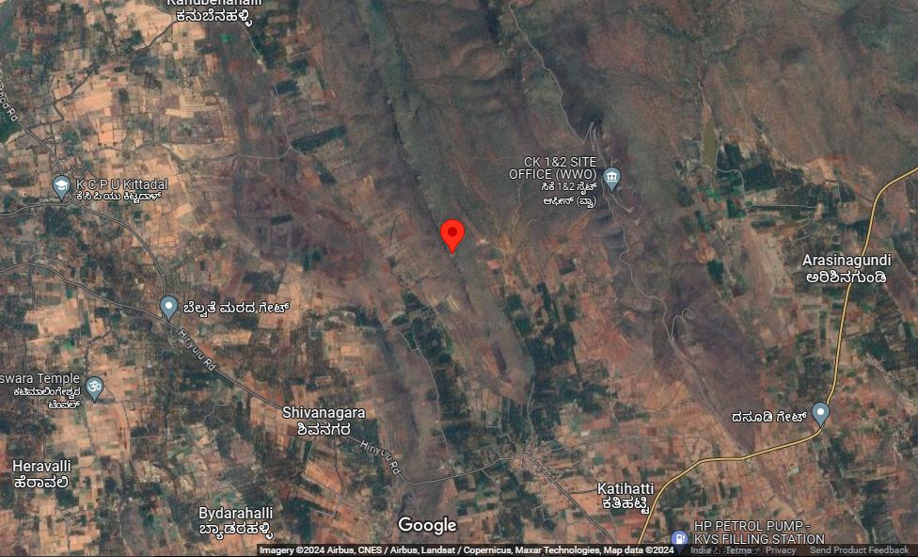
RAJASTHAN
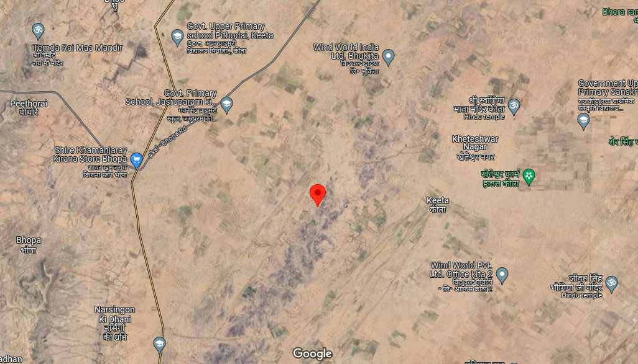

ENCLOSURE: II– PHOTOGRAPHS OF THE PROPERTY

JAISALMER, RAJASTHAN

 | 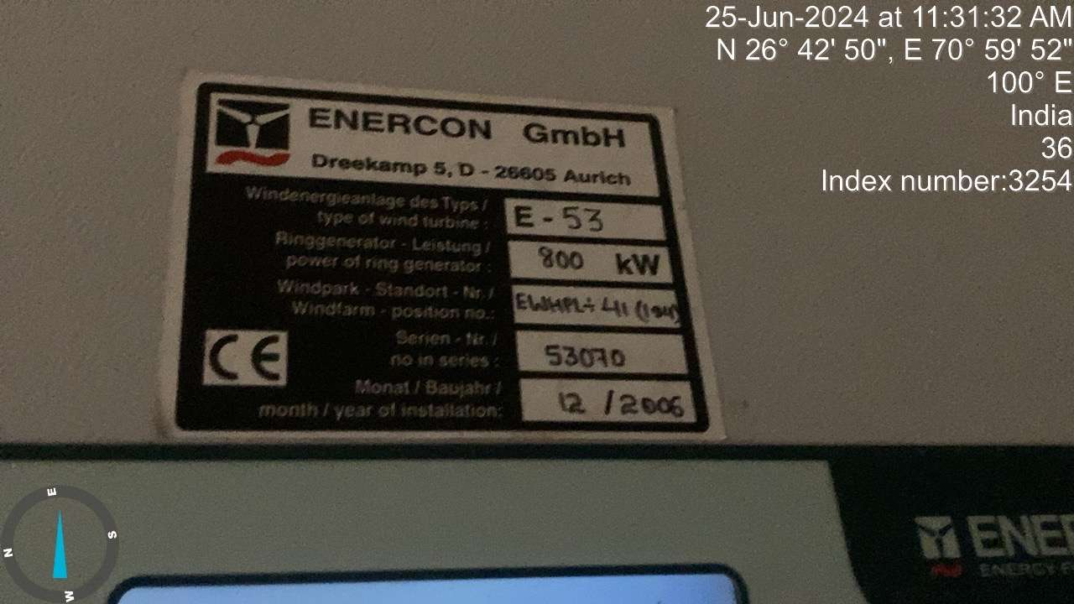
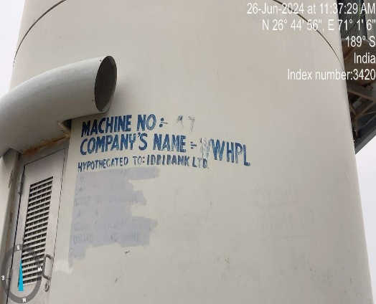 | 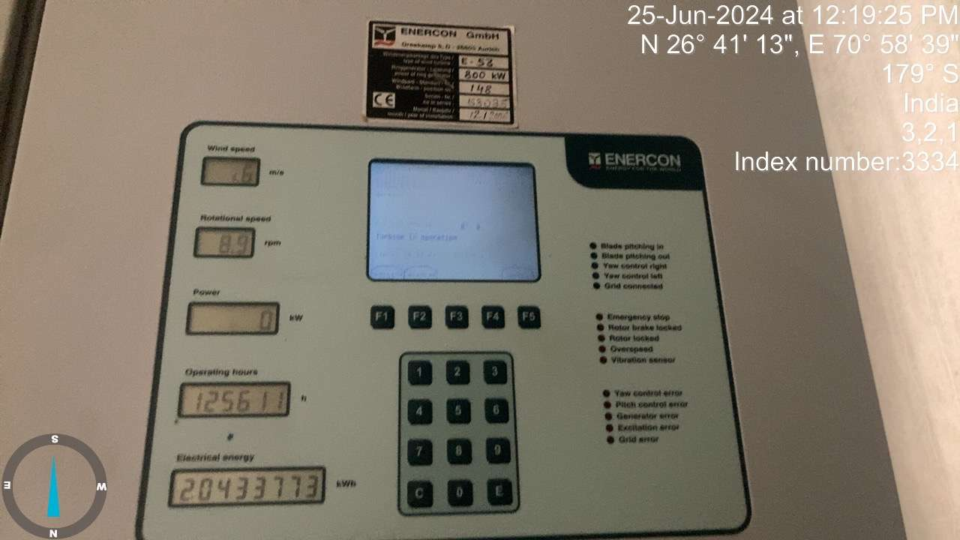
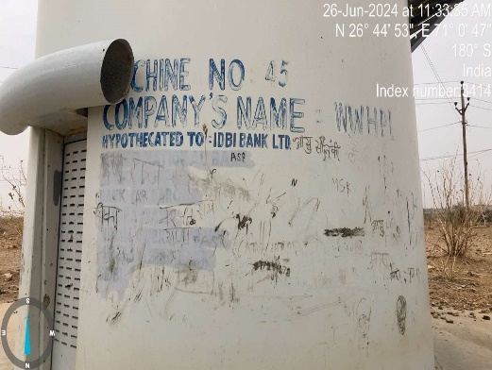 | 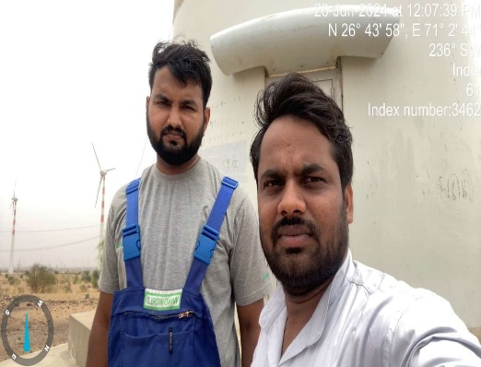

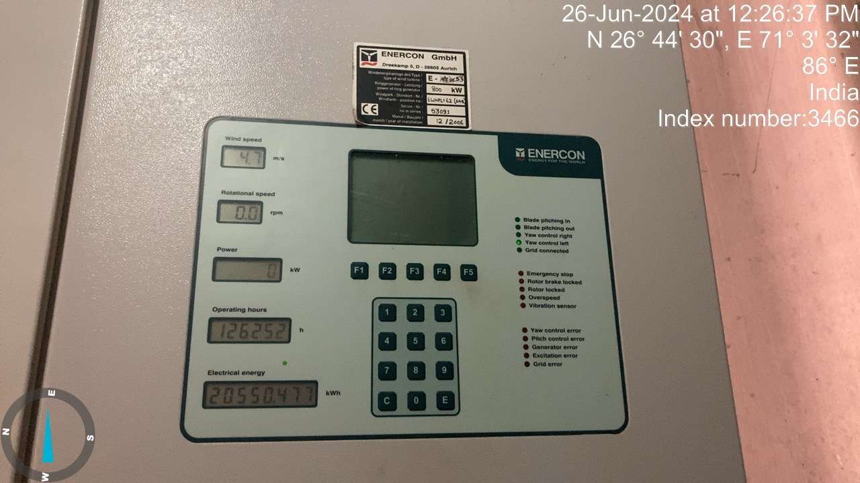 | 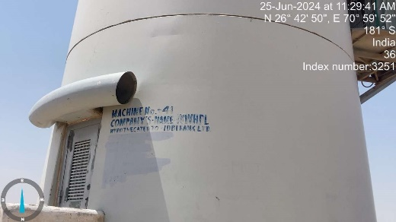
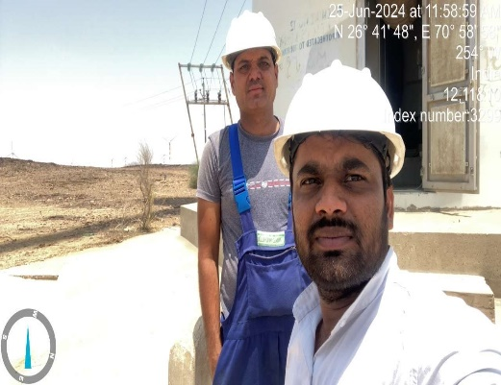 | 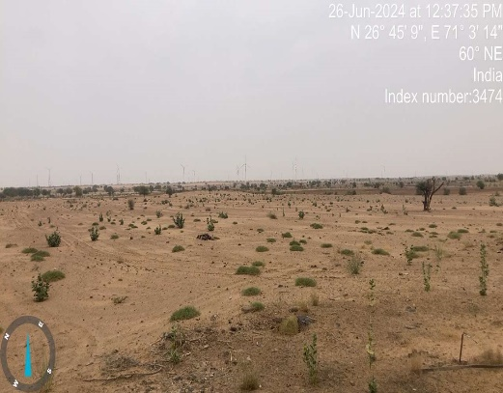
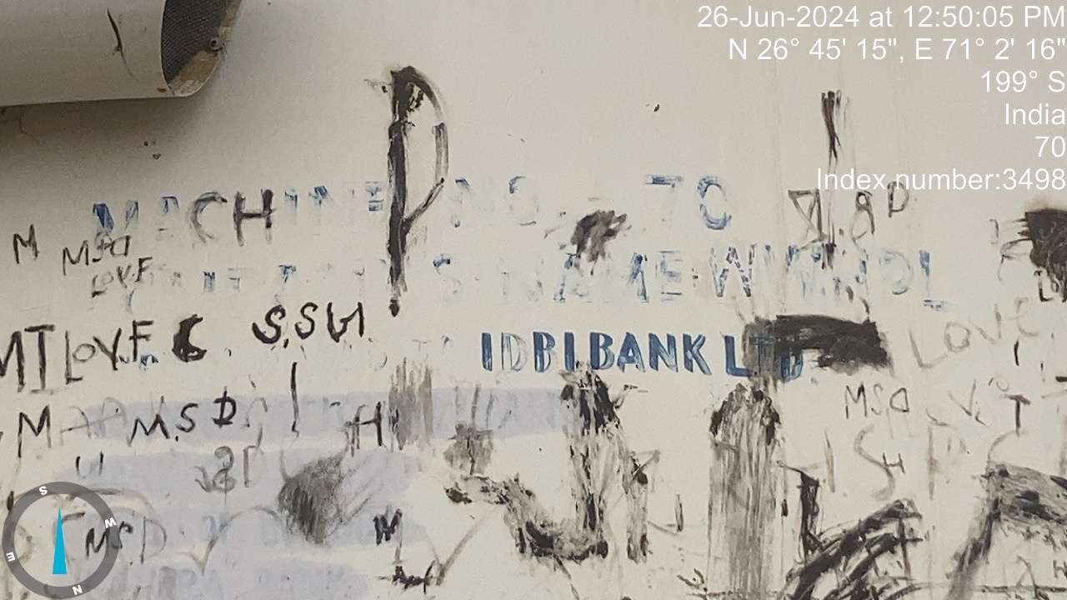

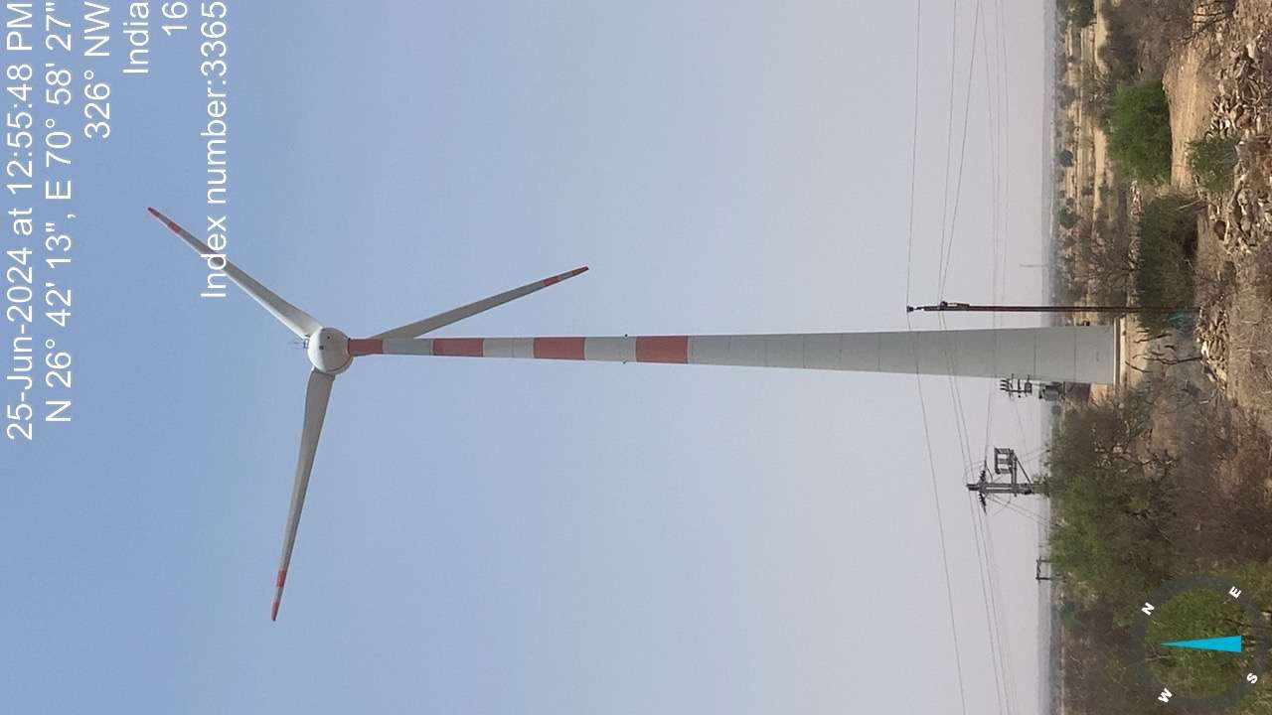 | 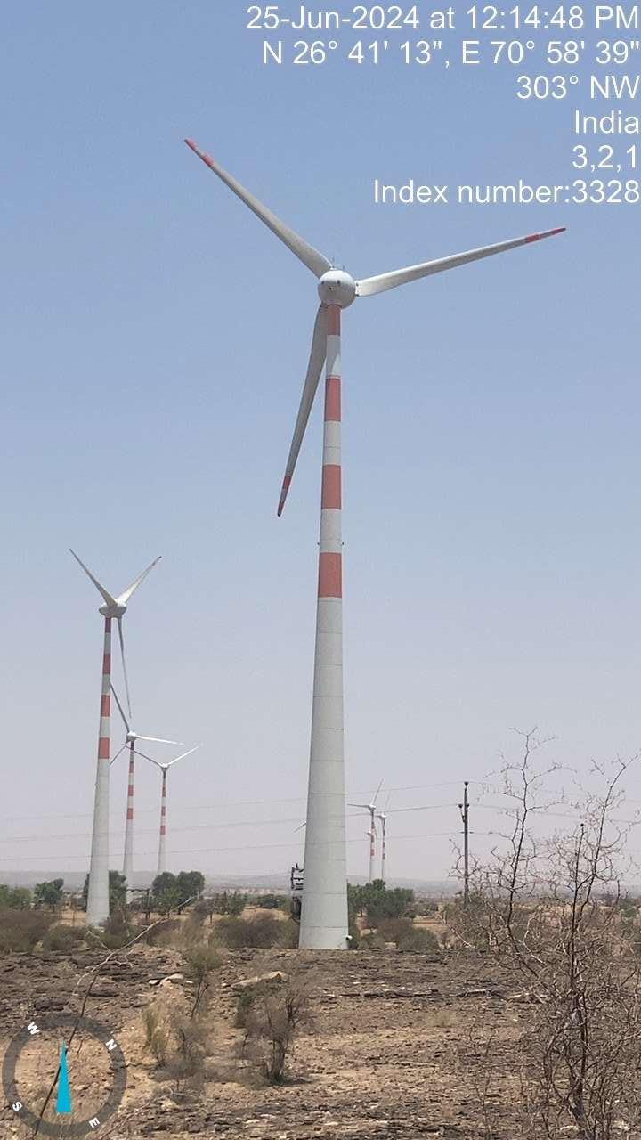 | 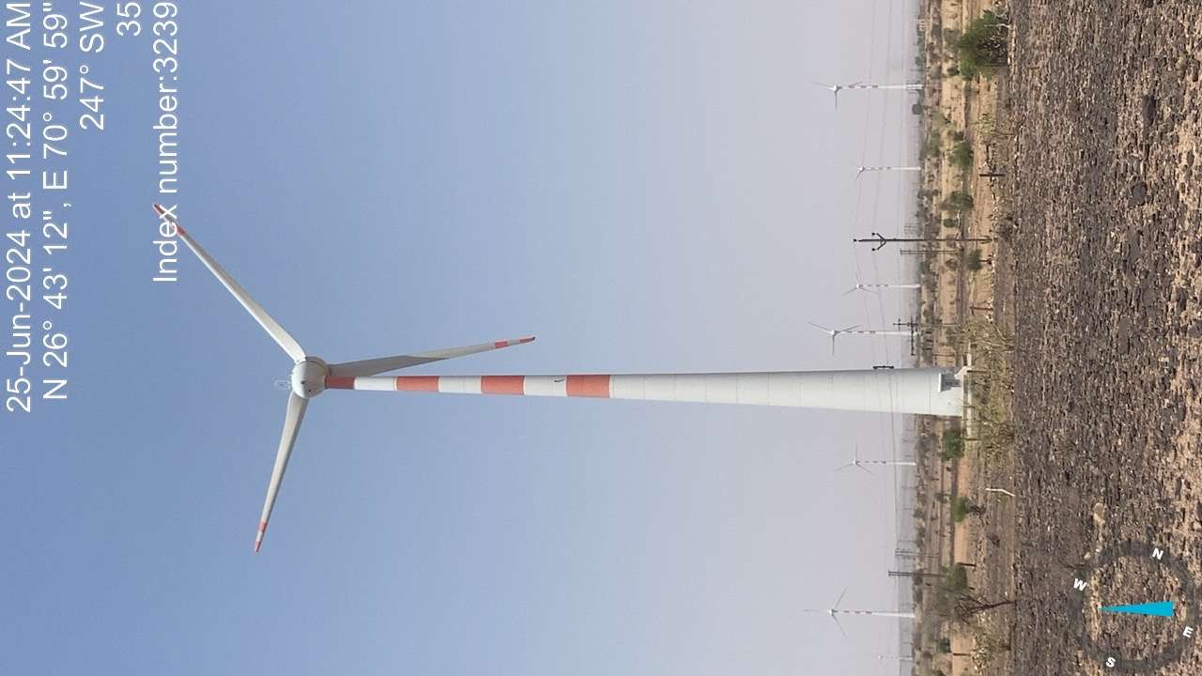
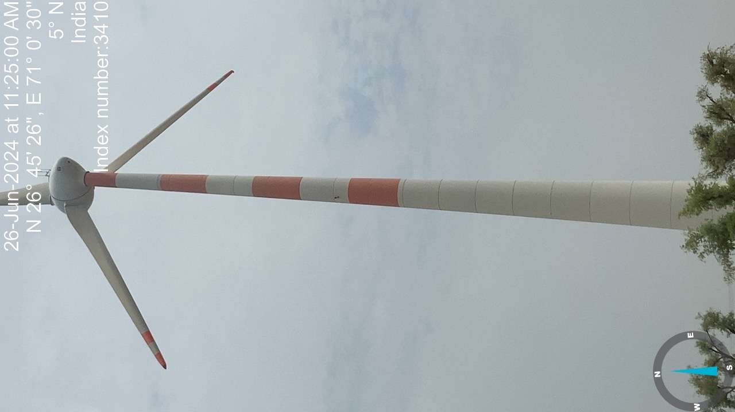 | 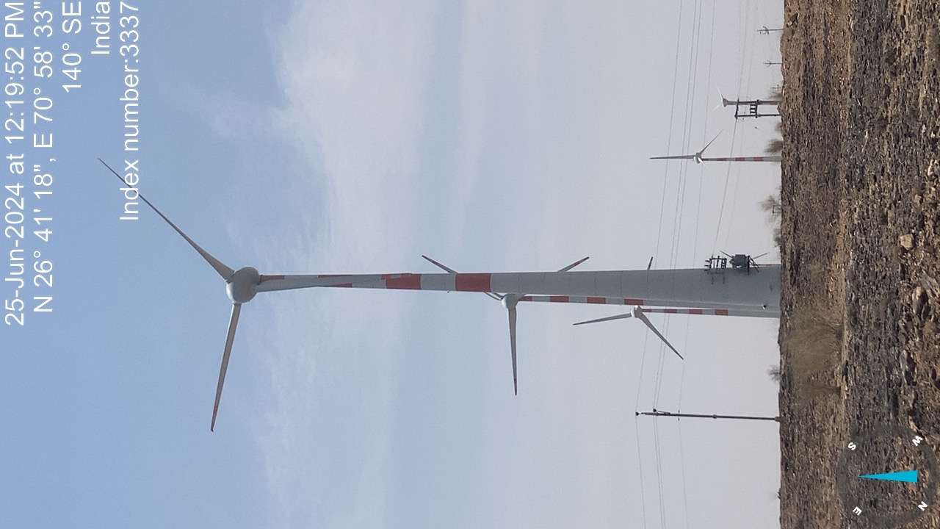 | 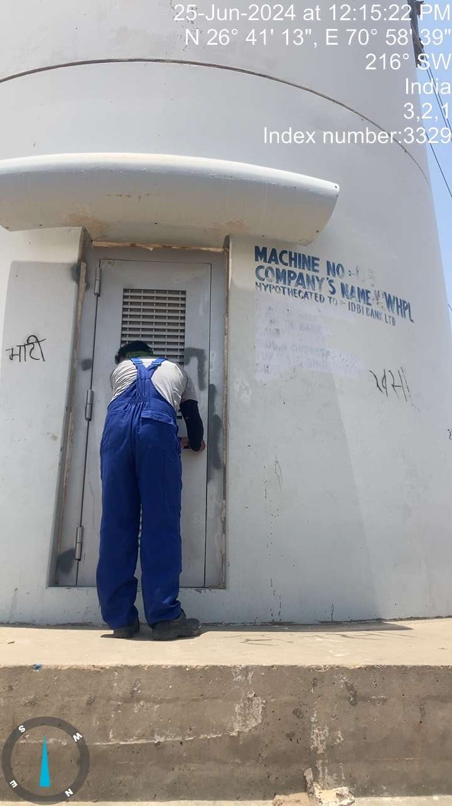

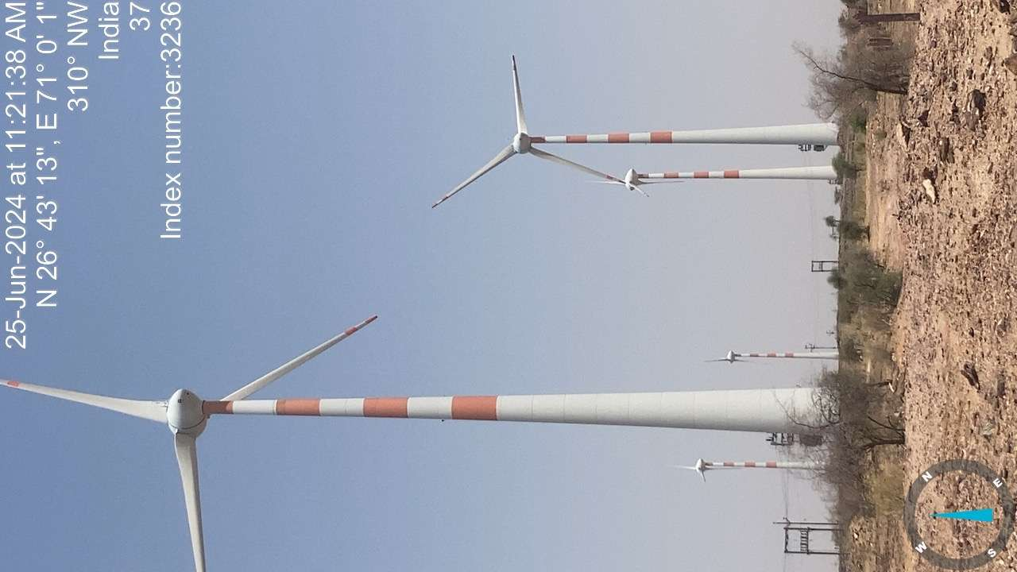 | 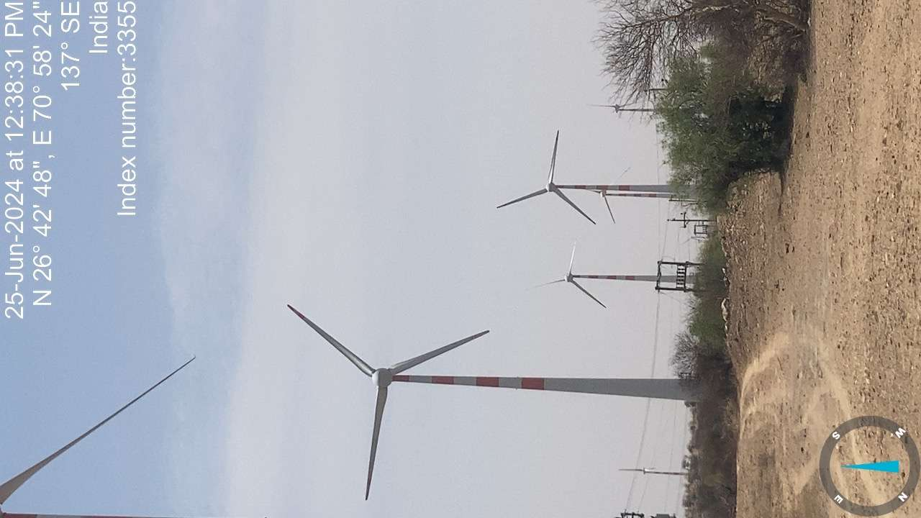 | 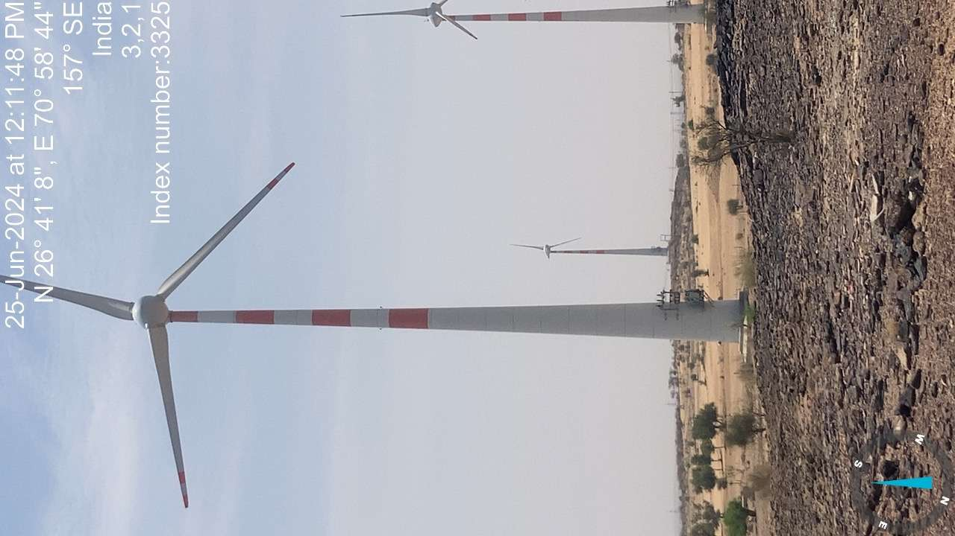
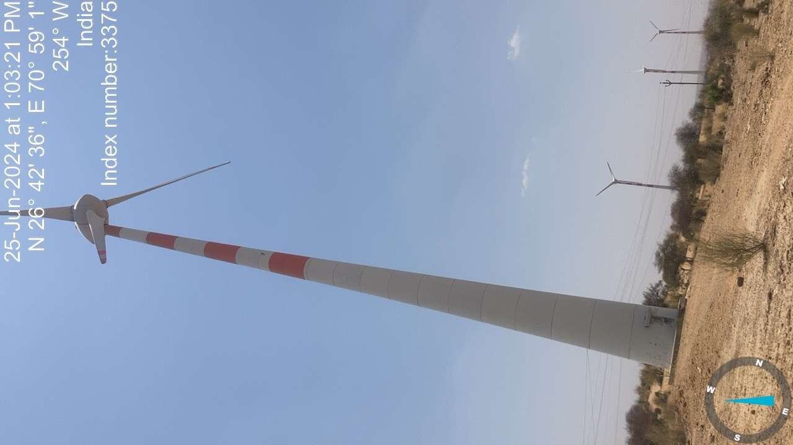 | 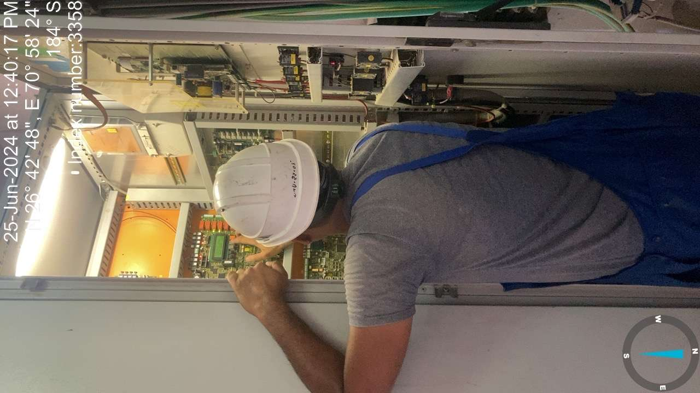 | 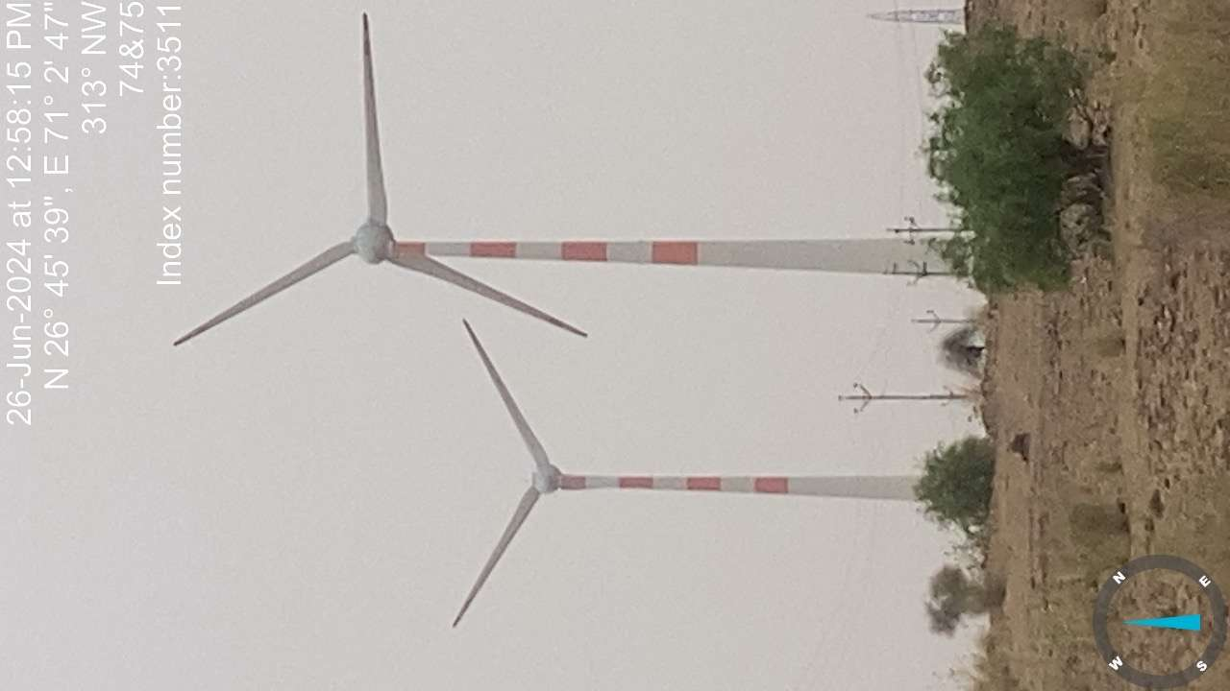

TUMKUR, CHITRADURGA & CHIKKANAYAKANA HALLI, KARNATAKA

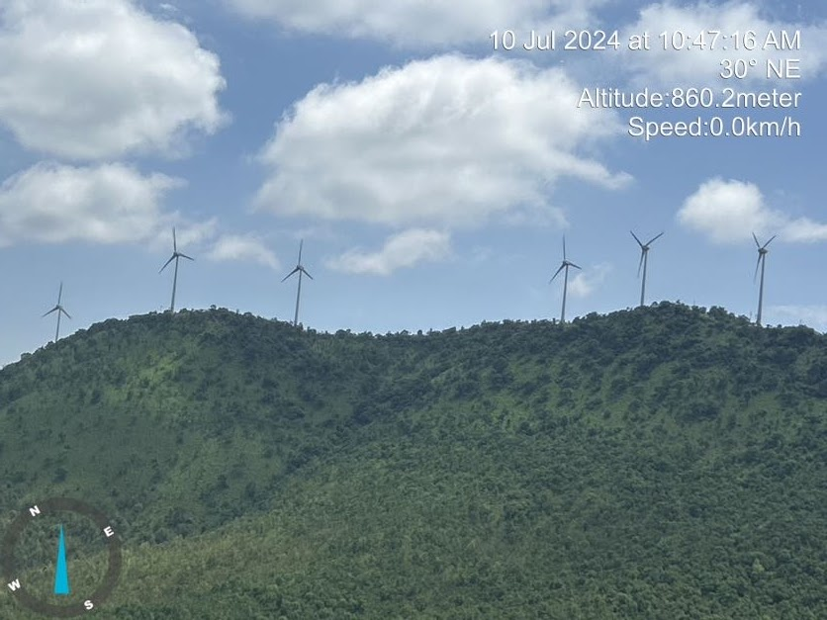 | 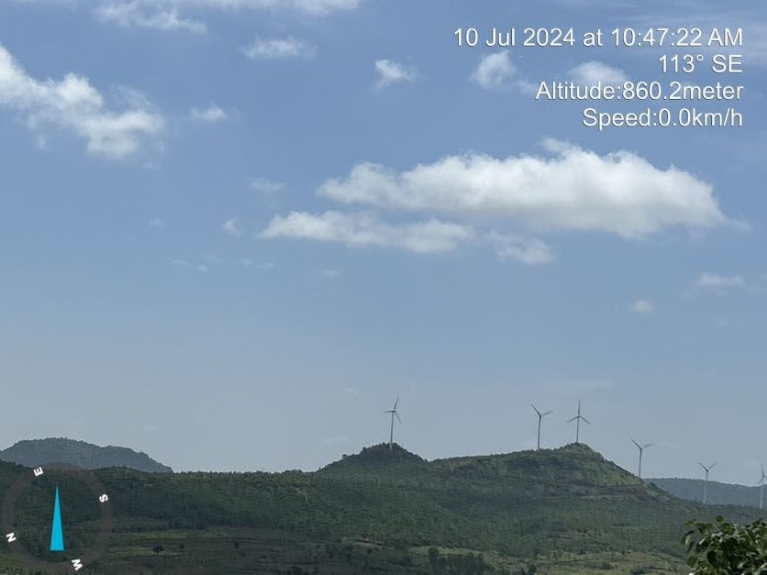
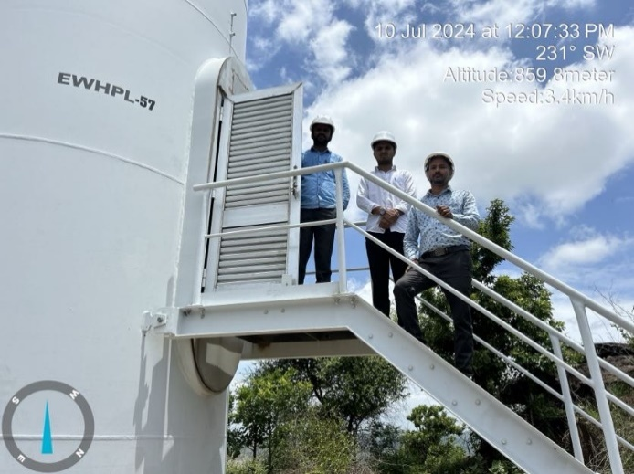 | 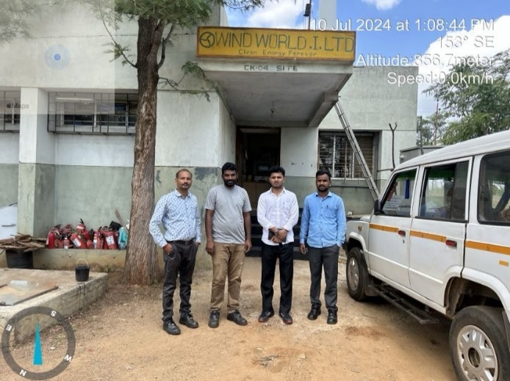
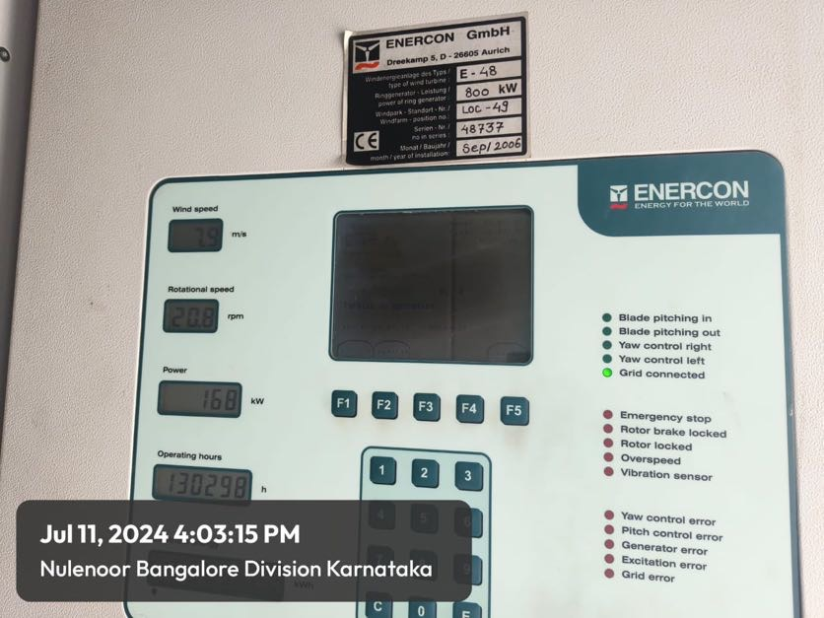 | 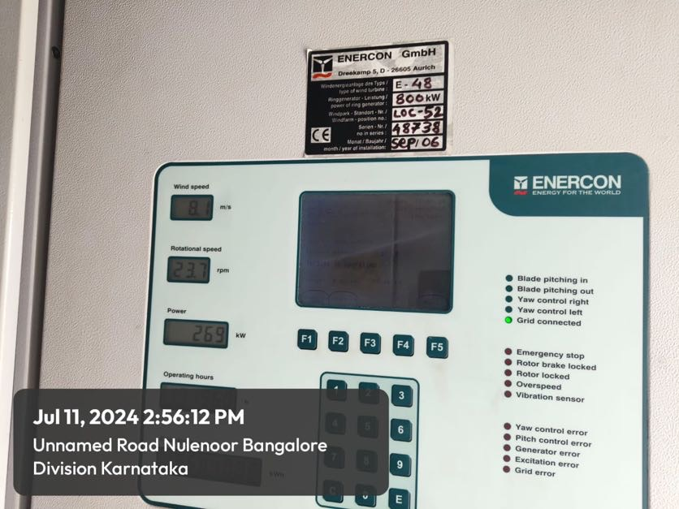

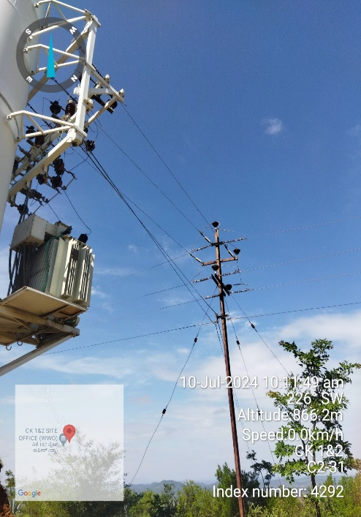 | 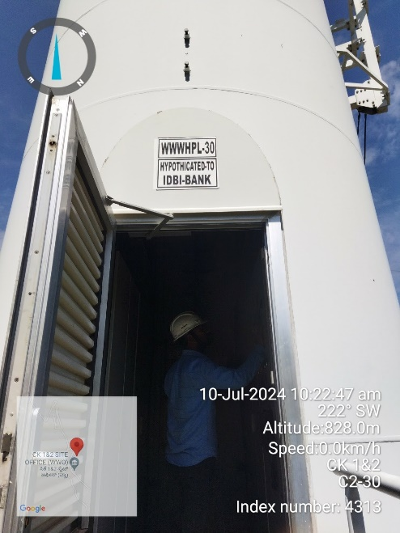 | 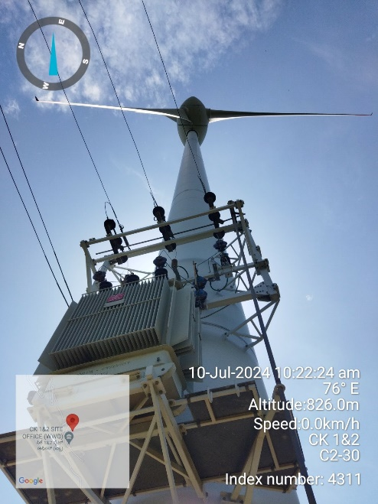
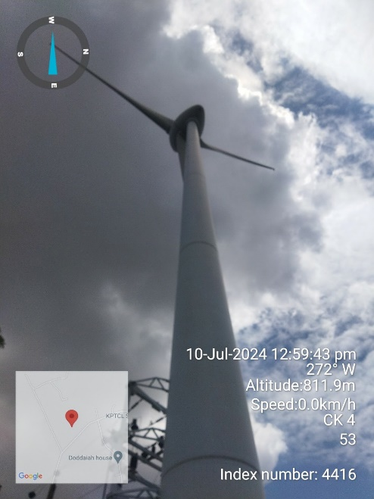 | 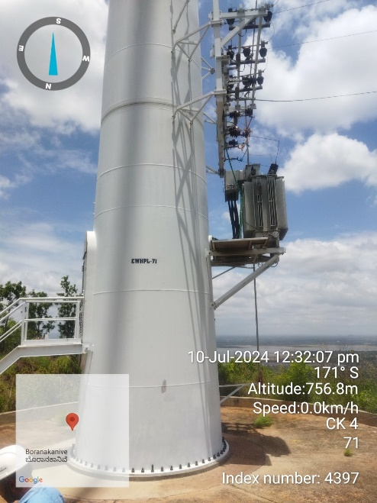 | 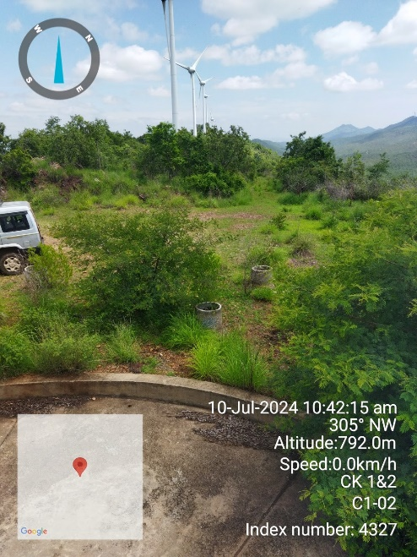

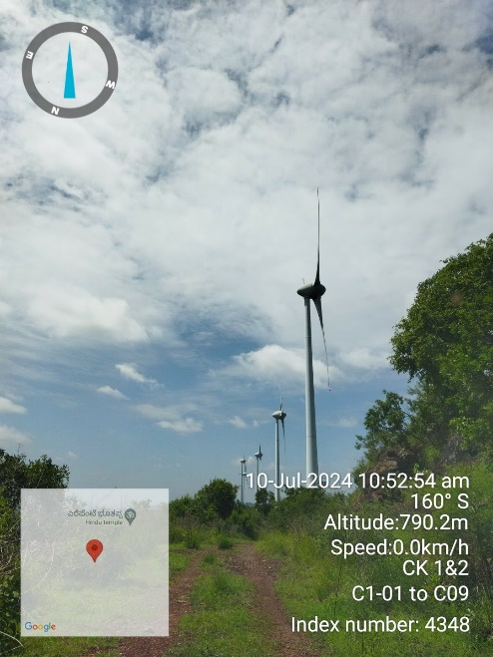 | 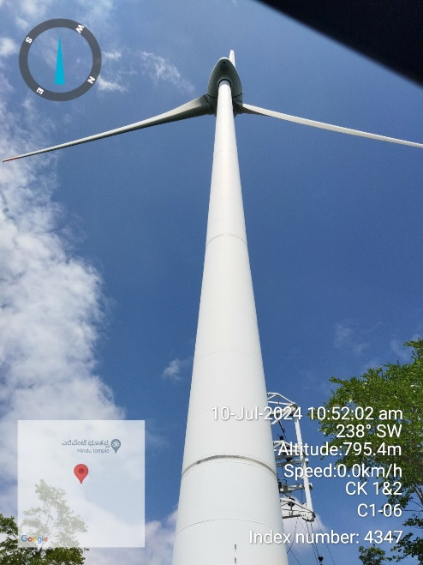 | 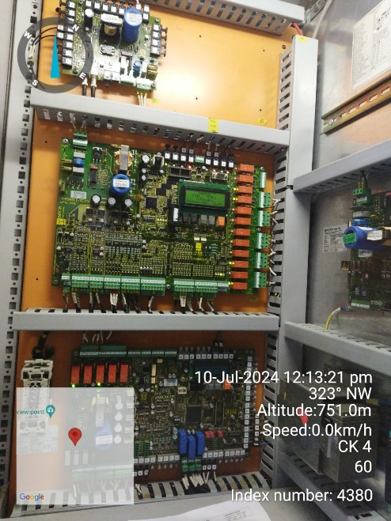

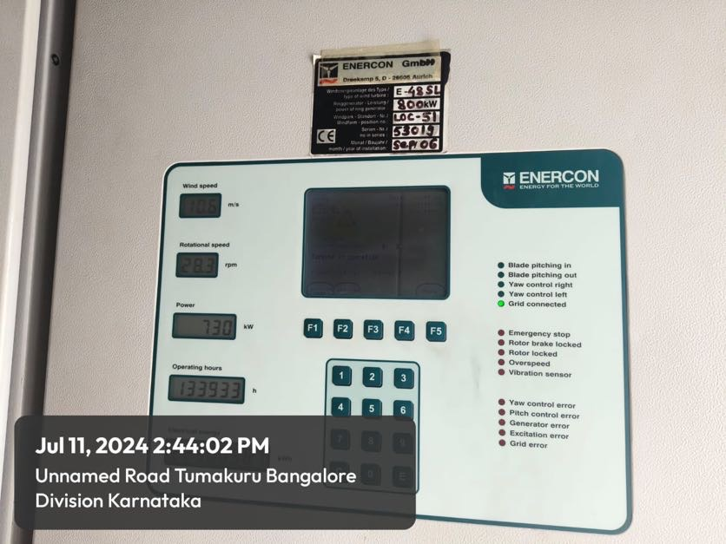 | 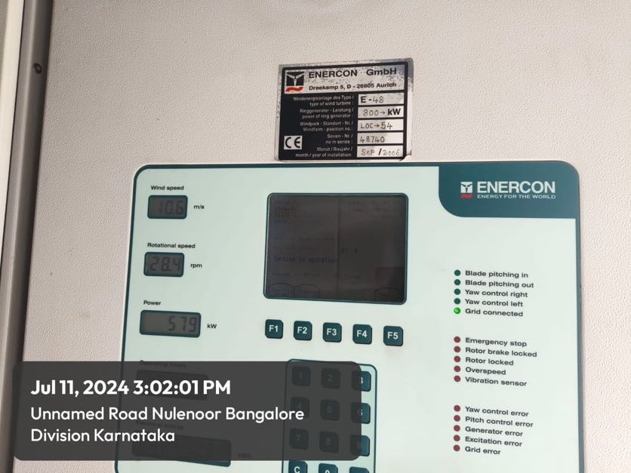

ENCLOSURE: III – IMPORTANT DOCUMENTS EXHIBIT

JAIPUR: - PPA
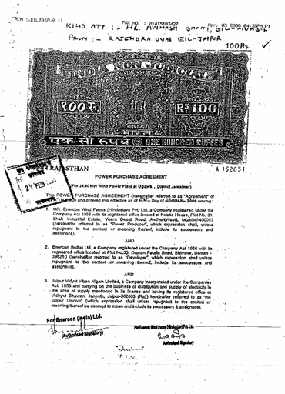 | 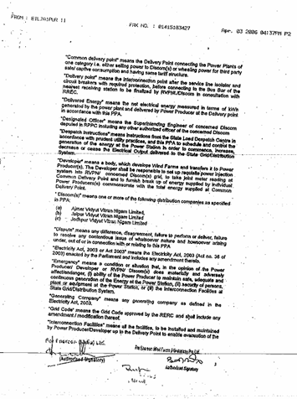

AJMER: - PPA
 | 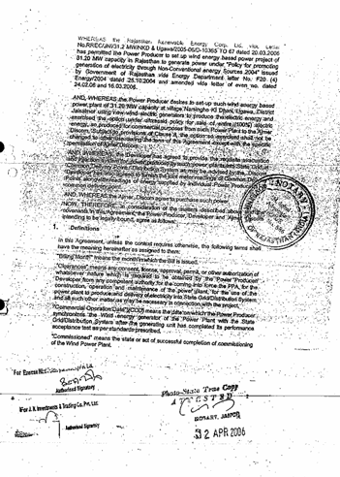

KARNATAKA: -PPA
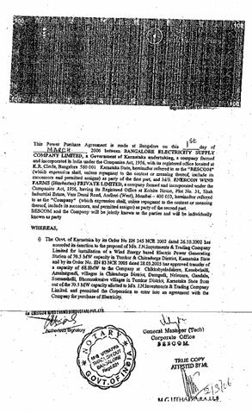 | 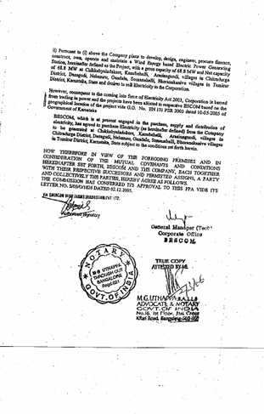

ENCLOSURE: IV – VALUER’S IMPORTANT REMARKS

Valuation is done for the asset found on as-is-where basis which owner/ owner representative/ client/ bank has shown/ identified to us on the site unless otherwise mentioned in the report of which some reference has been taken from the information/ data given in the copy of documents provided to us and informed verbally or in writing out of the standard checklist of documents sought from the client & its customer which they could provide within the reasonable expected time out of the standard checklist of documents sought from them and further based on certain assumptions and limiting conditions. The information, facts, documents, data which has become primary basis of the report has been supplied by the client which has been relied upon in good faith and is not generated by the Valuer.
The client/ owner and its management/ representatives warranted to us that the information they have supplied was complete, accurate and true and correct to the best of their knowledge. All such information provided to us either verbally, in writing or through documents has been relied upon in good faith and we have assumed that it is true & correct without any fabrication or misrepresentation. I/We shall not be held liable for any loss, damages, cost or expenses arising from fraudulent acts, misrepresentations, or willful default on part of the owner, company, its directors, employee, representative or agents.
Legal aspects for e.g. Investigation of title, ownership rights, lien, charge, mortgage, lease, sanctioned maps, and verification of documents provided to us such as title documents, Map, etc. from any concerned Govt. office etc. have to be taken care by legal expert/ Advocate and same is not done at our end. It is assumed that the concerned Lender/ Financial Institution has asked for the valuation of that property after satisfying the authenticity of the documents given to us for which the legal verification has been already taken and cleared by the competent Advocate before requesting for the Valuation report. I/ We assume no responsibility for the legal matters including, but not limited to, legal or title concerns.
In the course of the valuation, we were provided with both written and verbal information. We have however, evaluated the information provided to us through broad inquiry, analysis and review but have not carried out a due diligence or audit of the information provided for the purpose of this engagement. Our conclusions are based on the assumptions and other information provided to us by the client during the course of the assessment.
Getting Cizra map or coordination with revenue officers for site identification is a separate activity and is not part of the Valuation services and same has not been done in this report unless otherwise stated.
Wherever any details are mentioned in the report in relation to any legal aspect of the property such as name of the owner, leases, etc. is only for illustration purpose and should not be construed as a professional opinion. Legal aspects are out of scope of this report. Details mentioned related to legal aspect are only based on the copy of the documents provided to us and whatever we can interpret as a non-legally trained person. This should be cross validated with a legal expert. We do not vouch any responsibility regarding the same.
We have made certain assumptions in relation to facts, conditions & situations affecting the subject of, or approach to this exercise that has not been verified as part of the engagement rather, treated as “a supposition taken to be true”. If any of these assumptions prove to be incorrect then our estimate on value will need to be reviewed.
This is just an opinion report based on technical & market information having general assessment & opinion on the indicative, estimated Market Value of the property for which Bank has asked to conduct the Valuation. It doesn’t contain any other recommendations of any sort including but not limited to express of any opinion on the suitability or otherwise of entering into any transaction with the borrower.
We have relied on the data from third party, external sources & information available on public domain to conclude the valuation. These sources are believed to be reliable and therefore, we assume no liability for the truth or accuracy of any data, opinions or estimates furnished by others that have been used in this analysis. Where we have relied on the data, opinions or estimates from external sources, reasonable care has been taken to ensure that such data is extracted from authentic sources, however we still can’t vouch its authenticity, correctness, or accuracy.
Analysis and conclusions adopted in the report are limited to the reported assumptions, conditions and information came to our knowledge during the course of the work and based on the Standard Operating Procedures, Best Practices, Caveats, Limitations, Conditions, Remarks, Important Notes, Valuation TOR and definition of different nature of values.
Value varies with the Purpose/ Date/ Asset Condition & situation/ Market condition, demand & supply, asset utility prevailing on a particular date/ Mode of sale. The indicative & estimated prospective Value of the asset given in this report is restricted only for the purpose and other points mentioned above prevailing on a particular date as mentioned in the report. If any of these points are different from the one mentioned aforesaid in the Report then this report should not be referred.
Our report is meant ONLY for the purpose mentioned in the report and should not be used for any other purpose. The Report should not be copied or reproduced for any purpose other than the purpose for which it is prepared for. I/we do not take any responsibility for the unauthorized use of this report.
We owe responsibility only to the authority/client that has appointed us as per the scope of work mentioned in the report. We will not be liable for any losses, claims, damages or liabilities arising out of the actions taken, omissions or advice given by any other person. In no event shall we be liable for any loss, damages, cost or expenses arising in any way from fraudulent acts, misrepresentations or willful default on part of the client or companies, their directors, employees or agents.
This report is having limited scope as per its fields & format to provide only the general basic idea of the value of the property prevailing in the market based on the site inspection and documents/ data/ information provided by the client. The suggested indicative prospective estimated value should be considered only if transaction is happened as free market transaction.
The sale of the subject property is assumed to be on an all cash basis. Financial arrangements would affect the price at which the property may sell for if placed on the market.
The actual realizable value that is likely to be fetched upon sale of the asset under consideration shall entirely depend on the demand and supply of the same in the market at the time of sale.
While our work has involved an analysis & computation of valuation, it does not include detailed estimation, design/ technical/ engineering/ financial/ structural/ environmental/ architectural/ compliance survey/ safety audit & works in accordance with generally accepted standards of audit & other such works. The report in this work in not investigative in nature. It is mere an opinion on the likely estimated valuation based on the facts & details presented to us by the client and third party market information came in front of us within the limited time of this assignment, which may vary from situation to situation.
Where a sketched plan is attached to this report, it does not purport to represent accurate architectural plans. Sketch plans and photographs are provided as general illustrations only.
Documents, information, data including title deeds provided to us during the course of this assessment by the client is reviewed only upto the extent required in relation to the scope of the work. No document has been reviewed beyond the scope of the work. These are not reviewed in terms of legal rights for which we do not have expertise. Wherever any information mentioned in this report is mentioned from the documents like owners name, etc., it is only for illustration purpose and may not necessary represent accuracy.
The report assumes that the borrower/company/business/asset complies fully with relevant laws and regulations applicable in its area of operations and usage unless otherwise stated, and that the companies/business/assets is managed in a competent and responsible manner. Further, as specifically stated to the contrary, this report has given no consideration to matters of a legal nature, including issues of legal title and compliance with relevant laws, and litigations and other contingent liabilities that are not recorded/reflected in the documents/ details/ information/ data provided to us.
This valuation report is not a qualification for accuracy of land boundaries, schedule (in physical terms), dimensions & identification. For this land/ property survey report can be sought from a qualified private or Govt. surveyor.
This Valuation report is prepared based on the facts of the property on the date of the survey. Due to possible changes in market forces, socio-economic conditions, property conditions and circumstances, this valuation report can only be regarded as relevant as at the valuation date. Hence before financing, Banker/ FI should take into consideration all such future risk and should loan conservatively to keep the advanced money safe in case of the downward trend of the property value.
Valuation of the same asset/ property can fetch different values under different circumstances & situations. For eg. Valuation of a running/ operational shop/ hotel/ factory will fetch better value and in case of closed shop/ hotel/ factory it will have considerable lower value. Similarly, an asset sold directly by an owner in the open market through free market transaction then it will fetch better value and if the same asset/ property is sold by any financer due to encumbrance on it, will fetch lower value. Hence before financing, Lender/ FI should take into consideration all such future risks while financing and take decision accordingly.

Valuation is done for the property identified to us by the owner/ owner representative. At our end we have just visually matched the land boundaries, schedule (in physical terms) & dimensions of the property with reference to the documents produced for perusal. Method by which identification of the property is carried out is also mentioned in the report clearly. Responsibility of identifying the correct property to the Valuer/ its authorized surveyor is solely of the client/ owner for which Valuation has to be carried out. It is requested from the Bank to cross check from their own records/ information if this is the same property for which Valuation has to be carried out to ensure that owner has not misled the Valuer company or misrepresented the property due to any vested interest. Where there is a doubt about the precision position of the boundaries, schedule, dimensions of site & structures, it is recommended that a Licensed Surveyor be contacted.
In India more than 70% of the geographical area is lying under rural/ remote/ non municipal/ unplanned area where the subject property is surrounded by vacant lands having no physical demarcation or having any display of property survey or municipal number / name plate on the property clearly. Even in old locations of towns, small cities & districts where property number is either not assigned or not displayed on the properties clearly and also due to the presence of multiple/ parallel departments due to which ownership/ rights/ illegal possession/ encroachment issues are rampant across India and due to these limitations at many occasions it becomes tough to identify the property with 100% surety from the available documents, information & site whereabouts and thus chances of error, misrepresentation by the borrower and margin of chances of error always persists in such cases. To avoid any such chances of error it is advised to the Bank to engage municipal/ revenue department officials to get the confirmation of the property to ensure that the property shown to Valuer/ Banker is the same as for which documents are provided.
If this Valuation Report is prepared for the Flat/ dwelling unit situated in a Group Housing Society or Integrated Township then approvals, maps of the complete group housing society/ township is out of scope of this report and this report will be made for the specific unit based on the assumption that complete Group Housing Society/ Integrated Township and the subject unit must be approved in all respect.
Due to fragmented & frequent change in building/ urban planning laws/ guidelines from time to time, different laws/ guidelines between regions/ states and no strict enforceability of Building Bye-Laws in India specially in non-metro and scale b & c cities & Industrial areas, property owners many times extend or make changes in the covered area/ layout from the approved/ applicable limits. There are also situations where properties are decades old when there was no formal Building Bye-Laws applicable the time when the construction must have been done. Due to such discrete/ unplanned development in many regions sometimes it becomes tough for the Valuer to determine the exact lawful situation on ground. Unless otherwise mentioned in the report, the covered area present on the site as per site survey will be considered in the Valuation.
Area of the large land parcels of more than 2500 sq.mtr or of uneven shape in which there can be practical difficulty in sample measurement, is taken as per property documents which has been relied upon unless otherwise stated.

Drawing Map, design & detailed estimation of the property/ building is out of scope of the Valuation services.
Valuation is a subjective field and opinion may differ from consultant to consultant. To check the right opinion, it is important to evaluate the methodology adopted and various data point/ information/ factors/ assumption considered by the consultant which became the basis for the Valuation report before reaching to any conclusion.
Although every scientific method has been employed in systematically arriving at the value, there is, therefore, no indisputable single value and the estimate of the value is normally expressed as falling within a likely range.
Value analysis of any asset cannot be regarded as an exact science and the conclusions arrived at in many cases will, of necessity, be subjective and dependent on the exercise of individual judgment. Given the same set of facts and using the same assumptions, expert opinions may differ due to the number of separate judgment decisions, which have to be made. Therefore, there can be no standard formula to establish an indisputable exchange ratio. In the event of a transaction, the actual transaction value achieved may be higher or lower than our indicative analysis of value depending upon the circumstances of the transaction. The knowledge, negotiability and motivations of the buyers and sellers, demand & supply prevailing in the market and the applicability of a discount or premium for control will also affect actual price achieved. Accordingly, our indicative analysis of value will not necessarily be the price at which any agreement proceeds. The final transaction price is something on which the parties themselves have to agree. However, our Valuation analysis can definitely help the stakeholders to take informed and wise decision about the Value of the asset and can help in facilitating the arm’s length transaction.
This Valuation is conducted based on the macro analysis of the asset/ property considering it in totality and not based on the micro, component, or item wise analysis. Analysis done is a general assessment and is not investigative in nature.
This report is prepared on the RKA V-L1 (Basic) Valuation format as per the client requirement and scope of work. This report is having limited scope as per its fields & format to provide only the general estimated & indicative basic idea of the value of the property prevailing in the market based on the information provided by the client. No detailed analysis, audit or verification has been carried out of the subject property. There may be matters, other than those noted in this report, which might be relevant in the context of the transaction and which a wider scope might uncover.
This is just an opinion report and doesn’t hold any binding on anyone. It is requested from the concerned Client/ Bank/ Financial Institution which is using this report for mortgaging the property that they should consider all the different associated relevant & related factors & risks before taking any business decision based on the content of this report.
All Pages of the report including annexures are signed and stamped from our office. In case any paper in the report is without stamp & signature then this should not be considered a valid paper issued from this office.
As per IBA Guidelines & Bank Policy, in case the valuation report submitted by the valuer is not in order, the banks / FIs shall bring the same to the notice of the valuer within 15 days of submission for rectification and resubmission. In case no such communication is received, it shall be presumed that the valuation report has been accepted.
Defect Liability Period is 15 DAYS. We request the concerned authorized reader of this report to check the contents, data, information, and calculations in the report within this period and intimate us in writing at valuers@rkassociates.org within 15 days of report delivery, if any corrections are required or in case of any other concern with the contents or opinion mentioned in the report. If no intimation is received within 15 (Fifteen) days in writing from the date of issuance of the report, then it shall be considered that the report is complete in all respect and has been accepted by the client upto their satisfaction & use and further to which R.K Associates shall not be held responsible in any manner. After this period no concern/ complaint/ proceedings in connection with the Valuation Services will be entertained due to possible change in situation and condition of the property.
Though adequate care has been taken while preparing this report as per its scope, but still we can’t rule out typing, human errors, over sightedness of any information or any other mistakes. Therefore, the concerned organization is advised to satisfy themselves that the report is complete & satisfactory in all respect. Intimation regarding any discrepancy shall be brought into our notice immediately. If no intimation is received within 15 (Fifteen) days in writing from the date of issuance of the report, to rectify these timely, then it shall be considered that the report is complete in all respect and has been accepted by the client upto their satisfaction & use and further to which R.K Associates shall not be held responsible in any manner.
Our Data retention policy is of ONE YEAR. After this period we remove all the concerned records related to the assignment from our repository. No clarification or query can be answered after this period due to unavailability of the data.
This Valuation report is governed by our (1) Internal Policies, Processes & Standard Operating Procedures, (2) R.K Associates Quality Policy, (3) Valuation & Survey Best Practices Guidelines formulated by management of R.K Associates, (4) Information input given to us by the customer and (4) Information/ Data/ Facts given to us by our field/ office technical team. Management of R.K Associates never gives acceptance to any unethical or unprofessional practice which may affect fair, correct & impartial assessment and which is against any prevailing law. In case of any indication of any negligence, default, incorrect, misleading, misrepresentation or distortion of facts in the report then we request the user of this report to immediately or atleast within the defect liability period to bring all such act into notice of R.K Associates management so that corrective measures can be taken instantly.
R.K Associates never releases any report doing alterations or modifications by pen. In case any information/ figure of this report is found altered with pen then this report will automatically become null & void.
We are fully aware that based on the opinion of value expressed in this report, we may be required to give testimony or attend court / judicial proceedings with regard to the subject assets, although it is out of scope of the assignment, unless specific arrangements to do so have been made in advance, or as otherwise required by law. In such event, the party seeking our evidence in the proceedings shall bear the cost/professional fee of attending court / judicial proceedings and my / our tendering evidence before such authority shall be under the applicable laws.
The final copy of the report shall be considered valid only if it is in hard copy on the company’s original letter head with proper stamp and sign on it of the authorized official upon payment of the agreed fees. User shall not use the content of the report for the purpose it is prepared for only on draft report, scanned copy, email copy of the report and without payment of the agreed fees. In such a case the report shall be considered as unauthorized and misused.

