**File No.: VIS (2024-25)-PL182-151-197 Dated: 28/06/2024**

**CONSTRUCTION PROGRESS & COST ESTIMATION REPORT**

**OF**

**M/S MMBM HOSPITALITY PRIVATE LIMITED**

**SITUATED AT**

**VILLAGE- BANSHIWALA, JHAJRA, PARGANA- PACHWADOON, TEHSIL- VIKAS NAGAR, DISTRICT- DEHRADUN, UTTARAKHAND**

**PROMOTER/S**

**M/S. MMBM HOSPITALITY PRIVATE LIMITED**

**REPORT PREPARED FOR**

**PUNJAB NATIONAL BANK, CBB BRANCH, RACECOURSE, DEHRADUN**

***\*\*Important - In case of any query/ issue or escalation you may please contact Incident Manager***

***at le@rkassociates.org. We will appreciate your feedback in order to improve our services.***

***NOTE: As per IBA Guidelines please provide your feedback on the report within 15 days of its submission after which report will be considered to be correct.***

# IMPORTANT NOTICE

***COPYRIGHT FORMAT:*** *This report is prepared on the copyright format of R.K Associates, to serve our clients with the best available information and analysis to facilitate them to take rational business decisions. Legally no one can copy or distribute this format without prior approval from R.K Associates. It is meant only for the advisory/ reference purpose for the organization/s as mentioned on the cover page of this report. Distribution or use of this format by any organization or individual other than R.K Associates will be seen as unlawful act and necessary legal action can be taken against the defaulters.*

*This report is intended for the sole use of the intended recipient/s and contain material that is STRICTLY CONFIDENTIAL AND PRIVATE.*

***DEFECT LIABILITY PERIOD:*** *- In case of any query/ issue or escalation you may please contact Incident Manager: @ le@rkassociates.org. We try our level best to ensure correctness in the calculations done, rates adopted and various other data points & information mentioned in the report but still can’t rule out typing, human errors or any other mistakes. In case you find any such mistake or inaccuracy in any data point of the report please help us by bringing all such points into our notice immediately or within 15 days of the report delivery in writing, to rectify these timely failing after which R.K Associates won’t be held responsible for any such inaccuracy in any manner. We would highly appreciate your feedback in order to improve our services.*

|  |  |
| --- | --- |
| **PART A** | **REPORT SUMMARY** |

|  |  |  |
| --- | --- | --- |
| **S.NO.** | **PARTICULARS** | **DESCRIPTION** |
|  | Name of the Project | M/s MMBM Hospitality Pvt. Ltd. |
|  | Project Location | Village- Banshiwala, Jhajra, Pargana- Pachwadoon, Tehsil- Vikas Nagar, District- Dehradun, Uttarakhand |
|  | Name of the Promotors | Shri Bharat Mahajan *(Director of the company)* |
|  | Address and Phone Number | Registered office- 12/5/1, Laxmi Road, Dalawala, Dehradun |
|  | Prepared for Bank | Punjab National bank, CBB Branch, Racecourse, Dehradun |
|  | Consultant Firm | M/s. R.K. Associates Valuers & Techno Engineering Consultants (P) Ltd. |
|  | Work Order Details | --- |
|  | Date of Survey | 27th June 2024 |
|  | Date of Estimation | 28th June 2024 |
|  | Date of Report | 28th June 2024 |
|  | Purpose of the Report | Evaluate construction progress and cost incurred. |
|  | Scope of the work provided by the Lender | Only to comment on the following below points based on the scope of work:   * Construction Progress report * Estimation of construction cost as per current status of work   *NOTE: This report doesn’t contain any other kind of recommendation or suggestions other than the above-mentioned point.* |

|  |  |
| --- | --- |
| **PART B** | **INTRODUCTION** |

1. **THE PROJECT:** The subject property is an under-construction premises for running Restaurant, Gymnasium, banquet Hall, Party Lawn, Sports Complex and other allied works. The subject location is a good location to put up such project as it in the middle of developing neighbourhood.
2. **PROJECT OVERVIEW:** M/s MMBM Hospitality Pvt. Ltd. is an under-construction Habutat Centre having total leasehold land area admeasuring 10000.98 sqm located at Khasra No. 1134, 1135ka, 1136, 1137kha, 1150ka, Village- Banshiwala, Jhajra, Pargana- Pachwadoon, Tehsil- Vikas Nagar, District- Dehradun, Uttarakhand.

As per copy of approved Sanction Plan no. MDDA/NC/AA/0017/22-23 dated 25-05-2023, the total land area of project is 10,000.91 sqm with total built-up area measuring 4,915.46 sqm for Block-1 & 2. The map was approved by Mussoorie Dehradun Development Authority.

As on date of site visit, the civil structure work was completed and internal & external finishing work was in progress in progress.

As per information received during site survey, the construction work contract was given to M/s Bharat & Company, Dehradun. Detailed contractor’s agreement comprising scope of work is not shared with us, As per latest contractor work details shared by the bank, details of invoices are as follows: -

|  |  |
| --- | --- |
| **Description** | **Invoice Amount (In Rs.)** |
| Invoices raised for work done | 8,04,04,238 |
| Pending Invoice of Work Done at site | 80,62,698 |
| **Grand Total** | **8,84,66,936** |

1. **CURRENT STATUS:** As per copy of section plan no. MDDA/NC/AA/0017/22-23 dated 25-05-2023, two numbers of blocks are proposed to be constructed at site with total built-up area measuring 4915.46 sqm. As per physical measurement, the total built-up area constructed is about 3,411 sqm. However, as per sanction plan it is about 3,603 sqm as per current construction status which is approximately is line with physical measurement. Thus, area as per sanction plan is considered for assessment.

Block-wise current status of project is as follows: -

|  |  |  |  |
| --- | --- | --- | --- |
| **Block Name** | **Built-up Area (In sqm)** | | **Remarks** |
| **Proposed as per sanction plan** | **Currently as per actual** |
| Block-A | 2,606.45 | 2,606.45 | * Super structure, Brick, Roof Slab work is completed. * Plaster work of community hall completed from inside & outside. * Roof work is completed * No flooring, electrical & plumbing work is yet be done. * Brick work of kitchen area in back is not completed yet only shed roofing is done. |
| Block-B | 2,309.01 | 996.47 | * Only super structure is completed till ground & mezzanine level. * Brick work is yet be completed. |
| **Total** | **4915.46** | **3602.92** |  |

1. **PHYSICAL CONSTRUCTION STATUS:** As per the observations made during the site visit, tabulated below is the status of physical construction:

|  |  |  |  |  |  |
| --- | --- | --- | --- | --- | --- |
| **S. No.** | **Different Parameters** | **Weightage** | **RCC Structure**  **% Completion** | | **Shed Structure**  **% Completion** |
| **Block-A** | **Block-B** | **Block-C** |
| 1 | Excavation, Concrete for Foundation and Plinth | 15% | 100% | 100% | 100% |
| 2 | Super structure concrete & Brickwork | 30% | 100% | 100% | 90% |
| 3 | Roof Slab | 15% | 100% | 100% | 100% |
| 4 | Flooring | 5% | 0% | 0% | 0% |
| 5 | Plastering & Painting | 10% | 0% | 0% | 70% |
| 6 | Doors, Windows & Woodwork | 10% | 0% | 0% | 0% |
| 7 | Water supply, sanitary fittings electrification &others | 15% | 20% | 0% | 0% |
| **Completion status (in %)** | | **100%** | **63%** | **60%** | **64%** |

As per the observations made during the site visit, it is assumed that the physical progress of the project building i.e. Block-1 & 2 is approx. 60% complete.

1. **COST INCURRED IN THE CONSTRUCTION OF BUILDING:** We have not received any copy of CA certificate & contractor agreement. This cost assessment is based on the market research, analysis & cost required to construct the such type of infrastructure. Details of same area tabulated below: -



|  |  |  |  |  |
| --- | --- | --- | --- | --- |
| **Description** | **Length** | **Height** | **Construction Cost**  **(In Rs. Per RMT)** | **Total Cost**  **(In Rs.)** |
| RCC Boundary Wall | 310 running mtr | 7 ft | 6,000 | 18,60,000 |
| Block-1 & 2 | | | | 5,28,42,507 |
| **Grand Total** | | | | **5,47,02,507** |

1. **OBSERVATIONS, REMARKS AND CONCLUSION BY RKA**

* As per our analysis, the total expenditure on construction of both blocks i.e. 1 & 2 and boundary wall is about Rs. 5,47,02,507/-.
* It is assumed that the average basic construction cost of such type of structures/block is in the range of Rs. 2000/- to Rs. 2200/- per sq. ft.
* As per our assessment approx. 60% of the construction has been completed.
* This assessment is only limited to the construction done at site and not to the advances paid and material lying on the site.
* The above made assessment is done on overall cost incurred on construction of building not material-wise assessment.

|  |  |
| --- | --- |
| **PART C** | **DISCLAIMER** |

* + - 1. No employee or member of R.K Associates has any direct/ indirect interest in the Project.
      2. This report is prepared based on the copies of the documents/ information which the Bank/ Company has provided to us out of the standard checklist of documents sought from them and further based on our assumptions and limiting conditions. All such information provided to us has been relied upon in good faith and we have assumed that it is true and correct in all respect. Verification or cross checking of the documents provided to us has not been done at our end from the originals. If at any time in future, it is found or came to our knowledge that misrepresentation of facts or incomplete or distorted information has been provided to us then this report shall automatically become null & void.
      3. This report is a general analysis of the project based on the scope mentioned in the report. This is not an Audit report, Design document, DPR or Techno-financial feasibility study. All the information gathered is based on the facts seen on the site during survey, verbal discussion & documentary evidence provided by the client and is believed that information given by the company is true best of their knowledge.
      4. All observations mentioned in the report is only based on the visual observation and the documents/ data/ information provided by the client. No mechanical/ technical tests, measurements or any design review have been performed or carried out from our side during Project assessment.
      5. Bank/FII should ONLY take this report as an Advisory document from the Financial/ Chartered Engineering firm and it’s specifically advised to the creditor to cross verify the original documents for the facts mentioned in the report which can be availed from the borrowing company directly.
      6. In case of any default in loans or the credit facility extended to the borrowing company, R.K Associates shall not be held responsible for whatsoever reason may be and any request for seeking any explanation from the employee/s of R.K Associates will not be entertained at any instance or situation.
      7. This is just an opinion report and doesn’t hold any binding on anyone. It is requested from the concerned Financial Institution which is using this report for taking financial decision on the project that they should consider all the different associated relevant & related factors also before taking any business decision based on the content of this report.
      8. All Pages of the report including annexures are signed and stamped from our office. In case any paper in the report is without stamp & signature then this should not be considered a valid paper issued from this office.
      9. Though adequate care has been taken while preparing this report as per its scope, but still we can’t rule out typing, human errors, over sightedness of any information or any other mistakes. Therefore, the concerned organization is advised to satisfy themselves that the report is complete & satisfactory in all respect. Intimation regarding any discrepancy shall be brought into our notice immediately. If no intimation is received within 15 (Fifteen) days in writing from the date of issuance of the report, to rectify these timely, then it shall be considered that the report is complete in all respect and has been accepted by the client upto their satisfaction & use and further to which R.K Associates shall not be held responsible in any manner.
      10. Defect Liability Period is **15 DAYS**. We request the concerned authorized reader of this report to check the contents, data and calculations in the report within this period and intimate us in writing if any corrections are required or in case of any other concern with the contents or opinion mentioned in the report. Corrections only related to typographical, calculation, spelling mistakes, incorrect data/ figures/ statement will be entertained within the defect liability period. Any new changes for any additional information in already approved report will be regarded as additional work for which additional fees may be charged. No request for any illegitimate change in regard to any facts & figures will be entertained.
      11. R.K Associates encourages its customers to give feedback or inform concerns over its services through proper channel at le@rkassociates.org in writing within 30 days of report delivery. After this period no concern/ complaint/ proceedings in connection with the Lender’s Independent Engineering Services will be entertained due to possible change in situation and condition of the subject Project.
      12. Our Data retention policy is of **ONE YEAR**. After this period, we remove all the concerned records related to the assignment from our repository. No clarification or query can be answered after this period due to unavailability of the data.
      13. R.K Associates never releases any report doing alterations or modifications from pen. In case any information/ figure of this report is found altered with pen then this report will automatically become null & void.

|  |  |
| --- | --- |
| **PREPARED BY** | **REVIEWED BY** |
|  |  |
| **Abhinav Chaturvedi**  **(Engineer Valuation)** | **---** |
| **Date: 28th June 2024** | **Date: 28th June 2024** |

***DEFECT LIABILITY PERIOD - In case of any query/ issue or escalation you may please contact Incident Manager by writing at valuers@rkassociates.org. We ensure 100% accuracy in the Calculations done, Rates adopted and various other data points & information mentioned in the report but still can’t rule out typing, human errors or any other mistakes. In case you find any mistake, variation, discrepancy or inaccuracy in any data point of the report, please help us by bringing all such points into our notice in writing at*** [***valuers@rkassociates.org***](mailto:valuers@rkassociates.org) ***within 30 days of the report delivery, to get these rectified timely, failing which R.K Associates Valuers Techno Engineering Consultants (P) Ltd. won’t be held responsible for any inaccuracy in any manner. Also, if we will not hear back anything from you within 30 days, we will assume that report is correct in all respect and no further claim of any sort will be entertained thereafter. We would welcome and appreciate your feedback & suggestions in order to improve our services.***

***COPYRIGHT FORMAT - This report is prepared on the copyright format of R.K Associates Valuers Techno Engineering Consultants (P) Ltd. to serve our clients in the best possible way. Legally no one can copy or distribute this format without prior approval from R.K Associates. It is meant only for the organization as mentioned on the cover page of this report. Distribution or use of this format other than R.K Associates will be seen as unlawful act and necessary legal action can be taken against the defaulter***

|  |  |
| --- | --- |
| **PART D** | **PHOTOGRAPHS** |

|  |  |
| --- | --- |
|  |  |
|  |  |
|  |  |

|  |  |
| --- | --- |
|  |  |
|  |  |
|  |  |

**Sanction Plan:**

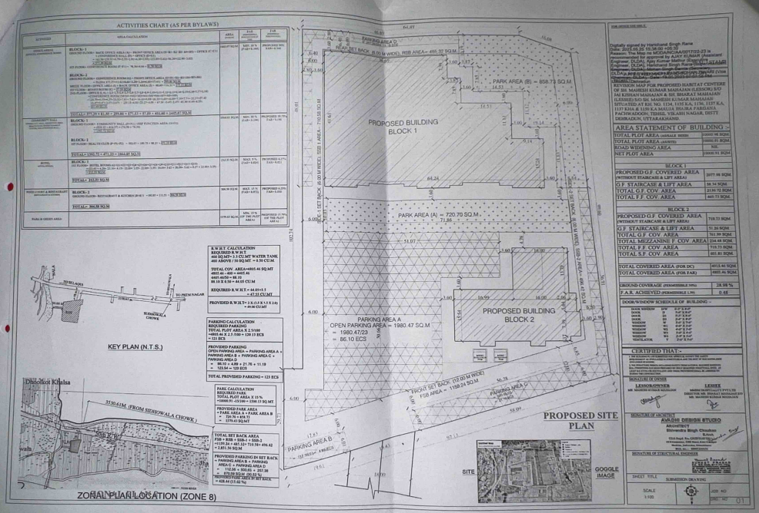

**Contract Work Details:**

