CREDIT APPRAISAL REPORT

of

Ratnaraj Blessing Milestone LLP
Registered Office: -
B-4 Shree Dattakrupa Chs Dr. Babasaheb Ambedkar Road,
Chinchpokli, Parel Opp. Voltas Ltd, Lalbaug, Parel,
Mumbai, Maharashtra – 400012

Site Office: -
“The Pinnacle”
C. S. No.: 2/71 of Parel Seweri Division,
at Mahadev Palav Marg, Currey Road, F/South Ward,
Mumbai, Maharashtra – 400012

(Strictly Private & Confidential)

C O N T E N T S
1. METHODOLOGY
1.1 Nature of Assignment
1.2 Due Diligence
2. EXECUTIVE SUMMARY
3. ORGANISATION AND MANAGEMENT
4. FINANCIAL ANALYSIS
PROJECT DETAILS
4.1 Cost of Project
4.2 Means of Finance
4.3 Security
4.4 Terms of repayment
5. SENSITIVITY ANALYSIS
6. TECHNICAL APPRAISAL
7. MARKET ANALYSIS
8. OTHER ASPECTS
9. BASIC ASSUMPTIONS FOR FINANCIAL PROJECTIONS
10. CONCLUSION
11. FINANCIAL PROJECTIONS

1. METHODOLOGY
1.1 Nature of Assignment
The objective of the Credit Appraisal report is to assess the financial viability of a scheme of Redevelopment of Residential Project by Kakadia Group. This project is upcoming under name & style of “The Pinnacle” with an approximate project cost of Rs.320.00 Crores situated at Parel, Mumbai.
  - Due Diligence
While preparing this report the following data provided by Ratnaraj Blessing Milestone LLP (RBM), Mumbai was basically relied upon.
- Financial Projections for the year 2024-25 to 2030-31.
- Discussions with Partners and key management executives of RBM.
- Visit at the Project site.
- Other information and explanation required by and provided by Ratnaraj Blessing Milestone LLP.

2. EXECUTIVE SUMMARY
Brief about the Firm
Name of Firm Ratnaraj Blessing Milestone LLP
Partners Blessing Infradevelopers LLP
Ratnaraj Developers Pvt. Ltd.

Registered Office Ratnaraj Blessing Milestone LLP
B-4 Shree Dattakrupa Chs Dr. Babasaheb Ambedkar Road, Chinchpokli, Parel Opp. Voltas Ltd, Lalbaug, Parel, Mumbai, Maharashtra – 400012
Site Office “The Pinnacle”
C. S. No.: 2/71 of Parel Seweri Division,
at Mahadev Palav Marg, Currey Road, F/South Ward,
Mumbai, Maharashtra – 400012

Constitution Limited Liability Partnership Firm
Industry Construction
Date of Incorporation 24th May 2012
of Partnership Firm
Date of converted into LLP 14th November 2022

PAN NO. AAPFR1174D

GST NO. 27AAPFR1174D2Z4

LLP No. ABZ-0470

- ORGANISATION & MANAGEMENT
  - Brief Profile of Ratnaraj Blessing Milestone LLP: -
Sr. No. | Name of Partners | PAN No. | Constitution | No. of years in existence
1 | Blessing Infradevelopers LLP | AAJFB8488L | LLP | 15
2 | Ratnaraj Developers Pvt Ltd. | AAFCR6143M | Private Limited Co. | 12

“Kakadia Group” is a leading real estate’s projects developer in Surat, Gujarat and Mumbai, Maharashtra. The main Partners of the firm are linked with the business of construction and thus possess good understanding of construction business. We have a strong presence in all major areas of real estate industry including residential, commercial, malls and schools. In a short span Kakadia Group has successfully changed the horizon in Surat creating Landmark in commercial and residential segment. Kakadia group is now applying its expertise and is in the process of changing the horizon of Mumbai city also. We have successfully developed various residential & commercial building in Surat, Gujarat. We have also re-developed various residential & commercial buildings in Mumbai, Maharashtra also. Every project of Kakadia Group bears a different thought process and more focused idea of creating a robust infrastructure that contains radical design and sensible amenities.
The organizers have maintained sound relations with raw materials and labor suppliers and different government bodies. The Partners are well experienced in the line of activity and have also successfully completed various projects. All of these would assist them in completing the project timely at a lower cost with quality work.

3.2 Brief about Partners: -

- Blessing Infradevelopers LLP: -
Blessing Infradevelopers was incorporated as a partnership firm on 01/04/2009. The firm was founded by Mr. Manhar M. Kakadia, founder of Kakadia Group is a self-made businessman. With his great experience in the construction market he took his business to another height. With a standing of over a decade in this field the firm has delivered timely and quality construction to the customers. Blessing Infradevelopers LLP was incorporated as a partnership firm & later on it was converted to LLP in 2011. The partners of the firm are Shree Aradhana Estate Pvt Ltd, Valentine Mercantile Pvt Ltd, Manharbhai Muljibhai Kakadia & Vimalkumar Manharbhai Kakadia. The firm has undertaken many residential & commercial projects.
Brief about partners in Blessing Infradevelopers LLP: -
1). Shree Aradhna Estate Private Limited
Shree Aradhna Estate Private Limited is a 28-years-old company incorporated on 01.08.1996. Its main line of business is construction. Directors of this company are – Vimalkumar Kakadia, Manharbhai Kakadia and Mansi Atul Jain (CS). The company is a partner in Blessing Infradevelopers LLP.
2). Valentine Mercantile Private Limited
Valentine Mercantile Private Limited is a private unlisted company which was incorporated 16-years-back on 28.07.2008. It is a partner in Blessing Infradevelopers LLP. The company has experience in the Real Estate business. Current board members & Directors of the company are – Vimalkumar Kakadia, Divyeshkumar Kakadia and Manharbhai Kakadia.
3). Manharbhai Muljibhai Kakadia
Mr. Manhar M. Kakadia aged 65 Years, is a self-made businessman. He is main promoter or face behind the Kakadia group. He is partner of Blessing Infradevelopers LLP & director in – Shree Aradhana Estate Pvt Ltd & Valentine Mercantile Pvt Ltd. He is the tycoon of Surat city. His able leadership and entrepreneurship is responsible to witness prestigious commercial & residential complexes, Multi-storied Buildings as well as various schools in Surat City. Execution of many projects at the same time is Herculean task and it needs massive financial strength and backing. Despite of being such a difficult task Manharbhai Kakadia is able to launch & successfully complete various multiple projects at the same time.
He had the credibility to get the financial support from fellow businessmen and it also shows his reputation in Surat City. He embarked upon taking up independent projects right from 1991 in the banner of “Kakadia Group”. The group have completed over 1.50 Crores SQFT constructions and handed over to the customers’ upto now. In the recent year the company is developing some prestigious projects not only in Surat but also in Mumbai. He believes in the core principle of maintaining high quality standards of production. He also does the maximum staff welfare activities like providing medical re-imbursements etc.
Born with an innate passion for building and creating, Kakadia embarked on his journey in the construction industry with a vision to redefine standards and push boundaries. His relentless pursuit of perfection coupled with a keen eye for detail set him apart early in his career. He believed in the power of architecture to not only shape skylines but also to transform lives, and this ethos became the cornerstone of his work.

4). Vimalkumar Manharbhai Kakadia
Mr. Vimalkumar Manharbhai Kakadia aged 38 years is well-experienced in the field of development. Vimal is the firm believer in the transformative power of real-estate to foster social and economic development. He incorporates these beliefs from his father Mr Manharbhai Kakadia. He is a very keen personality & started to take interest in his father’s business since childhood while he was completing his higher education. He implements projects that not only yield profit but also contribute to the betterment of communities. He understands the importance of adopting to emerging technologies in the real estate field. He has grasped the key of this business from his father and now has sound knowledge in this field. Bringing new concepts and ideas are one of his most appreciating qualities. He always remains updated and curious about new things. He is also one of the major partners in Blessing Infradevelopers LLP & directors of – Shree Aradhana Estate Pvt Ltd & Valentine Mercantile Pvt Ltd.

- Ratnaraj Developers Private Limited.: -
In the dynamic tapestry of the real estate industry, where every project has the potential to shape lives and landscapes, Ratnaraj Developers Pvt. Ltd. emerges as a beacon of innovation and quality. From luxurious residential enclaves to vibrant commercial complexes, Ratnaraj's portfolio epitomizes a harmonious blend of aesthetics, functionality, and sustainability. It was incorporated on 01.08.2011. With a rich legacy spanning over a decade, Ratnaraj Developers has established itself as a trusted name synonymous with quality construction, timely delivery, and customer satisfaction. Ratnaraj’s mission is to redefine urban living by creating sustainable, aesthetically pleasing communities that enrich the lives of our customers and contribute positively to the environment.

Brief about partners in Ratnaraj Developers Private Limited: -
1). Shripal Babulal Jain
Mr. Shripal Babulal Jain aged 51 years is a visionary real-estate developer with a passion for creating architectural marvels that redefine urban landscape. He is one of the partners of Ratnaraj Developers Private Limited. He believes in going above and beyond excellence to exceed the expectations of his clients, delivering projects that surpass industry standards. He is known for his innovative approach to design and construction. Shripal brings fresh perspective and flair for innovation for every project he undertakes.

2). Purnima Shripal Jain
Mrs. Purnima Jain, aged 50 years, a prominent figure in the real estate industry, has carved a niche for herself through her entrepreneurial spirit, innovative vision, and unwavering commitment to excellence. With a career spanning over two decades, she has emerged as a trailblazer in the field of real estate development, leaving an indelible mark on the landscape of urban development. As a visionary leader and innovator, Purnima Jain continues to push the boundaries of possibility in the realm of real estate development. Her dedication to excellence, coupled with her passion for creating vibrant and sustainable communities, serves as an inspiration to aspiring entrepreneurs and industry professionals alike. She is also one of the partners of Ratnaraj Developers Private Limited.

3.3 Illustrative List of projects Completed/ about completion by the group: -
Sr. No. | Name of Project | Nature of  Project | Approx. Project Value (Rs. In Crores) | No. of Units | Project Duration
1 | Deepa Complex & Kunti Shopping | Residential cum commercial | 10.00 | 88 Flats  35 Shops  18 Offices | 1991-94
2 | Kakadia Complex | Residential cum commercial | 15.00 | 108 Flats | 1992-95
3 | Ashirwad Township | Residential | 10.00 | 510 Flats | 1995-98
4 | Malhar Complex | Residential cum commercial | 10.00 | 36 Flats  42 Shops | 1996-99
5 | Amrutdhara Complex | Residential cum commercia | 10.00 | 48 Flats  18 Shops | 1996-99
6 | Ashirwad Complex | Residential | 15.00 | 132 Flats | 1997-00
7 | China Town | Residential | 20.00 | 98 Row Houses | 1997-00
8 | Ashirwad Square | Residential cum commercial | 11.00 | 45 Shops  25 Godowns  50 Offices | 1997-00
9 | Malabar Hills | Residential cum commercial | 15.00 | 132 Flats | 1998-01
10 | Ashirwad Bungalows | Residential | 10.00 | 71 Bungalows | 1998-01
11 | Raghukul Textile Market | Commercial | 100.00 | 2850 Shops | 1998-01
12 | Abhinandan Textile Market | Commercial | 15.00 | 472 Shops | 1999-02
13 | Abhishek Park | Residential | 20.00 | 60 Flats | 1999-02
14 | Kohinoor Textile Market | Commercial | 50.00 | 2500 Shops | 1999-02
15 | Amrut Kunj | Residential | 20.00 | 132 Flats | 2000-03
16 | China Gate – 1 | Residential | 10.00 | 78 Row Houses | 2001-04
17 | China Gate – 2 | Residential | 15.00 | 102 Row Houses | 2001-04
18 | Adarsh Market – 2 | Commercial | 10.00 | 370 Shops | 2001-04
19 | Ashirwad Park | Residential | 30.00 | 264 Flats | 2001-04
20 | Ashirwad Farm | Residential | 25.00 | 168 Farm Houses | 2002-05
21 | China Row House | Residential | 3.00 | 21 Row Houses | 2002-05
22 | Ashirwad Villa | Residential cum commercial | 50.00 | 434 Row Houses  18 Shops | 2002-05
23 | Ashirwad Kunj | Residential | 10.00 | 91 Row Houses | 2003-06
24 | China Gate – 3 | Residential | 2.00 | 13 Duplex Row Houses | 2003-06
25 | Silent Zone | Residential | 200.00 | 485 Farm Houses | 2004-07
26 | Ashirwad Palace | Residential | 250.00 | 461 Flats | 2005-08
27 | Ashirwad Industrial Park | Industrial Shed | 15.00 | 334 Industrial Shed | 2005-08
28 | Ashirwad Residency | Residential | 48.00 | 161 Bungalows | 2006-09
29 | Ashriwad Enclave | Residential | 150.00 | 544 Flats | 2007-10
30 | G.D. Goenka International School | Complete school with Hostels | School Building | -- | 2010-12
31 | Ashirwad Avenue | Residential | 125.00 | 248 Flats | 2011-15
32 | Ashirwad Homes | Residential | 50.00 | 48 Flats | 2015-19

During completion of above projects the promoters of the project has diversified themselves into the education segment. They developed their existing renowned G D Goenka International School & scaled it to such an extent such that currently majority of rich population of Surat city are now willing to send their children to G D Goenka International School.

3.4 Illustrative List of Running /Upcoming Projects: -
Sr.  No. | Name of Project | Name of Developer | Type of Project
1 | The Pinncale | Ratnaraj Blessing Milestone LLP | Re-development project
2 | Upcoming IB Board School | Ashirwad Kelawani Public Charitable Trust | IB Board School

3.6 Key Personnel: -

Architect | M/s. Kanhere Associates LLP
Structural Engineer | B Plus AC Pvt. Ltd.

Architect: -

M/s. Kanhere Associates LLP
M/s. Kanhere Associates LLP is a Limited Liability Partnership which is registered at Registrar of Companies (ROC-Mumbai). The company has 3 partners/designated partners Saurabh Satish Jadhav, Rajesh Ramchandra Dabekar and Asavari Kanhere. It is a renowned architectural firm celebrated for its innovative designs, sustainable practices and commitment to excellence in the field of architecture. Within a short span, Kanhere Associates has established itself as a leading name in architectural industry. M/s. Kanhere Associates LLP brings a wealth of expertise and creativity to every project they undertake. Further, the firm uses cutting-edge technologies and digital tools to enhance the design process and streamline project delivery. The clientele of firm includes – M/s Talahti & Partners LLP, Dudhwala Group, Samartha Realtors, Prameya Developers, Jigna Construction & Co. etc.

Structural Engineer: -

B Plus AC Pvt. Ltd.: -
B+AC is an engineering consulting is a foreign based company. Its headquarter is in Chelsea, Massachusetts, USA. The company is founded in 2014 and since thenit has earned very good reputation in the market. It is focused on providing practical structural engineering service and problem solving. They draw upon the depth and breadth of their experiences with respected consulting powerhouses. Their humble beginnings give them an ability to promptly respond to their clients’ needs and stay nimble in their approach. They like to be flexible for clients while respecting the laws of society, science, engineering and ethics. They are specialist in the field of Structural Engineering, Peer Review, High Rise, Long Span, Expansion, Renovations, and Lateral Upgrade. They have good team consisting of around 50 employees. Balram Chamaria, President/ Principal of the company. Balram Chamaria’s focus on service to client needs through elegant solutions and financial efficiency continues to be the central tenet of his leadership of B+AC. His deft steering permits accommodation for such needs while also respecting the laws of society, science, engineering and ethics. Before founding B+AC in 2014, Mr. Chamaria spent many years with numerous respected, international consulting powerhouses, amassing a broad, still-growing portfolio. The resulting accumulated proficiency has been a springboard for innovative elegance and client satisfaction.

- FINANCIAL ANALYSIS
PROJECT DETAILS ---All Rs. In Crores---
4.1 COST OF PROJECT
Particulars | Total  Cost
Land Related Exps, | 35.21
Construction Exps. | 188.79
Paid FSI Exps. | 45.74
A & S and P & P Costs | 9.15
IDCP | 29.25
Contingencies | 11.86
Total | 320.00
4.2 MEANS OF FINANCE
Particulars | Total  Means
Promoters Contribution | 85.00
Advances from customers | 95.00
Term Loan | 140.00
Total | 320.00

4.3 Terms of Repayment
Loan Facilities Bank Loan of Rs 140.00 Crores
Rate of Interest for Calculation 10.50%
Rate of Interest Requested 9.05 %
Tenure 72 Months including of Moratorium of 36 months
Repayment Schedule As per Cash Flow Statement & Detailed Project Report attached

  - Securities: -
- Primary Security: -
FSI & Proposed Sales Wing Building of “The Pinnacle” situated at C. S. No.: 2 /71, Parel Seweri Division, Mahadev Palav Marg,Currey Road, F/South Ward, Mumbai City, 400012; with Total No. of Flats 92 Units with admeasuring carpet area of 83508 Sq. Fts. along with Total No. of 181 Units usable Parking. The project cost of Primary Security amounting Rs. 320.00 crores considered as value of Primary Security.
(NOC over one by one units would be released by Bank on proportionate repayment of Loan; hence, primary security coverage would be maintained.)

Primary Security Coverage would be 228.57 % of loan Amount

- Collateral Security: -
Land situated at Revenue Survey No.38/1+2 + 38/A+B, Block No. 111, T.P. no. 65, O.P. No. 4, F.P. No. 4 admeasuring about 7852 Sq. Mtr. Moje: Bharthana–Vesu, Taluka: Majura, District: Surat, Gujarat. With a Realizable value around Rs. 126.78 Crores. Owned by M/s Blessing Infradevelopers LLP. Collateral Security Coverage would be 90.55% of loan amount.

Thus, Total Security coverage percentage for proposed loan would be 319.12%

- Guarantees of following: -
Sr. No. | Name of Trustees | Role | Status | Net-worth*  On Book Value  (Rs. In Lacs)
1. | Blessing Infradevelopers LLP | Partner in Ratnaraj Blessing Milestone LLP | Guarantor | 21152.83
2. | Ratnaraj Developers Private Limited | Partner in Ratnaraj Blessing Milestone LLP | Guarantor | --
3. | Shri Aradhana Estate Private Limited | Partner in Blessing Infradeveloper LLP | Information | 28846.79
4. | Valentine Merchantile Private Limited | Partner in Blessing Infradeveloper LLP | Information | 20366.73
5. | Manharbhai Muljibhai Kakadia | Partner in Blessing Infradeveloper LLP | Information | 17818.44
6. | Vimalkumar Manharbhai Kakadia | Partner in Blessing Infradeveloper LLP | Information | 601.73
 | TOTAL |  |  | 88786.52
*Market Value of land bank in Blessing Infra developers LLP, Shri Aradhana Estate Pvt. Ltd., Valentine Mercantile Pvt. Ltd., Manharbhai Kakadia and Vimalbhai Kakadia are very very high in comparison of Book value. Promoters have very-very sound land bank in Surat city with very-very high market values. Here in above table only BOOK VALUES are mentioned.
If necessary then only Guarantees of Sr. No. 3 to 6 may be explored/ taken.
5. SENSITIVITY ANALYSIS
With Respect Change in Market Demand: - As the demand is very high and a huge number of visitors and queries to purchase residential units in the project suggest that the project would be entirely successful. However, for financial projections a very conservative approach is followed. Hence, even in the rare case of low demand; projections would be achieved very easily. It is to inform that the promoters are selling the units at very reasonable rate.
Change in Tariff/ Sale Proceeds: - Compared with other projects in the same locality and other localities in the city & considering the market trends; change in tariff/ sale proceeds would be always towards positive.

6.1 TECHNICAL APPRAISAL
Bank’s empanelled Valuer’s Valuation Report and Advocate’s Title Clearance Reports may be obtained.
Brief Write-Up for Re-development Rights:-
- Promoters legally obtained re-development rights by way of development agreement from Kamgar Swa-Sadan Co-operative Housing Society located in Parel by legally winning tender.
- However, few mischievous tenants raised objections against the decision of the society & moved to court.
- After Court order for vacating premises; the tenants vacated Building.
- The vacating process of Society started & ended during the Period of April 2023 to June 2023.
- All substitute house rental payments had been made to all of the tenants in advance.
- All shifting expenses & other expenses had been also paid to tenants.
- The Promoters have already taken all the necessary approvals from competent authorities including IOD approval.
- The Promoters have also obtained NOC from Godrej Projects Development Private Limited for earlier entered Agreement.
- RERA approvals have been given by RERA Authorities.
- RERA approval is license for inviting booking from public at large and normally RERA Authorities give RERA Registration after satisfying with all aspects including legal, technical etc.
- Since RERA certificate has already been issued it becomes evident that there are no legal & technical issues pending for re-development of the society.
- The firm already have possession over the project land.
- Builders have already started the construction of the project & construction is going on in full swing.
- Further, builders are fully committed to give back Rehab part to vacated tenants ASAP as agreed within 24 Months of now.

Implementation schedule Target month’s Total period
Land | Sale/ Purchase Agreement entered into | ---
Construction Works  -Started  -Completed | July, 2024  June, 2027 | 36 Months
Booking of units  -Started  -Completed | July, 2024  June, 2027 | 36 Months
Possession of units  -Started  -Completed | July, 2027  June, 2030 | 36 Months
Period of Project | 36 months’ construction/ moratorium/ disbursement  & 36 months of sales/ possession / repayment totaling 72 months | 72 Months  (Loan Period)
Bank Loan Requirement | Rs. 140.00 Crores
Period of Loan | 36+36 = 72 months | 72 Months
Disbursement Period | 36 months | 36 Months
Repayment Period | 36 months | 36 Months

  - Brief about “The Pinnacle: -
The proposed project “The Pinnacle” is about a redevelopment of the existing society named “Kamgar Swa-Sadan C.H.S. Ltd. The buildings of the society were constructed around 90 years back and now they are in very dilapidated and precarious condition which is beyond repair and require urgent demolition and reconstruction. So in view of compelling circumstances, the members of the society took a primary decision to proceed with redevelopment of the property. For this the society through its Project Architect and Management Consultant floated a tender. After all deliberation and considering suggestions and recommendation of the members unanimously approved and accepted the offer and appointed M/s. Ratnaraj Realty (which is now converted into Ratnaraj Blessings Milestone LLP). The old homeowners get larger areas, more modern amenities and a better lifestyle and the developer is able to offer the additional residences to new homebuyers making it a win-win for all stakeholders. The sales table is given as below: -
Floor | BHK | No. of  Floor  (A.) | No. of Flats Per Floor (B.) | Total No. of  Flats (C.)= (A.*B.) | Carpet Area  Per Flat (in Sq. ft)  (D.) | Total Carpet Area (in Sq. ft) (E.) = (C.)*(D.) | Sale Price  per Sq. ft  (F.) | Total  Sales  (G.) = (E.*F.)
FLATS – WING C:-
11th to 16th Floor | 2BHK | 6 | 2 | 12 | 802.00 | 9624.00 | 48000 | 461952000
11th to 16th Floor | 3BHK | 6 | 2 | 12 | 1023.00 | 12276.00 | 48000 | 589248000
17th Floor (Refuge) | 2BHK | 1 | 2 | 2 | 802.00 | 1604.00 | 48000 | 76992000
17th Floor (Refuge) | 3BHK | 1 | 1 | 1 | 1023.00 | 1023.00 | 48000 | 49104000
18th to 23rd Floor | 2BHK | 6 | 2 | 12 | 802.00 | 9624.00 | 48000 | 461952000
18th to 23rd Floor | 3BHK | 6 | 2 | 12 | 1023.00 | 12276.00 | 48000 | 589248000
24th Floor (Refuge) | 2BHK | 1 | 2 | 2 | 802.00 | 1604.00 | 48000 | 76992000
24th Floor (Refuge) | 3BHK | 1 | 1 | 1 | 1023.00 | 1023.00 | 48000 | 49104000
25th to 30th Floor | 2BHK | 6 | 2 | 12 | 802.00 | 9624.00 | 48000 | 461952000
25th to 30th Floor | 3BHK | 6 | 2 | 12 | 1023.00 | 12276.00 | 48000 | 589248000
31st Floor (Refuge) | 2BHK | 1 | 2 | 2 | 802.00 | 1604.00 | 48000 | 76992000
31st Floor (Refuge) | 3BHK | 1 | 1 | 1 | 1023.00 | 1023.00 | 48000 | 49104000
32nd to 33rd Floor | 2BHK | 2 | 2 | 4 | 802.00 | 3208.00 | 48000 | 153984000
32nd to 33rd Floor | 3BHK | 2 | 2 | 4 | 1023.00 | 4092.00 | 48000 | 196416000
34th Floor (Refuge) | 2BHK | 1 | 2 | 2 | 802.00 | 1604.00 | 48000 | 76992000
34th Floor (Refuge) | 3BHK | 1 | 1 | 1 | 1023.00 | 1023.00 | 48000 | 49104000
TOTAL |  |  |  | 92 |  | 83508.00 |  | 40083840000.00

Earlier the society consisted of 4 buildings comprises 19 shops, 222 residential tenements, 3 Society rooms, 1 godown and 1 society office. Now the proposed project would be consisting of A, B & C Towers. Out of theses towers the flats & shops of A & B will be given for redevelopment to existing society members i.e. for Rehab purpose. The flats of C Tower will be sold to new buyers. Tower C would consist of 34 floors, out of this upto 10 floors there will be parking and from 11th floor to 34th floor there will be average 4 flats on each floor totaling to 93 flats. There will be 2 sizes/types of flats on each floor i.e. 3BHK & 2BHK Flats. The data of the same is given in the table above.

The Party has also proposed to sell their parking units. The details of the same are given as below:-

Parking Floor | Total No. Of Parking | Number of Parking Available for Use* | Average sales price of each parking | Total Sales of Parking
Basement | 28 | 28 | 10,00,000 | 28000000
1st Floor (Podium) | 17 | 17 | 10,00,000 | 17000000
2nd Floor (Podium) | 17 | 17 | 10,00,000 | 17000000
3rd Floor (Podium) | 18 | 17 | 10,00,000 | 17000000
4th Floor (Podium) | 18 | 17 | 10,00,000 | 17000000
5th Floor (Podium) | 18 | 17 | 10,00,000 | 17000000
6th Floor (Podium) | 18 | 17 | 10,00,000 | 17000000
7th Floor (Podium) | 18 | 17 | 10,00,000 | 17000000
8th Floor (Podium) | 18 | 17 | 10,00,000 | 17000000
9th Floor (Podium) | 18 | 17 | 10,00,000 | 17000000
SUBTOTAL | 188 | 181 |  | 181000000
Thus the total sales amounts to Rs. 4189384000.00 (Rs. 40083840000.00+ Rs. 181000000)

Amenities of the Project: -
- Kid’s play area
- Gazebo seating area
- Seating area
- Wide Balcony
- Lush green garden
- Party lawn
- Temple
- Name plate for each apartment

- MARKET ANALYSIS

A. Mumbai: -
- Formerly known as “Bombay”
- Capital city of Maharashtra
- Financial Capital of India
- Most Populous city of India with estimated population of Rs 2.30 crores in the Mumbai Metropolitan region
- Sixth most populous metropolitan area of world
- One of the nine declared metropolitan city of India
- Home to highest number of billionaires in Asia
- Third highest number of billionaires in the World
- Group of 7 islands
- Entertainment Capital of South Asia and constitutes “Bollywood”
- Home to “Bombay Stock Exchange”
- Home to various big conglomerates
- Ranked amongst the fastest city in the country for business startup in 2009
- Mumbai's culture offers a blend of traditional and cosmopolitan festivals, food, entertainment, and night life. The city's cosmopolitan and urban-centric modern cultural offerings are comparable to other world capitals.
- Known for jolly mood of public
- Known for Bombay Stock Exchange
- Known for eating habits of public
- Known for wealthy and lavish lifestyle of public
- Known for easiest earning city
- Known for its local train connectivity
- Known for way of enjoying all of the festivals
- Known for the highest growth-rate in population since Independence
- Known for cleanliness of the city
- Known for one of the best municipalities of the world
- Known as Prosperous and Wealthy City

The locations of all of the proposed projects are highly posh and are considered as highly costly area. The market prices in real estate industry of Mumbai is higher than most of the cities in India which indicates its already well-established & developed Real Estate industry. The growth potentiality in Mumbai is tremendous and enjoys highest population in India. Population growth is crux of real estate industry and main factor for viability of real estate projects. Considering highest population and economical growth rate and lower prices; the real estate market of Mumbai city is booming. The similar location seen approximately 30 to 40 % price rise in last 6 to 12 months; we have not taken into our projections this latest price rise due to conservative approach. However, considering the trend prices of real estate space are likely to shoot up more and more. The promoters had a long track record of timely completing and selling of various projects in similar locality which gives huge comfort for lending Institutions. The projected Sales Price and time are highly conservative and likely to be achieved very -very smoothly. The price of similar locality may be doubled at the time of completion and delivery of the projects; but, for projections we are taking lower than current prevailing prices.
In 2008, Mumbai was named as ALPHA WORLD CITY.

Mumbai lies on the Konkan coast on the west coast of India and has a deep natural harbour. The seven islands that constitute Mumbai were earlier home to communities of Marathi language-speaking Koli people. The city houses important financial institutions and the corporate headquarters of numerous Indian companies and multinational corporations. The city is also home to some of India's premier scientific and nuclear institutes and the Hindi and Marathi film industries. Mumbai's business opportunities attract migrants from all over India. Mumbai is on a narrow peninsula on the southwest of Salsette Island, which lies between the Arabian Sea to the west, Thane Creek to the east and Vasai Creek to the north. Mumbai's suburban district occupies most of the island.
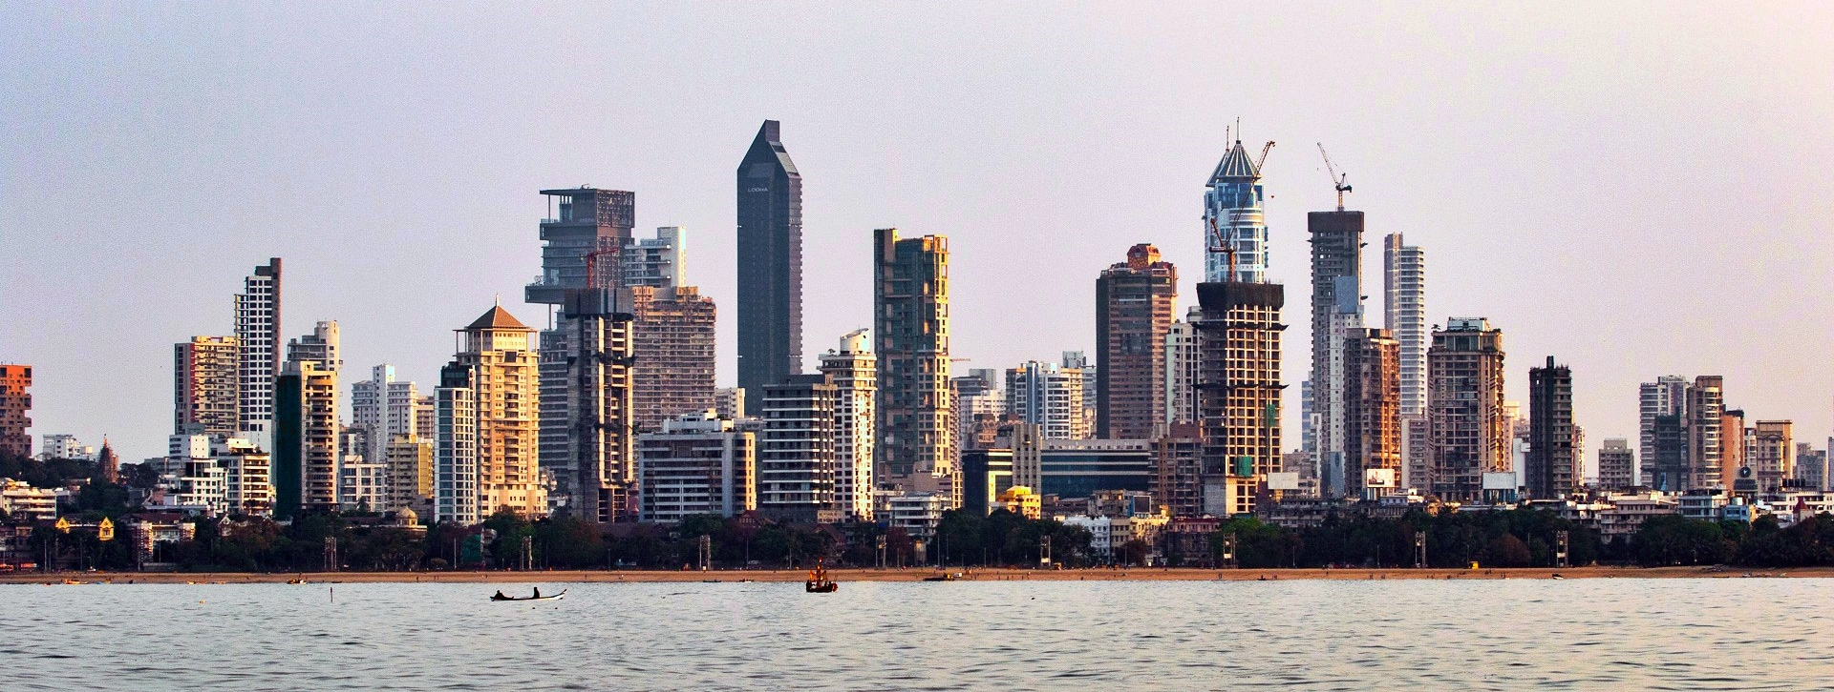
MAJOR DEVELOPMENTS: -

Chhatrapati Shivaji Maharaj International Airport, Mumbai:-

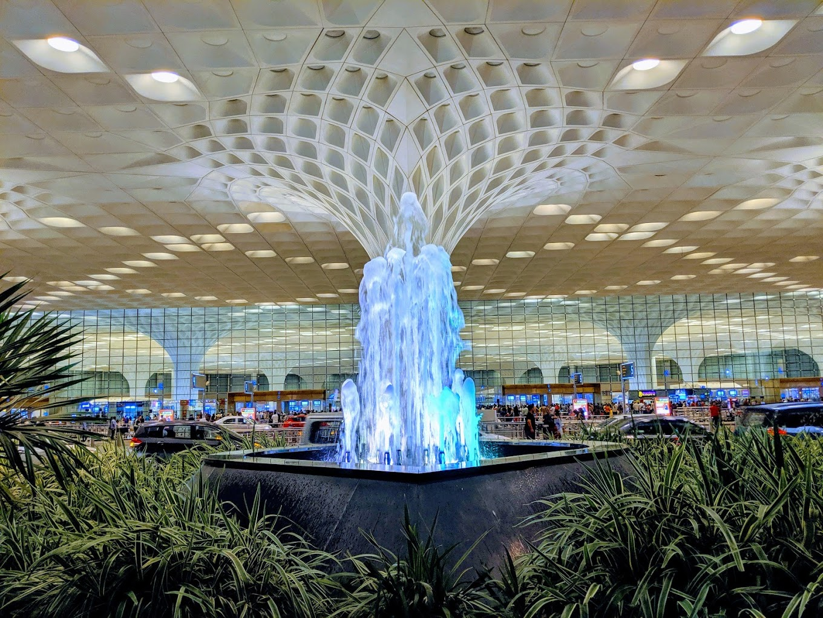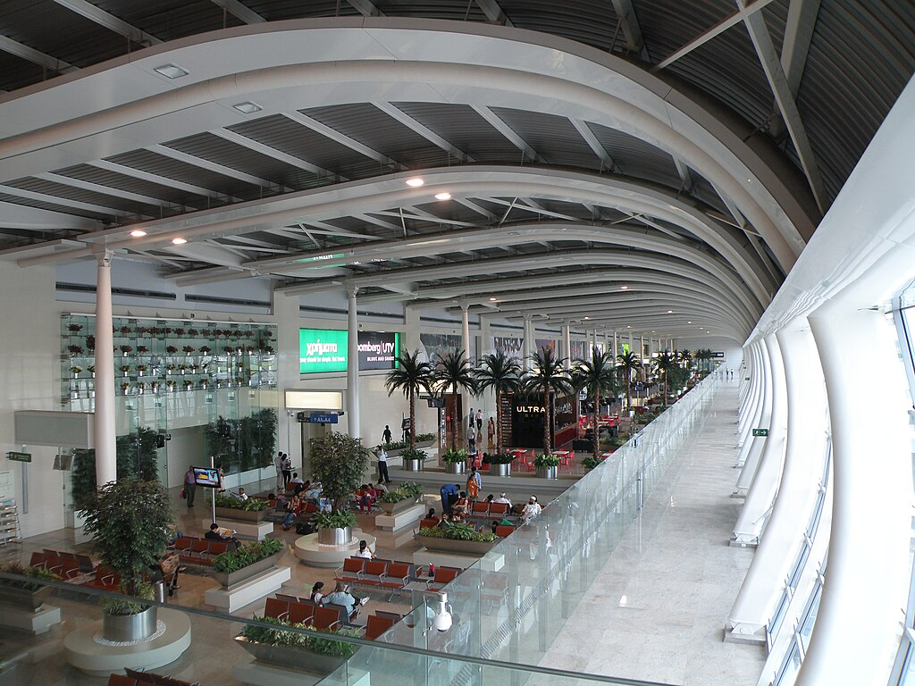
Chhatrapati Shivaji Maharaj International Airport, Mumbai is an international airport serving Mumbai and the Mumbai Metropolitan Region (MMR). It is the second busiest airport in India in terms of total and international passenger traffic after Delhi, and was the ninth busiest airport in Asia and 25th busiest airport in the world by passenger traffic in fiscal year 2023-24. The airport is operated by Mumbai International Airport Limited (MIAL), a Joint Venture between Adani Enterprises, a subsidiary of the Adani Group and Airports Authority of India. The airport offers nonstop or connecting flights to all six inhabited continents.
Its passenger traffic was about 49.8 million in year 2018. It is also the second busiest airport in terms of cargo traffic. In March 2017, the airport surpassed London's Gatwick Airport as the world's busiest to operate a single runway at a time.
This was later surpassed again by Gatwick Airport at the end of 2019 due to passenger numbers falling at Mumbai. It handled a record of 1,007 aircraft movements on 9 December 2018, higher than its earlier record of 1,003 flight movements in a day in June 2018. It handled a record of 51 movements in one hour on 16 September 2014. In financial year 2020, the Mumbai Airport handled 45.87 million passengers, only second to IGI's 67.3 million in India. In financial year 2023-24, the airport handled the highest ever passengers in its history of 52.8 million passengers, surpassing its maximum capacity of 50 million passengers per year, and second only to IGI's 73.6 million in India.
Mumbai Local Railway Lines connectivity: -
The Mumbai Suburban Railway (colloquially called local trains or simply locals) consists of exclusive inner suburban railway lines augmented by commuter rail on main lines serving outlying suburbs to serve the Mumbai Metropolitan Region. Spread over 390 kilometres (240 mi), the suburban railway operates 2,342 train services and carries more than 7.5 million commuters daily.
The daily commuters constitute around 40% of the daily commuters of Indian Railways. By annual ridership (2.64 billion), the Mumbai Suburban Railway is one of the busiest commuter rail systems in the world. Trains run from 04:00 until 01:00, and some trains also run up to 02:30 or 03:00. It is the first suburban rail network in India.
The Mumbai Monorail and Mumbai Metro have been built and are being extended in phases to relieve overcrowding on the existing network. The Monorail opened in early February 2014. The first line of the Mumbai Metro opened in early June 2014.
Mumbai is the headquarters of two zones of the Indian Railways: the Central Railway (CR) headquartered at Chhatrapati Shivaji Terminus (formerly Victoria Terminus), and the Western Railway (WR) headquartered at Churchgate. Mumbai is also well connected to most parts of India by the Indian Railways. Long-distance trains originate from Chhatrapati Shivaji Terminus, Dadar, Lokmanya Tilak Terminus, Mumbai Central, Bandra Terminus, Andheri and Borivali.
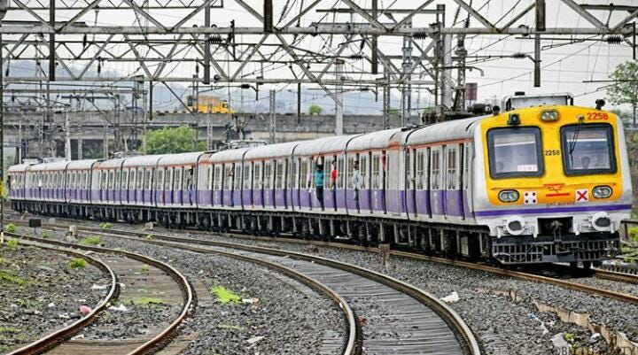
Home to many conglomerates: -
Mumbai is one of the top ten largest trading centres in the world in terms of global financial flows. 6.16% of the Indian GDP and accounting for 25% of industrial production, 70% of Indian maritime trade and 70% of capital transactions to the Indian economy.
Several major Indian companies are headquartered in Mumbai. The three largest private companies in India, Tata Group, Reliance Industries, and Aditya Birla Group, are based in Mumbai.
It is home to some of India's largest consumer packaged goods companies, such as Tata Consumer Products, Colgate-Palmolive, Godrej Consumer Products, and many much more.

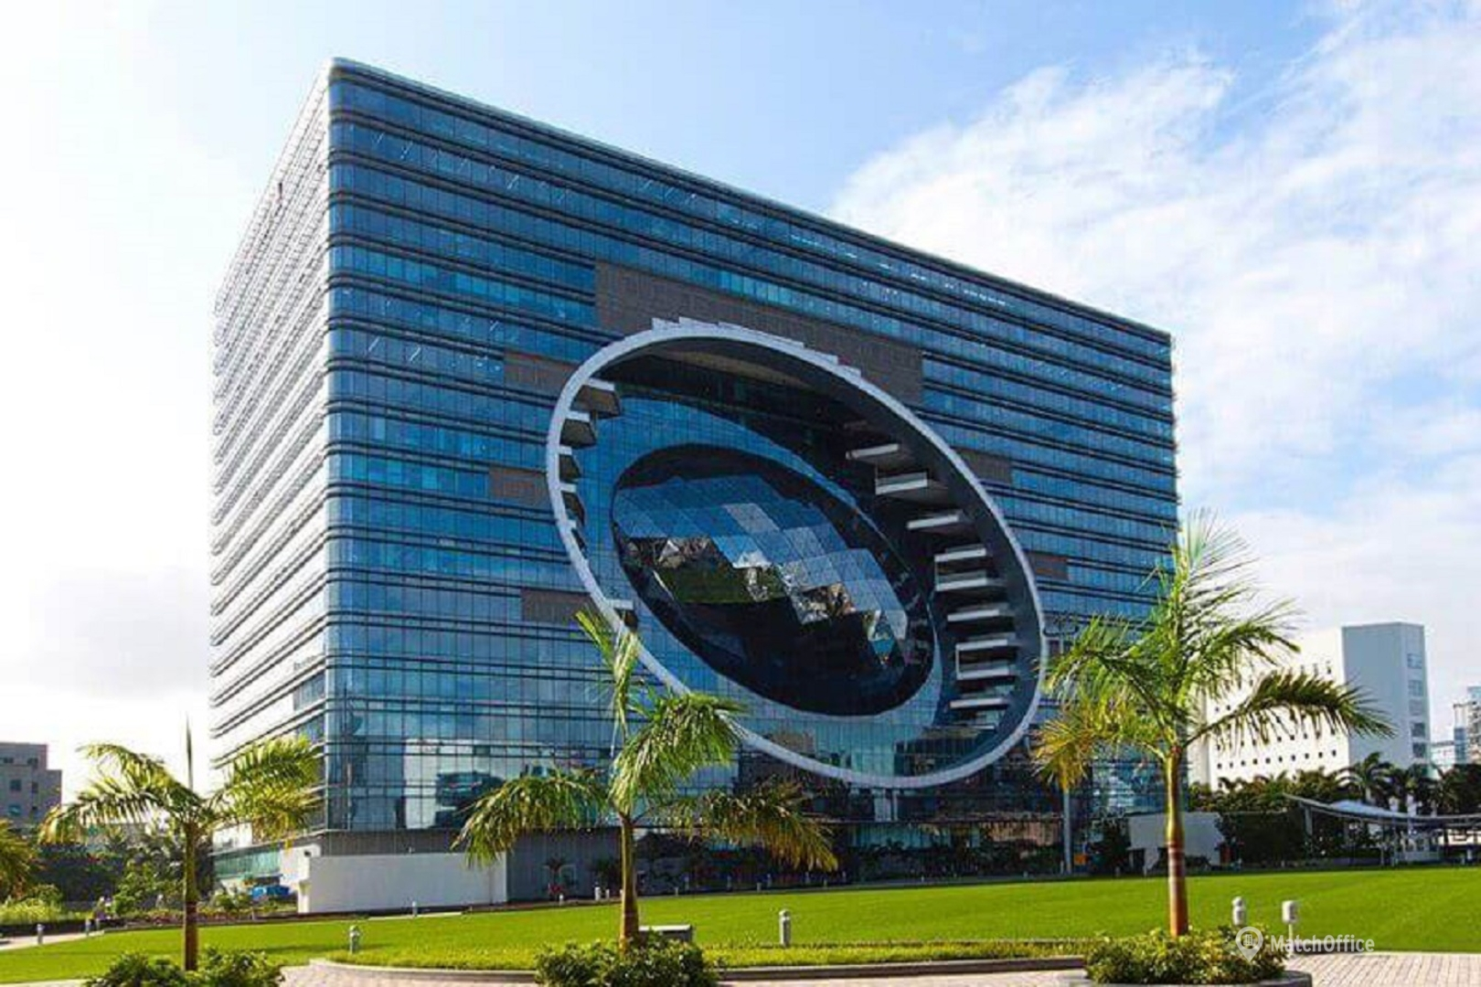
Skyscrapers Boom: -
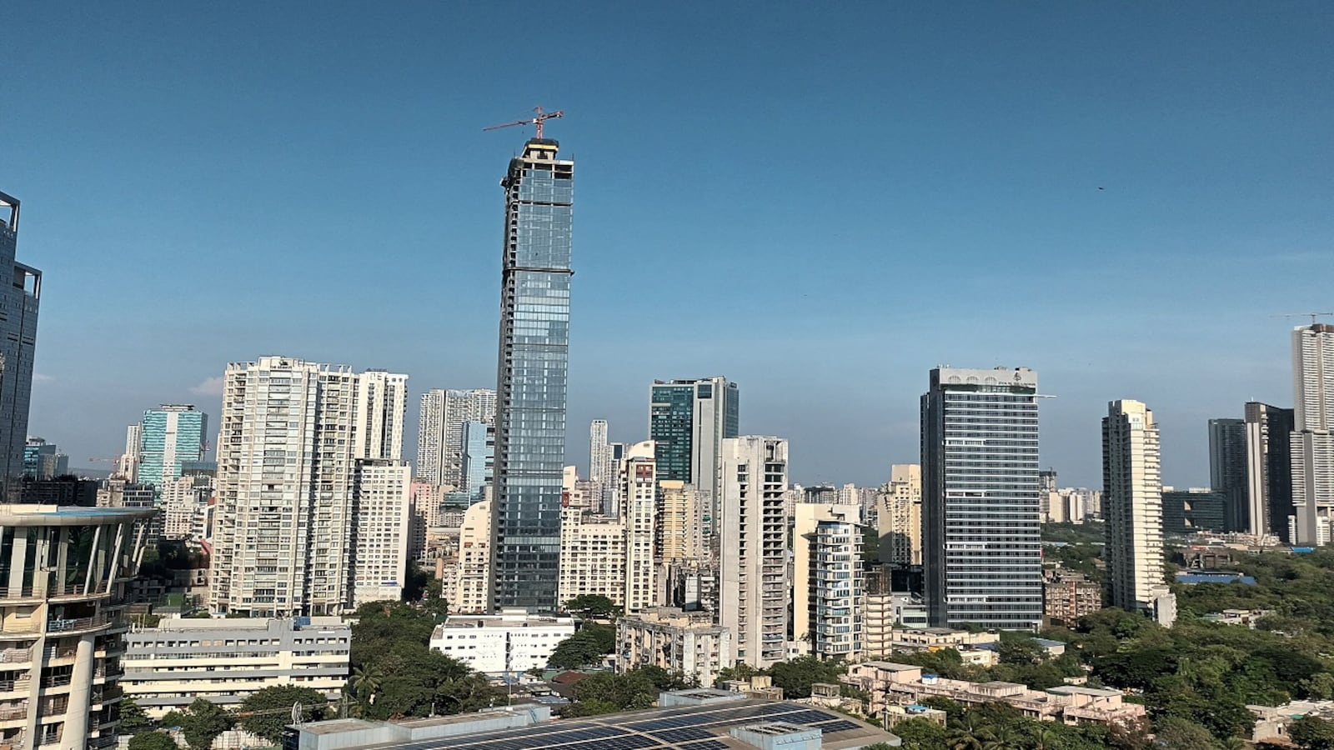
Mumbai, the commercial and financial capital of India, has the highest number of skyscrapers and high-rise buildings in India. More than 200 skyscrapers and 4,000 high-rise buildings have already been constructed in the city of Mumbai.

The first skyscrapers in Mumbai were constructed during the 1970s, when Usha Kiran and Matru Mandir were developed and stood at about 76 metres (250 feet), or 25 floors, each. After a significant lull, construction projects since the mid-1990s began taking the skyline upwards, with a major acceleration in the pace of development since 2000, when the Lower Parel area began developing. The upcoming project is also coming in this area which possess a huge scope of development.

Bombay Stock Exchange: -
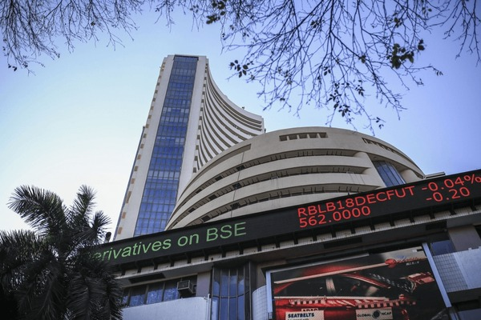
BSE Limited, also known as the Bombay Stock Exchange (BSE), is an Indian stock exchange which is located on Dalal Street, known as the Wall Street of Mumbai, in turn described as the New York of India. Established in 1875 by cotton merchant Premchand Roychand, it is the oldest stock exchange in Asia, and also the tenth oldest in the world. The BSE is the world's 8th largest stock exchange with a market capitalization exceeding US$4.5 trillion as of January 2024.
Maharashtra accounts for the most number of investors. More than 15 million or 21 percent of registered investors with the BSE are from the state, followed by Gujarat (8.6 million), Uttar Pradesh (5.3 million), Tamil Nadu (4.3 million) and Karnataka (4.2 million). These five states account for more than half or 53 percent of all the registered investors.
Road connectivity of Mumbai: -
Mumbai is served by National Highway 48, National Highway 66, National Highway 160 and National Highway 61. The Mumbai–Chennai and Mumbai–Delhi prongs of the Golden Quadrilateral system of National Highways start from the city. The Mumbai–Pune Expressway was the first expressway built in India. The Eastern Freeway was opened in 2013. The Mumbai–Nashik Expressway, Mumbai–Vadodara Expressway, are under construction. The Bandra–Worli Sea Link bridge, along with Mahim Causeway, links the island city to the western suburbs. The three major road arteries of the city are the Eastern Express Highway from Sion to Thane, the Sion Panvel Expressway from Sion to Panvel and the Western Express Highway from Bandra to Bhayandar. Mumbai has approximately 1,900 km (1,181 mi) of roads. There are five tolled entry points to the city by road.
Mumbai had about 721,000 private vehicles as of March 2014, 56,459 black and yellow taxis as of 2005, and 106,000 auto rickshaws, as of May 2013.
Film City Mumbai: -
Film City; officially Dadasaheb Phalke Chitranagari is an integrated film studio complex situated near Sanjay Gandhi National Park in Goregaon East, Mumbai in India. It has several recording rooms, gardens, lakes, theatres and grounds that serve as the venue of many Bollywood and Marathi films. It was built in 1977 by the state government to provide facilities and concessions to the film industry. Approximately 800 people work in the studio's eight filming locations on any given day.
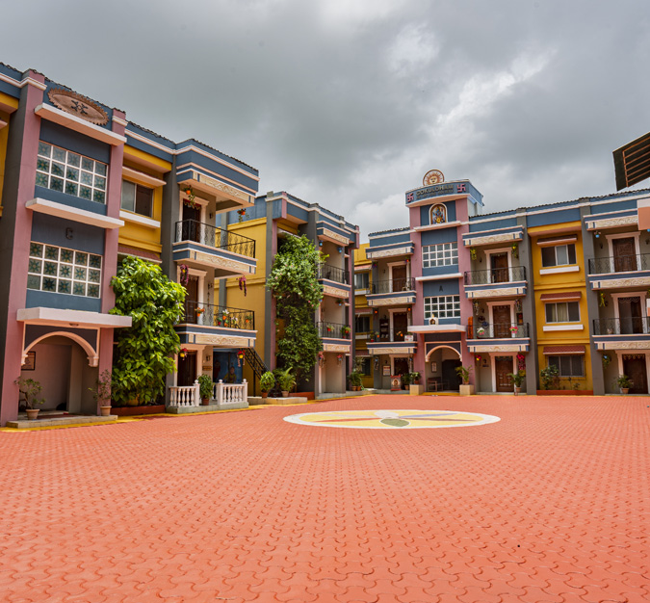

RECENT DEVELOPMENT: -
Mumbai Trans Harbour Link
The Mumbai Trans Harbour Link (MTHL), with a length of nearly 22 km, being inaugurated on January 12, is designed to connect Mumbai city with mainland Navi Mumbai. The six-lane bridge, christened Atal Setu after former Prime Minister Atal Bihari Vajpayee, is set to commence from Sewri in South Mumbai, extending to Chirle near Nhava Sheva.
Overseen by the Mumbai Metropolitan Region Development Authority, this project is classified as a Regional Development Project and is being executed at an estimated cost of approximately Rs 18,000 crore. The project holds significant promise for the economic advancement of Navi Mumbai and a portion of Raigad district, while also ensuring swifter connectivity with the upcoming Navi Mumbai International Airport. Upon reaching full operational capacity, the sea bridge is poised to contribute substantially to the enhanced connectivity and economic progress of the Mumbai Metropolitan Region. As per a report in The Times of India, for the initial year, the toll for a one-way passage on MTHL is set at Rs 250, while the roundtrip toll is Rs 375. Both the MTHL and Navi Mumbai International Airport are further expected to boost India’s GDP by 1 percentage point.
Third Mumbai:-
With the goal of enhancing housing, infrastructure, and efficient transportation for the expanding population of the Mumbai Metropolitan Region (MMR), the state government has approved a comprehensive preliminary plan for the establishment of a new city known as ‘Third Mumbai’. The proposed city is envisioned to be situated around the Navi Mumbai International Airport, connected to Mumbai via Atal Setu, commonly referred to as the Mumbai Trans Harbour Link (MTHL). The proposal of a ‘Third-Mumbai’ has only been approved as of now, and the details of the project are yet to be chalked out. As per a report by the Hindustan Times, this new city has been proposed to further boost economic activity and contribute to the country’s GDP.

Mumbai Coastal Road Project:-
Apart from the many important buildings, locations, cinema, food, and being the economic capital of the country, Mumbai is also known for its traffic. To reduce or manage some of this traffic on existing roads, the Brihanmumbai Municipal Corporation (BMC) has conceptualised the Mumbai Coastal Road Project along the Western seafront. The project's primary aim, according to BMC, is to establish an alternative North-South Trunk route for the residents, enhancing connectivity within the city. This initiative is designed to complement the 33.5 km underground Aqua Line 3 of the Mumbai Metro, connecting Cuffe Parade to Aarey and facilitating improved mobility between North and South Mumbai. The inaugural phase of the Mumbai Coastal Road Project spans 9.98 km, extending from the Princess Street Flyover at Marine Lines to the Worli end of the Bandra-Worli Sea Link. This phase involves seafront development and stands out as a pioneering effort in India. Expected to be completed in the first half of 2024, Phase 1 is estimated to incur a project cost of approximately Rs 13,000 crore.

Aqua Line 3 of Mumbai Metro Network:-
The Aqua Line 3 of Mumbai's Metro Network spans 33.5 km and is entirely underground, traversing the Colaba-Bandra-SEEPZ corridor and establishing crucial connections between the city's financial centres like Nariman Point, Bandra-Kurla-Complex, Fort, Worli, Lower Parel, and Goregaon. The entire route is anticipated to become operational in 2024, with Phase 1 potentially commencing by April. The estimated cost of the project is around Rs 33,000 crore. According to Mumbai Metro Rail Corporation Ltd. (MMRCL), the metro line is poised to serve over 16 lakh commuters daily, contributing to a reduction in travel time in the densely congested city. Upon completion, this fully subterranean North-South metro corridor will encompass 27 stations and interchange points, facilitating connections with the renowned suburban railway, Monorail, and the 'Versova-Andheri-Ghatkopar' Metro-1, which links the city from East to West.
Write up on Mumbai’s Redevelopment Projects: -
- The Mumbai real estate market has of late been witnessing a surge in housing society redevelopment projects with several listed developers picking up old buildings in the land starved city to redevelop them into modern apartments.
- This is primarily because there are several buildings that are old enough to require immediate facelift and there is interest by many large and listed developers as they have the financial wherewithal to execute such projects.
- Redevelopment is a very complex process and requires the expertise of experienced builders with deep financial pockets and sound construction capabilities.
- Due to paucity of land, redevelopment is the only way forward for Mumbai city, and the new policy by the government has really enabled this.
- The policy, being clear and transparent, has given developers from Mumbai Metropolitan Region (MMR) as well as outside ample opportunities to participate actively, he said.
- Mumbai has a massive stock of old dilapidated buildings on prime land across the city. With the latest redevelopment scheme, these parcels are a prime opportunity both for the homeowners living in these old buildings and for developers to add to the skyline of the city.
- The old homeowners get larger areas, more modern amenities and a better lifestyle and the developer is able to offer the additional residences to new homebuyers making it a win-win for all stakeholders
- Several listed real estate developers have started taking up redevelopment projects in Mumbai because there not too many new land banks are available to them.
- The introduction of the Cluster Redevelopment Policy introduced a few months back (under which they get an additional floor space index for redeveloping existing housing societies) has given these projects a boost.
- What makes redevelopment a lucrative investment is the rising demand from the city dwellers to upgrade, most preferring the same location where they reside. Hence, prime locations are becoming a hub for new redevelopment projects.
- It also helps in upgrading and uplifting the old localities as developers bring in their new developments with modern facilities and infrastructure.
- Redevelopment is a ₹1 lakh crore investment opportunity in Mumbai.

B. Demand Position of the project: -
Highlights for Demand Assessment & Marketability of the projects: -
Demand: -
- “The Pinnacle” is proposed to come at Parel, which is one of the posh area as well as developed Residential as well as Commercial areas of Mumbai city.
- Lower Parel is one of the most popular Residential and commercial suburbs of Mumbai.
- The location of the project is very prominent. It is close to all major road connections with areas like Prabhadevi, Dadar, Lalbaug, Wadala etc.
- The proposed project “The Pinnacle” is surrounded by many residential projects, temples, schools, bus-stops & commercial shops.
- The demand of units in “The Pinnacle” would be very high; which is evident by huge visitors & inquiries by potential purchasers.
- The developer has taken care of each and every small & tiny things or needs of the residents. They have tried to give their best for comfort of the customers through this project.
- This group does not require any huge marketing as it is one of the renowned group of the city. This Group is well established and prominent player in Real Estate for more than 20-30 years.
- The Promoters have very good experience and have high net worth.
- The builders are well known for quality construction and enjoy very good reputation in the society. They have received overwhelming response for the projects already developed by them. As seen above, they have very good experience with wide varieties of construction activities-Residential, Commercial etc. in Surat.
- Sales price projected in the project is reasonably lower than the real market price prevailing in the locality; in spite of luxurious quality supplies by the developers.
- “Kakadia Group” successfully completed/sold out various project in Surat as well as Mumbai city.
- The symptom of above may be very evident by seeing huge queries and inquiries on the projects and positive response from Rehab civilians;
- The location of the project is fantastic & highly prominent;
- Easy availability of housing loan in the industry.

Further, Real Estate demand is primarily linked with INCREASING POPULATION/ AND NOT ON EXISTING POPULATION.

- The population:-
The current metro area population of Mumbai in 2024 is 21,673,000, a 1.77% increase from 2023. The metro area population of Mumbai in 2023 was 21,297,000, a 1.6% increase from 2022. The metro area population of Mumbai in 2022 was 20,961,000, a 1.42% increase from 2021. Chart showing Mumbai’s population growth is enclosed herewith.

Mumbai's urban population is estimated to be over 22 million, and the densely populated city is the largest in India in terms of population, trade activity and business. The metropolitan area has experienced an explosion in growth over the past 20 years, a common occurrence with metropolitan areas in India. The rapid population growth is attributed to migration from other regions in the country, with migrants seeking business and employment opportunities.
The population of Mumbai has more than doubled since 1991, when the census showed that there were 9.9 million people living in the area. The rapid expansion has led to serious health issues that have to be addressed by the government, and a large percentage of residents live in the city’s slums.

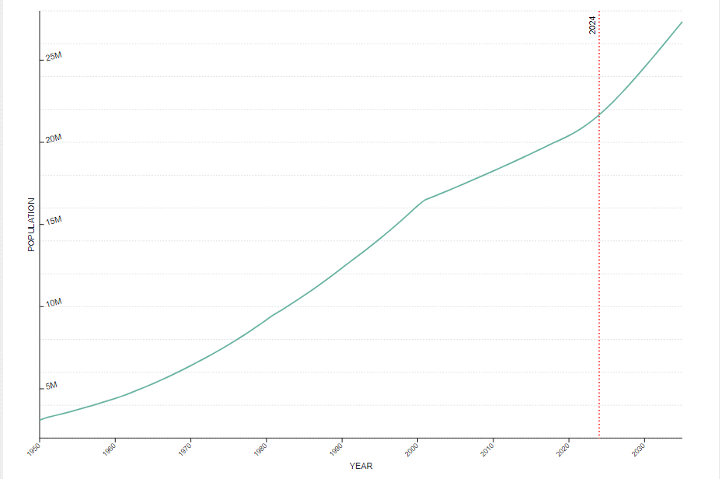
- Reason for Growth in population/ increase in demand:-
The reason for increase in population of the city is primarily due to highest rate of increasing migrants from all over of India. Increasing migrants are mainly due to better infrastructure, healthcare, air connectivity, water connectivity, road connectivity, economic opportunities etc.
Down Level Chain requirements like Hospitals/ Doctors, Schools, Medical Colleges, Engineering Colleges, Other Colleges, Hotels, Restaurants, Multiplexes, Entertainments Centres, Club- Houses, Health Centres, Shopping Malls, Banks, Other Infrastructural facilities and further at zero level CAs, Advocates, Architects, Furnishers, Designers, Cement- Brick- Stone- Tiles-Reti- Kapachi Suppliers, Sweets shops, medicine shops, barber shops, washer men, Vegetable shops, ration shops, dairy, spectacles shops, shoes shops, ready made garments shops, medical laboratories, electronic shops, electrical items shops, private tuition classes, various other classes are increasing sharply.
And, a huge shortage is felt in supplying adequate REAL ESTATE SPACE FOR ALL OF THESE.

- Demand in Real Estate Sector multifold:-
In normal cities the demand in real estate increases due to birth rates; urbanization; division of family; or moderate scale of Industrialization. But, Mumbai is growing with a phenomenon growth rate and it is evident by highest population growth rate in India.
Mumbai Metropolitan Region (MMR) has witnessed a sharp surge in housing sales, as well as, completion of residential projects in 2023 despite the high home loan interest rates and a spike in property prices in the country. The top-7 real estate markets in India--National Capital Region of Delhi (Delhi-NCR), Mumbai Metropolitan Region, Bengaluru, Pune, Hyderabad, Chennai, and Kolkata saw a 31% rise in housing sales last year, according to the latest data by Anarock Research. MMR saw a 40% jump in housing sales in 2023. A total of 1,53,870 houses were sold in MMR in 2023 as against 1,09,730 units sold in 2022. The Mumbai Metropolitan Region also saw the highest completion of housing units in 2023 at 1,43,500 units.

- Accumulation of demand due to slow down during Covid-19:-
During and after world wide heavy slow down all of the public stopped their real estate buying due to Covid-19 and in a result all of real estate players stopped constructing new projects. Now, demand for 3 to 4 Years are accumulated and to be fulfilled with 2 Years. This supply back log can not be fulfilled specially in Mumbai.
- Current Demand Level:-
Heaviest demand in the History of Mumbai Real Estate and can not fulfil entire demand
There are homebuyers in every segment today. People after COVID understand that real estate is the real money and the real investment. The need to have a good house after the pandemic has been pronounced. The great growth in the economy has helped this," observed Vyomesh Shah, managing director of Hubtown Ltd.
Reflecting on the post-pandemic market dynamics, data from the Anarock Group indicated a 31% year-on-year increase in sales across India's top seven cities in 2023, with MMR leading the pack with around 153,870 units sold. This resurgence highlights the region's robust recovery and its dominant share in the national real estate landscape.
Mumbai's real estate market ranked third in the Knight Frank’s Prime Global Cities Index for prime residential price growth in the last quarter of 2023, indicating a strong demand for lifestyle upgrades among affluent buyers, the primary driver behind the city's 10% price growth over the past 12 months.

8. OTHER ASPECTS: -
A. Security for Bank: -
The market value of land of the project is very high in comparison with book value. The final saleable value of project after the construction would also be very high in comparison with book value.
B. Availability of Chain Business to bank: -
Bank may impose a condition for chain business like housing loan, shop loan etc. Bank may impose a first right of refusal condition.
C. Why to first finance to Mumbai: -
Mumbai's real estate market is known for its resilience and stability, even during economic downturns. Property prices in Mumbai have historically shown steady appreciation, making it an attractive destination for long-term investment. And hence it shows that the demand of the property in Mumbai is always at booms and which from finance point of view is a strong point as the projects are always in demand. Also the groups long term standing makes it more easy to attract buyers.

9. BASIC ASSUMPTIONS FOR FINANCIAL PROJECTIONS
The assumptions made for the preparation of the financial projection is listed below.
- Interest & Moratorium: -
Interest on Bank Loan has been considered at 10.50% per annum for projection purpose and Rate of Interest at 9.05% per annum is requested. After considering the needs of the project moratorium period is taken as 36 months. The repayment period is assumed to be of 36 months after a moratorium period of 36 months; thus, the total project period would be of 72 months.
- Latest Position of Sources & Utilization of Funds: -
CA. certificate towards expenditure incurred till date on project and Sources for said expenditures would be submitted in the due course of appraisal (before submission of proposal to sanctioning authority) for latest position.
3. Taxation: -
The tax working for the project is projected as per current tax slabs.

10. CONCLUSION
Considering the stability in the market of residential as well as commercial units, centralized location of the project, growth potentiality of city clubbed with advantage of nearby vicinity of all the amenities and luxurious residential units i.e. quality houses at reasonable prices makes the project primarily highly viable. The experience & background of the partners, status & identity enjoyed in the society and business circles by the partners as an established and well-known figure, financial projections, ratio analysis & a very high real market price of the project as a whole and of every unit, the proposed project seems to be financially viable.
Considering all of this the project seems to be overall viable.

Financial
Enclosures

