REPORT FORMAT: CL-1 | Version: 1.0_2018

FILE No.: VIS (2024-25)-PL193-162-215 Date: 05-07-2024

DOCUMENT NAME: Progress Report on the machines and equipment for manufacturing Sterile water for injection plant which is proposed to be installed in Khasra No.398, Village Nanhera Roorkee, Haridwar, Uttarakhand.

PREPARED FOR ORGANIZATION: State Bank of India, SME Branch, Ranipur, Haridwar.

- BORROWER COMPANY’S NAME: M/s. GNE Life Sciences Private Limited.

ASSET TYPE: Machines required for manufacturing of Sterile Water for Injection.

CURRENT LOCATION OF THE MACHINES: Machines supplied at site and are proposed to be installed in Khasra No.398, Village Nanhera Roorkee, Haridwar, Uttarakhand.
TO WHOMSOEVER IT MAY CONCERN

S. NO. | PARTICULARS | DESCRIPTION
1. | Date of Survey | 01-07-2024
2. | Date of Document | 05-07-2024
3. | Documents provided for perusal | List of machines verified during site visit
4. | Current Location of the Machines | Khasra No.398, Village Nanhera Roorkee, Haridwar, Uttarakhand.
5. | Borrowing Company | M/s. GNE Life Sciences Private Limited.
6. | Type of Asset | Machines required for manufacturing of Sterile Water for Injection.
7. | Type of Assessment | Progress of machines purchased and proposed to be installed at site.
8. | Scope of Assessment | Progress of machines purchased and proposed to be installed at site.
9. | Nature of Machinery | Machines required for manufacturing of Sterile Water for Injection.
10. | Current Progress of the machines | As per physical inspection made during site visit,  Company has the machines have been arrived at site and are proposed to be installed at the site.
11. | Condition of Machines | Purchased machines and equipment are new and installation about to start.

OBSERVATIONS:

We have been provided with the list of machines that has to be purchased/ installed/ proposed to be installed by the borrower company.
Based on the information provided by the subject company (M/s. GNE Life Sciences Private Limited.) and site visit dated 01-07-2024, it is assessed that the following machines have been purchased & proposed to be installed at the above-mentioned site address.

LIST OF MACHINES AND EQUIPMENTS
S. NO. | NAME OF MACHINERY | Status During Site Visit Dated 01st July 2024
 | Autoclave | Machine Purchased & arrived at site
 | DG Set – 500KVA | Arrived at site and Kept on Foundation.
 | DM Water Storage Tank 3000 Ltr. | Purchased & arrived at site
 | Distilled Water Storage Tank 3000 Ltr. | Purchased & arrived at site
 | Multi Column Distillation Plant 1000 Ltr. | Purchased & arrived at site
 | Air Compressor 30HP | Machine Purchased & Arrived at site
 | Loop Line | Purchased & arrived at site
 | HVAC Work | Work In Progress of Ducting
 | Electric Work | Purchased & arrived at site
 | FFS Machine | Machine Purchased & arrived at site
 | Sticker Labelling Machine | Machine Purchased & arrived at site
 | Super Heated Tunnel | Machine Purchased & arrived at site
 | Wood Fired Boiler 800kg | Purchased & arrived at site

Disclaimer:
- This progress report is stated on the basis of the site visit by the surveyor and we don’t recommend any sort of recommendation in our Document.
- As per physical inspection and observation made during site visit dated 01st July 2024. Company has started ducting work of HVAC and proposed to installation of all the machines mentioned in the provided list.
- This Document doesn’t include any work related to drawing, design, sketch plan, and technical specifications of the machines.
- Ownership and other legal point of view in respect of the asset is not considered in this report as same is out of scope of this Document.
- This Document is made at the request of the Bank.

For R.K Associates Valuers & Techno FOR INTERNAL USE Engineering Consultants (P) Ltd.
TYPED BY: Er. Manmohan

REVIEWED BY: Er. Abhinav Chaturvedi

ANNEXURE: LIST OF MACHINES AS PROVIDED BY THE CLIENT

S. NO. | NAME OF MACHINERY
1 | Autoclave
2 | DG Set – 500KVA
3 | DM Water Storage Tank 3000 Ltr.
4 | Distilled Water Storage Tank 3000 Ltr.
5 | Multi Column Distillation Plant 1000 Ltr.
6 | Air Compressor 30HP
7 | Loop Line
8 | HVAC Work
9 | Electric Work
10 | FFS Machine
11 | Sticker Labelling Machine
12 | Super Heated Tunnel
13 | Wood Fired Boiler 800kg

ANNEXURE: PHOTOGRAPHS

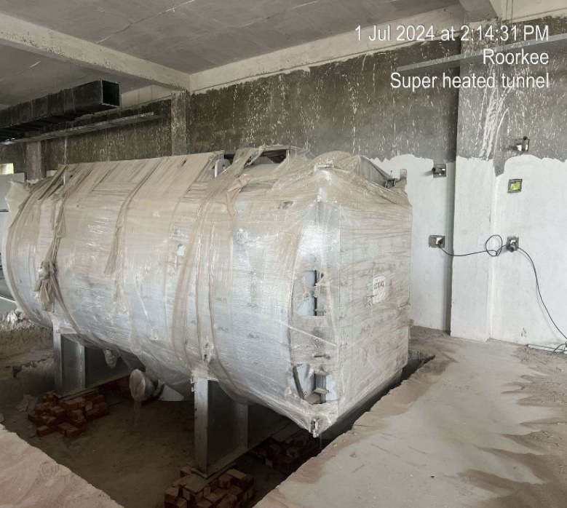 |  | 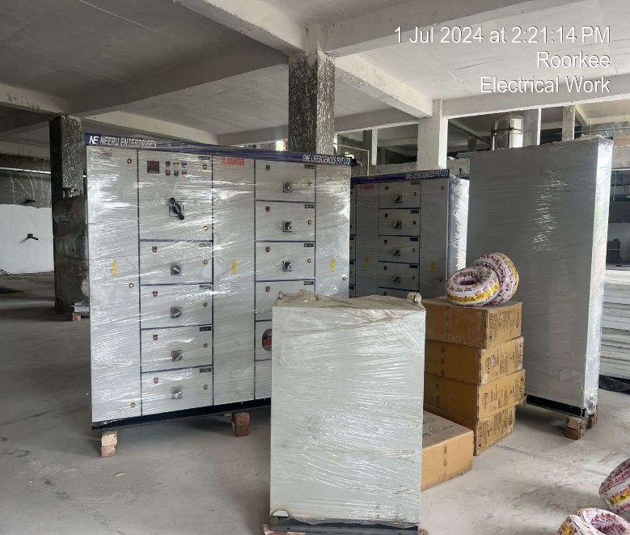
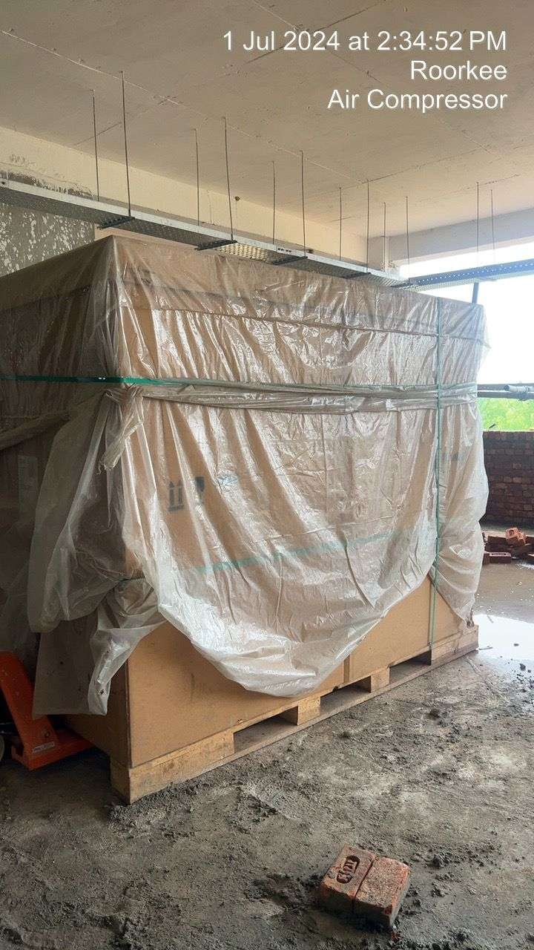 |  | 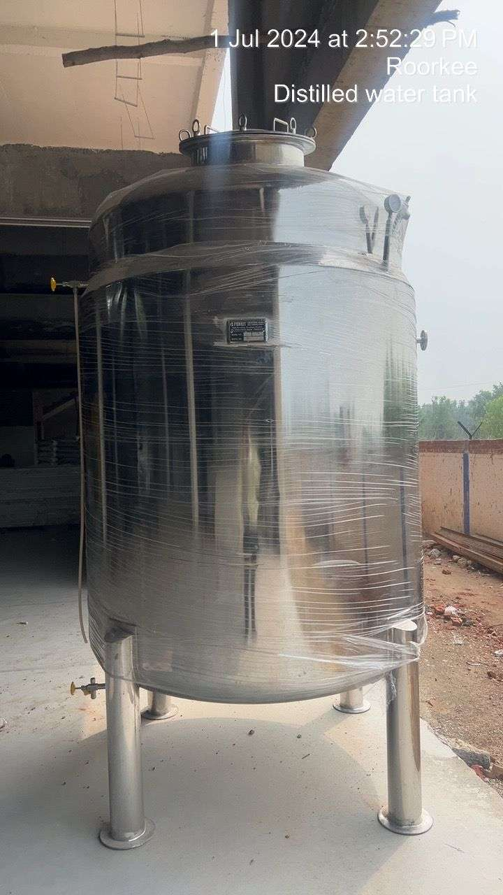
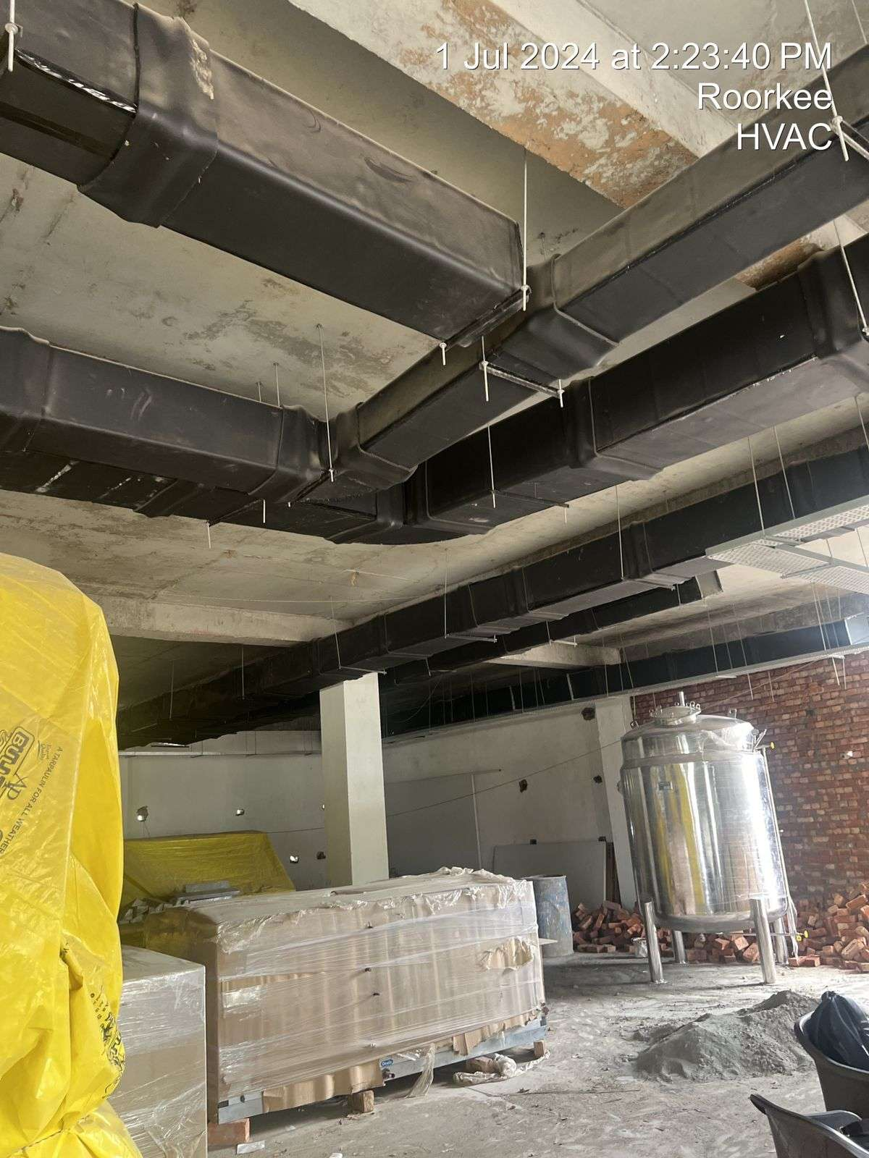 | 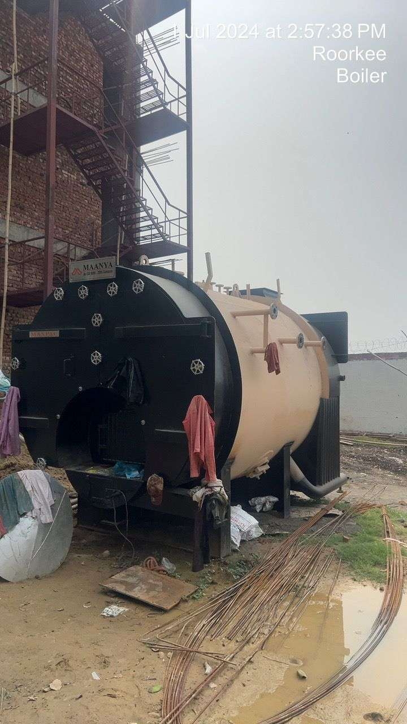
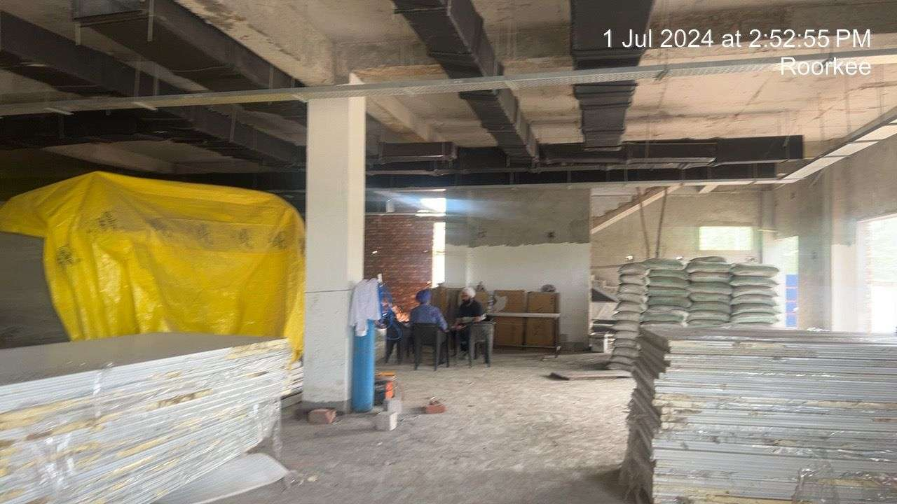 | 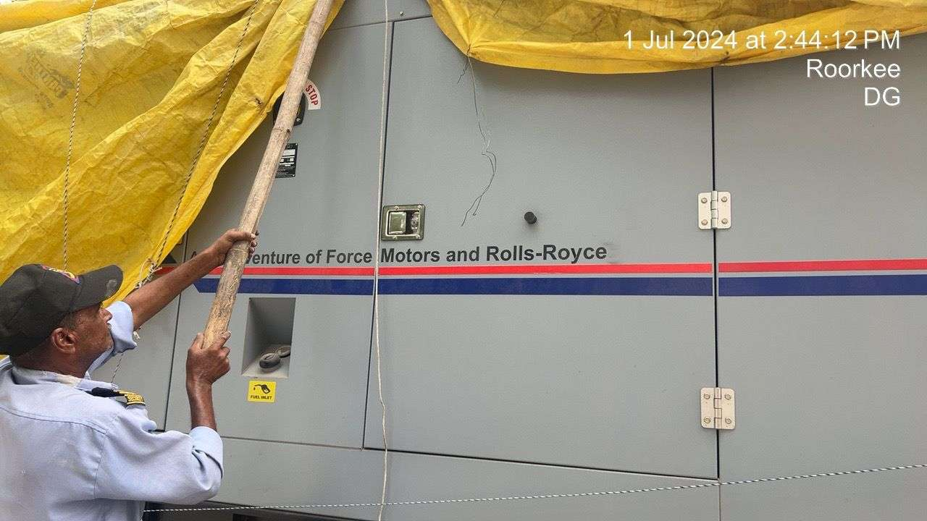
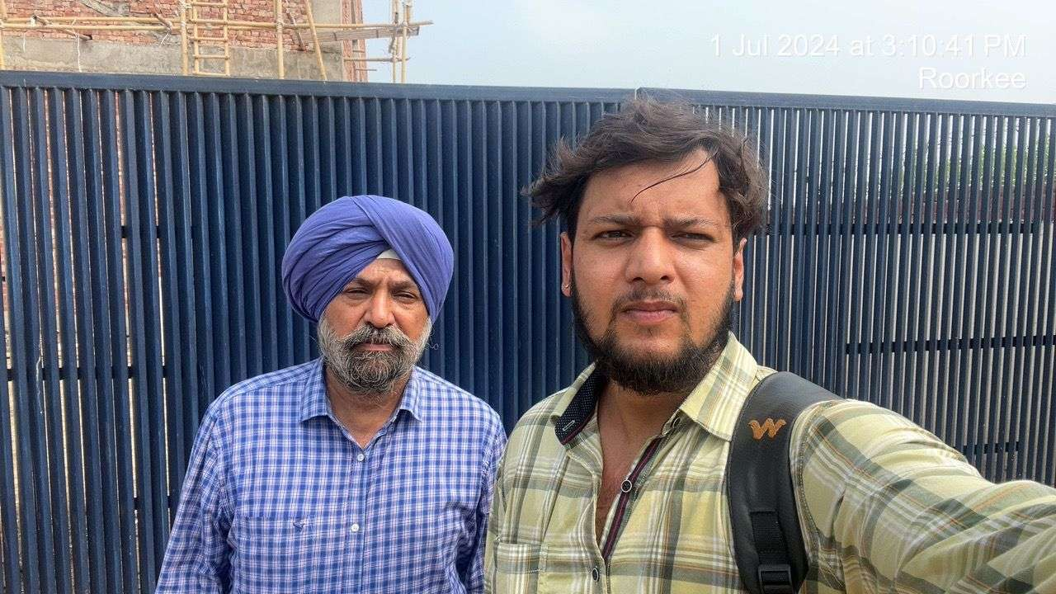 | 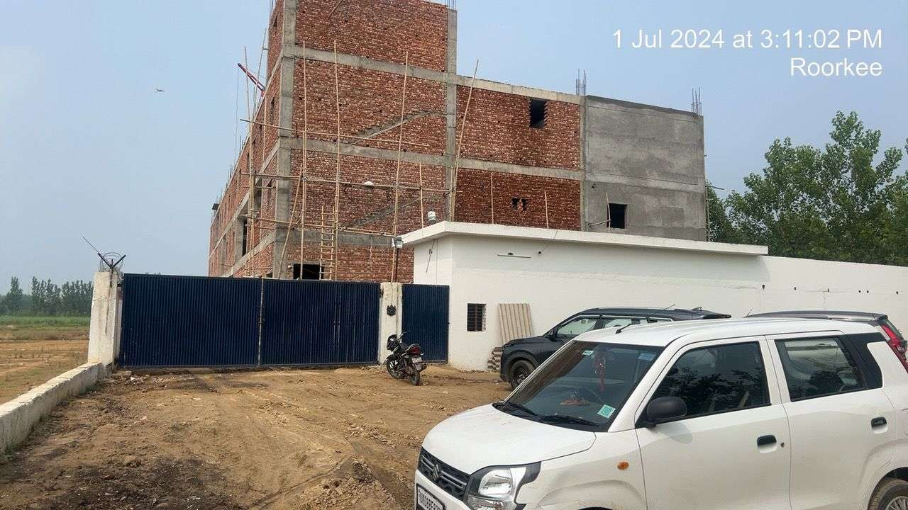

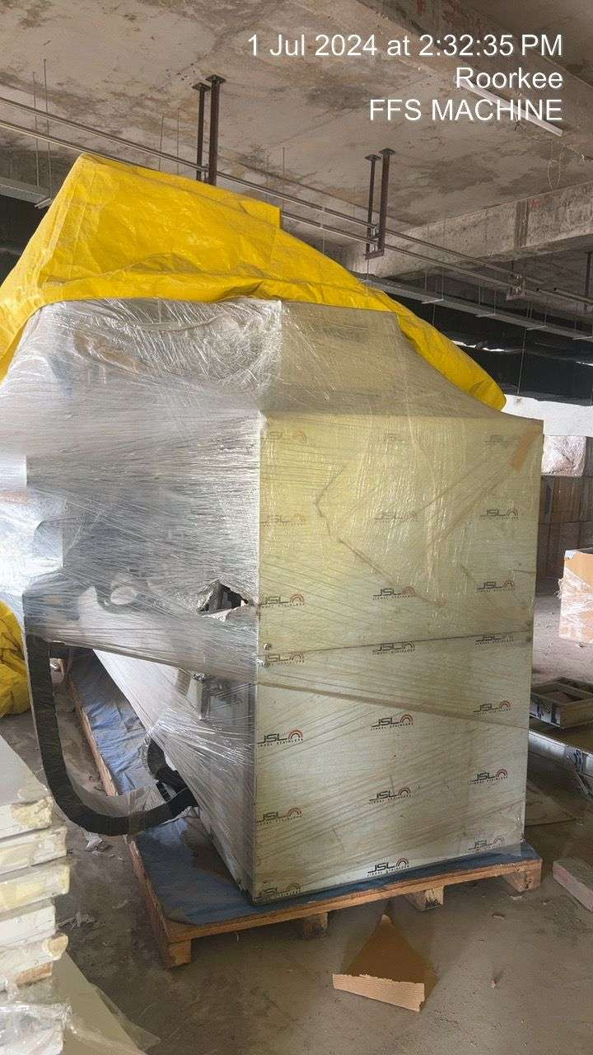 | 