File No.: VIS (2024-25)-PL211-178-235 Dated: 29.08.2024

LENDER’S INDEPENDENT ENGINEER REPORT (4th)
(FOR QUARTER ENDING MARCH 2024)

OF

NEW POULTRY LAYER UNIT OF CAPACITY 2 LAKH LAYER BIRDS.

SITUATED AT

VILLAGE BARANATA, CHAKULIA, PURBI SINGBHUM, JHARKHAND.

IMPLEMENTED BY
M/S RIYA DIYA AGRO FARMS LLP

REPORT PREPARED FOR
STATE BANK OF INDIA, SME BRANCH ADITYAPUR JAMSHEDPUR.

**Important - In case of any query/ issue or escalation you may please contact Incident Manager at le@rkassociates.org. We will appreciate your feedback in order to improve our services.
NOTE: As per IBA Guidelines please provide your feedback on the report within 15 days of its submission after which report will be considered to be correct.

TABLE OF CONTENTS
SR. NO. | DESCRIPTION | PAGE NO.
PART A | Report Summary | 03
PART B | Introduction | 04
 | - The Project | 04
 | - Location of the Project | 04
 | - Project Overview | 05
 | - Scope of the Project During Project Duration | 06
 | - Purpose of the Report | 06
 | - Methodology Adopted | 06
PART C | Plant Infrastructure Sections & Facility Details with Actual Progress | 07
 | - Building and Structure Details | 07
 | - Plant Machinery and Equipment | 10
PART D | Project Consultants, Contractors & Suppliers | 13
PART E | Project Cost and Means of Finance | 14
 | - Cost of Project | 14
 | - Current Status and Total Expenditure Incurred Till Date | 15
 | - Sources of Finance & Utilization of Funds | 17
PART F | Statutory & Regulatory Approvals, Clearances & NOC | 18
PART G | Project Schedule & Current Status | 19
PART H | Disclaimer | 20
PART I | Enclosure | 24
PART J | Photographs | 31-36

IMPORTANT NOTICE

COPYRIGHT FORMAT: This report is prepared on the copyright format of R.K Associates, to serve our clients with the best available information and analysis to facilitate them to take rational business decisions. Legally no one can copy or distribute this format without prior approval from R.K Associates. It is meant only for the advisory/ reference purpose for the organization/s as mentioned on the cover page of this report. Distribution or use of this format by any organization or individual other than R.K Associates will be seen as unlawful act and necessary legal action can be taken against the defaulters.

This report is intended for the sole use of the intended recipient/s and contain material that is STRICTLY CONFIDENTIAL AND PRIVATE.

DEFECT LIABILITY PERIOD: - In case of any query/ issue or escalation you may please contact Incident Manager: le@rkassociates.org. We try our level best to ensure correctness in the calculations done, rates adopted and various other data points & information mentioned in the report but still can’t rule out typing, human errors or any other mistakes. In case you find any such mistake or inaccuracy in any data point of the report please help us by bringing all such points into our notice immediately or within 15 days of the report delivery in writing, to rectify these timely failing after which R.K Associates won’t be held responsible for any such inaccuracy in any manner. We would highly appreciate your feedback in order to improve our services.

PART A | REPORT SUMMARY

1. | Name of Project: | To set up a new poultry layer unit of capacity 2 lakh layer birds and also setting up in-house feed making unit along with layer farming business.
2. | Project Location: | Village-Baranata, Chakulia, District- Purbi Singbhum, State- Jharkhand
3. | Name of the Borrower: | M/s Riya Diya Agro Farms LLP.
4. | Director’s/Partner’s: | Mr. Durga Madhav Dagara  Mrs. Kajal Dagara
5. | Prepared for Bank: | State Bank of India Sme Branch Adityapur, Jamshedpur
6. | LIE Consultant Firm: | M/s. R.K. Associates Valuers & Techno Engineering Consultants (P) Ltd.
7. | Date of Survey: | 2nd of August 2024
8. | Date of Report: | 29th of August 2024
9. | Purpose of the Report: | To provide fair detailed analysis report to the Bank based on the “in-scope points” mentioned below for facilitating them to know the current status of the Project.
10. | Scope of the work provided by the Lender: | - Periodic Project physical status review  - Periodic review of expenditure of the Project.
11. | Documents perused for Proposal: | - CA Certificate dated 28/06/2024  - Copy of Invoices for machines already installed
12. | Annexure with the report: | - Copies of Project Statutory approvals  - CA Certificate

PART B | INTRODUCTION

- THE PROJECT:
M/S RIYA DIYA AGRO FARMS LLP is setting up a new poultry layer unit of capacity 2 lakh layer birds and also setting up in-house feed making unit along with layer farming business at Village Baranata, Chakulia, District- Purbi Singbhum, and State- Jharkhand. The unit is proposed to construct its own in house 5-6 tons per hour Maize Feed Plant having 60-90 days storage capacity silos. To know the Project progress bank has appointed M/s R.K Associates Valuers & Techno Engineering Consultants (P) Ltd. for review of periodic physical & expenditure of the project. This is 4th LIE Report for Quarter ending March’24 in continuation to previous inception LIE Report submitted on 28/01/2024. The Project status in the report is as on 29/08/2024 but the expenditure considered in the report is till March 2024 as per the Bills/ CA Certificate shown to us by the company.

- PROJECT LOCATION:
Details about Location of Unit is as below:
Particulars | Description
Postal Address
Village-Baranata, Chakulia, District- Purbi Singbhum, State- Jharkhand
Location
The location is in rural area of village area, nearby lands are mostly agricultural area or barren land. It is next to Power Grid Birdho.
Google Coordinates
Latitude | 22°33'08.8"N
Longitude | 86°44'20.4"E
Connectivity Systems
Road | The project site of the subject under construction plant has a ~15 feet wide uneven approach road named Baranata Village Road. Chakulia-Belpahadi road is the nearest main road, at distance of 30 km from the subject project.
Rail | The Nearest Railway station to the subject locality is Chakulia Railway Station which is about 12 Km from the Subject Project.
Air | The nearest Domestic Airport to the subject project is Kazi Nazrul Islam Airport which is about 160 Km from the subject project.
Geographical Conditions On The Site
Temperature | The area has generally hot climate. The maximum temperature is around 105°F while the minimum is 36°F.
Rainfall | The average annual rainfall of this area is about 1200 mm to 1400 mm.
Seismic Zone | The above plant site area falls in Seismic Zone II.

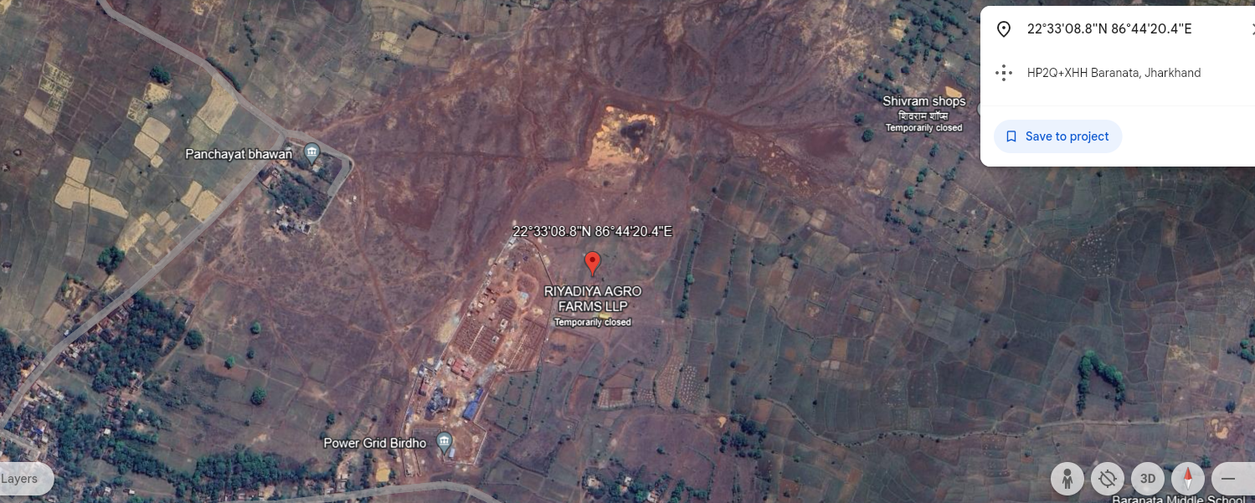
Source: Google Earth
Figure: Location of Manufacturing Unit

- PROJECT OVERVIEW:
M/S RIYA DIYA AGRO FARMS LLP is setting up a new poultry layer unit of capacity 2 lakh layer birds and also setting up in-house feed making unit along with layer farming business at Village Baranata, Chakulia, District- Purbi Singbhum, and State- Jharkhand. The unit is proposed to construct its own in house 5-6 tons per hour Maize Feed Plant having 60-90 days storage capacity silos. The project is developed on total land area 6.15 Acre (as per the information provided to us, during site survey) which was already available with M/s Riya Diya Agro Farms LLP.

Layer birds are egg-laying poultry birds which are raised for the purpose of commercial egg production.

The cost of project is estimated to be Rs.23.95 Cr. which broadly consists of Rs.11.72 crore in Building & Civil works, and Rs.8.66 crores in Plant & Machinery. Project land is not the part of Project cost since it was already available with the company. Total expenditure shown by the company till 31st March is Rs.16,00,71,714.67/- Detailed breakup of the same is available in later section of the report.
Project is proposed to be implemented by 31.12.2024.

Presently the construction is in progress and few machines have been arrived and installed too. Detailed status is mentioned in later section of the report. As per present status and work in progress, it is expected that the Project will may not be completed within the deadline.

As per the Demand Note Cum Load Sanction Letter for New HT connection M/S RIYA DIYA AGRO FARMS LLP has demanded 232 KVA load on 11 KV Supply Voltage from Jharkhand Bijli Vitran Nigam Limited, (JBVNL) Jharkhand.

- SCOPE OF WORK DURING PROJECT DURATION:
- Periodic Project physical status review
- Periodic review of expenditure of the Project.

- PURPOSE OF THE REPORT: To provide fair detailed analysis report to the Bank based on the “in-scope points” mentioned above for facilitating them to know the current Project status.

- METHODOLOGY ADOPTED:
- Study of Project Planning documents/ reports to know about the Project.
- Additional information, data, documents collection from the borrower.
- Site Inspection.
- Review and analysis of the documents and information obtained from the borrower and corroborating it with the site inspection status.
- Information compilation, analysis and reporting.

PART C | PLANT INFRASTRUCTURE SECTIONS & FACILITY DETAILS WITH ACTUAL PROGRESS

- LAND DEVELOPMENT AND OTHER STRUCTURE WORK DETAILS: The project is developed on total land area 6.15 Acre (as per the information provided to us, during site survey) owned by M/S Riya Diya Agro Farms LLP. Since land was already with the promoters so it is not part of the LIE report as such.

- Buildings/structures as per sanctioned building plan approved by Pramukh, Chakulia Prakhand, Jharkhand:

As Per Building Plan Approved By Pramukh, Chakulia Prakhand, Jharkhand
SR. No. | Particulars | Floors | Type of Structure | Area (sq. mt.) | Height (feet)
1 | Administrative Building | G+1 | R.C.C | 1,572 | 10
2 | Grooming and Breeding Shed | 1 | Tin Shed | 996 | 45
3 | Layer 1 | 1 | Tin Shed | 1,342 | 45
4 | Layer 2 | 1 | Tin Shed | 1,386 | 45
5 | Layer 3 | 1 | Tin Shed | 1,386 | 45
6 | Layer 4 | 1 | Tin Shed | 1,386 | 45
7 | Food Mill | 1 | Tin Shed | 563 | 45
Note: The above details are taken from the sanctioned building plan provided.

- Buildings/structures and progress as per site survey dated 2nd August 2024 is shown below:

As Per Site Survey Dated 2nd August 2024
Building Name | Area (Sq. ft.) | Type of Structure | Progress as on  June 2023 | Progress as on  December 2023 | Progress as on 2nd August 2024
Boundary Wall | 2,748  (R. MT.) | Pre-Cast | - Completed (As informed by representative as the backside of the site was not accessible due to dense bushes) | - Status same as mentioned in previous report | - Status same as mentioned in previous report
Boundary Wall | 1,074  (R. MT.) | Chain Link Fencing | - Completed (As informed by representative as the backside of the site was not accessible due to dense bushes) | - Status same as mentioned in previous report | - Status same as mentioned in previous report
Breeding & Grooming Shed | 12,308 | GI shed over RCC structure and walls | - Foundation/footing work is in progress, and is completed till plinth beam level. | - The super structure work along with the major finishing work is completed.  - The assembling of cages was in progress, which was observed to be reaching its completion stage, with few pending works. | - The super structure work along with the major finishing work is completed.  - The assembling of cages is completed and currently in operation.
Layer Shed-1 | 16,535 | GI shed over RCC structure and walls | - Foundation/footing work is in progress and more than half of the plinth beam is been casted | - Super structure work including foundation, columns, brickwork has been completed.  - Trusses have been installed on roof, with tin shed fixed on half of the structure. | - The super structure work along with the major finishing work is completed.  - The assembling of cages was in progress.
Layer Shed-2 | 16,535 | WIP | - Work not started | - Super structure work i.e. Footing/foundation work is in progress and is completed till the plinth level.  - Soil filling has been done, and the compaction of the soil is to be done. | - Super structure work i.e. Footing/foundation work is completed.  - Blockwork from both sides has been done, the balance blockworks are currently in progress.
Layer Shed-3 | 16,535 | WIP | - Work not started | - Super structure work i.e. Footing/foundation work is in progress. | - Super structure work i.e. Footing/foundation is completed.  - Column reinforcement work is in progress, shuttering and casting is due.
Layer Shed-4 | 16,535 | Not started yet | - Work not started | - Work has not started yet. | - Super structure work i.e. Footing/foundation work is completed.
JVNL Meter Room | 194 | R.C.C Framed Structure | - Work not started | - Completed | - Same as previous report
Water Tank  (Ground Floor) | 675 | R.C.C Framed Structure | - Work not started | - Structure and block work has been completed | - Same as previous report
Water Tank  (First Floor) | 675 | R.C.C Framed Structure | - Work not started | - Structure work has been completed | - Same as previous report
DG Concrete Base | 614 | Concrete Base | - Base is ready | - Status same as mentioned in previous report | - Same as previous report
Egg Store House | 4,368 | R.C.C Framed Structure | - Work not started | - The super structure work is completed.  - Brickwork has been completed till the slab level.  - Slab casting is due, the same was observed to be in progress at the time of survey. | - All the civil works has been done. Roof shed work is due.  - Blockwork and plaster work has been completed from inside
Office Room | 39 | R.C.C | - Work not started | - Construction and finishing work is completed. | - Same as previous report
Food Mill Shed  (Excluding Mezzanine) | 6,739 | Steel Structure | - Work not started | - The Truss and the iron support structure, along with footing has been completed.  - The Covering on sides and tin shed on roof is due, however the work was observed to be in progress.  - Construction of base of mezzanine is done, further no finishing work is observed on the mezzanine yet. | - Construction work along with finishing work, has been completed  - Mezzanine status same as previous report
Food Mill Mezzanine | 3,370
Temporary Store Room | 1500 | Temporary GI Shed over brick walls | - Store with tin shed is constructed, however it is informed to be temporary structure by the representative | - Status same as mentioned in previous report | - Same as previous report
Labor Kitchen | 221 | G.I Shed over brick walls | - Work Not started | - Construction completed | - Same as previous report
Labor Shed | 2,152 | G.I Shed over brick walls | - Work Not started | - Construction completed | - Same as previous report
Shed of Container | 253 | G.I Shed | - Work Not started | - Construction completed | - Same as previous report
Silo Base (Platform) | --- | R.C.C | - Work Not started | - Footing and Wall casting is done.  - Soil filling in between is done  - Slab casting of the same is due | - Status same as previous report, further slab casting work has been executed
Notes:
- The Physical progress captured in the report is on approximate basis as per status of structures observed on site during site inspection.
- MACHINERIES, OTHER EQUIPMENTS & UTILITIES:
In the subject poultry project, following list of plant and machinery is proposed:

S. No | Particulars | Supplier/Vendor
 | Water Plant | Netsol Water Solutions Pvt Ltd
 | DSI Automatic Cage 4 Row 5 tier (1 Grooming and 4 layer house) | DS ISPAT
 | Maize Feed Plant | Sai Durga Agrotech Industries
 | Silos | Sai Durga Industries

The status as on date 21/08/2024 is as below:-

S. No | Particulars | Supplier/Company | Status Achieved
S. No | Particulars | Supplier/Company | Quotation Received | Purchase Order | Received on site | Installed
 | Water Plant | Netsol Water Solutions
 | Automatic Cage (1 growing and 4 layer house) | DS ISPAT
 | Maize feed Plant | Sai Durga Agro Industries
 | Silos | Sai Durga Industries
 | Transformer  (315 KVA) | Synergy Power Equip Pvt. Ltd.
 | Silent Diesel Generator  (30 KVA) | Kirloskar

Note:
- The major machineries/ equipment’s mentioned in the above table have arrived on the site and installation of the same is in progress, as observed during the survey date 21/08/2024.
- As per CA certificate, the total amount incurred against the purchase of Plant, Machinery and equipment’s amounts to Rs.3.10cr. against the proposed amount of Rs.8.66 Cr.
- As per purchase orders provided to us by the company the major vendor for the machines, plants and equipment’s is M/s DS ISPAT, Sai Durga Agrotech Industries, Netsol Water Solutions Pvt Ltd etc.
Technical details and aspect of the above plant/machineries and equipment’s is shown below:
- Water Plant:
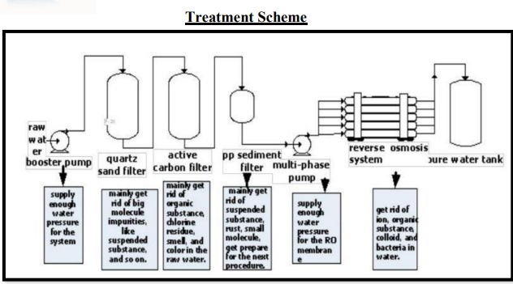

- Automatic Cage 4 row 5 tier(one growing and 4 layer house)
The setup proposed to be installed in the layer house is automated, and it includes feeding trolley, manure removal system, egg collection system, water drinking system etc.
Parameters:
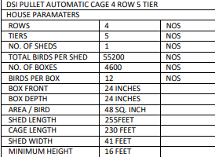

- Silos
GI Corrugated 1500 MT Flat bottom silos with loading and unloading system.
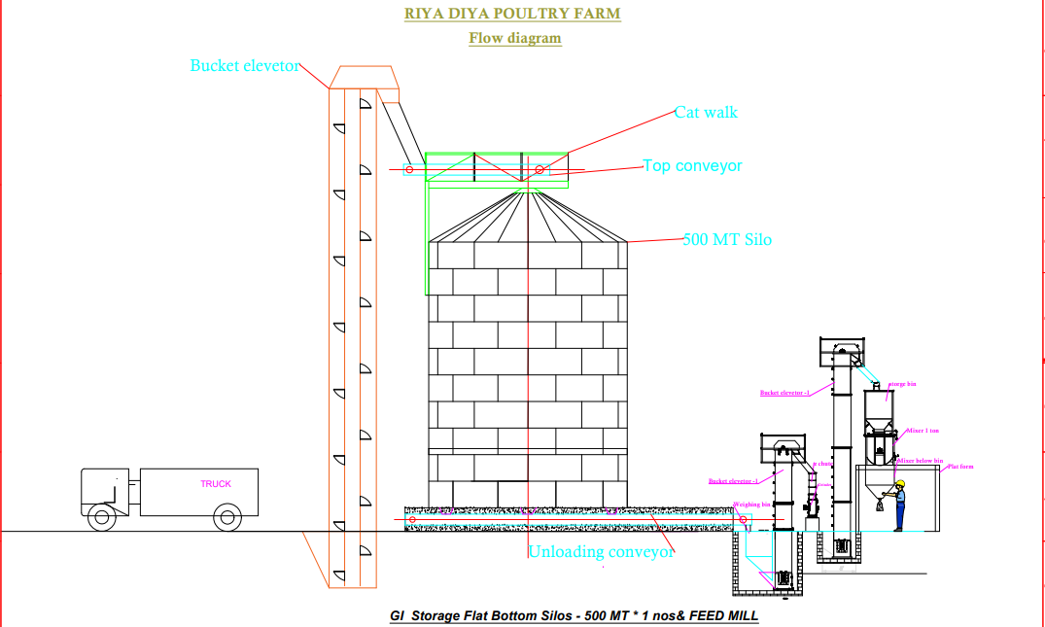

- Transformer (315 KVA)
Company: Synergy Power Equipment Pvt. Ltd.
Voltages: 1100 High Voltage to 433 Low Voltage
Phases: 3 phase

- Silent Diesel Generator
Company: Kirloskar
Load: 30 KVA
Features: Silent Generator

PART D | PROJECT CONSULTANTS, CONTRACTORS & SUPPLIERS

Following are the project consultants, contractors & suppliers:
S. No. | Contractor Name | Work Assigned
 | Netsol Water Solutions Pvt Ltd | Water Plant
 | DS ISPAT | Automatic Cage (1 growing and 4 layer house)
 | Sai Durga Agrotech Industries | Maize feed Plant
 | Synergy Power Equipment Pvt. Ltd. | Transformer (315 KVA)
 | Kirloskar | Silent Diesel Generator (30 KVA)

PART E | PROJECT COST & MEANS OF FINANCE

- TOTAL PROJECT COST: M/S RIYA DIYA AGRO FARMS LLP has estimated the Total Project Cost amounting to Rs.23.95 Cr.
Particulars | In Rs. (In Cr.)
Land Development/Building/Other Civil Works | 11.72
Plant & Machinery | 8.66
Electrical Installation | 0.41
Furniture & Fixture | 0.06
Security Deposit | 0.02
Others | 1.42
Working Capital Margin | 1.66
Total | 23.95

- CURRENT STATUS & TOTAL EXPENDITURE INCURRED TILL DATE: Details of the expenditure in the Table below is recorded for the expenditure incurred up to 31st March 2024 as per CA Certificate dated 28th June 2024 with UDIN No. 24403137BKHBSE8944.
Particulars | Total Estimated Cost  (In Rs. In Cr.) | Expenditure as per CA Certificate  till 31st March 24  (In Rs. In Cr.) | Amount Of Work Done On Site  (Till 08/01/2024) | Remarks
Land Development and other civil works | 11.72 | 11.28 | ~9.03 | We have done the cost assessment independently as per present status of work on site using benchmark cost.  Please refer to the table below for the cost assessment done as per the status of construction during site survey conducted on 02nd August 2024.  Cost of material lying on the site and any advances paid to the contractor is not covered in our assessment which may have been done in CA Certificate due to which difference is coming.
Plant, Machinery and equipment | 8.66 | 3.10 | ~2.75 | Cost assessment is done as per the confirmation of the payment by the said vendors/ supplier’s invoices and bills raised by the supplier till March 2024 for the machines seen on the site during site inspection conducted on 02nd August 2024.
TOTAL | 20.38 | 14.38 | ~11.78

Note:
- The above assessment is done cumulatively as per site survey observation done on 21/08/2024.
- Civil work assessment is done independently as per present status of work found on site using benchmark cost. Cost of material lying on site and any advances paid to vendors/ suppliers is not covered in our assessment.
- In Plant & Machinery head, only those machinery cost is included as per Bills/ Invoices which were found on site during site visit. Advances paid to vendors/ suppliers is not covered in our assessment.

CONSTRUCTION COST ASSESSMENT AS PER SURVEY DATED 21/08/2024
Particular | Type of Structure | Unit | Quantity | Rate | Amount
Earth Work | --- | m3 | 37,332 | 300 | 1,11,99,685
Boundary Wall | Precast | Sq. ft. | 17,346 | 100 | 17,34,600
Boundary Wall | Chain Link Fencing | Sq. ft. | 7,518 | 90 | 6,76,620
Grooming Shed | GI shed over RCC structure and walls | Sq. ft. | 12,308 | 1,600 | 1,96,92,175
Layer Shed 1 | GI shed over RCC structure and walls | Sq. ft. | 16,535 | 1,200 | 1,98,41,502
Layer Shed 2 | GI shed over RCC structure and walls | Sq. ft. | 16,535 | 600 | 99,20,751
Layer Shed 3 | GI shed over RCC structure and walls | Sq. ft. | 16,535 | 400 | 66,13,834
JVNL meter room | R.C.C Framed Structure | Sq. ft. | 194 | 1,200 | 2,32,381
Water Tank  (Ground Floor) | R.C.C Framed Structure | Sq. ft. | 675 | 1,350 | 9,10,645
Water Tank  (1st Floor) | R.C.C Framed Structure | Sq. ft. | 675 | 1,250 | 8,43,190
DG Concrete Base | R.C.C Platform | Sq. ft. | 614 | 300 | 1,84,098
Egg Store House | R.C.C Framed Structure | Sq. ft. | 4,368 | 1,100 | 48,04,701
Office Room | R.C.C Framed Structure | Sq. ft. | 414 | 1,400 | 5,79,878
Food Mill Shed (excluding Mezzanine) | Steel structure | Sq. ft. | 6,739 | 850 | 57,28,202
Food Mill Mezzanine | Steel structure | Sq. ft. | 3,370 | 600 | 20,21,719
Temporary Store | GI Shed | Sq. ft. | 1,500 | 550 | 8,25,000
Labour Kitchen | G.I Shed over brick walls | Sq. ft. | 221 | 750 | 1,66,050
Labour Shed | G.I Shed over brick walls | Sq. ft. | 2,152 | 750 | 16,13,760
Shed of container | G.I Shed | Sq. ft. | 253 | 225 | 56,874
Silo Base | R.C.C | Cum | 89 | 9,793 | 8,75,415
Steel in Silo Base | TMT Steel Bars | KG | 21,052 | 89 | 18,73,610
Total |  |  |  |  | 9,03,94,690

Comments:
- Cost of assessment is done based on progress of each structure using plinth area rates as per type of structure to have an independent view.
- Bills/ Invoices have not been verified at our end.

Party | Purpose | Sum as per confirmation verification | Breakup
M/s AN Elec Equipment | Electrical work | 10,00,000 | 5,00,000
M/s AN Elec Equipment | Electrical work | 10,00,000 | 5,00,000
Synergy power Equip | Electrical work | 5,19,200
DS ISPAT | Cages | 2,15,96,594 | 20,00,000
DS ISPAT | Cages | 2,15,96,594 | 40,00,000
DS ISPAT | Cages | 2,15,96,594 | 25,74,000
DS ISPAT | Cages | 2,15,96,594 | 52,26,000
DS ISPAT | Cages | 2,15,96,594 | 11,19,423
DS ISPAT | Cages | 2,15,96,594 | 5,50,000
DS ISPAT | Cages | 2,15,96,594 | 18,84,711
DS ISPAT | Cages | 2,15,96,594 | 10,04,047
DS ISPAT | Cages | 2,15,96,594 | 4,94,530
DS ISPAT | Cages | 2,15,96,594 | 9,80,443
DS ISPAT | Cages | 2,15,96,594 | 4,90,000
DS ISPAT | Cages | 2,15,96,594 | 12,73,440
SAI Durga Agro Tech | Silo and mesh feed | 40,00,000 | 16,00,000
SAI Durga Agro Tech | Silo and mesh feed | 40,00,000 | 16,00,000
SAI Durga Agro Tech | Silo and mesh feed | 40,00,000 | 8,00,000
Bala Industries and Entertainment Pvt. Ltd. | LPG Heater | 2,96,770 | ---
Bala Industries and Entertainment Pvt. Ltd. | Spare Parts | 48,698 | ---
TOTAL |  | Rs.2,74,61,262/-

Comments:
- Cost assessment of plant, machinery and equipment’s is done as per the confirmation letter provided by the client till March for the machines seen on the site during site dated 21st August 2024.
- Bills/ Invoices have not been verified at our end.

- SOURCES OF FINANCE & UTILIZATION OF FUNDS:

The Project cost mentioned above has been planned to be covered from following resources:
PARTICULARS | (Amount in Rs. Crore)
Promoter’s Contribution (Equity) | 10.03
Term Loan (Debt) | 13.92
TOTAL | 23.95
Source: As per technical vetting report dated 7th January 2023

PART F | STATUTORY & REGULATORY APPROVALS, CLEARANCES & NOC

Sr. No. | NAME OF LICENSE/ REGISTRATION | PURPOSE | DATE OF ISSUE | Current Status
Sr. No. | ISSUING AUTHORITY | PURPOSE | LICENCE NO. | Current Status
1. | Sanctioned Building Plan | Approval of building plans | 27/07/2022 | Approval for the Building Plan is obtained by the Company from the competent Authority.
1. | Pramukh, Chakulia Prakhand | Approval of building plans | 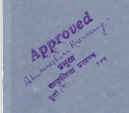
2. | Power Connection | Load Sanction Letter | 09/09/2022 | Load of 11 KV is demanded.
2. | Jharkhand Bijli Vitran Nigam Limited | Load Sanction Letter | NC36938091HT | Load of 11 KV is demanded.
3. | Groundwater Abstraction Clearance | NOC for groundwater abstraction | 04/05/2023 | NOC is obtained by the Company from the competent Authority.
3. | Central Groundwater Authority | NOC for groundwater abstraction | CGWA/NOC/IND/ORIG/2023/18441 | NOC is obtained by the Company from the competent Authority.
Observations & Comments:
- Since the poultry farm comes under Agricultural sector, therefore it doesn’t requires any major approvals as such.
- Major approvals are shown above as obtained by the company.
- The approvals shown are the same as taken previously, no new approval has been taken by the company during the assessment period.

PART G | PROJECT SCHEDULE & CURRENT STATUS

IMPLEMENTATION SCHEDULE OF RIYA DIYA AGRO FARMS LLP
S.  No. | Particular | Commencement | Completion | Current Status  As per survey dated – 2nd August 2024
1. | Construction of grooming shed. | Started | July-23 | - The super structure work along with the major finishing work is completed.  - The assembling of cages is completed and currently in operation.
2. | Construction of 1st layer shed. | Started | Nov-23 | - The super structure work along with the major finishing work is completed.  - The assembling of cages was in progress.
3. | Construction of 2nd layer shed. | Started | Apr-24 | - Super structure work i.e. Footing/foundation work is completed.  - Blockwork from both sides has been done, the balance blockworks are currently in progress.
4. | Construction of 3rd layer shed. | Started | Aug-24 | - Super structure work i.e. Footing/foundation is completed.  - Column reinforcement work is in progress, shuttering and casting is due.
5. | Construction of 4th layer shed. | --- | Dec-24 | - Super structure work i.e. Footing/foundation work is completed.
6. | Commencement of Operations | --- | Dec-24 | - Yet to be achieved

PART H | DISCLAIMER

      - No employee or member of R.K Associates has any direct/ indirect interest in the Project.
      - This report is prepared based on the copies of the documents/ information which the Bank/ Borrower has provided to us out of the standard checklist of documents sought from them and further based on our assumptions and limiting conditions. The client/owner and its management/representatives warranted to us that the information they supplied was complete, accurate and true and correct to the best of their knowledge. All such information provided to us has been relied upon in good faith and we have assumed that it is true and correct in all respect. I/We shall not be liable for any loss, damages, cost or expenses arising from fraudulent acts, misrepresentations, or wilful default on part of the owner, borrower, its directors, employee, representative or agents. Verification or cross checking of the documents provided to us from the originals or from any Govt. departments/ Record of Registrar has not been done at our end since this is beyond the scope of our work. If at any time in future, it is found or came to our knowledge that misrepresentation of facts or incomplete or distorted information has been provided to us then this report shall automatically become null & void.
      - Legal aspects for eg. investigation of title, ownership rights, lien, charge, mortgage, lease, sanctioned maps, verification of documents, etc. have not been done at our end and same has to be taken care by legal expert/ Advocate. It is assumed that the concerned Lender/ Financial Institution has satisfied them with the authenticity of the documents, information given to us and for which the legal verification has been already taken and cleared by the competent Advocate before requesting for this report. I/ We assume no responsibility for the legal matters including, but not limited to, legal or title concerns.
      - This report is a general analysis of the project based on the scope mentioned in the report. This is not an Audit report, Design document, DPR or Techno feasibility study. All the information gathered is based on the facts seen on the site during survey, verbal discussion & documentary evidence provided by the client and is believed that information given by the borrower is true best of their knowledge.
      - All observations mentioned in the report is only based on the visual observation and the documents/ data/ information provided by the client. No mechanical/ technical tests, measurements or any design review have been performed or carried out from our side during Project assessment.
      - Bank/FII should ONLY take this report as an Advisory document from the Financial/ Chartered Engineering firm and its specifically advised to the creditor to cross verify the original documents for the facts mentioned in the report which can be availed from the borrowing borrower directly.
      - In case of any default in loans or the credit facility extended to the borrowing borrower, R.K Associates shall not be held responsible for whatsoever reason may be and any request for seeking any explanation from the employee/s of R.K Associates will not be entertained at any instance or situation.
      - The documents, information, data provided to us during the course of this assessment by the client is reviewed only upto the extent required in relation to the scope of the work. No document has been reviewed beyond the scope of the work.
      - This report only contains general assessment & opinion as per the scope of work evaluated as per the information given in the copy of documents, information, data provided to us and/ and confirmed by the owner/ owner representative to us at site which has been relied upon in good faith. It doesn’t contain any other recommendations of any sort including but not limited to express of any opinion on the suitability or otherwise of entering into any transaction with the borrower.
      - We have relied on data from third party, external sources & information available on public domain also to conclude this report. These sources are believed to be reliable and therefore, we assume no liability for the truth or accuracy of any data, opinions or estimates furnished by others that have been used in this analysis. Where we have relied on data, opinions or estimates from external sources, reasonable care has been taken to ensure that such data has been correctly extracted from those sources and /or reproduced in its proper form and context, however still we can’t vouch its authenticity, correctness or accuracy.
      - This Report is prepared by our competent technical team which includes Engineers and financial experts & analysts.
      - This is just an opinion report and doesn’t hold any binding on anyone. It is requested from the concerned Financial Institution which is using this report for taking financial decision on the project that they should consider all the different associated relevant & related factors also before taking any business decision based on the content of this report.
      - All Pages of the report including annexures are signed and stamped from our office. In case any paper in the report is without stamp & signature then this should not be considered a valid paper issued from this office.
      - Though adequate care has been taken while preparing this report as per its scope, but still we can’t rule out typing, human errors, over sightedness of any information or any other mistakes. Therefore, the concerned organization is advised to satisfy themselves that the report is complete & satisfactory in all respect. Intimation regarding any discrepancy shall be brought into our notice immediately. If no intimation is received within 15 (Fifteen) days in writing from the date of issuance of the report, to rectify these timely, then it shall be considered that the report is complete in all respect and has been accepted by the client upto their satisfaction & use and further to which R.K Associates shall not be held responsible in any manner.
      - Defect Liability Period is 15 DAYS. We request the concerned authorized reader of this report to check the contents, data and calculations in the report within this period and intimate us in writing if any corrections are required or in case of any other concern with the contents or opinion mentioned in the report. Corrections only related to typographical, calculation, spelling mistakes, incorrect data/ figures/ statement will be entertained within the defect liability period. Any new changes for any additional information in already approved report will be regarded as additional work for which additional fees may be charged. No request for any illegitimate change in regard to any facts & figures will be entertained.
      - R.K Associates encourages its customers to give feedback or inform concerns over its services through proper channel at valuers@rkassociates.org in writing within 15 days of report delivery. After this period no concern/ complaint/ proceedings in connection with the Financial Feasibility Study Services will be entertained due to possible change in situation and condition of the subject Project.
      - Our Data retention policy is of ONE YEAR. After this period, we remove all the concerned records related to the assignment from our repository. No clarification or query can be answered after this period due to unavailability of the data.
      - This Lender’s Independent Engineer report is governed by our (1) Internal Policies, Processes & Standard Operating Procedures, (2) Information/ Data/ Inputs given to us by the client and (3) Information/ Data/ Facts given to us by our field/ office technical team. Management of R.K Associates never gives acceptance to any unethical or unprofessional practice which may affect fair, correct & impartial assessment and which is against any prevailing law. In case of any indication of any negligence, default, incorrect, misleading, misrepresentation or distortion of facts in the report then it is the responsibility of the user of this report to immediately or at least within the defect liability period bring all such act into notice of R.K Associates management so that corrective measures can be taken instantly.
      - R.K Associates never releases any report doing alterations or modifications from pen. In case any information/ figure of this report is found altered with pen then this report will automatically become null & void.

SURVEY ANALYST | ENGINEERING ANALYST | REVIEWER
Rajat Choudhary and Kishanu Sarkar | Deepak Kumar Singh | Sr. VP Projects

For
R.K. Associates Valuers and Techno Engineering Consultants Pvt. Ltd
Place: Noida
Date: 29th August 2024

DEFECT LIABILITY PERIOD - In case of any query/ issue or escalation you may please contact Incident Manager by writing at valuers@rkassociates.org. We ensure 100% accuracy in the Calculations done, Rates adopted and various other data points & information mentioned in the report but still can’t rule out typing, human errors or any other mistakes. In case you find any mistake, variation, discrepancy or inaccuracy in any data point of the report, please help us by bringing all such points into our notice in writing at valuers@rkassociates.org within 30 days of the report delivery, to get these rectified timely, failing which R.K Associates Valuers Techno Engineering Consultants (P) Ltd. won’t be held responsible for any inaccuracy in any manner. Also, if we will not hear back anything from you within 30 days, we will assume that report is correct in all respect and no further claim of any sort will be entertained thereafter. We would welcome and appreciate your feedback & suggestions in order to improve our services.

COPYRIGHT FORMAT - This report is prepared on the copyright format of R.K Associates Valuers Techno Engineering Consultants (P) Ltd. to serve our clients in the best possible way. Legally no one can copy or distribute this format without prior approval from R.K Associates. It is meant only for the organization as mentioned on the cover page of this report. Distribution or use of this format other than R.K Associates will be seen as unlawful act and necessary legal action can be taken against the defaulter

ENCLOSURE 1: IMPORTANT DOCUMENTS EXHIBIT

DOCUMENT-1: CA CERTIFICATE DATED 28/06/2024
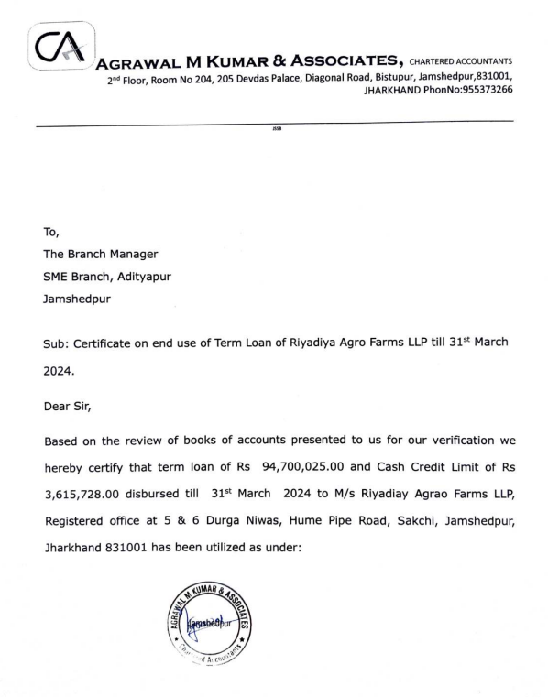

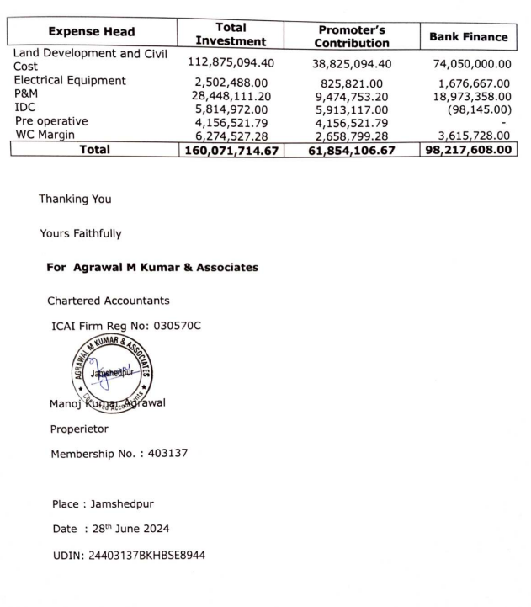

DOCUMENT- 2: NOC FROM CENTRAL GROUND WATER AUTHORITY

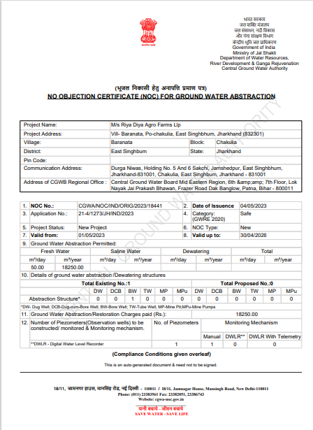

DOCUMENT-3: ELECTRICITY DEMAND NOTE CUM LOAD SANCTION LETTER
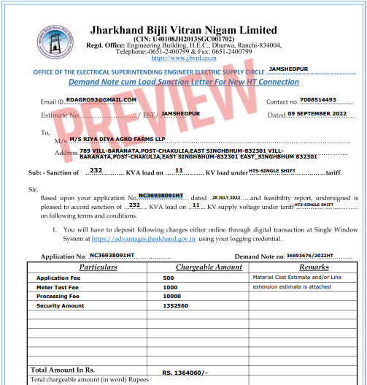
DOCUMENT 4: PROJECT TIMELINE
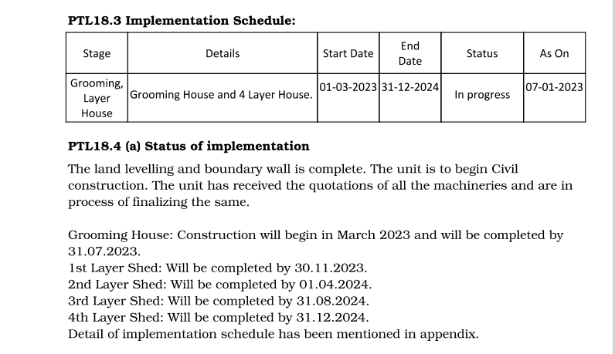
DOCUMENT 5: SANCTIONED LAYOUT PLAN
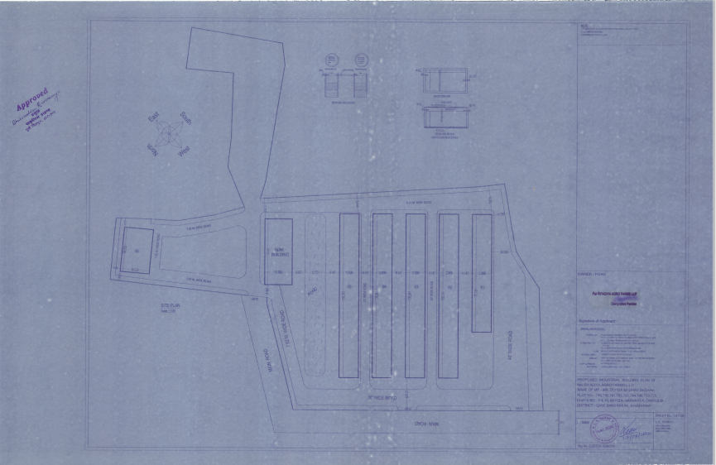

DOCUMENT 6: PURCHASE ORDERS OF MACHINERIES OR EQUIPMENTS
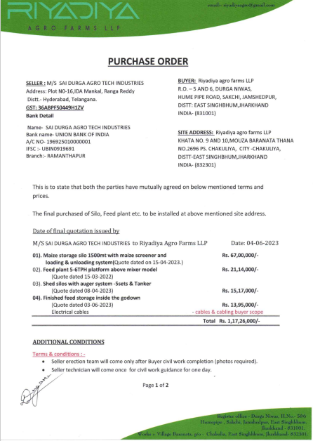

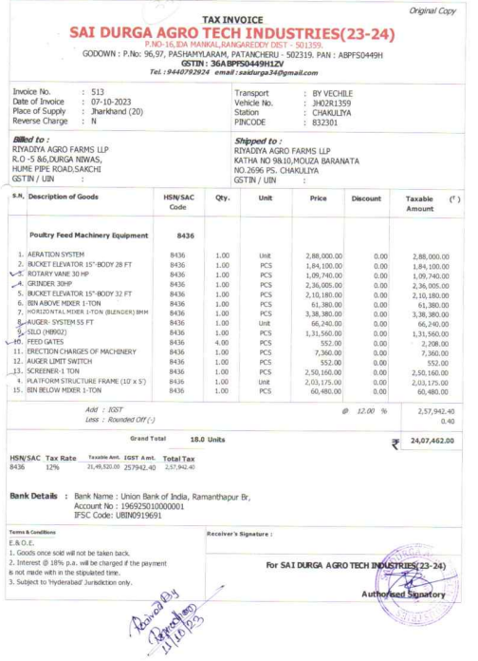

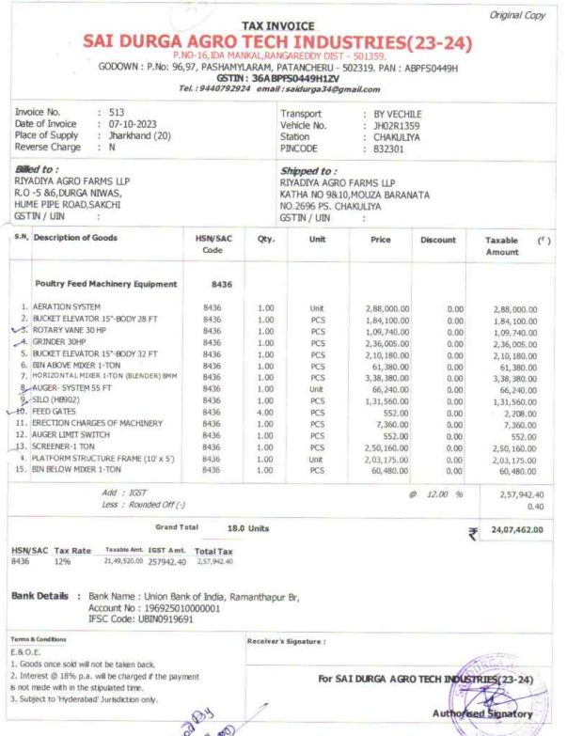

ENCLOSURE-2: - SITE PHOTOGRAPHS

Bui

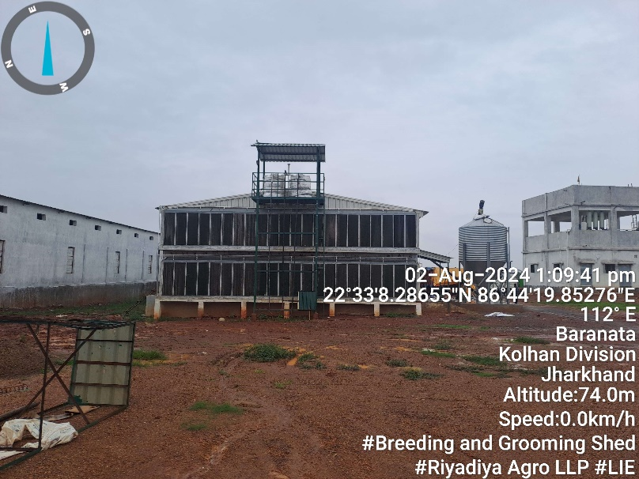 | 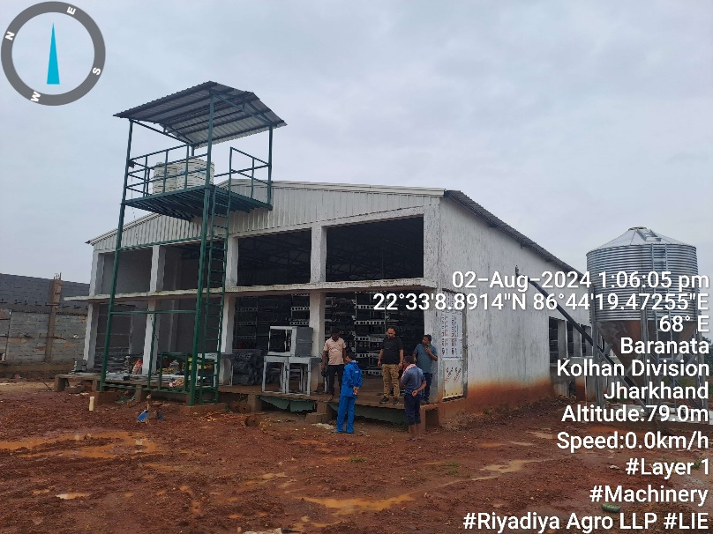
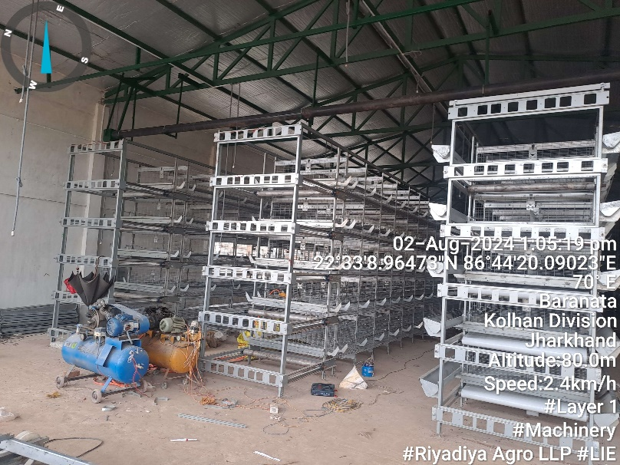 | 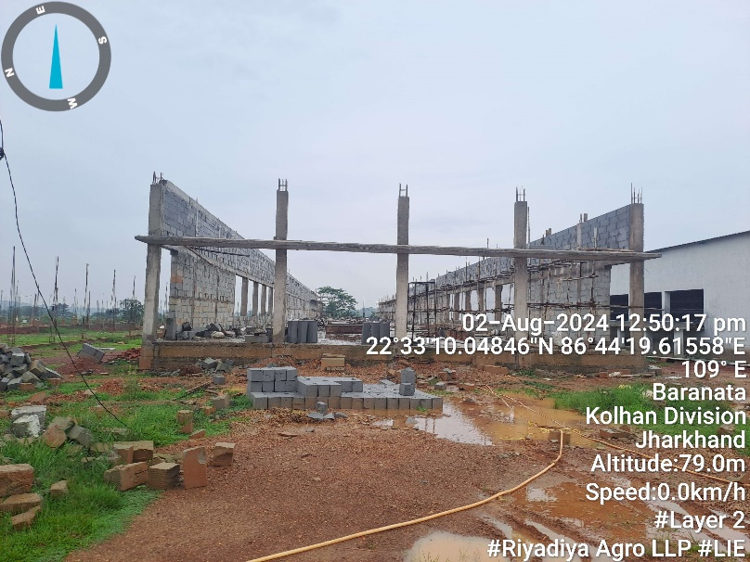
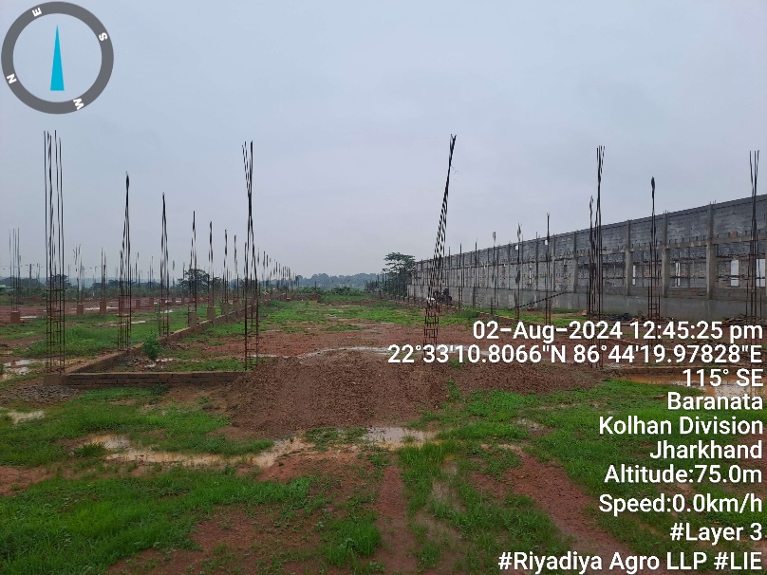 | 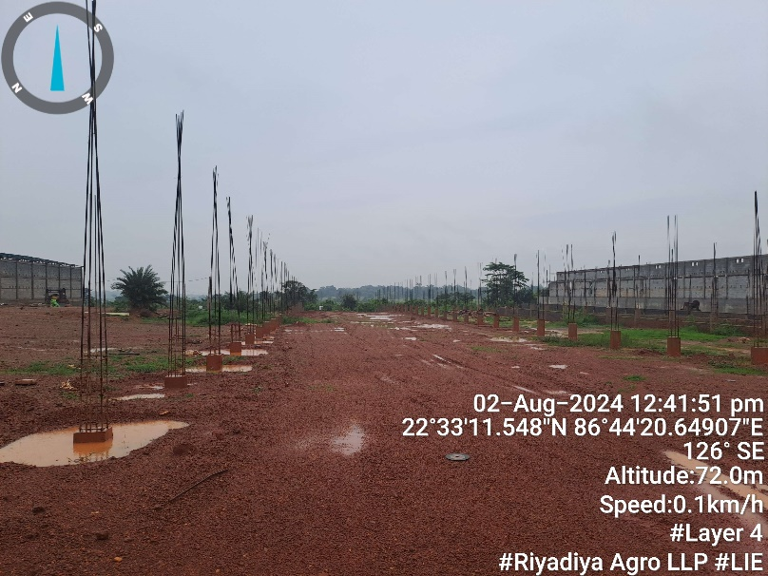

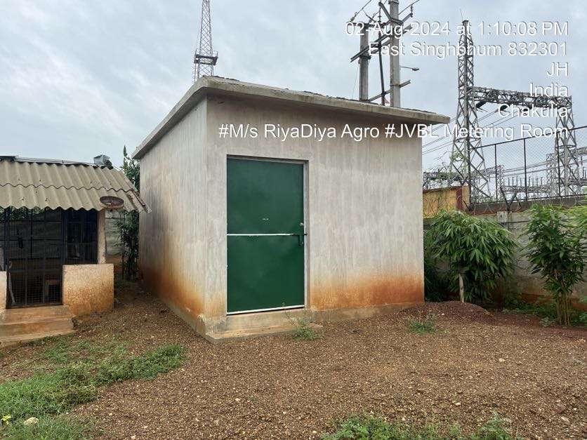 | 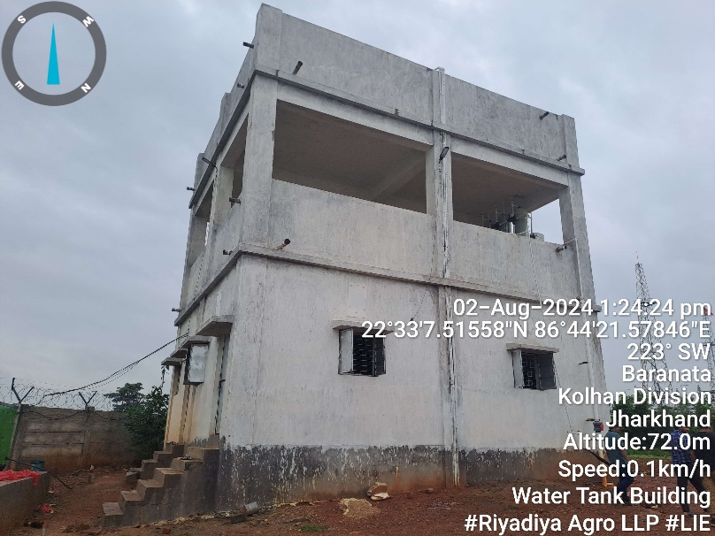
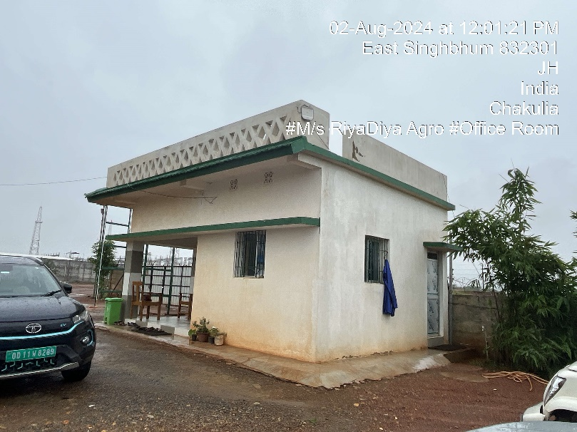 | 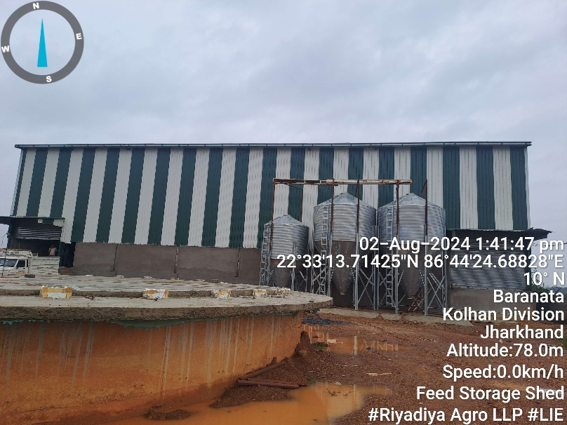
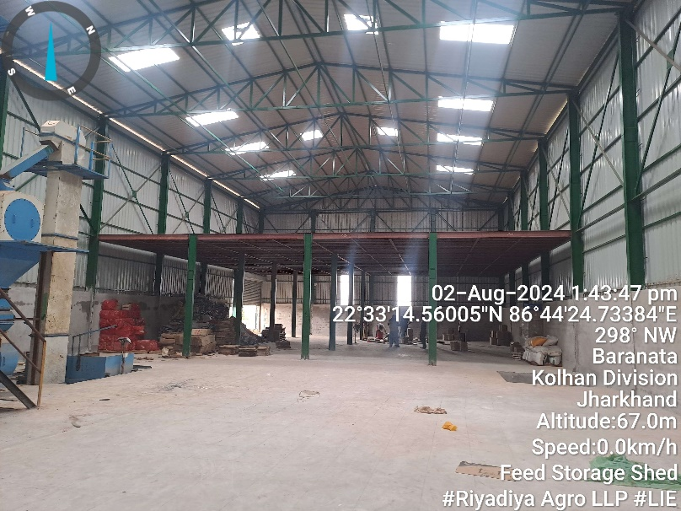 | 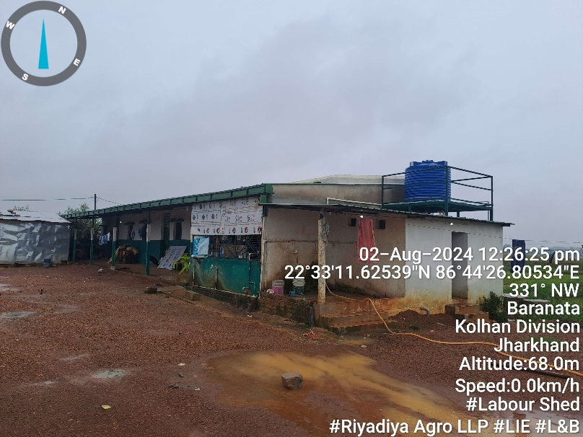

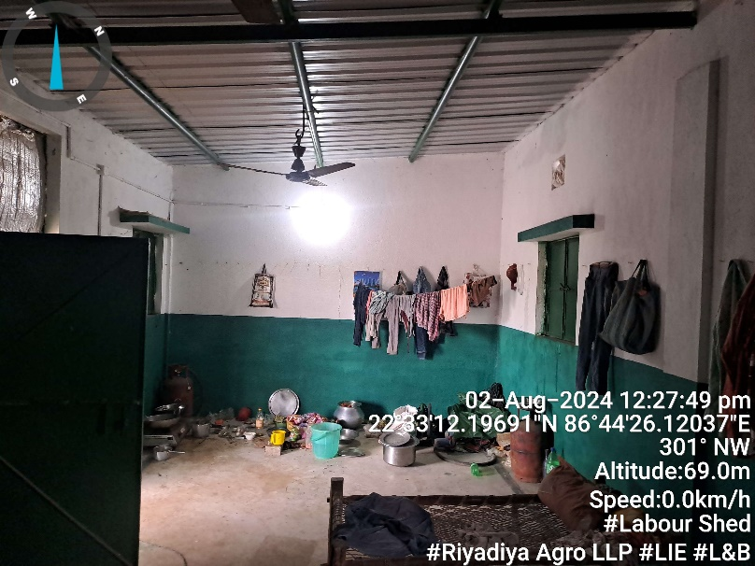 | 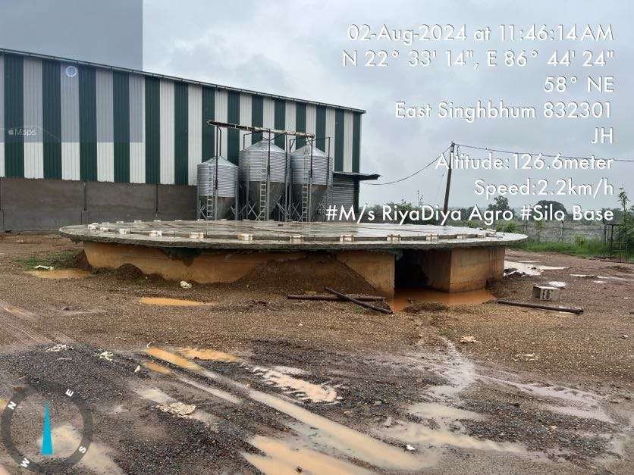
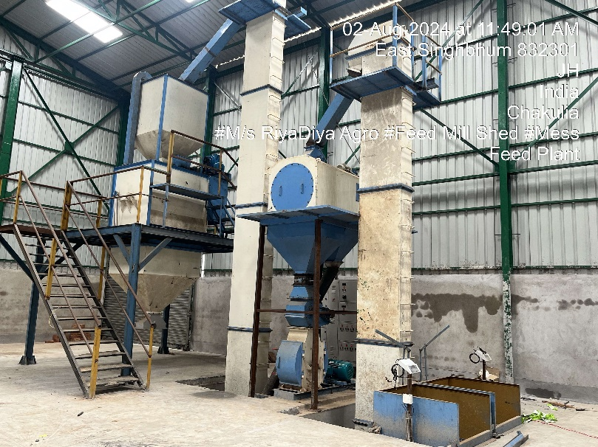 | 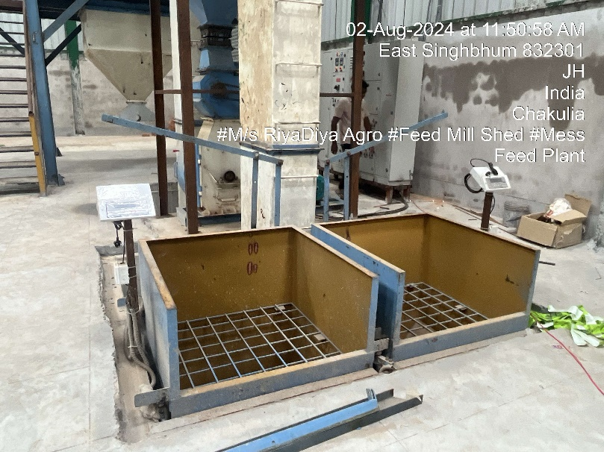
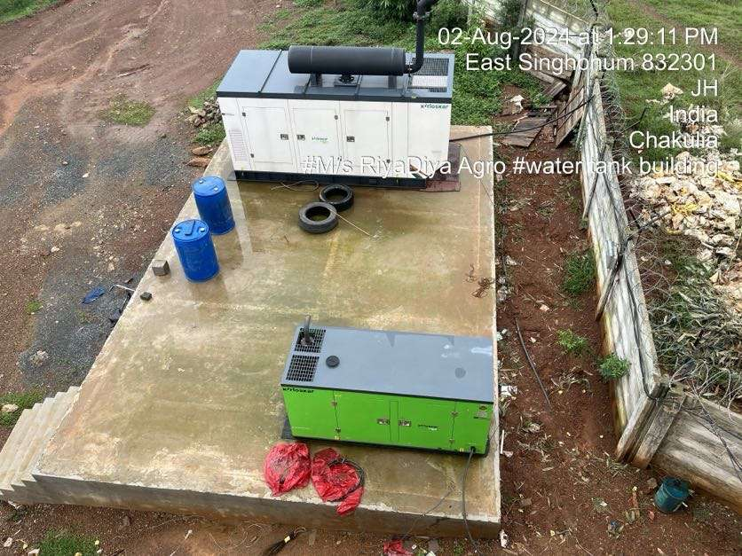 | 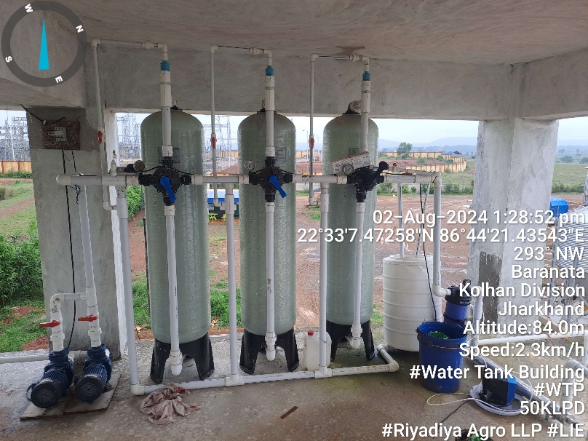

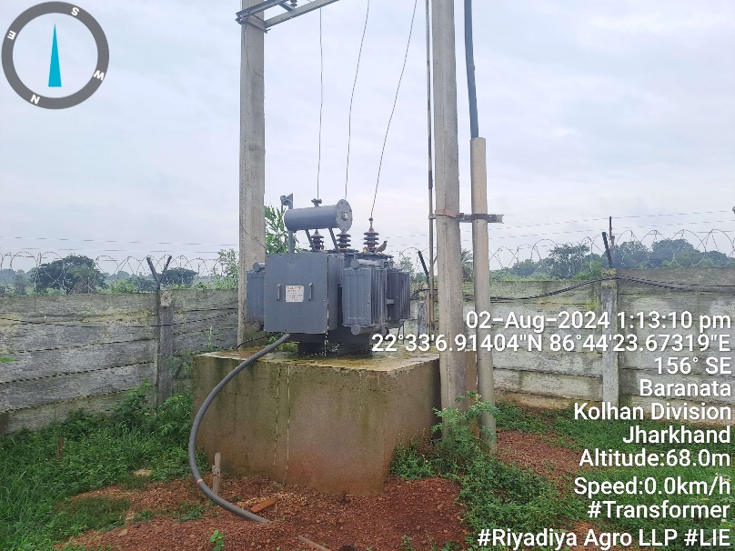 | 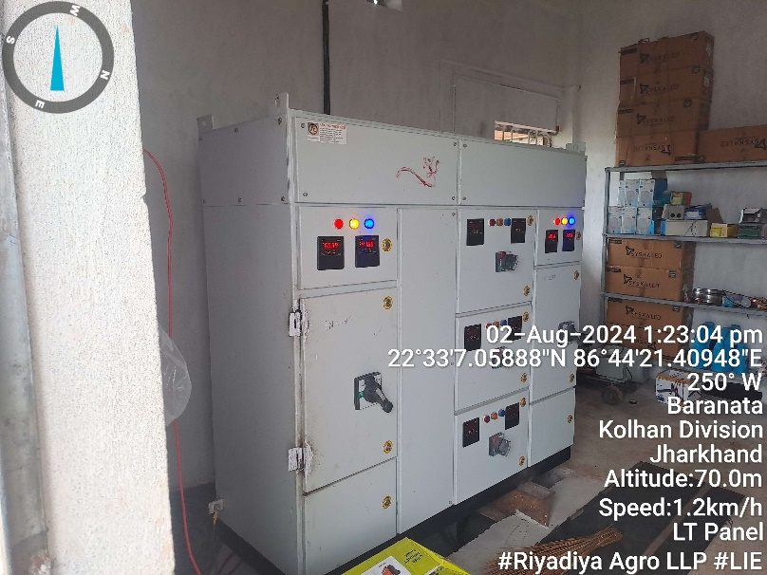
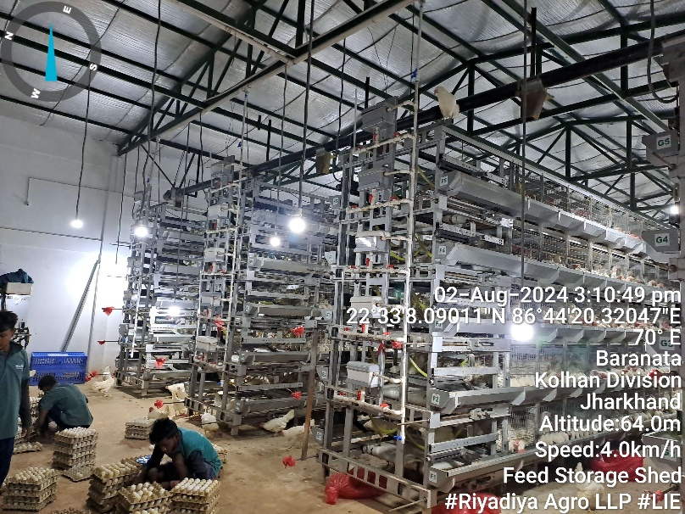 | 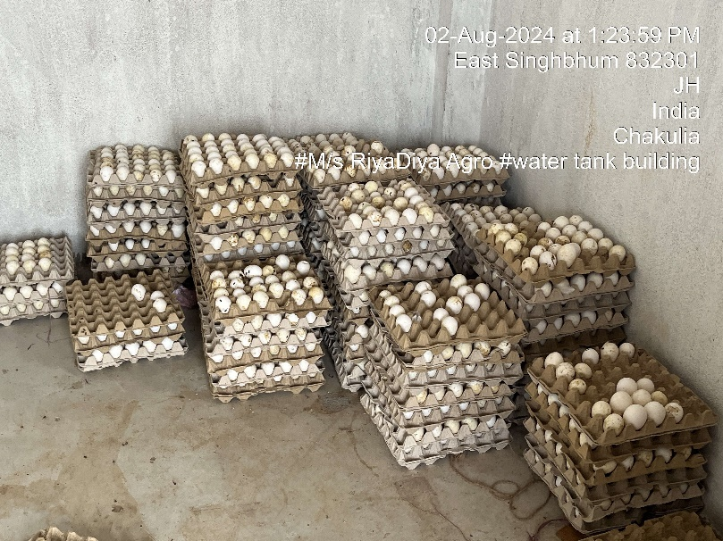
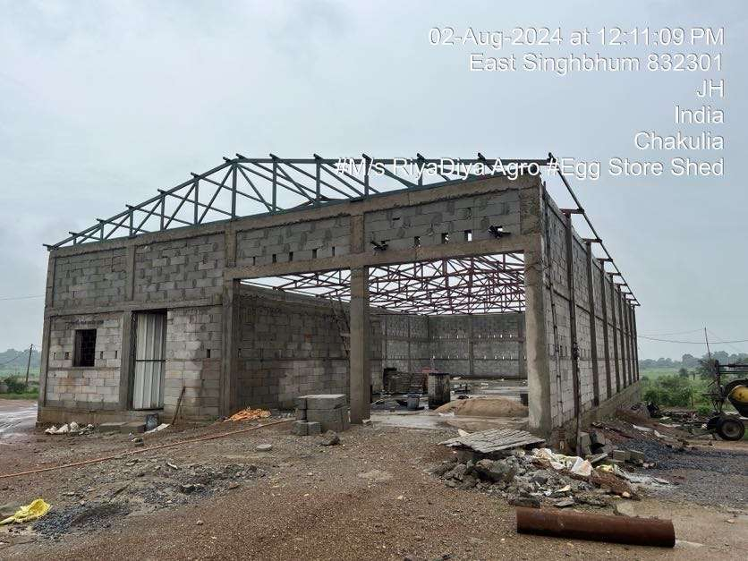 | 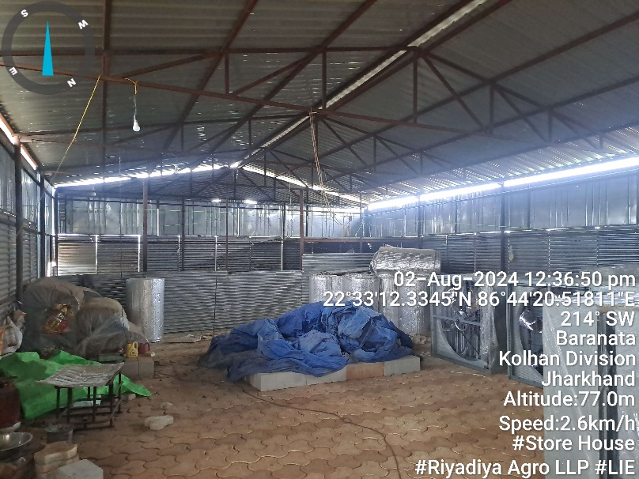

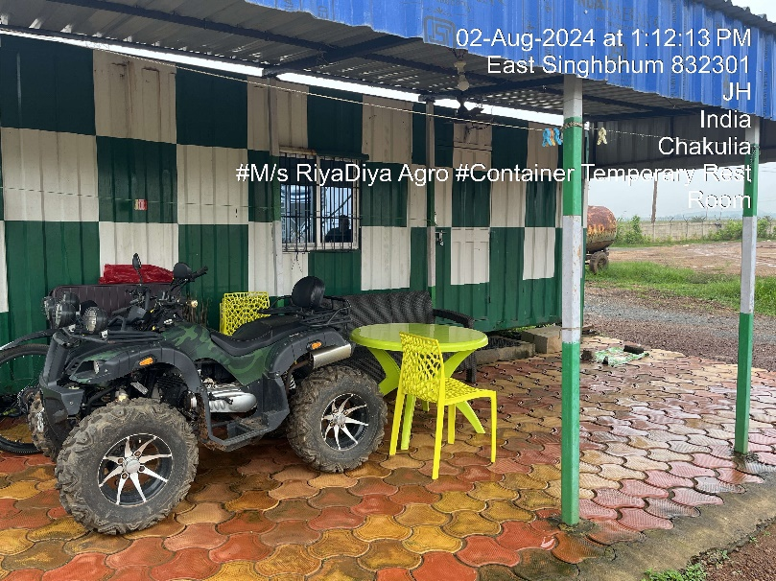 | 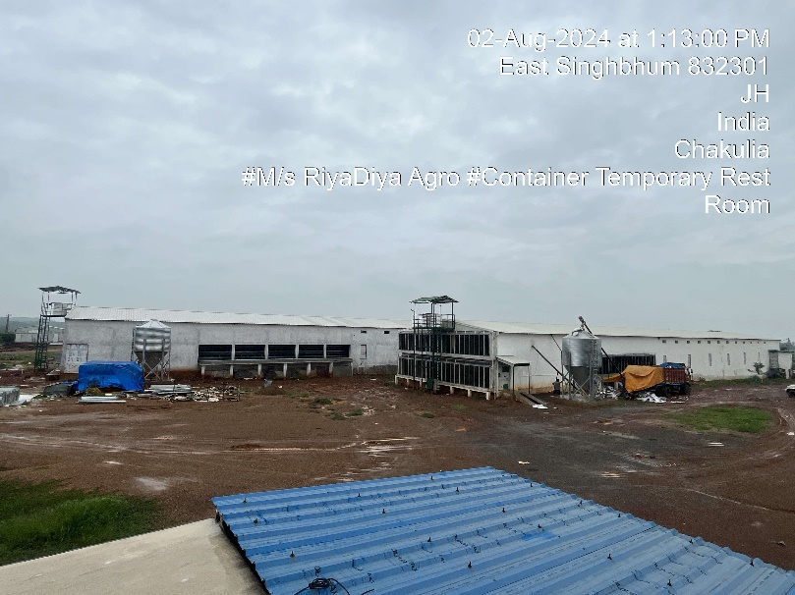
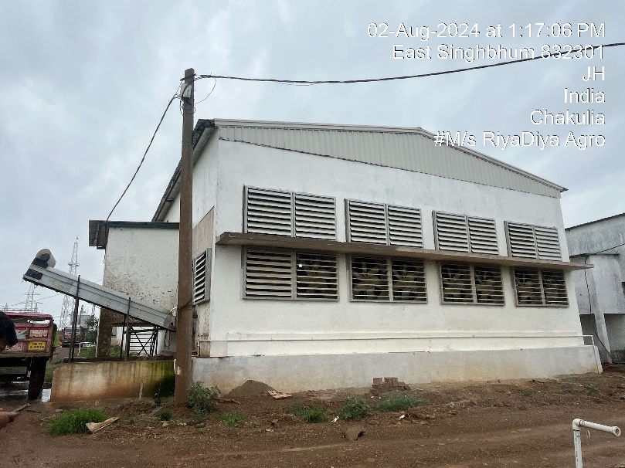 | 