**File No.: VIS (2024-25)-PL-225-192-253 Dated: 12.08.2024**

**TECHNO-ECONOMIC VIABILITY**

**STUDY REPORT**

**OF**

**45000 TPA KRAFT PAPER PLANT WITH 2 MW CO-GENERATION POWER PLANT**

**SETUP BY**

**M/S HARDOLI PAPER MILLS LIMITED**

**REPORT PREPARED FOR**

**STATE BANK OF INDIA, S.M.E. BRANCH, OPP. AGRASEN CHHATRAWAS, RAVI NAGAR CHOWK, AMRAVATI ROAD, NAGPUR - 440033**

***\*\*Important - In case of any query/ issue or escalation you may please contact Incident Manager Valuers@rkassociates.org***. ***We will appreciate your feedback in order to improve our services.***

***NOTE: As per IBA Guidelines please provide your feedback on the report within 15 days of its submission after which report will be considered to be correct.***

**IMPORTANT NOTICE**

***COPYRIGHT FORMAT:*** *This report is prepared on the copyright format of R. K. Associates Valuers & Techno Engineering Consultants (P) Ltd. (R. K. Associates) to serve our clients with the best possible information and analysis to facilitate them to take rational business decisions. Legally no one can copy or distribute this format without prior approval from R. K. Associates. It is meant only for the advisory/ reference purpose for the organization/s as mentioned on the cover page of this report. Distribution or use of this format or report or any of its content/ information/ data by any organization or individual other than R.K Associates will be seen as an unlawful act and necessary legal action can be taken against the defaulters.*

*This report is intended for the sole use of the intended recipient/s and contains material that is* ***STRICTLY CONFIDENTIAL AND PRIVATE.***

***DEFECT LIABILITY PERIOD:****In case of any query/ issue or escalation you may please contact Incident Manager at valuers@rkassociates.org. Though adequate care has been taken while preparing this report as per its scope, but still we can’t rule out typing, human errors, over sightedness of any information or any other mistakes. Therefore, the concerned organization is advised to satisfy themselves that the report is complete & satisfactory in all respect. Intimation regarding any discrepancy shall be brought into our notice immediately. If no intimation is received within 15 (Fifteen) days in writing from the date of issuance of the report, to rectify these timely, then it will be considered that the report is complete in all respect and has been accepted by the client up to their satisfaction & use and further to which R.K Associates shall not be held responsible in any manner.*

***Part N: R. K. Associates Important Disclaimer and Remarks*** *are integral part of this report and Feasibility assessment is subject to this section. Reader of the report is advised to read all the points mentioned in these sections carefully.*

|  |  |  |
| --- | --- | --- |
| **TABLE OF CONTENTS** | | |
|  | | |
| **SECTIONS** | **PARTICULARS** | **PAGE NO.** |
| **Part A** | **REPORT SUMMARY** | 4 |
| **Part B** | **INTRODUCTION** |  |
| 1. About the Report | 6 |
| 1. Executive summary | 6 |
| 1. Purpose of the Report | 8 |
| 1. Scope of the Report | 9 |
| 1. Methodology/ Model Adopted | 10 |
| 1. Data Information received from | 10 |
| 1. Documents/ Data Referred | 10 |
| **Part C** | **Company Profile** |  |
| 1. Company Overview | 11 |
| 1. Shareholding Details | 12 |
| 1. Promoters/Directors Profile | 13-16 |
| **Part D** | **Restructuring Proposal** | 17 |
| **PART E** | **Infrastructure Details** |  |
| 1. Plant Location | 20 |
| 1. Location Map | 21 |
| 1. Layout Plan | 22 |
| 1. Land Details | 23 |
| 1. Site pictures | 23 |
| 1. Building & Civil Works | 31 |
| 1. Plant and Machinery/ Equipment details | 31 |
| 1. Utilities | 36 |
| **Part F** | **Project Technical details** |  |
| 1. Capacity of Kraft Paper Manufacturing Plant | 37 |
| 1. Production Process | 37 |
| 1. Process Flow Chart | 39 |
| 1. Technology used (Kraft Paper Unit) | 40 |
| 1. Technical Assessment (Power Plant Section) | 41 |
| 1. Testing/Quality Assurance | 43 |
| 1. Manpower | 43 |
| **Part G** | **Product Profile** |  |
| 1. Introduction | 44 |
| 1. Product Category | 46 |
| 1. Pricing Strategy | 48 |
| 1. Marketing, Selling & Distribution Plan | 48 |
| **Part H** | **Raw Material Analysis** | 49 |
| **Part I** | **Industry Overview** | 51 |
| **Part J** | **SWOT Analysis** | 55 |
| **Part K** | **Statutory Approvals | Licences | NOC** | 57 |
| **Part L** | **Company’s Financial Feasibility** | 59 |
| **Part M** | **Conclusion** | 75 |
| **Part N** | **Disclaimer | Remarks** | 77 |

|  |  |
| --- | --- |
| **PART A** | **REPORT SUMMARY** |

|  |  |  |
| --- | --- | --- |
| S. No. | PARTICULAR | DESCRIPTION |
|  | **Name of the Company:** | M/s Hardoli Paper Mills Ltd |
|  | **Registered Address:** | Krishna Kunj, 1st Floor, Bhavsar Chowk, C.A. Road, Nagpur-440032 |
|  | **Project Name:** | 45000 TPA Kraft Paper Plant with 2 MW Co-generation Power Plant |
|  | **Project Location:** | 42KM, Nagpur Amravati Road, Village-Hardoli, Tahsil-Katol, District Nagpur, Maharashtra-441103 |
|  | **Project Type:** | 16 B.F., 18 B.F. & 20 B.F. Kraft Paper (110 GSM - 200 GSM) |
|  | **Project Industry:** | Paper Manufacturing Industry |
|  | **Product Type / Deliverables:** | High B.F. Quality Kraft Paper |
|  | **Report Prepared for Organization:** | State Bank of India, S.M.E. Branch, Opp. Agrasen Chhatrawas, Ravi Nagar Chowk, Amravati Road, Nagpur - 440033 |
|  | **TEV Consultant Firm:** | M/s. R.K Associates Valuers & Techno Engineering Consultants (P) Ltd. |
|  | **Report type:** | Techno-EconomicViability Report |
|  | **Purpose of the Report:** | To assess Project’s Techno EconomicViability to help lender/s to take financial exposure decision on the Project. |
|  | **Scope of the Report:** | To assess, evaluate & comment on Technical, Economical & Commercial Viability of the Project as per data information provided by the client, independent Industry research and data/ information available on public domain. |
|  | **Date of Report:** | 12th August, 2024 |
|  | **Documents referred for the Project:** | 1. **PROJECT INITIATION DOCUMENTS:** 2. Brief Write-up about the project. 3. Financial Projections of the Project 4. Write-up Assumptions for Restructuring Proposals 5. Statutory Approval Details 6. Layout and Site Plan 7. Audited Financial Statement for last 5 years. 8. **PROCUREMENT DOCUMENTS:** 9. List of Plant & Machinery along with acquisition costs for the same 10. Major Existing Customer Line 11. List of Expected Raw material Supplier 12. Process Flow Chart 13. Sanction/proposed map of the sites 14. Deed-wise statement of the Land 15. **STATUTORY APPROVALS, LICENCES & NOCs** 16. Pollution Control Application/Certificates 17. Consent to Establish (NOC) Application 18. MSME Certificate |
|  | **Means of Finance:** | Equity & Debt |
|  | **Key Financial Indicators:** | |  |  | | --- | --- | | **Key Indicators** | **Value** | | **Average DSCR** | 1.31 | | **Average EBITDA Margin** | 5.77% | | **Avg. EBIT Margin** | 2.64% | | **NPV** | INR 2573.48 Lakhs | |

**Note**: *Above financial indicators are based on the financial projections of the project provided by the firm and assessment and analysis of the same done by us.*

|  |  |
| --- | --- |
| **PART B** | **INTRODUCTION** |

1. **ABOUT THE REPORT:**

This is a Techno-Economic Viability Study Report of the Kraft Paper Manufacturing Plant (45000 TPA) at 42KM, Nagpur Amravati Road, Village-Hardoli, Tahsil-Katol, District Nagpur, Maharashtra-441103, setup by M/sHardoli Paper Mills Limited.

1. **EXECUTIVE SUMMARY:**

M/s Hardoli Paper Mills Limited (HPML) was incorporated on 24th February, 1995 with Registrar of Companies, Mumbai vide Corporate Identification Number L21010MH1995PLC085883. M/s Hardoli Paper Mills Limited has been into the business of Manufacturing Kraft Paper since 1995 and having its presence in the market as one of the oldest manufacturers of Kraft Paper.

The company is established as a public (non-govt.) company limited by shares with Registration no. 85883. The company is registered at ROC, Mumbai having registered office at Krishna Kunj, 1st Floor, Bhavsar Chowk, C.A. Road, Nagpur-440032 & the plant is located at42 KM, Nagpur Amravati Road, Village-Hardoli, Tehsil-Katol, District-Nagpur, Maharashtra-441103, under the leadership of Mr. Kailash Purushottam Agrawal, Mr. Anilkumar Murarilal Lakhotiya, Mr. Jarnailsingh Gurdasssingh Saini and Mr. Omprakash Rathi.

The promoters of HPML appears to be well experience in businesses of paper manufacturing as the company is already running an established Kraft paper manufacturing plant with a capacity of 45000 TPA in Nagpur. At present, the Company is running its manufacturing unit with a total strength of 167 employees (68 permanent and 99 contractual).

HPML is engaged in the production of various grades of kraft papers (16,18 & 20 B.F. Kraft paper with GSM ranges from 110-200), and related products primarily used in the packaging industry, particularly for the fabrication of corrugated boxes. The company processes waste materials like kraft waste, white cuttings, and computer printouts into kraft paper, which is then utilized to create corrugated boxes for diverse packing needs, including envelopes and other packaging solutions. The company sells the Kraft Paper directly to various parties and through network of dealers in the domestic market. The company had a considerable track record in this business which has resulted in long term relationships with both suppliers and customers.

As per the data/information provided by the client, the plant is operational at a land parcel of ~42,492 Sq. mts. which has been purchased in the year 1995 as per the sale deed. HPML has modified the original layout plan for the installation of Co-generation Power Plant. The modified layout plan has been prepared by the architect Mr. Pranav Lakhotiya (Reg. CA/2010/47314) which is sent for approval to the concerned authorities. *(Refer the section Infrastructure Details in the later part of the report).*

As per the information provided by the client/company in the FY2022, HPML had commenced the installation of Turbine at the existing plant site to curb its power cost and to provide the uninterrupted supply of electricity for continuous production. Since June 2024, the company has successfully installed the turbine and started using the power generated from the in-house cogeneration plant. HPML has also reduced its sanctioned load of power supply from the power grid from 2000 KVA to 500 KVA.

As per data/information provided to us, the company has obtained some Statutory Approvals/NOC’s such as NOC from Ground Water Department, Factory License, labour Licence etc. from the respective authorities. *(Refer the section Statutory Approval in the later part of the report).*

As per the information provided, company’s sales turnover has significantly reduced due to a number of factors including delays in Co-Gen project implementation, shrinking demand for goods and services and fall in commodity prices. This can be seen in the decreasing quantities sold that dropped from 33,750 MT (FY 2023) to 23,555 MT (FY 2024). The combination of lower sales volumes and price corrections resulted in decreased turnover for FY 2024.

**HISTORICAL FINANCIAL PERFORMANCE OF THE COMPANY:** Below mentioned table shows the historical performance of the company for past 6 years from FY 2019 to FY 2024:

***(INR Lakhs)***

|  |  |  |  |  |  |  |
| --- | --- | --- | --- | --- | --- | --- |
| **Particulars** | **FY 2019** | **FY 2020** | **FY 2021** | **FY 2022** | **FY 2023** | **FY 2024** |
| **Revenue** | **8,066.52** | **6,997.64** | **8,209.49** | **11,254.13** | **10,534.09** | **5,900.84** |
| **EBITDA** | **1,019.27** | **480.48** | **723.64** | **286.46** | **-231.06** | **-334.91** |
| **EBITDA%** | 12.64% | 6.87% | 8.81% | 2.55% | -2.19% | -5.68% |
| **EBIT** | **854.59** | **308.55** | **546.36** | **106.88** | **-411.88** | **-530.75** |
| **EBIT%** | 10.59% | 4.41% | 6.66% | 0.95% | -3.91% | -8.99% |
| **PAT** | **589.93** | **113.92** | **342.73** | **38.25** | **-377.31** | **-511.11** |
| **PAT%** | 7.31% | 1.63% | 4.17% | 0.34% | -3.58% | -8.66% |

Graphical Representation of the Key Financials of the previous years:

For the last two years, it has been an uphill task both for the company as well as the paper industry at large. In FY 2022-23, there was a net loss of ~Rs. 3.77 crores and a net loss ~ Rs. 5.11 crores for FY 2023-24 as reported by the company. The profitability margins of the company are also constantly declining for the financial years (FY19-FY24) on account of limited value addition given the highly competitive nature of industry.

The Company has encountered significant financial challenges over the past two fiscal years, primarily attributed to intense competition and recessionary pressures within the paper market. With the pandemic (COVID-19) in 2020 and Ukraine war in the year 2022, the entire paper industry turned mindful of the supply chain scenario for 2023.

The coal prices have also been impacted by Indonesia's decision to curb exports. The issue of a conspicuous shortage of basic raw materials together with their higher cost has aggravated the pressure on the margins and the unviability of the operations which has even led to the closure of some of the paper mills. The Indian paper industry is highly competitive, with several large and small players heavily concentrated in a single community. Price competition, coupled with increasing demand for high-quality paper products, affects the industry's profitability.

However, with the stabilization of market situation in the last quarter of the previous financial year and with the implementation of the turbine plant in the current financial year, the Company is expected to attain financial stability in the coming financial years.

Due to losses and temporary liquidity issues faced by the company considering the huge capital cost incurred in the last couple of years and due to unfavorable market conditions, the company wants to voluntarily initiate proceedings for restructuring of its advances in accordance with notification dated May 29, 2015, 'Framework for Revival and Rehabilitation of Micro, Small and Medium Enterprises' (FRR for MSMEs) and respective guidelines issued thereby on March 17, 2016.

**In this regard, State Bank of India, S.M.E. Branch, Opp. Agrasen Chhatrawas, Ravi Nagar Chowk, Amravati Road, Nagpur – 440033 has appointed R.K. associates as TEV consultant to review technical, commercial and financial viability of the project based on our independent EIC research and information/data provided to us by M/s Hardoli Paper Mills Limited.**

1. **PURPOSE OF THE REPORT:** To assess Project’s Technical and Financial Feasibility to help lender/s to take further course of action on loan account.
2. **SCOPE OF THE REPORT:** To only assess, evaluate & comment on Technical & Financial Feasibility of the Kraft Paper Manufacturing Plant set up by M/s Hardoli Paper Mills Limited as per the information provided by the company.

***NOTES:***

* *Scrutiny about the company, background check, and credibility, credit worthiness of the company or its promoters is out-of-scope of this report.*
* *Any verification of the documents/ information from originals/ source is out-of-scope of this report.*
* *This report is only an opinion in respect to Technical and Financial Feasibility of the project as per the future projections provided by the firm and independent analysis done by us and doesn’t contain any recommendations including taking decision on the loan or any other financial exposure.*
* *This is not an audit activity of any kind. We have relied upon the data/ information shared by the company in good faith.*
* *Any review of the existing business of the promoters is out of scope of this report.*
* *Detailed cost estimation or detailed cost vetting is out of scope of the project.*
* *This is not a Detailed Project Report or a detailed design or architecture document. Land and property details mentioned in the report is only for illustration purpose as per the information provided to us by the client. The same doesn’t tantamount for taking any responsibility regarding its legality, ownership and conforming to statutory norms.*
* *Project status is taken as per the Site inspection carried out by our survey team.*

1. **METHODOLOGY/ MODEL ADOPTED:**
2. Data/ Information collection.
3. Review of Data/ Information collected related to TEV study.
4. Review of Restructuring Proposal.
5. Independent review & assessment of technology used and financial projections provided by the company.
6. Projections of Revenue, P&L, Balance Sheet, Working Capital Schedule, Depreciation Schedule, Loan Schedule as per the inputs given by the company and assessed by us.
7. Calculation of key financial indicators and ratio analysis including DSCR, NPV & IRR and payback period of the project.
8. Report compilation and Final conclusion.
9. **DATA/ INFORMATION RECEIVED FROM:** All the data/Information has been received from Mr. Anwar Akhtar and the required details about him shown in the below table:

| **Particulars** | **Details** |
| --- | --- |
| Designation | **Accountant - Finance** |
| Company | M/s Hardoli Paper Mills Limited |
| Email Address | hardolipaper@gmail.com |
| Contact No. | +91-8668688731 |

1. **DOCUMENTS / DATA REFFERED:**
2. Detailed Project Report and Promoters Profile.
3. Financial Projections of the Kraft Paper Manufacturing Plant.
4. Production flow chart.
5. Previous Five Year’s Financial Statements of the company.
6. List of Plant & Machinery.
7. List of existing Raw Material Suppliers and customers.
8. Workforce Details
9. Site/Layout Plan
10. Land Deed
11. Certificates of Statutory approvals/NOCs.
12. Survey Report conducted at the site.

|  |  |
| --- | --- |
| **PART C** | **COMPANY PROFILE** |

1. **COMPANY OVERVIEW:**

As per certificate of incorporation shared by the client/company, M/sHardoli Paper Mills Limited has been into the business of Manufacturing of Kraft Paper since 1995. Company was incorporated on 24th February 1995 as a listed public company limited by shares with Registration no. 085883.

The Certificate of commencement of business was issued on 25th April, 1995. The Permanent Account Number (PAN) of the company is AAACH1472N and GSTIN is 27AAACH1472N1ZE. As per Udyam registration certificate provided by the client, the company is categorised as Medium Manufacturing enterprise having the Udyam Registration Number UDYAM-MH-20-0021657.

Currently, HPML had plant for manufacture of light weight paper of different variety at village Hardoli, District-Nagpur in the state of Maharashtra, the paper manufactured by the company is used for corrugated boxes used in various types of material packing purpose, envelops, etc. The major raw material used in the production is waste paper such as kraft waste, white cutting, computer printout etc. Below table shows the incorporation details of the company:

|  |  |
| --- | --- |
| **Incorporation Details of the Company** | |
| **Particular** | **Description** |
| **Company / LLP Name** | M/s Hardoli Paper Mills Limited |
| **Date of Incorporation** | 24th Feb, 1995 |
| **CIN** | L21010MH1995PLC085883 |
| **Company Category** | Listed Company limited by Share |
| **Company Subcategory** | Non-govt. company |
| **ROC** | Mumbai |
| **Registration Number** | 085883 |
| **Registered Address** | Krishna Kunj, First Floor Bhavsar Chowk, C.A. Road, Nagpur, Maharashtra, India, 440002 |
| **Authorized Capital** | INR 3,50,00,000/- |
| **Paid up Capital** | INR 2,69,22,650/- |
| **Date of last AGM** | 24/07/2023 |
| **Date of Balance Sheet** | 31/03/2023 |

***Source:*** *As per the data available on the MCA website*

1. **SHAREHOLDING DETAILS:**

As per the Audited Financials as on 31st March 2024 shared by the client, Company is having authorized share capital of Rs. 3.50 crores and the total subscribed and paid-up capital is Rs 2.69 crores. The shareholding pattern of the company is mentioned in the below table:

|  |  |  |
| --- | --- | --- |
| **Particulars** | **As at 31st March, 2024** | |
| **No of Shares** | **INR Crore** |
| **Authorised Share Capital** |  |  |
| Equity shares of Rs. 10/- each | 35,00,000 | 10.00 |
| **Subscribed & fully paid up** |  |  |
| Equity Share of Re. 10/- each fully subscribed & paid up | 26,92,265 | 10.00 |

***Source:*** *Data/Information provided by the Client.*

**Details of Shareholders holding more than 5% shares in the Company**

|  |  |  |  |  |  |
| --- | --- | --- | --- | --- | --- |
| **S. No.** | **Name of Shareholder** | **Number of shares as on 31.03.2024** | **% of Holding** | **Number of shares as on 31.03.2024** | **% of Holding** |
| 1 | Gaurav Anilkumar Lakhotiya | 3,37,058 | 12.52% | 3,37,058 | 12.52% |
| 2 | Omprakash Damodar Rathi | 2,67,360 | 9.93% | 2,68,860 | 9.99% |
| 3 | Kailash P. Agarwal | 2,41,995 | 8.99% | 2,41,995 | 8.99% |
| 4 | Akshay Omprakash Rathi | 2,28,405 | 8.35% | 2,28,405 | 8.35% |
| 5 | Anil Kumar Lakhotiya | 1,86,295 | 6.92% | 1,86,295 | 6.92% |
| 6 | Mangla Omprakash Rathi | 1,50,945 | 5.61% | 1,50,945 | 5.61% |

***Source:*** *Data/Information provided by the Client.*

1. **PROMOTERS/DIRECTORS PROFILE:**

Mr. Anil Kumar Murarilal Lakhotiya, Mr. Kailash Chand Purshottam Agrawal, Mr. Jarnail Singh Gurdas Singh Saini and Mr. Omprakash Damodharji Rathiare the promoters of M/s Hardoli Paper Mill Limited. Currently, they are successfully running their company and have acquired good knowledge & experience in paper industry.

As per data/information provided to us, below table illustrate the educational & professional experience of the promoters along with the DIN:

|  |  |  |  |  |
| --- | --- | --- | --- | --- |
| 1. **Directors/Promoters Details** | | | | |
| **S. No.** | **Name** | **DIN** | **Age** | **Designation** |
| **1** | **Mr. Anil Kumar Murarilal Lakhotiya** | 00367361 | 72 | Managing Director |
| **2** | **Mr.Kailash Chand Purshottam Agrawal** | 00367292 | 78 | Whole Time Director |
| **3** | **Mr. Narasimhan Varadarajan** | 08177714 | 71 | Director |
| **4** | **Mr. Prem Sadhuram Kewalramani** | 08177725 | 66 | Director |
| **5** | **Ms. Priyanka Praful Deshmukh** | 08177708 | 39 | Director |
| **6** | **Mr. Omprakash Damodharji Rathi** | 00895316 | 72 | Whole Time Director |
| **7** | **Mr. Jarnail Singh Gurdas Singh Saini** | 00367656 | 76 | Whole Time Director |

|  |  |
| --- | --- |
| 1. **Education & Experience** | |
| **Mr. Anil Kumar Murarilal Lakhotiya** | * Appointed as Director on 24th February 1995. * As per data/information shared by the client, Mr. Anil Kumar Murarilal Lakhotiya is a commerce graduate with a degree of Bachelor of Commerce (B. Com). He has an experience of 30 years in the paper industry. * Currently, Mr. Anil Kumar Murarilal Lakhotiya is successfully running M/s HPML. |
| **Mr. Kailash Chand Purshottam Agrawal** | * Appointed as Director on 24rd May 2007. * As per data/information shared by the client, Mr. Kailash Chand Purshottam Agrawal is a graduate. He has an experience of 30 years in the relevant industry. * Currently, Mr. Kailash Chand Purshottam Agrawal is successfully running M/s HPML. |
| **Mr. Narasimhan Varadarajan** | * Appointed as Director on 26th July 2018. * As per data/information shared by the client, Mr. Narasimhan Varadarajan is a Chartered Accountant. He has an experience of 43 years. * Currently, Mr. Narasimhan Varadarajan is serving as an Independent Director of HPML. |
| **Mr. Prem Sadhuram Kewalramani** | * Appointed as Director on 26th July 2018. * As per data/information shared by the client, Mr. Prem Sadhuram Kewalramani is a Commerce Graduate. He has an experience of 40 years. * Currently, Mr. Prem Sadhuram Kewalramani is serving as an Independent Director of HPML. |
| **Ms. Priyanka Praful Deshmukh** | * Appointed as Director on 26th July 2018. * As per data/information shared by the client, Ms. Priyanka Praful Deshmukh is a Company Secretary (CS). She has an experience of 11 years. * Currently Ms. Priyanka Praful Deshmukh is serving as an Independent Director of HPML. |
| **Mr. Omprakash Damodharji Rathi** | * Appointed as Director on 26th July 2018. * As per data/information shared by the client, **Mr. Omprakash Damodharji Rathi** has an experience of 30 years in the relevant industry. * Currently **Mr. Omprakash Damodharji Rathi** is successfully running M/s HPML. |
| **Mr. Jarnail Singh Gurdas Singh Saini** | * Appointed as Director on 24rd May 1995. * As per data/information shared by the client, **Mr. Jarnail Singh Gurdas Singh Saini** has passed S.S.C Exam. He has an experience of 30 years in the relevant industry. * He is also currently working as Chief Finance Office (CFO) in HPML since 1995. |

***Source:*** *Data/ Information provided by the company*

Below tables shows the information of the companies with which each Director is associated with to give a basic background detail of the promoters as found on public domain in general/ tertiary category research.

**(Mr. Anil Kumar Murarilal Lakhotiya)**

|  |  |  |  |  |  |
| --- | --- | --- | --- | --- | --- |
| **S. No** | **Company Name**  **(CIN/FCRN)** | **Designation** | **Original Date of Appointment** | **Date Of Appointment at Current Designation** | **Date Of Cessation (If Applicable)** |
| 1 | Hardoli Paper Mills Limited (L21010MH1995PLC085883) | Managing Director | 24/02/1995 | 01/04/2021 | - |
| 2 | Hardoli Paper Mills Limited (L21010MH1995PLC085883) | Whole-time director | - | 24/02/1995 | 11/12/2013 |
| 3 | Hardoli Paper Mills Limited (L21010MH1995PLC085883) | Managing Director | - | 11/12/2013 | 31/03/2021 |

***Source:*** *As per the data available on the MCA website*

**(Mr. Kailash Chand Purshottam Agrawal)**

|  |  |  |  |  |  |
| --- | --- | --- | --- | --- | --- |
| **S. No** | **Company Name**  **(CIN/FCRN)** | **Designation** | **Original Date of Appointment** | **Date Of Appointment at Current Designation** | **Date Of Cessation (If Applicable)** |
| 1 | Hardoli Paper Mills Limited (L21010MH1995PLC085883) | Whole-time director | 24/05/2007 | 01/04/2021 | - |
| 2 | Federation Of Indian Paper Recyclers  (U74999GJ2017NPL098222) | Director | 10/07/2017 | 10/07/2017 | - |
| 3 | Hardoli Paper Mills Limited (L21010MH1995PLC085883) | Director | - | 18/04/2008 | 01/10/2009 |
| 4 | Hardoli Paper Mills Limited (L21010MH1995PLC085883) | Managing Director | - | 24/05/2007 | 01/04/2021 |

***Source****: Information extracted from MCA website & public domain*

**(Mr. Narasimhan Varadarajan)**

|  |  |  |  |  |  |
| --- | --- | --- | --- | --- | --- |
| **S. No** | **Company Name**  **(CIN/FCRN)** | **Designation** | **Original Date of Appointment** | **Date Of Appointment at Current Designation** | **Date Of Cessation (If Applicable)** |
| 1 | Hardoli Paper Mills Limited (L21010MH1995PLC085883) | Director | 26/07/2018 | 31/08/2018 | - |
| 2 | Hardoli Paper Mills Limited (L21010MH1995PLC085883) | Additional Director | - | 26/07/2018 | 31/08/2018 |

***Source****: Information extracted from MCA website & public domain*

**(Mr. Prem Sadhuram Kewalramani)**

|  |  |  |  |  |  |
| --- | --- | --- | --- | --- | --- |
| **S. No** | **Company Name**  **(CIN/FCRN)** | **Designation** | **Original Date of Appointment** | **Date Of Appointment at Current Designation** | **Date Of Cessation (If Applicable)** |
| 1 | Hardoli Paper Mills Limited (L21010MH1995PLC085883) | Director | 26/07/2018 | 31/08/2018 | - |
| 2 | Hardoli Paper Mills Limited (L21010MH1995PLC085883) | Additional Director | - | 26/07/2018 | 31/08/2018 |

***Source****: Information extracted from MCA website & public domain*

**(Ms. Priyanka Praful Deshmukh)**

|  |  |  |  |  |  |
| --- | --- | --- | --- | --- | --- |
| **S. No** | **Company Name**  **(CIN/FCRN)** | **Designation** | **Original Date of Appointment** | **Date Of Appointment at Current Designation** | **Date Of Cessation (If Applicable)** |
| 1 | Hardoli Paper Mills Limited (L21010MH1995PLC085883) | Director | 26/07/2018 | 31/08/2018 | - |
| 2 | Hardoli Paper Mills Limited (L21010MH1995PLC085883) | Additional Director | - | 26/07/2018 | 31/08/2018 |

***Source****: Information extracted from MCA website & public domain*

**(Mr. Omprakash Damodharji Rathi)**

|  |  |  |  |  |  |
| --- | --- | --- | --- | --- | --- |
| **S. No** | **Company Name**  **(CIN/FCRN)** | **Designation** | **Original Date of Appointment** | **Date Of Appointment at Current Designation** | **Date Of Cessation (If Applicable)** |
| 1 | Kaygaon Paper Mills Private Limited (U21010MH1989PTC051317) | Whole-time director | 10/04/1989 | 01/11/2013 | - |
| 2 | Federation Of Indian Paper Recyclers  (U74999GJ2017NPL098222) | Director | 10/07/2017 | 10/07/2017 | - |
| 3 | Hardoli Paper Mills Limited (L21010MH1995PLC085883) | Whole-time director | 26/07/2018 | 31/08/2018 | - |
| 4 | Kaygaon Paper Mills Private Limited (U21010MH1989PTC051317) | Managing Director | - | 01/10/2007 | 02/04/2012 |
| 5 | Hardoli Paper Mills Limited (L21010MH1995PLC085883) | Additional Director | - | 23/04/2010 | 17/09/2010 |
| 6 | Samarkand Investments Private Limited  (U65990MH1988PTC047828) | Director | - | 02/05/1994 | 30/05/2016 |
| 7 | Kaygaon Paper Mills Private Limited (U21010MH1989PTC051317) | Director | - | 02/04/2012 | 01/11/2013 |
| 8 | Hardoli Paper Mills Limited (L21010MH1995PLC085883) | Director | - | 17/09/2010 | 09/10/2013 |
| 9 | Hardoli Paper Mills Limited (L21010MH1995PLC085883) | Additional Director | - | 26/07/2018 | 31/08/2018 |
| 10 | Kaygaon Paper Mills Private Limited (U21010MH1989PTC051317) | Managing Director | - | 10/04/1989 | 30/09/2007 |

***Source****: Information extracted from MCA website & public domain*

**(Mr. Jarnail Singh Gurdas Singh Saini)**

|  |  |  |  |  |  |
| --- | --- | --- | --- | --- | --- |
| **S. No** | **Company Name**  **(CIN/FCRN)** | **Designation** | **Original Date of Appointment** | **Date Of Appointment at Current Designation** | **Date Of Cessation (If Applicable)** |
| 1 | Hardoli Paper Mills Limited (L21010MH1995PLC085883) | CFO | - | 22/04/2019 | - |
| 2 | Hardoli Paper Mills Limited (L21010MH1995PLC085883) | Whole-time director | 24/02/1995 | 31/08/2018 | - |
| 3 | Hardoli Paper Mills Limited (L21010MH1995PLC085883) | Director | - | 24/02/1995 | 31/08/2018 |

***Source****: Information extracted from MCA website & public domain*

|  |  |
| --- | --- |
| **PART D** | **RESTRUCTURING PROPOSAL** |

As per the details shared with us, the Company had encountered significant financial challenges over the past two fiscal years, primarily attributed to intense competition and recessionary pressures within the paper market. Some of the factors which led to the financial distress have been mentioned below:

1. The cost of buying wastepaper from other countries changes regularly. During the previous financial year, the cost dropped, but the company still had to pay the higher prices on which they had previously agreed on. Later, when the prices dropped again, it caused the value of the products made from the wastepaper to go down, leading to less money earned for each unit sold.
2. The rising fuel prices over the past two years are mainly due to mining disruptions, which have caused shortages and increased costs.
3. The increase in electricity costs over the last few years has been a big financial challenge, affecting overall profits and budget planning. However, starting a co-generation plant offers a great chance to save a lot of money, which has already been commissioned and has started providing continuous power supply to the manufacturing unit.
4. Several external factors like Covid-19, Ukraine War, Indonesia decision to limit exports have also contributed to the increasing financial burden on the company.

Due to losses and temporary liquidity issues faced by the company considering the significant capital costs incurred (Installation of Co-generation Plant) in the last couple of years and unfavourable market conditions, the company wishes to voluntarily initiate proceedings for restructuring its advances in accordance with the notification dated May 29, 2015, 'Framework for Revival and Rehabilitation of Micro, Small and Medium Enterprises' (FRR for MSMEs) and the respective guidelines issued on March 17, 2016.

In accordance with these guidelines, the provisions of the framework apply to MSMEs with loan limits up to Rs. 25 crores. Further, an MSME borrower may voluntarily initiate proceedings under the framework, subject to certain conditions mentioned therein. Hence, the company is requesting the bank to restructure its banking credit facilities based on the following points:

1. **To renew the Cash Credit limit at a reduced level of Rs. 6 crores:** The company has a sanctioned cash credit limit of Rs. 9.00 crores. Due to delays in project implementation and a temporary reduction in the scale of operations, the company is requested the bank to reduce this limit by Rs. 3 crores from the existing sanctioned amount. Additionally, there has been a reduction in the drawing power (DP).
2. **Sanction of Fresh Term Loan of Rs. 6 crores towards the unfunded Capex incurred in the last 3 years**: The company faced losses in FY 2023 and FY 2024 but met its repayment obligations. Due to delays in implementing the co-generation plant, the company experienced cost overruns and has not sought additional loans, except for a recent Rs. 3.0 crore corporate loan. Over the past 3 years, the company incurred a total Capex of Rs. 21.83 crores and sought term loans totalling Rs. 12.15 crores. To improve cash flow and streamline operations, the company now seeks a Rs. 6.00 crore term loan at 9.50% interest to be repaid over the total term period of 7 years, including a moratorium period of 1 year. This loan will be used partly to repay the Cash Credit limit reduction and for working capital needs.
3. **Deferment of Term Loan Repayments**: The company requests the bank to restructure all existing term loans (except GECL) and extend the repayment period to 7 years, including a 1-year moratorium, with ballooning repayment.
4. **Conversion of Deferred Interest into Fixed Interest Term Loan for 3 Years**: The company requests the bank to allow an interest holiday on term loans for the next year. They also ask to convert the interest due on Fund Based Working Capital Facilities and various term loans from April 2024 to March 2025 into an interest-free Fixed Interest Term Loan (FITL) for 3 years, with repayment starting in April 2025 after a one-year moratorium.
5. **Reduction in Interest rate and other concessions as mentioned:** Considering the company's weak financial position, they request the bank to extend its support and grant various concessions as mentioned below:

|  |  |  |
| --- | --- | --- |
| **Interest Rate** | | |
| **Facility** | **Rate of Interest/ Commission** | |
| **Existing Sanctioned** | **Proposed** |
| Cash Credit Limit | 10.25% | 9.50% |
| Term Loans/ Corporate Loans | 10.25% | 9.50% |
| GECL Loans | 9.25% | 9.25% |
| New Term Loan | NA | 9.50% |
| FITL | NA | NIL |
| Bank Guarantee | 1.60% pa | 1.25% pa |

|  |  |  |
| --- | --- | --- |
| **Margins for Cash Credit** | | |
| **Facility** | **Existing Sanctioned** | **Proposed** |
| Raw Material | 25% | 25% |
| Finished Goods | 25% | 25% |
| Semi-Finished Goods | 40% | 25% |
| Receivables | 40% | 25% |
| Bank Guarantee | 25% | 10% |

|  |  |
| --- | --- |
| **PART E** | **INFRASTRUCTURE DETAILS** |

1. **PLANT LOCATION:**

M/s Hardoli Paper Mills Limited is operating an Kraft Paper Manufacturing Unit at 42 KM Milestone, Nagpur Amravati Road, Village-Hardoli, Tahsil-Katol, District-Nagpur, Maharashtra-441103 which is spread over an area of ~42,492 Square meter as per the sale deed and site plan provided to us by the company.

The property is having the proximity to the civic amenities such as hospital is situated ~6 km away, school is situated ~6 km away and market is situated ~6 km away from the plant location. The site is located on NH-06 (earlier named NH-53) (Mumbai-Nagpur Highway). Table: 1 is showing the details of the adjoining properties of the land for plant’s site location and Table: 2 is showing the Connectivity Details of the Location:

| **Table: 1 Adjoining Property Details** | |
| --- | --- |
| **Location** | **Details** |
| East | Drainage |
| West | Open Plot Survey No.29 & 30 |
| North | Drainage and Forest |
| South | NH-06 (Earlier named NH-53) (Mumbai-Nagpur Highway) |

| **Table: 2 Connectivity Details of the Location** | |
| --- | --- |
| **Connectivity** | **Details** |
| Road | NH-06 (earlier named NH-53) |
| Rail | Kodhali Junction - ~28 km away |
| Airport | Dr. BabaSaheb Ambedkar International Airport- ~50 km away |

1. **LOCATION MAP:**
2. **GOOGLE MAP LOCATION**:

Project location is 21°08'15.0" North and 78°41'39.5" East at 42 KM, Nagpur Amravati Road, Village-Hardoli, Tahsil-Katol, District Nagpur, Maharashtra-441103 and the location as per the Google map has been attached below:

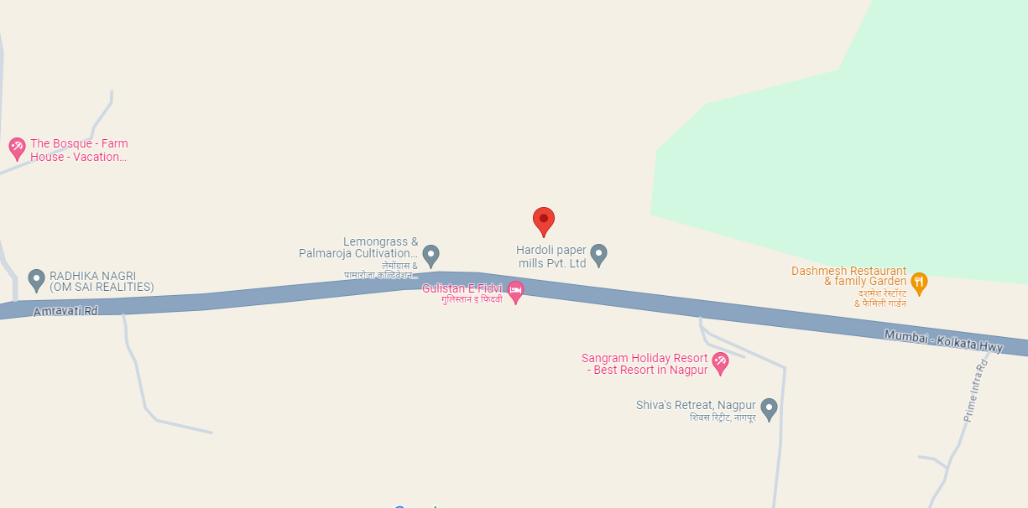

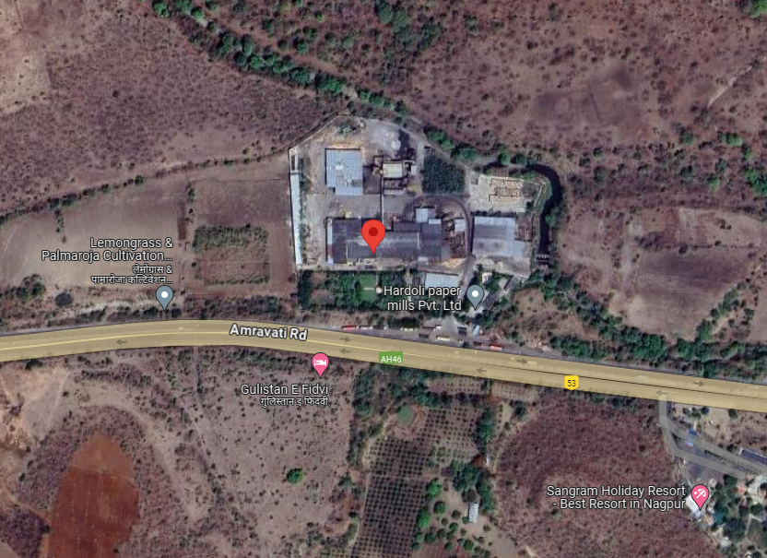

1. **Google Map Layout:**

Demarcation of the whole plant site with approximate measurement on the Google map are attached below:

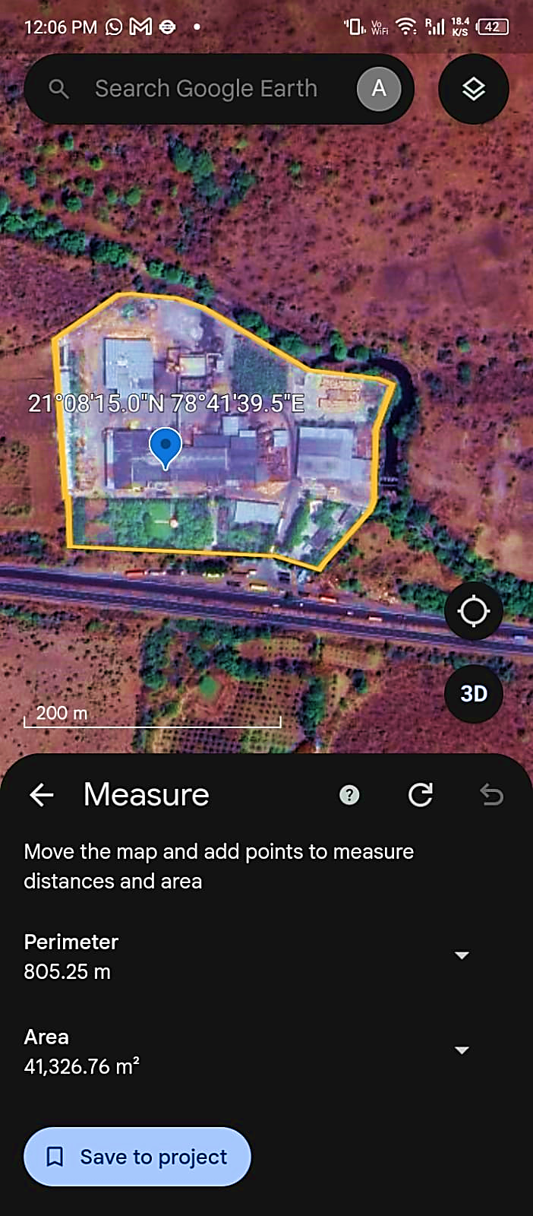

1. **LAYOUT PLAN:**

As per the data/information provided by the client, HPML has modified the original layout plan for the installation of Co-generation Power Plant. The modified layout plan has been prepared by the architect Mr. Pranav Lakhotiya (Reg. CA/2010/47314) which is sent for approval to the concerned authorities.For reference, updated layout plan has been attached below:

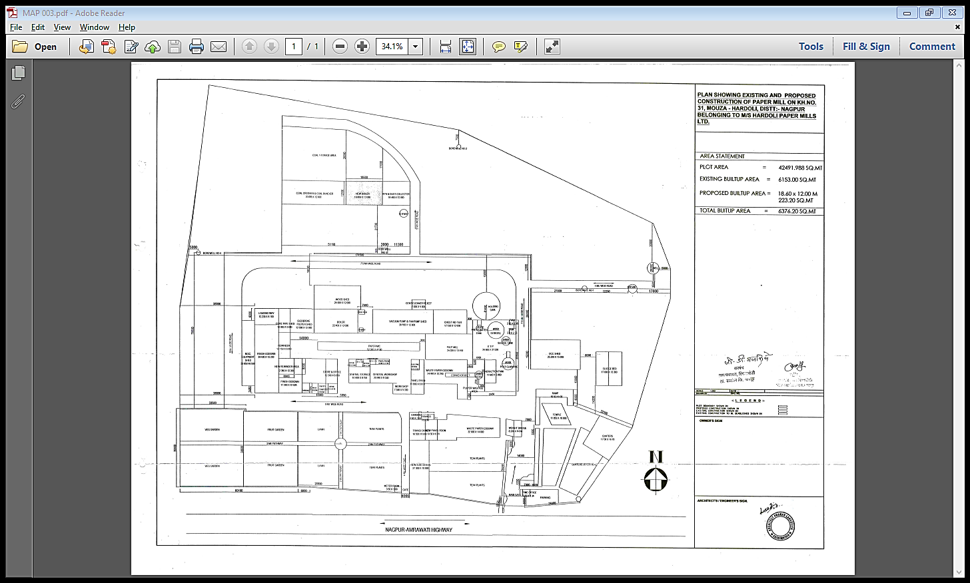

1. **LAND DETAILS:**

M/s Hardoli Paper Mills Limited is operating a Kraft Paper Manufacturing Unit at 42KM Milestone, Nagpur Amravati Road, Village-Hardoli, Tahsil-Katol, District Nagpur, Maharashtra-441103, which is spread over an area of ~42,492 Square meter as per the land deed and site plan provided to us by the company.

As per the site layout plan, the total buildup area of the plant including the area utilised to install the cogeneration power plant is 6376.20 sq. meter. The land is located at Khasra No. 31, Hardoli, District – Nagpur, Maharashtra - 441103 as per the site plan shared with us. As per the information provided by the company, the land is already mortgaged with the bank.

As per the details available with us, we have verified the areas of respective plots with the sale deed of the land and found the areas/details in line with information mentioned aforesaid. During the site visit on 12th July 2024, we found that the plant was not operational at that time as the maintenance work of turbine was going on at the time of survey.

1. **SITE PICTURES:** Site pictures were captured during the site survey on 12th July 2024, for reference few of the pictures are attached below:

|  |  |
| --- | --- |
|  |  |
|  |  |
|  |  |
|  |  |
|  |  |
|  |  |
|  |  |
|  |  |
|  |  |
|  |  |
|  |  |
|  |  |
|  |  |
|  |  |
|  |  |
|  |  |
|  |  |
|  |  |
|  |  |
|  |  |
|  |  |
|  |  |
|  |  |
|  |  |
|  |  |
|  |  |
|  |  |
|  |  |
|  |  |
|  |  |

1. **BUILDING & CIVIL WORKS:**

As per the proposed and existing layout plan shared with us, the built-up area of the existing plant is spread over an area of ~6,153.00 Sq. Mt. and the proposed expansion is spreading over a built-up area of ~223.20 Sq. Mt., which makes the total build up area of the plant to be 6376.20 Sq. Mt.

As per the shared layout plan, the plant is situated at the aforesaid address having total land area admeasuring ~ 42,492 sq. mts., which is mortgaged with bank as per the documents shared with us. We have also cross-checked the area from google satellite measurement and it seems to match with the area mentioned in the document.

The plant comprises multiple structures including Office Building, Coal Shed, OCC Shed, Main Block, etc. The details of built-up area of all building/structures measured at site are as follows:

|  |  |  |  |
| --- | --- | --- | --- |
| **S. No.** | **Particular** | **Structure** | **Built up Area (Sq. Mtr.)** |
| 1 | Building | RCC | 4090.00 |
| 2 | Reject Plastic Shed | Shed | 248.96 |
| 3 | Fire fighting | Shed | 127.33 |
| 4 | Coal Shed | Shed | 1000.00 |
| 5 | OCC Shed | Shed | 1100.00 |
| 6 | New Shed for Storage | Shed | 520.00 |
| **Total Area** | | | **7086.29** |

As per the observation made during site visit on 12th July 2024, we found that the plant area is fenced with walls on all the four sides of the property, with its dedicated entry from the Northern Side of the Property. The property is adjoined with Drainage on the East Side, Plot Survey No. 29 & 30 on the West Side, Drainage and Forest on the North Side and NH-06 (Mumbai-Nagpur Highway) on the South Side.

1. **PLANT & MACHINERY/ EQUIPMENTS DETAILS:**

As per the information provided by client/company, the plant has capacity of 45000 metric tonne per annum (TPA). Details of the major plant and machinery at the unit is mentioned in the table below along with the manufacturer and specification details:

|  |  |  |  |
| --- | --- | --- | --- |
| **S. No.** | **Particulars** | **Supplier (Party Name)** | **Invoice Amount (Incl. GST)** |
| **Turbine** | | | |
| 1 | Surface, Gland Condenser & Steam Jet Ejector | Kessels Engineering Works Pvt. Ltd. | 42,48,000.00 |
| 2 | Alternator with AVR | Kessels Engineering Works Pvt. Ltd. | 68,44,000.00 |
| 3 | Steam Turbine on Base Plate with Accessories | Kessels Engineering Works Pvt. Ltd. | 90,86,000.00 |
| Crane | | | |
| 4 | Crain Capacity 6Ton Span 6.60mtrx12mtr Lift / Pvc Shrouded Bus Bar 19mtr Long with Assembly / Crain Beam Rail 50x40mm Rect Bar 19mtr Each Side | Supreme Elmech Pvt. Ltd. | 16,55,540.00 |
| Water Treatment Plant | | | |
| 5 | Water Treatment Plant | WTE Infra Projects Pvt. Ltd. | 37,76,000.00 |
| 6 | Water Storage Tank Cap-42KL Size Dia-3.69M H-4MM for Water Treatment Plant Tank Accessories | GranuAqua Tanks Pvt. Ltd. | 3,53,362.00 |
| 7 | Water Storage Tank Cap-66KL Size Dia-4.61M H-4MM for Water Treatment Plant Tank Accessories | GranuAqua Tanks Pvt. Ltd. | 5,43,641.00 |
| 8 | for Pump | WTE Infra Projects Pvt. Ltd. | 7,96,500.00 |
| Boiler Modification | | | |
| 9 | Motor CGL TEFC SQ CAGE 110KW/150HP 4 POLE F-MNTG / Motor CGL TEFC SQ CAGE 15KW/20HP 2 POLE F-MNTG | Makharia Machineries Pvt. Ltd. | 4,32,396.54 |
| 10 | MS Plate HR / PM Plate 16mm for Boiler Work | Future Steel Industries | 3,94,811.00 |
| 11 | MS Angle 50x6 / MS Channel 100x50 / MS Flat 40x5 / MS Tube 11/2" for Boiler Work | Future Steel Industries | 4,69,352.50 |
| 12 | F. D. Fan (AirFan) 1800 Rpm Efficiency-65% | Air Fans, Pune | 4,72,000.00 |
| 13 | I. D. Fan (AirFan) 900 Rpm Efficiency-65% | Air Fans, Pune | 3,42,200.00 |
| 14 | Bed Outer Coil with Studs Carbon Steel / Bed Inner Coil Without Studs | NAV DURGA BOILER & EQUIPMENTS P. LTD. | 3,68,160.00 |
| 15 | MS Tube / MS Plate | NAV DURGA BOILER & EQUIPMENTS P. LTD. | 7,37,393.00 |
| 16 | MS Plate | NAV DURGA BOILER & EQUIPMENTS P. LTD. | 7,70,203.00 |
| 17 | for SS Nozzle | Industrial Boilers Limited | 2,14,949.00 |
| 18 | De Superheated Station | Ari Armaturen Steamline LLP, Pune | 4,72,000.00 |
| 19 | Pump WL 65/10 Normal / Base Frame with Coupling & Guard Pump WL 65/10 for Turbine | S.V. Traders | 6,91,480.00 |
| 20 | Steel Tube / Seamless Tube (for Super Heater Header Material | NAV DURGA BOILER & EQUIPMENTS P. LTD. | 5,98,802.96 |
| 21 | Steel Seamless Tube 44.50x4.06 H SA 213 GR. T-11 MSL | Motilal Laxmichand Sanghavi | 10,21,108.00 |
| 22 | 6"x300# Gate Valve F/E Gr.WCB / 12"x150# Gate Valve F/E Gr.WCB / 1/2"x800# Gate Valve S/W Gr. A105 / 8"x150# Gate Valve F/E Gr. WCB | Sigma Industries | 2,93,348.00 |
| 23 | Economizer Coil for Boiler No. MR/16449 (for Expan Boiler Work) | NAV DURGA BOILER & EQUIPMENTS P. LTD. | 7,90,600.00 |
| 24 | Plenum Chamber Fabrication / Air Nozzle, for Boiler Use Project | Shree Engineering | 2,83,200.00 |
| 25 | MS Chequered Plate, MS Plate, MS Channel, MS Angle, for Coal Bunker Use Boiler Modification | Future Steel Industries | 4,44,029.00 |
| 26 | Accoset-50, White Heat K, Thermotex, Ceramics Blanket, Ceramic Paper, Standard Fire Bricks IS-8, for Boiler Refractory material | Mahi Enterprises | 3,45,516.00 |
| 27 | "Intermediate Trunk" for Bucket Elevator, CHP Plant Boiler | Globe Engineering Company | 2,97,360.00 |
| 28 | Firecrete Castable 25Kg Bag, Accoset-50 (25 Kg Bag), Thermotex 40 Kg, Ceramic Paper 05mm, for Boiler Modification Work | Mahi Enterprises | 3,12,488.00 |
| 29 | MS Pipe ERW Size 60 OD x 2 mm THK, FOR APH WORK | Rolex Industrial Corporation | 2,05,662.00 |
| 30 | Instruments Of Boiler (for Boiler Project (Steam Flow Meter, Deaerator Level, Pre/Drum Level, Scada Work, Three Valve Manfold, Signal Cable, Isoletor, Thermocouple, Toggle Switch, etc) | AAR Tech Engineering | 6,99,032.00 |
| 31 | VFD 150 HP Make Fuji AC Drive 110 KW/150HP, for boiler | AAR Tech Engineering | 2,65,500.00 |
| 32 | Steel Tube as under ERW Tube | Motilal Laxmichand Sanghavi | 4,44,264.10 |
| 33 | Steel Tube as under ERW Tube | Motilal Laxmichand Sanghavi | 2,42,457.56 |
| 34 | Charges for Water Valve MPV Tubes 234 Nos, Charges for Water Valve Streat Furnace Tubes 81 Nos, for Boiler Work | NAV DURGA BOILER & EQUIPMENTS P. LTD. | 11,80,000.00 |
| 35 | for Manufacturing of Economizer Coil with Mtrl. 14 Nos. with Hydraulic Test & Approved by Boiler Inspector as per IBR for Boiler No. MR/16449 | NAV DURGA BOILER & EQUIPMENTS P. LTD. | 7,90,600.00 |
| 36 | Supply & Application LRB Mattresses 100Kg/m3 50mm T, Supply & Application LRB Mattresses 100Kg/m3 100mmT, Supply & Application LRB Mattresses 100Kg/m3 150mmT, Supply & Application LRB Mattresses 100Kg/m3 200mmT, Dismantling/Removing of Old Insulation Charges, for Boiler Thermal Insulation | Altherm Engineers | 17,32,464.15 |
| 37 | for removing & refitting of Economizer Coil 14 Nos with casting plate & fitting with Hydraulic Aprroved Boiler Inspector IBR 2) Chgs. removing & refitting old Econimizer coil 6 Nos. with repairing work | NAV DURGA BOILER & EQUIPMENTS P. LTD. | 3,49,044.00 |
| 38 | Charges for Water Valve MPV Tubes 234 Nos, Charges for Water Valve Streat Furnace Tubes 81 Nos, for Boiler Work (Work Completed) | NAV DURGA BOILER & EQUIPMENTS P. LTD. | 10,03,000.00 |
| 39 | Charges for removing & refitting of water valve streat furnace tubes with Grinding welding complete work with Hydraulic test & approved by Boiler Inspector as per IBR for Boiler No. MR/16449 Qty. 81 Nos. | NAV DURGA BOILER & EQUIPMENTS P. LTD. | 3,48,690.00 |
| 40 | Charges for Insulation work for Boiler Furnace with material LRB complete work with Aluminium clading with Charges for Govt. Challan | NAV DURGA BOILER & EQUIPMENTS P. LTD. | 6,43,825.00 |
| Ash Handling Plant | | | |
| 41 | MS Joist (Beam) MS Angle MS Channel MS Flat MS Plat | Future Steel Industries | 5,05,102.00 |
| 42 | Ash Conditioner,Terminal Boxes MS Pipe Bends (for Boiler Ash Silo Project) | Global Technologies | 22,86,250.00 |
| 43 | Surge Hopper & Binvent with Internals for Ash Hdnli (for Boiler Ash Silo Project) | Global Technologies | 9,14,500.00 |
| 44 | Spares for Ash Handling System | Global Technologies | 11,43,125.00 |
| 45 | Fabrication of M.S. SILO / Screw Feeder / RAV+Distance Pieces+Slide Gate / Binvent (for Silo Work) | NAV DURGA BOILER & EQUIPMENTS P. LTD. | 6,68,124.00 |
| 46 | Cement Bends with Internals for Ash Handling Sys | Global Technologies | 2,28,625.00 |
| 47 | Compressor EG 30-7.5V 400V/50HZ / ELRD300 AC for Compresor / VA00 120 3000L 7 ASME 2062V for Compresor / PFE0280 for Compresor / FFE0280 for Compresor (Compressor for Project) | Indian Machinery Store | 14,76,770.00 |
| **Cooling Tower** | | | |
| 48 | Parts of Cooling Towers | Paharpur Cooling Towers LTD | 31,86,000.00 |
| 49 | CS Elbow 6" / FCS Half Coupling (Socket) IBR 1" / for MCW Pipeline Cooling Tower Project Work | Gupta Machinery Stores, Nagpur | 3,31,221.10 |
| 50 | MS BW Fittings / MS SW Fittings / MS Flange for Cooling Water Line Cooling Tower Expansion | Rolex Industrial Corporation | 3,85,817.68 |
| 51 | Steel Tube | Motilal Laxmichand Sanghavi | 8,86,627.00 |
| 52 | SS ERW Pipe | Motilal Laxmichand Sanghavi | 4,71,630.31 |
| 53 | Swing Check Valve F/E Gr. WCB / Lift Check Valve S/W Gr. A105 / Needle Valve S/E Gr. SS316 / Flap Check Valve Wafer Type Gr.CS / Butterfly Valve Wafer Type Gr.CI / Globe Valve S/W Gr. A105 / Globe Valve S/W Gr. A105 / Globe Valve S/W Gr. A105 / Globe Valve F/E Gr. WCB / Globe Valve S/W Gr. A105 / Gate Valve S/W Gr. A105, for Power Plant Project | Sigma Industries | 2,55,706.00 |
| 54 | Motor ABB Make 5.5KW/7.5 HP 2 Pole Foot Mounted / Motor ABB Make 45KW/60 HP 4 Pole Foot Mounted, for Water Pump Water Treatment for Cooling Tower Pump | Makharia Machineries Pvt. Ltd. | 2,18,291.62 |
| Power Plant_TG | | | |
| 55 | Crane Working Charges for Erection of Turbine & Attached Equipment | R. D. Cranes | 2,48,980.00 |
| 56 | Control & Instrumentation with Inlet Flow Meter | Kessels Engineering Works Pvt. Ltd. | 33,04,000.00 |
| 57 | Governing System | Kessels Engineering Works Pvt. Ltd. | 20,06,000.00 |
| 58 | Battery & Battery Charger | Kessels Engineering Works Pvt. Ltd. | 8,26,000.00 |
| 59 | Forced Lubrication System | Kessels Engineering Works Pvt. Ltd. | 15,93,000.00 |
| 60 | Oil Centrifuge | Kessels Engineering Works Pvt. Ltd. | 5,90,000.00 |
| 61 | Electrical Panels (Turbine) | Kessels Engineering Works Pvt. Ltd. | 21,24,000.00 |
| 62 | First Fill & Flushing Lube Oil, for Forced Lubrication System Lubrication Expansion work | Kessels Engineering Works Pvt. Ltd. | 11,80,000.00 |
| 63 | Pipe Valve, Fitting, for Power Plant Line | Kessels Engineering Works Pvt. Ltd. | 5,90,000.00 |
| 64 | Gate Valve, for Steam Line IBR Line | Sigma Industries | 5,01,934.80 |
| **Others Machineries** | | | |
| 65 | Conveyor Assembly with Belt Roll Idler Frame Column, for Husk Transfer in Boiler | Prayag Industries | 12,68,500.00 |
| 66 | Inflow Pressure Screen Model NLS25 | Zhengzhou Yunda Paper Machinery Co. Ltd. | 55,74,942.00 |
| 67 | Paper Roll Assembly-Paper Roll in Front of Dryer9 / Paper Roll Assembly-Paper Roll After Jumbo Press / Stretcher Sliding Bracket, for Part of Paper Machine | JMC Paper Tech Pvt Ltd | 2,27,740.00 |
| 68 | Electronic Thickness Gauge (QCS) | Jasch Industries Limited | 48,97,000.00 |
| 69 | Spair for Vibrating Screen, for Coal Vibrating Screen | Globe Engineering Company | 3,30,400.00 |
| 70 | Heater 50 with Ledge 20 Fag, for Bearing Mounting to heater | Bearing Centre | 2,47,800.00 |
| 71 | Pulper Spare Bearing Housing MS Bracket Cover for Pulper | Prayag Industries | 5,78,200.00 |
| 72 | AC Drive ATV930IP00 160KW 400V/480V Breaking (For Coutch Roll) | ELE+MECH ENGINEERING SOLUTIONS | 4,27,278.00 |
| 73 | Consistency Control Loop, Steam Control Loop | Accurate Engineering | 12,39,000.00 |
| 74 | Aluminium Armoured Cable 300Sqmm x 3.5 Core, Aluminium Armoured Cable 240Sqmm x 3.5 Core, & Hamali, for PCC Room LT & M/c Panel | PUNJAB MACHINE TOOLS | 6,53,101.00 |

As per the observation made during site visit on 12th July 2024, we found that the plant & machineries installed at the site are well maintained and in good or average condition with timely maintenance when required.

1. **UTILITIES:**

Details of Water, Electricity and other utilities are as below:

1. **WATER:**

The source of water to meet the plant’s make up water requirement will be through Bore wells. The company had already obtained NOC certificate for ground water from Ministry of Jal Shakti, Government of India (Ref: NOC No.: CGWA/NOC/IND/REN/1/2022/6672, Valid from 23.04.2021 to 23.04.2024). NOC has been expired for which company applied the fresh renewal application (No. **21-4/1092/MH/IND/2017)** to the **Central Ground Water Authority (CGWA)**.

As per the data/information provided by the client, the company has applied for ground water extraction 192 cubic meter / day of water per ton of paper production.

1. **ELECTRICITY:**

As per the data/information provided to us by the client, the company has a sanctioned load of 2000 KVA for the existing plant. Now the company has installed an in-house 2MW cogeneration power plant which will be sufficient for the plant. However, as per the information shared with us, the company has reduced its sanctioned load to 500 KVA after installation of the turbine.

|  |  |
| --- | --- |
| **PART F** | **PROJECT TECHNICAL DETAILS** |

1. **CAPACITY OF KRAFT PAPER MANUFACTURING UNIT:**

As per the data/information provided by the client, Company has capacity of 45,000 MTPA project along with 2MW cogeneration power plant as shown in the below table:

|  |  |  |  |  |
| --- | --- | --- | --- | --- |
| **Year** | **Installed Capacity in M.T.** | **Capacity Utilisation%** | **Production in M.T.** | **Sales in M.T.** |
| **2024-25** | 45,000 | 70% | 31,500 | 31,500 |
| **2025-26** | 45,000 | 75% | 33,750 | 33,750 |
| **2026-27** | 45,000 | 80% | 36,000 | 36,000 |
| **2027-28** | 45,000 | 82% | 36,900 | 36,900 |
| **2028-29** | 45,000 | 85% | 38,250 | 38,250 |
| **2029-30** | 45,000 | 87% | 39,150 | 39,150 |
| **2030-31** | 45,000 | 87% | 39,150 | 39,150 |

1. **PRODUCTION PROCESS:**
2. **KRAFT PAPER SECTION**

The detailed process of manufacturing kraft paper includes the following steps:

1. **Collection:** First of all, the waste paper is collected from various sources such as offices, shopping malls, markets, etc. Then the collected paper is wrapped in tight bales and then transported to the paper mill.
2. **Sorting:** Paper is sorted into different grades such as newspapers, duplex, white cutting, boards, core pipes, etc. suitable for manufacturing different grades of papers. Afterwards, the bales are transferred to the conveyors.
3. **Wire Section:** At the wet end of the paper machine sits the headbox, which distributes a uniform jet of watery stock. The liquid falls onto the wire or forming fabric. Beneath the wire foils (short for hydrofoils) remove water and improve fibre uniformity, ensuring that the fibres weave together in a tight mat. The wire passes over suction boxes that vacuum out the water, leaving a soft mat of pulp that forms the paper sheet, also known as the paper web. By now the wire has travelled 30-40 metres. The water content has dropped to 75%-80%, and the web has lost its wet sheen.
4. **Press Section:** The next stage of water removal consists of passing the paper web through a series of nip rollers that squeeze the water out of the pulp mat. This pressure also compresses the fibres so they intertwine to form a dense, smooth sheet. At this stage, about 45%-55% of the water content is reduced.
5. **Drying Section:** The paper web goes through a number of steam-heated drying cylinders. They are warmed up to 130°C using steam heat to ensure that the paper is now 80% to 85% dry. Wet sizing solution is now applied to the paper in order to add a thin layer of starch to the surface. At the end of this process, the paper roughly loses 93% of its water.
6. **Finishing:** To give the paper a smooth and glossy surface to optimise it for printing, the paper passes through a set of smooth rollers, which can be hard or soft, that press the paper.
7. **POWER PLANT SECTION**

A steam turbine is driven with high pressure steam produced by a boiler or heat recovery steam generator (HRSG). Unlike gas turbines or microturbines, steam turbines do not directly consume fuel. Rather, the fuel driving the process is the fired boiler or plant equipment that produces heat for the HRSG (e.g., a gas turbine). The thermodynamic cycle involves several stages:

1. **Water pumping:** Water is first pumped to a high-pressure level.
2. **Heating:** The high-pressure water is then heated to generate high-pressure steam.
3. **Expansion:** The high-pressure steam passes through a steam turbine, where its energy is converted into mechanical power.
4. **Power generation:** The mechanical power from the turbine drives an electrical generator, producing electricity.
5. **Combined Heat and Power (CHP):** In CHP configurations, the low-pressure steam exiting the turbine is utilized to meet on-site thermal needs, such as heating or other industrial processes.
6. **Condensation and Return:** The steam, after expanding through the turbine, condenses back into a liquid state. The condensed liquid is then returned to the pump, and the cycle repeats.

This continuous cycle of water pumping, heating, expansion, power generation, and condensation allows steam turbines to efficiently convert steam energy into both mechanical power and thermal energy, making them suitable for various applications, including combined heat and power systems.

In summary, the PID turbine's operations are characterized by a meticulous steam utilization process, maximizing energy efficiency through both electrical power generation and facilitating industrial processes such as kraft paper manufacturing.

1. **PROCESS FLOW CHART:**
2. **KRAFT PAPER SECTION**

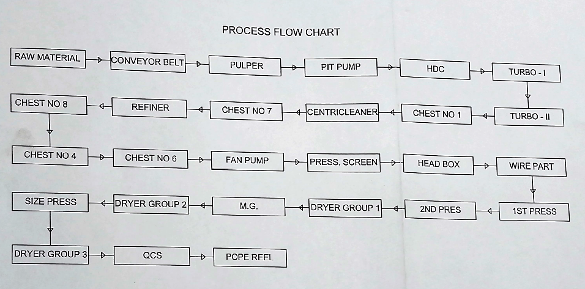

1. **POWER PLANT SECTION**

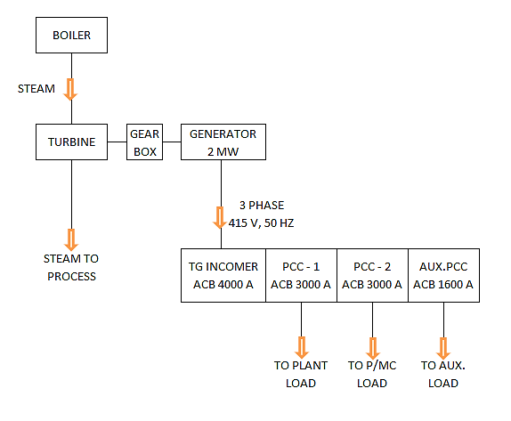

1. **TECHNICAL ASSESSMENT (KRAFT PAPER UNIT):**
2. **TECHNOLOGY USED:**

Company is producing recycled Kraft paper, which is developed from recycled paper and paper products. The fibres of recycled Kraft paper are smaller in size and it has less bright appearance than other Kraft papers.

During the site visit we found that the existing unit of the company is a semi-automatic Kraft paper manufacturing plant with an installed capacity of 45,000 MTPA. Kraft paper machine used by company, mainly consists of three sectional systems namely forming section, press section, drying section, and lastly the calendar section. Kraft Paper machines systems are the drive systems that increase the performance of the machine and delivers improved quality of the paper.

As informed by the client, company is using recycling technology. Recycling can be defined as the conversion of waste paper into useful Kraft Paper. The waste paper is pulped with water and chemicals to remove plastic, staples and glue etc.

1. **MODERN/LATEST TECHNOLOGY:**

The latest technology in Kraft paper machineries is automatic PLC control system. A Programmable logic controller (PLC) is an industrial microprocessor-based controller with programmable memory used to store program instructions and various functions.

This high-end technology has paved the way to an easy manufacturing process in the pulp and paper industry. With the help of automatic PLC system, the machine gains ample speed and faster manufacturing with lesser human efforts. The increased speed reduced the time taken for manufacturing of the products and thus, saves energy and power.

The latest innovations in paper manufacturing are transforming the industry in many ways. They are making paper production more sustainable, efficient, and cost-effective, while also improving the quality and functionality of paper products. These innovations are using advanced technologies such as digital printing, nanotechnology, and smart paper, and are exploring new materials and production methods such as biodegradable paper, lightweight corrugated board, and pulp molding.

Overall, these innovations are helping the paper industry to adapt to changing market demands and consumer preferences, while also addressing environmental concerns and contributing to a more sustainable future.

1. **TECHNOLOGICAL ASSESSMENT:**

As per the above technical analysis, M/s Hardoli Paper Mills Ltd. is using the technology which is a prevailing, going on, recognized and trending in the market at present. Thus, based on the above analysis, it seems to be reasonable to comment that the company will be technologically viable by holding the ownership of the equipment, plant & machinery.

1. **TECHNICAL ASSESSMENT (POWER PLANT SECTION):**
2. **TECHNOLOGY USED AND PERFORMANCE CHARACTERISTIC:**

As per the information provided by the client, the company has installed a steam turbine of 2 MW alongwith the boiler of 40TPH.

The PID turbine works best with steam for around 15-16 tons at an inlet pressure of 32 kg/cm² and temperature of 380°C. In this configuration, steam drives the rotor of the turbine which efficiently converts its kinetic energy into electricity through rotating movement.

During operation, the turbine uses steam then condenses around 4-5 tons of steam. Relaying back this condensed steam is important for minimizing costs associated with heating again and thus maintaining good efficiency in running. The process facilitates production of about 1.6 MWH (megawatt-hours) where the turbine effectively utilizes energy from steam.

Turbine after using up water under specified parameters exhausts roughly nine to ten tons of water vapor at a decreased pressure of 3.5 kg/cm² via its extraction pipe. This extracted steam initially maintains a temperature of about 200°C at which point it undergoes a desuperheating process. Thereafter, it is sent into manufacturing processes that involve making kraft paper at approximately150 degrees Celsius.

1. **LATEST/MODERN TECHNOLOGY:**

A steam turbine is an important component in a combined heat and power plant, converting biomass, RDF/SRF, or waste into electricity and/or steam. As per our tertiary research and the information available on the public domain, there are some advancements in steam turbines in the last few years like Advanced Blade Designs, Supercritical and Ultra-Supercritical Steam Conditions, Combined Heat and Power (CHP) Systems, Improved Efficiency through Reheat and Regenerative Systems, Digitalization and Predictive Maintenance, Advanced Control Systems, etc. These advancements collectively aim to make steam turbines more efficient, reliable, and environmentally sustainable, thus contributing to the transition towards cleaner and more sustainable energy systems.

As per the above technical analysis, the company is using Combined Heat and Power (CHP) technology which is a prevailing, going on and recognized in the market at present. Thus, based on the above analysis, it seems to be reasonable to comment that the company will be technologically viable by holding the ownership of the steam turbine & boiler for the kraft paper manufacturing unit.

1. **TECHNICAL ASSESSMENT OF VIABILITY:**

As per the information provided by the client, the company is consuming ~231 units of electricity to produce per MT of Paper at present and the current electricity rates are around INR 10.00 per unit from public electricity grid which makes the current electricity cost per tonne of paper to be around INR 2310 PMT.

After installation of Turbine, the electricity consumption from government grid would be reduced to 20% of the current usage and 80% of the consumption will be through captive production which will reduce the power cost from government grid.

Although, the turbine will require steam to operate. So, there will be an increase in fuel cost. As per the information shared with us, 80% of the power required will be generated through turbine plant on which there will be savings of Rs. 4 per unit on the units generated through the plant and remaining Rs. 6 per unit will incurred as cost of fuel to operate the turbine. So approximate net savings due to Installation of turbine and boiler for FY25 & FY26 will be as follows: -

|  |  |  |  |
| --- | --- | --- | --- |
| **Particulars** | **FY24** | **FY25** | **FY26** |
| Sales quantity (MT) | 23,117.35 | 31,500.00 | 33,750.00 |
| Gross Power Cost (INR Lakh) | 533.91 | 727.51 | 779.47 |
| Cost per unit | 10.00 | 10.00 | 10.00 |
| **Total Power units Required** | **53,39,066.12** | **72,75,079.27** | **77,94,727.79** |
| % to be generated through co-gen |  | 0.80 | 0.80 |
| Annualized co-gen units |  | 58,20,063.42 | 62,35,782.23 |
| Savings per unit |  | 4.00 | 4.00 |
| **Annualized Savings (INR Lakh)** |  | **232.80** | **249.43** |
| No. of months savings |  | 9.00 | 12.00 |
| **Total Savings (INR Lakh)** |  | **174.60** | **249.43** |
| **Savings per kg sold (INR)** |  | **0.74** | **0.74** |
| **Adjusted Power Cost (INR Lakh)** |  | **552.91** | **530.04** |

Thus, the decision to install a new 2MW Steam Turbine for Inhouse production of electricity for cost saving purpose seems to be an economical decision of the management and it also seems to be technically viable to install Co-generation power plant.

1. **TESTING/QUALITY ASSURANCE:**

Quality is an important ingredient of kraft paper manufacturing process. Utmost emphasis is placed on the quality of the products of the company. Every Kraft Paper Product undergoes stringent quality tests, across various parameters, at different stages of manufacture.

As per the data/information provided to us by the client, all the contemporary machines are equipped for efficient drying and quality control. This ensures the production of high quality Kraft Paper with uniform and superior basis weight and moisture that meet International Quality Standards. Company ensures the quality check of the product based on the criteria such as Strength, Burst, Tear and Moisture, GSM (Grams per Square Meter), Load Bearing Capacity, Surface Finish, Cobb Value, Dimensions etc.

As per communicated by client, company has a quality control Laboratory, wherein, they check the entire range on defined parameters like design, quality and finish. The unit is proposed to be equipped with all the essential tools, machine, and technology in order to ensure the production quality as per the standard benchmark for the project.

1. **MANPOWER:**

As per the data/information shared by the client, currently the company has employed 167 employees including the production staff and administrative & managerial staff. Out of these 167 employees, 68 are on the HPML’s payroll and the other 99 are hired on contractual basis. The details of Manpower is shown in the table below:

|  |  |  |  |  |  |
| --- | --- | --- | --- | --- | --- |
| **S. NO.** | **PARTICULARS** | **SKILLED** | **SEMI SKILLED** | **UNSKILLED** | **TOTAL** |
| **ON MUSTER ROLL**: | | | | | |
| 1 | OFFICE STAFF | 6 | 3 | 0 | 9 |
| 2 | FACTORY STAFF | 2 | 5 | 0 | 7 |
| 3 | TECHNICAL STAFF | 52 | 0 | 0 | 52 |
| **TOTAL** | | **60** | **8** | **0** | **68** |
| **CONTRACTOR LABOUR:** | | | | | |
| 1 | MAHADEO MOTGHARE | 0 | 0 | 22 | 22 |
| 2 | RAMU NEHARE | 0 | 0 | 21 | 21 |
| 3 | VIRENDRA PRASAD YADAV | 0 | 0 | 32 | 32 |
| 4 | OM SAI ENGINEERING | 6 | 0 | 18 | 24 |
| **TOTAL** | | **6** | **0** | **93** | **99** |

|  |  |
| --- | --- |
| **PART G** | **PRODUCT PROFILE** |

1. **INTRODUCTION:**

Kraft paper is primarily used in the corrugated box packaging industry. In India, recycled Kraft paper is among the widely utilized types, and plays a crucial role in manufacturing multi-ply corrugated boxes, with the common ones being 3-ply, 4-ply (litho laminated), 5-ply, and 7-ply boxes. Sometimes even 9 ply and 11 ply boxes are made.

|  |  |  |
| --- | --- | --- |
|  | **Types of Kraft Paper and Their Best Business Uses** | |
| **S. No.** | **Type of Kraft Paper** | **Description** |
|  | Virgin Natural Kraft Paper | * Virgin natural kraft paper is the heavy lifter of the paper world. Its clean and durable fiber content and its low cost make it an ideal option for heavy-duty applications that require a high level of tear resistance. * It is perfect for printing as well, so it's a natural for branded packaging and protective layering, wrapping, pallet interleaving, carrier sheets, and dunnage. * Virgin kraft paper come standard in weights from 30# to 70# |
|  | Natural Recycled Kraft Paper | * Although not as strong and tear resistant as virgin natural kraft, natural recycled kraft paper is a more environmentally friendly option, and still carries enough strength to do an excellent job with dunnage and void fill applications, as liners for trays and boxes, interleavers, and bottom wrap for newspapers. * Recycled kraft paper come standard in weights from 30# to 70# |
|  | Black Kraft Paper | * The most common use of black kraft paper is as a dark, durable backing for pictures frames, but that’s not its only use. |
|  | Colored Kraft Paper | * Colored kraft paper is available in just about every color of the rainbow. Its vibrant hues make it perfect for all manner of craft projects, as well as fun backings for bulletin boards, standard school supplies, scrapbooking, and similar applications. |
|  | White or Bleached Kraft Paper | * Similar to virgin natural kraft in strength and durability, white or bleached kraft paper makes an especially powerful impact when a crisp, clean appearance is desired. * Many restaurants like to use white kraft paper as an attractive and economical alternative to linen tablecloths. * It also serves well for wrapping and can stand up well to the standard wear and tear a package may receive. |
|  | Printed Kraft Paper | * Many different industries take advantage of the versatility and value of custom printed kraft paper for creating branded wrapping, packaging, and in-store displays. * Many fashion manufacturers ship their garments out with printed kraft paper sleeves or sheets between individual articles, or wrapping the inside of a shoebox, again with branded logos and other information prominently displayed. |
|  | Insulating Kraft Paper | * Insulating kraft paper is treated with special additives to improve its electrical insulating properties. It is used in electrical applications to provide insulation and protection. * It is widely used in Electrical Insulation, High Voltage Cables. |
|  | Bituminized Kraft Paper | * Bituminized kraft paper is coated with bitumen, a type of asphalt or tar, on one or both sides. The bitumen coating provides water resistance and enhances its durability. * It is widely used in Roofing Underlayment, Pipe Wrapping |
|  | Medical Grade Kraft Paper | * Medical grade kraft paper is specially manufactured to meet the stringent requirements of the medical and healthcare industries. * Medical grade kraft paper is used in medical packaging for sterilization purposes. It is commonly used in packaging items for autoclaving and ethylene oxide (ETO) sterilization. * It is used in hospitals and healthcare facilities to wrap medical instruments and equipment for sanitation and hygiene. |

***Source:*** *Data/information available in public domain*

The key specifications that determine the quality and usability of Kraft paper are GSM (Grams per Square Meter) and BF (Burst Factor). These parameters influence the paper's strength, weight, thickness, and durability.

1. **PRODUCT CATEGORY:**

GSM is a metric that describes the weight of the paper per square meter. A higher GSM means a heavier and thicker paper, often indicating a higher quality product. For example, a newspaper might have a GSM of around 55, while a business card might be 350 GSM.

The range of GSM values in paper production can vary significantly based on the intended use of the paper. Higher GSM values typically correlate with increased paper thickness and, subsequently, higher strength and stiffness. The type of box (3-ply, 5-ply, or 7-ply) is often associated with specific Board GSM values to ensure the box's durability and resilience.

The Bursting Factor is a key indicator of the strength of Kraft paper. It signifies the pressure the paper can withstand before rupturing, calculated by a standard method. A higher BF means the paper has a higher burst strength, making it suitable for applications requiring superior quality and toughness.

|  |  |  |
| --- | --- | --- |
| **Types of Recycled Kraft Paper Based on GSM and BF** | | |
| **S. No.** | **Grade of Craft Paper** | **Description** |
|  | Low GSM (100-150) and Low BF (14-18) | * This type of Kraft paper is lightweight and relatively less robust due to its lower GSM and BF. It is generally used for making 3-ply boxes, ideal for packaging lightweight items like cosmetics, pharmaceutical products, and small electronic items. |
|  | Medium GSM (180-200) and Medium BF (20-22) | * This category offers a balanced combination of weight and strength. Its medium GSM and BF make it versatile, suitable for creating 3-ply and 5-ply boxes. * These boxes are used to package slightly heavier items like books, toys, and kitchen appliances. At U-Pack we use 180 GSM paper to make our corrugated carton boxes. |
|  | High GSM (230-250) and High BF (24-28) | * High GSM and high BF Kraft paper offer the best strength and durability. It is commonly used to manufacture 5-ply and 7-ply boxes, perfect for shipping heavier items like home appliances, machinery, and automotive parts. |

***Source:*** *Data/information available in public domain*

Company is manufacturing 16 B.F ,18 B.F, and 20 B.F. Kraft paper with GSM ranges from 110-200 in the existing manufacturing unit having the capacity of 45000 MTPA.

* **16 BF,18 BF and 20 BF KRAFT PAPER, GSM: 110 – 200:**

M/s Hardoli Paper Mills Limited is producing 16 B.F ,18 B.F, and 20 B.F Kraft Paper at present in the unit, which is available in various length and thickness as per the client' specifications.

Company’s array of Kraft papers is made with premium grade paper pulp owing to which the products have deluxe fair surface, smoothness and high strength. These Kraft papers are used in varied paper-based applications due to their perfect finishing and high seal-ability. Furthermore, it is also suitable for any type of corrugating box.

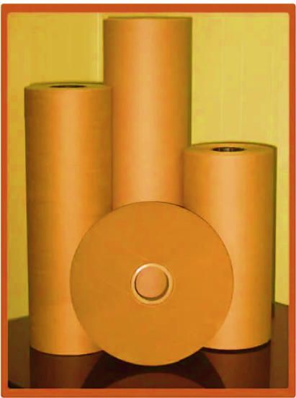

1. **PRICING STRATEGY:**

At present, the company is manufacturing the Kraft Paper in various grammage starting from 110 GSM and varying upto 200 GSM. As per data/information shared by the client, company will be selling its finished (Kraft paper) product through distributors at an average price of Rs 26000 per MT.

As per the current market scenario and as per our tertiary research on the industry trends, we found that the average price per MT ranges from INR 24000 per MT to INR 30,000 Per MT for more than 80 GSM paper depending on the quality and specification of the product.

Thus, the average selling price of 110-200 GSM Kraft Paper has been considered as INR 26000 per MT, which is reasonable and on conservative side and is in the line with industry trends.

References:

1. <https://www.exportersindia.com/product-detail/kraft-paper-rolls-7974395514.htm>
2. <https://www.indiamart.com/proddetail/20-bf-200-gsm-kraft-paper-roll> 2852126635997.html?pos=3&DualProdscaps
3. <https://dir.indiamart.com/nashik/kraft-paper.html>
4. https://www.tradeindia.com/products/brown-kraft-paper-rolls-6372782.html
5. <https://www.tradeindia.com/products/craft-paper-roll-c8413839.html>
6. **MARKETING, SELLING & DISTRIBUTION PLAN:**

The company has been manufacturing Kraft Paper since 1995. As per information provided by the client and discussions with management, HPML's use of its dealer network offers several advantages. HPML has built long-term relationships with dealers which ensures consistent sales and customer retention.

This structure allows HPML to reach diverse markets, even those where they have no direct presence, reducing the need for extensive investment in their own sales infrastructure and cutting costs. By leveraging dealers' local market knowledge and customer research, the company benefits from tailored products and effective marketing strategies. Expanding the dealer network enhances brand visibility and awareness, while localized after-sales support improves customer satisfaction and fosters high levels of client loyalty. This model also facilitates rapid operational scaling without significant internal expansion.

|  |  |
| --- | --- |
| **PART H** | **RAW MATERIAL ANALYSIS** |

1. **INTRODUCTION:**

Kraft paper is the most used material in packaging Industry. It is made by the sulphate pulping process. The product to be manufactured under the envisaged project is high B.F. Kraft paper, which is the most important raw material in the Packaging Industry particularly after the ban on plastic.

In the manufacturing process, colors and chemicals like S.S. Powder, Maize, Starch, Retention-Aids & B.F. Booster etc. are used as per requirement.

The major raw materials used by the company for production of High-quality Kraft Paper is Indigenous and Imported Waste Paper to produce High quality Kraft Paper of required strength. The Waste Paper required is old used Cartons, Boxes, Scrap Paper, etc.

1. **RAW MATERIAL USED:**

As per the information shared by the client, the raw materials to be used in the manufacturing of Kraft Paper by M/s Hardoli Paper Mills Limited includes below mentioned list.

|  |  |  |
| --- | --- | --- |
| **RAW MATERIAL REQUIREMENT TO PRODUCE ONE TON OF KRAFT PAPER** | | |
| **S. No.** | **Particulars** | **Quantity Required PMT** |
| 1 | Waster Paper - Imported | 190 Kgs |
| 2 | Waste Paper - Indigenous | 855 Kgs |
| 3 | Recycled Trim & Waste Paper | 35 Kgs |
| 4 | Chemicals | 450 grams |
| 5 | Starch | 25 Kgs |

As the Nagpur area is well-known for the paper industry and the easy availability of the raw material will be an added advantage for the company. As per our independent research and information available on public domain, the major raw material, i.e., indigenous waste paper has price ranging from Rs. 10500/- to Rs 20000/- per MT. The cost of the indigenous waste paper was also verified by the invoices/quotations shared by the client.

**References:**

1. <https://www.indiamart.com/proddetail/pepar-scrap-27291278673.html?pos=2>
2. <https://www.justdial.com/jdmart/Vadodara/Recyclable-Old-Notebooks-Scrap/pid-2221994896/0265PX265-X265-191220123221-Y1I5?idx=0&jdmid=jdm-1117809-ent-2-17740778&flow=result&searchfrom=b2b_prsltpg>.
3. <https://www.justdial.com/jdmart/Navi-Mumbai/Waste-Paper-Scrap/pid-2220099319/022PXX22-XX22-220811165017-W2Z8?idx=0&jdmid=&flow=result&searchfrom=b2b_prsltpg>
4. <https://www.indiamart.com/proddetail/used-paper-scrap-20196247648.html>
5. <https://www.indiamart.com/proddetail/occ-waste-paper-scrap-2851118039355.html?pos=4>
6. <https://www.indiamart.com/proddetail/paper-scrap-17022567930.html?pos=5>
7. **RAW MATERIAL SUPPLY ANALSIS:**

As per data information provided by the client, the promoters have established a strong network of suppliers, customers through their existing business. This network can be leveraged for sourcing raw materials, securing sales contracts, and establishing strategic partnerships. Their existing relationships in the industry will facilitate smooth operations and market penetration.

The company has long standing relationship with its suppliers thereby ensuring timely supply of key raw materials. As per the data/information shared by the client, the following list shows some of the major suppliers of the raw material of the company.

|  |  |  |  |
| --- | --- | --- | --- |
| **S. No.** | **Supplier Name** | **ADDRESS** | **Description** |
| 1 | JSM Marketing | Ganeshpeth, Nagpur | Waste Paper |
| 2 | Karan Enterprises | Satranjipura Road, Nagpur | Waste Paper |
| 3 | Lakhotiya Traders Pvt Ltd | Dipti Signal, Nagpur | Waste Paper |
| 4 | Maa Tarini Traders | Kendujhar, Odisa | Waste Paper |
| 5 | Maheshwari Agency | Wadhoda, Nagpur | Chemical |
| 6 | Oswal Udhyog | Andheri (W), Mumbai | Chemical |
| 7 | Sanjeevani Gum Udyog | Kapsi, Tah Kamptee, Nagpur | Chemical |
| 8 | Seion Enterprises | Nagpur | Chemical |

|  |  |
| --- | --- |
| **PART I** | **INDUSTRY OVERVIEW** |

1. **INTRODUCTION:**

The Indian Paper Industry accounts for about 4% of the world's production and is positive over the coming years. The growth is expected to be driven by the rising demand for paper products, which is majorly supported by various government education programmes. India’s per capita consumption of paper is just around 14 kg, one of the lowest in the world whereas for USA, it is around 320 kg, European Union -129 kg, Asia 45 kg and 75 kg in China. It is said, an increase of 1 kg in per capita consumption will lead to a demand of 1 million tonnes of paper products.

There are vast demands in the area of tea bags, filer paper, tissue paper, medical-grade coated paper, lightweight online coated paper, etc. This denotes a huge potential. However, the industry is facing challenge to adopt environment friendly technology and to practice conservation measures. Its capacity utilization is also wavering around 80% due to old technology.

From just 17 paper mills in the year 1951 with a capacity of 0.14 million tonnes, the Indian paper industry has grown to 825 mills with a total capacity of 17 million tonnes. While the paper Industry comprises a number of small-scale mills, relatively large mills continue to contribute to a sizable share of total production. Large Paper Mills, about 80 units accounts for production share of about 60% and balance smaller units produce the remaining 40% of paper goods.

1. **MARKET OVERVIEW:**

India’s Paper Industry Sector is set to grow at a 7.81% CAGR over the next five years and will reach 27 million tonne capacity from the current capacity by 2028.

**Printing & Writing (P&W):** Printing and writing segment caters to school books, office stationery, printed textbooks, copier papers, notebooks etc. This segment forms ~31% of domestic paper industry. Governments thrust on education through steps like Sarva Shiksha Abhiyan, Right to Education, increase in e-commerce venture and other service sector are key factors contributing to the growth of this segment.

**Packaging & Paper board:** This segment primarily caters to packaging industry in tertiary and flexible packaging of FMCG goods, pharmaceuticals, textiles and e-commerce deliveries. This segment forms ~47% of the domestic paper industry and is currently rising rapidly due to factors of ecommerce, urbanization and higher share in organized retail in FMCG and pharmaceuticals. This is currently fastest growing segment owing to the above factors. On the packaging segment, corrugated boxes made of Kraft paper segment is highly

Unorganized with nearly 90 percent of the production coming from small and unorganized players. Within Paperboards, there is also a rising demand for Value-Added Paperboards (VAP)

**Newsprint:** Newsprint is used in production of newspaper & magazines industry. India has 84,000 Newspapers in multiple languages and 110 million copies in circulation. Newsprint segment forms ~18% of Indian paper industry. However, this segment is under stress from imports from South East Asia.

The urban population is driving the growth, with 80% of urban populace with read and writing ability, it creates a latent demand for consumption of newspaper/magazines. The regional media in tier-2 and 3 penetration is growing at 10-15%. Another case with India is newspaper have become brand advertorials and purchase guide.

The growing usage of compostable and sustainable packaging materials owing to the increasing awareness regarding the detrimental impact of plastic and other non-biodegradable variants is primarily propelling the growth of the Indian Kraft paper market.

Indian Kraft paper industry is fragmented across India and not even a single mill has more than 1% of market share, mostly all are into the MSME Sector and there are around 600 mills scattered across the country.

Most of these units are located at some of the most backward areas and offer millions of jobs to rag pickers, sorters, loaders, unloaders, truckers, etc. These Kraft paper mills are real eco-friendly turning waste paper into a quality Kraft Paper. It’s the paper waste recyclers who handle the waste and produce good quality packaging paper and supply to the converters who make the boxes for the end consumers.

1. **ENVIROMENTAL CONCERN:**

The availability of paper pulp- the key raw-material has always been a matter of concern for the industry with increasing deforestation and civilization encroachment into pasture lands. The industry has been requesting the government to allot degraded revenue and forest lands to cultivate fodder for wood pulp and social forestry programme for generating feedstock. But nothing major has been done by government.

Another concern from environmentalists are water consumption and waste discharge. The industry which used to consume 200 cu. meter of water has reduced it now to 50 cu. meter and efforts are on to reduce it further to 40 cu. meter. Many paper mills have been forced to shut down on account of water shortage

1. **TECHNOLOGIES AND RELATED ISSUES:**

Large number of industries has been facing issues due to obsolescence of technology used by them for paper making operations. The major problem in upgradation and modernization is due to the high capital requirement for up gradation and scale of operation at which no standard state of the art equipment and machinery are available.

The large number of small and micro level units operating in India face problems in technology up gradation, as most of them are based on decade’s old machinery. Three segments of industry namely-wood, agro and recycled fibre based have different technological levels.

Many of the agro and recycled paper mills still use conventional process technology which is otherwise obsolete by international standards. Some of the wood-based mills and few agro / recycled mills have upgraded the technology from time to time for improvement in the quality of paper, energy efficiency and reduction in the pollution load.

The foremost difference between the Indian paper industry and global leaders lies in the economies of scale. As compared to international capacities, we lag far behind. Scandinavian countries, USA, the Russian Federation, China, Indonesia and Japan are the major players in the field of pulp and paper.

These countries have some of the best available raw materials for paper production, cutting edge technologies and control the global trade. However, only a few mills in India employ the state-of-art technologies. One of the serious implications of technological obsolescence is the environmental impact which can be overcome only through appropriate technology upgradation and modernization.

The technological interventions required to fulfil the technology gaps may be taken up through a dedicated technology modernization programme in the wood and agro based & recycled fibre-based paper mills. Technology modernisation should basically aim to improve the competitiveness of industry through acquisition of state-of-art technologies. This can be achieved through Acquisition of proven technology of foreign or indigenous origin/design and drawing, Acquisition / license of patent rights, Acquisition of capital goods for transfer of process technology, Contractual R&D activities leading to technology upgradation of the units.

1. **CONCLUSION:**

The rising focus of the Indian government authorities on banning the use of plastics is also creating a positive outlook for the Kraft paper market across the country. For instance, in June 2022, the Central Pollution Control Board (CPCB), a federal agency under the Ministry of Environment, issued a list of steps to be taken to prohibit the use of specific single-use plastic products.

Numerous other factors, such as the inflating popularity of Kraft paper in the printing and publication sectors and the introduction of advanced packaging solutions, including stand-up pouches, zipper pouches, etc., are anticipated to stimulate the Indian Kraft paper market over the forecasted period.

The paper Industry holds immense potential for growth in India as the per capita consumption globally is one of the lowest. Around 15 per cent of the world population stays in India but consumes only 5 per cent of the total paper produced in the world.

The technology modernisation & upgradation should lead to emergence of core competencies in critical areas including quantifiable increase in productivity, quality improvement with reduced cost, improvement in energy efficiency norms and better compliance with environmental protection legislations, safeguards for Eco sustainability of products as well as also compliance with legislation relating to patent as per the WTO regime. Issues faced by paper industry such as raw material upgradation, Resource conservation, Product quality, Process improvement, Energy conservation, Environmental compliance, Research & Development.

**Paper industry is bracing for consolidation and now time is ripe for another round of consolidation and co-operation among various players in the next few years. The move will help leverage fast changing manufacturing technologies and smoothen backward integration for raw materials.**

**Despite the continued focus on digitization, India’s demand for paper is expected to rise 53 per cent in the next six years, primarily due to a sustained increase in thrust in rural education, growing ecommerce consumerism, increase in organized modern retailing, increasing use of documentation are expected to positively affect paper consumption and demand in India.**

|  |  |
| --- | --- |
| **PART J** | **SWOT ANALYSIS** |

|  |  |
| --- | --- |
| **SWOT ANALYSIS** | |
| **STRENGTHS** | * **Manufacturing Experience:** Promoters are having several years of experience in the same line of business & industry as company is running an existing unit having 45,000 MTPA capacity. * **Established chain of buyers and sellers:** The company is running the kraft paper manufacturing plant since 1995 and has developed connections with both the buyers of the final product and suppliers of the raw material. * **Cogeneration:** With the installation of Steam Turbine & Boiler, the company will be generating the electricity required in-house and the excess steam will be used in the production process. Therefore, the company will get dual benefits by installing the turbine and it will be able to reduce its dependency on the external sources for the required power to run the plant. |
| **WEAKNESSES** | * **CAPEX:** The CAPEX requirement in the pulp and paper industry is quite high as the majority of the plant and machinery used in the industry are quite expensive. * **Environmental Impact:** Most of the paper manufacturing factories are associated with pollution and causing harm to adjacent areas. * **Depletion of Natural Resources:** The kraft paper industry often involves the consumption of vast quantities of natural resources, including water and energy. * **GSM:** Company is producing low and medium GSM Kraft paper only, thus can lose the opportunity to acquire the high GSM demanding customers. * **Import:** The cost of buying wastepaper from other countries changes regularly, which create an uncertainty about the price of the raw material. |
| **OPPORTUNITIES** | * **Recyclability:** Recycling can be defined as a great boost for the kraft paper industry as it uses the process of conversion of waste paper into useful Kraft Paper. * **E-Commerce:** The increase in e-commerce industry has resulted in high demand for packaging solutions. * **FMCG & Pharmaceuticals Industries:** These industry demand huge amount of Kraft paper to fulfil their day-to-day operations need which can boost higher demand of Kraft paper in India. * **Growing Demand:** Demand for India’s Paper Industry Sector is expected to grow at a CAGR of ~7.81 % in the upcoming years. |
| **THREATS** | * **Increasing Competition:** The number of paper mills is growing and so is the competition between the mills. * **Entry of New Substitutes:** Entry of substitutes like E-Paper, Eco-friendly Plastics and other similar productspose a threat to the kraft paper industry. * **Economic Factors:** Profitability of the project may hamper due to any blockage of feed stock. * **Changing Government Regulations:** New rules and regulations imposed by the Government regarding pollution and the environmental protection pose a constant threat to the industry. * **Water Scarcity for future:** Water is one of the key necessary ingredients to manufacture Kraft Paper. But the scarcity of this natural resource is very critical for the paper industry. |

|  |  |
| --- | --- |
| **PART K** | **STATUTORY APPROVALS | LICENCES | NOC** |

As shown in the below table along with current status, following major approvals are required. However, the list is not exhaustive and State/District Authorities may be approached for further clearances required (if any):

|  |  |  |  |
| --- | --- | --- | --- |
| **S. No.** | **REQUIRED APPROVALS** | **DATE**  **REFERENCE NO.** | **STATUS**  (Approved/ Applied For/ Pending) |
|  | Certificate of Incorporation  *Ministry of Corporate Affairs, Government of India* | 24th Feb 1995  CIN: L21010MH1995PLC085883 | Approved |
|  | GST Registration Certificate | 1st July, 2017 | Approved |
|  | Labour Licence  *Registration & grant of license under Sub section 2 of Section 7 of the Contract Labour Act, 1970, Assistant Commissioner of Nagpur* | 20th June 2015  Registration No. 1652300710007330 | Approved |
|  | Factory Licence  *Directorate of Industrial Safety and Health (Labour Department) in accordance the provision of the Factories Act 1948.* | 11th June 2022  Registration No. 110501710500933 | Approved |
|  | Importer-Exporter Code  *DGFT, Ministry of Commerce and Industry* | Date of Issue: 11th April 1996  Last Modified: 22th June 2023  IEC: **0396001645** | Approved |
|  | Building and Civil Works Plan Sanction Approval  *Concerned local development authority* | - | Pending for Approval |
|  | Fire NOC (on completion)  *Fire Services Department* | - | Pending |
|  | Consent to Establish under Air (Prevention and Control of Pollution) Act, 1981 & Water (Prevention and Control of Pollution) Act, 1974  *Maharashtra Pollution Control Board* | 30th June 2023  MPCB CONSENT-  0000170242/CR/2306002316 | Approved |
|  | No Objection Certificate (NOC) for ground water abstraction  *Ministry Of Jal Shakti, Govt. Of India* | 24th April 2024  Application for Renew of NOC No. 21-4/1092/MH/IND/2017 | Applied For Renewal |
|  | Udyam Registration Certificate (MSME) | 2nd February 2021  UDYAM-MH-20-0021657 | Approved |

***Observation Note:***

1. Renewal of NOC issued to the Project of abstracting ground water by the Ministry of Jal Shakti (Central Ground Water Authority) for the required 192 cubic meter per day of total water requirement is applied as on 24th April 2024 which is yet to be approved by concern authority as per the data/information provided by the company.
2. HPML has modified the original layout plan for the installation of Co-generation Power Plant. The modified layout plan has been prepared by the architect Mr. Pranav Lakhotiya (Reg. CA/2010/47314) which is sent for approval to the concerned authorities as per the information shared with us.
3. Above is the only illustration of the major approvals sought or to be sought by the company. It should not be construed as the exhaustive list and in case any approval is missed to be mentioned then it is the sole responsibility of the company to keep the unit compliant with the necessary statutory approvals/ NOCs.

|  |  |
| --- | --- |
| **PART L** | **COMPANY’S FINANCIAL FEASIBILITY** |

1. **HISTORICAL PERFORMANCE OF THE COMPANY:**

As per the financial statements provided by the company/client, below table shows the historical performance of the company from FY 2018-19 to FY 2023-24.

1. **HISTORICAL PROFIT & LOSS ACCOUNT:**

***(INR Lakhs)***

|  |  |  |  |  |  |  |
| --- | --- | --- | --- | --- | --- | --- |
| **Particulars** | **FY 2019 A** | **FY 2020 A** | **FY 2021 A** | **FY 2022 A** | **FY 2023 A** | **FY 2024 A** |
| Net Revenue | 8,056.48 | 6,987.26 | 8,197.59 | 11,240.22 | 10,523.18 | 5,891.82 |
| Other Income | 10.03 | 10.38 | 11.90 | 13.91 | 10.91 | 9.02 |
| **Total Income** | **8,066.52** | **6,997.64** | **8,209.49** | **11,254.13** | **10,534.09** | **5,900.84** |
| Purchase of Traded Goods | - | 12.35 | - | - | - | - |
| Cost of Material Consumed | 4,881.48 | 4,328.76 | 5,529.20 | 8,669.42 | 8,151.24 | 4,139.30 |
| Changes in Inventories of finished goods and stock-in-progress | -44.56 | 56.87 | -82.48 | -9.88 | 6.23 | 123.56 |
| Employee Benefit Expense | 214.22 | 213.37 | 216.41 | 245.34 | 184.74 | 205.98 |
| Other Expenses | 1,996.11 | 1,905.82 | 1,822.72 | 2,062.79 | 2,422.94 | 1,766.91 |
| **Total Expenses** | **7,047.24** | **6,517.16** | **7,485.85** | **10,967.67** | **10,765.15** | **6,235.75** |
| **EBITDA** | **1,019.27** | **480.48** | **723.64** | **286.46** | **-231.06** | **-334.91** |
| Depreciation | 164.68 | 171.93 | 177.28 | 179.58 | 180.82 | 195.84 |
| **EBIT** | **854.59** | **308.55** | **546.36** | **106.88** | **-411.88** | **-530.75** |
| Finance Cost | 143.77 | 93.56 | 63.72 | 76.03 | 85.88 | 156.45 |
| **Profit before Tax** | **710.83** | **214.99** | **482.64** | **30.85** | **-497.76** | **-687.20** |
| **Tax Expense** |  |  |  |  |  |  |
| Current Tax | 161.60 | 45.15 | 130.81 | 25.84 | - | - |
| Earlier Year Taxes | - | - | 17.00 | - | - | - |
| MAT credit Entitlement | - | 54.41 | - | - | - | - |
| Deferred Tax | -40.71 | 1.51 | -7.90 | -33.24 | -120.45 | -176.09 |
| **Profit After Tax** | **589.93** | **113.92** | **342.73** | **38.25** | **-377.31** | **-511.11** |

1. **HISTORICAL BALANCE SHEET:**

***(INR Lakhs)***

|  |  |  |  |  |  |  |
| --- | --- | --- | --- | --- | --- | --- |
| **Particulars** | **FY 2019 A** | **FY 2020 A** | **FY 2021 A** | **FY 2022 A** | **FY 2023 A** | **FY 2024 A** |
| **Non-Current Assets** |  |  |  |  |  |  |
| Property, Plant & Equipment | 2,344.12 | 2,263.95 | 2,162.30 | 2,079.48 | 1,934.28 | 3,701.79 |
| Capital Work in Progress | 4.85 | 4.02 | 3.13 | 403.81 | 1,464.47 | - |
| Security Deposits | 28.71 | 22.13 | 19.85 | 23.83 | 34.70 | 34.57 |
| Other Non-Current Assets | 56.75 | 63.77 | 116.37 | 232.33 | 160.10 | 192.06 |
| Deferred Tax Assets (Net) | - | - | - | - | - | 135.03 |
| **Total Non-Current Assets** | **2,434.42** | **2,353.88** | **2,301.65** | **2,739.45** | **3,593.55** | **4,063.45** |
| **Current Assets** |  |  |  |  |  |  |
| Inventories | 511.85 | 678.24 | 675.14 | 515.93 | 626.63 | 269.24 |
| Trade Receivables | 899.57 | 948.54 | 1,557.60 | 1,665.55 | 1,158.02 | 811.61 |
| Cash and bank balances | 2.89 | 3.67 | 3.34 | 0.79 | 2.40 | 2.79 |
| Other Financial Assets | 57.69 | 85.43 | 72.81 | 83.63 | 109.50 | 74.08 |
| Other Current Assets | 72.77 | 51.07 | 41.59 | 62.56 | 100.37 | 76.13 |
| Current Tax Assets (Net) | 5.73 | 5.85 | 6.73 | 23.23 | 0.28 | 4.89 |
| **Total Current Assets** | **1,550.50** | **1,772.80** | **2,357.21** | **2,351.69** | **1,997.20** | **1,238.74** |
| **Total Assets** | **3,984.92** | **4,126.68** | **4,658.86** | **5,091.14** | **5,590.75** | **5,302.20** |
| **Shareholders' Funds** |  |  |  |  |  |  |
| Share Capital | 269.23 | 269.23 | 269.23 | 269.23 | 269.23 | 269.23 |
| Reserve and Surplus | 1,947.63 | 2,059.69 | 2,413.72 | 2,463.01 | 2,090.25 | 1,593.65 |
| **Total Equity** | **2,216.86** | **2,328.92** | **2,682.95** | **2,732.24** | **2,359.48** | **1,862.88** |
| **Non-Current Liabilities** |  |  |  |  |  |  |
| Long-term Borrowings | 311.06 | 263.43 | 319.86 | 430.66 | 1,145.89 | 1,122.03 |
| Provisions | 16.62 | 21.83 | 15.44 | 9.75 | 8.39 | 4.96 |
| Deferred Tax Liabilities (net) | 130.24 | 184.57 | 194.75 | 161.51 | 41.06 | - |
| **Total Non-Current Liabilities** | **457.92** | **469.83** | **530.05** | **601.92** | **1,195.34** | **1,126.99** |
| **Current Liabilities** |  |  |  |  |  |  |
| Short-term Borrowings | 556.76 | 618.44 | 435.76 | 568.42 | 1,012.75 | 1,149.46 |
| Trade Payable | 496.57 | 590.45 | 796.28 | 873.56 | 915.98 | 1,094.95 |
| Other Financial Liabilities | 206.00 | 82.41 | 111.41 | 215.19 | 63.98 | 25.77 |
| Other Current Liabilities | 5.39 | 5.38 | 66.86 | 65.68 | 23.13 | 25.43 |
| Short-term Provision | 45.43 | 31.25 | 35.56 | 34.11 | 20.10 | 16.72 |
| **Total Current Liabilities** | **1,310.14** | **1,327.93** | **1,445.87** | **1,756.96** | **2,035.94** | **2,312.33** |
| **Total Equity and Liabilities** | **3,984.92** | **4,126.68** | **4,658.86** | **5,091.14** | **5,590.75** | **5,302.20** |

1. **KEY FINANCIAL RATIO:**

|  |  |  |  |  |  |  |
| --- | --- | --- | --- | --- | --- | --- |
| **YEAR** | **FY 2019 A** | **FY 2020 A** | **FY 2021 A** | **FY 2022 A** | **FY 2023 A** | **FY 2024 A** |
| **EBITDA Margin %** | 12.64% | 6.87% | 8.81% | 2.55% | -2.19% | -5.68% |
| **Average** | ***3.83%*** | | | | | |
| **EBIT Margin %** | 10.59% | 4.41% | 6.66% | 0.95% | -3.91% | -8.99% |
| **Average** | ***1.62%*** | | | | | |
| **PAT Margin %** | 7.31% | 1.63% | 4.17% | 0.34% | -3.58% | -8.66% |
| **Average** | ***0.20%*** | | | | | |

**Note:** As per the historical analysis, it is observed that all the margins of the company are showing a downward trend on account of limited value addition given the highly competitive nature of industry.

1. **GRAPHICAL REPRESENTATION OF KEY RATIOS:**

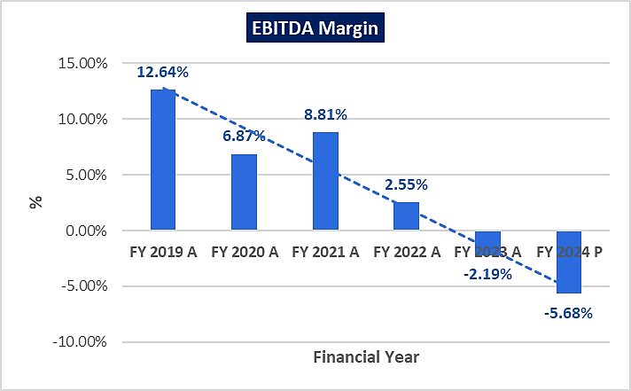

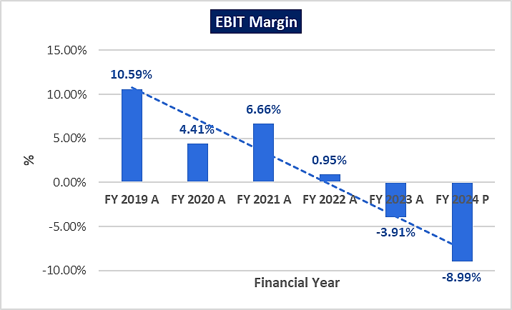

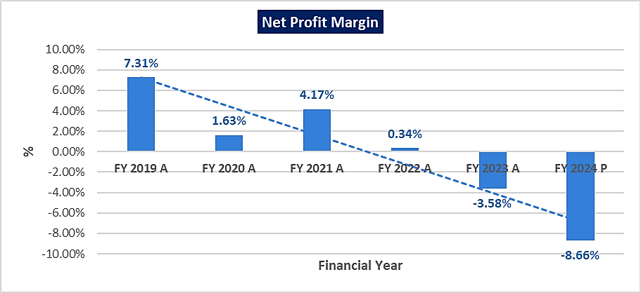

1. **PROJECTIONS OF THE FIRM:**

The financial projections of the project are prepared from FY 2024-25 to FY 2030-31 based on the restructuring plan to assess the financial feasibility of the project are elaborated below:

1. **PROJECTED PROFIT & LOSS ACCOUNT:**

***(INR Lakhs)***

|  |  |  |  |  |  |  |  |
| --- | --- | --- | --- | --- | --- | --- | --- |
| **PARTICULARS** | **2024-25** | **2025-26** | **2026-27** | **2027-28** | **2028-29** | **2029-30** | **2030-31** |
| Installed Capacity Mt | 45,000 | 45,000 | 45,000 | 45,000 | 45,000 | 45,000 | 45,000 |
| Capacity Utilisation% | 70% | 75% | 80% | 82% | 85% | 87% | 87% |
| Production in M.T. | 31,500 | 33,750 | 36,000 | 36,900 | 38,250 | 39,150 | 39,150 |
| Sales in M.T. | 31,500 | 33,750 | 36,000 | 36,900 | 38,250 | 39,150 | 39,150 |
| **Net Sales** | **8,347.50** | **8,943.75** | **9,540.00** | **9,778.50** | **10,136.25** | **10,374.75** | **10,374.75** |
| **Cost of Sales:** |  |  |  |  |  |  |  |
| Raw Materials | 5,676.30 | 6,081.75 | 6,487.20 | 6,649.38 | 6,892.65 | 7,054.83 | 7,054.83 |
| Other Spares | 83.48 | 89.44 | 95.40 | 97.79 | 101.36 | 103.75 | 103.75 |
| Power & Fuel |  |  |  |  |  |  |  |
| - Power | 552.91 | 530.04 | 565.38 | 579.51 | 600.71 | 614.85 | 614.85 |
| - Fuel | 960.75 | 1,029.38 | 1,098.00 | 1,125.45 | 1,166.63 | 1,194.08 | 1,194.08 |
| Direct Labour | 216.28 | 227.09 | 238.45 | 250.37 | 262.89 | 276.03 | 289.83 |
| Other Manufacturing Expenses | 250.43 | 268.31 | 286.20 | 293.36 | 304.09 | 311.24 | 311.24 |
| Repair and Maintenance | 84.08 | 85.76 | 87.47 | 89.22 | 91.01 | 92.83 | 94.68 |
| Depreciation | 301.51 | 303.36 | 301.71 | 299.92 | 297.50 | 297.50 | 297.50 |
| **Cost Of Production** | **8,125.73** | **8,615.13** | **9,159.80** | **9,384.99** | **9,716.84** | **9,945.11** | **9,960.77** |
| Add: Opening Finished Goods | 41.09 | 136.11 | 145.85 | 155.09 | 159.00 | 164.60 | 168.50 |
| **Subtotal** | **8,166.82** | **8,751.25** | **9,305.66** | **9,540.09** | **9,875.84** | **10,109.70** | **10,129.26** |
| Less: Closing Finished Goods | 136.11 | 145.85 | 155.09 | 159.00 | 164.60 | 168.50 | 168.82 |
| **Total Cost of Sales** | **8,030.70** | **8,605.39** | **9,150.56** | **9,381.09** | **9,711.24** | **9,941.21** | **9,960.44** |
| Selling & Distribution Exp. | 114.92 | 123.13 | 131.34 | 134.62 | 139.54 | 142.83 | 142.83 |
| **Sub Total** | **8,145.62** | **8,728.52** | **9,281.90** | **9,515.70** | **9,850.79** | **10,084.04** | **10,103.27** |
| **Operating Profit before interest** | **201.88** | **215.23** | **258.10** | **262.80** | **285.46** | **290.71** | **271.48** |
| (a) Interest on T/L | 123.15 | 136.36 | 119.92 | 102.08 | 79.62 | 51.45 | 17.66 |
| (b) Interest on W/C | 57.00 | 57.00 | 57.00 | 57.00 | 57.00 | 57.00 | 57.00 |
| **Profit Before Tax** | **21.73** | **21.87** | **81.18** | **103.71** | **148.85** | **182.26** | **196.82** |
| Provision for Taxes | - | 4.55 | 29.71 | 44.06 | 62.66 | 77.81 | 87.27 |
| **Net Profit** | **21.73** | **17.32** | **51.47** | **59.65** | **86.19** | **104.46** | **109.55** |

1. **PROJECTED BALANCE SHEET:**

Below table shows the Projected Balance Sheet of the project from FY 2024-25 to FY 2030-31 based on the restructuring plan to assess the financial feasibility of the project are elaborated below:

***(INR Lakhs)***

|  |  |  |  |  |  |  |  |
| --- | --- | --- | --- | --- | --- | --- | --- |
| **PARTICULARS** | **2024-25** | **2025-26** | **2026-27** | **2027-28** | **2028-29** | **2029-30** | **2030-31** |
| **Non-Current Assets** |  |  |  |  |  |  |  |
| Property, Plant & Equipment (Gross) | 3,500.28 | 3,196.91 | 2,895.21 | 2,595.29 | 2,297.79 | 2,000.28 | 1,702.78 |
| Security Deposit | 34.57 | 34.57 | 34.57 | 34.57 | 34.57 | 34.57 | 34.57 |
| Other Non-Current Assets | 192.06 | 192.06 | 192.06 | 192.06 | 192.06 | 192.06 | 192.06 |
| Deferred Tax Assets (Net) | 135.03 | 135.03 | 135.03 | 135.03 | 135.03 | 135.03 | 135.03 |
| **Total Non-Current Assets** | **3,861.94** | **3,558.57** | **3,256.87** | **2,956.95** | **2,659.45** | **2,361.94** | **2,064.44** |
| **Current Assets** |  |  |  |  |  |  |  |
| Inventories | 639.90 | 685.69 | 729.13 | 747.50 | 773.81 | 792.13 | 793.67 |
| Trade Receivables | 1,222.87 | 1,310.22 | 1,397.57 | 1,432.50 | 1,484.91 | 1,519.85 | 1,519.85 |
| Cash and bank balances | 19.18 | 82.09 | 140.48 | 229.49 | 304.71 | 374.56 | 398.17 |
| Other Financial Assets | 74.08 | 74.08 | 74.08 | 74.08 | 74.08 | 74.08 | 74.08 |
| Other Current Assets | 76.13 | 76.13 | 76.13 | 76.13 | 76.13 | 76.13 | 76.13 |
| **Total Current Assets** | **2,032.16** | **2,228.21** | **2,417.39** | **2,559.71** | **2,713.65** | **2,836.76** | **2,861.90** |
| **Total Assets** | **5,894.10** | **5,786.80** | **5,674.26** | **5,516.65** | **5,373.10** | **5,198.70** | **4,926.35** |
| **Shareholders' Funds** |  |  |  |  |  |  |  |
| Share Capital | 269.23 | 269.23 | 269.23 | 269.23 | 269.23 | 269.23 | 269.23 |
| Reserve and Surplus | 1,615.38 | 1,632.70 | 1,684.17 | 1,743.81 | 1,830.00 | 1,934.46 | 2,044.01 |
| **Total Equities** | **1,884.61** | **1,901.93** | **1,953.40** | **2,013.04** | **2,099.23** | **2,203.69** | **2,313.24** |
| **Non-Current Liabilities** |  |  |  |  |  |  |  |
| Long-term Borrowings | 1,475.94 | 1,229.80 | 977.81 | 698.31 | 384.81 | - | - |
| Unsecured Loans | 448.42 | 448.42 | 448.42 | 448.42 | 448.42 | 448.42 | 448.42 |
| Provisions | 4.96 | 4.96 | 4.96 | 4.96 | 4.96 | 4.96 | 4.96 |
| **Total Non-Current Liabilities** | **1,929.32** | **1,683.18** | **1,431.19** | **1,151.69** | **838.19** | **453.38** | **453.38** |
| **Current Liabilities** |  |  |  |  |  |  |  |
| Working Capital Limit | 600.00 | 600.00 | 600.00 | 600.00 | 600.00 | 600.00 | 600.00 |
| Short term Maturity of Long-Term Loan | 211.23 | 246.14 | 251.99 | 279.50 | 313.50 | 384.81 | - |
| Trade Payable | 1,210.11 | 1,296.70 | 1,378.85 | 1,413.59 | 1,463.34 | 1,497.99 | 1,500.89 |
| Other Current Liabilities | 16.69 | 16.69 | 16.69 | 16.69 | 16.69 | 16.69 | 16.69 |
| Other Financial Liabilities | 25.43 | 25.43 | 25.43 | 25.43 | 25.43 | 25.43 | 25.43 |
| Short-term Provision | 16.72 | 16.72 | 16.72 | 16.72 | 16.72 | 16.72 | 16.72 |
| **Total Current Liabilities** | **2,080.18** | **2,201.68** | **2,289.68** | **2,351.93** | **2,435.68** | **2,541.64** | **2,159.73** |
| **Total Equity and Liabilities** | **5,894.10** | **5,786.80** | **5,674.26** | **5,516.65** | **5,373.10** | **5,198.70** | **4,926.35** |

1. **PROJECTED CASH FLOW STATEMENT:**

***(INR Lakhs)***

|  |  |  |  |  |  |  |  |
| --- | --- | --- | --- | --- | --- | --- | --- |
| **PARTICULARS** | **2024-25** | **2025-26** | **2026-27** | **2027-28** | **2028-29** | **2029-30** | **2030-31** |
| **A. SOURCES OF FUNDS:** |  |  |  |  |  |  |  |
| Change in Share Capital | - | - | - | - | - | - | - |
| Increase in Working Capital Limit | - | - | - | - | - | - | - |
| Cash Accruals | 323.24 | 320.69 | 353.17 | 359.57 | 383.69 | 401.96 | 407.06 |
| Increase In Secured Loan | 785.47 | - | - | - | - | - | - |
| Decrease in Current Assets | - | - | - | - | - | - | - |
| Increase in Current Liabilities | 106.08 | 86.60 | 82.15 | 34.74 | 49.75 | 34.65 | 2.90 |
| Decrease in Non-Current Assets | - | - | - | - | - | - | - |
| **TOTAL** | **1214.79** | **407.28** | **435.32** | **394.30** | **433.44** | **436.61** | **409.95** |
| **B. APPLICATION OF FUNDS:** |  |  |  |  |  |  |  |
| Acquisition of Fixed Assets | 100.00 | - | - | - | - | - | - |
| Decrease in Working Capital | 296.44 | - | - | - | - | - | - |
| Decrease in Secured Loan | 24.93 | 211.23 | 246.14 | 251.99 | 279.50 | 313.50 | 384.81 |
| Decrease in Current Liabilities | - | - | - | - | - | - | - |
| Increase in Current Assets | 777.03 | 133.14 | 130.79 | 53.31 | 78.72 | 53.26 | 1.53 |
| Increase in Non-Current Assets | - | - | - | - | - | - | - |
| **TOTAL** | **1198.40** | **344.37** | **376.93** | **305.30** | **358.22** | **366.76** | **386.35** |
| **C. SURPLUS** |  |  |  |  |  |  |  |
| Opening Balance | 2.79 | 19.18 | 82.09 | 140.48 | 229.49 | 304.71 | 374.56 |
| Surplus (A-B) | 16.39 | 62.91 | 58.39 | 89.00 | 75.23 | 69.85 | 23.61 |
| **Closing Balance** | **19.18** | **82.09** | **140.48** | **229.49** | **304.71** | **374.56** | **398.17** |

1. **KEY FINANCIAL RATIO:**

|  |  |  |  |  |  |  |  |
| --- | --- | --- | --- | --- | --- | --- | --- |
| **YEAR** | **FY 2025** | **FY 2026** | **FY 2027** | **FY 2028** | **FY 2029** | **FY 2030** | **FY 2031** |
| **EBITDA Margin %** | 6.03% | 5.80% | 5.87% | 5.75% | 5.75% | 5.67% | 5.48% |
| **Average** | ***5.77%*** | | | | | | |
| **EBIT Margin %** | 2.42% | 2.41% | 2.71% | 2.69% | 2.82% | 2.80% | 2.62% |
| **Average** | ***2.64%*** | | | | | | |
| **PAT Margin %** | 0.26% | 0.19% | 0.54% | 0.61% | 0.85% | 1.01% | 1.06% |
| **Average** | ***0.65%*** | | | | | | |

1. **GRAPHICAL REPRESENTATION OF KEY RATIOS:**

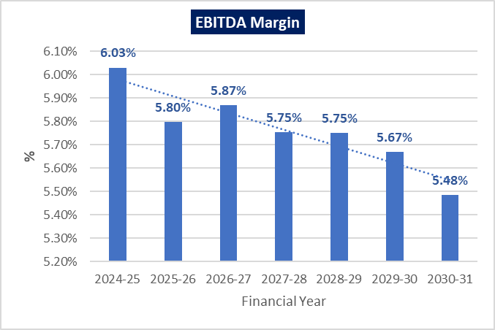

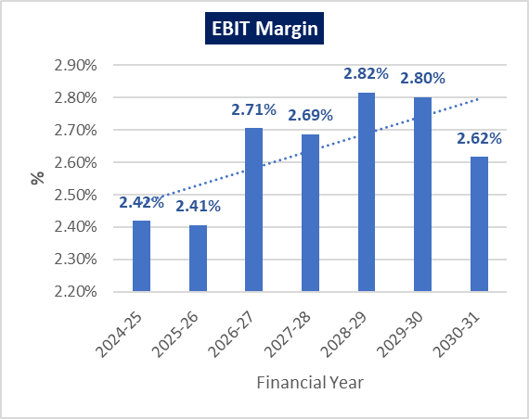

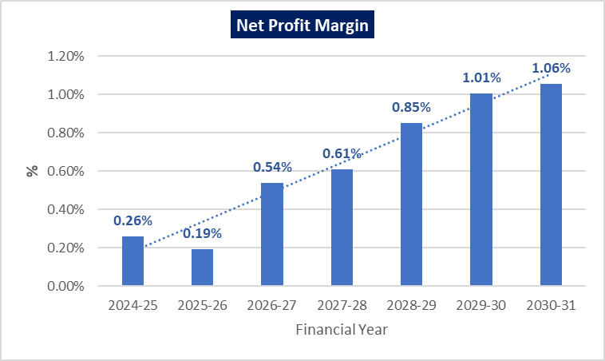

1. **ESTIMATED DEBT SERVICE COVERAGE RATIO (DSCR):**

|  |  |  |  |  |  |  |  |
| --- | --- | --- | --- | --- | --- | --- | --- |
| **Particular** | **2024-25** | **2025-26** | **2026-27** | **2027-28** | **2028-29** | **2029-30** | **2030-31** |
| Cash Accruals | 323.24 | 320.69 | 353.17 | 359.57 | 383.69 | 401.96 | 407.06 |
| Interest on term loan | 123.15 | 136.36 | 119.92 | 102.08 | 79.62 | 51.45 | 17.66 |
| Interest on CC | 57.00 | 57.00 | 57.00 | 57.00 | 57.00 | 57.00 | 57.00 |
| **Subtotal** | **503.39** | **514.04** | **530.10** | **518.65** | **520.31** | **510.41** | **481.72** |
| Loan Repayment | 24.93 | 211.23 | 246.14 | 251.99 | 279.50 | 313.50 | 384.81 |
| Interest on term loan | 123.15 | 136.36 | 119.92 | 102.08 | 79.62 | 51.45 | 17.66 |
| Interest on CC | 57.00 | 57.00 | 57.00 | 57.00 | 57.00 | 57.00 | 57.00 |
| **Subtotal** | **205.08** | **404.59** | **423.07** | **411.07** | **416.12** | **421.95** | **459.48** |
| **DSCR** | 2.45 | 1.27 | 1.25 | 1.26 | 1.25 | 1.21 | 1.05 |
| **Average D.S.C.R.** | **1.31** | | | | | | |
| **Max. D.S.C.R.** | **2.45** | | | | | | |

1. **SENSITIVITY ANALYSIS OF D.S.C.R:**

The proposed restructuring plan is found comparatively more sensitive with respect to the revenue, than with the cost of raw material. Sensitivity analysis of the project with respect to various factors i.e revenue, cost of raw material, etc has been shown in the below table:

|  |  |  |  |
| --- | --- | --- | --- |
| **Sensitivity Analysis of D.S.C.R.** | | | |
| **S. No.** | **Particular** | **Average D.S.C.R.** | **Max. D.S.C.R.** |
|  | If the projected revenue decreased by 2% | 0.92 | 1.64 |
|  | If the projected Cost of raw material increased by 2% | 1.07 | 1.90 |
|  | If the projected revenue decreased by 5% | 0.19 | 0.42 |
|  | If projected cost of raw material is increased by 10%. | -0.26 | -0.21 |
|  | If projected cost of raw material is increased by 5% | 0.58 | 1.07 |
|  | If no interest concession is extended. | 1.27 | 2.30 |
|  | If no moratorium is extended for next 1 year. | 1.40 | 1.82 |
|  | If profitability declines by 5%. | 1.31 | 2.45 |

1. **NPV OF THE PROJECT:**

***(INR Lakhs)***

|  |  |  |  |  |  |  |  |
| --- | --- | --- | --- | --- | --- | --- | --- |
| **Free Cash Flow for the Project** | | | | | | | |
| **Particulars** | **2024-25** | **2025-26** | **2026-27** | **2027-28** | **2028-29** | **2029-30** | **2030-31** |
| EBIT | 201.88 | 215.23 | 258.10 | 262.80 | 285.46 | 290.71 | 271.48 |
| Less: Taxes | -50.81 | -54.17 | -64.96 | -66.15 | -71.85 | -73.17 | -68.33 |
| **NOPAT** | **151.06** | **161.06** | **193.14** | **196.65** | **213.61** | **217.54** | **203.15** |
| Add: Depreciation & Amortisation | 301.51 | 303.36 | 301.71 | 299.92 | 297.50 | 297.50 | 297.50 |
| +/- WCC | -670.96 | -46.54 | -48.64 | -18.57 | -28.97 | -18.61 | 1.37 |
| Capex | -100.00 | 0.00 | 0.00 | 0.00 | 0.00 | 0.00 | 0.00 |
| **Free Cash Flow to Firm (FCFF)** | **-318.38** | **417.88** | **446.20** | **478.00** | **482.15** | **496.43** | **502.02** |
| **Discount Rate** | **15.16%** | | | | | | |
| **Expected Terminal Growth Rate** | **1.00%** | | | | | | |
| **Terminal Value** | - | - | - | - | - | - | 3580.79 |
| **FCFF + TV** | **-318.38** | **417.88** | **446.20** | **478.00** | **482.15** | **496.43** | **4082.81** |

|  |  |  |
| --- | --- | --- |
| **Key Input for NPV & IRR** | | |
| **S. No.** | **Key Input** | **Description** |
|  | Nifty 50 Returns (CAGR) in the Last 20 Years | 14.16% *(*https://kunaldesai.blog/nifty-returns/*)* |
|  | Company Risk Premium | 1.00% |
|  | Discount Rate | 15.16% |
|  | Perpetual Growth Rate | 1.00% |
| **NPV** | | **INR 2,573.48 Lakhs** |

1. **OTHER FINANCIAL RATIOS:**

|  |  |  |  |  |  |  |  |
| --- | --- | --- | --- | --- | --- | --- | --- |
| **Particulars** | **2024-25** | **2025-26** | **2026-27** | **2027-28** | **2028-29** | **2029-30** | **2030-31** |
| Current Ratio | 0.98 | 1.01 | 1.06 | 1.09 | 1.11 | 1.12 | 1.33 |
| DER | 1.13 | 1.01 | 0.86 | 0.71 | 0.55 | 0.38 | 0.19 |
| TOL/ATNW | 2.13 | 2.04 | 1.90 | 1.74 | 1.56 | 1.36 | 1.13 |
| ROE | 1.15% | 0.91% | 2.63% | 2.96% | 4.11% | 4.74% | 4.74% |
| ICR | 2.79 | 2.66 | 3.00 | 3.26 | 3.81 | 4.71 | 6.45 |

1. **BREAK-EVEN ANALYSIS:**

***(INR Lakhs)***

|  |  |  |  |  |  |  |  |
| --- | --- | --- | --- | --- | --- | --- | --- |
| **Particulars** | **2024-25** | **2025-26** | **2026-27** | **2027-28** | **2028-29** | **2029-30** | **2030-31** |
| Sales | 8347.50 | 8943.75 | 9540.00 | 9778.50 | 10136.25 | 10374.75 | 10374.75 |
| Variable Expenses | 7684.91 | 8259.63 | 8828.46 | 9066.48 | 9410.05 | 9645.31 | 9660.19 |
| Contribution | 662.59 | 684.12 | 711.54 | 712.02 | 726.20 | 729.44 | 714.56 |
| Fixed Expenses | 640.94 | 666.81 | 660.08 | 652.37 | 640.01 | 624.99 | 605.00 |
| **BEP%** | **96.72%** | **97.47%** | **92.77%** | **91.62%** | **88.13%** | **85.68%** | **84.67%** |
| **CASH BEP%** | **51.23%** | **53.13%** | **50.37%** | **49.50%** | **47.16%** | **44.89%** | **43.03%** |

1. **TERM LOAN INPUTS:**

***(INR Lakhs)***

|  |  |  |  |  |
| --- | --- | --- | --- | --- |
| **Nature of Facility** | **Existing** | | **Proposed** | |
| **Loan Amout** | **Interest Rate (%)** | **Loan Amout** | **Interest Rate (%)** |
| TL 1 | 461.99 | 10.25 | 461.99 | 9.50 |
| TL2 | 111.60 | 10.25 | 111.60 | 9.50 |
| GECL 1 | 0.69 | 9.25 | 0.69 | 9.25 |
| GECL 2 | 62.63 | 9.25 | 62.63 | 9.25 |
| Corporate Loan | 289.72 | 10.25 | 299.72 | 9.50 |
| New Term Loan | - | - | 600.00 | 9.50 |
| FITL | - | - | 175.47 | - |
| **Total** | **926.63** |  | **1712.10** |  |
| CC limit | 896.44 | 10.25 | 600.00 | 9.50 |

|  |  |
| --- | --- |
| **Term Loan Repayment Inputs** | |
| **Disbursement** | 1. **New Term loan of Rs.600.00 Lakhs should be disbursed in 2nd quarter of 2024-25** 2. **Addition Corporate loan of Rs.10.00 Lakhs disbursed in 1st quarter of FY 2024-25** 3. **\*FITL of Rs 175.47 Lakhs will be disbursed in the 4th Quarter of 2024-25** |
| **Moratorium Start & End Month (except for GECL loan)** | **April 2024 to March 2025 (Term loan, corporate loan and CC limit)** |
| **Repayment Start** | **April 2025** |
| **Repayment End** | **March 2031** |
| **Repayment Period** | **6 years** |

*Interest on term loan, corporate loan and CC limited during the moratorium period will be converted in a new FITL loan at the end of 2024-25 and will be repaid in next 3 years

***(In Lakhs)***

|  |  |  |  |  |  |  |  |
| --- | --- | --- | --- | --- | --- | --- | --- |
| **Financial Year (FY)** | **2024-25** | **2025-26** | **2026-27** | **2027-28** | **2028-29** | **2029-30** | **2030-31** |
| Opening Balance | 926.63 | 1,687.18 | 1,475.94 | 1,229.80 | 977.81 | 698.31 | 384.81 |
| Disbursement | 785.47 | - | - | - | - | - | - |
| Repayment of Principal | 24.93 | 211.23 | 246.14 | 251.99 | 279.50 | 313.50 | 384.81 |
| Closing balance | 1,687.18 | 1,475.94 | 1,229.80 | 977.81 | 698.31 | 384.81 | - |
| Interest | 123.15 | 136.36 | 119.92 | 102.08 | 79.62 | 51.45 | 17.66 |
| CC Interest | 57.00 | 57.00 | 57.00 | 57.00 | 57.00 | 57.00 | 57.00 |

1. **DEPRECIATION SCHEDULE (STRAIGHT LINE METHOD):**

**(INR Lakhs)**

|  |  |  |  |  |  |  |  |
| --- | --- | --- | --- | --- | --- | --- | --- |
| **Particulars** | **2024-25** | **2025-26** | **2026-27** | **2027-28** | **2028-29** | **2029-30** | **2030-31** |
| Depreciation - Building | 23.14 | 23.14 | 23.14 | 23.14 | 23.14 | 23.14 | 23.14 |
| Depreciation - P&M | 222.74 | 224.30 | 224.30 | 224.30 | 224.30 | 224.30 | 224.30 |
| Depreciation – Furniture & Fixtures | 0.70 | 0.70 | 0.70 | 0.70 | 0.70 | 0.70 | 0.70 |
| Depreciation – Office Equipment | 1.22 | 1.51 | 0.00 | 0.00 | 0.00 | 0.00 | 0.00 |
| Depreciation - Computer | 0.66 | 0.66 | 0.51 | 0.00 | 0.00 | 0.00 | 0.00 |
| Depreciation - Vehicle | 3.69 | 3.69 | 3.69 | 2.41 | 0.00 | 0.00 | 0.00 |
| Depreciation -Electrical Installations | 49.36 | 49.36 | 49.36 | 49.36 | 49.36 | 49.36 | 49.36 |
| **Total SLM Depreciation** | **301.51** | **303.36** | **301.7** | **299.91** | **297.5** | **297.5** | **297.5** |

1. **KEY ASSUMPTIONS & BASIS:**

|  |  |  |
| --- | --- | --- |
| **S. No.** | **Item** | **Assumptions and Basis** |
|  | **General** | * 1. The projections of the firm are done for the period from FY 2024-25 to FY 2030-31, 7 years, to cover the proposed restructured term loan period.   2. We have considered both Revenue & cost-based model (top to bottom approach) while making the future financial projections.   3. Revenue modelling and Expense modelling has been done based on the capacity utilization during the respective year. |
|  | **Revenue Build up** | * 1. The plant is assumed to be operational annually. Total income for the respective financial years during the forecasted period will be generating from selling of different category of Kraft papers.   2. To calculate the operating revenue at 70% capacity utilization, Sales price has been considered as INR 26500 per MT based on the data/information provided by the client and based on our tertiary research and information available in the public domain.   3. Sales Value of the production has been calculated by multiplying the average price to the total production at the respective year capacity.   4. Thus, the company is generating INR 83.47 Crore in the first year of projections, i.e., FY 2024-25, further it has increased up to INR 103.74 Crore till FY 2030-31. |
|  | **Pricing (Average Price Per Unit)** | * 1. As per data/information shared by the client, company will be selling its finished (Kraft paper) product through distributors at a pre decided price of INR 26000 for FY 2024-25 per MT.   2. Also, as per secondary and tertiary research, industry trend and pricing offered by other companies and vendors in this line and data/information available in public domain, we found that the price per MT ranges from INR 24000 to 30000 Per MT for more than 80 GSM paper depending on the quality and specification of the product.   (Ref: <https://www.exportersindia.com/product-detail/kraft-paper-rolls-7974395514.htm>;  <https://www.indiamart.com/proddetail/20-bf-200-gsm-kraft-paper-roll>*)*   * 1. Thus, justifiably average price has been considered as INR 26500 per MT, which is reasonable and on conservative side and is in the line with industry trends. |
|  | **Capacity Utilization** | * 1. For Kraft Paper Manufacturing facility company having 45000 TPA installed capacity.   2. We have considered the capacity utilisation at 70% in the first year of projections, i.e., FY 2024-25. The capacity utilization rates considered during the projected period is shown in the table below:  |  |  | | --- | --- | | **Year** | **Capacity Utilization Rate** | | 2024-25 | 70% | | 2025-26 | 75% | | 2026-27 | 80% | | 2027-28 | 82% | | 2028-29 | 85% | | 2029-30 | 87% | | 2030-31 | 87% |  * 1. Thus, to start the capacity utilization from 70% is in the line with industry and it is reasonable and on conservative side to keep a mark-up for future market & economic risks in the Project.   2. As per the Kraft paper manufacturing sectoral trends, it is assumed that the project will be achieving the capacity utilization of 87% in the 6th year of the forecasted period. |
|  | **Expenses** | * 1. Major expenses include raw material, power and fuel, salaries and wages, Repair and maintenance, SG&A, etc.   2. Based on the historical financial data, raw material expenses are averagely 69% of revenue of last 6 years from FY 2019 to 2024. However, from FY 2019-2021 the average raw material expenses were averagely 63.33%. From 2022-2023 it shot up higher to 77% which is because of increase in raw material prices but in preceding year 2024, the cost reduced to 70% of the revenue.   Therefore, based on the above facts and the data and explanation provided by the company, in our assumptions, for calculating expense for future years, it is assumed at 68% of the revenue at a normalised rate.   * 1. As per the information provided by the client, the company is consuming ~231 units of electricity to produce per MT of Paper at present and the current electricity rates are around INR 10.00 per unit from public electricity grid which makes the current electricity cost per tonne of paper to be around INR 2310 PMT. HPML has reduced its sanctioned load to 500 KVA from 2000 KVA was already after the installation of co-generation plant.   After installation of Turbine, the electricity consumption from government grid is assumed to be reduced to 20% of the current usage and 80% of the consumption will be through captive production which will reduce the power cost from government grid.  To run the cogeneration power plant, there will be an increase in fuel cost. It is assumed that the 60% of the savings will be incurred towards the cost of running the power plant and the plant will save approx. INR 4 per unit on the electricity utilised from the power plant. *(For detailed working of net savings and power cost, kindly refer to the section “Project Technical Details” in the report above)*.   * 1. Direct labour (Employee Benefit Expenses) is considered at an annual escalation rate of 5% to the previous years’ charges.   2. Cost of other spares is calculated based on the historical financial data (as a percentage of revenue) at 1% of revenue.   3. Selling & Administrative Overheads is calculated based on the historical financial data (as a percentage of revenue) at 1% of revenue.   4. Other Manufacturing Expenses which consist of packing, sorting, disposal and other factory expenses. It is calculated based on the historical financial data (as a percentage of revenue) at 3% of revenue.   5. Historical Average Fuel Cost of Plant & Machinery is approx. 3050 PMT which is considered as the average fuel cost per tonne of production during the projected years.   6. Repair & Maintenance has been estimated at an increase of 2% has been considered of previous years’ charges. |
|  | **Capex Expenditure incurred** | * 1. For FY 2024-25, the company has already incurred an expenditure of approximately 20 lakhs on the turbine, which has been effectively operational since June 2024. Additionally, the company plans to incur an estimated expenditure of 80 lakhs on the turbine during the remainder of the year. This increased investment has led to a rise in the company's capital expenditure on plant and machinery which will utilized from internal sources. |
|  | **Debt, Repayment and Interest assumptions** | * 1. As per the information shared by the client, the company has two active term loans of INR 4.62 Crores and INR 1.116 Crores. Apart from these, the company 2 active loans under the GECL scheme of INR 0.69 Lakhs and INR 62.63 Lakhs. HPML also has an outstanding Corporate Loan of INR 2.8972 crores.   2. As per the restructuring proposal, the company has proposed the bank to reduce its working capital limit from INR 9 Crores to INR 6 Crores.   3. HPML has requested an additional of INR 600 lakhs towards the unfunded capex done in the last 3 years.   4. The company has proposed one year interest and Principal repayment moratorium for the period from its April 2024 to 31st March 2025 on all loans except GECL.   5. As per informed by bank, the proposed repayment period is 6 Years, i.e., it is proposed to be repaid till March 2031.   6. As per informed by company, the interest rate assumed on all the restructured loans (Fund Based Working Capital Facilities as well as various Term Loans) is 9.50% (except GECL).   7. HPML has proposed to convert the interest charged during the moratorium period into a separate interest free FITL with a repayment period of 3 years w.e.f. April 2025 (after one year moratorium). |

**Key Findings:**

* + - 1. Average DSCR, EBIDTA margin, EBIT margin is **1.31, 5.77%** and **2.64%** respectively during the estimated period.
      2. The company is having a positive NPV of INR 2573.48 Lakhs while it may vary with changes in the assumptions & micro and macro-economic trends considered as on date.
      3. Based on the above key financial ratios of the Project during the forecasted period shows that the project appears financially viable if the promoters of the project are able to maintain assumed capacity utilization, revenue and can contain cost as assumed above in the calculation.

|  |  |
| --- | --- |
| **PART M** | **CONCLUSION** |

Based on the technological, economical and market analysis done above, various assumptions of sectoral trends taken, product pricing to be adopted by the company, the Project appears to be Techno-commercially viable subject to the risks, threats, weaknesses, limitations of the product as detailed previously.

As per financial projections for the estimated period, **Average DSCR, EBITDA Margin and EBIT Margin** of the project are **1.31, 5.77%** and **2.64%** respectively, where higher DSCR is the indicator of the project capability to pay out its outstanding debt and EBITDA margin shows the capability of the project to generate the operating profits over the forecasted period.

The Kraft Paper Manufacturing facility is having a positive **NPV** as **INR 2573.48 Lakhs**. While it is not avoidable that the future projections may change in the upcoming years due to various factors impacting the operation, managerial, financial efficiency and economies of scale of the project.

While it would be depending on the management’s capability in future that how efficiently company adopts marketing and advertisement strategy, supply chain and carry out inventory & resource management to achieve higher profitability. After considering the foreseen demand of the Kraft Paper both domestically and globally, financial analysis of the project based on the assumptions taken over the projected period, it appears reasonable to comment that the project is “**Technically and Economically”** Viable subject to current assumptions considered and occurring the same in the upcoming years same as the forecasted period which is dependent on the sincerity and efforts of the management and various micro and macroeconomic & industry situation.

We have tried our level best to analyse the Project techno-economic feasibility of the Project based on the industry research, Project information and various futuristic assumption taken within the limitations and challenges came in front of us. However, achieving the financial milestones depends on the ability, sincerity and efforts of the company, promoters and its key management to maintain the projected revenue level Y-o-Y basis keeping the fact in mind that the project is found sensitive with respect to the down side fluctuation in the revenue.

|  |  |
| --- | --- |
| **Declaration** | 1. The undersigned does not have any direct/indirect interest in the above property/project/Company. 2. The information furnished herein is true and correct to the best of our knowledge, logical and scientific assumptions. 3. This TEV Report is carried out by our Financial Analyst team on the request from State Bank of India, S.M.E. Branch, Opp. Agrasen Chhatrawas, Ravi Nagar Chowk, Amravati Road, Nagpur – 440033. 4. Meeting of Financial projections will be subject to the market & economy stability factors, judicious business operations and proper & timely implementation of the project and putting proper plan for achieving high productivity, efficiency and achieving cost saving benefits to increase profitability. 5. We have submitted TEV report to the client. |
| **Number of Pages in the Repost** | 86 |
| **Enclosed Documents** | Disclaimer & Remarks 77-80 |
| **Place** | Noida |
| **Date** | 12th August 2024 |

|  |  |  |
| --- | --- | --- |
| **FOR ON BEHALF OF**  **M/S. R.K. ASSOCIATES VALUER & TECHNO ENGINEERING CONSULTANTS PVT. LTD.** | | |
| **SURVEYED BY** | **PREPARED BY** | **REVIEWED BY** |
| **Mr. Anit Bhanjhi** | **Mr. Mohd Umair** | **Mr. Rachit Gupta** |
|  |  |  |

|  |  |
| --- | --- |
| **PART N** | **DISCLAIMER | REMARKS** |

* + - 1. No employee or member of R.K Associates has any direct/ indirect interest in the Project.
      2. This report is prepared based on the copies of the documents/ information which the Bank/ Company has provided to us out of the standard checklist of documents sought from them and further based on our assumptions and limiting conditions. The client/owner and its management/representatives warranted to us that the information they supplied was complete, accurate and true and correct to the best of their knowledge. All such information provided to us has been relied upon in good faith and we have assumed that it is true and correct in all respect. I/We shall not be liable for any loss, damages, cost or expenses arising from fraudulent acts, misrepresentations, or wilful default on part of the owner, company, its directors, employee, representative or agents. Verification or cross checking of the documents provided to us from the originals or from any Govt. departments/ Record of Registrar has not been done at our end since this is beyond the scope of our work. If at any time in future, it is found or came to our knowledge that misrepresentation of facts or incomplete or distorted information has been provided to us then this report shall automatically become null & void.
      3. Legal aspects for e.g. investigation of title, ownership rights, lien, charge, mortgage, lease, sanctioned maps, verification of documents, etc. have not been done at our end and same has to be taken care by legal expert/ Advocate. It is assumed that the concerned Lender/ Financial Institution has satisfied them with the authenticity of the documents, information given to us and for which the legal verification has been already taken and cleared by the competent Advocate before requesting for this report. I/ We assume no responsibility for the legal matters including, but not limited to, legal or title concerns.
      4. This report is a general analysis of the project based on the scope mentioned in the report. This is not an Audit report, Design document, DPR or Techno feasibility study. All the information gathered is based on the facts seen on the site during survey, verbal discussion & documentary evidence provided by the client and is believed that information given by the company is true best of their knowledge.
      5. This Techno Economic-Viability study is prepared based on certain futuristic assumption which are intra dependent on economic, market and sectorial growth condition in future and socio-economic, socio-political condition at macro and micro level.
      6. Meeting of assumption and financial ratio will entirely depend on the sincerity and efforts of the company, promoters and its key managerial performance.
      7. All observations mentioned in the report is only based on the visual observation and the documents/ data/ information provided by the client. No mechanical/ technical tests, measurements or any design review have been performed or carried out from our side during Project assessment.
      8. This report has been diligently prepared by our techno-financial team to the best of their ability. However, it's important to note that the recommendations provided in this Total Economic Viability (TEV) assessment do not imply an endorsement, validation, or certification of the accuracy or completeness of the disclosed information by the involved stakeholders. Furthermore, we do not claim or endorse that the opinions presented herein are the sole best course of action for decision-makers to follow. There may exist additional approaches and inputs that have not been covered within this report or fall outside the scope of this report.
      9. Bank/FII should **ONLY** take this report as an Advisory document from the Financial/ Chartered Engineering firm and its specifically advised to the creditor to cross verifies the original documents for the facts mentioned in the report which can be availed from the borrowing company directly.
      10. In case of any default in loans or the credit facility extended to the borrowing company, R.K Associates shall not be held responsible for whatsoever reason may be and any request for seeking any explanation from the employee/s of R.K Associates will not be entertained at any instance or situation.
      11. The documents, information, data provided to us during the course of this assessment by the client are reviewed only up to the extent required in relation to the scope of the work. No document has been reviewed beyond the scope of the work.
      12. This report only contains general assessment & opinion as per the scope of work evaluated as per the information given in the copy of documents, information, data provided to us and/ and confirmed by the owner/ owner representative to us at site which has been relied upon in good faith. It doesn’t contain any other recommendations of any sort including but not limited to express of any opinion on the suitability or otherwise of entering into any transaction with the borrower.
      13. We have relied on data from third party, external sources & information available on public domain also to conclude this report. These sources are believed to be reliable and therefore, we assume no liability for the truth or accuracy of any data, opinions or estimates furnished by others that have been used in this analysis. Where we have relied on data, opinions or estimates from external sources, reasonable care has been taken to ensure that such data has been correctly extracted from those sources and /or reproduced in its proper form and context, however still we can’t vouch its authenticity, correctness or accuracy.
      14. This Report is prepared by our competent technical team which includes Engineers and financial experts & analysts.
      15. This is just an opinion report and doesn’t hold any binding on anyone. It is requested from the concerned Financial Institution which is using this report for taking financial decision on the project that they should consider all the different associated relevant & related factors also before taking any business decision based on the content of this report.
      16. All Pages of the report including annexure are signed and stamped from our office. In case any paper in the report is without stamp & signature then this should not be considered a valid paper issued from this office.
      17. Though adequate care has been taken while preparing this report as per its scope, but still we can’t rule out typing, human errors, over sightedness of any information or any other mistakes. Therefore, the concerned organization is advised to satisfy themselves that the report is complete & satisfactory in all respect. Intimation regarding any discrepancy shall be brought into our notice immediately. If no intimation is received within **15 (Fifteen) days** in writing from the date of issuance of the report, to rectify these timely, then it shall be considered that the report is complete in all respect and has been accepted by the client up to their satisfaction & use and further to which R.K Associates shall not be held responsible in any manner.
      18. Defect Liability Period is **15 DAYS**. We request the concerned authorized reader of this report to check the contents, data and calculations in the report within this period and intimate us in writing if any corrections are required or in case of any other concern with the contents or opinion mentioned in the report. Corrections only related to typographical, calculation, spelling mistakes, incorrect data/ figures/ statement will be entertained within the defect liability period. Any new changes for any additional information in already approved report will be regarded as additional work for which additional fees may be charged. No request for any illegitimate change in regard to any facts & figures will be entertained.
      19. R.K Associates encourages its customers to give feedback or inform concerns over its services through proper channel at valuers@rkassociates.org in writing within **15 days** of report delivery. After this period no concern/ complaint/ proceedings in connection with the Techno- Economic Viability Study Services will be entertained due to possible change in situation and condition of the subject Project.
      20. Our Data retention policy is of **ONE YEAR**. After this period, we remove all the concerned records related to the assignment from our repository. No clarification or query can be answered after this period due to unavailability of the data.
      21. This Techno Economic Viability Study report is governed by our (1) Internal Policies, Processes & Standard Operating Procedures, (2) Information/ Data/ Inputs given to us by the client and (3) Information/ Data/ Facts given to us by our field/ office technical team. Management of R.K Associates never gives acceptance to any unethical or unprofessional practice which may affect fair, correct & impartial assessment and which is against any prevailing law. In case of any indication of any negligence, default, incorrect, misleading, misrepresentation or distortion of facts in the report then it is the responsibility of the user of this report to immediately or at least within the defect liability period bring all such act into notice of R.K Associates management so that corrective measures can be taken instantly.
      22. R.K Associates never releases any report doing alterations or modifications from pen. In case any information/ figure of this report is found altered with pen then this report will automatically become **null & void**.
      23. If this report is prepared for the matter under litigation in any Indian court, no official or employee of R.K Associates will be under any obligation to give in person appearance in the court as a testimony. For any explanation or clarification, only written reply can be submitted on payment of charges by the plaintiff or respondent which will be 10% of the original fees charged where minimum charges will be Rs. 15,000/.

**EXTRACTS OF IMPORTANT DOCUMENTS PROVIDED BY THE CLIENT**

