File No.: VIS(2024-25)-PL267-229-300 Dated: 06-09-2024

LENDER’S INDEPENDENT ENGINEER’s REPORT

OF

9.13 MWp (DC) GRID CONNECTED GROUND MOUNTED SOLAR POWER PLANT

PROPOSED TO BE SET-UP AT
VILLAGE-BARU, TEHSIL-BAP, DISTRICT- JODHPUR, RAJASTHAN

DEVELOPER:
M/S PRERAK SOLAR INFRA 1 PRIVATE LIMITED

REPORT PREPARED FOR
STATE BANK OF INDIA, SME SOUTH EXTENSION, NEW DELHI

**Important - In case of any query/ issue or escalation you may please contact Incident Manager
at le@rkassociates.org. We will appreciate your feedback in order to improve our services.
NOTE: As per IBA Guidelines please provide your feedback on the report within 15 days of its submission after which report will be considered to be correct.

IMPORTANT NOTICE

COPYRIGHT FORMAT: This report is prepared on the copyright format of R.K Associates to serve our clients with the best possible information and analysis to facilitate them to take rational business decisions. Legally no one can copy or distribute this format without prior approval from R.K Associates. It is meant only for the advisory/ reference purpose for the organization/s as mentioned on the cover page of this report. Distribution or use of this format by any organization or individual other than R.K Associates will be seen as an unlawful act and necessary legal action can be taken against the defaulters.
This report is intended for the sole use of the intended recipient/s and contains material that is STRICTLY CONFIDENTIAL AND PRIVATE.

DEFECT LIABILITY PERIOD: - In case of any query/ issue or escalation you may please contact Incident Manager at le@rkassociates.org.
Though adequate care has been taken while preparing this report as per its scope, but still we can’t rule out typing, human errors, over sightedness of any information or any other mistakes. Therefore, the concerned organization is advised to satisfy themselves that the report is complete & satisfactory in all respect. Intimation regarding any discrepancy shall be brought into our notice immediately. If no intimation is received within 15 (Fifteen) days in writing from the date of issuance of the report, to rectify these timely, then it shall be considered that the report is complete in all respect and has been accepted by the client upto their satisfaction & use and further to which R.K Associates shall not be held responsible in any manner.

TABLE OF CONTENTS
SECTIONS | PARTICULARS | PAGE NO.
Part A | REPORT SUMMARY | 03
Part B | INTRODUCTION | 04
 | - Name of the Project | 04
 | - Project Overview | 04
 | - Scope of the Report | 06
 | - Purpose of the Report | 06
 | - Methodology Adopted | 06
Part C | PROJECT DETAILS AND KEY TECHNICAL PARAMETERS | 07
Part D | ENERGY YIELD ASSESSMENT | 08
Part E | POWER PURCHASE AGREEMENT TERMS | 13
Part F | CURRENT STATUS OF WORK | 15
Part G | PROJECT COST & EXPENDITURE | 16
Part H | ENVIRONMENT, HEALTH, SAFETY, AND SUSTAINABILITY IMPACT (EHSS) | 18
Part I | TRACT RECORD OF EPC CONTRACTOR | 20
Part J | PHOTOGRAPHS | 21
Part K | OTHER DOCUMENTS & REFERENCES | 22
Part L | DISCLAIMER | 30

PART A | REPORT SUMMARY

 | Name of the Project | 9.13 MWp Grid Connected Gound Mounted Solar Power Plant
 | Project Location | M/s Prerak Solar Infra 1 Private Limited at Village-Baru, Tehsil Bap, District-Jodhpur, Rajasthan
 | Seller Company | M/s Prerak Solar Infra 1 Private Limited
 | Buyer | Jodhpur Vidyut Vitaran Nigam Limited
 | Prepared for Organization | State Bank of India, SME South Extension, New Delhi
 | LIE Consultant Firm | M/s. R.K. Associates Valuers & Techno Engineering Consultants (P) Ltd
 | Work Oder Details | Via E-mail dated 29-07-2024
 | Capacity (DC) | 9.13 MW
 | Capacity (AC) | 6.52 MW
 | Location GPS Co-ordinates | 27°24'5.25"N, 71°51'24.81"E
 | Current Status | Project has not started yet.
 | Date of Survey | Not applicable
 | Date of Report | 06-09-2024
 | Details & documents provided by | Company
 | Report Type | Lender’s Independent Engineering Report
 | Purpose of the Report | Review of Project cost, CUF and Irradiation Data, current status to facilitate bankers to take business decision on the Project
 | Scope of the Report | To review Project cost and examine the current status of installation/ Commissioning of the Project
 | Documents produced for Perusal | - Copy of Power Purchase Agreements (PPAs)  - Copy of Plant Layout  - Copy of PV Syst reports
 | Annexure with the Report | - Benchmark Cost by MNRE  - Market Comparables  - Global Solar Atlas by World Bank Group

PART B | INTRODUCTION

- NAME OF THE PROJECT: 9.13 MWp Grid Connected Ground Mounted Solar Power Plant in RESCO Model to be installed at Village-Baru, Tehsil-Bap, District-Jodhpur, Rajasthan.
- PROJECT OVERVIEW: M/s Prerak Solar Infra 1 Private Limited having registered office at L-11, First Floor, Green Park Extension, Delhi., is an “Solar Power Generator or SPG” which was selected as Solar Power Generator for implementation of Solar Power Project under Pradhan Mantri Kisan Urja Suraksha Jevem Utthan Mahabhiyan (PM-KUSUM) Scheme Component C (Feeder Level Solarization).
As per copy of letter of award JDVVNL/CE(HQ)/SE(RA&C)/RE-DSM/TN-DSM-53/LOA No.460/D.4383 dated 16-03-2024, Ms. Tripta Tanwar has received award for design, survey, supply, installation, testing, commissioning, operation & maintenance for 25 years from Commercial Operation Date (COD) of grid connected solar power Plant(s) through RESCO mode, for solarization of agriculture consumers connected on 11 kV feeders of the GSS, under KUSUM Scheme-Component C (Feeder Level Solarization) in JDVVNL against TN-DSM-53 at Dholiya Sub-station for 4.00 MW (AC) & 2.52 MW (AC) capacity of solar plant.
Further, Ms. Tripti Tanwar Incorporated SPG named as M/s Prerak Solar Infra 1 Private Limited.
As per information provided by the company, Power Purchase Agreement is under process. However, draft copy of PPA is shared with us. M/s Prerak Solar Infra 1 Private Limited Shall sign 2 nos. of Power Purchase Agreement (PPAs) with Rajasthan Urja Vikas and IT Services Limited, (Formerly known as Rajasthan Urja Vikas Nigam Limited/ RUVNL) on behalf of Jodhpur Vidyut Vitaran Nigam Limited for Design, Manufacture, Supply, Erection, Testing and Commissioning including Warranty, Operation & Maintenance of ground solar power plant having AC capacity of 6.52 MWp for 25 years of plant operation/ PPA tenure.
As per details dated 29th July 2024 shared by the company, the total project cost is estimated at a price of Rs. 34.23 Cr. including duties and taxes. M/s Prerak Solar Infra 1 Private Limited has approached SBI for credit facility to construct these plants who have in turned appointed M/s R.K Associates Valuers & Techno Engineering Consultants Pvt. Ltd. as Lenders Independent Engineer for a specific scope of work.
As per information shared by the company, presently physical work has not started yet. Thus, our scope of work includes only review & comment on total Project cost, CUF and Irradiation Data.
RESCO Model: -
MNRE had introduced the PPP/RESCO model policy setting tariff rates for solar to be arrived on transparent competitive bidding model through PPP route.

The RESCO model is one of the methods of implementing rooftop solar installations. Under the RESCO model, a renewable energy service company ("RESCO"), (i.e., an energy service company that provides energy to consumers from renewable energy sources), develops, installs, finances, operates and owns the rooftop solar power project ("Project"), and supplies power generated from the Project to the consumer on whose premises the Project is set up ("Customer") or to the grid through net-metering.

'Build, Own, Operate and Transfer' (BOOT) is a special kind of RESCO model in which the RESCO constructs, owns, operates, and transfers the ownership of the Project to the Customer after the expiry of a predefined period. The RESCO and the Customer enter into a long-term power purchase agreement ("PPA") for an agreed tenure, which sets out, among others, the terms at which the power generated from the Project will be sold to the Customer and the tariff at which the power will be sold. Excess power from the Project (if any) could be sold by the Customer to the distribution utility through net metering system – the net metering regulations differ from state to state.

Under the PPA, the RESCO owns the Project and is responsible for its installation as well as its operation and maintenance of the Project throughout the tenure of the Project, and at the end of the PPA term, the ownership of the Project is transferred to the Customer. Thereafter, the Customer may either choose to retain the RESCO for operation and maintenance services or engage a third-party operator.

If the entity on whose premises the Project is located does not intend to buy the power generated from the Project and does not enter into a PPA with the RESCO, that entity can either lease the rooftop premises to the RESCO by means of a lease agreement or enter into a license agreement granting the RESCO the right to use the premises for the limited purpose of setting up and operating the Project. The RESCO then operates the Project and exports the energy generated to the local distribution utility at a predetermined feed-in tariff (FiT) approved by the State Electricity Regulator under relevant schemes issued by the relevant state.
- SCOPE OF THE REPORT: To verify and review the Project cost, CUF and Irradiation Data of the Solar Power Plants set-up/ being set-up by M/s Prerak Solar Infra 1 Private Limited: -
- Industry/ sector research and demand & supply trend is out of scope of the report.
- Financial feasibility study of the Project is out of scope of the report.
- Providing any kind of design report or map is out-of-scope of the report.
- Scrutiny of contracts, Agreements and arrangement between the parties from legal perspective is out-of-scope of this report.
- Location feasibility is ascertained based on the PVSyst Report provided by the client.
- Any kind of technical & economic feasibility of the Project is out-of-scope of this Report.

All the assessment carried out for the Project is done based on the documents and information provided to us and various other discussions with the Project proponents and thus forming an opinion out of it.

Project assessment is done in totality and not component wise unless otherwise mentioned.

- PURPOSE OF THE REPORT: To provide fair detailed analysis report to the Bank based on the “in-scope points” mentioned above for facilitating them to take appropriate business decision on the Project.

- METHODOLOGY ADOPTED:
- To gather relevant data/ information/ documents related to Project planning, execution, current status.
- Study of copy of Project Planning documents/ Agreements to know the scope of work of the company.
- To procure, study and analysis of any additional information, data, and documents required/ provided by the company.
- Research about the Project/ sector from the sources in the public domain.
- Correlation of the provided information against Industry/ sector benchmarks/ trend.
- Information compilation, analysis and reporting.

PART C | PROJECT DETAILS

As per information provided by the company’s management, the proposed project shall be installed on leasehold land. Company has signed lease deed dated 25-06-2024 with local farmer for a period of 29 years 11 months which can be extended for another 5-year period mutually. The total leased land area is 14.80 acre. The lease rent is Rs. 32,400/- per acre.
As per the information and copy of documents shared by the management of the company, details of the subject plants have been tabulated below:
S. No. | Offtaker | AC Power (MWp) | DC Power  (MWp)
1 | Jodhpur Vidyut Vitaran Nigam Limited | 6.52 | 9.13
Total |  | 6.52 | 9.13

Location Map: -
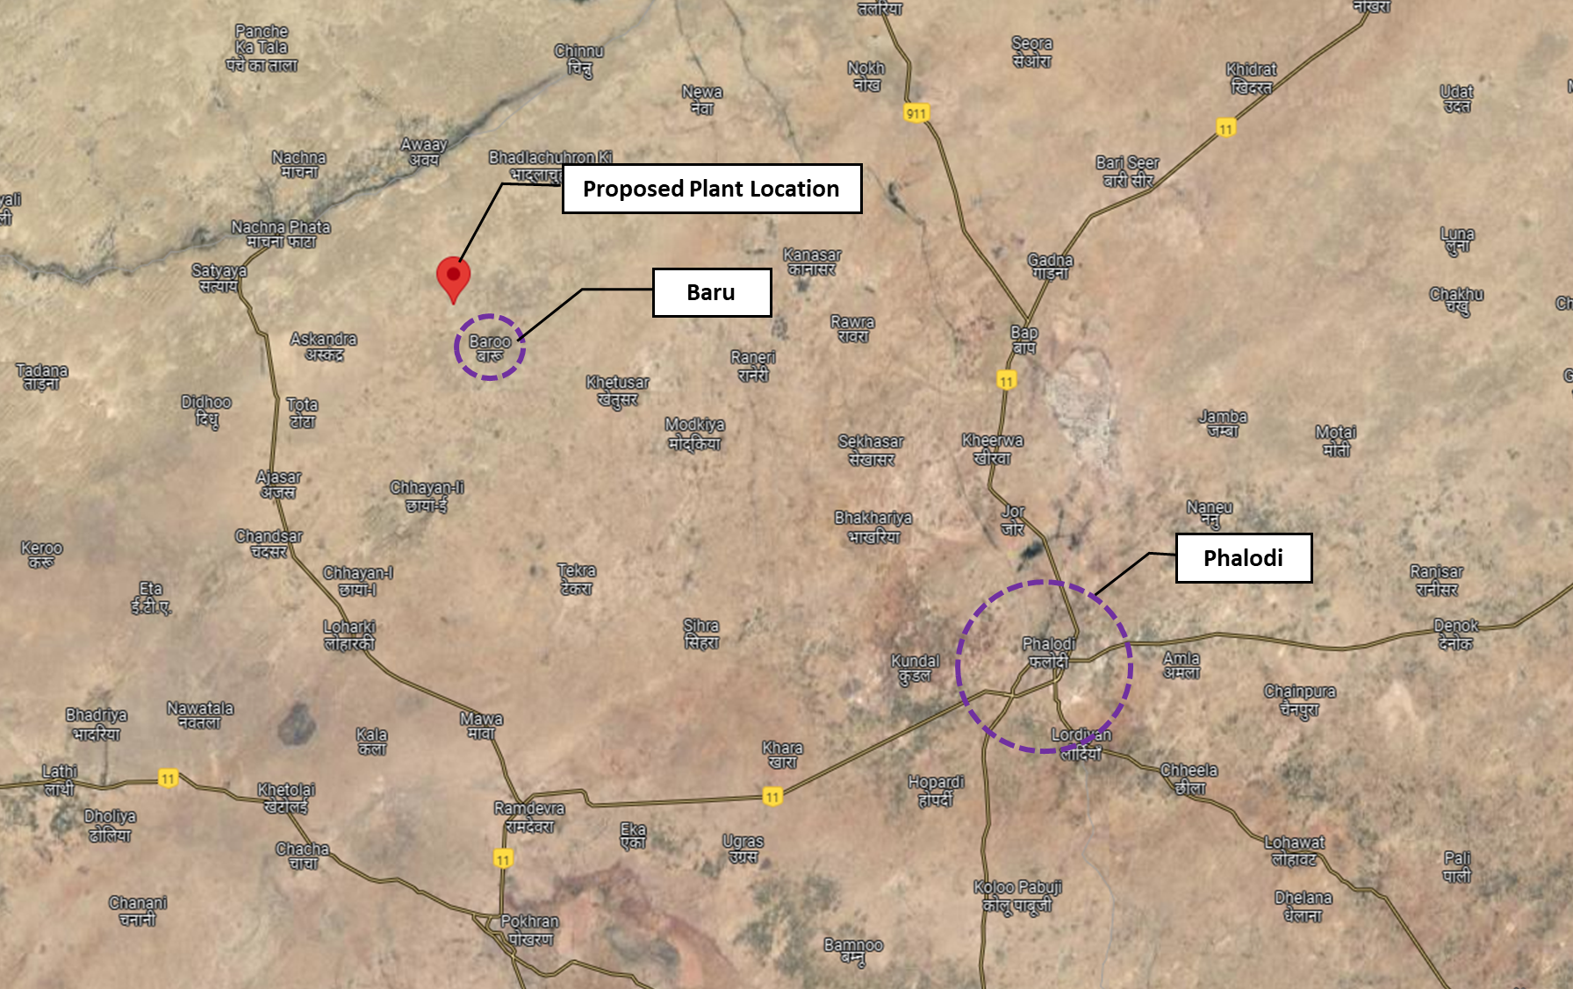
Location: Village Baru, Tehsil Bap, District-Jodhpur GPS: 27°24'05.5"N 71°51'23.9"E
Technical parameters/specifications of solar plant to be installed are as follow: -
S. No. | Particular | Specifications
1 | No. of Modules | 15741
2 | Modules Capacity | 580 Wp
3 | No. of Transformers (IDT) | 01 x 2.75MVA & 01 x 4.50 MVA
4 | Transformers | Tesla Transformers (India) Ltd.
5 | No. of Invertors | 02
6 | Invertor Make | Sungrow
7 | Inverter AC Output | 3300kVA
8 | Inverter AC Voltage (Nominal Output) | 660V
Please note that the above details, including make and capacity, are tentative, and subject to change during detailed engineering stage.
PART D | ENERGY YIELD ASSESSMENT

Company has used PVSyst V7.4.8 to assess energy yield calculation which is the standard Industry practice. The yearly average of main results of irradiation and energy yield from the provided PVSyst is as under:
Annual production probability (kWh):
S. No. | Plant | As per PVSyst  (In kWh/kWp/Year) |  | Performance  Ratio (%) | CUF (%)
 |  | P50 | P90
1 | Baru | 1,849 | 1,785 | 83.54% | 19%

Estimated Specific Production (kWh/kWp/Year):
S. No. | Plant | As per PVSyst  (In kWh/kWp/Year) | As per Global Solar Atlas  (In kWh/kWp/Year)
1 | Baru | 1,849 | 1746.4

Observations and Remarks:

- As per above inputs and analysis estimated specific production found to be generating slightly less as specified in PVSyst report.

Analysis of Irradiation & PV Output data: In respect to Irradiation & PV Output data, company has provided to us PVSyst Report V7.4.8 in which key Irradiation components and PV Output data is given as enumerated in table below. We have analyzed and compared it with other data source points also such as Solar Resource by Global Solar Atlas of World Bank and ISRO Solar Calculator to confirm its legitimacy as mentioned in table below:
Particulars | Samson Controls Private Limited
 | As per Global Solar Atlas | As per PVSyst
Global horizontal Irradiation (kWh/m²) | 2022.9 | 2016.0
Diffuse horizontal Irradiation (kWh/m²) | 892.4 | 893.0
Direct Normal Irradiation (kWh/m²) | 1709.1 | -
Specific Photovoltaic Power Output per year (kWh/kWp/year) | 1746.4 | 1859
Annual Global Insolation (ISRO Solar Calculator) (kWh/m2/year) | 1573

Observations and Remarks:
- As per comparative analysis, PVSyst Irradiation and PV Output data is approximately in line to our analysis from Global Solar Atlas of World Bank and ISRO Solar Calculator with minuscule difference.
- As per the information provided by the management of the company, the estimated minimum Capacity Utilization Factor (CUF) is 19.00%.
- As per details shared by the company, the expected Net Energy Generation is about 15195.972 MWh/year (±5%). However, actual generation would be affected by weather and maintenance of the plant.
- As per PVSyst’s set programme, plant location is showing as Girrajsar which is same as GPS Co-ordinates provided by the company.

Monthly averages- Direct Normal Irradiation (kWh/m²)
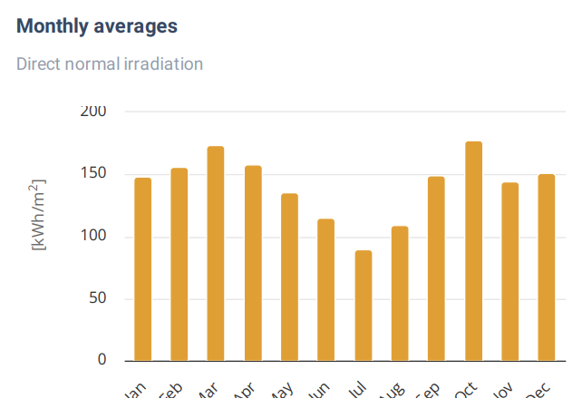
Source: Global Solar Atlas

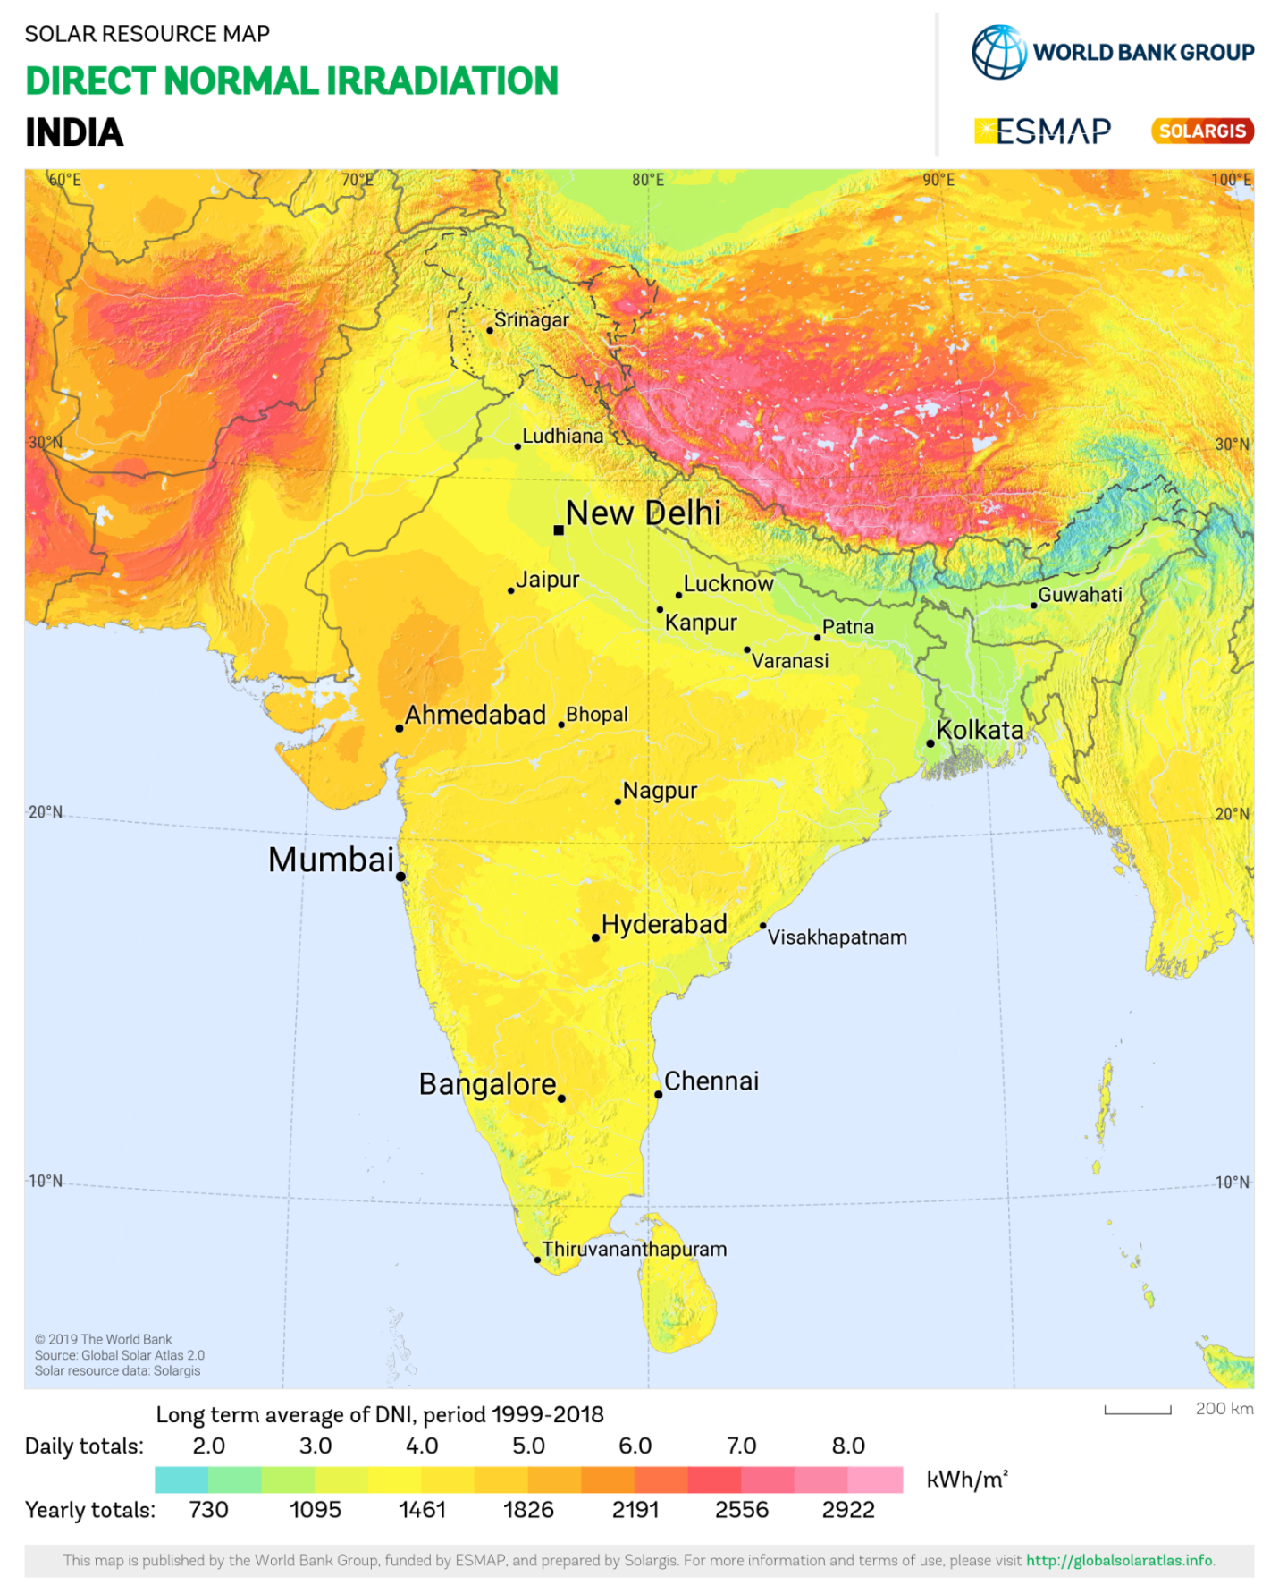
Baru Plant lies below 6.0 daily (2191 annually) Kwh/m².
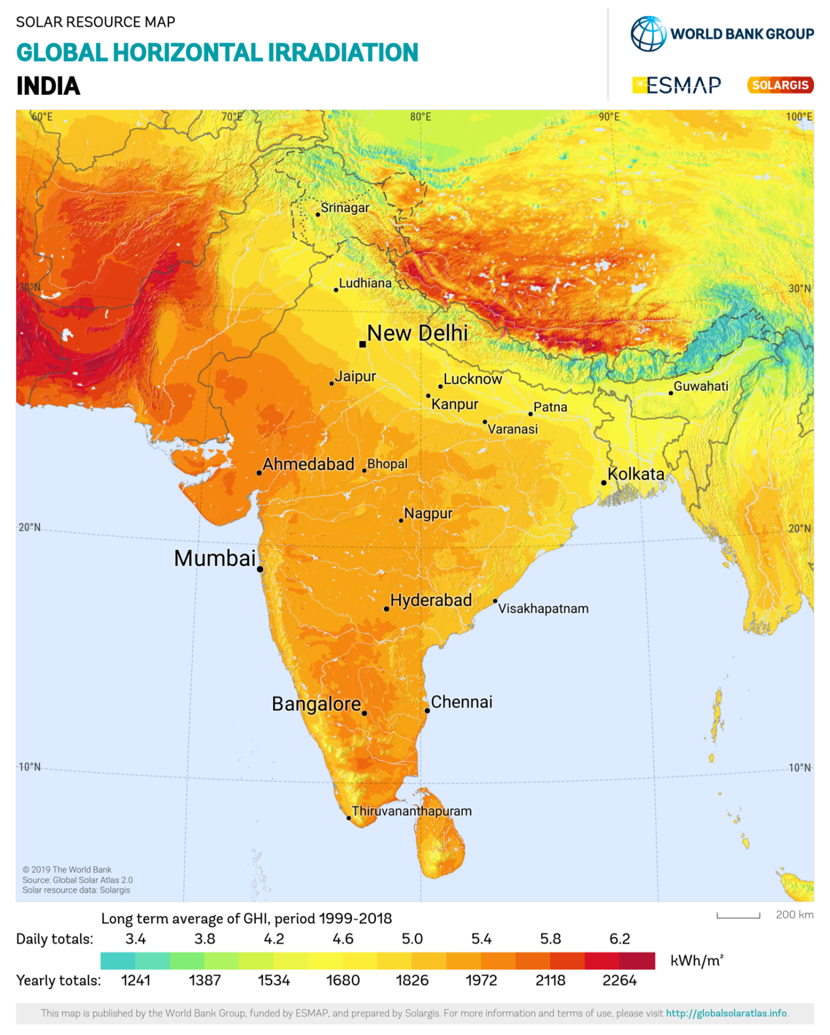
Baru Plant lies below 5.8 daily (2118 annually) Kwh/m².
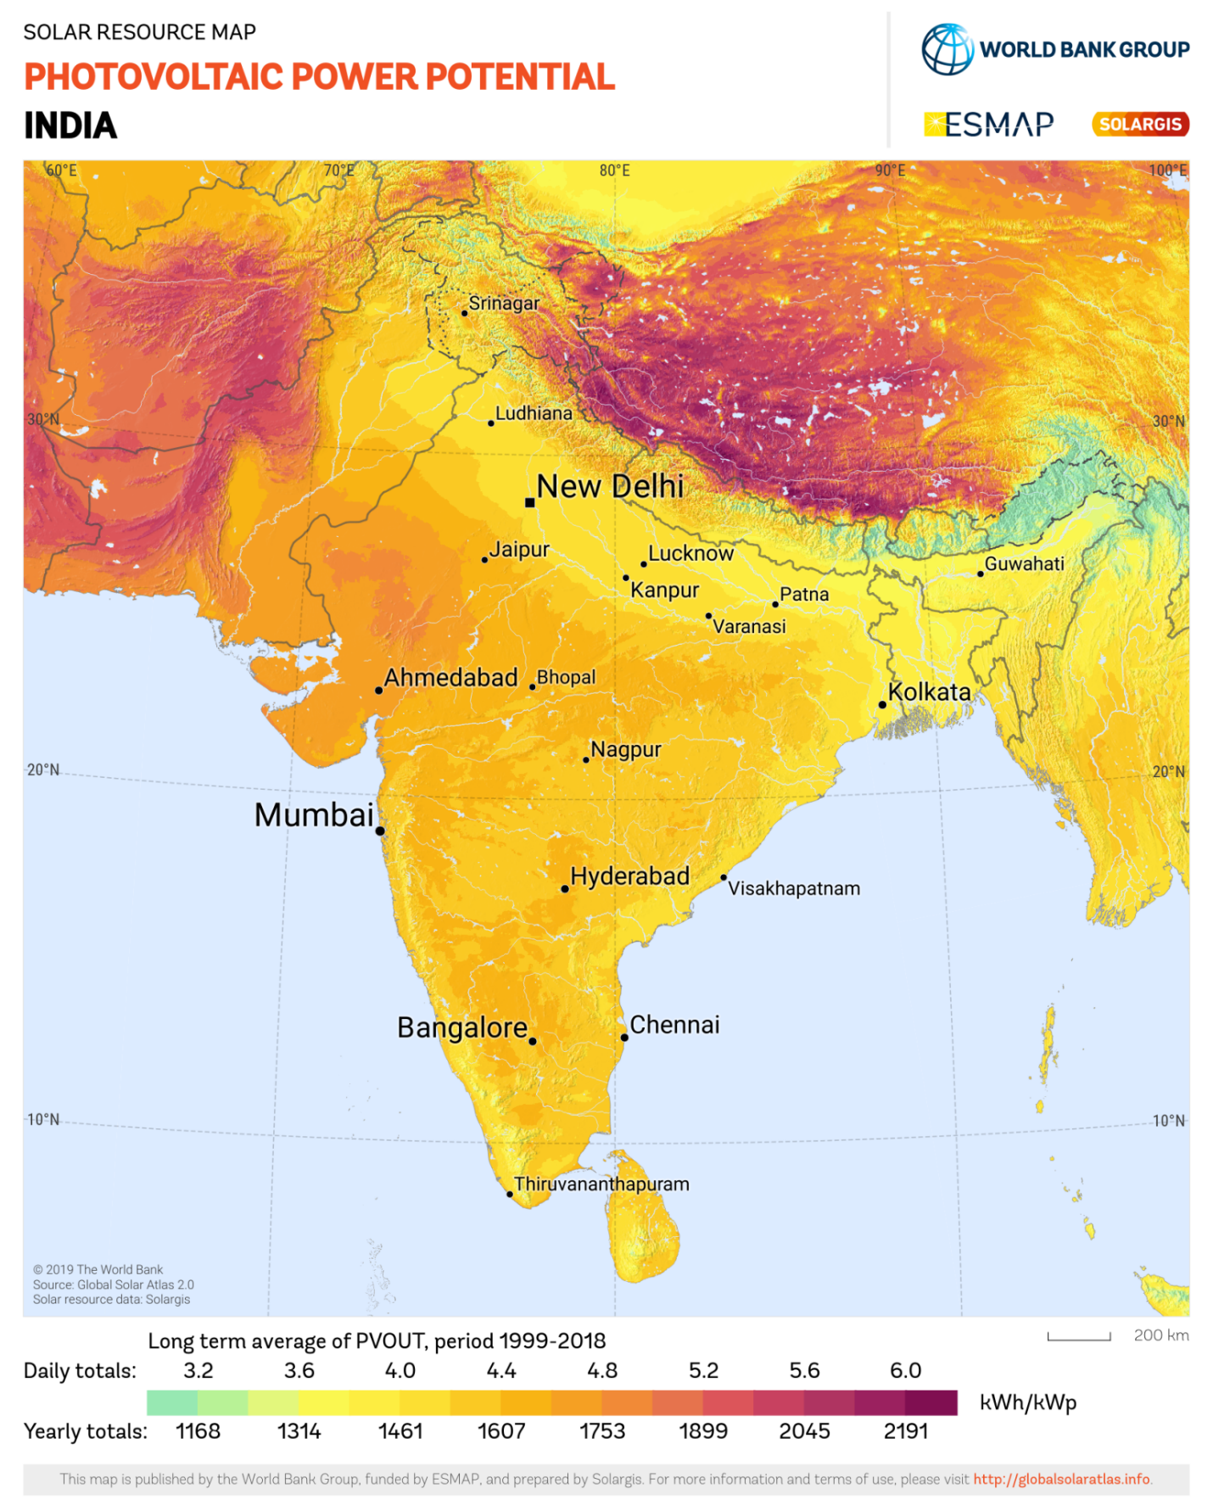
Baru Plant lies above 4.8 daily (1753 annually) Kwh/m².
PART E | POWER PURCHASE AGREEMENT TERMS

As per the documents provided by the company, the total proposed DC capacity of the solar power plant is 9.13 MWp. As on date, company has signed PPA to install the power plant and supply power. Power Purchase agreement is not signed yet. As per information provided by the company’s management, the agreement is in process. However, copy of draft PPA is shared with us along with Letter of Award. Details as mentioned in LOA & PPA are tabulated below:
S. No. | Particular | AC Capacity  (MWp) | Tariff  (Rs. /Unit) | Minimum Energy Generation (Million Units) | Tenure
1 | 9.13 MW DC | 6.52 | 2.97 | 10.85 MU | 25 Years
Total |  | 6.52

PART F | CURRENT STATUS OF WORK

As per information shared by the company officials, Solar Plant installation work is not begun yet. Therefore, physical inspection of the plant was not conducted from our end. Hence, we have analyzed the plant location area via Google Map for its whereabouts and shading.
Please refer to the image attached below: -
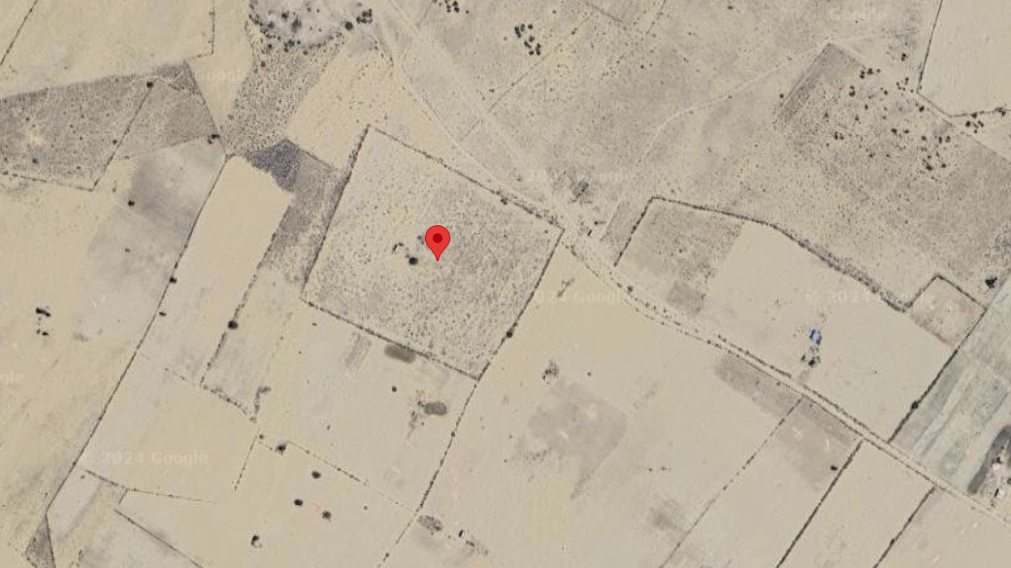
From google imaginary tool, no major shadow or obstruction is found on ground which may block the Direct Sunlight.

PART G | PROJECT COST & EXPENDITURE

- PROJECT COST: As per details shared by the company, the total project cost for installation of 9.13 MW solar project is Rs. 34.23 Cr. including GST.
As per details provided, company is in process to offload the supply, installation, testing, commissioning of the plant to its subsidiary company named as Avengers Rays Solar Private Limited (ARSPL). Company has shared 02 nos. of quotations from ARSPL for supply of Solar Modules & balance of plant works.
Details of the same are as follows: -
S. No. | Date | Ref. No. | Particulars | Amount (Inclusive of GST)
1 | 31-05-2024 | Kusum/Supply Contract/001 | Supply of Solar Modules for 9.13 MWdc | Rs. 18.10 Cr.
2 | 03-07-2024 | Kusum/Supply and Installation Contract/002 | Award for the Balance of Plant Works | Rs. 14.59 Cr.
Total Amount to be paid to Avengers Rays Solar Private Limited |  |  |  | Rs. 32.69 Cr.
Total Project Cost |  |  |  | Rs. 34.23 Cr.
Per kW Cost |  |  |  | Rs. 37,491/-

Scope of work
- Testing & Supply of Solar Modules;
- Supply of all equipment (other than Solar PV Modules) for the 9.13 MWdc Solar Project;
- Make arrangements for infrastructure for development of the Project and for Connectivity with the 33/11 kV sub-station for confirming the evacuation of power by the Scheduled Commissioning date or COD, whichever is earlier, and all clearances related thereto;
- Obtaining all Consents, Clearances and Permits as required and maintaining all documents;
- Designing, constructing, erecting, commissioning, completing and testing the Power Project in accordance with the applicable Law, the Grid Code, the terms and conditions of the LOA, PPA and Prudent Utility Practices;
- Commencement of supply of power up to the Contracted Capacity to JDVVNL no later than the Scheduled Commissioning date;
- Connecting the Power Project switchyard with the Interconnection Facilities at the Delivery Point. Make adequate arrangements to connect the Power Project switchyard with the Interconnection Facilities at Interconnection / Metering / Delivery Point. Laying of dedicated 33 kV line from Solar Power Plant to sub-station, construction of bay and related switchgear & metering equipment at sub-station where the plant is connected to the grid and metering is done;
- Coordinate and dealing with JDVVNL / RUVITL, and other authorities in all respects;
- Ensure the adherence to all applicable rules regarding project registration with the State Nodal Agency (JDVVNL) in line with the provisions of the applicable policies / regulations of the State of Rajasthan;
Observations and Remarks:
- Project cost calculated on the basis of the Benchmark Cost provided by the MNRE has been tabulated below:
S. No. | Particulars | Benchmark Cost  (In Rs. /kW) | Project Capacity  (In MW) | Total Project Cost  (Excluding GST)  (In Rs.) | Total Project Cost  (Including ~14% GST)  (In Rs.)
1 | As per Ministry of New & Renewable Energy | 35,886* | 9,130 | 32,76,39,180 | 37,28,53,387
 |  |  |  |  | ~Rs. 37.29 Cr.
*Benchmark cost for 2021-22 Excludes GST

- Project cost calculated on the basis of market comparable:
S. No. | Particulars | Including GST | Remark
Per KW Cost
(In Rs.)
1 | Subject project installation cost | 37,479 | As per Company
Market Research Details
Market Research
2 | Reference- 1 | 44,564 | Refer Annexures
3 | Reference- 2 | 46,088
4 | Reference- 3 | 40,000
5 | Reference- 4 | 38,000
6 | Reference- 5 | 42,247

- The overall project cost is slightly higher than that of Benchmark cost.
- As per our analysis and market research, the installation cost of Solar Power Plant varies from Rs. 38,000/- per KW to Rs. 46,088/- per KW. For the smaller setups the price is higher and for large set-up, price is less.
- The implementation cost of the said project is Rs. 37,491/- per kW which is less than that of market comparable. Thus, we can say that the cost of the project is fair & reasonable.
- The project cost solely depends upon the project location, contractors profit, type of module and its supporting structures, make, etc.
Note:
- Project cost is analyzed based on lump sum cost only and not item wise.
- Project cost is assessed for the date of this report only and due to price fluctuations, it may vary from time to time.

- EXPENDITURE: Details of expenses incurred till date are not shared with us. Thus, we cannot comment upon expenditure incurred till date on the project.

PART H | EHSS (ENVIRONMENT, HEALTH, SAFETY, AND SUSTAINABILITY) IMPACT

The impact of solar plant on EHSS (Environment, Health, Safety, and Sustainability) can be significant and positive if implemented and managed responsibly. Here are some key considerations:

PARAMETERS | POSITIVE | NEGATIVE | REMARKS
Environmental Impact | Solar Power comes under renewable energy Project. Solar Power Projects generates clean energy and thus contributes in reducing carbon footprints, as otherwise production of the same amount of energy through conventional methods would have required burning of coal which would have led to emission of greenhouse gases in our environment. | None directly from this Project implementation. | Positive
Health and Safety | Non-polluting Project and doesn’t involve any industrial hazardous process. | No health and safety impact as such. | None
Social Impact | Implementation of Solar Project under RESCO model will help reducing power bills of the Project owner which will have positive economic benefit.  Increases local employment.  Use of diesel generators may be avoided due to uninterrupted power supply through owned power system and thus further helps in keeping pollution and noise free environment.  Renewable energy ultimately reduces carbon footprint and thereby provides better health & environment. | None | Positive
Sustainability | Solar Energy is a natural resource providing limitless renewable energy.  Moreover, since Solar Projects helps in lowering carbon footprints and thus good for our environment. Therefore, it is sustainable for human health and mother earth. | The only issue with Solar Power Project is its availability during peak power demand where its limitation comes for which battery storage can be the only solution but again mass use of battery storage again give rise to pollution due to its manufacturing and its disposal. | More towards positive.

Note: It is crucial to note that the EHSS impact can be influenced by factors such as the design, construction, and ongoing operation and maintenance of the solar plant. Adhering to industry best practices, complying with regulations, and implementing robust EHSS management systems are essential to maximizing the positive impact and minimizing potential risks.
PART I | TRACK RECORD OF EPC CONTRACTOR

As per information shared by the company, M/s Prerak Wind Energy Private Limited is a subsidiary company of The Aright Group. The Aright Group has extensive experience of executing large utility scale projects. Details of some of projects completed, as per details provided by the group are as follows: -
- In 2016-17, the Group partnered with national and foreign direct investors to conceptualize, fund, execute, and operate a 175 MWdc solar project in the Bhadla Solar Park in Rajasthan. The project had a power purchase agreement with NTPC.
- Company had recently finished development of a 400 MWac/ 550 MWdc Solar Park in Bikaner Rajasthan, in collaboration with Brookfield Renewable.
- The group is currently developing two more solar parks. A 400 MWac/ 550 MWdc Solar Park connected to the Bhadla-III ISTS substation and located in Village-Nokh, District Phalodi, Rajasthan, is being developed in collaboration with Brookfield Renewable, and is slated to be commissioned in August 2025.
- The group is developing another 400 MWac/ 550 MWdc Solar Park in Village-Netawaton ki Dhani, District Bikaner, Rajasthan.

PART J | PHOTOGRAPHS

Since the installation work related to solar panels is yet to start and this is just a Desktop LIE based upon documents provided. Thus, Photographs are not available

PART K | OTHER DOCUMENTS & REFERENCES

Market Comparables:
Annexure-1
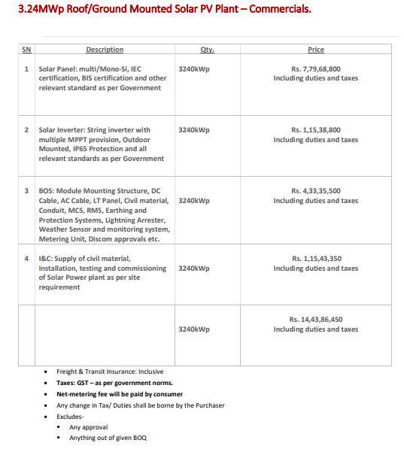
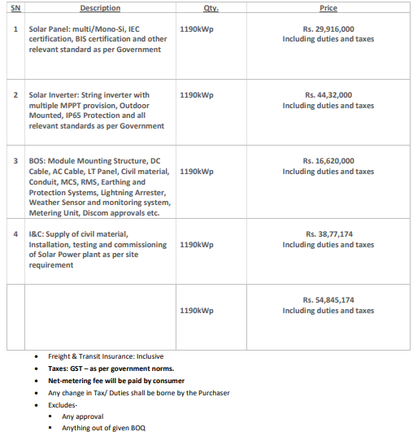

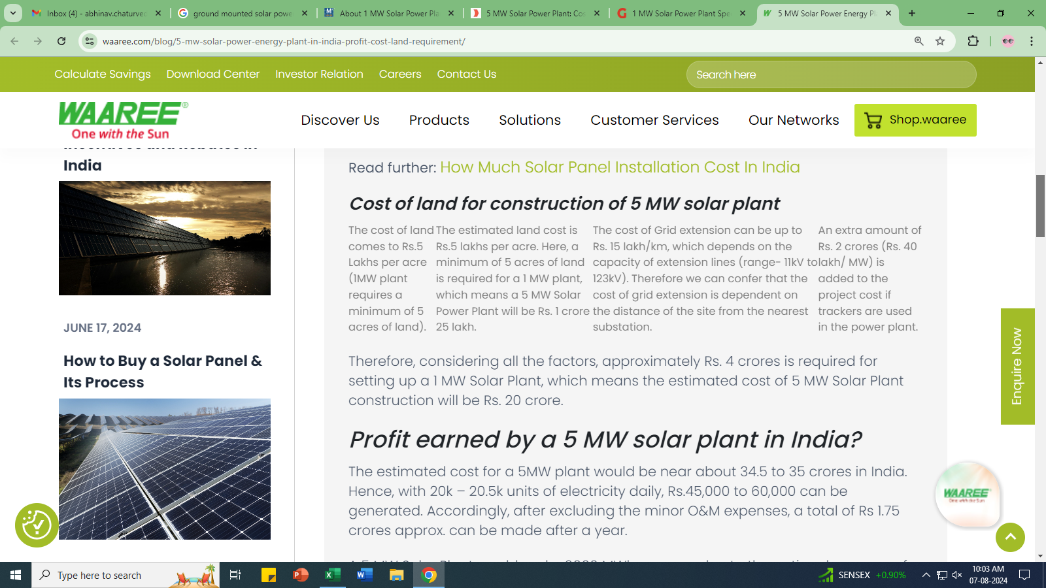

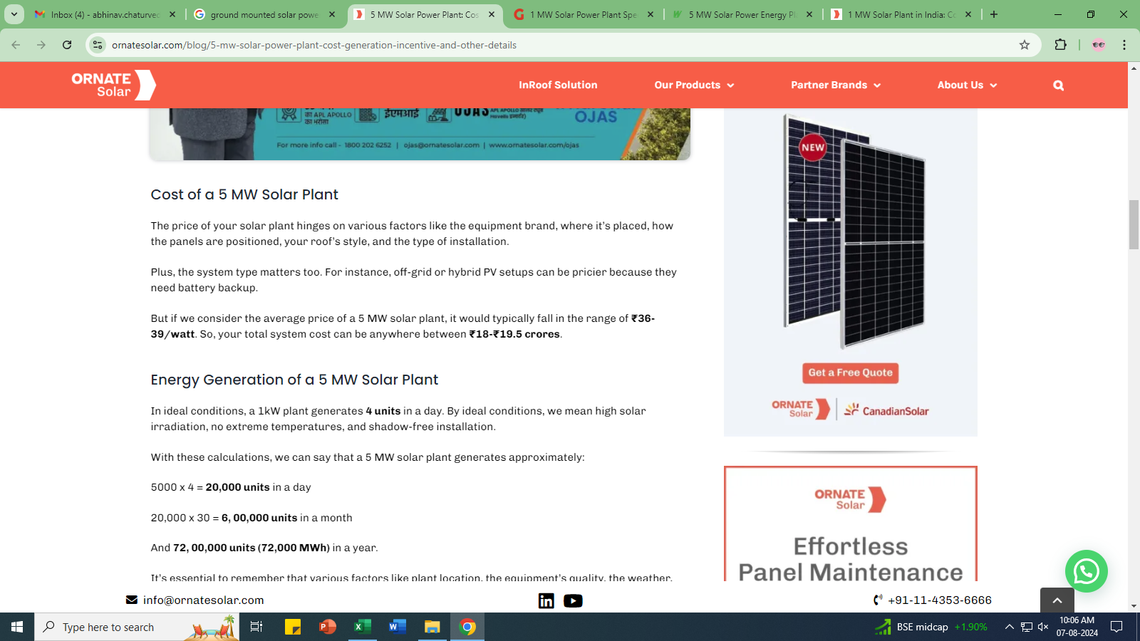

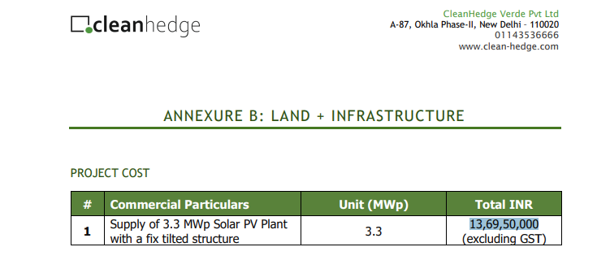

Data by Global Solar Atlas by World Bank Group
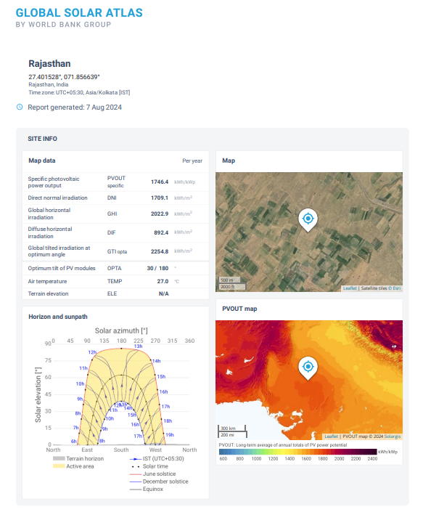

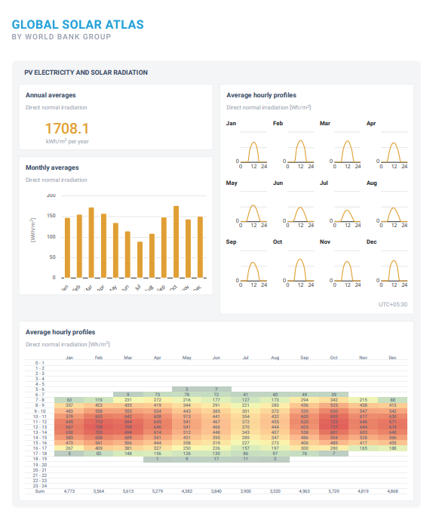

Solar Plant Diagram

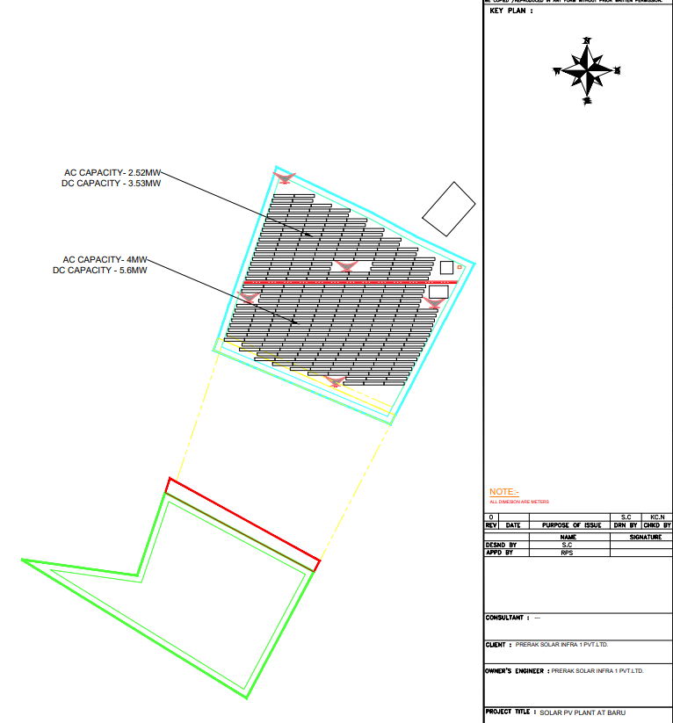

Draft Copy of PPA

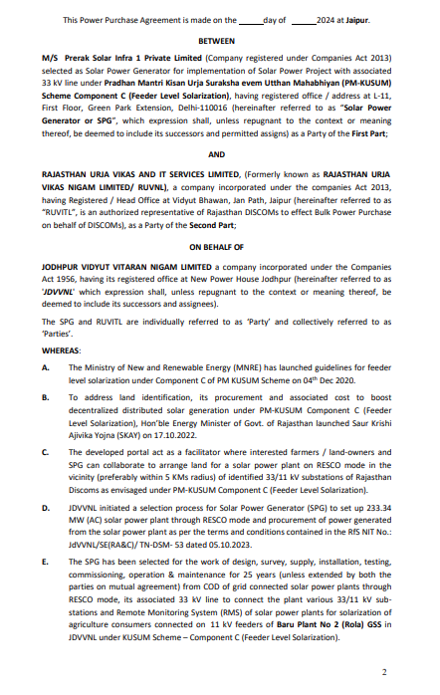

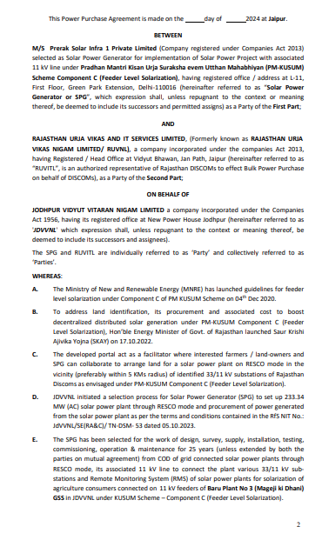
Letter of Award

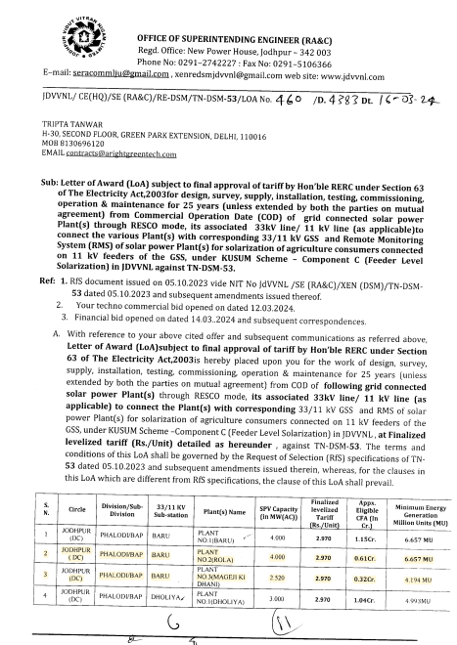
PART L | DISCLAIMER

      - No employee or member of R.K Associates has any direct/ indirect interest in the Project.
      - This report is prepared based on the copies of the documents/ information which the Bank/ Company has provided to us out of the standard checklist of documents sought from them and further based on our assumptions and limiting conditions. All such information provided to us has been relied upon in good faith and we have assumed that it is true and correct in all respect. Verification or cross checking of the documents provided to us has not been done at our end from the originals. If at any time in future, it is found or came to our knowledge that misrepresentation of facts or incomplete or distorted information has been provided to us then this report shall automatically become null & void.
      - This report is a general analysis of the project based on the scope mentioned in the report. This is not an Audit report, Design document, DPR or Techno-financial feasibility study. All the information gathered is based on the facts seen on the site during survey, verbal discussion & documentary evidence provided by the client and is believed that information given by the company is true best of their knowledge.
      - All observations mentioned in the report is only based on the visual observation and the documents/ data/ information provided by the client. No mechanical/ technical tests, measurements or any design review have been performed or carried out from our side during Project assessment.
      - Bank/FII should ONLY take this report as an Advisory document from the Financial/ Chartered Engineering firm and it’s specifically advised to the creditor to cross verify the original documents for the facts mentioned in the report which can be availed from the borrowing company directly.
      - In case of any default in loans or the credit facility extended to the borrowing company, R.K Associates shall not be held responsible for whatsoever reason may be and any request for seeking any explanation from the employee/s of R.K Associates will not be entertained at any instance or situation.
      - This Report is prepared by our competent technical team which includes Engineers and financial experts & analysts.
      - This is just an opinion report and doesn’t hold any binding on anyone. It is requested from the concerned Financial Institution which is using this report for taking financial decision on the project that they should consider all the different associated relevant & related factors also before taking any business decision based on the content of this report.
      - All Pages of the report including annexures are signed and stamped from our office. In case any paper in the report is without stamp & signature then this should not be considered a valid paper issued from this office.
      - Though adequate care has been taken while preparing this report as per its scope, but still we can’t rule out typing, human errors, over sightedness of any information or any other mistakes. Therefore, the concerned organization is advised to satisfy themselves that the report is complete & satisfactory in all respect. Intimation regarding any discrepancy shall be brought into our notice immediately. If no intimation is received within 15 (Fifteen) days in writing from the date of issuance of the report, to rectify these timely, then it shall be considered that the report is complete in all respect and has been accepted by the client upto their satisfaction & use and further to which R.K Associates shall not be held responsible in any manner.
      - Defect Liability Period is 15 DAYS. We request the concerned authorized reader of this report to check the contents, data and calculations in the report within this period and intimate us in writing if any corrections are required or in case of any other concern with the contents or opinion mentioned in the report. Corrections only related to typographical, calculation, spelling mistakes, incorrect data/ figures/ statement will be entertained within the defect liability period. Any new changes for any additional information in already approved report will be regarded as additional work for which additional fees may be charged. No request for any illegitimate change in regard to any facts & figures will be entertained.
      - R.K Associates encourages its customers to give feedback or inform concerns over its services through proper channel at le@rkassociates.org in writing within 30 days of report delivery. After this period no concern/ complaint/ proceedings in connection with the Lender’s Independent Engineering Services will be entertained due to possible change in situation and condition of the subject Project.
      - Our Data retention policy is of ONE YEAR. After this period, we remove all the concerned records related to the assignment from our repository. No clarification or query can be answered after this period due to unavailability of the data.
      - This Lender’s Independent Engineering report is governed by our (1) Internal Policies, Processes & Standard Operating Procedures, (2) Information/ Data/ Inputs given to us by the client and (3) Information/ Data/ Facts given to us by our field/ office technical team. Management of R.K Associates never gives acceptance to any unethical or unprofessional practice which may affect fair, correct & impartial assessment and which is against any prevailing law. In case of any indication of any negligence, default, incorrect, misleading, misrepresentation or distortion of facts in the report then it is the responsibility of the user of this report to immediately or at least within the defect liability period bring all such act into notice of R.K Associates management so that corrective measures can be taken instantly.
      - R.K Associates never releases any report doing alterations or modifications from pen. In case any information/ figure of this report is found altered with pen then this report will automatically become null & void.
FOR INTERNAL USE
FOR R.K ASSOCIATES VALUERS & TECHNO ENGINEERING CONSULTANTS (P) LTD.
SURVEYED BY | PREPARED BY | REVIWED BY
NA | Abhinav Chaturvedi | Vishal Singh

DEFECT LIABILITY PERIOD - In case of any query/ issue or escalation you may please contact Incident Manager by writing at valuers@rkassociates.org. We ensure 100% accuracy in the Calculations done, Rates adopted and various other data points & information mentioned in the report but still can’t rule out typing, human errors or any other mistakes. In case you find any mistake, variation, discrepancy or inaccuracy in any data point of the report, please help us by bringing all such points into our notice in writing at valuers@rkassociates.org within 30 days of the report delivery, to get these rectified timely, failing which R.K Associates Valuers Techno Engineering Consultants (P) Ltd. won’t be held responsible for any inaccuracy in any manner. Also if we will not hear back anything from you within 30 days, we will assume that report is correct in all respect and no further claim of any sort will be entertained thereafter. We would welcome and appreciate your feedback & suggestions in order to improve our services.

COPYRIGHT FORMAT - This report is prepared on the copyright format of R.K Associates Valuers Techno Engineering Consultants (P) Ltd. to serve our clients in the best possible way. Legally no one can copy or distribute this format without prior approval from R.K Associates. It is meant only for the organization as mentioned on the cover page of this report. Distribution or use of this format other than R.K Associates will be seen as unlawful act and necessary legal action can be taken against the defaulter.

