**File No.: VIS (2024-25)-PL271-233-305 Dated: 05/08/2024**

**INDEPENDENT ENGINEERING REPORT**

**OF**

**EXPANSION PROJECT OF**

**ULTRATECH CEMENT LIMITED**

**SITUATED AT**

**SH-5 KOTA, DALLA, DISTRICT SONEBHADRA, UTTAR PRADESH**

**COMPANY/PROMOTER**

**M/S. ULTRATECH CEMENT LIMITED**

****

**REPORT PREPARED FOR**

**THE PRADESHIYA INDUSTRIAL & INVESTMENT CORPORATION OF U.P. LIMITED (PICUP), PICUP BHAWAN, GOMTI NAGAR, LUCKNOW-226010 (INDIA)**

***\*\*Important - In case of any query/ issue or escalation you may please contact Incident Manager at le@rkassociates.org. We will appreciate your feedback in order to improve our services.***

***NOTE: Please provide your feedback on the report within 15 days of its submission after which report will be considered to be correct.***

**IMPORTANT NOTICE**

***COPYRIGHT FORMAT:*** *This report is prepared on the copyright format of R. K. Associates Valuers & Techno Engineering Consultants (P) Ltd. (R. K. Associates) to serve our clients with the best possible information and analysis to facilitate them to take rational business decisions. Legally no one can copy or distribute this format without prior approval from R.K Associates. It is meant only for the advisory/ reference purpose for the organization/s as mentioned on the cover page of this report. Distribution or use of this format by any organization or individual other than R.K Associates will be seen as an unlawful act and necessary legal action can be taken against the defaulters.*

*This report is intended for the sole use of the intended recipient/s and contains material that is STRICTLY CONFIDENTIAL AND PRIVATE.*

***DEFECT LIABILITY PERIOD****: In case of any query/ issue or escalation you may please contact Incident Manager at valuers@rkassociates.org. Though adequate care has been taken while preparing this report as per its scope, but still, we can’t rule out typing, human errors, over sightedness of any information or any other mistakes. Therefore, the concerned organization is advised to satisfy themselves that the report is complete & satisfactory in all respect. Intimation regarding any discrepancy shall be brought into our notice immediately. If no intimation is received within 15 (Fifteen) days in writing from the date of issuance of the report, to rectify these timely, then it shall be considered that the report is complete in all respect and has been accepted by the client up to their satisfaction & use and further to which R.K Associates shall not be held responsible in any manner.*

*R.K Associates Important Notes and Part G–Disclaimer are integral part of this report and Value is assessment is subject to both of these sections. Reader of the report is advised to read all the points mentioned in these sections carefully.*

|  |  |  |
| --- | --- | --- |
| **TABLE OF CONTENTS** | | |
| **SECTIONS** | **PARTICULARS** | **PAGE NO.** |
| **PART A** | **REPORT SUMMARY** | 03 |
| **PART B** | **INTRODUCTION** | 04 |
| 1. Name of the Project | 04 |
| 1. Project Overview | 04 |
| 1. Project Location | 05 |
| 1. Scope of the Report | 06 |
| 1. Purpose of the Report | 06 |
| 1. Survey Details | 06 |
| 1. Methodology Adopted | 06 |
| **PART C** | **PROJECT TECHNICAL DETAILS** | 08 |
| 1. Plant Capacity | 08 |
| 1. Plant Production Chart | 08 |
| 1. Manufacturing Process Flow Chart | 08 |
| **PART D** | **PROJECT INFRASTRUCTURE SECTIONS & FACILITY DETAILS** | 11 |
| 1. Land Details | 11 |
| 1. Building & Structural Details | 11 |
| 1. Plant Machinery & Equipment | 11 |
| **PART E** | **PROJECT CONSULTANTS, CONTRACTORS & SUPPLIERS** | 14 |
| **PART F** | **PROJECT COST & EXPENDITURE** | 15 |
| 1. Total Project Cost | 15 |
| 1. Current Stratus & Total Expenditure incurred till date | 16 |
| **PART G** | **PHOTOGRAPHS OF THE PLANT** | 19-26 |
| **PART H** | **IMPORTANT DOCUEMENTS** | 27-37 |
| **PART I** | **DISCLAIMER** | 38-40 |

|  |  |
| --- | --- |
| **PART A** | **REPORT SUMMARY** |

|  |  |  |  |
| --- | --- | --- | --- |
|  | **Name of the Project** | **:** | Expansion of its existing capacity of cement production from 0.5 MTPA to 1.8 MTPA, clinker production from 2.0 MTPA to 2.2 MTPA, and installation of 13 MW Waste Heat Recovery System (WHRS) |
|  | **Name of product** | **:** | Ordinary Portland Cement (OPC) and Portland Pozzolana Cement (PPC) |
|  | **Project Location** | **:** | SH-5 Kota, Dalla, District Sonebhadra, Uttar Pradesh |
|  | **Name of the Company** | **:** | M/s. Ultratech Cement Limited |
|  | **Prepared for Organization** | **:** | The Pradeshiya Industrial & Investment Corporation of U.P. Ltd. (PICUP) PICUP Bhawan, Gomti Nagar, Lucknow |
|  | **Chartered Engineer Firm** | **:** | M/s. R.K. Associates Valuers & Techno Engineering Consultants (P) Ltd |
|  | **Date of Survey** | **:** | 1st and 2nd August, 2024 |
|  | **Date of Report** | **:** | 05th August, 2024 |
|  | **Report Type** | **:** | Independent Engineering Report |
|  | **Purpose of the Report** | **:** | To examine the installation & verification of Capital expenditure, status of the Project in regard to the special facilities & incentives given to the companies under Industrial Investment & Employment Promotion Policy 2017 |
|  | **Scope of the Report** | **:** | The scope of this report includes only the assessment & verification of installation, commissioning and capital expenditure incurred in the expansion project of M/s. Ultratech Cement Limited located at aforesaid address |
|  | **Documents produced for Perusal** | **:** | 1. Detailed Project Report 2. Approved map 3. List of Invoices with description of the items 4. Invoices of Items 5. CA Certificate (w.r.t. investment) |
|  | **Annexure with the Report** |  | 1. Detailed List of Items 2. Photographs 3. Other annexures |

|  |  |
| --- | --- |
| **PART B** | **INTRODUCTION** |

1. **NAME OF THE PROJECT:** Expansion of its existing capacity of cement production from 0.5 MTPA to 1.8 MTPA, clinker production from 2.0 MTPA to 2.2 MTPA, and installation of 13 MW Waste Heat Recovery System (WHRS).
2. **PROJECT OVERVIEW:** M/s. Ultratech Cement Limited is expanding its current plant capacity to increase the capacity of cement production from 0.5 MTPA to 1.8 MTPA, clinker production from 2.0 MTPA to 2.2 MTPA, and installation of 13 MW Waste Heat Recovery System (WHRS). Company was granted Letter of Comfort vide ref. no. PICUP/IIEPP-2017/ Ultratech (Dalla)/1853 dated 07th February, 2024 for special facilities/reliefs under Uttar Pradesh Industrial Investment & Employment Promotion Policy, 2017-Mega plus Category, for proposed investment of Rs.528.26 Cr. (as mentioned in DPR), however as per the LOC dated 07/02/2024 provided by PICUP the capital investment is of 473.05 Crores as the capital investment done in modification of the existing plant is excluded.

In this relation the company has informed PICUP that they have implemented the project with fixed capital investment of Rs.454.65 Cr. during the period of 01/11/2020 to 26/06/2024 including Phase-1 and Phase-2 both which comprises of increase in Cement capacity and Installation of WHRS, addition of clinker production capacity, raw mill, etc. Upgradation of captive power plant has not been executed as envisaged in the plan. The table below shows a comparison between the proposed expansion as per the LOC and the actual expansion executed on the ground:

**Table: 01**

|  |  |  |  |  |
| --- | --- | --- | --- | --- |
| **Products** | **Existing** | **Phase-I (expansion)** | **Phase-II (expansion)** | **Total**  **(TPA)** |
| **As Per LOC** | | | | |
| **Cement** | 0.50 | 1.50 | --- | 2.00 |
| **Clinker** | 2.00 | --- | 0.20 | 2.20 |
| **Waste Heat Recovery System (WHRS)** | --- | 13 MW | --- | 13 MW |
| **Captive Power** | 27 MW | --- | 3 MW | 30 MW |
| **Actual expansion executed** | | | | |
| **Cement** | 0.50 | 1.30 | --- | 1.80 |
| **Clinker** | 2.00 | --- | 0.20 | 2.20 |
| **Waste Heat Recovery System (WHRS)** | --- | --- | 13 MW | 13 MW |
| **Captive Power** | 27 MW | --- | --- | 27 MW |

Thus, PICUP has engaged R.K Associates for the assessment and verification of the factual position of capital investment made by the company from start date to the date of commercial production.

M/s. Ultratech Cement Limited is presently operating on the land parcel measuring 347.96 Acres and the expansion has taken place within the same parcel of land. The summary of the existing and the expansion to be executed is as below:

**Table: 02**

|  |  |  |  |  |
| --- | --- | --- | --- | --- |
| **Products** | **Existing** | **Phase-I (expansion)** | **Phase-II (expansion)** | **Total**  **(TPA)** |
| **Cement** | 0.50 | 1.30 | --- | 1.80 |
| **Clinker** | 2.00 | --- | 0.20 | 2.20 |
| **Waste Heat Recovery System (WHRS)** | --- | --- | 13 MW | 13 MW |
| **Captive Power** | 27 MW | --- | --- | 27 MW |

In this expansion, major sections such as Cement Mill including Ball Mill, Packing Machine, Belt conveyors, Cement Silo, Pre heating unit and OLBC, Cooling Unit, have been expanded & upgraded. WHRS has been added as new in this expansion. Building structures like MCC room, Cement Mill hopper, cement bulk loading unit have been constructed as new in this expansion. However as per the LOC dated 07/02/2024 provided by PICUP, costs incurred in upgradation to existing facility like ESP TPP, L1-Cooler ESP upgradation, L1 DC to AC conversion, L1 Kiln upgradation, are not considered in this assessment.

During the site survey on 1st and 2nd August 2024, it was observed that the expansion work has been executed as per the plan shown in Project Report with some modifications and is currently in use.

1. **PROJECT LOCATION:**

**Table: 03**

|  |  |
| --- | --- |
| **Particulars** | **Description** |
| **Postal Address** | |
| SH-5 Kota, Dalla, District-Sonebhadra, Uttar Pradesh | |
| **Google Coordinates** | |
| 24°27'03.2"N 83°02'27.0"E | |
|  | |
| ***Image source: Google Map*** | |

1. **SCOPE OF THE REPORT:** To verify and examine the commissioning, installation and capital expenditure verification incurred by M/s. Ultratech Cement Limited at site (Building, Plant & Machinery) during the period of 01/11/2020 to 26/06/2024 in Phase 1 and Phase 2.
2. **PURPOSE OF THE REPORT:** To examine the status of Capital expenditure made by the company in regard to the special facilities & incentives given to the companies under Industrial Investment & Employment Promotion Policy 2017.
3. **SURVEY DETAILS:** This plant has been surveyed by our team on August 1st and 2nd, 2024. Site inspection was done in the presence of the plant representatives Mr. Prasham Jain. All the details pertaining to physical setup and progress of the plant have been cross checked as per the documents/ information provided to us.

The photographs have been taken of all different sections of the plant to give a clear visual representation of the plant establishment.

1. **METHADOLOGY ADOPTED:**
2. Study of Detailed Project Report to know the Project proposed plan & estimates.
3. Study of Project Work Orders, Invoices.
4. Site visit by our engineering team to assess the project execution status on the ground at the site.
5. Various documents and information collected from the company through e-mail.
6. Study and analysis of the documents and information obtained from the company and their correlation with the observations during site survey.
7. Other information obtained regarding the project from the sources in the public domain.
8. Building & Civil work capital expenditure assessment is done based on the Market Plinth Area Rates.
9. Plant & Machinery capital expenditure assessment is done based on the Invoices provided by the company for the machines found on the site.

|  |  |
| --- | --- |
| **PART C** | **PROJECT TECHNICAL DETAILS** |

1. **PLANT CAPACITY:** Total capacity of the plant is distributed among several sections for the production of cement. Currently the plant is operational to the following capacity as described in the table below:

**Table: 04**

|  |  |  |  |  |
| --- | --- | --- | --- | --- |
| **Products** | **Existing** | **Phase-I (expansion)** | **Phase-II (expansion)** | **Total** |
| **Cement** | 0.50 | 1.30 | --- | 1.80 MTPA |
| **Clinker** | 2.00 | --- | 0.20 | 2.20 MTPA |
| **Waste Heat Recovery System (WHRS)** | --- | --- | 13 MW | 13 MW |
| **Captive Power** | 27 MW | --- | --- | 27 MW |

***Source: Company***

1. **PLANT PRODUCTION CHART:** Company has provided us the production data of last six months i.e. from February 2024 to July 2024. A table and bar chart of the same has been shown below:

**Table: 05**

|  |  |  |
| --- | --- | --- |
| **Month** | **Total Production** | **Percentage of Utilisation** |
| Feb-24 | 1,35,862.19 | 91% |
| Mar-24 | 1,57,715.80 | 105% |
| Apr-24 | 1,29,783.58 | 87% |
| May-24 | 1,55,909.14 | 104% |
| Jun-24 | 1,39,352.40 | 93% |
| Jul-24 | 1,35,259.88 | 90% |

***Source: Company***

1. **MANUFACTURING PROCESS:** The manufacturing process of the cement production is shown below:
2. **Mining and Raw Material Extraction:**

*Limestone Quarrying: This includes extraction of limestone, the primary raw material from mine*

1. **Crushing & Stacking :**

*Primary Crusher: Large rocks of limestone and other materials are crushed from 1-1.5 mt. to 75mm and then stacked*

1. **Raw Material Grinding:**

*Raw Mill: Raw materials are grinded into a fine powder in large rotating mills called as Ball mill, mixed with required additives*

1. **Preheating and Pyro-processing:**

*a. Preheating: The raw mix is preheated.*

*b. Rotary Kiln: The preheated raw mix is fed into a rotary kiln where it is heated to about 1300-1400°C. This process forms clinker.*

*c. The hot clinker is cooled down, and stocked/moved in Clinker Silos.*

1. **Cement Grinding Unit (Ball Mill):**

*Ball Mill: The cooled clinker is grinded into a fine powder, and gypsum is added to control the setting time of the cement and blended with other additives like fly ash to provide the final product i.e. Cement.*

|  |  |
| --- | --- |
| **Approved product** | **Rejected product** |

*Cement products that do not meet the required quality standards are returned to the vertical roller mill for re-grinding and blending. Ensuring that only cement of the specified quality is ultimately stored in the silos for distribution and use*

*The cement product, once it meets the required quality standards, is transported to cement silos via an air vent or shoot. These silos serve as storage units for the finished cement product, ready for distribution and use in various applications.*

|  |  |
| --- | --- |
| * 1. **Cement Silos:** | * 1. **Reject Building:** |

1. **Packing Plant/Bulk Loading:**

*After receiving the finished cement product from the cement silos it is packaged using well-equipped packing machines.*

*For larger bulk orders, a bulk loader is available to load containers directly, facilitating the efficient handling of larger quantities of cement for transportation and distribution.*

|  |  |
| --- | --- |
| **PART D** | **PLANT INFRASTRUCTURE SECTIONS & FACILITY DETAILS** |

1. **LAND DETAILS:** M/s. Ultratech Cement Limited is presently operating on the land parcel measuring 347.965 acres. Since this is an expansion project on existing land, therefore no expenses incurred in the purchase of the land.

**Table: 06**

|  |  |
| --- | --- |
| **M/s UltraTech Cement Works** | |
| **Particulars** | **Area** |
| Owned Area | 243.885 |
| Lease Area | 104.08 |
| **Total Area** | **347.965 Acres** |

1. **BUILDING & STRUCTURAL DETAILS:** As per the expansion plan following new structures have been built under this phase. Details of the buildings are shown below:

**Table: 07**

|  |  |  |  |  |
| --- | --- | --- | --- | --- |
| **S. No.** | **Particulars** | **Type of Structure** | **Height**  **(In ft.)** | **Area  *(in sq. mtr.)*** |
|  | MCC ROOM (Cement Mill) | RCC | 15 | 16,275 |
|  | MCC ROOM (Packing plant) | RCC | 15 | 3,806 |
|  | COOLING TOWER & Pump house (Cement mill) | RCC | 10 | 3,554 |
|  | CEMENT MILL HOPPER | RCC | 40 | 13,711 |
|  | CEMENT MILL & ROLLER PRESS | RCC | 40 | 55,441 |
|  | CEMENT BULK LOADING | RCC | 40 | 4,053.4 |

1. **PLANT MACHINERY & EQUIPMENT:** M/s. UltraTech Cement Limited has strategically expanded its operations to enhance production efficiency while prioritizing sustainability. This expansion includes the adoption of green technologies like the Waste Heat Recovery System (WHRS), which captures excess heat from the cement manufacturing process and converts it into electricity. Additionally, UltraTech has implemented Alternative Fuels and Raw Materials (AFR), further cutting down greenhouse gas emissions. Details of the same is captured in the table below:

**Table: 08**

|  |  |  |  |
| --- | --- | --- | --- |
| **Products** | **Existing** | **After Expansion (TPA)** | **Cost (In Cr.)** |
| Cement | 0.50 | 1.80 | 135 Cr. |
| Waste Heat Recovery System | --- | 13 MW | 126.3 Cr. |
| Crusher and OLBC | --- | --- | 107.3 Cr. |
| AFR | --- | --- | 36.4 Cr. |
| Miscellaneous (Cooler Up gradation, Raw Mill, ESP TPP, Mining Equipment’s, Air Blast Control etc.) | --- | --- | 49 Cr. |
| **TOTAL** | | | **~454 Cr.** |

**Table: 09**

|  |  |  |  |
| --- | --- | --- | --- |
| **S. No.** | **Project name** | **Name** | **Tech Specification** |
|  | WHRS | Turbo Generator 12 MW | 13 MW |
|  | Boiler | --- |
|  | WHRS plant and machinery - other | --- |
|  | Cement Mill | Cement Mill Roller Press with Ball 185 TPH and other | 185 TPH |
|  | Packer Machine | Packer system model 1 X 240 TPH - 16 SPOU |
|  | 3 Truck Loader | 3 X120 TPH Floor Mounted |
|  | Belt Conveyor | --- |
|  | Bucket Elevators | --- |
|  | Compressor | Blower, 415V, 1020RPM, 0.70KG/CM2, 6MK |
|  | Process & Bag Filter | --- |
|  | Bulk Reception Unit (BRU) | Bulk Reception Unit Capacity 200 TPH |
|  | Cement Silo feeding & Extraction | --- |
|  | Fly ash Silo Feeding | --- |
|  | E&I | --- |
|  | Cement Mill Plant & Machinery | --- |
|  | OLBC | OLBC Machinery | --- |
|  | OLBC Plant and Machinery - Other | --- |
|  | Ventury & Firing point modification | LS circular Coal Dome shed at Julgul Stacker | --- |
|  | Cooler Up gradation | AFR feeding system for K5 unit to achieve 10% TSR | --- |
|  | Process Optimization | ROBO Lab | --- |
|  | Retrofitting of Turbine | --- |
|  | Other plant and machinery | --- |

**Source: DPR**

***Observation & Comments:***

* *Invoices wise list of the capital investment made in machines & components have been shared by the company. Major machines have been verified during site inspection.*
* *The plant was operational at the time of survey.*
* *Auxiliary machines or machines which are a part of other bigger machines could not be verified separately.*
* As per the LOC dated 07/02/2024 provided by PICUP*, costs incurred in upgradation to existing facility like ESP TPP, L1-Cooler ESP upgradation, L1 DC to AC conversion, L1 Kiln upgradation, are not considered in this assessment.*

|  |  |
| --- | --- |
| **PART E** | **PROJECT CONSULTANTS, CONTRACTORS & SUPPLIERS** |

As per the information received by the client for construction of building and civil works company has hired contractors and suppliers. For Plant and machineries major Contractors & Suppliers during the inception of the project which includes Supply, Erection, Construction, Testing & Commissioning. Supplier’s details with their scope of work are given below:

**Table: 10**

|  |  |
| --- | --- |
| **VENDOR NAME** | **LOCATION** |
| WEIMA MASCHINENBAU GMBH | AFR |
| ATS CONVEYORS INDIA PVT LTD | AFR |
| FLSMIDTH A/S | Line-1 Cooler Updragation |
| HUMBOLDT WEDAG INDIA PVT LTD | Line-1 Cooler Updragation |
| TRIVENI TURBINE LIMITED | WHRS |
| SIMAR INFRASTRUCTURE LIMITED | WHRS |
| SIMAR INFRASTRUCTURE LIMITED | WHRS |
| THYSSENKRUPP INDUSTRIES INDIA | Cement Mill |
| SHREEVIM INFRA PROJECTS PVT. LTD, Dalla | Cement Mill |
| COMTECH | Cement Mill |
| AUMUND FORDERTECHNIK GMBH & CO | Cement Mill |
| SABIA,INC. | OLBC |
| MACMET ENGINEERING LIMITED | OLBC |
| TATA HITACHI CONSTRUCTION MACH | Mining Equipment’s |

***Source: Compiled from the Invoices/ Bills provided by the company***

|  |  |
| --- | --- |
| **PART F** | **PROJECT COST & EXPENDITURE** |

1. **TOTAL PROJECT COST:** The cost as per DPR and CA Certificate as per mentioned heads is as follows:

**Table: 11**

|  |  |  |  |
| --- | --- | --- | --- |
| **Sl. No.** | **Particulars** | **Amount**  **(As per DPR)**  **(In Rs. In Cr.)** | **Amount**  **(As per CA cert)**  **(In Rs. In Cr.)** |
|  | Land | --- | --- |
|  | Buildings and Civil works | 29.63 | 29.63 |
|  | Plant and Machinery | 498.63 | 429.02 |
| **Total Cost** | | **528.26** | **454.65** |

***Source: DPR & CA Certificate***

1. **CURRENT STATUS & TOTAL EXPENDITURE INCURRED TILL DATE:** KKC & Associates LLP, having registered office at Sunshine Tower, Level 19, Senapati Bapat Marg, Elphinstone Road, Mumbai-400013 has issued a statutory auditors certificate (UDIN: 24168237BKBHQC4346) dated 29.06.2024 in respect of the Investment in Building, Plant and machinery Equipment. Details of the expenditure in the table below is recorded for the expenditure incurred in the period (1.11.2020 – 26.06.2024) :

**Table: 12**

|  |  |  |  |  |
| --- | --- | --- | --- | --- |
| Sl. NO. | PARTICULARS | AMOUNT INCURRED  As Per  CA Cert.  (In Rs. In Cr.) | AMOUNT INCURRED As per IE  (In Rs. In Cr.) | CURRENT STATUS OF WORK AND REMARKS |
|  | **Land & Site Development** | --- | --- | Since this is an expansion project on existing land, therefore no expenses incurred in the purchase of the land. |
|  | **Civil & Structure Works** | 29.63 | ~20.67 | **Cost is approved based on the below analysis:**   * Cost Assessment of Civil & Structure Works is done independently based on Plinth Area rates as per market standards for each building based on its specification & height. The cost shown by company seems to be on a higher side. * Area measurement is taken as per area sheet provided by the company. Area of some of the buildings are cross verified at the site. * Please refer Table 13 for detailed assessment |
|  | **Plant & Machinery** | 425.02 | ~384.86 | * Cost of Plant & Machines is verified from the detailed inventory sheet provided to us related to plant & machinery having description of assets, supplier name, invoice number, date of invoice etc. * Status of only major machines have been cross checked during site survey. * Against the list above, major and significant invoices from all the sections of plant & machinery through the copy of Invoices is done to check the veracity of list * Cost of machinery foundation has been also included in plant & machinery head * Contractor wise expenses made are attached with the report in Annexure-H * Costs incurred in upgradation and modification of existing facility like ESP TPP, L1-Cooler ESP up gradation, L1 DC to AC conversion, L1 Kiln upgradation, are not considered in this assessment as per the LOC provided. * Expenses made for services or consultancy has been excluded from the assessment as per IIEPP-2017 * Custom duty and ITC reversible has been considered in the assessment. * However GST has not been considered which is applicable for ITC * Please refer Table 14 for detailed assessment |
| TOTAL | | **454.65** | **~405.53** |  | |

**Table: 13**

**(RCC STRUCTURE)**

**ASSESSMENT OF BUILDING & CIVIL WORK**

|  |  |  |  |  |  |  |  |
| --- | --- | --- | --- | --- | --- | --- | --- |
| **Building /**  **Structure Name** | **Area (sq. ft.)** | **Height (ft.)** | **Year of Construction** | **Construction Cost** | **Amount** | **Phase 1** | **Phase 2** |
| MCC Room (Cement Mill) | 16,275 | 15 | 2022 | 1,400 | 2,27,85,000 | **93%** | **7%** |
| MCC Room(Packing Plant) | 3,806 | 15 | 2022 | 1,500 | 57,09,000 |
| Cooling Tower & Pump House | 3,554 | 5 | 2022 | 1,400 | 49,75,600 |
| Cement Mill Hopper | 13,711 | 30 | 2022 | 2,400 | 3,29,06,400 |
| Cement Mill & Roller Press | 55,441 | 30 | 2022 | 2,400 | 13,30,58,400 |
| Cement Bulk Loading | 4,053 | 30 | 2022 | 1,800 | 72,96,120 |
| **Total** | | | | | **20,67,30,520** | **19,22,59,383** | **1,44,71,136** |

**Table: 14**

**ASSESSMENT OF PLANT & MACHINERY**

|  |  |  |  |  |
| --- | --- | --- | --- | --- |
| **Products** | **Amount Shown by Company** | **Cost approved by IE** | | |
| **Total** | **PHASE-I** | **PHASE-II** |
| Cement Mill | 105.8 Cr. | 106,10,88,500 | 99,74,23,190 | 6,36,65,310 |
| Waste Heat Recovery System | 126.8 Cr. | 123,24,80,386 | 118,31,81,170 | 4,92,99,215 |
| Crusher and OLBC | 107.3 Cr. | 107,35,39,978 | 63,33,88,587 | 44,01,51,391 |
| AFR | 36.1 Cr. | 35,92,87,607 | 3,95,21,637 | 31,97,65,970 |
| Miscellaneous  (Mining Equipment’s, Air Blast Control, Raw Mil ESP, L1-Cooler ESP) | 49 Cr. | 12,22,31,315 | 3,38,14,568 | 8,84,16,747 |
| **TOTAL** | **~428.81 Cr.** | **Rs.384,86,27,786/-** | **Rs.288,73,29,152/-** | **Rs.96,12,98,634/-** |

**Note:**

1. *The expenditure incurred before the cut-off date i.e. 01/11/2020 amounting to Rs.33.43 Lakhs, is found to be spent on WHRS, which is included in expansion, therefore has been considered in the assessment. Date of Invoice for this expenditure is in between 06/10/2020 to 31/10/2020. The following fall under P&M head. Details of the same is shown below:*

**Table No. 15**

|  |  |  |  |  |  |
| --- | --- | --- | --- | --- | --- |
| **Inward id** | **Barcode** | **Vendor name** | **Invoice value** | **Invoice date** | **Other Remark** |
| Dl01201100414 | DAL2021006261 | Rashtriya Ispat Nigam Limited | 9,89,380 | 30-10-20 | WHRS |
| Dl01210100260 | DAL2021008092 | Paharpur Cooling Towers Limited | 7,50,000 | 31-10-20 | WHRS |
| Dl01210100259 | DAL2021008093 | Paharpur Cooling Towers Limited | 7,50,000 | 31-10-20 | WHRS |
| Dl01201100699 | DAL2021006552 | Ravin Cables Limited | 6,51,820 | 30-10-20 | WHRS |
| Dl01201000451 | DAL2021005244 | B K Construction Company | 1,00,000 | 06-10-20 | WHRS |
| Dl01210100257 | DAL2021008095 | Paharpur Cooling Towers Limited | 89,600 | 31-10-20 | WHRS |
| Dl01201001003 | DAL2021005806 | Central Zone Marketing | 8,580 | 29-10-20 | WHRS |
| Dl01210100203 | DAL2021008124 | Patel Electrical Stores | 3,900 | 20-10-20 | WHRS |
| **TOTAL** | | | **33,43,280/-** |  |  |

1. *As per the LOC dated 07/02/2024 provided by PICUP, costs incurred in upgradation and modification like ESP TPP- 1.87 Cr., L1-Cooler ESP upgradation-27.94 Cr., L1 DC to AC conversion-1.18 Cr., L1 Kiln upgradation-5.48 Cr., are not included in the assessment. The same can be found in tabular form below:*

**Table No. 16**

|  |  |  |  |
| --- | --- | --- | --- |
| **Particulars** | **Total Amount** | **Phase 1** | **Phase 2** |
| *ESP TPP* | 1,87,76,626 | --- | 1,87,76,627 |
| *L1-Cooler upgradation* | 27,94,05,201 | 72,974 | 27,93,32,227 |
| *L1 DC to AC conversion* | 1,18,49,707 | 29,72,366 | 88,77,342 |
| *L1 Kiln upgradation* | 5,48,73,419 | 55,86,750 | 4,92,86,670 |
| **Total** | **~RS. 36,49,04,956/-** | **~RS.86,32,090** | **~RS.35,62,72,865** |

1. *Expenses made for services or consultancy amounting to Rs. 7,73,12,941.63 has been excluded from the assessment as per IIEPP-2017. Annexure of the same can be found in enclosure no. 02 on page No. 32*

|  |  |
| --- | --- |
| **PART G** | **PHOTOGRAPHS OF THE PLANT** |

|  |  |
| --- | --- |
| **WHRS** | |
|  |  |
|  |  |
|  |  |

|  |  |
| --- | --- |
| **PREHEATING AND COOLING TOWER** | |
| C:\Users\engineer2\AppData\Local\Microsoft\Windows\INetCache\Content.Word\TimePhoto_20240802_111311.jpg |  |
|  |  |
|  |  |

|  |  |
| --- | --- |
| **CEMENT MILL** | |
|  |  |
|  |  |
|  |  |

|  |  |
| --- | --- |
| **AFR** | |
|  |  |
|  |  |
|  |  |

|  |  |
| --- | --- |
| **PACKING PLANT** | |
| **C:\Users\engineer2\AppData\Local\Microsoft\Windows\INetCache\Content.Word\TimePhoto_20240802_120941.jpg** | **C:\Users\engineer2\AppData\Local\Microsoft\Windows\INetCache\Content.Word\TimePhoto_20240802_121025.jpg** |
|  |  |

|  |  |
| --- | --- |
| **COOLING, RAW MILL & CENTRAL CONTROL ROOM** | |
|  |  |
|  |  |
|  |  |

|  |  |
| --- | --- |
| **OLBC, MINES AND CRUSHER** | |
|  |  |
|  |  |
|  |  |
|  |  |
|  | **C:\Users\engineer2\AppData\Local\Microsoft\Windows\INetCache\Content.Word\TimePhoto_20240802_164800.jpg** |

|  |  |
| --- | --- |
| **PART H** | **IMPORTANT DOCUEMENTS** |

**ENCLOSURE 1: INVOICES**

|  |  |
| --- | --- |
|  |  |
|  |  |

|  |  |
| --- | --- |
|  |  |
|  |  |

|  |  |
| --- | --- |
|  |  |
|  |  |

|  |  |
| --- | --- |
|  |  |
|  |  |
|  |  |
|  |  |

**ENCLOSURE 2: LIST OF PARTICULARS EXCLUDED IN ASSESSMENT**

|  |  |  |
| --- | --- | --- |
| **Row Labels** | **Nature of Work** | **Taxable Amount** |
| AIRTEL COMMUNICATIONS | Telecom | 39,200 |
| CHECKMATE SERVICE (P) LTD | Security Services | 70,96,395 |
| CHOLAMANDALAM MS RISK SERVICES | Insurance | 26,15,337 |
| FEE FOR NEW CEMENT MILL CEIG APPROVAL | Approval Fees | 1,11,500 |
| Fees towards electro inspectors | Fees | 40,500 |
| INEXT SECURITIES AUTOMATION PV | Security | 74,400 |
| INSURANCE FOR PROJECT | Insurance | 7,01,383 |
| LOYAL CORPORATE CONSULTANTS PVT LTD | Consultancy Fees | 75,000 |
| POWER CONSULTANTS | Consultancy Fees | 2,70,000 |
| Project Allocation from Head Office | Interest | 37,53,190 |
| Project Insurance | Insurance | 10,79,340 |
| Scrap Sales | Scrap Credit | -16,85,385 |
| SECMEC CONSULTANTS PVT.LTD | Consultancy Fees | 58,49,108 |
| SIS LIMITED | Security Services | 3,64,229 |
| STRUCTWEL DESIGNERS & CONSULTANTS PVT LTD | Consultancy Fees | 4,14,660 |
| TATA AIG GENERAL INSURANCE CO | Insurance | 3,61,228 |
| TATA PROJECTS LIMITED | Architectural Fees | 39,54,493 |
| TC COMMUNICATION PVT LTD | --- | 57,033 |
| T-SAFE TRADE LINKS | Maintenance | 50,850 |
| TUV SUD SOUTH ASIA PRIVATE LIMITED | Inspection Fees | 66,37,529 |
| U.P. RAJKOSH | Fees | 9,32,400 |
| ULTRATECH CEMENT LTD | Scrap Credit | -57,10,295 |
| ULTRATECH CEMENT LTD.-HO- DDD Allocation | Interest on ECB | 2,64,647 |
| ULTRATECH CEMENT LTD.-HO- Interest on ECB | Interest on ECB | 2,04,46,624 |
| ULTRATECH CEMENT LTD.-HO- Project Allocation | Interest on ECB | 83,57,766 |
| ULTRATECH CEMENT LTD | Insurance Claim | -5,54,040 |
| ULTRATECH CEMENT LTD | Project Salaries | 1,14,12,637 |
| UTCL- HO- Project Allocations | Interest on ECB | 76,28,805 |
| UTCL- HO-D&D Allocations | Interest on ECB | 25,11,106 |
| VINTECH TELESYSTEMS | Telecom | 1,16,303 |
| WI 2 FI NETWORKS | Telecom | 47,000 |
| **Grand Total** | | **Rs.7,73,12,942** |

**ENCLOSURE:3 Plan Layout**

**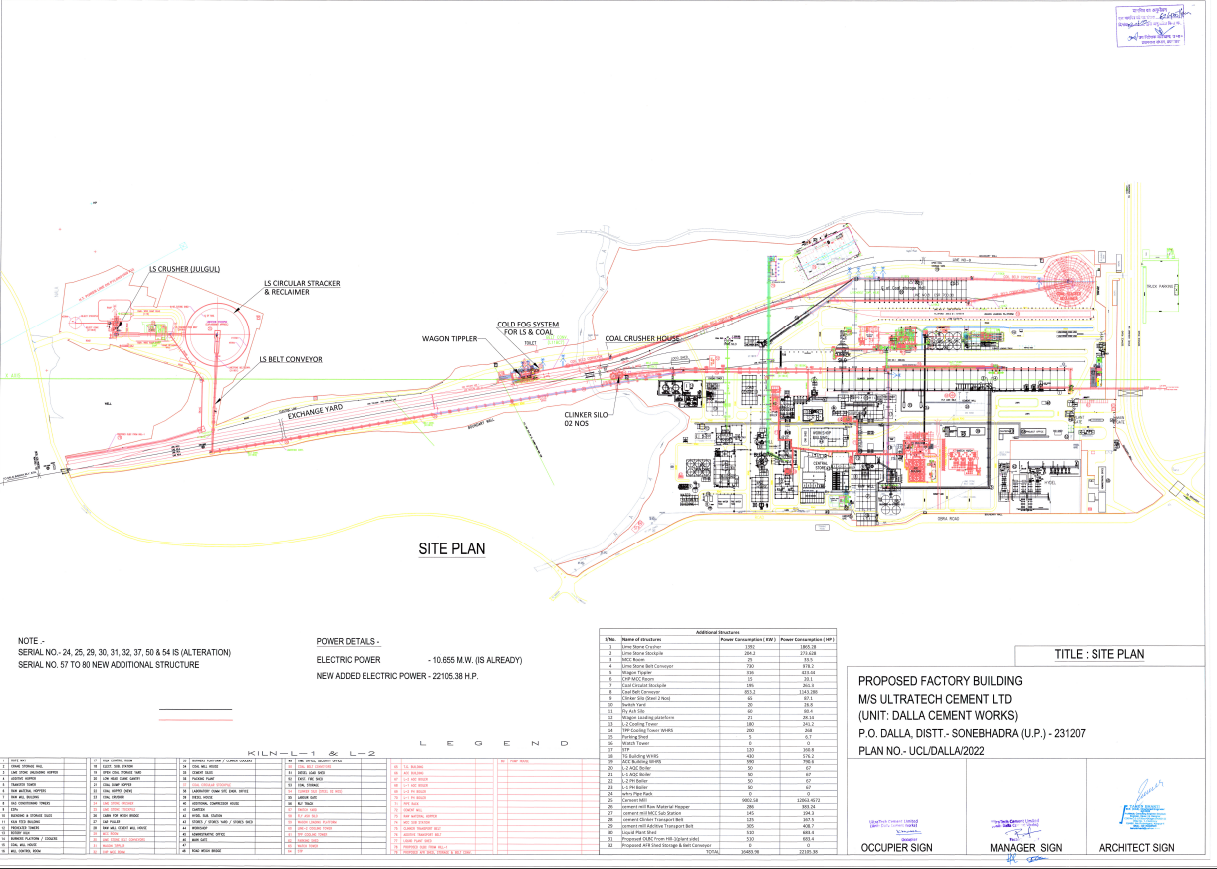**

**ENCLOSURE 4: FACTORY LICENSE**

**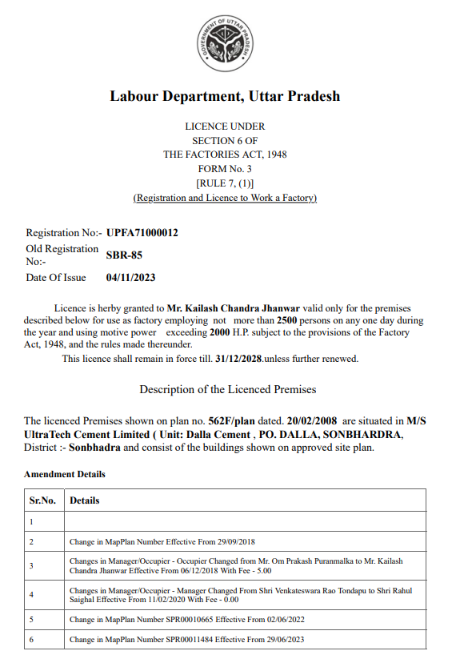**

**ENCLOSURE:5 FIRE NOC**

**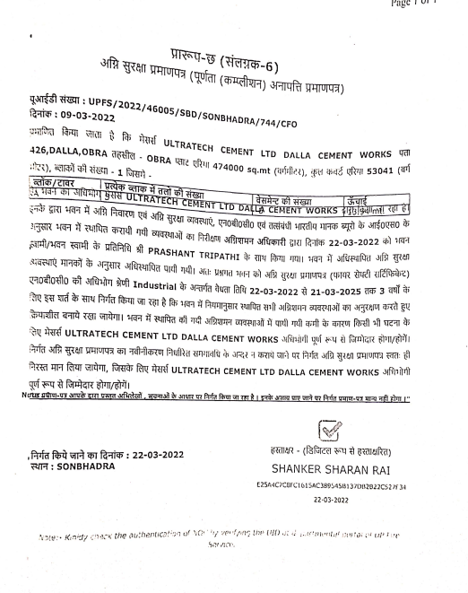**

**ENCLOSURE 6: POLLUTION NOC**

**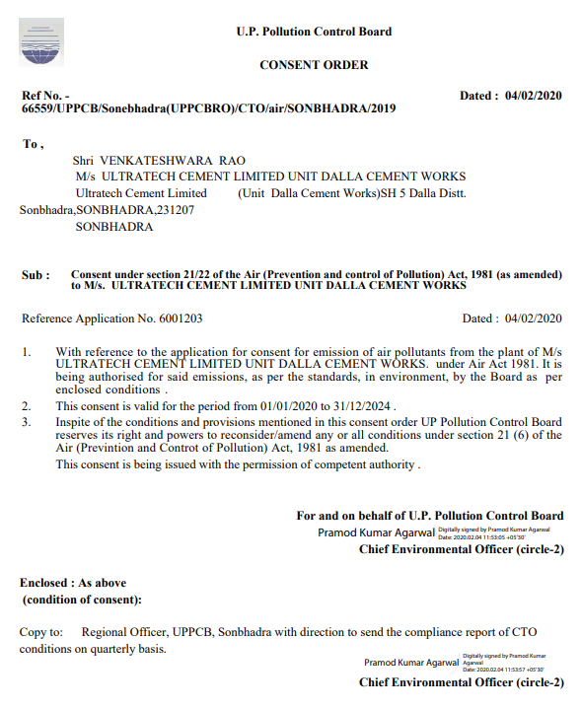**

**ENCLOSURE 7: CA CERTIFICATE**

**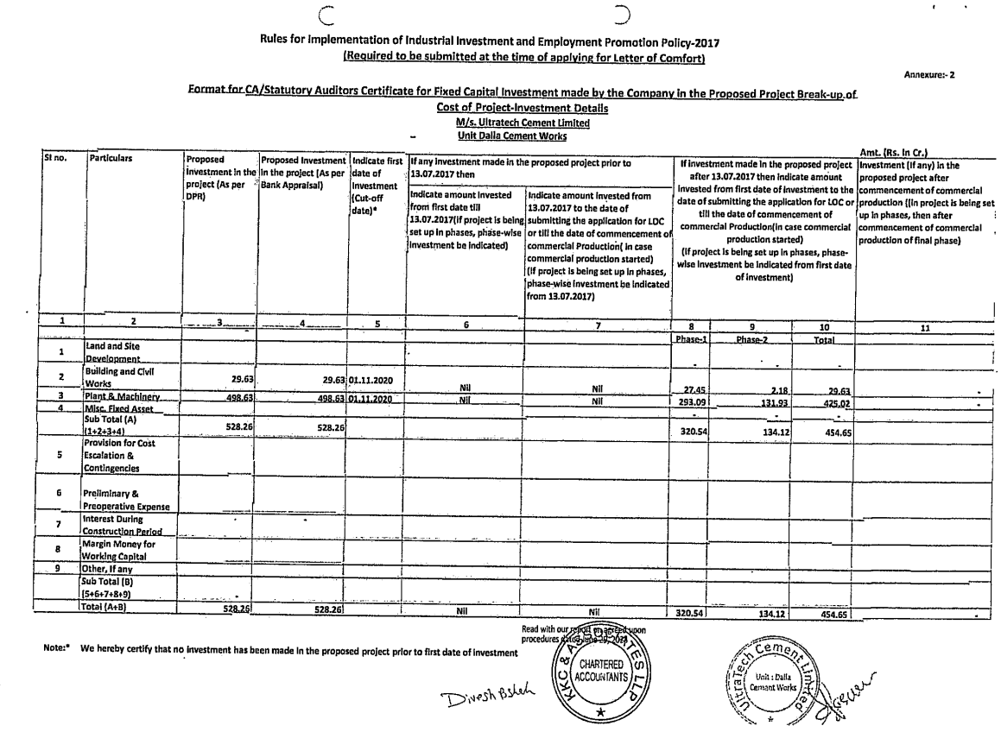**

**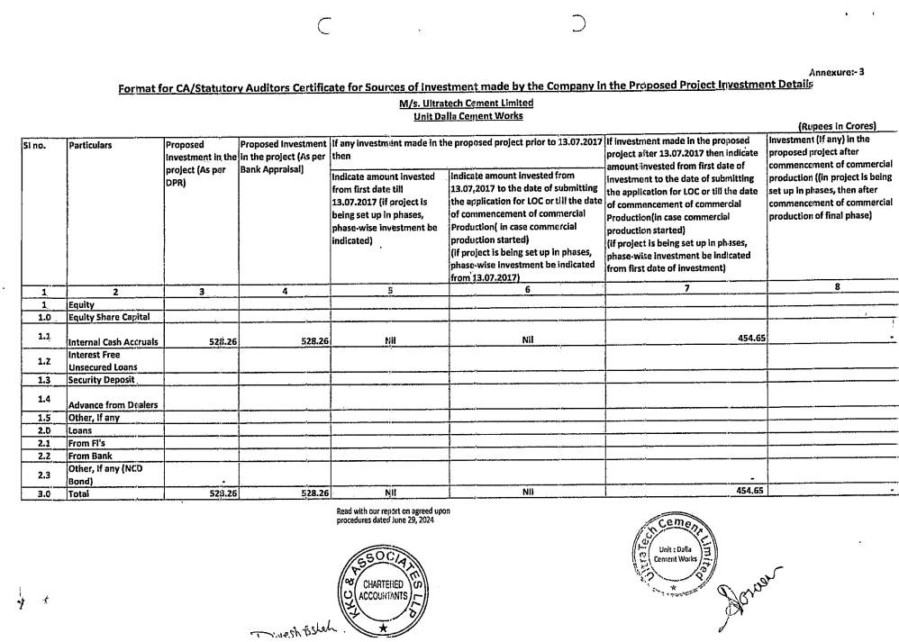**

|  |  |
| --- | --- |
| **PART I** | **DISCLAIMER** |

* + - 1. No employee or member of R.K Associates has any direct/ indirect interest in the Project.
      2. This report is prepared based on the copies of the documents/ information which interested organization or customer could provide to us out of the standard checklist of documents sought from them and further based on our assumptions and limiting conditions. All such information provided to us has been relied upon and we have assumed that it is true and correct. Verification or cross checking of the documents provided to us has not been done at our end from the originals. If at any time in future it’s found or came to our knowledge that misrepresentation of facts or incomplete or distorted information has been provided to us then this report shall automatically become null & void.
      3. This report is a general analysis of the project and not an audit report. All the information gathered is based on the facts seen on the site during survey, verbal discussion & documentary evidence provided by the client and is believed that information given by the company is true best of their knowledge.
      4. All observations mentioned in the report is only based on the visual observation and the documents/ data/ information provided by the client. No mechanical/ technical tests, measurements or any design review have been performed or carried out from our side during Project assessment.
      5. User of this report should ONLY take this report as an Advisory document from the Financial/ Chartered Engineering firm and it’s specifically advised to the creditor to cross verify the original documents for the facts mentioned in the report which can be availed from the borrowing company directly.
      6. In case of any default in loans or the credit facility extended to the borrowing company, R.K Associates shall not be held responsible for whatsoever reason may be and any request for seeking any explanation from the employee/s of R.K Associates will not be entertained at any instance or situation.
      7. This Report is prepared by our competent technical team which includes Engineers and financial experts & analysts.
      8. This is just an opinion report and doesn’t hold any binding on anyone. It is requested from the concerned Financial Institution which is using this report for taking financial decision on the project that they should consider all the different associated relevant & related factors also before taking any business decision based on the content of this report.
      9. All Pages of the report including annexures are signed and stamped from our office. In case any paper in the report is without stamp & signature then this should not be considered a valid paper issued from this office.
      10. Defect Liability Period is **30 DAYS**. We request the concerned authorized reader of this report to check the contents, data and calculations in the report within this period and intimate us in writing if any corrections are required or in case of any other concern with the contents or opinion mentioned in the report. Corrections only related to typographical, calculation, spelling mistakes will be entertained within the defect liability period. No request for any illegitimate value revision, date change or any other facts & figures changes will be entertained other than the one mentioned above.
      11. R.K Associates encourages its customers to give feedback or inform concerns over its services through proper channel at le[@rkassociates.org](mailto:ers@rkassociates.org) in writing within 30 days of report delivery. After this period no concern/ complaint/ proceedings in connection with the Valuation Services can be entertained due to possible change in situation and condition of the property.
      12. Our Data retention policy is of **ONE YEAR**. After this period, we remove all the concerned records related to the assignment from our repository. No clarification or query can be answered after this period due to unavailability of the data.
      13. This Valuation report is governed by our (1) Internal Policies, Processes & Standard Operating Procedures, (2) R.K Associates Quality Policy, (3) Valuation & Survey Best Practices Guidelines formulated by management of R.K Associates, (4) Information input given to us by the customer and (4) Information/ Data/ Facts given to us by our field/ office technical team. Management of R.K Associates never gives acceptance to any unethical or unprofessional practice which may affect fair, correct & impartial assessment and which is against any prevailing law. In case of any indication of any negligence, default, incorrect, misleading, misrepresentation or distortion of facts in the report then it is the responsibility of the user of this report to immediately or atleast within the defect liability period bring all such act into notice of R.K Associates management so that corrective measures can be taken instantly.
      14. R.K Associates never releases any report doing alterations or modifications from pen. In case any information/ figure of this report is found altered with pen then this report will automatically become null & void.
      15. If this report is prepared for the matter under litigation in any Indian court, no official or employee of R.K Associates will be under any obligation to give in person appearance in the court as a testimony. For any explanation or clarification, only written reply can be submitted on payment of charges by the plaintiff or respondent which will be 10% of the original fees charged where minimum charges will be Rs.15,000/-.

|  |  |  |
| --- | --- | --- |
| **SURVEYED BY** | **PREPARED BY** | **L2 REVIEW BY** |
| Vishal Singh  And Deepak Singh | Vishal Singh | Sr. V.P Projects |
|  |  |  |

Place : Noida

Date : 05.08.2024

Note : This report contains 40 pages

***DEFECT LIABILITY PERIOD - In case of any query/ issue or escalation you may please contact Incident Manager by writing at valuers@rkassociates.org. We ensure 100% accuracy in the Calculations done, Rates adopted and various other data points & information mentioned in the report but still can’t rule out typing, human errors or any other mistakes. In case you find any mistake, variation, discrepancy or inaccuracy in any data point of the report, please help us by bringing all such points into our notice in writing at*** [***valuers@rkassociates.org***](mailto:valuers@rkassociates.org) ***within 30 days of the report delivery, to get these rectified timely, failing which R.K Associates Valuers Techno Engineering Consultants (P) Ltd. won’t be held responsible for any inaccuracy in any manner. Also, if we will not hear back anything from you within 30 days, we will assume that report is correct in all respect and no further claim of any sort will be entertained thereafter. We would welcome and appreciate your feedback & suggestions in order to improve our services.***

***COPYRIGHT FORMAT - This report is prepared on the copyright format of R.K Associates Valuers Techno Engineering Consultants (P) Ltd. to serve our clients in the best possible way. Legally no one can copy or distribute this format without prior approval from R.K Associates. It is meant only for the organization as mentioned on the cover page of this report. Distribution or use of this format other than R.K Associates will be seen as unlawful act and necessary legal action can be taken against the defaulter***