**File No. VIS (2024-25)-PL303-264-349 DATED: 10.09.2024**

**CHARTERED ENGINEERING ASSESSMENT REPORT**

**OF**

**MANUFACTURING UNIT OF PRINTED CIRCUIT BOARD**

**SITUATED AT**

**B-18, PHASE-2, NOIDA -201305 (UTTAR PRADESH)**

**IMPLEMENTED BY**

**[REXXAM DIXON ELECTRONICS PRIVATE LIMITED](https://www.zaubacorp.com/company/JGN-SUGAR-AND-BIOFUELS-PRIVATE-LIMITED/U15420DL2022PTC404736)**

**REPORT PREPARED FOR**

**IFCI LIMITED, IFCI TOWER, 61, NEHRU PLACE, NEW DELHI – 110019**

***\*\*Important - In case of any query/ issue or escalation you may please contact Incident Manager at le@rkassociates.org. We will appreciate your feedback in order to improve our services.***

***NOTE: As per IBA Guidelines please provide your feedback on the report within 15 days of its submission after which report will be considered to be correct.***

|  |  |  |
| --- | --- | --- |
| **TABLE OF CONTENTS** | | |
| **SR. NO.** | **DESCRIPTION** | **PAGE NO.** |
| **PART A** | **Introduction** | **04-05** |
| **PART B** | **Certificate For PLI Scheme (as per format of IFCI)** | **06** |
| **PART C** | **Project Details** | **07-09** |
| **PART D** | **Annexure-I – Assets for Eligible Investment** | **10-15** |
| **Annexure-II – Photographs of Assets and Site Visit** | **16-19** |
| **Annexure-III – Claim Year Capacity** | **20-22** |
| **Annexure-IV – Claim Year Incremental Capacity** | **23** |
| **Annexure-V – Details of assets at third parties** | **24** |
| **Annexure-VI – Details of Insurance Cover** | **25-26** |
| **Annexure-VII – Manufacturing Process Flow Diagram** | **27-28** |
| **Annexure-VIII – Empanelment Document** | **29** |
| **Annexure-IX – Project Approval Letter** | **30** |
| **Annexure-X – Invoices of Major Machinery** | **31-33** |
| **Annexure-XI – Property Documents** | **34-35** |
| **PART E** | **Chartered Engineer Remarks, Caveats, Limitations & Disclaimers** | **36** |

*NOTE: Part – B, C & D are strictly as per format of IFCI. Any additional CE’s Remarks, Observations, Caveats, Limitations & Disclaimers are covered in Notes of various Annexures and Part-E.*

# IMPORTANT NOTICE

*This report is intended for the sole use of the intended recipient/s and contain material that is STRICTLY CONFIDENTIAL AND PRIVATE.*

***DEFECT LIABILITY PERIOD:*** *- In case of any query/ issue or escalation you may please contact Incident Manager at*[*le@rkassociates.org*](mailto:le@rkassociates.org)*.*

*Though adequate care has been taken while preparing this report as per its scope, but still, we can’t rule out typing, human errors, over sightedness of any information or any other mistakes. Therefore, the concerned organization is advised to satisfy themselves that the report is complete & satisfactory in all respect. Intimation regarding any discrepancy shall be brought into our notice immediately. If no intimation is received within 15 (Fifteen) days in writing from the date of issuance of the report, to rectify these timely, then it shall be considered that the report is complete in all respect and has been accepted. CE Important Remarks / Limitations/ Caveats/ Disclaimers mentioned in Part-E is the integral part of this assessment.*

|  |  |
| --- | --- |
| **PART A** | **INTRODUCTION** |

|  |  |  |  |  |
| --- | --- | --- | --- | --- |
| **S.NO.** | **PARTICULARS** | **DETAILS** | | |
|  | **Report/ Certificate Type** | Chartered Engineering Assessment for GOI PLI Scheme | | |
|  | **Name of the Project** | M/s Rexxam Dixon Electronics Private Limited, Manufacturing Unit of Printed Circuit Board B-18, Industrial Phase 2 Block A Road, Industrial Area Phase 2, Noida, Gautam Buddha Nagar, Uttar Pradesh - 201305 | | |
|  | **Project Location** | * City: Noida * District: Gautam Buddha Nagar * State: Uttar Pradesh | | |
|  | **Name of the Company** | M/s Rexxam Dixon Electronics Private Limited | | |
|  | **Client Name** | M/s Rexxam Dixon Electronics Private Limited | | |
|  | **Coordinating Person Name and Number** | Name | Designation | Number |
| Mr. Ritik Jain | AGM Finance | 09311242256 |
|  | **Work Order Number** | Email Dated: 08.08.2024 | | |
|  | **Chartered Engineering Firm Name** | M/s. R.K. Associates Valuers & Techno Engineering Consultants (P) Ltd. | | |
|  | **Date of Survey** | 13th August 2024 | | |
|  | **Date of Report** | 10th September 2024 | | |
|  | **Purpose of the Assessment** | For GOI Production Linked Incentive claims | | |
|  | **Scope of the work** | To review production capacity of the Project based on the information/ data supplied by the company | | |
|  | **Documents provided/ pursued for the Project** | 1. Bills/Invoices 2. Customs Bill of Entry 3. FAR 4. GST Details 5. Project Approval Letter 6. Manufacturing Process Flow Diagram 7. Production and Stock RM Data 8. Daily Sales Register 9. Catalogue of Major Machinery 10. Production Target and Capacity of Major Machinery 11. Insurance Cover Details 12. Property Documents 13. Electricity Bills | | |
|  | **Documents/ Information Provided by** | Name | Designation | Number |
| Mr. Ritik Jain | AGM Finance | 09311242256 |
|  | **Annexure with the report** | 1. Bills/Invoices 2. Customs Bill of Entry 3. FAR 4. GST Details 5. Project Approval Letter 6. Empanelment Letter 7. Manufacturing Process Flow Diagram 8. Catalogue of Major Machinery 9. Production Target and Capacity of Major Machinery 10. Insurance Cover Details 11. Property Documents | | |

|  |  |
| --- | --- |
| **PART B** | **CERTIFICATE FOR PLI SCHEME** |

To,

IFCI Limited,

IFCI Tower, 61,

Nehru Place,

New Delhi – 110019

This certificate is being issued in connection with Production Linked Incentive Scheme (PLI) for promoting domestic manufacturing of AC and LED Light in India (hereinafter referred as ‘PLI Scheme’) as notified vide **Notification No. CG-DL-E-16042021-226671 dated 16.04.2021** read with operational guideline dated **4th June 2021**, as amended from time to time (hereinafter referred as ‘the PLI Scheme’).

**M/s Rexxam Dixon Electronics Private Limited** was approved under PLI Scheme vide letter no. **IFCI/CASD/DPIIT/PLIWG-211112039** dated **12th November, 2021** issued by IFCI Limited (Project Management Agency appointed under the Scheme).

M/s R.K. Associates Valuers and Techno Engineering Consultants Pvt. Ltd. is empaneled with IFCI Ltd. for evaluation of asset class **‘Plant, Machinery & Equipment’** vide letter no. **IFCI/CAD/-221006029** Dated **06th October, 2022** valid till **05th October, 2025** issued by IFCI. M/s Rexxam Dixon Electronics Private Limited appointed us for the said certification work.

To evaluate and give a certificate on status of compliance with eligibility criteria of Greenfield Project and Committed investment for the period FY 2021 – 2023 by M/s Rexxam Dixon Electronics Private Limited under PLI Scheme. We have carried out the physical inspection of the plant, examined the relevant records and other documents to evaluate whether applicant has met the eligibility criteria of Greenfield Project and Committed Investment under Production Linked Incentive (PLI) Scheme for FY 2021 – 2023.

To carry out an independent verification/determination of Claim production capacities for the claim year 2023 – 2024 of M/s Rexxam Dixon Electronics Private Limited under PLI Scheme.

We have carried out the physical inspection of the plant and machinery installed and examined the relevant records for determining claim capacity of all the manufacturing processes involved in the production of eligible products for FY 2023 – 2024. In this regard, we enclosed the capacity of F.Y 2023 – 2024 & incremental capacity generated from incremental investments for the year in **Annexure III and Annexure IV.**

**Thanks & regards,**

**For R.K Associates Valuers & Techno Engg. Consultants (P) Ltd.**

**Project Engineering Team**

|  |  |
| --- | --- |
| **PART C** | **PROJECT DETAILS** |

1. **Details of the Project Set-up by the applicant:**

|  |  |  |
| --- | --- | --- |
| **S.NO.** | **PARTICULARS** | **DETAILS** |
|  | Name of the Applicant | M/s Rexxam Dixon Electronics Private Limited |
|  | Project Address | B-18, Industrial Phase 2 Block A Road, Industrial Area Phase 2, Noida, Gautam Buddha Nagar, Uttar Pradesh - 201305 |
|  | Eligible products being manufactured | Control Assemblies for IDU, ODU and Remotes |
|  | Committed investment during the Scheme Period | Rs. 51 crores |
|  | Threshold Investment up to 31st March 2023 | Rs. 10 crores |
|  | Eligible investment ~~shown by the company~~ physically verified of the investment period F.Y. 2021-23 ~~during the Gestation Period~~ | **Rs.22.07 crores (Details attached as Annexure I)** |
|  | Date of site visit and company officials facilitating the inspection | **Date: 13-08-2024**  **Company Official:** Mr. Ritik Jain (AGM Finance) |
|  | Whether Project has been set-up in a new factory premises or the existing factory premises | Existing premises taken on rent. |
|  | Whether claimed Associated Utilities are exclusive to PLI-White Goods or shared with other activities | As per site visit, the said unit is only exclusively for Control Assemblies for IDU, ODU and Remotes and therefore all associates facilities are exclusively used for it. |
|  | Whether plant/ unit was operational on the date of visit? | Yes |
|  | Status of Land & Building (leased/ Owned/ Common Facilities with any other person or group company) | Rented. As per rent deed provided to us, Dixon Technologies (India) Limited is the lessor of the premises from NOIDA Authority which has in turn rented out the said premises to M/s Rexxam Dixon Electronics Private Limited on from 01.04.2022 to 31.03.2036. Copy attached in Annexure-XI. |

|  |  |  |
| --- | --- | --- |
| **Cumulative Eligible Investment Details** | | |
| **S.No.** | **Particular** | **Amount (Rs. In Crore)** |
|  | Eligible Investment in FY 21-22 (Gross Book Value) | NA |
|  | Eligible Investment in FY 22-23 (Gross Book Value) | Rs. 22.07 crores |
|  | Eligible Investment in FY 23-24 (Gross Book Value) | NA |
|  | Eligible Investment in FY 24-25 (Gross Book Value) | NA |
|  | Eligible Investment in FY 25-26 (Gross Book Value) | NA |
|  | Eligible Investment in FY 26-27 (Gross Book Value) | NA |
|  | **Total (A)** | **Rs. 22.07 crores** |
|  | Less: - Sold/ Written off Eligible Investment (if any) for investment period as on 31st March, 2023 | NA |
|  | Eligible Investment in FY 21-22 (Gross Book Value) | NA |
|  | Eligible Investment in FY 22-23 (Gross Book Value) | NA |
|  | Eligible Investment in FY 23-24 (Gross Book Value) | NA |
|  | Eligible Investment in FY 24-25 (Gross Book Value) | NA |
|  | Eligible Investment in FY 25-26 (Gross Book Value) | NA |
|  | Eligible Investment in FY 26-27 (Gross Book Value) | NA |
|  | **Total (B)** | NA |
|  | **Net Cumulative Investment as on 31st March, 2023 (A - B)** | **Rs. 22.07 crores** |

1. We visited the project site on **13-08-2024** and the photograph of the site with visiting team is attached at **Annexure II**.
2. The project set-up by **M/s Rexxam Dixon Electronics Private Limited** at **B-18, Industrial Phase 2 Block A Road, Industrial Area Phase 2, Noida, Gautam Buddha Nagar, Uttar Pradesh** for eligible products **Control Assemblies for IDU, ODU and Remotes** is a Greenfield Project as defined under clause 2.21 respectively of the Scheme Guidelines.

All the Plant & Machinery, Associated Utilities or R&D Equipment being utilized in the production of eligible projects are new as per the Invoices and declaration given by the company. No second hand/ used/ refurbished plant, machinery, equipment, utilities has been used to manufacture the eligible products approved under PLI Scheme in compliance with clause 14.1.4. of the Scheme Guidelines.

1. The capex items claimed for eligibility criteria of committed investment under the PLI Scheme are required for the manufacturing of eligible products Control Assemblies for IDU, ODU and Remotes and all such plant & machinery have been installed in the factory premises of **M/s Rexxam Dixon Electronics Private Limited at Noida, Gautam Buddha Nagar, Uttar Pradesh.**
2. All capital items which have been claimed as products eligibility criteria of investment are being used in regular course for the manufacturing of eligible product under PLI scheme and the cost of investment claim under PLI scheme is reasonable.
3. All capital items have been purchased at prices that are in our opinion reasonable and in-line with prevailing market value as on the date of the purchase.

*Please note that all capital items have been considered as per the Invoices/ FAR provided to us. Some of these are special and custom design machines procured from Rexxam Co. Ltd., Japan and market rates are not available openly for such machines.*

1. With reference to clause 8.4.2 of the Scheme Guidelines, the amount of Associated Utilities claimed under eligible capex is Rs. 1,38,42,467/- as per the FAR given by the company.
2. We Confirm that utilization of the Plant, Machinery and Equipment for manufacturing of eligible product(s) under target segment for financial year for which the applicant is claiming incentive under the Scheme.
3. The manufacturing of the eligible products in the Greenfield Project meets the criteria set up under clause 2.21 of the Scheme Guidelines.
4. The capex items included in Eligible Capex are installed at the Project Location except for certain items situated at third parties/ vendors whose details are furnished as **Annexure V.**
5. We have examined the insurance policies for capex items considered under Eligible Investment. Company has taken insurance cover for an amount of ₹ 40.00 crore (For Plant and Machinery). Extract of insurance policies is furnished as **Annexure VI**. In our view insurance cover obtained by the Company for the Eligible Investment is adequate.
6. The manufacturing process flow diagram (MPFD) of each eligible product is attached as **Annexure-VII.** We have observed the manufacturing process followed by the Company and the same is in line with the MPFD(s) attached.at **Annexure VII.**
7. Site Photographs with GPS coordinates (the factory premises, visiting team from CE and company official (give name and designation) should be appearing in photograph at **Annexure – II.**

**DECLARATIONS:**

1. It has been ensured that the information furnished is true and correct as furnished by the company to the best of our knowledge. No part of it is false or misleading and no relevant information has been concealed or withheld to the best of our knowledge.
2. We have requisite expertise, experience, and qualification to evaluate the project and give this certificate.
3. Neither of our director/ partner/ proprietor or employee has any present or prospective interest in the Greenfield Project or M/s Rexxam Dixon Electronics Private Limited (name of the applicant).
4. Neither I nor any of my partners or director or employee is a partner, director or an employee of M/s Rexxam Dixon Electronics Private Limited (name of applicant) or its associated concerns.
5. That the assessment is done based on the inputs/ data/ information provided by the company verbally or in writing has been relied upon.

This report is issued without prejudice or conflict of interest.

**Signature & Seal of CE with Membership number**

**ANNEXURE-I – ASSETS FOR ELIGIBLE INVESTMENT**

|  |  |  |  |  |  |  |
| --- | --- | --- | --- | --- | --- | --- |
| **Classification as per PLI** | **Usage in Production Process** | **Asset No. in FAR** | **Asset Description as per FAR** | **Capitalization Date** | **Balance Sheet Head** | **Amount Capitalized** |
| Plant & Machinery | SMT | 5000068 | Pick & Place with Accessories (FUJI NXTIII) | 08-02-2023 | Plant & Machinery | 37376876 |
| Plant & Machinery | SMT | 5000000 | Pick & Place with Accessories (FUJI NXTIII) | 15-10-2022 | Plant & Machinery | 32984550 |
| Plant & Machinery | PCB Inspection | 5000007 | PCBA Optical Inspector (Sherlock-3D 1100S) | 15-10-2022 | Plant & Machinery | 12611352 |
| Plant & Machinery | PCB Inspection | 5000063 | PCBA OPTICAL INSPECTOR SHERLOCK-3D 1100S | 31-01-2023 | Plant & Machinery | 10754713 |
| Plant & Machinery | PCB Marking | 5000011 | Laser Marker (Watson QR 800) | 15-10-2022 | Plant & Machinery | 8412850 |
| Plant & Machinery | PCB Marking | 5000070 | PCB Laser Marker Watson QR-800 | 29-01-2023 | Plant & Machinery | 7769184 |
| Plant & Machinery | PCB Printing | 5000066 | PRECISION PAST PRINTER WITH ACCESSORIES | 07-02-2023 | Plant & Machinery | 7489300 |
| Plant & Machinery | PCB Inspection | 5000009 | Solder Print Inspection System (3D SPI) (Sherlock | 15-10-2022 | Plant & Machinery | 7414714 |
| Plant & Machinery | PCB Printing | 5000003 | Precision Past Printer With Accessories (FUJI GPX) | 15-10-2022 | Plant & Machinery | 7320950 |
| Plant & Machinery | Soldering Machine | 5000047 | Wave Soldering Machine (JTWS-350) | 15-10-2022 | Plant & Machinery | 6748630 |
| Plant & Machinery | PCB Inspection | 5000072 | 3D SPI (SHERLOCK SP700) | 01-12-2022 | Plant & Machinery | 6401615 |
| Plant & Machinery | Quality Inspection | 5000069 | XSCAN-A100R | 06-03-2023 | Plant & Machinery | 6344387 |
| Associated Utilities | Power Generation | 6000022 | 500KVA DG Set (Engine Model KTAA19-G10) | 01-08-2022 | Plant & Machinery | 5600000 |
| Plant & Machinery | PCB Inspection | 5000051 | Automatic Optical Inspection Machine Sherlock - 30 | 01-02-2023 | Plant & Machinery | 5344665 |
| Plant & Machinery | Soldering Machine | 5000002 | Reflow Oven with Accessories (JT RS-1000IINe DL) | 15-10-2022 | Plant & Machinery | 4767720 |
| Plant & Machinery | Paste and Glue Dispensing | 5000001 | Yamaha Dispenser with Accessories (YSD 2Head: Max. | 19-10-2022 | Plant & Machinery | 4067966 |
| Plant & Machinery | Soldering Machine | 5000065 | REFLOW OVEN WITH ACCESSORIES | 22-02-2023 | Plant & Machinery | 3930625 |
| Plant & Machinery | Coating and Inspection | 5000013 | Auto Coating & Inspection Machine (Pegasus 600I) | 15-10-2022 | Plant & Machinery | 3208289 |
| Plant & Machinery | PCB Inspection | 5000006 | PCBA Optical Inspector (Sherlock-300R) | 15-10-2022 | Plant & Machinery | 2067565 |
| Plant & Machinery | Testing Unit | 5000057 | Universal Test Unit RS-510 | 01-03-2023 | Plant & Machinery | 1986110 |
| Plant & Machinery | PCB Inspection | 5000005 | PCBA Optical Inspector (Sherlock-300IH) | 15-10-2022 | Plant & Machinery | 1568497 |
| Plant & Machinery | Repairing | 5000014 | Repair Station | 15-10-2022 | Plant & Machinery | 1509204 |
| Associated Utilities | Production Support | 6000017 | Screw Air Compressor Model: EG 37-8.5 CV | 12-08-2022 | Plant & Machinery | 1500000 |
| Plant & Machinery | Repairing | 5000054 | Repair Station | 01-02-2023 | Plant & Machinery | 1445350 |
| Plant & Machinery | PCB Conveyors | 6000193 | Automatic Magazine Unloader Model: NMT-UL-0003-M1M | 13-03-2023 | Plant & Machinery | 1395000 |
| Plant & Machinery | PCB Conveyors | 6000174 | NMT-SC-0500-A2M | 08-02-2023 | Plant & Machinery | 1328400 |
| Plant & Machinery | PCB Conveyors | 6000043 | Shuttle Conveyor 2 in 2 Out Model: NMT-SC-0500-A2 | 15-10-2022 | Plant & Machinery | 1328400 |
| Plant & Machinery | PCB Conveyors | 6000170 | NMT-RC-1000-A1M | 06-02-2023 | Plant & Machinery | 1160000 |
| Plant & Machinery | PCB Conveyors | 6000039 | Reject Conveyor, NG Model: NMT-RC-1000-A1M | 15-10-2022 | Plant & Machinery | 1160000 |
| Plant & Machinery | PCB Inspection | 5000049 | Appearance Inspection Support System (Model- KR1) | 21-12-2022 | Plant & Machinery | 1025229 |
| Plant & Machinery | Testing Unit | 5000017 | Function Tester VB2W6FCT0106 | 15-10-2022 | Plant & Machinery | 983060 |
| Plant & Machinery | Testing Unit | 5000022 | Function Tester VB2W6FCT0105 | 15-10-2022 | Plant & Machinery | 938458 |
| Plant & Machinery | PCB Conveyors | 6000178 | NMT-UL-0003-M1M | 07-02-2023 | Plant & Machinery | 930000 |
| Associated Utilities | Power Generation | 8000015 | DUAL FUELING GAS SYSTEM 500 KVA GENSET | 27-03-2023 | ELECTRICAL INSTALL | 877032 |
| Plant & Machinery | PCB Conveyors | 6000014 | PCB conveyor (L18mtr*W600mm*H750mm) with 3 AC Drive | 20-10-2022 | Plant & Machinery | 850224 |
| Plant & Machinery | Material Handling | 6000016 | ACE Diesel Forklift Truck - Model AF 20D 2 Ton Cap | 15-08-2022 | Plant & Machinery | 795000 |
| Plant & Machinery | Testing Unit | 5000034 | Function Tester VB179FCT0119 | 15-10-2022 | Plant & Machinery | 762401 |
| Tools & Dies | Material Handling | 14000000 | ESD Safe PCB Magazine Racks | 15-10-2022 | Tools & Dies | 740000 |
| Plant & Machinery | PCB Conveyors | 6000142 | Belt conveyor (L12mtr.*W590mm*H850mm) with AC drive | 25-11-2022 | Plant & Machinery | 705400 |
| Plant & Machinery | PCB Conveyors | 6000153 | Automatic Magazine Loader Model: NMT-LD-0003-M1M | 25-11-2022 | Plant & Machinery | 634680 |
| Plant & Machinery | PCB Conveyors | 6000166 | NMT-LD-0003-M1M | 05-02-2023 | Plant & Machinery | 634680 |
| Plant & Machinery | Power Utility | 6000163 | UPS 120 KVA MAKE: EPX+33120L32 FOR 2ND LINE REFLOW | 22-02-2023 | Plant & Machinery | 615000 |
| Associated Utilities | Power Utility | 6000019 | 60 kVA Double Conversion True Online UPS | 12-08-2022 | Plant & Machinery | 540000 |
| Plant & Machinery | PCB writing | 5000036 | CPU Writing Jig VB179WRT0113 | 15-10-2022 | Plant & Machinery | 530762 |
| Plant & Machinery | Testing Unit | 5000037 | Insulation/ Withstanding Tester Jig VB179MEG0102 | 15-10-2022 | Plant & Machinery | 530762 |
| Plant & Machinery | PCB CPU writing | 5000024 | CPU Writing Fixture VB2W6WRT0102 | 15-10-2022 | Plant & Machinery | 519148 |
| Plant & Machinery | Testing Unit | 5000018 | In circuit Tester VB2W6ICT0102 | 15-10-2022 | Plant & Machinery | 517765 |
| Associated Utilities | Power Utility | 6000000 | UPS 30 KVA ON LINE 3 PH I/P 3 PH O/P MODEL: EPX | 20-07-2022 | Plant & Machinery | 513000 |
| Associated Utilities | Production Support | 9000003 | SHERLOCK 3D EDITOR PRECISION 5820 TOWER | 28-01-2023 | Computer Software | 510189 |
| Plant & Machinery | Soldering Machine | 6000046 | Soldering Iron (FX951) | 15-10-2022 | Plant & Machinery | 465000 |
| Associated Utilities | Production Support | 6000005 | AIR DRYER ELRD400 400 CFM ELGI | 25-08-2022 | Plant & Machinery | 448000 |
| Associated Utilities | Production Support | 8000002 | ESD1280 DRY DEHUMIDITIFIRE CABINET 1200L | 19-01-2023 | ELECTRICAL INSTALL | 430000 |
| Plant & Machinery | PCB Conveyors | 6000135 | Cooling Conveyor, 1000 mm (Shuttle) Model: NMT-CC- | 15-10-2022 | Plant & Machinery | 389000 |
| Plant & Machinery | PCB Conveyors | 6000177 | NMT-CC-1000-A2M | 09-02-2023 | Plant & Machinery | 389000 |
| Associated Utilities | Computer | 10000015 | DESKTOP ACER M200 I5 8GB 1TB WIN 5YR | 15-10-2022 | Computer-Hardware | 379000 |
| Plant & Machinery | Testing Unit | 5000023 | In circuit Tester VB2W6ICT0103 | 15-10-2022 | Plant & Machinery | 371425 |
| Plant & Machinery | Testing Unit | 5000035 | In circuit Tester VB179ICT0108 | 15-10-2022 | Plant & Machinery | 363896 |
| Plant & Machinery | Electrical Maintenance | 5000059 | Digital Multimeter AD7451A | 01-03-2023 | Plant & Machinery | 353457 |
| Plant & Machinery | PCB Conveyors | 6000045 | Inspection Conveyor, 1000 mm (Shuttle) Model: NM | 15-10-2022 | Plant & Machinery | 330200 |
| Plant & Machinery | PCB Conveyors | 6000176 | NMT-IC-1000-A2M | 08-02-2023 | Plant & Machinery | 330200 |
| Plant & Machinery | PCB Conveyors | 6000192 | Automatic Magazine Loader Model: NMT-LD-0003-M1M3 | 18-03-2023 | Plant & Machinery | 317340 |
| Plant & Machinery | Testing Unit | 5000020 | Insulation/Withstanding Tester VJ-2W6-311 | 15-10-2022 | Plant & Machinery | 316362 |
| Associated Utilities | Networking | 10000002 | FORTINET SWITCH FS-124E(24 PORTS) | 15-10-2022 | Computer-Hardware | 308781 |
| Plant & Machinery | Electrical Maintenance | 5000026 | Transformer JJ-TRANCE-200-10 | 15-10-2022 | Plant & Machinery | 307379 |
| Associated Utilities | Software | 9000001 | SHERLOCK SPI EDITOR (HASP KEY AND INSTRUCTION MANU | 28-01-2023 | Computer Software | 304323 |
| Plant & Machinery | PCB Conveyors | 6000037 | Link Conveyor, 500 mm Model: NMT-LC-0500-A1M | 15-10-2022 | Plant & Machinery | 280000 |
| Plant & Machinery | PCB Conveyors | 6000168 | NMT-LC-0500-A1M | 03-02-2023 | Plant & Machinery | 280000 |
| Associated Utilities | Networking | 10000066 | Server Lenovo ST 250 | 25-11-2022 | Computer-Hardware | 265000 |
| Associated Utilities | Power Utility | 6000003 | UPS 20 KVA ON LINE 3 PH I/P 1 PH O/P MODEL: DS II | 20-07-2022 | Plant & Machinery | 264000 |
| Associated Utilities | Software | 9000004 | CODE SOFT & INTERPHONE SOFTWARE | 22-11-2022 | Computer Software | 225000 |
| Plant & Machinery | Motor | 5000028 | Motor 2YC48AXD | 15-10-2022 | Plant & Machinery | 221518 |
| Plant & Machinery | Motor | 5000029 | Motor 2YC71AXD | 15-10-2022 | Plant & Machinery | 221518 |
| Plant & Machinery | Desoldering | 6000147 | Desoldering Tool (FR410) | 25-11-2022 | Plant & Machinery | 210000 |
| Associated Utilities | Printer | 8000014 | BBP12 PRINTER-300 DPI, LCD INTERFACE | 27-12-2022 | ELECTRICAL INSTALL | 200000 |
| Plant & Machinery | Cutting Machine | 6000189 | PCB CUTTING MACHINE (MODEL: CM-805A) | 05-03-2023 | Plant & Machinery | 195000 |
| Plant & Machinery | PCB Conveyors | 6000146 | Belt conveyor (L15mtr. *W690mm*H850mm) with AC drive | 25-11-2022 | Plant & Machinery | 182280 |
| Associated Utilities | Measuring Tool | 10000096 | MEASUREMENT BOARD SECI-15-CP | 30-03-2023 | Computer-Hardware | 176450 |
| Associated Utilities | Water Purification | 6000013 | RO PLANT 1000 LPH MAKE: SHRI BALAJI AQUA | 25-08-2022 | Plant & Machinery | 150000 |
| Associated Utilities | Networking | 10000075 | FORTINET SWITCH FS-424E (24 PORTS) | 04-02-2023 | Computer-Hardware | 144933 |
| Associated Utilities | Networking | 10000011 | FORTINET WIRELESS FAP-421 | 15-10-2022 | Computer-Hardware | 144448 |
| Plant & Machinery | Lead Forming | 5000031 | Lead Forming Fixture VJ-303-332/JJ-500-1843 | 15-10-2022 | Plant & Machinery | 143314 |
| Plant & Machinery | Lead Forming | 5000032 | Lead Forming Fixture VJ-2W6-331/JJ-500-1843 | 15-10-2022 | Plant & Machinery | 143263 |
| Associated Utilities | Power Utility | 6000032 | STEP DOWN ISOLATION TR 30 KVA 3 PH I/P 200 V O/P | 20-09-2022 | Plant & Machinery | 138000 |
| Plant & Machinery | Barcode scanner | 6000156 | Model-DC810 with inbuilt label &barcode facility & | 25-11-2022 | Plant & Machinery | 132000 |
| Plant & Machinery | Material Handling | 6000028 | Hand Pallet Truck, Model: JPR 2500, Capacity 2500 | 15-09-2022 | Plant & Machinery | 127600 |
| Associated Utilities | Tank | 6000007 | AIR VESSEL VA0004010 1000 L | 25-08-2022 | Plant & Machinery | 124000 |
| Plant & Machinery | Desoldering | 6000076 | Desoldering Tool (FR301) | 15-10-2022 | Plant & Machinery | 120000 |
| Plant & Machinery | Material Handling | 12000022 | Fuji Feeder Trolly 40*2=80 PCS Storage Capacity | 05-02-2023 | Office Equipment | 120000 |
| Associated Utilities | Barcode scanner | 10000067 | Zebra DS2208 1D 2D Handheld Barcode Scanner | 26-12-2022 | Computer-Hardware | 117500 |
| Plant & Machinery | Assembly Machine | 5000030 | Assembly Fixture VJ-2W6-601 | 15-10-2022 | Plant & Machinery | 109085 |
| Tools & Dies | Tools | 14000001 | ELECTRONIC SCREWDRIVER FOR SUDONG MAKE.M | 28-01-2023 | Tools & Dies | 101500 |
| Associated Utilities | Sofware | 9000002 | SHERLOCK MANAGER (HASP KEY AND INSTRUCTION MANUAL) | 28-01-2023 | Computer Software | 98458 |
| Plant & Machinery | Barcode scanner | 5000061 | Code Reader 1950GHD-1-V-J-INT | 01-03-2023 | Plant & Machinery | 90639 |
| Plant & Machinery | Insulation Machine | 5000021 | Masking Fixture JJ-500-1717 | 15-10-2022 | Plant & Machinery | 83153 |
| Tools & Dies | Crimping Tool | 14000011 | CRIMPING TOOL YRS-490 | 10-03-2023 | Tools & dies | 77460 |
| Associated Utilities | Networking | 10000000 | FIREWALL FORTINATE FG-60F | 15-10-2022 | Computer-Hardware | 75003 |
| Plant & Machinery | Power Utility | 5000033 | Power Supply PWR401ML | 15-10-2022 | Plant & Machinery | 74203 |
| Plant & Machinery | Power Utility | 5000019 | DC Power unit PK-80L | 15-10-2022 | Plant & Machinery | 69151 |
| Associated Utilities | Monitor | 10000025 | TFT ACER 19.5" K202HQL | 15-10-2022 | Computer-Hardware | 59500 |
| Plant & Machinery | Temperature Measuring | 6000164 | Thermometer (FG101B) | 18-12-2022 | Plant & Machinery | 50000 |
| Associated Utilities | Fan Blower | 13000011 | EXHAUST BLOWER BHP : 6.7 HP REC.MOTOR : | 28-02-2023 | Fan & Cooler | 44350 |
| Plant & Machinery | Soldering Paste | 6000140 | Solder Cream Mixture (Model No. ZB500S) | 15-10-2022 | Plant & Machinery | 43000 |
| Plant & Machinery | Temperature Measuring | 6000034 | Thermometer (FG100B) | 15-10-2022 | Plant & Machinery | 42000 |
| Associated Utilities | Fan Blower | 13000000 | AXIAL FLOW FAN 18” WITH 1 HP MOTOR 1440 RPM CROMPT | 25-11-2022 | Fan & Cooler | 41950 |
| Plant & Machinery | Counter | 6000141 | Component Counter (YS-802E) | 15-10-2022 | Plant & Machinery | 40000 |
| Associated Utilities | Air filter | 12000019 | Smoke Extractor Make - Bakon 493 | 30-12-2022 | Office Equipment | 31500 |
| Associated Utilities | Fan Blower | 13000012 | EXHAUST BLOWER BHP: 2.8 HP REC.MOTOR | 25-02-2023 | Fan & Cooler | 29050 |
| Associated Utilities | Air filter | 6000011 | FINE FILTER MODEL FF 235 | 25-08-2022 | Plant & Machinery | 29000 |
| Associated Utilities | Air filter | 6000008 | PARTICULATE FILTER MODEL PF235 | 25-08-2022 | Plant & Machinery | 29000 |
| Plant & Machinery | Resistivity Meter | 6000181 | SURFACE RESISTIVITY METER WITH WEIGHT PR | 13-12-2022 | Plant & Machinery | 28870 |
| Plant & Machinery | LCR Meter | 6000182 | Smart Tweezer (LCR Meter USB Chargeable) | 23-12-2022 | Plant & Machinery | 28800 |
| Plant & Machinery | Microscope | 6000184 | Microscope with LCD Panel 7" 1-1200X | 20-12-2022 | Plant & Machinery | 28000 |
| Associated Utilities | Printer | 10000055 | EPSON A3 COLOUR PRINTER L1300 | 15-10-2022 | Computer-Hardware | 24500 |
| Associated Utilities | Rotor Pump | 6000021 | FLAMEPROOF MOTORIZED BARREL PUMP ROTOPOWER | 20-07-2022 | Plant & Machinery | 20500 |
| Plant & Machinery | Measuring Tool | 6000186 | MITUTOYO300MM DIG VERNIER CAL NO.500-754 | 29-12-2022 | Plant & Machinery | 16650 |
| Plant & Machinery | Measuring Tool | 6000157 | Model- DS 252 Electric weighing m/C Capacity-7.50K | 25-11-2022 | Plant & Machinery | 16500 |
| Plant & Machinery | Assembly Tool | 5000048 | PCB ASSY SECI-15-CP | 25-11-2022 | Plant & Machinery | 13101 |
| Plant & Machinery | Measuring Tool | 6000187 | MITUTOYO 150MM DIG VERNIER CALIPER NO.50 | 28-12-2022 | Plant & Machinery | 12460 |
| Plant & Machinery | Measuring Tool | 6000155 | Model- DS 415N Electric weighing m/C Capacity-100K | 25-11-2022 | Plant & Machinery | 11500 |
| Plant & Machinery | Computer | 5000025 | Laptop for CPU Writing Fixture ThinkPad E15 Gen2 | 15-10-2022 | Plant & Machinery | 5796 |
| Plant & Machinery | Insulation Machine | 5000038 | Masking Jig 3PCB5099-71/VB-2W6-801 | 15-10-2022 | Plant & Machinery | 1029 |
| Plant & Machinery | Insulation Machine | 5000039 | Masking Jig VB-179-102/VB-179-802 | 15-10-2022 | Plant & Machinery | 1026 |
|  |  |  | **Total** | | | **22,07,05,623** |

***Source: Company’s FAR***

**Note: -**

1. Above is the complete list of the machines as per FAR and Invoices shared by the company.
2. Due to voluminous items, only major machines/ equipments were verified at site against the FAR and Invoices shared by the company covering approximately 75% of the total amount.
3. Bill of Entry from customs is also reviewed for some of major machines on sample basis in respect of the imported machines.
4. The said unit also involves some other testing equipment from Dixon Technologies, IT equipment, ACs & other machines as present in the FAR and on site but these have not been considered under PLI scheme.

**ANNEXURE – II – PHOTOGRAPHS OF THE ASSETS AND SITE VISIT**

|  |  |  |  |  |  |  |
| --- | --- | --- | --- | --- | --- | --- |
| **S.**  **No.** | **Machine/ Asset Name** | **Model#** | **Serial#** | **Make/ Manufacturer** | **Fixed Asset Code**  **Asset ID** | **Building where installed** |
| 1. | Pick & Place with Accessories (FUJI NXTIII) | NXTIII | SD0106513,  SD0106514,  SD0106515 | FUJI | 5000000 | B-18, Phase -II, Noida |

|  |  |  |  |  |  |
| --- | --- | --- | --- | --- | --- |
| **Invoice#** | **Invoice date** | **Description of Asset as per Invoice** | **Name of**  **Seller/ Vendor** | **Status (Running/ Idle/ Under maintenance/ To be commissioned/ etc.)** | **Amount Capitalized**  **(₹)** |
| NSEZG23012 | 19.09.2022 | Pick and Place Machine with Standard Accessories – NXT III_8 x M3III +2 x M6III R-Dixon | NMTRONICS INDIA PVT.LTD | Running | 3,29,84,550 |

|  |
| --- |
| **Photo of Asset:** |
|  |

|  |  |  |  |  |  |  |
| --- | --- | --- | --- | --- | --- | --- |
| **S.**  **No.** | **Machine/ Asset Name** | **Model#** | **Serial#** | **Make/ Manufacturer** | **Fixed Asset Code**  **Asset ID** | **Building where installed** |
| 2. | Pick & Place with Accessories (FUJI NXTIII) | NXTIII | SD0108496,  SD0108497,  SD0108499 | FUJI | 5000068 | B-18, Phase -II, Noida |

|  |  |  |  |  |  |
| --- | --- | --- | --- | --- | --- |
| **Invoice#** | **Invoice date** | **Description of Asset as per Invoice** | **Name of**  **Seller/ Vendor** | **Status (Running/ Idle/ Under maintenance/ To be commissioned/ etc.)** | **Amount Capitalized**  **(₹)** |
| NSEZG23024 | 23.01.2023 | Pick and Place Machine with Standard Accessories – NXT III_8 x M3III +2 x M6III R-Dixon | NMTRONICS INDIA PVT.LTD | Running | 3,73,76,876 |

|  |
| --- |
| **Photo of Asset:** |
|  |

|  |  |  |  |  |  |  |
| --- | --- | --- | --- | --- | --- | --- |
| **S.**  **No.** | **Machine/ Asset Name** | **Model#** | **Serial#** | **Make/ Manufacturer** | **Fixed Asset Code**  **Asset ID** | **Building where installed** |
| 3. | PCBA Optical Inspector | Sherlock-3D 1100S | R420104 | Rexxam | 5000007 | B-18, Phase -II, Noida |

|  |  |  |  |  |  |
| --- | --- | --- | --- | --- | --- |
| **Invoice#** | **Invoice date** | **Description of Asset as per Invoice** | **Name of**  **Seller/ Vendor** | **Status (Running/ Idle/ Under maintenance/ To be commissioned/ etc.)** | **Amount Capitalized**  **(₹)** |
| G3220323-01 | 23.03.2022 | Automatic Optical Inspection Machine Sherlock 3D-1100S (Main Unit) | REXXAM CO. LTD. | Running | 62,84,420 |

|  |
| --- |
| **Photo of Asset:** |
|  |

**PHOTOS OF SITE VISIT**

|  |  |
| --- | --- |
|  |  |
|  |  |
|  |  |

**ANNEXURE - III**

1. **DETERMINATION OF CLAIM YEAR CAPACITY:**

|  |  |  |  |
| --- | --- | --- | --- |
|  | **Manufacturing location(s)** | **Date of Inspection** | **Greenfield/ Brownfield/ Both** |
| B-18, Industrial Phase 2 Block A Road, Industrial Area Phase 2, Noida, Gautam Buddha Nagar, Uttar Pradesh | 13/08/2024 | Greenfield |
|  | **Actual Investment: up to 31st March 2023** | Rs. 22.07 crores (eligible investment) | |
|  | **Eligible products manufactured** | Control Assemblies for IDU, ODU and Remotes (PCB) | |
|  | **No. of working shift on the date of site visits** | 2 shifts | |
|  | **New Manufacturing Facility** | | |
| **5.1** | **Production/ Manufacturing capacity as**  **per the Machinery installed p.a. (FY 2023-24)** | **Item** | **Quantity** |
| PCB’s assembly | 3.58 million units in FY 2023-24 |
| **5.2** | **Present Utilization of total production/ manufacturing Capacity by unit p.a. (Actual capacity)** | **Item** | **Quantity** |
| PCB’s assembly | 3.08 million units in FY 2023-24 |

**CHARTERED ENGINEER’S COMMENTS ON SITE INSPECTION FINDINGS:**

1. We have thoroughly inspected all the machines/items described above and hereby we confirm that they are in compliance with the records.

*Due to vast number of machines running into more than 280 line items, verification is done only for major machines comprising about 75% of total claim value. Also refer Part E of the report in this regard.*

1. We have verified the eligible product wise Manufacturing Process Flow Charts and found in conformity with the productions processes observed at the manufacturing location(s) for the following Eligible Products. Process Flow Charts is annexed as Annexure – VII.
2. Control Assemblies for IDU,
3. Control Assemblies for ODU and
4. Control Assemblies for Remotes
5. We have verified the number of eligible products manufactured in the year (2023- 2024) from the examination of the ERP/internal production records provided by the company, explanations provided by the company and the capacity of the Production lines as detailed in the process flow chart and information submitted in the PLI-White Goods portal and the capacity for the locations visited and on the basis of our verification as detailed below.
6. **DETAILS OF AVERAGE CAPACITY UTILIZATION OF COMPANY’S PRODUCTS AT THE COMPANY’S MANUFACTURING FACILITIES FOR THE SPECIFIED PERIODS:**

|  |  |  |  |  |  |  |  |
| --- | --- | --- | --- | --- | --- | --- | --- |
| **S.**  **No** | **Name of Eligible Products** | **Standard Capacity as on 31.03.2024**  **(in nos.)** | **No. of products manufactured in the**  **F.Y 2023-24**  **(in nos.)** | **No. of Days the products was/were manufactured in the F.Y 2023-24**  **(in nos.)** | **Number of working Shifts**  **per day** | **No. of Products manufactured per day per shift in the year** | **Variance as per CE’s**  **findings** |
| **Location – Noida, Gautam Buddhnagar, Uttar Pradesh** | | | | | | | |
| 1. | Control Assemblies for IDU | 25,49,570 | 21,88,834 | 321 | 2 shifts | 3409 | --- |
| 2. | Control Assemblies for ODU | 6,61,000 | 5,40,551 | 50 | 2 shifts | 5406 | --- |
| 3. | Control Assemblies for Remotes | 3,77,714 | 3,56,915 | 136 | 2 shifts | 1312 | --- |
| **Total** | | **35,88,284** | **30,86,300** |  |  |  |  |

**Notes:**

1. The information relating to the installed capacity as of the dates included above are based on ‘various assumptions’ *(details are given under in foot note)* and estimates that have been taken into account for calculation of the installed capacity. The assumption is also based on the three (3) shifts that the Company is running for eight (8) hours a shift. The assumptions and estimates taken into account include the following: (i) Number of working days in a fiscal year-300, (ii) Number of days in a month-30, (iii) Number of shifts in a day- 3, (iv) Number of hours- 8 in a shift and (v) Schedule preventive maintenance days-8.
2. The information relating to the actual production as of the dates included above are based on the examination of the ERP/internal production records provided by the Company, explanations given, the period during which the manufacturing facilities operate in a fiscal year, expected operations, availability of raw materials, downtime resulting from schedule maintenance activities, unscheduled breakdowns, as well as expected operational efficiencies.

**CE Observations**

1. As per discussion with the company proponents and as per the manufacturing process the capacity of the unit can be determined based on FUJI NXT III Pick & Place machine. The capacity of the machine is different for different segment of the chip manufactured depending on its size & height. All the segments have different cycle time. Company also manufactures different segments; therefore, no fixed capacity can be fixed.
2. Based on the above specification, company has given the calculation for the Production capacity on hourly basis.
3. Further these electronic machines also have in built counters in it which shows the Production record.
4. Production data of the company is also corroborated from the Sale record of the company for the corresponding period which is found to be inline.
5. The hourly production targets for different segment as follows:

|  |  |  |  |  |  |  |
| --- | --- | --- | --- | --- | --- | --- |
| **S.No.** | **Segment** | **PCB Size**  **Length x Width**  **(in mm)** | **Production Target/Hr.** | | **Total Cycle Time for 1 piece (in sec)** | **Hourly Production** |
| **Top** | **Bottom** |
|  | IDU | 250*138 | 480 | 680 | 12.79 | **281.4** |
|  | ODU | 320*196 | 400 | 220 | 25.36 | **141.8** |
|  | Remote | 220*191 | 900 | 1440 | 6.5 | **553.9** |

***Source: Company***

1. *Company is having 2 pick and place machines which can run simultaneously. In above table, Top and Bottom capacity has been estimated based on that.*
2. *Above is the average estimation and has been rounded off to the next whole number.*
3. Accordingly, the total achievable Production is assessed if a single product is produced and all 3 products are produced simultaneously:

|  |  |  |  |  |
| --- | --- | --- | --- | --- |
| **Production Capacity of 1 FUJI NXT III on Hourly Basis** | | | | |
|  |
| **Working Days** | **Working hours (24 hrs.)** | **IDU** | **ODU** | **Remote** |  |
| **300** | 7200 | 20,25,931 | 10,21,935 | 39,87,692 |  |
| **For 2 machines** | **14400** | **40,51,862** | **20,43,871** | **79,75,385** |  |
| **Production Capacity for Single Product(approx.)** | | **40,00,000** | **20,00,000** | **79,00,000** |  |
| **Production Plan of Product (in hrs.) X Hourly Production** | | **9061 x 281.4** | **4657 x 141.8** | **682 x 553.9** |  |
| **Production Capacity as per plan** | | **~25,49,570** | **~6,61,000** | **~ 3,77,714** |  |
| **Expected Capacity Grand Total of all products (IDU+ ODU+ Remotes) (A)** | | | | **35,88,284** |  |
| **Time loss (less 5% of production target) (B)** | | | | **1,79,414** |  |
| **Adjusted Expected Production Capacity (A-B)** | | | | **34,08,870** |  |

1. *Above is the expected capacity made based on certain assumptions.*
2. *This is the expected capacity if product is produced without considering breakdown, changeover time.*
3. *This shows the number of % produced within the optimum production assessment which appears to be reasonable if all 3 products are produced simultaneously.*
4. Therefore, based on the above assessment, ERP/internal production records provided by the company, explanations provided by the company and the capacity of the Production lines as detailed in the process flow chart.

**ANNEXURE IV - INCREMENTAL CAPACITY FOR THE CLAIM YEAR**

**Annexure A**

|  |  |  |  |
| --- | --- | --- | --- |
| **S. No.** | **Name of Eligible Products** | **Standard Capacity as on 31.03.2024 from new manufacturing facility as per section 2.10 or 2.21 of the scheme guidelines (in nos.)** | **No. of products manufactured in the year 2023-24 from new manufacturing facility as per section 2.10 or 2.21 of the scheme guidelines (in nos.)** |
| **Location – Noida, Gautam Buddhnagar, Uttar Pradesh** | | | |
|  | Control Assemblies for IDU | 25,49,570 | 21,88,834 |
|  | Control Assemblies for ODU | 6,61,000 | 5,40,551 |
|  | Control Assemblies for Remotes | 3,77,714 | 3,56,915 |
| **Total** | | **35,88,284** | **30,86,300\*** |

**Annexure B**

|  |  |  |  |  |
| --- | --- | --- | --- | --- |
| **S. No.** | **Name of Eligible Products** | **Standard Baseline Capacity as per Original Baseline Certificate (B) (in nos.)** | **Base Year actual Production as per CE Certificate (in nos.)** | **No. of products manufactured in the year F.Y 2023-24 (in nos.)** |
| **Location – Noida, Gautam Buddhnagar, Uttar Pradesh** | | | | |
| **1.** | Control Assemblies for IDU | 0 | 0 | 21,88,834 |
| **2.** | Control Assemblies for ODU | 0 | 0 | 5,40,551 |
| **3.** | Control Assemblies for Remotes | 0 | 0 | 3,56,915 |
|  |  |  |  | **30,86,300\*** |

**Note:**

1. Baseline Capacity certificate is not applicable as this is a new project and commercial production started on 01.07.2022 and the Claim year is FY 2023-24.
2. *Number of products manufactured in the year 2023-24 is as per the records and explanation furnished by the company.

**ANNEXURE -V**

**Details of assets at third parties**

No assets claimed as Eligible Investment under the Scheme Guidelines are lying outside the premises of the Company at premises of third parties which are its vendors/ suppliers/ etc.

**ANNEXURE -VI - DETAILS OF INSURANCE COVER**

|  |  |  |  |  |  |  |  |
| --- | --- | --- | --- | --- | --- | --- | --- |
| **S.**  **No.** | **Type of Insurance**  **(Assets covered)** | **Policy No.** | **Name of Insurer** | **Start date of cover** | **Details of risks**  **covered** | **End date of**  **cover** | **Amount**  **(Rs. cr.)** |
| 1. | P&M, CWIP, Stocks etc. | 2999206357934900000 | HDFC ERGO General Insurance Company Limited | 01-04-2024 | Material Damage | 31-03-2025 | 218.01 |
| 2. | Business Interruptions | 2999206357934900000 | HDFC ERGO General Insurance Company Limited | 01-04-2024 | Business Interruptions | 31-03-2025 | 50 |
|  |  |  |  | **Total** |  |  | **268.01** |

|  |
| --- |
|  |

|  |
| --- |
|  |
|  |

**ANNEXURE -VII - MANUFACTURING PROCESS FLOW DIAGRAM (MPFD)**

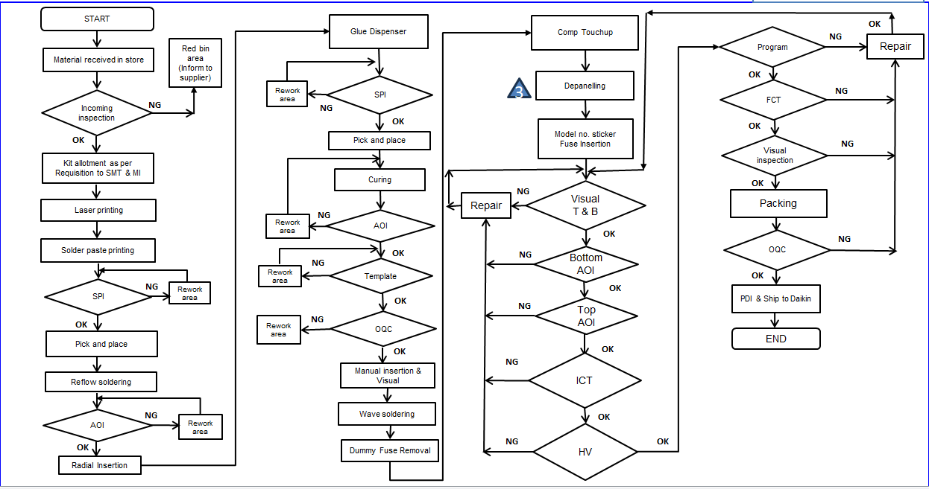

***Source: Company***

**Process Flow Chart for Daikin AC PCB**

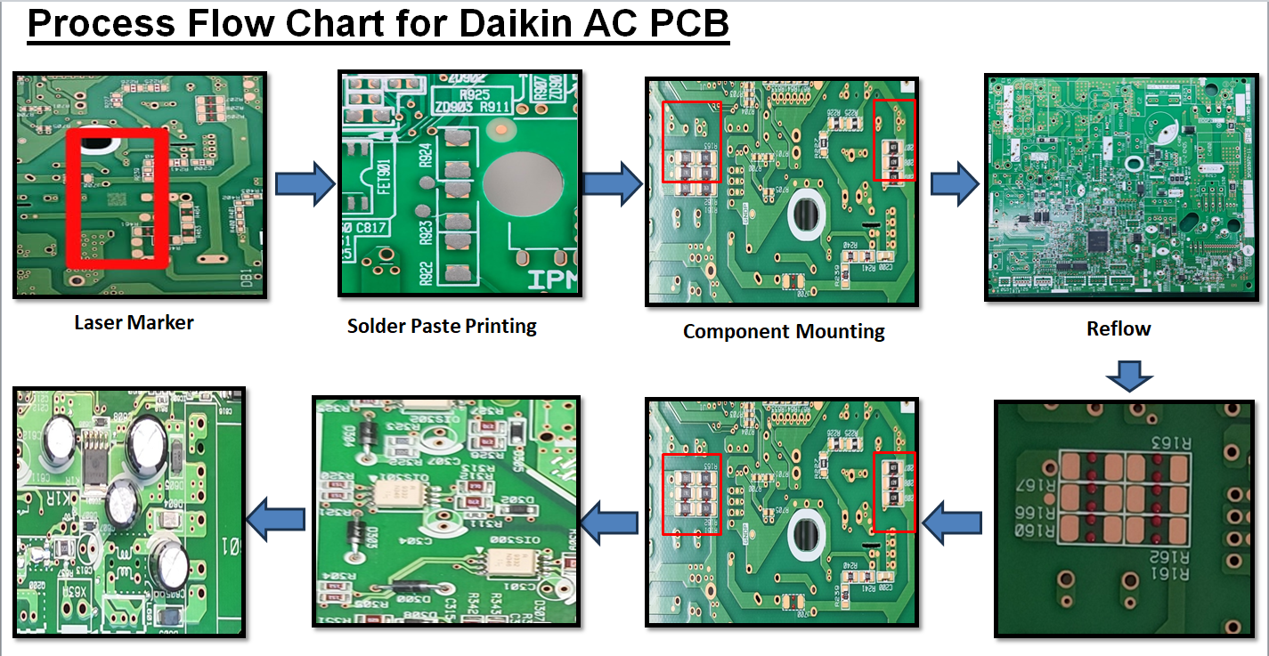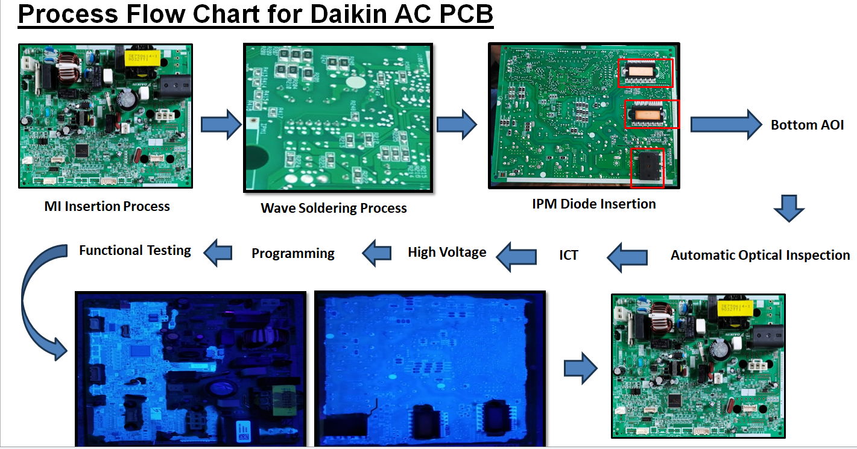

***Source: Company***

**ANNEXURE -VIII - EMPANELMENT DOCUMENT**

|  |
| --- |
| **ANNEXURE -IX – PROJECT APPROVAL LETTER FROM IFCI(PMA)** |
|  |

**ANNEXURE – X- INVOICES OF MAJOR MACHINERY**

**FUJI NXT III - PICK AND PLACE (1st)**

|  |
| --- |
|  |

**INVOICE PICK AND PLACE (2nd)**

|  |
| --- |
|  |

**FUJI NXT III – BILL OF ENTRY (1ST)**

|  |
| --- |
|  |

**FUJI NXT III – BILL OF ENTRY (2ND)**

|  |
| --- |
|  |

**ANNEXURE – XI - IMPORTANT PROPERTY DOCUMENTS EXHIBIT**

**Rent Deed**

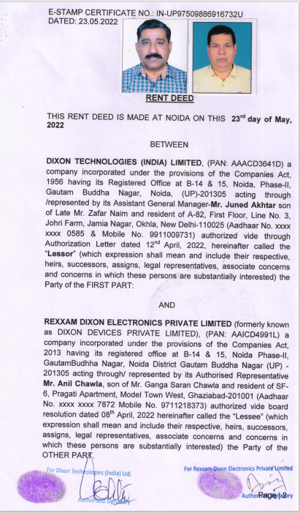

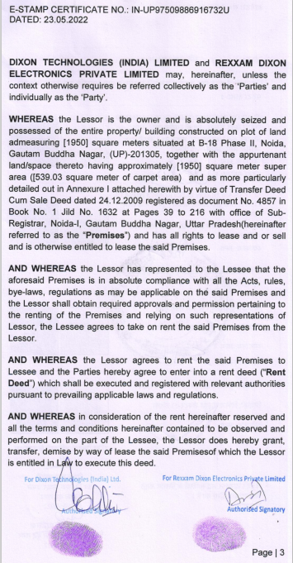

|  |  |
| --- | --- |
| **PART E** | **CE IMPORTANT REMARKS / LIMITATIONS/ CAVEATS/ DISCPLAIMERS** |

1. Due to vast number of machines running into more than 280 line items, verification is done only for major machines comprising about 75% of total claim value against the FAR and Invoices provided by the client. Our team has verified top 80 machines as per value.
2. Any amount referred in the assessment is based on the Invoices.
3. In the course of the assessment, we were provided with both written and verbal information. We have however, evaluated the information provided to us through broad inquiry, analysis and review but have not carried out a due diligence or audit of the information provided for the purpose of this engagement. Our conclusions are based on the assumptions and other information provided to us by the client during the course of the assessment.
4. The client/ owner and its management/ representatives warranted to us that the information they have supplied was complete, accurate and true and correct to the best of their knowledge. All such information provided to us either verbally, in writing or through documents has been relied upon in good faith and we have assumed that it is true & correct without any fabrication or misrepresentation. I/We shall not be held liable for any loss, damages, cost or expenses arising from fraudulent acts, misrepresentations, or willful default on part of the owner, company, its directors, employee, representative or agents.
5. Legal aspects for e.g. Investigation of title, ownership rights, lien, charge, mortgage, lease, verification of documents from source or any concerned Govt. office etc. has not been covered in this assessment.
6. Machines are assessed as seen on site on as-is-where basis at the time of survey.
7. The condition of the machinery and assets are only based on the visual observations and appearance found during the site survey. We have not carried out any physical tests to assess the working and efficiency of the machines and assets.
8. We have not commented upon machines operating efficiency, useful or residual life.
9. Site Survey has been carried out on the basis of the physical existence of the assets rather than their technical expediency.
10. We have made certain assumptions in relation to facts, conditions & situations affecting the subject of, or approach to this exercise that has not been verified as part of the engagement rather, treated as “a supposition taken to be true”. If any of these assumptions prove to be incorrect then our estimate on value will need to be reviewed.
11. Our report is meant only for the purpose and the client mentioned in the report and should not be used for any other purpose or by any other person. The Report should not be copied or reproduced for any purpose other than the purpose for which it is prepared for. I/we do not take any responsibility for the unauthorized use of this report.
12. We owe responsibility only to the authority/client that has appointed us as per the scope of work mentioned in the report. We will not be liable for any losses, claims, damages or liabilities arising out of the actions taken, omissions or advice given by any other person. In no event shall we be liable for any loss, damages, cost or expenses arising in any way from fraudulent acts, misrepresentations or wilful default on part of the client or companies, their directors, employees or agents.
13. At our end we have not verified the authenticity of any documents provided to us from the originals or any Govt. authority. Documents/ details/ information submitted to us both verbally or in writing have been relied upon in good faith.