Production Linked Incentive (PLI) Scheme for White Goods (Air Conditioners and LED Lights)
SITE VISIT REPORT
Rexxam Dixon Electronics Private Limited
OVERVIEW
# | Particulars | Details
1 | Application No. | PLIWG/20210914/021
2 | Name of the Manufacturing Company (Applicant/ its Subsidiary) | Rexxam Dixon Electronics Private Limited (Applicant)
3 | Address of Plant | B-18, Phase-2, Noida -201305 (Uttar Pradesh)
4 | a) Target Segment  b) Investment Category | AC (Low Value Intermediaries)  Normal Investment
5 | Eligible Products Manufactured | - Control Assemblies for IDU or ODU or Remotes
6 | Gestation Period | 1st April’2021 to 31st March’2023
7 | a) Total Committed Investment  b) Cumulative Threshold investment up to 31.03.2023  c) Actual investment for FY21-23  d) Eligible investment up to 31.03.2023 | a) INR 51 Cr.  b) INR 10 Cr.  c) INR 24.46 Cr.  d) INR 22.07 Cr.
8 | GSTIN | 09AAICD4991L1ZY
9 | SEZ/ non-SEZ | Non-SEZ
10 | Greenfield /Brownfield | Greenfield
11 | Status of availability of land | Privately Leased Premises Valid from 01.04.2022 to 31.03.2036
12 | Land Area | 1,950 sq mtr
9 | Date of Site Visit | 25th July’2024
10 | Purpose of Visit | Physical Verification of investment of FY 2021-23
11 | PMA’s Officials who visited the site | - Mr. Vishal Sahrawat, Senior Associate Technical  - Mrs. Neha Gupta, Associate
12 | DPIIT Officials who visited the site if any | - NA
13 | Applicant’s Officials met during Site Visit | - Mr Harcharan Singh, DGM, Harcharan.singh@dixoninfo.com,  +91-9760135544  - Mr Ritik Jain, AGM,  Ritik.jain@dixoninfo.com  +91-9311242256

PROJECT LOCATION 1

2.1 Snapshot of Location on Map
GPS Location: 28.536278015746717, 77.40985797766956
Satellite View:
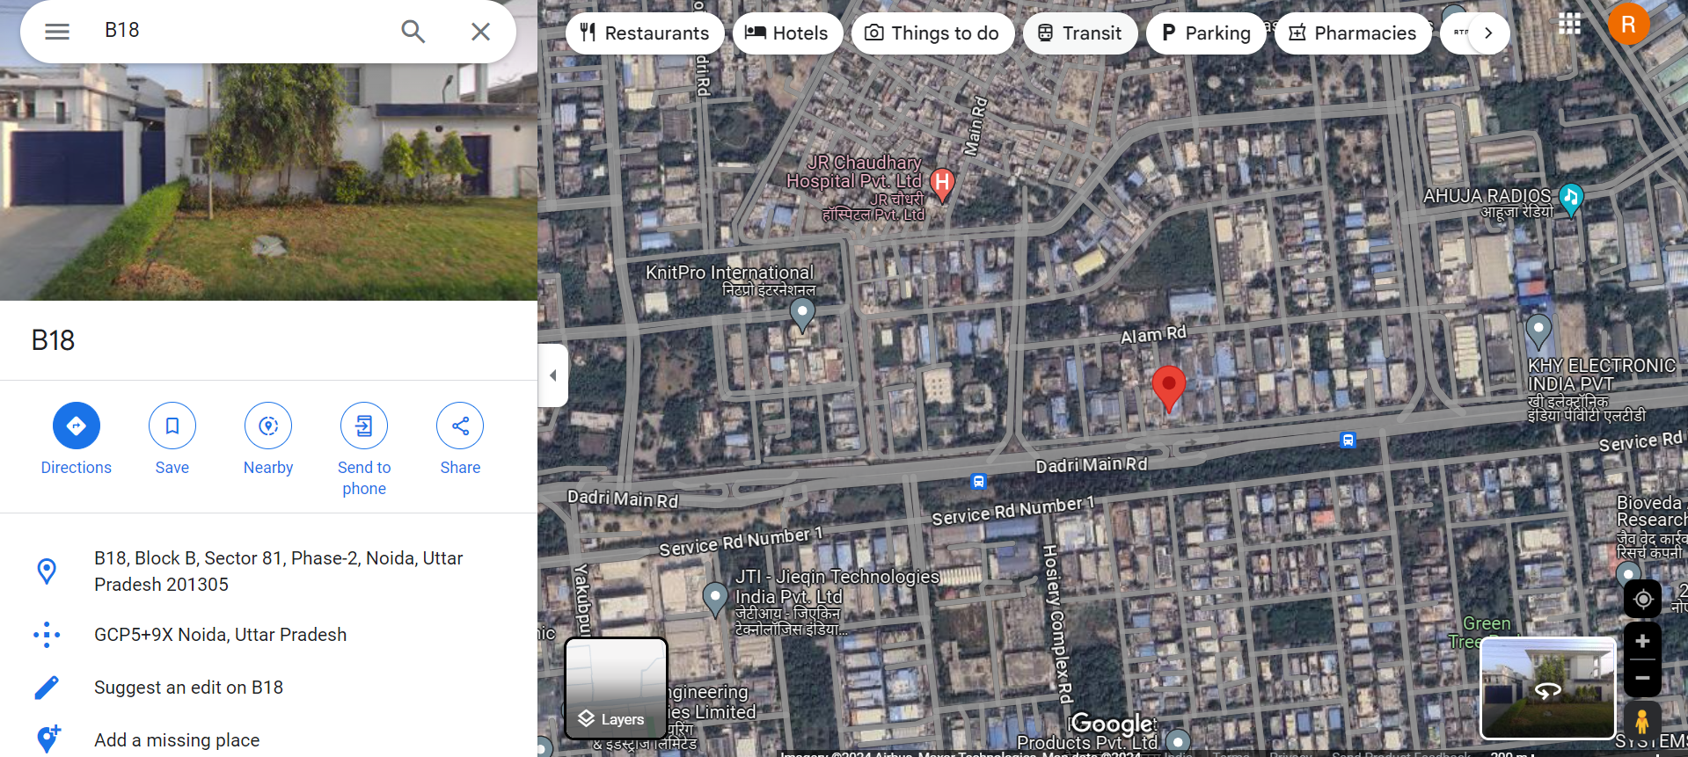

Regular View:
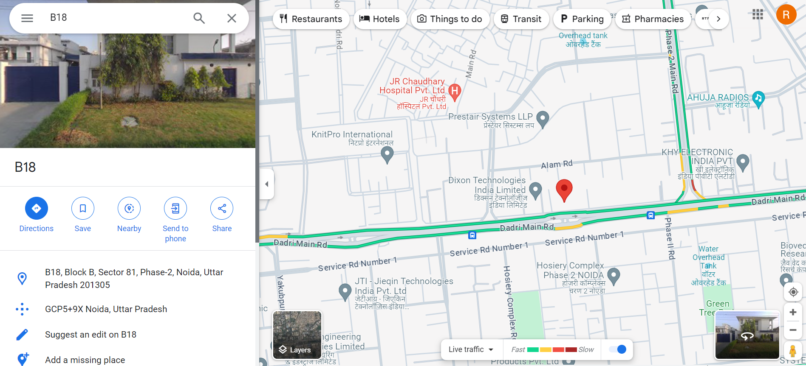

2.2 Picture of Entry Gate displaying name & address of Unit with GPA location with Company official and PMA official:
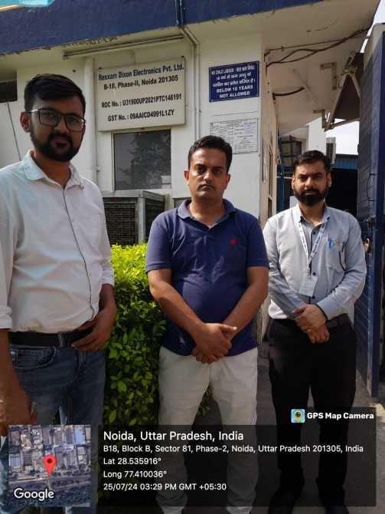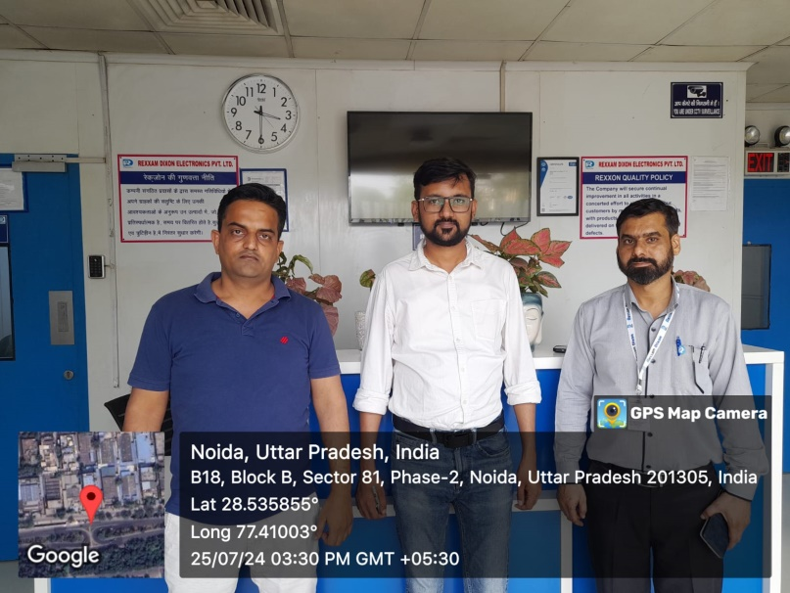

Factory Layout:
Basement:
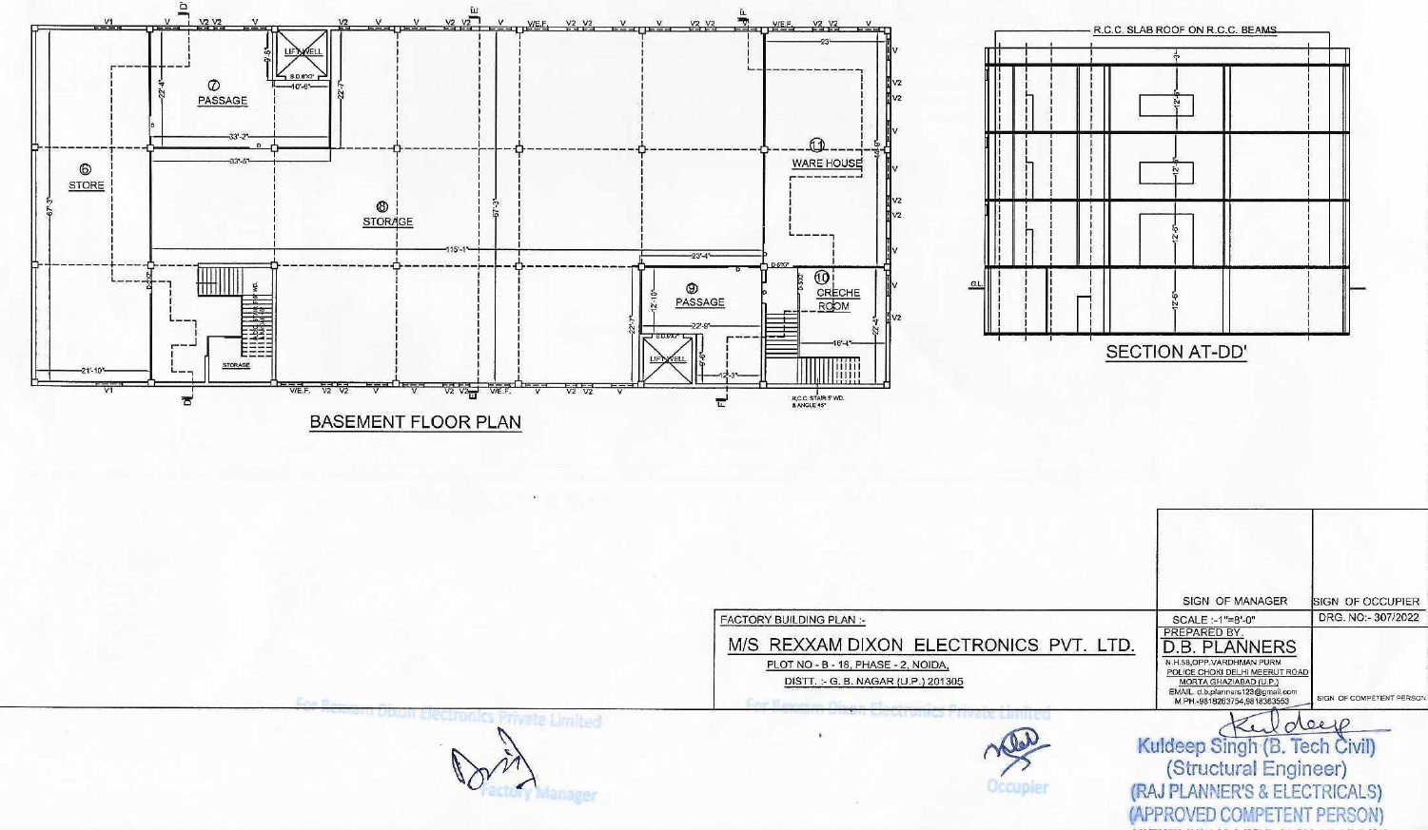
Ground Floor:
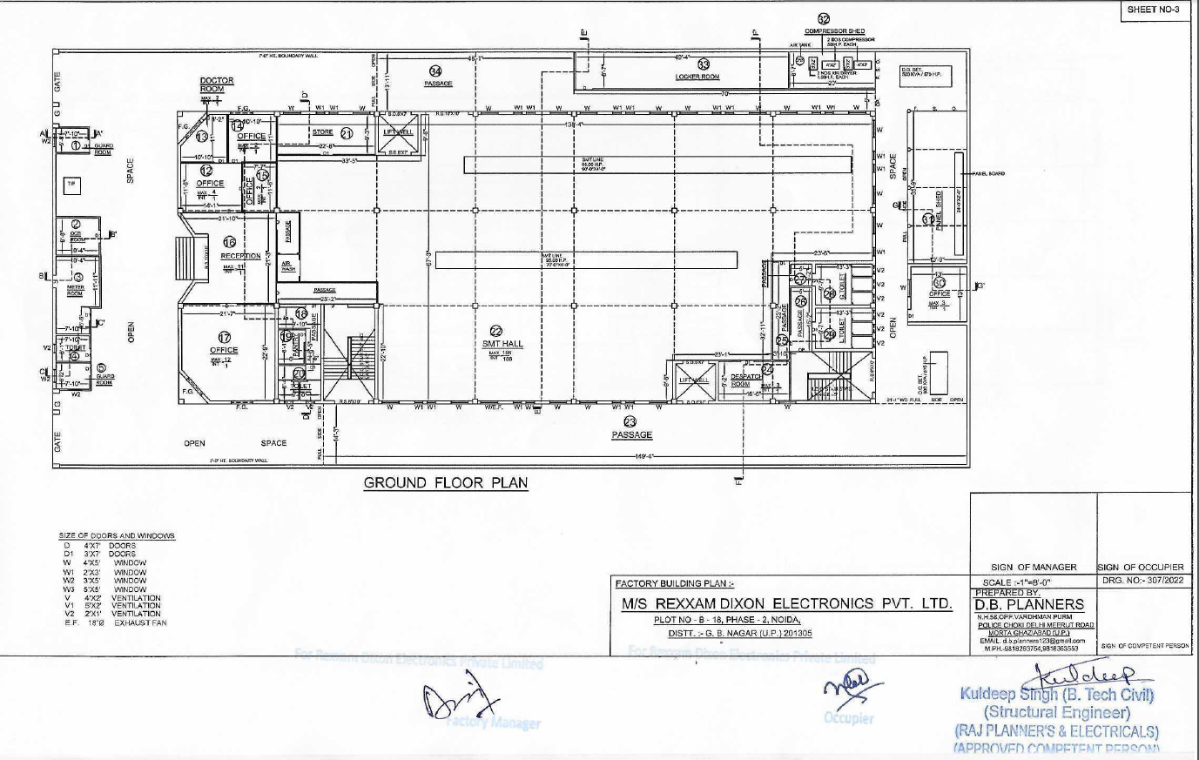

1st Floor:
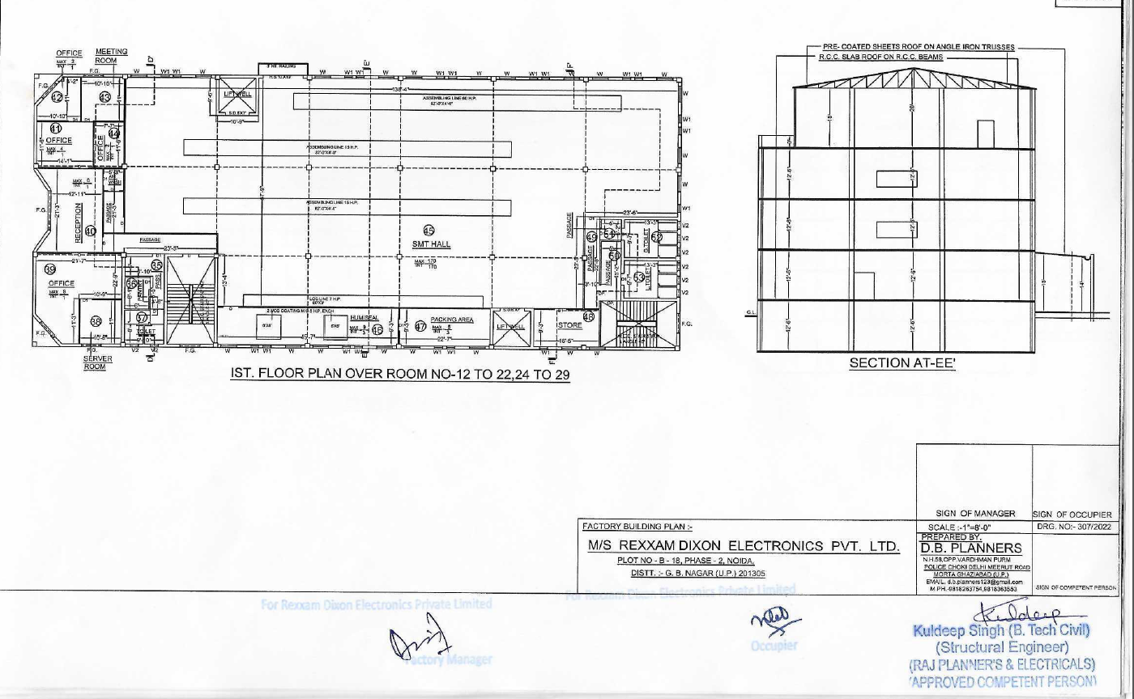

Second Floor:
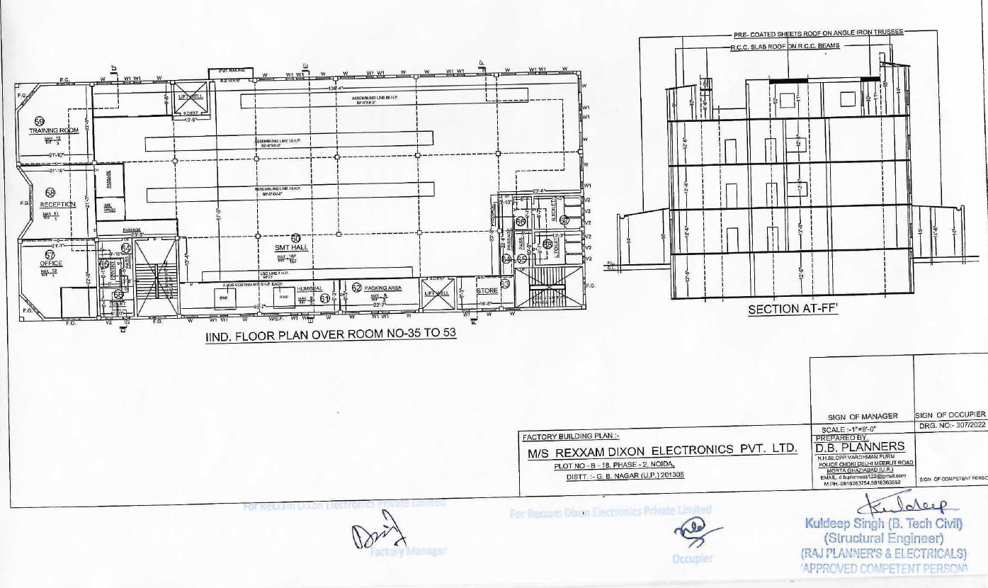

Third Floor:
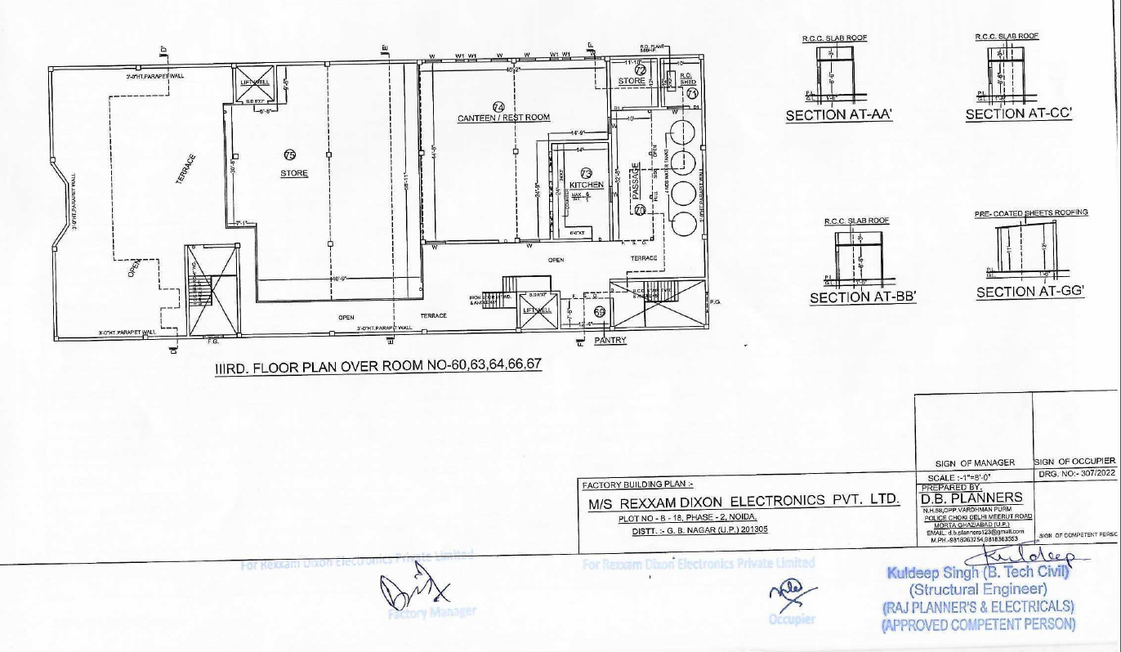

2.3 Investment (01/04/2021 to 31/03/2023)
Investment reported by the Applicant, at this location, is as follows:
# | Asset Head | Amount (₹ Cr.)
1 | Plant, Machinery & Equipment (PME) | 20.59
2 | Associated Utilities (AU) | 1.38
3. | Tool, dies, Moulds, jigs, fixtures | 0.09
4. | Tool Room investment, if any | -
5 | Research & Development (R&D) | -
6. | Transfer of Technology (ToT) | -
 | Total | 22.07

2.4 Verification of Investment:
Following is the list of assets verified physically on site:
# | Machine/ Asset Name | Model No. | Serial No. | FAR no. | Name of Seller/ Manufacturer | Invoice# | Invoice date | Invoice Value (₹) | Amount Capitalized (₹) | Status
1 | Pick & Place With Accessories (FUJI NXTIII) | NXTIII | SD0106513, SD0106514, SD0106515 | 5000000 | NMTRONICS (INDIA) PVT LTD | NSEZG23012 | 19.09.2022 | 3,29,84,550 | 3,29,84,550 | Running
2 | Pick & Place With Accessories (FUJI NXTIII) | NXTIII | SD0108496, SD0108497, SD0108498 | 5000068 | NMTRONICS (INDIA) PVT LTD | NSEZG23024 | 23.01.2023 | 3,73,76,876 | 3,73,76,876 | Running
3 | Solder Print Inspection System (3D SPI) | SP-700 | R460104 | 5000009 | REXXAM CO., LTD. | G3220323-01 | 23.03.2022 | 36,94,860 | 37,07,357 | Running
4 | 500KVA DG Set | KTAA19-G10 | 22070396 | 6000022 | JAKSON LTD | 1P0522100475 | 29.07.2022 | 28,00,000 | 28,00,000 | Running
5 | 500KVA DG Set | KTAA19-G10 | 22100730 | 6000023 | JAKSON LTD | 1P0522100862 | 27.10.2022 | 28,00,000 | 28,00,000 | Running
6 | CRIMPING TOOL | YRS-490 |  | 14000011 | REXXAM CO., LTD. | J232170-EX | 13.02.2023 | 67,146 | 77,460 | Running
 | Total |  |  |  |  |  |  | 7,97,23,432 | 7,97,46,243

Exterior Building  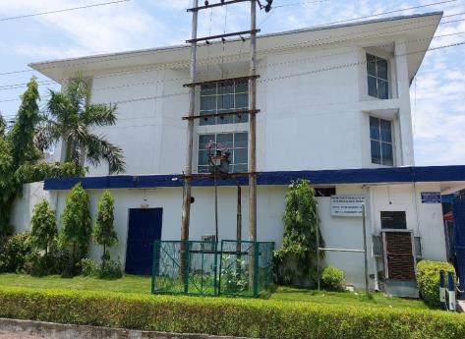 | 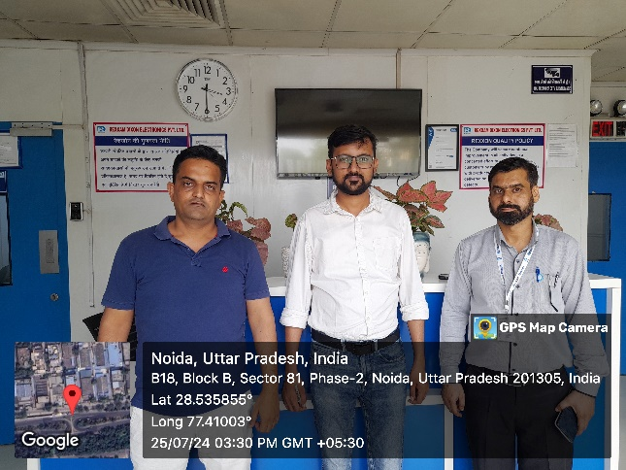
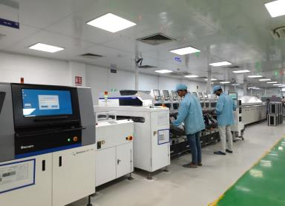  SMT Line - 1 | 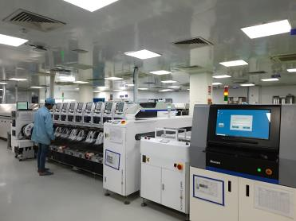  SMT Line - 2
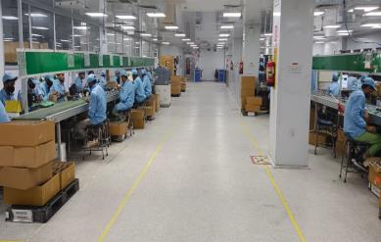  MI Line - 1 | 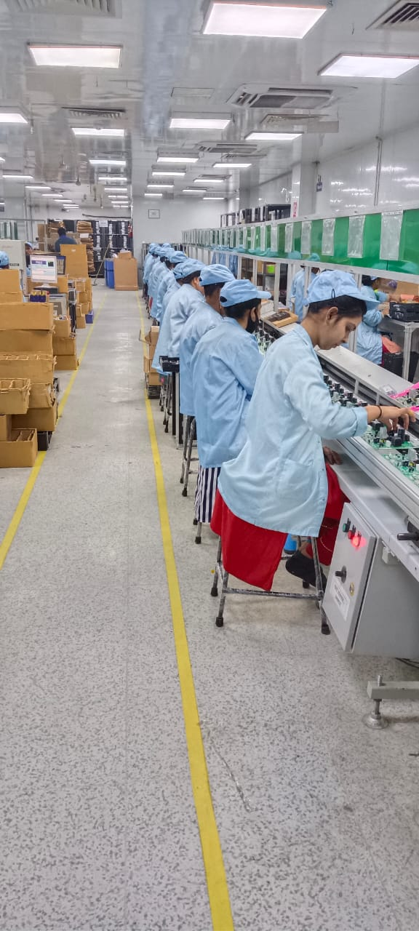  MI Line - 2

2.5 Products being manufactured at the Unit: Control Assemblies for IDU or ODU or Remotes
2.5.1 Eligible Products being manufactured at the unit are as follows: (As per Company)
# | Name of Eligible Product | HSN Code
1 | Control Assemblies for IDU or ODU or Remotes | 84159000

Sample photo of each of the eligible products mentioned above:
AC-PCB  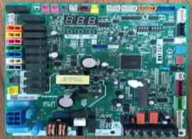 | AC-PCB  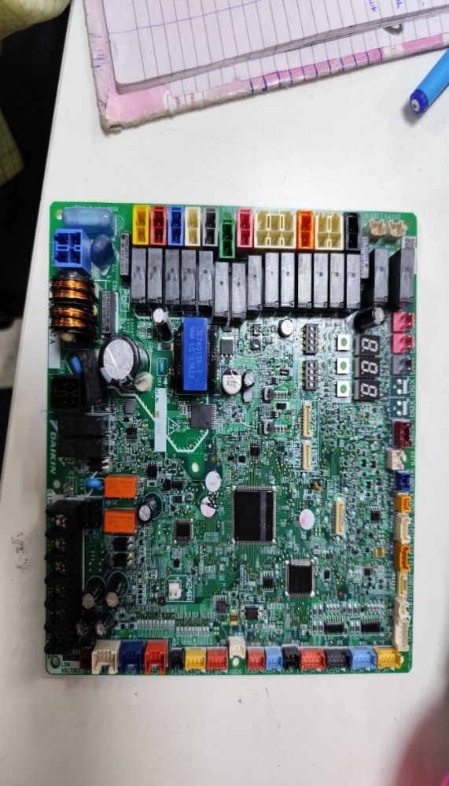
AC-PCB  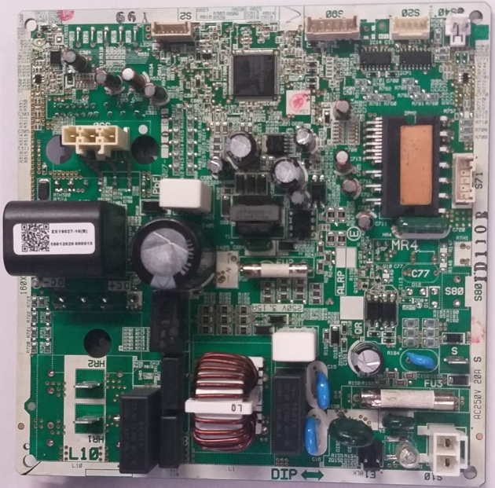 | AC-PCB  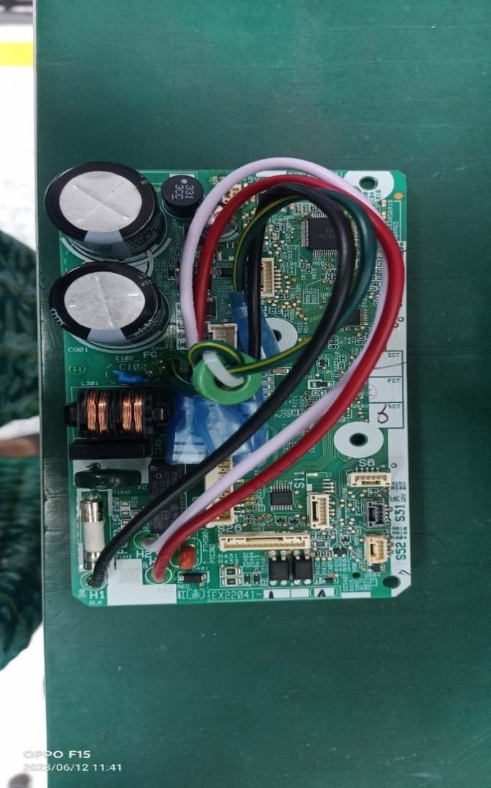

2.5.2 Approved Eligible Products not being manufactured at the unit are as follows:
# | Name of Eligible Product | Remarks, if any
NA

2.5.3 Whether any of the above eligible products is being planned to be manufactured during the year, if yes, please mention below:
------------------------------------------------------NA---------------------------------------------------
2.5.4 Non-Eligible Products being manufactured at the unit are as follows:
------------------------------------------------------NA---------------------------------------------------
2.6 Present manufacturing operations for Eligible products:
Manufacturing Process Flow Diagram (MPFD):
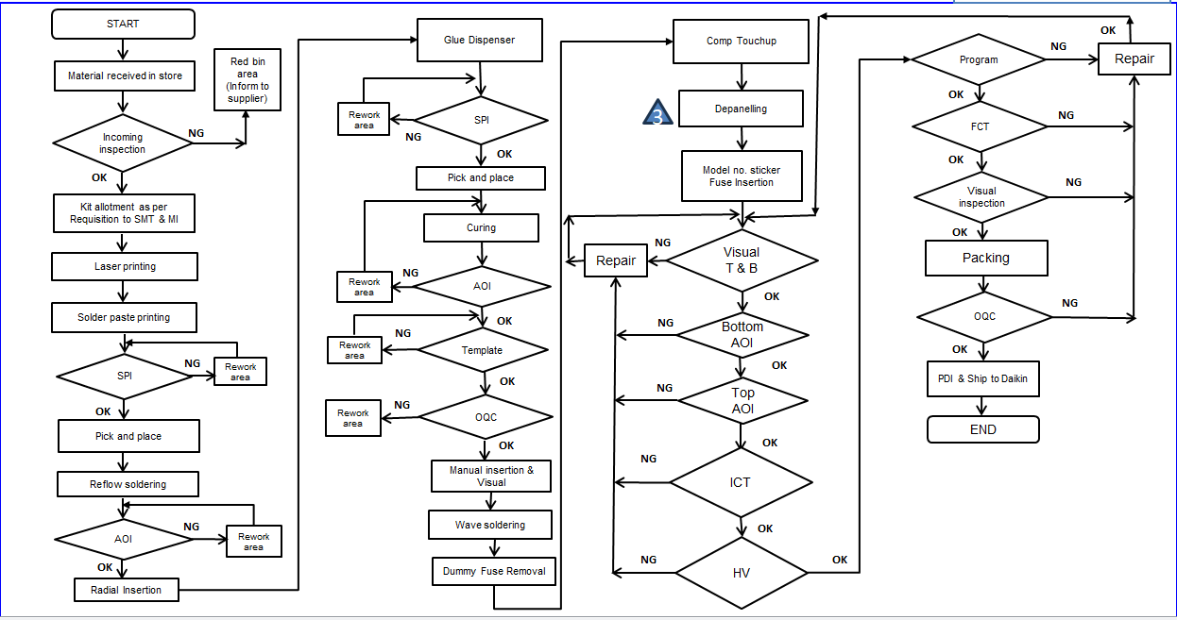

Simple flow chart
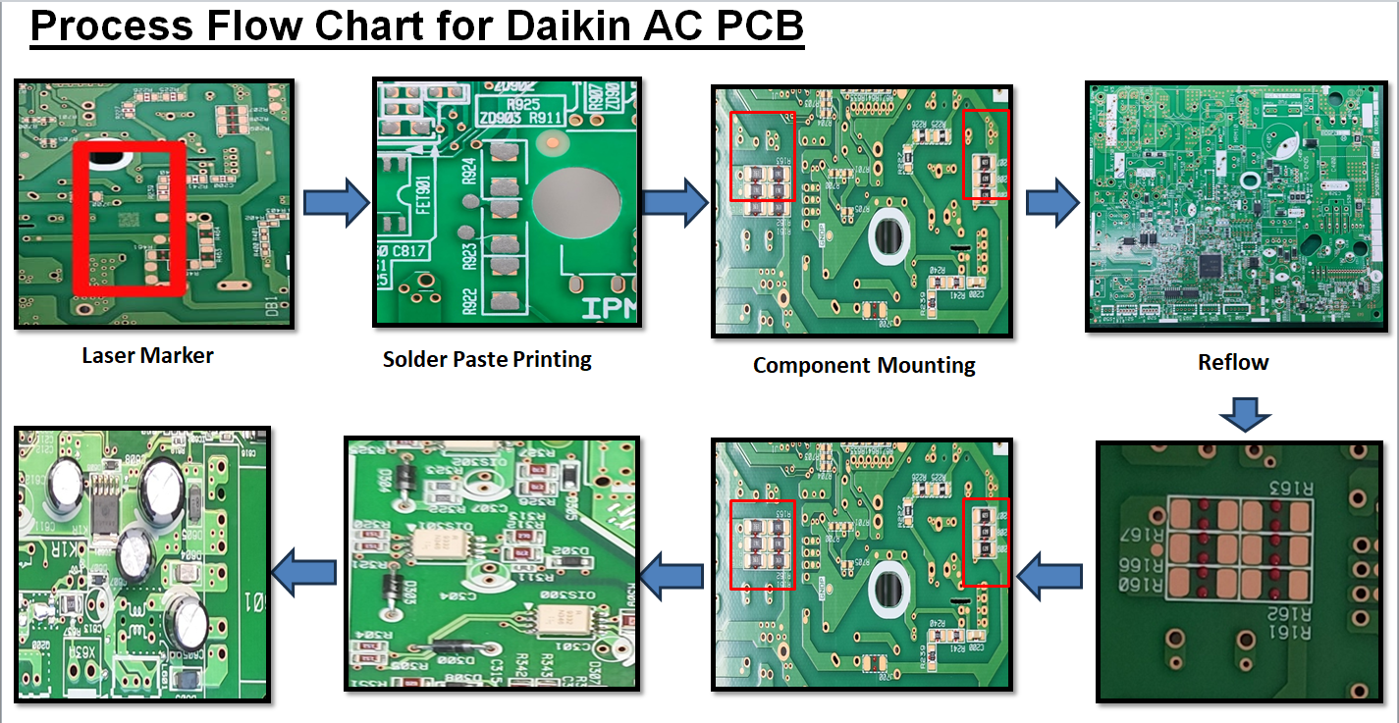
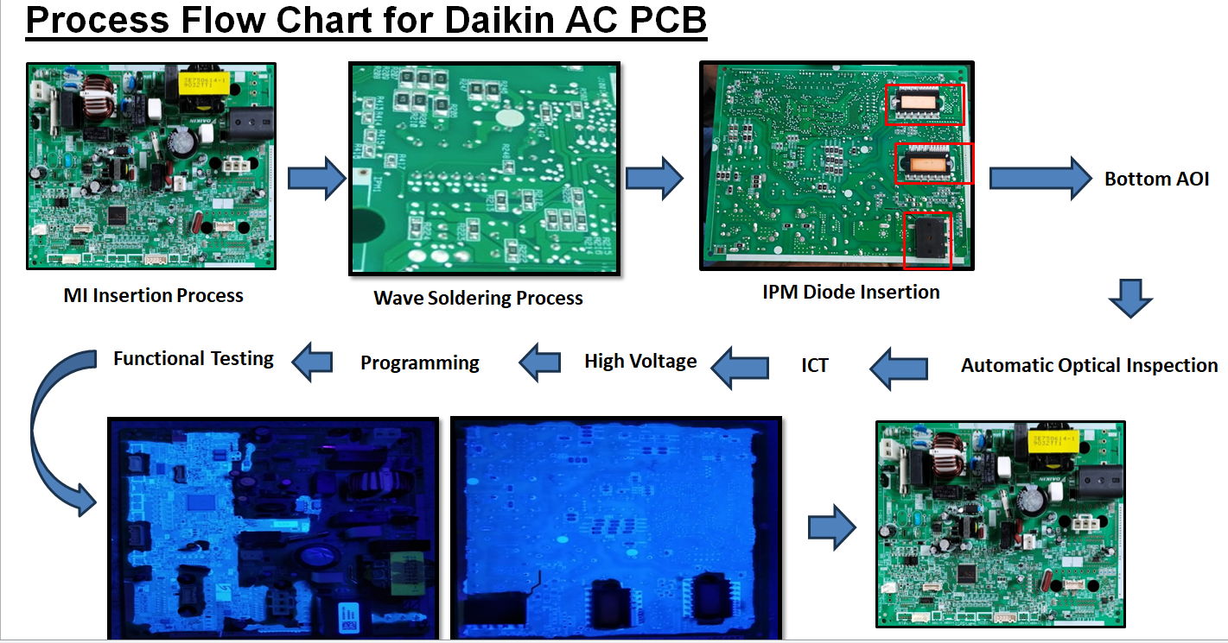

2.7 Employment (As Per Company)
Employment (as on 31.3.24) (as per QRR): 403
Employment present at the time of Visit: About 430 persons
# | Item | Particulars
1 | Working hours per day | 16 hrs.
2 | Working days p.a. | 301
3 | No. of shifts in a day | 2
4 | Installed Capacity Product wise (As Per Company) | P1 – 3.86 Mn PCBA per annum
5 | Actual Production (As Per Company) | P1 – 3.08 Mn PCBA (Sales Quantity – FY 23-24)

3. Insurance
i) | Name of the Insurance Company | HDFC Ergo
ii) | Policy No. | 2999206357934900000
iii) | Policy Amount | INR 218 crs (Includes Stock for INR 175 crs)
iv) | Policy Issue Date | 23rd April’2024
v) | Policy Expiry Date | 31/03/2025
vi) | Period of Insurance | 01/04/2024 to 31/03/2025
vii) | Status of Policy | Active

4. OTHER OBSERVATIONS, if any

- This Site Visit report is prepared based on discussion with company officials and written submission made by the Applicant.
- Further, visual observations during the visit have been considered.
- The undersigned visited the aforementioned location(s) of the Applicant, and the status of land/ building and project implementation is as mentioned in the report above.
- Applicant categorised Utilities equipment in P&M in FAR, category changed to Associated Utilities of value Rs. 1.38 Cr.
- Computer hardware (laptops and printers) is included in associated utilities but is related to office use. This investment is considered ineligible for Rs. 0.22 crore.
- According to the company, they only manufacture controllers for IDUs and ODUs for Daikin, with no captive consumption, as Rexxam sells directly to customers.
- Applicant purchased machineries valued at Rs. 6 Cr. from Rexxam company, Japan, which is a major shareholder (60%) in Rexxam Dixon Electronics Pvt Ltd (Joint Venture)

Name | Vishal Sahrawat | Name | Ritik Jain
Designation | Sr. Associate Technical | Designation | AGM
 | IFCI Ltd | Plant | B-18, Phase-II, Noida

Date:

