**REPORT FORMAT:** CL-1 | Version: 1.0\_2018

# FILE NO.: VIS (2024-25)-PL309-270-356 Date: 23/08/2024

* ***CERTIFICATE* NAME:** *Rent Assessment Certificate for a commercial shop situated at Kharsa No. 50,Mauza Athurwala, Dehradun, Uttarakhand*
* ***PREPARED FOR:*** *IDBI Bank, Doiwala Branch, Dehradun*
* ***ASSET TYPE****: Commercial Shop*
* ***LOCATION OF THE BUILDING****: Kharsa No. 50,Mauza Athurwala, Dehradun, Uttarakhand*

# TO WHOM IT MAY CONCERN

|  |  |  |
| --- | --- | --- |
| **S.**  **NO.** | **PARTICULARS** | **DESCRIPTION** |
| 1. | Date of Survey | 21-08-2024 |
| 2. | Date of Certificate | 23-08-2024 |
| 3. | Documents provided  for perusal | Lease Deed |
| 4. | Location of the Building | Kharsa No. 50,Mauza Athurwala, Dehradun, Uttarakhand |
| 5. | Borrower/Lessee | IDBI Bank, Doiwala Branch, Dehradun |
| 6. | Type of Asset | Commercial shop |
| 7. | Type of Assessment | Rent Assessment Certificate |
| 8. | Scope of Assessment | To assess the ongoing market rent of the commercial shop |
| 9. | Nature of Building | Commercial |
| 10. | Year of Construction | ~ 15 years |
| 11. | Total Purchase Cost /  Expenses Incurred | No information available |

|  |  |  |
| --- | --- | --- |
| 12. | Total built Up Area of  the property | 150 sq.ft |
| 13. | Area Adopted | Area adopted on the basis of the Lease Deed provided to us by the bank. |
| 14. | Current Estimated Market Value | As per the discussion with the property consultant of the subject location we came to know that ongoing rent for the commercial shop in the subject vicinity varies within the rate range of **Rs.110/- to Rs.130/- per sq. ft. on covered area** For ready to move-in properties depending upon the various amenities, floor and location of the property. These rates are for the commercial shop at and around the subject location. |

## OBSERVATIONS:

1. We have been provided with the copy of the Lease Deed through which we have considered the total built-up area of the property.
2. During the time of our site visit we have found that presently the property was occupied by IDBI Bank, Doiwala Branch, Dehradun
3. Monthly Rental Income vetted for the subject property is for the commercial shop at the subject location.
4. Based on our market research proposed monthly rent of the subject property for above mentioned area of 150 Sq. ft. comes out to be in the range of Rs.16,500/- to Rs.19,500/-

***Disclaimer:***

* 1. *This certificate is to be referred only for the purpose of the rent assessment of the commercial built-up unit situated at the aforesaid address.*
  2. *This certificate doesn’t include any work related to drawing, design, sketch plan, procurement of the building structure.*
  3. *Ownership and other legal point of view in respect of the asset is not considered in this report as same is out of scope of this certificate.*
  4. *This certificate is made at the request of IDBI Bank, Doiwala Branch, Dehradun*

**For R.K Associates Valuers & Techno FOR INTERNAL USE Engineering Consultants (P) Ltd. *TYPED BY: Er. Mohit yadav REVIEWED BY:***

**ANNEXURE: I- COPY OF LEASE DEED**

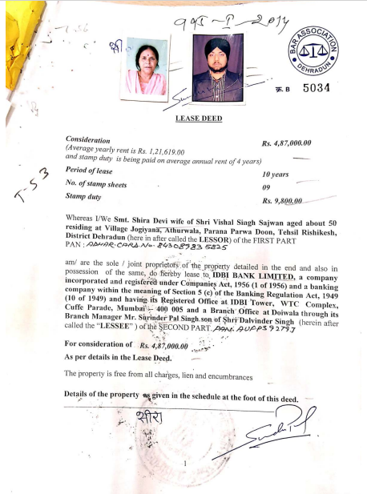

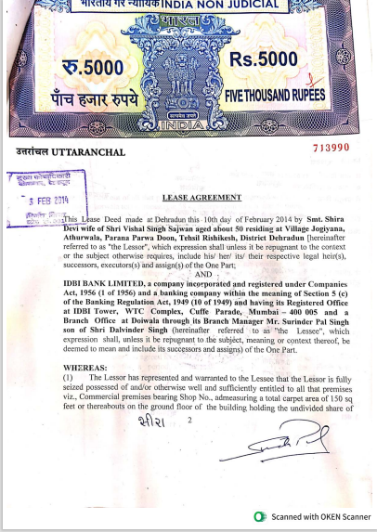

**ANNEXURE: II- COPY PHOTOGRAPHS PF PROPERTY**

|  |  |
| --- | --- |
| **Z:\Mohit Yadav\VIS(2024-25)-PL309-270-356\SiteImage\c_TimePhoto_20240821_135834.jpg** | **Z:\Mohit Yadav\VIS(2024-25)-PL309-270-356\SiteImage\c_TimePhoto_20240821_135914.jpg** |
| **Z:\Mohit Yadav\VIS(2024-25)-PL309-270-356\SiteImage\c_TimePhoto_20240821_135920.jpg** | **Z:\Mohit Yadav\VIS(2024-25)-PL309-270-356\SiteImage\c_TimePhoto_20240821_135902.jpg** |