File No.: VIS (2024-25)-PL-329-290-385 Dated: 11-11-2024

TECHNO-ECONOMIC VIABILITY
STUDY REPORT

OF

15 LUXURY VILLAS WITH 18 ROOMS RESORT
SETUP BY

M/S VAYU SUITES

REPORT PREPARED FOR

PUNJAB NATIONAL BANK, MID CORPORATE CENTER, 4-5 KALPATRU APARTMENT, OPPOSITE OLD INCOME TAX OFFICE, NEW FATEHPURA, UDAIPUR - 313001

**Important - In case of any query/ issue or escalation you may please contact Incident Manager Advisory@rkassociates.org. We will appreciate your feedback in order to improve our services.

NOTE: As per IBA Guidelines please provide your feedback on the report within 15 days of its submission after which report will be considered to be correct

IMPORTANT NOTICE

COPYRIGHT FORMAT: This report is prepared on the copyright format of R. K. Associates Valuers & Techno Engineering Consultants (P) Ltd. (R. K. Associates) to serve our clients with the best possible information and analysis to facilitate them to take rational business decisions. Legally no one can copy or distribute this format without prior approval from R. K. Associates. It is meant only for the advisory/ reference purpose for the organization/s as mentioned on the cover page of this report. Distribution or use of this format or report or any of its content/ information/ data by any organization or individual other than R.K Associates will be seen as an unlawful act and necessary legal action can be taken against the defaulters.
This report is intended for the sole use of the intended recipient/s and contains material that is STRICTLY CONFIDENTIAL AND PRIVATE.

DEFECT LIABILITY PERIOD: In case of any query/ issue or escalation you may please contact Incident Manager at advisory@rkassociates.org. Though adequate care has been taken while preparing this report as per its scope, but still we can’t rule out typing, human errors, over sightedness of any information or any other mistakes. Therefore, the concerned organization is advised to satisfy themselves that the report is complete & satisfactory in all respect. Intimation regarding any discrepancy shall be brought into our notice immediately. If no intimation is received within 15 (Fifteen) days in writing from the date of issuance of the report, to rectify these timely, then it will be considered that the report is complete in all respect and has been accepted by the client up to their satisfaction & use and further to which R.K Associates shall not be held responsible in any manner.

Part M: R. K. Associates Important Disclaimer and Remarks are integral part of this report and Feasibility assessment is subject to this section. Reader of the report is advised to read all the points mentioned in these sections carefully.

TABLE OF CONTENTS
SECTIONS | PARTICULARS | PAGE NO.
Part A | Report Summary | 4
Part B | Introduction
Part B | - About the Report | 6
Part B | - Executive summary | 6
Part B | - Purpose of the Report | 8
Part B | - Scope of the Report | 8
Part B | - Methodology/ Model Adopted | 9
Part B | - Data Information received from | 10
Part B | - Documents/ Data Referred | 10
Part C | Partnership Firm Profile
Part C | - Partnership Firm Overview | 11
Part C | - Partners Shares and Contribution | 12
Part C | - Key Designated Partners/Directors Details | 12
Part D | Proposed Unit’s Infrastructure Details
Part D | - Proposed Location | 14
Part D | - Location Map | 15
Part D | - Layout Plan | 16
Part D | - Land Details | 16
Part D | - Photographs of the Project | 18
Part D | - Building & Civil Works | 20
Part D | - Equipment Details | 24
Part D | - Furniture and Fixtures | 26
Part D | - Utilities | 30
Part D | - Manpower | 31
Part D | - Marketing Strategies | 32
Part E | Industry Overview & Analysis | 34
Part F | SWOT Analysis | 43
Part G | Risk & Mitigation | 45
Part H | Project Cost and Means of Finance | 47
Part I | Project Schedule | 48
Part J | Statutory Approvals | Licences | NOC | 50
Part K | Company/Entity’s Financial Feasibility | 52
Part L | Conclusion | 90
Part M | Disclaimer | Remarks | 93

PART A | REPORT SUMMARY

S. No. | PARTICULAR | DESCRIPTION
 | Name of the Company/Entity: | M/s Vayu Suites
 | Registered Address: | Lobby Level, Inside Hotel Vishnupriya, 9, Gulab Bagh Road, Udaipur (Rajasthan)
 | Project Name | “Vayu Suites” Luxury Resort Project
 | Project Location: | Commercial Land (KH. No. 579/546), Revenue Village-Sena, Tehsil-Bali, Pali (Rajasthan).
 | Project Type: | Luxury Resort with 18 luxurious villa rooms with 15 exclusive villas
 | Project Industry: | Hospitality Industry
 | Product Type / Deliverables: | 15 luxury villas with 18 Rooms with Restaurant/Bar, Swimming Pool, Spa and Fitness facilities.
 | Report Prepared for Organization: | Punjab National Bank, Mid Corporate Center, 4-5 Kalpatru Apartment, Opposite Old Income Tax Office, New Fatehpura, Udaipur - 313001
 | TEV Consultant Firm: | M/s. R.K Associates Valuers & Techno Engineering Consultants (P) Ltd.
 | Report type: | Techno-Economic Viability Report
 | Purpose of the Report: | To assess Project’s Technical, Economical & Commercial Viability for the purpose of seeking external financial assistance to start a green field Project.
 | Scope of the Report: | To assess, evaluate & comment on Technical, Economical & Commercial Viability of the Project as per data information provided by the client, independent Industry research and data/ information available on public domain.
 | Date of Report: | 11th November 2024
 | Documents referred for the Project: | - PROJECT INITIATION DOCUMENTS:  - Financial Projections of the Project  - Project proposed Schedule  - Statutory Approval Details  - Layout and Master Plan  - PROCUREMENT DOCUMENTS:  - List of Equipment along with estimated costs for the same  - List of furniture & fixtures along with estimated costs for the same  - Proposed map of the site  - Sale deeds of the Land
 | Means of Finance: | Equity & Debt
 | Key Financial Indicators:
  Key Indicators | Value
  Average DSCR | 1.75
  Maximum DSCR | 2.77
  Average EBITDA Margin | 34.81%
  Avg. PAT Margin | 9.00%
  IRR | 11.60%
Note: Above financial indicators are based on the financial projections provided by the firm and assessment and analysis of the same done by us.

PART B | INTRODUCTION

- ABOUT THE REPORT:
Techno-Economic Viability Study Report of the proposed luxury resort of 18 luxurious villa rooms with 15 exclusive villas at registered office Business Address: Lobby Level, Inside Hotel Vishnupriya, 9, Gulab Bagh Road, Udaipur (Rajasthan), India, setup by M/s Vayu Suites.

- EXECUTIVE SUMMARY:
- Overview of M/s Vayu Suites: M/s Vayu Suites was established on 8th February 2022 under the Indian Partnership Act, 1932, with Firm Registration Number RF/UDP/2022/1768, specifically to enter the hospitality sector. The firm, as per its Partnership Deed, comprises two designated partners: Mr. Parth Karnawat, with over 13 years of experience in the hotel industry, and Mr. Anubhav Singhvi, who brings expertise in both hospitality and the marble and stone industry. Firm has obtained the building permit to construct buildings for commercial purpose as per regulations of Gram Panchayat office by Panchayat Samiti-Bali, Tehsil- Pali (Rajasthan) (No.2024/114).
- Project Details and Scope: M/s Vayu Suites has acquired a 3.28-acre plot (32,800 square meters) for the project, with 3,762 square meters designated for hotel development. The layout plan for the resort includes 18 luxurious villa rooms with 15 exclusive villas (12 on individual basis and 6 single/double occupancy basis), fully equipped with modern amenities such as private pools, air conditioning, minibars, LCD TVs, and safes. Guests will also have access to unique experiences like village walks, forest treks, and guided sunrise and sunset tours. The architectural style combines traditional Rajasthani elements with modern aesthetics, featuring wave-like structures, open spaces, and large arched windows for natural lighting.
- Environmental Commitment and Community Impact: The resort will implement eco-friendly practices, including wastewater recycling and water harvesting, and will generate over 40 direct and 50 indirect employment opportunities. It aims to showcase local art, crafts, and culture, enriching the community and attracting sustainable tourism.
- Prime Location Advantage: This project site lies within Pali tehsil and is nearby from famous Jawai. The resort's strategic location near the Jawai wildlife Safari, known for one of the highest leopard populations outside of forested areas, positions it as a premier destination for wildlife tourism which conveniently located approx. 3 km from location.
One of the primary tourist attractions in Jawai, other than the leopard safari, is the Jawai Dam, also known as Jawai Bandh (water reservier with the deepth of 62 feet deep which is spread over 5 km range and in every direction, there are prodigious formation of mountains with lava rocks.) which is approx. 20 Km from hotel location. The popularity among tourists grew all the more with crocodile sightseeing destination in all of Rajasthan. The area is also home to several ancient temples and shrines, including the famous Jain temple dedicated to Lord Mahaveer.
- Project Cost and Financial Structure: The estimated project cost for the development of the luxury boutique hotel with 18 Luxury Villa Rooms is INR 29.35 crore. The financing structure comprises:
- Term Loan of INR 20.00 Crore
- Partner’s Capital of INR 9.35 Crore
Cost Breakdown of Project Development:
Total Project Cost (TPC)
Particulars | Cost (In INR Lakhs)
Land [owned] | 5.00
Building | 2,066.00
Equipments | 313.00
Furniture & Fixtures | 291.00
Interest Capitalisation and other cost | 295.92
Total Project Cost | 2,934.92
- Layout and Functional Zoning of Resort: The resort will be organized into six distinct blocks for optimal operational efficiency:
- Block A: Designed for guest services, featuring the Reception, Waiting Area, Conference Hall, and Café.
- Block B: Focused on dining and culinary facilities, with a Restaurant, Bar, Store, and Kitchen.
- Block C: Dedicated to wellness, offering a Gym and Spa.
- Block D: Accommodates 12 single-room for guests.
- Block E: Provides 3 double-room for couples or small groups which are separately available for renting out. i.e. the total no. available luxury villa will be 18 for renting out. (12 on individual basis and 6 single/double occupancy basis).
- Block F: Reserved for operational support, including areas for Staff, a CCTV Room, Security Room, and Housekeeping.
- Project Cost and Financial Structure: As of the site inspection conducted on 29th August 2024, the land was found to be demarcated by barbed wire, remains vacant with no structures yet in place. The superstructure phase is expected to be completed by the end of Dec 2026.
To support the project’s financial requirements, Vayu Suites has applied for a term loan of INR 20 crore from Punjab National Bank (PNB). PNB’s Udaipur branch has engaged R.K. Associates to conduct a comprehensive Techno-Economic Viability (TEV) study for this luxury hotel project, which will assess its feasibility and potential for long-term success. This project represents a significant opportunity within the premium hospitality sector in Rajasthan, leveraging eco-friendly design and local cultural integration to attract high-value tourism and contribute to regional economic development.

- PURPOSE OF THE REPORT:
To assess the Technical, Economical and Financial Feasibility of the proposed green field luxury resort project for the purpose of financial assistance.

- SCOPE OF THE REPORT:
To assess, evaluate & comment on the Technical, Economical & Financial Feasibility of the proposed luxury segment resort set by M/s Vayu Suites, as per the data/information provided by the client/company/stakeholder and our independent research.
NOTES:
- Independent scrutiny about the partners, background check, credibility, credit worthiness is not covered under this report. Wherever any such information is mentioned in the report, is based on the details provided by the company/entity.
- This is not an audit activity of any kind. We have relied upon the data/ information supplied by the company/entity in good faith that it is true and without any fabrication.
- This report is only an opinion in respect to Technical and Financial Feasibility of the project as per the future projections provided by the firm and independent analysis done by us but doesn’t contain any recommendations including taking decision on the financial exposure.
- Any changes in the current business plan/total project cost/factors effecting future revenue generations/force majeure etc. will be out of scope of this assignment.
- Total Project and head wise Cost is considered as provided by the company/entity. During the assessment, RKA team has given due care to check the unusual higher or under cost as per their experience and general market benchmarks/ indices, wherever available. However, this can’t be construed as detailed item wise cost vetting of Project cost heads which is out of scope of the work as agreed upon.
- We have relied upon the data/information and justifications provided by banker/client in good faith based on the estimated costs done by appointed parties by bank and company/entity.
- This is a techno economic viability study report to assess the technical, economic and commercial viability of the project (Luxury segment hotel) limited to the assigned scope of work.
- Land and property details mentioned in the report is based on the documents submitted by the borrower and the legal validity of the same is not confirmed on our part. The same doesn’t tantamount for taking any responsibility regarding its legality, ownership and conforming to statutory norms.

- METHODOLOGY/ MODEL ADOPTED:
- Data/ Information collection from client/bank/public domain/ suppliers/vendors etc.
- Review of Data/ Information collected related to TEV study.
- Independent review & assessment of technology used and financial projections provided by the company/firm.
- Projections of Revenue, P&L, Balance Sheet, Working Capital Schedule, Depreciation Schedule, Loan Schedule as per the inputs given by the company/firm and assessed by us
- Calculation of key financial indicators and ratio analysis including DSCR.
- Report compilation and Final conclusion.

- DATA/ INFORMATION RECEIVED FROM: All the data/Information has been received from Mr. Chirag Lodha and Mr. Parth Karnawat (Partner of the Firm) the required details about him shown in the below table:
Person from Whom Data Obtained
Particulars | Details
Designation | Partner
Company/Firm | Prakash Chandra Jain & Co
Email Address | chiraglodha19@gmail.com
Contact No. | +91-9950626382

Apart from the above, we have referred the data/information available in public domain, information provided by various vendors/consultant and Industrial/sectoral benchmarks and organisational expertise during preparation of the TEV study.

- DOCUMENTS / DATA REFFERED:
- Partnership Firm agreement.
- Financial Projections for next 15 Years.
- Brief history and description of the Firm.
- Selling, Marketing & Distribution Plan of the Firm.
- Market study report of the proposed project.
- List of equipment, furniture & fixtures along with their estimated cost.
- Layout Plan.
- Certificates of Statutory approvals/NOCs.
- Survey Report conducted at the site.
- Data information in Public Domain.

PART C | PARTNERSHIP FIRM PROFILE

- PARTNERSHIP FIRM OVERVIEW:
M/s. Vayu Suites was incorporated on 8th February 2022 with Partnership Deed having the registration no. RF/UDP/2022/1768. It is a Partnership firm, having its Registered Office at Lobby Level, Inside Hotel Vishnupriya, 9, Gulab Bagh Road, Udaipur, Rajasthan, 313001. Under this entity, firm has taken up to set up a luxury resort with 18 luxurious villa rooms with 15 exclusive villas equipped with modern amenities & facilities at Commercial Land (KH. No. 579/546), Revenue Village-Sena, Tehsil-Bali, Pali (Rajasthan).
As per data/information available with us below table shows the incorporation details of the entity:
Incorporation Details of the Entity
Particular | Description
Firm Name | M/s. Vayu Suites
Date of Incorporation | 8th February 2022
Registration no. | RF/UDP/2022/1768
PAN | AAVFV2158B
Category | Partnership firm
Status | Active
Registered Address | Lobby Level, Inside Hotel Vishnupriya, 9, Gulab Bagh Road, Udaipur, Rajasthan, 313001
Date of Filling | 31st March 2024
Source: Data/Information extracted from Client.

- PARTNERS SHARES AND CONTRIBUTION:
As per the data/information provided by client, Contribution by Partners is as specified in the below table on 31st March 2024:
NAME OF THE PARTNERS | DESIGNATION | CONTRIBUTION RECEIVED (RS. Lakhs) | Profit Sharing
Mr. Parth Karnawat Deshpande | Designated Partner | 2.50 | 0.50
Mr Anubhav Singhvi | Designated Partner | 2.50 | 0.50
Source: Data/Information provided by the Client.
- KEY DIRECTOR/DESIGNATED PARTNER DETAILS:
NAME | APPOINTMENT DATE | QUALIFICATION/EXPERIENCE
Mr. Parth Karnawat (Designated partner) | 08th February, 2022 | - Mr. Parth Karnawat is registered with the Ministry of Corporate Affairs as a Director (DIN/DPIN No. 03372019) in Indian Companies.  - Currently, he serves as a director in 4 Companies in India. He is associated with companies from various industries such as Hotels, Restaurants, Financial Intermediation Services and Quarrying of stone, sand and clay Milap Marbles.
Mr. Anubhav Singhvi  (Designated partner) | 08th February, 2022 | - Mr. Anubhav Singhvi is registered with the Ministry of Corporate Affairs as a Director (DIN/DPIN No. 07663953) in Indian Company and Partner in Limited Liability Partnership Firm.  - Currently, he serves as a director in a Company and currently partner in the two-partnership firm in India. He is associated with company which worked under class of buying, selling, renting, managing and appraising real estate on a fee or contract basis.
Source: Data/ Information provided by the Company and extracted from MCA website.
Below tables shows the information of the companies/LLPs with which each designated partner is associated with to give a basic background detail of the partners as found on public domain in general/ tertiary category research as on 14th August 2024.
MR. PARTH KARNAWAT- (DIN/DPIN No. 03372019)
S. No | Company Name (CIN/FCRN) | Designation | Original Date of Appointment | Date Of Appointment at Current Designation
- List of Associated Companies
1 | MILAP MARBLES PRIVATE LIMITED (U14101RJ1994PTC008261) | Director | 22/05/2024 | 22/05/2024
2 | SHRI SAI PROFIN PRIVATE LIMITED (U67190RJ1996PTC012352) | Director | 14/11/2011 | 29/09/2012
3 | PATHIK HOTEL AND MOTEL PRIVATE LIMITED (U55101RJ1987PTC004031) | Director | 25/01/2011 | 25/01/2011
4 | DREAM STAR HOLIDAYS PRIVATE LIMITED  (U55101RJ2010PTC031658) | Director | 27/04/2011 | 27/04/2011
5 | SHRI SAI PROFIN PRIVATE LIMITED (U67190RJ1996PTC012352) | Additional Director | - | 14/11/2011
Source: Information extracted from MCA website & public domain on 18th August 2024.
MR. ANUBHAV SINGHVI - (DIN/DPIN: 07663953)
S. No | Company Name (CIN/FCRN) | Designation | Original Date of Appointment | Date Of Appointment at Current Designation
- List of Associated Companies
1 | NEENA INFRA PRIVATE LIMITED (U70200RJ2017PTC056932) | Director | 01/02/2017 | 01/02/2017
- List of Associated LLPs
1 | Raffle Stones LLP  (AAY-9267) | Designated Partner | - | 07/10/2021
2 | PB QUARRIES LLP (AAJ-4996) | Designated Partner | - | 24/05/2017
Source: Information extracted from MCA website & public domain on 18th August 2024.

PART D | PROPOSED HOTEL/RESORT’S INFRASTRUCTURE DETAILS

- PROPOSED LOCATION:
The proposed green field project is an 18 luxurious villa rooms with 15 exclusive villas, which will be set up by M/s Vayu Suites (Registered Partnership Firm) at Commercial Land (KH. No. 579/546), Revenue Village-Sena, Tehsil-Bali, Pali (Rajasthan), which is spread over an area of 3.28 Acres (32,800 Square meter) as per the information provided to us by the firm.
The land parcel offers open views on three sides—South, West, and East—bordered by agricultural land and green fields. To the North, the property faces an existing unpaved road (Kacha Road), which will serve as the resort main frontage. Although there is only one access point to the site, the firm needs to be taken steps to construct a solid, paved road to provide a smooth entry into the proposed resort, enhancing both accessibility and the overall guest experience
The resort's strategic location ~3 km from the Jawai wildlife Safari the natural beauty of Jawai, Rajasthan, this project offers with its picnic spots and nearby resorts. A major highlight is the Jawai Leopard Safari, renowned for hosting one of the highest concentrations of leopards outside forest areas, making it a top tourist attraction. The project’s location provides guests exciting wildlife experiences. Exclusive safari tours, led by knowledgeable naturalists, ensure a more engaging and educational adventure.
The site enjoys connectivity by air, rail, and road. The nearest railway connection is Falna Railway Station, with convenient pick-up and drop-off services available for guests. For road travellers, the site is easily accessible via NH-62, particularly from Udaipur or Jaipur route to Pali District. Details of neighbouring properties and further connectivity insights, gathered during the site visit, are outlined in the tables below for a comprehensive overview.
Connectivity Details of the Proposed Location
Connectivity | Details
Rail | Falna Railway Station ~25 km away ``
Airport | Udaypur Airport ~150 km away
Bus Stop | Sena Village ~5 Km away
Highway | National Highway 62 ~35 km away

- LOCATION MAP:
- GOOGLE MAP LOCATION:
Project location is 25°02'54.7" North and 73°12'38.9" East at Commercial Land (KH. No. 579/546), Revenue Village-Sena, Tehsil-Bali, Pali (Rajasthan) and the location as per the Google map has been attached below:
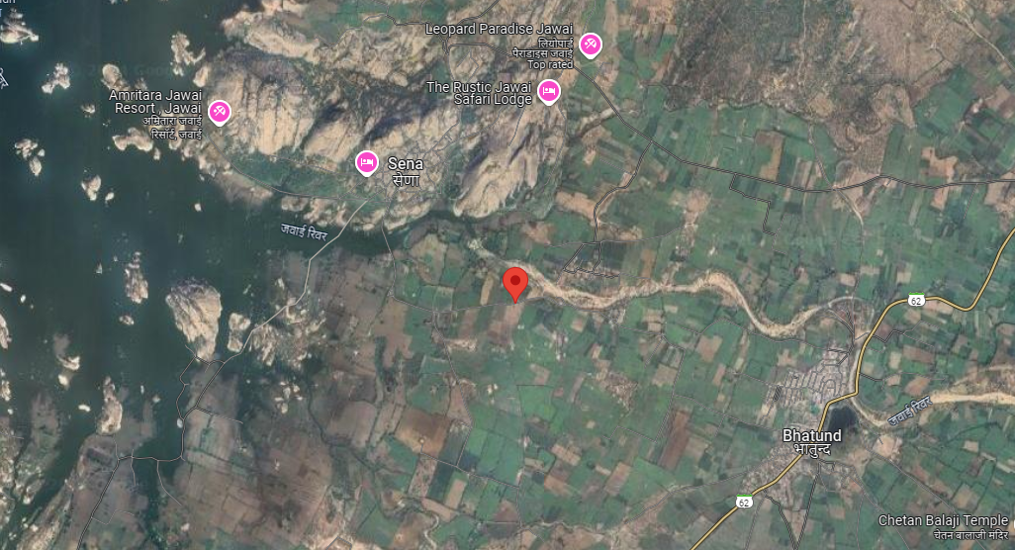
- GOOGLE LAYOUT PLAN:
Demarcation of the land with measurement on the Google map is as shown in the below picture:
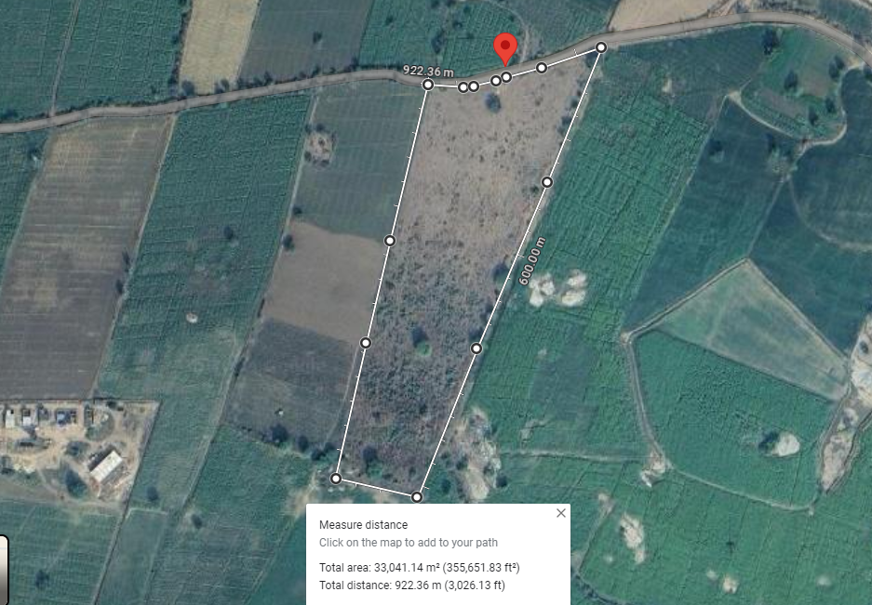

- LAYOUT PLAN:
The approved layout plan for the proposed site, has been prepared in accordance with the requirements of the project with due considerations of the requirements of hotel business, the facilities and user amenities required.
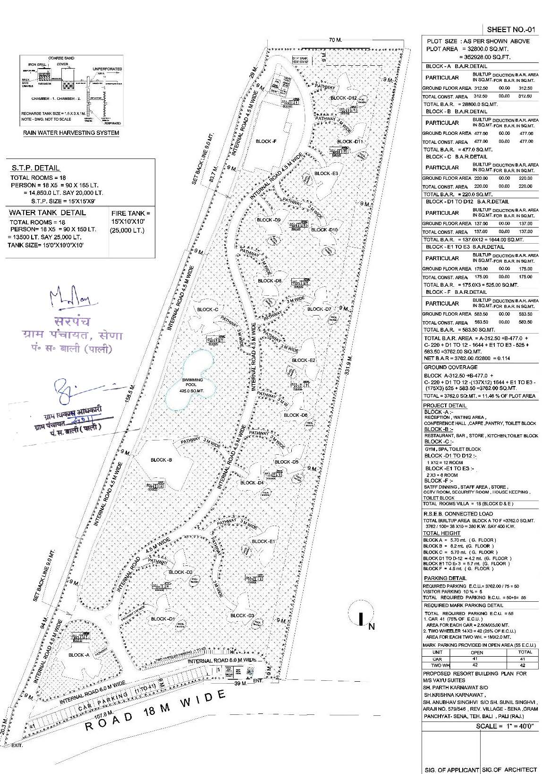
- LAND DETAILS:
M/s Vayu Suites (Partnership Firm) acquired 3.44 hector (34400 Sq. Mt.) of land in a transaction to facilitate the development of the proposed luxury resort. According to the sale deeds provided by the client, comprising 7.10 acres (71,000 Sq. Mt.), was purchased on 25th February, 2022, for a sale consideration of INR 5,00,000/-, which was paid by the firm Vayu Suites.
As per Title Search & Legal Scrutiny provide by the client, previously, the agricultural land with Khasra No. 473 was owned by Sh. Raghuveer Singh, son of Sh. Nainsingh, as recorded in the revenue records. He gifted this land to his relative, Smt. Renukunwar, wife of Sh. Ravindra Singh Ji, through a registered Gift Deed dated 14.08.2020, which was recorded in the office of the Sub-Registrar in Beda (Bali), Pali, on the same day with document number 202001474000525.
Subsequently, Smt. Renukunwar gifted this land to her sister-in-law, Smt. Saroj Kunwar, wife of Mahipal Singh Ji Champawat, through a registered Gift Deed dated 01.01.2022, which was recorded in the office of the Sub-Registrar in Beda (Bali), Pali, on 19.01.2022 with document number 202201474000040.
Thereafter, Smt. Saroj Kunwar sold a part of Aaraji No. 473, measuring 3.44 hectares, to the applicant borrower, M/s Vayu Suites, represented by partners Sh. Parth Karnawat, son of Late Sh. Krishna Kant Kamawat, and Sh. Anubhav Singhvi, son of Sh. Sunil Singhvi, residing in Udaipur. This transaction was completed through a registered sale deed dated 25.02.2022, which was recorded in the office of the Sub-Registrar in Beda, Tehsil Bali, Pali (Rajasthan), on the same day with document number 202201474000300.
Subsequently, M/s Vayu Suites, through its partners, applied to the District Collector of Pali for the conversion of the land from agricultural to commercial use. Upon review, the District Collector of Pali issued a conversion order (No. LC/2022-23/127615) dated 27.01.2023, and the conversion order was registered in the office of the Sub-Registrar in Bali, Pali (Rajasthan), under document number 202401153001746.
However, in conversion order dated 27th January 2023, Khasra no. of land has been changed from 473 to 579/546 and 0.15 hectare of land affected by the road boundary will remain intact in the account of applicant. Site is a large parcel of land, congenial for the development of a spacious luxury Leisure Resort. The land parcel presents an almost flat terrain, with little or no plants or forestation, making it ready and easy for immediate development.
During the site visit on 26th April 2024, we found that the rates of commercial land near to the proposed project are ~INR 1 Crore per hectare. This higher rate attributed to nearby forest of Jawai wildlife, which attracts tourists from various parts of India and around the world.

- PHOTOGRAPHS OF THE PROJECT:
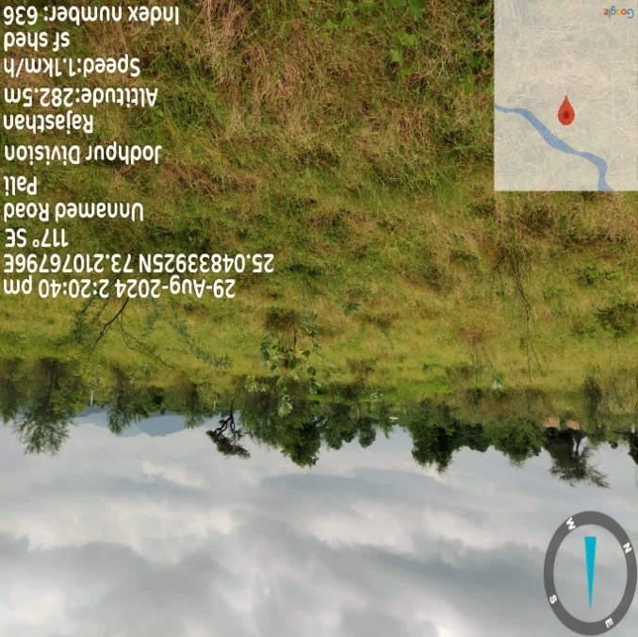 | 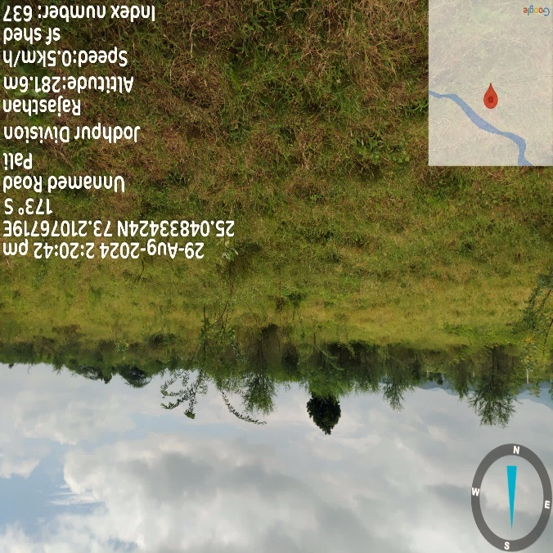
 | 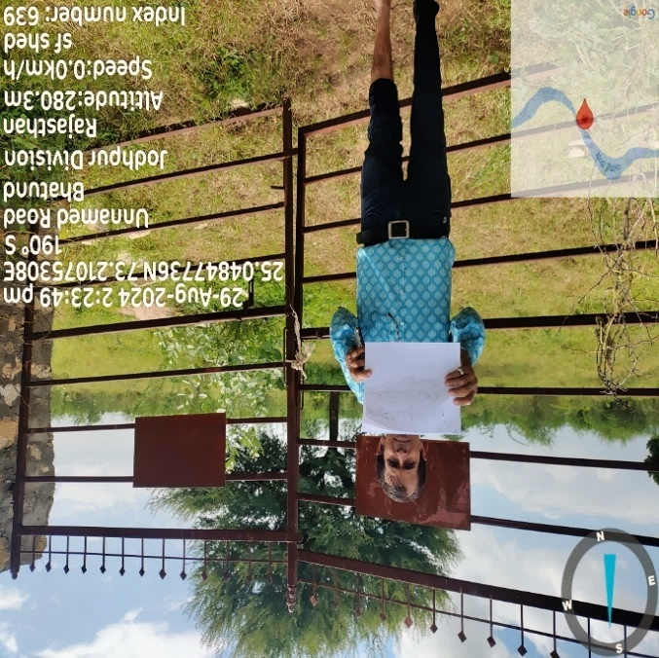
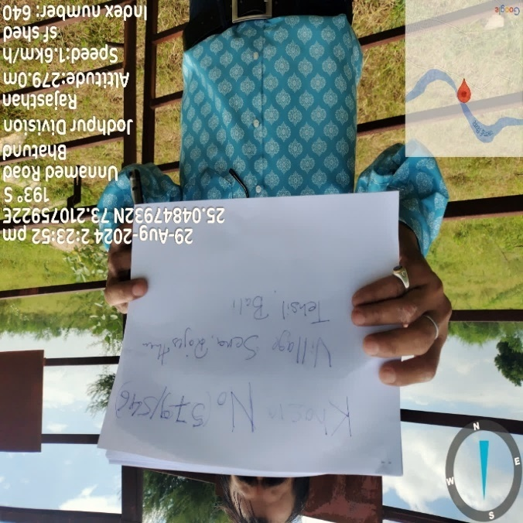 | 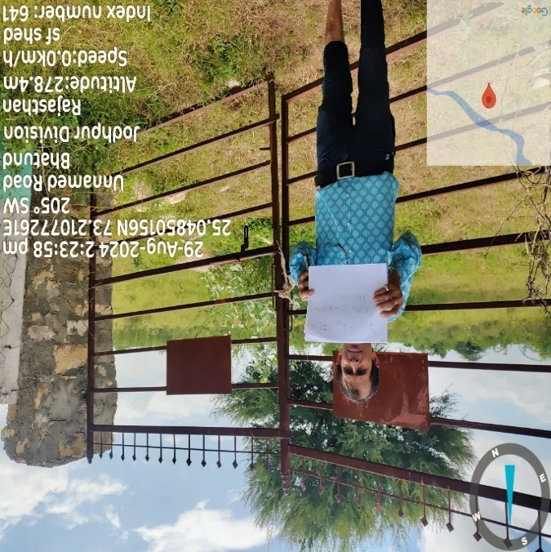
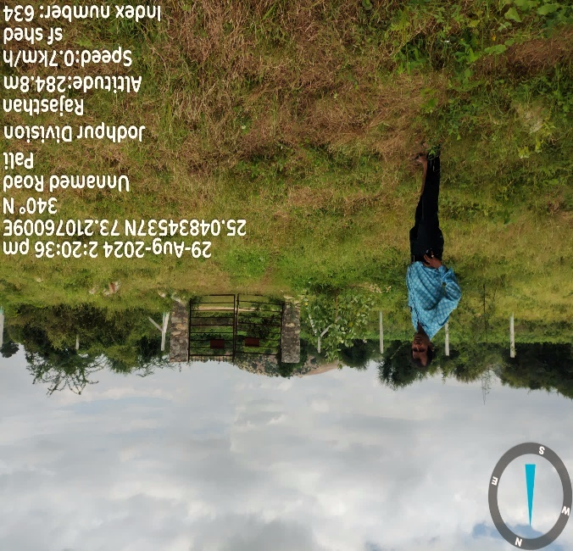 | 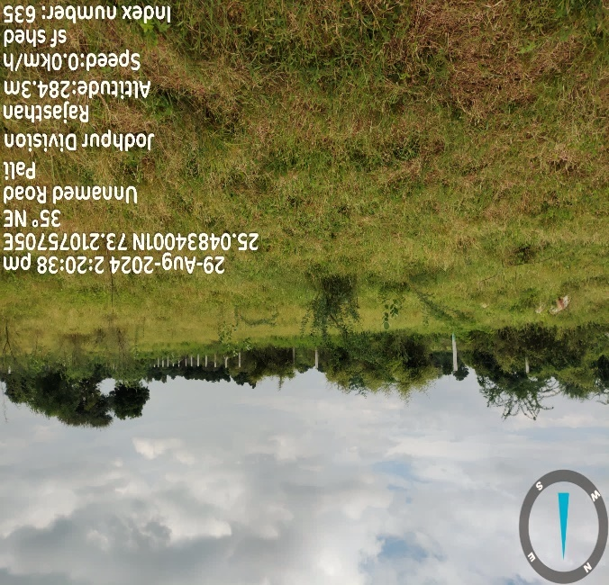
 | 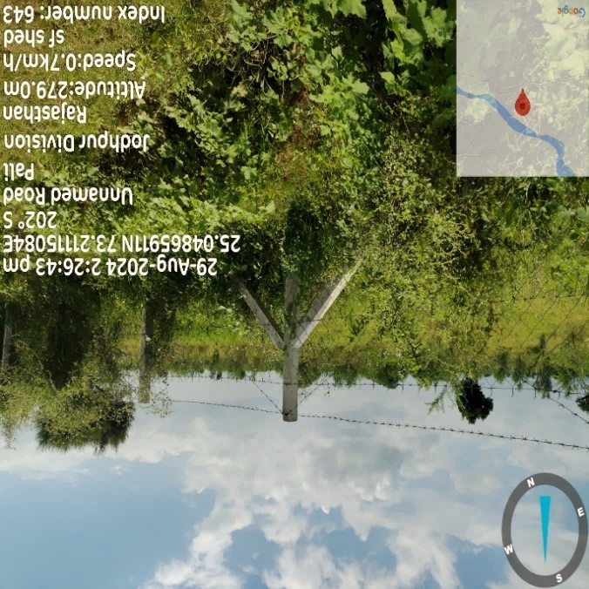
- BUILDING & CIVIL WORKS:
As per the information shared by the client/company, the planning of the building structures and infrastructure facilities has been done keeping in view the major attributes like entrance to the hotel, vehicular movement inside the hotel and other functional requirements for hotel business. As per information provided by the company/client, the building and the civil work have been done according to the layout plan which has been approved by the competent Authority – Gram Panchyat: Kariya, Tehsil: Bali, Dist.: Pali, Rajasthan.
As per the masterplan of 18 luxurious villa rooms shared by M/s Vayu Suites. The total area available at site is 32,800.00 Sq. Mt., out of which Build-up area of the proposed luxury resort with its civil structures admeasures 3,762 Sq. Mt.
Providing guests with an added level of luxury. The resort’s distinctive architecture combines traditional Rajasthani elements with modern comforts, creating an experience that is both authentic and contemporary. The design showcases sleek, wave-like structures and open spaces that harmonize beautifully with the surrounding nature. Inside, the room a modern aesthetic, with large arched windows that flood the space with natural light, minimalist furniture, and thoughtfully curated artwork, resulting in a stylish and inviting atmosphere. The resort also offers exclusive amenities such as a spa, swimming pool, and a fine dining restaurant/bar, making it the perfect destination for those seeking both adventure and relaxation.
As per the information shared by the client, M/s Flex Stone Inc. will be appointed for main building civil shell and core works. As per scope of work, M/s Flex Stone Inc. will be engaged for civil and structure work, landscaping, designing and other work for the proposed resort project.
M/s FlexStone Inc.
Founded in 2010 by Canadian entrepreneurs Devdatt Sharma and H.P. Singh in India, FlexStone was created out of a need for high-quality façade cladding materials. Initially developed to meet their own residential needs, Devdatt Sharma and H.P. Singh recognized the broader potential for innovative cladding solutions in India’s evolving construction market. Inspired by the beauty of nature, FlexStone launched 14 years ago with a focus on creating maintenance-free, handcrafted stone facades. Through technological innovation and teamwork, FlexStone has expanded its offerings to encompass a variety of construction solutions.
FlexStone delivers comprehensive solutions for custom-designed facades and floors, bringing clients' visions to life through a wide array of techniques and integrated solutions. Specializing in handmade cladding stones that are exterior-grade and maintenance-free, FlexStone provides numerous options suitable for both interiors and exteriors, alongside full installation services. Its product line includes handmade bricks, stones, laser-cut patterns, textured panels, Nano topping, architectural facades, custom artifacts, and commercial stamping, all crafted to high standards.
With a strong track record of successful global projects, FlexStone has established a diverse clientele, including leading names such as Reliance, Tata Housing, Marina Homes Dubai, Miraj Group Nathdwara, Lafarge, Allen, Woodland, Mahindra, Goyal & Co., A. Shridhar, Pacifica Groups, Lodha, Honest, Havmor, as well as numerous state government projects, institutional buildings, commercial hubs, and landmark structures
Below table shows the bifurcation of the estimated cost of construction provided by the client:
Cost Of Construction
S. No. | Description Of Each Building | Area Sq. Ft. | Rate Per Sq. Ft. | Estimated Cost INR Lacs.
1 | Supply & Erection of custom designed FEFS complete shell structure (both side plaster finish) with openings (door & window shapes) and framework as per drawings. One Room Villa -12 | 17,140.59 | 3,000 | 514.22
2 | Supply & Erection of custom designed FEFS complete shell structure (both side plaster finish) with openings (door & window shapes) and framework as per drawings. Two Room Villa -3 | 5,529.68 | 3,000 | 165.89
3 | Supply & Erection of custom designed FEFS complete shell structure (both side plaster finish) with openings (door & window shapes) and framework as per drawings. Reception Block | 3,368.38 | 2,100 | 70.74
4 | Supply & Erection of custom designed FEFS complete shell structure (both side plaster finish) with openings (door & window shapes) and framework as per drawings. SPA & GYM | 2,361.84 | 1,620 | 38.26
5 | Supply & Erection of custom designed FEFS complete shell structure (both side plaster finish) with openings (door & window shapes) and framework as per drawings. Restaurant & Bar Block | 5,300.62 | 1,950 | 103.36
6 | Supply & Erection of custom designed FEFS complete shell structure (both side plaster finish) with openings (door & window shapes) and framework as per drawings. BOH | 6,394.03 | 1,950 | 124.68
7 | Supply & Erection of custom designed FEFS complete shell structure (both side plaster finish) with openings (door & window shapes) and framework as per drawings. Staff Area | Lumpsum |  | 80.00
8 | Supply & Execution of Land Scaping As per Design. | Lumpsum |  | 100.00
9 | Supply & Erection of Foundation as per Design. | Lumpsum |  | 525.00
10 | Miscellaneous | Lumpsum |  | 29.00
SUB-TOTAL |  |  |  | 1,751.15
GST @18% |  |  |  | 315.207
TOTAL |  |  |  | 2,066.36
Source: Data/information provided by the client.
In construction or design, FEFS, or Flexible Edge Finishing System, refers to methods and products used to create clean, aesthetically pleasing edges for various surfaces. This system allows for versatility in design while ensuring durability and functionality.
Key features often include:
- Aesthetic Appeal: FEFS provides a polished look to edges, enhancing the overall design of the space.
- Durability: Materials used in FEFS are typically designed to withstand wear and tear, making them suitable for high-traffic areas.
- Versatility: It can be applied to various surfaces, including walls, floors, and countertops, allowing for creative design options.
- Easy Installation: Many FEFS products are designed for straightforward installation, making them accessible for contractors and DIY projects.
- Weather Resistance: In outdoor applications, these systems often offer protection against the elements, preventing damage from moisture and temperature fluctuations.
Overall, FEFS helps achieve a professional finish in construction and design projects, combining functionality with a modern aesthetic. Below table shows the area statement mentioned in the master plan for the proposed project:
Area Statement As per Approved Masterplan
S. No. | Description | Area (Sq. Mt.)
 | Total Site Area (As per layout & Katha) | 32,800 Sq. Mt.
 | Total Site Area (As available at Site) | 32,800 Sq. Mt.
- Proposed Block A - (Reception, Waiting Area, Conference Hall, Cafe)
 | Ground Floor Area | 312.50 Sq. Mt.
 | Total Floor Area | 312.50 Sq. Mt.
- Proposed Block B - (Restaurant, Bar, Store, Kitchen)
 | Ground Floor Area | 477.00 Sq. Mt.
 | Total Floor Area | 477.00 Sq. Mt.
- Proposed Block C (Gym, SPA)
 | Ground Floor Area | 477.00 Sq. Mt.
 | Total Floor Area | 477.00 Sq. Mt.
- Proposed Block D1 to D12 (1 Room)
 | Ground Floor Area | 137.00 Sq. Mt.
 | Total Floor Area | 137.00 Sq. Mt.
- Proposed Block E1 to E3 (2 Rooms)
 | Ground Floor Area | 175.00 Sq. Mt.
 | Total Floor Area | 175.00 Sq. Mt.
- Proposed Block F (Staff Area, CCTV Room, Security Room, House Keeping)
 | Ground Floor Area | 583.50 Sq. Mt.
 | Total Floor Area | 583.50 Sq. Mt.
Total Build Up Area Block A to F |  | 3762 Sq. Mt.
Source: Master plan shared by the client/LLP.

Area of Villa
S. No. | Room Type | No. of room | Area per Villa Sq. Ft. | Total Area in Sq. Ft.
1 | Villas D1-D12 | 12 | 1474.66 | 17695.92
2 | Villas E1-E3 | 6 | 1883.68 | 22604.16

Floor wise construction: (hotel complex)
Floor | Area of construction Sq. Ft. | Area of construction Sq. m | No of rooms | Amenities
Ground | 40493.94 | 3762 | 18 | 10
Sources: Master plan shared by the client/LLP.
As per copy of quotation dated received from Flex Stone Inc., the estimated construction cost for the building and civil works including finishing work is approximately INR 20.66 crore. Also, this estimate has been certified (estimate report dated 07-11-2024) by a government-approved and bank empanelled valuer, Om Prakash Shrimali (Reg. No. SCA/2016/27/360512), who estimated the cost at INR 20.74 crore.
The construction cost for the said project is Rs. 5,102/- per sq. ft. including all the development & infrastructure work. As per our analysis & market research conducted, the constructed cost of luxurious resorts/hotels varies from Rs. 5,000/- to Rs. 5,500/- per sq. ft for presently flex based construction basis. Based on our market analysis and cost verification, we find this construction cost to be reasonable.

- EQUIPMENT AND PLANT & MACHINERY DETAILS:
As per the data/information provided by the client, the proposed luxury resort will use equipment, which are marketed for easy to control, operate, install and maintain like washers, dryers, ironers, modern stoves and refrigerators, frozen cells, self-service elements, dishwashers, bar and stainless-steel furniture and fittings use by customers and guests.
Detailed bifurcation of the proposed plant and machinery has been shown in the below table along with the estimated cost provided by client:
S. No | Particulars | QTY | Rate per Unit | Estimated Cost  (INR Lacs)
1 | Air Conditions | 65 | 1.25 | 81.25
2 | DG Set | 2 | 16.15 | 32.30
3 | Transformer | 2 | 7.61 | 15.22
4 | CCTV | 1 | 31.87 | 31.87
5 | Television Sets | 25 | 1.40 | 35.00
6 | Sewerage Treatment Plant | 1 | 5.66 | 5.66
7 | Water Softener Plant | 1 | 4.96 | 4.96
8 | Air Source Heat Pump Water Heater | 1 | 4.25 | 4.25
9 | Swimming Pool Equipments | 2 | 33.28 | 33.28
10 | Refrigerator & Heater | 18 | 0.33 | 5.94
11 | Kitchen Equipments | 1 | 35.62 | 35.62
12 | COMPUTER SYSTEM | 1 | 19.53 | 19.53
13 | Epabx System, Telephone Sets and Telephone Lines | 1 | 8.46 | 8.46
Total |  |  |  | 313.34
Source: Data/information provided by the client.
Thus, the estimated cost for the proposed equipment is INR 3.13 crores according to the client's estimate.
The cost for firefighting measures will be borne by the client, as these are not included in the initial quotation. According to the client, installing a sprinkler firefighting system is not feasible in the proposed hotel due to its unique structural design. Instead, the client will provide individual fire safety cylinders in each luxury villa room.
As per the tender documents shared by the client, below are the quotations of various vendors received by the client to justify the estimated costs:
Quotation For | Amount (INR) | Quotation From
IP-CCTV System | 31,87,000 | IT Magic Udaipur
Supply of AC units and low site work charges | 81,24,480 | Chandras Landmark
OLED TV | 35,00,000 | Chandras Landmark
180 KVA Silent DG Set | 32,30,000 | Electromak Energy and Equipment
400 KVA Transformer | 15,22,000 | Electromak Energy and Equipment
Sewerage Treatment Plant | 5,66,000 | Global Enterprises
Water Softener Plant | 4,96,000 | NAV Durga Associates
Air Source Heat Pump Water Heater | 4,24,800 | Chandra Heating Solutions
Swimming Pool Equipment (18 luxurious villa rooms) | 29,74,000 | Global Water Bodies
Swimming Pool Equipment (Main Pool) | 3,54,000 | Global Water Bodies
18*92 Ltr Refrigerator & Heater 18 Oil heater | 5,86,224 | Chandras Landmark
Kitchen Equipments | 35,62,000 | Jetha Air Conditioning Works
COMPUTER SYSTEM (1-Server and 20 PCs) | 19,53,000 | Ficusa Enterprises
Epabx System, Telephone Sets and Telephone Lines | 8,46,000 | Ficusa Enterprises
Total | 3,13,34,000
As per our independent tertiary research, and data/information available in the public domain, we found that all the vendors are known players. We have also inspected the cost range of the equipment, which seems to be reasonable.

- FURNITURE AND FIXTURES:
The list of furniture to be utilized at the proposed hotel includes items such as beds, chairs, tables, desks, wardrobes and sofas. The furniture chosen should be comfortable, functional and durable. It should also align with the hotel’s design aesthetic and brand image. Fixtures refer to items that are attached to the walls or floors of the hotel, such as mirrors, towel racks, lighting fixtures, etc. These items are crucial in creating a comfortable and functional space for guests. Accordingly, proposed hotel management shared the details of furniture and fixtures with quantity, rate and estimated cost:
S. No. | Description | QTY | Rate per Unit (In Lacs) | Estimated Cost (In Lacs)
1 | Rooms Furniture | 18 | 9.50 | 171.00
2 | Restaurant Furniture | 1 | 26.00 | 26.00
3 | Reception Furniture | 1 | 20.00 | 20.00
4 | Banquet Furniture | 1 | 16.00 | 16.00
5 | Other Area Furniture | 1 | 13.61 | 13.61
Total |  |  |  | 246.61
Add: GST @ 18% |  |  |  | 44.39
Total |  |  |  | 291.00
Source: Data/information provided by the client
Thus, the estimated cost for the proposed furniture & fixtures will be INR 2.91 crores as per the client. As TEV consultants, we have independently verified the cost of the proposed furniture & fixtures by consulting several vendors who specialize in similar market. We found that the cost of proposed furniture & fixtures to be reasonable and within permissible ranges.
It's important to note that the cost of proposed furniture & fixtures may vary depending on the brand name and quality of the furniture & fixtures. As per the data/information shared by the client, vendor/supplier details for furniture are shown in the below table:
FURNITURE QUOTATION RECEIVED FROM THE HARSH INC.
S. No. | Category | Product | Elements Description | Size (in inch) | Qty | Price/Unit | Total
 | Room  Type 1 | Bed | Teak Bed with Natural cane headboard, Bed base in 16mm BWP ply. Polish as per choice | 78*78 | 18 | 40000.00 | 720000.00
 |  | Side Table | Teak side Table with Cane. | 24*18*20 | 36 | 15000.00 | 540000.00
 |  | Wardrobe | Teak wardrobe with CNC jhali at front shutters and carcass in BWP 16 mm ply. Soft close hettich hinges | 60*26*86 | 18 | 51000.00 | 918000.00
 |  | Luggage Rack | Teak foldable luggage rack. | 27*17*23 | 18 | 20000.00 | 360000.00
 |  | Tv Console | Teak TV console with CNC jhali on front shutters, carcass in BWP ply 16mm. Powder coated metal leg. | 60*15*20 | 18 | 45000.00 | 810000.00
 |  | Bar Cabinet | Teak Cabinet with cane jhali, soft close hettich hinges, with kettle stand on top. | 36*24*36 | 18 | 52000.00 | 936000.00
 |  | Writing Desk | Teak writing desk with 3 drawers. | 48*26*30 | 18 | 30000.00 | 540000.00
 |  | Writing Chair | revolving chair with alluminium base. | 24*24*38 | 18 | 22000.00 | 396000.00
 |  | Arm Chair | Teak chair with cane back, upholestry sitting with 40 density foam. Sitting height 17.5 inches. | 28*24*33 | 36 | 20000.00 | 720000.00
 |  | Centre Table | Teak center table with marble round top, caning at sides. | Dia-24, H- 18 | 18 | 18500.00 | 333000.00
 |  | Outdoor Furniture | 4 wicker chair set with center table. |  | 18 | 28000.00 | 504000.00
 |  | Dressing | Teak frame dressing unit with mirror. |  | 18 | 25000.00 | 450000.00
 |  | End Bed Bench | White ash wood carving legs with upholestry sitting. | 36*22*18 | 18 | 22000.00 | 396000.00
 |  | Console | ply with veneer top console with 2 drawers and metal chrome polish leg. | 60*15*36 | 18 | 16500.00 | 297000.00
 |  | Cabinet | white ash wood bar cabinet with soft close hinges and metal legs, carcass in BWP ply. | 36*24*72 | 18 | 45200.00 | 813600.00
 |  | Sofa | white ash wood base with upholestry back and sitting, 40 density foam. Sitting height 17.5 inches. | 90*26*33 | 18 | 45000.00 | 810000.00
 |  | Center Table | Ply with veneer top, base in metal. | 26*24*18 | 18 | 31500.00 | 567000.00
 | Reception | Sofa | Sofa with white ash wood frame, chesterfield sofa. 3 +2 seater set. | 90*25*36,  66*25*36 | 8 | 125000.00 | 1000000.00
 |  | Reception Wall Panelling | wall paneling with bwp ply and veenar pn top of greenlam/century with polish as per choice. |  | 1525 | 1150.00 | 1753750.00
 |  | Reception Desk | flutted wall panel reception desk with italian marble top. As per drawing |  | 1 | 275000.00 | 275000.00
 |  | Host Desk | flutted MDF panel hosk desk. As per drawing | 36*24*36 | 1 | 61000.00 | 61000.00
 |  | Office Chair | revolving chair. |  | 10 | 11000.00 | 110000.00
 |  | Center Table | Liveage aakashiya table with metal base | 36*24*18 | 8 | 22500.00 | 180000.00
 |  | Console | MDF wooden panel console unit with marble top. | 36*15*40 | 2 | 35000.00 | 70000.00
 | OUTDOOR | Rope Chair At Pool Side | Metal chair with silk rope (all weather) and cushion sitting on top. Color as per selection. Only sitting cushion no back pillow. |  | 36 | 6900.00 | 248400.00
 |  | ROPE/JUTE BAR  STOOLS At Pool Side | Metal chair with JUTE rope (May get damage by water)/silk rope (all weather) and cushion sitting on top. Color as per selection. Only sitting cushion no back pillow |  | 24 | 11450 | 274800.00
 |  | SQUARE TABLE | Table with metal powder coated legs with water proof and termite resistant raw ply/FINISHED HDHMR. CLIENT CAN PASTE MARBLE TOP ON SITE AS PER HIS SELECTION. HIEGHT - 2'5". *1.5 Inch Top. |  | 18 | 24500 | 441000.00
 |  | SQUARE TABLE | Table with metal powder coated legs with water proof and termite resistant raw ply/FINISHED HDHMR. CLIENT CAN PASTE MARBLE TOP ON SITE AS PER HIS SELECTION. HIEGHT - 2'5". *1.5 Inch Top. | 3'6"*4' | 5 | 21920.00 | 109600.00
 |  | BAR TABLE | Table with metal powder coated legs with water proof and termite resistant raw ply/FINISHED HDHMR. CLIENT CAN PASTE MARBLE TOP ON SITE AS PER HIS SELECTION. HIEGHT - 3'4". *1.5 Inch Top. | 6'*6' | 4 | 41400.00 | 165600.00
 | INDOOR RESTAURANT | SITTING Sofa | Premium Indian draw iron sofa with premade rattan at the back. upholstery seat and back. powder coating and fabric of your choice. | 72*24*18 | 15 | 75000.00 | 1125000.00
 |  | Room Wall Panelling | wall panelling in bwp ply with veenar finish |  | 890 | 1350.00 | 1201500.00
 |  | Counter | BWP ply with fluted MDF Panel. |  | 1 | 606207.00 | 606207.00
 |  | Chair | Premium Indian draw iron sofa with premade rattan at the back. upholstery seat. powder coating and fabric of your choice. |  | 46 | 9200 | 423200.00
 |  | SOFA SITTING TABLE | Table with metal powder coated legs with teak TOP (EASY TO MAINTAIN+ NO COMPLAIN OF JOINTRY). HIEGHT - 2'4".  *1.5 Inch Top. | 6X3 | 14 | 34500.00 | 483000.00
 |  | OTHER 4 SITTING  TABLE 0PTION 1 METAL BASE | Table with metal powder coated legs with teak TOP (EASY TO MAINTAIN+ NO COMPLAIN OF JOINTRY). HIEGHT - 2'4".  *1.5 Inch Top. | 4X4 | 6 | 21000.00 | 126000.00
 |  | OTHER 4 SITTING  TABLE 0PTION 2 ROD IRON | Table with metal powder ROD IRON legs with teak TOP (EASY TO MAINTAIN+ NO COMPLAIN OF JOINTRY). HIEGHT -  2'4". *1.5 Inch Top. | 4X4 | 4 | 22500.00 | 90000.00
 | Spa Block | Bed | recliner bed with massager with 4 yr warranty |  | 4 | 75000.00 | 300000.00
 |  | Room Wall Panelling and Fix Furniture | 1450 sq. ft wall panelling in bwp ply with veneer finish |  | 1300 | 1350.00 | 1755000.00
 | GARDEN BLOCK ` | Bench | Aluminium bench with powder coating warranty 20 yr |  | 18 | 25000.00 | 450000.00
 |  | Chair | Aluminium chair with powder coating warranty 20 yr |  | 26 | 6450.00 | 167700.00
 | BANQUET | Room Wall Panelling and Fix Furniture | Wall panelling in bwp ply with veneer finish polish as per client selection. |  | 2550 | 920.00 | 2346000.00
 |  | Table | foldable aluminium light weight table |  | 15 | 11900.00 | 178500.00
 |  | Chair | aluminium light weight chair |  | 74 | 2090.00 | 154660.00
 |  | Counter | BWP ply with flutted MDF Panel. |  | 1 | 454500.00 | 454500.00
Total |  |  |  |  |  |  | 24661017.00
GST 18% |  |  |  |  |  |  | 4438983.06
GRAND TOTAL |  |  |  |  |  |  | 29100000.06
Source: Data/information provided by the client
- UTILITIES:
- WATER: According to the information shared by the client, both the groundwater and bore well will be in place at the site location. Firm has proposed to establish standard water treatment plant as per industry norms using STP technology. After the treatment of water, there will be an abundant water supply for bathrooms, cleaning and cooking. Bottled water will be provided for guests' drinking purposes. Additionally, water recycling measures will be implemented, utilizing bathroom wastewater for toilet flushing and irrigation of lawns and plants. Rainwater harvesting will also be incorporated at the site in the future.

- ELECTRICITY: As per the client's information, the area has an adequate electricity supply, and electrical connections for hotels are available upon request. For this greenfield project, a commercial electrical connection with a 150 kW load will be obtained from Ajmer Vidhyut Vitran Nigam Limited. Additionally, a DG (diesel generator) will be provided for backup power support.

- Transportation: The proposed hotel is conveniently located in Bali (Tehsil). A 30-meter unpaved (kacha) road currently provides access to the location, with plans to upgrade it to a paved (pakka) road which connected to NH-62. The nearby Falna Railway Station offers services from major cities, including Delhi, Agra, Mumbai, Chennai, Bikaner, Jaipur, and Ahmedabad. Additionally, Udaipur/Jodhpur Airport, which is well-connected with regular domestic flights from Delhi and Mumbai, is within reach.

- MANPOWER:
As per information shared by the client/company, an estimate of manpower requirement allowing for leave, absenteeism, sickness and holidays for smooth and for efficient operation of different sections of the proposed hotel including its administrative departments, has been prepared based on technical and management ground primarily to indicate the order of manpower requirement. In estimating the manpower requirement, a proper ratio between the administrative, managerial, supervisory and floor staff has been maintained with a view to affording proper industrial and professional management at various levels.
As per informed by client, firm have estimated around 40 workers will be required at the time of commencement of commercial operations which is in the line with the industry. The basic structure of the manpower will require for the proposed project are.
Designation | No. of Persons
General Manager | 1
Accountant cum Cashier | 1
Store Keeper | 1
Sales & Marketing Online | 1
Maintenance Team | 2
Security Team | 3
Gardeners & Pest Control | 2
Front Office Associates | 3
Executive Housekeeper | 1
Housekeeping Room Attendants | 10
Manager | 1
Executive Chef | 1
Kitchen Seniors | 1
Kitchen Juniors | 2
F&B Supervisors | 2
F&B Stewards | 5
Manager | 1
Masseuse | 2
Total | 40
In general the state of Rajasthan has a lot of trained manpower which is required for the hotel industry, as the area has been catering to the tourism industry. Hence, the lower level staff would be hired locally. The senior and additional staff requirements would be met from the management client/company with whom marketing tie up/agreement will be entered by the client.

- MARKETING STRATEGIES:
As per information provided by the client/company, marketing strategies for proposed luxury hotels will be to attract and retain guests while maintaining their luxury image. Here are the major marketing strategies used by Vayu Suites:
Brand and Positioning: Establishing a strong brand identity and positioning the hotel as a premier luxury destination is crucial. The proposed hotel will explore future Tie-up with luxury hotel chains, after the completion of the super-structure, which will further add to a big advantage to the hotel.
Targeted Advertising: Implementing targeted advertising campaigns to reach the desired audience is essential for a new hotel at one of the developing tourist places like Jawai. This includes advertising in high-end lifestyle magazines, digital advertising on premium websites, and strategic partnerships with luxury travel agencies & tie-ups with big brands.
Content Marketing: This content may include blog posts, videos, and social media updates showcasing the resort's offerings and destinations.
Partnerships and Collaborations: Travel agencies, and other luxury brands to offer exclusive packages, promotions, and loyalty programs, expanding its reach and attracting new guests.
Online Presence: By maintaining strong online presence through its website and social media channels, where it showcases its properties, shares guest reviews and testimonials, and engages with followers to build brand loyalty.
Personalized Guest Experience: Positive guest experiences can lead to word-of-mouth recommendations and repeat business. To provide a personalized and tailored experience to guests will be the hallmark of the proposed luxury hotel. This includes anticipating and meeting guest needs and preferences, offering custom amenities, and providing exceptional customer service throughout the stay.
Unique Selling Proposition (USP): Highlighting the hotel's unique features and offerings is critical. The resort boasts unique architecture that blends traditional Rajasthani design with modern amenities, offering an authentic yet contemporary experience. The architectural design includes modern, wave-like structures and open spaces, seamlessly integrating with the natural surroundings. Additionally, the project boasts exclusive amenities like a spa, swimming pool, and fine dining restaurant. Emphasizing these unique selling points helps differentiate the hotel from competitors and attracts discerning travellers seeking exceptional experiences
By implementing the above marketing strategies, M/s Vayu Suites aim to attract discerning travellers seeking luxury experiences while maintaining a competitive edge in the hospitality industry.
PART E | HOSPITALITY AND TOURISM INDUSTRY OVERVIEW

- INTRODUCTION:
The hospitality market in India is experiencing an unprecedented boom, driven by a combination of economic growth, increasing disposable incomes, and a burgeoning middle class with a penchant for travel and leisure. As the world's seventh-largest country by land area and second-most populous nation, India's diverse landscape and rich cultural heritage offer immense potential for the hospitality sector.
In 2023, India continued its ascent on the global stage, building on its status as the world’s fifth-largest economy achieved the previous year. The country seized the spotlight, surpassing China as the most populous country, hosting over 200 meetings during its G20 presidency, and achieving a historic milestone by successfully landing Chandrayaan-3 on the moon’s unexplored South Pole, the first country to ever do so. Moreover, fuelled by favourable demographics, robust domestic demand, and increased investments, India’s economic resilience persisted amidst global challenges. Fuelled by these positive sentiments, both leisure and business travel increased significantly in the country.
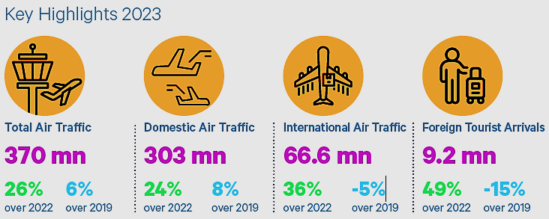
Sources: Airport Authority of India, Ministry of Tourism, India, HVS Research.
The hospitality industry in India experienced a remarkable revival in 2023, marked by escalating hotel prices, soaring airfares, and increased travel expenditures. This translated into a promising year for hospitality in India. As we delve into 2024, sustained growth is strongly indicated in domestic as well as international travel. Premium hotels nationwide reported impressive occupancy rates ranging from 70% to 72%. The Indian Luxury Hotel Market size is expanding at a CAGR of 8.1% from 2023 to 2032.
India has become one of the most sought-after travel destinations worldwide, resulting in the tourism and hospitality industry emerging as a major growth driver in the services sector. Similar to many other countries, tourism in India plays a pivotal role in generating foreign exchange earnings. Foreign exchange earnings experienced a Compound Annual Growth Rate (CAGR) of 7%.
- MARKET SIZE:
As per the Ministry of Tourism, Foreign Tourist Arrivals (FTAs) in March 2023 were 7,95,827 as compared to 3,42,308 in March 2022 with a positive growth rate of 132.5%. FTAs during the period January-March 2023 were 25,29,766 as compared to 7,84,750 in January-March, 2022 and 31,79,792 in January-March 2019 registering a growth of 222.4% and -20.4% with respect to 2023 and 2019 respectively.
In 2021, the travel and tourism industry's contribution to India's GDP was valued at US$ 178 billion, and it is projected to reach US$ 512 billion by 2028. The industry's direct contribution to India's GDP is expected to grow annually at a rate of 7-9% between 2019 and 2030. In 2020, the travel and tourism industry contributed US$ 121.9 billion to India's GDP. By 2022, the contribution of the travel and tourism industry to India's economy reached US$ 15.7 trillion.
The travel market in India is expected to reach US$ 125 billion by FY27, an increase from an estimated US$ 75 billion in FY20. The Indian airline travel market, valued at approximately US$ 20 billion, is projected to double in size by FY27 due to improvements in airport infrastructure and increased passport accessibility.
The Indian hotel market, including domestic, inbound, and outbound segments, was estimated at around US$ 32 billion in FY20 and is expected to reach approximately US$ 52 billion by FY27. This growth will be driven by the rising demand from travellers and the ongoing efforts of travel agents to stimulate the market.
By 2028, international tourist arrivals are projected to reach 30.5 billion, generating revenue of over US$ 59 billion. However, the growth in the tourism sector is expected to be primarily driven by domestic tourists in the post-pandemic period. International hotel chains are expanding their presence in India and it reached approximately 50% of the country's tourism and hospitality sector.

- PERFORMANCE ANALYSIS OF INDIAN HOTEL SECTOR FY2023:
The Indian hotel sector closed the calendar year 2023 with a nationwide occupancy rate in the range of 63-65%, up 3-5 percentage points (pp) from the previous year and nearly reaching the pre-pandemic level of 65-67% in 2019. The average rate (ARR) for 2023 reached an impressive INR 7,400-7,600, which surpassed the figures from 2022 by 21-23% and 2019 by 24-26%, highlighting the sector’s ability to push rates driven by the buoyant demand.
The growth in average rates helped RevPAR to reach INR 4,662-4,940 in 2023, indicating a significant increase of 29-31% from 2022 and 19-21% in 2019. As per our tertiary research and data/information available in the public domain, KPIs of Indian hotel sector is shown in the below picture for FY 2023:
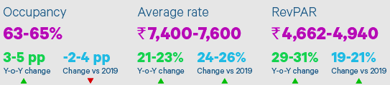
Sources: STR, HVS Research; all the data is for the calendar year and represents averages for the Indian hotel sector
The year got off to a good start with the nationwide occupancy rate breaching the 70% mark in February 2023, a first since the pandemic. The weddings segment, the upswing in business travel, and the Men’s IPL helped boost demand for hotel accommodation. The occupancy rate of 65-67% in Q1 2023 was 15-17 pp higher than in Q1 2022, which was impacted by the Omicron wave and the reintroduction of travel restrictions in the country. ARR meanwhile, experienced a year-on-year increase of 49-51% in Q1 2023, helping RevPAR to nearly double during this period.
Due to the seasonal retreat of travel, the occupancy rate moderated to 62-65% in the second quarter and while the trend was similar to Q2 2019 levels, it was 1-3 pp lower than Q2 2022. Despite this, ARR continued its growth trajectory and was 16- 18% and 23-25% higher than Q2 2022 and Q2 2019, respectively, driven by strong demand in the leisure and social events segments.
The seasonal moderation in Q2 continued into Q3, with occupancy rate in the 60-62% range. International events such as the G20 Summit, along with sustained demand from corporate travel and the growing popularity of Leisure helped drive the average rates in several key corporate markets such as Delhi and Mumbai. During this quarter, average rates experienced a year-on-year growth of 15-17% to reach INR 6,700-6,900, and were 24-26% higher than the same period in 2019.
The final quarter saw occupancy in the range of 64-66%, with ARR reaching INR 8,200-8,400. This helped RevPAR to reach INR 5,250-5,545. The ICC Men’s Cricket World Cup coupled with the wedding season and year-end holiday season, allowed the sector to end the year on a high note. Goa and Bengaluru continued to garner the highest interest from hotel operators in 2023 as shown in the below table. Hotel brands also increased their presence in smaller cities.
Ranking 2023 | By Keys |  | Ranking in 2022
S. No. | City | Number
1 | Goa | 1350 | 2
2 | Bengaluru | 1093 | 1
3 | Hyderabad | 1062 | 52
4 | Guwahati | 1038 | 79
5 | Amritsar | 926 | 5
6 | Jaipur | 908 | 12
7 | Indore | 801 | 37
8 | Lucknow | 768 | 38
9 | Ayodhya | 699 | 119
10 | Kasauli | 624 | 42

BRAND OPENINGS DURING 2019 TO 2023
In 2023, the surge in travel demand facilitated the opening of 12,435 branded hotel rooms, marking a 13% increase from 2022, with hotel operators continuing the trend of partial opening of their properties. Notably, domestic brands led the expansion, accounting for 73% of the new openings by properties, thereby continuing their dominance over international hotel chains in the market.

Note: openings include full and partial openings; Data received from 21 hotel operators as of 31st March 2024

- INVESTMENTS AND RECENT DEVELOPMENTS:
The Ministry of Tourism received an investment of Rs. 2,400 crore as the tourism sector presents significant opportunities for youth employment and entrepreneurship. To promote the establishment of new hotels, an investment-linked deduction is available under Section 35 AD of the Income Tax Act. This allows a 100% deduction for capital expenditures incurred in setting up hotels of 2-star category and above across India.
In the Union Budget 2023-24, the Ministry of Tourism was allocated US$ 290.64 million to leverage the sector's potential for job creation, youth entrepreneurship, and tourism promotion. The focus is on active state participation, government program convergence, and public-private partnerships.
Additionally, states will be encouraged to set up Unity Malls in their capital cities, serving as prominent tourism centers to promote local products, including One District One Product, Geographical Indication (GI) products, handicrafts, and products from other states. Below are some investments and developments:
- The Indian government has set a target to create 220 new airports by 2025, aiming to enhance connectivity and facilitate tourism growth.
- The Emergency Credit Line Guarantee Scheme (ECLGS) has been expanded to include tourism and hospitality stakeholders, providing financial support to micro, small, and medium enterprises (MSMEs). Exhibition-cum-convention centres have been granted infrastructure status.
- A separate liquidity window of INR 15,000 crore has been established for the tourism sector to address financial challenges.
- As of September 2022, a total of 48,775 accommodation units (classified and unclassified) have been registered on the National Integrated Database of Hospitality Industry (NIDHI) portal. Additionally, 11,220 units have self-certified for SAATHI standards, ensuring quality and safety.
- The Medical Tourism sector is projected to grow at a Compound Annual Growth Rate (CAGR) of 21.1% from 2020 to 2027.
- The Indian government estimates that India will have a market size of 1.2 million cruise visitors by 2030-31. Dream Hotel Group plans to invest approximately US$ 300 million in the next 3-5 years to develop India's cruise sector.
- India is at the forefront of digital travel, with its population utilizing digital tools for travel planning, booking, and experiences. The growing middle class and increasing disposable income have contributed to the growth of domestic and outbound tourism.

- GOVERNMENT INITIATIVES:
The Indian government has recognized the immense potential of the tourism industry and has implemented various measures to position India as a global tourism hub. In the Union Budget 2023-24, the Ministry of Tourism has been allocated a budget of US$ 290.4 million. Within this budget, an allocation of US$ 170.85 million has been made for the Swadesh Darshan Scheme.
This scheme aims to develop a comprehensive package of 50 tourist destinations, focusing on enhancing physical, digital, and virtual connectivity, as well as ensuring the availability of tourist guides and improving tourist security. Under the Budget 2023-24, an allocation of US$ 30.25 million has been made for the development of tourist circuits under the PRASHAD scheme. Since its launch in January 2015, the Ministry has sanctioned 37 projects in 24 states, with an estimated expenditure of US$ 146.4 million.
The Government of India, has collaborated with the Quality Council of India (QCI) for an initiative called SAATHI (System for Assessment, Awareness, and Training for the Hospitality Industry). This initiative aims to assist the hospitality industry in operating safely and mitigating risks arising from the COVID-19 pandemic. To support the tourism service sector affected by COVID-19, the government introduced the Loan Guarantee Scheme for Covid Affected Tourism Service Sector (LGSCATSS). This scheme provides loans of up to US$ 12,110 to approved and recognized tour operators, travel agents, and tourist transport operators under the Ministry of Tourism.
Furthermore, guarantees for skill development loans, up to INR 1.5 lakh, are being extended by member banks of the Indian Banks' Association (IBA) to eligible borrowers without collateral or third-party guarantee. This initiative aims to promote skill development within the tourism sector.
- Rising Rajasthan 2024: Opportunities for the Hotel Industry
Rising Rajasthan 2024 is poised to significantly impact the hospitality and tourism sectors, offering numerous opportunities for growth and investment in the state’s hotel industry. Rajasthan, with its rich cultural heritage, historical landmarks, and growing infrastructure, is becoming an increasingly attractive destination for both leisure and business tourism. The state’s commitment to becoming a global investment hub is reflected in the focus on sustainable and high-value sectors such as hospitality.

Key Opportunities for the Hotel Industry:
- Growing Tourism Sector: Rajasthan continues to draw both domestic and international tourists due to its iconic destinations such as Jaipur, Udaipur, Jodhpur, and Pushkar. As part of the Rising Rajasthan 2024 initiative, the state government aims to further boost tourism by attracting investments in hospitality infrastructure. This could lead to a rise in demand for high-quality hotels, resorts, and serviced apartments, particularly in emerging destinations and Tier-II cities.
- Focus on Infrastructure Development: With significant investments planned for road connectivity, smart city initiatives, and transport infrastructure, the state's push to modernize infrastructure will enhance the travel experience and increase tourist arrivals. Hotels and other accommodation providers will benefit from improved connectivity and higher footfalls, particularly in key tourist hubs. The development of infrastructure also includes the promotion of cultural and spiritual tourism corridors such as those around Udaipur, Pushkar, and religious sites like the Brahma Temple in Ajmer.
- Investment Opportunities for Hotel Chains: The “Rising Rajasthan 2024” event is expected to attract hotel chains, international hospitality brands, and private investors. The state’s focus on green energy and sustainable development aligns well with the growing trend of eco-friendly tourism. Hotels that align with these values could receive greater attention from investors and consumers alike.
- Promotion of Sustainable Tourism: As part of the state’s commitment to sustainable practices, there is a push to promote eco-tourism and responsible hospitality practices. Hotels in Rajasthan could benefit from incentives related to sustainable building practices, renewable energy adoption, and waste management. This aligns with the global trend of eco-conscious travelers seeking sustainable accommodations.
- Incentives and Policy Reforms: While not directly linked to this budget, the "Rising Rajasthan 2024" summit provides a platform to call for government action regarding the hospitality sector’s challenges, such as the granting of infrastructure status to hotels, simplified taxation, and improved ease of doing business (EODB). The focus on hospitality infrastructure development could create a more conducive environment for new hotel investments and the growth of the sector.
- Strategic Collaborations: As the event brings together investors, industry leaders, and policymakers, it offers an opportunity for hotel operators to forge strategic partnerships and collaborations. International hotel chains may see this as an opportunity to expand into the state, leveraging the increased visibility and investment climate generated by the summit.
Conclusion: Rising Rajasthan 2024 holds immense potential for the hotel industry, creating a wealth of opportunities driven by infrastructure development, investment in tourism, and government policy reforms. By capitalizing on these trends, hotels in Rajasthan can position themselves as key players in the state’s rapidly expanding hospitality sector, catering to the growing influx of both domestic and international tourists.
- FUTURE OUTLOOK:
The future outlook for the hotel industry is shaped by several factors, including shifting travel preferences, advancements in technology, and economic conditions. Key trends suggest steady growth, albeit with regional and operational differences:
- Growth in Leisure and Domestic Tourism: While global tourism continues to recover post-pandemic, domestic tourism has remained strong and is expected to grow, especially in emerging economies. The trend towards local and experiential travel is particularly notable, with travelers increasingly seeking culturally immersive experiences in unique destinations. This has led hotels to emphasize location-specific services and sustainable practices​
- Luxury and Boutique Segment Expansion: There's rising demand for luxury and boutique hotels, with travelers seeking unique, upscale, and personalized experiences. Boutique hotels, in particular, are expanding to cater to millennials and Gen Z guests who prioritize aesthetics, individuality, and authenticity over standard luxury. The luxury market is also evolving to include eco-friendly practices and sustainable luxury as core components​
- Technological Integration: Automation and AI are transforming hotel operations and guest experiences. Hotels are increasingly using AI for guest interaction, reservation management, and personalized services. The use of digital check-ins, smart rooms, and in-app service requests is on the rise, enabling hotels to offer a more streamlined, personalized experience​
- Emphasis on Sustainability: Sustainability is a key trend as travelers become more environmentally conscious. Hotels are adopting green practices like energy-efficient lighting, waste reduction, and locally-sourced food to attract eco-conscious travelers. Certifications for sustainability, such as LEED or Green Key, are also becoming important indicators of a hotel’s commitment to environmentally responsible practices​.
- Work-from-Hotel and Bleisure Travel: The rise of remote work has led to an increase in "work-from-hotel" or "bleisure" (business and leisure) travel, where guests combine work and vacation. Hotels catering to this trend are providing co-working spaces, high-speed internet, and flexible stay options, especially in leisure destinations that allow guests to work during the week and relax on weekends​
- Expansion in Emerging Markets: Regions such as Asia-Pacific, Latin America, and parts of Africa are experiencing a boom in hotel development. These markets present opportunities due to rising middle-class populations and increased disposable incomes. Countries like India and Indonesia are focusing heavily on tourism and infrastructure development, creating significant opportunities for hotel chains to expand in these areas​
- Rising Costs and Economic Challenges: Inflation and rising interest rates pose challenges, especially for capital-intensive projects in the hospitality industry. Additionally, labor shortages and wage increases are pushing hotels to rethink staffing models, often turning to automation and flexible hiring practices to manage costs and maintain service quality​.
In summary, the hotel industry is expected to grow and adapt to new traveler expectations, technological advancements, and sustainability trends. While economic uncertainties and cost pressures exist, hotels that innovate and align with consumer trends are positioned to thrive in the evolving market.

PART F | SWOT ANALYSIS

SWOT ANALYSIS
STRENGTHS | - Prime Locations: The project is located in a natural setting with picnic spots and resorts. One of the main tourist attractions is the Jawai Leopard Safari, known for having one of the world’s highest non-forest leopard concentrations, providing guests with thrilling wildlife experiences.  - Diverse Portfolio: The project offers a diverse portfolio of services, including accommodation, dining/bar, spa, and event facilities, catering to a wide range of guest needs.  - High-Quality Service: Luxurious accommodations feature state-of-the-art facilities and stunning views of the surrounding landscape and relaxing environment. Each room comes with a private pool, adding an extra touch of luxury and privacy for guests.  - Price Point: The proposed resort offers affordable rates compared to other resorts and provides luxurious rooms. Its unique design combines traditional Rajasthani style with modern comforts, giving guests an experience that feels both authentic and up-to-date.  - Experienced Partner: Mr. Parth Karnawat is the partner of the firm; he is experienced person having wide experience of more than 13 years in the line of Hotel Business. He has been serving as a director at Pathik Hotel & Motel Pvt Ltd., Shree Sai Provin Pvt Ltd. and Dream Star Holidays Pvt Ltd. since 2011.
WEAKNESSES | - Dependency on Tourism: Tourist destinations can be affected by changes in the number of visitors, which can impact how many rooms are filled and the revenue they generate  - Seasonal Demand: Tourism often varies by season, with peak periods attracting more visitors and high occupancy, while off-peak seasons see fewer guests and lower occupancy rates. This fluctuation affects revenue stability, requiring strategic planning to balance operational costs year-round  - High Competition: The presence of numerous hotels and resorts in the area increases competition, making it challenging to attract and retain guests.  - Accessibility: The area may have limited accessibility or infrastructure issues, which can make travel challenging for visitors. These obstacles could affect the ease and appeal of visiting the destination.
OPPORTUNITIES | - Expansion into New Markets: The proposed luxury resort is exploring opportunities to expand into new geographic location to reach a broader customer base.  - Diversification of Offerings: Introducing new services or amenities by proposed resort, such as wellness programs, culinary experiences, or eco-friendly initiatives, could attract new customers and enhance the overall guest experience.  - Partnerships and Collaborations: Forming strategic partnerships with hotel brands help resorts to reach new customers and drive bookings.  - Digital Innovation: Leveraging technology to enhance the booking process, improve guest communication, and personalize the guest experience will provide a competitive edge for resorts.  - Expected CAGR: The industry for hospitality in India is expected to increase at a compound annual growth rate (CAGR) of 5.41% between 2024 and 2030.
THREATS | - Competition: Intense competition from other luxury hotel chains both domestically and internationally, as well as from alternative accommodation options such as vacation rentals and boutique hotels.  - Economic Factors: Economic downturns or fluctuations in currency exchange rates can impact disposable income and travel spending, potentially affecting demand for luxury accommodations.  - Regulatory Challenges: Changes in government policies or regulations related to tourism, taxation, or licensing can impact the operating environment for resorts in India.  - Construction Phase: At present, Vayu Suites will start the construction phase, hence cost and time overrun risk are the major challenges faced by the client.  - Statutory Approvals: Acquiring statutory approvals is a pivotal component in the development of a new luxury hotel. Any delays or complications in securing these approvals can present a notable risk to the project.

PART G | RISK ASSESSMENT & MITIGATION

Key Risks | Proposed Mitigation of Risk
Experience and Capability | - M/s Vayu Suites Resort/Hotel is a greenfield project, with one of the firm’s partner, Parth Karnawat, contributing over 13 years of valuable experience in the hotel industry and project management. However, there are potential challenges related to the expertise and capabilities of the individuals and entities involved in the development and operation of the proposed hotel.  - Mitigating these risks involves careful planning, hiring the right people, and establishing robust systems.  - M/s Vayu Suites will hire an experienced construction management team with a history of successfully delivering projects on time and within budget.  - Before hiring anyone, Proposed hotel will conduct due diligence on the experience of hired member and also check successful completion of various projects by key team members.  - Firm will also hire a hotel management team to provide comprehensive training programs for staff to ensure firm understand and adhere to high-quality service standards.
Funding Risk | - Funding risk is a significant consideration for the development of a green field hotel, as it involves the potential challenges associated with securing and managing financial resources.  - To mitigate funding risks, firm have a comprehensive financial strategy and risk management plan.  - Proposed hotel had a mix of funding sources, including partners’ capital and loans. Hence, it is not dependent on single funding source.  - Partners of the firm are financially strong. Hence, unplanned financial requirement will be met through the support of the partners additional capital.  - Proposed hotel Opted for long-term financing options to provide stability and avoid the risk of interest rate fluctuations.  - Proposed hotel implements robust financial monitoring and reporting systems to track expenditures, revenue, and overall financial health to mitigate Inadequate monitoring of financial performance and deviations from the budget.
Cost/Time Overrun Risk | - Cost and time overrun risks are common challenges at the time of the construction of the proposed project.  - Proposed hotel conducts a detailed feasibility study and project planning to identify potential challenges and accurately estimate costs and timelines.  - Proposed hotel regularly monitoring and reporting of project progress against the planned schedule and budget.  - Establishing strong, well-defined agreements with suppliers can prevent delays in material supply, essential for on-time project execution.and assessing the quality of workmanship throughout the construction phase.
Statutory Approvals | - Statutory approvals, also known as regulatory approvals, are a critical aspect of the development process for a new luxury hotel. Delays or complications in obtaining these approvals can pose a significant risk to the project.  - Proposed hotel management had established early and open communication with local planning authorities, municipal bodies, and other relevant agencies. They had already taken required approvals to start the construction of the proposed hotel.  - As per the requirement, proposed hotel is planning for getting the statutory approvals.  - Approvals are pending like Pollution Certificate, No Objection Certificate (NOC) For Ground Water Abstraction and others which are require after Date of Commencement of Commercial Operations (DCCO).
Competition Risk | - Competition risk is a significant concern for the proposed hotel, as it involves the challenges associated with standing out and thriving in a competitive market.  - Sujan Jawai Resort, Brij Pola Resort and Amritara Jawai Resort, these are some of the competitors of the proposed hotel.  - To mitigate competition risk, proposed hotel is planning for careful market analysis like branding and positioning, targeted advertising, online presence and digital marketing, personalized guest experience.  - The proposed hotel will feature a distinctive architectural design, with modern, wave-like structures that set it apart from competitors, offering a unique and competitive edge.  - Proposed hotel is planning to develop a clear and compelling differentiation strategy that highlights unique features, services, or experiences offered to customers.  - Proposed hotel will also implement feedback mechanisms to continuously improve service based on customer input.
Demand Risk | - It is crucial for hotel developers and operators to understand and address this risk to ensure the long-term success of the establishment.  - For the proposed hotel demand risk refers to the uncertainty and potential fluctuations in the market demand for the services provided.  - Mitigation strategies considered by the proposed hotel for demand risk are thorough market research, diversification of target markets, flexible pricing strategies, strategic alliances and partnerships, event and group booking strategies, customer loyalty programs, adaptability to industry trends and customer feedback and reviews
Pricing Level and Sustainability | - Pricing level and sustainability risk in the context of a new hotel involve challenges related to determining the appropriate pricing strategy while ensuring the long-term sustainability of the business.  - To mitigate this risk proposed hotel had conduct market research to identify competitors pricing strategies, customer expectations, and overall market trends. And also analyze local and global economic conditions to make informed pricing decisions.  - Proposed hotel utilizes dynamic pricing strategies that allow for adjustments based on demand fluctuations, seasonality, and other factors. They also implement revenue management systems to optimize pricing and maximize revenue during peak periods.  - Situated near the Jawai wildlife Safari, the resort benefits from a prime location that attracts wildlife enthusiasts and eco-tourists, further supporting premium pricing due to its access to unique, high-demand experiences.

PART H | PROJECT COST AND MEANS OF FINANCE
As per data/information shared by the client, below are the details of Total project Cost (TPC) and means of finance of the proposed project:
Total Project Cost
Particulars | Total (INR Lakhs)
Land (Owned) | 5.00
Building | 2,066.00
Plant & Machinery Equipment | 313.00
Furniture & Fixtures | 291.00
Interest Capitalisation & Other cost | 259.92
Total | INR 2,934.92 Lakhs

Means Of Finance
Particular | Total (INR Lakhs)
Term Loan | 2,000.00
Partners’ Capital Account | 934.92
Total | INR 2,934.92 Lakhs

Notes:
- The cost of the land is INR 5.00 lakhs, including registration and stamp duty.
- The cost of construction has been estimated at INR 2066.00 lakhs, including development of all the support infrastructure and civil work.
- The cost of equipment and plant & machinery for the project at an estimated cost of INR 313 lakhs and furniture and fixtures at INR 291 Lakhs.
- The firm has estimated the interest capitalization and other soft cost at INR 259.92 lakhs.
- Partner contribution was ₹ 5.00 Lakhs by way of Land and INR 929.92 lakhs by way of additional capital in next 3 years (2024-25 to 2026-27) to meet up the requirement of fund in construction of hotel.
MEANS OF FINANCE: Out of the total project cost of INR 2,934.34 lakhs, it is proposed that the INR 934.34 lakhs will be from partners of the firm by way of capital in to the proposed project, INR 2,000.00 lakhs will be met through a bank term loan. Partners net worth certificates, indicate that the partners possess ample assets to fund the project whenever necessary. Partners of the firm are financially strong. Hence, unplanned financial requirement will be met through the support of the partners.
PART I | PROJECT SCHEDULE

Below is the tabulated presentation of the status of the project showing expected duration shared by the project manager of the entity/company. The project is expected to be complete soon.
S. No. | Particulars | Activity | Start Date | Expected Completion Date | Current Status  (As on 11.11.2024)
1. | Acquisition of Land | Land Procurement | Feb 2022 | Feb 2022 | Owned
1. | Acquisition of Land | Land Development | Dec 2024 | - | Scheduled
2. | Sanction of Rupee Term Loan | Sanction of Rupee Term Loan | Dec 2024 | - | Scheduled
3. | Building & Civil Works | Appointment of Architect | - | - | Not Appointed Yet
3. | Building & Civil Works | Building Plan Preparation | Jun 2024 | - | Completed
3. | Building & Civil Works | Building Plan Sanction | Jun 2024 | - | Completed
3. | Building & Civil Works | Appointment of Civil contractor/ developer | - | - | To be Appointed
3. | Building & Civil Works | Building & Civil Works | - | Dec 2026 | To be started
4. | Plant & Machinery | Finalization of P&M suppliers | - | June 2025 | To be started
4. | Plant & Machinery | Orders to P&M suppliers | - | - | To be started
4. | Plant & Machinery | Arrival of P&M | Apr 2025 | Jan 2027 | To be started
4. | Plant & Machinery | Installation of P&M | Apr 2025 | Feb 2027 | To be started
4. | Plant & Machinery | Utility Installation | Apr 2025 | Feb 2027 | To be started
5. | Furniture and Fixtures | Purchase of other Fixed Assets/ Furniture & Fixtures | Apr 2025 | Feb 2027 | To be started
6. | Statutory Approvals, registrations & NOCs | Some of the approvals are taken from the respective authorities. | - | - | Some of the approvals are taken from the respective authorities.
7. | Trail Run |  | 1nd March 27 | 31st March 27 | To be started
8. | Commercial Operation Date | - | - | 1st April 2027 | To be started

Notes:
- Schedule has been made based on current status as per feasibility to achieve different milestones.
- Achievement of Milestone will depend on sanction of term loan as per proposed timeline.
- Thus, as per this timeline, expected COD will be 1st April 2027 and financial projection also has been made accordingly.
- Please refer to Part-J of the report, for statutory approvals, licenses, and NOCs.

PART J | STATUTORY APPROVALS | LICENCES | NOC

Following major approvals are required. However, the list is not exhaustive and State / district Authorities may be approached for further clearances required (if any):
S. No. | REQUIRED APPROVALS |  | REFERENCE NO./ DATE | STATUS  (Approved/ Applied For/ Pending)
1. | Registration Certificate from GST REG-06, Government of India | Registration of Good and Service Tax | 08AAVFV2158B1ZX  24th March 2023 | Approved
3. | Registration of Partnership Agreement from Government of Rajasthan, India | Registration of Partnership Agreement | RF/UDP/2022/1768  16th May 2022 | Approved
4. | Land Conversion Certificate, Office of the Deputy Commissioner, Pali District, Rajasthan, India | Change of land use from agricultural to non-agricultural purposes | LC/2022-23/127615  27th January 2023 | Approved
6. | Business Registration Number (BRN) From Department of Statistics, Government of Rajasthan | To get a unique identification number assigned to a business. | 8006230010000641  16th March 2024 | Approved
7 | Udyam Registration Certificate from Ministry of Micro, Small and Medium Enterprises, Government of India | To get a business license in India for businesses to register under the Ministry of MSME | UDYAM-RJ-33-090950  19th October 2024 | Approved
8 | Site Plan approved by Gram Panchyat: Bali, Tehsil-Pali, Rajasthan | A legal agreement for obtaining government approval for construction. | 15th June 2024 | Approved
9 | Pollution Certificate from Rajasthan State Pollution Control Board. Bali, Rajasthan | To get pollution under control | - | Pending
10 | No Objection Certificate (NOC) For Ground Water Abstraction, Ministry of Jal Shakti, Government of India | Ensuring that precious groundwater resources are neither misused nor depleted but are harnessed sustainably. | - | Pending
11 | Fire Safety Permit | To get permission to conduct certain activities that may pose a fire risk. | - | Pending
12 | Trade License from Department of the Local Authority | To ensure that bar and restaurant adhere to all of the health department’s guidelines | - | Pending
13 | Bar License from Excise Department, Government of Rajasthan | To serve alcoholic drinks to the consumer | - | Pending
14 | License under prevention of Food Adulteration Act (FASSAI License) | To ensure the safety and quality of food products being produced, processed, distributed, and sold in India. | - | Pending

Observations & Comments:
- Firm has obtained preliminary statutory clearances and approvals except those which are mentioned as in Process or Pending above.
- Pollution Certificate, No Objection Certificate (NOC) for Ground Water and any additional pending approvals that are required following the Date of Commencement of Commercial Operations (DCCO) will be applied soon in the coming days as per the information provided by the client.
PART K | PROJECT’S FINANCIAL FEASIBILITY

- PROJECTIONS OF THE PROPOSED HOTEL: As a greenfield project, the projections of the proposed luxury hotel are prepared from the commencement of commercial operations i.e. FY 2027-28 to FY 2039-40 based on the revenue generation capacity from room rent, food, beverage and bar sale and banquet sale and total expected expenses are shown as below.
- PROJECTED PROFIT & LOSS ACCOUNT: Table shows the Projected Profit & Loss Account of M/s Vayu Suites from the period FY 2027-28 to FY 2039-40.
(In INR Lakhs)
Particulars | 2027-28 | 2028-29 | 2029-30 | 2030-31 | 2031-32 | 2032-33 | 2033-34
Room Sale | 640.58 | 813.04 | 934.09 | 1,022.53 | 1,117.48 | 1,219.37 | 1,328.65
Extra Food & Beverage Sale | 76.87 | 97.56 | 112.09 | 122.70 | 134.10 | 146.32 | 159.44
SPA income | 44.84 | 56.91 | 65.39 | 71.58 | 78.22 | 85.36 | 93.01
Safari Income | 57.65 | 60.53 | 63.56 | 66.74 | 70.08 | 73.58 | 77.26
Event Income | 72.00 | 79.20 | 87.12 | 91.48 | 96.05 | 100.85 | 105.89
Total Income | 891.94 | 1,107.25 | 1,262.25 | 1,375.02 | 1,495.93 | 1,625.48 | 1,764.25
Housekeeping Exp. (10% of Room Sale) | 64.06 | 81.30 | 93.41 | 102.25 | 111.75 | 121.94 | 132.87
Food Expenses (Including in Room) (35% of Room revenue) (Breakfast-Dinner) | 224.20 | 284.56 | 326.93 | 357.89 | 391.12 | 426.78 | 465.03
Extra Food & Beverage (35% on Sale of Extra Food and Beverages) | 26.90 | 34.15 | 39.23 | 42.95 | 46.94 | 51.21 | 55.80
Sales & Marketing Exp. (2% of Total Sales) | 17.84 | 22.15 | 25.25 | 27.50 | 29.92 | 32.51 | 35.29
Safari Exp. (50% of Safari Income) | 28.83 | 30.27 | 31.78 | 33.37 | 35.04 | 36.79 | 38.63
Event Expenses (35% of Event Sale) | 25.20 | 27.72 | 30.49 | 32.02 | 33.62 | 35.30 | 37.06
Salary & Wages | 98.40 | 108.24 | 119.06 | 130.97 | 144.07 | 158.48 | 174.33
Property & Maintenance | 26.76 | 29.43 | 32.37 | 35.61 | 39.17 | 43.09 | 47.40
Power & Fuel | 44.60 | 49.06 | 53.97 | 59.37 | 65.31 | 71.84 | 79.02
Admin. Exp. | 8.92 | 11.07 | 12.62 | 13.75 | 14.96 | 16.25 | 17.64
Depreciation | 313.44 | 277.56 | 246.54 | 219.45 | 195.66 | 174.64 | 156.02
License, Government Fee | 12.00 | 13.20 | 14.52 | 15.97 | 17.57 | 19.33 | 21.26
Other Miscellaneous | 10.00 | 11.00 | 12.10 | 13.31 | 14.64 | 16.11 | 17.72
Term Loan Interest | 199.38 | 194.25 | 188.25 | 182.25 | 173.00 | 161.00 | 149.00
Total Expenses | 1,100.53 | 1,173.96 | 1,226.52 | 1,266.66 | 1,312.76 | 1,365.27 | 1,427.07
Profit before tax | -208.59 | -66.71 | 35.73 | 108.36 | 183.17 | 260.21 | 337.18
Income Tax | - | - |  | - | 15.59 | 78.06 | 101.15
Profit after Tax | (208.59) | (66.71) | 35.73 | 108.36 | 167.58 | 182.15 | 236.03

(Continue)
Particulars | 2034-35 | 2035-36 | 2036-37 | 2037-38 | 2038-39 | 2039-40
Room Sale | 1,395.08 | 1,464.84 | 1,538.08 | 1,614.98 | 1,695.73 | 1,780.52
Extra Food & Beverage Sale | 167.41 | 175.78 | 184.57 | 193.80 | 203.49 | 213.66
SPA income | 97.66 | 102.54 | 107.67 | 113.05 | 118.70 | 124.64
Safari Income | 81.12 | 85.18 | 89.44 | 93.91 | 98.60 | 103.53
Event Income | 111.19 | 116.75 | 122.59 | 128.72 | 135.15 | 141.91
Total Income | 1,852.46 | 1,945.09 | 2,042.34 | 2,144.45 | 2,251.68 | 2,364.26
Housekeeping Exp. (10% of Room Sale) | 139.51 | 146.48 | 153.81 | 161.50 | 169.57 | 178.05
Food Expenses (Including in Room) (35% of Room revenue) (Breakfast-Dinner) | 488.28 | 512.69 | 538.33 | 565.24 | 593.51 | 623.18
Extra Food & Beverage (35% on Sale of Extra Food and Beverages) | 58.59 | 61.52 | 64.60 | 67.83 | 71.22 | 74.78
Sales & Marketing Exp. (2% of Total Sales) | 37.05 | 38.90 | 40.85 | 42.89 | 45.03 | 47.29
Safari Exp. (50% of Safari Income) | 40.56 | 42.59 | 44.72 | 46.95 | 49.30 | 51.77
Event Expenses (35% of Event Sale) | 38.92 | 40.86 | 42.91 | 45.05 | 47.30 | 49.67
Salary & Wages | 191.76 | 210.94 | 232.03 | 255.23 | 280.75 | 308.83
Property & Maintenance | 52.14 | 57.35 | 63.09 | 69.40 | 76.34 | 83.97
Power & Fuel | 86.92 | 95.61 | 105.17 | 115.69 | 127.26 | 139.99
Admin. Exp. | 18.52 | 19.45 | 20.42 | 21.44 | 22.52 | 23.64
Depreciation | 139.48 | 124.77 | 111.65 | 99.96 | 89.51 | 80.19
License, Government Fee | 23.38 | 25.72 | 28.30 | 31.12 | 34.24 | 37.66
Other Miscellaneous | 19.49 | 21.44 | 23.58 | 25.94 | 28.53 | 31.38
Term Loan Interest | 137.00 | 120.67 | 97.96 | 70.25 | 35.91 | 4.62
Total Expenses | 1,471.61 | 1,518.99 | 1,567.41 | 1,618.50 | 1,670.99 | 1,735.03
Profit before tax | 380.85 | 426.10 | 474.93 | 525.95 | 580.69 | 629.23
Income Tax | 114.26 | 127.83 | 142.48 | 157.79 | 174.21 | 188.77
Profit after Tax | 266.60 | 298.27 | 332.45 | 368.17 | 406.48 | 440.46
Above Projected P & L is built as per the revenue and cost recognition in which the recognised cost has been considered from FY 2027-28 since the revenue has been recognised from FY 2027-28. Tax rate has been considered as applicable.
In the first two years, the projected financials for the proposed hotel show an accounting loss due to high depreciation expenses. However, these losses are non-cash in nature, as they do not involve actual cash outflows. The hotel is generating positive cash profit, amounting to Rs. 104.85 lakhs in the first year and INR 210.85 lakhs in the second year. This demonstrates positive cash flow performance despite the accounting loss, indicating no real cash loss or outflow, and highlighting the hotel's underlying profitability in cash terms.
- PROJECTED BALANCE SHEET: Below table shows the Projected Balance Sheet of M/s Vayu Suites from the period FY 2027-28 to FY 2039-40.
(In INR Lakhs)
Particulars | 2027-28 | 2028-29 | 2029-30 | 2030-31 | 2031-32 | 2032-33 | 2033-34
Equity & Liability
Capital Account | 934.92 | 726.33 | 659.62 | 695.35 | 803.71 | 971.29 | 1153.44
Addition | 0.00 | 0.00 | 0.00 | 0.00 | 0.00 | 0.00 | 0.00
Net Profit after tax transferred to Capital A/c | -208.59 | -66.71 | 35.73 | 108.36 | 167.58 | 182.15 | 236.03
Total | 726.33 | 659.62 | 695.35 | 803.71 | 971.29 | 1153.44 | 1389.47
Net Capital A/c | 726.33 | 659.62 | 695.35 | 803.71 | 971.29 | 1153.44 | 1389.47
Term Loan | 1975.00 | 1915.00 | 1855.00 | 1795.00 | 1675.00 | 1555.00 | 1435.00
Unsecured Loan from Directors/Relatives | - | - | - | - | - | - | -
Current Liabilities | 48.98 | 58.51 | 65.98 | 72.08 | 78.68 | 85.80 | 93.50
Total Equity & Liability | 2750.31 | 2633.13 | 2616.33 | 2670.79 | 2724.97 | 2794.24 | 2917.97
Assets
Fixed Assets | 2621.19 | 2343.62 | 2097.09 | 1877.63 | 1681.98 | 1507.34 | 1351.32
Deposit & Advances | 0.00 | 95.62 | 244.46 | 431.37 | 601.73 | 772.91 | 973.56
Sundry Debtors | 74.33 | 92.27 | 105.19 | 114.59 | 124.66 | 135.46 | 147.02
Stock | 23.03 | 28.87 | 33.05 | 36.07 | 39.31 | 42.77 | 46.49
Cash & Bank Balance | 31.77 | 72.75 | 136.54 | 211.13 | 277.29 | 335.76 | 399.59
Total Assets | 2750.31 | 2633.13 | 2616.33 | 2670.79 | 2724.97 | 2794.24 | 2917.97

(Continue)
Particulars | 2034-35 | 2035-36 | 2036-37 | 2037-38 | 2038-39 | 2039-40
Equity & Liability
Capital Account | 1389.47 | 1656.07 | 1954.34 | 2286.79 | 2654.96 | 3061.44
Addition | 0.00 | 0.00 | 0.00 | 0.00 | 0.00 | 0.00
Net Profit after tax transferred to Capital a/c | 266.60 | 298.27 | 332.45 | 368.17 | 406.48 | 440.46
Net Capital a/c | 1656.07 | 1954.34 | 2286.79 | 2654.96 | 3061.44 | 3501.90
Term Loan | 1315.00 | 1115.00 | 865.00 | 565.00 | 185.00 | 0.00
Unsecured Loan from Directors/Relatives | - | - | - | - | - | -
Current Liabilities | 99.59 | 106.13 | 113.15 | 120.69 | 128.80 | 137.52
Total Equity & Liability | 3070.66 | 3175.47 | 3264.94 | 3340.65 | 3375.24 | 3639.42
Assets
Fixed Assets | 1211.83 | 1087.07 | 975.43 | 875.46 | 785.95 | 705.76
Deposit & Advances | 1192.40 | 1371.67 | 1535.42 | 1686.31 | 1806.68 | 2087.55
Sundry Debtors | 154.36 | 162.09 | 170.20 | 178.70 | 187.65 | 197.02
Stock | 48.82 | 51.26 | 53.82 | 56.51 | 59.34 | 62.30
Cash & Bank Balance | 463.24 | 503.39 | 530.09 | 543.66 | 535.63 | 586.78
Total Assets | 3070.66 | 3175.47 | 3264.94 | 3340.65 | 3375.24 | 3639.42

Out of the total project cost of INR 2,934.34 lakhs, it is proposed that the INR 934.34 lakhs will be from partners of the firm by way of capital in to the proposed project, INR 2,000.00 lakhs will be met through a bank term loan. Partners net worth certificates, indicate that the partners possess ample assets to fund the project whenever necessary. Partners of the Firms are financially strong. Hence, any unplanned financial requirement will be met through the support of the partners.
- PROJECTED CASH FLOW STATEMENT: Below table shows the Projected Cash Flow Statement of M/s Vayu Suites from the period FY 2027-28 to FY 2039-40.
(In INR Lakhs)
Particulars | 2027-28 | 2028-29 | 2029-30 | 2030-31 | 2031-32 | 2032-33 | 2033-34
Sources of Funds
Capital a/c | 0.00 | 0.00 | 0.00 | 0.00 | 0.00 | 0.00 | 0.00
Profit after tax | -208.59 | -66.71 | 35.73 | 108.36 | 167.58 | 182.15 | 236.03
Term Loan | 0.00 | 0.00 | 0.00 | 0.00 | 0.00 | 0.00 | 0.00
Depreciation | 313.44 | 277.56 | 246.54 | 219.45 | 195.66 | 174.64 | 156.02
Increase in Current Liabilities | 48.98 | 9.54 | 7.47 | 6.10 | 6.60 | 7.13 | 7.70
Total | 153.83 | 220.39 | 289.73 | 333.92 | 369.83 | 363.92 | 399.75
Application of Funds
Capital Expenditure | 0.00 | 0.00 | 0.00 | 0.00 | 0.00 | 0.00 | 0.00
Investment and Deposit | 0.00 | 95.62 | 148.84 | 186.91 | 170.36 | 171.18 | 200.64
Increase in Current Assets | 97.35 | 23.79 | 17.10 | 12.41 | 13.31 | 14.26 | 15.28
Repayment of Term Loan | 25.00 | 60.00 | 60.00 | 60.00 | 120.00 | 120.00 | 120.00
Total | 122.35 | 179.41 | 225.94 | 259.33 | 303.67 | 305.45 | 335.92
Opening Balance | 0.29 | 31.77 | 72.75 | 136.54 | 211.13 | 277.29 | 335.76
Surplus | 31.48 | 40.98 | 63.79 | 74.59 | 66.16 | 58.47 | 63.83
Closing Balance | 31.77 | 72.75 | 136.54 | 211.13 | 277.29 | 335.76 | 399.59
(Continue)
Particulars | 2034-35 | 2035-36 | 2036-37 | 2037-38 | 2038-39 | 2039-40
Sources of Funds
Capital a/c | 0.00 | 0.00 | 0.00 | 0.00 | 0.00 | 0.00
Profit before tax but after Interest & depreciation | 266.60 | 298.27 | 332.45 | 368.17 | 406.48 | 440.46
Term Loan | 0.00 | 0.00 | 0.00 | 0.00 | 0.00 | 0.00
Depreciation | 139.48 | 124.77 | 111.65 | 99.96 | 89.51 | 80.19
Increase in Current Liabilities | 6.09 | 6.54 | 7.02 | 7.54 | 8.11 | 8.72
Total | 412.17 | 429.57 | 451.12 | 475.66 | 504.10 | 529.37
Application of Funds
Capital Expenditure | 0.00 | 0.00 | 0.00 | 0.00 | 0.00 | 0.00
Investment and Deposit | 218.85 | 179.26 | 163.75 | 150.89 | 120.37 | 280.87
Increase in Current Assets | 9.68 | 10.16 | 10.67 | 11.20 | 11.76 | 12.35
Repayment of Term Loan | 120.00 | 200.00 | 250.00 | 300.00 | 380.00 | 185.00
Total | 348.52 | 389.42 | 424.42 | 462.09 | 512.13 | 478.22
Opening Balance | 399.59 | 463.24 | 503.39 | 530.09 | 543.66 | 535.63
Surplus | 63.65 | 40.15 | 26.70 | 13.57 | -8.03 | 51.15
Closing Balance | 463.24 | 503.39 | 530.09 | 543.66 | 535.63 | 586.78

- REVENUE BUILD-UP: The analysis is based on assumptions with regards to current financial environment, construction period, whereas at the time of actual implementation the situation might be different altogether.
However, it is pertinent to note that the assumptions may vary, and any different assumption may produce different financial results. We have assumed that revenue generation will begin from FY 2027-28. As per the discussions/assumptions & information shared by the client/company, below are the details of expected revenue from the project for first year of the projection i.e. FY 2027-28.
Revenue Projections for the year 2027-28
No. of Rooms | 18
No. of days hotel is in operation | 365
Particular | Amount
Estimated Revenue
At a capacity utilisation of | 39%
Average Room Rent [Net]
Room Rent | 25,000.00
Max. Room Nights [ No. of Rooms * 365] | 6,570
Max. No. of Guests [ Room nights * 3] | 19,710
Food & Beverage sale per person per day | 1,000.00
Safari Income per visit | 2,250
Revenue from Spa per person | 3,500
Income | Amount (In lakhs)
Room Sale | 640.58
Food Sale | 76.87
Revenue from Spa | 44.84
Safari Income | 57.65
Event Income (2500 per person * 2 meals including rent * 24 no. of event * 60 Persons) | 72.00
TOTAL | 891.94

For FY 2028-29 to FY 2029-30, we have considered escalation rate of 10% to calculate Revenue from Room, Food, Spa, Safari and Event. And from FY 2030-31 onwards, we have considered a 5% escalation rate for the remaining projected years.
(In INR Lakhs)
Particular | 2027-28 | 2028-29 | 2029-30 | 2030-31 | 2031-32 | 2032-33 | 2033-34
Total Rooms | 18 | 18 | 18 | 18 | 18 | 18 | 18
Max. Room Nights [ No. of Rooms * 365] | 6,570 | 6,570 | 6,570 | 6,570 | 6,570 | 6,570 | 6,570
Max. No. of Guests [Room nights * 3] | 19,710 | 19710 | 19710 | 19710 | 19710 | 19710 | 19710
Capacity Utilised | 39% | 45% | 47% | 49% | 51% | 53% | 55%
Average Room Rent
Rooms Rent | 25,000 | 27,500 | 30,250 | 31,763 | 33,351 | 35,018 | 36,769
Extra Food & Beverage sale per person per day | 1,000 | 1,100 | 1,210 | 1,271 | 1,334 | 1,401 | 1,471
SPA income per person per day | 3,500 | 3,850 | 4,235 | 4,447 | 4,669 | 4,903 | 5,148
Safari Income per visit | 2,250 | 2,475 | 2,723 | 2,859 | 3,002 | 3,152 | 3,309
Room Sale | 640.58 | 813.04 | 934.09 | 1,022.53 | 1,117.48 | 1,219.37 | 1,328.65
Extra Food & Beverage Sale | 76.87 | 97.56 | 112.09 | 122.70 | 134.10 | 146.32 | 159.44
SPA income | 44.84 | 56.91 | 65.39 | 71.58 | 78.22 | 85.36 | 93.01
Safari Income | 57.65 | 60.53 | 63.56 | 66.74 | 70.08 | 73.58 | 77.26
Event Income | 72.00 | 79.20 | 87.12 | 91.48 | 96.05 | 100.85 | 105.89
Total Income | 891.94 | 1,107.25 | 1,262.25 | 1,375.02 | 1,495.93 | 1,625.48 | 1,764.25

Particular | 2034-35 | 2035-36 | 2036-37 | 2037-38 | 2038-39 | 2039-40
Total Rooms | 18 | 18 | 18 | 18 | 18 | 18
Max. Room Nights [ No. of Rooms * 365] | 6,570 | 6,570 | 6,570 | 6,570 | 6,570 | 6,570
Max. No. of Guests [Room nights * 3] | 19,710 | 19,710 | 19,710 | 19,710 | 19,710 | 19,710
Capacity Utilised | 55% | 55% | 55% | 55% | 55% | 55%
Average Room Rent
Rooms Rent | 38,608 | 40,538 | 42,565 | 44,693 | 46,928 | 49,274
Extra Food & Beverage sale per person per day | 1,544 | 1,622 | 1,703 | 1,788 | 1,877 | 1,971
SPA income per person per day | 5,405 | 5,675 | 5,959 | 6,257 | 6,570 | 6,898
Safari Income per visit | 3,475 | 3,648 | 3,831 | 4,022 | 4,223 | 4,435
Room Sale | 1,395.08 | 1,464.84 | 1,538.08 | 1,614.98 | 1,695.73 | 1,780.52
Extra Food & Beverage Sale | 167.41 | 175.78 | 184.57 | 193.80 | 203.49 | 213.66
SPA income | 97.66 | 102.54 | 107.67 | 113.05 | 118.70 | 124.64
Safari Income | 81.12 | 85.18 | 89.44 | 93.91 | 98.60 | 103.53
Event Income | 111.19 | 116.75 | 122.59 | 128.72 | 135.15 | 141.91
Total Income | 1,852.46 | 1,945.09 | 2,042.34 | 2,144.45 | 2,251.68 | 2,364.26

Notes: -
- Based on industry research and information provided by the client, we have developed revenue forecasts for the proposed 18-room luxury hotel. In the first year, we anticipate an occupancy rate of 39%. In the second year, we project a 6% increase, bringing occupancy to 45%. Over the following three to five years, we plan for a 2% annual increase, reaching 55% by the end of the fifth year, with no further increases projected thereafter.
- Our approach to room rates is conservative. For the first year, we have set the per-night room rent at INR 25,000. In the subsequent forecasted years, we project a 10% annual escalation for the first two years, followed by a 5% annual increase for the remaining years in the forecast period, leading to a final projected room rate of INR 49,274 by the last year.
- Given the competitive nature of the location, for food & beverages we have set a rate of INR 1,000 per person per day. This rate is also projected to increase by 10% annually for the first two years, followed by a 5% increase annually for the remaining years in the forecast.
- The hotel’s inventory of 18 luxurious villa rooms, with 365 days of operation, provides a total of 6,570 available room nights annually. With an initial occupancy forecast of 39%, we expect 2,562.3 room nights to be occupied, accommodating approximately 5,124.6 guests throughout the year. The average spa visitation rate is estimated at 25%, resulting in around 1,281.15 spa visitors annually. With a forecasted spend per spa visit of Rs. 3,500, projected spa revenue is Rs. 44.84 lakh. This rate is expected to increase by 10% annually for the first two years and by 5% per year thereafter.
- The proposed location, renowned for its wildlife, presents strong potential for generating Safari-related income. With 6,570 room nights available annually, and an initial forecasted occupancy rate of 39%, it is anticipated that 2,562.3 room nights will be occupied in the first year. Based on a projected spend of Rs. 2,250 per occupied room night, the total anticipated room revenue for the year is estimated at Rs. 57.65 lakh. For the forecast period, we have applied a 10% annual rate escalation for the first two years, followed by a 5% increase per year in the remaining years.
- The hotel is also expected to host 24 events each year, with an average of 60 non-staying guests per event. Each event spans one day and includes two meals per person. The average rate per person, including venue rental, is set at Rs. 2,500. With these assumptions, the projected gross revenue from non-staying event guests is Rs. 72.00 lakh. This rate is expected to increase by 10% annually for the first two years, followed by a 5% annual increase for the remaining forecast years.

- ESTIMATED KEY FINANCIAL METRICS: For revenue earning & recognition period:
(In INR Lakhs)
Particular | 2027-28 | 2028-29 | 2029-30 | 2030-31 | 2031-32 | 2032-33 | 2033-34
Revenue | 891.94 | 1107.25 | 1262.25 | 1375.02 | 1495.93 | 1625.48 | 1764.25
EBITDA | 304.23 | 405.10 | 470.52 | 510.06 | 551.83 | 595.85 | 642.20
EBITDA Margin % | 34.11% | 36.59% | 37.28% | 37.10% | 36.89% | 36.66% | 36.40%
EBIT | -9.21 | 127.54 | 223.98 | 290.61 | 356.17 | 421.21 | 486.18
EBIT Margin % | -1.03% | 11.52% | 17.74% | 21.13% | 23.81% | 25.91% | 27.56%
Net profit | -208.59 | -66.71 | 35.73 | 108.36 | 167.58 | 182.15 | 236.03
--Net Profit Margin % | -23.39% | -6.02% | 2.83% | 7.88% | 11.20% | 11.21% | 13.38%
Revenue | 891.94 | 1107.25 | 1262.25 | 1375.02 | 1495.93 | 1625.48 | 1764.25
Revenue Growth Rate % | 0.00% | 24.14% | 14.00% | 8.93% | 8.79% | 8.66% | 8.54%

(Continue)
Particular | 2034-35 | 2035-36 | 2036-37 | 2037-38 | 2038-39 | 2039-40
Revenue | 1852.46 | 1945.09 | 2042.34 | 2144.45 | 2251.68 | 2364.26
EBITDA | 657.33 | 671.53 | 684.54 | 696.16 | 706.12 | 714.04
EBITDA Margin % | 35.48% | 34.52% | 33.52% | 32.46% | 31.36% | 30.20%
EBIT | 517.85 | 546.77 | 572.89 | 596.20 | 616.60 | 633.85
EBIT Margin % | 27.95% | 28.11% | 28.05% | 27.80% | 27.38% | 26.81%
Net profit | 266.60 | 298.27 | 332.45 | 368.17 | 406.48 | 440.46
Net Profit Margin % | 14.39% | 15.33% | 16.28% | 17.17% | 18.05% | 18.63%
Revenue | 1852.46 | 1945.09 | 2042.34 | 2144.45 | 2251.68 | 2364.26
Revenue Growth Rate % | 5.00% | 5.00% | 5.00% | 5.00% | 5.00% | 5.00%

Below mentioned average of above key financial metrics.
Particular | %
Average EBITDA Margin | 34.81%
Average EBIT Margin | 22.52%
Average Net Profit Margin | 9.00%
Average Revenue Growth Rate | 7.93%

EBITDA Margin-

EBITDA margin provides insights into a Proposed hotel's operating efficiency, profitability, and overall financial health. Here’s a structured approach to analysing EBITDA margin.
- Revenue Growth:
- Revenue is projected to grow each year, from Rs.891.94 lakhs in 2027-28 to Rs.2364.26 lakhs in 2039-40.
- This indicates consistent growth, which is a positive trend for the business due to increased sales, successful market expansion, or higher demand.
- If this trend continues, the revenue could likely keep increasing in subsequent periods
- EBITDA Growth:
- EBITDA also shows a steady increase, moving from INR 304.23 lakhs in 2027-28 to INR 714.04 lakhs in 2039-40.
- The growth in EBITDA aligns with the revenue increase, indicating effective cost management or scaling.
- EBITDA Margin %:
- EBITDA Margin % starts at 34.11% in 2027-28, reaches a peak of 37.28% in 2029-30, and gradually decreases to 30.20% by 2039-40.
- The decreasing trend in EBITDA margin % over the years suggests that costs are rising relative to revenue, which could be due to increased operational expenses or competitive pricing pressures. However, the net profit margin of the project is showing an upward trend, primarily due to lower fixed costs, such as depreciation and interest expenses, that the project's profitability is improving over time because its fixed costs, specifically depreciation and interest expenses, are relatively low.
EBIT Margin-
EBIT margin provides a view into the Proposed hotel's core profitability after operating expenses but before interest and taxes. This margin reveals how well a proposed hotel manages its production and operating costs relative to its revenue.
- EBIT Growth:
- EBIT begins with a negative value of INR -9.21 Lakhs in 2027-28, indicating a loss.
- From 2028-29 onwards, EBIT turns positive and grows consistently, reaching INR 633.85 Lakhs by 2039-40.
- This shows that the Proposed hotel expects to overcome initial losses and achieve significant profitability growth over time.
- EBIT Margin %:
- EBIT Margin % is initially negative at -1.03% in 2027-28, due to the negative EBIT.
- It turns positive at 11.52% in 2028-29 and reaches a peak of 28.11% in 2035-36.
Net Profit & Net Profit Margin-
- Net Profit Growth:
- The Proposed hotel starts with a net loss of INR -208.59 Lakhs in 2027-28, which reduces to INR -66.71 Lakhs in 2028-29.
- From 2029-30 onwards, the Proposed hotel begins to show positive net profits, reaching INR 440.46 Lakhs by 2039-40.
- This reflects an anticipated turnaround from initial losses to growing profitability.
- Net Profit Margin %:
- The Net Profit Margin % starts at -23.39% in 2027-28 and -6.02% in 2028-29, due to the initial losses.
- It becomes positive in 2029-30 at 2.83% and shows steady growth each year, reaching 18.63% by 2039-40.
- The increasing trend in Net Profit Margin % indicates improved profitability and suggests effective cost and revenue management over time.
- INTERNAL RATE OF RETURN (IRR): An IRR of 11.60% suggests that the hotel is projected to generate an annual return of 11.60% on the investment over the forecast period. This means that if the cost of capital—such as the interest rate on borrowed funds—is lower than 11.60%, the project is likely to be profitable. A higher IRR than the cost of capital indicates a potential for positive returns, providing a financial cushion above break-even. Furthermore, an IRR of 11.60% may be considered favorable within the industry, making the project appealing to investors.
Particular | Construction Period | 2027-28 | 2028-29 | 2029-30 | 2030-31 | 2031-32 | 2032-33 | 2033-34
EBIT |  | -9.2 | 127.5 | 224.0 | 290.6 | 356.2 | 421.2 | 486.2
Taxes |  |  | 38.3 | 67.2 | 87.2 | 106.9 | 126.4 | 145.9
NOPAT |  | -9.2 | 89.3 | 156.8 | 203.4 | 249.3 | 294.8 | 340.3
Depreciation + Exp Written Off |  | 313.4 | 277.6 | 246.5 | 219.5 | 195.7 | 174.6 | 156.0
CAPEX | 2934.9 | 0.0 | 0.0 | 0.0 | 0.0 | 0.0 | 0.0 | 0.0
Investment in WC |  | 48.4 | 14.2 | 9.6 | 6.3 | 6.7 | 7.1 | 7.6
FCFF | (2934.9) | 255.9 | 352.6 | 393.7 | 416.6 | 438.3 | 462.4 | 488.8
(Continue)
Particular | 2034-35 | 2035-36 | 2036-37 | 2037-38 | 2038-39 | 2039-40 | Terminal Value
EBIT | 517.9 | 546.8 | 572.9 | 596.2 | 616.6 | 633.9
Taxes | 155.4 | 164.0 | 171.9 | 178.9 | 185.0 | 190.2
NOPAT | 362.5 | 382.7 | 401.0 | 417.3 | 431.6 | 443.7
Depreciation + Exp Written Off | 139.5 | 124.8 | 111.7 | 100.0 | 89.5 | 80.2
CAPEX | 0.0 | 0.0 | 0.0 | 0.0 | 0.0 | 0.0
Investment in WC | 3.6 | 3.6 | 3.6 | 3.7 | 3.7 | 3.6
FCFF | 498.4 | 503.9 | 509.0 | 513.6 | 517.5 | 520.3 | 705.8
IRR | 11.60%
- BREAK EVEN POINT ANALYSIS:
Break Even Analysis
Particulars | 2027-28 | 2028-29 | 2029-30 | 2030-31 | 2031-32 | 2032-33 | 2033-34
Sales | 891.94 | 1107.25 | 1262.25 | 1375.02 | 1495.93 | 1625.48 | 1764.25
Capacity Utilisation | 39% | 45% | 47% | 49% | 51% | 53% | 55%
Variable Cost
Total Variable Cost | 486.37 | 590.05 | 668.20 | 729.13 | 794.78 | 865.47 | 941.59
Contribution | 405.57 | 517.20 | 594.05 | 645.89 | 701.15 | 760.01 | 822.66
Contribution Margin | 45% | 47% | 47% | 47% | 47% | 47% | 47%
Fixed Cost
Total Fixed Cost | 614.16 | 583.91 | 558.32 | 537.53 | 517.98 | 499.80 | 485.48
PV Ratio | 0.45 | 0.47 | 0.47 | 0.47 | 0.47 | 0.47 | 0.47
Break Even Point Sales | 1350.67 | 1250.07 | 1186.33 | 1144.33 | 1105.12 | 1068.95 | 1041.14
Break Even Point % of Sales | 151% | 113% | 94% | 83% | 74% | 66% | 59%
(Continue)
Particulars | 2034-35 | 2035-36 | 2036-37 | 2037-38 | 2038-39 | 2039-40
Sales | 1852.46 | 1945.09 | 2042.34 | 2144.45 | 2251.68 | 2364.26
Capacity Utilisation | 55% | 55% | 55% | 55% | 55% | 55%
Variable Cost
Total Variable Cost | 997.07 | 1056.16 | 1119.15 | 1186.29 | 1257.89 | 1334.34
Contribution | 855.39 | 888.93 | 923.19 | 958.16 | 993.79 | 1029.92
Contribution Margin | 46% | 46% | 45% | 45% | 44% | 44%
Fixed Cost
Total Fixed Cost | 474.54 | 462.83 | 448.26 | 432.21 | 413.10 | 400.69
PV Ratio | 0.46 | 0.46 | 0.45 | 0.45 | 0.44 | 0.44
Break Even Point Sales | 1027.68 | 1012.73 | 991.68 | 967.33 | 935.98 | 919.81
Break Even Point % of Sales | 55% | 52% | 49% | 45% | 42% | 39%

- DEBT SERVICE COVERAGE RATIO (DSCR):
(INR Lakhs)
Particular | 2027-28 | 2028-29 | 2029-30 | 2030-31 | 2031-32 | 2032-33 | 2033-34
Profit after tax | -208.59 | -66.71 | 35.73 | 108.36 | 167.58 | 182.15 | 236.03
Add: Depreciation for the year | 313.44 | 277.56 | 246.54 | 219.45 | 195.66 | 174.64 | 156.02
Add: Interest on Term Loan | 199.38 | 194.25 | 188.25 | 182.25 | 173.00 | 161.00 | 149.00
Total "A" | 304.23 | 405.10 | 470.52 | 510.06 | 536.24 | 517.79 | 541.05
Repayment of Term Loan | 25.00 | 60.00 | 60.00 | 60.00 | 120.00 | 120.00 | 120.00
Interest on Term Loan | 199.38 | 194.25 | 188.25 | 182.25 | 173.00 | 161.00 | 149.00
Total "B" | 224.38 | 254.25 | 248.25 | 242.25 | 293.00 | 281.00 | 269.00
D.S.C.R. | 1.36 | 1.59 | 1.90 | 2.11 | 1.83 | 1.84 | 2.01
Average D.S.C.R. | 1.75

(Continue)
Particular | 2034-35 | 2035-36 | 2036-37 | 2037-38 | 2038-39 | 2039-40
Profit after tax | 266.60 | 298.27 | 332.45 | 368.17 | 406.48 | 440.46
Add: Depreciation for the year | 139.48 | 124.77 | 111.65 | 99.96 | 89.51 | 80.19
Add: Interest on Term Loan | 137.00 | 120.67 | 97.96 | 70.25 | 35.91 | 4.62
Total "A" | 543.08 | 543.70 | 542.06 | 538.37 | 531.91 | 525.27
Repayment of Term Loan | 120.00 | 200.00 | 250.00 | 300.00 | 380.00 | 185.00
Interest on Term Loan | 137.00 | 120.67 | 97.96 | 70.25 | 35.91 | 4.62
Total "B" | 257.00 | 320.67 | 347.96 | 370.25 | 415.91 | 189.62
D.S.C.R. | 2.11 | 1.70 | 1.56 | 1.45 | 1.28 | 2.77
Average D.S.C.R. | 1.75

An average DSCR of 1.75 for a hotel indicates that the hotel's net operating income is 1.75 times its debt obligations, meaning it generates 75% more income than needed to cover its debt payments. Throughout the entire forecast period, the hotel's DSCR remains above 1.10 anaully, indicating that the income generated is consistently sufficient to cover its debt payments.

- SENSITIVITY ANALYSIS:
WHEN THERE IS A DECREASE IN ROOM RENT BY 05%
(INR Lakhs)
PARTICULARS | 2027-28 | 2028-29 | 2029-30 | 2030-31 | 2031-32 | 2032-33 | 2033-34
INCOME
Net Sales | 859.91 | 1,066.59 | 1,215.54 | 1,323.90 | 1,440.06 | 1,564.51 | 1,697.82
EXPENDITURE
Running Expenses Variable | 486.37 | 590.05 | 668.20 | 729.13 | 794.78 | 865.47 | 941.59
Running Expenses Fixed | 101.34 | 112.10 | 123.53 | 135.82 | 149.32 | 164.16 | 180.45
Finance Expenses | 199.38 | 194.25 | 188.25 | 182.25 | 173.00 | 161.00 | 149.00
Depreciation | 313.44 | 277.56 | 246.54 | 219.45 | 195.66 | 174.64 | 156.02
Preliminary Expenses | - | - | - | - | - | - | -
Total Expenditure | 1,100.53 | 1,173.96 | 1,226.52 | 1,266.66 | 1,312.76 | 1,365.27 | 1,427.07
Income before Tax | (240.61) | (107.37) | (10.98) | 57.24 | 127.30 | 199.24 | 270.75
Taxation | - | - | - | - | - | 7.45 | 81.22
Income after Tax | (240.61) | (107.37) | (10.98) | 57.24 | 127.30 | 191.79 | 189.52
Cash Accruals | 72.83 | 170.20 | 235.56 | 276.69 | 322.95 | 366.44 | 345.54
Interest on T/L | 199.38 | 194.25 | 188.25 | 182.25 | 173.00 | 161.00 | 149.00
Installment of T/L | 25.00 | 60.00 | 60.00 | 60.00 | 120.00 | 120.00 | 120.00
DSCR | 1.21 | 1.43 | 1.71 | 1.89 | 1.69 | 1.88 | 1.84

(Continue)
PARTICULARS | 2034-35 | 2035-36 | 2036-37 | 2037-38 | 2038-39 | 2039-40
INCOME
Net Sales | 1,782.70 | 1,871.84 | 1,965.43 | 2,063.70 | 2,166.89 | 2,275.23
EXPENDITURE
Running Expenses Variable | 997.07 | 1,056.16 | 1,119.15 | 1,186.29 | 1,257.89 | 1,334.34
Running Expenses Fixed | 198.06 | 217.40 | 238.65 | 262.01 | 287.67 | 315.88
Finance Expenses | 137.00 | 120.67 | 97.96 | 70.25 | 35.91 | 4.62
Depreciation | 139.48 | 124.77 | 111.65 | 99.96 | 89.51 | 80.19
Preliminary Expenses | - | - | - | - | - | -
Total Expenditure | 1,471.61 | 1,518.99 | 1,567.41 | 1,618.50 | 1,670.99 | 1,735.03
Income before Tax | 311.09 | 352.86 | 398.02 | 445.20 | 495.90 | 540.21
Taxation | 93.33 | 105.86 | 119.41 | 133.56 | 148.77 | 162.06
Income after Tax | 217.76 | 247.00 | 278.61 | 311.64 | 347.13 | 378.14
Cash Accruals | 357.25 | 371.76 | 390.27 | 411.60 | 436.64 | 458.33
Interest on T/L | 137.00 | 120.67 | 97.96 | 70.25 | 35.91 | 4.62
Installment of T/L | 120.00 | 200.00 | 250.00 | 300.00 | 380.00 | 185.00
DSCR | 1.92 | 1.54 | 1.40 | 1.30 | 1.14 | 2.44
Average DSCR | 1.60

WHEN THERE IS A INCREASE IN VARIABLE COST BY 5%
(INR Lakhs)
PARTICULARS | 2027-28 | 2028-29 | 2029-30 | 2030-31 | 2031-32 | 2032-33 | 2033-34
INCOME
Net Sales | 891.94 | 1,107.25 | 1,262.25 | 1,375.02 | 1,495.93 | 1,625.48 | 1,764.25
EXPENDITURE
Running Expenses Variable | 510.69 | 619.55 | 701.62 | 765.59 | 834.52 | 908.74 | 988.67
Running Expenses Fixed | 101.34 | 112.10 | 123.53 | 135.82 | 149.32 | 164.16 | 180.45
Finance Expenses | 188.35 | 174.83 | 158.99 | 143.16 | 127.32 | 111.49 | 95.65
Depreciation | 313.51 | 276.50 | 244.88 | 217.53 | 193.64 | 172.64 | 154.09
Preliminary Expenses
Total Expenditure | 1,113.89 | 1,182.98 | 1,229.02 | 1,262.09 | 1,304.80 | 1,357.03 | 1,418.87
Income before Tax | (221.95) | (75.73) | 33.23 | 112.93 | 191.13 | 268.45 | 345.38
Taxation | - | - | - | - | 11.88 | 80.54 | 103.61
Income after Tax | (221.95) | (75.73) | 33.23 | 112.93 | 179.25 | 187.92 | 241.76
Cash Accruals | 91.56 | 200.77 | 278.11 | 330.46 | 372.89 | 360.56 | 395.86
Interest on T/L | 199.38 | 194.25 | 188.25 | 182.25 | 173.00 | 161.00 | 149.00
Installment of T/L | 25.00 | 60.00 | 60.00 | 60.00 | 120.00 | 120.00 | 120.00
DSCR | 1.30 | 1.55 | 1.88 | 2.12 | 1.86 | 1.86 | 2.03
(Continue)
PARTICULARS | 2034-35 | 2035-36 | 2036-37 | 2037-38 | 2038-39 | 2039-40
INCOME
Net Sales | 1,852.46 | 1,945.09 | 2,042.34 | 2,144.45 | 2,251.68 | 2,364.26
EXPENDITURE
Running Expenses Variable | 1,046.93 | 1,108.97 | 1,175.11 | 1,245.60 | 1,320.79 | 1,401.06
Running Expenses Fixed | 198.06 | 217.40 | 238.65 | 262.01 | 287.67 | 315.88
Finance Expenses | 79.82 | 63.98 | 48.15 | 32.31 | 16.48 | 2.30
Depreciation | 137.66 | 123.06 | 110.07 | 98.50 | 88.18 | 78.96
Preliminary Expenses
Total Expenditure | 1,462.46 | 1,513.41 | 1,571.98 | 1,638.42 | 1,713.12 | 1,798.20
Income before Tax | 390.00 | 431.68 | 470.36 | 506.03 | 538.56 | 566.06
Taxation | 117.00 | 129.50 | 141.11 | 151.81 | 161.57 | 169.82
Income after Tax | 273.00 | 302.18 | 329.25 | 354.22 | 376.99 | 396.24
Cash Accruals | 410.66 | 425.24 | 439.32 | 452.72 | 465.17 | 475.21
Interest on T/L | 137.00 | 120.67 | 97.96 | 70.25 | 35.91 | 4.62
Installment of T/L | 120.00 | 200.00 | 250.00 | 300.00 | 380.00 | 185.00
DSCR | 2.13 | 1.70 | 1.54 | 1.41 | 1.20 | 2.53
Average DSCR | 1.73

WHEN THERE IS INCREASE IN INTEREST RATE BY 1.00%
(INR Lakhs)
PARTICULARS | 2027-28 | 2028-29 | 2029-30 | 2030-31 | 2031-32 | 2032-33 | 2033-34
INCOME
Net Sales | 891.94 | 1,107.25 | 1,262.25 | 1,375.02 | 1,495.93 | 1,625.48 | 1,764.25
EXPENDITURE
Running Expenses Variable | 486.37 | 590.05 | 668.20 | 729.13 | 794.78 | 865.47 | 941.59
Running Expenses Fixed | 101.34 | 112.10 | 123.53 | 135.82 | 149.32 | 164.16 | 180.45
Finance Expenses | 220.36 | 214.70 | 208.07 | 201.43 | 191.21 | 177.95 | 164.68
Depreciation | 313.51 | 276.50 | 244.88 | 217.53 | 193.64 | 172.64 | 154.09
Preliminary Expenses
Total Expenditure | 1,121.58 | 1,193.35 | 1,244.69 | 1,283.91 | 1,328.95 | 1,380.21 | 1,440.82
Income before Tax | (229.64) | (86.10) | 17.56 | 91.11 | 166.98 | 245.27 | 323.43
Taxation | - | - | - | - | - | 61.55 | 97.03
Income after Tax | (229.64) | (86.10) | 17.56 | 91.11 | 166.98 | 183.71 | 226.40
Cash Accruals | 83.87 | 190.40 | 262.45 | 308.63 | 360.62 | 356.35 | 380.49
Interest on T/L | 220.36 | 214.70 | 208.07 | 201.43 | 191.21 | 177.95 | 164.68
Installment of T/L | 25.00 | 60.00 | 60.00 | 60.00 | 120.00 | 120.00 | 120.00
DSCR | 1.24 | 1.47 | 1.76 | 1.95 | 1.77 | 1.79 | 1.92

(Continue)
PARTICULARS | 2034-35 | 2035-36 | 2036-37 | 2037-38 | 2038-39 | 2039-40
INCOME
Net Sales | 1,852.46 | 1,945.09 | 2,042.34 | 2,144.45 | 2,251.68 | 2,364.26
EXPENDITURE
Running Expenses Variable | 997.07 | 1,056.16 | 1,119.15 | 1,186.29 | 1,257.89 | 1,334.34
Running Expenses Fixed | 198.06 | 217.40 | 238.65 | 262.01 | 287.67 | 315.88
Finance Expenses | 151.42 | 133.37 | 108.27 | 77.64 | 39.70 | 5.11
Depreciation | 137.66 | 123.06 | 110.07 | 98.50 | 88.18 | 78.96
Preliminary Expenses
Total Expenditure | 1,484.21 | 1,529.99 | 1,576.15 | 1,624.44 | 1,673.44 | 1,734.29
Income before Tax | 368.25 | 415.10 | 466.19 | 520.01 | 578.24 | 629.97
Taxation | 110.48 | 124.53 | 139.86 | 156.00 | 173.47 | 188.99
Income after Tax | 257.78 | 290.57 | 326.33 | 364.01 | 404.77 | 440.98
Cash Accruals | 395.44 | 413.63 | 436.41 | 462.51 | 492.95 | 519.94
Interest on T/L | 151.42 | 133.37 | 108.27 | 77.64 | 39.70 | 5.11
Installment of T/L | 120.00 | 200.00 | 250.00 | 300.00 | 380.00 | 185.00
DSCR | 2.01 | 1.64 | 1.52 | 1.43 | 1.27 | 2.76
Average DSCR | 1.68

WHEN THERE IS DECREASE IN OCCUPANCY RATE BY 5.00%
(INR Lakhs)
PARTICULARS | 2027-28 | 2028-29 | 2029-30 | 2030-31 | 2031-32 | 2032-33 | 2033-34
INCOME
Occupancy | 34% | 40% | 42% | 44% | 46% | 48% | 50%
Net Sales | 783.21 | 988.02 | 1131.5 | 1237.73 | 1351.76 | 1474.11 | 1605.3
EXPENDITURE
Running Expenses Variable | 433.94 | 532.57 | 605.19 | 662.70 | 724.73 | 791.59 | 863.68
Running Expenses Fixed | 96.44 | 106.73 | 117.62 | 129.35 | 142.24 | 156.40 | 171.96
Finance Expenses | 199.38 | 194.25 | 188.25 | 182.25 | 173.00 | 161.00 | 149.00
Depreciation | 313.44 | 277.56 | 246.54 | 219.45 | 195.66 | 174.64 | 156.02
Preliminary Expenses
Total Expenditure | 1,043.20 | 1,111.11 | 1,157.60 | 1,193.75 | 1,235.62 | 1,283.62 | 1,340.67
Income before Tax | (259.99) | (123.09) | (26.10) | 43.98 | 116.14 | 190.49 | 264.63
Taxation | - | - | - | - | - | - | 61.82
Income after Tax | (259.99) | (123.09) | (26.10) | 43.98 | 116.14 | 190.49 | 202.82
Cash Accruals | 53.45 | 154.48 | 220.44 | 263.43 | 311.79 | 365.13 | 358.84
Interest on T/L | 199.38 | 194.25 | 188.25 | 182.25 | 173.00 | 161.00 | 149.00
Installment of T/L | 25.00 | 60.00 | 60.00 | 60.00 | 120.00 | 120.00 | 120.00
DSCR | 1.13 | 1.37 | 1.65 | 1.84 | 1.65 | 1.87 | 1.89

(Continue)
PARTICULARS | 2034-35 | 2035-36 | 2036-37 | 2037-38 | 2038-39 | 2039-40
INCOME
Occupancy | 50% | 50% | 50% | 50% | 50% | 50%
Net Sales | 1685.58 | 1769.86 | 1858.35 | 1951.27 | 2048.83 | 2151.27
EXPENDITURE
Running Expenses Variable | 914.88 | 969.45 | 1,027.63 | 1,089.69 | 1,155.91 | 1,226.63
Running Expenses Fixed | 188.75 | 207.21 | 227.49 | 249.77 | 274.26 | 301.18
Finance Expenses | 137.00 | 120.67 | 97.96 | 70.25 | 35.91 | 4.62
Depreciation | 139.48 | 124.77 | 111.65 | 99.96 | 89.51 | 80.19
Preliminary Expenses
Total Expenditure | 1,380.12 | 1,422.09 | 1,464.73 | 1,509.67 | 1,555.60 | 1,612.62
Income before Tax | 305.46 | 347.77 | 393.62 | 441.60 | 493.23 | 538.65
Taxation | 91.64 | 104.33 | 118.09 | 132.48 | 147.97 | 161.60
Income after Tax | 213.82 | 243.44 | 275.54 | 309.12 | 345.26 | 377.06
Cash Accruals | 353.31 | 368.20 | 387.19 | 409.08 | 434.77 | 457.24
Interest on T/L | 137.00 | 120.67 | 97.96 | 70.25 | 35.91 | 4.62
Installment of T/L | 120.00 | 200.00 | 250.00 | 300.00 | 380.00 | 185.00
DSCR | 1.91 | 1.52 | 1.39 | 1.29 | 1.13 | 2.44
Average DSCR | 1.58

From the above sensitivity analysis, it is observed that the business plan of the proposed hotel is sensitive to decrease in the room rent, increase in variable cost, increase in the interest rate and decrease in occupancy rate.
The proposed hotel will have to ensure that all the plans of the firm as envisaged in the proposed business plan are implemented in letter and spirit to achieve the targeted projections and due funding by way of equity infusion and deferment of loan is arranged for to address any cash shortage during the projected period. The same is essential for the long-term viability of the business plan.
Key Financail Ratios :

Projected Years | Current Ratio | Assets Coverage Ratio | Debt Equity Ratio | DSCR | Cash Ratio | Total Net Worth  (In Lakhs)
27-28 | 2.64 | 1.37 | 2.72 | 1.36 | 0.65 | 726.33
28-29 | 3.31 | 1.34 | 2.9 | 1.59 | 1.24 | 659.62
29-30 | 4.16 | 1.37 | 2.67 | 1.90 | 2.07 | 695.35
30-31 | 5.02 | 1.45 | 2.23 | 2.11 | 2.93 | 803.71
31-32 | 5.61 | 1.58 | 1.72 | 1.83 | 3.52 | 971.29
32-33 | 5.99 | 1.74 | 1.35 | 1.84 | 3.91 | 1153.44
33-34 | 6.34 | 1.97 | 1.03 | 2.01 | 4.27 | 1389.47
34-35 | 6.69 | 2.26 | 0.79 | 2.11 | 4.65 | 1656.07
35-36 | 6.75 | 2.75 | 0.57 | 1.70 | 4.74 | 1954.34
36-37 | 6.66 | 3.64 | 0.38 | 1.56 | 4.68 | 2286.79
37-38 | 6.45 | 5.70 | 0.21 | 1.45 | 4.50 | 2654.96
38-39 | 6.08 | 17.55 | 0.06 | 1.28 | 4.16 | 3061.44
39-40 | 6.15 | 0 | 0 | 2.77 | 4.27 | 3501.90

Current Ratio
Initial Years 27-28 to 29-30:
- The Current ratio starts at 2.64 times in 2027-28 and increases to 4.16 times by 2029-30
- The ratio above 2 is generally considers safe, as indicates the proposed hotel has more than enough current assets to cover its liabilities
- The initial increase suggest that the proposed hotel is building its liquidity position, accumulating cash or other liquid assets.
Middle Years 30-31 to 34-35:
- The current ratio continues to rise from 5.02 in 30-31 to 6.69 in 34-35.
- Ratios in this range indicate exceptionally high liquidity, suggesting that the proposed hotel has a significant cushion to meet its obligations.
Peak and Stabilization (35-36 to 39-40)
- The current ratio peaks at 6.75 times in 2035-36 and then stabilizes, slightly decreasing to 6.15 times by 2039-40.
- The ratio remains above 6, indicating ample liquidity and strong financial health
Overall, the firm shows excellent liquidity across the period. However, with such high ratios, there may be an opportunity to strike a balance between maintaining liquidity and utilizing resources more effectively to drive growth
Assets Coverage Ratio
- A ratio above 1.0 generally indicates good financial health, as it shows that assets exceed liabilities, and the entity can potentially cover its debt obligations.
- However, higher ratios are generally more favourable, as they indicate a stronger ability to cover debts.
- The increasing asset coverage ratio reflects a strong financial position, as the entity’s assets increasingly surpass its debt. By 2039-40, with no debt left, the coverage ratio effectively becomes irrelevant.
- The entity shows a healthy progression with growing assets, reducing current liabilities, and eliminating debt over the period.

Cash Ratio
- The Cash Ratio measures the entity ability to cover its current liabilities solely with cash and cash equivalents, reflecting the liquidity strength.
- Years 27-28 to 30-31: The Cash Ratio increases significantly from 0.65 to 2.93. Initially below 1.0, the ratio quickly surpasses 1.0, indicating that cash reserves are now more than sufficient to cover current liabilities.
- Years 31-32 to 35-36: The Cash Ratio continues to rise, reaching 4.74 in Year 35-36. This sustained increase highlights the entity’s strong cash position relative to its short-term obligations.
- Years 36-37 to 39-40: The ratio remains high, fluctuating slightly but generally stable around 4.5. A Cash Ratio above 4.0 is very high, showing ample cash reserves to meet liabilities several times over, indicating strong liquidity.
- The entity is in an increasingly strong liquidity position, with cash reserves growing steadily and easily covering current liabilities multiple times. The high cash ratio reflects low financial risk and strong operational cash generation, providing a comfortable cushion for obligations and potential growth initiatives.

Debt Service overage ratio
- A DSCR greater than 1.0 indicates that the entity can comfortably meet its debt obligations. The DSCR consistently exceeds 1.0 in most years, showing that the entity is generally able to cover its debt service requirements. For example, during 29-30, 30-31, 33-34, and 34-35, the ratio is well above 2.0, which is a very comfortable level, signifying robust financial health and a strong ability to service debt.
- The dip in 37-38 and 38-39 (with DSCR values of 1.45 and 1.28) due to the higher repayment of loan during these periods, the entity sufficient cash flow to cover debt payments.
- The DSCR of 2.77 in 39-40 indicates a significant recovery, which could be due to improved earnings, a reduction in debt that allowed the entity to enhance its debt servicing capacity. The improvement suggests a strong recovery in the entity’s ability to generate income relative to its debt obligations.
Total Net Worth

- Initial Capital Infusions are crucial for setting up operations and funding early growth, creating a financial base for the entity.
- Losses in the years 2027-28 and 2028-29 temporarily reduced net worth, highlighting the challenges of scaling operations, but these were quickly overcome by strategic management and operational improvements.
- Sustained Profitability after 2029-30 enabled consistent growth in net worth, with reinvested profits driving equity growth and eliminating the need for further capital.
- By 2039-40, the entity’s substantial net worth of Rs.3061.44 lakhs reflect a strong financial foundation and profitable entity for long-term stability and growth.

- GRAPHICAL REPRESENTATION OF KEY FINANCIAL METRICS:
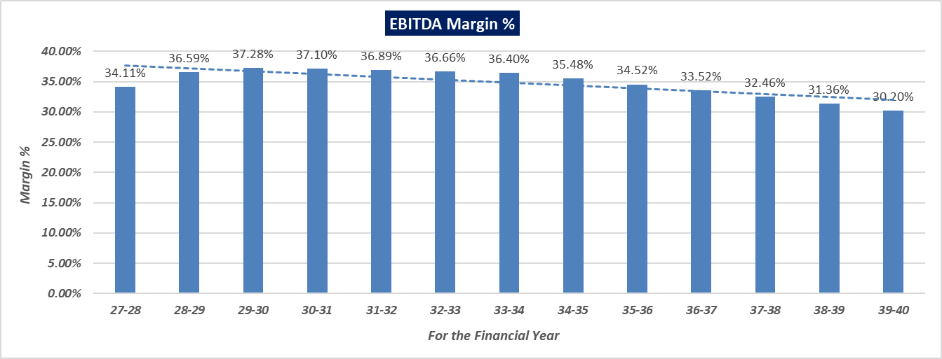
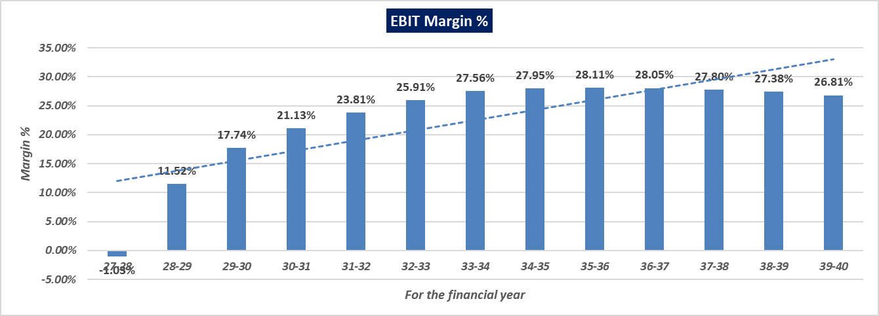
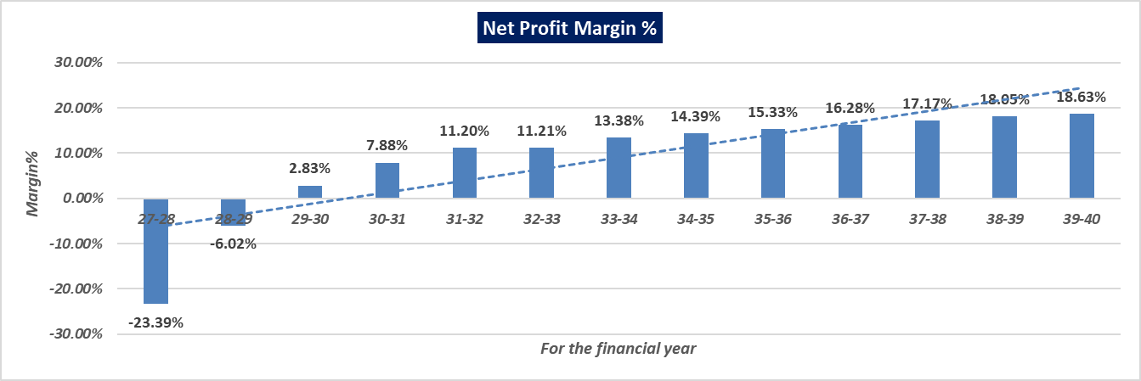
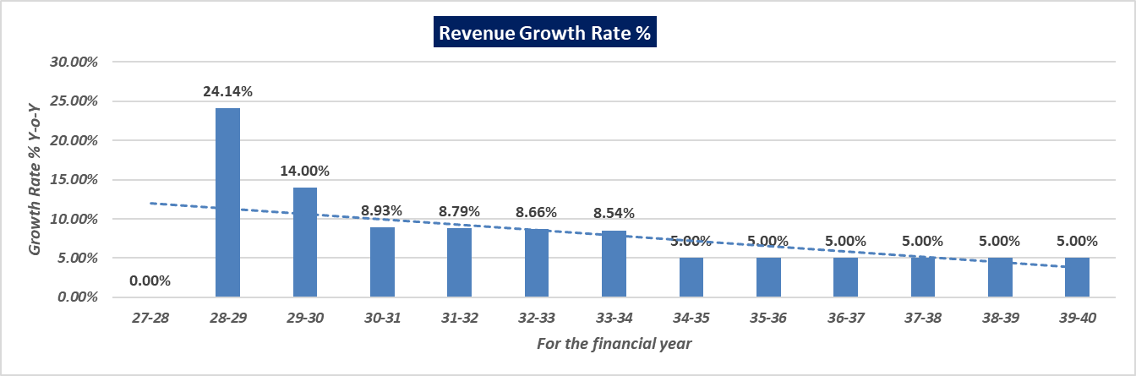
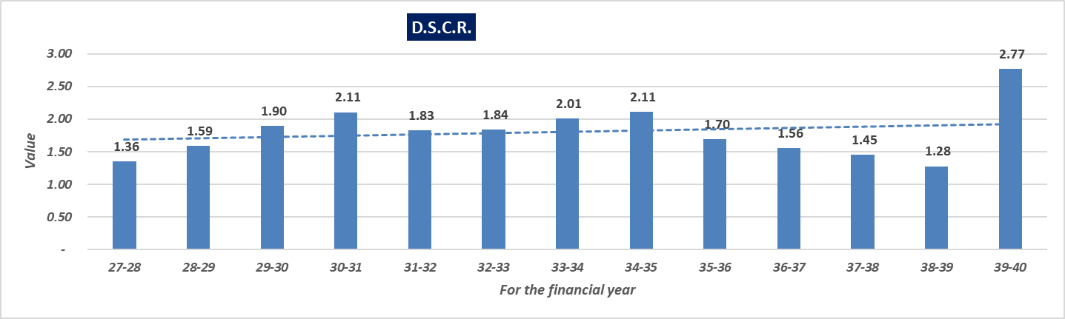
- LOAN AMORTIZATION SCHEDULE: As per Loan disbursement and amortization schedule shared by the client/company, according to the project costs incurred during the estimated period below table shows the balance of principle and intrest during the projected period.
Term Loan Repayment Inputs
Amount of Term Loan (in Lakhs) | 2000.00
Rate of Interest | 10.50%
SCOD (Scheduled Commercial Operation Date) | April-27
Disbursal Start Date | Dec-24
Repayment Start Date | Nov-27
Repayment Period (Years) | 12
Total Monthly Instalments | 144
Moratorium from first drawl (Months) | 36
Door to Door Tenure in Months (including Principal Moratorium period) | 180

(INR Lakhs)
2024-25 | Opening | Received | Total | Repaid | Closing | Interest | Yearly  Interest
Nov-24 | 0.00 | 0.00 | 0.00 | 0.00 | 0.00 | 0.00
Dec-24 | 0.00 | 70.00 | 70.00 | 0.00 | 70.00 | 0.58
Jan-25 | 70.00 | 70.00 | 140.00 | 0.00 | 140.00 | 1.17
Feb-25 | 140.00 | 70.00 | 210.00 | 0.00 | 210.00 | 1.75
Mar-25 | 210.00 | 70.00 | 280.00 | 0.00 | 280.00 | 2.33 | 5.83

2025-26 | Opening | Received | Total | Repaid | Closing | Interest | Yearly  Interest
Apr-25 | 280.00 | 70.00 | 350.00 | 0.00 | 350.00 | 2.92
May-25 | 350.00 | 70.00 | 420.00 | 0.00 | 420.00 | 3.50
Jun-25 | 420.00 | 70.00 | 490.00 | 0.00 | 490.00 | 4.08
Jul-25 | 490.00 | 70.00 | 560.00 | 0.00 | 560.00 | 4.67
Aug-25 | 560.00 | 70.00 | 630.00 | 0.00 | 630.00 | 5.25
Sep-25 | 630.00 | 70.00 | 700.00 | 0.00 | 700.00 | 5.83
Oct-25 | 700.00 | 70.00 | 770.00 | 0.00 | 770.00 | 6.42
Nov-25 | 770.00 | 70.00 | 840.00 | 0.00 | 840.00 | 7.00
Dec-25 | 840.00 | 70.00 | 910.00 | 0.00 | 910.00 | 7.58
Jan-26 | 910.00 | 70.00 | 980.00 | 0.00 | 980.00 | 8.17
Feb-26 | 980.00 | 70.00 | 1050.00 | 0.00 | 1050.00 | 8.75
Mar-26 | 1050.00 | 70.00 | 1120.00 | 0.00 | 1120.00 | 9.33 | 73.50

2026-27 |  | Opening |  | Received |  | Total |  | Repaid |  | Closing |  | Interest |  | Yearly  Interest
Apr-26 |  | 1120.00 |  | 75.00 |  | 1195.00 |  | 0.00 |  | 1195.00 |  | 9.96
May-26 |  | 1195.00 |  | 75.00 |  | 1270.00 |  | 0.00 |  | 1270.00 |  | 10.58
Jun-26 |  | 1270.00 |  | 75.00 |  | 1345.00 |  | 0.00 |  | 1345.00 |  | 11.21
Jul-26 |  | 1345.00 |  | 75.00 |  | 1420.00 |  | 0.00 |  | 1420.00 |  | 11.83
Aug-26 |  | 1420.00 |  | 75.00 |  | 1495.00 |  | 0.00 |  | 1495.00 |  | 12.46
Sep-26 |  | 1495.00 |  | 75.00 |  | 1570.00 |  | 0.00 |  | 1570.00 |  | 13.08
Oct-26 |  | 1570.00 |  | 75.00 |  | 1645.00 |  | 0.00 |  | 1645.00 |  | 13.71
Nov-26 |  | 1645.00 |  | 75.00 |  | 1720.00 |  | 0.00 |  | 1720.00 |  | 14.33
Dec-26 |  | 1720.00 |  | 75.00 |  | 1795.00 |  | 0.00 |  | 1795.00 |  | 14.96
Jan-27 |  | 1795.00 |  | 75.00 |  | 1870.00 |  | 0.00 |  | 1870.00 |  | 15.58
Feb-27 |  | 1870.00 |  | 75.00 |  | 1945.00 |  | 0.00 |  | 1945.00 |  | 16.21
Mar-27 |  | 1945.00 |  | 55.00 |  | 2000.00 |  | 0.00 |  | 2000.00 |  | 16.67 |  | 160.58
2027-28 | Opening |  | Received |  | Total |  | Repaid |  | Closing |  | Interest |  | Yearly  Interest
Apr-27 | 2000.00 |  | 0.00 |  | 2000.00 |  | 0.00 |  | 2000.00 |  | 16.67
May-27 | 2000.00 |  | 0.00 |  | 2000.00 |  | 0.00 |  | 2000.00 |  | 16.67
Jun-27 | 2000.00 |  | 0.00 |  | 2000.00 |  | 0.00 |  | 2000.00 |  | 16.67
Jul-27 | 2000.00 |  | 0.00 |  | 2000.00 |  | 0.00 |  | 2000.00 |  | 16.67
Aug-27 | 2000.00 |  | 0.00 |  | 2000.00 |  | 0.00 |  | 2000.00 |  | 16.67
Sep-27 | 2000.00 |  | 0.00 |  | 2000.00 |  | 0.00 |  | 2000.00 |  | 16.67
Oct-27 | 2000.00 |  | 0.00 |  | 2000.00 |  | 0.00 |  | 2000.00 |  | 16.67
Nov-27 | 2000.00 |  | 0.00 |  | 2000.00 |  | 5.00 |  | 1995.00 |  | 16.63
Dec-27 | 1995.00 |  | 0.00 |  | 1995.00 |  | 5.00 |  | 1990.00 |  | 16.58
Jan-28 | 1990.00 |  | 0.00 |  | 1990.00 |  | 5.00 |  | 1985.00 |  | 16.54
Feb-28 | 1985.00 |  | 0.00 |  | 1985.00 |  | 5.00 |  | 1980.00 |  | 16.50
Mar-28 | 1980.00 |  | 0.00 |  | 1980.00 |  | 5.00 |  | 1975.00 |  | 16.46 |  | 199.38
2028-29 |  | Opening |  | Received |  | Total |  | Repaid |  | Closing |  | Interest |  | Yearly  Interest
Apr-28 |  | 1975.00 |  | 0.00 |  | 1975.00 |  | 5.00 |  | 1970.00 |  | 16.42
May-28 |  | 1970.00 |  | 0.00 |  | 1970.00 |  | 5.00 |  | 1965.00 |  | 16.38
Jun-28 |  | 1965.00 |  | 0.00 |  | 1965.00 |  | 5.00 |  | 1960.00 |  | 16.33
Jul-28 |  | 1960.00 |  | 0.00 |  | 1960.00 |  | 5.00 |  | 1955.00 |  | 16.29
Aug-28 |  | 1955.00 |  | 0.00 |  | 1955.00 |  | 5.00 |  | 1950.00 |  | 16.25
Sep-28 |  | 1950.00 |  | 0.00 |  | 1950.00 |  | 5.00 |  | 1945.00 |  | 16.21
Oct-28 |  | 1945.00 |  | 0.00 |  | 1945.00 |  | 5.00 |  | 1940.00 |  | 16.17
Nov-28 |  | 1940.00 |  | 0.00 |  | 1940.00 |  | 5.00 |  | 1935.00 |  | 16.13
Dec-28 |  | 1935.00 |  | 0.00 |  | 1935.00 |  | 5.00 |  | 1930.00 |  | 16.08
Jan-29 |  | 1930.00 |  | 0.00 |  | 1930.00 |  | 5.00 |  | 1925.00 |  | 16.04
Feb-29 |  | 1925.00 |  | 0.00 |  | 1925.00 |  | 5.00 |  | 1920.00 |  | 16.00
Mar-29 |  | 1920.00 |  | 0.00 |  | 1920.00 |  | 5.00 |  | 1915.00 |  | 15.96 |  | 194.25
2029-30 |  | Opening |  | Received |  | Total |  | Repaid |  | Closing |  | Interest |  | Yearly  Interest
Apr-29 |  | 1915.00 |  | 0.00 |  | 1915.00 |  | 5.00 |  | 1910.00 |  | 15.92
May-29 |  | 1910.00 |  | 0.00 |  | 1910.00 |  | 5.00 |  | 1905.00 |  | 15.88
Jun-29 |  | 1905.00 |  | 0.00 |  | 1905.00 |  | 5.00 |  | 1900.00 |  | 15.83
Jul-29 |  | 1900.00 |  | 0.00 |  | 1900.00 |  | 5.00 |  | 1895.00 |  | 15.79
Aug-29 |  | 1895.00 |  | 0.00 |  | 1895.00 |  | 5.00 |  | 1890.00 |  | 15.75
Sep-29 |  | 1890.00 |  | 0.00 |  | 1890.00 |  | 5.00 |  | 1885.00 |  | 15.71
Oct-29 |  | 1885.00 |  | 0.00 |  | 1885.00 |  | 5.00 |  | 1880.00 |  | 15.67
Nov-29 |  | 1880.00 |  | 0.00 |  | 1880.00 |  | 5.00 |  | 1875.00 |  | 15.63
Dec-29 |  | 1875.00 |  | 0.00 |  | 1875.00 |  | 5.00 |  | 1870.00 |  | 15.58
Jan-30 |  | 1870.00 |  | 0.00 |  | 1870.00 |  | 5.00 |  | 1865.00 |  | 15.54
Feb-30 |  | 1865.00 |  | 0.00 |  | 1865.00 |  | 5.00 |  | 1860.00 |  | 15.50
Mar-30 |  | 1860.00 |  | 0.00 |  | 1860.00 |  | 5.00 |  | 1855.00 |  | 15.46 |  | 188.25
2030-31 |  | Opening |  | Received |  | Total |  | Repaid |  | Closing |  | Interest |  | Yearly  Interest
Apr-30 |  | 1855.00 |  | 0.00 |  | 1855.00 |  | 5.00 |  | 1850.00 |  | 15.42
May-30 |  | 1850.00 |  | 0.00 |  | 1850.00 |  | 5.00 |  | 1845.00 |  | 15.38
Jun-30 |  | 1845.00 |  | 0.00 |  | 1845.00 |  | 5.00 |  | 1840.00 |  | 15.33
Jul-30 |  | 1840.00 |  | 0.00 |  | 1840.00 |  | 5.00 |  | 1835.00 |  | 15.29
Aug-30 |  | 1835.00 |  | 0.00 |  | 1835.00 |  | 5.00 |  | 1830.00 |  | 15.25
Sep-30 |  | 1830.00 |  | 0.00 |  | 1830.00 |  | 5.00 |  | 1825.00 |  | 15.21
Oct-30 |  | 1825.00 |  | 0.00 |  | 1825.00 |  | 5.00 |  | 1820.00 |  | 15.17
Nov-30 |  | 1820.00 |  | 0.00 |  | 1820.00 |  | 5.00 |  | 1815.00 |  | 15.13
Dec-30 |  | 1815.00 |  | 0.00 |  | 1815.00 |  | 5.00 |  | 1810.00 |  | 15.08
Jan-31 |  | 1810.00 |  | 0.00 |  | 1810.00 |  | 5.00 |  | 1805.00 |  | 15.04
Feb-31 |  | 1805.00 |  | 0.00 |  | 1805.00 |  | 5.00 |  | 1800.00 |  | 15.00
Mar-31 |  | 1800.00 |  | 0.00 |  | 1800.00 |  | 5.00 |  | 1795.00 |  | 14.96 |  | 182.25
2031-32 |  | Opening |  | Received |  | Total |  | Repaid |  | Closing |  | Interest |  | Yearly  Interest
Apr-31 |  | 1795.00 |  | 0.00 |  | 1795.00 |  | 10.00 |  | 1785.00 |  | 14.88
May-31 |  | 1785.00 |  | 0.00 |  | 1785.00 |  | 10.00 |  | 1775.00 |  | 14.79
Jun-31 |  | 1775.00 |  | 0.00 |  | 1775.00 |  | 10.00 |  | 1765.00 |  | 14.71
Jul-31 |  | 1765.00 |  | 0.00 |  | 1765.00 |  | 10.00 |  | 1755.00 |  | 14.63
Aug-31 |  | 1755.00 |  | 0.00 |  | 1755.00 |  | 10.00 |  | 1745.00 |  | 14.54
Sep-31 |  | 1745.00 |  | 0.00 |  | 1745.00 |  | 10.00 |  | 1735.00 |  | 14.46
Oct-31 |  | 1735.00 |  | 0.00 |  | 1735.00 |  | 10.00 |  | 1725.00 |  | 14.38
Nov-31 |  | 1725.00 |  | 0.00 |  | 1725.00 |  | 10.00 |  | 1715.00 |  | 14.29
Dec-31 |  | 1715.00 |  | 0.00 |  | 1715.00 |  | 10.00 |  | 1705.00 |  | 14.21
Jan-32 |  | 1705.00 |  | 0.00 |  | 1705.00 |  | 10.00 |  | 1695.00 |  | 14.13
Feb-32 |  | 1695.00 |  | 0.00 |  | 1695.00 |  | 10.00 |  | 1685.00 |  | 14.04
Mar-32 |  | 1685.00 |  | 0.00 |  | 1685.00 |  | 10.00 |  | 1675.00 |  | 13.96 |  | 173.00
2032-33 |  | Opening |  | Received |  | Total |  | Repaid |  | Closing |  | Interest |  | Yearly  Interest
Apr-32 |  | 1675.00 |  | 0.00 |  | 1675.00 |  | 10.00 |  | 1665.00 |  | 13.88
May-32 |  | 1665.00 |  | 0.00 |  | 1665.00 |  | 10.00 |  | 1655.00 |  | 13.79
Jun-32 |  | 1655.00 |  | 0.00 |  | 1655.00 |  | 10.00 |  | 1645.00 |  | 13.71
Jul-32 |  | 1645.00 |  | 0.00 |  | 1645.00 |  | 10.00 |  | 1635.00 |  | 13.63
Aug-32 |  | 1635.00 |  | 0.00 |  | 1635.00 |  | 10.00 |  | 1625.00 |  | 13.54
Sep-32 |  | 1625.00 |  | 0.00 |  | 1625.00 |  | 10.00 |  | 1615.00 |  | 13.46
Oct-32 |  | 1615.00 |  | 0.00 |  | 1615.00 |  | 10.00 |  | 1605.00 |  | 13.38
Nov-32 |  | 1605.00 |  | 0.00 |  | 1605.00 |  | 10.00 |  | 1595.00 |  | 13.29
Dec-32 |  | 1595.00 |  | 0.00 |  | 1595.00 |  | 10.00 |  | 1585.00 |  | 13.21
Jan-33 |  | 1585.00 |  | 0.00 |  | 1585.00 |  | 10.00 |  | 1575.00 |  | 13.13
Feb-33 |  | 1575.00 |  | 0.00 |  | 1575.00 |  | 10.00 |  | 1565.00 |  | 13.04
Mar-33 |  | 1565.00 |  | 0.00 |  | 1565.00 |  | 10.00 |  | 1555.00 |  | 12.96 |  | 161.00
2033-34 |  | Opening |  | Received |  | Total |  | Repaid |  | Closing |  | Interest |  | Yearly  Interest
Apr-33 |  | 1555.00 |  | 0.00 |  | 1555.00 |  | 10.00 |  | 1545.00 |  | 12.88
May-33 |  | 1545.00 |  | 0.00 |  | 1545.00 |  | 10.00 |  | 1535.00 |  | 12.79
Jun-33 |  | 1535.00 |  | 0.00 |  | 1535.00 |  | 10.00 |  | 1525.00 |  | 12.71
Jul-33 |  | 1525.00 |  | 0.00 |  | 1525.00 |  | 10.00 |  | 1515.00 |  | 12.63
Aug-33 |  | 1515.00 |  | 0.00 |  | 1515.00 |  | 10.00 |  | 1505.00 |  | 12.54
Sep-33 |  | 1505.00 |  | 0.00 |  | 1505.00 |  | 10.00 |  | 1495.00 |  | 12.46
Oct-33 |  | 1495.00 |  | 0.00 |  | 1495.00 |  | 10.00 |  | 1485.00 |  | 12.38
Nov-33 |  | 1485.00 |  | 0.00 |  | 1485.00 |  | 10.00 |  | 1475.00 |  | 12.29
Dec-33 |  | 1475.00 |  | 0.00 |  | 1475.00 |  | 10.00 |  | 1465.00 |  | 12.21
Jan-34 |  | 1465.00 |  | 0.00 |  | 1465.00 |  | 10.00 |  | 1455.00 |  | 12.13
Feb-34 |  | 1455.00 |  | 0.00 |  | 1455.00 |  | 10.00 |  | 1445.00 |  | 12.04
Mar-34 |  | 1445.00 |  | 0.00 |  | 1445.00 |  | 10.00 |  | 1435.00 |  | 11.96 |  | 149.00
2034-35 |  | Opening |  | Received |  | Total |  | Repaid |  | Closing |  | Interest |  | Yearly  Interest
Apr-34 |  | 1435.00 |  | 0.00 |  | 1435.00 |  | 10.00 |  | 1425.00 |  | 11.88
May-34 |  | 1425.00 |  | 0.00 |  | 1425.00 |  | 10.00 |  | 1415.00 |  | 11.79
Jun-34 |  | 1415.00 |  | 0.00 |  | 1415.00 |  | 10.00 |  | 1405.00 |  | 11.71
Jul-34 |  | 1405.00 |  | 0.00 |  | 1405.00 |  | 10.00 |  | 1395.00 |  | 11.63
Aug-34 |  | 1395.00 |  | 0.00 |  | 1395.00 |  | 10.00 |  | 1385.00 |  | 11.54
Sep-34 |  | 1385.00 |  | 0.00 |  | 1385.00 |  | 10.00 |  | 1375.00 |  | 11.46
Oct-34 |  | 1375.00 |  | 0.00 |  | 1375.00 |  | 10.00 |  | 1365.00 |  | 11.38
Nov-34 |  | 1365.00 |  | 0.00 |  | 1365.00 |  | 10.00 |  | 1355.00 |  | 11.29
Dec-34 |  | 1355.00 |  | 0.00 |  | 1355.00 |  | 10.00 |  | 1345.00 |  | 11.21
Jan-35 |  | 1345.00 |  | 0.00 |  | 1345.00 |  | 10.00 |  | 1335.00 |  | 11.13
Feb-35 |  | 1335.00 |  | 0.00 |  | 1335.00 |  | 10.00 |  | 1325.00 |  | 11.04
Mar-35 |  | 1325.00 |  | 0.00 |  | 1325.00 |  | 10.00 |  | 1315.00 |  | 10.96 |  | 137.00
2035-36 |  | Opening |  | Received |  | Total |  | Repaid |  | Closing |  | Interest |  | Yearly  Interest
Apr-35 |  | 1315.00 |  | 0.00 |  | 1315.00 |  | 16.67 |  | 1298.33 |  | 10.82
May-35 |  | 1298.33 |  | 0.00 |  | 1298.33 |  | 16.67 |  | 1281.67 |  | 10.68
Jun-35 |  | 1281.67 |  | 0.00 |  | 1281.67 |  | 16.67 |  | 1265.00 |  | 10.54
Jul-35 |  | 1265.00 |  | 0.00 |  | 1265.00 |  | 16.67 |  | 1248.33 |  | 10.40
Aug-35 |  | 1248.33 |  | 0.00 |  | 1248.33 |  | 16.67 |  | 1231.67 |  | 10.26
Sep-35 |  | 1231.67 |  | 0.00 |  | 1231.67 |  | 16.67 |  | 1215.00 |  | 10.13
Oct-35 |  | 1215.00 |  | 0.00 |  | 1215.00 |  | 16.67 |  | 1198.33 |  | 9.99
Nov-35 |  | 1198.33 |  | 0.00 |  | 1198.33 |  | 16.67 |  | 1181.67 |  | 9.85
Dec-35 |  | 1181.67 |  | 0.00 |  | 1181.67 |  | 16.67 |  | 1165.00 |  | 9.71
Jan-36 |  | 1165.00 |  | 0.00 |  | 1165.00 |  | 16.67 |  | 1148.33 |  | 9.57
Feb-36 |  | 1148.33 |  | 0.00 |  | 1148.33 |  | 16.67 |  | 1131.67 |  | 9.43
Mar-36 |  | 1131.67 |  | 0.00 |  | 1131.67 |  | 16.67 |  | 1115.00 |  | 9.29 |  | 120.67
2036-37 |  | Opening |  | Received |  | Total |  | Repaid |  | Closing |  | Interest |  | Yearly  Interest
Apr-36 |  | 1115.00 |  | 0.00 |  | 1115.00 |  | 20.83 |  | 1094.17 |  | 9.12
May-36 |  | 1094.17 |  | 0.00 |  | 1094.17 |  | 20.83 |  | 1073.33 |  | 8.94
Jun-36 |  | 1073.33 |  | 0.00 |  | 1073.33 |  | 20.83 |  | 1052.50 |  | 8.77
Jul-36 |  | 1052.50 |  | 0.00 |  | 1052.50 |  | 20.83 |  | 1031.67 |  | 8.60
Aug-36 |  | 1031.67 |  | 0.00 |  | 1031.67 |  | 20.83 |  | 1010.83 |  | 8.42
Sep-36 |  | 1010.83 |  | 0.00 |  | 1010.83 |  | 20.83 |  | 990.00 |  | 8.25
Oct-36 |  | 990.00 |  | 0.00 |  | 990.00 |  | 20.83 |  | 969.17 |  | 8.08
Nov-36 |  | 969.17 |  | 0.00 |  | 969.17 |  | 20.83 |  | 948.33 |  | 7.90
Dec-36 |  | 948.33 |  | 0.00 |  | 948.33 |  | 20.83 |  | 927.50 |  | 7.73
Jan-37 |  | 927.50 |  | 0.00 |  | 927.50 |  | 20.83 |  | 906.67 |  | 7.56
Feb-37 |  | 906.67 |  | 0.00 |  | 906.67 |  | 20.83 |  | 885.83 |  | 7.38
Mar-37 |  | 885.83 |  | 0.00 |  | 885.83 |  | 20.83 |  | 865.00 |  | 7.21 |  | 97.96
2037-38 |  | Opening |  | Received |  | Total |  | Repaid |  | Closing |  | Interest |  | Yearly  Interest
Apr-37 |  | 865.00 |  | 0.00 |  | 865.00 |  | 25.00 |  | 840.00 |  | 7.00
May-37 |  | 840.00 |  | 0.00 |  | 840.00 |  | 25.00 |  | 815.00 |  | 6.79
Jun-37 |  | 815.00 |  | 0.00 |  | 815.00 |  | 25.00 |  | 790.00 |  | 6.58
Jul-37 |  | 790.00 |  | 0.00 |  | 790.00 |  | 25.00 |  | 765.00 |  | 6.38
Aug-37 |  | 765.00 |  | 0.00 |  | 765.00 |  | 25.00 |  | 740.00 |  | 6.17
Sep-37 |  | 740.00 |  | 0.00 |  | 740.00 |  | 25.00 |  | 715.00 |  | 5.96
Oct-37 |  | 715.00 |  | 0.00 |  | 715.00 |  | 25.00 |  | 690.00 |  | 5.75
Nov-37 |  | 690.00 |  | 0.00 |  | 690.00 |  | 25.00 |  | 665.00 |  | 5.54
Dec-37 |  | 665.00 |  | 0.00 |  | 665.00 |  | 25.00 |  | 640.00 |  | 5.33
Jan-38 |  | 640.00 |  | 0.00 |  | 640.00 |  | 25.00 |  | 615.00 |  | 5.13
Feb-38 |  | 615.00 |  | 0.00 |  | 615.00 |  | 25.00 |  | 590.00 |  | 4.92
Mar-38 |  | 590.00 |  | 0.00 |  | 590.00 |  | 25.00 |  | 565.00 |  | 4.71 |  | 70.25
2038-39 |  | Opening |  | Received |  | Total |  | Repaid |  | Closing |  | Interest |  | Yearly  Interest
Apr-38 |  | 565.00 |  | 0.00 |  | 565.00 |  | 31.67 |  | 533.33 |  | 4.44
May-38 |  | 533.33 |  | 0.00 |  | 533.33 |  | 31.67 |  | 501.66 |  | 4.18
Jun-38 |  | 501.66 |  | 0.00 |  | 501.66 |  | 31.67 |  | 469.99 |  | 3.92
Jul-38 |  | 469.99 |  | 0.00 |  | 469.99 |  | 31.67 |  | 438.32 |  | 3.65
Aug-38 |  | 438.32 |  | 0.00 |  | 438.32 |  | 31.67 |  | 406.65 |  | 3.39
Sep-38 |  | 406.65 |  | 0.00 |  | 406.65 |  | 31.67 |  | 374.98 |  | 3.12
Oct-38 |  | 374.98 |  | 0.00 |  | 374.98 |  | 31.67 |  | 343.31 |  | 2.86
Nov-38 |  | 343.31 |  | 0.00 |  | 343.31 |  | 31.67 |  | 311.64 |  | 2.60
Dec-38 |  | 311.64 |  | 0.00 |  | 311.64 |  | 31.67 |  | 279.97 |  | 2.33
Jan-39 |  | 279.97 |  | 0.00 |  | 279.97 |  | 31.67 |  | 248.30 |  | 2.07
Feb-39 |  | 248.30 |  | 0.00 |  | 248.30 |  | 31.67 |  | 216.63 |  | 1.81
Mar-39 |  | 216.63 |  | 0.00 |  | 216.63 |  | 31.67 |  | 184.96 |  | 1.54 |  | 35.91
2039-40 |  | Opening |  | Received |  | Total |  | Repaid |  | Closing |  | Interest |  | Yearly  Interest
Apr-39 |  | 184.96 |  | 0.00 |  | 184.96 |  | 26.43 |  | 158.53 |  | 1.32
May-39 |  | 158.53 |  | 0.00 |  | 158.53 |  | 26.43 |  | 132.10 |  | 1.10
Jun-39 |  | 132.10 |  | 0.00 |  | 132.10 |  | 26.43 |  | 105.67 |  | 0.88
Jul-39 |  | 105.67 |  | 0.00 |  | 105.67 |  | 26.43 |  | 79.24 |  | 0.66
Aug-39 |  | 79.24 |  | 0.00 |  | 79.24 |  | 26.43 |  | 52.81 |  | 0.44
Sep-39 |  | 52.81 |  | 0.00 |  | 52.81 |  | 26.43 |  | 26.38 |  | 0.22
Oct-39 |  | 26.38 |  | 0.00 |  | 26.38 |  | 26.43 |  | 0.00 |  | 0.00 |  | 4.62

Yearly | 2024-25 | 2025-26 | 2026-27 | 2027-28 | 2028-29 | 2029-30 | 2030-31 | 2031-32
Interest | 5.83 | 73.50 | 160.58 | 199.38 | 194.25 | 188.25 | 182.25 | 173.00
Principal | 280.00 | 840.00 | 880.00 | 0.00 | 0.00 | 0.00 | 0.00 | 0.00
Repayment | 0.00 | 0.00 | 0.00 | 25.00 | 60.00 | 60.00 | 60.00 | 120.00
Outstanding | 280.00 | 1120.00 | 2000.00 | 1975.00 | 1915.00 | 1855.00 | 1795.00 | 1675.00
Current Maturity | 0.00 | 0.00 | 25.00 | 60.00 | 60.00 | 60.00 | 120.00 | 120.00
Long Term Maturity | 280.00 | 1120.00 | 1975.00 | 1915.00 | 1855.00 | 1795.00 | 1675.00 | 1555.00
EMI | 5.83 | 73.50 | 160.58 | 224.38 | 254.25 | 248.25 | 242.25 | 293.00
(Continue)
Yearly | 2032-33 | 2033-34 | 2034-35 | 2035-36 | 2036-37 | 2037-38 | 2038-39 | 2039-40
Interest | 161.00 | 149.00 | 137.00 | 120.67 | 97.96 | 70.25 | 35.91 | 4.62
Principal | 0.00 | 0.00 | 0.00 | 0.00 | 0.00 | 0.00 | 0.00 | 0.00
Repayment | 120.00 | 120.00 | 120.00 | 200.00 | 250.00 | 300.00 | 380.00 | 185.00
Outstanding | 1555.00 | 1435.00 | 1315.00 | 1115.00 | 865.00 | 565.00 | 185.00 | 0.00
Current Maturity | 120.00 | 120.00 | 200.00 | 250.00 | 300.00 | 380.00 | 185.00 | 0.00
Long Term Maturity | 1435.00 | 1315.00 | 1115.00 | 865.00 | 565.00 | 185.00 | 0.00 | 0.00
EMI | 281.00 | 269.00 | 257.00 | 320.67 | 347.96 | 370.25 | 415.91 | 189.62

- DEPRECIATION SCHEDULE: Depreciation schedule is prepared based on the Income Tax Act. Below table shows the Depreciation Schedule along with applicable rate and allocated expenses.
Particulars | Rate | 2024-25 | 2025-26 | 2026-27 | 2027-28 | 2028-29 | 2029-30 | 2030-31 | 2031-32
Land |  | 5.00 | 5.00 | 5.00 | 5.00 | 5.00 | 5.00 | 5.00 | 5.00
Building | 10%
WDV (Beg.) |  | 0.00 | 567.21 | 1679.46 | 2282.11 | 2053.90 | 1848.51 | 1663.66 | 1497.29
Additions |  | 567.21 | 1112.25 | 602.65 | 0.00 | 0.00 | 0.00 | 0.00 | 0.00
Total |  | 567.21 | 1679.46 | 2282.11 | 2282.11 | 2053.90 | 1848.51 | 1663.66 | 1497.29
Current Dep. |  | 0.00 | 0.00 | 0.00 | 228.21 | 205.39 | 184.85 | 166.37 | 149.73
WDV (End of Year) |  | 567.21 | 1679.46 | 2282.11 | 2053.90 | 1848.51 | 1663.66 | 1497.29 | 1347.56
Plant & Machinery | 15%
WDV (Beg.) |  | 0.00 | 0.00 | 0.00 | 292.43 | 248.57 | 211.28 | 179.59 | 152.65
Additions |  | 0.00 | 0.00 | 292.43 | 0.00 | 0.00 | 0.00 | 0.00 | 0.00
Total |  | 0.00 | 0.00 | 292.43 | 292.43 | 248.57 | 211.28 | 179.59 | 152.65
Current Dep. |  | 0.00 | 0.00 | 0.00 | 43.86 | 37.28 | 31.69 | 26.94 | 22.90
WDV (End of Year) |  | 0.00 | 0.00 | 292.43 | 248.57 | 211.28 | 179.59 | 152.65 | 129.75
Computers & Software | 40%
WDV (Beg.) |  | 0.00 | 0.00 | 0.00 | 19.53 | 11.72 | 7.03 | 4.22 | 2.53
Additions |  | 0.00 | 0.00 | 19.53 | 0.00 | 0.00 | 0.00 | 0.00 | 0.00
Total |  | 0.00 | 0.00 | 19.53 | 19.53 | 11.72 | 7.03 | 4.22 | 2.53
Current Dep. |  | 0.00 | 0.00 | 0.00 | 7.81 | 4.69 | 2.81 | 1.69 | 1.01
WDV (End of Year) |  | 0.00 | 0.00 | 19.53 | 11.72 | 7.03 | 4.22 | 2.53 | 1.52
Furniture & Fixture | 10%
WDV (Beg.) |  | 0.00 | 0.00 | 0.00 | 335.56 | 302.00 | 271.80 | 244.62 | 220.16
Additions |  | 0.00 | 0.00 | 335.56 | 0.00 | 0.00 | 0.00 | 0.00 | 0.00
Total |  | 0.00 | 0.00 | 335.56 | 335.56 | 302.00 | 271.80 | 244.62 | 220.16
Current Dep. |  | 0.00 | 0.00 | 0.00 | 33.56 | 30.20 | 27.18 | 24.46 | 22.02
WDV (End of Year) |  | 0.00 | 0.00 | 335.56 | 302.00 | 271.80 | 244.62 | 220.16 | 198.14
Total Current Dep. |  | 0.00 | 0.00 | 0.00 | 313.44 | 277.56 | 246.54 | 219.45 | 195.66
(Continue)
Particulars | Rate | 2032-33 | 2033-34 | 2034-35 | 2035-36 | 2036-37 | 2037-38 | 2038-39 | 2039-40
Land |  | 5.00 | 5.00 | 5.00 | 5.00 | 5.00 | 5.00 | 5.00 | 5.00
Building | 10%
WDV (Beg.) |  | 1347.56 | 1212.81 | 1091.53 | 982.37 | 884.14 | 795.72 | 716.15 | 644.54
Additions |  | 0.00 | 0.00 | 0.00 | 0.00 | 0.00 | 0.00 | 0.00 | 0.00
Total |  | 1347.56 | 1212.81 | 1091.53 | 982.37 | 884.14 | 795.72 | 716.15 | 644.54
Current Dep. |  | 134.76 | 121.28 | 109.15 | 98.24 | 88.41 | 79.57 | 71.62 | 64.45
WDV (End of Year) |  | 1212.81 | 1091.53 | 982.37 | 884.14 | 795.72 | 716.15 | 644.54 | 580.08
Plant & Machinery | 15%
WDV (Beg.) |  | 129.75 | 110.29 | 93.75 | 79.68 | 67.73 | 57.57 | 48.94 | 41.60
Additions |  | 0.00 | 0.00 | 0.00 | 0.00 | 0.00 | 0.00 | 0.00 | 0.00
Total |  | 129.75 | 110.29 | 93.75 | 79.68 | 67.73 | 57.57 | 48.94 | 41.60
Current Dep. |  | 19.46 | 16.54 | 14.06 | 11.95 | 10.16 | 8.64 | 7.34 | 6.24
WDV (End of Year) |  | 110.29 | 93.75 | 79.68 | 67.73 | 57.57 | 48.94 | 41.60 | 35.36
Computers & Software | 40%
WDV (Beg.) |  | 1.52 | 0.91 | 0.55 | 0.33 | 0.20 | 0.12 | 0.07 | 0.04
Additions |  | 0.00 | 0.00 | 0.00 | 0.00 | 0.00 | 0.00 | 0.00 | 0.00
Total |  | 1.52 | 0.91 | 0.55 | 0.33 | 0.20 | 0.12 | 0.07 | 0.04
Current Dep. |  | 0.61 | 0.36 | 0.22 | 0.13 | 0.08 | 0.05 | 0.03 | 0.02
WDV (End of Year) |  | 0.91 | 0.55 | 0.33 | 0.20 | 0.12 | 0.07 | 0.04 | 0.03
Furniture & Fixture | 10%
WDV (Beg.) |  | 198.14 | 178.33 | 160.50 | 144.45 | 130.00 | 117.00 | 105.30 | 94.77
Additions |  | 0.00 | 0.00 | 0.00 | 0.00 | 0.00 | 0.00 | 0.00 | 0.00
Total |  | 198.14 | 178.33 | 160.50 | 144.45 | 130.00 | 117.00 | 105.30 | 94.77
Current Dep. |  | 19.81 | 17.83 | 16.05 | 14.44 | 13.00 | 11.70 | 10.53 | 9.48
WDV (End of Year) |  | 178.33 | 160.50 | 144.45 | 130.00 | 117.00 | 105.30 | 94.77 | 85.29
Total Current Dep. |  | 174.64 | 156.02 | 139.48 | 124.77 | 111.65 | 99.96 | 89.51 | 80.19

- KEY ASSUMPTIONS & BASIS:
S. No. | Item | Assumptions and Basis
 | General | - The projections of the firm are done for the period from FY 2027-28 to FY 2039-40 and door to door tenor is from November 2024 to October 2039 (15 years) to cover the term loan period.  - We have considered Revenue and cost recognition-based model while making the future financial projections.
 | Occupancy Rate | - Key factors that affect hotel occupancy rate are location, seasonality, pricing, competitor, guest reviews etc. Apart from above It's important to note that occupancy rates can also fluctuate based on the factors, like overall state of the global economy, political stability, natural disasters, and other unforeseen circumstances like covid-19.  - At the time of survey, we have checked occupancy rate from nearby hotels.  - Based on our industry research and the information provided by the client, we have developed revenue forecasts for the proposed 18-room luxury hotel. For the first year, we anticipate an initial occupancy rate of 39%. In the second year, we project a 6% increase, bringing the occupancy rate to 45%. Over the next three to five years, we plan to increase the occupancy rate by 2% each year, ultimately reaching 55% by the end of the five-year period, with no further increases during that time  - The peak tourist season spans from October to March, and local tourists visiting prefer weekends for their visits. Therefore, keeping in mind, the peak seasons and slack seasons, we have considered occupancy rate constant at 55%.  - Also, the proposed luxury hotel is located in the nearby of Jawai Rajasthan, hence, we have taken a conservative approach by setting a maximum occupancy rate of 55%. This cautious estimate accounts for the hotel's location and ensures a realistic projection.
  S.No. | Particulars | Occupancy rate
  1. | Brij Pola (12 Rooms) | 50% to 60%
  2. | Sujan Jawai (8 Rooms) | 50% to 65%
  3. | Amritana Hotels | 45% to 60%
 | Room Rent | - At the time of survey, we have checked per room rent from the nearby hotels. Below are some observations:  - References of above:  Link: https://bookings.brijhotels.com/?chainId=6197&propertyId=6206  Link: https://thesujanlife.com/jawai  Link:https://bookings.amritara.co.in/?chainId=5971&propertyId=5982  - We have taken a conservative approach to the room rates. For the first year, we have considered a per-night room rent of INR 25,000/-. From there, for the subsequent forecasted financial years, we have projected a 10% escalation rate annually for the First two years afterward we have given only 5% escalation in price for remaining years in forecast. This leads to a final projected room rate of INR 49274/- in the last year of the forecast.
  S. No. | Particulars | Per Night Room Rent
  1. | Brij Pola (12 Rooms) | Rs. 45,000/- to Rs. 68,000/-
  2. | Sujan Jawai (8 Rooms) | Rs. 65,000/- to Rs. 1,21,000/-
  3. | Amritara Hotels | Rs. 25,000/- to 35000/-
 | Food & Beverage sale per person per day | - The average Food & Beverage (F&B) sale per person per day in a luxury hotel can be depending on the location, hotel reputation, dining options, and the preferences and spending habits of guests. It's important to note that there can be significant variations in F&B sales between different hotels and regions.  - The proposed luxury hotel is located in the nearby of Jawai Rajasthan, a popular tourist destination that attracts visitors. Due to the significant number of tourists visiting Jawai, there are several hotels available for accommodation.  - On digital booking platforms, hotels and resorts often offer packages and discounts to attract customers. Some guests may choose not to dine at a luxury hotel due to the higher prices associated with such establishments.  - Taking into account all these factors and considering the competitive nature of the location, we have determined a rate of INR 1,000/- per person per day for the proposed hotel.  - We have projected a 10% escalation rate annually for the First two years afterward we have given only 5% escalation in price for remaining years in forecast.
 | Revenue from Spa and Fitness | - Below are the spa & fitness assumptions for the first forecasting year:  - Forecasting spa and fitness revenue involves analysing historical data, market trends, and pricing changes to estimate future demand and revenue accurately. Considering these facts, it seems to be reasonable.  - We have projected a 10% escalation rate annually for the First two years afterward we have given only 5% escalation in price for remaining years in forecast.
  Particulars | Assumptions
  Inventory | 18
  Days Operational | 365
  Total Room Nights Available | 6570
  Forecast Occupancy | 39%
  Total Room Nights Occupied | 2562.3
  Total No: Guests (Annual) | 5124.6
  Average Spa Visitation Rate | 25%
  Total No of Spa Guests (Annual) | 1281.15
  Forecast Spend per Visit (Rs.) | 3500
  Forecasted Revenue (In Lakhs) | 44.84
 | Revenue from Safari Visit | - Below are the Income from Safari assumptions for the first forecasting year:  - Proposed location is famous for wildlife and Forecasting Safari income involves analysing historical data, market trends, and pricing changes to estimate future demand and revenue accurately. Considering these facts, it seems to be reasonable.  - We have projected a 10% escalation rate annually for the First two years afterward we have given only 5% escalation in price for remaining years in forecast.
  Particulars | Assumptions
  Inventory | 18
  Days Operational | 365
  Total Room Nights Available | 6570
  Forecast Occupancy | 39%
  Total Room Nights Occupied | 2562.3
  Forecast Spend per Visit (Rs.) | 2250
  Forecasted Revenue (In Lakhs) | 57.65
 | Event Income | - Below are the Income from Event assumptions for the first forecasting year  - Forecasting Event income involves analysing historical data, market trends, and pricing changes to estimate future demand and revenue accurately. Considering these facts, it seems to be reasonable  - We have projected a 10% escalation rate annually for the First two years afterward we have given only 5% escalation in price for remaining years in forecast.
  Particulars | Assumptions
  No. of Events | 24
  Average No. of Non-Staying Guests per Event | 60
  Average No. of Days per Event | 1
  Average No. of Meals per Day | 2
  Average Rate per person including Venue Rent (Selling Price) | ₹ 2,500.00
  Gross Revenue from Non-Staying Guests | ₹ 72.00 Lakhs
 | Revenue Build up | - Total revenue for the financial years during the forecasted period will be generating from Room sale, food sale, Spa income, Safari income and Event receipt. Below are the basic assumptions to calculate revenue:
  Revenue Projections for FY 2026-27
  No. of Rooms | 18
  No. of days hotel is in operation | 365
  Particular | Amount
  Estimated Revenue
  At a capacity utilisation of | 39%
  Average Room Rent [Net]
  Room Rent | 25,000.00
  Max. Room Nights [ No. of Rooms * 365] | 6570
  Max. No. of Guests [Room nights * 3] | 19710
  Food & Beverage sale per person per day | 1,000.00
  Spa Income | 3,500.00
  Safari income | 2,250.00
  Income
  Room Sale | 640.58
  Food & Beverage Sale | 76.87
  Spa Income | 44.84
  Safari income | 57.65
  Event Income (2500 per person *2 meals including rent* 24 no. of event*60 Persons) | 72.00
  TOTAL | INR 891.94 Lakhs
 | Housekeeping  Expenses | - When forecasting housekeeping expenses as a percentage of room sales, it is crucial to consider various factors such as industry benchmarks, occupancy rate, property size and layout, room quantity and type, guest service expectations, and specific amenities or offerings that may impact housekeeping needs.  - Based on the analysis conducted and the information provided by the client/company, we have determined that housekeeping expenses should be set at 10% of room sales, which seems to be reasonable.
 | Food Expenses | - When forecasting food expenses as a percentage of food sales, we take into account industry benchmarks. Typically, food expenses as a percentage of food sales in hotels fall within a range of 30% to 50%.  - However, it's important to recognize that this range is broad, and percentages outside this range can occur due to various factors. These factors include the hotel's location, the hotel's menu offerings, pricing strategy, changes in customer preferences, market trends, inflation, and other factors that may influence food expenses.  - Considering a comprehensive analysis of all these factors, we have determined that food expenses should be set at 35% of the food sales. This percentage reflects a careful consideration of industry benchmarks and the specific circumstances of the hotel.
 | Safari Exp. | - We've examined the proportion of Safari Expenses relative to total sales from Safari Income, recognizing that this ratio may differ among various in the hospitality industry.  - Consequently, having scrutinized all relevant factors for the envisioned hotel and information provided by the client we have determined that allocating 50% of the Safari sales to safari expenses.
 | Sales and Marketing Expenses | - We've examined the proportion of Sales and Marketing expenses relative to total sales, recognizing that this ratio may differ among various in the hospitality industry. The specific percentage is contingent on factors such as category of hotel, marketing approach, market competitiveness, nature of amenities/services, and the stability of the business  - Consequently, having scrutinized all relevant factors for the envisioned hotel, we have determined that allocating 2% of the total sales to sales and marketing expenses aligns with industry standards.
 | Event  Expenses | - We've assessed banquet expenses relative to Event receipts, and for the proposed hotel, we have considered it as 35% of the Event receipt, consistent with industry norms, which varies between 25% to 40% for the luxury segment hotels.
 | Salary & Wages | - As per data information provided by client/company, below table shows the details of number of employees and their salary:  - As per our tertiary research, industry benchmark varies from 15% to 20% of the total revenue for the hotels in India. It depends on various factors such as location, category of the hotel, demand-supply gap/work force availability (skilled, unskilled) etc. Proposed hotel in located in outskirts of Udaipur city, Rajasthan. Workforce availability is better, due to which manpower available at lower cost. Therefore, in the forecasted financials salary and wages varies from 9% to 11% of the total revenue.
  Designation | No. of Persons | Salary p.m. | Amount
  General Manager | 1 | ₹ 50,000.00 | 50,000.00
  Accountant cum Cashier | 1 | ₹ 25,000.00 | 25,000.00
  Store Keeper | 1 | ₹ 20,000.00 | 20,000.00
  Sales & Marketing Online | 1 | ₹ 25,000.00 | 25,000.00
  Maintenance Team | 2 | ₹ 15,000.00 | 30,000.00
  Security Team | 3 | ₹ 15,000.00 | 45,000.00
  Gardeners & Pest Control | 2 | ₹ 10,000.00 | 20,000.00
  Front Office Associates | 3 | ₹ 25,000.00 | 75,000.00
  Executive Housekeeper | 1 | ₹ 35,000.00 | 35,000.00
  Housekeeping Room Attendants | 10 | ₹ 12,000.00 | 1,20,000.00
  Manager | 1 | ₹ 65,000.00 | 65,000.00
  Executive Chef | 1 | ₹ 40,000.00 | 40,000.00
  Kitchen Staff | 3 | ₹ 30,000.00 | 90,000.00
  F&B Supervisors | 2 | ₹ 25,000.00 | 50000.00
  F&B Stewards | 5 | ₹ 15,000.00 | 75,000.00
  Manager | 1 | ₹ 25,000.00 | 25,000.00
  Masseuse | 2 | ₹ 15,000.00 | 30,000.00
  Total Salary Paid | 40 |  | 8,20,000.00
 | Other Operating and admin. expenses | - This category encompasses expenses related to Property & Maintenance, power and fuel, Admin. Exp., License, Government Fee, and Miscellaneous Expenses. The assumption details for the initial projected year (FY 2027-28) are provided below:  - To estimate the aforementioned expenses for the subsequent forecasted years, a 10% escalation has been applied, aligning with industry standards.
  Particulars | Amount (In Lakhs)
  Power & Fuel | 44.60
  Property & Maintenance | 26.76
  Administrative Expenditure | 8.92
  License, Government Fee | 12
  Miscellaneous Expenses | 10
 | Working Capital | - The client has not requested separate working capital funding from the bank. According to the client, any working capital gap will be covered through capital contributions as needed, and in later years, cash accruals are expected to be sufficient to meet working capital requirements  - While assessing the adequacy of working capital we have checked the current ratio of the forecasted financials which come out more than 1. It indicates that company has more current assets than current liabilities, suggesting a potentially healthy working capital position.  - Managing working capital effectively involves maintaining a balance between liquidity, profitability and inventory. Therefore, once the proposed hotel will be operational, they need to ensure that they have enough cash and equivalent to cover short-term obligations without holding excessive levels of idle capital.  - Thus, during the projected period we have not considered any working capital loan.
 | Term Loan | - According to the information supplied by the client/company, the proposed hotel intends to seek a term loan amounting to INR 2,000 Lakhs for the construction of the hotel infrastructure. The following are the benchmark dates for all the loan-related activities.  - The interest rate, determined to be 10.50% based on the latest information from the client/company, will apply for the entire duration of the term loan.
  Activity | Bench Mark Dates
  Financial Closure [Loan sanction by Bank] | November 2024
  First Disbursement | December 2024
  Date of Commencement of Commercial Operations | 1st April 2027
  Implementation Period | Two years & 04 months (From December 2024 to March 2027)
  Moratorium including Implementation | Three Years (From November 2024 to October 2027)
  Repayment of loan to start in Month Ending | November 2027
  Last instalment to be paid in Quater Ending | October 2039
  Door to Door Tenor from December 2024 to October 2039 | 180 Months
 | Interest on term loan and other soft cost | - The interest on the pre-construction period of INR 239.92 lacs, along with a soft cost of INR 20 lacs, has been capitalized. Capitalizing pre-construction interest means that this cost is added to the asset's value rather than being expensed immediately. This approach is often used to recognize the financing costs of constructing assets.

Key Findings:
      - DSCR, EBITDA, EBIT and Net Profit margin are showing a positive trend in all the projected years. The company/entity has achieved DSCR of more than 1.10 annually during the loan repayment period.
      - Throughout the estimated period, the Average DSCR is 1.75, with Average EBIDTA margin, EBIT margin, and Net Profit margin registering at 34.81%, 22.5%, and 9.00% respectively.
      - In the forecasted period, a 1% increase in the interest rate will result in the Average DSCR reaching 1.68. This sensitivity analysis highlights the responsiveness of the DSCR to a 1% upward fluctuation in the interest rate.
      - Based on the above key financial ratios of the proposed Project during the forecasted period shows that the project appears financially viable if the Partnership Firm & Partners are able to maintain assumed occupancy rate, revenue and can contain cost as assumed above in the calculation. However, the above-mentioned projections are calculated on the basis of the plan shared by the client/company. If the entity differs from the approved plan during the implementation, the projections may differ resulting to altered concluded viability.
      - The income assumptions outlined above, including occupancy rates, room rates, food & beverage pricing, spa revenue, safari-related income, and event revenue, are based on industry research, client-provided data, and current market trends. These assumptions are general and justifiable given the current market scenario, taking into account factors such as location, competitive landscape, market trends, and available data. The approach reflects realistic expectations and aligns with the prevailing conditions in the hospitality industry.
      - The expense assumptions outlined above, including housekeeping, food, safari, sales & marketing, banquet, salaries, and property maintenance, are based on a comprehensive analysis of industry benchmarks and the specific circumstances of the proposed hotel. These assumptions are general and justifiable given the current market scenario, taking into account factors such as location, competitive landscape, market trends, and available data. The approach reflects realistic expectations and aligns with the prevailing conditions in the hospitality industry
PART L | CONCLUSION

Based on the economic and market analysis done above, various Industry assumptions taken, pricing to be adopted by the firm, the proposed hotel project appears to be technically feasible and economically viable subject to the risks, threats, weaknesses, limitations of the services and equipment as detailed previously. In the future, If the partners opt for the tie-ups with big brands, it will be beneficial for all current and future stakeholders. This can also be used as one of the key attributes while promoting the project.
In India, higher average room rates (ARR) and hotel room occupancy lifts profitability of the domestic hotel industry, with EBITDA margins around 34% this fiscal against the 24% growth seen in FY20, the pre-pandemic year. Currently there are hotels that make more than 50% EBITDA, if they are luxurious and located in developing countries where the expenses for labour are low and the room rates are high like India, Thailand, Philippines, Vietnam, Indonesia, China etc.
As per financial projections for the estimated period, Average DSCR, EBITDA Margin of the project are 1.75%, and 34.81% respectively, where higher DSCR is the indicator of the project capability to pay out its outstanding debt and EBITDA margin shows the capability of the project to generate the operating profits over the forecasted period, which are in line with the industry. The proposed hotel is having a positive IRR as 11.60%. While it is not avoidable that the future projections may change in the upcoming years due to various factors impacting the operation, managerial, financial efficiency and economies of scale of the project.
It would be depending on the management’s capability in future that how efficiently firm adopts marketing and advertisement strategy, hotel's unique features and offerings specialized spa and wellness facilities, Michelin-starred restaurants, exclusive access to events or experiences, or partnerships with luxury brands, to achieve higher profitability. Emphasizing these unique selling points helps differentiate the hotel from competitors and attracts discerning travellers seeking exceptional experiences.
After considering the high demand of luxury travels and financial analysis of the project based on the assumptions taken over the projected period, it appears reasonable to comment that the proposed project appears to be “Technically, Economically and Commercially” viable subject to current assumptions considered and occurring the same in the upcoming years same during the forecasted period which is dependent on the sincerity and efforts of the management and various micro and macroeconomic & industry situation.
We have tried our level best to analyse the economic feasibility of the Project based on the industry research, Project information and various futuristic assumption taken. However, achieving the financial milestones depends on the ability, sincerity and efforts of the firm, partners and its key managerial performance.

Declaration | - The undersigned does not have any direct/indirect interest in the above property/project/company/entity.  - The information furnished herein is true and correct to the best of our knowledge, logical and scientific assumptions.  - This TEV Report is carried out by our Financial Analyst team on the request from Punjab National Bank, Mid Corporate Center, 4-5 Kalpatru Apartment, Opposite Old Income Tax Office, New Fatehpura, Udaipur - 313001.  - Meeting of Financial projections will be subject to the market & economy stability factors, judicious business operations and proper & timely implementation of the project and putting proper plan for achieving high productivity, efficiency and achieving cost saving benefits to increase profitability.  - We have submitted TEV report to the Punjab National Bank, Mid Corporate Center, 4-5 Kalpatru Apartment, Opposite Old Income Tax Office, New Fatehpura, Udaipur – 313001.  - Undertaking: The bank reserve the right to take appropriate legal action including dis-empanelment and filing/lodging/ reporting complaint to IBA/ any professional body in case our services are found to be negligent, or where any willful negligence/malpractice on our part is found to be a causative factor for fraud.  - In reference to above, TEV report in itself doesn’t tantamount to success of the project. It depends on the project proposal and the company that how efficiently it implements and operates the project in cost efficient manner. Success depends on disciplined execution, efficient resource management, and adaptability to changing conditions to achieve project viability.
Number of Pages in the Repost | 101
Enclosed Documents | Disclaimer & Remarks
Place | Noida
Date | 11th November 2024

FOR ON BEHALF OF
M/S. R.K. ASSOCIATES VALUER & TECHNO ENGINEERING CONSULTANTS PVT. LTD.
SURVEYED BY | PREPARED BY | REVIEWED BY
Atul Gola | Mohd Umair | Rachit Gupta

PART M | DISCLAIMER | REMARKS

      - No employee or member of R.K Associates has any direct/ indirect interest in the Project.
      - This report is prepared based on the copies of the documents/ information which the Bank/ partnership firm has provided to us out of the standard checklist of documents sought from them and further based on our assumptions and limiting conditions. The client/owner and its management/representatives warranted to us that the information they supplied was complete, accurate and true and correct to the best of their knowledge. All such information provided to us has been relied upon in good faith and we have assumed that it is true and correct in all respect. I/We shall not be liable for any loss, damages, cost or expenses arising from fraudulent acts, misrepresentations, or wilful default on part of the owner, firm, its partners, employee, representative or agents. Verification or cross checking of the documents provided to us from the originals or from any Govt. departments/ Record of Registrar has not been done at our end since this is beyond the scope of our work. If at any time in future, it is found or came to our knowledge that misrepresentation of facts or incomplete or distorted information has been provided to us then this report shall automatically become null & void.
      - Legal aspects for e.g. investigation of title, ownership rights, lien, charge, mortgage, lease, sanctioned maps, verification of documents, etc. have not been done at our end and same has to be taken care by legal expert/ Advocate. It is assumed that the concerned Lender/ Financial Institution has satisfied them with the authenticity of the documents, information given to us and for which the legal verification has been already taken and cleared by the competent Advocate before requesting for this report. I/ We assume no responsibility for the legal matters including, but not limited to, legal or title concerns.
      - This report is a general analysis of the project based on the scope mentioned in the report. This is not an Audit report, Design document, DPR or Techno feasibility study. All the information gathered is based on the facts seen on the site during survey, verbal discussion & documentary evidence provided by the client and is believed that information given by the firm is true best of their knowledge.
      - This Techno Economic-Viability study is prepared based on certain futuristic assumption which are intra dependent on economic, market and sectorial growth condition in future and socio-economic, socio-political condition at macro and micro level.
      - Meeting of assumption and financial ratio will entirely depend on the sincerity and efforts of the firm, partners and its key managerial performance.
      - All observations mentioned in the report is only based on the visual observation and the documents/ data/ information provided by the client. No mechanical/ technical tests, measurements or any design review have been performed or carried out from our side during Project assessment.
      - This report has been diligently prepared by our techno-financial team to the best of their ability. However, it is important to note that the recommendations provided in this Techno Economic Viability (TEV) assessment do not imply an endorsement, validation, or certification of the accuracy or completeness of the disclosed information by the involved stakeholders. Furthermore, we do not claim or endorse that the opinions presented herein are the sole best course of action for decision-makers to follow. There may exist additional approaches and inputs that have not been covered within this report or fall outside the scope of this report.
      - Bank/FII should ONLY take this report as an Advisory document from the Financial/ Chartered Engineering firm and its specifically advised to the creditor to cross verifies the original documents for the facts mentioned in the report which can be availed from the borrowing firm directly.
      - In case of any default in loans or the credit facility extended to the borrowing firm, R.K Associates shall not be held responsible for whatsoever reason may be and any request for seeking any explanation from the employee/s of R.K Associates will not be entertained at any instance or situation.
      - The documents, information, data provided to us during the course of this assessment by the client are reviewed only up to the extent required in relation to the scope of the work. No document has been reviewed beyond the scope of the work.
      - This report only contains general assessment & opinion as per the scope of work evaluated as per the information given in the copy of documents, information, data provided to us and/ and confirmed by the owner/ owner representative to us at site which has been relied upon in good faith. It doesn’t contain any other recommendations of any sort including but not limited to express of any opinion on the suitability or otherwise of entering into any transaction with the borrower.
      - We have relied on data from third party, external sources & information available on public domain also to conclude this report. These sources are believed to be reliable and therefore, we assume no liability for the truth or accuracy of any data, opinions or estimates furnished by others that have been used in this analysis. Where we have relied on data, opinions or estimates from external sources, reasonable care has been taken to ensure that such data has been correctly extracted from those sources and /or reproduced in its proper form and context, however still we can’t vouch its authenticity, correctness or accuracy.
      - This Report is prepared by our competent technical team which includes Engineers and financial experts & analysts.
      - This is just an opinion report and doesn’t hold any binding on anyone. It is requested from the concerned Financial Institution which is using this report for taking financial decision on the project that they should consider all the different associated relevant & related factors also before taking any business decision based on the content of this report.
      - All Pages of the report including annexure are signed and stamped from our office. In case any paper in the report is without stamp & signature then this should not be considered a valid paper issued from this office.
      - Though adequate care has been taken while preparing this report as per its scope, but still we can’t rule out typing, human errors, over sightedness of any information or any other mistakes. Therefore, the concerned organization is advised to satisfy themselves that the report is complete & satisfactory in all respect. Intimation regarding any discrepancy shall be brought into our notice immediately. If no intimation is received within 15 (Fifteen) days in writing from the date of issuance of the report, to rectify these timely, then it shall be considered that the report is complete in all respect and has been accepted by the client up to their satisfaction & use and further to which R.K Associates shall not be held responsible in any manner.
      - Defect Liability Period is 15 DAYS. We request the concerned authorized reader of this report to check the contents, data and calculations in the report within this period and intimate us in writing if any corrections are required or in case of any other concern with the contents or opinion mentioned in the report. Corrections only related to typographical, calculation, spelling mistakes, incorrect data/ figures/ statement will be entertained within the defect liability period. Any new changes for any additional information in already approved report will be regarded as additional work for which additional fees may be charged. No request for any illegitimate change in regard to any facts & figures will be entertained.
      - R.K Associates encourages its customers to give feedback or inform concerns over its services through proper channel at advisory@rkassociates.org in writing within 15 days of report delivery. After this period no concern/ complaint/ proceedings in connection with the Techno- Economic Viability Study Services will be entertained due to possible change in situation and condition of the subject Project.
      - Our Data retention policy is of ONE YEAR. After this period, we remove all the concerned records related to the assignment from our repository. No clarification or query can be answered after this period due to unavailability of the data.
      - This Techno Economic Viability Study report is governed by our (1) Internal Policies, Processes & Standard Operating Procedures, (2) Information/ Data/ Inputs given to us by the client and (3) Information/ Data/ Facts given to us by our field/ office technical team. Management of R.K Associates never gives acceptance to any unethical or unprofessional practice which may affect fair, correct & impartial assessment and which is against any prevailing law. In case of any indication of any negligence, default, incorrect, misleading, misrepresentation or distortion of facts in the report then it is the responsibility of the user of this report to immediately or at least within the defect liability period bring all such act into notice of R.K Associates management so that corrective measures can be taken instantly.
      - R.K Associates never releases any report doing alterations or modifications from pen. In case any information/ figure of this report is found altered with pen then this report will automatically become null & void.
      - If this report is prepared for the matter under litigation in any Indian court, no official or employee of R.K Associates will be under any obligation to give in person appearance in the court as a testimony. For any explanation or clarification, only written reply can be submitted on payment of charges by the plaintiff or respondent which will be 10% of the original fees charged where minimum charges will be Rs. 15,000/.

EXTRACTS OF IMPORTANT STATUTORY APPROVALS PROVIDED BY THE CLIENT

