REPORT FORMAT: V-L14 (Bank - Composite Plant – Large) | Version: 10.2_2022

CASE NO. VIS (2024-25)-PL380-331-447 DATED: 25/11/2024

VALUATION REPORT

OF

NATURE OF ASSETS | LAND & BUILDING, PLANT & MACHINERY & OTHER MISCELLANEOUS FIXED ASSET
CATEGORY OF ASSETS | INDUSTRIAL
TYPE OF ASSETS | THERMAL POWER PLANT

SITUATED AT

VILLAGE-SIDHIKHURD, POST-TIYARA, TEHSIL WAIDAN, SINGRAULI DISTRICT, MADHYA PRADESH

OWNER/ PROMOTER
M/S RELIANCE POWER LIMITED (RPL) A/C: M/S. SASAN POWER LIMITED (SPL)

REPORT PREPARED FOR
STATE BANK OF INDIA, OVERSEAS BRANCH, MUMBAI, MAHARASHTRA
**Important - In case of any query/ issue/ concern or escalation you may please contact Incident Manager @ valuers@rkassociates.org. We will appreciate your feedback in order to improve our services.
NOTE: As per IBA Guidelines please provide your feedback on the report within 15 days of its submission after which report will be considered to be accepted & correct.
Valuation Terms of Services & Valuer’s Important Remarks are available at www.rkassociates.org for reference.
IMPORTANT NOTICE
COPYRIGHT FORMAT: This report is prepared on the copyright format of R. K. Associates Valuers & Techno Engineering Consultants (P) Ltd. (R. K. Associates) to serve our clients with the best possible information and analysis to facilitate them to take rational business decisions. Legally no one can copy or distribute this format without prior approval from R.K Associates. It is meant only for the advisory/ reference purpose for the organization/s as mentioned on the cover page of this report. Distribution or use of this format by any organization or individual other than R.K Associates will be seen as an unlawful act and necessary legal action can be taken against the defaulters.

This report is intended for the sole use of the intended recipient/s and contains material that is STRICTLY CONFIDENTIAL AND PRIVATE.

DEFECT LIABILITY PERIOD: In case of any query/ issue or escalation you may please contact Incident Manager at valuers@rkassociates.org. Though adequate care has been taken while preparing this report as per its scope, but still, we can’t rule out typing, human errors, over sightedness of any information or any other mistakes. Therefore, the concerned organization is advised to satisfy themselves that the report is complete & satisfactory in all respect. Intimation regarding any discrepancy shall be brought into our notice immediately. If no intimation is received within 15 (Fifteen) days in writing from the date of issuance of the report, to rectify these timely, then it shall be considered that the report is complete in all respect and has been accepted by the client up to their satisfaction & use and further to which R.K Associates shall not be held responsible in any manner.

R.K Associates Important Notes and Part K–Valuer’s Important Remarks are integral part of this report and Value is assessment is subject to both of these sections. Reader of the report is advised to read all the points mentioned in these sections carefully.

LIST OF ABBREVIATIONS
SBI | State Bank of India
DPR | Detailed Project Report
FAR | Fixed Asset Register
EPC | Engineering, Procurement & Construction
COD | Commercial Operation Date
PPA | Power-Purchase Agreement
FSA | Fuel Supply Agreement
CERC | Central Electricity Regulatory Commission
GCV | Gross Calorific Value
RCC | Reinforced Cement Concrete
ESP | Electro-Static Precipitator
HVAC | Heating, Ventilation & Air-conditioning
CII | Cost Inflation Index
PAF | Plant Available Factor
PLF | Plant Load Factor
GIS | Gas Insulated Switchyard
TG | Turbine-Generator
BTG | Boiler, Turbine & Generator
ESP | Electro-Static Precipitator
FA | Fly Ash
GT | Generator Transformer
ID | Induced Draft
DCS | Distributed Control System
SPV | Special Purpose Vehicle
SG | Steam Generator
STG | Steam Turbine Generator
BFP | Boiler Feed Pump
HP | High Pressure
LP | Low Pressure
SPL | Sasan Power Limited
RKA | R. K. Associates Valuers & Techno Engineering Consultants (P) Ltd.
SUMPP | Sasan Ultra Mega Power Project
OLC | Over Land Coal Conveyers

TABLE OF CONTENTS
SECTIONS | PARTICULARS | PAGE NO.
Part A | SNAPSHOT OF THE ASSET/ PROPERTY UNDER VALUATION | 05
Part B | SUMMARY OF THE VALUATION REPORT | 06
Part C | INTRODUCTION | 08
Part C | - Name of the Project | 08
Part C | - Purpose of the Report | 08
Part C | - Brief Description of the Project | 08
Part C | - Type of Report | 22
Part C | - Scope of the Report | 22
Part C | - Documents/Data Referred | 23
Part D | SBI FORMAT ON OPINION REPORT ON VALUATION | 24
Part E | AREA & SPECIFICATION DESCRIPTION OF THE PROJECT | 29
Part E | - Land Area | 30
Part E | - Building & Structures Area | 32
Part F | PROJECT NOCS & STATUTORY APPROVAL DETAILS | 39
Part G | PROCEDURE OF VALUATION ASSESSMENT | 40
Part G | - General Information | 40
Part G | - Assessment Factors | 40
Part G | - Land Valuation Assessment | 48
Part G | - Building & Civil Infrastructure Valuation Assessment | 53
Part H | CHARACTERISTICS DESCRIPTION OF PLANT/ MACHINERY | 56
Part I | PROCEDURE OF VALUATION ASSESSMENT – PLANT & MACHINERY | 63
Part J | CONSOLIDATED VALUATION ASSESSMENT OF THE PLANT | 68
Part K | VALUER’S IMPORTANT REMARKS | 93

PART A | SNAPSHOT OF THE ASSET/ PROPERTY UNDER VALUATION

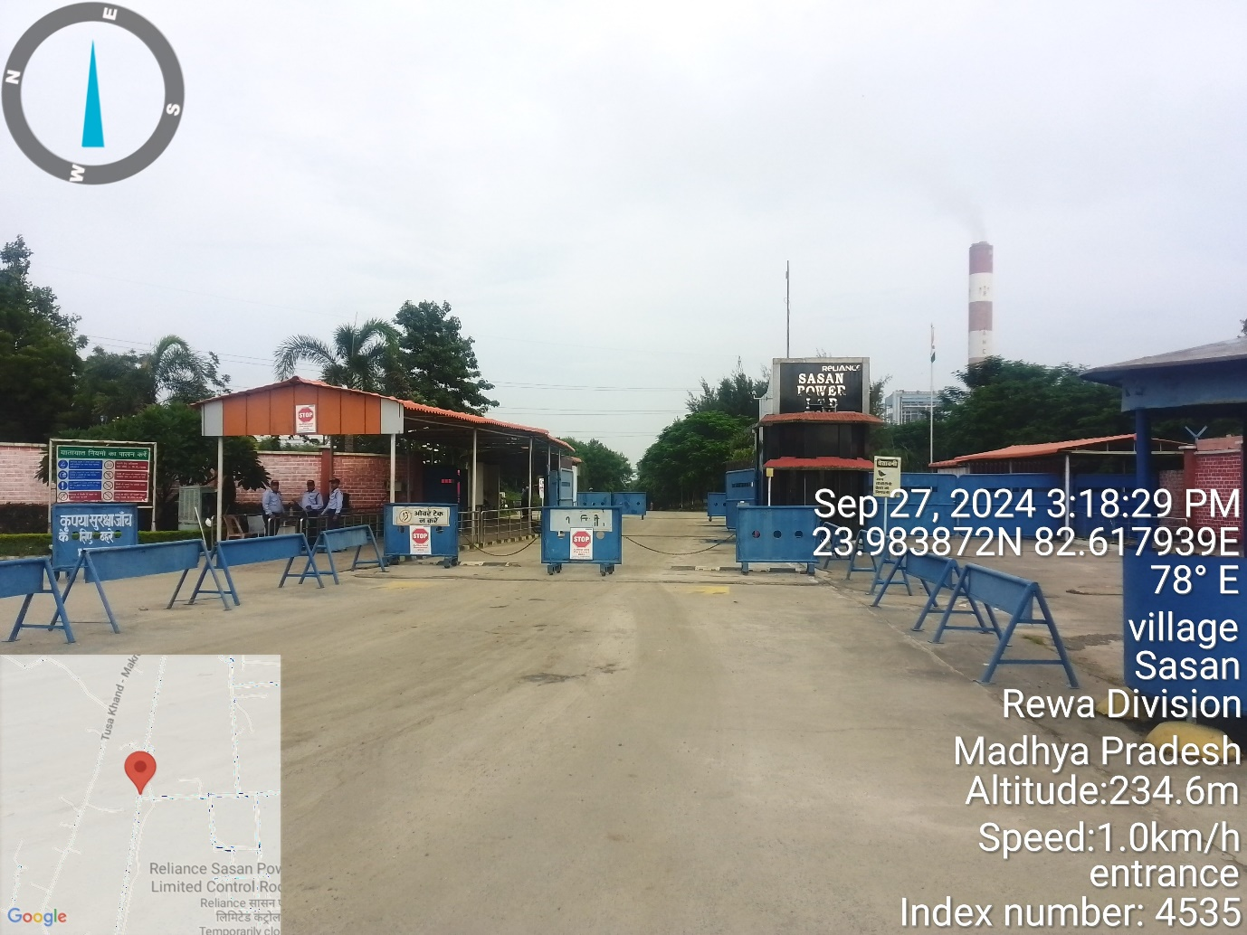
VILLAGE-SIDHIKHURD, POST-TIYARA, TEHSIL WAIDAN, SINGRAULI DISTRICT, MADHYA PRADESH

PART B | SUMMARY OF THE VALUATION REPORT

S.NO. | CONTENTS | DESCRIPTION
 | GENERAL DETAILS
 | Report prepared for | State Bank of India, Overseas Branch, Mumbai, Maharashtra
 | Work Oder Details | Via e-mail dated 17-08-2024
 | Name of Borrower unit | M/s. Sasan power Limited.
 | Name of Property Owner | M/s. Sasan Power Limited.
 | Address & Phone Number of the owner | Reliance Centre Santacruz-Prabhat Colony, Santacruz East, Mumbai, Maharashtra-400055
 | Type of the Property | Thermal Power Plant (Land, Building and Plant & Machinery)
 | Type of Valuation Report | Industrial Land & Building and Plant & Machinery Valuation
 | Report Type | Detailed Asset Valuation
 | Date of Inspection of the Property | From 25 September 2024 to 27 September 2024
 | Date of Valuation Assessment | 25 November 2024
 | Date of Valuation Report | 25 November 2024
 | Surveyed in presence of | Company's representative |  | Mr. M. K. Ghosh  - +91 76663 31660
 | Purpose of the Valuation | For Periodic Re-valuation of the mortgaged property
 | Scope of the Report | Non Binding Opinion on General Prospective Valuation Assessment of the Property identified by Property owner or through its representative
 | Out-of-Scope of Report | - Verification of authenticity of documents from originals or cross checking from any Govt. deptt. is not done at our end.  - Legal aspects of the property are out-of-scope of this report.  - Identification of the property is only limited to cross verification from its boundaries at site if mentioned in the provided documents.  - Getting Cizra map or coordination with revenue officers for site identification is not done at our end.  - Measurement is only limited up to sample random measurement.  - Measurement of the property as a whole is not done at our end.  - Drawing Map & design of the property is out of scope of the work.
 | Documents provided for perusal | Documents Requested |  | Documents Provided
 | Documents provided for perusal | Total 08 Documents requested. |  | Total 08 documents provided.
 | Documents provided for perusal | Property Title document |  | Copy of TIR & Mortgage Deed
 | Documents provided for perusal | Copy of balance sheet |  | Copy of balance sheet
 | Documents provided for perusal | Copy of FAR |  | Copy of FAR
 | Documents provided for perusal | Copy of land area statement |  | Copy of land area statement
 | Documents provided for perusal | Building area sheet |  | Building area sheet
 | Documents provided for perusal | Capacity Utilization |  | Capacity Utilization
 | Documents provided for perusal | Process Flow Diagram |  | Process Flow Diagram
 | Documents provided for perusal | Copy of approvals |  | Copy of approvals
 | Documents provided by | Mr. M. K. Ghosh |  | AGM Finance
 | Identification of the property |  | Done from the name plate displayed on the property
 | Identification of the property |  | Identified by the Owner's representative

 | VALUATION SUMMARY
 | Total Prospective Fair Market Value | Rs. 2,54,38,00,00,000/-
 | Total Expected Realizable/ Fetch Value | Rs. 2,16,22,30,00,000/-
 | Total Expected Distress/ Forced Sale Value | Rs. 1,90,78,50,00,000/-

Valuation Summary
S. No. | As per SPL dated 31-03-2024 |  |  | As per RKA as on 25-11-2024
S. No. | Asset Class | Gross Block  (in ₹ Cr.) | Net Block  (in ₹ Cr.) | GCRC  (in ₹ Cr.) | Fair Value  (in ₹ Cr.) | Realizable Value (in ₹ Cr.) | Distress Value  (in ₹ Cr.)
1 | Land | 707.82 | 617.74 | 3,057.39 | 3,057.39 | 2,598.78 | 2,293.04
2 | Building | 718.01 | 418.12 | 1,044.02 | 539.18 | 458.30 | 404.38
3 | Plant & Machinery | 29,376.20 | 18,349.68 | 33,847.87 | 21,841.81 | 18,565.54 | 16,381.36
Total |  | 30,802.02 | 19,385.53 | 37,949.29 | 25,438.38 | 21,622.62 | 19,078.78
Per MW Cost |  | Rs. 7.78 Cr. | Rs. 4.90 Cr. | Rs.9.58Cr | Rs. 6.42 Cr. | Rs. 5.46 Cr. | Rs. 4.82 Cr.

 | ENCLOSURES
 | Part A | Snapshot of The Asset/ Property Under Valuation
 | Part B | Summary of the Valuation Report
 | Part C | Introduction
 | Part D | SBI format on opinion Report on Valuation
 | Part E | Area & Specification Description of The Project
 | Part F | Project NOCs & Statutory Approval Details
 | Part G | Procedure of Valuation Assessments
 | Part H | Characteristics Description of Plant & Machinery
 | Part I | Procedure of Valuation Assessment – Plant & Machinery
 | Part J | Consolidated Valuation Assessment of The Plant
 | Enclosure-I | Google Map Location
 | Enclosure-II | Photographs
 | Enclosure-III | Copy of Circle Rate-Unavailable
 | Enclosure-IV | Important Property Documents Exhibit
 | Enclosure-V | Declaration-Cum-Undertaking
 | Enclosure-V | Model Code of Conduct For Valuers

PART C | INTRODUCTION

- NAME OF THE PROJECT: This is a detailed Fixed Asset Valuation of (6 X 660) MW Pulverized Coal Fired Super Critical Thermal Power Plant set up by M/s Reliance Power Limited at Village-Sidhikhurd (and many other villages), Post- Tiyara, Tehsil-Waidan, Singrauli District of Madhya Pradesh, India.

- PURPOSE OF THE REPORT: R.K Associates has been appointed by State Bank of India, Overseas Branch, Mumbai, Maharashtra for carrying out the fixed asset valuation (i.e. valuation of land, building and Plant & Machinery) of the subject property on as-is-where-is basis as mentioned in the appointment letter. Valuation of Mining Assets is not part of this report.

- BRIEF DESCRIPTION OF THE PROJECT: Sasan Ultra Mega Power Project (SUMPP) (hereinafter known as M/s Sasan Power Limited or Company) is one of the four Ultra Mega Power Projects planned by the Government of India. This Ultra Mega Power plant is set up, operated & maintained by M/s Sasan Power Limited (a wholly owned subsidiary of M/s. Reliance Power Limited). It was awarded to Reliance Power in the international bidding process conducted by Ministry of Power. Pursuant to above, Power Finance Corporation awarded RIL the intent for setting up 6x660 MW Ultra Mega Thermal Power Project in Singrauli district of Madhya Pradesh based on supercritical technology primarily to meet the power requirements of distribution companies of Uttar Pradesh, Rajasthan, Madhya Pradesh, Punjab, Delhi, Uttarakhand, Haryana. SUMPP uses super critical technology which results in high operating efficiency and also reduces the carbon emission compared to the sub critical plants.
This is a Project Fixed Asset Valuation report and comprises of Land & Building, Plant & Machinery, Coal Mines infra and other miscellaneous assets Valuation of the Super Critical Thermal Power plant located in Tehsil Waidan, Singrauli District of Madhya Pradesh. This assessment is based on Depreciated Replacement Value of the asset. This report doesn’t cover Enterprise/ Business Valuation aspects and the value derived out of it shall not be construed as Transaction Value of the Plant. Details of Land & Building and Plant & Machinery are enumerated in different section of this report.
This Ultra Mega Power Plant has been divided into two phases commonly known as Islands i.e. Island #1 (3x660 MW) comprising of Unit-1, 2 & 3. Island #2 (3x660 MW) comprising of Unit-4, 5 & 6. Unit wise commissioning detail are mentioned below:
S. no. | Particular | Capacity  (in MW) | Date of Commissioning | Current Status
1 | SPL Unit-1 | 660 | 14-08-2013 | Running
2 | SPL Unit-2 | 660 | 28-01-2014 | Running
3 | SPL Unit-3 | 660 | 12-04-2014 | Running
4 | SPL Unit-4 | 660 | 27-05-2014 | Running
5 | SPL Unit-5 | 660 | 26-01-2014 | Running
6 | SPL Unit-6 | 660 | 27-03-2015 | Running

  - Location
SPL's 6 x 660 MW Ultra Mega Power Project (UMPP) is situated in the villages of Sidhi-Kalan, Sidhi Khurd, Tiyara, Harrahwa, and several others within Waidhan Tehsil of Singrauli District, Madhya Pradesh. This region, located in the eastern part of the state, along with the adjoining southern area of Sonbhadra District in Uttar Pradesh, is collectively referred to as Singrauli. Known as the "Energy Capital of India," Singrauli is home to major power sector companies, many of which also engage in coal mining for electricity generation. In recent years, several private firms have entered the power sector operations in the area.

Other major companies operating at Singrauli are NTPC Limited (3 Power Plant with combined generation capacity of 9760 MW), Coal India Limited (Through its subsidiary Northern Coalfields Limited annual coal production 80 million MT), Essar Power Limited (1200 MW), DB Power Limited (1320 MW) etc.
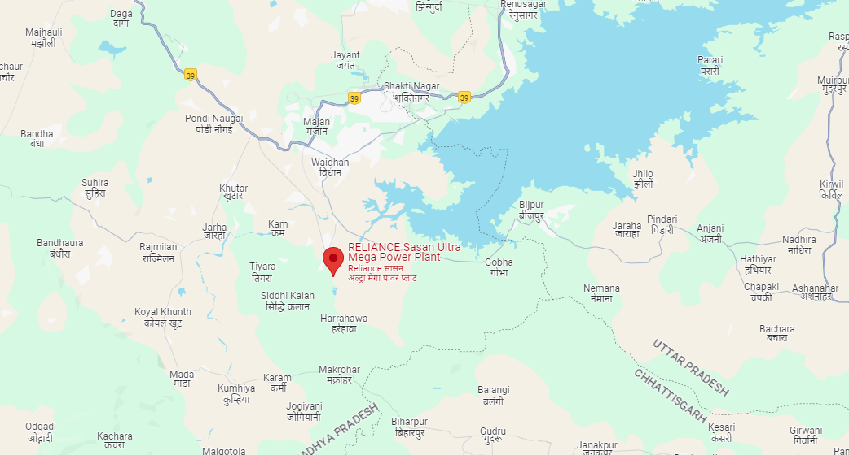

The Plant is located on the south-west side of Govind Ballabh Pant Sagar reservoir (Rihand reservoir), about 12 km from Waidhan town. The nearest railway station is Shakti Nagar on main line connecting Varanasi to Jabalpur, which is at a distance of about 18 km. The nearest airport is Varanasi Airport which is located at a distance of about 250 km from the plant while the nearest sea port is Haldia Port which is about 1300 km from the plant.
  - Project Cost
As per the original schedule of implementation, lenders approved project cost is indicated below:
S. No. | Component | Lenders Approved Project Cost (In ₹ Cr.)
1 | Land and R&R Cost | 780
2 | EPC Work | 16,454
3 | Coal Mines Block | 3,858
4 | Preliminary and Pre-operative Expenses | 1,143
5 | Contingencies | -
6 | IDC & Financial Charges | 3,997
7 | Margin Money | 173
Total |  | 26,405

  - Land
The land allocated to SPL consists of various types of land holdings, primarily including land acquired directly from private owners and government land. of the total land, 1,426.07 hectares were purchased from private parties, while 591.53 hectares consist of government-owned land. Additionally, 1,518.14 hectares of forest land were diverted for the project.
The total land allocation covers areas required for several project components: The Power Plant itself, Infrastructure for the Mines, Overburden areas (where soil and rocks are stored during mining), Roads, the Overland Conveyor System, a dedicated Pipeline from the Rihand Reservoir, a Pump House, and other associated facilities.
The forest land that was diverted for the project is situated in both the plant and mining areas. The diversion of forest land within the plant area has been approved for a period of 30 years, while the diversion of forest land in the mining areas is valid for 20 years. These periods are effective from the date the land diversion was officially awarded.

The summary of the total land under M/s Sasan Power Limited is given below:
S. No. | Particulars | Area (in Hectares) | Area (In Acre)
1 | Forest Land | 1,406.52 | 3,475.51
2 | Acquired Land | 1,055.50 | 2,608.13
3 | Government Land | 591.53 | 1,461.68
4 | Purchased Land | 370.57 | 915.69
5 | Revenue Forest land | 111.62 | 275.81
Total |  | 3,535.74 | 8,736.82
Village-wise land area details are as follows: -
In Hectare
S. No. | Village | Acquired Land | Government Land | Forest Land | Revenue Forest land | Purchased Land | Total | Location
1 | Sidhikhurd | 324.67 | 98.42 | 312.82 | - | 1.62 | 737.53 | Power Plant Area
2 | Siddhi kala | 64.81 | 26.05 | & | 8.11 |  | 98.97 | Power Plant Area
3 | Tiyara | 70.33 | 111.20 | - | - |  | 181.53 | Township Area
4 | Jhanjhitola | 9.72 | 3.65 | - | - |  | 13.37 | Ash dyke Area
5 | Harrahwa | 236.52 | 81.55 | - | - | 0.16 | 318.23 | Ash dyke Area
6 | Gadahra khurd | 7.43 | 0.66 | - | - |  | 8.09 | OLC Area
7 | Kam | 2.87 | 0.55 | - | - |  | 3.42 | OLC Area
8 | Hirrawah | 5.74 | 2.88 | - | - |  | 8.62 | OLC Area
9 | Pachaur | 3.02 | 0.84 | - | - |  | 3.86 | OLC Area
10 | Bilaujibhatawa | 3.89 | 1.08 | - | - |  | 4.97 | OLC Area
11 | Dhaturabarwa | 7.11 | 0.36 | - | - | 0.06 | 7.53 | OLC Area
12 | Naugarh | 9.46 | 2.18 | - | - | 0.48 | 12.12 | OLC Area
13 | Amlori | 8.27 | 1.36 | - | - | 0.66 | 10.29 | OLC Area
14 | Majhauli | - | 29.55 | - | - | 69.92 | 99.47 | Power Plant R&R
15 | Chachar | - | 27.68 | - | - | 23.12 | 50.80 | Power Plant R&R
16 | Sasan | - | - | - | - | 0.02 | 0.02 | Power Plant Area
17 | Naugarh (R&R) | 16.15 | 11.29 | - | - | 6.43 | 33.87 | Mine OB & Infrastructure Area
18 | Amlori | 34.69 | 62.82 | 101.89 | 31.30 | 258.70 | 489.40 | Mine R&R colony
19 | Muher | 250.81 | 129.42 | 991.81 | 72.21 | 9.42 | 1,453.66 | Mine Area
Grand Total |  | 1,055.50 | 591.53 | 1,406.52 | 111.62 | 370.57 | 3,535.74
Source: Sasan Power Limited

As per information & data provided by the company, only 1517.56 Ha or 3749.89 acre is mortgaged with the land as per Indenture of Mortgage (IOM). Village-wise summary of the same are as follows: -
S. No. | Village | Acquired Land  (Area in Ha) | Govt. Land  (Area in ha) | Total  (Area in ha) | Remarks
1 | Siddhikhurd | 325.17 | 98.42 | 423.59 | Plant Land Area
2 | Siddhi kala | 64.81 | 26.05 | 90.86 | Plant Land Area
3 | Tiyara | 70.33 | 111.20 | 181.53 | Township Land Area
4 | Jhajhi Tola | 9.72 | 3.65 | 13.37 | Ash Dye Land Area
5 | Harrahwa | 235.05 | 81.55 | 316.60 | Ash Dye Land Area
6 | Gadhara Khurd | 7.43 | 0.66 | 8.09 | Conveyer Land Area
7 | Kam | 2.87 | 0.55 | 3.42 | Conveyer Land Area
8 | Hirrawah | 5.74 | 2.88 | 8.62 | Conveyer Land Area
9 | Pachaur | 3.02 | 0.84 | 3.86 | Conveyer Land Area
10 | Bilaujibhatawa | 3.89 | 1.08 | 4.97 | Conveyer Land Area
11 | Dhatura Barwa | 7.11 | 0.36 | 7.47 | Conveyer Land Area
12 | Naugarh | 9.86 | 2.18 | 12.04 | Conveyer & R&R Land Area
13 | Amlori | 8.49 | 54.43 | 62.92 | Mines Land Area
14 | Muher | 250.81 | 129.41 | 380.22 | Mines Land Area
Total |  | 1,004.30 | 513.26 | 1,517.56
Therefore, for the purpose of Valuation we have considered only 1517.56 Ha or 3749.89 acre which is mortgaged with the Bank. Area which is not mortgaged is mostly the core coal mining area. However, Mining area complex other than core mining field is considered under valuation.
  - Buildings
Main sections of the plant include Boiler, Turbine, Generator, Coal Handling Plant, Ash Handling Plant, De-mineralization Plant, Effluent Treatment Plant, Switchyard, Transmission line, Water pipeline system to bring raw water to the plant, and other auxiliary machinery for running the plant. Main sections in the mines area are Primary receiving Pit, secondary receiving pit, substations and administration control rooms.
Plant is distributed into different buildings as per their utility. These mainly comprises of Industrial Structures consisting of massive steel structural members embedded in RCC base and covered by Industrial heavy duty corrugated steel sheets. Buildings of the Plant are constructed on various construction practices like GI shed mounted and cladded on prefabricated steel Structure & RCC Structures. Area of Administration & Official Blocks is constructed of RCC framed Structures. Office blocks and electrical control room are Air conditioned. Firefighting system is installed in the various Buildings. Year of construction, type of construction, and Physical condition of various buildings are mentioned in the Building and Civil Work valuation Section “Part-E” of the report. Details regarding building area statement are provided to us by the SPL Management and are totally relied upon. The total built-up area of the buildings and civil structures located at Thermal Power plant, Captive Coal Mines and township are as follows: -
- Thermal Power Plant – 1,85,456 Sq.mtr/19,96,248 Sq. ft.
- Residential Township – 35,921 Sq.mtr/3,86,654 Sq. ft.
- Captive Coal Mines – 1,15,683 Sq.mtr/12,45,213 Sq. ft.

We have segregated the building head from the Fixed Asset Register. Main buildings and civil work capitalized under the building head include service building, central control room, OLC substation, fire station building, SRP control room, switchyard control room, multiutility building, workshop substation building, site office buildings, tyre shop, chimney, ANFO store and many more. Other than this Roads, Drainage, Boundary wall are also included.
  - Engineering Procurement and Construction
Company leveraged the in-house project management expertise of the Reliance Group for executing the Boiler Turbine Generator (BTG) section, Balance of Plant (BOP), and civil works of the project. The project was implemented through a turnkey EPC contract with Reliance Infrastructure Limited (RIL) and Reliance Infra Projects (UK) Limited (RIPUL) on June 24, 2008, for the Engineering, Procurement, and Construction (EPC) of the project. The Project Company executed the project using a multi-package contract scheme, including the BTG package and BOP packages. The BTG contract was awarded to M/s. Shanghai Electric-China (SEC).
The scope of work encompasses the design, engineering, manufacturing, assembly, testing, packing and forwarding, supply, transportation, and arrangement of comprehensive insurance, as well as the erection, testing, pre-commissioning, and commissioning of the Boiler, Turbine, and Generator (BTG) and their auxiliaries. It also includes station control and instrumentation, auxiliary boiler, and commissioning spares for the three super-critical units of the plant, along with conducting performance and guarantee tests.
The company further awarded the major BOP contracts and non-EPC contractors to various contractors. The detailed list of the BOP contractors is annexed below:
Package-0
S. No. | Project Activities | Vendor/Supplier
1 | Road from Mine to Plant | M/s MBL Infrastructure
2 | PMGSY Road | M/s KN International & M/S Baghel Infra Pvt. Ltd.
3 | Development of BTG Laydown area | M/s Vinod Kumar Shah
4 | Anchor Nuts & Bolsts - CHP and ESP Foundation | M/s Unique Fabricators
5 | Anchor Nuts & Bolsts - Boiler Structure | M/s Niharika
6 | Labour Camp | M/s Prateek Gupta and Company
7 | O & M of Crushing Plant | M/s MBL
8 | O & M of Batching Plant | M/s RV Akash Ganga
9 | Seismograph instrument | M/s Amil Ltd
10 | Universal Testing Machine | M/s Blue Star Ltd
11 | Design Consultancy for Central Control Room & Control Tower | M/s Pyrotech Workspace
12 | Rollers and Mechanized Tables | M/s Leoduct
13 | Fire Tender & Fire Extinguisher + Chassis | M/s Newage Industries
14 | 33 TC Transmission line for Water intake & 132 KV Transmission line for mining (Complete supply and erection) | M/s Schaltech Automation Pvt. Ltd.
15 | Nuts & Lock Nuts for PHB and Mill Foundation | M/s Shakun
16 | Electric Shear Wrench | M/s Tristar
17 | Welding Machines | M/s Arctech
18 | Weigh Bridge | M/s Schenck
19 | Puddle Flanges | M/s Niharika
20 | O & M of Construction Power | M/s Star Electricals
21 | CBBY - Electrical | M/s Star Electricals
22 | CS pipes | M/s PSL Ltd

Package-1
S. No. | Project Activities | Vendor/Supplier
1 | Area Granding & Site Development Works | M/s Startech Enggcon P. Ltd, M/s Baghel, M/s KN International
2 | Boundary Wall | M/s Leo Duct
3 | Permanent Store | M/s SG Construction
4 | Material Management/Handling | M/s BLR
5 | Consultancy for Switchyard | M/s SNC Lavalin, Canada
6 | GCW - 1 for first 03 units | M/s JMC Lavalin, Canada
7 | GCW - 1 for balance 03 units | M/s ITDC
8 | Erection of CW Piping | M/s JMC/ITDC/Gammon.
9 | Structural Steel - Built-up Section | M/s Jindal
10 | Bolted Structure | M/s Zhejlang Hangxiao Steel
11 | BTG Erection Package | M/s IOT & M/s Power Mech
12 | Roads & Drains | M/s MBL & M/s Gammon India
13 | Hiring of 250 T Crawler Cranes | M/s Saren Heavy Lifts
14 | Civil Works for Water Intake Structure & Outflow - Route C | M/s Ahluwalia
15 | Civil work for OLC | M/s MBL & M/s STC
16 | Civil work for Water Intake structure & Outflow - Route B | M/s ITDC & M/s Gammon India Ltd.
17 | Coal handling System & OLC | M/s HNI Shenyang, M/s Sangha Erectors & M/s MK Enterprises
18 | Reserve Aux. Transformer | M/s ABB
19 | Generator Transformers | M/s Hyundai, Korea
20 | 80 MVAR Reactors | M/s Xian China
21 | Interconnecting Transformer | M/s Hyundai, Korea
22 | Coal Transformer - Overland Belt Conveyor | M/s HNI Shenyang
23 | IDCT (Mechanical) | M/s Hammon, China
24 | Logistics Package | M/s VR Logistics & M/s Ideal Movers Pvt. Ltd.
25 | Township - Type E (192) & Hostel (120 Rooms and 24 studio apartments) | M/s Topline Buildtech Pvt Ltd/ M/s Ramky
26 | Ash Handling System | M/s Sinofinn, China
27 | Unit Aux. Transformer | M/s Areva

Package-2
S. No. | Project Activities | Vendor/Supplier
1 | Third Party Inspection Services for BOP | M/s TUV & M/s IRS
2 | Third Party Inspection Services for BTG | M/s Lloyds & TUV
3 | Chimney | M/s Gammon
4 | Electrical Work for Chimney | M/s Sachin Electricals
5 | Stack Elevators for Chimney | M/s Mekaster
6 | Circulation Water Pipes for CW System | M/s PSL
7 | ACW Pipes | M/s PSL
8 | Supply of Pipes - Raw Water Intake - route B & Route C | M/s PSL
9 | Laying of Pipes - Raw Water Intake - Route C | M/s Raunaq
10 | Laying of Pipes - Raw Water Intake - Route B | M/s Techofab
11 | Plate Heat Exchangers | M/s GEA
12 | Tie Transformer | M/s Areva
13 | Supervision of ETC of Tie Transformer | M/s Areva
14 | 50 MVAR Reactor | M/s Areva
15 | Supervision of ETC of 50 MVAR Reactor | M/s Areva
16 | EOT Cranes | M/s Anupam Industries
17 | GCW 2 | M/s ITDC & M/s Ahluwalia
18 | Electro - Mechanical Works - Intake Structure - Route C | M/s KBL
19 | Electro - Mechanical Works - Intake Structure - Route B | M/s KBL
20 | Generator Bus Duct (IPBO) | M/s Jiangsu Daqo, China
21 | Compressed Air System | M/s Airox Nigen
22 | DM Plant | M/s Ion Exchange
23 | PT Plant | M/s Ion Exchange
24 | Fuel Oil Handling System | M/s Raunaq
25 | Electrical System fir Raw Water Pump House - Route C | M/s Konstelec
26 | HT Cables for Main Pant | M/s Polycab
27 | LT Bus duct (NSPBD) | M/s Powergear
28 | HT Aux transformer | M/s Areva
29 | Bus ducts - SPBD | M/s Jiangsu Daqo, China
30 | Generator Circuit Breaker | M/s ABB Schweiz
31 | Chlorination Plant | M/s Industrial Devices
32 | CW Pumps | M/s WPIL
33 | Horizontal Pumps | M/s WPIL
34 | Vertical Pumps | M/s WPIL

Package-3
S. No. | Project Activities | Vendor/Supplier
1 | LT Switchgear | M/s Popular Switchgear
2 | LP Piping | M/s Technofab
3 | STP | M/s Wipro Water
4 | ETP | M/s Thermax
5 | LT Aux, Transformer (Dry Type) | M/s QRE, China
6 | LT Aux, Transformer (Oil Type) | M/s Areva
7 | HT Switchgear | M/s Areva
8 | Fre Protection & Detection System | M/s UTC Fire & M/s Security India Ltd

Package-4
S. No. | Project Activities | Vendor/Supplier
1 | 132 KV Route Survey Double Circuit Transmission Line from 765/ 400 Switchyard | M/s Imagis
2 | Consultancy for Structural Works for Switchyard | M/s Bhavani
3 | Bridges for OLC | M/s ITDC
4 | Bus Post Insulators - 400 KV and 132 KV | M/s Aditya Birla Insulators
5 | Surge Arrestors 400 KV | M/s Oblum
6 | 132 KV Surge Arrestors | M/s Oblum
7 | 132 KV Disconnecting Switches | M/s Switchgear and structural steel
8 | 765 KV Disconnecting Switches | M/s Areva
9 | 132 KV Circuit Breaker | M/s Areva
10 | 132 KV Instrument Transformer | M/s Areva
11 | Isolators/ Disconnecting Switches - 400 KV | M/s Switchgear and structural steel
12 | Circuit Breaker - 400 KV | M/s Areva
13 | Circuit Breaker - 765 KV | M/s Areva
14 | Wave Trap - 400 KV | M/s Areva
15 | Instrument Transformers (CVT) - 765 KV | M/s Electotecnica, Spain
16 | Instrument Transformers (CVT) - 400 KV | M/s Areva
17 | Instrument Transformers (CT) - 400 KV
18 | Instrument Transformers (CT) - 765 KV | M/s Arteche DYH, Chaina
19 | Raw Water Reservoir | M/s Baghel
20 | Erection of Structural Steel Works Including Field Fabrication of Miscellaneous | M/s Power Mech
21 | Stop Log Gates * Screens | M/s Triveni
22 | Earthing Material - GS Flat and GI Wires for Switchyard - 20 mm & 40 mm | M/s Industrial Perforation
23 | Transfer of Earthing Material - MS Rods for Switchyard - 20 mm & 40 mm | M/s Reliance Infratel
24 | Butterfly Valves | M/s Tyco Valves
25 | Ventilation System | M/s Sterling Wilson
26 | EOT Cranes for Workshop and Permanent Store Building | M/s Electro Mech
27 | ACSR Moose Flexible Conductor - Switchyard | M/s Hindustan Vidyut Pvt Ltd
28 | Illumination System | M/s Shrihans Electricals
29 | 33 KV Neutral Grounding Transformer - Switchyard | M/s Bajaj Electricals
30 | Illumination System | M/s Siemens
31 | AC System | M/s Blue Star
32 | Service Elevator | M/s ECE
33 | Battery for Switchyard | M/s AMCO
34 | Battery Charger for Switchyard | M/s HBL
35 | Wave Trap 400 KV & 765 KV | M/s AMCO
36 | LT Switchgear for Switchyard | M/s Areva
37 | Electrical Control & Relay Panel for GT/UAT | M/s Popular Switchgear Ltd.
38 | Ash Dyke | M/s Areva
39 | Mill Reject System | M/s Baghel & M/s K N International
40 | Plant Communication | M/s Larsen & Toubro Limited
41 | Coal mine road Illumination | M/s Larsen & Toubro Limited
42 | Plant Illumination | M/s Larsen & Toubro Limited
43 | Electrical Lab | M/s Larsen & Toubro Limited
44 | Electrical Erection | M/s Larsen & Toubro Limited

Package-5
S. No. | Project Activities | Vendor/Supplier
1 | Structural Steel for Switchyard - 400 & 132 KV | M/s BG Shrike
2 | HV Cable for Switchyard | M/s KEC International Ltd. (RPG Cables)
3 | Neutral Grounding Resistors | M/s Amp Control Equipment's
4 | LT Power & Control Cables for Switchyard | M/s Polycab
5 | Clamps & Connectors | M/s Raychem RPG
6 | Structural Steel for Switchyard - 765 KV | M/s RS Infraprojects
7 | Sump Pump | M/s Varat Pumps
8 | Clamp & Connectors 765 KV | M/s Venson Technolink

Package-6
S. No. | Project Activities | Vendor/Supplier
1 | Composite Disc Insulator - 400 KV and 132 KV | M/s GK Electricals
2 | Aluminium Tube | M/s Hindalco
3 | 33 KV, 1.6 MVA Service Transformer | M/s Victory Electricals
4 | Erection and Commissioning of Switchyard | M/s Techno Electric
5 | Cable Trays for Switchyard | M/s Kanadde Anand Udhyog
6 | Vibration Monitoring System | M/s Larsen & Toubro Limited
7 | Field Instruments and flow element | M/s Larsen & Toubro Limited
8 | master clock | M/s Larsen & Toubro Limited
9 | BOP PLC network system | M/s Larsen & Toubro Limited
10 | Control Valve & Actuator | M/s Larsen & Toubro Limited
11 | C & I lab | M/s Larsen & Toubro Limited
12 | CCTV | M/s Larsen & Toubro Limited
13 | C&I Erection | M/s Larsen & Toubro Limited
14 | Composite Disc Insulator - 400 KV and 132 KV | M/s Larsen & Toubro Limited
15 | Aluminium Tube | M/s Larsen & Toubro Limited

For other ancillary equipment company management has shared the following details: -
S. No. | Equipment | Make | Capacity | Qty
1 | Dragline | CAT | 62 m3 | 2
2 | Electric Rope Shovel | Bucyrus | 42 m3 | 6
3 | Front End Loader | Letourneau | 42 m3 | 2
4 | Hydraulic backhoe excavator | Liebherr | 24 m3 | 1
5 | Rear Dumper | CAT | 240 T | 55
6 | Water Sprinkler | WS-70 | 70 KL | 5
7 | Track Dozer | Komatsu | 850 HP | 10
8 | Wheel Dozer | Komatsu | 450 HP | 6
9 | Motor Grader | Komatsu | 280 HP | 8
10 | Backhoe Excavator | Tata Hitachi | 2.5 m3 | 1
11 | Loader | CAT | 5.3 m3 | 1
12 | IDM Drill Machine | Atlas Copco | 159 mm | 4
13 | PV- Drill Machine | Atlas Copco | 259 mm | 8
14 | DMM Drill Machine | Atlas Copco | 311 mm | 4
15 | Auxiliary Equipment (FB, WT, FL, Trucks, Cranes) | Man India & Others | 220 HP | 40

  - Water Requirement
The water required for the plant is sourced from Gobind Ballabh Pant Sagar (Rihand Reservoir), located 25 km from the project site. It is pumped from the intake pump house via dedicated pipelines to the plant's water reservoir to meet the plant's water requirement.
The Project Company has signed a water supply agreement with the Water Resources Department of the Government of Madhya Pradesh (GOMP). The department has granted permission to withdraw 0.14 MAF (million acre-feet) of water (19,715 m³/h) from the Rihand Reservoir. Through recycling and reusing water, the company has further optimized its consumptive water requirement to 12,532 m³/h (0.091 MAF), which is sufficient to meet the project's water requirements.
Two raw water reservoirs have been built within the plant, providing a storage capacity for four days. Water from these reservoirs is supplied to meet the needs of the cooling tower makeup, DM plant makeup, and other requirements. This is facilitated through a raw water pump house to be constructed near the reservoir.
  - Power Purchase Agreement
This power plant has been allocated to Reliance Power Ltd. under the Government of India’s Ultra Mega Power Plant (UMPP) scheme, which has awarded the project to the lowest bidder. The selected bidder receives a letter of comfort for securing a direct Power Purchase Agreement (PPA) with 14 distribution companies (Discoms). M/s Sasan Power Limited (SPL) has entered into a 25-year PPA with 14 Discoms across seven Indian states: Madhya Pradesh, Uttar Pradesh, Rajasthan, Punjab, Haryana, Delhi, and Uttarakhand. The agreement, signed on August 7, 2007, includes the following list of distribution companies.
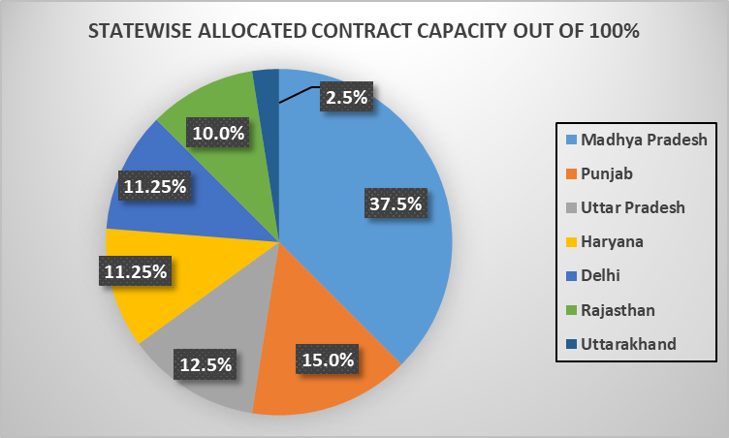

Under the PPA, 94% of the power generated by the plant is supplied to the respective Distribution Companies (Discoms). The contracted capacity for each unit is 620.4 MW, which represents the rated net capacity at the interconnection point. The total contracted capacity for the entire power station is 3,722.4 MW. According to the EPC contract, the guaranteed gross output of each unit at the generator terminals is 660 MW, with 6% of the gross output allocated for auxiliary power consumption. Based on this, the proposed project capacity aligns with the contracted capacity outlined in the PPA.
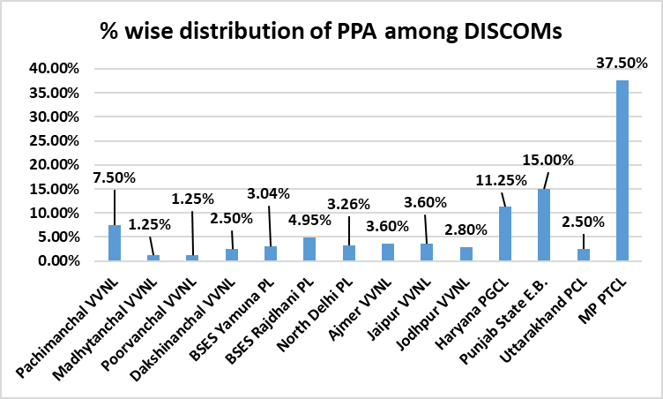
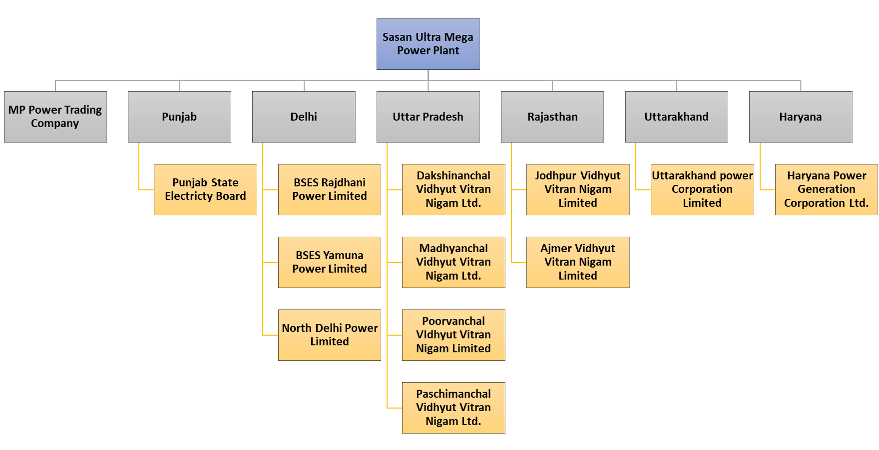

  - Power Evacuation
The Sasan UMPP switchyard is built with four voltage levels: 765 kV for connecting the generators and the main transmission system, 400 kV for startup and standby power routes, 132 kV for supplying power to the captive coal mines, and 33 kV for the plant's auxiliary power supply system.
A 765 kV and 400 kV switchyard has been constructed adjacent to the TG building, utilizing a breaker-and-a-half scheme for enhanced reliability and operational flexibility. Additionally, a 132 kV switchyard has been constructed to meet the power requirements of the coal mine loads. The bus configuration for this switchyard includes two main buses and a transfer bus with a single breaker scheme.
The power generated by the plant is transmitted through three single-circuit 765 kV transmission lines and two double-circuit 400 kV transmission lines. Two of the 765 kV transmission lines from the project connect to the National Grid at Satna, which is located 265 km away, while the third 765 kV line connects to the Vindhyachal pooling station, approximately 10 km from the project site. The two 400 kV double-circuit transmission lines connect the Vindhyachal Super Thermal Power Station to the Jabalpur Sub-Station.

  - FUEL SUPPLY ARRANGEMENTS
The Sasan Ultra Mega Power Plant primarily relies on domestic coal as its main fuel source. The Moher and Moher Amlorhi Extension coal blocks, located in the Singrauli coal field, have been allocated to M/s Sasan Power Limited as captive coal sources. Although the Chattrasal coal block was also allocated to the project, its allocation was recently canceled by the Ministry of Coal.
The coal mining plan for the Moher and Moher Amlorhi Extension blocks was approved for an annual production of 20 million tons per annum (MTPA). As per the revised mine plan, the yearly production target remains 20 MTPA, with the mine's operational lifespan projected at 29 years. This includes coal production of 20 MTPA for the first 15 years, 16 MTPA for the following 8 years, and the remaining 42.43 million tons spread over the last 6 years. The total net geological reserve for both mines is estimated at 575 million tons.
Coal from the Moher and Moher Amlorhi Extension mines is transported to the power plant via a dedicated Over Land Coal Conveyor (OLC) system. This single-point conveyor spans approximately 22.5 kilometers from the mines to the plant.
MOHER AND MOHER AMLOHRI EXTENSION OC MINE PROJECT:
 | Name of the Mine | MOHER & MOHER AMLOHRI EXT. OC PROJECT
 | Name of the Company | M/s Sasan Power Limited
 | Target Capacity of the Mine | 20 million Tons per year
 | Life of the Mine | 29 Years
 | End use of Coal | Sasan Ultra Mega Power Plant  (3960 MW) and other power plants under RPL group.
 | Grade of Coal | G-10 to G-11
 | Geological Blocks & Reserves | Net Geological Reserves
 | Geological Blocks & Reserves | Coal Seams | Net Proved Coal Reserves (Million Tones)
 | Geological Blocks & Reserves | Coal Seams | Moher Block | Moher Amlorhi Extension Block |  | Total
 | Geological Blocks & Reserves | Turra | 186.56 | 107.90 |  | 294.46
 | Geological Blocks & Reserves | Purewa Merged | 130.10 | 150.44 |  | 280.54
 | Geological Blocks & Reserves | Total | 316.66 | 258.34 |  | 575.00
 | Extractable Coal Reserves | Net Geological Reserves (MT) |  |  |  | 575
 | Extractable Coal Reserves | Mineable Coal Reserves (MT) |  |  |  | 470.43
 | Extractable Coal Reserves | Percentage of Extraction (%) |  |  |  | 81.18
 | Extractable Coal Reserves | Estimated Volume of Overburden (MBCM) |  |  |  | 1893.73
 | Extractable Coal Reserves | Stripping Ratio (M3 / Te) |  |  |  | 4.03
 | Estimated Volume of Overburden (MBCM) | 1893.73
 | Exploration Details | Agency | Series | No. of Bores holes |  | Meterage
 | Exploration Details | GSI | SN & SNAM | 8 |  | 1662.45
 | Exploration Details | NCDC | NCSB | 4 |  | 452.8
 | Exploration Details | CMPDIL | CMSM | 155 |  | 18271.94
 | Exploration Details | IBM | SGR | 1 |  | 280
 | Exploration Details | CMPDIL | CMAE | 47 |  | 12812
 | Exploration Details | Total |  | 215 |  | 33479.19
 | Exploration Details | Overall Density of Boreholes is 14 per Sq. Km.
 | Range of Top Overburden Cover | 13 Mtr to 287 Mtr.
 | Total Mining Lease area (for a period of 30 Years) | 1586.05 Ha (Total Area of Project is 2037 Ha)
 | CHP DETAILS | Capacity of Primary Crushers |  |  | 2,250 TPH X 2 = 4,500 TPH
 | CHP DETAILS | Capacity of Secondary Crusher |  |  | 1,500 TPH x 4 = 6,000 TPH
 | CHP DETAILS | Length of Conveyor in Mine Area (SRP to TH5) |  |  | 6.3 KM
 | CHP DETAILS | Length of Conveyor from TH 5 to Sasan UMPP |  |  | 14.5 KM
 | CHP DETAILS | Speed of the Conveyor Belt |  |  | 3.6 to 4.8 mtr/sec.

  - Coal Transport Arrangement
The Moher and Moher Amlorhi Extension Coal Blocks are situated about 21.5 kilometers from the project site, and coal is transported to the power plant via a dedicated coal conveyor system. An Over Land Conveyor (OLC) has been installed to transport coal from these captive coal blocks to the power plant. This OLC is a single-flight conveyor with no transfer points along its 22.5-kilometer route. The conveyor is designed to carry 4,500 tons per hour (TPH) and operates at a speed of 5.6 meters per second. It features a belt width of 1,800 mm, constructed from steel cord fabric. The conveyor belt typically runs 3.5 meters above ground level.
  - Status of Plant during Site Survey
Our engineering team has visited the power plant project site from 25th September 2024 to 27th September 2024. During the site visit, the plant was found to be fully operational and all the machinery and equipment were maintained properly.
- TYPE OF REPORT: Detailed Fixed Asset Valuation of the Project.
- SCOPE OF THE REPORT: To assess and determine Fair Market Valuation of the tangible assets under of a Thermal Power Plant owned by M/s Sasan Power Limited covering following below points:
- Prospective Market Valuation of Project Land
- Depreciated Replacement Valuation of the structures
- Depreciated Replacement Valuation of Plant & Machinery and other equipment

- DOCUMENTS/DATA REFFERED:
LAND
- Land area statement details in Excel format
- Copy of TIRs
- Copy of Indenture of Mortgaged
- Copy of Sale Deed

BUILDING
- Copy of Building area sheet.
- Copy of Layout Plan
- Copy of approvals
Plant & Machinery
- Copy of Fixed Assets Register dated 31-03-2024
- Copy of Power Purchase Agreement
- Copy of Process Flow Chart
- Copy of Capacity Utilization
- Copies of Approvals and NOC’s from various Government agencies and departments
- Technical Diary of the plant

PART D | SBI FORMAT ON OPINION REPORT ON VALUATION

Name & Address of the Branch | State Bank of India, Overseas Branch, Mumbai
Name & Designation of concerned officer | Smruti Ranjan
Name of the Borrower Unit | M/s. Sasan Power Limited

S.NO. | CONTENTS |  |  |  | DESCRIPTION
 | GENERAL
 | Purpose of Valuation |  |  |  | For Periodic Re-valuation of the mortgaged property
 | - Date of Inspection of the Property |  |  |  | From 25 September 2024 to 27 September 2024
 | - Date of Valuation Assessment |  |  |  | 22 October 2024
 | - Date of Valuation Report |  |  |  | 22 October 2024
 | List of documents produced for perusal (Documents has been referred only for reference purpose) |  |  |  | Documents Requested |  |  | Documents Provided |  |  |  |  | Documents Reference No.
 |  |  |  |  | Please refer Page No. 06 & 23
 | Name of the owner(s) |  |  |  | M/s. Sasan Power Limited
 | Address/ Phone no. |  |  |  | Address: Village-Sidhikhurd (and many other villages), Post- Tiyara, Tehsil Waidan, Singrauli District of Madhya Pradesh, India
 |  |  |  |  | ---
Brief description of the property:
This valuation is prepared for the property situated at the aforesaid address having total land area admeasuring 1517.56 Hectares as per land area details shared by the company. Copy of TIRs and Sale deeds were also provided to us on sample basis.
Other details of the Project are already mentioned in Part-C on page no. 08.
Valuation is conducted of the property as shown on the site by the company’s representative of which photographs is also attached with the report and same is to be considered in this report irrespective of any details taken from any documents which might have been updated, changed or incorrect.
 | Location of the property
 | - Plot No. / Survey No. |  |  |  | Multiple
 | - Door No. |  |  |  | ---
 | - T. S. No. / Village |  |  |  | Multiple Villages (Refer Part-C)
 | - Ward / Taluka |  |  |  | Post-Tiyara, Tehsil-Waidan
 | - Mandal / District |  |  |  | Singrauli
 | - Postal address of the property |  |  |  | M/s Reliance Power Limited at Village-Sidhikhurd (and many other villages), Post- Tiyara, Tehsil Waidan, Singrauli District of Madhya Pradesh, India
 | - Latitude, Longitude & Coordinates of the site |  |  |  | 23°58'21.8"N 82°36'58.7"E
 | - Nearby Landmark |  |  |  | Itself a landmark
 | City Categorization |  |  |  | Village |  |  |  |  | Rural
 | Type of Area |  |  |  | Rural area and most of the nearby land is lying barron
 | Classification of the area |  |  |  | Lower Middle Class (Average) |  |  |  |  | Rural
 |  |  |  |  | Within unnotified Industrial area
 | Local Government Body Category  (Corporation limit / Village Panchayat / Municipality) - Type & Name |  |  |  | Rural |  |  |  |  | Village Panchayat (Gram Panchayat)
 |  |  |  |  | Local Gram Panchayat
 | Whether covered under any prohibited/ restricted/ reserved area/ zone through State / Central Govt. enactments (e.g. Urban Land Ceiling Act) or notified under agency area / scheduled area / cantonment area/ heritage area/ coastal area |  |  |  | No |  |  |  |  | Notified area Sasan Power Plant as per Singrauli district Master Plan
 |  |  |  |  | For part of forest land, received clearance from Ministry of Environment & Forests.
 | In case it is an agricultural land, any conversion of land use done |  |  |  | Yes from Agricultural to Industrial
 | Boundary schedule of the Property
 | Are Boundaries matched |  |  |  | Project land is spread across large area purchased via multiple sale deeds. Therefore practically it is not possible to match the boundaries from each such deed and land parcel.
 | Directions |  |  | As per Documents |  |  |  |  | Actually, found at Site
 | North |  |  | NA |  |  |  |  | Refer to map attached
 | South |  |  | NA |  |  |  |  | Refer to map attached
 | East |  |  | NA |  |  |  |  | Refer to map attached
 | West |  |  | NA |  |  |  |  | Refer to map attached
 | Dimensions of the site
 | Directions |  |  | As per Documents (A) |  |  |  |  | Actually, found at Site (B)
 | North |  |  | Not available in documents. |  |  |  |  | Shape uneven, not measurable from sides.
 | South |  |  | Not available in documents.
 | East |  |  | Not available in documents.
 | West |  |  | Not available in documents.
 | Extent of the site |  |  | 1517.56 Hectares |  |  |  |  | ~ 1517.56 Hectares
 | Extent of the site considered for valuation (least of 14A & 14B) |  |  |  | 3,37,060 sq.mtr (Built-up Area)  1517.56 Hectare (Land Area) (only mortgaged land)
 | Property presently occupied/ possessed by |  |  |  | M/s Sasan Power Limited (Company)
 | If occupied by tenant, since how long? |  |  |  | NA
 | Rent received per month |  |  |  | NA
 | CHARACTERISTICS OF THE SITE
 | Classification of the locality |  |  |  | Already described at S.No. I (Point 08).
 | Development of surrounding areas |  |  |  | Rural area
 | Possibility of frequent flooding / sub-merging |  |  |  | No
 | Proximity to the Civic amenities & social infrastructure like school, hospital, bus stop, market, etc.
 | School | Hospital | Market |  |  | Bus Stop | Railway Station |  |  |  |  | Metro |  | Airport
 | 2.0 km | 12 km. | 12 km. |  |  | 13 km. | 40 km. |  |  |  |  | NA |  | 270 km.
 | Level of land with topographical conditions |  |  |  | on road level/ Plain Land
 | Shape of land |  |  |  | Irregular
 | Type of use to which it can be put |  |  |  | Appropriate for industrial use
 | Any usage restriction |  |  |  | No
 | Is plot in town planning approved layout?/ Zoning regulation |  |  |  | Yes |  |  |  |  |  | Singrauli Development Plan (Draft 2035)
 | Corner plot or intermittent plot? |  |  |  | It is not a corner plot
 | Road facilities
 | - Main Road Name & Width |  |  |  | Jhansi-Ranchi Road |  |  |  |  |  | 60 ft.
 | - Front Road Name & width |  |  |  | Approach Road |  |  |  |  |  | 25 ft.
 | - Type of Approach Road |  |  |  | Bituminous Road
 | - Distance from the Main Road |  |  |  | 14 km
 | Type of road available at present |  |  |  | Bituminous Road
 | Width of road – is it below 20 ft. or more than |  |  |  | More than 20 ft.
 | Is it a land – locked land? |  |  |  | No
 | Water potentiality |  |  |  | Available from Gobind Ballabh Pant Reservoir
 | Underground sewerage system |  |  |  | Yes
 | Is power supply available at the site? |  |  |  | Yes
 | Advantages of the site |  |  |  | Near to reservoir & coal mines sea and therefore water & coal availability is easy.
 | Special remarks, if any, like:
 | - Notification of land acquisition if any in the area |  |  |  | No such information came in front of us and could be found on public domain
 | - Notification of road widening if any in the area |  |  |  | No
 | - Applicability of CRZ provisions etc. (Distance from sea-coast / tidal level must be incorporated) |  |  |  | No
 | - Any other |  |  |  | None
 | VALUATION OF LAND
 | Size of plot |  |  |  | Please refer to Part B – Area description of the Property.
 | North & South
 | East & West
 | Total extent of the plot
 | Prevailing market rate (Along with details/reference of at least two latest deals/ transactions with respect to adjacent properties in the areas) |  |  |  | Please refer to Part G - Procedure of Valuation Assessment section.
 | Guideline rate obtained from the Registrar’s Office (evidence thereof to be enclosed)
 | Assessed / adopted rate of valuation
 | Estimated Value of Land
 | VALUATION OF BUILDING
 | Technical details of the building
 | - Type of Building (Residential / Commercial/ Industrial) |  |  |  | INDUSTRIAL / INDUSTRIAL PROJECT
 | - Type of construction (Load bearing / RCC/ Steel Framed) |  |  |  | Structure |  |  | Slab
 |  |  |  |  | Mixture of RCC, Load Bearing and Steel Frame Structure |  |  | Mixture of RCC, GI Shed and Asbestos Cement (AC) Sheet
 | - Architecture design & finishing |  |  |  | Interior |  |  |  |  |  | Exterior
 |  |  |  |  | Ordinary regular architecture / Simple/ Average finishing |  |  |  |  |  | Ordinary regular architecture / Simple/ Average finishing
 | - Class of construction |  |  |  | Class B construction (Good)
 | - Year of construction/ Age of construction |  |  |  | 2011 and so on |  |  |  |  |  | Please refer Building Sheet in Part-G
 | - Number of floors and height of each floor including basement, if any |  |  |  | Please refer Building Sheet in Part-G
 | - Plinth area floor-wise |  |  |  | Please refer Building Sheet in Part-G
 | - Condition of the building |  |  |  | Interior |  |  |  |  |  | Exterior
 |  |  |  |  | Good |  |  |  |  |  | Good
 | - Maintenance issues |  |  |  | No maintenance issue, structure is maintained properly
 | - Visible damage in the building if any |  |  |  | No visible damages in the structure
 | - Type of flooring |  |  |  | Please refer to the attached specifications annexure
 | - Class of electrical fittings |  |  |  | Mixed (Internal & External)/ Normal quality fittings used
 | - Class of plumbing, sanitary & water supply fittings |  |  |  | Mixed (Internal & External)/ Normal quality fittings used
 | Map approval details
 | - Status of Building Plans/ Maps and Date of issue and validity of layout of approved map / plan |  |  |  | Internally approved layout
 | - Approved map / plan issuing authority |  |  |  | Multiple plants departments
 | - Whether genuineness or authenticity of approved map / plan is verified |  |  |  | Approved map not available
 | - Any other comments on authenticity of approved plan |  |  |  | Verification of authenticity of documents with the respective authority can be done by a legal/ liasoning person and same is not done at our end.
 | - Is Building as per copy of approved Map provided to Valuer? |  |  |  | Cannot comment since no approved map provided to us on our request.
 | - Details of alterations/ deviations/ illegal construction/ encroachment noticed in the structure from the approved plan |  |  |  | ☐ Permissible alterations |  |  |  |  |  | NA
 |  |  |  |  | ☐ Non permissible alterations |  |  |  |  |  | NA
 | - Is this being regularized |  |  |  | Not Applicable
 | SPECIFICATIONS OF CONSTRUCTION (FLOOR-WISE) IN RESPECT OF
 | Foundation |  |  |  | This Valuation is conducted based on the macro analysis of the asset/ property considering it in totality and not based on the micro, component or item wise analysis. These points are covered in totality in lump sum basis under technical details of the building under “Class of construction, architecture design & finishing” point.
 | Basement
 | Superstructure
 | Joinery / Doors & Windows (please furnish details about size of frames, shutters, glazing, fitting etc. and specify the species of timber)
 | RCC works
 | Plastering
 | Flooring, Skirting, dadoing
 | Special finish as marble, granite, wooden paneling, grills, etc
 | Roofing including weather proof course
 | Drainage
 | Compound wall |  |  |  | Yes
 | Height |  |  |  | 10-12 ft.
 | Length |  |  |  | Approx. 7494 RMT
 | Type of construction |  |  |  | RCC Wall with barbed wiring on top
 | Electrical installation |  |  |  | Please refer to “Class of electrical fittings” under technical details of the building above in totality and lump sum basis. This Valuation is conducted based on the macro analysis of the asset/ property considering it in totality and not based on the micro, component or item wise analysis.
 | Type of wiring
 | Class of fittings (superior / ordinary / poor)
 | Number of light points
 | Fan points
 | Spare plug points
 | Any other item
 | Plumbing installation |  |  |  | Please refer to “Class of plumbing, sanitary & water supply fittings” under technical details of the building above in totality and lump sum basis. This Valuation is conducted based on the macro analysis of the asset/ property considering it in totality and not based on the micro, component or item wise analysis.
 | No. of water closets and their type
 | No. of wash basins
 | No. of urinals
 | No. of bath tubs
 | No. of water closets and their type
 | Water meter, taps, etc.
 | Any other fixtures

*NOTE:
- For more details & basis please refer to Part G - Procedure of Valuation Assessment section.
- This valuation is conducted based on the comparable composite market rate method which is inherently inclusive of the additional items as mentioned in S.No. 2 to 8 if present in the flat at ordinary level. For any exclusive and superfine finish over and above ordinary finishing, additional value is taken in lumpsum as described in the Procedure of Valuation Assessment section under “Valuation of Additional Aesthetic & Decor Works in the Property”.
- Estimated Value is subject to the assumptions, limitations, basis of computation, caveats, information, facts came during valuation within the limited available time & cost.
- PART D - SBI format on opinion report on Valuation is just the description of the asset as per the format requirement of the client. The real procedure of Valuation is discussed from PART G – Procedure of Valuation Assessment where all different aspect of Valuation as per the standards are described in detail.
- This Valuation is guided by Valuation Terms of Service and Valuer’s Important Remarks which can also be found at www.rkassociates.org.
PART E | AREA & SPECIFICATION DESCRIPTION OF THE PROJECT TANGIBLE ASSET

- LAND AREA:
Detailed breakup of Project Land into Private, Government and forest is as follow: -
In Hectare
S. No. | Village | Acquired Land | Government Land | Forest Land | Revenue Forest land | Purchased Land | Total | Location
1 | Sidhikhurd | 324.67 | 98.42 | 312.82 | - | 1.62 | 737.53 | Power Plant Area
2 | Siddhi kala | 64.81 | 26.05 | & | 8.11 |  | 98.97 | Power Plant Area
3 | Tiyara | 70.33 | 111.20 | - | - |  | 181.53 | Township Area
4 | Jhanjhitola | 9.72 | 3.65 | - | - |  | 13.37 | Ash dyke Area
5 | Harrahwa | 236.52 | 81.55 | - | - | 0.16 | 318.23 | Ash dyke Area
6 | Gadahra khurd | 7.43 | 0.66 | - | - |  | 8.09 | OLC Area
7 | Kam | 2.87 | 0.55 | - | - |  | 3.42 | OLC Area
8 | Hirrawah | 5.74 | 2.88 | - | - |  | 8.62 | OLC Area
9 | Pachaur | 3.02 | 0.84 | - | - |  | 3.86 | OLC Area
10 | Bilaujibhatawa | 3.89 | 1.08 | - | - |  | 4.97 | OLC Area
11 | Dhaturabarwa | 7.11 | 0.36 | - | - | 0.06 | 7.53 | OLC Area
12 | Naugarh | 9.46 | 2.18 | - | - | 0.48 | 12.12 | OLC Area
13 | Amlorhi | 8.27 | 1.36 | - | - | 0.66 | 10.29 | OLC Area
14 | Majhauli | - | 29.55 | - | - | 69.92 | 99.47 | Power Plant R&R
15 | Chachar | - | 27.68 | - | - | 23.12 | 50.80 | Power Plant R&R
16 | Sasan | - | - | - | - | 0.02 | 0.02 | Power Plant Area
17 | Naugarh (R&R) | 16.15 | 11.29 | - | - | 6.43 | 33.87 | Mine OB & Infrastructure Area
18 | Amlorhi | 34.69 | 62.82 | 101.89 | 31.30 | 258.70 | 489.40 | Mine R&R colony
19 | Moher | 250.81 | 129.42 | 991.81 | 72.21 | 9.42 | 1,453.66 | Mine Area
Grand Total |  | 1,055.50 | 591.53 | 1,406.52 | 111.62 | 370.57 | 3,535.74

Mining lease has been permitted on the Land located at Moher & Amlohri villages. A mining lease agreement has been signed between Sasan Power Limited and State Government on 15th September 2011 for the period of 30 years.
As per the information provided by the management of M/s. Sasan Power Limited, a total of 1517.56 Ha or 3749.89 of land has been mortgaged to the lenders. This mortgaged land includes both the main plant area and additional land outside the plant, which was acquired for facilities such as OLC (Overland Conveyor)/plant roads, and other purposes. The attached maps show the Cizra map for the project land (thermal power plant) and the mining lease area for the captive mines.
In the Cizra map for the thermal power plant, the green-colored section represents forest land, the yellow-colored section represents government land, and the uncolored section represents private land.
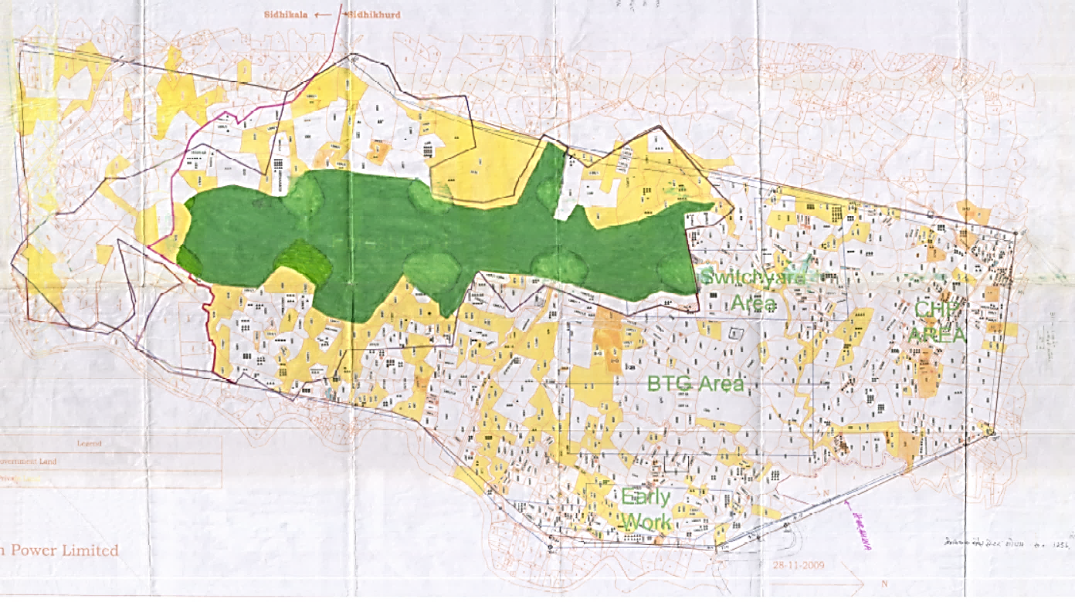
In the mining lease area map, the orange-colored section indicates government land, the yellow section shows private land, and the green section represents forest land.
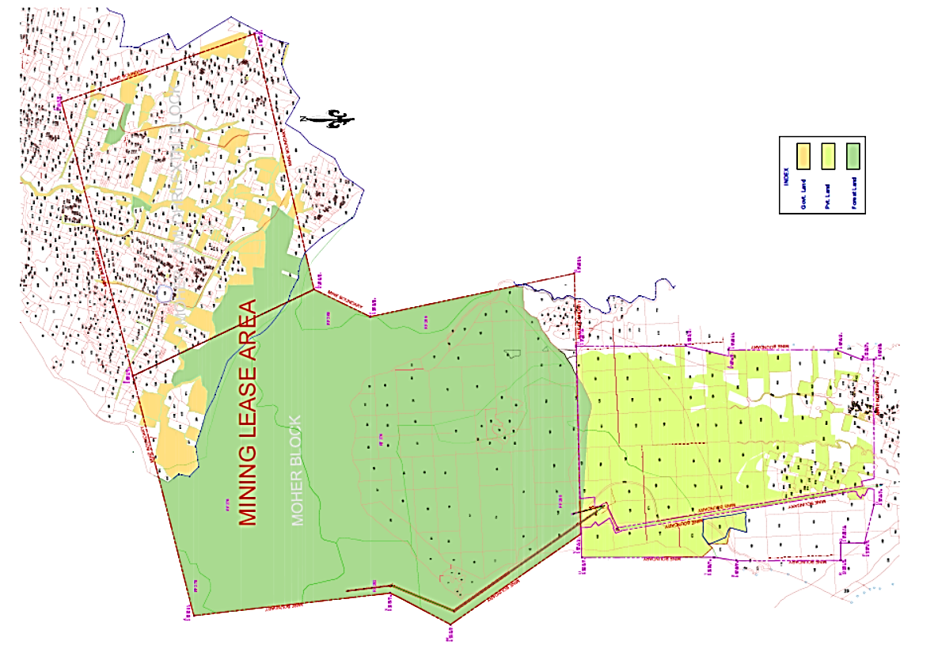

As per information & data provided by the company, out of the total plant & mining area only 1517.56 Ha or 3749.89 acre is mortgaged with the land. Village-wise summary of the same are as follows: -
S. No. | Village | Acquired Land  (Area in Ha) | Govt. Land  (Area in ha) | Total  (Area in ha) | Remarks
1 | Siddhikhurd | 325.17 | 98.42 | 423.59 | Plant Land Area
2 | Siddhi kala | 64.81 | 26.05 | 90.86 | Plant Land Area
3 | Tiyara | 70.33 | 111.20 | 181.53 | Township Land Area
4 | Jhajhi Tola | 9.72 | 3.65 | 13.37 | Ash Dye Land Area
5 | Harrahwa | 235.05 | 81.55 | 316.60 | Ash Dye Land Area
6 | Gadhara Khurd | 7.43 | 0.66 | 8.09 | Conveyer Land Area
7 | Kam | 2.87 | 0.55 | 3.42 | Conveyer Land Area
8 | Hirrawah | 5.74 | 2.88 | 8.62 | Conveyer Land Area
9 | Pachaur | 3.02 | 0.84 | 3.86 | Conveyer Land Area
10 | Bilaujibhatawa | 3.89 | 1.08 | 4.97 | Conveyer Land Area
11 | Dhatura Barwa | 7.11 | 0.36 | 7.47 | Conveyer Land Area
12 | Naugarh | 9.86 | 2.18 | 12.04 | Conveyer & R&R Land Area
13 | Amlori | 8.49 | 54.43 | 62.92 | Mines Land Area
14 | Muher | 250.81 | 129.41 | 380.22 | Mines Land Area
Total |  | 1,004.30 | 513.26 | 1,517.56
Therefore, for the purpose of Valuation we have considered only 1517.56 Ha or 3749.89 acre which is mortgaged with the Bank. Area which is not mortgaged is mostly the core coal mining area. However, Mining area complex other than core mining field is considered under valuation.

PLANT BOUNDARY
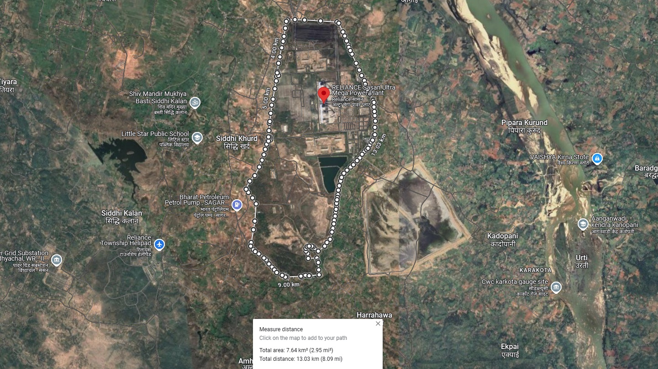
ASH DYKE BOUNDARY
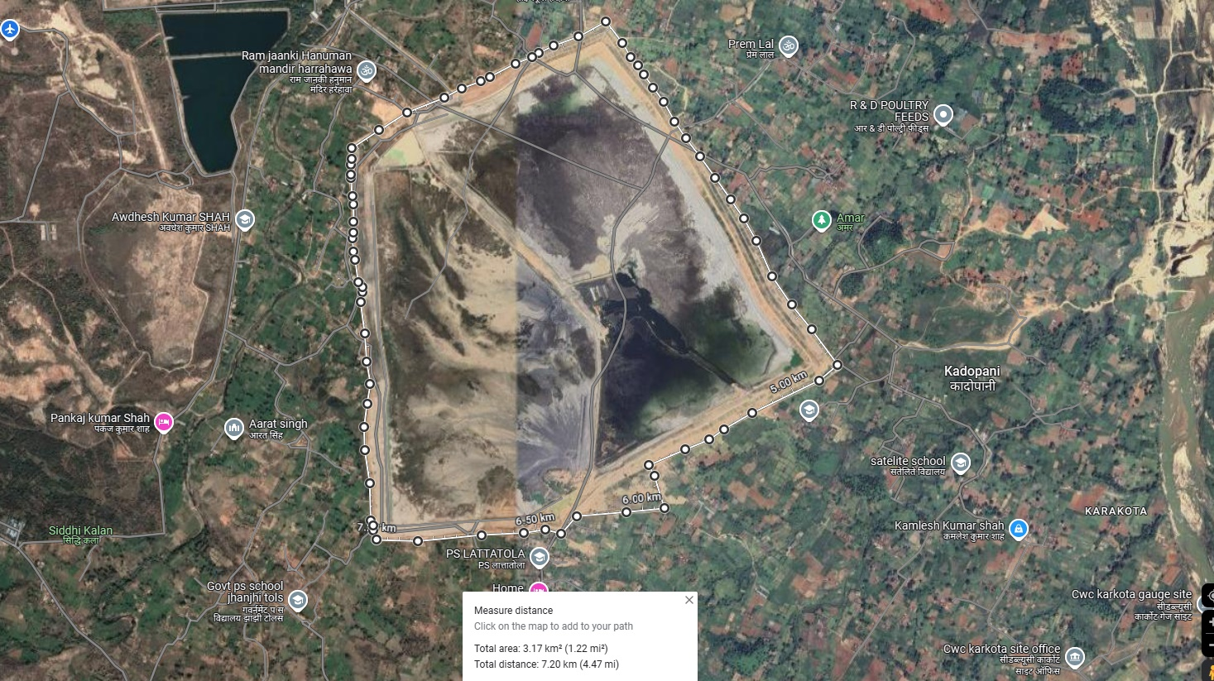

- BUILDING & STRUCTURE AREA:
The plant is divided into various buildings based on their functional utility. These primarily include industrial structures featuring massive steel structural components anchored in RCC (Reinforced Cement Concrete) foundations and clad with heavy-duty corrugated steel sheets. The plant's buildings are constructed using diverse practices, such as GI sheds mounted and clad on prefabricated steel structures, as well as RCC structures. The administration and official blocks are built as RCC-framed structures, with office blocks and the electrical control room equipped with air conditioning. A firefighting system is installed across multiple buildings. Information about the building area statement has been provided by SPL Management and is fully relied upon. Details of Plant, Township, Coal Mines building area and other civil infrastructures are as follows: -

Plant Area
S. No. | Description | Total BUA Area (sqm) | Structure Details | Type of Structure
1 | AHP Compressor Building 1, 2 & 3 | 305 | Single Storied | RCC
2 | AHP Compressor Building 4, 5 & 6 | 305 | Single Storied | RCC
3 | AHP Electric Building | 275 | Single Storied | RCC
4 | AHP Electric Building | 275 | Single Storied | RCC
5 | Ash Slurry Electrical Room | 370 | Single Storied | RCC
6 | Ash Slurry Electrical Room | 370 | Single Storied | RCC
7 | Ash Slurry Pump House 1, 2 & 3 | 220 | Single Storied | RCC
8 | Ash Slurry Pump House 4, 5 & 6 | 220 | Single Storied | RCC
9 | Ash Water Pump House 1, 2 & 3 | 435 | Single Storied | RCC
10 | Ash Water Pump House 4, 5 & 6 | 435 | Single Storied | RCC
11 | CBBY | 2,527 | Single Storied | RCC with sheet roofing
12 | CCR Building | 4,000 | Ground + 2 | RCC
13 | Cement Store Permanent-5 no. | 1,500 | Single Storied | RCC with sheet roofing
14 | Chemical House For AHP | 90 | Single Storied | RCC
15 | CHP Maintenance Building | 500 | Single Storied | RCC with sheet roofing
16 | CHP MCC Room | 1,500 | Ground + 2 | RCC
17 | Clarified Water Pump House | 400 | Single Storied | RCC
18 | Construction Store (5 Nos.) | 3,160 | Single Storied | GI sheet
19 | CPU Regeneration Building 1 | 600 | Single Storied | sheet roofing + RCC
20 | CPU Regeneration Building 2,3,4&5 | 1,475 | Single Storied | sheet roofing + RCC
21 | CPU Regeneration Building 6 | 600 | Single Storied | sheet roofing + RCC
22 | CT Electrical Building1 | 200 | Single Storied | RCC
23 | CT Electrical Building2 | 200 | Single Storied | RCC
24 | CT Electrical Building3 | 200 | Single Storied | RCC
25 | CT Electrical Building4 | 200 | Single Storied | RCC
26 | CT Electrical Building5 | 200 | Single Storied | RCC
27 | CT Electrical Building6 | 200 | Single Storied | RCC
28 | CW Chlorination Plant | 520 | Single Storied | RCC
29 | CW Pump House | 1,650 | Single Storied | RCC
30 | DM Control Building | 960 | Ground + 1 | RCC
31 | Dozer Shed | 210 | Single Storied | RCC with sheet roofing
32 | ESP Control Building 1 | 900 | Ground + 1 | RCC
33 | ESP Control Building 2 | 900 | Ground + 1 | RCC
34 | ESP Control Building 3 | 900 | Ground + 1 | RCC
35 | ESP Control Building 4 | 900 | Ground + 1 | RCC
36 | ESP Control Building 5 | 900 | Ground + 1 | RCC
37 | ESP Control Building 6 | 900 | Ground + 1 | RCC
38 | ETP MCC Room | 115 | Single Storied | RCC
39 | Filtered Water Pump House | 375 | Single Storied | RCC
40 | Fire Station | 375 | Single Storied | RCC
41 | Fire Water Pump House | 1,225 | Single Storied | RCC with sheet roofing
42 | Hydrogen Generation Plant | 450 | Single Storied | RCC with sheet roofing
43 | Intermediate Ash Electrical Room | 35 | Single Storied | RCC
44 | OHC | 300 | Single Storied | RCC
45 | OLC Control Room | 850 | Ground + 1 | RCC
46 | Permanent Store | 5,000 | Ground + 1 | RCC + sheet roofing
47 | Power House Building 1 | 21,800 | Ground + 6 | RCC + sheet roofing at top
48 | Power House Building 2 | 21,800 | Ground + 6 | RCC + sheet roofing at top
49 | Power House Building 3 | 21,800 | Ground + 6 | RCC + sheet roofing at top
50 | Power House Building 4 | 21,800 | Ground + 6 | RCC + sheet roofing at top
51 | Power House Building 5 | 21,800 | Ground + 6 | RCC + sheet roofing at top
52 | Power House Building 6 | 21,800 | Ground + 6 | RCC + sheet roofing at top
53 | Raw Water Pump House | 430 | Single Storied | RCC with sheet roofing
54 | RW Chlorination Plant | 875 | Single Storied | RCC
55 | Service Building | 7,200 | Ground + 3 | RCC
56 | Silo Utility Building | 615 | Single Storied | RCC
57 | Site Office | 2,260 | Single Storied | RCC with sheet roofing
58 | STP | 64 | Single Storied | RCC
59 | Switchyard Control Building 1 | 1,400 | Ground + 1 | RCC
60 | Switchyard Control Building 2 | 380 | Single Storied | RCC
61 | Switchyard Control Building 3 | 85 | Single Storied | RCC
62 | Switchyard Control Building 4 | 85 | Single Storied | RCC
63 | Switchyard Control Building 5 | 85 | Single Storied | RCC
64 | Switchyard Control Building 6 | 85 | Single Storied | RCC
65 | Switchyard Control Building 7 | 315 | Single Storied | RCC
66 | Work Shop Building | 2,550 | Single Storied | RCC with sheet roofing
Total |  | 1,85,456

Mines Area
S. No. | Description | Total BUA Area (sqm) | Type of Structure | Condition
1 | Admin Building | 1,176 | Structural/GI sheet | Good
2 | Admin Canteen Building | 189 | Structural/GI sheet | Good
3 | Canteen Building & Time office / First Aid/ Training Centre | 1,022 | Structural/GI sheet | Good
4 | Canteen cooking area | 48 | RCC | Good
5 | X Ray Room & Pathology room | 63 | RCC | Good
6 | Priest Room | 16 | RCC | Good
7 | Temple | 144 | RCC | Good
8 | Waste Oil Shed 01 | 208 | Structural/GI sheet | Good
9 | Waste Oil Shed 02 | 208 | Structural/GI sheet | Good
10 | Waste Oil Loading Shed | 78 | Structural/GI sheet | Good
11 | Warehouse 1 | 480 | Structural/GI sheet | Good
12 | Warehouse 2 | 480 | Structural/GI sheet | Good
13 | Warehouse 3 | 480 | Structural/GI sheet | Good
14 | Oil shed | 360 | Structural/GI sheet | Good
15 | Store Shed Closed | 8,418 | Structural/GI sheet | Good
16 | Store Shed Open shed | 4,182 | Structural/GI sheet | Good
17 | Store office Building inside store | 30 | RCC | Good
18 | Cold storage room inside store | 30 | RCC | Good
19 | Dumper Dozer Bay (Workshop) | 12,120 | RCC/Structure  RCC  Structural /OPEN | Good
20 | ETP complex of Workshop | 1,058 | RCC/Structure  RCC  Structural /OPEN | Good
21 | Dumper Washing Bay | 550 | RCC/Structure  RCC  Structural /OPEN | Good
22 | Workshop Substation | 468 | RCC | Good
23 | Diesel Dispensing Unit office | 45 | RCC | Good
24 | Diesel Dispensing Unit open tank area | 3,600 | OPEN | Good
25 | LNG Complex | 4,680 | OPEN | Good
26 | LNG Control Room | 18 | RCC | Good
27 | Weigh Bridge Control Room | 27 | RCC | Good
28 | Tyre Shop | 2,116 | Structural/GI sheet | Good
29 | Nitrogen Unit | 84 | Structural/GI sheet | Good
30 | Main Substation Building | 1,296 | RCC | Good
31 | Multiutility Building | 490 | Structural/GI sheet | Good
32 | SRP Control Room | 630 | RCC | Good
33 | South Receiving Pit | 1,632 | RCC | Good
34 | M4C Pent House | 70 | RCC | Good
35 | M4C conveyor | 1,190 | Structural/GI sheet | Good
36 | Reservoir & Pump House | 4,800 | RCC | Good
37 | SRP ETP | 4,250 | RCC/Open | Good
38 | SRP ETP control room | 80 | RCC | Good
39 | Secondary crusher House | 1,332 | RCC | Good
40 | M6C tunnel | 1,070 | RCC | Good
41 | M6C pent House | 70 | RCC  Structural/GI sheet | Good
42 | M6C Conveyor | 872 | RCC  Structural/GI sheet | Good
43 | TH3 | 306 | Structural/GI sheet | Good
44 | M7C | 20,000 | Structural/GI sheet | Good
45 | Drive House | 360 | Structural/GI sheet | Good
46 | TH4 | 456 | Structural/GI sheet | Good
47 | M8C | 460 | Structural/GI sheet  Structural/GI sheet  RCC  Structural/GI sheet  Structural/GI sheet  Structural/Asbestos sheet | Good
48 | TH5 | 208 |  | Good
49 | OLC Substation Building | 500 |  | Good
50 | Bike stand | 400 |  | Good
51 | Bike stand II | 400 |  | Good
52 | ANFO | 1,350 |  | Good
53 | BMD Parking | 144 | Structural/Asbestos sheet | Good
54 | Drivers Rest Room | 20 | RCC | Good
55 | SME Complex | 5,670 | RCC | Good
56 | Chemical room | 480 | Structural/GI sheet | Good
57 | Bailing Shed | 100 | Structural/GI sheet | Good
58 | SME Control room | 260 | RCC | Good
59 | SME Store shed | 144 | Structural/GI sheet | Good
60 | NRP | 4,800 | Structural/GI sheet | Good
61 | Conveyor M1C | 2,000 | Structural/GI sheet | Good
62 | Conveyor M2C | 3,000 | Structural/GI sheet | Good
63 | Conveyor M3C | 7,500 | Structural/GI sheet | Good
64 | TH1 | 329 | Structural/GI sheet | Good
65 | TH2 | 376 | Structural/GI sheet | Good
66 | NRP Substation | 396 | RCC | Good
67 | NRP Reservoir | 1,020 | RCC | Good
68 | Worker lunch Room Main Sub Station | 56 | Structural/GI sheet | Good
69 | Worker lunch Room Blasting | 56 | Structural/GI sheet | Good
70 | Production Office | 360 | Structural/GI sheet | Good
71 | Welding Yard Shed | 99 | Structural/GI sheet | Good
72 | Gen Toilet west of M3C | 12 | RCC | Good
73 | Pump Office with Gen Toilet | 44 | Structural/GI sheet | Good
74 | Fire Office & Barrak | 162 | Structural/GI sheet | Good
75 | Fire Tender Shed | 90 | Structural/GI sheet | Good
76 | Security Office | 110 | RCC | Good
77 | RM 9 Shed | 90 | Structural/GI sheet | Good
78 | RM12 Shed | 90 | Structural/GI sheet | Good
79 | Room at Admin west | 62 | RCC | Good
80 | Shed in SME Area | 60 | Structural/GI sheet | Good
81 | Sheds for RM Substations 4 Nos | 480 | Structural/GI sheet | Good
82 | Sheds for Drivers accommodation | 216 | Structural/GI sheet | Good
83 | Canteen & Gen Toilet for Drivers | 95 | Structural/GI sheet & RCC | Good
84 | Electrical Office at Main SS | 110 | Structural/GI sheet | Good
85 | Shed in Main SS | 100 | Structural/GI sheet | Good
86 | Bus Stop near Open Store | 12 | Structural/GI sheet | Good
87 | Structure for RO Plant | 24 | Structural/GI sheet | Good
88 | Brouser Shed | 15 | Structural/GI sheet | Good
89 | Wash Room for Security | 20 | RCC | Good
90 | Sheds at Bucket Welding Yard | 279 | Structural/GI sheet | Good
91 | ANFO Store-II | 1,343 | Structural/GI sheet | Good
92 | General Toilet for worker at 132 KV SS & Welding Yard | 20 | RCC | Good
93 | Chemical Storage Sheds at SME area | 123 | Structural/GI sheet | Good
94 | Construction of CCTV Monitoring Room at Admin Parking | 22 | Structural/GI sheet | Good
95 | New Sheds at Moher for RM Substation | 125 | Structural/GI sheet | Good
67 | Shed for HEMM Field Workshop at Moher Dumper Parking | 195 | Structural/GI sheet | Good
68 | Central Tool Room at HEMM Shop | 375 | Structural/GI sheet | Good
Total |  | 1,15,683

Township Area
S. No. | Description | Total BUA Area (sqm) | Structure Details | Type of Structure | Condition
1 | A - Block | 2,043 | Ground + 2 | RCC | Good
2 | B - Block | 2,001 | Ground + 2 | RCC | Good
3 | C - Block | 2,001 | Ground + 2 | RCC | Good
4 | D - Block | 2,085 | Ground + 2 | RCC | Good
5 | E Blocks | 13,440 | Ground + 2 | RCC | Good
6 | Canteen + Dining | 1,080 | Single Storied Structure | RCC | Good
7 | OHC | 311 | Single Storied Structure | RCC | Good
8 | Executive Dining | 192 | Single Storied Structure | RCC | Good
9 | Switchyard room | 223 | Single Storied Structure | RCC | Good
10 | F Block-1 (64quarter) | 560 | Ground + 1 | RCC | Good
11 | F Block-2 (64quarter) | 560 | Ground + 1 | RCC | Good
12 | F Block-3 (64quarter) | 560 | Ground + 1 | RCC | Good
13 | F Block-4 (64quarter) | 560 | Ground + 1 | RCC | Good
14 | F Block-5 (64quarter) | 560 | Ground + 1 | RCC | Good
15 | F Block-6 (64quarter) | 560 | Ground + 1 | RCC | Good
16 | F Block-7 (64quarter) | 560 | Ground + 1 | RCC | Good
17 | F Block-8 (64quarter) | 560 | Ground + 1 | RCC | Good
18 | Row Hostel - Block no.1(15 quarter) | 800 | Single Storied Structure | Brick work with sheet roofing | Good
19 | Row Hostel - Block no.2(15 quarter) | 800 | Single Storied Structure | Brick work with sheet roofing  RCC with sheet roofing  RCC | Good
20 | Auditorium | 1,680 | Single Storied Structure | Brick work with sheet roofing  RCC with sheet roofing  RCC | Good
21 | Gym building | 428 | Single Storied Structure | Brick work with sheet roofing  RCC with sheet roofing  RCC | Good
22 | Toilet Complex | 115 | Single Storied Structure | RCC with sheet roofing | Good
23 | Swimming Pool | 2,200 | Total covered area | RCC | Good
24 | Buddha Temple | 472 | Total covered area | RCC | Good
25 | VIP Guest House | 170 | Single Storied | RCC/steel structure with sheet roofing | Good
26 | Pavilion | 800 | Ground + 1 upper floor | RCC/steel structure with sheet roofing | Good
27 | Buddha Canteen | 200 | Single Storied Structure | RCC/steel structure with sheet roofing | Good
28 | Outside temple Canteen | 400 | Single Storied Structure | RCC/steel structure with sheet roofing | Good
Total |  | 35,921

Apart from the above-mentioned building/structures, multiple roads, drain also constructed for the plant. We have been bifurcation area details of same along with its construction type. Details of the same are as follows: -

Road
S. No. | Particulars | Size |  | Area (SQM) | Type of road
S. No. | Particulars | Length (M) | Width (M) | Area (SQM) | Type of road
1 | TH5 To Th3 | 2500 | 7.5 | 18750 | Carpeting / RCC
2 | TH3 to Tyre shop | 100 | 7.5 | 750 | Carpeting
3 | Tyre shop to mine barrier | 100 | 15 | 1500 | WBM
4 | Th3 to Main Substation | 600 | 7.5 | 4500 | Carpeting
5 | Main Substation to CHP area | 580 | 7.5 | 4350 | Carpeting
6 | LNG area & DDU area | 250 | 7.5 | 1875 | Carpeting
7 | Admin Inside | 220 | 4.5 | 990 | Carpeting
8 | Admin to canteen/ temple | 570 | 3.75 | 2137.5 | Carpeting
9 | Admin to store | 520 | 6 | 3120 | Carpeting
10 | Th3 to store | 180 | 7.5 | 1350 | Carpeting
11 | Temple corner to Main Road | 130 | 7.5 | 975 | Carpeting
12 | Th3 to Dumper washing | 220 | 7.5 | 1650 | WBM
13 | Workshop area | 430 | 15 | 6450 | WBM
14 | Main road to SME/ANFO | 870 | 6 | 5220 | Carpeting
15 | Inside SME | 320 | 6 | 1920 | RCC
16 | Conveyor west side | 1700 | 6 | 10200 | WBM
17 | Weighbridge road | 180 | 6 | 1080 | WBM
Total |  |  |  | 66817.5

Boundary Wall
S. No. | Particulars | Length (M) | Type of Boundary
1 | Workshop backside to SME Complete | 2955 | RCC/ Block
2 | West side conveyor SME to Th5 | 1823 | RCC/ Block
3 | TH5 To barrier | 1566 | RCC/ Block
4 | Admin Boundary | 324 | RCC/ Block/Plaster
5 | LNG Boundary | 274 | RCC/ Brick/Plaster
6 | DDU boundary | 260 | RCC/ Block
7 | ANFO | 292 | RCC/ Block/Plaster
Total |  | 7494

Drain
S. No. | Particulars | Length (M) | Type of Structure
1 | TH5 To Th3 both side | 3000 | RRM
2 | TH3 to Tyre shop both side | 200 | RRM
3 | Tyre shop to mine barrier | 100 | RRM
4 | Th3 to Main Substation both side | 1200 | RRM
5 | Main Substation to CHP area both side | 1160 | RRM
6 | LNG area & DDU area | 250 | RCC
7 | Admin Inside | 220 | RCC
8 | Admin to canteen/ temple both side | 1140 | RRM
9 | Admin to store both side | 1040 | RRM
10 | Th3 to store both side | 360 | RRM
11 | RCC drain for Pond | 100 | RCC
12 | RCC drain for Haul Road crossing near SRP | 150 | RCC
13 | Th3 to Dumper washing | 220 | RRM
14 | Workshop area backside to admin | 600 | RRM/ Brick work
15 | Inside SME | 320 | Brick work / RCC
16 | Conveyor west side | 1700 | RRM
17 | Weighbridge road | 180 | RRM
18 | SRP to NRP | 3000 | RRM
19 | Mid pit & NRP Gorbi | 2100 | RRM
20 | West side Conveyor NRP | 1200 | RRM
21 | Grid 18 to dumper washing | 800 | RRM
22 | In Mines near coal stock & other area Misc | 900 | RRM
Total |  | 19940

Note:

- Area measurements considered in the Valuation Report pertaining to Land & Building is adopted from relevant approved documents or actual site measurement whichever is less. All area measurements are on approximate basis only.

- Verification of the area measurement of the property is done based on sample random checking only.

- Area of the large land parcels of more than 2500 sq.mtr or of uneven shape, is taken as per property documents verified with digital survey through google which has been relied upon.

- Drawing Map, design & detailed estimation of the property/ building is out of scope of the Valuation services.

PART F | PROJECT STATUTORY APPROVAL & NOCS DETAILS

S. No. | REQUIRED APPROVALS | APPROVING AUTHORITY | REFERENCE NO./ DATE | STATUS  (Approved/ Applied For/ Pending)
 | Consent to Operate | M.P. Pollution Control Board | Outward No:119384,21/12/2023  Valid till 31-08-2028 | Approved
 | Environment Clearance | Ministry of Environnent, Forest & Climat Change | Via letter no. 30-06-2015 | Approved
 | License to work a Factory | Chief Inspecter Of Factories, M.P. | Licence No : 35/14902/SGN/2m(i)/NH dated 08-12-2023  Valid till : 31-12-2024 | Approved
 | PESO Certificate | Ministry of Commerce & Industry | No. : P/HQ/MP/15/2863 (P293035) dated 01-12-2021  Valid till : 31-12-2026 | Approved
 | Forest Clearance | Ministry of Environnent & Forest | No. J-13011/15/2006-IA-II(T) dated 21-07-2009 | Approved
 | Boiler Registration | Directorate of Boiler, Bhopal | Received for all 06 boilers | Approved

OBSERVATIONS: The project meets preliminary necessary compliance statutory approvals.

PART G | PROCEDURE OF VALUATION ASSESSMENT - LAND & BUILDING AND AESTHETIC WORKS

 | GENERAL INFORMATION
 | Important Dates |  | Date of Inspection of the Property |  |  |  |  |  | Date of Valuation Assessment |  |  |  |  |  | Date of Valuation Report
 |  |  | 14 October 2023 to 16 October 2023 |  |  |  |  |  | 30 October 2023 |  |  |  |  |  | 30 October 2023
 | Client |  | State Bank of India, Overseas Branch, Mumbai, Maharashtra
 | Intended User |  | State Bank of India, Overseas Branch, Mumbai, Maharashtra
 | Intended Use |  | To know the general idea on the market valuation trend of the property as per free market transaction. This report is not intended to cover any other internal mechanism, criteria, considerations of any organization as per their own need, use & purpose.
 | Purpose of Valuation |  | General Value Assessment
 | Scope of the Assessment |  | Non binding opinion on the assessment of Plain Physical Asset Valuation of the property identified to us by the owner or through his representative.
 | Restrictions |  | This report should not be referred for any other purpose, by any other user and for any other date other then as specified above.
 | Manner in which the property is identified |  |  | Done from the name plate displayed on the property
 |  |  |  | Identified by the owner’s representative
 | Is property number/ survey number displayed on the property for proper identification? |  | No.
 | Type of Survey conducted |  | Full survey (inside-out with approximate sample random measurements verification & photographs).
 | ASSESSMENT FACTORS
 | Valuation Standards considered |  | Mix of standards such as IVS and others issued by Indian authorities & institutions and improvised by the RKA internal research team as and where it is felt necessary to derive at a reasonable, logical & scientific approach. In this regard proper basis, approach, working, definitions considered is defined below which may have certain departures to IVS.
 | Nature of the Valuation |  | Fixed Assets Valuation
 | Nature/ Category/ Type/ Classification of Asset under Valuation |  | Nature |  |  |  |  | Category |  |  |  |  |  |  |  |  | Type
 |  |  | LAND & BUILDING, PLANT & MACHINERY & OTHER MISCELLANEOUS FIXED ASSET |  |  |  |  | INDUSTRIAL |  |  |  |  |  |  |  |  | INDUSTRIAL POWER PLANT
 |  |  | Classification |  |  |  |  | Income/ Revenue Generating Asset
 | Type of Valuation (Basis of Valuation as per IVS) |  | Primary Basis |  |  |  |  | Fair Market Value
 |  |  | Secondary Basis |  |  |  |  | On-going concern basis
 | Present market state of the Asset assumed (Premise of Value as per IVS) |  | Under Normal Marketable State
 |  |  | Reason: Asset under free market transaction state
 | Property Use factor |  | Current/ Existing Use |  |  |  |  | Highest & Best Use  (in consonance to surrounding use, zoning and statutory norms) |  |  |  |  |  |  |  |  | Considered for Valuation purpose
 |  |  | Industrial |  |  |  |  | Industrial |  |  |  |  |  |  |  |  | Industrial
 | Legality Aspect Factor |  | Assumed to be fine as per copy of the documents & information produced to us.  However Legal aspects of the property of any nature are out-of-scope of the Valuation Services. In terms of the legality, we have only gone by the documents provided to us in good faith.  Verification of authenticity of documents from originals or cross checking from any Govt. dept. have to be taken care by Legal expert/ Advocate.
 | Class/ Category of the locality |  | Lower Middle Class (Average)
 | Property Physical Factors |  | Shape |  |  |  |  |  |  | Size |  |  |  |  |  | Layout
 |  |  | Irregular |  |  |  |  |  |  | Very Large |  |  |  |  |  | Normal Layout
 | Property Location Category Factor |  | City Categorization |  |  |  | Locality Characteristics |  |  |  |  |  | Property location characteristics |  |  |  |  | Floor Level
 |  |  | Village |  |  |  | Ordinary |  |  |  |  |  | On Wide Road |  |  |  |  | Refer Building details on Page 25
 |  |  | Rural |  |  |  | Normal |  |  |  |  |  | Near to Highway |  |  |  |  | Refer Building details on Page 25
 |  |  |  |  |  |  | Within good village area |  |  |  |  |  | Normal location within locality |  |  |  |  | Refer Building details on Page 25
 |  |  | Property Facing
 |  |  | South Facing
 | Physical Infrastructure availability factors of the locality |  | Water Supply |  |  |  | Sewerage/ sanitation system |  |  |  |  |  | Electricity |  |  |  |  | Road and Public Transport connectivity
 |  |  | Yes |  |  |  | Underground |  |  |  |  |  | Yes |  |  |  |  | Easily available
 |  |  | Availability of other public utilities nearby |  |  |  |  |  |  |  |  |  | Availability of communication facilities
 |  |  | Transport, Market, Hospital etc. are available in close vicinity |  |  |  |  |  |  |  |  |  | Major Telecommunication Service Provider & ISP connections are available
 | Social structure of the area (in terms of population, social stratification, regional origin, age groups, economic levels, location of slums/ squatter settlements nearby, etc.) |  | Medium Income Group
 | Neighbourhood amenities |  | Good
 | Any New Development in surrounding area |  | None |  |  |  |  |  |  |  | ----
 | Any specific advantage/ drawback in the property |  | Near to Coal Mines & Water reservoir which is ideal for any Thermal Power Plant.
 | Property overall usability/ utility Factor |  | Restricted to a particular use
 | Do property has any alternate use? |  | No
 | Is property clearly demarcated by permanent/ temporary boundary on site |  | Yes demarcated properly
 | Is the property merged or colluded with any other property |  | No
 |  |  | Comments: Multiple land merged to form a single property
 | Is independent access available to the property |  | Clear independent access is available
 | Is property clearly possessable upon sale |  | Yes
 | Best Sale procedure to realize maximum Value (in respect to Present market state or premise of the Asset as per point (iv) above) |  | Fair Market Value
 |  |  | Free market transaction at arm's length wherein the parties, after full market survey each acted knowledgeably, prudently and without any compulsion.
 | Hypothetical Sale transaction method assumed for the computation of valuation |  | Fair Market Value
 |  |  | Strategic disinvetsment sale (on-going concern basis)
 | Approach & Method of Valuation Used |  | Land & Building |  | Approach of Valuation |  |  |  |  |  |  |  | Method of Valuation
 |  |  |  |  | Mixture of Market & Cost Approach |  |  |  |  |  |  |  | Market Comparable Sales Method – For Land  Depreciated Replacement Cost Method – For Building
 | Type of Source of Information |  | Level 3 Input (Tertiary)
 | Market Comparable
 | References on prevailing market Rate/ Price trend of the property and Details of the sources from where the information is gathered (from property search sites & local information) |  | 1 |  |  | Name: |  |  |  |  |  |  |  | Mr. Prabhakar Jaiswal
 |  |  |  |  |  | Contact No.: |  |  |  |  |  |  |  | +91 9926393924
 |  |  |  |  |  | Nature of reference: |  |  |  |  |  |  |  | Habitant of subject location
 |  |  |  |  |  | Size of the Property: |  |  |  |  |  |  |  | Not specified
 |  |  |  |  |  | Location: |  |  |  |  |  |  |  | Near the mine area
 |  |  |  |  |  | Rates/ Price informed: |  |  |  |  |  |  |  | Around Rs.1.25 Cr. to 1.50 Cr. per acre
 |  |  |  |  |  | Any other details/ Discussion: |  |  |  |  |  |  |  | As per discussion with the habitant of the locality, such a large land parcel is not available for sale near to the coal mines. However, ongoing land rates on road are in range of Rs. Rs.1.25 Cr. to 1.50 Cr. per acre.
 |  |  | 2 |  |  | Name: |  |  |  |  |  |  |  | Mr. Brijendra Kumar
 |  |  |  |  |  | Contact No.: |  |  |  |  |  |  |  | +91 99263 93922
 |  |  |  |  |  | Nature of reference: |  |  |  |  |  |  |  | Property Consultant
 |  |  |  |  |  | Size of the Property: |  |  |  |  |  |  |  | Not specified
 |  |  |  |  |  | Location: |  |  |  |  |  |  |  | Nearby the plant
 |  |  |  |  |  | Rates/ Price informed: |  |  |  |  |  |  |  | ~Rs. 2.00 Cr. per acre
 |  |  |  |  |  | Any other details/ Discussion: |  |  |  |  |  |  |  | As per discussion with the habitant of the locality, such a large land parcel is not available for sale near to the Sasan Power Plant. However, ongoing land rates near the plant are in range of Rs. Rs.1.75 Cr. per acre.
 |  |  | 3 |  |  | Name: |  |  |  |  |  |  |  | Mr. Saurabh Singh
 |  |  |  |  |  | Contact No.: |  |  |  |  |  |  |  | +91 88893 76934
 |  |  |  |  |  | Nature of reference: |  |  |  |  |  |  |  | Property Consultant
 |  |  |  |  |  | Size of the Property: |  |  |  |  |  |  |  | Not specified
 |  |  |  |  |  | Location: |  |  |  |  |  |  |  | Nearby the township
 |  |  |  |  |  | Rates/ Price informed: |  |  |  |  |  |  |  | Around Rs.0.70 Cr. to 0.80 Cr. per acre
 |  |  |  |  |  | Any other details/ Discussion: |  |  |  |  |  |  |  | As per discussion with the habitant of the locality, such a large land parcel is not available for sale near to the township. However, ongoing land rates near the township are in range of Rs.0.70 Cr. to 0.80 Cr. per acre as it is less populated area.
 | Considered Rates Justification |  | Please refer to detailed land valuation below.
NOTE: We have taken due care to take the information from reliable sources. The given information above can be independently verified from the provided numbers to know its authenticity. However, due to the nature of the information most of the market information came to knowledge is only through verbal discussion with market participants which we have to rely upon where generally there is no written record.

Related postings for similar properties on sale are also annexed with the Report wherever available.
 | Other Market Factors
 | Current Market condition | Normal
 | Current Market condition | Remarks: None
 | Current Market condition | Adjustments (-/+): 0%
 | Comment on Property Salability Outlook | Sellability of this property is related to its current use only and therefore limited only to the selected type of buyers involved in such kind of activities. But Power sector outlook appears to be positive presently.
 | Comment on Property Salability Outlook | Adjustments (-/+): 0%
 | Comment on Demand & Supply in the Market | Demand |  |  |  |  |  |  |  |  |  | Supply
 | Comment on Demand & Supply in the Market | Low |  |  |  |  |  |  |  |  |  | Abundantly available
 | Comment on Demand & Supply in the Market | Remarks: Demand is related to the current use of the property only and only limited to the selected type of buyers
 | Comment on Demand & Supply in the Market | Adjustments (-/+): 0%
 | Any other special consideration | Reason: None
 | Any other special consideration | Adjustments (-/+): 0%
 | Any other aspect which has relevance on the value or marketability of the property | Marketability of this property is directly proportional to industry outlook of the sector.  Valuation of the same asset/property can fetch different values under different circumstances & situations. For eg. Valuation of a running/ operational shop/ hotel/ factory will fetch better value and in case of closed shop/ hotel/ factory it will fetch considerably lower value. Similarly, an asset sold directly by an owner in the open market through free market arm’s length transaction then it will fetch better value and if the same asset/ property is sold by any financer or court decree or Govt. enforcement agency due to any kind of encumbrance on it then it will fetch lower value. Hence before financing, Lender/ FI should take into consideration all such future risks while financing.  This Valuation report is prepared based on the facts of the property & market situation on the date of the survey. It is a well-known fact that the market value of any asset varies with time & socio-economic conditions prevailing in the region/ country. In future property market may go down, property conditions may change or may go worse, property reputation may differ, property vicinity conditions may go down or become worse, property market may change due to impact of Govt. policies or effect of domestic/ world economy, usability prospects of the property may change, etc. Hence before financing, Banker/ FI should take into consideration all such future risk while financing.
 |  | Adjustments (-/+): 0%
 | Final adjusted & weighted Rates considered for the subject property | Refer Valuation below
 | Basis of computation & working
- Specific basis of computation is mentioned in specific asset section.
- Valuation of the asset is done as found on as-is-where basis on the site as identified to us by client/ owner/ owner representative during site inspection by our engineer/s unless otherwise mentioned in the report.
- Analysis and conclusions adopted in the report are limited to the reported assumptions, conditions and information came to our knowledge during the course of the work and based on the Standard Operating Procedures, Best Practices, Caveats, Limitations, Conditions, Remarks, Important Notes, Valuation TOR and definition of different nature of values.
- For knowing comparable market rates, significant discreet local enquiries have been made from our side based on the hypothetical/ virtual representation of ourselves as both buyer and seller for the similar type of properties in the subject location and thereafter based on this information and various factors of the property, rate has been judiciously taken considering the factors of the subject property, market scenario and weighted adjusted comparison with the comparable properties unless otherwise stated.
- References regarding the prevailing market rates and comparable are based on the verbal/ informal/ secondary/ tertiary information which are collected by our team from the local people/ property consultants/ recent deals/ demand-supply/ internet postings are relied upon as may be available or can be fetched within the limited time & resources of the assignment during market survey in the subject location. No written record is generally available for such market information and analysis has to be derived mostly based on the verbal information which has to be relied upon.
- Market Rates are rationally adopted based on the facts of the property which came to our knowledge during the course of the assessment considering many factors like nature of the property, size, location, approach, market situation and trends and comparative analysis with the similar assets. During comparative analysis, valuation metrics is prepared and necessary adjustments are made on the subject asset.
- The indicative value has been suggested based on the prevailing market rates that came to our knowledge during secondary & tertiary market research and is not split into formal & informal payment arrangements. Most of the deals takes place which includes both formal & informal payment components. Deals which take place in complete formal payment component may realize relatively less actual transaction value due to inherent added tax, stamp registration liabilities on the buyer.
- Secondary/ Tertiary costs related to asset transaction like Stamp Duty, Registration charges, Brokerage, Commission, Bank interest, selling cost, Marketing cost, etc. pertaining to the sale/ purchase of this property are not considered while assessing the indicative estimated Market Value.
- This report includes both, Govt. Guideline Value and Indicative Estimated Prospective Market Value as described above. As per the current market practice, in most of the cases, formal transaction takes place for an amount less than the actual transaction amount and rest of the payment is normally done informally.
- Area measurements considered in the Valuation Report pertaining to asset/ property is adopted from relevant approved documents or sample site measurement whichever is less unless otherwise mentioned. All area measurements are on approximate basis only.
- Verification of the area measurement of the property is done based on sample random checking only.
- Area of the large land parcels of more than 2500 sq.mtr or of uneven shape in which there can be practical difficulty in sample measurement, is taken as per property documents which has been relied upon unless otherwise stated.
- Drawing, Map, design & detailed estimation of the property/ building is out of scope of the Valuation services.
- Construction rates are adopted based on the present market replacement cost of construction and calculating applicable depreciation & deterioration factor as per its age, existing condition & specifications based on visual observation only of the structure. No structural, physical tests have been carried out in respect of it. No responsibility is assumed for latent defects of any nature whatsoever, which may affect value, or for any expertise required to disclose such conditions.
- Construction rates are adopted based on the plinth area rates prevailing in the market for the structure as a whole and not based on item wise estimation or Bills of Quantity method unless otherwise stated.
- The condition assessment and the estimation of the residual economic life of the structure are only based on the visual observations and appearance found during the site survey. We have not carried out any structural design or stability study; nor carried out any physical tests to assess structural integrity & strength.
- Any kind of unpaid statutory, utilities, lease, interest or any other pecuniary dues on the asset or on its owners has not been factored in the Valuation.
- This Valuation is conducted based on the macro analysis of the asset/ property considering it in totality and not based on the micro, component or item wise analysis. Analysis done is a general assessment and is neither investigative in nature nor an audit activity.
- Valuation is done for the asset found on as-is-where basis which owner/ owner representative/ client/ bank has shown to us on site of which some reference has been taken from the information/ data given in the copy of documents provided to us which have been relied upon in good faith and we have assumed that it to be true and correct.
 | ASSUMPTIONS
- Documents/ Information/ Data provided by the client/ property owner or his representative both written & verbally is true and correct without any fabrication and has been relied upon in good faith.
- Local verbal enquiries during micro market research came to our knowledge are assumed to be taken on record as true & factual.
- The assets and interests therein have been valued free and clear of any liens or encumbrances unless stated otherwise. No hidden or apparent conditions regarding the subject assets or their ownership are assumed to exist. No opinion of title is rendered in this report and a good title is assumed unless stated otherwise.
- It is assumed that the concerned Lender/ Financial Institution has asked for the valuation of that property after satisfying the authenticity of the documents given to us and for which the legal verification has been already taken and cleared by the competent Advocate before requesting for the Valuation report. I/ We assume no responsibility for the legal matters including, but not limited to, legal or title concerns.
- Payment condition during transaction in the Valuation has been considered on all cash bases which includes both formal & informal payment components as per market trend.
- Sale transaction method of the asset is assumed as Free market transaction without any compulsion unless otherwise mentioned while assessing Indicative & Estimated Fair Prospective Market Value of the asset unless otherwise stated.
 | SPECIAL ASSUMPTIONS
 | Fragmentation sale of a large land may have different values. While assessing the Valuation of the land in this Valuation Report, it is considered as on-is-where basis for the purpose it is used for which was found at the time of site survey.
 | LIMITATIONS
 | It is just fixed asset valuation not an enterprise valuation. This report doesn’t cover any prospective sale value of the Power Plant as a whole which is based on the income approach and cash flows of the business.

3. | LAND VALUATION ASSESSMENT

- LAND AREA:
The Valuation of mortgaged land is carried out in this section of the report, which belongs to Sasan Power Limited (SPL).
As per land area statement & IOM shared by the company, total mortgaged land area at different locations is about 1517.56 Hectare:
S. No. | Village | Land  (Area in Ha) | Remarks
1 | Siddhikhurd | 423.59 | Plant Land Area
2 | Siddhi kala | 90.86 | Plant Land Area
3 | Tiyara | 181.53 | Township Land Area
4 | Jhajhi Tola | 13.37 | Ash Dye Land Area
5 | Harrahwa | 316.60 | Ash Dye Land Area
6 | Gadahrakhurd | 8.09 | Conveyer Land Area
7 | Kam | 3.42 | Conveyer Land Area
8 | Hirrawah | 8.62 | Conveyer Land Area
9 | Pachaur | 3.86 | Conveyer Land Area
10 | Bilaujibhatawa | 4.97 | Conveyer Land Area
11 | Dhatura barwa | 7.47 | Conveyer Land Area
12 | Naugarh | 12.04 | Conveyer & R&R Land Area
13 | Amlori | 62.92 | Mines Land Area
14 | Muher | 380.22 | Mines Land Area

- METHODOLOGY ADOPTED:
In this Valuation assessment, the land value is considered based on the Power Project Land only as its best use since the transaction of this land will always remain closely associated with the Project only and separation of it from the Project will be virtually impossible at least up to the complete economic life cycle of this Plant which will be around 25 to 30 years.
For acquiring such a vast land parcel for Industrial use, one will go to the Govt. or purchase the land privately. In present day scenario purchasing such a vast land parcel is a highly tedious task. If the Govt. would be already having this much of land parcel acquired previously then it will allot through its Industrial Authority or in case such a vast land parcel is not available on the desired location then it will acquire it through land acquisition policy. In land acquisition policy, the rates will vary based on the circle rates or the comparable market rates presently going on in that area.
In the subject case 34% of the land is acquired by the Govt. and allotted to the Project. Generally, also in such kind of Projects, mostly it is acquired by the Govt. and allotted to the Project.
Since the land area is very vast therefore, in the subject case, Land Value assessment is done based on the Land Acquisition Rehabilitation and Resettlement (LARR) Policy approach prescribed by the Govt. prevailing at the time of survey.
Fragmentation sale of a large land may have different values. While assessing the Valuation of the land in this Valuation Report, it is considered on as-is-where-is basis for the purpose it is being used as found at the time of site survey.
Government Guideline Value: The government Guideline Rates of the land is described by Odisha Government and Guideline Value is shown below:
 |  | In Rs. Per Hectare
S. No. | Village |  | Land Area  (In Ha) | Industrial Guideline Land rate | Guideline Land Value (In Rs.)
1 | Siddhikhurd |  | 423.59 | 2,40,00,000 | 1016,61,60,000
2 | Siddhi kala |  | 90.86 | 2,65,00,000 | 240,77,90,000
3 | Tiyara |  | 181.53 | 2,65,00,000 | 481,05,45,000
4 | Jhajhi Tola |  | 13.37 | 1,21,00,000 | 16,17,77,000
5 | Harrahwa |  | 316.60 | 1,30,00,000 | 411,58,00,000
6 | Gadahrakhurd |  | 8.09 | 2,31,00,000 | 18,68,79,000
7 | Kam |  | 3.42 | 2,59,00,000 | 8,85,78,000
8 | Hirrawah |  | 8.62 | 1,30,00,000 | 11,20,60,000
9 | Pachaur |  | 3.86 | 1,43,00,000 | 5,51,98,000
10 | Bilaujibhatawa |  | 4.97 | 1,57,00,000 | 7,80,29,000
11 | Dhatura barwa |  | 7.47 | 1,57,00,000 | 11,72,79,000
12 | Naugarh |  | 12.04 | 90,00,000 | 10,83,60,000
13 | Amlori |  | 62.92 | 1,50,00,000 | 94,38,45,000
14 | Muher |  | 380.22 | 2,63,00,000 | 999,97,86,000
Total |  |  | 1517.56 |  | 3335,20,86,000
Source:https://www.mpigr.gov.in/igrs_cms_api/api/website/download?filePath=pdf/GuideLineReport2024-25/2024-2025_C_Singroli_HI.pdf
Fair Market Value: Market Value of this Project land would be the value which any new promoters’ company will be spending the amount in procuring the equal measurement of the land parcel if it wants to setup a similar plant today at the same or similar location.
Purchase and congregation of such a large land parcel is a difficult task and can be done only through acquisition and purchase of individual land parcels which is nearly impossible job to do by individual negotiation.
The subject land parcels fall under ‘Angul division’ and are mostly tribal land which can’t be sold or purchase to non-tribal. Therefore, for any Industrial purpose the only way to acquire such lands is RFCTLAR&R Act- 2013 and accordingly the State & District administration acquires the individual land/ plots.
Since for the Industrial development, the land in this area can be acquired only through land acquisition act and which will be applicable to any person, therefore for the purpose of assessing the Market Value of this Project land it is assessed based on the Land acquisition Policy prevailing in the area.
In the procedure of assessment following points are taken into consideration after making rational factors of adjustment on it based on situation & condition of the land:
- As per market research and analysis conducted during site survey, it was observed that the land rates near to the Sasan Power plant, Township area have been increased significantly. Land rates on the road which is connected to power plant is having higher land rates than that of the other land. The ongoing market land rates in the locality are in range of Rs. 1.50 Cr. to Rs. 2.50 Cr. per acre depending upon shape, size, locality, frontage and distance from the power plant & population etc.
- As per the discussion during the site survey, we came to know that if any new promoter has to come for the development of such kind of project, then they have to apply to Local District Administration for the acquisition of desired land area. After that Local District Administration will notify the land under RFCTLAR&R Act- 2013 and acquire the land from the local villagers after doing proper social impact assessment of the respective village land.
- Normally now a days, for the acquisition of such large size of land parcel for development of the similar large infrastructure project at any location one goes through the land acquisition policy prescribed by the Govt. Hence, for the Valuation assessment of the subject project land, we have considered Land Acquisition Rehabilitation and Resettlement Act- 2013 of the state.
- For the valuation assessment, we have taken Guideline Rates as notified by M.P. Government as mentioned above as the base rate for computing the valuation based on RFCTLAR&R Act- 2013.
- As per the Right to Fair Compensation & Transparency in Land Acquisition, Rehabilitation and Resettlement Act, 2013, market value is considered twice the prescribed Govt. Guidelines rates.
- As per the Right to Fair Compensation & Transparency in Land Acquisition, Rehabilitation and Resettlement Act, 2013, additional 100% Solatium is added on the total cost of the land calculated.
- Additional market value on cost of land @12% per year for two years is considered. As shown below: -
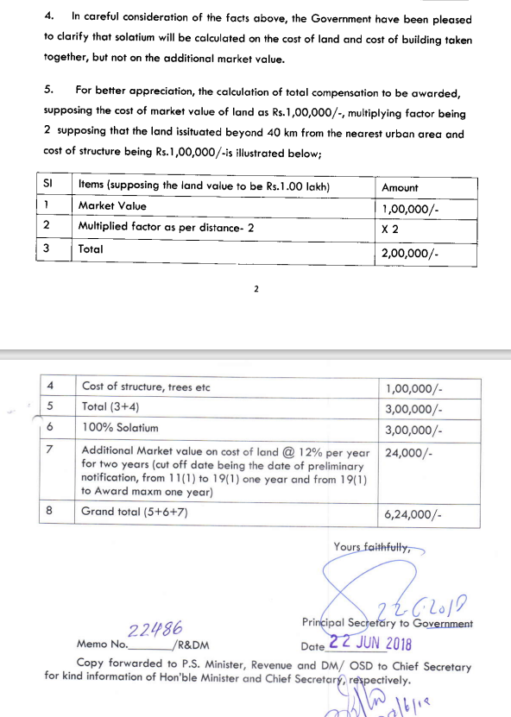
VALUATION via RFCTLAR&R Act- 2013
Village | Area  (in Acres) | Circle Rate for Irrigated Land (in INR per acre) | Total Value of Land  (in INR)
Siddhikhurd | 423.59 | 56,61,800 | 239,82,81,862
Siddhi kala | 90.86 | 41,17,700 | 37,41,34,222
Tiyara | 181.53 | 41,56,000 | 75,44,38,680
Jhajhi Tola | 13.37 | 25,34,600 | 3,38,87,602
Harrahwa | 316.60 | 25,08,000 | 79,40,32,800
Gadahrakhurd | 8.09 | 32,95,600 | 2,66,61,404
Kam | 3.42 | 45,98,000 | 1,57,25,160
Hirrawah | 8.62 | 25,08,000 | 2,16,18,960
Pachaur | 3.86 | 17,87,700 | 69,00,522
Bilaujibhatawa | 4.97 | 49,40,000 | 2,45,51,800
Dhatura barwa | 7.47 | 53,60,000 | 4,00,39,200
Naugarh | 12.04 | 8,31,000 | 1,00,05,240
Amlori | 62.92 | 18,35,000 | 11,54,63,705
Muher | 380.22 | 43,09,000 | 163,83,67,980
Total (A) | 1,517.56 |  | 625,41,09,137
Multiplying Factor as per Distance (B) |  | 2 x A | 12,50,82,18,274
Value of Assets attached to land or building (C) |  |  | -
Total (D=B+C) |  |  | 1250,82,18,274
Add Solatium (100%) (E) |  | 100% of D | 1250,82,18,274
Total Award Value (F=D+E) |  |  | 2501,64,36,548
Additional value on cost of land (G) |  | 12% of D | 3,00,19,72,386
Total Value (H=F+G) |  |  | 2801,84,08,934

- CALCULATION OF LAND VALUE:
The Fair Market Value of the land has been calculated as described below:
VALUATION
Particulars | Total Value of Land  (in INR)
Land Value via RFCTLAR&R Act- 2013 | 2801,84,08,934
Land Value considering Industrial Circle Rate | 3335,20,86,000
Land Value considering Market Land Rate | 3035,12,60,000
Fair Market Value of Mortgaged land (1517.56 Ha) (Average of all three values) | 3057,39,18,311
Notes: -
- Final value of the project land has been reached through taking average of the values assessed by land acquisition policy, circle rate value & Market Approach.

Based on the above calculation the Fair Market Value of Land is calculated as Rs. 3057,39,18,311 Crore.

BUILDING & CIVIL INFRASTRUCTURE VALUATION ASSESSMENT

- METHODOLOGY ADOPTED: The fair market value of the building as on the date of valuation is its cost of reproduction on that date less the depreciation & other deterioration deductions from the date of completion of the buildings to the date of its valuation.
- Valuation assessment has been conducted of the building & civil works that has been capitalized in the books/ FAR of the company.
- The main heads considered in this part of valuation are Plant Building, Township, Roads, Site Development, Boundary Wall, Drains etc.
- We have only considered the Buildings for the Valuation which is under the buildings head in the Fixed Asset Register provided to us. Building name mentioned in FAR and as used in actual on site and as per Building area sheet provided to us nomenclature used in both source of information is different. Therefore, matching both the information is not possible. In FAR the total gross block shown under building head is Rs. 718.01 Cr. for all buildings/structures in the plant.
- Therefore, to avoid duplicity we have considered cost capitalized in FAR against each building as the sole basis of the valuation calculation and the buildings and civil works mentioned in the FAR are taken as it is.
- For the veracity of capitalized cost of Building ibn FAR, we have also cross-checked the per sq.ft. construction of building/structures which appears to within the market standards & cost prescribed by the CPWD except few buildings such as Service Building and CCR which are very heavy buildings due to its use. However overall cost of Building seems to be reasonable.
- For estimating Replacement cost, WPI index of the Civil Structures/ works is calculated based on the major item wise cost inflation calculation for specific year. Other methods which could be used is CPWD plinth area rate or Construction cost inflation index issued by Construction Industry Development Council. However, for each year CPWD rates are not prescribed and CCI is not available post December 2019 on their website. Therefore, out of all the available data. Material wise WPI index is applied to reach to more accurate replacement cost.
- The weighted average indices have been taken for different components as depicted below to find out the inflation of the complete assets mentioned in the FAR from their respective date of capitalization till the date of valuation.

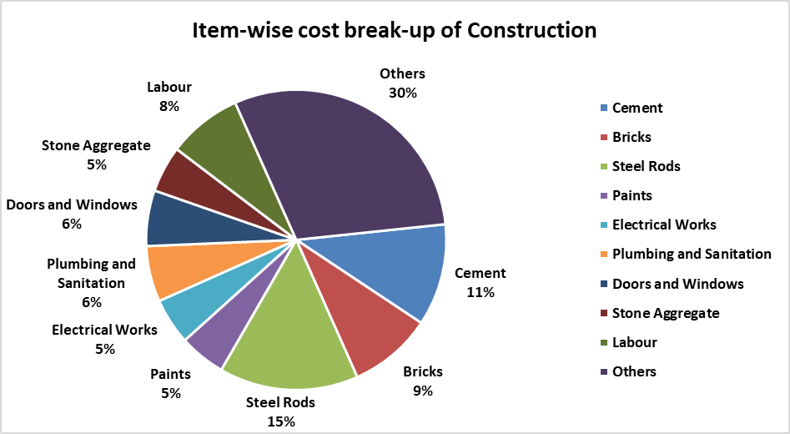
- The head ‘Others’ comprises Layout and Excavation, Flooring, Design and Fee for Engineer/ Architect, Soil, Water, Shuttering/ formwork, Borewell, Sand, etc. Inflation of these components has been taken approx. 4% per Year as per market trend for such services.
- The above bifurcation also includes a Labour component which constitutes approx. 8% of the total construction cost. Inflation of this component has been taken as per Cost Inflation Index (CII).
- The weighted average inflation has been applied on the Gross Block mentioned in the FAR to reach the Gross Current Reproduction Cost.
- Depreciation is then charged on the structures/civil works to reach at the depreciated replacement cost or Fair value, considering the life to be 05-45 years to absorb their respective economic life.
- The economic life of the RCC building & PEB Steel structure is considered as 35-45 years, which are more than the economic life of the plant as it is assumed that the plant shall still remain ongoing concern/ operative even after its core economic life after getting major overhauling, retrofitting, etc. and its utility shall be intact. For other structures such as roads, culverts the economic life is taken as per industry trend.
- Condition of the buildings and structures was found to be good during the site visit.
- The buildings in the plant comprises Service building, Township, CCR building, Store shed, Workshop, SME Plant, Canteen etc. etc.
- For detailed break-up of the buildings capitalized in the FAR, please refer Building sheet.

BUILDINGS & CIVIL WORKS VALUATION: Below table shows the Cost of Capitalization under Buildings head which is extracted from the Fixed Asset Register dated 31-03-2024 provided to us by the company & their valuation as on date:
In Rs. Cr.
As per SPL as on 31-03-2024 |  |  |  | As per RKA as on 25-11-2024
S. No. | Particulars | Gross Block | Net Block | Gross Current Replacement Cost | Depreciated Replacement Cost
1 | Building & other infrastructure | 718.01 | 418.12 | 1,044.02 | 539.18
Total |  | 718.01 | 418.12 | 1,044.02 | 539.18
Notes:
      - All the details related to the buildings and civil work has been provided by Company and all the details are relied upon for the assessment.
      - The economic life of the RCC building & PEB Steel structure is considered as 25-35 years, which are more than the economic life of the plant as it is assumed that the plant shall still remain ongoing concern/ operative even after its core economic life after getting major overhauling, retrofitting, etc. and its utility shall be intact. For other structures such as roads, culverts the economic life is taken as per industry trend.
      - As on date of site visit, the physical condition of plant building was fair and there was not physical deterioration was observed.

PART H | CHARACTERISTICS DESCRIPTION OF PLANT/ MACHINERY

S.NO. | CONTENTS | DESCRIPTION
 | TECHNICAL DESCRIPTION OF THE PLANT/ MACHINERY
 | Nature of Plant & Machinery |  | Power, Super-critical Thermal Power Plant
 | Size of the Plant |  | - Ultra Large scale Plant
 | Type of the Plant |  | - Fully Automatic
 | Year of Installation/ Commissioning/ COD (Commercial Operation Date) |  | - Unit-1: 14th August 2013  - Unit-2: 28th January 2014  - Unit-3: 12th April 2014  - Unit-4: 27th May 2014  - Unit-5: 26th January 2014  - Unit-6: 27th March 2015
 | Production Capacity |  | - 6x660 MW  Total: 3960 MW
 | Capacity at which Plant was running at the time of Survey |  | ~95.00% PLF
 | Number of Production Lines |  | Total 06 no. of units
 | Condition of Machines |  | Good.
 | Status of the Plant |  | Fully operational
 | Products Manufactured in this Plant |  | Power/ Electricity [PPA with 14 nos. of DISCOMs, refer Part-C of the Report)
 | Recent maintenance carried out on |  | Normal operational repair & maintenance is ongoing. However, details of recent maintenance are not shared with us.
 | Recent upgradation, improvements if done any |  | None
 | Total Gross Block & Net Block of Assets |  | As on 31st March 2024
S. No. | Particular | Gross Block  (In ₹ Crore) | Net Block  (In ₹ Crore)
1 | Plant & Equipment | 29,338.81 | 18,341.48
2 | Furniture & Fixtures | 19.02 | 1.73
3 | Motor Vehicles | 4.12 | 1.93
4 | Office Equipment | 7.99 | 2.22
5 | Computers | 5.14 | 2.18
6 | Computer software | 1.12 | 0.15
Total |  | 29,376.20 | 18,349.68

 | Any other Details if any |  | None
 | MANUFACTURING PROCESS
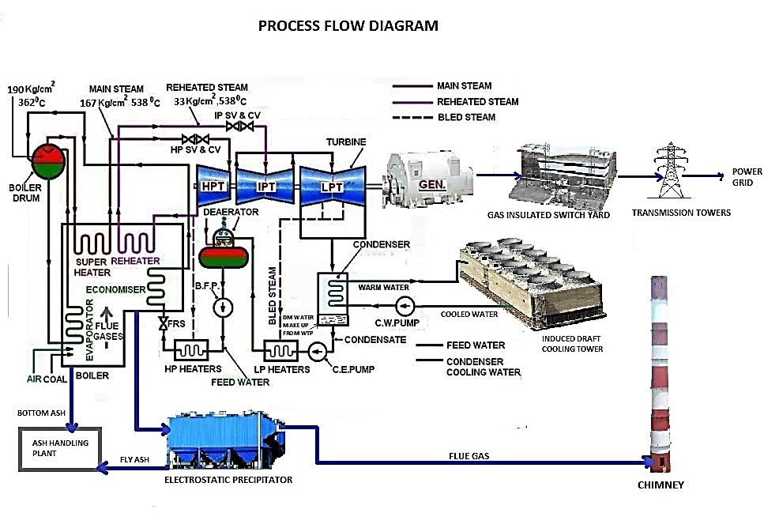
- First, the pulverized coal is burnt into the furnace of the steam boiler or is powered by gas.
- High pressure steam is produced in the boiler.
- This Steam is then passed through the super heater, where it is further heated up.
- This heated steam is then entered into a turbine at high speed.
- In the turbine, this steam at high pressure rotates the turbine blades i.e., the potential energy of the high-pressured steam is converted into mechanical energy.
- After rotating the turbine blades, the Steam loses its high pressure, passes out of turbine blades and enters into a condenser.
- In the condenser the cold water is circulated with the help of a pump which condenses the low-pressure wet steam.
- This condensed water is then further supplied to low pressure steam increases the temperature of this feed water; it is then again heated in a high-pressure heater where the high pressure of steam is used for heating.
- The turbine in a thermal power station acts as a prime mover of the alternator.
 | INDIAN POWER SECTOR
- Economic and Sector Outlook
Indian power sector is undergoing a significant change that has redefined the industry outlook. Sustained economic growth continues to drive electricity demand in India. In last 10 years India has continuously maintained GDP growth rate in the range of 5.5% to 8%. Graphical representation of Indian Thermal/Coal Power outlook are as follows: -

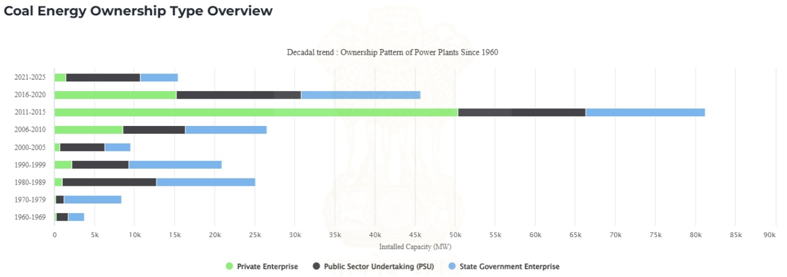
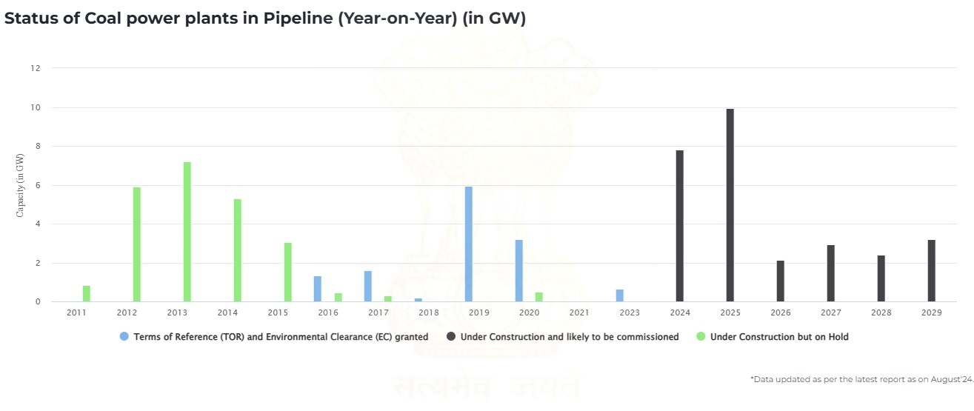
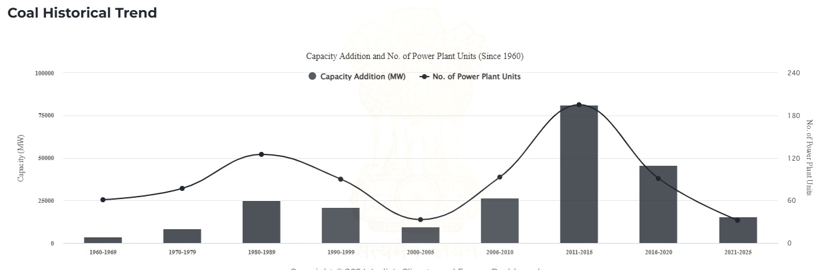
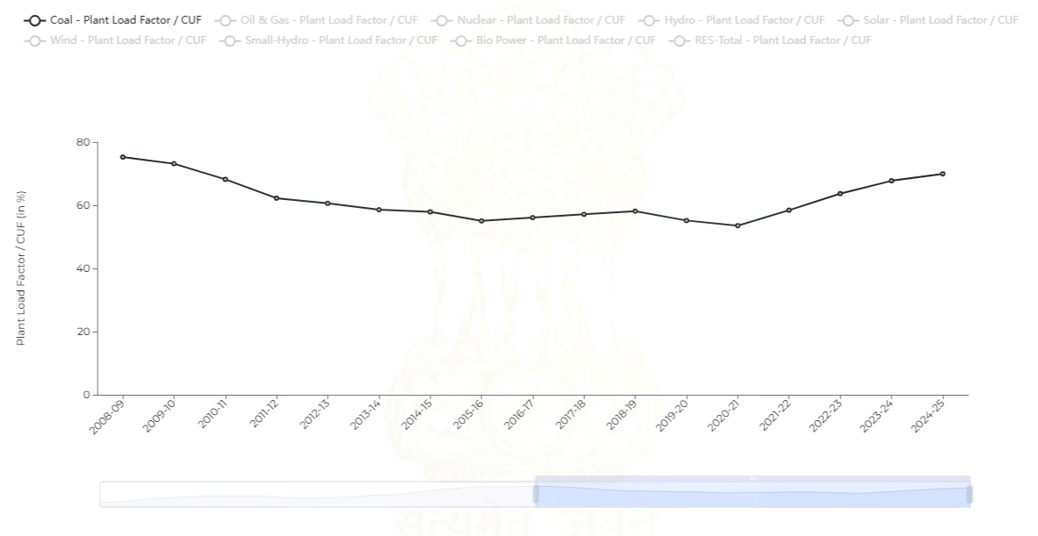
- Growth in power generation:
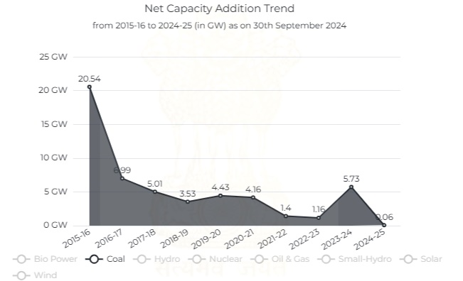

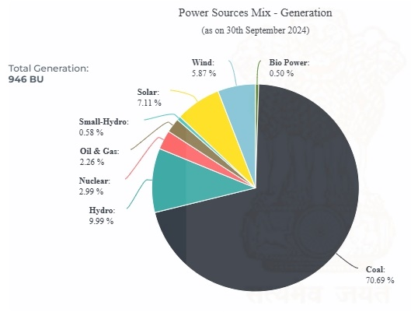 | 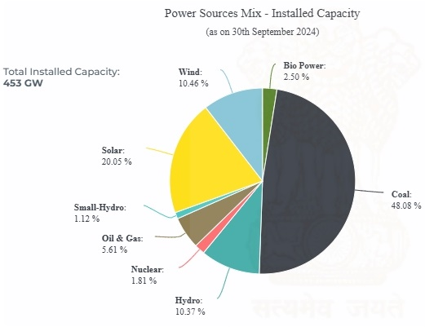
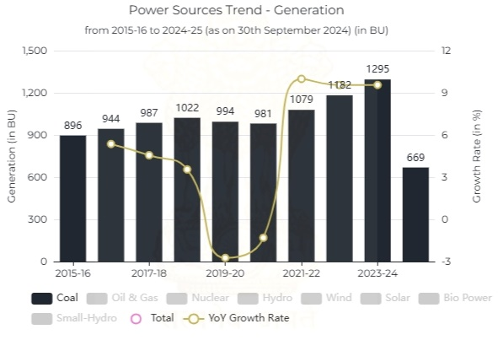 | 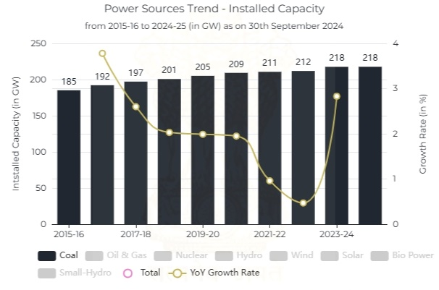

- India Power Supply & Demand Review
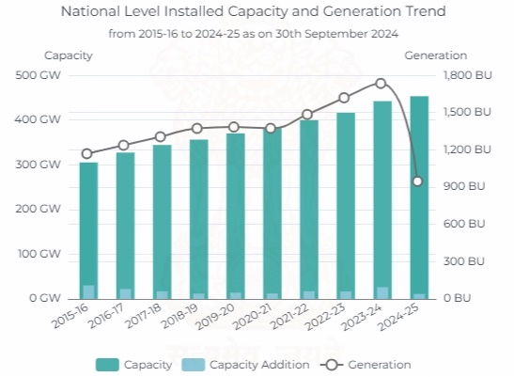 | 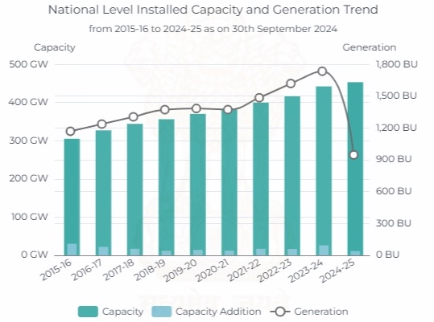

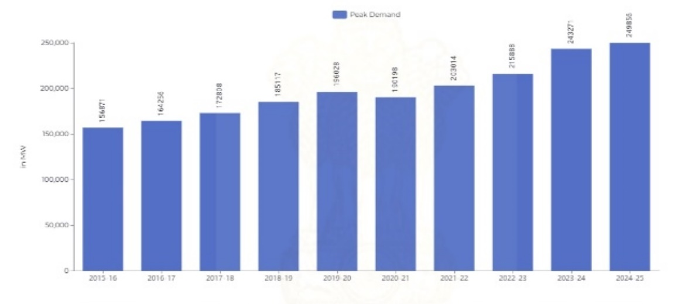
- Sector Challenges
The Indian power sector is under considerable stress. The respective state DISCOMS have generally shied away from signing long term PPAs for thermal power plants thereby severely impacting the visibility of cash flows of plants with significant untied capacity. Some of the major challenges area as follows: -
- Underutilized manufacturing capacity.
- Implementation of the new environmental norms leading to retirements of units.
- Large scale disposal of energy storage devices like batteries.
- Adequate balancing capacity, steep ramping requirement.
- Low PLF and flexible operation of the Thermal Plants.
 | PLANT LOAD FACTOR FOR THE PAST FIVE YEARS (Quarter-wise)
 | 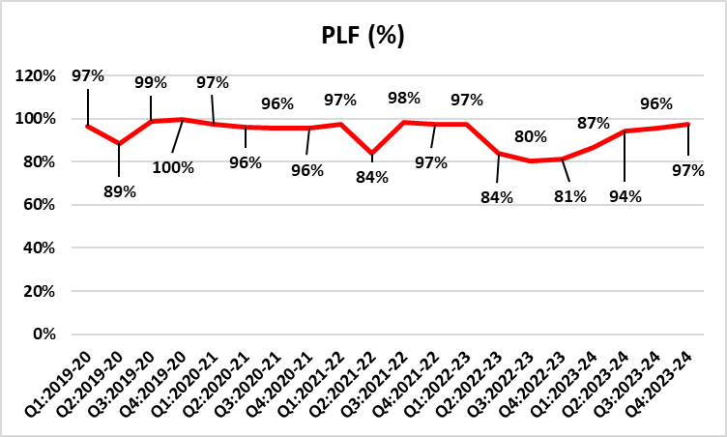
 | TECHNOLOGY TYPE/ GENERATION USED AND TECHNOLOGICAL COLLABORATIONS IF ANY
 | - Technology Type/ Generation Used in this Plant | It is based on Super Critical technology
 | Technological Collaborations If Any | - Yes, Technical Collaboration & Machine help for maintenance purpose with OEM & its supplier.
 | Current Technology used for this Industry in Market | - Ultra Super Critical technology
 | RAW MATERIALS REQUIRED & AVAILABILITY
 | Type of Raw Material | Coal and Water
 | Availability | - Coal is sourced from Moher and Moher Amlorhi Captive Coal Mines.  - Water is sourced from Govind Ballabh Pant Sagar Reservoir
 | AVAILABILITY & STATUS OF UTILITIES
 | Power/ Electricity | Auxiliary power from power plant itself
 | Water | Available from Govind Ballabh Pant Sagar Reservoir
 | Road/ Transport | Available
 | COMMENT ON AVAILABILITY OF LABOUR
 | Availability | Appears to be easily & adequately available and no labour issues came to our knowledge during site inspection.
 | Number of Labours working in the Plant | More than 1000 manpower
 | SALES TRANSACTIONAL PROSPECTS OF SUCH PLANTS/ MACHINERY
 | Strategic Sale as part of the ongoing concern company.
 | Reason: This is a Large Scale Plant and can only be sold only as an Integrated Industry to preserve its value since complete process line & machines are special purpose machines and can't be used in any other Industry. So, for fetching maximum value is through strategic sale to the players who are already into same or similar Industry who have plans for expansion or any large conglomefrate who plans to enter into this new Industry is through strategic sale to the players who are already into same or similar Industry who have plans for expansion or any large conglomefrate who plans to enter into this new Industry
 | DEMAND OF SUCH PLANT & MACHINERY IN THE MARKET
 | Appears to be good as per general information available in public domain. Power demand is increasing in India and therefore Power sector has good growth outlook in future. Presently India is dependent on Coal based Thermal Power Plant for meeting its peak demand.
 | SURVEY DETAILS
 | Plant has been surveyed by our Engineering Team From 25 September 2024 to 27 September 2024
 | Site inspection was done by our team members Er. Dhawal Vanjari and Er. Anit Bhanji in the presence of Company's Employee Mr. Mantu Ghosh and other respective in-charge of the plant who were available from the company to furnish any specific detail about the tangible assets.
 | Our team examined & verified the machines and utilities from the FAR provided by the Company. Only major machinery, process line & equipment has been verified.
 | Photographs have also been taken of all the Machines and its accessories installed there.
 | Plant was found fully operational at the time of survey.
 | Details have been cross checked as per the documents provided to us by the company and what was observed at the site.
 | Condition of the machines is checked through visual observation only. No technical/ mechanical/ operational testing has been carried out to ascertain the condition and efficiency of machines.
 | Site Survey has been carried out on the basis of the physical existence of the assets rather than their technical expediency.
 | As per the overall site visit summary, Plant appeared to be in good condition.

PART I | PROCEDURE OF VALUATION ASSESMENT – PLANT & MACHINERY

 | GENERAL INFORMATION
 | Important Dates | Date of Inspection of the Property |  | Date of Valuation Assessment | Date of Valuation Report
 | Important Dates | From 25 September 2024 to 27 September 2024 |  | 25 November 2024 | 25 November 2024
 | Client | State Bank of India, Overseas Branch, Mumbai, Maharashtra
 | Intended User | State Bank of India, Overseas Branch, Mumbai, Maharashtra
 | Intended Use | To know the general idea on the market valuation trend of the property as per free market transaction. This report is not intended to cover any other internal mechanism, criteria, and considerations of any organization as per their own need, use & purpose.
 | Purpose of Valuation | For Periodic Re-valuation of the mortgaged property
 | Scope of the Assessment | Non binding opinion on the assessment of Plain Physical Asset Valuation of the property identified to us by the owner or through his representative.
 | Restrictions | This report should not be referred for any other purpose, by any other user and for any other date other then as specified above.
 | Identification of the Assets |  | Cross checked from the name of the machines mentioned in the FAR/ Inventory list name plate displayed on the machine
 | Identification of the Assets |  | Identified by the company's representative
 | Identification of the Assets |  | Due to large number of machines/ inventories, only major production lines & machines have been checked
 | Is property number/ survey number displayed on the property for proper identification? | No.
 | Type of Survey conducted | Full survey (inside-out with approximate sample random measurements verification & photographs).
 | ASSESSMENT FACTORS
 | Valuation Standards considered | Mix of standards such as IVS and others issued by Indian authorities & institutions and improvised by the RKA internal research team as and where it is felt necessary to derive at a reasonable, logical & scientific approach. In this regard proper basis, approach, working, definitions considered is defined below which may have certain departures to IVS.
 | Nature of the Valuation | Fixed Assets Valuation
 | Nature/ Category/ Type/ Classification of Asset under Valuation | Nature |  |  | Category |  |  | Type
 |  | PLANT & MACHINERY |  |  | INDUSTRIAL |  |  | INDUSTRIAL PLANT & MACHINERY
 |  | Classification |  |  | Only business use asset
 | Type of Valuation (Basis of Valuation as per IVS) | Primary Basis |  | Fair Market Value
 | Type of Valuation (Basis of Valuation as per IVS) | Secondary Basis |  | On-going concern basis
 | Present market state of the Asset assumed (Premise of Value as per IVS) | Under Normal Marketable State
 |  | Reason: Asset under free market transaction state
 | Physical Infrastructure availability factors of the locality | Water Supply | Sewerage/ sanitation system |  |  |  | Electricity |  | Road and Public Transport connectivity
 | Physical Infrastructure availability factors of the locality | Yes | Underground |  |  |  | Yes |  | Easily available
 | Physical Infrastructure availability factors of the locality | Availability of other public utilities nearby |  |  |  |  | Availability of communication facilities
 | Physical Infrastructure availability factors of the locality | Transport, Market, Hospital etc. are available in close vicinity |  |  |  |  | Major Telecommunication Service Provider & ISP connections are available
 | Neighbourhood amenities | Good
 | Any New Development in surrounding area | None |  |  |  | ---
 | Any specific advantage/ drawback in the plant and machines | - Near to Coal Mines  - Plant having its own captive mines  - Near to Water Reservoir  - Having long term PAA
 | Machines overall usability/ utility Factor | High utility
 | Best Sale procedure to realize maximum Value (in respect to Present market state or premise of the Asset as per point (iv) above) | Fair Market Value
 |  | Free market transaction at arm's length wherein the parties, after full market survey each acted knowledgeably, prudently and without any compulsion.
 | Hypothetical Sale transaction method assumed for the computation of valuation | Fair Market Value
 |  | Free market transaction at arm's length wherein the parties, after full market survey each acted knowledgeably, prudently and without any compulsion.
 | Approach & Method of Valuation Used | Approach of Valuation |  |  |  |  | Method of Valuation
 | Approach & Method of Valuation Used | Cost Approach & Market Approach |  |  |  |  | Depreciated Reproduction Cost Method
 | Type of Source of Information | Level 3 Input (Tertiary)
 | Any other aspect which has relevance on the value or marketability of the machines | The marketability for the machines depends upon the industry outlook, make, market condition, raw material, maintenance, raw material, usability, capacity.  This Valuation report is prepared based on the facts of the assets & market situation on the date of the survey. It is a well-known fact that the market value of any asset varies with time & socio-economic conditions prevailing in the region/ country. In future assets market may go down, asset conditions may change or may go worse, plant vicinity conditions may go down or become worse, plant market may change due to impact of Govt. policies or effect of domestic/ world economy, usability prospects of the Plant may change, etc. Hence before financing, Banker/ FI should take into consideration all such future risk while financing.
 | Basis of computation & working
Main Basis:

- Basic Methodology: For arriving at fair market value of P&M & other fixed assets our engineering team has rationally applied the mixture of ‘sales comparison approach (market approach)’ and the ‘cost approach (depreciated replacement cost)’. The fair market value of Plant & Machinery on the date of valuation is its cost of reproduction & commissioning on that date less the depreciation & other deterioration deductions (Technological, Economic, Functional obsolescence) or additions for good maintenance from the date of commissioning of the machinery to the date of its valuation.
- Core P&M Asset Valuation is done keeping in mind various factors like technology used, machines availability, its condition, average age, maintenance & service and parts replacement availability of the machines and more importantly demand in the market.
- Main Machinery of this Plant are specific purpose machines used for the Power generation plant with auxiliary equipment’s are Boiler, Turbine, Generator, C&I, Coal Handling Plant, Switchyard & BOP, Transmission line, Water conveyor system among other auxiliary machinery for running the plant which limits its realizable value to specific purpose.
- The main data point for the Valuation of Plant & Machinery is the Fixed Asset Register maintained by the company. Plant & Machinery FAR has been provided by the company which has been relied upon in good faith. Provided FAR included assets in different heads like Land, Building, Plant & Machinery, Electrical equipment’s, Furniture & fittings, Office equipment, etc. Assets under different heads are segregated and are evaluated separately. From the Fixed Asset Register List two key inputs, Date of Capitalization and Cost of capitalization are taken which play vital role in evaluating used Plant & Machinery valuation.
- Provided Capitalization cost include soft cost incurred during the Project establishment like Pre-operative, IDC & Finance cost expenses also. On our request we have not got break-up of hard & soft cost separately hence we have to go by the given figure.
- For calculating Replacement Cost of the machines as on date, Cost Inflation Index is taken into consideration.
- For evaluating depreciation, Central Electricity Regulatory Commission Guidelines & Chart of Companies Act-2013 for ascertaining useful life of different types of machines are followed. Useful life of Primary machines of the Plant like Boiler, Turbine, Generator, Coal Handling System etc. is taken as 25 years. For other auxiliary machinery & equipment average life varies from 5 – 25 years.
- Market & Industry scenario is also explored for demand of such Plants. The subject project appears to be attractive to potential suitors since Plant has long term PPA with 14 discoms.
- No further obsolescence/ deterioration or maintenance factor has been applied on the Depreciated Replacement Cost (DRC) since the Depreciated Replacement Cost (DRC) looks to be in line with the estimated Prospective Fair Market Value.
- Valuation of the asset is done as found on as-is-where basis on the site as identified to us by client/ owner/ owner representative during site inspection by our engineer/s unless otherwise mentioned in the report.
- The valuation of the Plant/ Machinery has been done considering the plant as a whole. The individual cost for machines shown is for illustration purpose, and may vary from market rates since the valuation is done using cost approach method and finally cross verified from market approach as a whole plant and not individual machine.
- Consolidated valuation sheet of Plant & Machinery and other asset items are mentioned below with depreciated current market value as per different category of the machines/assets cumulated together. Our engineering team has separated the Cost of Equipment’s in the different sections of the plant. The cost of equipment considered from P&M List includes Pre-operative, Finance, and IDC Charges etc. The capitalized/ purchase cost of machinery considered from P&M List consists of final commissioning of machines which includes freight, taxes, insurance, etc.

Other Basis:
- Analysis and conclusions adopted in the report are limited to the reported assumptions, conditions and information came to our knowledge during the course of the work and based on the Standard Operating Procedures, Best Practices, Caveats, Limitations, Conditions, Remarks, Important Notes, Valuation TOR and definition of different nature of values.
- The indicative value has been suggested based on the prevailing market rates that came to our knowledge during secondary & tertiary market research and is not split into formal & informal payment arrangements. Most of the deals takes place which includes both formal & informal payment components. Deals which takes place in complete formal payment component may realize relatively less actual transaction value due to inherent added tax, stamp registration liabilities on the buyer.
- Secondary/ Tertiary costs related to asset transaction like Installation, maintenance and Logistics costs pertaining to the sale/ purchase of the assets are not considered separately while assessing the indicative estimated Market Value and is assumed to be included in the Cost of capitalization provided by the client.
- The condition assessment and the estimation of the residual economic life of the machinery and assets are only based on the visual observations and appearance found during the site survey. We have not carried out any physical tests to assess the working and efficiency of the machines and assets.
- Any kind of unpaid statutory, utilities, lease, interest or any other pecuniary dues on the asset or on its owners has not been factored in the Valuation.
- Valuation is done for the asset found on as-is-where basis which owner/ owner representative/ client/ bank has shown to us on site of which some reference has been taken from the information/ data given in the copy of documents provided to us which have been relied upon in good faith and we have assumed that it to be true and correct.
 | ASSUMPTIONS
- Documents/ Information/ Data provided by the client/ property owner or his representative both written & verbally is true and correct without any fabrication and has been relied upon in good faith.
- The assets and interests therein have been valued free and clear of any liens or encumbrances unless stated otherwise. No hidden or apparent conditions regarding the subject assets or their ownership are assumed to exist. No opinion of title is rendered in this report and a good title is assumed unless stated otherwise.
- It is assumed that the concerned Lender/ Financial Institution has asked for the valuation of that property after satisfying the authenticity of the documents given to us and for which the legal verification has been already taken and cleared by the competent Advocate before requesting for the Valuation report. I/ We assume no responsibility for the legal matters including, but not limited to, legal or title concerns.
- Payment condition during transaction in the Valuation has been considered on all cash basis which includes both formal & informal payment components as per market trend.
- Sale transaction method of the asset is assumed as Free market transaction without any compulsion unless otherwise mentioned while assessing Indicative & Estimated Fair Prospective Market Value of the asset unless otherwise stated.
 | SPECIAL ASSUMPTIONS
 | Valuation to be considered on ongoing concern basis. Sales comparison method mentioned above refers in relation to Plant as a whole and not for a particular machine.
 | LIMITATIONS
 | This is just Fixed Asset Valuation and not an Enterprise Valuation. This report doesn’t cover any prospective sale value of the Power Plant as a whole which is based on the cash flows of the business.

VALUATION COMPUTATION OF PLANT & MACHINERY

In Rs. Cr.
As per CEPL as on 31-03-2023 |  |  |  | As per RKA as on 30-10-2023
S. No. | Particulars | Gross Block | Net Block | Gross Current Replacement Cost | Depreciated Replacement Cost
1 | Plant & Equipment | 29,338.81 | 18,341.48 | 33,802.82 | 21,825.33
2 | Furniture & Fixtures | 19.02 | 1.73 | 24.78 | 9.13
3 | Motor Vehicles | 4.12 | 1.93 | 4.92 | 2.20
4 | Office Equipment | 7.99 | 2.22 | 8.61 | 3.50
5 | Computers | 5.14 | 2.18 | 5.67 | 1.58
6 | Computer software | 1.12 | 0.15 | 1.07 | 0.07
Total |  | 29,376.20 | 18,349.68 | 33,847.87 | 21,841.81
Notes:
      - Assets pertaining to Sasan Power Limited is only considered for valuation in this report.
      - Valuation of Government Grant is not considered.
      - The Company has provided us the Fixed Asset Register (FAR) as on 31st March 2024, for the purpose of Valuation.
      - For evaluating useful life for calculation of depreciation, Central Electricity Commission Guidelines, Chart of Companies Act-2013 and finally general practical trend of Power Plants are referred.
      - Useful life of Primary machines of the Plant like Boiler, Turbine, Generator, Coal Handling System etc. is taken as 15-25 years. For other auxiliary machinery & equipment average life varies from 5-25 years.
      - $ fluctuation is not considered separately in our assessment since the adjustment of this fluctuation in the overall cost of the project is already capitalized by the company in FAR. Also, the bifurcation of imported machines also shared with us.
      - Our engineering team visited all the sections and manually inspected the machines and equipment on the basis of their physical existence.
      - Final valuation includes Design, erection, procurement, installation & commissioning charges as well.
      - Final value doesn’t include value of Government Grants i.e. Rs. 2,122.77 Cr. given to the plant in year 2021.
      - As on date of site survey, the plant was fully operational and overall condition of the machines was good.

PART J | CONSOLIDATED VALUATION ASSESSMENT OF THE PLANT

S. No. | Particulars | Book Value  as on 31-03-2024 | Indicative & Estimated Prospective Depreciated Value  as on 25-11-2024
 | Land Value (A) | Rs. 617,73,67,784/- | Rs. 3057,39,18,311/-
 | Building Value (B) | Rs. 4,18,11,73,736/- | Rs. 539,17,70,863/-
 | Additional Aesthetic Works Value (C) | Rs. 4,18,11,73,736/- | Rs. 539,17,70,863/-
 | Plant & Machinery Value (D) | Rs. 18349,67,83,164/- | Rs. 21841,81,05,659/-
 | Total Add (A+B+C+D) | Rs. 19385,53,24,684/- | Rs. 25438,37,94,833/-
 | Additional Premium if any | --- | ---
 | Details/ Justification | --- | ---
 | Deductions Charged If Any | --- | ---
 | Justification
 | Total Indicative & Estimated Prospective Fair Market Value | --- | Rs. 25438,37,94,833/-
 | Rounded Off | --- | Rs. 25438,00,00,000/-
 | Indicative & Estimated Prospective Fair Market Value in words | --- | Rupees Twenty-Five Thousand Four Hundred and Thirty-Eight Crore Only
 | Expected Realizable Value (@ ~15% less) | --- | Rs. 21622,30,00,000/-
 | Expected Distress Sale Value (@ ~25% less) | --- | Rs. 19078,50,00,000/-
 | Concluding Comments/ Disclosures if any
- This valuation is based on the cost approach and basically shows the current depreciated replacement value of the asset. However, market players may weigh it differently keeping in mind the various macro & micro economic factors and demand & supply of power at the time of actual transaction.
- In spite of global recession and high inflation across major economies, still world over economists are bullish on India’s growth.
- Therefore, based on the above points it appears that market sentiments towards this Plant should be positive because of high power demand.
- As per the market research, there are a few prominent market players which might be interested in the subject power plant.
- Therefore, for this reason we have not tried to match the previous market comparable to this Plant value and kept it only as computed from cost approach.
- This is just core Asset Valuation and not an Enterprise Valuation. This report doesn’t cover any prospective sale value of the Power Plant as a whole which is based on the cash flows of the business.
- Fragmented/ Individual component wise may fetch different values, however this Valuation is prepared based on the ongoing concern and the Values has been applied in totality/ group of assets.
- This valuation exercise has been performed to reach the prospective fair market value using the replacement cost for setting up such Greenfield integrated plants in current scenario. This should not be treated as the transactional value of these assets.
- Secondary/ Tertiary costs related to asset transaction like Stamp Duty, Registration charges, Brokerage, Bank interest etc. pertaining to the sale/ purchase of this property are not considered while assessing the Market Value.
- Fragmented/ Individual component wise may fetch different values, however this Valuation is prepared based on the ongoing concern and the Values has been applied in totality/ group of assets.
- This valuation exercise has been performed to reach the prospective fair market value using the replacement cost for setting up such Greenfield integrated plants in current scenario. This should not be treated as the transactional value of these assets.
- Secondary/ Tertiary costs related to asset transaction like Stamp Duty, Registration charges, Brokerage, Bank interest etc. pertaining to the sale/ purchase of this property are not considered while assessing the Market Value.
- We are independent of client/ company and do not have any direct/ indirect interest in the property.
- This valuation has been conducted by R.K Associates Valuers & Techno Engineering Consultants (P) Ltd. and its team of experts.
- This Valuation is done for the property found on as-is-where basis as shown on the site by the Bank/ customer of which photographs is also attached with the report.
- Reference of the property is also taken from the copies of the documents/ information which interested organization or customer could provide to us out of the standard checklist of documents sought from them and further based on our assumptions and limiting conditions. All such information provided to us has been relied upon in good faith and we have assumed that it is true and correct. However we do not vouch the absolute correctness of the property identification, exact address, physical conditions, etc. based on the documents provided to us since property shown to us may differ on site Vs as mentioned in the documents or incorrect/ fabricated documents may have been provided to us.
- Legal aspects for eg. investigation of title, ownership rights, lien, charge, mortgage, lease, verification of documents from originals or from any Govt. department, etc. has to be taken care by legal experts/ Advocates and same has not been done at our end.
- The valuation of an asset is an estimate of the worth of that asset which is arrived at by the Valuer in his expert opinion after factoring in multiple parameters and externalities. This may not be the actual price of that asset and the market may discover a different price for that asset.
- This report only contains opinion based on technical & market information which came to our knowledge during the course of the assignment. It doesn’t contain any recommendations.
- This report is prepared following our Standard Operating Procedures & Best Practices and will be subject to Limitations, Conditions, Valuer’s Remarks, Important Notes, Valuation TOS and basis of computation & working as described above.
- The use of this report will become valid only after payment of full fees as per the Payment Terms. Using this report or any part content created in this report without payment of charges will be seen as misuse and unauthorized use of the report.
 | IMPORTANT KEY DEFINITIONS
Fair Value suggested by the competent Valuer is that prospective estimated amount in his expert & prudent opinion of the subject asset/ property without any prejudice after he has carefully & exhaustively evaluated the facts & information came in front of him or which he could reasonably collect during the course of the assessment related to the subject asset on an as-is, where-is basis in its existing conditions, with all its existing advantages & disadvantages and its potential possibilities which is just & equitable at which the subject asset/ property should be exchanged between a willing buyer and willing seller at an arm’s length transaction in an open & unrestricted market, in an orderly transaction after proper marketing, wherein the parties, each acted knowledgeably, prudently without any compulsion on the date of the Valuation.
Fair Value without using the term “Market” in it describes that the value suggested by the Valuer may not mandatorily follow or may not be in complete consonance to the established Market in his expert opinion. It may or may not follow market dynamics. But if the suggested value by the valuer is not within the prevailing Market range or is assessed for an asset is located in an un-established Market then the valuer will give reasonable justification & reasoning that for what reasons the value suggested by him doesn’t follow the prevailing market dynamics.
Fair Market Value suggested by the competent Valuer is that prospective estimated amount in his expert & prudent opinion of the subject asset/ property without any prejudice in consonance to the Market dynamics after he has carefully & exhaustively evaluated the facts & information came in front of him or which he could reasonably collect during the course of assessment related to the subject asset on an as-is, where-is basis in its existing conditions, with all its existing advantages & disadvantages and its potential possibilities which is just & equitable at which the subject asset/ property should be exchanged between a willing buyer and willing seller at an arm’s length transaction in an open & unrestricted market, in an orderly transaction after proper marketing, wherein the parties, each acted knowledgeably, prudently without any compulsion on the date of the Valuation.
Here the words “in consonance to the established Market” means that the Valuer will give opinion within the realms & dynamics of the prevailing market rates after exhaustively doing the micro market research. However due to the element of “Fair” in it, valuer will always look for the factors if the value should be better than the market realms which is just & equitable backed by strong justification and reasoning.
Market Value suggested by the competent Valuer is that prospective estimated amount which is average price of the similar comparable assets prevailing in an open & established market during the near period of the date of valuation at which the subject asset/ property should be exchanged between a willing buyer and willing seller on an as-is, where-is basis in its existing conditions, with all its existing advantages & disadvantages and its potential possibilities at an arm’s length transaction in an open, established & unrestricted market, in an orderly transaction, wherein the parties, each acted without any compulsion on the date of the Valuation.
Using the term “Market Value” without “Fair” omits the elements of proper marketing, acting knowledgeably & prudently.
Market and market participants can be sentimental, inclined towards the transaction without the element of complete knowledge & prudence about facts or due diligence of the asset therefore “each acted knowledgeably, prudently” has been removed from the marker Value definition.
 | Realizable Value is that minimum prospective estimated value of the asset/ property which it may be able to fetch at the time of actual property transaction factoring in the element of discount due to the prospects of deep negotiations between the buyer & seller when the parties in-principally find Fair Market Value reasonable and sits together to close the deal and the transaction across the table. Discount percentage on the Fair Market Value due to negotiation will depend on the nature, size, various salability prospects of the subject asset, the needs of the buyer & the seller and kind of payment terms. In some of the cases Realizable and Fair Market Value may also be equal.
 | Distress Sale Value* is that value when the property is attached with any process such as mortgaged financing, financial or operational dues which is under any stress condition or situation and the stakeholders are under process of finding resolution towards it to save the property from being attached to a formal recovery process. In this type of sale, minimum fetch value assessed will always be less than the estimated Fair Market Value where the discount of percentage will depend upon various circumstances and factors such as nature, size, salability prospects of the property and kind of encumbrance on the property. In this type of sale, negotiation power of the buyer is always more than the seller and eagerness & pressure of selling the property will be more on the seller than the buyer.
 | Liquidation Value is the amount that would be realized when an asset or group of assets are sold due to any compulsion or constraints such as in a recovery process guided by statute, law or legal process, clearance sale or any such condition or situation thereof where the pressure of selling the asset/ property is very high to realize whatever maximum amount can be from the sale of the assets in a limited time for clearance of dues or due to closure of business. In other words, this kind of value is also called as forced sale value.
Difference between Cost, Price & Value: Generally, these words are used and understood synonymously. However, in reality each of these has a completely different meaning, premise and also having different definitions in professional & legal terms. Therefore, it is our professional responsibility to describe the definitions of these words to avoid ambiguity & confusion in the minds of the user of this report.
The Cost of an asset represents the actual amount spend in the construction/ actual creation of the asset.
The Price is the amount paid for the procurement of the same asset.
The Value is defined as the present worth of future rights in the property/ asset and is a hypothetical or notional price that buyers and sellers are most likely to conclude for a good or service. Value is not a fact, but an estimate of the likely price to be paid for a good or service at a given time in accordance with a particular definition of value.
Therefore, in actual for the same asset/ property, cost, price & value remain different since these terms have different usage & meaning.

Valuation Summary
S. No. | As per SPL dated 31-03-2024 |  |  | As per RKA as on 25-11-2024
S. No. | Asset Class | Gross Block  (in ₹ Cr.) | Net Block  (in ₹ Cr.) | GCRC  (in ₹ Cr.) | Fair Value  (in ₹ Cr.) | Realizable Value (in ₹ Cr.) | Distress Value  (in ₹ Cr.)
1 | Land | 707.82 | 617.74 | 3,057.39 | 3,057.39 | 2,598.78 | 2,293.04
2 | Building | 718.01 | 418.12 | 1,044.02 | 539.18 | 458.30 | 404.38
3 | Plant & Machinery | 29,376.20 | 18,349.68 | 33,847.87 | 21,841.81 | 18,565.54 | 16,381.36
Total |  | 30,802.02 | 19,385.53 | 37,949.29 | 25,438.38 | 21,622.62 | 19,078.78
Per MW Cost |  | Rs. 7.78 Cr. | Rs. 4.90 Cr. | Rs.9.58Cr | Rs. 6.42 Cr. | Rs. 5.46 Cr. | Rs. 4.82 Cr.

IMPORTANT NOTES
DEFECT LIABILITY PERIOD - In case of any query/ issue or escalation you may please contact Incident Manager by writing at valuers@rkassociates.org. We try our level best to ensure maximum accuracy in the Calculations done, Rates adopted and various other data points & information mentioned in the report but still can’t rule out typing, human errors, assessment or any other mistakes. In case you find any mistake, variation, discrepancy or inaccuracy in any data point mentioned in the report, please help us by bringing all such points into our notice in writing at valuers@rkassociates.org within 30 days of the report delivery, to get these rectified timely, failing which R.K Associates shouldn’t be held responsible for any inaccuracy in any manner. Also, if we do not hear back anything from you within 30 days, we will assume that the report is correct in all respect and no further claim of any sort will be entertained thereafter. We would welcome and appreciate your feedback & suggestions in order to improve our services.

Our DATA RETENTION POLICY is of ONE YEAR. After this period we remove all the concerned records related to the assignment from our repository. No clarification or query can be answered after this period due to unavailability of the data.

COPYRIGHT FORMAT - This report is prepared on the copyright format of R.K Associates to serve our clients in the best possible way. Legally no one can copy or distribute this format without prior approval from R.K Associates. It is meant only for the organization as mentioned on the cover page of this report. Distribution or use of this format or any content of this report wholly or partially other than R.K Associates will be seen as unlawful act and necessary legal action can be taken against the defaulters.

IF REPORT IS USED FOR BANK/ FIs
NOTE: As per IBA Guidelines in case the valuation report submitted by the valuer is not in order, the banks / FIs shall bring the same to the notice of the valuer within 15 days of submission for rectification and resubmission. In case no such communication is received, it shall be presumed that the valuation report has been accepted.

At our end we have not verified the authenticity of any documents provided to us. Bank is advised to verify the genuineness of the property documents before taking any credit decision.
Valuation Terms of Services & Valuer’s Important Remarks are available at www.rkassociates.org for reference.
SURVEY ANALYST | VALUATION ENGINEER | L1/ L2 REVIEWER
Er. Dhawal Vanjari &  Er. Anit Bhanji | Abhinav Chaturvedi | Sr. V P Projects

ENCLOSURE: I – GOOGLE MAP LOCATION
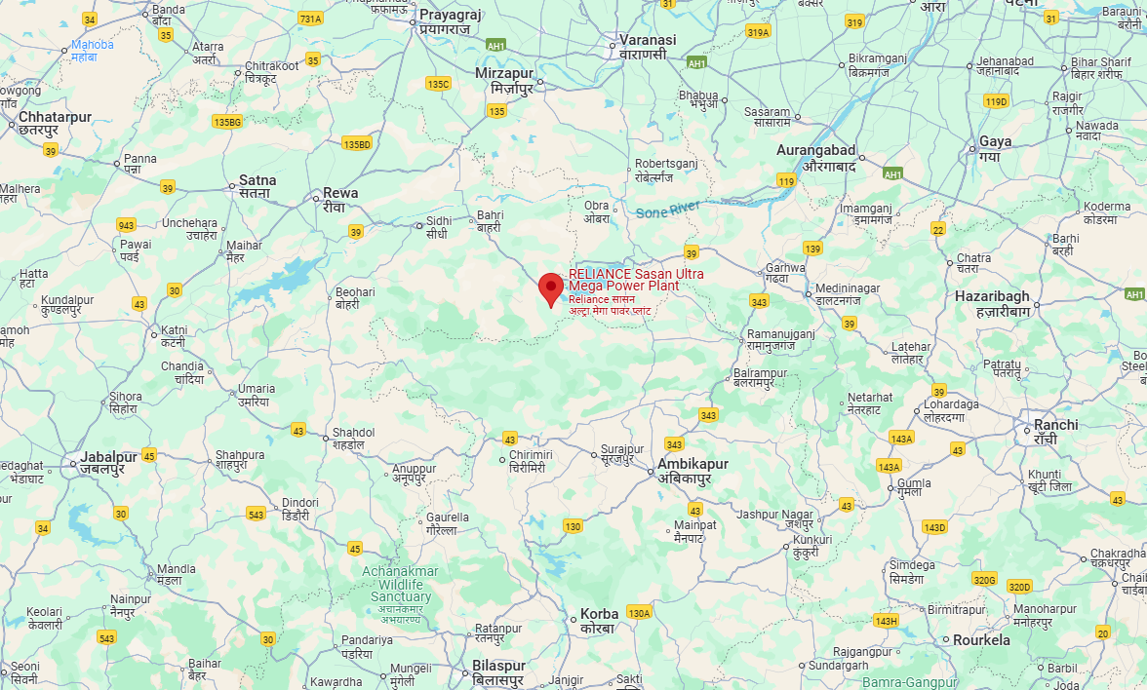
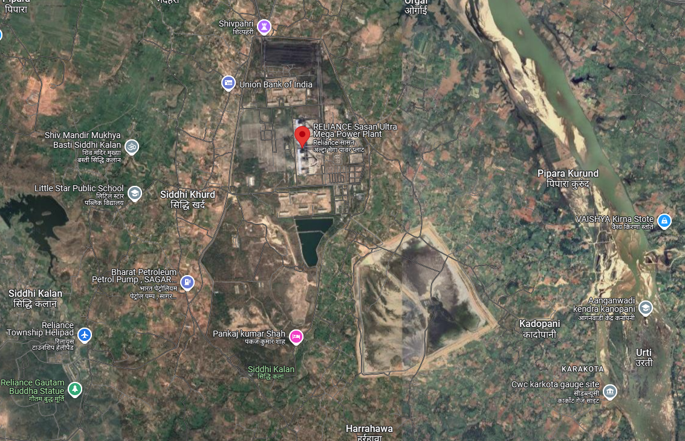

ENCLOSURE: II – ASSET’S PHOTOGRAPHS
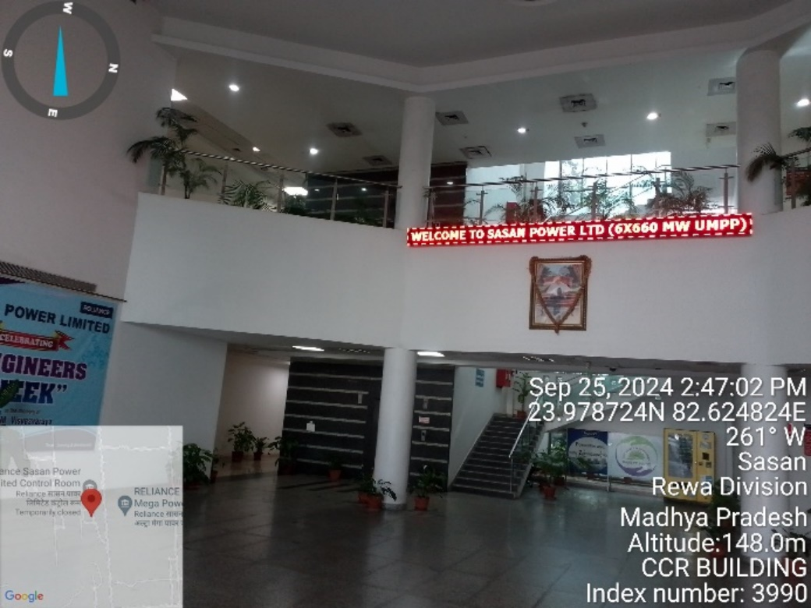 | 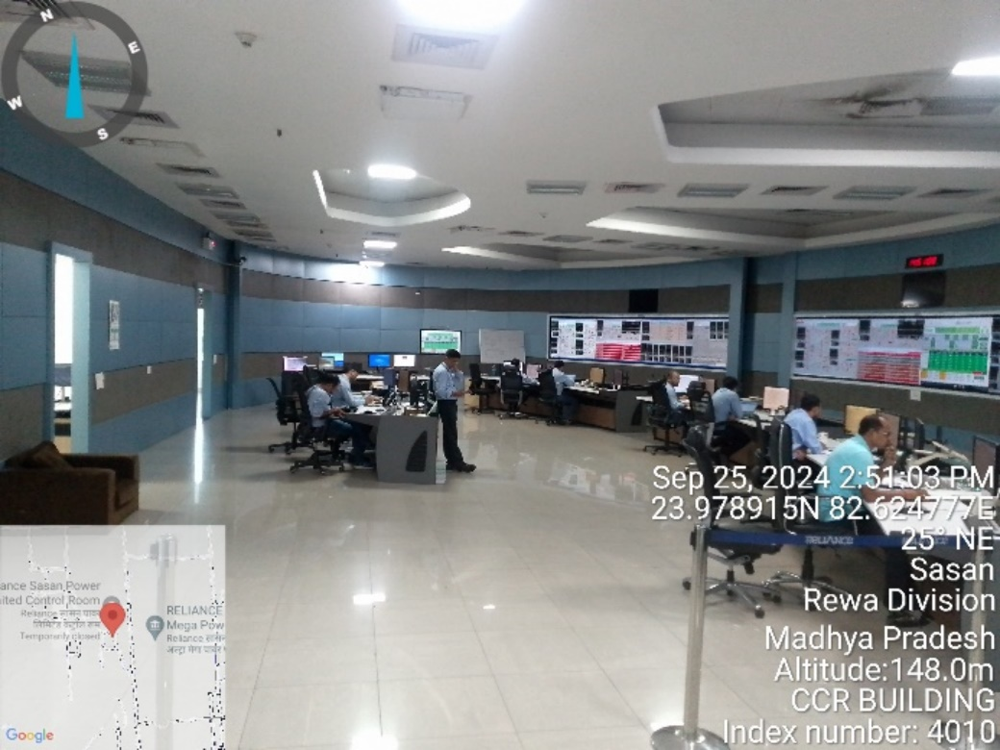
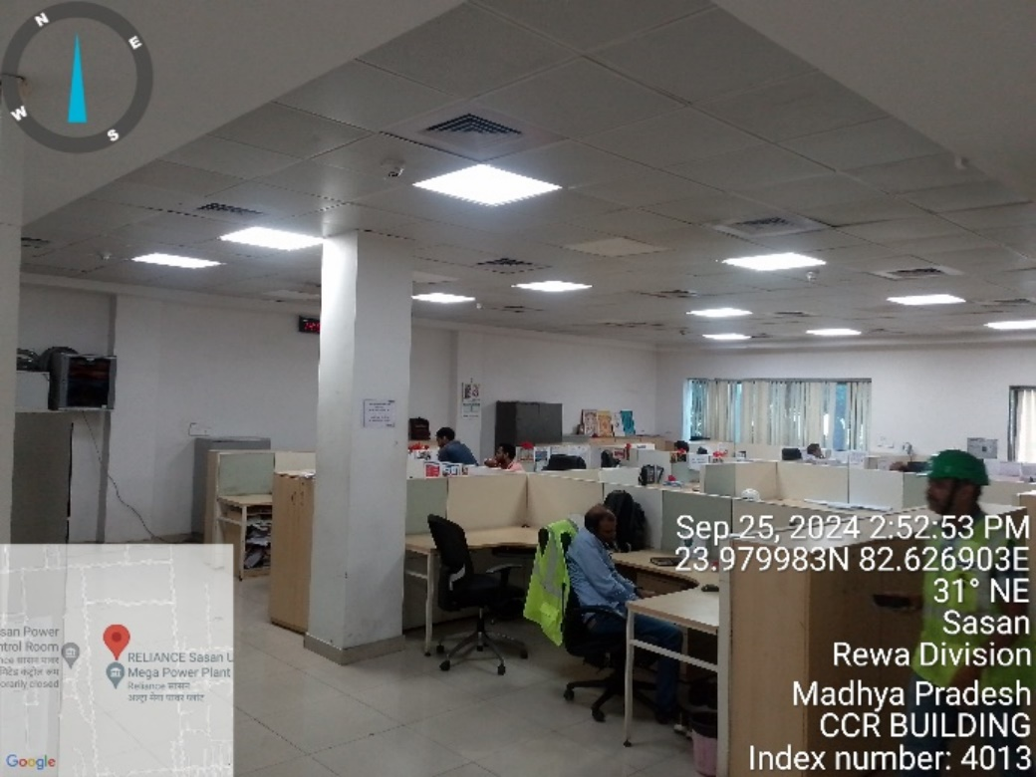 | 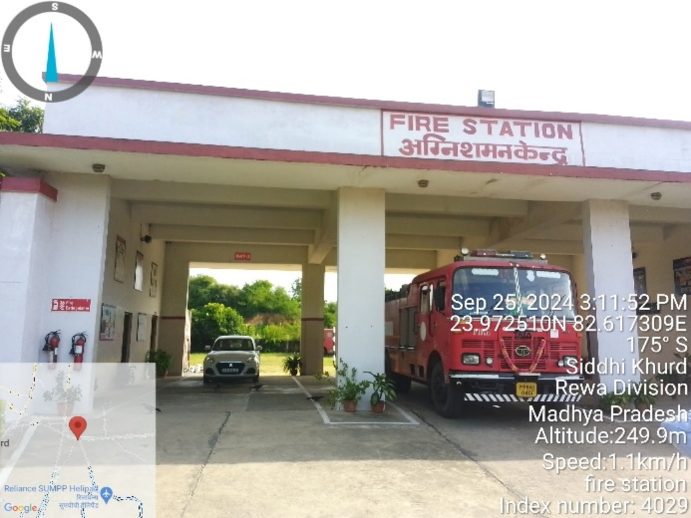
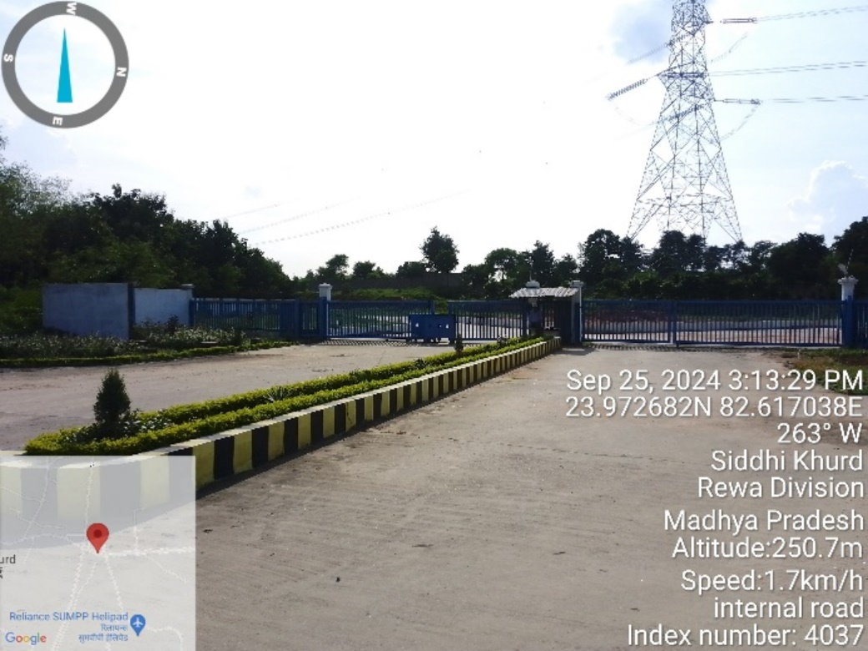 | 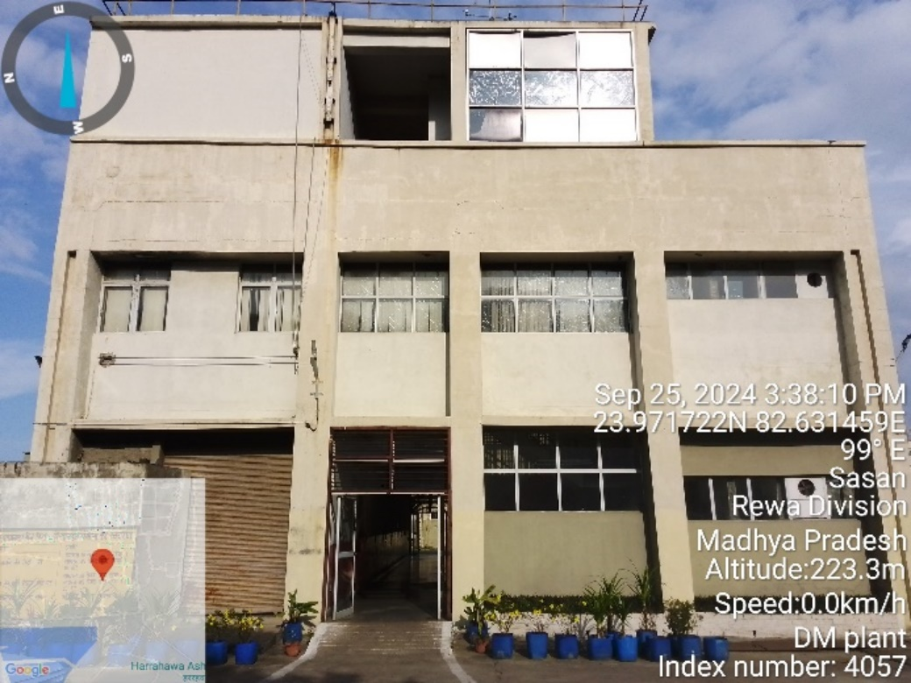

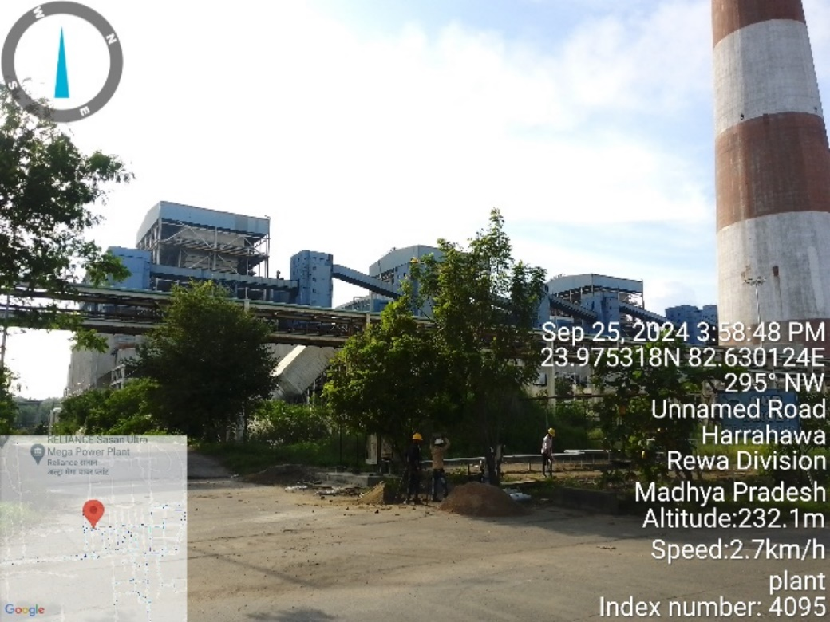 | 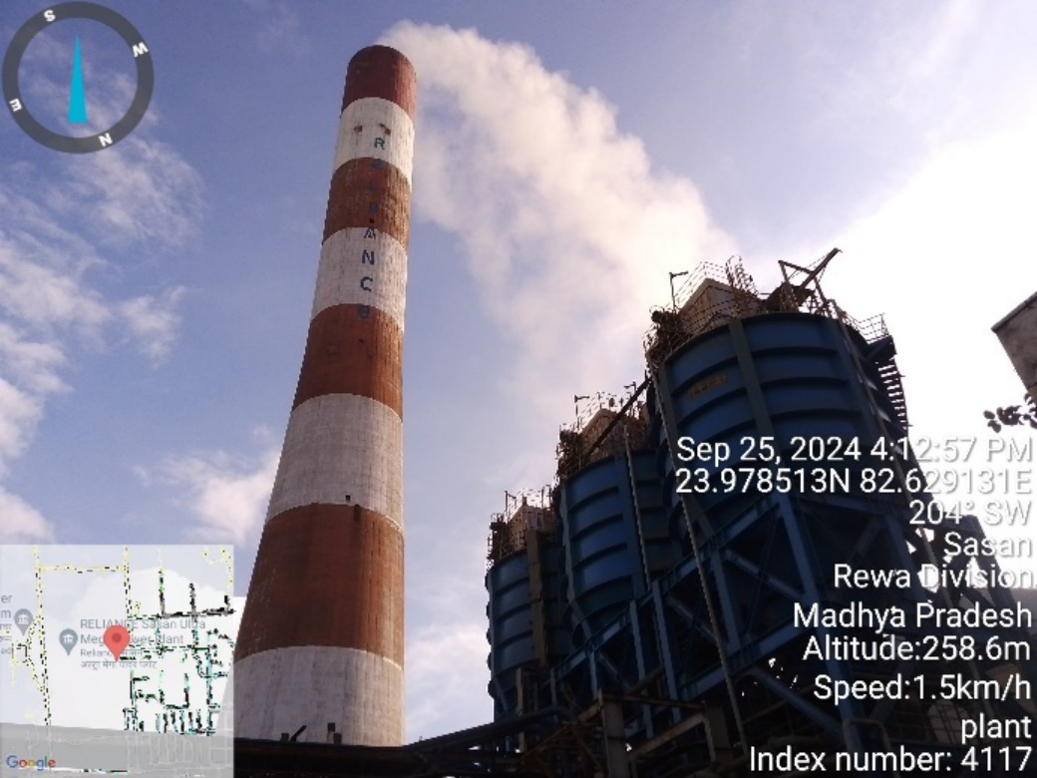
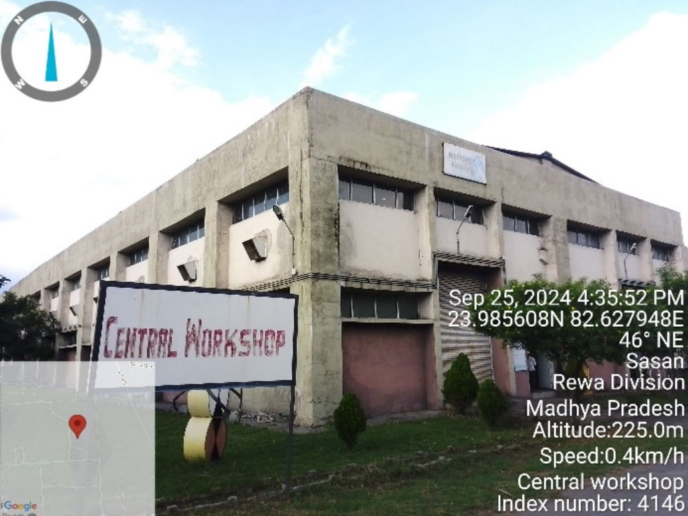 | 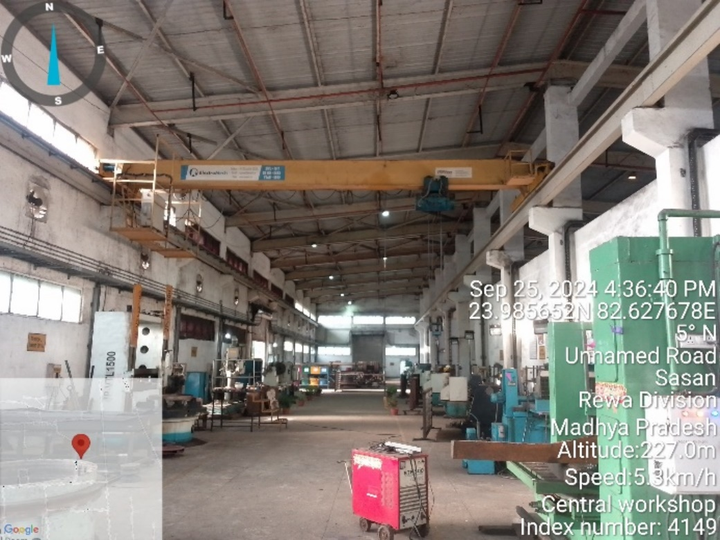
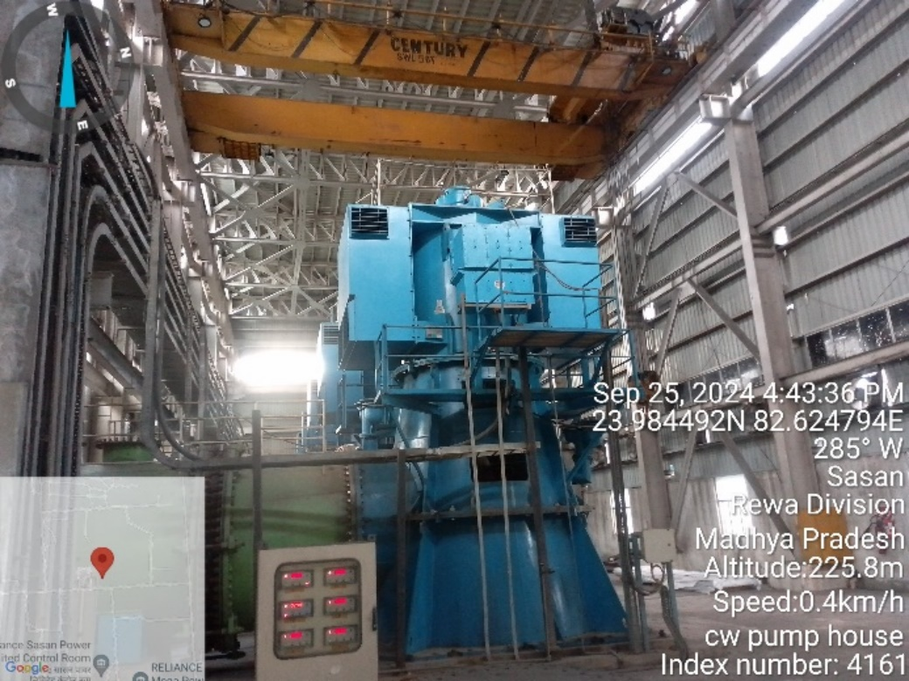 | 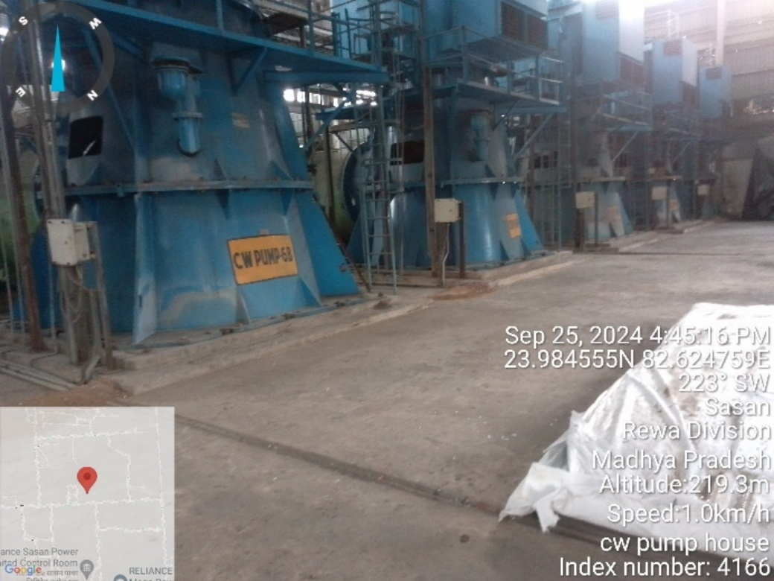

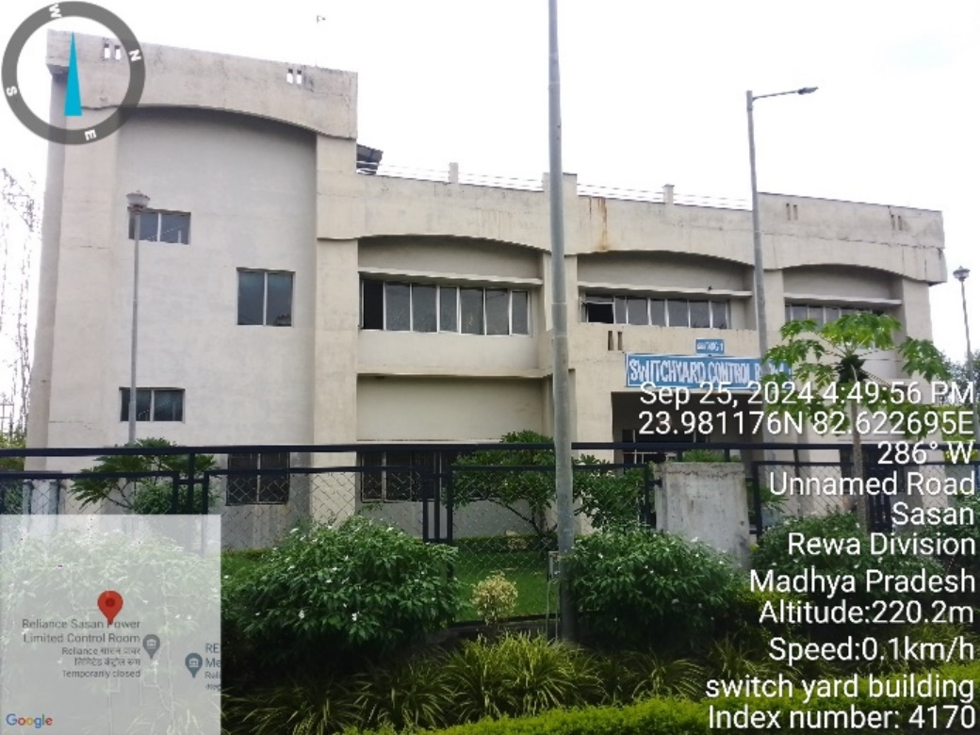 | 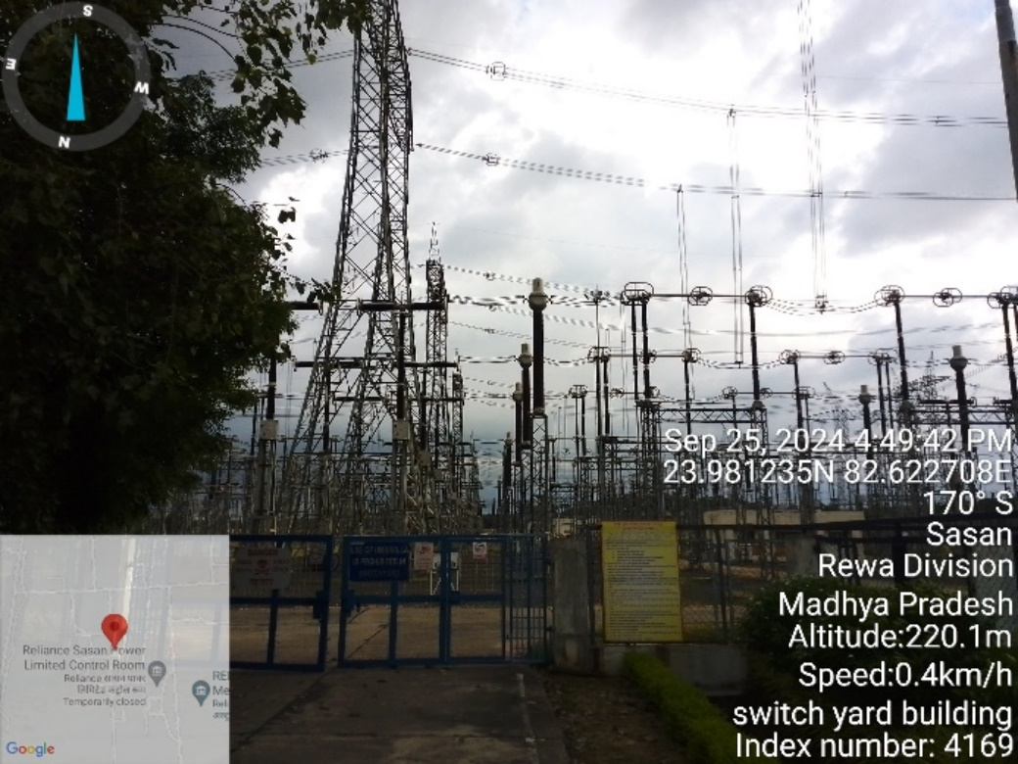
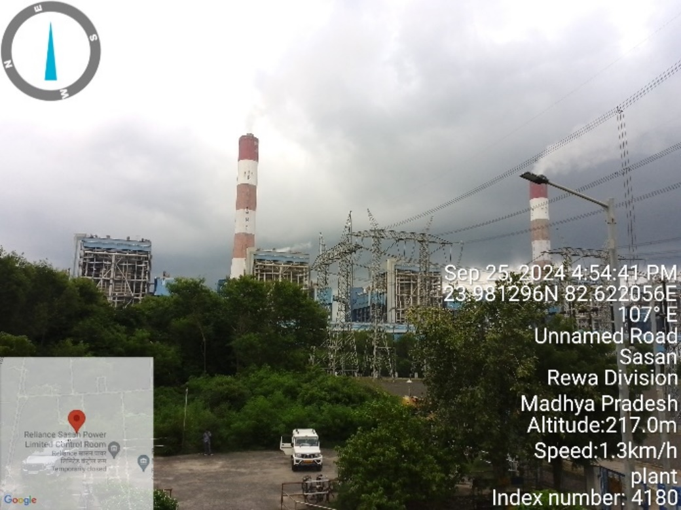 | 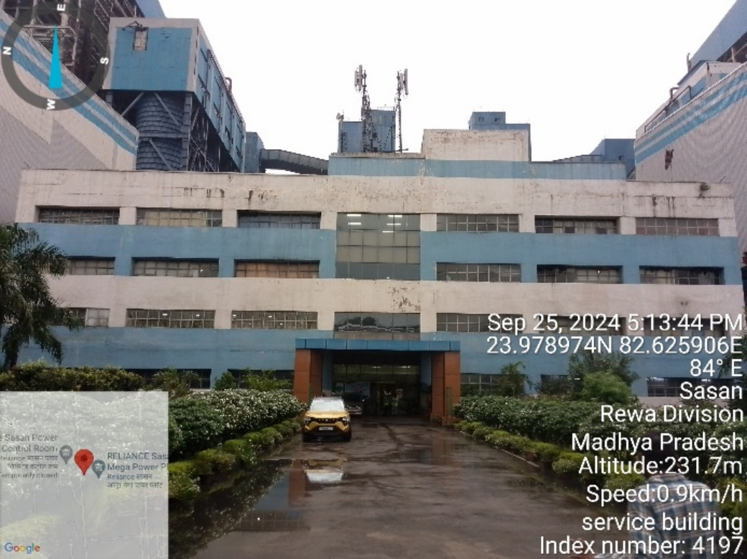
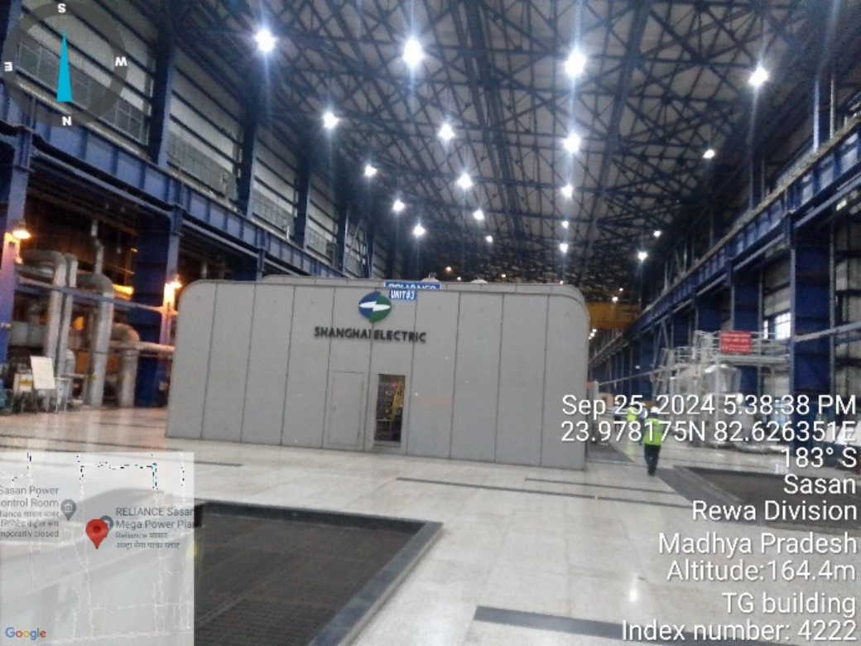 | 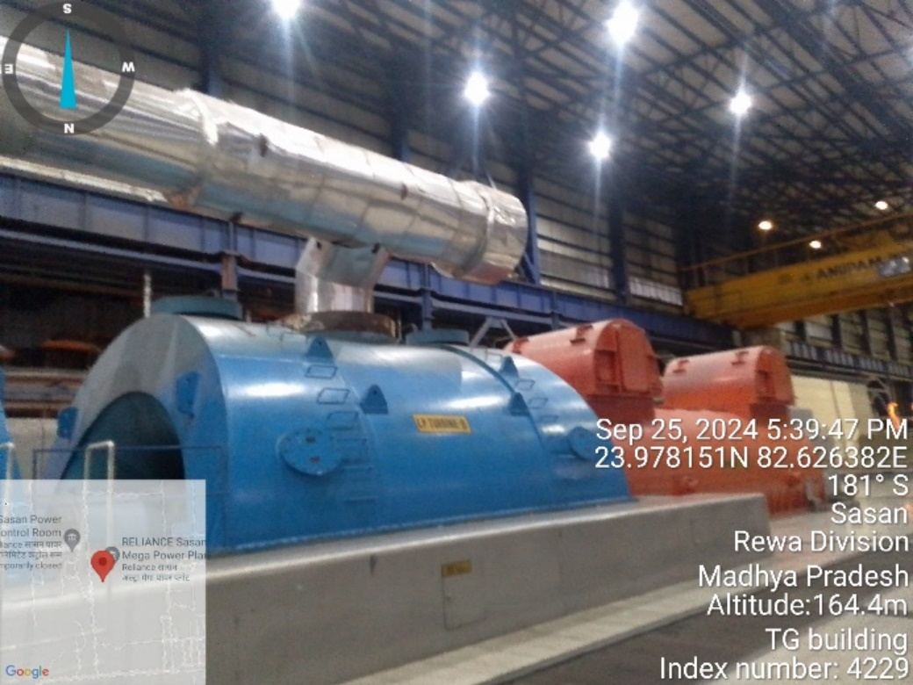

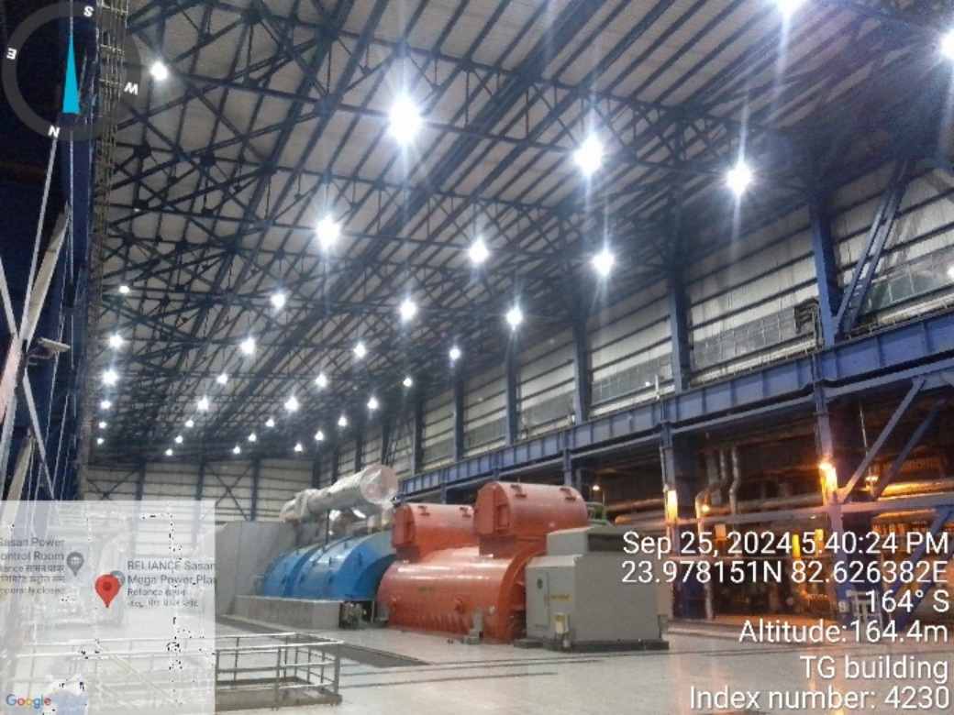 | 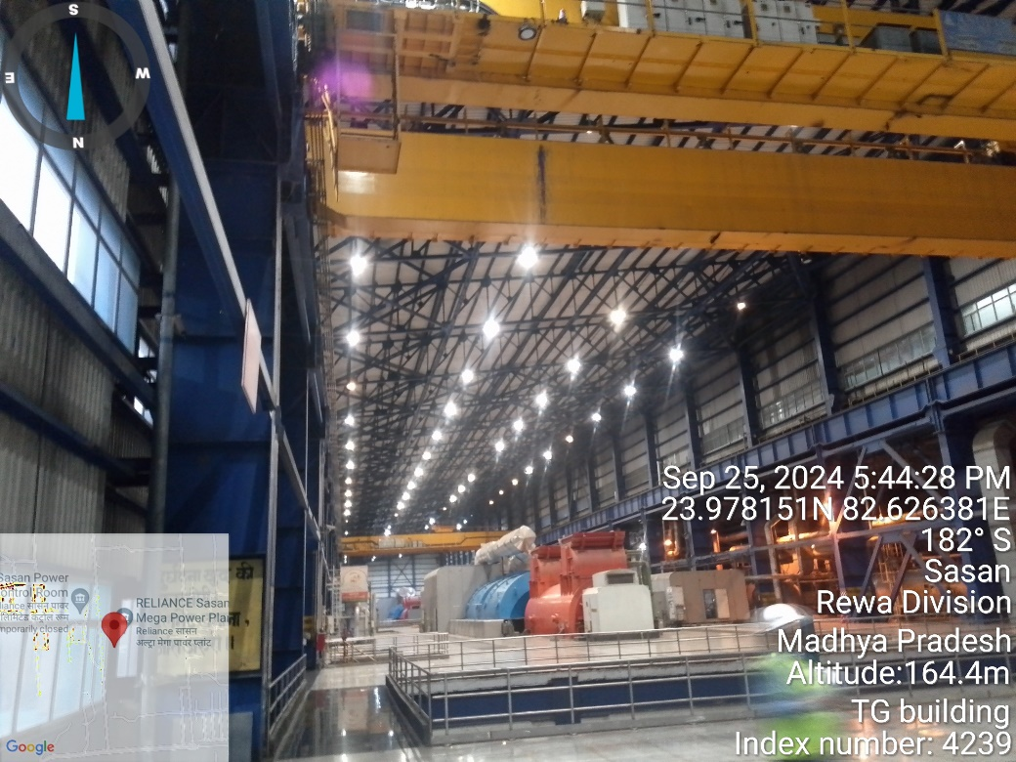
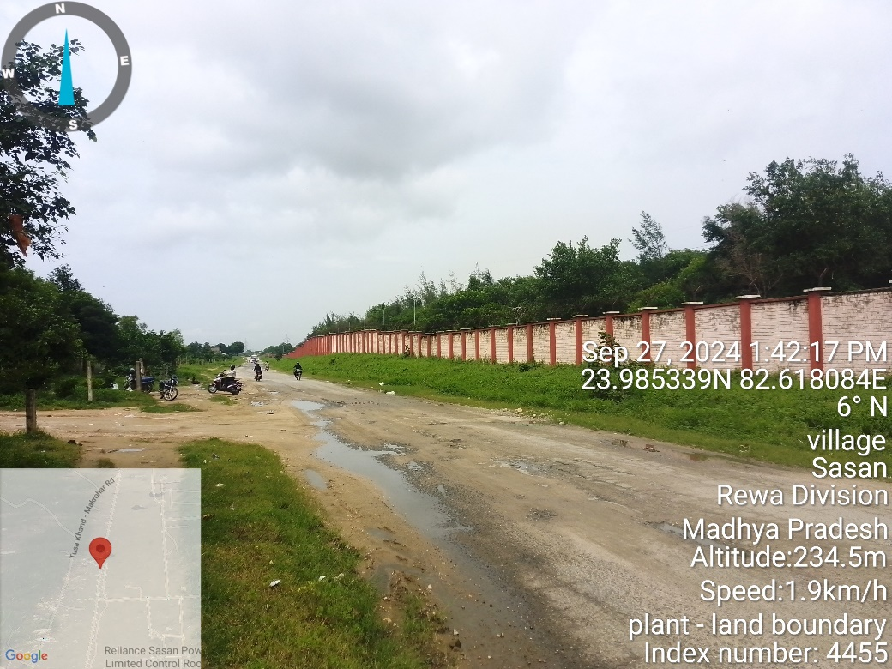 | 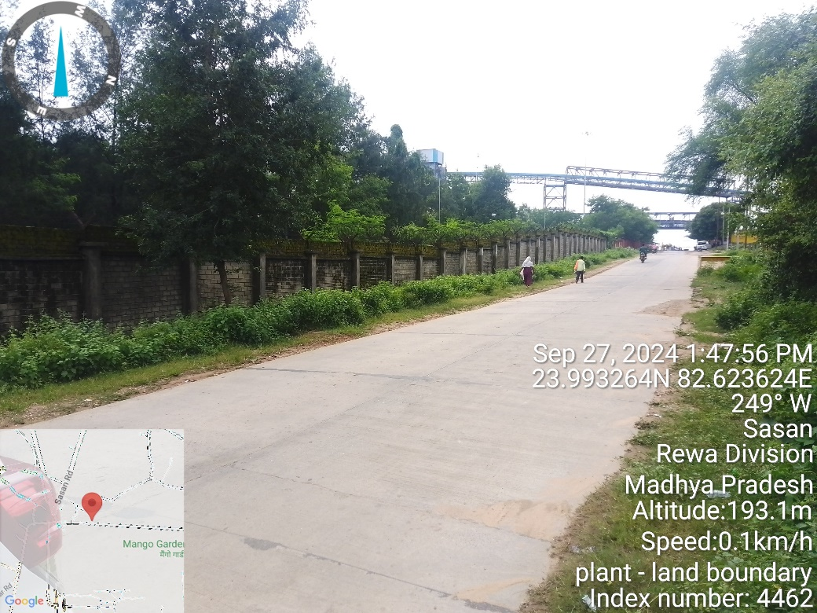
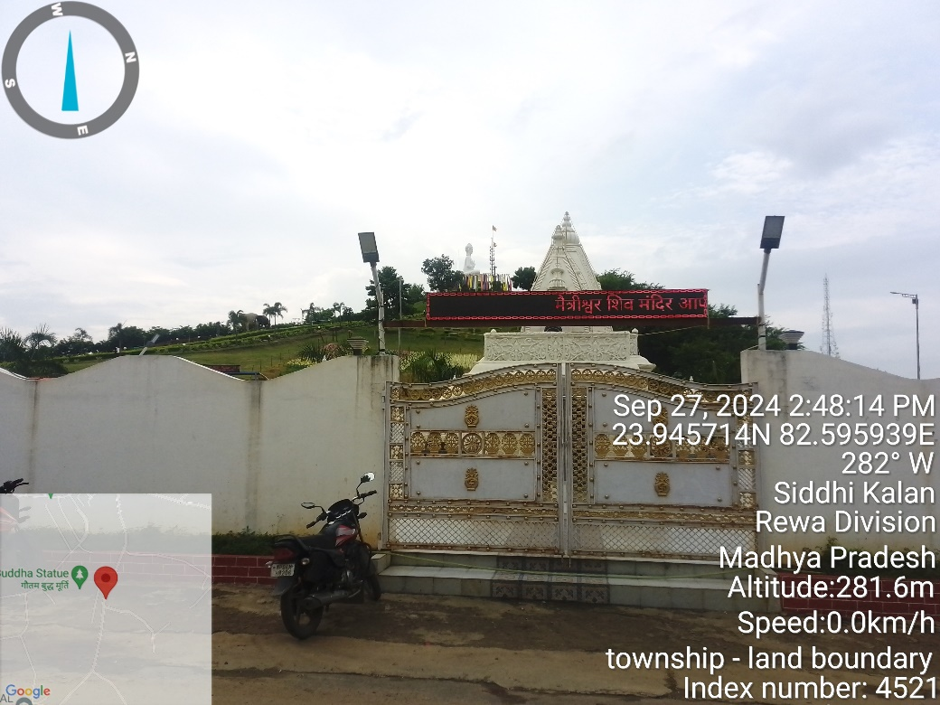 | 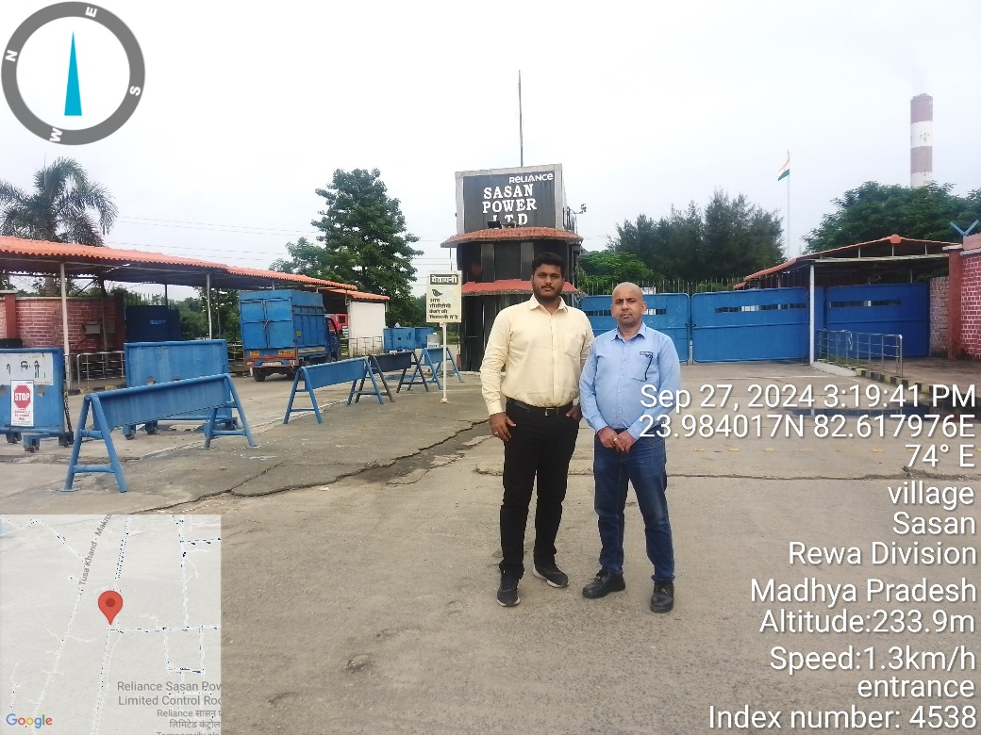

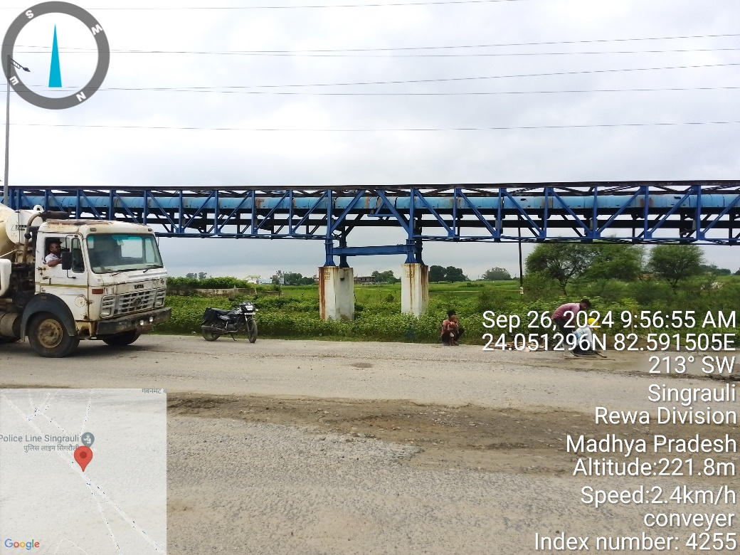 | 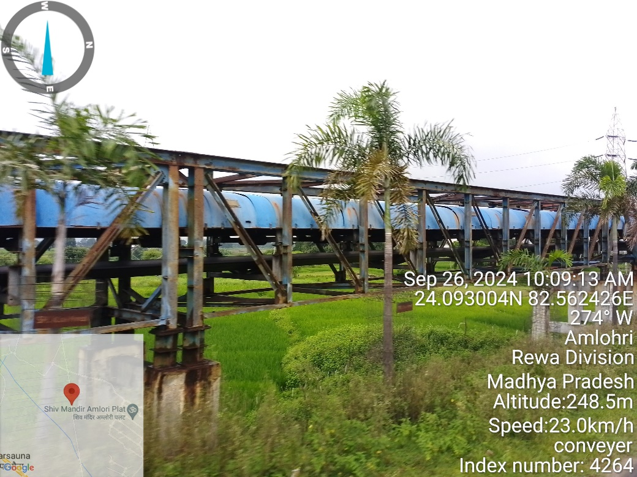
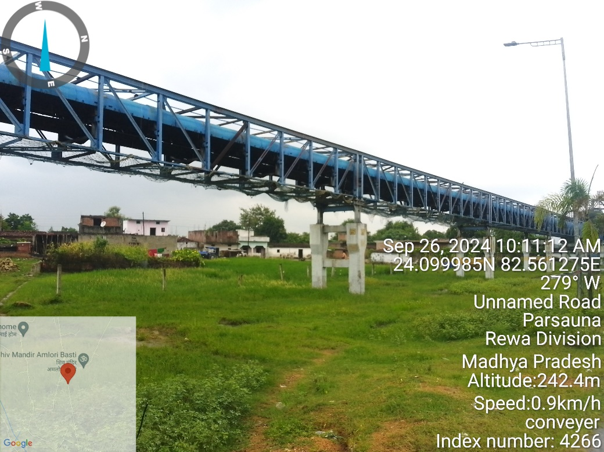 | 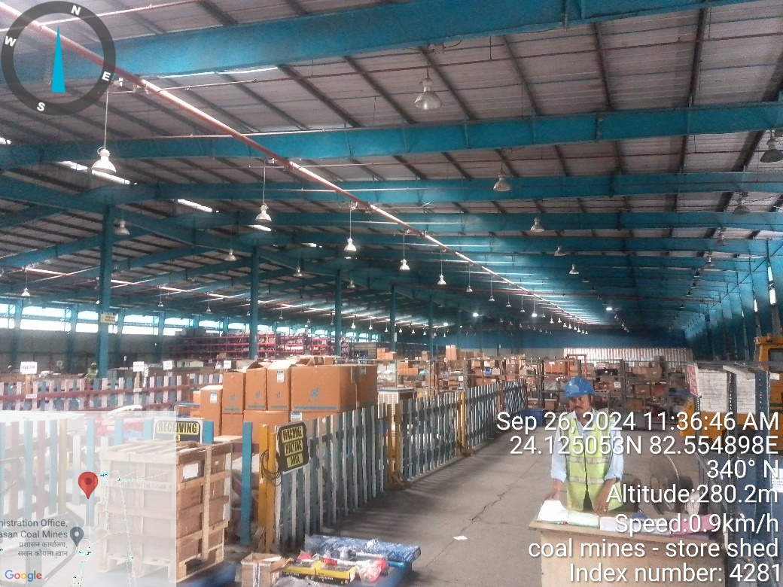
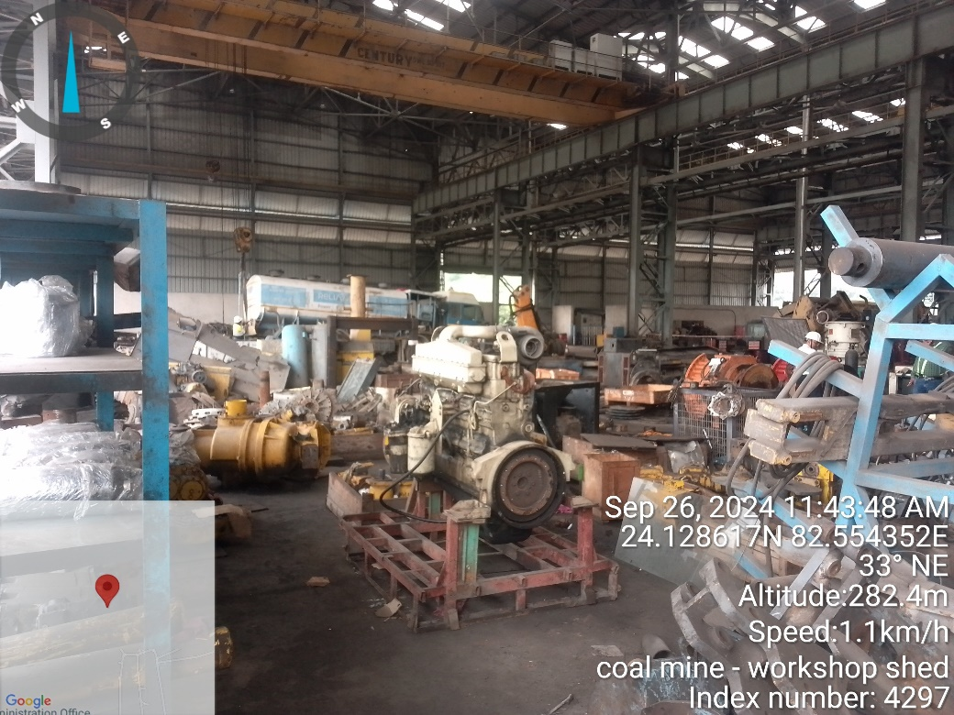 | 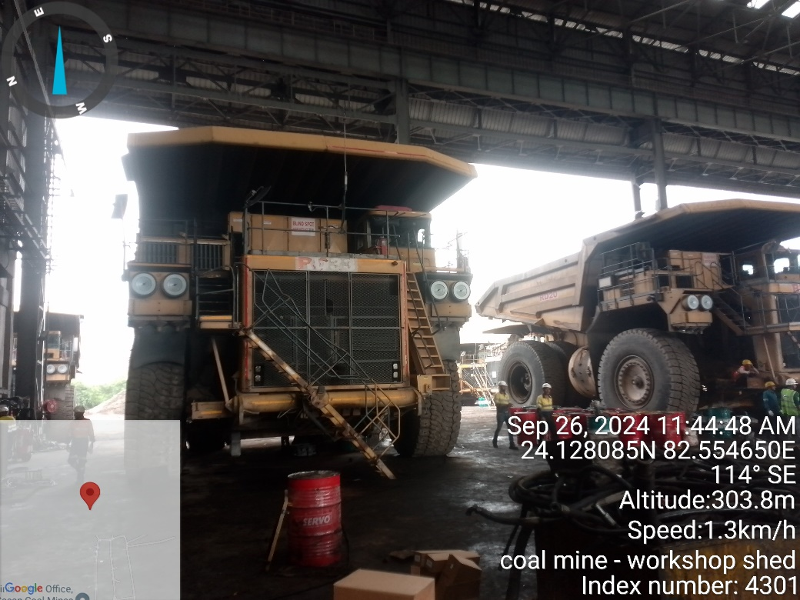

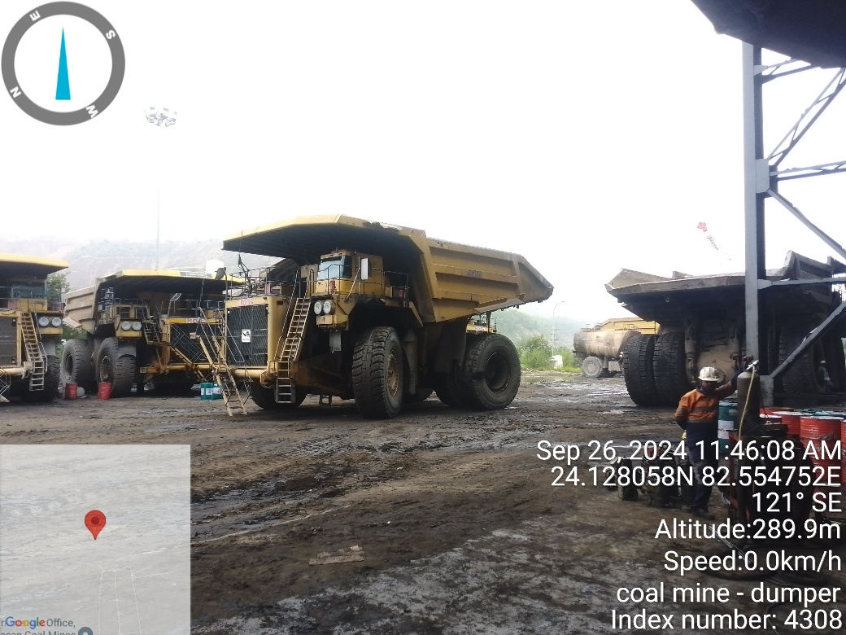 | 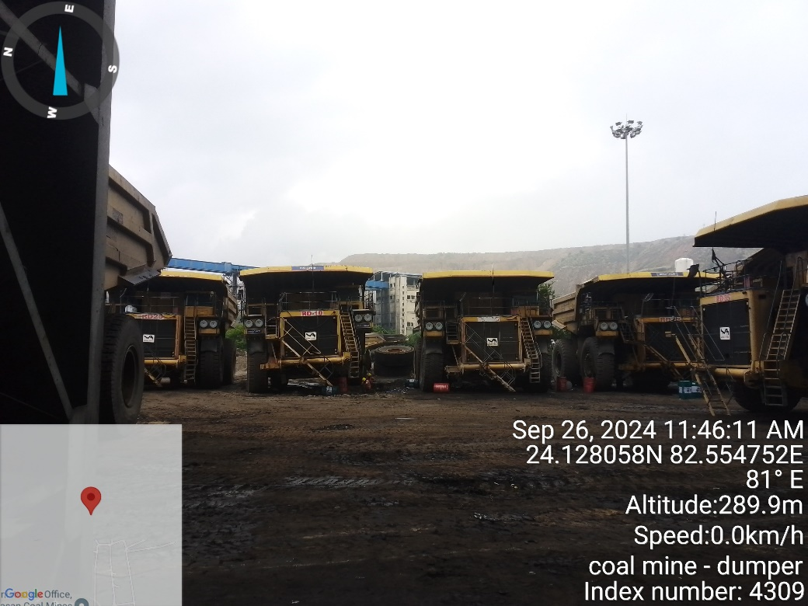
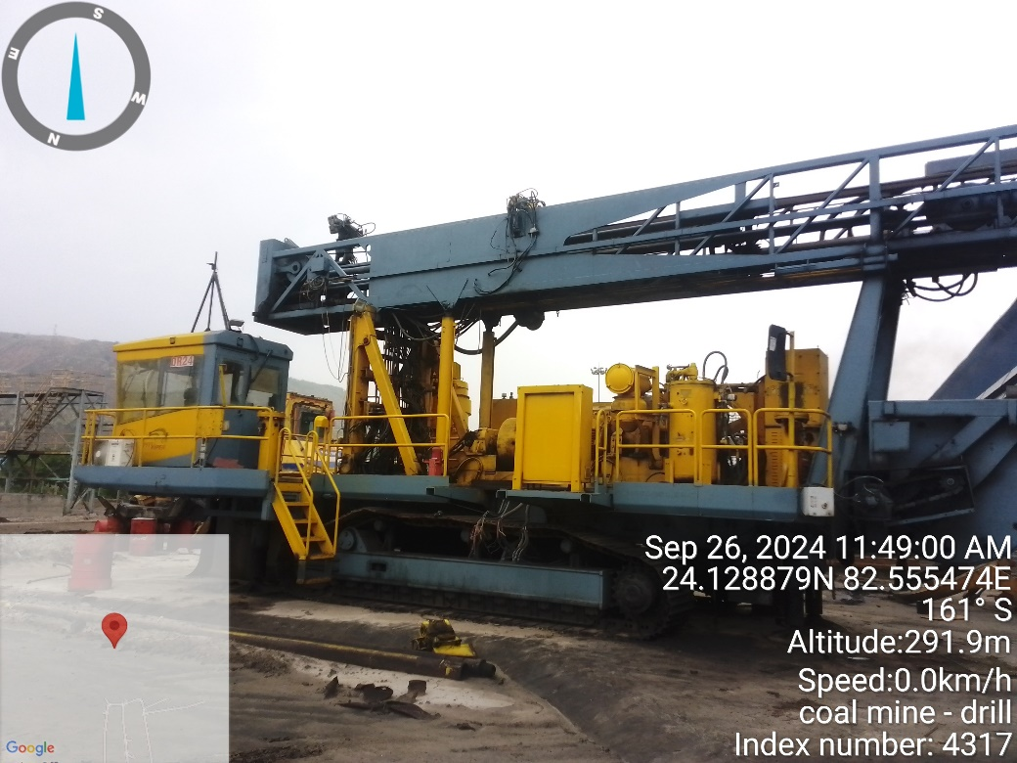 | 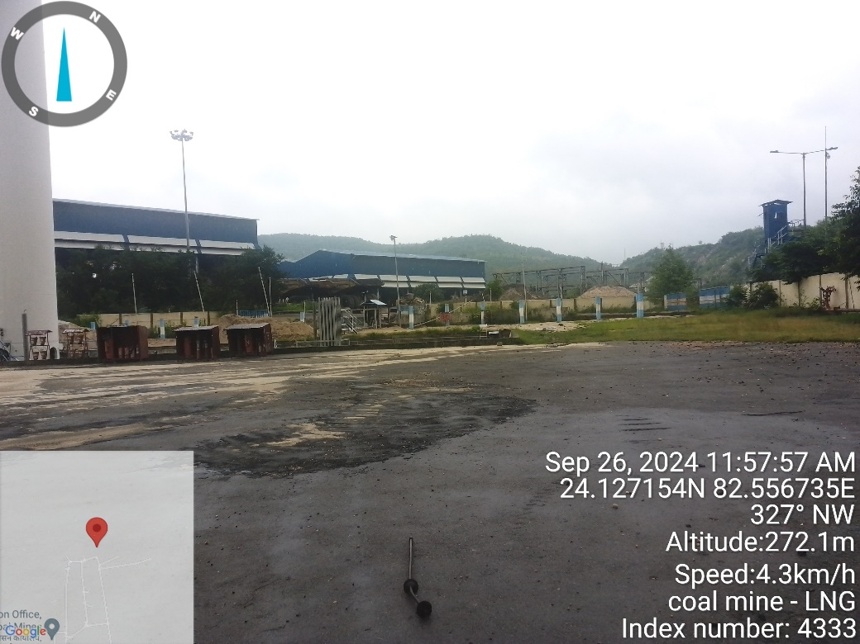
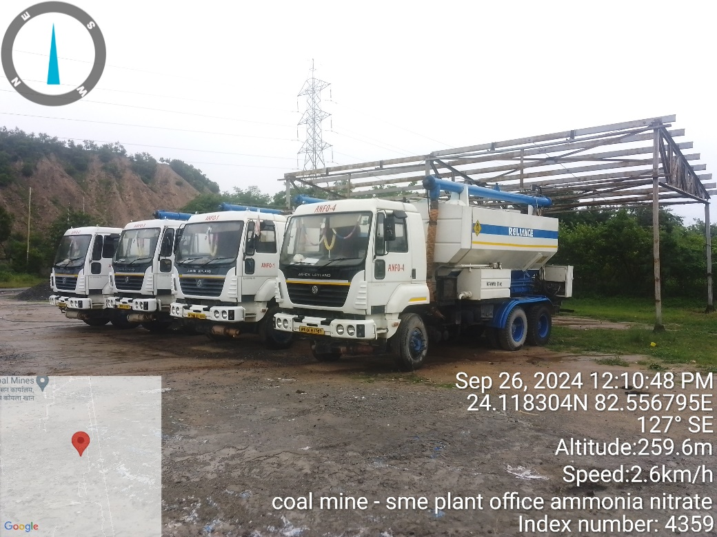 | 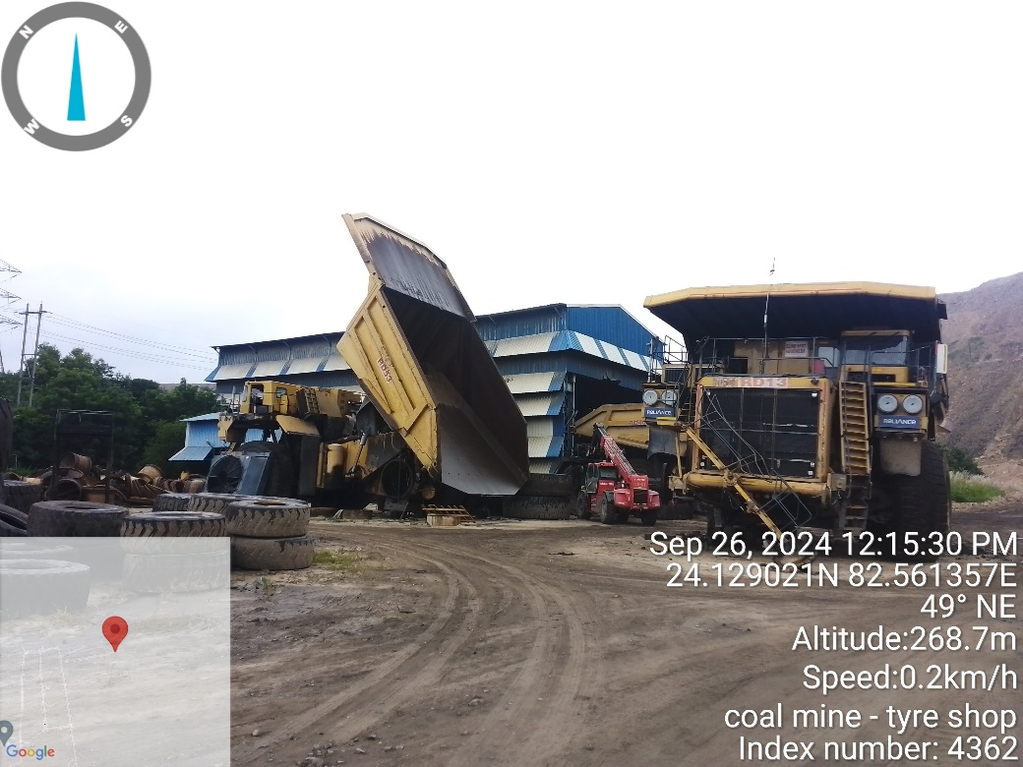

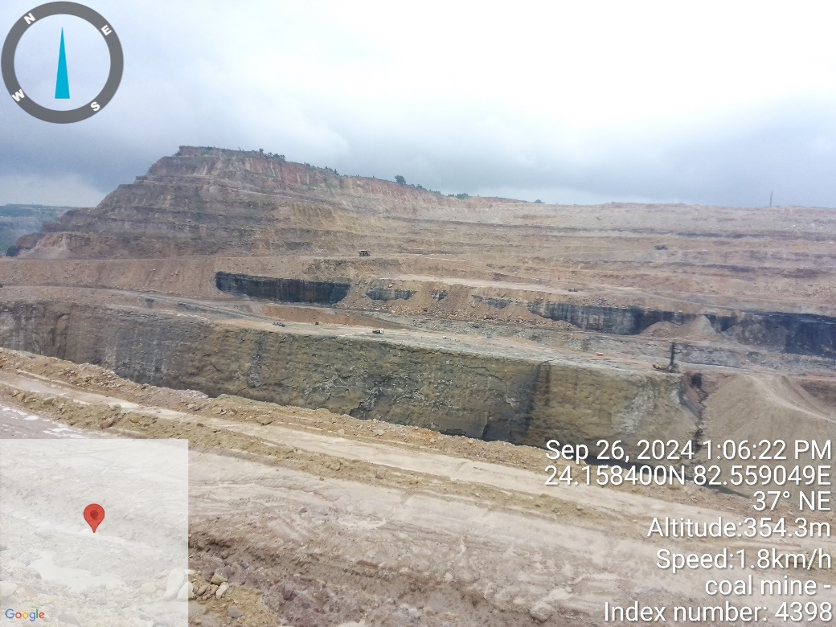 | 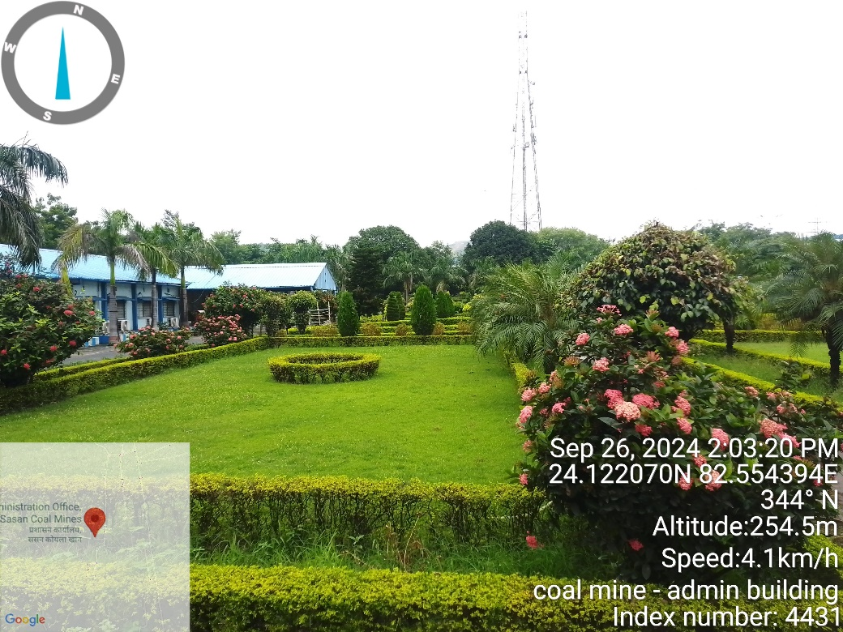
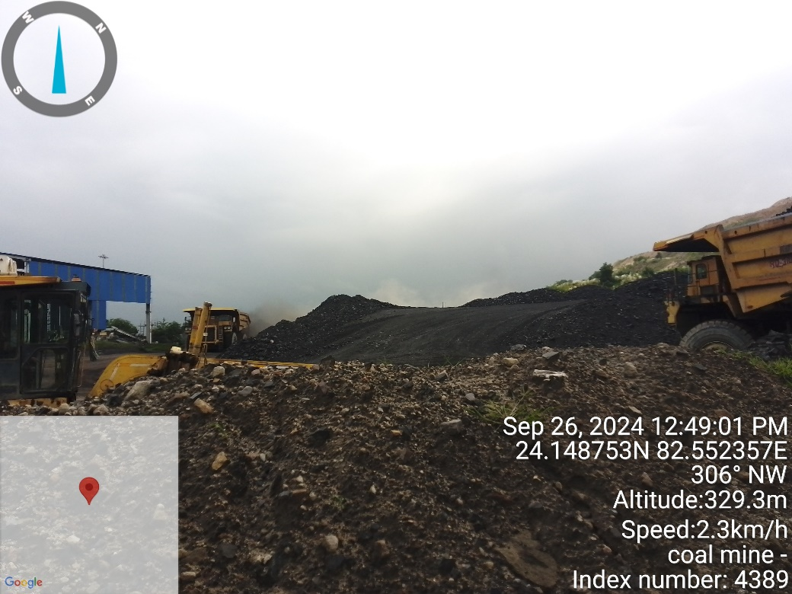 | 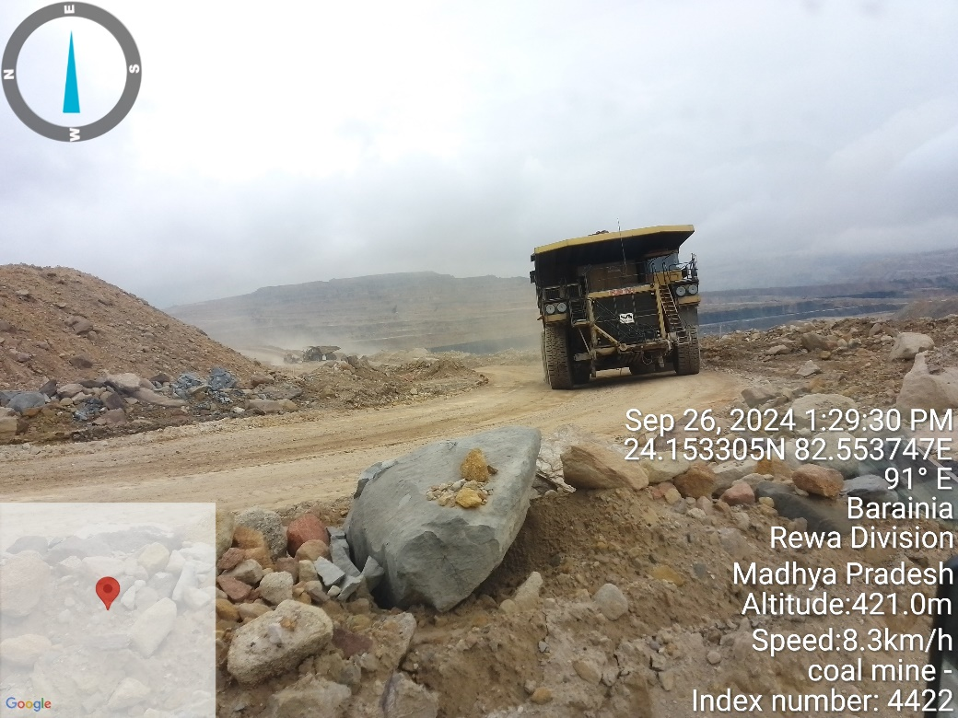
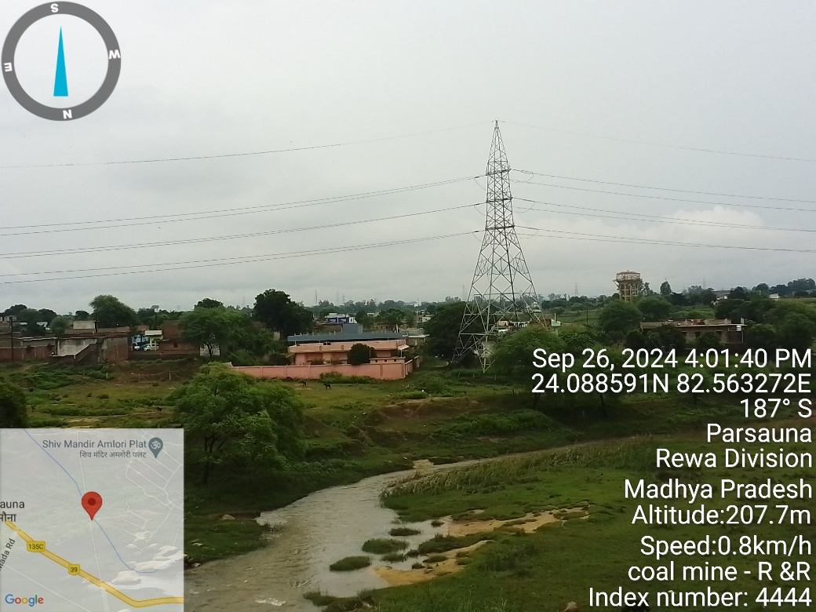 | 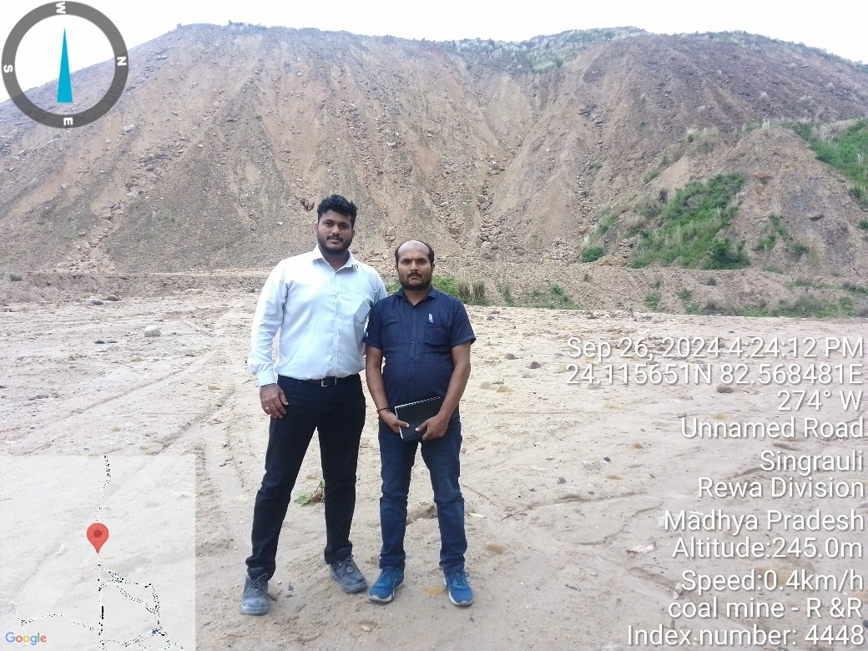

ENCLOSURE: III – COPY OF CIRCLE RATE

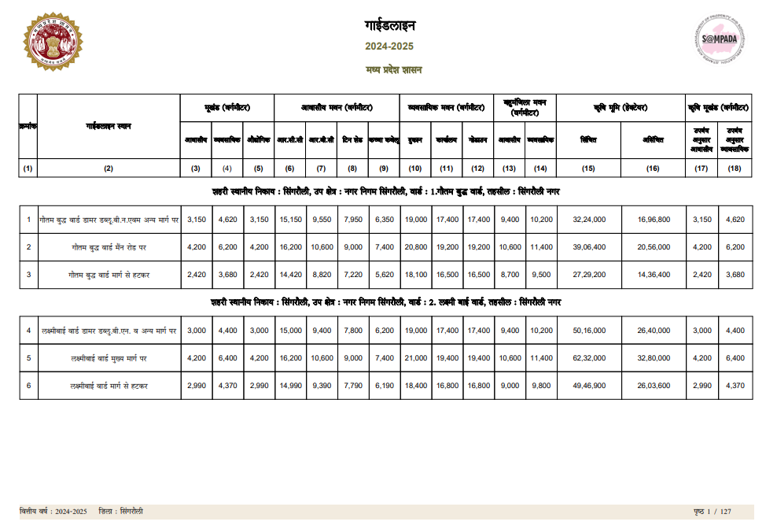
Source:https://www.mpigr.gov.in/igrs_cms_api/api/website/download?filePath=pdf/GuideLineReport2024-25/2024-2025_C_Singroli_HI.pdf

ENCLOSURE IV: IMPORTANT PROPERTY DOCUMENTS EXHIBIT

CTO for Coal Mines
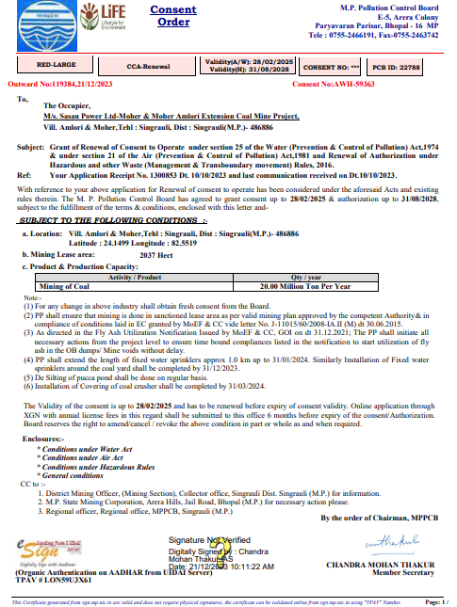

Environment Clearance for Coal Mines
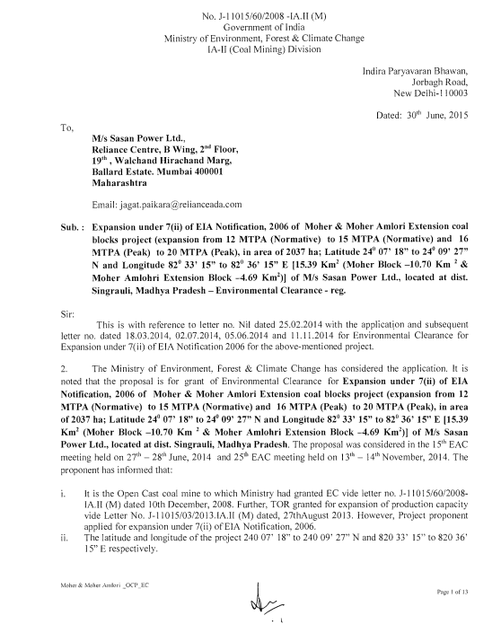

Factory License
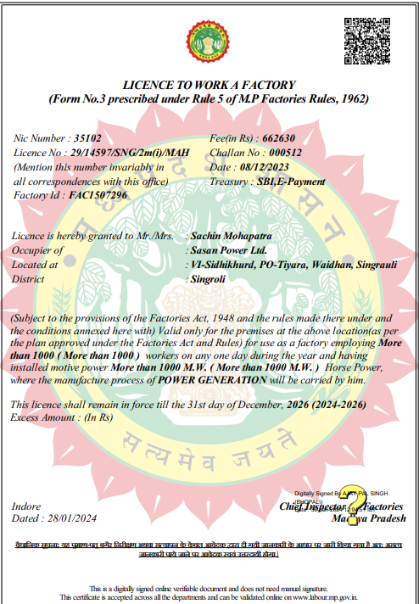

Factory License: Coal Mines


Environment Clearance: Power Plant
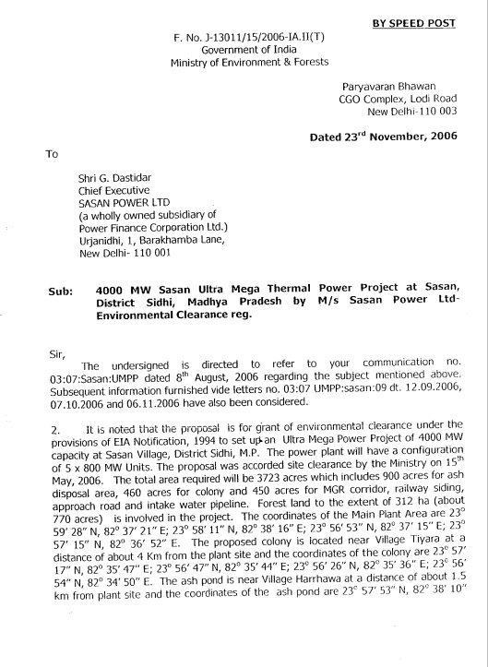

Boiler Registration Certificate
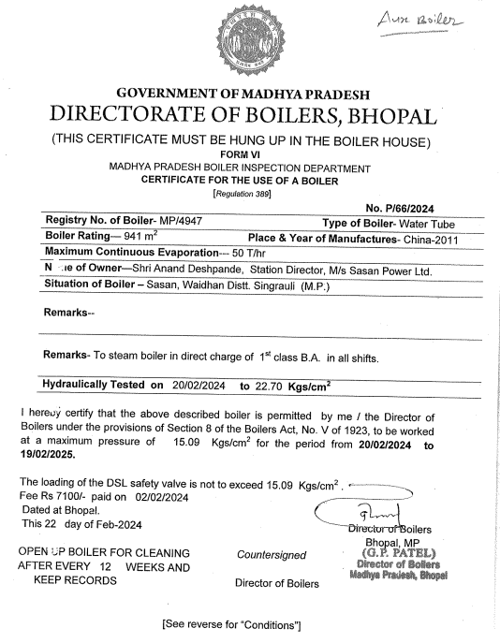

ENCLOSURE VI: DECLARATION-CUM-UNDERTAKING

- Persons worked on this report are citizen of India.
- No employee or member of R.K Associates has any direct/ indirect interest in the property or become so interested at any time during a period of three years prior to our appointment as valuer or three years after the valuation of assets was conducted by us.
- The information furnished in our valuation report dated 25/11/2024 is true and correct to the best of our knowledge and belief and we have made an impartial and true valuation of the property.
- Our authorized Engineer/ surveyor Mr. Dhawal Vanjari and Mr. Anit Bhanji have personally inspected the property from 25/9/2024 to 27/9/2024 the work is not subcontracted to any other valuation firm and is carried out by us.
- Valuation Report is covering all the points as per the format as prescribed by the Bank.
- We have not been depanelled/ delisted by any other bank and in case any such depanelment by other banks during my empanelment with you, we will inform you within 3 days of such depanelment.
- We have not been removed/ dismissed from service/employment earlier.
- We have not been convicted of any offence and sentenced to a term of imprisonment.
- Company is not found guilty of misconduct in professional capacity.
- Persons worked on this report are not declared to be unsound mind.
- Company is not undischarged bankrupt or has not applied to be adjudicated as a bankrupt.
- Company is not an undischarged insolvent.
- No penalty is levied under section 271J of Income-tax Act, 1961 (43 of 1961) and time limit for filing appeal before Commissioner of Income tax (Appeals) or Income-tax Appellate Tribunal, as the case may be has expired, or such penalty has been confirmed by Income-tax Appellate Tribunal, and five years have not elapsed after levy of such penalty.
- Company is not been convicted of an offence connected with any proceeding under the Income Tax Act 1961, Wealth Tax Act 1957 or Gift Tax Act 1958 and
- Our PAN Card number/ GST number as applicable is AAHCR0845G/ 09AAHCR0845G1ZP.
- We undertake to keep you informed of any events or happenings which would make us ineligible for empanelment as a valuer.
- We have not concealed or suppressed any material information, facts and records and we have made a complete and full disclosure.
- We have read the Handbook on Policy, Standards and procedure for Real Estate Valuation, 2011 of the IBA and has tried to apply the “Standards” enshrined for valuation in the Part-B of the above handbook to the best of our ability as much as practically possible in the limited time available.
- We have read the International Valuation Standards (IVS) and the report submitted to the Bank for the respective asset class and has tried to apply the “Standards” as enshrined for valuation in the IVS in “General Standards” and “Asset Standards” as applicable to the best of our ability as much as practically possible in the limited time available.
- Procedures and standards adopted in carrying out the valuation and is mentioned in Part-D of the report which may have certain departures to the said IBA and IVS standards in order to provide better, just & fair valuation.
- We abide by the Model Code of Conduct for empanelment of valuer in the Bank.
- The authorized Engineers of the company who has worked on the assignment has signed this valuation report.
- The work is taken on the instructions of the Bank.
- Further, we hereby provide the following information:

S. No. | Particulars | Valuer comment
 | Background information of the asset being valued | This valuation report is prepared for 3960 MW Coal Fired Super Critical Thermal Power Plant set up by M/s Reliance Power Limited at Village-Sidhikhurd (and many other villages), Post- Tiyara, Tehsil Waidan, Singrauli District of Madhya Pradesh, India. It became fully operational in year 2015, found on as-is-where basis which company’s representative has shown/ identified to us on the site physically unless otherwise mentioned in the report of which some reference has been taken from the information/ data given in the copy of documents provided to us and informed verbally or in writing.
 | Purpose of valuation and appointing authority | Please refer to Part-D of the Report.
 | Identity of the experts involved in the valuation | Survey Analyst: Er. Dhawal Vanjari & Er. Anit Bhanji  Valuation Engineer: Er. Abhinav Chaturvedi  L1/ L2 Reviewer: Er. Sr. V.P. Projects
 | Disclosure of valuer interest or conflict, if any | No relationship with the borrower and no conflict of interest.
 | Date of appointment, valuation date and date of report | Date of Appointment: | 17/8/2024
 | Date of appointment, valuation date and date of report | Date of Survey: | 25/9/2024 to 27/9/2024
 | Date of appointment, valuation date and date of report | Valuation Date: | 25/11/2024
 | Date of appointment, valuation date and date of report | Date of Report: | 25/11/2024
 | Inspections and/ or investigations undertaken | Yes, by our authorized Survey Engineer Dhawal Vanjari and Anit Bhanji from 25/9/2024 to 27/9/2024. Property was shown and identified by Mr. Mantu Ghosh (-+91 76663 31660)
 | Nature and sources of the information used or relied upon | Please refer to Part-D of the Report. Level 3 Input (Tertiary) has been relied upon.
 | Procedures adopted in carrying out the valuation and valuation standards followed | Please refer to Part-D of the Report.
 | Restrictions on use of the report, if any | Value varies with the Purpose/ Date/ Market & Asset Condition & Situation prevailing in the market. We recommend not to refer the indicative & estimated prospective Value of the asset given in this report if any of these points are different from the one mentioned aforesaid in the Report.  This report has been prepared for the purposes stated in the report and should not be relied upon for any other purpose. Our client is the only authorized user of this report and is restricted for the purpose indicated in this report. I/we do not take any responsibility for the unauthorized use of this report.  During the course of the assignment, we have relied upon various information, data, documents in good faith provided by Bank/ client both verbally and in writing. If at any point of time in future it comes to knowledge that the information given to us is untrue, fabricated, misrepresented then the use of this report at very moment will become null & void.  This report only contains general assessment & opinion on the indicative, estimated Market Value of the property for which Bank has asked to conduct the Valuation for the asset as found on as-is-where basis which owner/ owner representative/ client/ bank has shown/ identified to us on the site unless otherwise mentioned in the report of which some reference has been taken from the information/ data given in the copy of documents provided to us and informed verbally or in writing which has been relied upon in good faith. It doesn’t contain any other recommendations of any sort including but not limited to express of any opinion on the suitability or otherwise of entering into any transaction with the borrower.  This report is not a certification of ownership or survey number/ property number/ Khasra number which are merely referred from the copy of the documents provided to us.
 | Major factors that were taken into account during the valuation | Please refer to Part A, B & C of the Report.
 | Major factors that were not taken into account during the valuation | Please refer to Part A, B & C of the Report.
 | Caveats, limitations and disclaimers to the extent they explain or elucidate the limitations faced by valuer, which shall not be for the purpose of limiting his responsibility for the valuation report. | Please refer to Part E of the Report and Valuer’s Important Remarks enclosed herewith.

Date: 25/11/2024
Place: Noida

Signature

(Authorized Person of R.K Associates Valuers & Techno Engg. Consultants (P) Ltd.)

ENCLOSURE VII: MODEL CODE OF CONDUCT FOR VALUERS

Integrity and Fairness
- A valuer shall, in the conduct of his/its business, follow high standards of integrity and fairness in all his/its dealings with his/its clients and other valuers.
- A valuer shall maintain integrity by being honest, straightforward, and forthright in all professional relationships.
- A valuer shall endeavor to ensure that he/it provides true and adequate information and shall not misrepresent any facts or situations.
- A valuer shall refrain from being involved in any action that would bring disrepute to the profession.
- A valuer shall keep public interest foremost while delivering his services.

Professional Competence and Due Care
- A valuer shall render at all times high standards of service, exercise due diligence, ensure proper care and exercise independent professional judgment.
- A valuer shall carry out professional services in accordance with the relevant technical and professional standards that may be specified from time to time.
- A valuer shall continuously maintain professional knowledge and skill to provide competent professional service based on up-to-date developments in practice, prevailing regulations/guidelines and techniques.
- In the preparation of a valuation report, the valuer shall not disclaim liability for his/its expertise or deny his/its duty of care, except to the extent that the assumptions are based on statements of fact provided by the company or its auditors or consultants or information available in public domain and not generated by the valuer.
- A valuer shall not carry out any instruction of the client in so far as they are incompatible with the requirements of integrity, objectivity and independence.
- A valuer shall clearly state to his client the services that he would be competent to provide and the services for which he would be relying on other valuers or professionals or for which the client can have a separate arrangement with other valuers.

Independence and Disclosure of Interest
- A valuer shall act with objectivity in his/its professional dealings by ensuring that his/its decisions are made without the presence of any bias, conflict of interest, coercion, or undue influence of any party, whether directly connected to the valuation assignment or not.
- A valuer shall not take up an assignment if he/it or any of his/its relatives or associates is not independent in terms of association to the company.
- A valuer shall maintain complete independence in his/its professional relationships and shall conduct the valuation independent of external influences.
- A valuer shall wherever necessary disclose to the clients, possible sources of conflicts of duties and interests, while providing unbiased services.
- A valuer shall not deal in securities of any subject company after any time when he/it first becomes aware of the possibility of his/its association with the valuation, and in accordance with the Securities and Exchange Board of India (Prohibition of Insider Trading) Regulations, 2015 or till the time the valuation report becomes public, whichever is earlier.
- A valuer shall not indulge in “mandate snatching or offering” convenience valuations” in order to cater to a company or client’s needs.
- As an independent valuer, the valuer shall not charge success fee.
- In any fairness opinion or independent expert opinion submitted by a valuer, if there has been a prior engagement in an unconnected transaction, the valuer shall declare the association with the company during the last five years.

Confidentiality
- A valuer shall not use or divulge to other clients or any other party any confidential information about the subject company, which has come to his/its knowledge without proper and specific authority or unless there is a legal or professional right or duty to disclose.
Information Management
- A valuer shall ensure that he/ it maintains written contemporaneous records for any decision taken, the reasons for taking the decision, and the information and evidence in support of such decision. This shall be maintained so as to sufficiently enable a reasonable person to take a view on the appropriateness of his/its decisions and actions.
- A valuer shall appear, co-operate and be available for inspections and investigations carried out by the authority, any person authorised by the authority, the registered valuers organization with which he/it is registered or any other statutory regulatory body.
- A valuer shall provide all information and records as may be required by the authority, the Tribunal, Appellate Tribunal, the registered valuers organization with which he/it is registered, or any other statutory regulatory body.
- A valuer while respecting the confidentiality of information acquired during the course of performing professional services, shall maintain proper working papers for a period of three years or such longer period as required in its contract for a specific valuation, for production before a regulatory authority or for a peer review. In the event of a pending case before the Tribunal or Appellate Tribunal, the record shall be maintained till the disposal of the case.

Gifts and hospitality.
- A valuer or his/its relative shall not accept gifts or hospitality which undermines or affects his independence as a valuer.
Explanation: For the purposes of this code the term ‘relative’ shall have the same meaning as defined in clause (77) of Section 2 of the Companies Act, 2013 (18 of 2013).
- A valuer shall not offer gifts or hospitality or a financial or any other advantage to a public servant or any other person with a view to obtain or retain work for himself/ itself, or to obtain or retain an advantage in the conduct of profession for himself/ itself.

Remuneration and Costs.
- A valuer shall provide services for remuneration which is charged in a transparent manner, is a reasonable reflection of the work necessarily and properly undertaken, and is not inconsistent with the applicable rules.
- A valuer shall not accept any fees or charges other than those which are disclosed in a written contract with the person to whom he would be rendering service.

Occupation, employability and restrictions.
- A valuer shall refrain from accepting too many assignments, if he/it is unlikely to be able to devote adequate time to each of his/ its assignments.
- A valuer shall not conduct business which in the opinion of the authority or the registered valuer organization discredits the profession.

Miscellaneous
- A valuer shall refrain from undertaking to review the work of another valuer of the same client except under written orders from the bank or housing finance institutions and with knowledge of the concerned valuer.
- A valuer shall follow this code as amended or revised from time to time

Signature of the Authorized Person: ________________
Name of the Valuation company: R.K Associates Valuers & Techno Engg. Consultants (P) Ltd.
Address of the Valuer: D-39, Sector-2, Noida-201301
Date: 25/11/2024
Place: Noida

PART K | VALUER’S IMPORTANT REMARKS

Valuation is done for the asset found on as-is-where basis which owner/ owner representative/ client/ bank has shown/ identified to us on the site unless otherwise mentioned in the report of which some reference has been taken from the information/ data given in the copy of documents provided to us and informed verbally or in writing out of the standard checklist of documents sought from the client & its customer which they could provide within the reasonable expected time out of the standard checklist of documents sought from them and further based on certain assumptions and limiting conditions. The information, facts, documents, data which has become primary basis of the report has been supplied by the client which has been relied upon in good faith and is not generated by the Valuer.
The client/ owner and its management/ representatives warranted to us that the information they have supplied was complete, accurate and true and correct to the best of their knowledge. All such information provided to us either verbally, in writing or through documents has been relied upon in good faith and we have assumed that it is true & correct without any fabrication or misrepresentation. I/We shall not be held liable for any loss, damages, cost or expenses arising from fraudulent acts, misrepresentations, or willful default on part of the owner, company, its directors, employee, representative or agents.
Legal aspects for eg. Investigation of title, ownership rights, lien, charge, mortgage, lease, sanctioned maps, verification of documents provided to us such as title documents, Map, etc. from any concerned Govt. office etc. have to be taken care by legal expert/ Advocate and same is not done at our end. It is assumed that the concerned Lender/ Financial Institution has asked for the valuation of that property after satisfying the authenticity of the documents given to us for which the legal verification has been already taken and cleared by the competent Advocate before requesting for the Valuation report. I/ We assume no responsibility for the legal matters including, but not limited to, legal or title concerns.
In the course of the valuation, we were provided with both written and verbal information. We have however, evaluated the information provided to us through broad inquiry, analysis and review but have not carried out a due diligence or audit of the information provided for the purpose of this engagement. Our conclusions are based on the assumptions and other information provided to us by the client during the course of the assessment.
Getting cizra map or coordination with revenue officers for site identification is a separate activity and is not part of the Valuation services and same has not been done in this report unless otherwise stated.
Wherever any details are mentioned in the report in relation to any legal aspect of the property such as name of the owner, leases, etc. is only for illustration purpose and should not be construed as a professional opinion. Legal aspects are out of scope of this report. Details mentioned related to legal aspect are only based on the copy of the documents provided to us and whatever we can interpret as a non-legally trained person. This should be cross validated with a legal expert. We do not vouch any responsibility regarding the same
We have made certain assumptions in relation to facts, conditions & situations affecting the subject of, or approach to this exercise that has not been verified as part of the engagement rather, treated as “a supposition taken to be true”. If any of these assumptions prove to be incorrect then our estimate on value will need to be reviewed.
This is just an opinion report based on technical & market information having general assessment & opinion on the indicative, estimated Market Value of the property for which Bank has asked to conduct the Valuation. It doesn’t contain any other recommendations of any sort including but not limited to express of any opinion on the suitability or otherwise of entering into any transaction with the borrower.
We have relied on the data from third party, external sources & information available on public domain to conclude the valuation. These sources are believed to be reliable and therefore, we assume no liability for the truth or accuracy of any data, opinions or estimates furnished by others that have been used in this analysis. Where we have relied on the data, opinions or estimates from external sources, reasonable care has been taken to ensure that such data is extracted from authentic sources, however we still can’t vouch its authenticity, correctness, or accuracy.
Analysis and conclusions adopted in the report are limited to the reported assumptions, conditions and information came to our knowledge during the course of the work and based on the Standard Operating Procedures, Best Practices, Caveats, Limitations, Conditions, Remarks, Important Notes, Valuation TOR and definition of different nature of values.
Value varies with the Purpose/ Date/ Asset Condition & situation/ Market condition, demand & supply, asset utility prevailing on a particular date/ Mode of sale. The indicative & estimated prospective Value of the asset given in this report is restricted only for the purpose and other points mentioned above prevailing on a particular date as mentioned in the report. If any of these points are different from the one mentioned aforesaid in the Report then this report should not be referred.
Our report is meant ONLY for the purpose mentioned in the report and should not be used for any other purpose. The Report should not be copied or reproduced for any purpose other than the purpose for which it is prepared for. I/we do not take any responsibility for the unauthorized use of this report.
We owe responsibility only to the authority/client that has appointed us as per the scope of work mentioned in the report. We will not be liable for any losses, claims, damages or liabilities arising out of the actions taken, omissions or advice given by any other person. In no event shall we be liable for any loss, damages, cost or expenses arising in any way from fraudulent acts, misrepresentations or willful default on part of the client or companies, their directors, employees or agents.
This report is having limited scope as per its fields & format to provide only the general basic idea of the value of the property prevailing in the market based on the site inspection and documents/ data/ information provided by the client. The suggested indicative prospective estimated value should be considered only if transaction is happened as free market transaction.
The sale of the subject property is assumed to be on an all cash basis. Financial arrangements would affect the price at which the property may sell for if placed on the market.
The actual realizable value that is likely to be fetched upon sale of the asset under consideration shall entirely depend on the demand and supply of the same in the market at the time of sale.
While our work has involved an analysis & computation of valuation, it does not include detailed estimation, design/ technical/ engineering/ financial/ structural/ environmental/ architectural/ compliance survey/ safety audit & works in accordance with generally accepted standards of audit & other such works. The report in this work in not investigative in nature. It is mere an opinion on the likely estimated valuation based on the facts & details presented to us by the client and third party market information came in front of us within the limited time of this assignment, which may vary from situation to situation.
Where a sketched plan is attached to this report, it does not purport to represent accurate architectural plans. Sketch plans and photographs are provided as general illustrations only.
Documents, information, data including title deeds provided to us during the course of this assessment by the client is reviewed only upto the extent required in relation to the scope of the work. No document has been reviewed beyond the scope of the work. These are not reviewed in terms of legal rights for which we do not have expertise. Wherever any information mentioned in this report is mentioned from the documents like owners name, etc., it is only for illustration purpose and may not necessary represent accuracy.
The report assumes that the borrower/company/business/asset complies fully with relevant laws and regulations applicable in its area of operations and usage unless otherwise stated, and that the companies/business/assets is managed in a competent and responsible manner. Further, as specifically stated to the contrary, this report has given no consideration to matters of a legal nature, including issues of legal title and compliance with relevant laws, and litigations and other contingent liabilities that are not recorded/reflected in the documents/ details/ information/ data provided to us.
This valuation report is not a qualification for accuracy of land boundaries, schedule (in physical terms), dimensions & identification. For this land/ property survey report can be sought from a qualified private or Govt. surveyor.
This Valuation report is prepared based on the facts of the property on the date of the survey. Due to possible changes in market forces, socio-economic conditions, property conditions and circumstances, this valuation report can only be regarded as relevant as at the valuation date. Hence before financing, Banker/ FI should take into consideration all such future risk and should loan conservatively to keep the advanced money safe in case of the downward trend of the property value.
Valuation of the same asset/ property can fetch different values under different circumstances & situations. For eg. Valuation of a running/ operational shop/ hotel/ factory will fetch better value and in case of closed shop/ hotel/ factory it will have considerable lower value. Similarly, an asset sold directly by an owner in the open market through free market transaction then it will fetch better value and if the same asset/ property is sold by any financer due to encumbrance on it, will fetch lower value. Hence before financing, Lender/ FI should take into consideration all such future risks while financing and take decision accordingly.

Valuation is done for the property identified to us by the owner/ owner representative. At our end we have just visually matched the land boundaries, schedule (in physical terms) & dimensions of the property with reference to the documents produced for perusal. Method by which identification of the property is carried out is also mentioned in the report clearly. Responsibility of identifying the correct property to the Valuer/ its authorized surveyor is solely of the client/ owner for which Valuation has to be carried out. It is requested from the Bank to cross check from their own records/ information if this is the same property for which Valuation has to be carried out to ensure that owner has not misled the Valuer company or misrepresented the property due to any vested interest. Where there is a doubt about the precision position of the boundaries, schedule, dimensions of site & structures, it is recommended that a Licensed Surveyor be contacted.
In India more than 70% of the geographical area is lying under rural/ remote/ non municipal/ unplanned area where the subject property is surrounded by vacant lands having no physical demarcation or having any display of property survey or municipal number / name plate on the property clearly. Even in old locations of towns, small cities & districts where property number is either not assigned or not displayed on the properties clearly and also due to the presence of multiple/ parallel departments due to which ownership/ rights/ illegal possession/ encroachment issues are rampant across India and due to these limitations at many occasions it becomes tough to identify the property with 100% surety from the available documents, information & site whereabouts and thus chances of error, misrepresentation by the borrower and margin of chances of error always persists in such cases. To avoid any such chances of error it is advised to the Bank to engage municipal/ revenue department officials to get the confirmation of the property to ensure that the property shown to Valuer/ Banker is the same as for which documents are provided.
If this Valuation Report is prepared for the Flat/ dwelling unit situated in a Group Housing Society or Integrated Township then approvals, maps of the complete group housing society/ township is out of scope of this report and this report will be made for the specific unit based on the assumption that complete Group Housing Society/ Integrated Township and the subject unit must be approved in all respect.
Due to fragmented & frequent change in building/ urban planning laws/ guidelines from time to time, different laws/ guidelines between regions/ states and no strict enforceability of Building Bye-Laws in India specially in non-metro and scale b & c cities & Industrial areas, property owners many times extend or make changes in the covered area/ layout from the approved/ applicable limits. There are also situations where properties are decades old when there was no formal Building Bye-Laws applicable the time when the construction must have been done. Due to such discrete/ unplanned development in many regions sometimes it becomes tough for the Valuer to determine the exact lawful situation on ground. Unless otherwise mentioned in the report, the covered area present on the site as per site survey will be considered in the Valuation.
Area of the large land parcels of more than 2500 sq.mtr or of uneven shape in which there can be practical difficulty in sample measurement, is taken as per property documents which has been relied upon unless otherwise stated.

Drawing Map, design & detailed estimation of the property/ building is out of scope of the Valuation services.
Valuation is a subjective field and opinion may differ from consultant to consultant. To check the right opinion, it is important to evaluate the methodology adopted and various data point/ information/ factors/ assumption considered by the consultant which became the basis for the Valuation report before reaching to any conclusion.
Although every scientific method has been employed in systematically arriving at the value, there is, therefore, no indisputable single value and the estimate of the value is normally expressed as falling within a likely range.
Value analysis of any asset cannot be regarded as an exact science and the conclusions arrived at in many cases will, of necessity, be subjective and dependent on the exercise of individual judgment. Given the same set of facts and using the same assumptions, expert opinions may differ due to the number of separate judgment decisions, which have to be made. Therefore, there can be no standard formula to establish an indisputable exchange ratio. In the event of a transaction, the actual transaction value achieved may be higher or lower than our indicative analysis of value depending upon the circumstances of the transaction. The knowledge, negotiability and motivations of the buyers and sellers, demand & supply prevailing in the market and the applicability of a discount or premium for control will also affect actual price achieved. Accordingly, our indicative analysis of value will not necessarily be the price at which any agreement proceeds. The final transaction price is something on which the parties themselves have to agree. However, our Valuation analysis can definitely help the stakeholders to take informed and wise decision about the Value of the asset and can help in facilitating the arm’s length transaction.
This Valuation is conducted based on the macro analysis of the asset/ property considering it in totality and not based on the micro, component, or item wise analysis. Analysis done is a general assessment and is not investigative in nature.
This report is prepared on the RKA V-L1 (Basic) Valuation format as per the client requirement and scope of work. This report is having limited scope as per its fields & format to provide only the general estimated & indicative basic idea of the value of the property prevailing in the market based on the information provided by the client. No detailed analysis, audit or verification has been carried out of the subject property. There may be matters, other than those noted in this report, which might be relevant in the context of the transaction and which a wider scope might uncover.
This is just an opinion report and doesn’t hold any binding on anyone. It is requested from the concerned Client/ Bank/ Financial Institution which is using this report for mortgaging the property that they should consider all the different associated relevant & related factors & risks before taking any business decision based on the content of this report.
All Pages of the report including annexures are signed and stamped from our office. In case any paper in the report is without stamp & signature then this should not be considered a valid paper issued from this office.
As per IBA Guidelines & Bank Policy, in case the valuation report submitted by the valuer is not in order, the banks / FIs shall bring the same to the notice of the valuer within 15 days of submission for rectification and resubmission. In case no such communication is received, it shall be presumed that the valuation report has been accepted.
Defect Liability Period is 15 DAYS. We request the concerned authorized reader of this report to check the contents, data, information, and calculations in the report within this period and intimate us in writing at valuers@rkassociates.org within 15 days of report delivery, if any corrections are required or in case of any other concern with the contents or opinion mentioned in the report. If no intimation is received within 15 (Fifteen) days in writing from the date of issuance of the report, then it shall be considered that the report is complete in all respect and has been accepted by the client upto their satisfaction & use and further to which R.K Associates shall not be held responsible in any manner. After this period no concern/ complaint/ proceedings in connection with the Valuation Services will be entertained due to possible change in situation and condition of the property.
Though adequate care has been taken while preparing this report as per its scope, but still we can’t rule out typing, human errors, over sightedness of any information or any other mistakes. Therefore, the concerned organization is advised to satisfy themselves that the report is complete & satisfactory in all respect. Intimation regarding any discrepancy shall be brought into our notice immediately. If no intimation is received within 15 (Fifteen) days in writing from the date of issuance of the report, to rectify these timely, then it shall be considered that the report is complete in all respect and has been accepted by the client upto their satisfaction & use and further to which R.K Associates shall not be held responsible in any manner.
Our Data retention policy is of ONE YEAR. After this period we remove all the concerned records related to the assignment from our repository. No clarification or query can be answered after this period due to unavailability of the data.
This Valuation report is governed by our (1) Internal Policies, Processes & Standard Operating Procedures, (2) R.K Associates Quality Policy, (3) Valuation & Survey Best Practices Guidelines formulated by management of R.K Associates, (4) Information input given to us by the customer and (4) Information/ Data/ Facts given to us by our field/ office technical team. Management of R.K Associates never gives acceptance to any unethical or unprofessional practice which may affect fair, correct & impartial assessment and which is against any prevailing law. In case of any indication of any negligence, default, incorrect, misleading, misrepresentation or distortion of facts in the report then we request the user of this report to immediately or atleast within the defect liability period to bring all such act into notice of R.K Associates management so that corrective measures can be taken instantly.
R.K Associates never releases any report doing alterations or modifications by pen. In case any information/ figure of this report is found altered with pen then this report will automatically become null & void.
We are fully aware that based on the opinion of value expressed in this report, we may be required to give testimony or attend court / judicial proceedings with regard to the subject assets, although it is out of scope of the assignment, unless specific arrangements to do so have been made in advance, or as otherwise required by law. In such event, the party seeking our evidence in the proceedings shall bear the cost/professional fee of attending court / judicial proceedings and my / our tendering evidence before such authority shall be under the applicable laws.
The final copy of the report shall be considered valid only if it is in hard copy on the company’s original letter head with proper stamp and sign on it of the authorized official upon payment of the agreed fees. User shall not use the content of the report for the purpose it is prepared for only on draft report, scanned copy, email copy of the report and without payment of the agreed fees. In such a case the report shall be considered as unauthorized and misused.

