REPORT FORMAT: CL-1 | Version: 1.0_2018

FILE No.: VIS (2024-25)-PL402-352-476 Date: 09-10-2024

- REPORT NAME: Cost Verification Report for machines which are proposed to be installed at Plot No. 70, Sector – 7, IIE SIDCUL, Haridwar, Uttarakhand.
- PREPARED FOR ORGANIZATION: State Bank of India, SME Branch, Haridwar, Uttarakhand
- BORROWER COMPANY’S NAME: M/s. Laksh Care Biotech
- ASSET TYPE: Pharmaceutical Machines & Accessories.
- CURRENT LOCATION OF THE MACHINES: Proposed to be installed at Plot No. 70, Sector – 7, IIE SIDCUL, Haridwar, Uttarakhand.
TO WHOM IT MAY CONCERN

S. NO. | PARTICULARS | DESCRIPTION
1. | Date of Survey | Not Applicable
2. | Date of Report | 09-10-2024
3. | Documents provided for perusal | Quotations of the machines
4. | Current Location of the Machines | Plot No. 70, Sector – 7, IIE SIDCUL, Haridwar, Uttarakhand
5. | Borrowing Company | M/s. Laksh Care Biotech
6. | Type of Asset | Pharmaceutical machines & accessories
7. | Type of Assessment | Cost Verification
8. | Scope of Assessment | Cost Verification of the new equipment which are proposed to be purchased and installed by the company
9. | Year of Manufacturing | Yet to be purchased
10. | Total Project Cost | Rs.3.49 Crore. (Total project cost includes only the purchase cost as per the quotations / invoices / purchase orders provided by the company). Excluding G.S.T.
11. | Current Estimated Market Value | The range of current market rates of such type of machinery & equipment is verified from various suppliers and also from the public domain for the new machinery and equipment’s.  As per quotes received from market and online references, we are of the view that rate range for establishing the machinery of similar kind of machinery are available around Rs.3.4 crore to Rs.3.6 crore.  According to our observation, the rate as per the list of machinery and their total purchase price provided to us by the company/ bank are quite reasonable when compared to the rates of similar machines currently prevailing in the market.
12. | Condition of Machines | The machines are yet to be purchased / installed.

OBSERVATIONS:
- We have been provided with the copy of quotation mentioning cost of machines/ equipment by the borrower company.
- As per the information provided by the company officials these machines are proposed to be installed at Plot No. 70, Sector – 7, IIE SIDCUL, Haridwar, and Uttarakhand.
- We have contacted several suppliers for similar items and also did research on the public domain. Accordingly, we have got the quotation from the suppliers and found that the price given in the list of quotations provided to us is well within the price range of similar items available in the market and seems to be reasonable.
- In this report, there can be some difference in the cost of some of the machines due to the cost of some of the auxiliary equipment and accessories.
- Also, the installation cost of any equipment like labour cost varies according to the scope of work and it is not possible to calculate exact amount for any fabrication work. So, we have considered the same as mentioned in the quotations provided by the company.
- Based on the information provided by the company (M/s. Laksh Care Biotech) and enquiries made by us in the open market and references found on the public domain for similar machines/equipment, it is certified that the total market cost for the procurement of similar type of machines of similar specifications should be around Rs.3.4 Crore to Rs.3.6 Crore and therefore the total purchase price of Rs.3,49,98,607/- (Excl. GST) (as per the quotations provided to us by the company) appears to be reasonable.

Disclaimer:
  - We can’t comment about the current status of machines whether these are purchased, installed or in transit. This cost vetting is done only on the basis of quotations provided to us by the company and we don’t recommend any sort of recommendation in our Report.
  - The estimated cost verification of item to item can’t exactly match as per our vetting due to several market consideration. In some of the items it is lower while in some of the item’s price comes to be higher but on an average the price as per list provided to us falls in the range as confirmed by us.
  - There can be variation in the estimated price if the specification & make of any items procured is different from the list provided to us during assessment.
  - The estimated cost verification is made based on the third-party information which has been replied upon in good faith.
  - The estimated price may vary at the time of actual procurement because of change in prices in the market for such kind of machinery/items for which we will not have any control. The cost vetting is only limited to the date of Report issued. We do not assume any responsibility in change of prices of the said machinery/items after this date.
  - This report doesn’t include any work related to drawing, design, sketch plan, procurement of the machines.
  - Ownership and other legal point of view in respect of the asset is not considered in this report as same is out of scope of this report.
  - This report is made at the request of the Bank.

For R.K Associates Valuers & Techno FOR INTERNAL USE Engineering Consultants (P) Ltd. TYPED BY: Manmohan REVIEWED BY: Abhinav Chaturvedi

ANNEXURE:- I (COMPARISON LIST)
S. No. | Name | Specifications | Vendor | QTY (in nos.) | Amount shown by company (Excl. GST) (INR) | Market Rate as per RKA (INR)
1 | Paste Cattle 100 ltr. | Complete assembly, Contact Parts - SS316,other parts - SS304 | RP Engineering | 1 | 2,05,000 | 3,25,000
2 | Fluid Bed Dryer 120 Kg. | Complete assembly, Contact Parts - SS316,other parts - SS304 | RP Engineering | 1 | 9,95,000 | 10,00,000
3 | Rapid Mixer Granulator 240 ltr. | Complete assembly, Contact Parts - SS316,other parts - SS304 | RP Engineering | 1 | 12,15,000 | 12,50,000
4 | Multi Mill | With Vaccum Pump, Complete assembly, Contact Parts - SS316,other parts - SS304 | RP Engineering | 2 | 4,00,000 | 2,90,000
5 | Sifter 32" | Complete assembly, Contact Parts - SS316,other parts - SS304 | RP Engineering | 1 | 1,50,000 | 1,25,000
6 | Octagonal Blender 450 ltr. | Complete assembly, Contact Parts - SS316,other parts - SS304 | RP Engineering | 1 | 5,00,000 | 7,30,000
7 | Coating Pan 48" | Complete assembly, Contact Parts - SS304 | RP Engineering | 1 | 8,15,000 | 9,70,000
8 | Blister Machine | Complete assembly, Contact Parts - SS304 | RP Engineering | 1 | 8,10,000 | 8,00,000
9 | Strip Machine | Complete assembly, Contact Parts - SS304 | RP Engineering | 1 | 4,00,000 | 3,50,000
10 | Alu Alu Blister Packing Machine | Complete assembly, Contact Parts - SS304 | RP Engineering | 1 | 12,85,000 | 12,50,000
11 | Syrup Plant Liquid Tanks | Sugar Tank- 500ltr. Manufacturing Tank-1500 ltr. , Storage Tank - 2000 ltr. Complete assembly, Contact Parts - SS304 | RP Engineering | 1 | 18,00,000 | 19,00,000
12 | Turn Table 36" Dia | With acrylic enclosure, Castor wheel, Loading and Unloading Trays etc. | NPM Machinery | 1 | 1,26,500 | 60,000
13 | Auto 4 head vertical air jet cleaning | With Changeover of each size 50ml, 250 ml, 500ml with acrylic enclosure with SS304 frame etc., Bottle size- 40mm to 130mm,∅ 27mm to ∅90mm, output- 60bpm. | NPM Machinery | 1 | 4,41,000 | 2,81,000
14 | Auto 4 head liquid bottle filling Machine | With Changeover of each size 50ml,250 ml,500ml with acrylic enclosure with SS304 frame, float tank capacity-150ltr., nitrogen flushing etc. | NPM Machinery | 1 | 8,72,000 | 10,17,000
15 | Auto 4 head ROPP Cap sealing machine | With Changeover of each size, motorised height arrangement for capping section, acrylic enclosure with SS304 frame | NPM Machinery | 1 | 7,18,000 | 6,43,000
16 | Online Bottle Inspection Machine with Magnifying Dome | with Accessories | NPM Machinery | 1 | 1,12,500 | 1,16,500
17 | Auto Linear Measuring placement and pressing machine | Changeover of each size of chute and oriental | NPM Machinery | 1 | 5,48,500 | 6,50,000
18 | Auto Self Adhesive Vertical Labelling Machine | Continuous Inkjet printing, Missing label detection, Rejection system and accessories. | NPM Machinery | 1 | 15,86,000 | 18,00,000
19 | Packing Conveyor Belt | 9" width endless sandwich belt 8 ft. length | NPM Machinery | 1 | 1,22,000 | 1,12,000
20 | Puff Wall Panels | 80mm thickness,40 m3 density | Kingspan Jindal | 400 sqm. | 7,80,000 | 7,20,000
21 | Puff Wall Panels | 50mm thickness,40 m3 density | Kingspan Jindal | 250 sqm. | 3,00,000 | 3,02,500
22 | Puff Wall Panels | 50mm thickness,40 m3 density | Kingspan Jindal | 80 sqm. | 96,000 | 96,800
23 | Puff Wall Panels | 30mm thickness,40 m3 density | Kingspan Jindal | 590 sqm. | 7,08,000 | 7,13,900
24 | Vision Cutout with Toughened Glass | 1000mm x 1000mm, PPGI channel | Kingspan Jindal | 6 | 28,800 | 16,146
25 | Return Air riser panel | 80mm thickness,40m3 density | Kingspan Jindal | 230 sqm. | 6,67,000 | 4,48,500
26 | Honeycomb GPSP Power Coated Door with Accessories hinges, door closer, lock, kick plate(SS304) etc. | Single door, 750mm x 2100mm | Kingspan Jindal | 10 | 1,51,440 | 1,86,090
27 |  | Single door, 900mm x 2100mm | Kingspan Jindal | 50 | 8,56,950 | 10,24,950
28 |  | Single door, 1000mm x 2100mm | Kingspan Jindal | 20 | 3,42,780 | 2,52,000
29 |  | Double door, 1200mm x 2100mm | Kingspan Jindal | 5 | 1,21,745 | 1,49,465
30 |  | Double door, 1500mm x 2100mm | Kingspan Jindal | 5 | 1,21,745 | 1,68,365
31 | PVC Coving | Flexible PVC | Kingspan Jindal | 960rmt. | 1,92,000 | 1,72,800
32 | Aluminium Truss with suspension | Truss with suspension | Kingspan Jindal | 33rmt. | 47,850 | 49,500
33 | Angle G.I. Sheet | 5mm thickness | Kingspan Jindal | 120rmt. | 14,400 | 20,340
34 | SITC AHU 1000CFM | AHU 1000CFM/ 3 TR | HVAC Solutions | 6 | 5,70,000 | 5,70,000
35 | SITC AHU 3000 CFM | 3000 CFM/ 8.75 TR | HVAC Solutions | 3 | 3,45,000 | 3,75,000
36 | SITC AHU 8000 CFM | 8000 CFM without cooling coil | HVAC Solutions | 2 | 3,10,000 | 2,40,000
37 | SITC AHU 4000 CFM | 4000 CFM/11TR | HVAC Solutions | 1 | 1,75,000 | 1,00,000
38 | SITC AHU 1500 CFM | 1500 CFM/4.25TR | HVAC Solutions | 1 | 1,05,000 | 1,05,000
39 | SITC of condensing unit with condenser, compressor and R-410 | 3.0TR | HVAC Solutions | 7 | 2,80,000 | 2,94,000
40 | SITC of condensing unit with condenser, compressor and R-410 | 5.5 TR | HVAC Solutions | 4 | 2,72,000 | 3,00,000
41 | SITC of condensing unit with condenser, compressor and R-410 | 8.5 TR | HVAC Solutions | 2 | 2,12,000 | 2,24,000
42 | SITC of sheet metal work of G.S.S. ducting complete fix. | 24G | HVAC Solutions | 16000 sqft. | 19,20,000 | 19,20,000
43 | SITC of sheet metal work of G.S.S. ducting complete fix. | 22G | HVAC Solutions | 2000 sqft. | 2,70,000 | 2,70,000
44 | Supply of Duct Insulation XLPE FR with aluminium foil | 12mm | HVAC Solutions | 9000 sqft. | 5,40,000 | 1,71,380
45 | Supply of Duct Insulation XLPE FR with aluminium foil | 9mm | HVAC Solutions | 9000 sqft. | 4,95,000 | 1,87,290
46 | SITC of ceiling mounted HEPA housing | 610mm x 610mm x 150mm | HVAC Solutions | 50 | 2,60,000 | 2,25,000
47 | SITC of ceiling mounted HEPA housing | 305mm x 305mm x 150mm | HVAC Solutions | 16 | 57,600 | 52,800
48 | SITC of 0.3 micron HEPA filter | 610mm x 610mm x 150mm | HVAC Solutions | 50 | 2,40,000 | 2,25,000
49 | SITC of 0.3 micron HEPA filter | 305mm x 305mm x 150mm | HVAC Solutions | 16 | 51,200 | 52,800
50 | SITC of SS304 capsule type grill | 710mm x 710mm | HVAC Solutions | 50 | 2,10,000 | 1,08,578
51 | SITC of SS304 capsule type grill | 400mm x 400mm | HVAC Solutions | 16 | 54,400 | 11,321
52 | SITC of SS304 capsule type grill | 450mm x 450mm | HVAC Solutions | 50 | 2,80,000 | 2,00,000
53 | SITC of SS304 capsule type grill | 300mm x 300mm | HVAC Solutions | 16 | 76,800 | 5,600
54 | SITC Electrical Panel for AHU and condensing unit | 1500-3000CFM | HVAC Solutions | 10 | 7,50,000 | 7,50,000
55 | SITC Electrical Panel for AHU and condensing unit | 4000 CFM | HVAC Solutions | 1 | 1,20,000 | 55,000
56 | SITC Electrical Panel for AHU and condensing unit | 8000 CFM | HVAC Solutions | 1 | 2,30,000 | 2,30,000
57 | Supply of copper refrigerant piping for condensing unit | With all fittings and pipe insulation, expansion valves and supports. | HVAC Solutions | 14 | 6,30,000 | 3,49,650
58 | Supply and Return Air grill | Diffuser | HVAC Solutions | 127 | 4,82,600 | 5,71,500
59 | Manual capsule filling machine | 300 holes with size 0 | Shiv Enterprises | 1 | 1,27,119 | 65,000
60 | Capsule machine (Lodar make) | PAAM size 1 | Shiv Enterprises | 1 | 1,90,678 | 1,00,000
61 | Tablet Disintegration Test M/c with 2 glass beakers containing 6 tubes | Machine with 128 x 64 LCD display and storage of 25 test method and 25 reports | VEEGO Instruments Corporation | 1 | 78,500 | 70,000
62 | Tablet Disintegration Test M/c with 2 glass beakers containing 6 tubes | Machine with 240 x 64 LCD display and storage of 95 test method and 48 reports | VEEGO Instruments Corporation | 1 | 1,29,500 | 1,35,000
63 | Tablet Dissolution Test with 8 shaft | RPM- 25-200,8 nos. dissolution glass vessel. | VEEGO Instruments Corporation | 1 | 2,47,500 | 2,50,000
64 | Friability Test apparatus | 2 drums,25rpm,4line LCD display | VEEGO Instruments Corporation | 1 | 57,500 | 80,000
65 | Melting/Boiling point apparatus | Capillary length-125mm, Dia- 1.4-1.6, 7" touchscreen | VEEGO Instruments Corporation | 1 | 3,45,500 | 4,80,000
66 | Melting/Boiling point apparatus | Capillary length-125mm, Dia- 1.4-1.6, LCD | VEEGO Instruments Corporation | 1 | 1,62,500 | 1,65,000
67 | Tablet Hardness Tester | Electronic load cell with solid state strain gauge Range 400N,Tablet Thickness- 35mm, | VEEGO Instruments Corporation | 1 | 2,24,500 | 2,50,000
68 | Auto Leak test apparatus | 300mm PC vaccum desiccators, vaccum level- 600mmhg. | VEEGO Instruments Corporation | 1 | 92,500 | 70,000
69 | Karl Fischer Titration Apparatus | 100ppm, dispensing resolution- 0.01ml,builtin magnetic stirrer and digital speed controller | VEEGO Instruments Corporation | 2 | 2,89,000 | 3,00,000
70 | Karl Fischer Titration Apparatus | 7 inch touch screen, computer based | VEEGO Instruments Corporation | 1 | 3,48,000 | 3,50,000
71 | Potentiometric Titrators | Valve less dispenser, built-in magnetic stirrer. | VEEGO Instruments Corporation | 1 | 3,48,000 | 3,35,000

72 | Tap Bulk density test apparatus | Tap height -USP-I- 14mm & USP-II-3mm with stepper motor,4x4 matrix feather touch keyboard, | VEEGO Instruments Corporation | 1 | 89,500 | 80,000
73 | Distribution Transformer 250KVA | Continuous, Rated input-11000v, output-433v,3 phase, Delta-star | Gurutegh Bahadur Metal works | 1 | 4,05,000 | 3,75,000
74 | Servo Voltage Stabilizer 250 KVA | Balance type upto 40% | Gurutegh Bahadur Metal works | 1 | 3,90,000 | 3,75,000
75 | Blister Machine | Forming reel dia. 440 mm, fill area 1100mm, punching width-222mm | Rapid Services | 1 | 17,50,000 | 20,00,000
76 | Double rotary tablet machine D tooling | 27 Station, 10 ton, Gravity feed frame, auto lubrication arrangement, SS 316. | Chamunda Pharma Machinery | 1 | 10,08,000 | 8,00,000
77 | Double rotary tablet machine B tooling | 35 station, 6.5 ton, Gravity feed frame, auto lubrication arrangement, SS 316. | Chamunda Pharma Machinery | 1 | 10,18,000 | 12,50,000
78 | Turn Table 30" Diameter | Disk Height 860mm,Container size- 58mm to 120mm,∅ 20mm to ∅60mm | Guru Pharma Machinery | 1 | 69,000 | 50,000
79 | Auto 4 head vertical air jet cleaning | Disk Height 860mm, Container size- 58mm to 120mm,∅ 28mm to ∅60mm | Guru Pharma Machinery | 1 | 2,81,500 | 2,00,000
80 | Auto Single head dry syrup powder filling | Height 860mm, Round container size- 58mm to 120mm,∅ 28mm to ∅60mm | Guru Pharma Machinery | 1 | 3,35,000 | 5,50,000
81 | Auto Single head screw cap sealing |  | Guru Pharma Machinery | 1 | 2,65,000 | 3,25,000
82 | Auto Round Bottle Sticker Labelling |  | Guru Pharma Machinery | 1 | 2,80,000 | 2,00,000
Total |  |  |  |  | 3,49,98,607 | 3,44,39,775

ANNEXURE:- II (QUOTATIONS/ REFERENCES FROM MARKET)
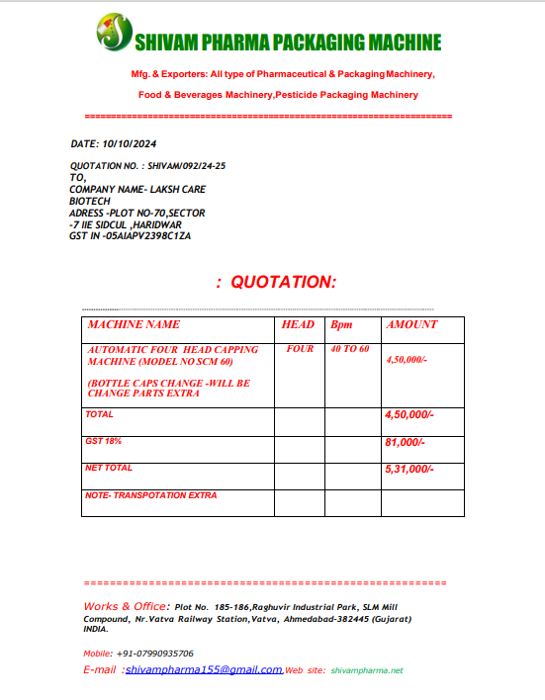

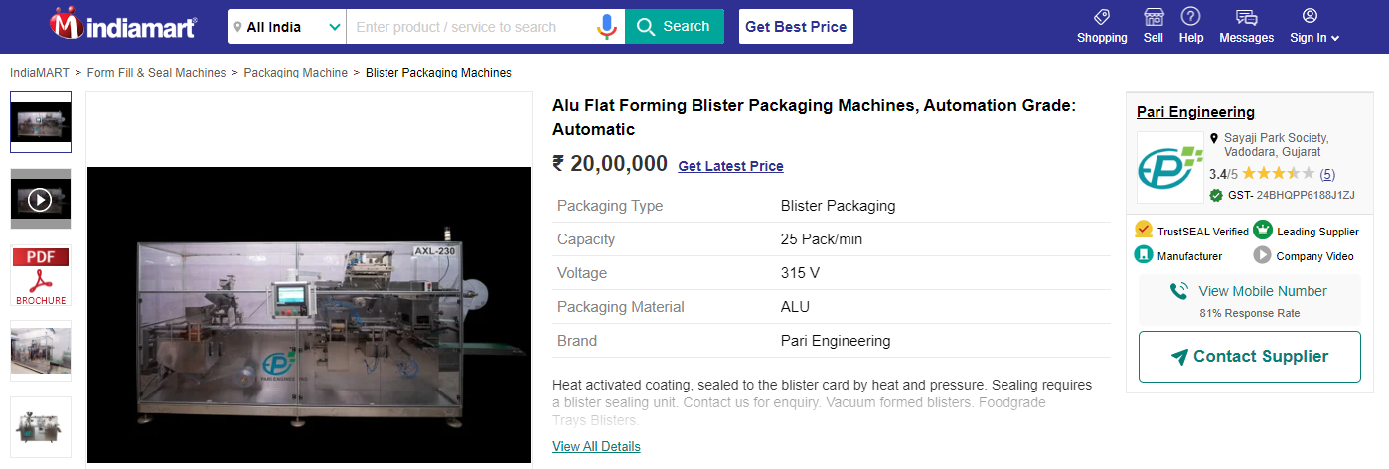
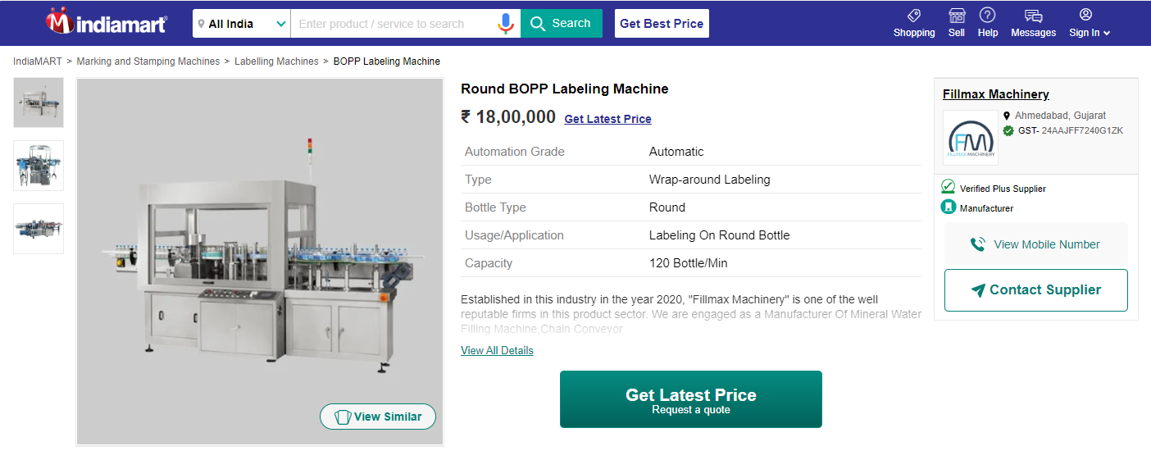
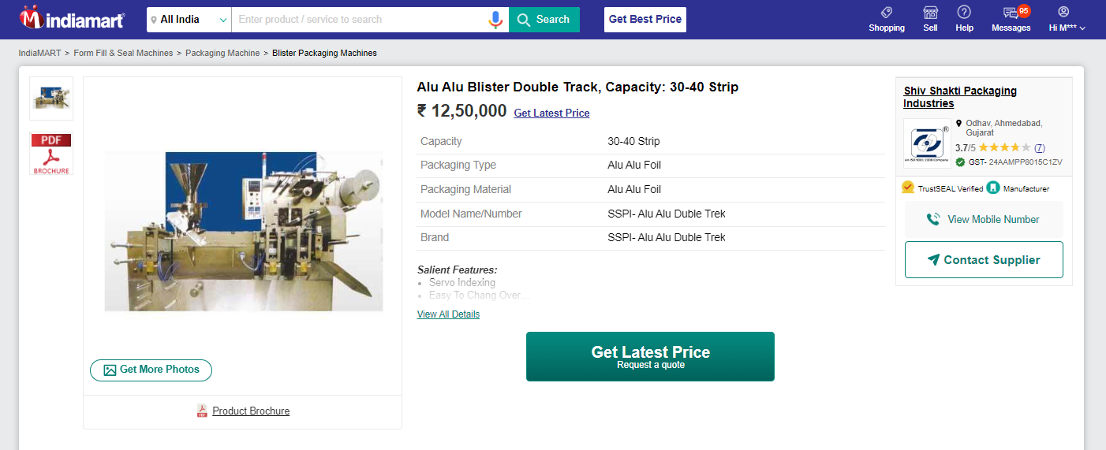

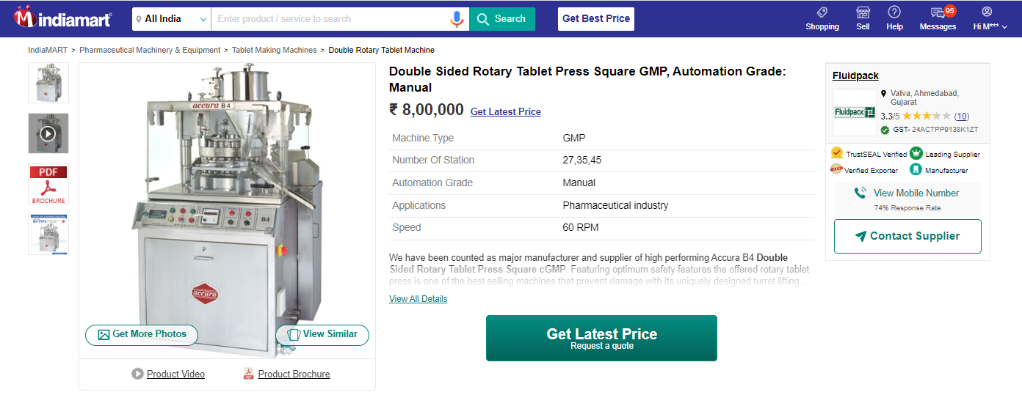
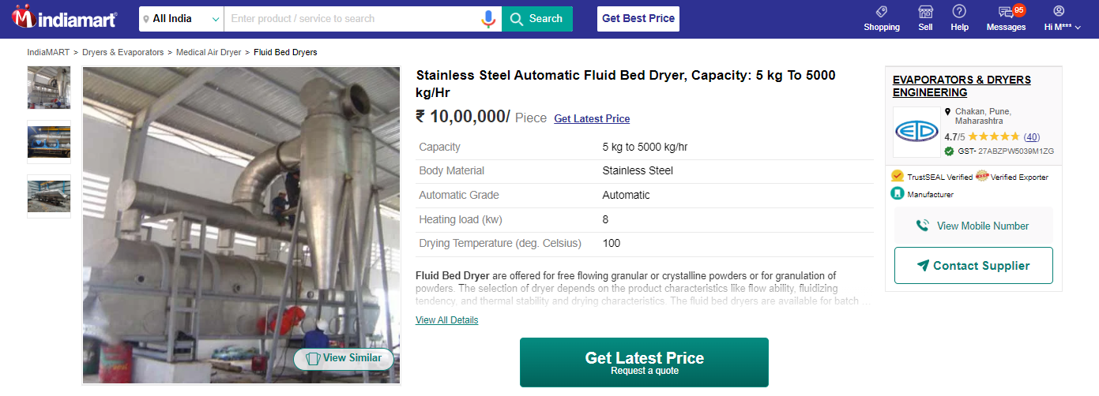
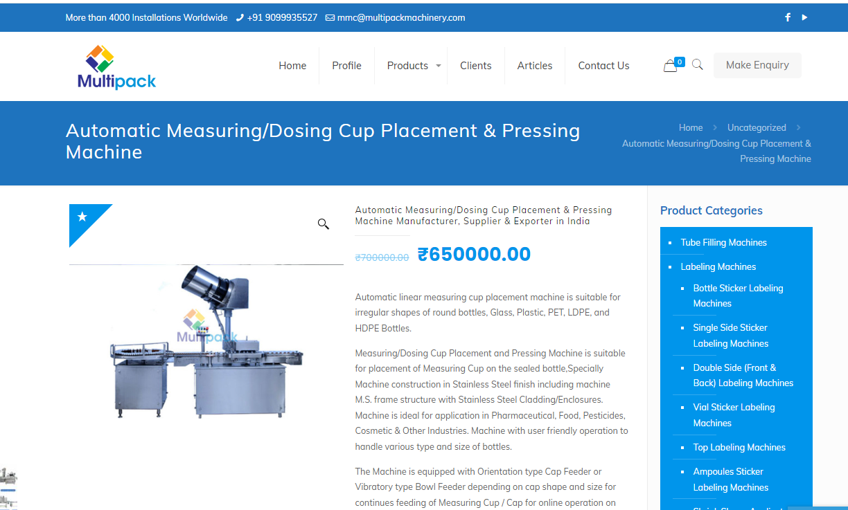

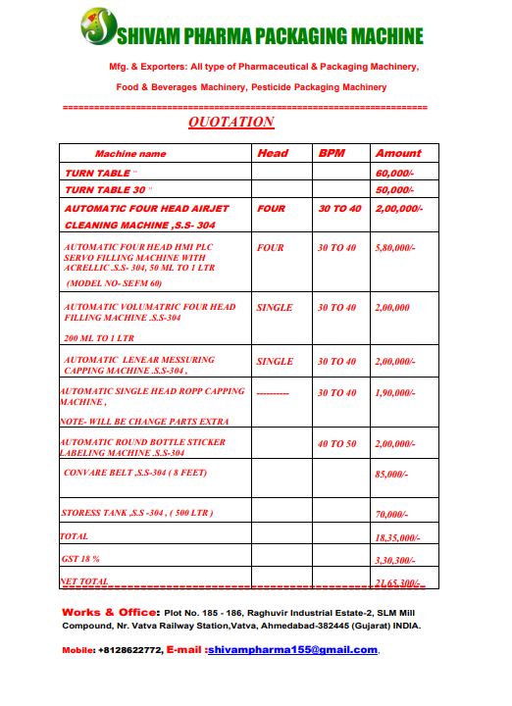

ANNEXURE: - III (DOCUMENTS PROVIDED BY CLIENT)

